FEDERAL COURT OF AUSTRALIA

AIA Australia Limited v Richards (No 4) [2017] FCA 1100

File number: | NSD 1853 of 2016
Judge: | ALLSOP CJ
Date of judgment: | 20 September 2017
Catchwords: | INSURANCE – fraudulent claims made by respondent under life insurance contract – summary judgment entered in favour of applicant – quantification of judgment sum – making of declarations
Legislation: | Insurance Contracts Act 1984 (Cth), s 56
Cases cited: | AIA Australia Ltd v Richards (No 3) [2017] FCA 1069
Date of hearing: | Determined on the papers
Date of last submissions: | 13 September 2017
Registry: | New South Wales
Division: | General Division
National Practice Area: | Commercial and Corporations
Sub-area: | Commercial Contracts, Banking, Finance and Insurance  Insurance List
Category: | Catchwords
Number of paragraphs: | 4
Counsel for the Applicant: | Ms R Francois
Solicitor for the Applicant: | William Roberts Lawyers
Counsel for the Respondent: | The Respondent did not appear

ORDERS
 |  | NSD 1853 of 2016
BETWEEN: | AIA AUSTRALIA LIMITED (ABN 79 004 837 861)  Applicant
AND: | VINCENT BRIAN RICHARDS  Respondent

JUDGE: | ALLSOP CJ
DATE OF ORDER: | 20 SEPTEMBER 2017

THE COURT ORDERS THAT:

- Judgment be entered in favour of the applicant including pre-judgment interest up to 20 September 2017 in the sum of $69,722.71.

THE COURT DECLARES THAT:

- On 19 October 2016, the applicant validly refused to pay claims made by the respondent pursuant to s 56(1) of the Insurance Contracts Act 1984 (Cth).
- The contract of insurance between the applicant and the respondent was validly cancelled by the applicant on 19 October 2016.

Note: Entry of orders is dealt with in Rule 39.32 of the Federal Court Rules 2011.

REASONS FOR JUDGMENT
ALLSOP CJ:
- On 11 September 2017, I made orders in relation to this matter and published reasons: see AIA Australia Ltd v Richards (No 3) [2017] FCA 1069. I directed that the applicant file a schedule of sums paid after February 2016, together with pre-judgment interest thereof. I attach the schedule which was filed on 13 September 2017. I have checked that schedule and there is an inaccuracy. The judgment sum should be $90.85 less than the sum indicated of $69,813.56. Therefore, the orders that I make will include an order for judgment in the sum of $69,722.71.
- In accordance with my reasons in Richards (No 3), the applicant is also entitled to the declarations sought in prayers 1(a) and (b) of the interlocutory application filed 21 July 2017.
- I have already made an order for costs.
- Therefore, the orders I would make, in addition to the orders made on 11 September 2017 are as follows:
- Judgment be entered in favour of the applicant including pre-judgment interest up to 20 September 2017 in the sum of $69,722.71.
- Declare that:
  - on 19 October 2016, the applicant validly refused to pay claims made by the respondent pursuant to s 56(1) of the Insurance Contracts Act 1984 (Cth); and
  - the contract of insurance between the applicant and the respondent was validly cancelled by the applicant on 19 October 2016.

I certify that the preceding four (4) numbered paragraphs are a true copy of the Reasons for Judgment herein of the Honourable Chief Justice Allsop.

Associate:

Dated: 20 September 2017

ANNEXURE A – SCHEDULE OF CLAIMED PAYMENTS AND INVESTIGATION COSTS
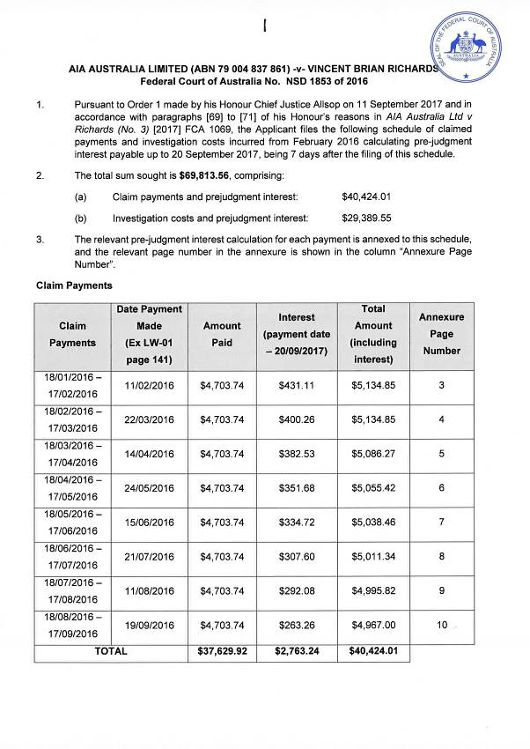
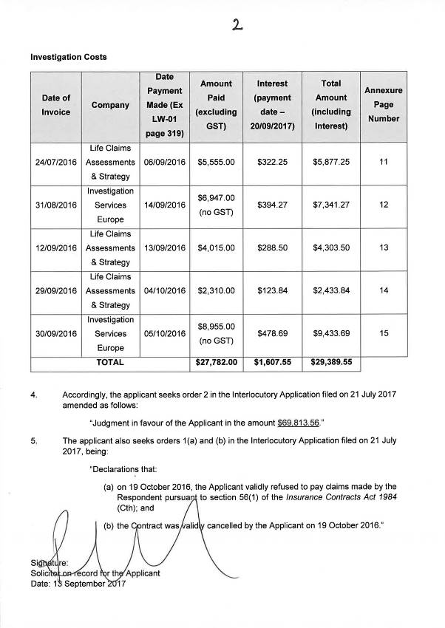

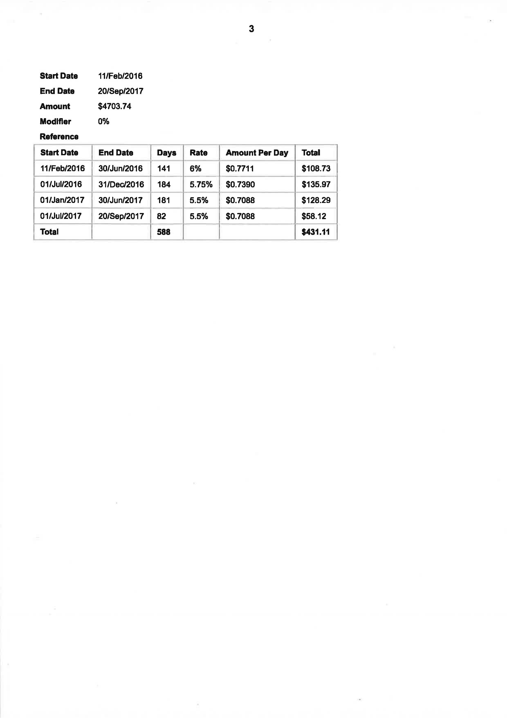

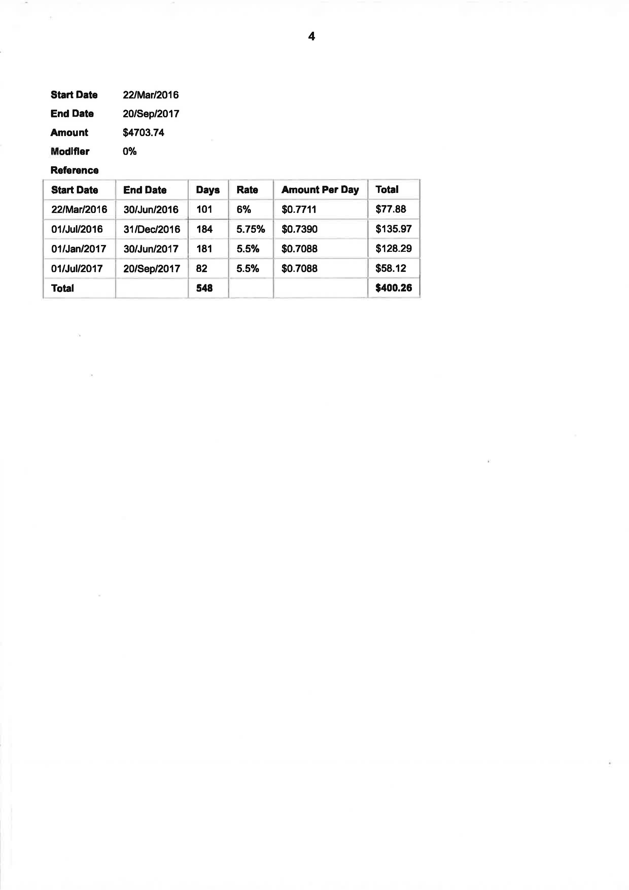

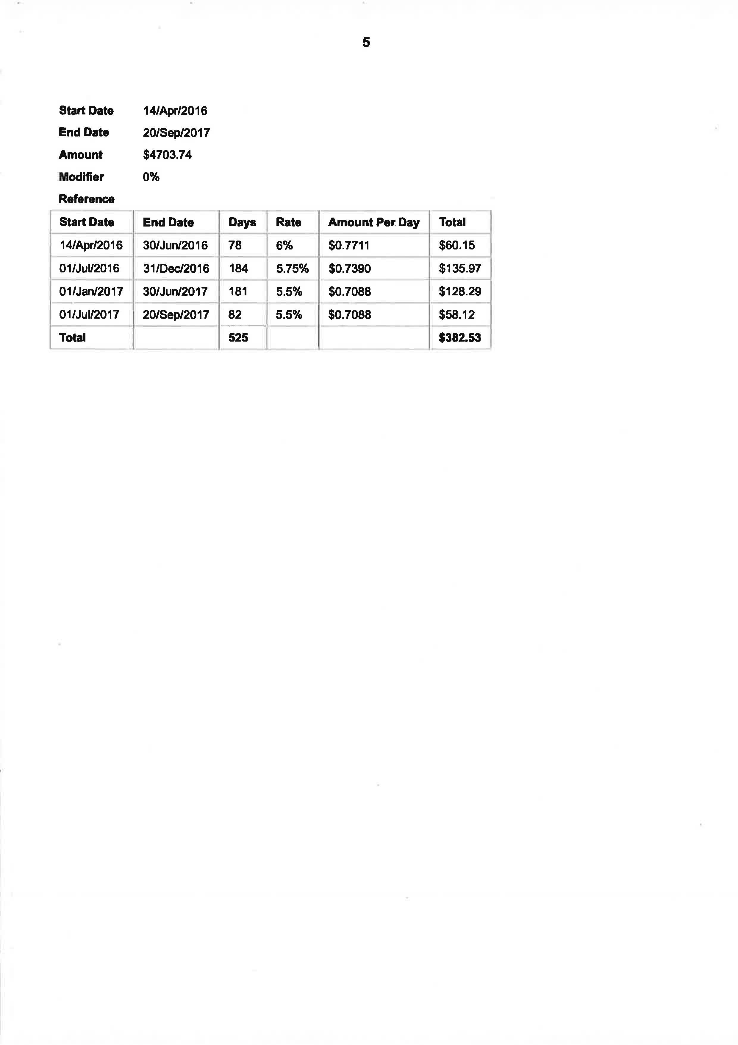

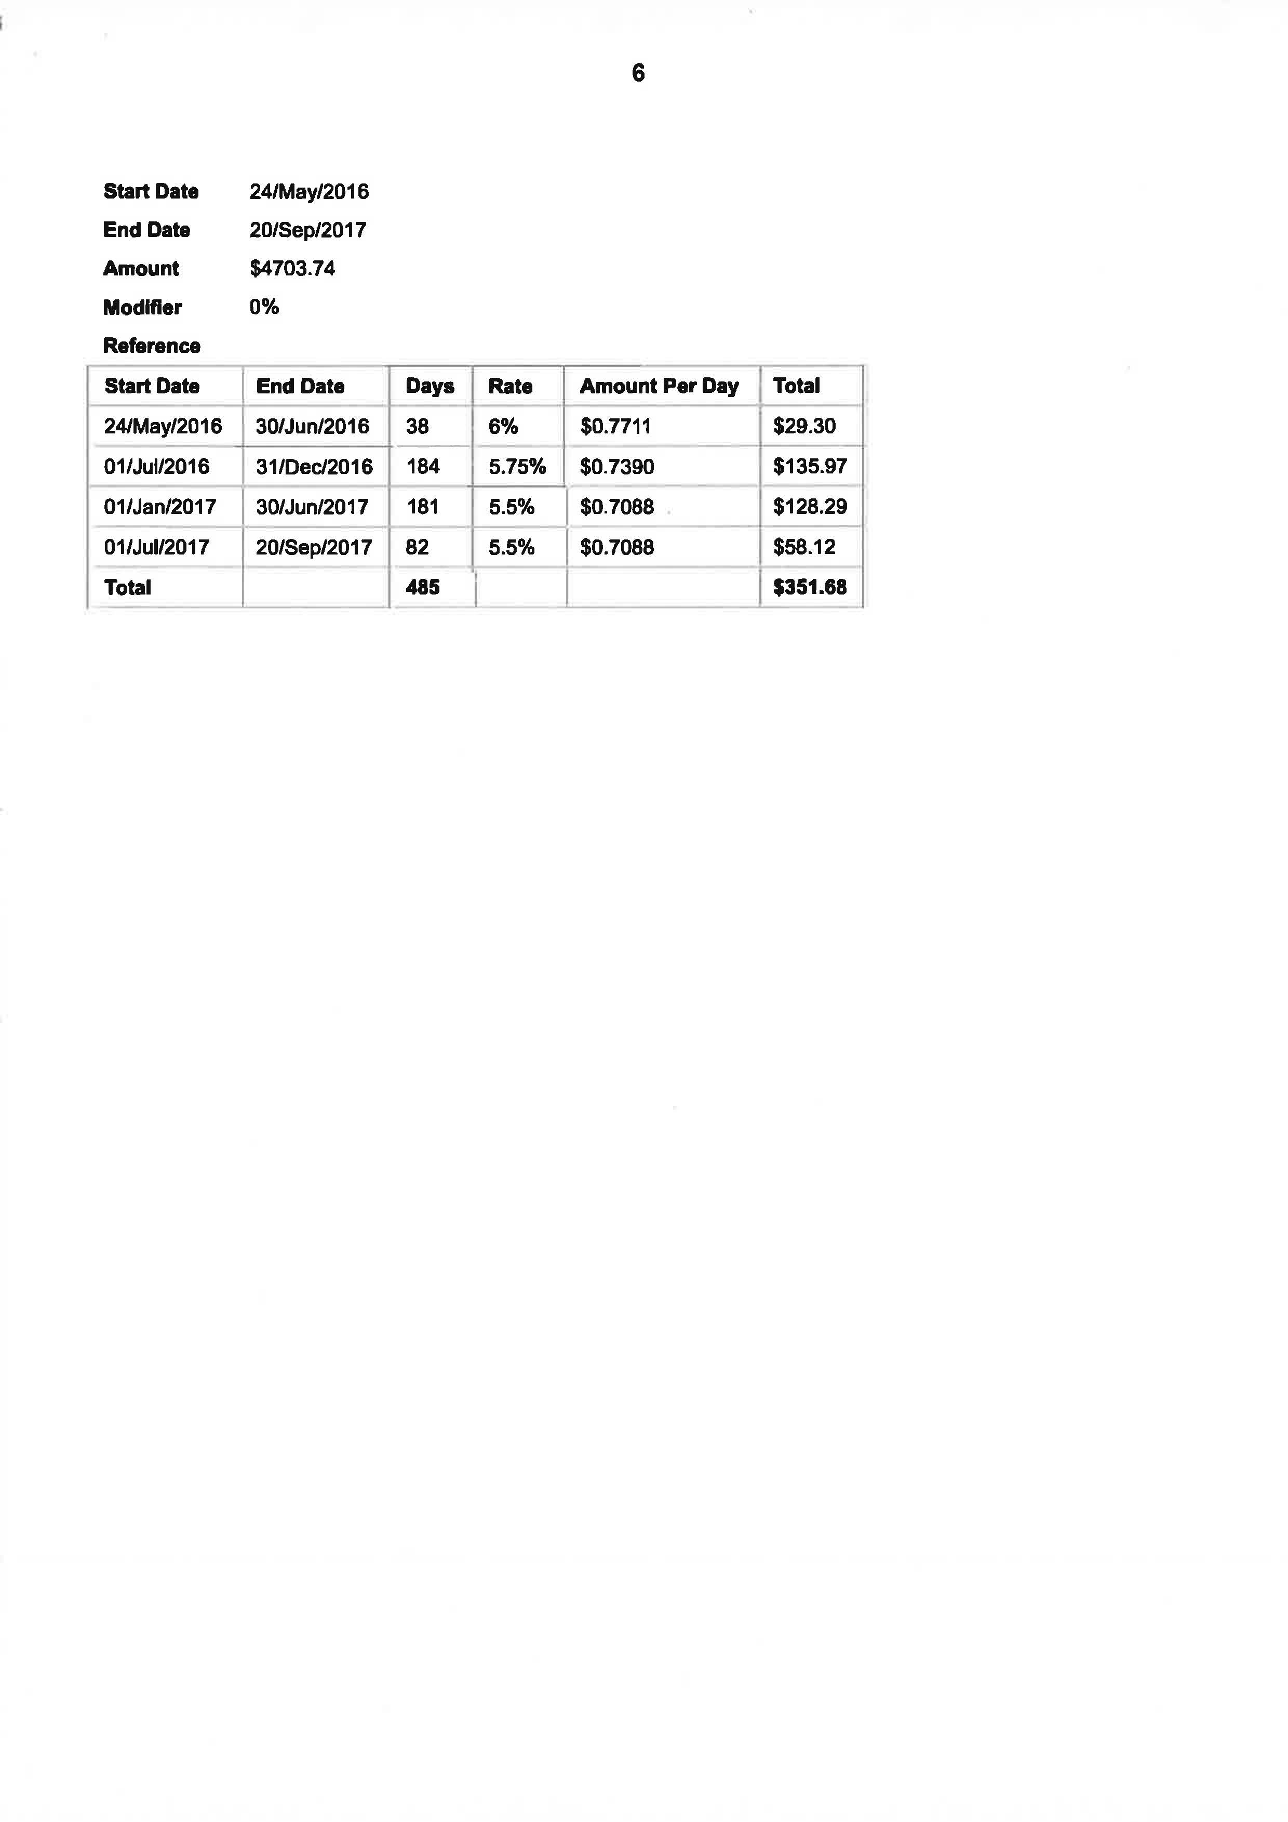

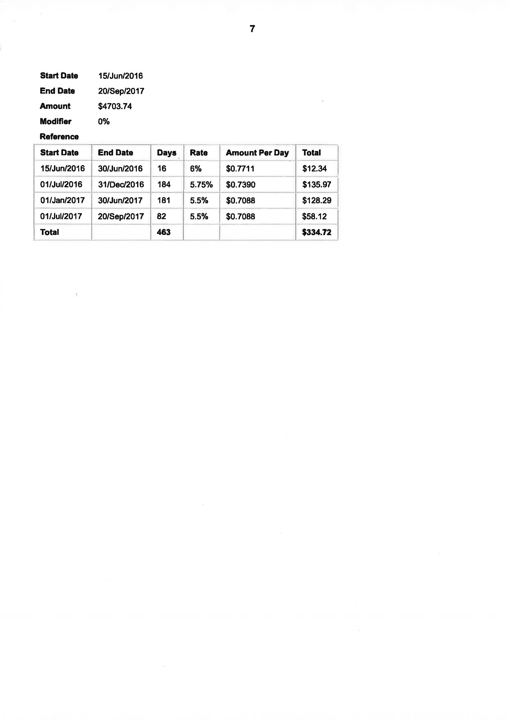

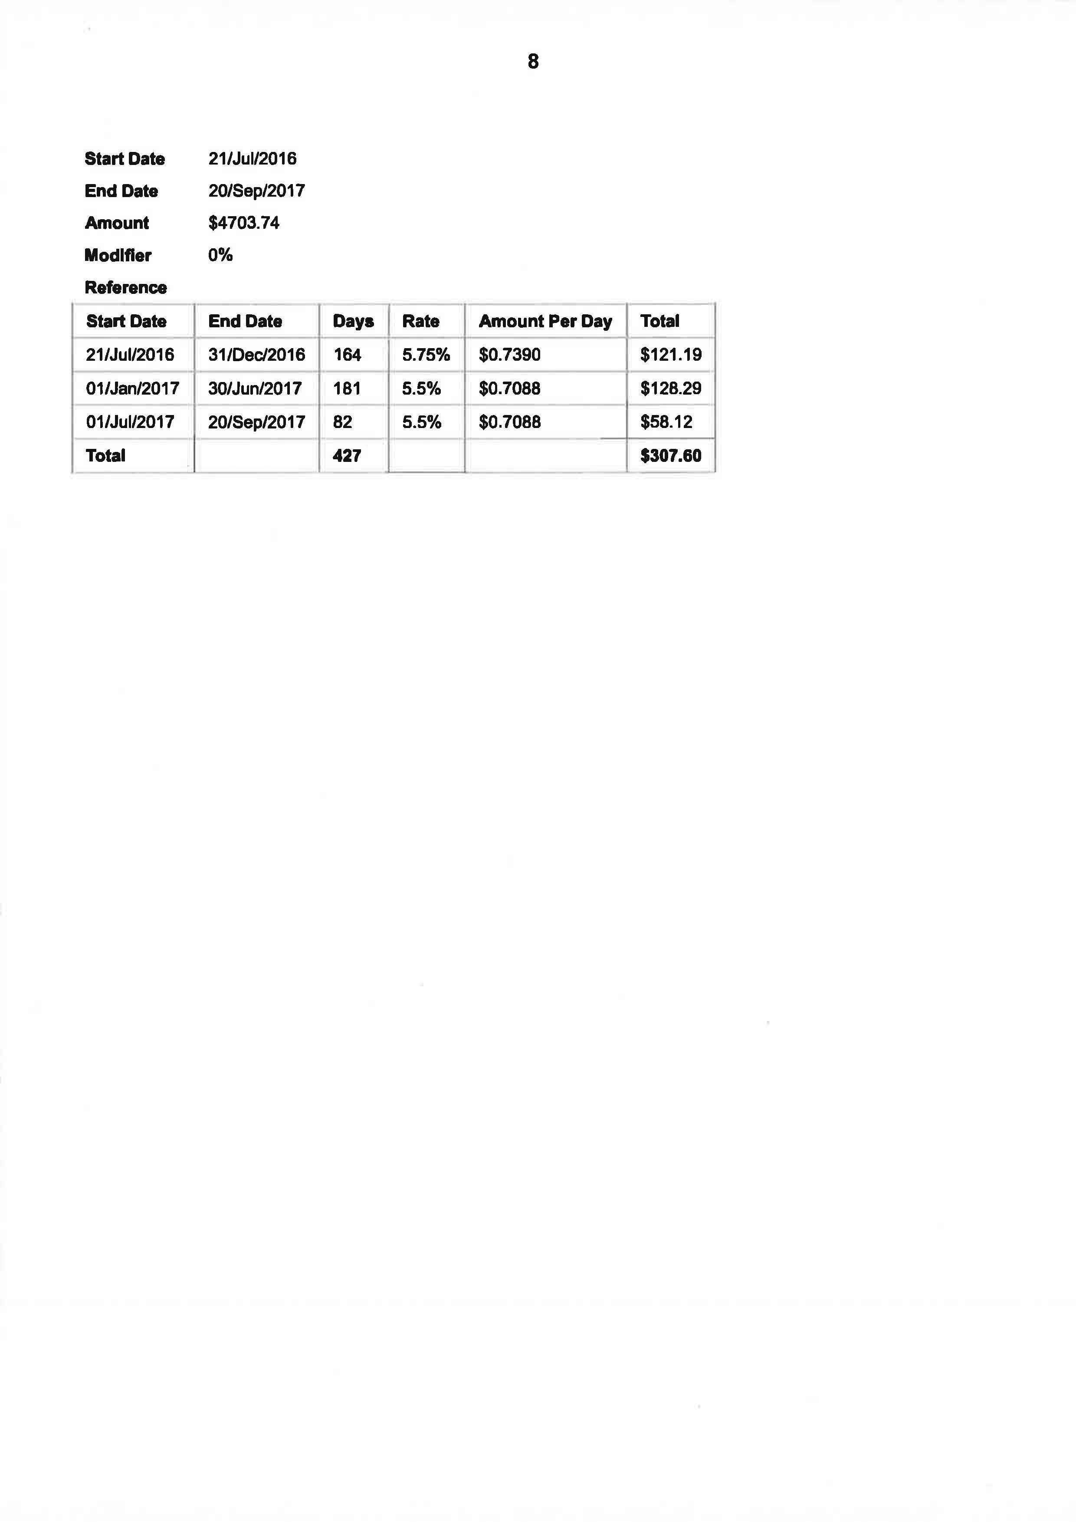

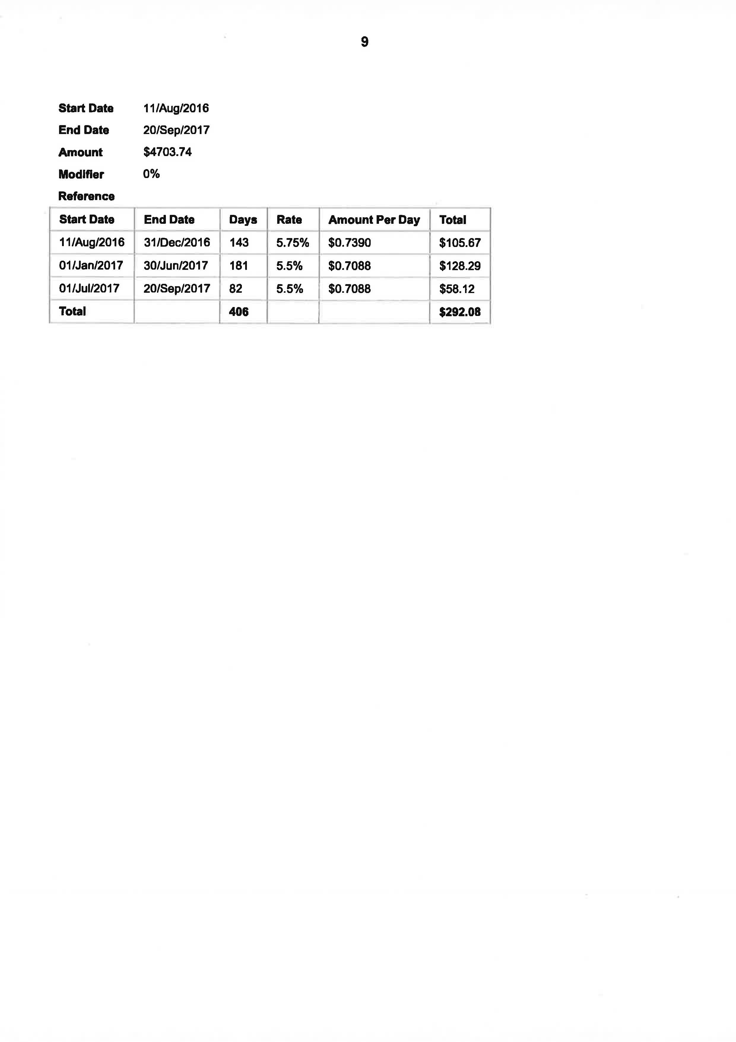

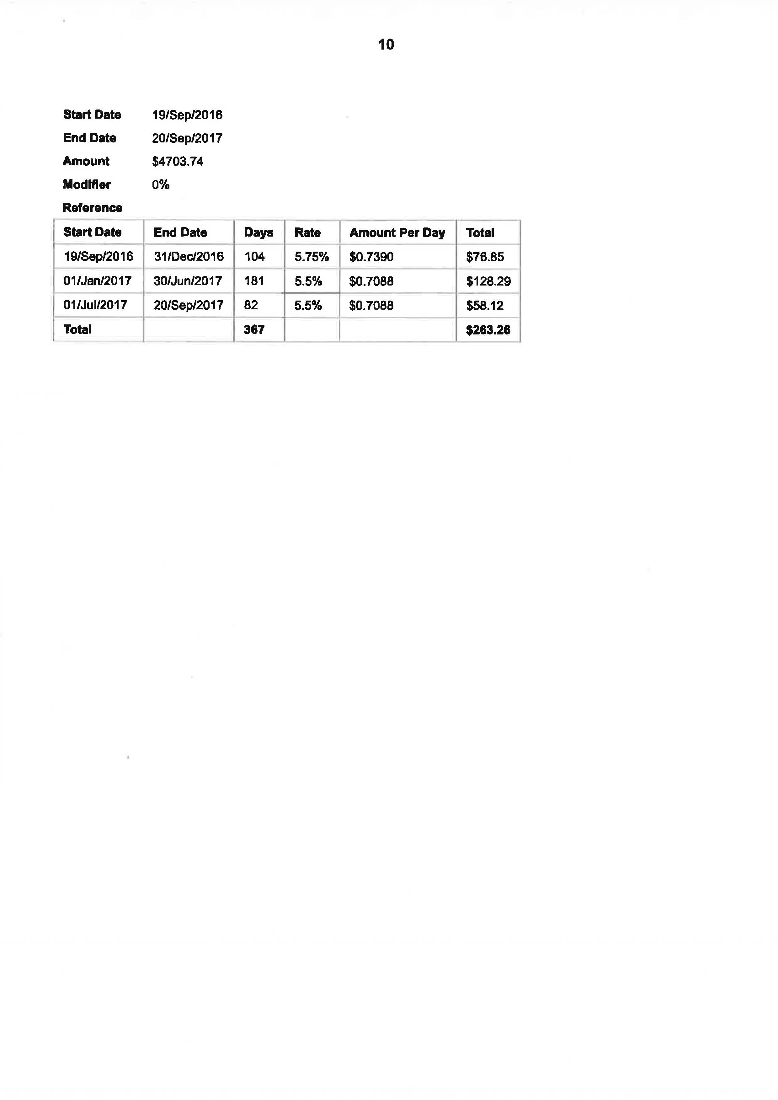

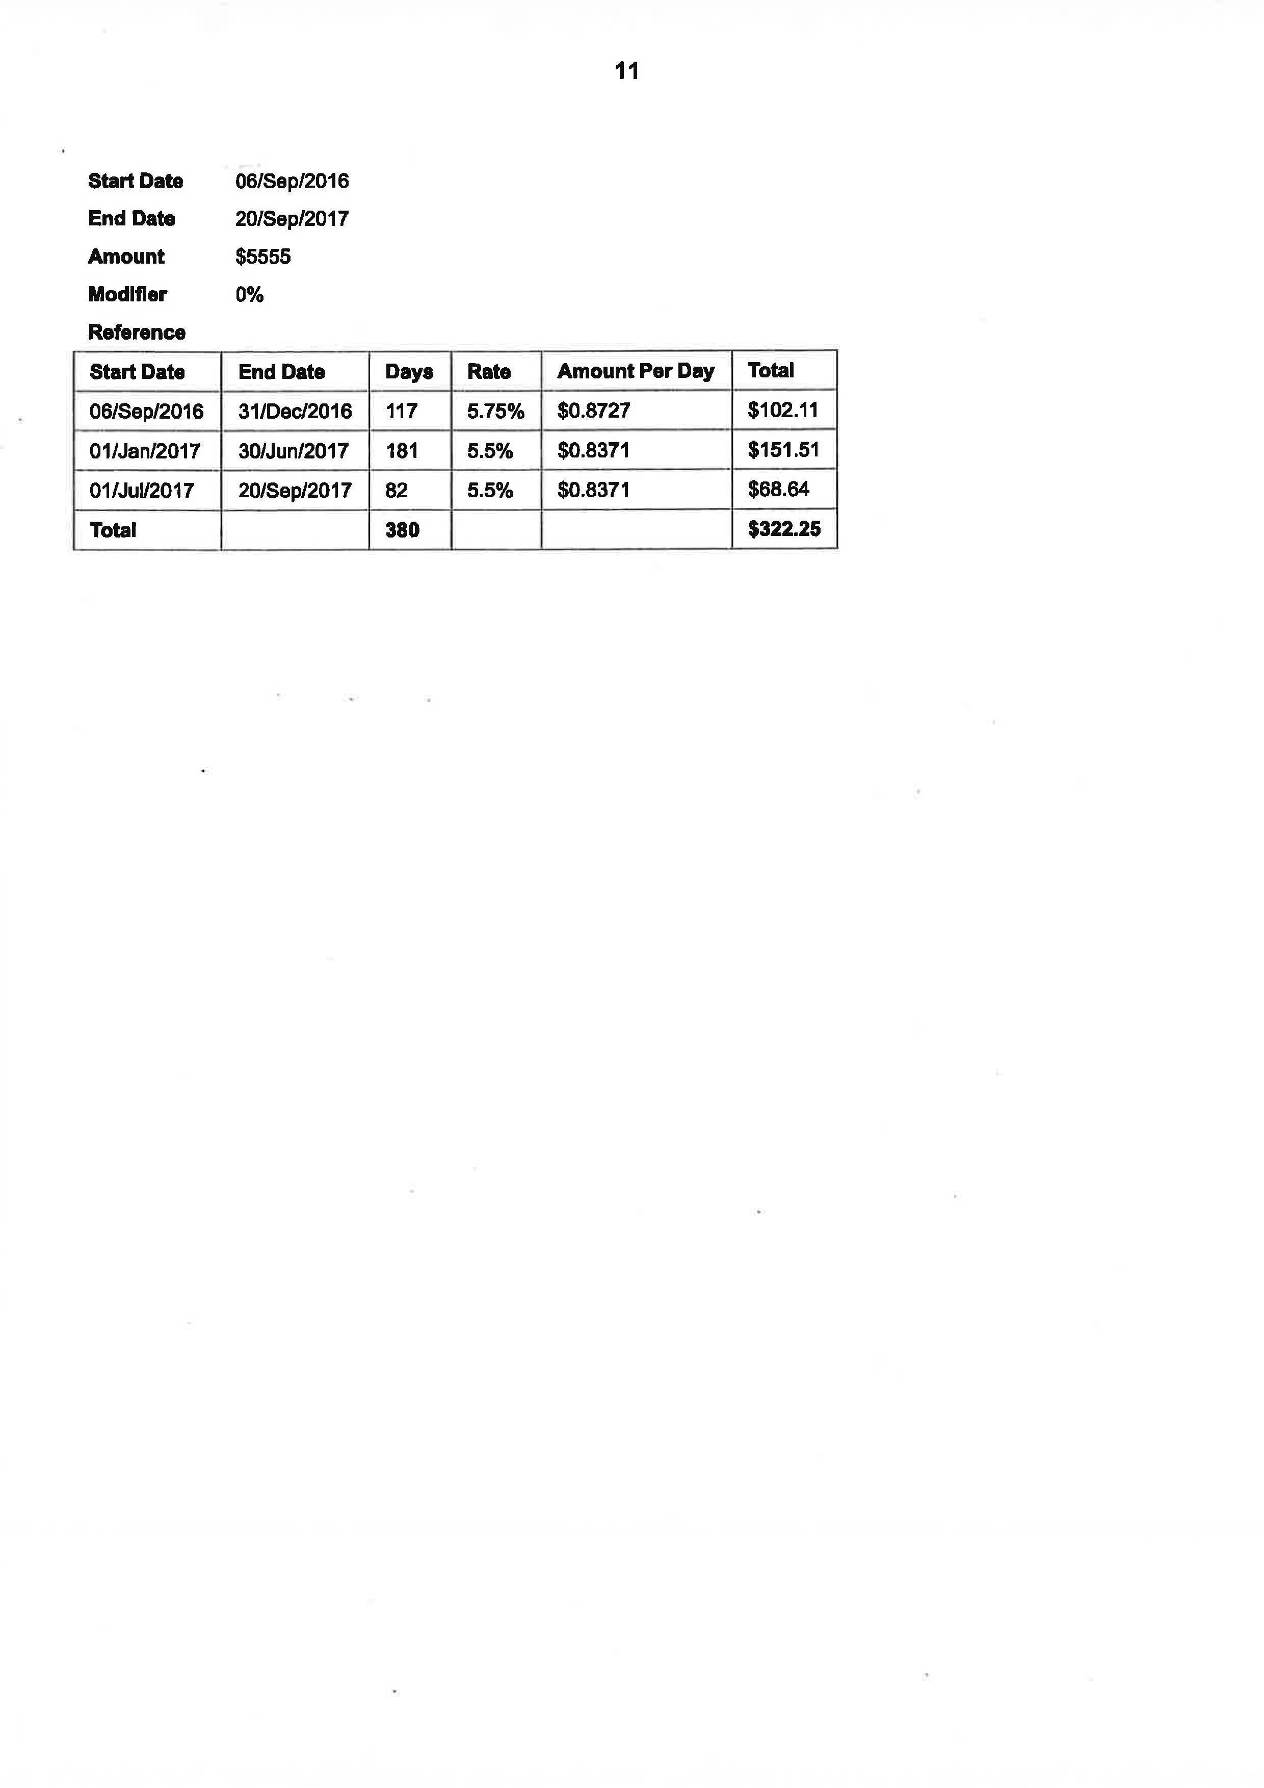

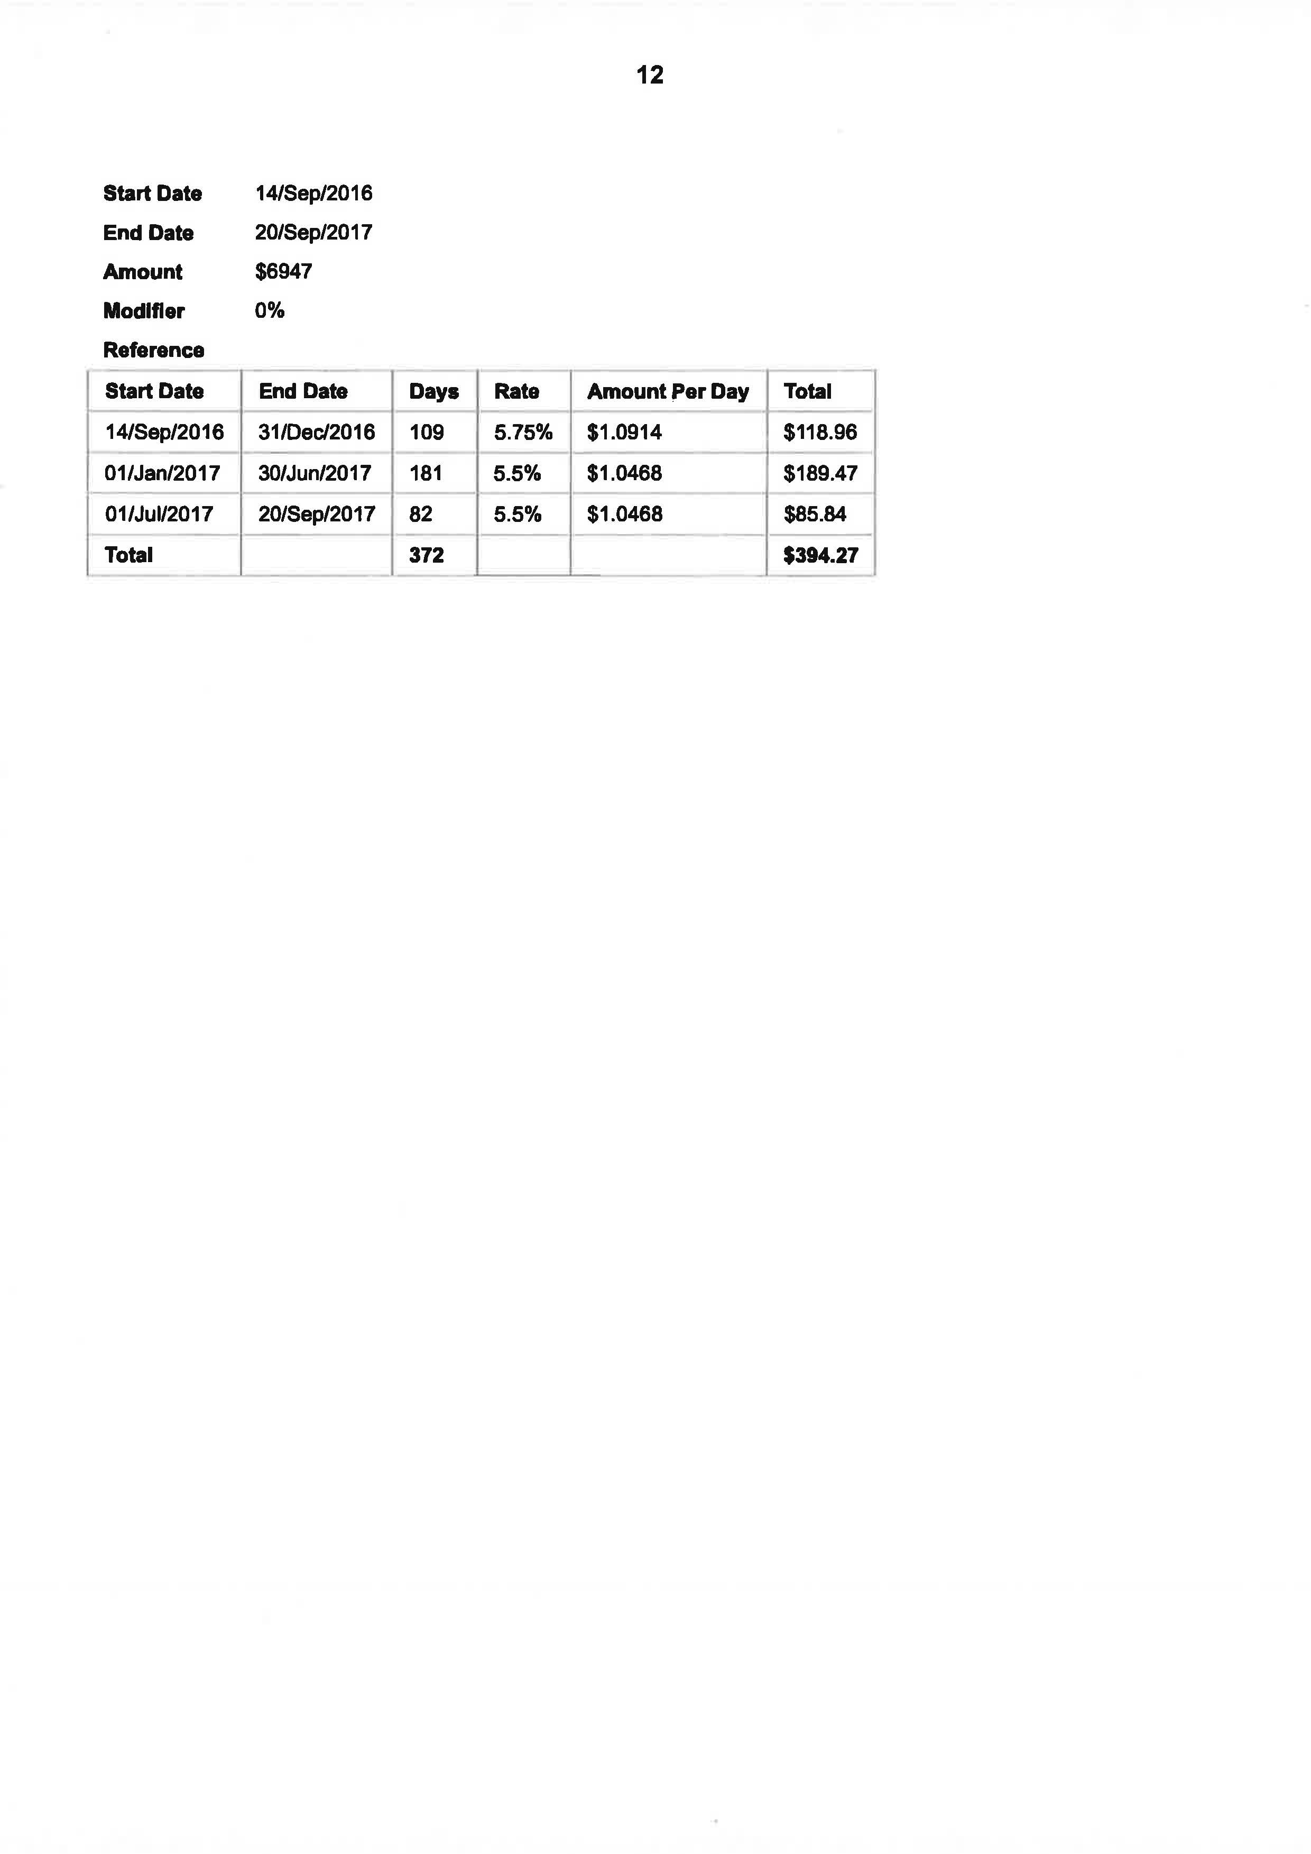

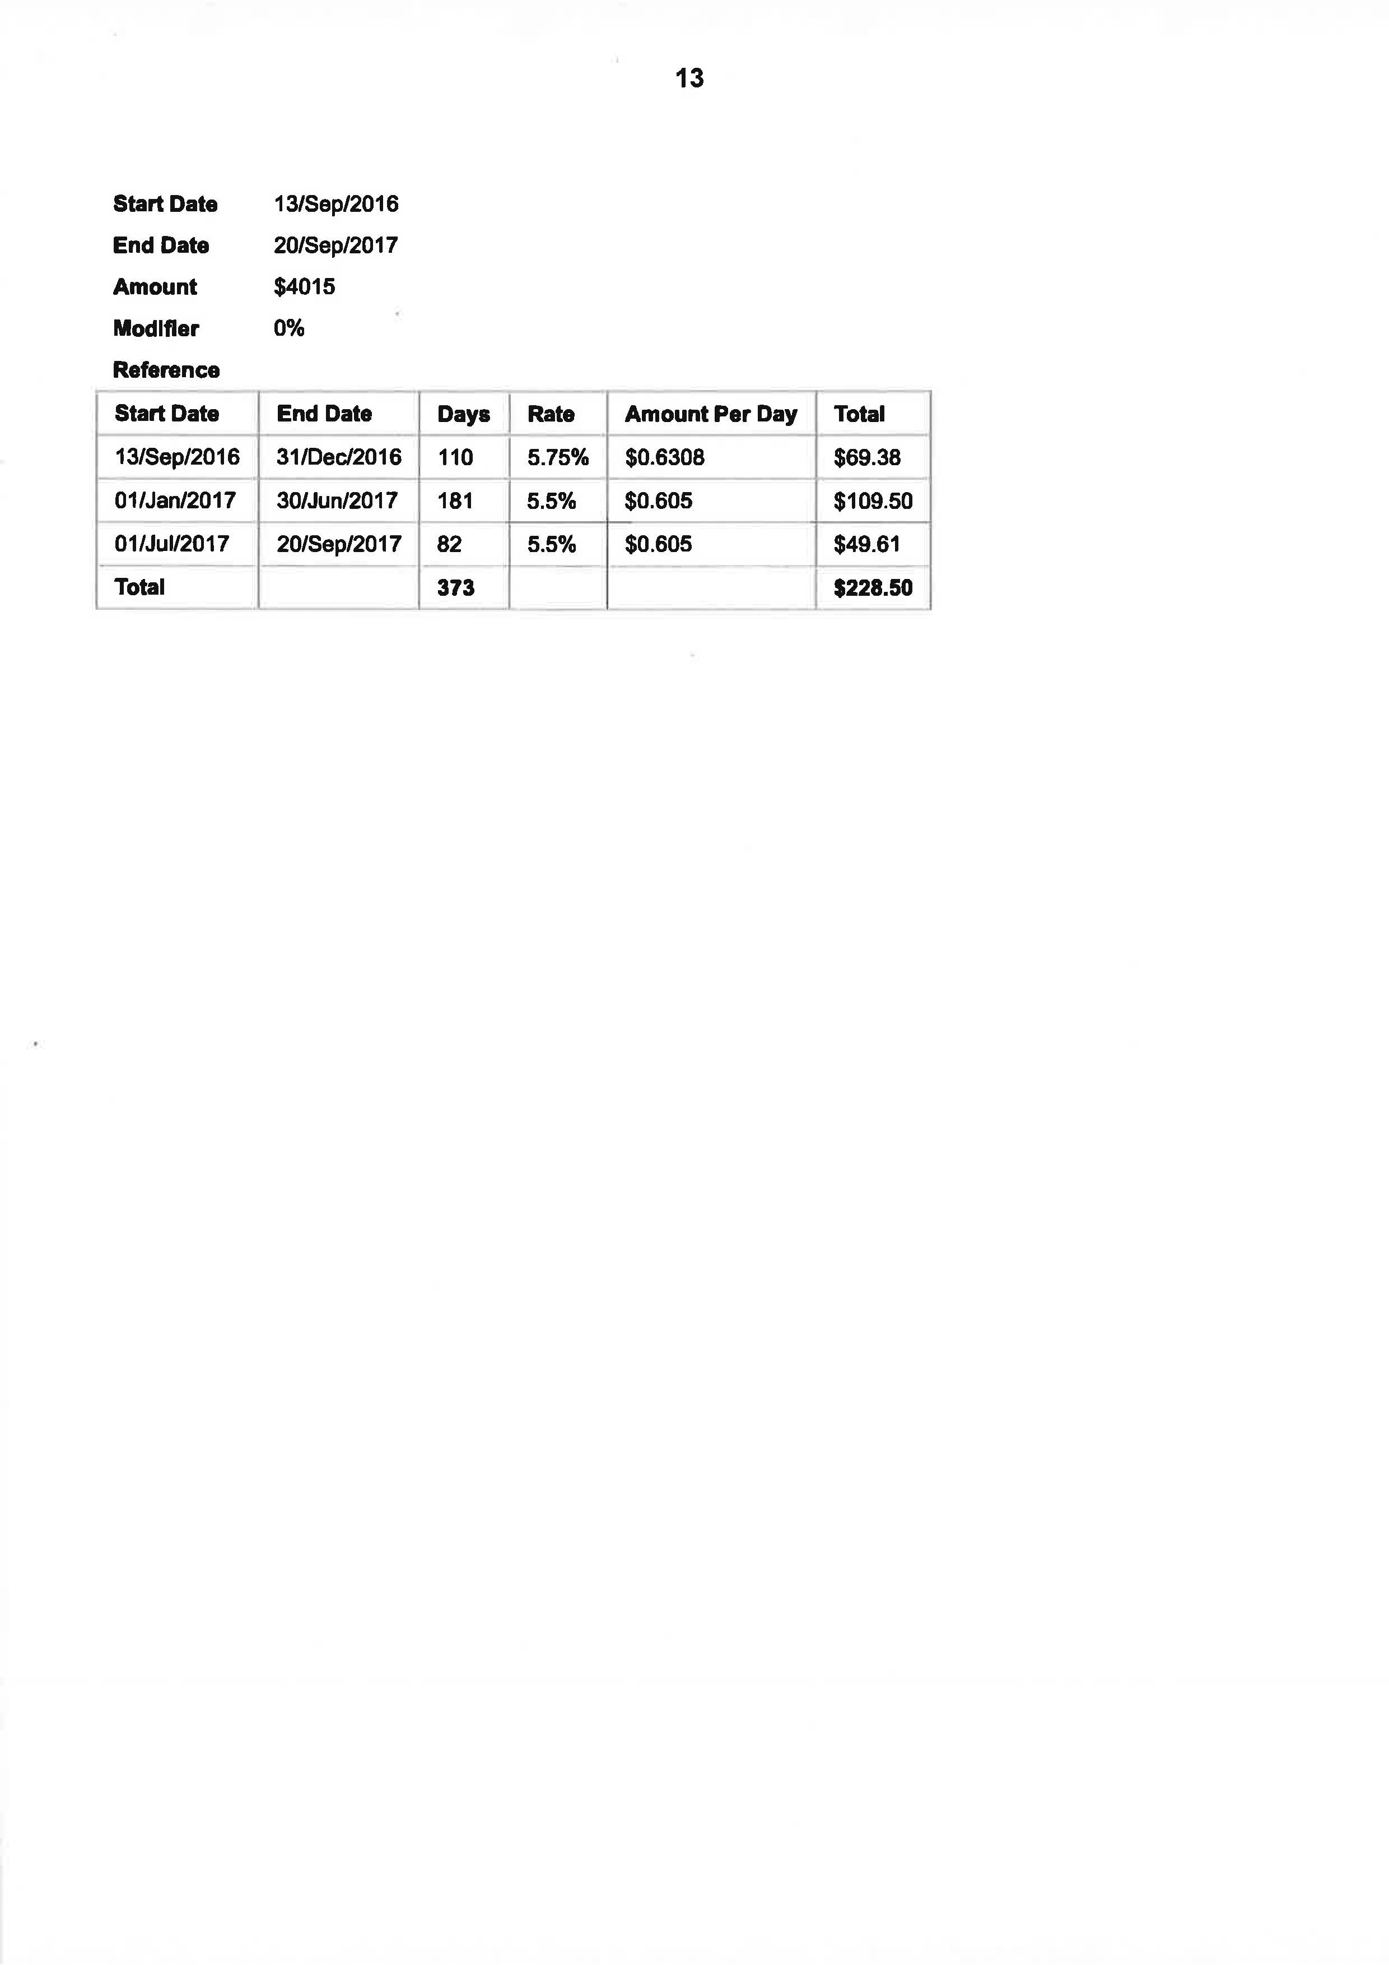

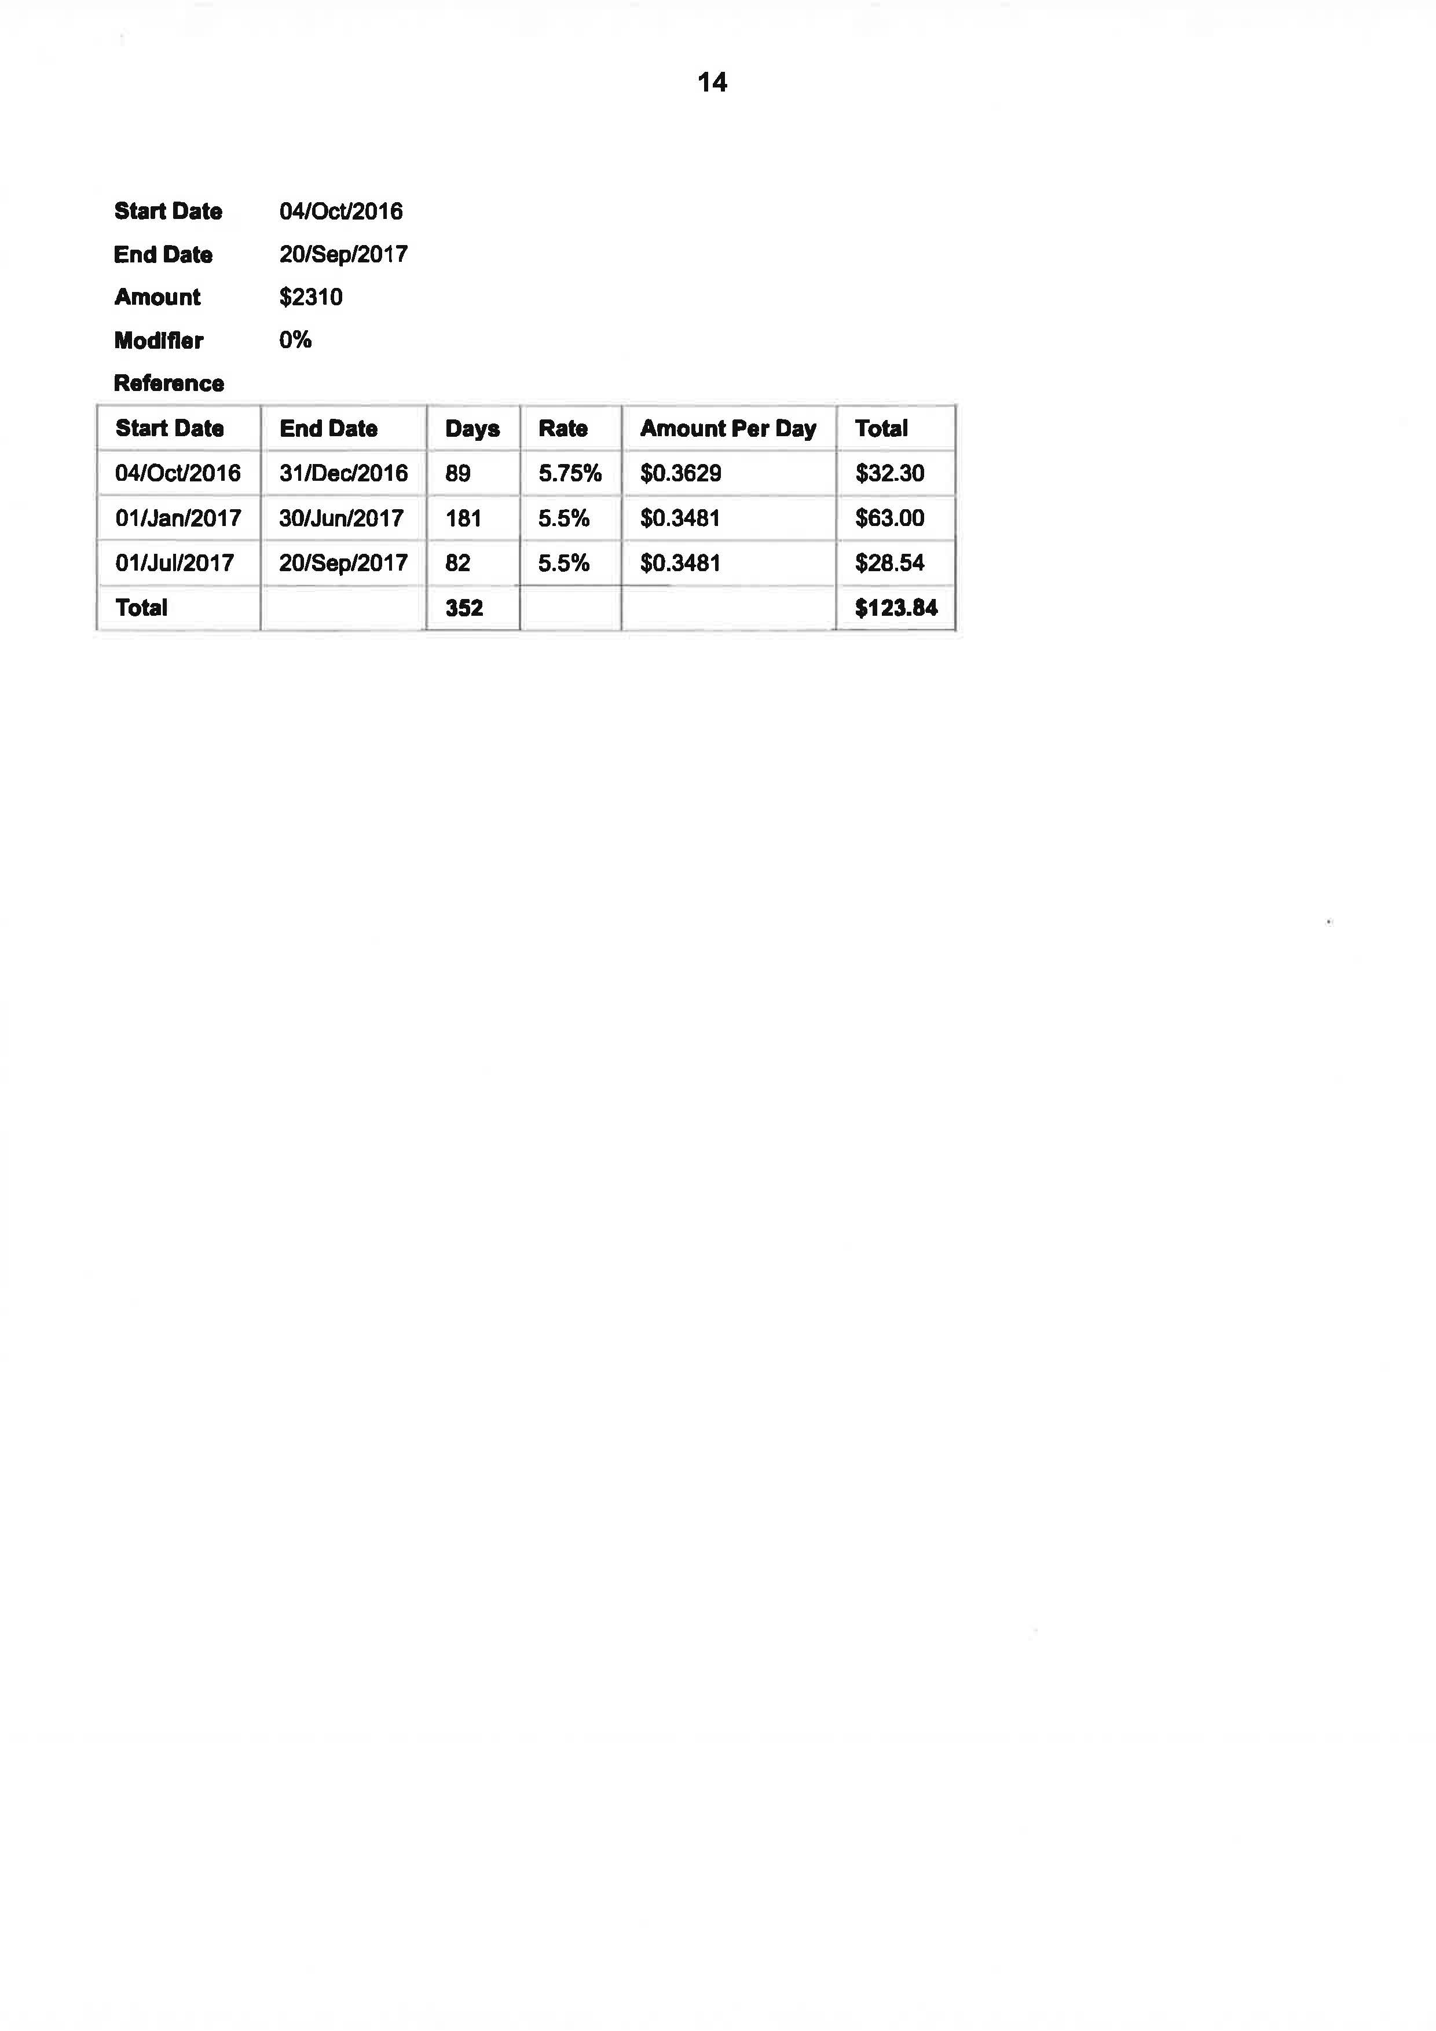

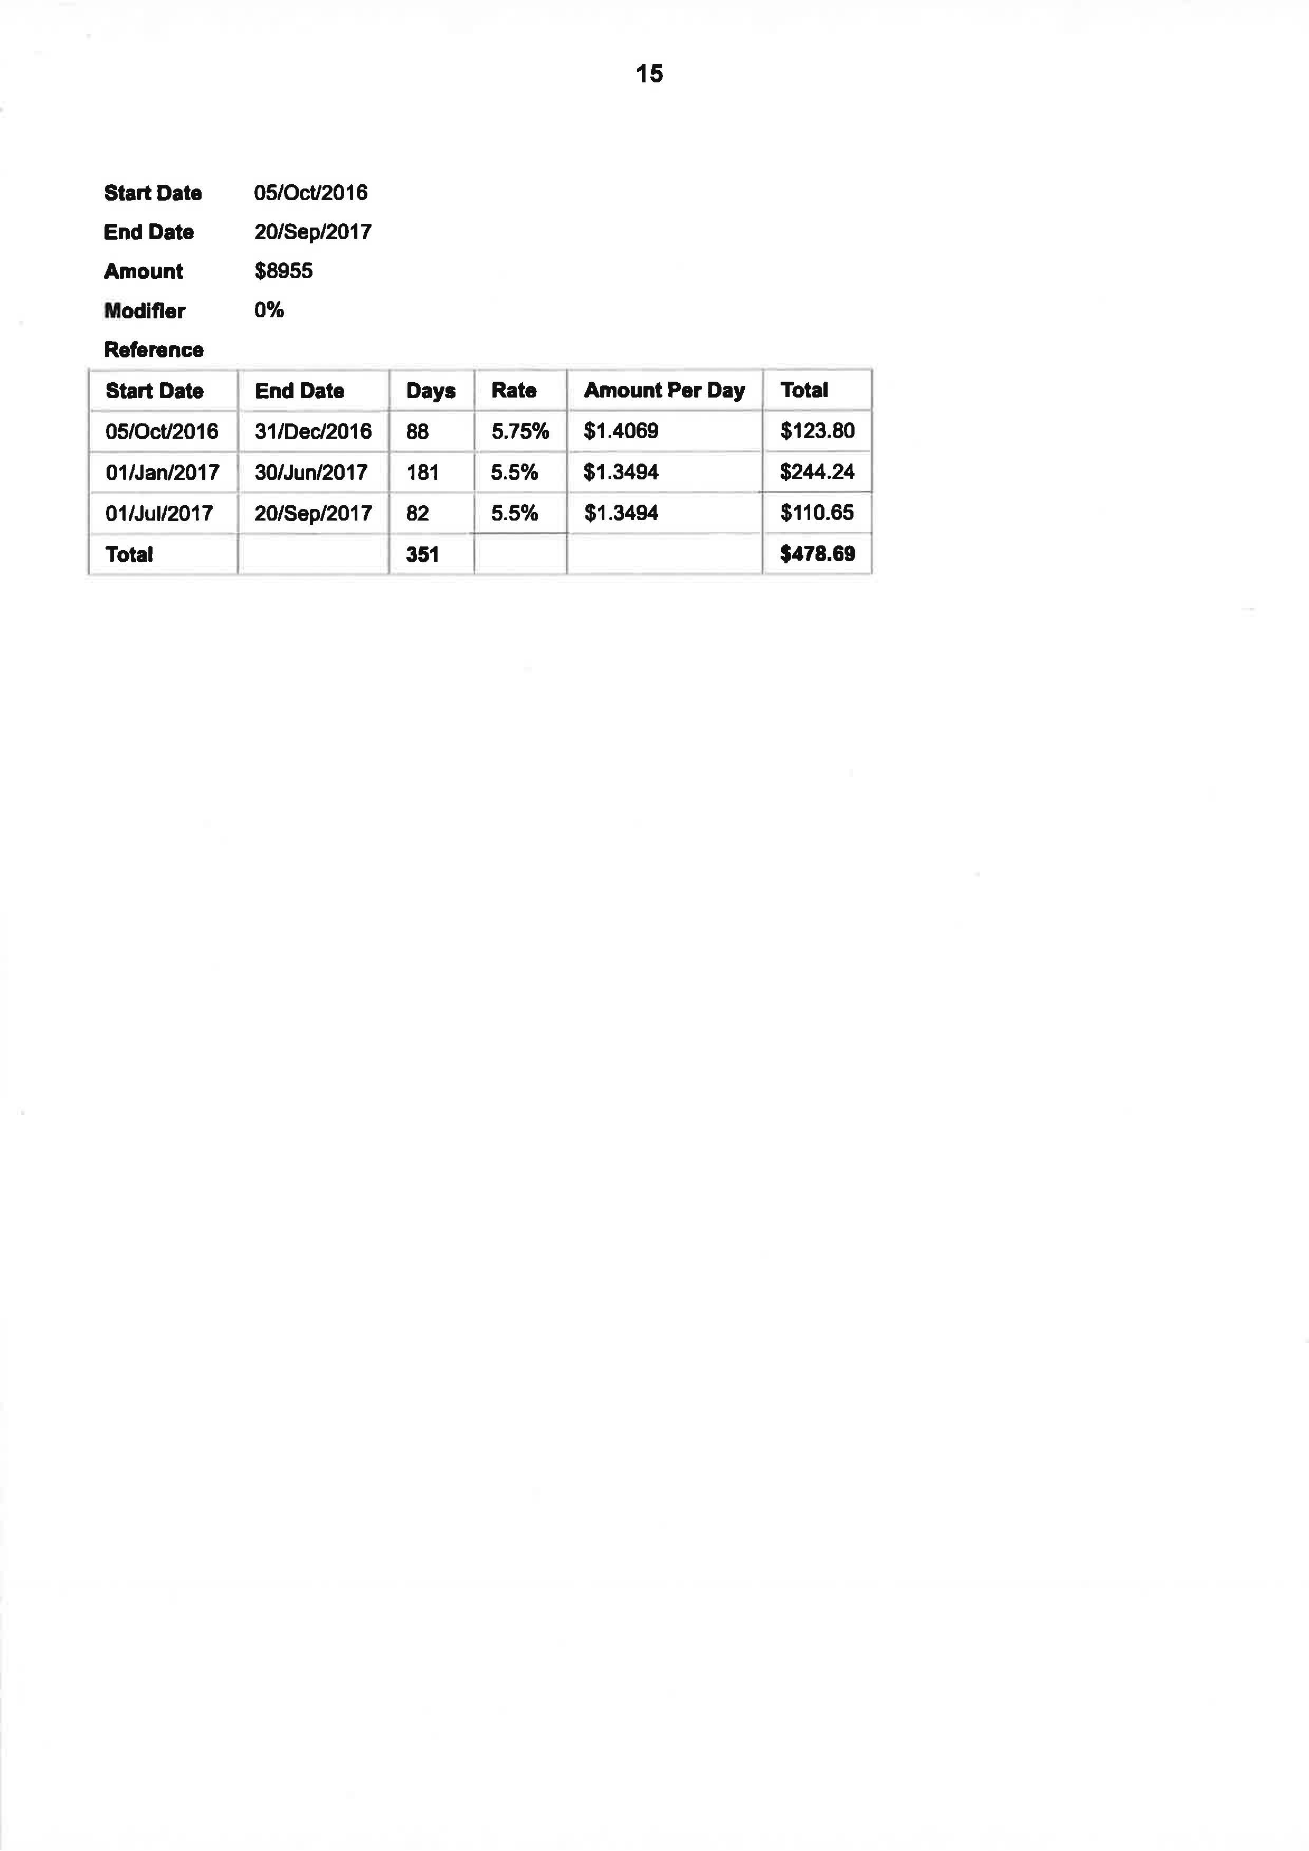

ANNEXURE B – CORRECTED SCHEDULE OF CLAIMED PAYMENTS AND INVESTIGATION COSTS
