Federal Court of Australia

de Vries, in the matter of the bankrupt estate of Cunningham [2021] FCA 188
File number: | NSD 1391 of 2020
Judgment of: | NICHOLAS J
Date of judgment: | 16 March 2021
Catchwords: | BANKRUPTCY AND INSOLVENCY – application under s 180 of the Bankruptcy Act 1966 (Cth) to replace trustees of bankrupt estates – where trustees are retiring from practice and wish to transfer files to registered trustees in the same firm – application for order to dispense with service requirement under r 8.02(4)(b) of the Federal Court (Bankruptcy) Rules 2016 (Cth) – whether order dispensing with compliance should be made – whether orders under s 180 should be made
Legislation: | Bankruptcy Act 1966 (Cth) s 180  Federal Court (Bankruptcy) Rules 2005 (Cth) rr 1.03(2)(a), 8.02(2)  Federal Court (Bankruptcy) Rules 2016 (Cth) rr 1.04, 1.34, 8.02  Federal Court Rules 2011 (Cth) r 1.34
Cases cited: | Allen, in the matter of Allen [2020] FCA 376  Coshott v Burke [2013] FCA 155  Donnelly v Maxwell-Smith [2010] FCAFC 154  Gollant, in the matter of ACN 065 229 831 Pty Ltd [2017] FCA 1158  Nixon, in the matter of Nixon [2015] FCA 976
Division: | General Division
Registry: | New South Wales
National Practice Area: | Commercial and Corporations
Sub-area: | General and Personal Insolvency
Number of paragraphs: | 25
Date of hearing: | 5 March 2021
Counsel for the Applicants: | Mr G McDonald

ORDERS
 |  | NSD 1391 of 2020
IN THE MATTER OF THE BANKRUPT ESTATE OF DAVID A CUNNINGHAM (AND EACH OF THE BANKRUPT ESTATES REFERRED TO IN THE SCHEDULE TO THESE ORDERS)
BETWEEN: | ANTONY DE VRIES  First Applicant  DAVID SOLOMONS  Second Applicant  MARK ROBINSON  Third Applicant  ANTONIO (ANTHONY) BAGALA  Fourth Applicant

order made by: | NICHOLAS J
DATE OF ORDER: | 16 March 2021

THE COURT ORDERS THAT:

- Pursuant to r 1.34 of the Federal Court Rules 2011 (Cth) and r 1.04(1) of the Federal Court (Bankruptcy) Rules 2016 (Cth) (“Bankruptcy Rules”) compliance with the requirements of r 8.02(4)(b) of the Bankruptcy Rules is dispensed with.
- Pursuant to s 180 of the Bankruptcy Act 1966 (Cth) (“the Bankruptcy Act”) the Court:
  - accepts the resignation of the first applicant from the office of trustee of the bankrupt estates referred to in Parts A, B and C of the Schedule to these orders;
  - accepts the resignation of the second applicant from the office of trustee of the bankrupt estates referred to in Parts D and E of the Schedule to these orders; and
  - accepts the resignation of the third applicant from the office of trustee of the bankrupt estates referred to in Parts C and E of the Schedule to these orders.
- Pursuant to s 180 of the Bankruptcy Act, and as a condition of making order 2 above, the Court appoints the third applicant and the fourth applicant as joint trustees of the bankrupt estates referred to in all parts of the Schedule to these orders.
- The resignations and appointments referred to in orders 2 and 3 hereof shall take effect on 16 March 2021.
- The applicants serve a copy of these orders on the Inspector-General in Bankruptcy by 4.00pm, 16 March 2021.
- There be no order as to the costs of the application.

Note: Entry of orders is dealt with in Rule 39.32 of the Federal Court Rules 2011.

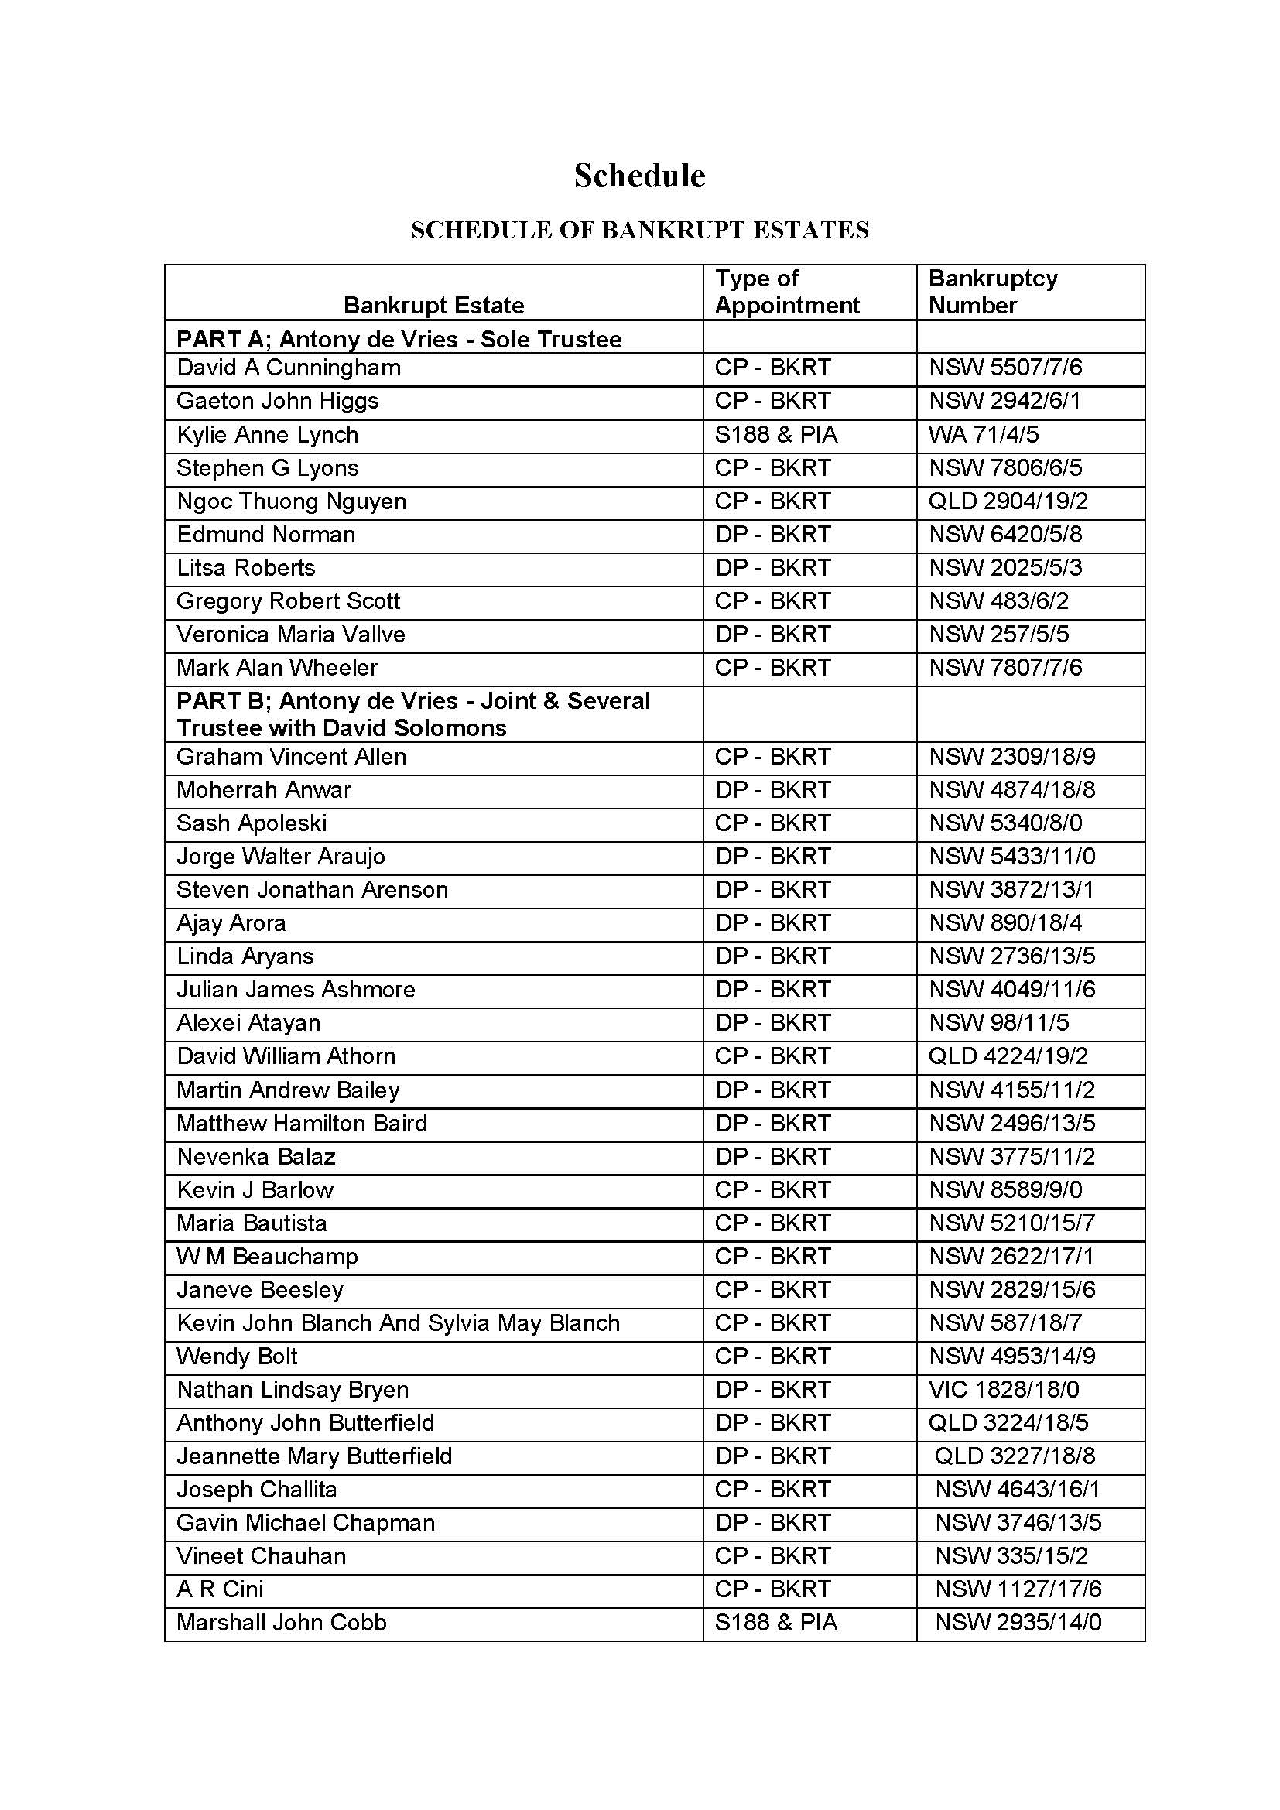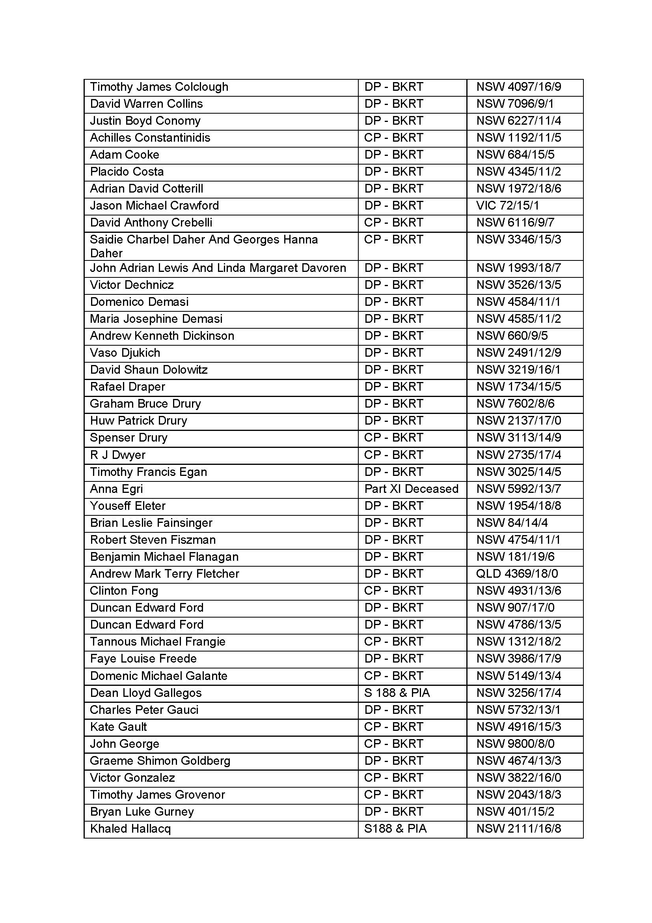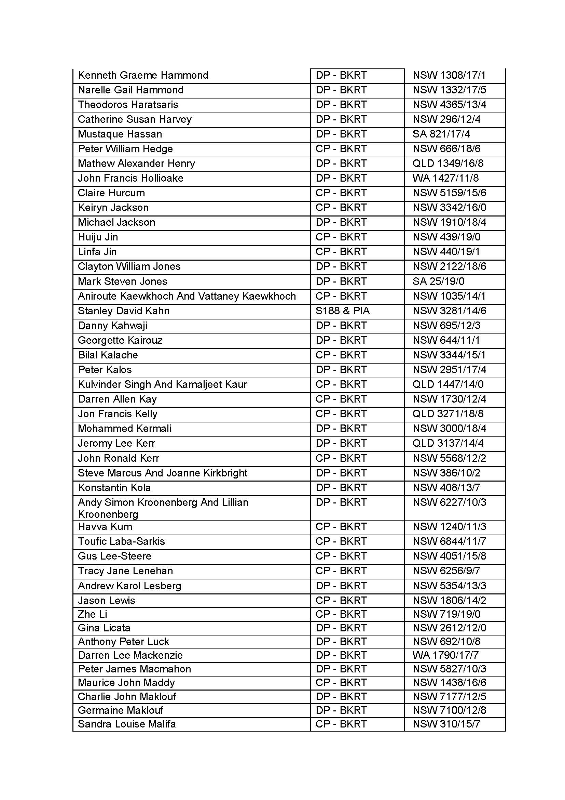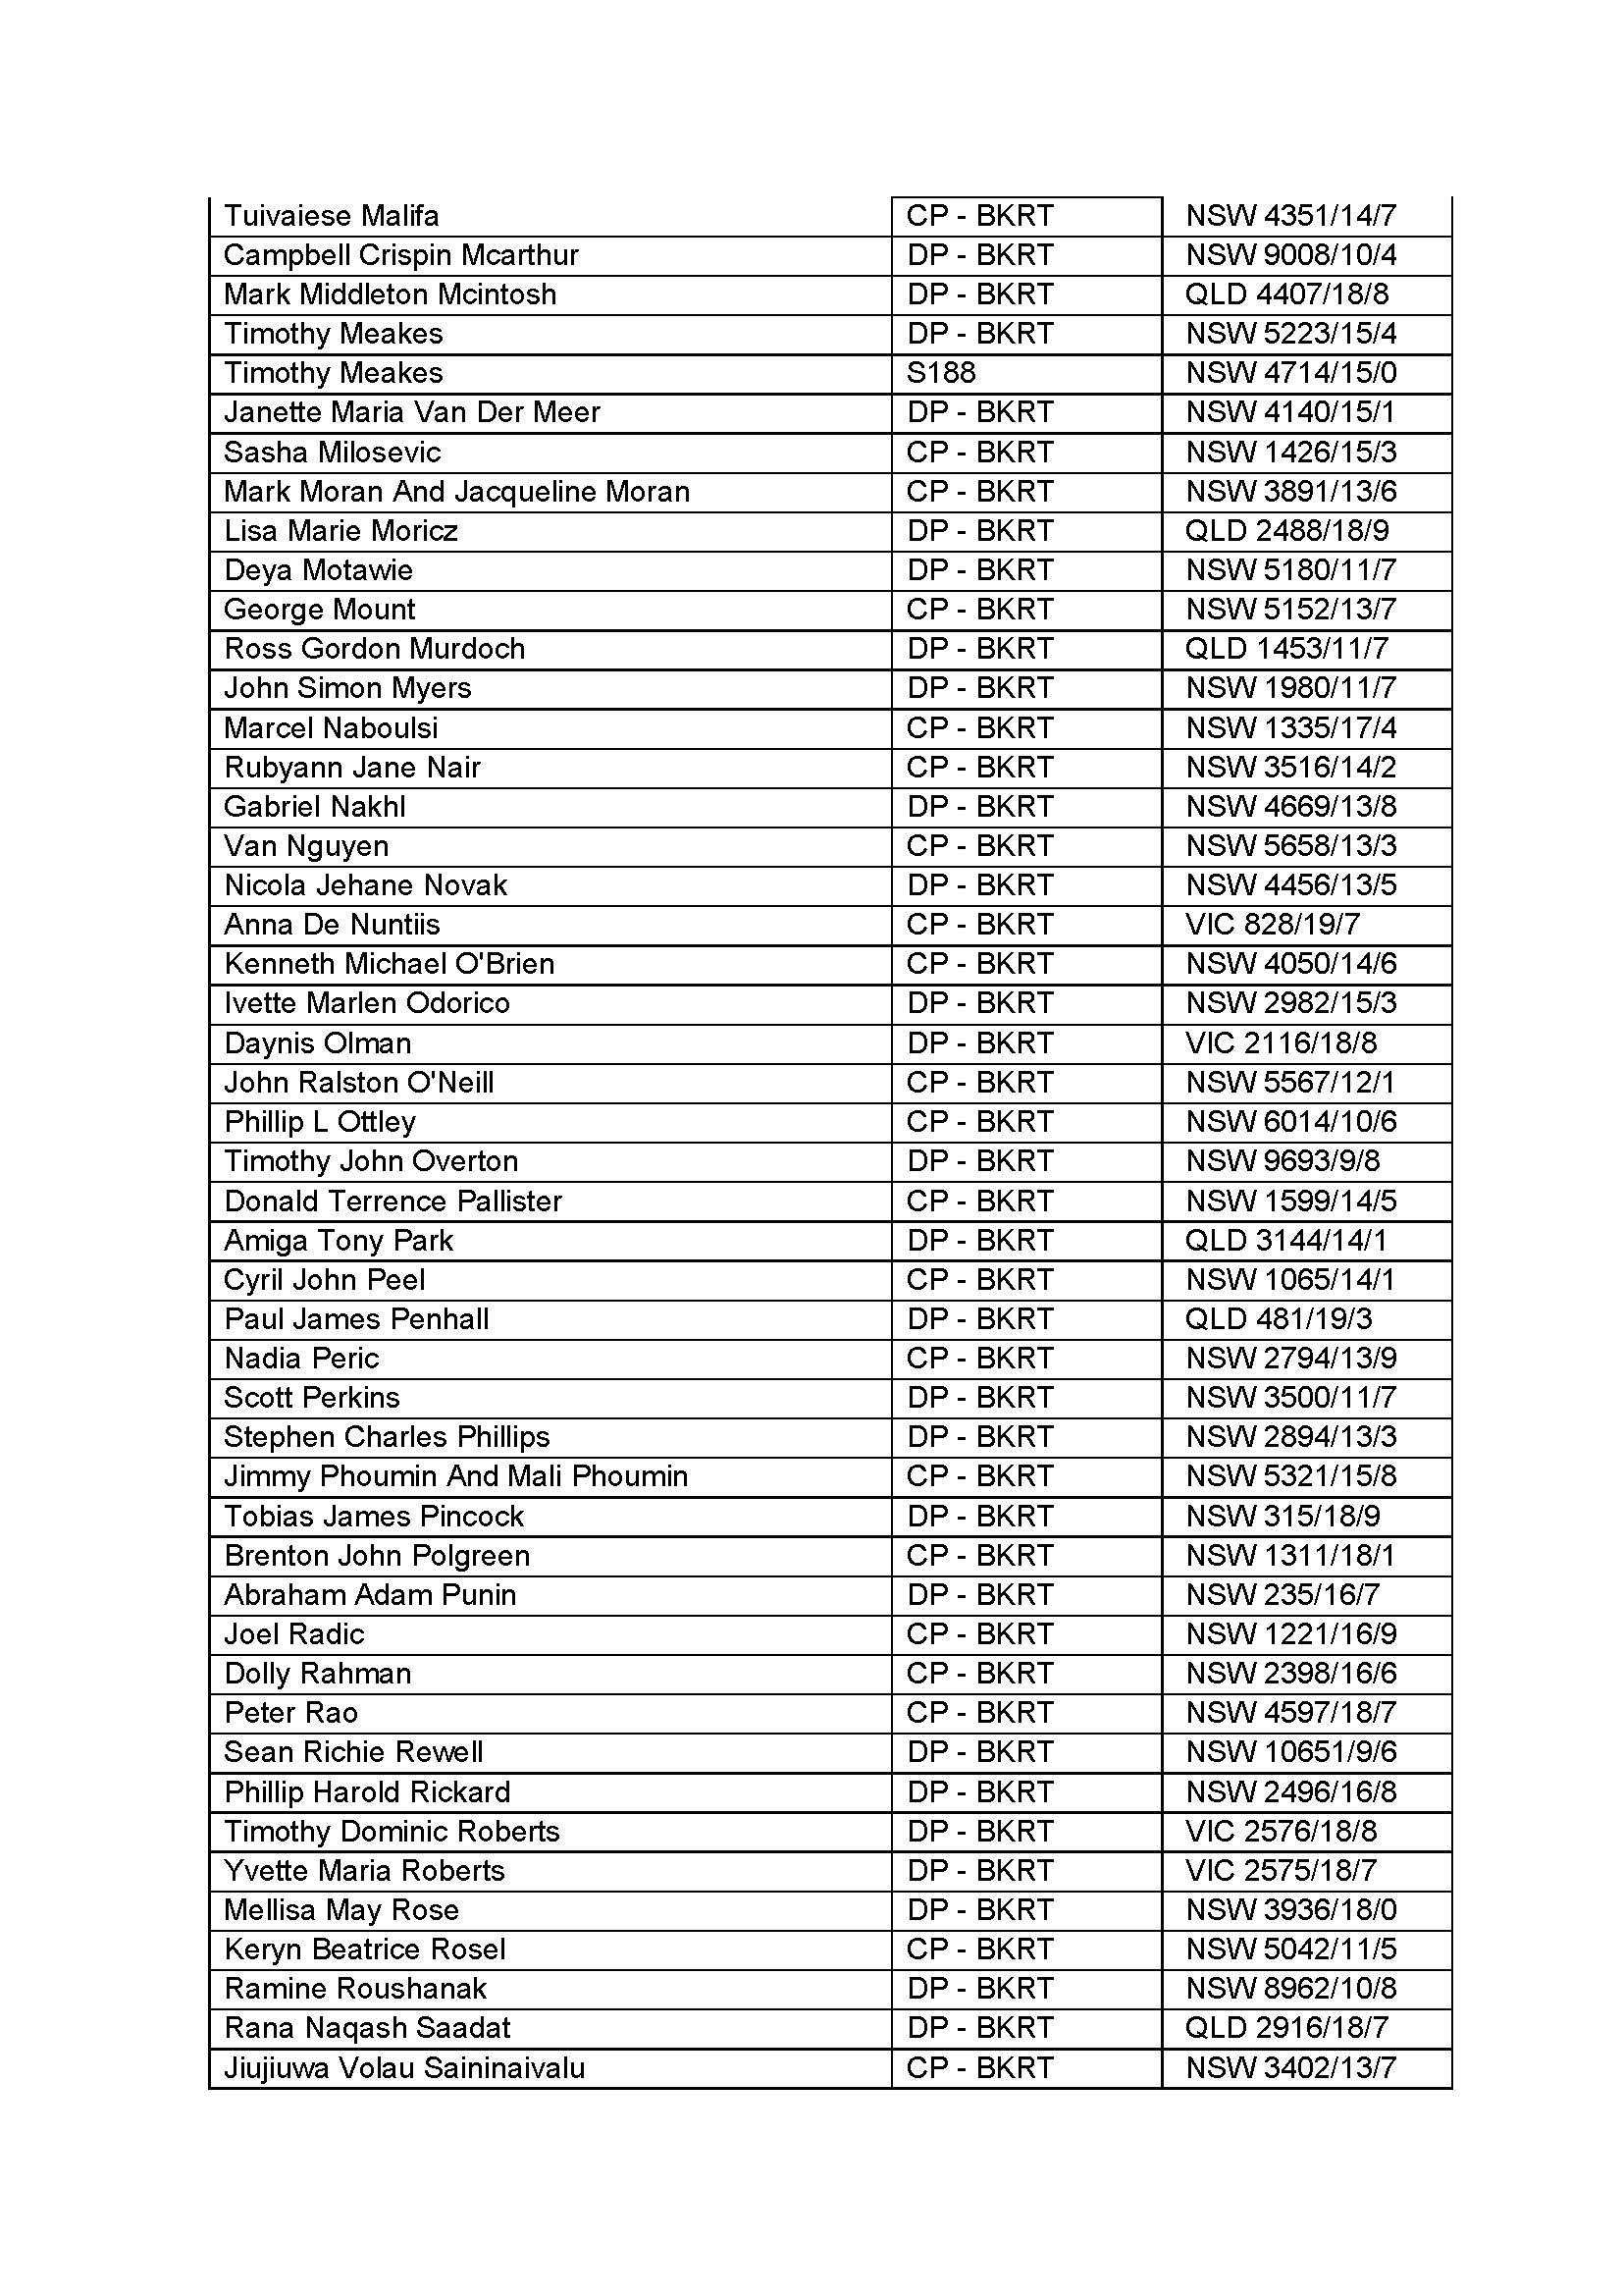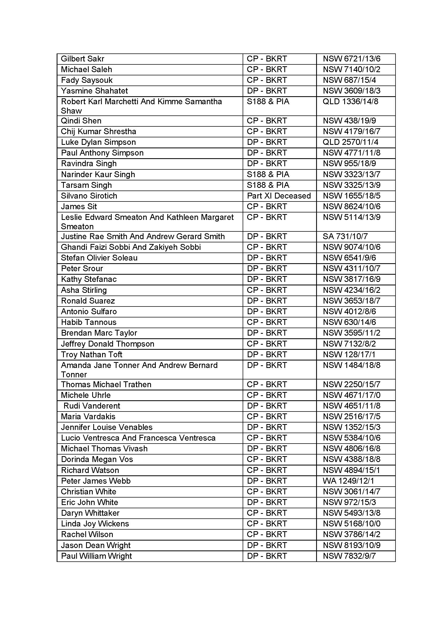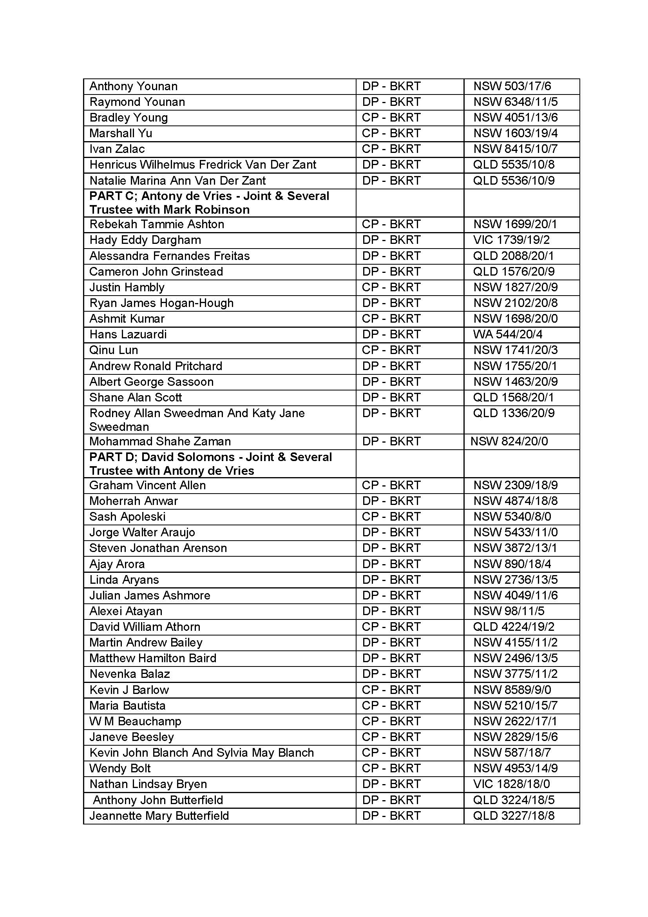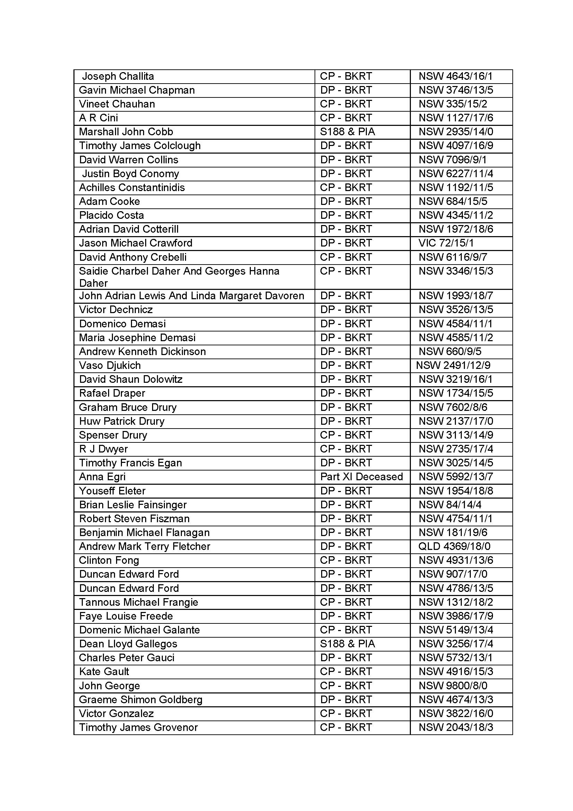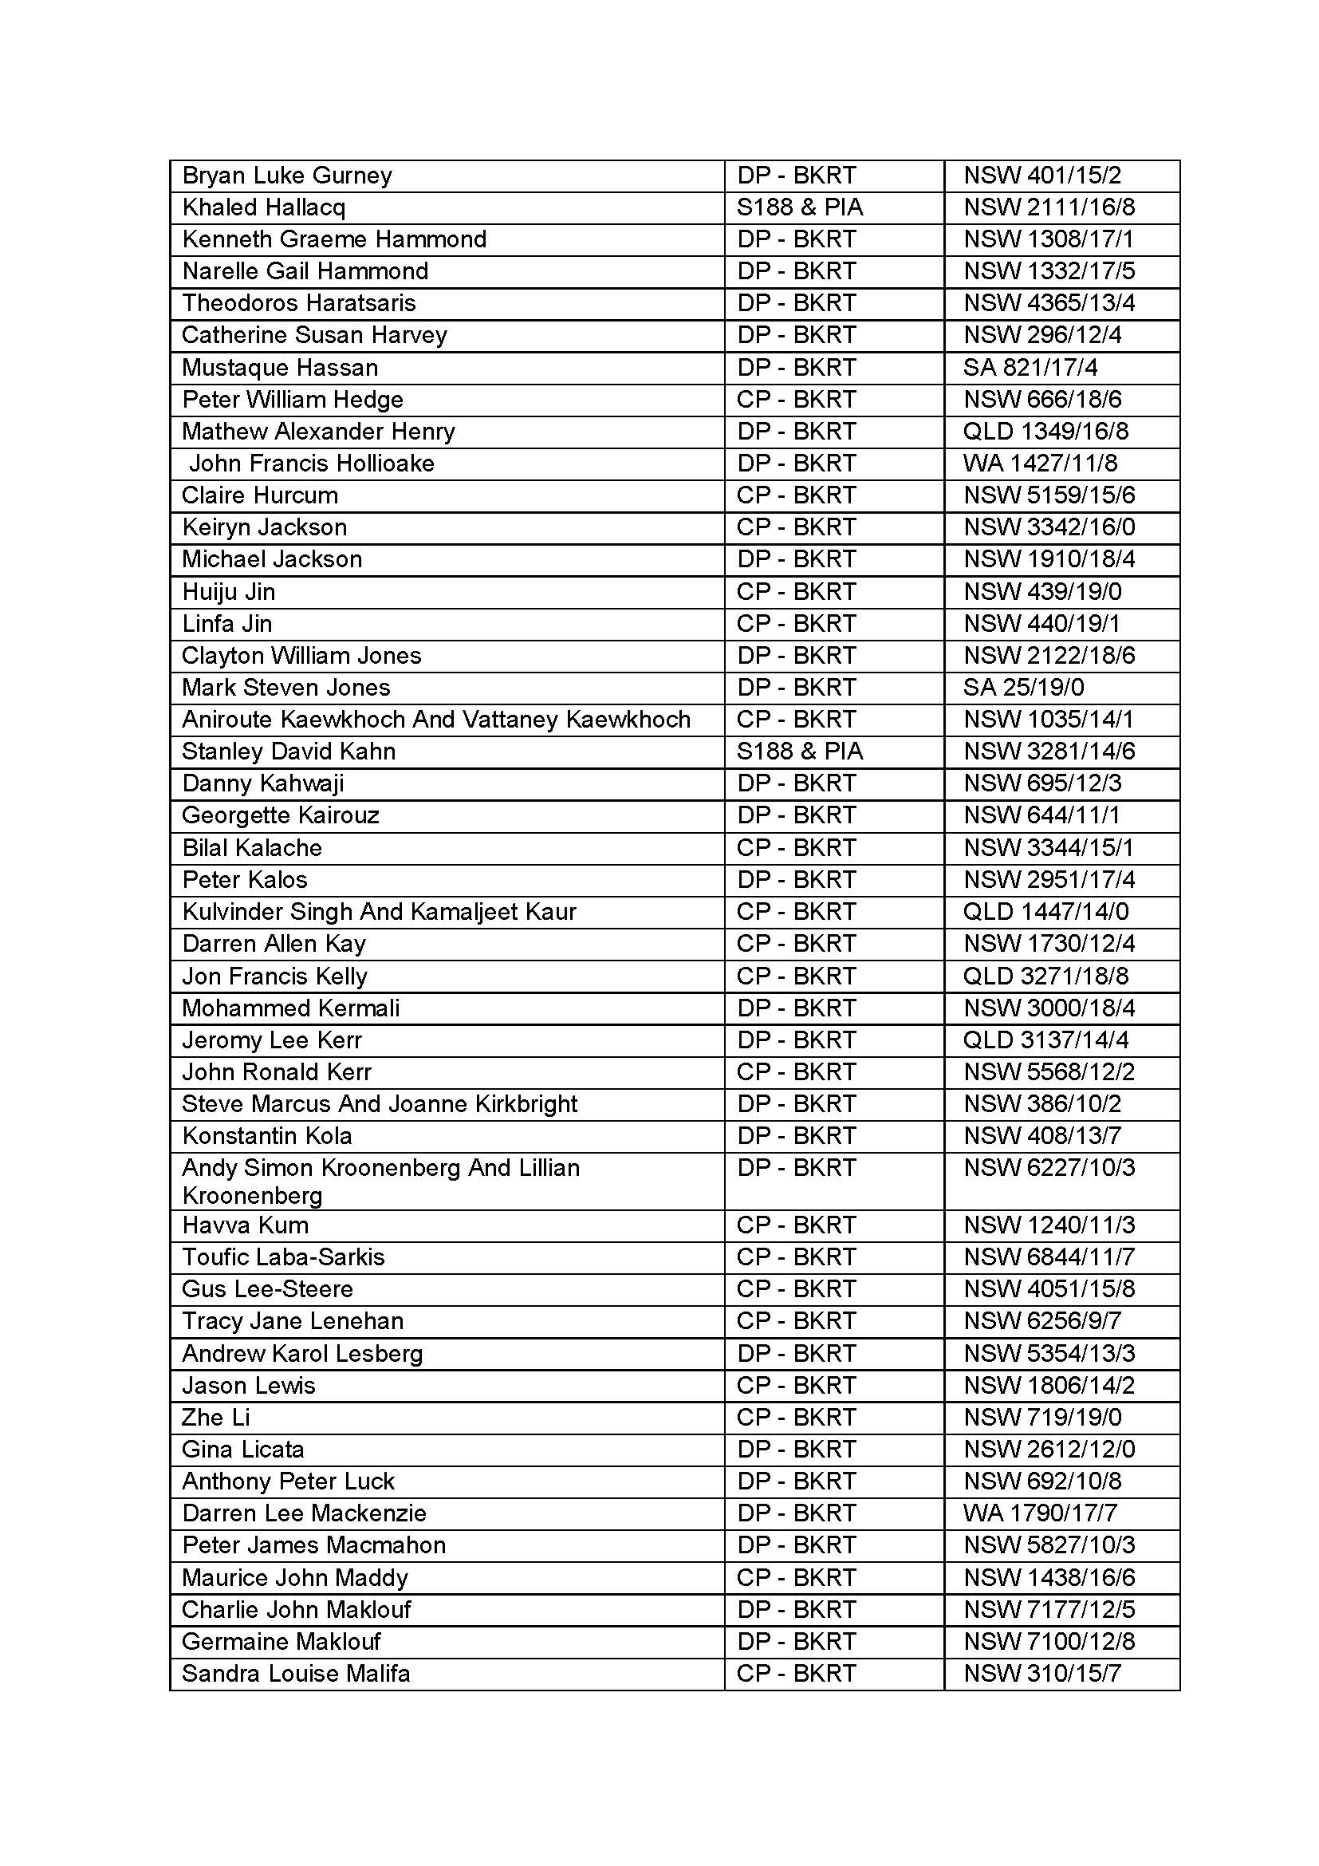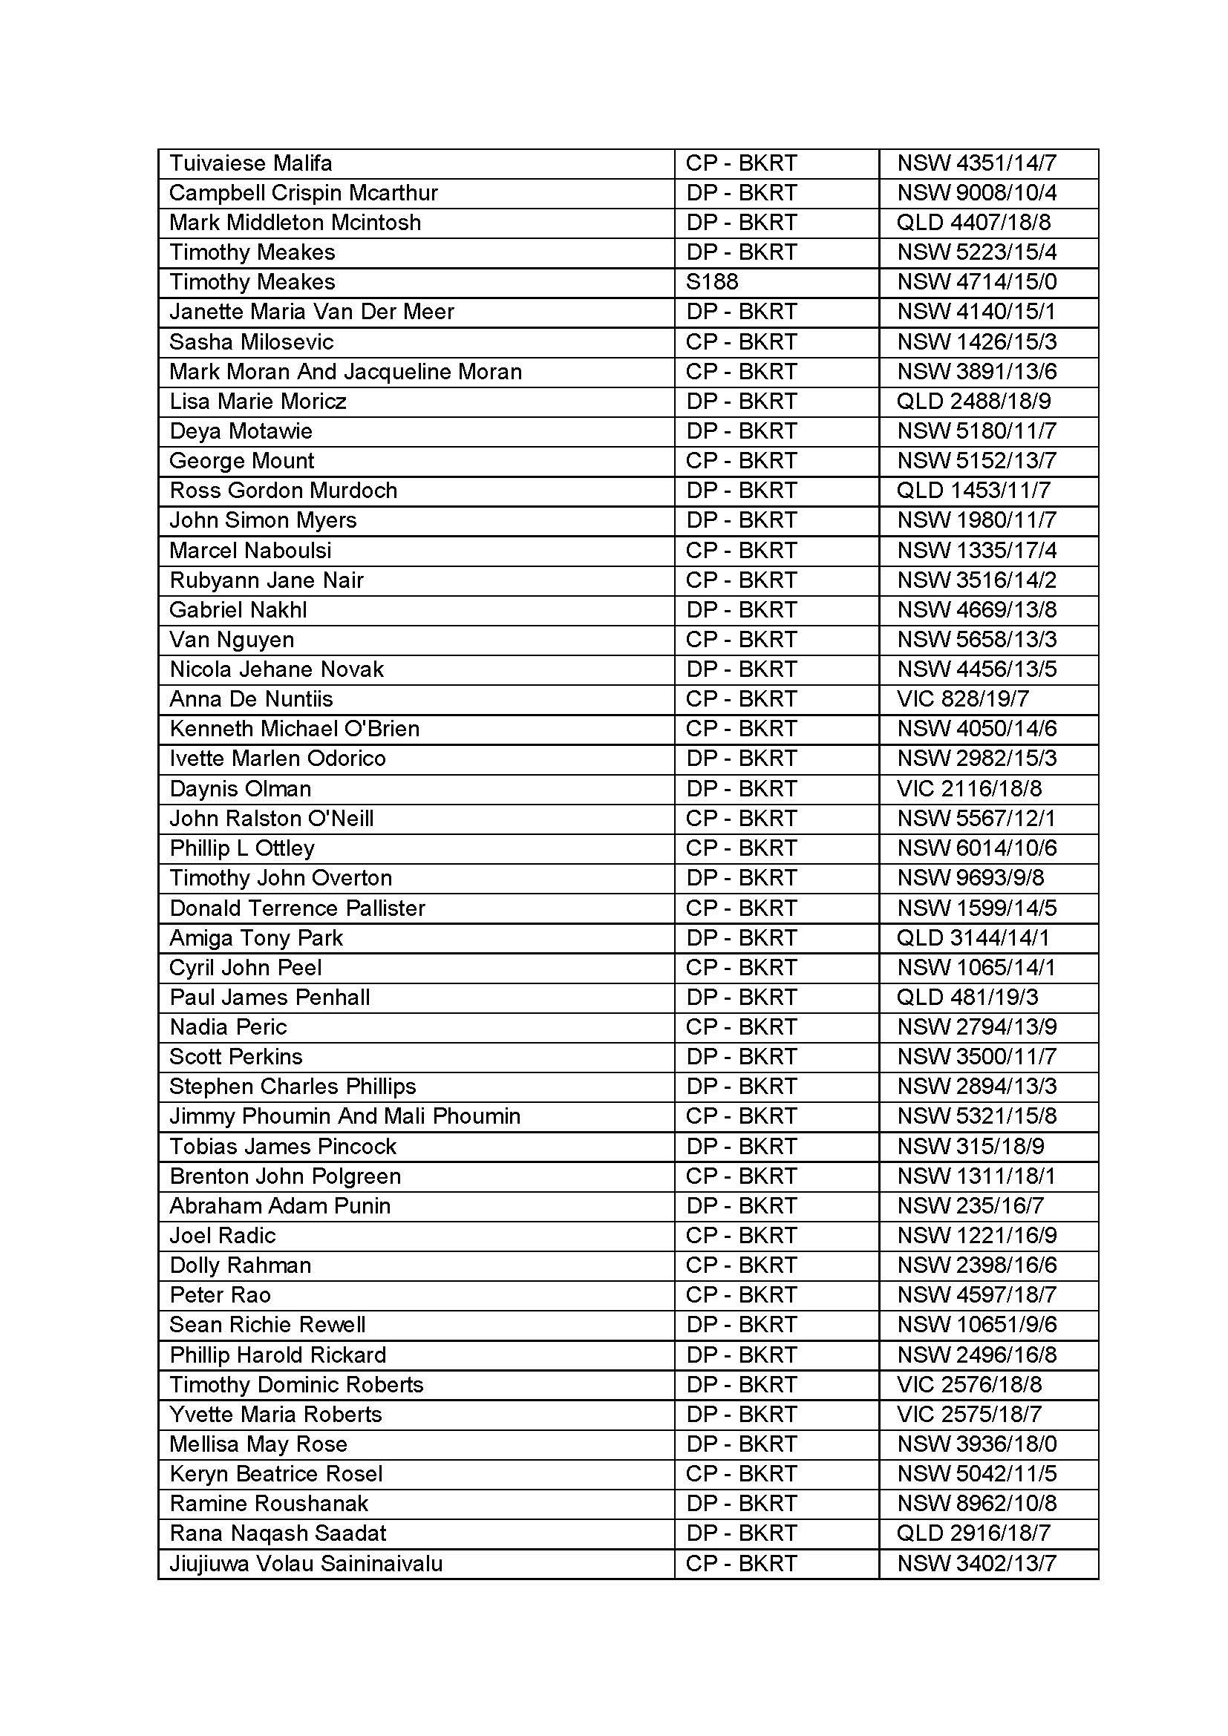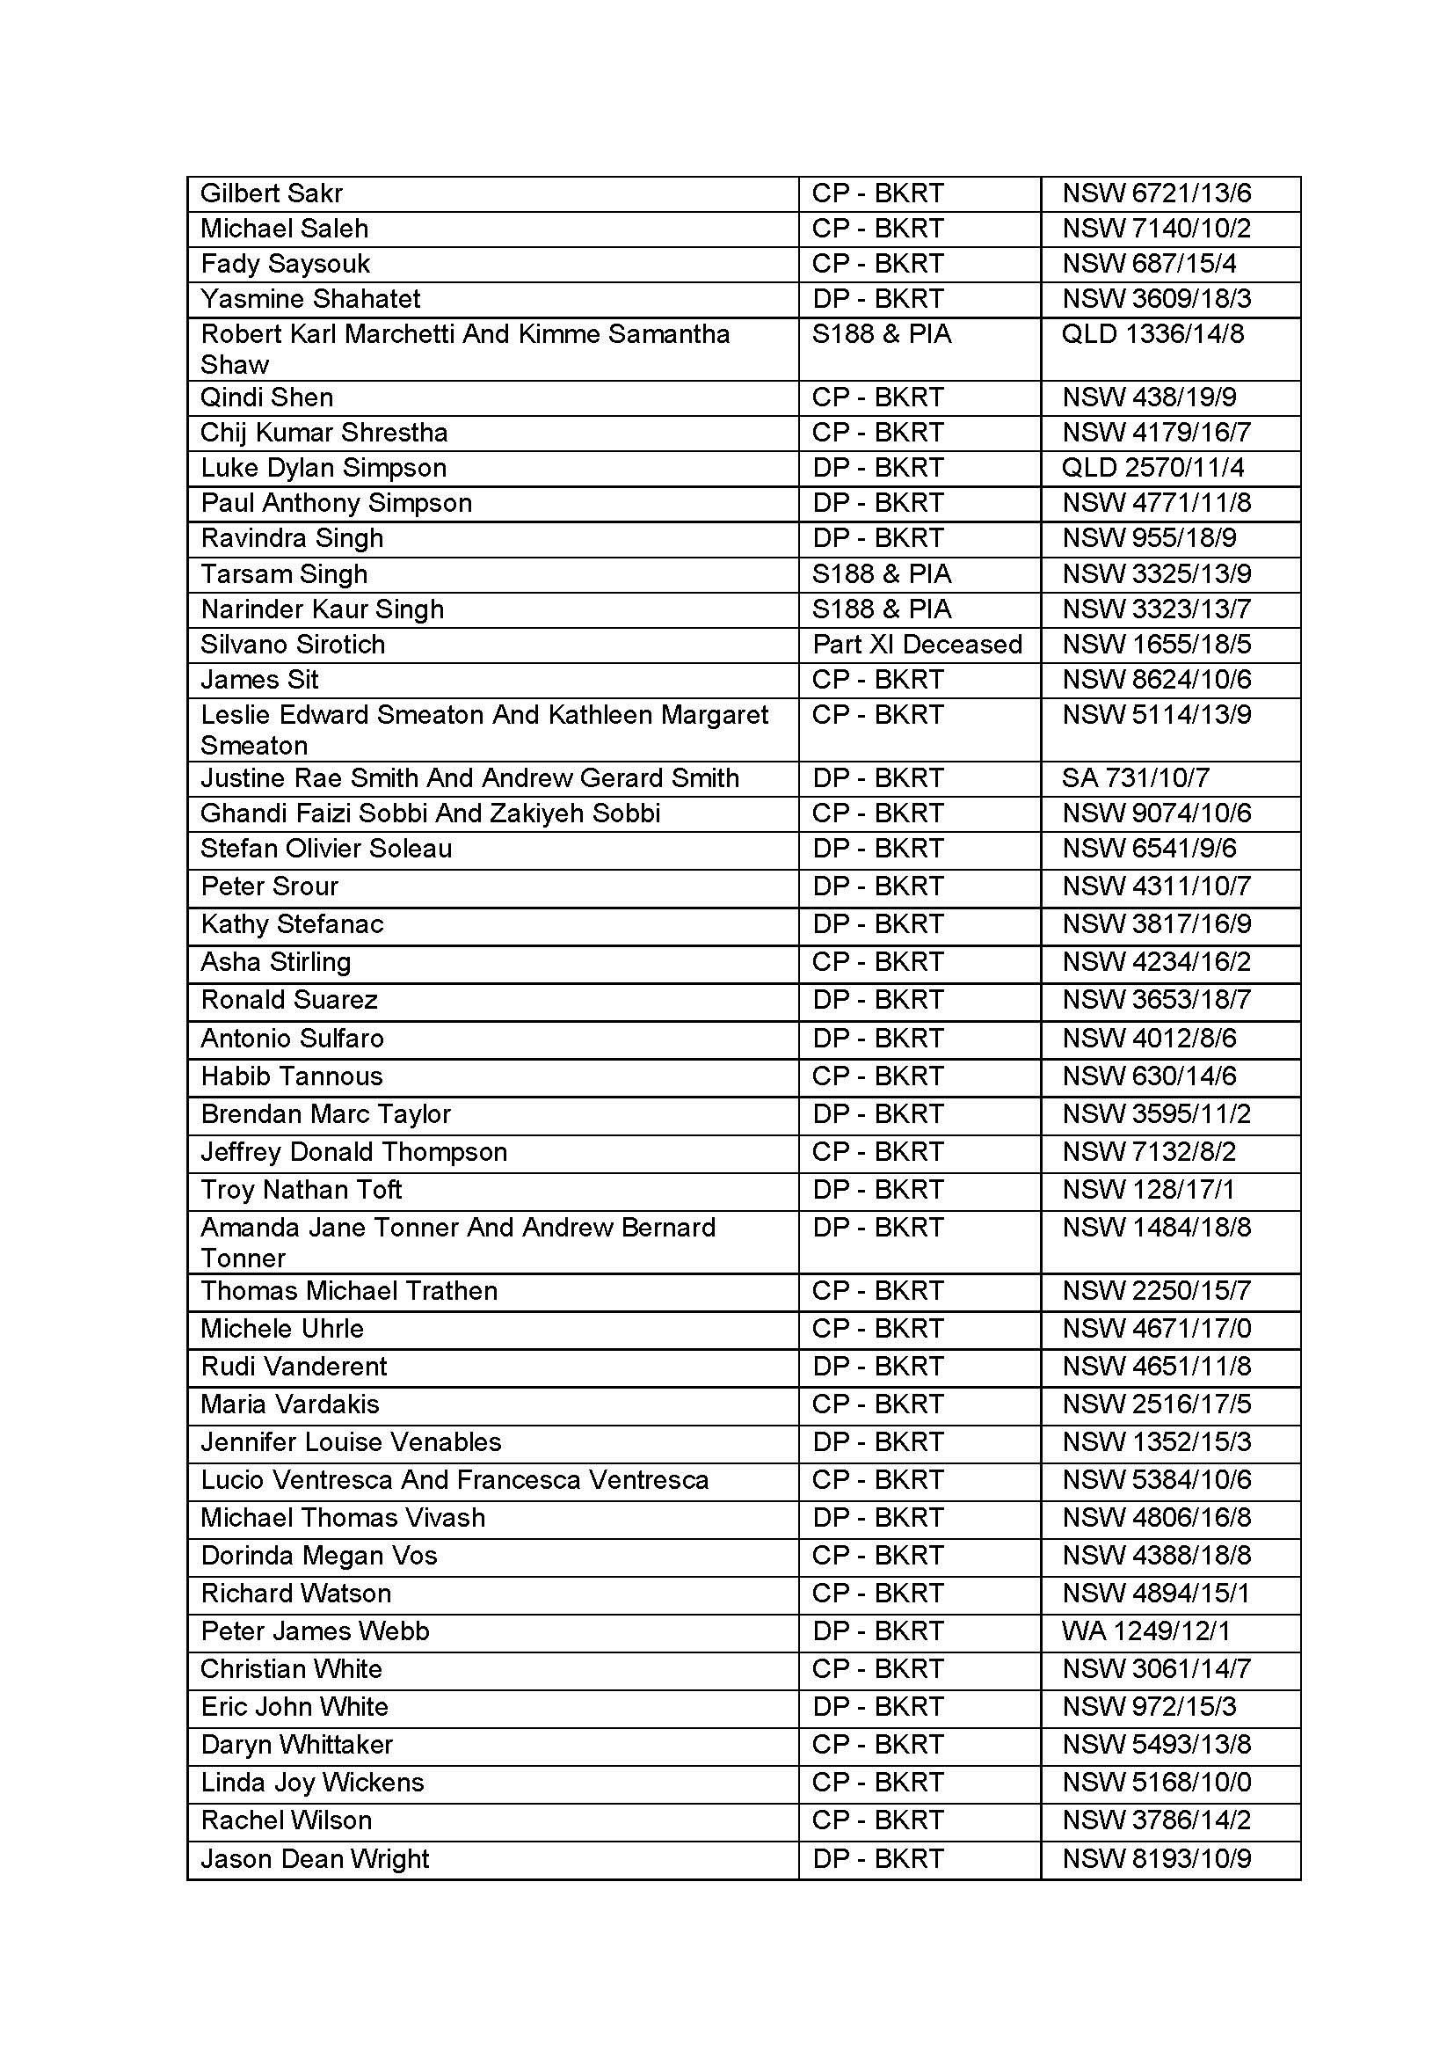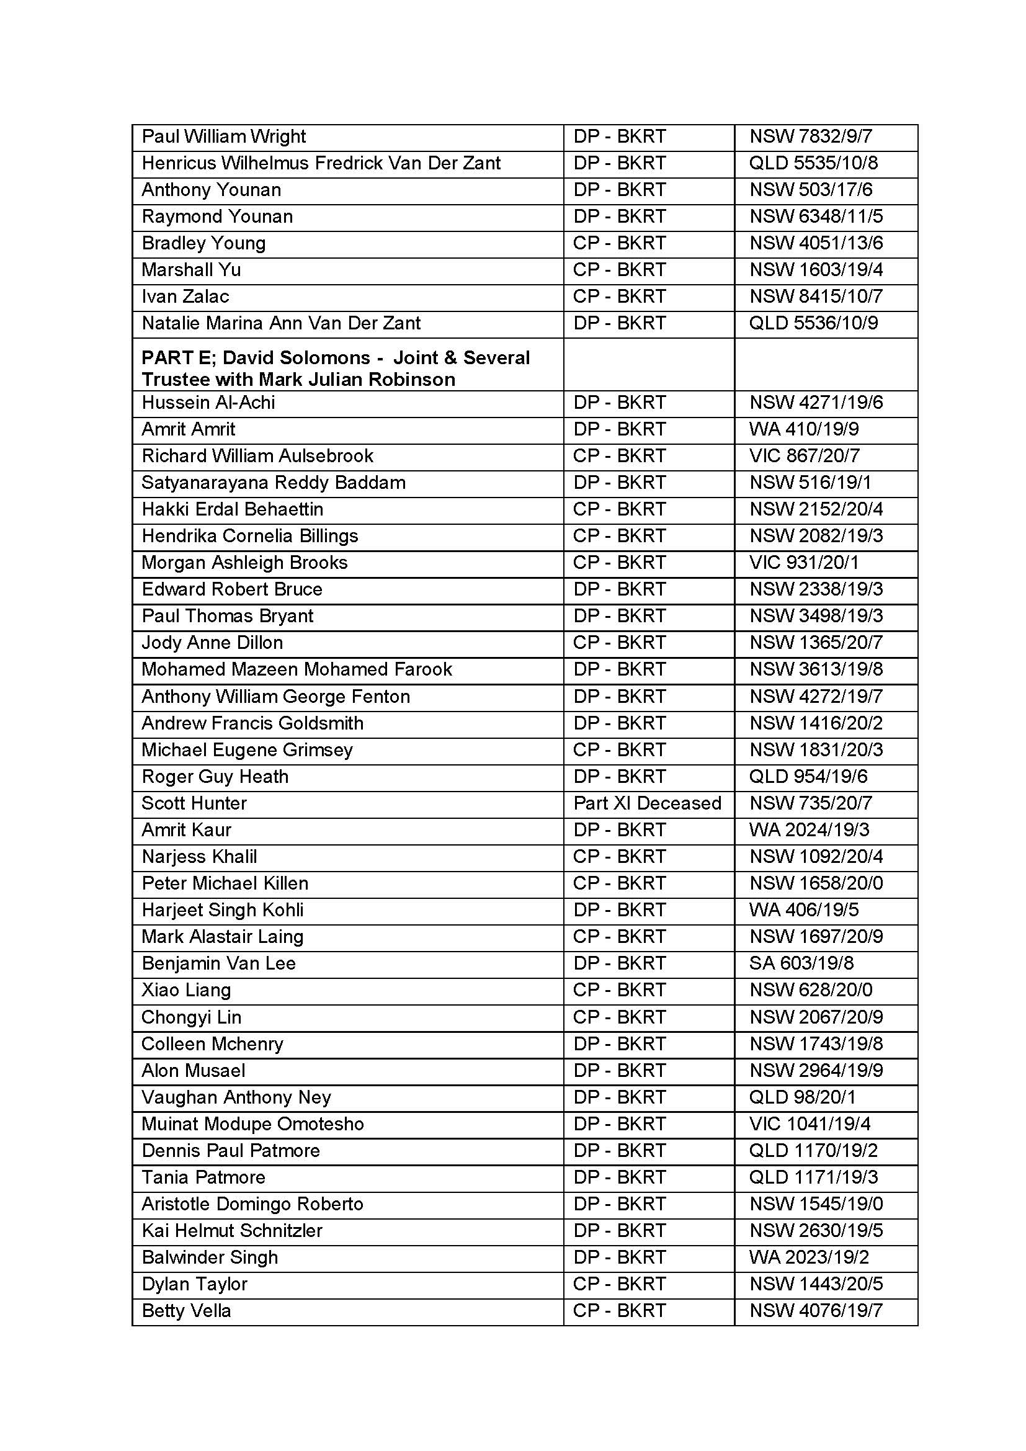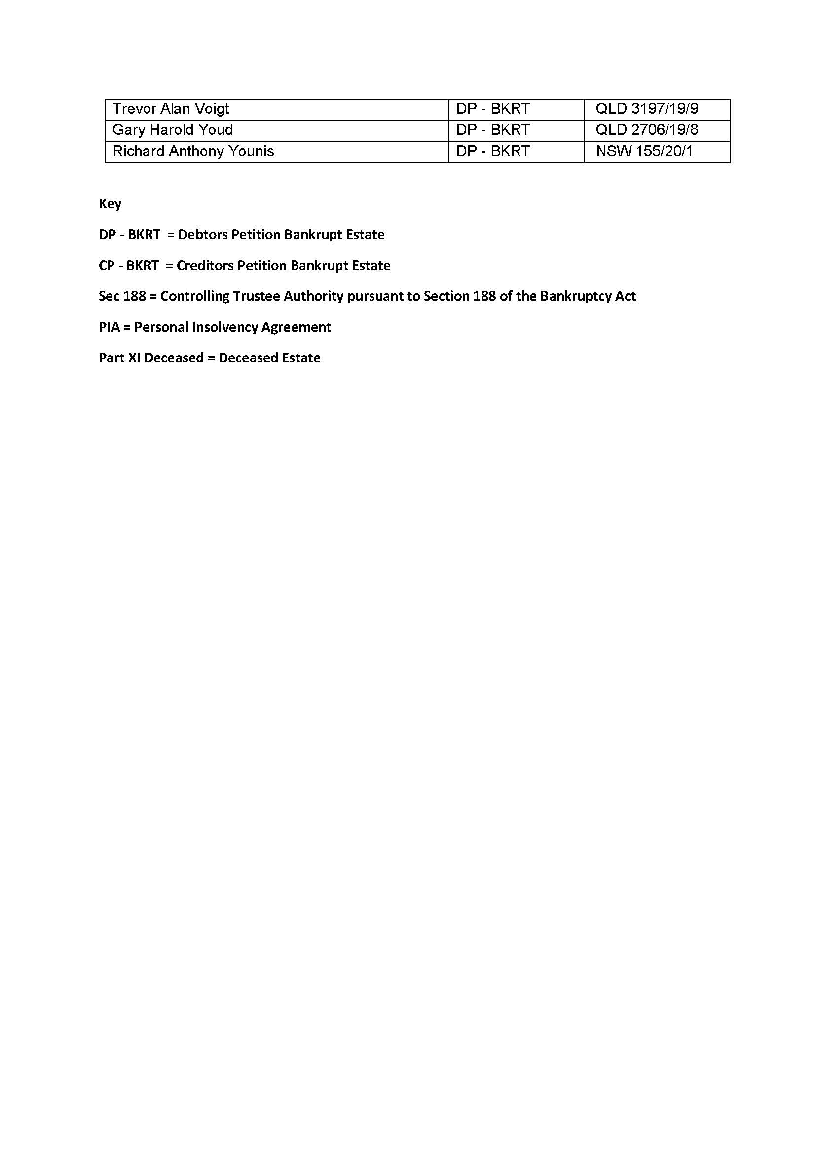

REASONS FOR JUDGMENT
NICHOLAS J:
- Before me is an application under s 180 of the Bankruptcy Act 1966 (Cth) (“the Act”) to have the Court accept the resignation of the first, second and third applicants as trustees in bankruptcy of the estates referred to in Part A, Part B, Part C, Part D and Part E of Schedule 2 (collectively “the relevant estates”) to the originating application filed on 29 December 2020.
- Following the hearing a number of issues were identified in relation to the schedule. To resolve these issues an updated schedule was provided to the Court along with letters of resignation for the first, second and third applicants.
- The first to fourth applicants are registered bankruptcy trustees. The first applicant (Mr de Vries) and the second applicant (Mr Solomons) are trustees of the relevant estates. Mr de Vries is a partner of the firm dVT Group, from which he intends to retire with effect from 31 March 2021. Mr Solomons was a partner of dVT Group from 1 January 2009 until 30 June 2020. He resigned as a partner on that date and has since worked as a consultant to the firm. He also intends to retire from the firm.
- The third applicant (Mr Robinson) and the fourth applicant (Mr Bagala) are both employed by dVT Group. Mr Robinson is a joint and several trustee of some of the relevant estates with Mr de Vries and is also a joint and several trustee for some others with Mr Solomons.
- It is proposed by the applicants that Mr de Vries, Mr Solomons and Mr Robinson resign, and that Mr Robinson and Mr Bagala be appointed as joint trustees of the relevant estates in their place.
- The Inspector-General in Bankruptcy has been served with a copy of the application and the supporting affidavits and has notified the applicants that the orders sought are not opposed and that the Inspector-General does not wish to be heard in relation to the application.
- The application is supported by affidavits made by each of the applicants. The evidence indicates that there are 248 relevant estates in which Mr de Vries or Mr Solomons are trustees in bankruptcy and that, of these, more than 90% have been finalised and are “inactive”. By this I mean that administration of those estates is essentially complete and it is unlikely that there will be anything more to be done by the trustee before the bankrupt is discharged.
- According to the evidence, both Mr Robinson and Mr Bagala are currently working on the active estates and Mr Bagala, in particular, is known to the bankrupts and some of the creditors of the active estates.
- The Court has the power under s 180 of the Act to appoint a new trustee as a condition of its acceptance of the resignation of the current trustee: Coshott v Burke [2013] FCA 155 (Buchanan J) at [9], Nixon, in the matter of Nixon [2015] FCA 976 (Edelman J) at [24], Gollant, in the matter of ACN 065 229 831 Pty Ltd [2017] FCA 1158 (Davies J) at [18].
- The applicants have not served their application or any of the supporting affidavits on the bankrupts or any creditor. They seek to be relieved from the requirement that they serve the bankrupts on the basis that, given the number of estates involved, the costs of doing so would be significant and uneconomic. There is a threshold question as to whether the Court may dispense with compliance with r 8.02(4)(b) of the Federal Court (Bankruptcy) Rules 2016 (Cth) (“the Bankruptcy Rules”).
- The position in relation to the Court’s power to dispense with service is by no means clear. Rule 8.02 of the Bankruptcy Rules relevantly provides:
8.02 Resignation or release of trustee
(1) This rule applies to the following applications:
(a) an application for the acceptance under section 180 of the Bankruptcy Act of a trustee’s resignation from the office of trustee of an estate;
…
(2) The application must be accompanied by an affidavit stating the grounds in support of the application.
…
(4) The application and supporting affidavit must be served on:
(a) the Official Receiver; and
(b) the bankrupt; and
(c) anyone else (including a creditor) as ordered by the Court.
…
- Rule 8.02(4) requires that the application and supporting affidavits be served on the Official Receiver, the bankrupt and anyone else (including a creditor) as ordered by the Court. On its proper construction, r 8.02(4) requires the applicant to serve the bankrupt and the Official Receiver.
- The issue that arises was referred to by Edelman J when sitting as a judge of this Court in Nixon. His Honour was there concerned with the requirements of r 8.02(2) of the Federal Court (Bankruptcy) Rules 2005 (Cth) which was in the same terms as r 8.02(4) which I have set out above.
- His Honour referred to r 1.34 of the Federal Court Rules 2011 (Cth) which allows the Court to “dispense with compliance with any of these Rules, either before or after the occasion for compliance arises” and r 1.03(2)(a) of the Federal Court (Bankruptcy) Rules 2005 (Cth) which provided that the “other Rules of the Court, apply, to the extent they are relevant and not inconsistent with these Rules … to a proceeding in the Court to which the Bankruptcy Act applies”. His Honour said at [24] that this rule might pick up r 1.34 of the Federal Court Rules 2011 (Cth). Subsequent to the publication of his reasons for judgment his Honour made the following order:
Pursuant to Rule 1.34 of the Federal Court Rules 2011 (Cth) (the Rules) and Rule 1.03(2) of the Federal Court (Bankruptcy) Rules 2005 (Cth) (the Bankruptcy Rules), compliance with the requirements of Rules 8.02(2)(b) and (c) of the Bankruptcy Rules be dispensed with.
- Murphy J in Allen, in the matter of Allen [2020] FCA 376 took the same approach and made an order in similar terms as that made by Edelman J in Nixon.
- Rule 1.04 of the Bankruptcy Rules relevantly provides:
1.04 Application of these Rules and other Rules of the Court
(1) Unless the Court otherwise orders:
(a) these Rules apply to a proceeding in the Court to which the Bankruptcy Act applies; and
…
(2) The other Rules of the Court apply, to the extent that they are relevant and not inconsistent with these Rules:
(a) to a proceeding in the Court to which the Bankruptcy Act applies; and
(b) to a proceeding in the Court under the Cross-Border Insolvency Act.
- There may be difficulties in holding that a rule that enables the Court to dispense with any rule under the Federal Court Rules 2011 (Cth) will also allow the Court to dispense with compliance with any rule under the Bankruptcy Rules. Rule 1.34 permits the Court to dispense with compliance with “any of these Rules” which is, of course, a reference to the Federal Court Rules 2011 (Cth). However, in circumstances where at least two judges of this court have applied r 1.34 to dispense with the requirement for service contained in r 8.02(4)(b) of the Bankruptcy Rules in a proceeding brought under s 180 of the Act, and given that I do not think either decision is plainly wrong, I propose to take the same approach.
- I accept that the costs of complying with r 8.02(4)(b), if no order is made under r 1.34, are likely to be considerable given the number of estates that will be affected by Mr de Vries’ and Mr Solomons’ resignations. In my view it would not be in the interests of justice to require the applicants to serve the bankrupts or the creditors of the relevant estates with the application and the supporting affidavits.
- There is nothing in the evidence to suggest that any of the bankrupts or creditors of the relevant estates are likely to have any objection to Mr Robinson and Mr Bagala replacing Mr de Vries and Mr Solomons given their desire to retire.
- Given that Mr Robinson and Mr Bagala already have some familiarity with the relevant estates or, at least, those that remain active, I am satisfied that it is appropriate to appoint them as replacements for Mr de Vries and Mr Solomons as a condition of accepting Mr de Vries and Mr Solomons’ resignations.
- The appointment of Mr Robinson and Mr Bagala as joint trustees of the relevant estates will, in my view, ensure that the transition is efficient and cost-effective having regard to their previous experience with these estates. It will ensure continuity in the administration of the estates and reduce the costs which would be incurred if a different trustee, one with less familiarity with the estates, was appointed.
- The applicants have suggested that they would prefer to have Mr Robinson resign as a trustee of the estates of which he is currently a joint and several trustee so that he may be re-appointed with Mr Bagala as joint trustee of all of the relevant estates. I do not see any difficulty in approaching the matter in that way. In accordance with that approach, the first, second and third applicants have provided the Court with resignation letters indicating that their resignation will take effect on the date the relevant orders are made in this proceeding.
- There will be orders made under s 180 of the Act accepting the resignations of Mr de Vries, Mr Solomons and Mr Robinson as trustees in bankruptcy of the relevant estates. These resignations will be accepted on the condition that Mr Robinson and Mr Bagala are appointed as joint trustees of the relevant estates. These appointments will take effect from the date of these orders.
- With regard to costs, the applicants have indicated that they will bear their costs of these proceedings and will not seek to recover those costs, or any part thereof, from any of the relevant estates. In those circumstances, the appropriate order is that there be no order as to the costs of the application: see Donnelly v Maxwell-Smith [2010] FCAFC 154 at [23].
- Orders accordingly.

I certify that the preceding twenty-five (25) numbered paragraphs are a true copy of the Reasons for Judgment of the Honourable Justice Nicholas.

Associate:
Dated: 16 March 2021

