FEDERAL COURT OF AUSTRALIA

W.R. Berkley Insurance (Europe) Limited, in the matter of Division 3A of Part III of the Insurance Act (1973) (No 3) [2016] FCA 1497

File number: | NSD 1201 of 2015
Judge: | ALLSOP CJ
Date of judgment: | 28 October 2016
Date of publication of reasons: | 13 December 2016
Catchwords: | INSURANCE – transfer of insurance scheme between general insurers – intra-group transfer – where both transferor and transferee are Australian branches of foreign insurers – reinsurance orders made – scheme confirmed without modification
Legislation: | Insurance Act 1973 (Cth) ss 12, 17B, 17C, 17F, 28, 116, 116A
Cases cited: | American Home Assurance Company (No 2) [2011] FCA 316  Application of Sompo Japan Insurance Inc. under the Insurance Act 1973 (Cth) (No 2) [2014] FCA 677  Atradius Credit Insurance N.V., in the matter of Atradius Credit Insurance N.V. (No 2) [2016] FCA 1495  Gordian RunOff Ltd (No 2) [2013] FCA 1329  HDI-Gerling Australia Insurance Company Pty Limited, in the matter of HDI-Gerling Australia Insurance Company Pty Limited (ABN 16 069 085 196) (No 2) [2010] FCA 669 In the matter of Reward Insurance Ltd [2004] FCA 151  Mercantile & General Reinsurance Company of Australia Ltd [2004] FCA 1773  SGIC General Insurance Ltd [2004] FCA 1639  W.R. Berkley Insurance (Europe) Limited, in the matter of Division 3A of Part III of the Insurance Act (1973) [2016] FCA 374  W.R. Berkley Insurance (Europe) Limited, in the matter of Division 3A of Part III of the Insurance Act (1973) (No 2) [2016] FCA 393  QBE Insurance (Australia) Ltd, in the matter of Division 3A of Part III of the Insurance Act 1973 (Cth) & QBE Insurance (Australia) Ltd (No 2) [2016] FCA 288
Date of hearing: | 25 October 2016
Registry: | New South Wales
Division: | General Division
National Practice Area: | Commercial and Corporations
Sub-area: | Commercial Contracts, Banking, Finance and Insurance  Insurance List
Category: | Catchwords
Number of paragraphs: | 60
Counsel for the Applicant: | Mr N Owens SC
Solicitor for the Applicant: | Clyde & Co
Solicitor for the Australian Prudential Regulation Authority (APRA): | Mr R Claxon, Australian Prudential Regulation Authority

ORDERS
 |  | NSD 1201 of 2015
IN THE MATTER OF W.R. BERKLEY INSURANCE (EUROPE) LIMITED ABN 81 126 483 681, AN APPLICATION UNDER DIVISION 3A OF PART III OF THE INSURANCE ACT 1973(CTH)

W. R. BERKLEY INSURANCE (EUROPE) LIMITED (ABN 81 126 483 68)
Applicant

JUDGE: | ALLSOP CJ
DATE OF ORDER: | 28 October 2016

THE COURT ORDERS THAT:

- Pursuant to s 17F of the Insurance Act 1973 (Cth) (the Act), the scheme for the transfer of all of the insurance business in Australia of the Applicant to Berkley Insurance Company (ABN 53 126 559 706) (the Scheme), in the form annexed to these orders and marked "A", be confirmed without modification.
- Pursuant to s 17F(2) of the Act, all outwards reinsurance responding to any contract transferred pursuant to the Scheme, and all rights attaching to it, be, by this order, transferred to Berkley Insurance Company (ABN 53 126 559 706).
- The Scheme shall take effect from 1 November 2016.
- The Applicant pay the costs of APRA as agreed, or if agreement cannot be reached, as taxed.
- The orders be entered forthwith.
- Reasons to be published.

Note: Entry of orders is dealt with in Rule 39.32 of the Federal Court Rules 2011.

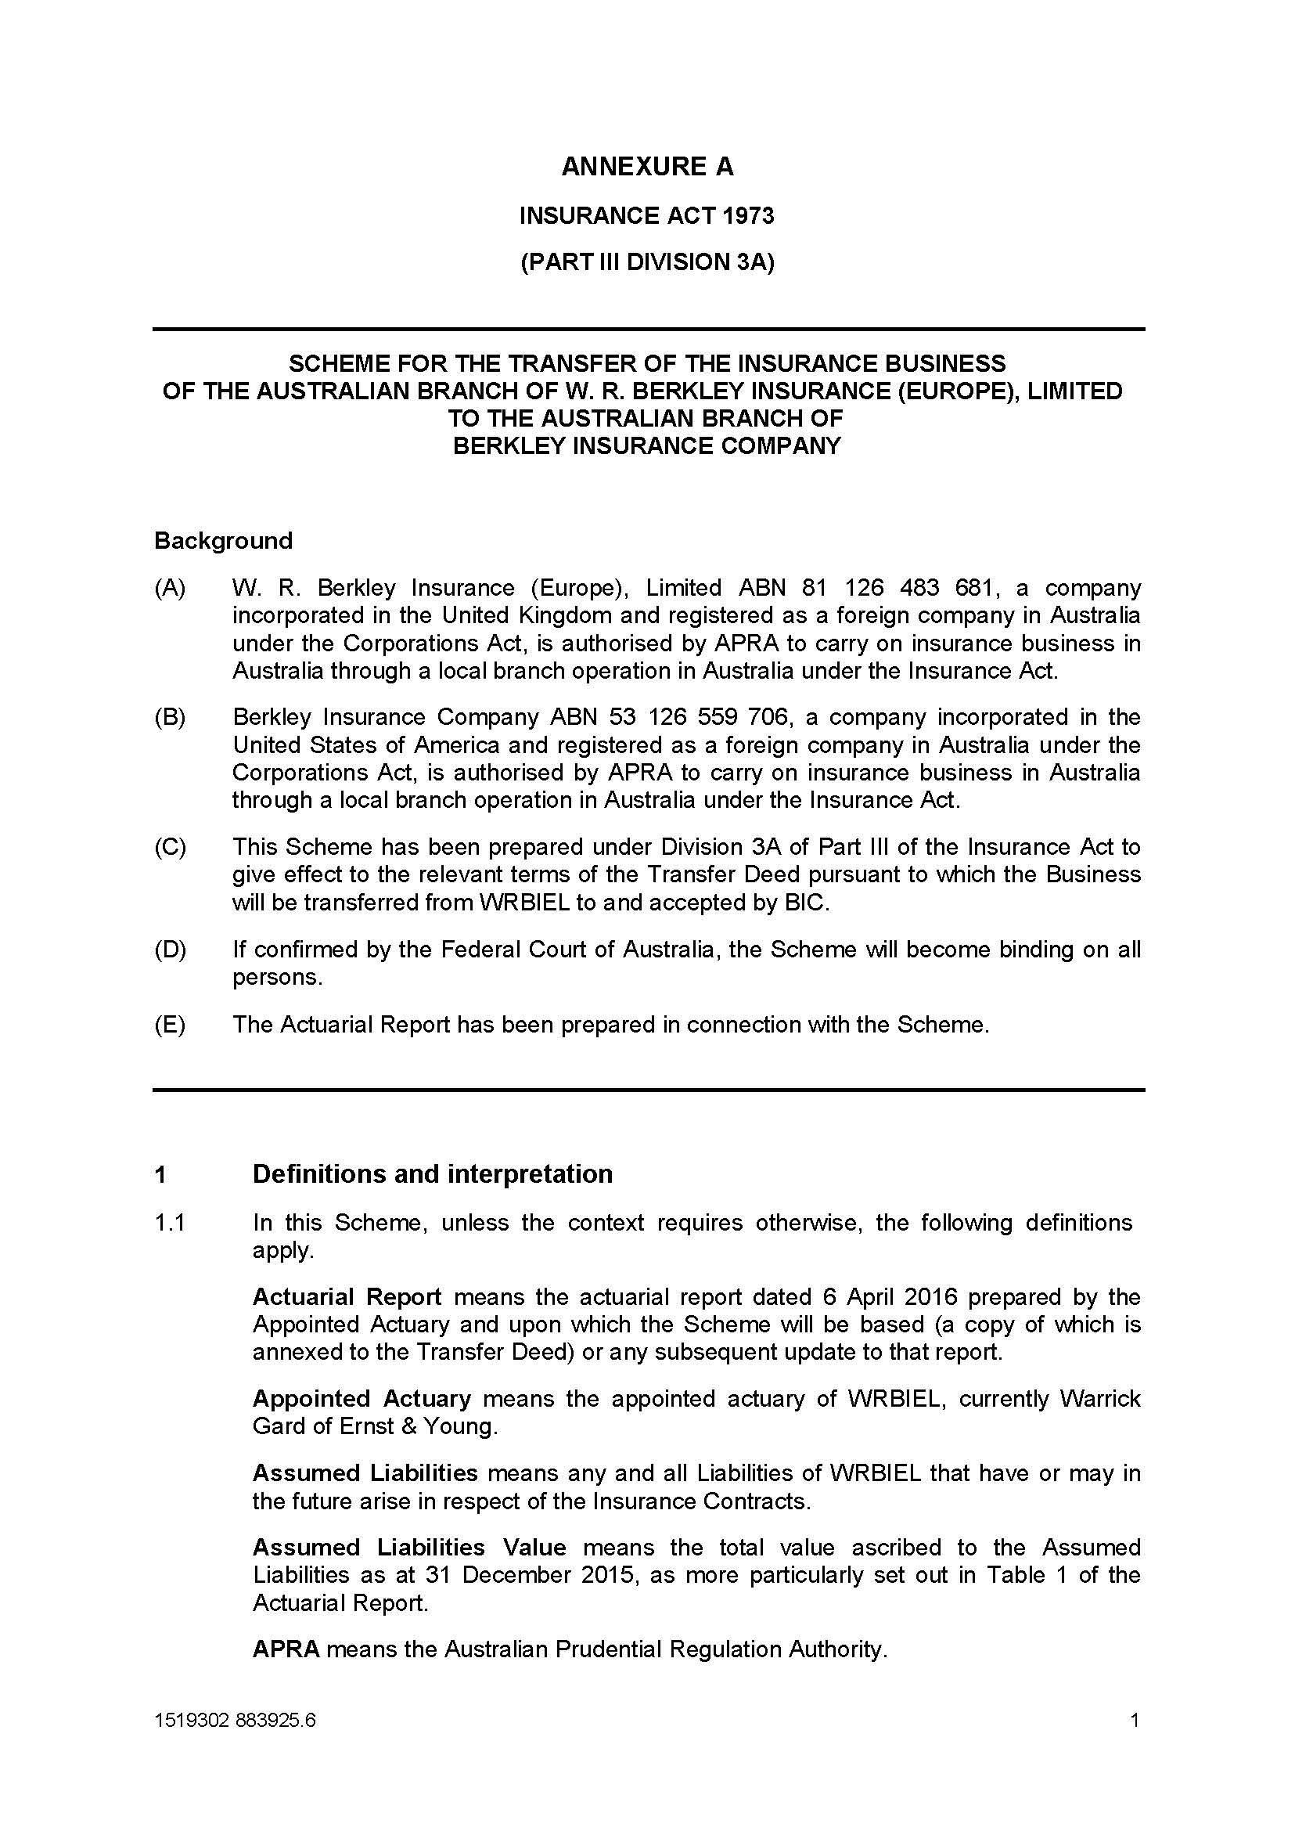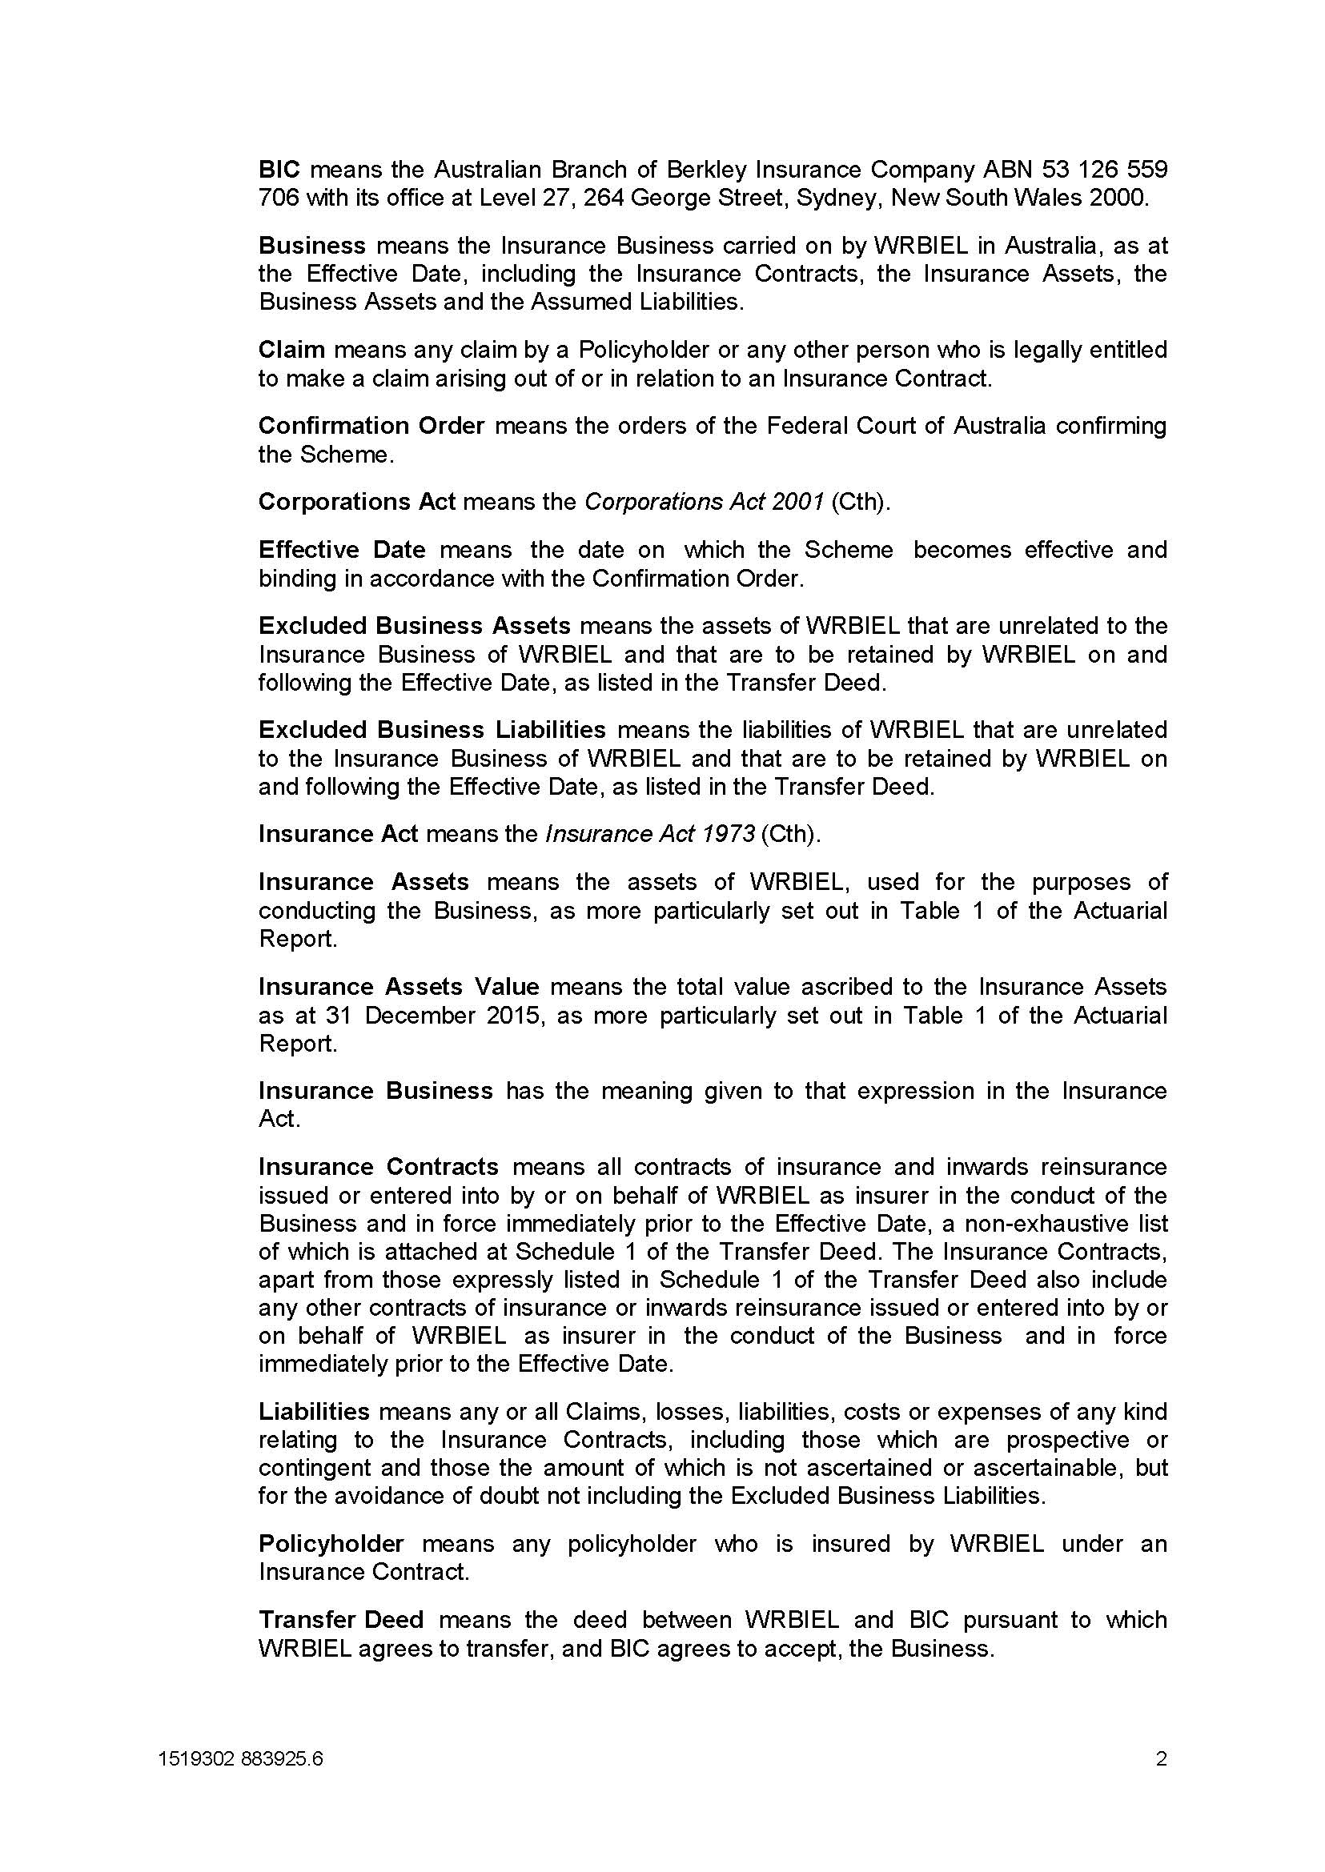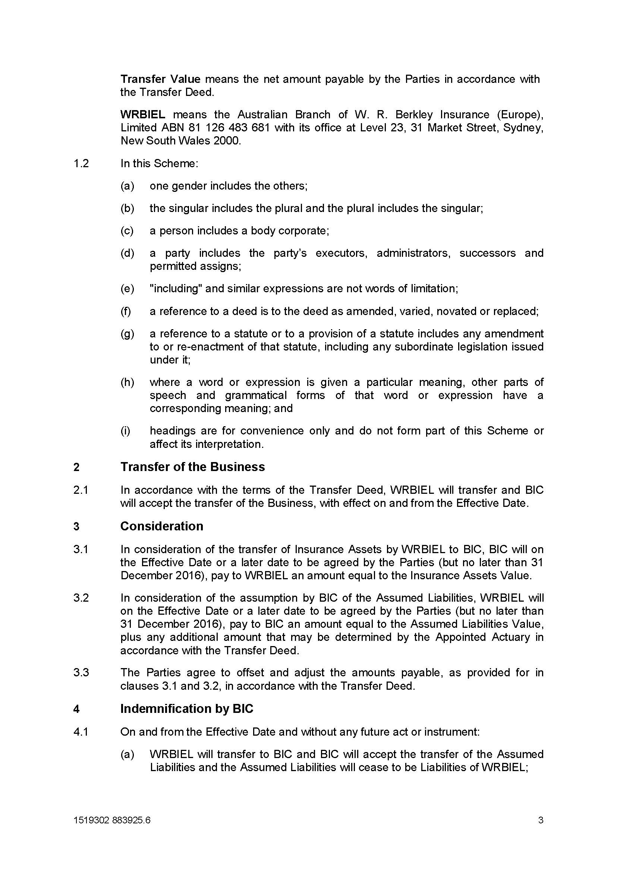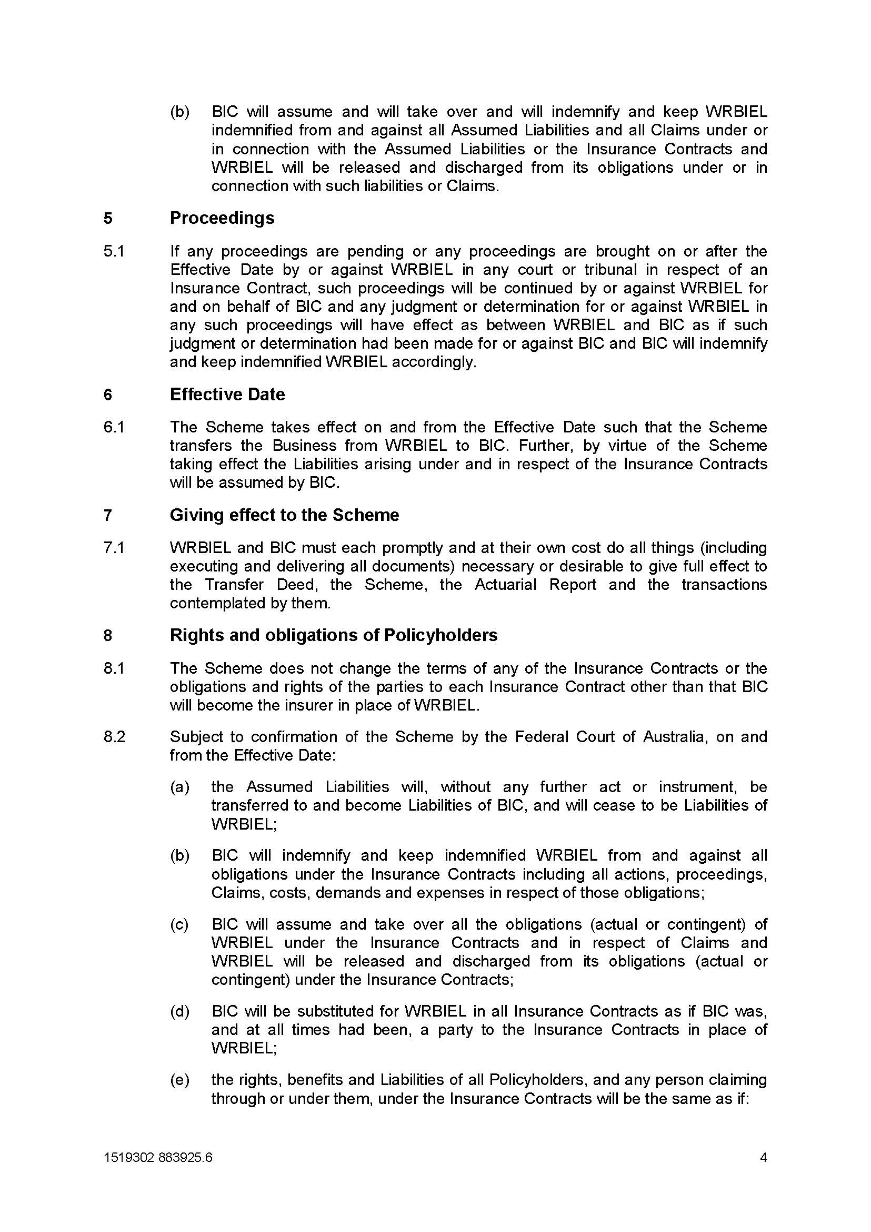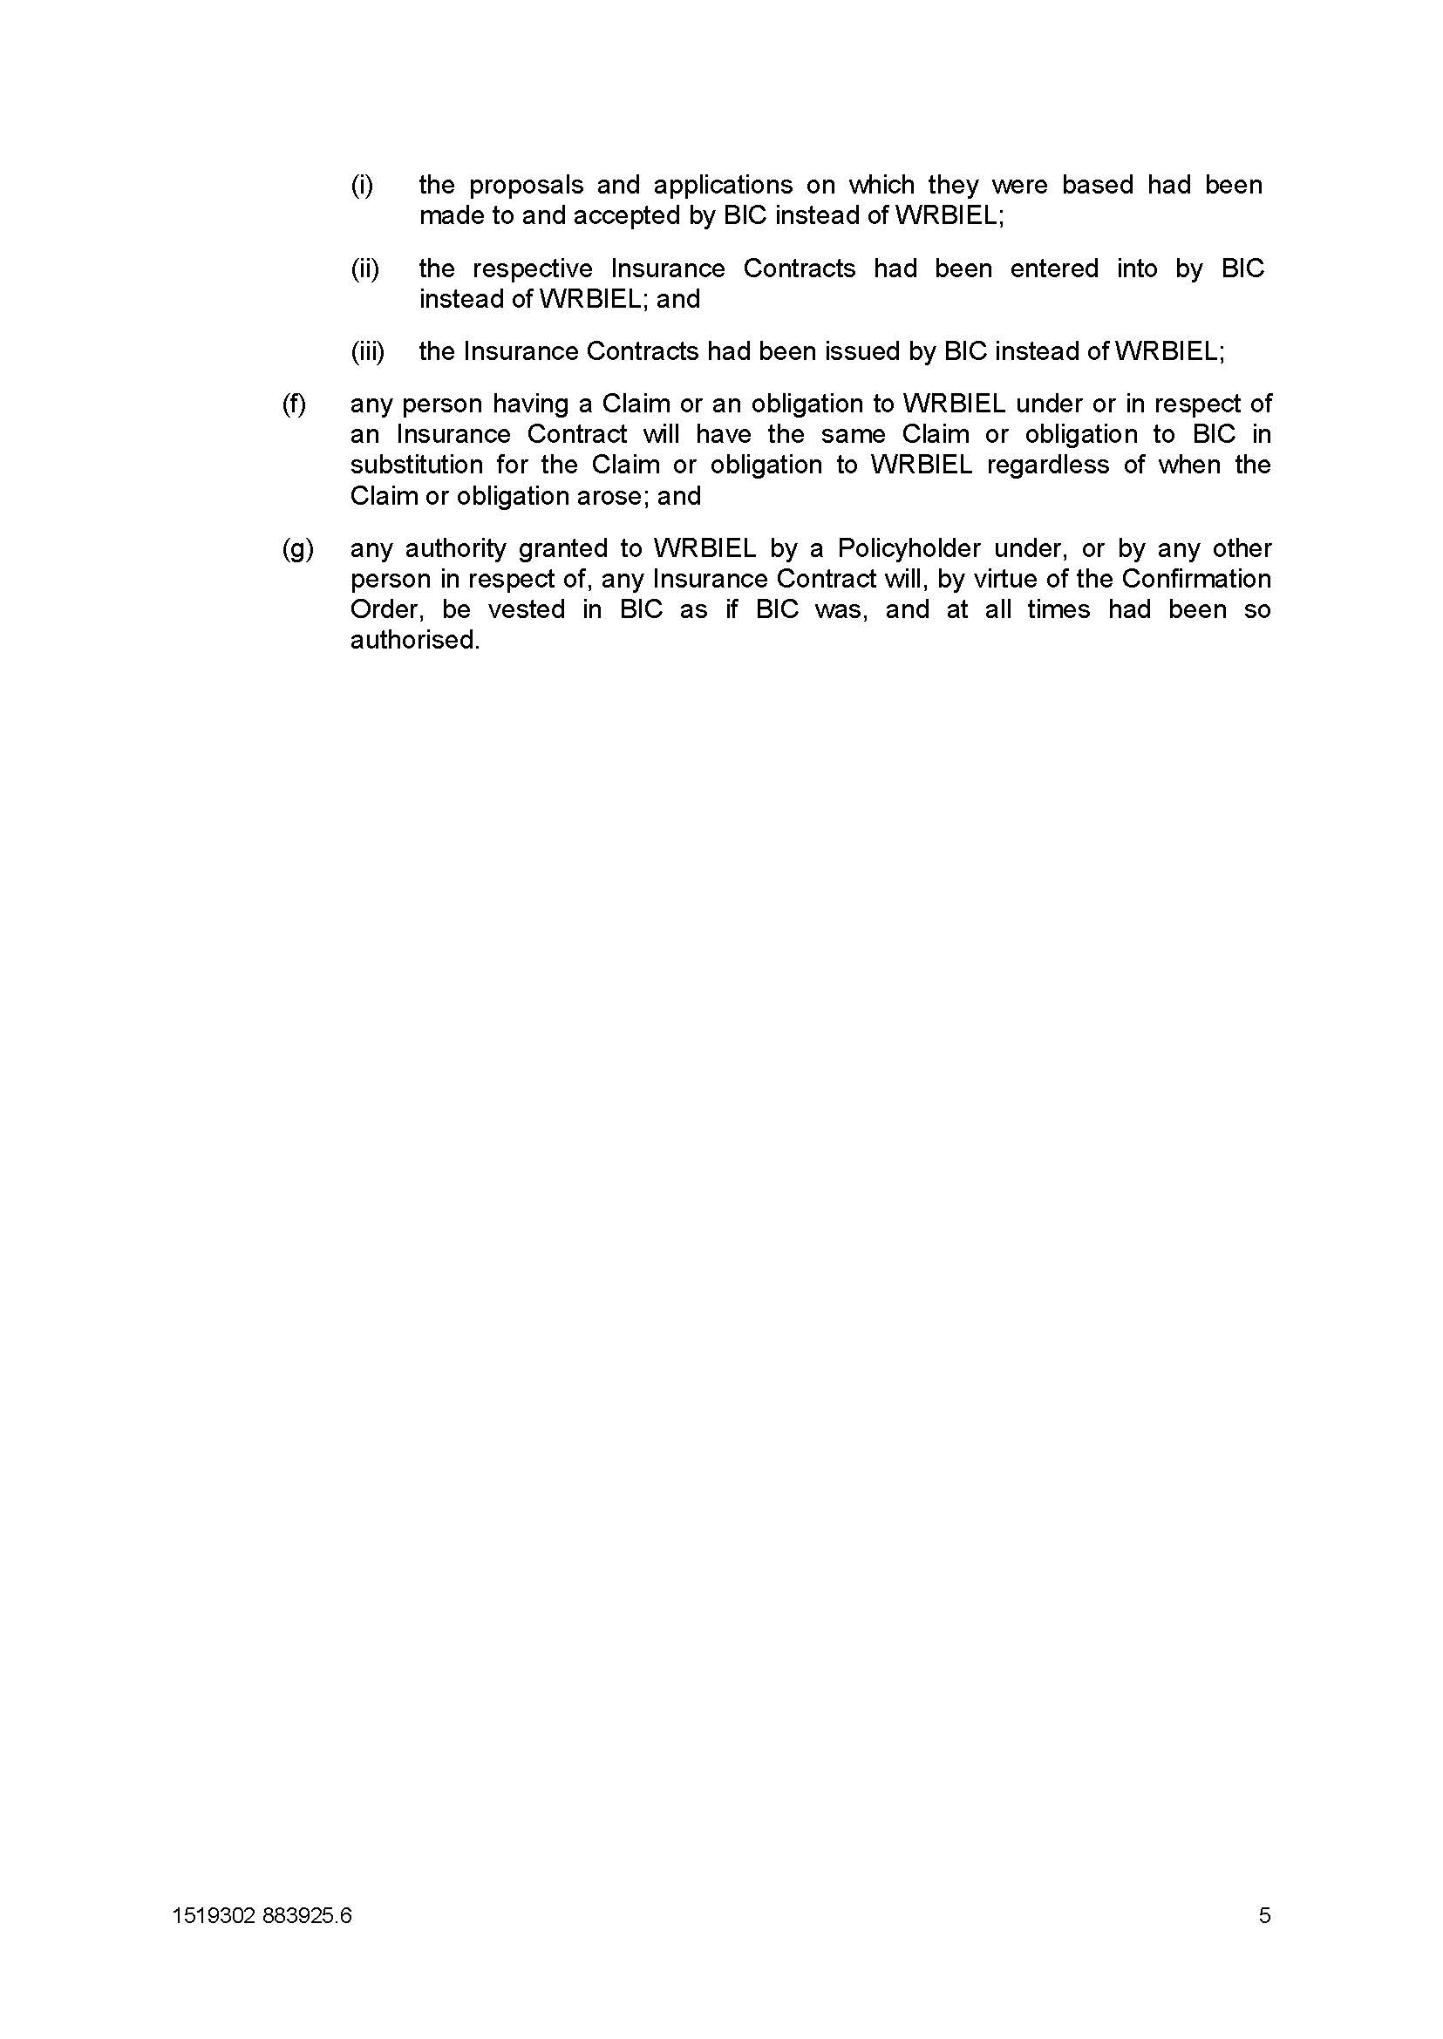

REASONS FOR JUDGMENT
ALLSOP CJ:
- On 28 October 2016, I made orders pursuant to s 17F of the Insurance Act 1973 (Cth) (the Act) confirming a scheme for the transfer of all of the insurance business in Australia of the applicant, W.R. Berkely Insurance (Europe) Ltd (WRBIEL), to the Australian branch of Berkley Insurance Company (BIC). These are the reasons therefor.

background to the scheme
- The applicant and BIC are both foreign corporations authorised under s 12 of the Act to carry on general insurance business in Australia through local branch operations. Both corporations are subsidiaries of the international insurance holding company, W.R. Berkley Corporation (WRBC), which was founded in 1967 and is listed on the New York Stock Exchange.
- WRBIEL has been licensed to write insurance in Australia since December 2007 in the areas of professional indemnity, associations liability, IT liability, medical malpractice, directors’ and officers’ liability, public liability, general liability, personal accident and travel, motor (commercial and fleet), management liability and certain other portfolios of risk. It writes business primarily through agents and broker-sourced insurance markets.
- BIC has also written insurance in Australia since 2007. Its initial business was directed to property and casualty reinsurance risks in Australia, in particular excess of loss and select proportional business for casualty facultative and treaty business. Since the transfer to BIC in October 2014 of all of WRBIEL’s renewal rights for Australian-sourced business as well as a restructure of both the WRBIEL and BIC businesses, however, it now operates with both direct and reinsurance risks in broadly the same categories as are written by WRBIEL
- The application for confirmation of scheme before the Court represents a further stage of the business reorganisation of the W.R. Berkley group of companies in Australia through the transfer of insurance contracts (including the rights, obligations and liabilities under the contracts) of one Australian branch of the group to another Australian branch.
- In addition, WRBIEL will transfer to BIC assets equal to the value of the assumed liabilities value plus an additional AUD$1,500,000. Following implementation of the scheme, WRBIEL will apply to the Australian Prudential Regulation Authority (APRA) to revoke its licence to carry on insurance business in Australia, and the remaining capital of WRBIEL will be repatriated to its UK head office.

legislative framework
- Section 17B(1) provides that no part of the insurance business of a general insurer may be transferred to another general insurer or amalgamated with the business of another general insurer except under a scheme confirmed by the Court. Section 17B(3) requires the scheme to set out the terms of the agreement or deed under which the proposed transfer or amalgamation is to be carried out; and the particulars of any other arrangements necessary to give effect to the scheme.
- Section 17C sets out the procedural steps relevant to the making of an application of this kind. It reads:
(1) In this section:
affected policyholder means the holder of a policy affected by a scheme.
approved summary means a summary approved by APRA.
(2) An application for confirmation of a scheme may not be made unless:
(a) a copy of the scheme and any actuarial report on which the scheme is based have been given to APRA in accordance with the prudential standards; and
(b) notice of intention to make the application has been published by the applicant in accordance with the prudential standards; and
(c) an approved summary of the scheme has been given to every affected policyholder.
(3) Without limiting the provision that may be made by the prudential standards for the purposes of paragraph (2)(b), the notice referred to in that paragraph must include, in relation to each body corporate affected by the scheme, details of the place and time at which an affected policyholder may obtain a copy of the scheme.
(4) An affected policyholder is entitled, on the person’s request, to be provided by the company with one copy of the scheme free of charge.
(5) The Federal Court may dispense with the need for compliance with paragraph (2)(c) in relation to a particular scheme if it is satisfied that, because of the nature of the scheme or the circumstances attending its preparation, it is not necessary that the paragraph be complied with.
- The requirement for the applicant to provide every affected policyholder with an approved summary of the scheme under s 17C(2)(c) was waived by orders of the Court made on 15 April 2016 on account of the difficulty in identifying the identity and/or address of every potentially affected policyholder. Instead, orders were made requiring the applicant to bring the proposed scheme to the attention of those affected policyholders who could be identified through the applicant’s databases and relevant searches: see W.R. Berkley Insurance (Europe) Limited, in the matter of Division 3A of Part III of the Insurance Act (1973) [2016] FCA 374 and W.R. Berkley Insurance (Europe) Limited, in the matter of Division 3A of Part III of the Insurance Act (1973) (No 2) [2016] FCA 393.
- Section 17F deals with the Court’s discretion to confirm a scheme. It provides:
(1) The Federal Court may:
(a) confirm a scheme without modification; or
(b) confirm the scheme subject to such modifications as it thinks appropriate; or
(c) refuse to confirm the scheme.
(1A) In deciding whether to confirm a scheme (with or without modifications), the Federal Court must have regard to:
(a) the interests of the policyholders of a body corporate affected by the scheme; and
(b) if a report relevant to all or part of the scheme has been filed with the Court under section 62ZI—that report; and
(c) any other matter the Court considers relevant.
(2) The Federal Court may make such orders as it thinks fit in relation to reinsurance.
- In relation to the requirement in s 17F(1A), the Court in exercising its general discretion will consider the interests of the policyholders of both the transferor and transferee entities, in this case WRBIEL and BIC respectively, and consider whether implementation of the scheme will materially detrimentally affect the policyholders: see Re Westport Insurance Corporation (No 2) [2009] FCA 1598; 181 FCR 530 at 535 [32] per Lindgren J.
- This involves the applicant providing the Court with actuarial evidence directed to explaining any change in the financial profile or risk profile projected to be experienced by transferring and existing policyholders. The Court should appreciate from the evidence ‘the nature of the actual or potential claims to which the transferor insurer is subject and the financial viability of the transferee insurer’: In the matter of Reward Insurance Ltd [2004] FCA 151 J at [3] per Heerey J.
- A further matter to note in relation to this scheme is the fact that it involves a transfer between the Australian branches of foreign corporations (albeit each belonging to the W. R. Berkley group of companies). Lindgren J summaries the regulation of foreign insurers by APRA in Westport 181 FCR at 532 [11]-[12]:
[11] An Australian “branch” of a foreign general insurer is a notional entity representing the assets and liabilities of that company in Australia. The branch is not a legal entity. However, the Australian Prudential Regulation Authority (APRA) is concerned only with the Australian branch and with the protection of the holders of policies issued by the Australian branch. There is a general requirement under the Act (s 28) that general insurers maintain “in Australia” assets of a value equal to or greater than the value of their liabilities “in Australia”. Other provisions of the Act also express the test of ability to meet a general insurer’s liabilities in Australia from its asset in Australia: see ss 62M, 62ZZC, 62ZZE. The meaning of assets and liabilities in Australia is refined and elaborated upon in s 116A of the Act. Prudential Standards require foreign general insurers to maintain assets in Australia in excess of their liabilities in Australia in an amount at least equal to a variant of a certain Minimum Capital Requirement (MCR) (see Prudential Standard GPS 110 Capital Adequacy, esp para 11). Foreign general insurers must therefore maintain a separate balance sheet in respect of their Australian operations in order to depict the financial condition of the Australian branch.
[12] This notional division between a foreign general insurer’s Australian operations and its other operations is reinforced by restrictions that APRA places on a foreign general insurer’s liberty to deal with its assets in Australia. It may not reduce its assets in Australia (save to the extent of repatriation, to a certain extent, of current year profits) without APRA’s approval.
- This passage remains a relevant introduction to APRA’s regulation of the Australian branches of foreign insurers, save that the expression ‘Minimum Capital Requirement’ has been revised to Prescribed Capital Requirement (PCR) in line with the current Prudential Standard GPS 110 Capital Adequacy (GPS 110).
- In exercising its discretion, the Court will focus exclusively on the interests of the policyholders within the Australian branch as compared with any overseas branch of the transferor or transferee insurer: Mercantile & General Reinsurance Company of Australia Ltd [2004] FCA 1773 at [11]. In having regard to the interests of such Australian policyholders, however, it often provides meaningful context for the Court to gain a broad overview of how the balance sheet and risk profile of an Australian branch of a foreign insurer stand vis-à-vis the balance sheet and risk profile of the foreign corporation to which it belongs and/or to which it will be transferred. I refer to my reasons in Atradius Credit Insurance N.V., in the matter of Atradius Credit Insurance N.V. (No 2) [2016] FCA 1495 at [17].

Evidence

The Actuarial Report
- It is instructive to set out some of the high level financial metrics pertaining to both WRBIEL and BIC to gain an overview of the balance sheets of both companies pre-transfer and post-transfer. This information is contained in an actuarial report dated 6 April 2016 prepared by Mr Warrick Gard, a fellow of the Institute of Actuaries in Australia and a partner of Ernst & Young (the Actuarial Report).
- On 19 October 2016, Mr Gard swore an affidavit setting out his view as to whether any of the conclusions or opinions expressed in the Actuarial Report should be changed in light of further financial information provided to him including the APRA returns for WRBIEL and BIC for the period ending 30 June 2016; an income statement for WRBIEL and BIC for the three month period ending 30 September 2016 and a letter from Mr John Honan, the Portfolio Manager of WRBIEL, advising that no changes had been made since 30 June 2016 to the overall asset allocation of investments and to counterparty exposures. Having regard to this updated information, Mr Gard states that he had ‘not identified any matters that cause me to change the conclusions or opinions set out in the Actuarial Report’: see affidavit of Warrick Evan Gard, sworn 19 October 2016 at [8].

The pre-transfer position of WRBIEL and BIC
- The submissions in this matter set out the relevant financial information as at 31 December 2015 (the date of the accounts used for the preparation of the Actuarial Report) and as at 30 June 2016 (the date of the latest APRA returns for both companies).

WBRIEL
- As at 31 December 2015, WRBIEL held total assets of $179,600,000 and had liabilities of $116,100,000, thereby amounting to a net asset position of $63,500,000. Its capital base, calculated in accordance with the Prudential Standards, was $63,700,000. Its prescribed capital requirement was $27,000,000, giving it a solvency coverage ratio of 236%.
- As at 30 June 2016, WRBIEL held total assets of $168,954,000, and had liabilities of $105,608,000, thereby amounting to a net asset position of $63,346,000. Its prescribed capital requirement was $25,621,000, giving it a solvency coverage ratio of 247%.
- WRBIEL’s Internal Capital Adequacy Assessment Process (ICAAP) has identified a target solvency coverage ratio of between 140% and 175%, with a solvency coverage ratio of 200% being a trigger point for capital utilisation or repatriation.

BIC
- At 31 December 2015, BIC held total assets of $485,700,000 and had liabilities of $320,000,000, thereby amounting to a net asset position of $165,700,000. Its capital base was recorded at $162,200,000. Its prescribed capital requirement was $84,400,000, giving it a solvency coverage ratio of 192%.
- As at 30 June 2016, BIC held total assets of $507,022,000, and had liabilities of $336,013,000, thereby amounting to a net asset position of $168,721,000. Its prescribed capital requirement was $87,114,000, giving it a solvency coverage ratio of 194%, which falls at the top of its target solvency coverage ratio of between 155% and 200%.

Actuarial opinion on the impact of the transfer
- The Court must have regard to the post-transfer solvency position of BIC to determine if it will have adequate capital relative to satisfy the claims of transferring policyholders from WRBIEL as well as the remaining policyholders of BIC. It is important for the Court to be attentive to any meaningful changes in solvency coverage for the transferring and remaining policyholders in order to assess the impact that implementation of the scheme will have on them, and to ensure as far as possible that that impact will not be one of material detriment.
- The solvency coverage ratios as at 30 June 2016 for WRBIEL was 247% and for BIC was 194%.
- The post-transfer solvency coverage ratio for BIC (as at 30 June 2016) is calculated to be 173%. The solvency coverage ratio for transferring WRBIEL policyholders will therefore fall from 247% to 173%, while existing BIC policyholders also will experience a fall in solvency coverage ratio from 194% to 173%.
- As noted at [6] in the affidavit of Mr Gard, sworn 19 October 2016, the post-transfer solvency coverage ratio of 173% falls within BIC’s target range of 155% to 200% and thereby offers policyholders substantial protection.
- Prior to the transfer, the solvency coverage ratios of both WRBIEL and BIC were in the top end of the target solvency coverage ratio range, and as noted in the submissions of the applicant, additional capital over the target solvency level does not necessarily represent additional security to policyholders given that such capital is available, with approval from APRA, for distribution to shareholders.
- The ‘Conclusions’ on p 23 of the Actuarial Report state that the fact of the transferring WRBIEL policyholders moving to an insurer with higher net assets and a higher capital base brings with it additional advantages, particularly in circumstances of unusually large claims. Mr Gard also notes being part of an insurer with greater diversification of risks by virtue of having non correlated claims experience means that BIC may have a lower probability of breaching the target solvency coverage ratio, this being so in spite of its lower solvency coverage ratio.
- In respect of BIC’s existing policyholders, Mr Gard concluded that there is no material detrimental impact upon them from a capital perspective on account of those policyholders being protected by an adequate capital base before and following the transfer in line with BIC’s capital management.

Transferring contracts and claims management
- The evidence is that there will be no change to the transferring insurance contracts, except for the substitution of BIC as insurer. Similarly, no changes will be experienced in relation to claims management due to the nature of the intra-group transfer and the fact that the operations of WRBIEL already have been outsourced to BIC since October 2014 as the first stage of the business reorganisation strategy.

Further information regarding WRBC and BIC
- In my view, it is important in transfers involving foreign insurers to gain some understanding at a confirmation hearing of the financial and risk profile not only as they pertain to the Australian “branch” of a foreign insurer but also as they pertain to the foreign insurer itself: see Atradius [2016] FCA 1495 at [17].
- In this matter, both the transferor and transferee are Australian branches of foreign insurers that are subsidiaries of the international insurance group WRBC. Meaningful context on WRBC was provided in the affidavit of Mr Kenneth Grant Robson, sworn 27 October 2016.
- WRBC is a listed entity on the New York Stock Exchange. Its market capitalisation was approximately USD7.03 billion as at 27 October 2016, and it had total assets of USD21.7 billion for the year ended 31 December 2015.
- It comprises domestic units that underwrite domestic commercial business primarily in the USA with total revenues of USD5.1 billion for the year ended 31 December 2015; international units operating in the United Kingdom, Europe, South America, Canada, Scandinavia and Australia, with total revenues of USD824 million for the year ended 31 December 2015. It also comprises global reinsurance units writing faculative and treaty business in the United States, United Kingdom, Europe, Australia, the Asia-Pacific and South Africa with total revenues of USD683 million for the year ended 31 December 2015.
- BIC is the largest underwriting entity of the W.R. Berkley Insurance Group. Its financial strength has an A+ (Superior) rating by A.M. Best and A+ (Strong) by Standard & Poor’s. It operates under the laws of Delaware, and is regulated by the Delaware Department of Insurance. Its annual statement for 2015 shows it has total assets of USD17 billion and premiums earned of USD5.1 billion for the year ended 31 December 2016.

Conclusions
- The independent opinion of Mr Gard contained in the Actuarial Report coupled with the further financial information provided by the applicant with regard to WRBC and BIC satisfy me that neither the policyholders of WRBIEL or BIC will experience a material detriment in terms of changes of security, regulatory environment or risk profile as a result of the transfer.

Procedural requirements
- Specific procedural requirements attend the making of an application of this kind.

Copy of Scheme documents
- The applicant provided a copy of the scheme and actuarial report to APRA as required by s17C(2)(a) in accordance with the prudential standards (see also GPS 410 at [5]). The affidavit of Christopher Richard Flanagan, sworn 3 August 2016, indicates that on 19 May 2016, the final drafts of the Notice of Intention, the Scheme and Scheme Summary and Actuarial Report dated 6 April 2016 were e-mailed to APRA in their finalised form. Approval by APRA of the Scheme Summary and Notice of Intention, as required by GPS 410 at [8] and [9] was obtained on 20 May 2016.

Publication of the Notice of Intention
- An applicant is required by s 17C(2)(b) of the Act to publish a notice of intention containing the information specified in Prudential Standard GPS 410 at [10]. The notice must be published in the Government Gazette and one or more newspapers, approved by APRA, circulating in each State and Territory in which an affected policyholder resides (Prudential Standard GPS 410 at [9]). At the dispensation hearing, I made orders requiring the applicant to publish the Notice of Intention on two separate occasions (no less than one week apart) in the Gazette and certain newspapers. I am satisfied that the applicant complied with this order, as evidenced by the affidavit of Christopher Flanagan at [58] and [59] and its annexures. The notice was published on 24 May 2016 for the first time and 31 May 2016 for the second time

Inspection Period
- With regard to the inspection period, I made the following order:
5. The Applicant make a copy of the Scheme, Scheme Summary and Actuarial Report available for inspection from 9.00am to 5.00pm (local time) everyday (except weekends and public holidays) for a period of at least 15 days (inclusive) at locations approved by APRA in each State and Territory in which an affected policyholder resides.
- The affidavit of Christopher Flanagan, sworn 3 August 2016, at [60] to [68] and its annexures illustrate that this order was complied with by the applicant, and the inspection sites were staffed and copies of the relevant documents made avaliable during the relevant period running from 25 May 2016 to 16 June 2016 (inclusive). The address of the inspection site in Victoria and the name of the entity for the Tasmanian inspection site changed after the date of the dispensation hearing. These updated details, however, were included in the Notice of Intention and Scheme Summary as published and circulated to policyholders. No person is recorded as attending the inspection sites during the relevant period: see [68] of the the affidavit of Christopher Flanagan.

Distribution of Scheme summary
- Order 2 made on 15 April 2016 concerned the persons to whom the Scheme Summary would be distributed. It read:
2. The Applicant causes a copy of the summary of the Scheme approved by the Australian Prudential Regulation Authority (Approved Summary) to be sent by pre-paid post to:
(a) each of the policyholders identified in the Policyholder Register as described in the affidavit of Christopher Richard Flanagan sworn on 7 April 2016 (Flanagan Affidavit) and the supplementary affidavit of Christopher Richard Flanagan sworn on 8 April 2016 (Flanagan Supplementary Affidavit);
(b) each of the brokers, coverholders, managing general agents and master policyholders as described in the Flanagan Affidavit, the Flanagan Supplementary Affidavit and the further supplementary affidavit of Christopher Richard Flanagan sworn on 14 April 2016 (Further Flanagan Affidavit); and
(c) the National Insurance Brokers Association, Steadfast and Austbrokers.
- The reference to the affidavit of Christopher Richard Flanagan, sworn on 7 April 2016, in fact referred to the information contained in Christopher Flanagan’s affidavit sworn on 6 April 2016, and Mr Flanagan proceeded to comply with the Court’s order on that basis.
- The affidavit of Christopher Flanagan, sworn 3 August 2016, provides details of assembly and finalisation of the Policyholder Register and Broker List (see [9] to [14]). The completed Policyholder Register consisted of 28,069 entries, as explained at [5] in the affidavit of Christopher Flanagan, sworn 19 October 2016. It provided a list of all Current claims for Segments A, B and C of the applicant’s business as these segments were explained at the dispensation hearing: see W.R. Berkley Insurance (Europe) Limited [2016] FCA 374. The completed Broker List comprised a list of broker names and addresses held on the relevant database.
- The completed Policyholder Register and Broker List were sent to representatives of Senses Direct Pty Ltd, the company in charge of completing relevant checks and implementing the mail-out. Mr Flanagan also took certain steps to identify the Australian addresses in cases where only overseas addresses appeared on the mailing list. In accordance with Order 2(c), Mr Flanagan also sent the required documents to the National Insurance Brokers Association, Steadfast and Austbrokers.
- A spreadsheet annexed to the affidavit of Mr Flanagan shows the returned and redirected mail from the mail-out. The return of 5455 letters was recorded. Attempts were made with regard to Segment A and C business, the Broker List and Segment B (including current claimants for this segment), with the exception of Queensland Underwriting Services (QUS), to determine updated addresses for these policyholders.
- The addresses used to send the Scheme Summary to policyholders of QUS represented risk locations of strata title properties that in some cases did not necessarily equate to a postal address. Further internet searches of the publicly available records on the internet were made to obtain updated information for the QUS component of returned mail, with the result that such searches did not yield any additional usable contact information. Accordingly it was decided not to pursue further internet searches for this category of policyholders
- The affidavit of Ian Robert Fulton, sworn 3 June 2016, deals with the practicalities of the mail-out itself. I am satisfied from this evidence that the applicant complied with the mail-out to policyholders as required by the orders.
- The affidavit of Christopher Flanagan, sworn 3 August 2016, also indicates that the Notice of Intention, the Scheme, the Scheme Summary and the Actuarial Report were available on the Berkley website from 23 May 2016 to 16 June 2016 inclusive, as required by Order 3 made on 15 April 2016.

Views of APRA
- Mr Claxton, who appeared on behalf of APRA, noted that APRA had supervised preparations of the Scheme and, on requiring some remediation to it, had received a high level of cooperation from the applicant. Mr Claxton informed the Court that APRA was satisfied with the orders for implementation of the scheme as presented to the Court.
- The Court accords significant weight to the views of APRA in confirming a scheme of this kind in light of the fact that it closely supervises the process and regulates insurance businesses with a view to managing risk and protecting the interests of policyholders.

Reinsurance Orders
- Section 17F(2) of the Act provides that the Court may make such orders as it thinks fit in relation to reinsurance.
- The applicant also sought an order pursuant to s 17F(2) transferring the outwards reinsurance responding to any contract transferred pursuant to the Scheme, and all rights attaching to it, to BIC. The affidavit of Christopher Flanagan, sworn 3 August 2016, describes at [72] the two broad categories of protection pertaining to the applicant’s reinsurance arrangements. The first represents those reinsurance contracts entered into by Berkely in Australia covering certain elements of its Australian risk. The second category is reinsurance contracts entered into by Berkley’s home office in the UK that cover insurance contracts written by Berkley’s Australian branch and insurance contracts classified as liabilities under s 116A of the Act representing the insurance business the subject of the application to the Court.
- As at 3 August 2016, all reinsurers had endorsed or novated reinsurance coverage to BIC in relation to both categories of protection detailed above i.e. the Australian and the UK reinsurance contracts.
- As explained in the affidavit of Christopher Flanagan, sworn 19 October 2016, after the endorsement process had commenced, the applicant became aware that some of the reinsurance contracts to be endorsed for BIC’s benefit, were not compliant with APRA Prudential Standard GPS 230 Reinsurance Management (GPS 230) at [34] which provides:
34. For any reinsurance contract entered into by a regulated institution incepting on or after 31 December 2008, the regulated institution must ensure that the reinsurance contract provides that:
(a) the governing law of the reinsurance contract is Australian law; and
(b) any disputes that fall to be determined by a court are to be heard in an Australian court.
- The novation and endorsement process contained a service of suit clause which was required by BIC's US regulator (the Delaware Department of Insurance), but was inconsistent with the requirements of para 34 of GPS 230. Following discussions a revised suit of service clause was agreed between the Applicant, BIC, APRA and the Delaware Department of Insurance to overcome the inconsistency with GPS 230 outlined above.
- The affidavit of Christopher Flanagan, sworn 21 October 2016, states that all 205 of the further endorsements provided to BIC and the applicant’s reinsurers have been completed.
- In spite of the novation and endorsement process, an order nevertheless was sought to ensure that affected policyholders are not deprived of the benefit of reinsurance that attached to their liabilities prior to the transfer: see QBE Insurance (Australia) Ltd, in the matter of Division 3A of Part III of the Insurance Act 1973 (Cth) [2016] FCA 288 at [75]-[83]; Application of Sompo Japan Insurance Inc. under the Insurance Act 1973 (Cth) (No 2) [2014] FCA 677 at [43]-[45]; Gordian RunOff Ltd (No 2) [2013] FCA 1329 at [25]-[28]; American Home Assurance Company (No 2) [2011] FCA 316 at [28]-[30]; HDI-Gerling Australia Insurance Company Pty Limited, in the matter of HDI-Gerling Australia Insurance Company Pty Limited (ABN 16 069 085 196) (No 2) [2010] FCA 669 at [58]-[59]; SGIC General Insurance Ltd [2004] FCA 1639 at [28].

Conclusion
- On the basis of the actuarial evidence, the evidence of the financial and risk profiles of the relevant foreign corporations, APRA’s support of the scheme and the fact that the procedural requirements were complied with by the applicant, I was prepared to make orders confirming the scheme as well as the order regarding transfer of outwards reinsurance.
I certify that the preceding sixty (60) numbered paragraphs are a true copy of the Reasons for Judgment herein of the Honourable Chief Justice Allsop.

Associate:

Dated: 13 December 2016

