Federal Court of Australia

Gordian RunOff Limited, in the matter of Gordian RunOff Limited (No 2) [2021] FCA 1632
File number: | NSD 1051 of 2021
Judgment of: | ALLSOP CJ
Date of reasons: | 23 December 2021
Date of orders: | 17 December 2021
Catchwords: | INSURANCE – scheme for transfer of insurance business – application to Court for confirmation of scheme pursuant to Division 3A of Part III of the Insurance Act 1973 (Cth) – scheme confirmed without modification
Legislation: | Insurance Acquisitions and Takeovers Act 1991 (Cth)  Insurance Act 1973 (Cth) ss 17B, 17C, 17F  Workers Compensation Act 1987 (NSW)
Cases cited: | ACE Insurance Ltd, in the matter of ACE Insurance Ltd (No 2) [2016] FCA 1258  Application of Sompo Japan Insurance Inc under the Insurance Act 1973 (Cth) [2014] FCA 396  Application of Sompo Japan Insurance Inc under the Insurance Act 1973 (Cth) (No 2) [2014] FCA 677  Asteron Life & Superannuation Limited, in the matter of Asteron Life & Superannuation Limited (No 3) [2021] FCA 1148; 394 ALR 89  Australian Branch of Great Lakes Insurance SE (trading as Great Lakes Australia), in the matter of the Australian Branch of Great Lakes Insurance SE (trading as Great Lakes Australia) [2020] FCA 1266  Colonial Mutual Life Assurance Society Limited, in the matter of the Colonial Mutual Life Assurance Society Limited [2021] FCA 394  Gordian RunOff Limited, in the Matter of Gordian RunOff Limited [2021] FCA 1386  In the Application of Commonwealth Insurance Holdings Ltd and The Colonial Mutual Life Assurance Society Ltd [2007] FCA 1012  In the matter of GIO Personal Investment Services Ltd and AMP Life Ltd [2000] FCA 1871  In the matter of Reward Insurance [2004] FCA 151  Insurance Australia Limited, in the Application of Insurance Australia Ltd [2016] FCA 1387  Mercantile and General Reinsurance Company of Australia Limited (ABN 35 000 172 350) [2004] FCA 1773  MLC Lifetime Company Limited and MLC Limited (No 2) [2006] FCA 1367  Re Insurance Australia Limited [2004] FCA 524; 139 FCR 450  Westport Insurance Corporation, in the matter of Westport Insurance Corporation (No 2) [2009] FCA 1598; 181 FCR 530
Division: | General Division
Registry: | New South Wales
National Practice Area: | Commercial and Corporations
Sub-area: | Commercial Contracts, Banking, Finance and Insurance –Insurance List
Number of paragraphs: | 88
Date of hearing: | 15 December 2021
Counsel for the Applicant: | Mr M Izzo SC with Ms S Tame
Solicitor for the Applicant: | Norton Rose Fulbright
Counsel for the Interested Person: | Mr M Newtown
Solicitor for the Interested Person: | Corrs Chambers Westgarth
Counsel for the Australian Prudential Regulation Authority: | Ms N Laing

ORDERS
 |  | NSD 1051 of 2021
IN THE MATTER OF GORDIAN RUNOFF LIMITED
BETWEEN: | GORDIAN RUNOFF LIMITED ACN 052 179 647  Applicant
AND: | NORTH INSURANCES PTY LTD ACN 050 197 110  Interested Person

order made by: | ALLSOP CJ
DATE OF ORDER: | 17 December 2021

THE COURT ORDERS THAT:

- Pursuant to s 17F of the Insurance Act 1973 (Cth), the scheme for the transfer of all the general insurance business of North Insurances Pty Ltd (ACN 050 197 110) (North) to Gordian RunOff Limited (ACN 052 179 647) (Gordian) (Scheme) be confirmed in the form of Annexure A to these orders.
- The Transfer Time for the purposes of the commencement of the Scheme shall be 12:01am on 20 December 2021.
- Pursuant to s 17F(2) of the Act, all of North’s reinsurance contracts that respond to any policy transferred pursuant to the Scheme, be transferred to Gordian.
- The applicant pay the costs of the proceedings of the Australian Prudential Regulation Authority as agreed or assessed.
- The Court’s reasons for Orders 1 to 4 will be published in due course.

Note: Entry of orders is dealt with in Rule 39.32 of the Federal Court Rules 2011.
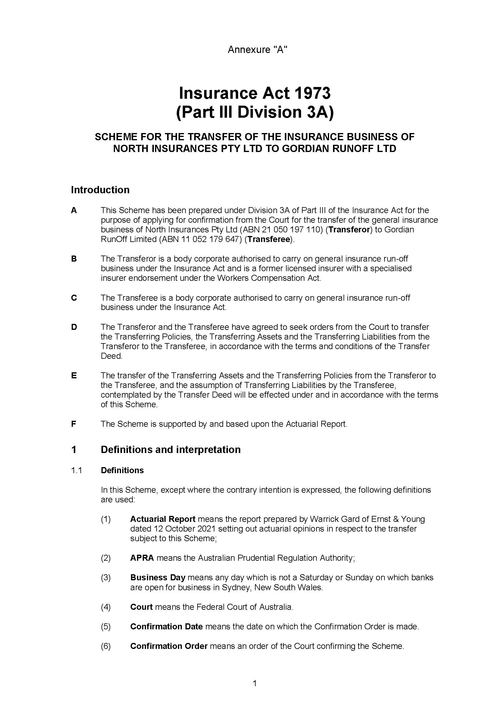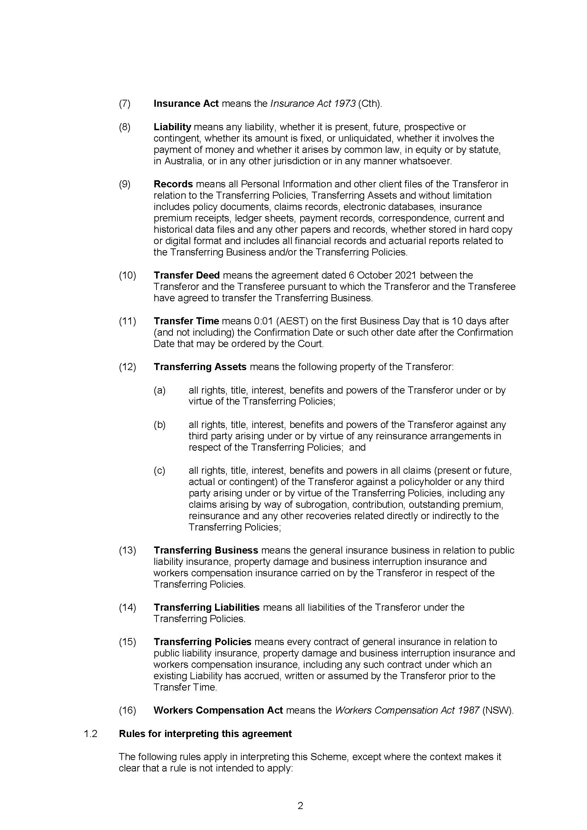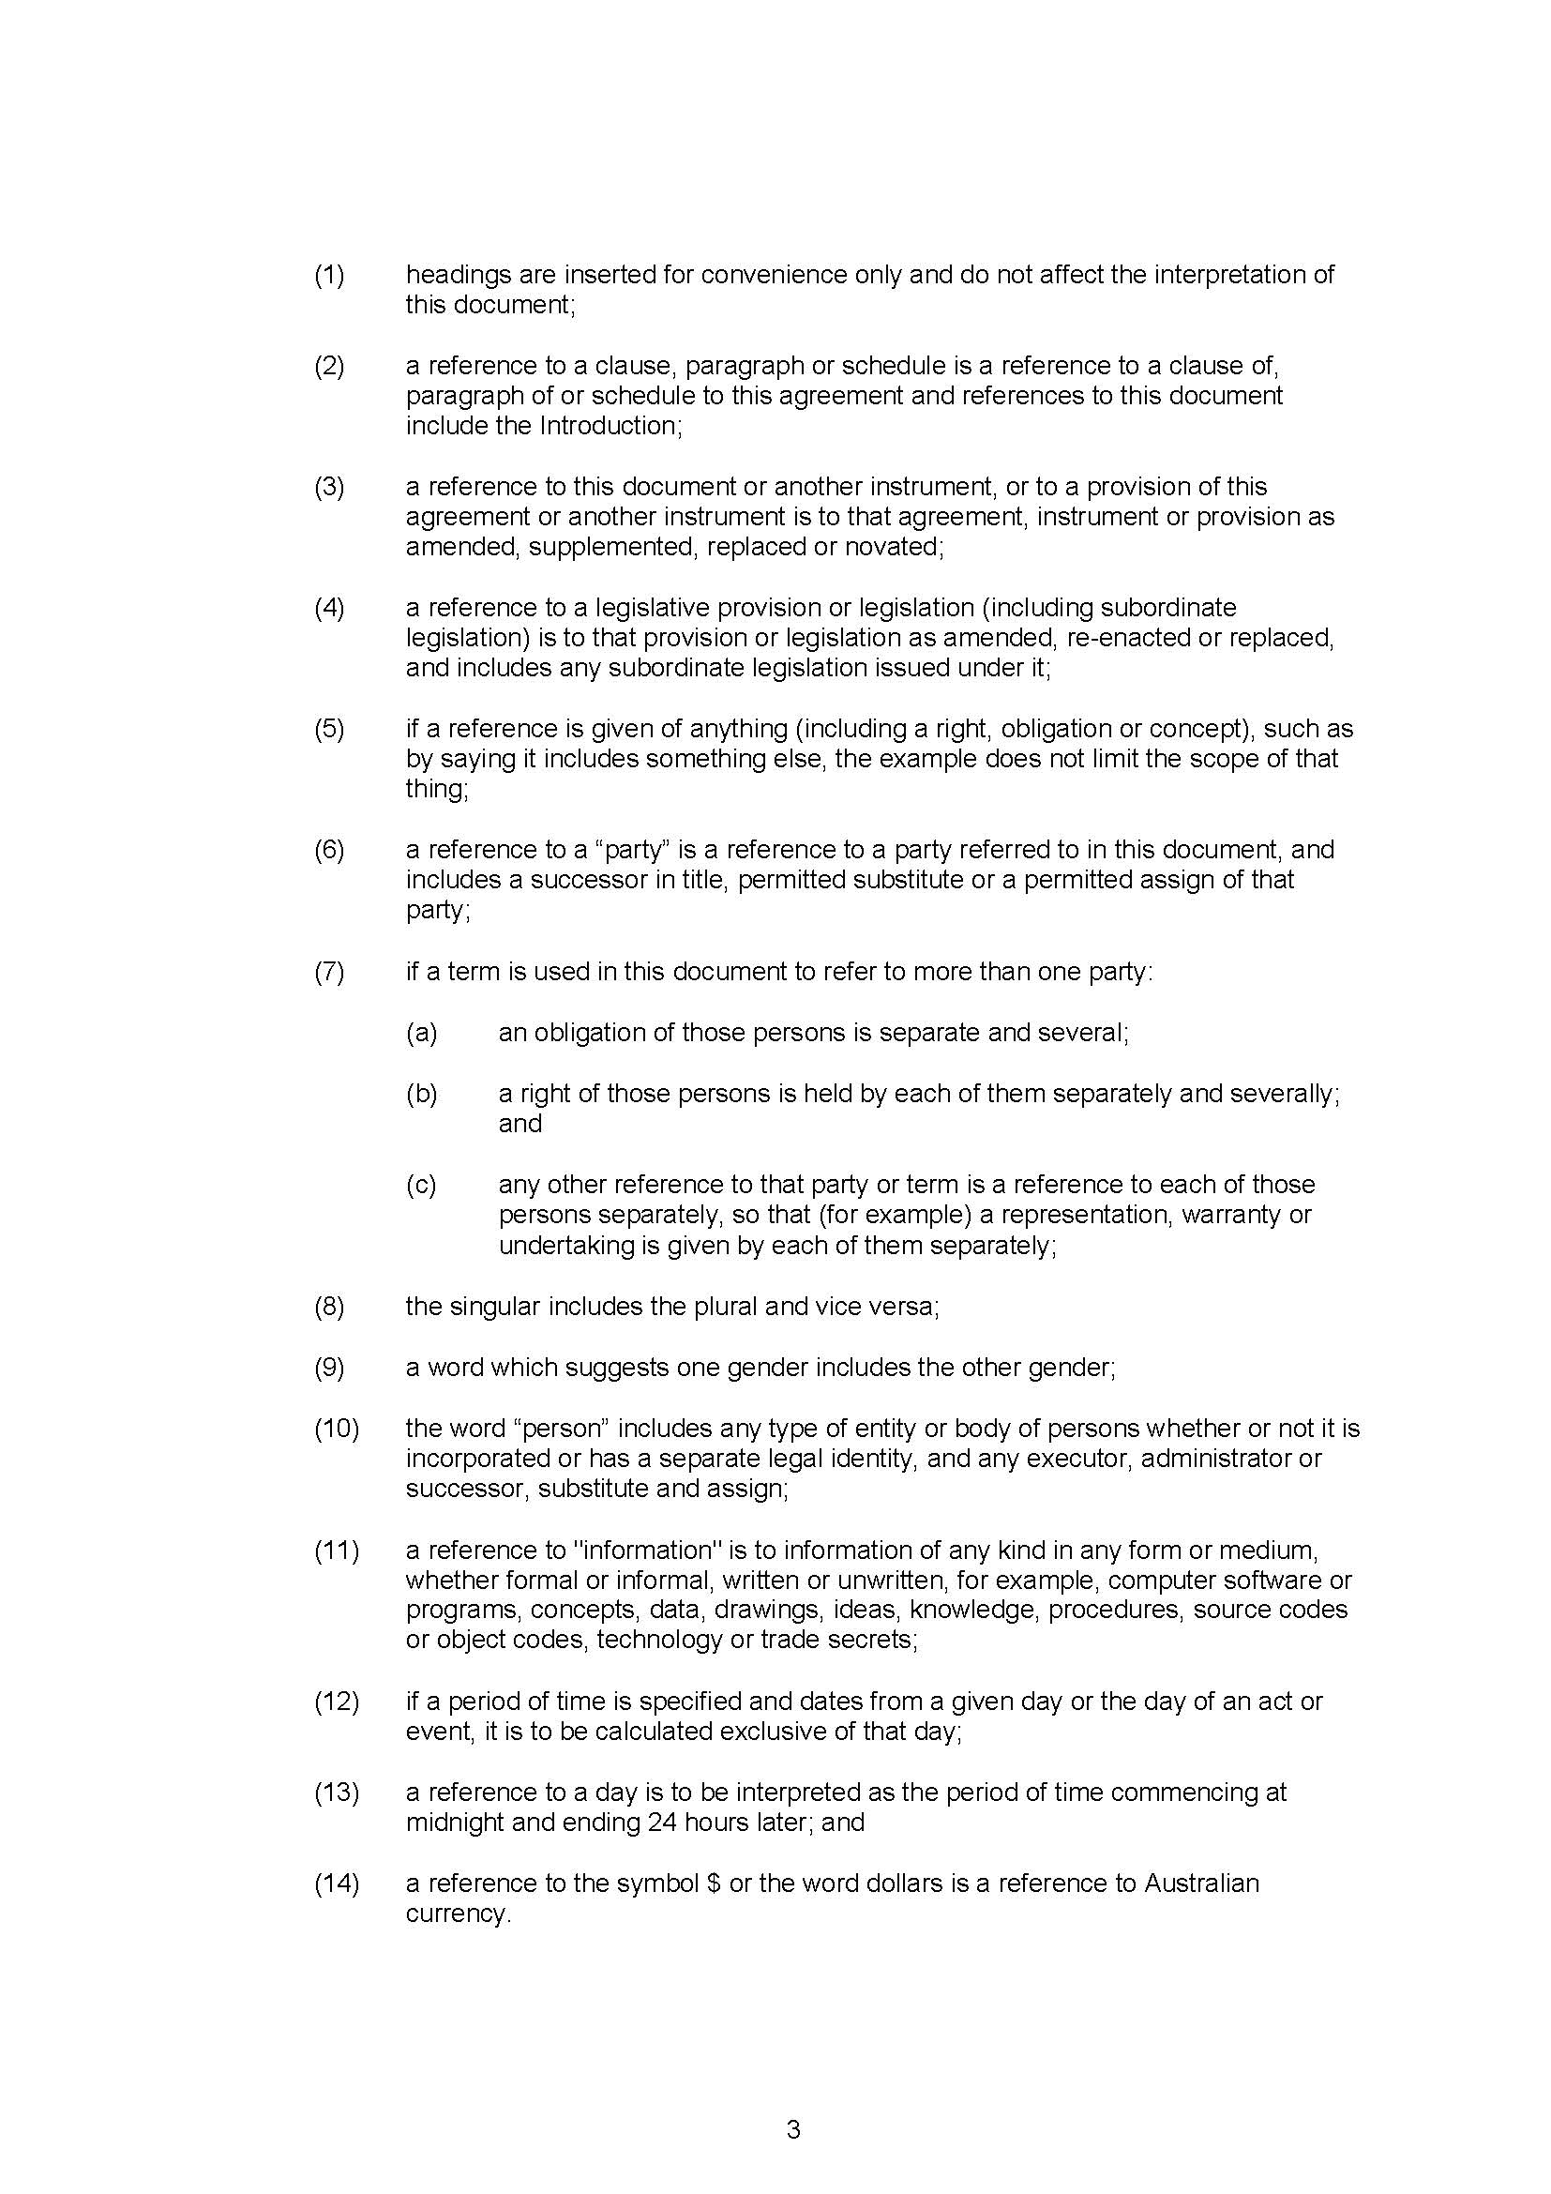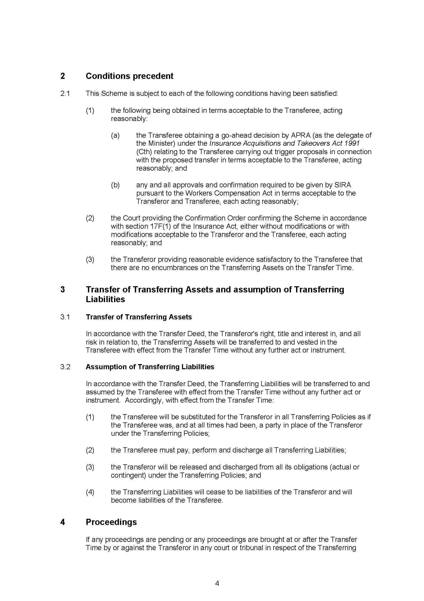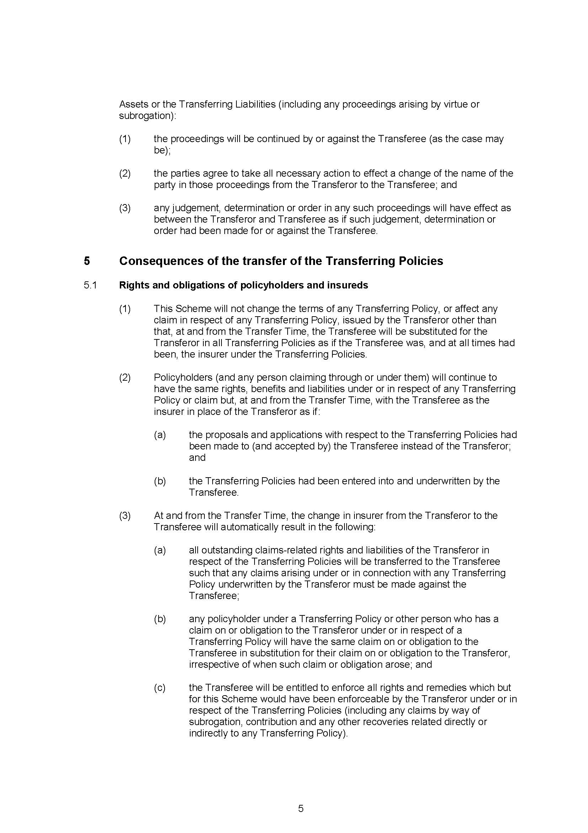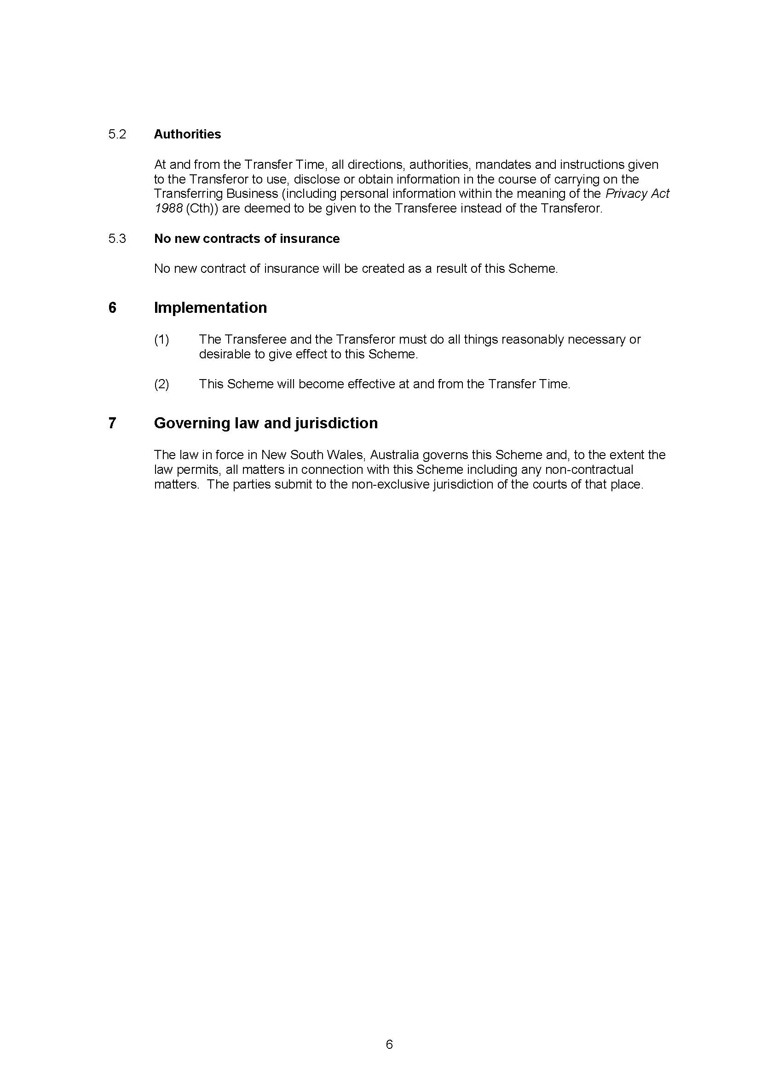

REASONS FOR JUDGMENT
ALLSOP CJ:
- On 17 December 2021 after hearing the matter on 15 December 2021, I made orders confirming the transfer of all the general insurance business from North Insurances Pty Ltd (North) to Gordian RunOff Limited (Gordian) (the Scheme) under s 17F of the Insurance Act 1973 (Cth) (the Act). These are the reasons for the orders.
- By s 17B of the Act, no part of the insurance business of a general insurer may be transferred to, or amalgamated with, the business of another general insurer except under a scheme confirmed by this Court.
- Section 17F sets out the nature of the authority to confirm a scheme, and the factors to which the Court is to have regard in deciding whether to confirm a scheme:
(1) The Federal Court may:
(a) confirm a scheme without modification; or
(b) confirm the scheme subject to such modifications as it thinks appropriate; or
(c) refuse to confirm the scheme.
(1A) In deciding whether to confirm a scheme (with or without modifications), the Federal Court must have regard to:
(a) the interests of the policyholders of a body corporate affected by the scheme; and
(b) if a report relevant to all or part of the scheme has been filed with the Court under section 62ZI—that report; and
(c) any other matter the Court considers relevant.
(2) The Federal Court may make such orders as it thinks fit in relation to reinsurance.
- The applicant sought interlocutory orders pursuant to s 17C(5) dispensing with the need to comply with s 17C(2)(c) of the Act, which provides that an application for confirmation of a scheme may not be made unless a summary of the scheme approved by the Australian Prudential Regulation Authority (APRA) has been given to every affected policyholder. At the conclusion of the dispensation hearing on 8 November 2021, I made orders dispensing with the requirement in s 17C(2)(c) provided that the applicant comply with certain conditions, and gave brief reasons for so doing: Gordian RunOff Limited, in the Matter of Gordian RunOff Limited [2021] FCA 1386.
- For the reasons that follow I am satisfied that the Scheme ought to be confirmed without variation.

Evidence
- Gordian and North relied on the affidavits read at the dispensation hearing on 8 November 2021, which were taken as read at the confirmation hearing, being:
- Affidavit of Sandra O’Sullivan sworn 3 November 2021;
- Affidavit of Sandra O’Sullivan sworn 5 November 2021;
- Affidavit of Warrick Evan Gard sworn 3 November 2021 annexing his actuarial report dated 12 October 2021; and
- Affidavit of Michele John Martino affirmed 4 November 2021.
- The application for confirmation was supported by the following further affidavits:
- Affidavit of Sandra O’Sullivan sworn 9 December 2021;
- Affidavit of Warrick Evan Gard sworn 10 December 2021;
- Affidavit of Michele John Martino affirmed 10 December 2021;
- Affidavit of Michele John Martino affirmed 14 December 2021;
- Affidavit of Daniel John Marquet sworn 10 December 2021;
- Affidavit of Matthew James Ellis affirmed 10 December 2021.
- Ms O’Sullivan is the Chief Executive Officer of Gordian, having held that position since 9 August 2011. Prior to her appointment as Chief Executive Officer, Ms O’Sullivan was the Chief Financial Officer of Gordian from March 2008.
- Mr Gard is a Fellow of the Institute of Actuaries of Australia, and a partner of Ernst & Young. He was jointly engaged by Gordian and North to prepare an actuarial report in support of the application to transfer the insurance business of North to Gordian pursuant to Div 3A of Part III of the Act. His actuarial report, dated 12 October 2021, is annexed to the affidavit of 3 November 2021, marked WEG-1.
- Mr Martino is the Chief Executive Officer of North. Mr Martino has held this position since 2018. From 2012 to 2018, Mr Martino was employed by Rio Tinto Limited as Group Risk Advisor.
- Mr Marquet is a partner of Corrs Chambers Westgarth, and has conduct of this proceeding on behalf of North.
- Mr Ellis is a partner of Norton Rose Fulbright Australia, and has care and conduct of this matter on behalf of Gordian.

Principles applicable to confirmation
- The principles applicable to the confirmation of the transfer of insurance business are uncontroversial, and were not in dispute. The matters the Court must consider, pursuant to s 17F(1A), are set out above. A crucial consideration (falling generally within s 17F(1A)(a)) is whether the implementation of the scheme will or may materially detrimentally affect policyholders: Westport Insurance Corporation, in the matter of Westport Insurance Corporation (No 2) [2009] FCA 1598; 181 FCR 530 at 535 [32]; Mercantile and General Reinsurance Company of Australia Limited (ABN 35 000 172 350) [2004] FCA 1773 at [23]; In the matter of GIO Personal Investment Services Ltd and AMP Life Ltd [2000] FCA 1871 at [27]. Affected policyholder is defined in s 17C as referring to the holder of a policy being transferred under the scheme, but this does not preclude from the consideration of the Court the effect of the scheme on other policyholders. A further “prime consideration” is the nature of actual and potential claims to which the insurer is subject, and the financial viability of the transferee insurer: In the matter of Reward Insurance [2004] FCA 151 at [3]; Australian Branch of Great Lakes Insurance SE (trading as Great Lakes Australia), in the matter of the Australian Branch of Great Lakes Insurance SE (trading as Great Lakes Australia) (No 2) [2020] FCA 1266 at [13].
- The authority and power of the Court to confirm a scheme, or decline to do so, pursuant to s 17F is a genuine discretion: confirmation of a scheme is not a matter of course, nor a mere formality: Colonial Mutual Life Assurance Society Limited, in the matter of the Colonial Mutual Life Assurance Society Limited [2021] FCA 394 at [27]; MLC Lifetime Company Limited and MLC Limited (No 2) [2006] FCA 1367 at [5]. This is so even in circumstances where, at least commercially, the proposed scheme is uncontroversial. Even in relatively simple matters which do not present, in the eyes of counsel and practitioners, any real commercial issues, the public importance of schemes such as these requires that full reasons are given, and necessitates an attending to the detail of the matter in recognition that the confirmation of a scheme is not a mere formality. These factors should always be recognised by parties and their advisers in the setting of contractual dates and their proximity to hearings by the Court. The task of the Court, in reaching a conclusion under s 17F, involves a close examination of extensive and detailed actuarial evidence and requires that due regard is given to the interests of policyholders. In Asteron Life & Superannuation Limited, in the matter of Asteron Life & Superannuation Limited (No 3) [2021] FCA 1148; 394 ALR 89 at 117 [129] I considered that the interests of policyholders transcend mere economic interests, and encompass notions of preference, and of corporate culture and values.

Compliance with dispensation orders
- The first matter that must be addressed in determining whether to confirm the Scheme is the compliance with the dispensation orders of 8 November 2021, given that the notification regime in s 17C(2) is a precondition to a valid application for confirmation of a scheme: but see Re Insurance Australia Limited [2004] FCA 524; 139 FCR 450 at 463 [62]–[63]. Orders 2 through 5 of the orders of 8 November 2021 established a notification regime for affected policyholders and parties. The extent of compliance (or any lack thereof) with these orders is considered below.

Order 2
- Order 2 of the orders of 8 November 2021 provided for the provision by pre-paid post or email of a copy of the summary of the Scheme (as approved by APRA) to:
- North Limited (ACN 005 233 689);
- Each of the Australian registered entities listed in Annexure A to the orders of 8 November 2021;
- Each of the seven overseas companies listed in Annexure A to the orders of 8 November 2021;
- The Australian Securities and Investments Commission, in respect of the 57 former or deregistered Australian companies listed in Annexure B to the orders of 8 November 2021;
- WHS/Workers Compensation, Unions NSW; and
- WHS/Workers Compensation Officer, Australian Manufacturing Workers Union.
- In his affidavit of 10 December 2021, Mr Martino addressed Gordian’s compliance with Order 2(a)–(c). Mr Martino deposed that he caused searches of Rio Tinto’s internal records to identify the company secretaries and registered addresses of each of the entities identified in Order 2(a)–(c) (excepting one entity listed in Annexure A under the heading ‘Australian registered entities that are part of the Rio Tinto Group’, being PSZ Pty Limited which was deregistered on 29 November 2020 and thus its inclusion in the annexure was in error). Mr Martino further deposed that on 10 November 2021 he sent an email to the company secretaries identified by those searches attaching correspondence to those entities and a copy of the summary of the Scheme as approved by APRA.
- As pertains to the nine entities listed under the heading ‘Australian entities that are not part of the Rio Tinto Group’ in Annexure A to the orders of 8 November 2021, the affidavit of Mr Marquet sworn on 9 December 2021 provides that Mr Marquet was responsible for causing company searches to be conducted for each of those nine entities. With respect to six of those entities, company searches showed that liquidators had been appointed. Mr Marquet caused letters (enclosing copies of the summary of the Scheme approved by APRA) to be sent to the registered address of each of the Australian external entities, or, where relevant, the address of the previously appointed receivers and managers and the address of the liquidators.
- With respect to Order 2(d), Mr Marquet deposed in his affidavit of 9 December 2021 that he caused a letter to be sent to the postal address of the Australian Securities and Investments Commission (ASIC) in respect of PSZ Pty Ltd (which was identified as a deregistered company) and the 57 former or deregistered companies listed in Annexure A to the orders of 8 November 2021. Mr Marquet deposed that the letter to ASIC enclosed a copy of the approved summary.
- With respect to Order 2(e) and (f), Mr Marquet deposed that he caused an email attaching a copy of the approved summary to the email addresses identified in the orders of 8 November 2021 for WHS/Workers Compensation, Unions NSW; and WHS/Workers Compensation Officer, Australian Manufacturing Workers Union.
- I am satisfied (with the immaterial qualifications to which Mr Izzo referred at the confirmation hearing) that Order 2 of the dispensation orders has been complied with in substance.

Order 3
- Pursuant to Order 3 of the orders of 8 November 2021 the applicant was to cause a copy of the notice of intention to be published in the following publications prior to the date that the Scheme was to be released for public inspection under Order 4:
- The Government Gazette;
- The Australian;
- The following metropolitan newspapers:
  - The Sydney Morning Herald;
  - The Age;
  - The Canberra Times;
  - The Mercury; and
  - The West Australian.
- The evidence as to the publication of the notice of intention is given by Mr Ellis in his affidavit of 10 December 2021. Mr Ellis gave evidence that in respect of the Age and the Sydney Morning Herald, the notice of intention was published on 9 November 2021. With respect to the Government Gazette, the Canberra Times, the Mercury and the West Australian, the notice of intention was published on 10 November 2021. With respect to the Australian, publication of the notice of intention occurred on 11 November 2021.
- Order 3, however, required that this publication occur prior to the date the Scheme was to be released for public inspection under Order 4. While the deadline for compliance with Order 4 was specified as 15 November 2021 in the orders, the Scheme documents were made available on the nominated website on 10 November 2021, prior to publication of the notice of intention in The Australian. I am satisfied that this non-compliance is technical in nature, and that Order 3 has been substantially complied with.

Order 4
- Pursuant to Order 4 of the orders of 8 November 2021, the applicant was to cause copies of the following documents to be made available for inspection at the website of North:
- the Scheme;
- the approved summary;
- the notice of intention;
- the actuarial report of Warrick Evan Gard; and
- the list of 58 overseas companies listed in Annexure C to the orders (with a note that those companies were insured under policies of insurance issued by North).
- Mr Martino deposed in his affidavit of 10 December 2021 that he caused to be established a dedicated website to facilitate access to the above documents, which were available for inspection at that website from 10 November 2021.
- I am satisfied that Order 4 has been substantially complied with.

Order 5
- Pursuant to Order 5 of the orders of 8 November 2021, the applicant was to establish a dedicated phone line to be monitored from 9.00am to 7.00pm AEST Monday to Friday during the period from 15 November 2021 to 10 December 2021.
- In his affidavit of 10 December 2021, Mr Martino deposed that the phone line was operative throughout the period in question, and that, as of 10 December 2021 no calls had been made to the phone line. I am accordingly satisfied that Order 5 has been complied with.

Steps to be taken prior to the application for confirmation
- Section 17C(2) of the Act sets out the steps that must be taken prior to making an application for confirmation of a Scheme:
(2) An application for confirmation of a scheme may not be made unless:
(a) a copy of the scheme and any actuarial report on which the scheme is based have been given to APRA in accordance with the prudential standards; and
(b) notice of intention to make the application has been published by the applicant in accordance with the prudential standards; and
(c) an approved summary of the scheme has been given to every affected policyholder.
Section 17C(2) is supplemented by APRA’s prudential standards, relevantly, Prudential Standard GPS 410 Transfer and Amalgamation of Insurance Business for General Insurers (GPS 410) as modified by Individual Prudential Standard No. A1 of 2021.
- I dealt with s 17C(2)(c) in my reasons of 8 November 2021 and the compliance with my orders of the same date at [15]–[29] above.
- The affidavit of Sandra O’Sullivan, sworn 3 November 2021 detailed that, in accordance with s 17C(2)(a), a copy of the Scheme and the actuarial report on which it was based were given to APRA on 12 and 13 October 2021. Pursuant to GPS 410, which requires that APRA’s approval is obtained prior to the publication of the notice of intention to make the application for confirmation of the Scheme, such approval was given on 4 November 2021, as detailed in the second affidavit of Sandra O’Sullivan, sworn 5 November 2021.
- Section 17C(2)(b) requires that a notice of intention be published in accordance with GPS 410, which in turn requires that the approved notice of intention be published in the Government Gazette and in one or more newspapers approved by APRA circulating in each State or Territory in which affected policyholders reside. In complying with Order 3, the applicant thereby complied with s 17C(2)(b) of the Act (subject to the qualifications identified above).
- I am satisfied that the steps outlined in s 17C(2) have been completed by the applicant.
- Further, Ms O’Sullivan deposed in her affidavit of 9 December 2021 that, as required by s 41(1) of the Insurance Acquisitions and Takeovers Act 1991 (Cth), Gordian received notice that the Treasurer had no objection to the proposed transfer on 23 November 2021.
- Finally, given that the transferring business of North includes workers’ compensation insurance business underwritten by North, Ms O’Sullivan deposed that Gordian has informed the State Insurance Regulatory Authority (SIRA) of the Scheme, and has obtained from SIRA a specialised insurer license issued pursuant to the Workers Compensation Act 1987 (NSW).

The nature of the Scheme
- In his actuarial report of 12 October 2021, provided at Annexure WEG-1 to the affidavit of Mr Warrick Evan Gard of 3 November 2021, the actuary provides the following outline of the proposed Scheme of transfer:
- North will transfer (and Gordian will assume) the following:
- The Transferring Business and Transferring Policies written by North prior to 1 July 2003, at which point North ceased writing insurance business
- Transferring Liabilities and Transferring Assets of North as part of conducting its business subject to the conditions detailed in the Transfer Deed …
- From the Effective Date:
- The Transferring Liabilities will be the liabilities of Gordian. Gordian will assume responsibility for the administration of the Transferring Liabilities
- All premiums and other amounts payable to, or recoverable by, North under the Transferring Policies will be payable to and recoverable by Gordian instead of North
- The Transferring Policies will be vested to Gordian with the same benefits, obligations and conditions that applied before the Proposed Transfer
- Any policyholder or beneficiary under the Transferring Policies or other person who has a claim on or obligation to North pursuant to the Transferring Policies will have the same claim on or obligation to Gordian
- In return for Gordian assuming and taking over the Transferring Business, Transferring Policies and Transferring Liabilities, North will pay to Gordian an amount of AUD $4.850m (i.e. the Transfer Sum) plus or minus (as the case may be) the Estimated Adjustment
- Any liabilities under the Transferring Policies recoverable by North under its reinsurance contracts will be recoverable by Gordian instead of North under the same terms and conditions that applied before the Proposed Transfer
- No employees will be transferring from North to Gordian as part of the Proposed Transfer
- Gordian and North will each assume their own respective costs and expenses incurred in the negotiation of the Transfer Deed. Otherwise, all third-party costs incurred as a result of the Scheme and its implementation will be shared evenly between Gordian and North.
- Of note is cl 5.1(1) of the Scheme, which provides that the
Scheme will not change the terms of any Transferring Policy, or affect any claim in respect of any Transferring Policy, issued by the Transferor other than that, at and from the Transfer Time, the Transferee will be substituted for the Transferor … as if the Transferee was, and at all times had been, the insurer under the Transferring Policies.
- By cl 5.1(2) policyholders will continue to have the same rights, benefits and liabilities under or in respect of any Transferring Policy or claim. By cl 5.1(3) all outstanding claims are to be made against the Transferee; any claim on or obligation to the Transferor will exist in respect of the Transferee, irrespective of when that claim or obligation arose; and all rights and remedies enforceable by the Transferor may be enforced by the Transferee.
- The Scheme was initially to take effect on 31 December 2021 (Effective Date), which Effective Date was subsequently revised to 20 December 2021.

The business of Gordian and North

Gordian
- Gordian is a body corporate incorporated in Australia in 1991 and authorised by APRA to carry on general insurance business limited to the conduct of run-off business. Gordian is a subsidiary of Enstar Group Limited (Enstar Group or Group). The affidavit of Ms O’Sullivan sworn 9 December 2021 outlines that Enstar is a company registered in Bermuda and publicly traded on the NASDAQ index with total assets of USD 26.1 billion and total liabilities of USD 19.6 billion as at 30 September 2021. The Enstar Group has more than 850 employees and 16 offices worldwide. The Enstar Group was established to acquire and manage insurance and reinsurance companies in run-off and provide management, consulting and other services to the global insurance and reinsurance industry. Since its formation in 2001, the Enstar Group has completed the acquisition of more than 110 insurance and reinsurance companies and portfolios of business. In Australia, the principal operating entities of the Group are Enstar Australia Limited and Gordian.
- Gordian entered into run-off in September 1999. It is currently a multi-line run-off insurer with the principle activity of running off written and acquired direct insurance and inward reinsurance portfolios. Gordian has three main portfolios, being:
- Gordian Direct (a direct and corporate risk portfolio);
- Gordian Re (an assumed or inwards reinsurance portfolio); and
- CTP (a NSW compulsory third party (CTP) motor vehicle portfolio).
I will consider these three portfolios in turn, relying on the evidence of Mr Gard.
- The Gordian Direct portfolio mainly relates to insurance policies written in the 1990s, including:
- Professional Indemnity and Directors and Officers;
- Public Liability, Construction Risk and NSW Heath Department policies;
- Short-tail policies;
- Financial Risks for construction projects;
- The acquired Municipal Mutual Insurance Ltd portfolio which wrote largely local authority and school cover until 1992;
- The acquired TGI Australia Ltd portfolio, which consists of Professional Indemnity, Directors & Officers, Health Department of Victoria, Public Liability including Harbour Pacific and NSW Department of Housing;
- The acquired Travelers Insurance Company Ltd Australia, which wrote predominantly Professional Indemnity and Public Liability risk between 2001 and 2002;
- The acquired non-Australian World Underwriters portfolio from Tower Insurance Ltd which wrote Workers Compensation insurance until 1987;
- The acquired Poseidon Insurance Company Pty Ltd portfolio liabilities consisting solely of reinsured Workers’ Compensation claims; and
- The acquired Long Grove Insurance Company Pty Ltd portfolio whose claims are assessed at nil with a sufficiency of 99.5%
- The Gordian Re portfolio mainly relates to Gordian’s assumed reinsurance treaties and includes:
- Minet International Professional Indemnity for accounting firms;
- Directors and Officers;
- Other Liability (that is, Clash, Professional Indemnity, Medical Malpractice and Australian Liability risks, among others);
- Aviation and Marine;
- Space;
- International Property;
- US facultative reinsurance;
- The acquired Sphere Drake Insurance Ltd portfolio, which wrote a combination of reinsurance and direct business until 1999;
- The acquired Cavell Insurance Company Ltd Australia portfolio which wrote reinsurance business and entered run-off in 1993;
- The acquired Copenhagen Reinsurance Company Ltd Australia portfolio which wrote reinsurance of Australia, New Zealand and Pacific Island business until 2001;
- The acquired IAG Re Ltd and Insurance Australia Group Limited portfolios which wrote international inwards reinsurance until 2001;
- The acquired QBE Portfolio and AWU portfolio of Tower which wrote lines in the AWU pool in addition to the lines underwritten by Gordian directly; and
- The acquired TGI portfolio of Inwards Re business, primarily the AWU pool.
- The CTP portfolio relates to the acquisition of Zurich’s comprehensive third party motor vehicle personal injury portfolio which is net nil to Gordian as a result of a 100% quota share arrangement with a related party.
- Gordian’s authorisation under the Act was renewed effective 1 July 2002. Conditions on Gordian’s authorisation include a prohibition on underwriting new business and on the ability to extract capital without consent from APRA.

North
- North is an Australian proprietary company registered under the Corporations Act 2001 (Cth). It is authorised by APRA to carry on insurance business in Australia for the sole purpose of discharging liabilities that arose under policies entered into with North as the insurer prior to 1 July 2013. North is a subsidiary of North Limited, which is the parent entity of the North group of companies (North Group). North was established in 1990 as a captive insurance company to underwrite and manage insurance risks for the companies within the North Group which engaged in mining activities in Australia and overseas. In or around 2000, North Limited became a wholly owned subsidiary of Rio Tinto Limited, and the companies in the North Group thereby became indirect, wholly owned subsidiaries of Rio Tinto Limited. North ceased underwriting new insurance business in 2003 and its business has, since that time, been in run-off. Accordingly, North currently operates as a run-off captive insurer with the principal activity of managing and resolving claims made under policies written prior to 1 July 2003. North has no employees: its management and operation is outsourced to Rio Tinto Services Limited. Workers’ Compensation claims management services are outsourced to QBE Insurance (Australia) Limited (QBE).
- North’s general insurance business comprised three types of business, being:
- Insurance policies providing various forms of cover, including public or general liability cover (so-called public liability policies);
- Industrial special risks insurance policies providing property damage and business interruption (PDBI) insurance; and
- Workers’ compensation insurance policies issued when North was licensed under the Workers Compensation Act 1987 (NSW).
In all cases, the insurances were supported by reinsurance. According to the affidavit of Mr Martino affirmed 4 November 2021, both insurance and reinsurance policies were generally negotiated on a year-by-year basis.
- The claims that were still open and active as at the date of the actuary’s report were Workers’ Compensation related claims. The last of the non-Workers’ Compensation claims were finalised in 2007.
- North (and its predecessor, North Broken Hill Peko Limited) underwrote its so-called Public Liability Insurance Business for the North Group from 1991 to 2000. Whilst compendiously referred to as ‘Public Liability’ policies, these policies provided a variety of forms of cover beyond that which is traditionally provided by public liability policies, including: excess aviation liability cover, company reimbursement cover, comprehensive crime insurance cover, airstrips/hangar keepers liability cover and forged transfer liability cover (amongst others). The nature of the so-called public liability policies is detailed in the affidavit of Mr Martino affirmed 4 November 2021. Following the acquisition of North Limited by Rio Tinto Limited, North continued to provide North Limited (and the entities which North Limited owned) public liability coverage for the remainder of the existing policy period.
- North underwrote PDBI insurance business from 1991 to 2000 for North Limited, including offshore corporations. These policies provided coverage for North Limited and the entities which were owned by North Limited. Following acquisition by Rio Tinto, North continued to provide coverage for the remainder of the existing policy period. The last PDBI and public liability claims were finalised in 2007.
- North wrote Workers’ Compensation Cover from 1991 to 2003 for three of its operations in NSW: Warman International; the Shoalhaven, Bomaderry, NSW operations of the Australian Pulp and Paper Mill; and NorthParkes underground copper-gold mine.

Substantive commercial considerations
- Having dealt with the procedural dimension of the discretion to confirm the Scheme (being compliance with the dispensation orders of 8 November 2021), the substantive dimension of the discretion (being any potential prejudice or material detriment to the interests of policyholders) now arises for consideration: In the application of Commonwealth Insurance Holdings Ltd and The Colonial Mutual Life Assurance Society Ltd [2007] FCA 1012 at [13].

North’s insurance liability reserves
- With respect to North’s insurance liability reserves, North has been in run-off for over 15 years. The largest contributor to the incurred but not reported (IBNR) provision has been the allowance for future asbestos claims. The asbestos IBNR allowance was established in 2004, and has been reducing over time, largely as a result of the reducing number of expected future asbestos claims.
- As of 31 December 2018, the total discounted net insurance liabilities provision was $4.6 million, including a risk margin of 30% of the net central estimate in accordance with the APRA requirements. The IBNR provision for future asbestos claims contributed 12.1% of the overall net claims liabilities at 31 December 2018. The total discounted net insurance liabilities provision as at 31 December 2019 was $6.2 million, including a risk margin of 30% of the net central estimate. There were no premium liabilities due to North ceasing to write business in 2003. As between 31 December 2018, and 31 December 2019, the insurance liability reserve increased by $1.6 million (or 35%) due to a review of historic claims data following the reopening of two hearing loss claims in 2019. In response, the total discounted net insurance liabilities provision as at 31 December 2019 was increased to allow for ten hearing loss claims with potential future payments. The IBNR provision for future asbestos claims contribute 8.4% to the overall claims liabilities as at 31 December 2019, which was reduced comparative to 2018 in light of the absence of reported new asbestos-related claims in 2019.
- Mr Gard concluded that the insurance liabilities reserves appeared to be reasonable, and that no material issues on the insurance liabilities were noted by the auditors.

North’s balance sheet and solvency position
- As at 31 December 2018, North’s total assets were $23.322 million and its total liabilities were $4.865 million, resulting in net assets of $18.457 million and an APRA capital base of $17.058 million. The Prescribed Capital Amount (PCA) (determined in accordance with APRA prudential standards) at this time was $2.104 million. In 2018, North had a capital surplus of $14.954 million. North’s PCA coverage ratio (being the total capital base divided by the PCA) at the end of 2018 was 8.11 and the target capital coverage ratio (being the total capital base divided by the target capital) was 6.76.
- As at 31 December 2019, total assets stood at $23.811 million, total liabilities at $6.36 million, resulting in net assets of $17.451 million and an APRA capital base of $15.592 million. North’s PCA at this time was $2.833 million. In 2019, North had a capital surplus of $12.759 million. At the end of 2019, North’s PCA coverage ratio was 5.50, and its target capital coverage ratio was 4.59. The reduction in the PCA coverage ratio between 2018 and 2019 was, according to Mr Gard, the result of the increase in the insurance liability reserves, which in turn increased the insurance and asset risk charges and thus the PCA.
- The second Gard affidavit provides more recent figures vis-à-vis the solvency position of North. As at 30 September 2021, North had a capital base of $14.943 million. Its PCA was $2.797 million giving it a capital adequacy multiple of 5.34.

North’s Internal Capital Adequacy Assessment Process
- As part of North’s run-off business plan, North aims to maintain a minimum PCA coverage ratio (as determined in accordance with APRA prudential standards) of above 1.20. The PCA coverage ratios of 8.11 in 2018 and 5.50 in 2019 were well above this benchmark. Accordingly, Mr Gard concluded that North is adequately capitalised and is able to meet its policyholder obligations.

North’s claims handling process and operations
- North currently has no open claims. It did, however, receive an inquiry on 6 December 2021 in relation to a potential further Workers’ Compensation claim arising from an injury occasioning hearing loss which occurred in 1999. This inquiry is detailed in the affidavit of Sandra O’Sullivan sworn 9 December 2021, and the second affidavit of Mr Martino affirmed 10 December 2021.
- North presently outsources its claims management to a third party provider, being QBE. Mr Gard did not consider it likely that there would be any material changes to these claims handling processes as a result of the proposed transfer, and thus concluded that policyholders would not experience any adverse impact in this regard. This conclusion was reached in light of: Gordian’s strong claims infrastructure; the nature of the outstanding insurance liabilities, being Workers’ Compensation claims governed by the Workers Compensation Act 1987 (NSW) which sets out claimants’ rights and the benefits payable to those claimants; Gordian’s intention to follow a similar claims management style to that of QBE; and the similarity of the nature of the claims transferred from North to Gordian.

Gordian’s insurance liability reserves
- Gordian’s total discounted net insurance liabilities provision as at 31 December 2018 was $52.1 million, including a risk margin of 21.8%. The total discounted net insurance liabilities provision as at 31 December 2019 was $50.3 million, including a risk margin of 25.2%. The auditors of Gordian, from whom these figures were obtained by Mr Gard, did not note any material issues on the insurance liabilities.

Gordian’s balance sheet and solvency position
- As at 31 December 2018, Gordian’s assets totalled $767.814 million and liabilities totalled $267.521 million, resulting in $470.954 million in net assets and an APRA capital base of $70.164 million. The PCA at this time was $31.889 million with a capital surplus of $38.275 million. Gordian’s PCA coverage ratio was 2.20 at the end of 2018, and the target capital coverage ratio was 1.00.
- As at 31 December 2019, Gordian’s assets totalled $685.246 million, and its liabilities totalled $207.319 million resulting in net assets of $477.927 million and an APRA capital base of $79.620 million. The PCA at this time was $25.822 million with a capital surplus of $52.798 million. Gordian’s PCA coverage ratio was 3.08 at the end of 2019, and the target capital ratio was 1.40. The PCA coverage ratio and the target capital coverage ratio increased as between 2018 and 2019 due to a decrease in the PCA resulting from a reduction in reinsurance recoveries.
- According to Mr Gard’s second affidavit, as at 30 September 2021, Gordian had a capital base of $78.238 million. Its PCA was $22.126 million giving it a capital adequacy multiple of 3.54.

Gordian’s Internal Capital Adequacy Assessment Process
- Gordian determines its required minimum capital, being the PCA, based on APRA prudential standards. Gordian aims to maintain a PCA coverage ratio 2.20, which was achieved in 2018 (with a PCA of 2.20) and exceeded in 2019 (with a PCA of 3.08). On this basis, Mr Gard concluded that Gordian appears adequately capitalised and in a strong position to meet its policyholder obligations.

Gordian’s claims handling process and operations
- Gordian internally manages claims across a range of classes of general insurance, including long tail public liability claims (including asbestos and personal injury claims) workers’ compensation and compulsory third party (CTP) claims. Like North’s outsourced claims management provider (QBE), Gordian is subject to a range of regulatory requirements with respect to its management of claims. Enstar Australia also holds an Australian Financial Services Licence, and in managing claims on behalf of Gordian it is subject to the financial services regime, including but not limited to the obligation to provide its claims handling and settling services honestly, efficiently and fairly, pursuant to s 912A(1)(a) of the Corporations Act 2001 (Cth).
- As above (at [62]), Mr Gard concluded that there was not expected to be any adverse impact on affected policyholders in terms of the claims management processes, insofar as Gordian’s approach to handling North’s claims will be largely the same as North’s existing approach. According to the affidavit of Sandra O’Sullivan of 9 December 2021, Gordian’s existing claims management function is sufficiently resourced to manage any claims it may receive in respect of the transfer of North’s business as and when those claims arise. Ms O’Sullivan anticipates that Gordian’s existing claims management processes will be sufficient to ensure that any claims under North’s transferring business are managed consistently.

Impact of proposed transfer

Insurance liability reserve
- As a result of the Scheme, Gordian will assume the full gross risk of North’s insurance liabilities related to North’s insurance business, increasing Gordian’s total liabilities by $2.031 million after the proposed transfer. Gordian will gain assets equal to $4.850 million, such that, offsetting the increased liabilities against the increased assets, the net position of Gordian will improve by $2.819 million as a result of the proposed transfer.
- Based on the position of North and Gordian as at 30 September 2021, Gordian’s pro-forma capital base after the proposed transfer would be $80.691 million and its PCA would be $22.507 million giving it a capital adequacy multiple of 3.59. While Gordian’s PCA coverage ratio of 3.59 following the transfer is lower than North’s PCA Coverage ratio prior to the transfer of 5.34, Mr Gard concluded that North policyholders will nevertheless benefit from access to a larger capital base following the transfer, in the event of significant adverse run-off development. Mr Gard further concluded that the proposed transfer will not occasion any material adverse impacts upon Gordian policyholders from a capital perspective, insofar as those policyholders are protected by extensive reinsurance contracts, and the increase in Gordian’s PCA coverage which is well above the minimum capital target.
- The capital positions of both North and Gordian prior to and following the proposed transfer as at 31 December 2019 are set out below, extracted from the actuarial report of Mr Gard:
Capital Position | North | Gordian | Gordian (after the proposed transfer)
Prescribed Capital Amount (PCA) | 2,833,000 | 25,822,000 | 26,166,000
Capital base | 15,592,000 | 79,620,000 | 82,439,000
Target capital | 3,400,000 | 56,808,000 | 57,565,000
Target capital coverage ratio | 4.59 | 1.40 | 1.43
PCA Coverage ratio | 5.50 | 3.08 | 3.15

- The proposed transfer therefore results in an increase in both PCA and target capital levels for Gordian, and thus a slight benefit to existing Gordian policyholders is expected. Mr Gard opined that a greater aggregation benefit is available following the transfer due to the increased diversification of risk within the larger business volume.
- Mr Gard deposed that he had reviewed the most recent returns of both Gordian and North, notably the solvency position of both companies, and concluded that he had not identified any matters that caused him to change his conclusions or opinions. Mr Gard set out the PCA coverage ratio for North and Gordian, prior to and following the proposed transfer, as at 30 June 2021, which was as follows:
Capital Position | North | Gordian | Gordian (after the proposed transfer)
Prescribed Capital Amount (PCA) | 2,797,000 | 23.039,000 | 23,425,000
Capital base | 15,002,000 | 77,443,000 | 79,786,000
Target capital | 3,356,000 | 50,686,000 | 51,514,000
Target capital coverage ratio | 4.47 | 1.53 | 1.55
PCA Coverage ratio | 5.36 | 3.36 | 3.41

- In his second affidavit, Mr Gard considered the 30 September 2021 quarterly returns of North and Gordian, and again set out the PCA coverage ratio for each of the companies:
Capital Position | North | Gordian | Gordian (after the proposed transfer)
Prescribed Capital Amount (PCA) | 2,797,000 | 22,126,000 | 22,507,000
Capital base | 14,943,000 | 78,238,000 | 80,691,000
Target capital | 3,356,000 | 48,677,000 | 49,515,000
Target capital coverage ratio | 4.45 | 1.61 | 1.63
PCA Coverage ratio | 5.34 | 3.54 | 3.59
- Mr Gard again affirmed that, having considered the September 2021 quarterly returns and the solvency position of both North and Gordian, he had not identified any matters which caused him to change the conclusions or opinions expressed in his actuarial report dated 12 October 2021.

Position of reinsurance
- Clause 3.1 of the Scheme provides that North’s right, title and interest in, and all risk in relation to, the Transferring Assets will be vested in Gordian from the Effective Date without further act or instrument. Clause 1.1 of the Scheme defines Transferring Assets to include “all rights, title, interest, benefits and powers of North against any third party arising under or by virtue of any reinsurance arrangements in respect of the Transferring Policies”. Thus, North’s reinsurance that responds to any policy transferred pursuant to the Scheme will be transferred to Gordian upon the Scheme becoming effective.
- Both North’s so-called public liability and Workers’ Compensation reinsurance purchases were placed in the Australian market. According to the actuarial report of Mr Gard, as at 31 December 2019 there were no outstanding public liability claims and no further claims anticipated. Between 1991 and 1995, North had reinsurance in respect of its so-called public liability policies with C.E. Health Casualty & General Insurance Ltd. According to the affidavit of Mr Martino of 3 November 2021, since 2000, there have been no claims made under any of the so-called public liability policies underwritten by North.
- North’s insurance liabilities as at 31 December 2019 related solely to Workers’ Compensation. The reinsurance for this product was placed with Allianz Australia Insurance Limited. In light of the AA- rating of Allianz, Mr Gard concluded that there were no known recoverability issues with the existing reinsurance arrangements as at the date of the proposed transfer, and that it was highly unlikely that there would be recoverability issues in the future. Reinsurance recoveries totalled $47,000 in 2019, such recoveries relating to two fatality claims which have since been closed, with no further recoveries anticipated.
- Some of North’s PDBI reinsurance contracts, however, were placed with reinsurers outside Australia. Thus, while the Scheme may (and indeed does) have the effect of transferring the rights of North under reinsurance policies with Australian regulated reinsurers, to the extent that any issues arises with respect to the foreign reinsurers, this is only of relevance to the PDBI reinsurance policies, under which no further reinsurance recoveries are anticipated. Further, as at 31 December 2019 there were no outstanding Fire and ISR claims, and, given the short-tailed nature of the Fire and ISR portfolio, with the last claim finalised in 2007, Mr Gard concluded that it is highly unlikely that there will be any further reinsurance recoveries relating to this portfolio.
- Mr Gard concluded that appropriate planning of the transfer of reinsurance arrangements had been completed, and that he was satisfied that a robust process had been put in place for the transfer of North’s reinsurance contracts to Gordian.
- In Mr Martino’s affidavit of 14 December 2021, he details the steps taken to notify the Australian reinsurers of the proposed Scheme and the responses he had received as at that date.

Conclusions on the actuarial evidence
- On the basis of the foregoing, Mr Gard reached the following conclusions in his actuarial report:
I have concluded that the Proposed Transfer will not have a materially adverse impact on the policyholders of either North or Gordian for the following reasons.
- North's PCA coverage ratio at 31 December 2019 is 5.50 and based on the pro forma balance sheet as at 31 December 2019 (allowing for the Proposed Transfer), the PCA coverage ratio for Gordian is estimated to increase from 3.08 to 3.15.
- Gordian's PCA coverage ratio post Proposed Transfer is lower than North's coverage ratio pre-Proposed Transfer. However, North policyholders transferring to Gordian have access to a larger capital base after the transfer, which will be beneficial in the event of significant adverse run-off development and continue to be protected by the same reinsurance protection in place prior to the Proposed Transfer.
- There is no materially adverse impact to Gordian's policyholders from a capital perspective arising as a result of the Proposed Transfer. Gordian policyholders continue to be protected by the extensive reinsurance contracts that Gordian has in place, Gordian's PCA coverage ratio increases as a result of the transfer and the PCA coverage ratio is well above Gordian's minimum capital target.
- Gordian intends to manage North's claims on the same underlying claims systems currently used by Gordian to manage claims of a similar nature. North's policyholders will have access to Gordian's strong claims infrastructure following the Proposed Transfer. As a result, for the North policyholders transferring to Gordian, there will be no materially adverse impact on the management of claims following the Proposed Transfer.
- All contracts subject to the scheme (including reinsurance) are to be transferred from North to Gordian without any change to their terms and conditions other than the substitution of Gordian for North as the licensed insurer. So, there will be no adverse impact on policy terms and conditions as a result of the transfer.
- I have reviewed and considered the APRA returns of Gordian and North, being the most recent returns (at 30 June 2021) lodged with APRA. Having regard to these returns, and in particular the solvency position of North and Gordian, I have not identified any matters that cause me to change the above-mentioned conclusions or opinions.
Overall, based on the above, the change in the capital position of North and Gordian as a result of the Proposed Transfer proceeding will not result in a materially adverse impact on existing or transferring policyholders of either North or Gordian.
- As adverted to earlier, these conclusions did not change following Mr Gard’s acquisition of North’s and Gordian’s updated financial information.
- I accept the conclusions of Mr Gard, and the evidence as to the potential impact of the Scheme on the interests of affected policyholders.

The policyholders
- In granting the dispensation orders sought on 8 November 2021, I was satisfied that the proposed notification regime would be likely to lead to notification of a sufficiently large number of affected policholders to bring forth any objection to the scheme based on viable grounds: Insurance Australia Limited, in the Application of Insurance Australia Ltd [2016] FCA 1387 at [42]; Application of Sompo Japan Insurance Inc under the Insurance Act 1973 (Cth) [2014] FCA 396 at [25]. Notwithstanding the efforts made to ensure that affected policyholders were aware of the Scheme and the avenues by which they were to raise any complaints or concerns, no such complaints were received, nor did any policyholder attend the confirmation hearing in order to be heard on the application. Gordian submitted that the lack of any objection to the Scheme by affected policyholders, in circumstances in which those policyholders were given an adequate opportunity to do so, speaks in favour of the confirmation of the Scheme: ACE Insurance Ltd, in the matter of ACE Insurance Ltd (No 2) [2016] FCA 1258 at [46]. I accept this submission.

The position of APRA
- APRA did not object to the proposed Scheme, nor did it object to the orders sought by Gordian at the confirmation hearing. This position, it was submitted, was reached in light of the nature of the proposed transfer, the lack of objection by affected policyholders, and the actuarial evidence which indicated that policyholders would not be adversely affected by the Scheme. In its written submissions, Gordian detailed the involvement of APRA in the oversight of the Scheme. It was submitted that the Court may draw significant comfort from the lack of objection by APRA: Application of Sompo Japan Insurance Inc under the Insurance Act 1973 (Cth) (No 2) [2014] FCA 677 at [41]; ACE Insurance Ltd, in the matter of ACE Insurance Ltd (No 2) [2016] FCA 1258 at [44]. I accept this submission.

Disposition
- It was by virtue of the foregoing that I was satisfied that the Scheme ought to be confirmed without variation, and that, in so ordering, the interests of policyholders would not suffer any material detriment.

I certify that the preceding eighty-eight (88) numbered paragraphs are a true copy of the Reasons for Judgment of the Honourable Chief Justice Allsop.

Associate:

Dated: 23 December 2021

