FEDERAL COURT OF AUSTRALIA

Ryan on behalf of the members of the Central Limbunya, Nawurlala, Parayi-Kakaru and Tjutamalin landholding groups v Northern Territory of Australia [2020] FCA 1283
File number: | NTD 1 of 2017
Judgment of: | WHITE J
Date of judgment: | 10 September 2020
Catchwords: | NATIVE TITLE – consent determination – requirements under s 87 of the Native Title Act 1993 (Cth) – agreement of all parties – determination of native title by consent.
Legislation: | Evidence Act 1995 (Cth) s 191  Native Title Act 1993 (Cth) ss 55, 56, 57, 66, 67, 68, 87, 94A, 190A, 223, 225
Cases cited: | King on behalf of the Eringa Native Title Claim Group v State of South Australia [2011] FCA 1386; (2011) 285 ALR 454  Lovett on behalf of the Gunditjmara People v State of Victoria [2007] FCA 474  Risk v Northern Territory of Australia [2006] FCA 404  Smith v State of Western Australia [2000] FCA 1249; (2000) 104 FCR 494  Yorta Yorta Aboriginal Community v State of Victoria [2002] HCA 58; (2002) 214 CLR 422
Division: | General Division
Registry: | Northern Territory
National Practice Area: | Native Title
Number of paragraphs: | 29
Date of hearing: | 10 September 2020
Counsel for the Applicant: | Mr T Ognenis
Solicitor for the Applicant: | Central Land Council
Counsel for the First Respondent: | Ms Z Spencer
Solicitor for the First Respondent: | Solicitor for the Northern Territory
Counsel for the Second Respondent: | The Second Respondent did not appear

ORDERS
 |  | NTD 1 of 2017
BETWEEN: | BANJO RYAN JANGALA, BILLY HAMMILL JAPARTA, ROBBIE PETERS JANGARI, TIMMY VINCENT JULAMA AND VIOLET WADRILL NANAKU ON BEHALF OF THE MEMBERS OF THE CENTRAL LIMBUNYA, NAWURLALA, PARAYI-KAKARU AND TJUTAMALIN LANDHOLDING GROUPS  Applicant
AND: | NORTHERN TERRITORY OF AUSTRALIA  First Respondent  JAM PASTORAL PTY LTD (ACN 140 077 327) AS TRUSTEE FOR THE JAM PASTORAL TRUST  Second Respondent

order made by: | WHITE J
DATE OF ORDER: | 10 SEPTEMBER 2020

THE COURT NOTES THAT:

A. The Applicant in this proceeding NTD1/2017 has made an application for the determination of native title (“the Application”) over an area of land and waters.
B. The Applicant, the Northern Territory of Australia and the Second Respondent (“the parties”) have reached agreement within the meaning of s 87(1)(a) of the Native Title Act 1993 (Cth) (“the Act”) as to the terms of the determination (“the Determination”) which is to be made in relation to the land and waters covered by the Application (“the Determination Area”). The external boundaries of the Determination Area are described in Schedule A and depicted on the map at Schedule B of the Determination.
C. The parties have, in accordance with s 87(1)(b) of the Act, filed with the Court their signed written agreement.
D. Pursuant to s 87 and s 94A of the Act the terms of the parties’ agreement involve the making of consent orders for a determination that native title exists in relation to the Determination Area as provided by the Determination.
E. The parties acknowledge that the effect of the making of the Determination is that the members of the native title claim group, in accordance with the traditional laws acknowledged and the traditional customs observed by them, should be recognised as the native title holders for the Determination Area as provided by the Determination.
F. The parties have requested that the Court hear and determine this proceeding in accordance with their agreement.
BEING SATISFIED that a determination of native title in the terms set out in the Determination in respect of this proceeding would be within power of the Court and, it appearing to the Court appropriate to do so, pursuant to section 87 of the Act and by the consent of the parties:

THE COURT ORDERS THAT:

1. There be a determination of native title in terms of the determination set out below.
2. The native title is not to be held on trust.
3. Malapa Aboriginal Corporation (ICN: 8452) is:
(a) to be the prescribed body corporate for the purposes of s 57(2) of the Act;
(b) to perform the functions outlined in s 57(3) of the Act after becoming a registered native title body corporate.
4. The parties have liberty to apply to establish the precise location and boundaries of any public works and adjacent land and waters identified or otherwise referred to in Schedule C of the Determination; and
5. There be no order as to costs.

THE COURT DETERMINES THAT:

The Determination Area

1. The Determination Area comprises NT Portion 2092, being the land and waters more particularly described in Schedule A and depicted on the map comprising Schedule B.
2. Native title exists in the Determination Area.
3. Native title does not exist in those parts of the Determination Area described in Schedule C.
The native title holders

4. The Determination Area comprises four estate areas associated with the Central Limbunya, Nawurlala, Parayi-Kakaru and Tjutamalin landholding groups (“the landholding groups”) respectively and the area of land and waters comprising Northern Limbunya.
5. The persons who hold the common or group rights comprising the native title are the Aboriginal persons who are:
(a) members of one or more of the landholding groups referred to in paragraph 4 by virtue of descent (including adoption) through father’s father, mother’s father, father’s mother and mother’s mother; or
(b) accepted as members of one or more of the landholding groups referred to in paragraph 4 by senior members of a landholding group, referred to in subparagraph 5(a), by virtue of the following non-descent connections to an estate:
(i) birth in an estate;
(ii) long-term association with an estate;
(iii) possession of secular and traditional spiritual knowledge, authority, status and responsibility for an estate or surrounding country, in particular, knowledge of sites and their mythology.
(c) have rights and interests in the land and waters of Northern Limbunya by virtue of succession and their descendants.
Native title rights and interests

6. The native title rights and interests in relation to the Determination Area comprise:
(a) the right to access and travel over any part of the land and waters;
(b) the right to live on the land, and for that purpose, to camp, erect shelters and other structures;
(c) the right to hunt, gather and fish on the land and waters;
(d) the right to take and use the natural resources of the land and waters;
(e) the right to access, take and use natural water on or in the land, except water captured by the holder of Perpetual Pastoral Lease No. 1136;
(f) the right to light fires for domestic purposes, but not for the clearance of vegetation;
(g) the right to share or exchange natural resources obtained on or from the land and waters, including traditional items made from the natural resources;
(h) the right to access and to maintain and protect sites and places on or in the land and waters that are important under traditional laws and customs;
(i) the right to conduct and participate in the following activities on the land and waters:
(i) cultural activities;
(ii) ceremonies;
(iii) meetings;
(iv) cultural practices relating to birth and death including burial rites;
(v) teaching the physical and spiritual attributes of sites and places on the land and waters that are important under traditional laws and customs,
(j) the right to make decisions about the use and enjoyment of the land and waters by Aboriginal people who recognise themselves to be governed by the traditional laws and customs acknowledged by the native title holders provided that the right does not extend to making any decision that purports to control the access of such persons to the Determination Area;
(k) the right to be accompanied on the land and waters by persons who, though not native title holders, are:
(i) people required by traditional law and custom for the performance of ceremonies or cultural activities on the land and waters;
(ii) people who have rights in relation to the land and waters according to the traditional laws and customs acknowledged by the native title holders;
(iii) people required by the native title holders to assist in, observe, or record traditional activities on the areas.
7. The native title rights and interests do not confer:
(a) possession, occupation, use and enjoyment of the land and waters on the native title holders to the exclusion of all others;
(b) any right to control access to, or the use of, the Determination Area or its resources.
8. The native title rights and interests are subject to and exercisable in accordance with:
(a) the valid laws of the Northern Territory of Australia and the Commonwealth of Australia;
(b) the traditional laws and customs of the native title holders for personal or communal needs which are of a domestic or subsistence nature and not for any commercial or business purpose.
Other rights and interests

9. The nature and extent of the other interests in the Determination Area are:
(a) NT Portion 2092:
(i) the rights and interests of Jam Pastoral Pty Ltd (ACN 140 077 372) as trustee for the Jam Pastoral Trust under Perpetual Pastoral Lease No. 1136;
(ii) the rights and interests of the proprietor of NT Portion 2677 under access easement registered on 15 January 1990 (Dealing No 226885);
(b) the rights and interests of the holders of the following mining titles granted under the Mineral Titles Act 2010 (NT) (or its predecessor):
No. | Expiry date | Holder
EL 31824 | 11/11/2024 | Scriven Exploration Pty Ltd (ACN 006 264 615)

(c) the rights and interests of the holders of the following petroleum titles granted pursuant to the Petroleum Act 1984 (NT) (or its predecessor):
No. | Expiry date | Holder
EP 200 | 15/02/2021 | Wiso Oil Pty Ltd (ACN 147 564 529)
EP 237 | 04/09/2020 | Paltar Petroleum Limited (ACN 149 987 459)
(d) the rights and interests of Telstra Corporation Limited (ACN 051 775 556):
(i) as the owner or operator of telecommunications facilities within the Determination Area;
(ii) created pursuant to the Post and Telegraph Act 1901 (Cth), the Telecommunications Act 1975 (Cth), the Australian Telecommunications Corporation Acts 1989 (Cth), the Telecommunications Act 1991 (Cth) and under Schedule 3 to the Telecommunications Act 1997 (Cth), including rights:
A. to inspect land;
B. to install and operate telecommunication facilities; and
C. to alter, remove, replace, maintain, repair and ensure the proper functioning of its telecommunication facilities; and
(iii) for its employees, agents or contractors to access its telecommunications facilities in and in the vicinity of the Determination Area in the performance of their duties;
(iv) under any lease, licence, access agreement or easement relating to its telecommunications facilities in the Determination Area.
(e) the rights of Aboriginal persons (whether or not native title holders) pursuant to the reservation in favour of Aboriginal people contained in pastoral leases set out in sections 38(2) to (6) of the Pastoral Land Act 1992 (NT);
(f) the rights of Aboriginal persons (whether or not native title holders) by virtue of the Northern Territory Aboriginal Sacred Sites Act 1989 (NT);
(g) rights of access by an employee, servant, agent or instrumentality of the Northern Territory, Commonwealth or other statutory authority as required in the performance of his or her statutory duties;
(h) the interests of persons to whom valid or validated rights and interests have been:
(i) granted by the Crown pursuant to statute or otherwise in the exercise of its executive power; or
(ii) conferred by statute.
Relationship between rights and interests

10. To the extent that the continued existence, enjoyment or exercise of the native title rights and interests referred to in paragraph 6 is inconsistent with the existence, enjoyment or exercise of the other rights and interests referred to in paragraph 9, the other rights and interests and the doing of any activity required or permitted to be done by or under the other interests prevail over, but do not extinguish, the native title rights and interests.
Other matters

11. There are no native title rights and interests in:
(a) minerals (as defined in s 2 of the Minerals Acquisition Act 1953 (NT));
(b) petroleum (as defined in s 5 of the Petroleum Act 1984 (NT));
(c) prescribed substances (as defined in s 5 of the Atomic Energy Act 1953 (Cth) and s 3 of the Atomic Energy (Control of Materials) Act 1946 (Cth)).
12. In this determination the term:
(a) ‘natural resources’ means:
(i) animals ferae naturae, birds, fish and plants, including timber, wax, resin and gum; and
(ii) surface soils, clays, stone, rocks and ochre,
but does not include minerals, petroleum and prescribed substances;
(b) ‘natural waters’ includes springs and rockholes.
13. Unless the contrary intention appears, a word or expression used in the Act has the same meaning in this determination as it has in the Act.

Note: Entry of orders is dealt with in Rule 39.32 of the Federal Court Rules 2011.

SCHEDULE A

1. The Determination Area comprises NT Portion 2092 comprising an area of 5,218 square kilometres 83 hectares 6,000 square metres held under Perpetual Pastoral Lease No. 1136.
2. The following areas within the external boundaries of the Determination Area are not included in the Determination Area:
(a) NT Portion 2677 comprising an area of 5,230 square metres held for an estate in fee simple by Air Services Australia.
(b) NT Portion 4744 comprising an area of 3 square kilometres 74 hectares held under Crown Lease in Perpetuity 1509 by Northern Territory Land Corporation.
(c) NT Portion 6287 comprising an area of 2 square kilometres 22 hectares 4,000 square metres held as an estate in fee simple by Jutamaling Aboriginal Corporation.
(d) NT Portion 6289 comprising an area of 1 square kilometre 20 hectares held as an estate in fee simple by Djudngaridi Aboriginal Corporation.
(e) The following roads:
(i) a road 100 metres wide (Limbunya Station Access Road) which traverses NT Portion 2092 from the boundary of NT Portion 4867 (Riveren Station) to the Limbunya Homestead.
(ii) a road 100 metres wide which traverses NT Portion 2092 from the junction with the Limbunya Station Access Road to NT Portion 6287.

SCHEDULE B – DETERMINATION AREA MAPS

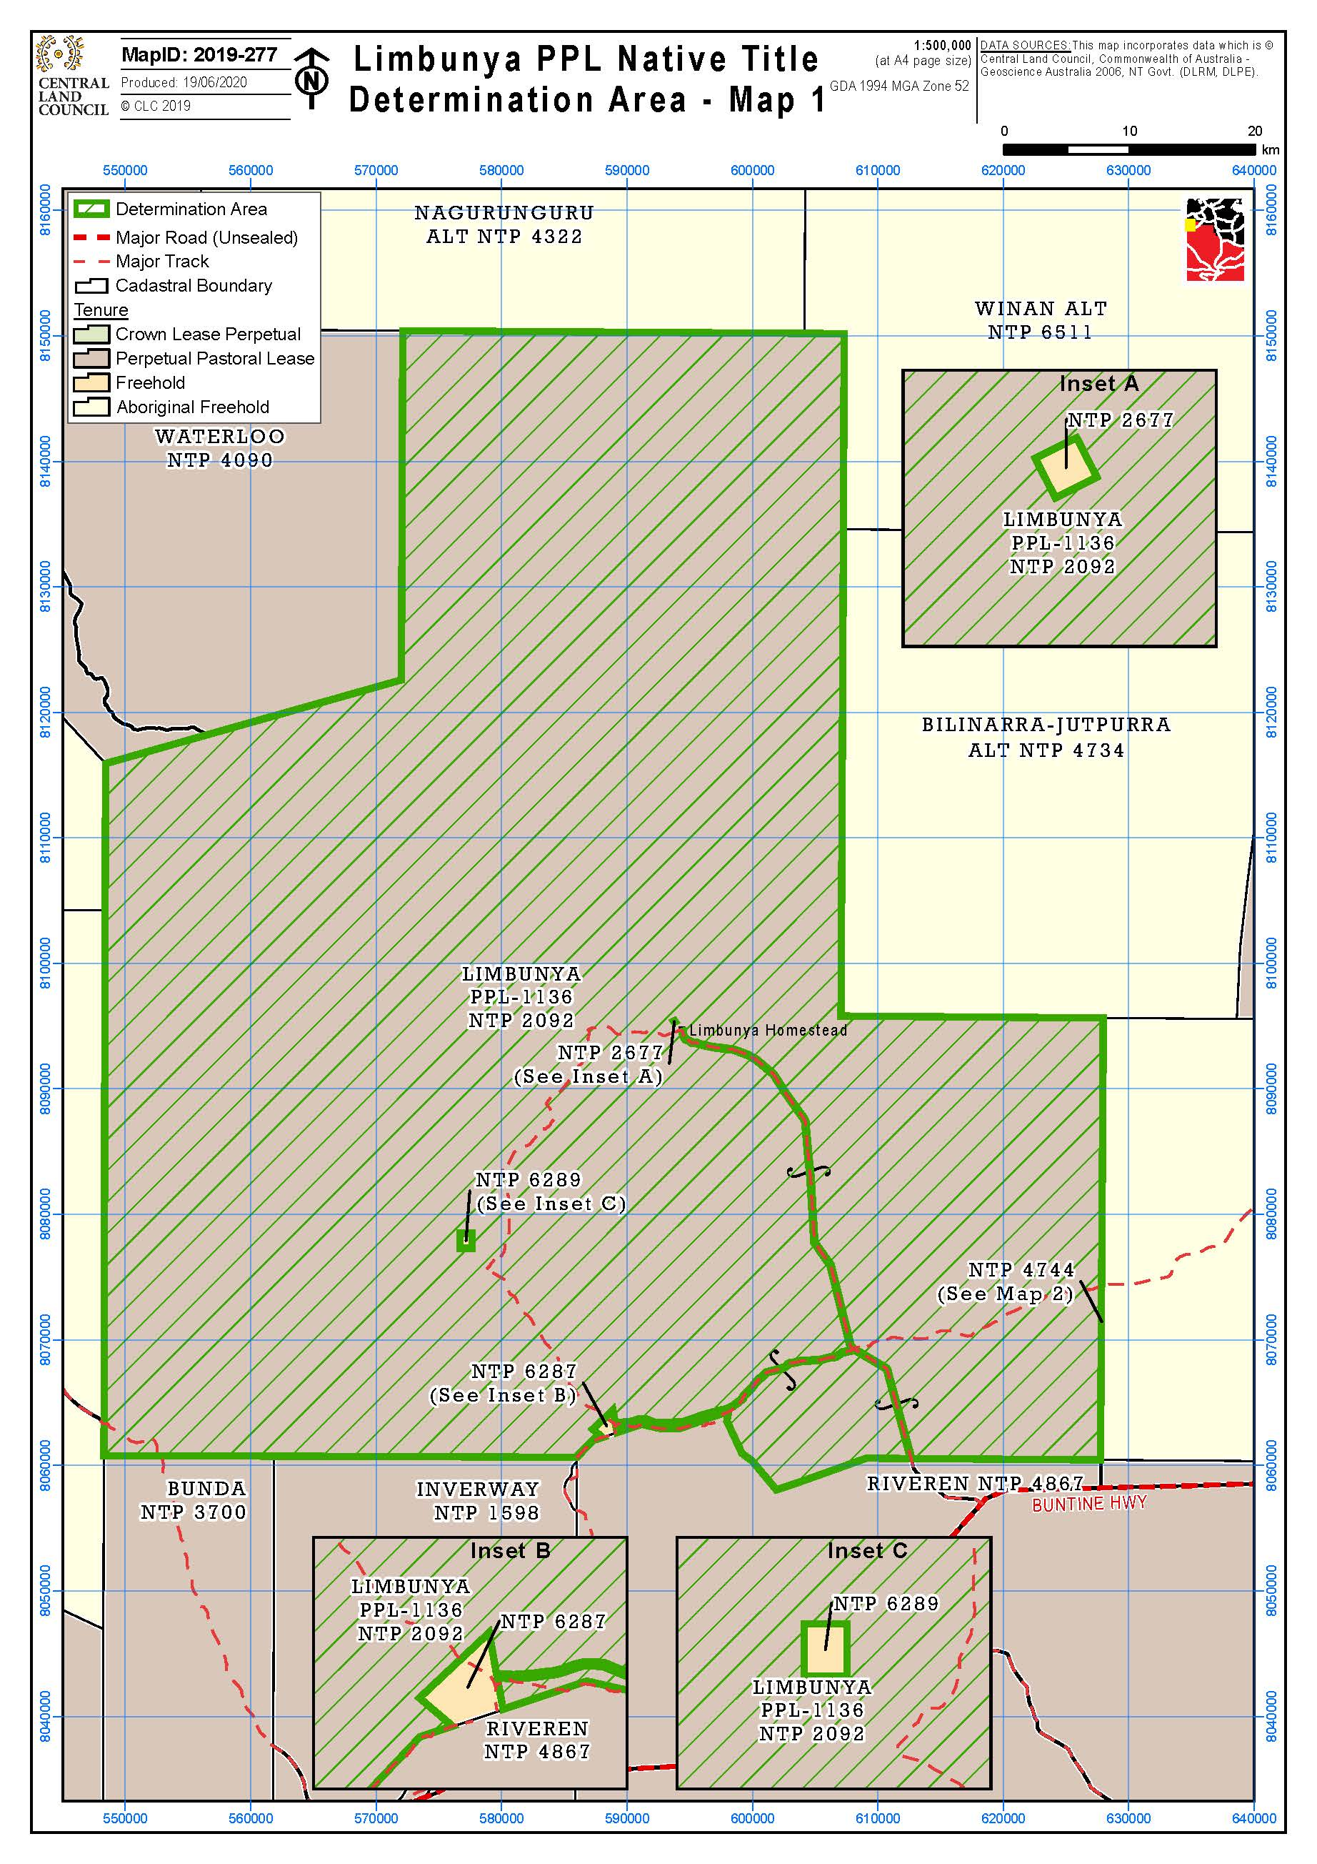

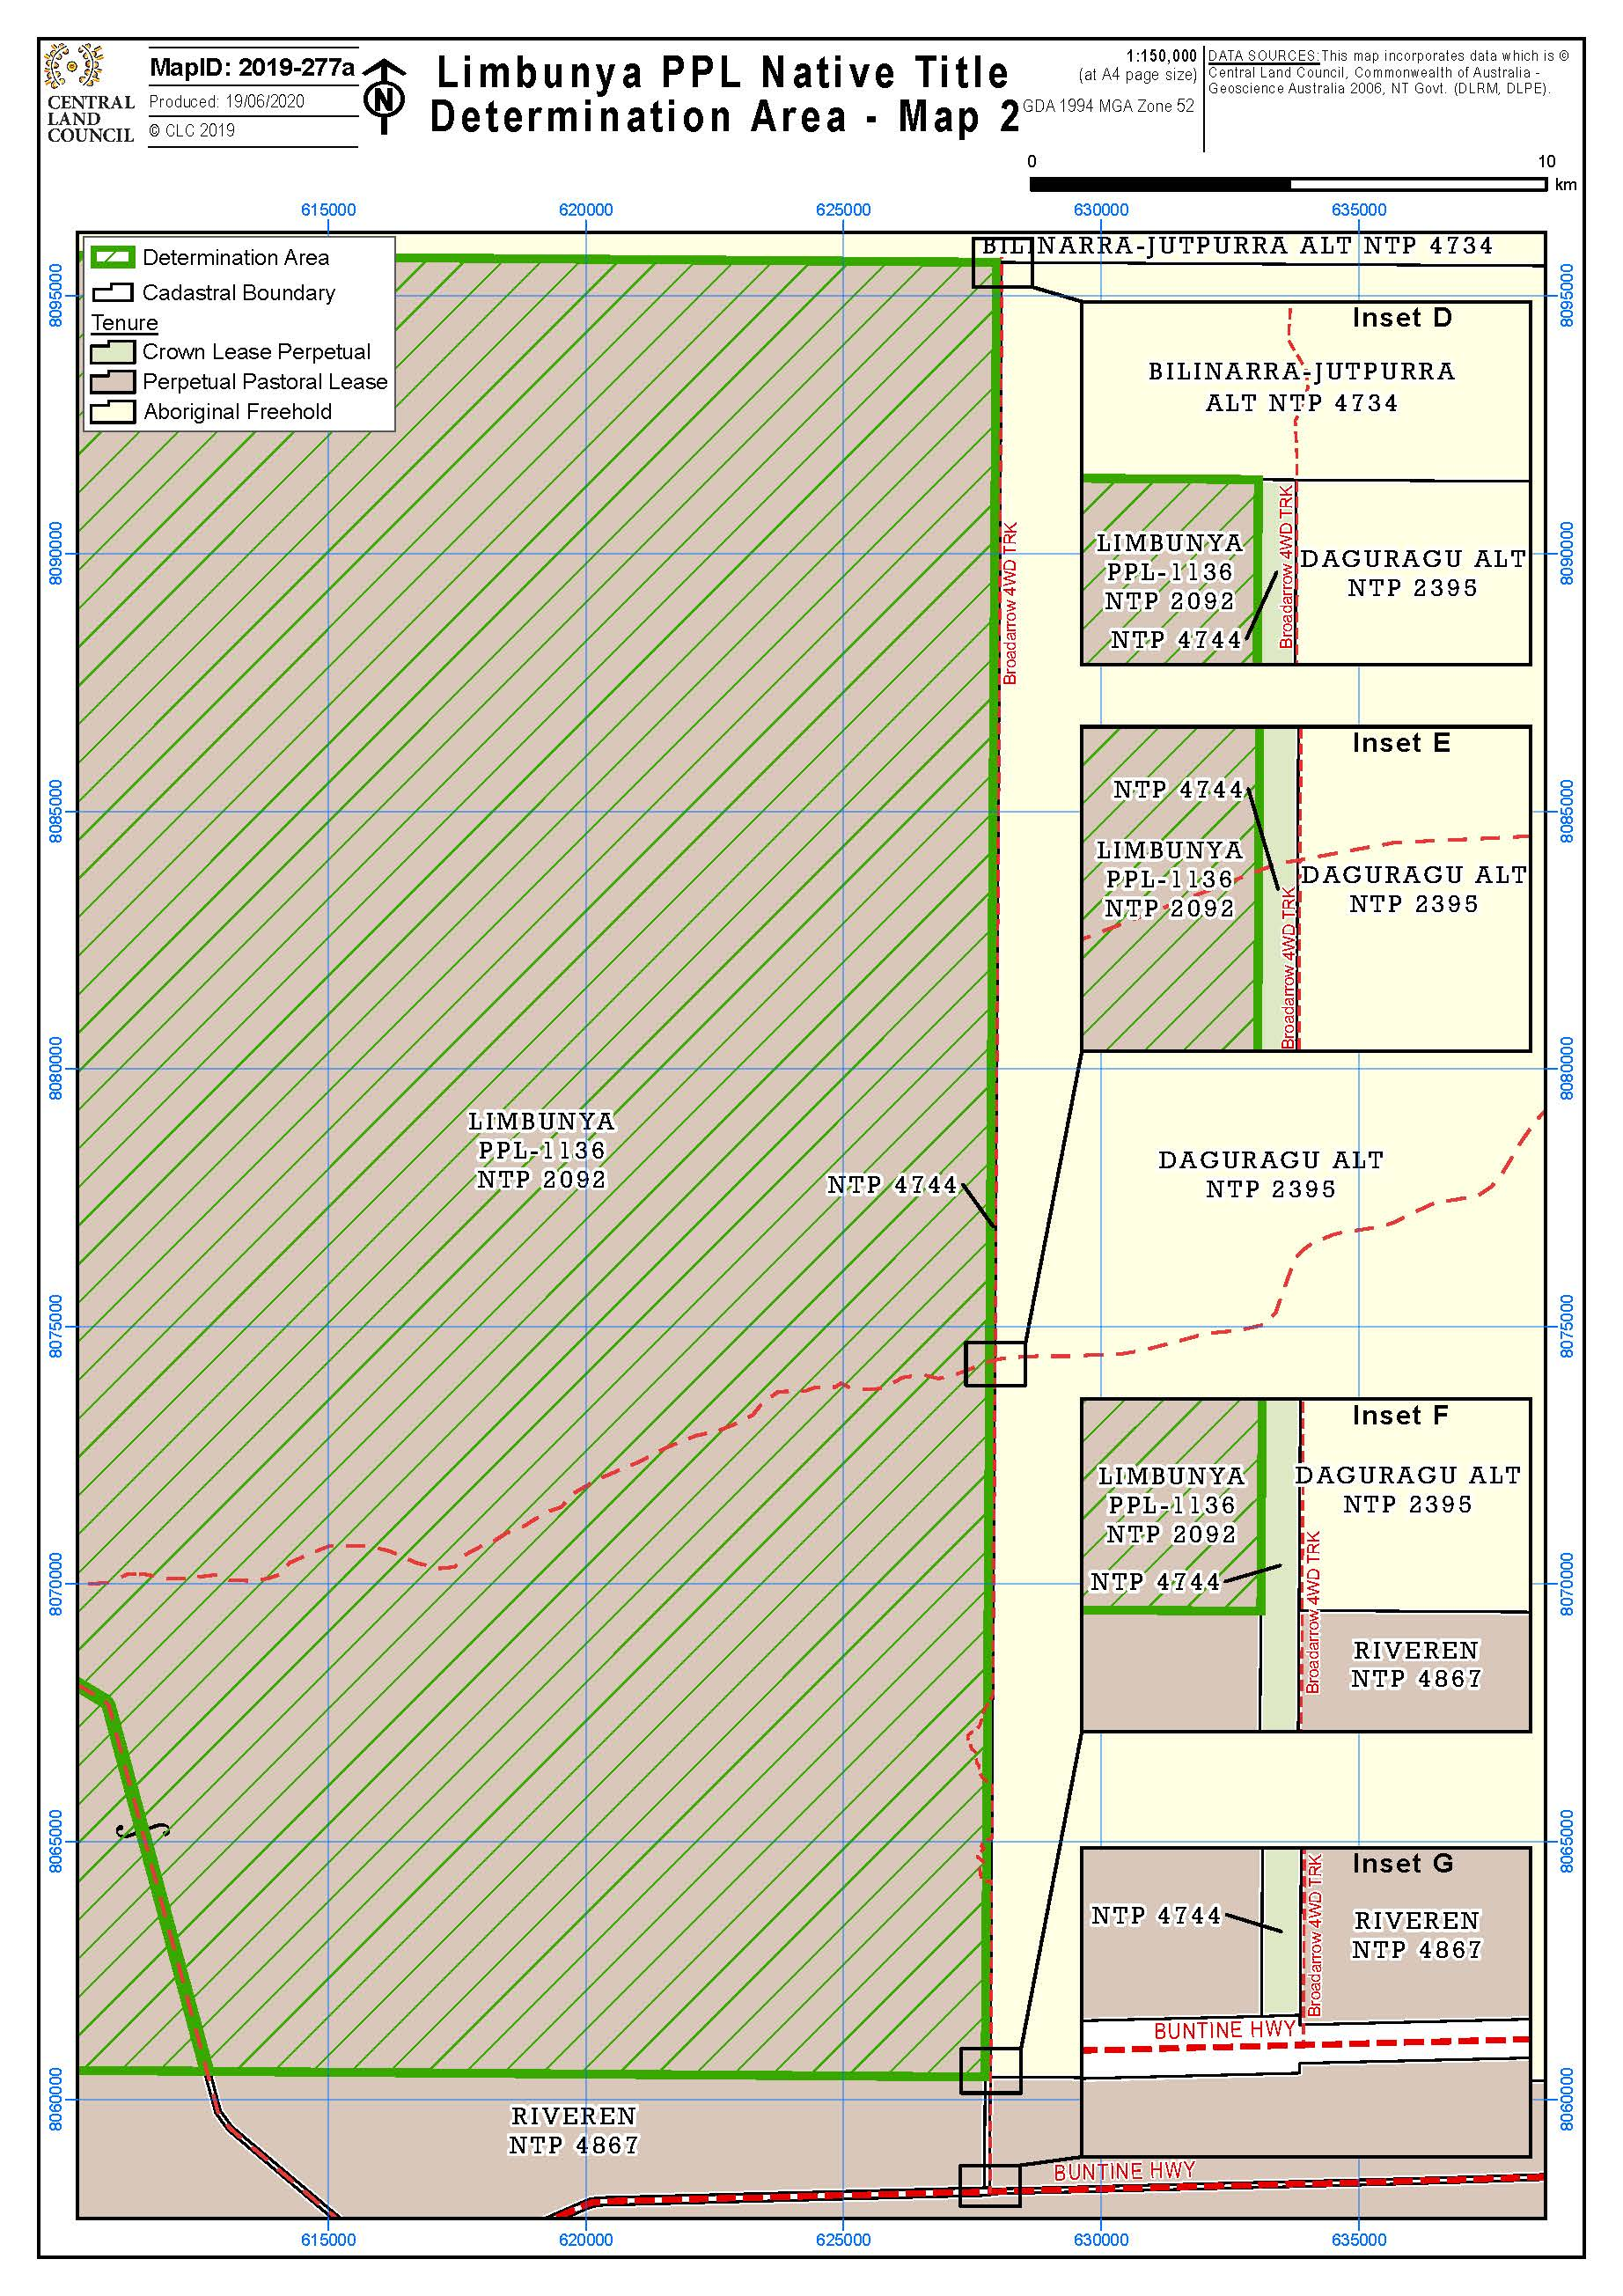

SCHEDULE C
Areas where native title does not exist
Native title rights and interests have been wholly extinguished in the following areas of land and waters.
Public works
1. Those parts of the Determination Area covered by public works as defined in section 253 of the Act that were constructed or established before 23 December 1996 or commenced to be constructed or established on or before that date (including land and waters within the meaning of section 251D of the Act), including:
(a) public roads, namely, rural public roads (50m either side of the centre line), rural arterial roads and national highways and associated road infrastructure;
(b) community, pastoral access and other roads (including access roads and tracks to public works referred to in this clause) which are not otherwise public roads;
(c) gravel and fill pits established to maintain the roads referred to in (a) and (b) above;
(d) government bores and associated works;
(e) river and rain gauges;
(f) transmission water pipes (adjacent area 5 metres either side of the centre line);
(g) distribution water pipes measuring 150mm diameter or less (adjacent area of 1.5m either side of the centre line) and greater than 150mm diameter (adjacent area 5 metres either side of the centre line);
(h) sewer pipes measuring 150mm diameter or less (adjacent area 1.5m either side of the centre line) and greater than 150mm (adjacent area 5 metres either side of the centre line); and
(i) bores, sewer pump stations, and overhead power lines.

REASONS FOR JUDGMENT
WHITE J:
1 The parties to this application for the determination of native title have reached agreement on the terms of an order to be made by consent and join in asking the Court to make the determination of native title pursuant to s 87 of the Native Title Act 1993 (Cth) (the Act).
2 The underlying application for the determination of native title was filed on 19 January 2017. It seeks a determination of native title in respect of NT Portion 2092 being the area held under Perpetual Pastoral Lease No. 1136 and known as “Limbunya”. The area is large, comprising over 5,218 km².
3 The application was amended by consent on 21 June 2019 and again on 2 July 2020. Both the application in its original and amended forms were accepted for registration pursuant to s 190A of the Act.

Statutory provisions
4 Section 87 of the Act provides (relevantly):
87 Power of Federal Court if parties reach agreement
Application
(1) This section applies if, at any stage of proceedings after the end of the period specified in the notice given under section 66:
(a) agreement is reached between the parties on the terms of an order of the Federal Court in relation to:
(i) the proceedings; or
(ii) a part of the proceedings; or
(iii) a matter arising out of the proceedings; and
(b) the terms of the agreement, in writing signed by or on behalf of the parties, are filed with the Court; and
(c) the Court is satisfied that an order in, or consistent with, those terms would be within the power of the Court.
Power of Court
(1A) The Court may, if it appears to the Court to be appropriate to do so, act in accordance with:
(a) whichever of subsection (2) or (3) is relevant in the particular case; and
(b) if subsection (5) applies in the particular case—that subsection.
Agreement as to order
(2) If the agreement is on the terms of an order of the Court in relation to the proceedings, the Court may make an order in, or consistent with, those terms without holding a hearing or, if a hearing has started, without completing the hearing.
Note: If the application involves making a determination of native title, the Court’s order would need to comply with section 94A (which deals with the requirements of native title determination orders).
…

5 As is apparent, s 87 applies when, after the end of the notification period specified in the notice under s 66 of the Act, the parties reach agreement on the terms of an order in relation to the proceedings and file the signed written agreement with the Court. When those circumstances exist (as they do in the present case), the Court is authorised to make a determination without conducting a hearing. Nevertheless, the Court must still be satisfied that the terms of the proposed determination are within its power and that the making of the determination is appropriate.
6 Section 94A of the Act, requires that an order by this court making a determination of native title must set out details of the matters mentioned in s 225. Section 225 provides:
225 Determination of native title
A determination of native title is a determination whether or not native title exists in relation to a particular area (the determination area) of land or waters and, if it does exist, a determination of:
(a) who the persons, or each group of persons, holding the common or group rights comprising the native title are; and
(b) the nature and extent of the native title rights and interests in relation to the determination area; and
(c) the nature and extent of any other interests in relation to the determination area; and
(d) the relationship between the rights and interests in paragraphs (b) and (c) (taking into account the effect of this Act); and
(e) to the extent that the land or waters in the determination area are not covered by a non-exclusive agricultural lease or a non-exclusive pastoral lease—whether the native title rights and interests confer possession, occupation, use and enjoyment of that land or waters on the native title holders to the exclusion of all others.
Note: The determination may deal with the matters in paragraphs (c) and (d) by referring to a particular kind or particular kinds of non-native title interests.

7 The expression “native title rights and interests” used in s 225(b) is defined in s 223(1) as follows:
223 Native title
Common law rights and interests
(1) The expression native title or native title rights and interests means the communal, group or individual rights and interests of Aboriginal peoples or Torres Strait Islanders in relation to land or waters, where:
(a) the rights and interests are possessed under the traditional laws acknowledged, and the traditional customs observed, by the Aboriginal peoples or Torres Strait Islanders; and
(b) the Aboriginal peoples or Torres Strait Islanders, by those laws and customs, have a connection with the land or waters; and
(c) the rights and interests are recognised by the common law of Australia.
Hunting, gathering and fishing covered
(2) Without limiting subsection (1), rights and interests in that subsection includes hunting, gathering, or fishing, rights and interests.

The power of the Court
8 The power of the Court to make a determination of native title derives from Pt 4 of the Act. The Court must have a valid application before it and must be satisfied that there has been no previous determination of native title in respect of the determination area (s 68). It must also be satisfied that there is no overlapping claim for native title (s 67(1)).
9 All of those conditions are satisfied in the present case.

The approach of the Court
10 There was a time when the Court would, before making a determination by consent, consider evidence bearing upon the appropriateness of the determination. However, the Court now adopts a more flexible approach which is in keeping with the evident policy of the Act to encourage parties to reach agreement on applications for native title. Moreover, s 87(2) expressly authorises the Court to make the order without holding a hearing or, if a hearing has started, without completing the hearing. The approach now adopted by the Court was stated by Keane CJ in King on behalf of the Eringa Native Title Claim Group v State of South Australia [2011] FCA 1386; (2011) 285 ALR 454 at [19]:
More recently, the Court has been prepared to rely upon the processes of the relevant State or Territory about the requirements of s 223 being met to be satisfied that the making of the agreed orders is appropriate. That is because each State and Territory has developed a protocol or procedure by which it determines whether native title (as defined in s 223) has been established. It acts in the public interest and as the public guardian in doing so. It has access to anthropological, and where appropriate, archaeological, historical and linguistic expertise. It has a legal team to manage and supervise the testing as to the existence of native title in the claimant group. Although the Court must, of course, preserve to itself the question whether it is satisfied that the proposed orders are appropriate in the circumstances of each particular application, generally the Court reaches the required satisfaction by reliance upon those processes. They are commonly explained in the joint submissions of the parties in support of the orders agreed …

11 As can be seen, Keane CJ emphasised the important role of the relevant State or Territory in assessing claims of native title and the reliance which this Court attaches to the State or Territory’s evaluation of claim. His Honour also observed in King v State of SA at [21] that, when s 87 is invoked, the Court does not routinely embark on its own inquiry into the merits of the claim in order to be satisfied that the orders sought are supportable and in accordance with law. However, this does not mean that the Court may not have regard to evidence for the limited purpose of being satisfied that the consenting State or Territory has acted in good faith and that there is a rational basis for its agreement.
12 The responsibility of the relevant State or Territory in assessing claims for native title was also emphasised in Smith v State of Western Australia [2000] FCA 1249; (2000) 104 FCR 494 in which, at [38], Madgwick J said:
… State governments are necessarily obliged to subject claims for native title over lands and waters owned and occupied by the State and State agencies, to scrutiny just as careful as the community would expect in relation to claims by non-Aborigines to significant rights over such land …

13 In Lovett on behalf of the Gunditjmara People v State of Victoria [2007] FCA 474, North J spoke of the significance to be attached to agreements in the resolution of native title claims. His Honour said:
[35] In the present case the Court has heard some evidence, but not a comprehensive case sufficient to establish the facts which would support a determination. Section 87(1) obviously contemplates that the Court can make orders in such circumstances because it applies when there is no hearing or no full hearing of the case.
[36] The focus of the section is on the making of an agreement by the parties. This reflects the importance placed by the Act on mediation as the primary means of resolving native title applications. Indeed, Parliament has established the National Native Title Tribunal with the function of conducting mediations in such cases. The Act is designed to encourage parties to take responsibility for resolving proceedings without the need for litigation. Section 87 must be construed in this context. The power must be exercised flexibly and with regard to the purpose for which the section is designed.
[37] In this context, when the Court is examining the appropriateness of an agreement, it is not required to examine whether the agreement is grounded on a factual basis which would satisfy the Court at a hearing of the application. The primary consideration of the Court is to determine whether there is an agreement and whether it was freely entered into on an informed basis … Insofar as this latter consideration applies to a State party, it will require the Court to be satisfied that the State party has taken steps to satisfy itself that there is a credible basis for an application … There is a question as to how far a State party is required to investigate in order to satisfy itself of a credible basis for an application. One reason for the often inordinate time taken to resolve some of these cases is the overly demanding nature of the investigation conducted by State parties. The scope of these investigations demanded by some States is reflected in the complex connection guidelines published by some States.
[38] The power conferred by the Act on the Court to approve agreements is given in order to avoid lengthy hearings before the Court. The Act does not intend to substitute a trial, in effect, conducted by State parties for a trial before the Court. Thus, something significantly less than the material necessary to justify a judicial determination is sufficient to satisfy a State party of a credible basis for an application. The Act contemplates a more flexible process than is often undertaken in some cases …

(Citations omitted)

Consideration
14 For the purpose of assisting the Court to conclude that the making of the determination is appropriate, the parties have provided the following material:
(a) a Statement of Agreed Facts dated 30 July 2020 received under s 191 of the Evidence Act 1995 (Cth);
(b) a copy of the anthropological report provided by Dr James Weiner on 17 February 2016;
(c) a copy of a supplementary anthropological report provided by Mr Craig Elliott on 9 August 2018;
(d) a copy of a further supplementary anthropological report provided by Mr Elliott on 11 January 2019;
(e) a map entitled “Sites, Dreaming Tracks and Estates” for Limbunya and surrounding area; and
(f) joint submissions of the applicant and the first respondent dated 30 July 2020.
15 Although these documents have been provided by the applicant and by the Northern Territory, the second respondent has indicated its consent to the orders on which the parties are agreed.
16 The Statement of Agreed Facts and the supporting material indicate that the Northern Territory has engaged in an appropriate assessment of the application for the determination of native title and that there is a rational basis for its agreement to the application.
17 I turn then to the requirements of s 225.
18 As noted earlier, s 223 defines the expression “native title rights and interests”. The content of that expression for the purposes of s 223(1) was considered by the High Court in Members of the Yorta Yorta Aboriginal Community v State of Victoria [2002] HCA 58; (2002) 214 CLR 422. The authorities were also reviewed by Mansfield J in Risk v Northern Territory of Australia [2006] FCA 404 at [44]-[58]. It is not necessary to repeat these reviews presently. It is sufficient to note that a claim group must show that it possesses rights and interests under the traditional laws acknowledged and the traditional customs observed by them and that those laws and customs give them a connection to the land.
19 The parties are agreed that the determination area comprises four estate areas associated with the Central Limbunya, Nawurlala, Parayi-Kakaru and Tjutamalin landholding groups respectively and the area of land and waters comprising Northern Limbunya. It is located in Malgnin territory. The parties are agreed that the persons who hold the common law group rights comprising the native title are Aboriginal persons who are members of one or more of these landholding groups by descent (including adoption) through a father’s father, mother’s father, father’s mother and mother’s mother or who, although not being descendants, are accepted as members by senior members of a landholding group or who have rights and interests in the lands and waters of Northern Limbunya by virtue of succession and their descendants. Clauses 4 and 5 in the determination identify these matters.
20 The four landholding groups are associated with different parts of the determination area, although some of those areas overlap. Some of those estates extend beyond the bounds of the determination area.
21 The proposed determination sets out with particularity the area in which native title is being recognised as well as those parts of the determination area in which it is recognised that native title does not exist (cll 1-3). Clause 3 states that native title does not exist in those parts of the determination area described in Schedule C. The description in Schedule C of the public works and other infrastructure in respect of which it is agreed that native title rights and interests have been wholly extinguished is expressed in generic terms. The parties have agreed that they should have liberty to apply to establish the precise location and boundaries of any public works and adjacent land and waters referred to in Schedule C. Order 4 gives effect to that agreement.
22 Clauses 6-8 identify the nature and extent of the native title and interests in the determination area.
23 Clause 9 identifies the nature and extent of other interests in the determination area and cl 10 specifies the relationship between the native title rights and interests, on the one hand, and those other rights and interests, on the other.
24 By ss 55 and 56 of the Act, the Court must determine whether the native title is to be held on trust and, if so, by whom. Proposed Order 3 indicates that the Malapa Aboriginal Corporation (ICN: 8452) is to be the prescribed body corporate for the purposes of s 57(2) of the Act and to perform the functions outlined in s 57(3) of the Act after becoming the prescribed native title body corporate.

General
25 As already noted, the agreement of the parties is necessary for the Court to exercise the power available under s 87. However, the fact of the agreement is also relevant to the appropriateness of the orders. The fact that all parties to the application both consent to, and support, the making of the determination is significant.
26 All parties have had the opportunity to obtain independent legal advice. There is no reason to suppose that a lack of legal representation has caused disadvantage to any party.
27 For the reasons given above, I am satisfied that it is appropriate to make the determination under s 87 on which the parties are agreed. Doing so will give effect to the objects of the Act.
28 I note, however, that the order of this Court does not amount to a grant of native title to the landholding groups. The order is instead a public and formal recognition that the native title rights and interests of the estate holders exist, and have always existed, at least since European settlement.
29 I will make orders in the terms proposed by the parties.
I certify that the preceding twenty-nine (29) numbered paragraphs are a true copy of the Reasons for Judgment of the Honourable Justice White.

Associate:
Dated: 10 September 2020

