FEDERAL COURT OF AUSTRALIA

Roadshow Films Pty Ltd v Telstra Corporation Limited [2017] FCA 965

File number: | NSD 269 of 2017
Judge: | NICHOLAS J
Date of judgment: | 18 August 2017
Catchwords: | COPYRIGHT – section 115A of the Copyright Act 1968 (Cth) – whether injunction should be granted requiring carriage service providers to take reasonable steps to disable access to online locations outside Australia infringing or facilitating infringement of copyright –form of orders – injunction granted
Legislation: | Copyright Act 1968 (Cth), ss 10, 115A, 126
Cases cited: | Roadshow Films Pty Ltd v Telstra Corporation Ltd (2016) 122 IPR 81  Universal Music Australia Pty Ltd v TPG Internet Pty Ltd [2017] FCA 435
Date of hearing: | 10 May 2017
Registry: | New South Wales
Division: | General Division
National Practice Area: | Intellectual Property
Sub-area: | Copyright and Industrial Designs
Category: | Catchwords
Number of paragraphs: | 42
Counsel for the Applicants: | Mr J Cooke
Solicitor for the Applicants: | Baker & McKenzie
Counsel for the First to Thirteenth Respondents: | The First to Thirteenth Respondents filed submitting appearances
Counsel for the Fourteenth to Thirty-First Respondents: | The Fourteenth to Thirty-First Respondents did not appear
Counsel for the Thirty-Second to Forty-Ninth Respondents: | The Thirty-Second to Forty-Ninth Respondents filed an address for service but did not otherwise appear

ORDERS
 |  | NSD 269 of 2017
BETWEEN: | ROADSHOW FILMS PTY LTD  (ACN 100 746 870)  First Applicant  (and others named in the Schedule)
AND: | TELSTRA CORPORATION LIMITED  (ABN 33 051 775 556)  First Respondent  (and others named in the Schedule)

JUDGE: | NICHOLAS J
DATE OF ORDER: | 18 August 2017

In these orders, the following terms have the following meanings:
(a) Domain Name means a name formed by the rules and procedures of the Domain Name System (DNS) and includes subdomains.
(b) DNS Blocking means a system by which any user of a respondent’s service who attempts to use a DNS resolver that is operated by or on behalf of that respondent to access a Target Online Location is prevented from receiving a DNS response other than a redirection as referred to in order 5.
(c) IP Address means an Internet Protocol address.
(d) Optus means the fourth to thirteenth respondents.
(e) Target Online Locations means the Target Online Locations and New Target Online Locations referred to in Attachment A and that are or were accessible:
(i) at the URLs listed in Attachment A to this Order (together, the Target URLs);
(ii) at the IP Addresses listed in Attachment A to this Order (together, the Target IP Addresses); and
(iii) at the Domain Names listed in Attachment A to this Order (together, the Target Domain Names).
(f) Telstra means the first to third respondents.
(g) TPG means the thirty-second to the forty-ninth respondents.
(h) URL means a Uniform Resource Locator.
(i) Vocus means the fourteenth to thirty-first respondents.

THE COURT ORDERS THAT:

1. The requirement under s 115A(4) of the Copyright Act 1968 (Cth) that the applicants give notice of their application to the persons who operate the Target Online Locations be dispensed with in so far as any such notice has not already been given.
2. Each respondent must, within 15 business days of service of these orders, take reasonable steps to disable access to the Target Online Locations.
3. Order 2 is taken to have been complied with by a respondent if that respondent implements any one or more of the following steps:
  - DNS Blocking in respect of the Target Domain Names;
  - IP Address blocking or re-routing in respect of the Target IP Addresses;
  - URL blocking in respect of the Target URLs and the Target Domain Names; or
  - any alternative technical means for disabling access to the Target Online Location as agreed in writing between the applicants and a respondent.
4. If a respondent in complying with order 2 does not implement one of the steps referred to in order 3, that respondent must, within 15 business days of service of these orders, notify the applicants of the step or steps it has implemented.
5. Each respondent must redirect any communication by a user of its service seeking access to any of the Target Online Locations which have been disabled pursuant to order 2 to a webpage established, maintained and hosted by either:
(a) the applicants, or their nominee, pursuant to order 6; or
(b) that respondent or its nominee.
The applicants' obligations pursuant to orders 6 and 7 only arise if a respondent notifies the applicants that the respondent will redirect a communication pursuant to order 5(a) and for so long as at least one respondent redirects communications to that webpage.
6. The applicants, or their nominee, must establish, maintain and host a webpage which informs users of a respondent’s service who have been redirected to the webpage pursuant to order 5 that access to the website has been disabled because this Court has determined that it infringes or facilitates the infringement of copyright.
7. Within 5 business days of these orders, the applicants will notify each of the respondents in writing of the URL of the webpage established, maintained and hosted under order 6 and, if the webpage ceases to operate for any reason, will notify each of the respondents in writing of a different URL that complies with order 6.
8. If, in complying with order 5, a respondent redirects any communication by a user of its service to a webpage established, maintained and hosted by it, that respondent or its nominee must ensure that the webpage informs the user of that respondent's service that access to that the website has been disabled because this Court has determined that it infringes or facilitates the infringement of copyright.
9. In the event that any of the applicants has a good faith belief that:
(a) any Target URL, Target IP Address or Target Domain Name which is subject to these orders has permanently ceased to enable or facilitate access to a Target Online Location; or
(b) any Target URL, Target IP Address or Target Domain Name has permanently ceased to have the primary purpose of infringing or facilitating the infringement of copyright,
a representative of the applicants must, within 15 business days of any of the applicants forming such a good faith belief, notify each respondent of that fact in writing, in which case the respondents shall no longer be required to take steps pursuant to order 2 to disable access to the relevant Target URL, Target IP Address or Target Domain Name that is the subject of the notice.
10. A respondent will not be in breach of order 2 if it temporarily declines or temporarily ceases to take the steps ordered in order 2 (either in whole or in part) upon forming the view, on reasonable grounds, that suspension is necessary to:
(a) maintain the integrity of its network or systems or functioning of its blocking system;
(b) upgrade, troubleshoot or maintain its blocking system;
(c) avert or respond to an imminent security threat to its networks or systems; or
(d) ensure the reliable operation of its ability to block access to online locations associated with criminal content if it reasonably considers that such operation is likely to be impaired, or otherwise to comply with its statutory obligations including under section 313(3) of the Telecommunications Act 1997 (Cth),
provided that:
(a) unless precluded by law, it notifies the applicants or their legal representative(s) of such suspension, including the reasons and the expected duration of such suspension, by 5.00 pm on the next business day; and
(b) such suspension lasts no longer than is reasonably necessary and, in any case, no longer than 3 business days or such period as the applicants may agree in writing or the Court may allow.
11. The owner or operator of any of the Target Online Locations and the owner or operator of any website who claims to be affected by these orders may apply on 3 days' written notice, including notice to all parties, to vary or discharge these orders, with any such application to:
(a) set out the orders sought by the owner or operator of the Target Online Locations or affected website; and
(b) be supported by evidence as to:
(i) the status of the owner or operator of the Target Online Locations or affected website; and
(ii) the basis upon which the variation or discharge is sought.
12. The parties have liberty to apply on 3 days' written notice, including, without limitation, for the purpose of any application:
(a) for further orders to give effect to the terms of these orders;
(b) for further orders in the event of any material change of circumstances including, without limitation, in respect of the consequences for the parties and effectiveness of the technical methods under order 2; and/or
(c) for orders relating to other means of accessing the Target Online Locations not already covered by these orders.
13. If a website the subject of any of the Target Online Locations is at any time during the operation of these orders provided from a different Domain Name, IP Address or URL:
(a) the applicants may file and serve:
(i) an affidavit which:
(A) identifies the different Domain Name, IP Address or URL; and
(B) states that, in the good faith belief of the deponent, the website operated from the different Domain Name, IP Address or URL is a new location outside Australia for the Target Online Locations the subject of these Orders and brief reasons; and
(ii) proposed short minutes of order to the effect that:
(A) the definition of Target Online Locations in these orders is amended to include the different Domain Name, IP Address or URL; and
(B) the time period in order 2 of these Orders starts to run in relation to the different Domain Name, IP Address or URL upon service in accordance with order 17(d) of the Orders as made.
14. These orders are to operate for a period of 3 years from the date of these orders.
15. Six months prior to the expiry of these orders:
(a) the applicants may file and serve:
(i) an affidavit which states that, in the good faith belief of the deponent, the Target Online Locations continue to have the primary purpose of infringing or facilitating the infringement of copyright; and
(ii) short minutes of order extending the operation of these orders for a further 3 year period; and
(b) the process contained in order 17 shall apply.
16. The affidavit referred to in orders 13 and 15 is to be given by a deponent duly authorised to give evidence on behalf of the applicants and may be given by their solicitor.
17. If an affidavit and short minutes of order are filed and served in accordance with orders 13 or 15:
(a) within 7 business days, the respondents must notify the applicants and the Court if they object to the orders being made in accordance with the short minutes of order served by the Applicants;
(b) if any respondent gives notice of any objection, or the Court otherwise thinks fit, the proceeding will be relisted for further directions;
(c) if no respondent gives notice of any objection and the Court does not otherwise require the proceeding to be relisted, then the Court may make orders in terms of the short minutes of order served by the Applicants without any further hearing; and
(d) the applicants must serve on the respondents any such orders made.
18. The Applicants pay Telstra's, Optus', Vocus' and TPG's compliance costs calculated at the rate of $50 per Domain Name the subject of DNS Blocking undertaking for the purposes of complying with order 2.
19. There be no order as to the costs of this proceeding.

Note: Entry of orders is dealt with in Rule 39.32 of the Federal Court Rules 2011.

Attachment A
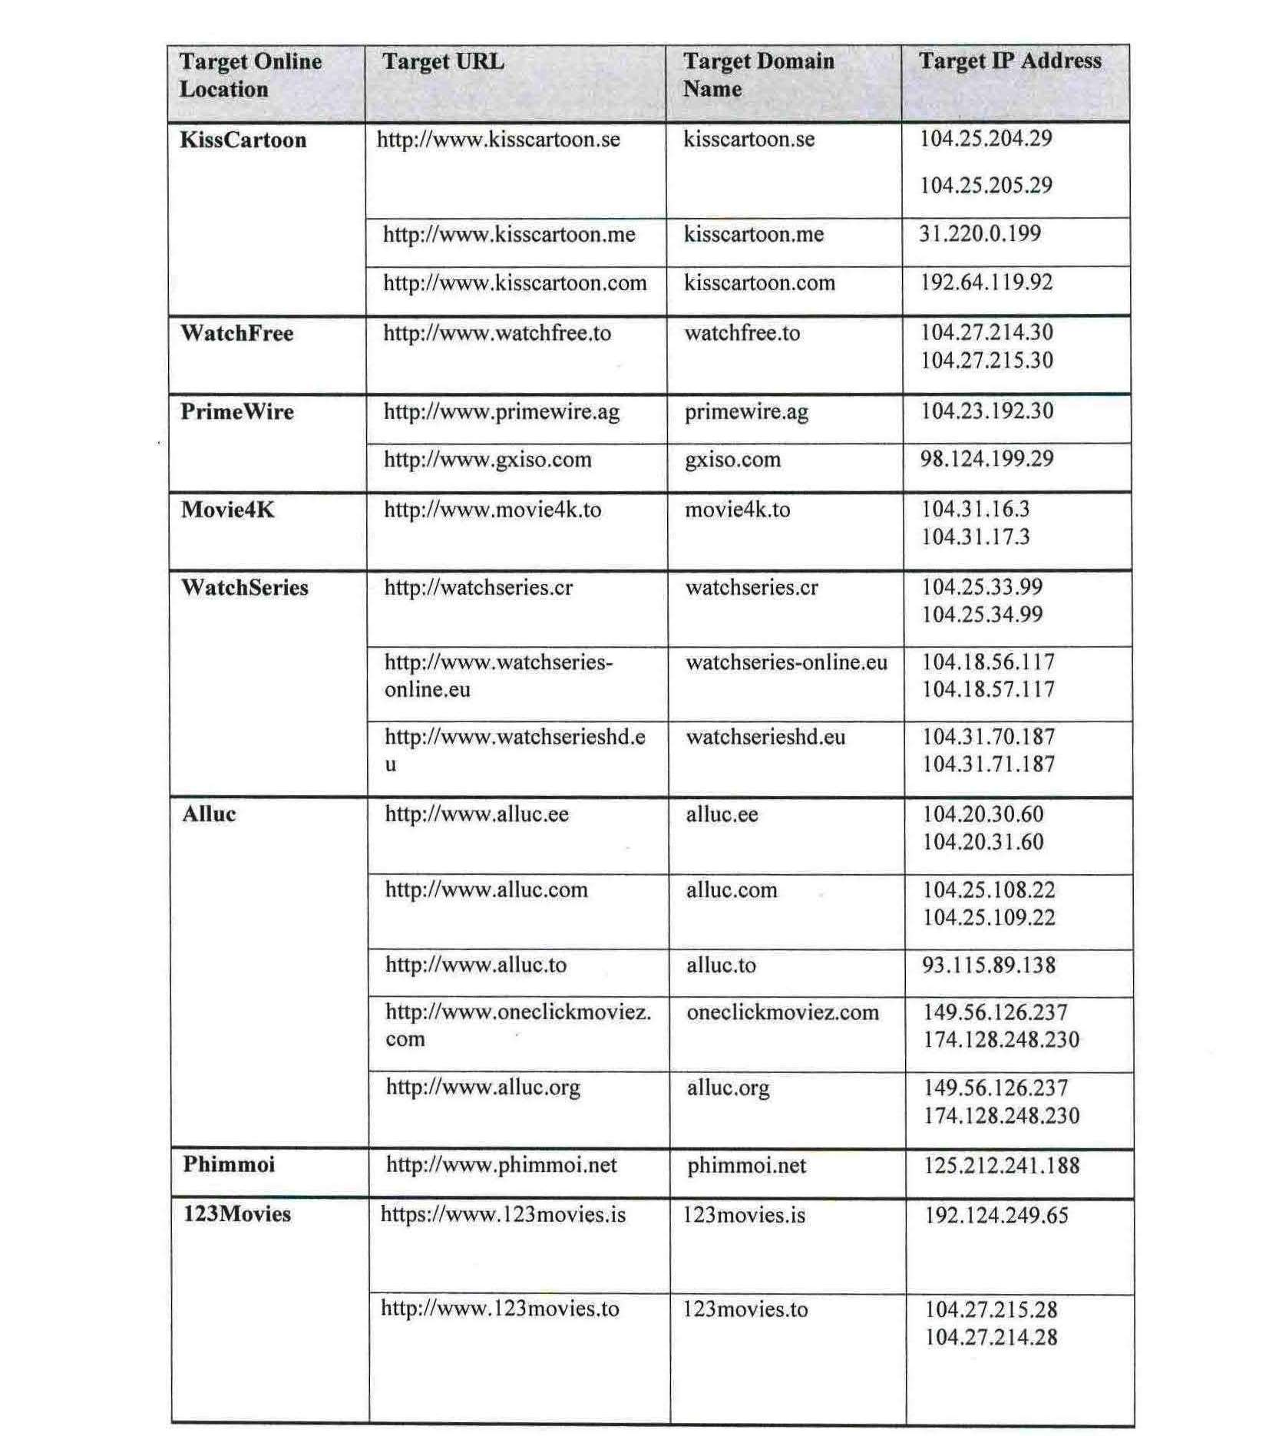
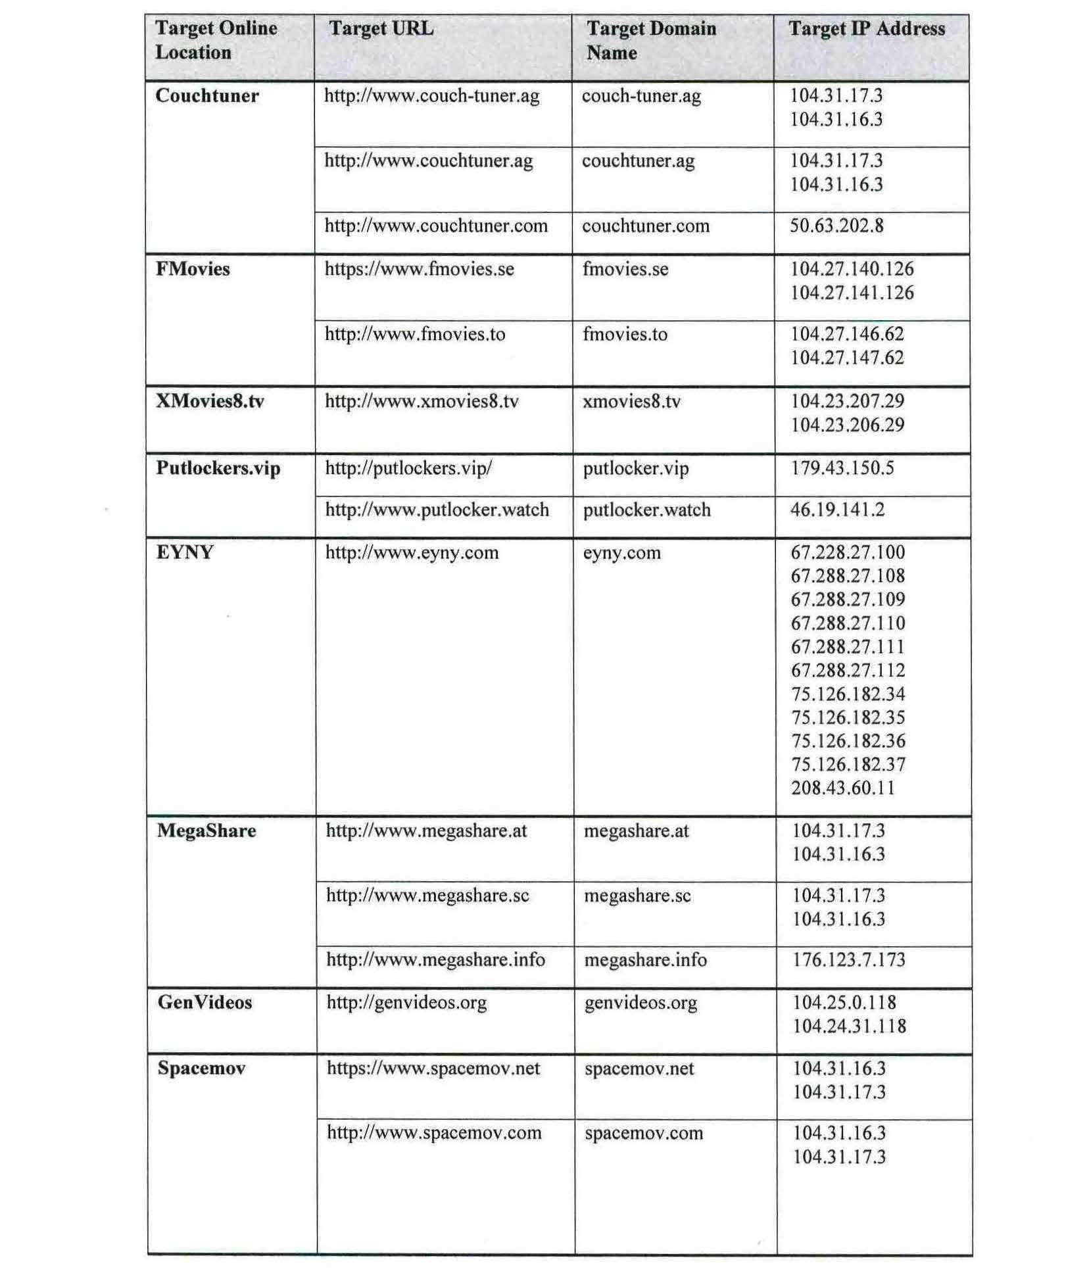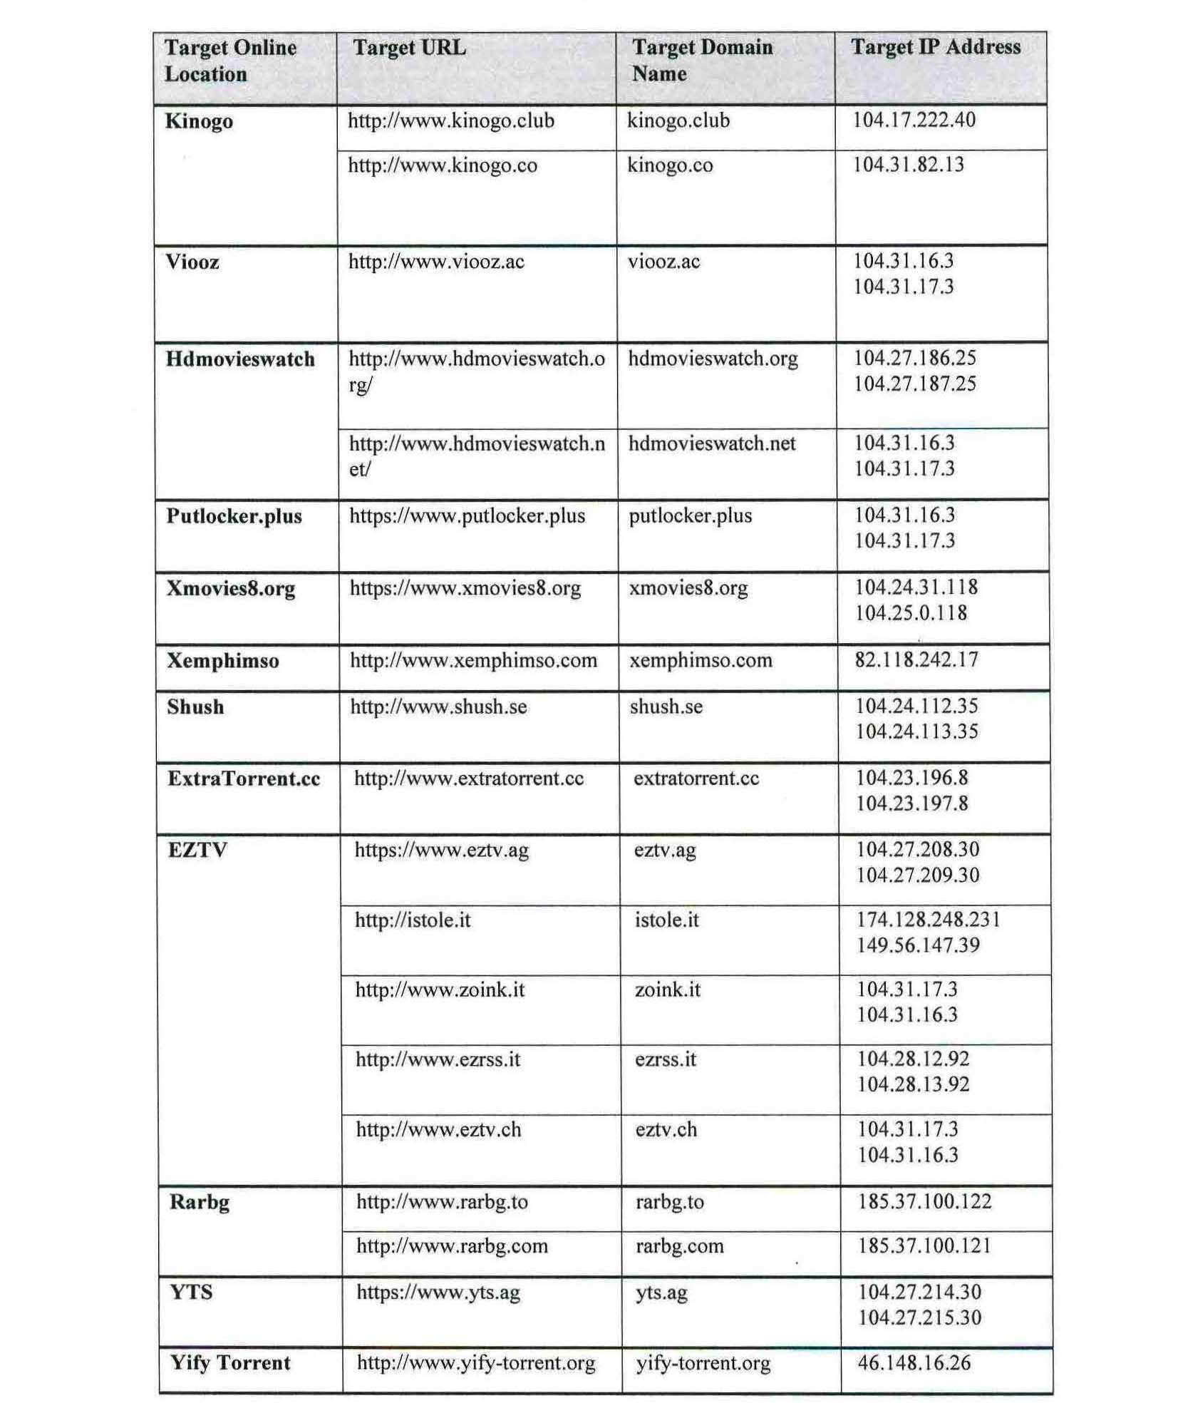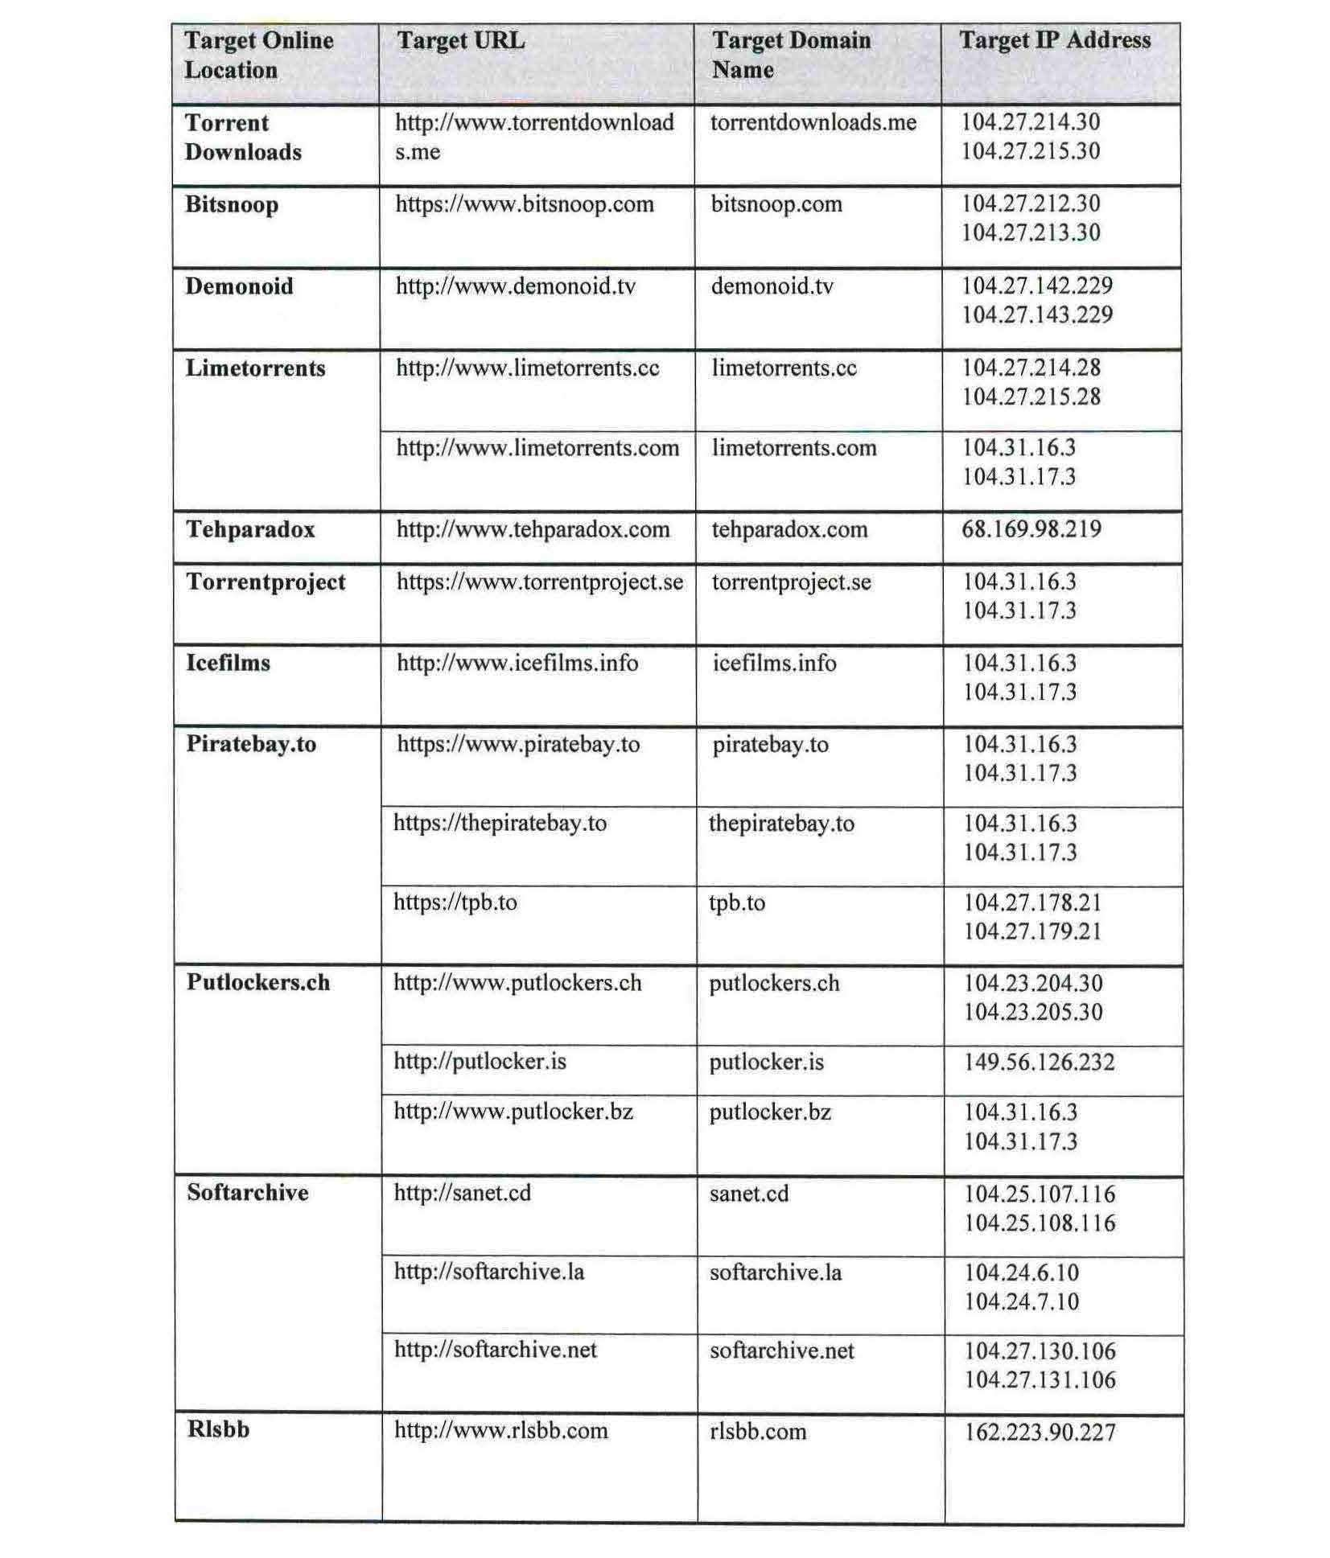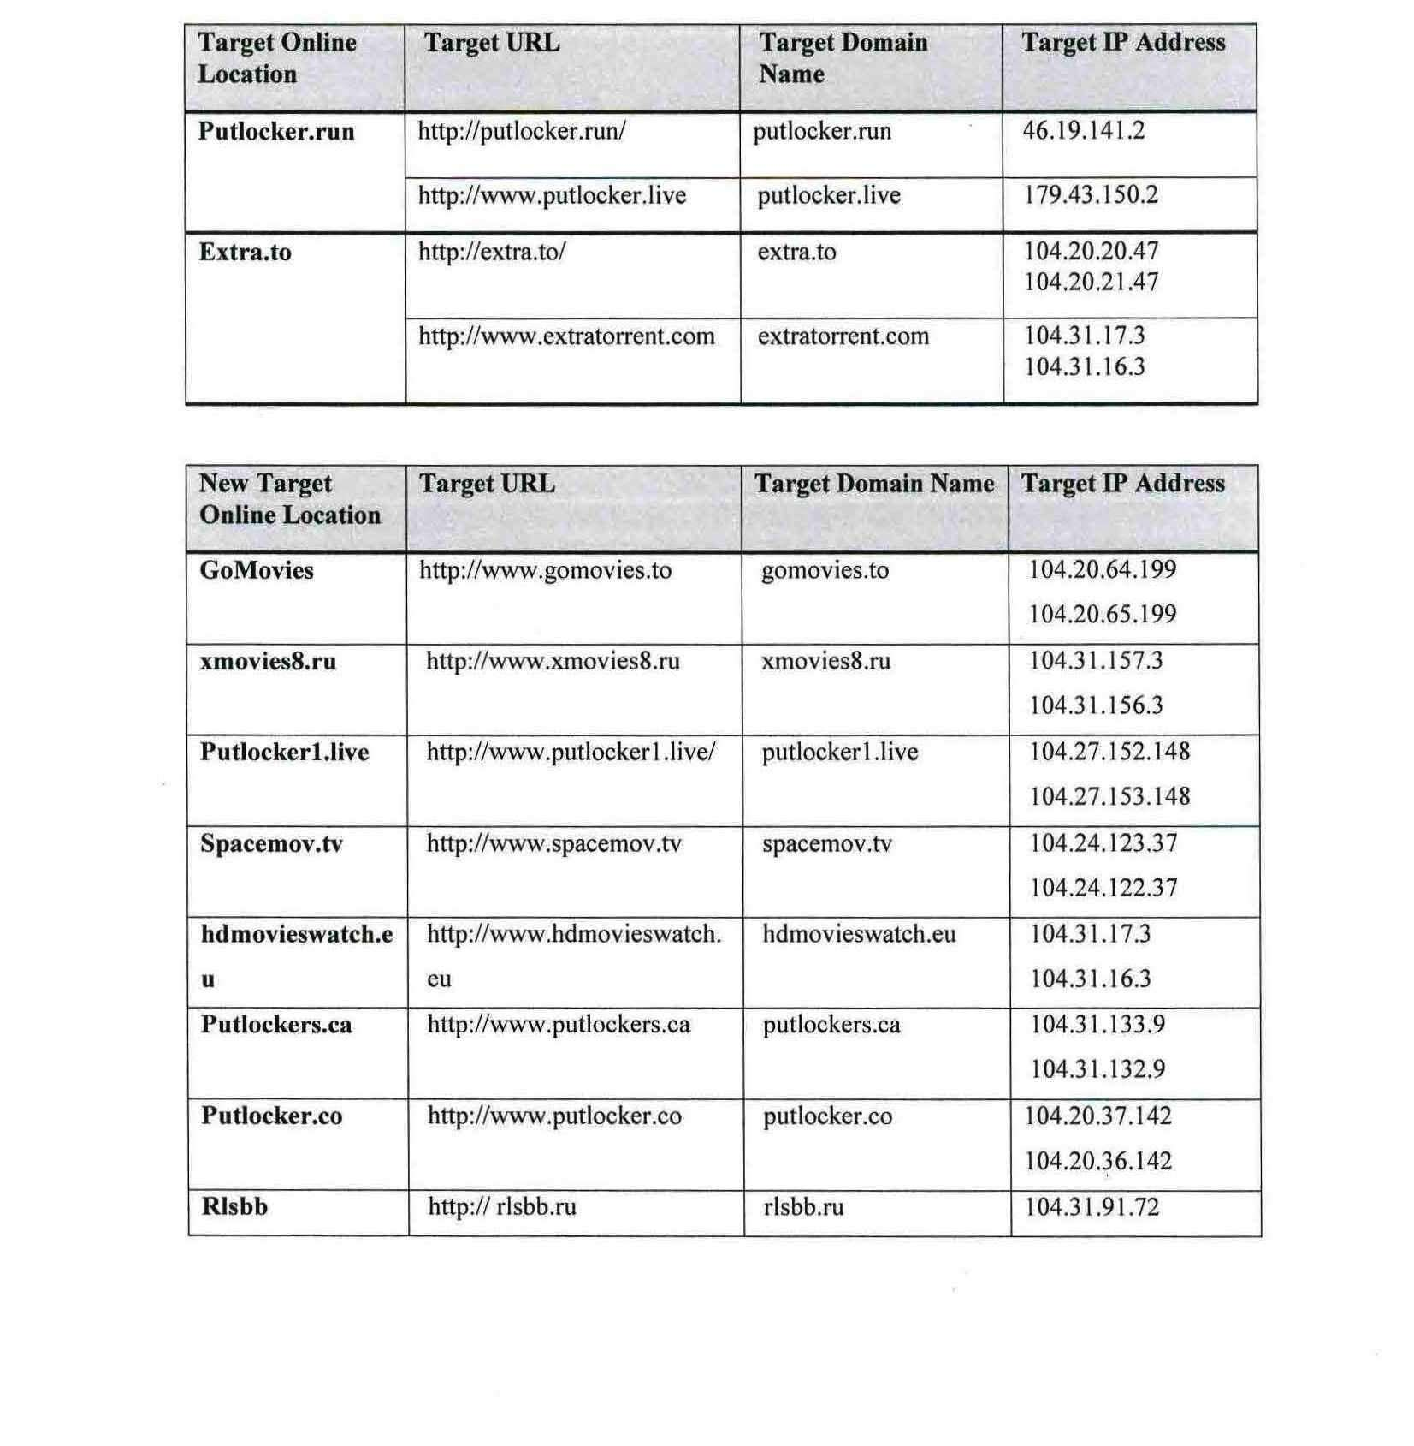

REASONS FOR JUDGMENT
NICHOLAS J:
- Before me is an application for relief under s 115A of the Copyright Act 1968 (Cth) (the “Act”) against various carriage service providers (“CSPs”) requiring them to take reasonable steps to block access to a number websites. The applicants allege that the relevant websites are situated outside Australia and that they infringe, or facilitate the infringement, of copyright in certain cinematograph films owned by the second to eighth applicants and, in respect of one of the films, exclusively licenced to the first applicant.
- The applicants are the same applicants as those in Federal Court Proceeding No NSD 239 of 2016 (the “First Roadshow Proceeding”) and rely on the same cinematograph films which they relied on in the First Roadshow Proceeding. The respondents are the same respondents or otherwise belong to the same corporate groups as the respondents in the First Roadshow Proceeding namely:
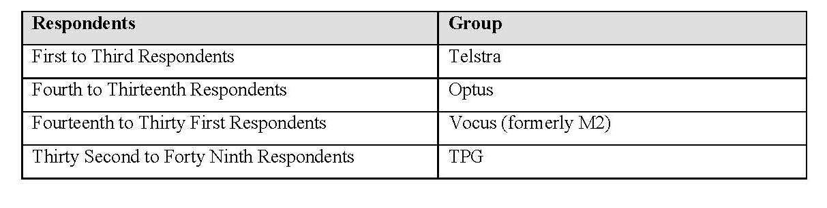
- The respondents have not participated or sought to be heard in the proceeding. The Telstra and Optus respondents have filed notices of submitting appearance. The TPG respondents have filed a notice of address for service but have not otherwise participated in the proceeding. The Vocus respondents have not filed a notice of address for service.
- As I describe further below, the applicants have taken steps to notify the operators of the relevant websites that the applicants have filed an application under s 115A of the Act. The owners or operators of the relevant websites have not sought to appear in the proceeding.

The applicants’ CASE

Overview
- In their amended originating application dated 10 May 2017, the applicants seek orders in relation to the “Target Online Locations” and “New Target Online Locations” (together, the “Online Locations”) identified in Appendix A to these reasons. The locations described in Appendix A as New Target Online Locations are accessible by a user entering the URL or domain name for a Target Online Location, and thereafter being re-directed to a New Target Online Location. They reflect recent changes to the Target Online Locations listed in the applicants’ originating application filed on 24 February 2017, and were introduced in the proceeding pursuant to leave granted at the hearing allowing the applicants to file and serve an amended originating application.
- The applicants allege that each of the Online Locations are located outside Australia and are accessible to users of the Internet in Australia using the carriage services provided by each of Telstra, Optus, Vocus and TPG and the Uniform Resource Locations (“Target URLs”) incorporating the domain names (“Target Domain Names”) and Internet Protocol addresses (“Target IP Addresses”) identified in Appendix A. The applicants contend that they are the owner or exclusive licensee of copyright subsisting in the cinematograph films identified in Appendix B (the “Roadshow Films”). The owners or operators of the Online Locations are alleged to have reproduced, made available or electronically transmitted copies of these works in Australia without licence or authority, and to have thereby infringed copyright in those works. It is also alleged that the owners or operators have facilitated these infringing acts in Australia. Each of the respondents is a “carriage service provider” as defined in the Telecommunications Act 1997 (Cth).
- In support of their application, the applicants rely on the affidavit evidence of Mr Gregory Fraser, Mr Andrew Stewart, Mr Nicholas Kraegen and Mr Simon Phillipson.
- Mr Fraser is the Senior Manager at Australian Screen Association Ltd. He has qualifications in forensic computing and has been involved in technical investigations relating to physical and online piracy since about 1987. He affirmed two affidavits in the proceeding on 28 April 2017 and 10 May 2017 respectively. His evidence addressed the steps he took to access the Target Online Locations using Telstra, Optus and Vocus’ carriage services and the Target URLs, Target Domain Names and Target IP Addresses for those Online Locations. His evidence also addressed the steps he took to access or download copies of at least one of the Roadshow Films from or via links available at these locations.
- Mr Stewart is a partner at Baker & McKenzie and the solicitor for the applicants. He swore one affidavit in this proceeding on 27 April 2017. He gave evidence relating to ownership of copyright subsisting in the Roadshow Films, the respondents’ status as carriage service providers pursuant to the Telecommunication Act 1997 (Cth) and notification to the respondents and service upon them of the originating application and concise statement. He also gave evidence regarding the applicants’ attempts to notify the owners or operators of the Target Online Locations of this proceeding, and orders made by the courts of other countries in relation to some of the Online Locations.
- Mr Kraegen is a solicitor in the employ of the solicitors for the applicants, Baker & McKenzie. He affirmed two affidavits in the proceeding on 27 April 2017 and 9 May 2017 respectively. His evidence addressed the steps he undertook to access the Online Locations using TPG’s carriage services and the Target URLs, Target Domain Names and Target IP Addresses for those Online Locations. He also gave evidence regarding the further steps the applicants have taken to notify the owners or operators of the Online Locations of this proceeding, including the owners or operators of the New Target Online Locations.
- Mr Phillipson is a director of the first applicant and the general counsel of Village Roadshow Ltd which controls or owns interests in the first and second applicants in these proceeding. He swore an affidavit on 12 May 2017 in which he deposed to the existence of an exclusive licence granted by the second applicant to Village Roadshow Distribution (BVI) Ltd which, through further agreements, was then granted to the first applicant in respect of copyright in the cinematograph film “The Lego Movie” in Australia.

The Online Locations
- The applicants seek orders under s 115A in relation to 49 Online Locations which are accessible using the Target URLs, Target Domain Names and Target IP Addresses identified in Appendix A.
- There are four categories of Online Locations:
- “Streaming Online Locations” which host and stream motion pictures and television programs to users of that location.
- “Linking Online Locations” which act as an index of hyperlinks to content located elsewhere. These hyperlinks redirect the user to a separate host site from which content can be streamed or downloaded.
- “Linking Searching Online Locations” which are similar to Linking Online Locations but differ in that they also provide indexes of other linking websites and sometimes enable users to search the indexes of those other websites.
- “P2P Online Locations” which provide access to peer to peer networks, such as the BitTorrent Network, and allow a group of computers with the same network program to connect with each other and directly access files from one another’s hard drives.
- As counsel for the applicants acknowledged during the hearing, there is a degree of cross-over between some of the functionality in categories (a), (b) and (c). For example, some of the locations categorised as “Linking Online Locations” may include embedded streaming functionality (category (a)) and search functionality (category (c)). A table identifying the relevant category designated by the applicants for each Online Location appears in Appendix C of these reasons.
- In Roadshow No 1 I provided some technical background relevant to the applications then before me based on expert evidence given in that proceeding. Mr Fraser adopted the technical description and definitions used in paras [7] to [24] of Roadshow No 1 in his affidavit evidence in this proceeding.
- There are a number of Target Domain Names and associated URLs for each location because, as Mr Fraser explained in his first affidavit, many of them are linking or secondary domain names that automatically re-direct to a single or primary domain name for the location. For example, in respect of the KissCartoon location, the domain name “kisscartoon.me” automatically re-directs the user to the primary domain name “kisscartoon.se” for that location.
- Mr Fraser, in his first affidavit, described the steps he undertook to access each Target Online Location using Telstra, Optus and Vocus’ carriage services in early 2017. He was also able to access or download at least one of the Roadshow Films from or via links available at these locations. Mr Fraser also conducted DNS queries to identify the relevant IP Addresses for the Target Online Locations and WHOIS look up searches for the Target Domain Names and IP addresses for each location.
- Mr Kraegen, in his first affidavit, carried out the same steps in relation to the Target Online Locations as those completed by Mr Fraser using TPG’s carriage services in early 2017. Mr Kraegen was able to access each Target Online Location using that service.
- Shortly before the hearing, on 1 and 2 May 2017, Mr Kraegen attempted to access each of the locations identified in Appendix A as Target Online Locations which had been the subject of his and Mr Fraser’s investigations in early 2017. In his second affidavit, he explained that, in May 2017, each of these locations were accessible by him via its corresponding Target URL with the exception of (i) certain URLs which re-directed him to new URLs and online locations (identified in Appendix A as ‘New Target Online Locations’) and (ii) 6 Target Online Locations (namely, KissCartoon, Couchtuner, MegaShare, Bitsnoop, Demonoid and Kinogo) which had become temporarily unavailable. Mr Kraegen was able to view or download, via links catalogued on the New Target Online Locations, at least one of the Roadshow Films using the same steps he and Mr Fraser performed in early 2017. Mr Kraegen also performed DNS and WHOIS searches in respect of the New Target Online Locations and obtained search results indicating that each of the New Target Online Locations is located outside Australia.
- Mr Kraegen gave evidence that the New Target Online Locations closely resemble the Target Online Locations. This is also clear from the screenshots for the New Online Locations, one of which I was taken to during the hearing. As I have explained above, the applicants sought to include the New Target Online Locations in this proceeding as result of recent changes to the Target Online Locations listed in their originating application filed 24 February 2017 which now re-direct to these new locations.
- Mr Fraser also provided a second affidavit on 10 May 2017. In that affidavit, he explained that between 8 to 9 May 2017 he was able to access each of the Online Locations that remained available using Optus’ carriage services. Save for the Rlssb.ru location (where links for the Roadshow Films were temporarily unavailable), Mr Fraser was able to view or download a copy of at least one of the Roadshow Films via those locations. Mr Fraser used the video capture software known as Camtasia to make a video record on a USB drive of what appeared on the screen of his laptop during these investigations in May 2017 which he exhibited to his affidavit.

Service of notices on website operators
- Section 115A(4)(b) obliges the copyright owner to notify the operator of the online location of the making of an application under subsection (1), but if the Court is satisfied that the owner of the copyright is unable, despite reasonable efforts, to determine the identity or address of the operator, or to send notices to that person, the Court may dispense with notice on such terms as it sees fit.
- Mr Stewart and Mr Kraegen gave evidence describing the applicants’ attempts, through its solicitors, to notify the persons who operate each of the Target Online Locations and the New Target Online Locations of this application. I am satisfied that the applicants made reasonable efforts to ascertain contact details which would enable them to notify the owner or operator of the relevant websites by both reviewing the websites and by carrying out DNS and WHOIS searches. I am also satisfied that notifications were sent to email and postal addresses (such as those listed on the websites or those disclosed by the WHOIS searches) which one would normally expect the operators of the Online Locations to check for communications relating to their online activities. In each case the operators: (a) did not respond, (b) provided a non-responsive or evasive response, or (c) the email address was not operational.
- In light of this evidence I am satisfied that the applicants have made reasonable efforts to determine the identity and addresses of the persons who operate each of the Online Locations, and to send the relevant notices to those persons. In the circumstances, I propose to make orders pursuant to s 115A(4) of the Act dispensing with the requirement for the applicants to give those persons notice of the application in so far as any such notice has not already been given.

application of section 115A
- The requirements for the making of orders under s 115A of the Act were discussed by me in Roadshow Films Pty Ltd v Telstra Corporation Ltd (2016) 122 IPR 81 (“Roadshow No 1”) at [25]-[54] and by Burley J in Universal Music Australia Pty Ltd v TPG Internet Pty Ltd [2017] FCA 435 (“Universal”) at [7]-[20].

Ownership and subsistence of copyright – s 115A(1)
- An application under s 115A(1) of the Act is required to be made by the “owner” of a copyright. Section 119 of the Act provides, inter alia, that except against the owner of the copyright, an exclusive licensee of copyright has the same rights of action, and is entitled to the same remedies, pursuant to s 115A as if the license had been an assignment.
- In this case, the second to eighth applicants claim to be the owners of the copyright in the Roadshow Films. The first applicant, which claims standing under s 119 of the Act, claims to be the exclusive licensee of one of those films, ‘The Lego Movie’. Copyright in ‘The Lego Movie’ is alleged to be owned by the second applicant.
- None of the respondents put either subsistence or ownership of copyright in issue. In those circumstances, it is open to the applicants to rely on s 126 of the Act in this case. In the absence of any evidence to suggest that the second to eighth applicants are not the owners of copyright in the Roadshow Films then subsistence and ownership should be taken to be established in this case. I reached the same conclusion in respect of subsistence and ownership of copyright in the same cinematograph films in the First Roadshow Proceedings: Roadshow No 1 at [58].
- As regards the standing of the first applicant, Mr Phillipson gave evidence that the first applicant is the exclusive licensee of copyright in the cinematograph film “The Lego Movie” by virtue of a number of agreements entered into on 31 January 2014, including, relevantly, an agreement which involved the grant of an exclusive licence of copyright in “The Lego Movie” film in Australia to the first applicant.

Have the respondent CSPs provided access to the Online Locations outside Australia – s 115A(1)(a)
- Subsection 115A(1)(a) requires the Court to be satisfied that the respondent CSPs provide access to “an online location outside Australia”. I discussed this requirement and the term “online location” in Roadshow No 1 at paras [36]-[40] and [53].
- In the present case, I am satisfied that each of the respondents is a carriage service provider for the purposes of s 115A(1)(a) of the Act, and that each of them provides, or has provided, access to the Online Locations identified in Appendix A. These locations are all websites which constitute “online locations” for the purposes of the Act. Whilst it is not clear which particular carriage service provider Mr Kraegen used to access the New Target Online Locations in early May 2017, I am satisfied, in this case, that if one particular CSP provides access to those locations, then it is likely that all respondent CSPs provide such access. Mr Fraser gave evidence to that effect in his first affidavit.
- At paragraphs [52] and [54] of Roadshow No 1, I discussed the meaning and effect of s 115A(1)(a) and (b) of the Act from a temporal perspective. In this case, the six online locations (KissCartoon, Couchtuner, MegaShare, Bitsnoop, Demonoid and Kinogo) which were unavailable in May 2017 were, at the time the proceeding was commenced in February 2017, accessible using the respondents’ carriage services. There is no evidence before me to suggest that those six locations may not infringe or facilitate the infringement of copyright in the future. Insofar as the recent disablement of these locations is relevant to exercise of the discretion under s 115A(1), I agree with the applicants that, in this case, it is appropriate that orders be made in respect of these six online locations.
- Having regard to Mr Fraser and Mr Kragen’s evidence and the DNS and WHOIS search results obtained by them, I am satisfied that each of the Online Locations is located outside Australia. In particular, the DNS and WHOIS search results obtained by Mr Fraser and Mr Kraegen indicate that each of the Target IP Addresses for the Online Locations is located outside Australia, including, for example, in the United States of America, Belize, Vietnam and Switzerland.

Have the Online Locations infringed, or facilitated an infringement of the copyright – s 115A(1)(b)
- Subsection 115A(1)(b) requires the Court to be satisfied that the Online Locations infringe or facilitates an infringement of copyright. I discussed the requirements of this provision at paras [42] – [47] of Roadshow No 1.
- I am satisfied, on the evidence of Mr Fraser, Mr Kraegen and Mr Stewart, that each Online Location has infringed or facilitated the infringement of copyright subsisting in one or more of the applicants’ Roadshow Films.
- In particular, I am satisfied that, by making the film “Kingsman: The Secret Service” available to the public on the Streaming Online Location “Kinogo” website, the copyright owner’s copyright has been infringed. In respect of all the Online Locations, the evidence establishes that each of those locations has facilitated infringement of copyright in one or more of the Roadshow Films. In particular, I am satisfied that the Online Locations have webpages which facilitate embedded streaming of one or more of the Roadshow Films and/or hyperlinks arranged by indexes, directories and catalogues that are designed to allow users to easily and quickly ascertain the existence and location of other online locations from which the applicants’ copyright material may be streamed or downloaded.

Is the primary purpose of the Online Locations to infringe, or facilitate an infringement of copyright (whether or not in Australia) – s 115A(1)(c)
- Subsection 115A(1)(c) requires the applicants to establish that the primary purpose of the Online Locations is to infringe, or facilitate an infringement of copyright. I discussed this requirement in Roadshow No 1 at paras [48] –[49].
- The applicants’ evidence establishes that the primary purpose of each of the Online locations is to make available online and/or facilitate the making available online or reproduction of motion pictures and television programs without the licence of the copyright owner, including in respect of one or more of the Roadshow Films. The Online Locations do not appear to me to have any real purpose other than to infringe or facilitate the infringement of copyright in cinematograph films many of which are well-known, popular, and recently released titles. As I have mentioned, the locations all contain searchable indexes, directories and catalogues of popular films and/or televisions programs which enable users to browse and/or search for particular titles to view or download. Many of them also include information instructing users how to upload, view or download unauthorised copyright materials. It is clear to me that each of the Online Locations has been designed by their operators to facilitate easy and free access to cinematograph films made available online without the permission of the owners of copyright in such films.
- I am satisfied that the requirements of s 115A(1)(c) have been established in this case.

Discretionary factors - s 115A(5)
- I have also had regard to the matters referred to in s 115A(5). The infringement or facilitation of infringement by the Online Locations is flagrant and reflect a blatant disregard for the rights of copyright owners. By way of illustration, one of the Online Locations is accessible via the domain name “istole.it” and it and many others include notices encouraging users to implement technology to frustrate any legal action that might be taken by copyright owners. Blocking orders have already been made in relation to many of the Online Locations in other jurisdictions. The discretionary factors in s 115A(5) strongly favour granting the relief sought by the applicants.

disposition
- In the result, I am satisfied that the requirements of s 115A(1) have been established and that an injunction should be granted under s 115A in respect of each of the Online Locations. Save for the particulars of the Online Locations and proposed order 19 which provides that there will be no order as to the costs of this proceeding, the orders sought by the applicants in their amended originating application, which I propose to make, are in the same form as orders 1 to 18 made by me in Roadshow No 1.
- There will be orders accordingly.

I certify that the preceding forty-two (42) numbered paragraphs are a true copy of the Reasons for Judgment herein of the Honourable Justice Nicholas.

Associate:
Dated: 18 August 2017

SCHEDULE OF PARTIES
 | NSD 269 of 2017
Applicants
Second Applicant: | VILLAGE ROADSHOW FILMS (BVI) LTD
Third Applicant: | DISNEY ENTERPRISES, INC
Fourth Applicant: | TWENTIETH CENTURY FOX FILM CORPORATION
Fifth Applicant: | PARAMOUNT PICTURES CORPORATION
Sixth Applicant: | COLUMBIA PICTURES INDUSTRIES, INC.
Seventh Applicant: | UNIVERSAL CITY STUDIOS LLC
Eighth Applicant: | WARNER BROS. ENTERTAINMENT INC.
Respondents
Second Respondent: | PACNET INTERNET (A) PTY LTD
Third Respondent: | PACNET SERVICES (A) PTY LTD (ACN 056 783 852)
Fourth Respondent: | OPTUS MOBILE PTY LIMITED
Fifth Respondent: | OPTUS NETWORKS PTY LIMITED
Sixth Respondent: | OPTUS ADSL PTY LIMITED
Seventh Respondent: | OPTUS SATELLITE PTY LIMITED
Eighth Respondent: | UECOMM OPERATIONS PTY LIMITED
Ninth Respondent | VIVIDWIRELESS PTY LIMITED
Tenth Respondent | OPTUS INTERNET PTY LIMITED
Eleventh Respondent | VIRGIN MOBILE (AUSTRALIA) PTY LIMITED
Twelfth Respondent | ALPHAWEST SERVICES PTY LIMITED
Thirteenth Respondent | OPTUS WHOLESALE PTY LIMITED
Fourteenth Respondent | M2 WHOLESALE PTY LTD ACN 119 220 843
Fifteenth Respondent | M2 WHOLESALE SERVICES PTY LTD
Sixteenth Respondent | M2 COMMANDER PTY LTD
Seventeenth Respondent | PRIMUS NETWORK (AUSTRALIA ) PTY LTD
Eighteenth Respondent | PRIMUS TELECOMMUNICATIONS PTY LTD  (ACN 071 191 396)
Nineteenth Respondent | PRIMUS TELECOMMUNICATIONS (AUSTRALIA) PTY LTD
Twentieth Respondent | DODO SERVICES PTY LTD
Twenty First Respondent | ENGIN PTY LTD
Twenty Second Respondent | EFTEL CORPORATE PTY LTD
Twenty Third Respondent | EFTEL RETAIL PTY LTD
Twenty Fourth Respondent | EFTEL WHOLESALE PTY LTD
Twenty Fifth Respondent | CLUBTELCO PTY LTD
Twenty Sixth Respondent | WHOLESALE COMMUNICATIONS GROUP PTY LTD
Twenty Seventh Respondent | 2TALK PTY LTD
Twenty Eighth Respondent | VOCUS PTY LTD
Twenty Ninth Respondent | AMCOM IP TEL PTY LTD
Thirtieth Respondent | AMNET BROADBAND PTY LTD
Thirty First Respondent | NEXTGEN NETWORKS PTY LTD
Thirty Second Respondent | TPG INTERNET PTY LTD
Thirty Third Respondent | TPG NETWORK PTY LTD
Thirty Fourth Respondent | FTTB WHOLESALE PTY LTD
Thirty Fifth Respondent | CHARIOT PTY LTD
Thirty Sixth Respondent | SOUL PATTINSON TELECOMMUNICATIONS PTY LIMITED
Thirty Seventh Respondent | SPT TELECOMMUNICATIONS PTY LIMITED
Thirty Eighth Respondent | SPTCOM PTY LIMITED
Thirty Ninth Respondent | SOUL COMMUNICATIONS PTY LTD
Fortieth Respondent | PIPE NETWORKS PTY LIMITED
Forty First Respondent | INTRAPOWER TERRESTRIAL PTY LTD
Forty Second Respondent | IINET LIMITED
Forty Third Respondent | INTERNODE PTY LTD
Forty Fourth Respondent | TRANSACT CAPITAL COMMUNICATIONS PTY LTD
Forty Fifth Respondent | TRANSACT VICTORIA COMMUNICATIONS PTY LTD
Forty Sixth Respondent | WESTNET PTY LTD
Forty Seventh Respondent | ADAM INTERNET PTY LTD
Forty Eighth Respondent | AAPT LIMITED
Forty Ninth Respondent | REQUEST BROADBAND PTY LTD

Appendix A

Appendix B
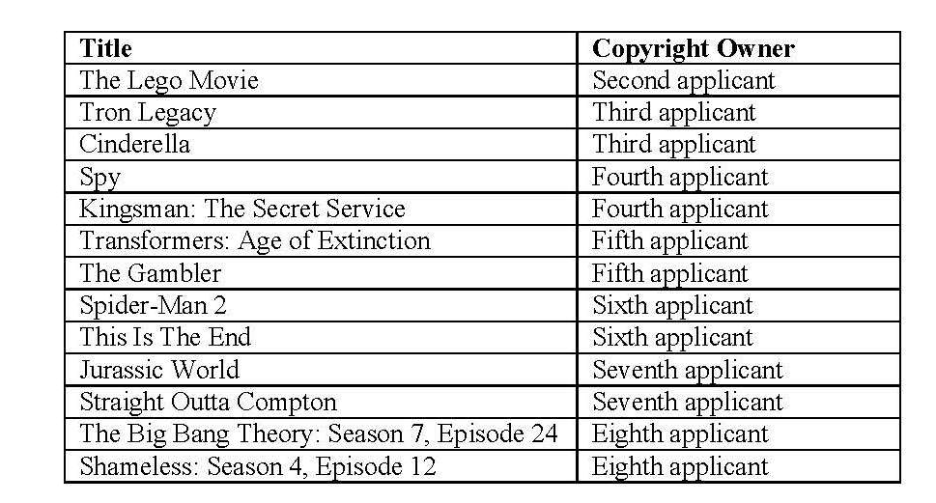

Appendix C
Streaming Online Locations
Kinogo.
Linking Online Locations
KissCartoon, WatchFree, PrimeWire, Movie4K, WatchSeries, Phimmoi, 123Movies, Couchtuner, FMovies, XMovies8.tv, Putlockers.vip, EYNY, MegaShare, Spacemov, Viooz, Hdmovieswatch, Putlocker.plus, Xmovies8.org, Xemphimso, Shush, Tehparadox, Icefilms, Putlocker.ch, Softarchive, Rlsbb, Putlocker.run, GoMovies, xmovies8.ru, Spacemov.tv, hdmovieswatch.eu, putlockers.ca, putlocker.co, Rlsbb.ru and Putlocker1.live.
Linking Searching Online Locations
Alluc and GenVideos,
P2P Online Locations
ExtraTorrent.cc, EZTV, Rarbg, YTS, Yify Torrent, Torrent Downloads, Bitsnoop, Demonoid, Limetorrents, Torrentproject, Piratebay.to and Extra.to

