AUSTRALIAN COMPETITION TRIBUNAL

Application for Authorisation of Acquisition of Macquarie Generation by AGL Energy Limited [2014] ACompT 1

Citation: | Application for Authorisation of Acquisition of Macquarie Generation by AGL Energy Limited [2014] ACompT 1
Applicant: | AGL ENERGY LIMITED
File number: | ACT 1 of 2014
Tribunal: | MANSFIELD J, President  MR G F LATTA, MEMBER  PROF D K ROUND, MEMBER
Date of decision: | 25 June 2014
Catchwords: | AUTHORISATION – authorisation under s 95AT Competition and Consumer Act 2010 (Cth) of acquisition of shares in the capital of a body corporate or to acquire assets of another person  BENEFIT TO THE PUBLIC – identification of potential public benefits – consideration of public benefits of proposed acquisition – review of claimed public benefits – weighing against public detriment  MARKET DEFINITION – existence of anti-competitive effects on the relevant markets – no substantial lessening of competition in the electricity wholesale and retail markets in NSW – effect of the proposed acquisition on the market for hedge contracts – consideration of the Victorian and South Australian electricity wholesale and retail markets  FUTURE WITH AND WITHOUT – robust and commercially realistic judgment – likely future if the proposed acquisition were to proceed – State’s fiscal position will be improved by approximately $1 billion – proposed acquisition was the sole offer above the retention value of the assets – funds to facilitate implementation of infrastructure improvement in NSW – consideration of likely future in the absence of the proposed acquisition – State will likely continue to operate the assets in the short term to medium term – State will continue to seek to dispose of the assets in the future – future sale price likely to be less than current sale price – funds available to invest in infrastructure be reduced
Legislation: | Competition and Consumer Act 2010 (Cth) ss 50, 95AT, 95AU, 95AV, 95AZA, 95AZC, 95AZD, 95AZEA, 95AZF, 95AZG, 95AZH, 95AZI, 95AZJ, 103, 105, 106  National Electricity (South Australia) 1996 (SA)  National Electricity Law  National Electricity Rules  Environmental Planning and Assessment Act 1979 (NSW)  Restart NSW Fund Act 2011 (NSW)  Energy Services Corporations Act 1995 (NSW)  State Owned Corporations Act 1989 (NSW)  Electricity Generator Assets (Authorised Transactions) Act 2012 (NSW)  Infrastructure Act 2011 (NSW)  Competition and Consumer Regulations 2010
Cases cited: | Australian Competition and Consumer Commission v Metcash Trading Ltd (2011) 198 FCR 297 cited  Australian Gas Light Co v Australian Competition and Consumer Commission(No 3) (2003) 137 FCR 317 cited  Queensland Co-operative Milling Association Ltd and Defiance Holdings Ltd (1976) 8 ALR 481 cited  Re Queensland Independent Wholesalers Ltd (1995) 132 ALR 225 cited  Re Qantas Airways Limited [2004] ACompT 9 cited  Re Australian Association of Pathology Practices Inc (2004) 206 ALR 271 cited  VFF Chicken Meat Growers’ Boycott Authorisation (2006) ATPR 42-120 cited  Application by Medicines Australia Inc (2007) ATPR 42-164 cited  Re 7-Eleven Stores Pty Limited (1994) ATPR 41-357 cited  Re Rural Traders Cooperative (WA) Ltd (1979) 37 FLR 244 cited  Re Howard Smith Industries Pty Ltd (1977) 28 FLR 385 cited
Date of hearing: | 2-6 and 10, 11 and 13 June 2014
Place: | Adelaide (via videolink to Sydney and Melbourne)
Category: | Catchwords
Number of paragraphs: | 396
Counsel for the Applicant: | AJL Bannon SC, CA Moore SC, RCA Higgins, D Roche and D Hughes
Solicitor for the Applicant: | Ashurst
Counsel for the Australian Competition and Consumer Commission: | C Scerri QC, N De Young, C Exell and D Forrester
Solicitor for the Australian Competition and Consumer Commission | DLA Piper

IN THE AUSTRALIAN COMPETITION TRIBUNAL
ACT 1 of 2014

RE: | APPLICATION FOR AUTHORISATION OF ACQUISITION OF MACQUARIE GENERATION BY AGL ENERGY LIMITED  Applicant

TRIBUNAL: | MANSFIELD J, PRESIDENT  MR G F LATTA, MEMBER  PROF D K ROUND, MEMBER
DATE OF ORDER: | 25 JUNE 2014
WHERE MADE: | ADELAIDe via video link to sydney and melbournE

THE TRIBUNAL DETERMINES THAT:

1. AGL Energy Limited (AGL) be granted an authorisation pursuant to s 95AT of the Competition and Consumer Act 2010 (Cth) to acquire the assets of Macquarie Generation, on the conditions (the Conditions) set out in the Schedule to this Determination and in accordance with the Sale and Purchase Agreement (Macquarie Generation Assets) entered between the State of New South Wales and AGL’s wholly owned subsidiary, AGL Macquarie Pty Ltd, on 12 February 2014.
2. The table titled “Credit exposure and maturity limits” in Annexure 1 to the Conditions must remain confidential and must not be published to any person other than the officers of AGL, the Australian Competition and Consumer Commission and its officers, and the Approved Independent Auditor appointed pursuant to the Conditions.
3. The acquisition of the assets of Macquarie Generation by AGL be completed by 24 June 2015.

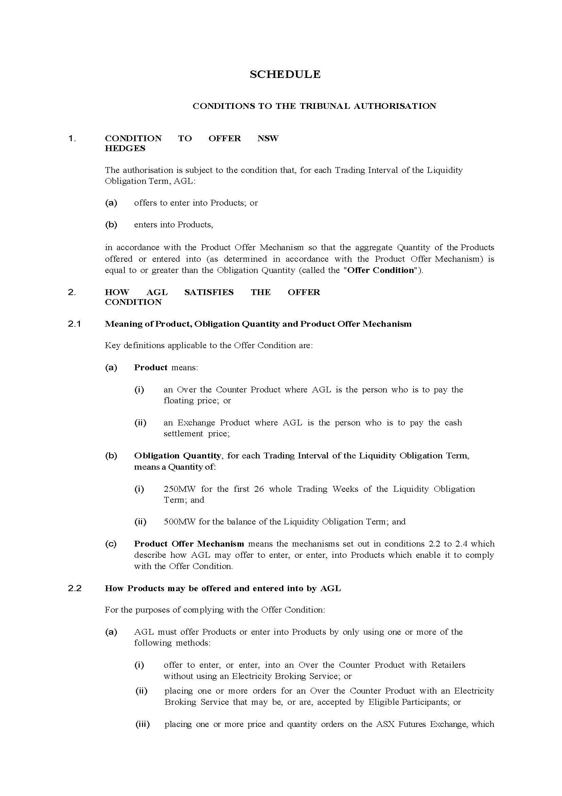

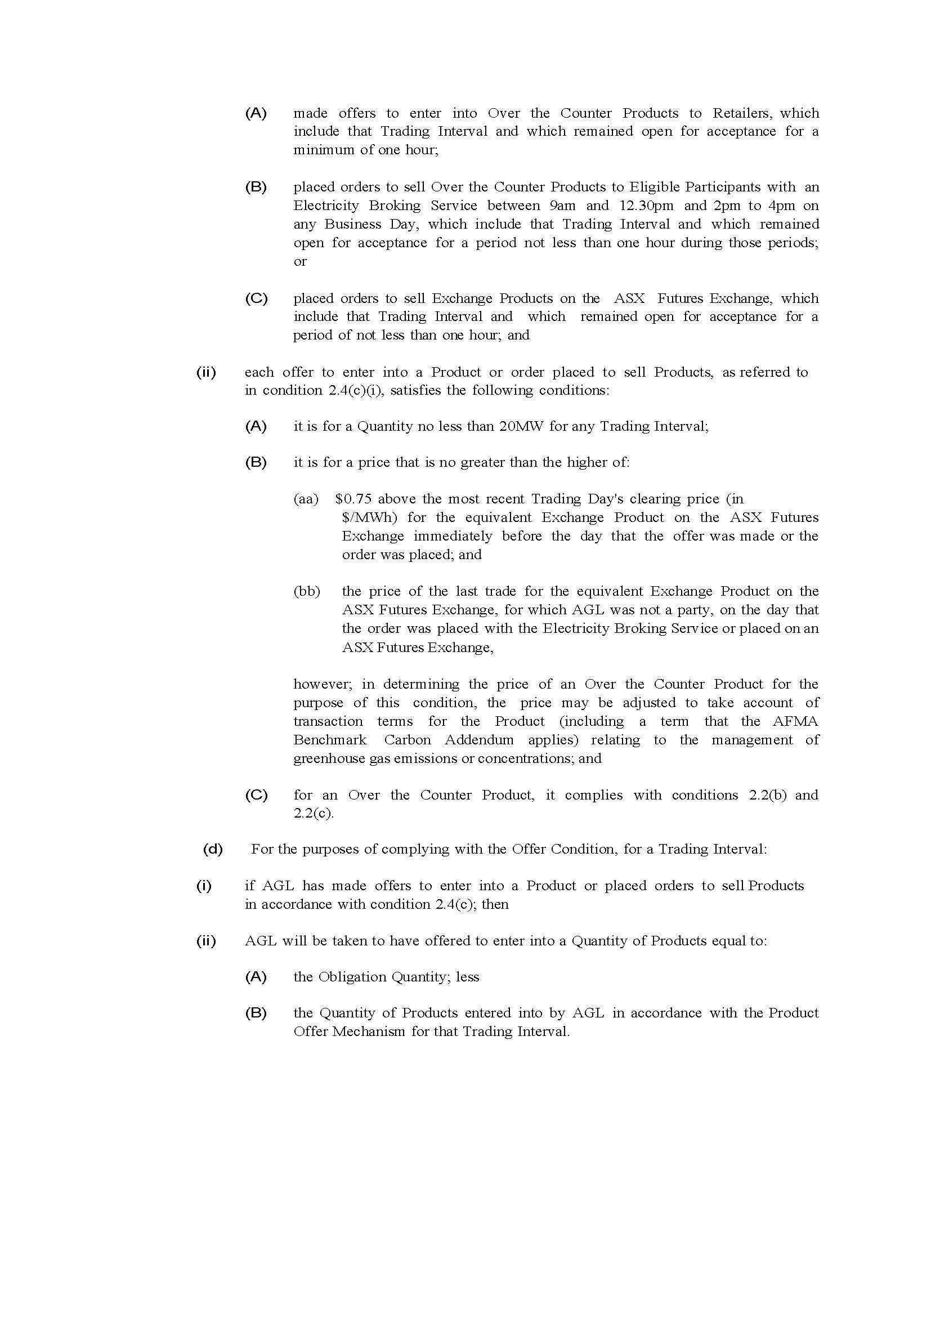

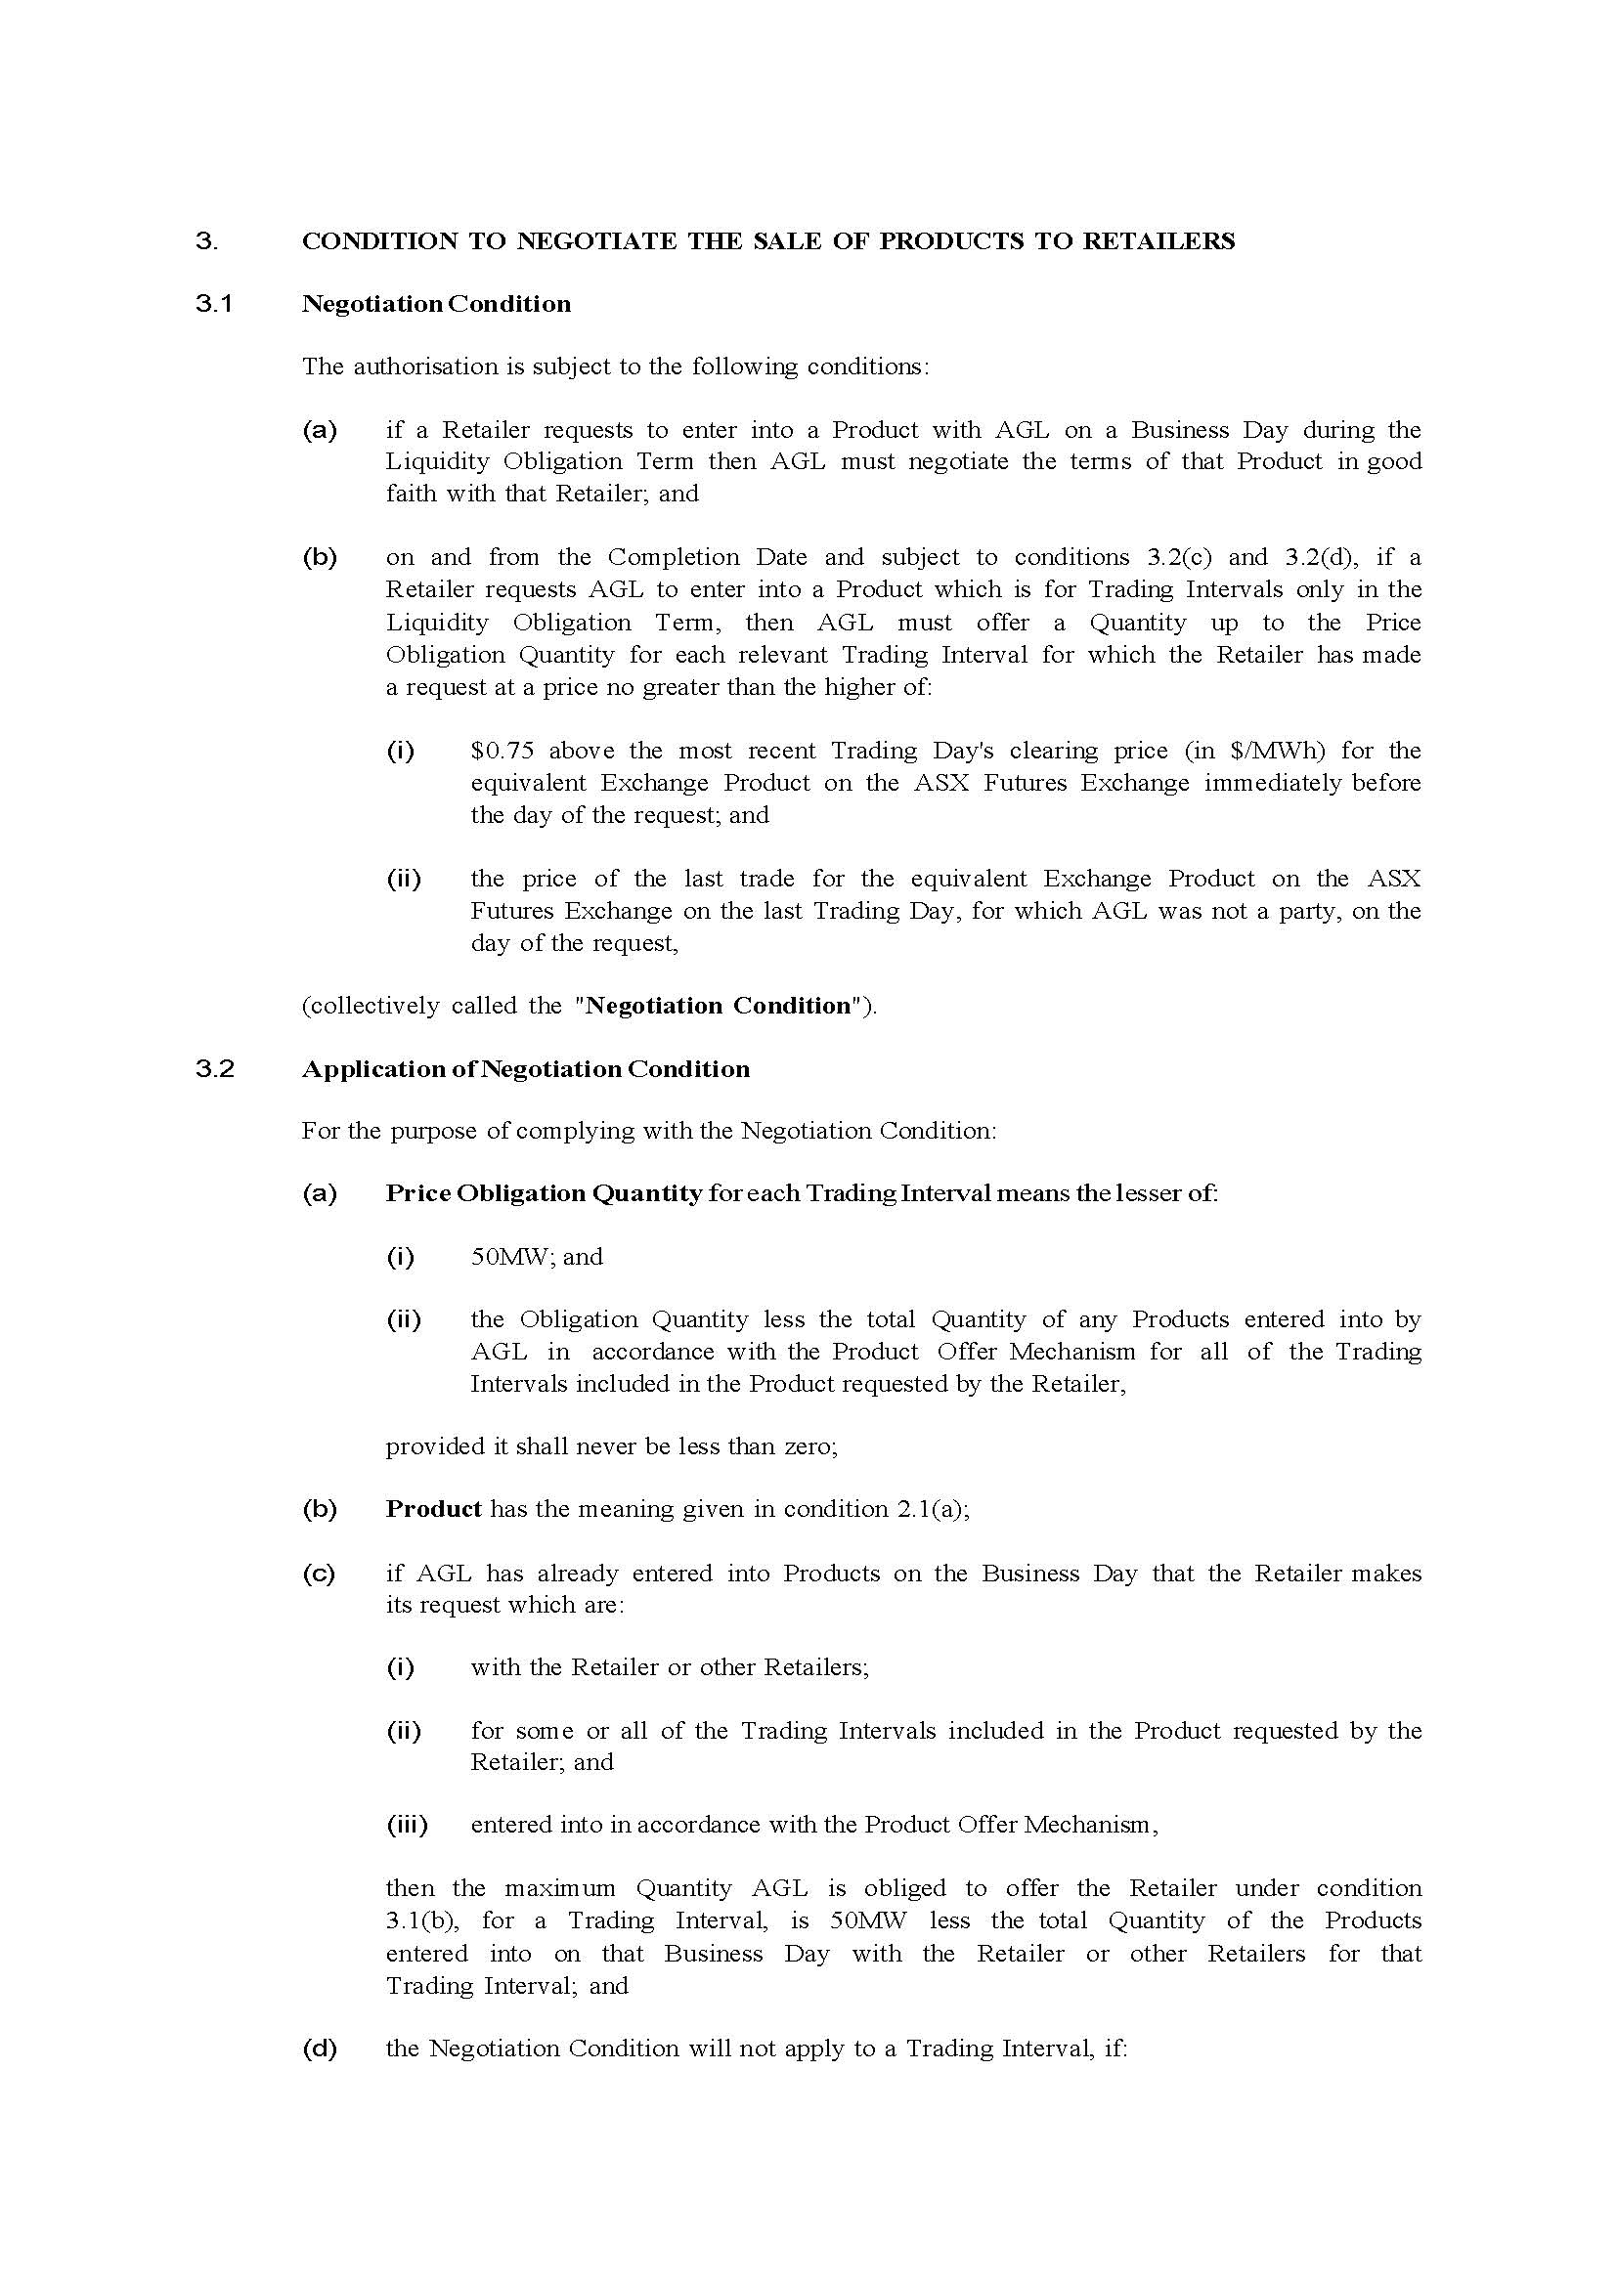

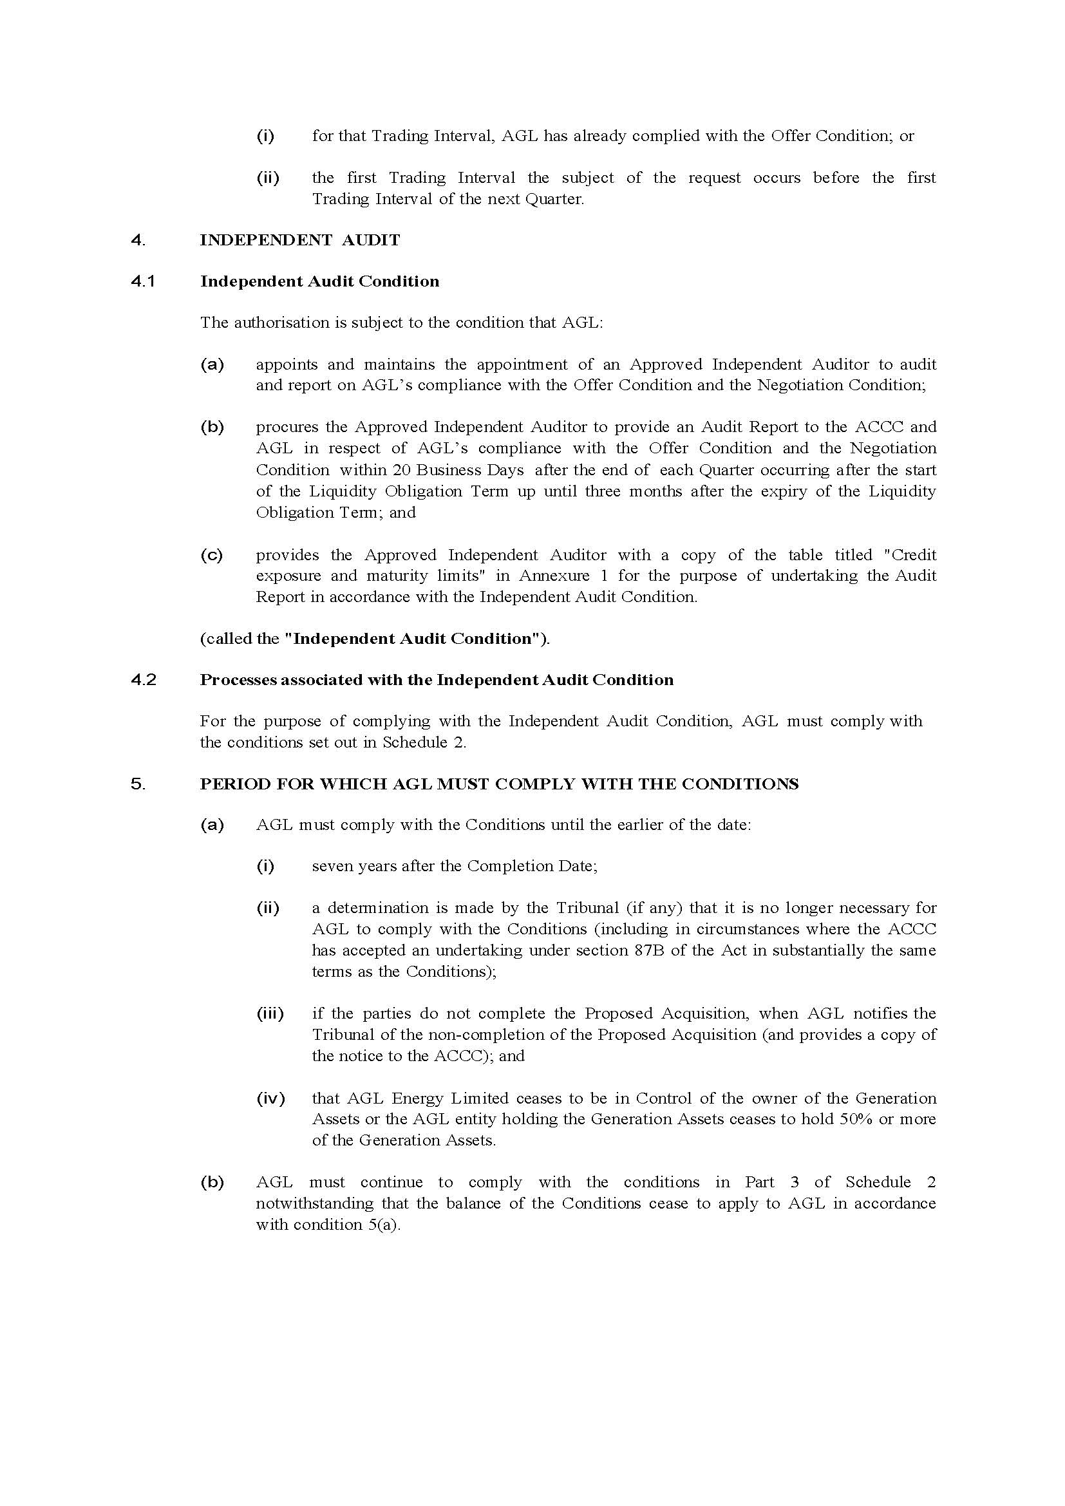

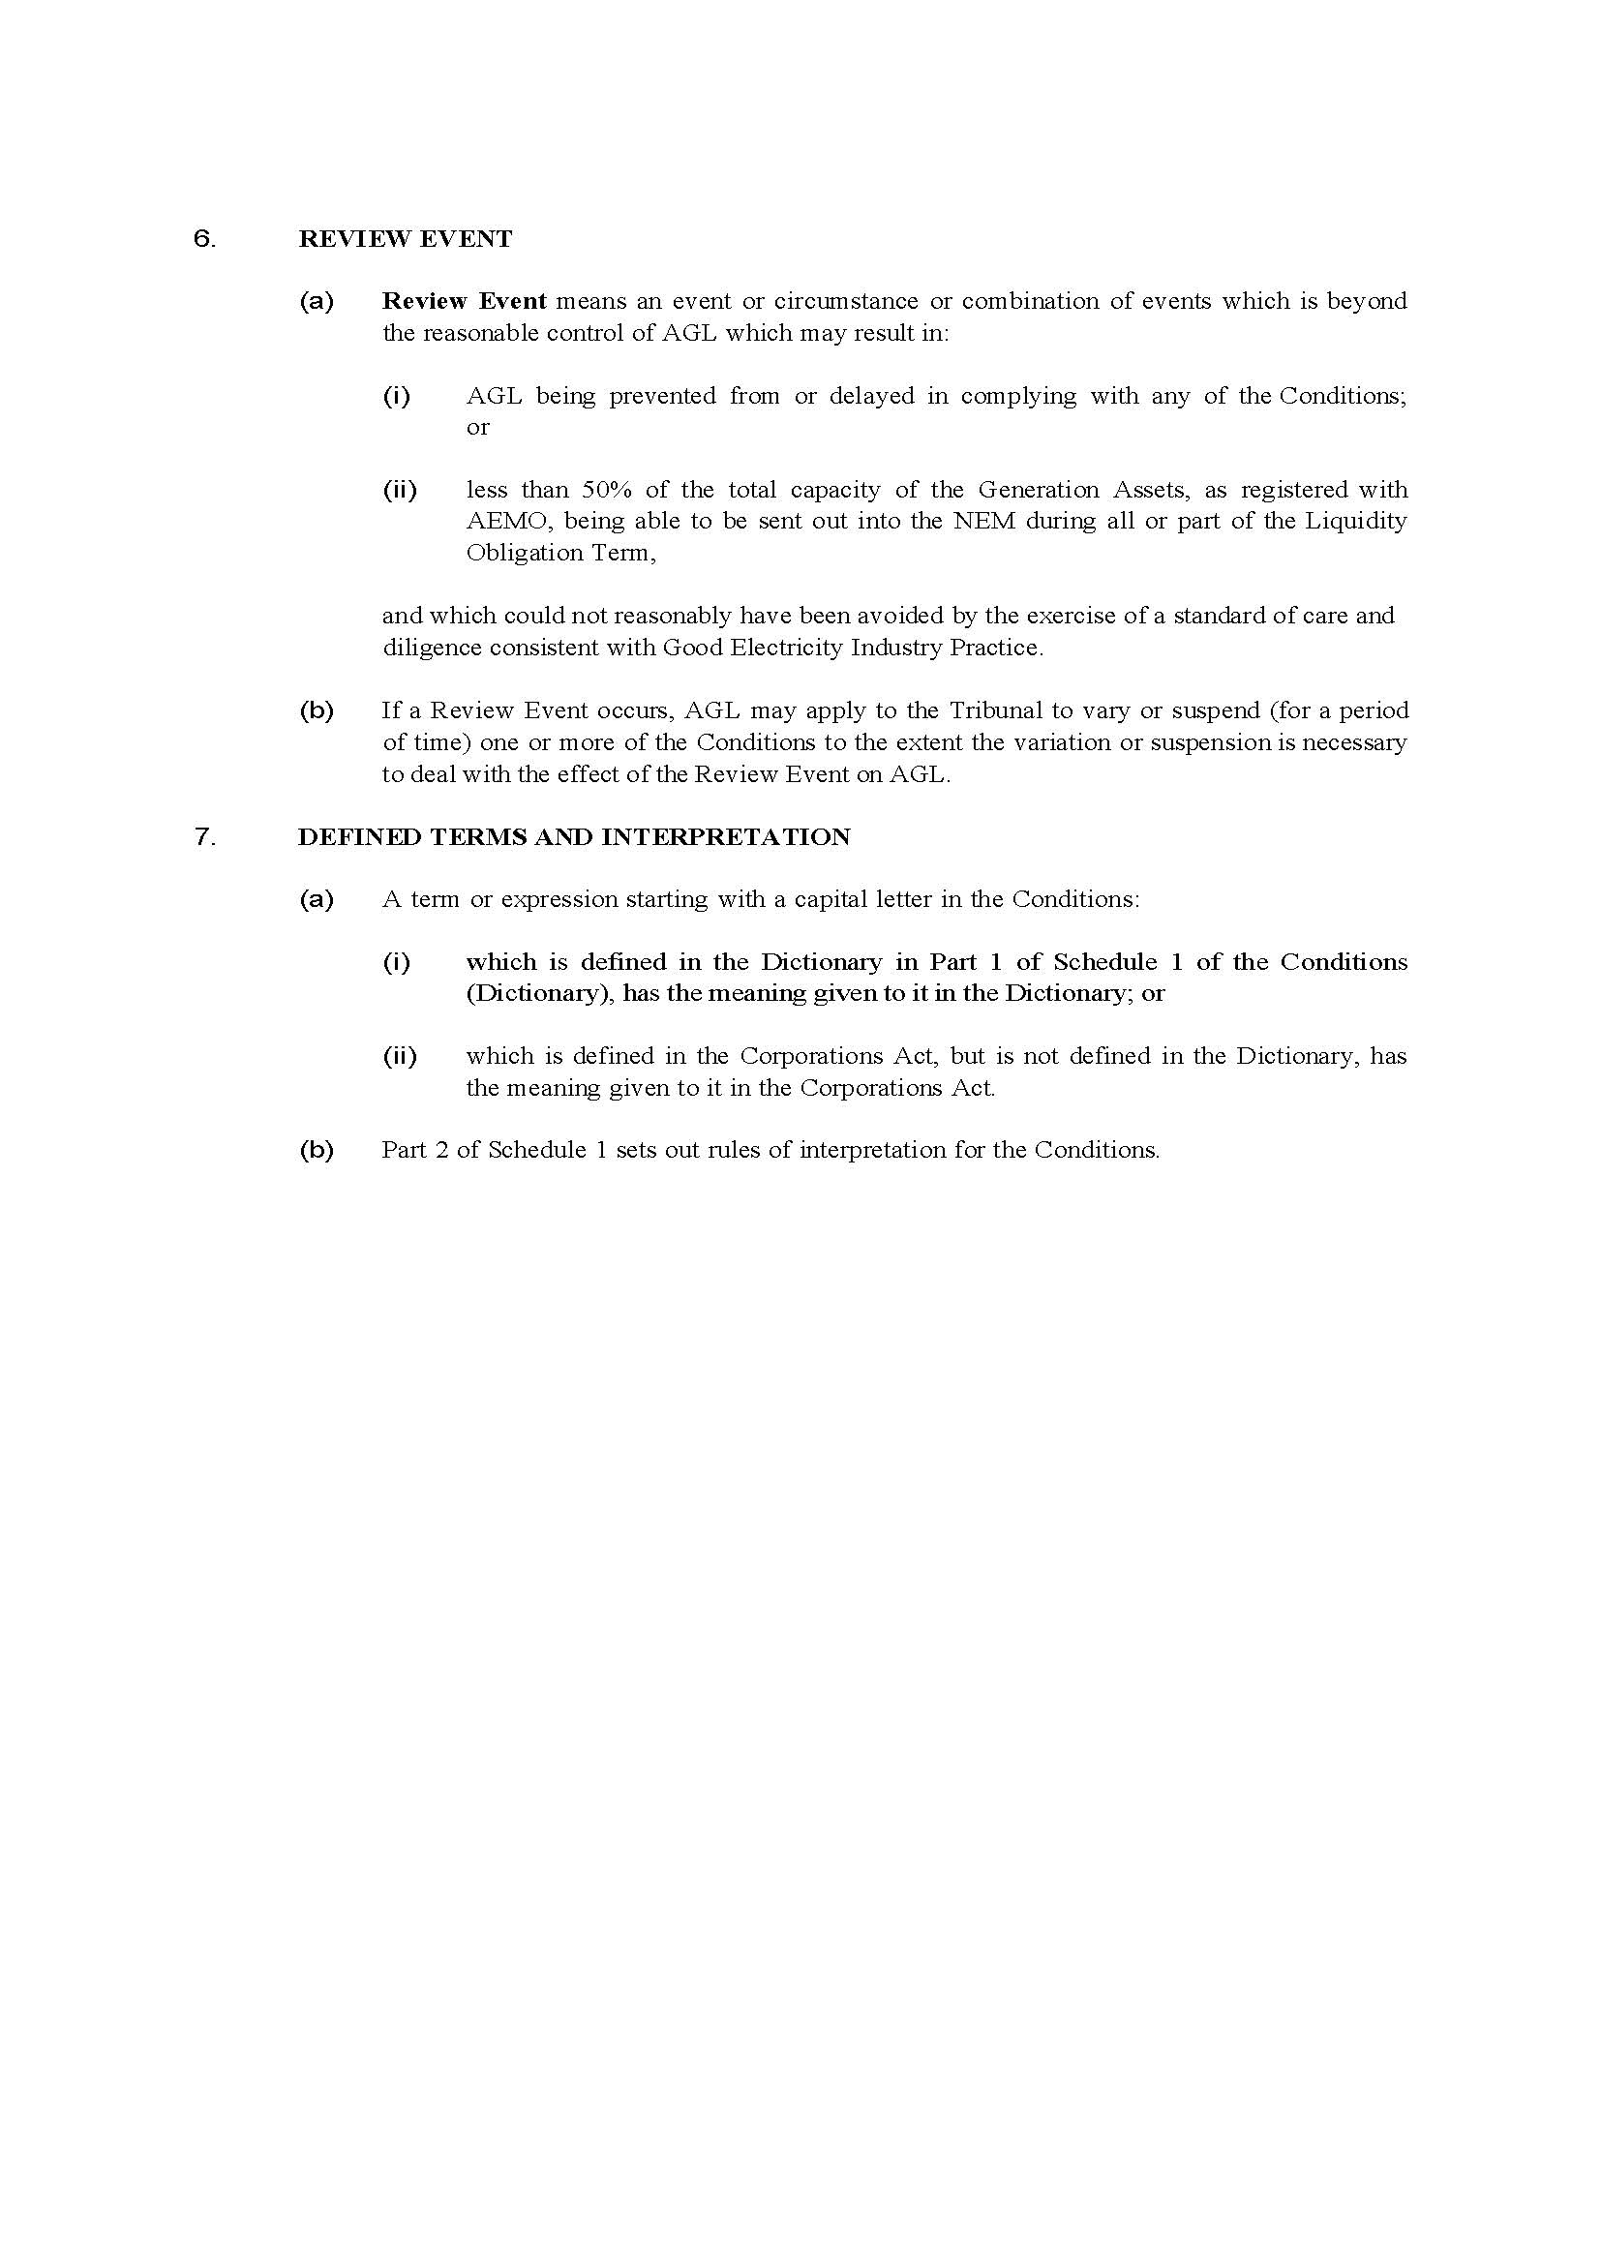

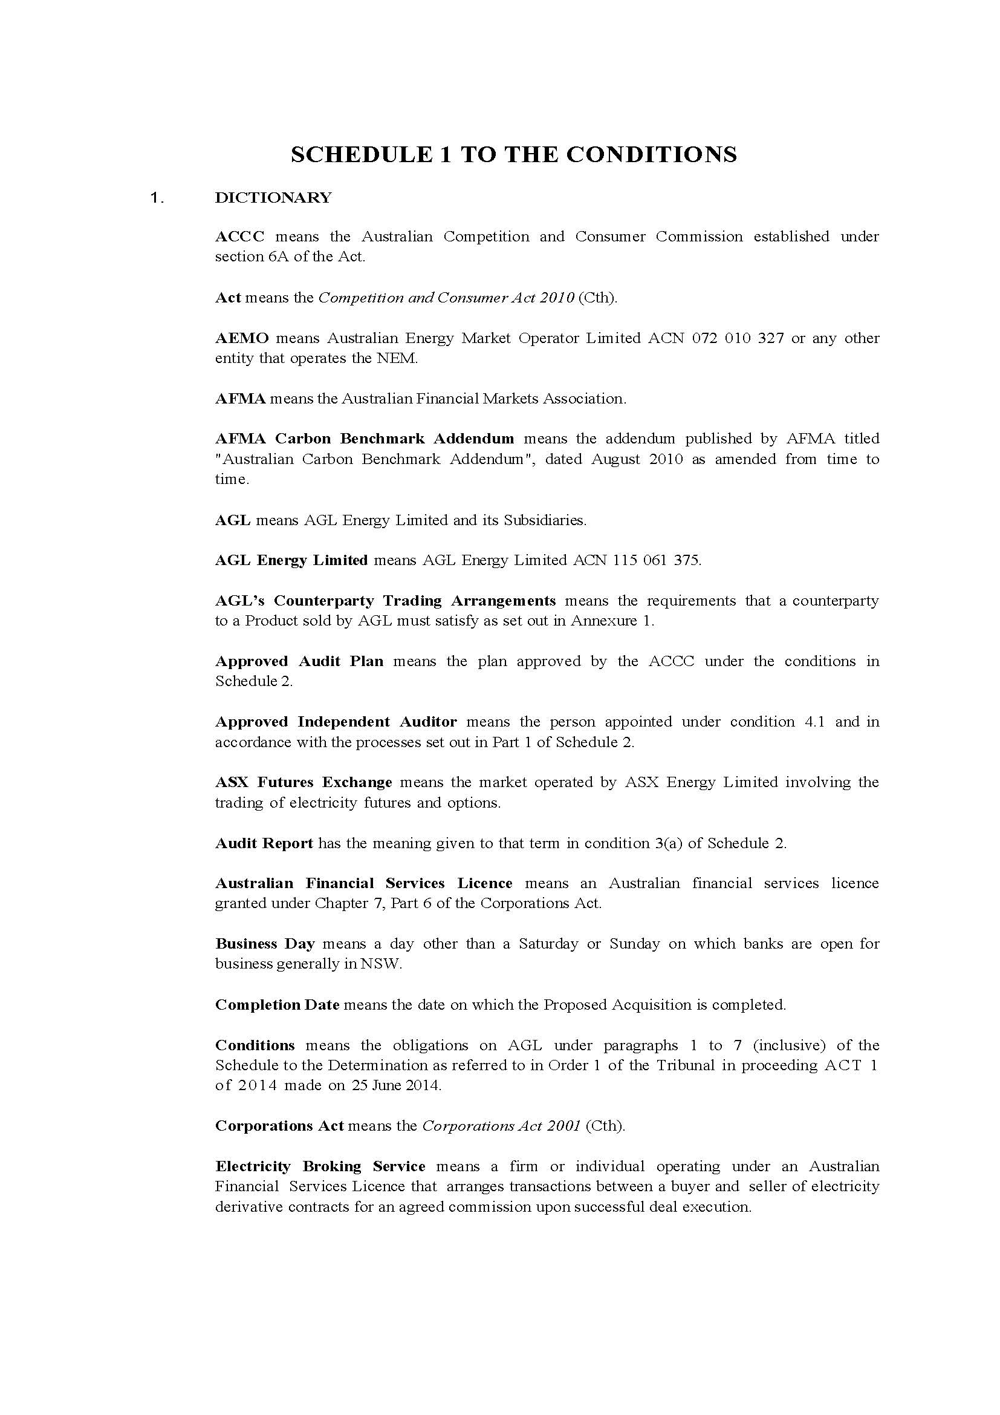

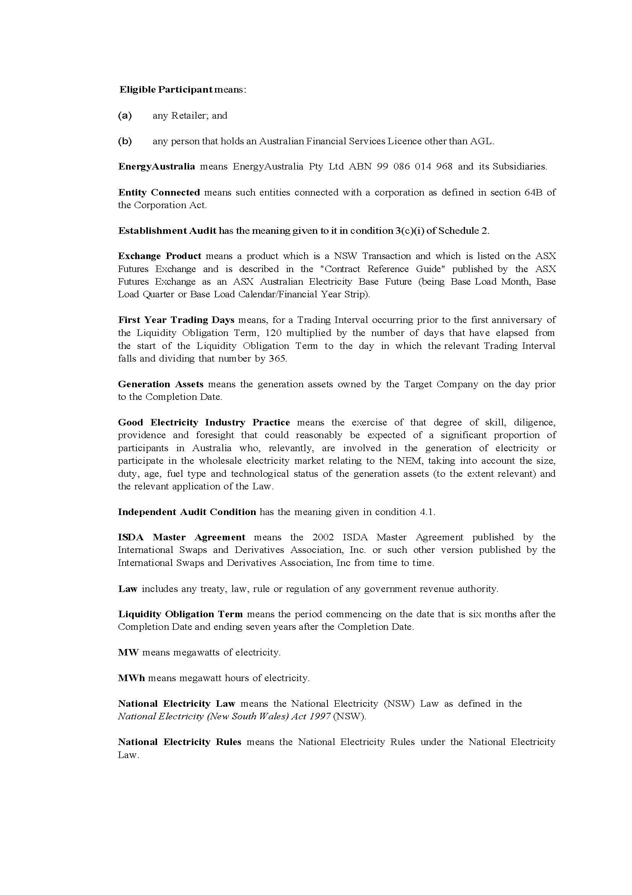

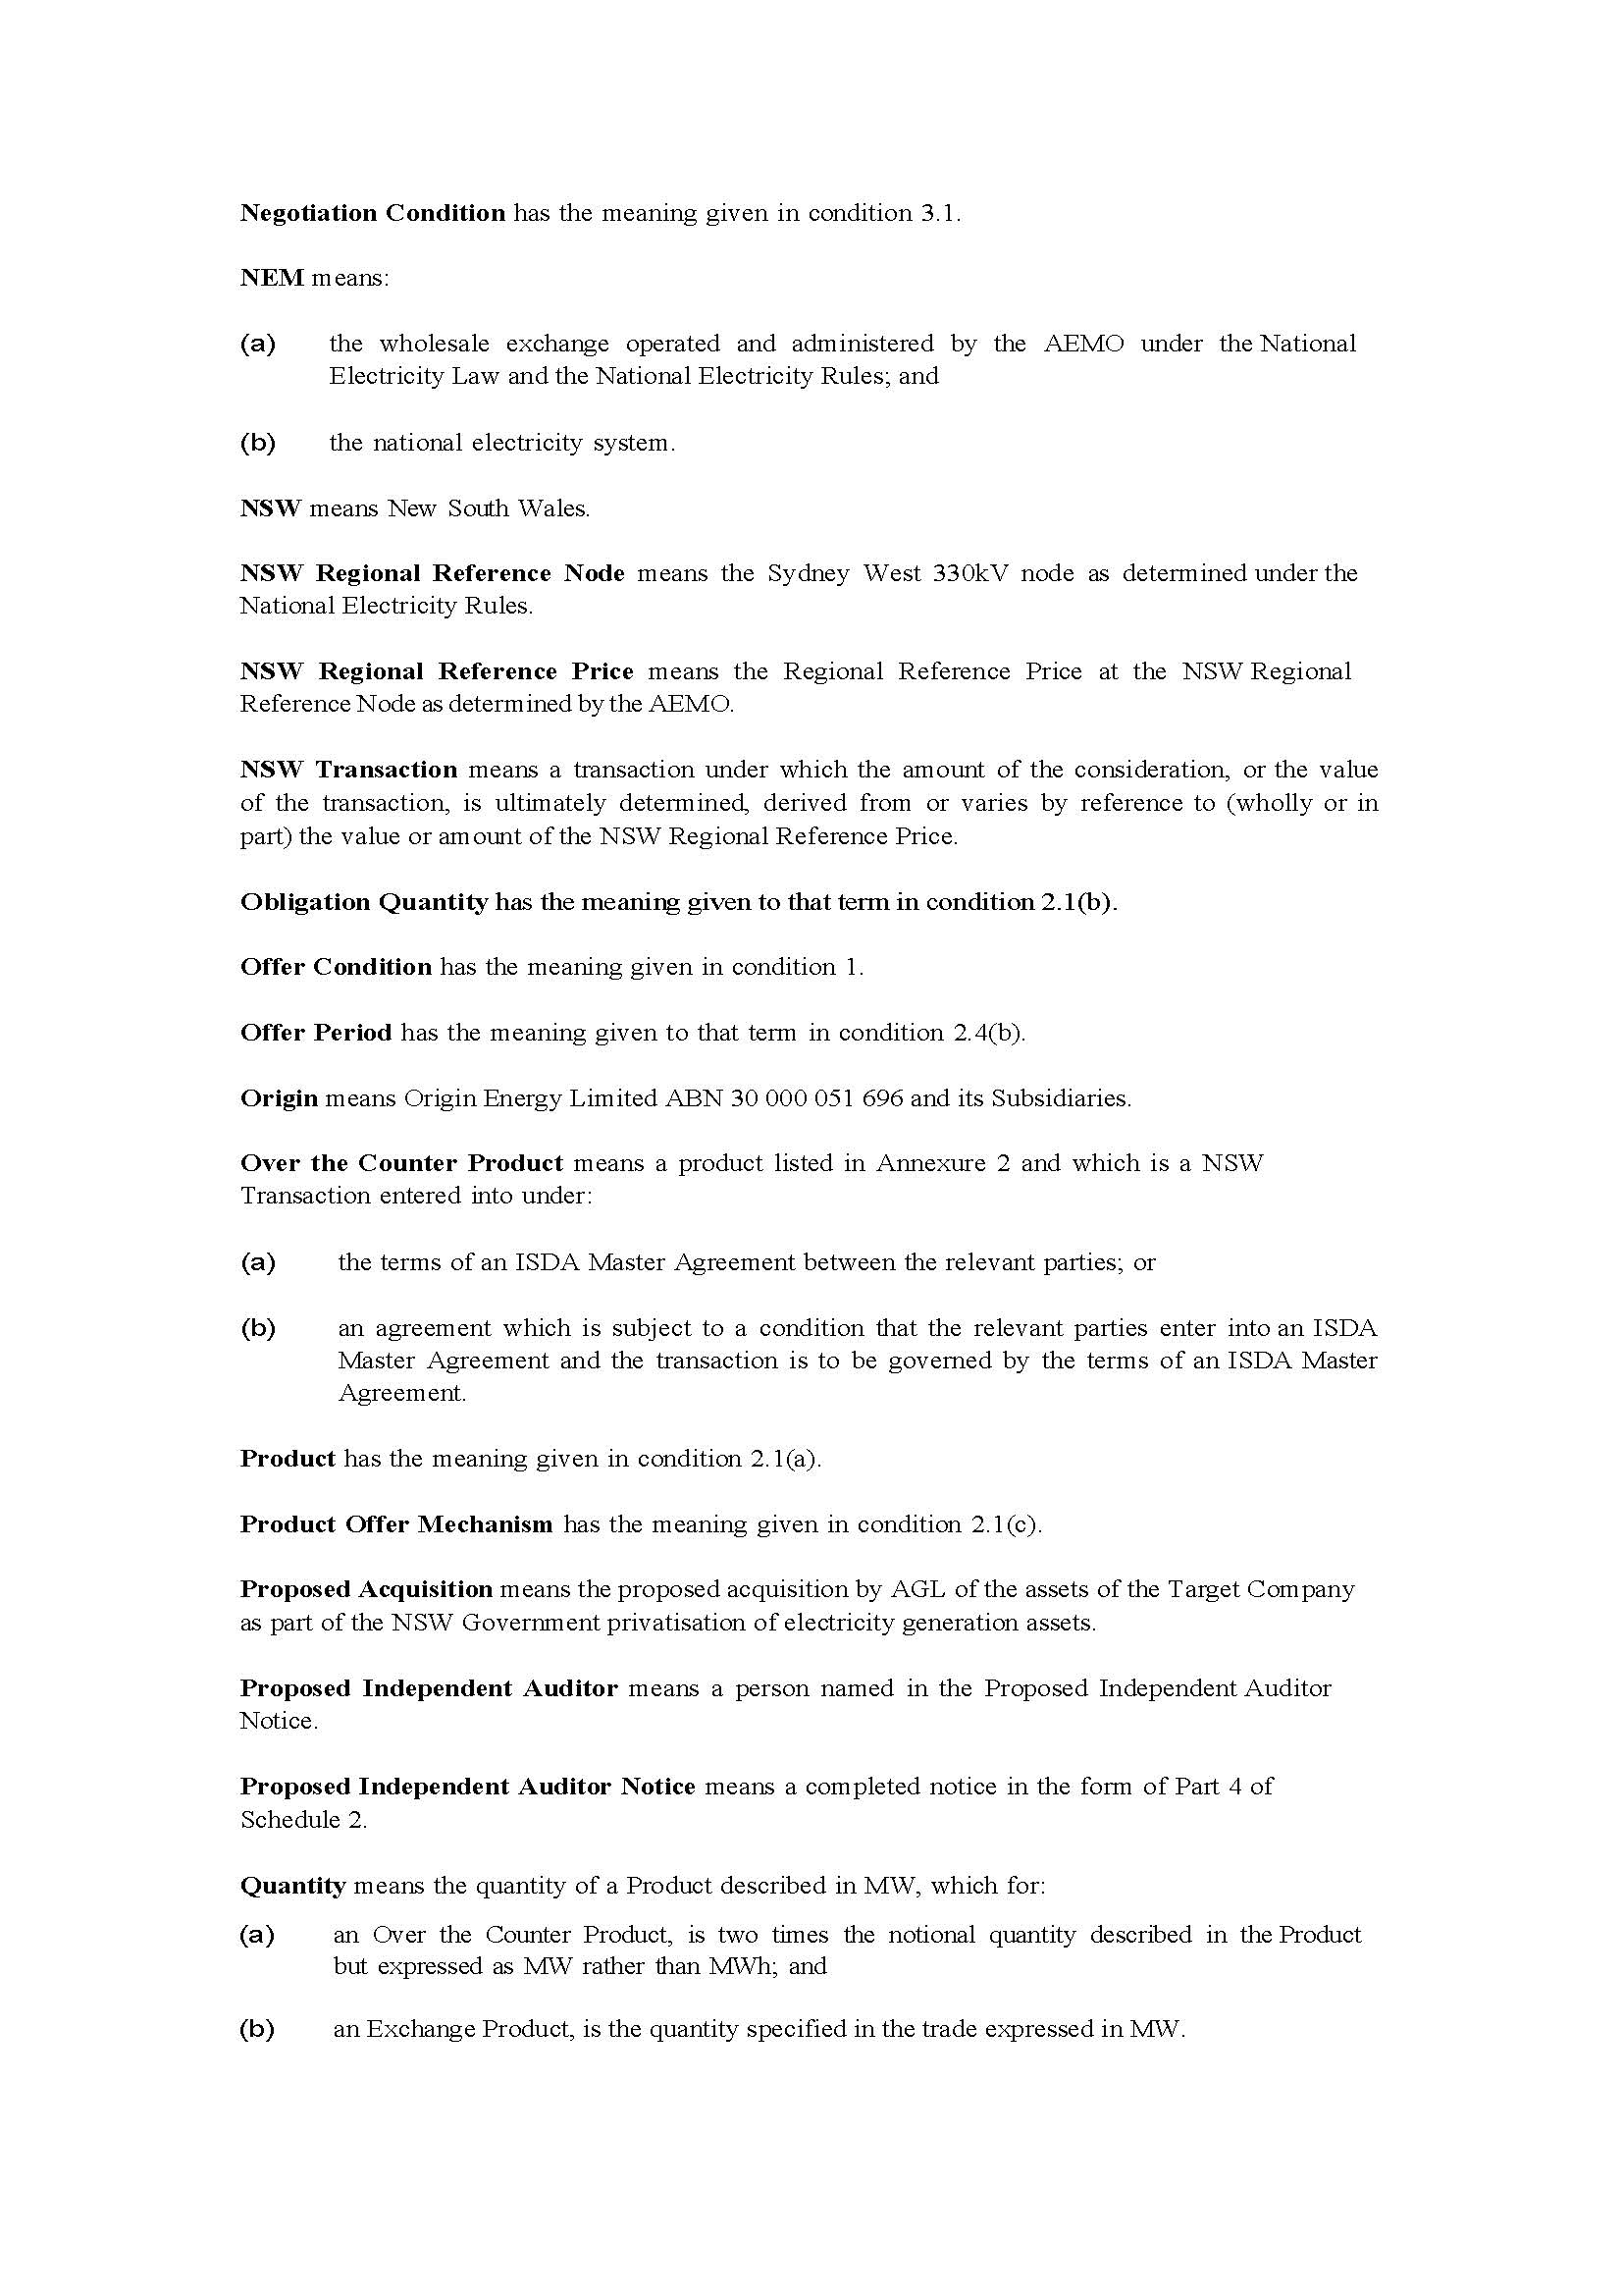

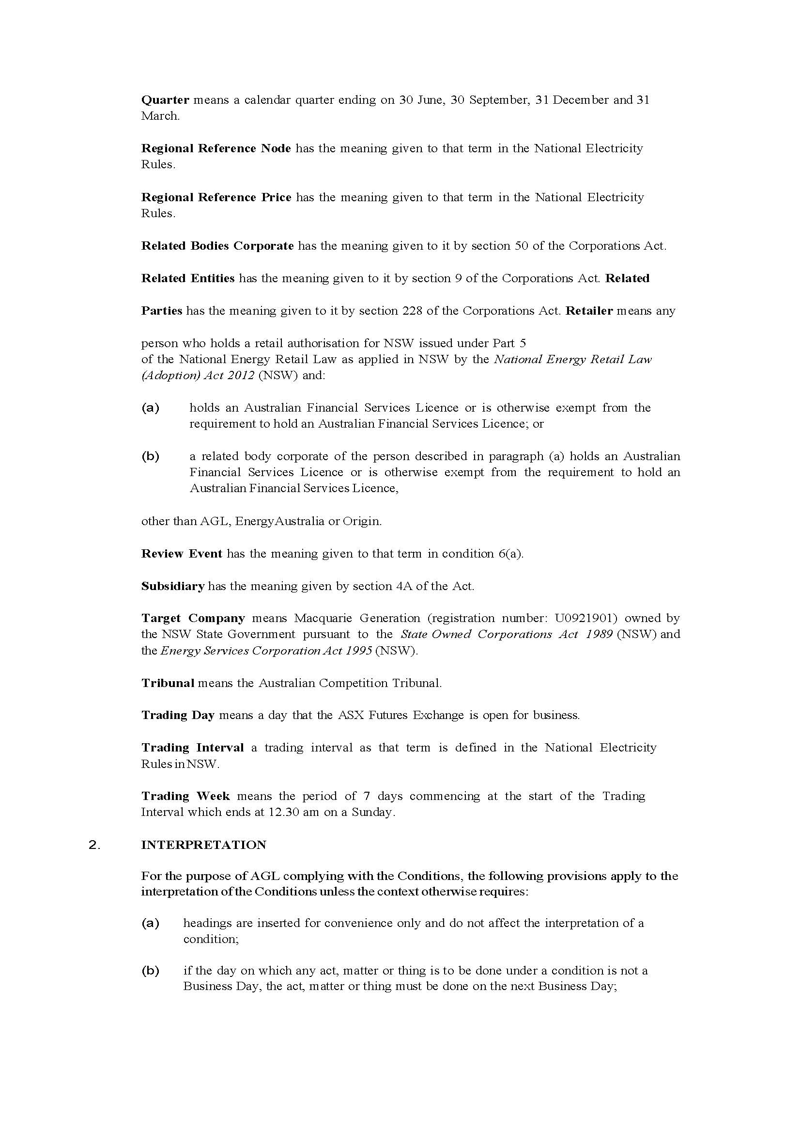

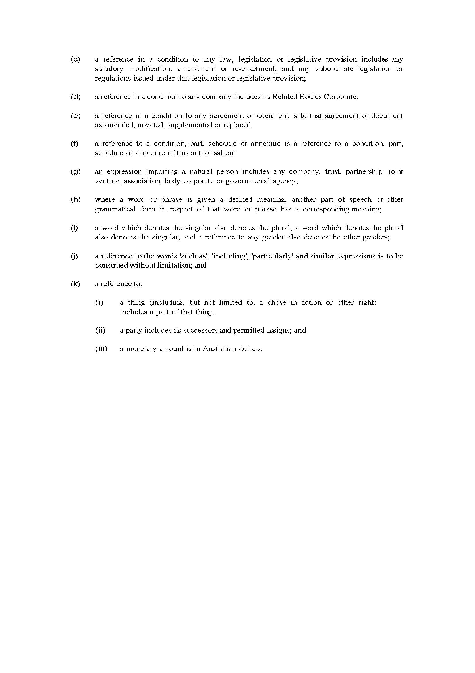

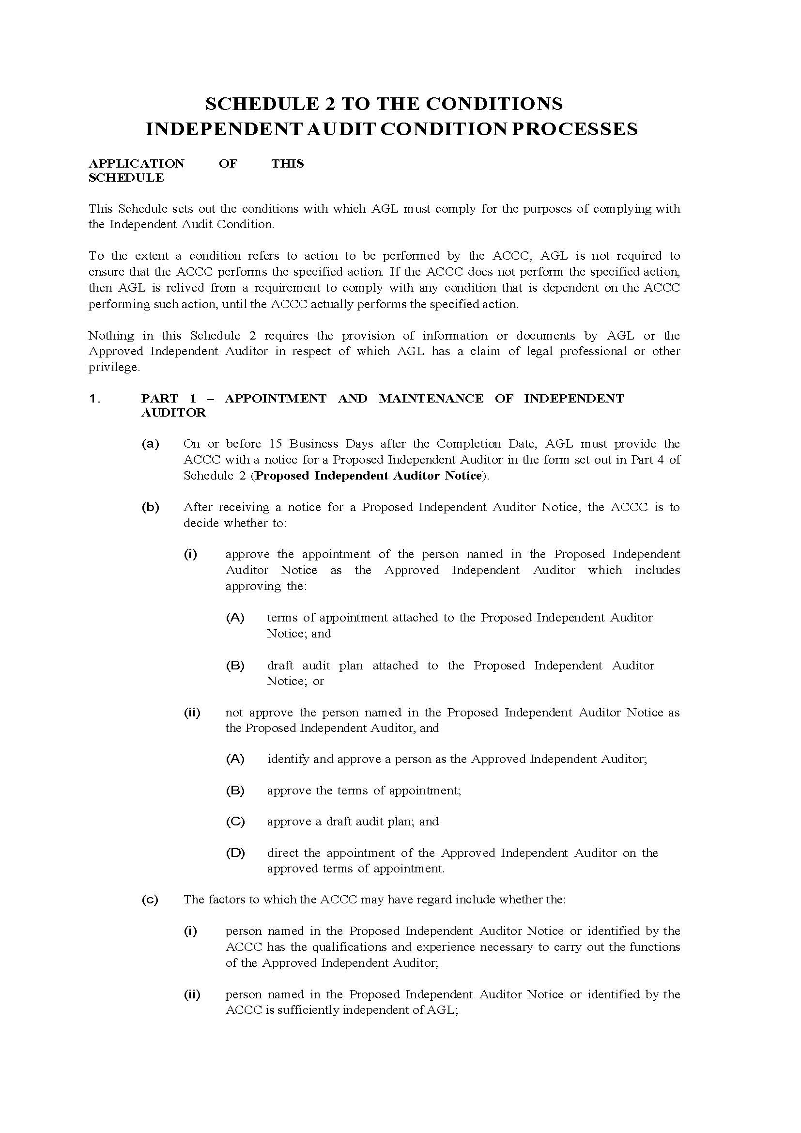

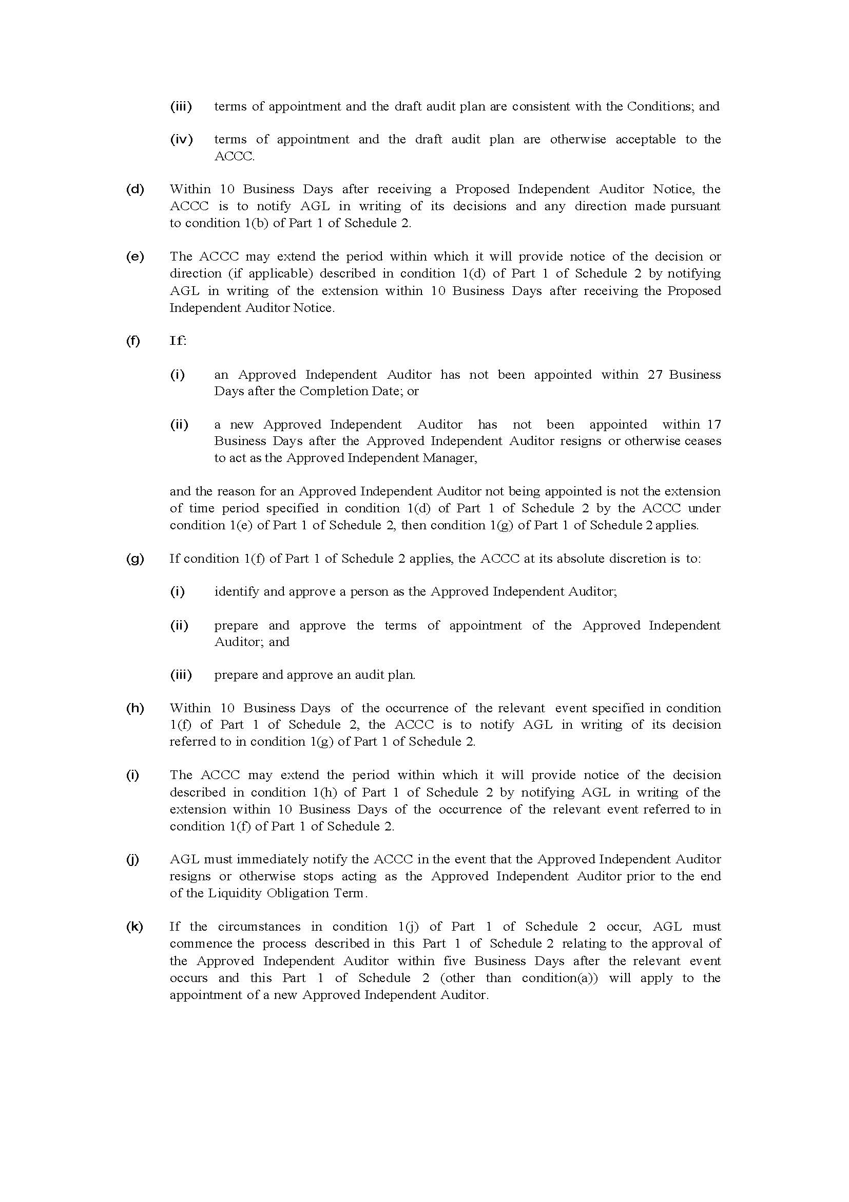

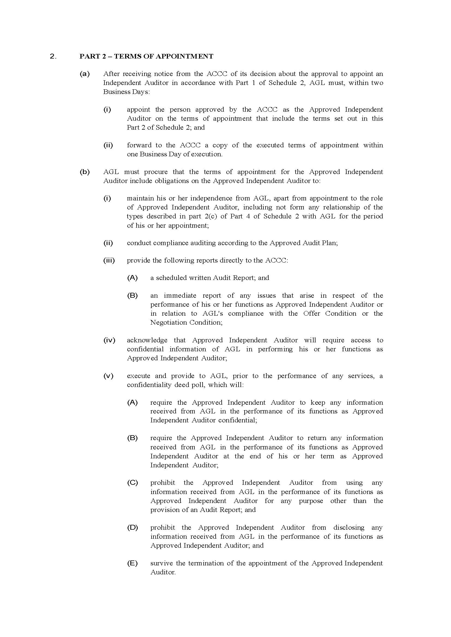

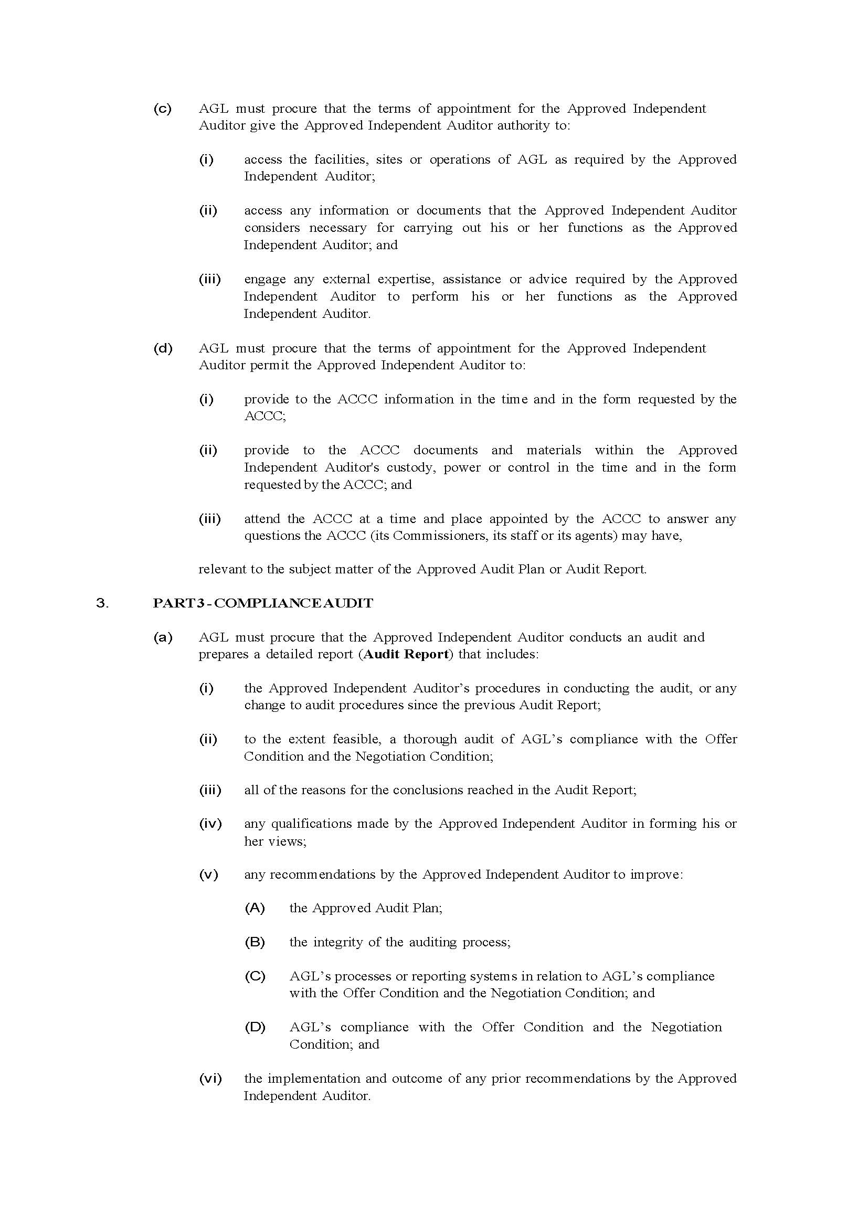

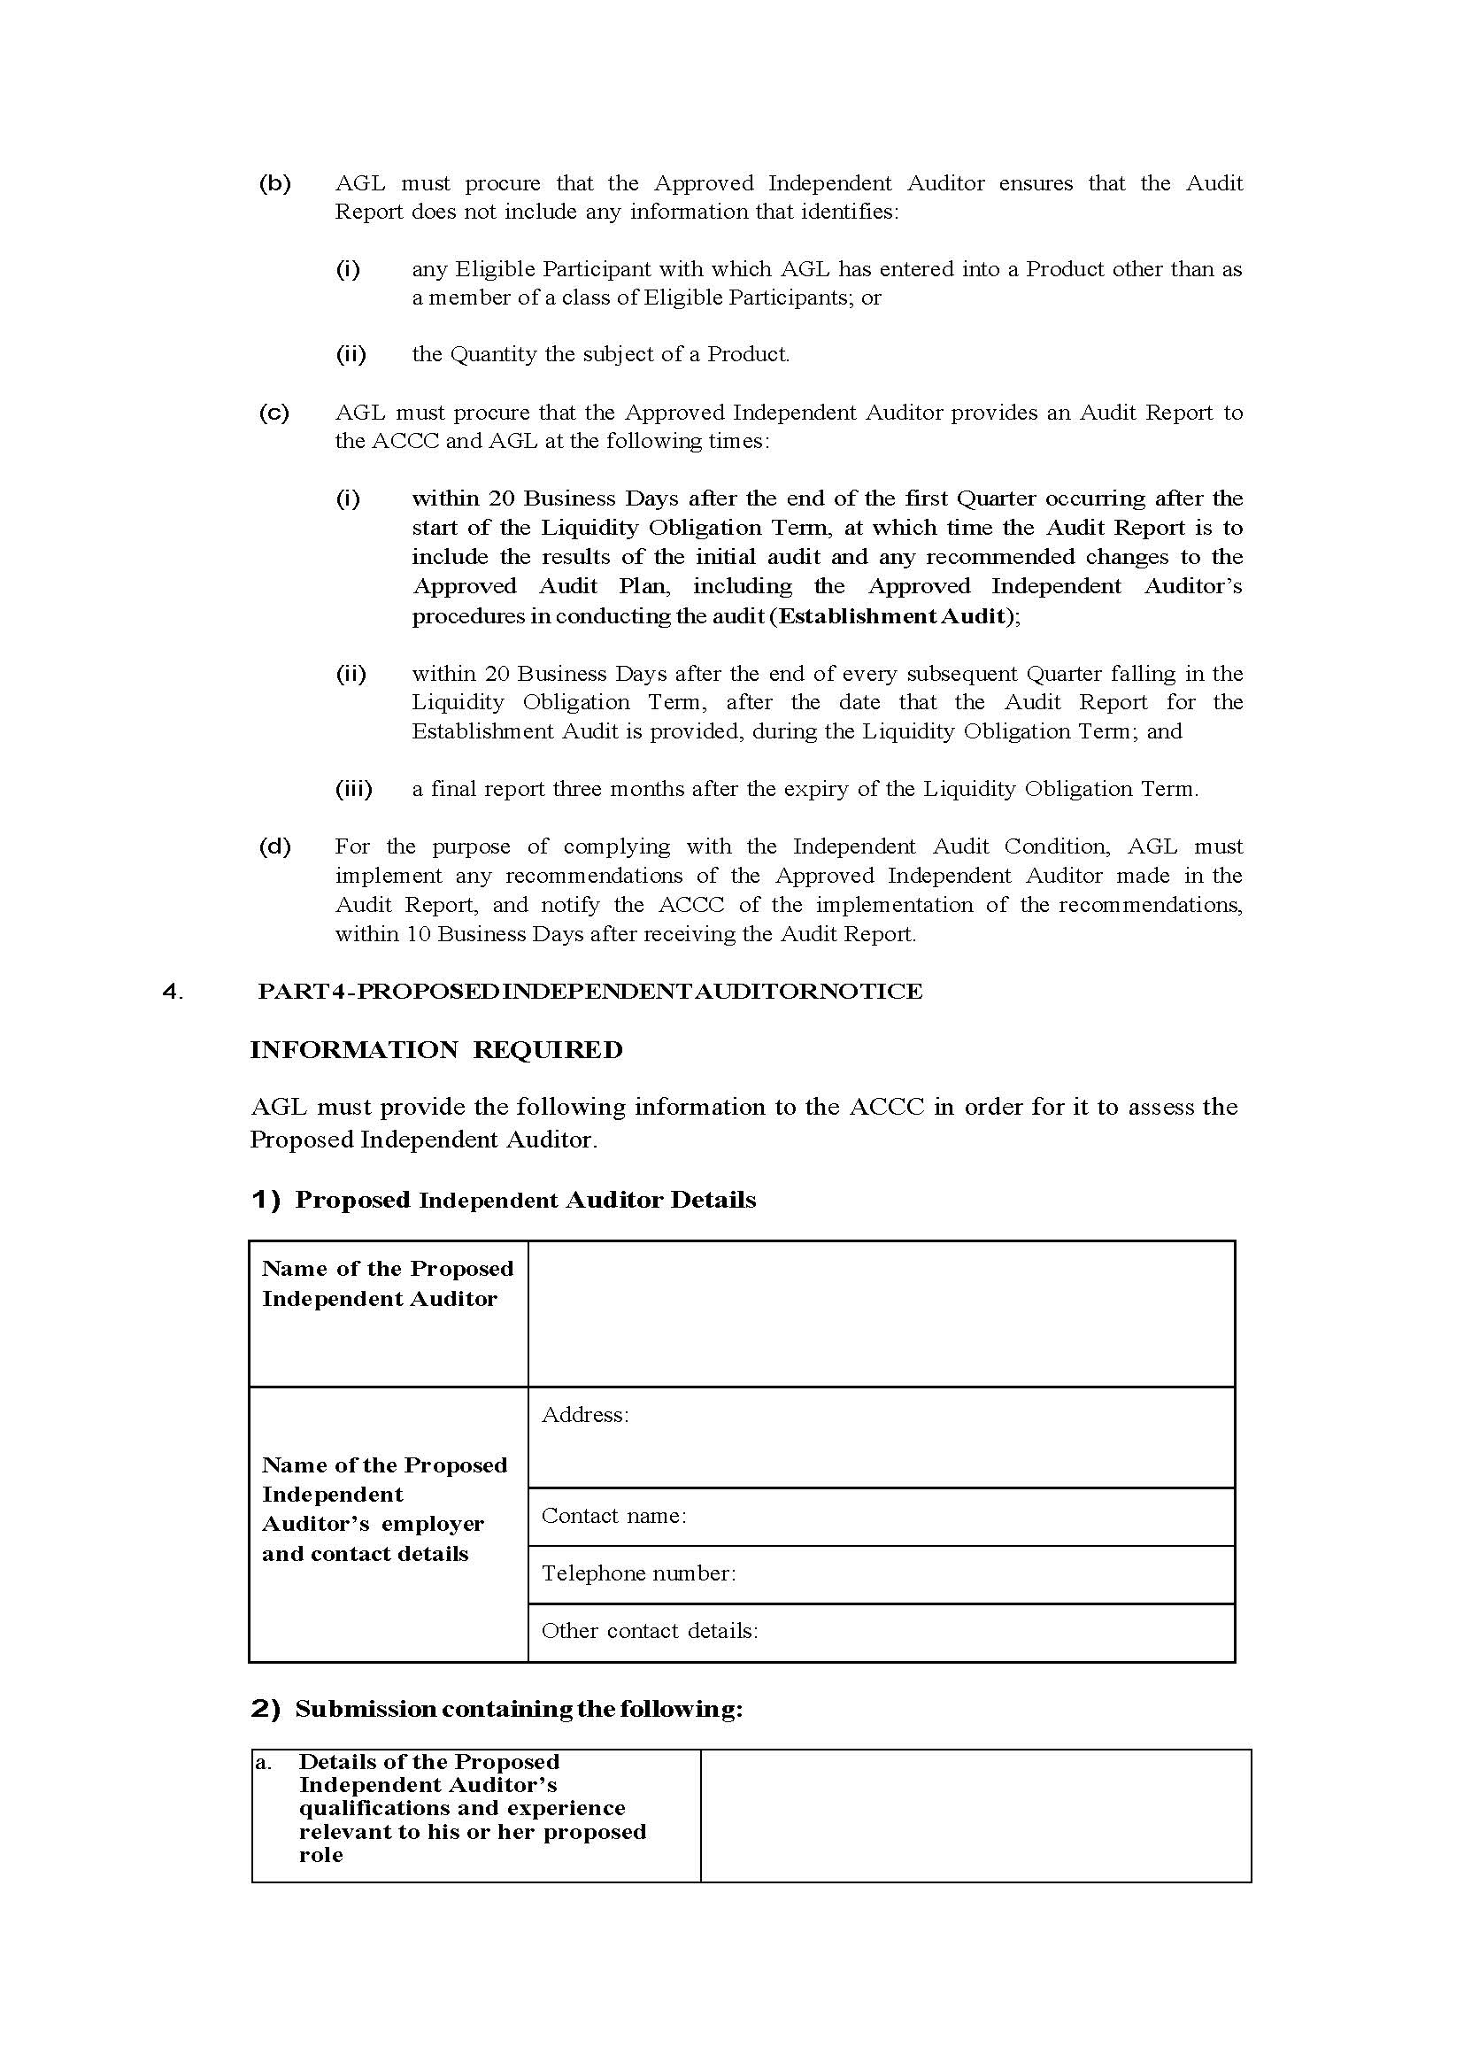
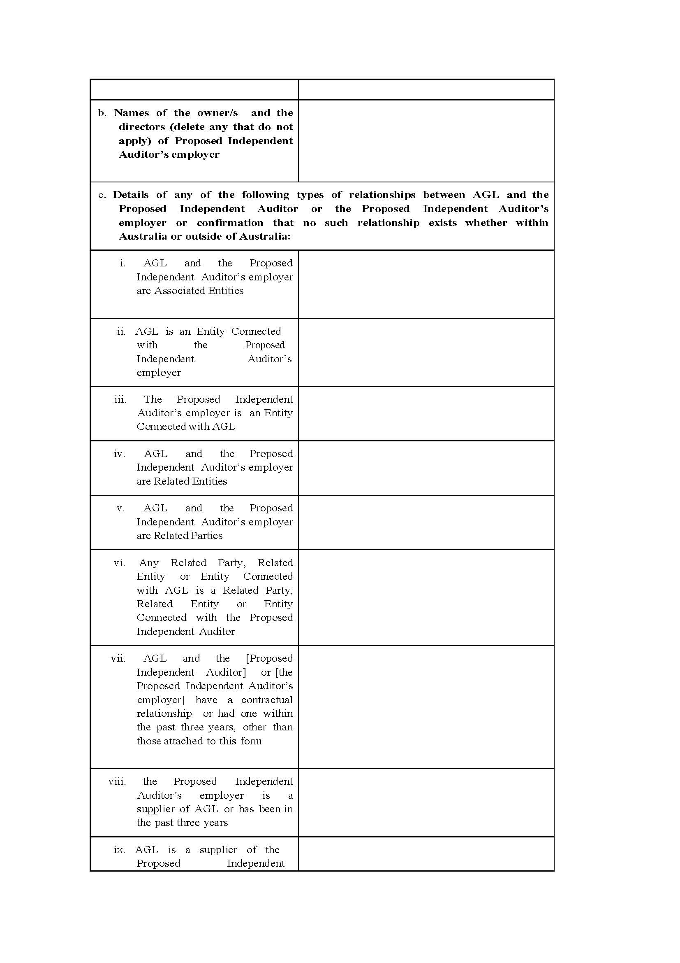
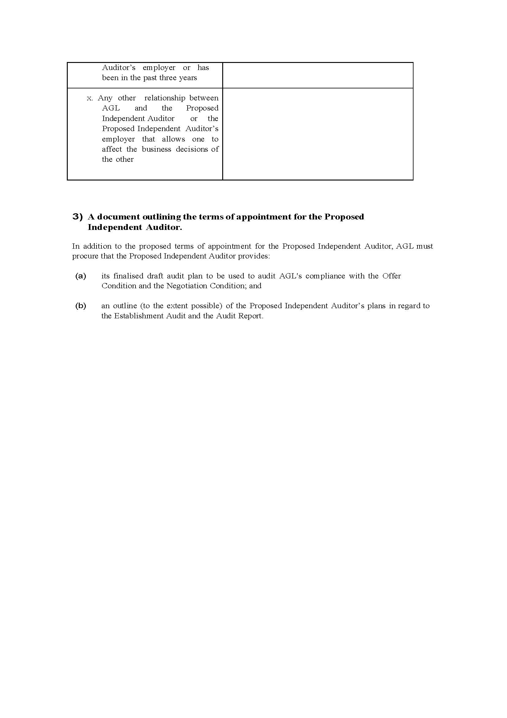
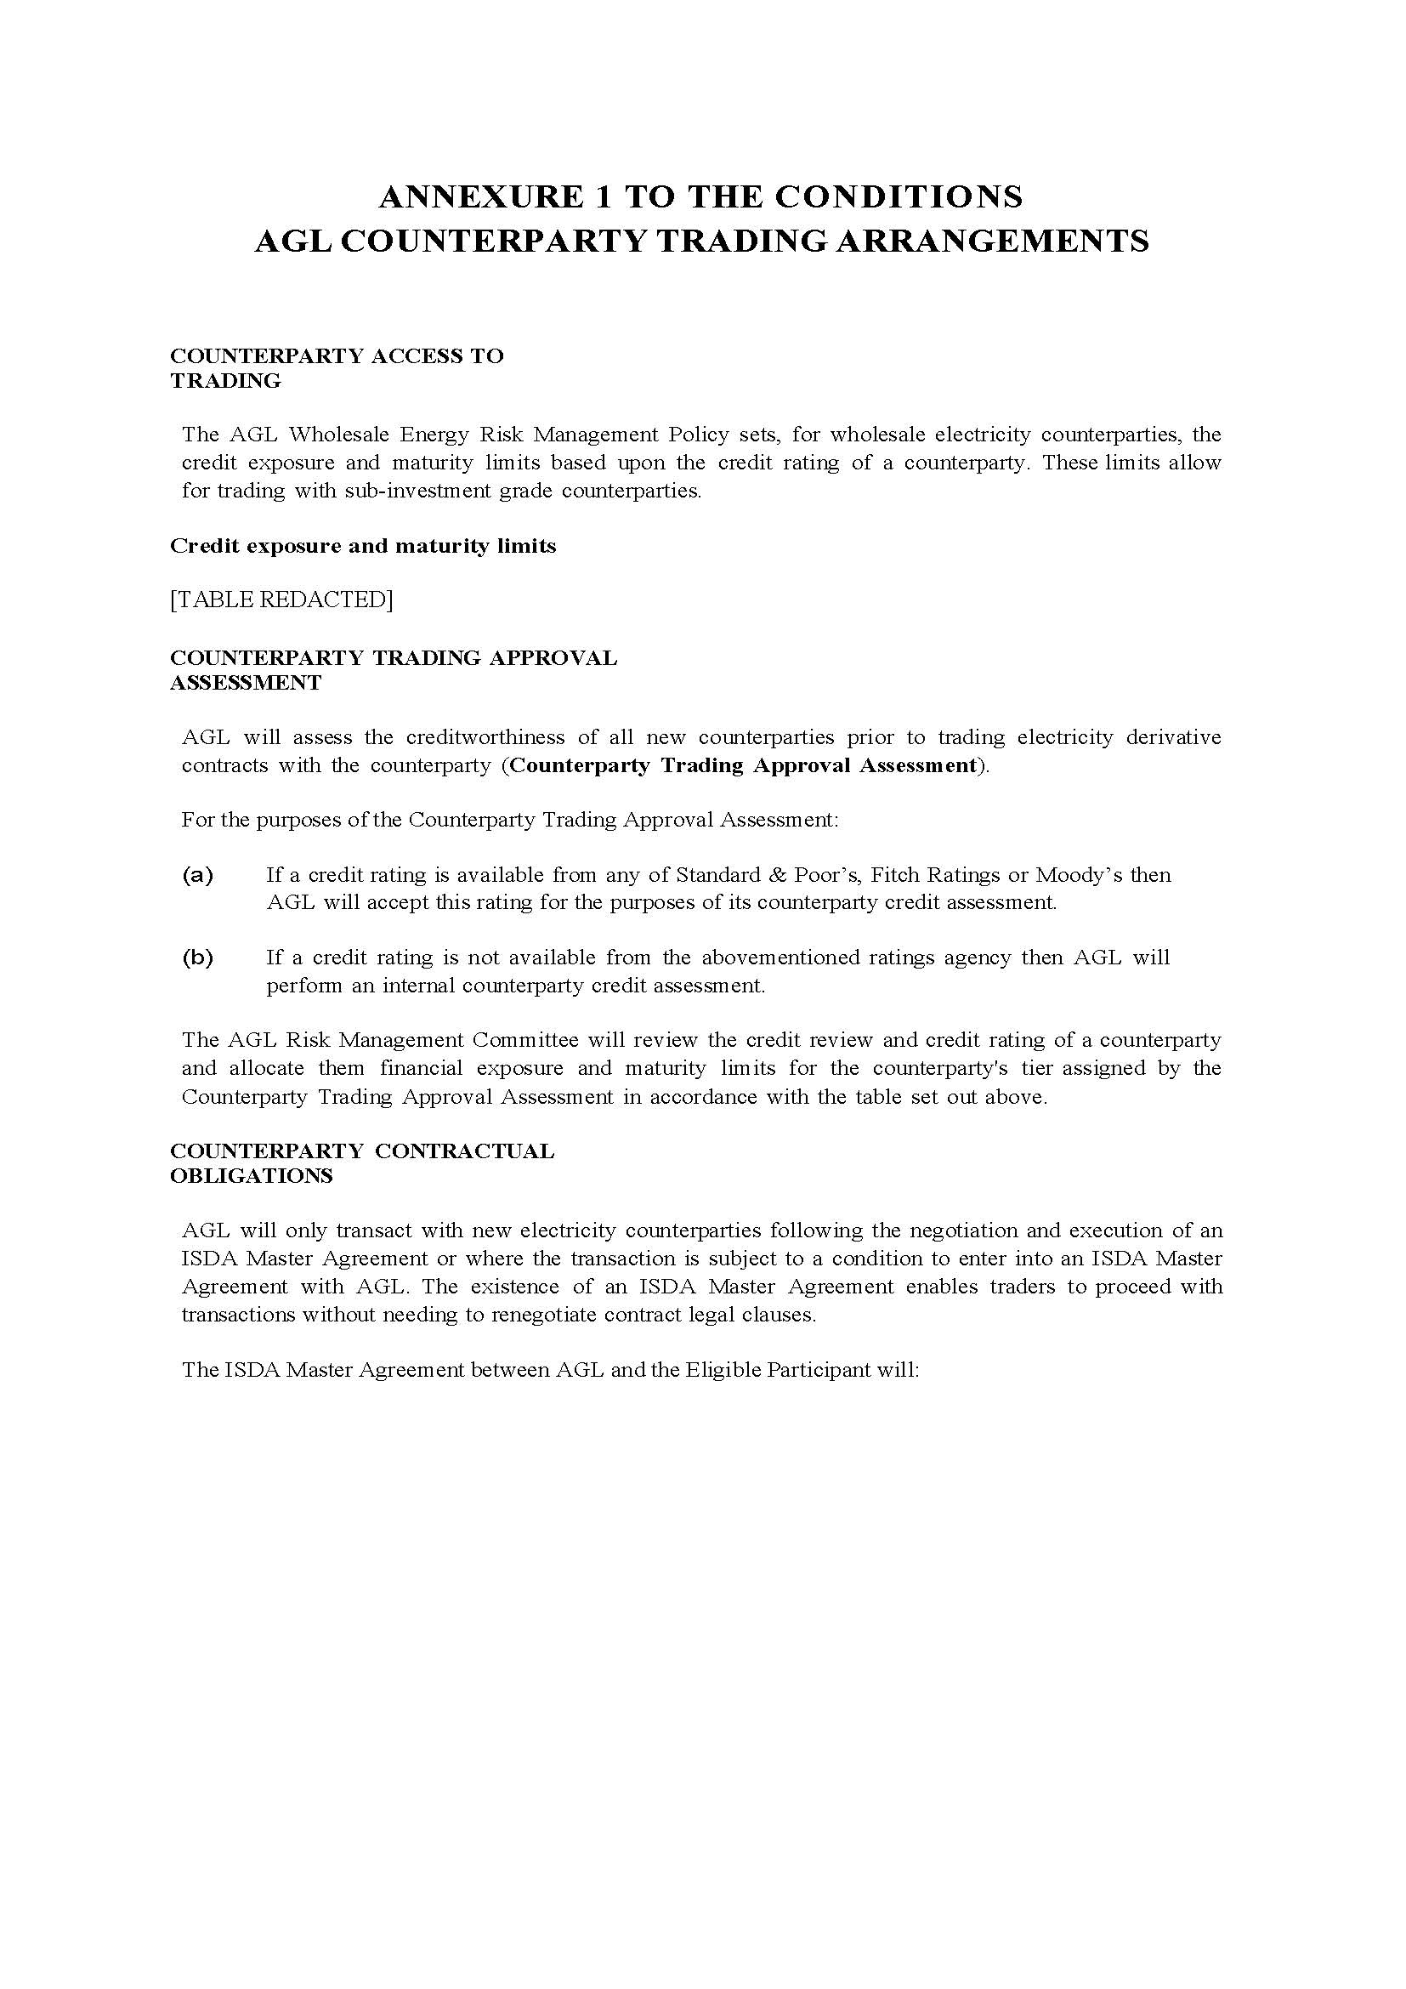
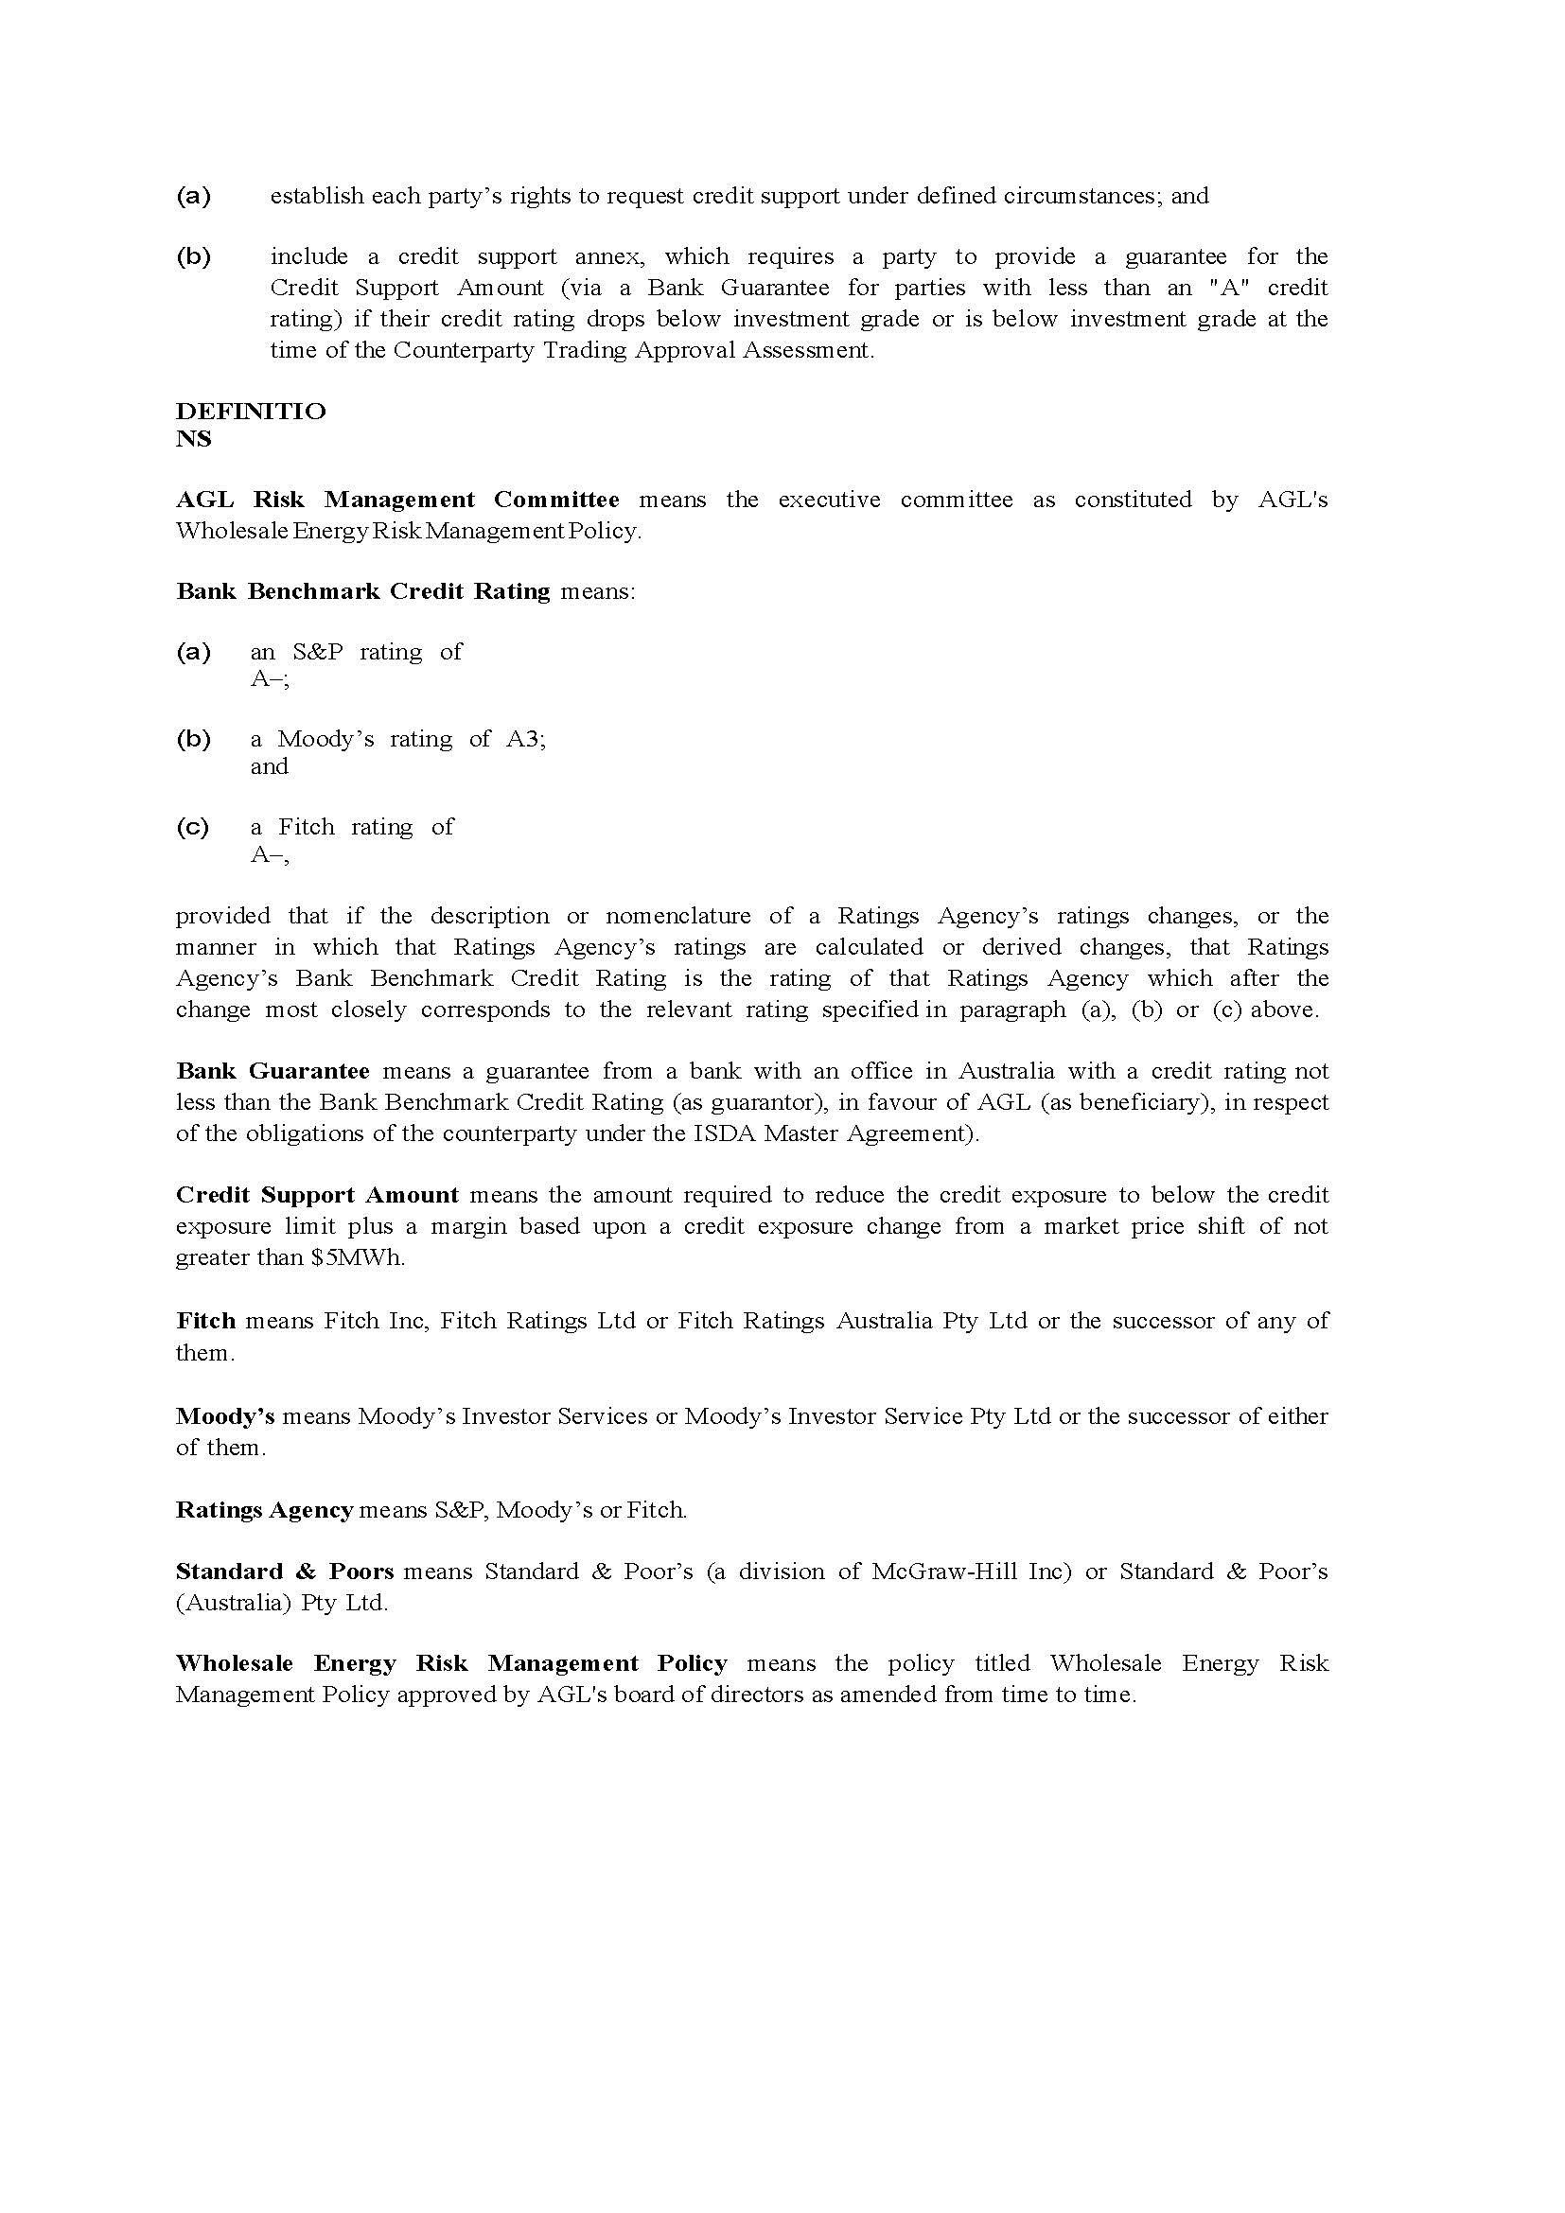

IN THE AUSTRALIAN COMPETITION TRIBUNAL
ACT 1 of 2014

re: | APPLICATION FOR AUTHORISATION OF ACQUISITION OF MACQUARIE GENERATION BY AGL ENERGY LIMITED  Applicant

TRIBUNAL: | MANSFIELD J, PRESIDENT  MR G F LATTA, MEMBER  PROF D K ROUND, MEMBER
DATE: | 25 JUNE 2014
PLACE: | ADELAIDE (VIA VIDEOLINK TO SYDNEY AND MELBOURNE)

REASONS FOR DECISION

INTRODUCTION
1 AGL Energy Limited (AGL) applied on 24 March 2014 to the Australian Competition Tribunal (the Tribunal) for an authorisation under s 95AT of the Competition and Consumer Act 2010 (Cth) (the CC Act) of the proposed acquisition by its subsidiary AGL Macquarie Pty Limited of the assets of Macquarie Generation (Proposed Acquisition). The Proposed Acquisition involves, in essence, acquisition of the Liddell and Bayswater electricity generation plants of Macquarie Generation in New South Wales (NSW). Macquarie Generation is presently wholly owned by the State of New South Wales (the State).
2 Following the lodgement of further documents by AGL, the Tribunal determined AGL’s application to be valid on 27 March 2014. It is common ground that, for the purposes of s 95AZI of the CC Act, a valid application was made on 27 March 2014.
3 The effect of an authorisation is that s 50 of the CC Act – which prohibits acquisitions of shares or assets that would have the effect, or be likely to have the effect, of substantially lessening competition in a market – will not apply to prevent the Proposed Acquisition from taking place.
4 The Tribunal may only grant the authorisation if it is satisfied in all the circumstances that the Proposed Acquisition would result, or be likely to result, in such a benefit to the public that the acquisition should be allowed to occur: s 95AZH of the CC Act.
5 In the process of considering the application, the Tribunal has had the very considerable benefit of the assistance of the Australian Competition and Consumer Commission (ACCC), as contemplated by ss 95AZEA and 95AZF of the CC Act. In particular, the ACCC Report provided under s 95AZEA is a substantial and helpful document, to which the Tribunal has had considerable regard. That assistance was provided over a relatively short period of time in order to meet the requirement under s 95AZI that the Tribunal should give its determination on the application within three months of a valid application having been made.

SUMMARY
6 The National Electricity Market (NEM) is established under the National Electricity (South Australia) Act 1996 (SA) as adopted and applied throughout the States of Australia. The Schedule to that Act is the National Electricity Law (NEL). The objective of the NEL, set out in s 7, is to promote efficient investment in, and efficient operation and use of, electricity services for the long term interests of consumers of electricity with respect to price, quality, safety, reliability and security of supply of electricity and the reliability, safety and security of the national electricity system.
7 The Australian Energy Market Operator (AEMO), established by the Council of Australian Governments (COAG), has from 1 July 2009 been responsible (amongst other things) for the NEM operations and systems as prescribed in the NEL, and in more detail in the National Electricity Rules (NER).
8 It is clear that the market for the generation and supply of electricity is a national market.
9 The NEM is centrally operated by the AEMO. All generators in the NEM submit bids to AEMO for the opportunity to supply electricity and, using the sophisticated NEM dispatch engine, AEMO determines how much electricity each generator is to supply in order to meet demand and “dispatches” the lowest cost generator first. It calculates a spot price for each region and for each 30-minute trading interval based on the average bids of the highest-priced generators dispatched to meet demand in each of six five minute intervals. It is a sophisticated process which is explained in more detail below.
10 Further, electricity flows between NEM regions via a series of transmission lines known as interconnectors. The interconnectors have the effect generally of equalising prices between NEM regions, although there are times when prices between NEM regions diverge particularly due to constraints such as capacity limitations or outages. Relevantly for present purposes, NSW has two interconnectors to Queensland and one to Victoria.
11 The Tribunal has found that the relevant retail market for electricity is a NSW one.
12 Retailers pay AEMO the spot price calculated for their region. As retail customers generally pay a flat tariff that does not reflect the spot price, one of the most important roles for retailers is to manage the risk of exposure to high spot prices. This is considered further below. Relevantly for the identification of the geographic extent of the relevant retail market, although there is usually little divergence in spot prices between regions, retail market participants tend to be regionally focused.
13 In NSW, until 30 June 2014, the retail price for electricity to domestic and small and medium enterprises (SMEs) has been regulated so that the retailers to end users have been unable to on-sell electricity to them at above that price. That price regulation is about to be removed, so that competition to acquire the supply of electricity to on-sell to SMEs and to domestic consumers in NSW from 1 July 2014 will not be constrained by price regulation.
14 Macquarie Generation, Origin Energy Limited (Origin), AGL and EnergyAustralia Holdings Limited (EnergyAustralia) are the largest generators in the NEM in terms of capacity, each holding between 10.2% and 12.6% market share. It is not common for any generator to consistently work to its full capacity and different types of generator will be used to a greater or lesser extent depending on their marginal costs of operation (since AEMO dispatches the lowest-cost generators first) and subject to any planned or unplanned outages. The top four generators in the NEM in terms of output are AGL, EnergyAustralia, GDF Suez Australian Energy Pty Ltd (GDF Suez) and Macquarie Generation, which each generated between 11.2% and 13.2% of the energy produced in the NEM in the 2013 financial year. Of the large number of other generators in the NEM, the largest in capacity terms are CS Energy, Delta Electricity, Snowy Hydro Limited (Snowy Hydro) and Stanwell Corporation (Stanwell).
15 The NEM is currently oversupplied with capacity. This has arisen from both increasing new generation capacity and declining demand. The growth in capacity has particularly arisen from increased investment in wind and solar generation encouraged by renewable energy schemes. The fall in demand has been driven by rising retail prices (commonly attributed to increasing costs of transmission infrastructure, solar subsidies and the carbon tax), the closure of energy-intensive industrial users such as aluminium smelters, and the growth in rooftop solar systems. The current oversupply of capacity is expected to continue for some years into the future.
16 The retail market for the supply of electricity in NSW is dominated by three large retailers that together supply about 96% of the retail market: AGL, with approximately a 24% market share and Origin and EnergyAustralia, which account for a further 40% and 32% respectively. Origin and EnergyAustralia are both vertically integrated in that they also hold generation assets in NSW, with 23% and 16.9% of capacity respectively. AGL presently has no generating capacity in NSW but on acquiring Macquarie Generation would hold 29.4% of NSW generation capacity and 35.9% of output. There are a number of other smaller retailers in NSW, some of who are also vertically integrated and others that do not have generation assets. The largest non-integrated generator in NSW (other than Macquarie Generation) is Delta Electricity, with 12.4% of capacity. As supply of electricity to retailers in NSW is in the NEM, there is the potential for supply from generators outside NSW where necessary to meet NSW retailer demand and subject to interconnection constraints. NSW is a net importer of electricity.
17 The ACCC has pointed out to the Tribunal that the Proposed Acquisition would mean that AGL would become a very significant “gentailer”, that is a vertically integrated generator/retailer: it would become the largest generator and remain the third largest retailer in NSW.

The Proposed Acquisition
18 AGL proposes to acquire the following assets from the State and Macquarie Generation by the Proposed Acquisition:
(1) the 2,640 megawatt (MW) coal-fired Bayswater power station located near Muswellbrook in NSW, and its related infrastructure;
(2) the 2,000 MW coal-fired Liddell power station located near Musswellbrook in NSW, and its related infrastructure;
(3) the 50 MW open cycle Hunter Valley gas turbine located near the Liddell power station;
(4) the Liddell solar farm;
(5) the development site known as the “Bayswater B generation development site” which has Concept Approval under the former Part 3A of the Environmental Planning and Assessment Act 1979 (NSW) for the development of a new (base load) power station with a maximum generating capacity of 2,000 MW powered by either pulverised coal or natural gas, located 4km west of Bayswater, Muswellbrook in NSW;
(6) the development site known as the “Tomago generation development site” for which project approval has expired, located 15 km west of Newcastle;
(7) various contracts entered into by Macquarie Generation including hedge contracts, coal supply and haulage contracts, diesel supply contracts, operations and maintenance agreements, carbon trading agreements and connection and metering services agreements;
(8) various rights, obligations and interests in Macquarie Generation’s registrations and authorisations required to operate the power stations; and
(9) Macquarie Generation’s other assets, rights and liabilities including policies of insurance, intellectual property, real property, equipment, consumables and spares.
(together, the Macquarie Assets).
19 The contracts referred to above include the electricity sale and hedge contracts entered into by Macquarie Generation with Tomago Aluminium Company Limited Pty Ltd (Tomago) on behalf of the of the participants in the Tomago joint venture.

The proceeds of sale
20 The gross sale proceeds from the Proposed Acquisition will be $1.505 billion by way of the purchase price payable by AGL, and a further $220 million by way of cash currently held by Macquarie Generation.
21 The proceeds from the Proposed Acquisition must be paid to the State into the Restart NSW Fund, subject only to specific authorised deductions from the transaction proceeds, as may be approved by the Treasurer of the State.
22 As at 30 June 2013, Macquarie Generation had total borrowings of $710.6 million. On the assumptions that:
(1) debt held by Macquarie Generation of approximately that amount will be repaid from the proceeds of the sale (as is permitted); and
(2) other permitted deductions from the proceeds of the sale will be relatively small;
approximately $1 billion will be transferred to the Restart NSW Fund upon completion of the Proposed Acquisition by AGL.

The possible detriments to competition
23 The Proposed Acquisition, if it is allowed, is suggested by the ACCC to produce significant anti-competitive effects principally because it will inhibit the capacity of other retailers to participate in the retail market, particularly smaller retailers, and partly because AGL will be in a much stronger position to seek to extend its share of the retail market because it will be a vertically integrated entity with the efficiencies that carries with it, including the “natural hedge” (explained in the following paragraph). The ACCC also suggests that AGL as a substantial gentailer will have the inducement to, and capacity to, directly influence the wholesale market for electricity in the NEM.
24 Both generators and retailers are vulnerable to significant price fluctuations or price spikes at short intervals in the wholesale market for electricity, mainly because demand fluctuates very significantly dependent upon circumstances such as severe weather events. Generators and retailers therefore adopt a “hedging” practice. That practice is particularly relevant to the retail market because retailers, dealing with their customers, are committed to supply at a particular price and on particular terms, even though they may be exposed intermittently to very much higher wholesale prices because of the erratic nature of the wholesale market. A gentailer, because it has both generating and retail capacity, has a “natural hedge” because it does not need to seek external hedge contracts to protect it from price fluctuations in the wholesale market to the extent that its generation capacity meets or balances with its share of the retail market. Where contractual hedging is required, the “hedge market” is a very sophisticated market involving long and short-term swap and cap contracts, and a range of other derivative contracts. Those hedging arrangements may be made directly between retailers and generators, or through intermediaries including on the Australian Securities Exchange (ASX); there are other entities which participate in ASX trades of those derivatives simply as investors or speculators, both physical and financial. The evidence is that the hedge or derivative trades represent over five times the total generating output for any given period of time.
25 Because AGL after the acquisition would have a natural hedge to the extent of its present retail share, it is apparent that its presently significant demand for hedge contracts (to protect itself as a retailer against wholesale price fluctuations) will be greatly reduced, at least to the extent that it will have a natural hedge. The ACCC has pointed out to the Tribunal that, by that significant reduction, the volume of hedge contracts that may be available for trading in NSW will be significantly reduced, because Macquarie Generation will not be hedging its generating capacity to the same extent because of the natural hedge with the AGL retail market share. The ACCC has suggested that, as other retailers will no longer be able to acquire the hedge contracts they previously acquired from Macquarie Generation either at all or at a sufficiently low price (due to the available hedge contracts being in short supply). small retailers in particular will be unable to compete effectively in the retail market. In addition, because AGL would gain the benefit of the natural hedge, as well as the efficiencies of vertical integration, the ACCC points out that AGL will be able to participate in the retail market more vigorously and again potentially to the detriment of small retailers.
26 The Tribunal has very carefully considered the material on that topic, and has reached the view that, at present (that is pre-acquisition) the “market” for hedge contracts available to retailers in NSW is not a tight one and is not therefore constrained. Whilst it accepts that the number of small retailers in NSW is significantly less than that in Victoria (where in broad terms a not dissimilar wholesale market structure exists, albeit with some different generating firms), the probable cause of that relatively lower participation of smaller retailers is, in part, the consequence of retail price regulation. The Tribunal also accepts that the consequence of retail price regulation may have been to limit the “head room” between the retail price (the regulated price) and all the costs incurred by second tier retailers in servicing their customers. While the Tribunal appreciates that the price of acquiring hedges is a significant component of retail cost, it is of the view that the lower market penetration achieved to date by second tier retailers in NSW compared with Victoria is not caused by a tight market for hedges in NSW.
27 The Tribunal has also reached the view that, post the Proposed Acquisition, retailers of electricity in NSW, including small retailers, will still have available a significant competitive “market” in NSW for the acquisition of hedge contracts.
28 The Tribunal has used the word “market” where it first appears in the preceding paragraph in parenthesis because neither AGL nor the ACCC have suggested that there is a need to consider a separate market for hedge contracts. Rather, hedge contracts are a feature of the separate markets for wholesale and retail supply and sale of electricity, used to protect the participants in those markets from significant price variations in the wholesale market. However, it is a convenient term to use to describe the extent to which hedge contracts are, and will be, available to the participants in the two markets. It is not used hereafter in a technical sense or as a term of art.
29 The reasons for those conclusions are set out in the Tribunal’s detailed reasons.
30 The consequence is that the Tribunal has reached the view that Proposed Acquisition is not likely to result in a significant detriment to the ability of retailers, including small retailers, to compete in the retail market for the supply of electricity in NSW. In addition, it has taken into account that post acquisition there will be three (four, if Snowy Hydro is included) gentailers competing for a share of the business of selling electricity to end users. Their rivalry will produce a vigorous competitive market.
31 Indeed, the Tribunal is satisfied that the risk identified by the ACCC is unlikely to occur. In reaching that view, the Tribunal has accepted the conditions proposed by AGL that it would continue to make available not less than 500 MW of hedge contracts per year to small retailers for a period of seven years. The availability of the conditions has not been critical to the Tribunal’s view, but has been accepted as providing a further additional comfort to address the concerns expressed by some smaller retailers and their representatives.
32 The Tribunal has also considered a range of “without” scenarios. The above comments reflect the Tribunal’s view of the likely future “with” the Proposed Acquisition. First, as AGL says, the State could simply retain and maintain Macquarie Generation as a generating entity from now and for the medium to long term. Second, as the Tribunal considers somewhat more likely, the State would, within two to five years (the medium term), sell or endeavour to sell the Macquarie Assets, either to a pure generator (preserving the structure of the electricity wholesale and retail markets as they now exist), or to a small or large existing retailer, or to a new retailer entering the retail market. The Tribunal is satisfied that none of the “without” scenarios would in any significant way affect the its assessment of any detriments to competition which may arise from the acquisition because none of the “without” cases would cause small retailers to be significantly assisted or impeded in competing in the NSW retail electricity market, compared to the future with the Proposed Acquisition.
33 More generally, whilst it is clear that the Proposed Acquisition, if it proceeds, will result in a not insignificant change in the input supply conditions faced by sellers in the retail market for the supply of electricity in NSW, the Tribunal is satisfied that structural change will not result in material detriment to the public by reason of a lessening of competition in the retail market for the supply of electricity in NSW.
34 The Tribunal has also considered whether AGL will, if the Proposed Acquisition occurs, be in a position to, and have the incentive to, “spike” the spot price or otherwise cause volatility in the wholesale market for electricity in the NEM to the detriment of the public interest. There is some evidence that AGL engaged, or attempted to engage, in such conduct in South Australia (SA) in 2008 to 2010 (when the interconnector function was, on the evidence, less effective and reliable and supply and demand conditions were tighter than at present). The Tribunal is satisfied that there is no real risk of AGL being able to engage in such conduct in NSW or elsewhere in the NEM. It does not find that the Proposed Acquisition will put AGL in a position to exert significant market power in the NEM (or in NSW as a region of the NEM) to spike the spot price or to cause volatility in the wholesale market.

The possible public benefits
35 The public benefits are said by AGL broadly to be in three categories:
(1) the benefits to the State and to the public of NSW of being able to dispose of the Macquarie Assets at a price which reflects their retention value, providing the State immediately with about $1 billion. The proceeds would be put into the Restart NSW Fund established by the Restart NSW Fund Act 2011 (NSW), which dictates its use for the funding of infrastructure improvements for NSW. The State would also be relieved of operating, at least in the short to medium term (or indefinitely as AGL would have it), the Macquarie Assets, which have a limited life and an increasing level of inefficiency and vulnerability to break down. The disposal of the Macquarie Assets would be in circumstances where the State has determined, on the basis of a series of reports extending back to the Owen Inquiry in 2007, that it is in the interests of NSW to do so.
(2) the investment by AGL of $345 million in the efficient operation of the Macquarie Assets, so as to increase their capacity and longevity, and in turn to generate more and cheaper electricity to the wholesale market;
(3) the public benefits arising from AGL being able to operate the Macquarie Assets more efficiently, and to invest significantly in their upgrading to ensure they operate more efficiently and effectively in the medium to longer term. This is said to enable AGL to be better able to compete in the retail market. The interests of ultimate consumers of electricity in NSW, it is said, would be better served by such competition and by the assurance of the longer term more secured life of the Macquarie Assets.
36 The ACCC has pointed out to the Tribunal that those benefits might be obtained whether the acquirer of the Macquarie Assets is AGL or some other entity which may not be a substantial existing retailer and so may not have such a large capacity to benefit from the natural hedge and other efficiencies which would follow the Proposed Acquisition. The Tribunal has carefully considered that contention. It has reached the view that there is no other potential acquirer which would be in a position to acquire the Macquarie Assets in the short term, and, in the short to medium term, there is no other acquirer that would be able to acquire those assets at a price which is reasonably commensurate with the price that AGL has offered. The Tribunal has considered the “without” possibilities referred to above and concluded that the State is unlikely to retain the Macquarie Assets indefinitely, so that, in the future without the Proposed Acquisition, the more likely scenario is that the State would retain and continue to operate the Macquarie Assets but with a view to disposing of them within a few years. The Tribunal accepts that other entities may then seek to acquire those assets, but, being deteriorating assets (particularly without significant expenditure being made on them), they are likely to be worth less than at present. There is evidence upon which the Tribunal finds that AGL, because of particular techniques which it has available to it, is likely to be able to make the Macquarie Assets operate more efficiently than other potential bidders would be able to do. The Tribunal has also had regard to the bidding process adopted by the State and its outcome. It has also had regard to the prospect that another bidder or bidders in the next few years may well include those with a not insignificant retail market share in NSW.
37 Having regard to these matters, the Tribunal is satisfied that there are significant benefits to the public of the character referred to in (1) and (2) of [35] above that are likely to follow from the Proposed Acquisition. The Tribunal’s more detailed reasons for its conclusions are set out later in its determination.
38 While the Tribunal has considered AGL’s claims as to the benefits to the public arising from the efficiencies in the Proposed Acquisition itself, it has not needed to decide them, except in relation to the amount another bidder may be prepared to pay for the Macquarie Assets, having regard to AGL’s ability, with particular techniques, to operate the Macquarie Assets more efficiently and to extend the life of the assets.

Conclusion
39 The Tribunal is satisfied that after the Proposed Acquisition there will be active competition in the NSW retail market, including by small retailers that will have a substantial and adequate hedge market available to them. It anticipates that the retail market will evolve in a similar way as the Victorian market has evolved in an environment where the retail price is not regulated, with an increased number of small retailers and a greater capacity to distinguish offerings to retail and SME end users by price, service and product differentiation. That has been the experience in Victoria where, it is said, the retail market is one of the most competitive retail markets for electricity of those countries where comparisons may fairly be made.
40 It also observes that, post acquisition, there will be three large gentailers (AGL, Origin and EnergyAustralia), and a number of smaller retailers including some with generating capacity who will be participants in the NSW retail market for the supply of electricity and with opportunities for new entrant retailers to participate. If AGL is to materially increase its market share, it must of necessity do so in a competitive way, which would involve it taking market share from the other gentailers. At a general level, such competition should produce a benefit to the public. It may well be, as has occurred in Victoria, that other smaller retailers will also participate in the market and acquire a more significant share of the market through competition against the large gentailers. It notes, for instance, that, after acquiring the Loy Yang A power station and thus a significant natural hedge in Victoria, AGL has lost market share to small retailers. However, the public benefit claimed by AGL under (1) of [35] above is sufficient on its own to warrant the grant of the authorisation sought.
41 As the Tribunal is satisfied that the Proposed Acquisition is likely to result in substantial public benefits and that the public detriments identified by the ACCC are unlikely to arise, the Tribunal is satisfied in all the circumstances that the Proposed Acquisition would result, or would be likely to result, in such a benefit to the public that the acquisition should be allowed to occur.
42 Accordingly, the Tribunal has determined to grant the authorisation AGL seeks for the Proposed Acquisition.

BACKGROUND

AGL
43 AGL is a company listed on the ASX. Its issued capital consists of 558,385,153 fully-paid ordinary shares. It has three shareholders with greater than 5% shareholding: HSBC Custody Nominees (Australia) Limited (14.94%), JP Morgan Nominees Australia Limited (14.41%) and National Nominees Limited (10.45%).
44 AGL produces and supplies gas and electricity for sale in wholesale and retail markets. It variously operates electricity generation and gas production assets and, in NSW, Victoria, Queensland and SA, operates electricity and gas retail businesses.
45 AGL also has coal seam methane production and exploration interests in NSW and Queensland.
46 AGL’s business has 3 main divisions:
(1) The Merchant Energy division manages AGL’s relationships with its large commercial and industrial customers and develops, operates and maintains AGL’s power generation assets, develops the company’s carbon strategy, and manages the risks related to buying and delivering gas and electricity for AGL’s wholesale and retail customer portfolio. There are four groups within Merchant Energy:
(a) Merchant Operations is responsible for operation and maintenance of AGL’s wind and water powered and gas fired and coal fired generation plants, as well as the coal mine associated with the Loy Yang A power station in Victoria;
(b) Energy Portfolio Management manages the risks associated with procuring gas, electricity and environmental market certificates, administers AGL’s hedge contract portfolio and bids AGL’s electricity generation into the NEM);
(c) Business Customers manages AGL’s business customer accounts; and
(d) Power Development develops wind and solar generation assets.
(2) The Retail Energy division sells and markets natural gas, electricity and energy-related products and services to over 3.8 million residential and small business customer accounts in NSW, Victoria, SA and Queensland. AGL has Australia’s largest retail energy and dual fuel customer base: as at 31 December 2013, it had 2,344,942 retail customers throughout the NEM, 812,883 of whom were in NSW. There are four business units within Retail Energy:
(a) Marketing & Retail Sales develops and implements AGL’s strategic sales and marketing objectives across residential and small to medium enterprise (SME) customers;
(b) Retail Operations is responsible for customer service and back office operations including billing, sales fulfilment, credit management and revenue assurance;
(c) Customer Experience & Digital, which delivers AGL’s customer experience and digital strategy; and
(d) Retail Business Architecture, which works with information technology to design and implement processes and systems for delivery of retail strategies;
(3) The Upstream Gas division invests in and operates gas exploration, development and production tenements and develops and operates gas storage facilities. It manages AGL’s upstream gas assets in Queensland and NSW.
47 AGL says that it does not have a specific volume cut-off to distinguish which customers will be supplied by Retail Energy and which by Merchant Energy. However, it says that, in the electricity industry, residential and SME customers are considered to be those that consume up to 160MWh per year and larger industrial and commercial customers are those whose annual electricity consumption exceeds 160MWh per year.

Macquarie Generation
48 Macquarie Generation is a State-owned corporation established under the Energy Services Corporations Act 1995 (NSW) (ESC Act) and the State Owned Corporations Act 1989 (NSW) (SOC Act). It is administered by the State Minister for Resources and Energy. Section 20H of the SOC Act provides that there must be two voting shareholders in a State owned corporation: the Treasurer and another Minister for the time being nominated by the Premier (the Premier can be nominated as a voting shareholder). There is no issue about its relevant decisions being properly made.
49 Macquarie Generation is one of three electricity generators within the meaning in s 3 of the ESC Act (the other two being Delta Electricity and Eraring Energy). Section 6(2) of the ESC Act provides that the principal functions of electricity generators are:
(a) to establish, maintain and operate facilities for the generation of electricity and other forms of energy, and

(b) to supply electricity and other forms of energy to other persons and bodies.

50 An electricity generator may also provide facilities or services that are ancillary or incidental to its principal functions, and may conduct any business (whether or not related to its principal functions) that it considers will further its objectives (ESC Act, s 6(3)).
51 Macquarie Generation’s principal assets include:
(1) the 2,640 megawatt (MW) black-coal fired baseload generation Bayswater power station (Bayswater), which comprises four 660 MW units commissioned between 1985 and 1986. Bayswater is located approximately 16 km south-east of Muswellbrook. Since FY2004, Bayswater has generated between 14,595 gigawatt hours (GWh) and 17,776 GWh of electricity each year;
(2) the 2,000 MW black-coal fired baseload and shoulder generation Liddell power station (Liddell). The Liddell power station comprises four 500 MW units, commissioned between 1971 and 1973. Liddell is situated adjacent to Lake Liddell, and next to Bayswater. Generation by the Liddell power station is closely linked with Macquarie Generation’s hedging contracts concerning electricity supplied to the Tomago aluminium smelter (Tomago Hedge Contracts);
(3) the Hunter Valley Gas Turbines (Hunter Valley Gas Turbines), which have a capacity of 50 MW;
(4) the development site for an ultra super-critical coal fired or closed cycle gas turbine Bayswater B power station (Bayswater B Development); and
(5) the development site for an open or closed cycle gas turbine Tomago power station (Tomago Development).
52 In 2013, the Bayswater and Liddell power stations represented 10.2% of total electricity generation capacity registered in the NEM, and 12% of total electricity output in the NEM.

ELECTRICITY SUPPLY IN AUSTRALIA
53 The following description of the supply of electricity in the NEM has been largely taken from the Frontier Economics General Industry Report, an expert report that was prepared for and provided to the Tribunal by AGL. The General Industry Report was not contentious and was referred to by both AGL and the ACCC in submissions.
54 The supply of electricity involves generation, transmission, distribution and retail supply. Generation is the production of electrical energy from other energy sources such as coal, gas, wind, the sun or water flow. Transmission is the long distance transport of high voltage electrical energy. Distribution is the transport of electrical energy from transmission networks to customers needing power at low or medium voltages. Retailers manage relationships with end customers, including the issuing of bills for power consumption.

Generators
55 Electricity supplied through the NEM is generated in a number of ways: thermal plants, which burn fuel, such as coal, gas or oil, to heat water and create steam that drives a turbine; gas turbines, in which the turbine is driven by the combustion of fuel; wind turbines and hydroelectric plants, in which the turbine is driven by the wind or water; and solar photo-voltaic (PV) cells.
56 Generators generally fall into one of three categories:
(a) Base load generators, which, due to their typically high sunk costs and relatively low variable costs, are most efficient to run continuously at near maximum output, although output can be reduced to a certain minimum level. Coal-fired power stations such as Bayswater and Liddell are base load generators.
(b) Intermediate or peaking generators have higher variable costs than base load generators and typically minimise their generation when the wholesale electricity price is below the generator’s marginal cost of generation. Gas-fired power stations, such as Delta Electricity’s Colongra power station and Snowy Hydro’s Laverton North power station are examples of this type of generator.
(c) Intermittent generators are those whose output is not readily predictable. This includes solar generators (which depend on sunlight), wind turbine generators (which require the wind to blow) and hydroelectric generators (which are dependent on water availability).
57 Generators in the NEM will also be “scheduled”, “semi-scheduled” or “non-scheduled”. Most large generators in the NEM are scheduled generators. This means that the generator is centrally dispatched by the AEMO. A semi-scheduled generator will have its output regulated by AEMO only at certain times. This generally refers to generators with greater than 30MW capacity but which are intermittent. A non-scheduled generator is not dispatched by AEMO. Generally, smaller generators (less than 30MW capacity), whose output is committed to a particular customer are non-scheduled.

Wholesale supply
58 Wholesale electricity supply in Tasmania, SA, Victoria, NSW and Queensland occurs through the NEM. The five regions of the NEM (each of which currently corresponds to a state) are connected by six interconnectors.
59 The electricity supply industry and the structure and operation of the NEM are formidable topics for the uninitiated. The complexity arises from the nature of electricity itself:
(1) Electricity cannot be stored (except in a very limited way) and its technical characteristics (such as voltage and frequency) mean that supply and demand must be matched at all times to avoid the power system becoming unstable.
(2) Electricity is homogeneous in that, within a network of generators and consumers, it is not possible to determine which generator produced the energy consumed by any customer.
(3) Demand for electricity is highly inelastic, which means that electricity demand is unresponsive to changes in price, especially in the short term. Electricity demand tends to be driven by other factors. For example, daytime electricity demand tends to be significantly higher than overnight demand, and demand increases in hot weather (as people switch on their airconditioners) and in cold weather (when people use more heating).
(4) Electricity supply infrastructure, particularly transmission and distribution networks, exhibits strong natural monopoly characteristics, which means that it may be most efficient for there to be a single provider. For this reason, in most cases, electricity transmission and distribution systems are subject to regulation.
60 The NEM is a “compulsory gross pool”, which means that all power (unless exempted) must be traded through the centralised spot market and all traded power is settled at spot prices. The compulsory gross pool can be compared to the net pool model, in which producers and consumers can enter bilateral contracts for electricity supply and only uncontracted power flows are settled through the market.
61 The NEM is energy-only, which means that generators are paid for energy produced, not capacity. In a “capacity market”, generators receive some compensation for capacity, or the energy they will produce at some point in future. In an energy-only market, generators recover both variable operating costs and fixed capital costs through wholesale spot prices or derivatives settled against spot prices. The spot price must at times rise above the operating cost of the plant that has the highest operating costs in the market to enable that plant to recover its fixed costs.
62 The NEM spot market is managed by AEMO. Generators submit offers to AEMO to supply the market with specific amounts of electricity at particular prices. Offers are submitted every five minutes and AEMO determines how much electricity is to be “sent out” by each generating unit in order to meet demand. The least cost generator is dispatched first and the last generating unit dispatched is the marginal unit and its offer price becomes the clearing price for the whole market.
63 Generators are required to provide AEMO with offers by 12.30 pm Australian Eastern Standard Time (AEST) each day for each half-hour “trading interval” for the following trading day, commencing at 4.00 am AEST. Generators must provide ten choices of prices, known as price “bands”, with subsequent price bands being no lower than the previous band. A “bid stack” consists of the ten escalating price bands, with a specified quantum of electricity offered at each band level. There must be at least one negative price band because, if there is more generation offered at a zero price than is required to meet demand, it may be more economical for some generators to pay (ie receive a negative price) not to be switched off by AEMO than to incur the delay and cost in switching off and on.
64 Once final bids have been submitted, the prices offered in each band cannot be changed and these prices apply over the trading day. However, generators can change or “rebid” how much (in MW) they are willing to supply at each price band and in each trading interval. Rebidding allows generators to manage the risk of not being able to meet the quantities previously promised, such as might occur where there has been a plant failure. Rebidding may also provide a means for generators to attempt to stimulate higher spot prices, which may be profitable, but it is at the risk of that generator not being dispatched by AEMO.
65 While generators are dispatched to minimise the aggregate cost of supply to all loads at all locations across the NEM, prices are determined at specific locations within each of the five NEM regions. Those locations are referred to as “regional reference nodes” (RRN) and the price determined at each RRN is referred to as the “regional reference price” (RRP). The RRP reflects the marginal value or cost of electricity at the RRN and is the price at which electricity sales and purchases for all generators and wholesale customers within that region are settled for the relevant trading interval.
66 Annual average prices in each NEM region since 2012 have ranged from $42.21/MWh to $69.75/MWh but spot electricity prices can be very volatile. The volatility arises because supply and demand in the NEM must be kept in balance at all times. This is a function of the nature of electricity, as it cannot, except to a very limited extent, be stored and the need for voltage and frequency to be kept within narrow ranges in order to maintain system security. The possibility that, where demand outstrips supply, there will be no price at which the market will clear is addressed by the imposition of a market price cap (MPC). The Australian Energy Market Commission (AEMC) calculates the MPC using a formula set out in Rule 3.9.4 of the NER and publishes by 28 February each year the MPC for the following financial year. For the financial year 2013-2014, the MPC was $13,100/MWh and for 2014-2015 it will be $13,500/MWh. The market floor price is set by Rule 3.9.6 at minus $1,000/MWh.
67 Although pricing and settlement is determined regionally (at the RRN), electricity does flow between regions through high voltage transmission lines known as interconnectors. Interconnectors allow generators in one region to supply customers in another, thereby increasing the effective supply of power in the “importing” region and meeting the effective demand in that region. In this way, interconnector power flows can help equalise demand and supply conditions across the NEM.
68 Further, when there are no power system constraints across the NEM, all RRPs in the market will be the same, when the value of electrical losses incurred through the transportation of electricity from one location to another is allowed for. This is because, in the absence of constraints, the marginal cost of meeting an increment of electricity demand at any location in the NEM will be the same (again, allowing for losses). This means that, without any binding constraints, any generator in the NEM could be dispatched to meet an increase in demand anywhere in the 5,000 km-long power system. However, if there are transmission constraints, different regions’ RRPs will diverge, reflecting the fact that the marginal cost of meeting an increase in demand in different regions will vary.

Electricity retailing
69 Retailers purchase electricity through the wholesale exchange operated by AEMO and arrange and pay for the provision of network services required to convey power to the premises of their customers. Retail electricity is a homogeneous physical product, so retailers differentiate and compete on price and ancillary services.
70 Until recently, electricity retailers in all NEM regions other than Victoria were subject to regulation in respect of residential and SME customers. Regulated retail tariffs in these jurisdictions were set by jurisdictional regulators taking account of the level of network tariffs, estimates of energy purchase costs and deemed efficient retail costs and margins. In NSW, the Independent Pricing and Regulatory Tribunal presently sets maximum retail tariffs for customers consuming up to 100 MWh per annum and who are not already on market contracts. However, retail electricity prices will be deregulated in NSW from 1 July 2014. Retail prices were deregulated in SA from 1 February 2013 and the Queensland Minister for Energy and Water Supply has announced an intention to remove retail price regulation in southeast Queensland by 1 July 2015.
71 Retailers generally offer flat tariffs (in c/kWh) that do not vary with prevailing market demand-supply conditions. Retail price variations will bear no relationship to short term fluctuations in wholesale spot prices. Therefore, while most retailers are paid a flat rate per kWh consumed by the customer, the prices they pay for wholesale electricity can vary dramatically on a half-hourly basis (theoretically between minus $1,000 and $13,500 in a single trading interval). A key task for retailers is therefore to manage financial risk.

Risk management
72 The volatility of spot prices in the NEM gives rise to a number of risks for generators and retailers. For present purposes the main risks are:
(1) Volume risk – Generators and retailers do not know in advance how much electricity they have available to sell or need to buy, respectively, in the future. For generators, volume uncertainty arises because the nature of generating plant is such that its operating reliability is less than 100%, so generators tend not to enter binding commitments to sell their entire potential output. While retailers may have some warning of circumstances that may increase demand, such as very hot or cold weather, they will not know the exact level of wholesale electricity they will be required to purchase on any day.
(2) Price risk – Generators are exposed to uncertainty about the price they will be paid for the electricity they produce and retailers are exposed to uncertainty about the price they will have to pay for the electricity they need to purchase to supply their customers. Generators produce electricity for which they are paid the applicable wholesale spot price, so are naturally “long” electricity because they gain if the spot price rises. Retailers purchase electricity for which they must pay the applicable wholesale spot price if their supply is not fully hedged, so retailers (and large customers) are naturally “short” electricity because they gain if the spot price falls.
73 The key ways of managing price risk for NEM participants are vertical integration of generation and retailing activities or the sale or purchase of financial derivative (hedge) contracts.

Vertical integration
74 Vertical integration can be achieved by:
(1) acquisition of existing generation or retail assets – commonly through a merger or government sales process;
(2) developing new generation or retail assets or activities; or
(3) acquisition of rights to the outputs or cashflows of generation or retail activities, such as through a power purchase agreement (PPA) between a retailer and generator, which entitles the buyer to either the physical power supply or the spot market proceeds from the electricity output of the subject generating plant.
75 Vertical integration between a generator and a retailer is often referred to as a “natural hedge” since a retailer’s exposure to high spot prices is offset by the generator’s naturally long position and the generator’s exposure to low spot prices is offset by the retailer’s naturally short position. The risk of the generator to the extent that its capacity equals its retail demand is approximately set off by the risk of the retailer to the extent that its generation capacity equals that demand, so the need for external hedge contracts to cover the risk to that extent is more or less abated.
76 The Tribunal notes the caution urged upon it by AGL in giving meaning to the phrase natural hedge. The use of the phrase in these reasons does not indicate that the Tribunal regards a natural hedge as necessarily being a precise or perfect hedge. Rather, it is used for the sake of simplicity and as a reflection of industry convention, including use of the phrase by AGL itself.

Contractual hedging
77 The two main forms of derivative contract utilised in the NEM are swaps and caps. Options written on these two contracts (swaptions and captions) are also fairly common. More exotic contracts (such as collars and other options) are also available.
78 Swap contracts are broadly defined as a series of financial forward contracts between two parties, whereby one stream of cash flows is “swapped” for another stream of cash flows at regular intervals over the term of the contract. Typically, they involve the swapping of a variable stream of cash flows based on (variable) spot prices with a fixed stream of cash flows based on an agreed strike price. Given that swaps are a form of forward contract, each party to the swap has an obligation to exchange the agreed cash flows on the settlement date.
79 A typical swap contract requires the seller (most often a generator) to pay the buyer (most often a retailer or large industrial customer) the difference between the spot price, which is variable, and a fixed contract strike price. This value is positive when the spot price is greater than the strike price, and negative when the spot price is less than the strike price. Under such an agreement, both the retailer and generator have certainty regarding the ultimate net price they will either pay or receive per unit of energy covered by the contract.
80 By way of illustration, during half-hours when the spot price is above the strike price of the swap the seller of the swap makes difference payments to the buyer. During half-hours when the spot price is below the strike price the seller receives difference payments from the buyer. The swap contract results in a fixed price (the strike price) for both the seller and buyer for a given level of coverage (determined by the size of the contract).
81 Swap contracts thereby allow parties exposed to the spot price to reduce cash flow uncertainty by effectively “locking in” the fixed strike price, which is based on an expectation of future spot prices. Most swap contracts trade at a modest premium to spot prices. This positive premium indicates that participants in the contract markets face asymmetric risk: there is greater potential for spot prices to rise well above contract strike prices than there is for prices to fall well below strike prices.
82 A cap contract is a “one-sided” swap contract which involves the buyer (usually a retailer or large industrial customer) receiving difference payments from the seller (usually a generator) when the spot price exceeds a certain level (the cap strike price). At all other times no difference payments are made. The difference payments made to the buyer are equal to the difference between the spot price and the cap strike price. To acquire this protection the buyer of the cap pays the seller a fixed cap premium in every half-hour of the contract. Cap contracts are typically utilised by electricity retailers to hedge infrequent but extremely costly spot price spikes.
83 Options contracts covering both swaps (swaptions) and caps (captions) give the buyer the right, but not obligation, to enter either a swap or cap as either a buyer or seller on a future date at a pre-determined strike price. To acquire this option, the buyer pays the seller an option premium for every half-hour covered by the underlying swap or cap contract. At the expiration of the option the buyer chooses whether to exercise the option or not. If the buyer chooses to exercise, then the buyer and seller become counterparties in the underlying swap or cap contract. If the buyer chooses not exercise, then the underlying swap or cap contract lapses.
84 An “Asian option” is an option where payment is calculated based on the difference between the strike price and the average spot price over an agreed period.
85 Derivative contracts are purely financial arrangements and are not subject to any physical constraints. As a result, they can be structured in many different ways to meet the risk management requirements of market participants. Examples of structured contracts include “shaped” or “load following” swaps or caps.
86 Under a standard swap, the parties agree on a strike price for a specified volume of electricity over a defined period. A shaped contract allows a retailer to tailor the swap so that the agreed volumes vary at different times of the day to reflect the shape of its exposure, for example the forecast customer demand. A load following swap is even more tailored to the retailer’s customers’ demand and will follow the actual usage of the retailer’s customers over the agreed period. These types of contracts allow the retailer to better manage volume risk, as well as price risk, but are generally more expensive than “vanilla” hedges.
87 Other exotic instruments, such as “weather derivatives” also exist and have been used in the NEM. An example of a weather derivative is a contract that is settled against a particular weather index, such as heating/cool degree days, maximum/minimum temperatures or precipitation over a period of time.
88 Derivative contracts in the NEM are of two main types: over-the-counter (OTC) instruments and exchange-traded futures (ETF) contracts.
89 OTC contracts involve customised bilateral commitments between two parties (generally retailers and generators), either directly or through a broker. OTC instruments tend to be customised to suit the needs of the two contracting parties and are non-transparent since they are negotiated and settled in private. In an OTC arrangement, the parties face the risk of credit default by the counterparty.
90 ETF contracts involve standardised contracts that are bought and sold through a securities exchange. In Australia, ETF electricity contracts were designed and developed by d-cyphaTrade and are sold through the ASX. ETF contracts tend to be highly standardised and transparent and are publicly reported. Due to the presence of a financial intermediary (clearing house) between contracting parties, ETF contracts are not subject to credit default risk.

Basis risk
91 An additional form of risk arises for NEM participants who seek to enter derivative contracts with counterparties located in different NEM regions in that prices between regions can and do diverge. This is referred to as “basis risk”. It is the risk that the price of a commodity bought or sold in the physical market moves differently to the hedge price of that commodity.
92 Standard derivative contracts can be used for hedging spot price volatility when all counter-parties are settled at the same RRP at which the relevant contract is settled. However, participants can be subject to basis risk in the NEM when they have entered into financial contracts with participants located in another region and transmission limits that restrict flows on interconnectors between those regions bind, causing the relevant RRPs to diverge.
93 Participants in the NEM can manage basis risk, at least to some extent, by acquiring inter-regional settlement residue (IRSR) units. Given that electricity usually flows from regions where the RRP is lower to regions with higher RRPs, a residue will accrue from the difference between the price paid to a generator in an exporting region and the price paid for electricity by retailers in an importing region. IRSR units provide their holder with a stream of payments that is based on the flow on a particular interconnector multiplied by the price difference between the relevant RRPs, with payments funded by the NEM settlements process. IRSR units are made available to participants through quarterly settlement residue auctions run by AEMO and can be used to hedge inter-regional price differences.
94 IRSR units do not always provide a reliable or “firm” hedge against divergences in RRPs. Where, for any of a variety of reasons, the flow on an interconnector is constrained, despite the fact that the relevant RRPs have separated, insufficient electricity can flow between regions to fully respond to the separation in RRPs. Participants sometimes respond to this risk by acquiring a greater quantity of IRSR units than their inter-regional exposure, or by discounting the face value of IRSRs to reflect a realistic assessment of the extent of the cover they provide.

THE PROPOSED ACQUISITION

Context of the Proposed Acquisition
95 AGL proposes to acquire the Macquarie Assets from the State and Macquarie Generation.
96 The sale of the Macquarie Assets is one of a number of transactions in the broader process of the privatisation of NSW electricity generators. The genesis of that process may be traced for present purposes back to 2007 and the key recommendation of the Owen Inquiry into Electricity Generation in NSW (Owen Report) that the State should divest itself of all State-owned retail and generation electricity assets. Following the Owen Report, the State in November 2008 decided to proceed with an Energy Reform Strategy involving the sale of the State’s retail businesses and certain development sites, contracting out of State-owned generation, and retention of State ownership of the network and transmission infrastructure. Two subsequent reports – the NSW Financial Audit 2011 (Lambert Inquiry Report) and the Final Report of the Special Commission of Inquiry into the Electricity Transactions (Tamberlin Report) of October 2011 – in general terms affirmed the Electricity Reform Strategy and made recommendations about how to progress its implementation.
97 The contracting out of generation came to be known as the “gentrader” option. The gentrader contracts involved the sale of the wholesale trading rights for certain state-owned generators to the private sector. The owner of those rights (the gentrader) paid capacity charges to the generators, which remained in the hands of the State. The gentrader had the exclusive right to trade the electricity output of the power stations and to all revenue resulting from trading that electricity in the NEM.
98 In 2010 to 2011, Origin and TruEnergy Holdings Pty Ltd (TRUenergy) (now EnergyAustralia) each acquired gentrader contracts and a NSW retail business:
(1) Origin Energy acquired the wholesale trading rights for the Eraring and Shoalhaven power stations (for 22 and 28 years, respectively, from 27 February 2011) and the Country and Integral retail businesses; and
(2) TRUenergy acquired the wholesale trading rights for Delta Electricity’s Mt Piper and Wallerawang power stations (for 33 and 19 years, respectively, from 1 March 2011), the EnergyAustralia retail business and several development sites.
99 The sales of Macquarie Generation and Delta Electricity’s Colongra and Vales Point power stations were not pursued until, following the recommendations of the Tamberlin Report, the Electricity Generator Assets (Authorised Transactions) Act 2012 (NSW) (EGA Act) was passed. The EGA Act authorised and made other provision for the transfer of Eraring Energy, Delta Electricity and Macquarie Generation to the private sector. Among the obligations in the EGA Act is a requirement that the proceeds of any sales made under it be paid into the Restart NSW Fund established under the Restart NSW Fund Act 2011 (NSW).
100 On 15 November 2012, the State Treasurer announced that the sale of the electricity generators would proceed in two stages: first, the sale of the assets of Eraring Energy and the western assets of Delta Electricity (ie, the Eraring, Shoalhaven, Mount Piper and Wallerawang power stations that remained State-owned pursuant to the gentrader arrangements); and second, the sale of the assets of Macquarie Generation and the central coast assets of Delta Electricity’s Colongra and Vales Point power stations.
101 The first stage has been completed. In August 2013, Origin Energy acquired the Eraring and Shoalhaven power stations and in September 2013 EnergyAustralia acquired the Mount Piper and Wallerawang power stations.
102 The sale of the Delta Electricity’s Colongra and Vales Point power station assets is yet to commence.

Genesis of AGL’s application for authorisation
103 The sale process for the Macquarie Assets began on 30 July 2013, with an announcement by the State Treasurer. AGL submitted an expression of interest on 19 August 2013 and on 21 October 2013 submitted an indicative bid.
104 Three entities, including AGL, made binding bids for the Macquarie Assets. AGL made its binding bid on 5 February 2014, offering $1.505 billion, conditional on AGL receiving clearance from the ACCC.
105 The State Government accepted AGL’s bid and on 12 February 2014. AGL entered into a binding agreement with the State of NSW and Macquarie Generation for the sale and purchase of the Macquarie Assets (SP Agreement).
106 On 12 February 2014, the State Treasurer announced in a press release that of the three bids received, AGL Energy was the only one that exceeded retention value and that, should the ACCC not provide clearance to AGL Energy, the State would not proceed with the sale of Macquarie Generation at that time.

Regulatory consideration
107 In the meantime, on 29 November 2013, AGL had lodged a written submission with the ACCC seeking informal clearance of the Proposed Acquisition. An informal clearance is a statement by the ACCC that it does not propose to take action to prevent a merger from taking place because it does not consider that merger is likely to result in a substantial lessening of competition and will thus not contravene s 50 of the CC Act.
108 The ACCC commenced its public review of the Proposed Acquisition on 2 December 2013. Interested parties were invited to make submissions by 18 December 2013. Additional information was provided by AGL and meetings and correspondence between AGL representatives and the ACCC took place.
109 On 6 February 2014, the ACCC released a Statement of Issues, outlining its concerns about the Proposed Acquisition.
110 The ACCC considered that it was relevant to consider the impact of the Proposed Acquisition on a NEM-wide basis because the Proposed Acquisition would raise issues in relation to wholesale electricity supply in the NEM.
111 The ACCC’s principal concern about the Proposed Acquisition was that it would increase barriers to entry and expansion in the retail supply of electricity in NSW by:
(1) significantly reducing liquidity in the supply of hedge contracts since AGL’s retail load would be supported with a natural hedge; and
(2) increasing AGL’s ability and incentive to withhold competitively priced and customised hedge contracts to independent retailers.
112 The ACCC also expressed concern that aggregating Macquarie Generation’s capacity with AGL’s existing generation capacity in the NEM may substantially lessen competition in wholesale electricity markets across one or more of NSW, Victoria and SA, or the NEM.
113 AGL provided further information to the ACCC, including in response to a notice issued under s 155 of the CC Act. On 17 and 18 February 2014, AGL gave the ACCC a proposed undertaking under s 87B of the CC Act that it would make hedge contracts available to market participants following completion of the Proposed Acquisition. The ACCC conducted further market inquiries in relation to the undertaking and AGL provided a submission in response to the Statement of Issues. The proffered undertaking formed the basis for the Conditions that AGL has proposed should apply to the Tribunal’s authorisation of its proposed acquisition of Macquarie Generation, notwithstanding that it does not consider the Conditions to be necessary.
114 On 4 March 2014, the ACCC announced that it would oppose the Proposed Acquisition because it considered that the Proposed Acquisition was likely to result in a substantial lessening of competition in the market for the retail supply of electricity in NSW.
115 The ACCC’s objection to the Proposed Acquisition entitled either AGL or the State to terminate the SP Agreement. On 20 March 2014, the State Treasury wrote to AGL, observing that AGL would not be in a position to complete the Proposed Acquisition unless and until an authorisation was granted by the Tribunal. The State Treasury reserved its termination rights in respect of the SP Agreement and confirmed that the State would continue to engage with other participants in the sales process to establish whether any would be able to transact on terms acceptable to the State, including that the transaction value exceeds the State’s retention value.
116 This application followed those events.

THE TRIBUNAL’S PROCESSES
117 In terms of procedure, the Tribunal in this matter has been sailing relatively uncharted waters. In January 2007, the then President of the Tribunal issued a series of Practice Directions for the making of merger authorisation applications and for the submitting of documents by interested parties and the ACCC. However, AGL’s merger authorisation application is only the second to have been made to the Tribunal and it is the first to have proceeded to determination.
118 The Tribunal is the original decision maker in relation to merger authorisations under the CC Act. The Tribunal’s consideration of a merger authorisation application has something of an inquisitorial character. It is necessary for the Tribunal to inform itself of the issues arising from the application and to obtain evidence going to those issues. The assistance of the ACCC in that process is integral. The role of the Tribunal in merger authorisation matters is quite different to its function in its merits review jurisdiction under the CC Act, where the Tribunal reviews decisions made by certain Ministers or the ACCC are conducted on the material that was before the original decision maker.
119 Section 103 of the CC Act stipulates that, in considering a merger authorisation application, the procedure of the Tribunal is, subject to the CC Act and the regulations, within the discretion of the Tribunal. Proceedings are to be conducted with as little formality and technicality and with as much expedition as proper consideration of the matter permits. The Tribunal is not bound by the rules of evidence.
120 The Tribunal must take into account: any timely submissions made by the applicant, the Commonwealth, a State, a Territory or any other person; any information received pursuant to requests issued by the Tribunal under ss 95AZC or 95AZD; any report by the ACCC given to it under s 95AZEA; and any information or evidence provided to the Tribunal in the course of the ACCC assisting it under s 95AZF: s 95AZG(2).
121 The Tribunal’s role as original decision maker and the requirements of s 103 require the Tribunal to take a more active role in proceedings than would ordinarily be the case if the Tribunal were reviewing a decision or determination of a Minister or the ACCC. However, the scope of the Tribunal’s task is subject to an implicit limitation on the Tribunal’s consideration of the application imposed by s 95AZI.
122 Section 95AZI requires the Tribunal to make its determination within three months beginning on the day a valid application was given to the Tribunal. If the Tribunal has not made its determination within that period, it is taken to have refused to grant the authorisation. The Tribunal may extend the three-month period by not more than three months if it determines in writing that the matter cannot be properly dealt with in that time because of complexity or other special circumstances. (In contrast, the corresponding period for a review by the Tribunal of an authorisation determination by the ACCC is 60 days: see s 102(1A) of the CC Act. For reviews of determinations and decisions under Part IIIA of the CC Act, the period is 180 days: see s 44ZZBC of the CC Act.)

Management of the application
123 AGL’s application is comprised of a document in the form of Form S in Schedule 1 of Part 5 of the Competition and Consumer Regulations 2010 (Form S), eight witness statements and three expert reports plus supporting documents. AGL claimed confidentiality in respect of some of the information in its application. Some of that information was confidential to Macquarie Generation and the State.
124 Following notification of AGL’s application to the ACCC as required by s 95AX, the Tribunal gave general notice of the application pursuant to s 95AY by including the application on its website and on its Merger Authorisation Register.
125 On 31 March 2014 at a case conference the Tribunal set a timetable for the making of any application to intervene, and for interested parties to make submissions. In the event, no person or entity applied to intervene. Several entities made submissions as interested parties. Those submissions were received by the Tribunal, and have been considered in the course of the Determination. In one instance, as a result of AGL and the ACCC having a slightly different view about the status of or clarity of the facts underlying one of those submissions, the Tribunal arranged for a representative of that entity to attend during the hearing to produce some primary records and to give oral evidence: that was Mr Greg Everett, the Chief Executive Officer of Delta Electricity, whose evidence is referred to elsewhere in these reasons.
126 At that case conference, the Tribunal also set in place a timetable (largely as suggested by the ACCC) for the ACCC to provide an Issues List, and its Report as required pursuant to s 95AZEA, as well as for the identification of information which the Tribunal might seek from other entities as well as from AGL under ss 95AZC and 95AZD of the CC Act.
127 The Tribunal also made a request under s 95AD for information from the State concerning its consideration of AGL’s bid and other bids and the State’s possible options if the Tribunal did not authorise the Proposed Acquisition. That information was clearly relevant to the “without” or counterfactual assessment and so to the Tribunal’s overall assessment of the Proposed Acquisition.
128 The Tribunal set down the hearing of the application for up to ten days, with a view to making its determination within the time specified by s 95 AZI.
129 Section 95AZI(2) does not invite a routine extension of time. Each application should be addressed in its particular circumstances. It is clear enough that the time frame imposed reflects a decision that it is in the public interest that a prompt determination is preferred to an exhaustive and prolonged inquiry that might take many months to complete. However, the Tribunal recognises the burden imposed on AGL and on the ACCC by the legislatively imposed time frame. In the context of that time frame, the Tribunal records its appreciation of the assistance of the ACCC in providing the Issues Paper and its Report under s 95AZEA, and for its very substantial assistance at the hearing in testing the evidence adduced by AGL, adducing oral and written evidence, and in its careful and thorough submissions. The Tribunal appreciates the very substantial efforts of the staff and representatives of AGL and the ACCC, which have enabled the Tribunal to make its determination within the statutory deadline.

Confidential information
130 It is appropriate for the Tribunal to comment on the presentation and handling of confidential information within the processes under Div 3 of Part VII of the CC Act. In considering questions of public benefit and, particularly, competitive detriment that may arise from a commercial transaction, it is inevitable that commercially confidential information will need to be considered. Confidential information may be provided by the applicant, by any intervenor or an interested party, and through information obtained by the ACCC. Information may be confidential because its disclosure may be of benefit to competitors in a market, or in other markets, or for other reasons. Section 95AZA, which sets out processes for the handling of confidential information in merger authorisation matters, recognises that that will occur, and identifies certain types of information which it is presumed will be confidential and is not to be published.
131 The provision of confidential information presents practical challenges in its recording and management.
132 In relation to its recording, s 95AZ requires the Tribunal to maintain on its Merger Authorisation Register the application, and documents and submissions provided to the Tribunal, and of course its Determination. Section 95AZA provides a regime for the protection of confidential information. First, it must be identified, and confidentiality claimed, when the information is provided to the Tribunal. Second, it must then be redacted from the information placed on the Register. Thirdly, the Tribunal must decide on the request for confidentiality, and if the request is not acceded to, the information provider or person making the submission must be given an opportunity to withdraw the information or the submission.
133 In response to information requests to seek comprehensive information about the market for hedge contracts in NSW, some information providers claimed confidentiality not simply from publication of the information on the Tribunal’s authorisations register (s 95AZ), but from certain persons seeing it at all. Some other entities (counterparties to hedge contracts) claimed that information provided by one entity contained information confidential to the counterparty, particularly about the identity of the counterparty or about the terms of the hedge contracts, where the information provider had not claimed confidentiality. Ultimately, in the assembly of all that information, especially with respect to hedge contracts, it became apparent that the process would not produce a sufficiently comprehensive data set to enable Mr MacLeod to use it as a firm foundation for the analysis of the hedge market available to retailers that he was proposing to undertake. An alternate basis for his analysis was therefore adopted. As appears later in these reasons, the Tribunal does not consider that, even if the full data set of actual hedge contracts had been obtained, its assessment of the weight to be given to his views would have been different, as its assessment of them depends on other factors. However, obviously there is scope to improve those sorts of inquiries. Also, some information was provided by the State about its tender process, or more accurately its assessment of particular bids or its dealing with particular communications and about its commercial strategies and options, which it sought to be confined to particular persons and on particular terms.
134 Those considerations flow into the issue of management of the information which was confidential. Even if it is not published on the Register, it was necessary to address the extent to which it should be made available to AGL, and, particularly in the case of the information provided by the State, to both AGL and to the ACCC. The State’s information was accepted as being extremely commercially sensitive.
135 Those matters led to quite extensive communications between AGL, the ACCC and others (largely through legal representatives) to address those concerns. The Tribunal was anxious to get as much relevant information as was appropriate. It notes that AGL and the ACCC through their respective legal teams spent considerable time dealing informally with those issues. Whilst the Tribunal was able to decide that the information over which confidentiality was claimed was (in almost all instances) in fact confidential and should be excluded from the Register, that did not resolve the issues about how the Tribunal should manage that information, or more accurately manage access to it. That is also a common issue in commercial litigation. Ultimately, a satisfactory regime for managing the various levels of confidential material was largely agreed upon, and following directions from the Tribunal, duly implemented.
136 That sort of issue is endemic and inevitable in such matters as this, but it is clear that the Tribunal should review its Practice Directions in an endeavour to make the resolution of such issues more efficient.

The hearing
137 It is also appropriate to refer briefly to the progress of the hearing.
138 The Tribunal had the benefit of opening submissions from AGL and the ACCC. It had, of course, read voluminous material in advance of the hearing. The evidence of AGL was then presented, largely documentary and supported by affidavits of a number of its senior management team. Where the ACCC considered that evidence might usefully be tested or challenged, or other information elicited, the AGL witness was asked questions by counsel for the ACCC. The ACCC, as noted earlier, also adduced some documentary material and affidavit material. For its part, counsel for AGL asked several of those persons questions for similar reasons. That process was efficient, focused and helpful.
139 Before the closing submissions, the expert evidence was given concurrently in five tranches:
(1) the NSW hedge market: availability;
(2) the NSW hedge market: liquidity;
(3) the retail market and the effects of the Proposed Acquisition;
(4) the wholesale market and the effects of the Proposed Acquisition;
(5) the public benefits arising from the Proposed Acquisition.
140 The evidence of NSW hedge market availability was given by Mr Angus MacLeod, Mr Daniel Price and Mr Tim Baker. That given on the NSW hedge market liquidity was given by Mr MacLeod, Mr Price and Professor Stephen Gray. It emerged in the course of that evidence that, apart from one significant issue, there was some overlap in the material relevant to the topics on availability and liquidity, and that apart from some inter-relationship between those topics, there was not a marked difference of opinion between the various experts, with one significant exception, which the Tribunal addresses in detail below. As appears above, the Tribunal has concluded that the hedge market in NSW available to retailers of electricity, particularly small retailers, prior to the Proposed Acquisition is not a tight one, and after the Proposed Acquisition will remain as a significantly competitive market so that the Proposed Acquisition will not cause any material detriment to small retailers securing such hedge contracts as they reasonably require. In the course of the concurrent evidence, it was generally agreed that the hedge market was presently displaying acceptable levels of liquidity.
141 The concurrent evidence concerning competition in both the retail and wholesale markets was given by Mr Greg Houston, Mr Toby Stevenson, Dr Philip Williams and Mr Price. Mr Stevenson’s focus was upon the New Zealand experience, where (he said) vertical integration had a significant detrimental effect upon small retail market participants.
142 Mr Stevenson’s views, based upon his experience in New Zealand, were obviously appropriate to be brought to the attention of the Tribunal. However, questioning of him to explore whether the New Zealand experience provided an appropriate analogue for the Tribunal to make decisions about the effect of the Proposed Acquisition indicated that there were quite significant differences between the NEM and the electricity industry structure in New Zealand, and between the nature of the retail market for electricity in NSW and the nature and structure of the retail market in New Zealand. Those differences were adequately brought out in the course of the evidence. It is not necessary to repeat them in detail for the purposes of these reasons.
143 There was some disagreement between Mr Macleod, an expert engaged by the ACCC, and Dr Williams and Mr Price, experts who were called by AGL, principally about the effect on the ability of small retailers to enter or participate in the retail market for electricity in NSW if the Proposed Acquisition were to go ahead. This is referred to in some detail when discussing the possible detriments to the public in that section of the Tribunal’s reasons.
144 Further, Mr Houston gave evidence suggesting a different methodology, namely a pivotal event analysis, to assess the potential detriments to the public arising from the Proposed Acquisition might demonstrate a competitive detriment in the retail market. The pivotal event analysis suggested by Mr Houston is an approach which, inevitably, requires looking backwards to assess its reliability. Such a detriment was not demonstrated by the methodology adopted by Mr Price in his modelling. Having heard the evidence given concurrently, including the questioning of Mr Price as to the reliability of his modelling and the reasons for his methodology, the Tribunal is satisfied that his methodology is an appropriate one and the inputs into the modelling and the modelling are appropriate. It is a methodology which is used extensively for normal commercial judgments in the electricity industry. The Tribunal is satisfied that the modelling adequately allows for closure or mothballing of generation plants. There is no other particular factor which was suggested to the Tribunal which might have justified a concern that the modelling undertaken by Mr Price was unreliable or unrealistic. The Tribunal is, therefore, satisfied that despite Mr Houston’s observations about an alternative methodology, it is appropriate to accept the outcomes produced by the modelling and methodology of Mr Price.
145 Mr Henry Ergas, an expert economist and Mr Nigel Lake, an expert accountant, gave evidence about the potential public benefits that might ensue to the State itself, and then to the public, if the Proposed Acquisition were to proceed. That involved a consideration of alternative ways in which infrastructure developments might be funded other than by the sale of the Macquarie Assets to AGL. That issue is addressed in detail later in these reasons.
146 The Tribunal appreciated the frankness and cooperation of each of the expert witnesses in endeavouring to define the extent of their consensus in their common areas of expertise, in identifying the areas of disagreement, and in explaining and exploring the reasons for that disagreement. Counsel for AGL and the ACCC, by their questions, also assisted in exposing the reasons for particular opinions. The concurrent evidence process, involving in all nine experts over the broad topics referred to, took about 1.5 hearing days. Having regard to the voluminous material that the experts had to consider, and their extensive reports, the Tribunal considers that the process also was efficient, focused and helpful.
147 The Tribunal accepts that all persons who gave information to the Tribunal were genuine and truthful. It is of course a matter for the Tribunal as to what it should make of the whole of that information. Where necessary, the Tribunal has addressed the evidence of the experts and particular witnesses below.

Submissions by interested parties
148 The Tribunal received submissions from:
(1) The Energy Users Association of Australia;
(2) Tomago;
(3) UnitingCare Australia;
(4) Delta Electricity;
(5) Choice; and
(6) The Public Interest Advocacy Centre Ltd.
149 The Tribunal also received one submission from a party who requested anonymity. AGL and the ACCC were provided with the substance of the anonymous party’s submission.
150 Tomago requested that the content of its submission not be placed on the Tribunal register or published on the ACCC website as it largely contained confidential commercial information.
151 The Tribunal has addressed the submissions in the course of considering its particular findings.

THE TEST FOR AUTHORISATION
152 Section 95AT of the CC Act provides that the Tribunal may grant an authorisation to a person to acquire shares in the capital of a body corporate or acquire the assets of another person. If the Tribunal grants the authorisation, s 50 of the CC Act does not prevent the person from acquiring the shares or assets in accordance with the authorisation. Section 50 prohibits acquisitions of shares or assets that would have the effect, or be likely to have the effect, of substantially lessening competition in any market.
153 The Tribunal must make a determination in writing either granting the authorisation or refusing to grant the authorisation: s 95AZG(1).
154 The test for the granting of an authorisation is set out in s 95AZH:
95AZH When authorisation must not be granted

(1) The Tribunal must not grant an authorisation in relation to a proposed acquisition of shares or assets unless it is satisfied in all the circumstances that the proposed acquisition would result, or be likely to result, in such a benefit to the public that the acquisition should be allowed to occur.

(2) In determining what amounts to a benefit to the public for the purposes of subsection (1):

(a) the Tribunal must regard the following as benefits to the public (in addition to any other benefits to the public that may exist apart from this paragraph):

(i) a significant increase in the real value of exports;

(ii) a significant substitution of domestic products for imported goods; and

(b) without limiting the matters that may be taken into account, the Tribunal must take into account all other relevant maters that relate to the international competitiveness of any Australian industry.

155 AGL did not submit that sub-s 95AZH(2) is relevant to its application in respect of the Proposed Acquisition.

Benefit to the public
156 This is the first time the Tribunal has had to consider s 95AZH. The Tribunal has considered on a number of occasions the expressions “the benefit to the public” and “the detriment to the public” appearing in s 90 of the CC Act (previously the Trade Practices Act 1974 (Cth)) which continue to apply to non-merger authorisations by the ACCC under the CC Act. It has that role under Div 1 of Part IX of the CC Act.
157 In Re Qantas Airways Limited [2004] ACompT 9 (Re Qantas), the Tribunal considered at some length s 90(9) of the TP Act, which is in substantially the same terms as s 95AZH.
158 The Tribunal noted the distinction between the tests for authorisation in ss 90(6) and (7) on the one hand and ss 90(8) and (9) on the other: while subsections (6) and (7) require the Tribunal to be satisfied that the public benefits of the conduct in question outweigh the detriments to the public constituted by any lessening of competition arising from the conduct, subsections (8) and (9) do not explicitly require the weighing of public benefits and detriments: Re Qantas, at [144]-[145].
159 The Tribunal has previously expressed the view that consideration of public detriment under s 90(9) may be broader than competitive detriment: Re Australian Association of Pathology Practices Inc (2004) 206 ALR 271 at [93]; VFF Chicken Meat Growers’ Boycott Authorisation (2006) ATPR 42-120 (VFF Chicken Meat Growers) at [66]-[67]; Application by Medicines Australia Inc (2007) ATPR 42-164 (Medicines Australia) at [115]. However, in this case, as in Re Qantas, no detriment other than competitive detriment has been raised by the ACCC in its Report and submissions in relation to the Proposed Acquisition, so the practical application of either test is same (see Re Qantas at [148]).
160 For present purposes, therefore, the test the Tribunal is to apply in assessing any detriment to the public interest by the Proposed Acquisition is to examine the likely anti-competitive effects of the Proposed Acquisition on the one hand and the likely public benefits flowing from it on the other and to weigh the two: Re 7-Eleven Stores Pty Limited (1994) ATPR 41-357 (Re 7-Eleven) at 42,654; Re Qantas at [149].
161 The benefit to the public encompasses, as observed in Queensland Co-operative Milling Association Ltd; re Defiance Holdings Ltd (1976) 8 ALR 481 (QCMA) at 510:
anything of value to the community generally, any contribution to the aims pursued by the society including as one of its principal elements (in the context of trade practices legislation) the achievement of the economic goals of efficiency and progress.

162 Provided there is a causal relationship between the benefit or benefits to the public asserted and the conduct to be authorised, the range of matters that may be considered is not limited: Medicines Australia, at [107].
163 In order to be taken into account, benefits must be of substance and have durability: Re Qantas at [205]; Re Rural Traders Cooperative (WA) Ltd (1979) 37 FLR 244 (Re Rural Traders) at 262-263. Any estimates should be robust and commercially realistic. The assumptions underlying their assessment must be spelled out in such a way that they can be tested and verified. Care must be taken to distinguish between one-off benefits and those of a more lasting nature. Appropriate weighting will be given to future benefits not achievable in any other less anti-competitive way, and so the options for achieving the claimed benefits must be explored and assessed: Re Qantas at [206].
164 For a benefit or detriment to be taken into account, the Tribunal must be satisfied that there is a real chance, and not a mere possibility, of the benefit or detriment eventuating. While it is not necessary to show that the benefits or detriments are certain to occur, or that it is more probable than not that they will occur, claims that are purely speculative in nature should not be given any weight: Re Qantas at [156]. See also Re Howard Smith Industries Pty Ltd (1977) 28 FLR 385 (Re Howard Smith); Medicines Australia at [109]; Re VFF Chicken Meat Growers at [83].)
165 It probably goes without saying that the relevant “public” is the Australian public, to the extent they may be affected by the Proposed Acquisition: Re Howard Smith; Re Rural Traders.

Efficiencies and public benefit
166 In this matter, part of the benefit to the public which AGL asserted would follow the Proposed Acquisition is the efficiencies which it would secure both for the assets to be acquired, and for the vertically integrated business of AGL.
167 In Re Qantas at [157-[162], the Tribunal said:
157 In assessing the nature and extent of public detriment and benefit, it is necessary to consider the significance of any issues of allocative, dynamic and productive efficiency.

158 In brief, allocative efficiency occurs when the optimal level of resources is employed in a market at a given point in time (it is a static concept), as a result of the efficient operation of the independent market forces of supply and demand. When allocative efficiency is achieved, as a result of the responses of firms to market signals, the socially optimal level of output will be produced, at the minimum achievable long-run cost. No alternative allocation of resources could improve the market’s outcome. In the reverse situation, allocative inefficiency is caused by socially non-optimal prices or output decisions.

159 Dynamic efficiency is a concept that involves consideration of adaptation by firms to the evolving supply and demand forces in the market. It is a function of innovation and change, and relates to the search for new ideas, new products and new production methods, all of which can expand consumer choice, raise output levels and lead to cost savings in production.

160 Productive or technical efficiency relates to the most efficient use of the resources and technology currently available to a firm, in any given time period. In this climate, the firm will produce the maximum output possible from its available inputs, given the various technological constraints under which it may be operating, resulting in the minimum possible costs of production for that time period.

161 A component of productive efficiency is “x-inefficiency”, which refers to those forms of productive inefficiency that result from the lack of competitive pressures on and incentives for a firm with market power. The greater the competitive pressures to which a firm is exposed, the greater the pressure on it, for example, to keep costs low, innovate in its production technology and processes, and motivate or induce people to work harder. By contrast, a firm with market power can allow inefficient management and production practices to occur and to persist over time. In addition, resources may be expended by such a firm on maintaining or enhancing its market power through lobbying of governments and regulators or undertaking excessive public relations campaigns.

162 Generally, where a merger or set of arrangements enhances a firm’s market power and leads to an increase in prices or fares, it is said to reduce allocative efficiency and create what is referred to in economic terms as “deadweight loss” (that is, the loss of producer and consumer surplus resulting from price increases). Such inefficiency amounts to a public detriment. However, the result of a merger or set of arrangements might also be that efficiencies are generated which lead to increased welfare, thereby constituting a public benefit.

168 The Tribunal maintains the view it expressed in Re Qantas that benefits that are not widely shared may nevertheless be benefits to the public, but the extent to which the benefits extend to ultimate consumers is a matter to be put into the scales. In that regard, while the formulation in s 95AZH(1) is a little different from the objective of the NEL referred to above, the Tribunal has been mindful of the possible impact upon domestic consumers of electricity in NSW by the Proposed Acquisition, and their possible position in the “without” scenarios which it has addressed.

Future with and without
169 In order to assess the relevant public benefits and detriments likely to arise from a proposed acquisition, the Tribunal applies what is often described as a “future with and without test”: see Medicines Australia at [117]. This test is not a “before and after” test but one in which the Tribunal is to appraise the future in which the acquisition does take place “in light of the alternative outcome, were the acquisition not to take place”: Re Queensland Independent Wholesalers Ltd (1995) 132 ALR 225 at 276.
170 In Medicines Australia at [118]-[119] the Tribunal considered the “with and without test” in the context of a review of a determination by the ACCC of a non-merger authorisation (emphasis in original):
118 The necessary condition for authorisation under s 90(6) requires consideration and comparison of the anti-competitive detriment and the public benefit likely to result if the proposal were to be put into effect. In the case of s 90(8) in its application to exclusionary provisions or third line forcing it is the public benefit likely to result if the proposal proceeds that must be considered (subject to discount for incidental or consequential detriment). The words "likely to result" in each case require consideration of a hypothetical future in which the subject proposal is in effect. Consideration of that future allows assessment of the nature and scale of relevant benefits and detriments and the likelihood of their occurrence.

119 Consideration of a future without the proposal in effect assists the public benefit and anti-competitive detriment assessment in at least three ways:

(i) If the claimed public benefits are unlikely to exist without the proposal they can be described as benefits flowing from the proposal.
(ii) If the claimed public benefits exist, in part, in a future without the proposal the weight accorded to them may be reduced appropriately.
(iii) If, in a future without the proposal, there are public detriments which are removed or mitigated in the future with the proposal that may be considered as an element of the claimed public benefit flowing from the proposal.

171 In order to assess the likely effects on competition of the proposed acquisition, it is necessary to identify all of the markets in which the proposed acquisition may have an anti-competitive effect: Re Qantas at [228].
172 It will not always be possible precisely to quantify the potential outcome of a proposed merger or acquisition, and the potential outcomes of the “without” scenarios which are relevant. In the ACCC Report, it has urged that so far as possible such quantification should be undertaken. Where that can be done, realistically, the Tribunal accepts that it is a desirable course. However, as with many such quantification processes, the outcome depends on the inputs. The inputs may well be a matter of judgment. There may be a range of potential inputs, or they may not be able to be precisely quantified, even as a series of options. The language of s 95AZH does not dictate mathematical precision. In practice it will often be the case that the factors going to the balancing exercise to determine whether the Tribunal has the necessary satisfaction as specified do not lend themselves to precise quantification. Even if precise quantification of the value of all competing benefits and detriments to the public cannot be made, the Tribunal is required to decide whether it has the specified level of satisfaction. If it does not, it may not approve the proposed merger or acquisition. If it does, it may do so. As the ACCC said in its final submissions, the Tribunal is called upon to make a robust and commercially realistic judgment, exposed by its reasoning process: cf Re Qantas at [206]-[210].

CONSIDERATION

Likely future with and without the proposed acquisition
173 AGL submitted that the likely future in the absence of the Proposed Acquisition is that the Macquarie Assets (including Bayswater and Liddell) will remain owned and operated by the State. This, it submits, is because AGL was the only party whose bid for the Macquarie Assets exceeded the State’s retention value of those assets.
174 AGL submitted that the Macquarie Assets are unlikely to be attractive to any bidder at a price that meets the State’s retention value because of uncertainty in the electricity industry arising from changes in input (fuel) prices, increasing costs from carbon abatement, uncertainty about future carbon abatement programs, declining electricity demand and increasing supply from renewable energy investments. AGL’s Chief Financial Officer, Mr Brett Redman, expressed the view that ERM Power Limited (ERM) and Marubeni Power Development Australia Pty Ltd (Marubeni) are unlikely to significantly increase their offers.
175 The ACCC considered that in the future without the Proposed Acquisition Macquarie Generation will be either retained and operated by the State of NSW or more probably sold to another purchaser that does not have a significant retail base in NSW. The ACCC submitted that the likelihood that Macquarie Generation will be sold to another purchaser in the near to medium term is increased by the State’s willingness to sell, demonstrated in the passage of the EGA Act and public statements by the then State Treasurer, the Hon. Mike Baird MP, made on 15 November 2012, 30 July 2013 and 10 December 2013. The ACCC also submitted that there is a willing buyer in ERM, which has stated that it maintains a strong and active interest in buying Macquarie Generation and will continue to pursue the acquisition while the State of NSW maintains an interest in selling the assets.
176 The State’s commitment to the sale of Macquarie Generation is qualified. On 4 March 2014, following the announcement by the ACCC that it would oppose the Proposed Acquisition, the Treasurer published a media release stating that the State would not sell Macquarie Generation unless the sale value exceeds the State’s retention value, adding that the sale of State-owned assets would only proceed if in the best interests of taxpayers and that the NSW Government is “not involved in a desperate fire-sale.”
177 It follows that the State’s retention value for Macquarie Generation, the value and terms of the unsuccessful bids and the possible terms of a sale to a buyer other than AGL are important to the Tribunal’s assessment of the likelihood that another buyer will make a successful bid for the Macquarie Assets. Certain information was provided by the State in response to a notice issued by the Tribunal on 10 April 2014, pursuant to s 95AZD(1) of the CC Act. As noted, given the extremely sensitive nature of the information, access to it was subject to a very strict confidentiality regime. The consideration of the information at the hearing was in a closed session confined to those senior and junior barristers for AGL and the ACCC who had signed an appropriate undertaking and to the lawyers for the State.
178 In coming to a conclusion as to the likely future without the Proposed Acquisition, it is not necessary for the Tribunal to set out the details of the State’s confidential information. It is sufficient to state that that information does establish that AGL submitted the only binding bid that satisfied the State’s conditions, including meeting the retention value.
179 However, it is clear that it is likely that the State would endeavour to sell the Macquarie Assets if the Proposed Acquisition were not to proceed. The timing of such a sale and its terms are inevitably somewhat speculative. Although, in the Tribunal’s view, the State is highly unlikely to retain the Macquarie Assets indefinitely, the likely future without the Proposed Acquisition is that the State would retain and operate Bayswater and Liddell in the short to medium term. That reflects the State’s presently stated public position.
180 Consequently, although AGL submitted that the only future “without” scenario is that the State would hold and operate the Macquarie Assets indefinitely, the Tribunal does not accept that in the medium to longer term it would necessarily do so.
181 Its reasons for the sale of the Macquarie Assets have their origins in the recommendations in the Owen Report in 2007, and the subsequent Lambert Inquiry Report and Tamberlin Report. It is apparent that the State has accepted, in general terms, that it is in the public interest that it should dispose of the Macquarie Assets, provided appropriate terms for such a disposition can be reached.
182 It may be accepted, as a starting point for this part of the Tribunal’s reasons, that the State has formed the view that it is in the public interest that it should divest itself of the Macquarie Assets on appropriate terms. It may also be accepted that the terms agreed between it and AGL are terms which it finds acceptable. One of its requirements is that the price to be paid should meet or exceed the retention value of the Macquarie Assets as they are presently assessed by the State.
183 There are, in those circumstances, a series of possible counterfactuals, or “without” scenarios.
184 The first, for which AGL contended, is that the Macquarie Assets will be held for the medium to long term. That is a possibility but probably not the more likely scenario. The evidence suggests that the present working life of the assets is limited to a number of years, and that without significant expenditure on maintenance and upgrading, the real value of the assets will diminish over time. This is especially so in circumstances where there is an oversupply of generation capacity in the NEM, or if measured only in NSW of generation capacity in NSW. The material before the Tribunal suggests that is likely to persist for a significant number of years. It may transpire that an alternative buyer for the assets will not be found, or at least a buyer for the assets at a price acceptable to NSW will not be found. At present the State’s stated position is that it will not sell the assets at less than their retention value.
185 The second “without” scenario, which the ACCC says is the likely one, is that the Macquarie Assets will be sold by the State in the short term for a price not significantly different from that which the State is presently prepared to accept. In theory, the potential purchaser may be an existing or new generator without any retail load, interested in acquiring such electricity infrastructure for its own sake, or an existing or new retailer in NSW with only a small or no share of the NSW retail market. The ACCC does not envisage either EnergyAustralia or Origin, both of which have significant generating capacity in NSW (of the order of 27% and 18% of NSW capacity respectively), seeking to acquire the Macquarie Assets to support their retail load. This is despite the fact that each is “short” in generation, given their respective shares of the NSW retail market are 32% and 40% respectively. Presumably, that is because either of those entities would confront similar issues to those presently confronting AGL because of their respective shares of both the generation capacity in NSW and of the retail market in NSW.
186 At least arguably, it is unclear whether AGL must satisfy the Tribunal of its proposed counterfactual on the balance of probabilities, or merely that there is a real chance of it occurring: cf Australian Competition and Consumer Commission v Metcash Trading Ltd (2011) 198 FCR 297. It is not, in the Tribunal’s view, necessary fully to explore that debate, because the Tribunal has reached a clear view about the likely future without the Proposed Acquisition, albeit necessarily – as it concerns that future – with some risks that it will not occur as anticipated. The Tribunal’s view about whether the Proposed Authorisation should be authorised is not dependent on those risks occurring or not occurring.
187 The ACCC rightly pointed out that the public benefits (other than the efficiency benefits) urged by AGL are to some degree dependent on its counterfactual, because the same public benefits would be likely to flow in the event that a different entity with no present significant retail market were to acquire the Macquarie Assets. In short, it said that there is no magic in the acquirer of the Macquarie Generation assets being AGL.
188 As the Tribunal has said above, its starting point is to find that the State will at some time in the future, in the event that this application is unsuccessful, endeavour to sell the Macquarie Assets to another entity for an acceptable price and on acceptable terms. It is at that point that the predictive issues become less clear.
189 The evidence discloses that, during the formal bidding process both ERM and Marubeni made bids for the Macquarie Assets. ERM has stated that it maintains a strong and active interest in buying Macquarie Generation and will continue to pursue the acquisition while the State of NSW maintains an interest in selling the assets. ERM currently does not have any generation assets in NSW and has minimal generation assets in the NEM. ERM has a small share of the electricity retail market in NSW. At present, it supplies business customers and not residential customers. Marubeni currently has minimal registered generating capacity in NSW or the NEM.
190 The Tribunal has carefully considered the bidding process, and the material available about those entities, and other small retailers in NSW. It has noted that the State has announced that it will proceed with the sale of state-owned assets only when the sale price exceeds the retention value of the assets, that is the value of the assets if they remain in State hands. The electricity industry is characterised by considerable uncertainty at present, so Macquarie Generation is unlikely to be an attractive investment to many investors. This uncertainty arises as a result of changes in the price of key inputs (particularly coal and gas); the cost pressures faced by generators as a result of the introduction of the carbon tax under the Clean Energy Policy (again as a matter of uncertainty, that tax may be removed and possibly some other policy will replace it), and more importantly, flattening or decreasing demand for electricity, and the increasing supply of electricity, including as a result of investments in renewable energy (wind turbines and solar power). The evidence also shows that AGL’s was the only bid to exceed the State’s retention value for the asset of the three otherwise complying bids. Finally, but perhaps less importantly, the State of NSW has publicly indicated its intention not to proceed with the sale of Macquarie Generation at this time if the Proposed Acquisition is unsuccessful.
191 The evidence does not identify any other entity to which the Macquarie Assets are likely to be sold in the near to medium term. It is clear that ERM is one possible alternative purchaser, as its Chief Executive, Mr Derek McKay has said that ERM maintains a strong and active interest in buying the Macquarie Assets. The Tribunal has considered the available evidence about the potential for other existing small retailers in NSW to acquire the Macquarie Assets
192 It is the view of the Tribunal, having regard to that material and to the particular efficiencies that AGL considers are available to it in operating the assets, that there is little real prospect that in the short term (say 1-2 years) there will be any alternative purchaser for the Macquarie Assets that can satisfy the State’s requirements as to price and conditions. In the medium to long term, that situation may change as the State of NSW will be faced with the decision either to hold those assets or dispose of them at a different price, and presumably revisit their retention value. Over the period from say two years (that is the medium to long term), there may be alternative buyers at what is then a lower, but acceptable, price to NSW and on otherwise acceptable terms. Smaller retailers may have the incentive to acquire the assets partly, themselves, for the benefit of the natural hedge and partly to have a significant generation capacity. However, that generation capacity will have to be viewed against the natural life of both Liddell and Bayswater. As noted, the other large generators in NSW would face issues arising from the concentration of generation capacity if they sought to acquire Macquarie Assets and other large retailers would face the same issues regarding the consequences of vertical integration which AGL is presently facing.
193 Consequently, the Tribunal considers that the likely “without” scenario is that the State would, in the short to medium term, hold and operate the Macquarie Assets and that after a period of two or so years it would probably be prepared to sell those assets to a buyer, more probably a small retailer but possibly an independent small generator or a new infrastructure investor, but at a price which would be significantly less than the price presently offered by AGL. That would be a significantly lesser price because the Macquarie Assets would have a shorter natural lifespan (and significantly so having regard to their present working life) and in the meantime it is likely that they would not have had funds expended on them by Macquarie Generation to maintain and to enhance their present levels of reliability and real output.

Benefits to the public
194 AGL submitted that the Proposed Acquisition will result in substantial benefits to the State in that the State will:
(a) be able to sell assets it desires to sell for the purpose of applying the net $1 billion proceeds towards what it has determined to be much needed public infrastructure works;
(b) be able to pursue such public infrastructure works without having to borrow or contemplate having to borrow an additional $1 billion dollars, the repayment of which could not be thought to come from the proceeds of the public infrastructure works, and would inevitably be a net increase in borrowings of an ongoing nature;
(c) be relieved of the burden of having to operate the assets in a competitive environment with the competitive and efficiency detriment of being unable to operate a retail arm in a vertically integrated business;
(d) be relieved of the burden of assets deteriorating in value and deteriorating in reliability, based on current and recent information;
(e) be relieved of the burden of having to address existing and future funding maintenance requirements of the assets as an unwilling and hence inevitably less motivated continuing owner of the assets and in competition with other State funding demands;
(f) avoid the serious timing risks for a sale process associated with the removal of the only competitive retention value bidder and a falling asset value (noting that this would require that it be permissible to contemplate a possible later sale, which AGL disputes on the materials and as a matter of principle);
(g) avoid credit risk implications associated with a failure to pursue, or even a delay in pursuing, needed asset sales; and
(h) avoid sales process risks and hence asset value risks in relation to other assets that the State proposes to sell in the future.
195 AGL submitted that the Proposed Acquisition will also result in substantial public benefit because:
(a) AGL will operate the assets as part of a vertically integrated business which is economically efficient;
(b) AGL has a unique capacity to operate the assets to extract a higher level of economically efficient output of the assets, including by resolving problems currently besetting the assets; and
(c) AGL has the financial capacity, unconstrained by high debt, to undertake the necessary capital expenditure to maintain the assets and hence maximize their output and their lifetime.
196 AGL submitted that the economic cost efficiencies arising from the Proposed Acquisition will flow to the public by virtue of stronger competition in an already competitive retail market and that the economic capacity efficiencies will be transferred to the public by the making available of more hedging capacity to competing retailers.
197 The ACCC raised with the Tribunal that the public benefits claimed by AGL which accrue directly to the State are unquantified, small or should otherwise be given little weight because they are indirect and uncertain. The ACCC also said that it could not credibly be asserted that a sale to AGL is the only mechanism by which the State's privatisation program can be implemented or that the State cannot sell the asset in the likely future without the Proposed Acquisition. It said that the State would be likely to achieve all or most of the benefits of privatisation and the transfer of the proceeds to the Restart NSW Fund by selling Macquarie Generation to a purchaser other than AGL in the future.
198 As to the efficiency benefits asserted, the ACCC submitted that the Tribunal ought not to be satisfied that any benefits would flow from AGL’s planned expenditure and, while it agrees that AGL is likely to achieve vertical integration efficiencies, AGL has not quantified these efficiencies. It expressed doubts that that the vertical integration efficiencies and labour cost efficiencies would be passed on to the public because the retail market following the Proposed Acquisition would not be competitive.
199 The Tribunal proposes to deal separately with the benefits to the public said to flow direct to the State, and so to the public of NSW, and the benefits to the public said to flow from increased efficiencies. There is in some respects an overlap.
200 The Tribunal has noted earlier in these reasons the background to the decision of the State to privatise its State-owned electricity assets, including the Macquarie Assets. It has also noted the process by which, on 12 February 2014, the State agreed to sell and AGL agreed to buy those assets.
201 The net proceeds from the sale of the Macquarie Assets of about $1 billion will be paid into the Restart NSW Fund. It is accepted by the Tribunal that those funds will be applied to infrastructure projects authorised by s 6(1)(b) of the Restart NSW Fund Act 2011 (NSW), and will be applied in accordance with decisions made by Infrastructure NSW under and in accordance with the Infrastructure Act 2011 (NSW).
202 The Tribunal therefore finds that the application of funds derived from the sale to AGL of the assets of Macquarie Generation to finance infrastructure projects in NSW, is for the public benefit: see QCMA at 510.
203 The Tribunal also accepts that the fact that the proceeds to be generated from the sale of assets, in which the State identified as appropriate to be sold, can be applied in accordance with the State Infrastructure Strategy of December 2012, is itself a benefit to the public. It has not really put any weight in the scales on this aspect, as it is not necessary to do so.
204 The nature of the public benefit was addressed by Mr Ergas, an independent expert economist by his witness statement of 26 March 2014. He also gave oral evidence concurrently with Mr Nigel Lake, a chartered accountant and financial consultant. Mr Ergas said that, by contributing approximately $1 billion to the State, the Proposed Acquisition would allow the State to undertake economically and socially beneficial infrastructure investments that otherwise would not take place at all, or would otherwise take place in a less beneficial way, in terms of financing, scope or timing. Mr Ergas considered the alternative ways in which the State might finance the planned projects. Such ways included making structural savings, increasing tax rates or increasing borrowings.
205 Mr Ergas said that those alternative funding methods would impose significant costs: structural savings alone would be insufficient to fund the planned increase in infrastructure investment, increasing tax rates would impose high marginal excess burdens at the expense of economic efficiency, and increasing borrowings was not a sensible option in light of the State’s fiscal position. In contrast, the Proposed Acquisition would result in the State obtaining funds for its planned infrastructure projects, and would also likely yield other public benefits because funding through the Proposed Acquisition would not impose any adverse economic effects that would otherwise accompany the anticipated investment.
206 Mr Lake provided a report dated on 14 May 2014. He there expressed the view that the funds raised from the Proposed Acquisition would not have a material effect on the ability of the State to undertake public infrastructure projects and to fund those projects. He relied on an analysis of the State’s liquidity position, to conclude that it would be able to fund the planned projects (including those to which the proceeds of the Proposed Acquisition would be applied) in any event. He addressed such funding options as the State selling other assets (such as the electricity transmission and distribution assets or its water and waste water infrastructure) or by public borrowing. Mr Lake said that the debt burden would decrease if part of the investments were to be financed by the Proposed Acquisition, but took the view that the decrease would not be material due to the very substantial cost of the planned infrastructure investments, so the $1 billion was a relatively insignificant amount. Mr Lake also considered that the State’s credit rating would not be materially affected if the State were to incur more debt to finance the proposed infrastructure investments, including by borrowing the $1 billion otherwise available. For those reasons, Mr Lake’s ultimate view was that the Proposed Acquisition would result in very marginal public benefit.
207 It is apparent from the above that the perspective of Mr Lake was not that required of the Tribunal by s 95AZH of the CC Act. That involves the balancing of the interests of the public served by the Proposed Acquisition against the detriments to the public which it will cause. It is not for the Tribunal routinely to question a decision made by the State that it wishes to sell a particular asset to secure funding for what are obviously proper reasons. The Tribunal’s role is as prescribed by the CC Act.
208 The material before the Tribunal supports the view that the decision to sell the Macquarie Assets is informed by the background of its recent performance, its future capital requirements, and the increased risks and challenges that is inherent in the electricity industry.
209 Mr Ergas and Mr Lake gave concurrent evidence during the hearing. It is convenient to illustrate the respective starting points that the two experts took at the commencement of the hearing. They both took the view that the proposed acquisition would result in an increase in the availability of public funds that would assist the State in financing its infrastructure investment. It was common ground that the State’s overall fiscal position will be improved by the sale as the Proposed Acquisition is at a higher price than the retention value of the Macquarie Assets.
210 At the commencement of the hearing, the two experts differed on three issues: the profitability and risks if Macquarie Generation continues to be run by the State; the materiality of the public benefits that the proposed acquisition would yield; and the merits of public borrowing to fund the infrastructure investments in light of the State’s fiscal position.
211 The areas of difference between Mr Ergas and Mr Lake was substantially narrowed during the course of the concurrent evidence. It was accepted that the State’s policy objective to divest an asset such as the Macquarie Assets for a price above the retention value in order to finance other development of benefit to the State, then it would be prudent to accept that point of view. Mr Lake commented that it would be a financially sound decision. That is the more so when the funds raised through that divestment exceed the value of retaining it. The experts agreed on that point.
212 Mr Lake pointed out that materiality only becomes significant when competition issues are factored into the analysis as well. Neither Mr Lake nor Mr Ergas was asked to consider competition issues. That issue is addressed later in these reasons.
213 In effect, it became the position of both experts that, absent consideration of whether any adverse competition issues would arise, the Proposed Acquisition would result in a benefit to the public. Mr Lake and Mr Ergas both had their own opinions on alternative or “superior” ways in which the State could raise those funds instead. However, with respect to the strategy adopted by the State in this matter, that is, the divestment of the Macquarie Assets for the proposed sum, both experts agreed that it is a proper method to obtain significant funds for further infrastructure development.
214 In the light of that shared expert opinion, while it may be that (as Mr Lake said) there are other avenues for the State to fund infrastructure development, at least to the extent of $1 billion, the State will be able to proceed without having to borrow that amount.
215 There is also the real prospect that, by reason of the National Partnership Agreement on Asset Recycling through the COAG, the Proposed Acquisition may generate a corresponding payment from the Commonwealth under the terms of that Agreement, being “15% of the proceeds received by the States from the sale of the asset(s) multiplied by the proportion of the proceeds reinvested by the states in infrastructure investment”. Mr Ergas calculated that as an additional $150 million.
216 The evidence before the Tribunal shows that a number of plant issues have arisen since the 2013/14 Business Plan of Macquarie Generation was developed, which will require a significant increase in expenditure due to unacceptable reliability or safety outcomes. Macquarie Generation, if retained by the State, will have to spend considerable amounts both in the short and medium terms to maintain Liddell and Bayswater so that they can operate satisfactorily.
217 The evidence from AGL’s Chief Engineer, which the Tribunal accepts, is that putting aside those recent considerations, the Macquarie Assets are not likely to operate even to their previously budgeted performance. AGL intends to spend $345 million in the short to medium term to have the plants operate efficiently and to secure their longer term operations (as well as to secure particular efficiencies by technology to which, the evidence indicates, Macquarie Generation (or any other operator) is unlikely to be unable to resort).
218 At a more general level, there was no evidence to contradict the evidence of Mr Ergas that, at least in general, the privatisation of electricity generation assets by state governments has brought various advantages to the management of those assets, including:
(a) the disciplines that come from monitoring by capital markets and by private investors of the efficiency with which those assets are being used;
(b) superior managerial skills, and greater scope to provide incentives for those skills to be fully exploited;
(c) a greater ability to diversify and hence manage risks, including through:
(i) in-bound and out-bound international investment; and
(ii) vertical integration into retailing, which state governments have largely exited and would face high costs in re-entering; and
(d) as a result of these factors, lower resource costs, including in terms of the cost of capital, and hence greater productivity.
219 The Tribunal has not placed any weight on these particular matters, simply because of their generalised nature. There has been no evidence on which the Tribunal can base a reliable assessment of the quality of the current management of Macquarie Generation.
220 However, the Tribunal accepts that the Proposed Acquisition is likely to generate a public benefit by allowing a restructuring of the State’s portfolio of assets from an activity in which the State no longer has an advantage to an activity or project in which the State’s capital is needed.
221 The ACCC pointed out that the sale is unlikely to result in a public benefit where, absent the sale, the State can simply increase its borrowings by an amount equivalent to the proceeds of sale, and use the income stream from Macquarie Generation to service and repay the debt over time.
222 However, that alternative does not of itself mean that the Proposed Sale will not have particular benefits.
223 Infrastructure NSW is the expert independent body established by the State to (among other things) assess the risk involved in funding infrastructure and advise the Premier on appropriate infrastructure funding models. It has proposed a 20-year plan for delivering infrastructure projects to NSW, including through the Restart NSW Fund, using net proceeds of asset sales and other windfall gains. Increased borrowing is not one of the funding strategies recommended by Infrastructure NSW, and it considers that there is little room to increase spending further whilst retaining the benefits of the State’s credit rating.
224 While the Tribunal accepts that the State could borrow the $1 billion to finance the proposed infrastructure investment that would otherwise be financed by the proceeds of the Proposed Acquisition, this would inevitably be at some cost to the State. That cost could be offset to a degree by the earnings from Macquarie Generation whilst it was retained by the State. While the evidence as to the likely extent of that offset was not conclusive, the Tribunal considers the shortfall between the cost of borrowing the $1 billion and the earnings from Macquarie Generation would be significant. That shortfall would be increased with the further capital expenditure requirements to maintain the efficient operation of, and prolong the operating life of, the Macquarie Assets.
225 The State would also be required to hold assets that it had decided it did not wish to hold where it had previously secured a sale of those assets at their retention value. Moreover, the value of the Macquarie Generation assets is likely to deteriorate in the medium term if the Macquarie Assets are not presently sold to AGL, leading to a concomitant downward reassessment of their retention value. Mr Lake agreed that the more recent data concerning their financial value and earnings potential to the State indicated a significantly depreciating asset. If the infrastructure development is not to be delayed, there will then be in due course the need to repay the borrowing (at least in theory, as Mr Lake said the reality is that the principal in such borrowing is never repaid) or to continue to finance it.
226 There was some disagreement between Mr Ergas and Mr Lake as to the impact upon the State’s credit rating were it to borrow the $1 billion. Whilst the available material shows that the ratings agencies are taking into account the State’s program of asset sales as relevant to the State’s current AAA credit rating, the Tribunal is not satisfied that the financing of $1 billion for infrastructure improvements by borrowing would put that rating at risk. On the other hand, it would represent a borrowing which might not be available to the State if it were otherwise to wish in the future to undertake significant borrowing. It is true that the capacity of any State to borrow without affecting its credit rating is not limitless. But that is a matter of only marginal significance to the Tribunal’s present assessment.
227 The Tribunal was also invited by the ACCC, in measuring the benefits to the public of having the $1 billion available by the sale of the Macquarie Assets, to have regard to it in the context of the infrastructure spending. However, the Tribunal considers that $1 billion is in itself a significant amount that represents a substantial contribution to public infrastructure spending. As AGL pointed out, the $1 billion will increase the current $4.7 billion balance of the Restart NSW Fund by more than 20%, and is ten times the $100 million value used to define a “major infrastructure project” in NSW. It will clearly make an important incremental contribution towards the accomplishment of the State’s infrastructure objectives.
228 That remains the case even though the State may have other assets available to sell to fund investments in public infrastructure. It must not be forgotten that the State has made a decision to sell this particular asset at this time. The Tribunal accepts the AGL submission that the existence of other assets that can be sold does not detract from the contribution to the public benefit that is likely to be made by the sale of the Macquarie Assets.
229 The ACCC also pointed out to the Tribunal that the investment of the proceeds from the sale into infrastructure projects in NSW might not be regarded as a public benefit because AGL can identify and quantify neither the benefits from the particular projects likely to be funded by the sale proceeds nor the costs of those projects. There is no question that the Tribunal’s task is greatly facilitated by having as much certainty in the quantification of benefits as possible. However, it is also beyond doubt that there are occasions, such as in the present matter, that quantification (apart from the amount to be spent) is not practicable. Here, it is apparent that the State has, in the NSW Infrastructure Strategy, developed a policy that it considers to be in the interests of the NSW public. It is clearly a carefully considered strategy following as it does from a series of Inquiries going back at least to the Owen Report in 2007. In those circumstances, the Tribunal accepts that the addition of $1 billion to the Restart NSW Fund will lead to its application to infrastructure development which will be a significant benefit to the public.
230 In Re Howard Smith at 392, the Tribunal observed:
Often it will be difficult to measure the public benefit from a merger in precise quantitative terms. At the time of a Commission or Tribunal hearing the claimed benefits of the merger are largely prospective. Indeed, the applicant companies themselves may not be able to estimate the likely commercial benefits accurately until after the merged venture has been in operation for some time. Apart from the commercial benefits there can be a variety of possible economic and social benefits and detriments flowing from a merger. Some of these may have to be expressed in qualitative rather than quantitative terms, because of the absence of suitable statistical information. Nevertheless, general statements about possible or likely benefits are not usually helpful to the Tribunal in making its assessment if they cannot be backed up by some factual material.

231 While it is not possible to identify with any precision the costs and benefits of particular projects likely to be funded by the proceeds of the Proposed Acquisition, the way the proceeds of the sale must be dealt with provides a proper foundation for the Tribunal to conclude, as it does, that the infrastructure projects funded by the sale proceeds are likely to result in public benefits. The Infrastructure Strategy prioritises investment in infrastructure that supports economic activity and improves amenity; enables the movement of people, goods and information; services the needs of households; supports the quality of life of individuals and resilience of communities; and connects individuals, businesses and communities with each other and the rest of the world. Those goals are in large part aspirational but investment that promoted those ends would be clearly beneficial to the NSW public. Moreover, the independence and legislative mandate of Infrastructure NSW are clear.
232 Having regard to the Tribunal’s assessment of the “without” scenarios, the Tribunal is satisfied that significant benefits to the public are likely to follow from the Proposed Acquisition by the payment of $1 billion to the Restart NSW Fund and by relieving the State of having to continue to operate the Macquarie Assets and, in the medium term future, of having to endeavour to sell the Macquarie Assets later to an entity other than AGL at a likely lower price.
233 As the Tribunal explains below, it is satisfied that the Proposed Acquisition is unlikely to result in any material detriments to the public. Having regard to this conclusion, and because the Tribunal is satisfied that significant public benefits will arise from the Proposed Acquisition, the Tribunal is satisfied that the Proposed Acquisition should be allowed to occur. Although it is not therefore necessary for the Tribunal to address AGL’s submissions that the Proposed Acquisition would give rise to benefits to the public through the efficiencies of vertical integration, or as a result of, AGL’s proposed investment in the Macquarie Assets, as these benefits are not determinative, it is desirable nevertheless to do so briefly.

Public benefits from AGL’s planned investment in Macquarie Generation
234 AGL has led evidence of the unique improvements that it will make to Macquarie Generation’s assets, and the public benefits that will result.
235 The Tribunal accepts AGL’s evidence that, if the Proposed Acquisition occurs, it will invest $345 million in Macquarie Generation. That expenditure will improve the longevity and reliability of both Bayswater and Liddell. It also accepts that the investment will more effectively lead to “whole of life” asset management strategies for the Macquarie Assets.
236 The Tribunal also accepts that since 2007 Macquarie Generation has used a new type of coal at Bayswater and Liddell which is causing those power stations to deteriorate. Mr Schumacher gave detailed and unchallenged evidence of the problems that the Bayswater and Liddell power stations presently face. The Tribunal also accepts that AGL has developed a package of solutions to overcome those issues that, on the evidence, is innovative. It is not a package of solutions that Macquarie Generation has available to it and it is unlikely to be employed by any other possible owner of Macquarie Generation.
237 Mr Schumacher’s evidence was said not to establish AGL’s claims that the Proposed Acquisition would give rise to public benefits in the form of increased reliability of Bayswater and Liddell. The Tribunal was urged to give no weight to his evidence. However, Mr Schumacher’s evidence was not challenged, so it is not necessary to discuss that evidence in any detail in these reasons.
238 In reaching the conclusion it has, the Tribunal appreciates the caution urged on it by the ACCC. The Tribunal looked carefully at all the evidence on the topic, including Mr Schumacher’s evidence, and the ACCC’s extensive submissions. The Tribunal is fortified in its conclusions by the fact that Macquarie Generation has recognised the problems with the power stations but is yet to implement a solution along the lines of that identified by AGL, and does not appear to have documented AGL’s proposed solution as a response to the problems. Further, there is nothing to suggest that other bidders for the Macquarie Assets have contemplated any such solution to the problems.
239 More generally, it is also clear from the evidence that, although it identified problems with both Liddell and Bayswater, Macquarie Generation planned to decrease its expenditure on maintenance on them. This may or may not reflect its desire to sell the assets in the short term rather than to continue operating them, although that may also be seen as inconsistent with the State’s interest in obtaining the best price. AGL’s due diligence processes confirmed the potential for deterioration of the assets in circumstances of declining expenditure. Deterioration may arise as a shortening of the plants’ operating lives or, as the data suggest is the case, their declining reliability. The coincidence of its assessment with historical data gives the Tribunal confidence in accepting the evidence presented to it on this topic.
240 Accordingly, the Tribunal accepts that AGL has identified real concerns about the risk of declining performance and reduced operating life of both Liddell and Bayswater without significant additional expenditure on them (beyond that which Macquarie Generation planned to undertake). It accepts that AGL is likely to incur the necessary expenditure. There are obvious commercial risks in it not doing so, especially given the price it has bid for the plants, and its post-acquisition plans as presented to its Board clearly put the expenditure as necessary to achieve its own performance targets, both in the short term and in the medium term.
241 In summary, on this aspect the Tribunal finds that the generation availability of Bayswater and Liddell has been declining. In particular, there has been a significant increase in unplanned outages at Bayswater due to plant issues. It also finds that such problems can be expected to continue if the Proposed Acquisition does not proceed. AGL pointed out the national “fleet” of coal-fired power stations is ageing. The NEM relies on these power stations to generate base load capacity. Much of the NEM base load generation is now attributable to plants that have passed their original design life. The Bayswater plant is one of the newer coal fired power stations in the “fleet”.
242 The Tribunal accepts there is a public interest in maintaining the availability of the Bayswater plant over the long term. It also accepts that AGL’s planned expenditure on, and management of, Bayswater should keep it operating for a materially longer period than would otherwise be the case.
243 The present declining availability and increased forced outages of Bayswater are a matter of social risk and concern. Forced outages can involve very significant direct and opportunity costs to all stakeholders in the process of generating and retailing electricity.
244 Mr Bunyon gave evidence of the public benefits that AGL’s proposed expenditure would create. His evidence was not challenged (except to the extent that it relied on Mr Schumacher’s evidence, on which the Tribunal was urged to afford no weight). Mr Bunyon expects that AGL’s planned expenditure will result in the following public benefits:
(1) it is likely that there will be higher levels of availability of generation units at the Bayswater baseload power station to generate electricity for supply into the NEM than would otherwise occur;
(2) there will be a lower risk of unplanned failure (particularly catastrophic plant failure) and resulting forced outages of generation units at Bayswater than would otherwise occur, and reduced risk of the higher costs involved in unplanned failure;
(3) there will be a reduced requirement for AGL to have other higher-cost generation plant operating but not generating at full capacity (“spinning reserve”), as a result of greater confidence in the reliable operation of the Bayswater power station; and
(4) it is likely that there will be a reduced incidence of expensive plant start-ups at Bayswater (start-ups are expensive because a significant amount of relatively expensive fuel oil is required to start up a coal-fired generator).
245 The Tribunal accepts that evidence. Other aspects of the public interest put forward by Mr Bunyon the Tribunal found to be more speculative. The Tribunal has afforded them little weight. They include a reduced environmental impact; safer operation of the Bayswater power station; reduced overall cost of maintenance, repair and capital expenditure on the Bayswater power station assets (achieving AGL’s target availability levels) over their projected life to 2035; an increased prospect of efficiently extending the operation of the Bayswater power station beyond 2035, or preserving that option at lower cost; reduced price volatility and lower prices in the wholesale supply of electricity into the NEM; and a significant and enduring positive effect on the Hunter region. This is not to say that such results would not be public benefits. Rather, the Tribunal does not consider that the evidence of Mr Bunyon is such that it can conclude that these benefits are in fact likely to flow from AGL’s proposed expenditures.
246 On the question of hedge contract availability, Mr Everett of Delta Electricity gave evidence supportive of the proposition by Mr Bunyon that improved reliability consequent on AGL’s expenditure on Bayswater and Liddell would likely increase hedge contract supply. Mr Macleod also referred in his evidence to the direct relationship between a plant’s reliability and its ability to support hedges. He said:
That unreliability of those generation units is exactly why it would be typical for a generator such as Macquarie Generation not to sell hedges against that capacity. That is exactly why AGL are proposing to spend substantial amounts of money augmenting that plant just to sustain that reliability.

247 The Tribunal accepts the logic that the more reliable a plant the more the generator can hedge its capacity.
248 Overall, the Tribunal finds that the Proposed Acquisition will lead to significant expenditure by AGL on the Macquarie Assets to maintain and improve them. That is likely to result in a more reliable, long-term, baseload electricity supply into the NEM from Bayswater.
249 Consequently, it finds that AGL’s proposed $345 million investment in Macquarie Generation represents a significant public benefit. It will prolong the life, and improve the availability of, critical base load generating capacity. It will do so in a way that, on the evidence, neither Macquarie Generation nor any other owner would be likely to be able to do as effectively.
250 Those findings reflect a further significant benefit to the public, available through the Proposed Acquisition. They are in broad terms in the same category as those already addressed, save that they depend also on the finding that AGL will in fact undertake the expenditure of $345 million which its proposal contemplates. When they are added to the balancing exercise, the Tribunal’s satisfaction under s 95AZH that the Proposed Acquisition will result, and would be likely to result, in such benefit to the public that it should be allowed becomes stronger.
251 The next, and final issue, on benefits to the public is more subtle, simply because the benefits of vertical integration accrue principally to AGL and the benefit to the public is somewhat more inchoate.

Public benefits from vertical integration
252 It is accepted by the Tribunal, and by the ACCC, that the Proposed Acquisition will produce efficiencies for both Macquarie Generation and AGL.
253 Vertical integration is one of the key ways in which electricity retailers and generators manage the risk associated with pool price volatility. This benefit was part of the rationale for the key recommendation in the Owen Report that the State divest itself of all ownership in electricity retail and generation.
254 Presently, AGL manages the exposure of its NSW retail load to pool price volatility through the purchase of hedge contracts and other derivative products. The Proposed Acquisition will enable AGL to manage this risk more efficiently through a natural hedge. As AGL’s Chief Financial Officer, Mr Brett Redman, explained, this is likely to lower AGL’s overall cost of funding. This cost efficiency will in turn enable AGL to compete more efficiently, not just in NSW, but nationally. This may result in lower prices for consumers.
255 AGL’s proposition on this topic is potentially two-edged. As Mr Redman explained, the difference that a standalone generator might have to pay compared to a vertically integrated company like AGL post-acquisition is in the order of at least 3%. That greater cost, it might be said, will impede the ability of smaller retailers’ to compete in the NSW retail market. Mr Redman said that lowering the cost of funding is like any cost efficiency and that, in the short term, the party achieving the efficiency will take advantage of that. However, Mr Redman said that AGL’s competitors would react and would try and win more customers by lowering their price and would ultimately be likely to find that same cost efficiency over the long haul. The result would be, said Mr Redman, that the cost efficiency will start to be traded away in an active competitive market.
256 The ACCC agreed that these efficiencies exist, but said that they would accrue solely or largely to AGL, and are unlikely to be shared with the broader community. In particular, the ACCC queried whether there is any likelihood that any costs savings or efficiencies would result in lower wholesale or retail prices for electricity.
257 The Tribunal has given that issue careful thought. It notes the vigorous competition that AGL faces at both the wholesale and retail levels. At the wholesale level, Macquarie Generation competes with the “gentailers” Origin, EnergyAustralia and (to a lesser extent) Snowy Hydro as well as with Delta Electricity, and is also constrained by generators located outside NSW. Further, there is significant excess capacity in the NEM generally and in NSW in particular, and there are several mothballed generation plants that could be expected to be reinstated in the event of consistent or sustained spot price increases.
258 At the retail level, AGL also faces vigorous competition. Mr Mark Brownfield, AGL’s General Manager of Marketing & Retail Sales, said in answer to Mr Latta that AGL would continue to compete with other retailers in the market in two ways: one is to be able to offer a competitive price or discount, and the other is to provide other value added services and innovation to be able to make customers’ lives more convenient with energy and energy related services. Mr Brownfield said that about half of the decision in the mind of the customer is on price, and the other half of the decision is on things other than price, so any efficiencies AGL gained would allow it to continue to invest in the development of innovative products and services to continue to provide customers with ongoing online digital loyalty programs, home services, and other things.
259 That is also consistent with the evidence of Mr McKay from ERM, namely that the cost efficiencies achieved through vertical integration are likely to be passed on to consumers, as cost efficiencies will be used to maximise competitiveness and to try and increase retail business.
260 The Tribunal accepts that potential benefits to the public flowing from the efficiencies of vertical integration may well exist. However, it is unnecessary for the Tribunal to come to a concluded view in this regard, since it considers that it can be satisfied in terms of s 95AZH on the basis of its findings about the public benefits likely result from the flow of the proceeds of the sale to the State of NSW.
261 However, while the immediate benefits of the efficiencies flowing from vertical integration may be found in the profitability of AGL, perhaps its capital value or share value, and perhaps in the dividends to its shareholders, there are benefits to the public that would flow from that increased efficiency. AGL would be in a better position to compete for SME and domestic consumers’ business. That competition is likely to be on price, service and product differentiation. Given the present conditions in the NSW retail market, AGL post-acquisition is likely to be driven to win market share from Origin or EnergyAustralia. That may make the task of small retailers getting a significant share of the SME or domestic consumer business a challenging one. That is, of course, the nature of competition. As appears below, the Tribunal is satisfied that the challenge confronting smaller retailers will not be made any more difficult by any impediment to securing suitable hedge contracts to enable them to participate in the market. Small retailers will be able to gain a significant foothold in the market if they have the ability to operate efficiently and to provide customers a competitive offer in terms of price, service or product, as has apparently occurred in Victoria.
262 The effect of vigorous competition for the business of SMEs and domestic consumers is, in the Tribunal’s view, a benefit to the public. That is, the greater capacity for AGL to compete in the retail market afforded it by the efficiencies flowing from vertical integration should, in the Tribunal’s view, lead to a benefit to the public by more vigorous competition for the business of SMEs and domestic consumers. The public constituted by SMEs and domestic consumers will receive the benefit of that competition.
263 However, propounded competitive effects are notoriously difficult to quantify and this matter provides no exception. Were it necessary, the Tribunal would endeavour to form a better view as to the nature and extent of that benefit. It may have thought it desirable to obtain more information about the processes leading to the vigorous competition for shares in the retail market in Victoria following AGL’s acquisition of Loy Yang A power station in 2012. It has considered those circumstances sufficiently to form a view as to whether, following the proposed acquisition, there will be a meaningful impediment in the hedge market value to small retailers in NSW.
264 For the reasons given, however, it does not need to address further the extent of the public benefit which would follow from the enhanced competition for that business following the Proposed Acquisition, or at least the extent of that benefit compared to the latter benefit in the event that the Macquarie Assets are sold in a few years’ time to a different entity.
265 While the Tribunal is satisfied that the Proposed Acquisition will result in such a public benefit that it should be allowed to occur, the position is not so clear as AGL would have it. This is because it is not simply a case of all or nothing at all. If the Proposed Acquisition is not approved, the Tribunal has concluded that, in the short term, (as AGL urged) there is no alternative buyer for the Macquarie Assets that is likely to meet the State of NSW’s terms. However, it has also concluded that, in the medium term, the State would try again to sell the assets, rather than continue to operate them. Although it is somewhat speculative, the Tribunal thinks the State would be prepared to revisit the retention value and that a buyer (other than an existing large retailer or large gentailer) would ultimately emerge which could acquire the assets at a lower, perhaps considerably lower, price than what has been bid by AGL. Inevitably, however, there can be no certainty about that outcome. The reasons why, in the medium term, the Macquarie Assets would be significantly reduced in value have been well traversed.
266 So the counterfactual has the State having to reluctantly continue to operate the assets, exposed to the risk of decreasing plant reliability and efficiency than in the factual, and then being exposed to the risks of entering into a process of selling the assets at a significantly lower price than if they are acquired by AGL. Indeed, Mr Lake emphasised the benefits of early realisation of the sale of the Macquarie Assets.
267 In that alternative scenario, most of the present benefits to the public, discussed above, would either be diminished or lost. It is not a case where, if the buyer were not AGL, another buyer which would not carry with it the potential anti-competitive detriments asserted by the ACCC (and so detriments to the public) would simply step into its place.
268 The present opportunity to sell the Macquarie Assets would be lost. The process of privatisation of electricity assets would be significantly delayed in respect of the Macquarie Assets. The $1 billion would not be received and at best in a few years’ time a significantly lesser sum would be received by the Restart NSW fund for the same purpose. Any subsidisation of the $1 billion by the Commonwealth would also at least be delayed, and at least when later received would be reduced. The funds available for fulfilling the NSW Infrastructure Strategy would, in the short term, also be reduced by at least $1 billion. The implementation of the Strategy would be delayed, to the extent that it would otherwise have been implemented, or if not delayed would be funded either by further borrowing with the cost consequences that carries, or by revenue obtained by other means within the State’s powers. The State would also be obliged to operate the Macquarie Assets for at least the short to medium term, faced with the challenges for its efficient operation and maintenance referred to above, with the inherent risks that implies. It would clearly do so reluctantly, given its policy and the legislative structure underlying the offering of the Macquarie Assets for sale. The State, and the public, would also lose the benefits of AGL’s proposed $345 million investment in the Macquarie Assets with the productive efficiency gains and the greater longevity that would be likely to follow.
269 The Tribunal for the reasons given does not need to attempt to quantify at this point the benefits to competition of a significant vertically integrated and therefore more efficient retailer.
270 The “with” and “without” scenarios paint a clear picture that there are significant benefits to the public in the Proposed Acquisition.
271 It is necessary to turn to the potential detriments to the public from the Proposed Acquisition. As noted, they are confined to anti-competitive detriments.

DETRIMENTS TO THE PUBLIC
272 The ACCC submitted that the Proposed Acquisition is likely to result in significant detriments in the markets for the retail supply of electricity to end users in NSW and the wholesale supply of electricity in the NEM. Concerns about loss of competition arising from the Proposed Acquisition were also raised by Tomago, Choice, Public Interest Advocacy Centre Inc, the Energy Users Association of Australia, UnitingCare Australia and by the party making the anonymous submission.
273 No party has submitted that the Proposed Acquisition is likely to result in public detriments other than detriments arising from a lessening of competition.

Markets
274 The product dimensions and functional levels of the markets relevant to the assessment of the likely effect on competition of the Proposed Acquisition are not in dispute. The relevant markets are for:
(1) the generation and wholesale supply of electricity (wholesale market); and
(2) the retail supply of electricity to end users (retail market).
275 The phrase “end users” in the retail market definition encompasses commercial and industrial, SME and domestic (mass market) customers.
276 Although AGL and the ACCC agreed that there are separate retail markets for the supply of electricity to commercial and industrial customers and to mass-market customers, neither submitted that the Tribunal’s analysis should be affected by this distinction.

Wholesale market – geographic dimension
277 It was agreed that there will be no horizontal generator aggregation arising from the Proposed Acquisition in NSW and that, when interconnectors are not constrained and demand is not peaking in a region, baseload plants across the NEM compete with each other for dispatch and price separation between regions is limited. It was also not in dispute that, when the interconnectors are not constrained, there is a single NEM spot price in all regions.
278 The ACCC submitted that competition analysis in electricity matters requires consideration of both a NEM-wide generation market, where relevant, and region-specific markets. It says that a hypothetical monopolist that owned all of the generation in a region would be able to increase the spot price very significantly and that the application of the SSNIP (Small But Significant Non-transitory Increase in Price) test could clearly support a region-based market.
279 AGL contended that the relevant wholesale market is NEM-wide because the NEM operates and is regulated on a national basis under the NEL and NER. AGL submits that it operates its own generation portfolio on a national basis and that generators make bidding decisions in the NEM having regard to the totality of the behaviour of other generators of varying types in all states in the NEM. AGL said that the wholesale supply of electricity in NSW is significantly affected by the supply and price of electricity in other regions of the NEM: NSW is a net importer of electricity from generators in Queensland and Victoria; constraints on the interconnectors between NSW and other NEM regions are relatively rare; and instances of constraint have fallen since 2010.
280 The Tribunal does not consider that the periods of price separation between NSW and other NEM regions occur with sufficient frequency, duration or predictability for it to conclude that there is a separate NSW wholesale market in which the competitive effects of the Proposed Acquisition should be considered. In this regard, the Tribunal is cognisant of the conclusions reached by French J (as the Chief Justice then was) in Australian Gas Light Co v Australian Competition and Consumer Commission (No 3) (2003) 137 FCR 317 (AGL v ACCC). His Honour in that case was considering the structure of the NEM in the context of AGL’s acquisition of 35% of the Loy Yang A power station (through the Great Energy Alliance Corporation Pty Limited).
281 In that case, the ACCC had advocated that a separate Victorian wholesale market existed because of regional price separation and evidence that both generators and retailers wished to hedge their supply and acquisition of electricity at the local RRN and were far less willing to offer contracts referenced to another RRN because of the basis risk: see AGL v ACCC at [281] and [380]-[385]. As in the present case, inter-regional settlement auctions were said to be recognised as not entirely effective because they could not fully hedge the risk, which AGL countered by pointing to evidence that generators can and do offer hedge products denominated against a different RRN. At [387], French J said:
The geographic market is not to be determined by a view frozen in time or by observations based on shortrun time scales. The NEM is an evolving market which is intended and designed to operate as a single market for electricity throughout the regions which it covers. Transient price separations between those regions may define temporally limited submarkets which can be referred to for the purposes of competition analysis. And they may well attract the appellation ‘market’ in the ordinary parlance of suppliers and retailers operating within them. In my opinion, however, having regard to the structure of the market and the extent to which its major participants operate across regional boundaries, I am satisfied that there is one NEM-wide geographic market for the supply of electricity, and associated with that, entry into electricity derivative contracts.

282 His Honour drew his conclusions at a time when the NEM had been in operation for less than five years. Conditions in the NEM have evolved considerably in the subsequent eleven years. There is now excess generation capacity in the NEM (this is discussed further below) and interconnector capacity and reliability have been improved such that spot prices in any one region are now more convergent than they were. This constraint is likely to continue to increase with continuing interconnector improvements and with the likely continuation of the current supply and demand conditions in the NEM.
Structure of the Wholesale market
283 The total generation capacity in the NEM grew from 43,466 MW in 2009 to 47,258 MW in 2013. In the same period, energy output in the NEM declined from 208,816 GWh to 194,299 GWh.
284 Macquarie Generation, Origin, AGL and EnergyAustralia are the largest generators in the NEM in terms of capacity, each holding between 10.2% and 12.6% of NEM generating capacity. The top four in terms of output are AGL, EnergyAustralia, GDF Suez and Macquarie Generation, each with market shares of between 11.2% and 13.2%. The following table is derived from tables provided by Frontier Economics in its General Industry Report. It shows the market shares, by capacity and output, for all those generators with greater than 1% share in the NEM, for the 2013 financial year.

Portfolio | Capacity | Output
AGL | 11.9 | 11.2
Alinta | 2.2 | 2.0
Arrow | 1.1 | 0.5
Aurora | 1.0 | 0.9
CS Energy | 8.6 | 9.5
Delta | 4.3 | 3.9
EnergyAustralia | 11.8 | 13.2
HydroTasmania | 4.6 | 5.3
Intergen | 2.8 | 4.7
GDF Suez | 7.4 | 11.8
Macquarie Generation | 10.2 | 12.0
Origin | 12.6 | 9.4
Snowy Hydro | 10.0 | 2.7
Stanwell | 8.2 | 9.5

285 The NEM is currently oversupplied with generation capacity. Excess capacity is the difference between the nameplate capacity of the scheduled generators and demand, allowing for the spare capacity needed to maintain security of supply and to allow for planned maintenance and unplanned outages. It is commonly expressed as the percentage of capacity that is in excess of peak demand in a year and is referred to as the reserve plant margin (RPM). The RPM for the NEM is currently above 30 per cent, a figure that is significantly above the average since the NEM was established.
286 This oversupply is attributed to a combination of continuing investment in new generation capacity, particularly investment in wind and solar generation driven by the renewable energy target (RET) scheme, and declining demand across the NEM. It is generally accepted that the fall in demand can be attributed to a number of factors, including:
(1) the closure of large scale energy intensive industries, particularly aluminium smelters such as Kurri Kurri, which was one of the top 10 electricity loads in Australia at the time it was closed;
(2) consumer responses to increases in electricity prices (which have been attributed to significant increases in regulated network prices and the effect of environmental policies such as the RET scheme, State-based energy efficiency schemes, solar energy subsidy schemes and the carbon tax); and
(3) the growth in rooftop solar PV systems arising from domestic and commercial subsidy schemes, which has reduced the demand for power from the NEM.
287 Demand growth is expected to be subdued for some time. In its National Electricity Forecasting Report 2014, AEMO indicates (at page 2-2) that even on its high growth forecast it does not see peak demand reaching the 2008-2009 historical peak until 2018-19. AEMO’s medium estimate does not see a return to the peak within the forecast period to 2023-24. AEMO states (at page 2-1) that the key drivers in its forecasts in the short term are increasing NEM electricity consumption driven by LNG projects in Queensland; declining energy-intensive industries including closure of the Point Henry aluminium smelter in Victoria; strong growth (23.6 per cent annually) in rooftop PV installations, particularly in Queensland and Victoria; and strong growth (10 per cent annually) in total energy efficiency savings. The Tribunal notes that the 2014 NEFR was not referred to in submissions, although it is in the public domain, but AGL and the ACCC referred to the 2013 NEFR which presents much the same picture. It is referred to in the Frontier Economics General Industry Report.
288 A higher level of excess capacity may have a significant bearing on the level of competition and prices in the NEM because any capacity withdrawn by a generator seeking to unilaterally drive up prices to profit from inelastic demand would be met by output from other generators (assuming there is no co-ordination between generators).
289 An expected outcome of excess generation capacity and decreasing demand in the NEM would be a lowering of NEM pool prices. AGL submitted that pool prices are in fact currently below most reasonable estimates of the long run marginal costs of generation and are therefore insufficient to justify investment in new generation capacity.

Retail market – geographic dimension
290 AGL submitted that the geographic dimension of the relevant retail market is NEM-wide or, alternatively, NSW.
291 The ACCC rejected a NEM-wide retail market as inconsistent with market realities and the commercial behaviour of retailers. It argued that the relevant retail market is confined to NSW because retailers in each region “fundamentally” require hedge contracts referenced to their local RRN.
292 AGL made extensive submissions seeking to establish that retailers in NSW, including AGL, can and do hedge between NEM regions. The Tribunal received evidence from a number of witnesses to this effect. The Tribunal is also aware that interconnector capacity and reliability have increased and market participants are now more familiar with IRSRs than was the case in 2003, when the ACCC and AGL had a common position that, in circumstances that were approximately analogous to those in the present matter, the relevant retail markets were regional (in that case, Victoria-based: AGL v ACCC at [380]).
293 While this all goes to establish that, on the supply side, the NSW retail market is not an island operating in perfect isolation from the rest of the NEM, on the demand side a price increase in NSW would not be expected to result in any or many consumers switching to a non-NSW retailer. The extent to which this is due to State-based retail regulation is not clear. It is clear, however, that retailers in Victoria or Queensland do not compete for customers in NSW in any significant way.
294 The Tribunal is satisfied that the geographic extent of the relevant retail market is NSW. This conclusion is consistent with the conduct of the proceedings, throughout which both the ACCC and AGL treated retail markets, for all intents and purposes, as regional and not NEM-wide. What is more, since the Tribunal is satisfied that the Proposed Acquisition – considered on the basis that the relevant retail market is NSW-based – is likely to result in such a public benefit that it should be allowed to occur, defining the market more broadly would have no effect on the nature of its decision.

Structure of the retail market
295 The NSW retail market is comprised of three large retailers – Origin, EnergyAustralia and AGL – and a fringe of smaller competitors. Origin, EnergyAustralia and AGL collectively supply approximately 96% of small retail customers in NSW. Estimated market shares for retailers to NSW small retail customers are set out in the following table.
296 Portfolio | Market Share
Origin | 40%
AGL | 24%
EnergyAustralia | 32%
Lumo | 1%
Red Energy | 1%
ActewAGL | 1%
Other | 1%
Total | 100%
Source: Frontier Economics analysis of Figure 5.1 in AER State of the Energy Market 2013; reproduced in Frontier Economics General Industry Report.

297 Origin, EnergyAustralia and Red Energy are vertically integrated with generation capacity (Snowy Hydro in the case of Red Energy), which gives them a competitive advantage relative to non-integrated retailers. The following table is derived from information provided by Frontier Economics in its General Industry Report. It shows the market shares in capacity and output of generators in NSW for financial year 2013.

Portfolio | Capacity | Output
Delta | 12.4% | 11.6%
EA | 16.9% | 25.7%
Eraring | 0.2% | 0.3%
Infigen | 0.3% | 0.2%
MacGen | 29.4% | 35.9%
Marubeni | 1.0% | 1.5%
Origin | 23.0% | 18.5%
Redbank | 0.9% | 1.7%
Snowy | 15.6% | 4.4%

Victoria
298 It is necessary to give some consideration to the electricity industry in Victoria, as both AGL and the ACCC cite market conditions in that State in support of their propositions in relation to the likely effects of the Proposed Acquisition.
299 AGL submitted that Victoria represents a “natural experiment” for how the NSW retail market may evolve should the Proposed Acquisition proceed. It said that, although vertically integrated generators control 98% of generation capacity in Victoria, the retail market is highly competitive. The Tribunal notes in this regard that VaasaETT, which describes itself as a “global energy think tank”, in its World Energy Retail Market Rankings 2012 (at p 2) described Victoria as the world’s only “super hot” market in 2011-2012, with world record levels of customer switching.
300 The table below reproduces a table provided by AGL, using figures obtained from a number of UBS reports (also provided to the Tribunal). It shows Victorian retail market shares (in percent), between 2008 and 2013. Market shares in the table were calculated to the nearest 10,000 customers (where zero signifies fewer than 10,000 customers), and AGL’s 2013 market share excludes customers of Australian Power and Gas, which AGL acquired in late 2013.

Retailer | 2008 | 2009 | 2010 | 2011 | 2012 | 2013
AGL (excluding APT) | 25.9 | 26.8 | 25.0 | 24.8 | 24.5 | 22.8
Origin Energy | 30.4 | 27.2 | 26.2 | 26.7 | 24.5 | 22.8
EnergyAustralia | 0 | 0 | 2.3 | 0 | 24.1 | 25.5
TRUenergy (now EA) | 23.1 | 23.2 | 21.5 | 24.0 | 0 | 0
Country Energy (now Origin) | 0.8 | 0.8 | 0.8 | 0 | 0 | 0
Alinta | 0 | 0 | 1.2 | 2.3 | 2.7 | 2.6
Simply Energy (GDF Suez) | 5.7 | 5.7 | 5.5 | 3.9 | 4.6 | 5.2
Lumo (Inertial) | 6.9 | 8.1 | 8.2 | 7.4 | 7.7 | 7.9
Red Energy (Snowy) | 5.3 | 6.1 | 6.3 | 6.6 | 7.3 | 7.5
Australian Power & Gas | 2.0 | 2.0 | 3.1 | 4.3 | 4.6 | 4.5
Dodo Energy | 0 | 0 | 0 | 0 | 0 | 1.1

301 The table shows that AGL’s market share in Victoria is trending downwards. AGL has drawn particular attention to the decline from 2012, when it acquired 100 per cent of Loy Yang A when its retail load was naturally hedged by its acquired generation capacity.
302 The ACCC does not accept AGL’s claim that Victoria is a natural experiment because the Victorian market is characterised by only two large gentailers (AGL and EnergyAustralia), a large generator with 37% of generation output and 5% of the retail market (GDF Suez, formerly International Power) and second-tier retailers that collectively hold approximately 27% of the consumer and SME market. The ACCC attributes the growth and market share of second-tier retailers in Victoria to the presence of GDF Suez, which is long in generation, and the Loy Yang A power station, which, prior to its acquisition by AGL in June 2012, was operated as an independent non-vertically integrated generator. Rather than showing how the NSW market might develop with the Proposed Acquisition, the ACCC suggests that the Victorian market structure is analogous to the likely market structure without the Proposed Acquisition.
303 The NEM generally and the Victorian electricity industry specifically have evolved considerably. In AGL v ACCC in 2003, French J considered an argument put forward by the ACCC that the residential and SME market in Victoria was highly concentrated, being primarily supplied by three incumbent retailers (AGL, Origin and TXU, which is now EnergyAustralia). As in the present case, the availability of hedge contracts was said to be a substantial barrier to new entry. His Honour said at [598]:
It was evident that these submissions depended upon the proposition that the proposed acquisition would lead to a thinning in the hedge market because of AGL’s withdrawal of forward contract cover on account of its acquisition of a natural hedge through its equity in LIP. For reasons which I have already outlined, I do not accept that such a withdrawal is a reasonable hypothesis. For that reason I do not accept the flow-on effects into the retail market propounded by the ACCC.

304 At that time, retail consumers in Victoria could either negotiate a contract with a retailer or remain on a regulated tariff. Retail deregulation in Victoria in 2009 removed what is accepted to be one of the more significant impediments to retail competition. Further, interconnector capacity between Victoria and each of South Australia and NSW has been significantly augmented and there is now also the Bass link interconnector between Victoria and Tasmania. There has also been significant growth in new generation capacity in Victoria and the NEM, particularly in wind generation.

Wholesale supply of electricity - Consideration
305 The ACCC was concerned that the Proposed Acquisition will result in a lessening of competition in the wholesale market because AGL is likely to have the ability and incentive to spike the spot price or cause volatility in the wholesale market, including by “economic withholding” of capacity, as it has previously done in South Australia.
306 AGL responded that:
230 an increase in the number of rare, unpredictable and temporally finite opportunities where AGL may have to engage in economic withholding if the Proposed Acquisition proceeds, compared to the situation in which Macquarie Generation continues to be owned by the State of NSW, would not amount to an ongoing ability to sustainably and profitably raise prices, such as could be considered to amount to AGL having market power following the Proposed Acquisition; and
231 the costs, risks and uncertainty involved in using those opportunities to engage in economic withholding are so significant as to undermine any theoretical incentive AGL may have to do so.
307 AGL challenged the relevance of its previous bidding of the Torrens Island Power Station (TIPS) on the basis that special circumstances applied to AGL in SA at the time. It submitted that considerable change has occurred since that time and the circumstances in NSW are very different from those in SA. AGL noted that the TIPS bidding strategy failed in one of the three years in which it was attempted and that an attempt to bid capacity such as to spike the spot price would involve a much higher risk in NSW than in SA.
308 The Tribunal does not consider that the Proposed Acquisition is likely to result in any competitive detriment in the wholesale electricity market.
309 By the Proposed Acquisition, AGL would have a significant share of the generating capacity in the NEM (about 22-23%) and it would be the largest generator in each of NSW, SA and Victoria.
310 It is accepted that, at present and on AEMO’s assessment for some years in the future, there is a significant excess generating capacity in the NEM. That position is, to a degree, sensitive to factors such as the RET, climate change policies, and the possibility of base load plants being mothballed. As Mr Houston said, market forces may include the mothballing of some baseload plants in the future. It is equally the case that, if demand for electricity increases so that it is economic to reactivate mothballed plants, that may occur.
311 The Tribunal has considered whether there is a realistic prospect of AGL (with the Macquarie Assets) being able to become pivotal, so that it could in effect offer its entire generating capacity to the market at the maximum price permissible, and AEMO in order to satisfy the demand for electricity would accept that price so that it becomes the spot price.
312 The Tribunal accepts that there is an example of AGL attempting to do that in 2008-2010 in SA, at times of peak demand.
313 The Tribunal is satisfied that such conduct by AGL is not a real risk given the current supply and demand conditions in NSW and the NEM. For the medium to long term, the available generating capacity will be significantly in excess of demand. That is consistent with the AEMO projections. The Pivotal Event analysis proposed by Mr Houston was not in fact applied by him to demonstrate what its application would indicate. In his report, he described the capacity of AGL with the Macquarie Assets to materially affect prices through the NEM as “very limited”.
314 The Tribunal considers that, having regard to the current and projected efficacy of the interconnectors supporting the NEM, it would not be a realistic commercial choice for AGL to adopt the policy of bidding its generation capacity into the pool at higher prices than it would naturally do so to secure a share of the dispatched electricity. No generator is recovering its costs if its generation is not dispatched. The disincentive to withhold generation is particularly strong for base load generators such as Liddell and Bayswater, which have high fixed costs and lower variable costs. The risks of doing so are acute at times of excess supply. The judgment AGL (and others) make is the balancing between volume and price. Those commercial judgments are made in the context of a range of competing large base load generators in the NEM. The oversupply of generation capacity has contributed to a relatively stable average wholesale price for electricity in the recent years, and on the evidence is likely to continue. The NSW Time Weighted Spot Pool Price (monthly) produced by Dean Willis in Solstice Development Services Pty Ltd Report of 12 May 2014 confirms that, apart from showing an increment of about $20 when the carbon tax was introduced. Mr Dean Willis and Mr Vernon Swanepoel of HydroTasmania in evidence to the Tribunal recognised the commercial imperatives of the larger generators bidding competitively into the pool, and offering hedge contracts to competing retailers to mitigate the risk of low pool prices.
315 The Tribunal also observes that the commercial incentive on the part of AGL to continue to supply hedges to its retail competitors in NSW (a matter addressed in more detail later in these reasons) itself operates to make AGL’s economic withholding of supply in the manner postulated by the ACCC commercially unrealistic. There is no real scope to earn revenue from increased pool prices if AGL has supplied large quantity hedge contracts.
316 The Tribunal accordingly accepts the views of Mr Price that there is no real risk that, by the Proposed Acquisition, AGL would be in a position to, or have the inducement to endeavour to, manipulate the wholesale price of electricity.

Retail supply of electricity - Consideration
317 The ACCC’s key theory of harm in relation to the effect of the Proposed Acquisition in the NSW retail markets is that it will lessen competition in the NSW retail market by raising barriers to entry and expansion for second-tier retailers (retailers that are not also generators and that hold small shares of the NSW market). On the ACCC’s submission, second-tier retailers are critical for effective retail competition but require a liquid market for hedge contracts in order to compete effectively. Since, in its opinion, the Proposed Acquisition will reduce hedge availability and liquidity, the ACCC was concerned that second-tier retailers will be less able to compete with the vertically integrated gentailers.
318 The ACCC’s theory of harm is informed by the following arguments.
(1) Availability of hedge contracts: The supply and demand conditions for hedge contracts which reference the NSW RRP are tight. If the Proposed Acquisition proceeds, a decrease in the availability of hedges is likely, with the likely effect that second-tier retailers will be unable to obtain the hedge contracts they need to sustain or grow their market share.
(2) Liquidity of hedge contracts: The Proposed Acquisition is likely to result in a material reduction in the liquidity of NSW hedge products, creating further difficulties for second-tier retailers to obtain hedge contracts when they need them and on terms (including price) that enable them to compete commercially against the three big gentailers.
(3) Interregional hedge contracts: Hedge contracts which reference the RRN of another NEM region cannot be used by second-tier retailers as a substitute for hedge contracts which reference with NSW RRN to any substantial extent, given the additional basis risk and costs involved. For the same reason, interstate generators are not likely to be prepared to provide a substantial net supply of hedge contracts into NSW which reference the NSW RRN.
(4) AGL’s incentive to supply hedge contracts: Following the Proposed Acquisition, AGL will be “long” in generation in NSW and will have a commercial incentive to achieve balance by increasing its retail base. It will also have incentives to increase the price of hedge contracts sold by them to their retail competitors and to withhold the supply of sculptured hedge contracts to second-tier retailers.
319 AGL rejected the propositions that the NSW hedge market is tight and that it is able to drive retailers out of the market or prevent them from effectively competing by refusing to supply hedge contracts. It says that the oversupply of generation makes it harder for generators to sell hedges as and when they wish and that any withholding would simply damage AGL through the loss of contract revenue and benefit its competitors who would supply the hedges.
320 AGL said it already has an incentive to increase its retail business, where to do so would earn more revenue and profit. It has this same incentive in Victoria and SA, where it is a vertically integrated generator facing excess capacity but its retail market share has been declining. AGL sells substantial volumes of hedge contracts to its direct retail competitors and has continued to trade with these parties in Victoria despite its own declining market share and the increasing market share enjoyed by at least some of those retailers in that State.
321 AGL argued that the ACCC’s case appears to be that AGL would refrain from supplying hedge contracts to competitive retailers (thus depriving itself of revenue from its wholesale business for a period and placing itself at a competitive disadvantage with other generators), allowing AGL to earn greater profits at some point in the future once sources of retail competition are eliminated. AGL said that it is constrained in its ability to recoup losses in withholding contracts by substantial competition, particularly from Origin and EnergyAustralia, which it submitted are its primary competitors, as well as from other vertically integrated gentailers such as Snowy Hydro.
322 All electricity retailers, whether gentailers or second-tier, face uncertainty in supplying electricity to final customers. This uncertainty stems from both supply and demand issues. Electricity effectively cannot be stored, and so retailers have to be able to call upon supply from the NEM to meet the variable demand from end users.
323 To do this, retailers need to have the assurance of supply, and of supply that is available at an overall average cost below the price at which they have contracted to sell electricity to end users. No retailer can afford to be heavily exposed to the spot market, where prices can surge to very high five minute peaks from time to time, with an immediate effect on the retailer’s profit, as this increase in input prices cannot, at least in the short run, be passed on to customers.
324 Accordingly, retailers seek to hedge their exposure to the spot market so as to have the surety of supply at a known, contracted price, obtained through one or a combination of the many hedge products available in the hedging market. Hedges may be obtained directly from the generators or from a variety of other financial intermediaries and, provided a hedge is financially “firm”, a buyer of a hedge contract will be indifferent to whether the contract is backed by capacity or not, and to the identity of the issuer of the contract (in the case of ELF hedge contracts).
325 Hedges are bought as much as three years in advance. They are traded frequently in what is a sophisticated and well-functioning competitive market, where information is readily available and where a NEM participant is able to tailor a hedge contract or “hedge book” to suit almost any demand.
326 A hedge contract in effect provides insurance both as to supply and as to price. That insurance comes at a cost because sellers of hedges also face risks for which they must be compensated. The free market forces of supply and demand in the hedge market will determine what the hedge premium is for any given contract. As the hedge market tightens or loosens according to current supply and demand conditions, and as participants’ expectations of future demand and supply conditions change, then the market-clearing prices for hedges can be expected to change as well.
327 A prime requirement for any market to perform well is liquidity. While the technical meaning of this term was the source of some debate in this matter, ultimately it boils down to whether there is a ready supply of contracts that will satisfy the likely demands of retailers. Of course, from time to time the price of a hedge contract may not be such as to please the buyer. But when this happens in a competitive market it simply means that the buyer is not prepared to pay the price which has been established in the market for the hedge. All markets work like this. If buyers cannot afford the going market price, then no product will be made available to them.
328 The fact that from time to time some buyers cannot get the product they want at the price they are prepared to pay does not indicate an illiquid market. In the end, the expert witnesses appeared to agree that present levels of liquidity in the market were unexceptional, with the total hedge volume measuring around 5.59 times the underlying generation capacity sold.
329 Of course, in assessing whether AGL should be authorised to buy Macquarie Generation, the relevant question is what will be the future availability of hedge contracts, and the liquidity of the hedge market in the future with the Proposed Acquisition.
330 It is common ground that one of the main reasons for vertical integration in the electricity industry is the natural hedge provided to a retailer by owning generation assets. This provides certainty of supply for the gentailer without the need to go to the hedge market for its entire retail requirements. While this means that perhaps less capacity is made available as a basis to sell hedges to other parties, and thus means a loss of some revenue for the generator, the availability of this capacity relieves the gentailer of the need to buy the equivalent hedging capacity on the open market and the premium paid for the hedge is internalised.
331 When a retailer that previously did not own any generation assets integrates with a generator, its requirement for hedge products will be reduced roughly in proportion to the extent that its generation capacity and its retail load are balanced. Accordingly, it can logically be expected that this hedge volume sourced ultimately from other generators would then be available to other retailers in the market. These generators, having lost the demand for hedges from the new gentailer, would presumably be keen to write new hedge contracts with other retailers. Given the excess production capacity that clearly exists in the NEM, both in terms of current operating plant as well as in mothballed capacity, then this future hedge availability to second-tier retailers or other gentailers, which are short in generation, will add to the available supply of hedges.
332 A key plank in the main theory of the competitive harm that the ACCC suggested would arise from the Proposed Acquisition was that it would be likely to raise barriers to entry and expansion for second-tier retail suppliers of electricity in NSW. Compared with a future in which Macquarie Generation is owned by a party other than AGL (which is one counterfactual suggested by the ACCC), the theory would be borne out if the Proposed Acquisition reduced the quantity (due to Macquarie Generation’s capacity being used as a natural hedge for AGL’s retail business) or the quality, or both, of available hedge contracts. The reduced quantity of hedge contracts was said to be likely to result in a reduction in market liquidity for hedges that could lead to the exit from the market by financial intermediaries and speculators. Quality decline was described as including the provision of less favourable supply terms and conditions.
333 An expert witness for the ACCC, Mr Angus Macleod, Managing Director of the consulting firm Energy Edge, provided an extensive assessment of the operation of the hedge and derivative markets in the NEM, in the context of the relationship between the generation capacity and retail load of gentailers, and of how vertical integration in one region of the NEM might affect the liquidity of the hedge market in that region. In particular, in the context of the Proposed Acquisition, he was asked to assess the likely long-run impact of this acquisition on the net volume of hedging products likely to be offered to all the non-vertically integrated electricity retailers in NSW, and of how this acquisition might affect the liquidity of the hedge market. He was also asked to evaluate the effect of the acquisition on the ability of small retailers to enter the NSW retail electricity market.
334 Mr Macleod’s evidence, both written and oral, methodology and factual, was disputed by AGL and its experts. His conclusions may be summarised briefly. He argued that the underlying supply and demand balance for hedge products in NSW was “tight”, with a deficit in swaps (which he believed were the “cornerstone of the market” as they were the most actively traded instrument because of their ability successfully to hedge the risk of a standard load energy exposure) outweighing a surplus in caps by some 873 MW in the first quarter of 2013. In particular, he believed that swap hedges that were customised or “shaped” to suit the second-tier retailers, particularly load following swaps, provided second-tier retailers with the most cost-effective cover for their future electricity needs, taking supply, risk and price into account.
335 In Mr Macleod’s opinion, small retailers would be unlikely to use inter-regional hedge products to any significant extent due to the basis risk arising from physical volume separation and price separation. He believed that, because the NSW retailer’s price exposure is to the NSW regional reference price (the NSW spot price), the most effective hedge against this price risk is a hedge bought against the NSW RRN from NSW generators.
336 He was of the opinion that in the long run there would be less incentive for AGL to offer long-term hedges of the sort required by smaller retailers than was currently on offer from Macquarie Generation. He believed that if AGL did not offer hedges to any party other than the big gentailers (why it would supply its major retail rivals and not supply the much smaller second-tier retailers was not considered by Mr Macleod), the supply of hedges of any material volume would be restricted to those provided by Delta Energy and Snowy Hydro. He discounted the supply of NSW hedges backed by interregional traders.
337 Accordingly, to the extent that this deficit in NSW hedges appeared, second-tier retailers would have to depend on hedge market liquidity and the supply of NSW hedges from risk takers, either financial intermediaries or inter-regional generators selling NSW hedges. While he acknowledged the role played by these intermediaries, he asserted that they were not necessarily able materially to increase the supply of NSW hedge products. He believed that following the acquisition there would be a significant decrease in hedging volumes in NSW and that this would have an adverse impact on liquidity in the NSW hedge market and on the ability of intermediaries to provide enough hedges to make up for the imbalance.
338 Expert witnesses for AGL strongly contested Mr Macleod’s methodology and factual understanding of the retail market. In addition, AGL submitted that the current substantial volume of hedges it obtained from other NSW generators would be available to third party retailers should the acquisition go ahead, as it would no longer need them to the extent that it would have a natural hedge. Therefore, the Proposed Acquisition would have no impact of the supply of hedges from the NSW market. Indeed, should it proceed and the reliability of the Macquarie Generation assets be improved in the manner suggested by AGL, then it would be likely that the Macquarie Generation assets would be able to provide a greater quantity of hedge contracts than is presently the case.
339 As well as relying on the evidence of its own expert, Professor Gray, AGL pointed out in closing submissions that Mr Macleod had ultimately acknowledged that current liquidity in the NSW hedge market was “adequate for most market participants to manage risk”. He also had stated that his expectation was that if this were the case the outcome would continue within the bounds of a band of adequate liquidity if the acquisition were to occur. Nor were ongoing liquidity problems foreseen by the intermediaries that responded to a request for information issued by the Tribunal on 1 April 2014.
340 AGL provided convincing evidence of a large number of sources from which it had secured a variety of different hedge products. In addition, it currently had a “good names” (based largely on financial considerations) list of 32 parties, including both large and small retail rivals, with which it was willing to trade OTC hedge contracts. When trading through a broker AGL has no knowledge of the identity of the buyer of its hedges, other than that it must be one of its 32 names. When AGL trades ETF products, it knows nothing of the identity of the counterparty to the trade.
341 The scenario presented to the Tribunal was one of willingness by generators, both vertically integrated and not, to enter into hedge contracts with many different retailers, and of retailers who sourced hedges from a wide range of generators both in their home retail markets and from other NEM regions.
342 A second plank in the ACCC’s proposition that the Proposed Acquisition would result in anti-competitive detriment was that it would give AGL both an incentive to foreclose access by other retailers to hedge contracts on terms and conditions that would let them compete effectively in the retail market, and the ability to do this because of an alleged insufficiency of other sources of hedging contracts for rival NSW retailers.
343 While this is tenable as a theory, the facts speak otherwise. Electricity retailing is a dynamic market that is conditioned by ever-changing supply and demand factors. AGL obviously thinks the acquisition of Macquarie Generation will help it compete more effectively in the retail market, and that, given the excess capacity of the Macquarie Generation plants, it will be able profitably to sell hedges to rival retailers. To deny hedges to potential buyers would lower its potential wholesale revenue and deny it a return on its very large financial investment in Macquarie Generation, and gift wholesale electricity market share to its gentailer rivals. As an input, wholesale electricity is as homogeneous a product as could be imagined, and in this physical input sense retailers would be completely indifferent as to where and by whom their electricity is generated.
344 However, the retail market is intensely competitive, as AGL has found out in its Victorian and South Australian operations. In both states it is a gentailer, yet its retail market share has been falling in each state.
345 The evidence, including from certain of AGL’s retail rivals who were called to give evidence, quite clearly demonstrates that in Victoria and SA AGL has a track record of supplying large volumes of hedge contracts to its large and small retail rivals, and that it continues to do this despite its falling retail market share in these states. One retailer who gave evidence described his company’s relationship with AGL as a supplier of hedge contracts in Victoria and South Australia as “excellent”. No concrete evidence was adduced from any of these witnesses as to what the likely state of hedges offerings by AGL was likely to be in the medium term if the acquisition were to go ahead. Evidence from retailers established the wide variety and availability of hedge contracts for retailers from many different sources. A witness called by the ACCC, Mr Dean Price, who at the time of compiling his affidavit was Senior Manager, Energy, at ASX Operations Limited, expressed the view that ETF contracts may not provide a perfect hedge but do enable retailers to obtain “a pretty good hedge at … a pretty good market-prevailing price at the time they need it”.
346 AGL submitted that the ETF market offered several advantages to small retailers. It was kept liquid by speculators, with the liquidity being such that a retailer looking for a hedge contract faced a liquidity factor of five or six times the underlying generating capacity that is sold in the market (this being consistent with the evidence of Professor Gray with which Mr Macleod had agreed). Speculators are more active when the market is volatile, as there is profit to be made in such circumstances, and this works to the benefit of retailers. ETF contracts can be bought more easily by a small retailer than can an OTC contract.
347 If AGL were to be able to deny hedge contracts to other retailers, it would appear to be commercially irrational in terms of the purchase price proposed for Macquarie Generation, as any such denial of supply would damage AGL and leave it for its gentailer rivals to supply the required hedges. In this market AGL has no ability to drive retail rivals from the market, nor can it prevent them from competing in this market. It can sell as many or as few contracts as it wishes, subject only to demand by retailers, and to the constraints imposed by Macquarie Generation’s excess generation capacity. The ability to supply hedges by the generators combined well exceeds the current demand, and this likely to be the case for the next few years.
348 Mr Greg Everett, CEO of Delta Electricity, gave evidence to the effect that his company has recently been unable to sell hedges to the extent he would like and that hedge prices are low and likely to remain so for the next three years. Mr Everett’s evidence on this point was supported by expert evidence given on behalf of AGL by Mr Tim Baker, an independent electricity industry consultant. According to Mr Baker, the contract price has declined over recent years such that, allowing for the carbon tax, a hedge can be bought for around the same price as in 2000.
349 The price levels for hedge contracts attests to the oversupply of generation capacity and supports the AGL position that there is no current or likely shortage of available hedges, especially for those hedges that are often bought as much as 36 months ahead of expected demand. As the current supply and demand conditions are forecast to continue for some time, no such shortage appears likely in the short to medium term.
350 Low hedge price levels also contradict the proposition that the hedge market is currently tight. The posited tightness is a product of the modelling done by Mr Macleod, from which he concluded that as current demand for hedges was met by the current supply of hedges, the market was tight. The current supply is of no use in this exercise because hedge availability is a function of the potential supply of hedges, which is undoubtedly much greater than current supply, due to the large amounts of excess generation capacity in the system that have existed for some years now in both the overall NEM and in NSW, and which are forecast to exist for some years.
351 In addition, the estimation process on which Mr Macleod based his conclusion tended to overstate tightness in hedge supply conditions for a number of reasons.
352 First, he used an N-1 model of generator availability based on the assumption that risk-averse generators will always keep one unit spare to meet any unforeseen problems with the plant that is operating. This is a very conservative assumption that evidence from other witnesses demonstrated was not an accurate characterisation of how generators managed this risk. He also took as his starting point of capacity the current half-hourly availability (in MW) and deducted from this the largest unit of generation capacity owned by the generator. Witnesses pointed out that achieved capacity already allows for outages, and that to deduct a whole unit of generator output effectively counted the reduction in capacity twice, leading to the impression of capacity being much tighter than it really is.
353 Evidence presented for AGL by Mr Baker was that generators continually reschedule their production, including planned outages, to support their sold hedge position for that day (which contracts can be sold up to 36 months ahead). In other words, generated electricity on a given day is determined by retailer requirements for that day and some generating plant for which a hedge was in place may not be used on any given day simply because there was no retail demand for its output. Clearly, observed supply is not the same thing as the capacity or the potential to supply.
354 Second, Mr Macleod assumed that retailers sought to be hedged up to 99 per cent in order to avoid unacceptable risk. This is a highly risk-averse assumption and does not reflect market realities, as Mr Baker explained based on his 17 years of trading experience in the NEM.
355 Third, on the evidence of Mr Price, Mr Macleod had not had regard to contracts that the market does in fact use. Mr Macleod had not allowed for interregional trading of hedges, despite the available evidence indicating that inter-regional hedge contracts are actively traded, albeit perhaps with a higher degree of risk and at a greater cost if this risk is to be curtailed. He also underestimated sales by intermediaries and hedges sold by interstate generators that are referenced to the NSW spot price. AGL submitted that these contracts are readily available and are used in not insignificant quantities.
356 For these reasons, the Tribunal does not consider that it can conclude from Mr Macleod’s methodology and results that there is a deficit of hedge contracts in NSW or that any such deficit is likely in the foreseeable future. Such a conclusion would also be contrary to evidence before the Tribunal from several industry participants. To the contrary, the Tribunal concludes that, after the Proposed Acquisition, AGL will not have the ability to exclude retailers of any size from the NSW retail market by refusing to supply them with hedge contracts. It finds that AGL will in fact continue to offer hedge contracts to retailers in NSW to the extent that it realistically is able to, after having regard to its natural hedge with its retail operations. A retailer to whom AGL were to refuse to supply a hedge contract could easily turn to another supplier, including generators in NSW or interstate or financial intermediaries. To refuse to supply would be not be profit maximising for AGL and would therefore be commercially irrational. It would be foregoing profit on the contract, and would have little or no effect on the retailer’s ability to secure supply, given the alternative sources of hedges.
357 This conclusion is reinforced by evidence that establishes that if the Proposed Acquisition proceeds, AGL will be long in generation in NSW by between some 800MW and 1,000MW until at least 2018. This exposure to low pool prices will reduce the return that AGL earns on its generation assets. It follows that AGL will have a strong commercial incentive to supply OTC contracts and sell ETFs to competing retailers, large and small, that are referenced against the NSW RRN. As such hedge contracts are generally at a price above the forward expectations of the pool price, it is commercially attractive to sell into this market demand. The opportunity cost of not selling against generator capacity when profits can be earned by doing so cannot be ignored. Retailers have many other sources of hedges and, as electricity cannot be stored, a sale foregone is revenue lost that can never be recovered. The same reasoning applies to an airline whose planes depart with empty seats.
358 For a strategy of withholding contracts against generation capacity to be profitable in the long run, AGL would need to be able to recoup the revenue lost by charging higher retail prices in the future. However, the Tribunal was provided no analysis of how this could occur given current and foreseen market conditions of supply and demand, the likely extent of such recoupment, or the time period needed to recoup the losses.
359 The commercial reality is that AGL faces substantial retail competition, principally from its vertically integrated gentailer rivals. It cannot manipulate to its own advantage the level and type of competition from these competitors. Neither its position in the market as a generator nor as a retailer, especially bearing in mind the nature of electricity as a product, give it the power to do so.
360 The ACCC presented evidence that suggests that the most significant competition, in terms of price and innovation, comes from small retailers. AGL presented evidence to the contrary. Mr Brownfield, General Manager Marketing and Retail Sales at AGL, provided evidence that it has been the first tier retailers that have primarily introduced the significant innovations in electricity retailing. As to the ACCC’s evidence that the second-tier retailers drive price competition, AGL pointed out the fact that smaller retailers typically offer pricing plans in which the entire discount is a pay-on-time discount, and that their basic selling price is not the product of a competitive mindset. This pay-on-time discount may be regarded as an add-on rather than a competitive pricing initiative, as it is not available to the not-inconsiderable percentage of their customers who never pay on time.
361 AGL clearly faces significant competition from all retailers, big and small. The evidence provides no foundation for a conclusion that AGL will be able to reduce competitive rivalry in what is a competitive retail market. As has been observed in other states, it could be expected that competition will intensify in NSW when retail prices are deregulated on 1 July 2014.
362 More generally, it is unrealistic to suggest that AGL will effectively be in a position to exclude all smaller retailers, or prevent any subsequent entry into the market. This has not happened in regions in which AGL is vertically integrated with substantial generation assets. In his second affidavit, Mr Brownfield demonstrated that Victoria and South Australia are the most competitive regions in the NEM in terms of retail activities.
363 The Tribunal is thus not persuaded by the key theory of competitive harm said by the ACCC to arise from the Proposed Acquisition. It is of the view for the reasons given that, following the Proposed Acquisition, retailers both large and small will be able to acquire hedges to support their retail activities in a liquid market for those hedges. Demand for hedges by such retailers will continue to be met from the range of hedge counterparties, including AGL, which will have clear incentives to continue to hedge against Bayswater and Liddell capacity.
364 As noted in the later section of these reasons headed “Proposed Conditions”, AGL has offered to submit to certain conditions intended to better secure the availability of a hedge market for small retailers for a period of years if the Proposed Acquisition is approved. The Tribunal proposes to accept that offer as it provides additional comfort to support its conclusion about the appropriate outcome of this application.
365 In closing submissions, the ACCC also recast as a discrete competitive effect a concern it had expressed earlier that the Proposed Acquisition will result in fundamental and permanent structural change in NSW. This structural change would entrench AGL, Origin and EnergyAustralia as an oligopoly of dominant NSW gentailers. That “Big 3” would collectively own approximately 70% of NSW generation capacity and account for approximately 80% of NSW output (presently, Origin and EnergyAustralia account for approximately 45% of NSW output) and supply over 95% of smaller retail customers in NSW and approximately 85% of the mass market and large customer retail electricity load in NSW. It was suggested that competition between the three large gentailers would become muted over time without the presence of other strong and emerging retailers.
366 The ACCC’s likely future without the Proposed Acquisition is that the NSW retail market will have two large gentailers (Origin and EnergyAustralia), a large non-vertically integrated retailer (AGL) and one large generator with a small or no retail share (Macquarie Generation or another purchaser) and a competitive fringe of second-tier retailers that are likely to flourish with the removal of price regulation on 1 July 2014 (as occurred in Victoria). In the long term there may be four major gentailers and a competitive fringe.
367 AGL did not respond directly to the ACCC’s structural theory of harm.
368 The Tribunal does not accept the contention that the Proposed Acquisition would entrench an uncompetitive oligopoly.
369 There is nothing inherently wrong with a market in which three large firms compete vigorously for market share where there are incentives to steal customers away from rivals. It is behaviour that matters, not structure per se. It appears to the Tribunal that it has been invited to assume that the “Big 3” will not constitute a competitive market principally on the basis of their combined market share immediately post-acquisition on an assumption that competition between them would become muted over time. In the opinion of the Tribunal, oligopolies should not be thus prejudged.
370 The Tribunal does not consider that any shift to an uncompetitive oligopoly is likely. It is accepted that AGL will be long in generation and will have a real commercial incentive to achieve some level of balance between its generation capacity and its retail load in the longer term. It can only do so by winning customers from Origin and EnergyAustralia. Origin and EnergyAustralia can be expected to resist; such is the nature of oligopolistic interdependence. The competitive environment that is likely to exist in that situation may be hostile for small, non-integrated retailers or it may present niche opportunities. However, the Tribunal cannot conclude that a more atomistic market structure that favours a particular class of competitors is intrinsically better for consumers in the long run. It is the competitive mindset that matters, not market structure.
371 In addition, the Victorian retail electricity market shows that a competitive fringe of serious rivals can emerge even when there are two large gentailer firms (admittedly with a large independent generator operating in the market). There is no apparent reason why the same picture will not emerge in NSW, following price deregulation. The ACCC provided no empirical support for its contention that three large gentailer firms were likely to result in a less competitive market. Consequently, even with three large gentailers in NSW, the Tribunal considers that the competition between them will not exclude in any way the opportunity for second tier retailers and new participants in the retail market in NSW to compete in that market by price, product differentiation and service. Of course, having the opportunity does not guarantee commercial success as this will depend on how buyers perceive the product offering of these smaller retailers and on how the other retailers respond to these initiatives.
372 While the ACCC did not suggest that some sort of tacit or implicit collusion could emerge, it provided no support for its contention that the emergence of three big gentailers must be inimical to the competitive process. Without more, this contention cannot be accepted. In a product as homogeneous as electricity it is hard to conceive that independent action could be taken successfully to give less and charge more, as this Tribunal put it in Re QCMA many years ago. If one gentailer sought to do this, the potential gains to a rival by not doing this would be commercially obvious.
373 With so much at stake, it is clear that AGL, if it were to acquire Macquarie Generation, would want to get maximum value out of this investment. Part of that would come from using the generating assets more intensively. To put extra capacity on the market would in all likelihood result in hedge prices falling, given the competitive state of the hedge market, thereby benefitting all retailers and ultimately, one would expect, consumers of electricity. AGL would have no commercial rationale to withhold capacity. And it would, naturally, seek to use its natural hedge to expand its retail market share. Such gains do not come easily in a market for a homogeneous product like electricity, and so it could be expected that any increased market share that it achieved would come about through simply offering a better product at a keener price. This is the very essence of competition.

Conclusion as to public detriments
374 In the light of the reasons of the Tribunal, it has reached the view that the Proposed Acquisition will have no adverse impact upon competition in the wholesale market for electricity in the NEM, and little or no adverse effect on competition in the retail market for electricity in NSW.
375 As the only potential detriments to the public which were identified, if the Proposed Acquisition were to take place, were adverse effects on competition in one or other or both of those markets, it follows that the Tribunal is satisfied that there are no material detriments to the public interest which need to be balanced against the benefits to the public which the Tribunal has found will follow if the Macquarie Assets are permitted to be transferred to AGL.
376 As the Tribunal has said, although the view it has reached on this aspect does not require it to impose any condition on AGL that it make available on an ongoing basis hedge contracts to small retailers in the retail market for electricity in NSW, it has accepted AGL’s proffered condition as an additional matter to reinforce the position of small retailers by the additional comfort which the condition provides.
377 It is desirable to say a little more about the conditions.

Proposed conditions
378 The Tribunal may grant an authorisation subject to conditions, including a condition that the person to whom the authorisation is granted must make, and comply with, an undertaking to the ACCC under s 87B of the CC Act (s 95AZJ). If a condition of an authorisation has not been complied with, the ACCC may apply to the Tribunal for the authorisation to be revoked (CC Act, s 95AZM(6)(b)).
379 AGL requested that the Tribunal grant authorisation on conditions in proposed orders that were annexed to the Form S (Proposed Conditions) that are intended to facilitate the supply of products priced with reference to the NSW RRP to parties other than AGL and thus alleviate the ACCC’s concern that second-tier retailers would face increased barriers to entry as a result of the Proposed Acquisition. AGL submitted that the Proposed Conditions are unnecessary as it considers that the Tribunal can be “comfortably satisfied” that the Proposed Acquisition would be likely to result in public benefits without them. Nevertheless, it provides the additional comfort to which the Tribunal has referred.
380 The Proposed Conditions reflect a proposed undertaking under s 87B of the CC Act that AGL offered to the ACCC in the course of the ACCC’s informal review of the Proposed Acquisition.
381 The Proposed Conditions are contained in the Schedule to this determination. In summary, they require AGL, for a period of six and a half years beginning on the date six months after completion of the Proposed Acquisition, to offer or enter into a prescribed quantity of ETF or OTC hedge contracts priced with reference to the NSW RRP. The prescribed quantity would begin at 250MW in each trading interval, rising to 500MW after the first 26 weeks.
382 Offers in respect of OTC contracts are to be made to NSW retailers directly (other than AGL, EnergyAustralia or Origin) or through a broker or holder of an Australian Financial Services Licence (other than to AGL). AGL is also required to execute price or quantity orders for ETF products on the ASX Energy Limited futures exchange, other than an order in relation to which AGL is the purchaser or acquirer. AGL will be deemed to have offered to enter into the required quantity of products (less the quantity that has already been entered into), where it has offered a minimum of 20MW for a NEM trading interval over 120 trading days in the previous 12 months at a price that is no more than $0.75 higher (measured in $/MWh) than the most recent trading day's clearing price for the equivalent ETF product immediately before the day on which the offer was made, or the price of the last trade on the futures exchange for which AGL was not a party.
383 AGL must negotiate in good faith, upon the request of a NSW retailer (other than AGL, Origin or EnergyAustralia), to offer a product where it has not already made a complying offer. If requested by a NSW retailer, AGL must offer up to 50MW of the requested product to that retailer, with the quantity to be offered for each business day capped at an aggregate of 50MW for each trading interval of products entered into with all NSW retailers for that day. The offer price must not be more than $0.75 (measured in $/MWh) above the most recent trading day's clearing price for the equivalent ETF product.
384 The Tribunal is aware of a general reticence among competition regulators, including the ACCC, to accept “behavioural” undertakings aimed at addressing competition concerns arising in merger matters. The ACCC raised specific concerns about the difficulty of enforcing the Proposed Conditions and the potential for AGL to circumvent them.
385 The Tribunal heard evidence that AGL may be able to enter transactions to offset the hedge contracts provided to retailers pursuant to the Proposed Conditions. It was said that AGL could engage in a “wash trade” – that is, a simultaneous purchase of the capacity sold – or enter into interregional or basis swaps for the capacity sold. However, the Tribunal also heard evidence that a retailer buying a hedge is indifferent to whether it backed by capacity or not, provided the hedge is financially firm.
386 Accordingly, the Tribunal is satisfied that the Proposed Conditions would be likely to mitigate any risk that the Proposed Acquisition might raise barriers to entry by second-tier retailers by restricting their ability to obtain hedge contracts.
387 Further, the Tribunal considers that the concerns raised by the ACCC are addressed by the provision for the appointment of an auditor, combined with the very significant consequences to AGL should it be found not to be in compliance and the authorisation revoked. While revocation proceedings and any subsequent actions that may arise for contravention of s 50 of the CC Act would of course be no small undertaking, the Tribunal considers that risk to be real and a credible restraint on AGL’s conduct.
388 The Proposed Conditions are likely to reduce the weight – relative to the likely public benefits – to be given to such anti-competitive detriment as may be likely to arise from the Proposed Acquisition. This is consistent with the Tribunal’s view expressed in Medicines Australia at [133].

Weighing of public benefits and public detriments
389 The task of the Tribunal under s 95AZH is to consider the application of AGL and to refuse it unless the Tribunal is satisfied that, in all the circumstances, the Proposed Acquisition would result in, or be likely to result in, such a benefit to the public that the Proposed Acquisition should be allowed to occur. If it is so satisfied, the Tribunal may grant the authorisation sought.
390 It is apparent that the balancing of the benefits to the public on the one hand and the detriments to the public on the other is, in this matter, a fairly straightforward process. The benefits to the public which the Tribunal has found to exist, and which it has taken into account, are clear and substantial. It has found that there is no material detriment to the public to be taken into account.
391 Consequently, the Tribunal is satisfied that the Proposed Acquisition should be authorised and it is hereby granted under s 95AT of the CC Act.
392 The Tribunal has variously in its reasons for this determination considered the position of end users of electricity, and within that group the position of SMEs and domestic consumers. Those submissions included one from Energy Users Association of Australia, particularly concerning the position in South Australia. The position of SMEs and domestic consumers was the focus of the submissions of The Public Interest Advocacy Centre Inc, UnitingCare Australia and Choice. It is entirely understandable that each was very concerned that the Proposed Acquisition might increase the prices for electricity that those whose interests they represent might have to pay. The inflation adjusted consumer price for electricity has in fact risen quite significantly over the last several years. There are, no doubt, many reasons for that. The Tribunal cannot predict the effect of price deregulation in NSW, or elsewhere on consumer prices for electricity supply. However, for the reasons given, it is satisfied that the Proposed Acquisition which it authorises will not adversely affect the competition amongst retailers in NSW to supply electricity to SMEs and domestic consumers. As the Tribunal’s reasons show, it considers that competition may well be enhanced in terms of price, service and product differentiation.

Specified period of authorisation
393 An authorisation may be expressed to be in force for a specified period (s 95AZK(2)).
394 The ACCC submitted that any authorisation be granted for a specified time period in which the Proposed Acquisition will take place. It submitted that market conditions, market structure and other relevant facts and competitive dynamics in the market can change over time and it considers that 12 months is likely to be an appropriate period.
395 The Tribunal agrees that it is appropriate to limit the period within which AGL may take advantage of the authorisation, in order to complete the Proposed Acquisition particularly having regard to the nature of the benefits to the public discussed above , and that 12 months is an appropriate period, for the reasons given by the ACCC.

CONCLUSIONS
396 AGL is authorised to proceed with the Proposed Acquisition, on condition that:
(a) AGL complete the Proposed Acquisition within 12 months from the date on which the authorisation is made ; and
(b) the Proposed Conditions apply.

I certify that the preceding three hundred and ninety six (396) numbered paragraphs are a true copy of the Reasons for Decision herein of the Honourable Justice Mansfield (President), Mr GF Latta, Member and Prof DK Round, Member).

Associate:

Dated: 25 June 2014

