Federal Court of Australia

Australian Competition and Consumer Commission v Tasmanian Ports Corporation Pty Ltd [2021] FCA 482
File number(s): | VID 1328 of 2019
Judgment of: | DAVIES J
Date of judgment: | 7 May 2021
Catchwords: | COMPETITION – imposition of a “Marine Precinct Tonnage Charge” (MPTC) after advice of intention to obtain towage and pilotage services from another port services provider – substantial degree of market power – MPTC advised to be payable for the performance of regulatory responsibilities to the State of Tasmania – no assessment of costs of performing these responsibilities – no legal right to request MPTC – charge imposed as a direct response to the attempted entry of a competitor – commercial likelihood of raising future costs of acquiring services from a competitor - conduct had the “likely effect” of substantially lessening competition in the towage market and the pilotage market.  PRACTICE AND PROCEDURE – declaratory relief in circumstances where no other relief sought or granted – utility in declaratory relief in cases involving regulatory bodies and the public interest – declaratory relief to deter other corporations.
Legislation: | Competition and Consumer Act 2010 (Cth)  ss 46(1), 76(1), 80, 87B  Federal Court of Australia Act 1976 (Cth) s 21
Cases cited: | Australian Competition & Consumer Commission v Eurong Beach Resort Ltd [2005] FCA 1134  Australian Competition and Consumer Commission v Coles Supermarket Pty Ltd [2014] FCA 1405  Australian Competition and Consumer Commission v Woolworths (South Australia) Pty Ltd (2003) 198 ALR 417; [2003] FCA 530  Australian Competition and Consumer Commission v Woolworths (South Australia) Pty Ltd [No 2]  [2004] FCA 128
Division: | General Division
Registry: | Victoria
National Practice Area: | Commercial and Corporations
Sub-area: | Economic Regulator, Competition and Access
Number of paragraphs: | 20
Date of hearing: | 4 May 2021
Counsel for the Applicant: | Mr N. de Young QC with Mr C. Tran
Solicitor for the Applicant: | Norton Rose Fulbright
Counsel for the Respondent: | Mr M. Hodge QC with Ms C. Van Proctor and  Mr D. Preston
Solicitor for the Respondent: | Arnold Bloch Leibler

ORDERS
 |  | VID 1328 of 2019
BETWEEN: | AUSTRALIAN COMPETITION AND CONSUMER COMMISSION  Applicant
AND: | TASMANIAN PORTS CORPORATION PTY LTD  Respondent

order made by: | DAVIES J
DATE OF ORDER: | 4 May 2021

THE COURT NOTES THAT:
- In order to resolve the issues between the Applicant and the Respondent without a lengthy and expensive proceeding, the Respondent:
  - consents to the orders contained in this proposed minute of order; and
  - has agreed to provide an undertaking to the Applicant pursuant to section 87B of the Competition and Consumer Act 2010 (Cth), in the terms of the Annexure to these orders.
THE COURT DECLARES THAT:
- Pursuant to section 21 of the Federal Court of Australia Act 1976 (Cth), the Respondent contravened section 46(1) of the Competition and Consumer Act 2010 (Cth) by engaging in conduct, between 6 November 2017 and 1 July 2019, in response to the entry or attempted entry of Engage Marine Tasmania Pty Ltd (Engage Marine) as a competitor, that had the likely effect of substantially lessening competition in the markets for towage and pilotage services in Northern Tasmania, by maintaining to Grange Resources Limited (Grange) that Grange was required to pay a new “marine precinct tonnage charge” (MPTC) for vessels calling at Port Latta, in circumstances where:
- the Respondent first sought the MPTC from Grange after Grange had notified the Respondent that it would cease acquiring marine services from the Respondent at Port Latta and begin acquiring those services from Engage Marine;
- there was a real commercial likelihood if Grange agreed to pay the MPTC that this would have the effect of raising Grange’s future costs of acquiring services from Engage Marine compared with if there had been no MPTC;
- the Respondent did not, without Grange’s agreement, have a legal right to require Grange to pay the charge; and
- the Respondent sought to impose the MPTC without having conducted a full assessment of the costs to the Respondent of providing the services that the Respondent would need to provide at Port Latta in order to perform the responsibilities imposed on the Respondent under the Deed dated 10 January 2014 between the Respondent, the Marine and Safety Authority and the Crown in right of the State of Tasmania.
THE COURT ORDERS THAT:
- The Respondent pay the Applicant, within 30 days of the date of this order, a contribution to the Applicant’s costs of and incidental to this proceeding fixed in the sum of $200,000.
- The proceedings otherwise be dismissed.

Note: Entry of orders is dealt with in Rule 39.32 of the Federal Court Rules 2011.
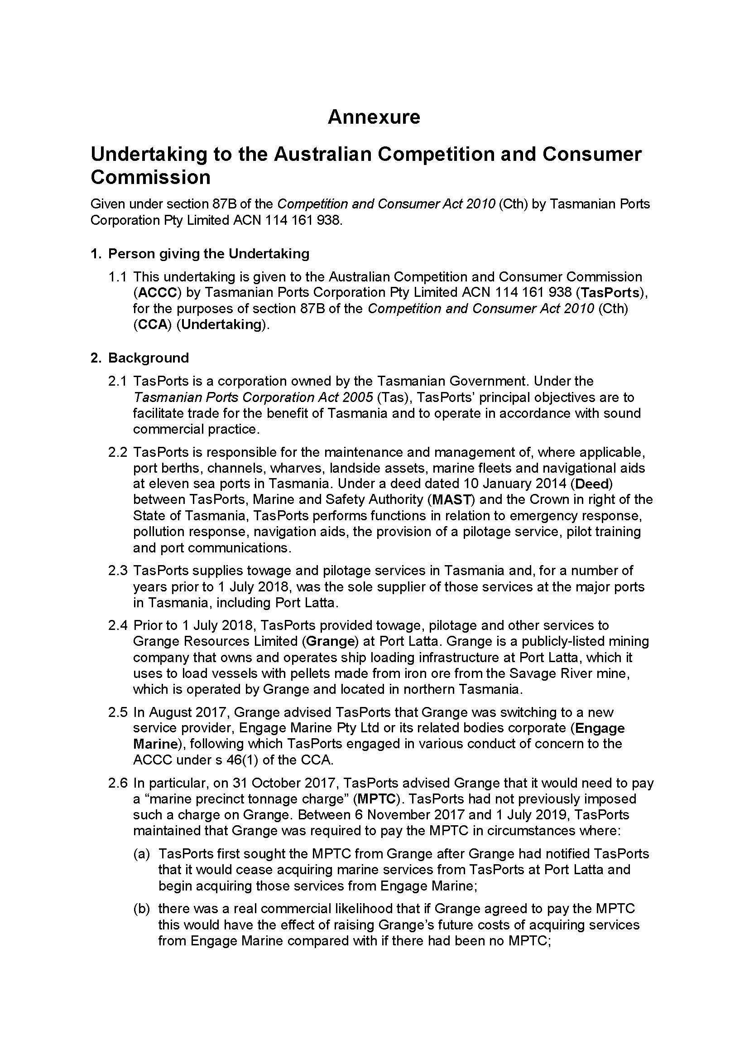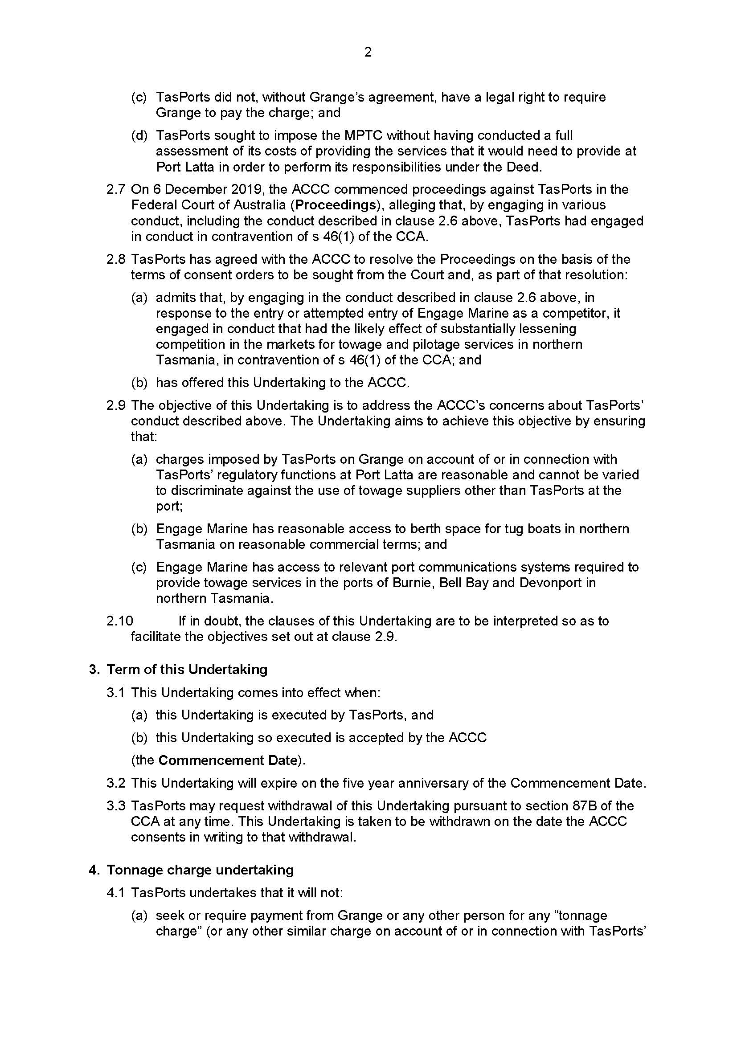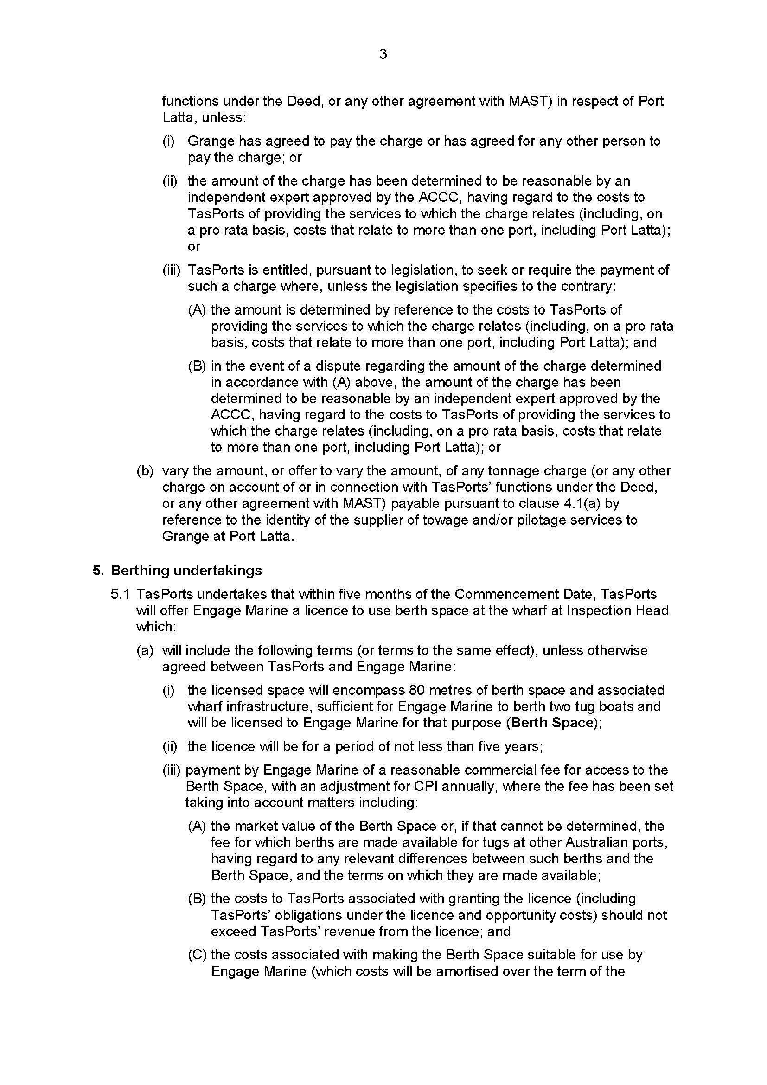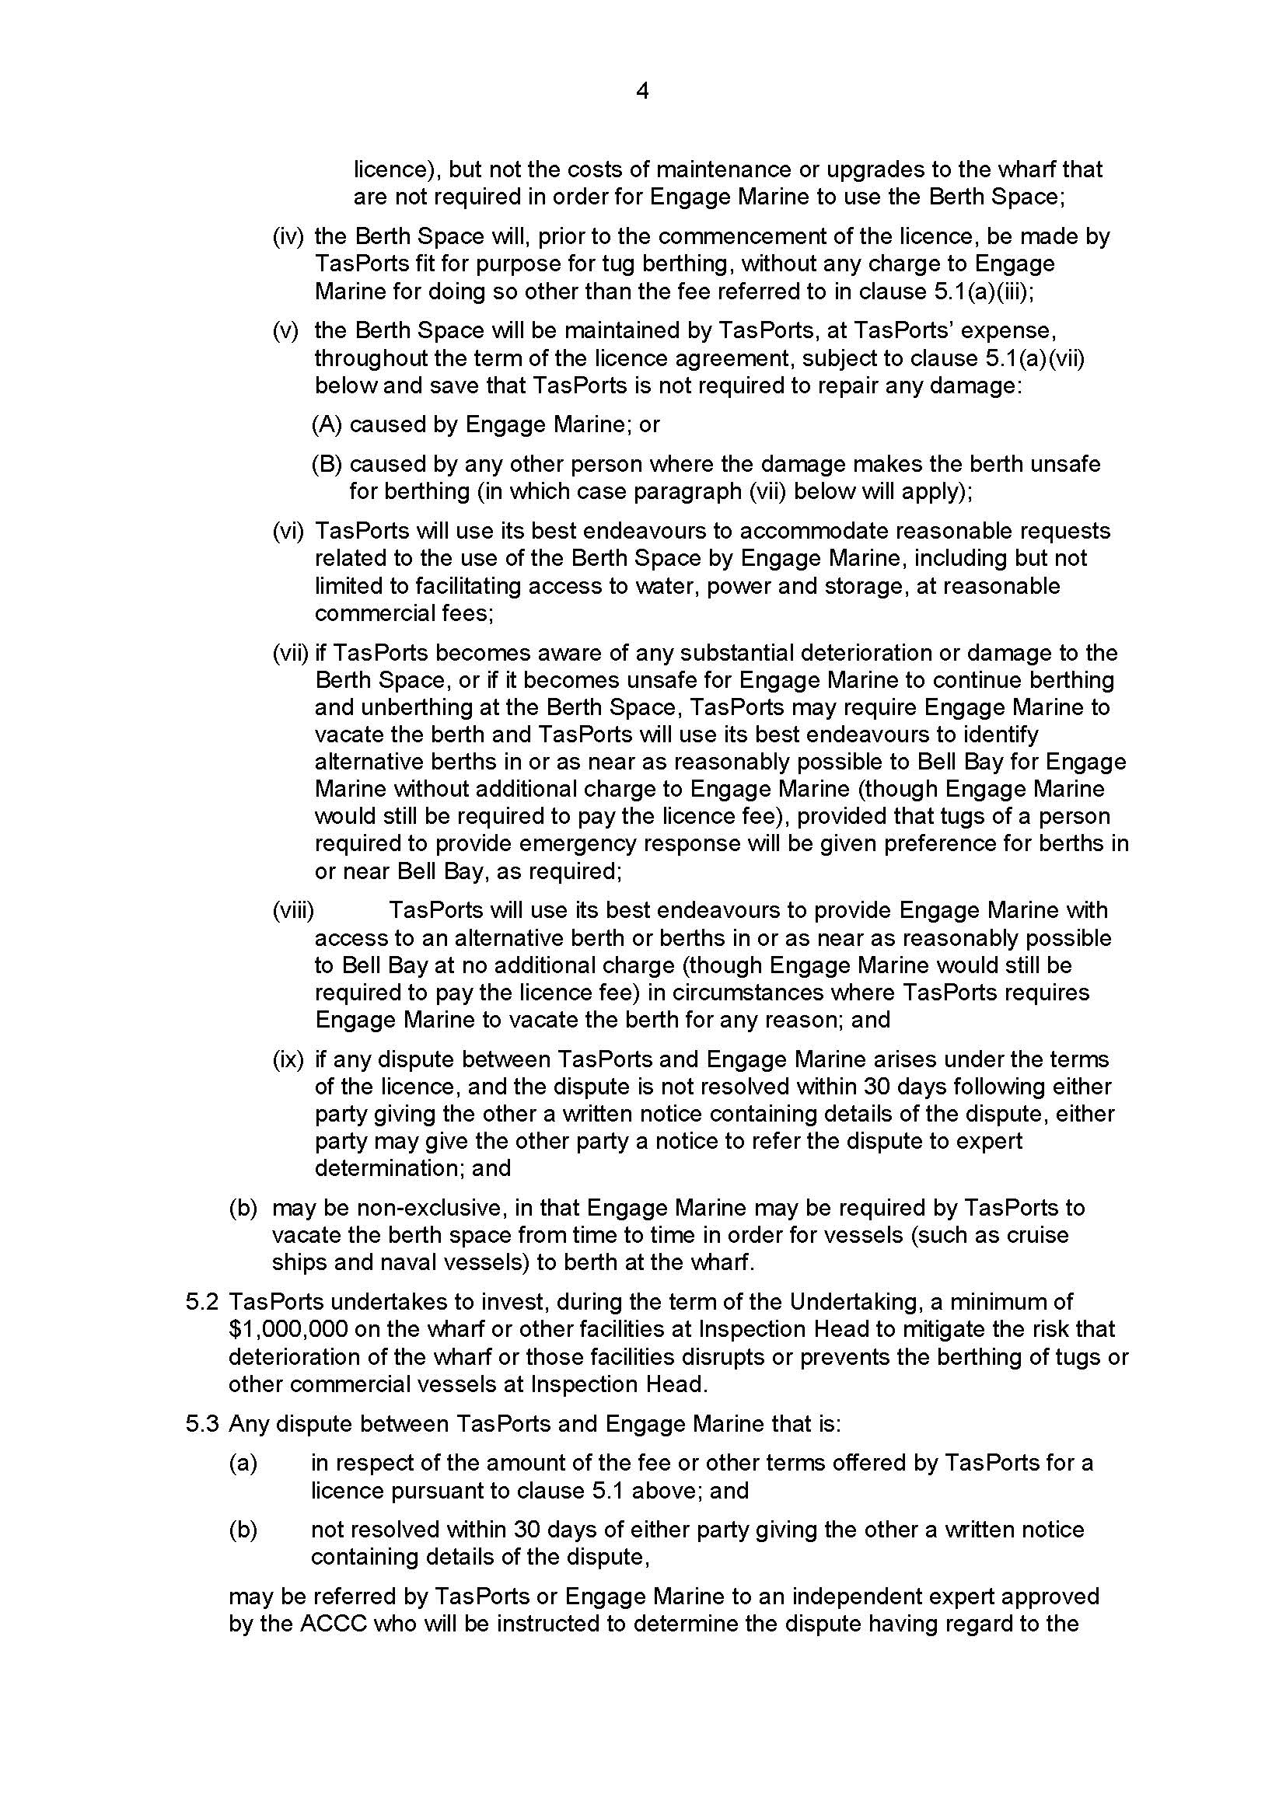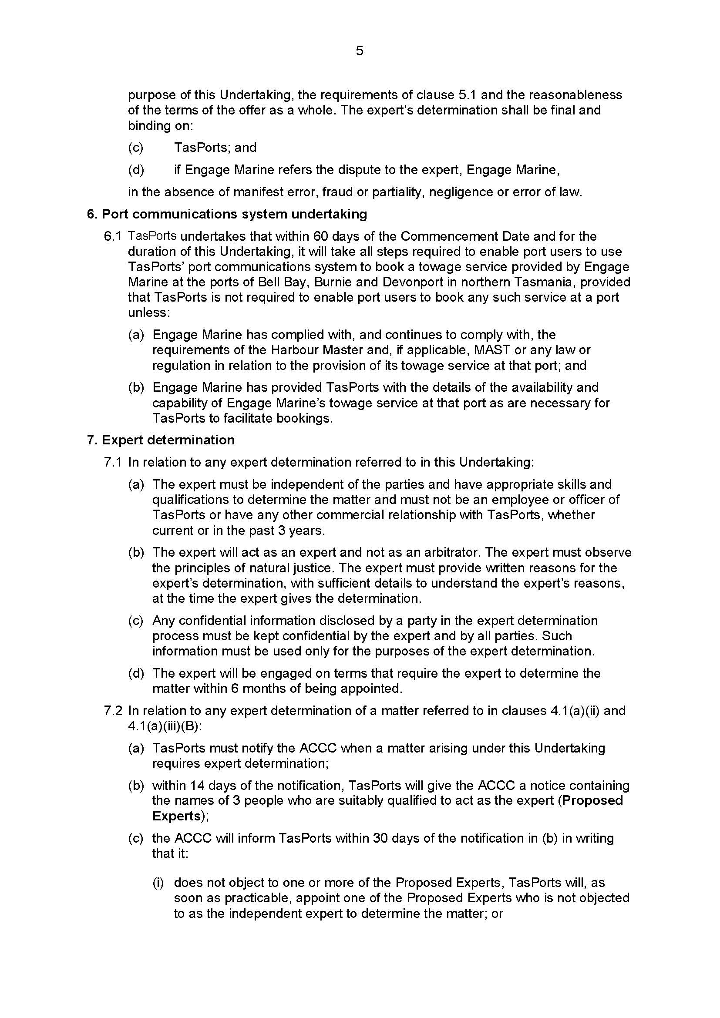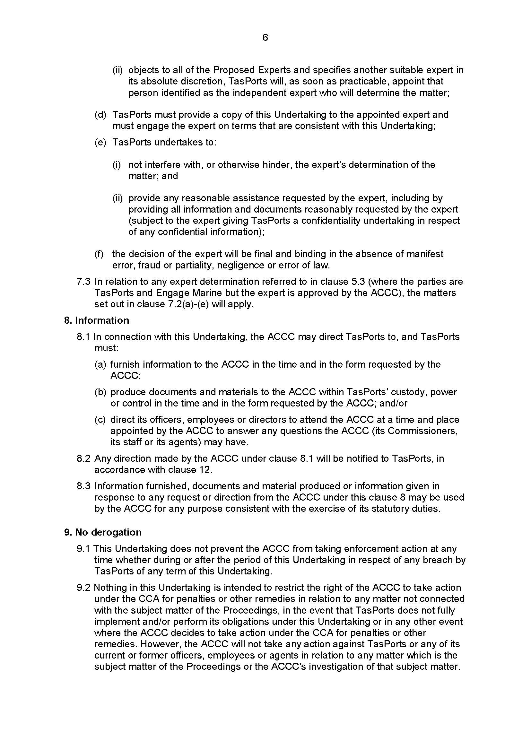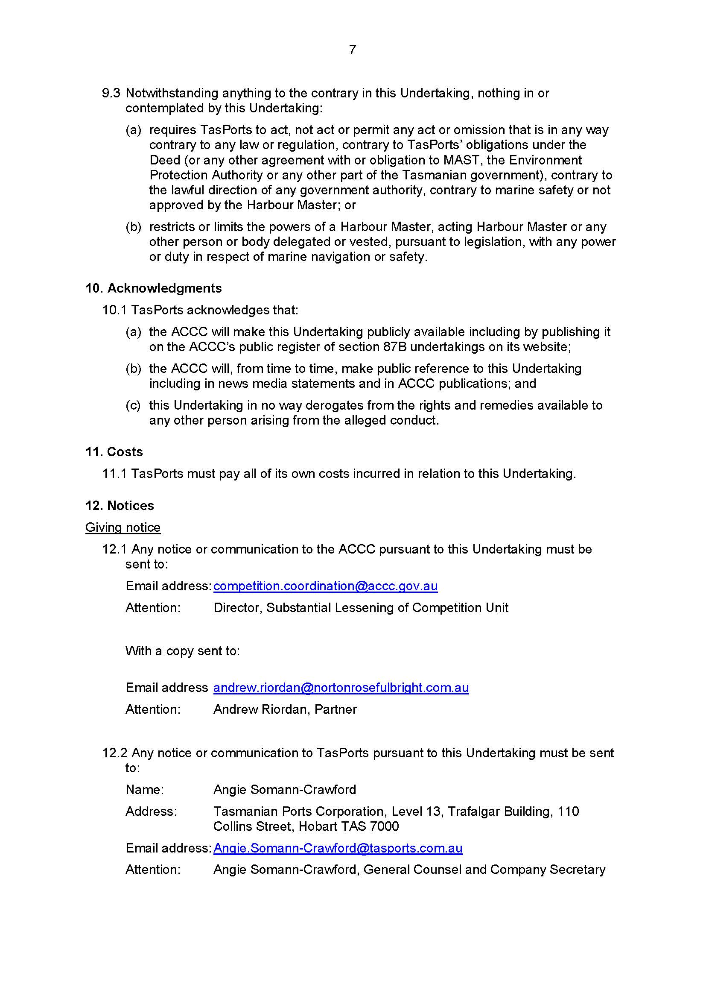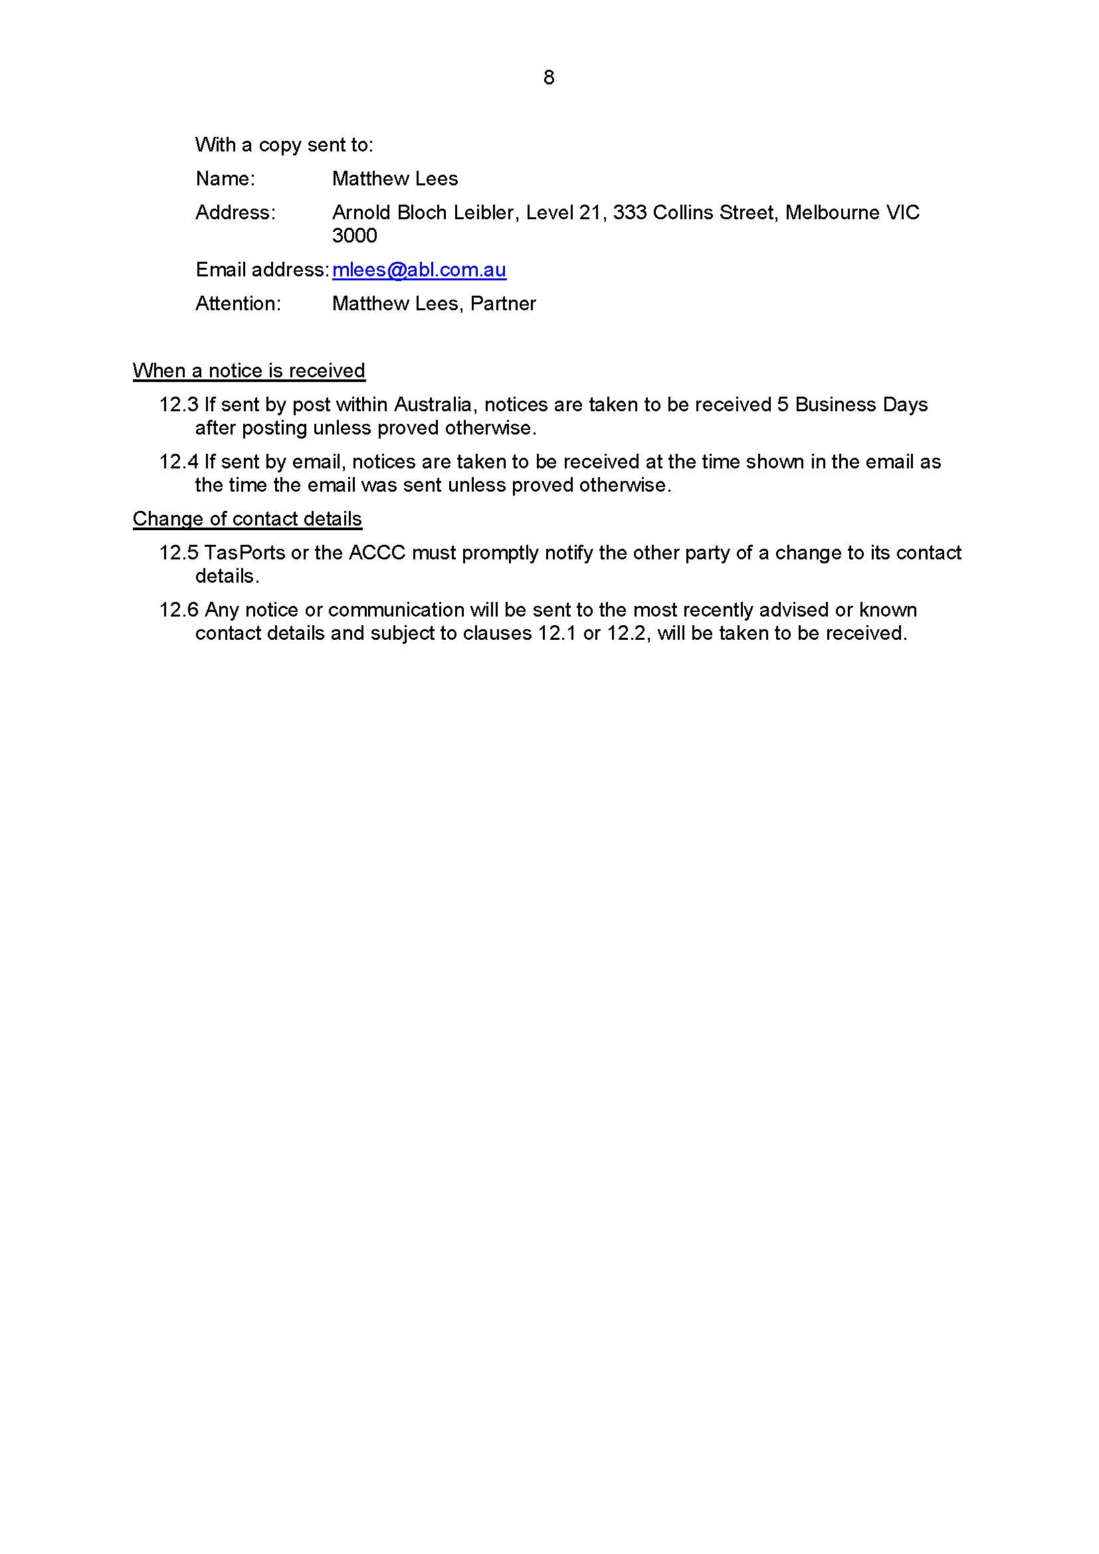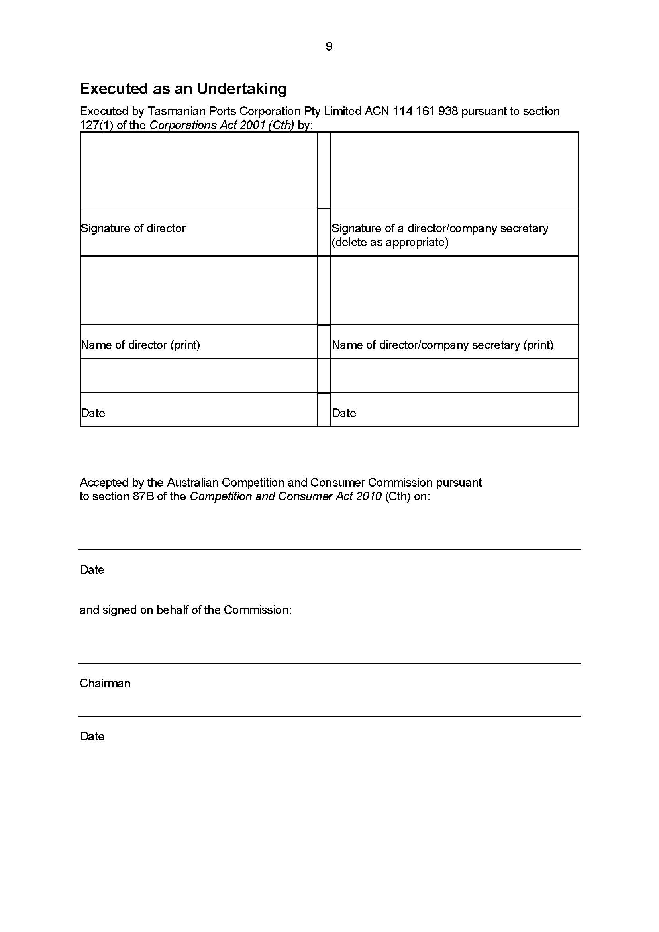

REASONS FOR JUDGMENT
DAVIES J:
- On 4 May 2021 I made orders in this proceeding in accordance with the proposed minute of order provided by the parties. These are my reasons for making those orders.

Background
- The Respondent (TasPorts) is a State owned company which provides marine services at 11 ports in Tasmania, including towage and pilotage services and various functions it is engaged to perform under a deed between TasPorts, Marine and Safety Authority and the Crown in the right of the State of Tasmania (the MAST Deed). Its revenue is derived primarily from charges to port users and other customers and from the lease of its assets.
- For a number of years prior to 1 July 2018, TasPorts was the sole provider of marine services at major ports in Tasmania, including Port Latta. Port Latta is privately owned and operated by Grange Resources Limited (Grange Resources) and TasPorts provided towage, pilotage and other marine services to Grange Resources under an agreement titled the Port Latta Services Agreement. From late 2016, Grange Resources and TasPorts were in negotiations for TasPorts to continue supplying Grange Resources with towage and pilotage services (among other services) at Port Latta after the initial expiry date of the Port Latta Services Agreement, however, in August 2017, Grange Resources advised TasPorts that it had decided not to continue negotiations and, instead, to obtain towage and pilotage services (among other services) from another port services provider, Engage Marine Pty Ltd (Engage Marine).
- On 31 October 2017, TasPorts advised Grange Resources that it would need to pay a “Marine Precinct Tonnage Charge” (tonnage charge) for vessels calling at Port Latta after the expiry of the Port Latta Services Agreement. TasPorts had previously not imposed such a charge on Grange Resources. TasPorts represented to Grange Resources that the tonnage charge was payable for the performance by TasPorts of its regulatory responsibilities to the State of Tasmania under the MAST Deed, however it neither conducted a full assessment of its costs of performing those responsibilities at Port Latta nor had the legal right to require Grange Resources to pay that tonnage charge (without Grange Resources’ agreement, which it did not have). Grange Resources disputed TasPorts’ entitlement to the charge and TasPorts subsequently offered a reduced tonnage charge for a fixed period. Although in July 2018, TasPorts began invoicing Grange Resources for the tonnage charge, Grange Resources did not pay the invoiced amount.
- On 15 July 2019, the Australian Competition and Consumer Commission (ACCC) notified TasPorts that it was investigating allegations of anti-competitive conduct. Following that notification, TasPorts agreed to not impose the charge without providing 30 days’ notice to the ACCC and has not, since then, taken any steps to charge a tonnage charge for vessels that enter Port Latta.
- The ACCC commenced this proceeding in 2019 seeking declarations of contravention of s 46(1) of the Competition and Consumer Act 2010 (Cth) (Competition and Consumer Act) by TasPorts, pecuniary penalties pursuant to s 76(1) of the Competition and Consumer Act and injunctive relief pursuant to s 80 of the Competition and Consumer Act. The parties agreed to resolve the proceeding and jointly filed the following documents:
  - a statement of agreed facts and admissions made by TasPorts;
  - a proposed minute of order setting out the relief which the parties submitted was appropriate;
  - submissions on the proposed minute of order; and
  - an undertaking given by TasPorts to the ACCC under s 87B of the Competition and Consumer Act.
- The statement of agreed facts is Annexure 1 to these reasons. On the basis of the facts and matters set out, TasPorts has admitted that between 6 November 2017 and 1 July 2019 (the relevant period), it engaged in the following conduct in contravention of s 46(1) of the Competition and Consumer Act: specifically in response to the entry or attempted entry of Engage Marine as a competitor, TasPorts maintained to Grange Resources that Grange Resources was required to pay a new charge (referred to as the “MPTC” in the agreed statement of facts) for vessels calling at Port Latta, in circumstances where:
  - TasPorts first sought the charge from Grange Resources after Grange Resources had notified TasPorts that it would cease acquiring marine services from TasPorts at Port Latta and begin acquiring those services from Engage Marine;
  - TasPorts did not, without Grange Resources’ agreement, have a legal right to require Grange Resources to pay the charge;
  - TasPorts sought to impose the charge without having conducted a full assessment of its costs of providing the services that it would need to provide at Port Latta in order to perform the responsibilities imposed on it under the MAST Deed; and
  - there was a real commercial likelihood if Grange Resources agreed to pay the charge that this would have the effect of raising Grange Resources’ future costs of acquiring services from Engage Marine, compared with if there had been no charge.
TasPorts has admitted, for the purposes of this proceeding, that this conduct was likely to have the effect of substantially lessening competition in the markets for towage and pilotage services in Northern Tasmania.
- The parties agreed on the following orders:
  - a declaration pursuant to s 21 of the Federal Court of Australia Act 1976 (Cth) (FCA Act) in the terms of the declaratory order now made;
  - an order that TasPorts pay to the ACCC, within 30 days of the date of the order, a contribution to the ACCC’s costs of and incidental to this proceeding fixed in the sum of $200,000; and
  - the proceedings otherwise be dismissed.
- The ACCC did not press for a pecuniary penalty against Tasmanian Ports, nor injunctive relief.
- Part of the settlement reached between the parties involved TasPorts agreeing to offer the ACCC an undertaking under s 87B of the Competition and Consumer Act. TasPorts has since executed that undertaking.

Legislative Framework
- Section 46(1) of the Competition and Consumer Act (in its current form) provides:
Misuse of market power
(1) A corporation that has a substantial degree of power in a market must not engage in conduct that has the purpose, or has or is likely to have the effect, of substantially lessening competition in:
(a) that market; or
(b) any other market in which that corporation, or a body corporate that is related to that corporation:
(i) supplies goods or services, or is likely to supply goods or services; or
(ii) supplies goods or services, or is likely to supply goods or services, indirectly through one or more other persons; or
(c) any other market in which that corporation, or a body corporate that is related to that corporation:
(i) acquires goods or services, or is likely to acquire goods or services; or
(ii) acquires goods or services, or is likely to acquire goods or services, indirectly through one or more other persons.
- Section 46, in its present form, commenced operation on 6 November 2017. Relevantly, under the provision as it now is, the test focusses on whether the conduct by a corporation with substantial market power has the purpose, effect or likely effect of substantially lessening competition. Thus, for a corporation to contravene s 46(1), the corporation, relevantly:
  - must have a substantial degree of power in a market; and
  - must engage in conduct which, relevantly, is likely to have the effect of substantially lessening competition in that market or another market in which it trades or is likely to trade.

Contravening Conduct
- The parties agreed that there are two markets relevant to an assessment of the likely effects of TasPorts’ impugned conduct. One is the market for towage services in Northern Tasmania (towage market), and the other is the market for pilotage services in Northern Tasmania (pilotage market). Both markets are apparent from the matters set out in paras 1 to 14 of the statement of agreed facts.
- TasPorts has admitted that during the relevant period, it had a substantial degree of market power in managing and maintaining infrastructure in ports (other than Port Latta) in Northern Tasmania. This admission is supported by the facts contained in paras 15 to 20 and 23 of the statement of agreed facts and, the court was informed, consistent with the opinion expressed by Dr Williams, the expert economist that the ACCC had proposed to call at trial.
- TasPorts has admitted that its conduct had the “likely effect” of substantially lessening competition in the towage market and the pilotage market. From 31 October 2017, based on the historical and expected size and number of vessels calling at Port Latta, the tonnage charge would have cost Grange Resources an estimated $940,000 a year. From 15 December 2017, after TasPorts offered to charge Grange Resources a reduced tonnage for a period of two years, it would have cost Grange Resources about $600,000 a year for those first two years. In March 2019, TasPorts reduced the amount to approximately $200,000 per annum, based on expected shipping levels. TasPorts has admitted that had Grange Resources had agreed to pay the tonnage charge, there was a real commercial likelihood that this would have had the effect of raising Grange Resources’ future costs of acquiring services from Engage Marine compared with if there had been no tonnage charge.
- The relevant period of the contravening conduct is between 6 November 2017 and 1 July 2019 by reason that:
  - the current version of s 46(1) commenced operation on 6 November 2017;
  - on about 1 July 2019 TasPorts sought to deal directly with shipping lines in relation to port charges for vessels that entered Port Latta and not long after that, following correspondence from the ACCC, TasPorts agreed with the ACCC not to charge any such tonnage charge at Port Latta without first giving the ACCC 30 days’ notice. Since that time, whilst it waited for the resolution of this proceeding, TasPorts has not taken any steps to charge a tonnage charge for vessels that enter Port Latta.
- On the basis of the facts and admissions in the statement of agreed facts, I was satisfied that the agreed declaratory relief is appropriate in the circumstances of this case. In matters of public interest, declaratory relief would ordinarily be regarded as appropriate, and not lacking any utility, even though other relief is not sought or granted. In Australian Competition & Consumer Commission v Eurong Beach Resort Ltd [2005] FCA 1134, Kiefel J stated at [5]-[6]:
Declarations in relation to conduct by competitors in the market would be of general importance. They show that the conduct will not be condoned and serve to educate the public. This submission finds support in the decision of a Full Court in Tobacco Institute of Australia Limited v Australian Federation of Consumer Organisations Inc (1993) 41 FCR 89. Sheppard J (at page 94) considered it appropriate to make declarations that the appellant had engaged in misleading and deceptive conduct as it gave formal effect to the court’s conclusion and the litigation involved the public interest. The latter was especially influential to his Honour’s decision. Hill J put the matter in even stronger terms, (at page 110):
‘There can be little doubt that a declaration might be obtained by a regulatory authority that particular conduct is in breach of a statutory provision, whether or not injunctive relief is appropriate: cf Australian Softwood Forests Pty Ltd v Attorney-General (NSW) (Ex rel Corporate Affairs Commission) (1981) 148 CLR 121 at 125. It has never been suggested that no power exists to grant such declaratory relief merely because the consequence of a declaration is to declare the existence of a wrong. The declaration that an offence has been committed is the concomitant of the non-existence of a right. Semantically, it may be said to be the declaration of a negative right. It is appropriate, in my view, to refer to it as a declaration of right.’
The statement of principle in that case should be followed in cases involving the public interest.
In this case, the declaratory relief serves to record the Court’s disapproval of the contravening conduct; vindicate the ACCC’s claim that TasPorts contravened s 46(1) of the Competition and Consumer Act; and informs the public of TasPorts’ contravening conduct. There is public benefit in the contravening conduct being clearly identified, as it assists the ACCC to carry out its duties conferred upon it by the Competition and Consumer Act and operates to deter other corporations from contravening Competition and Consumer Act. There is also a considerable public interest in corporations observing the requirements of the Competition and Consumer Act which warrants the grant of declaratory relief when the Act is breached.
- The undertaking that TasPorts has given the ACCC is an important part of the parties’ agreement to seek the proposed declaration jointly. The undertaking provides that TasPorts will:
  - charge the tonnage charge only: (1) with Grange Resources’ agreement; (2) where TasPorts is entitled to do so pursuant to legislation and the amount is determined by reference to TasPorts’ costs, unless otherwise specified by the legislation; and (3) where the amount has been determined to be reasonable by an independent expert approved by the ACCC;
  - offer Engage Marine berth space at Inspection Head on reasonable commercial terms, including making the berth space fit for purpose and charging a reasonable commercial fee for access;
  - invest a minimum of $1,000,000 in wharf infrastructure at Inspection Head over five years to mitigate the risk of it becoming unsuitable for berthing tugs; and
  - enable port users to book towage services provided by Engage Marine using TasPorts’ port communications system.
- I was satisfied that the undertaking is within the power of the ACCC to accept (Australian Competition and Consumer Commission v Woolworths (South Australia) Pty Ltd (2003) 198 ALR 417; [2003] FCA 530 at [44]; Australian Competition and Consumer Commission v Woolworths (South Australia) Pty Ltd [No 2] [2004] FCA 128 at [16]; Australian Competition and Consumer Commission v Coles Supermarket Pty Ltd [2014] FCA 1405 at [10], [123]). As the settlement in this matter involved the undertaking, it was also appropriate that the undertaking be noted in the orders.
- For those reasons, the orders were made.
- I certify that the preceding twenty (20) numbered paragraphs are a true copy of the Reasons for Judgment of the Honourable Justice Davies.

Associate:

Dated: 10 May 2021

ANNEXURE 1
