FEDERAL COURT OF AUSTRALIA

Roadshow Films Pty Ltd v Telstra Corporation Limited [2021] FCA 1588
File number: | NSD 936 of 2021
Judgment of: | NICHOLAS J
Date of judgment: | 21 December 2021
Catchwords: | Copyright – application for “site blocking” orders under s 115A of the Copyright Act 1968 (Cth) – whether orders should be made – consideration of appropriate form of ancillary orders including form of order to facilitate extension of orders to cover new target online locations
Legislation: | Copyright Act 1968 (Cth) s 115A  Copyright Amendment (Online Infringement) Act 2018 (Cth)
Cases cited: | Roadshow Films Pty Limited v Telstra Corporation Limited (2019) 144 IPR 1  Roadshow Films Pty Ltd v Telstra Corporation Ltd (2020) 151 IPR 449  Roadshow Films Pty Limited v Telstra Corporation Ltd (No 2) (2020) 153 IPR 317
Division: | General Division
Registry: | New South Wales
National Practice Area: | Intellectual Property
Sub-area: | Copyright and Industrial Designs
Number of paragraphs: | 33
Date of hearing: | 25 October 2021, 16 December 2021
Counsel for the Applicants: | Ms F St John
Solicitor for the Applicants: | Baker & McKenzie
Counsel for the First to Ninth Respondents: | The first to ninth respondents filed submitting appearances

Counsel for the Tenth to Twenty-Seventh Respondents: | The tenth to twenty-seventh respondents did not appear
Counsel for the Twenty-Eighth to Forty-Eighth Respondents | The twenty-eighth to forty-eighth respondents filed submitting appearances

ORDERS
 |  | NSD 936/2021
BETWEEN: | ROADSHOW FILMS PTY LIMITED ACN 100 746 870  (and others named in the Schedule)  First Applicant
AND: | TELSTRA CORPORATION LIMITED ABN 33 051 775 556  (and others named in the Schedule)  First Respondent

order made by: | NICHOLAS J
DATE OF ORDER: | 21 DECEMBER 2021

THE COURT NOTES:
In these orders, the following terms have the following meanings:
(a) Domain Name means a name formed by the rules and procedures of the Domain Name System (DNS) and includes subdomains.
(b) DNS Blocking means a system by which any user of a Respondent's service who attempts to use a DNS resolver that is operated by or on behalf of that Respondent to access a Target Online Location is prevented from receiving a DNS response other than a redirection as referred to in Order 6.
(c) IP Address means an Internet Protocol address.
(d) Optus means the second to ninth Respondents.
(e) Target Online Locations means the online locations as referred to in Schedule A and that are or were accessible:
(i) at the URLs listed in Schedule A to this Order (together, the Target URLs);
(ii) at the IP Addresses listed in Schedule A to this Order (together, the Target IP Addresses);
(iii) at the Domain Names listed in Schedule A to this Order (together, the Target Domain Names); and
(iv) any other domain names, URLs and IP addresses that the Applicants notified to the Respondents pursuant to Order 12 (subject to the procedure set out in that Order).
(f) New Target Online Locations means the locations referred to in Order 13.
(g) New Target Online Location Orders refers to orders sought or made under Orders 13 or 15 hereof.
(h) Telstra means the first Respondent.
(i) TPG means the twenty-eighth to the forty-fifth Respondents.
(j) URL means a Uniform Resource Locator.
(k) Vocus means the tenth to twenty-seventh Respondents.
(l) Vodafone means the forty-sixth to forty-eighth Respondents.
THE COURT ORDERS THAT:
1. Each Respondent must, within 15 business days of service of these Orders (and thereafter within 15 business days of an obligation to disable access to a Domain Name, IP Address or URL arising under Order 12), take reasonable steps to disable access to the Target Online Locations.
2. Order 1 is taken to have been complied with by a Respondent if that Respondent implements any one or more of the following steps:
(a) DNS Blocking in respect of the Target Domain Names;
(b) IP Address blocking or re-routing in respect of the Target IP Addresses;
(c) URL blocking in respect of the Target URLs and the Target Domain Names; or
(d) any alternative technical means for disabling access to the Target Online Locations as agreed in writing between the Applicants and a Respondent.
3. If a Respondent in complying with Order 1 does not implement one of the steps referred to in Order 2, that Respondent must, within 15 business days of service of these Orders, notify the Applicants of the step or steps it has implemented.
4. Each Respondent must redirect any communication by a user of its service seeking access to the Target Online Locations which have been disabled pursuant to Order 1 to a webpage established, maintained and hosted by either:
(a) the Applicants, or their nominee, pursuant to Order 5; or
(b) that Respondent or its nominee.
The Applicants’ obligations pursuant to Orders 5 and 6 only arise if a Respondent notifies the Applicants that the Respondent will redirect a communication pursuant to Order 4(a) and for so long as at least one Respondent redirects communications to that webpage.
5. The Applicants, or their nominee, must establish, maintain and host a webpage which informs users of a Respondent’s service who have been redirected to the webpage pursuant to Order 4 that access to the website has been disabled because this Court has determined that it infringes or facilitates the infringement of copyright.
6. Within 5 business days of these Orders, the Applicants will notify each of the Respondents in writing of the URL of the webpage established, maintained and hosted under Order 4 and, if the webpage ceases to operate for any reason, will notify each of the Respondents in writing of a different URL that complies with Order 5.
7. If, in complying with Order 4, a Respondent redirects any communication by a user of its service to a webpage established, maintained and hosted by it, that Respondent or its nominee must ensure that the webpage informs the user of that Respondent's service that access to that the website has been disabled because this Court has determined that it infringes or facilitates the infringement of copyright.
8. In the event that any of the Applicants has a good faith belief that:
(a) any Target URL, Target IP Address or Target Domain Name which is subject to these Orders has permanently ceased to enable or facilitate access to any Target Online Location; or
(b) any Target URL, Target IP Address or Target Domain Name has permanently ceased to have the primary purpose of infringing or facilitating the infringement of copyright,
a representative of the Applicants must, within 15 business days of any of the Applicants forming such a good faith belief, notify each Respondent of that fact in writing, in which case the Respondents shall no longer be required to take steps pursuant to Order 1 to disable access to the relevant Target URL, Target IP Address or Target Domain Name that is the subject of the notice.
9. A Respondent will not be in breach of Order 1 if it temporarily declines or temporarily ceases to take the steps ordered in Order 1 (either in whole or in part) upon forming the view, on reasonable grounds, that suspension is necessary to:
(a) maintain the integrity of its network or systems or functioning of its blocking system;
(b) upgrade, troubleshoot or maintain its blocking system;
(c) avert or respond to an imminent security threat to its networks or systems; or
(d) ensure the reliable operation of its ability to block access to online locations associated with criminal content if it reasonably considers that such operation is likely to be impaired, or otherwise to comply with its statutory obligations including under section 313(3) of the Telecommunications Act 1997 (Cth),
provided that:
(e) unless precluded by law, it notifies the Applicants or their legal representative(s) of such suspension, including the reasons and the expected duration of such suspension, by 5.00 pm on the next business day; and
(f) such suspension lasts no longer than is reasonably necessary and, in any case, no longer than 3 business days or such period as the Applicants may agree in writing or the Court may allow.
10. The owner or operator of any of the Target Online Locations and the owner or operator of any website who claims to be affected by these Orders may apply on 3 days' written notice, including notice to all parties, to vary or discharge these Orders, with any such application to:
(a) set out the orders sought by the owner or operator of the Target Online Locations or affected website; and
(b) be supported by evidence as to:
(i) the status of the owner or operator of the Target Online Locations or affected website; and
(ii) the basis upon which the variation or discharge is sought.
11. The parties have liberty to apply on 3 days' written notice, including, without limitation, for the purpose of any application:
(a) for further orders to give effect to the terms of these Orders;
(b) for further orders in the event of any material change of circumstances including, without limitation, in respect of the consequences for the parties and effectiveness of the technical methods under Order 2; and/or
(c) for orders relating to other means of accessing the Target Online not already covered by these Orders.
12. If a website the subject of any of the Target Online Locations is at any time during the operation of these Orders provided from a different Domain Name, IP Address or URL outside Australia, the Applicants may, by their solicitor:
(a) provide a notice in writing to the Respondents and the Court that:
(i) identifies the different Domain Name, IP Address or URL; and
(ii) certifies that, in the good faith belief of the Applicants and their solicitor, the website operated from the different Domain Name, IP Address or URL is a new location for any of the Target Online Locations the subject of these Orders and brief reasons therefore;
(b) within 7 business days of the notice given pursuant to Order 12(a), the Respondents must notify the Applicants and the Court in writing if they object to taking steps pursuant to Order 1 to disable access to the Domain Name, IP Address or URL notified in accordance with Order 12(a);
(c) if any Respondent objects to disabling a Domain Name, IP Address or URL notified in accordance with Order 12(a), or the Court otherwise considers it appropriate to do so, the proceeding will be relisted for further directions; and
(d) If, within the time period specified in Order 12(b) no Respondent objects to disabling access to any Domain Name, IP Address or URL notified in accordance with Order 12(a) and the Court does not otherwise require the proceeding to be relisted, then upon receipt of a notification from the Applicants that the Court does not require the matter to be relisted, that Respondents must take steps pursuant to Order 1 to disable access to the Domain Name, IP Address or URL notified in accordance with Order 12(a).
13. The Applicants have leave to file and serve an amended originating application seeking further orders (New Target Online Location Orders) in respect of any additional target online location (New Target Online Location) that appears to the Applicants’ solicitors to be associated with any of the Target Online Locations (based on its name, branding or the identity of its operator) and making available online the same or substantially the same content that the Target Online Location is or was previously making available online.
14. Subject to any further order or direction, the leave granted under Order 13 continues to apply for the duration of these Orders.
15. Subject to any further order or direction, if the Applicants file any amended originating application pursuant to Order 13, then the following shall apply:
(a) The Applicants must serve on the Respondents a copy of the amended originating application together with any supporting affidavit evidence to be relied on in support of the application for the New Target Online Location Orders within 7 days of filing the amended originating application.
(b) The Applicants must give notice of their application for the New Target Online Location Orders in accordance with the requirements of s 115A(4) of the Copyright Act 1968 (Cth).
(c) Any Respondent who wishes to be heard in relation to the New Target Online Location Orders must notify the Applicants and the Court within 7 business days after being served in accordance with Order 15(a) above.
(d) If no notice is given by any Respondent in accordance with Order 15(c) above, then the Applicants may approach the Court for the purpose of seeking the New Target Online Location Orders and the Court may in its discretion, consider and determine the application for the New Target Online Location Orders on the papers without further notice and without any oral hearing.
16. These Orders are to operate for a period of 3 years from the date of these Orders.
17. No less than two months prior to the expiry of these Orders:
(a) the Applicants may file and serve:
(i) an affidavit which states that, in the good faith belief of the deponent, the Target Online Location continues to have the primary purpose of infringing or facilitating the infringement of copyright; and
(ii) short minutes of order extending the operation of these Orders for a further 3-year period; and
(b) the process contained in Order 18 shall apply.
18. The affidavit referred to in Order 17 is to be made by a deponent duly authorised to give evidence on behalf of the Applicants and may be given by their solicitor.
19. If an affidavit and short minutes of order are filed and served in accordance with Order 17:
(a) within 7 business days, the Respondents must notify the Applicants and the Court if they object to the Orders being made in accordance with the short minutes of order served by the Applicants;
(b) if any Respondents give notice of any objection, or the Court otherwise thinks fit, the proceeding will be relisted for further directions;
(c) if no Respondent gives notice of any objection and the Court does not otherwise require the proceeding to be relisted, then the Court may make orders in terms of the short minutes of order served by the Applicants without any further hearing; and
(d) the Applicants must serve on the Respondents any such orders made.
20. The Applicants pay Telstra’s, Optus’, Vocus’, TPG’s and Vodafone’s compliance costs calculated at the rate of $50 per Domain Name the subject of DNS Blocking undertaken for the purposes of complying with Order 1.
21. There be no order as to costs.

Note: Entry of orders is dealt with in Rule 39.32 of the Federal Court Rules 2011.

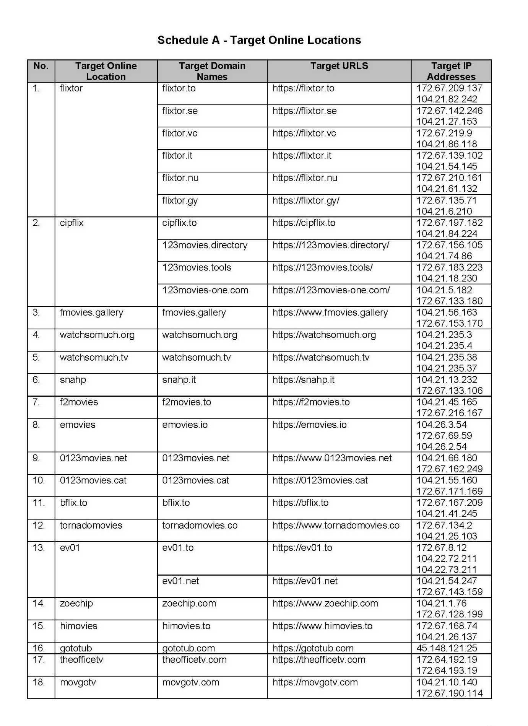
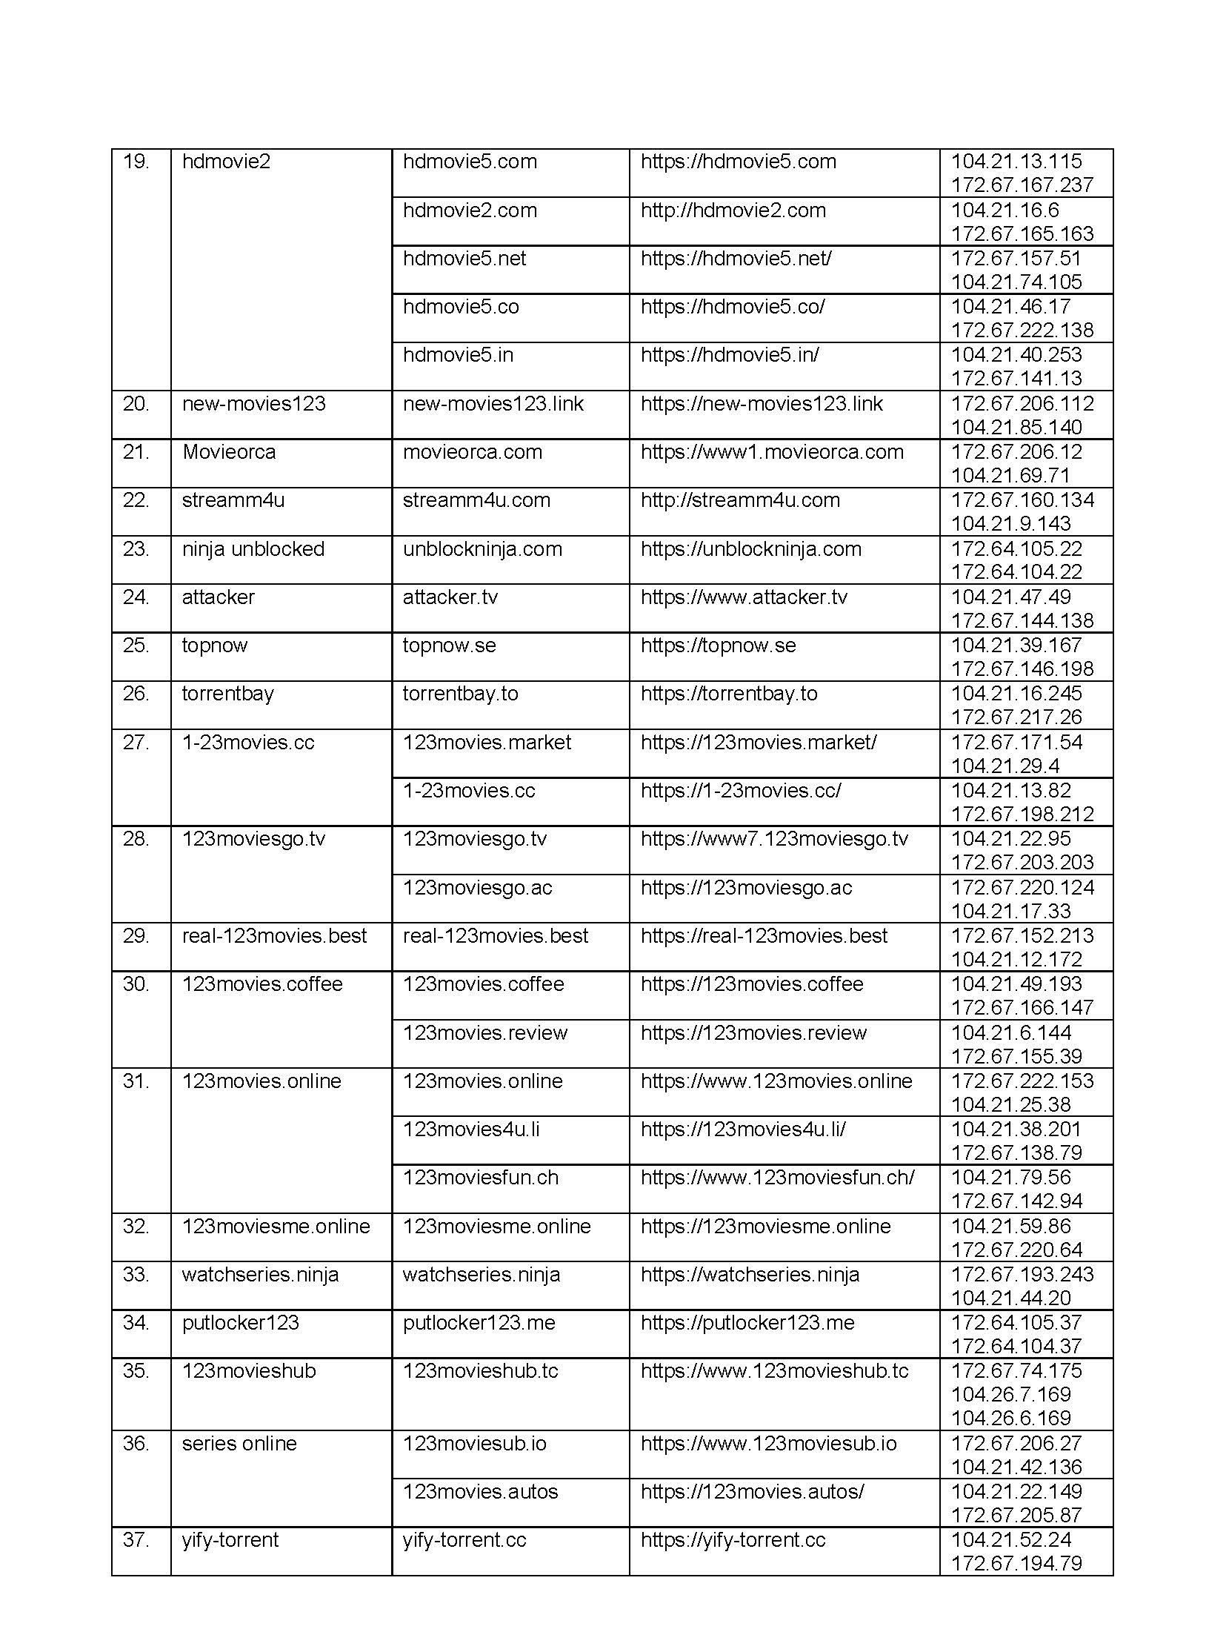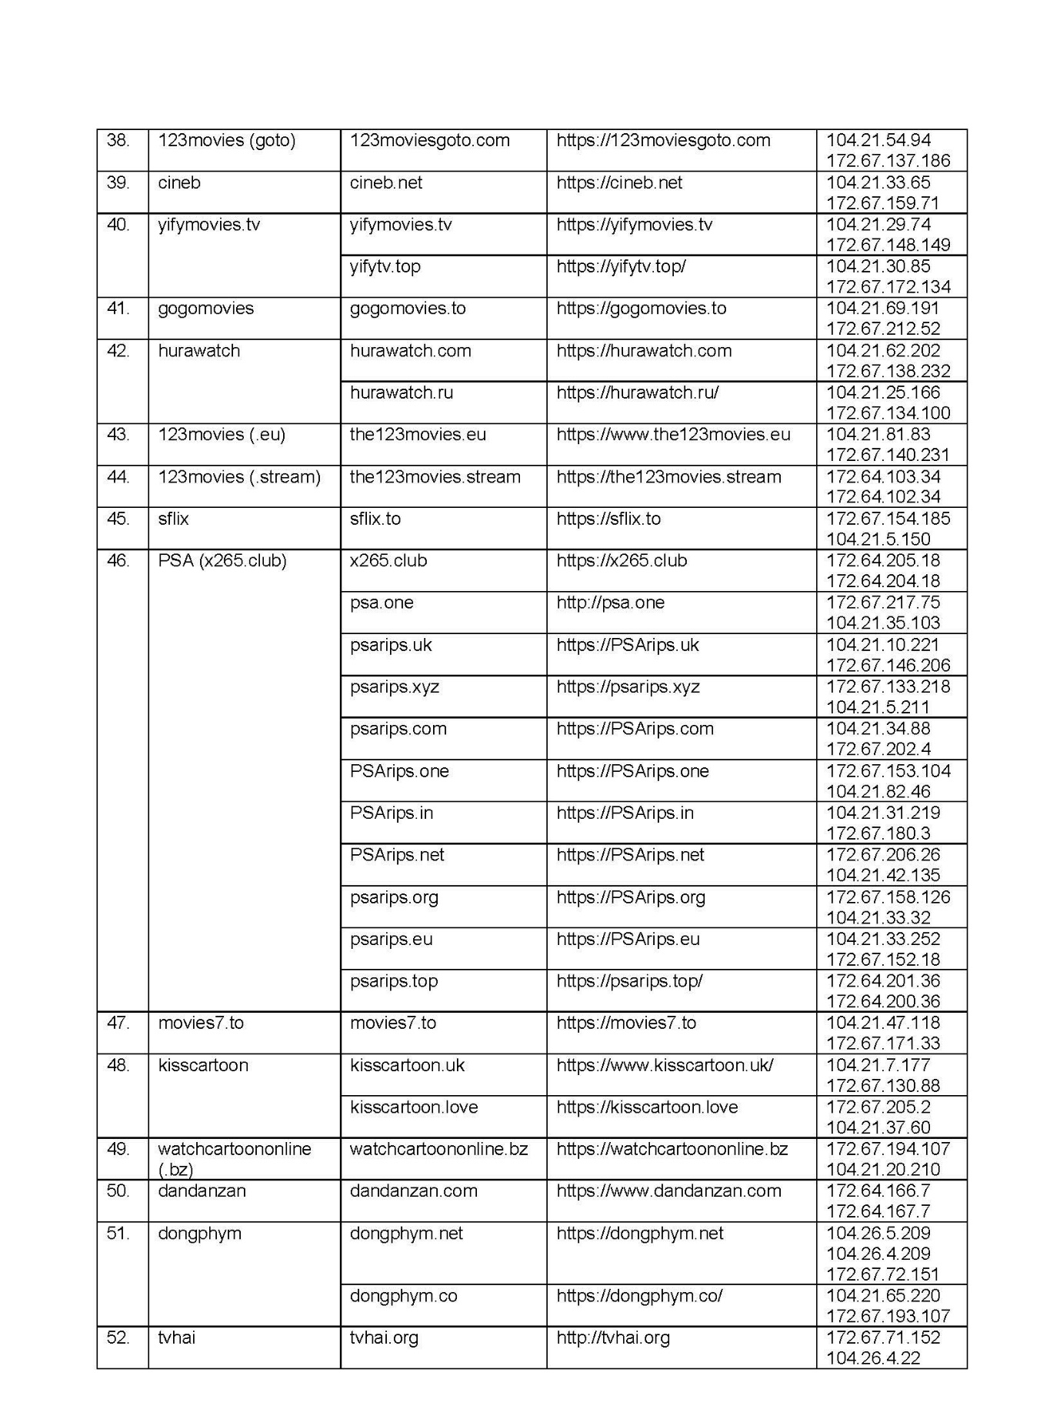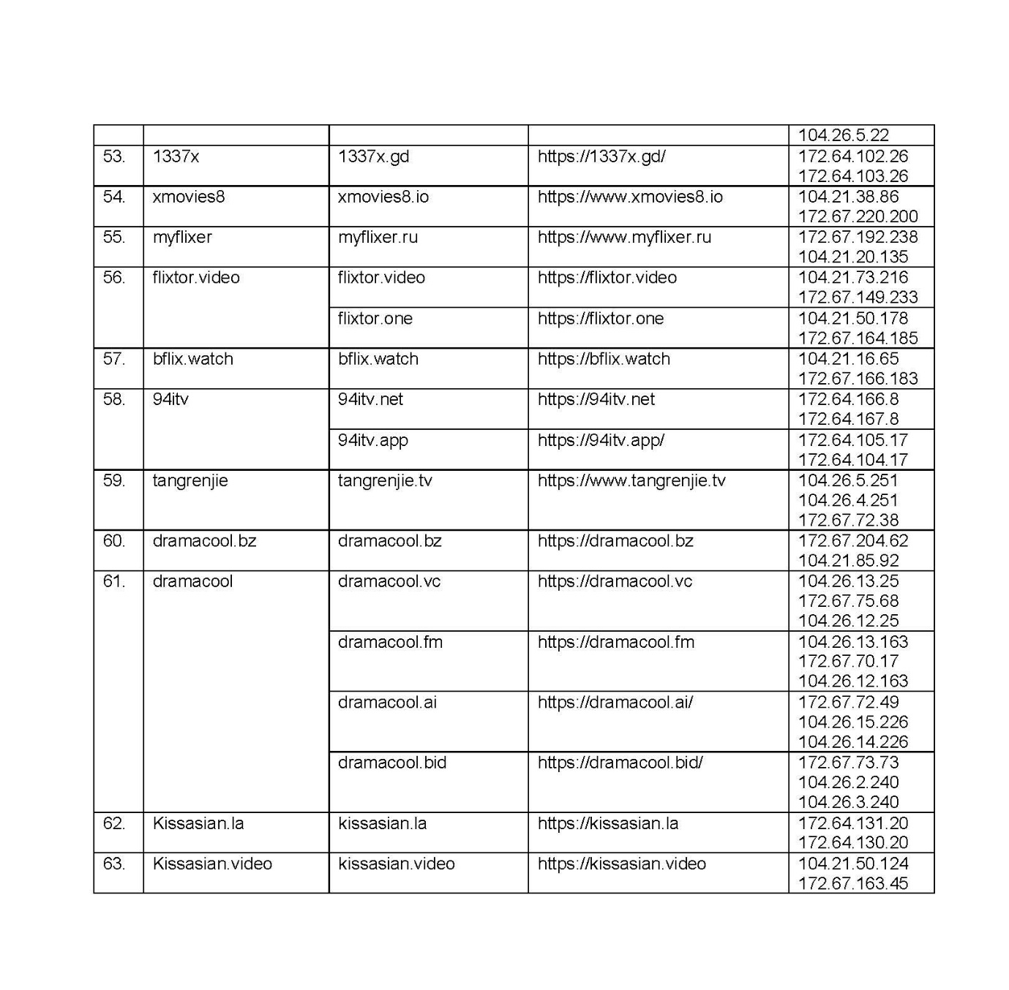

REASONS FOR JUDGMENT
NICHOLAS J:
1 Before me is an application under s 115A of the Copyright Act 1968 (Cth) (“the Act”). There are 48 respondents, each of which is a carriage service provider, and a member of the Telstra, Optus, Vocus (formerly M2), TPG or Vodafone corporate groups. The first to ninth and twenty-eighth to forty-eighth respondents have not sought to be heard in the proceeding and submitting notices have been filed on their behalf. The tenth to twenty-seventh respondents did not appear.
2 The applicants allege that the relevant websites are online locations situated outside Australia and that they infringe, or facilitate the infringement of, copyright in large numbers of cinematograph films including motion pictures and television programs, the copyright in which is owned by the various applicants.
3 The affidavit evidence relied upon by the applicants consists of affidavits made by Andrew Gavin Stewart, Nicholas Vincent Kraegan, Daniella Marie Lambert (all of whom are solicitors with Baker & McKenzie, the solicitors for the applicants), Gregory Donald Fraser, Kong Wo Tang, Xiaoguo Weng and Wu Kam Ming. The evidence includes detailed schedules that identify the portions of the evidence relevant to particular websites including details of communications with the operators of the websites and relief obtained by the copyright owners in respect of some of those websites in other jurisdictions.
4 Sections 115A(1), (2A) and (2B) of the Act relevantly provides:
115A Injunctions relating to online locations outside Australia
Application for an injunction
(1) The owner of a copyright may apply to the Federal Court of Australia to grant an injunction that requires a carriage service provider to take such steps as the Court considers reasonable to disable access to an online location outside Australia that:
(a) infringes, or facilitates an infringement, of the copyright; and
(b) has the primary purpose or the primary effect of infringing, or facilitating an infringement, of copyright (whether or not in Australia).
…
Granting the injunction
(2A) The Court may grant the injunction in the terms, and subject to the conditions, that the Court considers appropriate.
Note 1: For the matters that the Court may take into account when determining whether to grant the injunction, see subsection (5).
Note 2: The terms and conditions of the injunction that apply to a carriage service provider under subsection (1) may be different from those that apply to an online search engine provider under subsection (2).
(2B) Without limiting subsection (2A), the injunction may:
(a) require the carriage service provider to take reasonable steps to do either or both of the following:
(i) block domain names, URLs and IP addresses that provide access to the online location and that are specified in the injunction;
(ii) block domain names, URLs and IP addresses that the carriage service provider and the owner of the copyright agree, in writing, have started to provide access to the online location after the injunction is made;
…
5 Sections 115A(3) and (4) of the Act relate to parties and service. In particular, s 115A(4) permits the Court to make an order dispensing with service on the operator of the online location on such terms as it thinks it fit if the Court is satisfied that the owner of copyright is unable, despite reasonable efforts, to determine the identity or address of the person who operates the online location or to send notices to that person. In all previous cases brought under s 115A the Court has made orders dispensing with the requirement of service in the case of some operators who either fail to identify themselves or fail to make available an address to which notices may be sent.
6 None of the operators of the relevant websites applied to be joined as a party to the proceeding and none sought to appear at the hearing. There was affidavit evidence in the proceeding given by solicitors acting for the applicants describing their attempts to notify the persons who operate each of the relevant websites of the commencement of this proceeding.
7 I am satisfied that the applicants have made reasonable efforts to determine the identity and address of the persons who operate the relevant websites, and to give them notice of this proceeding and the orders sought.
8 Section 115A(5) of the Act sets out matters that the Court may take into account in determining whether or not to grant an injunction. The matters referred to include the flagrancy of the infringement or the facilitation of infringement, the availability of directories, indexes or categories of infringing copyright material available for download, whether the operator of the online location demonstrates a disregard for copyright generally and whether disabling access to the online location is a proportionate response in the circumstances.
9 In Roadshow Films Pty Limited v Telstra Corporation Limited (2019) 144 IPR 1 at [10]-[12] I drew attention to some of the amendments made to s 115A by the Copyright Amendment (Online Infringement) Act 2018 (Cth) (“the 2018 Amendments”) which took effect on 11 December 2018. Burley J also considered the effect of the amendments in Roadshow Films Pty Ltd v Telstra Corporation Ltd (2020) 151 IPR 449 and Roadshow Films Pty Limited v Telstra Corporation Ltd (No 2) (2020) 153 IPR 317.
10 Although s 115A of the Act applies only to online locations outside Australia, s 115(5A) creates a presumption that an online location is outside of Australia unless the contrary is established. The applicants rely on that presumption in this proceeding although there is also evidence from which it may be inferred that the online locations the subject of the application are in fact located outside Australia.
11 The evidence satisfies me that each of the target online locations identified in the applicants’ proposed orders infringes or facilitates the infringement of the applicants’ copyright in various well-known cinematograph films. I am also satisfied that the target online locations have the primary purpose, or the primary effect, of infringing or facilitating an infringement of copyright in large numbers of commercially released cinematograph films.
12 Having had regard to the matters listed in s 115A(5) of the Act, I consider that a site blocking order in the form of proposed orders 1 and 2 should be made against each of the respondents in relation to each of the target online locations. Having regard to the evidence and the applicants’ submissions, I also consider that orders in the form of proposed orders 3 to 11 should be made.
13 This brings me to proposed orders 12 and 13 which are less straightforward.
14 Target Online Location is defined in the proposed orders as follows:
Target Online Locations means the online locations as referred to in Schedule A and that are or were accessible:
(i) at the URLs listed in Schedule A to this Order (together, the Target URLs);
(ii) at the IP Addresses listed in Schedule A to this Order (together, the Target IP Addresses);
(iii) at the Domain Names listed in Schedule A to this Order (together, the Target Domain Names); and
(iv) any other domain names, URLs and IP addresses that the Applicants notified to the Respondents pursuant to Order 12 (subject to the procedure set out in that Order).
15 Schedule A includes 64 entries, the first of which refers to the Target Online Location “flixtor” as shown below:
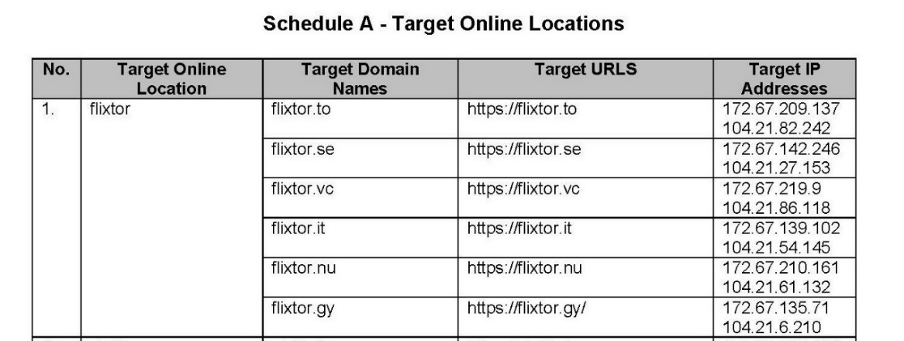
16 The applicants’ proposed order 12 is broadly in the form that has been made in some of the more recent proceedings brought under s 115A of the Act. It provides:
If a website the subject of any of the Target Online Locations is at any time during the operation of these Orders provided from a different Domain Name, IP Address or URL outside Australia, the Applicants may, by their solicitor:
(a) provide a notice in writing to the Respondents and the Court that:
(i) identifies the different Domain Name, IP Address or URL; and
(ii) certifies that, in the good faith belief of the Applicants, the website operated from the different Domain Name, IP Address or URL is a new location for the Target Online Locations the subject of these Orders and brief reasons therefore;
(b) within 7 business days of the notice given pursuant to Order 12(a), the Respondents must notify the Applicants and the Court in writing if they object to taking steps pursuant to Order 1 to disable access to the Domain Name, IP Address or URL notified in accordance with Order 12(a);
(c) if any Respondent objects to disabling a Domain Name, IP Address or URL notified in accordance with Order 12(a), or the Court otherwise considers it appropriate to do so, the proceeding will be relisted for further directions; and
(d) If, within the time period specified in Order 12(b) no Respondent objects to disabling access to any Domain Name, IP Address or URL notified in accordance with Order 12(a) and the Court does not otherwise require the proceeding to be relisted, then upon receipt of a notification from the Applicants that the Court does not require the matter to be relisted, that Respondents must take steps pursuant to Order 1 to disable access to the Domain Name, IP Address or URL notified in accordance with Order 12(a).
17 Proposed order 12 requires that the solicitor for the applicants to certify that in the good faith belief of the applicants the website operated from the different domain name, IP address or URL is a new location for any of the existing online locations referred to in Schedule A to the proposed orders. In my opinion the order should require the certificate to be given by the solicitor who should certify to the good faith belief of both the applicants and the solicitor providing the certificate. In most (if not all) proceedings under s 115A that have come before the Court to date, the solicitors for the applicants have given evidence in support of the application. If the order 12 procedure is to be invoked then I think it is important that the Court be able to take some comfort in the fact that the solicitor for the applicants will have certified that he or she, and the applicants, have a good faith belief in the matter referred to in para (a)(ii) of the order. Of course, that is not to say that, in giving that certificate, the solicitor is not entitled to rely upon information obtained from the applicants. But neither the solicitor nor the applicants should be invoking the order 12 procedure without a good faith belief that the circumstances entitle them to do so.
18 Proposed order 13 provides:
For the purposes of Order 12, “website the subject of any of the Target Online Locations” includes a website operating under a name that is substantially the same as the name under which the website that was the subject of that Target Online Location was operating on the date these orders were made.
19 Proposed order 13, if made, would enable the procedure set out in proposed order 12 to be followed in the case of a website with a name that is “substantially” the same as any of the existing websites referred to in Schedule A of the proposed orders.
20 It appears from the evidence that in previous cases in which an order in the form of proposed order 12 has been made, the applicants have been reluctant to act under the terms of that order in circumstances where there has been any change to the name of an existing website. Rather, the applicants have felt compelled to commence a new proceeding in respect of the website notwithstanding that, based upon similarities of name and website content, it may be inferred that the website is merely a new version of a website the subject of an existing site blocking order.
21 One of the applicant’s witnesses, Mr Fraser, is an expert in online copyright, and has conducted investigations and given evidence in numerous proceedings brought under s 115A. Through that work, he has become familiar with what he describes as the “brands” of the major infringing websites and the various guises in which they appear. He says that it is the brand of an infringing website, rather than way the brand is rendered or the other formatting of the site, that indicates to him that the website is related to a site that has already been blocked. According to Mr Fraser, if he sees a new website that bears the brand of a site that has already been blocked, then almost invariably the functionality and purpose of the new website will be the same as the previous iteration of that site.
22 Mr Fraser also explains that operators of infringing websites use the same branding when creating new websites because it indicates to users the service they can expect from the new sites (namely the ability to access copyrighted material), and that this helps the operators to draw traffic.
23 As an example, Mr Fraser refers to “123Movies”, an online location blocked in a previous application under s 115A. Users of that website know that other websites operating under names similar to the name “123Movies” will also provide access to a wide range of infringing copyright works. Mr Fraser says that in his investigations, he has found that the name of a website is a good indication of its connection to previously blocked websites even if the name is slightly different from the name of a blocked website. He says that in his experience, “brand names and variations on them of that kind are recognisable to internet users who access infringing copyright works as instances of existing, well-known infringing websites”. For example, he says that in his experience the website named “Movies123” invariably shares the functionality and purpose of the “123Movies websites”. Another example referred to by Mr Fraser are websites branded “Yify-Torrent” and “Yify-Movies”, both of which share the same functionality.
24 In his evidence, Mr Stewart, the solicitor for the applicants, says that he has acted in nine s 115A proceedings for the Roadshow and Motion Picture Association applicants (including this proceeding) and in six proceedings for the Television Broadcasts applicants, and that throughout that time it has frequently been the case, both during the proceedings and after blocking orders have been made, that new iterations of online locations that the Court has considered and blocked are made accessible at new domains not covered by the orders. He says that these new iterations of blocked sites sometimes look substantially similar to the original blocked sites, but that they sometimes have aesthetic or structural differences, adopting different colour schemes or layouts or using different categorisations of their infringing content. Mr Stewart notes that many of these new websites operate under the same or substantially the same name as websites blocked in previous proceedings even where they have aesthetic or structural differences in their website layout. Mr Stewart says that in cases where new iterations do not look substantially similar to the blocked iterations of these sites, the applicants have not used the regime set out in proposed order 12, but have instead included the new iterations as separate target online locations in respect of which relief is sought in a new proceeding.
25 As I have mentioned, proposed order 12 is in a form that has been made in other proceedings. But the mechanism provided for by that form of order for capturing different domain names, IP addresses or URLs does not apply in the case of what amounts to a new online location. That is to say, while the order 12 procedure may be invoked against a website that changes its domain name, IP address or URL, it cannot be invoked against a different website with a different domain name, a different IP address and a different URL.
26 A different website, no matter how similar to a blocked website, that has a different domain name, IP address and URL, would not be a “Target Online Location” as defined by the orders. That limitation on the scope of order 12 is important because it would not be appropriate to permit it to be invoked against a different website not already covered by the existing orders in circumstances where the Court had not, or at least had not yet, been satisfied of the matters referred to in s 115A(1)(b) of the Act which form the basis of the Court’s power to grant an injunction disabling access to an online location.
27 As Burley J in observed in Roadshow Films Pty Ltd v Telstra Corporation Limited (2020) 151 IPR 449 at [78] when referring to the purpose of the amendments made to s 115A by the 2018 Amendments:
It is apparent that the legislative intention is to facilitate, in appropriate cases, a more expeditious and less expensive means by which orders may be amended. Importantly, parliament did not intend, and the orders I propose to make do not permit, the applicants to bring new target online locations within the scope of the orders. Rather, the applicants may only seek to bring within the scope of the orders new domain names, IP Addresses or URLs for the 86 target online locations which are in issue in these proceedings. Should the applicants wish to block access to a new target online location, a separate application will need to be brought.
28 I respectfully agree with what his Honour said in that paragraph. I would note, however, that a separate application need not necessarily be made in a fresh proceeding. It would be open to the applicants in an appropriate case to make an application to amend the originating application and to seek from the Court further orders in respect of a new target online location if it appears to be associated with an existing online location the subject of a blocking order previously made in the same proceeding or in circumstances where there is reason to believe that the new target online location has been established for the purpose of circumventing a blocking order made in the same proceeding.
29 This brings me to the difficulty with proposed order 13. Proposed order 13 would permit the applicants (by the procedure provided for by proposed order 12) to extend the operation of the existing orders to a different website operating from a different domain name, different IP address and different URL if the new website was “operating under a name that is substantially the same as the name in which the [blocked] website … was operating on the date the [original] orders were made”. This would apply to websites which have undergone a change of name and location merely for the purpose of circumventing an existing site blocking order, but it may also apply to a website that has a name that is similar to an existing Target Online Location (as defined) but which is not related in any way, other than by similarity of name to an existing Target Online Location.
30 While I understand that proposed order 13 offers some advantages to the applicants in that they would not need to make any further application to the Court in relation to the new online location if it operates under a name that is substantially the same as that of a blocked website, I do not think it appropriate to make that order given that it would enable proposed order 12 procedure to be deployed against a new target online location without the applicants satisfying the Court of the matters referred to in s 115A(1) of the Act.
31 The orders I propose to make in lieu of proposed order 13 would allow the applicants to make a further application to the Court in this proceeding seeking to extend any existing orders to a new target online location that appears to the applicants’ solicitors to be associated with any existing target online location (including by name, branding or the identity of the operator) and which is making available online the same or substantially the same content that the existing target online location is or was previously making available online.
32 The orders I propose to make include orders 13-15 which will establish a procedure requiring the giving of appropriate notice to both the respondents and the operator of the new target online location of the application for a blocking order in respect of that online location. If the application is not contested by any of the respondents or the operator, then it will be open to the Court to consider and determine the application on the papers without any oral hearing. That procedure, it seems to me, strikes an appropriate balance between the need to ensure that any further blocking orders that may be made in respect of a new target online location are made having regard to the requirements of s 115A(1) of the Act and the need to facilitate the expeditious resolution of any unopposed application made in the existing proceeding for a blocking order in respect of a new target online location that appears to be associated with, and which makes available the same or substantially the same content, as an existing online location.
33 Orders accordingly.

I certify that the preceding thirty-three (33) numbered paragraphs are a true copy of the Reasons for Judgment of the Honourable Justice Nicholas.

Associate:
Dated: 21 December 2021

SCHEDULE OF PARTIES

 | NSD 936/2021
Applicants
Second Applicant: | VILLAGE ROADSHOW FILMS (BVI) LTD
Third Applicant | DISNEY ENTERPRISES, INC.
Fourth Applicant | PARAMOUNT PICTURES CORPORATION
Fifth Applicant | COLUMBIA PICTURES INDUSTRIES, INC.
Sixth Applicant | UNIVERSAL CITY STUDIOS LLC.
Seventh Applicant | WARNER BROS. ENTERTAINMENT INC.
Eighth Applicant | NETFLIX STUDIOS, LLC
Ninth Applicant | TELEVISION BROADCASTS LIMITED (COMPANY REGISTRY NUMBER 0011781)
Tenth Applicant | TVBI COMPANY LIMITED (COMPANY REGISTRY NUMBER 0084193)
Respondents
Second Respondent: | OPTUS MOBILE PTY LIMITED (ACN 054 365 696)
Third Respondent | OPTUS NETWORKS PTY LIMITED (ACN 008 570 330)
Fourth Respondent | OPTUS ADSL PTY LIMITED (ACN 138 676 356)
Fifth Respondent | OPTUS SATELLITE PTY LIMITED (ACN 091 790 313)
Sixth Respondent | UECOMM OPERATIONS PTY LIMITED (ACN 093 504 100)
Seventh Respondent | OPTUS INTERNET PTY LIMITED (ACN 083 164 532)
Eighth Respondent | OPTUS MOBILE MIGRATIONS PTY LIMITED (ACN 092 726 442)
Ninth Respondent | OPTUS WHOLESALE PTY LIMITED (ACN 092 227 551)
Tenth Respondent | M2 WHOLESALE PTY LTD (ABN 99 119 220 843)
Eleventh Respondent | M2 WHOLESALE SERVICES PTY LTD (ACN 071 659 348)
Twelfth Respondent | M2 COMMANDER PTY LTD (ACN 136 950 082)
Thirteenth Respondent | PRIMUS NETWORK (AUSTRALIA) PTY LTD (ACN 109 142 216)
Fourteenth Respondent | PRIMUS TELECOMMUNICATIONS PTY LTD (ACN 071 191 396)
Fifteenth Respondent | PRIMUS TELECOMMUNICATIONS (AUSTRALIA) PTY LTD (ACN 061 754 943)
Sixteenth Respondent | DODO SERVICES PTY LTD (ACN 158 289 331)
Seventeenth Respondent | ENGIN PTY LTD (ACN 080 250 371)
Eighteenth Respondent | EFTEL CORPORATE PTY LTD (ACN 154 634 054)
Nineteenth Respondent | EFTEL RETAIL PTY LTD (ACN 092 667 126)
Twentieth Respondent | EFTEL WHOLESALE PTY LTD (ACN 123 409 058)
Twenty First Respondent | CLUBTELCO PTY LTD (ACN 144 488 620)
Twenty Second Respondent | WHOLESALE COMMUNICATIONS GROUP PTY LTD (ACN 109 626 011)
Twenty Third Respondent | 2TALK PTY LTD (ACN 161 656 499)
Twenty Fourth Respondent | VOCUS PTY LTD (ACN 127 842 853)
Twenty Fifth Respondent | AMCOM IP TEL PTY LTD (ACN 065 092 962)
Twenty Sixth Respondent | AMNET BROADBAND PTY LTD (ACN 092 472 350)
Twenty Seventh Respondent | NEXTGEN NETWORKS PTY LTD (ACN 094 147 403)
Twenty Eighth Respondent | TPG INTERNET PTY LTD (ACN 068 383 737)
Twenty Ninth Respondent | TPG NETWORK PTY LTD (ACN 003 064 328)
Thirtieth Respondent | FTTB WHOLESALE PTY LTD (ACN 087 533 328)
Thirty First Respondent | CHARIOT PTY LTD (ACN 088 377 860)
Thirty Second Respondent | SOUL PATTINSON TELECOMMUNICATIONS PTY LIMITED (ACN 001 726 192)
Thirty Third Respondent | SPT TELECOMMUNICATIONS PTY LIMITED (ACN 099 173 770)
Thirty Fourth Respondent | SPTCOM PTY LIMITED (ACN 111 578 897)
Thirty Fifth Respondent | SOUL COMMUNICATIONS PTY LTD (ACN 085 089 970)
Thirty Sixth Respondent | PIPE NETWORKS PTY LIMITED (ACN 099 104 122)
Thirty Seventh Respondent | INTRAPOWER TERRESTRIAL PTY LTD (ACN 081 193 259)
Thirty Eighth Respondent | IINET LIMITED (ACN 068 628 937)
Thirty Ninth Respondent | INTERNODE PTY LTD (ABN 82 052 008 581)
Fortieth Respondent | TRANSACT CAPITAL COMMUNICATIONS PTY LTD (ACN 093 966 888)
Forty First Respondent | TRANSACT VICTORIA COMMUNICATIONS PTY LTD (ACN 063 024 475)
Forty Second Respondent | WESTNET PTY LTD (ACN 086 416 908)
Forty Third Respondent | ADAM INTERNET PTY LTD (ACN 055 495 853)
Forty Fourth Respondent | AAPT LIMITED (ACN 052 082 416)
Forty Fifth Respondent | REQUEST BROADBAND PTY LTD (ACN 091 530 586)
Forty Sixth Respondent | TPG TELECOM LIMITED (ACN 096 304 620)
Forty Seventh Respondent | VODAFONE NETWORK PTY LIMITED (ACN 081 918 461)
Forty Eighth Respondent | VODAFONE PTY LIMITED (ACN 062 954 554)

