FEDERAL COURT OF AUSTRALIA

Deputy Commissioner of Taxation v Shi [2018] FCA 1915

File number: | NSD 2193 of 2018
Judge: | YATES J
Date of judgment: | 27 November 2018
Catchwords: | PRACTICE AND PROCEDURE – ex parte application for freezing orders – whether real risk of removal or dissipation of assets
Legislation: | A New Tax System (Goods and Service Tax) Act 1999  Federal Court Rules 2011, rr 7.32, 7.35  Superannuation Guarantee (Administration) Act 1992 (Cth), s 16  Taxation Administration Act 1953 (Cth), Sch 1, Pt 2-5, Div 12, s 255-5
Cases cited: | Deputy Commissioner of Taxation (ACT) v Sharp (1988) 91 FLR 70  Deputy Commissioner of Taxation v Ausmart Services Pty Ltd [2018] FCA 1912  Deputy Commissioner of Taxation v Hua Wang Bank Berhad [2010] FCA 1014  Deputy Commissioner of Taxation v Vasiliades [2014] FCA 1250
Date of hearing: | 27 November 2018
Registry: | New South Wales
Division: | General Division
National Practice Area: | Taxation
Category: | Catchwords
Number of paragraphs: | 21
Counsel for the Applicant: | Mr S White SC with Mr P Afshar and Ms T Epstein
Solicitor for the Applicant: | Australian Government Solicitor
Counsel for the Respondents: | The respondents did not appear

ORDERS
 |  | NSD 2193 of 2018
BETWEEN: | DEPUTY COMMISSIONER OF TAXATION  Applicant
AND: | ZU NENG SHI  First Respondent  YUN FENG SHI  Second Respondent  YU QIN ZHANG  Third Respondent

JUDGE: | YATES J
DATE OF ORDER: | 27 NOVEMBER 2018

THE COURT ORDERS THAT:

- The Originating Process be returnable instanter.
- This proceeding and proceeding NSD 2194 of 2018 be heard together.
- Evidence in this proceeding also be evidence in proceeding NSD 2194 of 2018.
- On the undertakings given by the applicant’s solicitor as to damages, and pursuant to r 7.32 of the Federal Court Rules 2011 (the Rules), freezing orders be made addressed to:
  - Zu Neng Shi, also known as Scott Shi, in the form of Annexure “A” to these orders;
  - Yun Feng Shi, also known as Michael Shi, in the form of Annexure “B” to these orders; and
  - Yu Qin Zhang, in the form of Annexure “C” to these orders.
- Pursuant to r 10.24 of the Rules, service on the first and second respondents may be effected by sending a copy of the Originating Process and the affidavits in support (with a link, which would enable the downloading of the exhibits to the affidavits) and these orders by 12.00 pm on 28 November 2018 by electronic mail message to:
    - Sydnew2010@gmail.com
    - scott@scottwell.com.au
    - Michael-shi@live.com
    - jane@labourhiregroup.com.au
- The time for service of the Originating Process and the affidavits in support and these orders on the third respondent be abridged to 4.00 pm on Thursday, 29 November 2018.
- Pursuant to s 37AF of the Federal Court of Australia Act 1976 (Cth) (the Act), upon the ground referred to in s 37AG(1)(a) of that Act, the contents of this application, the Originating Process, the affidavits in support of these orders, these orders and the fact of this proceeding not be published or otherwise disclosed, except to the provisional liquidators appointed in proceeding NSD 2194 of 2018, until 7.00 am on 28 November 2018.
- Pursuant to s 37AF of the Act, save with respect to the applicant and the applicant’s legal representatives, the transcript of the hearing on 27 November 2018 be kept confidential and not be provided to any person before 12.00 pm on 28 November 2018, without prior leave of the Court.
- The proceeding be listed for case management at 9.30 am on 30 November 2018.
- These orders be entered forthwith.
- The costs of this application be reserved.
- Any party affected by these orders may move to modify or discharge them on 24 hours’ notice to the applicant.
THE COURT NOTES THAT
- The applicant will endeavour to serve each of the respondents personally with all of the materials set out in Order 5 above (excluding hard copy of the exhibits) by 6.00 pm on 28 November 2018.

Date that entry is stamped: 27 November 2018

Note: Entry of orders is dealt with in Rule 39.32 of the Federal Court Rules 2011.

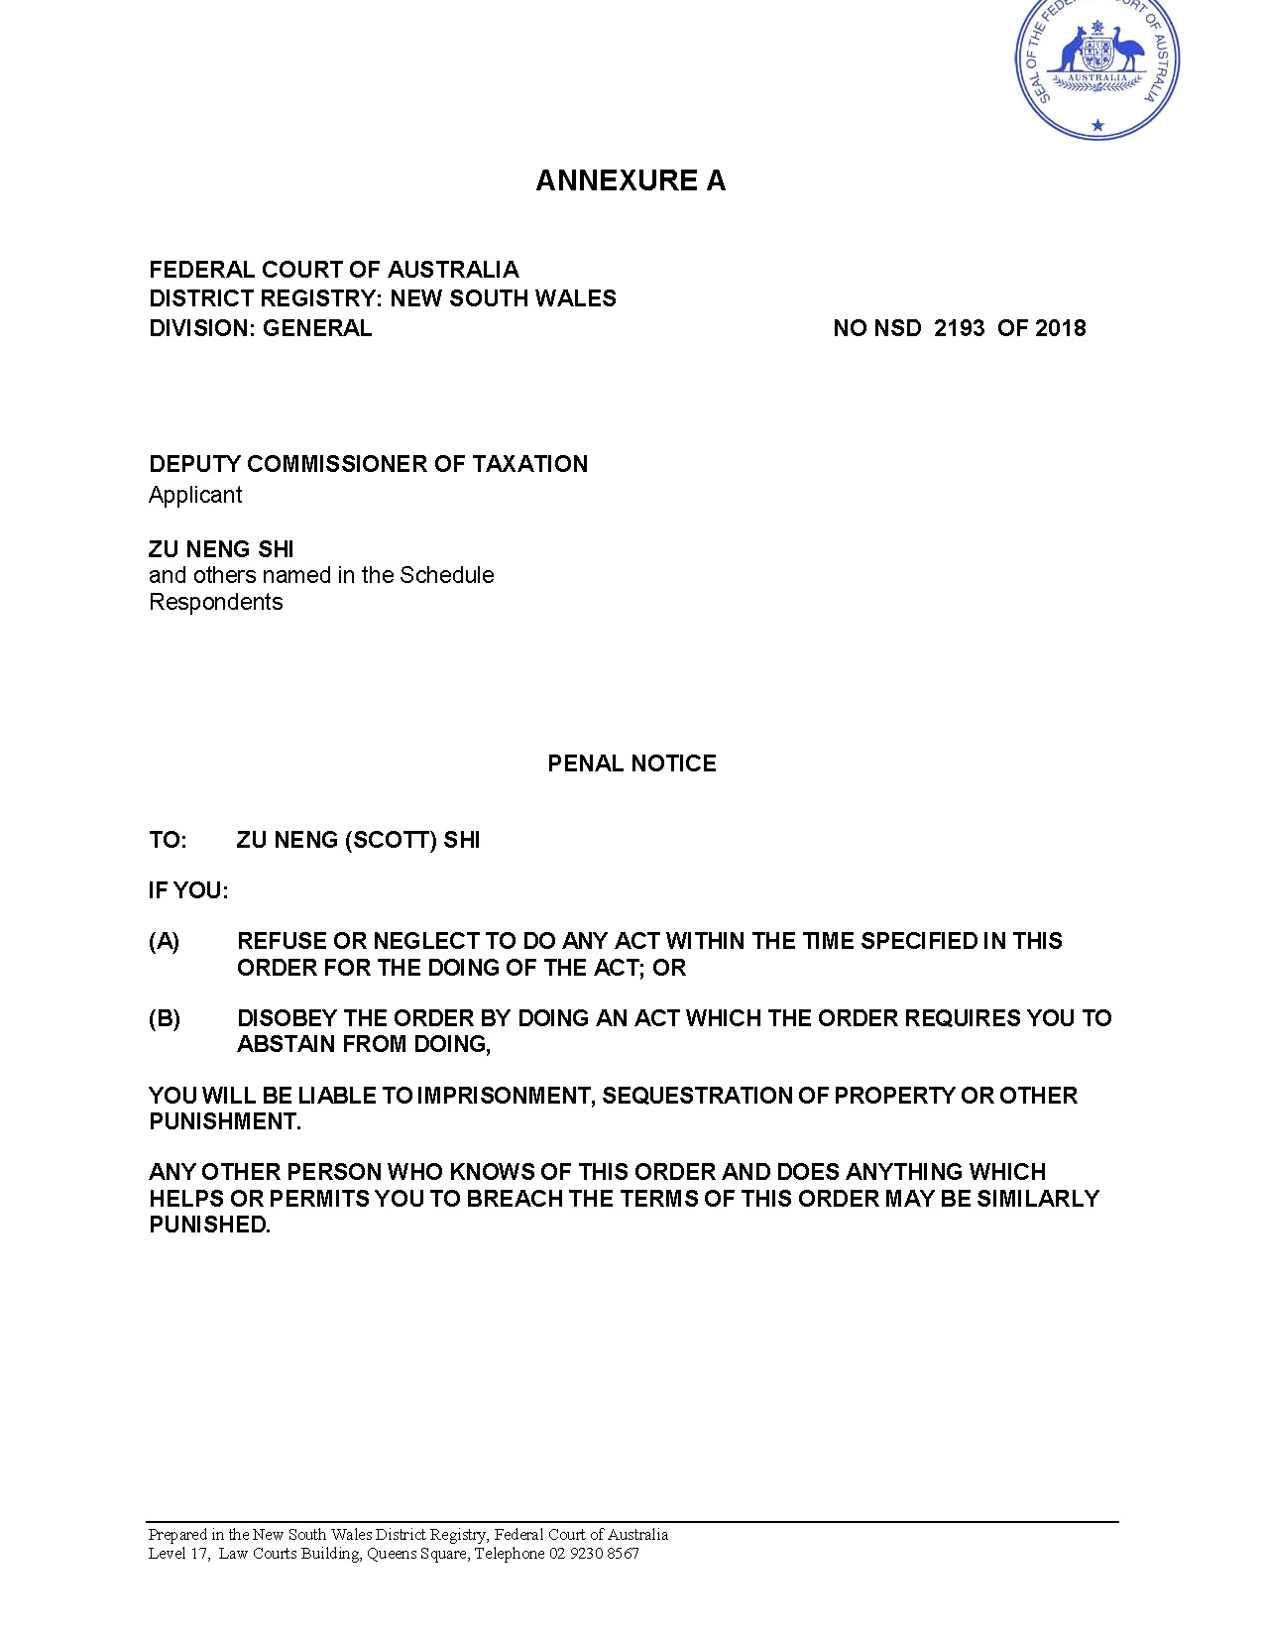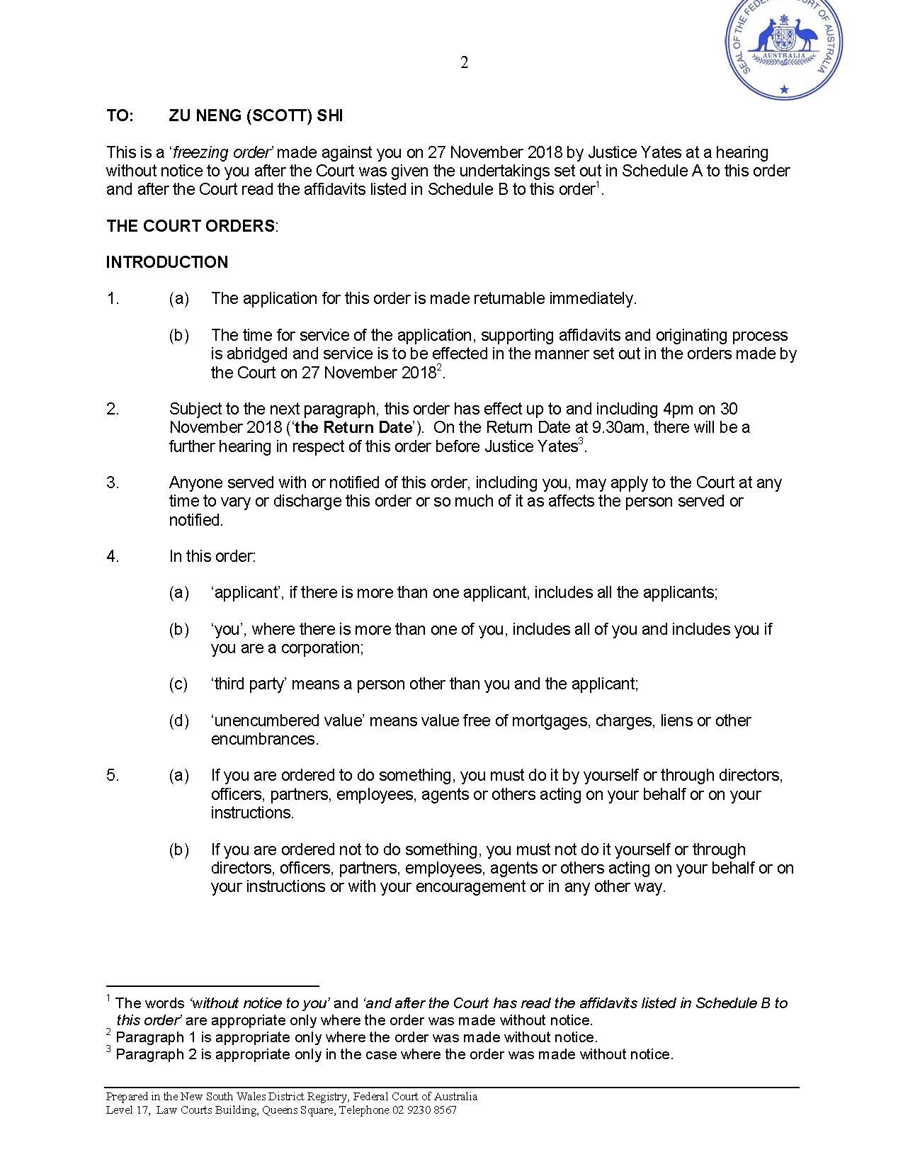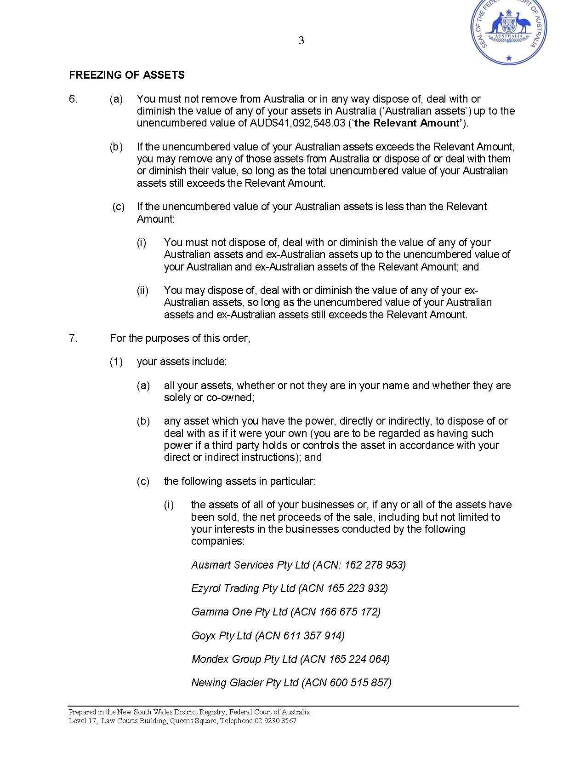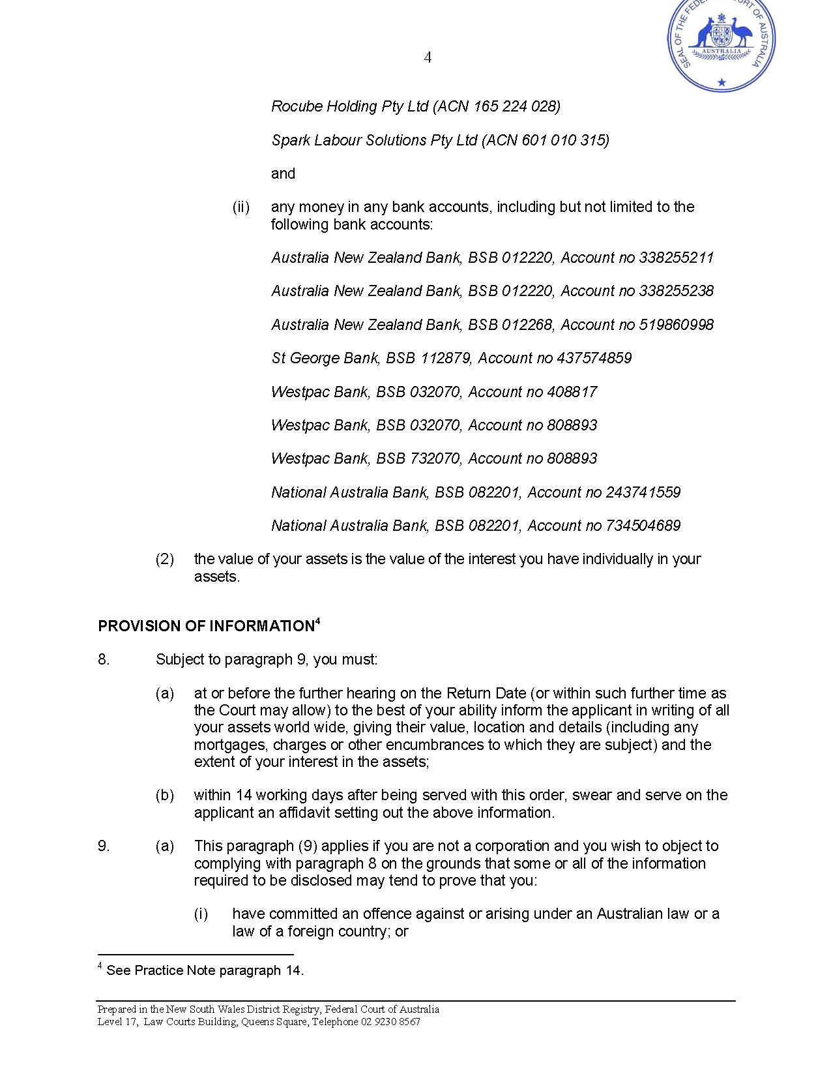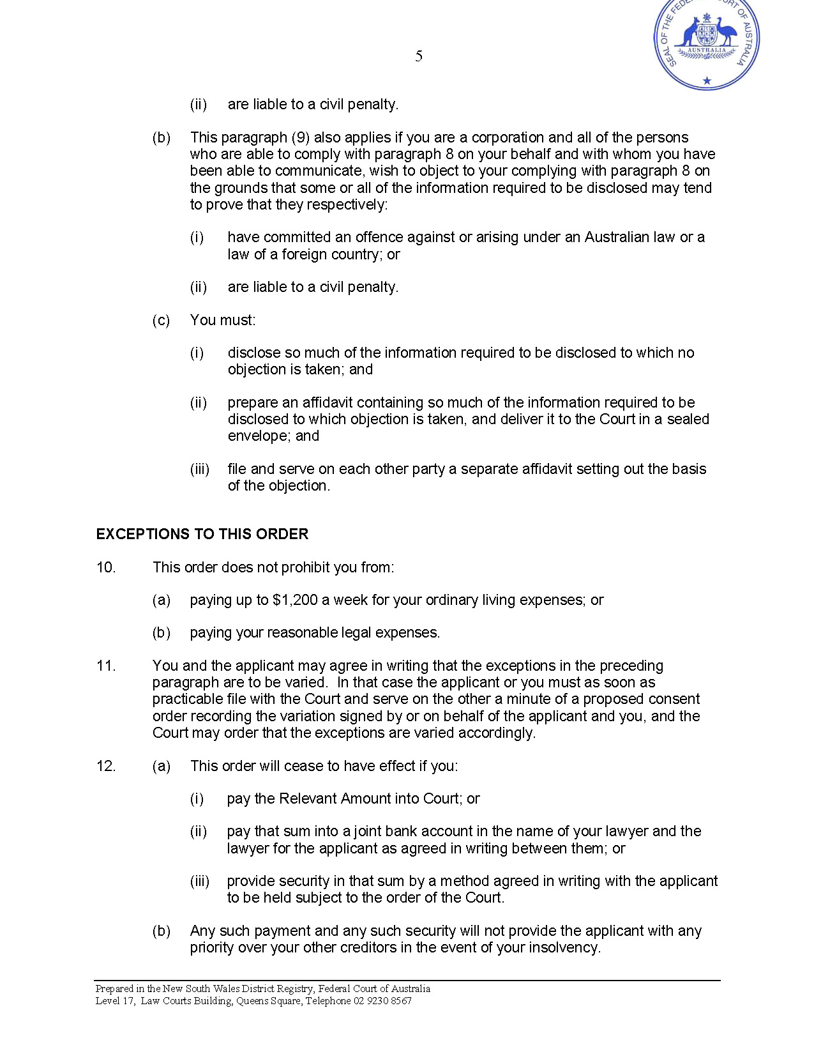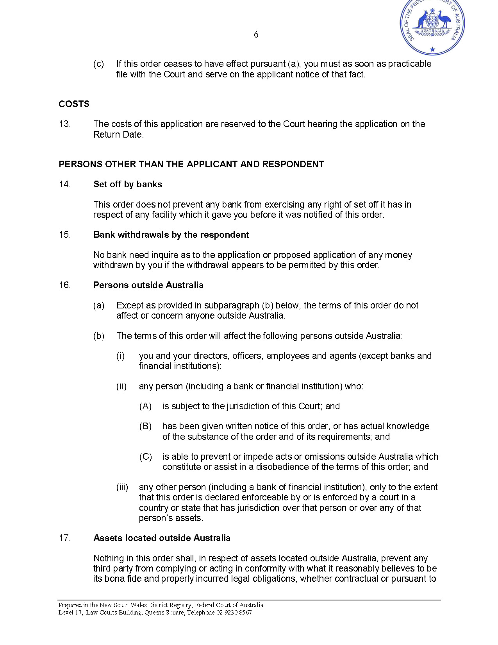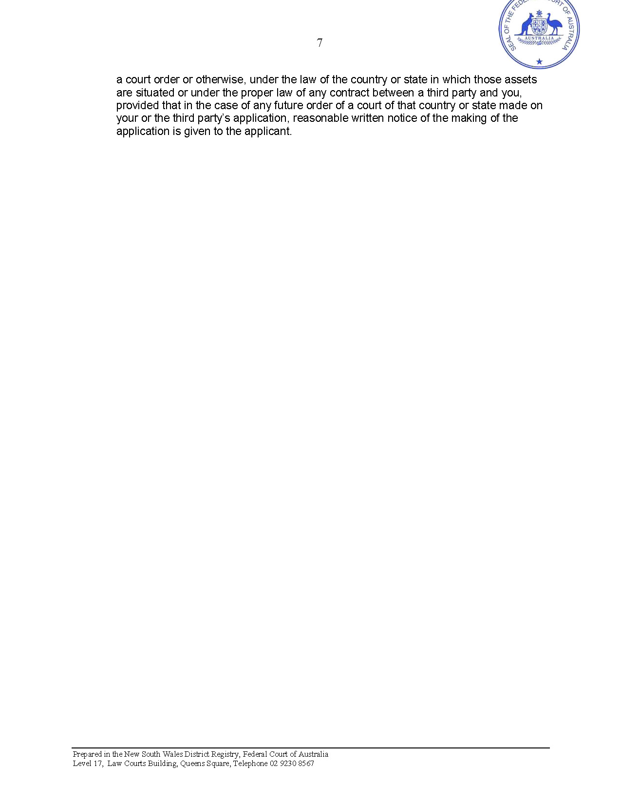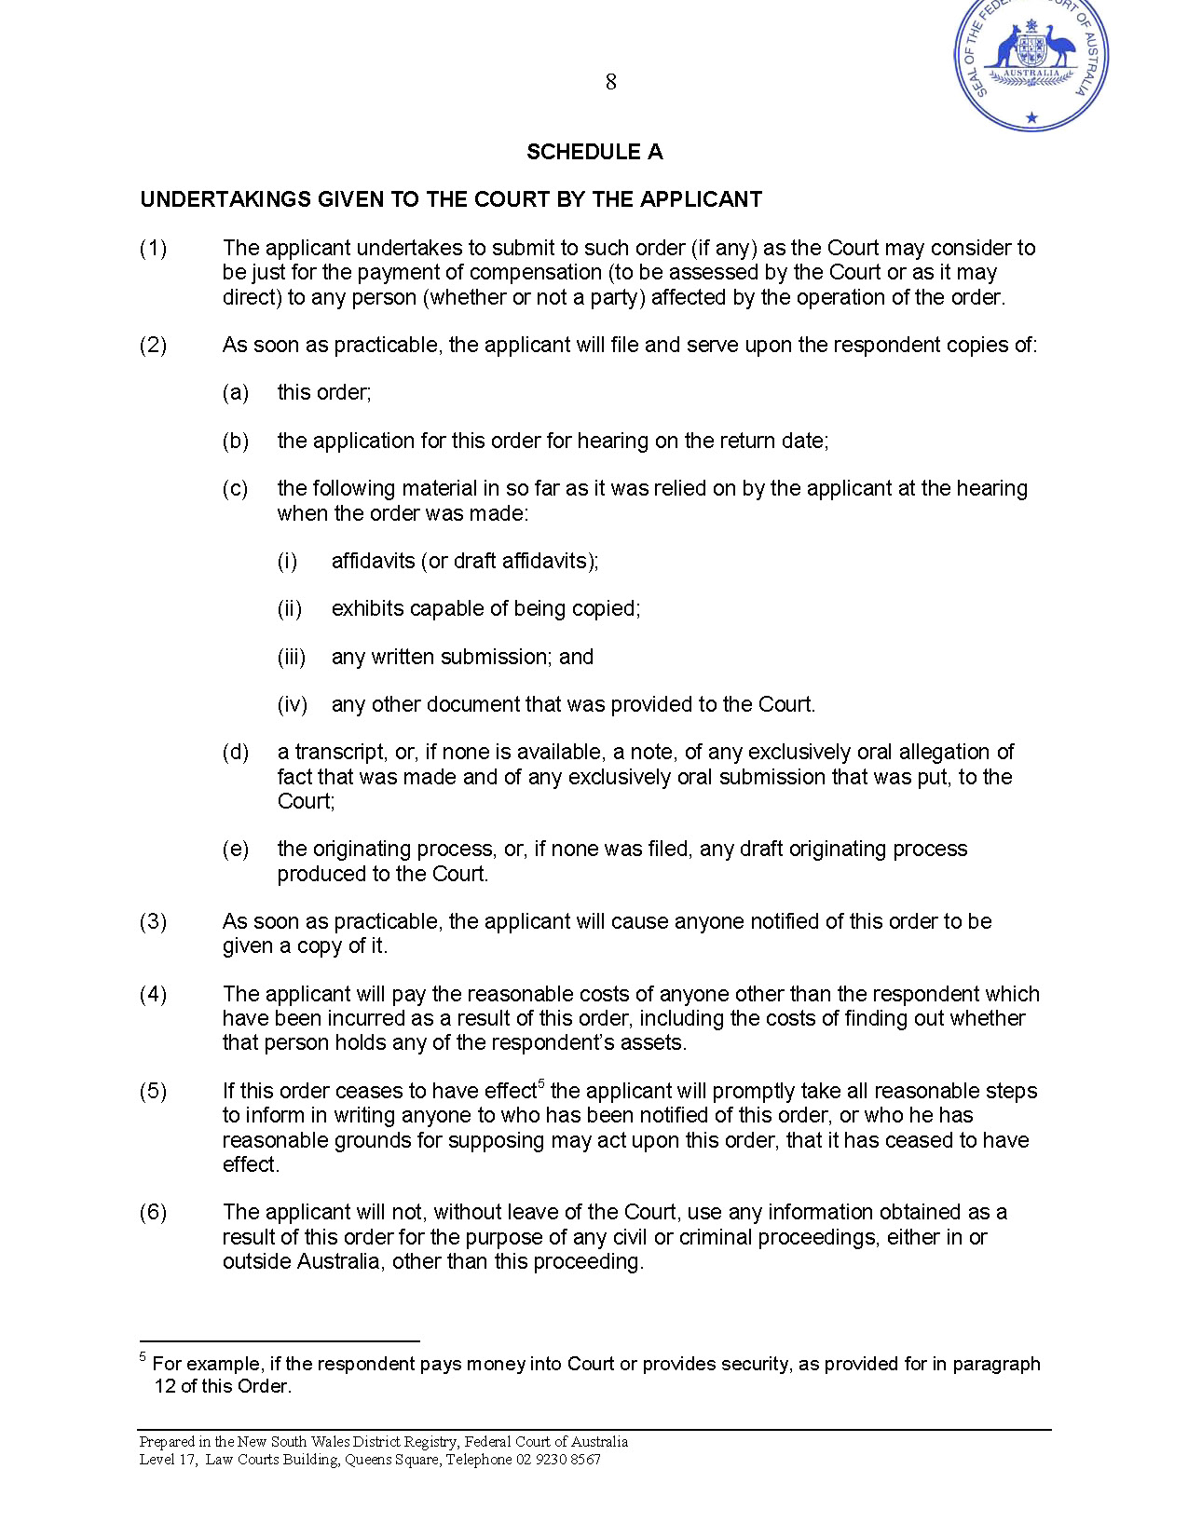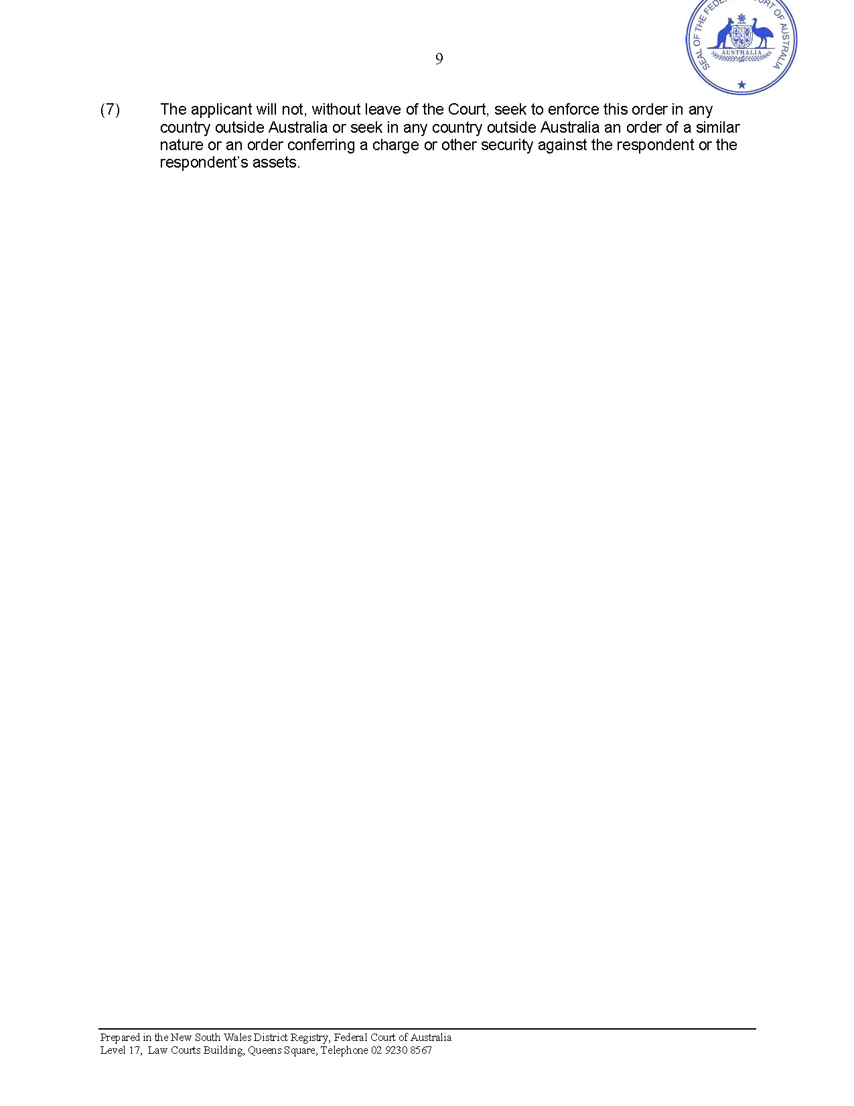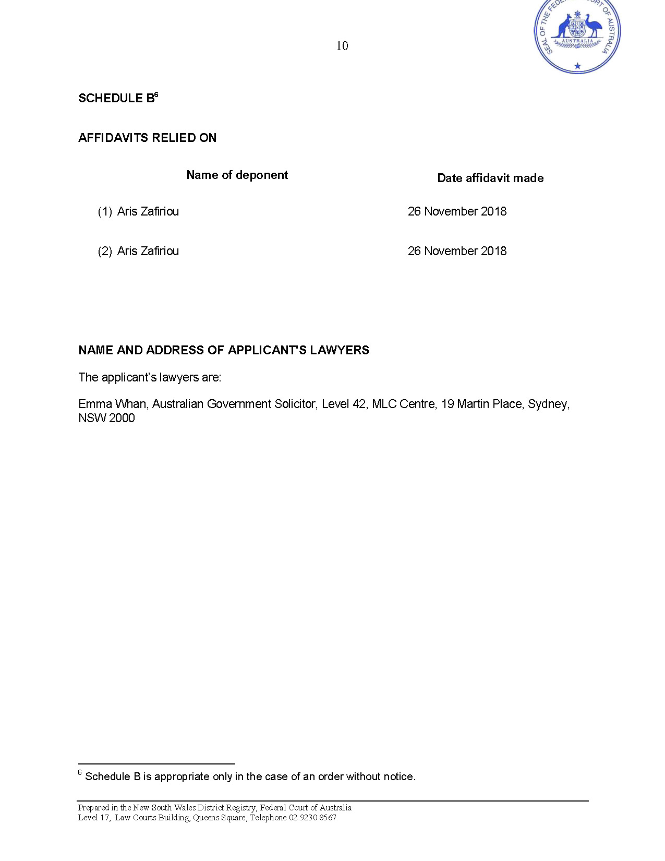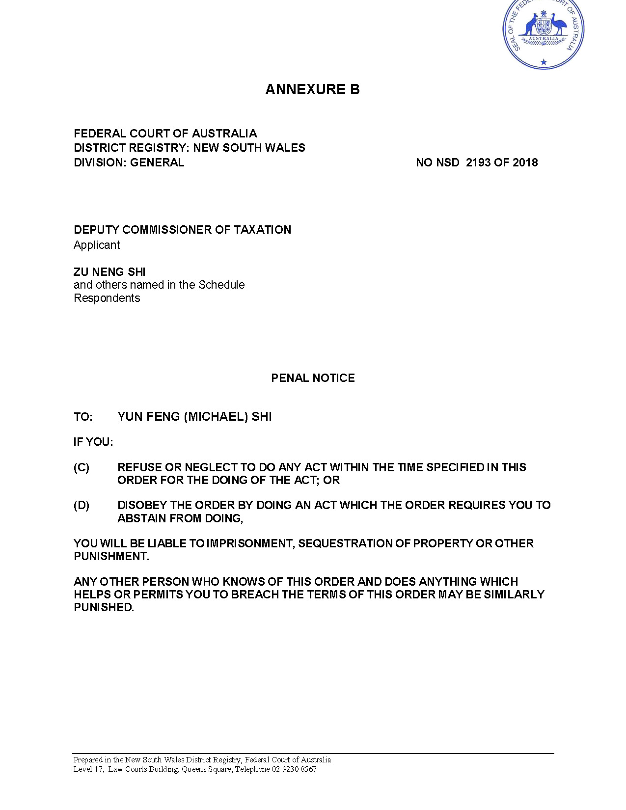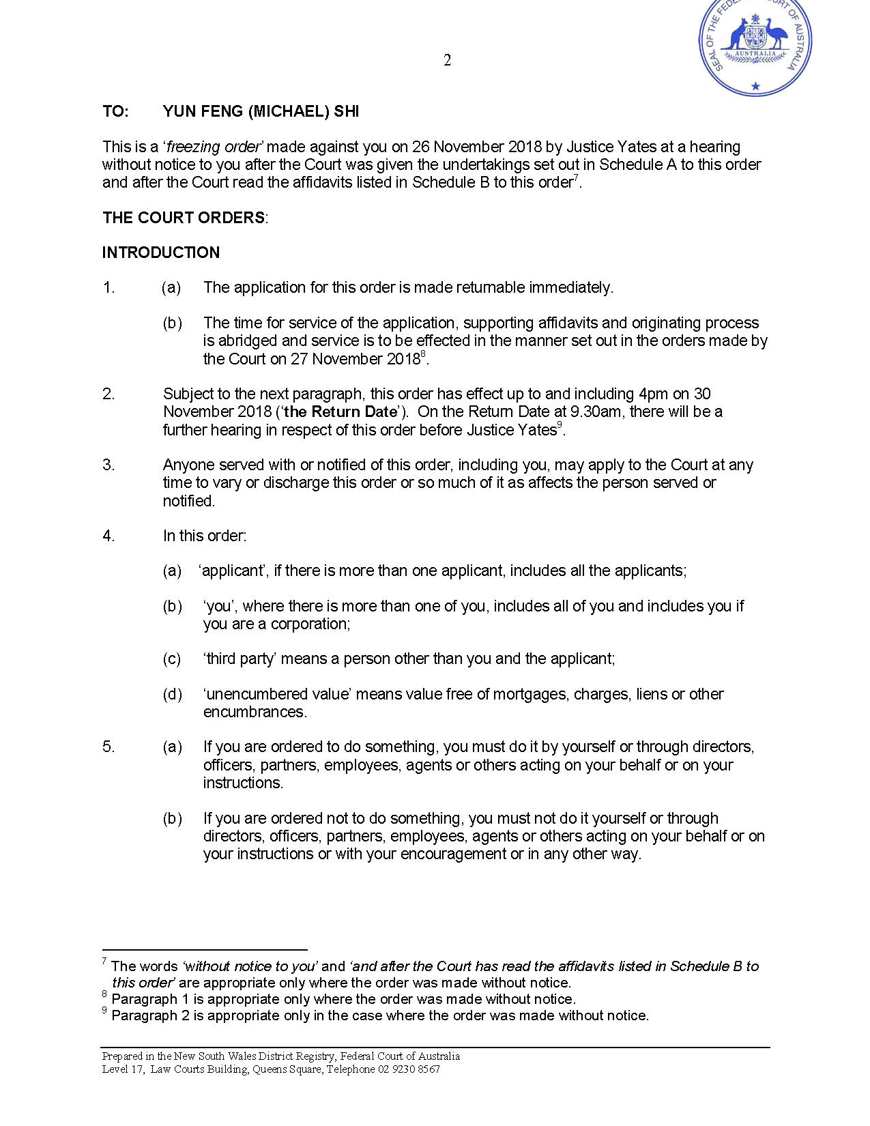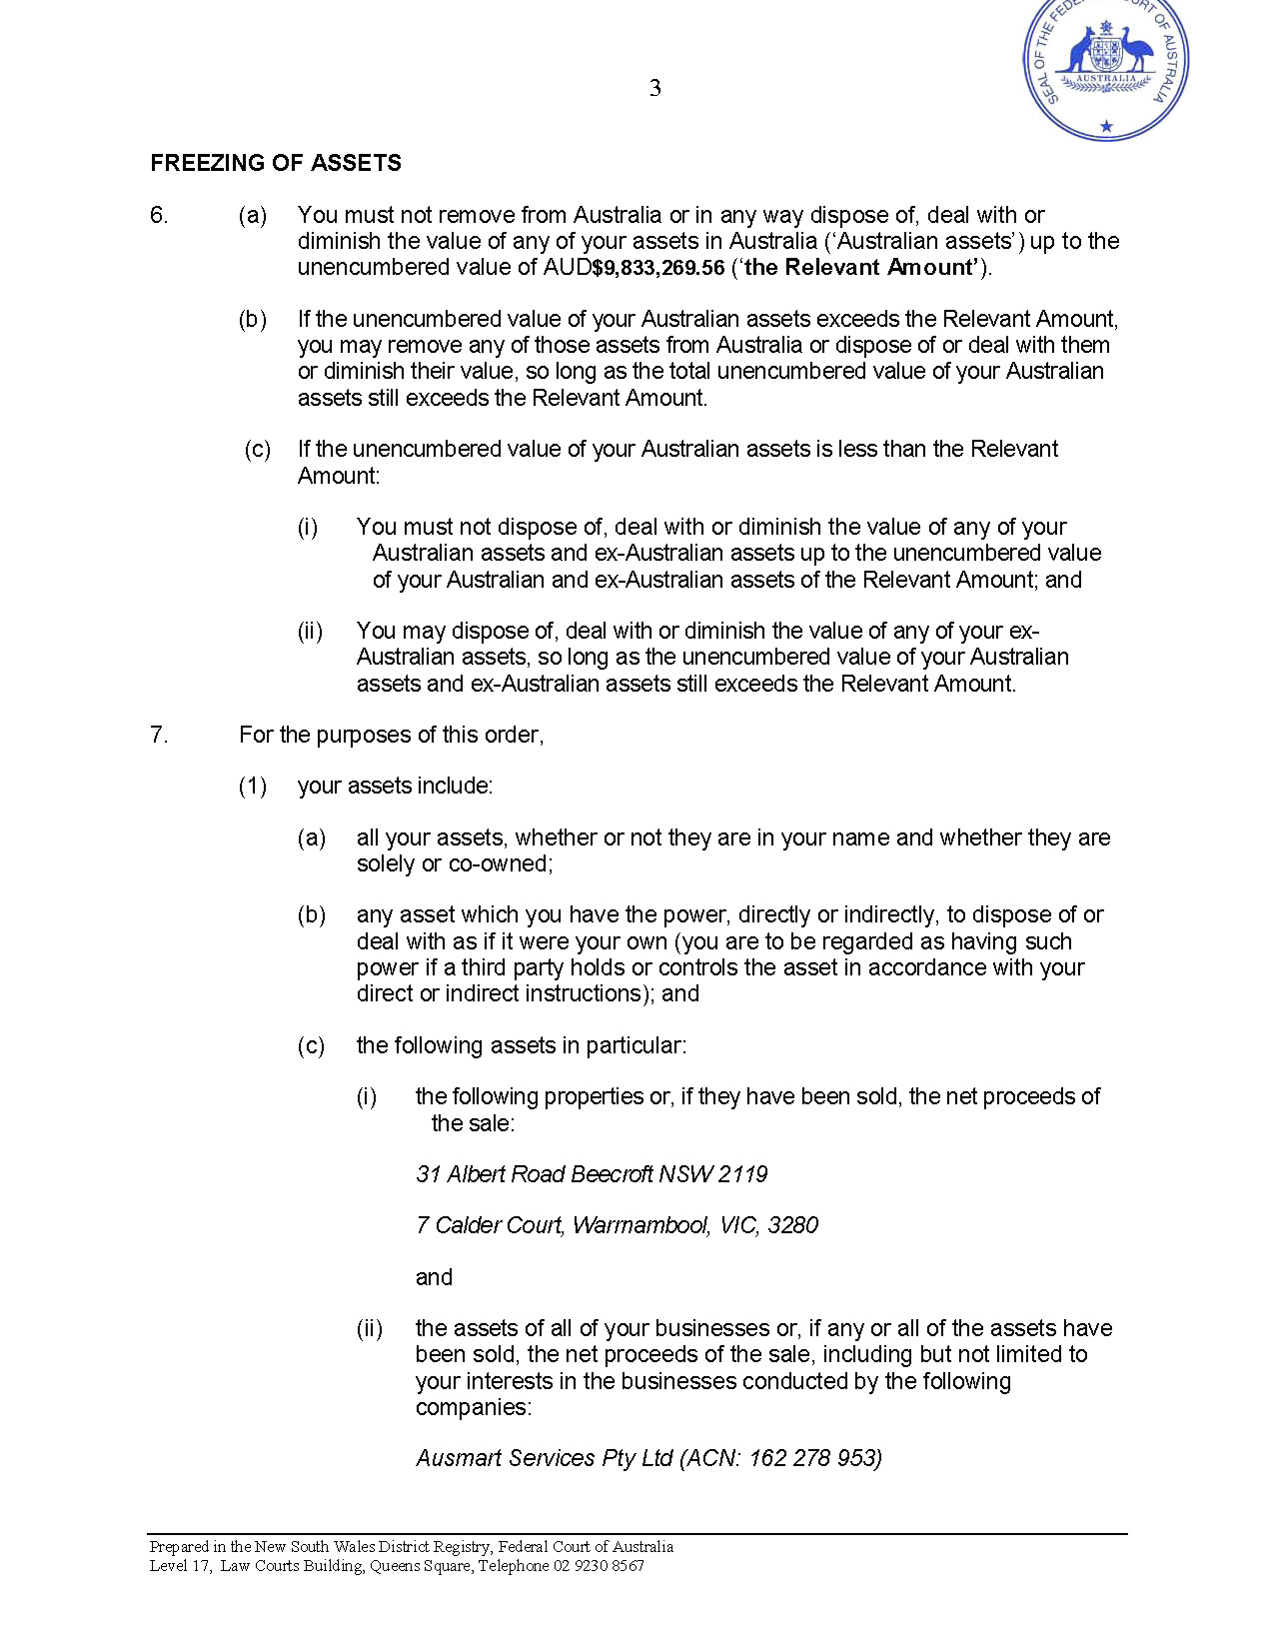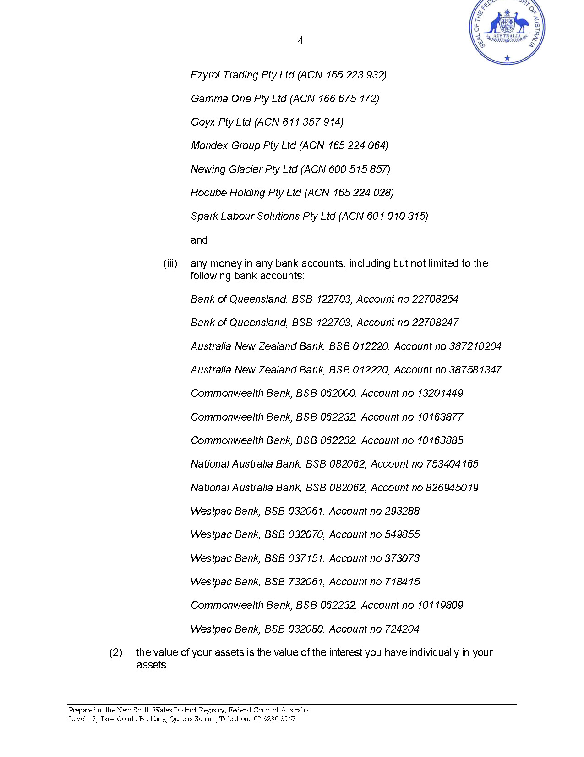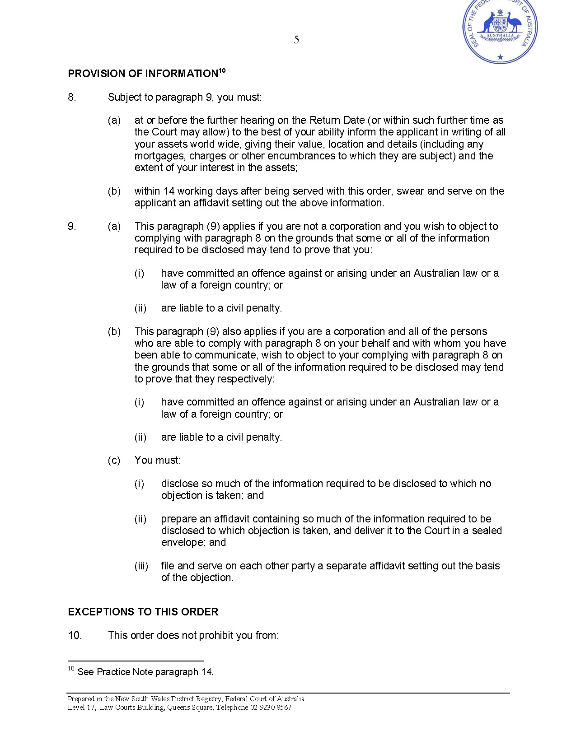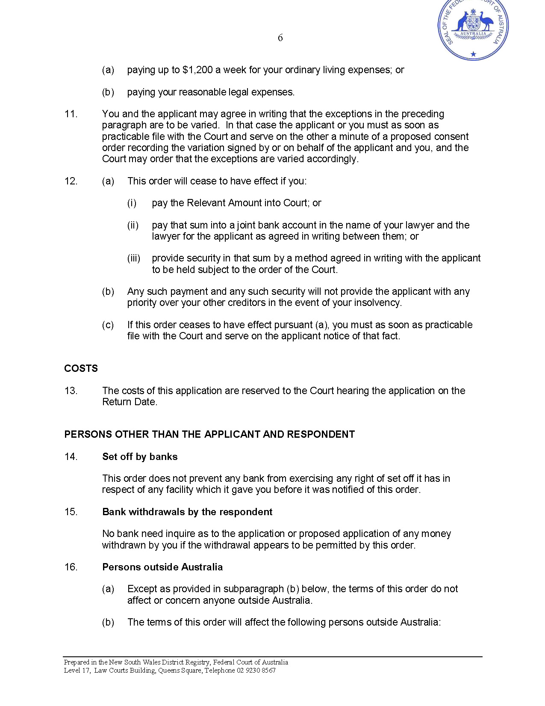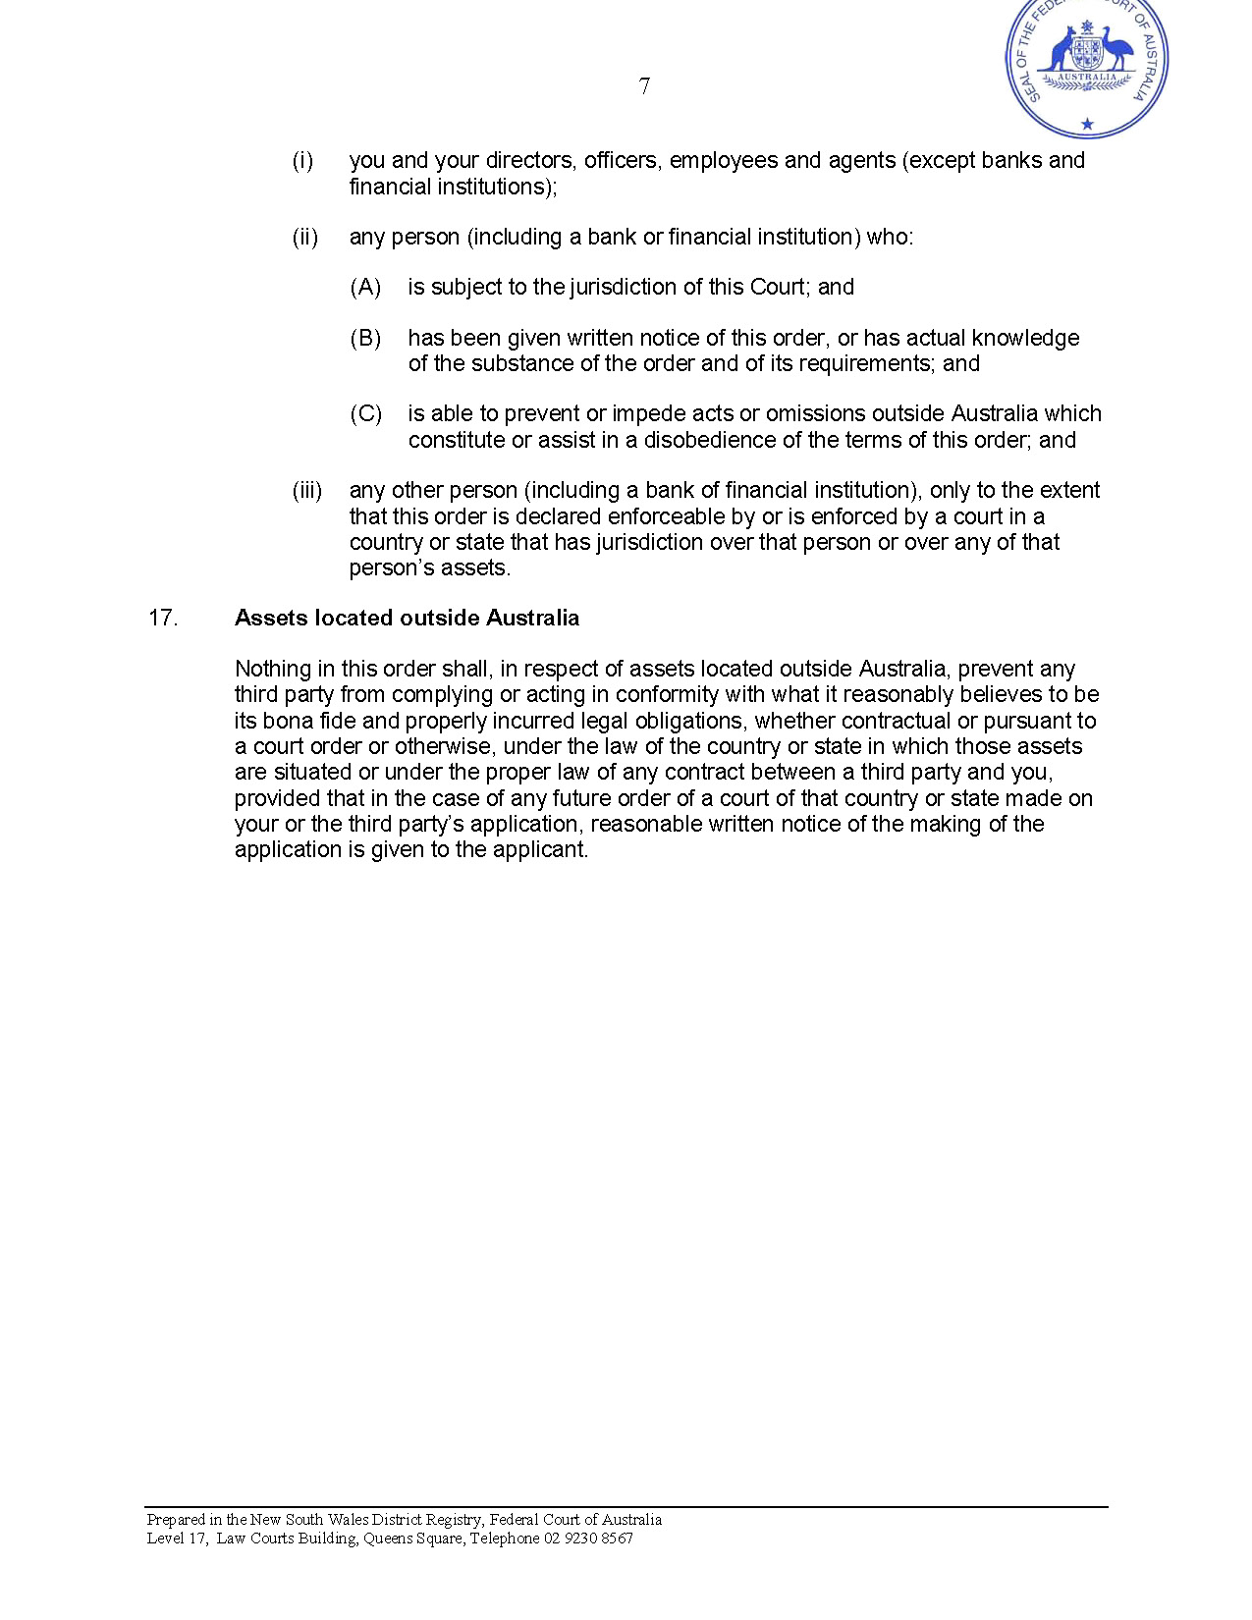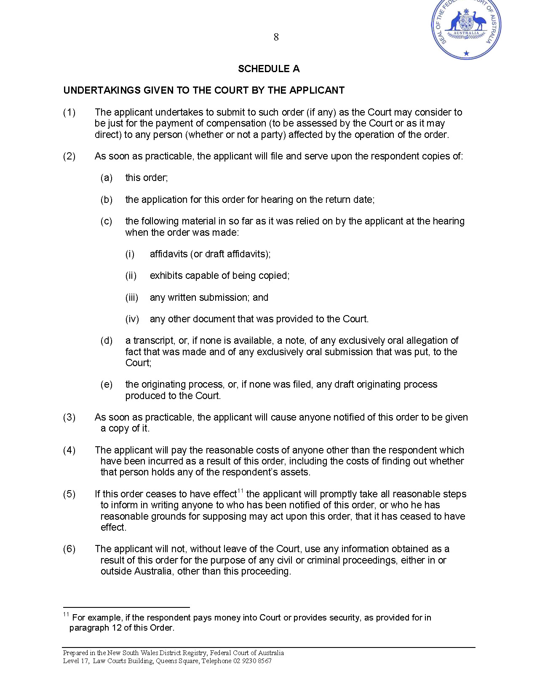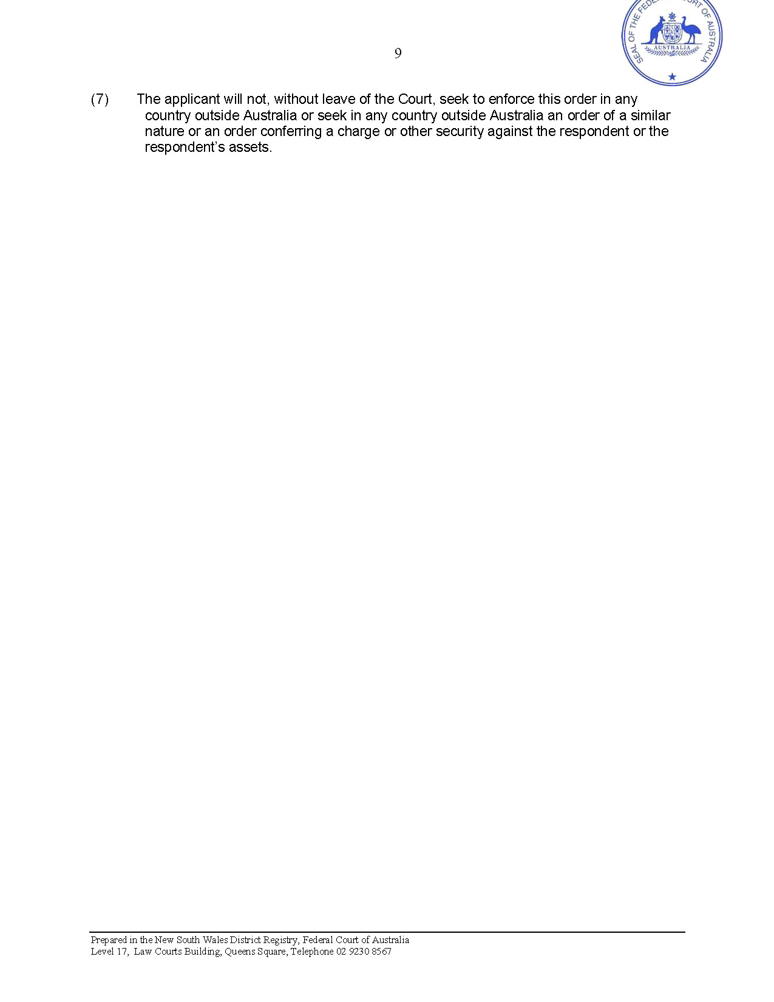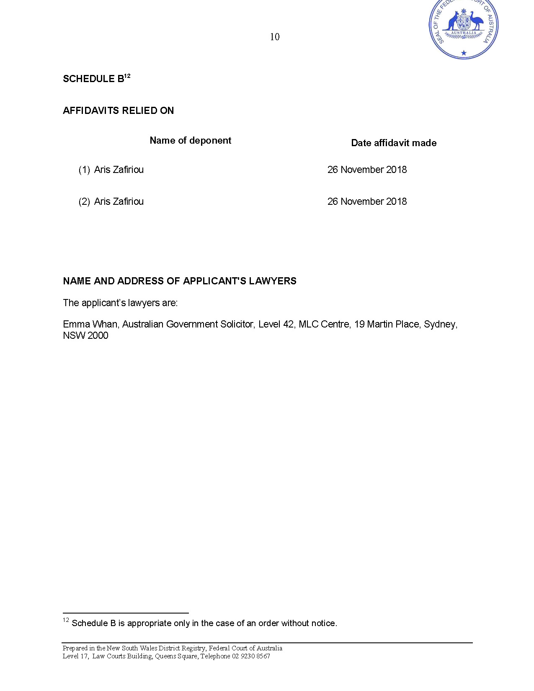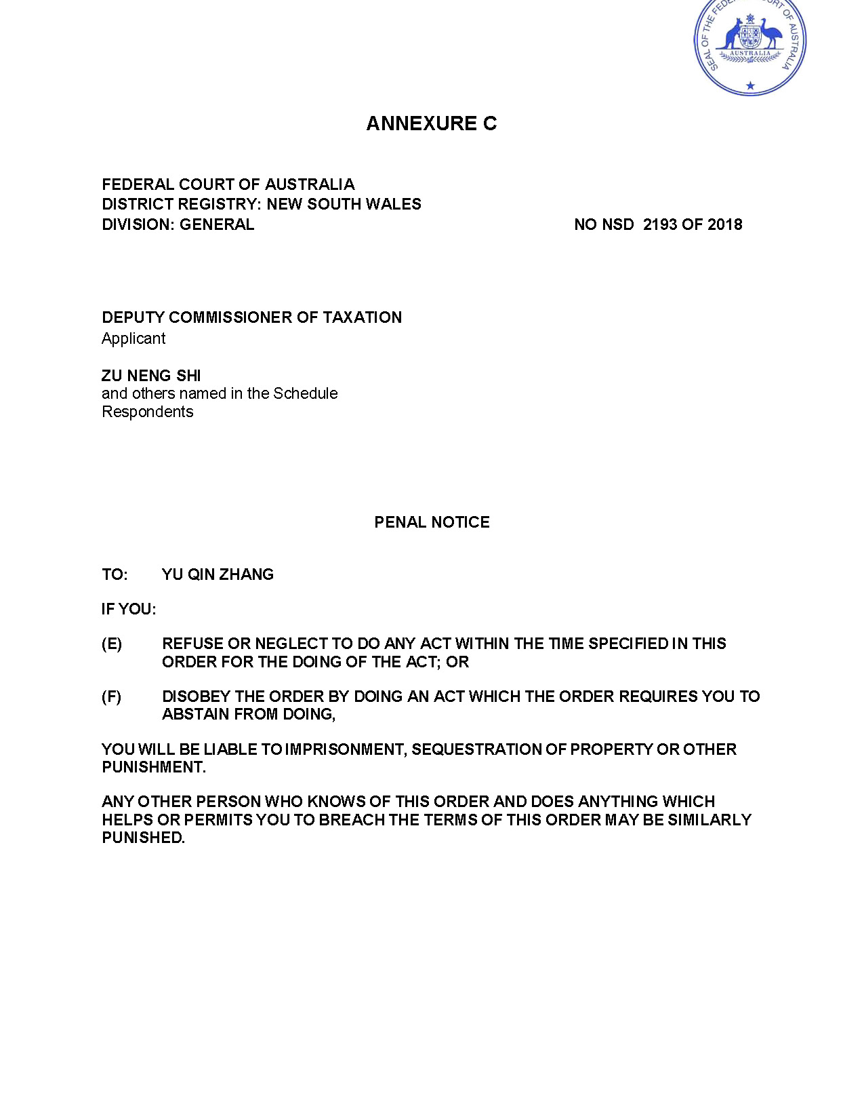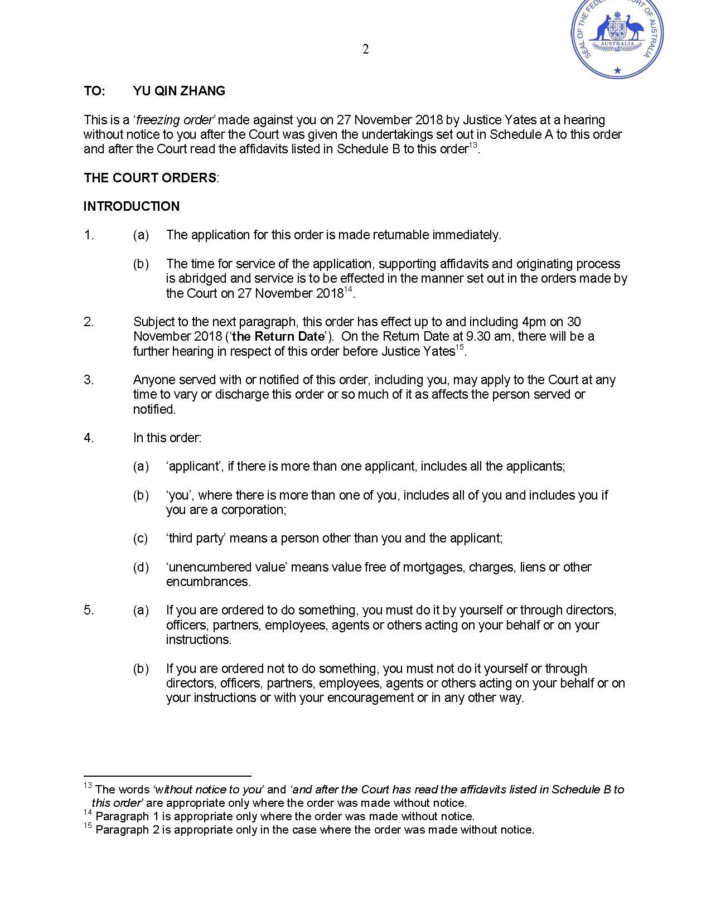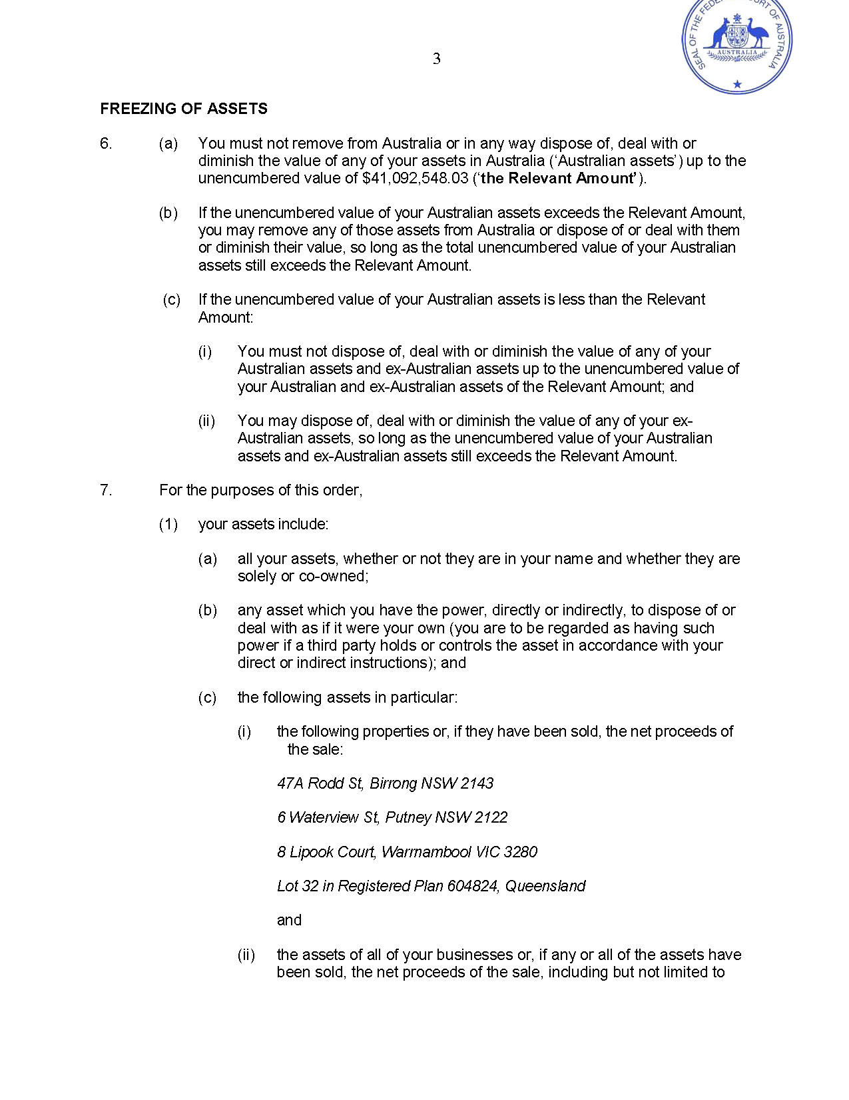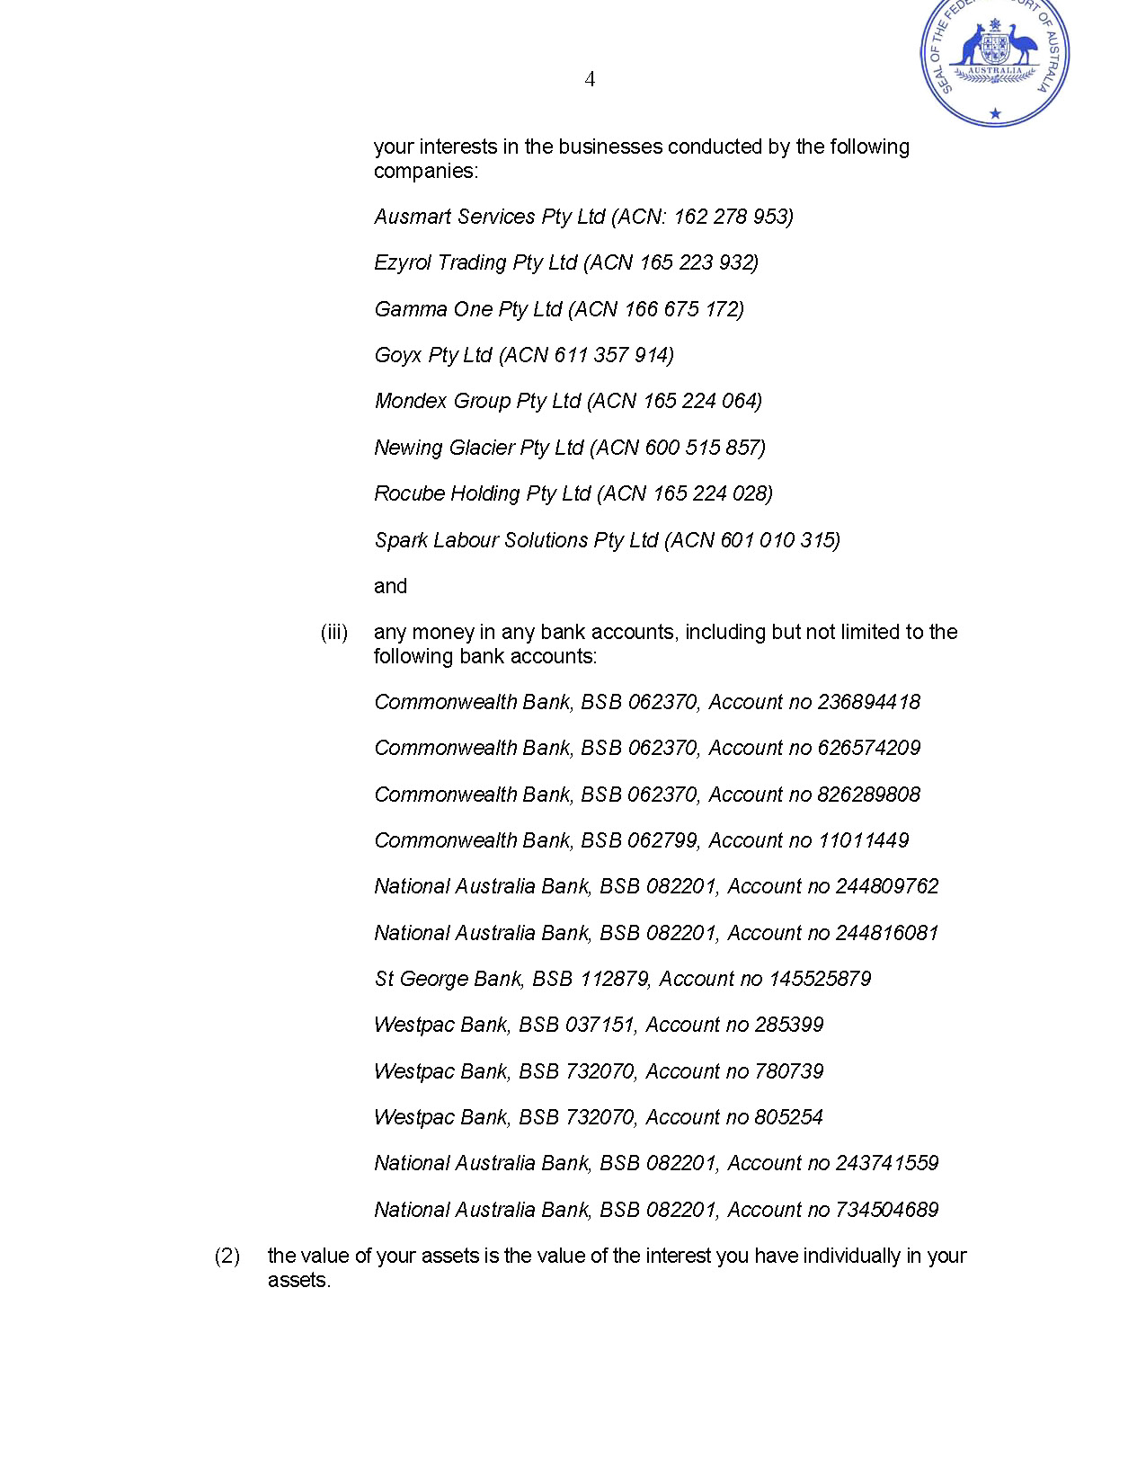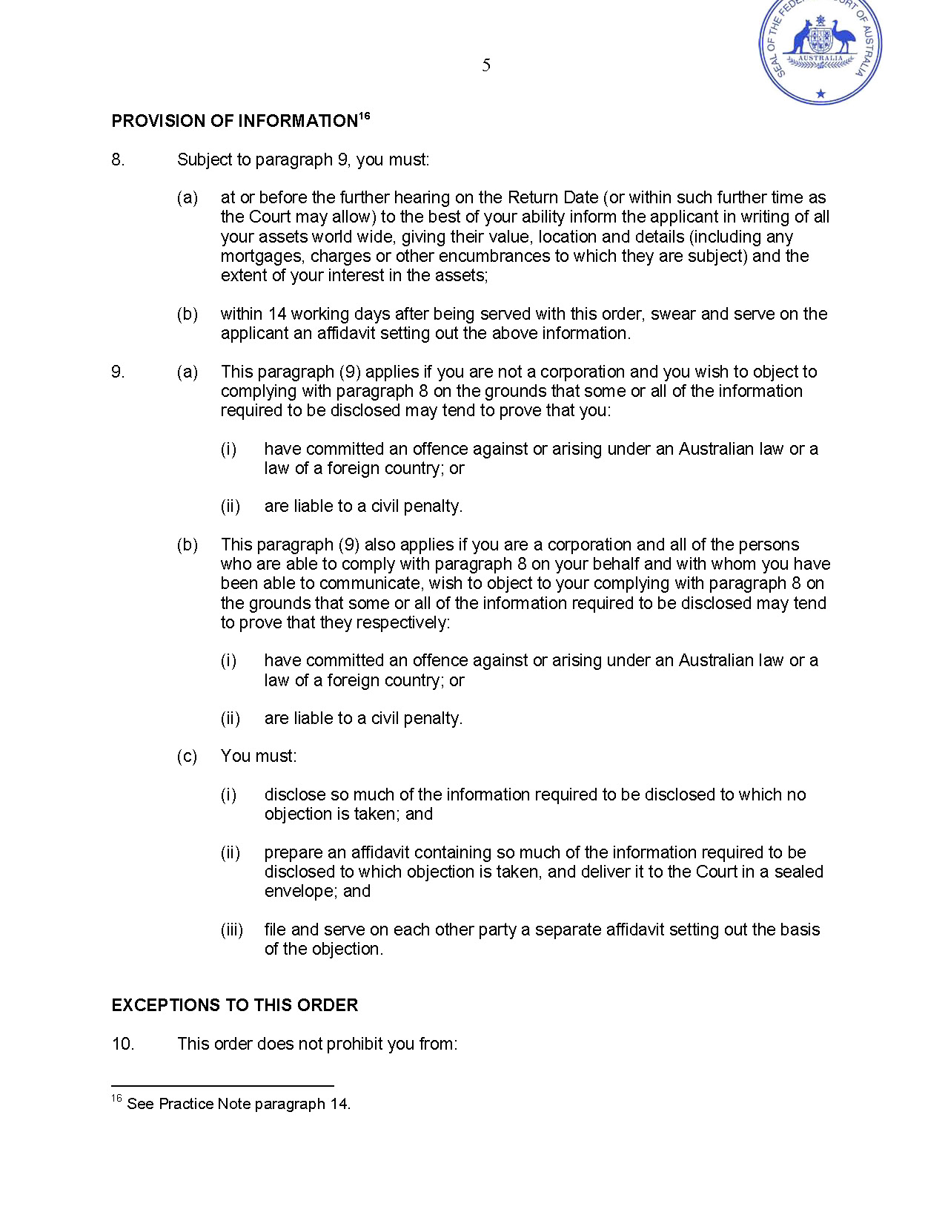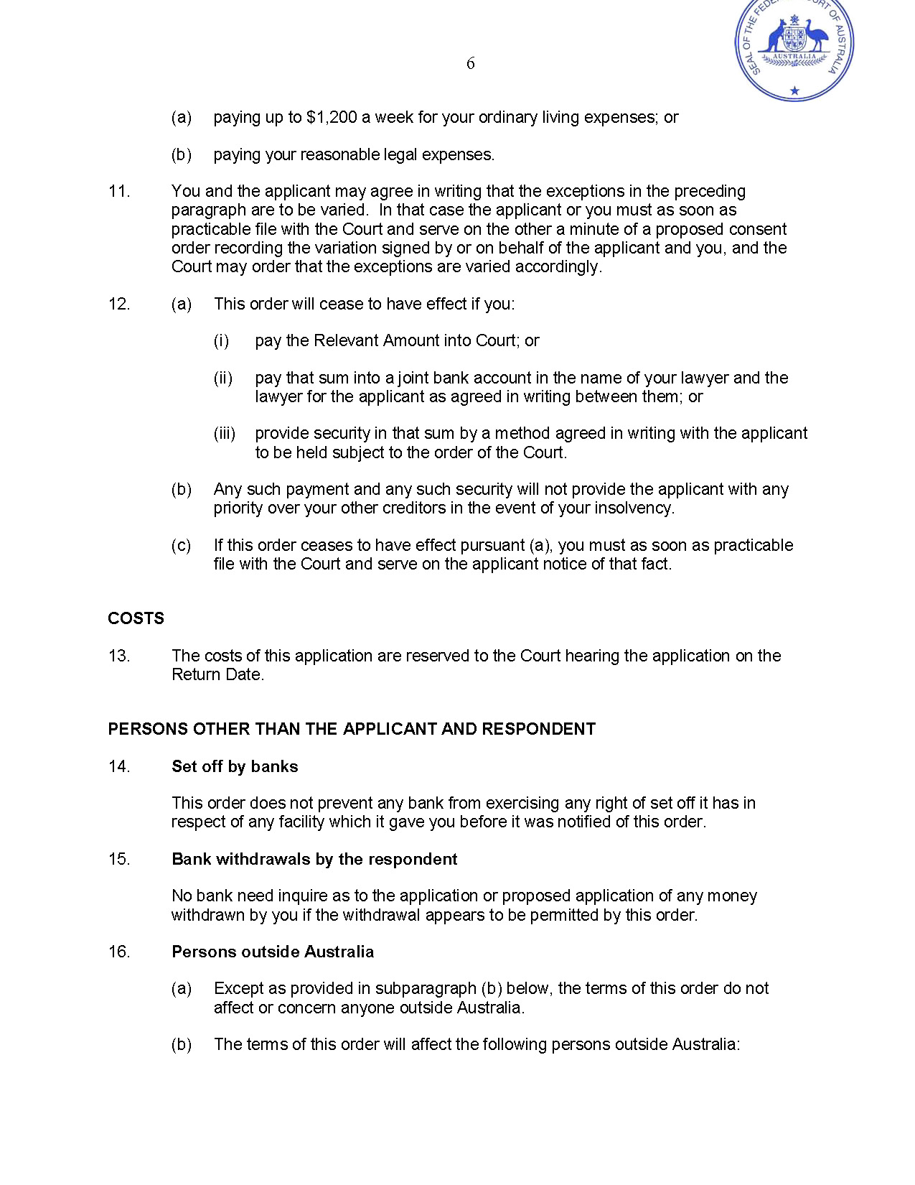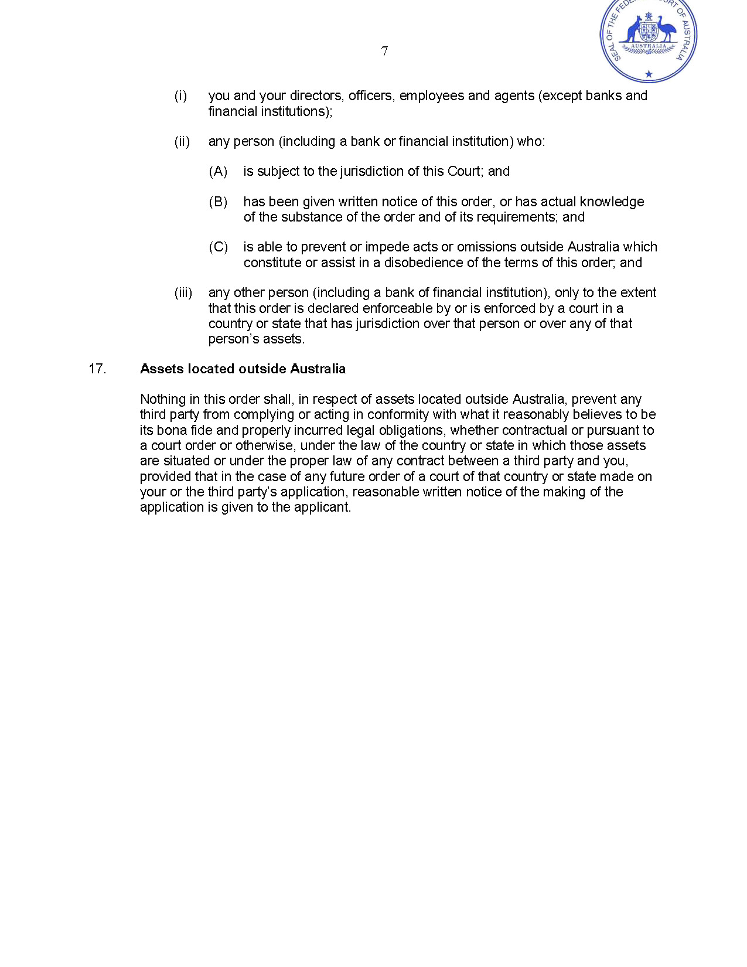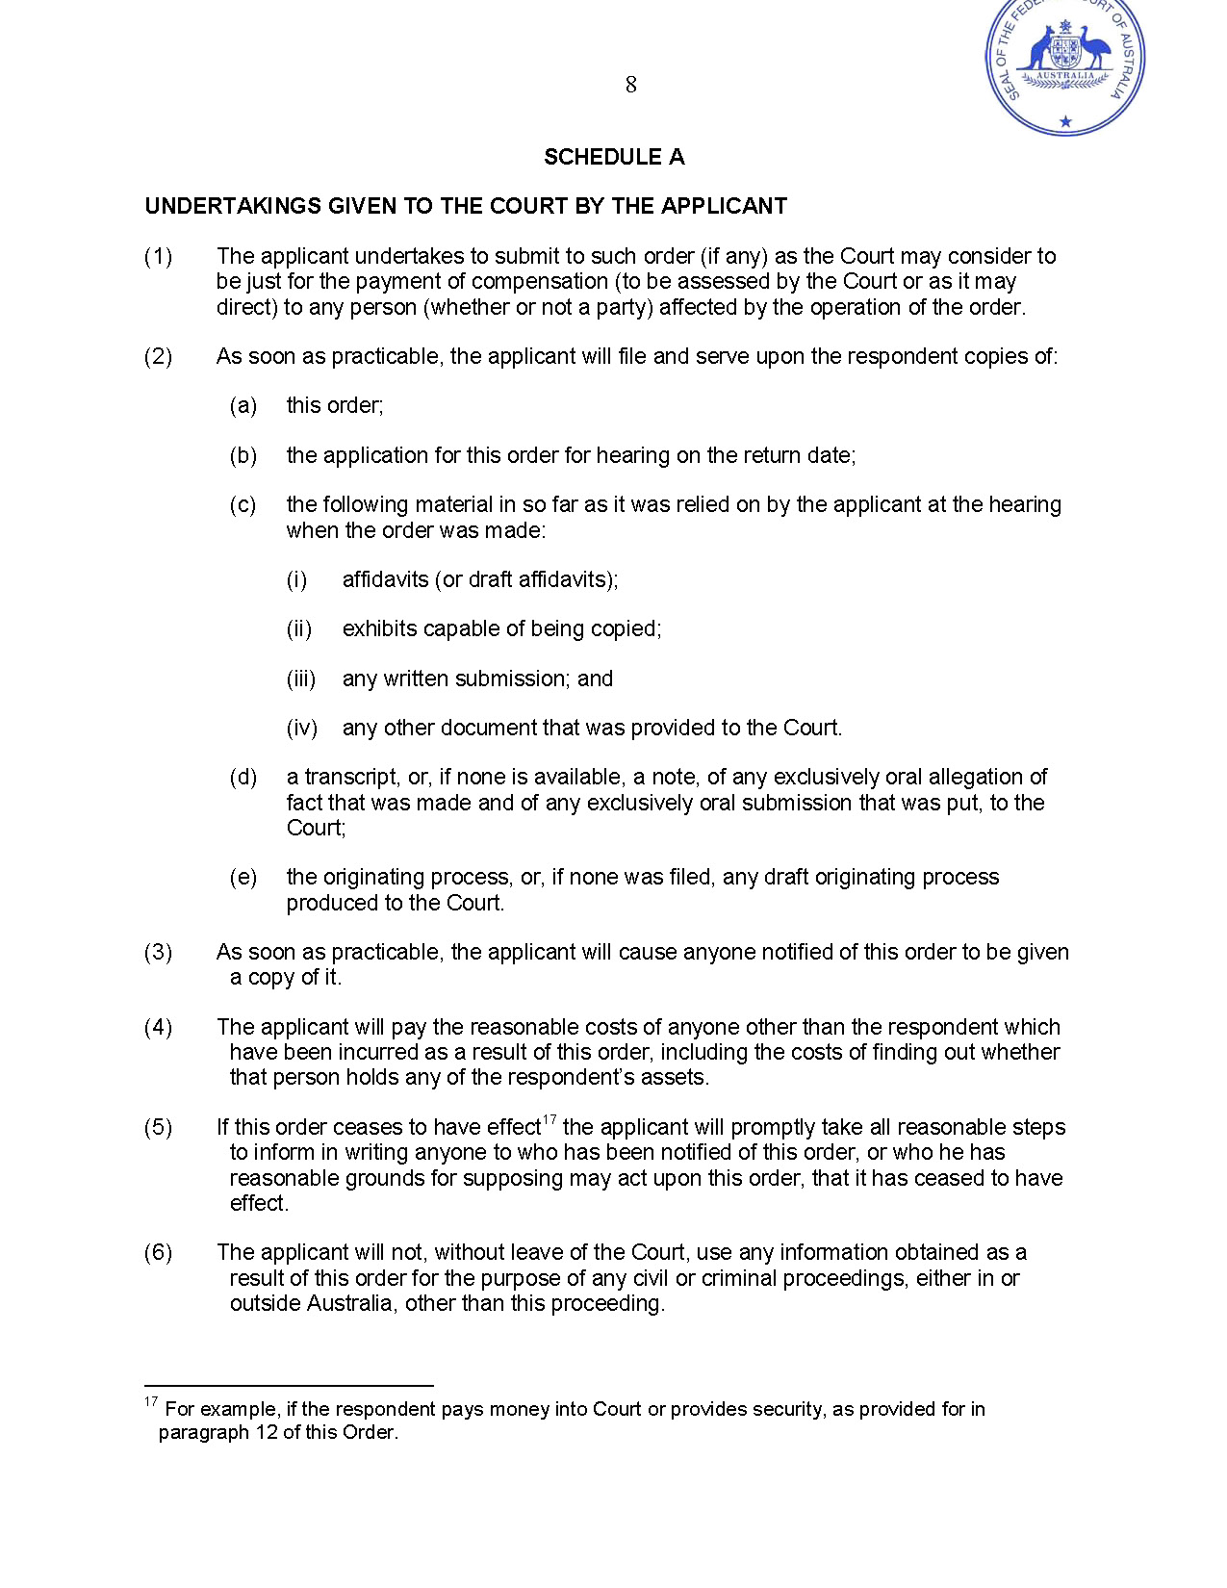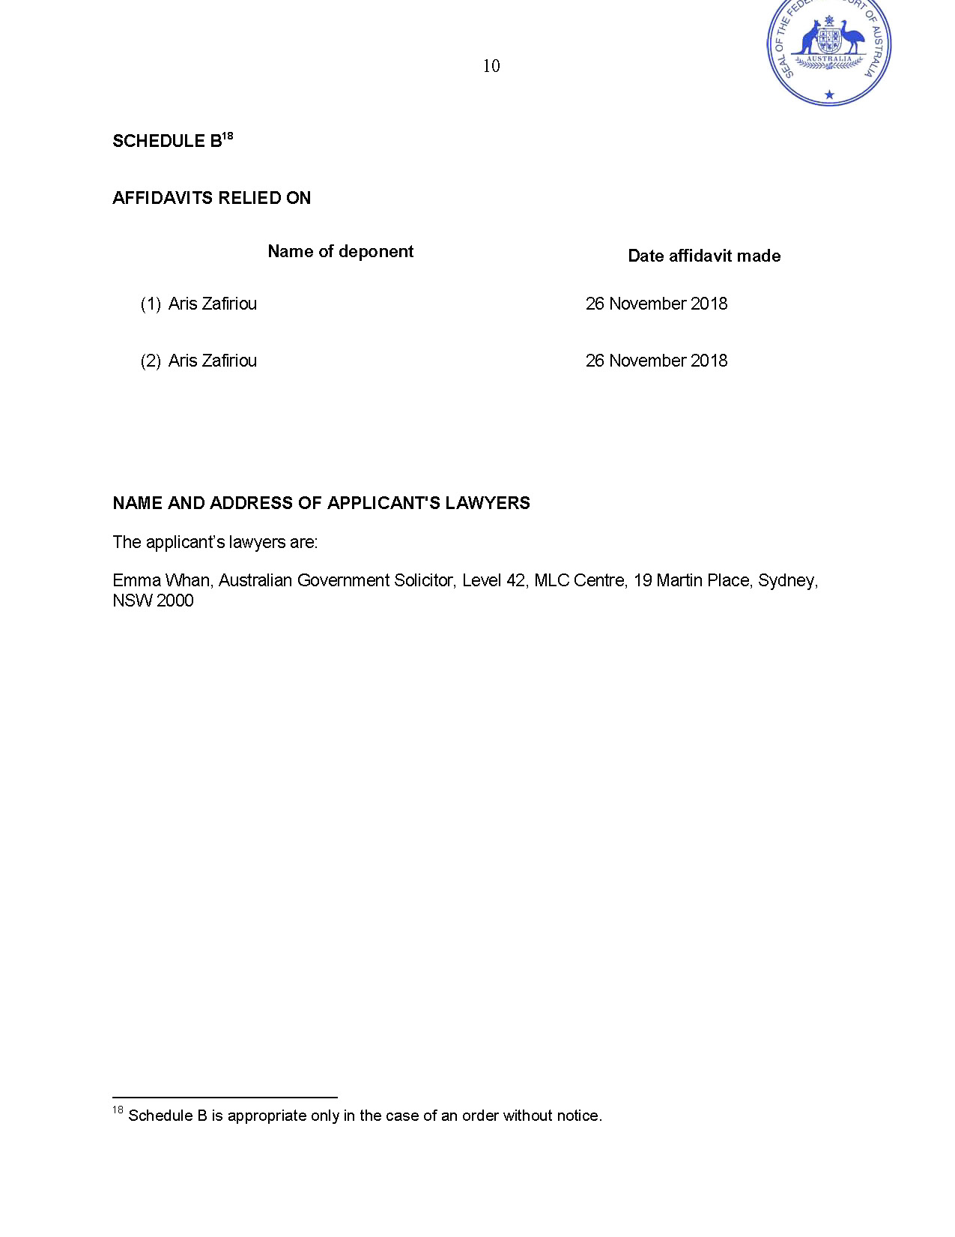
REASONS FOR JUDGMENT
YATES J:

Introduction
- The applicant, the Deputy Commissioner of Taxation (the Commissioner), has commenced proceedings seeking judgment against each respondent for his or her taxation liabilities to the Commonwealth. On 27 November 2018, I made ex parte freezing orders against each respondent. These are my reasons for making those orders.

Evidence
- The Commissioner relied on two affidavits made by Aris Zafiriou, each sworn on 26 November 2018. Mr Zafiriou is an Executive Level Officer in the Australian Public Service, employed at the Australian Taxation Office (ATO) as Director, Significant Debt Management. Mr Zafiriou gave the following evidence.
- In early 2014, a task force, led by the ATO, became aware of the first respondent, Zu Neng Shi (also known as Scott Shi), and his associated companies who were involved in the meat processing industry. Mr Shi was the head of a large labour hire business that supplied the majority of workers, through various companies, to a number of abattoirs. Mr Shi was not named as a director on ASIC’s register, but appeared to be (either himself or through his associates) the controller of all the companies. In July 2015, the taskforce began an intense audit of this group of companies (the Shi Group) and persons associated with it.
- As a result of this audit, it was determined that the companies in the Shi Group, which include the defendants in NSD 2194 of 2018 (commenced at the same time as the present proceeding), have incurred liabilities, which include:
  - amounts withheld from the wages of employees pursuant to Div 12 of Pt 2-5 of Sch 1 to the Taxation Administration Act 1953 (Cth) (TAA) but not remitted;
  - goods and services tax pursuant to A New Tax System (Goods and Service Tax) Act 1999 (Cth) in relation to labour hire contracts with abattoirs;
  - superannuation guarantee charges pursuant to s 16 of the Superannuation Guarantee (Administration) Act 1992 (Cth) in relation to employees; and
  - income tax.
- Many companies in the Shi Group have gone into liquidation or have been deregistered without paying their tax liabilities. The directors of the companies in the group usually changed a short time before each company was wound up or deregistered. The employees of each company in the labour hire contracts with each abattoir were transferred to a new company set up in the Shi Group. There are usually several companies in the Shi Group in operation at any one time, with some companies having contracts with abattoirs to supply workers and other companies using their bank accounts to pay workers.
- Nearly all the money received by companies in the group, not used to pay wages or business expenses, was withdrawn by Mr Shi or his family members and associates either in cash or transferred overseas to Mr Shi, his relatives or associates, or to companies controlled by Mr Shi, his relatives or associates.
- The Commissioner has determined that there have been significant tax shortfalls for Mr Shi for the income years ended 30 June 2010 to 30 June 2016. The Commissioner has formed the opinion that these shortfalls have arisen because, through fraud and/or evasion, Mr Shi deliberately excluded income which is assessable to him.
- The Commissioner has issued amended notices of assessment for Mr Shi for the income years ended 30 June 2010 to 30 June 2016 including as assessable income amounts withdrawn from the accounts of the Shi Group companies under his control and applied for his benefit. The Commissioner has also imposed administrative penalties for the relevant years and Shortfall Interest Charge. The total income tax, penalty and interest adjustments for the relevant years amount to $41,092,548.03.
- The second respondent, Yun Feng Shi (also known as Michael Shi), is Mr Shi’s son. Michael Shi is connected with a number of Shi Group companies through directorships, shareholding and as a bank account signatory. The employment history in his income tax returns shows that he was employed by a number of Shi Group companies. He has received a number of payments from Shi Group related companies. Rental properties owned or co-owned by him have also been used by Shi Group companies, with rent paid to him. Mr Shi gave evidence in other proceedings that he ran his businesses with Michael Shi.
- The Commissioner has determined that there have been significant tax shortfalls for Michael Shi for the income years ended 30 June 2010 to 30 June 2016. Once again, the Commissioner has formed the opinion that shortfalls have arisen because, through fraud and/or evasion, Michael Shi deliberately excluded income which is assessable to him.
- Michael Shi failed to lodge income tax returns for the income years ended 30 June 2010 and 30 June 2011. The Commissioner has reasons to believe that Michael Shi derived assessable income in each of those income years, and has issued default assessments for those years. The Commissioner has issued amended notices of assessment for Michael Shi for the income years ended 30 June 2012 to 30 June 2016 including as assessable income amounts withdrawn from the accounts of companies under his or his associates’ control and applied for his benefit, and other amounts representing ordinary income. The Commissioner has also imposed administrative penalties, failure to lodge on time penalties, and General Interest Charge (GIC) for the relevant income years. The total income tax, penalty and interest adjustments for the relevant years amount to $9,833,269.56.
- The third respondent, Yu Qin Zhang (Mrs Shi) is Mr Shi’s wife. Mrs Shi has failed to lodge income tax returns since 2006. The Commissioner has reason to believe that Mrs Shi derived assessable income in the income years ended 30 June 2010 to 30 June 2015, inclusive. The Commissioner has issued notices of assessment for Mrs Shi for the income years ended 30 June 2010 to 30 June 2015 including as assessable income rent derived from properties owned by her; salary and wage income earned from Fujian Zongeteng Co Ltd; and other unidentified deposits in her bank accounts, including amounts transferred from Shi Group companies. The Commissioner has also imposed administrative penalties, failure to lodge on time penalties and GIC for the relevant years. The total income tax, penalty and interest adjustments for the relevant years amount to $2,525,212.15.
- The audit has disclosed that Mr Shi, Michael Shi and Mrs Shi have been the recipients of large amounts of money that have been withdrawn from Shi Group company bank accounts in cash (through ATMs, EFTPOS and cheques made to cash) and by transfer (including through the Money Chain Foreign Exchange service (Money Chain)) to overseas bank accounts controlled by them or their associates, including their relatives. AUSTRAC reports show at least $28,699,046 in overseas funds transfers through Money Chain and up to approximately $43 million when taken with direct overseas funds transfers. The audit has also disclosed that Michael Shi is a director of several Hong Kong companies. Despite these matters, income tax returns lodged by Mr Shi and Michael Shi show that each individual did not disclose his foreign dealings and transactions, as required.
- Michael Shi and Mrs Shi individually own a number of properties. Each respondent also operates a large number of bank accounts at various major banks.
- The evidence as to the respondents’ individual tax affairs must also be considered in relation to the taxation affairs of the Shi Group of companies, which are summarised in reasons published today as Deputy Commissioner of Taxation v Ausmart Services Pty Ltd [2018] FCA 1912.

Analysis
- An assessment of tax issued by the Commissioner creates a statutory debt when the liabilities assessed become “due and payable”. The production of the notice of assessment, or a copy of it, is conclusive evidence of the due making of the assessment and, subject to certain exceptions (not presently relevant), that the amount and all the particulars of the assessment are correct. The Commissioner may sue in a court of competent jurisdiction to recover a taxation liability due to the Commonwealth: s 255-5 of Sch 1 to the TAA. Such as action is justiciable in this Court: Deputy Commissioner of Taxation v Vasiliades [2014] FCA 1250 at [42].
- The issuing of an assessment creates a prospective cause of action at the suit of the Commissioner, even though service of the notice of assessment has not been effected: Deputy Commissioner of Taxation v Hua Wang Bank Berhad [2010] FCA 1014 at [18].
- The Court may make a freezing order, without notice to a respondent, for the purpose of preventing the frustration or inhibition of the Court’s process by seeking to meet a danger that a prospective judgment of the Court will be wholly or partly unsatisfied: r 7.32(1) of the Federal Court Rules 2011. A freezing order may restrain a respondent from removing assets located in or outside Australia or from disposing of, dealing with, or diminishing the value of, those assets: r 7.32(2).
- The Court may make a freezing order against a prospective judgment debtor, if satisfied, having regard to all the circumstances, that there is a danger that a prospective judgment will be wholly or partly unsatisfied because the assets of the prospective judgment debtor might be removed from Australia or from a place inside or outside Australia, or disposed of, dealt with, or diminished in value: r 7.35(4). In order to obtain such a freezing order, it is not necessary for the Commissioner to show that the statutory debt is presently payable. It is sufficient that it be payable in the future: Deputy Commissioner of Taxation (ACT) v Sharp (1988) 91 FLR 70 at 74.
- On the evidence presented, I was satisfied that the Commissioner had established against each respondent a strong prima facie case of at least prospective indebtedness for a very large sum in respect of his or her tax liabilities. I was also satisfied that the facts and circumstances surrounding each respondent’s taxation affairs (including, on the Commissioner’s case, an apparently deliberate failure to disclose taxable income), and each respondent’s ability to access and transfer offshore large sums to other entities which he or she controls or with which he or she has an association, established that there is a real (as opposed to a supposed) danger that a judgment or prospective judgment obtained against him or her might be wholly or partly unsatisfied because assets (in particular, liquid assets) might be removed from Australia or otherwise disposed of or dealt to the disadvantage or detriment of the Commonwealth. I was satisfied that the balance of convenience favoured the grant of the relief sought and that it should be granted on an ex parte basis.

Disposition
- Orders as sought were made.

I certify that the preceding twenty-one (21) numbered paragraphs are a true copy of the Reasons for Judgment herein of the Honourable Justice Yates.

Associate:

Dated: 30 November 2018

