FEDERAL COURT OF AUSTRALIA

Gordian Runoff Limited, in the matter of Gordian Runoff Limited (No 2) [2016] FCA 687
File number: | NSD 316 of 2016
Judges: | ALLSOP CJ
Date of judgment: | 9 June 2016
Catchwords: | INSURANCE— general insurance—application for confirmation of a scheme for the transfer of an insurance business—when both transferee and transferor insurer are conducting a runoff insurance business—the Court’s discretion to confirm a scheme—where the size of the business being transferred is minimal
Legislation: | Insurance Act 1973 (Cth) ss 12, 32, 17A-17G  Life Insurance Act 1995 (Cth)
Cases cited: | In the matter of GIO Personal Investment Services Ltd and AMP Life Ltd [2000] FCA 1871  In the matter of Reward Insurance Ltd [2004] FCA 151  Re Insurance Australia Ltd [2004] FCA 524; 139 FCR 450  Re Royal & Sun Alliance Life Assurance Ltd [2000] FCA 1259; 104 FCR 37  Re Westport Insurance Corporation (No 2) [2009] FCA 1958; 181 FCR 530
Date of hearing: | 6 June 2016
Registry: | New South Wales
Division: | General Division
National Practice Area: | Commercial and Corporations
Sub-area: | Commercial Contracts, Banking, Finance and Insurance
Category: | Catchwords
Number of paragraphs: | 80
Counsel for the Applicant: | Mr N J Owens
Solicitor for the Applicant: | HWL Ebsworth Lawyers
Solicitor for APRA | Mr D Tran

ORDERS
NSD 316 of 2016
GORDIAN RUNOFF LIMITED, IN THE MATTER OF GORDIAN RUNOFF LIMITED ABN 11 052 179 647

GORDIAN RUNOFF LIMITED ABN 11 052 179 647
Applicant

JUDGE: | ALLSOP CJ
DATE OF ORDER: | 9 June 2016

THE COURT ORDERS THAT:

- Pursuant to s 17F of the Insurance Act 1973 (Cth) (the Act), the scheme for the transfer of all of the insurance business of Poseidon Insurance Co Ltd (Poseidon) to Gordian Runoff Limited (Gordian) (the Scheme) be confirmed in the form of Annexure “A” attached to these orders.
- The transfer date for the purposes of the Scheme is 10 June 2016.
- Pursuant to s 17F of the Act, all rights and obligations owed to Poseidon pursuant to any reinsurance treaties, including the claims indemnity agreements with the Indemnitors identified in Annexure “B”, be transferred to Gordian and any reinsurance treaties and indemnity agreements to which Poseidon was a party shall be amended by replacing Poseidon with Gordian.
- Gordian pay the costs of the proceedings of APRA as agreed or assessed.

Note: Entry of orders is dealt with in Rule 39.32 of the Federal Court Rules 2011.

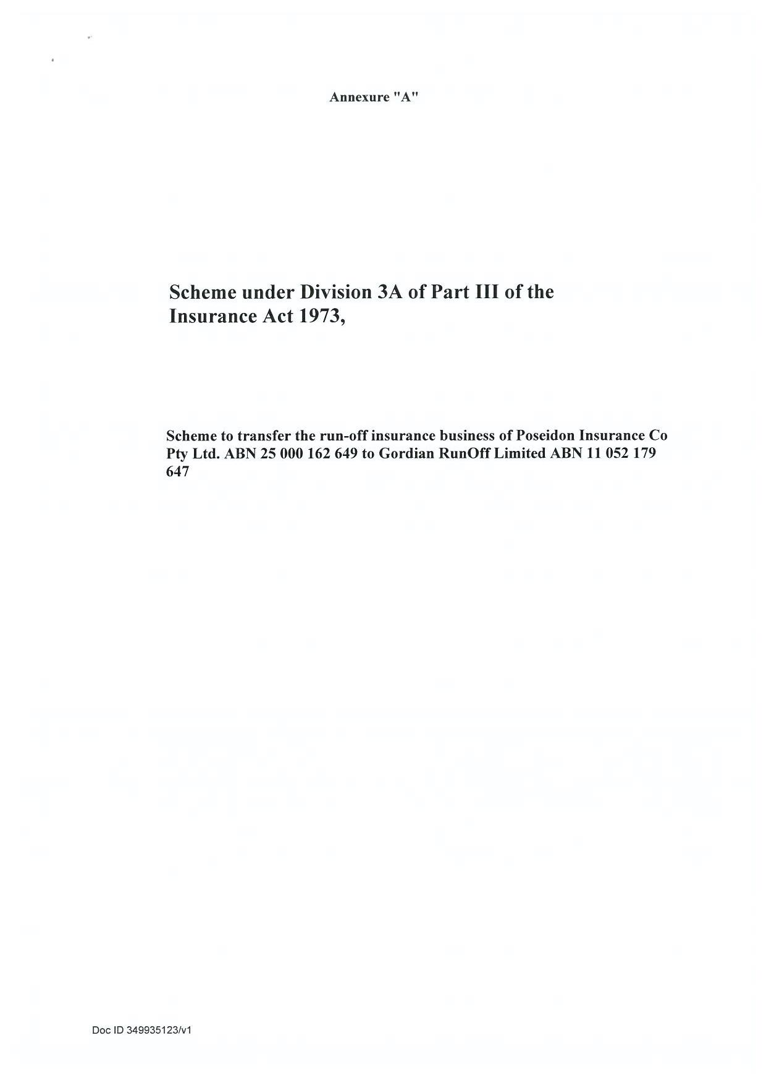

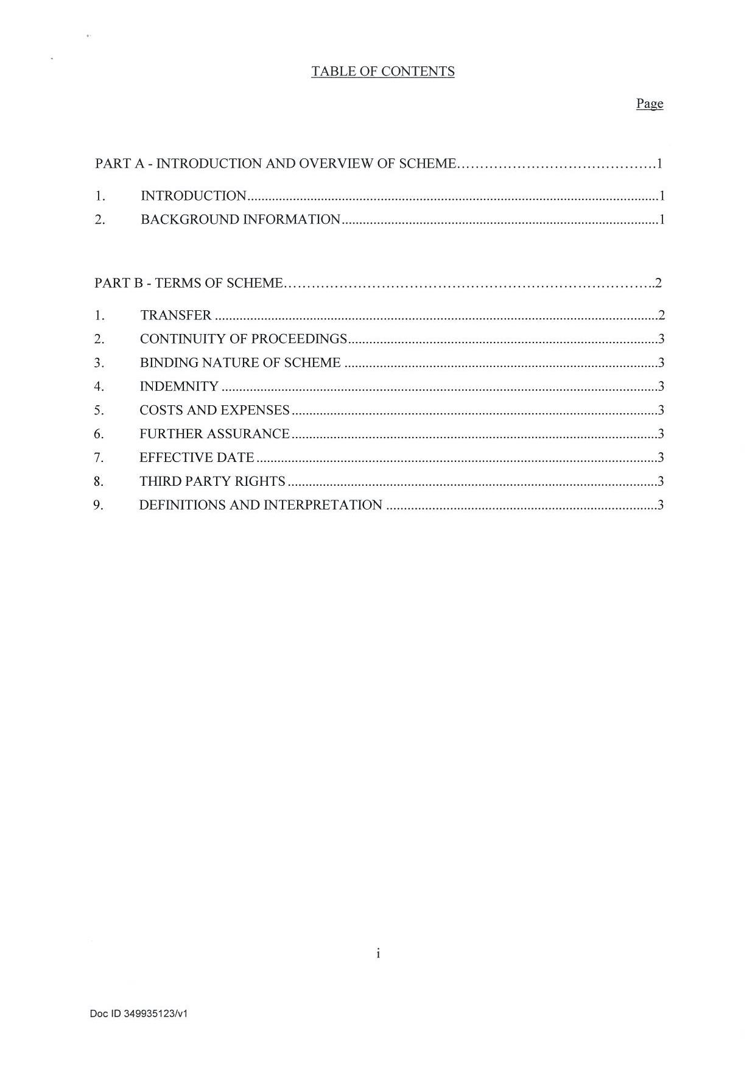

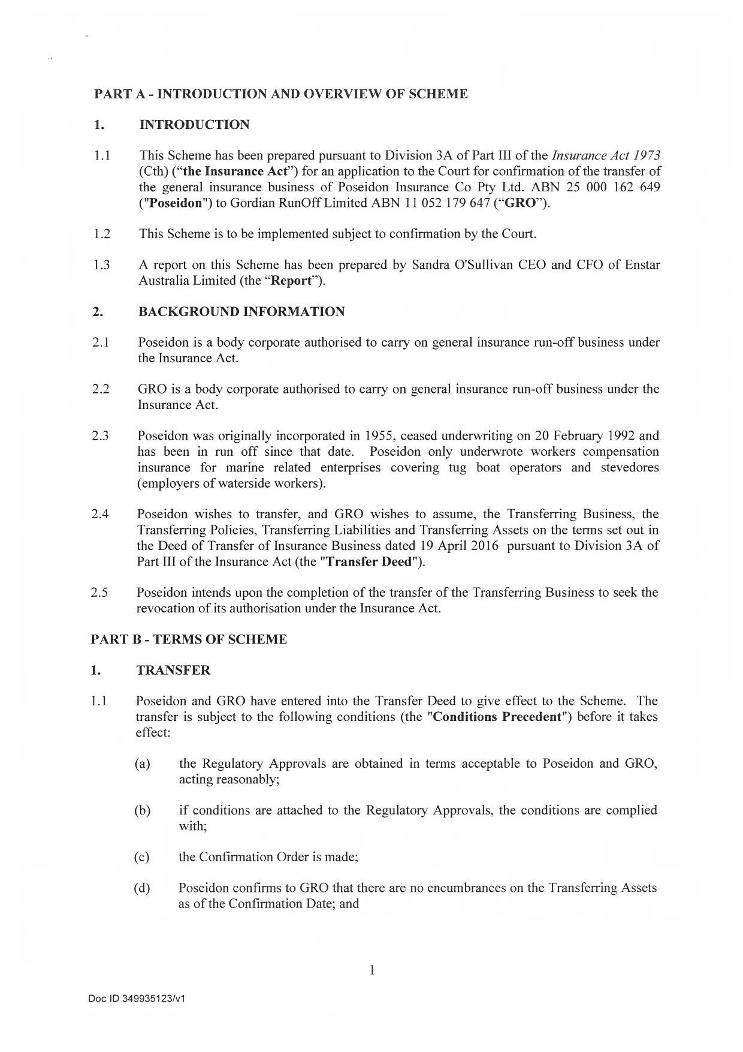

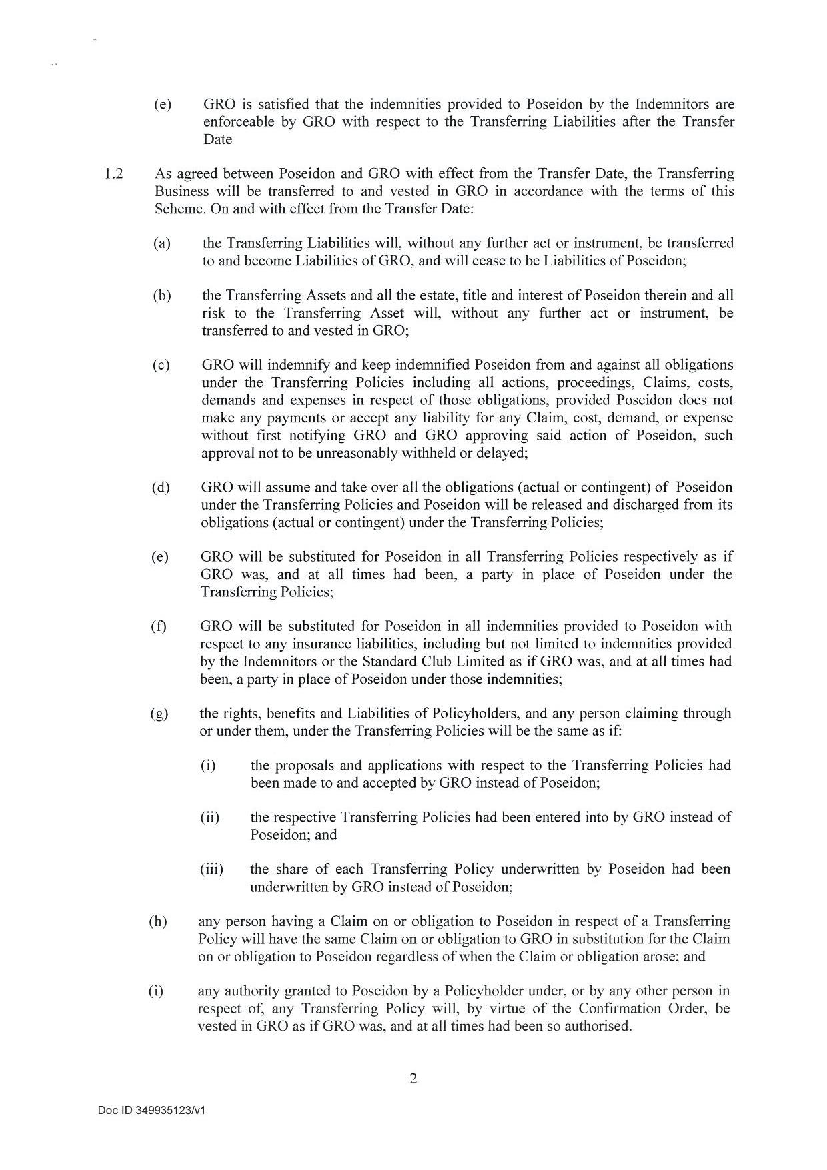

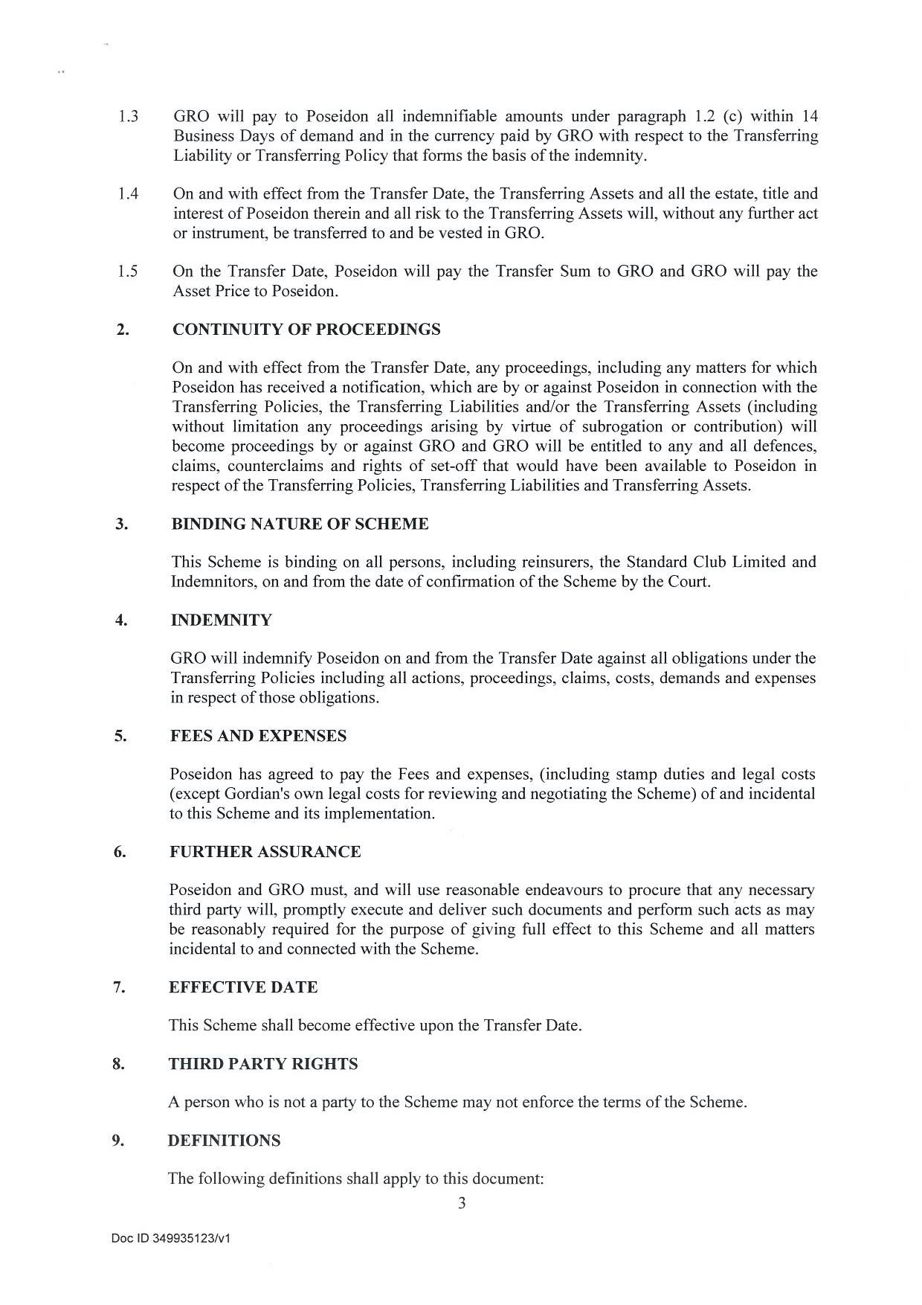

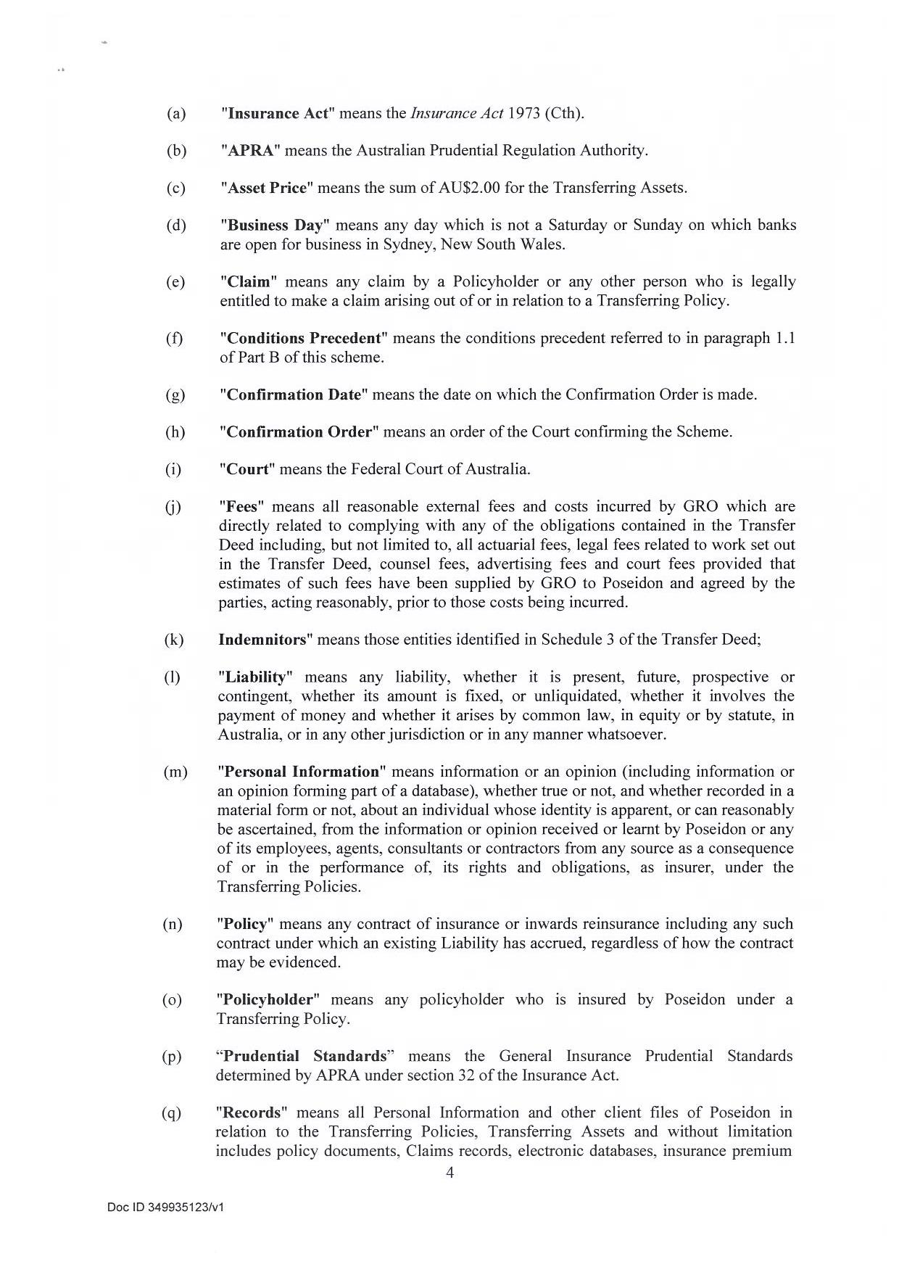

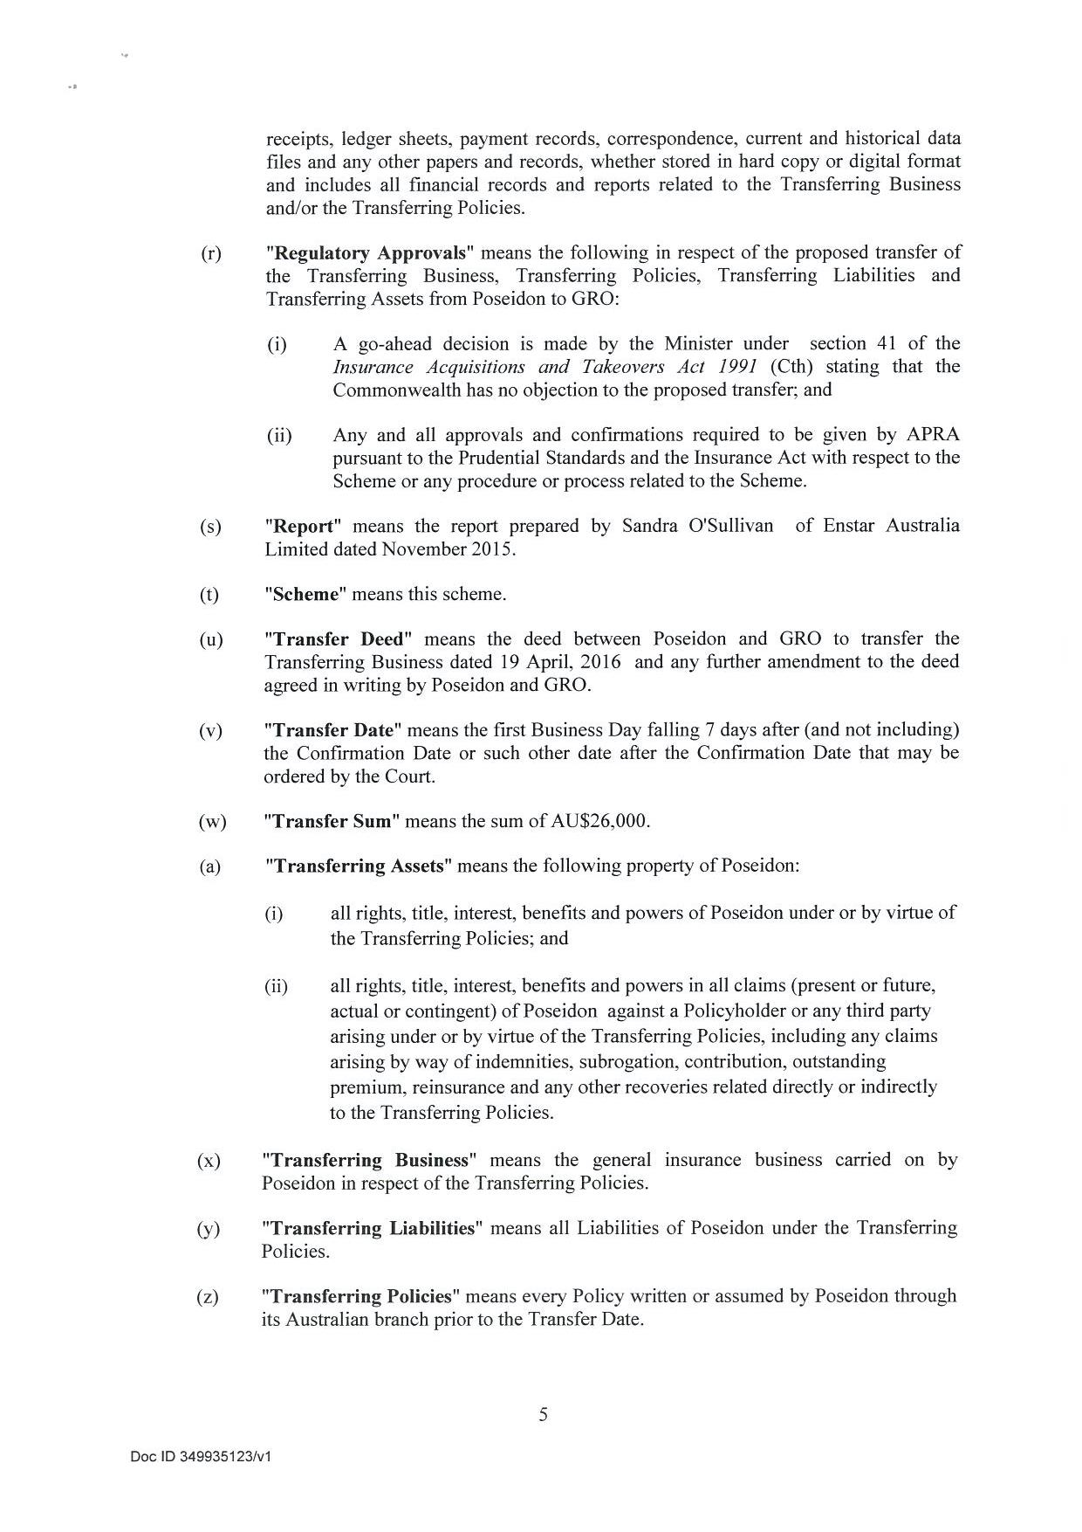

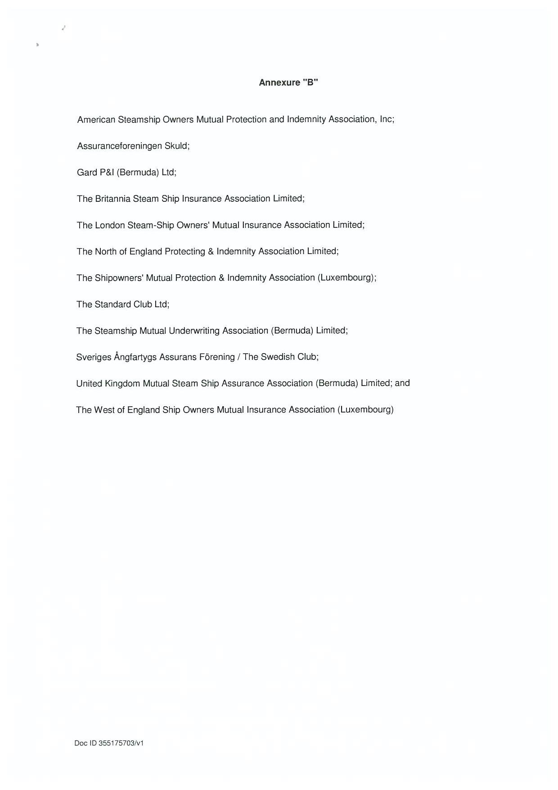
REASONS FOR JUDGMENT
ALLSOP CJ:
- This is an application made by Gordian RunOff Limited (Gordian) under Division 3A of Part III of the Insurance Act 1973 (Cth) (the Act). The applicant seeks orders for confirmation of a scheme transferring the insurance business of Poseidon Insurance Co Pty Ltd (Poseidon) to Gordian (the Scheme).

THE RELEVANT ENTITIES

Poseidon
- Poseidon is an Australian corporation authorised under s 12 of the Act to carry on an insurance business in Australia. It is managed by Enstar Australia Ltd (Enstar Australia).
- Poseidon began writing workers’ compensation insurance for marine related enterprises (including tug boat operators and stevedores) in 1955. It ceased writing business on 20 February 1992, and since that time has been in run-off.
- The small size of Poseidon’s run-off business means that APRA has exempted it from some of the requirements made of general insurers under the Prudential Standards determined by APRA pursuant to s 32 of the Act. For example, Poseidon is authorised to have a minimum prescribed capital of $2,000,000 rather than the usual $5,000,000 required of most categories of regulated general insurer: Prudential Standard GPS 110, Capital Adequacy. A summary of Poseidon’s balance sheet as at 31 March 2015 illustrates this, with its net asset position amounting to only $3,062,000 (Figure derived from extracts of Poseidon’s quarterly APRA return, 31 March 2016, within Exhibit SOS3 attached to the affidavit of Ms Sandra O’Sullivan, sworn 2 June 2016.)
- Further, APRA has exempted Poseidon by virtue of its position as a small insurer in run-off from having an appointed actuary and from preparing an annual valuation of its insurance liabilities. By virtue of APRA’s exemption, the claims liability reserve of the business therefore is determined solely on the basis of outstanding case estimates and does not take account of claims that may have been incurred but not reported (IBNRs).
- A number of international marine Protection and Indemnity Clubs (P&I Clubs) effectively provide reinsurance to Poseidon in respect of its liabilities. A list of those P&I Clubs, referred to in the Scheme as the “Indemnitors”, are set out in Annexure B to the orders of this judgment. One of the indemnitors, the Standard Club Limited, provides a further indemnity in the event that the other indemnitors fail to pay amounts owing to Poseidon pursuant to their underlying indemnities.
- The Court has been provided with a report which details the financial situation of Poseidon and gives an overview of the benefits and risks associated with the proposed transfer of scheme. That report was prepared by Ms Sandra O’Sullivan, the Chief Executive Officer and Chief Financial Officer of Enstar, and is attached to her affidavit dated 17 March 2016 as part of Exhibit SOS1.
- In a transfer of scheme under Division 3A of Part III of the Act, financial information provided to the Court is usually prepared by an appointed actuary. As noted above, however, APRA has exempted Poseidon from adherence to some of the usual requirements demanded of general insurers. APRA considered that the small size of Poseidon’s portfolio meant that, in lieu of an actuarial report, Ms O’Sullivan’s report was sufficient to set out the business and financial information pertaining to both the transferor and transferee insurers.
- Ms O’Sullivan’s report states that as at 30 September 2015, Poseidon’s total gross outstanding claims amounted to $90,000. Its total net outstanding claims were nil due to the indemnities held by it from the P&I clubs. Its total assets amounted to $3,234,000 and its total liabilities amounted to $145,000. These figures are inclusive of the $90,000 of claims due under the indemnities. Its net asset position therefore was $3,089,000. Based on the minimum prescribed capital amount of $2,000,000, its solvency coverage ratio was 1.54.
- In her affidavit of 2 June 2016, Ms O’Sullivan provides updated information on Poseidon’s financial records. Attached to that affidavit as part of the Exhibit SOS3 are extracts of Poseidon’s quarterly APRA return, specifically its Prescribed Capital Amount and Statement of Financial Position. As at 31 March 2016, Poseidon’s gross outstanding claims remained at $90,000 with recoveries in respect of those claims still provided for at $90,000. Its total assets were $3,212,000 and its total liabilities were $150,000. Its net asset position therefore amounted to $3,062,000. Its solvency ratio was 1.53.
- Poseidon’s position at 31 March 2016 therefore remained largely unchanged from that at 31 September 2016.

GORDIAN
- Like Poseidon, Gordian is an Australian authorised insurer managed by Enstar Australia.
- Gordian was incorporated in Australia in 1991 and carried on and handled two portfolios. The first portfolio, Gordian Direct, was a direct insurance portfolio that dealt mainly with policies written in the 1990s concerned with professional indemnity and directors and officers, public liability (construction risk and NSW Health Department policies), short tail policies, financial risks and a number of acquired portfolios. The second, Gordian Re, operated as a reinsurance treaty portfolio, and encompassed areas as diverse as professional indemnity and directors and officers, casualty risks, aviation and maritime, space, international property, US facultative reinsurance and eight acquired portfolios.
- Gordian entered intro run-off in or around September 1999.
- Certain conditions attach to its authorisation by APRA to carry on its business as a general insurer, including a prohibition on its underwriting new business and on its ability to extract return of capital from the business without the consent of APRA. It has no remaining live exposures or unearned premiums and its only insurance liabilities are comprised of outstanding claims.
- The report of Ms O’Sullivan states that as at 31 September 2015, Gordian’s total net claims liabilities at 75% probability of sufficiency amounted to $85,900,000. Its total assets amounted to $210,100,000, and total liabilities to $103,700,000. Its net assets were $106,400,000 and its solvency coverage range was 4.8.
- In her affidavit sworn 1 June 2016, Ms O’Sullivan states that since her report, Gordian, with the consent of APRA, reduced its capital position by $23.7 million. In oral evidence at the hearing, Ms O’Sullivan explained the significance of this as an indicator of the satisfactory financial position of Gordian, given that APRA will only approve such reductions of capital when the insurance liabilities of an insurer in run-off are valued to a 99.5 per cent probability of sufficiency
- As with Poseidon, Ms O’Sullivan undertook a further review of the solvency and capital adequacy position of Gordian. Attached to Exhibit SOS3 of her affidavit, affirmed 2 June 2016, are extracts from Gordian’s quarterly APRA return, specifically its Prescribed Capital Amount and Statement of Financial Position. As at 31 March 2016, its total outstanding claims liabilities amounted to $88,504,000 and its total assets to $540,480,000. Its total liabilities were $94,072,000 and its net assets were $446,336,000. Its solvency ratio coverage was 3.85, the drop from September in large part attributable to the recent APRA-approved capital release.

Background and outline of the transfer
- Kenmare Holdings Ltd (Kenmare), a foreign company incorporated in Bermuda and wholly owned subsidiary of Enstar Group Limited, acquired all of the issued and outstanding share capital of Poseidon on 2 November 2015.
- As Poseidon’s runoff has been assumed by Enstar Group Limited, the purpose of the scheme before the Court is to transfer the insurance liabilities of one of Enstar’s Australian subsidiaries, that is Poseidon, to the Australian subsidiary in which Enstar holds most of its Australian insurance liabilities, that is Gordian.
- The key elements of the transfer, as set out in Ms O’Sullivan’s report, are:
  - All liabilities of insurance policies written or assumed by Poseidon (the transferring policies) to be transferred to Gordian
  - All general insurance business carried on by Poseidon to be transferred to Gordian
  - All entitlements to reinsurance and other indemnities supporting Poseidon’s liabilities under the transferring policies to be transferred to Gordian
- Gordion will receive $26,000 as consideration for the transferring policies.
- In additions, certain assets associated with the transferring policies will transfer from Poseidon to Gordian, including:
  - All rights, title, interest, benefits and powers of Poseidon under the transferring policies
  - All rights, title, interest, benefits and powers in all claims of Poseidon against a policyholder or any third party arising out of the transferring policies
  - All claims, personal information and other client files of Poseidon in relation to the transferring policies
- Gordian will pay consideration of $2.00 in respect of the transferring assets.

The legislative framework
- Division 3A of Part III of the Act relevantly deals with the transfer of an insurance business.
- Section 17B(1) provides that no part of the insurance business of a general insurer may be transferred to another general insurer or amalgamated with the business of another general insurer except under a scheme confirmed by the Court.
- The application for confirmation can be made by any of the bodies corporate affected by the scheme, provided that application is made in accordance with prudential standards: ss 17E(1) and 17E(2). Section 17A in substance says that a body corporate affected by the scheme refers to a body corporate that is a party or a proposed party to the contract by which the transfer provided for by the scheme is to be carried out. In this matter, it is the transferee company, Gordian, that brings the application for confirmation before the Court.
- The steps to be taken before an application for confirmation is heard by the Court are outlined in s 17C(2).
- Section 17F(1) states the Court may confirm the scheme without modification, confirm the scheme subject to such modifications as it thinks appropriate, or refuse to confirm the scheme.

the discretion to confirm the scheme
- The Court is required to have regard to several factors when exercising its discretion under s 17F(1). Section 17F(1A) relevantly provides:
(1A) In deciding whether to confirm a scheme (with or without modification), the Federal Court must have regard to:
(a) the interests of the policyholders of a body corporate affected by the scheme; and
(b) if a report relevant to all or part of the scheme has been filed with the Court under section 62ZI—that report; and
(c) any other matter the Court considers relevant.
- Subsection (b) is not relevant to the scheme before the Court.
- The case law on transfers of schemes, including those made pursuant to the Act and those made pursuant to the similar provisions of the Life Insurance Act 1995 (Cth), has emphasised as central to the Court’s inquiry whether ‘affected policyholders’ may experience a material detriment as a result of the transfer or amalgamation of scheme: Re Insurance Australia Ltd [2004] FCA 524; 139 FCR 450 at 465 [76]; In the matter of GIO Personal Investment Services Ltd and AMP Life Ltd [2000] FCA 1871 at [27].
- The expression ‘affected policyholder’ is defined in s 17C of the Act as the ‘holder of a policy affected by a scheme’. In Re Insurance Australia Limited Lindgren J held at [19]-[24] that for the purposes of s 17C, ‘affected policyholders’ will refer only to the holders of a policy being transferred under the scheme, in this case the policyholders of Poseidon. For the purposes of s 17C, therefore, it is the policyholders of the transferor insurer that must be provided with an approved summary of the scheme before an application is made.
- Nevertheless, when the Court is making its decision whether to confirm the scheme with or without modification under s 17F(1), the insertion of s 17F(1A)(a) makes clear that the Court must consider the interests of policyholders of both the transferor insurer (Poseidon) and transferee insurer (Gordian): See Westport Insurance Corporation (No 2) [2009] FCA 1958; 181 FCR 530 at 537 [44].

factors relevant to the exercise of the discretion
- In considering whether the transfer will be of material detriment to the interests of the policyholders of Poseidon and Gordian, it is necessary to consider the financial and solvency impact of the transfer.
- Gordian’s post-transfer solvency position is relevant to the transferring policyholders of Poseidon, as they will be required to look to Gordian for the satisfaction of their claims. Just as before the transfer, the existing policyholders of Gordian also will continue to require Gordian to satisfy their claims. For this reasons, the Court must be satisfied from the evidence that Gordian will have sufficient capital to afford adequate protection to both groups of policyholders.
- The change in solvency coverage to be experienced by the transferring and existing policyholders also speaks to the question of whether either group will suffer a material detriment as a result of the scheme.
- The financial reports of Poseidon and Gordian as at 31 March stated that the solvency coverage ratio:
  - of Poseidon was 1.53
  - of Gordion was 3.85
- As a consequence of the transfer, Poseidon policyholders will enjoy an increase in the solvency coverage ratio of their insurer, while for existing Gordian policyholders, there will be no material change in this respect.
- In the particular circumstances of this scheme, information on whether solvency coverage ratios will increase or decrease does not prove as significant as it may be in other transfers of scheme. This is because usual methods of arriving at a figure for minimal capital have not been engaged for Poseidon because of the exemption afford to it by APRA.
- For this reason, I place greater emphasis on the conclusions in the Ms O’Sullivan’s report that Poseidon’s policyholders will benefit from the more diversified portfolio of Gordian as well as the fact that it holds significantly more net assets and capital. The benefit of this for Poseidon policyholders may arise in the event where a particularly large claim arises that may have had a material impact on Poseidon’s ability to satisfy any other claims. Following the transfer, such a large claim would not affect the net assets of Gordian in the same way. I am satisfied, therefore, that the policyholders of Poseidon will not be detrimentally affected by the transfer in this respect, and may even experience benefits from the larger, more diversified portfolio of Gordian that would appear more resilient in respect of any unexpected development in its claims profile.
- In order to meet my satisfaction further that no material detriment will be experienced by Poseidon’s policyholders, Ms O’Sullivan was called to give evidence in the hearing on 6 June 2016 and to comment on whether, historically, there have been any indicators of instability or volatility in Gordian’s claims portfolio. Ms O’Sullivan commented while some classes have not performed as well as expected in Gordian’s international assumed reinsurance portfolio, the incurred development overall has been positive for the company.
- Ms O’Sullivan also spoke to the capital reductions that have been approved by APRA in the recent history of Gordian. She noted that for a runoff insurer, a 99.5 per cent probability of sufficiency is the benchmark for which APRA can approve a capital release and stated that “good development has occurred over a substantial number of years” to allow Gordian to carry out APRA-approved capital releases “somewhere in the order of approximately $600 million”.
- This indicator of the health of Gordian coupled with absence of any remarkable historical volatility in its claims portfolio contribute to my satisfaction that the policyholders of Poseidon will face no material detriment.
- Further, I am satisfied from the evidence that Gordian’s existing policyholders likewise are not forecast to experience any disadvantage to them. This is due to the relative size of Gordian’s capital base proportionate to the small value of the claims liabilities attaching to the transferring policies of Poseidon.
- Further, the fact that Poseidon is transferring the benefit of its indemnities with the P&I Clubs in respect of its liabilities means that the net value of the liabilities to be transferred is nil, subject to the solvency risk carried by the indemnifiers. When compared with Gordian’s total outstanding claims liabilities of $88,504,000 as at 31 March 2016, the impact on existing Gordian policyholders will be minimal.
- I am satisfied, therefore, that neither the policyholders of the transferor or transferee insurer will suffer material detriment as a result of confirmation of the scheme.

Contractual Terms and Claims Management
- Both Poseidon’s and Gordian’s claims currently are managed by way of an outsourcing arrangement to Enstar. This is not expected to change following the transfer. I am satisfied therefore that there will be no impact on the claims management for the transferring policyholders.
- Further, the terms of the transferring contracts are not expected to change as a consequence of the scheme. I am satisfied that neither the policyholders of Poseidon or of Gordian will experience any disadvantage in this respect.

The views of APRA
- APRA is entitled pursuant to s 17E(3) of the Act to be heard on an application for confirmation. It has been involved in the oversight of this transfer, and has dealt with Gordian, amongst other matters of oversight, in relation to its capital reductions.
- In relation to this scheme, it expressed no objection. Given APRA’s central place in administering prudential supervision, I take its non-objection into account in making the orders for confirmation: Jacobson J in Gordian RunOff Limited, in the matter of Insurance Australia Limited (No 2) [2011] FCA 1116 at [31]; Katz J in Re Royal & Sun Alliance Life Assurance Ltd [2000] FCA 1259; 104 FCR 37 at 40-41 [24]–[27].

the preconditions to making an application
- The procedural steps required of an applicant before the Court is moved for an order of confirmation of the scheme are set out in s 17C(2) of the Act and Prudential Standard GPS 410, Transfer and Amalgamation of Insurance Business for General Insurers.
- I am satisfied that prior to 20 April 2016, the applicant provided a copy of the scheme and a copy of Ms O’Sullivan’s report to APRA as required by s 17C(2)(a). These steps were taken before any publication of the notice of intention and before the provision of the summary of the scheme to the affected policyholders as required by GPS 410 at [5]. The letter sent by Mr Mark Kimberley, partner of HWL Ebsworth and solicitor for the applicant, in satisfaction of this step is attached to Exhibit SOS3 of Ms O’Sullivan’s affidavit of 2 June 2016.
- I am further satisfied that on 29 April 2016, the applicant obtained APRA’s approval of its summary of scheme and its notice of intention as required by GPS 410 at [8]. The letter of approval from APRA is also attached to Exhibit SOS3.
- On 22 March 2016, I made orders dispensing with the need for the applicant to comply with s 17(2)(c) on the condition that the applicant make the scheme documents available through various channels. The applicant’s level of compliance with these orders is detailed below.

Notification of affected policyholders
- First, prior to the date on which the scheme documents were to be made available for public inspection, the applicant was to cause a copy of the approved summary of the scheme to be sent to all persons who, as at that date, had been identified as affected policyholders from records and publically available sources for which the applicant had an address.
- The affidavit of Mr Vu Pham, sworn 1 June 2016, states that on 2 May 2016, Mr Pham caused the scheme summary to be sent to the five affected policyholders of Poseidon, all of whom are companies registered with ASIC.
- Mr Pham states that only one of the envelopes containing the scheme summary was returned marked ‘Return to Sender’. That envelope was addressed to an affected policyholder by the name of Pauline M Laffan Pty Ltd (formerly Esar Bunkering Services Pty Ltd).
- Mr Pham was able to resend the documents to that company by obtaining its current registered address by means of an ASIC search.
- Mr Pham states that he further caused the scheme summary and a copy of the scheme to be sent on 2 May 2016 to the indemnitors. He has not received any enquiries from them in relation to the scheme.
- I am satisfied from the evidence of Mr Pham that the applicant notified the policyholders and indemnitors of Poseidon in compliance with my order.

Publication in newspapers
- Second, the applicant was to cause an advertisement approved by APRA providing notification of the proposed scheme to be placed in a range of national and state newspapers.
- The affidavit of Mr Pham states that on 29 April 2016, Mr Pham made arrangements for the notice of intention to be published in the newspapers stipulated in my orders. A copy of that document as it appeared in each of those newspapers on 6 May 2016 is found in Exhibit VP1 of Mr Pham’s affidavit.

Publication in journals and other sources
- I made further orders that an advertisement providing notification of the proposed scheme also appear in various other publications including the NSW, Victorian and Queensland Law Society Journals and the international edition of Lloyd’s List.
- In relation to those publications, the affidavit of Mr Pham provided evidence that approved notice was published in the online version of the Law Society of NSW Journal; the Proctor (the Queensland Law Society Journal); and Lloyd’s List from 2 May 2016 onwards.
- Mr Pham was informed by Gordian’s solicitors that the Law Institute of Victoria could not include the notice of intention in its hard copy or online version of the Law Society Journal for May 2016 but would include it in its daily new roundup entitled LawNews from 4 May to 6 May 2016. A copy of the notice of the scheme as it appeared in that publication is attached to Exhibit VPI.
- Whilst the applicant therefore did not comply in exact terms with my orders from the dispensation hearing, I am nevertheless satisfied that the inclusion of an advertisement in the Law Institute of Victoria’s LawNews provided adequate circulation amongst the intended legal audience in the state of Victoria, especially given the advertisement was also placed in The Age as required by my orders, and also in satisfaction of s 17C(2)(b) and GPS 410 that deal with the publication of the notice of intention in the Government Gazette and other newspaper circulating in states and territories where affected policyholders reside.
- I am satisfied from the copies of the notice of intention as it appeared in each of the online publications in Exhibit VPI that the applicant duly attended to advertising the scheme in the channels stipulated by the orders.

Website Link to Document
- Order 5 of 22 March 2016 also required the proposed scheme, a summary of the proposed scheme and the September report of Ms O’Sullivan to be made publically available on Enstar’ s website.
- Printouts of the website link to these documents are included in Exhibit VP1. I am satisfied that the procedural requirement of providing links on Enstar’s website was complied with by the applicant.

Notification of Care NSW (icare)
- By the orders of 22 March 2016, I also required the applicant to forward copies of the scheme, the summary of the scheme and Ms O’Sullivan’s report to the WorkCover Authority of NSW.
- Since the making of those orders, I have been informed that the regulatory and insurance functions of WorkCover have been assumed by three discrete organisations. The relevant organisation for workers compensation insurance is Care NSW (icare).
- Mr Pham’s affidavit states that he caused to be sent by post the relevant documents to icare on 3 May 2016. Exhibit VP1 contains a copy of the letter accompanying the relevant documents.
- I am satisfied therefore that the relevant workers compensation body in NSW was notified of the transfer.

The Public Inspection
- APRA’s Prudential Standard GPS 410 requires that a copy of the scheme be available for public inspection from 9.00am until 5.00pm for a period of 15 business days: GPS 410 at [16]. The requirement of a public inspection period was also incorporated in my orders of 22 March 2016.
- I am satisfied from the affidavits of Mr Pham and Ms Rani Donohue, sworn 1 June 2016, that the relevant scheme documents were made available for public inspection in the Sydney and Melbourne offices of HWL Ebsworth Lawyers from 9 May 2016 to 27 May 2016. Both Mr Pham and Ms Donohue state that no person attended for public viewing of the scheme documents during the inspection period.
- The reason for the public inspection occurring only in Sydney and Melbourne is the fact that GPS 410 stipulates that the scheme documents are to be available in each State and Territory in which an affected policyholder resides. Poseidon’s policyholders are located exclusively in the States of NSW and Victoria.
- I am satisfied therefore that the period of public inspection occurred for the required number of days in the required locations and that no person inspected the documents by way of that channel.

Conclusion
- The applicant has attended diligently to the procedural requirements attaching to an application of this kind and, in light of evidence placed before the Court, I am satisfied that the policyholders of the transferee and transferor insurers will experience no material detriment as a result of the scheme.
- It is appropriate that the scheme be confirmed, without modification.

I certify that the preceding eighty (80) numbered paragraphs are a true copy of the Reasons for Judgment herein of the Honourable Chief Justice Allsop.

Associate:

Dated: 9 June 2016

