FEDERAL COURT OF AUSTRALIA

Australian Competition and Consumer Commission v Woolworths Limited [2016] FCA 44

File number: | NSD 941 of 2014
Judge: | EDELMAN J
Date of judgment: | 5 February 2016
Catchwords: | CONSUMER LAW – pecuniary penalties – relevant matters – assessment of comparative cases – effect of incommensurability – relevance of previous acknowledgment of likely similar contravention – relevance of payment of compensation by contravening party – whether payment of compensation is only relevant to whether the contravening party is contrite  CONSUMER LAW – pecuniary penalties – s 224(4)(b) Australian Consumer Law – meaning of the “same conduct” – effect of the course of conduct principle
Legislation: | Australian Consumer Law (Schedule 2 of the Competition and Consumer Act 2010 (Cth)) ss 18, 29, 29(1)(a), 29(1)(g), 33, 87B, 131, 131(1), 131(2), 131(4), 131(5), 224(2), 224(3), 224(4)(b), 246(2)(a), 246(2)(b), 1330  Federal Court of Australia Act 1976 (Cth) s 21  Trade Practices Act 1974 (Cth) ss 52, 53(eb)
Cases cited: | ACCC v Cotton On Kids Pty Ltd [2012] FCA 1428  ACCC v George Weston Foods Ltd (2000) ATPR 41-763; [2000] FCA 690  Australian Competition & Consumer Commission v Econovite Pty Ltd [2003] FCA 964  Australian Competition and Consumer Commission v ABB Transmission and Distribution Ltd (No 2) [2002] FCA 559; (2002) 190 ALR 169  Australian Competition and Consumer Commission v Apple Pty Ltd [2012] FCA 646  Australian Competition and Consumer Commission v Coles Supermarkets Australia Pty Limited [2015] FCA 330  Australian Competition and Consumer Commission v Reebok Australia Pty Ltd [2015] FCA 83  Australian Competition and Consumer Commission v Singtel Optus Pty Ltd (No 4) [2011] FCA 761; (2011) 282 ALR 246  Australian Competition and Consumer Commission v Sontax Australia (1988) Pty Ltd [2011] FCA 1202  Australian Competition and Consumer Commission v TPG Internet Pty Ltd [2013] HCA 54; (2013) 250 CLR 640  Australian Competition and Consumer Commission v Woolworths Ltd [2002] FCA 1001; (2002) ASAL 55-085  Commonwealth of Australia v Director, Fair Work Building Industry Inspectorate [2015] HCA 46  Construction, Forestry, Mining and Energy Union v Cahill [2010] FCAFC 39; (2010) 269 ALR 1  Forster v Jododex Aust Pty Ltd [1972] HCA 61; (1972) 127 CLR 421  ICI Australia Operations Pty Ltd v Trade Practices Commission (1992) 38 FCR 248  NW Frozen Foods Pty Ltd v Australian Competition and Consumer Commission [1996] FCA 1134; (1996) 71 FCR 285  Pearce v The Queen [1998] HCA 57; (1998) 194 CLR 610  Ryan v The Queen [2001] HCA 21; (2001) 206 CLR 267  Singtel Optus Pty Ltd v Australian Competition and Consumer Commission [2012] FCAFC 20; (2012) 287 ALR 249  Thewlis v The Queen [2008] NSWCCA 176; (2008) 186 A Crim R 279  Trade Practices Commission v CSR Ltd [1991] ATPR 41-076  Weininger v The Queen [2003] HCA 14; (2003) 212 CLR 629  McGregor H, McGregor on Damages (19th ed, Sweet & Maxwell, 2014) 13 [2-001]  Chapman B “Law, Incommensurability, and Conceptually Sequenced Argument” (1998) 146 Uni Penn Law Rev 1487  Sunstein C “Incommensurability and Valuation in Law” (1993) 93 Mich Law Rev 779  Schauer F “Instrumental Commensurability” (1998) 146 U Pa L Rev 1215
Date of hearing: | 4 February 2016
Registry: | New South Wales
Division: | General Division
National Practice Area: | Commercial and Corporations
Sub-area: | Regulator and Consumer Protection
Category: | Catchwords
Number of paragraphs: | 193
Counsel for the Applicant: | Dr R C A Higgins with Mr B A Mee
Solicitor for the Applicant: | Baker & McKenzie
Counsel for the Respondent: | Mr M Darke SC with Ms S Mirzabegian
Solicitor for the Respondent: | Clayton Utz

ORDERS
 |  | NSD 941 of 2014
BETWEEN: | AUSTRALIAN COMPETITION AND CONSUMER COMMISSION  Applicant
AND: | WOOLWORTHS LIMITED ACN 000 014 675  Respondent

JUDGE: | EDELMAN J
DATE OF ORDER: | 5 FEBRUARY 2016

THE COURT DECLARES THAT:

- Between 4 June 2012 and 4 July 2012, by continuing to offer the Abode 3 Litre Stainless Steel Deep Fryer, Model DF30BW (the Deep Fryer) for retail sale after it became aware that the side handles of the Deep Fryer may detach when the Deep Fryer was lifted, leading to a consequential hazard comprising oil spills and possible burn injuries if the appliance was moved while containing hot oil, by its silence and by refraining from:
  - withdrawing the Deep Fryer from sale at its Big W stores; and
  - recalling the Deep Fryer from its Big W stores;
once a reasonable period of time in which it could have identified, assessed and responded to this safety hazard had elapsed, Woolworths engaged in conduct (the Deep Fryer Silence Conduct) that was:
  - misleading or deceptive, or likely to mislead or deceive; and
  - liable to mislead the public as to the suitability of the Deep Fryer for its purpose,
because:
  - the side handles of the Deep Fryer may (and did on one known occasion prior to 4 June 2012) detach when the Deep Fryer was lifted, leading to a consequential hazard comprising oil spills and possible burn injuries if the appliance was moved while containing hot oil;
  - Woolworths had knowledge of the matters stated in subparagraph (e) above; and
by the Deep Fryer Silence Conduct, Woolworths:
  - engaged in conduct, in trade or commerce, which was misleading or deceptive, or likely to mislead or deceive, in contravention of section 18 of the ACL; and
  - engaged in conduct, in trade or commerce, that was liable to mislead the public as to the suitability of the Deep Fryer for its purpose, in contravention of section 33 of the ACL
(the Deep Fryer Contravention).
- Between in or about 25 August 2013 and in or about 20 March 2014, Woolworths, in offering the house brand consumer good Woolworths Select Drain Cleaner 1L (Select Drain Cleaner) for retail sale to consumers, with a cap that bore the text, “Close tightly while pushing down turn”, accompanied by two arrows directing an anti-clockwise motion, expressly and impliedly represented that the Select Drain Cleaner could only, within the ordinary range of uses of the product, be opened by applying downward pressure to the cap while turning it (the Select Drain Cleaner Opening Representation), which representation was:
(a) misleading and deceptive, or likely to mislead or deceive; and
(b) a false or misleading representation that the Select Drain Cleaner was of a particular standard or quality and had certain performance characteristics; and
(c) liable to mislead the public as to the suitability for its purpose of the Select Drain Cleaner,
because the cap on the Select Drain Cleaner:
(d) was ineffective, in that it did not lock securely on the bottle; and
(e) could be opened or open without the application of downward pressure to the cap while turning it,
and thereby, Woolworths:
(f) engaged in conduct, in trade or commerce, which was misleading or deceptive, or likely to mislead or deceive, in contravention of section 18 of the ACL; and
(g) made a false or misleading representation, in trade or commerce, in connection with the supply or possible supply of house brand home ware products, that the Select Drain Cleaner was of a particular standard or quality and had certain performance characteristics, in contravention of sections 29(1)(a) and 29(1)(g) of the ACL; and
(h) engaged in conduct, in trade or commerce, that was liable to mislead the public as to the suitability for its purpose of the Select Drain Cleaner, in contravention of section 33 of the ACL
(the First Select Drain Cleaner Contravention).
- Between 24 February 2014 and 20 March 2014, by continuing to offer the Select Drain Cleaner for retail sale after it became aware that the Select Drain Cleaner was unsafe when deployed during ordinary or reasonably foreseeable uses of the product, because the cap on the Select Drain Cleaner was ineffective, in that it did not lock securely on the bottle and could be opened without applying downward pressure to the cap while turning it, by its silence and by refraining from:
(a) withdrawing the Select Drain Cleaner from Woolworths, Safeway, Food For Less, and Flemings stores; and
(b) recalling the Select Drain Cleaner from its Woolworths, Safeway, Food For Less, and Flemings stores,
once a reasonable period of time in which it could have identified, assessed and responded to this safety hazard had elapsed, Woolworths engaged in conduct (the Select Drain Cleaner Silence Conduct) that was:
(c) misleading or deceptive, or likely to mislead or deceive; and
(d) liable to mislead the public as to the suitability of the Select Drain Cleaner for its purpose
because:
(e) when deployed during ordinary or reasonably foreseeable uses of the product, the cap on the Select Drain Cleaner:
(i) was ineffective, in that it did not lock securely on the bottle;
(ii) could be opened without applying downward pressure to the cap while turning it, which hazard in fact materialised; and
(f) Woolworths had knowledge of the matters stated in subparagraphs 3(e) above, and
by the Select Drain Cleaner Silence Conduct, Woolworths:
(g) engaged in conduct, in trade or commerce, which was misleading or deceptive, or likely to mislead or deceive, in contravention of section 18 of the ACL; and
(h) engaged in conduct, in trade or commerce, that was liable to mislead the public as to the suitability of the Select Drain Cleaner for its purpose, in contravention of section 33 of the ACL
(the Second Select Drain Cleaner Contravention).
- Between 6 June 2012 and 28 June 2012, by continuing to offer the house brand 10 x 45 Homebrand Safety Matches (the Safety Matches) for retail sale after it became aware that the Safety Matches were unsafe when deployed during ordinary or reasonably foreseeable uses of the product because the Safety Matches suffered the defect that, in some instances, the head of the match may break or give off sparks upon ignition, and if that defect occurred the product may fail resulting in possible injury or property damage, including by causing the box of matches to ignite, by its silence and by refraining from:
(a) withdrawing the Safety Matches from Woolworths supermarket stores;
once a reasonable period of time in which it could have identified, assessed and responded to this safety hazard had elapsed, Woolworths engaged in conduct (the Safety Matches Silence Conduct) that was:
(b) misleading or deceptive, or likely to mislead or deceive; and
(c) liable to mislead the public as to the suitability of the Safety Matches for their purpose;
because:
(d) the Safety Matches suffered the defect that, in some instances, the head of the match may break or give off sparks upon ignition;
(e) if that defect occurred the product may fail resulting in possible injury or property damage, including by causing the box of matches to ignite, which defect and hazard in fact materialised;
(f) Woolworths had knowledge of the matters stated in subparagraphs (d) and (e) above; and
by engaging in the Safety Matches Silence Conduct, Woolworths:
(g) engaged in conduct, in trade or commerce, which was misleading or deceptive, or likely to mislead or deceive, in contravention of section 18 of the ACL; and
(h) engaged in conduct, in trade or commerce, that was liable to mislead the public as to the suitability of the Safety Matches for their purpose, in contravention of section 33 of the ACL
(the Safety Matches Contravention).
- Between in or about 1 May 2012 and 31 August 2012, Woolworths, in offering the Padded Flop Chair for retail sale to consumers, made an express representation that the Padded Flop Chair was capable of bearing weights up to 115 kg, which representation was:
(a) misleading or deceptive, or likely to mislead or deceive; and
(b) a false or misleading representation that the Padded Flop Chair was of a particular standard or quality and had certain performance characteristics; and
(c) liable to mislead the public as to the suitability for its purpose of the Padded Flop Chair,
because the Padded Flop Chair was not, in all cases, capable of bearing weights of up to 115 kg and, under testing, could reliably support no more than 92 kg, and thereby, Woolworths:
(d) engaged in conduct, in trade or commerce, which was misleading or deceptive, or likely to mislead or deceive, in contravention of section 18 of the ACL; and
(e) made a false or misleading representation, in trade or commerce, in connection with the supply or possible supply of house brand home ware products, that the Padded Flop Chair was of a particular standard or quality and had certain performance characteristics, in contravention of sections 29(1)(a) and 29(1)(g) of the ACL; and
(f) engaged in conduct, in trade or commerce, that was liable to mislead the public as to the suitability for its purpose of the Padded Flop Chair, in contravention of section 33 of the ACL
(the Padded Flop Chair Contravention).
- Between 31 August 2012 and 22 July 2013, Woolworths, in offering the Folding Stool for retail sale to consumers, made an express representation that the Folding Stool was capable of bearing weights up to 100 kg, which representation was:
(a) misleading or deceptive, or likely to mislead or deceive; and
(b) a false or misleading representation that the Folding Stool was of a particular standard or quality and had certain performance characteristics; and
(c) liable to mislead the public as to the suitability for its purpose of the Folding Stool,
because the Folding Stool was not capable of bearing weights of up to 100 kg and, under testing, could reliably support no more than 90 kg, and thereby, Woolworths:
(d) engaged in conduct, in trade or commerce, which was misleading or deceptive, or likely to mislead or deceive, in contravention of section 18 of the ACL; and
(e) made a false or misleading representation, in trade or commerce, in connection with the supply or possible supply of house brand home ware products, that the Folding Stool was of a particular standard or quality and had certain performance characteristics, in contravention of sections 29(1)(a) and 29(1)(g) of the ACL; and
(f) engaged in conduct, in trade or commerce, that was liable to mislead the public as to the suitability for its purpose of the Folding Stool, in contravention of section 33 of the ACL
(the Folding Stool Contravention).

THE COURT ORDERS THAT:

- In respect of the misleading or deceptive conduct Woolworths pay to the Commonwealth of Australia within 30 days a pecuniary penalty of $3,000,000 based on the following courses of conduct:
(a) the Deep Fryer contraventions $ 600,000
(b) the two Select Drain Cleaner courses of contraventions: $1,400,000
(c) the Safety Matches contraventions $ 400,000
(d) the Flop Chair contraventions $ 300,000
(e) the Folding Stool contraventions $ 300,000
- In respect of the eight section 131 contraventions Woolworths pay to the Commonwealth of Australia within 30 days a pecuniary penalty of $57,000:
(a) the Deep Fryer s 131 contravention $ 10,000
(b) the Select Drain cleaner s 131 contravention $ 5,000
(c) the other six s 131 contraventions $ 42,000
- Woolworths within 30 days prominently publish on the Internet homepage of Woolworths supermarkets, Big W, Masters Home Improvement and Ezibuy a link to an internet page in the form and terms set out in Annexure A.
- Woolworths within 30 days or otherwise agreed with the ACCC prominently publish on the Woolworths supermarket Smartphone Application:
(a) details of products currently recalled by Woolworths and products recalled in the past 12 months; and
(b) a link to the Recalls Australia website.
- Woolworths:
(a) implement the upgraded dedicated product safety compliance program in accordance with the requirements set out in Annexure B for the employees and other persons engaged in Woolworths’ business, being a program designed to minimise its risk of future breaches of sections 18, 29 and 33 of the ACL in relation to the safety of its products and of section 131 of the ACL (the Program), which would be provided to the ACCC within 3 months of the Orders being made;
(b) continue to develop and implement for a period of 3 years from the date of these orders the Program; and
(c) provide, at its own expense, a copy of any documents requested by the ACCC evidencing Woolworth’s implementation of the Program, including the documents referred to in clauses 4, 6, 12 of Annexure B.
12. Woolworths pay to the ACCC within 14 days of the date of this order the ACCC’s costs of the proceeding in the sum of $50,000.

Note: Entry of orders is dealt with in Rule 39.32 of the Federal Court Rules 2011.

REASONS FOR JUDGMENT
EDELMAN J:
Introduction | [1]
Woolworths’ quality review processes and their inadequacies | [5]
The Abode Deep Fryer incidents | [20]
The First Deep Fryer Incident | [21]
The Second Deep Fryer Incident | [29]
Withdrawal and recall of Deep Fryers | [32]
The Select Drain Cleaner incidents | [36]
The first Select Drain Cleaner incident | [41]
The second Select Drain Cleaner incident | [43]
The third Select Drain Cleaner incident | [45]
The fourth Select Drain Cleaner incident | [47]
Withdrawal of Select Drain Cleaner from sale | [50]
The fifth Select Drain Cleaner incident | [54]
ACCC inquiry and recall of Select Drain Cleaner | [60]
The Safety Matches incidents | [62]
The Safety Match incidents | [64]
Withdrawal of Safety Matches from sale | [69]
Further Safety Matches incidents | [72]
The ACCC inquiry and the second recall of Safety Matches | [73]
The Padded Flop Chair incidents | [74]
The Folding Stool incidents | [80]
Six additional failures to report incidents of serious injury or illness | [86]
The Multix Cling Wrap Premium Value 120m | [87]
The BBQ Chicken | [88]
The Homebrand Yellow Fruit Rings 400g | [89]
The Lamb, Herb, Garlic Cocktail K’Babs (10 Sticks pack) | [90]
The Arcosteel Coffee Plunger 6 Cup | [91]
Chicken Thigh Fillets | [92]
The contraventions | [93]
The category of contraventions concerning misleading or deceptive conduct and misrepresentations | [94]
1. The Deep Fryer contraventions: | [100]
2. The Select Drain Cleaner labelling contraventions | [102]
3. The Select Drain Cleaner offer for sale contraventions | [103]
4. The Safety Matches Contraventions | [104]
5. The Padded Flop Chair Contraventions | [105]
6. The Folding Stool Contravention | [106]
The category of contraventions concerning Woolworths’ failures to report | [107]
Pecuniary Penalties | [113]
Legal principles | [113]
The course of conduct principle | [113]
The relevant factors and comparative cases | [122]
The cases referred to by the parties as comparators | [138]
Assessment of the relevant factors | [143]
The circumstances and effect of the contraventions (including nature and extent of the conduct and loss and damage) | [143]
The period over which the contraventions occurred | [145]
The unintentional nature of the contraventions and Management’s knowledge | [146]
Woolworths’ culture of compliance | [150]
Size of Woolworths, its financial position and the profits associated with its contraventions | [155]
Co-operation with the ACCC, admission of culpability, compensation and contrition | [161]
Previous contraventions and previous conduct | [168]
Conclusions and orders | [178]
Pecuniary Penalties | [178]
Non-pecuniary orders | [185]

Introduction
- The applicant – the Australian Competition and Consumer Commission (ACCC) – brought proceedings alleging that Woolworths contravened the Australian Consumer Law. Woolworths admitted to engaging in misleading or deceptive conduct, making false or misleading representations, and failing to report, or inadequately reporting, incidents of serious injury or illness. It cooperated with the ACCC, and agreed many of the facts described in these reasons.
- Woolworth’s most significant contraventions of the Australian Consumer Law arose in relation to five different house brand products that Woolworths or its subsidiaries sold to consumers: a deep fryer, a drain cleaner, safety matches, a padded flop chair and a folding stool. In broad terms, Woolworths’ contraventions involved:
- a failure to withdraw and recall a Deep Fryer from sale when the side handles of the Deep Fryer could detach when it was lifted, potentially leading to burns from hot oil;
- misrepresentations on the text and directions on the cap of the Select Drain Cleaner which did not lock securely on the bottle and failing to withdraw the Select Drain Cleaner from sale;
- misrepresentations that Safety Matches were safe, and failing to withdraw them from the stores, when the head of the match could break or give off sparks upon ignition causing the box of matches to ignite;
- misrepresentations that a Padded Flop Chair was capable of bearing weights up to 115 kg when it could not reliably support any more than 92 kg; and
- misrepresentations that a Folding Stool was capable of bearing weights up to 100 kg when it could not reliably support any more than 90 kg.
- During the periods of contravention many of these products were sold. The largest number of sales during a period involving a course of contraventions was 124,825 sales of Select Drain Cleaner during the first period of contraventions in relation to that product. The smallest number of sales was 1,840 sales of Folding Stools during the approximately eleven month period of contraventions. Some consumers suffered serious injury and illness as a result of using the products in question, particularly the Select Drain Cleaner. A man suffered permanent damage to his eyesight and could no longer work as a boilermaker. A baby girl suffered serious burns to her leg, requiring a skin graft and causing permanent scarring.
- The parties agreed proposed non-pecuniary penalty orders and declarations. I consider those orders to be appropriate for the reasons explained in my conclusion to these reasons. The central issue in the proceeding was the amount of the pecuniary penalty to be imposed on Woolworths. For the reasons below, I consider the appropriate total penalty to be $3.057 million. This is comprised of $3 million for the six courses of conduct involving the products that I have described and $57,000 in relation to the contraventions concerning Woolworths’ reporting obligations under s 131. A breakdown of those amounts is provided in the conclusion to these reasons.

Woolworths’ quality review processes and their inadequacies
- Woolworths is a household name. It is a national retailer with over 3000 stores located in Australia and New Zealand. Woolworths supplies a spectrum of low priced consumer goods including food, liquor, petrol, general merchandise, hardware, home improvement and hotel accommodation.
- Woolworths is the owner in Australia of 931 supermarkets trading under (i) the “Woolworths” brand, (ii) the “Safeway” brand in Victoria, (iii) the “Flemings” brand and (iv) the “Food For Less” brand. Woolworths also owns a national chain of 182 discount department stores trading under the “Big W” brand and a national chain of 49 hardware and home improvement stores trading under the name “Masters Home Improvement”.
- House brand goods are offered for sale at Woolworths supermarkets, Big W stores and Masters Home Improvement stores. Woolworths stocks more than 28,000 non-food house brand products across its trading divisions (i.e. supermarkets, Big W stores and Masters stores). Woolworths sources its house brand products globally from over 4500 factories.
- At all relevant times Woolworths had a compliance system to ensure that officers and employees understood the obligations of the company and its officers and employees arising from the Competition and Consumer Act. That system included a Compliance Policy, a Code of Conduct and a compliance framework which identified compliance responsibilities throughout the Woolworths group. Woolworths also had, and has, a People Policy Committee which reports to the Board of Directors and covers the area of “Safety and Health” and an Audit, Risk Management and Compliance Committee which provides advice and assistance to the Woolworths Board with respect to the oversight of the management of risk and compliance, including areas such as health and safety, and Australian consumer law.
- In 2010, Woolworths created a centralised Group Quality Assurance (QA) function. This was a change from the previously decentralised QA functions. That function was formed to monitor and ensure high standards of product quality at a reduced cost. The QA function was designed to ensure that all house brand goods sourced by Woolworths went through the QA evaluation process. During 2011 to 2014 all new house brand non-food goods (around 44,000 in total) went through Woolworths’ QA processes before being offered for sale by Woolworths. However, in some instances some products did not go through all the relevant steps.
- Woolworths had a regime to internally assess the consumer incidents reported to it by reference to a severity scale. The severity scale was graded 1 to 3, in which Severity 1 incidents were classified in accordance with the language used in s 131 of the Australian Consumer Law. Under this scale:
- Severity 1 incidents were required to be escalated by a store feedback form, and included any complaint in regard to: actual or potential death; actual or potential serious injury or illness (i.e. requiring hospitalisation or medical attention by a doctor or nurse, or emergency dental work); any injury or illness involving a sensitive demographic (i.e. babies, children aged under 10, disabled, pregnant mothers, the elderly over 65); actual death to a pet; and any complaint that could cause national brand damage (i.e. talk back radio, national broadcast television, news etc.);
- Severity 2 incidents were required to be escalated if they could not be resolved, and included any complaint in regard to: mild injury or illness (i.e. a customer feeling unwell but not requiring medical treatment); injury or illness to pets (i.e. requiring medical attention by a vet); any complaint that could cause localised brand damage (i.e. community newspaper, low media coverage and enquiries, personal posts on social media etc.); and
- Severity 3 incidents were required to be escalated if they could not be resolved, and included any complaints that have no safety impact and would not lead to any brand/reputation damage.
- During 2012 and 2013, the ACCC became aware of issues relating the safety of Woolworths’ house brand goods. The incidents included a Dick Smith Electronics portable DVD player which caught on fire due to a faulty battery causing severe burns to a child. That incident was the subject of correspondence between the ACCC and Woolworths (which then owned Dick Smith Electronics) referred to later in these reasons. There was also (i) an increase in withdrawals and product recall announcements made by Woolworths in relation to its house brand goods, (ii) an increase in complaints received by Woolworths regarding its house brand goods and (iii) a large number of mandatory reports relating to its house brand goods lodged by Woolworths with the ACCC under s 131 of the Australian Consumer Law (i.e. in 2012 Woolworths lodged 16 reports and in 2013 it lodged 59 reports).
- During mid-2012 Woolworths commenced a review of its product quality processes. From this time, Woolworths also responded to concerns from the ACCC about the safety of Woolworths’ house brand goods and its QA processes. Woolworths maintained that it was continually striving to improve their quality management system and that it had made significant progress in the areas of product standards and supplier audits. Woolworths assured the ACCC that quality assurance process improvements were being planned. The planned improvements included a revised factory audit system, an improved customer complaints handling system, and improvements to the assessment of private label goods.
- The outcome of the mid-2012 review by Woolworths was an internal, and confidential, Woolworths presentation titled “Creating daylight through Quality: Woolworths end-to-end quality management program”.
- In that presentation, Woolworths recognises that its quality performance “is not where we want it to be. Recent recall figures are higher than most comparable benchmarks…with consequences to our customers ranging from inconvenience to injuries. Recent recalls analysis shows some potential areas to focus.” Indeed, Woolworths reported that withdrawals and recalls had increased in the period between 2010 to 2012. Woolworths reiterates six times in the presentation slides that its quality performance was not where it wanted it to be. Woolworths also identified that “Quality is not mentioned in Corporate Priorities”, that there was a “lack of clear roles within the business to investigate and follow-up with customer complaints”, and that “QA processes [were] by-passed on some occasions”. Woolworths also acknowledged that in “some cases, product testing not sufficient to ensure quality product” and that the “QA team [was] under resourced”; that there were “Significant inconsistencies in the way product specifications are given” and that “Previous recall analysis shows that product testing specifications are not sufficient to ensure the appropriate level of quality”.
- Despite these observations, Woolworths said, in an isolated statement on one page, (which was accepted by senior counsel to be incorrect) that its “Risk and Assurance and Business Review structures provide good risk and safety management” and that it had “good recall and withdrawal processes”. I do not accept that this single statement in a very lengthy collection of detailed slides can be read in isolation to suggest that Woolworths’ management had no awareness of defects in its quality assurance processes that could bear upon its product representations and its withdrawal and recall procedures. This is particularly clear in light of Woolworths’ response to the 2012 review and the “Creating daylight through Quality” presentation.
- Following the 2012 review of its product quality systems and processes, and the “Creating daylight through Quality” presentation, Woolworths made changes during the course of 2013 and 2014 as follows:
- in January 2013 Woolworths launched a Group Quality Program. This initiative was implemented by the leader of each business with the aim of improving product quality across the Woolworths Group;
- during 2013 Woolworths introduced improvements to its handling of customer complaints, including:
(a) in July 2013 Woolworths revised its Severity 1 Complaint Dashboard and established a Quality Excellence Steering Committee. This resulted in weekly reporting of significant Severity 1 incidents to the Head of Quality and Head of Commercial Teams for the relevant product;
(b) in December 2013 Woolworths launched a Severity 1 Closed loop process. This focussed on investigating, reviewing and actioning of high risk Severity 1 complaints;
- from late 2013 through 2014 Woolworths implemented a new “New Product Development” (NPD) program. That program was extremely costly and it involved the following:
(a) in September 2013 Woolworths established a “New product brief” and “New business rules” to support the NPD processes being developed and put in place;
(b) in November 2013 Woolworths signed off the NPD process;
(c) in January 2014 Woolworths published the new NPD framework and established a “New Sourcing Leadership” team;
(d) in July 2014 Woolworths’ divisions each signed off on the implementation of the NPD process;
(e) in August 2014 Woolworths implemented its NPD program framework and NPD tools which included a compliance requirement for product quality of house brand goods;
- in April 2014 Woolworths introduced a New Quality Governance Policy; and
- the implementation of the new QA function was completed in August 2014 which included an additional $12 million investment in QA resources to support the end to end NPD process across the business divisions.
- In January 2013, Woolworths also produced a Supplier Manual which required all goods supplied to Woolworths to be inspected before shipping by an inspection company. The Manual required that goods should only be released for shipment once the pre-shipment report was approved by Woolworths Quality Assurance.
- On 7 June 2013, the ACCC issued a notice under s 133D of the Competition and Consumer Act 2010 (Cth) to Woolworths seeking information about five private label consumer goods that had caused or had the potential to cause injury to consumers. Two of those goods were the house brand deep fryer and safety matches discussed below.
- Although Woolworths had product quality processes and a compliance system in place, it failed to prevent product safety issues from occurring and continuing to occur during 2013 and 2014. In the period from January 2012 to November 2014, Woolworths issued 47 non-food product recalls for its house brand goods (i.e. 18 recalls in 2012, 8 recalls in 2013 and 20 recalls in 2014). Further, although Woolworths took steps in 2012 and 2013 to address shortcomings in its product quality processes, these steps were not fully implemented until August 2014. During the intervening period, the Select Drain Cleaner and Folding Stool contraventions occurred.

The Abode Deep Fryer incidents
- Between approximately August 2011 and 9 July 2012, Woolworths offered a Deep Fryer for sale in its Big W stores. An image and the model number can be seen in Annexure 1 to these reasons. The Deep Fryer was intended for use in household cooking with a frying temperature range of between 130°C and 190°C. Woolworths sold 10,726 Deep Fryers during this time.

The First Deep Fryer Incident
- On 27 May 2012, Ms DW suffered serious burns when a side handle snapped off the Deep Fryer she had purchased from a Big W store in Lake Macquarie. At the time she was moving the deep fryer full of hot oil. The hot oil spilled onto her. She was treated at the John Hunter Hospital emergency department and subsequently by her general practitioner. She was absent from work for three days.
- On 30 May 2012, Ms DW returned the Deep Fryer to Big W and notified Woolworths of the incident. Big W in Charlestown reported the incident internally:
Customer has returned an abode deepfryer kc 8230828, purchased 23/5/12 as they feel it is not fit for purpose. The deepfryer was used on 27/5/12 and then when attempted to move back to prevent children from being able to reach it the handles on the side snapped off spilling hot oil over the customer of which medical treatment was required. Customer is concerned it may happen to others and would like the product checked out as screws holding handles in place are very small and short.... (emphasis added)
- On 1 June 2012, Woolworths’ Group Quality Assurance Department recorded concerns about the screws in internal emails:
I think the two screws alone is not sufficient to secure especially if one screw is not tight, the other alone is not strong enough.
Seems to be that initial design was with four screw but then the two on top of handle has been changed to be a guide for cost saving.
- Woolworths’ Group Quality Assurance Department inspected the Deep Fryer returned by Ms DW and concluded that it was defective and that a withdrawal from sales was “likely”. The defects included problems with the handle where the pillar was too thin and the screws were too small.
- On 4 June 2012, Woolworths completed an internal “Group Quality Assurance Product Incident Report”, based on a check of six new units, including two units with the same data code as the unit purchased by Ms DW, which stated that:
Checks of other new units from stock did not show any problem, and the handles are installed with the correct orientation. When filled to the maximum level with water, the handles did not come off when lifting the unit. Testing was also carried out with the handles installed the wrong way round. When secured properly, they still did not come off when lifting unit with water filled to maximum level.
From the above checks and tests, the handles are secure when fitted correctly. However, if the screws are loose and the handle is fitted with the wrong orientation, it is possible for the handle to flex away from the unit causing the pillars to crack when the unit is lifted.
No other unit has been found to have the handle installed incorrectly or loose, however it is recommended that the design be improved so that the handle cannot be incorrectly fitted. This could easily be achieved by changing the spacing so that the distance between the two screws is not the same as the distance between the two plastic pins. The number of screws on handle should also be increased...
- On 5 June 2012, Woolworths informed Woolworths HK Procurement Ltd that the handle of the Deep Fryer needed to be modified and that the Deep Fryer should have a warning label on the front of the unit that contained the words:
Do not move the unit during use. Allow unit and oil to completely cool down prior to moving unit.
- On 27 July 2012, Woolworths settled Ms DW’s claim for $8,000, including a payment of $110 for her medical expenses.
- On or about 27 July 2012, Woolworths paid $110 to Whitebridge Medical Centre for Ms DW’s medical expenses, and on or about 23 August 2012 Woolworths provided Ms DW and her partner with a $100 WISH gift card as a gesture of goodwill.

The Second Deep Fryer Incident
- On 2 July 2012, an 18 year old woman, Ms KA, suffered burns when the handle of a Deep Fryer snapped off when she tried to pick up and move the Deep Fryer full of hot oil. The Deep Fryer spilled hot oil on her. She described the pain as excruciating. The burn had already begun to blister on her way to hospital. The medical practitioners who treated her considered a skin graft but the skin had set within 24 hours. For six weeks she was heavily reliant on pain relief. She could not bend her leg and she was heavily reliant upon her sister for everyday living.
- The photos of Ms KA’s burns are vivid. They extend over about 20cm of her upper left thigh. The burns continue to affect her life. For a year she was required to be very conscious of sunlight on her thigh. Her self-consciousness of the burn also affected her social life.
- On 5 July 2012, Ms KA returned the Deep Fryer to the Big W store where she had purchased it and she informed Woolworths of the incident. On 23 December 2014, following a period of discussion between lawyers, Ms KA’s claim was settled by Woolworths making a payment to her of $44,000.

Withdrawal and recall of Deep Fryers
- Immediately after the second incident, the Group Quality Assurance Manager withdrew the Deep Fryer from sale in Big W stores. The manager required further tests to be conducted on a larger sample size to re-assess the safety of the Deep Fryer.
- After the internal tests, on 10 July 2012, the manager summarised the results in an email:
Two customer complaints were received where customers indicated the handle(s) of unit have come away when moving resulting in hot oil being spilt onto the customer which then required medical attention.
Subsequently QA completed testing on 24 samples from Stores and DC finding that 8 units had cracked pillars where the screw is secured on the handle and on 5 units the screw has stripped the plastic on the pillar. Both issues result in weakening the strength of the handle. It is therefore reasonable to assume this is how the injury to the customer occurred and therefore execution of a recall is necessary.
- On 10 July 2012, Woolworths initiated a voluntary recall of the Deep Fryer. It notified the recall action to Big W stores and to the public, explaining the potential safety hazard where the side handles may detach when the Deep Fryer is lifted, and the risk of oil spills and possible burn injuries if the appliance is lifted or moved while containing hot oil.
- On 10 July 2012, Woolworths notified the ACCC of its voluntary recall action, as required by s 128 of the Australian Consumer Law.

The Select Drain Cleaner incidents
- From approximately 25 August 2013 until 20 March 2014, Woolworths offered for sale a house brand Select Drain Cleaner. The house brand Select Drain Cleaner was supplied to Woolworths by Pascoes Pty Ltd under a contract with Woolworths which contained express terms (i) requiring the safety of the product and (ii) an ability to terminate, in Woolworths’ absolute discretion, if an unacceptable number of complaints were received, or if Woolworths reasonably believed that there had been a breach of any term. Woolworths also had the ability to terminate, without cause, on one month’s written notice.
- The Select Drain Cleaner and its model details are pictured at Annexure 2 to these reasons. It was sold through Woolworths, Safeway, Food For Less, and Flemings stores in Australia. Woolworths sold 124,825 units of Select Drain Cleaner.
- The Select Drain Cleaner was intended for use in a domestic or household environment to unblock drains. It contained sodium hydroxide, non-ionic surfactants and water and was classified by the relevant criteria as a hazardous substance (2X), a dangerous good, and a Schedule 6 poison. Section 25(1) the Poisons Standard 2013 required the Select Drain Cleaner to be sealed with a child resistant closure conforming to Australian Standard 1928-2007 Child resistant packaging requirements and testing procedures for reclosable packages.
- The Select Drain Cleaner had the following risks: severe burns; serious damage to the eyes; health damage from ingestion; and cumulative adverse effects from exposure. The following safety measures were therefore required during its use: it must be kept locked up; gas, fumes, vapour and spray must not be inhaled or breathed; users must avoid contact with the skin; users must avoid contact with the eyes; users must wear suitable protective clothing; users must wear suitable protective gloves; and users must wear eye/face protection.
- The Select Drain Cleaner was sold in bottles which appeared to have a child resistant cap. The top of the cap read “Close tightly while pushing down turn” and there were two arrows directing an anti-clockwise motion for opening the bottle and a clockwise motion for closing the bottle. Each side of the bottle had the word “POISON” on it and the bottle contained the following text:
Warning: Corrosive. May produce severe burns. Attacks skin and eyes;
Caution: Keep out of reach of children. Read safety directions before opening or using; Safety: Wear eye protection when mixing or using. Wear protective gloves when mixing or using. Do not mix with hot water;
First Aid: For advice call Poisons Information Centre ...If swallowed, do not induce vomiting. If in eyes, hold eyelids apart and flush the eye continuously with running water. Continue flushing until advised to stop by the Poisons Information Centre or a doctor, or for at least 15 minutes. If skin or hair contact occurs, remove contaminated clothing and flush skin and hair with running water.

The first Select Drain Cleaner incident
- On 2 February 2014, Ms VW dropped a bottle of Select Drain Cleaner at Woolworths, in Mountain View, Queensland. When Ms VW dropped the bottle, the cap came off and the contents splashed on her forehead, left eye and nostrils. Ms VW had medical treatment for a minor nose bleed, burns to the inner corner of her eyelid, her forehead and the inner lining of her nose.
- On 24 February 2014, Ms VW informed Woolworths of the incident by an online Woolworths enquiry form. Woolworths classified the First Select Drain Cleaner Incident as a Severity 1 incident.

The second Select Drain Cleaner incident
- On 22 February 2014, Ms MW was unpacking a trolley outside the Woolworths Gateways Store in Western Australia, when a bottle of Select Drain Cleaner fell over in her trolley. The cap of the bottle came off and the contents of the bottle splashed onto Ms MW’s legs and feet. Ms MW suffered a burn and blistering on her leg.
- On 24 February 2014, Ms MW informed Woolworths of the incident by an online Woolworths enquiry form. Woolworths initially classified the Second Select Drain Cleaner Incident as a Severity 2 incident but, by mid April 2014, it was reclassified as a Severity 1 incident.

The third Select Drain Cleaner incident
- On 18 March 2014, Mrs AL and her husband, Mr L, were at a residential premises when the cap came off a bottle of Select Drain Cleaner. The contents splashed onto the corners of Mr L’s mouth, causing burns to both corners of his mouth. The contents also spilled onto the carpet and Mr L’s mobile telephone, causing damage to both. Mrs AL told Woolworths about the incident the next day. Woolworths classified the Third Select Drain Cleaner Incident as a Severity 1 incident.
- On 6 May 2014, Woolworths paid $500 as a contribution to Mr L’s medical expenses.

The fourth Select Drain Cleaner incident
- On 19 March 2014, Mr TK was working at the Woolworths Ingleburn store in New South Wales as a night fill associate, stocking shelves. He lifted a bottle of the Select Drain Cleaner out of a box, holding the bottle by the lid. The cap came off the bottle. The contents of the bottle splashed into Mr TK’s eyes and burned his eyes and forehead. He washed his eyes with water and was taken by Woolworths’ staff to Campbelltown Hospital for observation and for treatment involving an eye flush. He later went to an ophthalmologist who diagnosed him as having severely burned and ulcerated eyes.
- The damage to Mr TK’s eyes was permanent. There is permanent scarring to his right eye. More than a year later his eyes continue to be sensitive to bright light and they experience dryness and itching. He is unable to continue his work as a boilermaker due to the bright light involved in welding.
- On 20 March 2014 the incident was reported through Woolworths’ incident management system, PULSE. Woolworths initially classified the Fourth Select Drain Cleaner Incident as a Severity 2 incident, but it was reclassified by mid April 2014 as a Severity 1 incident.

Withdrawal of Select Drain Cleaner from sale
- On 20 March 2014, a Woolworths Category Manager sent an email to Woolworths Quality Assurance notifying them of the Fourth Select Drain Cleaner Incident and suggesting a product recall until Woolworths was certain that there was no safety risk.
- On 20 March 2014, Woolworths staff checked the remaining Select Drain Cleaner stock at the store where the Fourth Select Drain Cleaner Incident occurred and found that 2 bottles had loose caps and a further 3 bottles had caps that had been leaking.
- In the evening of 20 March 2014, Woolworths withdrew the Select Drain Cleaner from shelves in Woolworths, Safeway, Food For Less, and Flemings stores across Australia but did not initiate a recall of the product.
- Between 21 and 31 March 2014, Woolworths was advised by Pascoes Pty Ltd (the supplier of the Select Drain Cleaner) that the bottle issue was caused by an inconsistency between the bottle heights and wall thickness of the neck. This inconsistency caused the cap to sit too high or crooked on the bottle. Pascoes Pty Ltd advised Woolworths of three changes to the packaging and manufacturing process to address the safety issues.

The fifth Select Drain Cleaner incident
- On 2 April 2014, a baby girl accessed a bottle of Select Drain Cleaner at a residential home and removed the cap. The contents of the Select Drain Cleaner spilled onto the girl’s right leg and burned a hole in the girl’s leg. The girl’s mother took her immediately to hospital where the child was diagnosed with a serious chemical burn to her right knee. The girl had surgery involving a debridement and skin graft. The girl was required to keep her leg in a cast for 4 weeks following surgery and she had weekly visits to a burns clinic for 7 weeks.
- On 3 June 2014, Woolworths was notified of the incident by a letter sent to Woolworths from the girl’s mother dated 26 May 2014.
- In response to the incident, on 10 June 2014 Woolworths sent a letter to the girl’s mother expressing sympathies, and encouraging the mother to appoint a solicitor to protect her interests and to further her daughter’s claim. Woolworths did not receive a response to this letter. On 26 November 2014, Woolworths sent a follow up letter noting that no response had been received and enclosing the original. In December, the Woolworths Customer Direct team attempted to conduct the mother via other means. On 4 December 2014, an officer from the Customer Direct team received a telephone call from the mother. The officer encouraged the mother to seek legal representation, and to let her know what the mother’s out-of-pocket expenses were.
- On 5 December 2014, Woolworths sent the mother a $500 gift card. After it was stolen, Woolworths arranged for a second $500 gift card to be sent, which was received. Woolworths subsequently paid an amount to the mother to refund her medical and associated expenses.
- On 5 June 2014, Woolworths submitted a mandatory report form to the ACCC. Woolworths did not include: (i) information regarding when, and in what quantities, the Select Drain Cleaner was supplied in Australia; (ii) any detail regarding the nature of the injury suffered by the girl other than it was a “chemical burn”; or (iii) information regarding any action that Woolworths had taken or was intending to take in relation to the Select Drain Cleaner.
- The failure by Woolworths to provide details of the injury meant that the ACCC was not aware of the seriousness of the girl’s injury until Woolworths, at the ACCC’s request, provided further information about the incident. Woolworths provided this further information by 12 June 2014.

ACCC inquiry and recall of Select Drain Cleaner
- Following communications between 8 and 11 April 2014 between the ACCC and Woolworths about the Select Drain Cleaner, including the incidents and the safety of the product, on 14 April 2014, the General Manager Products and Quality at Woolworths sent an internal email which explained that Woolworths was recalling its Select Drain Cleaner after 4 incidents of caps leaking/coming off in store. The email described the background (which I have set out above) and said:
Further to the withdrawal the ACCC have contacted us to question why we did not follow mandatory reporting and formally report this to them (our risk teams assessment is that this was not required as the incidents happened in store). They also asked very leading questions about our risk assessment, focusing on the fact the cap does not meet legislative CRC requirements.
- On 15 April 2014, Woolworths initiated a voluntary recall of the Select Drain Cleaner. Woolworths notified the ACCC of its voluntary recall action, as required by s 128 of the Australian Consumer Law. On 3 July 2014, Woolworths re-issued the Select Drain Cleaner recall following correspondence with the ACCC about the wording of the recall notice.

The Safety Matches incidents
- Between 1 April 2012 and 1 November 2012, Woolworths offered a house brand consumer good, Homebrand Safety Matches, for retail sale in Woolworths supermarket stores throughout Australia. During that period, Woolworths sold 300,000 packs of Safety Matches (each comprising 10 boxes with 45 matches in each box). An image of the Safety Matches is at Annexure 3 to these reasons.
- Safety matches are described as being ‘safe’ because they are designed so that they do not spontaneously combust. In theory, they need to be struck against a special surface in order to ignite. When a lit safety match is touched against an unlit safety match there should be a delay of at least about five seconds before the unlit match ignites to prevent accidental ignition.

The Safety Match incidents
- Between 4 May 2012 and 23 May 2012, Woolworths received three complaints concerning the quality and safety of the Safety Matches. Woolworths assessed these complaints as Severity 3 incidents.
- On 6 June 2012, Ms SM complained online to Woolworths that she had struck a match and the entire box ignited. She wrote that her thumb was burned and it was very painful and swollen. She took photographs. She suggested that Woolworths consider a recall, describing the product as extremely dangerous. Woolworths assessed this complaint as a Severity 2 incident.
- On 14 June 2012, Woolworths received a second complaint from an unidentified customer alleging that the Safety Matches did not comply with required standards and that after ignition the “shaft of the match continues to smolder glowing red and the tip of the match falls off at that section”. Woolworths rated the complaint as a Severity 3 incident.
- On 17 June 2012, Woolworths received a third complaint from an unidentified customer who bought the Safety Matches. The customer described how the entire box of matches ignited when she lit a match. Woolworths rated the complaint as a Severity 2 incident.
- On 27 June 2012, Woolworths received a fourth complaint from an unidentified customer who again said that when lighting a match the whole box caught fire, burning the customer’s finger and thumb. Woolworths rated the complaint as a Severity 1 incident.

Withdrawal of Safety Matches from sale
- On 28 June 2012, a Woolworths employee who reviewed the third complaint said that excessive sulphur might have fallen off the struck match and ignited the others. The employee recommended that the vendor of the Safety Matches be contacted because a few samples were tested which ignited instantly.
- On 28 June 2012, the same employee sent a further internal email saying that another complaint had been received and that the products should be removed from sale. The next day Woolworths withdrew the total stock of Safety Matches from retail sale across Australia.
- During July 2012 Woolworths instructed the supplier of the Safety Matches to change the formulation of the head of the matches to reduce the sensitivity of ignition of the match head. Woolworths also instructed that the quality of the wood used in the matches be improved so that the matches do not snap when lit. The reformulated matches were tested for product quality, which took place between June and August 2012, and a new formulation was approved on or around 18 August 2012.

Further Safety Matches incidents
- Between August and October 2012, Woolworths received another five complaints from customers, including allegations: from one customer that the Safety Matches were dangerous because the thinness of the wood required concentration to strike a match; from another customer that the entire box had ignited; from another that material fell off the matches when they were ignited; from another that they split and broke and had no ignition; and from another that the matches all broke and fell to the floor while alight.

The ACCC inquiry and the second recall of Safety Matches
- On 11 October 2012, the ACCC contacted Woolworths in response to a customer complaint about the Safety Matches. The ACCC said it was concerned that Woolworths had received other complaints of this nature. Following communications with the ACCC, on 30 October 2012 Woolworths decided to recall the Safety Matches. Woolworths decided that the 11 complaints (including five after the first recall which were rated Severity 1) raised concerns about the safety of the product.

The Padded Flop Chair incidents
- Between 1 May 2012 and 31 August 2012, Woolworths offered a house brand consumer good, a Padded Flop Chair, for retail sale in Woolworths and Big W stores. Woolworths sold 13,440 units of the Padded Flop Chair at those outlets. An image of the Padded Flop Chairs is at Annexure 4 to these reasons.
- The Padded Flop Chair carried the following text on its packaging:
Comfortable support: Ideal for any room in your home
Sturdy Construction: Steel frame supports up to 115 kg
Design: Instantly add colour and style to any room in your home.
- The Padded Flop Chair also had the following warning label attached to it:
WARNING
The maximum weight limit for this chair is 115 kg.
Do not exceed 115 kg or you may cause injury to yourself and or damage to the chair.
- On 22 August 2012, Woolworths received a complaint by a customer that after he constructed the chair, the customer had sat on it, fallen straight back and hit his head on a metal garage door and on the concrete floor. The customer said that the chair was faulty because the locking pin on one of the legs did not lock in correctly.
- An investigation by Woolworths revealed that all of the Padded Flop Chairs had the same fault. The locking pin was not locked in place so the hinge caused the chair to collapse when 92 kg of weight or more was placed on it.
- On 31 August 2012, Woolworths initiated a voluntary recall of the Padded Flop Chair. From 1 May 2012 until this date, 107 Padded Flop Chairs have been returned to Woolworths as faulty goods.

The Folding Stool incidents
- Between 31 August 2012 and 22 July 2013, Woolworths offered a house brand consumer good, a Plastic Folding Stool (the Folding Stool), for retail sale in Masters Home Improvement stores. Woolworths sold 1,908 units of the Folding Stool. An image of the Folding Stool is at Annexure 5 to these reasons.
- The Folding Stool contained the following text:
Line up tabs and push down
Top then locks into place
Caution: To help ensure stability of stool, line up the four tabs (two on each side) to the top and push down
Maximum loading 100 kg.
- On 18 July 2013, Woolworths received a complaint from a customer who fractured a vertebrae in her lower back when she fell to the floor while sitting on the Folding Stool. She was 75 kg.
- On 22 July 2013, Woolworths withdrew the Folding Stool from sale. Between 31 August 2012 and 22 July 2013, consumers returned 75 Folding Stools to Woolworths.
- On 13 August 2013, Woolworths performed a quality assurance check on 16 Folding Stools. Ten of the 16 units tested showed signs of failure across the hinge in the centre of the stool in less than a minute of loading 90 kg on the stool.
- On 5 September 2013, following communication with the ACCC, Woolworths voluntarily recalled the Folding Stool.

Six additional failures to report incidents of serious injury or illness
- For the six incidents listed below, Woolworths’ complaint handling systems recorded the customers’ complaints, which were then internally assessed. In each case, Woolworths failed to file the mandatory incident report required under the Australian Consumer Law.

The Multix Cling Wrap Premium Value 120m
- Woolworths sold Multix Cling Wrap Premium Value 120 m at its Boronia supermarket. On 12 March 2011, Mrs CW told Woolworths that the previous week she had picked up this Cling Wrap at home and the serrated edge came off and hit her in the eye. Her doctor told her that her eye was scratched. It became swollen and subsequently infected. Woolworths failed to give a notice that complied with s 131(5) of the Australian Consumer Law.

The BBQ Chicken
- Woolworths sold BBQ Chicken at its Dandenong supermarket. On 25 March 2011, Mr S told Woolworths that he ate some of the BBQ Chicken and approximately four hours later experienced severe vomiting. He went to hospital and was given Buscopan and injections to stop his vomiting. Woolworths failed to give a notice of this incident that complied with s 131(5) of the Australian Consumer Law.

The Homebrand Yellow Fruit Rings 400g
- Woolworths sold a house brand consumer good, Homebrand Yellow Fruit Rings 400 g through its stores throughout Australia. On 17 May 2011, Ms TP told Woolworths that she had bought and eaten the Fruit Rings and subsequently developed welts and swelling on her face and body. Her doctor gave her an injection to stop the welts and swelling. Woolworths failed to give a notice about this incident that complied with s 131(5) of the Australian Consumer Law.

The Lamb, Herb, Garlic Cocktail K’Babs (10 Sticks pack)
- From April 2008 until January 2010, Woolworths sold these Lamb K’Babs at its Baulkham Hills store. On 23 August 2011, Mr KP told Woolworths that after buying and eating the Lamb K’Babs from that store he began vomiting for 20 minutes and had difficulty breathing. His doctor gave him an injection and for the next week he had diarrhoea, stomach cramps, vomiting and was cold, shivering, unable to stand up straight or walk and lethargic. Woolworths failed to give a notice about this incident that complied with s 131(5) of the Australian Consumer Law.

The Arcosteel Coffee Plunger 6 Cup
- Woolworths sold the Arcosteel Coffee Plunger 6 Cup at its Gosford supermarket. On 21 November 2012, Ms DW told Woolworths that after buying this Coffee Plunger she filled it with coffee and boiling water and when she stirred it, a two inch piece of glass blew out of the side of the Coffee Plunger. This caused boiling water and coffee to spill onto Ms DW’s hands and lower body. She suffered burns which blistered. Her doctor informed her that she had severe burns to 3% of her body. Woolworths failed to give a notice about this incident that complied with s 131(5) of the Australian Consumer Law.

Chicken Thigh Fillets
- Woolworths sold chicken thigh fillets at its South Melbourne supermarket. On 12 February 2013, Mr JM told Woolworths that the previous week he had purchased six of these Chicken Fillets and eaten three of them. He said that over the next three hours he began vomiting uncontrollably and had severe diarrhoea. His doctor said that he had food poisoning and administered an injection of Maxalon. Woolworths failed to give a notice about this incident that complied with s 131(5) of the Australian Consumer Law.

The contraventions
- The precise description of the contraventions by Woolworths is set out in the declarations made. In summary, however, the contraventions by Woolworths can be divided into two broad categories. The first category broadly consists of its misleading or deceptive conduct including misrepresentations about the characteristics (including the safety) of products. The second category consists of its failures to report consumer goods associated with the death or serious injury or illness of any person.

The category of contraventions concerning misleading or deceptive conduct and misrepresentations
- Woolworths admits to six courses of conduct giving rise to contraventions of the provisions of the Australian Consumer Law relating to misleading or deceptive conduct and false or misleading representations. The relevant provisions are ss 18, 29(1)(a), 29(1)(g) and 33.
- Section 18 of the Australian Consumer Law provides:
- A person must not, in trade or commerce, engage in conduct that is misleading or deceptive or is likely to mislead or deceive.
- Nothing in Part 3‑1 (which is about unfair practices) limits by implication subsection (1).
- Section 29 of the Australian Consumer Law relevantly provides:
- A person must not, in trade or commerce, in connection with the supply or possible supply of goods or services or in connection with the promotion by any means of the supply or use of goods or services:
(a) make a false or misleading representation that goods are of a particular standard, quality, value, grade, composition, style or model or have had a particular history or particular previous use; or
…
(g) make a false or misleading representation that goods or services have sponsorship, approval, performance characteristics, accessories, uses or benefits…
- In many cases, a breach of s 29 will also constitute a breach of s 18: Australian Competition and Consumer Commission v Bunavit Pty Ltd [2016] FCA 6 [20] (Dowsett J). A breach of s 29 may attract a civil penalty, but a breach of s 18 will not.
- Section 33 of the Australian Consumer Law provides:
A person must not, in trade or commerce, engage in conduct that is liable to mislead the public as to the nature, the manufacturing process, the characteristics, the suitability for their purpose or the quantity of any goods.
- I accept Woolworths’ admissions (made for the purposes of these proceedings) and, based on my findings above, I conclude that Woolworths committed the following contraventions.

1. The Deep Fryer contraventions:
- For the month between 4 June 2012 and 4 July 2012, Woolworths offered the Deep Fryer for retail sale although it was aware that the side handles of the Deep Fryer could detach when the Deep Fryer was lifted, leading to oil spills and possible burns if it contained hot oil.
- Woolworths’ contraventions consisted of its failure to report the incidents to the ACCC within two days of the incidents occurring, and its failure to withdraw and recall the Deep Fryer from sale at its Big W stores after a reasonable period of time to identify and respond to this safety hazard. That conduct was misleading or deceptive, or likely to mislead or deceive (s 18); and it was liable to mislead the public as to the suitability of the Deep Fryer for its purpose, because the side handles of the Deep Fryer may detach when the Deep Fryer was lifted, leading to possible burns if it was moved while containing hot oil (s 33).

2. The Select Drain Cleaner labelling contraventions
- Between 25 August 2013 and 20 March 2014 Woolworths offered the Select Drain Cleaner for sale. The text and directions on the cap of the Select Drain Cleaner, described above, were contraventions because they were: (i) misleading and deceptive, or likely to mislead or deceive (s 18); (ii) a false or misleading representation that the Select Drain Cleaner was of a particular standard or quality and had certain performance characteristics (ss 29(1)(a) and 29(1)(g)); and (iii) liable to mislead the public as to the suitability for its purpose of the Select Drain Cleaner (s 33). Each of these contraventions arose because the instructions on the cap represented that the Select Drain Cleaner could only be opened, in ordinary use, by the application of downward pressure to the cap while turning it. In fact, the cap on the Select Drain Cleaner did not lock securely on the bottle and could be opened without the application of downward pressure to the cap while turning it.

3. The Select Drain Cleaner offer for sale contraventions
- Between 24 February 2014 and 20 March 2014, Woolworths committed contraventions by offering the Select Drain Cleaner for retail sale when it was aware that the Select Drain Cleaner was unsafe during ordinary or reasonably foreseeable uses of the Select Drain Cleaner. It was unsafe because the cap did not lock securely on the bottle and could be opened without applying downward pressure to the cap while turning it. The contraventions committed by Woolworths were by its silence concerning this safety hazard and by refraining from withdrawing and recalling the Select Drain Cleaner within a reasonable time of identification, assessment and response to the hazard. These actions were misleading or deceptive, or likely to mislead or deceive (s 18); and liable to mislead the public as to the suitability of the Select Drain Cleaner for its purpose (s 33).

4. The Safety Matches Contraventions
- From 6 June 2012 until it withdrew them from sale on 28 June 2012, Woolworths offered the Safety Matches for sale when it was aware that the Safety Matches were unsafe when used during ordinary or reasonably foreseeable uses. This was because in some instances the head of the match could break or give off sparks upon ignition, causing possible injury or property damage, including by causing the box of matches to ignite. Woolworths’ contravening conduct was its silence in relation to this safety hazard and its failure to withdraw the Safety Matches from its stores once a reasonable period of time in which Woolworths could have identified, assessed and responded to these safety hazards had elapsed. This conduct was misleading or deceptive, or likely to mislead or deceive (s 18); and liable to mislead the public as to the suitability of the Safety Matches for their purpose (s 33).

5. The Padded Flop Chair Contraventions
- Between 1 May 2012 and 31 August 2012, Woolworths offered the Padded Flop Chair for sale, making an express representation that the Padded Flop Chair was capable of bearing weights up to 115 kg. This representation was false because the Padded Flop Chair could not reliably support any more than 92 kg. This conduct involved the following contraventions: it was misleading or deceptive, or likely to mislead or deceive (s 18); it was a false or misleading representation that the Padded Flop Chair was of a particular standard or quality (s 29(1)(a)) and had certain performance characteristics (s 29(1)(g)); and it was liable to mislead the public as to the suitability for purpose of the Padded Flop Chair (s 33).

6. The Folding Stool Contravention
- Between 31 August 2012 and 22 July 2013, Woolworths offered the Folding Stool for sale with an express representation that it was capable of bearing weights up to 100 kg. In fact, Woolworths was aware that under testing the Folding Stool could reliably support no more than 90 kg. The express representation involved the following contraventions: it was misleading or deceptive, or likely to mislead or deceive (s 18); it was a false or misleading representation that the Folding Stool was of a particular standard or quality (s 29(1)(a)) and had certain performance characteristics (s 29(1)(g)); and it was liable to mislead the public as to the suitability for its purpose of the Folding Stool (s 33).

The category of contraventions concerning Woolworths’ failures to report
- In 2010, the Australian Consumer Law introduced a new national product safety regime, which commenced in January 2011. This regime built upon the product safety regime that Australia has had for decades by introducing a requirement of mandatory reporting of consumer goods associated with death or serious injury or illness of any person.
- Woolworths admits to eight instances of failing to report incidents of serious injury or illness caused by the use of its consumer goods. This contravenes s 131 of the Australian Consumer Law. Under this section, suppliers must notify the Minister within two days of becoming aware of the incident. Section 131 of the Australian Consumer Law provides:
131 Suppliers to report consumer goods associated with the death or serious injury or illness of any person
(1) If:
(a) a person (the supplier), in trade or commerce, supplies consumer goods; and
(b) the supplier becomes aware of the death or serious injury or illness of any person and:
(i) considers that the death or serious injury or illness was caused, or may have been caused, by the use or foreseeable misuse of the consumer goods; or
(ii) becomes aware that a person other than the supplier considers that the death or serious injury or illness was caused, or may have been caused, by the use or foreseeable misuse of the consumer goods;
the supplier must, within 2 days of becoming so aware, give the Commonwealth Minister a written notice that complies with subsection (5).
- The Australian Consumer Law defines serious injury or illness in s 2 to mean an acute physical injury or illness that requires medical or surgical treatment by, or under the supervision of, a medical practitioner or a nurse.
- Section 131(4) provides for ways in which the supplier can become aware of the circumstances requiring a report. These include receiving the information from a consumer. Section 131(5) also provides for the matters that must be contained in the notice including: identification of the goods; the circumstances in which the death or serious injury or illness occurred; the nature of any serious injury or illness suffered by any person; the circumstances of the incident; action that the supplier has taken or is intending to take; and information known about the quantities manufactured in, or imported into, or exported from, Australia.
- There are exceptions where s 131(1) does not apply, contained in s 131(2). These include where (a) it is clear that the death or serious injury or illness was not caused by the use or foreseeable misuse of the consumer goods; or (b) it is very unlikely that the death or serious injury or illness was caused by the use or foreseeable misuse of the consumer goods.
- Woolworths committed eight contraventions of s 131(1):
- it failed to notify the ACCC within two days of becoming aware of the first Deep Fryer incident because notification did not occur until 1 June 2013;
- it failed to notify the ACCC of all the details required by s 131(5) within two days of becoming aware of the Fifth Select Drain Cleaner incident;
- it failed to notify the ACCC within two days of becoming aware of the Cling Wrap incident;
- it failed to notify the ACCC within two days of becoming aware of the BBQ Chicken incident;
- it failed to notify the ACCC within two days of becoming aware of the Fruit Rings incident;
- it failed to notify the ACCC within two days of becoming aware of the Lamb K’Babs incident;
- it failed to notify the ACCC within two days of becoming aware of the Coffee Plunger incident; and
- it failed to notify the ACCC within two days of becoming aware of the Chicken Fillets incident.

Pecuniary Penalties

Legal principles

The course of conduct principle
- A pecuniary penalty may be imposed at the Court’s discretion for any act or omission that contravenes ss 29, 33 or 131 of the Australian Consumer Law.
- Section 224(3) of the Australian Consumer Law provides that the maximum civil pecuniary penalty for a body corporate:
- for each contravention of ss 29 and 33 of the Australian Consumer Law is $1.1 million; and
- for each contravention of s 131(1) of the Australian Consumer Law is $16,500.
- Woolworths submitted that it engaged in six courses of conduct involving multiple contraventions. It submitted that the maximum possible penalty is $6.732 million ($1.1 million for each of the six courses of conduct and $16,500 for each of the eight s 131 contraventions).
- There are two steps to assessing Woolworths’ submission that the maximum possible penalty is necessarily fixed at $6.732 million. The first step is whether the conduct in each course of conduct is the “same” conduct which contravenes two or more provisions. Where the same conduct contravenes two or more provisions, a person is not liable to more than one pecuniary penalty in respect of the same conduct: s 224(4)(b) of the Australian Consumer Law.
- Whether conduct is the “same” contravening conduct depends upon characterisation of the facts. That characterisation exercise focuses upon the level of generality at which the contravention is described. It is not a matter of how the contravention is pleaded. It is a matter of substance. If the conduct is characterised at a low, and particular, level of generality then the contravening conduct will often be different and multiple contraventions will not be the “same”. But as the conduct is characterised at higher levels of generality it becomes easier to say that the conduct is the “same” so that the person is liable for only one penalty for multiple contraventions.
- Professor Schauer makes the same point by giving the example of saying to his friend “I own a 1990 White Subaru Legacy Station Wagon”. The friend might reply “I have the same car”. In this ordinary use of language the facts are characterised at a higher level of generality than an examination of whether the two cars are materially identical in all respects other than the described characteristics. As Schauer explains in “Instrumental Commensurability” (1998) 146 U Pa L Rev 1215, 1217:
The use of the word “same” often suggests not only that a number of relevant similarities exist even in the face of dissimilarities, but also that in the instant context these dissimilarities are immaterial.
- It is unnecessary in this case to engage in the exercise of characterisation beyond saying that I am content to proceed upon the common assumption by counsel that the only conduct that was the same was where, within a course of conduct, the same facts were relied upon as establishing contraventions of multiple provisions. Senior counsel for Woolworths did not submit, for example, that the multiple infringements within a course of conduct were materially the “same” conduct. I am also prepared to proceed on that basis. Hence, it is not necessary to consider whether the maximum penalty is required to be limited to a total of $1.1 million for each course of conduct or a total of $16,500 for all the s 131 contraventions.
- If conduct involving multiple contraventions, properly characterised, is not the “same” conduct then the next question is whether the conduct is so closely related that, as a matter of discretion, the maximum penalty for a single contravention should be treated as a guide, but not a limit, to the penalty to be imposed for all the related contraventions: Australian Competition and Consumer Commission v Reebok Australia Pty Ltd [2015] FCA 83 [160] (McKerracher J). In Construction, Forestry, Mining and Energy Union v Cahill [2010] FCAFC 39; (2010) 269 ALR 1, 13 [41], Middleton and Gordon JJ explained that the course of conduct principle is based in an underlying concern to avoid double punishment: it “recognises that where there is an interrelationship between the legal and factual elements of two or more offences for which an offender has been charged, the court must ensure that the offender is not punished twice for the same conduct” (emphasis in bold added). The assumption of counsel in this case was that the notion of the “same” conduct is used here by Middleton and Gordon JJ in a broader sense than in s 224(4)(b) of the Australian Consumer Law. The concern to avoid double punishment in this context might also be seen as an aspect of what is sometimes described as the first limb of the “totality” principle: the total penalty should reflect the overall culpability involved.
- The exercise of characterising the contravening conduct, at the (assumed) less strict standard of applying the course of conduct principle involves an evaluative judgment. In my view, each of the six courses of conduct involved, at least, a high degree of interrelationship between the legal and factual elements of the contraventions involved so as to fall within that principle. For each of the six courses of conduct the “course of conduct” principle is relevant and the maximum penalty of $1.1 million for a single contravention is appropriately part of the exercise of evaluation (as one factor to consider) in determining the appropriate total penalty for each course of contraventions involved. I do not consider that the principle has the same force in relation to the eight s 131 contraventions which involved different and unrelated circumstances even though they might all be related by a failure by Woolworths to have a system which ensured notification. Nor, after careful consideration, do I consider that the principle has the same force in relation the two courses of contraventions involving the Select Drain Cleaner even though the conduct involved in those courses of contravention was related both in character and in time.

The relevant factors and comparative cases
- Section 224(2) of the Australian Consumer Law provides that in determining the appropriate pecuniary penalty, the court must have regard to all relevant matters including:
(a) the nature and extent of the act or omission and of any loss or damage suffered as a result of the act or omission; and
(b) the circumstances in which the act or omission took place; and
(c) whether the person has previously been found by a court in proceedings under Chapter 4 or this Part to have engaged in any similar conduct.
- These mandatory considerations are only three of the matters to which the Court must have regard. Although other factors are commonly described as “discretionary factors” there is no real discretion involved. Once another factor is relevant, the Court is required to have regard to it.
- Some of the commonly relevant matters other than those in (a) to (c) to which the Court must have regard if relevant were described by Perram J in Australian Competition and Consumer Commission v Singtel Optus Pty Ltd (No 4) [2011] FCA 761; (2011) 282 ALR 246, 250-251 [11] (a list which was referred to without objection on appeal: Singtel Optus Pty Ltd v Australian Competition and Consumer Commission [2012] FCAFC 20; (2012) 287 ALR 249, 258 [37] (the Court)):
- the size of the contravening company;
- the deliberateness of the contravention and the period over which it extended;
- whether the contravention arose out of the conduct of senior management of the contravener or at some lower level;
- whether the contravener has a corporate culture conducive to compliance with the Act (or the new Australian Competition and Consumer Law) as evidenced by educational programmes and disciplinary or other corrective measures in response to an acknowledged contravention;
- whether the contravener has shown a disposition to co-operate with the authorities responsible for the enforcement of the Act in relation to the contravention;
- whether the contravener has engaged in similar conduct in the past;
- the financial position of the contravener; and
- whether the contravening conduct was systematic, deliberate or covert.
- Underlying many of these factors is what numerous authorities describe as the principal object of deterrence in the award of civil penalties. Deterrence can be “specific” to the particular person who committed the contravention and also “general” to persons in the same or similar circumstances to the person being subjected to the pecuniary penalty.
- A consideration of deterrence, general and specific, also means that the following factors will also commonly be relevant:
(9) the extent of contrition;
(10) whether the contravening company made a profit from the contraventions;
(11) the extent of the profit made by the contravening company; and
(12) whether the contravening company engaged in the conduct with an intention to profit from it.
- There was some dispute in this case about whether payments of compensation made by Woolworths is a relevant factor. As I explain later, I consider that this is a relevant factor to consider both directly and indirectly (as a matter which is relevant to contrition).
- There are deep philosophical questions that underlie the process of reasoning to a conclusion by reference to multifarious factors and also by comparison with other cases. It is necessary to say something about these issues to explain why I do not accept a submission, powerfully pressed, by senior counsel for Woolworths.
- Consistency and the rule of law require consideration of the penalties awarded in similar cases, particularly if it is possible to discern a range from those cases. But how can the penalties in similar cases be compared if the weight of the relevant factors differs and those factors are incommensurable? Professor Sunstein has argued that “[a]n especially large task for legal theory is to offer an adequate description of how, in legal contexts, choices should be made among incommensurable goods and among different possible kinds of valuation”: Sunstein C “Incommensurability and Valuation in Law” (1993) 92 Mich Law Rev 779, 861. Can problems of incommensurability be resolved by the adoption of a common metric and, if so, what should that metric be? Can they be resolved by lexical ordering? If so, are formal notions of Right conceptually prior to utilitarian notions of Good as suggested by Chapman B “Law, Incommensurability, and Conceptually Sequenced Argument” (1998) 146 Uni Penn Law Rev 1487?
- Courts have generally given short shrift to these concerns. In criminal law, the dominant approach to sentencing based on the triptych of purposes of punishment (retribution, rehabilitation, and deterrence) involves an “instinctive synthesis” of the factors relevant to those purposes. An already complicated process of sentencing should not be made more complicated by attempting to reduce sentencing to some formula or to make it overly technical: Weininger v The Queen [2003] HCA 14; (2003) 212 CLR 629, 645 [50] (Kirby J); Ryan v The Queen [2001] HCA 21; (2001) 206 CLR 267, 309-310 [144] (Hayne J). In Pearce v The Queen [1998] HCA 57; (1998) 194 CLR 610, 622-623 [39], McHugh, Hayne and Callinan JJ explained why, in criminal law, “excessive subtleties and refinements” must be avoided. Quoting from Sir John Barry their Honours said that criminal law:
… has to employ methods which are, in important respects, rough and ready, and in the nature of things it cannot take fully into account mere individual limitations and the philosophical considerations involved in the theory of moral, as distinct from legal, responsibility. It must be operated within society as a going concern. To achieve even a minimal degree of effectiveness, it should avoid excessive subtleties and refinements. It must be administered publicly in such a fashion that its activities can be understood by ordinary citizens and regarded by them as conforming with the community’s generally accepted standards of what is fair and just. Thus it is a fundamental requirement of a sound legal system that it should reflect and correspond with the sensible ideas about right and wrong of the society it controls, and this requirement has an important influence on the way in which the judges discharge the function of imposing punishments upon persons convicted of crime.
- The same “instinctive synthesis” approach does not directly apply to civil proceedings (see Commonwealth of Australia v Director, Fair Work Building Industry Inspectorate [2015] HCA 46; (2015) 90 ALJR 113, 127 [56] (French CJ, Kiefel, Bell, Nettle and Gordon JJ)). But there is a common process of assessing the relevant factors and synthesising a conclusion as to penalty where the parties have not agreed an appropriate penalty and the central purpose of the penalty is deterrence.
- These matters are important in this case because the submissions of the parties focused upon several significant cases involving pecuniary penalties as comparable cases. In oral submissions, both counsel properly accepted that these few cases of contravention did not establish a range. The circumstances in the cases cited were simply too different from this case and from each other. Indeed, Woolworths’ attempt to consider the limited possible comparison between this case and the other different cases involved unarticulated assumptions about factors that might be thought to be incommensurable. A simple hypothetical example might be two cases of misrepresentation which are similar in all other respects except in one case the misrepresentation was intentional and cynical but with relatively minor consequences and in the other case the misrepresentation was careless but with very major consequences. How can those incommensurable factors be weighed?
- In the course of making reference to cases which were said to be comparable, in oral and written submissions Woolworths referred to the “parity principle”. That principle does not assist Woolworths. It does not suggest that incommensurable factors in the different circumstances of single cases can or should be compared. In NW Frozen Foods Pty Ltd v Australian Competition and Consumer Commission (1996) 71 FCR 285, 295, Burchett and Kiefel JJ said that a “hallmark of justice is equality before the law, and, other things being equal, corporations guilty of similar contraventions should incur similar penalties”. But their Honours went on to say that different circumstances mean that “other things are rarely equal when contraventions of the Trade Practices Act are concerned”. Further, as their Honours observed, cases are authorities for matters of principle. But a penalty decided on the basis of findings of fact in one case which differs from the circumstances of another case cannot dictate the penalty in that other case.
- In summary, although the cases to which I refer below were discussed in some length by Woolworths, there are a number of reasons why these cases are, at best, of very limited utility in explaining the appropriate penalty.
- The first reason is the lack of any range that emerges from those three or four cases. Even the notion of deriving a range from other cases is not acceptable in some circumstances: Singtel Optus Pty Ltd v Australian Competition and Consumer Commission [2012] FCAFC 20; (2012) 287 ALR 249, 264 [60] (the Court). Without a range, direct comparisons of cases involving different factual circumstances can be very misleading. An example is the submission by senior counsel that the penalty imposed in Singtel Optus Pty Ltd v Australian Competition and Consumer Commission (considered below) should be regarded as an “outlier” or the outer limit for the most extreme contraventions. But what does this mean? Is this outer limit the penalty imposed by the Full Court ($3.61 million)? Or is it the penalty imposed by the primary judge, based on findings of fact which were overturned but where the Full Court did not suggest that the penalty was otherwise manifestly excessive ($5.26 million)? Senior counsel seemed to assume that the former penalty was the outlier. Even if this were so, what does it mean for a case to be an “outlier” when compared with only two other cases which involve different circumstances? And, even on the facts found by the Full Court, why should the amount of $3.61 million be the outlying amount when the Full Court did not suggest that $3.61 million was the outer limit of the awards that might have been made?
- The second reason is more fundamental. There is little utility in comparisons with the cases cited is the unarticulated, but intuitive, assumptions involved in the process of comparison between incommensurables.
- The third reason becomes apparent upon consideration of the cases below. To reiterate the point from NW Frozen Foods Pty Ltd, the comparison is of very little use due to the considerable variety of the different circumstances involved in those cases.

The cases referred to by the parties as comparators
- I do not consider any of the cases relied upon by the parties to be useful comparators. However, in light of the detailed focus on these cases in otherwise meticulous submissions I will explain briefly why the circumstances of those cases are so different that I do not find the cases of significant assistance.
- The first case relied upon by Woolworths was Australian Competition and Consumer Commission v Apple Pty Ltd [2012] FCA 646. In that case Apple contravened s 33 of the Australian Consumer Law by four different courses of conduct involving representations about connectivity of its iPad device to the Telstra mobile date network. A total penalty of $2.25 million was imposed. Although Woolworths pointed to some similarities with this case, there were numerous differences, some more mitigating, some more aggravating. Those differences included the following. First, there was an absence of any evidence of loss or damage to consumers. Secondly, there was the deliberate nature of its conduct, which involved senior management in circumstances in which the risk of contravention of s 33 was described by the primary judge as “reasonably obvious”. Thirdly, it was not possible for the primary judge to say whether Apple had a corporate culture conducive to compliance. Fourthly, the penalty in the Apple case was imposed by the Court as an appropriate penalty which had been agreed between the parties. Since the parties had agreed upon a suggested pecuniary penalty, the question before the Court was slightly different from the one before the Court now. An agreed penalty might be adopted if the Court considers it an amount as appropriate as any other even if the Court “might otherwise have been disposed to select some other figure”: Commonwealth of Australia v Director, Fair Work Building Industry Inspectorate [2015] HCA 46 [47] (French CJ, Kiefel, Bell, Nettle and Gordon JJ).
- The second case relied upon by Woolworths was Australian Competition and Consumer Commission v Coles Supermarkets Australia Pty Limited [2015] FCA 330. That case involved four courses of contraventions by Coles in advertising bread products with phrases such as “Baked Fresh”. This implied that the bread had been baked on the day that it was offered for sale when, in fact, only part of it had been baked that day. Again, there are numerous differences in the circumstances of that case and the present case. One of the most fundamental differences is again that the consequences of the contraventions in Coles did not endanger the health or safety of any consumer. A second difference is that Coles obtained an EBIT of $7.28 million from the bread products sold. A third difference is that Coles set out to achieve a purpose of bettering its position over its competitors. Further senior management was involved in the contraventions by approving the language of the advertisements when it ought to have been appreciated that they might contravene the Australian Consumer Law. A fourth difference is that there was no evidence of any corporate culture of compliance and there was no co-operation which entitled Coles to a discount in sentence. A fifth difference is that the offending conduct took place over 3 years compared with the intermittent periods in this case. However, in Coles, there was no evidence of consumer complaints.
- The third case relied upon by Woolworths was Singtel Optus Pty Ltd v Australian Competition and Consumer Commission [2012] FCAFC 20; (2012) 287 ALR 249. The contraventions involved eleven courses of conduct. The primary judge imposed a penalty of $5.26 million. On appeal this was reduced to $3.61 million after factual findings were set aside (including that Optus did not take its obligations under the Australian Consumer Law seriously), with penalties of up to $600,000 imposed for each of the eleven course of conduct. Again, there were numerous differences with this case. One difference is that there was little or no loss to consumers as a result of the contraventions. The Full Court observed that “the absence of loss or damage to consumers is a circumstance which would usually attract a less severe penalty than if substantial harm had been inflicted on consumers” (at 264 [58]). A second difference is that there was no effect on the health or safety of any consumers. A third is the number of contraventions involved which was considerably more in Optus than the present case. A fourth is that the purpose of the contravening conduct was for Optus to increase its market share. A fifth is that Optus was not a first time offender, its conduct was contrary to an express undertaking that it had given, and there was an acute need for specific deterrence. A sixth difference is that Optus did not co-operate with the ACCC in the proceedings.
- The ACCC referred to the decision in ACCC v Cotton On Kids Pty Ltd [2012] FCA 1428. In that case Cotton On Kids committed contraventions concerning two items of children’s nightware. The misrepresentations by Cotton On Kids concerned the labelling of the nightware which infringed safety standards. A penalty of $1 million was imposed. However, as the ACCC itself submitted, the case involved numerous differences from this case. First, there was the difference (described above) that the penalty was agreed. Secondly, there was the difference that no consumer was actually injured. Thirdly, Cotton On Kids was a far smaller retailer than Woolworths. Fourthly, the number of contravening products sold by Woolworths, and the number of consumers exposed, was greater than Cotton on Kids (only 2,476).

Assessment of the relevant factors

The circumstances and effect of the contraventions (including nature and extent of the conduct and loss and damage)
- As I have explained, the contraventions concerning the Deep Fryer, the Select Drain Cleaner and the Safety Matches were extremely serious. Some of the contraventions involving these products also occurred after Woolworths had become aware of previous serious incidents. There were also many consumers exposed to the potential for injury even during the short period of some of the contraventions. The Select Drain Cleaner was the most extreme, exposing in the first period of contravention 124,825 consumer purchasers to potential injury. I do not overlook that the products the subject of the contraventions represent less than 0.02% of the non-food house brand products stocked by Woolworths. But the absolute numbers of consumers potentially affected, as part of the assessment of the consequences of the contraventions, are nevertheless very significant.
- The injuries suffered in relation to the Padded Flop Chair and the Folding Stool cannot be associated with the contraventions because the weight of the consumers was either less than the established safety level or unknown. But those contraventions were also far from trivial. Like the other contraventions, they exposed many consumers to potential physical injury albeit only if the true weight limit was exceeded.

The period over which the contraventions occurred
- Consumers were exposed to the risk of injury during the periods of contravention which were not inconsequential periods of time. The Safety Matches Contraventions lasted up to three weeks. The Deep Fryer and second Select Drain Cleaner Contraventions lasted up to a month. The Padded Flop Chair contravention period was around four months. The period of the first Select Drain Cleaner Contravention was seven months. The period of contravention involving the Folding Stool was around 11 months.

The unintentional nature of the contraventions and Management’s knowledge
- Woolworths’ contravening conduct was not deliberate or intentional. Woolworths’ senior management was not involved in the contravening conduct in the sense of taking part in any aspect of it. However, the contraventions were the consequence of inadequate procedures which led to the misrepresentations and to the delays in withdrawing the Deep Fryer, Select Drain Cleaner, and Safety Matches and to the failures to report. The inadequacy of quality assurance procedures at the time of the Select Drain Cleaner incident were known to management as powerfully illustrated in the February 2013 ‘Creating daylight through Quality’ presentation which I have described (which was given after the Deep Fryer, Safety Matches and Padded Flop Chair contraventions).
- Management at Woolworths had also been made aware from at least September 2012 of the ACCC’s concerns regarding Woolworths’ product safety and its quality assurance processes. The extent of that awareness from that letter should, however, not be overstated. The concerns were expressed in a letter on 11 September 2012 (exhibit 3) which concerned a recall of a faulty DVD player. In the course of that single spaced, three page letter, the ACCC said:
The ACCC also notes that in the last 2 months alone, besides the DSE portable DVD player, Woolworths has recalled a home-brand chair with a faulty locking pin that may cause the chair to collapse and cause injury … an all-in-one iPad accessory kit that does not comply with the applicable mandatory Australian electrical safety standard … a home-brand electric blanket that poses a fire hazard … and a home-brand electric deep fryer with handles that may detach, potentially spilling hot water on the user and bystanders … Needless to say, receiving such regular announcements of product safety recalls does little to instil confidence that the quality assurance processes at Woolworths are sufficient to provide consumers with adequate protection from harm.
- Management were also aware of the particular quality assurance issues during the latter part of the period of the Select Drain Cleaner contraventions. For instance, the First Select Drain Cleaner incident occurred in late February 2014 and was classified as a ‘Severity 1’ incident. In accordance with the revised Severity 1 Complaint Dashboard implemented in July 2013, this incident was reported to Woolworths’ Head of Quality and Head of Commercial Teams. Consequently, from late February 2014, these people were aware that there was a potential safety issue with the Select Drain Cleaner.
- In summary, during the periods of contraventions, Woolworths’ management was aware of inadequate procedures, with different degrees of specific awareness at different times. However, the effect of this awareness on specific deterrence is substantially reduced because management nevertheless did make significant efforts to improve the processes. Those efforts were, in some respects, inadequate or not made in time. It is to those efforts by Woolworths that I now turn.

Woolworths’ culture of compliance
- As I have explained, Woolworths maintained a compliance program designed to ensure officers and employees understood the company’s legal obligations arising from the Competition and Consumer Act 2010 (Cth). However, the mere existence of such a program is meaningless, particularly where a company is dealing with large volumes of products which affect hundreds of thousands, or millions, of consumers. A compliance program might be entirely notional, or it might be wide reaching and large scale. It is essential to consider the effectiveness of any compliance programs: ICI Australia Operations Pty Ltd v Trade Practices Commission (1992) 38 FCR 248 at 258 (Lockhart J, French J agreeing at 268); ACCC v George Weston Foods Ltd [2000] FCA 690; (2000) ATPR 41-763 at [20]-[23], [44]-[53] (Goldberg J). In addition to the effectiveness of the compliance program it is also important, for the purposes of specific deterrence, to consider whether the program is adapted and developed in response to identified shortcomings.
- There were serious defects in Woolworths’ compliance programs, as it properly accepts. An obvious manifestation of those defects was the number of serious contraventions involved in this case and avoidable delays in recall and withdrawal processes. Other defects included Woolworths’ repeated failures in eight instances of its reporting requirements under s 131 of the Australian Consumer Law. This is not to suggest that Woolworths should be subject to a penalty aimed at specific deterrence to achieve impossible perfection. It is, sadly, almost inevitable that a business dealing with thousands of products across hundreds of stores will have some defective products which involve misrepresentations. But the more serious the possible consequences, and the larger the enterprise, the more reasonable it is to expect a substantial and effective quality assurance program to eliminate, as far as possible, misrepresentations (particularly concerning product safety) and to make recall and withdrawal of products as efficient as possible.
- Nevertheless, as I have described in some detail, Woolworths has been constantly striving to improve its compliance. It has also worked with the ACCC to improve its processes including by consenting to orders to ensure continued review of its substantial NPD program and the engagement of an external auditor. It has also centralised its reporting process to ensure that the s 131 notification function is performed centrally and without delay.
- The ACCC says that specific deterrence is also required because of continuing failures by Woolworths and continued inadequacies in its quality assurance and compliance programs. The ACCC points to the period from 1 December 2014 to 21 August 2015, where Woolworths submitted 11 recall notifications to the Minister responsible for product safety on the grounds that they may be unsafe. Some of the safety defects were very serious. For instance, home brand bleach bottles were found to have small pin sized holes near the bottom of the bottle with the potential to cause a leak of the poisonous contents. However, I do not consider that these recalls are an aggravating factor. The recall notifications may emphasise increased detection mechanisms and an increasingly cautious approach to product safety based upon the developments to Woolworths’ compliance program.
- However, there remain matters of concern about Woolworths’ processes which are needed to avoid further misrepresentations in the offer for sale of its products. One of the processes is adequate pre-shipment inspection. In relation to mugs that had been made in China and recalled, the ACCC emailed Woolworths on 11 August 2015 and asked if pre-shipment inspections were conducted by Woolworths or the supplier on the mugs. Woolworths responded that the mugs were not pre-shipment inspected. Senior counsel for Woolworths pointed to information that the mugs were sourced from overseas but provided by a local supplier. Nevertheless, Woolworths accepted the products despite the lack of pre-shipment inspection by the local supplier. As I have mentioned, it was an agreed fact that in January 2013, Woolworths had produced a Supplier Manual which required all goods supplied to Woolworths to be inspected before shipping by an inspection company. The Manual required that goods should only be released for shipment once the pre-shipment report was approved by Woolworths Quality Assurance. It would seem to defeat the purpose of such a compliance measure if the identical goods could be acquired by Woolworths without pre-shipment inspection if they had been first acquired by a local intermediary.

Size of Woolworths, its financial position and the profits associated with its contraventions
- As I have explained, Woolworths is a very large ASX listed company, with over 3,000 stores across Australia and New Zealand. Over the last three years Woolworths’ total group revenue each year has been around $50-60 billion.
- Woolworths’ group revenue and earnings before interest and tax for the last 3 financial years, as well as for the relevant reportable segments, are set out in the table below:
Group/segment | 2014 | 2013 | 2012
Sales ($m)
Group Total | 60,772.8 | 59,158.0 | 56,700.1
Australian Food and Liquor | 41,170 | 40,031.2 | 37,549.2
General Merchandise | 4,351.8 | 4,383.4 | 4,179.6
Home Improvement | 1,572.4 | 1,239.3 | 8228.3
Earnings before interest and tax ($m)
Group Total | 3,775.2 | 3,607.0 | 2,956.7
Australian Food and Liquor | 3,278.7 | 3,016.6 | 2,817.2
General Merchandise | 152.9 | 191.3 | 178.4
Home Improvement | (169.0) | (138.9) | (96.7)

- The profits that Woolworths made from the products involved in the contraventions are as follows:
Product | Period | Quantity | Sales | Gross Total
Deep Fryer | 04/06/2012 – 04/07/12 | 2,875 | $69,334 | $19,337
Select Drain Cleaner | 25/08/2013 – 20/03/2014 (First Select Drain Cleaner Contravention)  24/02/2014 – 20/03/2014  (Second Select Drain  Cleaner Contravention) | 124,825  16,029 | $696,789  $90,464 | $444,361  $57,631
Safety Matches | 06/06/2012 – 28/06/2012 | 29,131 | $20,916 | $4,274
Padded Flop Chair | 01/05/2012 – 31/08/2012 | 7,392 | $26,680 | $2,468
Folding Stool | 31/08/2012 – 22/07/2013 | 1,840 | $12,210 | $8,958
Total |  |  | $825,929 | $479,398
- The profits made from the sale of these products are a relevant consideration but in this case they do not have a significant effect on the penalty that I consider to be appropriate. The profits will be entirely eliminated, at least several times over, by the penalty which I would impose in any event. In other words, although profits are a relevant consideration, they are not a significant factor requiring an increase in the award, from that which I would otherwise impose, for reasons of deterrence.
- The size of the penalty that I consider should be imposed, coupled with the other orders and publicity associated with them, also means that this is not a case which requires any further increase in penalty for the reasons explained by French CJ, Crennan, Bell and Keane JJ in Australian Competition and Consumer Commission v TPG Internet Pty Ltd [2013] HCA 54; (2013) 250 CLR 640, 659 [66], that a penalty “must be fixed with a view to ensuring that the penalty is not such as to be regarded by [the] offender or others as an acceptable cost of doing business. ... [T]hose engaged in trade and commerce must be deterred from the cynical calculation involved in weighing up the risk of penalty against the profits to be made from contravention” (quoting from Singtel Optus Pty Ltd v Australian Competition and Consumer Commission [2012] FCAFC 20; (2012) 287 ALR 249); see also Trade Practices Commission v CSR Ltd [1991] ATPR 41-076, 51, 152 (French J); NW Frozen Foods Pty Ltd v Australian Competition and Consumer Commission [1996] FCA 1134; (1996) 71 FCR 285, 294-295 (Burchett and Kiefel JJ).
- As to the significant size of Woolworths, its revenue and its EBIT, those matters are relevant considerations for reasons of specific deterrence as well as general deterrence for other similar sized corporations. As Allsop CJ said in Australian Competition and Consumer Commission v Coles Supermarkets Australia Pty Ltd [2015] FCA 330 at [92]:
Coles’ financial resources… are clearly relevant to considering the size of the penalty required to achieve the end of specific deterrence and can be weighed against the need to impose a sum which will be recognised by the public as significant and proportionate to the seriousness of the contravention for the purposes of achieving general deterrence.
See also Australian Competition and Consumer Commission v Apple Pty Ltd [2012] FCA 646.

Co-operation with the ACCC, admission of culpability, compensation and contrition
- Woolworths provided significant cooperation with the ACCC. This should be recognised and should provide a significant discount from the penalty that I would otherwise award. I do not accept the submission by the ACCC that Woolworths’ failure to agree a penalty with the ACCC, or a delay in finalising an agreed statement of facts detracts in any real way in this case from the substantial discount to which Woolworths should be entitled to for cooperation. If Woolworths’ suggested penalty had been less than $2 million then my conclusion might have been different. But there is a difference between cooperation and complete capitulation.
- Woolworths’ substantial cooperation included assistance with the ACCC investigation between 2013 and 2014 and undertaking to the ACCC that it would address its concerns. Its cooperation included engaging with the ACCC on Woolworths’ new product quality framework and other new initiatives. Woolworths also cooperated by initiating settlement discussions and reaching agreement on contraventions with the ACCC including the appropriate relief (other than as to penalty) to be recommended to the Court. The agreement on contraventions meant that the parties and the Court were spared the substantial cost of a trial. Woolworths’ actions of cooperation are also evidence of a desire to redress its failings.
- Woolworths’ cooperation is also evidence of contrition for its contraventions. Coupled with this cooperation there is some further evidence of contrition by Woolworths’ offers of, and payments of, compensation and its apologies to affected consumers. Woolworths’ offers of compensation were not cynical offers made on the eve of litigation. Compensation was paid to some consumers even before this litigation was commenced. All those who sought compensation were compensated. The compensation might not be able to be described as overly generous, especially in light of the size of Woolworths. As Spigelman CJ said in Thewlis v The Queen [2008] NSWCCA 176; (2008) 186 A Crim R 279, 280 [2], quoting from Hunt CJ at CL, “[w]here there has been a substantial degree of sacrifice involved in the repayment, that is a matter which may properly be taken into account by way of mitigation”. But when the compensation was paid, it was at least the amounts to which the consumers were legally entitled and sometimes slightly more. Those who received compensation were invited to raise any concerns that they had. Other than where lawyers were involved (and communications were made through the lawyers), Woolworths invited consumers to suggest compensation, including in relation to breaches of s 131 where no consumer was entitled to any compensation.
- The only respect in which I consider that Woolworths might have been more proactive in relation to compensation concerns the mother of the baby who was severely burned. Woolworths took many steps to contact her and to follow up on that contact including inviting her to raise issues concerning compensation. But in a year and a half after the incident, apart from paying some medical bills and expenses, Woolworths never actively proposed to the mother any amount of compensation for the serious injuries that her baby daughter had suffered.
- The parties disputed whether compensation was relevant in any other way than to show contrition. Initially, the ACCC submitted that the payment of compensation was a relevant factor only indirectly as a show of contrition. I do not accept that the payment of compensation is only relevant in this manner. Counsel for the ACCC accepted that no authority had confined the relevance of compensation in this way (ts 30) and I do not doubt that her research in this area, as in all others, was comprehensive.
- Apart from being evidence of contrition, compensation is relevant directly as an action which is associated with the contraventions which attempts to redress, in the limited manner in which money can do it, the consequences of the contraventions: see also Australian Competition and Consumer Commission v AGL Pty Ltd [2015] FCA 399; (2015) 146 ALD 385, 391 [35] (White J). Section 224(2)(a) of the Australian Consumer Law directs attention to the loss or damage suffered as a result of the act or omission. If that loss or damage is ameliorated in any way then that amelioration should also be relevant. An apology might go some way to ameliorating loss or damage which arises by hurt feelings. A payment of money will go some way to ameliorating loss or damage that involves a loss of income. And, as the common law concerning general damages recognises, the payment of money is awarded as “a substitute for that which is generally more important than money: it is the best that a court can do”: McGregor H, McGregor on Damages (19th ed, Sweet & Maxwell, 2014) 13 [2-001]. Section 227 further emphasises the relevance of compensation to pecuniary penalties by creating a hierarchy between payments of compensation and pecuniary penalties requiring preference to be given to orders requiring payments of compensation to victims.
- The extent to which payments of compensation will be a mitigating factor in this direct manner will vary. In cases where the loss and damage suffered is monetary then monetary compensation will be a stronger mitigating factor than cases of personal injury. The extent of compensation that is paid will also be relevant.

Previous contraventions and previous conduct
- The existence of previous contraventions and previous conduct is a matter which is relevant to the extent to which specific deterrence is required. The ACCC pointed to an example of a previous contravention and a circumstance of previous conduct which were relevant because they involved known contravening conduct or likely contravening conduct.
- One example was that Woolworths was found to have violated s 52 of the Trade Practices Act in 2002 for an advertorial published in four country newspapers regarding the source of their beef: Australian Competition and Consumer Commission v Woolworths Ltd [2002] FCA 1001; (2002) ASAL 55-085. Justice Lindgren held that this was misleading or deceptive or likely to mislead or deceive.
- A second example was in 2010 when Woolworths gave an undertaking under s 87B of the Competition and Consumer Act 2010 (Cth) to the Australian Competition and Consumer Commission in relation to the mandatory safety standard for the labelling of children's nightwear. Big W stores were selling children’s nightwear that was incorrectly labelled “low fire danger”. It should have been labelled “warning high fire danger keep away from fire”. In its undertaking Woolworths acknowledged that “by offering these products for retail sale in circumstances where the garments carried the incorrect fire warning label, it was likely to have contravened section 52, 53(a), 53(c), and 65C of the [Trade Practices Act]”. The undertaking required Woolworths to implement measures to improve its buying and quality assurance procedures for children’s nightwear products.
- I do not accept the submission by Woolworths that these previous matters are irrelevant. It is, however, important to note that these previous matters are relevant to be considered in a different manner from the consideration of cases for the purposes of an assessment of parity of penalty. A consideration of similar past offending is part of an overall matrix of assessment of the relevant facts and circumstances of the case. It is not undertaken for the purpose of some form of quantitative comparison in outcome. Hence, I do not accept the submissions by counsel that the same considerations are involved when (i) deciding whether a case involving a different party can be used for consideration of parity in penalty or (ii) deciding whether a case involving the same party is sufficiently similar to be one of “all relevant matters” (s 224(2)) used as part of the overall assessment of the facts and circumstances.
- The previous contravention by Woolworths of s 52 in the advertorial was not a contravention of a pecuniary penalty provision. The ACCC submitted that it is sufficiently similar to be taken into account as a relevant matter under s 224(2)(c) (“the person has previously been found by a court in proceedings under Chapter 4 or this Part to have engaged in any similar conduct”). But neither the ACCC nor Woolworths made any submissions concerning whether the finding had been made by a court in proceedings under Chapter 4 (Offences). Section 52 was not a proceeding under the Offence section of the Trade Practices Act (the Competition and Consumer Act was then entitled). No express finding was made by Lindgren J about any offence provision. Although the ACCC in that case brought its action on the basis also of s 53(eb) (“false or misleading representations as to the origin of goods”), Lindgren J said at [8] that he would adopt the same approach as the parties’ submissions in writing and orally which concentrated on the alleged contravention of s 52 of the Trade Practices Act and did not separately address subs 53(eb).
- Nevertheless, I consider that the contravention by Woolworths, although potentially not falling within s 224(2)(c) was a “relevant matter” to which the Court can have regard because it involved a contravention which was sufficiently similar to the circumstances of this case. In particular it involved a contravention which arose as a result of a misrepresentation about one of Woolworths’ products.
- However, its weight as a relevant circumstance is extremely limited, even miniscule. It was a single advertorial contravention. It occurred approximately a decade before the contraventions in this case. The consequences were far less serious than those in this case. During the preceding decade Woolworths has offered for sale and described thousands, perhaps hundreds of thousands of other products.
- I also consider that the undertaking given by Woolworths is a relevant matter to consider. It involved an acknowledgement by Woolworths that it was likely to have contravened provisions of the Trade Practices Act in respect of misrepresentations on labels on its products which concerned consumer safety. I do not accept the submission by Woolworths that an undertaking can only ever be a relevant matter if the conduct involved in the case concerned a breach of that undertaking. The passage that Woolworths relied upon for this assertion was from the decision in Australian Competition and Consumer Commission v TPG Internet Pty Ltd [2013] HCA 54; (2013) 250 CLR 640, 658-659 [64] (French CJ, Crennan, Bell and Keane JJ). In that passage their Honours explained why the Full Court of the Federal Court had erred in concluding that the undertaking was not a relevant matter because “the facts underlying the undertaking were never proved and no breach was ever alleged”. Their Honours said:
The Full Court erred in failing to appreciate the relevance of the undertaking in relation to the claims of personal deterrence upon the sentencing discretion. The fact that the undertaking had not been sufficient to secure TPG's adherence to the requirements of the TPA indicated that a more severe penalty was necessary to accomplish the task of securing that adherence. In Singtel Optus Pty Ltd v Australian Competition and Consumer Commission, it was rightly said by the Full Court of the Federal Court that the court, in fixing a penalty, must "make[] it clear to [the contravener], and to the market, that the cost of courting a risk of contravention ... cannot be regarded as [an] acceptable cost of doing business.”
- Their Honours were not suggesting in that passage that an undertaking could only ever be relevant to personal deterrence if it concerned exactly the same conduct as the contravention which was found by the court to have been committed. Such a narrow conclusion would involve the same error as that committed by the Full Court when their Honours failed to appreciate the relevance of the undertaking to personal deterrence.
- Although I consider that the undertaking is relevant, its weight is also limited, although less so than in relation to the advertorial. It was more recent in time and it involved an acknowledgement of a likely contravention concerning a representation which related to consumer safety. But it was a single representation, there was no positive finding of any contravention, and the conduct in this case was not a breach of the undertaking.

Conclusions and orders

Pecuniary penalties
- As Finkelstein J explained in Australian Competition and Consumer Commission v ABB Transmission and Distribution Ltd (No 2) [2002] FCA 559; (2002) 190 ALR 169, 179-180 [38], there are different approaches which have been taken to the award of penalties. In some cases a separate penalty has been imposed for each contravention. In others a single global penalty has been imposed for all contraventions (eg Australian Competition and Consumer Commission v Coles Supermarkets Australia Pty Limited [2015] FCA 330 [85]).
- The contraventions in this case involved different conduct and different events. But they overlapped in significant respects. In particular, the most serious contravening conduct by Woolworths stemmed from the same systemic conduct in a broad sense. As Woolworths described that conduct it involved misrepresentations about the characteristics of some of its products, refraining from withdrawing products within a reasonable time, and refraining from recalling unsafe products within a reasonable time.
- In this case, following the acceptance in Commonwealth of Australia v Director, Fair Work Building Industry Inspectorate [2015] HCA 46 that parties to civil penalty cases can make submissions about the quantum of a penalty, Woolworths submitted that an appropriate total penalty would be $2.2 million. The ACCC submitted that an appropriate total penalty would be $4 million.
- The $2.2 million proposed by Woolworths is insufficient. Even taking into account the significant mitigating factors which I have described, such a penalty is insufficient in the context of the seriousness of the contraventions, particularly when one takes into account the contraventions in relation to products such as the Select Drain Cleaner and Deep Fryer, where the misleading of the public about suitability for purpose and delays in withdrawing and recalling the products seriously endangered the health of consumers during the period of contraventions. Nevertheless, in the circumstances I have described, including the mitigating factors involved and the maximum statutory penalty for a single contravention of $1.1 million, a penalty of $4 million exceeds the amount that I consider should be awarded.
- Overall, the appropriate penalties should be as follows. In imposing these penalties I have taken into account considerations of totality:
(1) In respect of the misleading or deceptive conduct: $3,000,000 based on the following courses of conduct:
(a) the Deep Fryer contraventions $ 600,000
(b) the two Select Drain Cleaner courses of contraventions: $1,400,000
(c) the Safety Matches contraventions $ 400,000
(d) the Flop Chair contraventions $ 300,000
(e) the Folding Stool contraventions $ 300,000
(2) In respect of the eight section 131 contraventions: $57,000
(a) the Deep Fryer s 131 contravention $ 10,000
(b) the Select Drain cleaner s 131 contravention $ 5,000
(c) the other six s 131 contraventions $ 42,000
- Therefore, having regard to all the factors I have described, I consider that the appropriate total penalty is $3,057,000. There is a need for deterrence, particularly general deterrence of this conduct and conduct similar to that which was involved in these infringements. There is also a need for some specific deterrence. I accept, however, that the need for specific deterrence is not as marked in this case for a number of reasons that I have described particularly including (i) Woolworths’ previously substantially clear compliance record despite the vast number of products in which it deals, (ii) the absence of any involvement in the contraventions by senior management, and (iii) because Woolworths has demonstrated contrition and a commitment to implementing, reviewing and updating processes and policies to ensure the safety of the goods it sells to consumers. Additionally, among the factors that reduce Woolworths’ penalty, one of the most significant is also Woolworths’ early admission of culpability and its co-operation with the ACCC.
- The penalties I have imposed are designed, in broad terms, to achieve specific and general deterrence by requiring vigilance concerning quality management procedures to ensure the accuracy of representations and effective procedures for recall or withdrawal of products and the notification of the ACCC. This is particularly so where the products can affect consumer safety and the person deals in the sale of large volumes of consumer products.

Non-pecuniary orders
- The proposed orders agreed between the ACCC and Woolworths provide for declarations, various non-punitive orders and a contribution by Woolworths to the ACCC's costs agreed in the sum of $50,000. All of these orders are appropriate.
- In relation to the proposed declarations under s 21 of the Federal Court of Australia Act 1976 (Cth), this case involved a real question in which the Commission had an interest, and as to which Woolworths was in the position of a proper contradictor: Forster v Jododex Aust Pty Ltd [1972] HCA 61; (1972) 127 CLR 421, 437-438 (Gibbs J). It is in the public interest that the declarations be made. The publicity of the contraventions serves the public interest by assisting to deter others and to inform consumers and also to record the Court’s disapproval of the conduct and to provide the foundation for the consequential orders: ACCC v Cotton On Kids Pty Ltd [2012] FCA 1428 [29] (Tracey J).
- The ACCC and Woolworths also propose non-punitive orders. These are orders for publication and an order that Woolworths upgrade its product safety compliance program.
- The publication orders require Woolworths to publish a prominent link on its internet homepages (for Woolworths, Big W, Masters Home Improvement, and Ezibuy) in terms which broadly: (i) inform customers of Woolworths’ obligations under the Australian Consumer Law; (ii) provide for how consumers can report a product safety incident including its hotline and online forms and how Woolworths will deal with the reports; (iii) describe Woolworths’ policy for quality assurance and safety checks for its house brand products; and (iv) provide details of products recalled in the last 12 months.
- The power to make the publication orders is contained in ss 246(2)(a) and (c) of the Australian Consumer Law. Respectively, those subsections empower the orders to be made (i) directing the person to perform a service that is specified in the order, and that relates to the conduct, for the benefit of the community or a section of the community; and (ii) “requiring the person to disclose, in the way and to the persons specified in the order, such information as is so specified, being information that the person has possession of or access to”.
- I am satisfied that the scope of the service ordered to be performed by Woolworths “relates” to the contravening conduct (Australian Competition & Consumer Commission v Econovite Pty Ltd [2003] FCA 964 [15] (French J)) and that providing this information to consumers will ensure they are better informed about Woolworths, its products and product safety obligations, and the processes for reporting defective goods.
- I also make the orders sought, pursuant to s 246(2)(b) “for the purpose of ensuring that the person does not engage in the conduct, similar conduct, or related conduct, during the period of the order”. Those orders require Woolworths to implement an upgraded product safety compliance program in accordance with the requirements agreed by the parties. The new program is directly related to the contraventions. It will ensure improvements to Woolworths’ current NPD program, including employee education and reporting and handling of incidents, and “ensure a company-wide awareness of responsibilities and obligations in relation to the contravening conduct or similar or related conduct”: Australian Competition and Consumer Commission v Sontax Australia (1988) Pty Ltd [2011] FCA 1202 [36] (Gordon J).
- It is appropriate that I order, as the parties seek, that Woolworths pay the Commission’s costs of this proceeding fixed in the sum of $50,000.
- Finally, I should conclude with a remark about the conduct of this penalty hearing. The matter was undoubtedly of great importance to the parties but the volume of material provided, and the level of minute detail to which it descended (including an additional sixteen substantial documents provided the night before the hearing), was extraordinary even in these proceedings for millions of dollars in penalties. Nevertheless, the excess of documentary information and facts before the court was amply mitigated by the finest submissions, written and oral, from Dr Higgins and Mr Mee (for the ACCC), Mr Darke SC and Ms Mirzabegian (for Woolworths) and those instructing them, that I have seen in proceedings of this nature.
I certify that the preceding one hundred and ninety-three (193) numbered paragraphs are a true copy of the Reasons for Judgment herein of the Honourable Justice Edelman.

Associate:

Dated: 5 February 2016

ANNEXURE A TO THE ORDERS
Website form and terms
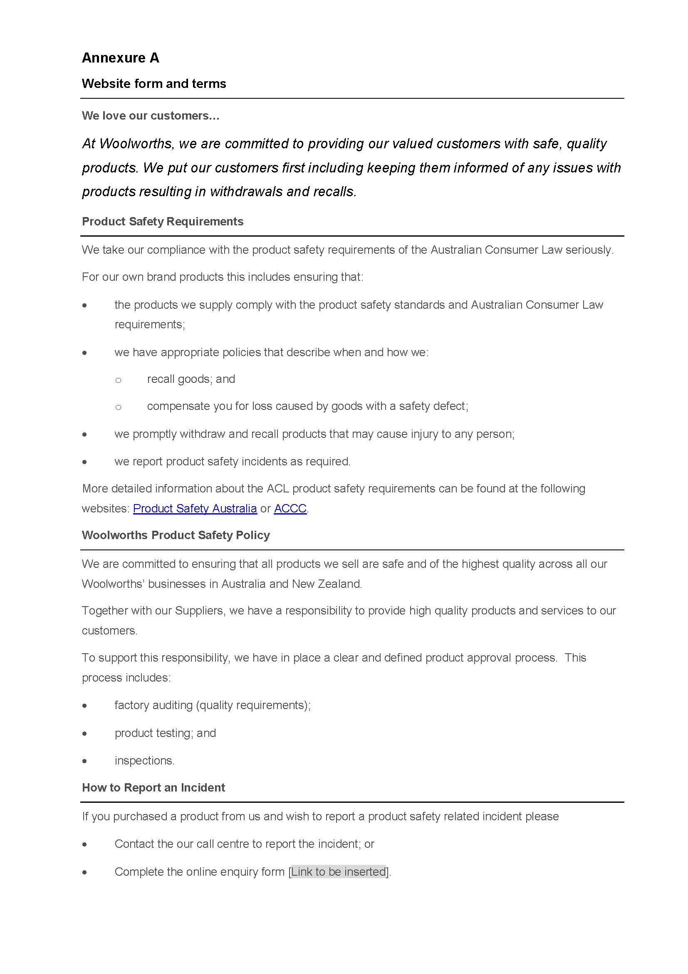

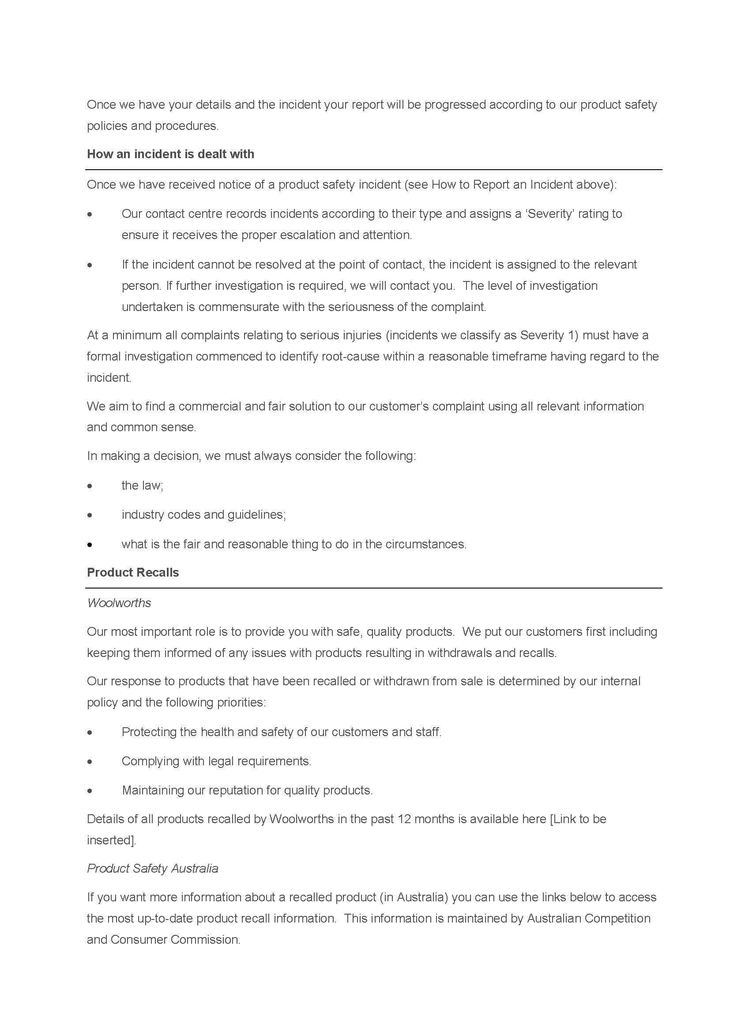

ANNEXURE B TO THE ORDERS
Requirements for product safety compliance program
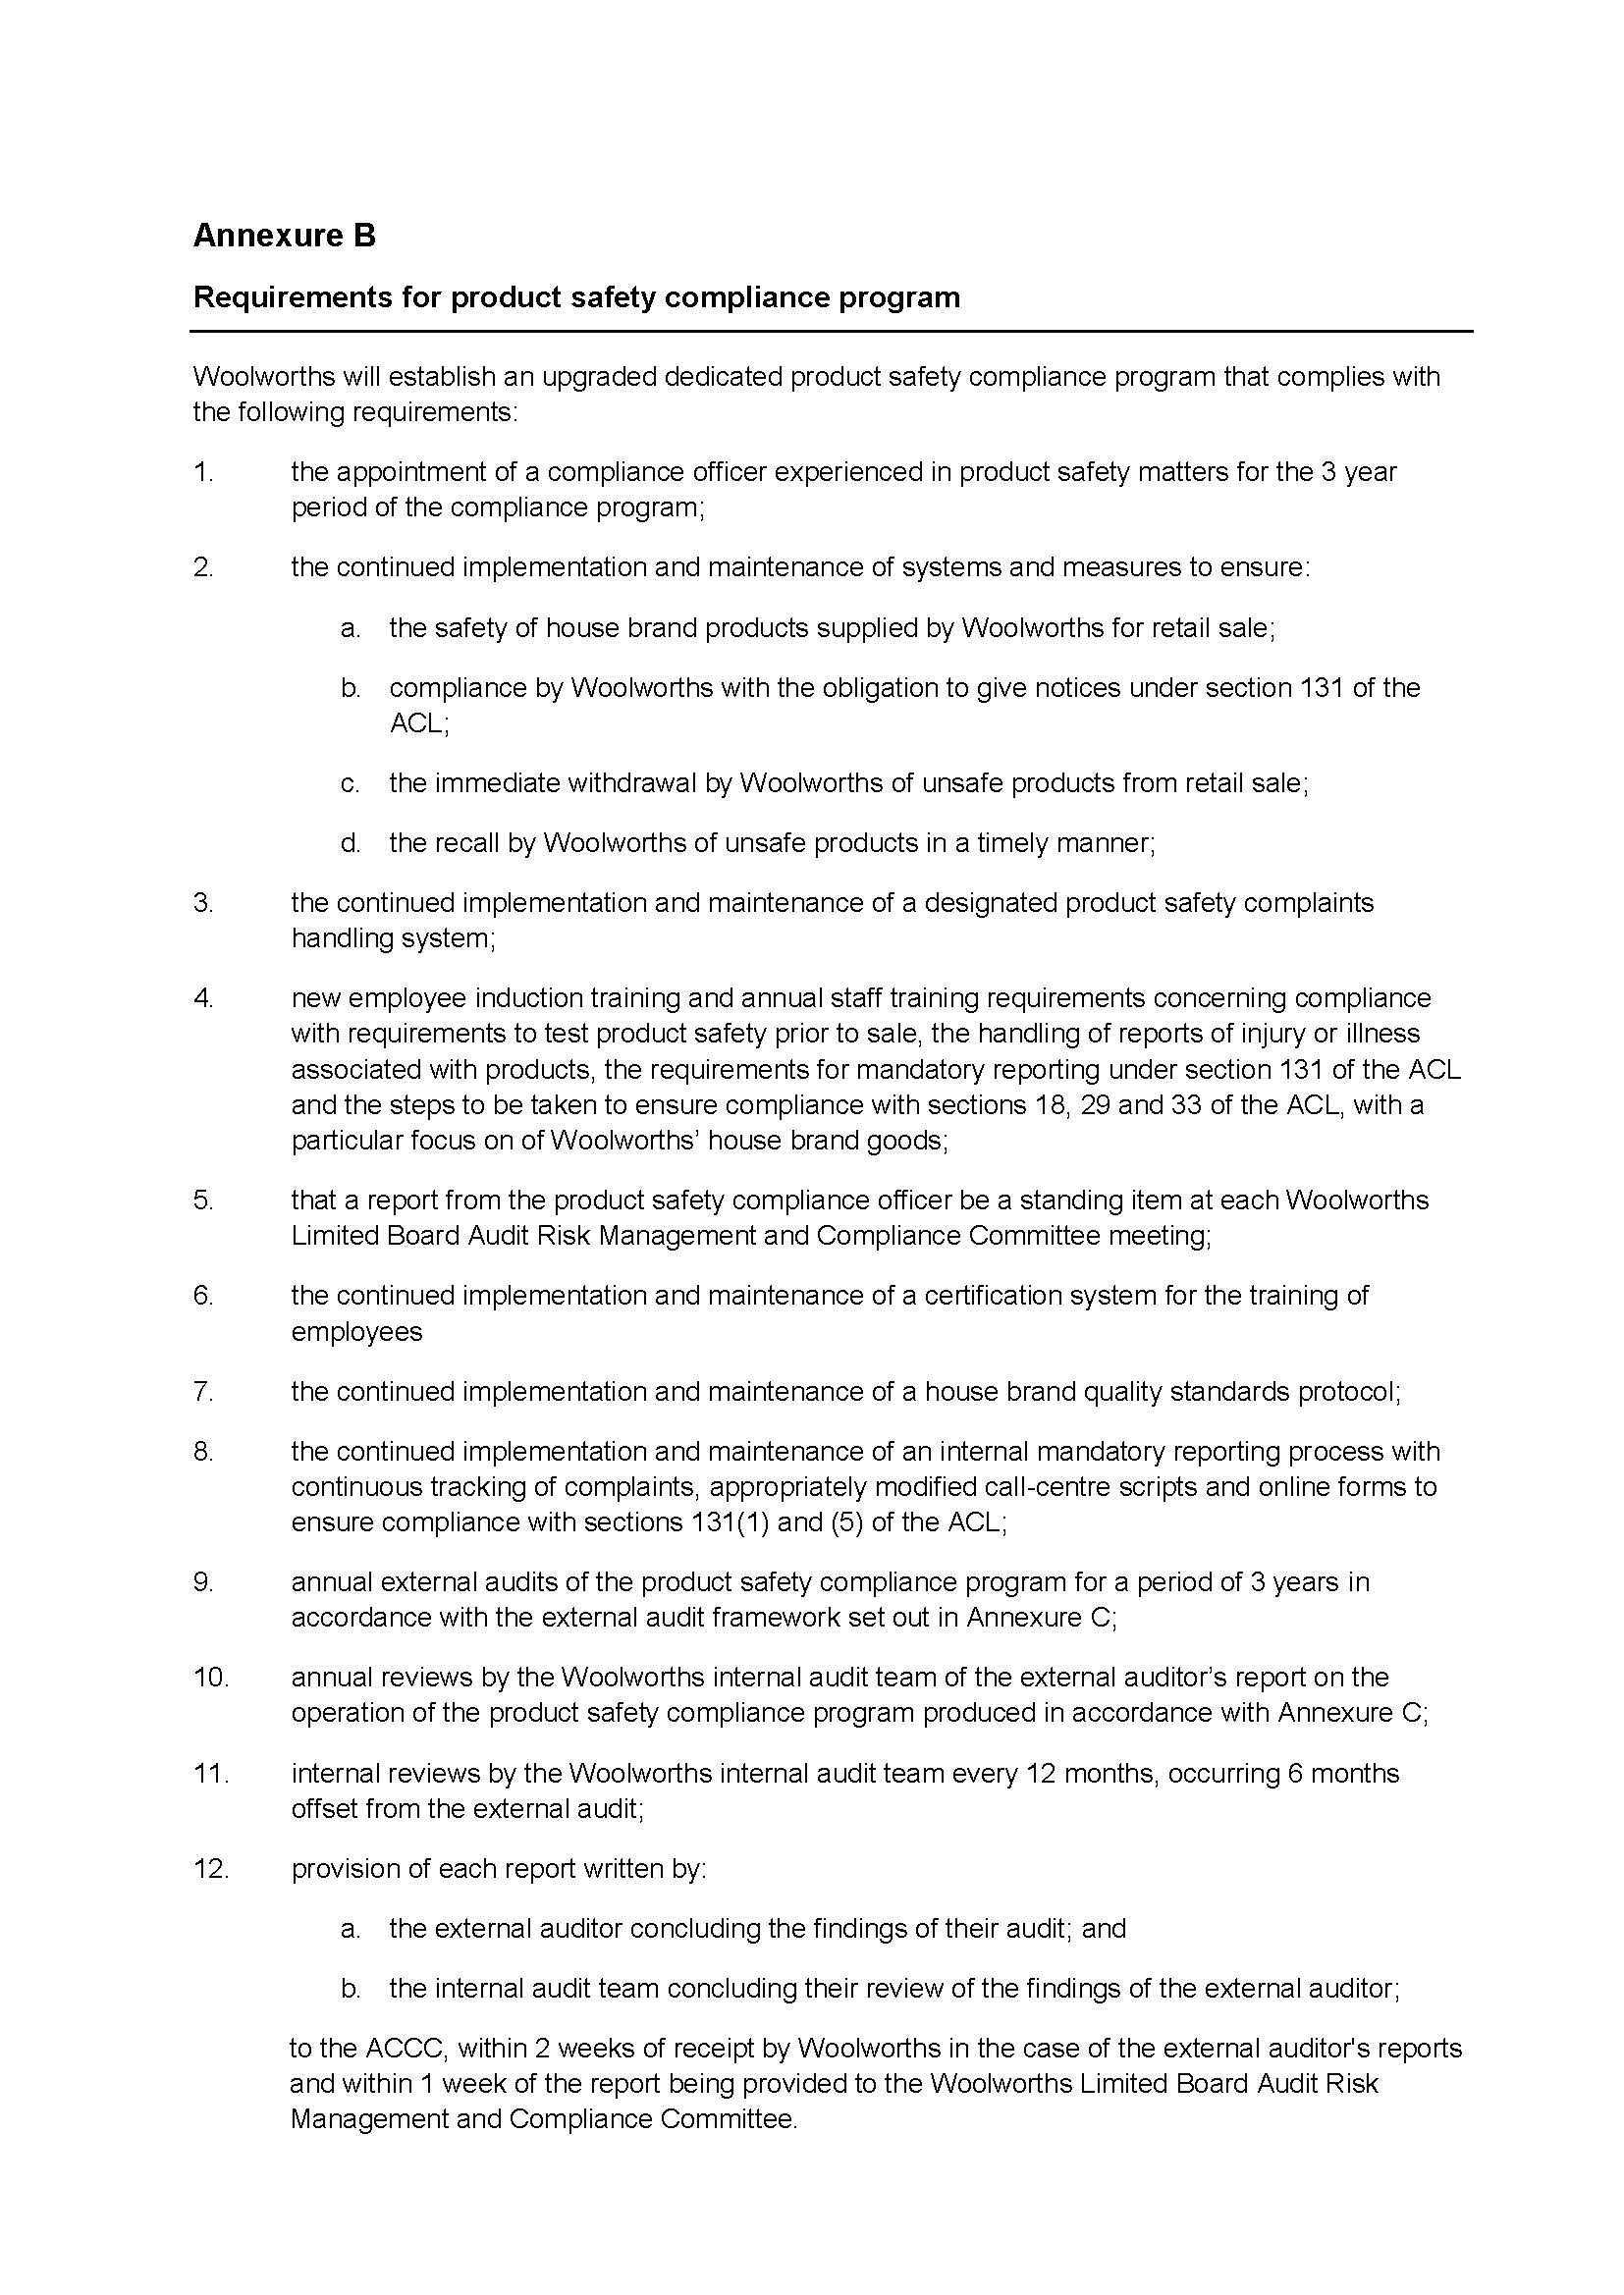

ANNEXURE C TO THE ORDERS
External Audit Framework

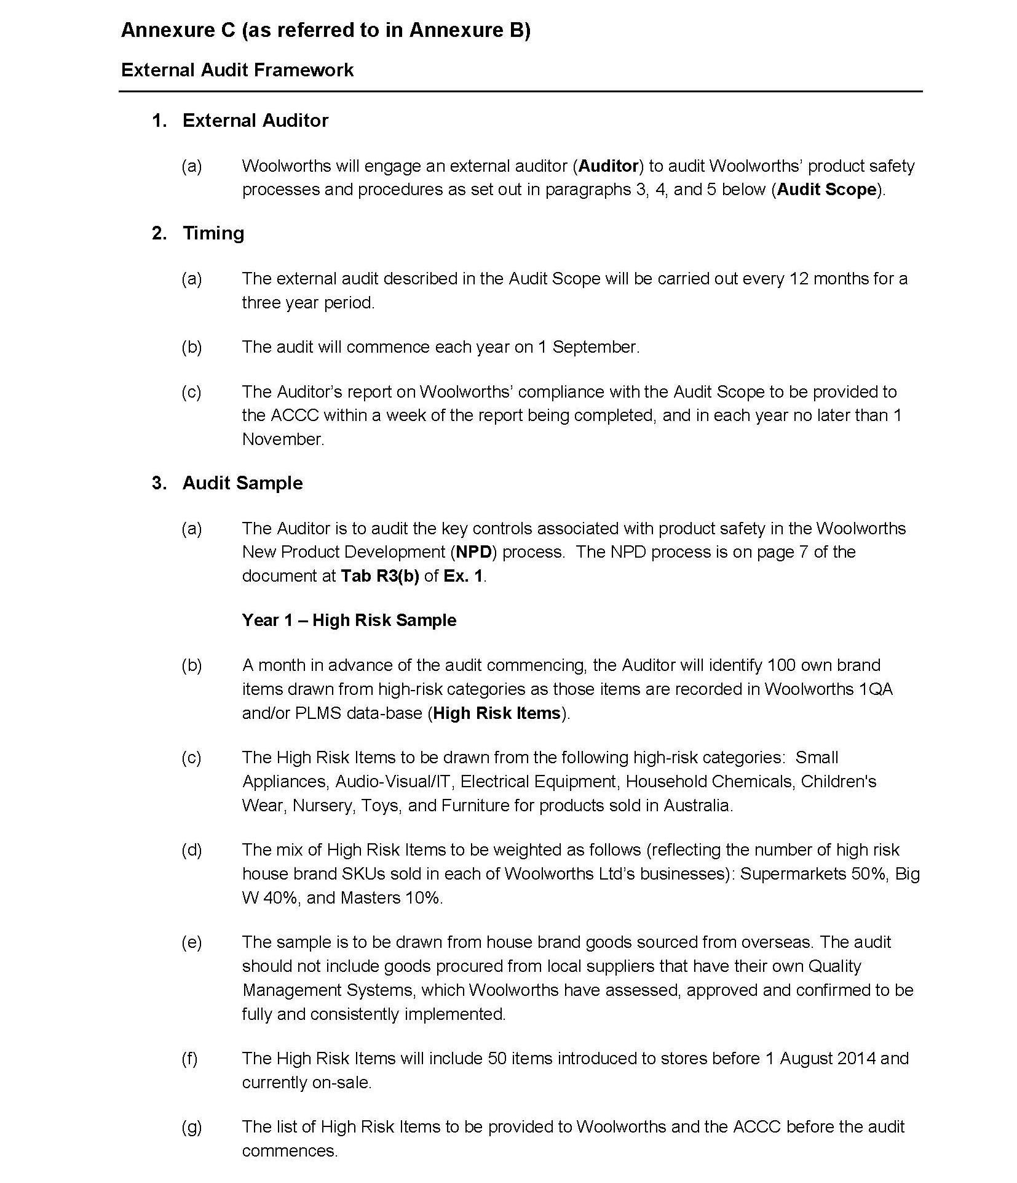

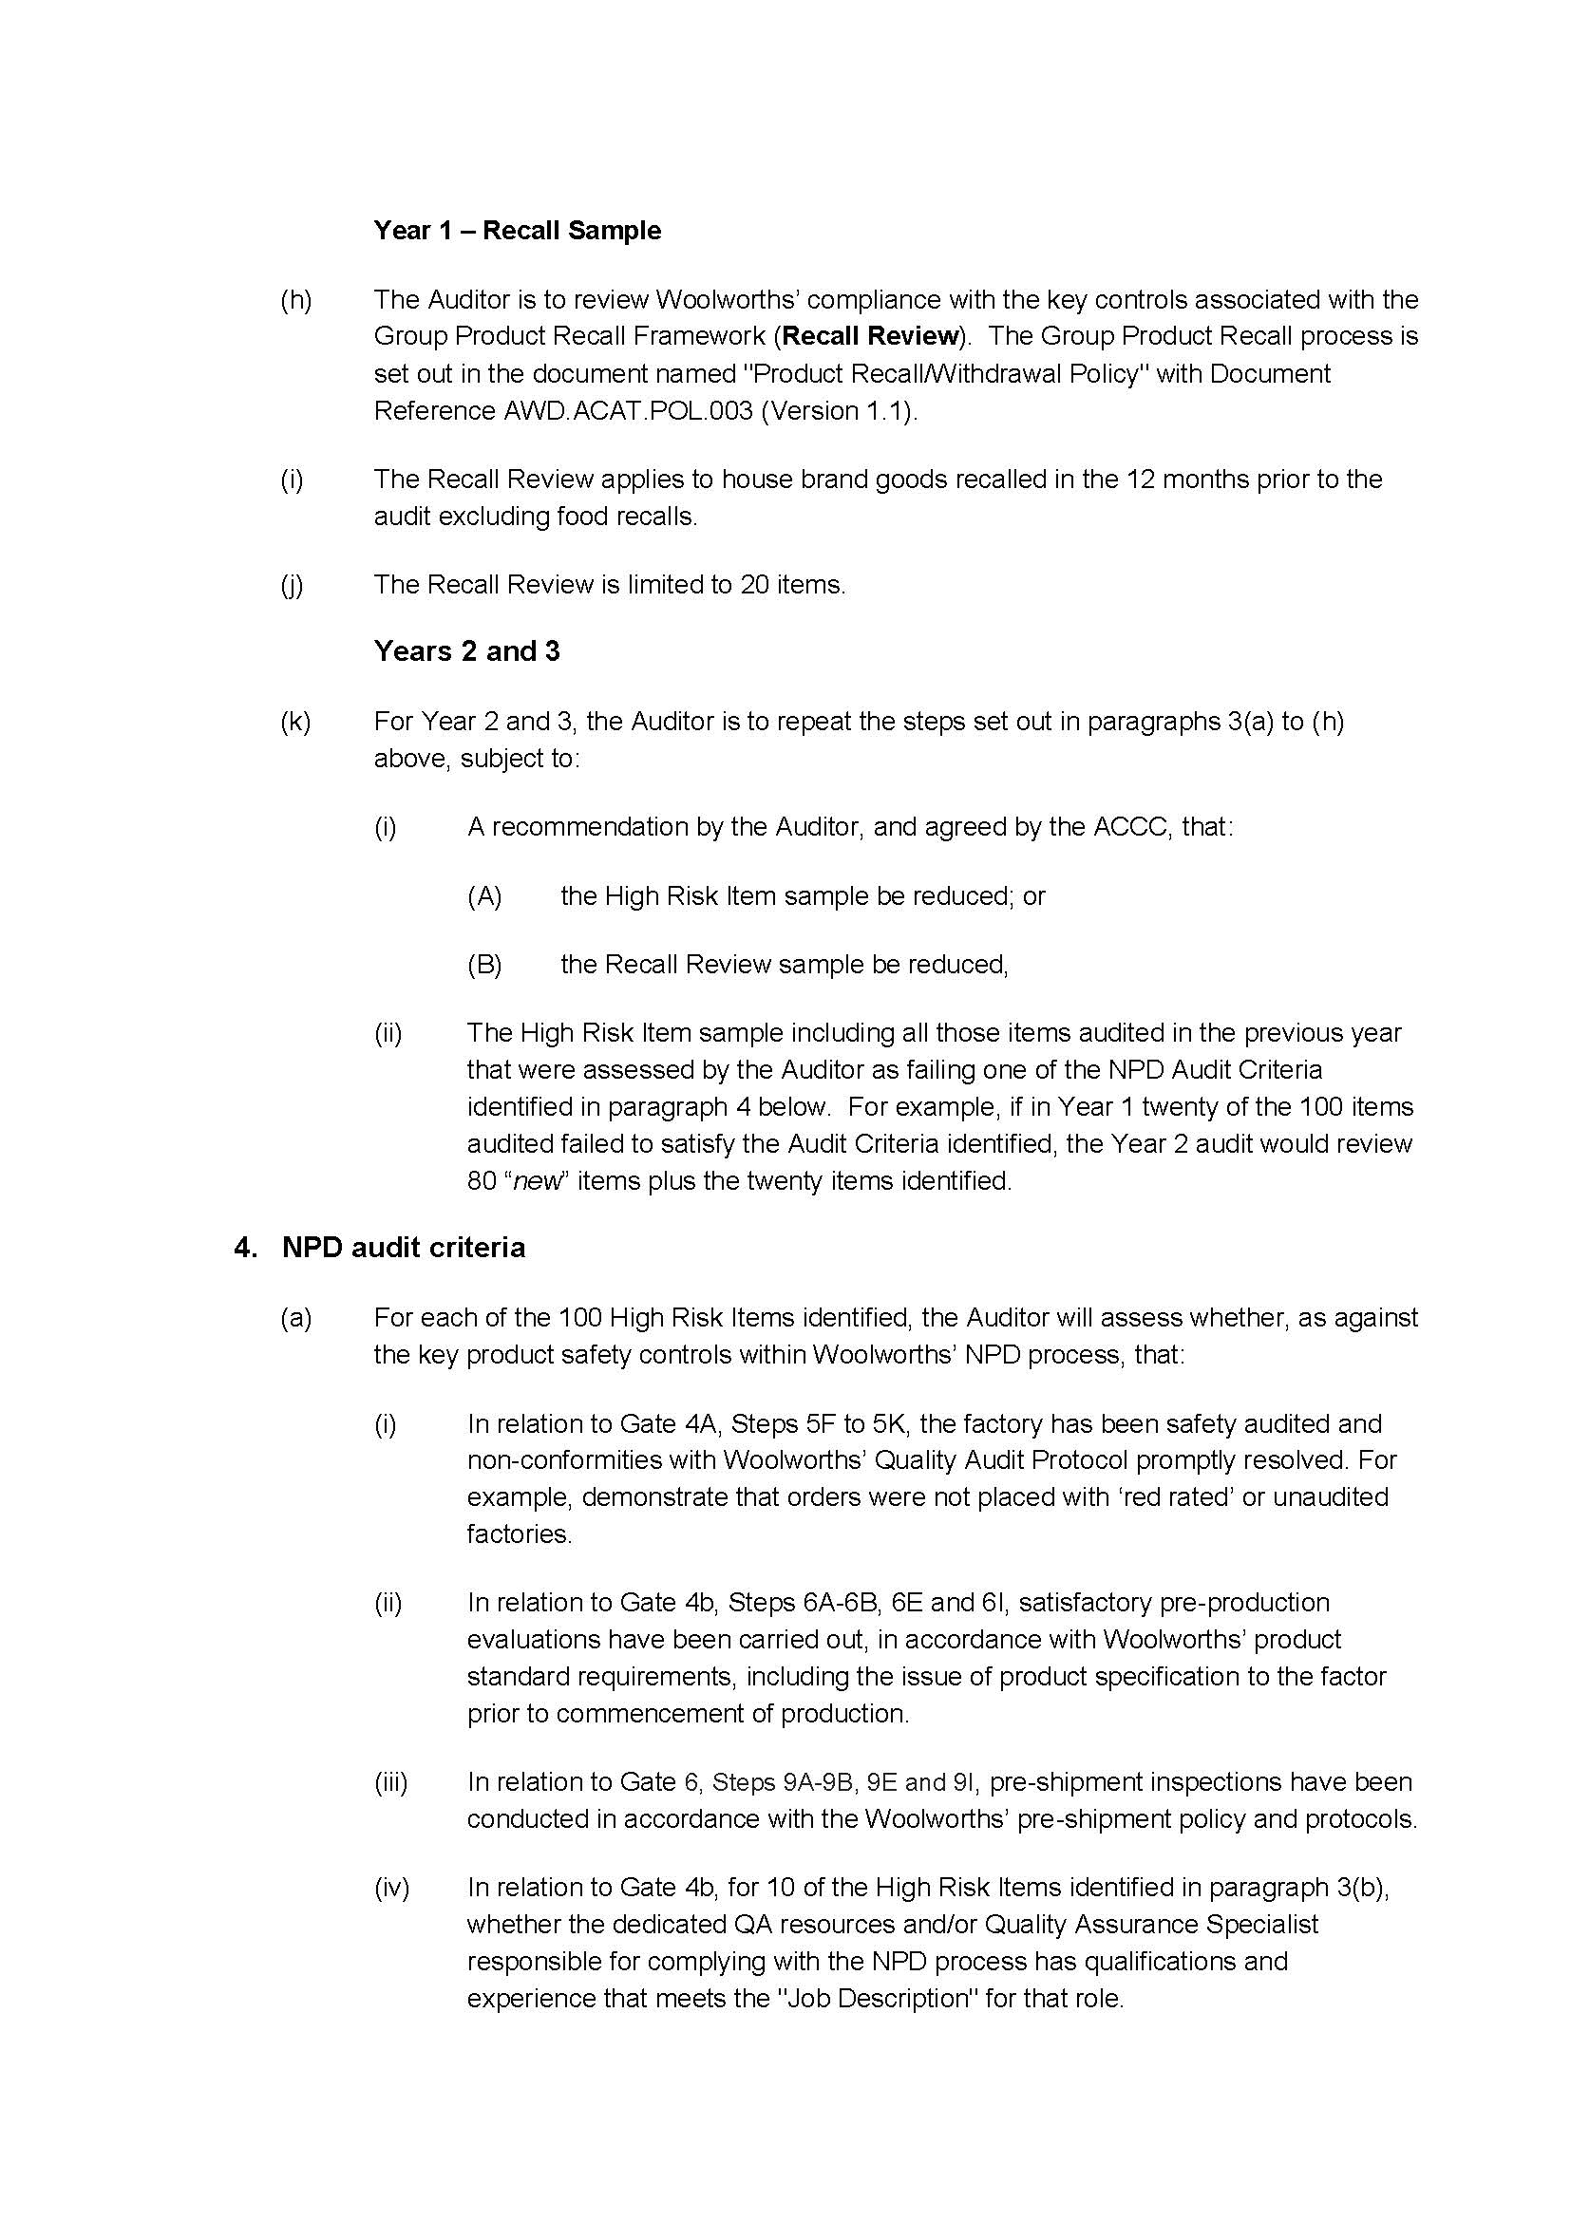

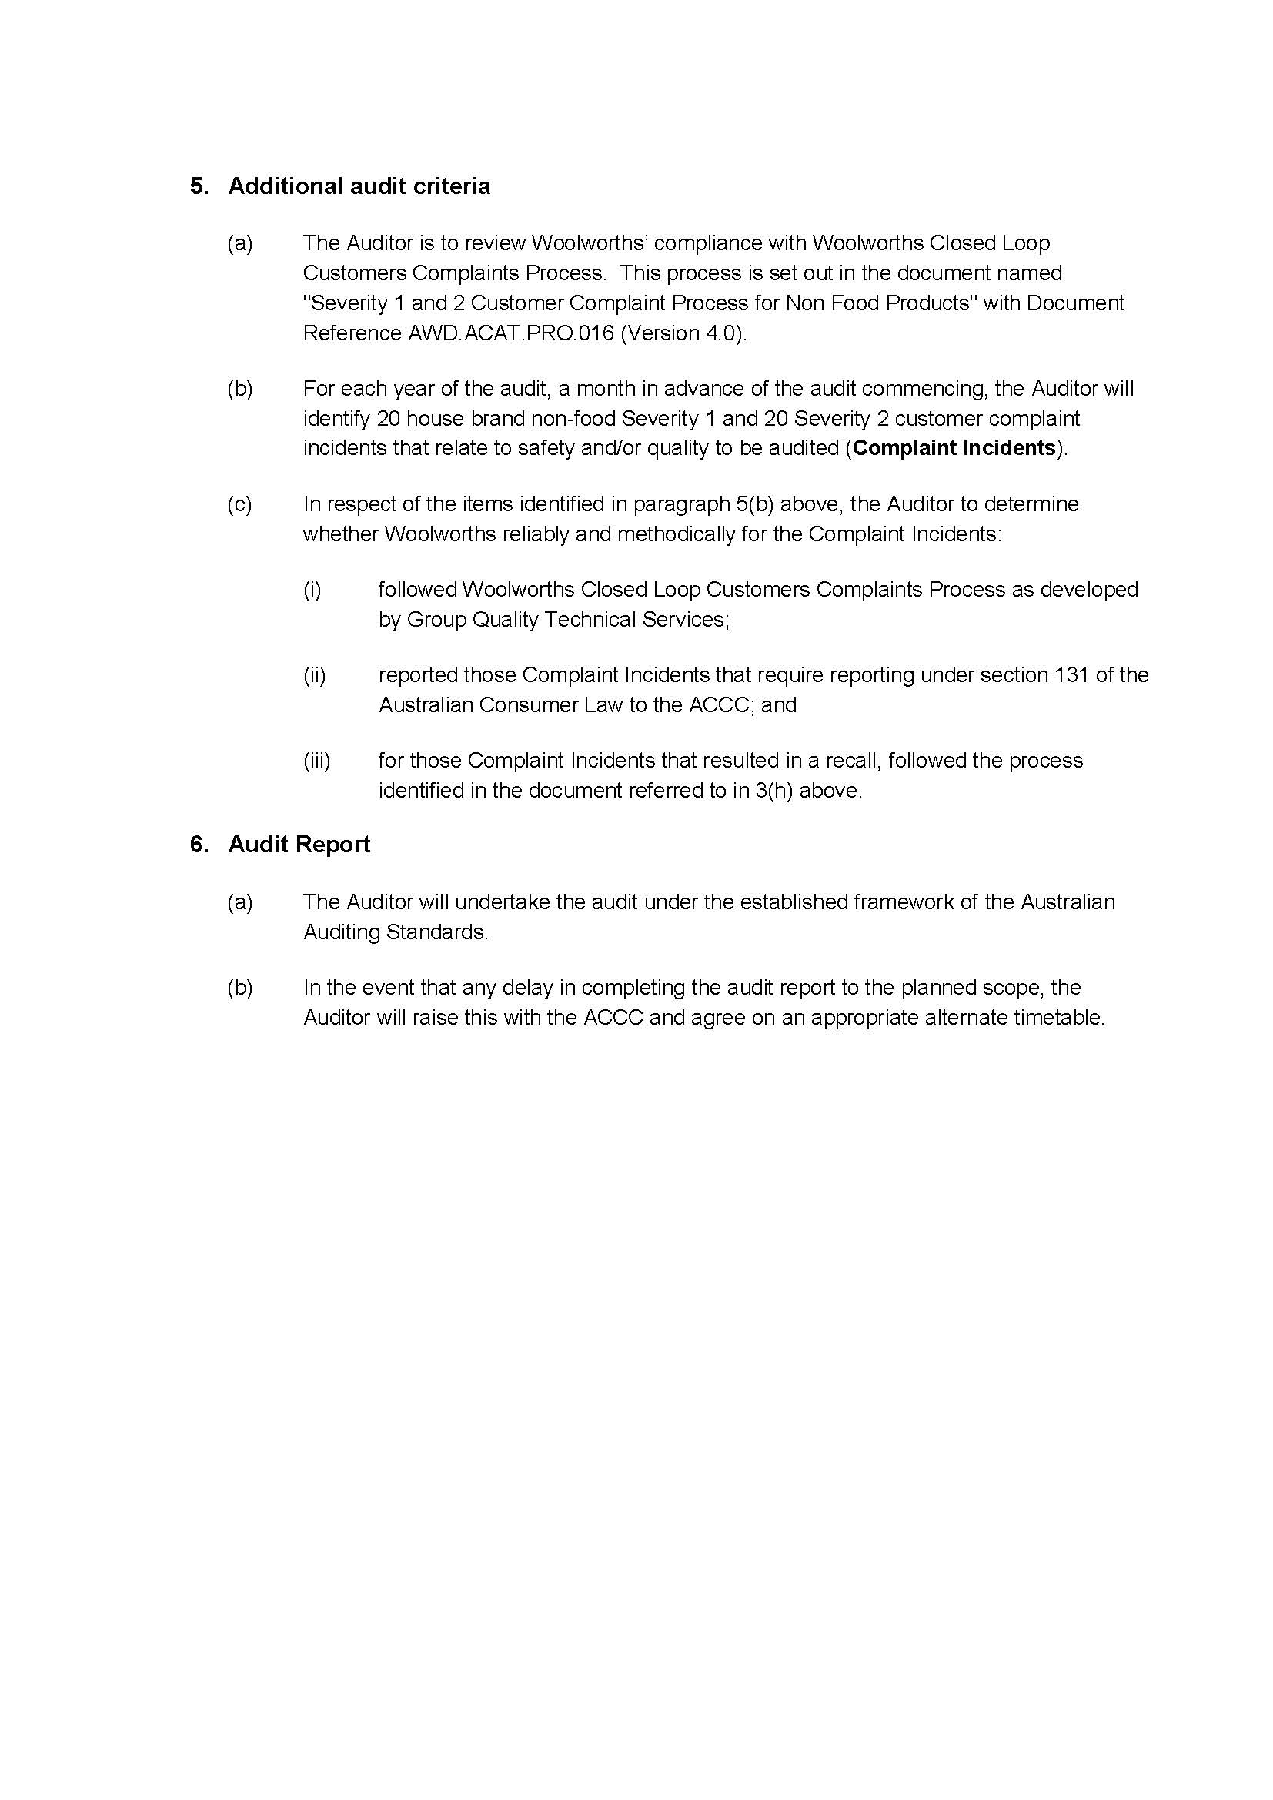

ANNEXURE 1 TO THE REASONS
Abode 3 Litre Stainless Steel Deep Fryer, Model DF30BW

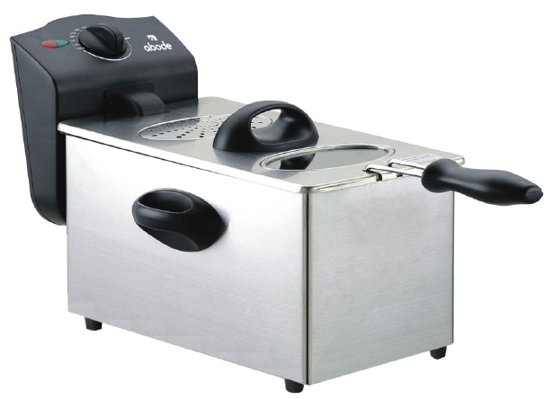

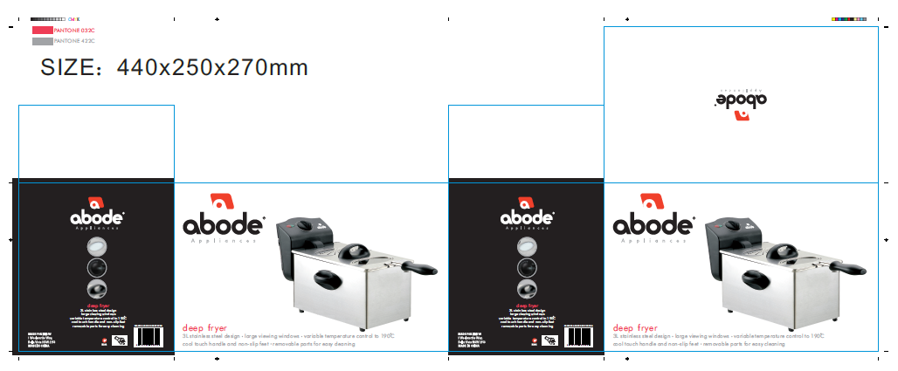

ANNEXURE 2 TO THE REASONS
The Select Drain Cleaner 1L Bottle

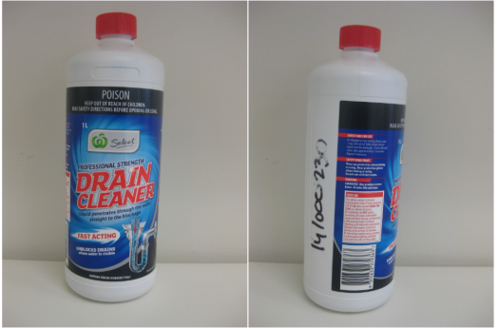
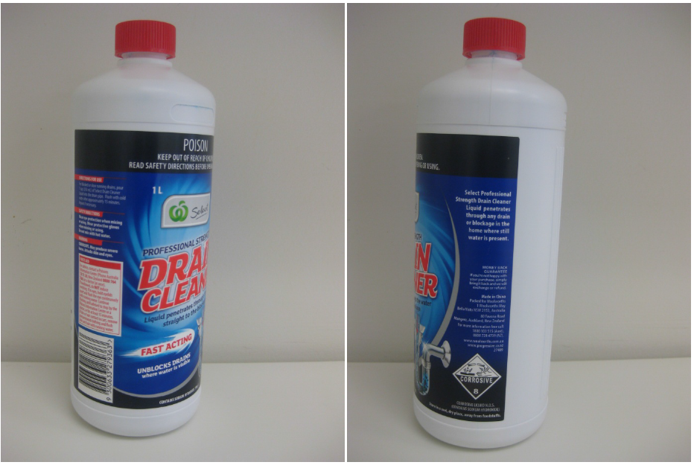

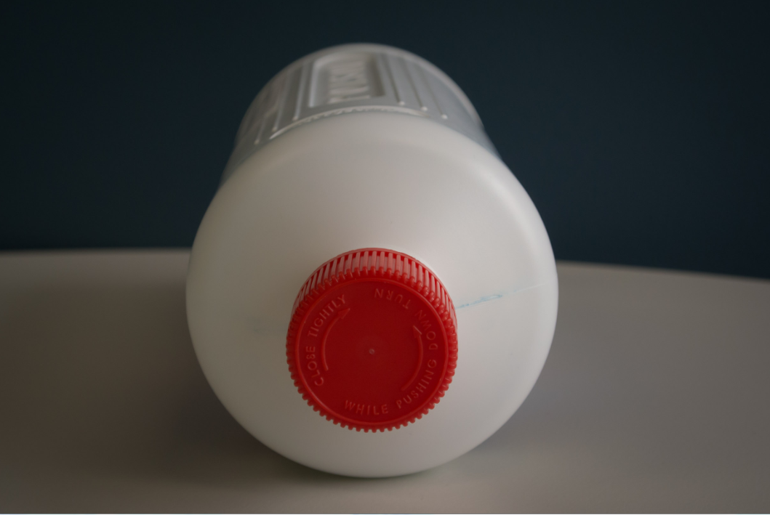

ANNEXURE 3 TO THE REASONS
10 x 45 Homebrand Safety Matches

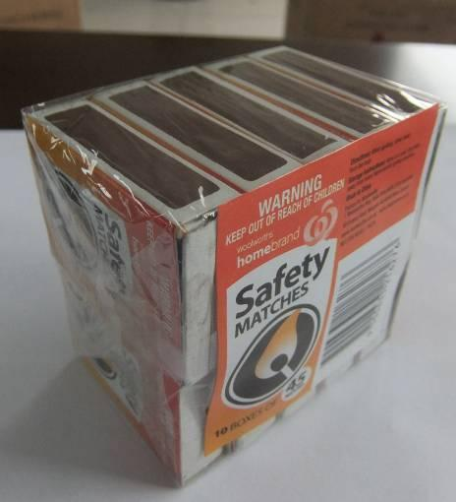
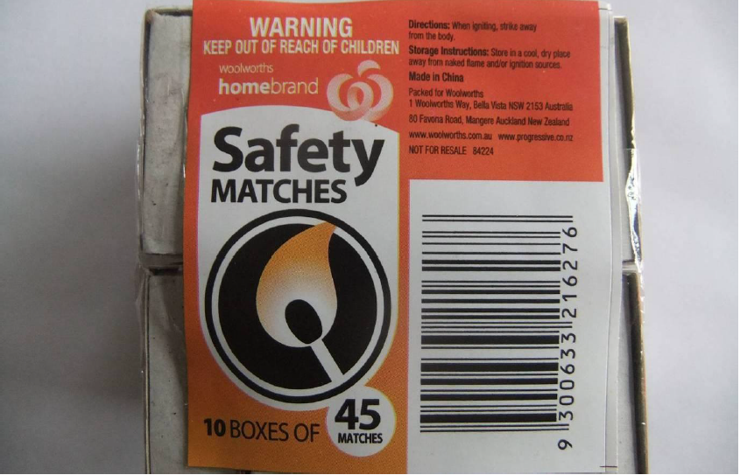

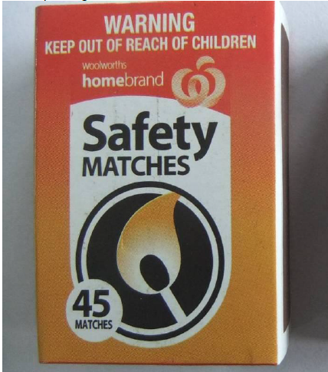
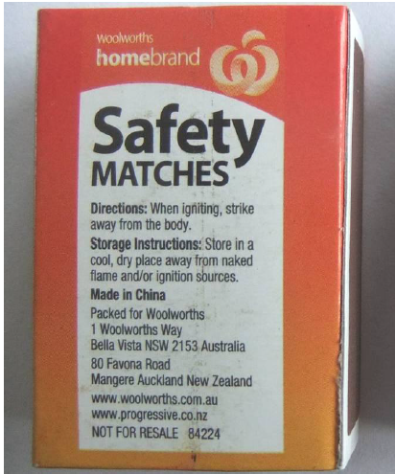

ANNEXURE 4 TO THE REASONS
The Padded Flop Chair

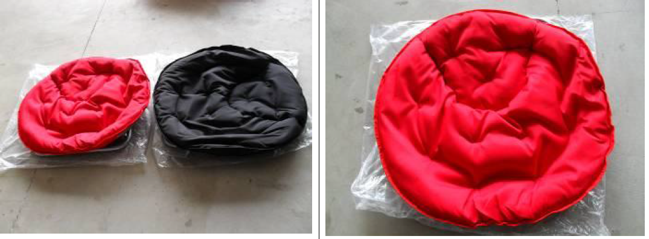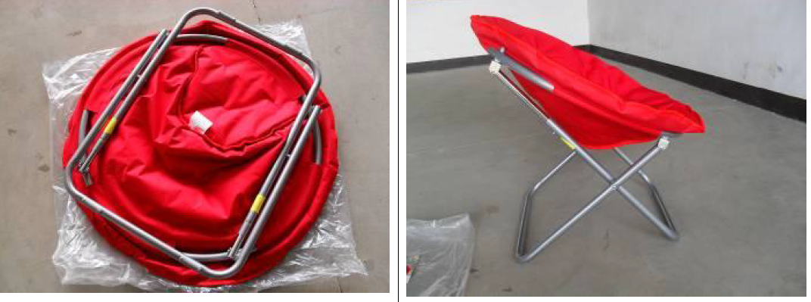
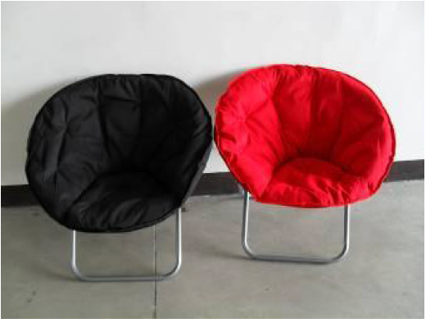

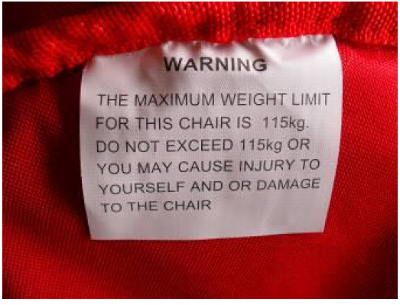
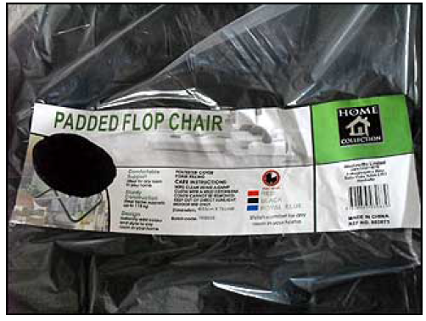
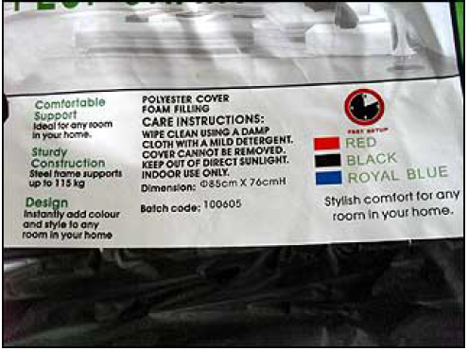
ANNEXURE 5 TO THE REASONS
The Folding Stool

