FEDERAL COURT OF AUSTRALIA

Perera v GetSwift Limited [2018] FCA 732

File numbers: | NSD 226 of 2018  NSD 440 of 2018  NSD 580 of 2018
Judge: | LEE J
Date of judgment: | 23 May 2018
Catchwords: | REPRESENTATIVE PROCEEDINGS – three overlapping open securities class actions against the same respondent – consideration of circumstances which have led to the rise of competing securities class actions – consideration of remedial response to competing class actions in Australia and North America – identification of multiple factors relevant to response – substantially the same claims and substantially the same causes of action – consideration of proposed common fund order and advantages of a funding model linking risk and return to funders by reference to costs incurred – comparative analysis of proceedings including proposals for reducing legal costs and likely return to group members – whether a continuation of duplicative proceedings would amount to an abuse of process – whether equity should intervene to enjoin parties to prevent multiplicity of proceedings – whether a “declassing” order should be made under s 33N(1) or s 33ZF of the Federal Court of Australia Act 1976 (Cth) – application for a permanent stay of two of the proceedings allowed – orders facilitating stay of two proceedings and continuation of one open class proceeding  EQUITY – equitable remedies to control multiple proceedings before the Court and protecting the processes of the Court – bills of peace
Legislation: | Acts Interpretation Act 1901 (Cth), s 15AA  Civil Dispute Resolution Act 2011 (Cth)  Corporations Act 2001 (Cth), Pt 9.6A, s 1041E  Federal Court of Australia Act 1976 (Cth), Pt IVA, ss 5(2), 22, 23, 33A, 33C, 33C(1), 33D, 33H, 33J, 33L, 33N(1), 33N(1)(a), 33N(1)(b), 33N(1)(c), 33N(1)(d), 33Q, 33R, 33S, 33T, 33V, 33X, 33Z, 33Y, 33ZB, 33ZF, 33ZF(1), 37M(3), 37P(2)  Federal Court Rules 2011, r 1.32  28 USC § 1407 (2012) (US)  All Writs Act 28 USC § 1651 (2012) (US)  Anti-Injunction Act 28 USC § 2283 (2012) (US)  Federal Rules of Civil Procedure, r 23  Private Securities Litigation Reform Act of 1995, Pub L No 104-67, 109 Stat 737 (US)  Securities Litigation Uniform Standards Act of 1998, Pub L No 105-353, 112 Stat 3227 (US)  Supreme Court of Judicature Act 1873 (UK)
Cases cited: | ABN AMRO Bank NV v Bathurst Regional Council [2014] FCAFC 65; (2014) 224 FCR 1  Ahmed v Chowdhury [2012] NSWSC 1452  Angelides v James Stedman Hendersons Sweets Limited (1927) 40 CLR 43  Batistatos v Roads and Traffic Authority of New South Wales [2006] HCA 27; (2006) 226 CLR 256  Beecham (Australia) Pty Ltd v Rogue Pty Ltd (1987) 11 NSWLR 1  Blairgowrie Trading Ltd v Allco Finance Group Ltd (recs and mgrs apptd) (in liq) (No 3) [2017] FCA 330; (2017) 343 ALR 476  Blairgowrie Trading Ltd v Allco Finance Group Ltd (recs and mgrs apptd) (in liq) [2015] FCA 811; (2015) 325 ALR 539  Blue Oil Energy Pty Limited v Tan [2014] NSWCA 81  Bray v F Hoffman-La Roche Ltd [2002] FCA 1405  Brookfield Multiplex Ltd v International Litigation Funding Partners Pte Ltd [2009] FCAFC 147; (2009) 180 FCR 11  Caason Investments Pty Limited v Cao (No 2) [2018] FCA 527  Caason Investments Pty Ltd v Cao [2015] FCAFC 94; (2015) 236 FCR 322  Campbells Cash and Carry Pty Limited v Fostif Pty Limited [2006] HCA 41; (2006) 229 CLR 386  Cantor v Audi Australia Pty Limited (No 2) [2017] FCA 1042  Capic v Ford Motor Company (No 2) [2016] FCA 1178  Chowder Bay Pty Ltd v Paganin [2018] FCAFC 25  Clarke v Sandhurst Trustees Limited (No 2) [2018] FCA 511  Coal and Allied Operations Pty Ltd v Australian Industrial Relations Commission [2000] HCA 47; (2000) 203 CLR 194  CPB Contractors Pty Limited v Celsus Pty Limited (formerly known as SA Health Partnership Nominees Pty Ltd) [2017] FCA 1620  CSR Limited v Cigna Insurance Australia Limited (1997) 189 CLR 345  Cyan Inc v Beaver County Employees Retirement Fund 138 S Ct 1061 (2018)  De Jong v Carnival PLC (No 3) [2016] NSWSC 1461  Dillon v RBS Group (Australia) Pty Ltd [2017] FCA 896; (2017) 252 FCR 150  Dorajay Pty Ltd v Aristocrat Leisure Ltd [2005] FCA 1483; (2005) 147 FCR 394  Earglow Pty Ltd v Newcrest Mining Limited [2016] FCA 1433  Femcare Ltd v Bright [2000] FCA 512; (2000) 100 FCR 331  Gee v Pritchard (1818) 2 Swans 402; 36 ER 670  Gorecki v Canada (AG) 2004 CarswellOnt 1266; (2004) 47 CPC (5th) 151  Grant-Taylor v Babcock and Brown Ltd (in liq) [2015] FCA 149; (2015) 322 ALR 723  Hardy v Reckitt Benckiser (Australia) Pty Limited (No 3) [2017] FCA 1165  Hassid v Queensland Bulk Water Supply Authority [2017] NSWSC 599  Henry v Henry (1996) 185 CLR 571  Hunter v Chief Constable of the West Midlands Police [1982] AC 529  In re Diplock; Diplock v Wintle [1948] Ch 465  Jackson v Sterling Industries Ltd (1987) 162 CLR 612  Jameson v Professional Investment Services Pty Ltd [2007] NSWSC 1437; (2007) 215 FLR 377  Jeffery & Katauskas Pty Limited v SST Consulting Pty Ltd [2009] HCA 43; (2009) 239 CLR 75  Johnson Tiles Pty Ltd v Esso Australia Limited [1999] FCA 56; (1999) ATPR 41-679  Kelly v Willmott Forests Ltd (in liquidation) (No 2) [2013] FCA 732  Kelly v Willmott Forests Ltd (in liquidation) (No 4) [2016] FCA 323; (2016) 335 ALR 439  King v GIO Australia Holdings Ltd [2000] FCA 617; (2000) 100 FCR 209  Kirby v Centro Properties Ltd [2008] FCA 1505; (2008) 253 ALR 65  Locking v Armtec Infrastracture Inc 2013 ONSC 331; (2013) 303 OAC 299  Madgwick v Kelly [2013] FCAFC 61; (2013) 212 FCR 1  Mancinelli v Barrick Gold Corporation 2015 ONSC 2717; (2015) 126 OR (3d) 296  Markt & Co Limited v Knight Steamship Company Limited [1910] 2 KB 1021  McKay Super Solutions Pty Ltd (Trustee) v Bellamy’s Australia Ltd [2017] FCA 947  McMullin v ICI Australia Operations Pty Ltd (1998) 84 FCR 1  Melbourne City Investments Pty Ltd v Myer Holdings Limited [2017] VSCA 187  Melbourne City Investments Pty Ltd v Treasury Wine Estates Ltd [2016] FCA 787; (2016) 243 FCR 474  Melbourne City Investments Pty Ltd v Treasury Wine Estates Ltd [2017] FCAFC 98; (2017) 252 FCR 1  Mitic v OZ Minerals Limited (No 2) [2017] FCA 409  Moore v Inglis (1976) 50 ALJR 589  Multiplex Funds Management Ltd v P Dawson Nominees Pty Ltd [2007] FCAFC 200; (2007) 164 FCR 275  National Mutual Holdings Pty Ltd v The Sentry Corporation (1989) 22 FCR 209  Nixon v Philip Morris (Australia) Ltd [1999] FCA 1107; (1999) 95 FCR 453  Oliver v Commonwealth Bank of Australia (No 2) [2012] FCA 755; (2012) 205 FCR 540  Palavi v Queensland Newspapers Pty Ltd [2012] NSWCA 182; (2012) 84 NSWLR 523  Patrick Stevedores Operations No 2 Pty Ltd v Maritime Union of Australia [1998] HCA 30; (1998) 195 CLR 1  Pearson v State of Queensland [2017] FCA 1096  Petersen Superannuation Fund Pty Ltd v Bank of Queensland Limited [2017] FCA 699  PNJ v The Queen [2009] HCA 6; (2009) 83 ALJR 384  Port of Melbourne Authority v Anshun Pty Ltd (1981) 147 CLR 589  Project Blue Sky Inc v Australian Broadcasting Authority [1998] HCA 28; (1998) 194 CLR 355  Re HIH Insurance Ltd (in liq) [2016] NSWSC 482; (2016) 335 ALR 320  Re Lethbridge v Mitchell (1887) 8 LR (NSW) 249  Regie Nationale des Usines Renault SA v Zhang [2002] HCA 10; (2002) 210 CLR 491  Ridgeway v The Queen (1995) 184 CLR 19  Rod Investments (Vic) Pty Ltd v Clark [2005] VSC 449  Rogers v The Queen (1994) 181 CLR 251  Rosengrens Limited v Safe Deposit Centres Limited [1984] 3 All ER 198  Setterington v Merck Frosst Canada Ltd 2006 CarswellOnt 506; (2006) 26 CPC (6th) 173  Sheffield Waterworks v Yeomans (1866) LR 2 Ch App 8  Smith v Australian Executor Trustees Limited [2016] NSWSC 17  Smith v Bayer Corporation 564 US 299 (2011); 131 S Ct 2368 (2011)  The Owners of the Ship “Shin Kobe Maru” v Empire Shipping Company Inc (1994) 181 CLR 404  Treasury Wine Estates Ltd v Melbourne City Investments Pty Ltd [2014] VSCA 351; (2014) 45 VR 585  TW McConnell Pty Ltd v SurfStitch Group Ltd [2017] NSWSC 1755  Voth v Manildra Flour Mills Pty Ltd (1990) 171 CLR 538  Walton v Gardiner (1993) 177 CLR 378  Williams v Spautz (1992) 174 CLR 509  Wong v Silkfield Pty Limited [1999] HCA 48; (1999) 199 CLR 255  Derrington SC, ‘Litigation Funding Inquiry’ (Speech delivered at the Increased Regulation of Litigation Funding – A Timely Crackdown or a Regulatory Solution in Search of a Problem? Seminar, Monash University, 9 April 2018)  Heydon JD, Leeming MJ and Turner PG, Meagher, Gummow and Lehane’s Equity: Doctrines and Remedies (5th ed, LexisNexis Butterworths, 2015)  Legg M, “A Critical Assessment of Shareholder Class Action Settlements – The Allco Class Action” (2018) 46 Australian Business Law Review 54  LexisNexis, Halsbury’s Laws of England  Mark S, ‘The Regulation of Third Party Litigation Funding in Australia – Discussion Paper’ (Discussion paper, New South Wales Office of the Legal Services Commissioner, March 2012)  Morabito V and Hatcher N, “Security for Costs in Unfunded Federal Class Actions: Back to the Future” (2018) 92 Australian Law Journal 105  Morabito V, “Replacing Inadequate Class Representatives in Federal Class Actions: Quo Vadis?” (2015) 38(1) University of New South Wales Law Journal 146  Morabito V, An Empirical Study of Australia’s Class Action Regimes, Fifth Report: The First Twenty-Five Years of Class Actions in Australia (Report, Monash University, 20 July 2017) <https://ssrn.com/abstract=3005901>  Pomeroy JN, A Treatise on Equity Jurisprudence, as Administered in the United States of America (5th ed, Bancroft-Whitney Company, 1941)  Redesdale, J Mitford, Baron, A Treatise on the Pleadings in Suits in the Court of Chancery by English Bill (AL Bancroft and Company, 1881)  Rowe T, “A Distant Mirror: The Bill of Peace in Early American Mass Torts and Its Implications for Modern Class Actions” (1997) 39 Arizona Law Review 711  Story J, Commentaries on Equity Jurisprudence as Administered in England and America (1st English ed, Stevens and Hayes, 1884)  Weiner W and Szyndrowski D, “The Class Action, from the English Bill of Peace to Federal Rule of Civil Procedure 23: Is There a Common Thread” (1987) 8 Whittier Law Review 935  Weinstein AS, “Avoiding the Race to Res Judicata: Federal Antisuit Injunctions of Competing State Class Actions” (2000) 75 New York University Law Review 1085
Date of hearing: | 11, 13, 24, 27 April, 7 May 2018
Registry: | New South Wales
Division: | General Division
National Practice Area: | Commercial and Corporations
Sub-area: | Corporations and Corporate Insolvency
Category: | Catchwords
Number of paragraphs: | 380
Counsel for the Applicant in NSD226/2018: | Mr WAD Edwards (11, 13, 24, 27 April 2018)  Ms A Banton of Squire Patton Boggs (7 May 2018)
Solicitor for the Applicant in NSD226/2018: | Squire Patton Boggs
Counsel for the Applicant in NSD440/2018: | Mr P Brereton SC and Dr B Kremer (13 April 2018)  Dr B Kremer (11, 24, 27 April 2018, 7 May 2018)
Solicitor for the Applicant in NSD440/2018: | Corrs Chambers Westgarth
Counsel for the Applicant in NSD580/2018: | Mr D Collins QC and Dr O Bigos (11, 13, 24 April 2018)  Mr T Finney of Phi Finney McDonald (27 April 2018)  Mr D Collins QC (7 May 2018)
Solicitor for the Applicant in NSD580/2018: | Phi Finney McDonald
Counsel for the Respondents in all proceedings: | Mr A Shearer (11, 13, 24 April 2018)  Ms M Fox of Quinn Emanuel Urquhart Sullivan (27 April, 7 May 2018)
Solicitor for the Respondents in all proceedings: | Quinn Emanuel Urquhart Sullivan

Table of Corrections
25 May 2018 | At paragraph [99], the heading “D.2.1 Stays & Abuse of Process” has been removed.
14 June 2018 | At paragraph [255], the word “not” has been inserted between the words “were” and “identified”.

ORDERS
 |  | NSD 226 of 2018
BETWEEN: | DWAYNE CAVAN SHANAHAN PERERA  Applicant
AND: | GETSWIFT LTD  First Respondent  JOEL MACDONALD  Second Respondent
JUDGE: | LEE J
DATE OF ORDER: | 23 May 2018

THE COURT ORDERS THAT:

- This proceeding be permanently stayed.
- For the avoidance of doubt, the permanent stay of this proceeding does not prevent the applicant making and moving upon any application as a group member in proceedings NSD 580 of 2018 pursuant to s 33T of the Federal Court of Australia Act 1976 (Cth) where he contends that Mr Webb, the applicant in that proceeding, is not able adequately to represent the interests of the group members in that proceeding including, without limitation, in circumstances where Mr Webb has failed to comply with any order relating to security for costs.

Note: Entry of orders is dealt with in Rule 39.32 of the Federal Court Rules 2011.

ORDERS
 |  | NSD 440 of 2018
BETWEEN: | SHAUN MCTAGGART  First Applicant  SAMANTHA MCTAGGART  Second Applicant
AND: | GETSWIFT LTD  First Respondent  JOEL MACDONALD  Second Respondent  BANE HUNTER  Third Respondent

JUDGE: | LEE J
DATE OF ORDER: | 23 may 2018

THE COURT ORDERS THAT:

- This proceeding be permanently stayed.
- For the avoidance of doubt, the permanent stay of this proceeding does not prevent the applicants making and moving upon any application as group members in proceedings NSD 580 of 2018 pursuant to s 33T of the Federal Court of Australia Act 1976 (Cth) where they contend that Mr Webb, the applicant in that proceeding, is not able adequately to represent the interests of the group members in that proceeding including, without limitation, in circumstances where Mr Webb has failed to comply with any order relating to security for costs.

Note: Entry of orders is dealt with in Rule 39.32 of the Federal Court Rules 2011.

ORDERS
 |  | NSD 580 of 2018
BETWEEN: | RAFFAELE WEBB  Applicant
AND: | GETSWIFT LTD  First Respondent  JOEL MACDONALD  Second Respondent

JUDGE: | LEE J
DATE OF ORDER: | 23 MAY 2018

THE COURT ORDERS THAT:

- The applicant file and serve a statement of claim on or by 4:00 pm on 28 May 2018.
- The respondents file and serve a defence to the statement of claim on or by 4:00 pm on 6 June 2018.
- On or by 2:00 pm on 7 June 2018, the applicants serve on the respondent and the solicitor for Mr Perera and the solicitor for the McTaggart applicants a copy of a proposed opt out notice and provide a copy to the Associate to Justice Lee.
- On or by 2:00 pm on 7 June 2018, the applicants serve on the respondent a copy of a draft common fund order and provide a copy to the Associate to Justice Lee.
- The matter be listed for a case management hearing at 9:00 am on 8 June 2018, for the purpose, among other things, of making orders in relation to the form and distribution of the opt out notice and that Mr Perera and the McTaggart applicants, International Litigation Partners No 18 Pte Ltd and Vannin Capital Ltd have leave to intervene, if they so wish, at the case management hearing for the purposes of making submissions as to the form of the opt out notice.
- Leave be granted to the applicants to issue a subpoena to ComputerShare Investor Services Pty Ltd in substantially the same form as comprises Annexure “A” to the interlocutory application filed in NSD 226 of 2018 dated 9 March 2018.
- Costs of the proceedings to date be reserved.

Note: Entry of orders is dealt with in Rule 39.32 of the Federal Court Rules 2011.

REASONS FOR JUDGMENT
LEE J:

A Introduction | [1]
B Contextual Matters | [10]
B.1 The Competing Securities Class Action Emerges | [10]
B.2 The Procedural Contradiction of Securities Class Actions | [30]
C The Factual & Procedural History of the Matter | [38]
C.1 Pre-Proceeding Background | [38]
C.2 The Competing Actions Emerge and the Court Orders | [44]
C.3 The Conduct of the Hearing and Summary of the Proposals | [63]
C.3.1 Mr Perera | [65]
C.3.2 McTaggart Applicants | [69]
C.3.3 Mr Webb | [72]
C.3.4 GetSwift | [74]
C.4 Group Definition and Overlap – A Logical Difficulty | [76]
D Remedial Response to Competing Class Actions: A Survey | [83]
D.1 The Australian Experience | [83]
D.2 The North American Experience | [95]
E Remedial Responses: Power & Applicable Principles | [105]
E.1 Identifying the Available Responses | [105]
E.2 Questions of Power & Applicable Principles | [109]
E.2.1 Permanent Stays | [109]
E.2.2 Declassing | [125]
E.2.3 Equitable Jurisdiction | [145]
E.3 Conclusions as to Questions of Power | [166]
F Factors Other Than Possible Comparative Net Returns | [168]
F.1 Introduction & Relevant Factors Relied Upon | [168]
F.2 Experience of Legal Practitioners | [172]
F.3 Available Legal Resources | [173]
F.4 State of Preparation | [174]
F.5 Funding Resources Available Including Security | [176]
F.5.1 The Funders’ Financial Position Generally | [177]
F.5.2 The Proposals for Security | [185]
F.6 Substantive Merits of Proceedings Generally | [199]
F.7 Substantive Merits of the Individual Cases of the Applicants | [206]
F.8 The Existence of Funding Agreements | [210]
F.9 The Number of Funded Group Members | [216]
F.10 Moral Hazard and Absence of Deadlock Provision | [218]
F.11 Estimated Cost | [225]
F.12 Measures for Controlling Legal Costs | [226]
F.13 Measures to Control Expert Costs | [231]
F.14 The Webb Proceeding and Public Policy | [235]
F.15 Prejudice to Third Parties | [240]
G Should a Common Fund Order be made? | [242]
G.1 Introduction | [242]
G.2 The Timing of Common Fund Order | [244]
G.3 An Order is Appropriate | [247]
H Comparative Estimates of Likely Returns to the Group | [250]
H.1 The Comparative Analysis – the Approach Taken | [250]
H.1.1 Assumptions in Orders | [251]
H.1.2 Differences Between Funding Proposals and Other Costs | [253]
H.2 Miscellaneous Contentions as to Comparative Financial Analysis | [258]
H.2.1 Mr Perera’s Fundamental Objection to the Process Adopted | [260]
H.2.2 Mr Perera’s more Specific Objection as to Contingencies | [264]
H.2.3 The McTaggart Applicants’ Objections as to ATE Costs in the Webb Proceeding | [265]
H.2.4 The McTaggart Applicants’ Submissions as to Webb “book build” Costs | [276]
H.2.5 Varying Costs as to Interlocutory Applications | [277]
H.2.6 The Evidence in Relation to the Late Mediation and Evidence in Reply | [279]
H.3 The Need for Common Assumptions | [280]
H.4 The Funding Models Generally | [283]
H.5 The Results of the Comparison: MFI B | [295]
I Summary of Findings | [305]
J An Assessment Of What Should Be Done | [325]
J.1 The Need for a Multifactorial Approach | [325]
J.2 Conclusions on the Comparative Multifactorial Assessment | [328]
K Orders as to the Other Proceedings | [331]
K.1 Permanent Stay the Appropriate Remedy | [331]
K.2 Alternative Relief | [350]
K.2.1 Equitable Relief | [350]
K.2.2 Declassing | [351]
K.3 The ‘Remedy’ of s 33T and Case Management Powers | [356]
K.4 Opt Out, Funding Agreements & Intervention | [362]
L Arbitraging Procedure, A Potential Issue | [371]
M Conclusion & Orders | [377]

A Introduction
- The controversy between the first respondent (GetSwift) and persons who acquired an interest in its listed securities presents for consideration a problem of signal importance relating to the conduct in this Court of Part IVA representative proceedings: the Court’s response to the phenomenon of competing securities class actions.
- In this matter (to use that word in its constitutional sense), three open class actions have been brought at the instigation of three different firms of solicitors, each with the support of different litigation funders: NSD 226 of 2018 (Perera Proceeding), NSD 440 of 2018 (McTaggart Proceeding) and NSD 580 of 2018 (Webb Proceeding).
- It is beyond the scope of these reasons to conduct an economic analysis of litigation funding and to deal, in any exhaustive way, with how the commercial opportunities presented to funders, and to solicitors with commercial relationships with funders, intersect with the role of the Court as an arm of government and the roles of solicitors as fiduciaries and officers of the Court in the administration of justice – these are very large and complex topics. What requires present attention is how the Court deals with competing commercial enterprises which seek to use the processes of the Court to make money and the role of the Court in ensuring the use of those processes for their proper purpose and informed by considerations including: (a) the statutory mandate (s 37M(3) of the Federal Court of Australia Act 1976 (Cth) (Act)) to facilitate the just resolution of disputed claims according to law and as quickly, inexpensively and efficiently as possible; and (b) the furtherance of the Court’s supervisory and protective role in relation to group members.
- I will make orders ensuring that only one of the three current open class actions continues. This result, and the ancillary orders facilitating that result, ensures protection of the Court’s processes and gives effect to the considerations to which I have just referred.
- Regrettably, these reasons are lengthy because of a perceived need to explain the background as to how the issue of multiplicity of competing class actions has arisen, deal with complex and contested issues as to power deal and then, following a comparative analysis, to make a determination as to an appropriate remedial response. At the outset, however, I wish to emphasise three things.
- First, as I will explain, other occasions of competing class actions have led to different procedural outcomes (and may well do so in the future); this is, after all, a case management decision rooted in the particular circumstances of the cases subject to case management. Here, the issue has emerged very early, the cases proposed to be advanced are substantially the same, and all interested parties are agreed that grasping the nettle now makes sense (although each of the representative applicants, unsurprisingly, differs as to the particular remedial response for which they advocate). This may not be the case in subsequent cases where apparently competing actions may raise different common issues for consideration, or span different time periods, or advance conflicting case theories (that is, bona fide and not as a stratagem to distinguish one case from another). In some cases there may be a sound reason to think the various promotors of the class action may, without undue delay, come to a consensus as to how the issue of competing claims is resolved which is acceptable to the Court. Each instance of competing class actions needs to be managed by reference to the bespoke circumstances before the Court. Having said this, although this case management decision is focussed on the particular circumstances, for reasons I will explain, the issues with which I am confronted reflect themes which now increasingly recur in what has emerged as the usual form of securities class actions.
- Secondly, the comparative assessment undertaken below is a multifactorial one reflecting the considerations identified by the parties and also the accumulated experience of how analogous multiplicity issues have been handled by courts in Australia, and also how North American courts have dealt with competing class actions, albeit in the different context of certification. It should be stressed that any principled assessment between class actions is not so crude so as to be determined by reference only to the relative size of the funding commission spruiked in promotional material. It is inconsistent with the principled exercise of judicial power, and also unedifying, for the Court to be perceived as akin to a metaphorical auctioneer going around the room adopting the curial equivalent of entreating: “Are we all done? It’s now going to go under the hammer!” The Court’s role is to quell controversies in accordance with Chapter III of the Constitution and, in doing so, ensure its processes are used for the purposes for which they were designed. To the extent a determination is required as to which open class securities class action goes forward, the weight to be given to a particular relevant consideration, including ‘headline’ commission rates of funders, will necessarily vary depending on the particular circumstances.
- Thirdly, much of what follows has, as its point of departure, the expectation that this dispute will resolve in the same way as all other securities class actions have done to date: by way of a paction sanctioned by the Court. I have not yet seen a defence, let alone evidence. Ratiocinations premised on this settlement assumption are based on nothing more than empirical evidence as to what is likely, and must not be seen as an indication that this matter is one GetSwift should or will necessarily settle; nor that any settlement will involve the payment of substantial compensation to group members. Moreover, as will be seen, this judgment involves reference to modelling done by reference to various damages scenarios. It should be obvious, but is worth emphasising, that these scenarios have been chosen to reflect various hypotheses based on ranges of damages suggested by the applicants’ solicitors (including estimates which have been disavowed as not reflecting the reality of a particularised claim). Modelling needs inputs and, in the absence of any evidence, nothing should be made of the figures chosen which, at least in part, simply reflect past experience of cases of this sort.
- I will return to the first two of these matters below, but part of working out how to manage and resolve a perceived problem, is appreciating why it exists. With this in mind, it is useful to start with asking the question: how did we get here? Or, put more particularly, how did the phenomenon of competing securities class actions arise?

B Contextual Matters

B.1 The Competing Securities Class Action Emerges
- The first Australian securities class action which bears all the essential characteristics of the genus was the Aristocrat class action (NSD 362 of 2004 Dorajay Pty Ltd v Aristocrat Leisure Ltd). As an illustration of how things have changed, and how the possibility of civil liability to investors for a breach of continuous disclosure obligations has seeped into the legal consciousness, it is well to remember the circumstances that gave rise to that litigation. A senior executive of Aristocrat had brought an action for wrongful dismissal. In the defence, Aristocrat, a listed company, contended that it was entitled to dismiss the executive for a number of reasons, including the fact that he had been responsible for failing to disclose material information to the market of investors in Aristocrat shares. The notion of a listed entity defending a legal proceeding by impliedly admitting that its investors may have been misled is something which seems from another age, and yet it is less than a generation ago.
- The post-Aristocrat securities class action not only has a common form, but often has a familiar genesis and development. A significant drop in the value of securities is scrutinised to determine whether it is likely that the relevant drop had been occasioned by the late revelation of material information. Premised on assumptions that: (a) the value of the relevant security reflects the expected discounted value of future cash flows to the security holders; and (b) that the security operates in an efficient market, the information released prior to the price-drop is reviewed to ascertain whether it was likely to have caused the market to alter its expectation of future cash flows (hence causing a repricing of the security to reflect these altered expectations). Analysis takes place as to whether there is a sufficient basis for assuming the existence of contravening conduct during a period anterior to the revelation (this will usually involve close consideration of any relevant disclosures and available analyst reports). Further analysis is undertaken as to the size of the potential loss that may be related to the suspected contravening conduct over an identified period (the duration of which is identified by the preceding analysis).
- Following this, if all the relevant boxes are ticked, the bugle is sounded. Funding terms are discussed and (at least prior to the advent of common funds orders) there is a concerted effort to sign up institutional and other group members. At some time during this developmental stage, an announcement might be made of a potential class action, garnering media attention which may augment the number of affected shareholders who may wish to participate actively in the proposed class action, but also may precipitate a further decline in the price of the securities.
- Of course, some actions may have different origins, such as an approach by a ‘whistle-blower’ or revelations through public inquiries, and the time needed for the analysis may vary considerably, but to anyone who has been involved actively in securities class actions since their advent, the pattern described above is familiar.
- I hasten to add that by identifying a commonplace pattern, I do not suggest that the development of the usual form of securities class actions should be looked upon askance. To the contrary, an informed observer would likely recognise that a consequence of these developments has been a heightened awareness among corporations, through their officers, of their obligations to act in such a way as to avoid continuous disclosure breaches and contravention of the norms prohibiting misleading and deceptive conduct. This is not the place to debate the social utility of securities class actions; this would involve a range of considerations which raise complex and collateral assessments (such as, for example, its impact on the price of D&O and ‘Side C’ liability cover), but despite what some would describe as their ‘commercialisation’ and concerns which may arise concerning a premature announcement of a proposed class action that never proceeds, it can be argued cogently that they have served, and continue to serve, a role in not only providing for significant amounts to be paid to investors for claimed losses occasioned by allegations of corporate malefaction (that would, absent securities class actions, never have been paid), but they also have occasioned a private regulatory discipline on the conduct of listed companies and their dealings with the market of investors in their securities.
- The securities class action has also been important as the vehicle driving the procedural development of Part IVA of the Act. One of these developments is of direct relevance to the present issue. It can be traced back to Aristocrat, where the primary judge, in an interlocutory hearing, took the view that a closed class (which included a criterion restricting composition of the group to those who had retained the solicitors for the applicant) was inappropriate because closed classes had the effect that “the clear legislative intention [of Part IVA] is subverted”: see Dorajay Pty Ltd v Aristocrat Leisure Ltd [2005] FCA 1483; (2005) 147 FCR 394 at 433 [135] per Stone J. That decision was followed shortly thereafter: see Rod Investments (Vic) Pty Ltd v Clark [2005] VSC 449 (Hansen J)) and Jameson v Professional Investment Services Pty Ltd [2007] NSWSC 1437; (2007) 215 FLR 377 (Young CJ in Eq). The heterodoxy that a class defined by reference to a funding or similar criterion was invalid was, however, eventually exposed in Multiplex Funds Management Ltd v P Dawson Nominees Pty Ltd [2007] FCAFC 200; (2007) 164 FCR 275 (French, Lindgren and Jacobson JJ), in essence because of the text of a critical provision within Part IVA, s 33C, which expressly provided that a proceeding could be commenced by only some of the persons who had claims against a respondent.
- This was a boon to litigation funders. It meant that a class could be constructed of persons who had signed funding agreements with an individual funder, thus eliminating the difficulty of so-called ‘free riders’, that is, persons who had not signed funding agreements but who would be part of any open class. However, like a ‘Whac-A-Mole’ game, where one mole is whacked by a mallet but another pops up, a further problem then emerged – if closed classes were allowed, how did a respondent obtain certainty against additional claims by settling only a closed class? A further procedural expedient resulted: allowing the ‘opening up’ and then ‘closing down’ of a class – this allowed certainty to be delivered to a respondent in settling what had originally been commenced as closed class proceedings (although this, in turn created its own controversies, which now appear to be largely resolved: see Melbourne City Investments Pty Ltd v Treasury Wine Estates Ltd [2017] FCAFC 98; (2017) 252 FCR 1 at 20-22 [70]-[76] per Jagot, Yates and Murphy JJ).
- But how should these arrangements, pursuant to which these funded proceedings were brought, be characterised? The superficial answer was simply as a means by which a proceeding governed by Part IVA of the Act could be conducted to the benefit of group members, the funder and the solicitors. A more complex answer was provided by the Full Court in Brookfield Multiplex Ltd v International Litigation Funding Partners Pte Ltd [2009] FCAFC 147; (2009) 180 FCR 11, where the majority (Sundberg and Dowsett JJ) found that the bilateral (or, with the solicitors, trilateral) arrangements pursuant to which these funded class actions were conducted were unregistered managed investment schemes for the purposes of the Corporations Act 2001 (Cth). A majority of the Full Court held that the class action (or, more particularly, the scheme constituted by the agreements which allowed the class action to be funded and maintained) had the following characteristics: (a) the promises given by the group members and the funder were ‘money’s worth’ contributed for the purposes of the litigation funding arrangement made in return for their acquiring rights to share in any judgment sum, and the benefit of the funder’s promises to meet legal costs; (b) the opportunity to prosecute a claim, with virtually no exposure to any costs or outgoings in the event of failure, was a benefit accruing to group members produced as a result of all parties carrying out their obligations under the scheme and that a successful prosecution of those claims would yield financial benefits to group members, the funder and, indirectly, the solicitors; (c) the pooling of contributions, which was effected by the group members making their individual promises available for the purposes and benefit of the scheme and, ultimately, for the funder’s benefit; (d) the litigation funding arrangement was a common enterprise in that there was a shared purpose of pursuing group members’ claims successfully that would then benefit the group members, the funder and the solicitors.
- The Full Court’s conclusions remain authoritative as a statement of how at least two of the three arrangements put in place for the prosecution of a class action against the present respondent should be conceptualised. This is notwithstanding the fact that unlike Brookfield Multiplex, all of the class actions with which we are concerned are open class. As will be explained, two of the three class actions involve the now familiar arrangement of funding agreements being signed by a number of group members and hence involve contractual relationships similar, but not identical, to those involved in Brookfield Multiplex. The third involves no funding agreements in the conventional sense (as between group members and the funder) but a single agreement to fund the litigation, relying on the Court making a common fund order. This characterisation point is significant in that this type of litigation, unlike conventional litigation, is one where there exists a shared purpose of each of the participants in the enterprise which transcends the representative applicants’ individual purpose to maintain their claim for statutory compensation. It will be necessary to return to thus unusual aspect of Part IVA funded proceedings below. This characterisation is also useful in illustrating that despite their differences, each proceeding, in effect, represents a common enterprise of a commercial character which uses the Court’s processes to obtain mutual benefits for each of the group members, the funder and the solicitors. The use of the processes of the Court in this way is, of course, entirely licit, but it brings into focus the point I made at the outset: the necessity of the Court, in safeguarding its processes, to control the use of those processes for a commercial enterprise and ensure that any such use is consistent with the role of the Court, the just and efficient resolution of claims, and the Court’s supervisory and protective role towards group members.
- Returning to the background narrative, in May 2010, a Class Order (Australian Securities and Investments Commission, Class Order, [CO10/333], 5 May 2018) exempted funded proceedings from the definition of managed investment schemes and also exempted funders and lawyers from the requirement to hold an Australian Financial Service Licence or act as an authorised representative of a licensee to provide financial services associated with funded proceedings. According to a discussion paper prepared by the New South Wales Office of the Legal Services Commissioner entitled “The Regulation of Third Party Litigation Finding in Australia” (March 2012), this had been immediately preceded by an announcement, by the then responsible Minister, noting that the Federal Government recognised that class actions are already subject to a regulatory regime consisting of legislation, court rules, and the legal profession rules protecting the interests of clients and, as a consequence, that the government did not consider it necessary to impose further regulatory burdens for litigation funders. The result was a reversion to business as usual, allowing conduct of closed class securities actions, and an environment whereby any regulation was as imposed by legislation governing the conduct of class actions and the Court and, indirectly, by the norms governing the conduct of lawyers.
- An inevitable consequence of the rise of the closed class representative proceedings was the rise of the competing class action. The reason was simple: if a proceeding could be commenced on behalf of only some of the investors, then this allowed a further, differently funded class action to ‘hoover up’ the balance (or a substantial part) of the unsigned class.
- If one pauses, one might be forgiven for thinking that these developments and, in particular, the emergence of these common enterprises, would not have been expected by those who were responsible for the report of the Australian Law Reform Commission (ALRC) tabled in Parliament in December 1988 entitled ‘Grouped Proceedings in the Federal Court’ (ALRC Report) upon which Part IVA of the Act was largely, but not wholly, based. The original design, as noted in the ALRC Report at [92], was identified as follows:
The main objective of [the class action regime]…is to secure a single decision on issues common to all and to reduce the cost of determining all related issues arising from the wrongdoing. To achieve maximum economy in the use of resources and to reduce the cost of proceedings, everyone with related claims should be involved in the proceedings and should be bound by the result.
(Emphasis added)
- Consistently with this, in describing the general objectives of the Bill which inserted Part IVA in the Act, the then Attorney-General stated that it would:
provide a new representative action procedure in the Federal Court. The new procedure will enhance access to justice, reduce the costs of proceedings and promote efficiency in the use of court resources…The Bill gives the Federal Court an efficient and effective procedure to deal with multiple claims. Such a procedure is needed for two purposes. The first is to provide a real remedy where, although many people are affected and the total amount at issue is significant, each person’s loss is small and not economically viable to recover in individual actions. It will thus give access to the courts to those in the community who have been effectively denied justice because of the high cost of taking action. The second purpose of the Bill is to deal efficiently with the situation where the damages sought by each claimant are large enough to justify individual actions and a large number of person wish to sue the respondent. The new procedure will mean that groups of person, whether they are shareholders or investors, or people pursuing consumer claims, will be able to obtain redress and do so more cheaply and efficiently than would be the case with individual actions.
(Second Reading Speech by Attorney-General, House of Representatives, 14 November 1991, Hansard, at pp 3174-3175)
- Given the policy objectives of Part IVA of the Act, the emergence of the notion rejected in Brookfield Multiplex, preventing closed classes by reference to a solicitor or funding criterion, is on one level understandable, because it was clearly anticipated that open classes of those affected by mass wrongs would be the norm and not the exception. The leitmotiv of the ALRC Report was the provision of access to justice to those with claims that could not be pursued practically by ordinary, inter partes litigation; it was not an occasion for consideration being given to the rise of litigation funding which, it must be said, has allowed Part IVA to be used very successfully in prosecuting mass claims. So much so that, according to a leading academic expert in Australia’s class action regime, Professor Vince Morabito (An Empirical Study of Australia’s Class Action Regimes, Fifth Report: The First Twenty-Five Years of Class Actions in Australia (Report, Monash University, 20 July 2017) https://ssrn.com/abstract=3005901), since the introduction of Part IVA in 1992, there have been (at least as at July 2017), over 513 class actions commenced in relation to 335 legal disputes. Of course, a significant number of these proceedings are multiple class actions over the same legal dispute, as is evident from these statistics.
- The prevalence and commercial attractiveness to funders of the securities class action, compared to other types of class actions, is evident from the following statistics also gathered by Professor Morabito (as provided to the ALRC), on substantive claims advanced in funded Part IVA proceedings filed between the introduction of Part IVA in 1992 and 3 March 2018:
Types of claims | Number of class actions
Claims by shareholders | 61 (52.1%).
Claims by investors | 25 (21.3%)
Consumer protection claims | 11 (9.4%)
Mass tort claims | 4 (3.4%)
Claims by employees/workers | 4 (3.4%)
Product liability claims | 4 (3.4%)
Claims by franchisees, agents &/or distributors | 4 (3.4%)
Claims by real estate owners | 1 (0.8%)
Claims by alleged victims of racial discrimination in non-migration proceedings | 1 (0.8%)
Claims by alleged victims of cartels | 1 (0.8%)
Misfeasance in public office claim | 1 (0.8%)
Total | 117 (100%)
- This brings us to the final development of which mention ought to be made and which has had the important effect of encouraging the commencement of open class representative proceedings. This was the emergence of the common fund order in Money Max Int Pty Ltd (Trustee) v QBE Insurance Group Limited [2016] FCAFC 148; (2016) 245 FCR 191 (Murphy, Gleeson and Beach JJ). Rather than the economics of a class action being dictated by the size of sign-up, a common fund order allows an open class representative proceeding to be commenced without the necessity to build a book of group members who have bargained away part of the proceeds of their claim. Instead of addressing the ‘free-rider’ problem by making ‘funding equalisation orders’ (to redistribute the additional amounts received ‘in hand’ by unfunded class members pro rata across the class as a whole), the Court indicated its willingness to fashion a solution whereby the funder, who had borne the risks of the litigation, is recompensed from the common fund of proceeds obtained by the group as a whole.
- Following on from this, in Blairgowrie Trading Ltd v Allco Finance Group Ltd (recs and mgrs appt) (in liq) (No 3) [2017] FCA 330; (2017) 343 ALR 476, Beach J accepted, in the context of that case, that it was reasonable for the funder to receive a funding commission rate of 30% of the net settlement sum having regard to a range of factors, including those identified in Money Max at 209 [80], being:
  - the proportion of group members who had voluntarily accepted the funding agreement, and how the proposed rate under the common fund order compared to the rate recoverable under the funding agreement;
  - how the proposed rate compared to other funding commission rates available, and to alternative funding mechanisms;
  - the risks assumed by the funder;
  - whether the commission to be received by the litigation funder was proportionate to the amount received by the group members; and
  - whether group members had an opportunity to opt out of the proceeding, or to notify their objections to the proposed funding commission.
- Beach J observed that the percentage a funder receives varies from case to case, but most commonly falls within a range of 25% to 40%, and that the proposed common fund order was at the lower end of that range. Had the gross settlement sum been substantially higher, Beach J would have applied a ‘sliding scale’ to the commission rate and accordingly set a lower rate “so that the amount paid to the funder would have remained proportionate to the investment and risk undertaken by the funder” (at 516 [160]).
- Most recently, in Caason Investments Pty Limited v Cao (No 2) [2018] FCA 527 at [159]-[174], Murphy J returned to the topic in the context of a funder seeking a common fund order at a rate of 30% of the gross recovery, which his Honour was prepared to order for reasons which included: first, a common fund order (which involved the funder not seeking the commission rate or project management fees to which it was contractually entitled) left all group members better off; secondly, it represented a simpler and more transparent mechanism for fairly apportioning funding charges; thirdly, group members were able to opt out if they wished; fourthly, the funder’s rate of return was low; and fifthly, it accorded with the Money Max factors referred to above, including that the rate was within the range of the funding rates available or common in the class action litigation funding market and that it was not a large settlement. Common fund orders are sought in this case. I return below to some criticisms of common fund orders and how the common fund order in this case may address some of these criticisms.
- The developments I have traced, culminating in the prospects of recovery out of a common fund, have now led to the present competitive market where funders and solicitors are in competition for carriage of class actions which they subjectively perceive as having prospects of success and hence the prospect of delivering a commercial return (a conclusion which could no doubt have been drawn by even a moderately interested observer). According to a recent presentation by the President of the ALRC, the Honourable Justice SC Derrington entitled, ‘Litigation Funding Inquiry’ (Speech delivered at the Increased Regulation of Litigation Funding – A Timely Crackdown or a Regulatory Solution in Search of a Problem? Seminar, Monash University, 9 April 2018), approximately 25 funding entities are currently operating in the Australian market. Additionally, according to information provided to the ALRC, approximately one-quarter of class actions that were proceeding through the Court in 2015 and 2016 were related actions. The only available conclusion is that this competitive market for funding and the emergence of open class securities class actions means that this Court is highly likely to continue to be confronted with the spectre of competing funded securities class actions.

B.2 The Procedural Contradiction of Securities Class Actions
- One matter left out of this historical survey is a characteristic of this type of litigation, which is both striking and singular. That is, that since the Aristocrat class action, there have been over 60 funded securities class actions commenced but not one of these actions has proceeded to the delivery of judgment following a fully contested hearing (albeit two have settled after an initial trial, but before judgment and at least one has settled during the course of the initial trial).
- It might be thought that there is something odd about Chapter III judicial power being invoked with great regularity without the controversy, in respect of which jurisdiction is invoked, ever being resolved by final determination of contested common issues between the parties. There are a number of reasons why this might be the case. First, such litigation is expensive. Secondly, it involves risk as at least one issue, commonly described as ‘market based causation’, is yet to receive express acceptance by the High Court (notwithstanding its acceptance by Perram J, in obiter, in Grant-Taylor v Babcock and Brown Ltd (in liq) [2015] FCA 149; (2015) 322 ALR 723 at 765-766 [219]-[220]; in the decision of the Full Court (on a pleading dispute) in Caason Investments Pty Ltd v Cao [2015] FCAFC 94; (2015) 236 FCR 322 at 333 [68] per Gilmour and Foster JJ; the decision of Brereton J in Re HIH Insurance Ltd (in liq) [2016] NSWSC 482; (2016) 335 ALR 320; and the relatively recent observations of two Full Courts as to indirect causation in ABN AMRO Bank NV v Bathurst Regional Council [2014] FCAFC 65; (2014) 224 FCR 1 at 272 [1375]-[1376] per Jacobson, Gilmour and Gordon JJ and Chowder Bay Pty Ltd v Paganin [2018] FCAFC 25 at [61] per Besanko, Markovic and Lee JJ). Thirdly, speaking generally, many cases have involved a real risk for the respondent of proof of contravening conduct, as such costly litigation is likely to be commenced only when the subjective view of those commencing the litigation is that it is likely that contravening conduct will be able to be established; this is because it is only in such circumstances that there is an efficient allocation of the resources of the funder (although, it must be said, these subjective views may well be wrong and a more competitive funding market and the entry of different players may lead to some cases being commenced which would not otherwise have been prosecuted at a more embryonic and ‘risk averse’ stage of the development of securities class actions). Fourthly, connected to the previous point, respondents and insurers have generally been likely to seek to minimise risk by being open to settlement, provided an acceptable sum can be agreed (including in cases of real risk for the respondent where the amount paid cannot be characterised as payment of a ‘nuisance sum’).
- To this list I would add a further and potentially worrisome reason for cases not proceeding to judgment following an initial trial. By reason of the very nature of the commercial model I have described, a desire exists on behalf of the funders to not only obtain a return, but to obtain that return with celerity. To those acting for applicants, there is a need to be alive to the possibility arising of a conflict between the commercial imperatives and demands of the funder, and the interests of the applicants and group members in maximising the recovery of their claims. To suggest simplistically that there is always an alignment between the funder and group members (because each have an interest in maximising relevant claims) is to fail to appreciate the difference between a commercial enterprise seeking consistent and predictable returns (and management of risk spanning a number of projects), with the position of a group member involved in one action who has a relatively small amount at stake which the group member may be willing to wager on the possibility of a greater return. I recently discussed this issue in Clarke v Sandhurst Trustees Limited (No 2) [2018] FCA 511 at [6]-[7] in the context of a settlement approval in a case where relatively modest damages were sought, and yet costs and funding charges were large compared to the recovery ultimately returned to group members.
- No doubt this issue could prove a fertile ground for a sophisticated economic and behavioural analysis, but it suffices to note that those acting for applicants have an important role in the administration of justice in ensuring that the interests of group members are not swamped by the interests of funders in obtaining predictable and early returns. This important role is buttressed by the protective and supervisory role that this Court has in approving settlements of such litigation. I stress that, to the extent relevant, the history of settlement approvals suggests that there has been no difficulty and there is no reason whatsoever to doubt the conscientiousness of those commonly acting for applicants, but it might be thought at the very least surprising that this type of litigation never, ever runs to a conclusion. For reasons I have explained, the factors favouring resolution of these types of claims are often powerful, but given that no cases have fully run, one must be alive to the possibility that at least in some cases, the economic interests of funders may have driven or influenced compromise in cases where running the case to judgment may have been better from the perspective of group members. At the very least, the notion of the sliding scale whereby the amount recoverable by a funder increases to reflect the increased risk associated with running a case to a conclusion may serve to operate as an important counterweight in this regard. Further, as I will explain below, the related point is that any funding terms set at the outset of litigation should reflect the reality that these cases never have resulted in a final judgment.
- The result of all of this is that there is potential procedural contradiction in the way in which securities class actions are conducted and managed. On the one hand, one goes through the solemnity of making orders on the basis that the litigation will be the subject of an initial trial at which contested issues will be determined by the application of judicial power, while on the other hand recognising that this, at least until now, never happens. Vast costs are commonly incurred and often, in the events that happen, are ultimately wasted. In my view, the time has come for the Court to recognise the reality (including in the context of applications such as the present), that securities class actions, at least as presently structured, are overwhelmingly likely to resolve by a bargain, subject to Court approval. To use an imperfect metaphor, managing litigation and incurring legal costs on the basis of an expectation that these cases will run is a bit like a passenger purchasing a railway ticket every day from Eastwood to Central, while knowing it is almost inevitable that they will be getting off the train every day at Strathfield, or, as is unfortunately more commonly the case, at Redfern (for the Victorians in the present matter, one can replace the destinations used in the last sentence with Williamstown Beach to Flinders Street, Footscray and North Melbourne, respectively).
- In saying this, it must be recognised that the settlements do not happen by accident. A determined, well-resourced respondent will not make a substantial settlement offer unless persuaded that the applicant is prepared, absent settlement, to run the case and is capable of doing so. Settlements also usually reflect a material risk that the applicant will succeed on liability and can establish losses suffered by the class. For a respondent to be persuaded of such a risk usually requires the applicant’s lawyers to undertake substantial work. Similarly, a conscientious applicant will not accept a low settlement offer unless persuaded that there is a significant risk that the case will fail on liability or that the claimed losses will not be established. To be in a position to accept a conditional settlement offer requires work, often very substantial work.
- Having noted this, the Court is to facilitate the quick and efficient disposition of litigation. In the case of securities class actions which will likely settle, this seems to me to require the Court to take an active role (including by fashioning interlocutory orders as to discovery and evidence) so that if, as anticipated, the case settles, it settles with alacrity or at least as early as practicable, with the minimum of cost for all parties and group members. Moreover, any orders as to common funds ought to reflect the reality of the empirical data as to prevalence of settlement of these cases, bearing in mind that the risk of a funder paying adverse costs of a trial in a securities class action has never once materialised.
- It is against the background of these historical and contextual matters, that I come to the present issue.

C The Factual & Procedural History of the Matter

C.1 Pre-Proceeding Background
- GetSwift is a technology company founded in 2015, listed in 2016, and which relevantly provides software for businesses to manage what are described as ‘last-mile’ delivery functions. After listing, GetSwift, at various times, made announcements to the ASX about agreements and ‘partnerships’ signed with clients. On 11 December 2017, the company announced a $75 million capital raising, at $4.00 per share. On 19 January 2018, the Australian Financial Review reported that GetSwift had allegedly failed to inform the market that its agreements with some customers had been terminated, and further alleged that it had announced the revenue forecasts tied to an agreement with the Commonwealth Bank of Australia prematurely. Shortly thereafter, on 22 January 2018, GetSwift shares were placed in a trading halt, and two days later were suspended from official quotation, pending the company’s response to questions from the ASX. A number of announcements relevant to the company’s suspension from official quotation (including questions raised by the ASX) were then apparently released up to reinstatement to official quotation on 19 February 2018.
- The evidence on this application suggests that before entering the trading halt on 22 January 2018, GetSwift’s share price was $2.92, however, following reinstatement, it declined to $0.51 as at the close of trade on 21 February 2018 – a total decline of approximately 82.5%.
- Ms Banton, a partner of Squire Patton Boggs (SPB), a large international law firm, gives evidence that SPB began investigating possible claims against GetSwift on 19 January 2018 and published a ‘Notice of Investigation’ into a potential class action on 2 February 2018 on the SPB website. Its purpose was to seek to bring the SPB investigations and the potential class action to the attention of shareholders who acquired shares in GetSwift in the period 24 February 2017 to 19 January 2018. A dedicated ‘GetSwift Class Action’ webpage and email address were established so that interested investors could register their interest online and obtain more information. Eventually, 103 shareholders chose to register with the SPB (Perera Funded GMs). The Perera Funded GMs are persons who also entered into funding arrangements with a funding entity, International Litigation Partners No 18 Pte Ltd (ILP18).
- Mr Pagent, a partner of Corrs Chambers Westgarth (CCW), a large national firm of solicitors, gives evidence that on 20 February 2018, a litigation funder, Vannin Capital Operations Limited (Vannin) announced it was investigating a potential class action against GetSwift and its executive directors and invited shareholders who purchased shares in GetSwift between 24 February 2017 and 19 January 2018 to register their interest in the proposed class action. Apparently, 441 investors registered their interest in participating in the class action via the website www.getswiftclassaction.com.au; and 208 investors signed litigation funding agreements with Vannin (McTaggart Funded GMs).
- Mr Phi, a solicitor with Phi Finney McDonald (PFM), which he describes as a “specialist class action law firm”, gives evidence that prior to 20 February 2018, preliminary steps were taken by PFM to consider and assess the merits of a potential claim against GetSwift. Preliminary discussions also took place between Mr Phi and representatives of Therium Capital Management Limited (Therium) about funding. Mr Phi gives evidence, which I accept, that he decided against announcing a potential class action until after GetSwift resumed trading as, in his experience, announcing a class action prior to the resumption of trading (or even shortly after an alleged corrective disclosure) may allow a respondent to argue that any share price fall was caused, at least in part, by the threat of a class action. He also deferred because: (a) his view was that it was appropriate to review analyst reports and media commentary to form a view as to the precise cause of a particular share price reaction; and (b) his preference was not to announce a class action until after he was satisfied that appropriate funding could be secured on terms he considered were favourable to group members. Despite this initial preference, following the filing of the Perera Proceeding on 20 February 2018, he caused an announcement of PFM’s investigation to be published on PFM’s website and the potential PFM class action was reported by the media the following day.
- Mr Phi also deposes to a flurry of activity immediately prior to the filing of the Perera Proceeding. On 19 February 2018, two further potential class actions were publicly announced before close of trading that day. The solicitors announcing those potential claims were Gadens and MC Lawyers & Advisers. I pause to note that nothing further has been heard by any party as to these two, at one time, proposed class actions.

C.2 The Competing Actions Emerge and the Court Orders
- As noted above, the Perera Proceeding was commenced by SPB on 20 February 2018 against GetSwift and Mr Joel Macdonald, an officer of GetSwift. A report was published by the Australian Financial Review the same day reporting that ‘International Litigation Partners’ was the funder. The originating application was listed for a first case management hearing on 23 March 2018, which was then adjourned to 29 March 2018.
- An overlapping class action, being the McTaggart Proceeding, was issued by CCW on 26 March 2018 against GetSwift, Mr Macdonald and Mr Bane Hunter, the Executive Chairman of GetSwift. Following communication with my chambers, this proceeding was also listed for a first case management hearing on 29 March 2018.
- On 29 March 2018, following discussion with the parties and a short adjournment, I indicated that I was disposed to make orders facilitating each of the applicants putting before the Court their proposals for how the issue of the competing class actions should be dealt with. The transcript records that there was no opposition to this course by either of the applicants or GetSwift, and orders were made in the Perera Proceeding and the McTaggart Proceeding for the parties, by 4 pm on 9 April 2018, to exchange and then file any affidavit evidence and submissions directed to:
  - the manner and form by which security for costs is to be provided in the respective proceedings;
  - the details, including any proposed percentage subject to further order, of the terms of any common fund order to be sought in the proceedings;
  - whether, subject to the filing of a defence, any issues in the proceeding are suitable for reference to a referee or whether a Court appointed or joint expert be appointed or retained in relation to any issue;
  - an estimate by the applicants’ solicitors, on affidavit, of the costs that are likely to be incurred (on the assumption) that issues of contravening conduct and causally related loss are in dispute;
  - the number of funded group members and the aggregate number of shares held by all funded group members;
  - what, if anything, is proposed to deal with potential overlap between the Perera Proceeding and the McTaggart Proceeding, such as a consolidation of the two proceedings; a permanent stay of one of the proceedings; an order declassing one of the proceedings under either s 33N(1) or s 33ZF of the Act; an order closing the class in one (but not the other) proceeding; or orders allowing a joint trial of both proceedings with each left constituted as open class proceedings;
  - in the event a temporary or permanent stay or declassing of a proceeding is proposed, the matters relied upon in support of that contention.
- I then, again without objection, listed the two proceedings for a further case management hearing on 13 April 2018, with a view to determining any application made by any party relating to the matters the subject of submissions filed pursuant to the orders made on 29 March 2018.
- In effect, as is evident from these orders, I put in place a process by which each of the then applicants could put their ‘best foot forward’ to come up with a detailed proposal and, if only one proceeding was to go forward, explain why it was that their proceeding should be preferred. To preserve the integrity of the process as to funding proposals, I further noted in the orders that “there should be no discussion between the applicants, the applicants’ lawyers or the funder in this proceeding and the applicant, the applicant’s lawyers or the funder in the Related Proceeding as to the content of the material to be filed and served pursuant to [the orders] until after the exchange provided for by that order”. The parties complied with my orders, albeit slightly late.
- An unexpected development then arose.
- Very shortly after the exchange between Mr Perera and the McTaggart applicants, an interlocutory application was filed on behalf of Mr Raffaele Webb seeking orders: that he be granted leave to intervene in both proceedings; for a regime for a notice to group members to be approved; as to distribution of the notice; and for an adjournment of the case management hearing until late May or June 2018.
- I arranged for the immediate relisting of the matter and a further case management hearing took place on 11 April 2018. At that time, following exchanges between the Bench and the parties, the adjournment of the case management hearing was not pressed and I made orders that Mr Webb have leave nunc pro tunc to intervene in the Perera Proceeding and the McTaggart Proceeding for the limited purpose of appearing at the case management hearing on 11 April 2018, and for the purpose of making any application he wished to make on 13 April 2018. Consistently with the orders earlier made, I ordered Mr Webb to exchange with the other applicants any affidavit evidence, submissions, and any other material related to the same issues which were the subject of the earlier exchange. I again preserved the integrity of the process by not allowing access by Mr Webb or his legal advisers to any material already filed and by noting in the orders that there be no discussions between the applicants. Finally, to prevent any procedural vulgarities that might have arisen as to the status of Mr Webb as an intervener, I indicated that I would grant leave to Mr Webb, on 13 April 2018, to file in Court, and have returnable instanter, an originating application commencing a Part IVA proceeding.
- It is convenient to interrupt the account of what occurred to deal with a matter that has arisen in written submissions filed after oral submissions on behalf of both Mr Perera and the McTaggart applicants. These applicants submit that Mr Webb obtained some advantage by reason of what occurred.
- The McTaggart applicants submit that when the Court comes to weigh up the respective advantages and disadvantages of the competing proposals, the Court should take into account “the fact that the Webb applicant enjoyed a process advantage compared with the McTaggart (and Perera) applicants”. This was said to arise because, after setting up what the parties accepted was a “competitive tender” process, Mr Webb’s “late entry put him at a clear advantage” apparently because at the time they submitted their respective proposals, the McTaggart applicants (and Vannin) and Mr Perera (and ILP18) “thought they were in a two-horse race, not a three-horse race, and they bid accordingly. But Webb knew it was a three-horse race, and he was able to bid accordingly”. It is also said that some apparent unfairness was occasioned because whereas Mr Perera and the McTaggart applicants were required to submit their evidence and proposals by 4.30 pm on 9 April 2018, Mr Webb was given until 4.30 pm on 12 April 2018 and this meant that Mr Webb was allowed to incorporate developments between 9 April and 12 April.
- Mr Perera colourfully submits that allowing persons such Mr Webb (PFM/Therium) to come along “at the heel of the hunt” would “encourage a phenomenon of entrepreneurial lawyers and funders parasitically lying in wait to steal the work product of those who have conscientiously been investigating claims on behalf of real people who have retained them”. The submission continues:
It might be added that what the conduct of Webb/PFM/Therium has led to in this case, is undermining the entire point of the competitive bid process which the Court’s orders put in train. Had it been known at the outset that there were three tenderers, what occurred would likely have been different, just as one does not go to an auction to buy a house expecting to pay the same price if there is only one other registered bidder, as if there are more than one. The market was distorted, and the process will have miscarried to the extent Webb/PFM/Therium’s proposal is considered at all.
- I reject these submissions for at least seven reasons.
- First, Mr Webb did not have access to any of the material filed by the other applicants. He (and PFM and Therium) like Mr Perera (and SPB and ILP18) and the McTaggart applicants (and CCW and Vannin), all knew that to the extent the Court was having regard to their respective responses to the topics the subject of the common orders, those responses were to be prepared without contacting or having access to the materials of the other applicants.
- Secondly, it is notable that the McTaggart applicants’ submissions are silent as to the details of the ‘developments’ which are asserted to have presented Mr Webb with a competitive advantage between the first exchange (between Mr Perera and the McTaggart applicants on 9 April) and the second exchange (between Mr Perera and the McTaggart applicants on the one hand, and Mr Webb on the other, on 12 April). Given Mr Webb did not have access to any of the details of the earlier proposals put forward, no relevant distortion occurred.
- Thirdly, no complaint whatever was made by the legal representatives of Mr Perera and the McTaggart applicants at the case management hearing on 11 April 2018 as to the orders made on that date binding Mr Webb and the respondents. Ultimately, and more generally, the orders made as to the process to be adopted were not the subject of objection by any party.
- Fourthly, what was put in place was not some process of bargaining between the Court (in its protective role as to group members) and scheme promotors; the analogy to an auction is, with respect, inapt. Each applicant party was to put its best foot forward. The applicant parties did so, and to the extent I consider relevant, the proposals will be judged on their individual merits. In this regard, the evidence that ILP18 would have approached the process differently in the event a third participant was to be involved (and not just a competition with Vannin) is not to the point. What the orders sought to elicit, among other things, was a considered proposal which best served the twin ends of furthering the overarching purpose and protecting the interests of group members, not the optimal commercial ‘deal’ for the funder pitched at the level to beat (but only just) the commercial ‘deal’ likely proposed by another funder.
- Fifthly, the notion that Mr Webb has acted in a way which can be accurately described as “parasitically lying in wait to steal the work product” of others is, with respect, not a fair characterisation of what has occurred. Mr Webb did not put up his hand by the time of the first case management hearing and indeed I expressed some criticism of this on 11 April 2018 (when I made it plain that toing and froing between applicant lawyers was not going to defer progress of the substantive proceeding). In defence of Mr Webb, however, Mr Phi provided an explanation of why his attention was directed to attempting to negotiate funding terms (which, on the evidence, only occurred on 4 April 2018) and as to why he deferred the commencement of proceedings. For reasons I will come back to, the evidence revealed that this was time well spent. Moreover, no doubt the orders made by the Court at the first case management hearing were not anticipated by Mr Webb.
- Sixthly, to the extent relevant, senior counsel for Mr Webb has submitted that the proposal put forward by Mr Webb reflects, at least as to funding rates and budgeted legal costs, those funding terms agreed with Therium and the budget proposed by PFM on 4 April 2018 – well before any orders were made on 11 April 2018.
- Seventhly, let me assume for a moment that Mr Webb had some unarticulated process advantage. There has been no descent into the detail as to how the supposedly superior and well thought through proposals and submissions made by Mr Perera and the McTaggart applicants would have changed. Each now submits that their respective proposals are superior, if the Court conducts a principled multifactorial analysis. As I noted in the Introduction, to proceed on the basis of an auctioneer procuring further bids would not only be unseemly, but also would undermine what the Court was trying to achieve: each applicant party putting forward considered and optimal funding proposals which, in the view of that applicant party, would best advance the interests of group members.

C.3 The Conduct of the Hearing and Summary of the Proposals
- When all the proceedings came before the Court for the first time on 13 April 2018, detailed evidence was adduced and submissions were made as to the approach the Court should take to resolve the issue of the competing class actions, the powers of the Court in this regard and the comparative merits of the competing proposals. Indeed, in an attempt to conclude argument, the Court sat late until it became clear that further time was needed to complete submissions. Indeed, as it happened, further argument then spanned three further listings with additional submissions and materials being filed after each listing.
- By the end of this process, it was possible to summarise the principal contentions of each of the applicants and GetSwift. I will return to the various submissions made by each of the applicant parties of a comparative nature below, but the principal submissions can be broadly summarised as follows.

C.3.1 Mr Perera
- As to power and the applicable legal principles, it was submitted that neither Part IVA, nor any other part of the Act, gives the Court the power to act as regulator with complete discretion and that the structure and words of the statute delimit ‘regulatory activity’ in two ways: first, the foundation of Part IVA is that representative proceedings can be commenced on behalf of “some or all” persons with claims against the same person (s 33C(1)) without their consent, and group members have the statutory right to choose to opt out (s 33J), necessarily carrying with it a consequential choice to vindicate their rights outside a group proceeding commenced on their behalf. Hence, Part IVA expressly contemplates that there may be more than one proceeding against the one respondent; and secondly, as a consequence of the opt out regime, it is not prima facie vexatious, oppressive or an abuse of process for a group member to commence a separate, individual proceeding (or a separate class action), unless the group member has not opted-out of an earlier-commenced class action: see Smith v Australian Executor Trustees Limited [2016] NSWSC 17 at [22] (Ball J); Oliver v Commonwealth Bank of Australia (No 2) [2012] FCA 755; (2012) 205 FCR 540 at 541-542 [3] and 544 [15] (Perram J).
- It follows, it was submitted, that the mere fact that a second class action is commenced does not provide a sound basis for permanently staying either the second, or the first, action. Put another way, it was said to be a “logical fallacy” that the mere existence of competing class actions is a principled basis for permanently staying one of them. Mr Perera recognised that these submissions as to power were inconsistent with the obiter views expressed by Beach J in McKay Super Solutions Pty Ltd (Trustee) v Bellamy’s Australia Ltd [2017] FCA 947, where his Honour observed that were it not for the fact that a substantial number of group members had committed themselves to litigation funding agreements and retainers in each proceeding before the Court, his Honour would have permanently stayed one of them: [8], [96]-[97]. It was further submitted “it is exceedingly doubtful whether, absent specific legislative warrant, this Court has the power on such grounds to permanently stay a regularly commenced representative proceeding which is not an abuse of process” and that a permanent stay “would be a novel step which would almost certainly be appealed, resulting in significant delay to the effective prosecution of group members’ claims”.
- As to the appropriate orders to be made, Mr Perera submitted that the Perera Proceeding should proceed as an open class action, and the Court should temporarily stay, or adjourn, the other proceedings until shortly after the date for opt out has passed in the Perera Proceeding and, subject to consideration of the number of persons who opt out, the remedy was then to either close or declass the other proceedings. At least when the McTaggart Proceeding was its only competitor, the contention was that the discrimen for deciding whether to close or declass (under s 33N of the Act) was whether the McTaggart Proceeding had “insufficient registered group members to justify it continuing as a representative proceeding”. This submission, and the further submission that the Webb Proceeding should, in any event, be declassed, necessarily presupposes that the Court has such a power in the present circumstances. This contention is controversial and it will be necessary to return to it below.
- As to the proposal of Mr Perera as to the conduct of the Perera Proceeding, it had the following components:
  - Mr Perera is the representative party, having acquired seven parcels of shares in November and December 2017 (each of which were sold at a profit) and he bought his first loss-making shares on 5 January 2018;
  - Mr Perera represents group members (including Perera Funded GMs who comprise 103 members of the class and who acquired 2,575,804 shares in the relevant period);
  - the Perera Proceeding is funded by ILP18; this is a special purpose entity and corporations related to ILP18 have monies on trust with SPB;
  - both funding agreements and retainer agreements (between the Perera Funded GMs and SPB) have been entered into with each of the Perera Funded GMs;
  - the ILP18 funding agreement provides for a commission ranging between 25% and 40% (discriminating between group members on the basis of the amount of shares held) but it is proposed that a common fund order be made which involves payment of the lesser of 25% of net proceeds or 22.5% of gross proceeds (which sum will be capped to ensure that it is an amount not greater than 25% of net proceeds);
  - as to a proposal relating to security for costs, Mr Perera indicated that ILP18 was prepared to abide by any order as to security, be it by way of cash deposit, bond or insurance cover;
  - no suggestion was made that any substantive question could be referred to a referee or be the subject of evidence from a Court appointed expert.

C.3.2 McTaggart Applicants
- As to power, the submission made by the McTaggart applicants is that s 33ZF of the Act includes the power to close a class “although it is doubtful whether it permits a permanent stay of a representative proceeding”. The McTaggart applicants point out that the concept of an abuse of process is not at large nor without meaning and it usually is demonstrated when proceedings are instituted for an improper purpose. It is said to be clear from the authorities that the bar for the order of a permanent stay is relatively high, and courts are reluctant to grant them, noting that a party bringing proceedings is entitled to expect them to proceed in the ordinary way in the absence of some countervailing consideration.
- The ultimate submission is that the McTaggart Proceeding should remain an open class proceeding and the Perera Proceeding should be closed under s 33ZF(1) of the Act. In relation to the Webb Proceeding, it is submitted that Mr Webb should be notified that the McTaggart Proceeding will be an open class, and the Perera Proceeding will be a closed class. Following this notification, if Mr Webb and Therium wish to continue with the Webb Proceeding, this claim should proceed as a single claim heard together with the other proceedings. Although not stated directly, this also presupposes that the Court should proceed to declass the Webb Proceeding.
- The proposal of the McTaggart applicants as to the conduct of their proceeding had the following components:
  - the McTaggart applicants are the representative parties, having bought 151,208 shares starting in September 2017 and, after selling some at a profit, sold all the remaining shares they then held on 19 February 2018, the day trading resumed, which is alleged to have crystallised a loss of $182,223;
  - the McTaggart applicants represent group members (including the McTaggart Funded GMs, who comprise 208 members of the class who acquired 1,545,374 shares in the relevant period);
  - the McTaggart Proceeding is funded by Vannin which is wholly owned by a substantial corporation known as Vannin Capital PCC, which meets Vannin’s request for funds to finance its litigation funding operations;
  - although funding agreements have been entered into between Vannin and each of the McTaggart Funded GMs, no retainer agreements have been entered into between the McTaggart Funded GMs and CCW;
  - the funding agreement entered into provides that the funding commission would be 10% if proceeds are received before the end of this year, 20% if received before 26 September 2019 and 30% if received thereafter; the McTaggart applicants did not indicate that they were prepared to make an application for a common fund at the time they initially filed materials in support of their proposal, preferring to abide further developments; notwithstanding this, during the course of oral submissions, it was indicated that the McTaggart applicants would be content with a common fund order which provided for essentially the same terms as in the funding agreement: being 10% of gross proceeds before 31 December 2018, 20% of gross proceeds until a date 42 days prior to the initial trial, and 30% of gross proceeds thereafter;
  - as to security, the McTaggart applicants indicated that a sum of $250,000 is presently held in the trust account of CCW and noted that the funding agreement requires Vannin to obtain ATE (After The Event) insurance of an amount well and truly in excess of an amount likely to be awarded for security; alternatively, during the course of oral submissions, it was indicated that the McTaggart applicants were prepared to provide security by way of cash deposit;
  - no suggestion was made that any substantive question could be referred to a referee or be the subject of evidence from a Court appointed expert.

C.3.3 Mr Webb
- As to power, Mr Webb did not contend that the Court lacked power to either permanently stay or declass proceedings in the present circumstances. What was clear was that Mr Webb agreed with both other applicants that only one proceeding should proceed as an open class. As to the appropriate orders to be made, Mr Webb contended that orders should be made allowing the Webb Proceeding to proceed on behalf of an open class and variously submitted directions should be made to either stay, declass or adjourn the other proceedings.
- As to the proposal of Mr Webb as to the conduct of the Webb Proceeding, it had the following components:
  - Mr Webb was identified as the applicant having purchased shares in GetSwift during the relevant period (there was no further evidence as to his purchases);
  - there are no funded group members in the Webb Proceeding;
  - Mr Webb produced a letter from Therium dated 12 April 2018, in which the ‘Investment Committee’ of another Therium entity represented that it had committed a sum for the purposes of Therium funding the costs incurred by PFM and indemnifying Mr Webb in relation to adverse costs;
  - the only retainer agreement entered into is between Mr Webb and PFM; no funding agreement which provides a ‘deadlock’ provision to resolve issues which may arise in the settlement context between Mr Webb and Therium exists;
  - the common fund order proposed by Mr Webb would entitle Therium to a funding commission that is the lesser of:
    - a multiple of the expenses that Therium has paid in the proceedings, being 2.2 times, if the parties enter into a settlement agreement on or before 12 April 2019, or 2.8 times if there is a successful resolution after 12 April 2019; or
    - 20% of the net litigation proceeds (that is, the settlement sum less approved professional fees and disbursements);
  - security for costs was proposed to be by way of an ATE policy together with a deed of indemnity but, during the course of oral submissions, Mr Webb indicated he was prepared to put up cash security should the Court so order (although the latter mode of providing security would involve a greater expense which, it was said, would be incurred by group members);
  - in relation to issues that may be the subject of references or Court appointed experts, Mr Webb asked the Court to appoint a referee to conduct periodic reviews of the reasonableness of Mr Webb’s legal costs, with only those costs assessed as reasonable being costs included for part-payment of Mr Webb’s legal costs; additionally, Mr Webb accepts that there is scope for the Court to appoint (or for the parties to engage jointly) a forensic economist to assist the Court in respect of matters of loss causation and the quantification of loss and damage.

C.3.4 GetSwift
- As to power, GetSwift submitted that this Court had an “inherent jurisdiction to stay its proceedings” as either an abuse of process or if the proceedings were unjustifiably oppressive or otherwise brought the administration of justice into disrepute among right-thinking people: see Jeffery & Katauskas Pty Limited v SST Consulting Pty Ltd [2009] HCA 43; (2009) 239 CLR 75 at 93-94 [28] per French CJ, Gummow, Hayne and Crennan JJ. The categories of abuse of process and vexation or oppression are not closed and are insusceptible of precise formulation. In the context of Part IVA proceedings, that means that the Court has power to stay a proceeding if it is likely that one party will be subject to vexation and oppression where “two extant civil actions are brought in circumstances where one will suffice to vindicate the rights at issue”. Additionally, GetSwift submitted that there was no issue as to power in relation to declassing any of the class actions.
- As to the issue of discretion, apart from the fact that GetSwift submitted that the appropriate form of security ought to be cash paid into Court, and that GetSwift wished to be heard as to the timing and quantification of security, it recognised that ultimately it was a matter for the Court as to which of the three proceedings should go forward.

C.4 Group Definition and Overlap – A Logical Difficulty
- Having identified aspects of each proposal in general, and prior to examining the approach that has developed in relation to dealing with competing class actions, I mention a matter which was not the subject of submissions, but creates a logical difficulty in ascertaining whether, as assumed by the parties, there exists a perfect overlap of the classes. This is the issue of class definition.
- All three class definitions contain a similar ‘causally connected loss or damage’ criterion defining group membership, which are specified as follows (emphasis added):
  - In the amended statement of claim filed in the Perera Proceeding: “Suffered loss or damage by, or which resulted from, the conduct of the Respondents, pleaded in this Statement of Claim”.
  - In the statement of claim filed in the McTaggart Proceeding: “Suffered loss or damage by reason of the conduct of the Respondents pleaded in this Statement of Claim”.
  - In the originating application in the Webb Proceeding: “Suffered loss and damage by or resulting from the contravening conduct of the Respondents as described in the accompanying affidavit”.
- A logical difficulty presents itself. The argument advanced by all parties contained the implicit premise that all classes were identical, but this is not necessarily the case. There are differences in the way the contravening conduct is identified. Although these differences are minor, it is at least logically possible that loss or damage may have been suffered by one group member arising only from one element of the contravening conduct that is advanced in one proceeding, but not in another.
- This is but an illustration of a broader logical problem, largely ignored, but which is inherent in this sort of subjective, causative element to a group definition. The argument that a subjective criterion causes practical difficulty was rejected by Wilcox J in Nixon v Philip Morris (Australia) Ltd [1999] FCA 1107; (1999) 95 FCR 453 at 486 [126]-[127] and Moore J in King v GIO Australia Holdings Ltd [2000] FCA 617; (2000) 100 FCR 209 at 226 [45]. In particular, Moore J considered that defining group membership by reference to a loss and damage criterion was unobjectionable.
- With respect, neither of those cases really grapples with the logical difficulty of a ‘causally connected loss or damage’ criterion. Upon commencement of a Part IVA proceeding, it is necessary to identify group members as required by s 33H, being, in accordance with s 33A, “a member of the group of persons on whose behalf a representative proceeding has been commenced”. A large number of provisions within Part IVA have embedded within them the notion that it is possible to identify, with particularity, during various stages of a proceeding, who in fact are the group members, for example: s 33J (the right to opt out); s 33L (where there are less than seven group members); s 33Q (determination of issues where not all issues are common); s 33R (individual issues); s 33S (directions relating to commencement of further proceedings by group members); s 33T (applications by group members as to adequacy of representation); s 33X (notice to be given to group members of certain matters); s 33ZB (the ‘statutory estoppel’ binding group members to orders).
- The difficulty with the criterion to which I have made reference is that at no stage is it possible to assert with certainty that a particular claimant is, in fact, a group member as defined by reference to all criteria specified. This must be the case because in the event that it is ultimately found, following a determination of individual issues, that no loss or damage has been suffered by a claimant as pleaded, it follows inexorably that the claimant is not, and never has been, a group member as presently defined. To describe that as a topsy-turvey result would be something of an understatement. In my view, it is necessary to be able to identify the persons whose claims are the subject of the class action at all times during the currency of the class action. The membership of the group is no more than a collection of persons who are identified by name or, if not by name, by the characteristics which allow them to be ascertainable at the time of the commencement of the class action (as required by s 33H) and at all times thereafter.
- Having noted this logical difficulty, all parties proceeded on the basis that the group membership between all three proceedings is the same, simply because they all are open class proceedings arising out of the same factual substratum. Accordingly, despite my concern that this is an oversimplification, I shall proceed to determine the applications on this basis.

D Remedial Response to Competing Class Actions: A Survey

D.1 The Australian Experience
- A survey of competing Part IVA class actions commences with Johnson Tiles Pty Ltd v Esso Australia Limited [1999] FCA 56; (1999) ATPR 41-679. In that case, Merkel J was confronted with three competing class actions. His Honour considered that it would be vexatious and oppressive for the respondent to be subjected to more than one class action and ordered that the first and second proceedings be consolidated and the third proceeding be declassed and stayed. The choice of lawyers was dealt with by allowing two firms of solicitors to stay on the record, but requiring them to engage one set of counsel.
- The next case deserving mention was the class action against various Centro entities. Two class actions were brought by Mr Kirby, who instructed Maurice Blackburn on behalf of a closed group, and another action was commenced by Mr Vlachos and others which represented the balance of the class, excluding those who were group members in the class actions commenced by Mr Kirby. In this way the three class actions did not have overlapping membership but Finkelstein J observed that they shared a nucleus of operative facts and would result in initial trials raising the same or similar issues. In words redolent of Edward VIII while Prince of Wales, his Honour indicated that “something must be done” and his Honour considered a number of options in Kirby v Centro Properties Ltd [2008] FCA 1505; (2008) 253 ALR 65, including allowing one proceeding to proceed as a test case, consolidation or a joint trial. The suggestion of an independently selected litigation committee was raised which would have solicited the views of group members, information about the experience of the solicitors, fees and the terms of litigation funding. Shortly thereafter, Finkelstein J, for entirely unrelated reasons, disqualified himself from hearing the litigation and when the matter was transferred, the notion of a litigation committee was not pursued and a joint trial took place.
- Without seeking to be exhaustive, and leaving to one side those cases where there was suggestion that one competing class action amounted to an abuse of process for reasons other than it being duplicative, five further cases call for some examination. The first two of these cases can, however, be dealt with in a relatively summary way.
- The first is the decision of Ball J in Australian Executor Trustees to which I have already made reference above. This case was not a securities class action and was an ‘outlier’ in the sense that although there were duplicate representative proceedings, the cases advanced in each of the proceedings were sufficiently different that there was a prospect that one case could have won and yet the other may have lost. Although Ball J found it would not be in the interests of justice to let both proceedings continue with overlapping group members, his Honour was not prepared to stay one of the proceedings as it would involve the Court making a choice between two proceedings in circumstances where it was inappropriate to express a view on the merits of the competing claims. In this regard, Ball J indicated that the position may be different if one claim was obviously flawed or the claims brought in one proceeding were a subset of those brought in the other: see [41]. An order was made for the two proceedings to be heard together with evidence in one being evidence in the other.
- The circumstances arising in the second case, Hassid v Queensland Bulk Water Supply Authority [2017] NSWSC 599, were also singular. This was also not a securities class action and was a case where the problem could be traced to a class action applicant purporting to exclude certain group member claims from being agitated in the proceeding. This course was based on a misapprehension of how group membership in Part IVA proceedings operates. A point I have made elsewhere is that group membership is a collection of persons and not a collection of claims of those persons: see Dillon v RBS Group (Australia) Pty Ltd [2017] FCA 896; (2017) 252 FCR 150 at 163 [58]. Beech-Jones J made orders which had the effect of removing overlapping group members.
- The third case is Bellamy’s, to which reference has also already been made. Before the Court were two open class actions both of which had a very substantial number of group members who had signed funding agreements (one action had 1500 group members who had signed funding agreements, and the other “over 1000”: see [2]-[3]). His Honour started from the premise that it was necessary to resolve the overlap in class definitions, and then identified five options (at [9]) being:
  - “Consolidation”, which Beach J considered inappropriate in the absence of agreement in circumstances where there were different litigation funders and different solicitors: [11]-[14];
  - “Declassing”, which Beach J considered was not appropriate in circumstances where s 33N was properly construed as requiring a comparison between a representative proceeding and a non-representative proceeding: [15]-[20] (an issue to which I will return);
  - “Wait and see”, the benefits of which Beach J considered were outweighed by the desirability of group members being in no doubt as to their position sooner rather than later, especially where common fund orders were to be sought: [21]-[22];
  - “Permanent stay” of one proceeding, which, as discussed below, his Honour considered in some detail but, in the particular circumstances of the case, rejected: [26]-[60];
  - “Class closure” in one proceeding, which was the course ultimately adopted: [61]ff.
- In summary, his Honour determined not to permanently stay one of the proceedings but to close the class in one, allow the other to remain as an open class proceeding, and to have a joint trial of both proceedings. Group members in the closed class were excluded from the open class to avoid overlapping and mechanisms were imposed to minimise duplication of work and expense. As noted above, however, Beach J made plain that but for the fact that a substantial number of group members had committed themselves to litigation funding agreements and retainers in each proceeding, he would have permanently stayed one of them: at [8], [96]-[97].
- Fourthly, reference should also be made to the decision of Foster J in Cantor v Audi Australia Pty Limited (No 2) [2017] FCA 1042. This involved two class actions commenced by one firm of solicitors and three class actions commenced by another firm. Further related proceedings were also commenced by the Australian Competition and Consumer Commission. All proceedings were being case managed together and the Court had, at the time of the judgment, fixed a hearing date for some issues. Common to all were allegations as to misleading and deceptive conduct and false and misleading representations with respect to motor vehicles. Enough has already been said to indicate that the case management burden visited upon his Honour in relation to such a complex series of cases was considerable. At [38]-[79], his Honour dealt with what he described as the “Overlapping Class Actions Issue”. This issue involved the question of whether the institution of multiple class actions in relation to the same subject matter is an abuse of process, vexatious and oppressive (see [59]). At [60] his Honour observed:
It is by no means clear or accepted in this Court that the continued maintenance of parallel class action proceedings necessarily constitutes an abuse of process (see, for example, the judgment of Beach J in [Bellamy’s] at [36]).
- At [62], his Honour reproduced the remarks of Beach J in Bellamy’s at [22] where his Honour said:
Now there is considerable wisdom in a wait and see approach in some contexts. And I do not doubt that such an approach has been warranted by other docket judges in other cases. But in my context where there are two open class proceedings, numerous group members signed up in each of the proceedings to different funding arrangements, and the prospect of a common fund application being made in each of the proceedings, it is desirable that clarity be injected sooner rather than later as to the proceedings to go forward and their constitution. This is not only in the best interests of group members in each of the proceedings, whether signed up or otherwise, but also in the interests of the respondent, who should not be vexed or oppressed by duplicate classes prosecuting duplicate claims. Let me elaborate on one aspect justifying the need to resolve these issues sooner rather than later. The applicant in each of the proceedings is proposing to seek a common fund order. Whether I grant such an order and its terms will need to be dealt with at an early point. In those circumstances, it is necessary to resolve the appropriate constitution of each of the proceedings first before dealing with common fund questions. It is undesirable that a common fund order be made in both proceedings. That would create considerable uncertainty for group members. Moreover, the economics of determining whether such an order and its terms are appropriate and in which proceedings would be considerably complicated if I was to endeavour to address the question at the same time in both proceedings as presently constituted. In summary, I do not consider that I can just wait and see what happens.
- After extracting these remarks, Foster J went on to note that they were of “the most general kind” and that his Honour did not consider that, by making those remarks, Beach J was “going so far as to suggest that the so-called problems of duplicate claims made in more than one set of class actions should be addressed before or as part of the opt out process”. At [74]-[75], Foster J explained by going on to observe:
In my view, it is not helpful in order to resolve particular issues presented by the existence of parallel proceedings in one case to point to general observations made by judges in other cases or even to point to specific solutions deployed by such judges. There can be no “one size fits all” approach to the various problems that may arise in group proceedings under Pt IVA of the Act. Each case must be considered upon the basis of a full and sensible appreciation of the relevant facts involved in the particular case and also by paying due regard to all relevant circumstances in play in the particular case. For the most part, decisions to be made by the Court in dealing with the issues raised from time to time in group proceedings under Pt IVA of the Act are discretionary. While it is obviously desirable that a consistent approach to problems which surface regularly from time to time is highly desirable, there is always scope, in my view, for judges to respond to particular issues differently and yet to still be appropriately exercising the discretion reposed in them. Whilst there may be some common features between cases, it remains the position that different judges may resolve the difficulties with which they are confronted differently depending upon how those judges assess the relevant considerations.
In the present case, I have consistently taken the view that I would permit the two groups of class actions to proceed in parallel for the time being. My decision to adopt that approach was not taken lightly or without due consideration. I do not agree that that decision has unduly vexed the respondents or oppressed them. Nor do I consider that that decision has been productive of undue cost, confusion or delay. To my way of thinking, the approach which I have taken has been a sensible approach to the problem presented to the Court by the existence of two groups of class actions. It may be that, in the future, some further action will need to be taken in order to address problems (which are not present at the moment) caused by the continued maintenance of parallel groups of class actions. This will be a matter to be kept under constant review as the litigation progresses. As is the way with these matters, the Court is attentive to the case management needs of each matter and will not ignore changes to courses of action previously charted which might become necessary as the interlocutory stages of the cases progress.
(Italics in original)
- Fifthly, Stevenson J in the Supreme Court of New South Wales in TW McConnell Pty Ltd v SurfStitch Group Ltd [2017] NSWSC 1755 was confronted with what his Honour described at [33] as a situation “which is similar to, but perhaps more complex than that considered by Beach J” in Bellamy’s. The context for the issue arising was an application for a common fund order, which was refused. Relevantly for present purposes, an open class funded securities class action alleging breaches of disclosure obligations was commenced against the relevant listed entity and its former CEO. Also before the Court was another competing and overlapping class action, also with an open class, which had been commenced earlier, promoted by another funder but against the listed company only. After both proceedings were issued, the listed entity entered administration, giving rise to a statutory stay with respect to both proceedings as against the company in administration, but allowing the proceedings against the CEO to move forward. The Court noted at [32] that it was “common ground that it would not be practicable for both proceedings to continue to trial as open class proceedings” and at [37] that at “some stage a decision…will have to be made as to how, in the best interests of group members, the progress of [both] …proceedings is to be managed”. However, Stevenson J considered such a decision, in the somewhat unusual facts of the matter before his Honour, would be premature.
- What the survey of the cases illustrates is a point I made at the commencement of these reasons. That is, at bottom, the remedial response to the issue of overlapping class actions is a case management decision informed by considerations peculiar to the circumstances of the cases which are being managed. I agree with Foster J that one size does not necessarily fit all. There may be circumstances, such as the unusual one that confronted his Honour, where some factors do militate in favour of adopting a ‘wait and see’ approach or others where allowing a short period for a possible acceptable consensus to emerge would be appropriate. There will, however, be cases (for example, where multiple promoters commence essentially similar, funded open class securities actions), where it might be thought delay will only increase cost and uncertainty and would simply defer addressing a problem which affects the processes of the Court and, as a consequence, should be resolved.

D.2 The North American Experience
- The North American experience needs to be approached with some caution because of the existence of a process of certification of class actions at a pre-commencement hearing. In the United States, r 23 of the Federal Rules of Civil Procedure provides that the court must, at an early practicable time, determine by order whether to certify the action as a class action. Procedural criteria need to be met, including that there are questions of law or fact common to the class and that the representative parties will fairly and adequately protect the interests of the class. Similarly, in Canada, eight of the ten Canadian jurisdictions that have formal class action regimes use certification.
- Having noted this, issues which arise in North America at the stage of certification, which involve the court exercising a control over whether a particular class action is an effective vehicle to pursue the claims of absent group members, are not dissimilar to the issues that confront a court in seeking to resolve the inefficiencies that result from competing class actions. This was recognised by Beach J in Bellamy’s, where, at [49]-[55], reference was made to the Canadian experience, concluding with the observation that Canadian practice is informative, and that his Honour would have had little difficulty in accepting a ‘carriage motion’ analogue in a scenario where neither of the competing proceedings have a substantial number of group members signed up to funding agreements.
- A good summary of this ‘carriage motion’ approach can be seen from two relatively recent appellate decisions from the Ontario Superior Court of Justice, Divisional Court, namely Locking v Armtec Infrastracture Inc 2013 ONSC 331; (2013) 303 OAC 299 and Mancinelli v Barrick Gold Corporation 2015 ONSC 2717; (2015) 126 OR (3d) 296. Each provides useful guidance as to the non-exhaustive factors to be applied, which are discussed in Bellamy’s at [58]:
  - the nature and scope of the causes of action advanced;
  - the theories advanced by counsel as being supportive of the claims advanced;
  - the state of each class action, including preparation;
  - the number, size and extent of involvement of the proposed representative applicant;
  - the relative priority of commencing the class action;
  - the resources, experience and competence of counsel;
  - the presence of any conflict of interest.
- What is useful to observe, is that the overriding consideration as to which of two or more competing class actions ought to proceed is, unsurprisingly, the best interests of group members: see Locking at [7] and Mancinelli [15] and [18]. I interpolate that this is not different from the approach taken by Finkelstein J in Centro at 74 [37], where his Honour considered it to be “the only important factor.” In Canada, the test is expanded a little, with the Court’s objective being “to make the selection that is in the best interests of the class, while being fair to the defendants and consistent with the objectives” of the relevant class action legislation, namely “access to justice, behaviour modification, and judicial economy for the parties and for the administration of justice”: see Mancinelli at [15]. It is under the umbrella of this objective (that the Court must consider what is in the best interests of group members), that the non-exhaustive factors referred to above have emerged as relevant to the Court’s determination.
- In balancing these factors, courts in Canada have stated that it is inappropriate to “parse the action finely or overly analyse [the respective actions] for the purposes of comparison but rather to scrutinize each for any glaring deficiencies”: Setterington v Merck Frosst Canada Ltd 2006 CarswellOnt 506; (2006) 26 CPC (6th) 173 at [19] (cited with approval in Locking). Further, in considering the causes of action pleaded in each proceeding, the court need not attempt to determine the ultimate success of a claim, only whether one is “fanciful or frivolous”: Gorecki v Canada (AG) 2004 CarswellOnt 1266; (2004) 47 CPC (5th) 151 at [14] (cited with approval in Setterington at [19] and Locking at [7], [8]); see also Locking at [19]. However, in the event that there is little difference between most of the relevant factors, it may be necessary for the court to conduct a more detailed and nuanced analysis of the nature and scope of the causes of action and case theories advanced, “because there is no other way to properly distinguish between the actions and chose the proceeding that is in the best interests of the class”: Locking at [25]; Mancinelli at [41].
- The position in the United States as to securities class actions also merits attention. The existence of competing securities class actions in that country has to be understood against a backdrop of legislative reform, such as the enactment of the Private Securities Litigation Reform Act of 1995, Pub L No 104-67, 109 Stat 737 (codified as amended in scattered sections of 15 USC) (PSLRA) which relevantly imposed various controls on securities class actions, including more stringent pleading requirements, a stay of discovery pending a motion brought to dismiss the action, and which established a process for appointment of lead plaintiff and lead counsel in securities class actions. Inventive plaintiff lawyers sought to get around the PSLRA’s restrictions by filing state law claims and federal securities claims in state courts. The response was law reform of law reform by Congress enacting the Securities Litigation Uniform Standards Act of 1998, Pub L No 105-353, 112 Stat 3227 (codified as amended in scattered sections of 15 USC).
- In Smith v Bayer Corporation 564 US 299 (2011); 131 S Ct 2368 (2011), a non-securities class action, the Supreme Court of the United States held a federal district court exceeded its authority when it enjoined a state court from considering a request for class certification when a federal district court had denied a similar class-certification request by a different plaintiff. The Court further held that this is true even if the plaintiff was part of the class for which certification was denied. In doing so, Kagan J remarked upon the problem of “serial relitigation of class certification” but observed that statutory reforms had enabled defendants to remove most significant class actions to federal courts, because a defendant can seek a transfer and consolidate all cases into multidistrict litigation (MDL) pursuant to 28 USC § 1407 (2012). This reform, together with “principles of comity” among federal courts should, it was suggested, minimise conflicting certification decisions (at [16]).
- A few months ago, in Cyan Inc v Beaver County Employees Retirement Fund 138 S Ct 1061 (2018), the Supreme Court had occasion to consider whether the legislative reforms relating to alleged securities violations stripped state courts of jurisdiction over securities class actions and whether defendants could remove class actions, alleging such violations, from state courts to federal courts. In effect, the Supreme Court held that if a plaintiff chooses to file a state court class action asserting only securities claims arising from a public offering of a listed security, the case will remain in the state court (and hence will not be subject to the procedural requirements imposed on federal courts in securities class actions).
- This is of significance because in federal courts, as noted above, if competing class actions with overlapping issues exist, a defendant can seek MDL treatment, the object of which is to bring all competing cases together for coordinated discovery and pre-trial proceedings, including determination of class certification issues. The existence of differing fora for securities class actions (state and federal) and the difficulty of coordinating or consolidating related cases has long been the subject of debate in the United States, including the prospect of federal courts enjoining prosecution of a competing class action under the All Writs Act 28 USC § 1651 (2012), and exceptions to the Anti-Injunction Act 28 USC § 2283 (2012): see, for example, the discussion by Andrew S Weinstein in “Avoiding the Race to Res Judicata: Federal Antisuit Injunctions of Competing State Class Actions” (2000) 75 New York University Law Review 1085.
- In any event, the experience in North America, albeit in a context requiring class certification, demonstrates that the Australian experience of competing class actions is not unique. Nor is the concern that competing securities class actions undermine the efficiency and fairness goals of the class action mechanism by occasioning duplication of effort, waste of private and public resources, and vexation of defendants. What should also be drawn from this comparative exercise may not be quite so obvious but, to my mind, is of real importance. A certification regime allows the court to control the commencement of class actions in such a way as to avoid the problems of duplication and waste. This regime was rejected, on policy grounds, in Australia, because it was thought that protections within the then proposed Bill which, with modification, became Part IVA, gave this Court extensive case management powers to prevent such problems arising (or to resolve problems if they arose). The policy choice in Australia was to adopt a scheme providing ease of commencement (s 33C), tempered by a discretionary ‘control’ mechanism (s 33N and the Court’s other case management powers). But control mechanisms only control if they are engaged. A sophisticated textual and contextual analysis reveals that absent certification, the Part IVA scheme has inbuilt protections and balances, but the system only works if, when problems arise, the Court takes active steps to make use of them and other powers of the Court to solve problems which, in other class action systems, would be addressed at the stage of certification. I will return to this topic when I come to the context relevant to the construction of s 33N of the Act.

E Remedial Responses: Power & Applicable Principles

E.1 Identifying the Available Responses
- As noted at [46] above, in the orders made requiring the service of material, various options were identified that may conceivably be available to deal with the competing class actions, being: (a) consolidation of the proceedings; (b) a permanent stay of proceedings; (c) an order declassing two of the proceedings under either s 33N(1) or s 33ZF of the Act; (d) an order closing the class in two proceedings; (e) orders allowing a joint trial of the proceedings with each left constituted as open class representative proceedings.
- No participants advocated for consolidation or for permitting each open class proceeding to continue to a joint initial trial. Consolidation is impractical absent some agreement between the applicant parties and in this case can be put to one side. For reasons which will become evident in my treatment of the other proposals, the prospect of allowing a joint trial of the proceedings with each left constituted as open class representative proceedings, was rightly seen as an unacceptable option.
- In addition to these proposals, I raised a further issue during the course of argument and invited further submissions as to whether, independent of notions of abuse of process stays, the Court could restrain two of the applicants from maintaining their proceeding by exercise of the power of courts of equity to manage cases, including the power to enjoin proceedings in order to prevent a multiplicity of suits.
- Issues of power or legal principle were raised in relation to three of these options, being: a stay of the proceedings in the present circumstances; declassing under either s 33N(1) or s 33ZF of the Act; and the existence of the Court’s equitable power to enjoin proceedings. It is to these issues that I now turn.

E.2 Questions of Power & Applicable Principles

E.2.1 Permanent Stays
- I have referred at [65] above to the submission made that it is “exceedingly doubtful” in the absence of an express statutory power, that the Court can permanently stay a regularly commenced representative proceeding “which is not an abuse of process” which would have occurred in Bellamy’s but for the existence of a factor absent here (a substantial number of group member funding and retainer agreements). This issue aside, it is, of course, uncontroversial the Court has power to stay a proceeding which constitutes an abuse of process; and debate focussed on whether the existence of a competing class action can provide a valid basis for finding that an abuse of process exists as the precondition to the imposition of a permanent stay. I will come back at [124] below to the concept of a stay absent an express finding of abuse of process, but prior to doing so, I will: first, identify in this section the legal principles that emerge from the authorities relevant to stays on the basis of an abuse of process; and secondly, whether, based on my findings, an abuse exists and whether the proper response is the grant of a permanent stay (which I consider in Section K.1 below).
- Before dealing with these issues, I will pause to explain why I prefer to use the term ‘implied’ rather than ‘inherent’ when dealing with the Court’s power to control its own processes. As I noted in CPB Contractors Pty Limited v Celsus Pty Limited (formerly known as SA Health Partnership Nominees Pty Ltd) [2017] FCA 1620 at [52]-[53]:
It is well established that only superior courts of record with unlimited jurisdiction are said to possess inherent jurisdiction. In Australia, the High Court, the Federal Court and the Family Court, all of which are superior courts of record, possess defined jurisdiction granted by either the Constitution or statute. As Wilson and Dawson JJ observed in Sterling Industries at 618:
federal courts differ from the supreme courts of the States which, although of statutory origin, are truly designated superior courts because they are invested with general jurisdiction by reference to the jurisdiction of the courts at Westminster.
Although federal courts possess similar powers, it is not, in this sense, inherent. In the same judgment, their Honours held that a declaration by the Federal Court as a superior court of record was to be given effect as far as it could be and that the “vesting of judicial power in the specific matters permitted by the Constitution (see ss. 75, 76, 77) carries with it such implied power as is necessarily inherent in the nature of the judicial power itself” (at 619, emphasis added). Accordingly, although it is less than accurate to say that the Court has an inherent power to grant the relief sought in the Stay Applications, the Court has ample power under s 23 of the FCAA, and by reason of its implied power to control its own proceedings, to grant the relief sought.
(Italics and bolding in original)
- This implied power to control the Court’s processes includes the power to prevent conduct which, although not inconsistent with the literal application of procedural rules of court, would nevertheless be manifestly unfair or would otherwise bring the administration of justice into disrepute among right-thinking people: Walton v Gardiner (1993) 177 CLR 378 at 393 per Mason CJ, Deane and Dawson JJ; Jeffery at 93 [28] per French CJ, Gummow, Hayne and Crennan JJ.
- Abuse of process can take many forms, many of which are presently irrelevant, including: bringing claims that can no longer be determined justly (Batistatos v Roads and Traffic Authority of New South Wales [2006] HCA 27; (2006) 226 CLR 256); or where there has been destruction of evidence (Palavi v Queensland Newspapers Pty Ltd [2012] NSWCA 182; (2012) 84 NSWLR 523); or in circumstances of re-litigation or attempts to litigate issues which could and should have been raised previously (Port of Melbourne Authority v Anshun Pty Ltd (1981) 147 CLR 589).
- The current examination of abuse of process in relation to competing class actions is novel, but some established categories have a somewhat closer similarity to the issue that presents itself here than others, such as: the bringing of concurrent proceedings in different courts relating to the same subject-matter (Moore v Inglis (1976) 50 ALJR 589) and stays which represent the application of principles relating to forum non conveniens.
- But what is particularly instructive is a sub-species of the abuse occasioned by instituting proceedings for an improper purpose (Williams v Spautz (1992) 174 CLR 509) in the context of securities class actions which can be seen in a series of cases involving Melbourne City Investments Pty Limited (MCI) and, most recently, the consideration by the Victorian Court of Appeal in being Melbourne City Investments Pty Ltd v Myer Holdings Limited [2017] VSCA 187.
- In Myer the Court upheld a stay because the applicant’s predominant purpose in bringing the proceeding was to generate income from the proceeding itself rather than to seek compensation for any wrong done to it, or to assist group members by acting as an applicant. Osborn and Ferguson JJA (with whom Whelan JA agreed) examined the applicant’s fundamental argument, which was that it was not an abuse of process to institute and maintain a genuine class action for the purpose of generating income or profit that could be properly earned from that proceeding pursuant to a valid legal process. This, it was claimed, was especially so when that legal process was sanctioned, controlled and regulated, and overseen by the Court such that no amount which might be earned could be received without close scrutiny by the Court, and a formal order being made (at [31]). The reasons for rejecting this argument can be seen at [41]-[52], but importantly those reasons included stating the proposition that when the proceeding is a representative action, the proper purpose is not limited to the determination of the applicant’s claim, but also involves the determination of the common questions for the benefit of group members. It follows that, in class actions, the proper purpose of such an action is the enforcement of the substantive rights of the applicant and laying the groundwork for enforcing the substantive rights of the group members.
- In another of the MCI cases, Melbourne City Investments Pty Ltd v Treasury Wine Estates Ltd [2016] FCA 787; (2016) 243 FCR 474, Foster J, at 496-510 [97]-[146] surveyed the relevant authorities and, at 510 [147], set out, among others, the following propositions which can be distilled from the leading authorities:
  - Notions of justice and injustice must reflect contemporary values if the courts and the administration of justice are to continue to enjoy the confidence of the public (Ridgeway v The Queen (1995) 184 CLR 19 at 75).
  - Abuses of procedure usually fall into one of the following three broad categories:
    - the court’s procedures are invoked for an illegitimate or improper purpose;
    - the use of the court’s procedures is unjustifiably oppressive to one of the parties or vexatious; or
    - the use of the court’s procedures in the manner contemplated would bring the administration of justice into disrepute (Rogers v The Queen (1994) 181 CLR 251 at 287; PNJ v The Queen [2009] HCA 6; (2009) 83 ALJR 384 at 613 [3]).
  - The onus of proving an abuse in any given case rests upon the party alleging abuse. That onus is a heavy one (Spautz at 529).
- Some other observations as to when abuse exists in other contexts do have present relevance. A good indication of the caution that should guide staying proceedings, which, like here, have been regularly commenced, can be seen in Voth v Manildra Flour Mills Pty Ltd (1990) 171 CLR 538, a case involving principles of forum non conveniens, where the following statement of principle appears at 554 per Mason CJ, Deane, Dawson and Crennan JJ:
First, a plaintiff who has regularly invoked the jurisdiction of a court has a prima facie right to insist upon its exercise. Secondly, the traditional power to stay proceedings which have been regularly commenced, on inappropriate forum grounds, is to be exercised in accordance with the general principle empowering a court to dismiss or stay proceedings which are oppressive, vexatious or an abuse of process and the rationale for the exercise of the power to stay is the avoidance of injustice between parties in the particular case. Thirdly, the mere fact that the balance of convenience favours another jurisdiction or that some other jurisdiction would provide a more appropriate forum does not justify the dismissal of the action or the grant of a stay. Finally, the jurisdiction to grant a stay or dismiss the action is to be exercised “with great care” or “extreme caution”.
(Emphasis in original)
See also Henry v Henry (1996) 185 CLR 571 at 587 per Dawson, Gaudron, McHugh and Gummow JJ (later applied in Regie Nationale des Usines Renault SA v Zhang [2002] HCA 10; (2002) 210 CLR 491 at 504 per Gleeson CJ, Gaudron, McHugh, Gummow and Hayne JJ).
- This caution can also be seen in the cases involving two actions being brought where one will lie. In Moore at 593 (Mason J), it was said that the power to stay or dismiss proceedings on the ground that they are an abuse of process is to be exercised with caution.
- Apart from caution, another feature of abuse of process to be drawn from the authorities is its dynamism in the sense that the categories where abuse arises are not closed. In Batistatos, Gleeson CJ, Gummow, Hayne and Crennan JJ observed that “what amounts to abuse of court process is insusceptible of a formulation comprising closed categories. Development continues” (at 265 [9]). Their Honours emphasised that no “hard and fast definitions” of abuse of process could be laid down, and that this was necessarily so as “notions of justice and injustice, as well as other considerations that bear on public confidence in the administration of justice, must reflect contemporary values and, as well, take account of the circumstances of the case” (at 267 [14]). As was relevantly explained in Jeffery at 93 [28]:
It has been said repeatedly in the judgments of this Court that the categories of abuse of process are not closed…This does not mean that abuse of process is a term at large or without meaning. Nor does it mean that any conduct of a party or non-party in relation to judicial proceedings is an abuse of process if it can be characterised as in some sense unfair to a party. It is clear, however, that abuse of process extends to proceedings that are “seriously and unfairly burdensome, prejudicial or damaging” or “productive of serious and unjustified trouble and harassment”.
(Citations omitted)
- According to GetSwift, an abuse of process is evident here because the use of the Court’s procedures has meant that the Court’s processes would, if more than one open class proceeding continued be being used for an improper purpose. Additionally, such a duplicative proceeding would be unjustifiably oppressive and vexatious and/or the use of the Court’s procedures in the manner contemplated would bring the administration of justice into disrepute. The question to which I will return in Section K.1 below is whether, based on my findings, the present circumstances fall into these or some other category of abuse and whether a stay should be ordered.
- Before leaving this topic, it is convenient to make three further points.
- I have referred to the repeated warnings as to the need for caution. There is no doubt that caution needs to be exercised in staying a proceeding permanently, but an important difference exists in the context of ordinary inter partes litigation, and in the context of class actions. In ordinary litigation, leaving aside forum non conveniens stays, the consequence of a permanent stay is that the party whose claim is stayed is shut out from being able to vindicate its rights. Preventing a litigant from vindicating their claim is a very serious step. This consideration does not, however, apply in the same way in the current circumstances. If a permanent stay is granted, this will not prevent the ‘claim’ of the stayed applicants (which have an existence separate from, and anterior to, the proceedings they commenced) being able to be advanced. Those claims can be litigated in the class action that remains and will be resolved, either by settlement approved by the Court or by curial determination. Moreover, each applicant (as a group member in any unstayed class action) has a statutory right under s 33J of the Act to opt out, and then maintain their own individual claim if they so wish. This is not to set at naught the admonitions in the authorities as to caution, but to recognise that one of the reasons why the categories of abuse of process are not closed is that it is a flexible concept which needs to adapt to a multitude of different contexts and circumstances, of which the rise of the competing class action is an example.
- The second point to be made goes back to Merkel J’s consideration of competing class actions in Johnson Tiles where his Honour found it would be vexatious and oppressive for the respondent to be subjected to more than one class action. I have already explained, however, that in some situations it is not vexatious, oppressive or an abuse of process for a separate class action as can be seen from the example of different types of claims being made in Smith v Australian Executor Trustees: see also Oliver and Bellamy’s. No doubt there will always be some prejudice to a respondent in facing multiple claims, but not only is this possibility of plural actions contemplated in Part IVA but even with competing class actions, the vexation associated with multiplicity does not, in and of itself, arise to the level sufficient to amount to an abuse, unless there is something more which warrants the intervention of the Court.
- The third point is the concept of a stay being ordered, absent an express finding of abuse of process. In Bellamy’s at [33], Beach J considered there was no doubt that there was power to order a permanent stay, whether in the exercise of the implied power or under the Rules of Court, including in furtherance of the objectives of s 22 of the Act, although his Honour doubted whether the broad power in s 33ZF(1) to “ensure that justice is done in the proceeding” allows for a permanent stay, however, it was unnecessary for his Honour to dwell on such questions. I will return to this topic in Section K.1 below

E.2.2 Declassing
- Section 33N(1)(c) of the Act relevantly provides that the Court may order that a proceeding be declassed where it is satisfied that it is in the interests of justice to do so because “the representative proceeding will not provide an efficient and effective means of dealing with the claims of group members”.
- In Bellamy’s, Beach J eliminated or “put to one side” the option of making a s 33N(1) order: at [10]. His Honour had two reasons, one of which went to power, and the other to discretion. I will deal below with the issue of discretion, but for present purposes I will for focus on his Honour’s construction of s 33N(1)(c) (which, for reasons explained by Beach J, is the only subsection of s 33N which is arguably relevant). At [18]-[19], Beach J observed that “[g]enerally speaking”, s 33N(1) requires consideration of the comparator of whether it is in the interests of justice that the proceeding be determined in numerous non-representative proceedings and, as such, the implicit focus in s 33N(1)(c) is on the commonality of issues and whether the representative proceeding is an efficient and effective means to resolve the common issues, rather than resolution by way of individual proceedings. It followed, according to his Honour, that the inquiry is not whether the common issues might be more efficiently resolved by way of a competing class action.
- Having made these points, his Honour cautioned that the matter is not free from doubt given that s 33N(1)(c) uses the definite article “the representative proceeding”, rather than the indefinite article (cf ss 33N(1)(a), 33N(1)(b) and 33N(1)(d)), such that it is open to argue that it could be satisfied if another class action could efficiently deal with group members’ claims made in the hypothesised to be ‘declassed’ proceeding. However, after noting that s 33N(1)(c) is not focussed on relative efficiency and effectiveness, but rather is expressed in more absolute terms, his Honour was not satisfied it was relevantly engaged in circumstances such as the present.
- The only other consideration of s 33N in the present context is in Johnson Tiles at 42,677 where Merkel J observed:
In the present matter the principle of oppression and vexation, to which I have referred, must be considered in the context of Pt IVA of the Act. A representative proceeding can be issued without leave of the Court, although the Court can order that a proceeding no longer continue as a representative proceeding under Pt IVA (see ss 33L, 33M and 33N) or that individual issues or issues that are not common issues be determined separately (see ss 33Q, 33R and 33S). Also, the Court has ample power under the inherent jurisdiction, the Rules of Court and the Act (see for example s 33N(1)(d)) to direct which representative proceeding is to continue as a proceeding under Pt IVA where more than one is issued).
(Emphasis added)
- To the extent Merkel J suggests that s 33N(1)(d) has work to do in the context of competing class actions, I respectfully disagree. This conclusion overlooks the fact that the question posed by s 33N is whether the interests of justice require that the proceeding not continue under Part IVA because of the existence of one or other of the circumstances listed in ss 33N(1)(a)-(c) or the Court is satisfied that it is otherwise inappropriate for the claims to be pursued as a representative proceeding under Part IVA: s 33N(1)(d) (note the disjunctive, and the use of the indefinite article).
- There is no suggestion whatsoever that it is inappropriate for the claims to be pursued in any class action, so s 33N(1)(d) is simply not engaged. A further reason why it is not engaged is because I consider that s 33N(1)(c) is available to be used to declass in the present circumstances, provided it is in the interests of justice to do so. It is necessary to explain this last point in a little detail.
- Without seeking to be inappropriately textualist (and conscious of the approach explained by McHugh, Gummow, Kirby and Hayne JJ in Project Blue Sky Inc v Australian Broadcasting Authority [1998] HCA 28; (1998) 194 CLR 355 at 384 [78]), the words of the subsection seem to me to be directed at the very situation that I am required to consider, namely, whether one or more of the current proceedings “will not provide an efficient and effective means of dealing with the claims of group members” being claims, of course, which are also represented in other class actions.
- Moreover, I consider that this construction, faithful to the text of the provision, is also to be preferred when one has regard to context generally and to s 15AA of the Acts Interpretation Act 1901 (Cth) (because it is a construction that would promote s 33N’s evident purpose of being a ‘control’ mechanism to allow for the efficient management of regularly commenced class actions pursuant to Part IVA of the Act).
- Two matters can be immediately observed about s 33N(1):
  - first, the section is part of an integrated scheme; its role is partly as a safeguard against inapt or maladroit use of the representative proceeding regime in circumstances where that scheme allows class actions to be commenced without the constraints of consent or permission of group members or the Court;
  - secondly, the discretion to be exercised is a statutory discretion which requires formation of one or other particular opinions or judgments of the type referred to in Coal and Allied Operations Pty Ltd v Australian Industrial Relations Commission [2000] HCA 47; (2000) 203 CLR 194 at 204-205 [19] (Gleeson CJ, Gaudron and Hayne JJ). At first glance, the discretion created in the opening words of the section may be thought to be a discretion limited only by subject matter, because the controlling discretionary opinion incorporates a concept of some breadth, viz “the interests of justice”. This would be an error, however, as consideration of this broad evaluative concept only arises if it is established that some or all of the circumstances described in ss 33N(1)(a)-(c) are present or, if not, s 33N(1)(d) is engaged.
- The first of these points is of real significance. The ALRC, in the ALRC Report (at 63-64 [147]), rejected a certification procedure in definitive terms, concluding that there was “no value in imposing an additional costly procedure, with a strong risk of appeals involving further delay and expense, which will not achieve the aims of protecting parties or ensuring efficiency”. This was notwithstanding that the ‘gateway’ requirements to Part IVA were deliberately undemanding; so undemanding that Part IVA requires only that a representative party surmount the s 33C criteria and have a sufficient interest to afford standing to bring the action; this is true even if the representative party subsequently ceases to have a claim against the respondent: s 33D.
- The rejection of certification was considered appropriate because embedded in the proposed Bill were protections and safeguards that existed both for group members and more generally. In addition to specific protections for group members to opt out (s 33J); seek substitution (s 33T); and the right to be notified (s 33Y), there exists the general safeguard, being s 33N.
- Of course, any consideration of s 33N must recognise that a precondition for this safeguard being engaged is that a properly constituted representative proceeding, passing through the s 33C and s 33H gateway provisions, is before the Court. The constitution and continuation of a class action are two distinct matters that must be kept quite separate.
- The broader context of the s 33N safeguard is that a policy choice was made to adopt a scheme providing ease of commencement, tempered by a discretionary control mechanism if the preconditions for its exercise were present. Section 33N represents a discipline necessary because of the rejection of certification and the consequence of that rejection, ease of commencement. In my view, this control mechanism should not be construed restrictively such that s 33N(1)(c) is only engaged in circumstances of comparison between ordinary proceedings and class actions. It does not seem to me that just because a class action might have been an efficient and effective means of dealing with the claims of group members in quite different circumstances (that is, absent another class action), this is the end of the analysis. As a matter of logic, it seems to me that the existence of a more efficient and effective class action could render a competing class action an inefficient and ineffective means of dealing with the same claims. It follows that I do not consider that the notion of relative efficiency is somehow foreign to determining whether the state of affairs described by s 33N(1)(c) exists.
- On the assumption that I am wrong, and s 33N has no work at all to do in the context of competing class actions, my initial orders invited submissions on whether an order in the nature of a ‘declassing’ order could be made under s 33ZF which, as is well known, provides that in any proceeding conducted under Part IVA, the Court may make “any order the Court thinks appropriate or necessary to ensure that justice is done in the proceeding”.
- The submission of the Mc Taggart applicants is that if s 33N is not engaged, this is the end of declassing, because:
the fact that the specific sec 33N power deals with closing of classes strongly suggests that resort may not be had to more general powers – in particular sec 33ZF – to deal with the same situation but reach a different result: see eg Anthony Hordern & Sons Ltd v Amalgamated Clothing and Allied Trades Union of Australia (1932) 47 CLR 1 at 7-8; Aust Education Union v Dept of Education (2012) 248 CLR 1 at 15 [31].
- I would, if I am wrong about s 33N, reject this argument for two reasons.
- First, the implicit premise of the argument, that s 33N is some sort of ‘code’ about declassing orders, is incorrect. Indeed, ss 33L and 33M also provide for declassing orders. All three sections provide discretions but they arise in very different ways. It follows that the existence of one of the preconditions identified in s 33N is not a necessary condition of all declassing type orders.
- Secondly, the argument unduly restricts s 33ZF and fails to have sufficient regard to the reality that it is a deliberately general power which operates as a ‘gap-filler’ where specific powers in Part IVA are not apt to resolve the relevant issue which is presented. It represents a legislative intention to equip the Court with the “widest possible power” such that the Court can resolve the peculiar difficulties encountered in representative proceedings: McMullin v ICI Australia Operations Pty Ltd (1998) 84 FCR 1 at 4C-4D per Wilcox J. Moreover, as with any provision conferring jurisdiction or granting powers to a Court, s 33ZF should not be construed narrowly by the making of implications or imposing of limitations not found in its express words: The Owners of the Ship “Shin Kobe Maru” v Empire Shipping Company Inc (1994) 181 CLR 404 at 421. An example of its width in a not entirely dissimilar circumstance can be seen by its use to make directions for the formation of a litigation committee constituted by group members to oversee an action and provide the views of the group members to the Court: Kirby at 74 [37] per Finkelstein J.
- Further to s 33ZF, if I otherwise concluded it appropriate to declass (and was fettered in my ability to do so because of a restrictive construction of s 33N(1)(c)), s 23 of the Act, s 37P(2) of the Act and/or FCR 1.32 empower the making of orders, including interlocutory orders, which are necessary or incidental to the exercise of the jurisdiction, that is, the grant of “remedies appropriate to the protection and enforcement of the right or subject-matter in issue” Jackson v Sterling Industries Ltd (1987) 162 CLR 612 at 621 per Brennan J. The power is directed to ensuring the effective exercise of the jurisdiction invoked: Patrick Stevedores Operations No 2 Pty Ltd v Maritime Union of Australia [1998] HCA 30; (1998) 195 CLR 1 at 33 [35] per Brennan CJ, McHugh, Gummow, Kirby and Hayne JJ. Orders declassing a proceeding are incidental to the Part IVA jurisdiction properly invoked (although as Wigney J observed in a different context in Blairgowrie Trading Ltd v Allco Finance Group Ltd (recs and mgrs apptd) (in liq) [2015] FCA 811; (2015) 325 ALR 539 at 559 [105]-[106], it is unlikely that s 23, s 37P(2) and FCR 1.32 would justify the making of the order if it were found to fail to meet the stipulations in s 33ZF).
- For reasons I will explain, I do not presently consider a declassing order would be appropriate or necessary to ensure that justice is done (although if no other remedy was available to deal with each of the competing class actions which are not efficient and effective means of dealing with the claims of group members, then this description of the circumstances necessary for the exercise of s 33ZF power would be met). For present purposes, on the disputed premise a s 33N(1) order is unavailable, I would, in any event, have power to make an order which will effect a declassing.

E.2.3 Equitable Jurisdiction
- Prior to the Judicature Act reforms, courts of Chancery often considered it necessary to protect or enforce an equity by enjoining proceedings at law or the taking of other steps at law that involved interference with equitable rights.
- Section 5(2) of the Act creates this Court as a court of law and equity and it was this aspect of the Court’s equitable (rather than implied) jurisdiction, together with the dispute raised as to whether a stay could be ordered in the present circumstances, that caused me to raise with the parties whether or not the appropriate relief in the present circumstances was the grant of an injunction rather than a permanent stay of proceedings. In particular, I requested submissions as to whether the Court has power to issue an injunction to restrain competing class actions, which might, at least in some respects, be analogous to the ‘bill of peace’ procedure in Chancery. The position of Mr Perera and the McTaggart applicants is that no power to grant equitable relief exists, whereas GetSwift submitted that the power not only exists, but should be exercised in the present circumstances.
- Although I made specific mention of relief in the nature of a bill of peace during the course of oral submissions, the notion of equity restraining the conduct of proceedings where they would be vexatious or oppressive is, as I will, explain, a broader topic. Having said this, it is convenient to commence by examining equity’s development of the bill of peace which, according to some scholars, is a ‘distant mirror’ or antecedent of the modern class action: see, for example, William Weiner and Delphine Szyndrowski, “The Class Action, from the English Bill of Peace to Federal Rule of Civil Procedure 23: Is There a Common Thread” (1987) 8 Whittier Law Review 935; Thomas Rowe, “A Distant Mirror: The Bill of Peace in Early American Mass Torts and Its Implications for Modern Class Actions” (1997) 39 Arizona Law Review 711 at 712.
- By the bill of peace, the plaintiff sought to establish a right which was capable of being, or had actually been, disputed in several actions, and claimed a perpetual injunction against future litigation and it could lie where one person claimed or defended a right against many, or where many claimed or defended a right against one: see Joseph Story, Commentaries on Equity Jurisprudence as Administered in England and America (1st English ed, Stevens and Hayes, 1884) at § 853; Lord Redesdale, A Treatise on the Pleadings in Suits in the Court of Chancery by English Bill (5th ed, VR Stevens and GS Norton, 1847) at 169-170.
- According to Halsbury’s Laws of England, vol 47 2 Jurisdiction and Equitable Remedies, ‘92 Former bills of peace’, the principle that Chancery would interfere to prevent multiplicity of suits was the foundation of the jurisdiction to entertain bills of peace. In this way, the bill was developed as a means for equity to interpose and prevent unnecessary expense and litigation, and to decide once and for all the validity or invalidity of questions of law or fact common to a larger controversy: see Sheffield Waterworks v Yeomans (1866) LR 2 Ch App 8 at 11-12 per Lord Chelmsford.
- The procedure’s, albeit embryonic, similarity to modern representative proceedings can be seen from Pomeroy’s comments in his seminal work A Treatise on Equity Jurisprudence, as Administered in the United States of America, where the author explained at § 269:
[N]otwithstanding the positive denials by some American courts, the weight of authority is simply overwhelming that the jurisdiction may and should be exercised either on behalf of a numerous body of separate claimants against a single party, or on behalf of a single party against such a numerous body, although there is no “common title,” nor “community or right,” or of “interest in the subject matter” among these individuals, but where there is and because there is merely a community of interest among them in the questions of law and fact involved in the general controversy, or in the kind and form of relief demanded and obtained by or against each individual member of the numerous body.
- In summary, the effect of the bill of peace was to provide a mechanism by which equity would overcome rigid common law joinder rules to bring together persons interested in a controversy and then direct a hearing of a suit in equity or a trial at law in a manner which would bind all concerned. The bill fell into disuse following the Judicature Act reforms, which provided that the equitable rules governing parties (which permitted actions of a representative character) would apply to all actions, even those actions that would once have only been at law. The effect of the Judicature Act reforms on the old Chancery practice can be seen from the comments of Vaughan Williams LJ in Markt & Co Limited v Knight Steamship Company Limited [1910] 2 KB 1021, where his Lordship said (at 1028-1029):
I think that, even taking the old practice … as governing the present practice, the writ in the present action cannot be supported, but I must observe that the practice regarding representative actions was limited to the Court of Chancery, and was not adopted by the Common Law Courts. What we have to do is to construe the Rules under the Judicature Act which define the application of the practice as to representative actions for the Common Law Division and the Chancery Division alike, and which properly construed will, I suppose, govern the present practice, notwithstanding any prior practice in the Court of Chancery.
- Notwithstanding that in New South Wales the judicature reforms were resisted until 1970, there is little reference in the case law to bills of peace in Australia although, in Re Lethbridge v Mitchell (1887) 8 LR (NSW) 249 at 254, Darley CJ referred to the possibility of a suit in equity in the nature of a bill of peace being instituted and that a court of equity ought to “interfere and grant a perpetual injunction to quiet the possession of the applicant and to suppress future litigation of their right”.
- More recently, Lindsay J in Ahmed v Chowdhury [2012] NSWSC 1452 at [51] observed:
that the jurisdiction in equity to make representative orders bears some similarity to the jurisdiction formerly arising on a Bill of Peace: Story, Commentaries on Equity Jurisprudence (1st English ed, 1884), ch 22 (paras 852-860, on pp 567-570); Halsburys Laws of England (1st ed, 1910) vol 13, para 68. Cf, Wong v Silkfield Pty Ltd (1999) 199 CLR 255 at 262 [15]. An object, under each head of jurisdiction, is to quell disputes and avoid a multiplicity of proceedings.
- The reference, by way of conferatur, to Wong v Silkfield Pty Limited [1999] HCA 48; (1999) 199 CLR 255 in the above quote is important in directing attention to the High Court’s discussion in that case of representative proceedings in equity and pursuant to Part IVA of the Act, starting at 261 [13]. At 262 [15], the High Court said:
In the United States, before the introduction in 1938 of the present Federal Rules of Civil Procedure and in particular r 23, there was much discussion as to whether the bill of peace, as understood in English equity, provided a model for class actions in tort, but without jury trial. In particular, there was a controversy as to what was involved in a requirement of a community of right, title and interest in the subject-matter.
(Citations omitted)
- Their Honours returned to the bill of peace at 263 [18], and after noting its characteristics said:
Part IVA establishes a regime which supplants these procedures, but the phrase in par (c) of s 33C(i) “a substantial common issue of law or fact” gives rise to issues of construction which reflect the disparate interests which the old procedures had sought to accommodate.
(Emphasis added)
- The McTaggart applicants make two submissions relating to the comments of the High Court in Wong. The first confirms the description of a bill of peace as being a procedural mechanism to allow, among other things, multiple plaintiffs seeking to assert similar rights against one person to do so and, in so summarising its effect, “the bill of peace does not appear to include some wider power justifying stays (temporary or permanent) of class action proceedings as contemplated in argument or as is in issue in the present proceedings”. The second point is that the High Court has held that Part IVA “supplants” all the representative procedures of equity, such that there is no longer a ‘bill of peace’ power in this Court so that the Court’s power to restrain a litigant from bringing multiple proceedings is located in the Court’s implied power to stay abuses of its processes. A similar point is made by Mr Perera.
- GetSwift submits that it is far from clear that the High Court’s comments in Wong were intended to have the effect that the enactment of Part IVA eliminated the powers associated with, or analogous to, the bill of peace procedure, relying on the fact that there is nothing in the extrinsic materials which supports the notion that Part IVA was designed to deprive this Court of any of its equitable powers. GetSwift submits that the better view is that the Court maintains its power to enjoin multiplicity in its equitable jurisdiction.
- Although it is plain that the procedural aspects of a bill of peace or orders in the nature of a bill of peace have fallen into desuetude and, in this sense, has been supplanted, that is an entirely different question to whether this Court, as a court of equity, has a power analogous to common injunctions which restrained defendants from pursuing proceedings in common law courts in circumstances where to allow pursuit of those proceedings would be unconscientious.
- Story in his Commentaries on Equity Jurisprudence at §900-901 explains that apart from the equity to stay suits in foreign countries by injunction in personam upon parties resident within the realm, there is a class of cases of an analogous nature in respect of which the process of an injunction “is also most beneficially applied is to suppress undue and vexatious litigation”. Story deals at length with bills of peace but notes, in a footnote to §901, that “the prevention of multiplicity of suits is a distinct ground upon which courts of equity maintain jurisdiction in a variety of cases.” This is part of a broader power to restrain an enjoined party in cases of vexatious or undue litigation which has an origin historically distinct from the implied power.
- That such a power exists seems to me to be consistent with an equity arising, sufficient to attract the intervention of the Court, in a range circumstances to facilitate the administration of justice, such as common injunctions restraining defendants from pursuing proceedings in other courts or, historically, orders in the nature of a bill of peace or otherwise preventing multiplicity of proceedings: see Angelides v James Stedman Hendersons Sweets Limited (1927) 40 CLR 43 at 66 per Isaacs ACJ. The somewhat undeveloped submission that fusion somehow deprived equity of a power to prevent unconscientious multiplicity seems, with respect, to bespeak a variation of the erroneous theme that fusion had an effect broader than allowing law and equity to be administered in the same court.
- The existence of a distinct equitable jurisdiction to prevent multiplicity is not inconsistent with the observations of the High Court in CSR Limited v Cigna Insurance Australia Limited (1997) 189 CLR 345, where the majority laid down a two-step test for granting anti-suit injunctions based on the Court’s equitable jurisdiction (this being a species of injunction based on furthering the proper administration of justice: see Meagher, Gummow and Lehane’s Equity: Doctrines and Remedies (5th ed, LexisNexis Butterworths, 2015) at [21-165]. In doing so, the Court explained that two quite distinct grounds may be relied upon by the Court in granting anti-suit injunctions: first, the inherent (or implied) jurisdiction of the court to protect the integrity of the Court’s processes; and secondly, the power derived from the Court’s equitable jurisdiction to restrain the unconscientious exercise of legal rights. At 390, the majority explained that the anti-suit injunction, at least in some instances, resembles a common injunction to protect the processes of a court of equity against interference by the processes of other courts. At 391-392, their Honours said:
that the power to stay proceedings on grounds of forum non conveniens is an aspect of the inherent or implied power which, in the absence of some statutory provision to the same effect, every court must have to prevent its own processes being used to bring about injustice.
The counterpart of a court’s power to prevent its processes being abused is its power to protect the integrity of those processes once set in motion….
Quite apart from the inherent power of a court to protect its own processes, a court may, in the exercise of the power deriving from the Chancery Court, make orders in restraint of unconscionable conduct or the unconscientious exercise of legal rights. If the bringing of legal proceedings involves unconscionable conduct or the unconscientious exercise of a legal right, an injunction may be granted by a court in the exercise of its equitable jurisdiction in restraint of those proceedings no matter where they are brought.
(Citations omitted, emphasis in original)
- The categories of conduct which can be characterised as unconscientious are not closed and, in the event I concluded that the pursuit of one or other of the class actions was contrary to good conscience in continuing a proceeding which had become vexatious or undue (to both a respondent as being superfluous, and/or as an inutile and oppressive vehicle for pursuing group member claims), such conduct could be enjoined in equity, leaving aside the separate notion of the implied power to protect the integrity of the Court’s processes from an abuse of process.
- To restrain an applicant in these circumstances is closely analogous to the common injunction restraining a party enjoined from pursuing proceedings in common law courts or other domestic courts: see National Mutual Holdings Pty Ltd v The Sentry Corporation (1989) 22 FCR 209 at 232. In Sentry, Gummow J was confronted with the conduct of a foreign proceeding which had a tendency to interfere with the due processes of the domestic court, hence generating the necessary equity to enjoin those proceedings. As his Honour made clear, the categories of proceedings which can exhibit a character of vexation, so that their maintenance amounts to an improper exercise of legal rights, should not be defined rigidly.
- The submission made was that this equitable diversion was unnecessary because if the Court was to interfere, it would be because an abuse of process had been established and hence a permanent stay would be the appropriate response. This does not account, however, for multiplicity issues arising in ways other than when two or more competing proceedings have been commenced and are before the same court. This can be illustrated by an example not far removed from the circumstances of this case. Assume that after the determination of this application, when an open class representative proceeding in respect of which a common fund order had been approved was before the Court, that the applicant became apprised of the intention of a promotor to commence another open class proceeding in this Court or another court exercising federal jurisdiction. Without prejudging any application, it is not clear to me why, in those circumstances, it is not arguable that the necessary equity existed to prevent the commencement of the duplicative proceeding so as to avoid multiplicity and to protect the integrity of the Court’s processes once set in motion. It may, of course, be necessary to consider in future cases whether it would be appropriate to intervene in other circumstances, although it may be noted that if proceedings were in two courts, additional considerations may intrude in the granting of equitable relief including the comity and constitutional issues similar to those discussed in Beecham (Australia) Pty Ltd v Rogue Pty Ltd (1987) 11 NSWLR 1 and the statutory overlay of the cross-vesting legislation.
- For completeness I note that the granting of the remedy of an injunction to prevent or restrain multiplicity in the new context of competing class actions seems to me to fulfil the requirement that the principled application of equitable remedies “must be shown to have an ancestry in history and in the practice and precedents of the courts administering equity jurisdiction”: see In re Diplock; Diplock v Wintle [1948] Ch 465 at 481-482; Gee v Pritchard (1818) 2 Swans 402 at 414; 36 ER 670 at 674.

E.3 Conclusions as to Questions of Power
- As will be now be evident, there is no dispute that in appropriate circumstances the Court has the necessary power to either stay one or other of the class actions. The issue is whether those circumstances exist. Additionally, I consider the Court would also have the power in appropriate circumstances to enjoin one or other of the applicants from continuing their class action, or to declass one or more of the proceedings.
- Before considering whether such powers (and, if so, which one) can and should be exercised in the present circumstances, it is appropriate to turn to a comparative analysis of the three proceedings.

F Factors Other Than Possible Comparative Net Returns

F.1 Introduction & Relevant Factors Relied Upon
- As I noted in the Introduction to these reasons, each party accepted that something must be done to resolve the issue of overlapping open class actions. Each applicant asserted that their case was the one that should proceed and that ancillary orders should be made to facilitate such an outcome. Irrespective of the views of the parties, I have also reached the view that only one open class proceeding should go forward so as to protect the processes of the Court, further the overarching purpose, and protect the interests of group members. I will explain this conclusion further below and what additional orders should be made in relation to the other proceedings. I will also canvass below the terms of common fund orders proposed and the possible comparative returns to group members (which considerations are obviously of importance and were the focus of the submissions before me).
- It is useful that I now identify the multifarious factors relied upon by each of the applicant parties in their submissions as to the discrimens between their open class proceeding and one or both of the others. They can be conveniently grouped into various categories (including, as noted below, into some of the categories identified by Beach J in Bellamy’s), as follows:
  - the experience of the legal practitioners involved in each of the actions (see Bellamy’s at [71(a)]);
  - the resources made available by each firm of solicitors and their accessibility to clients (see Bellamy’s at [71(d)]);
  - the state of preparation of each proceeding (see Bellamy’s at [71(e)]);
  - the position offered by each funder on security for costs and the resources available to fund the costs of the applicant and adverse costs (so as to provide certainty for group members) (see Bellamy’s at [71(h)], [74]);
  - the respective merits of the common issue cases as pleaded or as foreshadowed (including the contention the Perera Proceeding and Webb Proceeding are subsets of the McTaggart Proceeding);
  - the respective strength of the individual cases of the representative applicants;
  - the decision or choice of some group members to enter into funding agreements (in the case of the Perera Funded GMs and the McTaggart Funded GMs) and retainer agreements (in the case of the Perera Funded GMs);
  - the relative numbers of the Perera Funded GMs and the McTaggart Funded GMs (and the absence of any funded Webb group members) (see Bellamy’s at [71(f)]);
  - the lack of a contractual deadlock provision in the Webb Proceeding funding arrangements and the alleged existence of a ‘moral hazard’;
  - the estimated costs deposed to by each of the applicants’ solicitors (see Bellamy’s at [71(b)]);
  - proposals made or adopted by the applicants to reduce and control costs, including ‘caps’;
  - proposals made or adopted by the applicants to reduce and control expert costs;
  - public policy issues bearing upon Mr Webb’s position;
  - the comparative consequences of a permanent stay, closure or declassing order in each proceeding would have on those affected by such an order.
- Before dealing with each of these factors, it will be observed that two considerations are omitted from this list. One is the common fund structure proposed by each of the applicants (an important issue, but is more conveniently dealt with in Section H.4 below). The other omission is a factor which refers to the order in which the proceedings were commenced. Mr Edwards, who appeared for Mr Perera, did not submit that the fact that the Perera Proceeding had been commenced first in time was a consideration to be given any weight. He was correct to do so. From a public policy standpoint, if ‘first in time’ was a consideration in and of itself, the deleterious consequences could easily be imagined. Not only would it encourage a race to the Registry, it would: (a) potentially reward and serve to encourage the analytical work I described at [11]-[12] above to be performed hastily; (b) force decisions to be made as to whether a case should proceed (and if so, how) under pressure and without mature reflection; (c) require funding terms to be negotiated against the metaphorical background noise of a ‘tick-tock’; (d) likely result in poorly thought through originating applications and pleadings; and (e) undermine the policy objectives of the Civil Dispute Resolution Act 2011 (Cth) and pose a real risk that insufficient attention would be given by an applicant to making a sincere and genuine attempt to resolve the dispute prior to commencement. This does not mean that delay could not be relevant in considering the respective merits of competing class actions. It is easy to imagine circumstances where delay (in the sense of tardiness) would be an important, indeed decisive, consideration. The important point is not to reward or encourage the opposite vice, that is, haste. In any event, for present purposes, any considerations as to timing can be put to one side as there was no delay evident here, as each applicant moved promptly and with evident care.
- I will now turn to my consideration of the factors I have identified. Some of these factors assume some significance and others, as will become evident, less so and can be dealt with shortly.

F.2 Experience of Legal Practitioners
- In this case the Court is spared the necessity of making any finding as to the relative experience of the solicitors or counsel engaged to conduct each of the proceedings. It is plain on the evidence that each firm of solicitors and the counsel they have retained are highly experienced in complex commercial litigation and also in the sub-specialty of securities class actions. Indeed, a number of the practitioners could be described, without overstatement, as among the most experienced practitioners in this area. For my part, I have no doubt that, irrespective of which class action goes forward, it will be able to be run with a high degree of competence and in the interests of group members.

F.3 Available Legal Resources
- Similarly, when it comes to the availability of resources, there is no reason to doubt that any of the three firms would have difficulty in running the litigation on behalf of the open class. Each of the firms, on the material filed, demonstrates an understanding of the type of work that is necessary to be undertaken in litigation of this sort and will, no doubt, apply the resources of the firm to ensure that there is proper engagement with group members. I will deal with the more controversial issue of the ability of the funders to fund the litigation (and the related issue of security for costs) in Section F.5 below.

F.4 State of Preparation
- Here, there is a point of distinction between the Webb Proceeding on the one hand and the Perera Proceeding and the McTaggart Proceeding on the other. As noted above, the Webb Proceeding was commenced last and by way of originating application together with a supporting affidavit, which I allowed to be filed in Court. I have already made reference to the evidence of Mr Phi as to why priority was given to the negotiation of funding terms, rather than proceeding to the preparation of a pleading. In addition to accepting that Mr Phi acted reasonably in this regard, to criticise the failure to file a statement of claim is to fall into the trap of criticising the orderly progression of the proceeding and the finalisation of funding terms, prior to pleading work being undertaken. This is all the more so when, for reasons I explain, the funding structure and terms secured in the Webb Proceeding present real advantages.
- Having said that, the affidavit of Mr Finney filed contemporaneously with the originating application makes it plain that a case very substantially similar to the Perera Proceeding will be advanced. There is no reason to think that there will be any delay in the progress of the Webb Proceeding in the event it was to proceed as an open class proceeding as compared to the Perera Proceeding or the McTaggart Proceeding. Appropriate directions can be made for the prompt filing of a statement of claim, a defence and for the provision of an initial tranche of discovery.

F.5 Funding Resources Available Including Security
- The parties’ submissions related to this topic can be usefully discussed under two general headings: first, the financial position of each of the funders generally; and secondly, the varying proposals to provide security for costs.

F.5.1 The Funders’ Financial Position Generally
- This was a matter relied upon heavily by the McTaggart applicants in relation to both competing actions.
- As to the Perera Proceeding, the McTaggart applicants point to the fact that ILP18 is a $1 company, based in Singapore. Ms Banton gave evidence that she thought that ILP18 had “about $2 million” in a trust account held by SPB, but she was “not positive” and she was “not sure presently”. Much was made of this, and the fact that there is no evidence from any representative of ILP18, or any related entity. Fairly characterised, Ms Banton gave evidence that “ILP and its related entities” have significant monies on trust with SPB to pay security for costs as required and that she thought that ILP18 had $2 million in the SPB trust account. I accept the evidence given by Ms Banton in cross-examination which, taken as a whole, was to the effect that there was no doubt about the ability of ILP18 to fund the proceeding and that ILP18 is in a position to provide security for costs by way of cash. This is hardly surprising, given the considerable track record of ILP entities funding litigation in this Court, which was adduced in evidence.
- As to the Webb Proceeding, the submission of the McTaggart applicants (adopted by Mr Perera) was that I should reject Mr Collins QC’s submission that the evidence would justify a finding that Therium is a funder of substance.
- I accept that Therium is a $2 company and Mr Webb did not adduce any evidence that it has any other assets other than the fact that Therium will have support from within the Therium group. With regard to this corporate support, Mr Webb relies on two letters to PFM of 11 and 12 April 2018. The 11 April letter relevantly states:
With regard to the risk of adverse costs orders against the Representative Claimant, subject to Investment Committee approval, Therium Litigation Finance (Australia) Limited will provide an indemnity for adverse costs to the Representative Applicant. That indemnity will be backed by Therium Finance 2 ICC, based in Jersey Channel Islands, which has a maximum potential commitment in respect of this case of [redaction, but an amount sufficient in the circumstances]…
- The 12 April letter relevantly states:
I write to confirm that Therium Finance 2 ICC has today, 12 April 2018, received approval from its investment committee to commit up to [redaction of amount specified in earlier letter] for the purposes of Therium funding own sides [sic] costs and indemnifying the Representative Claimant with respect to adverse costs.
- Although the two letters that Mr Webb relies upon are letters from the funder rather than the related corporation providing the funds, there is no reason identified to doubt that Therium (supported by other companies within the Therium group) has the necessary funds to provide security and fund the litigation. Certainly there is no evidence to suggest otherwise. Indeed, what the evidence does reveal is that what appears to be the principal entity, Therium Capital Management Limited, is a founding member of the Association of Litigation Funders of England and Wales. Mr Coope gives evidence, which I accept, that this Association is an independent body that has been charged by the Ministry of Justice with delivering self-regulation of litigation funding in England and Wales. The code of conduct of the Association, with which members must comply, requires each member to maintain adequate financial resources at all times in order to meet their funding obligations to fund all their funding projects in England and Wales and to gather aggregate funding liabilities under all their funding agreements for a minimum period of 36 months. Although this obligation is directed to domestic funding obligations, this rather suggests, together with the evidence from Mr Phi that Therium is involved as a funder in another proposed shareholder class action, the Court can have comfort that the Therium group (and Therium as part of that group) is not without substance.
- The McTaggart applicants also make the point that if there is real ambiguity or lack of clarity in the funding proposal in the Webb Proceeding, then this is an important factor. In the abstract this may have some force, but although there is no written funding agreement in the Webb Proceeding, I have no reason to doubt the genuineness of the commitment to fund which emerges from the evidence and, in any event, if there is any ambiguity as to terms absent a funding agreement, then these problems will be overcome with a properly calibrated common fund order similar to the type of order made in Pearson v State of Queensland [2017] FCA 1096. In that case, Murphy J specified, with precision, the terms to which the funder would be bound.
- I do not consider it is likely that there will be any difficulty occasioned in any of the funders providing sufficient funds to maintain the proceedings and provide adequate protection in relation to adverse costs. Ultimately, however, the proof of the pudding will be in the eating: if there is a problem with security, then a stay will result and no doubt another funder would be able to step into the breach. If there is a difficulty in funding the applicant’s own costs, causing solicitors to cease to act or preventing payment of experts or counsel then, yet again, the question of whether the applicant is able to adequately represent group members will arise starkly. I mention this, not because I think such events are likely to occur, but to note that if, contrary to expectation, they do occur, protections exist.

F.5.2 The Proposals for Security
- The issue of security assumed some importance in the comparative analysis. It is useful to commence by identifying what each of the applicants proposed to provide by way of security.
- Mr Perera was the only applicant who proposed unequivocally to put up cash or bond by way of security, rather than provide security by the alternative means of an ATE insurance policy.
- The position of the McTaggart applicants (and Vannin) did not include any unequivocal promise or agreement to provide security by way of cash. Rather, it was suggested that if Vannin ‘elects’ to satisfy an order for security, Vannin would provide security for costs either in funds or by way of a deed of indemnity or by way of a deed of indemnity from an ATE insurer. In this regard, Mr Coope of Vannin gave detailed evidence about the expected cost of an ATE policy, being a cost which would be visited on group members. It seems to me that although an indication was given that cash would be provided in the event that a cash security was ordered, Vannin’s preference would be to provide security by way of an ATE policy coupled with a deed of indemnity (a topic to which I will return below).
- The position advanced by Mr Webb (and Therium) was provision of an ATE policy coupled with a deed of indemnity, and did not initially extend to any proposal to put up cash by way of security, although senior counsel for Mr Webb did say that Therium would, if the Court required, put up security by way of cash (although initially the cost consequences of the cash method were confused until clarified by later instructions).
- By reason of the above, Mr Perera (and ILP18) submit that they, uniquely when compared to the other applicants, are in a position where sufficient cash is onshore and would be put up and that there will be no additional loading of an ATE insurance premium on to the costs borne by group members. It followed, so Mr Perera submitted, that neither of the other proposals for security carried with them the certainty of a cash deposit and, to the extent that the other applicants now say they seek to put up cash, there was insufficient evidence that either of the other funders is committed to fund the proceedings at the rates originally proposed on the basis of security being put up as initially proposed. In this regard, I pause to note that I have no doubt whatsoever that either Vannin or Therium is committed to fund the proceedings at the common fund rates proposed on the basis of security being put up in any form ordered. Whatever else may be said about the funders, lack of enthusiasm would be about as inapt a description as one could imagine.
- I will return below to examine (and reject) the primary submission of Mr Perera that any comparison between the three cases should be conducted solely pursuant to the evidence initially filed about costs (including the costs as to security). It is convenient at this point for me to explain that the evidence and initial submissions concerning security led me to the conclusion that if some sensible comparison was going to be performed, there needed to be more clarity about what was proposed by way of security and the quantum of security. This requires reflection on security for costs in the context of proceedings of this type.
- If one looks at a selection of cases, such as Bray v F Hoffman-La Roche Ltd [2002] FCA 1405, Madgwick v Kelly [2013] FCAFC 61; (2013) 212 FCR 1, De Jong v Carnival PLC (No 3) [2016] NSWSC 1461, Kelly v Willmott Forests Ltd (in liquidation) (No 2) [2013] FCA 732 and Capic v Ford Motor Company (No 2) [2016] FCA 1178, one can see the difficulties that can arise about the circumstances in which security for costs will be ordered in relation to unfunded class actions. For a very recent detailed discussion see Professor Vince Morabito and Naomi Hatcher, “Security for Costs in Unfunded Federal Class Actions: Back to the Future” (2018) 92 Australian Law Journal 105.
- No such difficulties arise in the case of funded class actions. It is accepted that in the event that funders are using the processes of the Court in order to procure a commercial benefit, a sine qua non of this is the provision of adequate security. It has been commonplace, where litigation has been funded by a listed domestic funding entity, for a deed poll to be provided accepting direct liability to the respondent in the event a costs order is made engaging a liability under the indemnity. That pragmatic solution has been adopted by some respondents, but ultimately the respondent is entitled to have comfort that any adverse costs will be paid if ordered.
- All applications for security for costs involve a balancing of interests between protecting the respondent against liability for costs on the one hand, with the prospect of stultifying or impeding a legitimate claim on the other. In the context of a funded class action, a further discretionary element intrudes. That is balancing the protection of the respondent against the cost of providing adequate security which, in cases which settle or are otherwise resolved favourably to the group members, will ultimately be borne by them, in most cases, indirectly through payments to the funder of an amount pursuant to an approved settlement scheme.
- I say in most cases this occurs indirectly, because the cost of security is usually ‘absorbed’ as a cost of doing business by the funder and is, in this sense, incorporated in the consideration ultimately paid to the funder (or more accurately, absorbed in the value of the promises extracted from group members to pay an amount to a funder upon any successful resolution). That cost may be incurred in a number of ways, including the deprivation of the use of funds placed on a cash deposit or the cost associated with a funder taking out an ATE policy to cover its liability for adverse costs under the indemnity the funder has provided. Although I am aware of cases where the premium for an ATE policy is ‘absorbed’ in the sense explained, there have been cases where the funder has attempted to recover the ATE premium in addition to obtaining a funding commission: see Kelly v Willmott Forests Ltd (in liquidation) (No 4) [2016] FCA 323; (2016) 335 ALR 439 at 461 [105] per Murphy J and Hardy v Reckitt Benckiser (Australia) Pty Limited (No 3) [2017] FCA 1165 at [13]-[15] per Nicholas J.
- I pause to remark that this is an illustration of the superficiality of comparing ‘headline’ funding rates; it all depends on whether expenses (such as an ATE premium) are separately identified and passed on directly to group members or ‘absorbed’ and passed on indirectly. Certainly for the process of any comparative analysis (or incidentally in considering the reasonableness of the total amount to be paid to a funder in the context of a s 33V application), it is the aggregate amount to be paid to the funder, including miscellaneous items such as ‘management fees’, that is relevant.
- There are no a priori rules in relation to the mode by which security is to be provided. Although it is understandable that GetSwift would be attracted to the notion of a cash deposit, the principled approach is that as long as a respondent has adequate protection, security should be given in a way which is the least disadvantageous to the party giving the security: Rosengrens Limited v Safe Deposit Centres Limited [1984] 3 All ER 198 at 200; Blue Oil Energy Pty Limited v Tan [2014] NSWCA 81 at [21]-[23] (Beazley P and Tobias AJA). In the context of class actions, I would add that security should be provided in a way that is the least disadvantageous to group members who will, albeit often indirectly, likely bear the ultimate cost of the provision of security. In this regard, the party proposing security bears an evidentiary and persuasive onus of satisfying the Court that the form contended for does not impose an unacceptable disadvantage on a respondent: see DIF III Global Co-Investment Fund, LP v BBLP LLC [2016] VSC 401 at [39] per Hargrave J.
- On these applications I have not been provided with the proposed terms of any ATE policy. Whether an ATE policy is ultimately provided which will be adequate, remains to be seen. What can be said is that in assessing any such proposal it will be critical to analyse precisely what is proposed in ascertaining whether a particular policy (backed by a deed poll creating a direct liability between the insurer and the respondent) is adequate. In making this comment I am aware of the observations of Yates J in Petersen Superannuation Fund Pty Ltd v Bank of Queensland Limited [2017] FCA 699 where his Honour was persuaded, depending upon the circumstances of a given case, that an appropriately worded ATE policy might be capable of providing sufficient security for the costs of the respondent. As his Honour explained, whether an ATE policy is sufficient in a given case turns on a form of risk assessment. Going forward, in this case, any ATE policy security proposal would need to address the matters referred to in Petersen at [107]-[127]. It is inappropriate for me to form a view now on the mode by which security will provided, but for present purposes, it is appropriate to proceed on the basis that it is by no means certain that it would be necessary for cash to be proffered, provided the proposed ATE policy (coupled with the provision of a deed by the insurer in favour of GetSwift) addressed the concerns raised in Petersen. If any legitimate concerns of GetSwift were addressed and such a mode provided real advantages to group members by way of cost, then there is no reason why it would not be preferred over another more expensive means of providing security.
- It follows from the above that it is appropriate to approach any comparative analysis by reference to the prospect that security could be provided either by way of cash or by way of ATE policy. Consistent with the submissions made and my earlier observations, I consider that any of the funders could and would provide security in either form if ordered – the only relevant difference is that in the Webb Proceeding, a cash deposit would make the provision of security significantly more expensive than would otherwise be the case.

F.6 Substantive Merits of Proceedings Generally
- I have reviewed the pleadings in the Perera Proceeding and the McTaggart Proceeding. The McTaggart applicants submit that apart from a couple of claims that are ‘unsound’, all the claims made in the Perera Proceeding are covered in the McTaggart Proceeding and the McTaggart claims are more comprehensive.
- There are a few differences between the claims made. Much is made of these differences in the submissions-in-chief filed by the McTaggart applicants noting, for example, the different way that contraventions have been pleaded in relation to various announcements and statements of GetSwift and pointing to alleged efficiencies in the s 1041E claim made in the Perera Proceeding.
- In a similar way, Mr Perera makes much of the difference in how the McTaggart Proceeding approaches the claims against directors when compared to the Perera Proceeding. In particular, criticism is addressed that an additional director is joined “simply for numbers it appears, as no different case is pleaded” in the McTaggart Proceeding. It also criticises the approach of suing Mr McDonald for misleading and deceptive conduct or s 1041E liability and yet omitting a claim of primary liability.
- I made reference above to courts in Canada cautioning against parsing the pleadings finely or overly analysing the respective actions for the purposes of comparison. The comparative analysis should be directed to scrutinising each for any glaring deficiencies. This admonition, in my view, makes sense given that the Court, at an early stage, will be unlikely to be able to (or should not) make fine judgments on relatively minor differences between the way an essentially similar case is pleaded. Of course, this reticence may not be possible if the case theories are radically different, but again, if both appear plausible, this may be a factor (such as in Smith v Australian Executor Trustees) to allow both cases to go forward. What matters is that in the present circumstances, this is something that can be put to one side.
- As is submitted by Mr Perera:
The McTaggart class action does not advance materially different claims to the Perera class action…
To summarise the similarities:
(a) like the Perera class action, the McTaggart class action pleads that GetSwift engaged in misleading or deceptive conduct in respect of the announcements it made concerning the Fruit Box Contract on 24 February and the CBA Deal on 4 April: McTaggart SOC [37]-[39], [54]-[56]
(b) like the Perera class action, the McTaggart class action pleads that GetSwift engaged in misleading or deceptive conduct, and contravened s 1041E of the Corporations Act by reason of all announcements it made concerning the contracts it had entered into, in light of the content of the 28 April 2017 announcement: McTaggart SOC [65], [79], [93], [103], [120], [132];
(c) like the Perera class action, the McTaggart class action pleads that GetSwift misleadingly represented it was in compliance with its continuous disclosure obligations (though it does so by reference to the cleansing notices filed in conjunction with announcing the completion of the two placements: McTaggart SOC [74]-[75], [139]-[141], [155]
(Uncorrected)
- Moreover, the relief sought in both proceedings is substantially the same and what might be described as the ‘case theory’ is also very similar. It is to be expected that minds will legitimately differ as to the precise way in which a case is pleaded and the emphasis given to one or other aspects of the claim, particularly prior to discovery.
- The relatively superficial differences between the Perera Proceeding and the McTaggart Proceeding are not of any great moment. Additionally, there is no sensible risk that, to the extent differences exist, they will persist if developments in the litigation require pleading decisions to be revisited. Each of the solicitors involved in the case have a contractual duty with the applicants to conduct the proceeding with reasonable care and acceptably in accordance with professional standards. Added to this is the fiduciary obligation owed to group members to advance the case in a manner which is not adverse to their interests. A statutory protection (s 33T) allows any group member to approach the Court in the event that they consider the case is being conducted in a way which fails to properly advance the interests of the group. Again, I mention this not because I have any present concern the case will be conducted other than competently, but to emphasise that there are protections if this expectation proves misplaced.

F.7 Substantive Merits of the Individual Cases of the Applicants
- Detailed submissions were advanced on behalf of the McTaggart applicants as to why it was that the individual cases of the McTaggart applicants were superior to the case of Mr Perera (which has been pleaded) and the case of Mr Webb (which has not, as yet, been pleaded). To my mind, these submissions were rather beside the point. As I described in Dillon, any initial trial will become a vehicle for the determination of three things, being: common issues, issues of commonality and the individual claim of the representative applicant. No party suggested the usual course would not apply here, in the unlikely event of an initial trial.
- My principal concern is the effective prosecution of common issues. Securing, if necessary, a determination in relation to the common issues and any issues of commonality (which will give rise to a determination of the Court binding not only the parties but also group members by reason of the statutory estoppel created by s 33ZB).
- It was submitted that the Court has no information about Mr Webb’s personal claim. This is true and the Court should not assume that Mr Webb has a direct reliance case. It was said further that Mr Webb’s exposure to an adverse costs order is potentially greater if he did not have a direct reliance case. That is too simplistic, apart from being a very unlikely outcome based on past empirical evidence as to how these cases resolve. If Mr Webb was to prevail on the common issues but did not run (or fails to establish) a direct reliance case, there would likely be one of two results: one would be Mr Webb succeeding on a market based causation case, the other would be that market based causation is rejected generally. If the latter occurs, costs may very well be differently calibrated depending upon whether contravening conduct was proved and, if adverse costs were awarded, the funder would be liable for them, not group members. As to the more likely scenario of settlement prior to the initial trial, it would be contrary to experience and bordering on fanciful to consider that any individual claim, unless by a very significant institutional investor, is likely to have any real effect on any proposed settlement of the whole group.
- In this way the question of whether the applicant has a direct or market based causation case is not really to the point. Nor is the quantum of individual damages that might be recoverable if any of the present applicants succeed on liability. The relevant consideration is whether or not the determination of the claim will provide an appropriate vehicle for the determination of issues which transcend the representative applicant’s claim. There is no reason to think that this would not be the case, irrespective of which proceeding advanced.

F.8 The Existence of Funding Agreements
- The mere existence of funding agreements and, in the case of the Perera Proceeding, numerous retainer agreements, does not seem to me to be a matter to which I should give any real weight. Obviously enough, by entering into these bilateral arrangements, various group members have made choices to accept the terms offered by the funder and have retained the solicitors to perform work in relation to their claim. However, in circumstances where each party now agrees that the appropriate way forward is for the Court to make a common fund order (despite initial reticence by the McTaggart applicants), the existence of funding agreements is a complication rather than being of assistance. I will return to these complications below, but it seems to me that both Mr Perera and the McTaggart applicants have worked on the basis that by maximising ‘book build’ one would be in a better position to resist any suggestion that an alternative open class proceeding go forward.
- I have already made reference to Beach J’s observations in Bellamy’s at [96]-[97] that but for the fact that in one proceeding over 1500 group members had signed up to retainers with solicitors and funding agreements with funders, and in the other over 1000 had entered such arrangements, his Honour would have had no hesitation in permanently staying one of the proceedings. What also needs to be stressed is the important comment made by his Honour at [97] that this circumstance, decisive in the particular circumstances of Bellamy’s, “should not be seen as an incentive to sign up group members before issue”.
- Notwithstanding this, signing up group members prior to issue is precisely what the promoters of the Perera Proceeding and the McTaggart Proceeding proceeded to do. Perhaps that was understandable in the case of the McTaggart Proceeding, where even up to the stage of oral submissions there was timidity in pursuing a common fund order, but in circumstances where each party now submits it is in the interests of group members to make a common fund order, the earlier book build and subsequent creation of the funding agreements served no useful purpose (other than to gather information as to identity and quantum, which could be obtained without group members entering into a series of promises with funders).
- I do not suggest that book builds are always inappropriate. In closed classes and cases where no common fund order is sought, they will obviously be necessary to protect the interests of a funder. I do not discount the possibility that there may be cases of competing securities class actions where the combined preference of a large number of group members (by number or shareholding) to be represented by one firm of solicitors, who have a relationship with a particular funder, may be a factor of some significance. But it would be wrong, in cases where common fund orders will be sought, to encourage the waste of costs associated with entry into serial funding agreements by giving any real weight to this consideration. For my part, I would be concerned if what happened here was to occur in the future: the curiosity of promises having been extracted from group members which now, if the funders extracting those promises get their way, will never be enforced, because quite different terms have been proposed by way of a common fund order.
- Additionally, two other relevant points should be made (apart from the fact that the modest sign up in this case makes it distinguishable from Bellamy’s, a topic addressed in the next section). The first is the further problem that the terms of the funding agreements in this case have become problematical because they do not contemplate competing class actions or stays and, as a consequence, it is at least arguable that a funder may have a prima facie right to recover commission, even in circumstances where their case is stayed, an issue which causes complications for opt out notices, gives rise to the potential of collateral disputation (if those promises are sought to be enforced), and is addressed in Section K.4 below. Secondly, the development of common fund orders has served the policy objectives of Part IVA and promoted access to justice by encouraging open classes. To give active encouragement to the existence of funding agreements in the context of competing open class actions would serve to undermine the benefit occasioned by the rise of the funded open class securities class action.
- It follows that in this matter I do not give the existence of funding agreements any significant weight and express my respectful agreement with Beach J that the result in Bellamy’s should not be seen as an incentive to book build and sign up before issue.

F.9 The Number of Funded Group Members
- The evidence is that as at 6 April 2018, 311 investors had signed with ILP18 and Vannin (being 103 Perera Funded GMs and 208 McTaggart Funded GMs), and hundreds of others had registered. By contrast, no investors have signed with Therium (not even Mr Webb).
- The McTaggart applicants suggest the result in Bellamy’s was “neutral”, similar numbers having signed up with the two relevant funders. They further suggested that this case is different because more than 200 investors have signed with Vannin, approximately half that number with ILP18, and none with Therium. I think I can put this somewhat Gilbertian use of statistics to one side. For reasons I have already explained in the previous section, the number of persons who have been bound to funding agreements is very different from the position in Bellamy’s because the sign up is so small.

F.10 Moral Hazard and Absence of Deadlock Provision
- One issue raised by the McTaggart applicants was that a moral hazard was created through the absence of any funding agreement which contained some control, conflict and “deadlock” provisions guarding against a funder having an inappropriate role in providing instructions as to settlement. When this is combined with the structure of the proposed Therium funding which, according to the McTaggart applicants, does not provide an incentive to maximise recovery for group members, the suggestion is that this creates a spectre to be avoided.
- Reference was made to the two-tiered commission structure proposed under Mr Webb’s common fund order, to which I will make detailed reference in Section H.4 below. The example was used of a proposed settlement of $18.5 million after service of Mr Webb’s evidence, if the costs actually incurred by Mr Webb were those estimated by CCW and SPB of around $2 million. Each of the proposed commission structures proposed by Mr Webb (the “costs multiple” basis and the “net litigation proceeds” basis) would both render a sum of $3.3 million. Because Mr Webb’s proposal allows Therium the lower of those two bases, Therium’s return would not increase if the gross settlement figure were increased above $18.5m as, in all gross settlement figures above $18.5m, Therium would be capped by the ‘costs multiple’ basis, and Therium would have no economic incentive to pursue a greater gross settlement figure. This was said to introduce a potential conflict of interest between Therium on the one hand, and Mr Webb and the group members on the other. The question was posed: assume Mr Webb or the group would like to settle for more than $18.5m, but Therium is happy with $18.5m, because Therium wishes to trouser its commission and knows it will not receive anything more by settling for a higher amount? Who resolves the deadlock? And how? The Court, it was submitted, does not and cannot know, because there is no Webb litigation funding agreement in evidence.
- I will explain why I consider the two-tiered funding model to have a significant advantage when compared to a simple percentage commission model below, but irrespective of my preference for this model, I do not believe that this criticism has merit for at least two reasons. The first is that any common fund order will set out the terms of the funding which will make it plain that the solicitors are to act on the instructions of the applicant and not on the instructions of the funder (although the funder will have a right to be consulted). If the funder wishes to withdraw the funding pursuant to the common fund order then it would need to make an application to do so if it disagrees with the instructions being given by the applicant. There is no reason for me to doubt that the applicant will not give adequate instructions or that the solicitors will not follow them. The second reason for rejecting the argument has connexion to the first. On any settlement, the solicitors in the Webb Proceeding and counsel (including senior counsel) would need to advance a s 33V application in order for settlement to be secured. This would invariably involve those lawyers forming the view, conscientiously, that the settlement the subject of the application was fair, reasonable and in the interests of all group members. It would be a plain breach of any contractual duty to the applicant and the fiduciary duties the lawyers owe to group members to prefer the interests of the funder in those circumstances. This is leaving aside the fact that to present falsely to the Court their view that the settlement was fair and reasonable would also be a breach of duty.
- In response to this, the McTaggart applicants say, correctly, that there can be a range of settlements which might be regarded as fair and reasonable in the interests of group members and the Court should ensure that any funding terms are struck in such a way as to maximise the recovery to group members within that range. Again I think this concern is significantly overstated. It would be wrong for those acting for Mr Webb, should the Webb Proceeding go forward, for it to settle at a figure less than they believe can be recovered from GetSwift on any settlement just because there is no ‘commercial incentive’ for the funder to achieve more.
- In making these comments, I am not seeking to ignore the issues that I raised at the Introduction about the risk that the interests of group members do not necessarily coincide with those of funders. Anyone experienced in class action settlements would know that irrespective of commission structure, tensions can and do sometimes arise between the commercial interests of funders in finalising a settlement and applicants and/or the lawyers, who believe that a greater sum can be achieved for group members. These issues need to be managed by persons who owe duties to both the group members and also, importantly, to the Court. Common fund orders will safeguard the position of resolving any conflicts that may arise just as well as any contractual mechanism in a funding agreement.
- Although pressure to settle can be subconscious, given the identity of the lawyers in this case, I have no doubt that one can put entirely to one side the notion that there would be a disregard of these duties. Having said this, it would be the role of the Court to scrutinise carefully any settlement. I do not believe that the moral hazard suggested creates any realistic prospect of a greater risk that a funder will attempt to drive a sub-optimal settlement and that lawyers will act, contrary to their duty, to fall in with such an approach. More particularly, I do not consider the two-tiered structure in the Webb Proceeding means it is any more likely that these conflicts will not be able to be adequately managed. Commercial drivers impacting the funder may be as various as there are funders; for listed funders, reporting dates may be important; for smaller funders, the need to obtain working capital quickly to fund another opportunity may be important. Tensions can arise for a variety of reasons, but what matters is that those with duties do their job.
- Accordingly, this factor does not, in my view, loom as significant in the present circumstances.

F.11 Estimated Cost
- I deal with comparative estimated returns to the class in Section H below and, as would be expected, a significant element in calculating estimated returns is an estimate of the costs that will be incurred in the proceeding. The estimated costs will be explained in detail in that section of the reasons, introduced by separate comments about how I have used the evidence as to costs given by the solicitors.

F.12 Measures for Controlling Legal Costs
- I made mention above to the fact that Mr Webb asks the Court to appoint a referee to conduct periodic reviews of the reasonableness of Mr Webb’s legal costs, with only those costs assessed as reasonable being costs included for part-payment of Mr Webb’s legal costs.
- This novel suggestion, which provides an important safeguard in the context of a two-tiered commission structure, was unique to the Webb Proceeding although each other applicant was open to the idea of a referee being appointed at the time of settlement to exercise a measure of control over legal costs. I should say at the outset that the criticism levelled at the Webb proposal that interim control by a referee would create an additional cost during the course of the proceeding is one that is misconceived. The ongoing involvement of a referee as proposed would serve to obviate the necessity for a referee or independent cost consultant to go back at a s 33V stage and check all the costs incurred during the course of the proceeding. Indeed the proposal has a very considerable advantage in that it would allow for an iterative process with a referee making interim reports and where, on adoption, some guidance could be provided to the solicitors to ensure that any practice which was resulting in unnecessary costs would be addressed at an early stage.
- One only needs to think of the way in which obtaining information as to precisely what occurred within the company during the relevant period is an important part of these types of cases, to see how this may be of practical benefit. Each of the proposals for costs made by the applicants has implicit within it the need for a significant review to be undertaken of discovered documents provided by GetSwift. Addressing information asymmetry between the applicant and the respondent is an important part of securities class actions. Discovery costs in these cases can quickly spiral, particularly if the scope of discovery is too large and primary and secondary reviews of documents are conducted by employees of firms of solicitors who may not have sufficient expertise and seniority to make decisions to weed out irrelevant documents. No doubt a costs referee, in assessing reasonableness on an ongoing basis, would be conscious that there might be significant costs savings in having more targeted reviews, with documents perhaps being refined by coders or artificial intelligence experts. Similarly, no doubt if the scope of documents to be produced was well delineated, junior barristers might be in a better position to make forensic judgments than junior solicitors or paralegals who may be charging at a higher time costing rate. It would also allow a form of intervention if costs were starting to rise unreasonably and prevent the Court being presented, at a later s 33V hearing, with a result which, if not a fait accompli, is potentially difficult to then address. I pause to remark that broad discovery (let alone serried ranks of paralegals and junior solicitors in airless rooms ploughing doughtily but joylessly through vast reams of documents) may not be the optimal way of redressing the information asymmetry, but this topic can be left to one side presently. In any event, a heightened discipline over interlocutory steps such as discovery, by requiring a referee to, in effect, sign off before such work is recoverable, is just one illustration of the real utility in the unprompted suggestion made by the solicitors for Mr Webb.
- Connected to this topic was a proposal which emerged in relation to a submission that there needed to be some protection from costs estimates being given which were based on unrealistic assumptions. For reasons I will come to, I think this problem is addressed by the Court making a sensible estimate based on common assumptions and the evidence as to estimated costs for the purpose of working out likely returns generated by different funding models, but during oral submissions, the question was raised as to whether to address this perceived problem the solicitors were prepared to agree to a ‘cap’ on the costs that they had estimated up until the time of settlement based on certain assumptions. Needless to say, any such cap would be premised on the basis that if assumptions changed materially then there would be an entitlement to charge in a way which reflected those changed assumptions. Although Mr Perera (with a 10% contingency) and the McTaggart applicants (unconditionally) agreed to such a course, when closely considered, a costs cap is highly undesirable.
- One of the reasons why funding has changed the nature of litigation in this country is that it has allowed for an ‘equality of arms’ between those acting for applicants and those acting for respondents. The Court is jealous to consider the interests of group members because of its protective role, and hence the focus is on the costs which are going to be visited upon absent non-parties. There is no equivalent focus by the Court on the costs incurred by the respondent. A cap in costs would raise the prospect of an uncapped respondent conducting litigation in such a manner as to take tactical advantage of a costs cap. One only needs to reflect on this briefly to realise that it could tempt behaviour which would be inconsistent with the overarching purpose. Again, this is not to suggest that such conduct would occur, simply that caps do not commend themselves as a development which is to be encouraged.

F.13 Measures to Control Expert Costs
- In addition to the proposal as to controlling legal costs, Mr Webb was the only applicant to accept that there was any scope for the Court to appoint (or for the parties to jointly engage) a forensic economist to assist the Court in respect of matters of loss causation and the quantification of loss and damage. More particularly, the evidence the subject of this proposal would be for an appointed (or jointly engaged) forensic economist to: (a) opine on whether and to what extent there existed an efficient market for the trading of GetSwift securities during relevant time periods; (b) undertake a regression analysis and prepare an event study for the purpose of quantifying the extent (if any) to which movements in the trading price of GetSwift’s securities were caused by GetSwift’s announcements or the release of other information regarding GetSwift by third party sources, and the constituent causes and components of those price effects; and (c) prepare one or more “inflation series” setting out the extent (if any) to which the trading price was inflated by the contravening conduct alleged at relevant times, based on various identified assumptions.
- Although it is premature to form any definitive views as to whether it is appropriate to adopt this proposal, it seems likely that very significant costs would be saved in the event a Court expert was appointed, rather than each party incurring costs as a result of engaging separate event study and materiality experts who are required to prepare multiple reports including reply reports and to confer during the course of a conclave conducted by a Registrar. Apart from cost savings, equally importantly, such a proposal may assist the parties and the Court in obtaining clarity as to loss causation and damages far more quickly than otherwise would be the case. It may make it more likely a mediation is not deferred until after the traditional, stately procession of competing expert evidence.
- Finally, and far from insignificantly, it would also potentially assist the Court to avoid the unbidden intrusion of selection bias in the presentation of opinion evidence. In making this comment I am alive to the fact that in cases of this sort, applicants and respondents have historically sought out experts who, at least in the Australian context, commonly act for one side of the record. This phenomenon, redolent of District Court medical negligence cases, is far from desirable.
- I had asked each party to consider ways in which the expedient of referees or Court appointed experts could assist the Court in the most efficient resolution of this dispute and Mr Webb was the only one of the applicant parties to embrace, even tentatively, this proposal as to a joint expert on the substantive liability and loss issues.

F.14 The Webb Proceeding and Public Policy
- It was submitted on behalf of Mr Perera that another form of moral hazard arises if parties can sit back and decide whether to seek to enter a market after other people have already committed resources and time to investigating a claim and drawing proceedings. It is said in such circumstances that there is “little to commend about the conduct of Webb, his lawyers or his funder”. This is said because the proceeding is referred to as a “hastily filed representative proceeding” which “apes” the work of others. Criticism is directed to Mr Phi of wearing, “as a badge of pride”, the fact that he has not conducted a book build notwithstanding that at least some consideration was given to starting a book build. It is said that the conduct of Mr Webb and his solicitors and funder ought not to be encouraged as a matter of public policy and that the Court should not even entertain, let alone accede to, the proposal made by Mr Webb.
- From what I have already said, it is no doubt clear that I reject these submissions to the extent they suggest there is some public policy imperative which requires me to refuse to deal with the Webb Proceeding in the same way I deal with the Perera Proceeding and the McTaggart Proceeding. I have accepted Mr Phi’s evidence as to deferring drawing a statement of claim. As it turned out, for reasons I have already touched upon, the time and attention given to negotiating funding terms seems to have paid some dividend in securing terms which are preferable to those secured from the funders of the Perera Proceeding and the McTaggart Proceeding. Mr Phi was unchallenged on his evidence that the novelty of the funding terms negotiated with Therium, and negotiations during which they were secured, are the reason why the negotiations took as long as they did. The time and evident care taken in pursuing this outcome does not seem to me to be a legitimate source of criticism.
- A somewhat similar doomster argument was advanced by the McTaggart applicants in the following terms:
But where does it end? Going forward, funders in the position of [ILP18] and Vannin will be reluctant to invest in or develop claims for fear of being gazumped by a free-rider. That would have a chilling effect on access to justice, and it would be antithetical to one of the primary objectives of Part IVA.
- One needs to approach submissions like this and similar criticism by one proposer of a commercial enterprise saying another promotor was “parasitically lying in wait to steal the work product” of others, with a good deal of caution. Leaving aside the emotive terms in which these submissions are expressed, to accept the premise that one class action should be punished on public policy grounds in circumstances where the Court does not find that there has been any operative delay, would not only be inconsistent with discouraging races to the Registry, but also fall into the trap of encouraging haste in negotiating the best outcome for group members with funders. If operative delay existed it would be a significant factor, but here there was no such delay. Indeed, the time taken to negotiate a unique funding model was to the benefit of group members. Finally, the empirical data would suggest that there is little need to worry too much about funders being “reluctant to invest in or develop claims”.
- I consider that the public policy arguments made are, with respect, significantly overblown. As to the fact that costs were incurred in book building and entering into funding agreements, then this is something that was done to advance the commercial interests of the funders, and, as I have noted, is something that should not be encouraged in the context of open classes likely to be subject of common fund orders.

F.15 Prejudice to Third Parties
- In Section F.8 above, I referred to the existence of funding agreements as being a complication. I also deal with how the Court might address this complication in Section K.4 below. Having noted this, I am conscious that both ILP18 and Vannin have the benefit of contractual promises made by the Perera Funded GMs and the McTaggart Funded GMs and, absent intervention by the Court, would have been entitled to fund each of those proceedings and, if those cases had settled or had been resolved successfully, would have obtained a financial benefit, potentially a significant financial benefit. Having said that, this financial benefit is commensurate, or said to be commensurate, with the risk of providing the promises by ILP18 and Vannin to fund the proceedings and be liable for adverse costs. Although there are sunk costs, relieved of ongoing obligations, the deprivation of the hoped for commercial return is not a prejudice of such significance as to be a matter of particular importance.
- There was reference in the submissions from both Mr Perera and the McTaggart applicants about the ‘choice’ made by group members to choose a particular funder or solicitor. At least insofar as the funder is concerned, I think that this notion of ‘choice’ may be somewhat exaggerated. Provided the group member is able to progress their claim in circumstances where they know that a funder will do what is necessary for their claim to be properly progressed, I very much doubt that many group members would regard the participation of one funder over another as being of particular moment; certainly there was no direct evidence of this, other than the mere existence of agreements. This is not to downplay the efforts of some funders to contribute tactically in the conduct of proceedings or to fail to recognise the expertise of some highly experienced individuals within some funders in the running of class actions. That being said, it seems to be common ground that the market is relatively price sensitive and that although there may be some disadvantage occasioned to group members in not having the funder of their choice, this does not seem to me to be of real significance in the overall mix. The choice of solicitors may be in a slightly different category, given the nature of the relationship between a solicitor and client, but in the event that a particular group member has sufficient desire to retain a particular solicitor, this can be accommodated by that group member opting out.

G Should a Common Fund Order be made?

G.1 Introduction
- I referred above at [26]-[28] above to the decisions of Beach J in Blairgowrie (No 3) and Murphy J in Caason (No 2), in the context of a funder seeking a common fund order and the factors regarded as relevant, in those cases, to the making of the order at the time of the settlement of the proceeding. It should be noted, however, that despite the public policy benefit of encouraging open classes, the actual process of arriving at making common fund orders, has not been without criticism. Complex issues arise in selecting ‘headline’ commission rates not limited to whether the court is well equipped to set returns which merit the epithet ‘fair and reasonable’. More particularly, the point has been made that the litigation funding market is currently in a state of flux and that expert evidence should be received on whether the litigation funding market is achieving normal or above normal returns: see, for example, Professor Michael Legg, “A Critical Assessment of Shareholder Class Action Settlements – The Allco Class Action” (2018) 46 Australian Business Law Review 54 at 63-66.
- I will consider and address these concerns in the circumstances of setting a common fund order in this case below.

G.2 The Timing of Common Fund Order
- Each applicant submitted that there is no difficulty in making a common fund order at this early stage of the conduct of the matter. No resistance to this course was indicated by GetSwift. Despite some earlier hesitancy in the Court making common fund orders at the commencement of a proceeding (rather than at the settlement stage), there is nothing which prevents an order being made sooner rather than later. Indeed in Bellamy’s at [22], Beach J noted that whether such an order should be granted and its terms needed, in the circumstances of that case, to be dealt with at “an early point”. It was for this reason, among others, that it was necessary to resolve the appropriate constitution of the competing class actions before dealing with common fund questions. Moreover, if the possibility of a ‘windfall’ can be removed, the basis for the hesitancy in setting fund rates at the commencement of a proceeding disappears.
- To my mind, provided the potential ‘windfall’ problem is minimised, there are significant advantages of making a common fund order and putting in place a funding regime sooner rather than later. First, it has the advantage of there being some certainty (subject to later variation) prior to the time being fixed for opt out. At the time of opt out, group members can make an informed decision, including as to whether they consider that the proposed funding regime is appropriate in all the circumstances. Secondly, it is already inherent in setting funding rates for different actions that there needs to be an assessment of risk by the funder. In this case the differing common fund proposals presumably reflect that assessment of risk. An assessment as to whether it is likely that the funder will have to pay adverse costs orders (an eventuality, it will be recalled, that has not, as yet, occurred) which would include a subjective assessment of the prospects of success of the case and the likelihood of settlement, should be an ex ante rather than an ex post analysis. The risk of hindsight bias is real when one is dealing with a common fund application at the conclusion of a case.
- It is notable that Murphy J in Pearson made orders early on during the course of proceedings in circumstances where group members would be informed of the requirement to pay the commission before they decided whether to opt out and which would allow members to opt out if they were unhappy with the order. Making the order at this time also avoided wasted costs associated with book building which would ultimately have been deducted from the possible recoveries, and the waste of time and effort that would have been needed to explain the details of funding arrangements against a backdrop of uncertainty as to what the Court would eventually do.

G.3 An Order is Appropriate
- I set out at [25]-[28] above the approach the Court has taken to common fund orders. Having regard to the matters set out in Money Max at 209 [80], to the extent that they are presently relevant, the funding rates proposed by Mr Perera is a significant improvement to that which is set out in the Perera Funding Agreement; the same can be said of the proposal by the McTaggart applicants, which is better than the funding arrangements to which a number of group members have agreed in the McTaggart Funding Agreement. In relation to Mr Webb, the funding terms, as I will discuss below, have a number of real advantages.
- Certainly compared to other securities class actions, the funding rates proposed in this case compare very favourably and, at least as a matter of theory, it seems that the commission that would be received by a litigation funder pursuant to any proposed form of the common fund orders would apparently be proportionate to the amount received by group members. To this I add that any common fund order is an interlocutory order, which can be varied should it be necessary to do so if a matter emerges which materially changes this assessment. Further, consistently with the position explained by Murphy J in Pearson, opt out will be better informed, and it will avoid further wasted costs associated with book building.
- Below, in Section H.4 below, I explain what I regard as the significant advantages in the form of the common fund order proposed to be made in the Webb Proceeding. As it turns out, it is the Webb Proceeding that is going to go forward. That being said, if I had formed the view that the weight of other factors meant that the Webb Proceeding be stayed, and one of the other proceedings went forward, I would have invited the funder of that proceeding to make submissions on why it was that the funding model that the funder proposed should be preferred to that suggested by Mr Webb.

H Comparative Estimates of Likely Returns to the Group

H.1 The Comparative Analysis – the Approach Taken
- It is important, at the outset, that I explain how I have approached the evidence adduced relevant to the comparative analysis. This involves not only identifying the assumptions that I originally made but also explaining the different approaches that I have taken as to the funding proposals originally put forward in comparison to the approach that I have taken in relation to the various estimates.

H.1.1 Assumptions in Orders
- The order I initially made at the first case management hearing not only provided that each funder, through the relevant applicant, put forward its considered proposal as to funding on a common fund basis, but also, relevantly, sought assistance in relation to the two other matters that caused the most debate during oral submissions: the manner and form by which security for costs is to be provided (see Section F.5 above) and an estimate by the applicants’ solicitor, on affidavit, of the costs that are likely to be incurred until a mediation of the proceeding (on the assumption that issues of contravening conduct and causally related loss are in dispute). I did not proceed to specify any more granular assumptions as to precisely what work would be conducted and the hours necessary to perform it.
- No doubt I have already explained why I embedded an assumption in the order that any costs estimate be provided on the basis that the case would settle. Mr Perera was correct to submit, after referring to empirical data, that it was appropriate to make the assumption that the case will settle, but further noted that “the possibility that [the matter] does not settle cannot be ignored”. The assumption as to settlement is a reasonable one, but in forming conclusions as to any overall comparative analysis, a relevant factor is the possibility (although I regard it as unlikely) that the case does not settle. Similarly, the other assumptions contained in the orders, as to what issues will be in contest and when the case is likely to settle, represented my attempt to identify scenarios which would assist in receiving evidence as to likely costs.

H.1.2 Differences Between Funding Proposals and Other Costs
- In comparing the evidence adduced by the applicants pursuant to my orders, there is a very significant difference between approaching the evidence given as to the terms of any commercial proposal made as to a common fund order, and the estimates of costs given as to the solicitors’ own costs and disbursements and estimates as to security. The difference is obvious: the funding proposals represent, in effect, the statement of the acceptable commercial basis upon which the funder is willing to be bound by reciprocal obligations specified in the common fund order, based on the ‘market’ for cases of this character and the funder’s subjective perception of risk and its estimate of the likely return in the circumstances of the case. It might also, for all I know, reflect factors which transcend this case, such as, for example, a general appetite for risk, or the balance of an overall funding portfolio. However calculated, in providing this statement of the basis upon which it is prepared to be bound, it is a reasonable assumption that the funder, through its officers, will have made its own individualistic assessments as to the risk and likely returns, which, no doubt, will have included an assessment as to the likely quantum of cost outlays which will be required to be expended prior to any anticipated settlement and the amount it will be required to venture by way of security for potential adverse costs prior to any resolution.
- Although the McTaggart applicants were originally somewhat chary about making a common fund proposal at this stage of the proceeding, this position changed quickly and it is possible to make an objective comparison of the proposals in each proceeding as a consequence.
- The position as to the estimates given as to costs and security is quite different. They represented each solicitor’s best estimate of likely costs. Not surprisingly, given that exhaustive assumptions were not identified in the orders, those estimates proceeded on quite different bases. Given the permutable nature of litigation, estimates of anticipated legal costs are always liable to give a spurious air of precision to a task which is inherently chancy. This is not to say the estimates are not of use. On the contrary, they are important and were sought to get an assessment of what three experienced litigation solicitors thought the costs would be. The critical point is that to the extent the comparative task is useful, the costs estimates must, to extent possible, be looked at by reference to common assumptions before they can be used meaningfully. This is illustrated by the evidence I refer to in Section H.3 below.
- I have already touched upon the fact that making assessments of a comparative nature informed by ‘unadjusted’ costs estimates based on differing assumptions, just because it is part of a proposed ‘package’, raises squarely the difficulty of a fair comparison miscarrying by reason of underquoting. For reasons I have explained, I do not consider a solution to potential underquoting is to start fixing caps. In these circumstances, although I do not consider it necessary I make a finding as to what I consider will be the likely costs to various stages but, to the extent I use the estimates as part of a broader analysis, it must be after some attempt has been made to try, as best one can, to adjust those costs estimates by reference to common assumptions.
- What also emerged during the course of oral submissions was a number of specific contentions and objections made by Mr Perera and the McTaggart applicants to the way in which the comparative task was being undertaken by Mr Webb (and also by Mr Perera as to how the comparative task was undertaken by the McTaggart applicants). I have already explained why it is was necessary for me to proceed to introduce common assumptions, but it is appropriate that I deal specifically with some of these objections as they form the basis for me reaching the conclusion that the comparative analysis summarising the evidence undertaken by Mr Webb is a preferable analysis to that undertaken by Mr Perera or the McTaggart applicants.

H.2 Miscellaneous Contentions as to Comparative Financial Analysis
- The miscellaneous contentions and objections made can be placed into the following categories:
  - Mr Perera’s fundamental objection to the process adopted;
  - Mr Perera’s more specific objection as to contingencies;
  - the McTaggart applicants’ objections as to ATE costs in the Webb Proceeding;
  - the McTaggart applicants’ objections as to book build costs in the Webb Proceeding;
  - varying costs as to interlocutory applications;
  - the evidence of Ms Banton in relation to the late mediation and evidence in reply.
- I will deal with each of these in turn.

H.2.1 Mr Perera’s Fundamental Objection to the Process Adopted
- The position taken by Mr Perera was not just to say that the McTaggart applicants’ comparison was incorrect, but that the whole process of comparison was fundamentally flawed. Indeed, the primary submission of Mr Perera was that each of the applicants ought to be ‘held’ to their precise evidence as to the costs they expect to incur in conducting the proceedings. Perhaps this was understandable as Ms Banton’s costs estimate was much lower than that made by others, but such an approach fails to appreciate the difference between funding proposals (which were the bases upon which, based on the funder’s assessment of risk and likely return, the funder was prepared to be bound by way of an order of the Court) and the costs estimates which were: (a) obtained in an attempt to elicit information as to the likely costs up to a certain point; and (b) only of use to the extent they could represent an ‘apples for apples’ comparison.
- Mr Perera submitted that any attempt to identify which funding structure provides the optimal net recovery for group members by equalising other elements in the equation (legal costs and the cost of providing security) is to ask the wrong question, as these other elements were components of a ‘package’ put forward at exchange by each applicant. It was said that there is no intellectually coherent way of allowing components to be equalised, and yet refusing to allow the parties to match each other’s bids in terms of the funding structure. The logic was that if the Court is prepared to allow parties to match each other’s costs proposals after exchange, the Court must also allow parties to match each other’s funding commission proposals and that this would, of course, defeat the ‘sealed bid’ procedure. It was further asserted that to the extent there is any difference between when the respective applicants assume mediation will occur, that reflects their plan for the litigation.
- I have already explained my rejection of the premise of this submission. It fails to appreciate the difference between common fund proposals and subjective estimates as to legal costs and expenses associated with security for adverse costs. It also is inaccurate to say the process adopted allowed parties “to match each other’s costs proposals”, rather it was necessary to equalise the assumptions upon which the estimates were based. The same consideration simply does not apply in relation to allowing parties to put forward different proposals for funding depending upon the commercial deal offered by other promoters of litigation.
- The rejection of this contention means that the comparative analysis put forward by Mr Perera, premised upon ‘holding’ the parties to differing estimates based on inconsistent assumptions, and which ultimately involved the production of a document marked MFI C, is not useful in providing a realistic comparative analysis.

H.2.2 Mr Perera’s more Specific Objection as to Contingencies
- This miscellaneous point is of no enduring substance. The complaint made by Mr Perera was that an accounting for contingencies added arbitrarily to the costs in the comparative analysis undertaken by Mr Webb, was a miscellaneous expense of 10% for disbursements. It was said that adding that contingency to the estimated fees was inconsistent with Ms Banton’s evidence. The issue had arisen in this way. In Exhibit AKB-3, which was served at the time of the exchange, a “miscellaneous expense” of 10% of disbursements was added to the estimate of costs. Following exchange, confidential Annexure A to a further affidavit of Ms Banton sworn on 10 April 2018 was filed and served without leave, whereby further estimates were given but no reference was made to the 10% contingency. It was on that basis that a 10% contingency was included in the comparative modelling based on the exchanged evidence. In any event, following this issue being raised in submissions, the document which I regard to be the most useful comparative document, MFI B, removed reference to this 10% contingency, but this exercise, quite minor in itself, does highlight both the lack of merit (indeed one might say the chutzpah) in Mr Perera asserting that parties must be strictly ‘held’ to the affidavit evidence that was initially exchanged, and also the artificiality of descending to such details when what was being sought was some sensible, broad-brush comparison.

H.2.3 The McTaggart Applicants’ Objections as to ATE Costs in the Webb Proceeding
- A further question arose: if a comparison is to be done by way of cash and ATE policy, what is the amount of the security and what amount should be factored in for the purposes of the costs of an ATE premium?
- In order to allow a comparative exercise, I asked the parties to assume that security for costs of $2.4 million would be ordered, payable in three tranches. This was not to forestall or anticipate any application that GetSwift may make as to the quantum of security, but seemed as good amount as any to allow the comparative exercise to take place.
- As to the assumed costs of the ATE policy based on this potential costs exposure, this has been the subject of extensive submissions. The background, as explained above, is that the evidence filed by Mr Webb and the McTaggart applicants contemplated that those applicants would or may provide security by way of an ATE insurance policy and deed of indemnity. As is invariably the case with any form of insurance, the price of the premium is directly related to the extent of the cover. Like assumptions as to legal costs, the assumption as to security quantum informed the extent of ATE policy required. Then came the complication.
- The position of the McTaggart applicants is that Mr Webb, who for the purposes of its initial modelling had estimated a much larger amount of security and hence a higher ATE insurance premium, should not now be allowed to assume, for the purposes of any modelling, that the costs of the premium would be reduced as the extent of cover reduced. This was because of an alleged lacuna in the evidence proving that Mr Webb could obtain ATE insurance at the price at which the McTaggart applicants’ evidence suggests that the McTaggart applicants could secure that insurance. The submission was a further variation of the theme that the parties should be held to the evidence that they filed and not make assumptions for the purposes of any comparative modelling that are inconsistent with that evidence.
- This was on one level a curious submission for the McTaggart applicants to make as they had recognised what was being sought in submitting:
The Court has asked for, if possible, an “apples for apples” comparison of the three competing proposals, recognising that any such comparison could only ever stand as a “rough and ready” one.
…
In order to model the return to group members under the respective proposals…in a way which gives an “apples for apples” comparison, it was necessary for the parties to:
(a) agree on assumptions about certain matters (for example, the number of documents that would be discovered, and the length of the mediation) and adjust estimates accordingly; and
(b) where possible, create estimates for scenarios which had not been specifically addressed in evidence using information otherwise contained in their evidence.
- This submission is accurate, and, in the light of this, the McTaggart applicants’ objection to the application of any common assumption concerning the cost of the ATE policy for comparative purposes, is less than helpful. Apart from that, in my view, it is misconceived.
- As noted above, the evidence filed by both Mr Webb and the McTaggart applicants each contemplated an ATE insurance policy. After the filing of that evidence, and after initial oral submissions, I indicated that for the purposes of modelling, the costs estimates of Mr Webb and the McTaggart applicants should assume that ATE insurance should be obtained at a cost consistent with Mr Coope’s evidence (including the percentage assumptions set out at paragraph 45 of Mr Coope’s affidavit affirmed on 9 April 2018) together with a further assumption that $2.4 million in coverage was required. The matter was adjourned to await final submissions but then relisted after the McTaggart applicants objected to modelling being done on this basis because, it was asserted, that there was no evidentiary basis for applying the assumption drawn from Mr Coope’s evidence as to the costs of ATE insurance to Mr Webb’s funding structure.
- In response, Mr Webb submitted that the application of this assumption simply requires the use of reasonable inferences drawn from all the evidence before the Court. Mr Webb points to the fact that all the evidence is in for all purposes and there is no reason why the McTaggart applicants should be able to apply the assumption as to the cost of ATE insurance but Mr Webb should not. Put more directly, it is said that there is no reason in the evidence to suppose that the cost of the ATE insurance would differ at all (let alone considerably) between the different insureds or that commensurate reductions in the premia referred to in the affidavit material, would not apply commensurately.
- I do not accept the assertion of a lack of evidence to support Mr Webb’s ATE premium payment under the comparative modelling. Again the submission is a curious one given the McTaggart applicants did not, unsurprisingly, adduce any specific evidence that would support the conclusion that they seek to draw, namely the description of the ATE policy referred to in Mr Coope’s affidavit at paragraph 45 would apply to a policy providing only $2.4 million in policy coverage (rather than the $5.25 million referred to in the affidavit).
- If I am to draw conclusions based on the evidence read by the McTaggart applicants as to the cost of ATE insurance, then there is no reason why I would not draw the same conclusion that the costs would be commensurate for Mr Webb in the absence of any reason for thinking that there was some basis for the insurer regarding the proposal made by Mr Webb as being riskier and hence having some rational difference on the striking of a premium rate. There is no basis on the evidence for me to draw this conclusion and I will proceed on the basis that a figure for the ATE premium would likely be roughly the same.
- It follows from the above that the comparative document prepared by the McTaggart applicants, being a document which was marked MFI A, is a less helpful comparative document than MFI B (the document prepared by Mr Webb), the latter document having been prepared on the basis of a common ATE policy expense. This conclusion is reinforced by the next topic to which I will turn. The way in which book build costs initially identified by Mr Webb are treated during the course of the varying comparative analyses.

H.2.4 The McTaggart Applicants’ Submissions as to Webb “book build” Costs
- This issue arises because Mr Webb’s original cost estimate included $100,000 in respect of “book build \ communicating terms \ identifying representative”. When this initial estimate was prepared, it was on the basis that a process would be undertaken to build a book of funded group members in what was then a proposed proceeding, including communicating funding terms to prospective group members and identifying an applicant from those persons. Mr Phi has given evidence that none of Mr Webb, Therium or PFM intend, in the events that happened, to conduct such a book build and have not done so. He has also given evidence that given that a decision has been made to pursue a common fund order, this would mean that a book build as originally contemplated was and is unnecessary. I accept this evidence which is consistent with the way Mr Webb has conducted the proceedings since seeking leave to intervene, and I accept that to conduct a comparison on the basis of costs which have not and will not be incurred would be to misreckon.

H.2.5 Varying Costs as to Interlocutory Applications
- This is a variation on a larger theme that I will address in the next section. The estimates in the materials supplied by Mr Webb and the McTaggart applicants assumed that there would be a number of contested interlocutory applications. By way of comparison, Mr Perera assumed no interlocutory applications would incur costs, other than an application to access the share register of GetSwift and the current multiplicity application (which Mr Webb and the McTaggart applicants had excluded).
- For reasons I will detail in Section H.3 below, it was necessary to make appropriate adjustments to reflect these different assumptions and the comparison contained in MFI B does so on what seems to me to be a sensible basis.

H.2.6 The Evidence in Relation to the Late Mediation and Evidence in Reply
- This issue, which again was raised as a flaw with the modelling process conducted by Mr Webb, involved a contention on behalf of Mr Perera that an additional $150,000 had been arbitrarily included relating to Mr Perera’s estimated legal costs under a “late mediation” scenario. As a consequence of this, the revised modelling in MFI B only took into account an amount of $150,000 for evidence in reply, which was consistent with Ms Banton’s earlier estimate for finalising this task which, on the assumptions of the parties, would be completed by the time of a late mediation. Again, this is not a point of significance and demonstrates just how assumption dependent the costs comparisons became and how argument descended into quite comminuted detail.

H.3 The Need for Common Assumptions
- For completeness, given the failed attempt to agree on comparative, likely financial returns to the group, based on common assumptions, was a focus in oral submissions (notwithstanding it was only one relevant factor out of many), it is worth demonstrating the common assumption point by a couple of examples which come from comparing costs estimates given by Mr Perera’s solicitor and those of the solicitor for the McTaggart applicants.
- Mr Pagent’s cost estimate assumed mediation after service of GetSwift’s lay evidence, the applicants’ evidence in reply, and expert evidence: see Pagent at [90]. He assumed a two-day mediation, with a mediator’s fee of $15,000: see Pagent at [91] and Exhibit CJP-36. By way of contrast, Ms Banton assumed mediation after service of the applicant’s lay evidence in chief only. She assumed a one-day mediation with a mediator’s fee of $8,000: see item 7A, Exhibit AKB-3 and the figure under “disbursements” on p 6 of Exhibit AKB-3. As was submitted by the McTaggart applicants, these differences do not in any rational way reflect qualitative differences between the two firms. There is no basis for thinking a mediation will take a shorter period of time with SPB rather than CCW. To start to equalise the assumptions, one needs to subtract from Mr Pagent’s estimate the amounts for preparation of the applicants’ reply evidence, review of GetSwift’s evidence, and preparation of expert evidence (given such cost items are not included in the estimate of Ms Banton). Further, the amount of $7,000 would need to be deducted from the costs of mediation to reflect the difference in the assumed mediator’s fee, and the amount allowed for the mediation halved to account for it taking one rather than two days.
- Of course, as has already been noted in relation to the estimated cost of interlocutory applications, a similar point can made about a range of other cost items. Mr Pagent assumed discovery would involve review of 20,250 documents, whereas Ms Banton assumed 15,000 (Pagent at [82]; Exhibit AKB-3, items 4C and 4D). Mr Pagent assumed six case management hearings, whereas Ms Banton assumed two (Pagent at [89]; Exhibit AKB-3, items 4A and 5A). The McTaggart applicants and Mr Webb illustrated in submissions how the figures given in evidence by Mr Pagent and Mr Phi can be reduced proportionately to adopt Ms Banton’s assumptions which, when done, demonstrates that the CCW cost estimate is roughly comparable to that of SPB: $2,025,866 compared to $1,957,932 (although I note that Mr Perera later submitted that the true estimate in the Perera Proceeding was $1,797,464). In any event, irrespective of the precise figure, the McTaggart applicants invited the Court to assume that costs incurred would not be very different at any given stage, irrespective of which case went forward. This submission had a ring of clarity and commonsense about it.

H.4 The Funding Models Generally
- As noted above, the common fund order proposed by Mr Webb would entitle Therium to a funding commission that is the lesser of: (a) a multiple of the expenses that Therium had paid in the proceeding (being 2.2 times if the parties in the proceeding enter into a settlement agreement on or before 12 April 2019, and that settlement subsequently receives Court approval, or 2.8 times if there is a successful resolution after 12 April 2019); or (b) 20% of the net litigation proceeds (e.g. the settlement sum less approved professional fees and disbursements). Additionally it provides that Therium would not receive any other fees outside of the commission structure.
- This is a departure from the terms of common fund orders made in other proceedings, which have been based on percentage sums of net or gross proceeds. In my view, the Webb proposal has a number of advantages.
- First, a significant attraction is that by aligning the reward of the funder with a multiple of legal costs, it recognises the reality that the risk of a funder increases incrementally as legal costs increase. Moreover, the increase in the legal costs expended by the applicant is likely to reflect, at least in some rough proportion, the increasing exposure to any adverse costs order. In this sense there is a real and demonstrable proportionality between risk and reward which is not directly reflected in ‘headline’ funding percentages.
- Secondly, as noted above, one of the criticisms made of common fund orders is the Court not receiving expert evidence in order to ascertain whether the returns proposed by funders are above average. There may be good reason to doubt the ability to obtain funding market evidence from persons who have a greater measure of specialised knowledge than the participants in the litigation, including the judges of the Court but, in the case of economic evidence, this would involve very large and difficult questions, including whether any economic analysis should be done by reference to the individual piece of litigation the subject of the order or by reference to the entirety of the funder’s business activities or indeed against comparable business activities such as other forms of managed investment schemes. Leaving aside questions as to the principled exercise of judicial power, one need only reflect on the complexity of the economic evidence placed before public utility regulators in making discretionary assessments or the former Prices Justification Tribunal to understand how ill equipped the Court is to perform any role analogous to that performed by a price regulator.
- The answer to the question of what should be an appropriate or fair return is not one that lends itself to a single answer. It is an inquiry without bright lines and at the margins. Value judgments, which may vary idiosyncratically from judge to judge, may intrude. When this is appreciated, it seems to me that assessing the value of risk as the proceeding progresses in a way which can be readily appreciated and understood by the Court, that is, by reference to costs, is beneficial. Although the multiple to be applied to the base legal costs and the alternative percentage based commission figure of 20% are components the reasonableness of which still involves some of the challenges of setting a ‘headline’ figure, linking the multiple to a figure which increases in way that has a direct relationship to heightened risk seems to me to be an improvement.
- Thirdly, tethering the return to funders to the risk associated with the expenditure of legal costs seems to me to better reflect that litigation funders are promoting a particular type of commercial enterprise, which is the provision of legal support and hence the funders have become indirectly engaged in the provision of legal services to a client.
- Fourthly, a further advantage is that this mechanism serves to prevent windfalls. Reservations have been expressed on a number of occasions about the possibility of a funder obtaining disproportionate sums where the ultimate recovery from a proceeding was very large. It is not unusual in securities class actions for estimates of damages to be in the range of hundreds of millions of dollars and indeed, in this case, the representatives of Mr Perera initially estimated that the likely damages range was up to $300 million (although this figure was disavowed during the course of oral submissions). In any event, at these very high figures, there is a very real danger of a disproportion between the risk undertaken and returns. It was for this reason that some hesitation has existed about specifying the amount recoverable under a common fund order until a settlement sum has been ascertained. Removing windfall possibilities allows common fund rates to be set at the outset of a proceeding, thus delivering the advantages of additional certainty and informed opt out to which I have already made reference.
- Fifthly, the alternative form of remuneration, that is, a 20% return on net proceeds in the event this sum is less than the relevant costs multiple, also guards against the prospect that the recovery could become disproportionate if legal costs are expended in a case where the return is minimal. This is a real problem which has been encountered in a number of recent class action settlements.
- Sixthly, without, I hope, descending into cynicism, it might be thought that fixation on ‘headline’ percentages may lead, in the future, to a form of reverse auction where common fund proposals are not struck by reference to mature assessments of risk and proportionate and commensurate return, but by competitive undercutting by press release or twitter. Apart from lending some credence to criticisms that in securities class actions excessive returns may hitherto have been enjoyed by funders, it serves to reinforce the wrongheaded perception that the role of the Court in determining which is the best vehicle for resolving group members claims is to act as a kind of desiccated calculating-machine.
- Although the model proposed by Mr Webb potentially removes the funder’s incentive to control legal cost expenditure, discipline over legal costs is addressed by having a referee progressively monitor those costs which ensures the multiple-based commission is calculated by reference to paid expenses that have been scrutinised and will be the subject of a report to the Court. Indeed this discipline is likely to serve to control overall costs.
- The Court needs to guard against the prospect of unreasonable transfers of proceeds from those to whom it owes a protective and supervisory role to the funder in circumstances where that transfer cannot be justified on rational economic grounds. Linking the return to the amount ventured and not, in effect, plucking figures of the air appears to me to represent a commendable effort to address this problem. Removing windfall possibilities provides some comfort in setting common fund rates in advance of ascertaining a settlement sum and also serves to promote predictability and certainty for group members and a funder and allow informed opt out decisions. Further, having approved costs as a base of remuneration is something a Court can more readily understand and assess rather than just trying its best, in the absence of detailed economic evidence, to fasten upon a fair headline figure in a dynamic market.
- I am not ignoring the fact that the proposal made by the McTaggart applicants also goes some way to address these issues by staggering the return in a way which is roughly equivalent to costs being progressively incurred over the course of the proceeding. This approach also seems to me to be preferable to a flat commission rate. Having said this, leaving aside predicted financial returns to the class, for reasons I have explained, the Webb proposal seems to me to be the preferable model as a matter of structure.

H.5 The Results of the Comparison: MFI B
- I sought to obtain from the applicant parties assistance in agreeing to a set of common assumptions and providing a joint document which demonstrated the differing funding proposals and the estimated return to group members. The underlying rationale of this request was that it should have been possible for three groups of experienced solicitors to reach a consensus as to the sort of work that would be necessary and to apply this to cost estimates on the basis of common assumptions. Regrettably, my hopes in this regard were dashed.
- The first difficulty was the position taken by Mr Perera that such an approach was misconceived, given that legal costs and the costs of security were integral parts of the overall ‘package’ presented to the Court in the way that I have explained. I have already dealt with this objection in the previous section. The second difficulty was the various disputes that arose because of the differing assumptions made by each of the practitioners. I trust I am not being overly critical of the parties in this regard, as the McTaggart applicants and Mr Webb in particular, did engage constructively in the process and the extent of the differences, which I have resolved in the previous section, were relatively minor.
- In any event, I mention these issues as an explanation as to why at the conclusion of submissions I was presented with three documents which sought to summarise the evidence adduced. I marked these documents MFI A in the case of the McTaggart applicants, MFI B in the case of Mr Webb and MFI C in relation to Mr Perera.
- Both MFI A and MFI B are not substantially different save for the range of possible scenarios and the differences I have already dealt with concerning ATE policy expenses and the costs initially identified by Mr Phi as to book builds. MFI C, being the document prepared by Mr Perera, proceeds on the basis that it is intellectually incoherent to attempt to provide an ‘apples for apples’ comparison. It follows from what I have already said that I regard MFI B as the most useful comparative document and I have attached it to these reasons as Annexure A.
- Although any comparative document is necessarily based on a number of assumptions, some of which may be highly contestable, it does seem to me to produce a relatively realistic application of the likely results of net returns based upon the security for costs figure that I have proposed and the two most likely modes of providing security in a range of scenarios. The document (when read together with Annexure B to these reasons being equalising cost assumptions prepared by the solicitor for Mr Webb) is largely self-explanatory, but it might be useful to make a few observations to aid comprehension.
- The first is that MFI B needs to be read together with the adjusted costs assumptions which comprise Annexure B. As can be seen by reviewing Annexure B, the costs estimates provided in evidence have been adjusted in order to identify common costs assumptions, being the Early Mediation Cost Assumptions (Section A) and the Late Mediation Cost Assumptions (Section B). Having identified the steps that will likely take place or have taken place at each of these stages, each of the costs estimates made by Mr Perera, the McTaggart applicants and Mr Webb have been adjusted in a manner which is reflected in the column “Adjustment or non-adjustment reason”. This then produces what is described as the “Corrected Amount” in respect of the costs incurred at these two stages. When one turns to MFI B, these adjusted cost amounts have been placed into the comparative table to identify the likely return to group members in the event that the matter settled in the very broad range of between $15 million to $300 million.
- There is nothing about the identified tasks to be completed at each stage, or about the “Adjustment or non-adjustment reasons” as identified in Annexure B, which do not make sense. I am satisfied that the “Corrected Amount” identified in relation to each of the cost estimates by the solicitors for Mr Perera, the McTaggart applicants and Mr Webb, is sufficiently accurate for present comparative purposes.
- Those “Corrected Amounts” are then used in MFI B, together with the differing common funding proposals, to identify the likely returns to group members in the settlement sum range at various times. Various dates are identified because proposed funding rates change at various times. Given what I have said about security, implicit in the calculations is the notion that security for $2.4 million will be provided and, as also can be seen by MFI B, the calculations are performed on the basis that security is provided either by way of cash or by way of ATE policy, for reasons I have already explained.
- If it was necessary for me to make definitive findings for the purposes of this application (which I do not consider necessary) then I would have thought the estimates given by both the McTaggart applicants and Mr Webb as to the likely costs incurred at both the Early Mediation, Late Mediation and initial trial stage are significantly more likely to be accurate than the lower amount given by Mr Perera. I would also find it is far more likely that the matter, if it settles, will settle well into next year rather than this year.
- It is unproductive for me to wade further into the detail. What is of importance is the overall effect of the comparison and that is that in the vast majority of scenarios, the funding proposal put forward by Mr Webb is more likely to result in a greater return to group members than that put forward by the McTaggart applicants and much more likely to result in a greater return to group members than that put forward by Mr Perera. Indeed, the comparison is overwhelmingly in favour of Mr Webb in the event, which I think more probable than not, that an ATE policy will likely be adequate to protect the position of GetSwift and if one does not bring to account the book build costs which are not going to be expended.

I Summary of Findings
- Prior to turning to an assessment of what should be done, it is convenient to pause. It seems to me that the most significant considerations that arise in the circumstances of this case and my findings in relation to those considerations can be summarised as follows.
- First, given that there are no significant differences in the scope, causes of action or the case theories proposed to be advanced in any of the three proceedings, there is no reason why the claims of group members against GetSwift cannot be vindicated in one open class proceeding.
- Secondly, in the light of the first point, to allow group member claims to be advanced in more than one open class proceeding would be conducive to increasing costs and inefficiencies and be contrary to the case management objectives of Part VB of the Act to resolve the claims as quickly, inexpensively and efficiently as possible. Nor would it be conducive to these aims to allow more than one open class proceeding, even if one or more were closed, to continue.
- Thirdly, again in the light of the first point, to allow group member claims to be advanced in more than one open class proceeding would mean that any duplicative proceeding, although commenced for a licit purpose, would not be necessary for the enforcement of the substantive rights of the applicant, nor would it have any continuing role in laying the groundwork for enforcing the substantive rights of group members. Although the purpose of Mr Perera and the McTaggart applicants remains a proper one in seeking vindication of their claims, the continuation of the vehicles which were instituted to serve the shared purpose of the participants in the relevant common enterprises would only serve to allow those enterprises to continue to use the processes of the Court to deliver financial benefits to the promotors of those enterprises.
- Fourthly, to allow more than one open class proceeding to go ahead would involve an element of vexation to be occasioned to GetSwift when there is no justifiable reason why it should face two or three open class actions rather than one.
- Fifthly, the matter is likely at some stage to settle, and to allow more than one class proceeding to continue is likely to mean that additional costs and expenses will need to be recovered in any settlement, thus likely reducing the amount available to group members.
- Sixthly, in the circumstances, any duplicative proceeding will not provide an efficient and effective means of dealing with the claims of group members (as that expression is used in s 33N(1)(c)) and it is in the interests of justice that it not continue.
- Seventhly, each of the proceedings are at a sufficiently equal state of preparation notwithstanding that no statement of claim has been filed in the Webb Proceeding and there is no reason to conclude that anything about any of the proceedings means that one would proceed to a mediation or an initial trial earlier than the other.
- Eighthly, there has been no operative delay or dilatoriness of any applicant and in this regard a delay in filing the statement of claim was not an attempt by Mr Webb to lie in wait and appropriate the work product of others but a conscious decision that funding terms should be concluded first. The novelty of the funding terms negotiated with Therium, and negotiations during which they were secured, are the reason why the negotiations took as long as they did.
- Ninthly, there is no difference in the experience or competence of the legal practitioners concerned and each team of legal representatives would be more than competent to advance the open class proceeding and would take adequate steps to devote sufficient resources to the task.
- Tenthly, there is nothing about any individual claim made by an applicant which would render any of the proceedings unsuitable to be the vehicle pursuant to which common issues and issues of commonality could be determined at an initial trial and I do not accept that there is any substance in suggesting that any applicant has any more significant risk of suffering an adverse costs order.
- Eleventhly, nothing about the existence of funding agreements or the number of group members who have signed funding agreements, in the circumstances of this case, should weigh significantly in the balance, particularly where no incentive should be given to encourage pre-action book building when common fund orders are sought.
- Twelthly, there is nothing about the absence of an executed funding agreement which does not regulate conflicts or provide a deadlock in the Webb Proceeding which is a source of concern when the funding arrangements which would be put in place if the Webb Proceeding is to proceed, will be by Court order which will make clear the terms upon which funding of the proceedings is to take place.
- Thirteenthly, there is no reason to doubt that any of the funders would fail to comply with any obligation to provide security for costs, payments to the legal representatives of the applicant and no reason to doubt that they have the financial capacity to do so.
- Fourteenthly, the proposals made in the Webb Proceedings for there to be an openness to the appointment of court appointed experts in relation to questions of liability (as to materiality of information) and loss causation are likely to reduce costs, perhaps significantly, and also avoid selection bias; at very least, Mr Webb’s non-opposition to such a course will potentially reduce the scope of disputation about whether or not such a course is appropriate.
- Fifteenthly, the Webb funding model is the clearly preferable of the three funding proposals as a matter of structure, having the advantage of producing a more direct correlation between the amount ventured and the likely return, avoiding the potential for a windfall return in the event that there is a late settlement at a very significant settlement sum, and hence assisting to facilitate the making of an early common fund order.
- Sixteenthly, connected to the funding model in the Webb Proceeding, the proposal for a referee to control costs during the course of proceedings is commendable in itself as a way of controlling costs as it allows for issues relating to costs to be addressed early. It also is likely to make the settlement process more efficient (because a referee will have conducted investigative work during the course of the proceeding) and finally avoids the difficulty that might be occasioned by cost capping, which may encourage a respondent to wear down the resources of an applicant subject to a cap.
- Seventeenthly, doing the best that one can to conduct a comparative analysis of the most likely returns to group members in a range of different scenarios on the basis of common costs assumptions, the Webb Proceeding is very likely to produce a better return for group members in the vast bulk of realistic scenarios at all stages of the proceedings.
- Eighteenthly, although sunk costs will be unlikely to be recovered, causing some prejudice to funders of any case which does not proceed, no significant prejudice would be occasioned to the funder if the proceeding promoted did not continue and no real prejudice would be occasioned to any group member who has retained solicitors, because if such a group member was sufficiently concerned, opt out is available.
- Nineteenthly, connected to the last point, notwithstanding issues arise by reason of the existence of funding agreements, there is presently no evidence that the funders would enforce obligations to pay amounts recovered in the proceedings other than the proceeding the funder promoted and, even if this was the case, there are potential responses which may be available to minimise the impact of this issue.

J An Assessment Of What Should Be Done

J.1 The Need for a Multifactorial Approach
- I have previously referred to the assessment as to which of the competing class actions should go forward as one which is multifactorial and I have identified the factors that I consider to be relevant in the assessment.
- As would no doubt already be clear, I accept the submission made by the McTaggart applicants that the comparison of the class actions, and the common fund models in particular, is more than a mere matter of arithmetic and the exercise is more nuanced than simply comparing likely financial outcomes. One cannot assess the value of a common fund proposal without taking into consideration other factors. For example, if the funder does not have the financial wherewithal to sustain the litigation, then attractive funding proposals are of little use. The McTaggart applicants also make the point that if there is real ambiguity or lack of clarity in the funding proposal then this would be an important factor. In the abstract this may have some force, but although there is no written funding agreement in the Webb Proceeding, I have no reason to doubt the genuineness of the commitment to fund and, in any event, if there is any ambiguity as to terms, these problems will be overcome with a properly calibrated common fund order similar to the order made in Pearson where Murphy J specified, with precision, the terms to which the funder would be bound.
- Put simply, what is being undertaken in the comparative analysis is a broad evaluative assessment and synthesis of all the factors to which I have referred and my findings in relation to them.

J.2 Conclusions on the Comparative Multifactorial Assessment
- As my findings indicate, many factors are equal but the Webb Proceeding has proposed innovative ways of seeking to reduce legal costs both by the discipline of subjecting ongoing legal costs to the scrutiny of an independently appointed referee, and also by being at least willing to be open to the prospect of a court appointed expert placing opinion evidence before the Court in the most efficient and useful way. Both these proposals not only reflect close attention to Mr Webb’s overarching purpose obligations, but are likely to operate to the advantage of group members in reducing costs prior to any settlement. Moreover, importantly, as I have explained, I consider the partly cost-based structure of the funding model to be superior to that suggested by Mr Perera or the McTaggart applicants for a range of reasons.
- Additionally, although I am conscious of the limitations of the modelling, I am satisfied that the Webb Proceeding is very likely, in most scenarios at all stages of the proceedings, to produce a better return for group members, being non-parties to whom the Court has special responsibilities of a protective nature,.
- When these and all my other findings are taken into account (as summarised in Section I above) there does not seem to me to be any doubt that the Webb Proceeding is the preferred vehicle for the resolution of the claims of group members.

K Orders as to the Other Proceedings

K.1 Permanent Stay the Appropriate Remedy
- In relation to the Court’s exercise of discretion to stay one of two representative proceedings, two themes that emerge from Beach J’s decision in Bellamy’s merit mentioning:
  - “the commencement of a second bona fide set of representative proceedings prior to the Court giving substantive directions in existing but overlapping representative proceedings (ie with overlapping group members), does not of itself establish any vexation, oppression or an abuse of process” (at [36]), and to justify permanently staying one proceeding “some powerful and significant reason must be demonstrated”: at [54];
  - it is a very serious matter for the Court to interfere with contractual arrangements entered into by members of a group with solicitors and a funder of their choice, and “displacing contractual arrangements made by significant numbers of group members should be avoided (if possible) where I can otherwise ensure that signed and unsigned group members’ interests are properly protected in any event”: at [39]; see also [56] and [97].
- The Perera Proceeding and the McTaggart Proceeding were both commenced bona fide and for a proper purpose. For them to be stayed does require a powerful and significant reason. In staying them I recognise that the Court will, in effect, be interfering with contractual arrangements entered into by members of a group with solicitors and a funder of their choice. This interference is, however, in the following context: (a) that one of the contractual counterparties (with the participation of the other) has decided to put forward a proposed common fund order which means that the relations between the funder and the funded group members in the common enterprise going forward were, in any event, to be regulated by order of the Court; (b) there are not a significant number of funded group members; (c) the permanent stays will not act in a way so as to prevent either Mr Perera or the McTaggart applicants from retaining solicitors of their choice in relation to their individual claim against GetSwift if they so wish (as explained below); and (d) there is a danger in present context of exalting, with undue emphasis, sanctity of contract, as at least some judges have observed that any contractual arrangements are subject to any exercise of judicial power under s 33V in any event: see Bellamy’s at [56].
- Of course, the further contextual matter is the first five of my findings summarised at [306]-[310] above which, in any event, establish and provide such a significant and powerful reason. This requires some elaboration.
- If one goes back to Campbells Cash and Carry Pty Limited v Fostif Pty Limited [2006] HCA 41; (2006) 229 CLR 386 at 433-434 [88], after referring to the submissions of the appellants as to the “officious intermeddling” said to arise by funded litigation and the characterisation of the funder as a “speculative investor in other persons’ litigation”, Gummow, Hayne and Crennan JJ observed that once these epithets were shorn, what they sought to fasten upon is that the issue of a funder working out who has claims and offering terms which would yield a profit did not, alone, or in combination, warrant condemnation as being contrary to public policy or leading to any abuse of process. The Court went on to say that any overarching rule of public policy preventing litigation funding should be rejected because to adopt such an overarching rule would be take “too broad an axe to the problems which may be seen to lie behind the fears” at 434 [91]. The difficulties in funded class actions were regarded as not substantively different to the problems the courts confront in different contexts, hence the solution to any problem would be “sufficiently addressed by existing doctrines of abuse of process and other procedural and substantive elements of the court’s processes”: see 435 [93].
- Consistently with the High Court’s observations, the problems occasioned with competing class actions (or at least these competing class actions, as demonstrated by my findings) can be addressed not, as some have suggested, by some broadsword which seeks to undermine the access to justice that funded litigation, particularly funded Part IVA litigation, undoubtedly provides, but by ensuring the Court uses its existing powers to control its processes to prevent abuses.
- As noted above, the Full Court in Brookfield Multiplex explained that a litigation funding arrangement was a common enterprise in that there was a shared purpose of pursuing group members’ claims successfully that would then benefit the group members, the funder and the solicitors. From the point of view of Mr Perera and the McTaggart applicants personally, they have entered into trilateral arrangements pursuant to which these funded class actions were commenced and pursuant to which they were provided with the opportunity to prosecute their individual claim, with adverse costs protection, and the successful prosecution of their claims (together with those of group members) would yield financial benefits to them personally (together with group members), the funder and, indirectly, the solicitors. The common enterprise was, however, just that: a shared purpose of pursuing group members’ claims successfully that would then benefit the group members, the funder and the solicitors.
- When this is understood, one immediately sees the limitations of viewing the predominant purpose of the litigation through the usual prism of the individual subjective motivations of the moving party. This perspective, for obvious reasons, is the whole focus of first category (see [116(b)(i)] above) of illegitimate or improper purpose cases.
- Although Mr Perera and the McTaggart applicants are participants in their respective joint commercial enterprises (in the sense explained at [17] above) they have individual claims for compensation and I accept that they legitimately wish to pursue them. Reference was made above to Myer where, at [7]-[20], Osborn JA and Ferguson JA set out the legal principles relating to abuse of process relief, including the scope of the remedy available in the proceeding such that there is no abuse of process: see Spautz at 535. This point had also been the subject of discussion by a differently constituted Court of Appeal in another MCI case, Treasury Wine Estates Ltd v Melbourne City Investments Pty Ltd [2014] VSCA 351; (2014) 45 VR 585 where, at 588 [11], Maxwell P and Nettle JA observed:
The authorities distinguish between two types of case. On the one hand, a proceeding will not be regarded as an abuse of process by reason only that it is brought for the purpose of taking collateral advantage of any judgment or settlement in vindication of legal rights or immunities which might be obtained in the proceeding. On the other hand, if a proceeding is brought for the predominant purpose of obtaining collateral advantage from the existence of the proceeding as such, as opposed to collateral advantage flowing from any judgment or settlement in vindication of legal rights or immunities which might be obtained in the proceeding, it will be an abuse of process and liable to be stayed.
(Footnote omitted)
- The distinction between the MCI cases and the one with which I am presently confronted is that no one gainsaid that Mr Perera and the McTaggart applicants have a bona fide claim for statutory compensation they wished to bring and, from the individual perspective of Mr Perera and the McTaggart applicants, the pursuit of the common enterprise in which they have participated was a means of advancing this proper purpose.
- Because of the unique and dual individual and representative roles of the applicant, and the nature of the Part IVA procedure, analysing the question of abuse of process solely by reference to the established category that procedures are being invoked by an applicant for an illegitimate or improper purpose is unsatisfactory. This is so for at least four reasons.
- First, because, as I have explained, although the individual purpose of the representative applicants was, and is, proper, as the Victorian Court of Appeal pointed out in Myer, proper purpose in the context of Part IVA proceedings is not limited to the determination of the applicant’s individual claim, but also involves the determination of the common questions in laying the groundwork for enforcing the substantive rights of the group members.
- Secondly, unlike ordinary inter partes litigation, the pursuit of the claim of Mr Perera and the McTaggart applicants is not dependent upon pursuit of the proceeding they have brought for its vindication because they are already included in a vehicle (the Webb Proceeding) which allows for vindication of their personal claim without multiplicity and the problems the subject of my findings.
- Thirdly, these are common enterprises. Apart from Mr Perera and the McTaggart applicants, the Court’s processes are being used by an enterprise in which others are participating where there is a shared purpose benefitting the group members, the funder and the solicitors: see Brookfield Multiplex at 36-37 [97].
- Fourthly, the principles relating to abuse of process are not so confined and include the prevention of misuse of the Court’s procedures in a way which, although not inconsistent with the literal application of procedure, would otherwise bring the administration of justice into disrepute among right-thinking people: see Jeffery at 93-94 [28], quoting Lord Diplock in Hunter v Chief Constable of the West Midlands Police [1982] AC 529 at 536. There is a reason why the categories of abuse of process are not closed and that what amounts to abuse of court process is insusceptible of exhaustive formulation as development continues: see Batistatos at 265 [9].
- If one starts from the premise that the individual claims of Mr Perera and the McTaggart applicants which are being properly pursued can still be pursued, to allow duplicative open class proceedings to proceed when they perpetuate unnecessary multiplicity are not otherwise an appropriate vehicle in enforcing the substantive rights of the group members (being the very representative purpose of Part IVA proceedings), would bring the administration of justice into disrepute. This is particularly the case when to allow such a state of affairs to continue would be to allow the use of the processes of the Court in a way which would be unfair to GetSwift by countenancing the conduct of a proceeding being conducted contrary to the overarching purpose (including by unnecessarily increasing costs) and also unfair to group members who will likely have to bear those increased costs, indirectly, through any resolution of their claims.
- All these considerations combine in the bespoke circumstances of multiple open class Part IVA proceedings to make a continuation of the Perera Proceeding and the McTaggart Proceeding abusive.
- Part IVA is to be used for the advancement and resolution of both the representative applicant’s and the group members’ claims efficiently and protectively. Provided commercial enterprises use the Court’s processes to achieve that end, that use is not only licit, but in many cases is necessary to facilitate its operation. When the use is untethered from advancing the proper purpose of such proceedings, but rather becomes a means of attempting to secure profit while impacting adversely on the progression of the claims of group members in accordance with the overarching purpose (hence causing unfairness to GetSwift) and likely reducing the amount available to resolve those claims, the administration of justice is undermined and brought into disrepute. In these circumstances it is necessary that something be done and the most effective way of doing something is to permanently stay those proceedings which have taken on this character.
- Before leaving stays, I have already mentioned the observations of Beach J in Bellamy’s at [33] that there is ‘no doubt’ power exists to order a stay, in the exercise of the implied power or under the Rules of Court, including in furtherance of the objectives of s 22 of the Act (although his Honour doubted the power could be exercised under s 33ZF of the Act to “ensure that justice is done in the proceeding”). I have not found it necessary to decide whether it was possible for me to grant a permanent or temporary stay in the interests of justice (see the discussion in Bellamy’s at [33], [40], [43] and [50]) that is, in circumstances where I have not expressly found that the continuation of the Perera Proceeding and the McTaggart Proceeding would amount to an abuse of process, but rather because it was in the interests of justice to do so because such a course was necessary to protect group members from unnecessary costs, prevent unfairness to GetSwift and otherwise safeguard the effective operation of Part IVA in the circumstances of this matter. In this case I did not consider it was necessary to form a concluded view on this topic because of the fluid and adaptable character of the doctrine of abuse of process in the circumstances. It would already be obvious, however, that if I have erred in characterising the continuation of the Perera Proceeding and the McTaggart Proceeding as an abuse of process, I would have taken all available steps to prevent multiplicity in the light of my findings including, on the assumption they are available, using the powers referred to by Beach J to grant a permanent stay (or, failing that, a temporary stay until after the determination of common issues).
- Having made this comment, I should note I also consider it is an open question as to whether s 33ZF is engaged in circumstances such as the present but, in the absence of submissions and given my findings, it is unnecessary to decide the point. At [138]-[144] above I explained the very broad and ‘gap filling’ nature of this power. It seems to me arguable that central to doing justice “in the proceeding” is ensuring that the group members, represented in the proceeding, are represented in a way best adapted to advance their claims in accordance with the overarching purpose and in a manner which best protects the dilution of their claims by unnecessary costs (which claims are presently part of the proceeding). The additional vexation of GetSwift in facing the costs of duplication by the proceeding is also relevant. In any event, the matter is not free from doubt and there is no present need for me to tarry over this point.

K.2 Alternative Relief

K.2.1 Equitable Relief
- In the event I was wrong and the Perera Proceeding and the McTaggart Proceeding ought not to be stayed, that is not the end of the matter. I conclude that it is contrary to good conscience to continue duplicative proceedings which have become vexatious or undue (to both a respondent as being superfluous, and/or to group members as being an inutile vehicle for pursuing group member claims, contrary to the overarching purpose). I also conclude the conduct going forward would oppressively interfere with the due processes of the proper conduct of Part IVA in this matter, hence generating the necessary equity to enjoin Mr Perera and the McTaggart applicants from further conduct of their proceedings (as distinct from advancing their claims).

K.2.2 Declassing
- In the event that I was in error in granting a stay and was otherwise prevented from enjoining the conduct of the parties, then rather than allowing multiplicity to continue with all its attendant difficulties, I would make a s 33N order. I would do so because I consider the circumstance identified in s 33N(1)(c) exists, that is, that each proceeding no longer is an efficient means of resolving the claims of group members and that it is in the interests of justice that they no longer continue as class actions. If this was also unavailable, I would effect a declassing under s 33ZF. As Beach J noted in Bellamy’s, such a declassing order does not bring the proceeding to an end but rather transmogrifies it into an individual proceeding. This was a factor which disinclined Beach J from making such a s 3N(1) order, even if he considered it was otherwise open for him to do so.
- I do not share this concern in the circumstances of this case because I would also make an order, relying on case management powers to further the overarching purpose, to adjourn the declassed proceedings until the conduct of the mediation. If the mediation was unsuccessful and the case did not otherwise settle (an event I consider quite unlikely), as presently disposed, I would also consider a further adjournment until after the initial trial and determination of common issues. If this second adjournment order was made, this would allow the individual proceeding to then be dealt with the same way as the other individual claims after the initial trial. Of course, in doing so, I am aware that in the unlikely event the matter did proceed to an initial trial, and the declassed cases did not proceed at the initial trial, Mr Perera and the McTaggart applicants would not be bound by the determination of common issues (because they would not be caught as parties or by the statutory estoppel in s 33ZB). This may have a perceived downside, but the eventuality is unlikely, relitigation of issues is even more unlikely, and savings in cost and efficiency would likely be considerable. In any event, I would hear from the parties in relation to any case management orders in the event it was necessary to consider such a course.
- One might ask why this would not be a preferable course rather than staying the proceedings? The answer is that no result is likely to be acceptable to GetSwift at any mediation unless it resolved all claims which are being made against it. This will necessitate the resolution of the individual claims of Mr Perera and the McTaggart applicants who, unlike other group members, will not be part of the open class because on this hypothesis they would, in a sense, ‘opt out’ by maintaining their individual proceedings.
- In order to resolve the entire matter, the declassed proceedings would need to be settled. It takes little imagination to conceive, as a matter of theory, that this might allow disproportionate amounts to be demanded to resolve individual cases (not covered by any s 33V approved settlement), as a price for achieving a quietus. This is not to suggest that Mr Perera or the McTaggart applicants would act in any way inappropriately or engage in conduct which could be characterised as ‘greenmail’ (and this is already a danger implicit in Part IVA in allowing for individual proceedings to be commenced following opt out), but the Court should only take a step which would bring about such a theoretical possibility in the event that there were no other available remedies to deal with the multiplicity issue.
- I have dealt with the approach I would take following a declassing order at some length, because it gives some guidance of the course that might be taken in relation to the cases of individuals who opted out of the Webb Proceeding. In any event, it may, at the very least, assist in drafting opt out notices which should apprise group members of what might possibly happen upon opt out, if that opting out led to commencement of further individual proceedings.

K.3 The ‘Remedy’ of s 33T and Case Management Powers
- In granting permanent stays I am sensible to the possibility that a decision made to allow the Webb Proceeding to go forward in its current form is an interlocutory order, and is not immutable.
- It may be that a problem arises. If so, a “safeguard” (to adopt the description used in Wong at 266 [25]) must exist. Section 33T provides:
If, on an application by a group member, it appears to the Court that a representative party is not able adequately to represent the interests of the group members, the Court may substitute another group member as representative party and may make such orders as it thinks fit.
- In Femcare Ltd v Bright [2000] FCA 512; (2000) 100 FCR 331 at 336 [18] (Black CJ, Sackville and Emmett JJ), the Full Court described s 33T as providing “a remedy for a group member who considers that a representative party is not able adequately to represent the interests of the group members”.
- Going back to a point I made earlier, in the United States’ federal class action regime and in Canada’s class action regimes, the adequacy of the class representative’s representation would be a pre-requisite to the initiation of a class proceeding. Part of the benefit of the approach reflected in Part IVA is that this issue is not just addressed at the commencement stage; the section gives group members a remedy to challenge the applicant’s conduct if it becomes evident to the group member that the applicant is not acting in the interests of the group. This was regarded by the ALRC as a superior strategy for safeguarding the interests of group members: see ALRC Report at 63 [147]; Professor Vince Morabito, “Replacing Inadequate Class Representatives in Federal Class Actions: Quo Vadis?” (2015) 38(1) University of New South Wales Law Journal 146 at 150.
- But, as Professor Morabito has pointed out, s 33T has some curiosities. Unlike cl 23(1) of the ALRC’s proposed Bill, in s 33T there is no express reference to the Court being able to make a replacement against a representative who is not conducting the proceeding in the interests of the group members (the expression “not able adequately to represent” being adopted rather than the proposal of “unable to conduct [the class action] in” – the interests of the group members). Additionally, as Professor Morabito notes (at 151) a “crucial departure from the ALRC’s provision was the failure to confer expressly on the court” the power to act on its own motion under s 33T and that this “omission is impossible to reconcile with the managerial and supervisory role” of the Court. It was suggested by Professor Morabito that “the failure of section 33T to expressly empower trial judges to activate, on their own initiative, the section 33T mechanism has been a principal cause of the Federal Court not giving adequacy of representation the prominence it deserves”.
- Be that as it may, despite the issues raised, for my part, I have no doubt that if the applicant in the Webb Proceeding, contrary to expectations, was unable to provide adequate security or was unable to fund adequately the prosecution of the proceeding, or somehow otherwise conducted the case maladroitly, a conclusion could be drawn that Mr Webb was not able adequately to represent the interests of group members. More generally, a representative who is not and cannot conduct the proceeding in the interests of group members has demonstrated an inability adequately to represent those group members. Even absent an application by a group member, the broad power contained in s 33ZF would allow the Court to intervene in order to ensure the claims of group members were being adequately represented and advanced. What deserves mention is that the permanent stay of the Perera Proceeding and McTaggart Proceeding does not interfere with the rights of the applicants in the stayed proceedings (as long as they remain group members in the Webb Proceeding) to bring any application to obtain orders under s 33T if they consider that Mr Webb has ‘dropped the ball’. For the avoidance of doubt, the orders will make this plain.

K.4 Opt Out, Funding Agreements & Intervention
- The funding agreement in relation to the Perera Proceeding is in evidence (Exhibit AKB-2) (Perera Funding Agreement), as is the funding agreement in relation to the McTaggart Proceeding (Exhibit PC-4) (McTaggart Funding Agreement). It is unnecessary to set out, in any detail, the provisions of each of these agreements save that they provide (by cl 7 of the Perera Funding Agreement and cl 4 of the McTaggart Funding Agreement) that upon resolution of the claim of the group member, the group member will pay to the funder, from any amount recovered, various amounts. In order to ascertain the obligation to pay and the amount to be paid, there is a need to have recourse to a series of broadly drawn definitions.
- Each funding agreement is drawn in conventional terms, but they both have the arguable effect of putting in place a contractual regime whereby, even if a group member’s claim is vindicated by, and recovered in, another proceeding, an obligation still rests upon the group member to pay an amount to ILP18 (in the case of Perera Funded GMs) or Vannin (in the case of the McTaggart Funded GMs). It follows, that where the Perera Proceeding and the McTaggart Proceeding do not proceed and yet the Webb Proceeding continues, the possibility arises of a common fund order requiring a group member to pay amounts to Therium (the funder with the benefit of a common fund order), but also pay amounts to ILP18 (in the case of the Perera Funded GMs) and Vannin (in the case of the McTaggart Funded GMs).
- It is inappropriate that I express any views, at present, as to the ability of either ILP18 or Vannin to enforce any apparent promise requiring payment in the circumstances of a payment made to Perera Funded GMs or the McTaggart Funded GMs by settlement or other resolution of their claims in the Webb Proceeding. No party addressed this issue in submissions and it would be premature for me to express even preliminary views as to the nature of the relevant contractual provisions and, if an obligation exists, what, if anything, should be done about it. It is presently relevant only to the extent it bears upon whether the course I have decided upon is practicable, and also as to the issue of what should be said in any opt out notice to the Perera Funded GMs and the McTaggart Funded GMs as to the possibility, notwithstanding the making of a common fund order, that they may be subject to some future claim by ILP18 and/or Vannin.
- This Court has already expressed views about its ability to use various powers to amend funding agreements when it considers it necessary or appropriate to do so: see Earglow Pty Ltd v Newcrest Mining Limited [2016] FCA 1433 (Murphy J); Blairgowrie (No 3) (Beach J) and Mitic v OZ Minerals Limited (No 2) [2017] FCA 409 (Middleton J). Other larger issues may arise as to varying funding agreements and as to the ability of a funder to seek to enforce promises given in the course of a common enterprise to use the processes of the Court in circumstances where the proceeding, contemplated by the common enterprise, is stayed and does not constitute the vehicle pursuant to which the group member recovers compensation. These questions may need to be addressed in due course and I will say no more about the topic for present purposes other than to make two points.
- First, as I have already foreshadowed, it will be necessary for something to be said concerning this issue in the course of opt out and it is for this reason that I will give leave to Mr Perera (and ILP18) and the McTaggart applicants (and Vannin) to make any submissions that they wish to make as to what should be communicated to group members, including the Perera Funded GMs and the McTaggart Funded GMs. Additionally, subject to hearing argument on approval of an opt out notice, it may be appropriate for consideration to be given to a regime being put in place whereby the only communication made to any group members concerning opt out is to be a communication approved by the Court. The purpose of this would be to ensure there is discipline and precision in the messages communicated. Additional consideration ought to be given as to whether, in these unusual circumstances, it is appropriate that an independent lawyer (possibly a junior barrister) to be appointed to answer any queries that the group members may have concerning the terms of the opt out notice. I am conscious that this may raise novel issues in circumstances where, in the case of the Perera Proceeding, the Perera Funded GMs are also, as I understand it, clients of SPB.
- Secondly, I mentioned above that this issue is relevant to the extent it bears upon consideration as to whether the course of staying funded proceedings is practicable. In making orders for the parties to put forward proposed funding arrangements, I was conscious of the comments of Beach J in Bellamy’s at [23] where his Honour, in dealing with the differences between Australia and the United States, noted that any sealed bid process could not have a meaningful utility “given the existence, magnitude and exposure” of the contractual arrangements that were entered into in that case between two litigation funders. Here, of course, the problem that arises in relation to the existing contractual arrangements does not loom in the same way as it did in Bellamy’s because of the relatively small number of funded group members. But another point made by Beach J (at [39]) in this context has present relevance. This was that group members who have entered into funding arrangements may wish to opt out of the non-stayed proceeding and run their own actions or may seek to join, together with other funded group members, an attempt to commence a further class action. As Beach J observed, such a result would be unsatisfactory. Indeed, left unchecked it could lead to a different type of multiplicity and would serve to undermine the protective steps I have taken and the cost and efficiency goals achieved in allowing only one open class proceeding to go forward.
- Fundamental to Part IVA is that each group member has a statutory right to opt out. The right represents a protection for group members in circumstances where consent is not required for an applicant to represent them. People may have an array of reasons for opting out, for example, scruples about being involved in any litigation, a corporate desire not to be involved in securities litigation, an unhappiness about the basis upon which the litigation is to be funded or conducted, and so on. It is not the place of the Court to interfere with any group member making a bona fide decision to opt out, irrespective of whether the Court may consider the group member is acting idiosyncratically or even contrary to what might objectively be perceived as being in their interests. Protection is not paternalism.
- What would be troubling, however, in circumstances where a funded proceeding has been stayed, would be for a funder of stayed proceedings to use what are alleged to be the benefit of their contractual rights under funding agreements to, in effect, ‘force’ opt out, as the price of providing comfort to funded group members that they will not be saddled with two sets of imposts. It would, in my view, be similarly undesirable for the promotors of stayed proceedings to ‘lobby’ group members or encourage opt out for the reason of commercial promotion of a further competing class action. I hasten to say that I do not think there is any basis for believing that either ILP18 or Vannin or their agents or the solicitors would rely on the provisions of the funding agreement in some sort of minatory way or act otherwise than conscientiously. I make these points merely to stress, as a matter of process, that great care needs to be taken in communicating Court approved messages to the funded group members about the relative advantages and disadvantages of opting out of the non-stayed proceeding and that the Court should take an active role in ensuring that correct, independent and complete information is given in order to allow group members to exercise an informed decision as to opt out. For one thing, those opting out should be aware of the prospect, subject to hearing submissions, that if they opt out, consistently with Part VB case management objectives, their individual proceeding may be adjourned pending a mediation (and if then unresolved) pending the determination of common issues in the open class proceeding.
- The existence of the problems occasioned by the existence of funding agreements entered into by a book building programme raises novel issues, but ones that, with active case management, will be able to be surmounted. It follows that this complication does not serve to outweigh the desirability of only one class action going ahead and, to the extent relevant, this was taken into account in my consideration of whether permanent stays or other relief should be ordered.

L Arbitraging Procedure, A Potential Issue
- One thing that should be evident from my survey of the history of funded securities class actions is the commercial sophistication of the promotors of such litigation and the flexibility of those promotors in driving and adapting to changes in the procedure by which class actions are governed.
- In Section D.2 above, I referred to the attempts by plaintiff lawyers to circumvent reforms in federal courts in the United States as to the conduct of securities class actions, by adopting the expedient of commencing securities proceedings in state courts. As I have explained, this has caused very significant, ongoing collateral disputation.
- Developing and adapting procedure and maintaining control over securities class actions in Australia has not been beset with any similar difficulty to date, because the vast bulk of securities class actions have been commenced in the Federal Court and, when on rare occasions they have been commenced in the Supreme Court of Victoria and created multiplicity, cross-vesting orders have allowed securities class actions elsewhere to be linked up to other proceedings in this Court.
- It has been possible to ensure the competing GetSwift class actions were case managed together and for the issue of competing class actions to be resolved with alacrity with the active and commendable cooperation of all participants. It would be naïve, however, not to recognise that the possibility of a stay will not cause disquiet among those who may, in another matter, contemplate promoting a future competing securities class action. No doubt other steps taken by this Court to maximise the return to group members in settlements by controlling legal, funding and other costs, might also be thought as inimical to the interests of those who stand to make a return from these common enterprises.
- In finance, arbitraging, in general terms, refers to the practice of taking advantage of price differences and capitalising upon the imbalance between markets. As a result of the autochtonous expedient (in this case reflected in Part 9.6A of the Corporations Act) of allowing class actions seeking relief for a breach of a Commonwealth statute to be commenced in a number of State courts with class action regimes, the theoretical possibility of some form of procedural ‘arbitrage’ exists.
- The promotors of class actions can, at least initially, exercise a choice of forum and it should come as no surprise that the response to one court taking active steps to exercise discipline and control over securities class actions (and competing actions in particular), may be for decisions to be made which represent an attempt to obtain an advantage by commencing securities class actions in the same matter in different courts. One result of this would be to increase overall costs and make case management and a speedy comparative analysis to be undertaken, more problematical. For a variety of reasons, such a development would be highly undesirable and, like in the past, remedial responses will no doubt have to be fashioned consistent with the provisions of the cross vesting legislation, considerations as to comity and the need to avoid multiplicity. It suffices to note that the possibility of such developments occurring highlights the point I made at the commencement of these reasons: one size does not fit all and how one manages competing class actions is essentially a case management decision rooted in the particular circumstances of the relevant matter.

M Conclusion & Orders
- Each party sought orders which would involve the Court taking steps to resolve multiplicity in one form or another. Having said this, I should finally note that I did give consideration to whether or not I should simply adopt a ‘wait and see’ approach. I do not consider that this was an appropriate response in the present matter for the same reasons it was rejected by Beach J in Bellamy’s. It is important for this problem to be resolved as soon as possible and to give each of the parties and group members certainty about the bases upon which this matter is to be conducted. Moreover, given my findings, to allow multiplicity to continue would cause the perpetuation of a state of affairs which must be brought to an end.
- Special problems no doubt arise when one promotor has decided, for some reason, to commence a proceeding in another court exercising federal jurisdiction, which conduct will no doubt necessitate some delay not present here. In the case of competing securities class actions all before the Court, however, one of the potential difficulties in just allowing the promoters of the various common enterprises to sort it out amongst themselves, is that there is a danger that any compromise between promotors (whereby each funder somehow ‘wets their beak’), may simply result in increased costs and may indirectly encourage forms of anti-competitive behaviour.
- Apart from making orders arranging for the interlocutory progression of the Webb Proceeding and permanent stays being granted in relation to the Perera Proceeding and the McTaggart Proceeding, I will also direct the provision of a draft opt out notice and fix a hearing at which time an opt out notice will be approved. For reasons I have explained, I will grant leave for Mr Perera, the McTaggart applicants and their funders to appear at that hearing. Additionally, prior to the approval of an opt out notice, I will make orders setting out the precise terms of the common fund order.
- I will hear from the parties at a case management hearing as to whether any variation is sought to these procedural directions in the Webb Proceeding, and on the issue of costs.

I certify that the preceding three hundred and eighty (380) numbered paragraphs are a true copy of the Reasons for Judgment herein of the Honourable Justice Lee.

Associate:

Dated: 23 May 2018

Annexure A

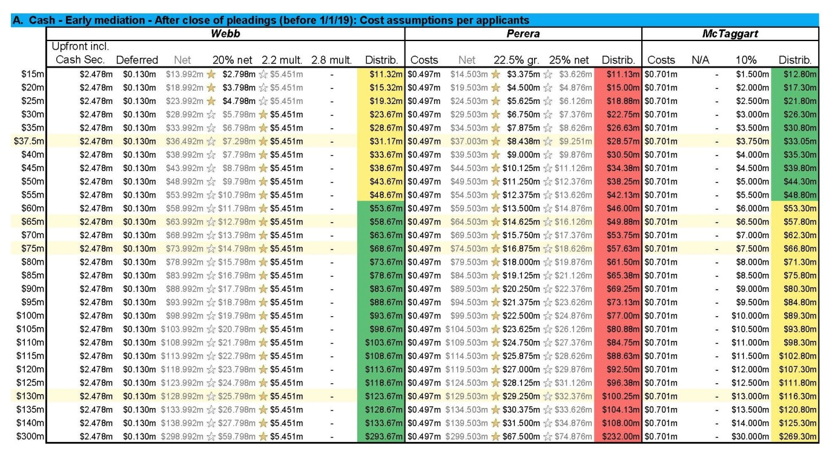

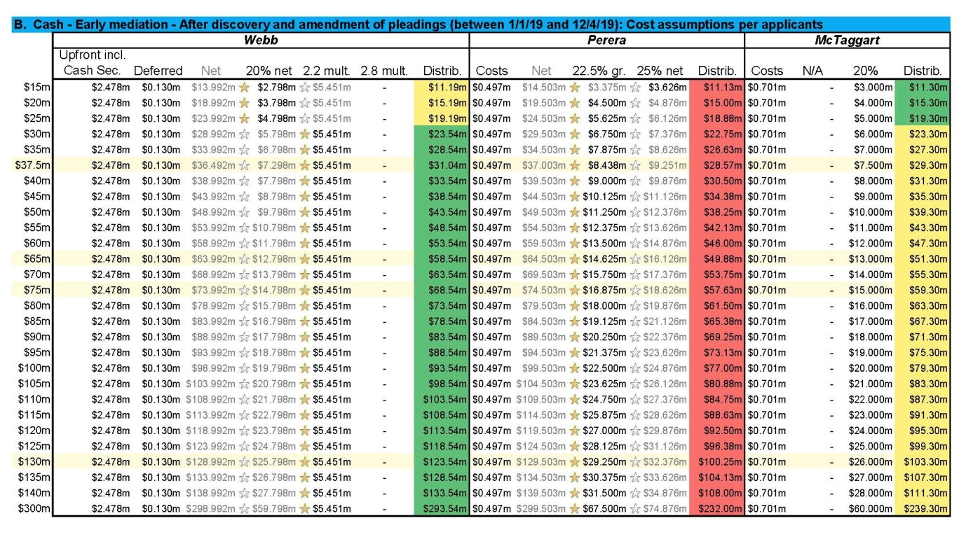

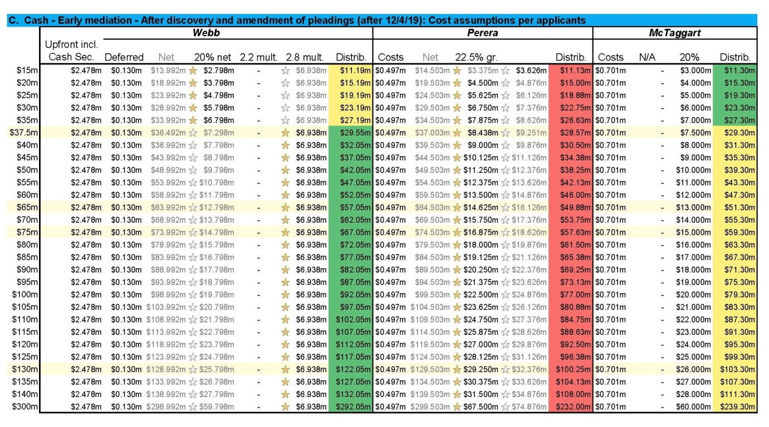

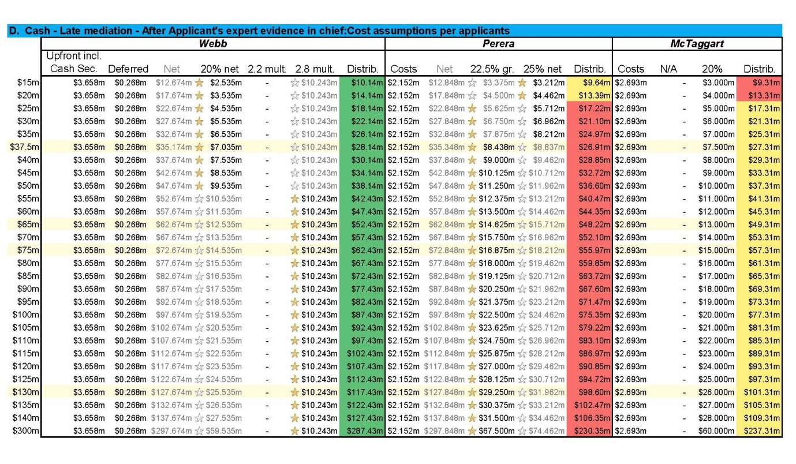

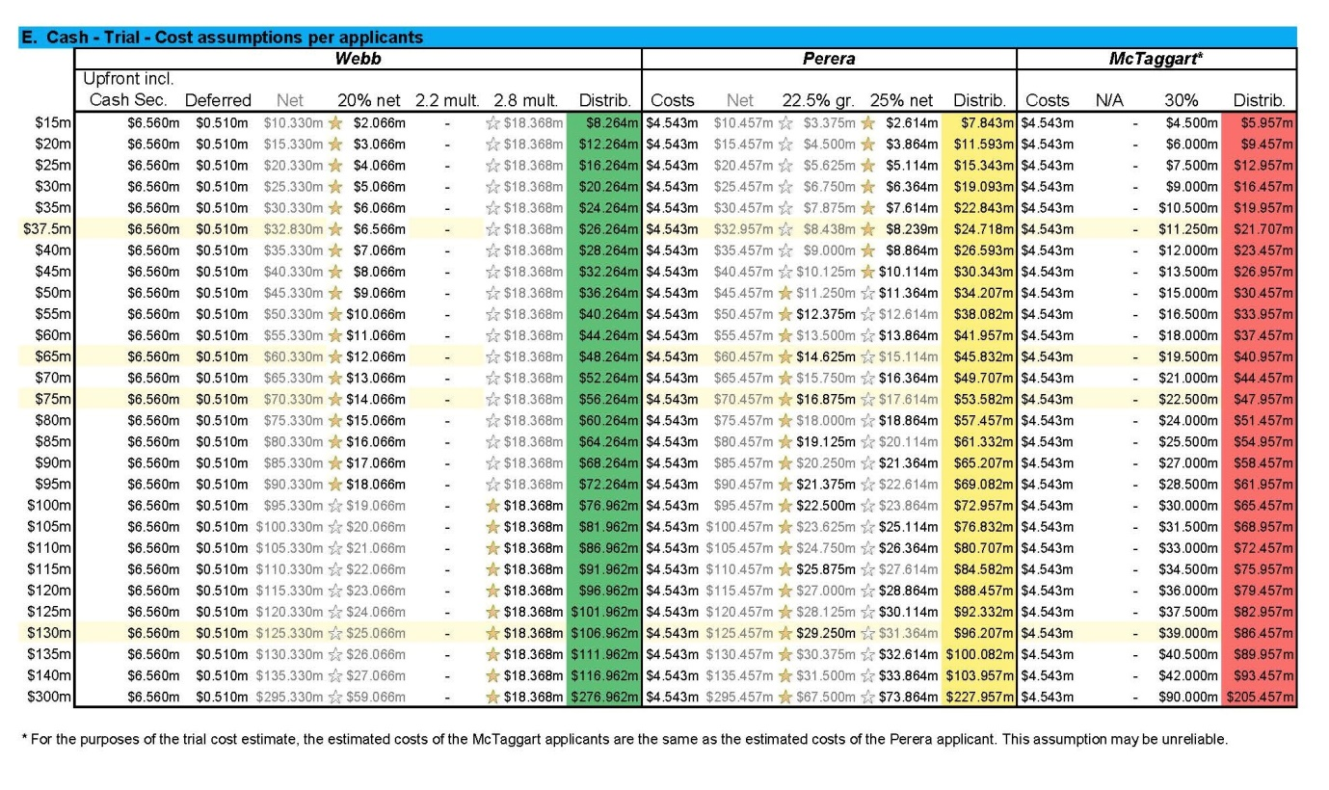

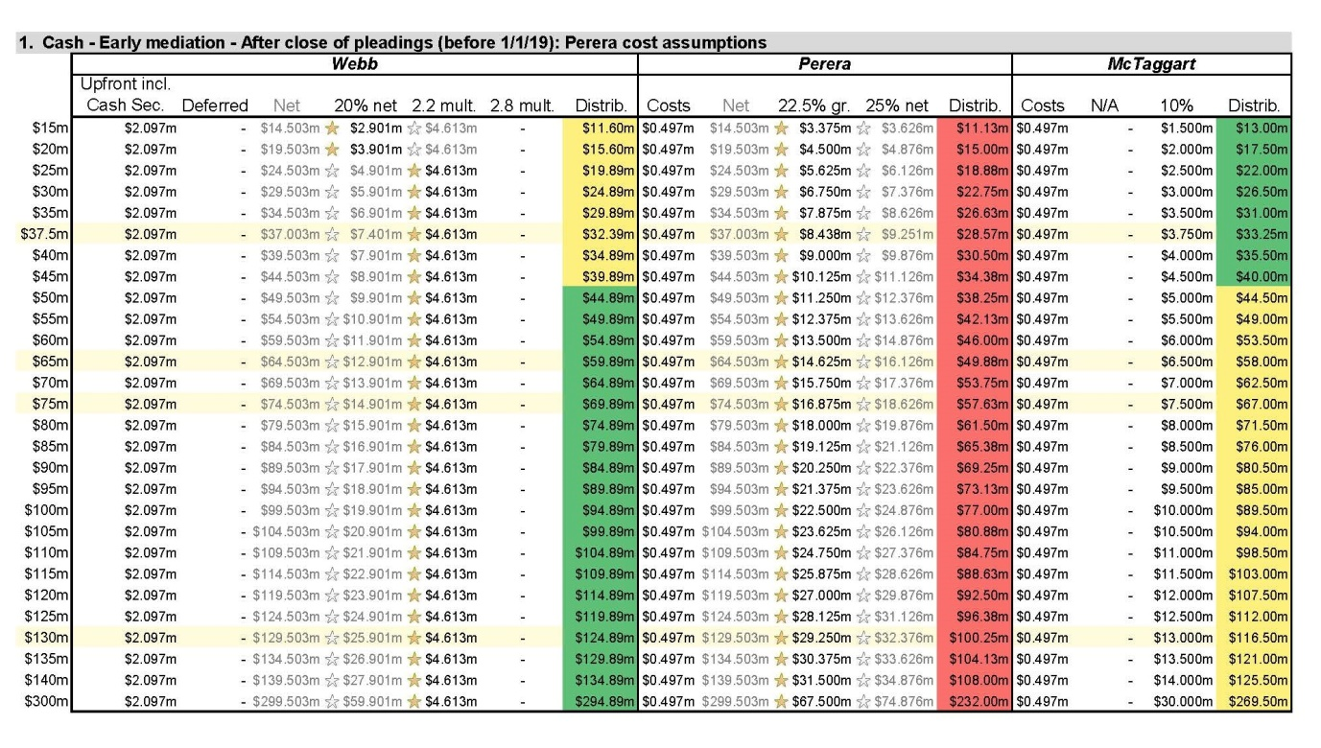

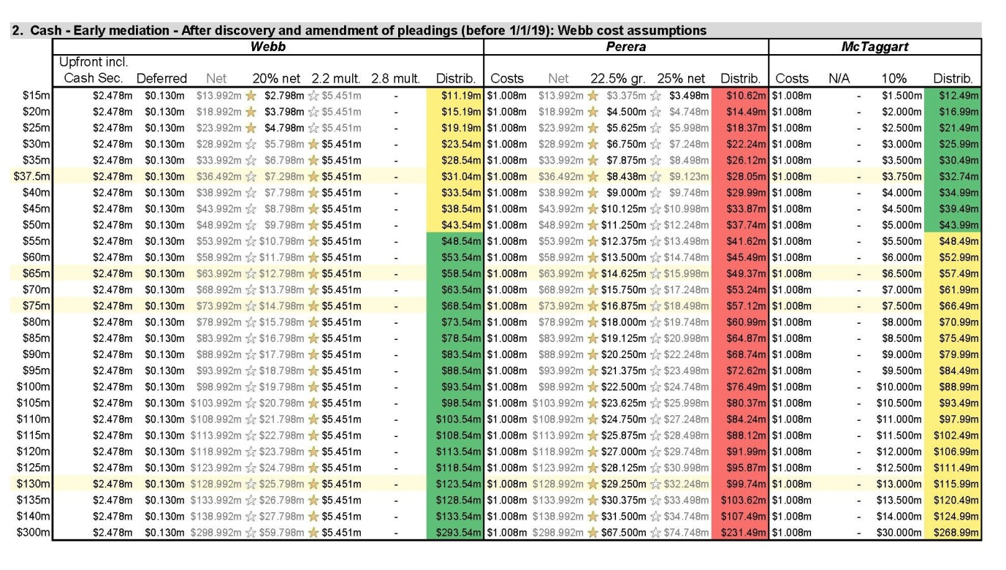

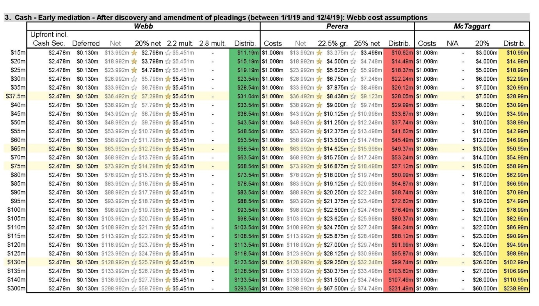

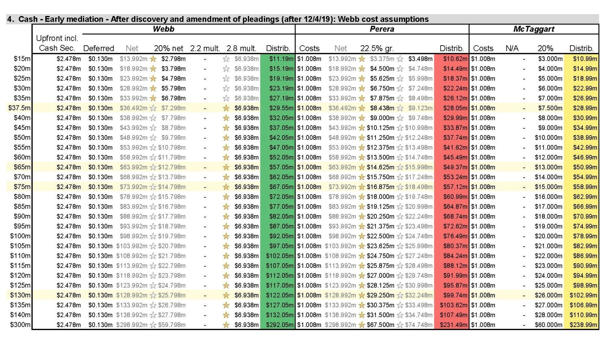

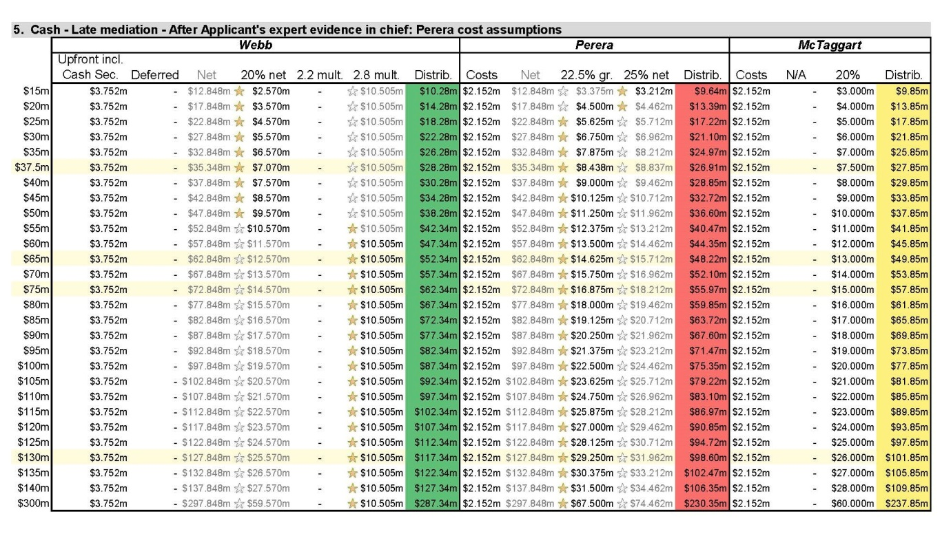

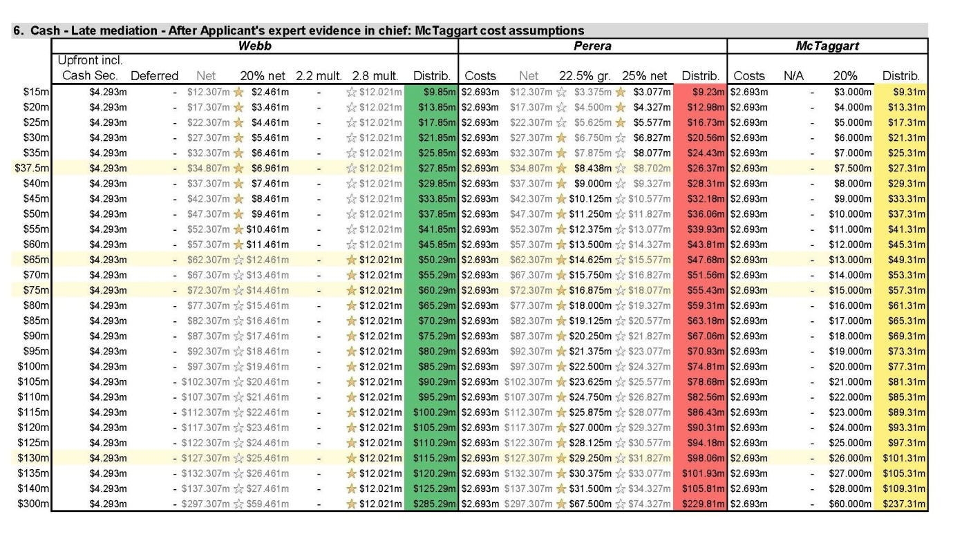

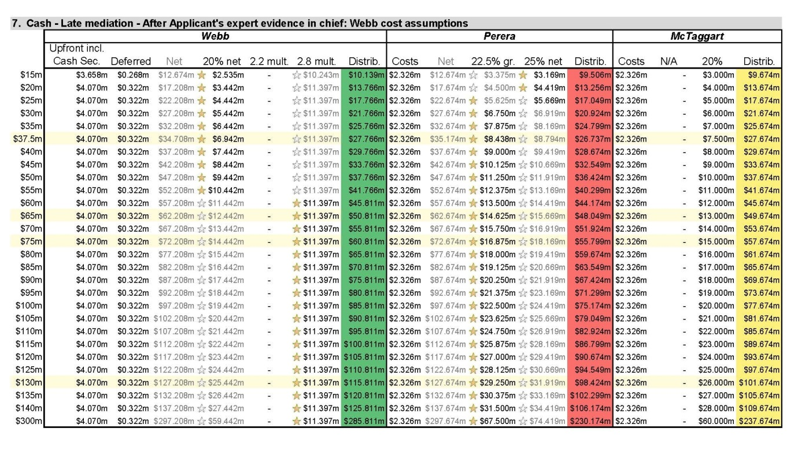

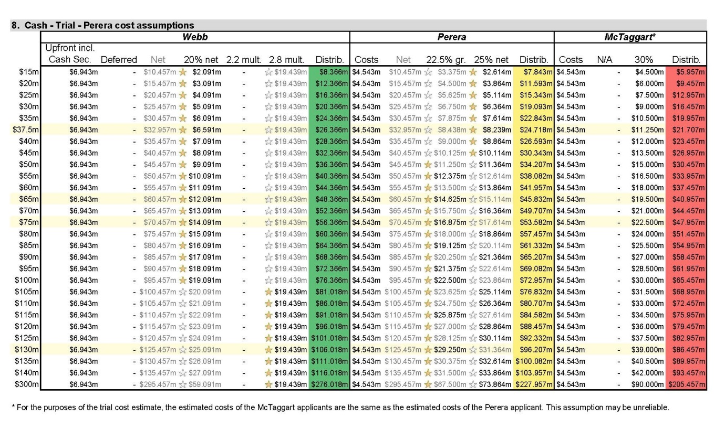

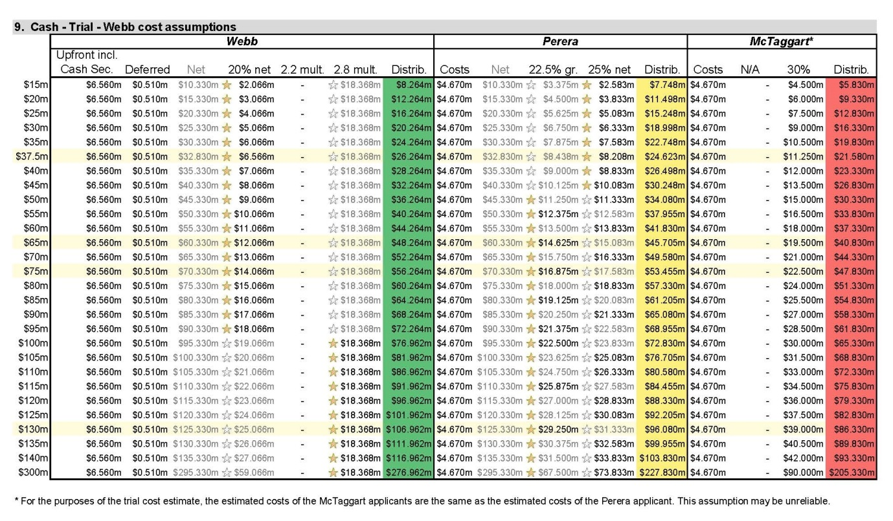

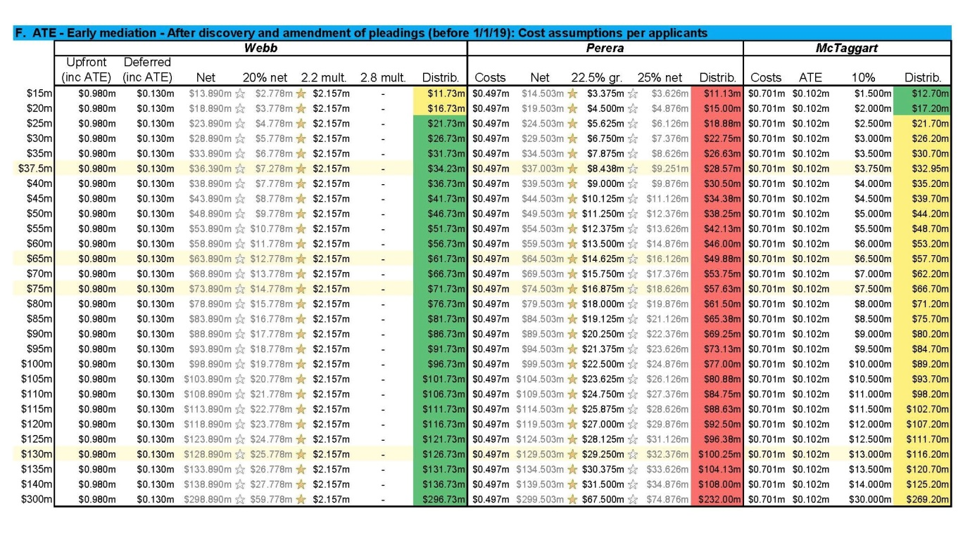

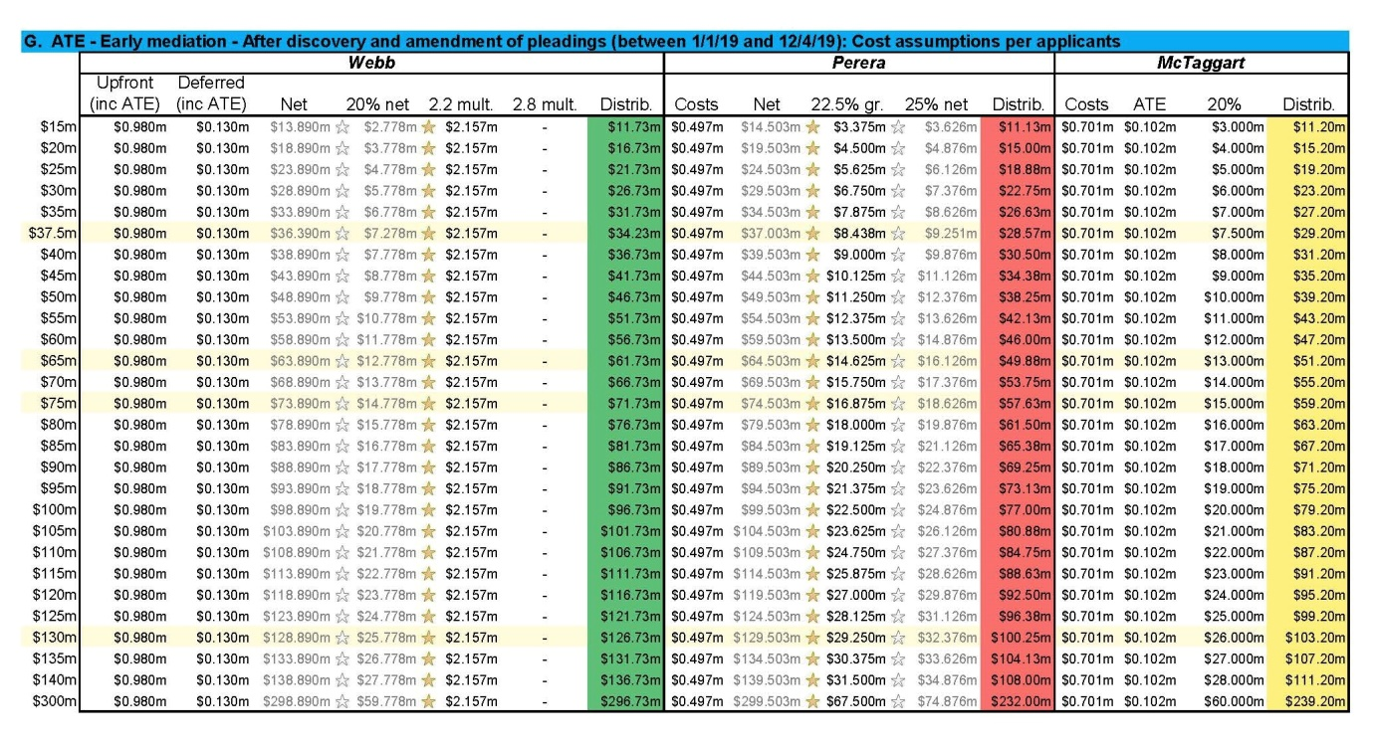

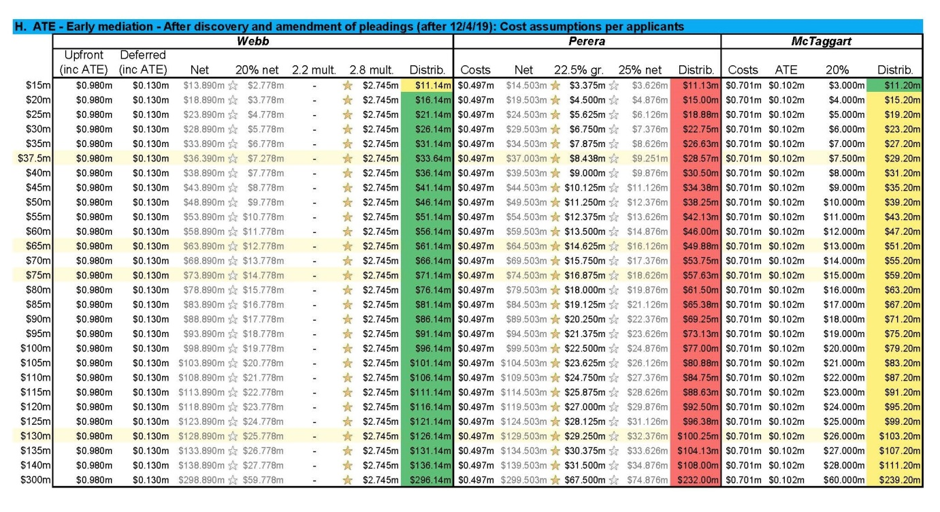

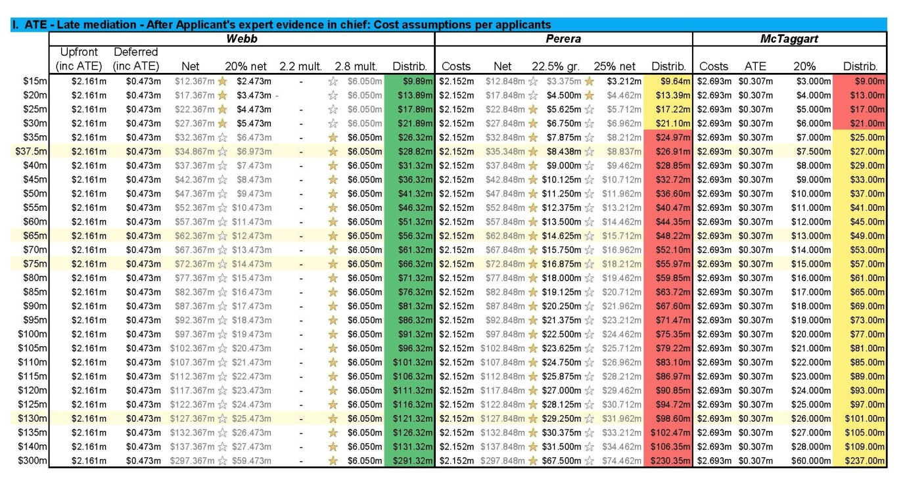

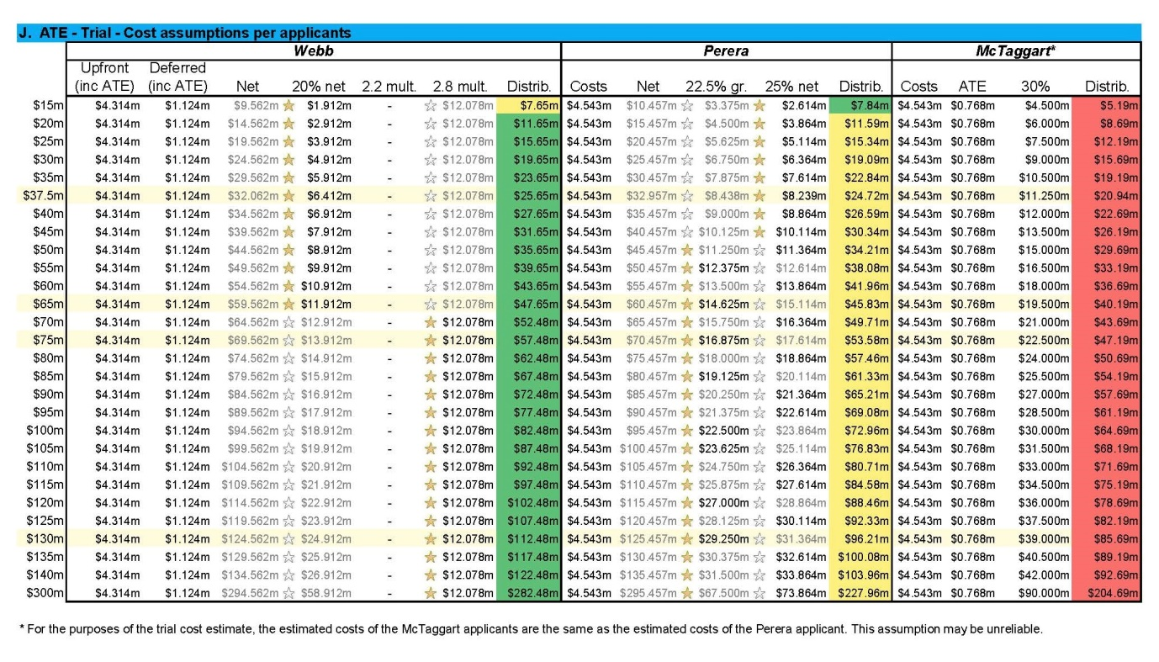

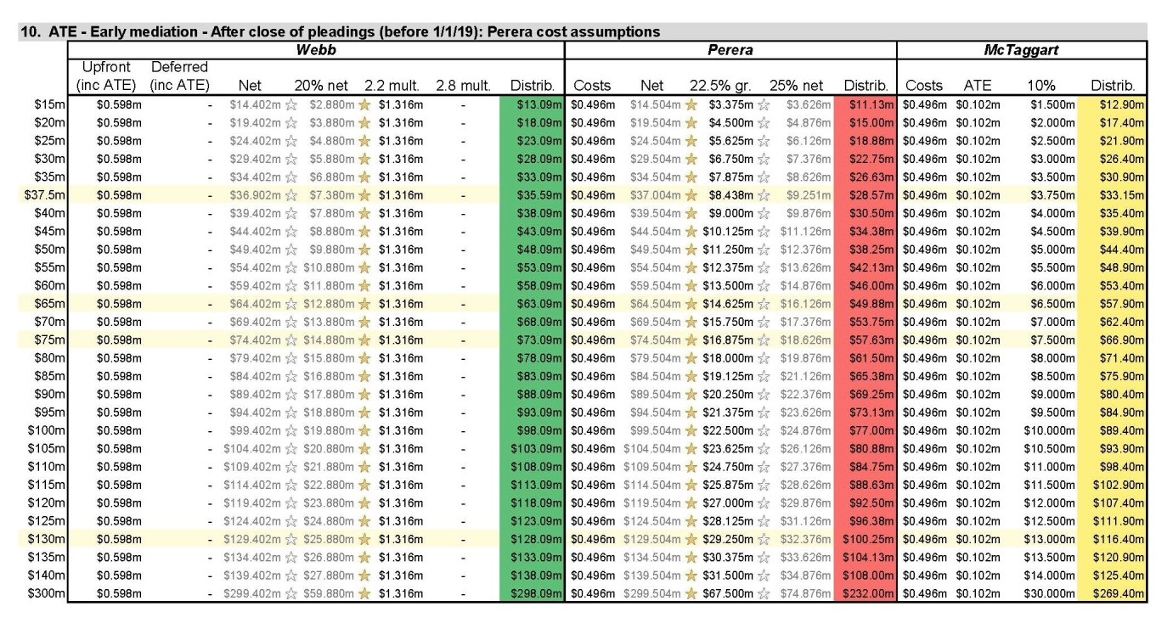

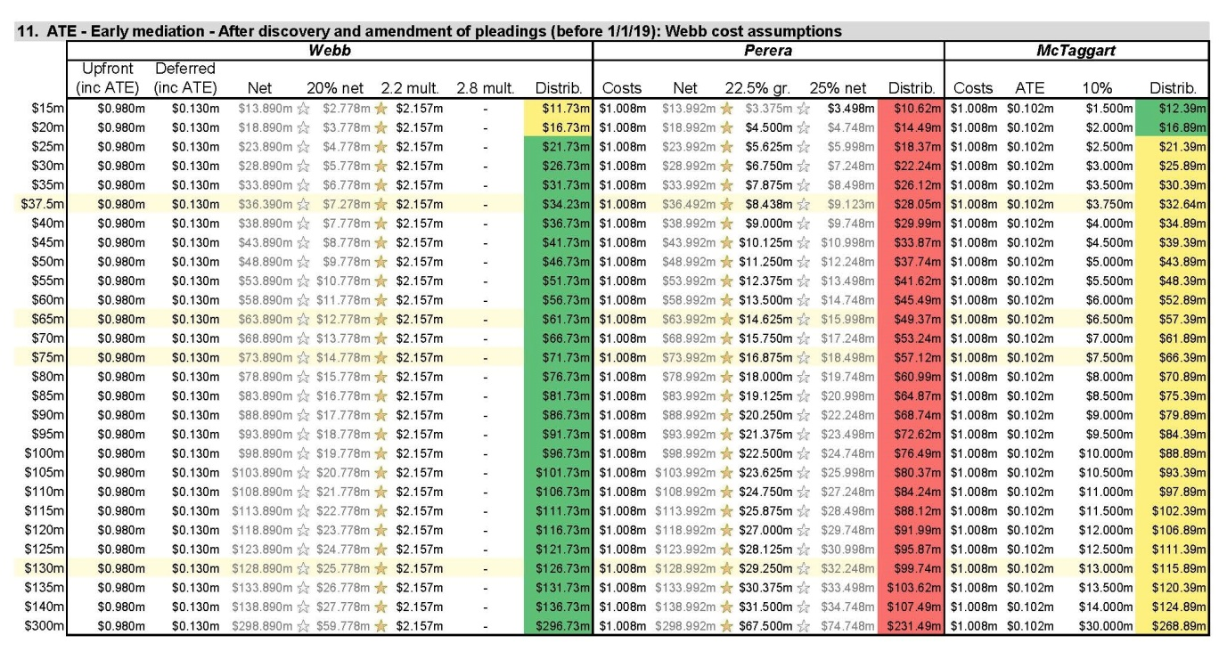

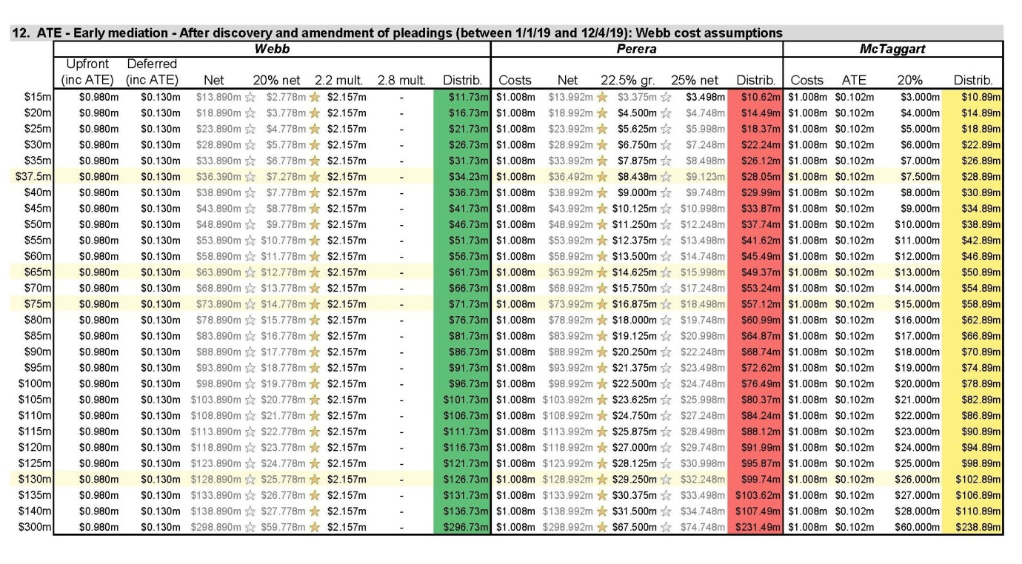

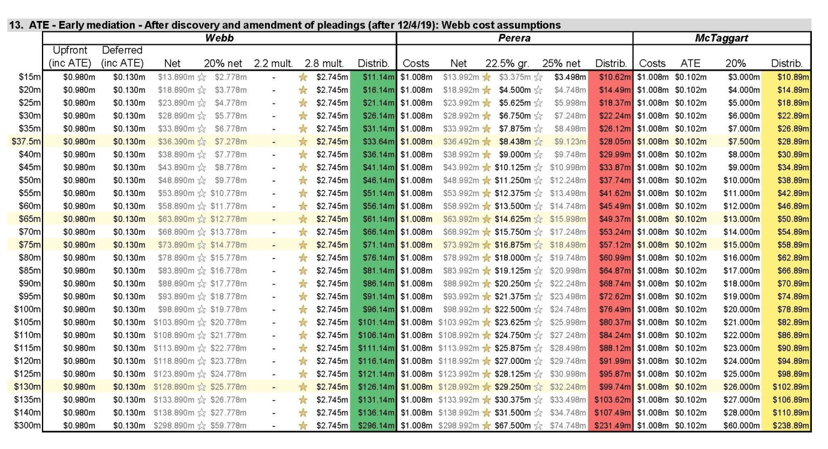

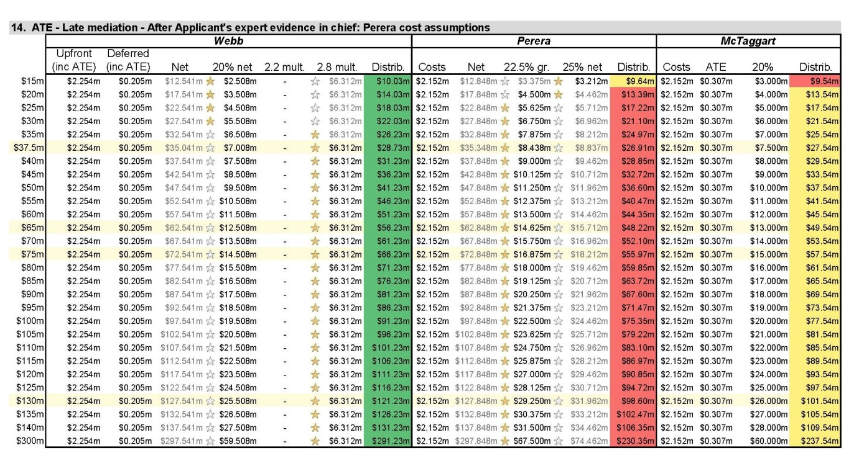

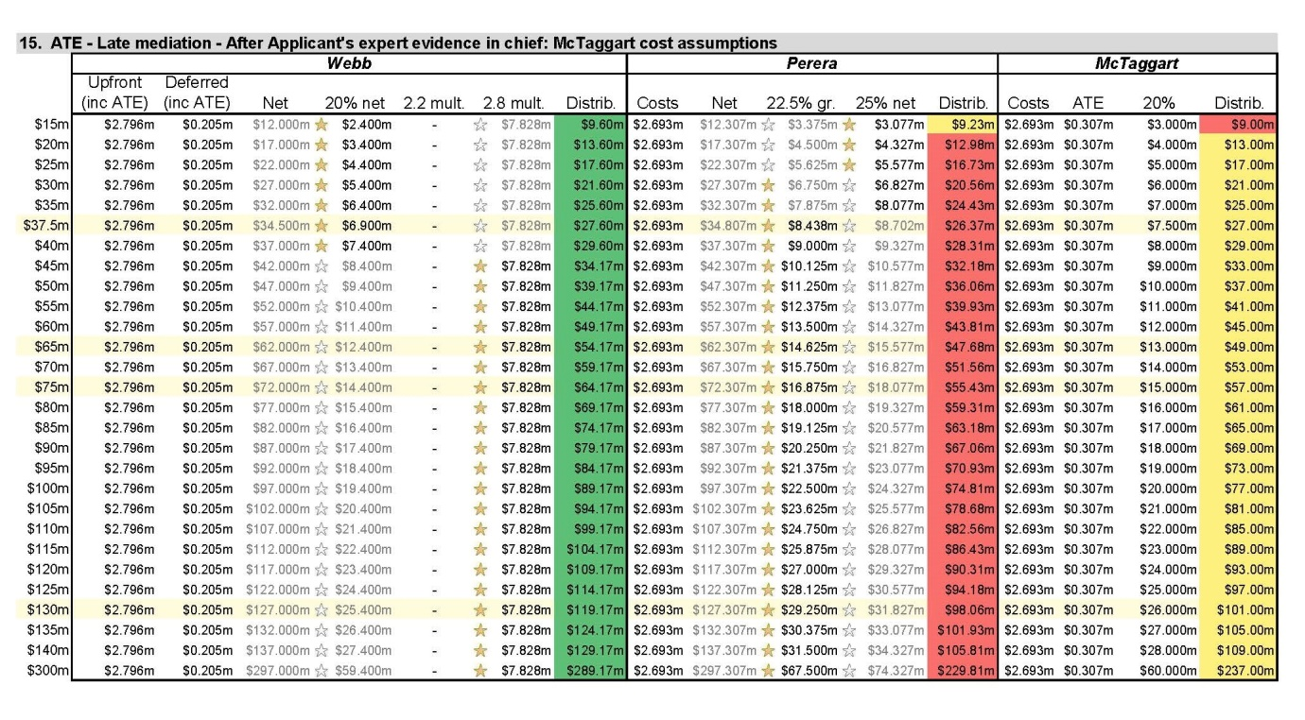

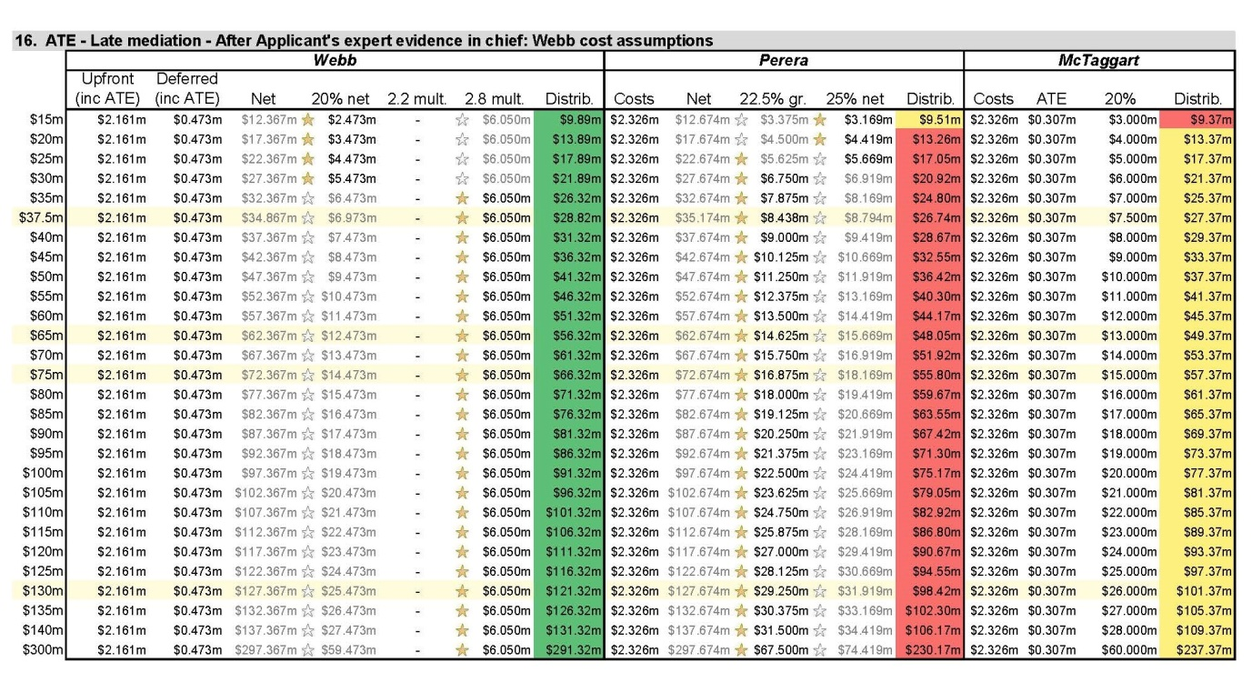

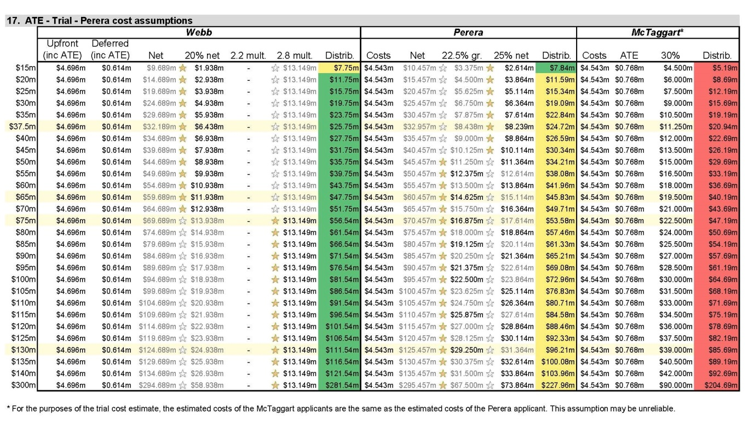

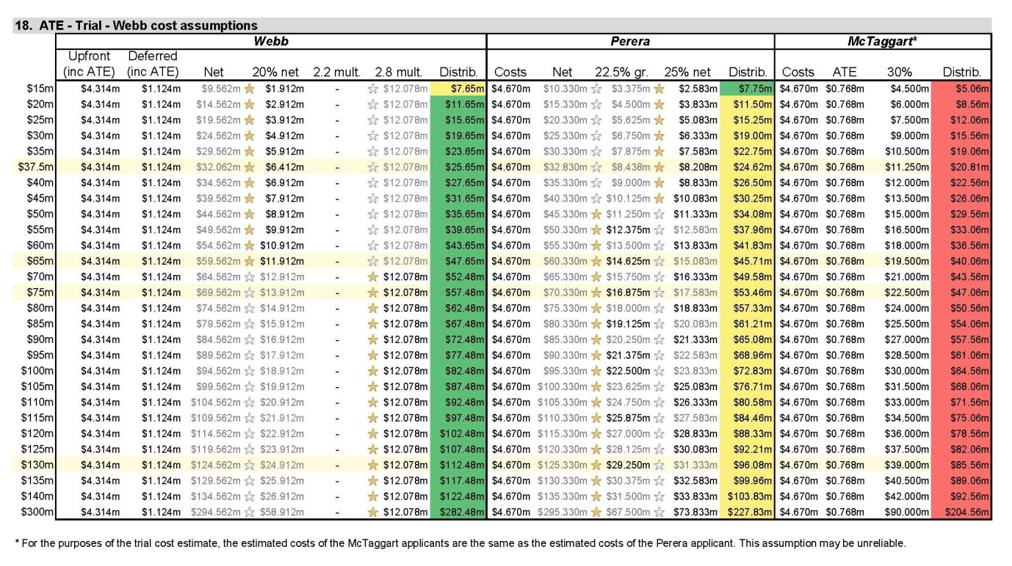

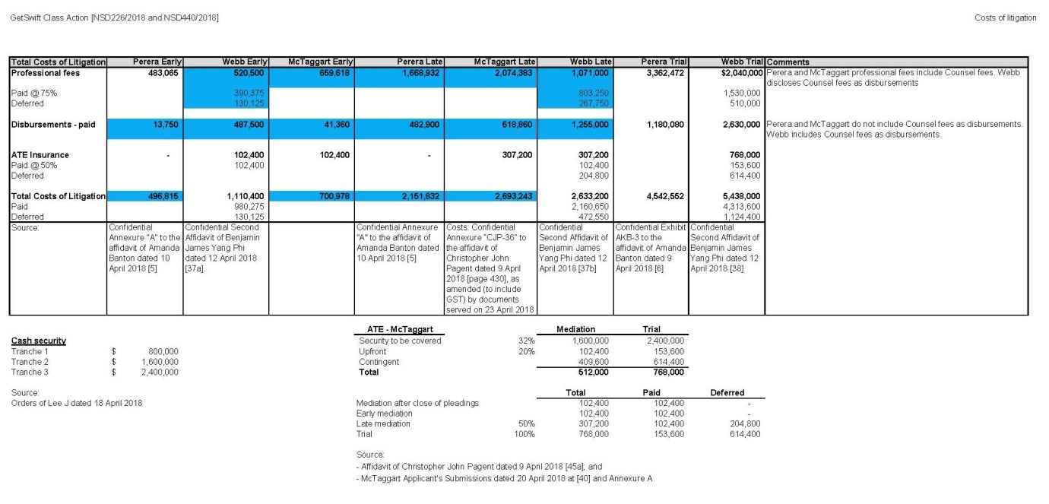

ANNEXURE B
 | COST ASSUMPTIONS WITH ADJUSTMENTS
A. Early Mediation Cost Assumptions
 | Perera Costs
 | Item | Phi Finney Sch A | Adjustment or non-adjustment reason | Corrected Amount
 | 1 – Investigating Claims | $150,309.50 |  | $150,309.50
 | 2A – Statement of Claim | $114,108.50 |  | $114,108.50
 | 2B – First Directions | $16,786.00 |  | $16,786.00
 | 2C – Common Fund Order Application / Competing Class Action | $33,682.00 |  | $33,682.00
 | 2D – Application for share register and issue of notice to shareholders | $18,645.00 |  | $18,645.00
 | 3A – Receipt of Particulars | $26,334.00 |  | $26,334.00
 | 3B – Receipt of Defence | $9,988.00 |  | $9,988.00
 | 3C – Request for Particulars | $19,750.50 |  | $19,750.50
 | 7 – Mediation | $93,461.50 |  | $93,461.50
 | Number of hearings | $4,500.00 |  | $4,500.00
 | Mediator | $8,000 |  | $8,000.00
 | Miscellaneous expense (10% of disbursement total) (AKB-3 p6) | 0 | Figure in AKB-3 omitted from Perera calculation; add it | $1,250.00
 | Total incl. GST | $495,565.00 |  | $496,815.00
 | nb: does not include Perera requested 10% contingency
 | McTaggart Costs
 | Item | Phi Finney Sch A | Adjustment or non-adjustment reason | Corrected Amount
 | Legal and factual analysis and pleadings | $246,360.00 |  | $246,360.00
 | Case management conference on 13 April 2018 | $172,878.00 |  | $172,878.00
 | Mediation expenses | $92,639.00 | Use 1/2 of original estimate for two day mediation of $192,278 | $96,139.00
 | Disbursements @ 50% of Late Mediation Estimate | $343,800.00 | Estimate was $587,600 for 2 days late mediation, which includes $550,000 in experts fees [CJP-36, Pagent 94]. Remove experts fees. | $18,800.00
 | Management and Reporting Loading @ same average rate in CJP-36 (15.5%) | $179,888.00 | Apply 20% to legal fees above as no basis in evidence for 15.5% assumption. | $103,075.40
 | Plus GST | $103,556.50 | Adjusted to reflect above adjustments. | $63,725.24
 | Total incl. GST | $1,139,121.50 |  | $700,977.64
 | Webb Costs
 | Item | Phi Finney Sch A | Adjustment or non-adjustment reason | Corrected Amount
 | Investigation / pre-drafting claim | $125,000.00 |  | $125,000.00
 | Bookbuild / communicating terms / identifying representative | $0.00 | Mr Phi deposed in the Second Phi Affidavit at [12] that none of Mr Webb, the funder Therium or Phi Finney McDonald intended to conduct such a bookbuild, and had not done so, and then at [13] that a common fund order regime would negate the purpose of such a bookbuild and hence avoid those costs. If the Court allows Mr Webb’s proceeding to proceed on an open basis and makes a common fund order in that proceeding, these costs will not be incurred, and hence has been excluded from the Further Revised Model. See further [16] - [17] of Submissions of 1 May 2018 | $0.00
 | Preliminary Strategic Case Work | $185,000.00 |  | $185,000.00
 | Multiplicity-related application | $150,000.00 |  | $150,000.00
 | Draft claim | $153,000.00 |  | $153,000.00
 | Filing, First Directions | $90,000.00 |  | $90,000.00
 | Particulars, Defence & Close Pleadings | $148,000.00 |  | $148,000.00
 | Group Member Communications and Reporting (half of total allowed estimate) | $20,000.00 |  | $20,000.00
 | Mediation | $137,000.00 |  | $137,000.00
 | Add costs associated with 6 monthly independent review of fees | $0.00 | These costs are built into the Webb Original Costs Estimate total, and does not require separate provision in the Further Revised Model, on the following grounds:  a. the Webb Applicant expects the work of that assessor to be largely costs neutral, in that it is likely to increase the extent to which the Webb Applicant’s approved costs will be less than total legal costs incurred; and in any event  b. the assessor’s costs otherwise would be incurred by the other Applicants in the course of applying for approval of any proposed settlement of the proceeding, hence a true ‘like for like’ comparison ought either to exclude those costs or include them for all three applicants.  See further [26]-[28] of Submissions of 1 May 2018 | $0.00
 | Add costs associated with 5% annual increase in fees | $0.00 | Webb's cost estimates have regard to provision for annual 5% rate increases. See further [29]-[31] of Submissions of 1 May 2018 | $0.00
 | Total incl. GST | $1,008,000.00 |  | $1,008,000.00
 | Total Professional Fees | $520,500.00 |  | $520,500.00
 | Total Disbursements and Counsel Fees | $487,500.00 |  | $487,500.00
 | Upfront Component of Professional Fees | $390,375.00 |  | $390,375.00
 | Deferred Component of Professional Fees | $130,125.00 |  | $130,125.00
B. Late Mediation Cost Assumptions
 | Perera Costs
 | Item | Phi Finney Sch A | Adjustment or non-adjustment reason | Corrected Amount
 | Original Cost Estimate incl. GST | $1,957,932.00 |  | $1,957,932.00
 | 5F - Respondent Expert Evidence (Professional Fees) | $87,054.00
 | 5G - Applicant Reply Expert Evidence (Professional Fees) | $73,414.00
 | Correct error in Disbursements - 2 x Expert Reports in Chief |  | Confidential Annexure A only includes $250,000 for reports in chief. AKB-3 has those costs as $400,000. Add the missing difference of $150,000 | $150,000.00
 | Disbursements - 2 x Expert Reports in Reply | $150,000.00 |  | $150,000.00
 | Miscellaneous expense (10% of disbursement total) (AKB-3 p6) |  | Figure in AKB-3 omitted from Perera calculation; add it | $60,150.00
 | Total incl. GST | $2,268,400.00 |  | $2,318,082.00
 | nb: does not include Perera requested 10% contingency
 | McTaggart Costs
 | Item | Phi Finney Sch A | Adjustment or non-adjustment reason | Corrected Amount
 | Legal and factual analysis and pleadings | $246,360.00 |  | $246,360.00
 | Case management conference on 13 April 2018 | $172,878.00 |  | $172,878.00
 | Security for costs | $12,535.00 | Not included in other estimates. Will be dealt with on this application
 | Discovery | $246,717.00 |  | $246,717.00
 | Subpoenas | $58,188.00 |  | $58,188.00
 | Advice on evidence | $35,670.00 |  | $35,670.00
 | Lay evidence | $47,908.00 | Annexure B was adjusted to match Perera with no respondent lay evidence. For present purposes, it must include respondent lay evidence. Add it. | $119,770.00
 | Expert evidence (professional fees) | $484,710.00 |  | $484,710.00
 | Case management hearings | $65,595.00 |  | $65,595.00
 | Mediation expenses | $92,639.00 | Use 1/2 of original estimate for two day mediation of $192,278 | $96,139.00
 | Management and Reporting Loading @ same average rate in CJP-36 (15.5%) | $359,776.00 | Consistent with the original Late Mediation estimate in CJP-36. No evidentiary basis for reduced estimate in McTaggart Applicants' evidence. | $359,776.00
 | Disbursements | $687,600.00 | Fix Typo: disbursements amount is $587,600 not $687,600: Pagent [94], CJP 36. Of these, $550,000 are experts. | $587,600.00
 | Plus GST | $251,057.60 | Do not apply GST to US expert fees (50% of $550,000). Apply GST to remaining amounts. | $219,840.30
 | Total incl. GST | $2,761,633.60 |  | $2,693,243.30
 | Webb Costs
 | Item | Phi Finney Sch A | Adjustment or non-adjustment reason | Corrected Amount
 | Original Cost Estimate incl. GST | $2,792,000.00 |  | $2,792,000.00
 | Less Interlocutory Applications | ($366,000.00) | Assume no interlocutory applications - multiplicity application costs already included in Original Cost Estimate. See further [17] to [23] of Submissions of 1 May 2018 | ($366,000.00)
 | Less costs of Bookbuild / communicating terms / identifying representative | ($100,000.00) | Mr Phi deposed in the Second Phi Affidavit at [12] that none of Mr Webb, the funder Therium or Phi Finney McDonald intended to conduct such a bookbuild, and had not done so, and then at [13] that a common fund order regime would negate the purpose of such a bookbuild and hence avoid those costs. If the Court allows Mr Webb’s proceeding to proceed on an open basis and makes a common fund order in that proceeding, these costs will not be incurred, and hence has been excluded from the Further Revised Model. See further [16] - [17] of Submissions of 1 May 2018 | ($100,000.00)
 | Add costs for case management hearings | $0.00 | The Webb Original Cost Estimate is organised by stage, and the specific costs of case management hearings are built into those stages. For instance, to the extent that issues of discovery are dealt with at a case management hearing, the associated cost is reflected in the total estimate of Discovery-related costs. See further [23] of Submissions of 1 May 2018 | $0.00
 | Add costs associated with 6 monthly independent review of fees | $0.00 | These costs are built into the Webb Original Costs Estimate total, and does not require separate provision in the Further Revised Model, on the following grounds:  a. the Webb Applicant expects the work of that assessor to be largely costs neutral, in that it is likely to increase the extent to which the Webb Applicant’s approved costs will be less than total legal costs incurred; and in any event  b. the assessor’s costs otherwise would be incurred by the other Applicants in the course of applying for approval of any proposed settlement of the proceeding, hence a true ‘like for like’ comparison ought either to exclude those costs or include them for all three applicants.  See further [26]-[28] of Submissions of 1 May 2018 | $0.00
 | Add costs associated with 5% annual increase in fees | $0.00 | Webb's cost estimates have regard to provision for annual 5% rate increases. See further [29]-[31] of Submissions of 1 May 2018 | $0.00
 | Revised Total incl. GST | $2,326,000.00 |  | $2,326,000.00
 | Total Professional Fees | $1,071,000.00 |  | $1,071,000.00
 | Total Disbursements and Counsel Fees | $1,255,000.00 |  | $1,255,000.00
 | Upfront Component of Professional Fees | $833,250.00 |  | $803,250.00
 | Deferred Component | $277,750.00 |  | $267,750.00

