FEDERAL COURT OF AUSTRALIA

Noicos v Dawson [2019] FCA 2197

File number: | SAD 271 of 2019
Judge: | WHITE J
Date of judgment: | 18 December 2019
Catchwords: | PRACTICE AND PROCEDURE – application for freezing orders against Respondents pursuant to r 7.32 of the Federal Court Rules 2011 (Cth) – Respondents alleged to have contravened s 12DA of the Australian Securities and Investments Commission Act 2001 (Cth) – Third Respondent opposed application on a number of bases including that he had not engaged in dishonest behaviour – whether there was a reasonably arguable case – whether there was a risk of dissipation of assets – consideration of balance of convenience – application allowed against First, Second, Third, Fourth and Sixth Respondents.
Legislation: | Australian Securities and Investments Commission Act 2001 (Cth) ss 12BAA, 12BAB, 12DA, 12GF  Federal Court Rules 2011 (Cth) rr 7.32, 7.33
Cases cited: | Cardile v LED Builders Pty Ltd [1999] HCA 18; (1999) 198 CLR 380  Deputy Commissioner of Taxation v Hua Wang Bank Berhad [2010] FCA 1014; (2010) 273 ALR 194  Deputy Commissioner of Taxation v Chemical Trustee Ltd (No 4) [2012] FCA 1064  Patterson v BTR Engineering (Aust) Ltd (1989) 18 NSWLR 319  Pearce v Waterhouse [1986] VR 603
Date of hearing: | 18 December 2019
Date of last submissions: | 18 December 2019
Registry: | South Australia
Division: | General Division
National Practice Area: | Other Federal Jurisdiction
Category: | Catchwords
Number of paragraphs: | 29
Counsel for the Applicants: | Mr J Cudmore with Mr H Gillis
Solicitor for the Applicants: | CCK Lawyers
Counsel for the First, Second and Fourth Respondents: | Ms M Hamlyn
Solicitor for the First, Second and Fourth Respondents: | Mellor Olsson
Counsel for the Third Respondent: | Mr A Carpenter
Solicitor for the Third Respondent: | Websters Lawyers

ORDERS
 |  | SAD 271 of 2019
BETWEEN: | THOMAS NOICOS  First Applicant  PASCAL TILGNER  Second Applicant  WILLIAM MCGRATH (and others named in the Schedule)  Third Applicant
AND: | TIMOTHY JOEL YORKE DAWSON  First Respondent  MICHAEL SCOTT POMERY  Second Respondent  SING CHUNG YAP (ALSO KNOWN AS CHRIS YAP OR CHRISTOPHER YAP) (and others named in the Schedule)  Third Respondent

JUDGE: | WHITE J
DATE OF ORDER: | 18 DECEMBER 2019

THE COURT ORDERS THAT:

- Subject to Orders 2 and 3, Orders 5 to 17 inclusive made in this action by Justice Besanko on 10 December 2019, a copy of which are annexed hereto and marked ‘A’, continue in full force and effect until further order.
- The time fixed by Order 10 of the freezing order directed to Mr Dawson and Mr Pomery is extended to 17 January 2020.
- The continuation of the orders does not preclude the withdrawal of the funds held in the account of Countinghouse held with Bankwest BSB 325-122 Account Number 055-708-7 for the purpose of payment of those funds to the Mellor Olsson Trust Account for the payment of legal expenses and does not preclude the Second Respondent withdrawing a sum up to $10,000 from the account BSB 085-005, Account Number 777511555 held with NAB for the purpose of depositing that sum in the Mellor Olsson Trust Account for the purpose of paying legal expenses.
- Any amended form of the notice to produce filed and served by the Applicants on 17 December 2019 is to be filed and served by 19 December 2019.
- The Applicants are by close of business on Monday 23 December 2019 to file and serve a statement of claim.
- Service of the Applicants’ statement of claim on the Sixth Respondent is to be by delivery to its registered office at Level 1, 72 Currie Street, Adelaide SA 5000.
- Any defences by the First, Second, Third, Fourth and Sixth Respondents are to be filed and served by 14 February 2020.
- Any reply to be relied upon by the Applicants is to be filed and served by 28 February 2020.
- The First, Second, Fourth and Sixth Respondents are to produce to the Applicants by Friday 31 January 2020 copies of each of the documents set out in the amended notice to produce which is the subject of Order 3.
- An ancillary order directed to PayPal Australia Pty Limited ACN 111 195 389 be issued in terms of the minutes provided to the Court by counsel for the Applicants today and as initialled by me.
- An ancillary order directed to Commonwealth Bank of Australia ACN 123 123 124 be issued in terms of the minutes provided to the Court by counsel for the Applicants today and as initialled by me.
- The matter be adjourned to a Case Management Hearing at 2:15pm on Friday 6 March 2020
- There be liberty to the parties to apply.
- The costs of today are reserved.

Note: Entry of orders is dealt with in Rule 39.32 of the Federal Court Rules 2011.

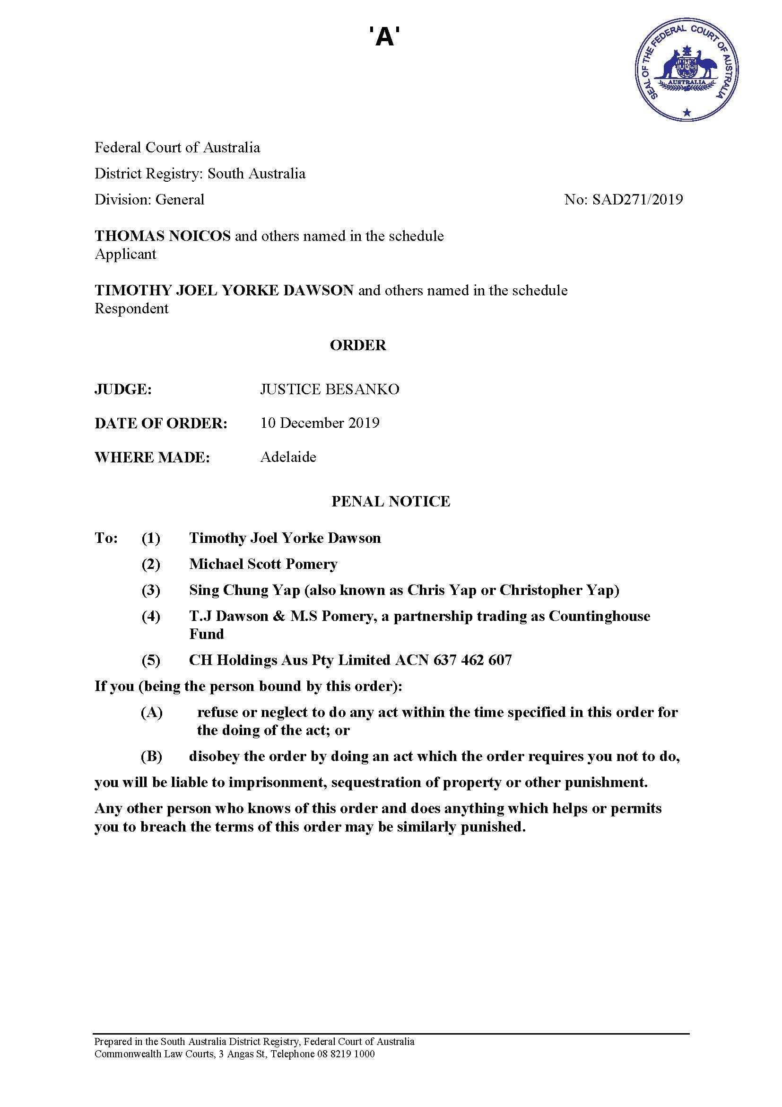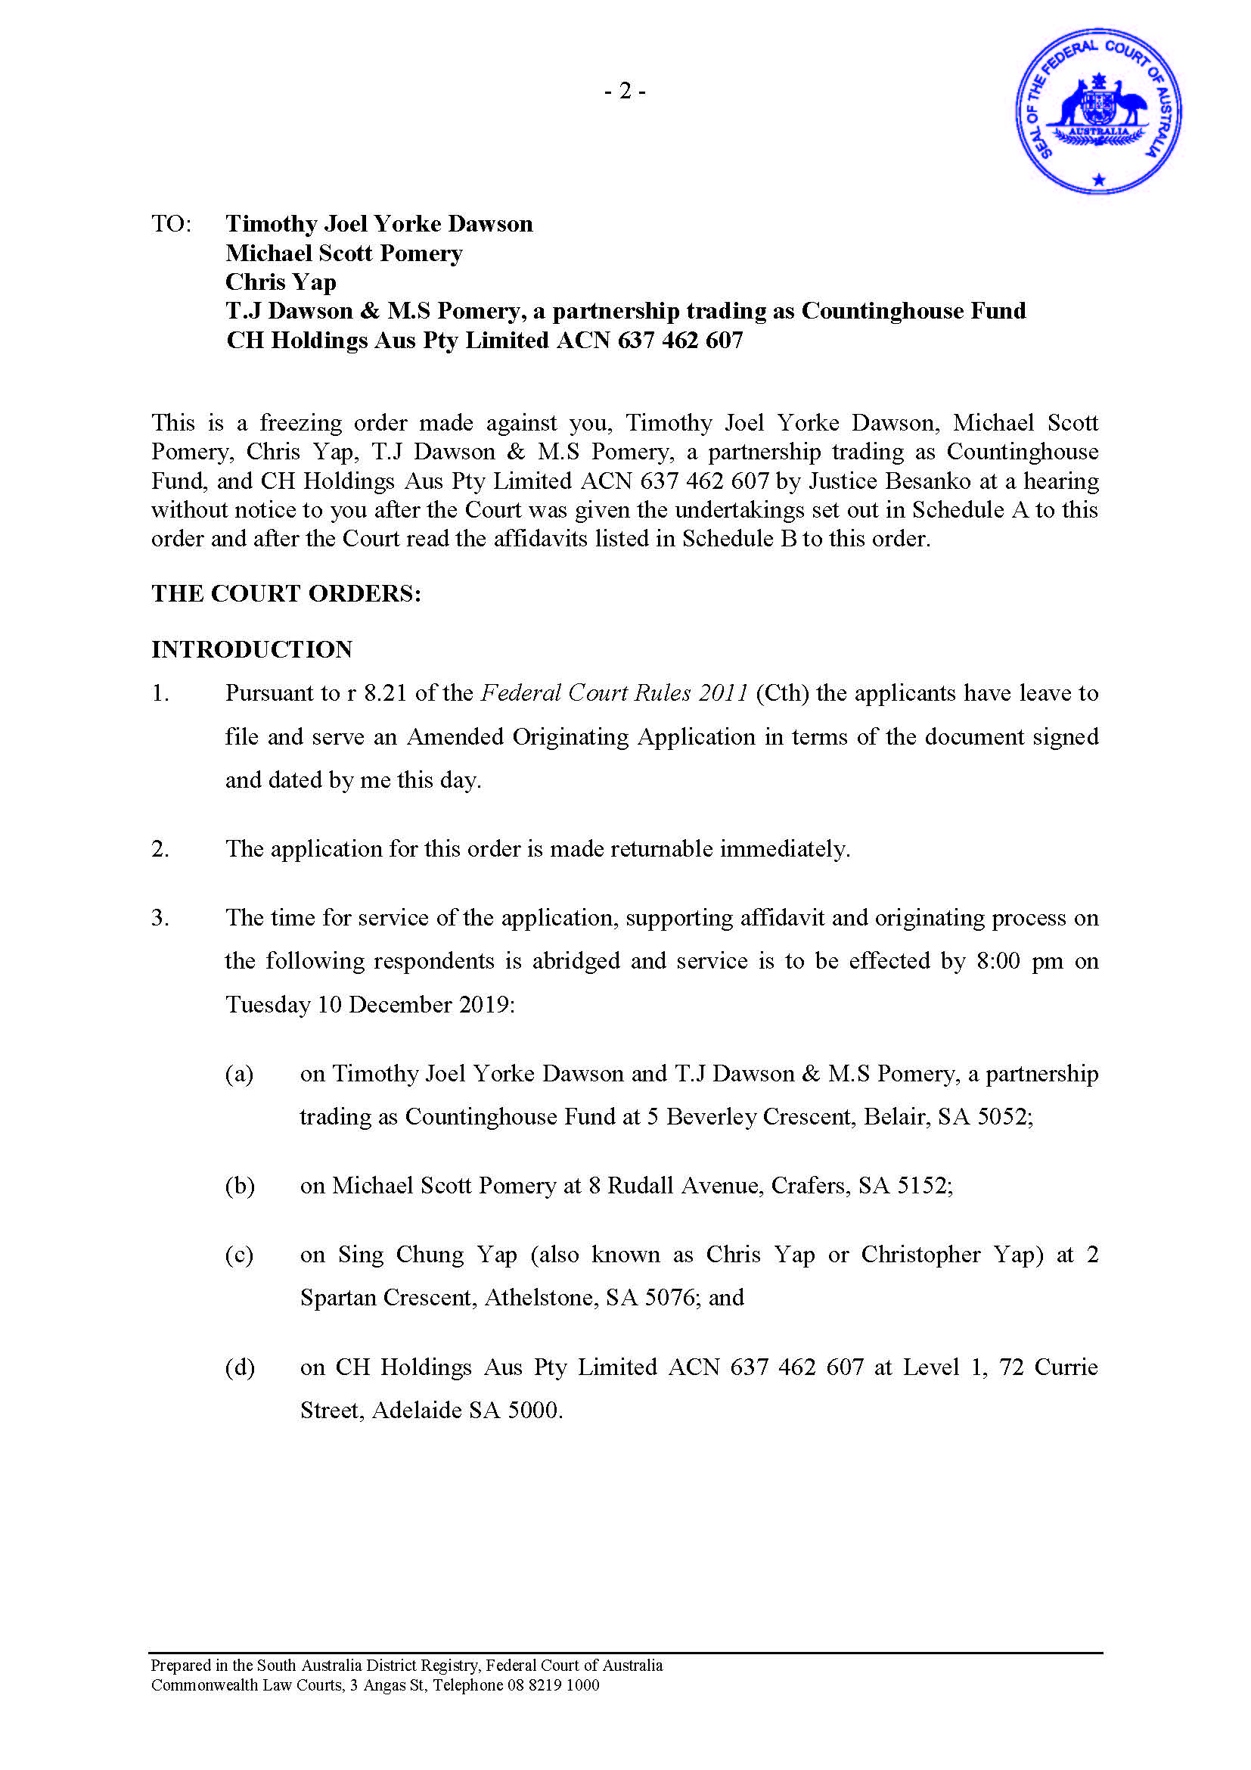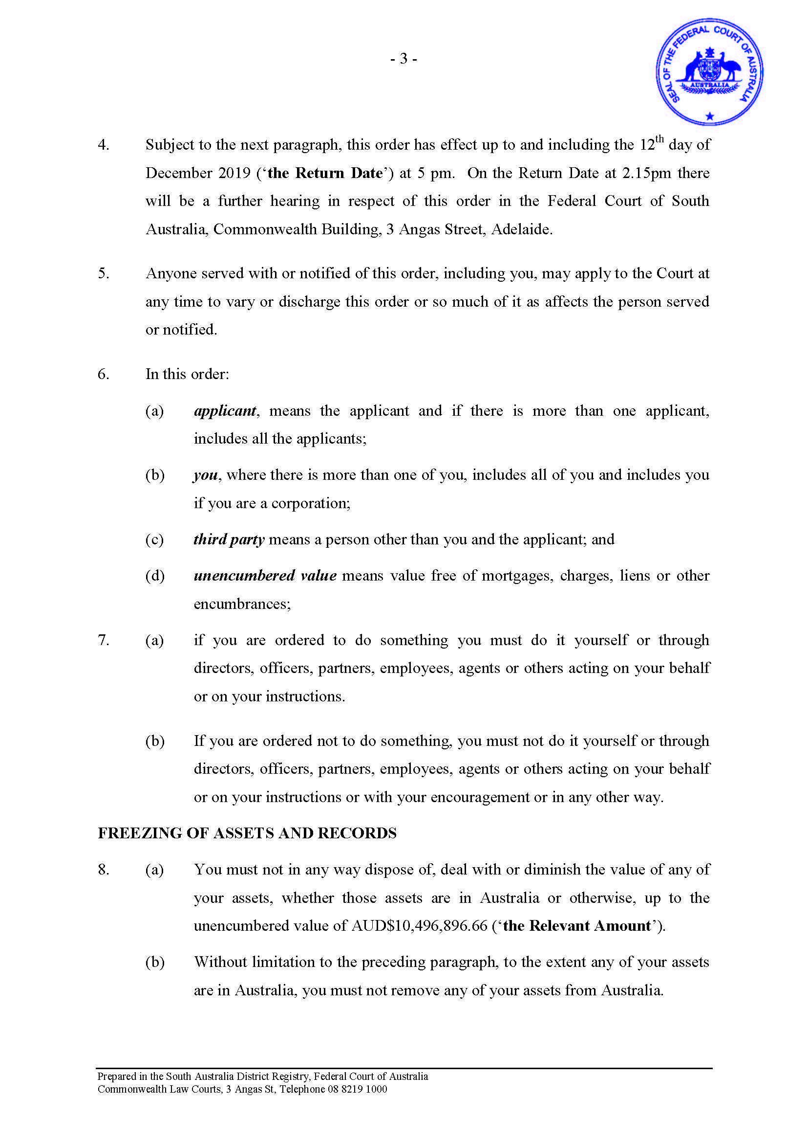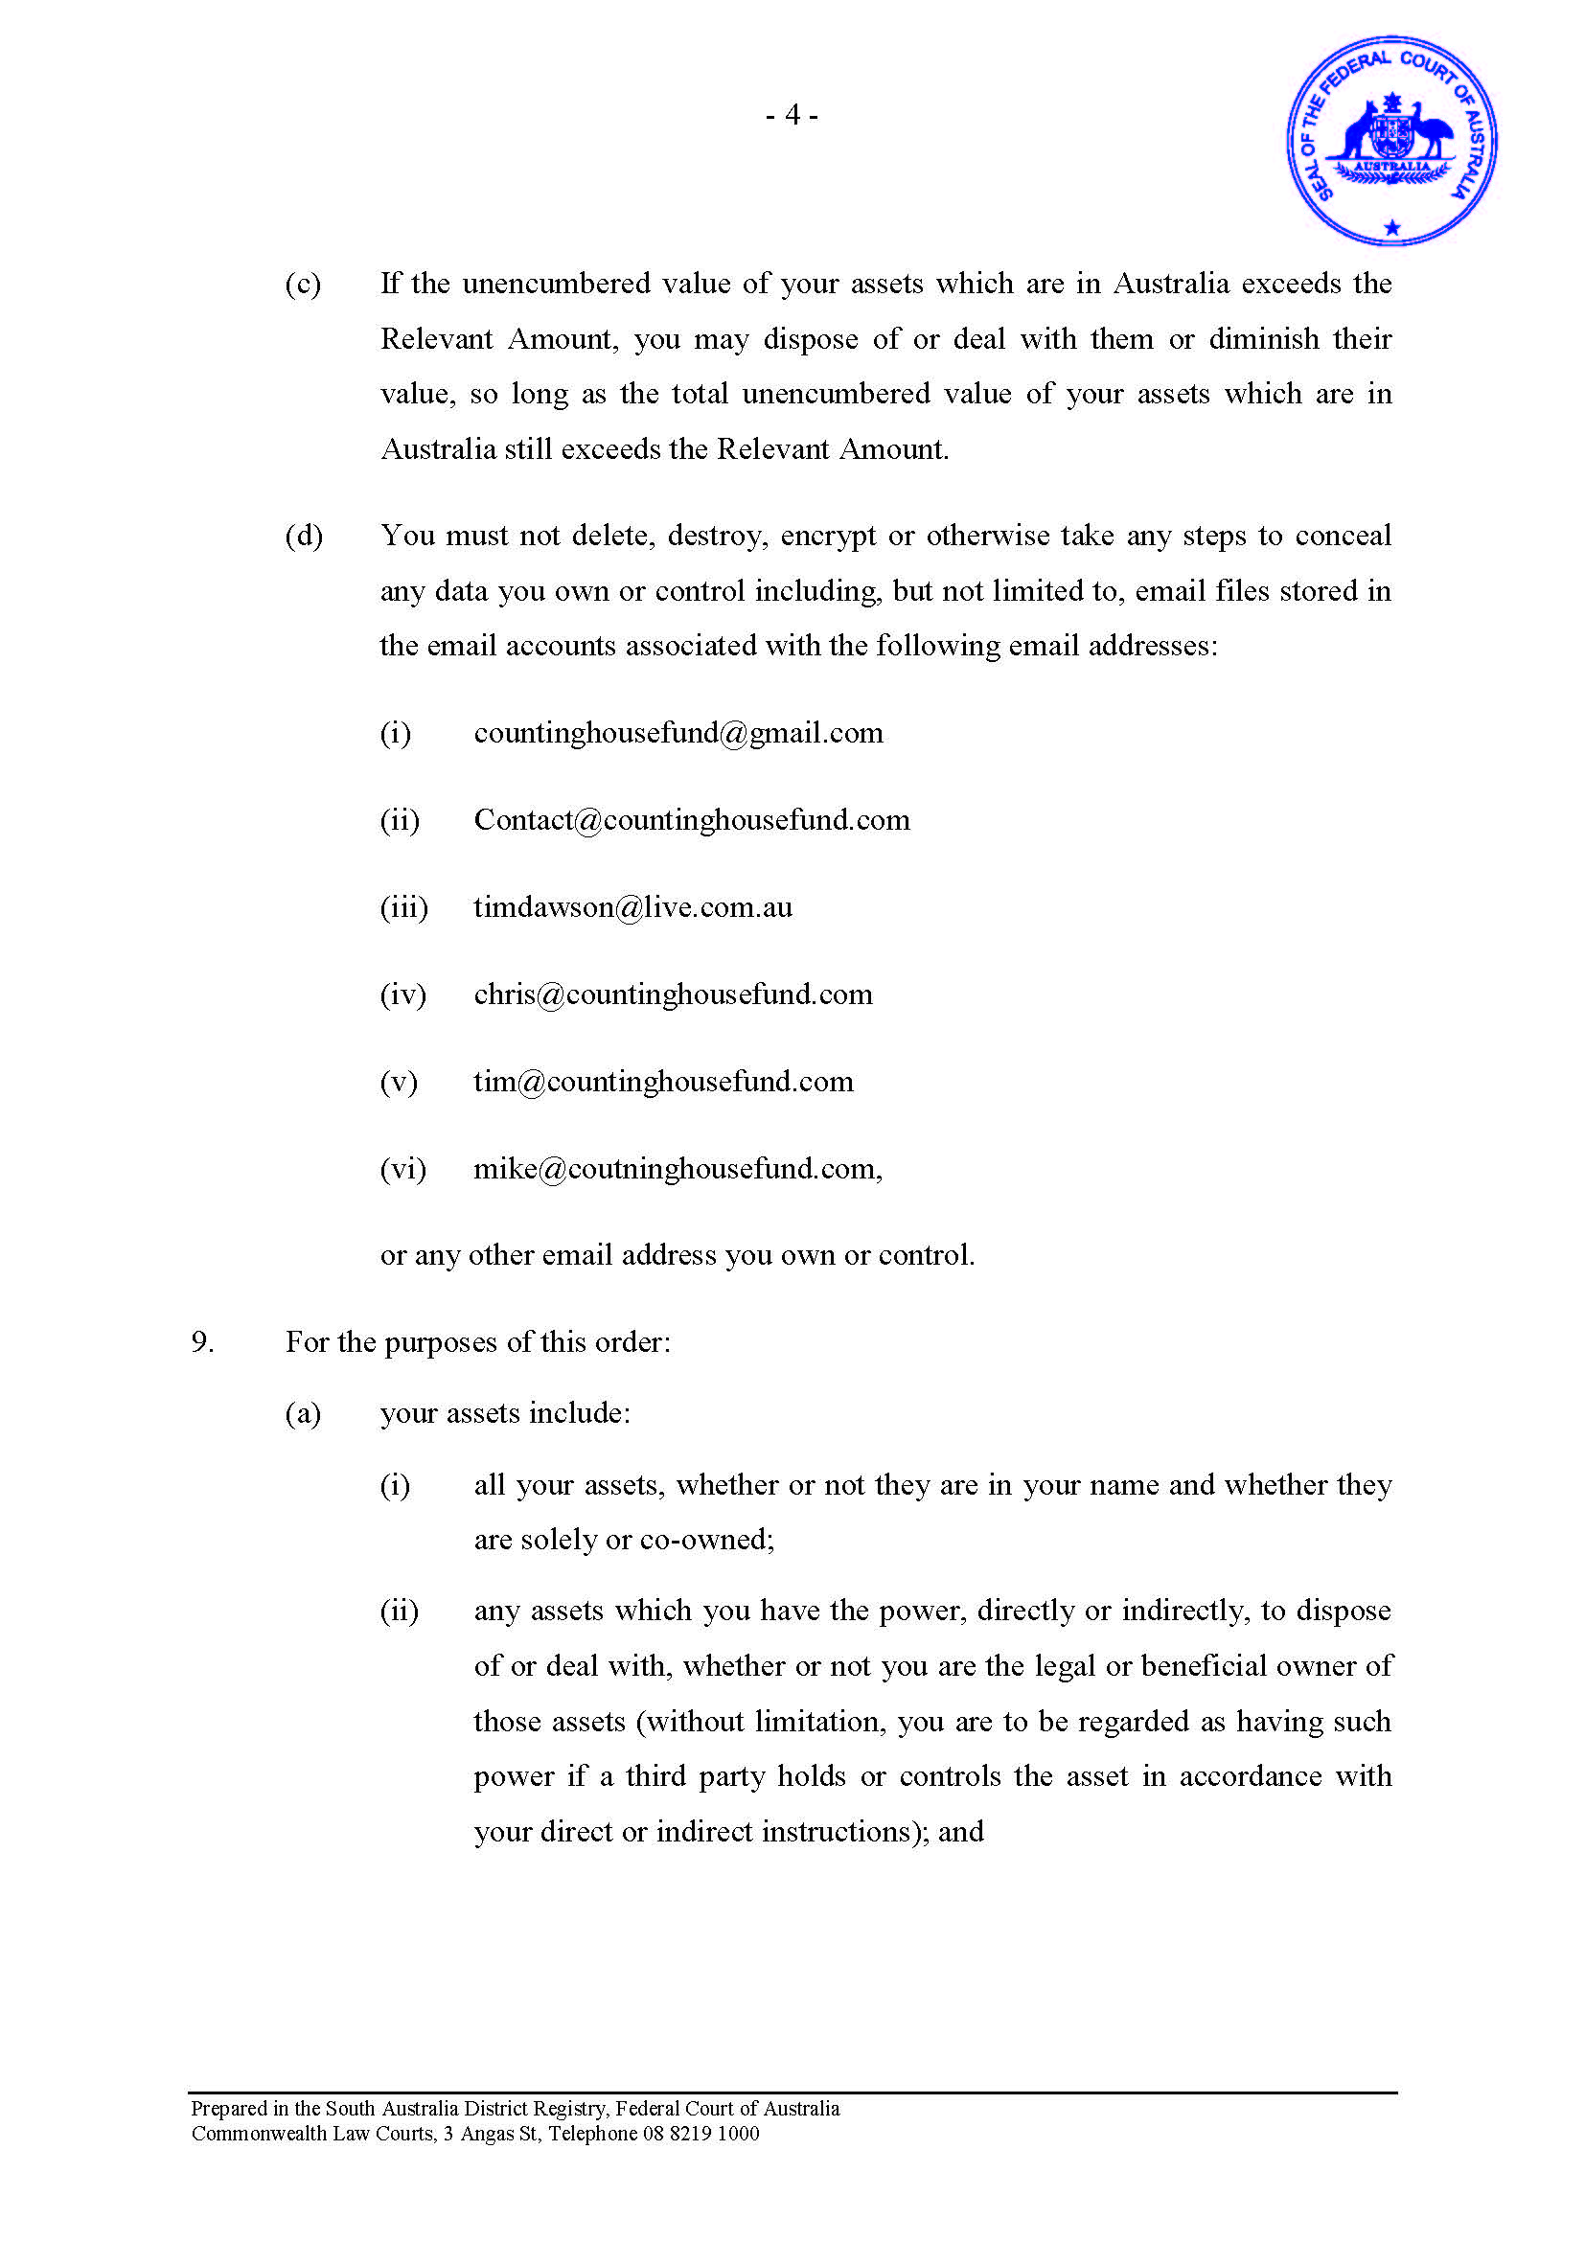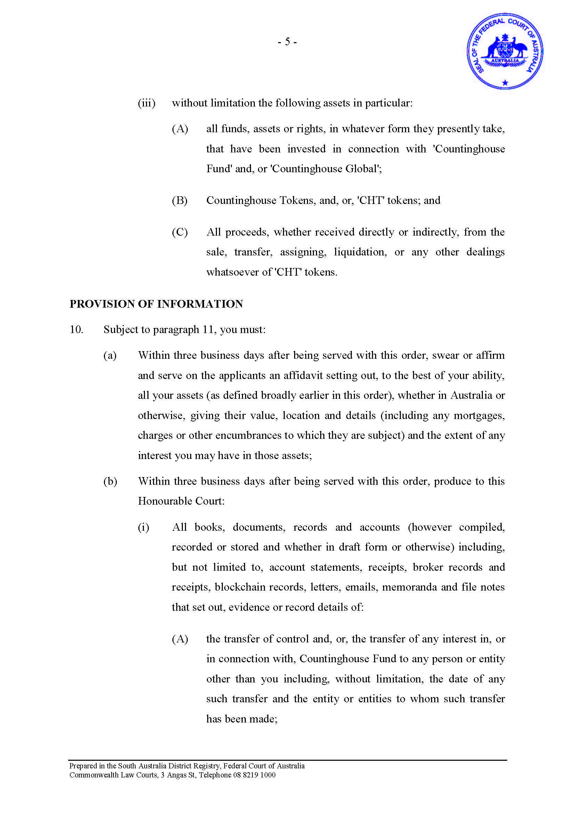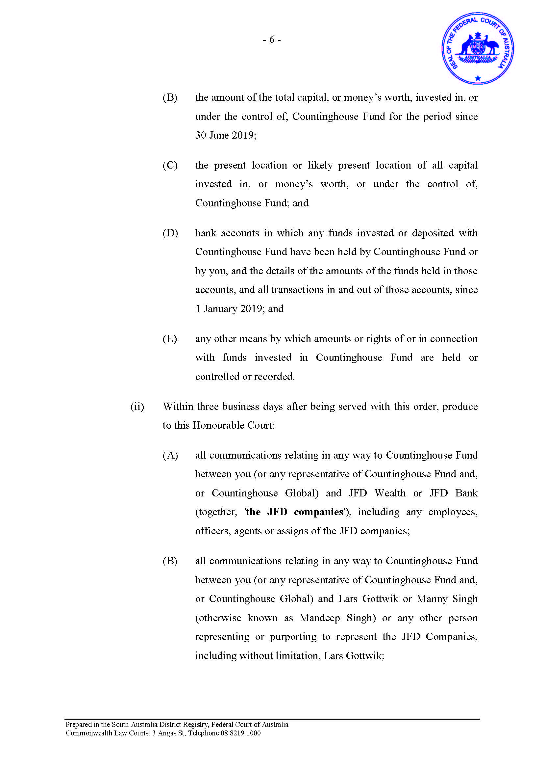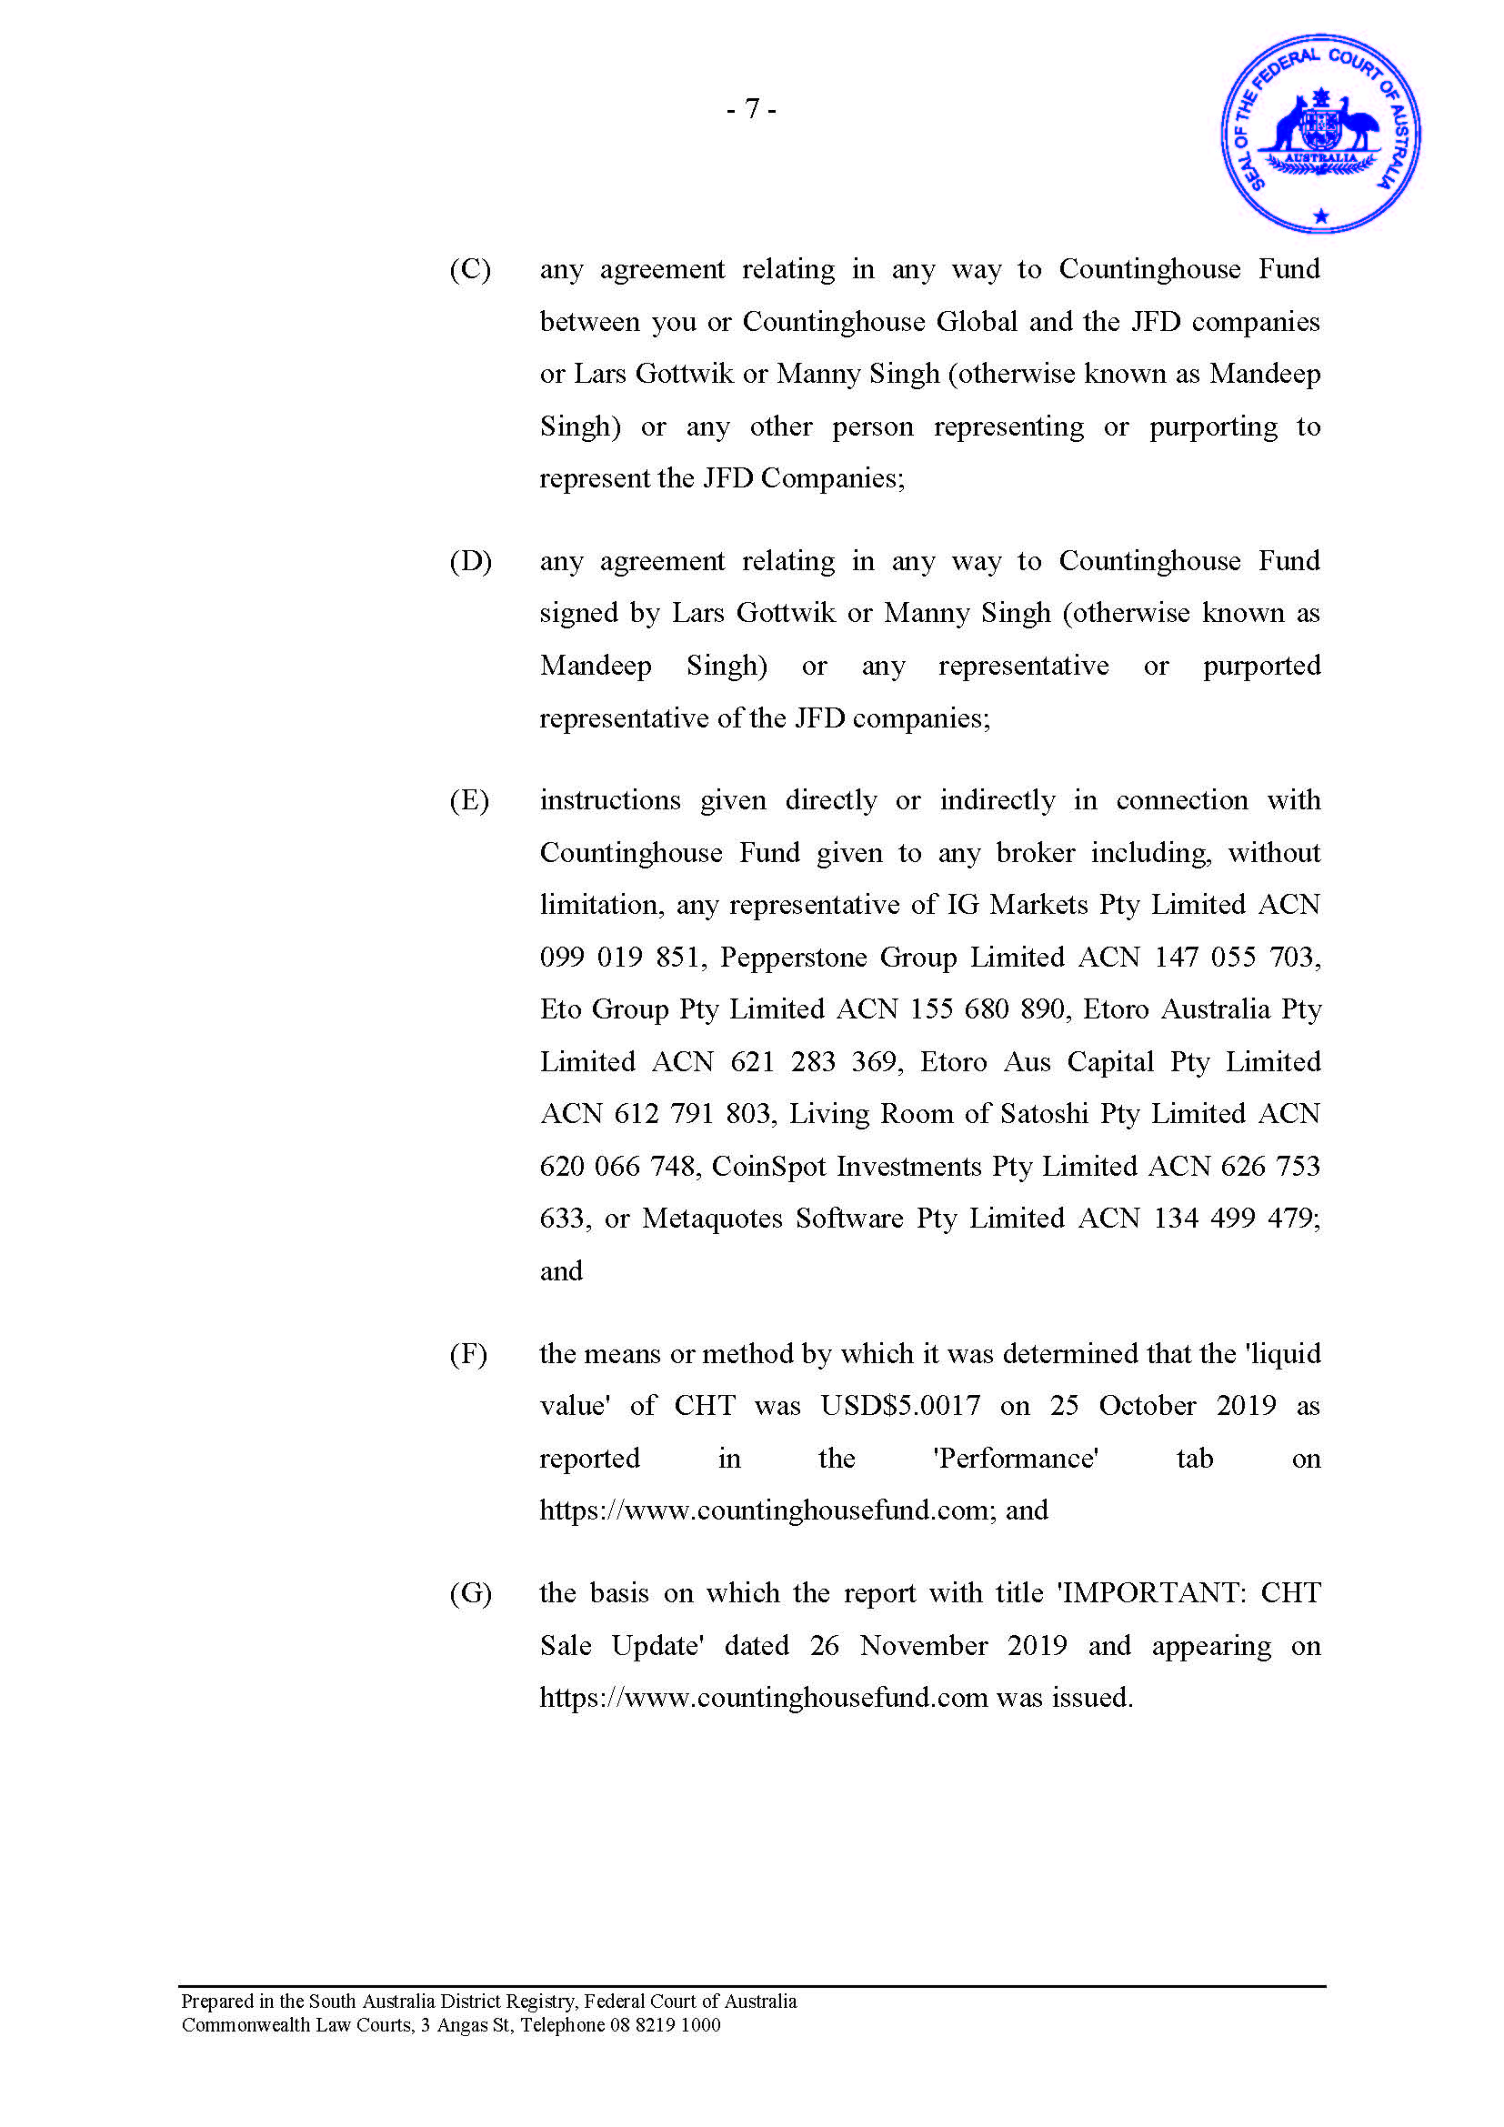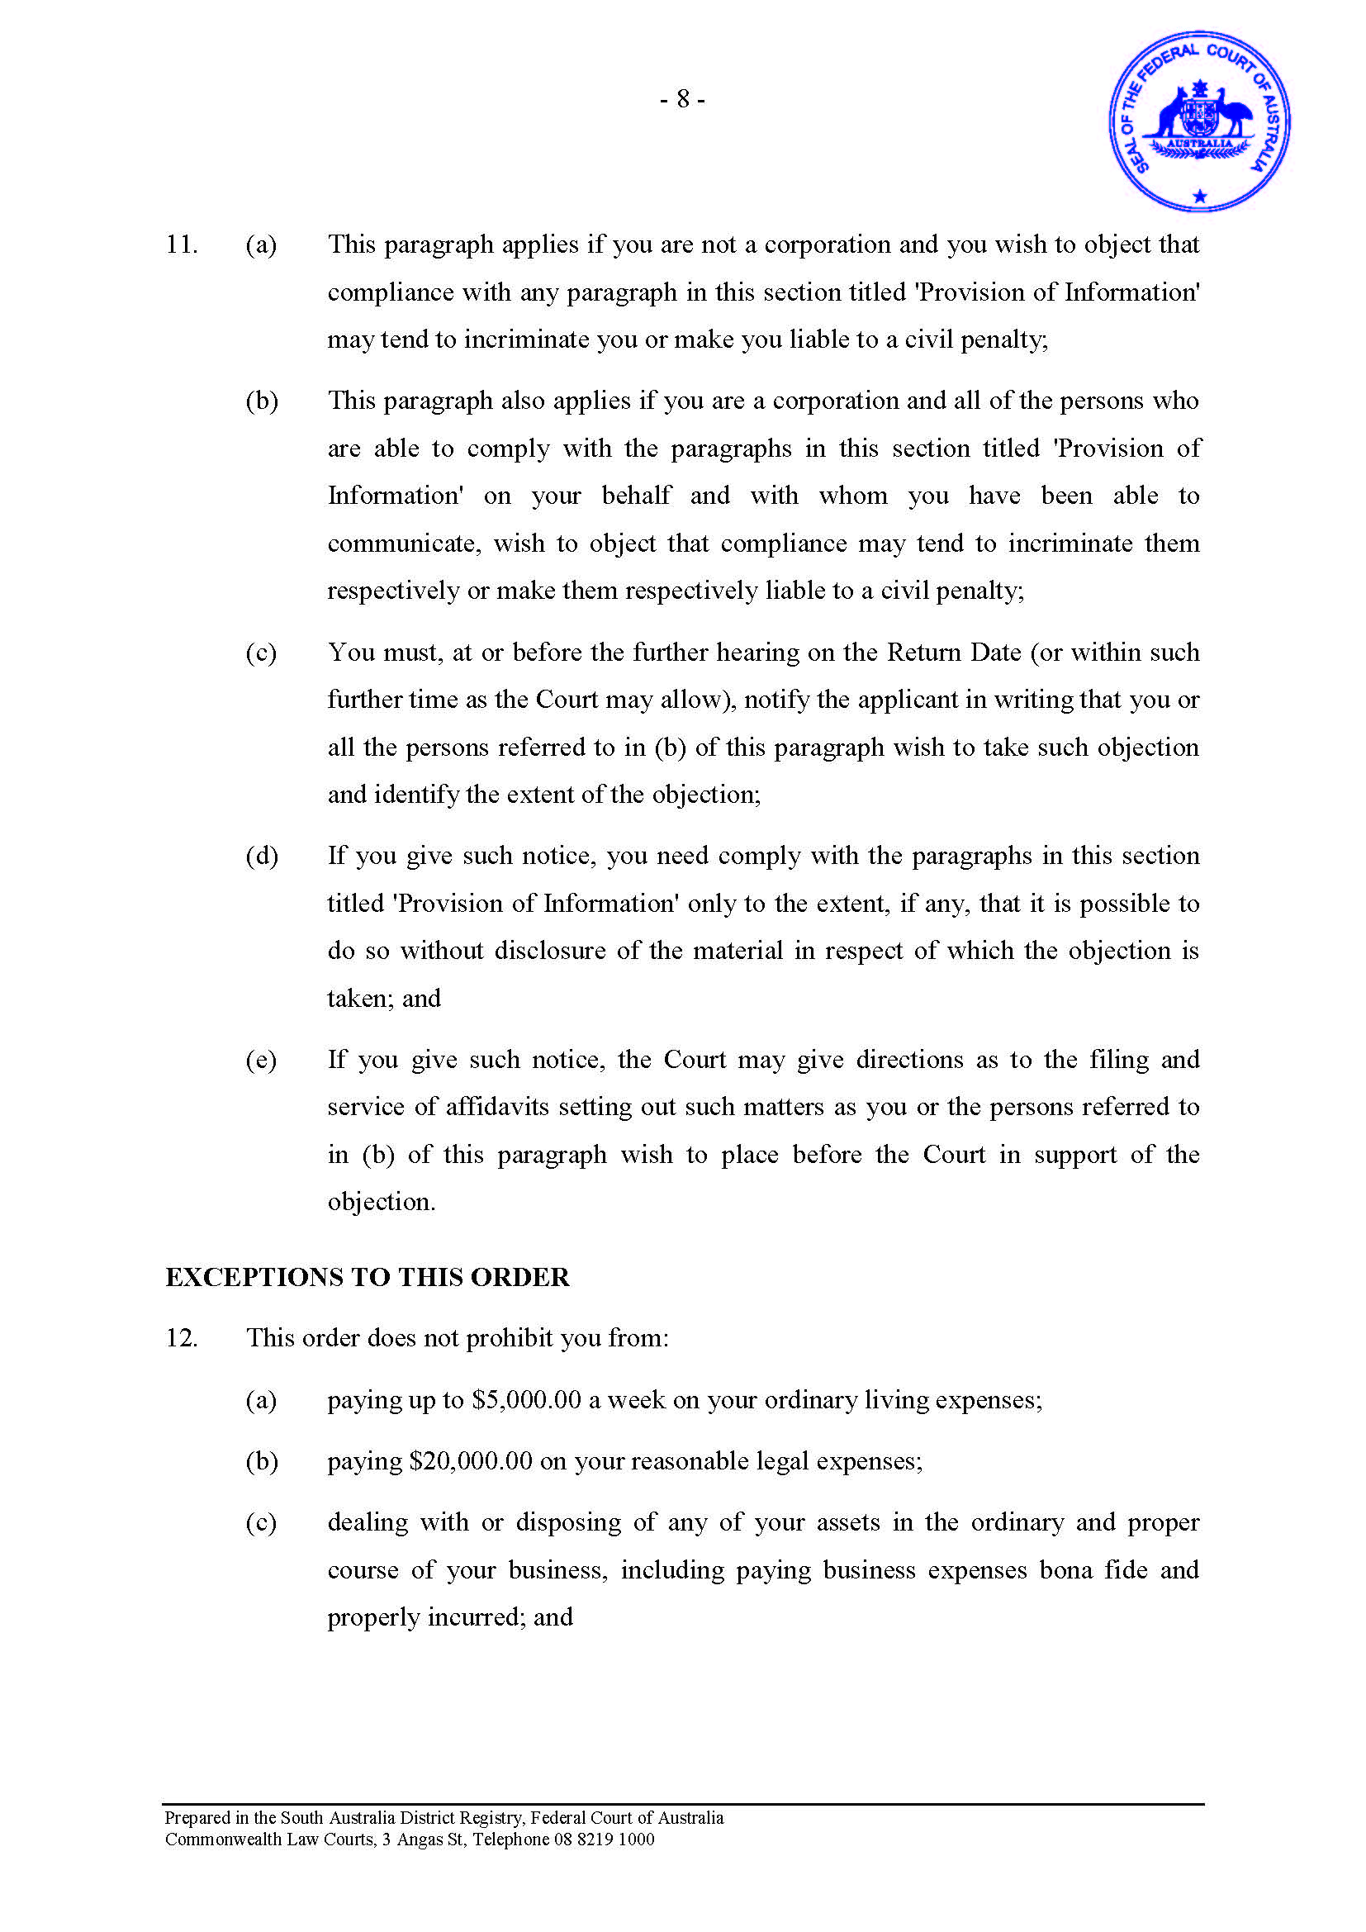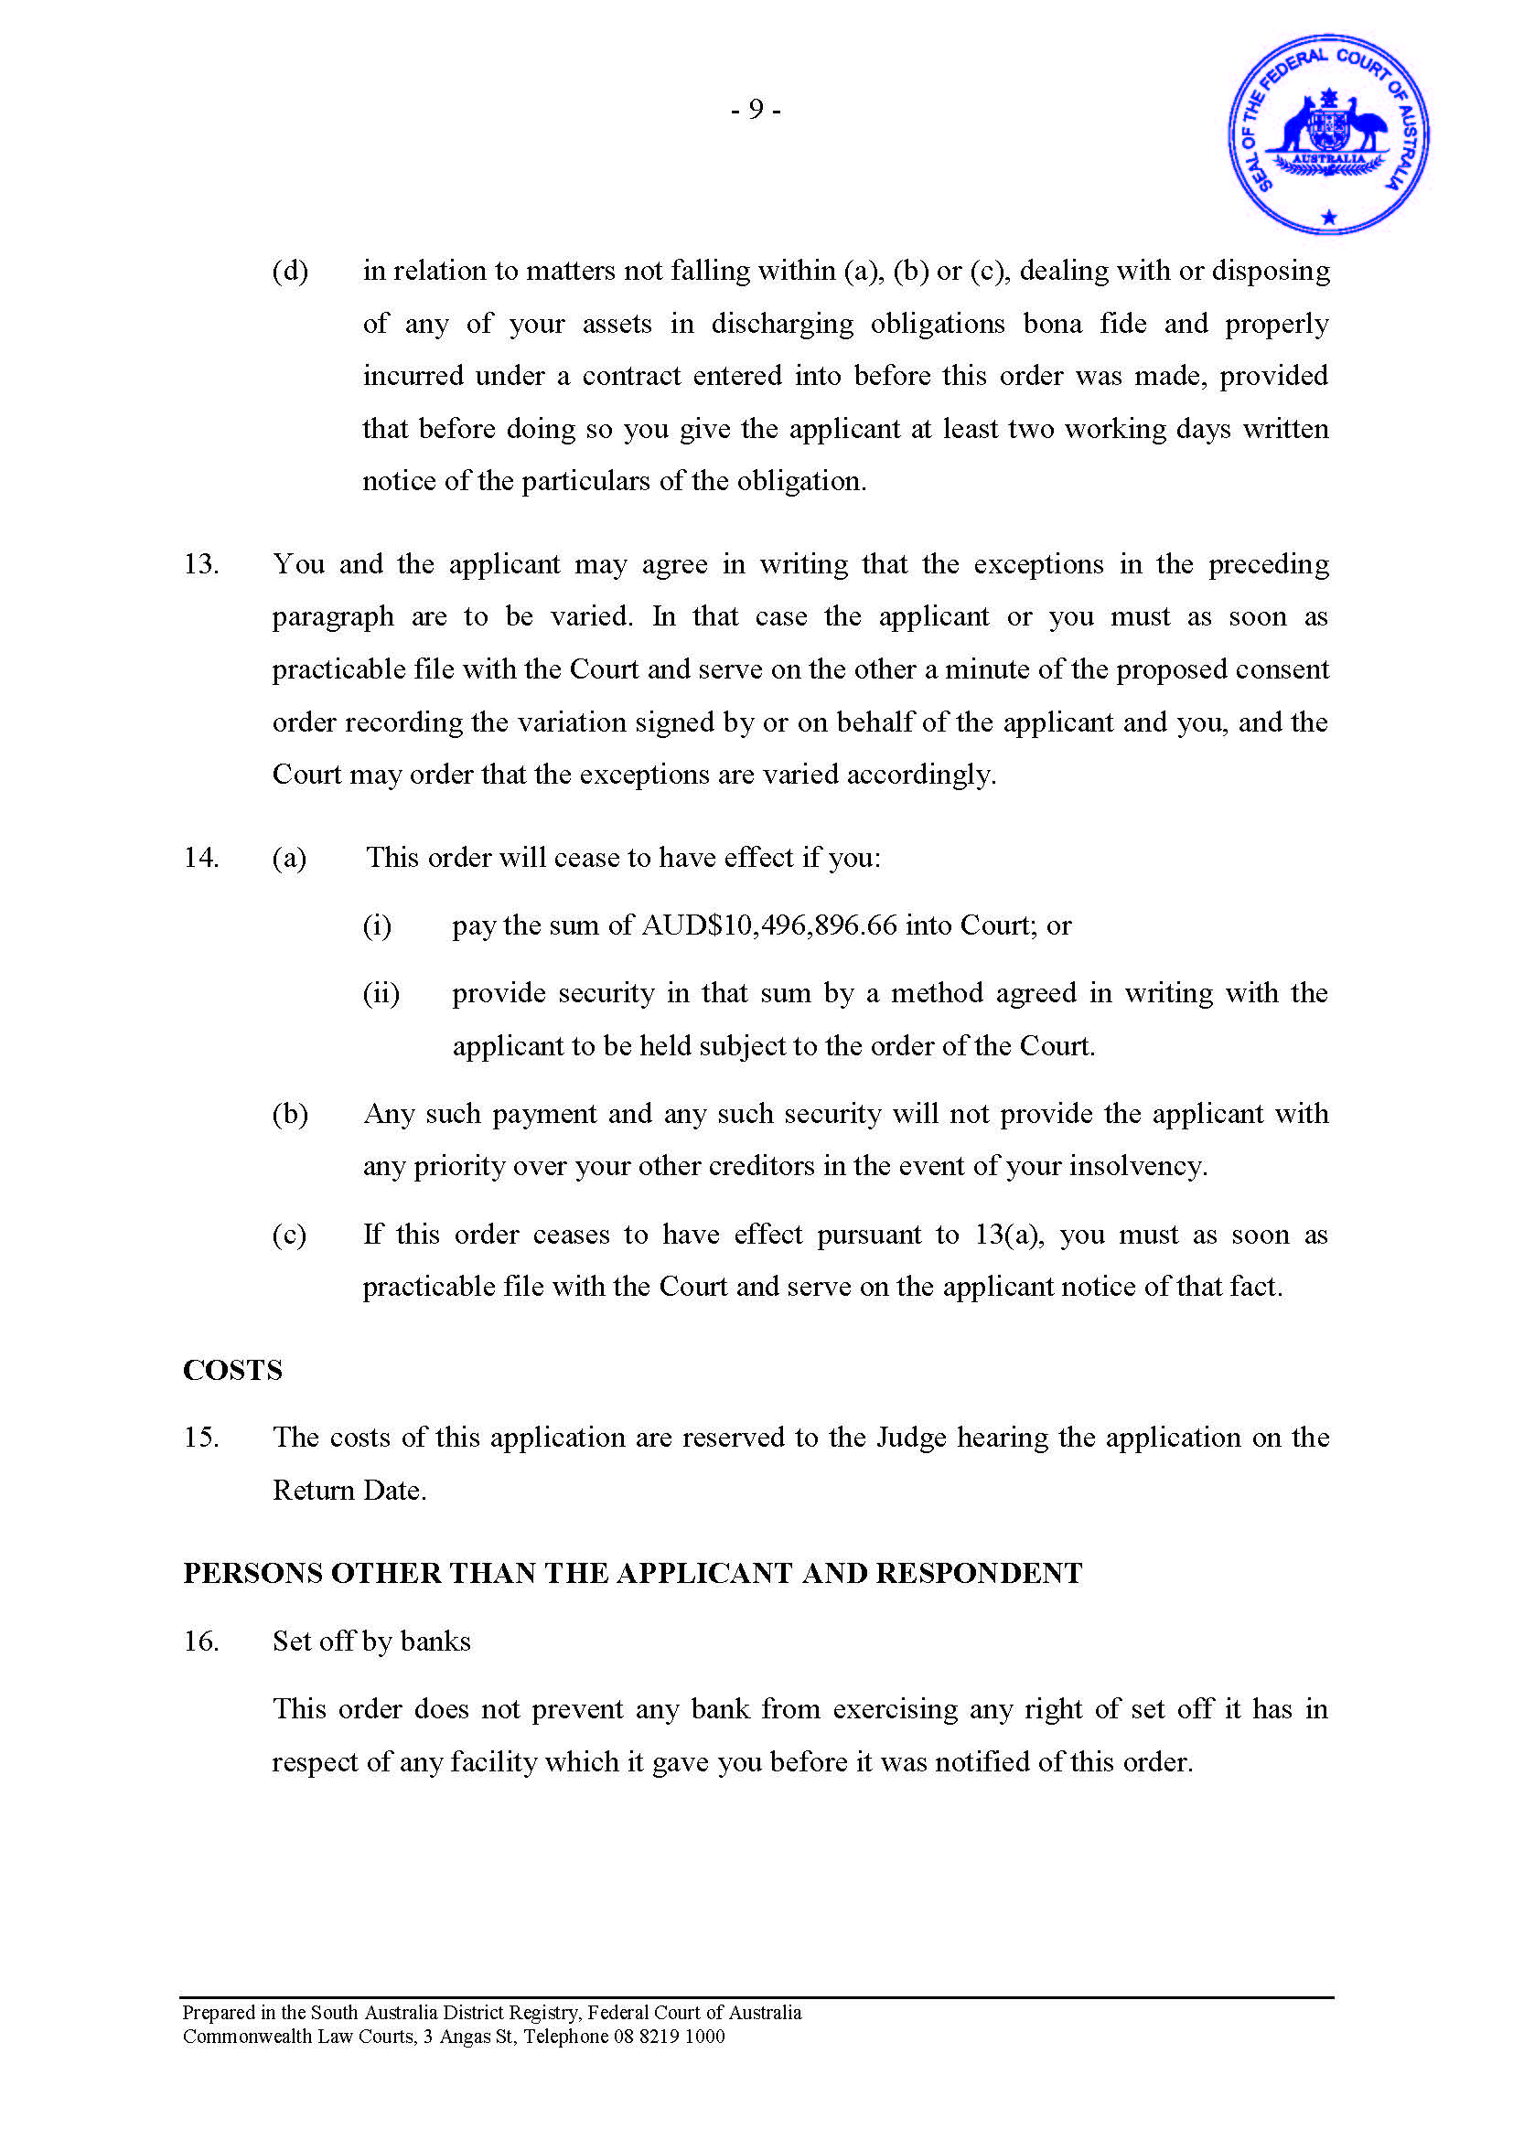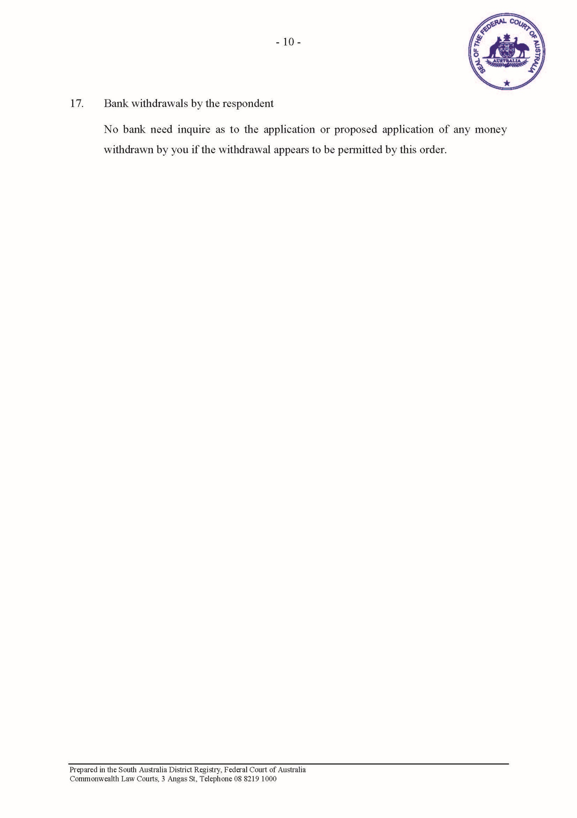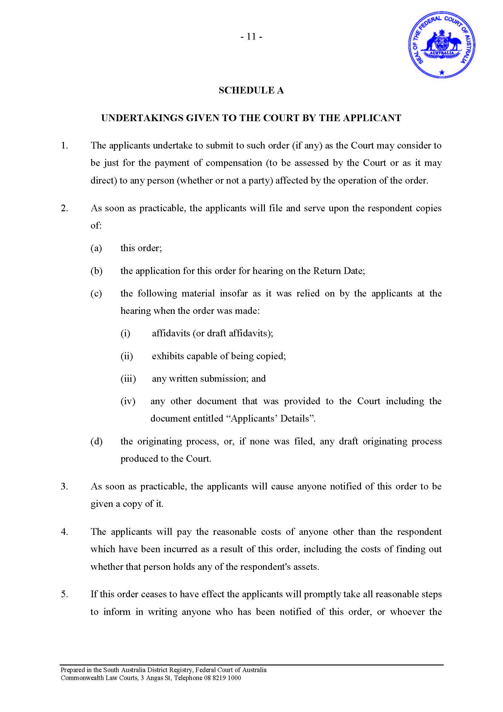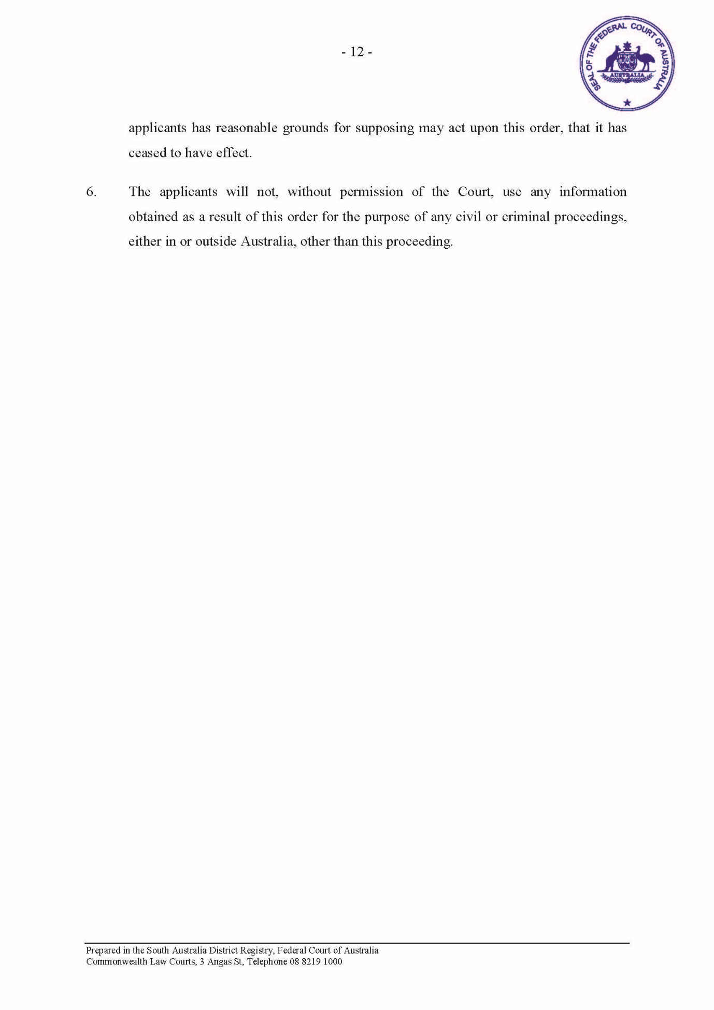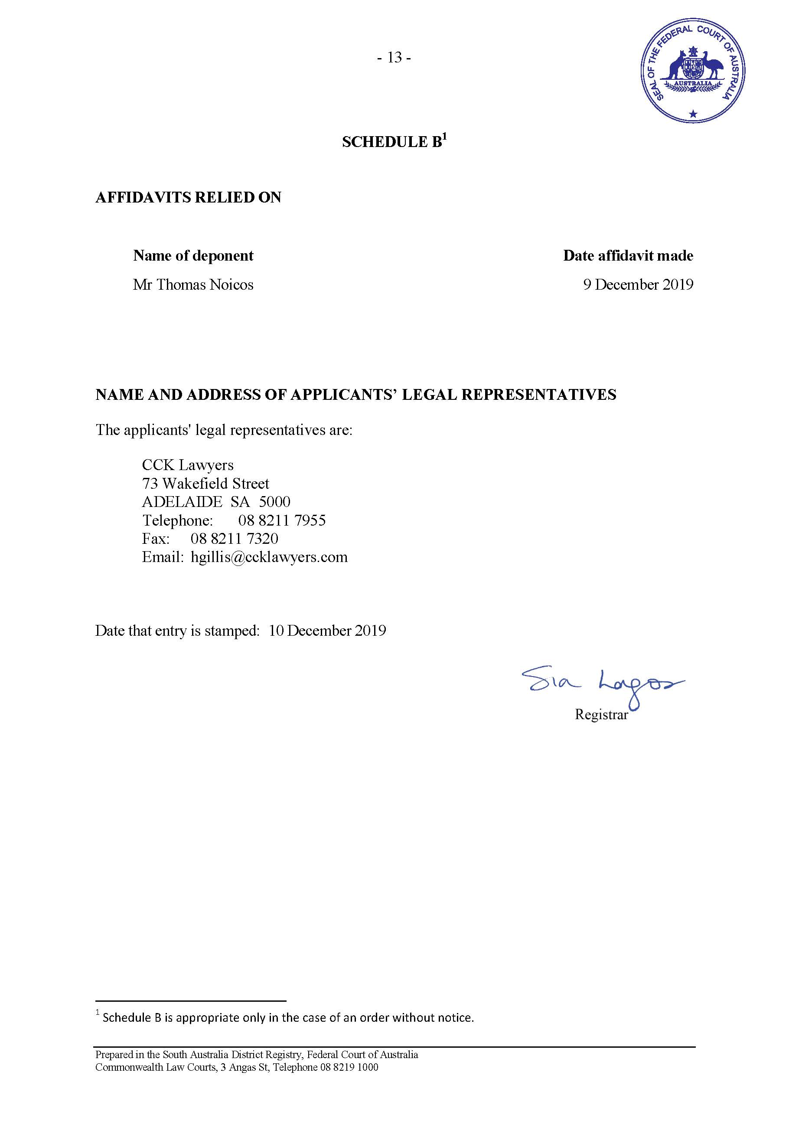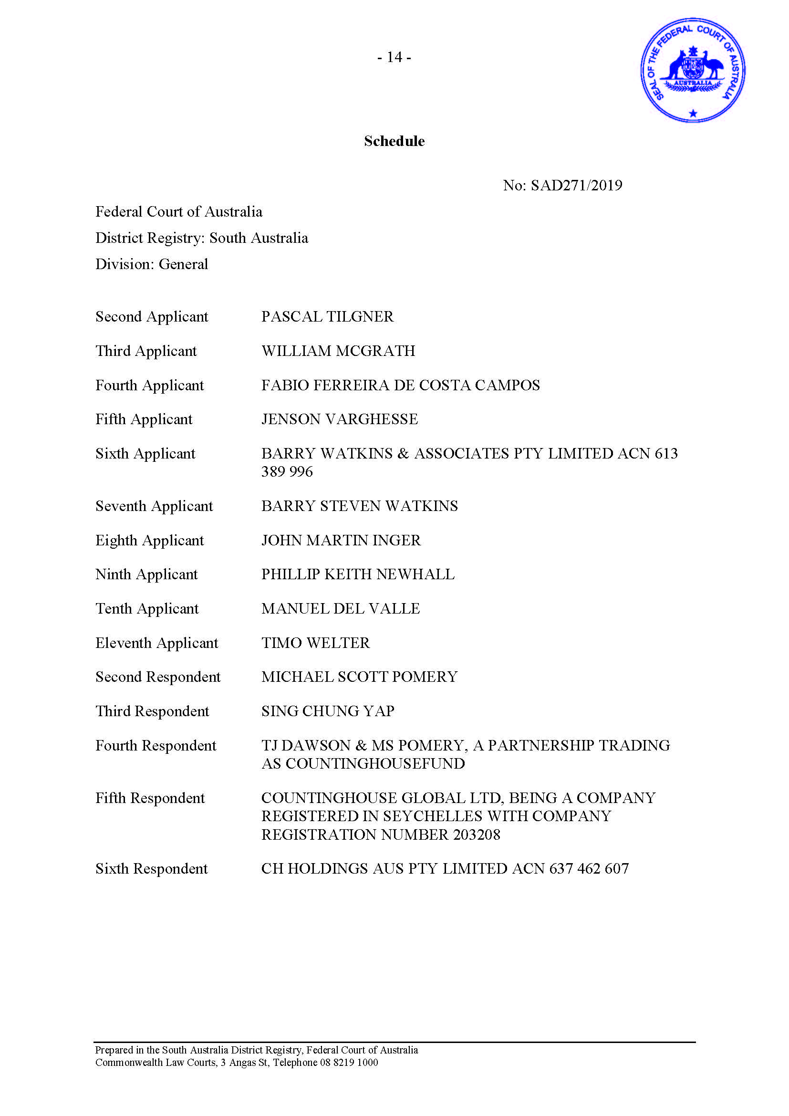

EX TEMPORE REASONS FOR JUDGMENT
WHITE J:

Introduction
- These proceedings were commenced by Thomas Noicos and 10 other applicants on 9 December 2019. They allege that the six respondents engaged in conduct in trade or commerce in relation to financial services which was misleading or deceptive, or likely to mislead or deceive, in contravention of s 12DA of the Australian Securities and Investments Commission Act 2001 (Cth) (the ASIC Act). The applicants allege, in the alternative, that if any one or more of the respondents did not contravene s 12DA, then those respondents were involved in the contravention of s 12DA by others, within the meaning of s 12GF of the ASIC Act.
- The Originating Application also sought urgent interim interlocutory freezing orders against each respondent, together with ancillary orders for the urgent production of documents and information.
- The respondents to the proceedings are Timothy Dawson, Michael Pomery, Sing Chung Yap, (also known as Christopher Yap), the partnership of Timothy Dawson and Michael Pomery trading as “Countinghouse Fund”, Countinghouse Global Ltd and CH Holdings Aus Pty Ltd.
- The application for the interim freezing and ancillary orders was heard by Besanko J on 10 December 2019. His Honour made interim freezing orders directed to all of the respondents other than Countinghouse Global Ltd. Those orders had effect up to and including 5 pm on 12 December 2019. His Honour also made ancillary orders for the production of documents directed to those same five respondents, as well as to a number of non-parties. At the same time, Besanko J directed that service of the Amended Originating Application, the application for the freezing order and the supporting affidavit be effected by 8 pm on Tuesday, 10 December 2019, and his Honour listed the application for further hearing at 2.15 pm on 12 December 2019.
- At the hearing on 12 December 2019, only the third respondent, Mr Yap, had legal representation, and his counsel had been instructed only shortly before the hearing. Mr Dawson and Mr Pomery appeared, but were unrepresented. Neither Countinghouse Global nor CH Holdings appeared. Countinghouse Global, a company registered in Seychelles, has not yet been served with the proceedings.
- On 12 December 2019, the applicant sought the continuation of the freezing orders directed to each of the five respondents against whom Besanko J had made the orders. Counsel for Mr Yap sought an adjournment of the hearing in order to pursue discussions with the applicants. Mr Dawson and Mr Pomery sought an adjournment so as to give them the opportunity to obtain legal advice. Each of these respondents consented to a continuation of the interim freezing orders, and I was satisfied that that continuation was appropriate. Accordingly, I extended the interim freezing orders to 5 pm on 19 December 2019. I indicated that I did so on the basis that the applicant would have the onus of persuading the Court that a continuation of the freezing orders after 19 December 2019 would be appropriate.

Power and principles
- Rule 7.32 of the Federal Court Rules 2011 (Cth) empowers the Court to make a freezing order with or without notice to a respondent for the purpose of preventing the frustration or inhibition of the Court’s process by seeking to meet a danger that a judgment or prospective judgment of the Court will be wholly or partly unsatisfied. By subr (2), the order may have the effect of restraining a respondent from removing an asset or from disposing of, dealing with, or diminishing the value of an asset.
- Rule 7.33 empowers the Court to make an order ancillary to a freezing order, including an order for the purpose of eliciting information relating to assets relevant to the freezing order.
- The grant of an application for the issue of a freezing order involves an exercise of discretion by the Court. The principles which inform the exercise of the discretion are well established. Applicants for freezing orders are expected to show that:
- there is a reasonably arguable case on legal and factual matters or a sufficiently realistic prospect of them succeeding in obtaining relief against the respondent in the proceedings: Cardile v LED Builders Pty Ltd [1999] HCA 18, (1999) 198 CLR 380 at [68]; Pearce v Waterhouse [1986] VR 603 at 605;
- there is a risk of dissipation of the assets if the order is not made: ibid at [25]-[26], [41]-[42]; and
- the balance of convenience favours the grant of the injunction: Deputy Commissioner of Taxation v Hua Wang Bank Berhad [2010] FCA 1014; (2010) 273 ALR 194 at [13].

Consideration
- At today’s hearing, counsel for Mr Dawson and Mr Pomery did not oppose the continuation of the freezing orders concerning them. On the other hand, the third respondent Mr Yap, did oppose the continuation of the freezing order concerning him. As already noted, it is not for Mr Yap to dissuade the Court from the continuation of the freezing order: it is instead for the applicants to satisfy the Court that a continuation of the order is appropriate.
- The applicants’ pleaded cause of action, as I have already indicated, is based on s 12DA of the ASIC Act. That section provides that a person must not, in trade or commerce, engage in conduct in relation to financial services which is misleading or deceptive or is likely to mislead or deceive. The term “financial service” is defined diffusely in s 12BAB(1) of the ASIC Act. Relevantly for present purposes, it includes the activity of dealing in a “financial product”. That term is defined in s 12BAA of the ASIC Act to be a facility through which, or through the acquisition of which, a person makes a financial investment, manages financial risk, or makes non-cash payments.
- The affidavit evidence indicates that the applicants are investors in cryptocurrencies. Mr Noicos deposes that the respondents, in particular Mr Dawson and Mr Pomery, using the name Countinghouse Global and/or Countinghouse Fund, prepared and issued an Information Memorandum described as a “White Paper” which solicited investment in a cryptocurrency hedge fund. The applicants deposed to having made investments in the fund. Mr Noicos deposes that the aggregate amount of their base investment was approximately equivalent to, in AUD$2,322,442 with a value at 25 October 2019 said to be AUD$10,496,896.66.
- Prima facie, the conduct of the relevant respondents in the establishment and conduct of the cryptocurrency hedge fund appears to be conduct “in relation to financial services”.
- The applicants allege that, by their conduct in relation to the Information Memorandum and their subsequent statements, the respondents led investors to believe that their investments, which took the form of, and were styled as, Countinghouse Tokens (CHTs), were properly administered, had integrity, were managed appropriately by the respondents, and represented a genuine opportunity for investors to generate a financial return from investment in the CHTs.
- Although the evidence on this topic is limited, the inference to which the matters deposed by Mr Noicos gives rise is that the investments have been substantially, if not wholly, lost. I did not understand any respondent to contest the drawing of that inference. Given the respondents’ attitude on the topic, it is not necessary for me to refer to the various matters supporting the inferences.
- The affidavits from the third respondent, Mr Yap, point to the prospect of there having been a form, or forms, of nefarious conduct in relation to the applicants’ investments. Again, that does not appear to be contested by the respondents, although there are issues as to who has been responsible for that conduct.
- Having regard to these matters, the statements in the White Paper and to the subsequent “information posts” concerning the fund into which the applicants invested, I am satisfied that there is a reasonably arguable case of contraventions of s 12DA.
- As to the risk of dissipation of assets by the respondents, it is not necessary that the Court be satisfied that the risk of dissipation is more probable than not, or for the applicants to adduce evidence of an intention on the part of the respondents to dissipate their assets: DCT v Hua Wang Bank Berhad at [8]-[10]; Deputy Commissioner of Taxation v Chemical Trustee Ltd (No 4) [2012] FCA 1064 at [23].
- At least in relation to the allegations made against the first, second and fourth respondents, it is appropriate, on the basis of the material presently before the Court, to take into account that the applicants allege dishonest conduct. It is also appropriate to take into account the repeated omissions by the first, second, fourth and sixth respondents to provide information to the applicants and other investors concerning their investments, the fate of those investments, and the progress of the alleged sale of the fund itself and its business to a third party investor. In that respect, those circumstances appear to be similar to those discussed by Gleeson CJ in Patterson v BTR Engineering (Aust) Ltd (1989) 18 NSWLR 319 at 325-6:
In particular, I consider that [the primary judge] was correct in taking the view that the evidence as to the nature of the scheme in which the appellant was allegedly involved, which established a prima facie case against him, was such as to justify the conclusion that there was a danger that the appellant would dispose of assets in order to defeat any judgment that might be obtained against him and that such danger was sufficiently substantial to warrant the injunction. There is no reason in principle why the evidence which is relevant to the first of the issues earlier referred to might not also have a bearing on the second, and this will be especially so where the prima facie case that is made out against a defendant is one of serious dishonesty involving diversion of money from its proper channels. The present is not a case in which a plaintiff who claims simply to be an unsecured creditor seeks to prevent a dissipation of assets which have no particular connection with the claim in question. This is a case in which the plaintiff claims that the defendant, making use of a corporation controlled by him, fraudulently misappropriated a large sum of money which, if it is still under the control of the appellant, would be quite likely to constitute, directly or indirectly, the bulk of his assets. As [the primary judge] held, the nature of the scheme in which, on the evidence to date, the appellant appears to have engaged, is such that it is reasonable to infer that he is not the sort of person who would, unless restrained, preserve his assets intact so that they might be available to his judgment creditor.

- Putting the position of Mr Yap to one side, those remarks are apposite in the present case. Accordingly, I am satisfied that there is a danger that a judgment which the applicants may obtain against the respondents will be wholly or partially unsatisfied, because the respondents may dispose of, deal with, or diminish the value of their assets.
- It is convenient at this point to refer to the position of Mr Yap as he is the only respondent to resist actively the continuance of the freezing orders.
- Counsel for Mr Yap submitted that the freezing order should not be continued against his client. In support of that position, he relied upon two affidavits of Mr Yap made on 12 and 18 December 2019 respectively. In those affidavits, Mr Yap deposed to a number of matters, including that he himself has lost money, potentially a very substantial amount of money, by reason of the conduct alleged against the other respondents; that he was simply an employee in the Countinghouse Fund business; that he acted pursuant to directions by the other respondents; and that he was not complicit in any intention to deceive or mislead, or in any other form of inappropriate conduct. He contends that that is evidenced by his conduct since the beginning of December 2019, in which he has assisted the applicants, and later the applicants’ solicitors in the investigation of the events giving rise to the circumstances to which I have already referred.
- Despite that, I am satisfied that the applicants have established a prima facie cause of action against Mr Yap. In saying that, I emphasise that I am referring only to a prima facie case. Whether the applicants are able to establish that case remains to be seen, but for the purposes of the application for a freezing order, I am satisfied that a prima facie case has been shown. That is not so much because of the references to Mr Yap in the White Paper, including a profile of him as one of the persons making up “the team” at Countinghouse. It is because of his seeming involvement in the preparation of information posts conveying over a period of time, information to investors as to the status of their investments and as to the state of the sale (perhaps “purported sale”) of the Countinghouse Fund to a third party investor.
- It is well established that a person may engage in misleading or deceptive conduct for the purposes of provisions such as s 12DA even when acting innocently. That is to say, a dishonest state of mind, a dishonest intention, or even an intention to deceive or mislead is not necessary. I am satisfied that counsel for the applicants has pointed to statements apparently authored by Mr Yap or in the preparation of which he had some input which indicate that he may have engaged in misleading or deceptive conduct. I emphasise again, that this is not a finding that Mr Yap has engaged in such conduct, only that he may have.
- I am also satisfied, having regard to the matters to which I referred earlier, that there is the potential for Mr Yap to dissipate his assets in the way about which the Court should be concerned.
- It is then appropriate for the Court to have regard to the balance of convenience. I keep firmly in mind that the making of any freezing order is likely to cause some prejudice to a respondent. That arises from the very fact that the effect of a freezing order is to inhibit respondents in dealing with their own assets. That by itself makes it appropriate for the Court to exercise caution before making the freezing orders sought.
- Balanced against that is the prejudice to the applicants arising from the risk that, in the absence of a freezing order, the respondents (pertinently, Mr Yap) may dissipate or remove his assets, thereby frustrating the enforcement of any judgment which the applicants may obtain. That too is an important consideration. I do not understand Mr Yap in his affidavits to depose to any particular additional prejudice which he may suffer by the continuation of the freezing orders. The Court seeks to mitigate the potential prejudice to respondents by making orders in terms which permit them to pay reasonable living expenses, to pay legal expenses, and to meet the obligations which they incur in the ordinary course of business.
- Having regard to all these circumstances, I am satisfied on balance that it is appropriate to continue the freezing order against all respondents, including Mr Yap, but excluding Countinghouse Global Ltd. In saying that, I recognise that the circumstances of Mr Yap, at least on the material before me, may be different from those of the other respondents.
- The applicants have offered the usual undertaking as to damages, and there is no reason to suppose that those undertakings are not of value. Accordingly, there will be orders continuing the freezing orders made by Besanko J on 10 December 2019 until further order.
I certify that the preceding twenty-nine (29) numbered paragraphs are a true copy of the Reasons for Judgment herein of the Honourable Justice White.

Associate:

Dated: 30 December 2019

SCHEDULE OF PARTIES

 | SAD 271 of 2019
Applicants
Fourth Applicant: | FABIO FERREIRA DA COSTA CAMPOS
Fifth Applicant: | JENSON VARGHESE
Sixth Applicant: | BARRY WATKINS & ASSOCIATES PTY LIMITED ACN 613 389 996
Seventh Applicant: | BARRY STEVEN WATKINS
Eighth Applicant: | JOHN MARTIN INGER
Ninth Applicant: | PHILIP KEITH NEWHALL
Tenth Applicant: | MANUEL DEL VALLE
Eleventh Applicant: | TIMO WELTER
Respondents
Fourth Respondent: | TJ DAWSON & MS POMERY, A PARTNERSHIP TRADING AS COUNTINGHOUSE FUND
Fifth Respondent: | COUNTINGHOUSE GLOBAL LTD BEING A COMPANY REGISTERED IN SEYCHELLES WITH COMPANY REGISTRATION NO 203028
Sixth Respondent: | CH HOLDINGS AUS PTY LIMITED ACN 637 462 607

