FEDERAL COURT OF AUSTRALIA

ACE Insurance Ltd, in the matter of ACE Insurance Ltd (No 2) [2016] FCA 1258

File number: | NSD 660 of 2016
Judge: | GLEESON J
Date of judgment: | 12 October 2016
Catchwords: | INSURANCE – application for transfer of general insurance business – approval of scheme
Legislation: | Insurance Act 1973 (Cth)  Insurance Acquisitions and Takeovers Act 1991 (Cth)
Cases cited: | ACE Insurance Ltd, in the matter of ACE Insurance Ltd [2016] FCA 997  American Home Assurance Company, in the matter of American Home Assurance Company (No 2) [2011] FCA 316  Application of Gordian RunOff Limited under the Insurance Act 1973 (Cth) (No 2) [2013] FCA 1329  HDI-Gerling Australia Insurance Company Pty Limited, in the matter of HDI-Gerling Australia Insurance Company Pty Limited (ABN 16 069 085 196) (No 2) [2010] FCA 669  In the matter of Reward Insurance Ltd [2004] FCA 151  MDU Australian Insurance Company Pty Limited, in the matter of MDU Australian Insurance Company Pty Limited [2008] FCA 490  Re Mercantile & General Reinsurance Company of Australia Ltd [2004] FCA 1773  Re Westport Insurance Corporation (No 2) [2009] FCA 1598; (2009) 181 FCR 530  QBE Insurance (Australia) Ltd, in the matter of Division 3A of Part III of the Insurance Act 1973 (Cth) & QBE Insurance (Australia) Ltd (No 2) [2016] FCA 288; (2016) 19 ANZ Insurance Cases 62-100  Re Insurance Australia Ltd [2004] FCA 524; (2004) 139 FCR 450  SGIC General Insurance Ltd [2004] FCA 1639  Sompo Japan Insurance Inc (No 2) [2014] FCA 677
Date of hearing: | 4 October 2016
Date of publication of reasons: | 26 October 2016
Registry: | New South Wales
Division: | General Division
National Practice Area: | Commercial and Corporations
Sub-area: | Commercial Contracts, Banking, Finance and Insurance
Category: | Catchwords
Number of paragraphs: | 84
Counsel for the Applicant: | Mr NJ Owens SC
Solicitor for the Applicant: | Clyde & Co
Solicitor for the Australian Prudential Regulation Authority: | Mr D Tran of Australian Prudential Regulation Authority

ORDERS
NSD 660 of 2016
IN THE MATTER OF ACE INSURANCE LIMITED (ABN 23 001 642 020)
ACE INSURANCE LIMITED (ABN 23 001 642 020)
Applicant

JUDGE: | GLEESON J
DATE OF ORDER: | 12 OCTOBER 2016

THE COURT ORDERS THAT:

- Pursuant to s 17F of the Insurance Act 1973 (Cth) (“Act”), the scheme for the transfer of all of the insurance business of Chubb Insurance Company of Australia Limited (ABN 69 003 710 647) (“Chubb”) to the applicant (“scheme”), in the form annexed to these orders and marked “A”, be confirmed without modification.
- Pursuant to s 17F(2) of the Act, all outwards reinsurance responding to any contract transferred pursuant to the scheme, and all rights attaching to it, be transferred to the applicant from the time the scheme becomes effective.
- The scheme become effective on 1 November 2016, subject to the applicant receiving before 1 November 2016 confirmation that the Commonwealth Government has no objection to the acquisition by the applicant of the insurance business of Chubb under s 41 of the Insurance Acquisitions and Takeovers Act 1991 (Cth).
- The applicant pay the costs of the proceedings of the Australian Prudential Regulation Authority as agreed, or if agreement cannot be reached, as taxed or assessed.
- There be liberty to apply.

Note: Entry of orders is dealt with in Rule 39.32 of the Federal Court Rules 2011.
ANNEXURE A 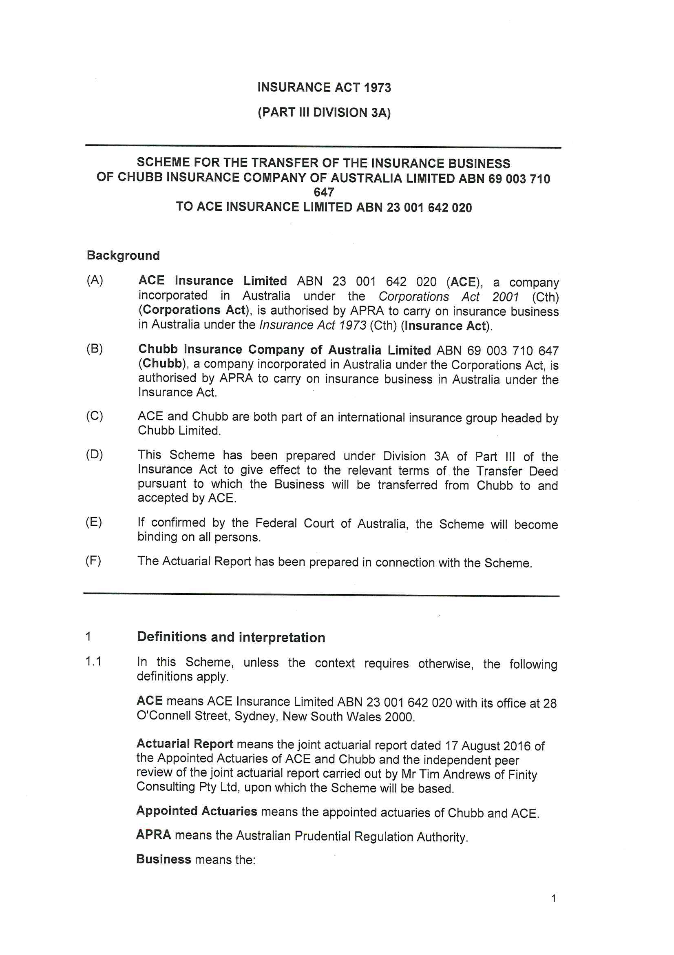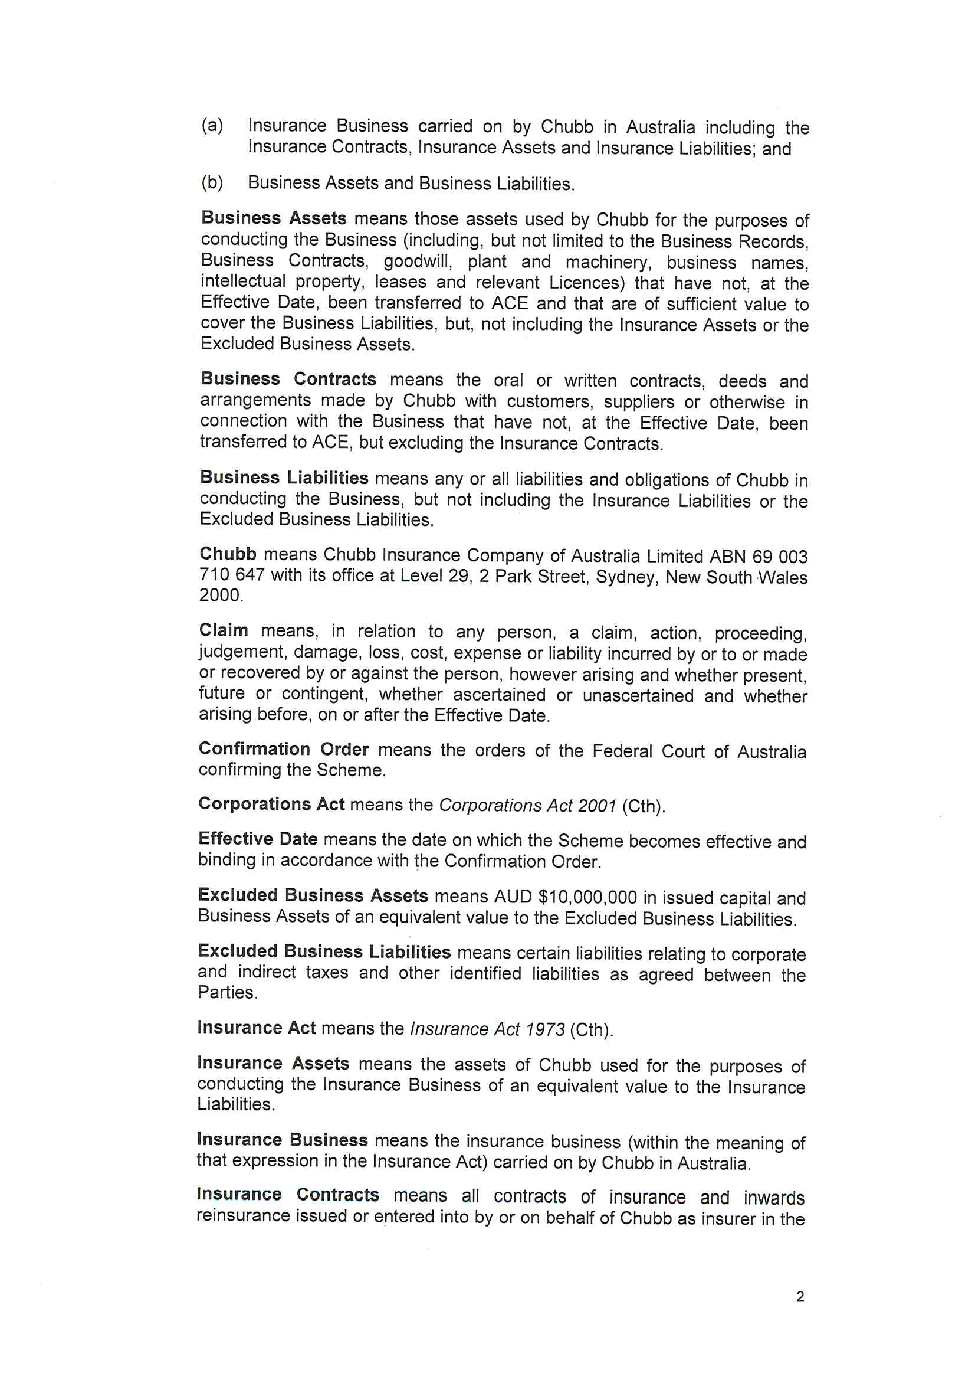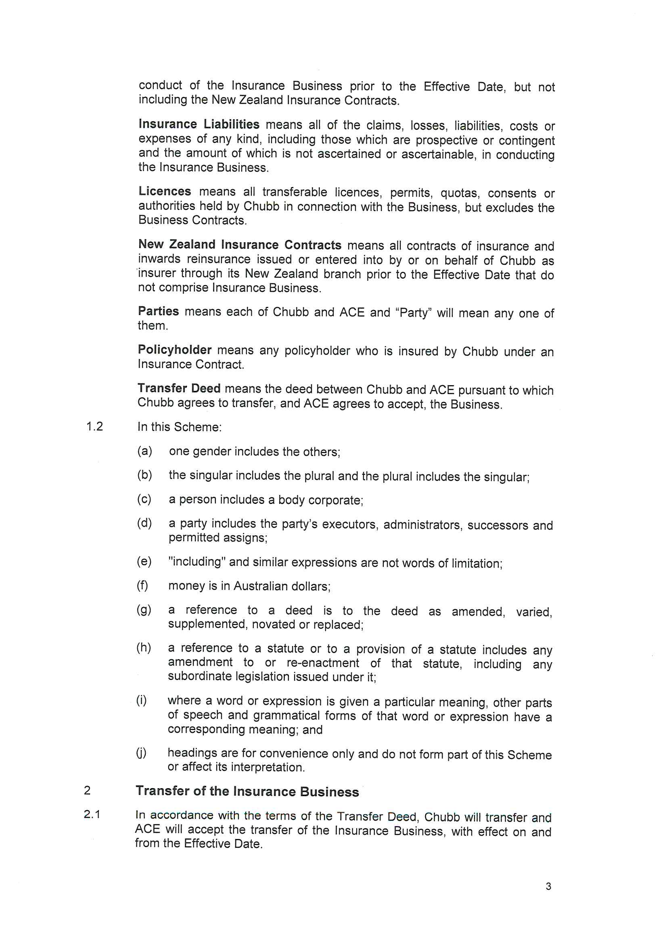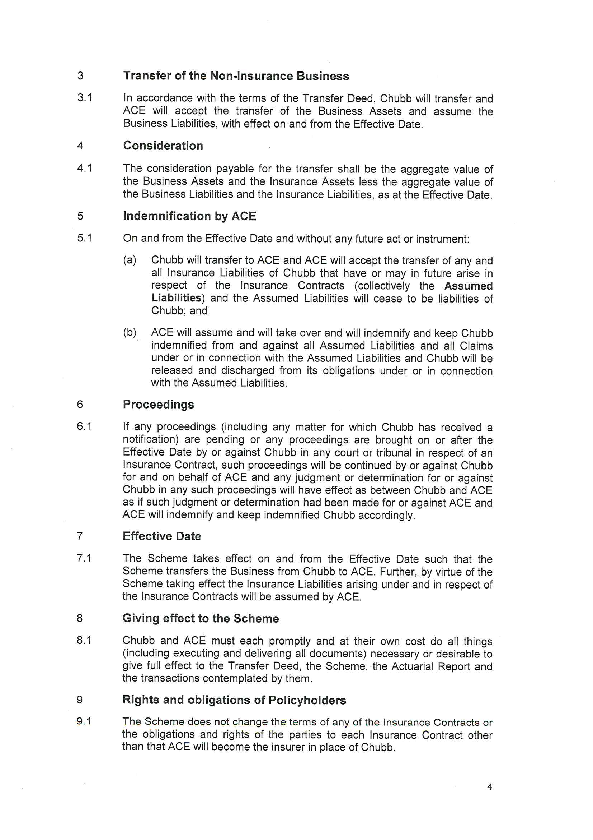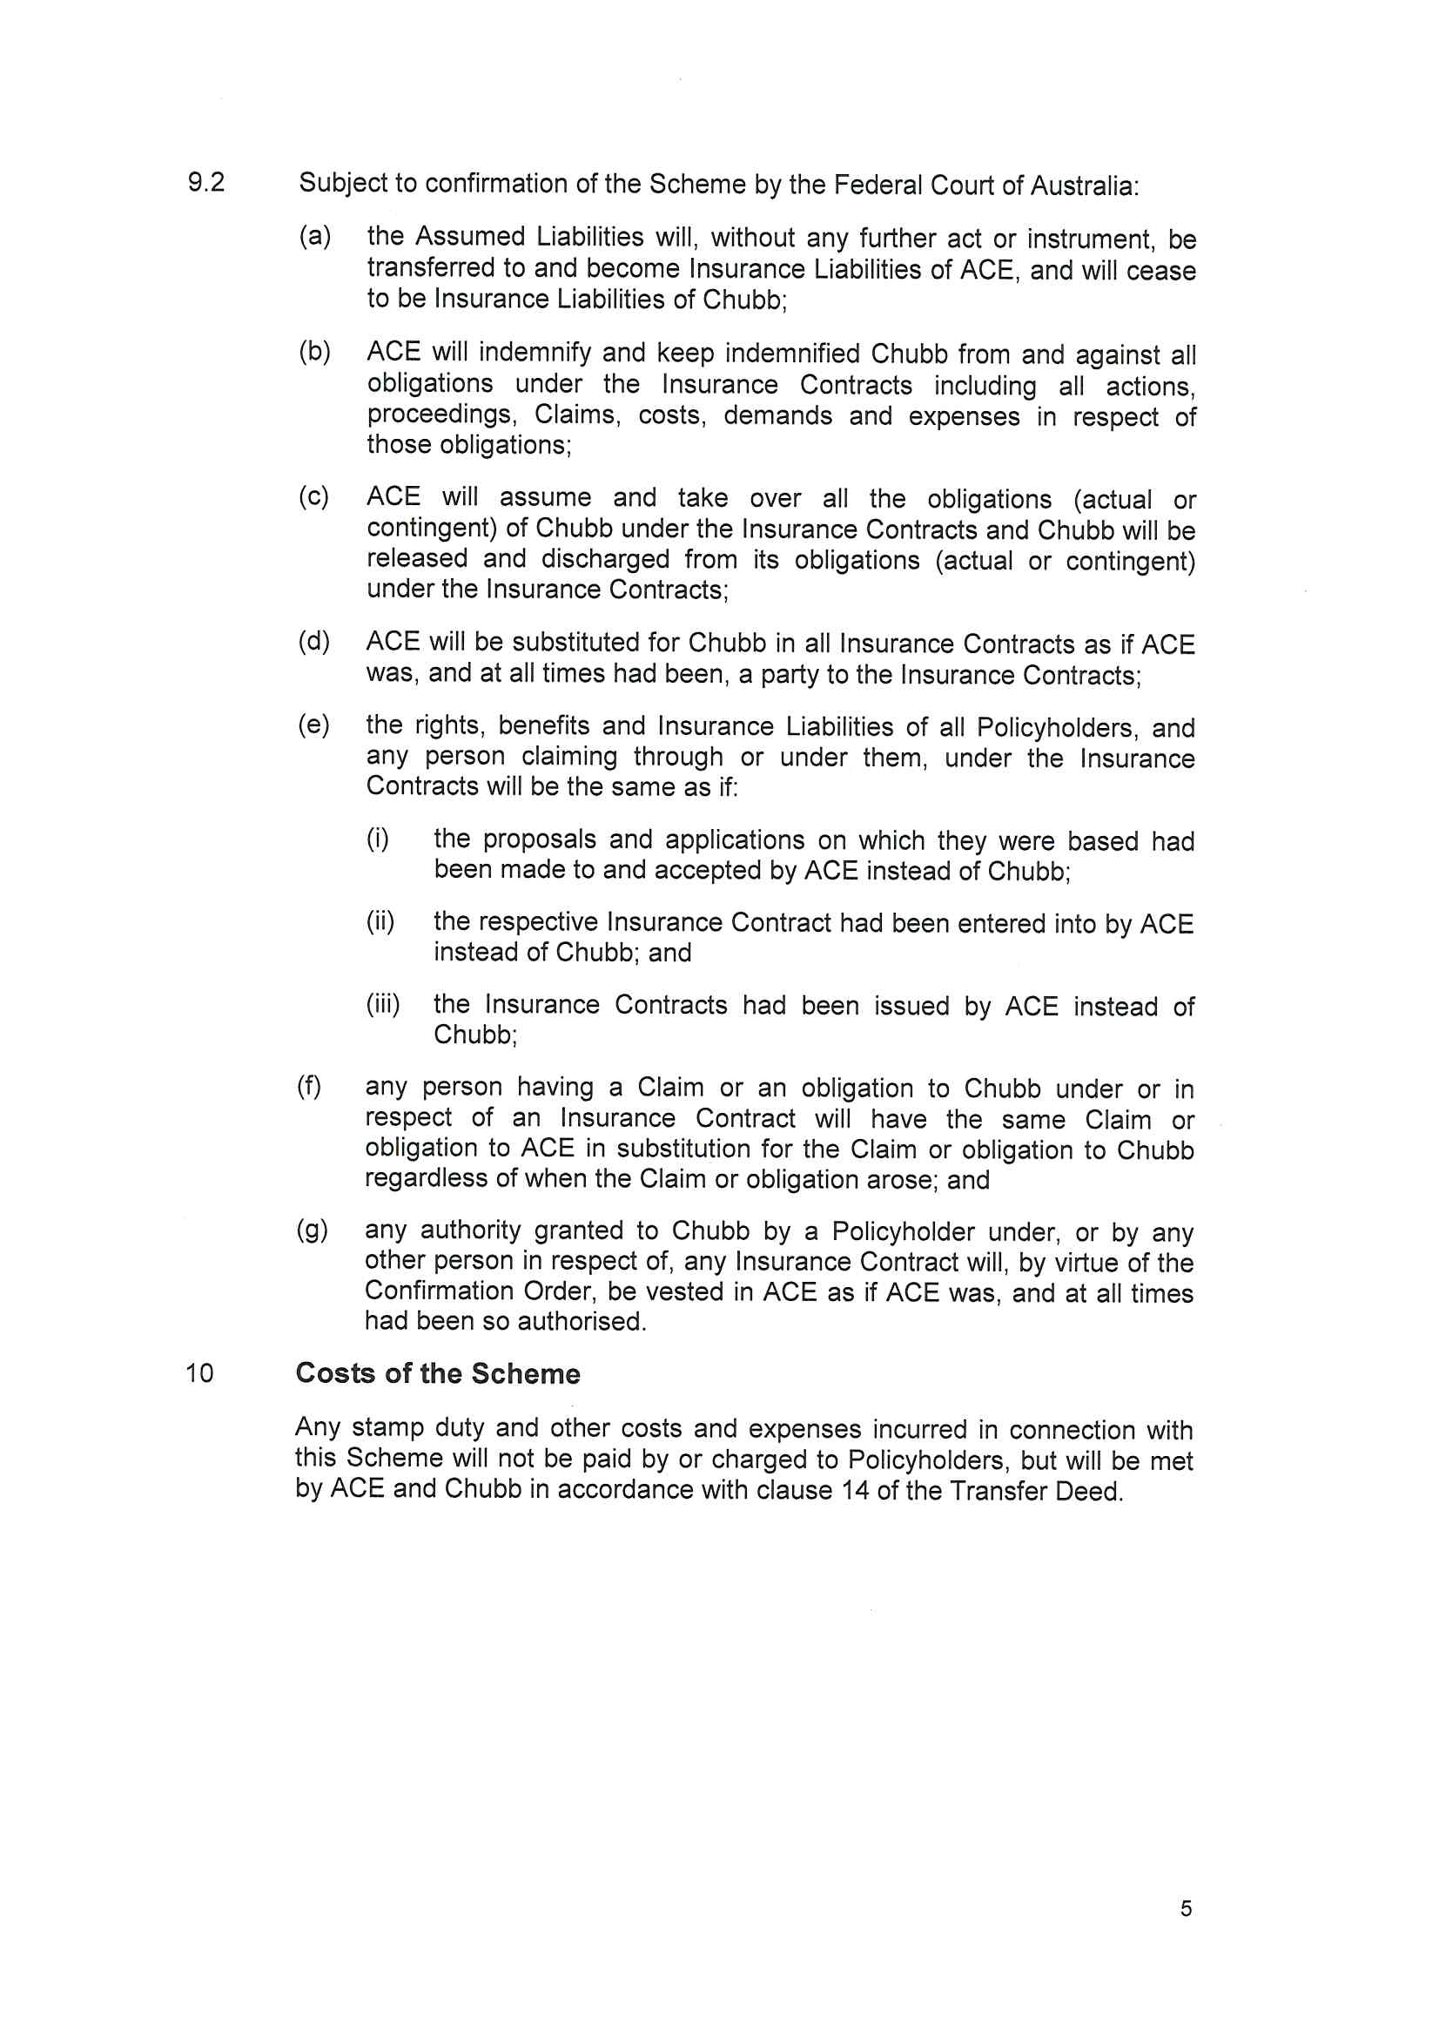

REASONS FOR JUDGMENT
GLEESON J:
- ACE Insurance Limited (“ACE”) seeks an order pursuant to s 17F of the Insurance Act 1973 (Cth) (“Act”) confirming a scheme for the transfer of all of the insurance business of Chubb Insurance Company of Australia Limited (“Chubb”) to ACE. ACE also seeks ancillary orders including, in particular, that all outwards reinsurance responding to any contract transferred pursuant to the scheme be transferred to ACE.
- By s 17E(3) of the Act, the Australian Prudential Regulation Authority (“APRA”) was entitled to be heard on the application. At the hearing, APRA appeared but limited itself to not opposing the orders sought, making no submissions concerning the application.
- No other party appeared to oppose the application.

Background
- On 8 August 2016, I made orders which provided partial dispensation of the requirement for distribution of the approved summary of the scheme, pursuant to s 17C(2)(c) of the Act: ACE Insurance Ltd, in the matter of ACE Insurance Ltd [2016] FCA 997 (“Re ACE Insurance (No 1)”). That earlier judgment records the following matters about the scheme:
[4] Both Chubb and ACE are Australian corporations authorised to carry on a general insurance business in Australia under s 12 of the Act.
[5] Before 15 January 2016 (Australian time), Chubb and ACE were members of different corporate groups headed by The Chubb Corporation and ACE Ltd respectively. On that date, ACE Ltd acquired The Chubb Corporation, effecting a global merger of the two groups. Following the merger, ACE Ltd is now known as Chubb Ltd and the combined group of companies is known as the Chubb Group of companies.
[6] According to ACE’s written submissions, the proposed scheme is “one component of the global reorganisation of the Chubb Group following the merger designed, in broad terms, to align what were two independent businesses into one”. Relevantly:
(1) previously, the shares in ACE were held by ACE Australia Holdings Pty Ltd;
(2) previously, the shares in Chubb were held by Federal Insurance Company;
(3) on 1 April 2016, as an interim measure under the new structure, the shares in Chubb were transferred to ACE Australia Holdings Pty Ltd (now re-named Chubb Holdings Australia Pty Ltd); and
(4) it is proposed that prior to the implementation of the scheme (assuming it is approved), the shares in Chubb will be transferred to ACE.
[7] Thus, the proposal is that Chubb will become a wholly-owned subsidiary of ACE, which will be (as it already is) a wholly-owned subsidiary of Chubb Holdings Australia Pty Ltd, the shares in which will be owned by a foreign subsidiary of the Chubb Group.
[8] Mr Owens submitted that the proposed scheme is an “intra-group” scheme, which will not involve any real change in the claims handling process of Chubb or any difficulty in a claim being referred onto the correct insurer as a result of the proposed scheme: cf Calliden Group Limited in the matter of Calliden Group Limited [2007] FCA 2019 (“Re Calliden”) at [62]; MMIA Pty Limited and QBE Insurance (Australia) Limited [2008] FCA 1239 at [24].
Business to be transferred under the proposed scheme
[9] The business is comprised of a portfolio of insurance contracts which have been underwritten in Australia since January 1981, initially as a branch of Vigilant Insurance Company and from April 1989 as Chubb. Chubb has mainly underwritten financial lines insurance (including directors’ and officers’ insurance and professional indemnity insurance), marine insurance, public and product liability insurance, property insurance, accident and health insurance, consumer credit insurance, travel insurance and house owners/householders insurance.
[10] The business is grouped into the following four segments:
(1) Global Brokers Unit, which operates through six large international insurance brokers (Aon, Marsh, JLT, Willis, Gallaghers and Locktons).
(2) Independent Brokers Unit, which operates through other, generally smaller, brokers (including “cluster” or “networks” of brokers such as Steadfast and Austbroker).
(3) Bulk-Booked Schemes, through which standardised cover is offered to a homogeneous group of individuals, for example, industry based groups, with individual underwriting, issuance and claims settlement authority being delegated to the broker or agent managing the scheme.
(4) Direct business, being business conducted by Chubb directly, without the involvement of a broker or agent.
- Following the transfer, the name of ACE will be changed to Chubb Insurance Australia Ltd (“CIAL”).

Evidence in support of confirmation application

Scheme documents
- ACE tendered the scheme and an execution copy of the transfer deed between ACE and Chubb, pursuant to which Chubb agrees to transfer and ACE agrees to accept the business, as defined.
- Relevantly, on the implementation of the scheme, it is proposed that the following will occur:
- Chubb’s Australian insurance assets and liabilities, and all of Chubb’s policyholders will be transferred to ACE via the scheme. Insurance liabilities are defined in accordance with APRA’s General Insurance Prudential Standard GPS320, containing risk margins to provide a level of sufficiency of 75%. For the purpose of the scheme, insurance assets are defined as the amount of assets equivalent to the value of insurance liabilities;
- Chubb’s business assets equivalent to the business liabilities will be transferred to ACE;
- $10 million issued capital and certain business liabilities such as corporate and indirect taxes and other liabilities as agreed between the parties, and the assets equivalent to these, will remain in Chubb;
- The retained earnings of Chubb will be transferred to ACE in the form of a dividend.

Actuarial evidence
- ACE read affidavits from the following three actuaries:
- Steven Faulkes, appointed actuary for Chubb;
- Stephen Wilson, appointed actuary for ACE; and
- Timothy Andrews, an independent actuary who is a director of Finity Consulting Pty Ltd.

Joint actuarial report
- The evidence included an actuarial report dated 17 August 2016, prepared jointly by Mr Faulkes and Mr Wilson. The joint actuarial report was supplemented by an additional report dated 22 September 2016 which took into account quarterly APRA returns lodged by each of ACE, Chubb and ACE’s parent company, Chubb Holdings Australia Pty Ltd (“CHAPL”) for the reporting period to 30 June 2016.
- The summary conclusions of the joint actuarial report are:
1. Given our understanding of the financial position of [ACE] and [Chubb] and the post transfer entity, we are satisfied that the Insurance Scheme provides adequate financial security to the policyholders, noting that there is always uncertainty around the outcomes of insurance business and ongoing solvency cannot be guaranteed. We note that [ACE] and [Chubb] are both wholly owned subsidiaries of the ultimate parent Chubb Limited which, on completion of the acquisition on 15 January 2016 (AEST), on a pro forma basis had market capitalization of US$51.2 billion, annual gross written premiums of US$37 billion and total assets of approximately US$150 billion. Chubb Limited is the world’s largest publicly listed P&C insurer and is AA rated by Standard & Poors.
2. The ratio of CIAL’s APRA Capital Base to its Prescribed Capital Amount (PCA) after the Scheme will be lower than that of [Chubb]. However this is in the context of the lower net impact of future claims due to changed reinsurance retentions, the greater size and diversification of the integrated entity, as well as capital no longer being required to support a standalone rating for [Chubb]. We therefore believe that the lower PCA Coverage Ratio does not materially lower the financial security for [Chubb] policyholders.
3. [ACE] will assume [Chubb] insurance liabilities on the same terms and conditions as currently apply. To that end, [Chubb] policyholders will be in the same position as before the Insurance Scheme. The Insurance Scheme will not of itself change the nature of the coverage that existing policyholders are entitled to.
4. We expect that post transfer CIAL claims handling procedures, and the end outcomes they produce, will be broadly consistent with those of both current organisations. Therefore, there is no reason to believe that policyholder and claimant expectations in relation to claims handling would be materially affected by the Insurance Scheme.
5. The Insurance Scheme will not reduce the amount of reinsurance protection for past liabilities and we do not expect any material adverse impact on policyholders due to future changes to the reinsurance arrangements following the insurance transfer.
6. Many of the risks currently faced by [ACE] and [Chubb] are similar. To the extent that there are some additional risks for each set of policyholders arising from the proposed merger, these can be offset against the benefits of the proposed merger: a more diversified spread of risk, with a broader policyholder base and greater scale.
- More particularly, the joint actuarial report concluded that:
Based on APRA capital adequacy, which is a simple but useful view of financial security, we find that if the Insurance Scheme were to have taken effect on 31 December 2015 all policy holders would continue to have a high level of capital protection, and:
- For [ACE]/CHAPL, the capital base of their insurer would increase from $202 million to $650 million, and the PCA CR would increase from 150% to 193%.
- For [Chubb] policyholders, the capital base of their insurer would increase from $548 million to $650 million, and the PCA CR would reduce from 238% to 193%, after a $100 million dividend is paid.
Further, the greater size and diversification of the integrated entity, together with the new reinsurance arrangements, means that lower expected PCA CR will not materially change the degree of certainty and security for [Chubb] Policyholders.
For all policyholders, CIAL will offer a very sound level of financial security. On this basis, we conclude that the proposed Insurance Scheme does not present any material risks to current capital adequacy for either [ACE] or [Chubb] policyholders.
- The proscribed capital amount coverage ratio (“PCA CR”) represents the ratio of an insurer’s APRA capital base to its PCA. For ACE, the actuarial analysis focusses on the PCA CR for ACE’s parent company, CHAPL, because there is an intercompany loan between ACE and CHAPL.
- APRA’s prudential standards require each regulated institution to have an Internal Capital Adequacy Assessment Process (“ICAAP”) to ensure that each regulated institution holds capital resources commensurate with its risk profile. The ICAAP is additional to the need to ensure compliance with regulatory capital requirements. Again, ACE’s ICAAP focusses on the capital adequacy ratio of CHAPL.
- According to the joint actuarial report, ACE/CHAPL and Chubb currently operate with different target capital ranges, namely:
- for ACE/CHAPL, the target PCA CR is 160%, with a preferred operating range of 145% to 160%;
- for Chubb, the preferred range is 200% to 250%.
- A new ICAAP target range will need to be determined for the post-scheme entity. That target range is expected ultimately to be lower than the current Chubb range (and, I infer, in all probability higher than the current ACE/CHAPL range), but will be determined following a process that will be managed with APRA, and with regard to the new features of the post-scheme, integrated, entity.

Dividend payment
- The joint actuarial report calculations of the post scheme capital position make allowance for a $100 million dividend planned to be paid by Chubb before the effective date. The dividend was paid on 21 September 2016.

Joint additional actuarial report
- The additional report contains the following table, which sets out the PCA CR for ACE, Chubb and CHAPL as at 30 June 2016. The table also presents a pro-forma post-integration position of CHAPL.
 | 30 June Actual Results – Pre Integration |  |  |  | Dividend Integration Post Integration
Component of PCA Coverage Ratio | ACE | Chubb | Adjustment | CHAPL | Impact  $m | adjustment  $m | CHAPL  $m
Insurance Risk | 56.1 | 106.4 | 0.0 | 162.6 | 0.0 | 0.0 | 162.6
Insurance Concentration Risk | 10.2 | 42.0 | 0.0 | 52.2 | 0.0 | -16.3 | 35.9
Asset Risk | 94.4 | 101.4 | -4.7 | 191.1 | -2.0 | 0.0 | 189.1
Asset Concentration Risk | 0.0 | 0.0 | 0.0 | 0.0 | 0.0 | 0.0 | 0.0
Operational Risk | 16.6 | 18. | -6.3 | 29.1 | 0.0 | 2.5 | 31.6
 | 177.3 | 268.7 | -11.1 | 434.9 | -2.0 | -13.8 | 419.1
Less Aggregation Benefit | 35.0 | 54.1 | 2.1 | 91.1 | 0.0 | -3.3 | 87.8
Less Approved adjustments | 6.6 | 0.0 | 0.0 | 6.6 | 0.0 | 0.0 | 6.6
Prescribed Capital Amount | 135.7 | 214.6 | -13.2 | 337.2 | -2.0 | -10.5 | 324.7
Capital Base | 266.3 | 575.3 | -39.4 | 802.2 | -100.0 | 0.0 | 702.2
Surplus Assets | 130.6 | 360.7 | -26.3 | 465.0 | -98.0 | 10.5 | 367.0
PCA Coverage Ratio | 196% | 268% |  | 238% |  |  | 216%

- The additional actuarial report concludes that the post-integration PCA CR has improved from 193% based on 31 December 2015 information to 216% based on 30 June 2016 information.

Independent peer review
- Mr Andrews conducted an independent peer review of the joint actuarial report and gave evidence concerning the additional report.
- In relation to the joint actuarial report, Mr Andrews concluded:
Financial security (as measured by APRA’s PCA Coverage Ratio) will be higher post-transfer for [ACE] policyholders and lower for [Chubb] policyholders. On the face of it, this appears to suggest a lower level of protection for [Chubb] policyholders compared to present levels, notwithstanding that the PCA Coverage Ratio is only one element of the assessment of financial security. It is important to recognise that:
- All else being equal, a larger insurer has less volatile results and thus can operate with a lower PCA Coverage Ratio.
- A PCA Coverage Ratio of 193% provides a substantial level of protection in its own right. The insurers are profitable and are projected to continue to remain so in most circumstances, providing a further buffer. While difficult to assess precisely, there is only a remote possibility of there being insufficient funds to pay claims.
- Post-transfer, all policyholders will still be within a company owned by CHAPL, and will continue to have the backing of the same large and diversified ultimate parent (Chubb Limited).
Hence, I am satisfied that the Scheme Actuaries’ view that the transfer does not materially adversely affect the [Chubb] policyholders is reasonable, despite the reduction in the PCA Coverage Ratio.
- These conclusions are necessarily affected by the different PCA CRs in the additional actuarial report. The most recent figures do not appear to support a conclusion that the financial security of ACE policyholders will be improved by the implementation of the scheme. However, the conclusion in Mr Andrews’ second bullet point is strengthened by the improved projected PCA CR of 216%. As to the third bullet point, this is based upon a commercial assumption of the parent’s likely preparedness to back CHAPL.
- Mr Andrews stated that he did not identify any matters in his review of the additional actuarial report that caused him to change the conclusions and opinions set out in his independent peer review report. Mr Andrews also stated that he does not know of any other matter or circumstances that would cause him to change the conclusions and opinions set out in the independent peer review report.

Compliance with procedural requirements for scheme confirmation
- Affidavits of the following persons were read as evidence of compliance with the procedural requirements for confirmation of the scheme:
- Andrew Gourley, head of integration, Chubb;
- Lidia Jukic, senior corporate counsel at Aon Risk Services Australia Limited;
- Kerri-Anne Varkoly, national manager – operations, Jardine Lloyd Thompson Pty Ltd;
- Lindsay May, director of The Mailing House Pty Ltd;
- John Gallagher, senior associate, Clyde & Co, lawyers acting for ACE on this application.

Legal Framework
- Division 3A of Part III of the Act is entitled “Transfer and amalgamation of insurance business. Section 17B provides relevantly:
(1) No part of the insurance business of a general insurer may be:
(a) transferred to another general insurer; or
(b) amalgamated with the business of another general insurer;
except under a scheme confirmed by the Federal Court.
…
(3) A scheme must set out:
(a) the terms of the agreement or deed under which the proposed transfer or amalgamation is carried out; and
(b) particulars of any other arrangements necessary to give effect to the scheme.
- Section 17C provides relevantly:
(1) In this section:
“affected policyholder” means the holder of a policy affected by a scheme.
“approved summary” means a summary approved by APRA.
(2) An application for confirmation of a scheme may not be made unless:
(a) a copy of the scheme and any actuarial report on which the scheme is based have been given to APRA in accordance with the prudential standards; and
(b) notice of intention to make the application has been published by the applicant in accordance with the prudential standards; and
(c) an approved summary of the scheme has been given to every affected policyholder.
(3) Without limiting the provision that may be made by the prudential standards for the purposes of paragraph (2)(b), the notice referred to in that paragraph must include, in relation to each body corporate affected by the scheme, details of the place and time at which an affected policyholder may obtain a copy of the scheme.
(4) An affected policyholder is entitled, on the person’s request, to be provided by the company with one copy of the scheme free of charge.
- Section 17F provides:
(1) The Federal Court may:
(a) confirm a scheme without modification; or
(b) confirm the scheme subject to such modifications as it thinks appropriate; or
(c) refuse to confirm the scheme.
(1A) In deciding whether to confirm a scheme (with or without modifications), the Federal Court must have regard to:
(a) the interests of the policyholders of a body corporate affected by the scheme; and
(b) if a report relevant to all or part of the scheme has been filed with the Court under section 62ZI—that report; and
(c) any other matter the Court considers relevant.
(2) The Federal Court may make such orders as it thinks fit in relation to reinsurance.
- The relevant prudential standard, for the purposes of s 17C(2)(a) and (b) of the Act, is Prudential Standard GPS 410, Transfer and Amalgamation of Insurance Business for General Insurers (“GPS 410”). Paragraphs 4 to 6 of GPS 410 concern the documents to be provided to APRA prior to a confirmation application being made to the Court. Paragraphs 7 to 11 concern requirements for notification of a confirmation application; paras 12 to 15 concern the approved summary required by s 17C(2)(c); para 16 requires the applicant to make a copy of the scheme available for public inspection.
- Steps required to be taken prior to the “making” of an application need only be taken prior to the time at which the Court is moved for an order of confirmation of the scheme. They are not required to have been taken prior to the filing of the application in the Court registry: Re Insurance Australia Ltd [2004] FCA 524; (2004) 139 FCR 450 at [30]-[37], per Lindgren J.
- As noted earlier, on 8 August 2016, the Court granted dispensation from compliance with s 17C(2)(a) on terms that ACE comply with the orders made on that date: ACE Insurance Ltd, in the matter of ACE Insurance Ltd [2016] FCA 997.
- Sub-section 17F(b) is not applicable in the circumstances of this scheme.

Discretion to confirm scheme
- In the matter of Reward Insurance Ltd [2004] FCA 151, Heerey J observed, at [3], that the discretion conferred by s 17F of the Act is a general one and that the Act does not specify any criteria which the Court must apply. His Honour described as “a prime consideration” the nature of the actual and potential claims to which the transferor insurer is subject and the financial viability of the transferee insurer. In MDU Australian Insurance Company Pty Limited, in the matter of MDU Australian Insurance Company Pty Limited [2008] FCA 490, Emmett J identified, at [7], “[t]he critical consideration” as being whether relevant policyholders would be detrimentally affected by the implementation of the scheme. In QBE Insurance (Australia) Ltd, in the matter of Division 3A of Part III of the Insurance Act 1973 (Cth) & QBE Insurance (Australia) Ltd (No 2) [2016] FCA 288; (2016) 19 ANZ Insurance Cases 62-100 at [25], Allsop CJ observed that “the Court will ask whether the implementation of the scheme will materially detrimentally affect any of the relevant policyholders” (citing Re Westport Insurance Corporation (No 2) [2009] FCA 1598; (2009) 181 FCR 530 at [32]).
- ACE accepted that the policyholders of a body corporate affected by the scheme, within the meaning of s 17F(1A), include both holders of Chubb policies and holders of ACE policies: cf. Re Westport Insurance Corporation (No 2) [2009] FCA 1598; (2009) 181 FCR 530 at [44] to [49] and [80].

Factors relevant to exercise of discretion

Post-scheme solvency position of ACE and CHAPL
- ACE submitted that the post-scheme solvency position of ACE/CHAPL is an important matter (indeed, the most important matter). ACE submitted that it is necessary to have regard to that solvency position for two reasons:
- First, following the transfer, it is to ACE/CHAPL that the Chubb policyholders will be required to look for satisfaction of their claims. Equally, the existing policyholders of ACE will, as they do now, be looking to ACE for that purpose. It is thus necessary for the Court to be satisfied that ACE and CHAPL will have sufficient capital relative to its/their liabilities to provide adequate security for both existing and transferring policyholders.
- Secondly, it is useful to consider the change in solvency coverage that will be enjoyed by both transferring Chubb policyholders, and existing ACE policyholders pre- and post-transfer. Such a comparison provides one means of assessing the impact of the transfer on all policyholders impacted by the scheme.
- As appears from the table set out in [17] above, as at 30 June 2016, the PCA CR:
- of Chubb was 2.68;
- of CHAPL was 2.38; and
- of ACE was 1.96.
- As also appears from that table, the projected post-scheme solvency coverage ratio of CHAPL (which is the entity by reference to which the actuaries consider the capital adequacy of ACE should be determined) is 2.16. This is based on figures derived from the 30 June 2016 APRA returns, which took into account the then expected A$100 million dividend from Chubb.
- Thus, as a result of the transfer and the dividend payment:
- from the perspective of transferring Chubb policyholders, the PCA CR of their insurer will fall from 2.68 to 2.16; and
- from the perspective of existing ACE policyholders, the PCA CR of their insurer will fall from 2.38 to 2.16.
- A reduction of the PCA CR will not necessarily be a concern. What is important is to consider whether the projected reduction is detrimental to policyholders: cf Re Mercantile & General Reinsurance Company of Australia Ltd [2004] FCA 1773 at [23] and HDI-Gerling Australia Insurance Company Pty Limited, in the matter of HDI-Gerling Australia Insurance Company Pty Limited (ABN 16 069 085 196) (No 2) [2010] FCA 669 at [51]-[57].
- Although it will be necessary to determine an ICAAP target range for the post-transfer entity, it is some comfort to note that the post-scheme solvency ratio of CHAPL will still be within Chubb’s existing ICAAP target range of 2.0 to 2.5.
- ACE submitted that a comparison of solvency coverage ratios before and after the transfer is not a completely meaningful measure of the impact of the scheme on policyholders. The critical question is not whether solvency coverage ratios have increased or decreased, but whether there is a material impact on policyholder security. As the actuaries noted (see [11] above):
- all policies will continue to have “a high level of capital protection”; and
- the “greater size and diversification of the integrated entity”, and new reinsurance arrangements (i.e., adopting the ACE lower retention approach), means that the lower solvency ratio “will not materially change the degree of certainty and security for [Chubb] policyholders”.
- The independent peer review report reached a similar conclusion.
- Having regard to these matters, I am satisfied that the position of all relevant policyholders from a financial security and solvency perspective will not be materially adversely affected by the scheme.

The terms of the insurance contracts will not change
- The terms of the transferring insurance contracts will not change as a consequence of the scheme, apart from the substitution of ACE as insurer.

Claims handling
- Because this is an “intra-group” transfer (there has been a common claims management structure since 1 April 2016), it is not expected that there will be any change to claims handling or management by reason of the scheme.

Views of APRA and affected policyholders
- Given that APRA is the government regulator charged with ensuring that insurance businesses are conducted in such a way that the legitimate interest of policyholders are protected, I place substantial weight on APRA’s non-objection to the scheme.
- Only one policy holder has indicated an intention to object to the scheme. The objection concerned the risk of detriment arising from possible claims arising at common law or under consumer protection legislation in connection with currently disputed claims under one or more policies. The relevant policyholder did not attend court to voice his objection. ACE submitted that the effect of the scheme is that any liability of Chubb that was incurred to a policyholder would be transferred to ACE, and policyholders would be entitled to enforce that liability against ACE. Further, to the extent that the claims are ultimately made, and are not able to be made against the transferee insurer, the available information strongly suggests that the assets that will be left in Chubb will be more than sufficient to cover any such claim.
- ACE submitted that the lack of any other objection to the scheme by affected policyholders, in circumstances where they have been given an adequate opportunity to do so, is a matter speaking in favour of the confirmation the scheme.

Compliance with procedural requirements

Compliance with s 17B(3)
- As required by s 17B(3), the proposed scheme sets out the terms of the transfer deed under which the proposed transfer is to be carried out and particulars of other arrangements necessary to give effect to the scheme. I am satisfied that the proposed transfer of retained earnings of Chubb to ACE in the form of a dividend is external to the scheme, and I note that the proposed transfer is subject to APRA approval.

Compliance with s 17C(2)(a)
- I am satisfied that a copy of the scheme was given to APRA on 8 August 2016 in accordance with GPS 410 para 5.
- I am satisfied that a copy of the joint actuarial report of Mr Faulkes and Mr Wilson, being the actuarial report on which the scheme is based, was given to APRA on 19 August 2016 in accordance with GPS 410 para 5, together with Mr Andrews’ independent peer review report.

Compliance with s 17C(2)(b)
- By letter dated 16 August 2016, a delegate of APRA approved the form of the notice of intention to make the confirmation application.
- Paragraphs 7 to 11 of GPS 410 set out notification requirements. Paragraph 7 provides that an application to the Court for confirmation of the scheme cannot be made unless, amongst other things, a notice of intention to make the application has been published by the insurer.
- As required by para 8 of GPS 410, ACE secured APRA’s approval of the summary of the scheme on 16 August 2016 before publishing the notice of intention.
- The notice of intention, in the form approved by APRA, was published in accordance with paras 9 and 10 of GPS 410 on 23 August 2016.
- As required by para 11 of GPS 410, the notice of intention to make the confirmation application was published before the scheme was released for public inspection on 24 August 2016.

Compliance with orders made on 8 August 2016
- On 8 August 2016, I ordered that the need for ACE to comply with s 17C(2)(c) of the Act was dispensed with provided that ACE complied with orders 2 to 7 made on that date. The relevant orders are:
2. The applicant, before the Scheme is released for public inspection under order 5 below, to cause a copy of the summary of the Scheme approved by the Australian Prudential Regulation Authority (“Approved Summary”) to be sent by pre-paid post or email to:
(a) each of the policyholders identified in the Final Policyholder Register as described in the affidavit of Andrew Robin Gourley sworn on 2 August 2016 (“Gourley Affidavit”);
(b) each of the brokers and agents as described in the Gourley Affidavit; and
(c) the National Insurance Brokers Association,
to the address or email address identified by the process described in the Gourley Affidavit.
3. The applicant, before the Scheme is released for public inspection under order 5 below, to cause a copy of the Notice of Intention to make the application as required under APRA Prudential Standard GPS 410 Transfer and Amalgamation of Insurance Business for General Insurers (July 2002) (in the form to be approved by APRA) (the “Approved Notice”) to be published in the following publications:
(a) the Government Gazette; and
(b) The Australian, being a newspaper circulating in each State and Territory in which an affected policyholder resides; and
(c) The following metropolitan newspapers:
(i) The Sydney Morning Herald
(ii) The Age
(iii) The Canberra Times
(iv) The Mercury
(v) The Advertiser
(vi) The Northern Territory News
(vii) The West Australian
(viii) Courier Mail
4. The applicant, once the Approved Summary has been sent in accordance with order 2 above and the Approved Notice has been published in accordance with order 3 above, to cause a page to be created on its website (accessible at www.chubb.com/au) that will contain a statement indicating that an application has been made to the Court for the confirmation of the Scheme and a link to the following documents:
(a) the Approved Notice, as described in the Gourley Affidavit;
(b) the Scheme, as described in the Gourley Affidavit;
(c) the Approved Summary, as described in the Gourley Affidavit;
(d) the Actuarial Report, as described in the Gourley Affidavit; and
(e) the Independent Peer Review, as described in the Gourley Affidavit,
such page to be available to the public until the conclusion of the public inspection under order 5 below.
5. The applicant to make a copy of the Scheme, Approved Summary, the Approved Notice, Actuarial Report and Independent Peer Review (“Scheme Documents”) available for public inspection from 9:00 am to 5:00 pm (local time) every day (except weekends and public holidays), for a period of at least 15 days at locations approved by APRA in each State and Territory in which an affected policyholder resides.
6. The applicant to provide a copy of the Scheme Documents on request to any affected policyholder free of charge.
7. Chubb to provide a copy of the Approved Summary to any new policyholders with their policy documentation, or to their brokers or agents to pass onto the policyholders (where applicable), for any new policies that are issued by Chubb after the policyholder notification process set out in order 2 has been completed until the effective date of the Scheme.

Notification of scheme to policyholders
- Mr Gourley’s evidence was that approximately 74,835 policyholders were sent a copy of the approved scheme summary by either Chubb or its broker network. This included 26,982 policyholders who were sent the scheme summary by a broker. After deducting returned mail and email “bounce backs”, approximately 68,874 policyholders were sent a copy of the approved scheme summary.

Order 2(a)
- As noted earlier, the scheme was released for public inspection on 24 August 2016.
- Mr Gourley’s affidavit made on 28 September 2016 describes the process by which ACE constructed the Final Policyholder Register as described in his 3 August 2016 affidavit. The intention, as described in para 56 of Mr Gourley’s 3 August 2016 affidavit, was to create a register that would constitute the list of addresses to be used for the proposed policyholder notification to be undertaken directly by Chubb.
- The register was initially based on a record management system which was said to contain a complete record of all brokered business and direct business that Chubb had had since the system was introduced in 1998. However, the policyholder contact details recorded in the system could not be assumed to be accurate, because they were entered into the system at the time of inception of the policy or when information relating to the policyholder was provided to Chubb by the relevant agent or broker. The evidence at the time of the dispensation hearing was that apparently valid addresses had been found for 36,385 policyholders or approximately 25% of the policyholders of the business within the relevant period.
- As at 17 August 2006, following a review and collation of policyholder details, the Final Policyholder Register contained 79,291 entries with both valid and invalid postal and email addresses for policyholders, and included 26,982 records for record holders whom ACE expected to be notified of the scheme by their broker. It was subsequently determined that 34,993 of these entries contained complete policyholder postal addresses (being an address which contained a name, street number, street name, suburb, postcode and state).
- On 18 and 19 August 2016, ACE caused a copy of the approved scheme summary to be sent to approximately 34,993 policyholders by post.
- Mr Gourley’s evidence was that the Final Policyholder Register included 6,093 entries which contained an email address which could be used by Chubb to contact policyholders directly. After removing duplicates and incomplete email addresses, on about 16 August 2016, ACE sent a copy of the approved scheme summary to 6,059 policyholders using the email contact details in the Final Policyholder Register.
- I am satisfied that the actions described above demonstrate compliance with the requirements of order 2(a).

Order 2(b)
- The brokers and agents described in Mr Gourley’s 3 August 2016 affidavit were classified by ACE into four classes according to their response to options proposed by Chubb for methods of notifying policyholders about the scheme.
- The “option 1” brokers comprised 2 global brokers unit brokers, 137 independent brokers unit brokers and 11 bulk booked scheme brokers. These brokers were sent the approved scheme summary by email on about 19 August 2016.
- The “option 2” brokers comprised 4 global brokers unit brokers, 16 independent brokers unit brokers and 2 bulk booked scheme brokers. These brokers provided policyholder contact details to Chubb, for inclusion in the Final Policyholder Register. They were also sent the approved scheme summary by email on about 19 August 2016.
- The “option 3 brokers” comprised 1 global broker unit broker and 2 independent brokers unit brokers. These brokers were sent the approved scheme summary by email on about 19 August 2016.
- The “option 4 brokers” comprised 234 independent brokers unit brokers. These brokers were sent the approved scheme summary by email on about 19 August 2016.
- I am satisfied that ACE complied with order 2(b).

Order 2(c)
- In compliance with order 2(c), the approved summary was sent to the National Insurance Brokers Association on 19 August 2016.

Other evidence of notification of scheme to policyholders
- In addition to Mr Gourley’s evidence, Ms Varkoly’s affidavit deposed to the fact that, on 19 August 2016, Jardine Lloyd Thompson Pty Ltd arranged for the distribution of the approved scheme summary to 2,308 addresses of relevant policyholders.
- Ms Jukic’s evidence was that, sometime in the week of 22 to 26 August 2016, Aon Risk Services Australia Limited sent a copy of the approved scheme summary to 9,723 relevant policyholders.
- There was also evidence that, on 31 August 2016 (that is, after the commencement of the public inspection period), ACE caused a copy of the approved scheme summary to be sent to a further 6,665 policyholders by post.
- As at 28 September 2016, 65 “option 1” brokers, two bulk-booked schemes and 197 brokers on a “care of broker list” had yet to confirm whether they had provided the approved scheme summary to a further 82,360 policyholders.

Order 3 (publication of notice of intention to apply for scheme confirmation)
- Mr Gourley’s 28 September 2016 affidavit verified that ACE complied with order 3 on 23 August 2016.

Order 4 (website publication of scheme documents)
- Mr Gourley’s 28 September 2016 affidavit verified that ACE complied with order 4 from 23 August 2016 to at least 13 September 2016.

Order 5 (public inspection of scheme documents)
- Mr Gourley’s 28 September 2016 affidavit and Mr Gallagher’s affidavit demonstrate that ACE complied with order 5 between 24 August 2016 and 13 September 2016. No person attended any of the inspection locations during that period, although Chubb received enquiries from policyholders and brokers who received a copy of the approved scheme summary. Mr Gourley’s evidence was that all queries were dealt with. The queries included the following categories:
- whether the recipient had a Chubb policy;
- whether any action was required on the recipient’s party;
- requests for further information regarding a policy with Chubb;
- requests to update contact details.

Order 6 (provide copies of scheme documents)
- Mr Gourley gave evidence that Chubb received five requests for a copy of the scheme documents. In each case, the scheme documents were provided in accordance with order 6.

Order 7 (provision of approved scheme summary to new policyholders)
- Chubb has acquired no new policyholders through direct business since order 7 was made. The evidence of Mr Gourley demonstrated that the approved summary was provided to all the relevant brokers with a request that it be passed on to new policyholders for any new policies issued after the policy holder notification process set out in order 2 was completed. I am, therefore, satisfied that order 7 has been complied with to date.

Compliance with para 16 of GPS 410
- An order is sought pursuant to s 17F(2) transferring the outwards reinsurance relating to transferring business to ACE. All domestic and key overseas reinsurers (either directly or through brokers) have been notified of the Scheme, and all key overseas reinsurers have been asked to consent to a novation (which would become effective on confirmation of the scheme). As at 30 September 2016, 23 out of 36 reinsurers have signed novation agreements.

Reinsurance
- ACE submitted that orders of the kind sought have frequently been made, in order to ensure that affected policyholders are not deprived of the benefit of reinsurance that existed pre-transfer in relation to their liabilities. See, for example: QBE Insurance (Australia) Ltd, in the matter of Division 3A of Part III of the Insurance Act 1973 (Cth) & QBE Insurance (Australia) Ltd (No 2) [2016] FCA 288; (2016) 19 ANZ Insurance Cases 62-100 at [75]-[83]; Sompo Japan Insurance Inc (No 2) [2014] FCA 677 at [43]-[45]; Application of Gordian RunOff Limited under the Insurance Act 1973 (Cth) (No 2) [2013] FCA 1329 at [25]-[28]; American Home Assurance Company, in the matter of American Home Assurance Company (No 2) [2011] FCA 316 at [28]-[30]; HDI-Gerling Australia Insurance Company Pty Limited, in the matter of HDI-Gerling Australia Insurance Company Pty Limited (ABN 16 069 085 196) (No 2) [2010] FCA 669 at [58]-[59]; SGIC General Insurance Ltd [2004] FCA 1639 at [28]; Insurance Australia Ltd [2004] FCA 524; (2004) 139 FCR 450 at [80].
- Ultimately, the effect of an order under s 17F(2) is not dramatically different from that which could be achieved by a standard assignment of contractual rights by the reinsured in any event. That is to say, it would always be open to a reinsured to assign any payments due to it to another entity without the consent of the reinsurer.
- In the circumstances, I accept that it is appropriate for the Court to make an order transferring Chubb’s reinsurance to ACE.

Conclusions
- I have previously found that I am satisfied that the implementation of the scheme will not materially affect any of the relevant policyholders. Taking into account all of the matters I have set out above, I am satisfied that the scheme should be confirmed without modification.

I certify that the preceding eighty-four (84) numbered paragraphs are a true copy of the Reasons for Judgment herein of the Honourable Justice Gleeson.

Associate:

Dated: 26 October 2016

