Federal Court of Australia

Barilaro v Google LLC [2022] FCA 650
File number(s): | NSD 484 of 2021
Judgment of: | RARES J
Date of judgment: | 6 June 2022
Catchwords: | DEFAMATION – where matters complained of were videos uploaded on YouTube – where respondent became liable as publisher after being notified of their defamatory content – where respondent belatedly abandoned all defences – where respondent had no belief in truth of matters complained of or imputations – where respondent failed to take down matters complained of and other videos uploaded by creator knowing that they contained defamatory and offensive attacks on applicant and his lawyers – where matters complained of contained racist, hate speech and cyber-bullying material – where matters complained of were part of creator / former respondent’s campaign using multiple videos uploaded on YouTube against applicant – where applicant former Deputy Premier of New South Wales – where respondent’s campaign drove applicant prematurely from public office  DEFAMATION – where creator uploaded matters complained of on YouTube before respondent became aware of them so as to be publisher – where many views of matters complained of in period before respondent became liable as publisher – whether damages discounted because of earlier publications when respondent not publisher  DAMAGES – compensatory and aggravated damages – where defamation a most serious case – where matters complained of were racist, hate speech and cyber-bullying – whether publisher’s conduct improper, unjustifiable or lacking in bona fides – where respondent published and failed to take down further racist, hate speech and cyber-bullying videos in campaign against applicant despite maintaining that it had policies against such publications – where publisher persisted in hopeless defences until commencement of trial – where publisher failed to apologise – whether cross-examination of applicant unjustifiable – Held: aggravated damages awarded  CONTEMPT OF COURT – contempt not in the face of Court – where respondent and former respondent published videos calculated to bring improper pressure to bear on applicant and his lawyers to abandon proceeding
Legislation: | Evidence Act 1995 (Cth) ss 8 and 56  Federal Court of Australia Act 1976 (Cth) ss 37AF, 37AG 37M and 37N  Racial Discrimination Act 1975 (Cth) ss 7, 18, 18C and 18D  Federal Court Rules 2011 rr 10.42 and 10.43  Defamation Act 2005 (NSW) ss 10A, 12A, 25, 29A, 30, 31, 34, 35  Defamation Amendment Act 2020 (NSW) Sch 1 ss 12A and 12B and Sch 2 ss 14B and 14C  Imperial Acts Application Act 1969 (NSW) s 7  Independent Commission Against Corruption Act 1988 (NSW) s 37  Kosciuszko Wild Horse Heritage Bill 2018 (NSW)  Limitation Act 1969 (NSW) s 14C  Surveillance Devices Act 2007 (NSW) s 7  Bill of Rights 1688 (Eng) Art 9  Defamation Act 2013 (UK) s 4  International Convention on the Elimination of All Forms of Racial Discrimination Art 4
Cases cited: | Austin v Mirror Newspapers Ltd [1986] AC 299; (1985) 3 NSWLR 354  Barilaro v Shanks-Markovina (No 1) [2021] FCA 789  Barilaro v Shanks-Markovina (No 2) (2021) 393 ALR 417  Barilaro v Shanks-Markovina (No 3) (2021) 393 ALR 469  Broome v Cassell & Co Ltd [1972] AC 1027  Cairns v John Fairfax & Sons Ltd [1983] 2 NSWLR 708  Carson v John Fairfax & Sons Ltd (1993) 178 CLR 44  Channel Seven Sydney Pty Ltd v Mahommed (2010) 278 ALR 232  Chau v Australian Broadcasting Corporation (No 3) (2021) 386 ALR 36  Commercial Bank of Australia Ltd v Preston [1981] 2 NSWLR 554  Cornwall v Rowan (2004) 90 SASR 269  Crampton v Nugawela (1996) 41 NSWLR 176  Crime Commission (2010) 240 CLR 651  Dingle v Associated Newspapers Ltd [1964] AC 371  Economou v de Freitas [2017] EMLR 4; [2019] EMLR 7  Fairfax Media Publications Pty Ltd v Voller (2021) 392 ALR 540  Feldman v Nationwide News Pty Ltd (2020) 103 NSWLR 307  Gardiner v John Fairfax & Sons Pty Ltd (1942) 42 SR (NSW) 171  Goldsbrough v John Fairfax & Sons Ltd (1934) 34 SR (NSW) 524  Harkianakis v Skalkos (1997) 42 NSWLR 22  Hearne v Street (2008) 235 CLR 125  Herald & Weekly Times Ltd v McGregor (1928) 41 CLR 254  Herron v HarperCollins Publishers Australia Pty Ltd [2020] FCA 805  Herron v HarperCollins Publishers Australia Pty Ltd [2022] FCAFC 68  Hinch v Attorney-General (Vic) (1987) 164 CLR 15  John Fairfax & Sons Ltd v Kelly (1987) 8 NSWLR 131  Jones v Dunkel (1959) 101 CLR 298  Kazal v Thunder Studios Inc (California) (2017) 256 FCR 90  Lange v Australian Broadcasting Corporation (1997) 189 CLR 520  Ley v Hamilton (1935) 153 LT 384  Nationwide News Pty Ltd v Rush (2020) 380 ALR 432  Praed v Graham (1889) 24 QBD 53  Saunders v Mills (1829) 6 Bing 213  Serafin v Malkiewicz [2020] 1 WLR 2455  Stead v Fairfax Media Publications Pty Ltd (2021) 387 ALR 123  Sutcliffe v Pressdram Ltd [1991] 1 QB 153  Thompson v Australian Capital Television Pty Ltd (1996) 186 CLR 574  Triggell v Pheeney (1951) 82 CLR 497  Uren v John Fairfax & Sons Pty Ltd (1966) 117 CLR 118  Walton v Gardiner (1993) 177 CLR 378  Webb v Bloch (1928) 41 CLR 331  Y and Z v W (2007) 70 NSWLR 377
Division: | General Division
Registry: | New South Wales
National Practice Area: | Other Federal Jurisdiction
Number of paragraphs: | 407
Date of hearing: | 21–24 March 2022
Counsel for the Applicant: | Ms S Chrysanthou SC and Mr N Olson
Solicitor for the Applicant: | Mark O’Brien Legal
Counsel for the Respondent: | Mr J Hmelnitsky SC and Mr D Hume
Solicitor for the Respondent: | Ashurst

ORDERS
 |  | NSD 484 of 2021
BETWEEN: | JOHN BARILARO  Applicant
AND: | GOOGLE LLC  Respondent

order made by: | RARES J
DATE OF ORDER: | 6 June 2022

THE COURT ORDERS THAT:

- Judgment be entered for the applicant in the sum of $715,000, inclusive of $40,000 prejudgment interest.
- On or before 14 June 2022 the applicant and respondent file and serve any evidence and written submissions limited to three pages if he or it seeks an order in respect of costs other than that the respondent pay the applicant’s costs, and, in default of any such application, it be ordered that:
2. The respondent pay the applicant’s costs.
- If either party makes an application pursuant to order 2:
  - on or before 21 June 2022 the opposing party file and serve any evidence and written submissions limited to three pages in response.
  - on or before 28 June 2022 the applying party file and serve any evidence and written submissions limited to one page in reply.
- The conduct of the respondent and Jordan Shanks-Markovina in the evidence admitted at the trial and Court’s reasons for judgment delivered today be referred to the Principal Registrar to consider whether to institute proceedings against each for what appear to be serious contempts of court by bringing improper pressure on the applicant and his lawyer not to pursue this proceeding.

Note: Entry of orders is dealt with in Rule 39.32 of the Federal Court Rules 2011.

REASONS FOR JUDGMENT
RARES J:
Introduction | [1]
The matters complained of | [3]
Procedural history | [7]
Mr Barilaro’s background | [12]
Mr Barilaro’s experience with friendlyjordies | [22]
The Koalakiller 2 video | [27]
The bruz video | [33]
Mr Barilaro’s reaction to the bruz video | [64]
The bruzboard video | [77]
The Secret Dictatorship video | [81]
Mr Barilaro’s reaction to the Secret Dictatorship video | [92]
The Super Barilaro Kart video | [101]
The Italian Job video | [104]
Google as a publisher | [112]
YouTube’s policies or guidelines on allowable content | [112]
Google becomes aware of friendlyjordies attacks on Mr Barilaro | [129]
Google becomes a publisher of the matters complained of | [137]
The bruz: eternal video | [146]
Google’s delay in removing the adverse reviews of Dungowan Estate | [174]
Mr Barilaro files this proceeding | [176]
The He’s Destroying Australia video | [187]
Google files its defence | [194]
Mr Shanks settles the claims against him | [200]
The bruz: withdrawal video | [204]
The impact on Mr Barilaro of strangers’ online abuse linked to Mr Shanks’ YouTube campaign | [208]
Further steps leading up to the hearing | [216]
The 22 December 2021 video | [220]
The cross-examination on the 22 December 2021 video | [231]
Google offers to settle | [241]
Google progressively drops its defences | [248]
The extent of publication | [254]
Google’s earnings from the matters complained of | [261]
The reputation evidence | [262]
Relief | [279]
The legislative context | [279]
Google’s liability for harm suffered before it became liable for defamatory character of videos on 22 December 2020 | [282]
General damages | [291]
Aggravated damages | [310]
Aggravated damages – principles | [311]
The initial, ongoing and recent inaction issues | [314]
The general conduct issue | [350]
The apology issue | [391]
The cross-examination issue | [395]
Should there be injunctive relief? | [400]
Conclusion | [402]

Introduction
- John Barilaro, the applicant, was the Deputy Premier of New South Wales and leader of the State Parliamentary National Party from 15 November 2016. He is known by the English equivalent of his actual name, Giovanni. On 5 October 2021, he resigned as Deputy Premier, announced his intention to retire from politics and, on the next day, resigned from his other Ministerial offices. For over a year preceding his resignation as Deputy Premier, Mr Barilaro had been the subject of a relentless, racist, vilificatory, abusive and defamatory campaign conducted on YouTube, a platform operated by Google LLC, the respondent. The creator of that campaign, known as Jordan Shanks and online as friendlyjordies, was formerly a respondent in this proceeding. YouTube is the second most visited website in the world after Google.
- Over the two weeks immediately preceding the second day of the trial, Google progressively abandoned all its defences. Some of those defences were obviously hopeless, such as Google’s denials that the matters complained of conveyed the imputations that Mr Barilaro pleaded.

The matters complained of
- The matters complained of were two YouTube videos, bruz, first uploaded on 14 September 2020, and Secret Dictatorship, first uploaded on 21 October 2020.
- Mr Barilaro pleads that the bruz video, in its natural and ordinary meaning, conveyed the following five imputations, or imputations that do not differ in substance (when I refer to imputations in these reasons I intend to include ones that do not differ from them in substance), that were defamatory of him, namely (statement of claim, par 9):
- Mr Barilaro is a corrupt conman;
- Mr Barilaro committed perjury nine times;
- Mr Barilaro has so conducted himself in committing perjury nine times that he should be gaoled;
- Mr Barilaro corruptly gave $3.3 million to a beef company; and
- Mr Barilaro corruptly voted against a Royal Commission into water theft.
- Mr Barilaro pleads that the Secret Dictatorship video, in its natural and ordinary meaning, conveyed the following three imputations that were defamatory of him, namely (statement of claim, par 15):
- Mr Barilaro has acted corruptly by engaging in the blackmailing of councillors;
- Mr Barilaro has acted corruptly by engaging in the blackmailing of councillors using taxpayer money; and
- Mr Barilaro has pocketed millions of dollars which have been stolen from the Narrandera Shire Council.
- Mr Barilaro contends that Google is liable for publication of both matters complained of on and from 22 December 2020, being the date on which he served it with a concerns notice.

Procedural history
- Following a hearing on 23 July 2021, on 13 August 2021, I declared that Mr Shanks’ proposed defences of justification to imputations 9(b) and honest opinion relating to a matter of public interest based on proper material within the meaning of ss 25 and 31 of the Defamation Act 2005 (NSW) would amount to questioning or impeaching proceedings in Parliament in contravention of Art 9 of the Bill of Rights 1688 (Eng), as applied in New South Wales by force of s 7 of the Imperial Acts Application Act 1969 (NSW). Google had not been served at the time I heard that issue and played no role in that decision. I also found that there were several deficiencies in Mr Shanks’ proposed defence that required substantial amendments and ordered him to pay costs: Barilaro v Shanks-Markovina (No 2) (2021) 393 ALR 417.
- Despite its very substantial, continuous online activity in Australia as part of its worldwide business, because it has no physical presence in this country, Mr Barilaro had to serve Google in California in the United States of America pursuant to order 1 made on 9 July 2021: Barilaro v Shanks-Markovina (No 1) [2021] FCA 789.
- After Google entered an appearance on 10 August 2021, it filed a defence on 25 August 2021 in which it pleaded that each of the bruz video and the Secret Dictatorship video was published on an occasion of qualified privilege at common law, under the implied constitutional freedom of communication on government and political matter, or under s 30 of the Act or, in the case of the bruz video only, it was a statement by a commentator (Mr Shanks) of his honest opinion based on proper material under s 31(3) of the Act. In addition, Google pleaded a defence under the new s 29A of the Act in respect of publications, on and after 1 July 2021, that each video concerned a matter or issue of public interest, the publication of which it reasonably believed was in the public interest.
- On 31 August 2021, I refused Mr Shanks’ application, that Google supported, that there be a trial by jury and ordered them to pay Mr Barilaro’s costs: Barilaro v Shanks-Markovina (No 3) (2021) 393 ALR 469.
- On 28 October 2021, Mr Barilaro and Mr Shanks agreed to settle the issues in this proceeding between them. The settlement involved, among other matters, Mr Shanks taking down to edit each matter complained of so as to remove those parts that conveyed the imputations, making an apology that his senior counsel read in open Court on 5 November 2021, and paying $100,000 in respect of Mr Barilaro’s costs of his unsuccessful applications for a stay of the proceeding and a jury trial.

Mr Barilaro’s background
- Mr Barilaro was born in 1971. In the mid-1960s, his parents had migrated to Australia from Calabria, in Southern Italy. They settled in Queanbeyan. Naturally, Italian was his parents’ first language and to this day his mother’s English is not good. His father was a joinder/carpenter, who died in 2020, and had learnt to speak English to be part of the local workforce. Mr Barilaro’s father worked for a Queanbeyan joinery business for two or three years after arriving in Australia and then started his own business with two partners called Little Joinery that became very successful. Later, his father founded his own company, Ryleho Mouldings and Timber, with a different partner. His father invented, and won a design award, for a pre-hung door system to facilitate fitting doors in a residential home. Mr Barilaro’s mother looked after their four children at home and worked for a company assembling flyscreens. Later she worked as a cleaner at Queanbeyan High School, before and after school hours. Mr Barilaro went to that school until his final two years which he spent at St Edmund’s College in Canberra. He began studying accounting at the University of Canberra but did not enjoy that, despite his parents’ ambitions for him to have a tertiary education. He persuaded his father to let him take a gap year working in the family business. Mr Barilaro said that he started at the bottom and his father worked him very hard, but he loved everything about the work.
- Mr Barilaro married Deanna and they have three daughters aged 25, 21 and 6 at the time of the trial. His children went (and the youngest daughter still goes) to school in Queanbeyan. Mr Barilaro’s father was an active member of the Queanbeyan community, President of the Multilingual Centre, a board member of the Queanbeyan District Hospital and the Marco Polo Club. Mr Barilaro was inspired by his father’s example.
- After his father retired in about 1997, Mr Barilaro and his wife bought out the other partner and he became managing director of Ryleho. Mr Barilaro changed the product line to focus on innovative building products including energy efficient windows and doors. He was proud of the success the business achieved.
- Mr Barilaro said that he followed in his father’s footsteps. He started the Monaro Panthers Soccer Club, involved himself in coaching young persons and sponsored many community groups. He spent a lot of time volunteering to assist in running the Monaro Panthers, in coaching, and he was on the executive in several capacities including as its President. It grew to having about 900 junior players, and about 200 senior ones. There were not enough grounds in Queanbeyan to accommodate the Monaro Panthers’s needs so the Queanbeyan City Council told the club to take the young players to Canberra to train. Mr Barilaro decided to stand at the 2008 Council elections as an independent to remedy the situation. He secured the second highest vote at the election and remained on the Council till 2012. He came to realise that there were limited opportunities at council level for him to deliver what he thought the community needed. He had an interest in State politics “because it was still local”. After approaches by both the Liberal Party and Nationals, he decided to seek preselection in about 2010 as a Nationals candidate for the local state seat of Monaro, then held by a locally popular Labor Government Minister, the Hon Steve Whan MP. He was preselected, campaigned for 12 months and won the seat by 750 votes with a swing of about 8.3% which was lower than the average for the incoming Government because of Mr Whan’s popularity in the 2011 State election.
- In his maiden speech he referred to his father as his superhero, because he was a migrant who came to this country and “showed courage and sacrifice”. He recalled in his evidence his father’s pride in his being elected. Mr Barilaro held several Parliamentary Committee positions between 2011 and 2014 and was Temporary Speaker from November 2011 to May 2014 when he was appointed as Parliamentary Secretary for Small Business and Regional Development until being made Minister for Regional Tourism, Minister for Skills and Minister for Small Business in October 2014.
- In mid-2014, Mr and Mrs Barilaro acquired Dungowan Estate, a large rural property, near Queanbeyan. Mrs Barilaro ran that property as an Airbnb style business and the family also used it as a second family home and spent holiday times there.
- Mr Barilaro won the 2015 election, again against Mr Whan, with a 6.3% margin, being more than the previous margin and a 2.5% swing, despite an unfavourable redistribution and a state-wide swing against the Government of over 9%. In the new Cabinet, Mr Barilaro was appointed Minister for Regional Development, Minister for Skills and again Minister for Small Business.
- On 15 November 2016, Mr Barilaro became leader of the Parliamentary National Party and Deputy Premier of New South Wales. In a reshuffle in January 2017, he retained the Minister for Skills and Small Business portfolios and also became Minister for Regional New South Wales.
- In the 2019 state election, Mr Barilaro was re-elected with a margin of 12%, winning every booth. He said this had never been done in State politics by either side. He said Monaro traditionally had been a bellwether seat which the government party had only failed to win twice in 29 elections. He was proud that, despite his Ministerial responsibilities, his enthusiasm for being a local member had made his seat a safe one, saying “It was the most humbling experience and an endorsement by my community that… I cherish forever”. From April 2019, he was Minister for Regional New South Wales, Industry and Trade.
- After he entered State Parliament in 2011, Mrs Barilaro agreed to run Ryleho’s business until the 2015 election when they could reassess matters, given the narrowness of his 750 vote win. After winning the 2015 election, with the birth of their youngest daughter, Mr and Mrs Barilaro decided that she should be at home with the young child. They also decided to sell the Ryleho business, which occurred in 2016. In late 2020, Mr and Mrs Barilaro separated.

Mr Barilaro’s experience with friendlyjordies
- In about the first half of June 2020, a journalist with The Daily Telegraph newspaper, James O’Doherty, approached Mr Barilaro’s director of communications and enquired whether he was aware of an online comedian who was imitating, using strong accents, the then-State Premier, the Hon Gladys Berejiklian MP, and Mr Barilaro. Both politicians are children of migrant parents whose first language was not English. This is how Mr Barilaro first learnt of Mr Shanks.
- Mr Barilaro asked for a link to the video to which Mr O’Doherty referred and then watched it. Mr Barilaro concluded that the video was “a low attempt at comedy, but it’s just racist and disgusting and I wanted to call it out”. He prepared a response that was given to Mr O’Doherty who then published a story in the Daily Telegraph. He gave this evidence:
You know, Gladys’ story is a great migrant story as well, and … and as a Deputy Premier you feel protective of the Premier, so … I was happy to be … the one that called it out, and I called it out. And that’s exactly what I did. I called out racism, and we gave the response to James O’Doherty [of] the Telegraph and, the day after, he printed the story with my comments.
- The Daily Mail also reported on this issue in an article posted on 22 June 2020. It noted that Mr Shanks had posted a YouTube video that had been viewed more than 204,000 times in which, the article stated, he “used a heavily exaggerated Italian accent when impersonating both politicians, before calling the deputy premier a ‘triggered little bitch’”. The article reported that Mr Barilaro had taken offence to that video on behalf of the then-Premier and quoted him as saying:
I don’t mind taking the mickey out of myself, but this is actually very offensive. It’s a low attempt at comedy and full of racist undertones.
- Mr Barilaro told The Daily Telegraph:
To imitate both myself and the Premier with such obvious distaste for our backgrounds is unacceptable. Our migrant story is actually the Australian success story, one this nation is proud of.
- The article noted that as at June 2020, friendlyjordies had 420,000 YouTube subscribers. It also said that Mr Shanks had told his viewers to post his nickname for the Premier, #koalakiller, on every update she posted on social media until she was “booted out of office” because “we also live in the age of Twitter pile-ons”.

The Koalakiller 2 video
- On 13 July 2020, Mr Shanks uploaded to YouTube a video entitled “#KoalaKiller 2.0 Meme Review” (the KoalaKiller 2 video).
- Mr Shanks tells viewers that his campaign against Ms Berejiklian and Mr Barilaro will involve this: “we are going to come up with memes to push the nicknames that we know for a fact now you don’t like” while showing pictures of her and Mr Barilaro with the expressions “#KoalaKiller” and “Super Barilaro Bruz” superimposed on their photos.
- He then says that if the viewer needs more context, he or she can look at earlier videos, including one that appears to be his response to being called out for racism by Mr Barilaro. He then displays and reads a rewritten Wikipedia entry for Mr Barilaro which refers to him as “Bruz Barilaro” and states “His preferred name is ‘Bruz’ and his favourite video game is Super Mario”. Mr Shanks then expatiates on what he calls “Italian food related memes”. The video super imposes Mr Barilaro’s face over frames with a character from an episode of The Simpsons which Mr Shanks describes as “Jesus, see, his face fits on the fat Cayman Islands guy more than the fat Cayman Islands guy’s face actually does” before he reads, with bursts of laughter, the captions on the frames below in a mimicked Italian accent reminiscent of Marlon Brando’s voice as Don Corleone, the Mafia boss, in the film The Godfather:
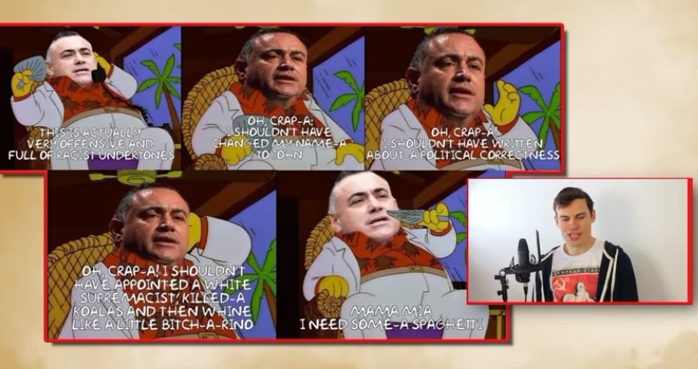
- The video then attacks the Premier on Mr Shanks’ koala killer theme, displaying a photoshopped image of Ms Berejiklian’s head looking at the superimposed heads of Mr Barilaro next to Mr Shanks. Mr Shanks reads the caption “I’m seeing double here, four wogs!” and then reads typed quotes in a parodied Italian accent from Mr Barilaro that appear on screen in which he denounced Mr Shanks’ racism and offensive conduct.
- At the end of the video, Mr Shanks tells viewers that Friendlyjordies has printed a second set of limited edition Super Barilaro Bruz tee-shirts costing $40 and promotes their sale, before inviting them to share and comment on the video.
- As I will describe, Mr Shanks’ publications of the matters complained of and other YouTube videos criticising Mr Barilaro provoked thousands of abusive, denigratory statements in response to Mr Shanks’ usual sign off inviting comments from his viewers.

The bruz video
- The first of the matters complained of is the bruz video. I have attached a transcript of the bruz video annexed to the statement of claim as annexure A to these reasons. The words in italics in annexure A appear onscreen as the bruz video plays.
- However, the transcript does not convey the many skilful visual, aural and animated depictions that form part of the bruz video. The presentation, as with other videos that Mr Shanks and his “friendlyjordies” production house published that are in evidence, appears to be professionally produced. Mr Shanks speaks both eloquently and with numerous, apparently well mimicked voices and accents. No doubt his presentational scripting and writing skills, and those of the persons involved in these productions, have enabled him to build a very large online following. Each video asked the viewer to post comments, usually at its conclusion, and thousands did.
- At the commencement of the bruz video, par 3 attributes Mr Barilaro’s denunciation of Mr Shanks’ earlier “racist behaviour” towards Ms Berejiklian to a report by News Corporation, the publisher of The Daily Telegraph. Mr Shanks then portrays Mr Barilaro as a parody or meme of the well-known Nintendo video game characters, the Mario Bros or Super Mario Bros, Mario and his brother, Luigi. Mr Shanks mocks Mr Barilaro before telling the viewer, as he is lying in a bath with a cigar in his hand, that “we’re not here to talk about my big fat wog cock, we’re here to talk about another big fat wog cock” and then the word “bruz” appears on the screen (pars 11, 12). Mr Shanks then uses an Italian accent to imitate the statements made by a photoshopped head of Mr Barilaro atop a The Simpsons cartoon body to mock him before telling viewers (pars 13–16) “Bruzamia! He’s a conman to the core, powered by spaghetti”. Mr Shanks then tells viewers that he intends to upset Mr Barilaro by referring to him as “Giovanni” and relapses into the parodied Italian accent to mock Mr Barilaro before calling him (par 24) “you ball of grease”.
- Next, Mr Shanks criticises Mr Barilaro’s absence in London on holiday during the late 2019 bushfires before using a photoshopped image of Mr Barilaro’s head on a depiction of a man next to a lyre as an adjacent city burns below him, saying “Looks like the Julio-Claudians weren’t wiped out after all”. The allusion is to the Emperor Nero fiddling while Rome burns (par 39).
- Mr Shanks then tells the viewers that he is now focussed on “water theft” and displays a screen shot of the headline “Barilaro’s backing of Federal Murray-Darling Basin royal commission muddies waters” (emphasis added) and the first two paragraphs of an article that appeared in The Sydney Morning Herald on 31 January 2019. The screenshot remained visible for only four seconds (pars 42–52).
- Next, there appears a screenshot of a post made on 8 August 2019 by the Shooters and Fishers Party. The post quotes that party’s Helen Dalton MP, condemning what she terms as Mr Barilaro’s “rank hypocrisy”. In a feat of twisted (il)logic, Mr Shanks tells the viewer “seriously though, I think he’s corrupt” because he did not vote to support a royal commission. This segment (pars 42–52) clearly conveyed imputation 9(e).
- Then, the bruz video presents the viewer with a screenshot of the tweet that Mr Barilaro sent Ms Dalton, 8 months earlier on 4 May 2020. Again, this tweet appears for about three seconds (at pars 47–49). Mr Shanks presents the tweet as if it were a direct response to Ms Dalton’s statement made 8 months earlier, before telling the viewers (par 50) “I told you he was a dumb fuck. It was like a caveman wrote that tweet” before reading it in a parodied Italian accent.
- The video then presents a screen shot with a headline from The Northern Daily Leader published on 25 May 2020 about Mr Barilaro defending allegations that he and the former Arts Minister had used favouritism to allocate regional cultural funds being “pork-barrelling” before quoting Mr Barilaro responding to the criticism “when we do, its pork-barrelling. Well my name is John Barilaro. Call me Pork-Barilaro and I have no apology, because at the end of the day I will stand up and fight for our communities” (yellow highlight in original video). Mr Shanks asserts that “he wears his corruption as a badge of honour”.
- Then, the bruz video compares Mr Barilaro with the Mario Bros game, juxtaposed with his Italian heritage, images of the game, him and other persons eating spaghetti by the mouth from plates with hands behind their backs in a spaghetti eating competition with a superimposed Super Mario cap. The screenshot below refers to Mr Barilaro’s June 2020 criticism of Mr Shanks’ racist comments:
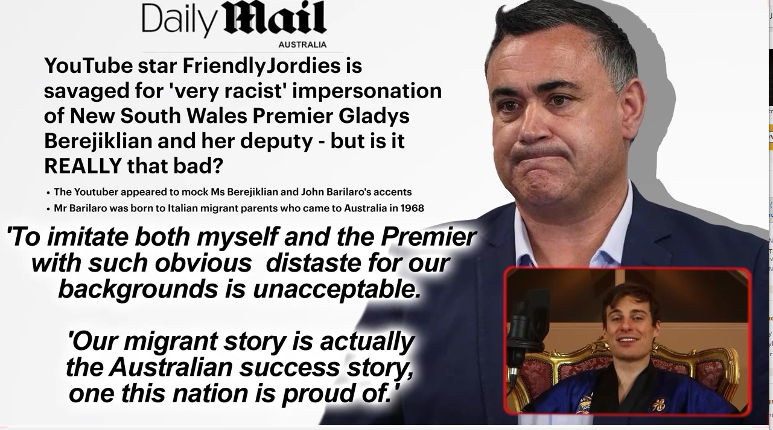
- Mr Shanks tells the viewer that this is the Deputy Premier adding disparagingly “Oh fuck, that’s tasty. Migrant success story! Obviously he’s trying to spin his pork-barrelling as John Barilaro AKA Greasy Ned Kelly” (emphasis added) captioned with a photoshopped image of him with Ned Kelly’s metal helmet (pars 56–61). The epithet “greasy” was racist.
- However, the viewer would not have been able to see detail of the two screenshots dealing with the royal commission issue and relate them to Mr Shanks’ unfounded assertions that Mr Barilaro acted corruptly or broke a promise. First, there was no indication in the bruz video of what could be categorised as “corrupt” in this episode and, secondly, the newspaper screenshot stated that Mr Barilaro supported a federal, not a State, royal commission.
- The bruz video proceeds to discuss the approval process under the New South Wales Government’s Go Equity Fund in respect of two investments, Australia’s Oyster Coast (par 70) and Stone Axe Pastoral, a wagyu beef company (par 80). Mr Shanks described Mr Barilaro as “a man who looks like a Mafia don” and parodies his voice again with an adaptation of the invitation to viewers to post comments that usually appears at the end of his videos, namely 2 photoshopped images of the heads of television presenter, David Koch, as a turtle and President of the United States of America, George W Bush, riding a horse. The adaption here was to superimpose, on the horse rider, Mr Barilaro’s head wearing a Mario Bros baseball cap. Mr Shanks then states what formed the basis for imputations 9(b) and (c) accompanied by several screenshots (pars 74–78):
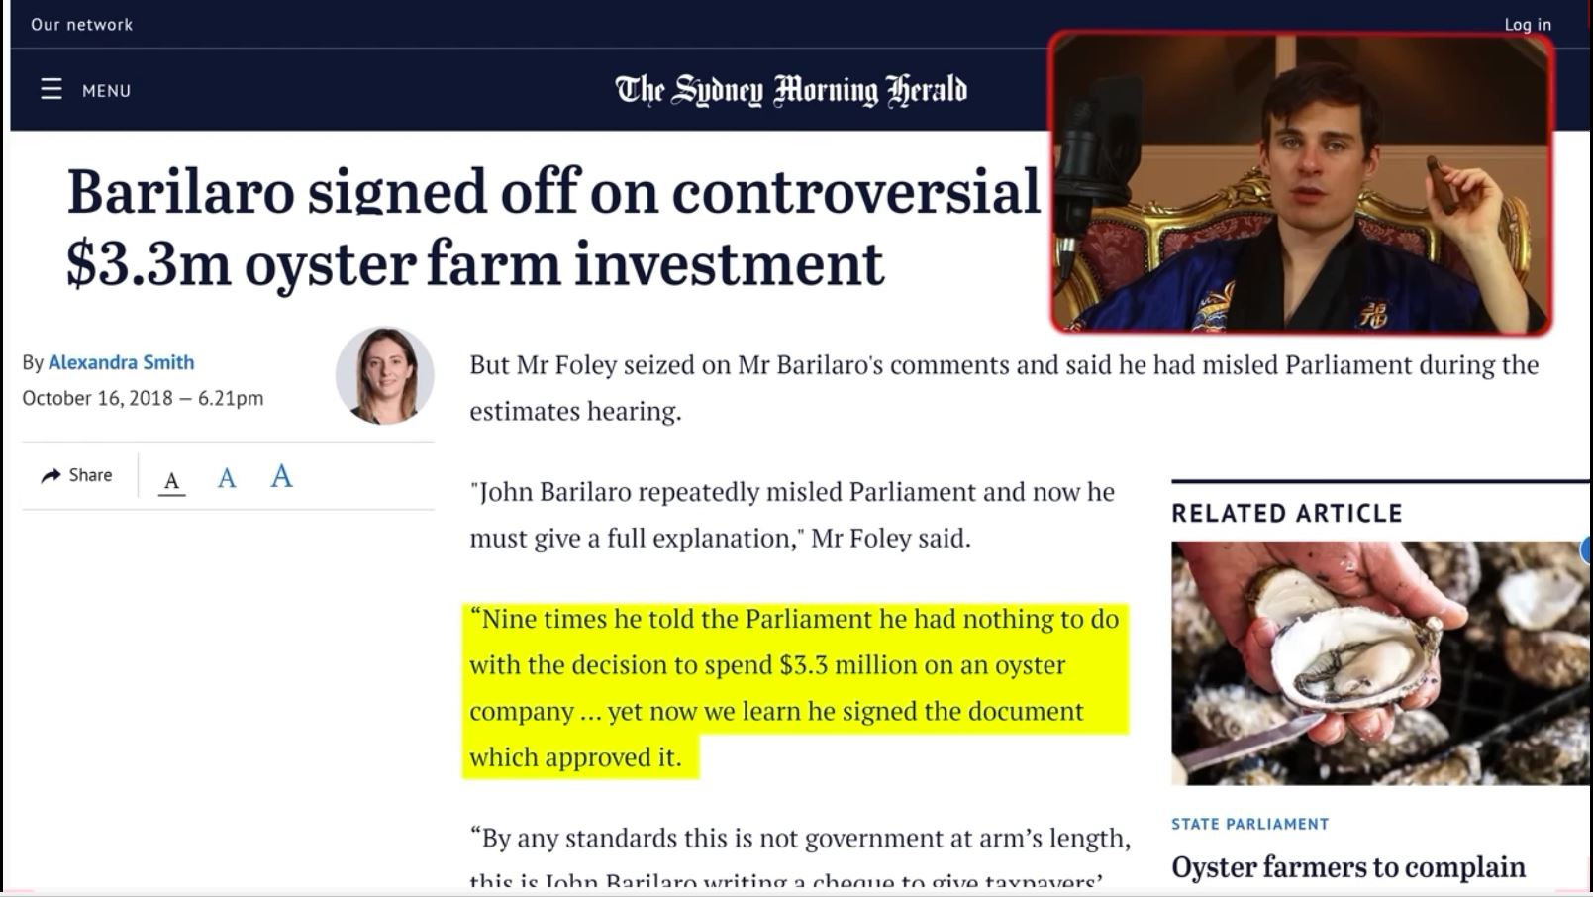
- When Mr Shanks tells viewers “I think you can see where this is going” a screenshot of part of an article published on 16 October 2018 in The Sydney Morning Herald appears for three seconds followed by a screenshot lasting five seconds of a part of a Ministerial Briefing Paper by Jobs for NSW to invest over $3.3 million in Australia’s Oyster Coast that Mr Barilaro signed as Deputy Premier on 5 April 2018. Earlier, there is a brief depiction of part of a press release made on 17 October 2017 entitled “Go NSW Equity Fund to invest in high growth companies”. It stated that the fund was “to buy a stake in companies with potential to create new jobs in NSW”.
- The full article in The Sydney Morning Herald recounted that Mr Barilaro had told question time that the investment decisions were endorsed by the independent board of Jobs for NSW but he had no role in the decision-making process. “Then they come to me for sign-off on the final decision”. The article said that this was in answer to the excerpt of the accusation by the then-leader of the Opposition, Luke Foley MP, that earlier, Mr Barilaro had misled an estimates committee of Parliament. The screenshot highlighted Mr Foley’s statement “Nine times he told the Parliament that he had nothing to do with the decision to spend $3.3 million on an oyster company… yet now we learn he sighted the document which approved it”. The screen shot of that document showed:
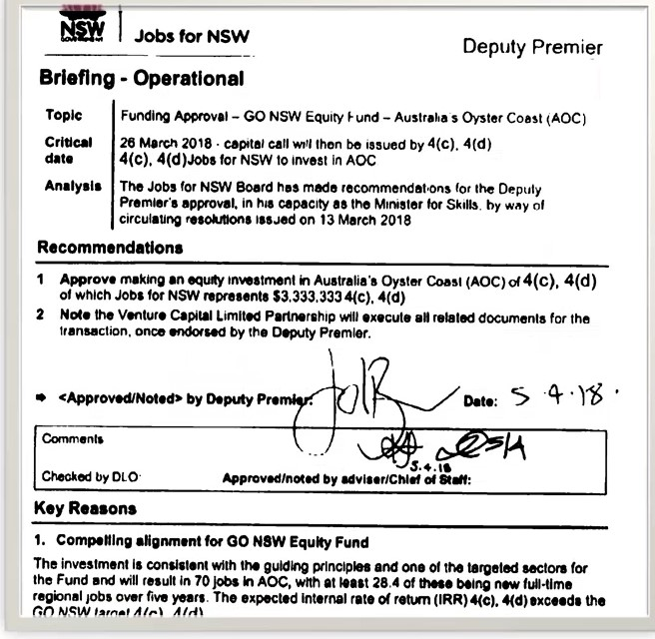
- The bruz video then gave a description of what it claimed was the decision to invest in the beef company in which the private equity fund, ROC Partners, had advised the CEO of the Equity Fund to make despite ROC Partners having a majority interest in Stone Axe Pastoral (in pars 79–81) as follows:
Then get ready for the second whammy that makes your mum say, oh no, that’s horrible. Because also $3.3 million was given to a beef company that just 10 months earlier ROC Partners bought a majority “stake” in. Ha. Do you get it? No?
Okay, let me make this as simple as possible. ROC Partners advised that the NSW Government give your money to ROC Partners. When Labor found about this they tried to force Giovanni to refer the deals to the Independent Pricing and Regulatory Tribunal but would obviously find what you would assume on hearing that, that that is blatant corruption and, wouldn’t you guess, Giovanni says what he says whenever someone makes a plausible accusation of corruption perpetrated by him.
[IN PARODIED ITALIAN ACCENT]: Fuck off.
- This voice-over rehearsed what appeared in the accompanying screenshot of part of an Australian Broadcasting Corporation (ABC) news post made on 4 September 2018.
- Mr Shanks omitted any reference to the ABC post’s statements that Mr Barilaro had told the budget estimates that ROC Partners had disclosed its interest to the board of Jobs for NSW when it considered the proposal and that its decision was that of an expert at arm’s length from the Government. Despite this, Mr Shanks told viewers that the approval was “blatant corruption”.
- Significantly, all the screenshots of media reports to which I have referred were of articles that were accessible by a Google search and the full documents were in evidence. Since Mr Shanks’ reporting of those matters made no reference to Mr Barilaro’s published responses or any part of his side responding to the accusations, no defence of qualified privilege under s 30 of the Defamation Act or under the implied freedom in accordance with what Brennan CJ, Dawson, Toohey, Gaudron, McHugh, Gummow and Kirby JJ held in Lange v Australian Broadcasting Corporation (1997) 189 CLR 520 at 571: see Barilaro (No 2) 393 ALR 417 at 430 [37]. That is because of the conduct of a publisher, such as Google, in publishing the bruz video could not be reasonable in the circumstances since it omitted any reference to Mr Barilaro’s known responses and it made no enquiry of him as to his response.
- Later, in par 95, in discussing the apparently disproportionate allocation of grants to Coalition Government members’ seats including his own, Mr Shanks says of Mr Barilaro:
Not to draw attention to his Italian heritage, because I know he hates that, but that’s a spicy meatball, in fact, he looks a bit like a meatball doesn’t he”.
(emphasis added)
- Mr Shanks adds in a parodied Italian accent “Five star pork mince, stooge”.
- Then, in discussing Mr Barilaro’s decision to promote the Kosciuszko Wild Horse Heritage Bill 2018 (NSW), Mr Shanks says of Mr Barilaro at par 103:
Scientists and National Parks proposed a cull. Giovanni, the greasy little scrotum, refused.
(emphasis added)
- Mr Shanks later engages in further mockery of Mr Barilaro’s and Ms Berejiklian’s heritages (at par 111).
- Next, the bruz video discusses the Dungowan Estate. Mr Shanks sought to question Mr Barilaro’s ability to afford the property by alluding only to what he could earn in his public office. Mr Shanks, falsely, suggested that Mr Barilaro’s ownership was evidence of some corrupt conduct linked to his Italian heritage (at pars 115–131). She also stayed there with their daughter.
- Mr Shanks then tells viewers that Mr Barilaro intervened in the legislative process to regulate holiday accommodation suppliers such as Airbnb and Stayz. A screenshot of part of an article in The Sydney Morning Herald of 24 November 2016 appears for about four seconds with the headline “Deputy Premier John Barilaro under fire over undeclared Airbnb business”. The screenshot recorded that Mr and Mrs Barilaro had “been hiring out a palatial $2 million holiday home” on those platforms “for thousands of dollars a night”. The screenshot also stated (but Mr Shanks did not) that Mr Barilaro had declared his ownership of the Dungowan Estate to Parliament for the previous two years. The screenshot stated that Mr Barilaro only had declared the business use by an amendment to his register of interests on the preceding Wednesday, after Fairfax Media (the newspaper’s publisher) had raised an issue about it.
- Mr Shanks accuses Mr Barilaro of having an undisclosed conflict of interest in the drafting of laws regulating Airbnb. In part of the article in The Sydney Morning Herald, that Mr Shanks neither displayed nor read out, the reader was told that a government report published the previous month had looked at regulating the online accommodation platforms. The article reported that Mr Barilaro had not been involved in that inquiry and that if the Government were to consider a response he would raise any likely conflict in Cabinet. The article stated that Parliamentary rules required members to disclose any additional income, including from a partnership, such as the business Mr and Mrs Barilaro ran. The business had registered the Dungowan Estate website on 20 June 2014 with an Australian Business Number. The article reported that Mr Barilaro’s spokesman had said that because the partnership had made a loss in the return periods, the partners had interpreted the rules as not requiring any declaration but that, in the interests of full disclosure, Mr Barilaro had then lodged a “discretionary return”. Again, this article was available on a Google search.
- The bruz video continues with Mr Shanks saying:
[119] They actually argued that, as well as, [IN PARODIED ITALIAN ACCENT]: “Bruz, what possible conflict of interest is there in me owning an extremely expensive property that I just admitted I want to maximise the value on as quickly as possible.”
[120] He’s declaring his conflict of interest in his own argument as to why he doesn’t have a conflict of interest.
[121] What repercussions were there for this blatant display of corruption and regulatory tailoring made to fit John Barilaro’s very specific waist? Nothing. Still do the job, still got to shape the laws, just another chapter in a long, distinguished career of rorting the system as much as he possibly can for the benefit of no one but la famiglia. His view of governing exactly what it was in ancient Rome. No vision for improving the state, no skills to govern, just a fat, decadent conman that by the grace of the gods was put in his position to ransack the Empire for all its worth.
[122] And yet he’s offended by being portrayed as an Italian stereotype.
[123] Well Giovanni, if you find that comparison deeply offensive, same offer as to all your other discrepancies, show me the evidence that you’re not a stereotype. I’ll stop. Show me how a man on a state minister’s salary could afford an estate, as not even your first house, your second house; a second house that’s so big it has a second and third house on it, like Mars’ two moons that just got attracted into its gravitational pull.
(emphasis added)
- The pun on “la famiglia” was a crude reference to the Italian Mafia. As Mr Shanks says on screen “And yet he’s offended by being portrayed as an Italian stereotype”, The Daily Mail extracts from 22 June 2020 again appear on screen (see [41] above).
- Mr Shanks continues in the bruz video to allege that Mr Barilaro “ostensibly afforded on a public servant’s salary” the acquisition of the Dungowan Estate (par 127), before accusing him of having shaped the laws to justify an extortionate cleaning charge of $750, about which he assures viewers, while breaking a glass bottle there, “I’ll make sure I get my money’s worth” (par 129-130). Mr Shanks then takes viewers on a tour of the property placing “some Super Mario Brothers paraphernalia around the house at points that really tick us off”.
- Mr Shanks invites viewers to “make sure you press ‘like’, subscribe and chuck us a couple of bucks”. He mocks the coffee provided in the pantry of Dungowan Estate as “AbruzzoExpressis” placing a Mario doll inside the packet.
- Mr Shanks tells viewers to use a handle “#SuperBarilaroBruz” and to buy a Super Barilaro Bruz shirt from the friendlyjordies website. He then does various stunts with a large Mario doll including as he describes (in par 145):
And finally, we’re going to put the Big Mario in the big bed, purely because I’m imagining that Super Barilaro bruz, will wake up one morning only to discover…
- This occurs with the camera panning over a double bed with the sheets covering occupants as Mr Shanks lifts the bed covers to parody the well-known scene from the movie “The Godfather” in which a horse trainer awakes to find his prize horse’s severed and bloody head in the bed next to him. Mr Shanks screams as he “discovers” that the big Mario doll is in the bed with him.

Mr Barilaro’s reaction to the bruz video
- Mr Barilaro said that he was aware that Mr Shanks had engaged in commentary on his calling out of the racism in earlier videos. Mr Barilaro said that he learnt of the bruz video when his staff asked whether he had seen it. He obtained the link and watched it. He said that he “realised it was a… disgusting video in retribution”. He testified that his reaction then and when it was played in the hearing was that “It’s just raw, it’s disgusting, it’s vile… It was complete racism. The accents … the terms that he used … and the total violation of my privacy”. Mr Barilaro’s concern about the violation of his privacy was because of the use of the Dungowan Estate house which was not only used in his wife’s running of the Airbnb business but also as the second home for his family.
- Mr Barilaro accepted that, as a politician, he was open to public scrutiny for his public conduct and policy stances. He noted that, ordinarily, when the media wanted to make “a story on you, they will put to you questions, they will put… issues, they will put to you an opportunity to respond”, but the bruz video “came out of nowhere”. Mr Barilaro was deeply hurt by that publication and broke down watching it in Court the day before he gave evidence and did so again in the witness box. He gave this testimony which evinced the emotional scar that he experienced:
that was just a vile attack on me using racism and claims of corruption … I would assume he thought it was funny, but it wasn’t. And, to this day, … I just can’t let it go; I’m traumatised by it; have always been. And I know, you know, people say, “You’re a politician; you’re used to this stuff”, but you’re used to the banter in the bear pit. You’re used to the banter. You get questioned by the media, you get a fair run, and, often, there’s two sides to the story. They… write the response, but not … with Friendlyjordies. This was clear it was retribution because I had the guts to call out racism, and ... that’s all to it; that’s ... at the heart of this.
(emphasis added)
- Mr Barilaro’s expression “the bear pit” is a well-known epithet for the chamber of the Legislative Assembly of New South Wales.
- Mr Barilaro realised as he watched the bruz video that Mr Shanks’ references to news media and other material in it “clearly don’t justify the attacks”. He said, and I find, that there has been no formal allegation of corruption made against him. He testified that although he and his officers had submitted all their documents in relation to the perjury allegations “nothing came from it”. He was hurt because Mr Shanks “picked the headline and not the content” of news media publications and amassed “an online community to believe the garbage that I was a conman or corrupt, that I perjured myself … and did it through racism”. And, he found very offensive the Mafia undertone in the mock bedroom scene based on The Godfather, connected to his Calabrian heritage, which he also saw as a threat. He felt the unfairness of Mr Shanks’ false accusation in the context where, unlike the mainstream media, who ask the person accused of wrong doing for his or her version, Mr Shanks “was judge and jury; he just declared I was corrupt and he used those videos for that purpose. But it was all in retribution because I called him out”. Mr Barilaro felt disgusted by the allegations saying “I didn’t get into politics to be corrupt.” He said that he had spent the previous 20 years in securing his financial position through his success in business before entering public life. He said that “you get called names in politics, but no one has had the guts to call you [scil: me] corrupt or a conman… I think it was the… start of breaking me”.
- Mr Barilaro was particularly hurt by the bruz video deprecating his Italian heritage by the use of the slurs “fat wog cock”, the word “bruz”, the Mario materials and the implication of Mafia connection with his Calabrian background. He understood the epithet “greasy” to refer to his ethnicity because, as he said:
Grease-ball, or being a greasy wog. I mean, they were terms that I grew up with, so he knew exactly what he was saying. So if you’re called a meatball or a greasy scrotum or anything like that, … that was just racist. But there was an undertone of also criminality or, you know, again defaming… but, I mean, just have a look at the way he used the word wog. I grew up with the word wog; wog and dago. You know, I used to go to school when I was in primary school and could start the morning in a punch-up because I was a wog. Now, I can recall those days where there was even a week of it. Every morning, go to school, end up at the back oval and going you end up in a fight for 30 minutes before school because you were a wog. It was the only reason that you had a fight. And so anyone that wants to use the word wog and believes it doesn’t offend, wogs was not used as a term of endearment; it was actually to offend. I grew up with that. And if you’re a comedian in a comedic show or you can take the mickey out of yourself and I don’t mind taking the mickey out of myself every so often as well, but this wasn’t. This was vile. This wasn’t comedy. It was vile. It was to attack me, to offend me. I think in these videos he also admits how upset I get from being called these names and my heritage. You know, he refers to that I’m embarrassed of my heritage because I’m called John. Well, you know, John was just the name at school. You know, I use the name Giovanni where I can. And the term wog I mean, this is I know I’m not you know, this is the part I get really angry with Google, because they talk they’re this corporate citizen that talks about minority groups and they look after all of them, but they can’t even accept that wog is a term that is so offensive for migrant Australians, and it’s offensive. I make it absolutely clear: it’s bloody offensive, and the way Jordan Shanks used it, it was vile, not just offensive.
(emphasis added)
- Mr Barilaro correctly described the deeply offensive nature and unacceptable use of the term “wog” in Australia today. Migrants from Southern Europe and their children who were of Mr Barilaro’s and his parents’ generations were, as he said, called “wogs” and “dagos” to signify abuse or denigration.
- Mr Barilaro said that some nationalities used the word “bruz” as a term of endearment but that was not the sense in which he understood Mr Shanks to use it. He said that it became a tagline for Mr Shanks’ campaign against him.
- Jeffrey McCormack had known Mr Barilaro for over 10 years. He was formerly Mr Barilaro’s deputy chief of staff. He gave evidence that Mr Barilaro was very challenged, physically and emotionally, by the videos, as were a number of the other members of his staff. He said that the toll that the bruz video took on his boss became very apparent and that Mr Barilaro was considering self-harm and discussing resignation from his office because he thought that the video “had gone beyond the pale of the offence that it had caused to him and his family”.
- Mr McCormack gave this evidence about the impact of the bruz video on Mr Barilaro:
Yes. I think that the bruz video and the fact that it had gone into a residence that his family so while it was a business, it was also the primary residence of his young daughter and wife, and the safety concern and the being away from the family you know, the perception that there could have been cameras placed in the building; all of the things that were alluded to in the commentary of the video created a deep unease around safety, and the comments that were made in the bruz video led to a lot of commentary locally and within colleagues within the Parliament questioning as to whether, you know, the comments were true and whether the statements were true, and I think that was one of the things that probably placed that toll on John for the bruz video.
(emphasis added)
- The Hon Bronwyn (Bronnie) Taylor MLC, who was as the time of the trial Minister for Regional Youth, Minister for Mental Health, Minister for Workers and Deputy Leader of the Parliamentary New South Wales National Party, also gave evidence of the significant impact that the bruz video had on Mr Barilaro. She spoke to him about it and observed his demeanour and mood to be “terrible; sad; violated; wounded. It was a really terrible time for him and for those of us who had a genuine concern for him… I will never forget that time and what that did to him and how it really changed the person that he was”. He told her that he had had enough and was cut to the core because of the racism and the significance that his Italian heritage had for him in his life. He said to her, “I thought this was over in the country that we live in today. I didn’t think that this could happen anymore.” He also told her of his thoughts about self-harm and how he might accomplish that outcome, which she found of special concern, because of her background as a clinical nurse consultant.
- On Friday, 18 September 2020, Mr Barilaro announced that he was taking four weeks mental health leave, which received wide publicity. Soon after the bruz video appeared tweets and Facebook messages on the friendlyjordies home page such as those below appeared:
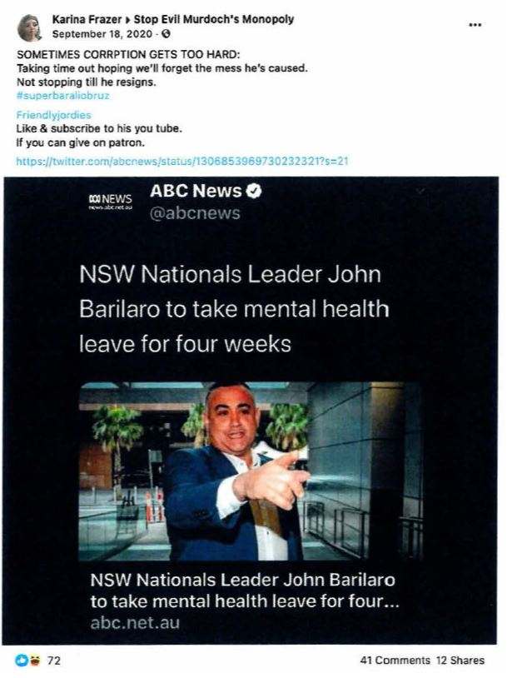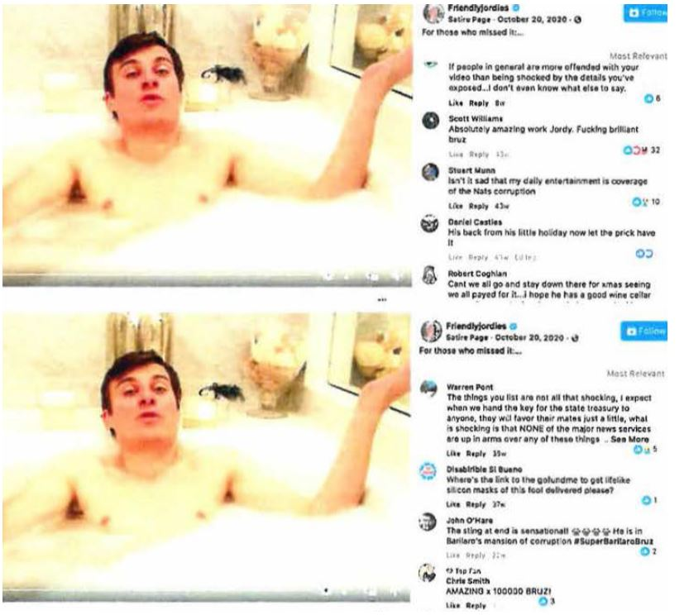

- On 4 October 2020, Mr Shanks tweeted the following tweet in response to commentary on the bruz video by the well-known journalist Emma Alberici, that is indicative of his deliberate racism:
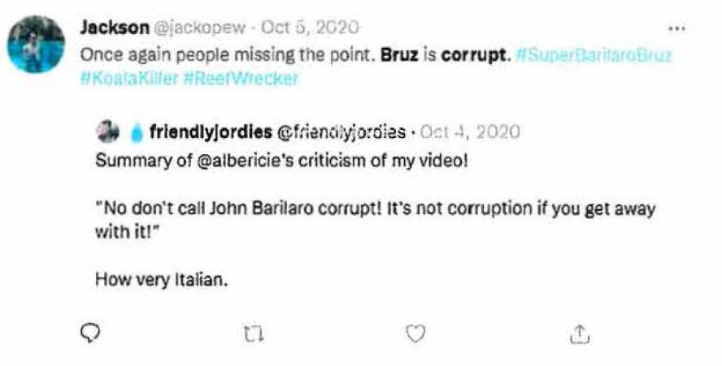
- The statement “How very Italian” was patently racist. Although Google may not have been aware of this tweet before Mr Barilaro gave discovery in this proceeding on 19 November 2021, it has been aware of it since about that time in combination with the content of the balance of his discovery and videos that I describe in these reasons.

The bruzboard video
- On 20 October 2020, Mr Shanks uploaded to YouTube a video entitled bruzboard. His opening line, delivered with a picture of Mr Barilaro onscreen is “Bruz, welcome back you fat little meatball”. Mr Shanks mocks Mr Barilaro’s “mental health sick month”, asks “You good? You all refreshed? That’s great. Anyway, here’s a fresh allegation of you doing illegal shit”. Next, Mr Shanks foreshadows that there is “an upcoming video about National’s corruption”, being a reference to the next day’s publication of the Secret Dictatorship video. He tells his viewers that “It’s going to be an hour long, depending on how much we have to butcher out of it for legal reasons. The point is we are not letting John Barilaro get away with any of his shady dealings. If you have any knowledge of it [sic] I want you to drop me a link via my… email” (the address of which appears on screen) (emphasis added). Later, Mr Shanks tells the viewers that “we’ve been informed by an anonymous source who started the email with ‘As you’re well aware John Barilaro has a penchant for ‘dumb little annoying crimes’’ nice little references to bruz”.
- Mr Shanks shows viewers the fence of a country property with corflute election signs that display Mr Barilaro’s photo and name. Mr Shanks asserts that Mr Barilaro has posted those signs on the fence for the past two State elections in contravention of State electoral laws. That was because, Mr Shanks tells viewers, a politician is not allowed to receive from a property developer any monetary or non-monetary gift or provision of a service at no, or a discounted, charge. Mr Shanks states the land is owned by a developer which later got a favourable development approval for it. Mr Shanks tells viewers “You know what that means? Unless he’s bought or leased the land, he’s broken the law [any law] Ok… How’s that in substitution for a welcome back gift basket, John? Here you go, Brand new allegation of illegal activity, Slap!” Soon after, Mr Shanks tells viewers, “Look, the point is, John Barilaro fucked up. In fact, not only has he fucked up… he’s currently f…ing up in the process of the last 8 years of a continued f… up”. He invites viewers to use Google maps to see the corflute signs still being displayed.
- He compares Mr Barilaro to disgraced United States President Richard Nixon, whom he tells viewers was known as “Tricky Dick”. “Vote for me, vote for me”, Mr Shanks says to his viewers using his parodied Italian accent as he tells viewers that the signs are still there and calls the fence “the Bruzlin wall”. Mr Shanks gleefully states:
I really don’t think he can use the defence [at which point Mr Barilaro’s photo appears on screen and Mr Shanks says in the parodied Italian accent]. “Bruz, how was I supposed to know about this shit? It’s just minutes away from my house on a major road. Dozens and dozens of pictures of myself. You can blink and miss that shit”.
- He invites viewers to view the corflute signs on the fence if they have not already and also uses the parodied Italian accent at more than one point in the video.

The Secret Dictatorship video
- The second matter complained of is the Secret Dictatorship video that first appeared on YouTube on 21 October 2020, being the day on which Mr Barilaro returned to his duties after taking one month’s mental health leave. It has a run time of about 40 minutes and relates to Narrandera, in the Riverina area in southern New South Wales. Mr Shanks opens this video saying:
[3] One day we put out a call on Twitter for dirt on John Barilaro. Our friend Stuart said come on down to the town I live in, it’s a Nationals stronghold so many people have had their lives ruined by that party, I’ll line you up with a bunch of interviews.
[4] So we went down to that little town in the Riverina. We were looking for maybe a handful of dirt but, Jesus Christ, we got a wheelbarrow of National Party corruption dirt shovelled right in our mouths.
[5] And seeing as it’s John Barilaro’s first day back, it’s time to shovel that dirt right on the top of John Barilaro’s virtually buried career.
(emphasis added)
- The video then presents a list of grievances that Mr Shanks discusses with a couple and their friends who claimed that their land was affected by sewerage that their neighbour allegedly pumped onto their land from the local treatment works run by the Narrandera Council. They claim that the Council and Environmental Protection Authority failed to act due to, among other causes, the Council allegedly providing the Authority with falsified and selectively edited documents.
- Mr Shanks’ informants assert that they have been subjected to police harassment (at par 48). Mr Shanks endorses this, saying that his producer, Kristo Langker, had been breath and drug tested by the police, who had been “tipped off” that he was coming to Narrandera.
- Mr Shanks tells viewers:
[70] It seems the man who poisoned [the couple’s] land is good friends with many councillors, past and present, as when even the EPA pointed out that Judy Charlton had selectively edited government documents in order to skew the Council vote to then Mayor, Neville Kschenka, he refused to do anything about it. Anyway, off topic. Here’s a picture of [the neighbour] and Mayor Kschenka having a nice time together. In fact, Mayor Kschenka is friends with a lot of important people. Here’s a picture of him receiving a grant with State Nationals MP, Steph Cooke. Here is with Federal Environment Minister, Sussan Ley, and Steph Cooke. And here he is with Bruz.
(emphasis added)
- The Secret Dictatorship video then discusses issues about whether the Council has dealt properly with Government grants that it has received and raises several allegations of misuse. Mr Barilaro is not named in this part of the video. To make his point Mr Shanks asserts (par 117):
You might be thinking stealing grants is just a mere case of larceny but, in fact, the Nationals and Narrandera Council’s misuse of grant money seems to be directly responsible for some of the worst environmental catastrophes in living memory.
- Mr Shanks then instances a blue-green algae bloom in the video. He states that it had been released from the Council’s sewerage works into the Murrumbidgee River causing it to be polluted. Mr Shanks’ principal informant, the husband in the couple, asserts that another Council’s waste is also polluting the river. Mr Shanks summarises his thesis (par 153):
So in your opinion, fish kills are a direct result of a bunch of local councils controlled by the Nationals that are skimming as much of the sewerage treatment grants off the top as they possibly can. So they’re obviously using the cheapest way possible to get rid of the sewerage and that was the result of the fish kills.
- He continues discussing pollution of the local water system and its impacts on wetlands. Next, the discussion turns to the 2017 by-election for Cootamundra at which the Nationals’ party candidate, Steph Cooke, was elected.
- Imputations 15(a) and 15(b) are respectively that Mr Barilaro has acted corruptly by engaging in the blackmailing of councillors and that Mr Barilaro has acted corruptly by engaging in the blackmailing of councillors using taxpayer money. The subject matter for imputations 15(a) and 15(b) appears to be pars 198–225 of the Secret Dictatorship video transcript. There, Mr Barilaro is alleged to have supported Ms Cooke’s campaign and promised to fund a feasibility study about the possible reestablishment of a disused rail line between Narrandera and Tocumwal. The Secret Dictatorship video asserts that after the Government received the report of the study, Mr Barilaro did not release it publicly but said that it was confidential.
- Mr Shanks tells his audience that, immediately after a local councillor, Wes Hall, had accused the Government of hiding the report, Mr Hall was “fired from his role as the rail spokesperson” by the mayor, Neville Kschenka. Mr Shanks interviews Ms Dalton MP who says that Mr Hall was “sacked from that committee because he asked a question”. He puts to Ms Dalton “you can assume that for the very fact that they’re not releasing this, that there is not a good answer. Otherwise they would release it, if it supported their argument”. He and she speculate on why this has not occurred. After that interview, Mr Shanks tells his audience that he has a letter from the mayor to Mr Hall which he then appears to begin summarising. He tells the viewers that the mayor wrote that Ms Cooke had told him of Mr Hall’s interviews and the questions he was raising. He went on (at Secret Dictatorship pars 221–225):
[221] What’s more interesting about this is I have a letter from Neville [Kschenka] to Wes [Hall]. Oh, it says State Nationals MP Steph Cooke informed Neville of some polite interviews Wes undertook which Neville then told Wes were jeopardising Narrandera’s chances of getting grants from Deputy Premier John Barilaro and Steph Cooke. You know what’s super interesting about this letter, Callum Foote from Michael West Media put questions to Barilaro, Cooke and Kschenka and got zero responses.
[222] Furthermore, everyone we spoke to in Narrandera thinks Neville is a bit slow, almost slow enough to let someone else write the letters for him. I’m just going to read a section of this letter out in some voice I’ve done before. See what you think.
[223] [In voice previously attributed to John Barilaro]: I am extremely concerned at the impact your action is having on council’s relationship with the local member, the Minister and the Deputy Premier and with the government as a whole, noting that the Deputy Premier’s controls the Restart NSW Grant Programs, the “poles and wires” money and the money flowing from Snowy Hydro2.
[224] And on an unrelated note, did you know blackmail’s illegal? I wonder how illegal it is to use taxpayer money as blackmail to shut your critics up. If this is who I think it is, and I do think that, he’s such a scab he doesn’t even use his own money to blackmail.
[225] Is it a wonder John was so happy to shut down any chances of the Narrandera to Tocumwal rail line being built? After all, that would create jobs and economic stimulus, and from what’s been described to me, another role of the Nationals in Narrandera is to keep the town in a permanent economic depression.
(italics emphasis in original, bold emphasis added)
- Next, the Secret Dictatorship video turns to developing the new topic, being the husband’s suggestion that the supposed permanent economic recession is the result of the National Party wanting to drive young people from Narrandera so as to leave “mainly old people and they all vote Nationals” (par 234). Mr Shanks endorses this saying (pars 271–277):
[271] There’s a grand plan from the Nationals which is to rid this town of any youth voters, i.e. get rid of the young people in town, so there’s only oldies here, so that they vote in an election to get Michael McCormack, who is the leader of the Nationals federally, in power and maintain that his seat is safe, and the only way that they can do that is by making rural Australia so sparsely populated, destroying the economy mind you. By doing that, you are completely turning this place into like a special region depression zone. It’s just permanently in a depression and I mean [LAUGHS] look around you.
[272] You have to come here on a Saturday because that’s really when Narrandera goes off and boy howdy were they right. There actually is people in town today. This is all by design and, look, I’m not the biggest fan of McDonalds, I’m a huge fan of KFC though, so I’m pretty fucking angry about that, but they didn’t let in any, any - this is a fairly big town - any McDonalds, any KFC. Obviously those things are going to do amazingly in a country town because until I came here I thought that their diet was fried chicken and burgers.
[273] Where do they even get them here. So my point is, not letting in any investment at all. Why? Because they want people to fuck off, so they just have a safe seat with a tiny, tiny population of oldies that basically have dementia going oh, I’ve met Pat before, he’s got a nice handshake. It’s all... It starts here.
[274] The rot is here, they’re the ones that are enforcing this. They are systematically destroying the lives of anyone who speaks up about this, trying to drive them out of town or put them in jail or we’ve even heard cases of people going missing, and this is all part of the plan to keep the Nationals in power, which is pretty much what we were discussing on the way here. This is a secret dictatorship. Rural Australia has become a secret dictatorship. There’s no democracy here anymore. Maybe there wasn’t.
[275] This is the other thing. When we were talking to the people in there, there was debate — think about this — debate for people that are in their 40s and 50s as to whether the local Council has ever worked in the benefit of the local community. It’s always been to keep a couple of fucking cunts at the top, at the top, so that they can control Australia on a federal and state level and basically rape and pillage the environment for their own enrichment. This is the other thing that we learnt.
[276] People like John Barilaro might be worth hundreds of millions of dollars. All these people that you assume are getting $100,000, $200,000 a year for being a public servant, this is garner wage to them, they don’t care about it. It’s the same thing as what happens with Putin where he’s just like, “l am just President, yes I get a little bit more than the American President.” Yeah, on the books. Off the books he’s richer than fucking Bill Gates.
[277] We’re quite certain that this is what’s happening to these towns because you tell me where the money goes. Council has close to $50 million sitting around in its accounts. Where is it now? Where did that money go? Certainly not going here. [LAUGHS] Oh I don’t know, yeah, that must have cost about 30 bucks.
(emphasis added)
- Mr Shanks then interviews John Sullivan, a retired former mayor of Narrandera, federal member for Riverina and State member for the seat of Sturt. Mr Shanks tells viewers that Mr Sullivan was elected to the Federal Parliament in 1974 “by defeating Al Grassby with the help of preferences from the high profile mafia murder victim, Donald Mackay” (par 278). Mr Shanks asserts that “[i]f any one was going to know anything about State and local government corruption, it’d be Mr Sullivan ‘cause he served Narrandera on every level”. Progressing from this bizarre logic, Mr Shanks claims that Mr Sullivan has been trying to avoid an interview but he and his team secure one by turning up on his doorstep. Mr Sullivan obliges, but, unsurprisingly, does not confirm Mr Shanks’ preconceived conspiracy theory. As they leave Mr Sullivan’s premises, Mr Shanks and his companions in their vehicle assert that a mysterious vehicle followed them (pars 278–296). Mr Shanks tells viewers that he had heard of drug running in Narrandera but cannot discuss that issue to protect his sources (par 298) before concluding the video thus (pars 299–300):
[299] So in summary, if you want your town to be run by crooks who apparently commit blackmail, voter fraud, forgery, environmental destruction, police and other public service manipulation, steal grant money, poison your land and, on top of all of that, put your town in a permanent economic recession, I think I know the party for you, the National Party. If you don’t want any of that, maybe think about voting for your local Shooters and Fishers candidate next election.
[300] And since Bruz is back in Parliament, let’s start asking him if he’s ever used his position to blackmail councillors he doesn’t like. Perhaps we can even refer him to ICAC with his good old mate, Gladys. Either way, subscribe, like the video, ‘cause we’ve got plenty more information coming out on Bruz. See you next time.
(emphasis added)

Mr Barilaro’s reaction to the Secret Dictatorship video
- Mr Barilaro watched the Secret Dictatorship video shortly after it was first published. He had been told about it by his staff, members of the public and Ms Cooke MP. He felt “completely dumbfounded” and angry and thought that it was “a whole heap of crap”. He noted that the last 10 or 15 minutes attacked him and asserted that he or his party were driving Narrandera “into the ground so that old people remain, young people leave… they will vote for the party … that I was making millions of dollars of grant funding from councillors. Again, it was disgusting, but I was more worried about Steph Cooke.” He was upset and felt that “it’s never going to end with this guy. It’s just going to be video after video, story after story, claim after claim, and at the heart of it is always just an attack on me”. He described watching the Secret Dictatorship video as “an hour of my life I will never get back”. Mr Barilaro was upset that in the Secret Dictatorship video “there were no facts whatsoever to make any claim of corruption or blackmail as everything that he had said”.
- And, as Mr Barilaro said, every time that Mr Shanks uploaded a video, Mr Barilaro was attacked in the appended or related comments, on social media, websites and in phone calls. He said that every time a video was posted “it ramped up so hard and so harsh” and he was traumatised by the videos as well as accompanying reactions from the viewers. He thought that Mr Shanks was “very callous” in the Secret Dictatorship video because most people were aware that he had taken a month’s mental health leave (which Mr Shanks told his viewers about) and Mr Barilaro had lost his father that year and was struggling with other issues in his life. As he said, Mr Shanks waited to launch this new attack on him on his first day back at work and “hit me when I was most fragile”.
- Mr Barilaro testified, with some justification:
No sane person would watch that video and say, “This is credible”. I’ve got to say this. It’s just impossible that anyone would go, “This is credible”, but the reality is because what he does he twists and turns everything and he attacks you. I mean, the idea the comment there that people have gone missing. Of course he says that because I’m Italian. We’re talking about the Riverina. Griffith’s down the road. You know, my wife’s family is actually from Leeton, half an hour outside Narrandera. I mean, the reality here is that it’s all done deliberately in a way to attack your credibility, to defame you, and there’s always an undertone of something, and that’s at the heart of everything he does. And the video is the video; the comments are the comments. But the problem for me was it just sparks hatred.
(emphasis added)
- Mr Barilaro referred to Griffith’s association with people going missing, the Mafia’s murder of the anti-drug campaigner, Donald Mackay, there in 1977, and the television series “Underbelly” that was set there. Mr Barilaro was visibly upset when he added:
You know, often four or five, six thousand comments. That’s directly on the YouTube site. But what happens to our Facebook, our Insta, our private messages? You know, the messages that I got are disgusting messages, revolting messages:” Go kill yourself.” “ You should be dead. You’re corrupt. You’re a piece of shit. Your daughter should be tied to a pole and raped in front of you, and then we’ll kill you.” I mean, that’s the stuff that comes off the back of these videos, and so I hate Google. I’m sorry to say that today, the way I’m saying it, because if they can’t see these videos for what they are, well, then there’s something bloody wrong with corporate Australia or corporate America or corporations.
(emphasis added)
- As will appear, I agree with Mr Barilaro’s assessment of Google’s behaviour. He referred to the Facebook message below that was particularly vile:
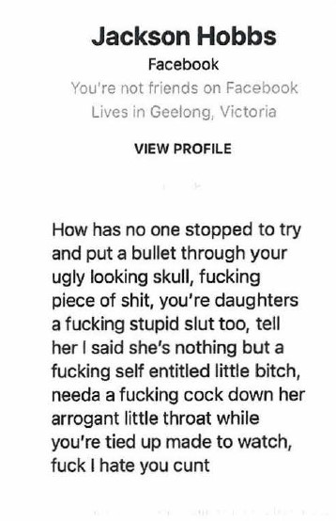
- Rory Cunningham, in his role as Mr Barilaro’s social media advisor, became aware of the bruz video soon after Mr Shanks uploaded it on 14 September 2020 because he noticed that “people were tagging John on Twitter and Facebook with links to that video”. The process of “tagging” involves a person posting, tweeting or messaging (depending on the social media platform) a statement such as “look at this video” with a [hyper]link to the video. Mr Cunningham had a similar experience when Mr Shanks uploaded the Secret Dictatorship video.
- Mr Cunningham said that there were a lot of social media comments about the two matters complained of “really just mirroring what was said in the videos: ‘John’s corrupt’; ‘changes legislation to help his corruption’; ‘wears his corruption as a badge of honour’”; as well as name-calling. Mr Barilaro’s social media accounts received thousands of messages in direct response to the matters complained of, so much so that Mr Cunningham eventually turned off Mr Barilaro’s Facebook inbox. Mr Cunningham said that he was up all night on several occasions hiding comments and deleting items from inboxes “because I knew that John was struggling sleeping at the time and I knew that he would see them”. He made a record of these comments before deleting them so that Mr Barilaro would not see them. That was because the two matters complained of probably “were worse than the others, but it was very stressful for John”. Mr Cunningham observed that Mr Barilaro was “very anxious about the videos” and the volume of social media comments that they had provoked, much of which Mr Cunningham said that he knew Mr Barilaro would see.
- Soon after the Secret Dictatorship video was uploaded onto YouTube tweets like those below appeared:
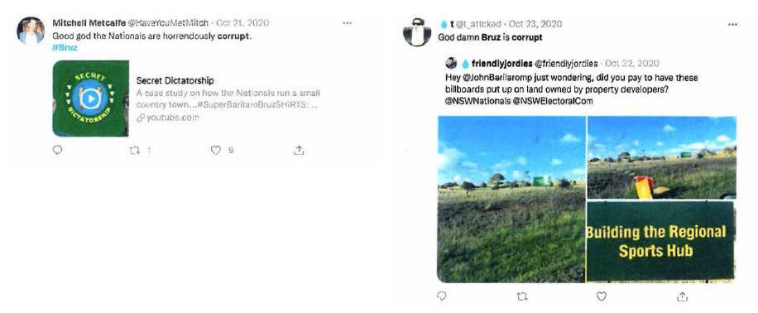
- The post on the left hand side “tagged” the Secret Dictatorship video because it enabled its readers to view the video directly.

The Super Barilaro Kart video
- On 23 October 2020, Mr Shanks uploaded a video entitled “Super Barilaro Kart”. This video begins with Mr Shanks impersonating Mr Barilaro, dressed in a Mario outfit and with a fake moustache driving his car. He is shown being approached by Mr Shanks, now dressed as a policeman, who stops the Mario character for talking on the phone while driving. Mr Shanks again uses the parodied Italian accent, making statements about looking for “bush tucker” which he then says is “ragu ravioli, just like mama used to make. The witchety grubs of Griffith”. Mr Shanks, as Mario, proceeds to try to bribe the policeman to not fine him. He says, using the accent, “As head of a conservative party I’m not a great fan of money going to the government so how about I just slip you some cash?... Come on, this always works in Monaro. We don’t even call it a bribe there … we just call it ‘the man from Snowy River’” while holding up to the camera Banjo Patterson’s depiction on the back of a $10 note. He complains that the fine “is like one fifth of a night at my Airbnb I can’t afford that shit”. Mr Shanks, still impersonating Mr Barilaro, then drives off and complains: “why is everyone picking on me just because I’m doing illegal shit?” The policeman pulls him over again and asks whether he knows why he has been stopped to which Mr Shanks replies:
Because you’re a racist and you have it in for the most persecuted people on earth, Italians, stooge.
- Soon after Mr Shanks, impersonating Mr Barilaro, offers a term of abuse, the policeman character tells him he has to fine him again for that and, Mr Shanks, as Mr Barilaro, complains in the parodied Italian accent “No this is bullshit … Only in Sydney bro. If I was back in my seat I’d say ‘officer my chicken is getting cold’, he’d escort me, and put the zinger right in my mouth, but here…” and he pretends to faint.
- This video is plainly racist in its depiction of Mr Barilaro.

The Italian Job video
- The Italian Job video was uploaded on 25 November 2020. Mr Shanks begins by saying:
Bruz, first off how are you? Second off I don’t think you’re going to be well after this because after releasing a week’s worth of dirt on you and going to your house and using your toilet … we’ve got something else that we assume added to you buying your big mansion. Ladies and gentlemen, I present to you [switching to the imitation Italian accent of Marlon Brando’s Don Corleone] “The Italian Job”.
- Mr Shanks continues narrating in that accent about the Barilaro family (with the obvious pun on “family” as a synonym for a Mafia family) connection to the Marco Polo Clubhouse in Queanbeyan, that he says “was going to require some … aggressive business tactics”. He says in his usual voice “Man, I feel good that we’ve established that you’re allowed to pay out Italians again” (emphasis added). He points to a map of the Adriatic, Italy and the Balkans saying “That’s where they’re from; that’s where I’m from … oh, oh ethnic immunity. Besides if anyone likes messing with Italians more than me it’s John Barilaro”. The video depicts a team of Italian soccer players and Mr Shanks accuses them of seeing how many fouls they can get away with by fake crying. Then, Mr Shanks uses his parodied Italian accent for Mr Barilaro, while displaying a screen shot of an article in The Sydney Morning Herald of 18 September 2020 headlined “NSW Deputy Premier John Barilaro takes a month of mental health leave” and says “and I took my lessons of fake crying into Parliament”. Mr Shanks says:
now I know what you’re wondering. It’s hard enough to steal a Twix [a chocolate bar] from Coles; how do you steal a building? You can’t even fit that in a backpack. They found a way. And believe me it would be a lot easier if they just built a building in the first place [switching to the Marlon Brando accent] but Calabrian habits die hard.
(emphasis added)
- The next segment takes about 34 seconds. A screen shot briefly appears of an Italian flag with the words “The Plan” superimposed on it and in small print at the foot “This is a just a theory based on documents we’ve discovered, the following contains exaggeration for comedic effect”.
- Mr Shanks then says:
First up, assemble a crack team of wogs. [A screen shot of a man’s face appears] “John’s dad, Domenic Barilaro; aka “The Don”, the brains, the cash, the leader of the operation. Francesco Barilaro… John’s mysterious brother; skills … er he’s Italian; next, you know him, baby brown eyes, Giovanni Dominico Barilaro; aka Super Barilaro bruz; aka fat Italian meatball; aka stupid fat idiot; or in this operation as he’s known, the muscle.
(emphasis added)
- At this point Mr Shanks uses his parodied Italian accent while a screenshot of Mr Barilaro appears saying “There’s a lot of muscle under this fat stooge”. Mr Shanks then says “and some other Italians called Luigi or something. I don’t know, they’re not that important to the story”. Reverting to the parodied Italian accent, Mr Shanks says “Put on your Gucci gloves boys, this is going to be a classic Italian debt trap”. The video displays edited footage of Mr Barilaro with a cap, long side burns and dark sunglasses saying, again in the parodied Italian accent “Dad help, what do we do?”
- Mr Shanks then purports to lay out a supposed scheme of “The Don”, whom he has identified as Mr Barilaro’s father, joining and assuming control of “the operation” to take over the land owned by the Marco Polo club after it is supposedly forced into insolvency. Further into the video, Mr Shanks refers to Mr Barilaro as “Codename: fat meatball” (emphasis added) and accuses him of having “done the damage”.
- At the end of recounting the story of how the club came to be evicted for non-payment of rent, Mr Shanks reverts to the parodied Italian accent and says:
In summary, this is how the debt trap worked: you join the club, you get it into debt from the inside, you buy the asset for pennies on the lira, you force the club to close down so you can sell it for an insane profit: that’s how you steal a building.
(emphasis added)
- At the conclusion of the video, Mr Shanks spruiks a “new bruz design” tee shirt which he invites viewers to buy.

Google as a publisher

YouTube’s policies or guidelines on allowable content
- YouTube had a set of internal policies, called “Community Guidelines” that were expressed to “outline what type of content isn’t allowed on YouTube”. Initially, Google sought suppression and non-publication orders in respect of the parts of those policies that applied to hate expressions that were available only internally within YouTube. However, after I queried how such orders could be necessary to prevent prejudice to the proper administration of justice to warrant any order under s 37AF of the Federal Court of Australia Act 1976 (Cth), Google abandoned that application. It was entirely without merit.
- The introduction to those policies asserted that their aim was “to make YouTube a safer community while still giving creators the freedom to share a broad range of experiences and perspectives” (emphasis added). The policies covered, among other matters, vulgar language, harassment and cyber-bullying, and hate speech.
- The harassment and cyber-bullying policies stated that:
Content that threatens individuals is not allowed on YouTube. We don’t allow content that targets an individual with prolonged or malicious insults based on intrinsic attributes. These attributes include their protected group status or physical traits.
…
What this policy means for you
If you’re posting content
Don’t post content on YouTube if it fits any of the descriptions noted below.
- Content that features prolonged name calling or malicious insults (such as racial slurs) based on someone's intrinsic attributes. These attributes include their protected group status, physical attributes…
(emphasis added)
- However, the policies are also subject to exceptions, including:
- Debates related to high-profile officials or leaders: Content featuring debates or discussions of topical issues concerning individuals who have positions of power, like high-profile government officials or CEOs of major multinational corporations.
- Scripted performances: Insults made in the context of an artistic medium such as scripted satire, stand up comedy, … Note: This exception is not a free pass to harass someone and claim “I was joking.”
(bold emphasis added, italicised words appeared bolded in original)
- The policies give examples of content said not to be allowed on YouTube.
In some rare cases, we may remove content or issue other penalties when a creator:
- Repeatedly encourages abusive audience behaviour.
- Repeatedly targets, insults and abuses an identifiable individual based on their intrinsic attributes across several uploads.
(emphasis added)
- The policies state that content that violates them will be removed from YouTube. The publicly available part of the hate speech policy states, relevantly, that:
Hate speech is not allowed on YouTube
(emphasis added)
- It tells “creators” that:
- Content promoting hatred against individuals based on attributes including ethnicity, nationality, race or immigration status will be removed.
- Not to post content the purpose of which is to
  - Encourage hatred against individuals based on any of those attributes;
  - Use racial or other slurs and stereotypes that incite or promote hatred based on any of the above attributes through form of speech, text or imagery promoting those stereotypes or treating them as factual;
  - Claim that individuals or groups are physically or mentally inferior or deficient based on any of those attributes, including by calling one group less intelligent or less capable;
  - Put “conspiracy theories saying individuals … are evil, corrupt or malicious based on any of [those attributes]” (emphasis added).
- The parts of the policies only available internally within YouTube included the following definitions that relevantly stated:
- EDSA [or] Educational, Documentary, Scientific or Artistic content must be posted “solely for EDSA purposes and the level of graphicness must not be gratuitous and should be properly balanced by the context as other value added to the content”.
- Hate [is] “any content that foments hatred or encourages violence … towards a person’s nationality, race, ethnicity… or other protected group”.
- “Harassment is content that intends to cause intimidation, injury, degradation or bullying towards a specific individual through either a malicious act or malicious expression … The general rule is (identifiable individual) + (Malicious act or expression) = Harassment” (emphasis added).
- Examples of malicious expression included “content that insults someone based on their physical attributes or race for a prolonged period”. This policy defined content as malicious “when it intends to cause intimidation… degradation or bullying or when it disregards the risk of causing any of these effects”.
- The hate speech policy overview asserts that YouTube does not allow video content that contains “hate signals such as dehumanization, inferiorization … with no mitigating circumstances (eg EDSA) regardless of the duration or length of such content”. The policy notes that some content can include a combination of hate speech, harassment and vulgar “violations” and when multiple policy violations occur simultaneously “we take action on the most severe”. The policy sets out a ranked hierarchy of potential violations. However, despite the policies’ earlier recognition of individuals, the most serious category of hate speech appears to relate only to “protected groups” (see [128] below). In contrast, the next category, harassment, refers to conduct that is hateful or malicious towards an individual where its “predominant purpose is to single out another person for abuse, malicious attack or ridicule unless EDSA”.
- The hate speech policy says that hate can be expressed verbally, in writing or by displaying images and “to express hatred means to convey an intense dislike through video, speech, writing or images.” The policy defines “slur” as a word that makes an insinuation or allegation about a person or group and intended to injure that person’s or group’s reputation or social standing”. The policy gives examples such as “nigger” or “chink” which, of course, have racially denigrating connotations.
- The hate speech policy notes that “anything can be considered a stereotype if it reinforces bigoted or hateful notions about someone’s race [or] ethnic origin” and that “Nearly every culture and race has a stereotype”. It reminds the reader that everything has to be viewed in context.
- Next, the hate speech policy discusses comedic intent, noting that, while offensive themes or language can be used with such an intent, “there is ultimately a limit to what we allow on YouTube and a clear line can be crossed which will result in removal”. It states that the use of a slur once or twice as a controversial theme to tell a joke may be allowable. The policy states:
but if the video is dedicated to repeating slurs over and over … it likely crosses the comedic line we set.
(emphasis added)
- The hate speech policy explains that “malicious expression” about an individual can involve the person being targeted by harassment or hate speech. It defines content “focused to insult” as it contains name calling or targeting intrinsic attributes that lasts for the shorter of 30 seconds or a quarter of the video. The hate speech policy states:
If there are pauses in insulting speech, the time between insults counts toward “Focus to Insult” evaluation. If a speaker begins name calling, pauses to speak on another topic and begins name calling again, the pause to speak on another topic counts toward the “Focus to Insult” evaluation.
- Note: If the pause goes on for longer than 30 seconds then the “Focus to insult” count should start over.
- It also characterises as egregious an insult used in a derogatory manner that dehumanises an identifiable individual equating the person with any non-human entity. The hate speech policy says that where a video has segments fitting the hate and harassment criteria in equal measure, it should be dealt with as hate speech. It makes clear that the harassment policy applies to the use of an egregious insult, such as a slur based on a protected group, in a derogatory manner to target an identifiable individual, regardless of whether the person is a member of that group “except in rare EDSA circumstances”.
- The policy has a table setting out policy enforcement guidelines and YouTube’s enforcement line in respect of particular targets including:
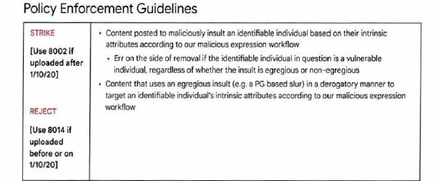
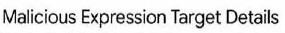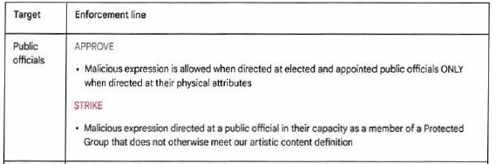
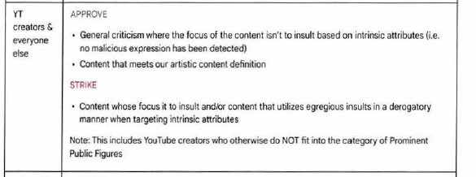

- The policies define “protected group” as “a group of people recognised for special protection by a law…” including race or ethnic origin. The guidelines for EDSA and public interest enforcement provide that malicious expression targeting a public official is allowable when directed at an elected or appointed public official (such as a member of Parliament or cabinet minister respectively) “ONLY when directed at their physical attributes” and is not permitted where it is directed at the public official in his or her capacity as a member of a protected group that does not meet the artistic content definition. The policy contains similar provisions about harassment of a public official.

Google becomes aware of friendlyjordies attacks on Mr Barilaro
- On 25 November 2020, Mr Barilaro’s deputy chief of staff, Mr McCormack, contacted Google Australia’s manager, public policy and government relations, Sanjay Kumar to complain about the racist, vile and untrue content of numerous friendlyjordies videos, Mr McCormack also raised with Mr Kumar the concern that some online attacks were also being made in reviews of Dungowan Estate. They discussed what processes were available for YouTube to consider the appropriateness of taking down videos that it had online. Mr Kumar put Mr McCormack in touch with Hannah Frank of Google’s government affairs and public policy section who dealt with YouTube’s public affairs issues. Ms Frank told him that she would investigate matters before he needed to make a formal complaint.
- On 26 November 2020, Mr Shanks tweeted the following thinly veiled reference to Mafia like conduct:
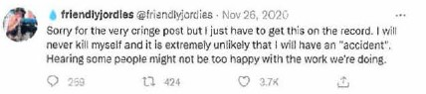
- On 30 November 2020, Mr Cunningham, Mr Barilaro’s social media manager, made a formal complaint to YouTube about the allegations of corruption and other matters against Mr Barilaro in, among others, the bruz and Secret Dictatorship videos including one entitled “I called John Barilaro… he answered” that Mr Shanks had uploaded on 30 November 2020. That video alleged that Mr Barilaro was having an extra marital affair.
- When Google did not act, Mr McCormack emailed Ms Frank on 1 December 2020 expressing concern that the videos had gone beyond what was acceptable and asking for matters to be “progressed through appropriate channels”. He attached a Dropbox link to the videos. She replied asking him to send URL links. Mr McCormack was unhappy that, after having already had a detailed conversation with her about the racist and vile nature of the videos and the online comments, Google asked that he complete a document with URL details.
- Early on 2 December 2020, after encountering technical problems with earlier attempts to provide Ms Frank with URL links to each of 11 videos, Mr Cunningham provided Ms Frank with those links. She responded that she would escalate to Google’s “Trust and Safety Team” the review of those 11 videos. The Trust and Safety Team were located in California.
- On 3 December 2020, the Trust and Safety Team found none of the 11 videos “to be violative of our hate/harassment policies”.
- On 15 December 2020, after an unexplained delay of two weeks, YouTube emailed friendlyjordies to inform it that it had taken down in Australia the I called John Barilaro… he answered video, stating that the video “describes this allegation as a nasty rumour and concedes the possibility of legal action”.
- Also on 15 December 2020, Google responded to Mr Cunningham’s complaints about other videos, including bruz, The Italian Job, by declining to take any action.

Google becomes a publisher of the matters complained of
- It is common ground that on and from 22 December 2020 Google became liable as a publisher of each of the bruz, Secret Dictatorship and other then existing friendlyjordies videos that affected Mr Barilaro.
- On 22 December 2020, Mr Barilaro’s solicitors (Mark O’Brien Legal) sent a letter to each of Google and Mr Shanks complaining of the “indefensibly racist and defamatory campaign that Mr Shanks had engaged in” against their client on his YouTube channel (the 22 December letter). The letter identified 10 videos, including bruz, The Italian Job, Secret Dictatorship, SUPER BARILARO KART and bruzboard. It noted that the bruz video contained the following statements about Mr Barilaro (which came to feature prominently in the bruz: eternal video that Mr Shanks uploaded on 3 May 2021, which I describe at [146]–[173] below):
a. “… another big, fat, wog cock …”;
b. “… he's a con-man to the core, powered by spaghetti ... “;
c. “… you ball of grease …”;
d. “Let's look at water theft ... seriously though, I think he's corrupt”;
e. “… /told you he was a dumb f-k ...”;
f. “… he wears his corruption as a badge of honour ...”;
g. “… John Barilaro aka greasy Ned Kelly …”;
h. “… a man who looks like a Mafia don …”;
i. “… he perjured himself nine times over …”;
j. “… not to draw attention to his Italian heritage … he looks a bit like a meatball …”;
k. “… Giovanni, the greasy little scrotum ...”; and
i. “… just a fat, decadent con-man ...”.
- The 22 December letter pointed out to Google that the contents of the 10 videos breached YouTube’s (publicly available) hate speech, harassment and cyber-bullying policies. It demanded that Google immediately remove the videos.
- On 24 December 2020, Google responded asking for, among other things, the timestamps on each of the 10 videos where the offensive statements appeared.
- On 12 January 2021, Mark O’Brien Legal replied with that detail, noting their (in my view understandable) surprise that Google required that information.
- On 2 February 2021, YouTube Legal Support emailed Mark O’Brien Legal advising that the videos not removed earlier had been sent for review “for potential harassment or other CG [scil: Community Guidelines]”. Later that day, Google’s Trust and Safety Team responded to the Legal Support section saying “we do not find them violating our Community Guidelines”.
- Google has persisted in this insouciant stance ever since.
- On 20 April 2021 Mr McCormack informed Mr Kumar that Mrs Barilaro was experiencing a lot of negative, Italian and racially motivated attacks in respect of Dungowan Estate as a consequence of Mr Shanks’ campaign against her husband. Mr McCormack attached a hyperlink to a Google Search result for the My Business listing of Dungowan Estate. He asked Mr Kumar for advice about how to remove those reviews. Mr Kumar forwarded the email to Ms Frank who sent it to the Trust and Safety team.
- On 27 April 2021, Ms Frank emailed Mr McCormack in response to his email of 26 April 2021 in which she remarked that some of the comments had been removed, but some of the racist ones remained. She told him that a first batch had been removed the previous day and she had requested that the Trust and Safety team reconsider the rest.

The bruz: eternal video
- On 3 May 2021, Mr Shanks uploaded the bruz: eternal video that had a run time of about 45 minutes. He initially appears wearing an “ultimate bruz” tee shirt. He announces, holding up a letter from Mr Barilaro’s lawyers (being the 22 December letter), that their client had threatened to sue him. Mr Shanks tells viewers that “this has been a long time coming”. He states that Mr Barilaro “really likes destroying New South Wales’ environment and is using his office to enrich himself”. Mr Shanks then says he “made fun” of Mr Barilaro and, against a photoshopped image of Mr Barilaro’s and Ms Berejiklian’s pictures with the caption “7 News humiliates me”, Mr Shanks says:
his response was to call me racist for putting on an Italian accent while doing so. He then got a bunch of smear articles about me written as I denigrated his migrant success story. This despite the fact that my family are migrants from the same region as him. But, because we found out that this was a soft spot of his, we obviously steered into making fun of his Italian pity story whilst continuing to expose his corruption like how he debt trapped the Italian community in Queanbeyan, allegedly [and, against a screen shot of Mr Barilaro and his father’s photos superimposed on an Italian flag under the heading “How they stole a building” and a caption “The Italian Job”] and now John Barilaro, or ‘greasy little scrotum’ as we know he hates being referred to. Now, as such, I will be referring to him as ‘greasy little scrotum’ much, much more.
(emphasis added)
- Mr Shanks then expostulates on how he responded to an earlier threat to sue him by businessman, Clive Palmer, and assures viewers that Mr Barilaro had not seen the video called “fatty”:
… it is unfortunate for you that you didn’t because if did watch the video fatty, it would have given you a preview into what threatening to sue me would look like for you. But, now that you have threatened to sue, we may wonder no more. Here’s what it looks like: “you on a key chain as some nuts” [as the following screen shot appears]:
(emphasis added)
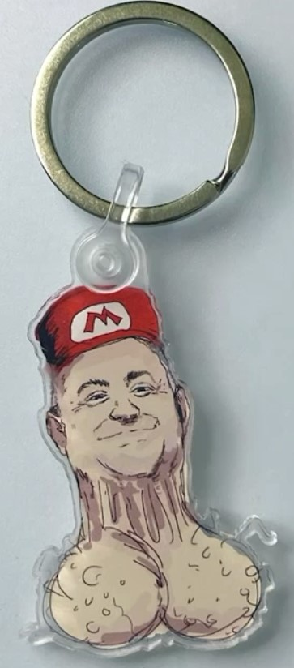
- This segues to an advertisement for the “Exclusive Bruz KeyChains” that Mr Shanks then tells viewers are available for purchase. He describes this as capturing Mr Barilaro’s “truly testicular appearance” before switching to the parodied Italian accent and saying that his “digital soul is yelling [while an image of the key chain is on screen] ‘No I’m so greasy and no one’s washing me’” (emphasis added). Mr Shanks then asks:
you like that? Your goal in sending this letter [displaying a screen shot of the 22 December letter headed “confidential and not for publication”] was to stop me referring to you as ‘greasy little scrotum’, all you’ve accomplished is upgrading an image of you that I’d truly forgotten about to thousands of monuments that will outlive you” … there will be people’s grandchildren asking [in the parodied Italian accent]:
Apapa, why is there a slimy Italian man with some balls on your desk? I bet-a-this man’s answer to one of the hardest questions in life ‘what would you do to be the third most known politician in the country?’ Anyway, there’s an appetiser of how seriously I’ll be taking your legal threats. I’d tell you to suck my balls but next time I see you I’ll just suck your head instead”
(emphasis added)
- The segment berating Mr Barilaro repeatedly as “greasy little scrotum”, that I have just described, lasted well over one minute. Despite Google’s policies, the video somehow remained online at least to the time of the trial.
- Next, a screenshot appears of the profile of Mr Barilaro’s solicitor, Paul Svilans, on Mark O’Brien Legal’s website, while Mr Shanks reads sarcastically from his letter “‘Further, your vile and racist attacks on our client have caused him immense personal hurt’ … Aw, I think everyone watching is pretty happy to hear that Paul”.
- Mr Shanks then engages in mocking Mr Svilans’ heading of “Confidential: Not for Publication” on the 22 December letter. He says that another online identity states that “Shysters, which I’m not accusing you of being; I don’t have to, your photo does all the talking, you look like, if you were born in the age of Aladdin, you’d be selling cursed monkey paws”. He says “slimeballs like Paul pull this dirty little trick of whacking a “Private and Confidential” stamp on their serve [sic] letters which is about as legally binding as bagsing the front seat when you’re five”. He asserts of Mr Svilans that:
what you’ve done here is label a legal document “Confidential and Not for Publication” when it absolutely is for publication. There is nothing legally preventing me from doing so… you suggesting otherwise is a flagrant violation of the Australian Solicitors’ Conduct Rules … knowingly breaching the rules that govern your conduct as a lawyer … and you start this divine defence of morality by breaching the rules that govern your conduct as a lawyer.
(emphasis added)
- Mr Shanks then states against the screenshot below:
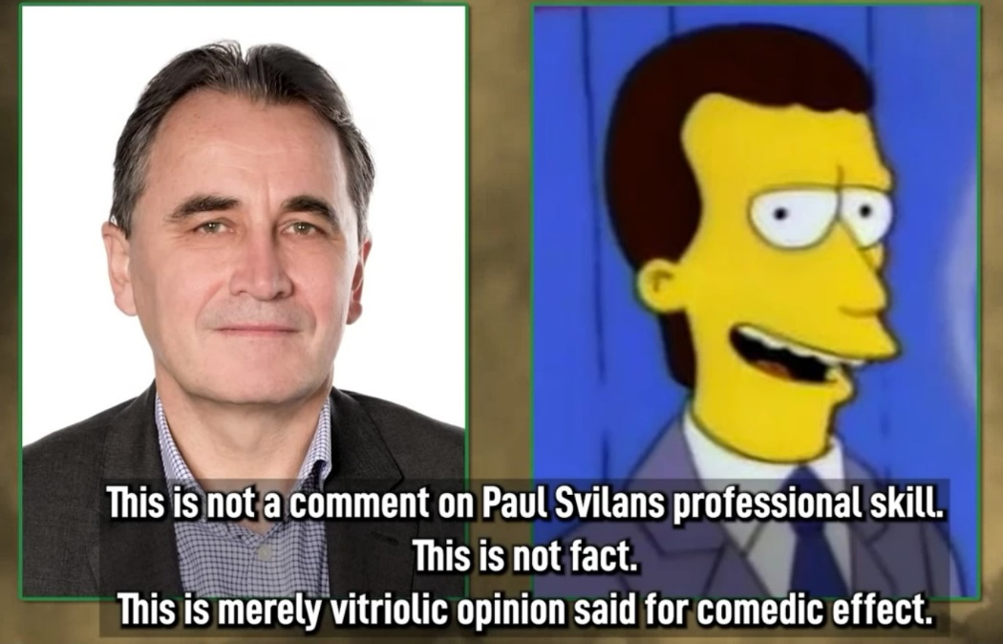
What a blight on the legal system you are, you spitting image of the Laramie cigarette spokesman. You get on your moral high horse and deliver me a decree that I have breached the law of the land and you start this divine defence of morality by breaching the rules that govern your conduct as a lawyer. Bamm, page [against another screenshot of the 22 December letter]. Geez, no wonder John chose y’all. I’d love to say the phrase “Birds of a feather flock together”, but bin chicken [against screenshots of Ms Berejiklian and an ibis] has nothing to do with this.
I know I’m not supposed to hit out at a lawyer when responding to defamation threats, but to use your own words Paul, “this is beneath contempt”. What you and Tubbo the Clown have concocted is basically an ode to stupidity that betters Clive Palmer’s intention to sue… And yet with the power of veal scallopini, I’m assuming [against a screenshot depicting Mr Barilaro in a kitchen with a caption “Today I’m going to do… something simple. A veal scallopini”] Bruz pole vaults over that, clears the bar with ease. The very first claim of defamation you draw on is me calling John Barilaro, quote, “another big fat wog cock” … You would have to argue in Court, as in get on official record, that he has a small penis. Talk about cutting off your cock to spite your greasy scrotum [against a screenshot of the key chain].
(emphasis added)
- Mr Shanks engages in further mockery of Mr Barilaro’s taking offence at being called “a big fat wog cock” before saying “You’re starting to see why it was a bad idea to send me a defamation threat”. He mocks Mr Barilaro for “suing me for that comparison” of being ‘a man who looks like a Mafia don’ saying “John, here’s a picture of you, here’s a picture of Al Capone [against screenshots of their photos]. The only way I can tell the difference between you two, is I assume Al Capone’s picture would have been taken in black and white”. Mr Shanks describes the 22 December letter’s listing of offensive or defamatory phrases in his videos as:
a compilation of the best calls I made in 2020. Paulie from legal boys [against a screenshot of Mr Svilans] tells me you weren’t holding back tears of laughter when you wrote “you have made the following statements about my client: ‘He’s a con-man to the core, powered by spaghetti’… and this energy powered, and this just happens to be my opinion, a con-man. My description of you as “a fat decadent con-man” and I do like how offended you are by being called fat, it’s like his card man, hey.
(emphasis added)
- Mr Shanks then makes numerous claims that Mr Barilaro is a con-man, including, again, accusing him of “stealing a building”. He states “I know you deny these allegations, but I don’t think ‘I didn’t do it’ will fly when we have documents that very clearly indicate that, yes, you did”.
- He repeats his allegation that Mr Barilaro committed perjury nine times in Parliament. Mr Shanks asserts that “the landmines you’ve set for yourself, like having to argue under oath that you don’t look like a meatball. Save yourself the Court fees, John. Let’s do a test run now. Ladies and gentlemen of the jury, exhibit A, exhibit B” while the screenshots below appear:
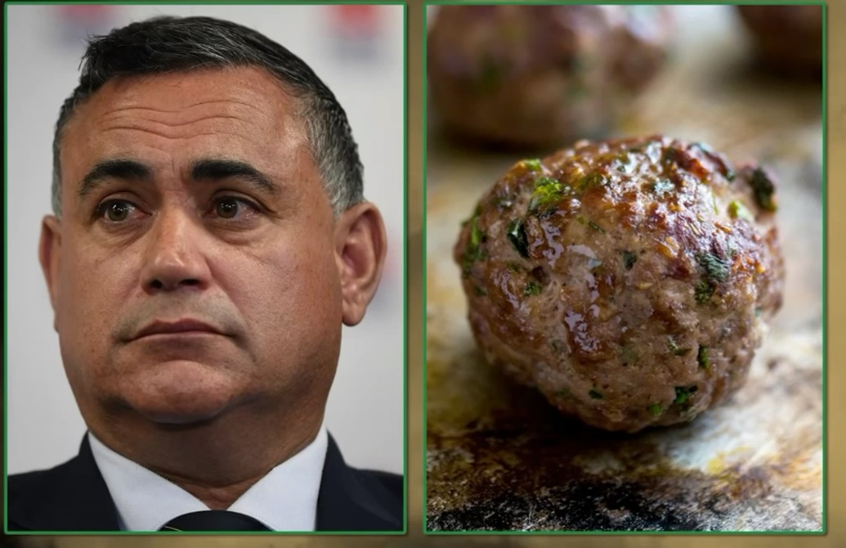
- Next, Mr Shanks says:
unlike the Al Capone photo, this one’s in colour, so I actually can’t tell the difference. The sheer waste of the Court’s resources when the Deputy Premier screams: ‘It doesn’t look anything like me’ [as the screenshot below appears and Mr Shanks uses the parodied Italian accent]
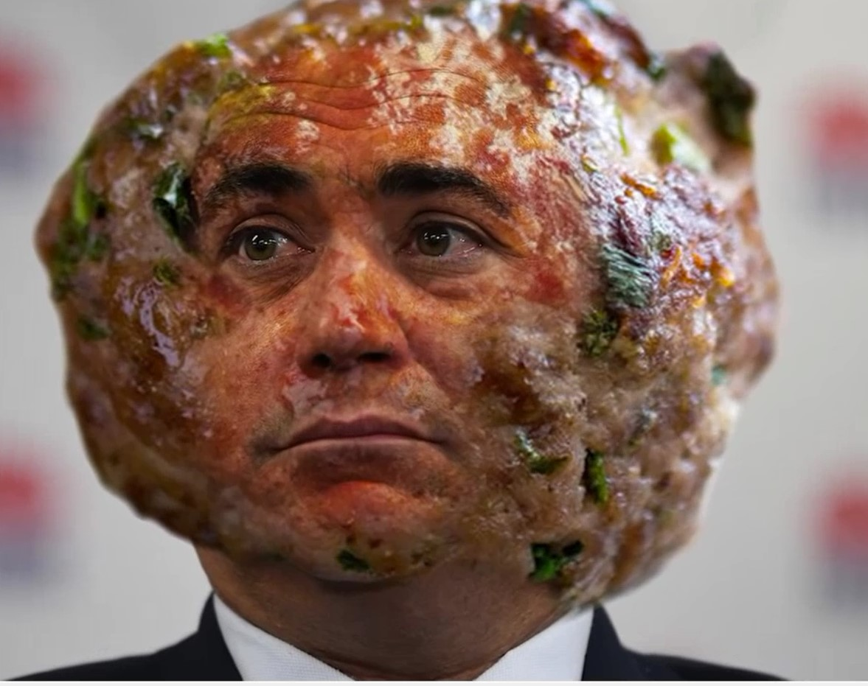
If future generations want to know why they live in a scary post-apocalyptic world, here’s your answer, exhibit A [as another photo of the meatball appears on screen followed by a list of derogatory statements that Mr Shanks had used in the bruz video, as Mr Shanks voices over], “let’s look at water theft … seriously though, I think he’s corrupt”. I do think you’re corrupt. What are you trying to say?
- The above segment heading with the meatball theme lasts at least 30 seconds and, again, appears to be in violation of Google’s policies.
- Mr Shanks repeats several times that Mr Barilaro is corrupt and then screams “He’s trying to sue me for what I think”. Mr Shanks repeats his statement, “he wears his corruption as a badge of honour”, several times. Mr Shanks returns to impugning Mr Svilans together with Mr Barilaro and suggests that because Mr Barilaro threatened to sue over the Super Barilaro Kart video:
in his [scil: Mr Barilaro’s] mind that shit was as believable as that leaked CCTV footage of him losing his licence. It’s a compliment. He’s saying that the resemblance of me dressed as Mario is so Daniel Day Lewis perfect that the people who saw it thought ‘Yeah, that’s the Deputy Premier, all right’.
- Mr Shanks exclaims that this is “incredible, but not as incredible as the fact that his lawyer wrote the grievance as [as the wording of the letter flashes up and Mr Shanks reads] ‘Jordan Shanks … impersonating our client as the character Mario from Mario’s Kart’”.
- Then, Mr Shanks repeats his allegation from the Secret Dictatorship video [as a silhouette of Mr Barilaro’s head with a question mark superimposed on it appears] that:
Do you know blackmail is illegal? I wonder how illegal it is to use taxpayer’s money as blackmail to shut your critics up. If this is what I think it is, and I do think that, he’s such a scab that he doesn’t even use his own money to blackmail.
- Next, Mr Shanks says “I think it’s you, John”, revealing Mr Barilaro’s head in place of the silhouette. He asserts that “that is my opinion, and this is a defence against defamation, honest opinion based on the facts available. You can deny it. I won’t believe you because you frequently perjure yourself in Parliament.”
- Mr Shanks follows this saying against the earlier screen shot of Mr Barilaro and Al Capone:
As an Italian, particularly one who looks like a mobster, I think you’ll resonate with this one, John: [using the mimicked accent of Marlon Brando in The Godfather] ‘where’s the respect. Stop-a-sending me mixed messages like I’m some-a-mixed seafood fettucine’.
(emphasis added)
- Mr Shanks then demands that Mr Barilaro listen to him and exclaims “Fire your lawyer” before using black and white footage of James Stewart, as a lawyer, to decry Mark O’Brien Legal for having written: “your strongest legal argument is based off [sic] a worse understanding of the law than some squid eating, mass renewing joke… like myself”, repeating Mr Shanks’ absurd proposition that blurting out “this is recording”, as Mr Shanks begins a telephone conversation with Mr Barilaro, constitutes Mr Barilaro’s implied consent to the conversation being recorded.
- He says “Geez, John, your lawyer writes about as well as you do, and remember you are the man who wrote to Helen Dalton: ‘Helen, you are disgusting human’”. Mr Shanks describes the 22 December letter as one that “cost thousands of dollars to put together”, showing a copy of it with Mr Svilans’ photograph “so I would expect a slightly higher standard than I would from ‘The Exposer 451’ [showing a screenshot of a tweet by that person]. Paulie, how would my words ever constitute consent from John Barilaro?” Mr Shanks says that he has googled s 7 of the Surveillance Devices Act 2007 (NSW) and, against the screenshot below, he says:
The only reason it would appear to constitute a contravention of the Surveillance Devices Act is because you don’t understand the law or again you are knowingly making a false statement as a lawyer, which, at this point, I’m starting to think that both options are just as likely as the other.
(emphasis added)
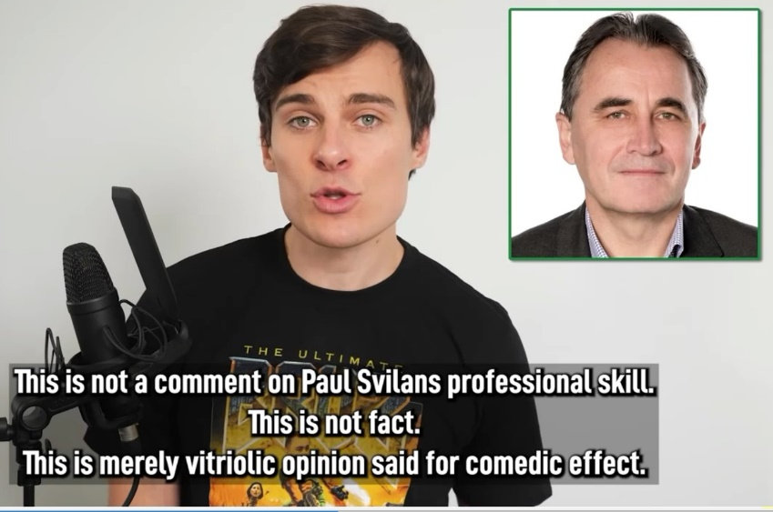
- Then, this screenshot appears:
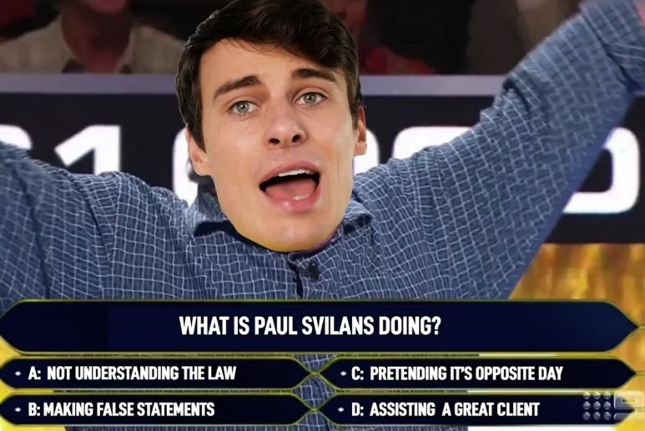
- Mr Shanks states “Meatball, continuing on with the conversation, very jovially, mind you, after I clearly stated that the conversation was being recorded, is implied consent”.
- At around this time, two professionally produced advertisements for well-known commercial products appear that last about two minutes, from which, I infer, YouTube earnt revenue. Mr Shanks had been repeating his claim that Mr Barilaro was “a dumbfuck”. He segues into asserting that Mr Shanks’ letters’ complaint about his calling Mr Barilaro equated to:
your argument would depend on proving he’s a dumbfuck. Your lawyer is a dumbfuck. Anything you successfully argue would be simultaneously proving that he is not fit to hold the office of Deputy Premier. That’s an amazing Catch 22.
(emphasis added)
- Mr Shanks asserts that, as his lawyer, Mr Svilans, put Mr Barilaro in that position and urged that Mr Barilaro:
fire him. Just replace him in court with a dog chasing its tail [as a dog chasing its tail appears on screen]. Same result; fraction of the price; double the fun.
(emphasis added)
- Mr Shanks then moves to lampooning Mr Barilaro in respect of the lack of funding for the National Parks and Wildlife Service and his response to the 2019 bushfires. He refers to the statement in the 22 December letter that one video had imputed that Mr Barilaro:
“has engaged the services of a white supremacist to cruelly kill koalas by burning them”.
[Mr Shanks protests:] How else can those facts be communicated? You hired a race realist to test if koalas like fire … Seeing how this is going to be a highly politicised case, shouldn’t you have selected a lawyer who knows a little more about our political system than a former cruise ship dancer I once spoke to? He spelt one of the major political parties’ name wrong… by mutilating “Labour’s [sic]”… that is the spelling of a lawyer representing the Deputy Premiere of the Nationales Party [while a screenshot of Mr Barilaro’s face represented as a meatball with a Mario cap on his head appears on screen and the text from which he read the quote appears].
- Mr Shanks then moves on to describe disparagingly five journalists who worked for major news outlets. He says:
Unlike those subservient bottom-feeders to scum like you [Mr Barilaro], I actually care about wiping out entire species…
(emphasis added)
- Mr Shanks later displays another screenshot with Mr Barilaro’s head depicted on multiple meatballs under a heading “Prepare to get served: Cloudy with a chance of meatball”. Subsequently, Mr Shanks returns to an earlier theme saying of Mr Barilaro:
And yet you’re suing me for calling you a dumbfuck? I’m being lenient. You’re not just a dumbfuck. You’re also dangerously incompetent and grotesquely self absorbed. I guess what I’m saying, John, is you’re a stupid fat idiot [at which point a screenshot of Mr Barilaro appears with the caption “Stupid Fat Idiot”]. Your grand plan is to spend years in court drawing attention to that fact [as the screenshot highlighting “told you he was a dumbf—k from the 22 December letter appears]. Yeah, that’ll prove you’re not a stupid fat idiot …”
- Mr Shanks then appears dressed up as Luigi and, with his companions, gate-crashes on camera an event at Macquarie University, at which Mr Barilaro is present. Mr Shanks screams out as he is filmed running towards where Mr Barilaro is “John, you silly calzone”, interrupting his address. Mr Shanks harangues Mr Barilaro yelling in his parodied Italian accent “I cannot believe this… man from the bush in Sydney”. The film footage shows security personnel removing Mr Shanks who screams in the parodied accent “John why you-a-no talk-a to me. You don’t answer your phone.” Mr Langker then says at the event, on film, that he has some documents for Mr Barilaro as the security personnel also try to remove him saying “John, why are you suing?”. Mr Barilaro tells the gatecrashers “this is a private function”. Mr Langker yells out: “John, why are you threatening to sue us? Why? He’s threatening to sue” as he is being removed from the event. He then confronts Mr Barilaro “I want to know why you are threatening to sue”. Mr Barilaro says that he is not threatening but is suing and tells Mr Langker “because you guys are liars”.
- Mr Shanks, still dressed Luigi, says in his studio, “well it’s no longer a threat. John Barilaro is suing me and I think that means we need some more Patreon bucks” [Patreon is an online fund transfer service which friendlyjordies used for its subscriptions and merchandise sales, as well as crowdfunding for his defence of this proceeding while he was a party to it]. He advertises a new tee shirt which he describes as “John Barilaro as Al Capone lighting up a koala” with the words “The Stupid Fat Idiot” in big letters, and urges his viewers to trend “#stupidfatidiot”. “It gets to him, as does being referred to as greasy little scrotum [with a screenshot of the keychain]”. Mr Shanks then has a series of male comedians addressing a camera repeating the line “stupid fat idiot; in my opinion”.

Google’s delay in removing the adverse reviews of Dungowan Estate
- On 5 May 2021, Ms Frank asked the Trust and Safety team again in an email headed to deal with “spammy reviews that seem racially motivated” in respect of Dungowan Estate, which read:
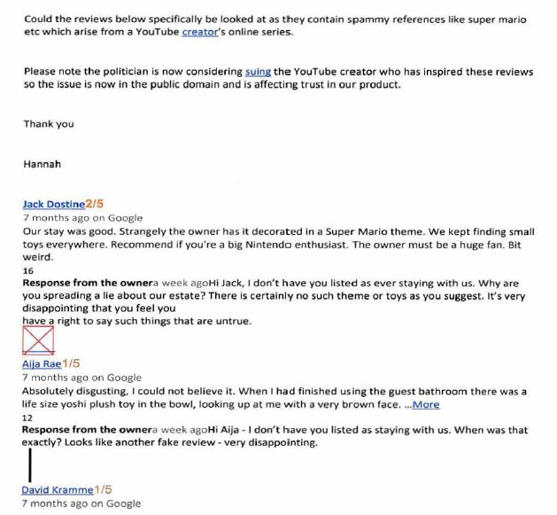
- The significance of Ms Frank’s email is that, first, the reviews she attached had remained online for the previous six months, despite Google’s publicising that it had policies that should have prevented the offensive material remaining online, and, secondly, her observation that “the issue is now in the public domain and is affecting trust in our product”, reveals focus of Google’s concern as being about its “product”.

Mr Barilaro files this proceeding
- On 27 May 2021, Mr Barilaro commenced this proceeding against Mr Shanks and Google.
- On 31 May 2021, Mr Shanks uploaded onto YouTube a video entitled The Lawsuit begins??
- On 3 June 2021, Mr Shanks uploaded onto YouTube another video, entitled We called John Barilaro’s Lawyer.
- On 4 June 2021, Mr Shanks uploaded onto YouTube yet another video entitled Lawyer CALMLY DISMEMBERS Me. None of these videos uploaded between 31 May 2021 and 4 June 2021 is in evidence.
- After Mr Shanks began publishing videos about this proceeding, which he linked to the criminal proceeding against Mr Langker, his subscribers or supporters posted a stream of tweets rehearsing Mr Shanks’ themes such as:
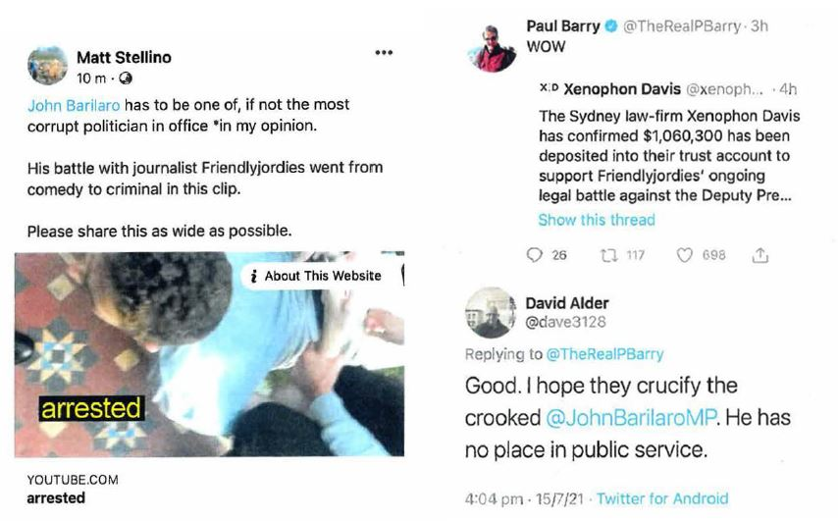
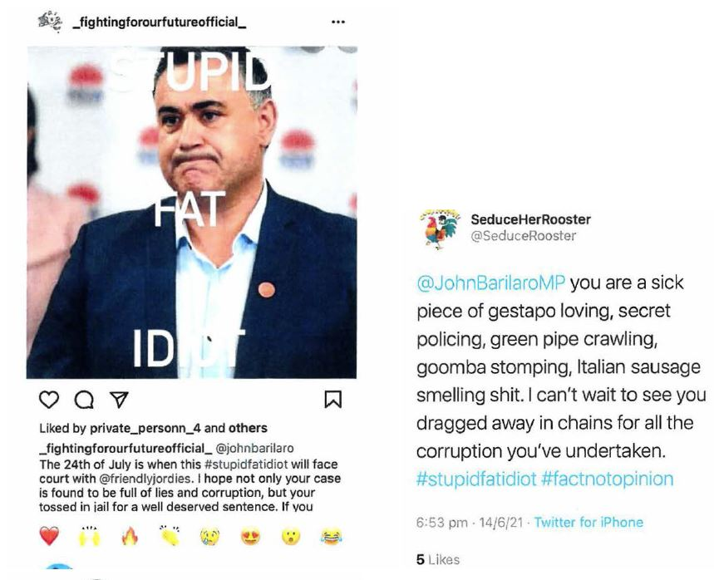
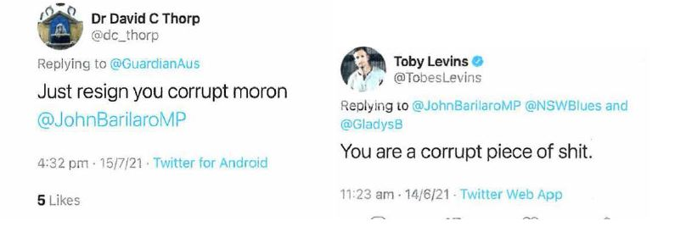
- Other tweets and Facebook posts repeated themes that Mr Shanks espoused about alleged corruption, racist slurs and represented Mr Barilaro as Joseph Stalin and Benito Mussolini. The cowardly and anonymous “Styled Armpit Hair” tweeted “And yet @JohnBarilaroMP has a conniption about being represented as …” above a photo of Mussolini.
- On 9 July 2021, I granted Mr Barilaro leave to serve Google in California under rr 10.42 and 10.43 of the Federal Court Rules 2011: Barilaro (No 1) [2021] FCA 789.
- On 23 July 2021, I heard argument as to whether Mr Shanks could plead justification under s 25 of the Defamation Act to imputation 9(b) (Mr Barilaro committed perjury nine times) and honest opinion under s 31 of that Act to imputation 9(c) (Mr Barilaro has so conducted himself in committing perjury nine times that he should be gaoled). On the same day Google was served in California.
- Mr Shanks’ public out of court attacks, such as in the bruz: eternal video, on Mr Barilaro’s lawyers and Mr Barilaro himself for bringing this proceeding were brazen attempts to bring improper pressure to bear on each of them: Kazal v Thunder Studios Inc (California) (2017) 256 FCR 90 at 124 [81]–[82] per Besanko, Wigney and Bromwich JJ; Y and Z v W (2007) 70 NSWLR 377 at 384 [38] per Ipp JA, with whom Spigelman CJ agreed at 379 [6]; Harkianakis v Skalkos (1997) 42 NSWLR 22 at 42A–D per Mason P with whom Beazley JA agreed; Commercial Bank of Australia Ltd v Preston [1981] 2 NSWLR 554 at 564F–G, 565C–F per Hunt J. For example, Mr Shanks posted the following diatribe on social media under two headings, the one below, and the other “@JOHNBARILARO UR A DUMB CUNT”. Those posts were about the hearing on 23 July 2021 involving whether Mr Shanks could be granted leave to file his defence out of time, the issues of Parliamentary privilege and the legal adequacy of the pleading itself. He posted:
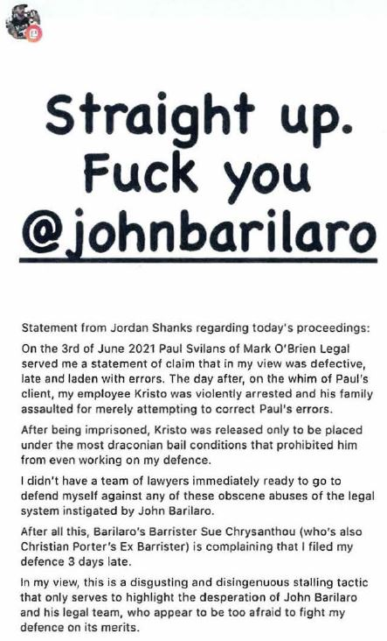
- On 10 August 2021, Google filed an appearance in this proceeding.
- On 13 August 2021 I gave reasons and made a declaration that Mr Shanks could not plead his proposed defences to imputations 9(b) and 9(c) under ss 25 and 31 because to do so would amount to questioning or impeaching proceedings in Parliament in contravention of Art 9 of the Bill of Rights: Barilaro (No 2) 393 ALR 417. I also found that Mr Shanks’ proposed defence was defectively pleaded and required substantial amendments to most of his proposed contextual imputations and particulars for all his surviving defences.

The He’s Destroying Australia video
- On 16 August 2021, Mr Shanks uploaded onto YouTube a video entitled He’s Destroying Australia, which is in evidence. Soon after this video commences, Mr Shanks begins talking about this proceeding, saying “Now I know he’s suing me for defo because I said a bunch of true shit about him”. He then speaks of Mr Barilaro’s senior counsel [on screen with words in the caption as he speaks]:
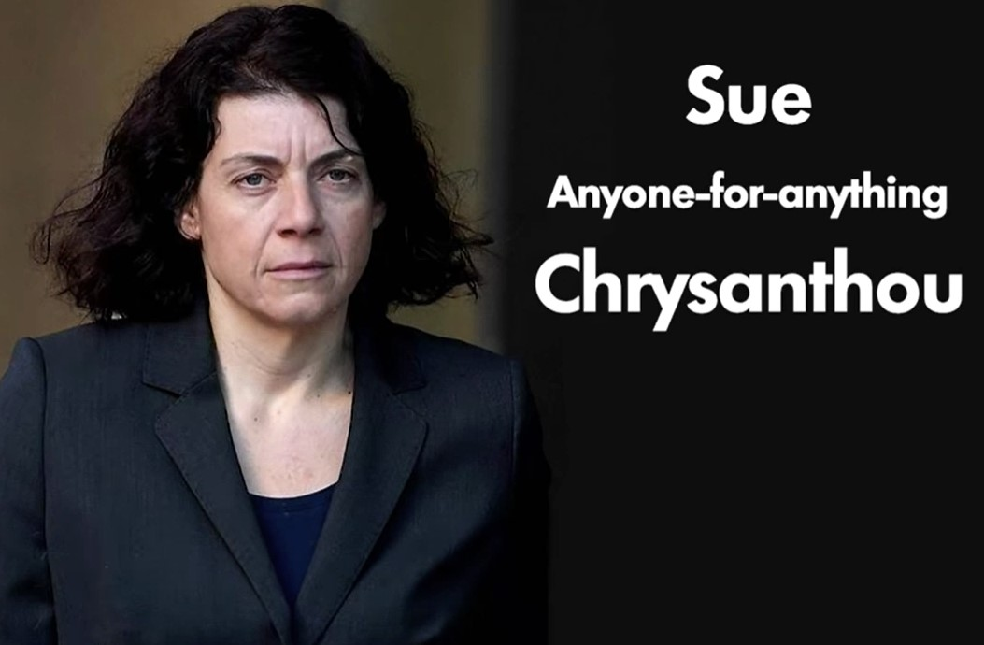
- The picture of her below appears saying:
Even John's barrister, who’s so good at her job she’s genetically predisposed for it. Look, she is named after what she does - Sue Chrysanthou - middle name: “anyone-for-anything”. And Sue, before you think of suing me for that joke, if you did, you’d prove that incredibly trivial joke is 100 percent correct so I’d just use the truth defence and I know how much you hate those.
(emphasis added)
- During the course of those statements another screenshot appeared of an article in The Guardian on 9 July 2021 reporting on the case management hearing that day, in which I set down the hearing on 23 July 2021 to deal with whether Mr Shanks should have leave to file a defence out of time and in its then form. During the case management hearing Ms Chrysanthou SC said that she would argue that the defence made serious allegations in relation to Mr Barilaro with a “complete failure to provide particulars”. She asserted that “barely a paragraph that will survive”.
- In the event, as Mr Shanks knew when he uploaded the He’s destroying Australia video, I not only had ruled against his defences of justification and honest opinion in respect of imputations 9(b) and (c), but also had held that many of the particulars given for various other substantial allegations in that proposed defence were deficient and had to be re-pleaded. Then, Mr Shanks returns to parodying Mr Barilaro and Nero and says, while displaying the screenshot below: “But a liar playing a lyre: fitting”.
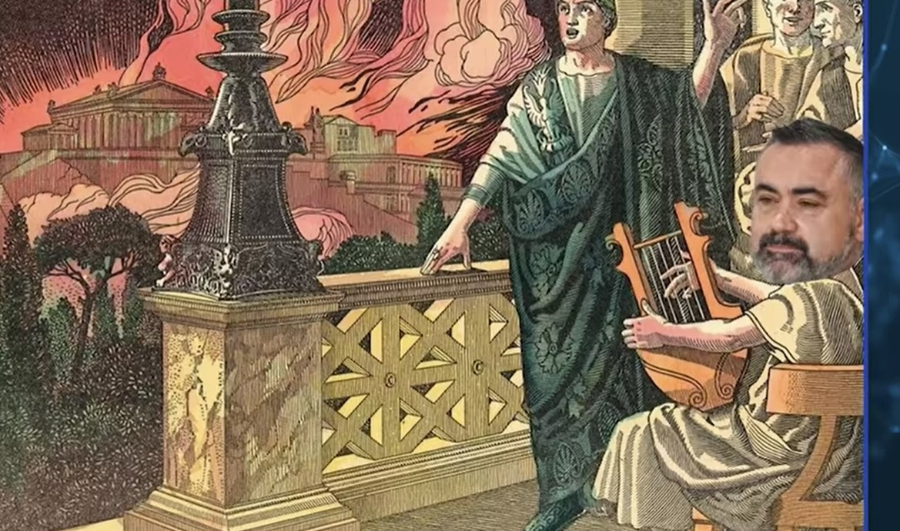

- Most of this video deals with Mr Shanks’ criticism of Mr Barilaro’s administration of national parks within his cabinet responsibilities including a proposed new plan of management for Kosciuszko National Park. Mr Shanks says at about the mid-point of the video:
And what’s meatball planning to do with this newly acquired power? Turn Kosciuszko into John’s epic Aspen elitist ski Wonderland.
(emphasis added)
- Later in the video, Mr Shanks superimposes Mr Barilaro’s face on a bare male torso of Sean Connery as James Bond being pampered in an onsen and segues into announcing a new film as the opening credit page scrolls down on screen, which he reads out from a reworked advertisement for You Only Live Twice as follows:
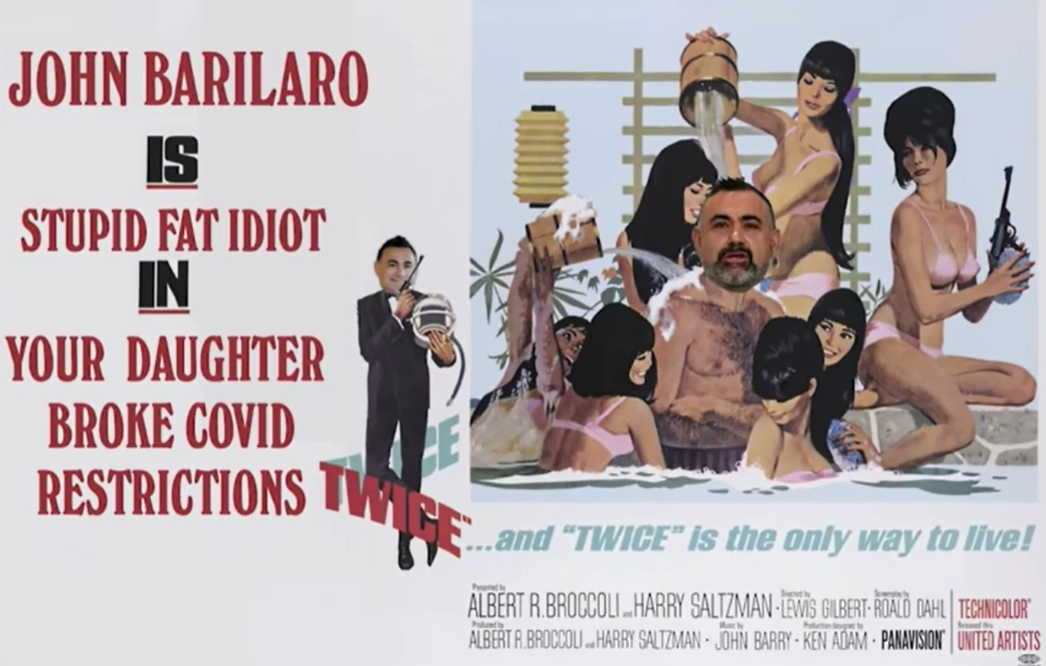
- Mr Shanks then says using the parodied Italian accent “oh can you shut the fuck up… she’s a private citizen”, demonstrating the gratuitous nature of the attack on Mr Barilaro’s daughter.

Google files its defence
- On 25 August 2021, Google filed a defence in which it:
- denied that any of the imputations was conveyed by either matter complained of;
- pleaded that the bruz and Secret Dictatorship videos were published under qualified privilege pursuant to, first, the implied freedom, secondly, the common law and thirdly, s 30 of the Defamation Act;
- pleaded pursuant to the newly introduced s 29A of the Defamation Act that in respect of publications after 1 July 2021, the bruz video concerned a matter of public interest and Google reasonably believed that its publication was in the public interest;
- pleaded pursuant to s 31(3) of the Defamation Act that the bruz and Secret Dictatorship videos were expressions of opinion of a person other than Google rather than a statement of fact, the opinion related to matters of public interest and was based either on proper material or alternatively to some extent on proper material and represented opinion that might be based on that material to the extent to which it was proper material.
- On 26 August 2021, Mark O’Brien Legal wrote to Ashurst, Google’s solicitors, and, among other matters:
- expressed justified incredulity as to how Google could deny that the bruz video conveyed imputations 9(a), (b) and (c), given that the very words of those imputations are in the video and Mr Shanks had also admitted that they were conveyed;
- disputed that the transitional provisions in the Defamation Amendment Act 2020 (NSW) (the Amendment Act) allowed Google to plead the new defence of public interest under s 29A;
- explained, correctly, based on Lange 189 CLR 520, that the plea of common law qualified privilege was hopeless.
- On 30 August 2021, Ashurst replied asserting that:
- Google’s denial that any of the imputations were conveyed was “made after proper and careful consideration”;
- s 29A applied to any download of the matters complained of, being acts of publication, that occurred after 1 July 2021;
- the (unspecified) circumstances supporting Google’s plea of common law qualified privilege were distinguishable from Lange 189 CLR 520 and had other attributes.
- On 28 September 2021, Mark O’Brien Legal wrote to Ashurst noting, among other matters, that Google continued to publish the indefensibly racist statements of and concerning Mr Barilaro that I have discussed above. Google and Ashurst did not respond to this observation, as a result of which on 5 October 2021, Mark O’Brien Legal gave Google notice that Mr Barilaro would rely, in support of his claim for aggravated damages, on Google “engaging in a vile and despicably racist smear campaign as against [him] to drive him out of office”.
- Earlier, Mr Barilaro had stated publicly that he was thinking of leaving politics in 2023, being the year of the next election. He believed that politics should not be a career. However, because of the constraints caused by the COVID-19 pandemic on the Government’s ability to pursue a reform agenda, he had told colleagues that he was thinking about leading his party to the 2023 election. Mr Barilaro said that if Google had taken down the videos in late 2020, when he asked it, he may have stayed on. When the new Premier, the Hon Dominic Perrottet MP, asked him to stay in office, Mr Barilaro explained his state of mind as follows:
Premier Perrottet, he pleaded with me to stay; the idea of a of a Perrottet-Barilaro government. But, to be honest, I was so broken emotionally; no strength. After what I endured in the by-election of Upper Hunter, where I’m being attacked by people with bruz shirts, I couldn’t face another election. I couldn’t face another term; I couldn’t face the end of this term. I mean, even if I wanted to go, I would have gone in 2023; … not in October …
And I saw the opportunity, because the premier had stood down. I was done. I was broken. I was hurt. I had nothing left in the tank, and I went. And like I said I should have, you know, I went on my terms, I suppose, but it’s a bit premature about what my terms could have been if I had been there for the rest of the term.
(emphasis added)
- On 5 October 2021, Mr Barilaro resigned his office as Deputy Premier and Minister in the New South Wales Government and announced his intention to retire from Parliament. On the next day he resigned as Parliamentary leader of the National Party.

Mr Shanks settles the claims against him
- On 28 October 2021, following a mediation in which Google also participated, Mr Barilaro and Mr Shanks entered binding heads of agreement. The heads provided that:
- Mr Barilaro and Mr Shanks consented to an order, that I made on 5 November 2021, that upon senior counsel for Mr Shanks making the statement below in open Court, Mr Shanks agreed to pay costs of $100,000 ordered against him on the interlocutory hearings dealing with Parliamentary privilege and a jury trial, Mr Barilaro would file a notice of discontinuance as against Mr Shanks with no order as to costs and that the proceeding between them was settled. Mr Shanks agreed to pay Mr Barilaro the agreed sum in respect of his costs within 28 days.
- The statement to the Court made by Mr Shanks’ senior counsel was in the following terms:
Throughout 2020 and 2021, Mr Shanks posted many videos about John Barilaro, the former Deputy Premier of New South Wales.
Freedom of expression for political communication is important, but Mr Shanks accepts that some of the videos he posted were offensive to Mr Barilaro. Mr Shanks understands that Mr Barilaro has been hurt and apologises to him for that hurt.
- Mr Shanks agreed to edit the bruz video to remove pars 11, 16, 24, 46, 53, 74–78, 95 (other than the first sentence), and 103, and the Secret Dictatorship video by removing pars 222–224, 276 and 277 and not to republish those portions.
- Mr Shanks undertook not to publish any further matter of and concerning Mr Barilaro “save to the extent that such matter relates to or comments upon the performance of any public functions by, or mass media discourse concerning [Mr Barilaro]”.
- Mr Shanks would no longer supply or sell merchandise naming, depicting or concerning Mr Barilaro.
- Mr Shanks made the agreed deletions from the bruz video by playing, among other pieces, Super Mario Bros music instead of his spoken words. However, he deleted the whole of the segments in the Secret Dictatorship video comprising the passages in pars 222–224 and 276–277. Mr Shanks substituted and uploaded the edited versions of bruz and Secret Dictatorship on 5 and 7 November 2021 respectively and Mr Barilaro filed his notice of discontinuance against Mr Shanks on 8 November 2021. Mr Barilaro agreed in cross-examination that the heads did not require Mr Shanks to remove the content in the bruz and Secret Dictatorship videos that he regarded as vulgar, hurtful and abusive and that he realised that both would remain online with that content, albeit that the portions that conveyed the imputations would no longer be published.
- On 10 November 2021, Ashurst wrote to Mark O’Brien Legal and asserted that Mr Barilaro had consented to the publication of the edited videos. In this letter, Google asserted that it “reserves the right” to call Mr Shanks in support of its defence.
- Of course, Mr Barilaro did not consent to the publication of the edited videos. His cause of action was in respect of the defamatory aspects of each of the matters complained of, not their gratuitous racism and offensive nature, as Mark O’Brien Legal pointed out in their response on 12 November 2021. They also informed Ashurst that Google’s conduct in leaving the bruz, Secret Dictatorship and other racist and offensive videos online continued to cause Mr Barilaro hurt and distress and was aggravating the damage done to him. They also required Google to state whether it was going to call Mr Shanks or not, given the expiry of the time for it to serve outlines of evidence of its witnesses by 29 September 2021.

The bruz: withdrawal video
- On 19 November 2021, Mr Shanks returned to express again his obsessional hatred of Mr Barilaro by uploading to YouTube a video entitled bruz: withdrawal. He begins by reminding viewers that Mr Barilaro resigned as Deputy Premier and they had come to an agreement. He says (while smirking):
John withdraws the lawsuit against me and I don’t have to take down my videos and I don’t have to pay him a cent in damages. But, John [speaking with heavy sarcasm] I do realise now that the videos I made did offend you, and I am sorry you felt that way.
- Mr Shanks then explains that the $100,000 that he had to pay Mr Barilaro for costs “pertains to the costs that the Court had already ordered me to pay”. He said that “I was stuck being sued for calling John a liar but barred from even repeating what I originally alleged was the lie in Court… talk about fighting with one hand tied behind your back.” Mr Shanks read out the terms of the heads, including the apology read in open Court, and then said:
Judge for yourself if you think that’s worth getting Paul Svilans and Sue Chrysanthou to launch a defamation suit on your behalf. If you like paying astronomical amounts of money for an apology to be read out by a lawyer, [it’s] probably really good value. But like the value of modern art; very subjective. In my view, you’d have more luck with the fixated persons unit – much better value because at least they’re free… Nice going you f***ing Mick.
- Someone else says: “That’s not very nice” and Mr Shanks smirks as he says “I’m sorry” while a cash register rings and “APOLOGY COST: $0” appears covering the whole screen. He then thanks his legal team and his donors of the $1 million legal fund that he had raised through crowdfunding.
- Next, he threatens: “We finished the defo suit but make no mistake. This entire ordeal is far from over” (emphasis added). Mr Shanks brings up onto the screen Mr Barilaro’s press release of 5 November 2021 in which he announced the settlement and expressed the hope “I am grateful for and accept Mr Shanks’ apology to me, and trust that we can now each move on with our lives (the italicised portion of which the video highlighted in yellow). Mr Shanks says “we sure can focus in on John’s involvement in sending a terror unit to my producer’s house”. He then says that he can refocus the use of the legal fund to paying for Mr Langker’s defence because he was able to resolve the defamation action by saying “soz bruz” and then using the parodied Italian accent to say “Thanks so much for playing my game” and the game ended musical tone from Super Mario. Mr Shanks then presents on screen highlights from earlier videos of Mr Barilaro’s complaints about his racist and offensive comments directed to the former Premier and himself.

The impact on Mr Barilaro of strangers’ online abuse linked to Mr Shanks’ YouTube campaign
- On 19 November 2021, Mr Barilaro gave discovery to Google which included copies of Facebook messages sent to his Facebook page and other social media posts by members of the public that mentioned him. Thus, in addition to the many obviously unfavourable comments about Mr Barilaro that viewers had posted below the YouTube videos to which I have referred above and to which Google had direct access, or could have had access if it chose, once it received the discovered documents it was certainly aware of the nature of antipathy towards Mr Barilaro that Mr Shanks’ videos had engendered.
- For example, individuals with a real or assumed name sent the following disgusting messages to Mr Barilaro’s Facebook page:
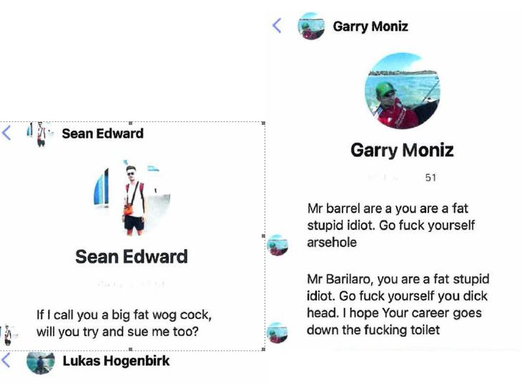
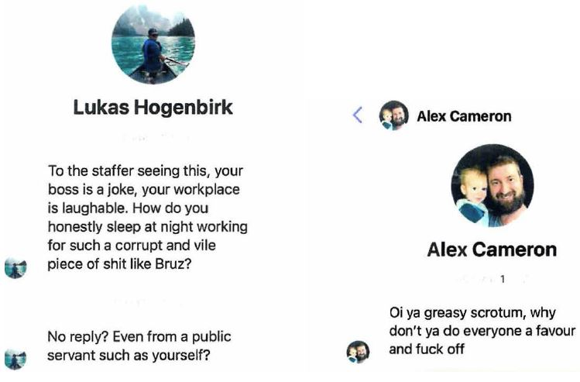

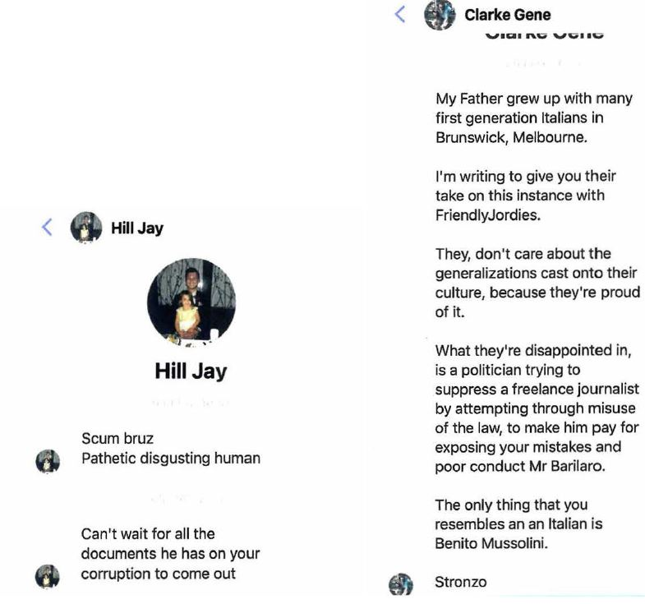
- Mr Barilaro or his staff had set an automated reply to many of those messages that indicated that the Facebook mailbox was not monitored and the user should email him at his electorate office. However, when he read them, he perceived the damage that Mr Shanks’ campaign was doing to his reputation and the vitriolic hatred of him that it had provoked. He gave this evidence, after referring to the Secret Dictatorship video. He became emotional as he did so, especially at Google’s indifference to its ongoing publications of Mr Shanks’ racial slurs, harassment and hate speech:
No sane person would watch that video and say, “this is credible”. I’ve got to say this. It’s just impossible that anyone would go, “this is credible”, but the reality is because what he does, he twists and turns everything and he attacks you. I mean, the idea the comment there that people have gone missing. Of course he says that because I’m Italian. We’re talking about the Riverina. Griffith’s down the road. You know, my wife’s family is actually from Leeton, half an hour outside Narrandera.
I mean, the reality here is that it’s all done deliberately in a way to attack your credibility, to defame you, and there’s always an undertone of something, and that’s at the heart of everything he does. And the video is the video; the comments are the comments. But the problem for me was it just sparks hatred. I’m sure in other countries, he would be up for hate crimes, because the abuse you get off the back of one video I mean, you touched on it. I don’t even know what the numbers are, but hundreds of thousands of views. You know, often four or five, six thousand comments. That’s directly on the YouTube site. But what happens to our Facebook, our Insta, our private messages? You know, the messages that I got are disgusting messages, revolting messages: Go kill yourself. You should be dead. You’re corrupt. You’re a piece of shit. Your daughter should be tied to a pole and raped in front of you, and then we’ll kill you.
I mean, that’s the stuff that comes off the back of these videos, and so I hate Google. I’m sorry to say that today, the way I’m saying it, because if they can’t see these videos for what they are, well, then there’s something bloody wrong with corporate Australia or corporate America or corporations. There’s no way and I’ve got to say, yesterday because I didn’t do it. I wasn’t the one who lodged the complaints. You know when you were going through the guidelines or you know, that they apply Google apply, and you your Honour, you even touched on some of the points in that. I started to think, There’s just no way that anyone at Google could have said this did not comply with their guidelines, and yet, 18 months on, hundreds of thousands of dollars of legal bills,
I have to sit here today, humiliated, watching those videos, humiliated and for my family and my girls who have to watch it or hear about it, and the stories that will come, the media that will watch. You know, its I can’t I just can’t believe, in this day and age, that I have to endure this. I can’t believe Google can’t see it. Look, friendlyjordies we took him on. He’s out of control. He has issues that, you know, he has to deal with, but Google are meant to be a responsible corporate citizen, and they’re not, and they need to be held to account. Yesterday, watching Jeff break down I mean, I just they own that. They own all of this, and they can’t run away from this.
(emphasis added)
- Mr Barilaro’s evidence above referred to a message that I have reproduced at [96], which was disgusting.
- Many of the Facebook messages, like the posts on each video’s YouTube page, repeat key lines from the videos, such as “stupid fat idiot”, “corrupt” or “corruption” or “greasy little scrotum”. The lines, as well as the posts and messages, were vitriolic and hateful. The posts, viewed in scale and context with the volume of similar communications on the same platform and their connection to Mr Shanks’ videos, amount objectively to harassment and cyber bullying of Mr Barilaro. These communications in their context, and as intended by Mr Shanks’ calls to arms in each video, bombard the platform. In the case of those media that were linked to, or are media accounts of, Mr Barilaro, the communications amount to a torrent of hectoring and bullying abuse.
- Politicians and those in public life must expect that their conduct and policies will be open to public scrutiny and criticism, including vehement disagreement. But that does not give critics, opponents or members of the public who disagree with the politician’s or public figure’s policies or are critical of his or her conduct or performance of their role, a licence to engage in a torrent of gratuitous racial slurring, stereotyping, name-calling, or threats of violence against not only the personal safety of that person, let alone his or her partner or children.
- It is an essential feature of a healthy democracy that everyone be able to communicate and express his or her opinion and exercise freedom of speech. Jordan CJ explained in Gardiner v John Fairfax & Sons Pty Ltd (1942) 42 SR (NSW) 171 at 174 that:
A critic is entitled to dip his pen in gall for the purpose of legitimate criticism; and no one need be mealy-mouthed in denouncing what he regards as twaddle, daub or discord.
(emphasis added)
- But the law recognises that, as in most areas of life, nothing is absolute. In Austin v Mirror Newspapers Ltd [1986] AC 299 at 313E; (1985) 3 NSWLR 354 at 360C, Lord Griffiths, giving the advice of Lord Hailsham of St Marylebone LC, Lord Keith of Kinkel, Lord Roskill and himself said:
Those in public life must have broad backs and be prepared to accept harsh criticism but they are at least entitled to expect that care should be taken to check that the facts upon which such criticism is based are true.

Further steps leading up to the hearing
- On 24 November 2021 Ashurst replied to Mark O’Brien Legal’s 12 November 2021 letter saying that it intended to call Mr Shanks.
- On 25 November 2021 Ashurst wrote to Mark O’Brien Legal seeking that Mr Barilaro and his lawyers sign confidentiality undertakings about numerous documents in Google’s discovery that it asserted were “particularly commercially sensitive, such as our client’s internal policies and guidelines” as well as personal contact details of its employees. The request had no justification in seeking any such undertaking, given the scope of the implied undertaking as determined in Hearne v Street (2008) 235 CLR 125. Google persisted until early in the trial in the untenable assertion that its internal policies and guidelines, that I have summarised above about hate speech, cyberbullying and harassment, could be made the subject of confidentiality, non-publication or suppression orders. When, during the trial, I required that Google give evidence of how it could be found that such an order was necessary to prevent prejudice to the proper administration of justice (see s 37AG(1)(a) of the Federal Court of Australia Act; Hogan v Australian Crime Commission (2010) 240 CLR 651), it abandoned that specious claim.
- On 26 November 2021, at a case management hearing, counsel then appearing for Google, stated that it intended to call Mr Shanks in support of its defence.
- On 17 December 2021, Mark O’Brien Legal wrote to Ashurst consenting to Google filing its amended defence that, relevantly, raised the untenable claim that by settling his proceeding against Mr Shanks on the terms of the heads, Mr Barilaro implicitly consented to the edited versions of the matters complained of being published by uploading on YouTube and thereby disentitled himself from being able to rely on Google’s conduct in publishing them as aggravating the damages.

The 22 December 2021 video
- On 22 December 2021, Mr Shanks uploaded onto YouTube a video entitled “” (a tongue emoji) (the 22 December 2021 video).
- It begins with the date 25 October 2021 filling the screen and a sound grab from a news broadcast in which the viewer hears that Ms Berejiklian’s counsel asked Mr Barilaro if he had any personal intimate affairs that he should disclose. This related to Mr Barilaro being examined in the Independent Commission Against Corruption (ICAC) in connection with an inquiry that had caused the Premier to resign early in October 2021 after ICAC expanded its investigation to consider an undisclosed affair she had had with a Government member of the State Parliament.
- After playing a video of counsel’s question and Mr Barilaro’s answer, Mr Shanks says of him “Smooth. Now there’s a silver tongued man who could talk his way out of any scenario”. He then says “Before we go on, I want to make it clear to John Barilaro’s lawyers, who from what I understand are avid viewers of this channel, and are most definitely watching this video right now (at which time Mr Svilans’ and Ms Chrysanthou SC’s photos captioned with his and her name appear on screen), definitely in a calm and collected manner and not having an aneurysm” that he is acting under the exception in the heads that allowed him to publish material in relation to Mr Barilaro’s performance of his public functions and mass media discourse concerning him (while he displays this term on screen) and disclaims any intention to breach the terms of the settlement.
- He says that the question put to Mr Barilaro about whether he had any intimate relationships had resulted in “a deluge of mass media stories surrounding Barilaro’s relationships”. He mentioned a story published in The Daily Telegraph on 8 October 2021 that Mr Barilaro and Mrs Barilaro had separated and a follow up story suggesting that would “not be single for long”. Mr Shanks asks how one cannot be expected to be single for long. He then brings up on screen another article published in The Daily Telegraph on 11 December 2021 that Mr Barilaro had “moved on” with another woman who had invited him to share Christmas with her family. He says that the woman was Mr Barilaro’s former senior media advisor who had moved to another job in August 2021 “right after Christo’s [Mr Langker’s] arrest.” Mr Shanks asserts that Mr Barilaro “definitely was not in a relationship [when] he said”, quoting his answer to ICAC again.
- Mr Shanks then smirks and says “well, perhaps I’ve come across some information that I think in a sense enriches these mass media reports and needs further examining”. Mr Shanks seeks to link Google’s decision on 15 December 2020 to remove one of his videos that alleged that Mr Barilaro had an extra-marital affair to:
John’s lawyers would have had to have signed statutory declarations saying that the video was false and defamatory. I know the process. I fought the complaint. I want to make it clear though. I am not saying that John has had affairs, but are you starting to see how dire it is for John if it turns out he has, as some mass media outlets are already claiming.
John would have deliberately misled ICAC; that’s a jailable offence; we would have had a terror unit chucked on us to cover up his affairs and John’s lawyers would have misled Google, their opponent in a defo suit, either through a gross lack of due diligence or purposeful and blatant dishonesty. It would render his entire lawsuit against them [Google] a complete and utter fraud as John’s claim centres around Google not removing my videos.
So if the one video Google did remove was done so due to brazen dishonesty from John’s lawyers, how on earth was Google ever meant to fairly evaluate the other videos that, according to mass media reports, [at this point the screenshot below appears] John’s lawyers are still demanding they remove.
(emphasis added)
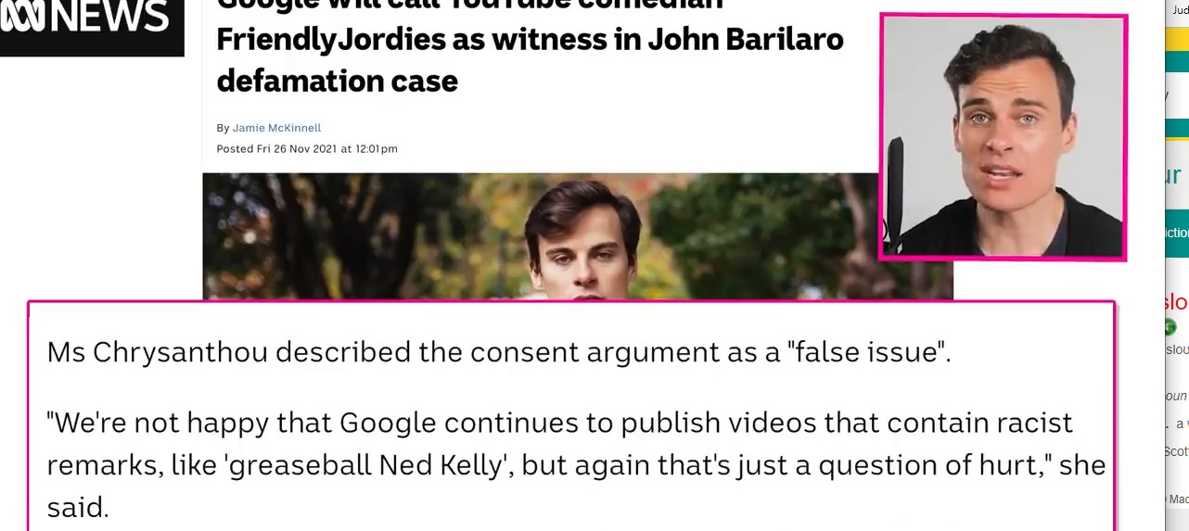
- Mr Shanks continued:
If John had affairs it would be a farce, an insult to the judicial system if the suit against Google continued. If his lawyers wanted to maintain even a shred of credibility they would have to drop the case and offer everyone they misled an apology and that list includes me, as the original concerns notice [as a screenshot of the first page of the 22 December letter appears], you know the threat to sue and bankrupt me, that old chestnut I received from them exactly a year ago to the day. It accuses me of defamation for conveying the imputation that he has committed adultery.”
(emphasis added)
- He continues by asserting that “If I were John’s lawyers … I’d start questioning John about” the allegations Mr Shanks was making. Mr Shanks then makes derogatory remarks about the police apparently investigating Mr Langker.
- The 22 December 2021 video asserted that Mr Barilaro’s lawyers, Mr Svilans and Ms Chrysanthou SC had made statutory declarations. The evidence does not suggest that Ms Chrysanthou SC or Mr Svilans had any involvement in Google’s removal of the video on 15 December 2020. I have found above that Mr McCormack and Mr Cunningham spoke to Google staff and exchanged emails with them from 25 November 2020 to 15 December 2020 without any mention of Mr Svilans or Ms Chrysanthou SC (see [129]–[136]). Moreover, there is no evidence, and it is inherently unlikely, that either Mr Svilans or Ms Chrysanthou SC made any statutory declaration, so as to prompt Google to act on 15 December 2020, by removing the video alleging the affair, about matters of which he and she would have had no direct knowledge.
- The 22 December 2021 video attacked the professional integrity of Mr Barilaro’s lawyers without any factual or intelligible basis to do so. It constituted a splenetic and vindictive public attack on each lawyer that was calculated to intimidate her and him from continuing to act for Mr Barilaro in this proceeding else, not only would this and Mr Shanks’ previous attacks on them remain online but they could expect more as and when it suited Mr Shanks to bring further illegitimate pressure to bear on them: see the cases cited at [184] above. And, of course, the 22 December 2021 video was also calculated to deter any other lawyer acting for Mr Barilaro so as to bring improper pressure on him or her to cease pursuing this proceeding.
- Mr Shanks also asserts in this video that an email address that was associated with Mr Barilaro appeared in information leaked in 2015 from the database of the Ashley Madison website, which, he reminded viewers was “the dating website specifically designed for cheating on your spouse”. Mr Shanks gives a lame disclaimer suggesting that it was possible that Mr Barilaro did not “use the account and or someone else set it up as some sort of joke or something”, before launching back into assembling his case to the contrary.
- Mr Barilaro said that there was “absolutely no truth whatsoever” in what Mr Shanks asserted in that video about the online (Ashley Madison) dating website.

The cross-examination on the 22 December 2021 video
- Senior counsel for Google cross-examined Mr Barilaro in the trial. The cross-examiner suggested that Mr Shanks was asserting in the 22 December 2021 video that Mr Barilaro had been untruthful in his evidence to the ICAC.
- At the time of that video’s publication and the trial, there was a live question as to first, whether a provision in State legislation such as s 37(3) of the Independent Commission Against Corruption Act 1988 (NSW) prevents or affects the admissibility in judicial proceedings of an answer such as that which Mr Barilaro gave in his evidence to ICAC or, secondly, whether ss 8 and 56 of the Evidence Act 1995 (Cth) have the effect that the State law is inoperative in this Court. Relevantly, s 37(3) provides:
(3) An answer made, or document or other thing produced, by a witness at a compulsory examination or public inquiry before the Commission or in accordance with a direction given by a Commissioner under section 35 (4A) is not (except as otherwise provided in this section or section 114A (5)) admissible in evidence against the person in any civil or criminal proceedings or in any disciplinary proceedings.
- In Herron v HarperCollins Publishers Australia Pty Ltd [2020] FCA 805, Jagot J, and in Feldman v Nationwide News Pty Ltd (2020) 103 NSWLR 307, the Court of Appeal of the Supreme Court of New South Wales, each held that the provision and its analogues did not apply if the person to whom the section refers is an applicant or plaintiff in the proceeding in which the evidence, document or other thing is sought to be tendered. The Full Court had reserved its decision in the appeal from Jagot J on how a State statutory analogue of s 37(3) applied having regard to ss 8 and 56 of the Evidence Act. Subsequently, the Full Court allowed the appeal from Jagot J and held that ss 8 and 56 of the Evidence Act govern the admissibility of such evidence and render State laws, such as s 37(3) inoperative: Herron v HarperCollins Publishers Australia Pty Ltd [2022] FCAFC 68 at [338], [363] per Lee J, with whom Rares J (at [85]) and Wigney J (at [233]) agreed.
- I allowed cross-examination to proceed. Mr Barilaro was asked if the video had suggested that he had not given a complete answer to the question in the ICAC hearing. He responded that the video had left the reference to his answer “hanging” rather than making an allegation or accusation. He was asked about Ms Chrysanthou SC’s statement early in the hearing when she had the video played that it effectively asserted that because he had “some sort of dating profile” which, according to Mr Shanks, meant that Mr Barilaro was not telling the truth at ICAC. Mr Barilaro in cross-examination gave the following evidence:
And that’s a fair description of the video, isn’t it? It does make allegations about you in connection with evidence that you gave at ICAC? --- Well, it gives references. It doesn’t change my view. I mean, I’ve just watched it. He covers himself and qualifies himself very, very well, and yes, it reflects on an Ashley Madison account; it reflects on evidence at ICAC. It leaves it like I said earlier, leaves it in the air for the public to consider what was in the video. It leaves it hanging. That’s why I use that term. But, you know, it’s the sort of horrible videos that I’ve received consistently.
(emphasis added)
- Mr Hmelnitsky SC pressed Mr Barilaro about why he had not complained or instructed his lawyers to complain, about the 22 December 2021 video being defamatory, as opposed to his complaining of Mr Shanks’ attack in it on his lawyers and the pressure it sought to bring on him to settle. He said that he thought that:
my legal team were being attacked in a defamatory way, which impacted on me, and it is why, at that time, I said ‘I’ve had enough, I want to settle’ … Because I thought it would never end … we had just settled with Mr Shanks, I had thought it was all over and it hadn’t. And that’s … at the heart of … why that video traumatised me, or pressured me at that time.
(emphasis added)
- In response to Mr Hmelnitsky SC’s questioning him about not suggesting, even in the witness box, that Mr Shanks’ characterisation of his evidence at ICAC was defamatory, Mr Barilaro said that he thought that it was very clever of Mr Shanks to qualify everything he said. This brought to a head the direction of the cross-examination in the following exchange:
Mr Barilaro, I have to suggest to you that you’re being a bit cute about this issue in an attempt to avoid a question about whether or not that allegation is true or false? --- Well, I’m not. I’m not being cute about it. And what is the allegation?
You lied at ICAC, is the allegation.
- When Ms Chrysanthou SC asked if Mr Hmelnitsky SC was making that allegation himself, he said “Absolutely not”.
- Mr Barilaro, not unnaturally, thought that the 22 December 2021 video was offensive and made him question the value of the settlement which he considered it devalued. Mr Barilaro acknowledged, after viewing parts of the edited bruz video during his cross-examination, that it still lampooned him in essentially the same way as the original, continued to use vulgar and abusive slurs about him and showed Mr Shanks wallowing in the fact that he was filming in Mr Barilaro’s family property. He accepted that, in the heads, he had agreed that Mr Shanks could continue to publish the edited bruz video, that it would appear on YouTube and that it would still be hurtful, vulgar and abusive.
- Mr Barilaro agreed that the edited Secret Dictatorship video deleted, rather than dubbing over, the parts that Mr Shanks agreed to edit but that this still left “quite a bit of material that is vulgar and offensive intact”. In answer to the question whether video continued to impact on and offend him, Mr Barilaro said, “The damage has been done”. Mr Barilaro gave this evidence in re-examination:
At the beginning of the cross examination, you were asked a series of questions which, on one view, ultimately culminated in a suggestion that you had lied at ICAC. How did you feel about being asked that, in circumstances where Google comes here with no defence to your case? --- It has taken me by surprise and shock. So the defence by Google seems to be to defame me further. That’s how I feel this morning, so it was a question. Yes, I yes. I’m in a bit of shock about it, so I just want this I want this ordeal to end. I want Google to end this. I’ve had enough.
(emphasis added)
- Mr Barilaro was an honest and reliable witness and I have accepted his evidence generally.

Google offers to settle
- Shortly after the 22 December 2021 video was uploaded, Google made a without prejudice offer to Mr Barilaro, on the same day, that remained open for acceptance until about 12 January 2022. The terms of that offer were not in evidence.
- On 23 December 2021, Mark O’Brien Legal wrote to Ashurst complaining of the slurs and false allegations made in the 22 December 2021 video against Ms Chrysanthou SC and Mr Svilans that each had, first, knowingly made a false statutory declaration and, secondly, engaged in brazen and blatantly dishonest conduct. The letter referred to the intimidating and punitive character of that video and asserted that Google’s publication of it had the tendency to interfere with Mr Barilaro’s right to a fair hearing. The letter reminded Google’s solicitors that, previously, their client had published indefensible, defamatory attacks on Mr Barilaro’s lawyers, including Ms Chrysanthou SC, as noted in an affidavit by Mr Svilans that was read in Court on 31 August 2021 for the purpose of the application for a jury. The letter suggested that Google’s conduct in publishing the 22 December 2021 video appeared to amount to a potential contempt. Mr Barilaro’s solicitors demanded that Google take down that and the other videos that attacked his lawyers.
- On 13 January 2022, having received no response from Google or its solicitors to Mark O’Brien Legal’s letter of 23 December 2021, Mr Barilaro’s solicitors wrote to Ashurst noting that Google had refused to remove the 22 December 2021 video or even to respond to their letter of 23 December 2021. It noted that as at 23 December 2021 there had been about 220,000 views of that video, and since then an extra 105,000 views had occurred, increasing the total to about 325,000. This letter noted that Google’s offer had been made on 22 December 2021 and the maintenance of that video online could be seen as an attempt to bring improper pressure on Mr Barilaro to settle on Google’s terms. The letter reiterated the demand to remove the videos attacking Mr Barilaro’s lawyers and noted that Mr Barilaro would rely on this aspect of Google’s conduct in support of his claim for aggravated damages.
- Eventually, on 20 January 2022, Ashurst responded, disagreeing that the 22 December 2021 video had the tendency to interfere in Mr Barilaro’s right to a fair hearing or otherwise amounted to contempt. Somewhat bizarrely, this response cited Hinch v Attorney-General (Vic) (1987) 164 CLR 15 and Kazal 256 FCR 90 in support of Google’s proposition that its conduct could not have amounted to contempt because, as a matter of practical reality, there was not a tendency or substantial risk of interference with the due course of justice. Google refused to remove the 22 December 2021 video from YouTube and there it remains.
- Mr Barilaro gave the following evidence as to how he felt as a result of Google’s lack of response to his solicitors’ 23 December 2021 letter and the overlap of the period in which its settlement offer remained open. He said in answer to his senior counsel’s question in chief, during which he became very emotional:
Well, the hell continued, and, .., I was shocked. …it played into my thoughts that this is all intimidation, and it was part and parcel of the process to get me to settle, and, …my team knows I asked you to settle. I remember telling you, Can you please settle? I wanted to settle. Going into Christmas, there was other articles. My kids were upset because the constant media speculation was there. It was never ending. I was ending my political career. I was looking at my next chapter and I wanted 2022 to be different. I asked you guys to settle. I’m being honest about it because they broke me. It just continues to break me, and it still breaks me today. I mean, I … you both asked me to sit on the idea, and ... you said, take the week out, and I did, and even when I withdrew the request for you to settle even then, it was still tough, and I couldn’t believe that Google still wouldn’t respond to the removal of the other video, and as soon as it expired the offer expired, guess what? We get a letter. And it just played into my mind that this is just a game that I’m now part of it, and it’s going to cost me thousands and thousands and thousands of dollars tens of thousands of dollars, and, …I thought 2022 was going to be different, but it’s not going to be.
(emphasis added)
- He said that initially on receiving Google’s offer he had wanted to settle and communicated this to his lawyers because he was worn down, very emotional and very upset. He said that when Google failed to respond to the request that it take down the 22 December 2021 video, “I felt it was just part of the tactic to put pressure on me … to settle”.
- On 27 January 2022, Mark O’Brien Legal wrote again to Ashurst demanding that Google take down those videos that had vile and racist slurs about Mr Barilaro, such as “greasy Ned Kelly”, “greasy little scrotum” and “big fat, wog cock”. Google has done nothing to address this, despite professing that it has policies that, one might think, should have resulted in their removal.

Google progressively drops its defences
- On 28 February 2022 Mark O’Brien Legal wrote to Ashurst enquiring whether Google was intending to call Mr Shanks given the lack of any apparent relevance of the paragraphs in his outline of evidence, about which their letter of 10 November 2021 had stated Google wished him to testify.
- On 2 March 2022, Ashurst responded to Mark O’Brien Legal informing them that Google no longer intended to call Mr Shanks.
- Next on 9 March 2022, Mark O’Brien Legal wrote to Ashurst enquiring if Google was maintaining, first, all the denials in its defence, including as to whether the matters complained of conveyed the imputations, secondly, its defences of qualified privilege and publication of a matter concerning an issue of public interest and, thirdly, reliance on all of the particulars of proper material pleaded in support of the defence of honest opinion.
- On 14 March 2022, Ashurst replied, following a discussion between the parties’ senior counsel, saying that the only defence Google was maintaining was that under s 29A of the Defamation Act in support of which it intended to call Spencer Hagan, the global manager of YouTube’s legal operations team.
- On the first day of the trial, 21 March 2022, senior counsel for Mr Barilaro repeated in her opening his position that s 29A was irrelevant. She stated that this was because Mr Barilaro was not making any claim for publication after 1 July 2021 since he could not satisfy the new requirements under ss 10A and 12A that applied to such a claim from 1 July 2021. That submission was the same as what she had put during argument on 31 August 2021. Later that day, Ashurst wrote to Mark O’Brien Legal saying that they had not previously understood that Mr Barilaro had limited his claim in that way, and, accordingly accepted that it would not press its defence under s 29A.
- Also on the first day of the trial, for reasons that are not in evidence, Google abandoned its denials that the matters complained of conveyed the imputations.

The extent of publication
- Up to 23 December 2020, there were 563,964 views of the bruz video (of which about 490,000 were in Australia) and 296,704 views of the Secret Dictatorship video (of which about 230,000 were in Australia).
- Google was not able to extrapolate the number of views from 22 December 2020 but could do so from 24 December 2020. In Australia there were 140,895 views of the bruz video and 65,854 views of the Secret Dictatorship video in the period between 24 December 2020 and 30 June 2021.
- In Australia in the period between 1 July 2021 and respectively 5 and 7 November 2021 (when Mr Shanks substituted the edited versions) there were 103,566 views of the bruz video and 37,335 views of the Secret Dictatorship video.
- Thus for the period in which Google was liable as a publisher in Australia there were over 244,461 views of the original bruz video and over 103,189 views of the Secret Dictatorship video (since there are no figures for views on 22 and 23 December 2020).
- Screenshots taken on 20 March 2022 of the home pages of the following videos showed:
Video | Upload date | Total views | Likes | Comments
bruz | 14 September 2020 | 863,566 | 78,000 | 5,429
Secret Dictatorship | 21 October 2020 | 424,065 | 40,000 | 4,055
bruz: eternal | 3 May 2021 | 851,418 | 59,000 | 4,560
bruz: withdrawal | 19 November 2021 | 325,702 | 29,000 | 1,984
The 22 December 2021 video | 22 December 2021 | 347,802 | 33,000 | 2,869
- At some point after 18 November 2021, YouTube disabled the dislike function and removed any previous record of dislike numbers. Most of the commentary, as with the like and dislike options reflected an adverse or credulous view of the subjects of each of those videos. Many were highly critical of Mr Barilaro.
- Google relied on its internal reports for the bruz and Secret Dictatorship videos that showed the respective average view durations as 10:57 and 16:34 minutes during time periods from their first uploading on 14 September 2020 and 21 October 2020, those periods were longer than the periods ending or beginning on 22 December 2020 above (as the total revenue figures were also greater). Google submitted that the total views figures did not reflect the more limited extent to which viewers watched the whole of either video. The difficulty in dealing with this evidence is that Google gave no evidence or qualitative breakdown of the view data that could be used to evaluate what the viewer would have looked at during the average view duration, how many viewers watched the whole video, whether a viewer used fast forward or skipped to go to any part of the video when the view occurred or watched any particular segment. As with the use of news media readership figures in trials, it is safe to infer that the vast majority of viewers saw the portions that conveyed the defamatory imputations. Google could have provided, had it wished, a witness to explain how the average view duration could assist the drawing of an inference favourable to it.

Google’s earnings from the matters complained of
- Google earned gross revenue totalling USD11,226.21 from its publication of the matters complained of. It earned from the bruz video in the periods from 14 September 2020 to 15 December 2020 and from 16 December 2020 to 5 November 2021, respectively, USD4,231.44 and USD3,068.74. It earned from the Secret Dictatorship video from 21 October 2020 to 15 December 2020 and from 16 December 2020 to 7 November 2021, respectively, USD2,580.92 and USD1,345.11. There is no evidence of Google’s earnings from the other videos that Mr Shanks uploaded to YouTube as part of his campaign against Mr Barilaro, but I infer that the revenue generated was not inconsiderable. No doubt this was part of the “product” of which Ms Frank wrote (see [174]).

The reputation evidence
- Mr Barilaro called seven witnesses, each of whom testified that he had a good reputation before publication of the matters complained of.
- Ricky Stuart was the head coach of the Canberra Raiders team in the National Rugby League competition. He had also coached both the Australian national and New South Wales State of Origin teams. Mr Stuart had known Mr Barilaro for about 20 years, initially through family and school connections in Queanbeyan and Canberra. For the last nine or so years, since he returned to live in Canberra, he had been in regular contact with Mr Barilaro.
- About 10 years ago, Mr Stuart and his wife established the Ricky Stuart Foundation, which is a charity that promotes awareness of autism and provides respite accommodation in two houses for children aged between 4 and 18. The Foundation aims to establish another house where young adults who have a disability can live independently.
- Mr Stuart mixed with people, in the Canberra–Queanbeyan region as well as in Sydney from a wide range of circles, in business, the community and socially, as well as with persons in connection with the Foundation. Over the years, Mr Stuart had asked Mr Barilaro to assist the Foundation with fund raising and other functions at which they both encountered common friends and acquaintances.
- In about September 2020, Mr Stuart became aware of the videos that had been published about Mr Barilaro. Prior to that time, Mr Stuart said that Mr Barilaro was known as a politician who “was very, very generous with his time, a very caring person especially for his people here of the community in … the Monaro region”. Mr Stuart said that Mr Barilaro was known for caring for his community, its people and was “a man that sticks to his word”, “a devoted family man”, “an honest bloke” who was always available to give a helping hand when needed. He said that Mr Barilaro was known as a very common person who made people, from the Prime Minister to people in a pub, feel comfortable in his presence and was willing to share time with people from all walks of life.
- Franca James had lived in Queanbeyan all her life. She and her husband had a building business and a cattle breeding business until 2018. She was involved with a number of charities including one called HOME in Queanbeyan that she, a priest and five other businesspersons began 16 years ago. This charity built 19 home units for people with mental health problems that it has operated for the last 12 years. She had known Mr Barilaro for about 40 years. They first met as part of the Italian community in Queanbeyan and became friends. Since then, they also maintained contact through business, football and charity work. She said that Mr Barilaro and his father supported charities and a football club, originally though his business Ryleho. Ms James said that subsequently Mr Barilaro continued his support of several charities with which she was involved, including HOME, first as a Queanbeyan Council councillor and then as a parliamentarian.
- Ms James became aware, after September and October 2020, of videos that friendlyjordies had published on YouTube. Ms James said that before September 2020, Mr Barilaro had a reputation of being friendly, helpful, from a loving family and community oriented. She said that, on a political level, he had a reputation throughout the Monaro region as a person who supported the region and was able to be approached in any situation. She said that a good example was his support for the community at the time of the Cobargo bushfires.
- Rogan Corbett was retired. He had been a councillor of Snowy Mountains Regional Council for nine years and deputy mayor for two years. He had lived in the Cooma region for over 60 years. He first met Mr Barilaro about 10 years ago and interacted with him through his work as a councillor and Mr Barilaro’s as a parliamentarian. Mr Corbett was aware of a video published about Mr Barilaro in September 2020. He said that before that publication Mr Barilaro’s reputation was of a person who “delivered on everything he said he would do” and was well regarded and interested in the problems of people around the local area.
- Benjamin Farinazzo had been an officer in the defence force before working in business. After suffering serious health problems, Mr Farinazzo represented Australia in the 2018 Invictus Games and won gold medals in indoor rowing and powerlifting. He is on the board of a charity called Soldier on Australia, an ambassador for Lifeline and an Australia Day ambassador.
- Mr Farinazzo first met Mr Barilaro about 10 years ago because their children attended the same public school and they had maintained infrequent contact with each other through moving in the same family circles and the Monaro Panthers soccer club, where his sons played and Mr Barilaro was frequently present. After the Invictus Games, Mr Farinazzo came across Mr Barilaro more often in charitable activities, and accompanied him to some.
- He was aware of a friendlyjordies video published on YouTube in September 2020. Mr Farinazzo said that before then Mr Barilaro had a very good reputation as a hardworking and honest person, who was also caring and sincere. He said that Mr Barilaro was known as epitomising “someone who had come up from the ground roots … to represent … the regions”.
- Mr McCormack said that prior to September 2020, Mr Barilaro’s reputation was of a person with an infectious energy or enthusiasm that caused people to volunteer and work for him because he was so positive. He said that Mr Barilaro was known as someone who got things done and done well. Mr Barilaro also had this reputation among his parliamentary and party room colleagues.
- After the publication of the videos, Mr McCormack said that Mr Barilaro’s reputation in his local area was being questioned, people were asking if he was in trouble or the allegations were true.
- Ms Taylor MLC first met Mr Barilaro when they contested National Party preselection for the seat of Monaro. He won but they became friends and by the time she gave evidence she said that he was one of her closest friends. She had come to appreciate “the sort of quality person he was”, and that he was an “incredible leader … what an incredible person”.
- Ms Taylor said that before September 2020, Mr Barilaro had an excellent reputation. The Minister said that country people saw him as someone who was genuine, cared about them and would represent them. She said:
I mean, anywhere you go in our communities, even if they disagree with John, or disagree with some of the policies of the party, or the Coalition Government, the respect for him is enormous. Because, as people will tell you, look at the Monaro, and look at what has been done, and …look at the difference before John was in to when he was. And I think that people love the fact that he’s such a fighter and and such … a credible person,
(emphasis added)
- The Minister said Mr Barilaro had a reputation as a person who was invested in and genuinely cared about his community and who created an infectious energy or support around him. She said he was regarded as “an unstoppable force in pursuing policy development … and things that make lives in the country so much better”. She had observed that there was “enormous respect … and love and admiration” for him in the community for what he had achieved for it as member for Monaro and that “John is very well thought of in the Monaro”.
- Ms Taylor said that after the publication of the videos:
in our world in politics, it can be a fairly vulgar world, if you will allow me to say, and people love to perpetuate conversations, and perpetuate things, and particularly in the halls of Macquarie Street. So in the context, your Honour, of saying that everybody was talking about it, everybody was whispering about it, everybody was you know, it was the topic of huge conversation … in terms of different colleagues and politicians, everybody sort of wanted to talk about it and wanted to have a go and particularly the people that didn’t like John because …John gets, well past tense, got things done and was so effective at that. There were people within our own government that didn’t like that …and feared that because he was relentless in his pursuit, so I think there was a lot of, you know, “Have you seen this? [viz: Mr Shanks’ videos] Have you done that?”, and that … was really awful because we all knew it was just repulsive, what was said in that video, and the way that it was done and, you know, how he sat on that chair and you know, all of that. Terrible. So I think it did affect that, absolutely, for a time.
(emphasis added)

Relief

The legislative context
- Relevantly, the Defamation Act provided at the time Mr Barilaro commenced this proceeding:

31 Defences of honest opinion
…
(3) It is a defence to the publication of defamatory matter if the defendant proves that—
(a) the matter was an expression of opinion of a person (the commentator), other than the defendant or an employee or agent of the defendant, rather than a statement of fact, and
(b) the opinion related to a matter of public interest, and
(c) the opinion is based on proper material.
…
34 Damages to bear rational relationship to harm
In determining the amount of damages to be awarded in any defamation proceedings, the court is to ensure that there is an appropriate and rational relationship between the harm sustained by the plaintiff and the amount of damages awarded.
35 Damages for non-economic loss limited
(1) The maximum amount of damages for non-economic loss that may be awarded in defamation proceedings is $250,000 or any other amount adjusted in accordance with this section from time to time (the maximum damages amount) that is applicable at the time damages are awarded.
(2) A court may order a defendant in defamation proceedings to pay damages for non-economic loss that exceed the maximum damages amount applicable at the time the order is made if, and only if, the court is satisfied that the circumstances of the publication of the defamatory matter to which the proceedings relate are such as to warrant an award of aggravated damages.
- From 1 July 2021, the Defamation Act provided:
29A Defence of publication of matter concerning issue of public interest
(1) It is a defence to the publication of defamatory matter if the defendant proves that—
(a) the matter concerns an issue of public interest, and
(b) the defendant reasonably believed that the publication of the matter was in the public interest.
(2) In determining whether the defence is established, a court must take into account all of the circumstances of the case.
(3) Without limiting subsection (2), the court may take into account the following factors to the extent the court considers them applicable in the circumstances—
(a) the seriousness of any defamatory imputation carried by the matter published,
(b) the extent to which the matter published distinguishes between suspicions, allegations and proven facts,
(c) the extent to which the matter published relates to the performance of the public functions or activities of the person,
(d) whether it was in the public interest in the circumstances for the matter to be published expeditiously,
(e) the sources of the information in the matter published, including the integrity of the sources,
(f) if a source of the information in the matter published is a person whose identity is being kept confidential, whether there is good reason for the person’s identity to be kept confidential (including, for example, to comply with an applicable professional code or standard),
(g) whether the matter published contained the substance of the person’s side of the story and, if not, whether a reasonable attempt was made by the defendant to obtain and publish a response from the person,
(h) any other steps taken to verify the information in the matter published,
(i) the importance of freedom of expression in the discussion of issues of public interest.
(4) Subsection (3) does not—
(a) require each factor referred to in the subsection to be taken into account, or
(b) limit the matters that the court may take into account.
- The Act since 1 July 2021, also provides in s 35(2)–(2B):
(2) The maximum damages amount is to be awarded only in a most serious case.
(2A) Subsection (1) does not limit the court’s power to award aggravated damages if an award of aggravated damages is warranted in the circumstances.
(2B) An award of aggravated damages is to be made separately to any award of damages for non-economic loss to which subsection (1) applies.

Google’s liability for harm suffered before it became liable for defamatory character of videos on 22 December 2020
- Google argued that it is not liable for any harm that Mr Barilaro suffered either in the period between 14 September 2020 and 21 December 2020 (the pre-publication period) or caused to him other than as a consequence of it being a publisher of the matters complained of on and from 22 December 2020. It contended that to the extent that Mr Shanks’ uploading of the matters complained of and other videos in his campaign before 22 December 2020 had caused damage to Mr Barilaro’s reputation and emotions, it could not be responsible and that the damages assessed against it should be attenuated commensurately. It submitted that a considerable part of the damage Mr Barilaro claimed to have suffered occurred before 22 December 2020 and that it could not be held liable for that.
- At first blush, there is some attraction in Google’s argument that it cannot be held liable for damage done in the pre-publication period because Mr Barilaro has only sued it as a publisher on and from 22 December 2020. However, as explained below, this has never been the law.
- A publisher cannot lead evidence of similar or earlier publications for the purpose of establishing that the publisher’s defamatory publication did not cause all of the damage of which the claimant complains in a proceeding for defamation. Such evidence may be admissible in aid of one or more of a publisher’s substantive defences, but not in mitigation or reduction of damages. Thus, for example, an earlier publication can be relied on to prove the fact, consisting of a statement (a protected statement) made under absolute or qualified privilege, like a statement made, debate occurring or a report tabled, in Parliament or evidence, argument or reasons for judgment in a judicial, quasi-legislative or administrative proceeding. Thus, a publisher who seeks, but fails, to establish that the defamatory publication was a fair report of a protected statement, or that the protected statement provided proper material in support of a defence of honest opinion, will be able to adduce evidence of that statement that self-evidently ante-dates the defamatory publication sued on but which may also be defamatory of the claimant.
- However, where the substantive defence, for the proof of which the protected statement was admissible evidence, fails, the fact that the protected statement was made and widely circulated does not avail a publisher in reducing the damages, unless the publisher pleads and proves that the protected statement caused the claimant to have bad reputation. This has been the law since Saunders v Mills (1829) 6 Bing 213 at 220 per Tindal CJ, 223 per Park J, per Burrough J and 224 per Gaselee J, as the House of Lords explained in Dingle v Associated Newspapers Ltd [1964] AC 371 at 395–397, 398–400 per Lord Radcliffe, with whom Lords Morton of Henryton and Cohen agreed (at 401, 404–406), 410–412 per Lord Denning and 416–418 per Lord Morris of Borth-y-Gest: see also Cornwall v Rowan (2004) 90 SASR 269 at 444 [794] per Bleby, Besanko and Sulan JJ and see too at 444–446 [795]–[799]. Lord Radcliffe expressed the rationale for this principle in Dingle [1964] AC at 396 in the following passage in his speech:
Whatever may be the qualifications or requirements as to evidence led on the issue of reputation by way of mitigation of damages for libel, I do not believe that it has ever yet been regarded as permissible to base such evidence on statements made by other persons about the same incident or subject as is embraced by the libel itself. In my opinion it would be directly contrary to principle to allow such an introduction. A libel action is fundamentally an action to vindicate a man’s reputation on some point as to which he has been falsely defamed, and the damages awarded have to be regarded as the demonstrative mark of that vindication. If they could be whittled away by a defendant calling attention to the fact that other people had already been saying the same thing as he had said, and pleading that for this reason alone the plaintiff had the less reputation to lose, the libelled man would never get his full vindication. It is, I think, a well understood rule of law that a defendant who has not justified his defamatory statements cannot mitigate the damages for which he is liable by producing evidence of other publications to the same effect as his; and it seems to me that it would involve an impossible conflict between this rule and the suggested proof of tarnished reputation to admit into consideration other contemporary publications about the same incident. A defamed man would only qualify for his full damages if he managed to sue the first defamer who set the ball rolling: and that, I think, is not and ought not to be the law.
(emphasis added)
- As Lord Morris added ([1964] AC at 416) “A publisher of defamatory matter acts at his peril”. Of course, damages for defamation are awarded not only for injury to reputation, as Windeyer J famously explained in Uren v John Fairfax & Sons Pty Ltd (1966) 117 CLR 118 at 150, namely:
It seems to me that, properly speaking, a man defamed does not get compensation for his damaged reputation. He gets damages because he was injured in his reputation, that is simply because he was publicly defamed. For this reason, compensation by damages operates in two ways––as a vindication of the plaintiff to the public and as consolation to him for a wrong done. Compensation is here a solatium rather than a monetary recompense for harm measurable in money. The variety of the matters which, it has been held, may be considered in assessing damages for defamation must in many cases mean that the amount of a verdict is the product of a mixture of inextricable considerations.
(emphasis added)
- The wrong done to the claimant includes the injury to both his or her feelings and reputation: John Fairfax & Sons Ltd v Kelly (1987) 8 NSWLR 131 at 142D–E per McHugh JA, with whom Kirby P agreed at 133A–B.
- Accordingly, Google’s liability in damages is not to be assessed by taking into account that Mr Shanks had published the bruz video since 14 September 2020 and the Secret Dictatorship video since 21 October 2020 and by doing so had damaged Mr Barilaro’s reputation prior to 22 December 2020. Mr Barilaro should not have his damages discounted on Google’s erroneous hypothesis that by the time it had notice of the defamatory character of those videos, namely 22 December 2020, Mr Barilaro’s reputation had already been tarnished and his feelings hurt so that it only had to compensate him for any further damage to his reputation or feelings.
- Mr Barilaro discontinued his proceeding against Mr Shanks and received no damages from him. Google may be able to seek contribution or indemnity from Mr Shanks, but that does not affect its liability to Mr Barilaro. Mr Barilaro had a separate cause of action against each of Mr Shanks and Google even though they were joint tortfeasors: Thompson v Australian Capital Television Pty Ltd (1996) 186 CLR 574 at 584–585 per Brennan CJ, Dawson and Toohey JJ. However, this does not affect the application of the principle in Saunders 6 Bing 213, Dingle [1964] AC 371 or Cornwall 90 SASR 269 to the liability of Google for all damage suffered by Mr Barilaro because it defamed him.
- There can be no question here that from 22 December 2020, Google was aware of all of Mr Shanks’ videos attacking Mr Barilaro then uploaded on YouTube and the contents of new ones to which I have referred about that he uploaded thereafter. Google’s conduct in allowing and maintaining uploads of those videos made it a publisher of them as much as Mr Shanks (Webb v Bloch (1928) 41 CLR 331 at 363–365 per Isaacs J; and also per Knox CJ at 359; Fairfax Media Publications Pty Ltd v Voller (2021) 392 ALR 540 at 546–548 [23]–[35] per Kiefel CJ, Keane and Gleeson JJ, at 553–555 [60]–[69] per Gageler and Gordon JJ).

General damages
- Mr Barilaro gave evidence, that I accept, that each of the imputations was false.
- I discussed the principles for assessing compensatory damages in Chau v Australian Broadcasting Corporation (No 3) (2021) 386 ALR 36 at 64–68 [110]–[123]. Essentially, the purpose of awarding compensatory damages is to provide, first, consolation to the claimant for the personal hurt and distress that the publication caused him or her to suffer, secondly, reparation for the damage done to his or her reputation and, thirdly, vindication of that individual’s reputation: Carson v John Fairfax & Sons Ltd (1993) 178 CLR 44 at 60–61 per Mason CJ, Deane, Dawson and Gaudron JJ. They reasoned that vindication is outward looking in the sense that the sum awarded must be, at least, the minimum amount necessary to signal to the public the vindication of the claimant’s reputation.
- In addition, s 34 of the Defamation Act requires the amount of damages (both compensatory and aggravated) to reflect an appropriate and rational relationship between the harm that is done to the claimant and the quantum of the award. By force of s 35(1) and (3), the current maximum sum of compensatory damages that can be awarded to Mr Barilaro for non-economic loss is $432,500. The Defamation Act did not cap Mr Barilaro’s entitlement to be awarded more than that amount if, in all the circumstances of the publication of a matter complained of, a court finds that an award of aggravated damages is appropriate: Nationwide News Pty Ltd v Rush (2020) 380 ALR 432 at 526 [458]–[463] per White, Gleeson and Wheelahan JJ.
- I am of opinion that Mr Barilaro’s right to bring this proceeding accrued before the Amendment Act commenced and that it is not necessary for me to separate the award of damages. However, as I explain below, I consider that this is a most serious case. The matters complained of resulted in Mr Barilaro being driven prematurely from office, so that the judgment sum, necessarily, will have to reflect the very substantial damage done to his feelings, his reputation, the need to nail the lie and to vindicate him to the public.
- In Ley v Hamilton (1935) 153 LT 384 at 386, Lord Atkin, with whom Lords Tomlin, Thankerton, Macmillan and Wright agreed, said:
It is precisely because the “real” damage cannot be ascertained and established that the damages are at large. It is impossible to track the scandal, to know what quarters the poison may reach: it is impossible to weigh at all closely the compensation which will recompense a man or a woman for the insult offered or the pain of a false accusation. No doubt in newspaper libels juries take into account the vast circulations which are justly claimed in present times.
(emphasis added)
- In addition, as Dixon, Williams, Webb and Kitto JJ noted in Triggell v Pheeney (1951) 82 CLR 497 at 513–514, in assessing general damages the Court is entitled to look at the whole of the conduct of the publisher from the time of publication to the time of the verdict (as Lord Esher MR said in Praed v Graham (1889) 24 QBD 53 at 55), the mode and extent of publication, the fact that the defamatory statement was never retracted, the fact that the publisher never offered an apology and the fact that the defamatory statement “had been persisted in to the end”. They adopted what Knox CJ, Gavan Duffy and Starke JJ had held in Herald & Weekly Times Ltd v McGregor (1928) 41 CLR 254 at 263, namely, that those factors might increase the area of publication, the effect of the defamatory publication on those who read, saw or heard it and its vitality and capability of causing (further) harm to the claimant.
- And, as Lord Hailsham of St Marylebone LC held in Broome v Cassell & Co Ltd [1972] AC 1027 at 1071C–D, the quantum of damages in a defamation action must be such that “in case the libel, driven underground, emerges from its lurking place at some future date, he [the claimant] must be able to point to a sum awarded by a jury sufficient to convince a bystander of the baselessness of the charge”. The award must also have regard to the “grapevine effect” of the publication complained of so as to ensure that the claimant recovers an appropriate amount of compensation: Crampton v Nugawela (1996) 41 NSWLR 176 at 194C–195A per Mahoney ACJ, with whom Handley JA agreed on this issue (at 195G).
- McColl JA, with whom Spigelman CJ, Beazley JA, McClennan CJ at CL and Bergin CJ in Eq agreed, held in Channel Seven Sydney Pty Ltd v Mahommed (2010) 278 ALR 232 at 277–278 [214]–[218], that the claimant can lead evidence of some occurrences after the publication of defamatory matter that are relevant to damages, including aggravated damages. These include evidence of statements made about, and conduct directed toward, the claimant as a consequence of the publication and, as in Praed 24 QBD at 55, subsequent conduct of the publisher up to the time of judgment.
- Mr Barilaro said that mid-September 2020 had been a very difficult time for him both personally, with the loss of his father earlier that year, the difficulties that were developing in his marriage, as well as politically. He acknowledged that at this time, there was a fairly serious political dispute between the parties in the Liberal-National Coalition Government concerning a State Environmental Planning Policy relating to koalas over which there were reports that his Ministers threatened to leave the Cabinet and that the Coalition itself was under threat. He accepted that, politically, it was a torrid time, albeit that this “is part and parcel of being a leader of … a party”. However, a tortfeasor such as Google, takes its victim as it finds him or her.
- Mr Barilaro was deeply affected by the publication of each of the bruz and Secret Dictatorship videos. He perceived that the bruz video “was … a disgusting video in retribution” for his act in calling out and defending against Mr Shanks’ earlier racist and offensive comments directed at both Ms Berejiklian and himself. To him it was “just raw; it’s disgusting; it’s vile”. He was traumatised by it. Having observed carefully him in giving his evidence, I am satisfied that Mr Barilaro was profoundly hurt by both the bruz video itself, through its inherently racist, spiteful and vituperative content, and also by Google’s deliberate decisions to continue making it and the Secret Dictatorship video available on YouTube from 22 December 2020 to 5 and 7 November 2021 respectively when Mr Shanks substituted the edited versions.
- The Secret Dictatorship video also left Mr Barilaro dumbfounded and angry. He felt Mr Shanks’ obvious spite and malice in uploading it on the day he (Mr Barilaro) returned to his Parliamentary duties after taking a month’s mental health leave saying that Mr Shanks “hit me when I was most fragile”. He was deeply hurt by Google leaving it available on YouTube for nearly 11 months after he had sought its removal. Both Mr McCormack and Ms Taylor MLC gave evidence of the impact of the bruz video and, I infer, the Secret Dictatorship video on Mr Barilaro’s reputation both in Parliament and the community ([274]–[278]).
- Mr Barilaro suffered harassment both in person and online as a direct result of the initial and ongoing publication of the matters complained of, Mr Shanks’ ongoing campaign against him and Google’s facilitation of that, at least, on and from 22 December 2020, by having the matters complained of available or allowing them and other videos published before and after them to be accessible on YouTube.
- Mr Barilaro instanced the following examples of situations in which strangers confronted him in circumstances with an apparent connection to Mr Shanks’ videos on YouTube:
- at the Supa Centa at Moore Park in Sydney, Mr Barilaro was shopping with his family when Mr Shanks filmed him there and posted the incident in one of the videos in evidence.
- in early 2021, as he left the Apple Store in Bondi Junction with his young daughter and was entering the Westfield Shopping Centre next door, he was verbally abused by a man. The man came up to him, asked if he was John Barilaro and when Mr Barilaro said he was, the man said in an aggressive, confrontational tone “Bruz, you’re a corrupt piece of shit”. As Mr Barilaro said, this was very distressing for him because it happened in front of his five or six year old child who was hanging onto his leg. He said his daughter could understand what was going on and had gone quiet, as he remonstrated with the abuser.
- in 2021, at the Glebe Hotel, in Hyde Park, at Rushcutters Bay, at the BP service station in Edgecliff and at Woolworths Double Bay he experienced distressing incidents that he did not describe in any detail.
- at Macquarie University, he was at a private event that Mr Shanks gate crashed as he depicted in the bruz: eternal video. However, as Mr Barilaro said of this incident, he was there in a professional capacity and “I sort of cop that to a degree … but not when you’ve got a weekend … and you’ve got your family with you. That’s just a bit harder … to cop”.
- in early to mid-2021, he went to Chifley Tower in Phillip Street, Sydney, near the Government offices at 52 Martin Place, with some of his staff for lunch, as he often did, when he was approached by another aggressive individual calling him “corrupt”, “bruz” and “a piece of shit”.
- in mid-2021, after a day at the races, he, Mr McCormack and some other Government staff were sitting in a booth in a pub chatting over a beer when a man, who had had a few drinks, confronted him aggressively, as if to punch him, calling him a “corrupt piece of shit, bruz”. Mr Barilaro said that Mr McCormack and the others intervened and the hotel security personnel removed the man, who then stayed outside for a considerable time looking through the window and making offensive gestures towards Mr Barilaro. Mr Barilaro said that during this incident “I’m just going; I’m not doing this anymore. I’m not going out anymore … I’m done. I’m done with all of this. I just can’t do this anymore”.
- Mr Barilaro said that he thought that he would be a bit safer in regional areas. But, during the Upper Hunter by-election, he was approached by “guys with shirts” (being “bruz” tee shirts sold by friendlyjordies) and “harassed a bit”. He said “It just never ends … thank God … I’ve deleted most of my social media accounts since leaving politics, but it won’t stop”.
- Mr McCormack said that before the friendlyjordies videos, Mr Barilaro was “incredibly social with his colleagues, staff, friends and family who were in Sydney”. He recalled a number of occasions, after the publication of the matters complained of began, when he was in a restaurant, café or pub with Mr Barilaro and members of the public approached them and referred to the videos. These persons called Mr Barilaro “bruz”, made racist comments and accused him of corruption in front of him, his friends or family members, including his children. Mr McCormack described these incidents as “extremely confronting because they were very aggressive in nature”. He observed that, having worked in politics for a number of years, including some hotly contested campaigns, these were “probably the most vile and aggressive confrontations that I have seen”.
- Mr McCormack said that from the time of the first publication of Mr Shanks’ videos to Mr Barilaro’s resignation, he noticed a deterioration in his boss’ ability to handle such confrontations which became progressively more aggressive and rude. He noticed that Mr Barilaro began to refrain from socialising with his friends, as he had before. Mr McCormack said that Mr Barilaro habitually would debrief with him in Sydney on the weekend and they would frequently dine together during the week. However, in the months leading up to Mr Barilaro’s resignation, Mr McCormack said that Mr Barilaro was not comfortable going out in public anymore, especially in Sydney, and would pull a cap over his head, wear sunglasses and seek to meet with him privately rather than in public. Mr McCormack had enjoyed their social catch ups and found that, for him, “one of the most telling factors was that he [Mr Barilaro] was feeling very sad”.
- While in office during 2020 and 2021, Mr Barilaro received many messages on his social media accounts that reflected Mr Shanks’ incitement to hate speech and harassment directed at Mr Barilaro. I have set out a few examples of those postings and messages at [74], [96], [99] and [180]. Mr McCormack and Mr Barilaro each referred in their evidence to the threats to Mr Barilaro and his daughter in the vile Facebook message reproduced at [96] above, and the real concern that it caused. As I set out at [210] above, Mr Barilaro testified that the revolting concept that his daughter should be raped in front of him and he should be shot is “the stuff that comes off the back of these videos”. How Facebook, with all its sophisticated algorithms to assist its revenue generation, can allow such material to be posted on its platform, is a question that deserves to be examined by the Parliament.
- Google argued that it could not be responsible in damages for posts and incidents of abuse that occurred before 22 December 2020. While some allowance should be made for this, Google did not cross examine or lead evidence about the timing of undated posts or incidents. The evidence leaves me comfortably satisfied that after 22 December 2020, Mr Barilaro received very significant social media posts and experienced many instances of abuse of which the bruz and Secret Dictatorship videos, and others posted on YouTube, in Mr Shanks’ campaign, were a cause.
- I am satisfied that the damage suffered by Mr Barilaro in his reputation and feelings caused by the matters complained of and in all the circumstances, leaving to one side any aggravating factors, requires a very large verdict because it is a most serious case. However, that award must include compensation for Google’s aggravation of the damages. I accept Mr Barilaro’s evidence that the relentless campaign of racial vilification, hate speech and the publication of the defamatory imputations each matter complained of conveyed, drove Mr Barilaro prematurely from his office of Deputy Premier and out of the public life as a member of Parliament to which he had sought to contribute and in which he had achieved both high office and the recognition of those in his community and in the State for the contribution that he had made.

Aggravated damages
- Mr Barilaro contended in his closing submissions that Google’s conduct aggravated the damage he has suffered by reason of each of the following six matters:
- Google’s initial failure in late December 2020 to remove the two matters complained of (the initial inaction issue).
- Google’s continuing failure to remove the matters complained of despite its knowledge of Mr Shanks’ ongoing campaign of harassment and abuse (the ongoing inaction issue).
- Google’s failure to remove the videos by no later than the first day of the trial when it had abandoned all its defences (the recent inaction issue).
- Google’s conduct of the proceeding (the general conduct issue).
- Google’s failure to apologise (the apology issue).
- Google’s improper cross-examination of Mr Barilaro (the cross-examination issue).

Aggravated damages – principles
- Aggravated damages are compensatory, not punitive. Conduct of a tortious wrongdoer that is improper, unjustifiable or lacking in bona fides can increase the harm done to the injured party so as to require a larger award of damages. Thus, the conduct of the publisher in a defamation action, including in the way in which it defends the proceeding itself, can increase the harm done if that conduct crosses the line of what is proper, justifiable or bona fide: Trigell 82 CLR at 514. Thus, as Dixon, Williams, Webb and Kitto JJ held (at 514–515), a publisher’s lack of any ground for belief in a defence can warrant a finding that its advancement in the proceeding was improper and aggravated the damage that the claimant suffered. In Sutcliffe v Pressdram Ltd [1991] 1 QB 153 at 170D–E, Lord Donaldson MR of Lymington said (which Lee J approved in Stead v Fairfax Media Publications Pty Ltd (2021) 387 ALR 123 at 179 [273]):
Aggravated damages are awarded precisely because other conduct by the defendants, which may or may not take the form of another libel, rubs salt in the wounds inflicted by the libel sued upon.
(emphasis added)
- In Rush 380 ALR at 517–519 [429]–[434], White, Gleeson and Wheelahan JJ discussed a number of principles relating to aggravated damages. In doing so, they approved the following passage from Nourse LJ’s reasons in Sutcliffe [1991] 1 QB at 184D–F:
The conduct of a defendant which may often be regarded as aggravating the injury to the plaintiff's feelings, so as to support a claim for “aggravated” damages, includes a failure to make any or any sufficient apology and withdrawal; a repetition of the libel; conduct calculated to deter the plaintiff from proceeding; persistence, by way of a prolonged or hostile cross-examination of the plaintiff or in turgid speeches to the jury, in a plea of justification which is bound to fail; the general conduct either of the preliminaries or of the trial itself in a manner calculated to attract further wide publicity; and persecution of the plaintiff by other means.
(emphasis added)
- This class of damage is additional to and distinct from ordinary compensatory damages to which a claimant may be entitled as a result of the publisher conducting a failed but bona fide defence. The mere fact that a defence fails is different from conducting a defence for which there is no basis. In each case, the fact that the proceeding was defended can cause harm to the claimant’s feelings and reputation; but a defence for which there was no basis and should never have been advanced is calculated to cause additional harm, because the publisher’s persistence in it suggests that, while ultimately unsuccessful, the publisher had a proper, justifiable and bona fide basis on which to dispute liability. For example, the publisher may deny that a matter complained of is defamatory, as occurred in Cairns v John Fairfax & Sons Ltd [1983] 2 NSWLR 708, where it was held that current community standards could influence whether an imputation about a moral or ethical issue was defamatory, or rely on a defence of justification that depended on the credibility of witnesses.

The initial, ongoing and recent inaction issues
- Each of the first three claims for aggravated damages (the initial, ongoing and recent inaction issues) relies on Google’s failures to remove the matters complained of and other videos at particular times; namely, first, immediately after Mr Barilaro made Google aware of their character on 22 December 2020, secondly, thereafter, including once this proceeding had commenced and Google was on notice of Mr Barilaro’s concerns about Mr Shanks’ campaign against him and its nature and thirdly, once Google eventually acknowledged that it did not, and, I infer, never had any bona fide defence.
- Google argued that its lack of response to, or action on, the 22 December letter did not aggravate the harm to Mr Barilaro. It contended that this was because, first, Mr Barilaro did not use a complaint form in respect of the Secret Dictatorship video, as he had earlier in respect of the bruz video. It submitted that it was understandable that a large company like Google “would treat a lawyer’s letter of demand in a manner different to a removal complaint lodged using official company forms”. It submitted that a lawyer’s letter would be given to lawyers “and treated with a ‘litigation’ mindset” instead of going to persons “tasked with deciding whether to remove the content”. Secondly, it asserted that Mr Barilaro had not suffered any, or any significant additional, harm because the existing harm caused by the earlier publication of the matters complained of was the “real kernel of Mr Barilaro’s distress”.
- I reject Google’s argument. As I have found, Mr Barilaro suffered considerable distress because of Google’s conduct. He said in the passages of his evidence that I have quoted in [210], [239] and [245], that he was very hurt by Google because of what it had put him through by leaving Mr Shanks’ videos on YouTube, and its conduct of this proceeding. He said, with justification, “I have to sit here today, humiliated … I can’t believe Google can’t see it … Google are meant to be a responsible corporate citizen, and they’re not” (quoted in part at [210]).
- Google called no evidence about the speculation, in which its submission indulged, concerning how it might treat a “lawyer’s letter”, Moreover, on 30 November 2020, Mr Cunningham made a formal complaint, using Google’s forms, that included both matters complained of ([131]) which he and Mr McCormack followed up with Ms Frank giving her the URL links on 2 December 2020. Thus, by 22 December 2020, Google had done nothing over the preceding three weeks, to remove both matters complained of from YouTube except to tell Mr Cunningham on 15 December 2020 that it would not remove the bruz video ([136]). That inaction would cause a reasonable person in Mr Barilaro’s position to have a lawyer write to Google to emphasise the seriousness of his (or her) concerns. Google’s submission displays an air of insouciance towards the seriousness of the issues raised in the “lawyer’s letter” that its subsequent conduct reinforced.
- Next, Google argued that there was no allegation that it “in fact believed, knew or even suspected” that there was a “smear campaign” against Mr Barilaro as he alleged in respect of The Italian Job, Super Barilaro Kart, bruzboard and bruz: eternal videos. It contended that Mr Barilaro’s “formal complaint” on 1 December 2020 was confined to the bruz and The Italian Job videos together with the video that Google removed being “I called John Barilaro”. It submitted that Mr Barilaro did not make a formal complaint “via Google’s complaint process in respect of” the Super Barilaro Kart, bruzboard and bruz: eternal videos. It also referred to Mark O’Brien Lawyers no longer relying at the trial on four of the ten videos the subject of the 22 December letter as somehow explaining its unawareness, by that time, of the blindingly obvious smear campaign in the videos. Of course, bruz: eternal was only published eight months later on 3 May 2021.
- Google’s arguments of its lack of awareness and the need, by 22 December 2020, for another “formal complaint” is without merit. It defied the reality that the second paragraph of the 22 December letter informed it in plain English:
We are instructed that a YouTube user with the account name friendlyjordies (whose name is Jordan Shanks-Markovina) has engaged in an indefensibly racist and defamatory campaign against our client. Mr Shanks-Markovina’s YouTube channel can be found at the following link: …
(emphasis added)
- It is little wonder that Google was not willing to call a witness to support its baseless submission. The racist comments and hateful content of the bruz and Secret Dictatorship videos, as well as the other videos Mr Shanks uploaded that I have described above, appeared to contravene Google’s policies.
- Google’s control of the operation and administration of YouTube, of what is posted on it and how that content is made accessible to the public for publication is absolute. It decides how material is posted, who can access it and whether and to which extent it should remain accessible once posted. And, it earns revenue from or as a result of videos posted on YouTube.
- Google was a publisher of all content posted on YouTube. It encouraged and facilitated publication of the matters complained of and each of Mr Shanks’ other videos and public comments posted on YouTube video pages, so that, it was also, from late November 2020, and certainly by 22 December 2020, a publisher of all of those: Voller 392 ALR at 548 [32] per Kiefel CJ, Keane and Gleeson JJ, 563–564 [104]–[105] per Gageler and Gordon JJ.
- Google structured its business model to enable persons to post videos and comments on YouTube as freely as possible while it used the posted material as a vehicle to earn advertising revenue. It held itself out as having policies that applied to regulate content posted on YouTube and that protected, and or would be used to protect, individuals or groups of individuals who may be harassed, made the subject of hate speech, vilification and cyberbullying.
- As I have explained above when discussing the various videos in evidence, they are replete with racist, hate filled rants that were calculated to bully and publicly hound Mr Barilaro. Mr Shanks repetitively calls him demeaning names, and posts depictions of him, such as “meatball”, “greasy”, “greasy little scrotum”, “wog”, “corrupt” and “Italian” in association with direct references or clear allusions to the mafia. And, he advertised the sale of tee shirts and the bruz key chain (see [148]) on YouTube as part of his videos.
- Of course, when used for the first time or in a limited way, such names or depictions can be humorous. But that was not the effect that Mr Shanks’ use of these devices had or was intended to have.
- The YouTube policies defined harassment and cyberbullying as content that features prolonged name calling or malicious insults such as racial slurs based on an individual’s intrinsic characteristics (see [114] above). While this definition was subject to an exception for debates of topical issues (as opposed to one sided diatribes) concerning public figures, such as Mr Barilaro was, and insults in scripted comedic performances, the policies made clear that the exception “is not a free pass to harass someone and claim ‘I was joking’” ([115]). The policies envisage “some rare cases” that would warrant removal of videos which repeatedly encourage abusive behaviour or repeatedly target, insult and abuse an identifiable individual based on his or her intrinsic attributes across several videos ([116]).
- The policies also prohibited hate speech, which they defined as including content that promoted hatred against an individual based on attributes such as ethnicity or race, racial or other slurs or stereotypes that incited hatred on such a basis, claims that an individual is “mentally inferior” on such a basis and putting conspiracy theories that an individual is “evil, corrupt or malicious based on any of those attributes” (emphasis added) ([117]–[118]).
- Racially directed hate speech is a well-known concept. The International Convention on the Elimination of All Forms of Racial Discrimination, opened for signature on 21 December 1965, is set out in the Schedule to the Racial Discrimination Act 1975 (Cth). That Act ratified the Convention in s 7. Part IIA of the Racial Discrimination Act is headed “Prohibition of offensive behaviour based on racial hatred”. An act done, communicated to the public, that is reasonably likely, in all the circumstances, to offend, insult, humiliate or intimidate another person and that is done because of the person’s race, national or ethnic origin, is unlawful by force of s 18C(1).
- However, s 18D provides, among other matters, that s 18C does not render unlawful anything said or done reasonably and in good faith” (emphasis added) in the performance, exhibition or distribution of an artistic work, or in making or publishing a fair and accurate report of an event or matter of public interest or a fair comment on any event or matter of public interest, if the comment is an expression of a genuine belief held by the person making the comment. The criterion of reasonableness must be satisfied if the exception in s 18D can be applied. Importantly, s 18 provides that if an act is done for two or more reasons, one of which is the race, national or ethnic origin (regardless of whether that reason is the dominant or a substantial reason for doing the act), then the act is deemed to have been done for that reason.
- Article 4 of the Convention provides:
States Parties condemn all propaganda and all organizations which are based on ideas or theories of superiority of one race or group of persons of one colour or ethnic origin, or which attempt to justify or promote racial hatred and discrimination in any form, and undertake to adopt immediate and positive measures designed to eradicate all incitement to, or acts of, such discrimination.
(emphasis added)
- Google’s policies, that I summarised earlier, appear to have been drafted to reflect the international norms in the Convention and Pt IIA of the Racial Discrimination Act. Google’s application, or rather lack of application, of its policies is another thing.
- Despite the above policies being publicly available, the videos in evidence that I have described earlier in these reasons show that Google did not appear to take the application of its policies seriously, no doubt because Mr Shanks was very popular and YouTube publications, such as his, earned Google revenue. Moreover, its policies, that were only internally available, that it sought to keep from public scrutiny in this proceeding, reinforced the same themes, as summarised above ([119]–[128]). The internal hate speech policy identified that a video that “is dedicated to repeating slurs over and over … is likely to cross the comedic line we set”. That line appears to prohibit repetitions over a 30-second period that have the proscribed character defined in the policies.
- The bruz video is a continuing tirade that attacks Mr Barilaro with the racially vilifying slurs of “wog”, “greasy” (which in the Australian lexicon of abuse are demeaning, exclusionary and derogatory synonyms for a person of Southern European ethnicity or heritage) and “greasy little scrotum”. Mr Shanks constantly calls Mr Barilaro corrupt. Google cannot hide behind the use of its Californian head office or American understandings of the English language as being the same as in Australia. It operates a very large business in Australia, has Australian staff and lawyers and could not suggest that it was somehow ignorant of how hurtful and bullying the bruz video was in its use of the slurs and venomous hate speech that Mr Shanks directed avowedly, deliberately at Mr Barilaro, for criticising Mr Shanks’ earlier racist behaviour, as the opening sequence states ([35]). That sequence is followed, just in case the purpose for the language used and content was not already evident, with a sequence that put onto the screen Mr Barilaro’s criticism while Mr Shanks mocks his “migrant success story” and labels him “AKA Greasy Ned Kelly” ([41]–[42]).
- Google argued that the hate speech, harassment and cyberbullying policies proscribed content only while the focus of that content was to insult. That submission ignores the policies’ other proscribed intentions including to “cause intimidation … degradation or bullying” and disregards the likely risks of the consequences to individuals that such conduct can cause ([120]). It is also conceptually difficult to understand Google’s submission that the focus of the bruz video was not to insult. The content of the bruz video was a running stream of insults, demeaning Mr Barilaro by reason of his race and national or ethnic origin. Early on, Mr Shanks tells viewers from his bath that he will be referring to Mr Barilaro as “Giovanni. And not just because that’s his name but also because he is such a Giovanni. Plus, it pisses him off [smells cigar]. I really like the thought of that man being upset” (emphasis added) (par 17). Mr Shanks also repeatedly calls Mr Barilaro various insulting, demeaning epithets in the Secret Dictatorship video segments dealing with Mr Barilaro. It was calculated to insult and demean him.
- The internal policies for EDSA and public interest enforcement provide that “malicious expression targeting a public official” is only allowed when directed to his or her “physical attributes”. Calling Mr Barilaro a “wog”, “greasy”, a “greasy little scrotum” and a “meatball” could not reasonably fall within that exception.
- Google argued that because each of the bruzboard, Super Barilaro Kart and The Italian Job videos was uploaded before 22 December 2020, none could be relied on as aggravating the damages, or that if it could, Mr Barilaro had not sought to establish “the quantum or proportion of publications” of it on and after 22 December 2020.
- Google’s submission ignored the fact that when it became a publisher on 22 December 2020, those three videos were also on YouTube and affected Mr Barilaro, as the 22 December letter had informed it. It was not necessary for Mr Barilaro to prove some viewing statistics for each video. He established his hurt to feelings from those videos. And, those videos compounded the harm to Mr Barilaro’s reputation from the matters complained of and provoked numerous comments from the public so that they can be taken into account without a discount even if they were online before 22 December 2020, including because Google left them there afterwards: Saunders 6 Bing 213; Dingle [1964] AC 371; Cornwall 90 SASR 269.
- Google also asserted that it is critical to distinguish Google’s position from that of Mr Shanks because it was “not the creator of the content”. That submission was untenable. Isaacs J debunked it in Webb 41 CLR at 364–366. Every publisher of defamatory matter is equally liable for its publication. His Honour said (at 365) that persons other than the author of a libel “cannot employ the master mind [viz. the author] for the very purpose, accept its suggestions, approve and disseminate its production, and then disclaim its malice”.
- Google made a deliberate decision on 22 December 2020 to publish the matters complained of and other videos then online and, in doing so, became fully liable as a publisher, including for Mr Shanks’ state of mind. Despite this having been the law for centuries, Google sought to excuse itself from the very conduct and damage that it put out to the world by leaving the publications on YouTube and continuing to earn revenue from doing so.
- By 22 December 2020, Google was aware of Mr Barilaro’s concerns about the racist, hate speech and cyber bullying characteristics of the bruz video and others uploaded to that time, described above. Yet, it allowed them to remain posted online until Mr Shanks replaced the matters complained of in early November 2021 and, in the case of the other videos in evidence, until at least the end of the final hearing.
- Google also became aware of the bruz: eternal video, I infer, soon after it was uploaded on 3 May 2021. In it, Mr Shanks made plain that he intended to continue with the same conduct, including the use of videos to achieve his aim of cyber bullying Mr Barilaro, as he had bullied Clive Palmer, into not suing him (see [145]–[148]) by advertising the scrotum keychain and telling Mr Barilaro that he (Mr Shanks) was not going to stop this hounding and harassing conduct. And, because of Google’s failure to remove this and earlier videos, that is just what Mr Shanks has continued to do.
- As I noted above at [149], the bruz: eternal video had a segment lasting over a minute with Mr Shanks berating Mr Barilaro as a “greasy little scrotum”. It is difficult to understand how any reasonable person with knowledge of Google’s policies could have considered that this video did not breach them. Moreover, it was explicit in hectoring Mr Barilaro and his lawyers with bullying threats and racist slurs, such as its emphasis on the scrotum keyring, that there would be much more of the same for each of them if Mr Barilaro sought to exercise his right to seek relief in the courts.
- Every person, regardless of his or her position in society, and whether or not he or she is popular or expresses views with which others agree or disagree, is entitled to approach this country’s courts to seek the decision of an impartial judge or jury about the merits of a claim. Public bullying of the kind displayed in the bruz: eternal video, the He’s destroying Australia video, the bruz: withdrawal video and the 22 December 2021 video all appear, first, to contravene Google’s policies and, secondly, to be calculated to bring pressure on each of Mr Barilaro and his lawyers not to avail of or exercise their lawful right to bring or pursue this proceeding for resolution by the Court. The same is true of Mr Shanks’ social media post set out in [184] above.
- In my opinion, Google had no reasonable basis under its policies for leaving up the videos then posted online after 22 December 2020 or allowing the subsequently posted ones to be there, including the edited versions of the matters complained of. Google has not called Mr Hagan or any other witness to explain how it applied its policies or its conduct of this litigation. I infer that, such evidence would not have assisted its case: Jones v Dunkel (1959) 101 CLR 298.
- Importantly, s 35(2) of the Defamation Act requires, as a condition of the power to award aggravated damages, that the Court must be satisfied that the circumstances of the publication of the defamatory matter warrant such an award.
- Mr McCormack had informed Google on 25 November 2020 of the racist, vile and untrue content of numerous videos that Mr Shanks had posted. On 30 November 2020, Mr Cunningham made a formal complaint about, among others, the bruz and Secret Dictatorship videos ([129], [131] above). By 15 December 2020, Google had declined to take down the matters complained of from YouTube ([136]). Google was by then on notice of the racist and defamatory content of the matters complained of and thus became a publisher (as it accepts) after receipt of the 22 December letter.
- I accept Mr Barilaro’s evidence, and that of Mr McCormack, Mr Cunningham and Ms Taylor MLC, of the traumatic impacts on him of Google’s conduct in permitting the videos to remain online when knowing of their content and their nature. Google’s conduct keeping the videos online was an essential aspect to assist Mr Shanks in his campaign. It has been a direct cause of driving Mr Barilaro prematurely from public office and bringing him into public hatred, ridicule and contempt.
- Of course, as a politician, Mr Barilaro could expect many people in the community not to agree with his policies or to regard him well. He could expect public criticism and condemnation for his political conduct and stances as part and parcel of being in political life, particularly in as publicly prominent a position as he had as Deputy Premier and a party leader. Hate filled speech and vitriolic, constant public cyberbullying, however, cannot be classified as in any way acceptable means of communication in a democratic society governed by the rule of law. Google’s conduct after 22 December 2020 in leaving both Mr Shanks’ existing and subsequently posted videos online magnified the hurt to Mr Barilaro’s feelings, inflamed hate filled responses directed at him by members of the public in personal confrontations and on social media and allowed a perception, until the trial, that Google actually had a bona fide defence in this proceeding for its conduct. That was conduct that was unjustifiable, improper (because of its contemptuous nature) and, in relation to the conduct of the proceeding, lacking in bona fides (as I explain below): Rush 380 ALR at 517–518 [431]–[432].
- For these reasons, in my opinion, each of Google’s initial inaction from late December 2020 and its subsequent continuing failure to remove the matters complained of and other videos in Mr Shanks’ ongoing campaign of harassment and abuse has aggravated the damages very substantially.

The general conduct issue
- The day after Google filed its defence on 25 August 2021, Mark O’Brien Legal wrote to Ashurst questioning how Google:
- could maintain its denial that the bruz video conveyed imputations 9(a), (b) and (c) despite express statements in it that made the denial untenable;
- could plead qualified privilege at common law despite Lange 189 CLR 520 making such a plea untenable;
- was seeking to establish the elements of a qualified privilege defence based on the implied freedom;
- could rely on the 2020 amendments to the Defamation Act that had come into force on 1 July 2021, and in particular on the new defence under s 29A;
- could rely on s 29A in any event when it required the publisher to have a reasonable belief at the time of publication of each matter complained of that its publication was in the public interest.
- Ashurst responded on 30 August 2021 asserting that:
- Google’s denials that imputations 9(a), (b) and (c) had “been made after proper and careful consideration”
- Google’s reliance on the 2020 amendments related to Mr Barilaro’s pleading that its publication of the matters complained of was ongoing before and after 1 July 2021 and the new provisions applied as defences only to the latter publications, despite the single publication rule in s 14C of the Limitation Act 1969 (NSW) that applied for the purpose of setting a limitation period for a cause of action.
- Google’s denial that the matters complained of conveyed the imputations which Mr Barilaro alleged was unjustifiable. Each imputation was as plain as day. Mr Shanks repeatedly called Mr Barilaro corrupt throughout the matters complained of. In the bruz video, he propounded that, for example, Mr Barilaro was a “conman to the core” (par 16), “just a fat, decadent conman that by the grace of the gods was put in his position to ransack the Empire for all its worth” (par 121), “seriously though, I think he’s corrupt” (par 46) and “He wears his corruption as a badge of honour” (par 55). Mr Shanks repeatedly alludes to Mr Barilaro, his Italian heritage, the mafia, and such things as “dumb little annoying crimes perpetrated by dumb little annoying people, aka ‘The Italian Stallion’ or Shetland Pony, rather ‘Giovanni Domenico Barilaro’” (par 9). Mr Shanks says “he perjured himself, nine times over. You usually go to jail for committing perjury once” (pars 77–78, in the context of pars 74–76). Mr Shanks told viewers, immediately after the accusation of perjury, that Mr Barilaro gave $3.3 million to a beef company in a dealing “that is blatant corruption and wouldn’t you guess, Giovanni says what he says whenever someone makes a plausible accusation of corruption perpetrated by him: ‘Fuck off’” (pars 80, 81) (see [47] above). Similarly, Mr Shanks tells viewers that Mr Barilaro promised a royal commission into water corruption, then voted against it (pars 42–44) immediately before saying that there was only one possible explanation for this conduct. At that point (par 45), he facetiously suggests and depicts on screen, that Mr Barilaro “switched heads with Jennifer Coolridge and no one noticed” (par 45), before adding the sting: “Seriously though, I think he’s corrupt” (par 46) (see [37]–[43] above).
- The whole tenor of the bruz video was to depict Mr Barilaro as a corrupt conman, as is evinced in pars 122–123, namely:
And yet he’s offended by being portrayed as an Italian stereotype.
Well Giovanni, if you find that comparison deeply offensive, same offer as to all your other discrepancies, show me the evidence that you’re not a stereotype. I’ll stop. Show me how a man on a state minister’s salary could afford an estate, as not even your first house, your second house; a second house that’s so big it has a second and third house on it, like Mars’ two moons just got attracted into its gravitational pull.
- Google gave no explanation for its pleaded denial that imputations 9(a)–(e) were conveyed by the bruz video. I infer that the pleading was known by it to be untenable. It was doomed to fail and an abuse of the process of the Court: Walton v Gardiner (1993) 177 CLR 378 at 393 per Mason CJ, Deane and Dawson JJ.
- Likewise, Google’s pleaded denial that imputations 15(a)–(c) were conveyed was equally hopeless as, I infer, it knew. Mr Shanks tells viewers “did you know blackmail’s illegal? I wonder how illegal it is to use taxpayer money as blackmail to shut your critics up. If this is who I think it is, and I do think that, he’s such a scab that he doesn’t even use his own money to blackmail. Is it a wonder that John [Barilaro] was so happy to shut down any chances of the Narrandera to Tocumal rail line being built” (emphasis added) (pars 224–225, in the context of pars 220–223) (see [89] above).
- Similarly, as pars 271–277 (set out at [90] above) make plain, Mr Shanks tells viewers about missing millions of dollars in Narrandera and other regional councils’ government grants:
People like John Barilaro might be worth hundreds of millions of dollars. All these people that you assume are getting $100,000, $200,000 a year for being a public servant, this is garner wage to them, they don’t care about it. It’s the same thing as what happens with Putin where he’s just like, “l am just President, yes I get a little bit more than the American President.” Yeah, on the books. Off the books he’s richer than fucking Bill Gates.
We’re quite certain that this is what’s happening to these towns because you tell me where the money goes. Council has close to $50 million sitting around in its accounts. Where is it now? Where did that money go? Certainly not going here. [LAUGHS] Oh I don’t know, yeah, that must have cost about 30 bucks.
- The certainty that Mr Barilaro has taken millions of dollars of Narrandera Council’s missing grant money, as Mr Shanks asserts, is driven home by his comparing his relatively meagre official salary to his potential worth of hundreds of millions of dollars, through conduct comparable to the corruption of President of the Russian Federation, Vladimir Putin.
- In my opinion, there was no proper basis for Google to deny that the Secret Dictatorship video conveyed imputations 15(a)–(c).
- Google’s denial that the matters complained of conveyed each of the imputations was unsustainable. In particular, there was no prospect that it could ever make out that the bruz video did not convey imputations 9(a), (b) and (c). In my opinion, this conduct aggravated the damages to which Mr Barilaro is entitled.
- Defamation proceedings, like all litigation in this Court, must be conducted in accordance with the statutory obligation that Pt VB of the Federal Court of Australia Act imposes on the Court, the parties and their legal representatives to act in a way that is consistent with the overarching purpose of the civil practice and procedure provisions, namely to facilitate the just realisation of the controversy according to law as quickly, inexpensively and efficiently as possible (ss 37M, 37N).
- The raising and maintaining of an untenable defence is calculated to cause pointless delay to the resolution of the proceeding and expense to the parties. Even if to plead such a defence may not be inconsistent with the literal application of procedural rules, it may be manifestly unfair to another party to the litigation or “otherwise bring the administration of justice into disrepute among right-thinking people”: Walton 177 CLR at 393. Defamation litigation of the present kind is likely to be expensive and, ordinarily, an applicant or plaintiff undertaking such an action is faced with a statutory cap on the amount of any damages (s 35 of the Defamation Act) and a shortfall in recoverable costs, if taxed on a party and party basis, should he or she succeed. Deep pocketed respondents or defendants cannot be permitted to use the procedural rules to conduct such litigation in a way that raises false or untenable issues contrary to the overarching purpose prescribed in Pt VB.
- Of course, a claim in defamation will often raise a real and genuine dispute as to how an ordinary, reasonable person to whom a publication is made would understand it. But no one viewing the bruz video could reasonably have understood it in a way that did not convey, what Mr Shanks said repeatedly in terms, that Mr Barilaro was a corrupt conman, had committed perjury nine times and, because of doing so, should be in jail.
- Likewise, as Google’s belated abandonment of the denials revealed, the other five imputations were clearly conveyed by each of the bruz and Secret Dictatorship videos, as the editing that Mr Shanks performed under his settlement with Mr Barilaro reinforced.
- Google’s pleading of a defence of qualified privilege at common law was also unjustifiable. First, there could not have been any reciprocity of duty and interest between it, as publisher of content on the YouTube platform, and the mass audience to warrant its communication of the matters complained of: Lange 189 CLR at 572. As Brennan CJ, Dawson, Toohey, Gaudron, McHugh, Gummow and Kirby JJ held in Lange 189 CLR at 572, at common law, except in limited circumstances, a claim of qualified privilege will fail where a publication is made to a large audience because, ordinarily, the publisher will not be able to establish that it was using the occasion honestly and without malice for the purpose of publishing the defamatory matter to all of the recipients.
- Here, YouTube operates indiscriminately in making uploaded videos available to all and sundry usually (but not in this matter on and after 22 December 2020) without even knowing what is in them, unless a complaint is made that, as here put it on notice of the potentially defamatory character of the publication.
- In its answers to interrogatories, Google averred that it did not intend to convey any of the imputations carried by each matter complained of and had no belief, before or after December 2020, in their truth. Thus, a defence of qualified privilege at common law in respect of a publication of defamatory matter to tens of thousands of recipients could not have succeeded. That is because it cannot be for the common convenience and welfare of society to damage the reputation of the person defamed to such a large audience: Lange 189 CLR at 572. That limitation of the common law defence was the reason why the High Court held in Lange 189 CLR 520 there that there had to be a new defence of qualified privilege based on the implied constitutional freedom of communication on government and political matter.
- However, the defences of qualified privilege based on the implied freedom or s 30 of the Defamation Act require the publisher to prove that its conduct in publishing was reasonable in the circumstances: Lange 189 CLR at 573–574; s 30(1)(c).
- Here, Google’s conduct was unreasonable. It did not intend to convey, and had no belief in the truth of any of the imputations. Had it done a Google search, or paused the bruz video so as to enable one to read the screen shots of the news articles from which Mr Shanks purported to quote, it would have seen that Mr Shanks had failed to contextualise his statements relating to his allegations of corruption. More importantly, Google made no attempt to seek, let alone put, Mr Barilaro’s side of the various subjects on which he was attacked and there was no conceivable reason to suggest doing so was not practicable or unnecessary (see [43]–[50] above). As the Court said in Lange 189 CLR at 574:
Whether the making of a publication was reasonable must depend upon all the circumstances of the case. But, as a general rule, a defendant's conduct in publishing material giving rise to a defamatory imputation will not be reasonable unless the defendant had reasonable grounds for believing that the imputation was true, took proper steps, so far as they were reasonably open, to verify the accuracy of the material and did not believe the imputation to be untrue. Furthermore, the defendant's conduct will not be reasonable unless the defendant has sought a response from the person defamed and published the response made (if any) except in cases where the seeking or publication of a response was not practicable or it was unnecessary to give the plaintiff an opportunity to respond
(footnote omitted, emphasis added)
- Moreover, Mr Shanks’ claims in the bruz video that Mr Barilaro must have acquired Dungowan Estate through corruption on no other basis than Mr Shanks’ assertion that he could not have afforded it on his publicly funded salary was obviously unreasonable. A moment’s thought would reveal multiple other possibilities such as that Mr Barilaro had an independent source of funds either from investments, assets acquired before he entered political life, assistance from his wife or family or an inheritance, not to mention a commercial loan. Google’s publication of Mr Shanks’ unsubstantiated allegation that corruption was the only explanation for the acquisition was reckless and unreasonable.
- More significantly, Google’s decision to publish Mr Shanks’ assertions that Mr Barilaro committed perjury nine times and, also because of that, he ought to have been in jail, required someone in Google to investigate if the claims had a basis and what, if any, response, Mr Barilaro had. As I explained (at [49] above), the ABC post, a screenshot of which Mr Shanks displayed when making these allegations, stated that Mr Barilaro had explained that he had no role in the Jobs for NSW Board making independent recommendations to him for final approval. Google gave no explanation as to why it pleaded and belatedly abandoned its hopeless defence of qualified privilege in respect of the bruz video. Again, I infer that it knew that the defence had no proper basis.
- Google pleaded its defence of honest opinion in respect of the bruz video two weeks after my ruling in Barilaro (No 2) 393 ALR 417 that Mr Shanks could not plead that defence to imputation 9(c), namely that Mr Barilaro had so conducted himself in committing perjury nine times that he should be gaoled. Google was aware of that ruling and, although not strictly bound by it, because it had not yet appeared when the argument took place, must have been aware that any attempt to prove the material for comment, namely the truth of the assertion that Mr Barilaro had committed perjury in giving evidence in proceedings in Parliament, necessarily would breach Parliamentary privilege and so was not justiciable.
- Nor could Google have established that there was proper material for defending the bruz video as Mr Shanks’ honest opinion in respect of other aspects. For example, in particular 14 of the proper material on which it relied in its defence, Google stated:
The Applicant and ROC decided to invest $3.3 million into Australia’s Oyster Coast (paragraphs 70 to 71, including the image and text which appears on screen at approximately 8:33, 8:45 and 9:42);
…
The material is proper material by reason that it is substantially true. The Second Respondent relies upon the following facts and matters in support of the substantial truth of the material:
(a) On 5 April 2018 the Applicant signed and executed an approval for an equity investment of $3.3 million in Australia’s Oyster Coast.
(b) On 25 May 2018 the Applicant, together with Minister for Transport and Infrastructure and Member for Bega Andrew Constance announced that the NSW Government, through the Fund, had invested $3.3 million in Australia’s Oyster Coast and would take an equity stake in the company.
(emphasis added)
- Yet, as the copy of the approval document reproduced at [46] above shows, the recommendation for the approval was made to Mr Barilaro by the Jobs for NSW Board, a Government body, not by ROC Partners.
- Similarly, pars 24–27 of Google’s particulars of proper material concerned the subject matter of imputation (d), namely that Mr Barilaro corruptly gave $3.3 million to a beef company. Those particulars asserted that ROC Partners had “advised the Government to give $3.3 million to a beef company” 10 months after ROC Partners had bought a majority stake in it and Mr Barilaro subsequently refused to refer the decision to the Independent Pricing and Regulatory Authority Tribunal. As I noted in [46]–[49] above, Mr Shanks asserted in the bruz video that this was “blatant corruption”, without referring to Mr Barilaro’s contemporaneous reported statement to the budget estimates committee that ROC Partners had disclosed its interest in the beef company to the Jobs for NSW Board when it considered whether to grant the approval.
- Unsurprisingly, Google also abandoned the defence of honest opinion. I infer that the defence could not have succeeded because of the many misstatements and distortions of the facts in the bruz video, such as those above, that made the task of establishing that Mr Shanks based his “honest” opinion on proper material within the meaning of s 31(5) and (6) hopeless.
- Google’s pleading of the new defence under s 29A of the Defamation Act, introduced on 1 July 2021, was equally hopeless. Mr Barilaro alleged that Google published each matter complained of from 22 December 2020. Schedule 1 of the Amendment Act provided that an amendment made by that Act applied only to the publication of defamatory matter after its commencement (which is now incorporated as item 7 in Pt 3 of Sch 4 of the Defamation Act).
- As Sch 2 of the Amendment Act made clear, in amending the Limitation Act by inserting ss 14B(2)–(4) and 14C, the date of publication (or first publication) of matter in electronic form for limitation purposes is “the day on which the matter was first uploaded for access or sent electronically to a recipient”.
- The Amendment Act also introduced the requirement for a person aggrieved by the publication of allegedly defamatory matter to give a concerns notice in writing to the publisher stating the defamatory imputations that he or she considers are, or may be, conveyed by it and why those are of concern, as a precondition of being able to commence defamation proceedings (ss 12A, 12B). Since Mr Barilaro had commenced this proceeding before 1 July 2021, he did not need to give a concerns notice about either of the bruz or Secret Dictatorship videos.
- It would be anomalous if, for limitation purposes, a plaintiff’s or applicant’s cause of action accrued on the date on which publication occurred by the first uploading of the defamatory matter in electronic form, yet a defendant or respondent could defeat that cause of action where the publication remained online after 1 July 2021 by pleading a defence under the new s 29A to a different cause of action, that could not have accrued until sometime after the first uploading had occurred. In other words, Parliament must have intended that the new defence in s 29A would apply only to a cause of action that accrued after s 29A commenced.
- Even though the amendments to the Limitation Act made in the Amendment Act did not apply expressly to the Defamation Act, Parliament will be presumed to seek to achieve harmonious goals in a cognate amending Act such as the Amendment Act. There is no evident legislative purpose that would be achieved by a construction of the Defamation Act and Limitation Act as each amended by the Amendment Act from 1 July 2021 that deemed a cause of action to have accrued on a date in 2020, when the bruz and Secret Dictatorship videos were first uploaded (or 22 December 2020, when Mr Barilaro asserted Google became liable) yet contemplated that s 29A would apply as if each uploading by a viewer, on or after 1 July 2021, created a new cause of action to which it would provide a publisher with a defence.
- Although it is not necessary for my decision, I am of opinion that s 29A provides a defence only to the publication of defamatory matter in electronic form that is first uploaded on or after 1 July 2021. The reason why it is not necessary for me to decide whether s 29A could have applied to give Google a defence is that Mr Barilaro particularised his claim as relying on publications after 22 December 2020 of the matters complained of as going only to damages. On 31 August 2021, his senior counsel made this clear when questioning why Google had pleaded on the defence under s 29A. Mr Barilaro never wavered from that position, yet Google maintained the s 29A defence until the first day of the trial when, as I noted at [252], it abandoned the defence.
- Even if s 29A could apply to this proceeding, Google would have had to establish that it reasonably believed that the publication of the bruz video was in the public interest under s 29A(1)(b). That criterion, of the reasonableness of Google’s belief, could not have been satisfied in respect of the bruz video. Google did not particularise any enquiry or research that it had made about the content of the bruz video.
- As Lord Griffiths said in Austin [1986] AC at 317 in relation to the issue of reasonableness for a defence of statutory qualified privilege:
When a journalist wishes to make such a trenchant and potentially damaging attack it is in the interests of society that he should be expected to take all reasonable steps to ensure that he has got his facts right. The media has enormous power both for good and ill and it would be a sorry day if newspapers were encouraged to believe that under the shield of qualified privilege the reputations of individuals could be attacked by slip-shod journalism that would provide no defence of comment because the facts on which the attack was based were not true. Where the defence of comment has failed because the jury has found the facts to be untrue, a judge should examine the circumstances leading up to the publication of those false facts very closely before concluding that it was reasonable to publish them.
(emphasis added)
- Of course, s 29A creates a defence with different criteria to qualified privilege under s 30 of the Defamation Act or in exercise of the implied freedom, and s 29A(3) specifies a non-exclusive set of circumstances that a court may take into account. Those circumstances include the seriousness of the defamatory imputations conveyed, the extent to which the matter complained of distinguishes between suspicions, allegations, and proven facts and whether it contained the substance of the side of the story of the person defamed (s 29A(3)(a), (b), (g)).
- The bruz video made no attempt to set out Mr Barilaro’s side of the story. It mixed suspicions and allegations together with an occasional proven fact in a way that did not enable a viewer to separate which was which, while conveying very serious false imputations about Mr Barilaro.
- It is important to appreciate that the defence under s 29A can apply where a publisher cannot establish other defences under the Act or at common law. The bruz video conveyed serious false imputations that Google could not defend as being published under qualified privilege or as honest opinion for the reasons above. That raises the question as to how Google reasonably could have believed it was in the public interest to publish it after Mr Barilaro’s staff and solicitors had raised their concerns about it with Google.
- It was common ground that s 29A is based on s 4 of the Defamation Act 2013 (UK). In Serafin v Malkiewicz [2020] 1 WLR 2455 at 2476 [74], Lord Wilson, with whom Lord Reed PSC, Lord Briggs, Lady Arden and Lord Kitchin JJSC agreed, discussed s 4 of the United Kingdom Act. It is differently worded from s 29A of the Defamation Act. His Lordship’s analysis identified three elements to the defence which are helpful here. Allowing for the differences in statutory language, it seems that s 29A(1) requires that:
- the matter concerns an issue of public interest;
- the publisher must believe that the publication of the matter was “in the public interest”; and
- the publisher’s belief must be reasonable.
- Lord Wilson emphasised that the circumstances in the analogue to s 29A(3) are not “requirements” that must always be met, but are matters that the Court can consider (at 2475 [69]). He suggested that a failure to invite comment from the claimant, or I would add, as s 29A(3)(g) provides, put the substance of his or her side of the story, will usually be considered and “may contribute to, perhaps even form the basis of, a conclusion that the [publisher] has not established that element [viz. the analogue of s 29A(1)(b)] of the defence” (at 2477 [76]).
- I reject Mr Barilaro’s submission that the Supreme Court in Serafin [2020] 1 WLR at 2473–2477 [67]–[78] endorsed the decisions of Warby J and the Court of Appeal in Economou v de Freitas [2017] EMLR 4 and [2019] EMLR 7 respectively. Lord Wilson criticised both judgments. He said (at 2476 [73]): “The concept of qualified privilege is laden with baggage which, on any view, does not burden the statutory defence”.
- Nonetheless, here it is impossible to discern how, as at 22 December 2020, Google could have believed that (continued) publication of the bruz video was reasonably in the public interest. Google did not intend to convey, and had no belief in the truth of, the very serious and false imputations (see [359]). It either made no examination of its contents, including doing a Google search of the excerpted documents, such as news articles, that Mr Shanks put on screen as his source for his assertions, to ascertain what were allegations, suspicions or proven facts or, if it did, it could not reasonably have concluded that the gross distortions in which Mr Shanks engaged in misrepresenting the facts were in the public interest. And, it is as plain as day that the bruz video made no attempt to put Mr Barilaro’s side of the story or its substance.

The apology issue
- Google failed to apologise. As it noted in its submissions, mere failure of a publisher to apologise, without more, is insufficient to amount to an aggravation of damage: Carson 178 CLR at 66. However, Google did not merely fail to apologise to Mr Barilaro. It deliberately continued to publish matters complained of and other videos, along with the associated denigratory comments posted on the YouTube platform, knowing of their defamatory content including Mr Shanks’ hate speech, racism and cyber bullying campaign. That added to Mr Barilaro’s hurt to feelings, public attacks on him and the injury to his reputation. Google chose to continue publishing Mr Shanks’ malicious, racist rants and false imputations conveyed in the matters complained of, rubbing salt into Mr Barilaro’s wounds: Sutcliffe [1991] 1 QB at 170D–E; Stead 387 ALR at 179 [273]. It cannot ignore the character of his splenetic campaign in its decision to continue publishing the matters complained as the same as having no belief in or intention to convey the false imputations: Webb 41 CLR at 364–365.
- As Mr Barilaro said, had Google made any check of Mr Shanks’ allegations using the excerpts from news media publications that he put on screen, it would have seen a balanced story and said: “‘Hang on, there is a problem here.’ But the crack team at Google somehow missed all that”. It was obvious that the imputations of corruption levelled at the Deputy Premier in both matters complained of were extremely serious. They were not comedic content; they impugned the honesty and integrity of Mr Barilaro in a sustained assault, yet Google chose to keep them online without any belief in their truth or, worse still, without conducting any inquiries to see if there was a basis for its decision to publish them.
- Mr Barilaro gave the following evidence as to how hurt he was by Google’s failure to apologise:
I just thought Google will be the first to come to us to settle to end it because … they will realise because they’ve got professional experts that understand it. It’s their rules. They set the guidelines. I can’t believe we actually settled with Friendlyjordies, and we haven’t settled with Google. I can’t believe that even on Friday when they’ve withdrawn their defences, they never sought to give me an apology. I assume that they’re not defending it, that they’ve actually accepted that I’ve been defamed. But I haven’t received an apology. There has been no apology. There’s no effort by Google and, at every step, they’ve just defended and defended, and … it has cost us thousands and thousands of dollars and hundreds and hundreds of hours, and, you know, I just can’t understand it. I mean - - -
Have they ever even offered you an apology? --- No. I’ve never ever never, never have been offered an apology because that would have gone a long way. We may not be here today.
(emphasis added)
- I share Mr Barilaro’s incredulity at Google’s unjustifiable persistence in failing to apologise to him for publishing indefensible imputations that it never had any basis to allow Mr Shanks to publish or keep online. Accordingly, I am of opinion that Google’s failure to apologise has aggravated the damages substantially.

The cross-examination issue
- Mr Barilaro argued that Google’s cross-examination of him in asking whether Mr Shanks’ allegation that he had lied in his evidence to ICAC was improper and unjustifiable (see [236]–[237]). Google retorted in its closing written submissions that Mr Hmelnitsky SC was not putting the allegation to Mr Barilaro that he had lied but, rather, that he was asking “whether Mr Barilaro understood that the video was putting an allegation against him (not whether the allegation was true or false) and Mr Barilaro was resisting the proposition that the video was in fact making an allegation” and that senior counsel had expressly stated that he was not putting that allegation.
- It is difficult to understand Google’s argument. The question that was put conveyed what I understood was the tenor of the cross-examination as it was proceeding. Indeed, when Ms Chrysanthou SC objected to Mr Hmelnitsky SC’s question she elicited his response that he “absolutely” was not putting to Mr Barilaro that he had lied in his evidence to ICAC. He then withdrew the question, and commented that “The only matter that’s relevant for your Honour is the question of aggravation and –” to which I interjected “Well, this might be contributing to it”.
- In my opinion, the question was improper and unjustifiable. The general rule is that evidence cannot be elicited, even for the purpose of mitigating damages, whether in chief or in cross-examination, which if proved would be a defence, unless such a defence has been pleaded: Goldsbrough v John Fairfax & Sons Ltd (1934) 34 SR (NSW) 524 at 529–530 per Jordan CJ. Google had no defence.
- The question was at best anxious to wound but afraid to strike. The only basis that Mr Barilaro could be questioned about being “a bit cute” was, as the question was put, namely, to challenge his “attempt to avoid a question about whether that allegation [by Mr Shanks] is true or false”. Thus, the question inferred that Mr Barilaro was evading answering a further question that had nothing to do with the harm done, of which he complained, resulting from Google’s publication and refusal to take down the 22 December 2021 video. The truth or otherwise of Mr Shanks’ allegation had no possible relevance to Mr Barilaro’s complaint. It just rubbed salt into the wound.
- Google did not explain how an answer, that Mr Barilaro admitted the allegation, was relevant or could make any difference to his claim that the 22 December 2021 video was an improper attack on his lawyers and aggravated the damage.

Should there be injunctive relief?
- Mr Barilaro argued that I should also enjoin Google from publishing the same or similar defamatory matter that Mr Shanks created.
- In my opinion, such an injunction is not appropriate. First, Mr Barilaro did not seek such an order in his pleaded case, secondly, the imputations of which he complains are no longer online as a result of Mr Shanks’ editing of the bruz and Secret Dictatorship videos and, thirdly, if the Principal Registrar brings proceedings for contempt, the propriety of Google’s publication of the rest of Mr Shanks’ obsessional campaign against Mr Barilaro is likely to be considered and the Court will be able to make any appropriate orders in a properly constituted proceeding.

Conclusion
- Google made a considered decision to keep the bruz and Secret Dictatorship videos available on YouTube from 22 December 2020, knowing of their content and Mr Barilaro’s complaints. Google had no defence to Mr Barilaro’s claim that each of the matters complained of conveyed the defamatory, very serious and false imputations on which he relied. It dragged the litigation out by pleading defences that had no prospect of succeeding, causing Mr Barilaro added distress, damage to his reputation, and delay to his vindication. Google encouraged and facilitated Mr Shanks in his vitriolic, obsessional, hate filled cyberbullying and harassment of Mr Barilaro both before and after Mr Shanks settled the defamation claims against him: Voller 392 ALR at 548 [32], 563–564 [104]–[105]; Rush 380 ALR at 517–519 [431]–[434]. It did so with a view to its commercial profit.
- Google sought to put itself forward to the public as having policies governing the use of YouTube that it would use to protect individuals, including public figures such as senior politicians, from being subjected to racist attacks, harassment, hate speech and cyber bullying. However, despite multiple breaches of those policies that were evident in each of the matters complained of and the other videos in Mr Shanks’ campaign described above, Google chose to continue publishing that material. It published the bruz and Secret Dictatorship videos without any belief in their truth or attempt to ascertain if there were any basis for them, knowing of their wide dissemination on YouTube and their connection to Mr Shanks’ obviously obsessional campaign.
- Google’s publication of the matters complained of drove Mr Barilaro prematurely from his chosen service in public life and traumatised him significantly. Google cannot escape its liability for the substantial damage that Mr Shanks’ campaign caused: Webb 41 CLR at 364–365. He needed YouTube to disseminate his poison. Google was willing to join Mr Shanks in doing so to earn revenue as part of its business model. It did so without regard to acting as a responsible or reasonable publisher, which actually intended its policies to be applied to Mr Shanks’ campaign, would have acted.
- Having regard to all of the evidence, the gravity of the imputations, the harm to Mr Barilaro’s feelings and reputation, Google’s significant aggravation of the damage and the need to vindicate Mr Barilaro’s reputation, I consider that he is entitled to judgment in the sum of $675,000. He is also entitled to prejudgment interest from 22 December 2020 of $40,000.
- Having regard to my findings on aggravated damages, my preliminary view is that Mr Barilaro may wish to seek a special order for costs. I will make orders that allow the parties to address on costs.
- I propose to refer the conduct of Mr Shanks and Google to the Principal Registrar of the Court to consider whether to institute proceedings against each for what appear to be serious contempts of court by bringing improper pressure on Mr Barilaro and his lawyers not to pursue this proceeding.
I certify that the preceding four hundred and seven (407) numbered paragraphs are a true copy of the Reasons for Judgment of the Honourable Justice Rares.

Associate:
Dated: 6 June 2022
ANNEXURE A
Transcript of the first matter complained of, being the bruz video, published on YouTube on or about 14 September 2020

1. | Friendlyjordies has been routinely exposing the corruption and misdeeds of the NSW Coalition Government.
2. | Naturally, mocking the premier and deputy premier in the process.
3. | Barilaro condemned Jordan’s use of the word “bruz” with an Italian accent as “deeply offensive” and “racist” — news.com.au
4. | And thus, a new nickname was born for the proud Italian.
5. | Jordan Shanks: Oh what the f**k
6. | [Picture of John Barilaro with Super Mario hat and caption: “Super Barilaro Bruz” with voice over saying: “Oh what the fuck!”]
7. | Welcome to the history of Super Barilaro Bruz
8. | Celebrated French writer, de Balzac once said, that behind every great fortune lies a great crime. I didn’t know he said that, I just remember Chris Rock misquoting it once.
9. | The point is, it’s very easy to look at plutocrats like Gina Rinehart, Rupert Murdoch, Maxmoefoe who’s clearly gotten away with public mutilation, and come to that conclusion. But, asterix, Behind… fairly impressive fortunes lie many, many dumb little annoying crimes perpetrated by dumb little annoying people, aka ‘The Italian Stallion’ or Shetland pony rather, Giovanni Domenic Barilaro.
10. | Now you might be thinking: [SUPPOSED TWITTER COMMENT FROM SAMANTHA]: “Oh no, he’s in a bath naked. Can’t you make something that isn’t crude so I can show my mum?”
11 | Ah, don’t you worry, we’re not here to talk about my big fat wog cock, we’re here to talk about another big wog cock.
12. | bruz
13. | [SITTING DOWN ON A THRONE-LIKE CHAIR] Aaahh. Now that we’re comfortable, John Barilaro is a man whose expediency seeps right down to his very genetics, as not only do his political convictions turn on a dime but so does his ethnicity. Proud Italian where he thinks he can score pity points.
14. | Rinky dink Johnny from the Bush when he thinks he can score a national seat.
15. | Willing to change his entire identity, right down to his name, surely distressing his inner child who would wonder, [IN PARODY ITALIAN ACCENT]: “Hey Giovanni, whatsa matter, you no talka with your accent no more?”
16. | Bruzamia! He’s a conman to the core, powered by spaghetti.
17 | As such, I’ll be referring to him from now on as Giovanni. And not just because that’s his name but also because he’s just such a Giovanni. Plus it pisses him off and [SMELLS CIGAR] I really like the thought of that man being upset
18. | IN PARODY ITALIAN ACCENT]: “Oh what the fuck! Another video. Bruz, as if the joke isn’t old already.”
19. | No, no, wait, I’ve got new material for you. You ready? Your response to the Berejiklian bushfires.
20. | Giovanni’s actions during the bushfires were like all his other actions in life, stupid as fuck, and very funny. Like the rest of us, he didn’t know exactly what to do but knew that the first step was to get mad at the people who had been attempting to warn him about the fires for the last decade.
21. | [IN PARODY ITALIAN ACCENT]: “Oh but bruz, I’m a visual learna, they shoulda turned what was going to happen into a movie, then I woulda paid attention.”
22. | He blamed the National Parks. One of the men most responsible on earth for the Black Summer Bushfires blaming the people least responsible for it, claiming that they were ideologically opposed to hazard reduction burns.
23. | [Inserted clip of John Barilaro saying “Ideologically don’t like the concept of hazard reduction, but we give them the responsibility.”]
24. | No, you ball of grease, the reason they’re not doing hazard reduction burns is because you cut their funding by 27%.
25. | They’d been begging, specifically fat lips here, for the funds so that they could do the hazard reduction burns. But you cut the number of rangers by 100, and you cut the number of people who make the plans for hazard reduction burns from 36 under Labor to 10 under the Coalition.
26. | Bruz, you’re into cooking.
27. | [Inserted clip of John Barilaro saying “Today I’m going to do something simple, a veal scallopini.
28. | Of course he eats veal. [IN PARODY ITALIAN ACCENT]: “Yeah, it’s tasty” What you did to the National Parks and Wildlife Service is like not adding water to minestrone and saying, [IN PARODY ITALIAN ACCENT]: “This minestrone is ideologically opposed to being a soup.”
29. | I mean it’s obvious when you look at Giovanni’s decisions and comments that he’s a moron, but I at least thought he’d be smart enough to come up with an excuse that is a little better than, [IN PARODY ITALIAN ACCENT]: “Bruz, it’s not the government’s fault, it’s the uh, um, government’s fault.”
30. | You’re in charge of the National Parks you idiot! Anyway, look at this: Uh, uh, trust me it’ll be funny later.
31. | John, like the rest of us remembers the bushfires as a time of great anguish as he was forced to take time out of his London holiday to moralise to all us city slickers in Sydney.
32. | Don’t worry though, he didn’t bother coming home to do it, he still continued on with his holiday to say, [IN PARODY ITALIAN ACCENT]: “You city slickers in Mount Druitt don’t understand the struggle of us fair dinkum bush battlers, like myself.”
33. | Oh, interesting, and where are you?
34. | [Image of John Barilaro on top of Big Ben]
35. | “Big Ben stooge! Gong!”
36. | Claiming that he’s battling for the bush.
37. | What part of sitting on your fat worthless arse in merry old England while the bush was burning, blaming the people who were putting out those fires, that you practically lit, screams battling for the bush to you.
38. | [IN PARODY ITALIAN ACCENT]: “Cos bruz, I make the battles and then I fight them, understand?”
39. | Looks like the Julio-Claudians weren’t wiped out after all, were they. It’s just they got so inbred that the only musical instrument they can play is that big horn at Canberra Raiders matches.
40. | If you’re battling for the bush, John, then I’m protecting the moon from having an atmosphere and every night it looks down and thanks just me.
41. | [John Barilaro as Man in the Moon]: I’d read him a bedtime story too if he wasn’t so far away
42. | Anyway, let’s look at water theft.
43. | Giovanni promised a royal commission into water corruption.
44. | Then when it came to crunch-time voted against it.
45. | There’s only one possible explanation for that, he switched heads with Jennifer Coolridge and no one noticed.
46. | Seriously though, I think he’s corrupt.
47. | Shooters and Fishers legend, Helen Dalton, asked why he so blatantly broke his promise.
48. | All he had to do was vote yes. Man of discipline, Giovanni, responded with — this is true, this is the actual message he sent:
49. | [IN PARODY ITALIAN ACCENT]: “Helen, you are disgusting human.”
50. | I told you he was a dumb fuck. It looks like a caveman wrote that tweet.
51. | [Image of John Barilaro as a caveman in front of a computer]
52. | [IN PARODY ITALIAN ACCENT]: “Helen, you are disgusting human!” He calls himself Pork-Barilaro.
53. | He wears his corruption as a badge of honour. Which you’ve got to admit: Boss
54. | I’m sorry, but we’re going to have to appreciate that set of photos. I’m not making this up. He was the Spaghetti Eating Champion for 25 years.
55. | And yet he gets offended when I point out he’s Italian.
56. | [Image of John Barilaro with a Super Mario Bros hat and text: Mario Level Boss]
57. | [IN PARODY ITALIAN ACCENT]: “Mario Level Boss.”
58. | Ladies and gentlemen of New South Wales, I present to you your Deputy Premier.
59. | Oh fuck, that’s tasty. Migrant success story!
60. | Obviously, he’s trying to spin his pork-barrelling as John Barilaro AKA Greasy Ned Kelly.
61. | [Image of John Barilaro as Ned Kelly]
62. | Stealing from the rich and giving to the battlers of the bush so the battlers of the bush can have what they desire most, fucked fish and chip shops.
63. | Do you have calamari?
64. | What’s capitani?
65. | Oh he pork barrels all right. He porks harder than your pork gets looking at Judith McGrath from All saints.
66. | Now that’s hard!
67. | In case you’re wondering what pork-barrelling is, it’s simply giving government money for seats that don’t need it.
68. | And the problem with Giovanni is, he only gives it to his friends, not even to electorates. For example, he announced a government fund called the GO NSW Equity Fund aimed at investing in small businesses in the bush.
69. | And to help him decided where to invest, he got a private equity fund called ROC Partners to help pitch in. Always a good start, when a politician privatises even their ability to make decisions. What confidence the people of Monaro must have in their Member when even he thinks the free market can do a better job than him but still wants our checks to not do it.
70. | Have a look at who ROC and Giovanni — wink — decided to invest in, Australia’s Oyster Coast. I wonder what they produce, coasts? Nup, oysters. Oh, sorry boys.
71. | Now why would Barilaro and ROC decide to invest $3.3 million into a company that loses money? There are perfectly good smaller oyster farms running at a profit. Could it have anything to do with the fact that Australia’s Oyster Coast is chaired by David Trebeck, ex-director of the Liberal Party’s Policy Unit and member of HR Nicholls Society, a thinktank created by Peter Costello.
72. | Surely a man who looks like a mafia don wouldn’t knowingly hand out millions of taxpayer dollars to a failing oyster farm just ‘cause his mate ran it. Gifting that enterprise taxpayer money would be shameless, almost as shameless as me asking you to like this video, which to put a new twist on an old classic, [IN PARODY ITALIAN ACCENT]:  “Come on, I’m liking here.”
73. | [Image of John Barilaro wearing a Super Mario Bros hat while riding a horse]
74. | Just to be sure though, New South Wales Parliament asked him over and over, did you give tax money to Australia’s Oyster Coast because your friend ran it? To which he repeatedly said [IN PARODY ITALIAN ACCENT]: “It wasn’t me. I didn’t have shit to do with this. Fuck off!” Or words to that effect, nine times over under oath.
75. | I think you can see where this is going. Labor got the documents, and would you look at that, Barilaro personally signed off on the deal. NSW Labor then said maybe you should step down for at least being, you know, slimier than me. Yeaaahhh! [SLIDES OVER SLIPPERY FLOOR]
76. | You know what he said? [IN PARODY ITALIAN ACCENT]: “But sir, it was an accident, I didn’t mean to do it bruz.” And that was that.
77. | Not only did he use the public’s money to prop up a friend’s failing business, he perjured himself, nine times over.
78. | You usually go to jail for committing perjury once. Let that sink in and then do what your mum does when she hears something that she doesn’t like on the news which is, owww.
79. | Then get ready for the second whammy that makes your mum say, oh no, that’s horrible. Because also $3.3 million was given to a beef company that just 10 months earlier ROC Partners bought a majority “stake” in. Hal Do you get it? No?
80. | Okay, let me make this as simple as possible. ROC Partners advised that the NSW Government give your money to ROC Partners. When Labor found about this they tried to force Giovanni to refer the deals to the Independent Pricing and Regulatory Tribunal but would obviously find what you would assume on hearing that, that that is blatant corruption and, wouldn’t you guess, Giovanni says what he says whenever someone makes a plausible accusation of corruption perpetrated by him.
81. | [IN PARODY ITALIAN ACCENT]: Fuck off.
82. | Anyway, Labor introduced an order to call for Giovanni’s GO Equity documents to be released.
83. | The Libs unsurprisedly[sic] voted not to show those documents. It only passed ‘cause of the crossbench, meaning basically only the NSW Government voted against the NSW Government being properly scrutinised.
84. | Another time Mr Barilaro awarded this man called Andrew Stoner. [IN PARODY ITALIAN ACCENT]: “Oh bruz, stoner! Do you think he is one?” See for yourself bro. Definitely a real photo.
85. | He has given 98 grand of your money for cutting grass.
86. | Didn’t know it cost that much. And I wonder what makes Andrew Stoner so special? Maybe it’s that Andrew Stoner is the former leader of the Nationals.
87. | And Super Barilaro, bruz, owes his entire political career to Andrew Stoner.
88. | So just remember, when Giovanni proudly touts the nickname Pork Barilaro, it’s not pork-barrelling for you, unless your name is Andrew Stoner, in which case you’re probably watching this saying, “Mate, you just said he is, idiot!”
89. | Sometimes he throws his constituency a bone, Barilaro and NSW Arts Minister, Don  Harwin, Jesus, I wonder what he does in a day, “Ah, anyone could make that. It sucks.”
90. | They had a $47 million arts grant program to dole out, conveniently as always, just before an election. Guess how much of that $47 million went to Coalition seats. $44 million. Jesus, who says the Coalition doesn’t support the arts, eh?
91. | Guess how much went to Labor seats? Four grand, $4,000 out of $47 million. Surely if this was Iraq, even the Kurds would have gotten a bigger slice. Labor got 0.0085% of the money. Out of every $11,750 dollars allocated, Labor seats got a buck! Fuck!
92. | The Nationals actually think the point of being in government is to rort funds, don’t they? This is just prototype sports rorts. Instead of wearing helmets, they’re wearing berets.
93. | On the plus side, it did force Barilaro to exercise his decision making muscles. If only it was his actual muscles he exercised. He pushed for the funding of eight projects that he was explicitly told not to fund as, heaven forbid, Labor got more than one in every $11,750.
94. | Barilaro’s own seat, Monaro, marginal seat, received nearly a thousand times more funding than all the Labor seats combined.
95. | If that wasn’t enough, it just came out that he personally approved $4 million in council grants for his own electorate. Not to draw attention to his Italian heritage, because I know he hates that, but that’s a spicy meatball. In fact, he looks a bit like a meatball, doesn’t he. [IN PARODY ITALIAN ACCENT]: “Five star pork mince, dude.”
96. | And now we get to my pet peeve, very peculiar I know as barely anyone in the press seems to care that Mr Barilaro was responsible for trashing a national treasure that is easily as iconic as Uluru, the Great Barrier Reef, Gosford.
97. | Kosciuszko National Park, degrading tens of thousands of hectares of wilderness, pushing 27 native species to the brink of extinction, and he did it for like ten grand. Nice to know he values his second-hand Kia so highly. But how’s he doing all this?
98. | Well, shut up bozo and I’ll tell you.
99. | He championed the Kosciuszko wild horse heritage bill.
100. | If he’s stupid enough to pass that he’d be stupid enough to pass a bill preserving the lice on his head. Brumbies are basically majestic rabbits. They should be murdered as quickly and inhumanely as possible. Oh no wait, sorry, I’m thinking of people from Newtown.
101. | The point is, our alpine ecosystems haven’t evolved to accommodate hoofed animals.
102. | The topsoil in this region is extremely delicate and when it’s dug up it’s permanently degraded. As a result, due to them destroying land, trampling animals that live in the grass, fouling up the water, there are dozens of native species going extinct.
103. | Scientists and National Parks propose to cull. Giovanni, the greasy little scrotum, refused.
104. | It’s a decision so stupid that New South Wales became a global laughing stock, which we completely deserve, as we elected a Deputy Premier whose highest qualification is a Cert IV in Housing that isn’t even from a TAFE. Think about that. He couldn’t graduate TAFE, an institution where if you fail, they let you look at the answers and redo the test immediately.
105. | A guy that couldn’t even do that is in charge of some of the most delicate ecosystems on earth that not even scientists properly understand. [IN AN ITALIAN ACCENT]: “Yeah, but I understand sumfing that they don’t, how to get $10,000.”
106. | All this carnage for what? To allow a bunch of inbred hillbillies to tie a frightened mother up to a tree, wait for her to give birth, steal the baby and leave her there to starve to death. That’s preserving the dignity of this “cultural icon” is it, Giovanni?
107. | It couldn’t be that you got ten grand in donations and then pretended to care about the cultural significance of a vermin that is destroying the most culturally significant national park to this nation’s heritage, all for the price of a pool table you are perfectly happy to commit ecocide just to go, “Yeah!” [SHOOTS AT POOL TABLE] “Shot. Want to play again?” “Nah.”
108. | That’s what he’s willing to sacrifice 27 species for.
109. | As usual, Labor demanded an investigation and that the bill be suspended until a conflict of interest was clear but nup.
110. | Good old moderate Gladys Berejiklian declared that the accusations were “grubby” and that even questioning the bill was “inappropriate” and that the bill was based on facts and community views.
111. | That’s odd because the bill made New South Wales a global laughing stock amongst scientists. Everyone at National Parks supported the cull. I didn’t know a donor’s opinion was fact and that he represented the community view alone. [IN PARODY ITALIAN ACCENT]: “Well now you do. If I could pass a bill protecting myself as a cultural icon, I would. Gladys, Gladys, can I be a protected species?” “Oh for the last time John, no!” “Oh but, miss, you look so pretty today.”
112. | So in summary, can everyone stop asking me what happened to Yilmaz. Clearly he’s the Deputy Premier now and... No, wait, that’s unfair. Yilmaz at least graduated TAFE.
113. | I think with the evidence provided so far, it’s been pretty well established that the constituency Barilaro truly represents as Deputy Premier of New South Wales is not New South Wales, nor is it the bush. No, no, Giovanni represents the electorate of Giovanni.
114. | And although he’s wide enough to be an electorate, I really don’t think even he needs all the resources he’s personally consuming.
115. | Take, for instance, when the NSW Government decided it was time to draft up laws regulating digital businesses like Airbnb and Stayz, Barilaro couldn’t stick his pudgy little hand up quick enough. [IN PARODY ITALIAN ACCENT]: “Pick me miss, pick me miss, please.”
116. | Why was Barilaro all of a sudden interested in this industry? Because it pertained to the oh so important seat of Giovanni.
117. | Four months prior to becoming Regional Tourism Minister he bought not just a mansion but an estate, equipped with a mineral pool, tennis court, boatshed, lakes, seven bedrooms, which he decided to let out via Airbnb and Stayz. Didn’t occur to him once to register an Airbnb’d estate as a potential conflict of interest when shaping the law surrounding Airbnbs and Stayz, he and his cronies arguing, [IN PARODY ITALIAN ACCENT]: “Bruz, the estate only makes around $160k a year.
118. | Yeah, just to be two and a half times the salary of the average Aussie in just one of the investments that he owns, that’s all. [IN PARODY ITALIAN ACCENT]: “Yeah but cuz, it’s still [19:25 UNCLEAR] in the negative, so it’s not an asset. Haven’t you read Rich Dad Poor Dad bruz?” “No.” “Me either, stooge.”
119. | They actually argued that, as well as, [IN PARODY ITALIAN ACCENT]: “Bruz, what possible conflict of interest is there in me owning an extremely expensive property that I just admitted I want to maximise the value on as quickly as possible.”
120. | He’s declaring his conflict of interest in his own argument as to why he doesn’t have a conflict of interest.
121. | What repercussions were there for this blatant display of corruption and regulatory tailoring made to fit John Barilaro’s very specific waist? Nothing. Still do the job, still got to shape the laws, just another chapter in a long, distinguished career of rorting the system as much as he possibly can for the benefit of no one but la famiglia. His view of governing exactly what it was in ancient Rome. No vision for improving the state, no skills to govern, just a fat, decadent conman that by the grace of the gods was put in his position to ransack the Empire for all its worth.
122. | And yet he’s offended by being portrayed as an Italian stereotype.
123. | Well Giovanni, if you find that comparison deeply offensive, same offer as to all your other discrepancies, show me the evidence that you’re not a stereotype. I’ll stop. Show me how a man on a state minister’s salary could afford an estate, as not even your first house, your second house; a second house that’s so big it has a second and third house on it, like Mars’ two moons that just got attracted into its gravitational pull.
124. | And might I just say, those spare houses are real nice, Giovanni. Yeah, I’m talking directly to you now, because as you probably gathered, or haven’t because you’re that dumb, I’m filming at your estate and I want you to be the first to know that I fucked in both your guesthouses.
125. | What is it your mate Bed Fordham always says, politics is a dirty game. Hey Barra, even with my track record of what I’ve done in your houses still nowhere near as dirty as what you’ve done to get them. Surely you should know that you make a lot of enemies in politics. Would have thought you’d at least check who’s booking your houses, as someone might want to have a little snoop.
126. | Remember when you chucked a tanty when the Arts Minister, Don Harwin, broke lockdown rules and visited his holiday house and then weeks later you did exactly the same thing and said, [IN PARODY ITALIAN ACCENT]: “No, but mine’s essential. I need to feed the chooks and mow the lawn. I’m a farmer.”
127. | You know, for a long time I thought you were lying you had chickens. This place is so big they’re hard to find. We checked the butler’s pantry, the mineral pool, your private fucking lake that you ostensibly afforded on a public servant’s salary. How did you afford to run this place at a loss, John?
128. | Ah, there they are. [POINTING TO CHICKEN COOP] Nice breed.
129. | We paid the obscenely lavish amount of money he charges to stay here so, if you could help us out by signing up to Patreon, that’d be great because this hurt. I mean there’s $750 clean-up bill to give you an idea. Whoo-hoo-hoo! Anyone would think someone shaped the laws to legalise that level of extortion. But don’t worry, I’ll make sure I get my money’s worth.
130. | oops. [DROPS GLASS BOTTLE ONTO FLOOR BREAKING IT]
131. | Seeing as we’re here though, I thought we’d give everyone a nice tour of this beautiful maison, just so everyone could really appreciate how spacious this place is and how much stuff Giovanni must have done that we don’t even know about to earn it. And, just as a little bonus, I felt that we’d place some Super Mario Brothers paraphernalia around the house at points that really tick us off. So, Giovanni, while you’re picking these up and you’re pissed that they’re there, that’s how I feel that you own this house in the first place.
132. | You might be wondering, [IN PARODY ITALIAN ACCENT]: “Oh my god bruz, how could he do this! Is this even legal?” Don’t worry Johnny B, I got permission to film here for my birthday, for my socials, and can I just say, Giovanni, this is the best present I’ve ever received.
133. | Make sure you press like, subscribe and chuck us a couple of bucks on Patreon. What a birthday! [THROWS SUPER MARIO TOY INTO THE AIR]
134. | [CLOSING MUSIC/SCENES]
135. | [IN PARODY ITALIAN ACCENT]: “Bruz, what do you think of the decoration that I made for you up there?” [POINTS TO SUPER MARIO TOYS HANGING OFF CHANDELIER]
136. | [CLOSING MUSIC/SCENES]
137. | This is how much Barilaro loves Gladys Berejiklian. [HOLDS UP MINIATURE SUPER MARIO TOY WITH ARMS SPREAD OUT TO EXPANSE OF LANDSCAPE]
138. | I’ll tell you what does get you going in the morning though, Abruzzo Expressis! [POINTS  TO COFFEE PACKAGING]
139. | I think we’re going to get him going in the morning. [DROPS SUPER MARIO TOY INTO COFFEE PACKAGING]
140. | [CLOSING MUSIC/SCENES]
141. | This is my impression of John Barilaro going down the stairs. [IN PARODY ITALIAN ACCENT]: “Letsa go! Wee! Whoa! Whoa! Whoa! Whoa!” [SLIDES A SUPER MARIO TOY DOWN STAIR BANISTER]
142. | [CLOSING MUSIC/SCENES]
143. | #SuperBarilaroBruz, get a trend in. Also, make sure you get your Super Barilaro Bruz shirt, available at friendlyjordies.com. But, for now, bruz, [IN PARODY ITALIAN ACCENT]: “Thanksa so mucha for watching my show. Lika, subscribe and share. Whoa!”
144. | [CLOSING MUSIC/SCENES]
145. | And finally, we’re going to put the Big Mario in the big bed, purely because I’m imagining that Super Barilaro, bruz, will wake up one morning only to discover…
146. | [THEME MUSIC FROM THE GODFATHER PLAYED / RE-ENACTMENT OF BED SCENE FROM THE GODFATHER]
147. | Bruz!
148. | [WOMBAT GRAZING]
149. | *He didn’t scare the wombat away. We were chilling with it all day
150. | [CLOSING SCENE - SHOWS NARRATOR PLAYING SUPER MARIO GAME ON HANDHELD DEVICE]

