FEDERAL COURT OF AUSTRALIA

Masters v Lombe (Liquidator); In the Matter of Babcock & Brown Limited (In Liq) [2019] FCA 1720

File numbers: | NSD 2525 of 2013  NSD 947 of 2014  NSD 501 of 2015
Judge: | FOSTER J
Date of judgment: | 18 October 2019
Catchwords: | CORPORATIONS - debts or claims provable in winding up pursuant to s 553 of the Corporations Act 2001 (Cth) - rejection of proofs of debt by liquidator - appeal against liquidator’s rejection pursuant to s 1321 of the Corporations Act 2001 (Cth) (repealed) - hearing de novo  CORPORATIONS - continuous disclosure obligations under s 674 of the Corporations Act 2001 (Cth) - application of ASX Listing Rules 3.1 and 3.1A - meaning of persons who commonly invest in securities - whether a reasonable person would expect certain forecast earnings information to have a material effect on the price or value of the company’s shares pursuant to s 677 of the Corporations Act 2001 (Cth) - whether s 674(2) of the Corporations Act 2001 (Cth) contravened by the company’s failure to disclose such information - whether breach caused the share price to be inflated - whether market-based causation theory applicable to prove that the breach caused the plaintiffs’ loss - whether relief available under s 1317HA of the Corporations Act 2001 (Cth)
Legislation: | Acts Interpretation Act 1901 (Cth), s 7(2)  Australian Securities and Investments Commission Act 2001 (Cth), s 12DA and s 12GF  Competition and Consumer Act 2010 (Cth), s 87  Corporations Act 2001 (Cth), ss 111AB, 111AC, 111AD, 553, 553D, 553E, 554A, 674, 675, 676, 677, 1041, 1041E, 1041F, 1041G, 1041H, 1041I, 1317DA, 1317HA, 1321, 1325, Pt 5.6 Div 6, Pt 7.10 Div 2  Federal Court of Australia Act 1976 (Cth), Pt IVA, Pt 5.6 Div 6  Insolvency Law Reform Act 2016 (Cth), Item 253 in Sch 2, Pt 2  Corporations Regulations 2001 (Cth), regs 5.6.40–5.6.56  ASX Listing Rules, rr 3.1, 3.1A, 19.1, 19.2, 19.3 and 19.12
Cases cited: | ABN AMRO Bank NV v Bathurst Regional Council (2014) 224 FCR 1  Adler v Australian Securities and Investments Commission (2003) 179 FLR 1  Algama v Minister for Immigration and Multicultural Affairs (2001) 115 FCR 253  Australian Consolidated Investments Ltd v Rossington Holdings Pty Ltd (1992) 35 FCR 226  Australian Securities and Investments Commission v Helou [2019] FCA 1634  Australian Securities and Investments Commission v Southcorp Ltd (No 2) (2003) 130 FCR 406  Australian Securities and Investments Commission v Vocation Limited (In Liquidation) [2019] FCA 807  Bonham v Iluka Resources Limited (2015) 107 ACSR 75  Brodyn Pty Ltd v Dasein Constructions Pty Ltd [2004] NSWSC 1230  Caason Investments Pty Ltd v Cao (2014) 104 ACSR 67  Caason Investments Ptd Ltd v Cao (2015) 236 FCR 322  Camping Warehouse Australia Pty Limited v Downer EDI Limited [2014] VSC 357  Camping Warehouse Australia Pty Ltd v Downer EDI Ltd [2016] VSC 784  Crowley v WorleyParsons Limited [2017] FCA 3  Garrett v Federal Commissioner of Taxation (2015) 233 FCR 226  Grant-Taylor v Babcock & Brown Ltd (in liq) (2015) 322 ALR 723  Grant-Taylor v Babcock & Brown Ltd (in liq) (2016) 245 FCR 402  In the matter of Federation Health Limited (Administrator Appointed) [2006] FCA 314  James Hardie Industries NV v Australian Securities and Investments Commission (2010) 274 ALR 85  Johnston v McGrath (2008) 67 ACSR 169  Jubilee Mines NL v Riley (2009) 40 WAR 299  Melbourne City Investments Pty Ltd v UGL Limited [2015] VSC 540  Money Max Int Pty Ltd (Trustee) v QBE Insurance Group Ltd (2018) 358 ALR 382  Money Max Int Pty Ltd v QBE Insurance Group Ltd (2016) 245 FCR 191  Murray v Donnelly (2000) 34 ACSR 630  Narain v Euroasia (Pacific) Pty Ltd (2009) 26 VR 387  Newstart 123 Pty Ltd v Billabong International Ltd (2016) 343 ALR 662  Perera v GetSwift Ltd (2018) 263 FCR 1  Promoseven Pty Ltd v Markey, in the matter of Bluechip Development Corporation (Cairns) Pty Ltd (in liq) (Receivers and Managers Appointed) [2013] FCA 1281  Re Chemeq Ltd; Australian Securities and Investments Commission v Chemeq Ltd (2006) 234 ALR 511  Re HIH Insurance Ltd (in liq) (2016) 335 ALR 320  Re Jay-O-Bees Pty Ltd (in liq); Rosseau Pty Ltd (in liq) v Jay-O-Bees Pty Ltd (in liq) (2004) 50 ACSR 565  Re North Sydney District Rugby League Football Club (admin apptd);  Tanning Research Laboratories Inc v O’Brien (1990) 169 CLR 332
Date of hearing: | 10–13 October 2016
Date of last submissions: | 26 October 2016
Registry: | New South Wales
Division: | General Division
National Practice Area: | Commercial and Corporations
Sub-area: | Corporations and Corporate Insolvency
Category: | Catchwords
Number of paragraphs: | 397
Counsel for the Plaintiffs: | Mr R White and Mr O Jones
Solicitor for the Plaintiffs: | Thomas Booler & Co
Counsel for the Defendant: | Mr JRJ Lockhart SC and Mr J Hutton
Solicitor for the Defendant: | Johnson Winter Slattery

ORDERS
 |  | NSD 2525 of 2013
IN THE MATTER OF BABCOCK & BROWN LIMITED (ACN 108 614 955) (IN LIQUIDATION)
BETWEEN: | MICHAEL MASTERS  First Plaintiff  JOSIE MARY MASTERS  Second Plaintiff  LOONG PHOONG PTY LTD (ACN 008 052 131) (and others named in the Schedule)  Third Plaintiff
AND: | DAVID LOMBE IN HIS CAPACITY AS LIQUIDATOR OF BABCOCK & BROWN LIMITED (ACN 108 614 955) (IN LIQUIDATION)  Defendant

JUDGE: | FOSTER J
DATE OF ORDER: | 18 October 2019

THE COURT ORDERS THAT:

1. The plaintiffs’ Application be dismissed.
2. The plaintiffs pay the defendant’s costs of and incidental to the said Application.

Note: Entry of orders is dealt with in Rule 39.32 of the Federal Court Rules 2011.

ORDERS
 |  | NSD 947 of 2014
IN THE MATTER OF BABCOCK & BROWN LIMITED (ACN 108 614 955) (IN LIQUIDATION)
BETWEEN: | BRUCE BROOME  First Plaintiff  MICHAEL HIRSCH  Second Plaintiff  STUART NORTON  Third Plaintiff (and others named in the Schedule)
AND: | DAVID LOMBE IN HIS CAPACITY AS LIQUIDATOR OF BABCOCK & BROWN LIMITED (ACN 108 614 955) (IN LIQUIDATION)  Defendant

JUDGE: | FOSTER j
DATE OF ORDER: | 18 October 2019

THE COURT ORDERS THAT:

1. The plaintiffs’ Application be dismissed.
2. The plaintiffs pay the defendant’s costs of and incidental to the said Application.

Note: Entry of orders is dealt with in Rule 39.32 of the Federal Court Rules 2011.

ORDERS
 |  | NSD 501 of 2015
IN THE MATTER OF BABCOCK & BROWN LIMITED (ACN 108 614 955) (IN LIQUIDATION)
BETWEEN: | SARAH WILHELM  First Plaintiff  DONALD FRANCIS HAMMON  Second Plaintiff  MARGARET ELIZABETH HAMMON (and others named in the Schedule)  Third Plaintiff
AND: | DAVID LOMBE IN HIS CAPACITY AS LIQUIDATOR OF BABCOCK & BROWN LIMITED (ACN 108 614 955) (IN LIQUIDATION)  Defendant

JUDGE: | FOSTER j
DATE OF ORDER: | 18 October 2019

THE COURT ORDERS THAT:

1. The plaintiffs’ Application be dismissed.
2. The plaintiffs pay the defendant’s costs of and incidental to the said Application.

Note: Entry of orders is dealt with in Rule 39.32 of the Federal Court Rules 2011.

TABLE OF CONTENTS
The Structure of the Plaintiffs’ Cases | [15]
The Plaintiffs’ Pleaded Claims | [49]
Relevant Circumstances of BBL Between August 2008 and January 2009 | [76]
Collapse in BBL’s Share Price | [77]
Market Announcements made by BBL | [78]
The Global Financial Crisis | [81]
Financial Media Coverage | [82]
Analyst Coverage | [84]
Conclusions | [86]
The Expert Evidence | [87]
Introduction | [87]
The Reports of Dr Coulton in Chief | [98]
The Evidence of Mr Potter | [151]
The Second Report of Dr Coulton | [220]
The Second Report of Mr Potter | [227]
The Joint Expert Report, the Concurrent Evidence and the Court’s Findings in Respect of the Expert Evidence | [229]
The Relevant Statutory Framework and Legal Principles (Non-Disclosure) | [265]
Consideration | [291]
The Alleged Contraventions | [293]
The First Alleged Non-Disclosure (13 August 2008) | [316]
The Second Alleged Non-Disclosure (21 August 2008) | [321]
The Third Alleged Non-Disclosure (8 October 2008) | [326]
Fourth Alleged Non-Disclosure (8 November 2008) | [333]
Fifth Alleged Non-Disclosure (8 December 2008) | [335]
Loss, Damage and Compensation | [341]
Causation | [342]
The Plaintiffs’ Causation Pleading | [349]
The Plaintiffs’ Submissions | [352]
The Liquidator’s Submissions | [357]
Consideration | [362]
Cases in Favour of Indirect or Market-based Causation | [364]
Subsequent Supreme Court Authority | [372]
Subsequent Federal Court Decisions | [377]
Decision | [382]
Conclusions | [396]

REASONS FOR JUDGMENT
FOSTER J:
1 There are before the Court three sets of proceedings:
(a) Masters & Ors v Lombe (NSD 2525 of 2013);
(b) Broome & Ors v Lombe (NSD 947 of 2014); and
(c) Wilhelm & Ors v Lombe (NSD 501 of 2015).
2 When each of the above proceedings was commenced, there were:
(a) One hundred (100) plaintiffs in the Masters proceeding;
(b) Eight hundred and eighty-seven (887) plaintiffs in the Broome proceeding; and
(c) Two hundred and thirty-four (234) plaintiffs in the Wilhelm proceeding.
3 During final submissions (at Transcript 350/5–352/15), Counsel for the plaintiffs informed the Court and the legal representatives of the defendant that a number of the plaintiffs no longer pressed any of their claims for relief. The identity of those plaintiffs who no longer pressed their claims was marked on three separate lists of plaintiffs (one list for each proceeding) by ruling through the names of those plaintiffs on those lists. Those lists, marked as I have described, became Exhibits E, F and G. No plaintiff applied to the Court for leave to discontinue his, her or its claims for relief and no party applied for an order dismissing the proceedings as between those plaintiffs who no longer pressed their case and the defendant. For these reasons, those plaintiffs remained as parties to the proceedings notwithstanding that they had abandoned all of their claims for relief. When final orders are made, the claims made by those plaintiffs will need to be dismissed or otherwise disposed of. At the conclusion of the hearing before me, of the 1,221 plaintiffs who commenced these proceedings, only 347 remained active. That is, by the end of the hearing, 874 plaintiffs had formally abandoned all of their claims.
4 None of the three proceedings is a group proceeding instituted under Pt IVA of the Federal Court of Australia Act 1976 (Cth) (FCA Act). Thus, each proceeding comprises a collection of individual cases with some common features. The cases all proceeded to a final hearing upon the basis that evidence in each case would be evidence in all of the others. No party sought a separate trial of any individual case and no party sought a separate trial of any one or more issues common to all cases.
5 Each of the named plaintiffs claims to have purchased ordinary shares in Babcock & Brown Limited (In Liquidation) (BBL) in the period between 12 August 2008 and 12 March 2009 (both dates inclusive) (the relevant period).
6 David Lombe, who is the liquidator of BBL, is the only defendant in each proceeding. In each proceeding, Mr Lombe is sued in his capacity as liquidator of BBL. BBL itself is not a party to any of the proceedings.
7 BBL was placed under administration on 13 March 2009. At the same time, Mr Lombe and Simon Cathro, both partners in the accounting firm then called Deloitte Touche Tohmatsu (Deloitte), were appointed as administrators of BBL.
8 On 24 August 2009, BBL was placed into liquidation by a resolution of its creditors. At the same time, Messrs Lombe and Cathro were appointed as the liquidators of BBL. On 9 August 2011, Mr Cathro resigned from the Deloitte partnership and was, for that reason, removed as one of the liquidators of BBL.
9 BBL was incorporated on 2 April 2004 and was listed on the Australian Securities Exchange (ASX) immediately thereafter. It was the non-trading holding company of the Babcock & Brown Group of companies (B&B Group). That group conducted a global financial services business which, according to its 2007 Annual Report, specialised in fund and asset management with longstanding capabilities in structured finance and the creation, syndication and management of asset and cash flow based investments.
10 At the end of 2007, BBL held a little over three-quarters of the issued capital of Babcock & Brown International Pty Ltd (BBIL) which, in turn, owned and controlled all of the Babcock & Brown operating and investment subsidiaries around the world. By early 2009, BBL held almost all of the issued capital of BBIL.
11 BBL’s financial year was from 1 January to 31 December.
12 On 17 April 2008, BBL lodged its 2007 Annual Report with the ASX.
13 In that Report, BBL reported a Profit After Tax Attributable to the B&B Group for the year ended 31 December 2007 of $643,046,000. In the same Report, it reported a Profit After Tax Attributable to the members of BBL of $525,149,000.
14 By the end of 2008, BBL was in serious financial difficulty. By that time, the Global Financial Crisis (GFC) was well under way. On 15 September 2008, Lehman Brothers Holdings Inc (Lehman) collapsed and went into bankruptcy. The plaintiffs in the present proceedings contend that, throughout the second half of 2008 and during the early part of 2009, BBL concealed its true financial position from the market.

THE STRUCTURE OF THE PLAINTIFFS’ CASES
15 In each proceeding, the plaintiffs allege that BBL failed to meet its continuous disclosure obligations under s 674 of the Corporations Act 2001 (Cth) (the Act) and under the ASX Listing Rules (Listing Rules) by failing to disclose to the ASX information relating to material changes in its financial position in the period after 11 August 2008. They argue, amongst other things, that, because of information which it had or of which it became aware in that period, BBL was obliged under its continuous disclosure obligations to revise downwards its earnings forecasts for 2008 and that it failed to do so. The plaintiffs contend that, as a result of these contraventions of s 674, the price of an ordinary share in BBL available for purchase on the ASX during the relevant period was inflated above the true value of such share. The plaintiffs argue that, by leaving a number of earlier earnings forecasts uncorrected, BBL continued to convey to the market an overly optimistic impression of BBL’s financial position and prospects.
16 The plaintiffs claim that they suffered loss as a result of the alleged non-disclosures. They rely upon market-based causation theory in order to establish the fact that they suffered loss and the quantum of that loss. They do not seek to establish loss by bringing forward in each individual case evidence of reliance on BBL’s compliance with the law or by seeking to establish the requisite causal connection between the alleged contraventions and the claimed loss by reference to other idiosyncratic features of each individual plaintiff’s purchase decision. Indeed, no individual plaintiff or person representing a corporate plaintiff gave evidence at the hearing before me.
17 Many (but not all) of the plaintiffs lodged a proof of debt with the liquidator seeking to claim his, her or its loss allegedly suffered as a result of BBL’s non-disclosures. Those claims were quantified as the amount by which the market price of a share in BBL was allegedly inflated at several specific points in time in the last few months of 2008 by reason of the failure of BBL to correct the earnings forecasts which it had given in early 2008. The plaintiffs allege that BBL should have downgraded those forecasts in light of its knowledge of its 2008 earnings and its financial position generally which progressively came to light during the last five months of 2008.
18 On or about 2 December 2013, all of the proofs of debt lodged with the liquidator were rejected by him.
19 In the three sets of proceedings now before the Court, each plaintiff who lodged a proof of debt appeals pursuant to s 1321 of the Act from the liquidator’s rejection of his, her or its proof of debt.
20 When the three sets of proceedings were commenced (on 13 December 2013, 19 September 2014 and 6 May 2015 respectively), s 1321 relevantly provided that a person aggrieved by any act, omission or decision of a liquidator might appeal to the Court in respect of that act, omission or decision. Under s 1321, the Court was empowered to confirm, reverse or modify that act or decision, or remedy that omission, as the case may be. The Court also had the power to make such orders and to give such directions as it thought fit.
21 The plaintiffs are clearly persons aggrieved within s 1321.
22 Section 1321 was repealed by the Insolvency Law Reform Act 2016 (Cth) (Item 253 in Sch 2, Pt 2). The repeal of s 1321 became effective on 1 September 2017. That repeal does not affect the present proceeding (s 7(2)(b), (c) and (e) of the Acts Interpretation Act 1901 (Cth)). Accordingly, the plaintiffs may continue to proceed under s 1321 of the Act.
23 In the present case, the plaintiffs seek an order reversing the liquidator’s decision (or decisions) to reject their proofs of debt. They also claim declaratory relief and an order awarding compensation to them directly. Those persons and entities who are named as plaintiffs but who never lodged any proof of debt with the liquidator have no standing in the present proceedings to appeal any of the decisions which the liquidator made to reject proofs of debt in respect of BBL. For that reason, the claims made by them in these proceedings must be dismissed irrespective of the outcome in respect of those plaintiffs who lodged a proof of debt which was rejected by the liquidator.
24 Part 5.6 Div 6 of the Act deals with the proof and ranking of claims in the liquidation of a company.
25 Section 553(1) of the Act provides:
553 Debts or claims that are provable in winding up
(1) Subject to this Division and Division 8, in every winding up, all debts payable by, and all claims against, the company (present or future, certain or contingent, ascertained or sounding only in damages), being debts or claims the circumstances giving rise to which occurred before the relevant date, are admissible to proof against the company.
26 Section 553D provides that a provable debt or claim may be proved formally or informally.
27 Section 553E provides:
553E Application of Bankruptcy Act to winding up of insolvent company
Subject to this Division, in the winding up of an insolvent company the same rules are to prevail and be observed with regard to debts provable as are in force for the time being under the Bankruptcy Act 1966 in relation to the estates of bankrupt persons (except the rules in sections 82 to 94 (inclusive) and 96 of that Act), and all persons who in any such case would be entitled to prove for and receive dividends out of the property of the company may come in under the winding up and make such claims against the company as they respectively are entitled to because of this section.
28 Under s 554A of the Act, if the liquidator is minded to admit a claim or debt in the winding up, he must either make an estimate of the value of the debt or claim as at the relevant date or refer the question of the value of the debt or claim to the Court. Here, of course, the liquidator rejected the relevant plaintiffs’ claims altogether and thus was not obliged to take any action pursuant to s 554A.
29 Regulations 5.6.40–5.6.56 of the Corporations Regulations 2001 (Cth) (Corps Regs) govern the requirements with which claimants against a company in liquidation and its liquidator must comply when dealing with proofs of debt prepared and lodged for the purpose of determining the identity of the company’s creditors and the quantum of each creditor’s debt or claim.
30 Regulation 5.6.54 of the Corps Regs is in the following terms:
5.6.54 Grounds of rejection and notice to creditor
(1) Within 7 days after the liquidator has rejected all or part of a formal proof of debt or claim, the liquidator must:
(a) notify the creditor of the grounds for that rejection in accordance with Form 537; and
(b) give notice to the creditor at the same time:
(i) that the creditor may appeal to the Court against the rejection within the time specified in the notice, being not less than 14 days after service of the notice, or such further period as the Court allows; and
(ii) that unless the creditor appeals in accordance with subparagraph (i), the amount of his or her debt or claim will be assessed in accordance with the liquidator’s endorsement on the creditor’s proof.
Note: The effect of regulation 5.6.11A is that if a recipient has, in accordance with that provision, nominated electronic means to receive notices, the notifier may give or send the notice mentioned in this subregulation by the nominated electronic means.
(2) A person may appeal against the rejection of a formal proof of debt or claim within:
(a) the time specified in the notice of the grounds of rejection; or
(b) if the Court allows—any further period.
(3) The Court may extend the time for filing an appeal under subregulation (2), even if the period specified in the notice has expired.
(4) If the liquidator has admitted a formal proof of debt or claim, the notice of dividend is sufficient notice of the admission.
31 In the present cases, it is agreed that the liquidator notified the plaintiffs of the grounds for his rejection of their proofs of debt in accordance with the requirements of Form 537 which is the prescribed form for the purposes of reg 5.6.54(1).
32 Ordinarily, in an appeal pursuant to s 1321 of the Act in respect of a liquidator’s rejection of a proof of debt, the plaintiff (appellant) would tender in evidence at the hearing of the appeal his, her or its proof of debt, all material provided to the liquidator in support of the claims made by the plaintiff in that proof of debt and the documents comprising the liquidator’s decision to reject that proof of debt and the reasons given for that decision. This last category of documents would include the relevant Form 537. The plaintiff is not obliged to tender any of these materials. On the other hand, the plaintiff does not have an automatic right to tender these materials at the hearing of the appeal.
33 Here, the plaintiffs did not tender in evidence before me any of the relevant proofs of debt nor did they tender any of the other material described at [32] above except to the extent that that material was part of those volumes of the Court Book actually tendered in evidence and marked as Exhibit A. All that the Court has before it in relation to the relevant proofs of debt are allegations made in each of the Statements of Claim to the effect that the plaintiffs submitted proofs of debt to the liquidator on 18 September 2013 and on 26 September 2013 and that, on or about 2 December 2013, all of those proofs of debt were rejected by the liquidator (par 4 and par 5 of each current iteration of the Statement of Claim). These allegations are all admitted by the liquidator even though, as I noted at [17] above, not all of the plaintiffs actually lodged a proof of debt with the liquidator.
34 The prevailing view in the relevant Australian authorities is that, at least in respect of a decision of the kind made by the liquidator here, an appeal pursuant to s 1321 of the Act is a hearing de novo (Tanning Research Laboratories Inc v O’Brien (1990) 169 CLR 332 (Tanning v O’Brien) at 340–341 per Brennan and Dawson JJ; and at 354 per Toohey J who generally agreed with Brennan and Dawson JJ; In the matter of Federation Health Limited (Administrator Appointed) [2006] FCA 314 at [32]–[36]; Re North Sydney District Rugby League Football Club (admin apptd); Murray v Donnelly (2000) 34 ACSR 630 at 631 [3] per Bryson J; Brodyn Pty Ltd v Dasein Constructions Pty Ltd [2004] NSWSC 1230 at [29]–[33] per Young CJ in Eq; and Promoseven Pty Ltd v Markey, in the matter of Bluechip Development Corporation (Cairns) Pty Ltd (in liq) (Receivers and Managers Appointed) [2013] FCA 1281 at [34]). This means that, in the present cases, the plaintiffs and the liquidator are not confined to the materials which were before the liquidator when he rejected the relevant proofs of debt but may adduce such relevant and admissible evidence as they think fit in support of their respective positions.
35 In an appeal under s 1321 which concerns the rejection of a proof of debt by a liquidator, the plaintiff must identify an alleged debt or liability corresponding to that which was claimed in the proof of debt but is not strictly confined to each allegation and proposition by which he, she or it sought to advance in the relevant proof of debt (Johnston v McGrath (2008) 67 ACSR 169 at 175 [26]).
36 A decision to reject a proof of debt affects the claimant’s substantive rights against the company in liquidation. In such an appeal, the Court can consider the merits of the plaintiff’s claim against the company in liquidation and determine on a final basis whether the plaintiff has a valid claim and, if so, the quantum thereof. In this way, the Court can effectively determine the plaintiff’s rights as against the company. For example, in determining such an appeal, the Court can decide whether a contract between the plaintiff and the company in liquidation should be rectified (Re Jay-O-Bees Pty Ltd (in liq); Rosseau Pty Ltd (in liq) v Jay-O-Bees Pty Ltd (in liq) (2004) 50 ACSR 565) at 571–572 [34]) or whether the company is estopped from denying the validity of the debt or claim (Tanning v O’Brien at 338–341 per Brennan and Dawson JJ; and at 352–354 per Deane and Gaudron JJ; cf Toohey J at 354).
37 In the three sets of proceedings before me, the plaintiffs proceeded both in their pleadings and in the conduct of their cases upon the basis that the Court has the power to determine their claims for compensation against BBL caused by BBL’s alleged contraventions of s 674 of the Act and that it should do so in the present proceedings when determining their appeals under s 1321 of the Act. The liquidator appears to have accepted that this approach on the part of the plaintiffs was both correct and appropriate.
38 In particular, the plaintiffs have conducted their cases upon the basis that those cases bear a sufficiently close resemblance to the claims which they advanced in their proofs of debt as to be well within the scope of any appeal from the liquidator’s decision to reject those proofs of debt. The liquidator did not suggest otherwise.
39 Accordingly, in order to determine the plaintiffs’ appeals, I must decide whether, before BBL went into liquidation, the plaintiffs had valid claims against BBL pursuant to s 674 of the Act and pursuant to the appropriate provision in the Act which was the source of the Court’s power to award compensation at the relevant time. In the event that the plaintiffs’ claims are found to be valid, I must then determine the quantum of those claims.
40 As submitted by the liquidator, the central questions in all three proceedings are whether, during the relevant period (viz the period from 12 August 2008 to 12 March 2009 (both dates inclusive)), disclosure by BBL of the information which the plaintiffs contend should have been disclosed in that period (which information concerned BBL’s actual trading performance in the first half of 2008 and its likely Net Profit After Tax (NPAT) for the full year 2008) would have been expected by a reasonable person to have had a material effect on its share price and would, in fact, have had such an effect. If those issues are answered in favour of the plaintiffs, there will be a further question about the extent of any inflation of the price of BBL’s shares sold on-market caused by BBL’s failure to make any pertinent disclosures in the relevant period and about the quantum of any recoverable compensation.
41 The liquidator argued that the Court ought not conclude, on the balance of probabilities, that the market had any expectations of a positive 2008 B&B Group NPAT at any time during the relevant period (12 August 2008 to 12 March 2009). The liquidator also submitted that the Court should not accept the plaintiffs’ contentions concerning their market-based causation theory.
42 The allegations made by the plaintiffs in each current iteration of the Statement of Claim in each proceeding are in precisely the same terms.
43 However, the Originating Applications are not identical.
44 In the Masters proceeding and in the Wilhelm proceeding, the plaintiffs claim relief pursuant to s 1041I of the Act. The plaintiffs in those proceedings also rely upon other sections of the Act. Section 1041I provides for the recovery of compensation for losses suffered by a person or persons as a result of contraventions of one or more of ss 1041E, 1041F, 1041G or 1041H of the Act. This latter group of provisions is found in Pt 7.10, Div 2 of the Act (the Market Misconduct provisions). No case based upon any of s 1041E, 1041F, 1041G or 1041H is sought to be made in any of the three sets of proceedings with which I am dealing. For this reason, s 1041I is not the relevant statutory provision for the recovery of compensation in respect of contraventions of s 674 of the Act and is irrelevant to the matters with which I am concerned.
45 In each proceeding, the plaintiffs also rely upon s 1325 of the Act as a source of the Court’s power to award compensation to them if I am otherwise satisfied of the validity and quantum of their claims. Section 1325 provides for ancillary orders to be made which are similar to those contemplated by s 87 of the Competition and Consumer Act 2010 (Cth). I doubt that that provision is apt to be applied in the present cases but will proceed for the time being upon the basis that it may be a relevant source of the Court’s power to award compensation in these cases.
46 The plaintiffs in the Wilhelm proceeding also rely upon s 1317HA of the Act as the source of the Court’s power to award compensation to them had they been able to sue BBL for pecuniary relief in respect of the losses suffered by them by reason of BBL’s alleged contraventions of s 674 of the Act.
47 At all relevant times, s 1317HA was in the following terms:
1317HA Compensation orders—financial services civil penalty provisions
Compensation for damage suffered
(1) A Court may order a person (the liable person) to compensate another person (including a corporation), or a registered scheme, for damage suffered by the person or scheme if:
(a) the liable person has contravened a financial services civil penalty provision; and
(b) the damage resulted from the contravention.
The order must specify the amount of compensation.
Note: An order may be made under this subsection whether or not a declaration of contravention has been made under section 1317E.
Damage includes profits
(2) In determining the damage suffered by a person or scheme for the purposes of making a compensation order, include profits made by any person resulting from the contravention.
Damage to scheme includes diminution of value of scheme property
(3) In determining the damage suffered by a registered scheme for the purposes of making a compensation order, include any diminution in the value of the property of the scheme.
(4) If the responsible entity for a registered scheme is ordered to compensate the scheme, the responsible entity must transfer the amount of the compensation to the scheme property. If anyone else is ordered to compensate the scheme, the responsible entity may recover the compensation on behalf of the scheme.
Recovery of damage
(5) A compensation order may be enforced as if it were a judgment of the Court.
48 I think that s 1317HA was the appropriate source of the Court’s power to award compensation to the plaintiffs against BBL had they been able to bring proceedings against it directly. Subject to considering, if necessary, s 1325 of the Act, I propose to determine the plaintiffs’ s 1321 appeals upon the basis that their claims for compensation against BBL could have and should have been brought under s 1317HA.

THE PLAINTIFFS’ PLEADED CLAIMS
49 In this section of these Reasons for Judgment, I summarise the case which the plaintiffs have sought to make in support of their claims for relief. That case is founded upon the allegations made in the three current Statements of Claim.
50 In its 2007 Annual Report which was published on 17 April 2008, in addition to announcing the profit figure of $643,046,000 to which I referred at [13] above, BBL also stated the following on p 7 of that Annual Report under the heading “Outlook”:
We believe the Group is well positioned to once again deliver earnings growth in 2008 and to take advantage of the opportunities that may arise in the current market environment. Based on the prevailing market conditions and taking into account transactions already announced or completed and secured recurring revenue growth, we currently expect a 2008 Group Net Profit of at least $750 million, representing in excess of 15% growth on the 2007 result.
While we expect all Divisions to contribute to this result, the Infrastructure Division is forecast to drive the growth of the Group in 2008.
51 The statements which I have extracted at [50] above appeared in the Annual Report immediately after a relatively detailed report in respect of the various operating divisions of BBL and also followed close behind the Segment Income Statement and Statement of the Key Performance Indicators for the year ended 31 December 2007.
52 At its Annual General Meeting held on 30 May 2008, BBL reaffirmed its position that it expected a group net profit for the year ending 2008 of at least $750 million.
53 On 11 August 2008, BBL announced to the ASX that its 2008 interim group NPAT was expected to be 25%–40% below the $250 million interim result reported for the same period in 2007. In that announcement, which was headed “Interim Result and Revised Full Year Guidance”, BBL stated that the wide range in the interim group NPAT guidance was due to the fact that the final outcome of the interim result review had not been determined.
54 After recording the matters which I have summarised at [53] above, BBL said the following in its announcement made on 11 August 2008:
The decline in the interim result is primarily due to non cash impairment provisions flowing through equity accounted investments, in particular real estate and Everest Babcock & Brown and provisions taken against real estate and other Corporate & Structured Finance assets. The 2008 interim result prior to impairment provisions is expected to be above the 2007 interim result.
The impairment adjustments will flow through to our full year earnings and combined with the ongoing deterioration in global markets will mean that Babcock & Brown’s 2008 earnings are now not expected to exceed 2007 Group Net Profit of $643 million.
At the operating level the Infrastructure Division and Operating Leasing Divisions continue to benefit from strong industry dynamics despite the macro environment and have strong global positions in those sectors.
Phil Green CEO of Babcock & Brown said “The volatile global capital market conditions have made and continue to make business conditions uncertain and forecasting in the short term difficult. We look to provide more detail on the 2008 outlook with our interim result to be reported on 21 August 2008.”
55 On 18 August 2008, BBL made another announcement to the ASX. In that announcement, it confirmed that impairment charges referrable to Babcock & Brown Power, a subsidiary of BBIL, had been included in the previous guidance for BBL. It also stated in that release that all finance covenants under its corporate debt facility remained well covered and that the facility did not stipulate any requirement for asset sales. It went on to say that the majority of write downs included in the interim result were non-cash items. It stated that operating cash flow for the half year to 30 June 2008 was expected to be approximately 60% above the result for the previous corresponding period.
56 In the 18 August 2008 ASX Release, the CEO of B&B Group, Mr Green, said:
The need for a range in the guidance we gave on 11 August 2008 primarily reflected the timing of the independent audit processes of our equity accounted funds and took account of the potential impact of the announcement today by BBP [referring to Babcock & Brown Power].
The interim result has been impacted by primarily non cash write downs, reflecting the current market environment. However at the operating level, in particular in the Infrastructure Division, Babcock & Brown continues to benefit from strong industry dynamics, its leading market position and continues to take advantage of a wide range of attractive investment opportunities for its institutional investor base.
57 On 21 August 2008, BBL announced to the ASX its 2008 Interim Result and Strategic Review Update. That announcement was in the following terms:
ASX Release
21 August 2008
2008 INTERIM RESULT & STRATEGIC REVIEW UPDATE
Summary of Result
- Reported Group Profit of $175 million includes the impact of non-cash impairment charges of $386 million and realised trading losses of $55 million across the four divisions.
- Net operating cashflow increased 62% on pcp to $299.6m
- Rolling 12 month interest cover at 30 June 2008 was 5.3x
- Undrawn capacity and unrestricted cash at 20 August 2008 in excess of $800 million
- Total remuneration as a % of Net Revenue was 38% compared to 46% on pcp
- Infrastructure Division driver of growth with a 97% increase in Net Revenue¹ generated primarily from the expanded funds and asset management platform and development revenue. Prior to impairment charges net revenue increased 125%
- Prior to impairment charges Real Estate Net Revenue was $126¹ million. The Division recorded an overall net revenue loss of $71.7¹ million for the period due to non-cash impairment charges and lower overall trading profits from assets sales.
- At the operating level Aircraft Operating Leasing delivered a small increase on pcp² a good result in the current environment. The reported result of $118.8 million was impacted by stronger $A and an impairment charge
- Higher tax rate of 24% reflects strong contribution from North America and the impact of impairment charges flowing through from the GPT Joint Venture.
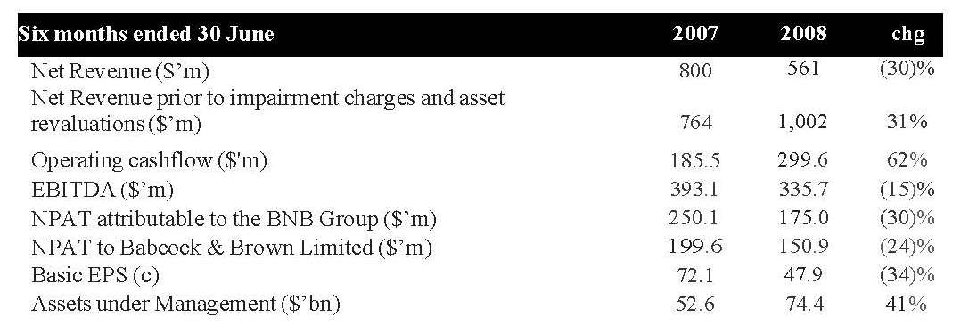
¹ After minority interests
2 Prior to impairment charge and impact of currency movements over pcp
International investment and specialised fund and asset management group Babcock & Brown (ASX: BNB), today announced a 2008 Interim Group Net Profit after tax of A$175 million.
Operating cashflow increased 62% over pcp to $299.6 million reflecting the non cash nature of most of the losses in the reported profit result.
New investment in the development pipeline included a 14% increase in wind energy development to $748.5 million, a further $50 million invested in solar energy development and $24.5 million in public private partnership projects. Total development investment declined to $1.2 billion due to the reclassification of completed real estate, and renewable fuel projects and the sale of the Transbay cable project.
During the six month period the three key business divisions focused on further institutional capital raising initiatives, with in excess of $2.6 billion of new capital commitments raised from co-investment partners. Uncommitted capital under discretionary management in our wholesale infrastructure funds at the current time is A$3.2 billion. Managed capital to expand aircraft under management in our Operating Leasing Division is in excess of US$584 million.
Dividend Policy
As a matter of prudence, no dividend will be paid until sufficient progress has been made on corporate debt reduction. Dividends are expected to re-commence in 2009.
Strategic Review Update
As part of the strategic review the Group is undertaking, Babcock & Brown also announced today a series of Board and Senior Executive changes. The changes include the decision by Managing Director and CEO, Phil Green, to step down from his Executive Director role with current CFO, Michael Larkin becoming Managing Director and CEO effective immediately. Mr Green will remain on the board as a Non-Executive Director.
Mr Larkin said, “Over the last few years in particular, Babcock & Brown has been very successful at achieving substantial growth based on the high levels of liquidity in the capital markets. This has led to the group being too highly leveraged and not sufficiently focussed. In view of the changed market environment, we are taking the necessary steps to reduce the leverage and refocus the Group on the areas where we can best deliver earnings growth for Babcock & Brown shareholders and investment performance for our Limited Partners and, investors in our funds other co-investors over the longer term, without taking undue risk.
“While the strategic review, which is being conducted with input from financial advisers Deutsche Bank and Goldman Sachs has some way to go, we are effecting four key areas of change that accelerate the evolution of Babcock & Brown’s business to a leading global alternative investment originator and asset manager:
1. Focus resources and capital on sectors where the company has a clear and proven competitive advantage in both origination and asset management – Infrastructure; Real Estate; and Operating Leasing.
2. Reduce the risk profile of the business through a de-leveraged and more transparent balance sheet. We will reduce the level of principal investment activity the firm undertakes and increase the emphasis on operating returns through growth in AUM. Consistent with this, we will target a lower ROE of 15-20% and operating cost savings run rate of at least 20% of annualised 2008 1H cost base to be delivered by the end of 2009.
3. Adopt a more disciplined approach to the allocation of capital focused on co­ investment and development activities, confined to our key business areas.
4. Enhance the alignment of interests between shareholders, fund investors, LP and other co-investor interests.
Mr Larkin said the primary purposes for which the balance sheet will be used can be broadly summarised as;
- Co-investment in our specialised fund and asset management platform.
- Greenfield and brownfield development of assets in our key business areas.
“To implement these changes, we have restructured the senior management team to improve capital allocation decisions across the Group” Mr Larkin said.
The senior management restructure includes:
- Creation of Chief Investment Officer (CIO) Role – Peter Hofbauer. In this role Peter will be responsible for the investment process across Babcock & Brown.
- Capital Markets Group to support all businesses – Headed by Richard Allsopp and Martin Rey this group will co-ordinate our interaction with long-term providers of capital across the key business and be responsible for deepening our existing relationships
- Infrastructure division organised into three regional units reporting direct to CEO – EMEA – Antonio Lo Bianco; North America – Mike Garland; Asia Pacific John Bowyer
- Real Estate and Aircraft Operating Leasing continue as global units headed by Eric Lucas Steve Zissis
- COO – David Ross to focus on achievement of reduced group operating cost base and restructuring employee compensation to achieve better shareholder / investor alignment
- New CFO – currently considering both internal and external candidates, a further announcement will be made shortly.
“The Corporate & Structured Finance Division (CSF) will gradually be wound down. Other assets and businesses not within the key areas of focus will be kept under review and divested or wound down as appropriate to maximise shareholder value,” he said.
“Existing private equity funds, BBDIF and BBGP, will continue to be managed by Babcock & Brown and have access to the Group’s co-investment pipeline. BBC, BCM, BBGI also will continue to be managed by Babcock & Brown and will pursue strategies, as previously announced, to maximise value for investors” said Mr Larkin
Rob Topfer, Head of the Corporate and Structured Finance Division will step down from that role, however he will continue to be a Director of and actively involved in BCM, BBC and BBDIF.
“The strategic review to restore value to the Australian listed funds platform also continues with fund Board initiatives underway in most funds. We remain committed to having both listed and unlisted funds, in key focus areas to ensure that value is delivered for investors,” Mr Larkin said.
Outlook
As previously advised, the Group 2008 NPAT is not expected to be above the 2007 Group NPAT of $643 million. The result is dependent on market conditions and:
- execution on the 2008 transaction pipeline
- 2008 asset sales program
- progress in relation to restructuring and cost reduction program
- impact of costs associated with the restructure
Mr Larkin said, “The volatile global capital market conditions have made and continue to make business conditions uncertain and forecasting in the short term difficult. The environment has created a number of challenges for the Group which we are actively working through at the current time to reach resolutions which endeavour to weigh the interests of all stakeholder groups.
“We believe that the changes to the business announced today will better equip Babcock & Brown to operate in the current market environment, to build on its leading position in its key markets and position itself for ongoing earnings growth in future years.
“I particularly want to acknowledge the continuous commitment and support of Babcock & Brown’s employees. The last few months have been very challenging and their support is key to the success of the Group,” Mr Larkin said.
ENDS
58 Brief pen pictures of some of the executives referred to in the 21 August announcement were attached to that announcement as an Appendix.
59 In September, November and December 2008, BBL made other announcements to the ASX but I need not refer to those announcements here.
60 On 7 January 2009, BBL made another announcement to the ASX. That announcement was in the following terms:
ASX RELEASE
7 January 2009
UPDATE ON FORECAST 2008 FINAL RESULT
Babcock & Brown (ASK: BNB) today advises that further to the announcement to the market on 19 November 2008, following progress on the asset impairment review process for its 2008 full year accounts, it now believes that asset impairment charges will be such that the Company will be in a substantial negative net asset position at 31 December 2008. This position encompasses the reclassification of ‘non-core’ assets on the balance sheet as ‘available for sale’, in line with the Company’s revised business strategy announced to the market on 19 November 2008. The impairment process is subject to finalisation and audit review which will not be completed until closer to the scheduled release of the Company’s results currently expected on 26 February 2009.
As detailed in its announcement on 4 December 2008 and reiterated in its response to the ASX on 6 January 2009, the Company is in discussions with its banking syndicate regarding a debt for equity swap or equivalent restructuring to stabilise the long term capital structure of the Group. Any debt for equity swap or similar arrangement will be designed to allow Babcock & Brown to continue operating its business and sell assets with a view to reducing its overall levels of debt. Any such capital restructure is expected to significantly dilute existing shareholders, negatively impacting the value of equity.
ENDS
61 After the ASX received the 7 January 2009 Release from BBL, BBL went into an immediate trading halt. On 10 January 2009, it was suspended from trading and did not trade again after that. As I have already mentioned, on 13 March 2009, BBL went into administration and, on 24 August 2009, BBL went into liquidation.
62 On 23 April 2009, BBL published its 2008 Annual Report, including the financial report of the B&B Group for the year ended 31 December 2008. That report disclosed that BBL had actually incurred a net loss of $5.6 billion for that financial year.
63 The plaintiffs allege that, between 21 August 2008 and 7 January 2009, BBL made no announcements to the ASX concerning its 2008 earnings nor did it make any announcements to the ASX revising its previous announcements concerning likely earnings for the 2008 Financial Year.
64 The plaintiffs allege that, after August 2008, BBL became aware that its business operations had made large losses in the second half of the 2008 Financial Year. The plaintiffs also allege that various internal earnings forecasts prepared by management within BBL demonstrated that, after August 2008, BBL’s expectations as to its earnings for the 2008 Financial Year were falling steeply and rapidly and that, in that period, its internal forecasts for that year were materially different from and much lower than the forecasts it had provided to the ASX earlier in 2008.
65 In their Opening Written Submissions, at pars 13–20, the plaintiffs set out the specific information of which they allege BBL was aware at certain particular times in the period from 13 August 2008 to 7 January 2009 which they contend constituted information which should have been disclosed by BBL to the ASX immediately after BBL became aware of it during the relevant period. The plaintiffs argue that, because none of the information to which reference is made in their Submissions was disclosed to the ASX during that period, or at all, BBL contravened s 674 of the Act and r 3.1 of the Listing Rules.
66 Paragraphs 13 to 19 of the plaintiff’s Opening Written Submissions are in the following terms:
13. In particular, by 13 August 2008, BBL was aware of the following information:
- Babcock Group’s earnings for FY 2008 were expected to be in the range between $400-$600 million, and that its earnings for FY 2008 were therefore expected to be materially different from the earnings guidance provided to the ASX on 30 May 2008 and 11 August 2008
14. By 21 August 2008, BBL was aware of the following information:
- Babcock Group’s earnings for FY 2008 were expected to be approximately $400 million, and that its earnings for FY 2008 were therefore expected to be materially different from the earnings guidance provided to the ASX on 30 May 2008, 11 August 2008 and 21 August 2008
15. By 30 September 2008, BBL was aware of the following information:
- John Fanning, BBL’s Chief Financial Officer, had written a Finance Report indicating that, for the 9 months ended September 2008, Babcock Group had lost approximately $3 million (excluding impairments), and that the Group was expected to incur further losses in the fourth quarter of 2008 of approximately $62 million [Whilst the Finance Report was prepared by the CFO, and BBL was thus aware of it on 30 September 2008, it was disclosed to the Board of BBL at its meeting on 8 October 2008] and that its earnings for FY 2008 were therefore expected to be materially different (being a loss) from the earnings guidance provided to the ASX on 30 May 2008, 11 August 2008 and 21 August 2008
16. By 8 October 2008, BBL was aware of the following information:
- The CEO of BBL reported to the BBL board at its meeting on 8 October 2008 that the Finance Report prepared by John Fanning was based on current estimates but that “reductions from this forecast are highly probable”
- The CEO Update paper presented to the BBL board at that meeting a summary table showing Babcock Group’s earnings for FY 2008 were expected to be approximately $258 million (excluding potential impairment charges) and that its earnings for FY 2008 were therefore expected to be materially different from the earnings guidance provided to the ASX on 30 May 2008, 11 August 2008 and 21 August 2008
17. By 8 November 2008, BBL was aware of the following information:
- Babcock Group’s earnings for FY 2008 were expected to be approximately $58 million (excluding potential impairment charges), and that its earnings for FY 2008 were therefore expected to be materially different from the earnings guidance provided to the ASX on 30 May 2008, 11 August 2008 and 21 August 2008
18. By 8 December 2008, BBL was aware of the following information:
- Babcock Group forecast that it would suffer a net loss for FY 2008 of approximately $352 million (excluding impairments) and approximately $2 billion (with impairments) and that its earnings for FY 2008 were therefore expected to be materially different from the earnings guidance provided to the ASX on 30 May 2008, 11 August 2008 and 21 August 2008
19. In each instance, it is admitted that the information known to BBL was not disclosed to the ASX. The information was material and required disclosure because it was information that a reasonable person would expect, if it were generally available, to have a material effect on the price or value of securities of BBL. Information that BBL’s earnings for FY 2008 were expected to be materially lower than the forecasts announced to the ASX in May and August 2008, was significant information which would, or would be likely to, influence persons who commonly invest in securities in deciding whether to acquire or dispose of BBL shares [ASX Listing Rule 3.1 (examples); Coulton Report; ASX Guidance Note 8 (para 93)].
67 This description of the information which the plaintiffs allege should have been disclosed to the ASX but was not so disclosed, with the exception of the information referred to in par 15 of the plaintiffs’ Written Submissions, the failure to disclose which is not pleaded as a contravention of s 674 (although it is mentioned in the pleading), is a substantially accurate narrative summary of the allegations made in pars 13AAA, 14BA, 14BB, 14C, 14CA and 14CB of the current Statements of Claim. In those paragraphs, the plaintiffs describe the information which they contend should have been disclosed to the ASX.
68 In the current Statements of Claim, the plaintiffs also allege that, by November 2008, BBL had and was aware of information to the effect that BBL had incurred a loss for the period from 1 January 2008 to 31 October 2008 of $93.5 million (before impairment charges) and that the loss for the full year was expected to be $352 million (Par 13AB in each current Statement of Claim). That allegation is based upon the contents of a Draft Forecast said to have been prepared in November 2008 in circumstances where the details of BBL’s actual earnings to 31 October 2008 were available to BBL.
69 The plaintiffs also allege that, from on or about 8 November 2008, BBL had, and was aware of, information that the non-cash impairment charges incurred by the B&B Group during the 2008 Financial Year would be approximately $1.7547 billion, that the B&B Group NPAT for 2008 would be a loss of approximately $2.107 billion and that there was therefore a material risk that the actual earnings for the B&B Group for the 2008 Financial Year would differ materially from the earnings guidance forecasts for the B&B Group announced by BBL to the ASX in August 2008 (Par 19 of the current Statements of Claim).
70 The plaintiffs allege that the information which BBL had from time to time on and after 13 August 2008 which I have described at [66]–[69] above was information which it should have disclosed to the ASX and that its failure to do so in that period constituted a series of contraventions of s 674 of the Act.
71 The liquidator advanced four broad answers to the plaintiffs’ claims.
72 First, he argued that, by 11 August 2008, BBL’s share price had already fallen to $6.80 from a high of $34.63 in June 2007. From 11 August 2008 to 7 January 2009, despite no further guidance on 2008 B&B Group NPAT being given by BBL, BBL share price collapsed from $6.80 to $0.33. By 28 August 2008, BBL’s share price had fallen to $2.43 and it never exceeded $2.50 after that date. The objective circumstances between 11 August 2008 and 9 January 2009, together with the expert evidence led by the liquidator, lead to the conclusion that the market had “priced in” a decline in BBL’s 2008 NPAT after the announcements which the company made on 11 August 2008 and on 21 August 2008 and, from about the time of the collapse of Lehman in mid-September 2008, had priced in that BBL would suffer a substantial loss in 2008. The liquidator submitted that, for these reasons, at no time did the market for BBL’s shares in the period after August 2008 reflect an expectation on the part of investors and potential investors that BBL’s 2008 NPAT would exceed the NPAT figures which the plaintiffs say ought to have been announced from time to time in the period after August 2008. These conclusions were said either to mean that the plaintiffs have failed to demonstrate that the information was of a character that would have had a material effect on the share price of BBL or to mean that the plaintiffs have failed to prove any loss.
73 Second, the liquidator contended that the plaintiffs failed to prove any loss because they failed to prove price inflation over the relevant period. The liquidator submitted that the expert called on behalf of the plaintiffs provided a flawed analysis when endeavouring to demonstrate such price inflation.
74 Third, the liquidator submitted that, for each of the alleged non-disclosures, there was no contravention for the additional reasons that the information was not information of which BBL was “aware” within the meaning of s 675 and the Listing Rules and, in any event, the information was subject to the indefinite information exception in the Listing Rules.
75 Fourth, the liquidator submitted that the plaintiffs’ claims are legally flawed because they depend upon this Court’s accepting market-based causation as being an appropriate foundation for a claim for compensation for a contravention of s 674 of the Act which, as a matter of principle, the Court ought not do.

RELEVANT CIRCUMSTANCES OF BBL BETWEEN AUGUST 2008 AND JANUARY 2009
76 In this section of these Reasons, I record a number of relevant circumstances affecting BBL during the relevant period. This material is largely taken from pars 47 to 67 of the liquidator’s Written Submissions dated 13 October 2016.

Collapse in BBL’s Share Price
77 By 11 August 2008, BBL’s share price had fallen from a high of $34.63 in June 2007 to $6.80. During the period in question, despite the fact that no further earnings guidance on the 2008 B&B Group NPAT was given, BBL’s share price collapsed from $6.80 to $0.33. By 28 August 2008, BBL’s share price had fallen to $2.43 and never rose above $2.50 at any time after that.

Market Announcements made by BBL
78 On 11 August 2008, BBL announced that 2008 Group NPAT was “not expected to exceed” 2007 Group NPAT of $643 million and that “… volatile global capital market conditions have made and continue to make business conditions uncertain and forecast in the short term difficult”.
79 On 21 August 2008, BBL confirmed that “the Group 2008 NPAT is not expected to be above the 2007 Group NPAT of $643 million” and stated further that “the result is dependent on market conditions” as well as “execution of the 2008 transaction pipeline”, “2008 asset sales program”, “progress in relation to restricting and cost reduction program” and “impact of costs associated with the restructure”.
80 During the relevant period, BBL and BBIL made further announcements to the ASX, namely:
(a) The CEO, the Executive Chairman, senior management and several directors were to resign (21 August 2008);
(b) BBL would restructure its business to become a specialist infrastructure business and divest all other businesses and assets when opportunities arose although there was no set timetable for asset sales (21 August 2008 and 19 November 2008);
(c) No dividend would be paid to shareholders until progress had been made on debt reduction (21 August 2008);
(d) BBL was attempting to renegotiate its credit facilities given that it would find it difficult to meet its financial covenants as a result of the “continuing and substantial deterioration in market conditions” (19 November 2008);
(e) Trading halts had been called as a result of speculation about management and board changes and the material dispute with a bank over release of a deposit (21 August 2008, 20 November 2008 and 21 November 2008). One such trading halt lasted from 20 November 2008 to 4 December 2008;
(f) BBIL’s credit rating had been downgraded to BB+, then BB-, then CCC+, then CC, the latter being the lowest issue or credit rating available in the absence of an actual payment default or bankruptcy filing (17 September 2008, 10 November 2008, 19 November 2008 and 21 November 2008); and
(g) BBIL’s credit rating had been withdrawn and there was a high risk of default in the near term (24 November 2008).

The Global Financial Crisis
81 At pars 4.52 to 4.60 of his first report, Mr Potter explained the timeline and impact of the GFC. I adopt that explanation as fair and reasonable.

Financial Media Coverage
82 At pars 58 to 63 of the liquidator’s Written Submissions, the liquidator referred to significant media coverage in respect of BBL in the period from mid-August 2008 to the end of 2008. At those paragraphs, the liquidator said (footnotes omitted):
According to contemporaneous newspaper articles, BBL’s 11 August 2008 announcement was preceded by “a string of profit warnings from banks, insurers and listed property interests” in the prior weeks. In light of the “financial crisis that began to unfold in mid 2007”, the announcement was said to be further evidence of “how tough the market has become for so-called financial engineers” like BBL. The unfolding credit crisis, as well as financiers’ “increasing aversion to highly geared, complex structures”, were perceived as having “wrong-footed” the company. The financial coverage observed that BBL’s CEO had “continue[d] to make business conditions uncertain and forecasting in the short term difficult”.
According to financial press coverage, by August 2008 BBL already faced “an uphill battle to win back investor confidence”, having “dismayed investors” and having lost the “confidence and credibility” of the market, in a context where “the impact of damage to Babcock & Brown’s reputation [was] unquantifiable”. This loss of credibility was perceived as a part of a dangerous trend because of its potential to “impair [BBL’s] ability to tap into equity and debt markets.” Despite BBL shares trading at a well-publicised discount of “87 per cent from their peak”, investors perceived the outlook as “grim” and risks as being “skewed to the downside”, such that the share price was deemed “unlikely to outperform”, while “rumours swirled through the market about the future of the investment bank”.
By mid-September the financial press was reporting that the intensifying “global liquidity crisis” had “exposed several flaws in [BBL’s] business model” and the shockwaves of that crisis had “further undermined confidence” that BBL’s “business model will survive the market rout.” One market commentator queried what value there could be in a company that is “not making any money”. Any hope of salvaging the company was placed entirely in “radical plans” to restructure its business, slash its global workforce and sell off assets. At the same time there was mounting concern for “companies that are being forced to sell assets in the current market downturn”, and investors predicted that BBL would be “a victim to imploding asset prices”. By 17 September 2008, commentators considered that the company “would not be able to repay $9.6 billion of debt”, that “the equity value is virtually nil” and that the company had “effectively collapsed already”. It was in this context that BBL is recorded as having said to the market that its profit outlook was “uncertain” – a statement repeated in the financial press.
As the crisis progressed in October the newspapers reported that plans to “restore confidence in the global financial system” had “collapsed” and financial stocks “faced the wrath of investors”.
By mid-November, BBL was reported facing increasing difficulty in meeting the terms of the financing arrangements with its banks, who “watched with concern” as the company “conceded that it may face more asset write-downs”. By late November the “stricken” company was perceived by the media as being in a state of “desperation”, abandoning all but one of its remaining business lines. At this point, the media reported that the company’s shares had “lost 99% of their value over the past year”.
By late November and early December 2008 BBL was being described as subject to a “war” between its lenders which led the market to perceive it as “on the brink of being placed into administration”, with its equity “close to worthless”, and where it seemed “all over for Babcock & Brown”. Any reprieve that the company was able to gain at that point was seen as “short-term” and “temporary”, with an “emergency lifeline” granted in early December being described as “a long way from the embattled company’s original request”.
83 This is a fair and reasonable summary of the important press articles concerning BBL in the relevant period.

Analyst Coverage
84 In similar vein, the liquidator provided an account of the relevant analyst’s coverage of BBL at par 64 of his Written Submissions. In that paragraph, the liquidator submitted:
The analysts who followed and published on BBL during the period that the applicants purchased shares also expressed increasingly negative views about it, although an important point is that in the period from August to November 2008 the number of analysts who followed BBL and were prepared to express expectations about 2008 Group NPAT dwindled from about 9 to only 2 (ABN AMRO and Citi) (see Joint Report, pp 12-14). A review of the analyst reports indicates that:
(a) by June 2008 analysts were already describing the stock as “speculative risk”, “highly speculative” or equivalent, by reason of BBL falling below its market capitalisation covenant, enabling its banking syndicate to call for a “review”. UBS observed in June 2008 that BBL’s share price had “collapsed”;
(b) also by June 2008, analysts were consistently referring to the high degree of uncertainty regarding BBL's earnings outlook. Credit Suisse observed on 13 and 26 June that there was “enormous uncertainty” regarding BBL “future earnings trajectory” and on 16 June Deutsche Bank observed that while it believed BBL could “survive” balance sheet de-gearing and restructuring, there could be no confidence regarding the “earnings outlook”;
(c) consistently with a move away from valuing BBL based on future earnings, a number of analysts shifted in June 2008, or had already shifted by June 2008, from a “price earnings” valuation methodology (interestingly, the methodology used by the applicants’ expert, Dr Coulton) to a “break up” or “net tangible assets” methodology, reflecting the high prospect of BBL defaulting. Deutsche Bank explained its methodology on the basis that “far less reliance can be placed on the promise of future earnings”;
(d) by late June 2008 analysts were saying that de-gearing and restructuring was inevitable irrespective of whether BBL’s banking syndicate chose to waive its right to a review, and emphasised the risks involved;
(e) the 11 August 2008 announcement and the guidance it included that BBL’s 2008 Group NPAT would be less than $643 million was greeted with scepticism by analysts, and queries were raised about the reliability of any BBL forecast given market conditions. UBS said blankly that it had “low confidence” in BBL’s earnings estimate and Credit Suisse said that it had not credited BBL with achieving its earnings guidance for some time;
(f) similar scepticism greeted the 21 August 2008 announcement, including its confirmation that 2008 Group NPAT would be less than $643 million. Aegis observed that earnings were “difficult to predict” and commented on BBL’s “near term challenges” and “lack of transparency as to its future prospects”, and confirmed that it was a “speculative investment”. Similar observations were made by Citi and ABN AMRO
(g) one thing, at least, is quite clear, which is that contrary to the applicants' initial case theory – which may now have been abandoned - the analysts did not regard the $643 million figure put forward in August 2008 as meaning that BBL was forecast to achieve earnings of $643 million. It was clearly understood as it was expressed – that is, as a ceiling. ABN AMRO observed that even approaching $643 million would be “ambitious”. Tricom observed that there was “no floor” on expected 2008 Group NPAT in BBL's announcement and opined that in the absence of asset sales the floor could be as low as $285 million (as at 21 August 2008);
(h) by September 2008 the analysts were frankly reporting that BBL was moribund. Even if positive 2008 Group NPAT estimates were maintained, the analysts' comments and discounts to valuation and target prices show that they regarded any such earnings as improbable. Citi stated that “BNB’s plight can only be described as speculative at best”;
(i) by October 2008 all remaining analysts were emphasising the likelihood of BBL breaching its debt covenants with the consequence of forced asset sales in an illiquid market, which would greatly reduce its net tangible assets;
(j) by 19 November 2008 there was plainly very little hope. Merrill Lynch moved to a “no rating”, observed that BBL’s restructuring plans were now in the hands of its banks, observed that breach of debt covenants due to asset writedowns was “likely”, and described the risk involved in the required sale of more than $7.5 billion in assets as “immense”.
85 These submissions accurately record that which they purport to record and I accept them as being accurate.

Conclusions
86 Upon the basis of the material to which I have referred in this section of these Reasons, the liquidator submitted that the objective circumstances set out above made it unlikely that there were any expectations in the market from the middle of 2008 to the end of December 2008 of positive earnings being achieved by BBL for the full Financial Year ending 31 December 2008 and that BBL’s actual share price throughout that period was most likely a reflection of expectations in the market of significantly depressed trading results and the impact of any restructuring. I think that this submission is correct and I accept it.

THE EXPERT EVIDENCE

Introduction
87 Each side of the record called one expert witness.
88 The plaintiffs retained Dr Jeffrey Coulton. The liquidator retained Mr Terence Michael Potter.
89 Dr Coulton has the degrees of B.Ec (Hons I), LLB and a PhD in accounting. He is also a chartered accountant.
90 At the time of the hearing before me, Dr Coulton was a full-time academic. At that time, he held the position of Senior Lecturer in Accounting at the University of New South Wales (UNSW). He had held that position since November 2005. For almost three years prior to that time, Dr Coulton had been a Lecturer in Accounting at UNSW. In the period from July 2000 to January 2003, he had been a Lecturer in Accounting at the University of Technology Sydney. In the period between July 1996 and July 2000, Dr Coulton had been an Associate Lecturer and then a Lecturer in Accounting at University of Sydney. In the period 1995 to July 1996, Dr Coulton was a solicitor employed at the law firm, Corrs Chambers Westgarth. In addition to holding the positions which I have described, in the period between August 2006 and January 2007, Dr Coulton was a Visiting Senior Lecturer in the Department of Accounting at McCombs School of Business at the University of Texas.
91 Dr Coulton has published a number of articles relating to matters of accounting and finance and has been involved in research activities concerning such matters. He also gave expert evidence in Grant-Taylor v Babcock & Brown Ltd (in liq) (2015) 322 ALR 723 (Grant-Taylor First Instance) and in Re HIH Insurance Ltd (in liq) (2016) 335 ALR 320 (Re HIH).
92 I consider Dr Coulton to be appropriately qualified to give the evidence which he gave before me. By and large, he did his best to assist the Court although, from time to time, he was a little too eager to assist the plaintiffs’ cause.
93 Mr Potter is a practising accountant. He has a Bachelor of Commerce from the University of Western Australia. He is an Associate Member of the Institute of Chartered Accountants in Australia and has been designated as a Business Valuation Specialist by that Institute. He is also an Associate Member of the Certified Practising Accountants in Australia. Mr Potter qualified as a chartered accountant in 1990 and is now the principal of Axiom Forensics Pty Ltd. In his first 13 years after qualifying, Mr Potter specialised in insolvency and reconstruction accountancy. That work included the sale, reconstruction and winding up of businesses and companies and consulting assignments. The consulting work performed by Mr Potter in this period also included reviews of the financial position of corporations for lenders and for shareholders. For approximately 18 years prior to 2016, Mr Potter conducted practice as a forensic accountant. He has conducted investigations for corporate regulators on issues including valuation, valuation disputes and competition-related disputes where accounting and/or valuation matters were at issue. He has also conducted many damages assessments for court proceedings and other consulting assignments. The Supreme Court of New South Wales has, from time to time, appointed Mr Potter as a referee.
94 I also considered Mr Potter to be qualified to express the opinions which he did in the evidence which he gave before me.
95 The only witnesses called to give oral evidence at the hearing were Dr Coulton and Mr Potter. The remaining material admitted into evidence comprised documentary material, most of which was contained in Exhibit A (the Court Book), and three particular affidavits read and relied upon by the liquidator being the affidavits of Lisa Renee Paul sworn on 23 August 2016, the affidavit of Cathy-Lee Jane Bell sworn on 23 August 2016 and the affidavit of Hiroshi Mark Oya sworn on 23 August 2016 including the annexures and exhibits annexed to those affidavits.
96 The viva voce evidence of Dr Coulton and Mr Potter was given concurrently by reference to the main matters in dispute between them. Dr Coulton and Mr Potter had prepared a Joint Report prior to the hearing and that Joint Report provided a satisfactory working basis against which consideration of those issues in dispute between the two experts was undertaken. The Joint Report is found at Vol N in Ex A.
97 The concurrent evidence proceeded as follows: Depending upon the nature of the issue, either Dr Coulton or Mr Potter gave a brief exposition of his views on the topic. Immediately after that exposition was given, the opposing expert was afforded a reasonable opportunity to outline his views on the particular matter. After the experts had given a brief outline of their views, limited cross-examination of each of them was permitted in an appropriate order. After that, re-examination took place, as necessary. Throughout the process, I had an opportunity to ask questions of the experts, as I thought fit. The concurrent evidence occupied the whole of one day and the morning of a second day.

The Reports of Dr Coulton in Chief
98 Dr Coulton prepared four separate reports for the purposes of these proceedings. Those reports are dated 21 June 2016, 16 September 2016, 29 September 2016 and 5 October 2016 respectively. All four of Dr Coulton’s reports were admitted into evidence as part of Ex A. Dr Coulton’s reports are found in Vol L of Ex A. The liquidator objected to several paragraphs in Dr Coulton’s first and second reports. I ruled on those objections at Transcript 85–86. As a result, paragraphs 39, 40, 41, 42, 49, 50, 51, 58, 59, 60, 65, 66, 67, 76, 77 and 78 of Dr Coulton’s first report were allowed as submissions only. The objections taken to Dr Coulton’s second report were not upheld with the consequence that that report was admitted into evidence without restriction.
99 Those paragraphs in Dr Coulton’s first report which were admitted as submissions only contained Dr Coulton’s conclusions on the question of whether the information which he identified as information which should have been disclosed to the ASX was, in fact, “material” for the purposes of s 674(2)(c) of the Act and Listing Rule 3.1.
100 The first, third and fourth reports of Dr Coulton comprised his evidence-in-chief. Leaving aside the reworked calculations in Dr Coulton’s second report, Dr Coulton’s second report is essentially his response to Mr Potter’s Expert Report dated 26 August 2016.
101 In this section of these Reasons, I will address Dr Coulton’s first, third and fourth reports.
102 In his first report, Dr Coulton addressed three questions, as he had been instructed to do. These questions were:
a. Should Babcock & Brown Limited (BBL) have disclosed certain material information to the Australian Securities Exchange (ASX) from 11 August 2008 to 9 January 2009 to comply with BBL’s obligations under s 674 of the Corporations Act 2001 and ASX Listing Rule 3.1?
b. Was the information such that a reasonable person would expect, if the material had been generally available, to have had a material effect on the price or value of shares in BBL?
c. If the information had been disclosed to the ASX in accordance with its obligations under the Listing Rules, what would have been the effect on the price or value of the shares in BBL?
103 Dr Coulton provided to the Court the letter of instructions dated 8 May 2016 which he had received from the plaintiffs’ solicitors and listed for the benefit of the Court and the liquidator the documents to which he had had regard in preparing his first report.
104 It will be immediately apparent that questions (a) and (b) asked of Dr Coulton related to important integers of liability under s 674 of the Act and that question (c) potentially concerned the issue of loss and damage.
105 In section I of his first report, Dr Coulton referred to a number of matters by way of background concerning BBL. At par 18, Dr Coulton referred to certain observations made by the liquidator in a report to creditors dated 12 August 2009 concerning the relationship between BBL and BBIL (referred to by Dr Coulton in his reports as “BBIPL”) and then said (at par 19):
I have assumed therefore, for the purposes of this report, that, for the relevant financial year ended 31 December 2008, the consolidated audited financial statements of BBIPL (excluding BBL) would be expected to be materially comparable with the BBL consolidated financial statements for the same year.
That assumption was criticised by Mr Potter as not precisely reflecting the true position.
106 In section II, Dr Coulton stated that he was proceeding upon the basis that BBL was subject to the continuous disclosure provisions in Ch 3 of the Listing Rules and the disclosure requirements in s 674 of the Act. That assumption accurately reflected BBL’s continuous disclosure obligations and was common ground among the parties.
107 In section III, Dr Coulton referred to a number of earnings announcements and profit forecasts that BBL had provided to the market in 2008.
108 This material is found at pars 21–28 of Dr Coulton’s first report.
109 The substance of the announcements referred to by Dr Coulton (as understood by him) may be summarised as follows:
(a) On 17 April 2008, BBL lodged its 2007 Annual Report with the ASX. That Report included financial statements for the Financial Year ended 31 December 2007. In that report, BBL’s consolidated profit excluding the BBIL minority interest for the Financial Year ending 31 December 2007 was stated to be $643,046,000. I note that, on p 7 of that Annual Report, BBL said that it expected that its 2008 Group Net Profit would be at least $750 million.
(b) As at 31 December 2007, BBL had on issue 293,924,578 ordinary shares.
(c) On 30 May 2008, BBL released to the ASX the Address given by its Chairman and by its CEO at its AGM. In his Address, the Chairman said that BBL remained on track to deliver NPAT of at least $750 million in 2008. The Managing Director and CEO made a statement to the same effect. The CEO described this growth in excess of 15% over the 2007 result. These statements reflected the forecast given at p 7 of the Annual Report.
(d) On 11 August 2008, BBL provided an announcement “Interim Result and Revised Full Year Guidance” to the ASX. In that announcement, BBL stated that “Babcock & Brown’s 2008 earnings are now not expected to exceed 2007 Group Net Profit of $643 million”. In that announcement, BBL also stated that “its 2008 interim Group Net Profit After Tax (NPAT) is expected to be 25% – 40% below the $250 million interim result reported in 2007”. The interim period to which those remarks were directed was the period from January to June.
(e) On 21 August 2008, BBL lodged an “Appendix 4D and Management Discussion & Analysis” with the ASX. At [57] above, I have set out a separate ASX Release dated the same day. In the Appendix 4D document, BBL’s consolidated NPAT (excluding minority interests) for the half year ended 30 June 2008 was said to be $150,920,000. (I interpolate here that this was at the very bottom of the range indicated in BBL’s announcement to the ASX made on 11 August 2008. Sixty percent of $250 million is $150 million.)
(f) On 7 January 2009, BBL announced to the ASX that “it now believes that asset impairment charges will be such that the Company will be in a substantial negative net asset position at 31 December 2008”. BBL was placed in a trading halt on 8 January 2009. BBL never lodged with the ASX its financial statements for the Financial Year ended 31 December 2008.
(g) BBL made no earnings announcement or profit forecast to the ASX between 21 August 2008 and 7 January 2009.
110 In section IV of his first report, Dr Coulton then proceeded to discuss the earnings information that he argues was known to BBL but not announced to the market or otherwise generally available in the market. He assumed, for the purposes of his first report, that none of the information to which he referred in section IV was generally available to the market.
111 First, Dr Coulton referred to information known to BBL but not generally available to the market on or around 13 August 2008. This information comprised the contents of a memorandum dated 13 August 2008 from Michael Larkin (the BBL Group Chief Financial Officer at that time who later became the Managing Director and CEO of the B&B Group) to the directors of BBL headed “FY08 Profit Guidance”. In his memorandum, Mr Larkin referred to the most recent earnings guidance provided by BBL to the ASX viz the guidance provided on 11 August 2008. Mr Larkin noted that that guidance did not provide a floor to BBL’s forecast of FY08 earnings. Mr Larkin set out in his memorandum a recommended guidance which was expressed to be subject to market conditions and outcomes from the sale of the B&B Group’s European wind assets, as well as the achievement of a number of other initiatives spelled out in his memorandum. Mr Larkin recommended that BBL retain its most recent guidance for the time being (ie that given on 11 August 2008) and that further guidance to the market be provided when the company had more clarity on some of the issues which might influence its earnings for 2008.
112 In his memorandum, Mr Larkin said that “If we adjust for the probability weighted outcome and apply +/- $100m factor, this allows earnings of between $400–$600 NPAT for the year”.
113 Dr Coulton treated that remark as information which BBL had as to a forecast range of expected earnings of $400–600 million. He then expressed the opinion that, if one were to take the midpoint of that range, viz $500 million, that was information that should have been disclosed to the market on or immediately after 13 August 2008. In other words, upon the assumption that BBL was aware of the contents of Mr Larkin’s memorandum, Dr Coulton took the view that BBL should have informed the market (ie the ASX) that it no longer adhered to the last earnings guidance given by it for the Financial Year 2008 ($643 million) but was now forecasting earnings of $500 million (approximately) for that year.
114 Second, Dr Coulton looked at BBL’s circumstances on or around 21 August 2008 when it lodged its Appendix 4D and Management Discussion & Analysis with the ASX. He noted that, on the same date (21 August 2008), BBL released to the ASX a document “2008 Interim Results and Presentation”. At p 23 of that Presentation, entitled “Full Year Guidance”, the following appeared:
- The Group 2008 NPAT is not expected to be above the 2007 Group NPAT of $643m. The result is principally dependent on:
– execution on the 2008 transaction pipeline
– 2008 asset sale program
– progress in relation to restructuring and cost reduction program
– Impact of costs associated with the restructure
- Market conditions remain extremely difficult.
...
115 At par 44 of his first report, Dr Coulton referred to another email sent on behalf of Mr Larkin. This was an email dated 20 August 2008 to Elizabeth Nosworthy, the Deputy Chairman of BBL, and copied to other directors.
116 In his email, Mr Larkin recommended that BBL advise the market that the 2008 full year result was then expected to be approximately $400 million NPAT, subject to there being no further impairment charges in the second half of 2008 and no significant restructuring costs. His memorandum also noted that the guidance that he was recommending did not include the impact of the sale of B&B Group’s European wind assets.
117 Dr Coulton then expressed the opinion that a change in BBL’s published earnings forecasts from “at least A$750 million” on 30 May 2008 and from “not exceeding … $643 million” on 11 August 2008 to a forecast of $400 million on or about 20 August 2008 was information that had to be disclosed to the market.
118 Third, Dr Coulton focussed on information contained in a financial document in the nature of a management account entitled “P&L YTD Mar 2008 FLASH – September 2008” which was provided to the directors’ meeting held on Wednesday 8 October 2008. Dr Coulton noted that, included within the materials provided to the Board on this occasion, was a group NPAT forecast for the Financial Year 2008 of $58.2 million. There was also reference to the fact that the previous forecast had been $258.2 million excluding impairment charges although, as far as he could tell, no such figure had appeared anywhere except in management accounts for September 2008. Dr Coulton said that this information should have been disclosed to the ASX on or immediately after 8 October 2008.
119 Fourth, Dr Coulton then considered earnings information which he said was available to BBL on or around 8 November 2008. The information relied upon by Dr Coulton was the same forecast NPAT for the Financial Year 2008 of $58.2 million which had been mentioned in the document which I have described at [118] above. That amount of $58.2 million excluded potential impairment charges. Dr Coulton then concluded that the forecast full year result of approximately $58.2 million before impairments was information that BBL became aware of on or about 8 November 2008 (at the latest) and that it should have been disclosed to the market then. This assumption proceeds upon the basis of a further assumption viz that this information was not disclosed to the market on or about 8 October 2008, as it should have been, according to Dr Coulton.
120 Fifth, Dr Coulton addressed certain information that was provided to the directors of BBL on 8 December 2008. Dr Coulton assumed that a document headed “Draft FY Forecast – November 2008 Forecast (with October actuals)” would have been brought to the attention of the Board when it met on that date. On that basis, Dr Coulton noted that the document showed that BBIL’s Group NPAT for the period ending October 2008 was a loss of $93,500,000 and that the forecast results for BBIL for the full year 2008, after including the second half impairments, was a loss of $2,107,500,000. Dr Coulton assumed that this financial information concerning BBIL came to the knowledge of the BBL directors because the two companies had common directors. I note that this information (a full year loss of $2.1 billion) was stated to relate to the position of BBIL (not BBL).
121 Then, at pars 74–76 of his first report, Dr Coulton said:
As outlined in paragraph 18 above, the financial performance of BBL and BBIPL were materially comparable for the year ending 31 December 2008. BBL’s equity investment in BBIPL was the major asset owned by BBL (see BBL’s stand-alone Balance Sheet in the 2007 Annual Report). A financial forecast for BBIPL equated, at the time, to a materially similar financial forecast for the listed entity, BBL.
In my opinion, BBL was aware, through its directors, who were also directors of BBIPL, of the $93,500,000 loss for the 10 months ending October 2008 contained in the November BBIPL November 2008 forecast, and that BBL was forecast, at that time, to be heading for a significant financial loss.
BBIPL’s forecast group NPAT for the year ended 31 December 2008 was a loss of $2,107,500,000. On or around 8 December 2008, the Board of Directors of BBL ought reasonably to have known that BBL’s expected group NPAT for the year ended 31 December 2008 was a loss of approximately $2,107,500,000. A forecast loss of over $2 billion, compared with the most recent forecast of a profit of not more than $643 million, is information that a reasonable person would expect to influence the price of BBL shares.
(Emphasis in original)
122 At pars 80–133 of his first report, Dr Coulton then considered the impact of the contravening conduct to which he had earlier referred in section IV of his first report.
123 At par 80 ff, Dr Coulton undertook an analysis which was intended by him to determine the quantum of the impact, if any, of the contravening conduct on the part of BBL as identified by him at pars 21 to 78 (repeated failures to disclose information to the ASX in breach of BBL’s continuous disclosure obligations) on the price at which shares in BBL traded on the five occasions when Dr Coulton claimed that BBL had contravened s 674 of the Act.
124 At par 80, Dr Coulton said that the primary approach which he took to determining the impact of the contravening conduct was “based on” the price-earnings ratio (PE ratio) applicable to BBL. The PE ratio is the ratio established by dividing the market price per share by the earnings per share at any given time. A more elaborate explanation referable to the Dividend Discount Model (DDM) was set out by Dr Coulton in Appendix F to his first report as follows:
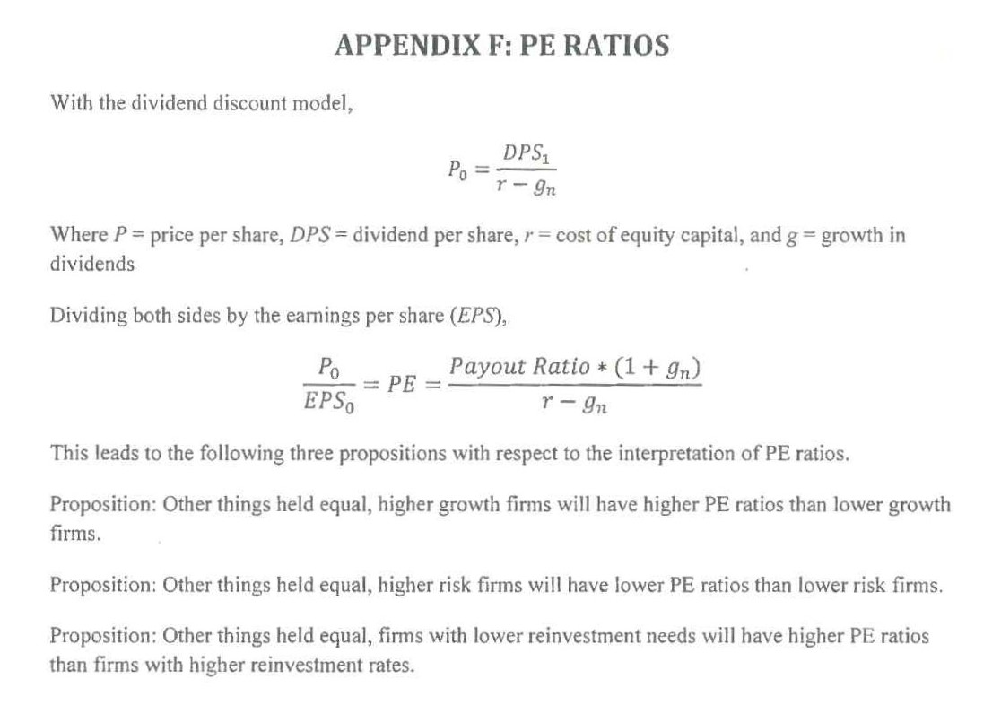
125 At pars 81–84 of his first report, Dr Coulton said:
There are a number of ways the PE ratio can be measured. Price can be the current market price, or can be an average price in a recent period (e.g., 20 trading days, 6 months, financial year). The measure of earnings can be the most recently announced earnings per share (this is referred to as a ‘trailing PE’) or a forecast of future earnings per share (referred to as a ‘forward PE’).
The use of a PE ratio approach to assessing the impact of the contravening conduct is appealing for a number of reasons. First, the contravening conduct in this instance relates to the disclosure of earnings, and of forecast earnings.
Second, earnings are a key financial performance metric for companies, and the PE ratio is an extremely commonly used valuation metric and reported statistic in the financial markets.
Third, security analysts have long been regarded as an important and informed intermediary in the financial markets, and there are hundreds of academic studies on security analysts’ forecasts (for a summary see Bradshaw 2011). Each of the security analysts following BBL were forecasting an earnings metric for BBL. The Larkin Memorandum of 13 August 2008 refers to the prevailing security analysts’ earnings forecasts for BBL. This shows that BBL recognised that analyst forecasts were an important source of information for the market. A majority of the analysts cited by the Larkin Memorandum used an earnings-based valuation method in determining their target prices for BBL.
126 When Dr Coulton refers to “recently announced earnings per share” in par 81 of his first report, he is referring to actual earnings as announced. The “trailing PE” described by him in that paragraph is the ratio derived by dividing the market price per share as at the selected moment in time or period of time by the actual earnings per share in respect of the most recently announced actual earnings period. The “forward PE” referred to by Dr Coulton in par 81 of his first report is the result of dividing the market price per share at selected moments or periods in time by the forecast earnings per share referable to each of those moments or periods of time.
127 At pars 85–90, Dr Coulton explained the approach which he took in order to determine the impact on the price of BBL shares of the contravening conduct.
128 First, he prepared a document which recorded the closing daily share prices, trading volumes and number of shares on issue for BBL for the period from 27 June 2008 to 27 February 2009. This document is Appendix E to Dr Coulton’s first report. I have reproduced Appendix E as Attachment A to these Reasons for Judgment.
129 Next, in order to determine the price per share which he proposed to use in his calculations, he took the closing price of the 20 trading days leading up to the date of each of the postulated contraventions (but not including the date of contravention) and averaged that closing price over that 20 day period. The market price per share arrived at was a simple arithmetic average of the 20 prices in question at each of the relevant moments in time.
130 Next, Dr Coulton assumed that the contravening conduct described in his report led the market to believe that BBL was trading more profitably than it really was and that this inflated the price of shares in BBL. These propositions were quite clearly assumptions which Dr Coulton made. He did not explain why he made those assumptions. He then proceeded to quantify the assumed impact of the contravening conduct on the market price of BBL shares and said (at par 88):
… The impact of the contravening conduct is represented by the difference between the price at which BBL shares actually traded on the market and the hypothetical price achieved by applying the PE ratio at which they traded to an adjusted earnings number.
131 It will be necessary to say something more about this approach when I come to discuss in a little more detail the calculations which Dr Coulton actually performed.
132 Dr Coulton then noted that an approach based upon a PE ratio is not appropriate when the actual or forecast earnings per share figures are negative. He said that, when those circumstances obtain, a company’s net asset value can be used as a proxy for the lower bound of plausible valuations. Price to book ratios and other alternative methods could also be used. In the present case, given that, by 8 December 2008, BBL’s actual earnings for the 2008 year to date and expected earnings for the full year 2008 were both negative, Dr Coulton opted for a price to book ratio in respect of the 8 December 2008 alleged contravention.
133 At par 93 ff, Dr Coulton proceeded to perform his calculations in relation to each of the postulated contraventions in turn. It is not necessary to set out, in detail, each of those calculations. Dr Coulton took the same approach to each of the August, October and November 2008 alleged contraventions. His approach to those first four alleged contraventions can be discerned from a detailed description of his calculation in respect of the alleged contravention which occurred on or around 13 August 2008.
134 The steps in those of Dr Coulton’s calculations which were based upon some relationship with BBL’s PE ratios as assessed by him from time to time may be summarised as follows:
(a) Dr Coulton took the BBL actual NPAT for the Financial Year ended 31 December 2007 (excluding the BBIL minority interests) of $643,046,000 and divided that figure by the number of shares on issue as at 31 December 2007. The figure thrown up by that calculation constituted the trailing or historical earnings per share of BBL as at 31 December 2007. The relevant figure was $2.19 (par 93 of Dr Coulton’s first report).
(b) The BBL Group actual NPAT figure for the Financial Year ended 31 December 2007 was then used by Dr Coulton as BBL’s most current forecast to the market at the time of each of the contraventions where the most recent guidance was expressed to be “not more than the 2007 result of $643 million” (pars 94 to 96 of Dr Coulton’s first report). The contraventions where that approach was applied were the August, October and November 2008 alleged contraventions.
(c) As at the close of trading on 12 August 2008, the average of the 20 previous closing prices in BBL’s shares (including the price for 12 August 2008) was $6.62. The number of shares on issue as at that date was 333,300,220 (par 97 of Dr Coulton’s first report).
(d) Therefore, according to Dr Coulton, at the close of trading on 12 August 2008, the PE ratio of BBL based upon the assumptions which I have set out was 3.03 ($6.62 ÷ $2.19 = 3.03) (par 98 of Dr Coulton’s first report).
(e) Information in BBL internal documents as at 13 August 2008 (the Larkin memorandum) indicated that the company’s expectation as at that date as to forecast earnings for the full year ending 31 December 2008 was $500 million (par 99 of Dr Coulton’s first report).
(f) Had BBL announced a forecast group NPAT of $500 million on or around 13 August 2008, the hypothetical forecast earnings per share at that point would be $1.50 ($500 million ÷ 330,300,220 shares on issue = $1.50) (par 100 of Dr Coulton’s first report).
(g) Therefore, the hypothetical share price at that point in time would have been $4.54 ($1.50 × 3.03) (par 101 of Dr Coulton’s first report).
(h) This is a difference per share between the hypothetically derived price ($4.54) and the actual price ($6.62) of $2.08.
135 Dr Coulton depicted these steps in Table 2 at par 104 of his first report. I now set out that table:
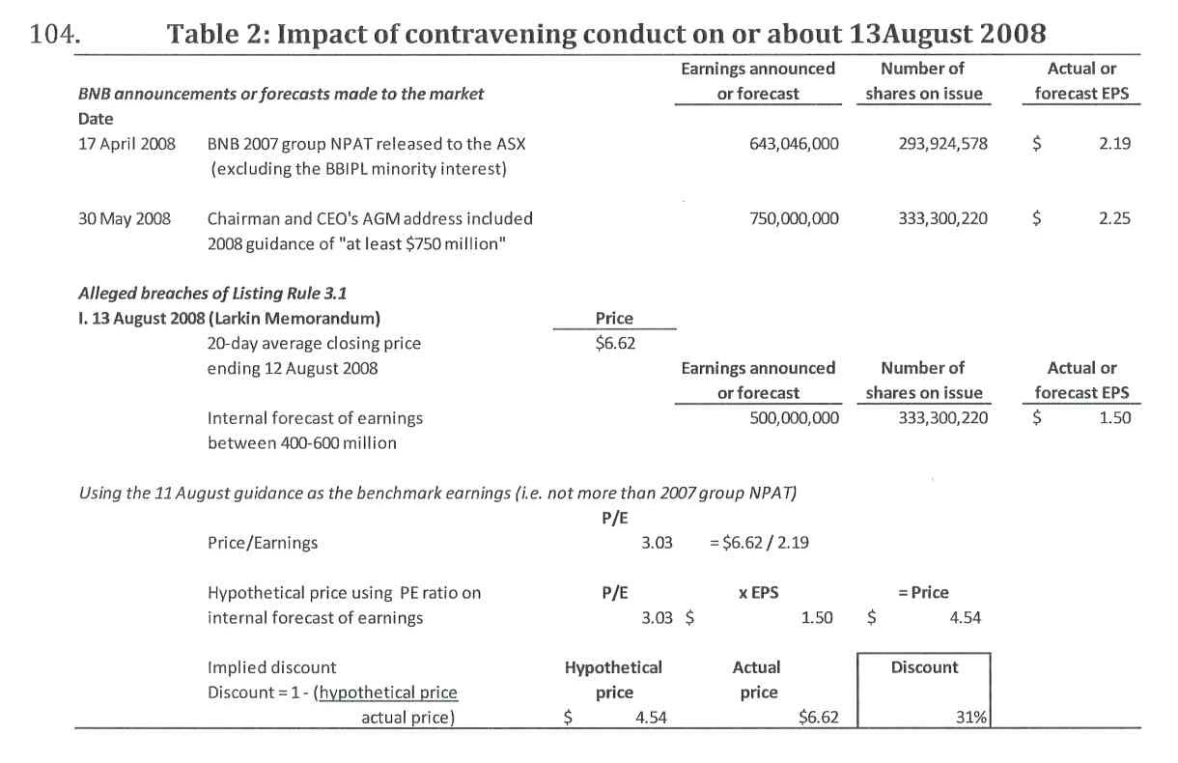
136 Dr Coulton then applied the same methodology in respect of the next three alleged contraventions which he had assumed had taken place viz those alleged to have occurred on or about 21 August 2008, 8 October 2008 and 8 November 2008 (as to which, see Tables 3, 5 and 6). Table 4 in Dr Coulton’s first report appears in that report as part of par 54 and has nothing to do with Dr Coulton’s assessment of the impact of the alleged contravening conduct on any of BBL’s share prices. Indeed, Table 4 is referred to in the text of par 54 as “Table 1”.
137 Subsequently, in his second report, Dr Coulton took a different approach to the quantification of the benchmark forecast earnings for use in his various calculations. Instead of using as the starting point the actual earnings of BBL for the Financial Year ended 31 December 2007 ($643,046,000) as that benchmark, Dr Coulton deployed, on each of the relevant occasions, the security analysts’ consensus earnings forecast from the Bloomberg service for the Financial Year 2008. Dr Coulton then reworked the various calculations which he had made in his first report and produced fresh calculations (Tables 2 to 5 at pars 102 to 107 of his second report) using the relevant forecast from Bloomberg. Subsequently, he discovered that he had made “typographical” errors in those reworked tables and he therefore reworked them again in his third report. The calculations which Dr Coulton performed in his third report constituted his final attempt to quantify the impact on the market price of shares in BBL at each of the points in time at which each of the postulated contraventions occurred. I now set out Revised Table 2 in Dr Coulton’s third report:
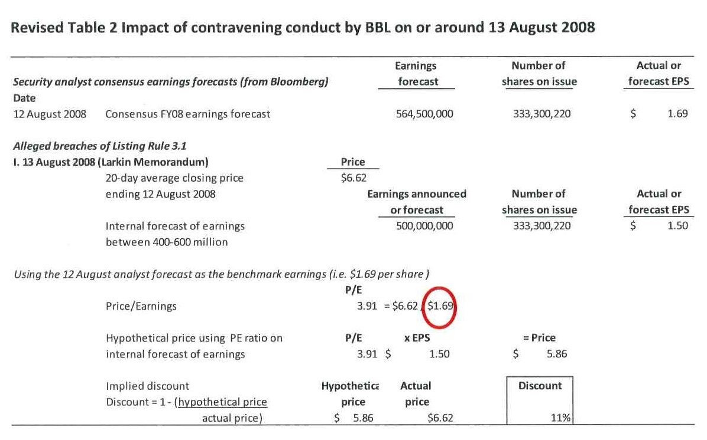
138 In his first report, at pars 122 to 123, Dr Coulton performed his calculations for the contravention which allegedly took place on around 8 December 2008 by not using a PE ratio but by using the ratio of the share price to book value of equity (price to book) as at that date. He said that that approach was equivalent to using a price to net asset comparison as book value of shareholders’ equity is the same as net assets (or assets less liabilities).
139 At pars 122 to 133 of his first report, Dr Coulton explained the calculations which he performed in the following terms:
On or around 8 December 2008, BBL was anticipating a net loss rather than profit (see the BBIPL 2008 November Forecast). The use of a PE ratio is therefore not appropriate to assess the impact of any contravening conduct as a negative PE ratio has no meaningful interpretation.
I Note that my estimated impact on the price of BBL shares of the failure by BBL to disclose an expected group profit of $52,800,000 was a discount of 93% (see paragraphs 100-105 above). The impact on share price of a forecast loss of over $2 billion would therefore necessitate a discount of at least 93%.
The impact of the contravening conduct is assessed using the ratio of the share price to book value of equity (Price to Book). This is equivalent to using a price to net asset comparison, as book value of shareholders’ equity is the same as net assets (or assets less liabilities).
In the 2007 Annual Report, BBL reported consolidated (i.e., group) Shareholders' equity at 31 December 2007 of $2,153,604,000 (see 2007 Annual Report Balance Sheet). The number of shares on issue on 31 December 2007 was 293,924,578 (2007 Annual Report). BBL’s Book value of equity per share was therefore $7.33.
On 30 June 2008, BBL reported Shareholders’ Equity of $2,632,433,000 (see the Balance Sheet in the BBL Appendix 4D released on 21 August 2008). At that time BBL had 333,300,220 shares on issue. The book value of equity per share was therefore $7.33 ($2,632,433,000 / 333,300,220 = $7.33).
On the basis that the financial statements of BBIPL at 31 December 2008 are materially comparable with the BBL consolidated financial statements at 31 December 2008, I use the forecast book value of equity of BBIPL as BBL’s forecast book value of equity in my calculations. While imperfect, this is the best available information to work with.
The BBIPL 2008 November forecast provides a forecast balance sheet in section 3.0. The final column of the forecast balance sheet shows the forecast BBIPL balance sheet for 31 December 2008. Total BBIPL equity is $690,250,000. On 8 December the number of shares on issue was 367,537,951. Forecast book value of equity per share is therefore $1.88.
The forecast balance sheet in section 3.0 of the BBIPL 2008 November Forecast contains forecast adjustments for impairments of $1,754,718,000. This reduces net assets (i.e. shareholders’ equity). The forecast impairment of $1,754,718,000 is also reflected in the Profit and Loss Forecast Flash (section 1.1).
The price-book ratio for BBL at 8 December 2008 was 0.05 ($0.39 / $7.90 = 0.05). Had BBL forecast book value of shareholders’ equity of $1.88, the hypothetical share price for BBL would be $0.09 (0.05 * $1.88 = $0.09). This is a discount of 76% to the 20 day average share price ending 5 December 2008.
I note from paragraphs 100-105 above that I estimated a discount of 93% using the PE ratio as the impact of BBL not having disclosed forecast earnings of $58,200,000. Disclosure of a forecast loss of over $2 billion would have a greater impact on share price than a forecast of a profit of $58,200,000. However the PE ratio cannot sensibly be used for a forecast loss.
It is my opinion that the impact of the contravening conduct on our [sic] around 8 December 2008 (being the non-disclosure of expected earnings) was to inflate the price of BBL shares by at least 76%, and most likely by more than 93%.
My calculations are summarised in Table 7 below.
140 Dr Coulton set out his calculations at Table 7 of his first report (at par 133) which I now set out below:
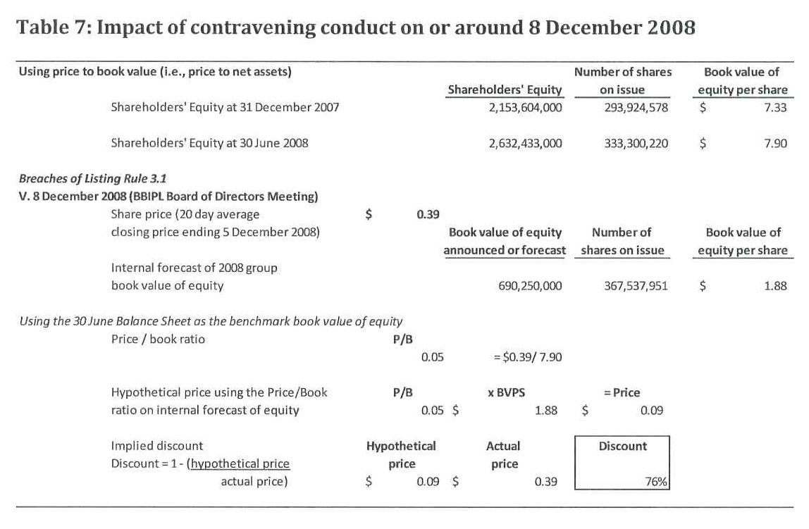
141 That calculation was subsequently revised in Dr Coulton’s second report but was not again revised in his fourth report. The revision of the table in Dr Coulton’s second report resulted in the same figures for the hypothetical price ($0.09) and the actual price ($0.39) as were recorded in the original version of Table 7 set out above.
142 On 5 October 2016, which was five days before the commencement of the hearing before me, Dr Coulton prepared and served a further report. That report was expressed to relate to a finance report dated 30 September 2008 written by John Fanning, who was then the Chief Financial Officer of BBL.
143 The Fanning Finance Report contained an actual Profit and Loss summary for the nine months to 30 September 2008 and a forecast of earnings for the Financial Year ending on 31 December 2008. The forecast excluded impairments on assets remaining on the balance sheet as at 31 December 2008. The report stated that impairments would be assessed via a separate exercise which had already commenced.
144 The Profit and Loss summary for the nine months ended 30 September 2008 showed that there was a net loss after tax (before deduction for outside minority interests) of $2,988,000. According to that summary, the NPAT attributable to the B&B Group for that period was $14,680,000.
145 The forecast for the full year ending on 31 December 2008 showed a net loss after tax (before deduction for outside minority interests) of $64,783,000. The forecast net loss after tax attributable to the B&B Group was shown as $39,684,000.
146 In his fourth report, Dr Coulton assumed that Mr Fanning would have become aware of the information contained in his report by no later than the end of October 2008.
147 In his fourth report, Dr Coulton expressed the view that the failure to disclose the information in the Fanning Report was a breach of the continuous disclosure requirements contained in s 674 of the Act and Listing Rule 3.1.
148 At pars 18 to 24 of his fourth report, Dr Coulton performed a calculation designed to demonstrate the impact of BBL’s failure to disclose the contents of the Fanning Finance Report to the market at around the end of October 2008. Consistent with his previous view that negative earnings or negative forecast earnings should be addressed by his price to book value approach, that is the approach which he took in performing these calculations. The result of Dr Coulton’s calculations was a comparison between his hypothetical price so derived with the actual price as at 31 October 2008.
149 I set out below Table 1 from Dr Coulton’s fourth report which depicts the calculations which he performed in relation to the Fanning Report:
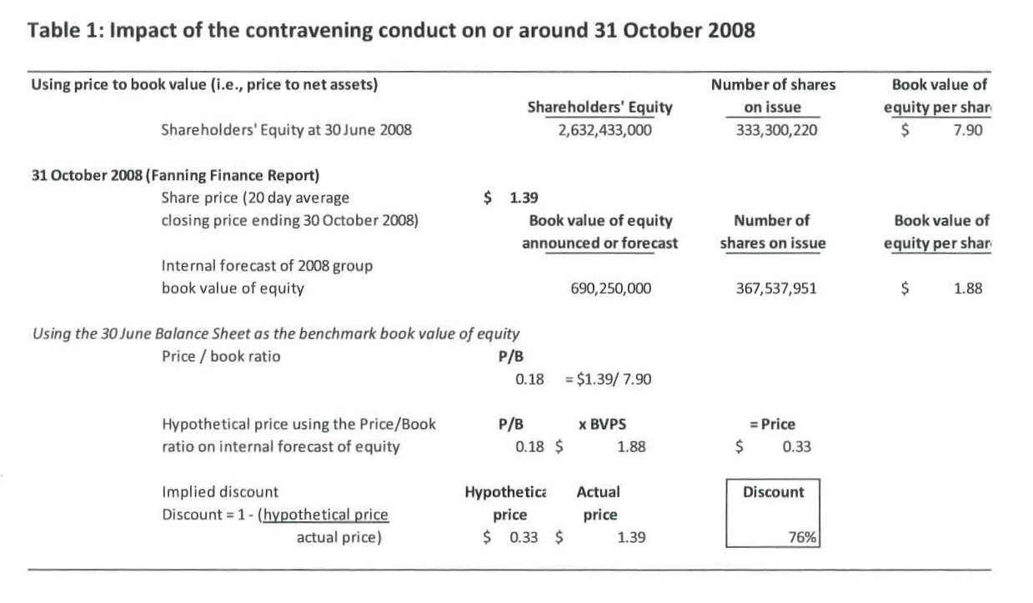
150 I will address Dr Coulton’s second report which, as I have already said, is largely a report responding to Mr Potter’s expert report of 26 August 2016, later in these Reasons.

The Evidence of Mr Potter
151 Mr Potter prepared two reports for the purposes of these proceedings, namely, his report dated 26 August 2016 and his report dated 7 October 2016. Mr Potter’s first report is 125 pages in length (excluding annexures and appendices) and is found in Vol M of Ex A. Mr Potter’s second report addresses Dr Coulton’s fourth report and is found in Vol T of Ex A.
152 Mr Potter took issue with most of Dr Coulton’s evidence and explained his reasons for so doing in his very lengthy report of 26 August 2016.
153 No objections were taken to Mr Potter’s report.
154 Mr Potter’s report is divided into ten separate sections. I have attached to these Reasons for Judgment as Attachment B the Table of Contents of Mr Potter’s report which shows the ten separate sections to which I have referred and the general subject matter of each section. In the succeeding paragraphs, I will endeavour to capture the essence of Mr Potter’s reports.
155 At pars 1.2 to 1.4 of his first report, Mr Potter set out his understanding of the substance of the plaintiffs’ claims in the present cases. I consider Mr Potter’s understanding of those claims to substantially accord with the true position.
156 In section 2 of his first report, Mr Potter set out his opinions in summary form. Each of the opinions expressed in section 2 was supported by detailed reasoning in the balance of his report.
157 In the balance of this section of these Reasons, I set out Mr Potter’s conclusions and, to the extent I consider necessary, the reasoning which he provided in support of those conclusions.
158 At par 2.2 of his first report, Mr Potter stated his overall opinion that it is not possible to conclude that the allegedly overstated earnings guidance provided by BBL at various dates throughout 2008 resulted in BBL’s shares trading at a higher price than the price at which those shares would have traded in the period from 13 August 2008 to 7 January 2009 had the guidance as to NPAT for the year ended 31 December 2008 been the NPAT that Dr Coulton considers BBL should have announced.
159 Mr Potter disagreed with Dr Coulton’s view that the market’s expectations of earnings per share (EPS) were “anchored” on the $643 million figure provided in the BBL earnings forecasts which referred to that figure and further disagreed with the manner in which Dr Coulton had applied the PE ratio and the price to book ratio (PB ratio) methodologies which were at the heart of his evidence.
160 Mr Potter did not accept that there was a correlation between the earnings guidance actually announced by BBL prior to the relevant period (ie prior to 13 August 2008) and BBL’s share price in that earlier period.
161 At par 2.5 of his first report, Mr Potter expressed the opinion (correctly, I think) that earnings guidance is not the only factor or source of information in the sharemarket. He noted that there had been a significant decline in BBL’s share price over the relevant period considered by Dr Coulton. He also observed that that decline occurred in the absence of any change in BBL’s earnings guidance. Upon the basis of the analyses carried out by him and set out in his first report, Mr Potter concluded that the decline in BBL’s share price over that period was reflective of a market expectation of a significant reduction in BBL’s NPAT for the year ended 31 December 2008 and following.
162 At pars 2.6 to 2.8 of his first report, Mr Potter said:
2.6 In section 3 of this report I have identified the following factors that assist in considering whether the claimed reduced earnings guidance proposed by Dr Coulton could have affected BBL’s share price:
2.6.1 The circumstances of BBL;
2.6.2 The circumstances of the market;
2.6.3 Analysts’ expectations of BBL’s future earnings; and
2.6.4 The market’s expectations of BBL’s future earnings.
2.7 The analyst’s and market’s expectation of future earnings is referring to the expected earnings in the year ended 31 December 2008 and the expected growth in the years following.
2.8 My review of the factors present both in the market generally and for BBL specifically indicate that BBL’s share price was affected both by extraneous events and events specific to BBL. These factors included:
2.8.1 The global financial crisis (“GFC”); and
2.8.2 The deterioration in asset prices in circumstances where BBL was attempting to undertake a restructure that involved the sale of assets.
163 In section 3 of his first report, Mr Potter considered the effect that the claimed reduced earnings guidance on the traded price for BBL shares over the relevant period might have had on the price of those shares. Mr Potter saw his task as endeavouring to assess the impact of the alleged overstatement in forecast earnings being the difference between:
(a) The earnings that were announced from time to time; and
(b) The earnings that should have been announced during the same period
and then quantifying the impact (if any) of this difference on BBL’s share price.
164 At 3.4 of his first report, Mr Potter noted (again correctly, I think) that the measurement of the potential effect of the guidance that Dr Coulton considered should have been given is not straightforward. Mr Potter noted that it is a generally accepted proposition that the price of a share is reflective of the market’s expectation of future earnings that will be received from ownership of that share. The difficulty for anyone attempting to assess that which he was attempting to assess is that the market’s expectations as to earnings in the year for which guidance is being provided and growth in subsequent years are not directly observable but have to be the subject of assessment and judgment. In the next paragraph, Mr Potter expressed the view that he needed to identify and examine factors that would influence the likelihood of whether the claimed reduced earnings guidance would have had a material effect on the share price of BBL during the relevant period.
165 Mr Potter emphasised that it was important in addressing the alleged impact of the failure to provide further guidance on the share price of BBL to take into account the fact that BBL did not have an entitlement to the entire B&B Group NPAT but rather had an entitlement to portion of that NPAT which in turn reflected BBL’s ownership interest in BBIL. At all times, Mr Potter reminded the Court that comparisons of NPAT had to be comparisons between BBL’s NPAT at various times and that it was not legitimate to compare BBL’s NPAT with B&B Group NPAT, as Dr Coulton had done on occasion.
166 At pars 3.11 to 3.13 of his first report, Mr Potter noted the earnings forecasts that Dr Coulton had set out at pars 24 to 28 of his first report. At par 3.13, Mr Potter set out a table which recorded the differences at relevant times between the NPAT for the B&B Group and BBL’s share of B&B Group’s NPAT. I set out that table (Table 5) below:
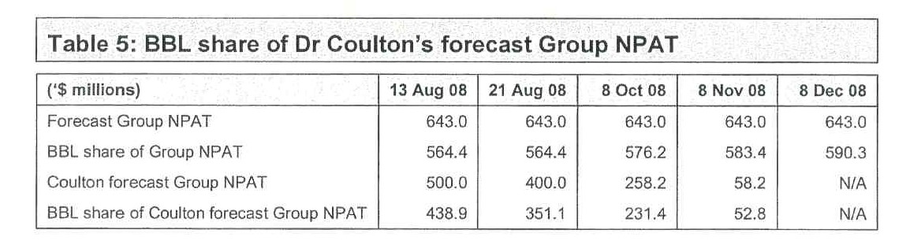
167 Mr Potter then examined the question of whether there was a correlation between past earnings guidance provided to the market by BBL and movements in its share price.
168 At pars 3.19 to 3.24, Mr Potter said:
3.19 Having regard to the above, it is apparent that not only is there not a one-for-one correlation between the variance of forecast NPAT to actual NPAT and share price movements but, in many instances, the ‘correlation’ is in fact negative, BBL’s share price declining following an earnings announcement that exceeded the prior guidance issued by BBL.
3.20 Whilst the past events where the actual NPAT exceeded the forecast NPAT in all instances is of limited application to the claims by the Plaintiffs that negative guidance should have been provided, it does show that the measurement of the potential effect of the guidance that Dr Coulton considers should have been made is not straightforward.
3.21 One such difficulty in measurement of the potential effect is the generally accepted proposition that the price or value of a share is reflective of expected future earnings.
3.22 Expected future earnings is not a single year that is the subject of the earnings guidance but also the years subsequent. The expectations as to earnings in years subsequent will be reflective of expectations as to growth. Not only is the market’s expectation as to the earnings in the year for which guidance is being provided not directly observable, market expectations of growth are also not directly observable.
3.23 I consider that one potential explanation or factor that would explain the lack of correlation identified above is that rather than the share price being entirely determined by the NPAT forecasts or guidance provided by the company, the more significant factor would be the market’s expectations of earnings. For example, in the table below I have compared the following for both BBL and a number of other larger companies listed on the ASX:
3.23.1 The percentage movement (increase or decrease) between expected earnings (based on ‘consensus’ analyst forecasts compiled by Bloomberg as a proxy for market expectations) and reported results (normalised to remove the effect of abnormal items); with
3.23.2 The percentage movement in the price at which the shares in the company traded (calculating the movement as being the difference between the closing price on the day prior to the announcement and the closing price on the day the announcement was issued).
3.24 Whilst the analysis may be considered to be relatively simple and not take account of growth expectations and broader financial market conditions as another explanatory variable, it does show that there is a higher degree of correlation (by reference to direction of difference in guidance and share price change, rather than value of change) between the movement in the share price and the difference between consensus analyst forecasts and reported NPAT. In particular, where the variance is positive, the share price has tended to increase and where the variance is negative, the share price has tended to decrease. Overall, the extent of the change in the share price is, however, a fraction of the variance between the analyst expectations and the actual NPAT.
169 Having established that there was no apparent direct correlation between the share price of BBL from time to time and earnings guidance provided by it to the market from time to time, Mr Potter considered that it was necessary to investigate the means by which measurement of the potential effect of the guidance that Dr Coulton considered should have been issued by BBL could be undertaken. He then proceeded to consider such means. He did so under the heading “Events study principles” (at pars 3.28 to 3.56 of his first report).
170 Mr Potter was of the opinion that the circumstances of BBL and of the broader market during the relevant period were such that an events study was not likely to be meaningful. He did, however, draw on events study principles as providing a useful guide in relation to a number of relevant factors to consider in the investigation of the extent (if any) to which Dr Coulton’s assessed NPAT guidance could have had on BBL’s share price.
171 At pars 3.33 to 3.37 of his first report, Mr Potter explained, in broad terms, the nature of an events study and set out the factors which he considered might be helpful in addressing the task with which he was confronted.
172 At pars 3.40 to 3.46, Mr Potter said:
3.40 The important point from the abovementioned examples of studies that have been undertaken is that they involved a comparison between the earnings guidance and market expectations of earnings. This is because the share price is a reflection of the market's expectations of earnings. Whilst a company’s earnings guidance may be a factor in the market arriving at its expectations of earnings, and it may be possible to identify where there has been a change in earnings guidance, the extent to which it is a factor in the price at which shares are traded is not readily apparent or measurable.
3.41 The second factor that the market evaluates quickly, correctly and completely the consequences of the news is, in essence, the efficient market hypothesis that I have explained further in section 7 of this report (refer to paragraph 7.71 to paragraph 7.78). In this case I have seen no information that would suggest the market is not efficient and accordingly believe such a pre condition for an events study would be satisfied.
3.42 Regarding the separation from other news factor, it is important to acknowledge that a change in the value of shares in a company does not typically occur in a vacuum. There are ordinarily confounding events that can be classified into three groups [Annexure 29, Cowan and Seguin paper at Chapter 36, tiled “Event Studies in Securities Litigation”, contained in the reference Fannon and Dunitz, Editors for “The Comprehensive Guide to Lost Profits and Other Commercial Damages” Fourth Edition, 2016, Business Valuation Resources LLC, United States (pages 1036-1037)]:
3.42.1 News that potentially affects all equities, including macroeconomic news such as interest rates, employment, GDP growth, consumer confidence etc and non-economic news with economic implications such as political change;
3.42.2 News that potentially affects industry equities, including macroeconomic news specific to the firm's industry and news announcements for firms in the same industry; and
3.42.3 Firm specific news that is simultaneous such as management malfeasance in combination with and [sic] earnings guidance.
3.43 A key assumption underpinning the event study method is that the change in market value of a share (also known as the return, that is the difference between the price of a share at the beginning of the period under examination ("event period") and the price at the end of the period) is that the return on the price at the beginning of the period can be separated into a market wide change in value and a change in value specific to the firm associated with the news event.
3.44 The event study involves comparison of the actual stock price movement over an event window that brackets the news event (often one trading day) to the expected stock price movement if the news event had not taken place to arrive at an abnormal return, which is then tested for statistical significance. The expected stock price movement is meant to take account of the news that has affected all equities, that is, overall stock market movements. A statistically significant abnormal return is the value effect of the specific news event.
3.45 The difficulty with ascertaining the extent to which other market wide news has affected the price of shares on particular trading days is that it is generally accepted that stock returns of some firms move proportionately more or less than the overall market reaction to economy wide news. This requires an adjustment for the relation between the stock returns of the individual firm and the returns of a relevant market index, in this case the ASX.
3.46 The relation between the stock returns of the individual firm and the returns of the market index is typically calculated using a statistical regression model over an appropriate estimation period prior to the relevant event being tested.
173 At pars 3.47 to 3.53, Mr Potter explained the statistical regression model to which he had referred at par 3.46 as follows:
3.47 Mitchell and Netter state that the predicted performance of a stock during an ‘event window’ is based on the firm’s stock price relationship with the market [Annexure 17, Mitchell and Netter, “The Role of Financial Economics in Securities Fraud Cases Applications at the Securities and Exchange Commission”, The Business Lawyer, Vol 49, page 567, February 1994]. Mitchell and Netter go on to estimate the market model using the following formula [Annexure 17, Mitchell and Netter, “The Role of Financial Economics in Securities Fraud Cases Applications at the Securities and Exchange Commission”, The Business Lawyer, Vol 49, page 567, February 1994]:
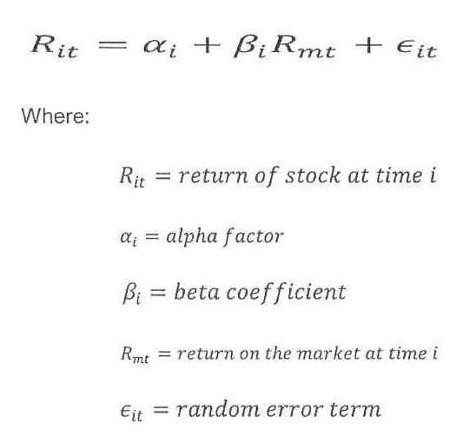
3.48 The abnormal return is then [Annexure 17, Mitchell and Netter, “The Role of Financial Economics in Securities Fraud Cases Applications at the Securities and Exchange Commission”, The Business Lawyer, Vol 49, page 568, February 1994]:
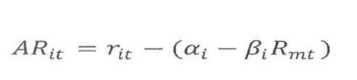
3.49 In this way, an abnormal return is assessed for a firm following a news event that is specific to the news event. It is the abnormal return that is the effect on the value of the share price of the news event.
3.50 An important variable to arrive at the relation between BBL’s share price of BBL and market wide events is the beta factor.
3.51 Betas are calculated from listed companies’ historical price data. It is a measure of the sensitivity of a company's returns, relative to changes in the market return as a whole. The Australian Graduate School of Management (“AGSM”) is generally accepted as a reliable source for beta factor data for Australian listed companies. It states the following in respect of beta [Annexure 16, AGSM Risk Measurement Service Introductory Notes, page 7]:
“Formally, beta is defined as the covariance of individual returns with those of the index, scaled by the variance of index returns. As a consequence, the beta of the “market” portfolio (containing shares in all companies in market value dollar proportions) will be equal to 1.0. Securities or portfolios with beta higher than 1.0 can be thought of as having higher risk than average, and those with betas less than 1.0 as having lower risk than average. In this context it is useful to remember that the beta of a portfolio is the weighted average of the betas of the individual shares comprising that portfolio, where the dollar weights are given by capital used value.
We described beta in a previous paragraph as a measure of the average sensitivity of a company's rate of return to that on the market index. Thus a share or a portfolio with a beta of 1.0 will on average move in fine with the market, Similarly a share with a beta of 2.0 will on average move 2.0 percent (up or down) for each 1.0 per cent move (up or down, respectively) by the market index. Such a share will on average perform well in a bull market and perform badly in a bear market. Conversely, a share with a beta of 0.5 will on average move 0.5 percent for each 1.0 percent movement in the market index, and consequently will on average under-perform the index in bull markets but out-perform the index in bear markets. Readers would, however, be well advised to note our inclusion of the words 'on average.' For example, a share with a beta of 1.0 cannot be expected to accurately track the market index. This is because the return on such a share contains specific risk as well as market risk. Only a market index portfolio, containing all shares in value weighted proportions, will track the index exactly since it is constructed to actually represent the index with all specific risk eliminated. All we can say about a share with a beta of 1.0 is that on average it will perform about as well as the market index, but there may be large deviations around this average on a day to day basis. This is still a very powerful statement, however, as the CAPM allows us to rank companies’ expected equity returns using beta as a scale as shown in the graph below.”
3.52 Changes in economy wide factors such as interest rates, exchange rates and changes in household disposable income or consumer spending will affect projected cash flows of particular companies differently and hence the company has a particular beta. Other market risks that could affect individual company’s future returns include government regulation and technological change.
3.53 It is also the case that an equity beta reflects the degree to which a company is leveraged. The higher the debt to equity ratio, the higher the beta factor.
174 At par 3.54 and 3.55, Mr Potter said:
3.54 I have assessed the beta factor of BBL in a range of periods prior to the news event to be as follows [Appendix 4, Potter calculation (Beta)]:
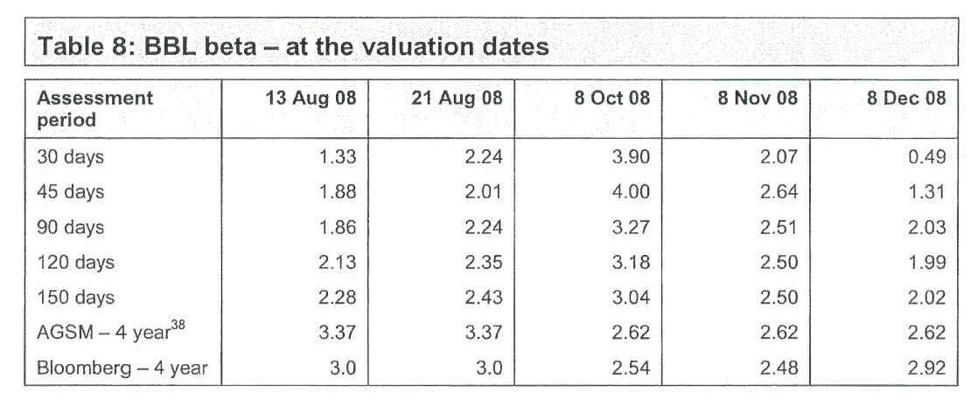
[³⁸ Annexure 32, AGSM Beta (relying on 30 June 2008 for 3 August and 21 August and 30 September 2008 for 8 October, 8 November and 8 December)]
3.55 In my experience, a beta factor in the range of 2 to 3 with a range of in excess of 1 for the high and low ranges, [Appendix 4, Potter calculation (Beta)] suggests that the share price of BBL is relatively highly affected by market wide events. The circumstances in the market over the relevant period of the claimed guidance is therefore an important consideration.
175 At par 3.56, Mr Potter set out his conclusion as to the relevant factors to be considered in making the assessment with which he was tasked. I set out par 3.56 in full:
3.56 The above analysis leads me to believe that:
3.56.1 The circumstances of BBL;
3.56.2 The circumstances of the market; and
3.56.3 Analysts’ expectations and the market’s expectations of BBL’s future earnings (being the NPAT for the year ended 31 December 2008 and the rate of growth in NPAT in the years following)
at the dates at which Dr Coulton considers that BBL’s (lower) NPAT guidance ought to have been given are important to ascertaining the likely effect of the claimed guidance on BBL's share price. I have further examined these issues in the following sections of this report.
176 In section 4 of his first report, Mr Potter undertook a very detailed analysis of the background to BBL and the circumstances in which it found itself in the market from about mid 2007 to late 2008/early 2009. The primary material upon which Mr Potter relied for this analysis was in evidence before the Court and was essentially not disputed by the plaintiffs or by Dr Coulton.
177 At par 4.2 of his first report, Mr Potter noted that BBL had a relatively complex structure of investments in listed and unlisted funds and was highly leveraged. He said that, as a consequence, the market considered BBL to be a risky investment. The GFC that began in mid 2007 was occurring throughout the relevant period so that isolation and assessment of the possible effect of the claimed reduced guidance was somewhat confounded. Mr Potter took the view that, from about mid-September 2008, market events were more likely to have been affecting the share price of BBL than was its earnings guidance.
178 At pars 2.12 to 2.19, Mr Potter summarised the important features of the analysis of the background to BBL and the market in 2008 which he undertook. I now set out those paragraphs in full:
2.12 In section 4 of this report I have examined the background of BBL and the circumstances in the market prior to and during the period in which Dr Coulton considers that BBL should have issued a reduced earnings guidance to the market. The available information leads me to believe that there was a close relationship between BBL’s share price and events in the global equity markets over this period, in particular the events of the GFC that began in mid 2007. This suggests that a major factor affecting BBL’s share price over the relevant period was, to an increasing extent, the events of the GFC rather than investor expectations of BBL’s earnings (although I note that these are interrelated issues due to BBL’s dependence on the value and performance of listed and unlisted funds in which BBL had an interest in and managed).
2.13 Further to my comments in paragraph 2.5, the closing price of shares in BBL on 21 August 2008 was $2.22 per share, a decline from the prior day closing price of $3.45 per share, representing a decline of approximately 36%. This decline followed an announcement to the market on 21 August 2008 that was consistent with an earlier announcement to the market on 11 August 2008.
2.14 The 21 August 2008 announcement contained the following items of news relating to BBL:
2.14.1 Group NPAT for the six month period ended 30 June 2008 was approximately 30% less than that achieved in the prior year;
2.14.2 Guidance previously given that Group NPAT for the year ended 31 December 2008 would be no more than that achieved in the year ended 31 December 2007 (that is, “not more than” $643 million) (throughout this report I note that I have assumed that ‘not more than’ $643 million means $643 million, rather than some lower figure. I make this assumption notwithstanding the risks identified by BBL when it provided this guidance (refer in particular to paragraph 4.77.5).
2.14.3 Additional risks to the result for the year were identified;
2.14.4 A restructuring of the business was re emphasized;and
2.14.5 Shareholders were informed of a decision to cease dividend payments for 2008.
2.15 All things being equal these additional announcements could be expected to reduce investors’ expectations of Group NPAT for the year ended 31 December 2008. The reduction in expectations can be seen in analyst reports that I have further addressed below.
2.16 It is not possible to discern the precise reason for the decline in the share price on 21 August 2008 given the broad range of announcements made on that day, although for the reasons explained in section 3 of this report, I consider the extent of the announcements over that period, together with the events of the GFC, to be confounding events that would make it extremely difficult, if not impossible, to quantify the potential impact, if any with a degree of confidence, of the claimed lower guidance assessed by Dr Coulton.
2.17 The effect of the GFC can be seen when BBL’s share price suffered a material decline in mid September 2008, being a decline that coincided with the collapse of Lehman Brothers in the United States. It is readily apparent that by this time the market was expecting (due to the previously announced restructure of BBL) material impairment losses to be incurred by BBL upon the sale of assets in a severely depressed global economy (so far as equity prices were concerned). For these reasons, I am of the opinion that following mid September 2008 the market's expectation of BBL's earnings was severely diminished.
2.18 The position of BBL then further deteriorated so that by mid November 2008 BBL:
2.18.1 Announced a larger restructure and asset sale program;
2.18.2 Was in a dispute with a lender(s) regarding release of a EUR 71 million bank deposit (in relation to which, on 20 November 2008, BBL requested a trading halt for its shares on the ASX on account of this dispute);
2.18.3 Had received a further credit downgrade from Standard & Poors (“S&P”) to CCC+; and
2.18.4 There was widespread market commentary to the effect that the BBL Group's overall survival and the viability of the planned restructure was subject to the cooperation of a banking syndicate.
2.19 In my opinion these events towards the end of 2008 mean that it was highly unlikely there were any expectations of positive earnings being achieved in the year ended 31 December 2008. As such the share price is most likely a reflection of expectations of significantly depressed trading results and what might occur in a restructuring of the company. In these circumstances, I do not consider the valuation models as applied by Dr Coulton are an appropriate means to assess the effect on BBL's share price had the claimed lower earnings guidance been given.
179 The conclusions which Mr Potter expressed at pars 2.12 to 2.19 of his first report were amply supported by the analysis which he performed in section 4 of that report.
180 Mr Potter noted (at par 4.19 of his first report) that BBL entities had partial ownership of listed and unlisted funds that owned and operated the relevant assets described as “Assets Under Management”. In the next paragraph, he said that the exchange traded value of the listed funds in which BBL had an interest had declined materially during the first half of 2008 and that there had been a substantial decline in the traded share price of BBL during the first half of 2008.
181 At pars 4.21 and 4.22, Mr Potter said:
4.21 The decline in values had an impact on the reported NPAT for the six months ended 30 June 2008 by way of recognition of impairment losses. I set out BBL’s financial performance by business type / income source for the six months ended 30 June 2008 and the year ended 31 December 2007 as follows [Pages 8 and 9 of BBL Appendix 4D and Management Discussion & Analysis dated 21 August 2008]:
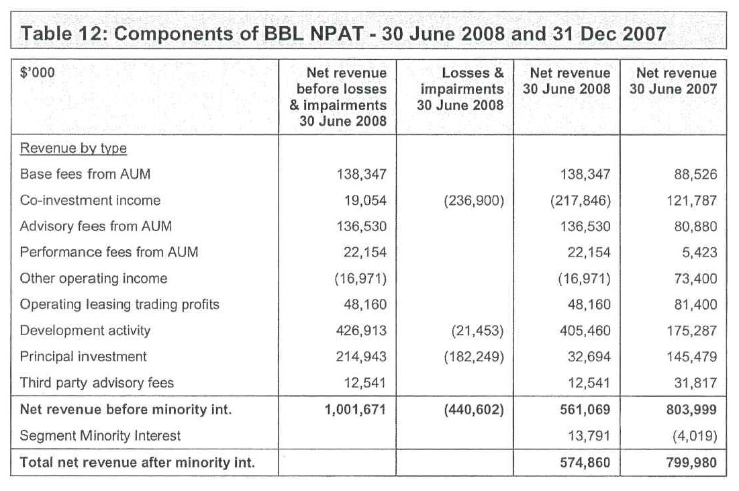
4.22 The losses and impairments have been identified as write down in asset values relating to the following business segments of BBL [Page 9 of BBL Appendix 4D and Management Discussion & Analysis dated 21 August 2008]:
4.22.1 The most significant write down of $198 million was in the Real Estate division, with $134 million attributed to the Co-Investment category, $21 million in Development and $43 million in Principal Investment;
4.22.2 The second largest write down in the Corporate and Structured Finance division, with $48 million attributed to Co-Investment and $92 million to Principal Investment; and
4.22.3 Smaller write downs of $87 million and $15 million in the Infrastructure and Operating Leasing segments respectively.
182 At pars 4.24 to 4.36, Mr Potter set out the summary of activities and relative asset values of each of the primary business segments of BBL.
183 At pars 4.37 to 4.63, Mr Potter set out relevant market circumstances concerning BBL in the period 2007 to 2008.
184 Having discussed BBL’s 2007 financial performance, at pars 4.41 to 4.47, Mr Potter said:
4.41 Following the peak price on 19 June 2007, BBL’s share price traded as follows [Appendix 4, Potter calculation (Raw share price date)]:
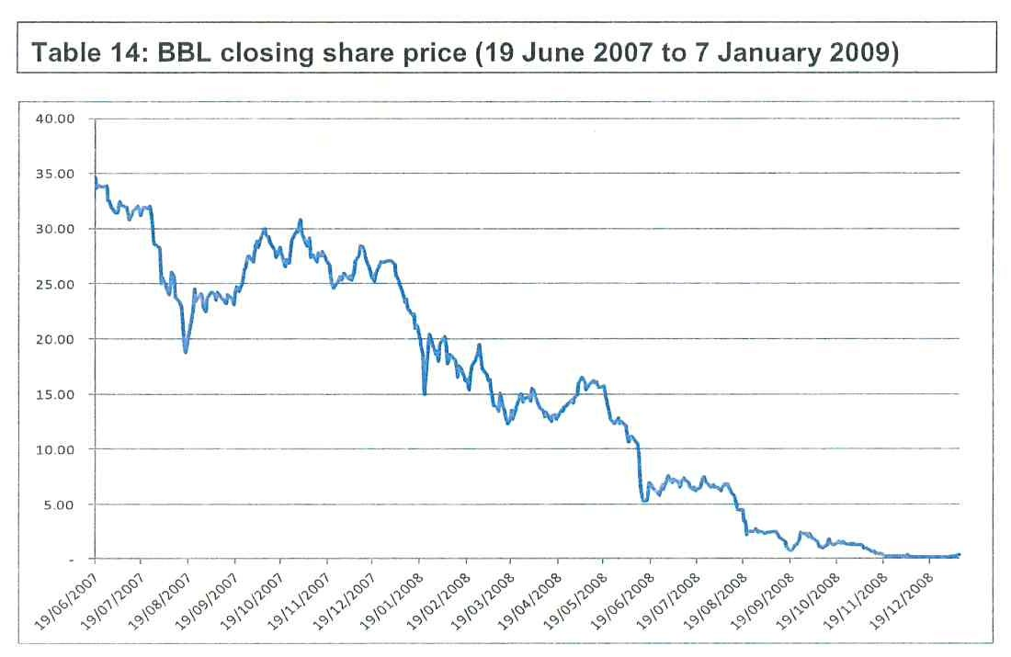
4.42 In relation to the above I note as follows:
4.42.1 Following the peak of $34.63 on 19 June 2007, BBL’s price sharply declined, dropping to $18.80 on 17 August 2007, representing a decline of approximately 46% over the course of two months;
4.42.2 Following this rapid decline, BBL’s share price increased to $30 by 8 October 2007 before closing the year at $27.15 on 31 December 2007;
4.42.3 BBL’s share price declined sharply in January 2008, dropping to a low of $14.99 on 22 January 2008;
4.42.4 BBL’s share price trended lower over the following months, declining by approximately 50% between 10 June 2008 and 13 June 2008, reaching a closing price of $5.25 on 13 June 2008;
4.42.5 BBL’s share price then steadily declined over the remainder of 2008, closing at $0.16 per share on 31 December 2008; and
4.42.6 BBL last traded on 7 January 2009 at $0.33 per share.
4.43 Over the course of 2008 the decline in the BBL’s market capitalisation, which would normally be considered reflective of lower expectations of earnings and value, resulted in a substantial reduction in BBL’s PB ratio. I set out a graph of BBL’s PB ratio over the period 2 January 2008 to 31 December 2008 as follows [Appendix 4, Potter calculation (BBL PB ratio)]:
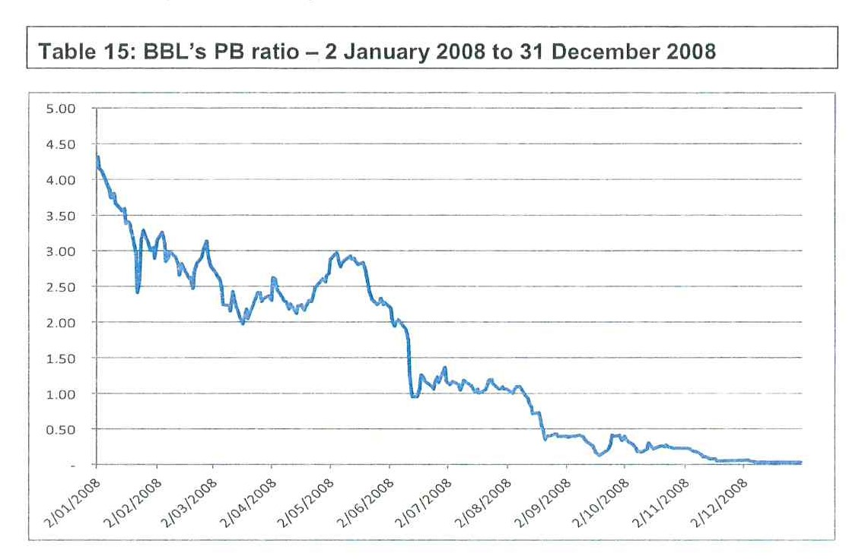
4.44 In relation to the above I note as follows:
4.44.1 Based on BBL’s share of Group net assets, BBL’s PB ratio declined materially over the course of 2008, from in excess of 4.0 in January 2008 to less than 0.03 by 31 December 2008;
4.44.2 BBL’s PB ratio first declined below 1.0 on 13 June 2008 but quickly rallied above 1.0, peaking at 1.37 on 30 June 2008, after which the PB ratio declined steadily until 12 August 2008 at which date it reached 0.97;
4.44.3 After 12 August 2008, BBL’s PB ratio never again exceeded 1.0, rapidly declining to 0.56 on 20 August 2008 and further to 0.36 on 21 August 2008; and
4.44.4 Thereafter, BBL’s PB ratio continued to steadily decline, reaching 0.03 by 31 December 2008.
4.45 I observe that there was a material disclosure regarding the recorded book value of a significant class of assets described as ‘Listed Securities Accounted for as Associates’ at 30 June 2008. Page 79 of BBL earnings announcement on 21 August 2008 in relation to the six months ended 30 June 2008 discloses that the recorded book value of the relevant assets in BBL’s accounts was $822.6 million but the market price of BB’'s interest had declined to $620 million at 30 June 2008 and to $561 million by 18 August 2008, a potential decline in value of $261.6 million that was not reflected in the value of assets as recorded in BBL’s financial statements. In relation to this, BBL stated that [BBL ASX Release dated 21 August 2008 (Appendix D, Note 21 - Events Occurring After Reporting Date (page 79))]:
“As at 30 June 2008 and as at the date of this report, Babcock & Brown had no intention or requirement to dispose of any interest in its equity accounted investments. As a consequence, the Directors believe the long term value of those investments remains appropriate and the fall in the market value of those investments subsequent to 30 June 2008 does not materially impact the carrying values of such investments in Babcock & Brown's balance sheet at 30 June 2008. As indicated in Note 1(E) this fall in market value provides evidence of partial impairment of Babcock & Brown’s investments in these funds. In accordance with the requirements of AASB 128 “Investment in Associates” Babcock & Brown has completed a review to ensure that the carrying value of its investment in these entities is recoverable. Where appropriate these reviews included an assessment of recovery from Babcock & Brown’s share of expected underlying cash flows. These cash flows are predicated on the business plans of associates which typically contemplate the long term use of the underlying assets of those investments”
4.46 The above disclosure highlights the sensitivity of the value of a material class of assets in BBL’s financial statements and market events that, all things being equal, could be expected to have had an effect on BBL’s PB ratio.
4.47 That BBL’s market capitalisation implied a PB ratio of less than 1.0 is, in my opinion, significant in considering the market's expectation of future earnings that would be reflected in the share price and the extent to which the claimed reduced earnings guidance could be expected to affect BBL’s share price. This issue is further addressed in section 6 of this report.
185 At pars 4.48 to 4.50, Mr Potter examined the trailing PE ratio of BBL in the following terms:
4.48 In addition to BBL’s PB ratio. I set out below a graph of BBL’s trailing PE ratio. This graph represents, on a daily basis, BBL’s market capitalisation divided by the prior year’s earnings. I set this out as follows [Appendix 4, Potter calculation (Raw share price data); I have prepared this analysis based on the prior full year NPAT and have not sought to update it for half year results as they were announced part way through FY08]:
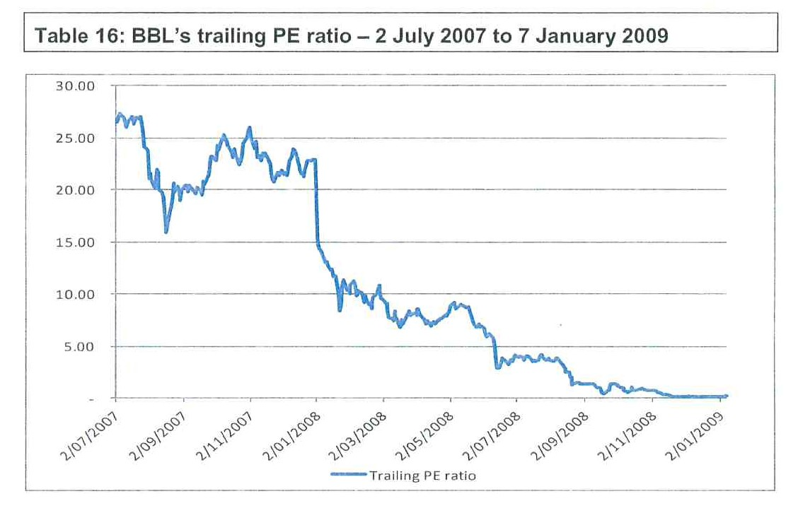
4.49 In relation to the above I note as follows:
4.49.1 BBL’s trailing PE ratio declined materially from 2007, where BBL was valued at up to approximately 27 times the prior full year earnings, to a multiple of approximately 15 times prior year earnings by 2 January 2008;
4.49.2 BBL’s trailing PE ratio continued to dramatically decline, dropping below 10 times prior year earnings on 22 January 2008 and below 8.0 times on 7 March 2008;
4.49.3 BBL’s trailing PE ratio continued to decline thereafter, dropping to below 5 on 12 June 2008 and to 3 by 13 August 2008; and
4.49.4 BBL’s trailing PE ratio thereafter continued to decline, first dropping to below 1 times prior year earnings on 15 September 2008.
4.50 The above graph shows that whereas the market had historically valued BBL at high multiple of historical earnings, the material ongoing decline in BBL’s PE trailing ratio indicates that, in my opinion, the market no longer expected BBL to generate the returns (earnings) that had historically been achieved.
186 At pars 4.52 to 4.61 of his first report, Mr Potter discussed the impact of the GFC on BBL’s business and share price. I set out those paragraphs in full:
4.52 The events of the GFC are relatively recent and well documented. A useful summary appears at pages 380 to 384 of the valuation text by Koller, Goedhart and Wessels of McKinsey & Company [Annexure 19, Koller, Goedhart and Wessels of McKinsey & Company titled “Valuation: Measuring and Managing the Value of Companies”, Fifth Edition, 2010, Wiley]. This reference outlines the following events:
4.52.1 In the years following 2001 and up to 2007 the financial, energy, utilities and materials sectors had experienced sharp increases in profits and values. The accelerated trends were a consequence of growth in Asian economies, particularly China, rises in housing prices, particularly the United States and Europe and expansion of credit markets including innovative financial instruments such as securitised finance instruments that provided lenders the opportunity to repackage and redistribute individual loans across many investors, the result of which was sharp increases in private sector debt. The combination of the rising house prices and innovative finance instruments allowed the transfer of mortgage default risk across banks globally. This led to the emergence of increasingly risky borrower segments known as sub­ prime loans;
4.52.2 A peak value of the S&P 500 Index was reached in mid 2007;
4.52.3 The financial crisis began to unfold in mid 2007 that drove the world's economy into its steepest downturn since the 1930s. Corporate profits dived and stock markets across the world lost more than half of their value from the peak levels in 2007 over the next year and a half;
4.52.4 A significant factor that emerged at the beginning of the crisis appears to have been the fall in United States housing prices and a resulting increase in mortgage default rates;
4.52.5 As a result of the high mortgage default rates finance institutions globally began to unwind their mortgage exposures. Values of underlying security plummeted bringing an increasing number of financial institutions into financial distress;
4.52.6 One of the most significant events was the collapse of the United States investment bank, Lehman Brothers in mid September 2008;
4.52.7 Other global financial institutions had to be rescued by governments including American International Group and Citigroup of the United States, Royal Bank of Scotland in the United Kingdom and Fortis and ING in the Netherlands;
4.52.8 The GFC resulted in the largest asset write-offs in history of around $2 trillion to $3 trillion for lenders in the United States and Europe; and
4.52.9 The economies in United States and Europe entered a deep recession, the lowest point of the S&P 500 occurring in March 2009.
4.53 I set out a graph of the S&P 500 index over the period 1 January 2007 to 30 June 2009 as follows [Appendix 4, Potter calculation (Graphs)]:
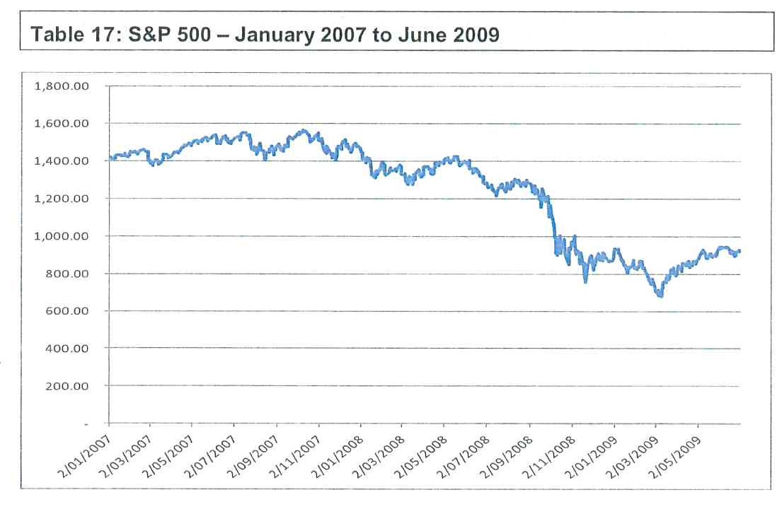
4.54 The events of the GFC and the effect on global economies has also been well documented in papers and presentations contained in bulletins issued by the Reserve Bank of Australia. For example, the RBA Bulletin for August 2008 documents the conditions prevailing globally and in Australia [Annexure 31, RBA Bulletin August 2008, pages 1 to 96], consistent with the outline set out in paragraph 4.52.
4.55 These events are particularly relevant to BBL because of the global nature of its assets and operations. The Real Estate division of BBL and its joint venture with GPT include a material investment in United States properties. The sharp decline in United States property values was one of the factors identified as driving the GFC. The decline in BBL’s share price is consistent with the decline in global markets and companies that were comparable to BBL over the period.
4.56 In that regard I set out a graph of BBLs share price as compared to the prices of Macquarie, Allco Finance Group Limited (“Allco”) [Macquarie Bank and Allco Finance Group have been included on the basis that they were the most comparable ASX-listed companies to BBL, both operating a similar business model (sourcing investments and deriving income from principal investment, advisory fees and asset management fees) and operating within the same industry segments (notably the infrastructure, leasing and property sectors)], the ASX 200 and the S&P 500 over the period 1 January 2008 to 31 December 2008 [Appendix 4, Potter calculation (Graphs) (Prices have been rebased to a starting value of 100 for comparability)]:
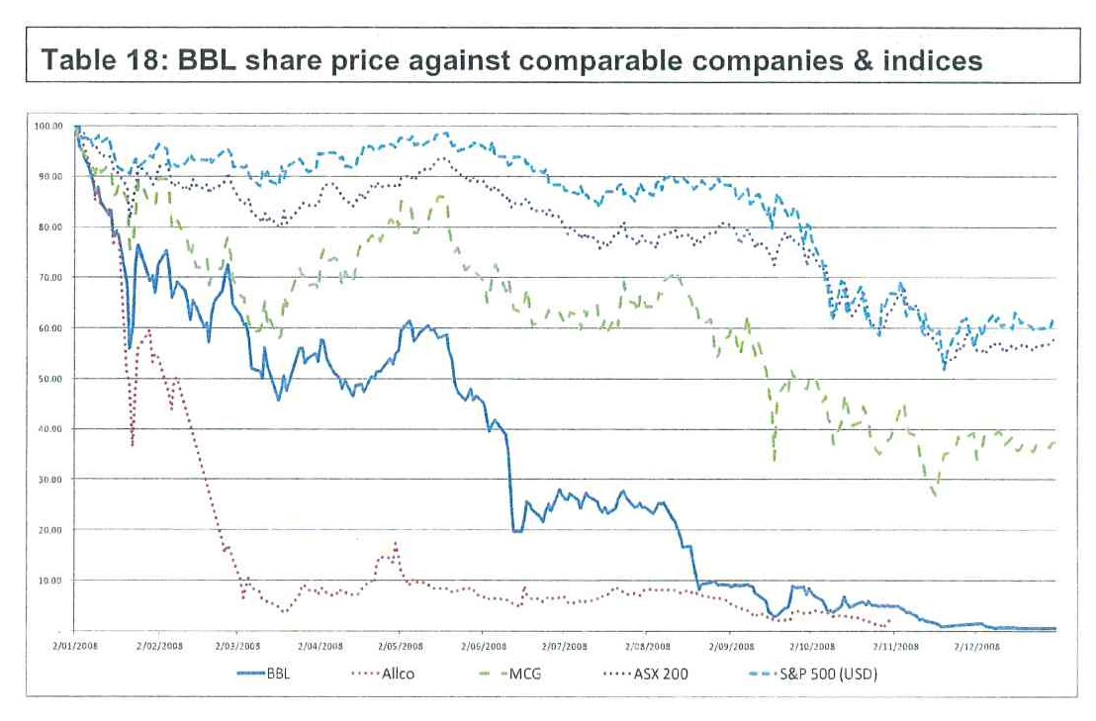
4.57 As illustrated, the decline in BBL’s share price followed a similar trajectory to that of Allco’s, albeit that BBL's share price fell over a longer period of time, and followed the same downward trajectory as that of Macquarie and the indices as a whole (albeit the decline in BBL (and Allco) was far more pronounced than for either Macquarie or the indices as represented by the ASX 200 and the S&P 500).
4.58 The effect of the decline in global market equity prices was reflected in the traded prices for shares in the listed funds in which BBL had an interest. The trends in the share prices are set out in the following graph [Appendix 4, Potter calculation (BBL managed funds - graphs) (Prices have been rebased to a starting value of 100 for comparability.).]:
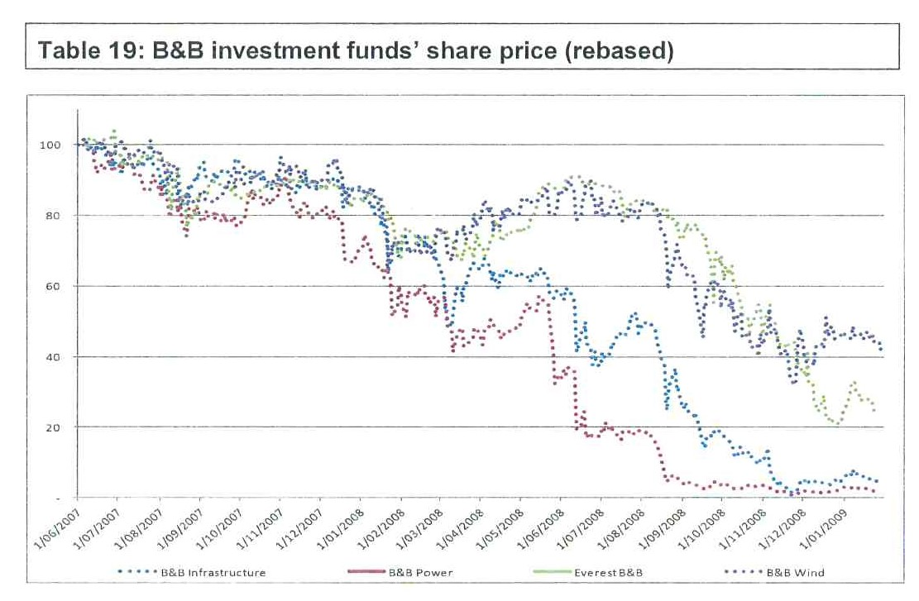
4.59 The above chart illustrates that the traded prices for shares in the Babcock & Brown Infrastructure and Babcock & Brown Power experienced sharper declines in the first half of 2008, following which all four funds declined dramatically.
4.60 In particular I note that, in addition to the substantial declines in share price that occurred over the course of May 2008 where the share price declined by approximately 40%, Babcock & Brown Power’s share price declined substantially during the week commencing 11 August 2008, declining by approximately 72% between 11 August 2008 and 20 August 2008.
4.61 In light of these substantial declines, I have reviewed the ASX announcements issued by Babcock & Brown Power with a view to explaining the cause of the decline.
187 At pars 4.62 and 4.63 of his first report, Mr Potter looked at the position of Babcock & Brown Power in a little more detail and concluded that the market expected that the business of that entity would not perform in accordance with management’s expectations.
188 At par 4.67 of his first report, Mr Potter noted that, at BBL’s Annual General Meeting held on 30 May 2008, shareholders were given some indication of a planned restructure. He then noted that, in mid-June 2008, an apparent debt issue had arisen that caused BBL to make a number of ASX announcements and a more formalised effort at a restructure. He noted the detail of these announcements at par 4.68 of his report.
189 Mr Potter then proceeded to look at events which affected BBL in August 2008. He considered those events in detail.
190 At pars 4.70 to 4.72, Mr Potter said:
4.70 The graph below shows BBL’s closing share price during the month of August 2008 [Appendix 4, Potter calculation (Raw share price date)]:
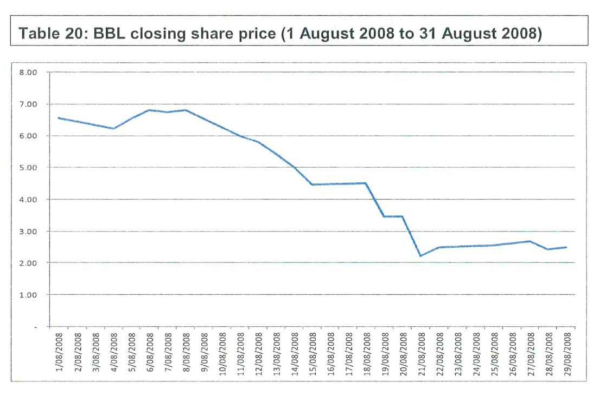
4.71 In relation to the above I note as follows:
4.71.1 On 1 August 2008 BBL closed at $6.55, rising to a high during the month of August of $6.80 on 6 August 2008 and 8 August 2008;
4.71.2 On 11 August 2008 BBL declined to $6.00, a decline of $0.80 (11.8%);
4.71.3 On the subsequent two trading days, BBL continued to decline, closing at $5.43 on 13 August 2008, taking the decline to $1.37 (20%) from the high on 8 August 2008;
4.71.4 On 14 August 2008 BBL declined a further $0.43 (8.6%);
4.71.5. On 15 August 2008 BBL declined a further $0.55 (11%);
4.71.6 On 19 August 2008 BBL declined a further $1.06 (24%);
4.71.7 On 21 August 2008 BBL declined from $3.45 to $2.22, representing a decline of $1.23 (36%); and
4.71.8 Therefore, between 1 August 2008 and 21 August 2008, BBL’s shares declined from $6.80 to $2.22, a decline of $4.58 or 67%.
4.72 Over the month of August 2008 BBL issued the following announcements to the ASX:
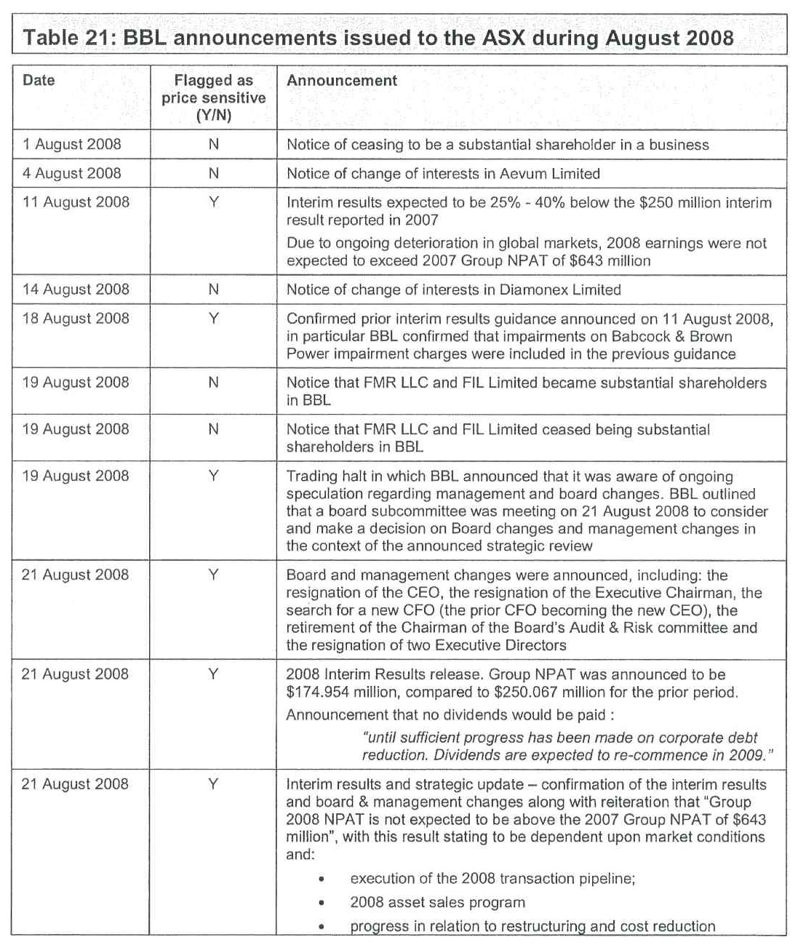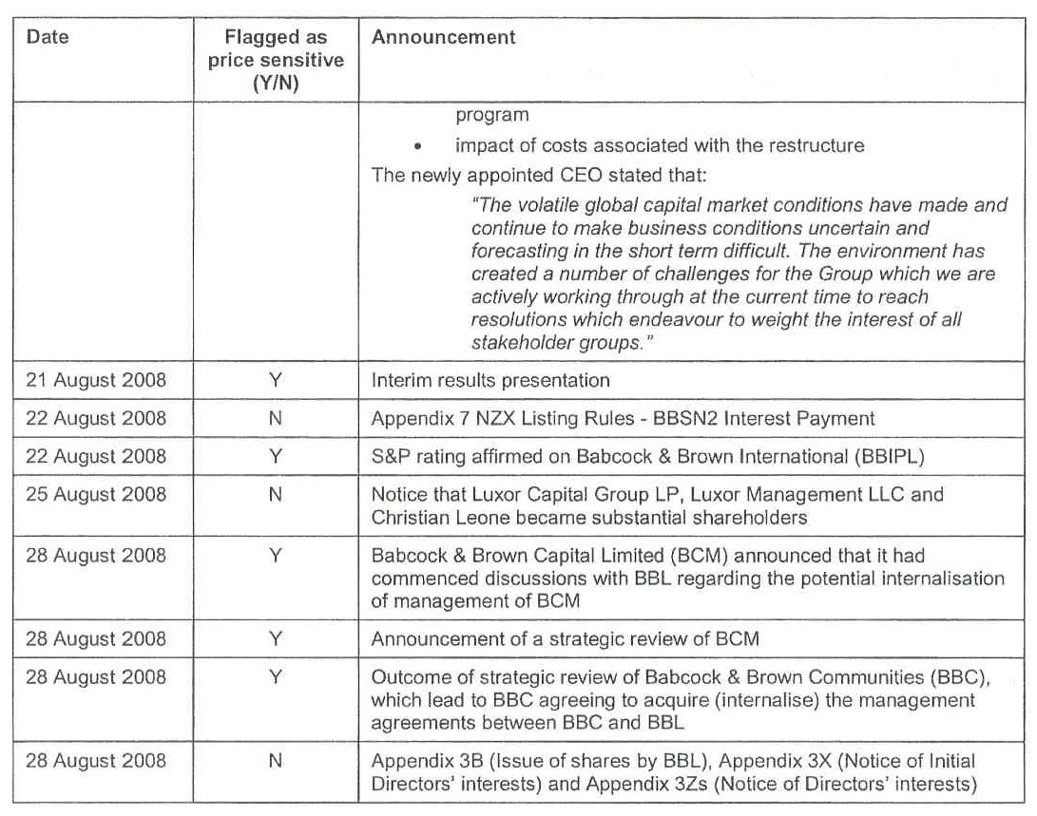
191 At pars 4.74 to 4.77, Mr Potter considered in detail the announcements made by BBL to the ASX during August 2008.
192 At par 4.78 of his first report, Mr Potter noted that the closing price of BBL shares on 21 August 2008 was $2.22 per share, a decline from the prior day’s closing price of $3.45 per share, representing a decline of approximately 36%.
193 At par 4.79, Mr Potter said:
It is not possible to discern the precise reason for the decline in the share price on 21 August 2008 given the broad range of announcements made on that day. I note that the guidance as to Group NPAT for the year ended 31 December 2008 remained the same, however a number of additional risks to the result for the year were identified. Further, the restructuring of the business was re-emphasized and shareholders were informed of a decision to cease dividend payments for 2008. All things being equal, these additional announcements could be expected to reduce investors’ expectations of future earnings.
194 Mr Potter then looked at relevant events affecting BBL in October 2008. At pars 4.80 and 4.81, Mr Potter said:
4.80 I set out a graph of BBL’s share price as compared to the prices of Macquarie, Allco, the ASX 200 and the S&P 500 over the period 1 September 2008 to 31 October 2008 [Appendix 4, Potter calculation (Graphs) (Prices have been rebased to a starting value of 100 for comparability)]:
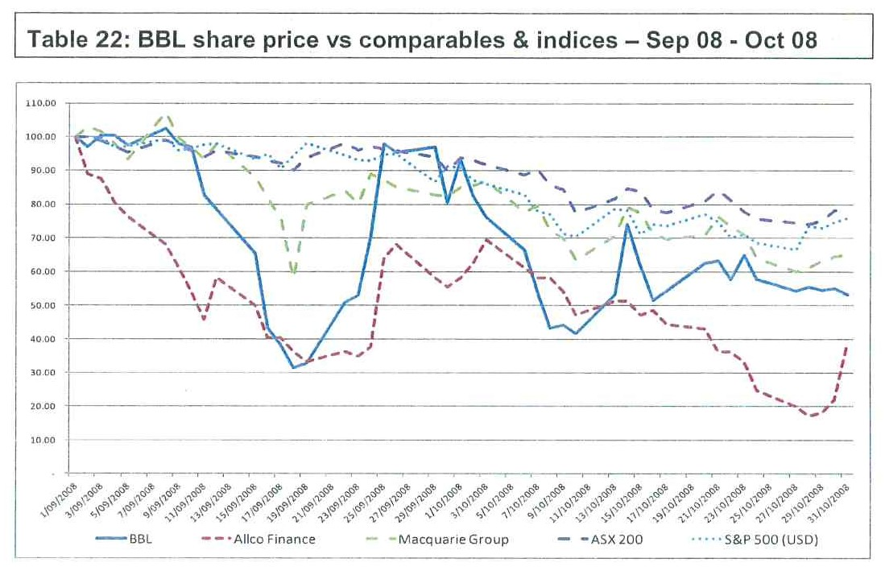
4.81 In relation to the above, I note as follows:
4.81.1 In the absence of any further earnings announcements issued by BBL, BBL's share price declined materially between September 2008 and October 2008;
4.81.2 Between 1 September 2008 and 15 September 2008, BBL’s share price declined from $2.42 to $1.58, a decline of $0.84 (35%);
4.81.3 On 16 September 2008, the day in which Lehman Brothers collapsed, BBL’s share price declined a further 34% (dropping from $1.58 to $1.05);
4.81.4 Over the coming days, BBL’s share price declined further, dropping to a low of $0.76 on 18 September 2008. At this point in time, BBL’s market capitalisation was approximately $264 million, compared to a book value of net assets of $2,060.5 million (representing an implied write-down to net assets of approximately $1.8 billion);
4.81.5 Whilst BBL’s share price recovered from this low, peaking at $2.37 on 25 September 2008, the price again rapidly declined to $1.01 by 10 October 2008. I note that the trend over this period can be observed to closely follow that of the ASX 200 and S&P 500;
4.81.6 Thereafter, BBL’s share price stabilised, closing on 31 October 2008 at $1.33; and
4.81.7 The declines in BBL’s share price mirrored declines in Allco, Macquarie, the ASX 200 and the S&P 500.
195 Mr Potter then considered relevant BBL events in November 2008 (at pars 4.82 to 4.92 of his first report). At 4.82 and 4.83 of his report, Mr Potter said:
4.82 I set out a graph of BBL’s share price as compared to the prices of Macquarie, the ASX 200 and the S&P 500 over the period 3 November 2008 to 31 December 2008 [Appendix 4, Potter calculation (Graphs) (Prices have been rebased to a starting value of 100 for comparability); Allco had ceased trading by this time]:
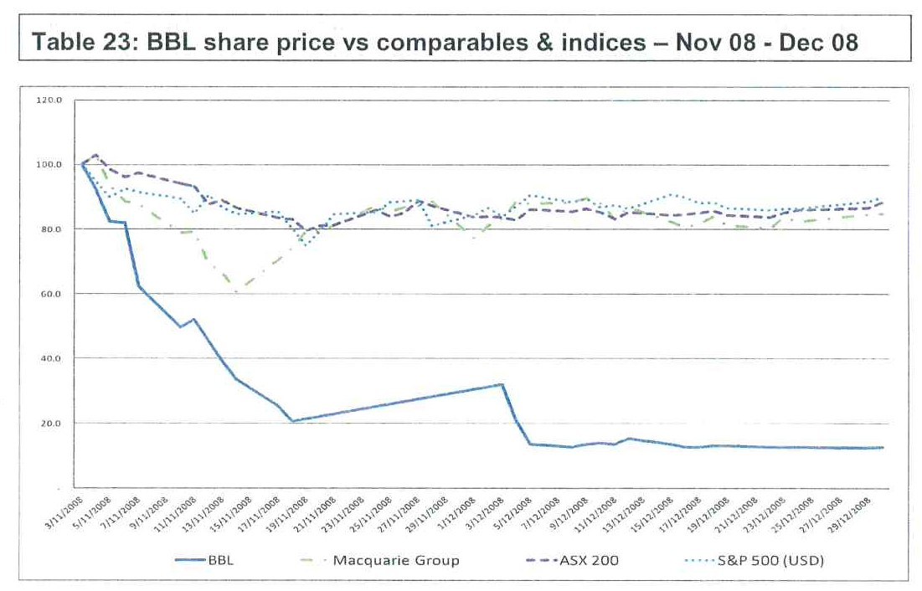
4.83 In relation to the above I note as follows:
4.83.1 In the absence of any further earnings announcements issued by BBL, BBL’s share price declined materially between 3 November 2008 and 31 December 2008;
4.83.2 BBL’s share price declined from $1.29 on 3 November to $1.00 on 7 November 2011, a decline of approximately 22%;
4.83.3 Over the period 10 November 2008 to 19 November 2008, BBL’s declined substantially, dropping from $1.00 on 7 November 2008 to $0.25 on 19 November 2008, a decline of 75% over a period of eight trading days;
4.83.4 Following the decline to $.025, BBL remained in trading halt until 4 December 2008, where BBL’s share price closed at $0.39; and
4.83.5 Thereafter, BBL’s share price steadily declined, reaching $0.155 on 31 December 2008.
196 Mr Potter then considered in detail the announcements made by BBL to the ASX during November 2008.
197 At par 4.91 of his first report, Mr Potter said that he considered that the equity in BBL can best be described as having been highly risky from about mid-September 2008 onwards as a result of market-wide factors. He considered that this opinion was confirmed by reference to company-specific factors, being factors that indicated that BBIL’s debt was speculative and, by necessary extension, the value of equity in BBL was increasingly becoming dependent upon restructuring efforts. He said that, in addition to reviewing the ASX announcements made by BBL, he reviewed press articles and analysts’ reports during the period.
198 At pars 4.93 to 4.99, Mr Potter set out his conclusions regarding market events and their effect on BBL from September 2008 in the following terms:
4.93 I consider the events of the GFC and other news that is specific to BBL (such as the announcement made on 21 August 2008) to mean there would be considerable difficulty in reaching a view as to the extent that a separate news event of reduced earnings guidance from the company would affect BBL’s share price, particularly where the announcement actually made contains negative news in any event. That is, it is more likely that there are too many confounding events to allow development of a reliable mathematical relation between the claimed reduced guidance and BBL’s share price.
4.94 I also consider that given these issues, it is important to obtain an understanding of the market's expectations of future earnings. With this knowledge it would be possible to reflect on the likelihood of the market’s reaction to the claimed reduced earnings guidance, assuming the market reacts in an economically rational manner. The consideration of the market's expectations is undertaken at section 5 and section 6 of this report.
4.95 The trends I have examined in this section of the report disclose a close relationship between BBL’s share price and events in the global markets for financial institutions. All of BBL, Macquarie and Allco suffered a material decline in mid September 2008 that coincided with the collapse of Lehman Brothers in the United States.
4.96 By mid September 2008 and following BBL’s PB ratio for BBL had declined to less than 0.25 and fluctuated around that level until reaching 0.03 by 31 December 2008.
4.97 It is readily apparent that by that stage the market was expecting the well publicised restructure of BBL to result in material realised impairment losses via the sale of assets in a severely depressed global economy (so far as equities were concerned).
4.98 The position of BBL then further deteriorated so that by mid November 2008 BBL:
4.98.1 Announced a larger restructure and asset sale program;
4.98.2 Was in a dispute with a lender(s) regarding release of a EUR 71 million bank deposit (in relation to which, on 20 November 2008, BBL requested a trading halt for its shares on the ASX on account of this dispute);
4.98.3 Had received a further credit downgrade from Standard & Poors (“S&P”) to CCC+; and
4.98.4 There was widespread market commentary to the effect that the BBL Group's overall survival and the viability of the planned restructure was subject to the cooperation of the banking syndicate.
4.99 In my opinion these events towards the end of 2008 mean that it was highly unlikely there were any expectations of positive earnings being achieved in the year ended 31 December 2008. As such the share price is most likely a reflection of expectations of significantly depressed trading results and what might occur in a restructuring of the company. In these circumstances, I consider that BBL’s share price is most likely a reflection of expectations surrounding the possible restructuring outcomes.
199 Section 5 of Mr Potter’s first report addressed analysts’ expectations regarding BBL in the second half of 2008.
200 At pars 2.20 and 2.22 of his report, Mr Potter said that his examination of the available reports prepared by equity analysts during the period August 2008 to November 2008 led him to conclude that the analysts’ consensus forecasts of BBL’s earnings were at a level of earnings that was considerably lower than the earnings guidance announced by BBL. He also expressed the opinion that the majority of the analysts further discounted their opinion of the value of BBL due to issues including market uncertainty. Taking all these matters into account, Mr Potter concluded that, in the period from August 2008 to November 2008, there was an expectation by analysts that BBL’s earnings would be lower than the guidance issued by BBL and, once the discounts were factored in, generally lower than the earnings guidance that Dr Coulton states that BBL should have issued. Mr Potter said that, by September 2008, certain analysts were already rating BBL as “speculative”.
201 Mr Potter supported these conclusions by a detailed analysis set out in section 5 of his report.
202 At par 5.17, Mr Potter said:
Having regard to the above, I consider that it is apparent that even adopting their own expectations of BBL’s forecast NPAT, being forecasts which are materially lower than the figure announced by BBL, analysts have further discounted their valuations of BBL in order to derive a ‘target price’. This further reduction represents, in my opinion, a discount for the uncertainty that was associated with BBL – being an uncertainty that was being reflected in the value attributed to BBL by the market. The material increase in the discount applied by analysts to their own valuations of BBL (35.3% compared to 9.3%) represents an increase in the uncertainty associated with BBL.
203 After more detailed consideration of the analysts’ reports, Mr Potter expressed his conclusions in respect of those reports in the following terms (at pars 5.19 to 5.21):
5.19 Because of the discounts to valuations made by the analysts, I am of the opinion that the consensus view of analysts was, in effect, that expected NPAT for the year ended 31 December 2008 was going to be lower than the reduced guidance that Dr Coulton considers should have been announced by BBL.
5.20 Having regard to the above, it is apparent that there was a deep degree of scepticism held amongst the analyst community regarding BBL’s forecasts and management's ability to successfully execute its plan. In particular, I note that:
5.20.1 Even amongst those analysts who were more optimistic toward BBL, such as Deutsche Bank, there was an unwillingness to express a positive view on the business or its prospects;
5.20.2 On 15 September 2008 BBL was regarded as “speculative” by Citigroup;
5.20.3 On 23 October 2008 Citigroup attributed a target price based on a “50% discount to our bearish estimate of NTA” indicating substantial risks associated with BBL's ability to continue as a going concern;
5.20.4 On 6 November 2008 ABN Amro considered that declining asset prices and difficult credit markets made it likely that BBL would breach its debt covenants in 2009;
5.20.5 On 17 November and 19 November, Citigroup issued reports in which it equated BBL with Allco, noting that Allco had been placed into Administration and Receivership on 4 November 2008. BBL was regarded as “Speculative” by Citigroup; and
5.20.6 On 19 November 2008, in light of the substantial uncertainty surrounding the future of BBL, Merrill Lynch issued a “No Rating” on BBL, stating that the future of the business lay in the hands of the banking syndicate.
5.21 The implication of the above is, in my opinion, that BBL was considered by a number of analysts to be a high risk, speculative investment from at least 15 September 2008; whilst there may have been the prospect for recovery, the downside risks were substantial, with substantial discounts being applied to net asset values.
204 Mr Potter then endeavoured to assess for himself the implied market expectation of BBL’s NPAT for the year ended 31 December 2008 by reverse engineering the residual income model (RIM). He said that he had cross checked this calculation by applying the Gordon Growth model as an alternate means of assessing the implied market expectation of BBL’s NPAT for the year ended 31 December 2008. Having done so, he concluded that the NPAT for the year ended 31 December 2008 implied by BBL’s traded share price was lower than the NPAT that Dr Coulton considered BBL should have announced and that the implied market expectation NPAT was declining rapidly over the relevant period. Mr Potter then concluded that, had the earnings guidance suggested by Dr Coulton been given, a significant change in the price of BBL’s shares was unlikely given that the market’s expectation of BBL’s NPAT was below the level that Dr Coulton said BBL should have announced.
205 In section 6 of his first report, Mr Potter explained in detail the way in which he had gone about his own assessment of the earnings that the market was expecting from BBL during the relevant period using the RIM.
206 At pars 2.23 to 2.28, Mr Potter explained in summary terms the way in which he used the RIM. He said:
2.23 In section 6 of this report I have undertaken my own assessment of the earnings that was expected by the market using the RIM. The RIM is a method for assessing the value of shares in a company.
2.24 The RIM provides that a firm’s share value reflects the cost of its existing net assets (that is, the book value of equity) plus the present value of expected future net revenues to the extent those revenues exceed the required return.
2.25 As I outline in section 6 of this report, the RIM implies that if a firm can earn only the investor’s required rate of return on the book value of its assets, then investors should be willing to pay no more than book value for its stock. Investors would pay more or less than book value if earnings are above or below this level. Thus, the difference between a firm’s market value and its book value depends on its ability to generate residual income.
2.26 The RIM arrives at the value of each share by adding:
2.26.1 Recorded book value of net assets per share;
2.26.2 The discounted value of EPS less the cost of equity accruing to equity holders (calculated as the required rate of return for equity holders multiplied by the book value of net assets per share) for the forecast period up to the date of assessment of a terminal value; and
2.26.3 The terminal value, which is an estimate of the value of the amount in paragraph 2.26.2 indefinitely at the end of the forecast period.
2.27 The benefit of the RIM model is that unlike the discounted cash flow model of valuation, it relies on accounting measures of net income rather than cash flows which necessitate more assumptions and the majority of the share value is explained by the net book value of assets. Unlike the discounted cash flow (“DCF”) methodology, the portion of the value attributed to the terminal value period (the period in perpetuity following the explicit forecast period), the period in which expectations are more unknown and relatively speculative, is minimised.
2.28 In relation to BBL and in the circumstances of this case, rather than use the RIM to assess the value of shares in BBL, I have used the RIM in order to derive a range of the market’s expectations of BBL’s implied NPAT for the year ended 31 December 2008, recognising that the application of any valuation model is not an exercise in precision. I have done so through a process known as reverse engineering. The range of more likely market expectations has been derived by the application of a range of assumed market expectations of growth, book value in net assets and with or without a terminal value. By testing a range of more likely market expectations I have assessed what I consider to be ‘boundaries’ of upper and lower expectations of implied Group NPAT for the year ended 31 December 2008.
207 Having performed his RIM analysis, Mr Potter expressed the opinion that it would not be reasonable to conclude that the earnings guidance proposed by Dr Coulton would have had a significant negative impact on BBL’s share price as calculated by Dr Coulton.
208 Mr Potter provided a detailed analysis in support of his RIM assessment in section 6 of his report. I do not propose, at this point in these Reasons, to discuss the detail of section 6.
209 In section 9 of his first report, Mr Potter prepared an alternate calculation by which he assessed the potential impact on BBL share price of Dr Coulton’s postulated earnings guidance under the net assets method. Using that method, Mr Potter considered that the impact of the earnings guidance proposed by Dr Coulton would have had little effect, if any, on BBL’s share price.
210 In sections 7 and 8 of his first report, Mr Potter provided detailed commentary on Dr Coulton’s methodology and calculations. At pars 2.43 to 2.74 of his first report, Mr Potter set out in summary form his responses to Dr Coulton’s first report. In summary, he disagreed both with Dr Coulton’s methodology and with his application of that methodology.
211 Mr Potter disagreed with Dr Coulton’s assumption that the market’s expectations of EPS were “anchored” on the $643 million figure provided in the BBL’s earnings forecast. Mr Potter explained why at pars 2.49 to 2.56 of his first report and, in more detail, at pars 7.8 to 7.54 of his first report. Dr Coulton appeared to accept the validity of Mr Potter’s criticisms as to the repetitive use of the $643 million figure when he revised his calculation using the Bloomberg analysts’ consensus earnings figures in his later reports.
212 Mr Potter also disagreed with Dr Coulton’s selection of the share price benchmark against which he purported to assess the hypothetical impact of the disclosure of the matters which he contended should have been disclosed. Mr Potter considered that taking the average closing price of BBL shares over the 20 days prior to the valuation date was a flawed approach. Mr Potter considered that the correct approach, on the assumption that Dr Coulton’s methodology was appropriate, would be to take the share price at each particular valuation date.
213 At pars 7.68 to 7.86, Mr Potter provided a detailed answer to the 20 day theory advanced by Dr Coulton. He said:
7.68 As outlined in paragraph 7.5.1, Dr Coulton calculates the average closing price over the 20 trading days prior to the valuation date, excluding the actual valuation date on the basis that doing so avoids “using a closing price that is influenced by the event under consideration”.
7.69 I disagree with Dr Coulton’s approach.
7.70 The closing share price on each specific valuation day reflects the value attributed to the shares in BBL by the market on each specific day.
7.71 A widely accepted finance theory to explain asset prices is the efficient markets hypothesis [Annexure 20, Brealey, Myers, Partington and Robinson, “Principles of Corporate Finance,” The McGraw-Hill Companies, Australian Edition, 2001, Chapter 13, pages 361-393 and Annexure 28, Brealey, Myers and Allen, “Principles of Corporate Finance,” The McGraw-Hill Companies, United States, 10th Edition, 2011, Chapter 13, pages 312-340]. An efficient market is one in which information is widely and cheaply available to investors and all relevant and ascertainable information is already reflected in asset prices. Competition amongst investors to obtain all relevant information has the result that the traded share prices at all times reflect true or fundamental value. As prices reflect all relevant information, then they will change only when new information arrives. Because new information cannot be predicted ahead of time, then share price changes must reflect only the unpredictable and the changes must be random.
7.72 It is also widely accepted that the share prices for individual firms traded on stock exchanges reflect, or track, the fundamental prices [Annexure 19, Koller, Goedhart, Wessels, “Valuation – Measuring and Managing the Value of Companies,” Fifth Edition, McKinsey & Company, 2010, Chapter 15, pages 325-343 and Chapter 17, pages 369-384].
7.73 A number of studies have been undertaken and found that new information is reflected in traded share prices almost immediately [Annexure 20, Brealey, Myers, Partington and Robinson, “Principles of Corporate Finance”, The McGraw-Hill Companies, Australian Edition, 2001, Chapter 13, pages 367-368, footnote 15]. These studies would suggest that the share price on the date of each valuation is appropriate. There are recognised forms of efficiency:
7.73.1 Weak form: where current prices fully reflect historical information and prices that is available to all;
7.73.2 Semi strong form: where the current market price incorporates all publicly available information; and
7.73.3 Strong form: where the current market price reflects all publicly and privately available information allowing for the possibility of insider trading.
7.74 In this case I am concerned with the semi strong form of market efficiency. The extent to which the exchange traded price reflects the information available to the market on each of the relevant claimed announcement dates.
7.75 There have been a number of studies undertaken since the development of the efficient markets hypothesis which have identified and investigated several potential observed anomalies that could indicate inconsistencies or unexplained events contrary to the efficient market hypothesis. An example of one of the theories developed from behavioural finance that is contrary to efficient markets hypothesis is the overreaction hypothesis.
7.76 The earlier over reaction hypothesis studies undertaken in the United States [Annexure 21, De Bondi and Thaler, “Further Evidence on Investor Overreaction and Stock Market Seasonality”, Journal of Finance, 1987, Vol 42, No. 3, pages 557-581] and one particular study in Australia [Annexure 22, Gaunt, “Overreaction in the Australian Equity Market: 1974-1997”, Pacific-Basin Finance Journal, Vol 8, No.3-4, pages 375-398, 2000] to a lesser extent, suggested that investors overreacted to unexpected news so that the exchange traded prices temporarily departed from their fundamental values. Stocks that performed well in previous periods (winners) and stocks that performed poorly in previous periods (losers) both tended to revert to their mean value in subsequent periods. The likelihood of market overreaction has however been found to be less likely where a large price change follows the release of information publicly and the use of more recent data to study the effect [Annexure 23, Larson and Madura, “What Drives Stock Price Behaviour Following Extreme One-Day Returns”, The Journal of Financial Research, Vol 26, No. 1, pages 113-127, 2003. See also Annexure 24, Clements, Drew, Reedman and Veerarahavan, “The death of the overreaction anomaly? A multifactor explanation of contrarian returns”, Australian Academic paper, Investment Management and Financial Innovations, Vol 6, Issue 1, 2009].
7.77 Since then research conclusions have been inconsistent and controversial. In particular, a number of researchers argue the overreaction hypothesis can be explained by failures in the design of the research undertaken [Annexure 25, Ball and Kothari, “Nonstationary Expected Returns: Implications for Tests of Market Efficiency and Serial Correlation in Returns”, Journal of Financial Economics, Vol 25, pages 51-74, 1989]. The overreaction hypothesis has also been rejected in research undertaken in Australia [Annexure 26, Brailsford, “A Test for the Winner-Loser Anomaly in the Australian Equity Market 1958-87”, Journal of Business Finance and Accounting, Vol 19, No. 2, pages 225-241, 1992. See also Annexure 27, Donovan, Evans and Simpson, “A Re-Examination of the Over-Reaction Hypothesis in the Equity Market: Australian Evidence 1980 to 1997,” Curtin University School of Economics & Finance, Working Paper No. 6, pages 1-21, 2000].
7.78 In conclusion, it is generally accepted that the studies undertaken to date surrounding the overreaction hypothesis and other potential anomalies are inconclusive and that the efficient markets hypothesis remains [Annexure 28, Brealey, Myers and Allen, “Principles of Corporate Finance,” The McGraw-Hill Companies, United States, 10th Edition, 2011, Chapter 13, pages 312-340, in particular pages 335 and 336].
7.79 Dr Coulton suggests that the market was not informed of a revision to BBL’s forecast earnings, being a revision that should have been made known to the market.
7.80 As I understand it, the thesis of Dr Coulton is that had up-to-date earnings guidance been issued, BBL’s shares would have traded at a lower price than they actually traded. It is not possible, in my opinion, for the absence of a disclosure that is claimed should have been made to adversely affect the price at which the shares in BBL actually traded.
7.81 The approach that I would adopt, if I were to assess the impact on the price of shares on a particular day, is to adopt the actual closing price on the specific valuation day. It is the price on this particular day that is said to have been affected by the absence of the disclosure, rather than the average price in the 20 days preceding the non­disclosure.
7.82 In addition to being conceptually preferred, I consider that the adoption of the closing price on the actual valuation date to be preferred, as doing so removes the effect of both:
7.82.1 Market movements generally; and
7.82.2 Company developments specifically, on BBL’s share price.
7.83 In that regard, I note that BBL’s share price was highly volatile and was on a downward trend over the period between August 2008 and December 2008. The adoption of an average closing share price therefore inappropriately incorporates both market and company-specific price movements into the determination of the hypothetical price of shares in BBL had the 'correct' NPAT forecasts been issued to the market.
7.84 I graph BBL's closing share price over the period 1 August 2008 to 8 December 2008 as follows [Appendix 4, Potter calculation (BBL share data)]:
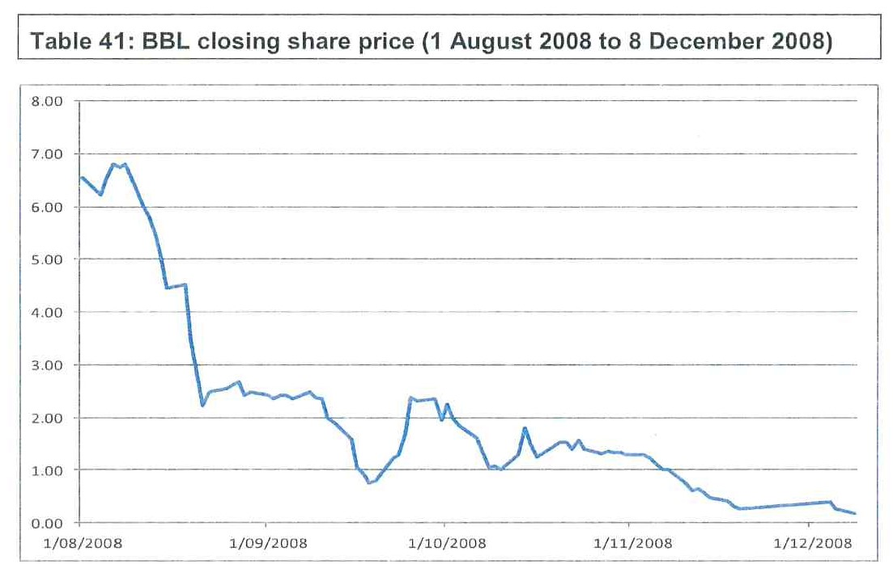
7.85 As illustrated, there were substantial movements in BBL’s share price, with the price declining sharply over the period. For instance, BBL’s share price declined from $5.81 on 12 August 2008 to $5.43 on 13 August 2008, representing a decline of $0.38 or 6.54%. Dr Coulton’s approach ignores entirely the effect of this actual decline in assessing the hypothetical price that BBL’s would have traded on 13 August 2008.
7.86 Further, Dr Coulton’s approach places equal weight on the closing price of BBL’s shares on each day between 16 July 2008 and 12 August 2008 (where BBL’s share price traded as high as $7.40) in assessing the hypothetical value of BBL’s share price on 13 August 2008. I consider that Dr Coulton’s approach is without foundation.
214 Mr Potter also disagreed with the NPAT adopted by Dr Coulton. He did so largely because of the failure on the part of Dr Coulton to take account of the fact that BBL’s NPAT was not the same as the B&B Group’s NPAT from time to time.
215 Having explained the issue in section 7 of his first report, Mr Potter stated his conclusions (at pars 7.91 and 7.92) in the following terms:
7.91 As at each valuation date I set out Dr Coulton's forecast of Group NPAT and my assessment of BBL’s share of Group NPAT as follows [Appendix 4, Potter calculation (BBL earnings)]:
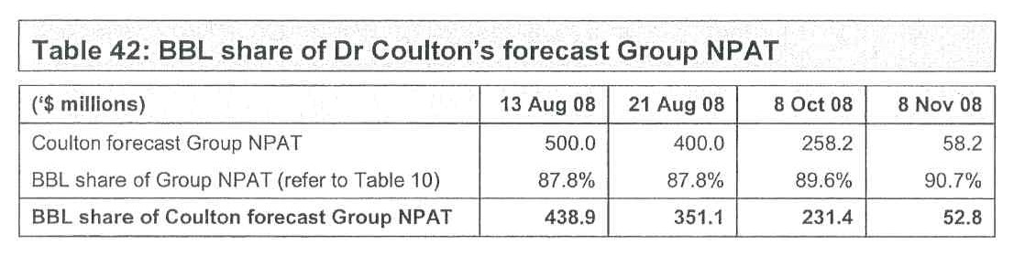
Potter opinion on Dr Coulton’s application of his PE ratio approach
7.92 Accordingly, for the reasons outlined, I consider that Dr Coulton has miscalculated BBL’s PE ratio, meaning that Dr Coulton has incorrectly assessed the effect on BBL’s share price under this methodology, being a methodology with which I otherwise disagree.
216 At pars 2.64 and 2.65, Mr Potter calculated BBL’s PE ratio, eliminating the errors which he identified in Dr Coulton’s approach. At those paragraphs, he said:
2.64 Based on BBL’s market capitalisation and the earnings guidance that was issued for the year ended 31 December 2008 I have calculated BBL’s PE ratio. I graph this as follows [Appendix 4, Potter calculation (BBL PB ratio)]:
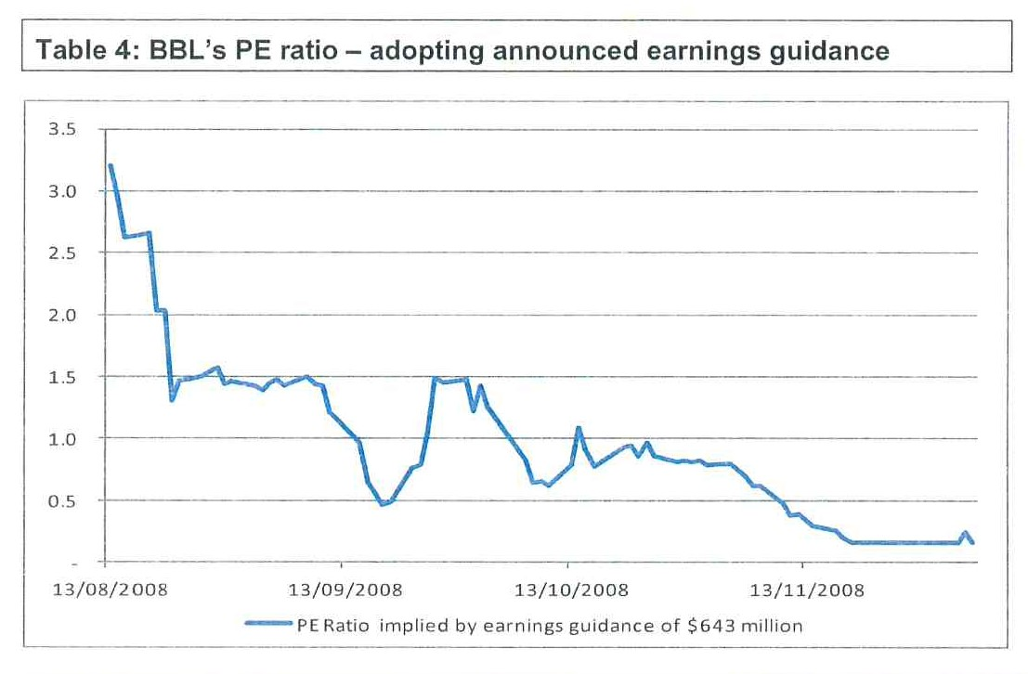
2.65 As illustrated, if BBL’s announced earnings guidance for the year ended 31 December 2008 is adopted, the PE ratio implied by BBL’s actual market capitalisation drops below a multiple of 1.0 (which first occurs on 15 September 2008). By 3 November the PR ratio reaches 0.80, declining to 0.16 on 19 November 2008. A PE ratio of below 1.0 is nonsensical, suggesting that the market has valued BBL’s entire business at less than the current’s years ‘expected’ earnings. This indicates that, in my opinion, the market’s expectation of the NPAT that BBL would achieve in the year ended 31 December 2008 is far lower than the earnings guidance that BBL announced. Accordingly, I consider that Dr Coulton’s approach, which is premised on the market having adopted BBL’s earnings guidance, is flawed.
217 Mr Potter then proceeded to consider Dr Coulton’s PB ratio methodology.
218 He stated his conclusions briefly at pars 2.70 to 2.74 of his report in the following terms:
2.70 I disagree both with the methodology applied by Dr Coulton and with Dr Coulton’s application of that methodology. I address these disagreements in turn.
Potter disagreement with Dr Coulton’s closing share price
2.71 As with my comments regarding Dr Coulton’s application of the PE ratio method, disagree that it is appropriate to assess the PB ratio at a particular date by reference to BBL’s closing share price over the 20 days prior to the valuation date. The approach that I consider is appropriate is to assess the PB ratio based on the market capitalisation of BBL at the actual valuation date, this involving adoption of the closing share price as at 8 December 2008. This is addressed further in paragraph 8.8 to paragraph 8.9 of this report.
Potter disagreement with Dr Coulton’s calculation of net assets per share
2.72 Whereas Dr Coulton calculates forecast net assets per share of $1.88 based on the number of BBL shares on issue at 8 December 2008 (refer to paragraph 8.11), the net assets per share adopted in calculating BBL’s PB ratio at 8 December 2008 assumes:
2.72.1 Reported net assets for the BBL Group at 30 June 2008; and
2.72.2 Issued shares at 30 June 2008.
2.73 I consider that the appropriate approach to adopt in assessing the PB ratio at 8 December 2008 is to adopt integers as at 8 December 2008. As such, the integers that I consider should be applied are [Refer to paragraph 8.11 to paragraph 8.19]:
2.73.1 BBL’s share of expected net assets of $2,923.5 million (accounting for both a correction so that net assets only reflect BBL’s share of net assets, rather than total Group net assets and the expected increment in net assets reflecting the expected profit between 1 July 2008 and 8 December 2008); and
2.73.2 Issued shares at 8 December 2008 of 367,537,951.
2.74 Accordingly, I consider that Dr Coulton has miscalculated BBL’s PB ratio, meaning that Dr Coulton has incorrectly assessed the effect on BBL’s share price under this methodology, being a methodology with which I otherwise disagree.
219 Mr Potter provided a detailed analysis in support of his conclusions in respect of the PB ratio approach in section 9 of his first report.

The Second Report of Dr Coulton
220 In his second report, Dr Coulton took issue with most of Mr Potter’s conclusions. This state of affairs ultimately found reflection in the joint report in which only one matter was agreed between Dr Coulton and Mr Potter viz … “it is the market’s expectation of BBL’s earnings that is a relevant starting point in both their respective models for the purposes of considering the impact of the alleged breaches by BBL”. The joint report then set out 33 pages in landscape format of disagreements between the two experts.
221 At pars 8 to 28 of his second report, Dr Coulton set out in summary form his responses to Mr Potter’s first report. The essence of his responses may be summarised as follows:
(a) There is no need to consider B&B Group’s NPAT separately from BBL’s NPAT. Security analysts and market participants regularly use earnings multiples based on group profit without making explicit adjustments for the extent of any non-controlling interest.
(b) Dr Coulton disagreed with Mr Potter’s alleged use of events study methodology. I interpolate here that I do not think that Mr Potter used such a methodology in section 3 of his first report. However, Dr Coulton also said (at par 16 of his second report):
… I do not believe that the data reported in section 3 of the Potter Report provides any useful information about assessing the potential impact of any earnings forecast by BBL on the price of shares in BBL.
(c) Mr Potter’s implementation of the RIM methodology was both unnecessary and flawed. It is unduly sensitive to the assumptions inputted into the model. Deploying the RIM methodology was unnecessary because the security analysts’ consensus earnings forecasts throughout the relevant period were much better than and more reliable assessments of market expectations of earnings in that period.
(d) The use of the figure of $643 million as a forecast throughout most of 2008 was legitimate, given the earnings guidance provided by BBL in the period from April 2008 to December 2008.
222 At pars 50 and 51 of his second report, Dr Coulton accepted that it was both sensible and appropriate to examine the forecasts that he believed BBL should have made by comparing those forecasts to the most recent security analysts’ consensus earnings forecasts. He then asserted that there was extensive literature that demonstrates that “bad news” forecasts are associated with negative share price reactions at the time of the forecast. Dr Coulton noted that security analysts’ consensus earnings forecasts are typically taken as a proxy for the market’s expectation of earnings.
223 At par 55 of his second report, Dr Coulton said:
I agree with Mr Potter’s conclusion that the consensus security analyst earnings forecasts for BBL for the 2008 financial year that were reported in the Bloomberg data were higher than the earnings information that I believe BBL should have disclosed at the Relevant Dates. This is shown in Table 1 below:
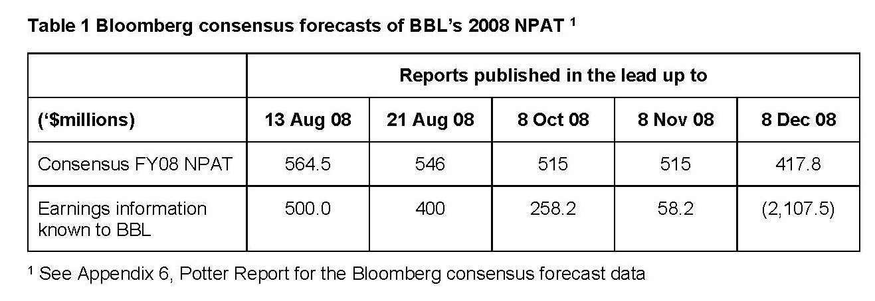
224 One explanation offered by Dr Coulton for this state of affairs was that the analysts believed that BBL’s earnings would decline after the end of the 2008 Financial Year. This appears to be pure speculation on the part of Dr Coulton.
225 Dr Coulton then undertook a detailed rebuttal of Mr Potter’s RIM assessment. He demonstrated, as was the fact, that the outcome of the RIM could vary substantially as a result of very small changes in the inputs, particularly BETA, the amount for forecast earnings and the growth rate. Dr Coulton expressed the opinion that he did not regard the inputs which Mr Potter had chosen for his RIM assessment as reasonable.
226 At pars 96 to 101 of his second report, Dr Coulton addressed a number of matters concerning the possibility that BBL would breach its loan covenants. Dr Coulton expressed the opinion that, in the relevant period, BBL had an incentive to withhold correct earnings guidance from the market.

The Second Report of Mr Potter
227 In Mr Potter’s second report, he addressed certain matters arising from Dr Coulton’s fourth report (referred to by Mr Potter as Dr Coulton’s third report).
228 For reasons which I will explain later in these Reasons, I do not accept that it is open to the plaintiffs to rely upon the non-disclosure of the material the subject of Dr Coulton’s fourth report as at 31 October 2008 or at all. Notwithstanding that view, I note that Mr Potter was of the opinion in his second report that it was not possible to conclude that BBL’s share price would necessarily have been adversely affected by BBL announcing the expected NPAT (and reduction to net assets) that Dr Coulton considered BBL should have announced at around the end of October 2008.

The Joint Expert Report, the Concurrent Evidence and the Court’s Findings in Respect of the Expert Evidence
229 The many and extensive differences of opinion between Dr Coulton and Mr Potter were subjected to scrutiny in the concurrent evidence process. Prior to the commencement of the oral evidence, the parties had agreed (with the Court’s approval) to address the many issues in dispute by reference to a document entitled “Agreed List of Issues for Giving of Concurrent Expert Evidence”. This document was marked as MFI-1.
230 The first issue that was addressed was the appropriateness of Dr Coulton’s then current method of assessing the market’s expectation of earnings as at the date of each of the alleged contraventions in the period from mid-August 2008 to early 2009 being the adoption of securities analysts’ consensus earnings forecasts extracted without adjustment from the Bloomberg Financial Service. It will be remembered that, in his first report, for all of the alleged contraventions except the last (the December 2008 postulated contravention), Dr Coulton had used as his benchmark forecast earnings the BBL NPAT for the Financial Year 2007 of $643 million. That approach was criticised by Mr Potter. Dr Coulton’s answer to that was to rework his calculations substituting for the $643 million benchmark the Bloomberg summary of the securities analysts’ consensus earnings forecasts at each of the relevant times.
231 In his oral evidence, in addressing this first issue, Dr Coulton said that:
(a) There is a large body of evidence that shows that management earnings forecasts that constitute “bad news” are associated with a negative share price reaction;
(b) In order to proceed with any assessment of the impact that the disclosure of the matters that were not disclosed would have had on the price of BBL’s shares, it was necessary to determine whether the subject matter of those non-disclosures would have been regarded as “good news” or “bad news”;
(c) In its guidance literature, the ASX identifies three possible benchmarks that can be used to infer the market’s expectations of earnings at any given point in time. These are:
(i) Prior forecasts provided by the company itself;
(ii) Securities analysts’ forecasts; and
(iii) Prior year forecasts
in descending order of preference;
(d) Dr Coulton’s revised calculations recorded in his second and third reports used the securities analysts’ consensus earnings forecasts in respect of BBL as the appropriate benchmark for BBL’s future earnings, both for the 2008 Financial Year and for subsequent years where appropriate; and
(e) The Bloomberg summary of those forecasts is both reliable and widely used.
232 When cross-examined by Senior Counsel for the liquidator, Dr Coulton maintained that there was no need to critically appraise those forecasts which had been fed into the Bloomberg summary in order to take account of the particular circumstances of BBL at any given point in time, even in circumstances where those circumstances were dynamic and changing at a fast pace. Dr Coulton was also asked, as was the fact with BBL in the present case, that the fact that analysts were ceasing to cover BBL was an indication that the analysts were taking a negative view of the prospects of the company. Dr Coulton agreed that that would be a reasonable assumption.
233 At Transcript p 122 ll 1–44, the following exchange took place:
MR LOCKHART: And would you agree with this: the fact that analysts are ceasing to cover Babcock and Brown generally reflects a view of negative prospects of the company held by those analysts?
DR COULTON: I think that would be a reasonable assumption. Yes.
MR LOCKHART: And you accept, of course, that it’s possible that analysts may have different views to each other obviously about forecast earnings.
DR COULTON: We see that in the variation in the forecasts that they were making. That’s correct.
MR LOCKHART: And different views about the prospects of the value of the stock.
DR COULTON: Absolutely.
MR LOCKHART: And those views can be vastly different on occasions, can they not?
DR COULTON: That’s correct. They can be.
MR LOCKHART: And very subjective as well.
DR COULTON: Absolutely.
MR LOCKHART: And would you agree that whatever reliability might be placed upon the views of analysts as reflected in the view of the overall market about forecast earnings is likely to reduce if the number of analysts covering the stock significantly declines?
DR COULTON: I think that’s also going to depend on – the quality of the analysts that are remaining would be a potential concern. It’s – so I can’t give an unqualified yes or no to that, is the problem I have. Ideally, the broader the coverage that you would have, I guess, the – you would need to look at both – there’s the consensus forecast and also the deviation of the forecast. It’s usually the case – we do know that security analysts tend to exhibit what we call herding behaviour, so they tend to try and group together.
You don’t want to be the one analyst that’s sort of the wrong analyst, if you like. So we do know that as the number of analysts tends to increase in coverage of a stock, the sort of, if you like, the deviation around the consensus forecast is likely to get smaller. It doesn’t necessarily follow that if we have a smaller number of analysts, then the information that they are providing is less useful to us. It’s - - -
234 Again, at Transcript p 129 ll 18–46, Dr Coulton gave the following evidence:
MR LOCKHART: Because your approach to ascertaining the market’s expectation of earnings for 2008 had no regard for the prices that were actually being paid on the relevant dates. Do you agree?
DR COULTON: The expectation of earnings was no direct use of the price. That’s correct, yes. The use of the price came in in terms of the price earnings ratio that we subsequently outlined. That’s correct.
MR LOCKHART: Rather, you preferred the earnings forecast figures channelling a number of analysts’ reports.
DR COULTON: That’s correct.
MR LOCKHART: And you preferred that approach even in circumstances where the analysts themselves have heavily discounted off their own valuations to reach a target price.
DR COULTON: Yes, that’s correct.
MR LOCKHART: And you’ve done that even where the analyst valuations have diverged from the actual price in the order of the very high percentage ..... in the joint report October 19. Do you agree?
DR COULTON: That’s correct. I’m focusing on the analyst earnings forecast rather than their valuation.
MR LOCKHART: You would also agree that the analysts’ forecasts in their report – they don’t provide the workings through as to how they reached those figures. Do you agree? They don’t reveal their workings.
235 Mr Potter responded to Dr Coulton’s evidence as follows:
(a) In the present case, the securities analysts’ earnings forecasts relied upon by Dr Coulton were “divorced from reality” at all relevant times for the following reasons:
(i) After the guidance that was actually given by BBL to the market on 11 August 2008, 21 August 2008 and 19 November 2008, the analysts reduced their forecasts of BBL’s earnings for the Financial Year 2008 well below the $643 million which had been used by Dr Coulton in his first report; and
(ii) The discounts which the analysts applied to those forecasts were for reasons which differed as between analysts and at different levels;
(b) In the present case, the Bloomberg summary forecast data was not reliable because it incorporated out of date data, being analysts’ reports which had been clearly overtaken by events (eg the 30 May 2008 and 29 July 2008 reports included in the Bloomberg data) and failed to incorporate other relevant analysts’ reports identified by Mr Potter in his first report.
236 Dr Coulton and Mr Potter agreed, at a general level, that the forecast of future earnings for any given financial year provided by security analysts would usually be an appropriate source for assessing the market’s expectation of future earnings.
237 Dr Coulton opined that the Bloomberg summary of the security analysts’ consensus earnings forecasts in respect of BBL which he used in his calculations in the present case without adjustment constituted a fair and reasonable set of forecasts of BBL’s earnings for the relevant period. Dr Coulton considered that there was no reason to make any adjustments to the summary arrived at by Bloomberg in its service, being the simple arithmetic average of a number of analysts’ forecasts.
238 Mr Potter said that, in the case of BBL in 2008, the Bloomberg summary adopted by Dr Coulton would not have served as a reliable source of relevant securities analysts’ earnings forecasts. He said that, in order to be reliable, those forecasts would have had to have been assessed carefully before being utilised in any calculations involving the market’s expectations of future earnings in respect of BBL and would also need to be adjusted so as to ensure that only relevant and up to date forecasts were used.
239 At Transcript p 106 ll 5 to 31, when asked whether he had discerned anything in the analysts’ reports which explained what he had described as the progressive discount by the analysts of the forecasts of BBL’s future earnings for the full Financial Year 2008, Mr Potter gave the following evidence:
MR POTTER: … There’s a large number of comments and growing in intensity, over the period August to December ’08 with this comment about the emerging global financial crisis, particularly after mid-September ’08 when Lehman Brothers collapsed, and how that meant that financial base companies globally were experiencing dramatic declines in value. And also in relation to Babcock, there was an increasing focus in the analysts’ reports on the difficulties with the banking syndicates and the expectation that there would be a restructuring, and it’s that – I think that growing view that Babcock needed a restructuring of its affairs, dramatically changed what – what I could see ..... the – the emphasis, if you like, on – on – on the Group’s future.
You – we saw the share – the Babcock share price drop from around $6 in – in August down to 17 cents by – by December, from a market capitalisation of $2 billion down to $60 million, and from all the insolvency related matters I’ve worked on, you can really on – where the company is talking about restructuring, it – it – it – it really means the markets arrived at a point by November/December that the company shares aren’t worth much. There aren’t really any high expectations of earnings. It’s all around what would – is there some positive value that would come out of a restructuring, rather than significant expected future earnings.
MR LOCKHART: Well, on the same topic, that is, the forecast earnings that the analysts have included in their projections – they being the ones that Mr White took you to – you get the healthy level of discounts. You’ve expressed the opinion in your report, paragraph 5.5, ..... explanation of that is that the analysts have retained the same level of headline earnings at a point of discount to reflect the risk associated with Babcock & Brown achieving ..... Is that a view that you had formed by reference to your – the observations you’ve referred to contained in those reports?
MR POTTER: Yes, it is.
240 I think that, in the circumstances in which BBL found itself in 2008, Mr Potter’s criticisms of Dr Coulton’s approach of carrying across into his calculations the securities analysts’ consensus earnings forecasts from the Bloomberg service without adjustment was a fair criticism and that a decision made by Dr Coulton to deploy the Bloomberg summary in that fashion was apt to produce a false result from his calculations, even if his PE ratio methodology were otherwise sound at the level of principle.
241 The next issue which was discussed in the concurrent evidence was the suitability of Mr Potter’s RIM methodology as a means of deriving and assessing the market’s expectation of the earnings of BBL in the relevant period.
242 Mr Potter said that, once he had formed the view that the securities analysts’ earnings forecasts in the present case were not reliable, he decided to come up with a methodology that would produce a more reliable assessment of the market’s expectations of BBL’s earnings for the second half of 2008.
243 Mr Potter’s RIM methodology involved deriving the market’s expectation as to future earnings in the case of BBL by assessing the quantum of future earnings which the market had impliedly built in when it determined the market price of the shares in BBL from time to time.
244 As he explained, the model starts with the closing traded share price each day.
245 The next matter which is utilised in the RIM is the reported value of the net assets as at 30 June 2008 available to the shareholders of BBL.
246 The next integer is the number of shares in BBL on issue as at the date of each of the alleged contraventions.
247 After feeding in those items, Mr Potter’s model derived the reported book value of net assets per share which, as he correctly pointed out, was just a calculation using the above assumptions.
248 He then used the capital asset pricing model (CAPM) feeding in a number of inputs as a matter of judgment on his part. These inputs included the market risk premium, the BETA factor and the growth rate.
249 Having deployed the model as I have outlined, he was able to reverse engineer the implied earnings per share that the market price at various points in time reflected.
250 He also noted that, like a discounted cash flow model, he had to deal with the question of terminal value and that he had used alternative assumptions in that regard. The assumption which he favoured was a nil terminal value.
251 Mr Potter then said that the result of the application of his RIM methodology was that, in the case of BBL, the market had priced in the decline in earnings expected for the balance of 2008 in such a way and to such an extent that, had BBL made the disclosures which Dr Coulton contends should have been made at various points in time in that period, the difference in the price of BBL shares would not have been significant because the earnings decline was already taken into account. In addition, the output of the application of Mr Potter’s RIM methodology was that, at all relevant times, the market was expecting NPAT at levels which were lower than the levels at which Dr Coulton said should have been the subject of specific disclosure and guidance in the latter half of 2008. In other words, even if Dr Coulton were completely correct in his conclusions that disclosure of the material that was not disclosed would have led to the market forecasting earnings below that which had in fact been announced by BBL in the relevant period, the amounts so forecast would be greater than the Potter-implied expectations derived from the application of his RIM methodology.
252 Dr Coulton consistently expressed the opinion that the reverse engineering approach of Mr Potter’s RIM based upon a series of assumptions which could vary depending upon the application of judgments, including subjective judgments, was not a useful or meaningful way of deriving an acceptable assessment of the market’s expectation of the future earnings of BBL in the latter half of 2008. Dr Coulton said that Mr Potter’s use of the RIM methodology was not the use for which the methodology had been designed. He said that the methodology was a valuation methodology and was never intended to be used in the way that Mr Potter was using it.
253 Mr Potter defended the use which he made of his RIM methodology by emphasising the point that the outputs from the application of that methodology were more in tune with what ultimately actually happened in the market than were the outputs of Dr Coulton’s calculations using his PE ratio approach and PB ratio approach. There was considerable force in that observation made by Mr Potter.
254 Dr Coulton then embarked upon a series of criticisms of the reasonableness of the inputs which Mr Potter had adopted, particularly the inputs of BETA and growth rate. In the course of outlining those criticisms, Dr Coulton went so far as to suggest that the CAPM was a flawed model and advocated for some of the more exotic variations of the CAPM that had been undertaken over the years. I do not give much credence to this latter criticism as it is well known that the CAPM is a useful tool when used in the fashion that it was designed to be used and for the purposes for which it was designed to be used.
255 Provided that the relevant inputs are reasonable and notwithstanding that the RIM methodology is usually used to value shares, logically there should be no reason why an expert such as Mr Potter cannot reverse engineer out of the application of the model the market’s expectation of future earnings at any given point in time implied from the market’s determination of the appropriate share price.
256 I tend to think that the RIM methodology used to derive forecast earnings in the way that Mr Potter has used the model in the present case is a little too theoretical and subjective to be regarded as a sound basis for inferring the market’s expectation of future earnings in the case of BBL for the second half of 2008. I do not think that Dr Coulton’s evidence totally discredited Mr Potter’s RIM but I do accept that there were difficulties with it.
257 The next question concerned the appropriateness of Dr Coulton’s fundamental methodologies which involved, at their heart, the application of PE ratios and PB ratios in respect of BBL.
258 Dr Coulton explained his approach in some detail at Transcript pp 177–182. That explanation broadly conformed to the explanation which he had given of his methodologies in his first report.
259 Mr Potter then recapitulated the criticisms which he had made of Dr Coulton’s PE ratio and PB ratio methodologies in sections 7, 8 and 9 of his first report. I have referred to these matters in detail at [209]–[219] above.
260 In the course of his exposition, Mr Potter emphasised that, instead of making an assessment of the quantum of BBL’s future maintainable earnings, as he should have done, by reference to future years beyond the end of Financial Year 2008, Dr Coulton adopted in his calculations only the forecast earnings for one single year viz 2008. Mr Potter went on to say that BBL’s business by the middle of 2008 was not stable and that there was considerable difficulty in using the PE ratio approach in respect of future earnings which could not be regarded as stable.
261 In the course of explaining his answers to Dr Coulton’s approach, at Transcript p 202 ll 16–28, Mr Potter said:
MR POTTER: Critical to Dr Coulton’s premise or assumption that he has made is that he has – he must have established a relation between what the analyst has forecast for that year ended December ’08 and the share price. That relation is established. Maybe he’s right. I don’t – I don’t know, but I doubt it. But I don’t think in any of the work he has done he has established any relationship between the analyst’s forecast December ’08 and the market’s expectations. And that’s the difficulty with the price earnings approach, the simplified approach, as he says it, is that he has used an integer where we can’t lift up the hood and see if it’s right. We just don’t – there’s no way of working it out. On the flipside I say with my residual income model, I open the hood on the how the market is assessing the prospects of the company, making a range of assumptions, a very wide range of assumptions and I come up consistently with the result that that relation Dr Coulton has assumed is not there.
262 After hearing and seeing the expert protagonists providing their oral evidence in relation to Dr Coulton’s methodology, I have come to the view that that methodology was flawed for the reasons which Mr Potter gave both in his first report and in his oral evidence.
263 In addition, in the course of Dr Coulton giving his oral evidence, the following exchange took place between him and me (at Transcript p 223 ll 5–39):
HIS HONOUR: Does your method of assessment take into account in all of the subsequent occasions that is post 13 August each of the prior calculations of loss that is reduction of share price caused by the prior failure to disclose?
DR COULTON: No. That’s actually a very good question, your Honour. No, it does not take into account - - -
HIS HONOUR: I thought it might be. That’s why I asked it. It doesn’t do that, does it.
DR COULTON: No, it doesn’t.
HIS HONOUR: Because you treat them all in isolation.
DR COULTON: I take the share price as given, and I don’t try and make any adjusted share price. Had - - -
HIS HONOUR: And why not? Because you can’t or - - -
DR COULTON: I’m assuming that each of the alleged contraventions – if you like – were standalone events. So - - -
HIS HONOUR: Yes, but standalone events which have a cumulative effect.
DR COULTON: Yes. But for the purposes of my calculation I’m assuming the alleged breach on 21 August happened but the 13 August one didn’t. If that explains the calculations.
HIS HONOUR: Well, it does, and I think I understood that, but what I’m really getting at is – if I were to find, as I think is being urged upon me, that all of these announcements should have been made at each occasion, then – you haven’t even tried to assess the impact on the share price at each of the subsequent occasions of the prior failure to disclose.
DR COULTON:… That’s correct. Yes.
264 Before leaving this section of these Reasons, I wish to reiterate that the task which Dr Coulton said that he was endeavouring to undertake was to assess the difference between the price at which shares in BBL actually traded on the market at the time of each of the alleged contraventions in the second half of 2008 and the hypothetical price at which those shares would have traded had BBL’s earnings guidance been adjusted to reflect the information which Dr Coulton assumed should have been disclosed to the market at those times. As he said at par 88 of his first report, his approach assumed that the contravening conduct which he described earlier in that report … “led the market to believe that BBL was trading more profitably than it really was, and that this inflated the price of shares in BBL”. Dr Coulton did not undertake any investigation or inquiry designed to make good this assumption. He did not prove it to be true. At most, he endeavoured to measure the extent of the assumed inflation of the price of BBL’s shares from time to time upon the assumption that there was, in fact, such an inflation of the price and also that such inflation was caused by the contravening conduct described by him in his first report and nothing else.

THE RELEVANT STATUTORY FRAMEWORK AND LEGAL PRINCIPLES (NON-DISCLOSURE)
265 At all relevant times, ss 674, 676 and 677 of the Act were in the following terms:
674 Continuous disclosure—listed disclosing entity bound by a disclosure requirement in market listing rules
Obligation to disclose in accordance with listing rules
(1) Subsection (2) applies to a listed disclosing entity if provisions of the listing rules of a listing market in relation to that entity require the entity to notify the market operator of information about specified events or matters as they arise for the purpose of the operator making that information available to participants in the market.
(2) If:
(a) this subsection applies to a listed disclosing entity; and
(b) the entity has information that those provisions require the entity to notify to the market operator; and
(c) that information:
(i) is not generally available; and
(ii) is information that a reasonable person would expect, if it were generally available, to have a material effect on the price or value of ED securities of the entity;
the entity must notify the market operator of that information in accordance with those provisions.
Note 1: Failure to comply with this subsection is an offence (see subsection 1311(1)).
Note 2: This subsection is also a civil penalty provision (see section 1317E). For relief from liability to a civil penalty relating to this subsection, see section 1317S.
Note 3: An infringement notice may be issued for an alleged contravention of this subsection, see section 1317DAC.
(2A) A person who is involved in a listed disclosing entity’s contravention of subsection (2) contravenes this subsection.
Note 1: This subsection is a civil penalty provision (see section 1317E). For relief from liability to a civil penalty relating to this subsection, see section 1317S.
Note 2: Section 79 defines involved.
(2B) A person does not contravene subsection (2A) if the person proves that they:
(a) took all steps (if any) that were reasonable in the circumstances to ensure that the listed disclosing entity complied with its obligations under subsection (2); and
(b) after doing so, believed on reasonable grounds that the listed disclosing entity was complying with its obligations under that subsection.
(3) For the purposes of the application of subsection (2) to a listed disclosing entity that is an undertaking to which interests in a registered scheme relate, the obligation of the entity to notify the market operator of information is an obligation of the responsible entity.
(4) Nothing in subsection (2) is intended to affect or limit the situations in which action can be taken (otherwise than by way of a prosecution for an offence based on subsection (2)) in respect of a failure to comply with provisions referred to in subsection (1).
Obligation to make provisions of listing rules available
(5) If the listing rules of a listing market in relation to a listed disclosing entity contain provisions of a kind referred to in subsection (1), the market operator must ensure that those provisions are available, on reasonable terms, to:
(a) the entity; or
(b) if the entity is an undertaking to which interests in a registered scheme relate—the undertaking’s responsible entity.
Note: Failure to comply with this subsection is an offence (see subsection 1311(1)).
…
676 Sections 674 and 675—when information is generally available
(1) This section has effect for the purposes of sections 674 and 675.
(2) Information is generally available if:
(a) it consists of readily observable matter; or
(b) without limiting the generality of paragraph (a), both of the following subparagraphs apply:
(i) it has been made known in a manner that would, or would be likely to, bring it to the attention of persons who commonly invest in securities of a kind whose price or value might be affected by the information; and
(ii) since it was so made known, a reasonable period for it to be disseminated among such persons has elapsed.
(3) Information is also generally available if it consists of deductions, conclusions or inferences made or drawn from either or both of the following:
(a) information referred to in paragraph (2)(a);
(b) information made known as mentioned in subparagraph (2)(b)(i).
677 Sections 674 and 675—material effect on price or value
For the purposes of sections 674 and 675, a reasonable person would be taken to expect information to have a material effect on the price or value of ED securities of a disclosing entity if the information would, or would be likely to, influence persons who commonly invest in securities in deciding whether to acquire or dispose of the ED securities.
“ED securities” in s 674 and s 677 are enhanced disclosure securities (as to which, see s 111AB to 111AD).
266 Throughout the relevant period, rr 3.1, 3.1A, 19.1, 19.2, 19.3 and 19.12 of the Listing Rules provided as follows:
Immediate notice of material information
General rule
3.1 Once an entity is or becomes [see chapter 19 for defined terms] aware of any information concerning it that a reasonable person would expect to have a material effect on the price or value of the entity’s [see chapter 19 for defined terms] securities, the entity must immediately tell ASX that information.
Introduced 1/7/96. Origin: Listing Rule 3A(1). Amended 1/7/2000, 1/1/2003.
Note: Section 677 of the Corporations Act defines material effect on price or value. As at 11 March 2002 it said for the purpose of sections 674 and 675 a reasonable person would be taken to expect information to have a material effect on the price or value of securities if the information would, or would be likely to, influence persons who commonly invest in securities in deciding whether or not to subscribe for, or buy or sell, the first mentioned securities.
“Information” may include information necessary to prevent or correct a false market, see listing rule 3.1B.
A confidentiality agreement must not prevent an entity from complying with its obligations under the Listing Rules, and in particular its obligation to give ASX information for release to the market where required by the rules.
Examples: The following information would require disclosure if material under this rule:
- a change in the entity’s financial forecast or expectation.
- the appointment of a receiver, manager, liquidator or administrator in respect of any loan, trade credit, trade debt, borrowing or securities held by it or any of its child entities.
- a transaction for which the consideration payable or receivable is a significant proportion of the written down value of the entity’s consolidated assets. Normally, an amount of 5% or more would be significant, but a smaller amount may be significant in a particular case.
- a change in the control of the responsible entity of a trust.
- a proposed change in the general character or nature of a trust.
- a recommendation or declaration of a dividend or distribution.
- a recommendation or decision that a dividend or distribution will not be declared.
- under subscriptions or over subscriptions to an issue.
- a copy of a document containing market sensitive information that the entity lodges with an overseas stock exchange or other regulator which is available to the public. The copy given to ASX must be in English.
- an agreement or option to acquire an interest in a mining tenement, including the number of tenements, a summary of previous exploration activity and expenditure, where the tenements are situated, the identity of the vendor and the consideration for the tenements. Cross reference: Appendix 5B, which requires this information quarterly, regardless of disclosure because of its materiality.
- information about the beneficial ownership of securities obtained under Part 6C.2 of the Corporations Act.
- giving or receiving a notice of intention to make a takeover.
- an agreement between the entity (or a related party or subsidiary) and a director (or a related party of the director).
- a copy of any financial documents that the entity lodges with an overseas stock exchange or other regulator which is available to the public. The copy given to ASX must be in English.
- a change in accounting policy adopted by the entity.
- any rating applied by a rating agency to an entity, or securities of an entity, and any change to such a rating.
- a proposal to change the entity’s auditor.
Cross-reference: Listing rules 3.1A, 3.1B, 5.18, 15.7, 18.7A, 19.2, Guidance Note 8 – Continuous Disclosure: Listing Rule 3.1.
Exception to rule 3.1
3.1A Listing rule 3.1 does not apply to particular information while all of the following are satisfied.
3.1A.1 A reasonable person would not expect the information to be disclosed.
3.1A.2 The information is confidential and ASX has not formed the view that the information has ceased to be confidential.
3.1A.3 One or more of the following applies.
- It would be a breach of a law to disclose the information.
- The information concerns an incomplete proposal or negotiation.
- The information comprises matters of supposition or is insufficiently definite to warrant disclosure.
- The information is generated for the internal management purposes of the entity.
- The information is a trade secret.
Introduced 1/1/2003.
Note: “Confidential” means confidential as a matter of fact. An entity may give information to third parties in the ordinary course of its business and activities and continue to satisfy rule 3.1A.2, provided the entity retains control over the use and disclosure of the information. Examples include information given to the following:
- the entity’s advisers for the purposes of obtaining advice;
- other service providers such as share registries and printers;
- a party with whom the entity is negotiating, for the purposes of the negotiation;
- a regulatory authority or ASX in the course of an application or submission.
ASX would be likely to consider that information has ceased to be confidential if the information, or part of it, becomes known either selectively or generally, whether inadvertently or deliberately. If information becomes known by others in circumstances where the entity does not retain control of its use and disclosure, rule 3.1A.2 is not satisfied, regardless of whether the entity or a third party disclosed the information.
Example: Where there is rumour circulating or media comment about the information and the rumour or comment is reasonably specific, this will generally indicate that confidentiality has been lost.
Cross-reference: Listing rules 3.1, 3.1B, 18.8A; Guidance Note 8 – Continuous Disclosure: Listing Rule 3.1.
…
Interpretation
Principles on which the listing rules are based
19.1 The listing rules are based on the principles set out in the Introduction.
Introduced 1/7/96.
Entity must comply with spirit, intention and purpose etc of rules
19.2 An entity must comply with the listing rules as interpreted:
- in accordance with their spirit, intention and purpose;
- by looking beyond form to substance; and
- in a way that best promotes the principles on which the listing rules are based.
Introduced 1/7/96. Origin: Foreword.
Note: The principles on which the listing rules are based embody their intention and purpose. See the Introduction.
…
Expressions used in the Corporations Act
19.3 Expressions that are not specifically defined in the listing rules, but are given a particular meaning in the Corporations Act, have the same meaning in the listing rules.
Introduced 1/7/96. Origin: Definitions. Amended 30/9/2001
…
Definitions
19.12 The following expressions have the meanings set out below.
Introduced 1/7/96. Origin: Definitions.
Expressions | meanings
…
aware | an entity becomes aware of information if a director or executive officer (in the case of a trust, a director or executive officer of the responsible entity) has, or ought reasonably to have, come into possession of the information in the course of the performance of their duties as a director or executive officer of that entity.  Introduced 1/7/96. Origin: Listing Rule 3A(1). Amended 1/7/98, 30/9/2001.
267 After the period with which the present cases are concerned, “information” was expressly defined in Listing Rule 19.12 as follows:
Expressions | meanings
information | For the purposes of Listing Rules 3.1 3.1B, information includes:  (a) matters of supposition and other matters that are insufficiently definite to warrant disclosure to the market; and  (b) matters relating to the intentions, or likely intentions, of a person.  Introduced 01/05/13
268 BBL was a “listed disclosure entity” within the meaning of that expression when used in s 674. The liquidator accepts that the continuous disclosure provisions applied to BBL at all relevant times.
269 In order for s 674 of the Act to be engaged, there must be a requirement in the relevant listing rules (here the ASX Listing Rules) that the entity notify the market operator (here the ASX) of the particular information or event. This requirement was adverted to by the Full Court in Grant-Taylor v Babcock & Brown Ltd (in liq) (2016) 245 FCR 402 (Grant-Taylor) at 412–413 [51]–[52] where the Court said:
There is a further requirement for s 674(2), namely, that provisions of the Listing Rules require the entity to notify the market operator of relevant information (s 674(1)). An ASX listed company satisfies such a requirement because of the disclosure obligations of Chapter 3 of the Listing Rules, particularly Listing Rule 3.1.
The objective and hypothetical (in one sense) requirement of s 674(2)(c)(ii) is identical to the equivalent part of Listing Rule 3.1; but Listing Rule 3.1 requires disclosure of information even if it has come into the public domain (is generally available) in contradistinction to the limitation of not being generally available in s 674(2)(c)(i).
270 In Grant-Taylor at 418–425 [91]–[124], the Full Court discussed and explained various construction questions which arose in that case in respect of the continuous disclosure provisions. The observations made by the Full Court in those paragraphs are of general application and must be applied by me in the present cases.
271 The first requirement of s 674(1) is that there be something constituting “information”, since that is the subject matter upon which the obligation to disclose fixes. In Grant-Taylor, at 418–419 [94], the Full Court made the following observations about the meaning of “information” when used in s 674:
Section 674(2) requires it to be established that the company has “information” which the Listing Rules require the company to notify to the market operator. “Information” is not defined for the purposes of s 674. But “information” is defined, for the purposes of the insider trading provisions, to include matters of supposition and matters relating to intentions; see s 1042A and the discussion of its background in Australian Securities and Investments Commission v Citigroup Global Markets Australia Pty Ltd (No 4) (2007) 160 FCR 35 at [526]–[544] per Jacobson J. But there is no similar statutory definition for the purposes of s 674. In that context, “information” may be given a more restrictive interpretation in the specific context of s 674 given the reference to “information about specified events or matters”. This is consistent with the philosophy underpinning Australian securities law, particularly in the takeovers context, that disclosure of speculation is not required and is to be avoided: Australian Consolidated Investments Ltd v Rossington Holdings Pty Ltd (1992) 35 FCR 226 at 228. But s 674(1) is a generic provision concerned to identify relevant provisions of the Listing Rules as to whether they exist. Further, “specified” is not a direct qualifier of “information”. Also, it is to be noted that one element of the exception in Listing Rule 3.1A refers to excluding information which “comprises matters of supposition or is insufficiently definite to warrant disclosure”. That might suggest that the Listing Rule 3.1 general context does prima facie use “information” as embracing speculation or insufficiently definite information, but leaves the work to the carve-out to operate to exclude supposition or indefinite information; or, it may simply be a way of emphasising the considerations referred to in Rossington. The current form of Listing Rule 19.12 now defines “information” as including “matters of supposition and other matters that are insufficiently definite”. Given the limited relevance of these matters to the appeal, it is neither necessary nor appropriate to express concluded views on the meaning of the word “information”, in particular without a factual context. The elucidation of the reach of the notion of information will, invariably, be assisted by analysis against specific factual circumstances.
272 The liquidator submitted that, one way or the other, matters that are insufficiently definite to warrant disclosure are excluded from the disclosure requirements, either because they do not relate to specific events or matters, and so are not “information”, or because they are within the exception within Listing Rule 3.1A.
273 The next requirement is that the entity must be shown to have “had” the relevant information (s 674(2)(b) of the Act). Listing Rule 3.1 required that the entity “[was] … aware of” the information, in the sense that the directors of the entity “[had], or ought reasonably to have, come into possession of [the information] … in the course of the performance of their duties” as directors (Listing Rule 19.12).
274 In Grant-Taylor (at 434 [185]), the Full Court said that these provisions are to be understood as requiring actual or constructive knowledge of the relevant information.
275 The next matter which a plaintiff must establish is materiality. The information in question must be information that “a reasonable person would expect, if it were generally available, to have a material effect on the price or value” of the entity’s shares, in the sense that “the information would, or would be likely to, influence persons who commonly invest in securities in deciding whether to acquire or dispose of” the entity’s shares (s 674(2)(c)(ii) and s 677 of the Act). Although Listing Rule 3.1 did not use the expression “commonly invest in securities”, the Full Court in Grant-Taylor held that Listing Rule 3.1 and s 674(2)(ii) were to be given a concordant operation with the consequence that the Listing Rule was to be taken to incorporate that expression.
276 At 420 [96], the Full Court said:
What is meant by “material effect” in s 674(2)(c)(ii)? As stated earlier, s 677 illuminates this concept and also identifies the genus of the class of “persons who commonly invest in securities”. It refers to the concept of whether “the information would, or would be likely to, influence [such] persons … in deciding whether to acquire or dispose of ” the relevant shares. The concept of “materiality” in terms of its capacity to influence a person whether to acquire or dispose of shares must refer to information which is non-trivial at least. It is insufficient that the information “may” or “might” influence a decision: it is “would” or “would be likely” that is required to be shown: TSC Industries Inc v Northway Inc 426 US 438 (1976). Materiality may also then depend upon a balancing of both the indicated probability that the event will occur and the anticipated magnitude of the event on the company’s affairs (Basic Inc v Levinson 485 US 224 (1988) at 238 and 239; see also TSC v Northway). Finally, the accounting treatment of “materiality” may not be irrelevant if the information is of a financial nature that ought to be disclosed in the company’s accounts. But accounting materiality does have a different, albeit not completely unrelated, focus. …
277 The relevant test is ex ante, in that it requires the Court to assess materiality as at the time it is alleged disclosure should have been made. Evidence of how the market actually reacted to a subsequent disclosure is relevant only as a “cross-check” as to the reasonableness of any ex ante judgment (James Hardie Industries NV v Australian Securities and Investments Commission (2010) 274 ALR 85 at 197 [534]–[537]).
278 In Australian Securities and Investments Commission v Helou [2019] FCA 1634 at [81], Beach J made a number of observations as to “materiality” to the same effect as those made by the Full Court in Grant-Taylor.
279 In Australian Securities and Investments Commission v Vocation Limited (In Liquidation) [2019] FCA 807 at [518]–[520], Nicholas J said:
Section 677 differs in its focus from the accounting treatment of materiality: Grant-Taylor at [96]. In particular, the accounting treatment of materiality has less relevance where the information is not financial information of a type that is required to be disclosed in a company’s accounts: Grant-Taylor at [96].
To satisfy the “materiality” requirement imposed by s 674(2)(c)(ii), the information must be “non-trivial” and rise beyond information that merely “might” influence a decision by investors. Determining whether information is material may sometimes involve balancing the probability that a particular event will occur and the potential impact of the event on the company’s business. As the Full Court explained in Grant-Taylor at [96]:
What is meant by “material effect” in s 674(2)(c)(ii)? As stated earlier, s 677 illuminates this concept and also identifies the genus of the class of “persons who commonly invest in securities”. It refers to the concept of whether “the information would, or would be likely to, influence [such] persons … in deciding whether to acquire or dispose of” the relevant shares. The concept of “materiality” in terms of its capacity to influence a person whether to acquire or dispose of shares must refer to information which is non-trivial at least. It is insufficient that the information “may” or “might” influence a decision: it is “would” or “would be likely” that is required to be shown: TSC Industries Inc v Northway Inc 426 US 438 (1976). Materiality may also then depend upon a balancing of both the indicated probability that the event will occur and the anticipated magnitude of the event on the company’s affairs (Basic Inc v Levinson 485 US 224 (1988) at 238 and 239; see also TSC v Northway). Finally, the accounting treatment of “materiality” may not be irrelevant if the information is of a financial nature that ought to be disclosed in the company’s accounts. But accounting materiality does have a different, albeit not completely unrelated, focus. […]
The Full Court’s reasons indicate that there may be situations in which information relating to a possible future event may be material in the relevant sense even though the risk of it occurring may be slight. This may be true of situations in which the risk, were it to materialise, could be expected to have a substantial impact on the value of the company’s business and, therefore, the value of its shares. The same may also be true of situations where the extent of risk and its impact are by their nature open to a range of outcomes extending from the relatively inconsequential through to the catastrophic.
280 After referring to Jubilee Mines NL v Riley (2009) 40 WAR 299 (Jubilee), his Honour made the following observations (at [566]):
Properly understood, Jubilee is authority for the proposition that information that is alleged by a plaintiff to be material, may need to be considered in its broader context for the purpose of determining whether it satisfies the relevant statutory test of materiality. For that reason it will often be necessary to consider whether there is additional information beyond what is alleged not to have been disclosed and what impact it would have on the assessment of the information that the plaintiff alleges should have been disclosed. The judgment of the Court of Appeal in James Hardie (referred to above) is authority for the same general proposition.
281 In Grant-Taylor, at 420–423 [97]–[116], the Full Court explained the meaning of “persons who commonly invest in securities” when used in s 677 for the purposes of s 674.
282 At 420–421 [97]–[101], the Full Court said:
What does the expression “persons who commonly invest in securities” in s 677 mean?
First, this expression is not defined. Moreover, it does not use the language of small or large, sophisticated or unsophisticated, or retail or wholesale investor.
Secondly, the expression “in securities” is broader than “ED securities”. The section uses the expressions “price or value of ED securities of a disclosing entity” and concludes with “the ED securities”. The definite article in the latter phrase is a reference back to the first part of the phrase “ED securities of a disclosing entity”. Further, the express reference to ED securities is to a subset of securities, which is perfectly understandable given the context of s 677 in Ch 6CA. Accordingly, the text of s 677 uses a broader concept for “securities” in the phrase “commonly invest in securities”. In our view, as a matter of text and context, there is no reason to give “securities” in that phrase any narrower meaning than its definition in s 92(3), which is expressed to specifically apply to Ch 6CA. One appreciates from s 92(3) that “securities” can embrace listed and unlisted shares, debentures, options, interests in managed investment schemes and the like. But what is apparent is that it is not confined to listed securities, securities of the same type or class of the ED securities or of the same sector as the entity that has issued the ED securities.
Thirdly, the phrase “commonly invest in securities” in s 677 may be contrasted with the phrase “commonly invest in securities of a kind whose price or value might be affected by the information” in s 676. The limiting words “of a kind” in s 676 do not appear in s 677. Textually then, the contrasting language between s 676 and s 677 demonstrates that the phrase in s 677 is broader than persons who commonly invest in securities of a kind whose price or value might be affected by the information.
Fourthly, we have considered the legislative background to these provisions and relevant extrinsic material, but such does not assist in explaining why different language was used. The legislative history of these provisions has been conveniently set out in Australian Securities and Investments Commission v Southcorp Ltd (2003) 130 FCR 406 at [7]-[16] per Lindgren J and Australian Securities and Investments Commission v Fortescue Metals Group Ltd (No 5) (2009) 264 ALR 201 at [218]-[226] per Gilmour J. The September 1991 Report of the Companies and Securities Advisory Committee recommended that a statutory based enhanced disclosure system be implemented by inclusion into the then Corporations Law (page 9). It favoured the then general test of materiality as found in s 1022(1) of the Corporations Law (the general disclosure then required under a prospectus, viz “all such information as investors … would reasonably require … for the purpose of making an informed assessment”), with the addition of the Listing Rule test(s) (pages 10 and 21), but did not elaborate. No “generally available” carve out was discussed, although other exemptions were noted (pages 21 and 22).
283 The Court then reviewed relevant extrinsic material and continued (at 422–423 [108]–[116]):
When regard is had to the text of each provision in context and in the light of the evident statutory purposes for each provision, the following may be stated.
First, undoubtedly, the expression “commonly invest” in ss 676 and 677 is to be similarly construed. We will return to what that means shortly.
Secondly, it is apparent that in s 677, the expression “commonly invest in securities” is broader than the expression “commonly invest in securities of a kind …”. So, for s 677 the class is not confined to listed securities. Moreover, it is not confined to the type of security or company involved, whether as to size or sector. Contrastingly, s 676 is narrower and looks at the type of securities in question.
Not only does the text support the difference, but one can appreciate the rationale. When one is talking about materiality (s 677), there is every reason to have a broader class. The potential class of investors is necessarily broader (“persons who commonly invest in securities”) even if they have not invested in securities of that kind before. But s 676 has a different function. It is looking at whether information is “generally available”. In that context one is looking at a more relevant but narrower class of persons who commonly invest in the kind of securities under consideration. Has that information been made known to them? If so, it is relevantly generally available. Both the text, context and evident purpose suggests a narrower class for s 676.
More generally, a purposive approach might suggest giving a broader reading to s 677, given its protective purpose, and a narrower reading to s 676 which in a sense is part of an “exclusion” (using that term informally).
Thirdly, what is meant by “commonly invest”? What work does the adverb perform? It does not appear to us to be an appropriate way to distinguish between the sophisticated and the unsophisticated investor. Further, it also does not use the division of large or small investor. Moreover, there would be problems with such a division. Would large or small be looked at in absolute terms or relative terms? And if in relative terms, relative to what?
A possible operation for the adverb might be to look at frequency of investment. So, the phrase is looking at persons who frequently invest, rather than those who are one off investors. But such a construction is also problematic. There is no good reason to limit s 677 in such a fashion.
We are of the view that the expression “persons who commonly invest in securities” is a class description. First, the plural “persons” is used in contradistinction to the singular “a reasonable person” in s 677. Secondly, to treat this as a class description avoids distinctions dealing with large or small, frequent or infrequent, sophisticated or unsophisticated individual investors. Such idiosyncratic distinctions are made irrelevant if one is looking at a class of investors. There is no reason to confine “likely to influence persons …” to the sophisticated. The unsophisticated also need protection. Likewise the small investor and likewise the infrequent investor. But not the irrational investor. Thirdly, in the context of s 676, the question is whether the information has been made known to the relevant class, albeit that the class may be narrower than for s 677. We accept that the phrase does not use the express language of “class”, but in using the plural “persons”, the legislature appears to be generalising to a group description.
The word “commonly” in s 677 has been employed to underline that the objective question of materiality posed by ss 674 and 675 by reference to the hypothetical reasonable person in turn has regard to what information would or would be likely to influence a hypothetical class of persons namely “persons who commonly invest in securities”.
284 At all times it must be kept in the forefront of the Court’s consideration of the requirements of s 674 that it is first necessary to identify the information that, according to the complainant, should have been disclosed. The Court must develop an hypothetical scenario against which it is required objectively to assess the entity’s compliance and the issue of materiality.
285 As submitted by the liquidator here, in Grant-Taylor, the Full Court accepted that it was required to assess materiality against an hypothetical disclosure both of the fact that a series of unauthorised reductions in capital had taken place and of the proposition that those reductions had no economic consequences. Once the circumstance that the postulated disclosure lacked economic significance was taken into account, the materiality test was not satisfied (see, in particular, 429–430 [149] and 431 [161]).
286 When considering the meaning of the phrase “generally available” in s 674(2)(c)(i), regard must be had to s 676 of the Act. Under that section, information is generally available if “it consists of readily observable matter” (s 676(2)(a)). This concept requires the Court to make findings of fact objectively and hypothetically. The question here is whether the information could have been observed, apparently by the public, easily or without difficulty (Grant-Taylor at 424 [118]–[120]).
287 The second limb of s 676(2) is that which is found in s 676(2)(b) which is that the information has not “been made known in a manner that would, or would be likely to, bring it to the attention of persons who commonly invest in securities of a kind whose price or value might be affected by the information” and where “since it was made known, a reasonable period for it to be disseminated among such persons, has elapsed”.
288 At 424–425 [122]–[124] of Grant-Taylor, the Full Court said:
The information has been “made known”, with a “reasonable period” for its dissemination — the second primary possibility (s 676(2)(b))
Extrinsic material relating to the comparable provisions proscribing insider trading explained this element of the second limb of the test as requiring that the information:
be made known in a manner that would, or would be likely to, bring it to the attention of persons who commonly invest in securities of bodies corporate of a kind whose price or value might be affected by the information. This provision is intended to define the term “generally available” in terms appropriate to closely held and unlisted companies as well as listed companies with dispersed shareholdings. It would not be sufficient for information to be released to a small sector of the investors who commonly invest in the securities. The information must be made known to a cross section of the investors who commonly invest in the securities; …
(Explanatory Memorandum to the Corporations Legislation Amendment Bill at [328])
The term “persons who commonly invest” is not defined in the Act. We will elaborate on this aspect shortly.
“Deductions, conclusions or inferences” from the primary sources — the third (but secondary) possibility (s 676(3))
The third (but secondary) means by which information may become “generally available” is if the information consists of “deductions, conclusions or inferences” based upon information that is either readily observable or publicly disseminated. A party seeking to prove the lack of general availability of information must negative the existence of relevant deductions, conclusions or inferences (R v Rivkin (2004) 59 NSWLR 284 at [178]). Extrinsic material relating to the provisions proscribing insider trading noted that it was not intended that the provisions would regard, as “inside” information, such things as deductions and conclusions which investors, brokers or other market participants may make based upon independent research of generally available information (Explanatory Memorandum to the Corporations Legislation Amendment Bill at [327]: see Woodcroft-Brown v Timbercorp Securities Ltd at [176]; R v Firns at [56]).
289 The final requirement or integer in a plaintiff’s case is the requirement that he, she or it establish loss or damage caused by the entity’s failure to disclose the matters the subject of the particular plaintiff’s non-disclosure case.
290 In the present case, most of the plaintiffs relied upon s 1325 of the Act as the source of the Court’s power to have awarded them compensation against BBL. As I explained at [45]–[48] above, I think that s 1325 is probably not the appropriate source of power. Nonetheless, I propose to regard all claims for compensation to have been made pursuant to both s 1317HA of the Act and s 1325 of the Act.

CONSIDERATION
291 At [15]–[70] above, I explained the structure of the plaintiffs’ cases and the way in which those cases have been pleaded in the latest iteration of the common Statement of Claim.
292 I now turn to consider whether the plaintiffs have now made out the cases which they sought to prove.

The Alleged Contraventions
293 In order to make good their allegations that BBL contravened s 674 of the Act, the plaintiffs were obliged to establish that all of the elements of the contravention have been proved in the present cases.
294 BBL was at all relevant times a listed disclosing entity and Listing Rule 3.1 is a provision of the kind described in s 674(1) of the Act. Accordingly, s 674(1) is satisfied in the present cases and BBL was bound to comply with s 674(2) of the Act as well as Listing Rule 3.1.
295 Having engaged s 674, the plaintiffs must then prove the various matters specified in s 674(2).
296 The first question that arises in the present cases is whether the plaintiffs have established that the material which they allege should have been disclosed to the ASX was “information” within the meaning of that word in s 674(1) and s 674(2)(b) and (c) of the Act.
297 The Full Court in Grant-Taylor did not finally determine the true meaning of “information” in this context. I have extracted the Full Court’s views on this point at [271] above.
298 In 2008 and 2009, there was no definition of “information” in Listing Rule 19.12. There is, of course, a definition of that word currently in that Listing Rule. That definition includes matters of supposition and the like.
299 Nonetheless, as the Full Court noted in Grant-Taylor at 419 [94], the wider view of “information” can still be supported based upon the reasoning in Australian Consolidated Investments Ltd v Rossington Holdings Pty Ltd (1992) 35 FCR 226.
300 Here, the liquidator submitted that none of the material which the plaintiffs contend BBL was required to disclose to the ASX was “information” within s 674 of the Act or Listing Rule 3.1. The liquidator relied upon a narrow interpretation of the concept of “information” and, in the alternative, the exceptions provided for in Listing Rule 3.1A.3. He submitted that, because the “information” had to be “about specified events or matters …” the more restricted interpretation was the correct interpretation.
301 The plaintiffs submitted that the wider interpretation of “information” was the correct interpretation.
302 Given the terms of the exceptions to the obligation to disclose provided for by Listing Rule 3.1A.3 (the second, third and fourth dot points), I prefer the wider interpretation of “information” discussed by the Full Court in Grant-Taylor.
303 However, the exercise of interpreting the word “information” in s 674 and in Listing Rule 3.1 is an arid one. Whether it be as part of the initial interpretive exercise or through the exceptions, information which concerns an incomplete proposal or comprises matters of supposition or is insufficiently definite to warrant disclosure or is generated for the internal management purposes of the entity is not required to be disclosed.
304 For the above reasons, the focus of the Court’s attention in the present cases must be on the questions:
(a) Whether the information which the plaintiffs allege was required to be disclosed was sufficiently definite as to require disclosure; or
(b) Whether that information was generated for management purposes of BBL.
305 I shall return to these questions when I come to deal with the question of materiality.
306 The next requirement under the continuous disclosure legislative scheme embodied in s 674 and Listing Rule 3.1 is the requirement that the entity must “be or become aware” of the relevant information.
307 The liquidator did not take a separate point to the effect that the plaintiffs had failed to establish the necessary “awareness” on the part of BBL. For that reason, I will proceed upon the basis that this element has been established. The concession made by the liquidator implicit in his not taking any point in respect of this element was appropriately made on the evidence before me.
308 The information which the plaintiffs allege was not disclosed was not generally available. To the extent that this is a requirement under the relevant scheme (as to which, see s 674(2)(c)(i)), this requirement was also satisfied in the present cases.
309 The next element of the contravention which the plaintiffs must establish in the present cases is that the information in question was material in the sense that “… a reasonable person would expect, if it were generally available, to have a material effect on the price or value of ED securities of the entity” (s 674(2)(c)(ii) and s 677 of the Act). The Listing Rules are to be regarded as incorporating the same requirement. At all relevant times, ordinary shares in BBL were ED securities (as to which, see s 111AD of the Act).
310 I have set out at [66] above the information upon which the plaintiffs rely as having not been disclosed by BBL in the present cases.
311 The Full Court in Grant-Taylor explained the concept of materiality in the present context. I have extracted the relevant passages from the Full Court’s judgment and also referred to two other cases on the topic at [275]–[280] above.
312 As the Full Court said in Grant-Taylor, the hypothetical group covered by the expression “persons who commonly invest in securities” is a class description. It is a class of persons who commonly invest in securities generally. It is not confined to those who have invested or who are interested in investing in the particular entity with which the case is concerned—here, BBL.
313 In 2008, the ASX had issued a version of Guidance Note 8. The plaintiffs placed reliance upon that Note. I do not think that it adds anything of substance to s 674 and Listing Rule 3.1 and, of course, in any event, is not binding.
314 According to the plaintiffs, there were six items of information that should have been disclosed to the ASX in the period from 13 August 2008 to 8 December 2008.
315 The alleged non-disclosure by 30 September 2008 of the material extracted from the Fanning Finance Report covering the period to 30 September 2008, being the non-disclosure addressed by Dr Coulton in his fourth report, was not pleaded as a contravention in the plaintiffs’ common Statement of Claim. The Fanning Finance Report was referred to in that pleading but no allegation was made that the failure to disclose its contents per se was a contravention of s 674. There is, however, an allegation that various matters were communicated to the Board of Directors of BBL on 8 October 2008 which incorporates reference to the Fanning Finance Report. It seems likely that that report was before the Board at its meeting on 8 October 2008 although the evidence of this was somewhat inconclusive. Notwithstanding this, I propose to confine the plaintiffs to reliance upon the description of the information not disclosed immediately after that Board meeting to the material which was addressed by them in par 16 of their Written Submissions (as to which, see [66] above).

The First Alleged Non-Disclosure (13 August 2008)
316 The first alleged non-disclosure is said to be of information which, by 13 August 2008, BBL was aware to the effect that its earnings for the full Financial Year 2008 were expected to be in the range between $400–$600 million and that its earnings were therefore expected to be materially lower than the earnings guidance previously provided on 30 May 2008 and on 11 August 2008. This information is extracted from the memorandum from Michael Larkin, the CFO of BBL at the time, to the BBL Board dated 13 August 2008. In that memorandum, Mr Larkin said that, on adjustment for a probability weighted outcome and applying a +/- factor of $100 million, 2008 Group NPAT was estimated to be between $400 million and $600 million. The memorandum also contained observations to the effect that the 2008 earnings were dependent upon the timing and outcome of the 2008 asset sale program, whether there was a requirement for further provisions against impairment and progress in relation to restructuring and costs reduction. Mr Larkin expressly recommended that BBL retain its most recent earnings guidance (no greater than $643 million) because of lack of clarity regarding any more definite guidance. The BBL Board considered Mr Larkin’s memorandum at its meeting of 14 August 2008, Mr Larkin spoke to it and the Board agreed that no change was warranted to the current forecast earnings guidance based upon Mr Larkin’s memorandum.
317 In his memorandum, Mr Larkin provided two Group NPAT estimates:
(a) A Base Case NPAT of $750 million which assumed that “Kallista completes in full”; and
(b) A second NPAT estimate of between $400 million and $600 million after adjustment for a probability weighted outcome and applying a +/- factor of $100 million to the $500 million adjusted NPAT estimate.
318 The liquidator submitted that the Larkin memorandum was clearly a management document within the exception specified in Listing Rule 3.1A.3 and that the information which the plaintiffs allege should have been disclosed was insufficiently definite to warrant disclosure.
319 As far as this first alleged non-disclosure is concerned, the plaintiffs selected one item of information which appeared in that memorandum without paying due regard to the context in which that item of information appeared. That context included the fact that Mr Larkin himself was of the opinion (expressed to the Board in the memorandum) that no further earnings guidance was warranted as at 13 August 2008.
320 Whether one takes the view that information which the plaintiffs allege should have been disclosed on 13 August 2008 was not information which was material in the relevant sense or whether one takes the view that it properly falls within the exceptions to the requirements to disclose provided for in Listing Rule 3.1A.3, I am of the opinion that BBL was not obliged to disclose to the ASX the information which the plaintiffs allege should have been disclosed on 13 August 2008.

The Second Alleged Non-Disclosure (21 August 2008)
321 The second non-disclosure concerns the information which the plaintiffs allege should have been disclosed on or about 21 August 2008. The plaintiffs allege that, by that date, BBL expected that its earnings for the full Financial Year 2008 were expected to be approximately $400 million which was materially different from the previous earnings guidance. The plaintiffs relied upon another communication from Mr Larkin, being an email sent on his behalf to Elizabeth Nosworthy and others on 20 August 2008 concerning earnings guidance. In that email, Mr Larkin proposed the release of earnings guidance to the ASX which was in the following terms:
Elizabeth
As you are aware we have not provided a floor to our earnings guidance and this is an issue at the moment
I have set our below an alternative construct of guidance which provides a point estimate but then caveats for the issues we have identified in formulating guidance. It also references the potential positive impact of European wind sales to this number.
Guidance proposed is
“Babcock and Brown advises that full year result is expected to be approximately $400 profit after tax.
This guidance is subject to no further impairment charges in 2H08 or significant restructuring costs however does include the impact of the impairment charges taken in the first half of the year. Notably the guidance does not include the impact of European wind sales assuming they occur in 2008. The current expectation is that the European wind portfolio will be sold in individual trenches rather than in “one line” and as a consequence the timing of the individual transactions, whilst currently expected to be Q3/Q4, may, in current conditions be deferred to 2009
The guidance is, as always, subject to market conditions."
The issues with this are:
1. Impact on BBW sale in progress now
2. Still leaves open RE values very explicitly
3. Does it create disbelief around cost cutting
Can we discuss at Board meeting please
Eric,Peter Kelly Advisers
Your comments
Regards
m
322 That email went hand in hand with a memorandum prepared for Mr Larkin dated the same day which noted significant limitations and qualifications in relation to the $400 million estimate of 2008 earnings.
323 At the committee meeting which took place on 20 August 2008, the committee received an update from Mr Larkin on the potential sale of the Spanish wind assets and, after extensive discussion which apparently took place in the presence of Mr Larkin, the committee decided that the guidance in the email was not appropriate because it was too heavily qualified. In particular, the directors of BBL had formed the opinion that project Kallista was likely to generate revenue for the Group during the 2008 Financial Year and that therefore Mr Larkin’s proposed alternate guidance was not appropriate, at least as at 20 August 2008.
324 Again, I am of the opinion that, because the proposed guidance suggested by Mr Larkin proceeded upon the basis that no account should be taken of the European wind assets in circumstances where the directors had formed the view that it was likely those assets would be sold within the financial year and did so on a reasonable footing, providing guidance as to the forecast earnings of BBL for the full Financial Year 2008 at $400 million was too uncertain to be appropriate.
325 Accordingly, I am of the opinion that there was no contravention on or about 20 August 2008 constituted by the failure to disclose material which the plaintiffs contend should have been disclosed at that time.

The Third Alleged Non-Disclosure (8 October 2008)
326 I now turn to the third alleged non-disclosure (8 October 2008).
327 The information which the plaintiffs allege should have been disclosed on or about 8 October 2008 is, once again, a revised earnings guidance which, on this occasion, they allege should have been $258 million for the full Financial Year 2008 (excluding potential impairment charges).
328 Dr Coulton highlighted the presence of the figure of $258 million in the 8 October 2008 documents to which he referred at pars 53 to 60 of his first report and deduced from the mention of that figure that there must have been a previous forecast to that effect.
329 The liquidator submitted that there was no proper basis for drawing the inference which Dr Coulton drew in respect of that alleged previous forecast. I agree with that submission.
330 The plaintiffs also relied upon another document which was tabled at the Board meeting held on 8 October 2008, being a profit and loss forecast “FLASH” report which recorded 2008 Group NPAT as $243,767,000.
331 The liquidator submitted that the plaintiffs could not rely upon this other document as supporting the pleaded allegation of non-disclosure. I also agree with that submission. It must be remembered that, in this context, the information which is alleged to be the subject of non-disclosure must be identified with precision. The plaintiffs pleaded that the relevant 8 October 2008 undisclosed information was contained in a different document and comprised a different amount from that upon which they relied in opening, being a document which referred to a forecast of $243,767,000 (being the document referred to at [330] above).
332 In any event, the liquidator submitted that, for the same reasons as the information relied upon by the plaintiffs as having not been disclosed as at 20 August 2008 was not required to be disclosed, the information the subject of the third alleged non-disclosure also was not required to be disclosed. In particular, the uncertainties relating to Kallista were continuing and the contemporaneous documents show that other (higher) forecasts were under discussion by the relevant executives of BBL at around 8 October 2008 and that, in the end, the decision was made to provide no further earnings guidance at that time.

Fourth Alleged Non-Disclosure (8 November 2008)
333 I now turn to the fourth alleged non-disclosure (8 November 2008).
334 Once again, the liquidator relied upon the indefinite information exception. He emphasised the fact that the Kallista sale was ongoing as at 8 November 2008 and that the forecasts under consideration were again found in a “FLASH” document with the words “Live Version”. The liquidator submitted that it was plainly within the management forecast exception. I agree.

Fifth Alleged Non-Disclosure (8 December 2008)
335 The plaintiffs allege that, by 8 December 2008, BBL knew that it was going to suffer a significant loss for the full Financial Year 2008. The losses were known to be $352 million (excluding impairments) and approximately $2 billion (with impairments).
336 The plaintiffs relied upon two documents, being the Fanning Finance Report and a second document headed “Draft FY Forecast – November 2008 Forecast (with October actuals) – For Review & Discussion”.
337 Notwithstanding the plaintiffs’ submissions that these documents were available in October 2008, I think that the better view is that submitted by the liquidator which was that the Fanning Finance Report may not have been prepared until after mid-November 2008 and the second document was not prepared until after 30 November 2008.
338 The evidence disclosed that both were to be presented at the ARMCO meeting to be held on 19 December 2008 and that that meeting never took place.
339 The liquidator submitted that the Court could not be satisfied that the documents had been prepared by 8 December 2008. That is true. However, even if I were satisfied that the documents existed prior to that date, I would not be prepared to conclude that the information relied upon by the plaintiffs extracted from the relevant documents was of such a character and such materiality that it was required to be disclosed at that time. Once again, to my mind, the liquidator’s submission that the material was within the indefinite information exception is sound.
340 In addition to the above conclusions and findings, I formed the opinion, as a result of my consideration of BBL’s circumstances as discussed at [76]–[85] above and Mr Potter’s helpful analysis of those circumstances that, by no later than the collapse of Lehman in mid-September 2008, any person looking to purchase shares in BBL would have been speculating that it might survive the GFC and might, through the proposed restructuring and trimming down of its businesses and business assets, re-establish itself in global infrastructure financing markets to such an extent that, over time, its share price would recover from the very low figure of around $2.20 to somewhere near the highs of 2007 or even the more modest level of early 2008. In my judgment, the simple fact was that potential investors in BBL, from about mid-September 2008 onwards, were prepared to take the substantial risk of investing in BBL at a price of around $2.20 per share for reasons entirely unconnected with BBL’s likely earnings for the full Financial Year 2008. By mid-September 2008, it was apparent to any potential investor in BBL that its capacity to realise earnings of the order of $643 million for the full Financial Year 2008 had been severely circumscribed by its own circumstances and by the GFC. In my view, by mid-September 2008, such investors would not have been influenced at all by being provided with earnings guidance at the times and in the terms of those which the plaintiffs allege should have been announced to the market.

Loss, Damage and Compensation
341 The plaintiffs did not plead or attempt to maintain a case that depended upon the individual circumstances and decision making process undertaken by each of the plaintiffs when deciding to purchase shares in BBL. Such an approach was expressly disavowed by the plaintiffs. Instead, the question of proof of loss was anchored entirely in the causation theory colloquially described as market-based causation.

Causation
342 Strictly speaking, given the conclusions which I have reached on liability, I need not consider the questions of loss and compensation. But, in deference to the parties’ full arguments on those questions, I will briefly state my views.
343 As outlined at [16] above, the plaintiffs claim that they suffered loss as a result of the alleged non-disclosures and rely upon market-based causation theory in order to establish the fact that they suffered loss and the quantum of that loss.
344 Section 1317HA permits recovery of compensation for damage that “resulted from” a breach of a financial services civil penalty provision. I have set out s 1317HA in full at [47] above. Section 1317DA provides that s 674(2) and s 674(2A) of the Act are financial services civil penalty provisions for the purposes of s 1317HA.
345 Section 1325 permits recovery of loss or damage “because of” conduct contravening various provisions of the Act including the provisions of Chapter 6CA, “Continuous Disclosure”.
346 Thus, in the two sections which specify the requisite causal connection between a s 674 non-disclosure contravention and the compensation that may be recovered by those adversely affected by that contravention, the expressions used to mark out the nature and extent of that connection are “resulted from” and “because of”. These expressions are different from the language used to specify the necessary causal connection used in respect of the misleading and deceptive conduct cases which is found in s 1041I viz “by”. Nonetheless, the different language chosen by the Parliament to describe the requisite causal connection between the postulated statutory contravention and recoverable compensation for loss caused by that contravention in ss 1317HA, 1325 and 1041I, may not be indicative of a legislative intention to mandate a different test for causation in respect of each group of contraventions to which each of ss 1317HA, 1325 and 1041I relates. I think that the better view is that each of the expressions chosen by the Parliament to specify the requisite causal connection means essentially the same thing.
347 There has been limited discussion in the authorities of the principles which should govern the determination of the necessary causal connection between a contravention of s 674 of the Act and the nature and extent of recoverable compensation under s 1317HA and/or s 1325 of the Act.
348 In their Originating Application in the Wilhelm proceeding, the plaintiffs in that proceeding also claim relief under s 12GF of the Australian Securities and Investments Commission Act 2001 (Cth) (ASIC Act). Section 12GF provides for recovery of compensation for loss and damage caused by conduct in contravention of certain provisions of Subdivision C of Div 2 of Pt 2 of the ASIC Act (Unconscionable Conduct) and Subdivision D (Consumer Protection) of the same Division. No case based upon any of the provisions of those subdivisions was sought to be made by the plaintiffs in the Wilhelm proceeding. Accordingly, I propose to disregard s 12GF as a relevant source of the Court’s power to award compensation in the present cases.

The Plaintiffs’ Causation Pleading
349 At pars 25 to 29 of their Statements of Claim, the plaintiffs plead the following matters:
The contraventions caused loss to the Applicants
25. The Applicants acquired shares in BBL in a market:
a. regulated by the ASX Listing Rules and the Corporations Act ;
b. in which the continuous disclosure obligations described above applied to BBL;
c. where the price or value of BBL shares would reasonably be expected to have been informed or affected by information disclosed in accordance with the ASX Listing Rules and section 674(2) of the Corporations Act; and
d. in which the Actual Loss Information had not been disclosed, which a reasonable person would expect, had it been disclosed, would have had a material effect on the price or value of the BBL shares.
e. in which each of the 8 October and 8 November and 8 December 2008 NPAT Forecast Information had not been disclosed, which a reasonable person would expect, had it been disclosed, would have had a material effect on the price or value of the BBL shares; and
f. in which Earnings Information had not been disclosed, which a reasonable person would expect, had it been disclosed, would have had a material effect on the price or value of the BBL shares; and
h. in which each of the 13 and 21 August 2008 Earnings Forecast Information had not been disclosed, which a reasonable person would expect had it been disclosed, would have had a material effect on the price or value of the BBL shares.
26. The Continuous Disclosure Contraventions, individually and cumulatively, resulted in the prices of the shares traded on the ASX in BBL on each of the Purchase Dates being higher than the prices at which the shares would have traded if the Contraventions had not occurred.
Particulars
Particulars will be provided in evidence.
26A Further or alternatively, if BBL had disclosed to the ASX the Actual Loss Information, the price of BBL shares would have fallen materially.
26BA Further, or alternatively, if BBL had disclosed to the ASX either of the 8 October and 8 November and 8 December 2008 NPAT Information at any time the price of BBL shares would have fallen materially.
Particulars
Particulars of the drop in price of BBL shares will be provided in evidence
26C Further, or alternatively, if BBL had disclosed to the ASX the Earnings Information at any time the price of BBL shares would have fallen materially.
Particulars
Particulars of the drop in price of BBL shares will be provided in evidence
26DA Further, or alternatively, if BBL had disclosed to the ASX either of the 13 or 21 August 2008 Earnings Forecast Information at any time the price of BBL shares would have fallen materially.
Particulars
Particulars of the drop in price of BBL shares will be provided in evidence
26E Further, or alternatively, the scale of the financial losses suffered by the Babcock and Brown Group were so substantial during the year ended 31 December 2008 that, had the Earnings Information been disclosed to the ASX, BBL would have been unable to continue as a going concern from the date of disclosure, and the Applicants would have been unable to acquire shares from that date.
Particulars
Auditor’s Report dated 22 April 2009
Loss or damage suffered by the Applicants
27. By reason of the Continuous Disclosure Contraventions (or any one or combination of those Contraventions), the Applicants suffered loss and damage.
Particulars
The loss suffered by each Applicant is calculated by reference to the difference between the price paid for the shares and the true value of the shares at the date of purchase if BBL had disclosed the Actual Loss Information, NPAT Forecast Information, Earnings Information or Earnings Forecast Information in accordance with s 674(2) of the Act.
These calculations will be provided in evidence.
28. By reason of the matters set out above, the Applicants are entitled to recover, pursuant to s 1325 of the Act, the amount of the loss and damage suffered by them as a result of BBL's contraventions of s 674(2) of the Act
29. The Applicants claim the relief specified in the application.
350 The plaintiffs’ pleaded case on causation may be summarised in the following way:
(a) The failures to disclose the information specified in pars 13AAA, 13AB, 14BA, 14BB, 14C, 14CA, 14CB and 19 of the Statements of Claim constituted multiple contraventions of s 674(2) of the Act. A narrative description of the information which the plaintiffs argue should have been disclosed is set out at pars 13 to 19 of the plaintiffs’ Opening Written Submissions. I have extracted those paragraphs in full at [66] above;
(b) Those failures, individually and cumulatively, resulted in the prices of the shares in BBL traded on the ASX on each of the following specific dates, namely, 13 August 2008, 21 August 2008, 8 October 2008, 8 November 2008 and 8 December 2008 being higher than the prices at which the shares would have traded on each of those dates had the contraventions not occurred ie had BBL disclosed to the ASX the information which the plaintiffs allege should have been disclosed.
(c) Alternatively to subpar (b) above, had proper disclosure been made by BBL in accordance with the requirements of the Act and Listing Rules on each of the dates specified in subpar (b) above, the price of the shares in BBL traded on the ASX would have fallen materially (ie substantially);
(d) Alternatively to subpars (b) and (c) above, had the Earnings Information (as defined in par 19 of the Statement of Claim) been disclosed on or about 8 November 2008, BBL would have been unable to continue as a going concern from about 8 November 2008 and the plaintiffs would not have been able to acquire shares in BBL from that date;
(e) By reason of the matters described in subpars (b), (c) and (d) above, the plaintiffs suffered loss and damage being the difference between the price paid by them for the shares in BBL purchased on each of the particular dates specified in subpar (b) above during the relevant period and the true value of those shares as at the date of purchase in each case.
351 The proposition advanced in subpar (d) of [350] above was not developed at all by the plaintiffs.

The Plaintiffs’ Submissions
352 In the context of s 1325, the plaintiffs submitted that the alleged contraventions caused loss to the plaintiffs quantified as the extent by which the actual price of shares in BBL was inflated above the true or correct price for those shares throughout the relevant period. In doing so, the plaintiffs relied upon the notion of indirect causation (the market-based causation theory).
353 In support of this argument, the plaintiffs relied upon the text of s 1325(2), obiter comments made by Perram J in Grant-Taylor First Instance at 765 [219] as well as Brereton J’s decision in Re HIH at 334–350 [43]–[78], with particular reference to the authorities considered by his Honour including Grant-Taylor First Instance at [67] and the interlocutory judgment of the Full Federal Court in Caason Investments Pty Ltd v Cao (2015) 236 FCR 322 (Caason) at 333–334 [68]–[70].
354 The plaintiffs submitted that Perram J’s obiter remarks should be followed. The plaintiffs relied upon several authorities which support the contention that obiter observations should be followed unless those observations are considered to be plainly wrong. This is said to be particularly the case when the obiter remarks have been “seriously considered” (Garrett v Federal Commissioner of Taxation (2015) 233 FCR 226 at 236 [33] per Kenny J; and Narain v Euroasia (Pacific) Pty Ltd (2009) 26 VR 387 at 396 [44] per Nettle JA). The plaintiffs submitted that Perram J’s observations in Grant-Taylor First Instance at 765 [219] were “seriously considered” within the meaning of this principle as his Honour had the benefit of full argument after which his Honour reserved and delivered carefully expressed reasons.
355 The plaintiffs further submitted that the reasoning of Brereton J in Re HIH is applicable to the present case, despite the underlying claims in Re HIH being concerned with misleading and deceptive conduct. The plaintiffs relied on the proposition articulated in Algama v Minister for Immigration and Multicultural Affairs (2001) 115 FCR 253 at 262–263 [50] per Whitlam and Katz JJ, French J agreeing, that for a case to be distinguished, “the point or points of distinction must be relevant to the subject matter upon which the Court has given its decision”. The plaintiffs contended that s 1325 of the Act refers to suffering loss “because of conduct of another person” which imports a requirement of causation and that there is no reason to suppose this requirement is any different from the requirement imported by the word “by” in the context of loss and damage “by” misleading and deceptive conduct considered by Brereton J in Re HIH.
356 Further, the plaintiffs submitted that Caason, also a misleading and deceptive conduct case, should be followed as the Full Court in that case considered s 728(1) of the Act which, like s 1325 of the Act, imports a requirement of causation through the use of the word “because” and in light of the fact that the majority in Caason saw no difference between a misleading and deceptive conduct case and a non-disclosure of market sensitive information for the purposes of causation.

The Liquidator’s Submissions
357 The liquidator submitted that the Court should not accept that market-based causation is a sufficient basis in principle to found a claim for damages or compensation by reason of a contravention of the continuous disclosure provisions of the Act.
358 The liquidator argued that there is no final decision of any superior Court in Australia which supports a finding that market-based causation applies to relief for a claim under s 1325 by reason of a contravention of s 674 of the Act. The liquidator distinguished the decision of Brereton J in Re HIH on the basis that a claim for damages or compensation on account of misleading and deceptive conduct is a materially different type of claim. The liquidator contended that misleading and deceptive conduct cases are not determinative on this issue because those cases evidence differing statutory purposes from non-disclosure cases.
359 The liquidator relied upon the statutory purposes considered by Farrell J in Caason Investments Pty Ltd v Cao (2014) 104 ACSR 67 at 87–89 [81]–[85], by reference to the accounts of the legislative history and extrinsic materials in Australian Securities and Investments Commission v Southcorp Ltd (No 2) (2003) 130 FCR 406 at 408–409 [8]–[12]; Re Chemeq Ltd; Australian Securities and Investments Commission v Chemeq Ltd (2006) 234 ALR 511 at 522–523 [42]–[46]; Jubilee at 313–315 [45]–[54]; and James Hardie Industries NV v Australian Securities and Investments Commission (2010) 274 ALR 85 at 162–163 [353]–[356].
360 The liquidator submitted that Chapter 6CA has various purposes which are interrelated, a number of which are not advanced by market-based or indirect approaches to causation. The liquidator contended that such approaches not only provide a right to compensation to investors who did not know the undisclosed information and would have acted differently if they had known but also to investors who either did not know the undisclosed information but who would have been indifferent to it had they known it or who actually knew the undisclosed information when purchasing shares.
361 The liquidator submitted that providing a right of compensation to the latter two categories of investors is contrary to the statutory purposes of Chapter 6CA, being, first, to enable individual investors and advisors to make informed trading decisions; and, second, to foster a well-informed market where all information is impounded into price so that market price more closely tracks true value. The liquidator argued that these statutory purposes are not advanced by allowing market based causation as this provides compensation to persons who, due to knowing or unknowing indifference to material information, do not act in a way that makes market value track true value.

Consideration
362 The inclusion of wording in the form “resulted from” in s 1317HA has been interpreted as requiring proof of causation. In Adler v Australian Securities and Investments Commission (2003) 179 FLR 1 at 156 [709], Giles JA, who delivered the judgment of the Court, held:
In my opinion, the words “resulted from” in s 1317H are words by which, in their natural meaning, only the damage which as a matter of fact was caused by the contravention can be the subject of an order for compensation. Like the word “by” in s 82 of the Trade Practices Act 1974 (Cth) (see Marks v GIO Australia Holdings Ltd (1998) 196 CLR 494 at [38]-[42]), they should be given their ordinary meaning of requiring a causal connection between the damage and the contravening conduct, free from the strictures of analogy with equitable claims against fiduciaries.
363 Whether the causal connection required may be indirect or direct has been the subject of considerable debate, and has not yet been conclusively determined by the High Court.

Cases in Favour of Indirect or Market-based Causation
364 In ABN AMRO Bank NV v Bathurst Regional Council (2014) 224 FCR 1 Jacobson, Gilmour and Gordon JJ considered the question of causation in the context of an action for misleading and deceptive conduct. The Full Court held that direct reliance is not necessary to establish causation. Rather, at 272 [1375]–[1376] their Honours made the following remarks:
ABN Amro misstates the applicable legal principles and, in any event, the contentions fail on the facts. First, the legal principles. There is no bright-line principle that it is insufficient for a plaintiff to prove that some other person relied on the alleged misleading conduct and that that person’s reliance led to the plaintiff suffering loss. Ingot Capital Investments does not stand for that proposition. Ingot Capital Investments is authority for the proposition that where misleading and deceptive conduct provides the opportunity for an investor to enter into a transaction, that investor will not be entitled to recover where the investor knows the truth of the underlying misrepresentation or was indifferent to its truth and proceeded nonetheless: Ingot Capital Investments at [19]-[22] and [612]-[619]; see also, Digi-Tech (Australia) Ltd v Brand (2004) 62 IPR 184 at [159].
Next, the entitlement to recover loss or damage in a case of misleading and deceptive conduct is not confined to persons who relied on the conduct: Janssen-Cilag Pty Ltd v Pfizer Pty Ltd (1992) 37 FCR 526. Indeed, a plaintiff need not establish that the plaintiff directly received and relied upon the misrepresentation made by a defendant: see, by way of example, Hampic Pty Ltd v Adams [2000] ATPR 41-737. The causation inquiry required to be undertaken for the purposes of s 82(1) of the TPA (and for s 5D of the Civil Liability Act) entails a determination of whether the loss or damage is the “real or direct or effective cause of the applicant’s loss”; “it must have been ‘brought about by virtue of’ the conduct which is in contravention of s 52”: Janssen-Cilag at 530. The inquiry is whether the plaintiff suffered loss or damage by reason of, or as a result of, the contravention: Janssen-Cilag at 531.
365 In Grant-Taylor First Instance, Perram J considered whether BBL failed to disclose important information to the market in breach of its continuous disclosure obligations under the Act. Justice Perram found that the plaintiffs failed on the question of liability for breach of the Act and, therefore, questions of causation and quantum did not arise (at 764 [211]). His Honour nonetheless dealt with those issues “relatively briefly”, concluding that, had it been necessary to reach a view on the issue of causation, his Honour would have likely agreed with the plaintiffs’ submissions for the reasons outlined at 765–766 [219], being:
(i) the relevant statutory questions appear in ss 1317HA (the damage resulted from the contravention) and 1325 (loss or damage because of conduct) of the Act;
(ii) provisions of this kind import a notion of causation;
(iii) while reliance is a sufficient condition for establishing causation it is not a necessary one. Cases involving diversion of customers from one trader to another caused by misleading conduct are one obvious example of this: Janssen-Cilag Pty Ltd v Pfizer Pty Ltd (1992) 37 FCR 526; 109 ALR 638 per Lockhart J;
(iv) it is relevant to take into account the underlying context of the alleged infringement. Here s 674 requires disclosure of market sensitive information where it would be expected to affect price (and where the listing rules also require disclosure). The provision assumes the existence of a price effect on the market in general;
(v) a plaintiff may not recover where it knows of the misleading nature of the alleged conduct: Ingot Capital Investments Pty Ltd v Macquarie Equity Capital Markets Ltd (2008) 73 NSWLR 653; 252 ALR 659; 68 ACSR 595; [2008] NSWCA 206 at [19]–[22] and [612]–[619] (CA); Digi-Tech (Aust) Pty Ltd v Brand (2004) 62 IPR 184; [2004] NSWCA 58 at [159] (CA). But those observations by the Court of Appeal do not preclude a case brought by a council against a ratings agency where the agency had communicated information to the financial services arm of a council association about particular financial instruments and the council had then relied on what the financial services arm had said. The Full Court held that such a case could be maintained: ABN AMRO Bank AV v Bathurst Regional Council (2014) 224 FCR 1; 309 ALR 445; 99 ACSR 336; [2014] FCAFC 65 at [1376] (FC) (ABN AMRO). See also Cahill v Kenna [2014] NSWSC 1763 at [264]–[265] per McDougall J; McBride v Christie’s Australia Pty Ltd [2014] NSWSC 1729 at [258]–[266] per Bergin CJ in Eq; Caason Investments Pty Ltd v Cao [2014] FCA 1410 at [87]–[92] per Farrell J.
(vi) ABN AMRO establishes that, at least in principle, where A misleads B and B in consequence misleads C, C is not necessarily precluded from recovering from A;
(vii) the facts on this case are different to those in ABN AMRO to this extent: here it is alleged A misled the market (that is many B’s) which then bid up the price which then caused loss to C. This is not the same factual situation as arose in ABN AMRO but I do not think it relevantly differs;
(viii) while I accept that generally a plaintiff must show in a misleading conduct case that they would have acted in a particular way but for the conduct (see, for example, Henjo Investments Pty Ltd v Collins Marrickville Pty Ltd (No 1) (1988) 39 FCR 546 at 559; 79 ALR 83 at 96 (FC); Metalcorp Recyclers Pty Ltd v Metal Manufactures Ltd [2004] ATPR (Digest) 46-243 at [50] (CA)) it is artificial to speak of reliance in non-disclosure cases such as the present: Campbell v Backoffıce Investments Pty Ltd (2009) 238 CLR 304; 257 ALR 610; 73 ACSR 1; [2009] HCA 25 at [143].
366 Justice Perram concluded at 766 [220] that for those reasons he “would accept that a party who acquires shares on a stock exchange can recover compensation for price inflation arising from a failure to disclose material required by s 674 to be disclosed, so long as they are not themselves aware of the non-disclosed material”.
367 In Bonham v Iluka Resources Limited (2015) 107 ACSR 75, Kerr J held that the remarks of Perram J in obiter in Grant-Taylor First Instance did not import into Australian law a fraud on the market doctrine. His Honour said that Perram J’s comments were directed to endorsing the efficient market hypothesis as a mechanism to measure loss at 89–90 [71]–[72].
Paragraphs 57 and 60 of the Preliminary Draft Statement of Claim invoke the doctrine of “fraud on the market” as a basis to satisfy the requirements of causation and proof of loss and damage. The fraud on the market doctrine theory is premised on the “efficient market hypothesis” and the notion that:
… shareholders rely on the integrity of the market price in making their investment decisions such that a misleading statement or omission affects all shareholders through the share price, meaning that individual reliance does not need to be proved.
(Cashman P and Abbs R, Prospects and problems for investors in class action proceedings in Lindgren KE (ed), Investor Class Actions, Ross Parsons Centre of Commercial Corporate and Taxation Law Monograph 6, (University of Sydney, 2009), 61-100 at 79 citing M Legg, Shareholder Class Actions in Australia – The Perfect Storm? (2008) 31 University of New South Wales Law Journal 669 at 678-680).
The doctrine was endorsed by the US Supreme Court in Basic v Levinson 485 US 224 (1988) but there has been resistance to its application in Australia (see for example Black A, “Investor class actions seminar 10 March 2009 - Commentary on all four papers” (pp 101-109) in Lindgren K E (ed), Investor Class Actions, (University of Sydney, 2009)). To date there has been no instance of which the Court is aware, where the doctrine has been given effect in Australia to establish causation. In my view it goes too far to treat the obiter remarks of Perram J in Grant-Taylor v Babcock & Brown (in liq) (2015) 104 ACSR 195; [2015] FCA 149 at [219]-[220] as doing more than endorsing the efficient market hypothesis as an available mechanism to measure loss.
368 Notwithstanding his Honour’s interpretation of Perram J’s remarks in Grant-Taylor First-Instance, Kerr J did acknowledge that Farrell J, in Caason Investments Pty Ltd v Cao (2014) 104 ACSR 67, had refused to treat the doctrine as not capable of satisfying the causation requirements of one of the causes of action relied upon by the plaintiffs in the proceedings before her Honour (at 90 [73]). Justice Kerr referred to 96 [106] of Farrell J’s decision:
… despite the strength of intermediate appellate court authority which requires reliance to be demonstrated as an element of causation where an investor has entered into a transaction to which the claim of misleading or deceptive conduct is relevant, recent High Court authority on s 82 of the TPA and the fact that market based causation claims relying on ss 1041H and 1041I and their analogues in the ASIC Act in the context of Ch 6CA have not been considered by the High Court suggest that the state of the law cannot be regarded as so settled that an appropriately pleaded claim would have no reasonable prospect of success...
369 In Caason, the Full Court heard an appeal from the judgment of Farrell J for refusing to grant leave to amend the Statement of Claim so as to include pleadings of market-based causation rather than reliance based causation in relation to the applicants’ claims under s 728 and s 729 of the Act. On appeal, the majority considered that, while there are no High Court or intermediate Court of Appeal decisions on the issue of market-based causation, there are single judge decisions which demonstrate that such an approach to causation is neither “futile” nor “likely to be struck out” (at 333 [66]). Justice Gilmour and I summarised the relevant single judge authorities at 333–334 [66]–[71].
As the applicants correctly submit, Ferguson J (as her Honour then was) in the Supreme Court of Victoria in Bolitho v Banksia Securities Ltd [2014] VSC 8, when the identical question on an amendment application in respect of a claim under s 729 based on both misleading statements and omissions in a prospectus, rejected the proposition that the amendment should be declined because the claim must necessarily fail. Her Honour said at [51]:
I do not think that the state of the law is so settled that Mr Bolitho’s case outlined in [47] above has no reasonable prospect of success.
Similarly, as the applicants also submit, in Camping Warehouse Australia Pty Ltd v Downer EDI Ltd (2014) 32 ACLC 14-051, Sifris J said at [60], on an application to amend in a case which included a cause of action under s 674 of the Corporations Act (breach of the continuous disclosure requirements) and claims for relief under ss 1041I, 1317HA and 1325:
The plaintiff has pleaded that the conduct in breach of the Act caused the loss in the sense of the reduced value of the shares. The essence of the claim is that the shares when acquired were overpriced directly because of such conduct. It cannot be accepted that this formulation is plainly hopeless or bound to fail.
These cases, in our opinion, and as the applicants submit, were not plainly wrong and ought to have been followed and the amendments to [3], [51], [58L], [71B] and [71C] ought to have been allowed. In any event, the provision sets out a test of causation: that a person suffers loss or damage “because an offer of securities under a disclosure document contravenes subsection 728(1)”. The text does not refer to reliance. Accordingly, while reliance is a sufficient condition for establishing causation, it is not a necessary one: see for example Janssen-Cilag Pty Ltd v Pfizer Pty Ltd (1992) 37 FCR 526 at 529–30.
We also note the final judgment in Grant-Taylor v Babcock & Brown Ltd (in liq) (2015) 322 ALR 723 delivered after the decision of the primary judge. There, as the applicants have identified, Perram J at [219], in obiter, said that if it had been necessary to decide whether shareholders could recover when it was alleged they bought shares at an inflated price caused by a listed company’s failure to disclose information to the market, as required by s 674(2), he would likely have accepted that they could. One factor referred to by his Honour as relevant was:
(iv) … the underlying context of the alleged infringement. Here s 674 requires disclosure of market sensitive information where it would be expected to affect price (and where the listing rules also require disclosure). The provision assumes the existence of a price effect on the market in general.
The applicants also referred to the judgment of Beach J in Earglow Pty Ltd v Newcrest Mining Ltd (2015) 230 FCR 469 at [79]–[102] where his Honour discussed a shareholder class action which raised market-based causation and importantly, examined, in detail, how such a case would or may be proved at an initial trial. It was, we accept, implicit in that analysis, that such a case was arguable.
As the applicants submit, quite arguably, although the cause of action provided by s 729 does not necessarily apply only in the case of capital raising by listed companies, at least where the company which is raising capital is, or intends to be listed, the policy considerations to which Perram J in Grant-Taylor referred, which supported market-based causation are equally applicable. Their further submission, which also has force, is that upon proper analysis, considered in context, the disclosure obligations upon a company which is proposing to raise capital and seek to be quoted on the official list of the Australian Stock Exchange (ASX) are almost exactly the same as the disclosure obligations arising by reason of continuous disclosure for already-listed companies.
370 In Caason, Edelman J (when his Honour was a judge of this Court) concluded at 338–339 [96] that the legal argument of market-based causation had reasonable prospects of success and should be allowed to proceed to trial, although whether or not market-based causation is ultimately established in any particular case is a different question which would require expert evidence.
371 Subsequent to the decisions in Caason and Grant-Taylor First Instance, there have been a number of Supreme Court decisions in which the question of indirect or market-based causation was considered.

Subsequent Supreme Court Authority
372 In Melbourne City Investments Pty Ltd v UGL Limited [2015] VSC 540, the defendant applied to strike out the plaintiff’s Statement of Claim. Relevantly for present purposes, the plaintiffs sought compensation pursuant to ss 1041I, 1317HA and 1325 in respect of the defendant’s alleged contravention of s 674(2) and s 1041H of the Act. Robson J referred to the reasoning of Sifris J in Camping Warehouse Australia Pty Limited v Downer EDI Limited [2014] VSC 357 at [147]–[149] and the cases referred to therein, as well as the majority decision and the decision of Edelman J (and the cases considered by his Honour) in Caason at 351–352 [150]–[155]. Upon reviewing these authorities, Robson J concluded at [156]:
These authorities satisfy me that the market based causation damages claims should be allowed to proceed (absent other grounds). In the face of these authorities, no useful purposes would be served for me to express any view on the ultimate validity of the market based causation claim to damages.
The decision of Robson J was appealed, however, the appeal did not affect the reasoning of Robson J on the issue of causation.
373 In Camping Warehouse Australia Pty Ltd v Downer EDI Ltd [2016] VSC 784, Digby J considered that Camping Warehouse faced significant difficulties in establishing the group members’ claims, including in relation to the necessary element of causation such that the risk was sufficient as to justify Camping Warehouse compromising those claims for considerably less than the damages sought by it in the proceedings (at [74]–[77]). His Honour made the following statements on the issue of market-based causation:
A further risk faced by Camping Warehouse at trial arose in relation to the necessary establishment of causation. Camping Warehouse’s foreshadowed case sought to rely upon market-based causation^{,[25]} rather than seeking to establish a case which included Camping Warehouse demonstrating that it, or the other group members, were materially affected by particular representations including as to the profitability of the RSM project, and that they relied upon those representations when purchasing their shares.
In February 2016, at the time the proposed conditional settlement was entered into between Camping Warehouse and Downer, there was no decided case in Australia as to whether market-based causation was a potentially effective means of establishing causation in group proceedings, although there has been some consideration of the efficacy of this mode of proof.^{[26]}
In the circumstances outlined above, Downer submits that a substantial ‘discount’ is objectively reasonable having regard to the vicissitudes and risks of the litigation.
Considering the difficulties Camping Warehouse faced in establishing the group members’ claim, and the extent and complexity of the defences relied upon by Downer, it is clear that sufficient risk existed in connection with the plaintiff’s claims to justify it compromising those claims for considerably less than the damages sought by it in these proceedings.
Footnote 25: Market-based causation is conditional upon the premise that if a disclosure failure by the company takes place and the market for a company’s securities is efficient (meaning the price of the shares is determined on the basis that all material information regarding the company was publicly available), a shareholder will suffer loss simply by having paid too much for the securities due to the company’s contravention.
Footnote 26: In Re HIH Insurance Ltd (in liq) (2016) 335 ALR 320; [2016] NSWSC 482, a decision handed down on 20 April 2016, Brereton J accepted that causation could be established via market-based causation, or as his Honour termed it “indirect causation”. Prior to the decision in HIH Insurance Lted, there had also been very limited judicial dicta in Australia which appeared to be supportive of market based causation as an acceptable mode of proof. See also P Dawson Nominees Pty Ltd v Multiplex Ltd (2007) 242 ALR 111; [2007] FCA 1061, Finkelstein J at 114 [11] regarding causation and the efficient market hypothesis. Finkelstein J at 114 [11] also made reference to American law and Basic Inc v Levinson (1988) 485 US 224 regarding the “rebuttable presumption of reliance”, stating this would only be relevant if it is necessary to establish reliance; Grant-Taylor v Babcock & Brown Ltd (in liq) (2015) 104 ACSR 195; [2015] FCA 149, Perram J in obiter at 237 [219] that reliance does not need to be established in “fraud-on-the-market” cases to establish causation. See case supporting the need for the establishment of reliance: Woodcroft-Brown v Timbercorp Securities Ltd (2013) 96 ACSR 307; [2013] VSCA 284 at 320–1 [68], 324 [81], 353–6 [226]–[239] (Warren CJ, Buchanan JA and Macaulay AJA) regarding recovery under s 1022B(2)(c) and s 1041I of the Corporations Act 2001 (Cth), reliance upon non-disclosure necessary; survey of authorities by Farrell J at [73] in Caason Investments Pty Ltd v Cao [2014] FCA 1410. Contrast cases of inducement resulting from a positive representation with non-disclosure cases. In Caason Investments Farrell J observes that, “causation may be found if disclosure would have caused action or inaction other than that which was taken”: at [73].
374 The comments by Digby J at [75] and footnote 26 reveal that there are conflicting authorities on the topic of market-based causation. They also demonstrate the emergence of a more recent line of authority, no longer confined to obiter comments, which supports market-based causation. The leading case in point, which the liquidator attempted to distinguish in his submissions, is Re HIH.
375 The majority decision in Caason and Perram J’s comments in obiter were relied upon by Brereton J in Re HIH. His Honour considered all of the relevant authorities on the issue of causation at 332–350 [37]–[78] and made the following remarks at 348–350 [73]–[78].
This is not a case in which, on the relevant hypotheses, no-one was misled: while the contravening conduct did not directly mislead the plaintiffs, it deceived the market (constituted by investors, informed by analysts and advisors) in which the shares traded and in which the plaintiffs acquired their shares. Investors who acquire shares on the share market do so at the market price. In that way, they are induced to enter the transaction (in this case, to their prejudice) on the terms on which they do by the state of the market. Investors who acquire shares on the ASX may reasonably assume that the market reflects an informed appreciation of a company’s position and prospects, based on proper disclosure. The notion that a market may be deceived, manipulated and distorted by misrepresentation is well established: in HTW Valuers (Central Qld) Pty Ltd v Astonland Pty Ltd, the High Court spoke of a distinction which is “sometimes difficult to draw, but…is old and fundamental” between ‘real’, ‘true’ or ‘intrinsic’ value on the one hand, and ‘market value’ on the other, and said that ‘market values’ that “are ‘delusive or fictitious’ because they are the result of ‘a fraudulent prospectus, manipulation of the market or some other improper practice on the part of the defendant” may be disregarded in ascertaining true value.
The plaintiffs bought their shares on the ASX, to which HIH released information, including the FY1999 results, the FY2000 interim results and the FY2000 final results, which formed part of the matrix of information that influenced the trading price of the shares from day to day. If the contravening conduct deceived the market to produce a market price which reflected a misapprehension of HIH’s financial position (which is a factual question to be resolved in conjunction with the quantification of damages), then it had the effect of setting the market at a higher level – and the price the plaintiffs paid greater – than would otherwise have been the case. In such circumstances, plaintiffs who decided – entirely oblivious to the contravening conduct – to acquire shares in HIH, were inevitably exposed to loss. Moreover, they were members of the class who would obviously be affected by the contravening conduct. Upon the assumption that the effect of the misleading conduct was, as the plaintiffs allege, that HIH shares traded on the market at a higher price than would otherwise have been the case, it was inevitable that any purchaser of HIH shares would, upon acquiring such shares, incur loss. The case is analogous to the first class described by McHugh J in Henville v Walker, though it is the laws of the market rather than those of nature which dictated that the inevitable consequence of the contravening conduct would be that share purchasers would pay an inflated price – although an investor who was shown to have acquired shares knowing that the results were overstated, or indifferent to it, could not be said to have incurred the loss “by” the contravening conduct – a decision to do so with such knowledge or indifference would break the causal chain. Alternatively put, the plaintiffs would have acted differently if the contravening conduct had not occurred, in that they would have paid a lesser price for their shares than they did.
The chain of causation was (1) HIH released overstated financial results to the market, (2) the market was deceived into a misapprehension that HIH was trading more profitably than it really was and had greater net assets than it really had, (3) HIH shares traded on the market at an inflated price, and (4) investors paid that inflated price to acquire their shares, and thereby suffered loss. Thus, the contravening conduct materially contributed to that outcome.
This can be tested by a counterfactual inquiry: what would have happened if each contravention had not occurred? On relevant assumptions, the answer is that the market price of the HIH shares would have been lower, and the plaintiffs would have paid less for the shares they acquired.
In those circumstances, I do not see how the absence of direct reliance by the plaintiffs on the overstated accounts denies that the publication of those accounts caused them loss, if they purchased shares at a price set by a market which was inflated by the contravening conduct: the contravening conduct caused the market on which the shares traded to be distorted, which in turn caused loss to investors who acquired the shares in that market at the distorted price. In the absence of any suggestion that any of the plaintiffs knew the truth about, or were indifferent to, the contravening conduct, but proceeded to buy the shares nevertheless. I conclude that “indirect causation” is available and direct reliance need not be established.
As Edelman J pointed out in Caason v Cao, that does not mean that indirect causation has been established. The above reasoning proceeds on the assumption that the contravening conduct caused the market to be inflated. The plaintiffs must establish, by evidence and/or inference, that the contravening conduct distorted the market price so as to cause the shares to trade at an inflated price. In this case, whether the contravening conduct had the effect of inflating the market price of HIH shares is intertwined with the quantification of the plaintiffs’ damages, if any.
376 These passages support the proposition that the theory of market-based causation would be available to the plaintiffs in the present cases provided that the theory is supported by the facts. However, Brereton J was careful to highlight that, just because it may be possible to prove causation by relying upon this theory, it does not mean that, in any given case, it is appropriate to rely upon this theory. This question of whether market-based causation is established will likely need to be the subject of extensive economic expert evidence.

Subsequent Federal Court Decisions
377 Before addressing the liquidator’s argument in submissions that Re HIH does not apply to relief sought for breaches of the continuous disclosure provisions because of the purpose and objects of the continuous disclosure, I will consider Federal Court consideration of market-based causation following the decisions in Grant-Taylor First Instance, Caason and Re HIH. The question of causation has often arisen before the Federal Court in the context of securities class actions. Recently, Lee J summarised the state of Federal Court authorities on this topic in Perera v GetSwift Ltd (2018) 263 FCR 1 at 15–16 [31]:
… Secondly, it involves risk as at least one issue, commonly described as ‘market based causation’, is yet to receive express acceptance by the High Court (notwithstanding its acceptance by Perram J, in obiter, in Grant-Taylor v Babcock and Brown Ltd (in liq) [2015] FCA 149; (2015) 322 ALR 723 at 765-766 [219]-[220]; in the decision of the Full Court (on a pleading dispute) in Caason Investments Pty Ltd v Cao [2015] FCAFC 94; (2015) 236 FCR 322 at 333 [68] per Gilmour and Foster JJ; the decision of Brereton J in Re HIH Insurance Ltd (in liq) [2016] NSWSC 482; (2016) 335 ALR 320; and the relatively recent observations of two Full Courts as to indirect causation in ABN AMRO Bank NV v Bathurst Regional Council [2014] FCAFC 65; (2014) 224 FCR 1 at 272 [1375]-[1376] per Jacobson, Gilmour and Gordon JJ and Chowder Bay Pty Ltd v Paganin [2018] FCAFC 25 at [61] per Besanko, Markovic and Lee JJ).
378 Importantly, it must be noted that in securities class actions the absence of superior court authority can, in part, be explained by the settlement of these matters prior to the delivery of judgment. For example, in the Billabong class action, proceedings were commenced on behalf of all shareholders who acquired Billabong securities during a specified period. The plaintiffs claimed that Billabong engaged in conduct that was misleading and deceptive in contravention of s 1041H of the Act and s 12DA of the ASIC Act and that Billabong had contravened its continuous disclosure obligations under the ASX listing rules and s 674(2) of the Act. In Newstart 123 Pty Ltd v Billabong International Ltd (2016) 343 ALR 662, Beach J considered whether it was appropriate to approve the settlement distribution scheme proposed by the parties in the proceeding. At 666–667 [22]–[23], Beach J made comments on the question of causation.
Moreover, there is a real possibility that absent a settlement, the litigation would not end with a trial. The proceeding raises important legal issues that have yet to be resolved at appellate level including the appropriate treatment of causation and the degree to which reliance must be shown by an applicant in cases involving the alleged non-disclosure of information that is material to the price of listed securities (that is, the debate about whether direct reliance must be shown, or whether “market-based” causation is sufficient), and the correct methodology for assessing loss and damage in the context of alleged contraventions that have had the effect of increasing or unjustifiably sustaining a listed entity’s security price.
I note however the recent decision of Re HIH Insurance Ltd (In Liq) (2016) 335 ALR 320; 113 ACSR 318; [2016] NSWSC 482, which accepts the indirect or market-based theory of causation, albeit not considered in the context of s 674 of the Corporations Act and through a narrower procedural mechanism than Part IVA proceedings. But given the significance of the issue, inevitably there is the potential for an appeal on this issue alone. The potential for an appeal and its implications for group members in terms of delay, uncertainty and costs, is a relevant factor in my present assessment.
379 A similar reasoning process was followed when the Court approved approving the settlement of the QBE class action. On appeal in relation to an interlocutory application seeking a common fund order, Murphy, Gleeson and Beach JJ summarised the substantive proceeding in Money Max Int Pty Ltd v QBE Insurance Group Ltd (2016) 245 FCR 191 at 197 [15]–[18] as follows:
The substantive proceeding was filed on 9 September 2015. The class is defined as all persons who acquired an interest in ordinary shares in QBE between 20 August and 6 December 2013 (the relevant period) and who claim that they suffered loss or damage resulting from the pleaded conduct of QBE (except for the Chief Justice or any Judge of this Court or the High Court). The applicant alleges that in connection with the performance of its North American business QBE engaged in misleading or deceptive conduct in breach of ss 1041E and 1041H of the Corporations Act 2001 (Cth), s 12DA of the Australian Securities and Investments Commission Act 2001 (Cth), and/or s 18 of the Australian Consumer Law in Sch 2 to the Competition and Consumer Act 2010 (Cth) and breached its continuous disclosure obligations under s 674 of the Corporations Act 2001 (Cth) and Australian Stock Exchange (ASX) Listing Rule 3.1.
It is common ground that the price of QBE shares declined by $4.63 per share over 9 and 10 December 2013 after the release of an announcement by QBE to the ASX (which the applicant describes as a corrective disclosure).
The principal theory of causation advanced in the proceeding is one of “market-based causation”, it being claimed that during the relevant period the QBE share price on the ASX was wrongly inflated because the market was trading while informed by QBE’s misleading conduct and without the benefit of information which ought to have been disclosed pursuant to QBE’s continuous disclosure obligations. The applicant alleges that potentially every person who acquired QBE shares in the relevant period is a class member because they paid more than the true value of the shares and suffered immediate loss or damage as a result. If the applicant makes out its market-based causation case, the applicant and all class members will have a common measure of compensation based upon a per share recovery by each of them. In the alternative, it is alleged that the applicant and class members relied on QBE’s various announcements and disclosures in acquiring QBE shares in the relevant period.
380 In Money Max Int Pty Ltd (Trustee) v QBE Insurance Group Ltd (2018) 358 ALR 382, Murphy J considered whether the proposed settlement was fair and reasonable. At 412 [136], his Honour said:
The question of causation also carries risks since it is not settled that market-based causation is available to establish causation of loss and damage for the purposes of the various statutory causes of action pleaded. If market-based causation is not available then class members will need to prove reliance. These matters too point in favour of settlement approval.
381 In Crowley v WorleyParsons Limited [2017] FCA 3, the plaintiff relied upon statutory causes of action based upon s 1041H(1) and s 1041H(2)(b) of the Act. The defendant sought to strike out certain paragraphs of the plaintiff’s Statement of Claim relating to the issue of causation, including a paragraph in which the plaintiff invoked, on behalf of other group members, the concept of “market based causation theory”. At [93]–[95], I held that the defendant’s challenge to the pleading in respect of causation failed and said:
It was submitted on behalf of WorleyParsons that the concept of “indirect reliance” mentioned in par 32 of the ASOC is ambiguous and incapable of meaning. It was suggested that that expression might be a reference to market based causation theory or it might be a reference to information being passed on through an intermediary to the plaintiff or to various group members. An example of such an intermediary would be a stockbroker. It was also submitted that the plaintiff was obliged in his pleading to articulate with precision whether his argument at trial in respect of causation will be based upon the theoretical proposition that market based causation theory imputes reliance or whether it is truly a causation analysis which is not dependent upon establishing reliance.
I think that the submissions which I have summarised at [93] above are entirely unreal. As I observed at [36] above, it is perfectly clear that the plaintiff’s case is that he and some group members relied on the August 2013 earnings guidance (whether or not they relied upon the restatement of that guidance in October 2013) and that, although other group members did not directly actually rely upon that guidance, those group members, the plaintiff and other group members are entitled to rely upon market based causation theory to establish the relevant loss. As submitted on behalf of the plaintiff, the pleading identifies what action or inaction would have occurred had the true position been known consistent with the authorities considered by Ferguson J in Bolitho v Banksia Securities Ltd [2014] VSC 8 at [23]–[35] and the observations of the plurality in Campbell v Backoffice Investments Pty Ltd (2009) 238 CLR 304 at 351–352 [143]. WorleyParsons’ submission to the effect that the plaintiff must specify in his pleading the jurisprudential foundation for his market based causation theory is unsound and I reject it.
Therefore, WorleyParsons’ challenge to the plaintiff’s pleading in respect of causation and loss and damage also fails.

Decision
382 The question of whether the market-based causation theory may legitimately be invoked in any given case depends upon the facts of that case.
383 In the present cases, the plaintiffs allege that BBL’s failure to disclose the information which I have described at [66] above caused the price of the shares in BBL traded during the relevant period to be inflated above the price at which those shares would have traded had the disclosures been made. In other words, the plaintiffs allege that, had the disclosures been made, the price of BBL shares during the relevant period would have been lower than in fact that price was during the relevant period.
384 The plaintiffs’ complaint is that, because the subject matter of the non-disclosures concerned earnings forecasts of BBL for the full Financial Year 2008, BBL’s failure to inform the market of the accurate position in respect of those forecasts from time to time during the relevant period led the market to believe that BBL was trading more profitably than it really was and that this was the reason that the shares in BBL were traded at an inflated price. This proposition is the proposition that Dr Coulton assumed at par 88 of his first report. The validity of Dr Coulton’s assumption in this regard was very much in contest between him and Mr Potter. Mr Potter, by means of his detailed analyses, concluded that, in the case of BBL, there was no correlation between announcements of forecasts earnings and movements in the share price, either up or down.
385 The task of the Court in dealing with loss said to be caused by the failure of an entity to make appropriate disclosures pursuant to s 674 of the Act and Listing Rule 3.1 is to determine what loss flows directly from those failures to disclose. In endeavouring to form a view about that matter, the Court must decide what would have happened had the disclosures been made. Here, the plaintiffs contend that, had the disclosures been made, the price of the shares in BBL during the relevant period would have been lower than the price at which those shares actually traded during that period. It is only in this sense that it can be said that the price of the shares was “inflated” during that period.
386 As I have said, for reasons already explained, I do not consider that the plaintiffs have established on the balance of probabilities that the price of the shares in BBL during the relevant period was higher than it would have been had the disclosures been made.
387 It is not a self-evident proposition that, in all circumstances and in respect of all listed companies, the downgrading of earnings forecasts, even to a substantial degree, necessarily leads to a reduction in the price of the shares in the entity. Whether that is the result of such a downgrade will depend upon all of the circumstances of the case. This is so notwithstanding the fact that financial professionals generally agree that such a consequence can generally be accepted.
388 In Re HIH, Brereton J accepted that the question of whether the contravening conduct deceived the market to produce a market price which reflected a misapprehension of HIH’s financial position was a factual question to be resolved in conjunction with the quantification of damages and could not simply be assumed as part of the market-based causation theory. It is only when that requirement is satisfied that one can move to consider the chain of causation which his Honour described at 349 [75] of his judgment.
389 As the liquidator submitted, it is not sufficient to prove that the market price of the shares in BBL would have been different at any given point in time. The enquiry has to commence with a finding, based upon the relevant facts and any pertinent expert evidence, that, had the information which was not disclosed in the present cases been disclosed, the market price of shares in BBL would have been lower. As I have said, the plaintiffs have failed to prove this essential matter and thus failed to secure the necessary finding.
390 There are difficulties with the market-based causation theory in any event. As Brereton J correctly identified, the theory allows recovery by persons who actually knew the information which was not disclosed and also by persons who would have taken no notice of the information had it been disclosed. His Honour addressed those problems by regarding the impact on the causal chain of such knowledge or indifference as a novus actus interveniens. By taking that approach, his Honour imported into the relevant enquiry the novus actus concept from tort where, as a matter of principle, the courts have placed the onus of proof on the defendant. Because he imported into the relevant inquiry the novus actus concept, Brereton J concluded that the onus of proving that there was a relevant break in the causal chain for the purposes of the market-based causation theory was on the defendant.
391 In the United States, the courts have presumed that the members of the relevant group of potential investors did not know/or were not indifferent to knowing the true position and, for that reason, have placed the onus of proof of those matters on the defendant.
392 I consider that Brereton J’s solution to the particular problems caused by the theory allowing compensation to investors who knew the truth or did not care about the truth is unsatisfactory. It may well indicate a serious problem with the theory.
393 Also, the theory does not comfortably accommodate subsequent sales of the shares made at a price which was no less than the price paid for the shares. That is to say, the theory allows compensation to persons who actually suffered no loss.
394 I do not need to express a final view about the applicability of the market-based causation theory in an appropriate case. For the reasons which I have explained, I am of the view that the theory does not assist the plaintiffs in the present cases.
395 In that part of these Reasons where I addressed the expert evidence, I explained why I was not persuaded that Dr Coulton’s assessment of the plaintiffs’ losses should be accepted. I do not need to repeat my conclusion here. At the end of the day, I do not think that Dr Coulton established on the balance of probabilities the quantum of the difference between the price at which BBL shares would have traded had the disclosures all been made and the price at which those shares actually traded during the relevant period.

CONCLUSIONS
396 For all of the above reasons, the plaintiffs’ claims for relief must be dismissed with costs.
397 There will be orders accordingly.

I certify that the preceding three hundred and ninety-seven (397) numbered paragraphs are a true copy of the Reasons for Judgment herein of the Honourable Justice Foster.

Associate:

Dated: 18 October 2019

ATTACHMENT A
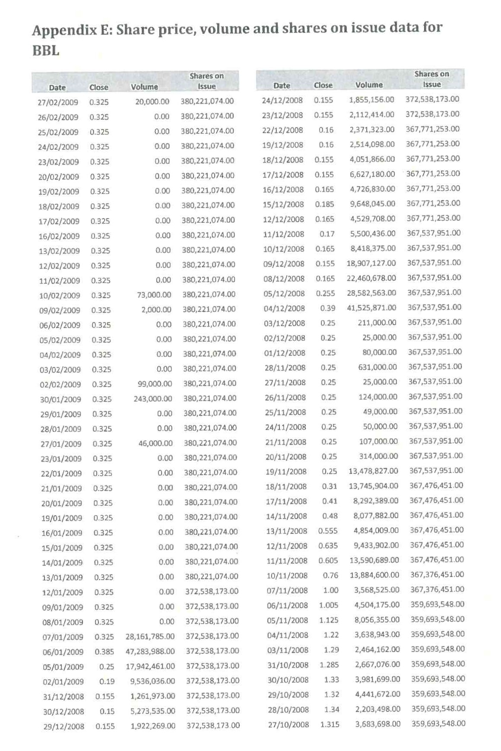
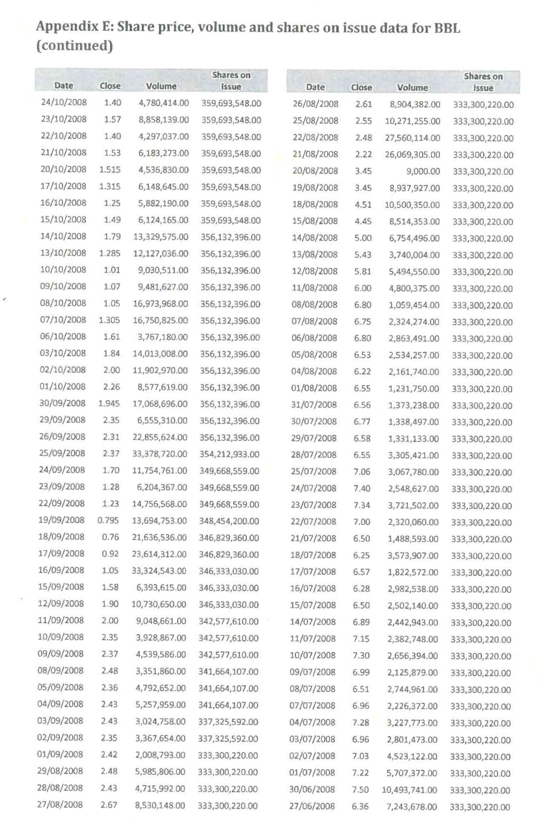

ATTACHMENT B
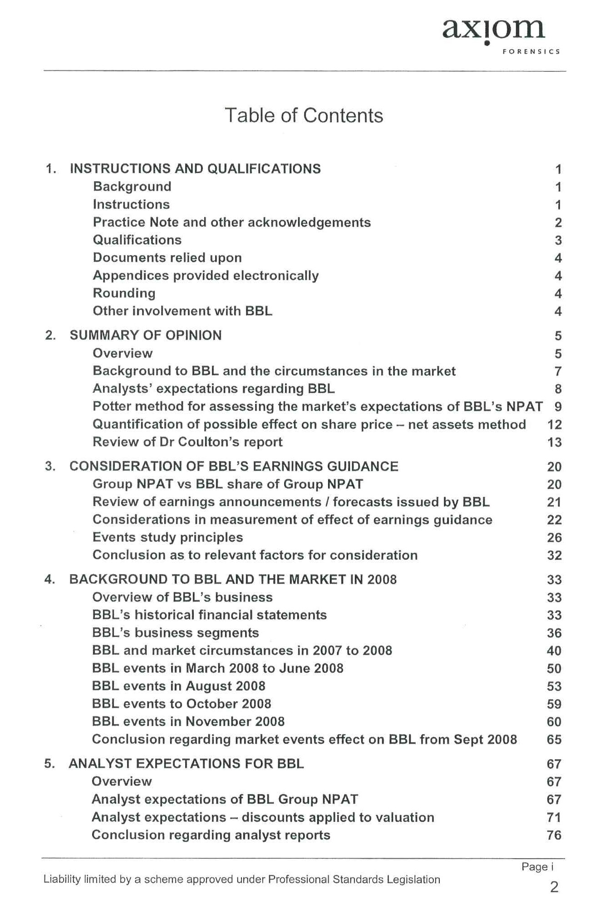

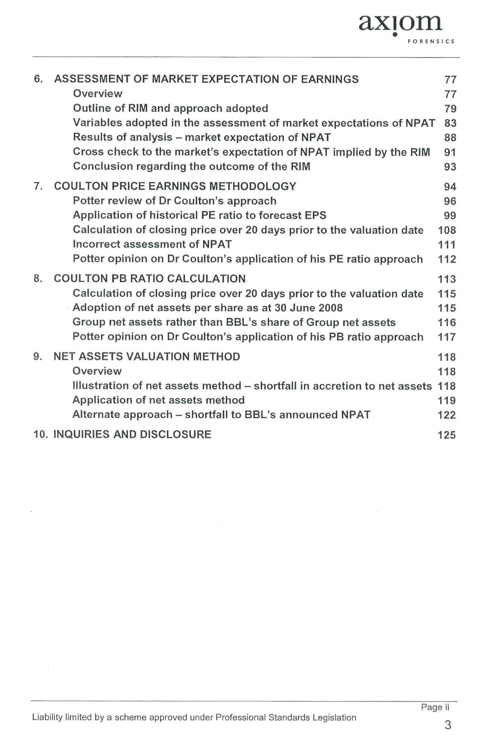

SCHEDULE OF PARTIES
 | NSD 2525 of 2013
PLAINTIFF NUMBER | PLAINTIFF
4. | INTERNATIONAL LIVESTOCK EXPORT PTY LTD (ACN 009 400 846)
5. | DEQUAN HE
6. | ROBMET INVESTMENTS PTY LTD (ACN 001 138 585)
7. | PAUL ANTHONY SIFIS
8. | UBET INVESTMENTS PTY LTD (ACN 072 755 796)
9. | KOIND PTY LIMITED (ACN 079 054 701)
10. | JOHN PAUL SCATTERGOOD
11. | ANGELIQUE SHARON ELLIS
12. | P.F.T. SOH PTY LTD (ACN 009 043 958)
13. | BRENT MARK WALL
14. | MANJIT SINGH
15. | 181 KING WILLIAM ROAD PTY LTD (ACN 112 9p41 410)
16. | COOLIBAH ESTATES PTY LTD (ACN 059 983 247)
17. | CHEBMONT PTY LTD (ACN 007 027 278)
18. | MELVIN LEGH FISHER
19. | TRANSIT MANAGEMENT PTY LTD (ACN 001 910 863)
20. | J T FOSSEY PTY LTD (ACN 000 105 699)
21. | GIMTAK PROPRIETARY LIMITED (ACN 004 883 309)
22. | LUCIANO PAOLO CROSETTA
23. | DENNIS GERRARD QUINN
24. | ANGUS CLIFFORD QUINN
25. | LYNE & ASSOCIATES PTY LTD (ACN 002 226 879)
26. | DONALD RUPERT ADAMS
27. | PATRICIA ADAMS
28. | PAVONE SUPERANNUATION FUND PTY LTD (ACN 087 254 206)
29. | J.T. FOSSEY (SALES) PTY LTD (ACN 000 178 222)
30. | EXTRUSION MACHINE CO (AUSTRALIA) PTY LTD (ACN 000 710 350)
31. | ETHEL JOYCE NICOLSON
32. | BRUCE GROUP PTY LTD (ACN 125 512 647)
33. | HERMANUS JOHANNES ALEXANDER JANSSEN
34. | HENDRINA ALLEGONDA PETRONELLA JANSSEN
35. | SHARON ANNE SAWERS
36. | WENDY ANN TWADDELL
37. | GRAHAM TWADDELL
38. | THE VILLAGE GROUP (NSW) PTY LIMITED (ACN 003 898 119)
39. | SANDY SOOK KHENG FOO
40. | LAN KOK GOH
41. | MS YI-LIN CHEN
42. | PETER PAUL RAUCHFUSS
43. | PATRICIA RAUCHFUSS
44. | SAM CHIU-WAI LAN
45. | PETER MARCELLIN CLARKE
46. | NEIL FRY
47. | PETER PRESS
48. | RON MCKITTRICK NOMINEES PTY LTD (ACN 065 584 830)
49. | HAMCAX PTY LTD (003 053 512)
50. | ALAN THUAN HUA
51. | SUI CU HUA
52. | ANTHONY RUDDELL
53. | MICHELLE PATRICIA SHEATHER
54. | LINDSAY DOWNS PTY LTD (ACN 006 164 496)
55. | EARL BEDE GRADY
56. | PAULINE CLAIR GRADY
57. | LUIGI PALMIERI
58. | KAREN ELIZABETH PALMIERI
59. | SEBASTIANA PALMIERI
60. | LESLY ANNE RADNIDGE
61. | JOHN ELDRED WILLIAMS
62. | ERIC JOHN GARDNER
63. | JENNIFER ANNE GARDNER
64. | GORDON FREDERICK WILSON
65. | MALCOLM MILES PEGG
66. | GARY JOHN CORBETT
67. | SUZANNE CORBETT
68. | IAN HENRY HERBERT
69. | CATHERINE HERBERT
70. | AUBREY PORTER STARK
71. | BARRY WRIGHT NOMINEES PTY LTD (ACN 009 891 598)
72. | DAVID TRAIL
73. | LYNETTE TRAIL
74. | THANH TANG
75. | LIONEL SIDNEY RICHARDS
76. | JOHN BONNICI
77. | STELLA BONNICI
78. | JAHANGIR SORAB DOODHA
79. | KASHMIRA JAHANGIR DOODHA
80. | JOSEPH ANANDA RAJARATNAM
81. | MARGARET HELEN RAJARATNAM
82. | PETER KWOK-KUEN CHEUNG
83. | LEY CHING CHEUNG
84. | JOHN ELDRED WILLIAMS
85. | JUNE MABEL WILLIAMS
86. | BAZPORT PTY LTD (ACN 126 025 732)
87. | PETER CHEUNG
88. | VIOLET CHEUNG
89. | CABINDE PTY LTD (ACN 003 104 569)
90. | TOM COXON INSURANCE SOLUTIONS PTY LTD (ACN 099 940 673)
91. | IMM CHOOI LOH
92. | NOEL DESMOND DALTON
93. | KAREN ANN DALTON
94. | ROBERT ALFRED LAMB
95. | JENNIFER JANE LAMB
96. | BASIL NOTARAS
97. | NOVADRIVE PTY LTD (ACN 092 156 084)
98. | ANNA CRISTINA PAVONE
99. | GREGORY JOHN SHEATHER
100. | IMM LOH

SCHEDULE OF PARTIES

 | SCHEDULE A | NSD 947 of 2014
PLAINTIFF NUMBER | PLAINTIFF
4. | JAMES RATCLIFFE
5. | STEPHEN MATTHEW SHOSTAK
6. | GUY PERKINS
7. | JONATHON PERKINS
8. | THOMAS PERKINS
9. | BRUCE RONALD ROUTLEY
10. | BR NOMINEES NSW PTY LTD (ACN 104 495 409)
11. | JOHN E GAULT
12. | CHARLES J. ZIEGLER
13. | JUDY ROE
14. | MELFORD ROE
15. | LIBERATING CONCEPTS PTY LTD (ACN 109 209 305)
16. | JILLIAN CAIN
17. | JOHN RICHARDS
18. | R&J KEMP PTY LTD (ACN 123 750 970)
19. | TOP LINE TIMBERS PTY LTD (ACN 004 398 243)
20. | PROSOLVE CONSULTING PTY LTD (ACN 062 773 522)
21. | BEVPHIL PTY LTD (ACN 107 381 448)
22. | DOUG DALTON CONSULTING PTY LTD (ACN 117 547 216)
23. | GOVE SUPERANNUATION NOMINEES PTY LTD (ACN 108 685 203)
24. | HOWARD FREDERICK
25. | SUSAN BOLLING
26. | RODNEY VICTOR NASH
27. | NOEL WITNEY
28. | JENKE FAMILY SUPERANNUATION FUND
29. | IAN D PERRETT
30. | TRIMOR INVESTMENTS PTY LTD (ACN 088 327 913)
31. | NEAL BOSTOCK
32. | YVONNE BOSTOCK
33. | PETER JOHN TURNBULL
34. | M J BASTON CONSULTING PTY LTD (ACN 006 601 458)
35. | MICHELE G DULCKEN
36. | MONSENA PTY LIMITED (ACN 002 851 247)
37. | LE LAPIN PTY LTD (ACN 114 252 158)
38. | JUDITH LOCH
39. | ROBERT GEORGE LOCH
40. | C FREDMAN
41. | LORICE FREDMAN
42. | HOFFMAN FAMILY TRUST
43. | CHARLES BRIAN BELCHER
44. | CLAIR POLONSKY
45. | ELIZABETH HYLAND
46. | KENNETH CHARLES HYLAND
47. | VINAY NEELAKANTAM
48. | GEOFF. CATT CORPORATION PTY. LTD. (ACN 005 893 738)
49. | BARRACOODA ENTERPRISES PTY LTD (ACN 102 871 198)
50. | KEITH ETTORE SORRENTINO
51. | GEORGE BROWNE
52. | LESLEY BROWNE
53. | SIDNEY GEORGE GARGIULO
54. | KENNITH ALLAN PREECE
55. | CHRIS EDWARDS
56. | PERRIER HOLDINGS PTY LTD (ACN 078 938 968) (VIC)
57. | LOMUS INVESTMENTS PTY LIMITED (ACN 000 748 649)
58. | ANDREW JOHN MATT
59. | SUSAN FRANCES MATT
60. | ELITE SUPERANNUATION SERVICES PTY LTD (ACN 009 456 544)
61. | KNAPMAN FILPTY LIMITED (ACN 002 662 991)
62. | ALICIA MARIE LARRATT
63. | JOHN KELVIN LARRATT
64. | ANDREW J GOODE
65. | RICHCUE PTY LTD (ACN 059 646 847)
66. | BRUCE CHARLES MOLLOY
67. | SANDRA LILLIAN MOLLOY
68. | GARY HARGRAVE
69. | R HARGRAVE
70. | JUDITH ANN NICHOLLS
71. | PETER JOHN NICHOLLS
72. | MISS S L MASTERTON
73. | BROWN MARKET RESEARCH PTY LTD (ACN 002 087 041)
74. | CAROLIN GRENFELL INVESTMENTS PTY LTD (ACN 074 652 547)
75. | GORDON JOSEPH MILNE
76. | AM RABIN
77. | P RABIN
78. | REPTON SUPERANNUATION PTY LIMITED (ACN 064 734 667)
79. | PR WILLIANS
80. | STEPHEN BLACKBURN ST
81. | DR AP GAFFNEY
82. | SJ GAFFNEY
83. | ANDREW MICHAEL ADA
84. | DR WAN KUM CHAN
85. | CAROLYN SANDERS
86. | AZAD DINESH GELDA
87. | PEGGY TENNANT
88. | WALLACE RAYMOND TENNANT
89. | CLUNY DISTRIBUTORS PTY LTD (ACN 001 262 460)
90. | MISS JUDITH ROSE
91. | BOOMGROVE PTY LIMITED (ACN 003 409 229)
92. | CANGALA PTY LTD (ACN 124 882 186)
93. | MICHAEL BARNES
94. | KRISTINA CHIONH
95. | L J K NOMINEES PTY LTD (ACN 001 325 944)
96. | HALEY JADE MCPHERSON
97. | MICHAEL GLENN BALLINGALL
98. | CRILLY AUTOMOTIVE PTY LIMITED (ACN 006 423 052)
99. | SETMALL PTY LIMITED (ACN 060 424 302)
100. | CRAIG ALAN MCLEAN
101. | VASANTHAKUMAR MAHENDRAN
102. | DAVID NORMAN CONLEY
103. | ANTHONY JAMES GIVNEY
104. | PATRICIA QUEZADA
105. | PHILIP JOHN BRAND
106. | BARRY CARR
107. | MICHAEL DAVID NICHOLS
108. | REBECCA PIK YUK SETO
109. | YUK SANG SETO
110. | DAWSON R & M SUPERANNUATION FUND
111. | REX SINCLAIR GILMOUR
112. | COLIN HEINZMAN
113. | LESLEY MARGARET HEINZMAN
114. | RICHARD W GRENSIDE
115. | MATI YOGEV
116. | SHARON YOGEV
117. | PATRICIA CHEAH
118. | VINCENT CHEAH
119. | ABEL YAM
120. | ALESSANDRA VECCHIO
121. | KATHRYN LOIS BERRY
122. | MATTHEW PETER BERRY
123. | ANDREA DEBORAH MURKIES
124. | MISS ROSALIND YIM LIM YUNG
125. | JEFFERY THORTON
126. | WELPAK NOMINEES PTY LTD (ACN 005 645 223)
127. | CARL ANTHONY SULLIVAN
128. | MOONLIGHT CINATA PTY LTD (ACN 006 513 631)
129. | GLENDA COHEN
130. | MALCOLM JOHN COHEN
131. | GREG W WOODS
132. | M A WOODS
133. | PAUL CONSTANCE AND ASSOCIATES PTY LTD (ACN 069 918 092)
134. | PATHOLD NO 218 PTY LTD (ACN 068 894 128)
135. | KEYIM YASIN
136. | KEREMU AIMIDIGNLI
137. | ALEX MANZONI
138. | JENNY MANZONI
139. | JOHN DICKIE
140. | JULIE MAY WOODBURN
141. | RICHARD JOSEPH WOOD BURN
142. | WESLEY JAMES JEFFERY
143. | ANTHONY ROBERT BAILEY
144. | CHRISTINE ELIZABETH STEWART
145. | CARMEL ELIZABETH BLAKELEY
146. | PETER ARTHUR BLAKELY
147. | SUZANNE GRENSIDE
148. | OSCARP PTY LIMITED (ACN 001 926 352)
149. | STUART CHARLES BRADSHAW
150. | LINDA JANE UZUNOVSKI
151. | MARK CHRISTOPHER ENGLAND
152. | JOHN KENNETH HILTON
153. | M T RIMOLDI
154. | L P STENSON
155. | M I W STENSON
156. | ORRABAN PTY LIMITED (ACN 057 491 531)
157. | TERENCE NABARRO PTY LIMITED (ACN 123 386 247)
158. | AIR BRAKE CORPORATION OF AUSTRALIA PTY LTD (ACN 003 223 747)
159. | CENTRAL WEST NOMINEES PTY LTD (ACN 074 204 863)
160. | TRAN & MANN PTY LTD (ACN 077 340 875)
161. | FOSTER STOCKBROKING NOMINEES PTY LTD (ACN 054 061 059)
162. | PAUL GILL
163. | MICHAEL HENRY VAINAUSKAUS
164. | JACKSON FIVE PTY LTD (ACN 004 630 488)
165. | K J MEREDITH
166. | M J MEREDITH
167. | P J MAUDE PTY LTD (ACN 081 997 515)
168. | TOD MIRGIS
169. | MICHAEL GEFFEN
170. | ARTHUR MURDOCH
171. | ROSEMARY JEAN MURDOCH
172. | MARJORIE E KELLY
173. | DYSENA PTY LTD (ACN 008 638 113)
174. | ARENEL PTY LTD (ACN 001 528 614)
175. | MIRIAM BLUMA WEINSTOCK
176. | ALLAN MADIGAN
177. | JOHN GEORGE VASILOPOULOS
178. | JOSEPH BANEK
179. | SALLY ANNE BANEK
180. | THE A & T SUPERANNUATION FUND PTY LTD (ACN 121 995 346)
181. | LEON JAMES MORAN
182. | THERESE MARY MORAN
183. | BEATRICE JACOBS
184. | NEW CENTURY INVESTMENT (AUSTRALIA) PTY LTD (ACN 117 473 631)
185. | MICHAEL JOHN LOY + ANNE LILLIAN LOY
186. | DRULLAND MANAGEMENT PTY LTD (ACN 001 707 437)
187. | CARLUKE PASTORAL CO PTY LTD (ACN 001 601 289)
188. | LINDA JANE MCCARTHY
189. | MARGARET JOY PARSONS
190. | T P JEFFERIS
191. | ANNE-MARIE JACQUELINE RABIN
192. | PERRY RABIN
193. | SANDCHIP PTY LTD (ACN 062 341 404)
194. | PERRY DENNIS RABIN
195. | TOMKIN ENTERPRISES PTY LTD (ACN 001 317 862)
196. | PETER LOUROS
197. | INTRAVEND PTY LTD (ACN 001 766 810)
198. | VERJ PTY LTD (ACN 114 882 334)
199. | JOHN DERMID GRIFFITH
200. | RAMONA CHUA
201. | ANN LIMBACK
202. | DARYL LIMBACK
203. | LYNETTE RITA MARESCA
204. | MANISHA GOYAL
205. | AH PHELAN
206. | JIM F PHELAN
207. | LAIDLAW MANAGEMENT SERVICES PTY LTD (ACN 079 017 164)
208. | JAMBER INVESTMENTS PTY LTD (ACN 116 102 768)
209. | CONNIE MARY SELLARS
210. | DESMOND JOHN SELLARS
211. | HOUSE OF LONDON PTY LTD (ACN 060 436 704)
212. | CRANPORT PTY LIMITED (ACN 003 854 000)
213. | JOHN KITCHEN SEETO
214. | S KLEIN
215. | ANTHONY GEORGE KLEIN
216. | IT SHOTAM
217. | ROHAN SMITH SPORTS & PROMOTIONS PTY LTD (ACN 084 060 444)
218. | JOHN G BROINOWSKI
219. | MICHELLE A BROINOWSKI
220. | VIELUN PTY LIMITED (ACN 000 093 694)
221. | TALBRO PTY LTD (ACN 095 552 015)
222. | DAVID JOHN FRENEY
223. | BERNADETTE YAM
224. | IRENA MARY BENJAMIN
225. | RAYMOND JEROME BENJAMIN
226. | TT MURPHY
227. | DIANE RHONDA CROWE
228. | DARYL ISADORE WOOLF
229. | WENDY ANNE WOOLF
230. | PETER JOHN HENNESSY
231. | GRAHAM ELLIS HAIGH
232. | PATRICIA ANN HAIGH
233. | AUSTIE DEVELOPMENTS PTY LIMITED (ACN 060 473 065)
234. | JANET ELIZABETH COCKS
235. | CAROLE PREECE
236. | LEON J PARISH
237. | WENDY ALLISON
238. | CECILIA CHUI FONG MAN
239. | QUINCY KING SAU WONG
240. | STEPHEN HALL
241. | ROBERT T FINLAYSON
242. | ROSLYN FINLAYSON
243. | FAY ANETTE ROBINSON
244. | JOHN MCKAY ROBINSON
245. | JARKS TRADING PTY LIMITED (ACN 124 295 192)
246. | IRENE JOAN WELLS
247. | JANET RUTH GARNHAM
248. | MALCOLM ROWLEY GARNHAM
249. | HOMAC TRADING PTY LTD (ACN 005 233 705)
250. | JUDITH LAWRENCE PAYTON
251. | MISS PAULINE PURSER
252. | IRENE RAHILLY
253. | JOHN RAHILLY
254. | RANALEX PTY LTD (ACN 007 977 157)
255. | DAVID G TOWELL
256. | MAUREEN TOWELL
257. | BASIL JOHN BALDWIN
258. | ANTHONY LYNN CURTIS
259. | FRANK R DEVLIN
260. | RONALD STEPHEN FITCH
261. | LEONE JANET MADDEN
262. | PETER LINDSAY MADDEN
263. | CHRISTINE ELLEN BURGESS
264. | RICHARD BARRIN GTON MEDLYN
265. | CATHERINE ANNE PARSONS
266. | WILLIAM ROBERTSON PARSONS
267. | ANTHONY CAMPBELL
268. | ROSEMARY CAMPBELL
269. | SHEARBROOK PTY LTD (ACN 086 023 056)
270. | ANN E BRITCHER
271. | ROGER ALLAN BRITCHER
272. | COLIN RICHARD NORTHEY
273. | FRANCESCO TERRANOVA
274. | JOSEPHINE TERRANOVA
275. | DONALD ARROWSMITH ARCHBOLD
276. | ANDREW JOHN NOLAN
277. | KRISTEN HELENE NOLAN
278. | SANTORINI SUN PTY LTD (ACN 102 560 654)
279. | ANTONINO RECHICHI
280. | CARMELA RECHICHI
281. | ECON (WA) PTY LTD (ACN 008 826 417)
282. | SILVERCURL PTY LTD (ACN 010 837 886)
283. | M L A WONG
284. | MUN CHEE PAUL ONG
285. | GREG TREZISE
286. | L TRESIZE
287. | RODNEY FRASER SCOTFORD
288. | M EDELMAN
289. | PETER DAVID EDELMAN
290. | ANDREW NIGHTINGALE
291. | CHRISTINE NIGHTINGALE
292. | KAREN LEEANNE BURNARD
293. | NEVILLE GRENFELL
294. | RACHEL LOUISE GRENFELL
295. | COLIN JAMES GARDINER
296. | PETER A BELL
297. | ANTHONY JAMES BYRNE
298. | CAROL BYRNE
299. | GREG JOHN ROBBINS
300. | ALLAN J YOUNG
301. | ANN M YOUNG
302. | NADINE REBECCA VECCHIO
303. | RICKY VECCHIO
304. | RUSSELL EDWARD ROPER
305. | SHARON LEE ROPER
306. | JACQUELINE BECROFT
307. | ILEFAR PTY LTD (ACN 002 051 603)
308. | REX BARBER
309. | SHONDA PTY LTD (ACN 001 537 962)
310. | IAN EDWIN LAGING
311. | MICHAEL GHAN
312. | NIE TJU GHAN
313. | HELEN JOY BRACHER
314. | JOSEPH WIILLIAM BRACHER
315. | MICHEL JOHN FRENCH
316. | YASMAR SUPERANNUATION PTY LTD (ACN 065 246 086)
317. | DAVID HARRY GLOVER
318. | DEBORAH BARBARA GLOVER
319. | JOHN ARTHUR MACDOUGALL
320. | KENG SEE MACDOUGALL
321. | HO SUM WONG
322. | SAU LIN WONG
323. | REX AIRD WELLS
324. | SUSAN WHITFORD
325. | BHOJ RAJ KHURANA
326. | VEENA KHURANA
327. | LONERAGAN PROPERTIES PTY LTD (ACN 087 947 108)
328. | KIM SUREDA
329. | RAYMOND SUREDA
330. | TRANG THU THI NGUYEN
331. | THOMAS WILLIAM HEENAN
332. | J L HAYES PTY LTD (ACN 001 178 543)
333. | J. GOTLIB & CO. PTY. LTD (ACN 004 433 050)
334. | INARA ZUBECKIS
335. | KARLIS ZUBECKIS
336. | ANNABEL KATE SAYERS
337. | MARTIN ROSS SAYERS
338. | PETER WILLIAM CROWE
339. | SANDRA MAY CROWE
340. | STANAL PTY LTD (ACN 128 102 312)
341. | FIRST CHOICE HAIR CARE PTY LTD (ACN 091 896 954)
342. | MARILYN KILNER
343. | GROVEMOOR SUPERANNUATION FUND
344. | PHILLIP LESLIE GOLDSMITH
345. | MICHAEL O’HAGAN
346. | LITELA PTY LIMITED (ACN 001 852 446)
347. | LYNETTE IRENE QUIGLEY
348. | BARBARA ANNE JOHANSSON
349. | KJELL SOREN JOHANSSON
350. | DIY SUPER SOLUTIONS PTY LTD (ACN 106 025 825)
351. | JUDITH DAWN ARNOLD
352. | SUE GLAB
353. | DENISE H BRICK
354. | LINGWOOD SUPER FUND A/C
355. | B J HASSETT
356. | LEON EDWARD HASSETT
357. | BALLANTINE
358. | DENISE W NEYLON
359. | Y S WHITE
360. | STUART J REID
361. | WATCENA PTY LIMITED (ACN 002 493 870)
362. | EST R MANN
363. | P A MANN
364. | SALLY ABROMWICH
365. | STEVEN ABROMWICH
366. | NIKOLAI LOBANOV
367. | A.C.N. 057 128 257 PTY. LIMITED (ACN 057 128 257)
368. | MARGARET INGLIS
369. | PETER INGLIS
370. | PETER MAXWELL HARRISON
371. | GAIL SMITH
372. | KEITH SM ITH
373. | SIMON KIDD MINING AND ENGINEERING PTY LTD (ACN 066 732 045)
374. | CHARLES U JONES
375. | J L JONES
376. | WINMEL PTY LTD (ACN 005 104 825)
377. | SHIRLEY MARGARET BUCKNALL
378. | G D & H S BOYCE PTY LIMITED (ACN 001 724 527)
379. | BERNARD DAVID MARCUS
380. | DANIEL TERRANCE BREALEY
381. | SUSAN EVE BREALEY
382. | GRAHAM DODD
383. | DAMIEN MITCHELL GRANT
384. | MCCLUSKEY SUPERANNUATION PTY LTD
385. | SUSAN MARGARET KEIR
386. | THE RS & RD TK S/FUND
387. | KAH KHEONG SOO
388. | MOH LEE NG
389. | VANYA FOURTEEN PTY LTD (ACN 007 016 524)
390. | EDNA MAY DRAKE
391. | GEOFFREY JOHN DRAKE
392. | ALEXANDER SCOTT CAMERON
393. | H CAMERON
394. | CORSAIR CORP PTY LTD (ACN 079 164 275)
395. | CATHERINE CARR
396. | GRANT THOMAS CARR
397. | KEVIN CHARLES ROWE
398. | MARGARET NORMA ROWE
399. | WESTMINSTER SCHOOL FOUNDATION INC
400. | BEVERLEY HUGH WALTERS
401. | HELEN PARIS WALTERS
402. | MICHAEL FLETCHER
403. | ROSLYN FLETCHER
404. | HELEN CAVEDON
405. | JOHN CAVEDON
406. | M G FISHER PTY LTD (ACN 000 261 816)
407. | MAROONE SKY ENTERPRISES PTY LIMITED (ACN 104 193 026)
408. | GLOBUS CASING CO PTY LTD (ACN 000 083 018)
409. | GLEN PHILLIPS
410. | JASMIN-CHRISTA PHILLIPS
411. | DONALD ARTHUR FIELD JACKSON
412. | FELICITY ANNE STODART JACKSON
413. | ECROHOLD PTY LTD (ACN 002 709 775)
414. | JUSTMISH PTY. LTD (ACN 096 854 081)
415. | J E RICHARDS
416. | WILLIAM WEMYSS RICHARDS
417. | MICHELLE ANNE SHERMAN
418. | BARBARA LYNETTE BUNNING
419. | LOUISE ANNE STINSON
420. | ABLES PTY LIMITED
421. | INSTANZ NOMINEES PTY LTD (ACN 073 513 658)
422. | KNIPPLE PTY LTD (ACN 088 03 158)
423. | WESCO PTY LTD (ACN 125 789 406)
424. | BLUE LAGOON INTERNATIONAL CORPORATION
425. | MICHELLE HERRING
426. | GARY BOUKARIM
427. | THERESE BOUKARIM
428. | WALTER MICHAEL SLOANE
429. | JOAN MILLER
430. | KENNETH MILLER
431. | AARON SCHENCK
432. | H MUGGENTHALER
433. | LEONIE MILLER
434. | AVRIL SYMON
435. | JOSEPH SYMON
436. | F D WARE & CO PTY LTD (ACN 008 045 716)
437. | DOBEDO TRADING TRUST
438. | VALAMOON PTY LTD (ACN 072 458 578)
439. | BERNARD BURCHAM RIDLEY WALKER
440. | DEEPAK KHURANA
441. | JANICE JOY DICKSON
442. | ERIC GEORGE DICKSON
443. | ANDREW HO
444. | ALEXANDER LAURENCE MARTIN
445. | GILORE PTY LTD (ACN 095 938 391)
446. | APOLLO BUILDING PTY LTD (ACN 000 714 956)
447. | CHIMERAT PTY LTD (ACN 078 091 497)
448. | DOROTHY JUDITH WALKER
449. | EVAN HERBERT WALKER
450. | D MORAWETZ
451. | ANDREW JOHN STEGGALL
452. | PHILATRO PTY LTD (ACN 006 075 289)
453. | IAN MACMILLAN & ASSOCIATES PTY LTD (ACN 071 295 335)
454. | KATRINA LUISE LLOYD
455. | ANTHONY JOHN BOURKE
456. | MAYLENE GLADYS EVANS
457. | ROGER KEITH EVANS
458. | ST GERMAINE SUPER FUND
459. | WARD SUPER FUND
460. | LESLIE ALAN WILSON PROPERTY TRUST
461. | STEPHEN WILSON FAMILY TRUST
462. | WALTER COMMINS NO. 2 FAMILY TRUST
463. | KLUTH FAMILY TRUST
464. | DAM SUPERANNUATION FUND
465. | FLORIZEL INVESTMENTS PTY LTD (ACN 004 937 026)
466. | LEZIROL SUPERANNUATION FUND
467. | P & H COMMINS FAMILY SUPERANNUATION FUND PTY LIMITED
468. | TRAPDAW SUPERANNUATION FUND
469. | HALE FAMILY SUPERANNUATION FUND
470. | LAIDLAW FAMILY INVESTMENTS TRUST #1
471. | M & L TWIGG FAMILY SUPERANNUATION FUND PTY LIMITED
472. | DIANE TWIGG
473. | AUSTRALIAN EXECUTOR TRUSTEES LIM ITED
474. | BAGOT’S EXECUTOR AND TRUSTEE COMPANY LIMITED
475. | SIMON ROBSON
476. | COMO SUPERFUND PTY LIMITED (ACN 092 230 076)
477. | COMMUNITY FOUNDATION NETWORK LTD
478. | GORDON MERCHANT NO2 P/L
479. | PURPLE SASH CORPORATION PTY (ACN 088 379 293)
480. | SELLY OAK PTY LTD (ACN 005 632 431)
481. | VIJAY RAO
482. | RUSSELL JAMIE WILLIAMS
483. | NEVILLE JAMES ANDERSON
484. | SHIRLEY JOAN ANDERSON
485. | ARTER & MOLLOY NOMINEES PTY LTD (ACN 123 672 702)
486. | TOM COXON
487. | DAHLAN LEONARD JAMES SIMPSON
488. | MARDIAH MARGARITA SIMPSON
489. | SHIRLEY LOUDER
490. | WILLIAM LOUDER
491. | BORSA INVESTMENTS PTY LTD (ACN 000 370 829)
492. | ANNETTE CHRISTENSEN
493. | CRAIG ANTHONY MILLS
494. | JOHN HESELEV
495. | JACK MARESCA
496. | ASHLIN PTY LIMITED (ACN 001 712 410)
497. | MUNERT PTY LTD (ACN 003 798 276)
498. | JILLIAN CLOUT
499. | KATHRIN ROSENMAYER
500. | MICHAEL IAN BURGESS
501. | DANIEL I TRAYLEN
502. | MAJAS BLUE PTY LIMITED (ACN 117 421 208)
503. | STEVE BALDWIN
504. | SEBUKI PTY LTD (ACN 002 734 787)
505. | LEONIE MILLER
506. | GAIL DENISE BLUNT
507. | KEDZIER SUPERANNUATION FUND
508. | ELIZABETH ANN MCLAUGHLIN
509. | PETER HENRY HESS
510. | M T HALL
511. | PETER S HALL
512. | GIAN GUPTA
513. | VINUM GUPTA
514. | SANDRO GIANFRANCO ALBERTI
515. | VENERINA LUCIA ALBERTI
516. | DARYL STANLEY SCOTT
517. | COLLEEN JOAN LANGTRY
518. | GARY PHILIP LANGTRY
519. | CHIN-TU HUANG
520. | YUEH-YUAN LAI
521. | EMOKE ANN-MARIE VARGA
522. | JOHN ARPAD VARGA
523. | PEARCE BROS NOMINEES PTY LTD (ACN 007 839 732)
524. | REYWOOD INVESTMENTS PTY LTD (ACN 005 022 159)
525. | ESTATE OF THE LATE GABRIELLE HOOD
526. | HARLOWES NOMINEES PTY LTD
527. | DBR SUPERANNUATION FUND
528. | VLADIMER DEBELAK
529. | YORUBA PTY LTD (ACN 003 943 968)
530. | HELEN ELIZABETH GIBSON
531. | IAN BERNARD GIBSON
532. | KAYE KAHN NEE BENNETTS
533. | GEORGE MELLER PTY LIMITED (ACN 001 178 338)
534. | CHOON SEANG LEE
535. | MIKKELINE KIRSTEN LEE
536. | BANTON PTY LIMITED (ACN 007 355 759)
537. | OLDE SUPER PTY LTD (ACN 115 440 796)
538. | DARREN ROSS WARD
539. | DENHAM PROPERTY DEVELOPMENTS PTY LTD (ACN 005 247 021)
540. | ANGELO DEL BORRELLO
541. | RUSTEVEN NOMINEES PTY LTD (ACN 004 803 310)
542. | SYDWICK PTY LTD (ACN 005 944 525)
543. | THE REIN DRAYER SUPERANNUATION FUND
544. | AXTHOM PTY LTD (ACN 002 051 676)
545. | ANTHONY JOHN HUNTER
546. | LINDA JANE HUNTER
547. | JZL PROFESSIONAL SERVICES PTY LIMITED
548. | CAJ ENTERPRISES PTY. LTD (ACN 088 829 270)
549. | TRINGA PTY LTD (ACN 003 255 712)
550. | KEVIN LEE
551. | TITFA CONSULTANCY P/L
552. | D M EGLINTON
553. | P J EGLINTON
554. | GRAEME BUCKLEY & ASSOCIATES PTY LIMITED (ACN 075 741 203)
555. | DAVID KEVIN ROWE
556. | SARAH-LOUISE ROWE
557. | JOE HOU
558. | JOHN KENDALL FRANCIS
559. | PAT STRANGIO
560. | PLUTEUS (NO 216) PTY LTD (ACN 003 527 893)
561. | JANICE MARION SMITH
562. | JOHN MARCUS SMITH
563. | ARTURO MARCO GARIPOLI
564. | MARGARET MARY CLARKE
565. | RAYMOND JOSEPH CLARKE
566. | BLAIR JOHN TRAVIS
567. | ANTHEA LEONE SMITH
568. | BRENT STIRLING
569. | MARGARET JUNE MACDONALD
570. | G N KOSTALIS PTY LIMITED (ACN 002 447 476)
571. | BROMBERGER SUPER FUND
572. | BRENDA MAY
573. | PETER EARLE SPENCER
574. | BUTTON FAMILY NOMINEES PTY LTD (ACN 107 081 452)
575. | RICHARD HOWARD LAWRENCE
576. | PHILLIP JAMES SHORT
577. | NONGAMA PTY LTD (ACN 002 148 110)
578. | CRAIG LEWISS WALLACE
579. | ELIZABETH LOUISE WALLACE
580. | PAUL VICE PTY LIMITED (ACN 126 700 169)
581. | VCL INVESTMENTS PTY LTD (ACN 120 695 767)
582. | ANDREW DODMAN
583. | JANE M DODMAN
584. | ASPI PESI CHUBB
585. | JANET AUDREY JUSTIN
586. | JEFFREY WAYNE JUSTIN
587. | JEREMY MICHAEL FEIGLIN
588. | JUDITH FEIGLIN
589. | BRUCE DRUMMOND
590. | JUDITH DRUMMOND
591. | BROWNWOOD NOMINEES PTY LTD (ACN 005 318 623)
592. | DAVID COLIN GOOLEY
593. | ROWENA ALICE FAIRFAX CALVERT
594. | JOHN XAVIER HEFFERNAN
595. | PETA JANE HEFFERNAN
596. | DANITZA SCHEALLER
597. | GREGORY DENIS SCHEALLER
598. | CARMELINA MARIA BROWN
599. | PAUL RAOUL BROWN
600. | DEREK MANOY
601. | ADRIAN PETER SOLIGO
602. | LISA ANNE SOLIGO
603. | LOU MARAFIOTI
604. | NELLA A MARAFIOTI
605. | PETER HAMILTON MOTT
606. | JANET CONROY
607. | ANDREW JOHNSTON STANIFORD
608. | B G STANIFORD
609. | CINTRA GAIL AMOS
610. | JOHN IAN AMOS
611. | GRAEME LEWIS CARDILLO
612. | KAYE ELIZABETH CARDILLO
613. | ROBERT HARRIE POWELL
614. | V JILL POWELL
615. | LYN MARESCA
616. | ANDREW MARK JENNINGS
617. | VICTORIA ALICE MURRAY
618. | REBECCA CREGAN
619. | JENNIFER GEORGINA COX
620. | SJ LEWIS FAMILY TRUST
621. | THE SUPPLY LINE AUSTRALIA PTY LTD (ACN 008 134 512)
622. | SHARON ROSE CAMPBELL
623. | MEYER E MUSSRY
624. | BULOKE TRUST
625. | LITHCA FAMILY TRUST
626. | THE SHEOAK TRUST
627. | GIORGIO GJERGJA
628. | DML SUPERANNUAT ION FUND
629. | MSL SUPERANNUATION FUND
630. | SATWEEZ PTY LTD (ACN 050 097 473)
631. | JOSIMA PTY LTD (ACN 002 327 951)
632. | CYNTHIA BRICKNELL
633. | HENRY CHAN
634. | IRENE CHAN
635. | JE & FJ CUNNINGHAM SUPER FUND PTY LTD (ACN 119 001 893)
636. | BRENNERHERZ PTY LTD (ACN 093 408 827)
637. | JODAK PTY LTD (ACN 123 213 178)
638. | INVIA CUSTODIAN PTY LTD (ACN 006 127 984)
639. | FIONA ROBSON
640. | MEDIANSKY SUPERANNUATION FUND
641. | D A QUICK
642. | MARTIN JOHN QUICK
643. | MISS MICHELLE JENNIFER KEMP
644. | SUSSAN LAM
645. | ARMINELLA PTY LIMITED (ACN 072 404 427)
646. | KURRAWA CORPORATION PTY LTD (ACN 097 347 898)
647. | AMY YUK YIN CHAN
648. | MICHAEL WAI YEE CHAN
649. | LYNDALL ROBYN CASH
650. | FRIDAY INVESTMENTS PTY LIMITED (ACN 010 677 102)
651. | WAYNE KINGSFORD CASH
652. | AVANTEOS INVESTMENTS LIMITED
653. | ZASE PTY LTD (ACN 088 183 055)
654. | WILLIAM O’YOUNG
655. | CHERYLE KHOURY
656. | CAROLYN LOUISE HOUSEGO
657. | JENNIFER ROSENTHALL
658. | SALLY CONSTABLE
659. | SIMON KENNEDY
660. | KIM BARNARD
661. | BILL CHOO PTY LTD (ACN 079 154 591)
662. | POH ENG QUAH
663. | LI REN CHOO
664. | GEOFF RUSSELL
665. | ELIZABETH MCMILLAN
666. | MIPAL PTY LTD (ACN 050 542 428)
667. | MICHAEL RUMBLE
668. | ENZA ALOISIO
669. | CHRISTOPHER JACQUES
670. | VIRGINIA JACQUES
671. | RICHARD JOHN PLAYER
672. | MICHAEL HUTCHISON
673. | JANICE SHEPPARD
674. | MAXWELL ROY SHEPPARD
675. | GERRIN PTY LTD (ACN 121 814 051)
676. | SATERA STEFANOPOULOS
677. | STEVEN STEFANOPOULOS
678. | ANIL KAMTE
679. | LIZ GILL
680. | ROSALINE DE LEACY
681. | ALEX SEONG LIM
682. | MY TRINH QUACH
683. | WAN ER WANG
684. | LEH LIM
685. | CLIFFORD PACIFIC SUPER FUND
686. | RIFOBA PTY LIMITED (ACN 059 142 200)
687. | CARMEL ROSCOE
688. | CLIVE ROSCOE
689. | PAPERCHASE INVESTMENTS PTY LTD (ACN 079 835 920)
690. | R TOCKAR PTY LTD SUPERANNUATION FUND (ACN 002 449 934)
691. | LEH CHEE
692. | SEONG KEAT LIM
693. | THOMAS FISCHER
694. | JILLIAN JOYCE TAIG
695. | PHILLIP ANDREW TAIG
696. | MAULYN HSU
697. | DIANE ENGELANDER
698. | BRUCE KELLY
699. | COLLEEN KELLY
700. | RITA CRAWFORD
701. | MCKINNON ROWLSTON & MOORE PTY LTD (ACN 127 842 497)
702. | PAUL LESLIE SEAGE
703. | DONALD FRANCIS HAMMON
704. | MARGARET ELIZABETH HAMMON
705. | JEFFERY STEPHEN HALL
706. | MALCOLM WHYTE
707. | ANDREW SCOTT GLENN
708. | KERRY ANNE WILLIAMS
709. | STEPHEN GERARD WILLIAMS
710. | RAJAKUMARI WINAYAKAN
711. | A J HUNTER
712. | C J HUNTER
713. | BEVERLEY HELEN MEYER
714. | JARROD M PHELPS
715. | BOND STREET CUSTODIANS
716. | GERALDINE MARY STEVENSON
717. | JANIFER VAN VLIET
718. | CURLAUST PTY LTD (ACN 008 463 385)
719. | ROBIN WILLIAM LUCAS
720. | RORY ALEXANDER LUCAS
721. | MB&L SMITH PTY LTD (ACN 123 388 885)
722. | LINDA CHEN
723. | ANDROD PTY LTD (ACN 104 845 132)
724. | RAM PANDEY
725. | CONRAD MICHAEL ROMANOW
726. | MISS HONG LU
727. | CHRISTINE FOX
728. | TERENCE FOX
729. | STAR TREASURE PTY LIMITED (ACN 088 309 166)
730. | ELSIE PTY LTD (ACN 126 221 341)
731. | JOSEPH MERCIECA
732. | JEREMY ALEXANDER KEAN
733. | FERNANDO RIVERA
734. | SPACE ERA NOMINEES PTY LTD (ACN 005 381 699)
735. | MAGDY MICHEL SEKLA
736. | RACHEL SEKLA
737. | ARTI KUMRIA
738. | ANTHONY JOHN DIXON
739. | BINH QUOC PHU
740. | SAM LEE
741. | SONAL SHAH
742. | DEBRA LISELLE MURPHY
743. | CAROL CARLAND
744. | DONALD ROBERT LOW
745. | DAVID BRUCE SLADE
746. | FRANK WALTER GIRALDI
747. | LESLIE JOHN MCKEE
748. | EDMUND CHI HO PAU
749. | BARBARA SYBIL NAIRNE
750. | ANTONIO ARAUJO
751. | MARK RICHARD WESTCOTT
752. | CYNTHIA LACHAT
753. | JEAN LYNETTE EMMERSON
754. | SHAUN ANDREW WILLIAMS
755. | LIANE FRANCESS GARRICK
756. | JAMES CLIFFORD CONSTRUCTION QUEENSLAND PTY LTD (ACN 060 235 618)
757. | LIGUANG YANG
758. | JUERG T WEHRLI PTY LTD (ACN 105 789 311)
759. | BARRY STANFORD
760. | GLEN NORMAN GRIFFITH
761. | KATHRINE ANNE GRIFFITH
762. | MALCOLM JOHN TASKER
763. | SANDRA KATHLEEN TASKER
764. | ALAN ALSTON
765. | LINDA CHRISTINE ALSTON
766. | DENNIS TAYLOR
767. | DENIS PASQUALINI
768. | HADY PASQUALINI
769. | ANTONIO POSITANO
770. | MISS PEI CHI LAU
771. | ABU SHIHABUDDIN
772. | CHRISTOPHER MICHAEL WEBB
773. | VAR LENG KHAV
774. | YEE DAH KUO
775. | KAREN URSULA TASIEVSKI
776. | WENG MUNN KOH
777. | MALATHI RAJASINGHAM
778. | SARATHCHANDRAN HERBERT RAJASINGHAM
779. | ELLEN MAREE BEVAN
780. | LAURIE WILLIAM BEVAN
781. | MEGARRY EXCAVATIONS & ROADWORKS PTY LTD (ACN 001 490 124)
782. | HARRY ARIALDO CAPARARO
783. | MATILDE MARIA CAPARARO
784. | AMADIO PELLIZZARO
785. | MANDIGA HOLDINGS PTY LTD (ACN 080 726 414)
786. | RICHARD ANDREW MCKENZIE
787. | ELIZABETH URWIN
788. | ROBERT URWIN
789. | STEPHEN KEITH PIPER
790. | MONIQUE BARBARA BLACKMAN
791. | LEEANE PAROLO
792. | GRANT FAYOLLE
793. | CARMEN MARY COLQUHOUN
794. | GEOFFREY IAN COLQUHOUN
795. | KHALED ZREIKA
796. | MARK WILLIAM DOYLE
797. | TINA MELROSE-DOYLE
798. | PRABAVATHY THANGARATNAM
799. | THAMBIAH THANGARATNAM

SCHEDULE OF PARTIES
 |  | SCHEDULE B | NSD 947 of 2014
 | PLAINTIFF  NUMBER | PLAINTIFF
 | 800. | HEATHER M LANDY
 | 801. | MICHAEL J LANDY
 | 802. | THI HONG DO
 | 803. | NGOC VINH NGUYEN
 | 804. | BRIAN TERRY KEELL HUTCHINGS
 | 805. | PATRICIA WAI CHONG LEE
 | 806. | VICKI ANN HAMILTON
 | 807. | KEITH HAMILTON
 | 808. | JENNIFER MARY BRADFORD
 | 809. | KENNETH EDGAR BRADFORD
 | 810. | PAUL ALWIN BOEHM
 | 811. | MARYAM ISLAM
 | 812. | RAM DEVELOPMENTS AUSTRALIA PTY LTD (ACN 098 915 836)
 | 813. | TOMASZ BANIEWICZ
 | 814. | TINA MARGARET WELLS
 | 815. | DARYL KENNETH WELLS
 | 816. | RITA FLORENCE WALSH
 | 817. | ROBERT JOHN WALSH
 | 818. | ROBERT JAMES THOMAS
 | 819. | ROBERT LESLIE MCINNES
 | 820. | CARMEN ISTANBOULI
 | 821. | KASSAN ISTANBOULI
 | 822. | CARMEN MARY COLQUHOUN
 | 823. | GEOFFREY IAN COLQUHOUN
 | 824. | PRABAVATHY THANGARATNAM
 | 825. | THAMBIAH THANGARATNAM
 | 826. | BARBARA THORN
 | 827. | BURNMAC PTY LTD (ACN 003 303 802)
 | 828. | PENINGA PTY LTD (ACN 010 168 297)
 | 829. | DUNCAN MARK TURNER
 | 830. | PEGGY ANNE XAVIER
 | 831. | DWIGHT BLACHFORD
 | 832. | KENNER GEORGE BOOTH
 | 833. | ROBERT JOHN EVERS
 | 834. | KUBA ENTERPRISES PTY LTD (ACN 010 129 996)
 | 835. | EDMOND JOSEPH BRENNAN
 | 836. | ANNETTE CHEUNG
 | 837. | JOHNNY YING WAI CHEUNG
 | 838. | EROL ANDREWS
 | 839. | JULIE JOHNSON
 | 840. | PAMELA MORROW
 | 841. | MARGARET DISLERS
 | 842. | ALFRED DISLERS
 | 843. | SANDRA ROSE PETERS
 | 844. | ANTHONY JOHN PETERS
 | 845. | ELISABETH JANE WALSH
 | 846. | MALCOLM JOHN MACHEN
 | 847. | SUSAN DAWN WESTCOTT
 | 848. | CHARLES LITTON WESTCOTT
 | 849. | MARION FRICKE
 | 850. | GEORGE FRICKE
 | 851. | WILLIAM HENDERSON
 | 852. | LEE EDWINA ANNEAR
 | 853. | IAN DINH
 | 854. | ANTONIO CATALANO
 | 855. | ESTATE OF THE LATE PHILIP JOSEPH CROWE
 | 856. | PHILIP ANTHONY FEITELSON
 | 857. | ICG TRANSPORT SYSTEMS PTY LTD (ACN 093 334 402)
 | 858. | HENRY STENNING
 | 859. | DANIEL GIOVINAZZO
 | 860. | PAUL BERNARD HICKEY
 | 861. | LINDA BERGSENG
 | 862. | SHANE GARWOOD
 | 863. | MALCOLM BURKE
 | 864. | CHRIS LESLIE
 | 865. | JASPAL SINGH JASSI
 | 866. | NEIL STEVEN MOSS
 | 867. | SHAUN MEADE
 | 868. | TRACY MEADE
 | 869. | MARC ANTHONY BISSETT
 | 870. | LOURA APOSTOLAKIS
 | 871. | TERRY BAILEY
 | 872. | DEANNE BAILEY
 | 873. | SUSAN ELIZABETH BERKIN
 | 874. | KATHLEEN BEATRICE RITTSON-THOMAS
 | 875. | EDVARD FARHAD
 | 876. | SEPIDEH PARVISI
 | 877. | WAHEEB KHALIL
 | 878. | POI KHEN THAI
 | 879. | ANA KARINA MARTINEZ
 | 880. | LUIS EDUARDO MARTINEZ
 | 881. | MATTHEW ROBERT COPPENS
 | 882. | HOWARD DAVID ELTON
 | 883. | REC INVESTMENTS PTY LTD (ACN 060 386 709)
 | 884. | IAN ALFRED LISTER
 | 885. | CHOON SEANG LEE
 | 886. | MIKKELINE KIRSTEN LEE
 | 887. | SPIDER WOOLF PTY LTD (ACN 068 289 761)

SCHEDULE OF PARTIES

 | NSD 501 of 2015
PLAINTIFF  NUMBER | PLAINTIFF
4. | MICHAEL J LANDY
5. | HEATHER M LANDY
6. | TINA JAN COURTENAY
7. | INDRA PERERA
8. | JOHN RICHARD ATKINSON
9. | ALEXANDRA LOUISE ATKINSON
10. | SUSAN LOUISE TARRANT
11. | MICHAEL HUTCHINSON
12. | DAVID ERIC KNOX
13. | DEVENDRA SAWANT
14. | THOMAS S CLARK
15. | MAXWELL ROY SHEPPARD
16. | JANNICE SHEPPARD
17. | GERRIN PTY LTD (ACN 121 814 051)
18. | DAVID LINDSAY ELSWORTH
19. | MANGAROO PTY LIMITED (ACN 130 990 359)
20. | GLENN SCHULTZ
21. | GRAEME SCHULTZ
22. | STEVEN PETER DAVIES
23. | MICHAIL NIKOLAENKO
24. | GUNA RAJA SOCKALINGAM
25. | JOHN LEES CARAH
26. | BURNMAC PTY LTD (ACN 003 303 802)
27. | JULIE MARIE CHAPMAN
28. | ALLAN MILLER
29. | IVAN MOSES VINES
30. | ASSAAD EL-ASSAAD
31. | MICHAEL SMAJDOR
32. | DON TSOUTSOULIS
33. | NADICIA TSOUTSOULS
34. | GABRIEL BACA
35. | DANIELA BACA
36. | WILLIAM MEGARRY
37. | SIDNEY KENNETH TURNER
38. | GABRIEL BACA
39. | PENINGA PTY LTD (ACN 010 168 297)
40. | MARK PATRICK DELPHIN
41. | TREASURY SERVICES CORPORATION PTY LTD
42. | PATRICK JEREMY RICE
43. | NGOC VINH NGUYEN
44. | THI HONG DO
45. | PARWINDER GHAG
46. | QIANG SU
47. | PAUL RAYMOND DAWSON
48. | MICHAEL JAMES DWYER
49. | BRIAN TERRY KEELL HUTCHINGS
50. | DAVID BRIAN SEXTON
51. | CHARLES JOSEPH MORRONE
52. | JAYNE TERESA MORRONE
53. | DUNCAN MARK TURNER
54. | PATRICIA WAI CHONG LEE
55. | WILLIAM TAN
56. | SEBI CONTE
57. | MARK ANTHONY GILL
58. | PEGGY ANNE XAVIER
59. | RUDOLPH JOSEPH RAINEY
60. | DAVID SEXTON
61. | DWIGHT BLACHFORD
62. | JULIA FELICITY REYNOLDS
63. | ISMAIL SARGIN
64. | JASON RICHARD PARKER
65. | HELEN PARKER
66. | SHANTING XU
67. | BAILING LI
68. | COOKE HOLDINGS (QLD) PTY LTD (ACN 137 770 766)
69. | JOSEPH AARONS
70. | KENNER GEORGE BOOTH
71. | HELEN VEDA GREGORY
72. | DAVID CHARLES SHELLEY-JONES
73. | KUO WEI KALVIN YEOH
74. | BARRY JOHN CHANDLER
75. | REGINA ELIZABETH CHANDLER
76. | WALTER BRIAN BEAVIS
77. | LESLEY KAY BEAVIS
78. | STEPHEN MACKAY
79. | TIMOTHY JOHN LINSDAY
80. | NOEL JOHN CAVE
81. | ROBERT JOHN EVERS
82. | GRANTLEY BRUCE EMMETT
83. | MICHAEL ROBERT LACE
84. | BRENDON SCOTT ADAMS
85. | PETER MARCUS FERRIS
86. | DAVID MICHAEL HAWORTH
87. | CHRISTOPHER IAN WARD
88. | SEMYON LITINETSKY
89. | BRIAN STEAN
90. | BRYCE GEORGE BOOTH
91. | 1AM.COM.AU PTY LTD (ACN 126 192 854)
92. | JOSEPH SAMUEL AZZOPARDI
93. | WARREN HUNG TOH WONG
94. | KUBA ENTERPRISES PTY LTD (ACN 010 129 996)
95. | CHRISTIAN HENDRAWAN KOESNADL
96. | MOULANG UNIT CONTAINERS PTY LTD (ACN 000 327 659)
97. | ADRIAN MERCIECA
98. | KEITH HAMILTON
99. | VICKI ANN HAMILTON
100. | DONALD ALBERT CROSS
101. | EDMOND JOSEPH BRENNAN
102. | BADWI BAKHOS
103. | VICKY BAKHOS
104. | JASON RICHARD PARKER
105. | JOHN EDWARD PARKER
106. | JOHNNY YING WAI CHEUNG
107. | ANNETTE CHEUNG
108. | KEITH PHILIP CHARLES
109. | PATRICIA CLAIRE CHARLES
110. | KENNETH EDGAR BRADFORD
111. | JENNIFER MARY BRADFORD
112. | VELUPPILLAI SELVENDRAN
113. | KAUSHALYA SELVENDRAN
114. | ELEONORA ANTONIETTA COLPA
115. | ANDREW QUIEROS
116. | JUDITH STOKES
117. | PETER MICHAEL BURNS
118. | ROBERT WATTS
119. | TAU CHEN CHAM
120. | PAUL ALWIN BOEHM
121. | LEANDRO GUISASOLA
122. | EROL ANDREWS
123. | JULIE JOHNSON
124. | MARYAM ISLAM
125. | WILFRED JOHN GILES
126. | RUI WU
127. | RAM DEVELOPMENTS AUSTRALIA PTY LTD (ACN 098 915 836)
128. | YUNITA WIJAYA
129. | JOHN ANTHONY SLYTH
130. | TOMASZ BANIEWICZ
131. | JOHNSON MARIYATHAS JESUTHASAN
132. | BERNADINE VINOTHINI
133. | GEOFFREY PAICE
134. | CHRISTINE PAICE
135. | MARTIN QUINTANO
136. | DEBORAH ANNE QUINTANO
137. | STUART RICHARD BELL
138. | TRACEY ANN DUXBURY
139. | RICHARD LAWRENCE
140. | DAVID CASTLE
141. | GARETH ALLEN
142. | PAMELA MORROW
143. | ALFRED DISLERS
144. | MARGARET DISLERS
145. | JENNIFER LOUISE URE
146. | CHERYL ANN SMITH
147. | GRAN-LEA HOLDINGS PTY LTD (ACN 001 699 216)
148. | RIZA ERDUGAN
149. | DARYL KENNETH WELLS
150. | TINA MARGARET WELLS
151. | ANTHONY JOHN PETERS
152. | SANDRA ROSE PETERS
153. | PETER KALADIS
154. | ROBERT TRPESKI
155. | SIMON BARRON HOCKEY FRENCH
156. | GEORGE FRIEND BELL
157. | ALBERT CHAN
158. | PETER REDFORD
159. | ENRIQUE BETANCUR
160. | VICKI MARIE CERCL
161. | DIETER SOLONEC
162. | LAWRY SYLVEIRA GORDON
163. | WENDY JANE GORDON
164. | ROBERT JOHN WALSH
165. | RITA FLORENCE WALSH
166. | KHENG HOO CHENG
167. | ELISABETH JANE WALSH
168. | MICHAEL CHANG
169. | PETER RYRIE
170. | JENNIFER CORAL SPENCER
171. | LYNETTE QUEALE
172. | ROBERT JAMES THOMAS
173. | ANTHONY SHANE TURNER
174. | ROBERT LESLIE MCINNES
175. | KASSAN ISTANBOULI
176. | CARMEN ISTANBOULI
177. | MALCOLM JOHN MACHEN
178. | ERIC WILLIAMS
179. | JULIE MAREE BROWN
180. | DOMINIC GUARINO
181. | TIMOTHY ROBERT MCMULLEN
182. | NAOMI KATRINA MILLER
183. | PAUL NIKAKIS
184. | JOANNE NIKAKIS
185. | CHARLES LITTON WESTCOTT
186. | SUSAN DAWN WESTCOTT
187. | DAVID WILLIAM GERALD PIKE
188. | HELEN PIKE
189. | GEOFFREY IAN COLQUHOUN
190. | CARMEN MARY COLQUHOUN
191. | STEPHEN ERIC RODDA
192. | IRMA CHRISTINE RODDA
193. | YASH KUMAR JALPOTA
194. | GEORGE FRICKE
195. | MARION FRICKE
196. | REGINALD STEWART FUGE
197. | LINDA CATHERINE WILCOX
198. | THAMBIAH THANGARATNAM
199. | PRABAVATHY THANGARATNAM
200. | MORTEZA RASHID-SALEHI
201. | CHRISTINE MARSH
202. | BARBARA THORN
203. | MALINI ADVANI
204. | BRUCE JAMES PEMBERTON
205. | MERRIYN KAY STEPHENSON
206. | KERRY JULIANNE DILLON
207. | PETER O’MEAGHER
208. | DENISE O’MEAGHER
209. | DAVID BRYDEN-BROWN
210. | COLEEN BENHAM
211. | RAY BENHAM
212. | LUCIA SENEVIRATNE
213. | MARTA OFELIA VANZULLI MUNS
214. | WAN ER WANG
215. | TREVOR COOMBER
216. | MARY COOMBER
217. | BILL KONSTAD
218. | DESPINA KONSTAD
219. | STEPHEN GORDON HILL
220. | SAMPATH HEWAMANA
221. | STUART JAMES MCDONALD
222. | ARDAN INVESTMENTS PTY LTD (ACN 086 220 662)
223. | JILL CZAPLEWSKI
224. | BRIAN WILLIAM SNEDDON
225. | RM & DM PELL PTY LTD (ACN 067 024 891)
226. | DARRYL WIECHMANN
227. | KOUROS ABBASZADEH
228. | PETRO FATSEAS
229. | MICHAEL ATALLAH
230. | FRANK DEL BORRELLO
231. | LEHMAN IAN BLOOM
232. | SIMEON BIDEROVSKY
233. | GUENNADI KISSELEV
234. | LIUDMILA KISSELEV

