FEDERAL COURT OF AUSTRALIA

Television Broadcasts Limited v Telstra Corporation Limited [2018] FCA 1434

File number: | NSD 2069 of 2017
Judge: | NICHOLAS J
Date of judgment: | 20 September 2018
Catchwords: | COPYRIGHT – application for “site blocking” orders under s 115A of the Copyright Act 1968 (Cth) – online locations from which files used to facilitate operation of online streaming of pre-recorded and live television content previously broadcast on free-to-air channels in Hong Kong – where broadcasts per se not the subject of copyright – where most of content the subject of such broadcasts comprises pre-recorded feature films, television series and segments in which copyright subsists as cinematograph films – whether requirements of s 115A satisfied – whether orders should be made
Legislation: | Copyright Act 1968 (Cth) s 10, 86, 115A  Copyright Amendment (Online Infringement) Act 2015 (Cth)
Cases cited: | Roadshow Films Pty Ltd v Telstra Corporation Ltd (2016) 248 FCR 178  Roadshow Films Pty Ltd v Telstra Corp Ltd (2018) 132 IPR 1  Universal Music Australia Pty Limited v TPG Internet Pty Ltd (2017) 348 ALR 493
Date of hearing: | 13 April and 2 May 2018
Registry: | New South Wales
Division: | General Division
National Practice Area: | Intellectual Property
Sub-area: | Copyright and Industrial Designs
Category: | Catchwords
Number of paragraphs: | 53
Counsel for the Applicants: | Mr J Cooke
Solicitor for the Applicants: | Baker & McKenzie
Counsel for the First to Third Respondents | The First to Third Respondents filed submitting appearances
Counsel for the Fourth to Thirteenth Respondents | The Fourth to Thirteenth Respondents filed submitting appearances
Counsel for the Fourteenth to Thirty-First Respondents | The Fourteenth to Thirty-First Respondents did not appear
Counsel for the Thirty-Second to Forty-Ninth Respondents | The Thirty-Second to Forty-Ninth Respondents filed submitting appearances

ORDERS
 |  | NSD 2069 of 2017
BETWEEN: | TELEVISION BROADCASTS LIMITED (COMPANY REGISTRY NUMBER 0011781)  First Applicant  TVBO PRODUCTION LIMITED  Second Applicant
AND: | TELSTRA CORPORATION LIMITED (ABN 33 051 775 556)  First Respondent  PACNET INTERNET (A) PTY LTD (ACN 085 213 690)  (and others named in the Schedule)  Second Respondent

JUDGE: | NICHOLAS J
DATE OF ORDER: | 20 September 2018

In these orders, the following terms have the following meanings:

- Domain Name means a name formed by the rules and procedures of the Domain Name System (DNS) and includes subdomains.
- DNS Blocking means a system by which any user of a Respondent’s service who attempts to use a DNS resolver that is operated by or on behalf of that Respondent to access a Target Online Location is prevented from receiving a DNS response other than a redirection as referred to in Order 5.
- IP Address means an Internet Protocol address.
- Optus means the fourth to thirteenth respondents.
- Target Online Locations means the online locations as referred to in Schedule 1 and that are or were accessible:
(i) at the URLs listed in Schedule 1 to this Order (together, the Target URLs);
(ii) at the IP Addresses listed in Schedule 1 to this Order (together, the Target IP Addresses); and
(iii) at the Domain Names listed in Schedule 1 to this Order (together, the Target Domain Names).
- Telstra means the first to third respondents.
- TPG means the thirty-second to the forty-ninth respondents.
- URL means a Uniform Resource Locator.
- Vocus means the fourteenth to thirty-first respondents.

THE COURT ORDERS THAT:

- The requirement under s 115A(4) of the Copyright Act 1968 (Cth) that the Applicants give notice of their application to the persons who operate the Target Online Locations be dispensed with in so far as any such notice has not already been given.
- Each Respondent must, within 15 business days of service of these Orders, take reasonable steps to disable access to the Target Online Locations.
- Order 2 is taken to have been complied with by a Respondent if that Respondent implements any one or more of the following steps:
  - DNS Blocking in respect of the Target Domain Names;
  - IP Address blocking or re-routing in respect of the Target IP Addresses;
  - URL blocking in respect of the Target URLs and the Target Domain Names; or
  - any alternative technical means for disabling access to the Target Online Location as agreed in writing between the Applicants and a Respondent.
- If a Respondent in complying with Order 2 does not implement one of the steps referred to in Order 3, that Respondent must, within 15 business days of service of these Orders, notify the Applicants of the step or steps it has implemented.
- Each Respondent must redirect any communication by a user of its service seeking access to any of the Target Online Locations which have been disabled pursuant to Order 2 to a webpage established, maintained and hosted by either:
  - the Applicants, or their nominee, pursuant to Order 6; or
  - that Respondent or its nominee.
The Applicants’ obligations pursuant to Orders 6 and 7 only arise if a Respondent notifies the Applicants that the Respondent will redirect a communication pursuant to Order 5(a) and for so long as at least one Respondent redirects communications to that webpage.
- The Applicants, or their nominee, must establish, maintain and host a webpage which informs users of a Respondent’s service who have been redirected to the webpage pursuant to Order 5 that access to the online location has been disabled because this Court has determined that it infringes or facilitates the infringement of copyright.
- Within 5 business days of these Orders, the Applicants will notify each of the Respondents in writing of the URL of the webpage established, maintained and hosted under Order 6 and, if the webpage ceases to operate for any reason, will notify each of the Respondents in writing of a different URL that complies with Order 6.
- If, in complying with Order 5, a Respondent redirects any communication by a user of its service to a webpage established, maintained and hosted by it, that Respondent or its nominee must ensure that the webpage informs the user of that Respondent’s service that access to that online location has been disabled because this Court has determined that it infringes or facilitates the infringement of copyright.
- In the event that any of the Applicants has a good faith belief that:
  - any Target URL, Target IP Address or Target Domain Name which is subject to these Orders has permanently ceased to enable or facilitate access to a Target Online Location; or
  - any Target URL, Target IP Address or Target Domain Name has permanently ceased to have the primary purpose of infringing or facilitating the infringement of copyright,
a representative of the Applicants must, within 15 business days of any of the Applicants forming such a good faith belief, notify each Respondent of that fact in writing, in which case the Respondents shall no longer be required to take steps pursuant to Order 2 to disable access to the relevant Target URL, Target IP Address or Target Domain Name that is the subject of the notice.
- A Respondent will not be in breach of Order 2 if it temporarily declines or temporarily ceases to take the steps ordered in Order 2 (either in whole or in part) upon forming the view, on reasonable grounds, that suspension is necessary to:
  - maintain the integrity of its network or systems or functioning of its blocking system;
  - upgrade, troubleshoot or maintain its blocking system;
  - avert or respond to an imminent security threat to its networks or systems; or
  - ensure the reliable operation of its ability to block access to online locations associated with criminal content if it reasonably considers that such operation is likely to be impaired, or otherwise to comply with its statutory obligations including under section 313(3) of the Telecommunications Act 1997 (Cth),
provided that:
(a) unless precluded by law, it notifies the Applicants or their legal representative(s) of such suspension, including the reasons and the expected duration of such suspension, by 5.00 pm on the next business day; and
(b) such suspension lasts no longer than is reasonably necessary and, in any case, no longer than 3 business days or such period as the Applicants may agree in writing or the Court may allow.
- The owner or operator of any of the Target Online Locations and the owner or operator of any online location who claims to be affected by these Orders may apply on 3 days’ written notice, including notice to all parties, to vary or discharge these Orders, with any such application to:
  - set out the orders sought by the owner or operator of the Target Online Locations or affected online location; and
  - be supported by evidence as to:
    - the status of the owner or operator of the Target Online Locations or affected online location; and
    - the basis upon which the variation or discharge is sought.
- The parties have liberty to apply on 3 days’ written notice, including, without limitation, for the purpose of any application:
  - for further orders to give effect to the terms of these Orders;
  - for further orders in the event of any material change of circumstances including, without limitation, in respect of the consequences for the parties and effectiveness of the technical methods under Order 2; and/or
  - for orders relating to other means of accessing the Target Online Locations not already covered by these Orders.
- If an online location the subject of any of the Target Online Locations is at any time during the operation of these Orders provided from a different Domain Name, IP Address or URL:
  - the Applicants may file and serve:
    - an affidavit which:
(A) identifies the different Domain Name, IP Address or URL; and
(B) states that, in the good faith belief of the deponent, the online location operated from the different Domain Name, IP Address or URL is a new location outside Australia for the Target Online Locations the subject of these Orders and brief reasons; and
    - proposed short minutes of order to the effect that:
(A) the definition of Target Online Locations in these orders is amended to include the different Domain Name, IP Address or URL; and
(B) the time period in Order 2 of these Orders starts to run in relation to the different Domain Name, IP Address or URL upon service in accordance with Order 17(d) of the Orders as made.
- These Orders are to operate for a period of 3 years from the date of these Orders.
- Six months prior to the expiry of these Orders:
  - the Applicants may file and serve:
    - an affidavit which states that, in the good faith belief of the deponent, the Target Online Locations continue to have the primary purpose of infringing or facilitating the infringement of copyright; and
    - short minutes of order extending the operation of these Orders for a further 3 year period; and
  - the process contained in Order 17 shall apply.
- The affidavit referred to in Orders 13 and 15 is to be given by a deponent duly authorised to give evidence on behalf of the Applicants and may be given by their solicitor.
- If an affidavit and short minutes of order are filed and served in accordance with Order 13 or 15:
  - within 7 business days, the Respondents must notify the Applicants and the Court if they object to the Orders being made in accordance with the short minutes of order served by the Applicants;
  - if any Respondent gives notice of any objection, or the Court otherwise thinks fit, the proceeding will be relisted for further directions;
  - if no Respondent gives notice of any objection and the Court does not otherwise require the proceeding to be relisted, then the Court may make orders in terms of the short minutes of order served by the Applicants without any further hearing; and
  - the Applicants must serve on the Respondents any such orders made.
- The Applicants pay Telstra’s, Optus’, Vocus’ and TPG’s compliance costs calculated at the rate of $50 per Domain Name the subject of DNS Blocking undertaking for the purposes of complying with Order 2.
- There be no order as to costs.

Note: Entry of orders is dealt with in Rule 39.32 of the Federal Court Rules 2011.

Schedule 1
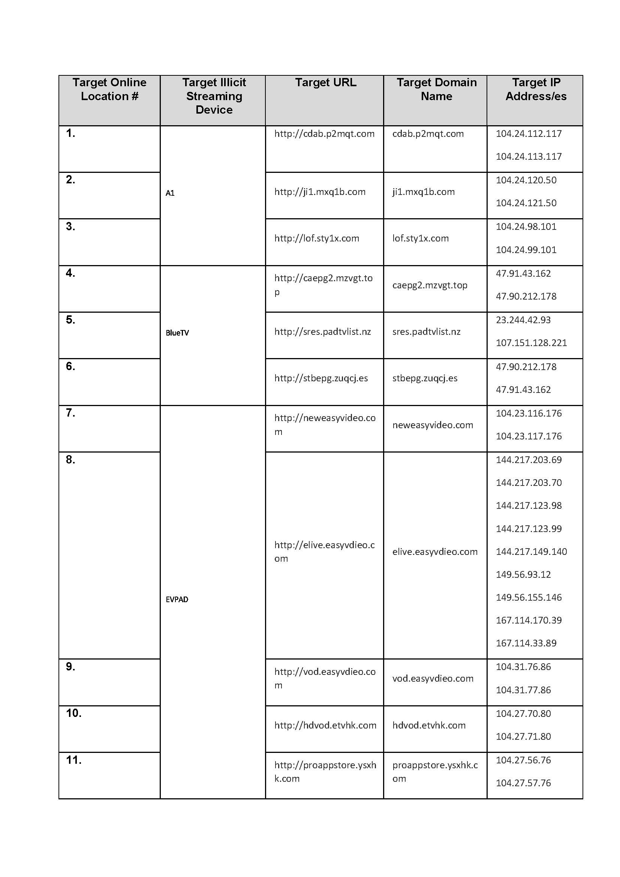
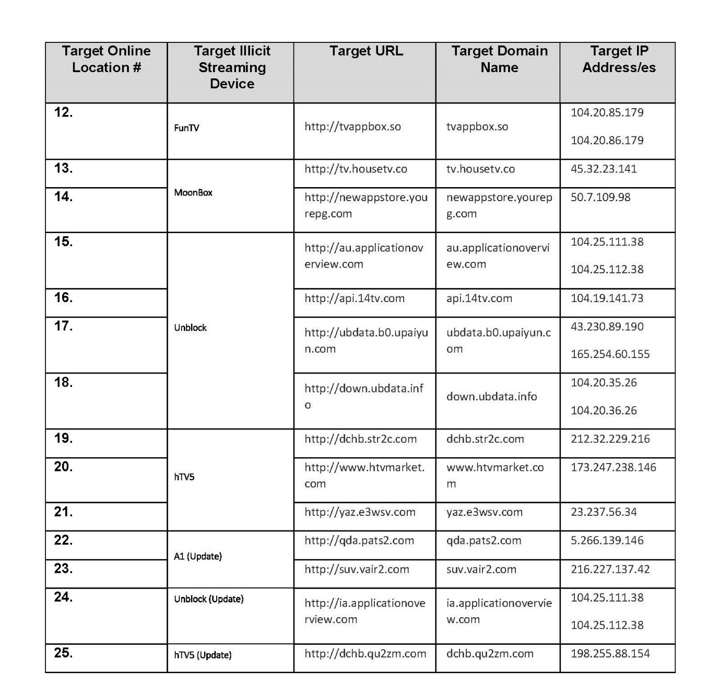

Note: Entry of orders is dealt with in Rule 39.32 of the Federal Court Rules 2011.

REASONS FOR JUDGMENT
NICHOLAS J:

Background
- Before me is an application under s 115A of the Copyright Act 1968 (Cth) (“the Act”) seeking orders that the respondents, each of which is a carriage service provider, take reasonable steps to disable access to various online locations.
- The first applicant (“TVB”) is a free to air television broadcaster based in Hong Kong Special Administrative Region of the People’s Republic of China (“Hong King China”). TVB is the holder of a Domestic Free Television Programme Service Licence that was most recently renewed on 12 May 2015. TVB is also a substantial producer of television content including pre-recorded television programs. The second applicant (“TVBO”) is a company related to TVB apparently based in Bermuda.
- There are 49 respondents in all each of which is a member of the Telstra, Optus, Vocus (formerly M2) or TGP groups. The respondents have not sought to be heard in the proceeding and submitting appearances have been filed on their behalf. The orders sought by the applicants are to the same effect as those made in Roadshow Films Pty Ltd v Telstra Corporation Ltd (2016) 248 FCR 178 (“Roadshow”), Universal Music Australia Pty Limited v TPG Internet Pty Ltd (2017) 348 ALR 493 (“Universal”) and Roadshow Films Pty Ltd v Telstra Corp Ltd (2018) 132 IPR 1 (“Roadshow 2”) except that they target different online locations.
- TVB operates five television channels in Hong Kong known as Jade, J2, TVB News, Pearl, and TVB Finance and Information:
Jade | Cantonese language channel which primarily broadcasts entertainment programs.
TVB News | Cantonese language 24 hour free to air news and information channel
Pearl | English-language channel showing predominantly documentaries, news, TV series and films
TVB Finance and Information | Cantonese language 24 hour free to air financial news and information channel. Its content primarily concerns information relating to finance, and includes documentaries on related topics
J2 | Primarily Cantonese language which occasionally it carries programs in other languages such as Mandarin, Japanese and Korean, primarily entertainment , lifestyle, travel and music programming

- TVB’s Australian subsidiary, TVB (Australia) Pty Ltd (“TVBA”), provides a pay-tv service in Australia allowing subscribers to access TVB’s television broadcasts via the internet.

The Applicants’ Evidence
- The applicants rely on various affidavits filed in this proceeding made by Mr Wu Kam Ming, Mr Xiaoguo Weng, Mr Andrew Stewart and Mr Nicholas Kraegen.
- Mr Wu is TVB’s Senior Executive Engineer. His affidavit explains the functionality provided by the online locations to the software applications that are or may be installed on the streaming devices, the availability of the applicants’ and third parties’ copyright content through the applications, how the target online locations are accessible using the respondents’ carriage services, and other matters relevant to the operation of the applications.
- Mr Weng is TVB’s Manager, Sales and Customer Service. His affidavit describes the purchase of the streaming devices, the status of the streaming devices at the time of purchase, logistical support provided to Mr Wu, and certain contact details identified in connection with the manufacturers of the streaming devices.
- Mr Stewart is the applicants’ solicitor in this proceeding. His affidavit describes the applicants’ ownership of copyright in the applicants’ cinematograph films. He also describes the Respondents’ status as carriage service providers.
- Mr Kraegen is a solicitor who assists Mr Stewart in this proceeding. His affidavit provides details of the steps undertaken by the applicants to notify the owners/operators of the target online locations, publicly-available material which promotes or explains the operation of the streaming devices and applications, and his investigations regarding the location and registration details of the online locations.

The Applicants’ Copyright
- By virtue of written agreements made between the applicants, with respect to the pre-recorded television programs, including the applicants’ cinematograph films:
(a) to the extent that such pre-recorded television programs came into existence prior to 1 January 2018:
  - TVB is the owner of copyright insofar as it concerns the exercise of the communication right under s 86(c) of the Act in Australia via the internet and any type of mobile telecommunications device via telecommunication network; and
  - TVBO is the exclusive licensee in Australia in respect of the rights referred to in subpara (i) above and owner of copyright under s 86(a) of the Act insofar as it concerns the reproduction right in Australia; and
(b) to the extent that such recordings and pre-recorded television programs came into existence from 1 January 2018:
(i) TVB is the owner of all rights comprised in copyright in Hong Kong; and
(ii) TVBO is the owners of all rights comprised in copyright outside Hong Kong, including Australia.
- It is important to note that whilst Hong Kong China, is a member of the World Trade Organisation, it is not a party to the Rome Convention. Consequently, the applicants do not rely on copyright in TVB’s television broadcasts per se and rely instead on their copyright in pre-recorded television programs that are included in those broadcasts.
- For the purpose of meeting the requirements of s 115A(1)(b), the applicants rely on three particular cinematograph films comprising Episode 1 from each of the television series “Dead Wrong”, “May Fortune Smile on You” and “Witness Insecurity” (“the applicants’ cinematograph films”). The applicants contend that their copyright in these films has been, and is being, infringed by persons unknown who make them available online without the consent of either of the applicants.

The Target Online Locations
- The application relates to various online locations that communicate with set-top streaming boxes which enable a user to receive TVB’s television broadcasts in Australia via the internet without having to subscribe to TVBA’s pay-tv service. The set-top boxes operate using the Android operating system and are marketed under the following brand names:
- A1;
- BlueTV;
- EV Pad Pro;
- FunTV;
- hTV5;
- MoonBox C; and
- Unblock TV Gen 3.
(“the streaming devices”).
- Each of the streaming devices is a computer that runs Google’s Android open-source operating system. They have an audio visual output which is typically fed into a television or other display screen for the purpose of viewing the audio visual output of the device, accessing, applications, and causing audio visual content available via those applications to be displayed on the television or other display. In this respect the streaming devices operate in a similar way to a desktop or laptop computer, with the television or other display being equivalent to the computer’s monitor.
- The uniform resource locators (“URL”), the domain names and the internet protocol addresses (“IP address”) for the online locations in respect of which orders are sought are identified in the Amended Originating Application and will be identified in the schedule to the orders made. All of these online locations are referred to in the Amended Originating Application as the “target online locations” which is how I shall describe them in these reasons. There are 25 target online locations.
- The target online locations fall into three groups:
- those that provide authentication and program guide functionality and a list of IP addresses of other servers from which the streaming devices may stream content;
- those that are used to obtain a list of software applications that are used to facilitate the streaming of content;
- those that enable the software applications to be installed on the streaming devices and/or updated included by providing the IP addresses of servers from which updated versions of those applications may be downloaded.
- The applicants say that the primary purpose of the target online locations is to facilitate the infringement of copyright by making available computer programs and/or electronic information that enable the streaming devices to stream the applicants’ and various third parties’ television programs for viewing by users of those devices in Australia.
- None of the target online locations +are a website in the usual sense. Rather, they are online locations from which specific files are downloaded by various applications that run under the Android operating system. The same was true of many of the online locations that were the subject of the blocking orders made in Roadshow 2.

The Facilitating Applications
- The streaming devices use proprietary Android-based software applications (“the facilitating applications”) to stream live television broadcasts which include cinematograph films the copyright in which is owned by or exclusively licensed to TVB or TVBO. In order for the application to facilitate the streaming of such content, it must first communicate with a facilitating server (“facilitating server”) and engage in an authentication process. After that has occurred, the facilitating applications may be used to download an electronic program guide (“EPG”) made available from another facilitating server which lists the content available for streaming to the streaming device from a different server that stores reproductions of the relevant content (“streaming server”).
- The facilitating applications allow the user operating the streaming devices to:
- view TV, by delivering the TVB television broadcasts via the internet with a delay of between about one and four minutes;
- provide a video-on-demand (“VOD”) service in which a range of cinematograph films (both feature films and television series) are made available and which will stream on demand;
- replay portions of TVB programs on demand up to 7 days after they have been broadcast.
- The facilitating applications come preinstalled on some of the streaming devices. For the streaming devices that do not come with them pre-installed, the facilitating applications must be obtained from facilitating servers that make available digital distribution platforms (“the distribution platforms”) for facilitating the download of applications that can be used with the streaming device. These online locations make available the facilitating applications for download allowing them to be installed and/or reinstalled on the streaming devices if deleted or if updated.
- Each of the facilitating applications is proprietary in the sense that it can only be used with the particular streaming device on which it is designed to operate. The facilitating applications and the distribution platforms are found at one or more domain names, which are used for the purpose of facilitating communications between particular streaming devices and facilitating servers. The distribution platforms are dedicated to making the facilitating applications available to the particular streaming devices with which they are associated.
- A user of the facilitating applications may select content from the EPG on the facilitating server which then provides the streaming device with details of the addresses of the streaming servers from which it may then stream the selected content.
- Some of the streaming devices have the Google Play Store application (“the Google Play App”) installed, which would allow a user to obtain access to the Google Play Store and many other applications that he or she might wish to install on the streaming device. Some of the streaming devices also include a function that gives the user the option to download and install the Google Play App. The evidence shows that blocking access to the facilitating applications would have no impact on the ability of a user of the streaming device to install or use the Google Play App or other applications made available at the Google Play Store.

Section 115A(1)-(2)
- Section 115A(1)-(2) of the Act provides:
(1) The Federal Court of Australia may, on application by the owner of a copyright, grant an injunction referred to in subsection (2) if the Court is satisfied that:
(a) a carriage service provider provides access to an online location outside Australia; and
(b) the online location infringes, or facilitates an infringement of, the copyright; and
(c) the primary purpose of the online location is to infringe, or to facilitate the infringement of, copyright (whether or not in Australia).
(2) The injunction is to require the carriage service provider to take reasonable steps to disable access to the online location.
- Section 115A, including the three requirements found in s 115A(1), (a), (b) and (c), was considered in Roadshow and Universal. I do not propose to refer at length to any of these decisions. It is sufficient for the moment to refer to the discussion in Roadshow at [25]-[54] and in Universal at [11]-[20].
- I am satisfied that each of the respondents is a carriage service provider that provides access to the target online locations each of which is located outside Australia: see 115(1)(a).
- I am also satisfied that the target online locations, by providing the functionality to which I have referred, facilitate the infringement of the applicants’ copyright in the applicants’ cinematograph films: see s 115(1)(b).
- The more difficult issue in this case is whether the “primary purpose” requirement of s 115(1)(c) is satisfied.

The Primary Purpose Requirement
- The primary purpose requirement imposes an important limitation on the power of the Court to make an order under s 115A. As explained in Roadshow (referring to the Revised Explanatory Memorandum to the Copyright Amendment (Online Infringement) Act 2015 (Cth)) at [48]-[49]:
[48] The requirement that the online location have as its primary purpose copyright infringement or the facilitation of copyright infringement provides an important check on the operation of s 115A. Thus, the fact that a particular website makes some unlicensed copyright material available online or is routinely used by some users to infringe copyright does not establish that the primary purpose of the website is to infringe or facilitate the infringement of copyright. The s 115A(1)(c) requirement is explained in the Revised Explanatory Memorandum as follows:
38. The Court must also be satisfied that the primary purpose of the online location is to either infringe copyright, or facilitate the infringement of copyright generally. This is an intentionally high threshold for the copyright owner to meet as a safeguard against any potential abuse. For example, the ‘primary purpose’ test would prevent an injunction to disable access to an art gallery website operated outside of Australia that may contain an unauthorised photograph. Thus, a website such as www.youtube.com or www.blogger.com would not prima facie satisfy the test as being an online location that infringes or facilitates infringement of copyright. Technology and technological change is not to be chilled or targeted by this amendment.
39. The primary purpose test would also prevent an injunction to block an online location operated overseas that provides legitimate copyright material to individuals within another geographic location, but are not licensed to distribute that copyright material in Australia. For example, the United States iTunes store does not operate with the primary purpose of infringing copyright or facilitating the infringement of copyright and therefore access to this online location would not be disabled under an injunction. The test is also not intended to capture Virtual Private Networks (VPNs) that are promoted and used for legitimate purposes, or merely used to access legitimate copyright material distributed in a foreign geographic market. VPNs have a wide range of legitimate purposes and have no oversight, influence or control over their customers’ activities.
40. The primary purpose test would direct the Court to consider the principal activity for which the online location exists and the principal intention of users of that online location. Purpose may be distinct from motive. An online location may have the ‘primary purpose’ of infringing, or facilitating the infringement of copyright even if the operator of the location derives a commercial advantage or profit from the operation of the location. For example, where an online location has copyright infringement as the principal activity for which it exists and the principal reason for attracting visits to the online location, the fact that the motive or incentive of its operator is to draw profits from advertising revenue does not mean that its primary purpose is to profit from advertising rather than to infringe copyright.
(emphasis added)
[49] The purpose of the online location may be ascertained by a consideration of the use that is or may be made of it. If the Court is satisfied that the principal activity for which the online location is used or designed to be used is copyright infringement or the facilitation of copyright infringement, then it will be open to conclude that the primary purpose of the online location is to infringe, or to facilitate the infringement of, copyright.
- The target online locations provide the streaming devices with the software that they require to stream the content that is broadcast by the TVB in Hong Kong. The content of the broadcast is stored on servers that allow it to be streamed between one to four minutes after it is broadcast by TVB on free-to-air channels in Hong Kong or at some later time using the video on demand facility. Most of this content consists of cinematograph films (feature films or episodes of television series) made by TVB or third parties together with various live programs that, although not pre-recorded, still contains some pre-recorded segments. These live programs include news, weather, finance and business content that will often include segments in which a television presenter will read from a script prepared by the presenter or other employees of TVB.
- A significant proportion of the content that can be streamed by using the streaming devices and the facilitating applications comprise cinematograph films the copyright in which is owned by the applicants. The evidence indicates that approximately 20% of the content broadcast by TVB in Hong Kong is likely to fall within this category.
- In addition, the evidence indicates that approximately 30% of content broadcast by TVB in Hong Kong comprise cinematograph films made by third parties for which TVB has non-exclusive licences permitting TVB to broadcast them in Hong Kong. These third party copyright owners include:
- Fox Networks Group Asia Pacific Limited – which is the exclusive licensee of copyright in Australia of a television series entitled “Nothing Gold Can Stay”;
- MediaCorp TV Singapore Pte Ltd – which is the owner of copyright in the films Cook Eat China;
- Sanlit E-Television Co, Ltd. – which is the owner of copyright in the films iWalker – One Two Free (V) and Memory Lane;
- Korea International Broadcasting Foundation (Arirang TV) – which is the owner of copyright in the cinematograph films known as Arts Avenue 2017;
- FreemantleMedia – which is a co-owner of copyright in (as described in the evidence) the films America’s Got Talent and Britain’s Got Talent”;
- Beijing iQIYI Science & Technology Co, Ltd – which is the owner of copyright in the films Tientsin Mystic.
- The applicants do not suggest that it is their copyright that is being infringed in the case of these films. Nevertheless, it is clear from the evidence that the copyright of these third parties is being infringed when these cinematograph films are made available online for viewing in Australia by users of the streaming devices and the facilitating applications.
- Viewed from a purely technical perspective, the function of the target online locations is to provide the streaming devices with the software they need to enable them to be operated by the user to view television content previously broadcast on TVB’s free-to-air channels in Hong Kong. However, in seeking to determine whether the primary purpose of the target online location is to infringe or facilitate the infringement of copyright, it is necessary to examine their function from a somewhat broader perspective.
- At a broader level, the target online locations are designed to provide users with access to television content consisting of films including movies, television series and live broadcasts of news, weather and finance programs, which also include some pre-recorded segments.
- There is no reason to think any of these movies, television series or pre-recorded segments that are made available are not the subject of copyright as cinematograph films. Nor is there any reason to think that the persons responsible for the establishment and maintenance of the target online locations, and the streaming servers from which the relevant content is streamed, have obtained the permission of copyright owners to make any such content available online to users of the streaming devices. The evidence shows that TVB, TVBO and the third party copyright owners or exclusive licensees I have referred to have not given any such permission to the operators of either the target online locations or the streaming devices from which the relevant content is streamed.
- I am satisfied that the feature films, episodes of television series and other pre-recorded content the subject of copyright delivered by the streaming devices operated using the facilitating applications available from the target online locations is being made available online in Australia without the permission of the relevant copyright owners in reach of copyright.
- I am also satisfied that the primary purpose of the target online locations is to facilitate the infringement of copyright by making such material available online in Australia in circumstances where this occurs without the consent of the relevant copyright owners. The making available of this material online constitutes an infringement of the communication right: see s 86 and the definition of “communicate” in s 10 of the Act.

Discretion
- With regard to the discretion to make an order under s 115A(1), s 115A(5) provides:
(5) In determining whether to grant the injunction, the Court may take the following matters into account:
(a) the flagrancy of the infringement, or the flagrancy of the facilitation of the infringement, as referred to in paragraph (1)(c);
(b) whether the online location makes available or contains directories, indexes or categories of the means to infringe, or facilitate an infringement of, copyright;
(c) whether the owner or operator of the online location demonstrates a disregard for copyright generally;
(d) whether access to the online location has been disabled by orders from any court of another country or territory on the ground of or related to copyright infringement;
(e) whether disabling access to the online location is a proportionate response in the circumstances;
(f) the impact on any person, or class of persons, likely to be affected by the grant of the injunction;
(g) whether it is in the public interest to disable access to the online location;
(h) whether the owner of the copyright complied with subsection (4);
(i) any other remedies available under this Act;
(j) any other matter prescribed by the regulations;
(k) any other relevant matter.
- As to the various considerations relevant to the exercise of the discretion in this particular matter, I think the following matters should be given most weight in determining whether to make the blocking orders sought:
- flagrancy of the infringements;
- impact on persons likely to be affected;
- availability of other remedies;
- proportionality of response; and
- compliance with s 115A.

Flagrancy
- There may be many people who use the streaming devices to view TVB broadcasts who do not appreciate that they are infringing copyright when doing so. Because the content made available by means of the streaming devices using the relevant software is available in Hong Kong in the form of free to air television broadcasts, there may be some users, perhaps many, who are unfamiliar with copyright law, and who do not appreciate that by using the streaming devices to view the TVB broadcasts in Australia that they are infringing copyright in feature films, television series, and pre-recorded segments included in the TVB broadcasts.
- Be that as it may, I regard as flagrant the copyright infringements of the persons who have made the TVB broadcasts available online, including those persons responsible for the establishment and maintenance of the target online locations that make it possible for users of the streaming devices to view the TVB broadcasts either in close to real time or at some later time using the VOD service.

Impact on persons likely to be affected
- I suspect (though there was no evidence of this) that there will be some people who use the streaming devices to view television programs which they may have grown accustomed to watching for free by viewing TVB free-to-air channels in Hong Kong. It may rankle some of these people that they might no longer be able to watch these TVB broadcasts in Australia free of charge or, at least, that the Court is being asked to make orders that may make it more difficult for them to do so. However, the suggestion that this would impose an undue burden or hardship on users of the streaming devices is really no different from saying that they should be permitted to enjoy the same content for free that other users of TVB Australia’s pay-tv service are required to pay to view. The unfairness inherent in this form of “free riding” extends not just to the copyright owners, but also to the Australian subscribers to the authorised TVB pay-tv service operated by TVBA.

Availability of other remedies
- I am satisfied that there are no other remedies that are available to the applicants that are practical, cost effective or likely to curtail the infringements of their copyright or the copyright of third parties whose cinematograph films are included in TVB’s television broadcasts. This is because, as the evidence shows, the operators of the target online locations, who are almost certainly based overseas, are virtually impossible to track down. Obtaining any form of effective injunctive relief against them in Australia is not a realistic option.

Proportionality of response
- Given my findings as to the nature and scale of copyright infringement that is being facilitated by the target online locations, the apparent lack of regard shown by their operators for the rights of copyright owners, and the difficulties confronting them in obtaining any direct relief against those responsible for making the applicants’ cinematograph films available online, I am satisfied that orders under s 115A(1) provide a proportionate response to the infringement of the applicants’ and third parties’ copyright that is made possible using the facilitating applications.
- The orders sought by the applicants will not prevent the users of the streaming devices from using them to download other applications which they may use to stream content that is made available online in Australia by or with the permission of the relevant copyright owner.
- I accept that access to some of content that was originally broadcast (ie. which was not pre-recorded) in which copyright does not subsist may also be blocked, but my strong impression from the evidence is that this is likely to constitute a relatively small proportion of the total content the subject of TVB’s television broadcasts in Hong Kong. This is not a case, in my view, where blocking orders, if made, will significantly curtail non-infringing use of the streaming devices.

Compliance under s 115A(4)
- Section 115A(4) requires the applicant to notify (inter alios) the person who operates an online location in respect of which the relevant order is sought of the application. The Court may dispense with this requirement if it is satisfied that the applicant is unable, despite making reasonable efforts, to determine the identity or address of the person who operates the online location, or to send a notice to that person.
- In the present case I am satisfied that the applicants have made reasonable efforts to ascertain the identity and address of the operators of the target online locations and to notify them of the application made. In particular, the applicants have, through Mr Kraegen, sought to ascertain the identity and contact information of the person in whose name the domain names and the IP addresses at which the target online locations are found are registered. This contact information included email addresses to which Mr Kraegen sent corresponding giving notice of the application. No responses were received, and none of the operators of the target online locations have sought to appear or make submissions.

Disposition
- I am satisfied that the power to make orders under s 115A in respect of each of the target online locations is enlivened and that, in the exercise of my discretion, it is appropriate to make such orders in the form sought by the applicants.
- There will be orders accordingly.

I certify that the preceding fifty-three (53) numbered paragraphs are a true copy of the Reasons for Judgment herein of the Honourable Justice Nicholas.

Associate:
Dated: 20 September 2018

SCHEDULE OF PARTIES

 | NSD 2069 of 2017
Respondents
Third Respondent | PACNET SERVICES (A) PTY LTD (ACN 056 783 852)
Fourth Respondent | OPTUS MOBILE PTY LIMITED (ACN 054 365 696)
Fifth Respondent | OPTUS NETWORKS PTY LIMITED (ACN 008 570 330)
Sixth Respondent | OPTUS ADSL PTY LIMITED (ACN 138 676 356)
Seventh Respondent | OPTUS SATELLITE PTY LIMITED (ACN 091 790 313)
Eighth Respondent | UECOMM OPERATIONS PTY LIMITED (ACN 093 504 100)
Ninth Respondent | VIVIDWIRELESS PTY LIMITED (ACN 137 696 461)
Tenth Respondent | OPTUS INTERNET PTY LIMITED (ACN 083 164 532)
Eleventh Respondent | VIRGIN MOBILE (AUSTRALIA) PTY LIMITED (ACN 092 726 442)
Twelfth Respondent | ALPHAWEST SERVICES PTY LIMITED (ACN 009 196 347)
Thirteenth Respondent | OPTUS WHOLESALE PTY LIMITED (ACN 092 227 551)
Fourteenth Respondent | M2 WHOLESALE PTY LTD ACN 119 220 843
Fifteenth Respondent | M2 WHOLESALE SERVICES PTY LTD (ACN 119 220 843)
Sixteenth Respondent | M2 COMMANDER PTY LTD (ACN 136 950 082)
Seventeenth Respondent | PRIMUS NETWORK (AUSTRALIA) PTY LTD (ACN 109 142 216)
Eighteenth Respondent | % PRIMUS TELECOMMUNICATIONS PTY LTD ACN 071 191 396%
Nineteenth Respondent | PRIMUS TELECOMMUNICATIONS (AUSTRALIA) PTY LTD (ACN 061 754 943)
Twentieth Respondent | DODO SERVICES PTY LTD (ACN 158 289 331)
Twenty First Respondent | ENGIN PTY LTD (ACN 080 250 371)
Twenty Second Respondent | EFTEL CORPORATE PTY LTD (ACN 154 634 054)
Twenty Third Respondent | EFTEL RETAIL PTY LTD (ACN 092 667 126)
Twenty Fourth Respondent | EFTEL WHOLESALE PTY LTD (ACN 123 409 058)
Twenty Fifth Respondent | CLUBTELCO PTY LTD (ACN 144 488 620)
Twenty Sixth Respondent | WHOLESALE COMMUNICATIONS GROUP PTY LTD (ACN 109 626 011)
Twenty Seventh Respondent | 2TALK PTY LTD (ACN 161 656 499)
Twenty Eighth Respondent | VOCUS PTY LTD (ACN 127 842 853)
Twenty Ninth Respondent | AMCOM IP TEL PTY LTD (ACN 065 092 962)
Thirtieth Respondent | AMNET BROADBAND PTY LTD (ACN 092 472 350)
Thirty First Respondent | NEXTGEN NETWORKS PTY LTD (ACN 094 147 403)
Thirty Second Respondent | TPG INTERNET PTY LTD (ACN 068 383 737)
Thirty Third Respondent | TPG NETWORK PTY LTD (ACN 003 064 328)
Thirty Fourth Respondent | FTTB WHOLESALE PTY LTD (ACN 087 533 328)
Thirty Fifth Respondent | CHARIOT PTY LTD (ACN 088 377 860)
Thirty Sixth Respondent | SOUL PATTINSON TELECOMMUNICATIONS PTY LIMITED (ACN 001 726 192)
Thirty Seventh Respondent | SPT TELECOMMUNICATIONS PTY LIMITED (ACN 099 173 770)
Thirty Eighth Respondent | SPTCOM PTY LIMITED (ACN 111 578 897)
Thirty Ninth Respondent | SOUL COMMUNICATIONS PTY LTD (ACN 085 089 970)
Fortieth Respondent | PIPE NETWORKS PTY LIMITED (ACN 099 104 122)
Forty First Respondent | INTRAPOWER TERRESTRIAL PTY LTD (ACN 081 193 259)
Forty Second Respondent | IINET LIMITED (ACN 068 628 937)
Forty Third Respondent | INTERNODE PTY LTD (ABN 82 052 008 581)
Forty Fourth Respondent | TRANSACT CAPITAL COMMUNICATIONS PTY LTD (ACN 093 966 888)
Forty Fifth Respondent | TRANSACT VICTORIA COMMUNICATIONS PTY LTD (ACN 063 024 475)
Forty Sixth Respondent | WESTNET PTY LTD (ACN 086 416 908)
Forty Seventh Respondent | ADAM INTERNET PTY LTD (ACN 055 495 853)
Forty Eighth Respondent | AAPT LIMITED (ACN 052 082 416)
Forty Ninth Respondent | REQUEST BROADBAND PTY LTD (ACN 091 530 586)

