FEDERAL COURT OF AUSTRALIA

Deputy Commissioner of Taxation v Advanced Holdings Pty Ltd
[2018] FCA 1263

File number: | NSD 1496 of 2018
Judge: | KATZMANN J
Date of judgment: | 21 August 2018
Catchwords: | PRACTICE AND PROCEDURE — ex parte application for freezing orders under rr 7.32 and 7.35 — where application made for judgment on certain taxation liabilities — good arguable case — evidence of recent history of dishonest conduct — danger that assets might otherwise be dissipated
Legislation: | Income Tax Assessment Act 1936 (Cth) ss 175, 264  Judiciary Act 1903 (Cth) s 39B(1A)(c)  Taxation Administration Act 1953 (Cth) Sch 1 ss 255-5, 255-45, 350-10, 353-10  Federal Court Rules 2011 (Cth) rr 7.32, 7.35, 39.05
Cases cited: | Batagol v Federal Commissioner of Taxation (1963) 109 CLR 243  Cardile v LED Builders Pty Ltd (1999) 198 CLR 380  Deputy Commissioner of Taxation v Hua Wang Bank Berhad (2010) 273 ALR 194; 80 ATR 449; [2010] FCA 1014  Deputy Commissioner of Taxation v Chemical Trustee Ltd (No 4) (2012) 19 ATR 711; [2012] FCA 1064  Deputy Commissioner of Taxation v Ma (2017) 106 ATR 773; [2017] FCA 1317  Deputy Commissioner of Taxation v Vasiliades (2014) 323 ALR 59; 99 ATR 799; [2014] FCA 1250  Federal Commissioner of Taxation v Naidoo (1981) 55 FLR 245  Frigo v Culhaci (unreported; NSW Court of Appeal, 17 July 1998)  Insolvency Guardian Melbourne Pty Ltd v Carlei (2016) 111 ACSR 236; [2016] FCA 72  Jackson v Sterling Industries Ltd (1987) 162 CLR 612  Ninemia Maritime Corporation v Trave Schiffahrtsgesellschaft and Co KG (The Niedersachsen) [1983] 1 WLR 1412; [1984] 1 All ER 413  Patterson v BTR Engineering (Aust) Ltd (1989) 18 NSWLR 319
Date of hearing: | 17 August 2018
Registry: | New South Wales
Division: | General Division
National Practice Area: | Taxation
Category: | Catchwords
Number of paragraphs: | 71
Counsel for the Applicant: | Mr R Scruby SC with Mr R A Jedrzejczyk
Solicitor for the Applicant: | Australian Government Solicitor
Counsel for the Respondents: | The Respondents did not appear

ORDERS
 |  | NSD 1496 of 2018
BETWEEN: | DEPUTY COMMISSIONER OF TAXATION  Applicant
AND: | ADVANCED HOLDINGS PTY LTD  First Respondent  SUMMER HILL BUSINESS ESTATE PTY LTD (ACN 123 332 730) AS TRUSTEE FOR THE CAMELLIA ESTATE TRUST  Second Respondent  RIVERLAND ESTATE PTY LTD (ACN 103 833 825) AS TRUSTEE FOR THE RIVERLANDS ESTATE TRUST  Third Respondent

JUDGE: | KATZMANN J
DATE OF ORDER: | 17 AUGUST 2018

THE COURT ORDERS THAT:

- The time for service of the originating application be abridged to 5 pm on 20 August 2018.
- The originating application, the affidavit of Craig Morelande affirmed 17 August 2018 and the affidavit of Maggie Ng affirmed 17 August 2018 be served on the respondents by 5 pm on 20 August 2018, in the first instance by:
  - courier delivery to Lionheart Lawyers, at Level 2, 64 Clarence Street Sydney NSW 2000 marked for the attention of Charbel Azzi; and
  - email to info@lionheartlawyers.com.au marked for the attention of Charbel Azzi.
- Pursuant to rules 7.32 and 7.35 of the Federal Court Rules 2011 (Cth) (FCR) orders be made against the first respondent in the terms set out in annexure A to these orders.
- Pursuant to FCR 7.33 the first respondent, by itself, its employees or agents, be restrained until further order from taking any step:
(a) to exercise any power as a unit holder under the Camellia Estate Trust and/or the Riverlands Estate Trust; or
(b) to cause any asset owned by the Camellia Estate Trust and/or the Riverlands Estate Trust to be sold, transferred, disposed of or otherwise diminished in value.
- Pursuant to FCR 7.32 and 7.34 orders be made against the second respondent in the terms set out in annexure B to these orders.
- Pursuant to FCR 7.33 and 7.34 the second respondent, by itself, its employees or agents, be restrained until further order from:
(a) creating or issuing any new units, or approving the transfer of any units, in the Camellia Estate Trust, or
(b) amending the trust deed of the Camellia Estate Trust; or
(c) without giving 14 days’ written notice to the applicant, retiring as trustee of the Camellia Estate Trust.
- Pursuant to FCR 7.32 and 7.34 orders be made against the third respondent in the terms set out in annexure C to these orders.
- Pursuant to FCR 7.33 and 7.34 the third respondent, by itself, its employees or agents, be restrained until further order from:
(a) creating or issuing any new units, or approving the transfer of any units, in the Camellia Estate Trust, or
(b) amending the trust deed of the Camellia Estate Trust; or
(c) without giving 14 days’ written notice to the applicant, retiring as trustee of the Camellia Estate Trust.
- The originating application be stood over for hearing or directions before the duty judge at 10.15am on Wednesday 22 August 2018.
- The parties have liberty to apply to the duty judge on 24 hours’ notice.
- These orders be entered forthwith.

Note: Entry of orders is dealt with in Rule 39.32 of the Federal Court Rules 2011.

ORDERS
 |  | NSD 1496 of 2018
BETWEEN: | DEPUTY COMMISSIONER OF TAXATION  Applicant
AND: | ADVANCED HOLDINGS PTY LTD  First Respondent  SUMMER HILL BUSINESS ESTATE PTY LTD (ACN 123 332 730) AS TRUSTEE FOR THE CAMELLIA ESTATE TRUST  Second Respondent  RIVERLAND ESTATE PTY LTD (ACN 103 833 825) AS TRUSTEE FOR THE RIVERLANDS ESTATE TRUST  Third Respondent

JUDGE: | KATZMANN J
DATE OF ORDER: | 21 AUGUST 2018

THE COURT ORDERS THAT:

- The applicant be granted leave to file an amended originating application in the form annexed to these orders and marked “A”.
- Pursuant to rule 39.05 of the Federal Court Rules 2011, the orders made on 17 August 2018 be varied as follows:
  - order 8(a) be varied by replacing the words “Camellia Estate Trust” with “Riverlands Estate Trust”;
  - order 8(b) be varied by replacing the words “Camellia Estate Trust” with “Riverlands Estate Trust”;
  - order 8(c) be varied by replacing the words “Camellia Estate Trust” with “Riverlands Estate Trust”;
  - the name of the second respondent in the schedule on page 3 of the orders be changed to: ‘Summer Hill Business Estate Pty Ltd ACN 123 332 730 as trustee for the Camellia Estate Trust’;
  - the name of the third respondent in the schedule on page 3 of the orders be changed to: ‘Riverland Estate Pty Ltd ACN 103 833 825 as trustee for the Riverlands Estate Trust’;
  - the name of the addressee in annexure C to the orders be changed to “Riverland Estate Pty Ltd atf the Riverlands Estate Trust”.
- Order 2 of these orders has effect nunc pro tunc from the making of the orders on 17 August 2018.
- The applicant serve a copy of the amended originating application and these orders on the respondents by 5 pm on 21 August 2018.

Note: Entry of orders is dealt with in Rule 39.32 of the Federal Court Rules 2011.
Annexure A
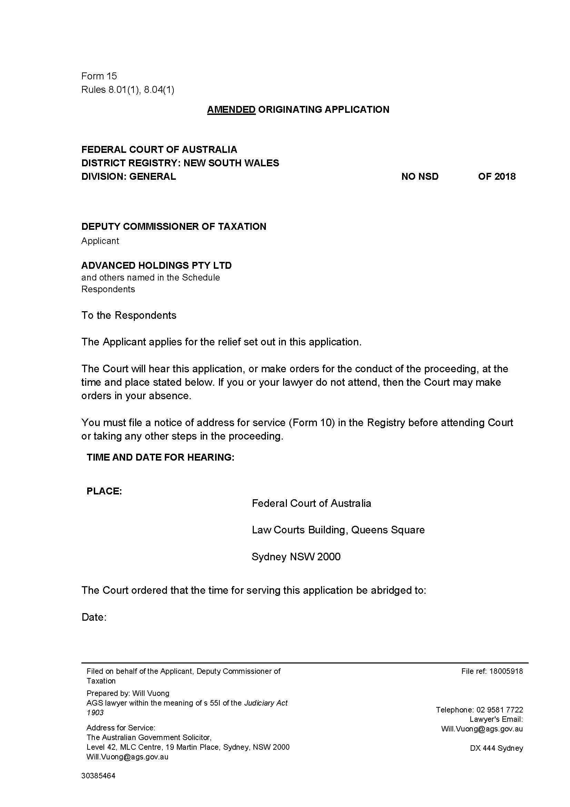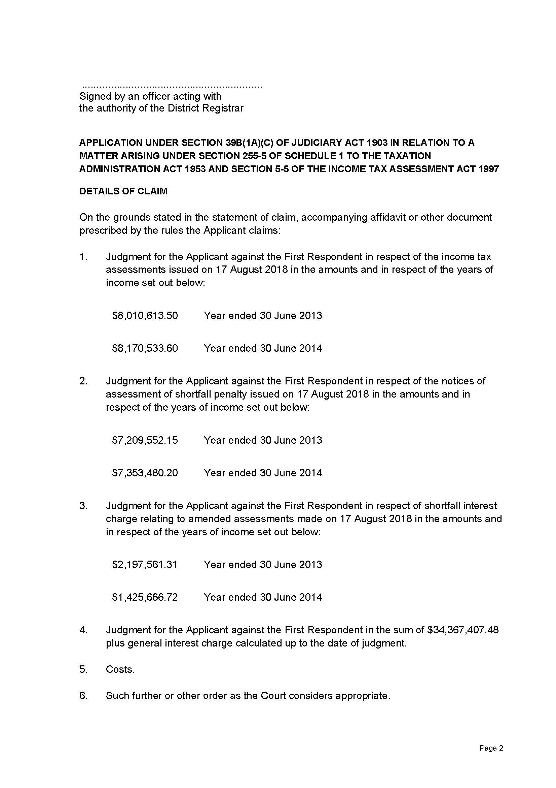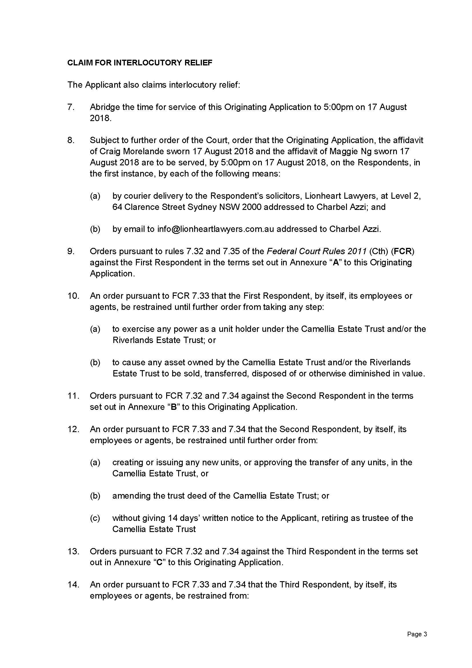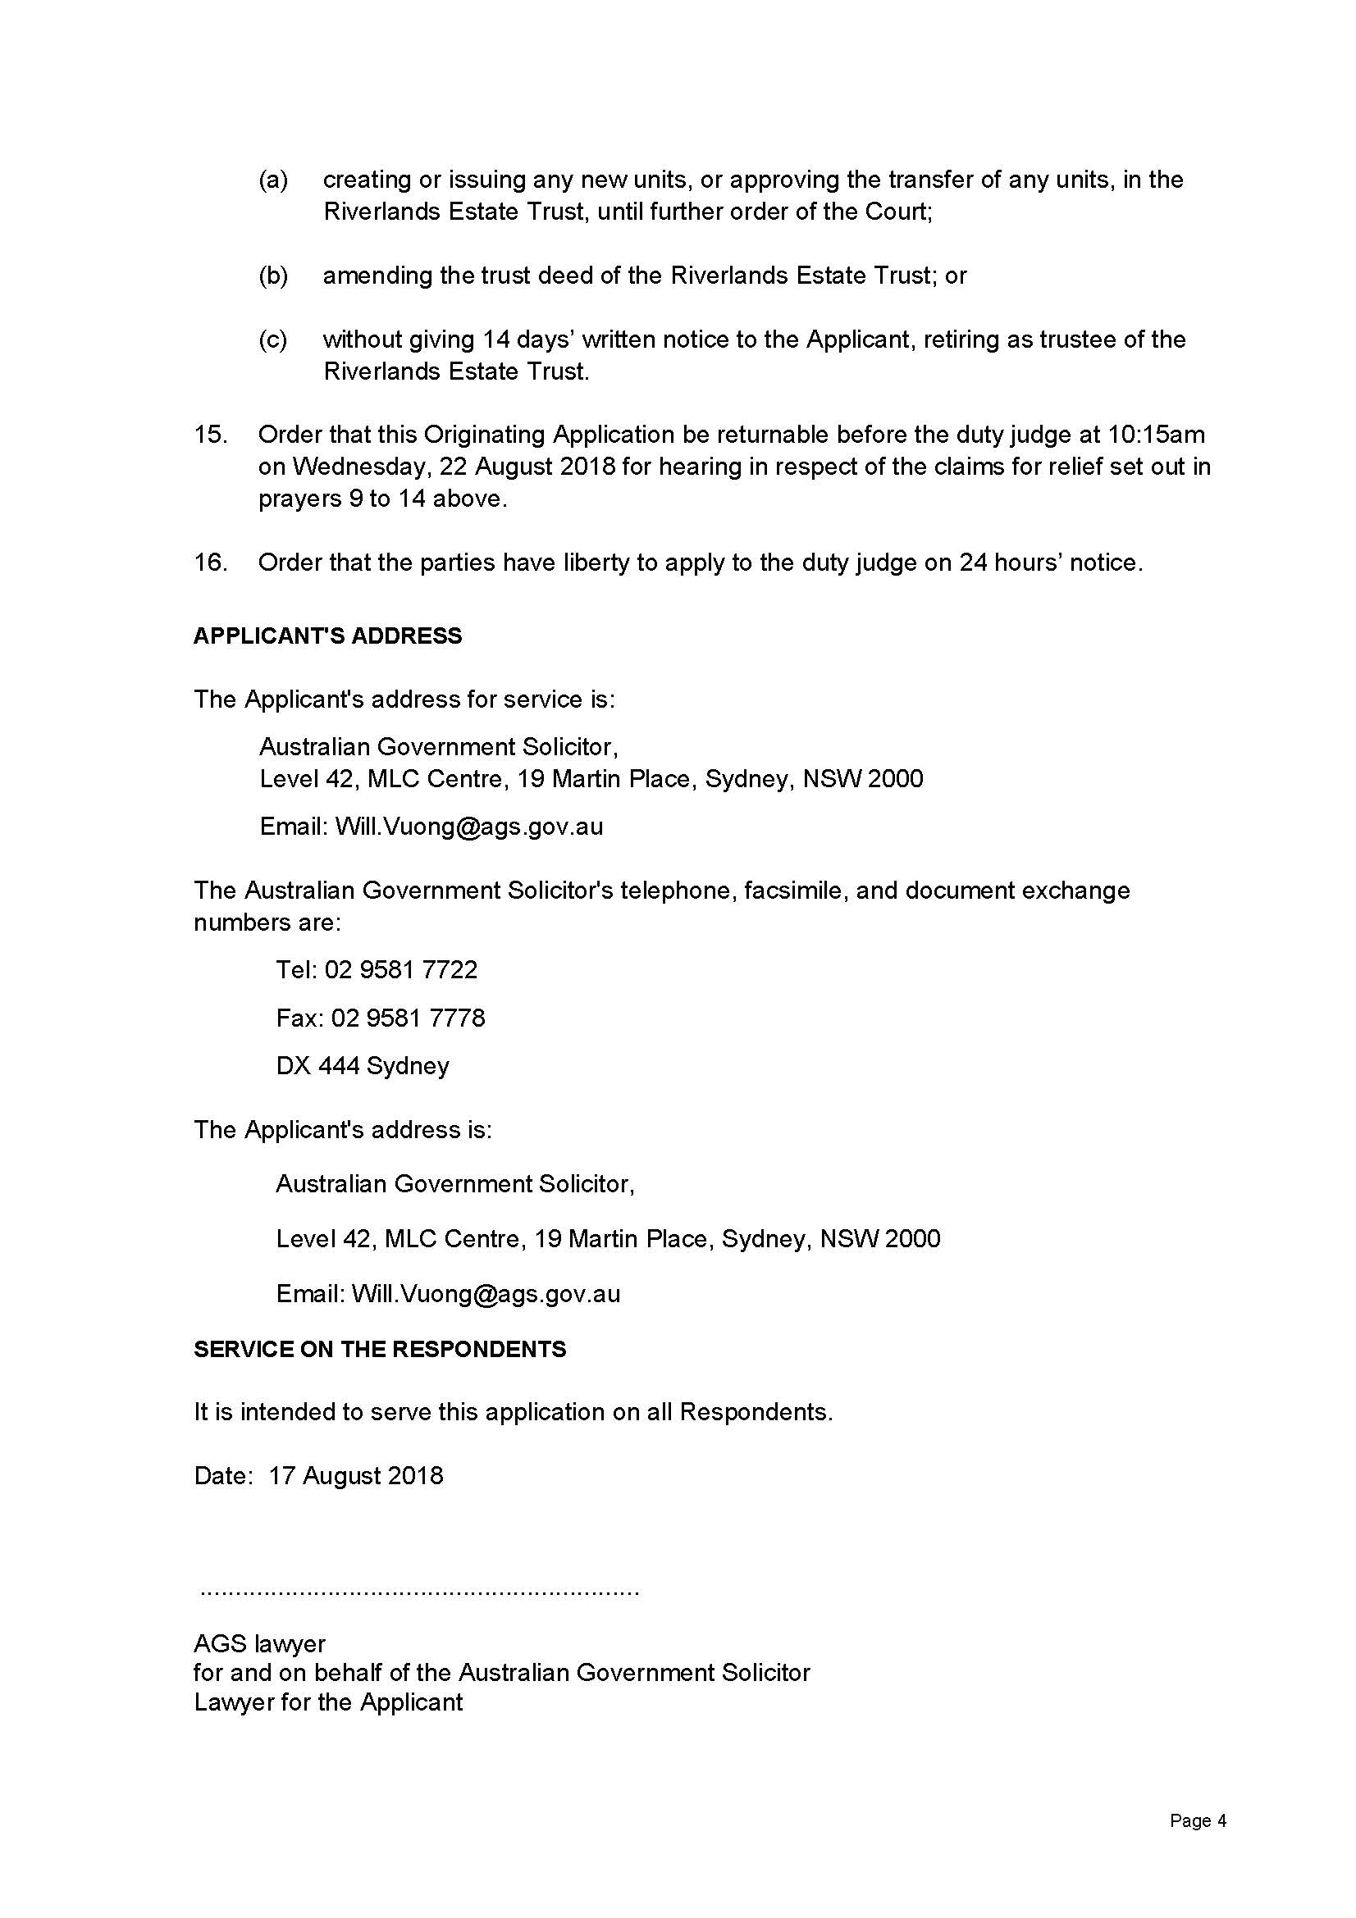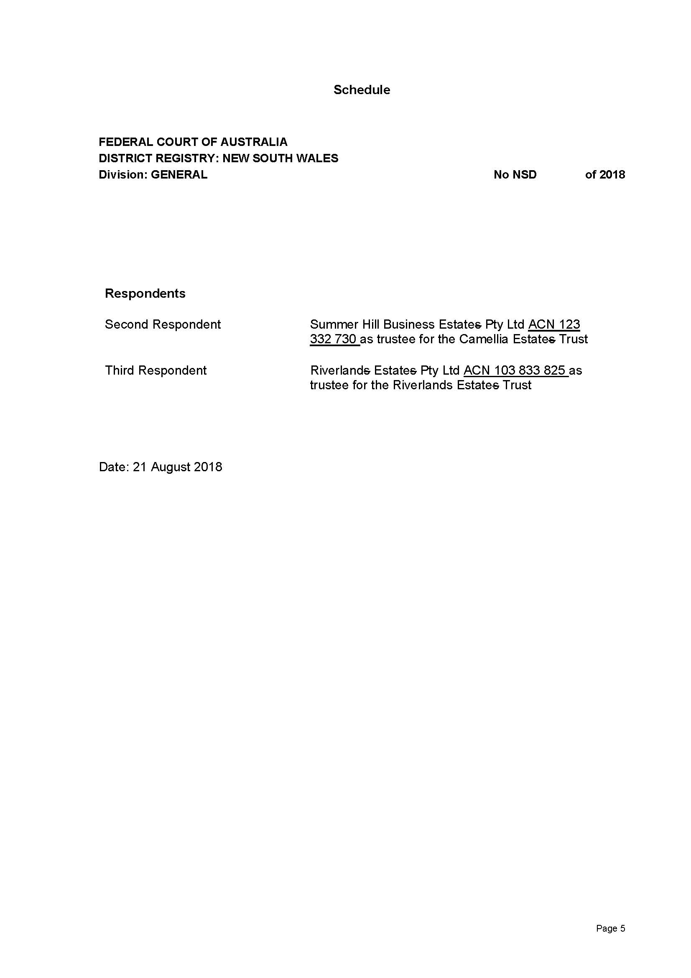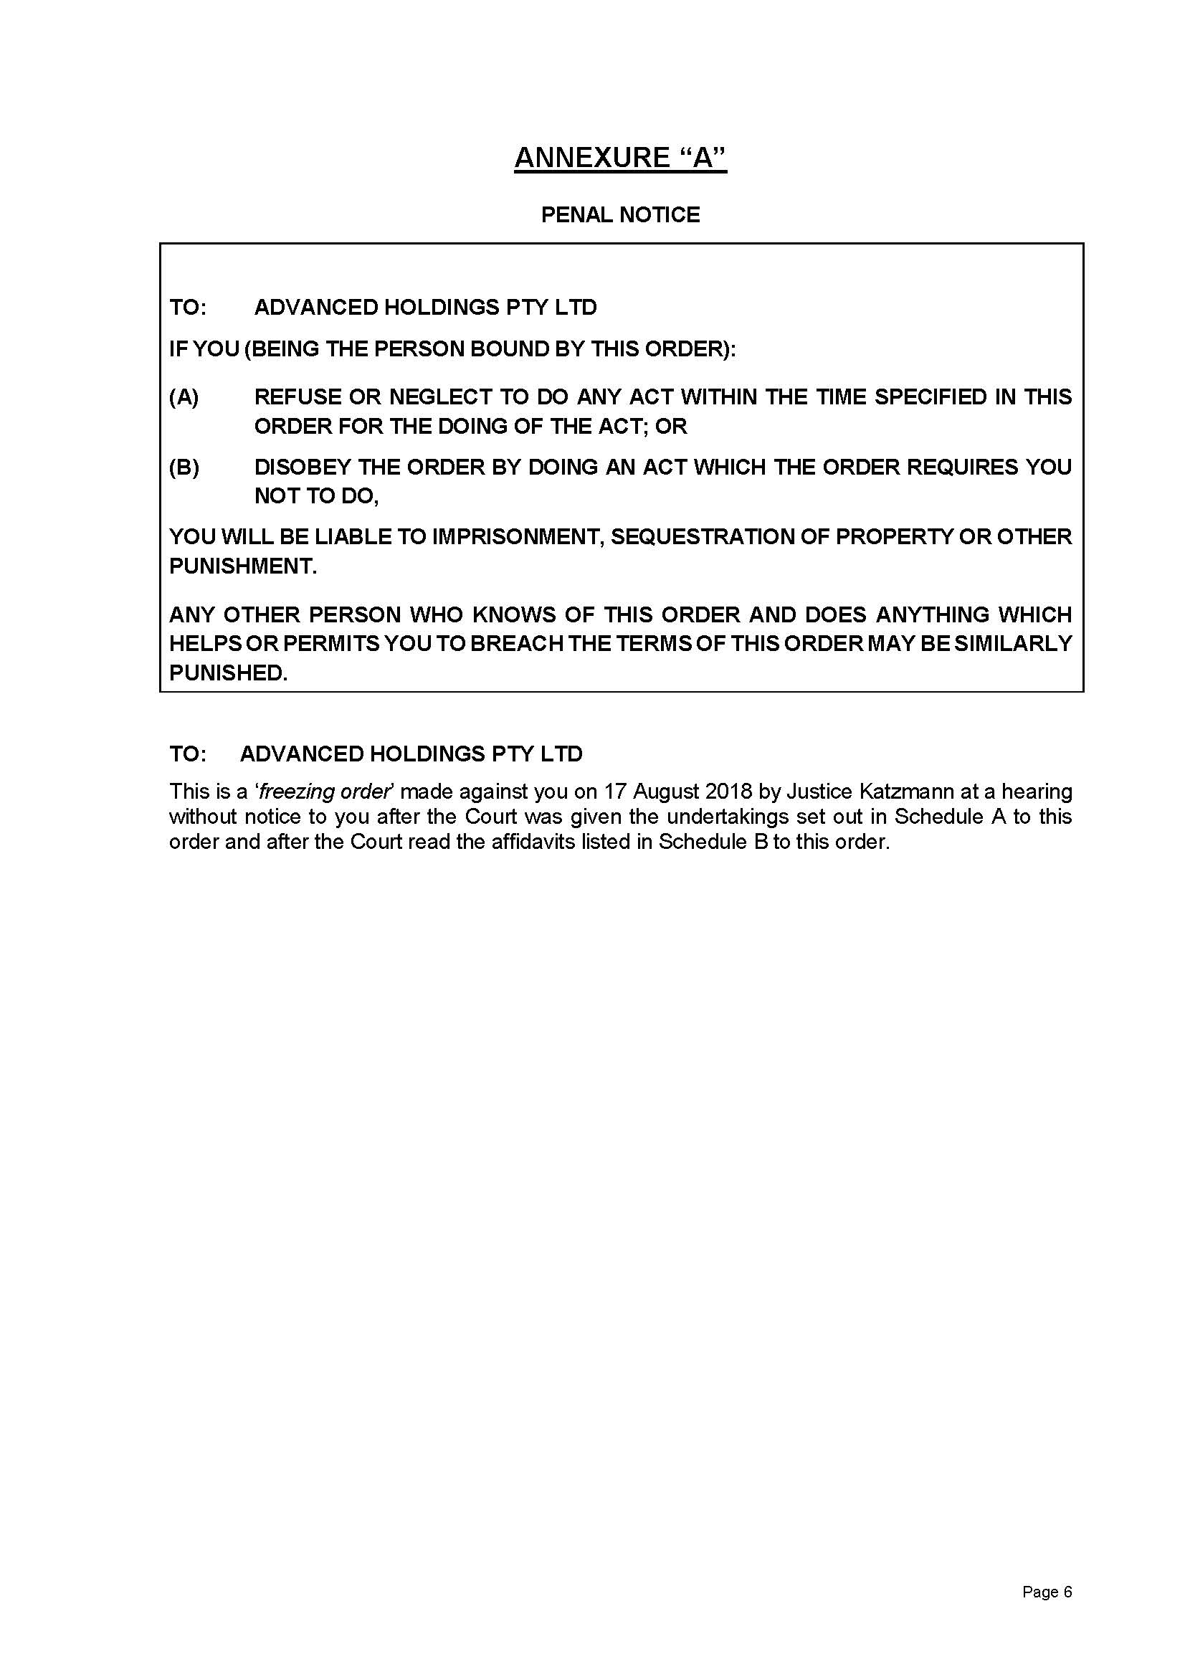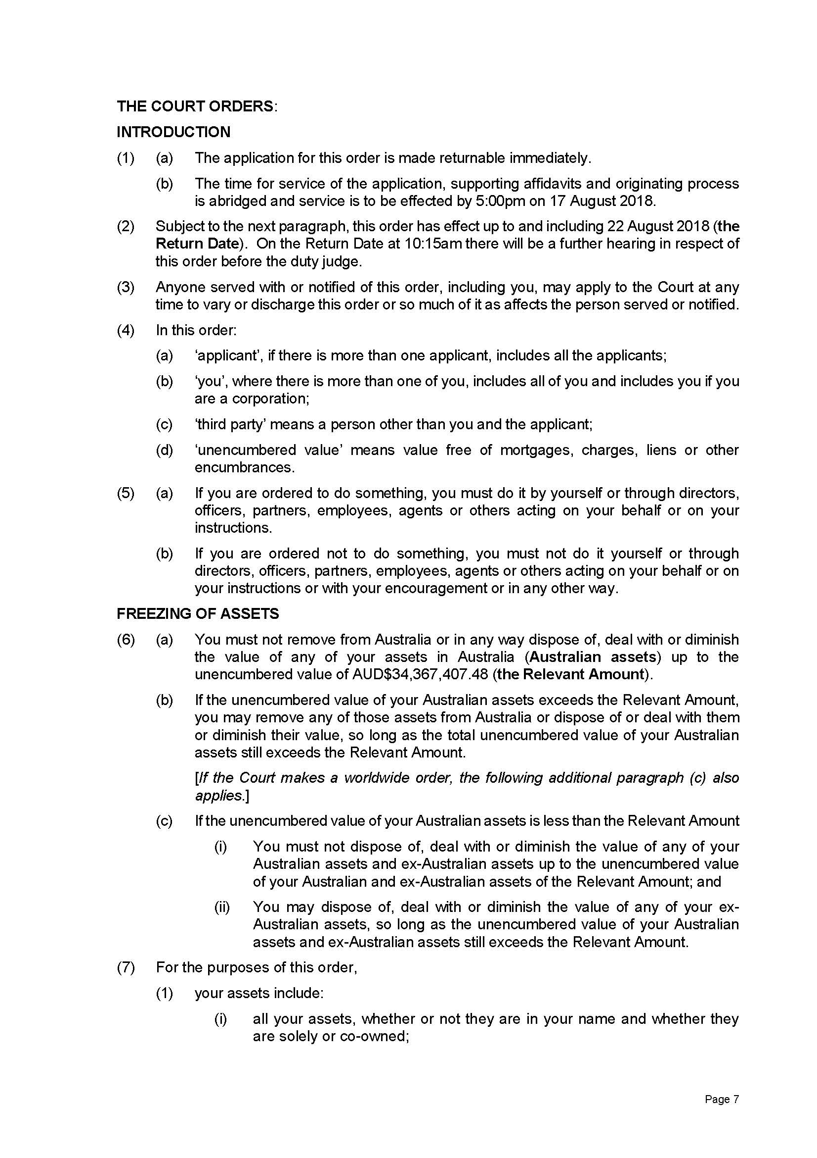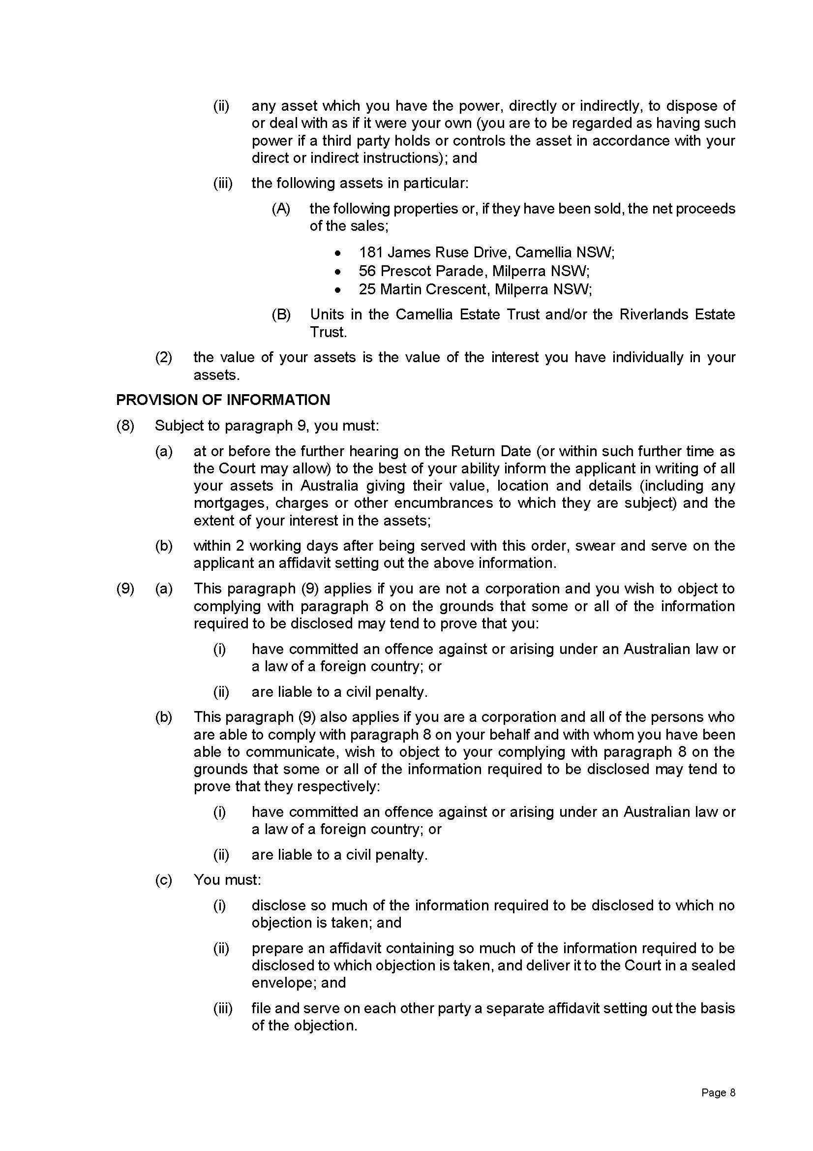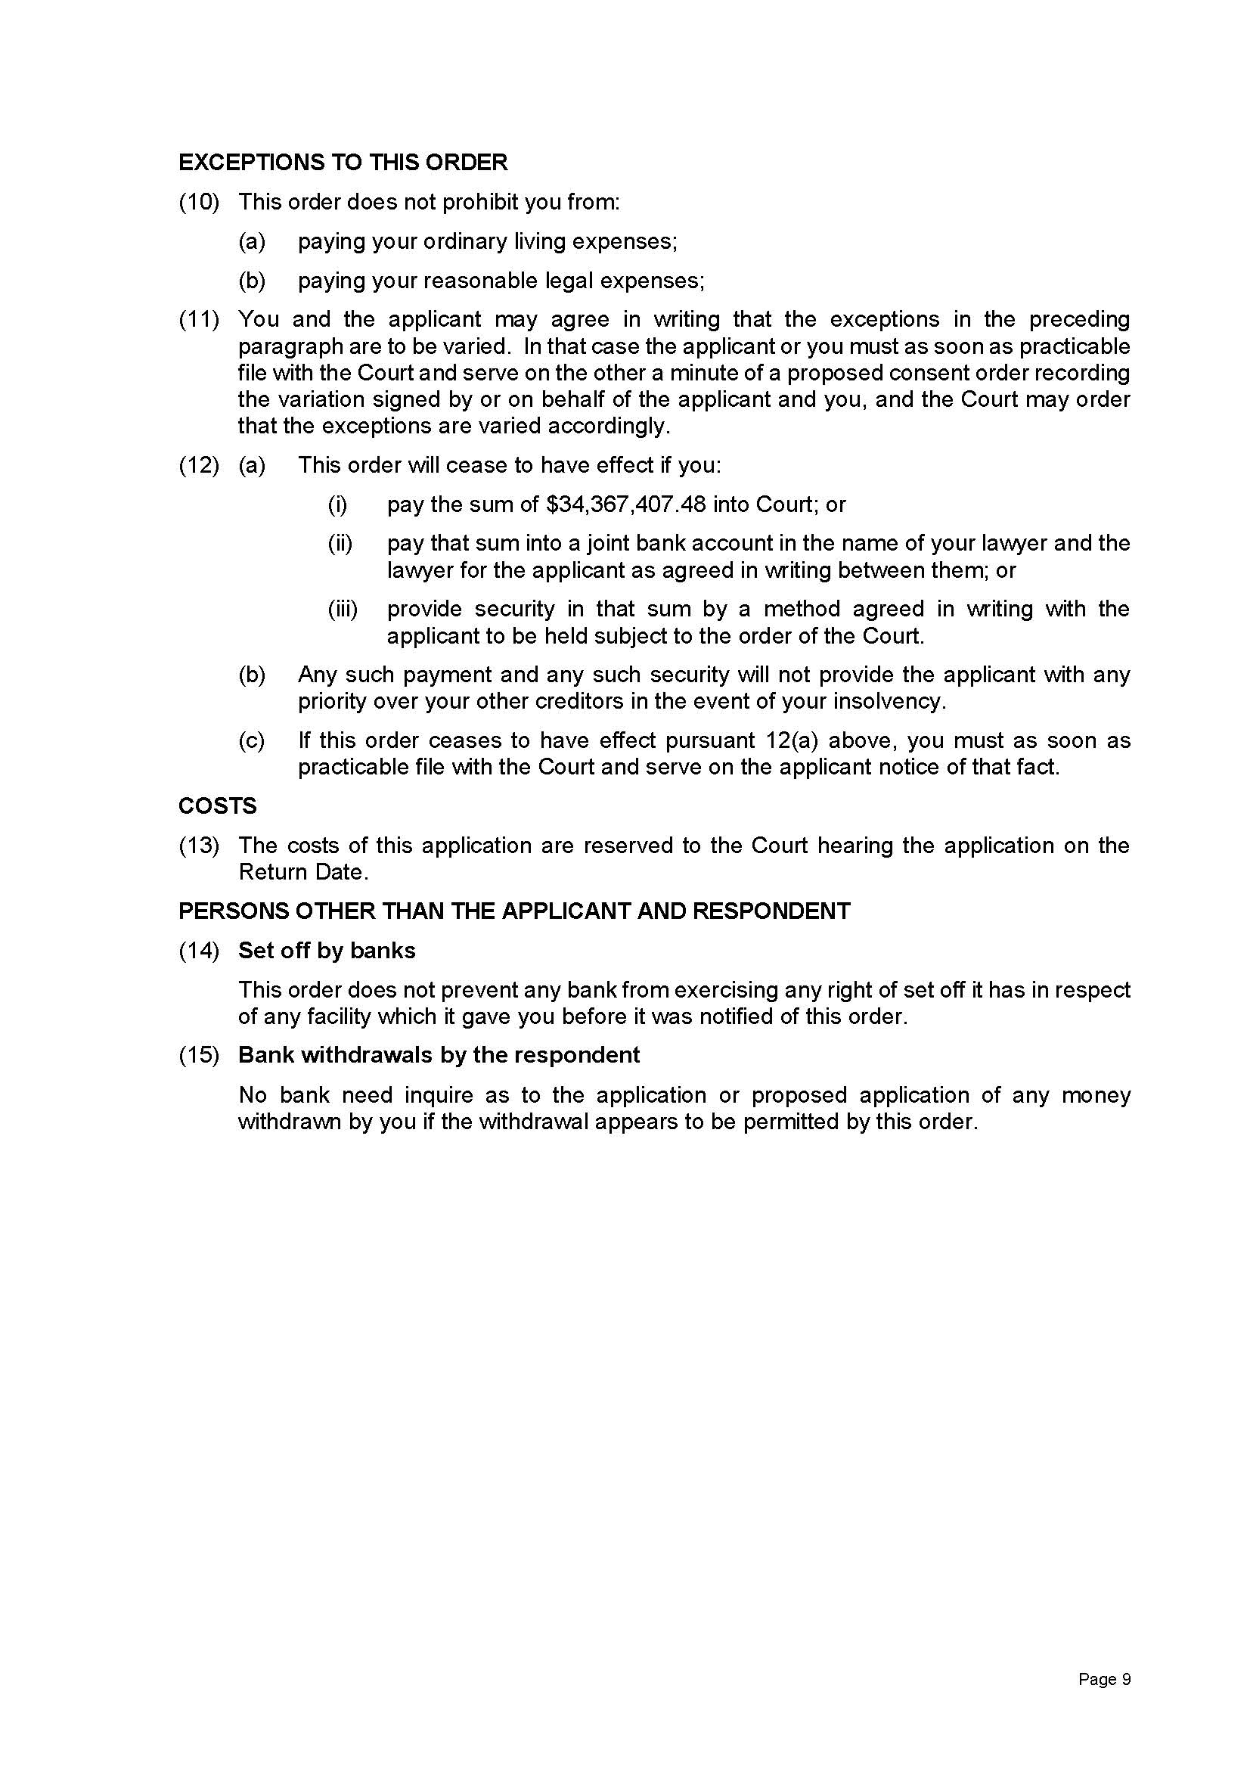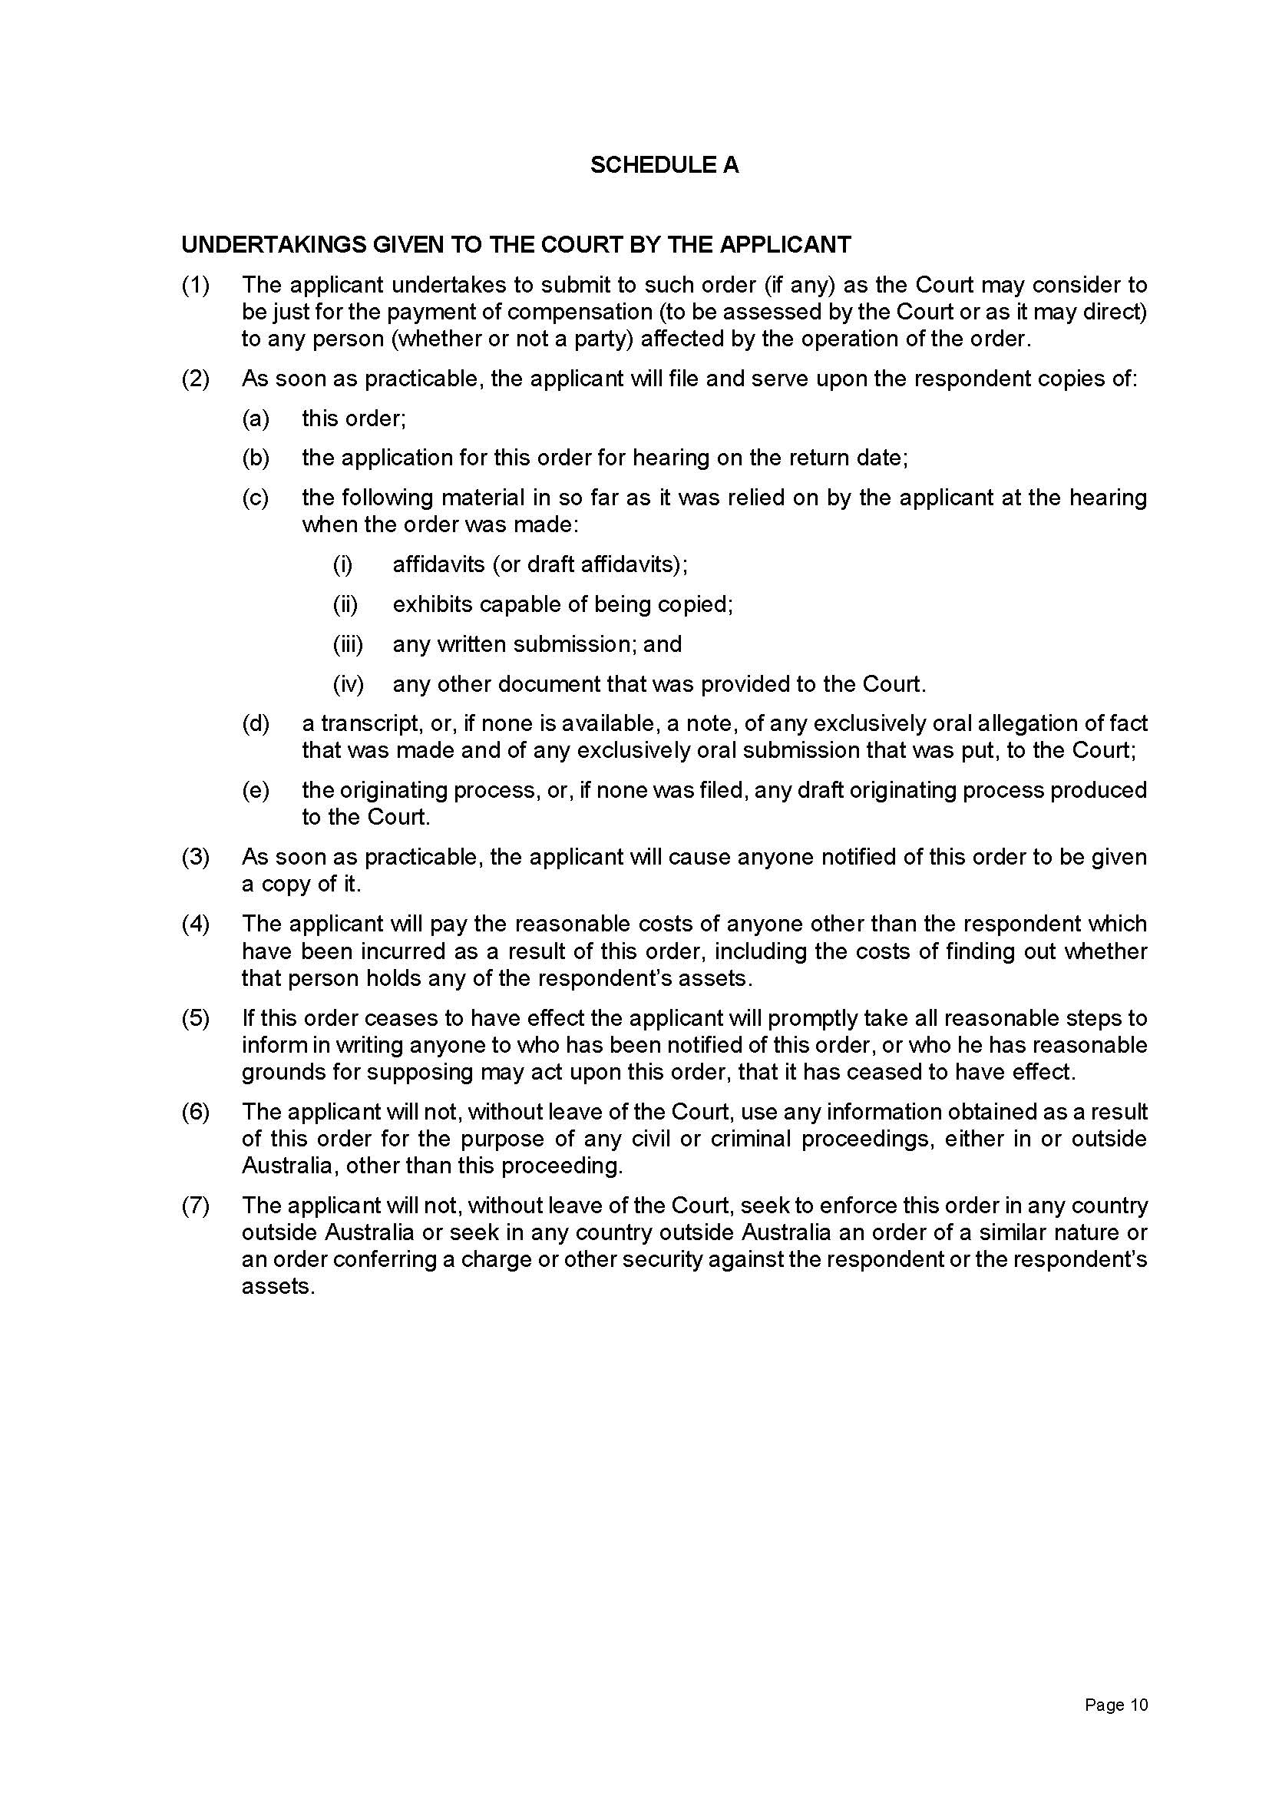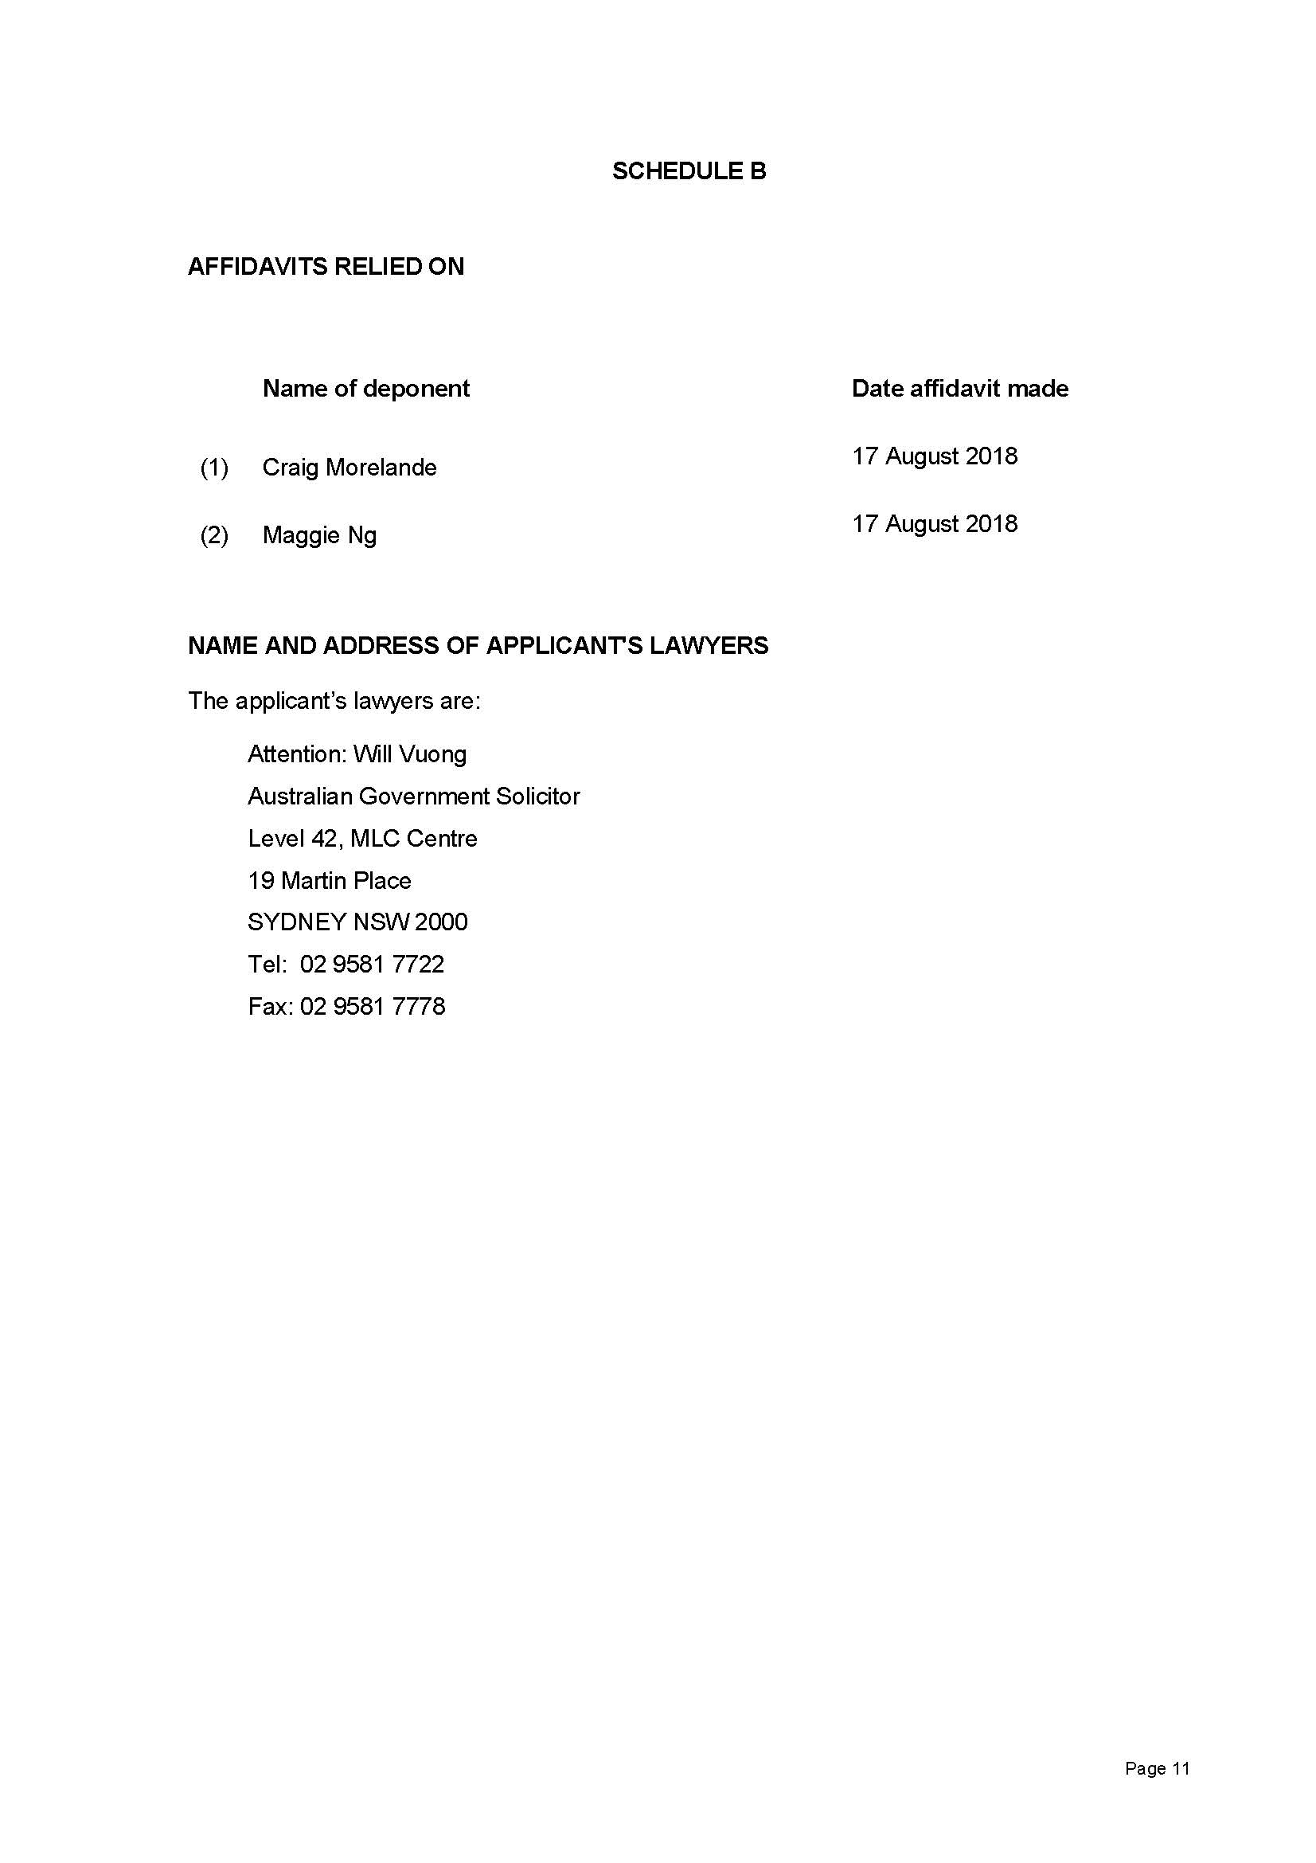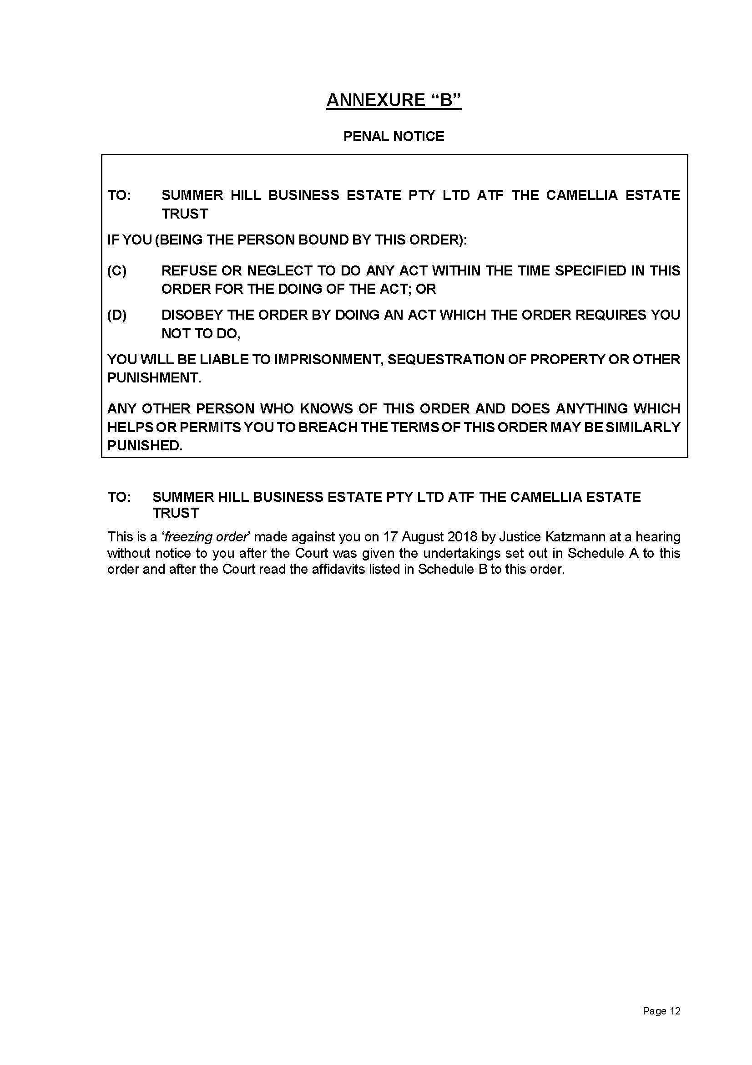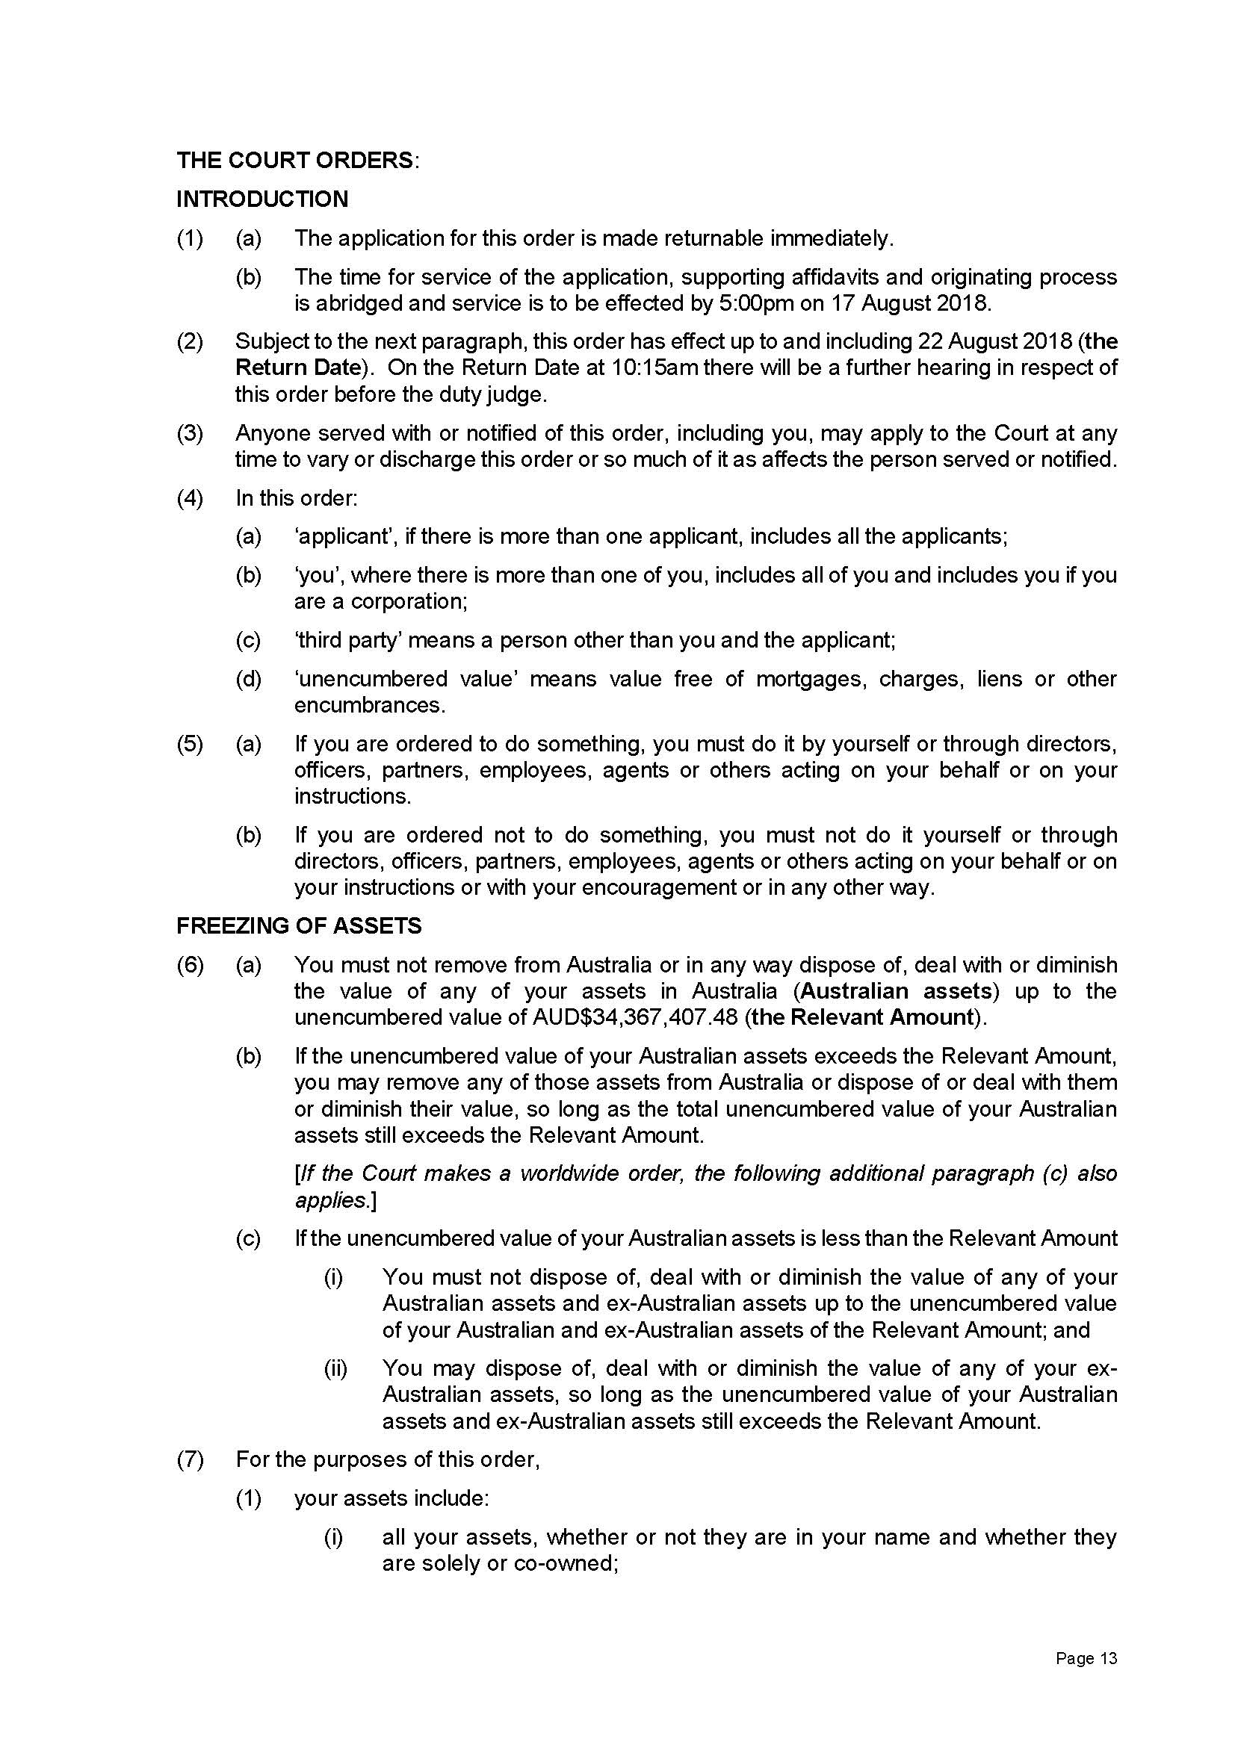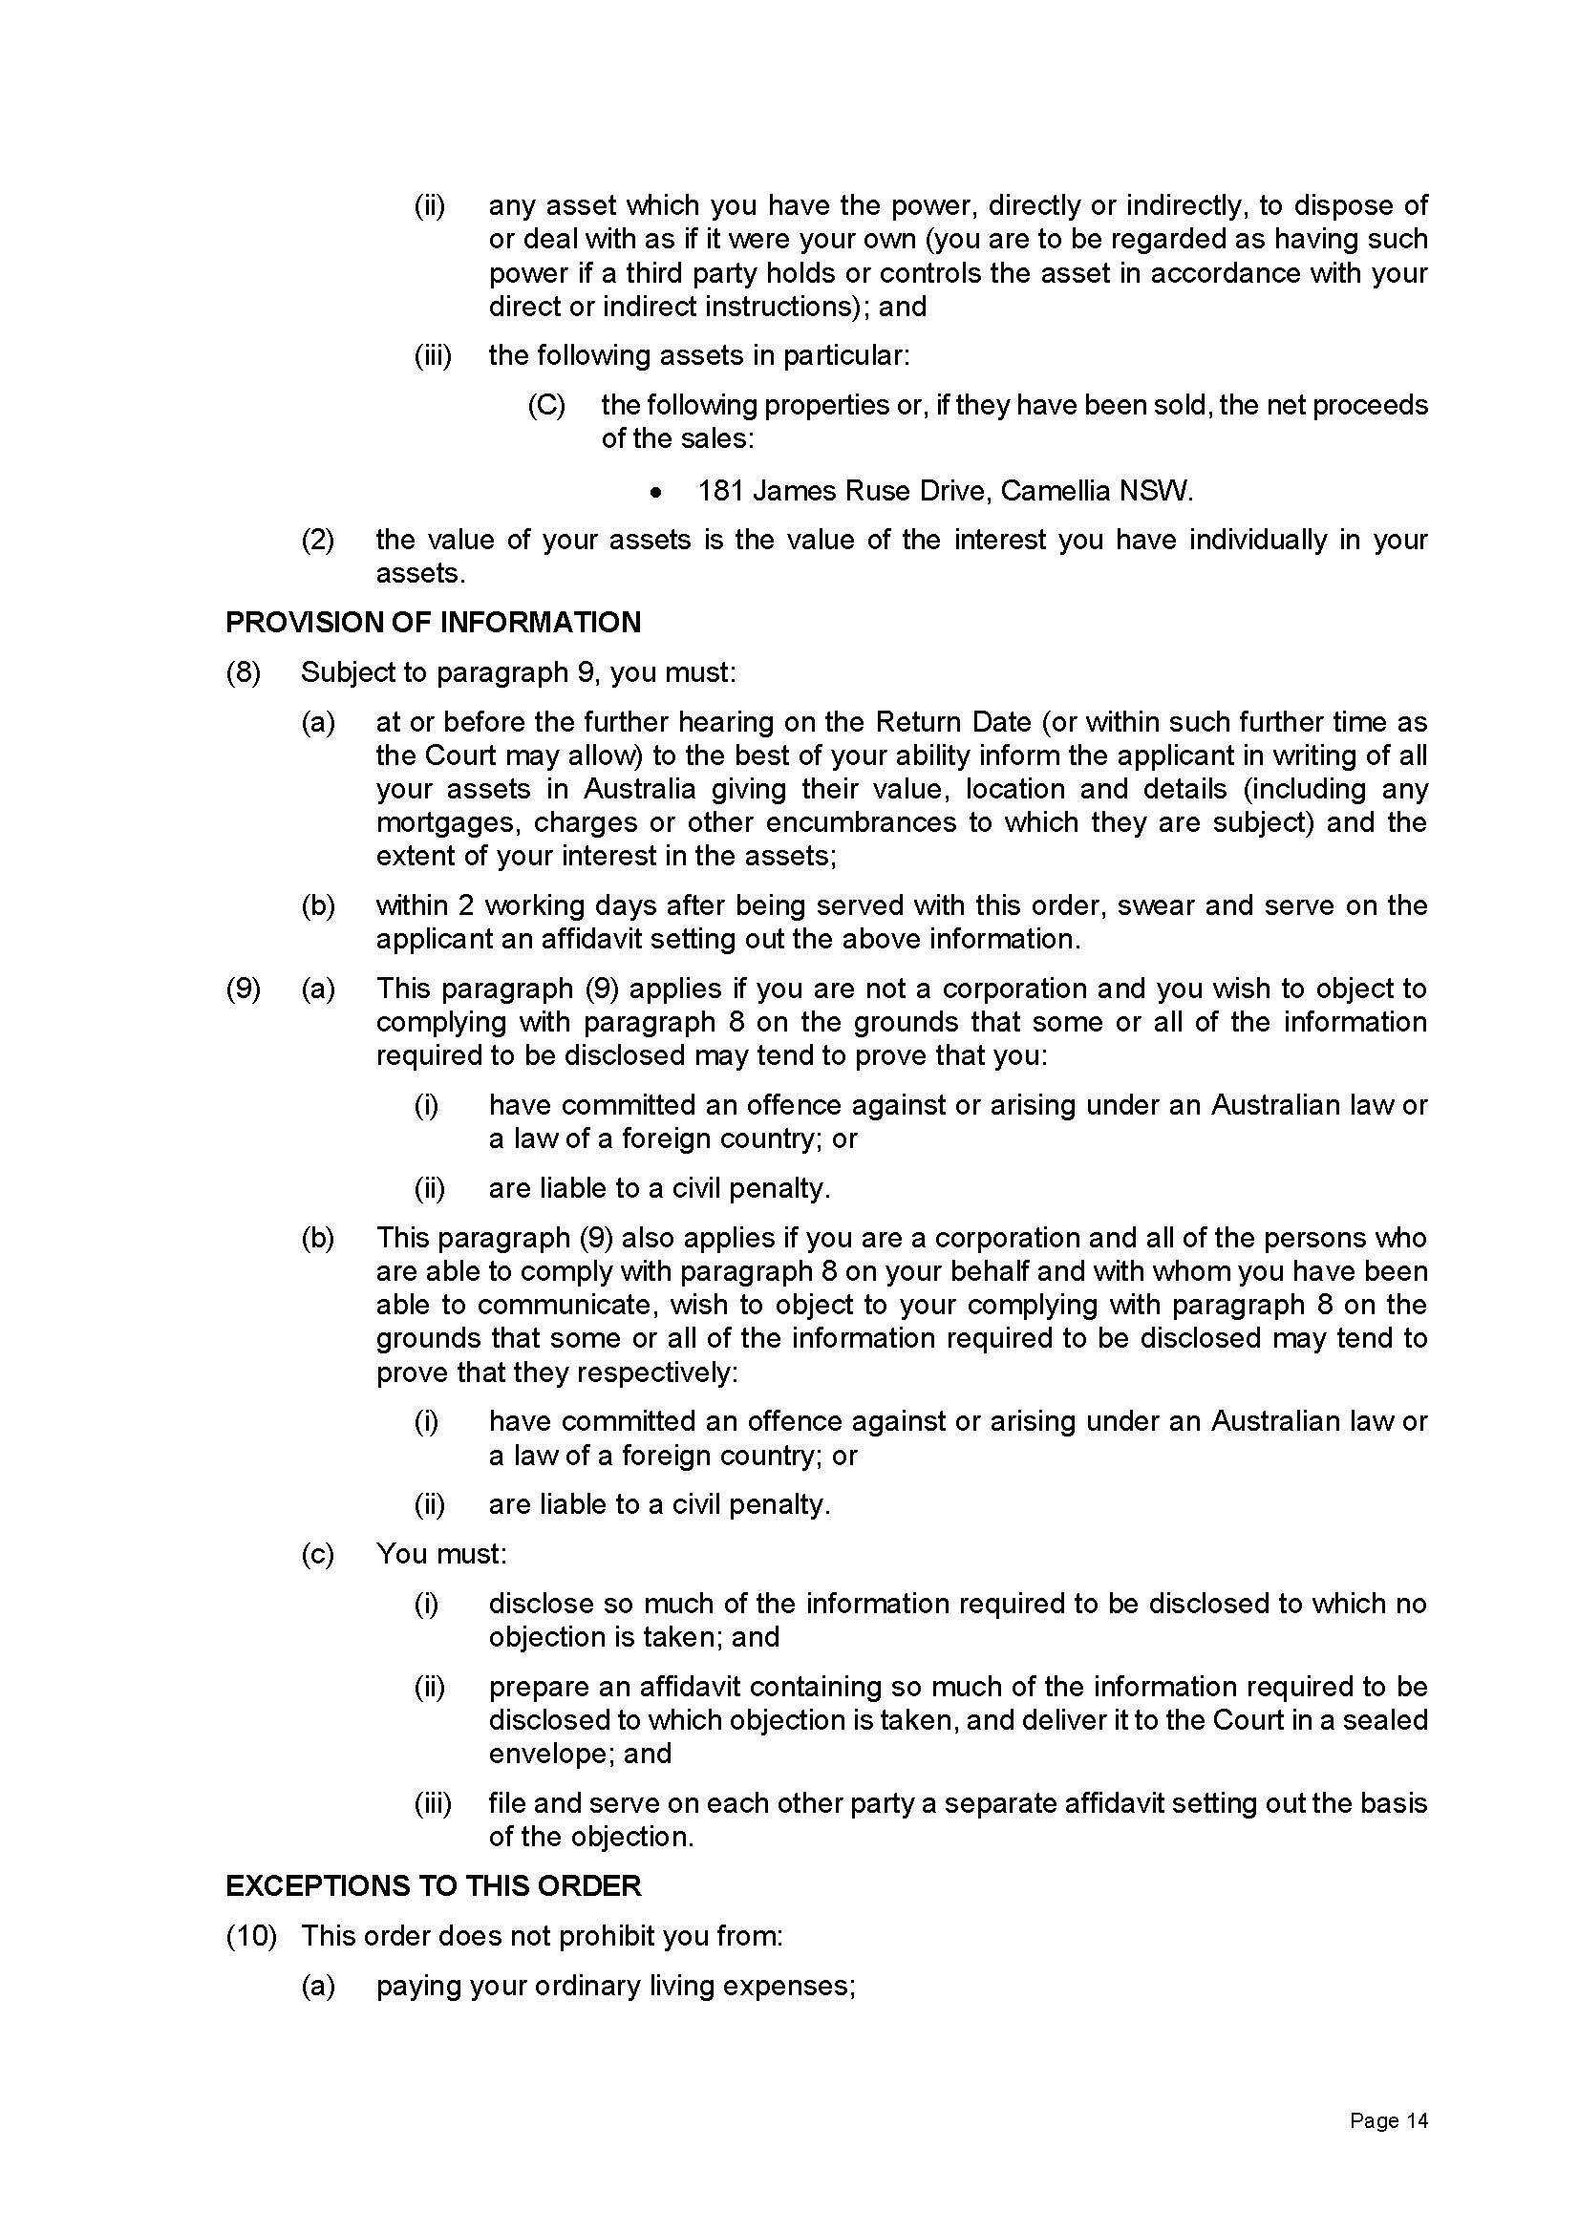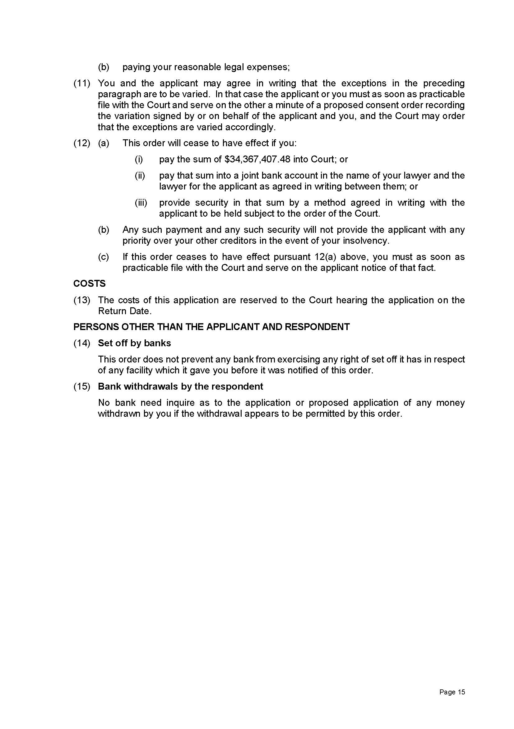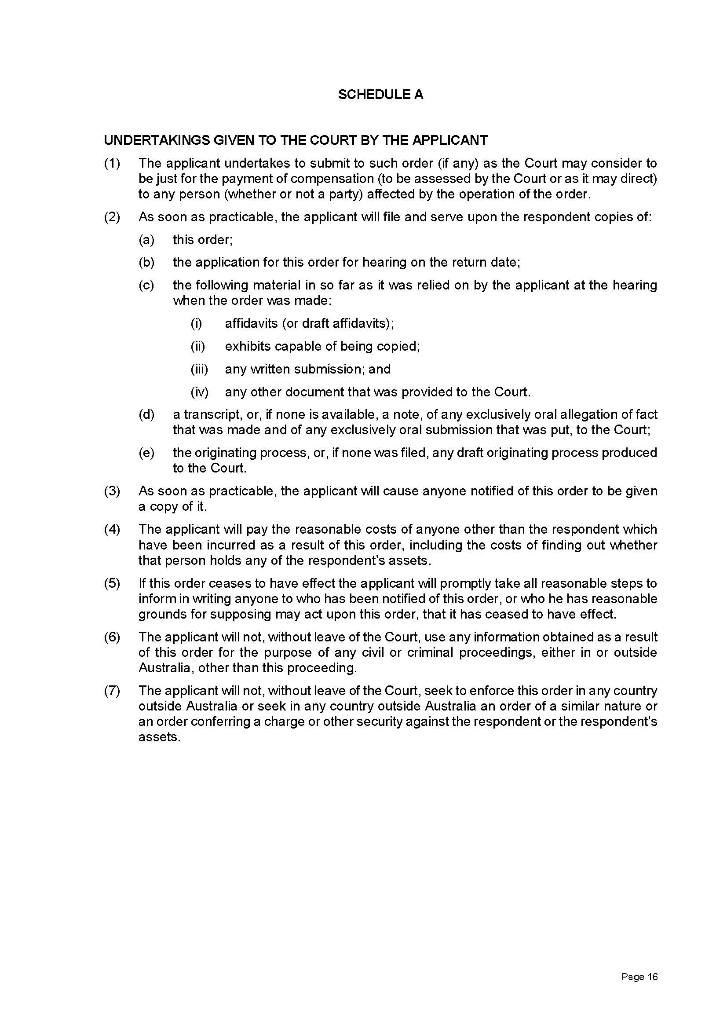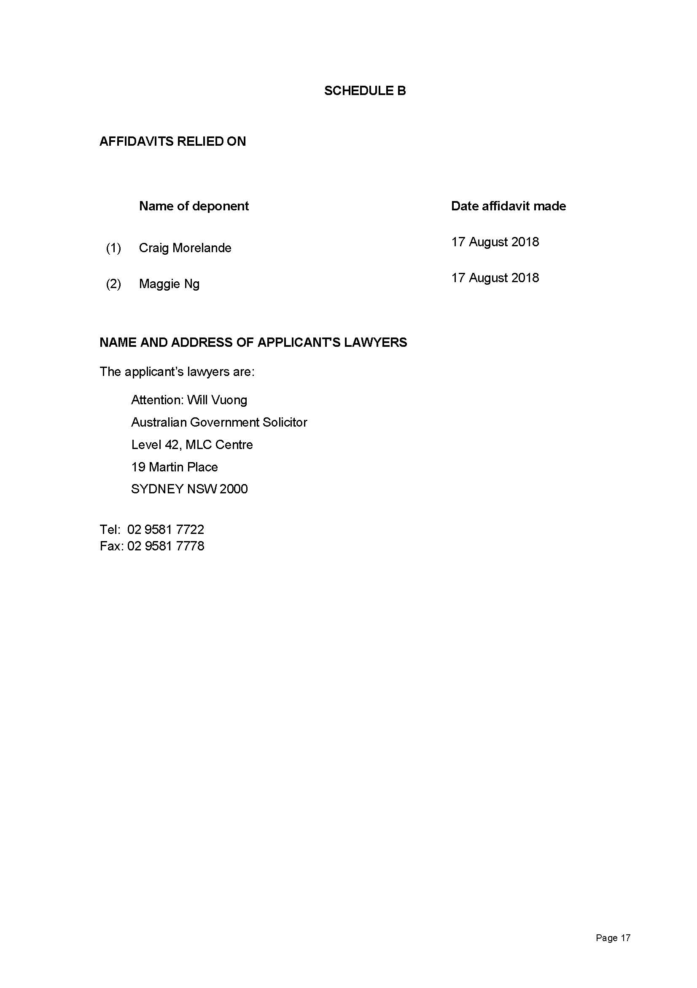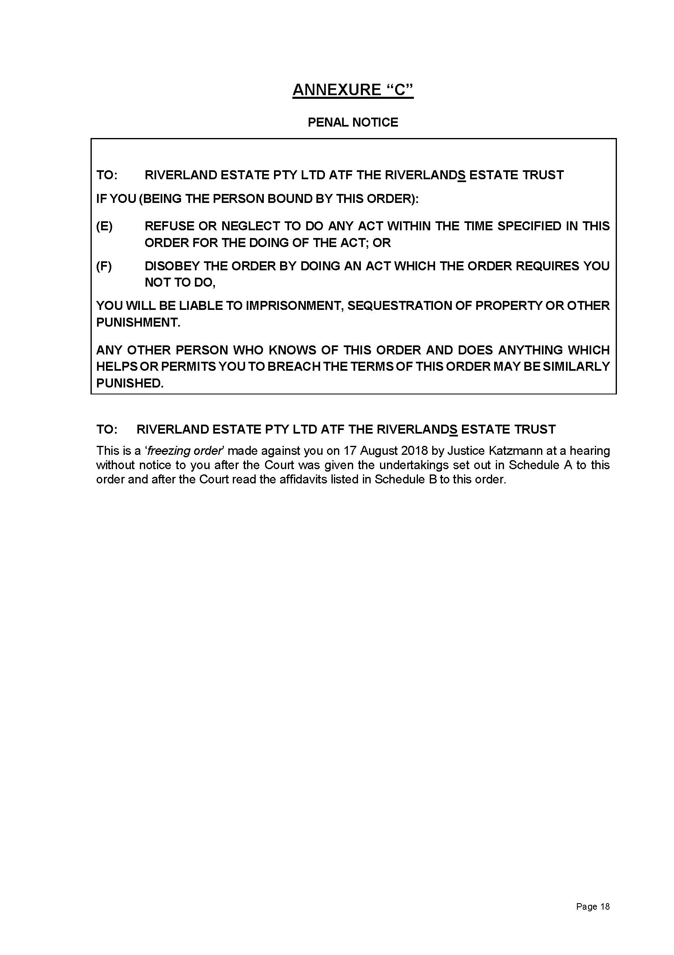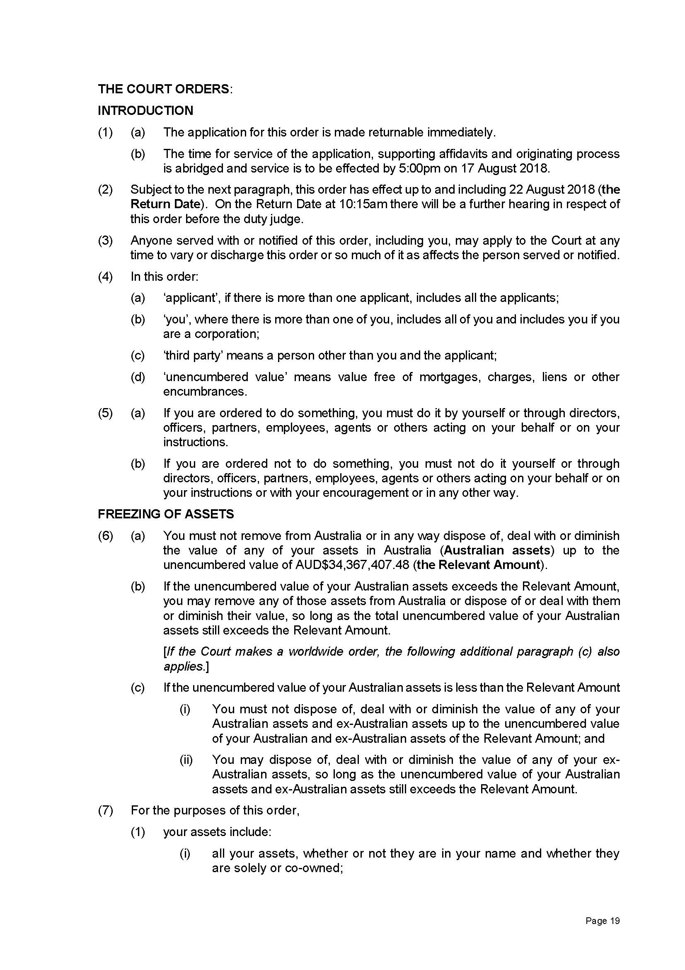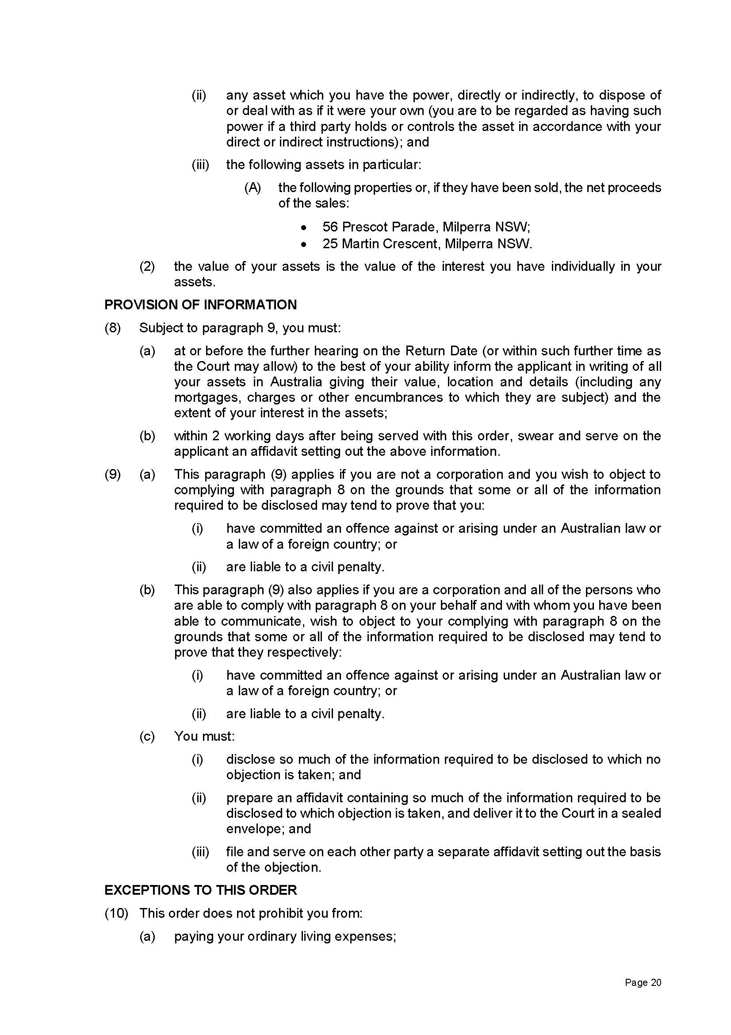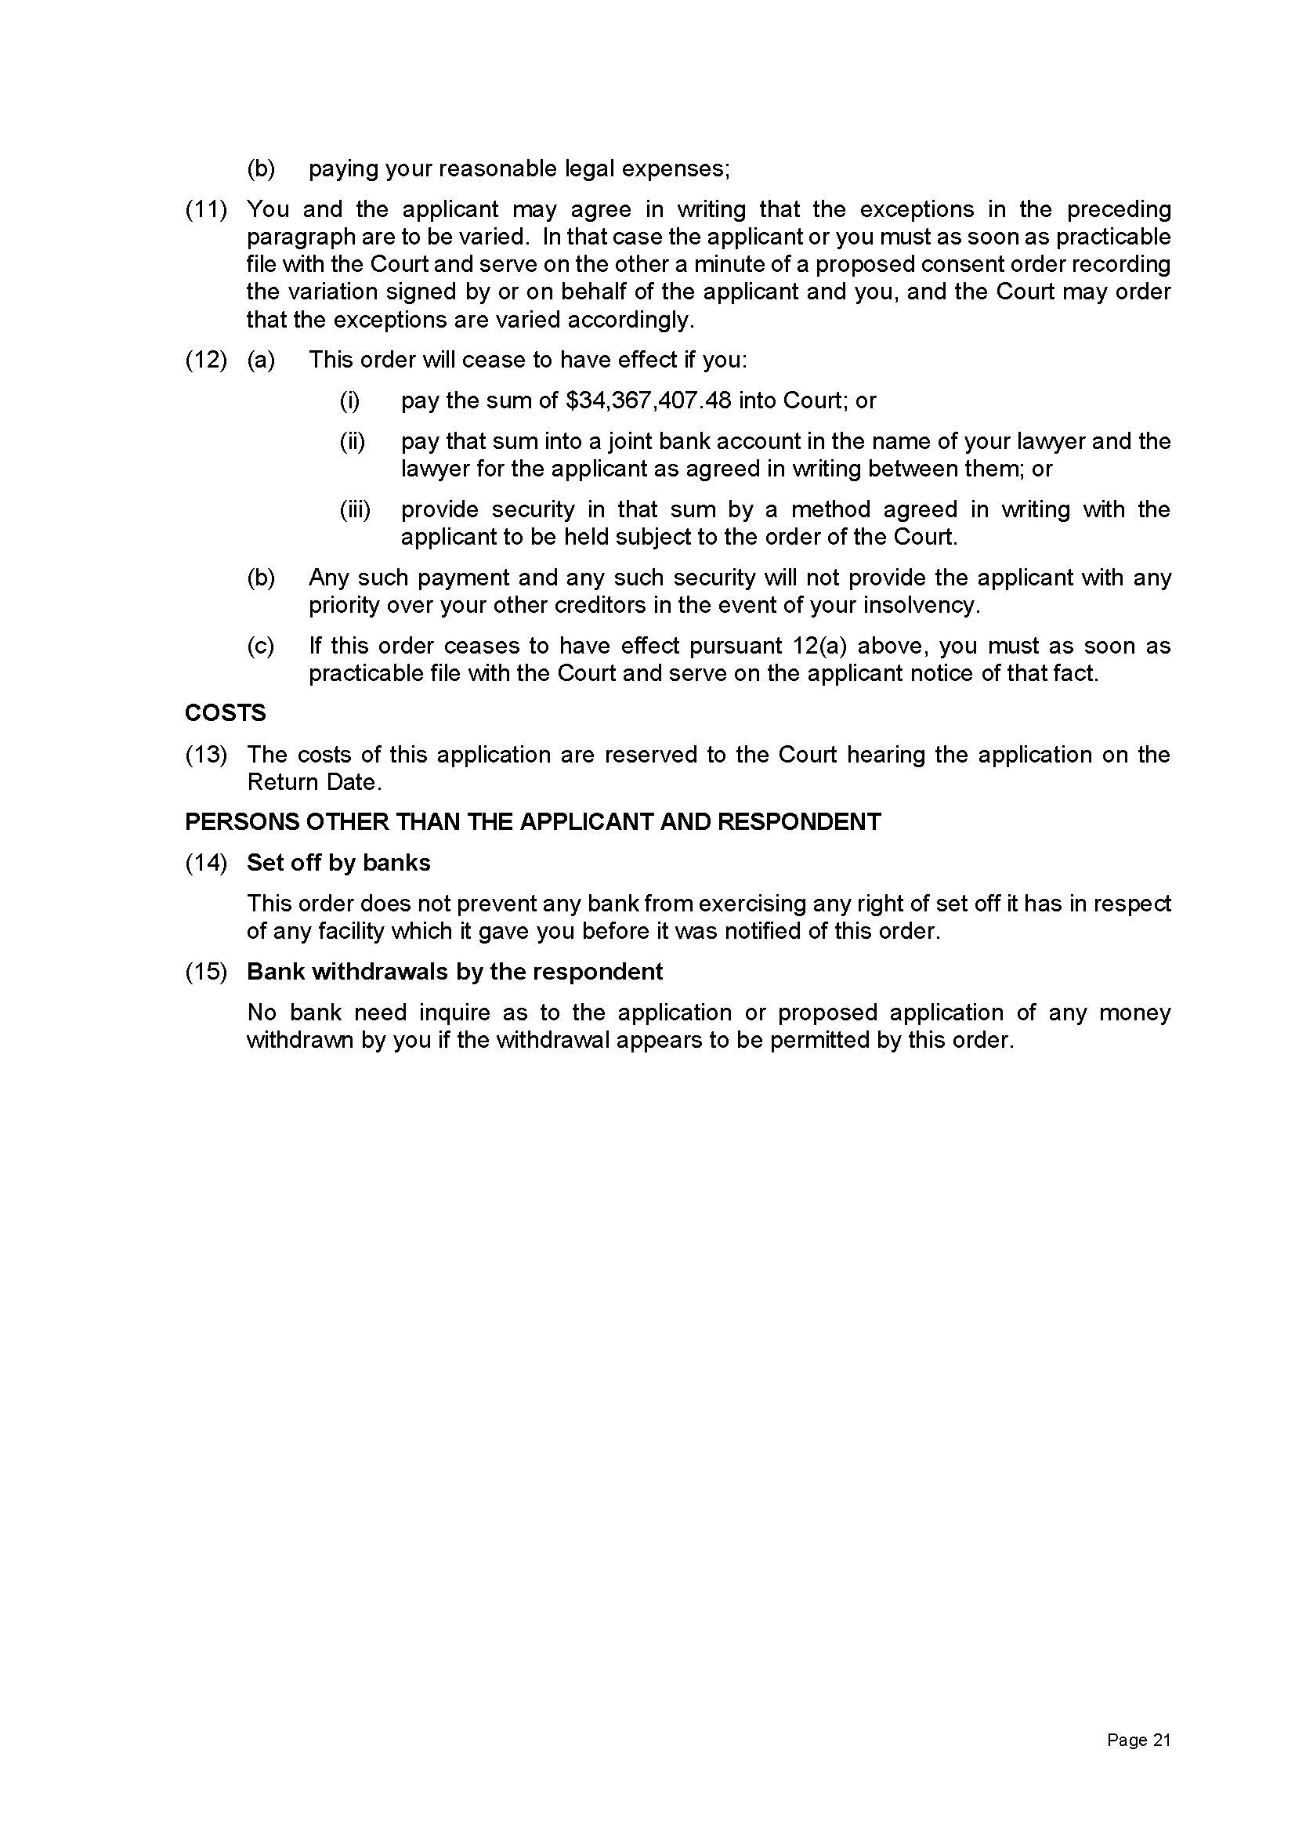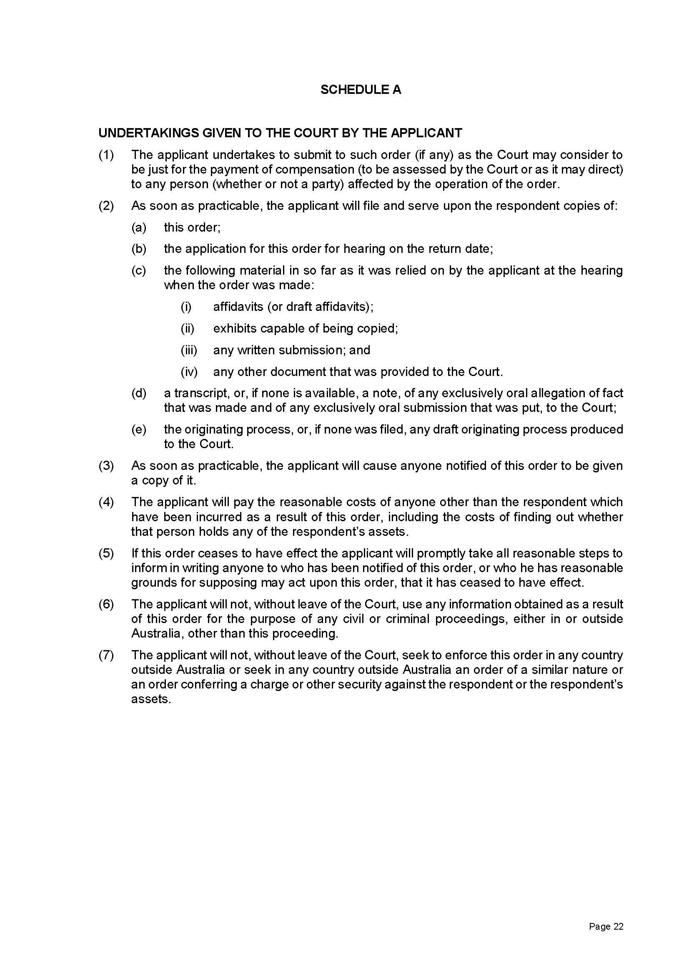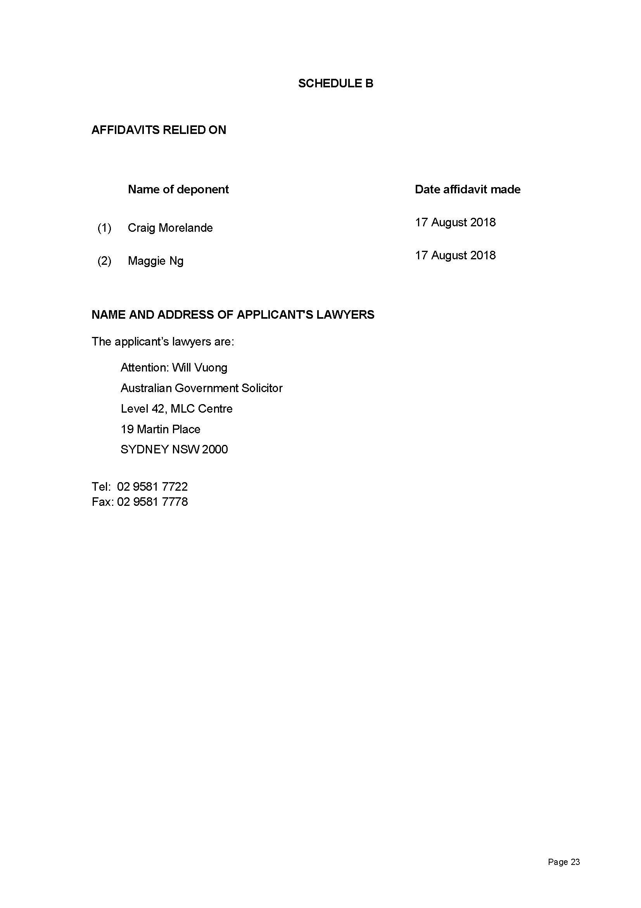

REASONS FOR JUDGMENT
- Charbel Demian is a property developer. He is also a director of a number of companies within a group of companies that bears his name (the Demian Group). He is the sole director and shareholder of several of those companies, including Advanced Holdings Pty Ltd (Advanced Holdings), Summer Hill Business Estate Pty Ltd, and Riverland Estate Pty Ltd.
- Following an audit into the taxation affairs of Mr Demian and the Demian Group and in reliance on information contained in documents provided to the Australian Taxation Office (ATO) by the accountants for the Demian Group during the course of the audit, the Commissioner of Taxation assessed the tax liabilities of the members of the Demian Group and issued notices of assessment. Objections were lodged by several of the companies in the group including Advanced Holdings (purportedly in its capacity as the trustee of The Demian Trust). Certain objections were allowed, others disallowed and, earlier this year, notices of appeal were filed against the Commissioner’s objection decisions under Pt IVC of the Taxation Administration Act 1953 (Cth) (TAA). Those proceedings are pending in the Court.
- On 17 August 2018 the Commissioner issued notices of amended assessment on Advanced Holdings for the 2013 and 2014 financial years (Amended Assessments), together with a notice of shortfall penalty (Penalty Notice). The total amount due is over $34.3 million.
- The same day the Deputy Commissioner filed an originating application in this Court seeking judgment in the amounts due under the Amended Assessments and the Penalty Notice.
- Included in the originating application were various claims for interlocutory relief. In short, the interlocutory relief the Deputy Commissioner sought consisted of freezing orders against Advanced Holdings, Summer Hill Business Estate Pty Ltd as trustee for the Camellia Estate Trust (Summer Hill) and Riverland Estate Pty Ltd as trustee for the Riverlands Estate Trust (Riverland) and orders restraining Summer Hill and Riverland from creating or issuing any new units or approving the transfer of any units in their respective trusts, amending the trust deeds, or retiring as trustees of their respective trusts without giving 14 days’ written notice to the Deputy Commissioner.
- The originating application was supported by two affidavits. The first was affirmed by Craig Morelande, who is employed by the ATO as a Senior Technical Leader, Significant Debt Management. Exhibited to that affidavit were two lever arch files of documents. The second was affirmed by Maggie Ng, a computer forensics officer employed in the Forensics and Investigations team of the ATO. Exhibited to that affidavit was one lever arch file of documents.
- I heard the application for interlocutory relief late in the afternoon of the day the originating application was filed. The application was made without notice to the respondents. On the basis of the material to which I was taken by senior counsel for the Deputy Commissioner and brief oral evidence adduced at the hearing, and with the considerable assistance of both written and oral submissions, I was satisfied that I had the power to make the orders and that the interests of justice and the balance of convenience favoured that course. Accordingly, I made orders in the terms the Deputy Commissioner sought. Given the lateness of the hour, however, I indicated I would give my reasons later. These are those reasons.

The power to make the orders sought
- The Deputy Commissioner relied on the powers conferred on the Court by rr 7.32 and 7.35 of the Federal Court Rules 2011 (Cth) (FCR or Rules), which appear in Div 7.4 of the Rules, although r 7.36 makes it clear that nothing in Div 7.4 “diminishes the inherent, implied or statutory jurisdiction of the Court” to make a freezing or ancillary order.
- Rule 7.32 provides as follows:
7.32 Freezing order
(1) The Court may make an order (a freezing order), with or without notice to a respondent, for the purpose of preventing the frustration or inhibition of the Court’s process by seeking to meet a danger that a judgment or prospective judgment of the Court will be wholly or partly unsatisfied.
(2) A freezing order may be an order restraining a respondent from removing any assets located in or outside Australia or from disposing of, dealing with, or diminishing the value of, those assets.

- Rule 7.35 concerns judgment debtors, prospective judgment debtors, and certain third parties. Since no judgment has been entered against Advanced Holdings, it is not a judgment debtor but a prospective judgment debtor. No judgment is sought against either of the other respondents but r 7.34 enables the Court to make a freezing order or an ancillary order against a person even if that person is not a party in a proceeding in which substantive relief is sought against one who is.

- Rule 7.35 relevantly provides that:
7.35 Order against judgment debtor or prospective judgment debtor or third party
(1) This rule applies if:
…
(b) an applicant has a good arguable case on an accrued or prospective cause of action that is justiciable in:
(i) the Court; …
…
(2) This subrule applies to a judgment if there is a sufficient prospect that the judgment will be registered in or enforced by the Court.
(3) …
(4) The Court may make a freezing order or ancillary order or both against a … prospective judgment debtor if the Court is satisfied, having regard to all the circumstances, that there is a danger that a … prospective judgment will be wholly or partly unsatisfied because any of the following might occur:
…
(b) the assets of the… prospective judgment debtor or another person are:
(i) removed from Australia or from a place inside or outside Australia; or
(ii) disposed of, dealt with or diminished in value.
(5) The Court may make a freezing order or an ancillary order or both against a person other than a… prospective judgment debtor (a third party) if the Court is satisfied, having regard to all the circumstances, that:
(a) there is a danger that a… prospective judgment will be wholly or partly unsatisfied because:
(i) the third party holds or is using, or has exercised or is exercising, a power of disposition over assets (including claims and expectancies) of the… prospective judgment debtor; or
(ii) the third party is in possession of, or in a position of control or influence concerning, assets (including claims and expectancies) of the… prospective judgment debtor; or
(b) a process in the Court is or may ultimately be available to the applicant as a result of a judgment or prospective judgment, under which process the third party may be obliged to disgorge assets or contribute toward satisfying the judgment or prospective judgment.
(6) Nothing in this rule affects the power of the Court to make a freezing order or ancillary order if the Court considers it is in the interests of justice to do so.

The applicant has a good arguable case on an accrued or prospective cause of action justiciable in this Court
- I was satisfied that the Deputy Commissioner has a good arguable case for the final relief he seeks for the following reasons.
- First, an applicant has “a good arguable case” if he has “a reasonably arguable case on legal and factual matters”: Insolvency Guardian Melbourne Pty Ltd v Carlei (2016) 111 ACSR 236; [2016] FCA 72 at [18] (Edelman J); Cardile v LED Builders Pty Ltd (1999) 198 CLR 380 at [68] (Gaudron, McHugh, Gummow and Callinan JJ).
- It is beyond doubt that the Deputy Commissioner has a good arguable case on both legal and factual matters.
- Copies of the Amended Assessments and Shortfall Penalty are in evidence.
- The particulars of assessment were summarised in a table in Mr Morelande’s affidavit:
Year ending | Type | Amount | Date issued | Date payable
30 June 2013 | Amended Assessment | $10,208,174.81 | 17 August 2018 | 7 September 2018
30 June 2013 | Shortfall penalty | $7,209,552.15 | 17 August 2018 | 7 September 2018
30 June 2014 | Amended Assessment | $9,596,200.32 | 17 August 2018 | 7 September 2018
30 June 2014 | Shortfall penalty | $7,353,480.20 | 17 August 2018 | 7 September 2018
Total |  | $34,367,407.48
- Production of a notice of assessment under a taxation law is conclusive proof that the assessment was properly made and, except in proceedings under Pt IVC of the TAA, that the amounts and particulars of the assessment are correct: TAA Sch 1 s 350-10 item 2.
- Second, a certificate under s 255-45 of Sch 1 of the TAA dated 17 August 2018 bearing the stamped signature of the Deputy Commissioner was included in the exhibit to Mr Morelande’s affidavit. It certified, amongst other things, that the Amended Assessments and the Penalty Notice were issued and served on Advanced Holdings. Section 255-45 provides that such a certificate, bearing the signature of the Deputy Commissioner, is prima facie evidence of such matters. Further, Mr Morelande stated that the Amended Assessments and Penalty Notice were served by hand at the offices of LCI Partners Pty Ltd, Level 3/239 Church Street Parramatta which is the registered office of all the respondents as disclosed by the records of the Australian Securities and Investment Commission exhibited to Mr Morelande’s affidavit. I interpolate that LCI Partners is a firm of “accountants, advisors, and consultants” apparently retained for some years by Mr Demian and the companies he controls. Mr Vuong testified that he had instructed a paralegal to serve the documents on Advanced Holdings at the above address and that she had confirmed by text message received at 1.03 pm that she had carried out his instructions.
- On the assumption that service of the Amended Assessments and Penalty Notice is valid, the case the Deputy Commissioner brings arises on an accrued cause of action because a cause of action in debt accrues to the Commissioner against a taxpayer upon service of the notice of assessment: Batagol v Federal Commissioner of Taxation (1963) 109 CLR 243 at 251–2 (Kitto J). Due service of a notice of assessment is “a condition precedent” to the creation of a liability to pay the tax assessed: Federal Commissioner of Taxation v Naidoo (1981) 55 FLR 245 at 256 (Everett J). If service of the Amended Assessments was not valid, however, the issuing of the Amended Assessments gives the Deputy Commissioner a prospective cause of action in debt against Advanced Holdings (the prospective judgment debtor): Deputy Commissioner of Taxation v Hua Wang Bank Berhad (2010) 273 ALR 194; 80 ATR 449; [2010] FCA 1014 at [18] (Kenny J).
- Third, non-compliance, if any, with the provisions of the Income Tax Assessment Act 1936 (Cth) (ITAA) does not affect the validity of the assessments: ITAA, s 175.
- Fourth, the Commissioner or the Deputy Commissioner may sue in a court of competent jurisdiction to recover any tax liability that is due to the Commonwealth and payable to the Commissioner: TAA, Sch 1, s 255-5. This Court is such a court; it has original jurisdiction, amongst other things, in a matter arising under a law of the Parliament: Judiciary Act 1903 (Cth), s 39B(1A)(c). As Gordon J put it in Deputy Commissioner of Taxation v Vasiliades (2014) 323 ALR 59; (2014) 99 ATR 799; [2014] FCA 1250 at [42], taxation “[a]ssessments owe their existence to federal law and depend upon federal law for their enforcement”. It follows that the cause of action is justiciable in this Court.

Sufficient prospect that the judgment will be registered in or enforced by the Federal Court of Australia
- There is sufficient prospect that the judgment will be registered in or enforced by the Court.

Danger that a prospective judgment will be wholly or partly unsatisfied
- The purpose of an order of this kind is to prevent an abuse or frustration of the court process by depriving the applicant of the fruits of the action: Jackson v Sterling Industries Ltd (1987) 162 CLR 612 at 625 (Deane J). Something more than a bare assertion is required: Ninemia Maritime Corporation v Trave Schiffahrtsgesellschaft and Co KG (The Niedersachsen) [1983] 1 WLR 1412 at 1419; [1984] 1 All ER 413 at 417 (Kerr LJ). It is “no light matter” to impose a freeze on the assets of a person so courts must be sensitive to the need for caution: Patterson v BTR Engineering (Aust) Ltd (1989) 18 NSWLR 319 at 324F (Gleeson CJ). Indeed, a freezing order has been aptly described as “a drastic remedy” which should not lightly be granted: Frigo v Culhaci (unreported; NSW Court of Appeal, 17 July 1998) at 10–11 (Mason P, Sheller JA and Sheppard AJA), cited with approval by the plurality in Cardile at [51].
- But the danger that a prospective judgment will be wholly or partially unsatisfied because the assets of the prospective judgment debtor or those of another person are removed from Australia or from a place inside or outside Australia or that the prospective judgment debtor would more probably than not dispose of, deal with or diminish the value of its assets need not be established on the balance of probabilities. Nor is it necessary that there be evidence that it had any such intention. See, for example, Hua Wang at [8]–[10]; Deputy Commissioner of Taxation v Chemical Trustee Ltd (No 4) (2012) 19 ATR 711; [2012] FCA 1064 at [23]–[24] (Perram J); and Patterson at 325C–D (Gleeson CJ).
- In the present case I was satisfied that there was such a danger because the evidence before the Court established that Advanced Holdings had the ability to divest itself of its assets and the incentive to do so and that there is reason to believe that in the recent past, in his dealings with the Commissioner and for the purpose of defeating the Commissioner’s interests, the sole director of Advanced Holdings dishonestly engaged in conduct of this very kind.
- First, the assets in this case consist of units in the trusts. The trust deeds for both the Camellia Estate Trust and the Riverlands Estate Trust exhibited to Mr Morelande’s affidavit show that Advanced Holdings owns 100% of the units in each trust. As the Deputy Commissioner argued, this gives the company effective ownership of the underlying assets of the trusts. Under the terms of both deeds, Advanced Holdings may require the trustee to terminate the trust merely by notifying the trustee that it is to terminate on a specified date (cl 95), in which case the trustee is obliged to realise the assets of the trust (cl 96). As a unit holder, it may apply to the trustee to redeem one or more units (cl 31). If it does so, within 90 days of the redemption the trustee is required to pay it the redemption price (cl 35) which may be effected through a transfer to it of the assets of the trust (cl 36). Although the trustee has an absolute discretion whether or not to accept an application for redemption (cl 32), as the owner of 100% of the units Advanced Holdings may remove a trustee any time “in accordance with law or by passing a special resolution” (cl 88).
- The powers vested in Advanced Holdings provide the means by which the company could dispose of, deal with, or diminish the value of its assets. As the Deputy Commissioner submitted, Advanced Holdings may dispose of its units in the trusts or take steps to result in a reduction in their value by borrowing against their security, by causing the trustees to issue new units to other entities, thereby diluting the value of the existing units, or by exercising its power as 100% unit holder to cause the trustees to dispose of the trusts’ assets.
- Mr Moreland’s affidavit contains an illustration of conduct of this nature only last year by another entity controlled by Mr Demian, Mt Lewis Estate Pty Ltd, after it was served with a statutory demand for the payment of a tax debt of $627,441.78. Mt Lewis was the registered proprietor of a property in Punchbowl, NSW. Seventeen days after Mt Lewis had been served with the statutory demand, the Punchbowl property was sold to the brother of a principal in the firm of lawyers that has represented the Demian Group in various proceedings against the Deputy Commissioner.
- Second, the amount of the liability to the Commissioner is a considerable one. That would give the respondents an incentive or motive to act as the Deputy Commissioner fears.
- Third, it appears from the evidence that Mr Demian, Advanced Holdings, and other entities Mr Demian controls have engaged in dishonest conduct intended to defeat the interests of the Commissioner. Evidence of dishonest behaviour or avoidance of liability on the part of a prospective judgment debtor may give rise to an inference that there is “a real and not fanciful risk” that it may try to dissipate or dispose of assets unless freezing orders are made: Deputy Commissioner of Taxation v Ma (2017) 106 ATR 773; [2017] FCA 1317 at [18] (Mortimer J).
- That conduct is set out at length in Mr Morelande’s affidavit and supplemented by the evidence of Ms Ng. For the purpose of the present application, and although his written submissions went further, at the hearing the Deputy Commissioner was content to rely on one instance of this kind of behaviour which came to light after the seizure of documents during the audit. It is reasonable to infer from this evidence that, unless restrained, Advanced Holdings would not be likely to preserve the assets of the company intact so that they might be available to its prospective judgment creditor: Patterson at 325–6 (Gleeson CJ).
- The facts are a little complicated.
- One of the entities in the Demian Group is Lewisham Estate Trust (LET). LET is a fixed unit trust that was settled on 1 May 2003. Advanced Holdings was the initial unit holder of the trust. It had paid $10 for 100 units — all the units in the trust. The corporate trustee of the trust is Lewisham Estate Pty Limited. On 8 July 2014 LET lodged an income tax return for the 2013 financial year. The return described LET’s main business activity as “renting or leasing of non-residential buildings as owner or leaseholder”.
- The return disclosed a gross income of $48,806,231, derived in part from rental income and income from the sale of two properties. LET claimed various deductions which resulted in an income of $10,817,178. It represented that 50% of its net income had been distributed to The Demian Trust and the other 50% to Abacus Funds Management Ltd. A month earlier, on 6 June 2014, The Demian Trust lodged its income tax return. It represented that it had distributed the money it had received from LET in various proportions to four companies: Tramdell Pty Ltd, Charles Apartments Pty Ltd, Ramsey Gardens Pty Ltd, and Merchant Project Marketing Pty Ltd (the primary beneficiaries). Mr Demian is the director of Tramdell and owns 99 of the ordinary shares, Hoda Demian, who is apparently Mr Demian’s wife, the other ordinary share. Mr Demian is also the sole director of Charles Apartments and Merchant Project Marketing and Hoda Demian the sole shareholder of both. Mr Demian is the sole director and shareholder of Ramsey Gardens.
- The returns filed by each of the primary beneficiaries for the 2013 financial year disclosed as part of their assessable income the amounts said to have been distributed to them in the tax return filed by The Demian Trust. Each of them purportedly had “carry forward losses” identical to the amount purportedly distributed to it by The Demian Trust. Consequently, according to their tax returns, none of them was liable to pay any tax in relation to these distributions.
- On 17 December 2013 Mr Demian was notified that an audit had begun into his tax affairs and that the audit would cover his related entities, including LET. The audit of the taxation affairs of The Demian Trust and LET began in August 2014.
- On 8 January 2015 the Deputy Commissioner issued Mr Gerardo Incollingo, the principal of LCI Partners, with a notice pursuant to s 264 of the ITAA requiring him “to provide details of the information and documentation relied upon to determine the unit holders reported in the 2013 income tax return in the statement of distribution lodged for [LET]”.
- Mr Incollingo replied to the notice by email dated 10 March 2015. Attached to the email were four documents including:
- a document entitled “Unit Certificate – Lewisham Estate Unit Trust” bearing Mr Demian’s signature and dated 15 May 2003, which purported to certify that Demian Holdings Pty Ltd as trustee of The Demian Trust was the registered holder of 100 units in LET (Unit Certificate); and
- a document entitled “The Fourth Schedule Hereinbefore Referred To Transfer Unit Trust”, also bearing Mr Damien’s signature and dated 15 May 2003, which purported to record the transfer of 100 units in LET from Advanced Holdings to Demian Holdings for consideration of $100 (Transfer Form).
- Mr Demian is the sole director and also the secretary of Demian Holdings Pty Ltd (Demian Holdings), the sole shareholder of which is Hoda Demian.
- The evidence indicates that both these documents were created in 2015, during the course of the Commissioner’s audit and after LCI Partners received the letter from the Deputy Commissioner, and that representations made in them and in Mr Incollingo’s email were accordingly false.
- On 14 December 2017 documents were seized from a number of premises associated with LCI Partners pursuant to search warrants obtained by the Australian Federal Police. Some of the documents obtained under the search warrants related to members of the Demian Group. The Commissioner later issued a notice under s 353-10 of the TAA to the ATO officer who had custody of those documents, and those documents were provided to the ATO’s audit team.
- The documents provided to the audit team included a number of emails passing between employees of LCI Partners and other professional advisors who were retained by the Demian Group in connection with the ATO audit.
- Amongst other things, those emails indicate that the Unit Certificate and the Transfer Form attached to Mr Incollingo’s email of 10 March 2015 were created in February 2015 and backdated to give the appearance that the documents came into existence in May 2003. It will be recalled that those documents were supplied by Mr Incollingo in response to the Deputy Commissioner’s request made in January 2015 for documentation relied upon to determine the unit holders reported in the 2013 income tax return lodged by LET.
- So much is apparent from the emails passing between Steven Amorello, a Senior Accountant at LCI Partners, and Mr Incollingo. It is also apparent from the evidence of Ms Ng, who, earlier this month, reviewed the electronic documents and analysed the metadata, which, as she said, shows “the digital footprint of when a document was created or modified”.
- The evidence also reveals that multiple drafts of both the Unit Certificate and the Transfer Form were created and circulated in February 2015.
- On 19 February 2015, for example, Mr Amorello wrote to Mr Incollingo asking him to look at a Unit Certificate and a Transfer document. The Unit Certificate relevantly read:
This is to certify that DEMIAN HOLDINGS PTY LIMITED A.C.N. 082 158 049 of 29 Sixth Avenue Loftus NSW 2232 is the registered holder of 100 Unit(s) of $1.00 in THE DEMIAN UNIT TRUST …

- These documents are unsigned.
- Ms Ng’s evidence establishes that this document was created on 18 and 19 February 2015. Different versions of the document were created on 24 February 2015, when the address was changed to “2-20 Carnarvon Street, Silverwater NSW 2125” (version 2), at 11.08 am on 27 February 2015 when “2-20” became “2/24” and the signatures of Mr Demian and Mr David Smedley (as witness), together with the date 15 May 2003 (in an apparently different hand), were added (version 3), and at 12.46 pm when the words “ATF The Demian Trust” were inserted and “Lewisham Estate Unit Trust” was substituted as the trust (version 4). This was the Unit Certificate attached to Mr Amorello’s email of 10 March 2015. It relevantly read:

This is to certify that DEMIAN HOLDINGS PTY LIMITED A.C.N. 082 158 049 ATF The Demian Trust of 2/24 Carnarvon Street, Silverwater NSW 2125 is the registered holder of 100 Unit(s) of $1.00 in LEWISHAM ESTATE UNIT TRUST …

- Ms Ng’s evidence is that this document was created on 27 February 2015.
- The other document Mr Amorello forwarded to Mr Incollingo was a form of transfer dated 15 May 2003 providing for the transfer to Advanced Holdings by Mr Demian of “100 units of the Company constituted by the Trust Deed dated the 15th day of May 2003 and made between Advanced Holdings Pty Ltd and Demian Holdings Pty Ltd”. Ms Ng’s evidence is that this document was created on 19 February 2015. A later version adding “Demian Holdings Pty Ltd” as transferor was created on 24 February 2015 (version 2). The signatures of Mr Demian and Mr Smedley appear on another version created at 11.08 am on 27 February 2015 (version 3). The final version produced to the Deputy Commissioner on 10 March 2015 swapped the names of the transferor and transferee (version 4). Ms Ng deposed that this version was created at 12.46 pm on 27 February 2015.
- At 2.27pm on 24 February Mr Incollingo emailed Mr Amorello asking him:
How is the ATO and Charlie going?
Is the paperwork ready to send?

- I infer from the context and a number of other documents mentioned in Mr Morelande’s affidavit that “Charlie” is Charbel Demian.
- Mr Amorello replied:
I’ve been trying to contact Charlie but he hasn’t answered or got back to me.
I’m chasing the business address from 2003 financial year … and then I can send over to you to review.

- Seven minutes later Mr Incollingo replied, telling Mr Amorello that he needed to send a text message “telling him that it is URGENT!!”
- At 3.59 pm Mr Amorello wrote to Mr Incollingo:
Find attached the Unit Holders documents for your review…
I confirmed the business address with Charlie.
Let me know if you need anything else.

- At 10.37 am on 26 February 2015 Mr Amorello emailed Mr Incollingo advising him that he had contacted “Charlie” the previous day “for signing of the Unit Holder documents”, that he said he would come past the office to sign, but that he did not turn up. Mr Amorello lamented that he had tried to contact “Charlie” twice that day but said that he had not received a response.
- At 10.57 am on 27 February 2015 Mr Amorello forwarded to Mr Incollingo a number of documents including version 3 of the Unit Certificate and the Transfer Form, both bearing the signatures of Mr Demian and Mr Smedley.
- The final versions of the Unit Certificate and Transfer Form that were produced to the Deputy Commissioner on 10 March 2015 were scanned at 12.55 pm on 27 February 2015 and emailed to Mr Incollingo the same day.

Extent of the orders
- The freezing orders extend to real property held by the Camellia Estate Trust and the Riverlands Estate Trust or to the proceeds of sale of those properties. Mr Moreland’s evidence reveals that the Camellia Estate Trust is the registered proprietor of a 6.8 hectare property in Camellia which is zoned for business use and upon which the trust proposes to build over 3,250 residential units and retail properties. The Demian Group valued the property in about October 2017 at $325 million. That evidence also reveals that Riverlands Estate Trust has substantial property holdings which, on the Group’s own assessment, are worth more than $200 million.
- Under the terms of the Camellia Estate Trust and Riverlands Estate Trust deeds, as I mentioned earlier, Advanced Holdings, being the sole unit holder, has the right to terminate the trusts and to compel the realisation of trust property. As the Deputy Commissioner submitted, the effect of those deeds is that Advanced Holdings has rights that are akin to those of a beneficial owner of the underlying trust assets. In the circumstances, the assets of those trusts are assets of Advanced Holdings over which it exercises a power of disposition: FCR 7.35(5)(a). Alternatively, through a process in the Court which might ultimately be available to the Deputy Commissioner as a result of a prospective judgment, the trustees may be obliged to disgorge those assets or contribute towards satisfying the prospective judgment: FCR 7.35(5)(b).

The interests of justice and the balance of convenience
- In all the circumstances, I considered that the interests of justice and the balance of convenience favoured the making of the freezing orders sought against all respondents.
- In reaching that conclusion, I took into account the following matters.
- First, the Deputy Commissioner has a strong case for final relief.
- Second, in the absence of freezing orders there is a real danger that assets will be dissipated.
- Third, the freezing orders are limited to the amount of the liabilities of Advanced Holdings to income tax, penalties, and interest.
- Fourth, the position of the respondents will be protected by the undertaking as to damages given by the Deputy Commissioner through his counsel.
- Fifth, I granted the respondents liberty to apply on one day’s notice. Moreover, the matter will be back before the Court tomorrow (or, if the parties agree, soon afterwards) at which time the respondents will have the opportunity to make any application to discharge or vary the orders. As Edelman J observed in Carlei at [29], this is one way in which an order can, and should be narrowed to protect the interests of respondents.
- Sixth, the orders were largely in the form of the orders set out in the current practice note. It deviated from the form by failing to include a carve-out for dealings with assets in the normal course of business. I accepted the Deputy Commissioner’s submission that this was appropriate in the circumstances because, if there were such a carve-out, the respondents might be able to create new units in the unit trusts or do other things which would defeat the purpose of the freezing orders.
- Seventh, I was unaware of any discretionary matters that would militate against the making of the orders.

Postscript
- In the course of preparing these reasons, I discovered minor errors in the names of the second and third respondents as they appeared in the originating application which were repeated in the orders sought and made. This morning, after those errors were drawn to his attention, the Deputy Commissioner applied for leave to file an amended originating application correcting the errors in the originating application and for orders to be made nunc pro tunc under FCR 39.05 correcting the errors in the orders. Rule 39.05 entitles the Court to vary an order after it has been entered, amongst other reasons, if the order is interlocutory, as these orders were.
- I granted the Deputy Commissioner leave to file the amended originating application and made the orders he sought in chambers. The errors were obviously inadvertent, no doubt a product of the haste with which the application was brought. Both the orders of 17 August and those made today appear at the front of this judgment.
I certify that the preceding seventy-one (71) numbered paragraphs are a true copy of the Reasons for Judgment herein of the Honourable Justice Katzmann.

Associate:

Dated: 21 August 2018

