FEDERAL COURT OF AUSTRALIA

Optus Mobile Pty Ltd v Telstra Corporation Limited [2018] FCA 745

File number: | NSD 759 of 2018
Judge: | GLEESON J
Date of judgment: | 23 May 2018
Catchwords: | CONSUMER LAW – whether respondent’s advertisements breached Australian Consumer Law (Sch 2 to the Competition and Consumer Act 2010 (Cth)) – misleading or deceptive conduct – false or misleading representations – conduct liable to mislead as to nature or characteristics of services – whether advertisements conveyed nothing, merely provoking “wonderment”, or whether ordinary and reasonable consumers would understand word “Unlimited” as connected to words “Australia’s best mobile network” and the respondent’s logo and therefore referable to usage and/or geographic coverage of respondent’s mobile network – whether representations so conveyed false where respondent offers “unlimited” plan relevantly subject to device restrictions and speed throttling once data usage allowance exceeded – contraventions found
Legislation: | Australian Consumer Law (Sch 2 to the Competition and Consumer Act 2010 (Cth)) ss 18, 29, 34
Cases cited: | Australian Competition and Consumer Commission v Singtel Optus Pty Ltd [2010] FCA 1177  Australian Competition and Consumer Commission v Singtel Optus Pty Ltd [2011] FCA 87  Australian Competition and Consumer Commission v TPG Internet Pty Ltd [2013] HCA 54; (2013) 250 CLR 640  Campomar Sociedad, Limitada v Nike International Limited [2000] HCA 12; (2000) 202 CLR 45  McWilliam’s Wines Pty Ltd v McDonalds System of Australia Pty Ltd [1980] FCA 159; (1980) 49 FLR 455  Medical Benefits Fund of Australia Ltd v Cassidy (2003) 205 ALR 402  Parkdale Custom Built Furniture v Puxu Pty Ltd [1982] HCA 44; (1982) 149 CLR 191  REA Group Limited v Fairfax Media Limited [2017] FCA 91  Reckitt Benckiser (Australia) Pty Limited v Procter & Gamble Australia Pty Ltd [2015] FCA 753  Singtel Optus v Telstra [2004] FCA 859  St Lukes Health Insurance v Medical Benefits Fund of Australia Ltd (1995) 17 ATPR 41-428  Taco Co of Australia Inc v Taco Bell Pty Ltd [1982] FCA 170; (1982) 42 ALR 177  Telstra Corporation Ltd v Singtel Optus Pty Ltd [2014] VSC 35  Tobacco Institute of Australia Limited v Australian Federation of Consumer Organisations Inc (No 2) (1993) 41 FCR 89
Date of hearing: | 18 May 2018
Registry: | New South Wales
Division: | General Division
National Practice Area: | Commercial and Corporations
Sub-area: | Regulator and Consumer Protection
Category: | Catchwords
Number of paragraphs: | 111
Counsel for the Applicant: | Mr R Lancaster SC with Mr D Roche
Solicitor for the Applicant: | Clayton Utz
Counsel for the Respondent: | Mr A McGrath SC with Mr T Sherman
Solicitor for the Respondent: | King & Wood Mallesons

ORDERS
 |  | NSD 759 of 2018
BETWEEN: | OPTUS MOBILE PTY LTD (ACN 054 365 696)  Applicant
AND: | TELSTRA CORPORATION LIMITED (ACN 051 775 556)  Respondent

JUDGE: | GLEESON J
DATE OF ORDER: | 23 May 2018

THE COURT DECLARES THAT:

- By publishing, broadcasting, communicating and/or otherwise distributing advertisements of the kind described in para 26 of the affidavit of Jeremy Anthony Nicholas affirmed 15 May 2018 (“Mr Nicholas’s affidavit”) and advertisements substantially similar to those advertisements including the advertisement on the Telstra website homepage containing the words “One word from Australia’s best mobile network. Unlimited”, which falsely convey the representation that Telstra offers a mobile product or service that is unlimited in the sense that Telstra imposes no limitations on:
  - the speed at which data can be downloaded;
  - the volume of data that can be downloaded at unrestricted speeds; and
  - the user’s ability to download data without interruption or delay,
the respondent has engaged in and is engaging in conduct that is misleading or deceptive and likely to mislead or deceive in contravention of s 18 of the Australian Consumer Law in Schedule 2 to the Competition and Consumer Act 2010 (Cth) (“Australian Consumer Law”).
- By publishing, broadcasting, communicating and/or otherwise distributing advertisements of the kind described in para 26 of Mr Nicholas’s affidavit, and advertisements substantially similar to those advertisements including the advertisement on the Telstra website homepage containing the words “One word from Australia’s best mobile network. Unlimited”, which falsely convey the representation that Telstra offers a mobile product or service that is unlimited in the sense that Telstra imposes no limitations on:
  - the speed at which data can be downloaded;
  - the volume of data that can be downloaded at unrestricted speeds; and
  - the user’s ability to download data without interruption or delay,
the respondent has engaged in and is engaging in conduct that is liable to mislead the public as to the nature or the characteristics of the respondent’s mobile network services in contravention of s 34 of the Australian Consumer Law.
- By publishing, broadcasting, communicating and/or otherwise distributing advertisements of the kind described in para 26 of Mr Nicholas’s affidavit, and advertisements substantially similar to those advertisements including the advertisement on the Telstra website homepage containing the words “One word from Australia’s best mobile network. Unlimited”, which falsely convey the representation that Telstra offers a mobile product or service that is unlimited in the sense that Telstra imposes no limitations on:
  - the speed at which data can be downloaded;
  - the volume of data that can be downloaded at unrestricted speeds; and
  - the user’s ability to download data without interruption or delay,
and that may be used on any kind of mobile device that can operate through Telstra’s mobile network, the respondent has engaged in and is engaging in conduct that is misleading or deceptive and likely to mislead or deceive in contravention of s 18 of the Australian Consumer Law.
- By publishing, broadcasting, communicating and/or otherwise distributing advertisements of the kind described in para 26 of Mr Nicholas’s affidavit, and advertisements substantially similar to those advertisements including the advertisement on the Telstra website homepage containing the words “One word from Australia’s best mobile network. Unlimited”, which falsely convey the representation that Telstra offers a mobile product or service that is unlimited in the sense that Telstra imposes no limitations on:
  - the speed at which data can be downloaded;
  - the volume of data that can be downloaded at unrestricted speeds; and
  - the user’s ability to download data without interruption or delay,
and that may be used on any kind of mobile device that can operate through Telstra’s mobile network, the respondent has engaged in and is engaging in conduct that is liable to mislead the public as to the nature or the characteristics of the respondent’s mobile network services in contravention of s 34 of the Australian Consumer Law.
- By publishing, broadcasting, communicating and/or otherwise distributing the advertisement on the Telstra website homepage containing the words “One word from Australia’s best mobile network. Unlimited”, which falsely conveys a representation that Telstra offers a “SIM-only plan for $69/mth” that has the particular quality of being unlimited in the sense in the sense that Telstra imposes no limitations on:
  - the speed at which data can be downloaded;
  - the volume of data that can be downloaded at unrestricted speeds; and
  - the user’s ability to download data without interruption or delay,
the respondent has made and is making a false representation that the services provided under that plan are of a particular quality in contravention of s 29(1)(b) and (g) of the Australian Consumer Law.
- By publishing, broadcasting, communicating and/or otherwise distributing advertisements of the kind described in para 26 of Mr Nicholas’s affidavit, and advertisements substantially similar to those advertisements including the advertisement on the Telstra website homepage containing the words “One word from Australia’s best mobile network. Unlimited”, which falsely convey the representation that Telstra’s mobile network provides unlimited geographical coverage throughout Australia, the respondent has engaged in and is engaging in conduct that is misleading or deceptive and likely to mislead or deceive in contravention of s 18 of the Australian Consumer Law.
- By publishing, broadcasting, communicating and/or otherwise distributing advertisements of the kind described in para 26 of Mr Nicholas’s affidavit, and advertisements substantially similar to those advertisements including the advertisement on the Telstra website homepage containing the words “One word from Australia’s best mobile network. Unlimited”, which falsely convey the representation that Telstra’s mobile network provides unlimited geographical coverage throughout Australia, the respondent has engaged in and is engaging in conduct that is liable to mislead the public as to the nature or the characteristics of the respondent’s mobile network services in contravention of s 34 of the Australian Consumer Law.

THE COURT ORDERS THAT:

- The proceeding be listed for hearing of the applicant’s claims for further relief.
- The respondent pay the applicant’s costs of the proceeding to date.

Note: Entry of orders is dealt with in Rule 39.32 of the Federal Court Rules 2011.

REASONS FOR JUDGMENT
GLEESON J:
- Since early May 2018, the respondent (“Telstra”) has conducted an advertising campaign across Australia centred around the use of the word “unlimited”. The campaign is connected with Telstra’s “Endless Data BYO Plan”. The campaign is designed primarily to drive interest in that plan.
- The advertisements in issue in this proceeding (“Telstra Unlimited advertisements”) have been displayed in billboard format in metropolitan areas and in digital media format on the Telstra internet homepage and the social networking websites Facebook, Instagram, LinkedIn and Twitter. In each case, the advertisements use the following words:
One word from Australia’s best mobile network.
Unlimited.
- In every relevant instance, the word “Unlimited” comprises a single word sentence or is displayed in a separate frame or image.
- Also in every relevant instance, the word “Unlimited” appears in the context of text below or near it proposing action which may be taken by any reader or viewer who seeks further information. The exact proposed action depends on the particular format of the advertisement. Thus, for billboards and outdoor street furniture (such as bus stops), the accompanying text is “Visit us today”. For digital media, the accompanying text is hyperlinked words (Find out more/Learn more/Link in bio) or a link such as “https://nkd.in.g-t36ad”, each of which takes the viewer to a web landing page on which further information can be found about the “Telstra Endless Data BYO Plan”, The advertisements and the “Telstra Endless Data BYO Plan” are described in more detail below.

Optus’s claim
- The applicant (“Optus”) contends that, by the use of the word “unlimited” without any qualification in the Telstra Unlimited advertisements, Telstra conveys the following representations (or one or more of them):
(1) Telstra offers a mobile product or service that is unlimited in the sense that there are no limitations on:
(a) the speed at which data can be downloaded;
(b) the volume of data that can be downloaded at unrestricted speeds;
(c) the user’s ability to download data without interruption or delay; [and]
(d) the type of mobile device (i.e. mobile phone or tablet) on which the product or service can be used.
(2) Telstra has a mobile network that provides unlimited geographical coverage throughout Australia, wherever the user is located.
- Although the alleged representations are concerned only with downloads, the evidence suggested that the issues raised by Optus concerned both downloads and uploads. However, I have restricted my consideration to the representations as stated in Optus’s concise statement.
- I will refer to the representations in (1) as the “unlimited service representations”, and the representation in (2) as the “unlimited coverage representation”.
- Optus contends that, by engaging in the conduct described above, Telstra has contravened the following provisions of Schedule 2 to the Competition and Consumer Act 2010 (Cth), the Australian Consumer Law (“ACL”):
- Telstra has engaged in conduct that is misleading or deceptive, or likely to mislead or deceive, in contravention of s 18 of the ACL;
- Telstra has, in connection with the possible supply of services or in connection with the promotion by any means of the supply or use of goods or services, made false or misleading representations that the services are of a particular standard, quality, value or grade, in contravention of s 29(b) of the ACL, and made false or misleading representations that the services have performance characteristics or benefits, in contravention of s 29(g) of the ACL; and
- Telstra has engaged in conduct that is liable to mislead the public as to the nature, the characteristics, the suitability for their purpose or the quantity of services, in contravention of s 34 of the ACL.

Telstra’s defence
- Telstra denies that the Telstra Unlimited advertisements convey the representations alleged by Optus. Telstra contends that the word “Unlimited” in the context of the surrounding words and imagery in the advertisements conveys “nothing definitive, doing no more than [to] cause a viewer to wonder about its meaning”.
- Mr Jeremy Nicholas, Telstra’s Executive Director of Brand Consumer and Business Marketing, was the senior executive put forward by Telstra to give evidence in connection with the Telstra Unlimited advertising campaign. Mr Nicholas described the advertisements as “teasers” that do not convey a clear message or statement to consumers, but rather “foster intrigue and arouse attention through consumer curiosity”.
- If conveyed, Telstra did not admit that the unlimited service representation is false, submitting that Optus’s evidence did not prove the representation’s falsity. The nature of the products and services provided by Telstra is a matter within its own knowledge. A litigant should not put an opposing party to proof of a matter that is within its own knowledge, particularly one that has sought and been given an early final hearing, because it tends to impose an unnecessary burden on the Court to resolve issues that are not genuinely in dispute. For reasons set out below, I am satisfied that, if conveyed, the unlimited service representation is false.
- Telstra does accept that the unlimited coverage representation, if made, is false.

Legal framework
- The relevant legal framework was not in dispute.
- By s 18(1) of the ACL, a person must not, in trade or commerce, engage in conduct that is misleading or deceptive or is likely to mislead or deceive.
- Section 29(1) provides, relevantly:
(1) A person must not, in trade or commerce, in connection with the supply or possible supply of goods or services or in connection with the promotion by any means of the supply or use of goods or services:
...
(b) make a false or misleading representation that services are of a particular standard, quality value or grade; or
…
(g) make a false or misleading representation that goods or services have sponsorship, approval, performance characteristics, accessories, uses or benefits;
...
- While s 29(1)(b) and (g) each use the expression “false or misleading” rather than “misleading or deceptive” (as in s 18(1)), there is no meaningful difference between these expressions: Australian Competition and Consumer Commission v Coles Supermarkets Australia Pty Ltd [2014] FCA 634; (2014) 317 ALR 73 at [40] per Allsop CJ.
- Section 34 provides:
A person must not, in trade or commerce, engage in conduct that is liable to mislead the public as to the nature, the characteristics, the suitability for their purpose or the quantity of any services.
- The following principles, which I set out in Reckitt Benckiser (Australia) Pty Limited v Procter & Gamble Australia Pty Ltd [2015] FCA 753 at [34]-[38] are relevant to an assessment of Telstra’s conduct in this case:
[34] The applicable legal principles in respect of misleading or deceptive conduct in advertising are well-established. They are summarised in the recent decisions of Allsop CJ in Australian Competition and Consumer Commission v Coles Supermarkets Australia Pty Ltd [2014] FCA 634; (2014) 317 ALR 73 (“ACCC v Coles”) at [35]-[47] and Nicholas J in Samsung Electronics Australia Pty Ltd v LG Electronics Australia Pty Ltd [2015] FCA 227 (“Samsung v LG”) at [60]-[76].
[35] A two-step analysis is required, addressing the following issues:
(1) whether each or any of the pleaded representations is conveyed by the advertisement; and
(2) whether each of the representations conveyed is false, misleading or deceptive or likely to mislead or deceive: Novartis Pharmaceuticals Australia Pty Ltd v Bayer Australia Ltd [2015] FCA 35 at [200].
[36] The causing of confusion or questioning is insufficient; it is necessary to establish that the ordinary or reasonable consumer is likely to be led into error: ACCC v Coles at [39].
[37] It is necessary to view the conduct as a whole and in its proper context (ACCC v Coles at [41]). The question whether conduct is misleading or deceptive or likely to mislead or deceive is a question of fact that must be determined in light of the relevant surrounding circumstances: Samsung v LG per Nicholas J at [61], applying Butcher v Lachlan Elder Realty Pty Ltd [2004] HCA 60; (2004) 218 CLR 592 at [109] per McHugh J. The dominant message will be of crucial importance: ACCC v Coles at [42], citing Australian Competition and Consumer Commission v TPG Internet Pty Ltd [2013] HCA 54; (2013) 250 CLR 640 (“TPG”) at [45].
[38] In Samsung v LG at [73], Nicholas J referred to the following observations of Hill J in Tobacco Institute of Australia Ltd v Australian Federation of Consumer Organisations Inc [1992] FCA 630; (1992) 38 FCR 1 at 50, albeit in the context of a newspaper advertisement:
Where, as in the present case, the advertisement is capable of more than one meaning, the question of whether the conduct of placing the advertisement in a newspaper is misleading or deceptive conduct must be tested against each meaning which is reasonably open. This is perhaps but another way of saying that the advertisement will be misleading or likely to mislead or deceive if any reasonable interpretation of it would lead a member of the class, who can be expected to read it, into error.
- In the case of representations to the public, “[t]he initial question which must be determined is whether the misconceptions, or deceptions, alleged to arise or to be likely to arise are properly to be attributed to the ordinary or reasonable members of the classes of prospective purchasers”: Campomar Sociedad, Limitada v Nike International Limited [2000] HCA 12; (2000) 202 CLR 45 (“Campomar”) at [105]. Reactions that are extreme or fanciful are excluded: Campomar at [105]; REA Group Limited v Fairfax Media Limited [2017] FCA 91 at [18] (“REA Group”).
- Conduct is misleading or deceptive, or likely to mislead and deceive, if it has a tendency to lead into error: Australian Competition and Consumer Commission v TPG Internet Pty Ltd [2013] HCA 54; (2013) 250 CLR 640 (“TPG”) at [39].
- Telstra submitted that an advertisement that merely causes “wonderment” is not misleading or deceptive. In Taco Co of Australia Inc v Taco Bell Pty Ltd [1982] FCA 170; (1982) 42 ALR 177 (“Taco Bell”) at 201, Deane and Fitzgerald JJ decided that the “question whether particular conduct causes confusion or wonderment cannot be substituted for the question whether the conduct answers the statutory description contained in s 52 [of the Trade Practices Act 1974 (Cth), the predecessor to s 18 of the ACL]”. That statement was affirmed by the High Court of Australia in Campomar at [106]. Taco Bell and Campomar were each cases concerned with whether an association between unrelated traders had been misrepresented. Similarly, in Parkdale Custom Built Furniture v Puxu Pty Ltd [1982] HCA 44; (1982) 149 CLR 191 at 198, Gibbs CJ affirmed the conclusion of Smithers and Fisher JJ in McWilliam’s Wines Pty Ltd v McDonalds System of Australia Pty Ltd [1980] FCA 159; (1980) 49 FLR 455 that to prove misleading or deceptive conduct it is not enough to establish that the conduct complained of was confusing or caused people to wonder whether two products may have come from the same source.
- The fact that some persons among the relevant class of consumers might eventually learn the true nature of Telstra’s mobile service offerings upon visiting a Telstra store, or reading the fine print online, is irrelevant to the question of whether the Telstra Unlimited advertisements are misleading or deceptive. The misleading or deceptive conduct occurs at the time the advertisement is published: Australian Competition and Consumer Commission v Singtel Optus Pty Ltd [2010] FCA 1177 (“Optus Think Bigger Plans case” at [16], citing Singtel Optus v Telstra [2004] FCA 859 at [42]; St Lukes Health Insurance v Medical Benefits Fund of Australia Ltd (1995) 17 ATPR 41-428 at page 40,823; and Medical Benefits Fund of Australia Ltd v Cassidy (2003) 205 ALR 402 at 417 [43]. The provisions of the ACL relied upon by Optus do not contain any limitation about what it is that consumers must be misled into doing to contravene them: cf Optus Think Bigger Plans case at [26].
- In TPG, the High Court of Australia considered advertisements which used the words “Unlimited ADSL2+ $29.99 per month” in the context of a bundling condition by which a consumer was required to rent a home telephone line at an additional charge in order to acquired unlimited ADSL2+ home internet for $29.99 per month. At [48]-[50], the plurality said:
[48] [T]he Full Court did not recognise that the tendency of the advertisements to mislead was to be determined, not by asking whether they were apt to induce consumers to enter into contracts with TPG, but by asking whether they were apt to bring them into negotiation with TPG rather than with one of its competitors on the basis of an erroneous belief engendered by the general thrust of TPG’s message.
[49] It might be said, as TPG did, that consumers, acting reasonably in their own interest, could be expected to obtain a clear understanding of their rights and obligations before signing up with TPG; but to say that is to confuse the question whether the consumer has suffered loss with the anterior question as to whether the advertisement, viewed as a whole, has a tendency to lead a consumer into error. Thus, in Campbell v Backoffice Investments Pty Ltd French CJ noted that the question of characterisation as to whether conduct is misleading is “logically anterior to the question whether a person has suffered loss or damage thereby”. French CJ observed that characterisation of conduct “generally requires consideration of whether the impugned conduct viewed as a whole has a tendency to lead a person into error”. As observed earlier in these reasons, questions of carelessness by consumers in viewing advertisements may be relevant to that question of characterisation.
[50] It has long been recognised that a contravention of s 52 of the TPA may occur, not only when a contract has been concluded under the influence of a misleading advertisement, but also at the point where members of the target audience have been enticed into “the marketing web” by an erroneous belief engendered by an advertiser, even if the consumer may come to appreciate the true position before a transaction is concluded. That those consumers who signed up for TPG’s package of services could be expected to understand fully the nature of their obligations to TPG by the time they actually became its customers is no answer to the question whether the advertisements were misleading.
(Footnotes omitted.)
- Concerning the knowledge of the target audience, the plurality said (at [53] and [54]):
[53] It may be accepted that if the hypothetical reasonable consumer is taken to know that ADSL2+ services may be sold as part of a bundle with telephony services, then, if he or she brings that knowledge to bear in a conscious scrutiny of the terms of TPG’s offer, he or she might be less likely to form the impression that the offer was of an ADSL2+ service available without a requirement to take and pay for an additional service from TPG. But the circumstance that many consumers might know that ADSL2+ services are commonly offered as a “bundle” was not apt to defuse the tendency of the advertisements to mislead, especially where the target audience is left only with the general thrust or dominant message after the evanescence of the advertisement.
[54] As the primary judge said, the vice of TPG’s advertisements was that they required “consumers to find their way through to the truth past advertising stratagems which have the effect of misleading or being likely to mislead them.” Given TPG’s strategy, the primary judge was entitled to draw the inference that consumers might be enticed to enter into negotiation with TPG without appreciating that TPG’s services were, in fact, being offered only as a “bundle”. It is pertinent to note again that “many persons will only absorb the general thrust” and that the question is not whether consumers suffered loss by signing up to a contract to accept and pay for TPG’s service: Campbell v Backoffice Investments Pty Ltd [2009] HCA 25; (2009) 238 CLR 304 at 351-352 [142]- [143].
- In Australian Competition and Consumer Commission v Singtel Optus Pty Ltd [2011] FCA 87 (“Optus Unlimited Broadband case”), North J held (at [57] to [59]) that Optus had engaged in misleading and deceptive conduct by representing that a broadband internet service included “unlimited broadband” when the plan was in fact limited by speed throttling implemented by Optus once consumers reached a specified data allowance as there had been no sufficiently prominent statement:
  - that such a reduction would be applied; and
  - that some multimedia uses would be either unworkable or significantly impaired at the reduced speed.

Evidence

The various advertisements
- Mr Nicholas’s evidence identified the different “executions” of advertisements published as part of the Telstra Unlimited campaign. Each execution includes the Telstra logo. The executions comprise at least the following:
(1) Posters on street furniture. An example was photographed in Victoria Park, Perth on 8 May 2018. The advertisements use the words “One word from Australia’s best mobile network. Unlimited. Visit us today”. Approximately 540 physical sites have displayed this execution since 1 or 2 May 2018.
(2) Digital billboards. Examples were displayed at the Paul Street overpass on Epping Rd, Sydney on 4 May 2018 and at the Epping Rd overpass on Beecroft Rd Epping on 8 May 2018. The advertisements use the same words as (1). There have been digital billboard executions at locations in Melbourne, Sydney, Brisbane, Perth, Adelaide, the Gold Coast and Canberra.
(3) “Programmatic standard display” advertisements, displayed on third party websites (for instance, that of the Guardian Newspaper). In each case, there are two frames. The first frame uses the words “One word from Australia’s best mobile network.” The second frame uses the words “Unlimited.” And a white box containing the words “Learn more”.
(4) A post on Telstra’s Facebook Page, as accessed through a desktop web browser, entitled “The news you’ve been waiting for” with a video of an excited dog overlaid with the words “One word from Australia’s best mobile network”, shown in the evidence by a static screenshot as accessed through a web browser.
(5) A post on Telstra’s Facebook Page, as accessed through the Facebook iPhone application, headed “News so good you’ll scream” accompanied a video of skydivers overlaid with text, shown in the evidence by a static screenshot as accessed through a mobile device. A screen shot annexed to the evidence of Mr Vujcic, assistant general counsel at Optus, includes a screen of the text overlaying the video – namely, the words “One word from Australia’s best mobile network” and “Unlimited”.
(6) A photo posted on Telstra’s Instagram Page, as accessed through the Instagram iPhone application, of a skydiver with the description “One word from Australia’s best network. Unlimited LINK IN BIO”.
(7) A post on Telstra’s Twitter Page headed “News so good you’ll scream”, accompanied by a video of a skydiver and the words “One word from Australia’s best mobile network exchange.telstra.com.au”. This shown in the evidence by a static screenshot of the page as accessed through a desktop web browser.
(8) The same post on Telstra’s Twitter Page referred to in (7), but as accessed through the iPhone web browser “Safari”.
(9) A post on Telstra’s LinkedIn Page, with the words “One word from Australia’s best mobile network. Unlimited. https://lnkd.in/g-T36az” above a photo of a skydiver overlaid with the word “Unlimited” and, under the photograph, “Unlimited data has arrived on Australia’s best mobile network exchange.telstra.com.au”. This is shown in the evidence by a static screenshot of the page as accessed through a desktop web browser.
- Images of these nine executions are annexures 1 to 9, respectively, to these reasons for judgment.
- In the social media executions ((4) to (9) above), the word “Unlimited” follows the words “One word from Australia’s best mobile network”, which are both overlaid on the videos depicting either an excited dog or a person skydiving.
- Each social media execution is accompanied by a link which permits a viewer to click through to a product landing page or a news article landing page, where further information about the “Endless Data BYO Plan” can be found.
- In addition to the “executions” identified by Mr Nicholas, the evidence included photographs of digital advertisements at Top Ryde City Shopping Centre (“Top Ryde”), and Westfield Chatswood Shopping Centre (“Westfield Chatswood”).
- The photographs of the Top Ryde billboard show that the billboard conveyed two messages in sequential frames. The first frame stated in large letters “One word from Australia’s best mobile network” and displayed a Telstra logo in the top right hand corner. The second frame stated in large letters “Unlimited. Visit us today”, again with the Telstra logo in the top right hand corner. The billboard was about three to four metres wide, and seven to eight metres high.
- The photographs of the Westfield Chatswood billboard show that it displayed two frames that are identical to those displayed at Top Ryde.
- Images of the billboard at Top Ryde are annexure 10 to these reasons for judgment.
- Further, the Telstra website homepage at www.telstra.com.au contains a lead image of a couple lying together on grass, with the male apparently listening to content using his phone and the female browsing content on her phone, next to which are the words “One word from Australia’s best mobile network. Unlimited.” Directly beneath this tag line are the words “SIM-only plan for $69/month. Min cost $828 over 12 months”. Beneath those words is a call to action button “Find out more”. This image is different from the other executions of the advertisement in that it explicitly refers to a particular plan.
- A screenshot of the Telstra website homepage, as accessed through a desktop web browser, is annexure 11 to these reasons for judgment.

Use of “unlimited” in advertising mobile network services
- Mr Nicholas explained that the word “unlimited” used in the context of telecommunication products and services is capable of referring, and is used by Telstra and its competitors to refer, to a wide range of different aspects of those products and services, including calls, “texts” (including both short message service (“SMS”) and multimedia messaging service (“MMS”) messages), international roaming, uploads, data volume, access to wireless internet (“Wi-Fi”) hotspots and access to sports and entertainment streaming services. He said, further, “[i]n [his] knowledge and experience, the word “unlimited” has no fixed meaning in the context of telecommunications services and no fixed connection to mobile data services in particular.” That evidence must be understood in the context of the cross-examination set out at [65] below.
- Telstra submitted that the market for telecommunications services is “awash” with the advertising of a wide range of products and services on an unlimited basis, adducing numerous examples of advertisements published by telecommunications companies that employ the word “unlimited”. Typically, these refer to “unlimited data”, “unlimited texts” and/or “unlimited calls”. In at least some cases, the advertisements refer to “unlimited data” without identifying any speed restrictions affecting the consumer’s ability to use the data. However, unlike Telstra’s “Endless Data BYO Plan”, the services so advertised are not subject to any “throttling” of the transmission speed after a certain data allowance is reached, typically being ADSL2+ or NBN home broadband services. In other cases, for instance in the advertisements for Vodafone Hutchison Australia Pty Ltd’s (“Vodafone”) “$60 Unlimited 12 month SIM only plan”, it is clearly stated that a user’s access to “unlimited data” is affected by speed “throttling” after a certain data allowance is reached.

Transmission speed
- Generally, transmission speed may be affected by network capacity, and consumers may have choices about transmission speed available under different plans. Speed of downloads and uploads may limit what a consumer can do with their data. There are consumers who will select a service on the basis of the speeds that the service provider can provide. As Mr McCarthy, Optus’s Vice President, Retail and Channel Sales, put it, “[i]t’s why we all invest so heavily in our networks”. I infer that Mr McCarthy was referring to Optus, Telstra and Vodafone, the three major mobile network operators in Australia.
- The significance of transmission speeds is identified the “Telstra mobile data speed guide” which states: “There are limits to what you can do when speeds are capped”.
- As the guide states, when speeds are capped at 1.5Mbps, pages may take longer to load, social media streaming may be slower, buffering may occur with standard definition video, and files will take longer to download or upload. According to Telstra, this transmission speed is unsuitable for high definition and ultra-high definition video.

Telstra telecommunications products and services
- Telstra offers both fixed line and mobile telecommunications services to customers in Australia.
- Fixed line telecommunications services are services offered via terrestrial networks including copper or optical fibre cables. Services which Telstra offers to fixed line customers include home phone and internet services. Fixed line internet services are also often referred to as fixed broadband or data services.
- Telstra’s mobile telecommunication services are services offered via wireless or cellular technology, which uses radio waves for transmission. Services which Telstra offers to mobile customers include voice calls, “text” (including SMS and MMS) and mobile internet services. Mobile internet services are also referred to as mobile broadband or data services.
- Mr Nicholas gave evidence that different devices can be used to access some or all of the mobile services offered by Telstra, including:
  - older-style mobile phones not capable of connecting to the internet;
  - smartphones, which are mobile phones which can connect to the internet; and
  - other mobile devices such as laptops, iPads and other tablets.
- Telstra also offers other products and services either separately or addition to its fixed and mobile telecommunications services, including:
(1) wireless internet services via its Telstra Air product. Telstra Air is Australia’s largest Wi-Fi hotspot network which provides free access to Wi-Fi at over one million Telstra Air hotspots across Australia, and millions of hotpots overseas, for eligible Telstra mobile and broadband customers;
(2) the streaming of particular entertainment, such as sporting events using Telstra’s Live Pass. Eligible Telstra customers who download the official app for certain sporting codes (including AFL, AFL Women’s, NRL and Netball) can stream sporting events live and/or re-watch events on demand using Live Pass on smartphones and other mobile devices;
(3) subscription to Apple Music, a music and video streaming service developed by Apple;
(4) Telstra TV, an IP television streaming service used by customers to access “content on demand” services like Netflix, Foxtel Now, Stan and YouTube; and
(5) “Smart home” services, a platform through which customers can control and monitor devices in their home connected to the mobile network using an application on their mobile device.
- According to Mr Nicholas, the fixed line and mobile services described above are offered by Telstra to customers through:
  - a plan, which involves the customer entering into a contract with Telstra for the supply of a bundle of telecommunications services (such as home phone and broadband or a mobile device and mobile services) on an ongoing basis and sometimes for a fixed contract term, typically 12 or 24 months; or
  - a prepaid arrangement, which involves the customer purchasing a pre­ determined amount of credit that is applied towards phone calls and data usage.

Telstra’s unlimited offerings
- Mr Nicholas’s evidence was that there are many existing products and services which are offered by Telstra and/or its competitors on an unlimited basis. Mr Nicholas explained that, for a particular product or service, this means that a customer will not be charged more than the amount of their plan, regardless of the amount of use of that particular product or service. Mr Nicholas identified the following products and services which are offered, in various configurations, by Telstra and/or its competitors on an unlimited basis:
  - local and national voice calls to standard Australian numbers (fixed line or mobile);
  - international voice calls (fixed line or mobile);
  - international roaming (the ability to use a mobile device for voice calls, text, or internet access in countries other than Australia) (mobile);
  - text (SMS) to standard Australian numbers (mobile);
  - text (MMS) to standard Australian numbers (mobile);
  - Wi-Fi access via Telstra Air (mobile);
  - home broadband/data - uploads and/or downloads (fixed line);mobile broadband/data volumes (mobile);
  - streaming of sporting events such as Australian Football League (“AFL”), AFL Women’s, National Rugby League (“NRL”) and Netball (mobile); and
  - streaming of third party subscription services, such as Apple Music, Foxtel, YouTube and Netflix (mobile and/or fixed).
- These offerings are only available to consumers who enter into an arrangement with Telstra and, to the extent that they are mobile services, they are subject to the geographical limits of Telstra’s mobile network.
- Mr Nicholas also gave evidence that, of the products and services listed in [47] above, the following services are or have been offered by Telstra on some type of unlimited basis:
  - local and national voice calls to standard Australian numbers (fixed line or mobile);
  - international voice calls (fixed line or mobile);
  - international roaming (the ability to use a mobile device for voice calls, text, or internet access in countries other than Australia) (mobile);
  - text (SMS) to standard Australian numbers (mobile);
  - text (MMS) to standard Australian numbers (mobile);
  - Wi-Fi access via Telstra Air (mobile);
  - home broadband/data - uploads and/or downloads (fixed line);
  - mobile broadband/data volumes (mobile) ;
  - streaming of sporting events such as AFL, AFL Women’s, NRL and Netball (mobile); and
  - streaming of third party subscription services, such as Apple Music (mobile) and Foxtel (fixed).
- Thus, there are aspects of plans offered by Telstra that have an unlimited quality.

Telstra Endless Data BYO Plan
- On 1 May 2018, Telstra launched the “Endless Data BYO Plan”, as shown by the online press release entitled “Unlimited data has arrived on Australia’s best mobile network”. The press release includes the following:
Many of you have asked for it, and today we have announced our first smartphone plan with unlimited data, giving customers the freedom to use their smartphone without ever worrying about data limits on the nation’s best network.
We have invested billions in our network, pioneered world-leading 4G speeds and pushed our 4G coverage out to more than 99 per cent of the population. We are no introducing the unlimited plan Australians tell us they want while maintaining the superior network experience they expect.
Available from 3 May 2018 and priced at $69 per month on a 12 month plan (min cost $828), the Telstra Endless Data BYO plan comes with unlimited date, including 40GB of data at uncapped speeds followed by peace of mind data capped at 1.5Mbps for the remainder of the month.
By the way, if you’re wondering what you may be able to do with speeds capped at 1.5Mps, it’s most suitable to stream video in standard definition on your mobile, listen to music, browse the web and access social media.
The plan also includes unlimited talk, text and MMS to standard Australian numbers plus exclusive extras available to Telstra mobile customers – including unlimited Wi-Fi data at more than one million Telstra Air hotspots around Australia and access to every AFL, NRL and netball game this season live, fast and data free.
Many customers love our existing plans and we will continue to offer our popular handset, leasing and BYO plans that now include our most generous data inclusions on record. The addition of our Endless Data BYO plan gives customers even more choice when looking to use a smartphone on Australia’s largest and most reliable network.
The Endless Data BYO Plan is for personal use in a smartphone only. After 40GB, speeds capped at 1.5Mbps and slowed further during busy periods (not suitable for HD video or high speed applications). Our FairPlay Policy also applies.
- The “Endless Data BYO Plan” costs $69 per month on a 12 month contract (minimum cost $828). The plan is for personal use on smartphones and provides a person who uses the services with the capacity to:
  - make an unlimited number of voice calls to standard Australian numbers;
  - send an unlimited number of SMS messages to standard Australian numbers;
  - send an unlimited number of MMS messages to standard Australian numbers;
  - use an unlimited number of gigabytes of data in Australia , subject to:
    - the first 40GB being provided at Telstra’s fastest available network speeds;
    - subsequent data usage being provided at speeds capped at 1.5Mbps and which may be slowed further during busy periods; and
    - the application of Telstra’s FairPlay Policy, (together “data terms”); and
  - stream an unlimited number of AFL, AFL Women’s, NRL and Netball games at Telstra’s fastest available network speeds.
- The speed cap for data usage after the first 40GB is a restriction placed on data download and upload speed, as Mr Nicholas agreed. This restriction is a limit on the mobile service available on the “Endless Data BYO Plan”. The speed cap of 1.5Mbps and which may be slowed further during busy periods is a significant restriction that may cause some people not to choose the “Endless Data BYO Plan”. As Mr Nicholas put it, the plan may be the gold standard “for some people but for others, no”. Telstra (and its competitors) offer other plans which include higher data allowances, but do not have “the unlimited piece at the back”.
- Telstra’s website provides information about activities that cause high download usage and high upload usage. It is clear from this information and from Mr Nicholas’s evidence about the availability of packages offering more than 40GB per month, that there is a segment of consumers of mobile telephone services for whom the “Endless Data BYO Plan” would not meet their usage needs.
- The “Endless Data BYO Plan” does not apply to tablets. Consumers with a tablet would buy a mobile broadband plan.
- Mr Nicholas’ evidence was that the proportion of use of the mobile network by smartphones is “considerable” and that the use by tablets is also considerable but nowhere near smartphone use.
- Based on the evidence set out above, I accept that speed cap in the “Endless Data BYO Plan” is a significant limit on usage of the services provided under the plan because the plan does not permit a user to download and upload unlimited volumes of data at unrestricted speeds.

Visits to Telstra shops
- Mr Wilding, a solicitor with Clayton Utz, Optus’s solicitors, visited the Telstra retail store at Top Ryde on 12 May 2018. Mr Wilding had the following conversation with a Telstra shop assistant:
Wilding: I have just seen a large Telstra ad which used the words “best mobile network” and “unlimited”. Do you have any “unlimited” plans?
Assistant: Do you mean broadband?
Wilding: No, the advertisement I just saw said Telstra has the “best mobile network”. Do you have any unlimited mobile plans?
Assistant: Yes, we have new mobile plan which is unlimited. It’s a $69 plan. It has unlimited voice and call, and unlimited data.
Wilding: Are there any restrictions which apply to the data?
Assistant: The data is at the fastest speed available up to 40GB. After that the download speed is slower. It’s 1.5Mbps.
Wilding: Is that the speed or the amount of data?
Assistant: It’s the speed.
Wilding: Do you have any brochures which explain the offer?
Assistant: No, but there are signs in store like the one over there. You are welcome to take a photo.
Wilding: The sign has the words “Fair Play policy”. What is that?
Assistant: I don’t know. I can check online if you like, but I think it is the 1.5Mbps.
Wilding: Do I get a phone as well for $69/month?
Assistant: No, you bring your own phone and we give you a SIM. It’s BYO phone.
- Ms Nelson, a second solicitor with Clayton Utz, visited the Telstra retail store at Westfield Bondi Junction on 13 May 2018. Ms Nelson had the following conversation with a Telstra shop assistant:
Nelson: Can you tell me about the unlimited plan?
Assistant: The unlimited plan is $69 per month and for that you get unlimited data, unlimited calls and texts. You can pay $10 a day for unlimited calls and texts when you’re overseas.
Nelson: What do you mean by unlimited data?
Assistant: You get up to 40GB at the fastest speed and then after that the download speed is slower, at 1.5Mbps.
Nelson: Do you have any brochures or print outs which explain the offer?
Assistant: No, this [pointing to the print out] is the brochure for this product.
Nelson: Ok, how do I sign up to the offer?
Assistant: I can sign you up now, do you know what phone you would like?
Nelson: Can I use it on an iPad?
Assistant: No, you can only use it on a smartphone. If you get the newest iPhone it will be $69 per month for the plan and $63 for the phone, so you would pay $132 per month in total.
- Ms Nelson also visited the Telstra retail store on George Street, Sydney, where she had the following conversation with a Telstra shop assistant:
Assistant: It’s $69 per month and for that you get unlimited data, unlimited calls and texts. But data is capped.
Nelson: What do you mean by capped?
Assistant: Data is “unlimited” [Kevin indicated quotation marks with his fingers] but you get the first 40GB at the fastest speed and then after that the download speed is 1.5Mbps so downloading is slower. It’s to stop people from downloading a lot of movies or similar on their phone.
Nelson: Do you have any brochures or print outs which explain the offer?
Assistant: No, the offer came out last week so we don’t have any brochures. You can look up all the details on the Telstra website.
Nelson: Can I use it on an iPad?
Assistant: No, it’s for smartphones only. If you don’t have your own phone, you will also need to pay for a phone.
Nelson: How do I sign up to the offer?
Assistant: Just come back into the store when you’re ready.
- Mr Dayal, a third solicitor with Clayton Utz, visited the Telstra retail store at Westfield Chatswood on 12 May 2018. Mr Dayal described visiting the Telstra retail store, where he had the following conversation with a Telstra shop assistant:
Dayal: Hi. I just saw an ad that said Unlimited. Just wanted to know what that was about.
Assistant: Unlimited data?
…
Assistant: It’s 69 dollars, up to 40 gigabytes uncapped until 150mbps, the fastest – Telstra has the fastest network – but after that it is throttled down.
Dayal: What does throttle down mean?
Assistant: The speed would be reduced to 1.5mbps.
Dayal: So what’s 1.5mbps? What can I do at that speed? Can I watch Netflix on it?
Assistant: At 1.5mbps you would be miserable. 1.5mbps is not suitable for that. It would be suitable for stuff like ebooks and similar applications.
Dayal: Can I use this on my tv?
Assistant: No. It’s for devices such as tablets and smartphones. But you can use it as a Hotspot to connect.

Telecommunications Consumer Protections Code
- Telstra’s website states: “Telstra is committed to providing the consumer protections in the Telecommunications Consumer Protections (TCP) Code”.
- According to Telstra’s website, the Consumer Protections Code took effect on 1 September 2012 and Telstra was an active contributor to the development of the Code and is committed to ensuring compliance with it. The website continues:
There is nothing more important at Telstra than improving the way we serve our customers and we’re committed to continually improving our customer service. The Code will help guide those efforts.
The Code contains a set of rules designed to protect the rights of consumers and clearly spells out the obligations of retail telecommunications service providers.
- Section 4.2 of the Consumer Protections Code is entitled “Advertising”. Section 4.2.1 concerns advertising content. It provides relevantly:
A Supplier must include any important conditions, limitations, qualifications or restrictions about an Offer in its Advertising of the Offer, to allow Consumers to make informed choices and to avoid Consumers being misled.
A Supplier must not engage in the following practices to enable this outcome:
…
(b) Unlimited: use the term ‘unlimited’ or an equivalent term in an unqualified manner when referring to usage, unless the ordinary use of the service in Australia is genuinely unlimited and not subject to exclusions, including exclusions for various types of calls or usage, or selected parts of the network;
…
- In cross-examination by Mr Lancaster SC, senior counsel for Optus, Mr Nicholas said that he considered the Telstra Unlimited campaign to be consistent with section 4.2.1 of the Consumer Protections Code. Initially, Mr Nicholas did not accept that the word “unlimited”, used on the digital billboard execution, referred to usage of the mobile network. However, he then gave the following answers to Mr Lancaster SC’s cross-examination:
Lancaster: So you think somebody reading the ad will think there’s no association at all between the word unlimited in the context of the ad and the usage that they might wish to make of the mobile network?
Nicholas: Usage – sorry, yes. Usage of the network, yes, sorry.
Lancaster: Right. So you accept the term unlimited in the Telstra ad refers to usage of the mobile network?
Nicholas: It could. It may refer to other things also.
Lancaster: Right. If you were to read it, if that was somebody else’s advertisement, would you think it referred to usage among other things?
Nicholas: Of the network – of the mobile network?
Lancaster: Yes?
Nicholas: Yes, it could.
Lancaster: If it were you, would you think that it did? You said it could. I want to know if it were you, would you think that it did refer to usage?
Nicholas: It – yes, it would refer to usage.
Lancaster: Right?
Nicholas: It could. The important thing is it could also refer to other things which Telstra provides which aren’t on the mobile network.
Lancaster: Right. Okay. So is that explanation that it’s okay to use the word unlimited because it’s truthful from one perspective?
Nicholas: Yes.
Lancaster: Right. But you accept it’s false from other perspectives?
Nicholas: It could be.
Lancaster: Well, what do you think? Is it false from other perspectives or could it be false from other perspectives?
Nicholas: Yes.
Lancaster: It is false from other perspectives?
Nicholas: Yes, but it – there are multiple things which are unlimited.

Consideration

Relevant class of consumers
- Optus submitted, and I did not understand it to be disputed, that the Telstra Unlimited advertisements are directed at members of the Australian public who are considering or may in the future consider acquiring a mobile telephone service or changing their current supplier: cf. Telstra Corporation Ltd v Singtel Optus Pty Ltd [2014] VSC 35 at [20]. See also Optus Think Bigger Plans case at [28]. The hypothetical reasonable consumer within this class can be taken to have some level of familiarity with the sort of plans provided by telecommunication providers, including that they are typically differentiated and advertised on the basis of attributes like price, call and SMS/MMS inclusions, data limits, download/upload speeds and network coverage. As Mr McCarthy said, a customer’s choice of mobile services provider and contract is influenced by factors including the “overall cost of the mobile services, data allowances and transmission (download/upload) speeds offered by a service provider’s mobile network infrastructure”.
- In the Optus Think Bigger Plans case, Perram J said (at [28]):
In my opinion, that consumer understands that broadplan plans have usage limits and that when those limits are exceeded there is likely to result considerable inconvenience. In those circumstances, I do not regard purveyors of broadband service as being obliged to draw to consumers’ attention the full significance of that fact in the same way that I do not regard car vendors as being obliged to point out to consumers that a car will not work without petrol.
- As North J noted in the Optus Unlimited Broadband case (at [54]), in the Optus Think Bigger Plans case, Perram J was not dealing with the effect of describing the service offered as unlimited. At [56], North J concluded:
The word unlimited applied to a broadband service may be understood by an ordinary reasonable consumer to mean that there is no limit on the volume of data that may be accessed, or it may be understood to mean that the speed of the service is not reduced during a specified period.

Do the Telstra Unlimited advertisements convey the representations alleged by Optus?

Submissions
- Optus submitted that the use of the word “unlimited” in connection with Telstra’s mobile network conveys to a reasonable consumer of mobile services that the characteristics or attributes of the service on Telstra’s mobile network are unlimited. Optus submitted that the “dominant message” or “general thrust” of the brief text of the Telstra Unlimited advertisements is that Telstra offers mobile network services that have no limits. Optus argued that Telstra’s contention (that the word “unlimited” conveys nothing definitive and does nothing more than cause a viewer to wonder about its meaning) ignores the context in which the word appears, namely, Telstra’s self-identification as “Australia’s best mobile network”.
- Telstra argued that the alleged representations are based on a strained and remote reading of the advertisements. It argued that the use of “unlimited” in the advertisements is imprecise, leaving ordinary reasonable viewers of the advertisements to wonder about the meaning of what is conveyed, whilst being told immediately where they can obtain information to satisfy that wonder. The word ‘Unlimited’ is not used as part of a compound phrase such as ‘unlimited calls’, ‘unlimited data’ or ‘unlimited broadband’. The advertisements simply say ‘Unlimited’. They make no particular claim in relation to the supply of any particular product or service at any particular price or any feature of Telstra’s mobile network. Thus, Telstra argued, the alleged representations find “no foothold” in the terms of the Telstra unlimited advertisements themselves. As Mr McGrath SC put it, the advertisements do not say enough for a person to be misled.
- Telstra argued that the advertisements consist of the following three components:
  - an introduction of the maker of the statement – by the use of Telstra’s branding and “One word from Australia’s best mobile network”;
  - the statement “Unlimited”; and
  - a call to action, for example, “Visit us today” or “Learn more”.
- Telstra’s submissions noted that, in each advertisement, the word “Unlimited” appears on its own, visually separated from the words which introduce the statement. In the billboard executions it appears on a different line to the introductory statement. In digital billboards and social media executions, it appears in a separate frame or screen. The sequential progression of the three separate components in the advertisements also places emphasis on the singular and unattached use of “Unlimited”. In context, Telstra argued, the use of the introductory statement “One word from Australia’s best mobile network”’ and the word “Unlimited” in the same advertisement does not give rise to a connection between that word and all characteristics or attributes of the services that are provided over that network.
- Telstra emphasised that each advertisement “also contains a directed path that leads interested consumers to a product that is consistent with the word that has piqued their interest”. A viewer who is moved to discover more about what is meant by the advertisement is directed to a mobile product offered by Telstra which is unlimited in the relevant senses referred to at [52] above. Thus, Telstra argued, the only possible meaning of each of the advertisements which is reasonably open does not lead to any error.
- Telstra submitted that Optus’s contention that the advertisements literally convey the dominant message that “Telstra offers mobile network services that have no limits” is an extreme and fanciful reading of them that no reasonable member of the audience to whom they are directed would arrive.
- Telstra argued that a reasonable member of the audience would not view the word “Unlimited” as conveying a claim that Telstra’s mobile services are available without any limits in all respects for all features of every service and/or may be used in every conceivable place and circumstance without any constraint whatsoever. In the context of the advertisements, a reasonable reading of the word “Unlimited” would give rise to the thought “unlimited in what way?” and convey “a claim with little content” in the sense described in REA Group at [85]-[86].
- Telstra submitted that an advertisement advertising a particular product at a particular price (as in each of TPG, the Optus Think Bigger Plans case and the Optus Unlimited Broadband case) stands in stark contrast to an advertisement which does not refer to any product or service, or provides no details about any product.
- In oral submissions, Mr McGrath SC suggested that there is a difference between the executions published on a billboard and the versions occurring on social media sites. As I understood the argument, for the social media executions, the presence of a link emphasises the relationship between the word “unlimited” and the “Endless Data BYO Plan”. Mr McGrath SC argued that the information about the plan is “embedded” into the social media representations by the links. Mr McGrath SC submitted that it is legitimate to advertise by piquing a curiosity so long as the viewer is not left at large without any idea about how their curiosity may be satisfied.
- Apart from the submission that the advertisements conveyed “wonderment … and nothing more” Telstra put a submission to the effect that the advertisements conveyed a representation that Telstra provides a range of unlimited products or services.
- Mr McGrath SC also argued that the word “from”, in the context of only a very few words, would make it clear to a reasonable consumer that the reference to “Australia’s best mobile network” is a reference to Telstra as the author of the word “Unlimited” and would not draw a connection between the word “Unlimited” and the network.
- As to the alleged unlimited coverage representation, Mr McGrath SC submitted that it is artificial in the absence of anything said about geographic reach in the advertisement itself, and where there is extensive coverage in the areas where the advertisements have been located.

Unlimited service
- The word “unlimited” is an ordinary English word with a simple meaning. Its power to convey meaning explains why its use is regulated by the Telecommunications Consumer Protections Code. The language of the Code suggests that consumers are keenly interested in the possibility of genuinely unlimited use of services such as mobile network services.
- An ordinary reasonable consumer of mobile network services would understand the word “unlimited” in the context of the Telstra advertisements to mean limitless or without limits, at least within the realms of what might be sensibly expected or might be within the control of Telstra. This understanding corresponds with the Macquarie Dictionary definition of “unlimited”.
- Of course, the word “unlimited” is an adjective and consequently is generally used to qualify a noun.
- By using the word “Unlimited” as a single word followed by a full stop, or as a single word, the reasonable consumer is led inevitably to consider whether there is a noun that is qualified by that adjective. To that extent, I accept that the advertisements are designed to raise a question in the mind of the reader, which could be described as “wonder”. In my view, this unconventional usage tends to increase the range of reasonable interpretations of the various advertisements. To that extent, I accept that the advertisements involve a degree of imprecision.
- However, I do not accept that the word “unlimited” would be understood as imprecise or having no fixed meaning because it is used in the context of the Telstra Unlimited advertisements, and the context of telecommunication services. On the contrary, I prefer the evidence given by Telstra’s own executive, Mr Nicholas, in cross-examination: the word “unlimited” in the context of these advertisements refers to usage. Mr Nicholas’s evidence was inconsistent with Telstra’s submission that the visual separation of the word “Unlimited” effectively prevents a reasonable reader from understanding that the word qualifies anything in particular. Rather, Mr Nicholas’s evidence is consistent with my own impression that, in asking the question whether the word “Unlimited” is referrable to anything in particular, a reasonable reader is most likely to connect “Unlimited” with the words “Australia’s best mobile network” (inferentially Telstra’s network, by reason of the Telstra logo) and therefore understand the advertisements to convey the representation that Telstra provides one or more plans under which it is possible to purchase unlimited usage of its mobile network.
- Contrary to what Mr McGrath SC’s oral submissions seemed to suggest, this is not an interpretation on which every conceivable aspect of Telstra’s offer is unlimited, but rather one on which the consumer can purchase a plan providing unlimited use of Telstra’s mobile network. Such a plan would impose no limitations on (amongst other things) the use of data, including by limiting the speed at which the data could be used or by limiting access to the network. While a plan of this type might have in the past been unrealistic, with the constant advance technology this cannot be said to be the case today.
- I am prepared to accept that some reasonable readers may draw meaning from the separation of the word “Unlimited” from the words “Australia’s best mobile network”, but not that they will necessarily do so. In my view, this submission involves a subtlety which is inconsistent with the identification of the “dominant message” of the advertisements. For the same reason, I am prepared to accept that some reasonable readers may draw meaning from the word “from” in the advertisements but not that they will necessarily do so.
- Mr Nicholas’s evidence was that the word “Unlimited” in the context of these advertisements could also refer to products and services which are not on the mobile network. This seems relatively unlikely to me, but I am prepared to accept this is an additional reasonable interpretation of the advertisements.
- Thus, relevantly, I find that the range of reasonable interpretations of the Telstra Unlimited advertisements includes the representation that Telstra offers a mobile product or service that is unlimited in the sense that Telstra imposes no limitations on:
  - the speed at which data can be downloaded;
  - the volume of data that can be downloaded at unrestricted speeds; and
  - the user’s ability to download data without interruption or delay.
- Separately, I also find that a reasonable interpretation of the advertisements includes the representation that Telstra offers a mobile product or service that is unlimited in the sense described above and may be used on any kind of mobile device that can operate through Telstra’s mobile network.
- I also do not accept that the placement of a “directed path” in or adjacent to each advertisement affects the reasonable interpretation of the advertisements. First, I do not accept that the relevant words or links make the advertisements less apt to convey meaning to a reasonable consumer. Secondly, to the extent that it was argued, I do not accept that any qualifying messages that can be gleaned by following the various “calls to action” can affect the meaning of the advertisements which, in my view, must be construed as stand alone communications.
- Telstra’s submission by reference to REA Group suggests that the advertisements are analogous to puffery, although Mr McGrath SC explicitly disclaimed a submission that the advertisements are in fact mere puffery. In REA Group, Murphy J found that the claim that Domain had the “number one” property mobile application in Australia was puffery, which made a claim of superiority but with little content. His Honour found that the claim merely invited the question “No. 1 in what way?”. The word “unlimited” is quite different from the concept of “number one”. It is clearly falsifiable, provided it is linked to a product or service. As I have concluded above, in my view, a reasonable consumer is likely to link the word to a service: access to Telstra’s mobile network.

Unlimited coverage
- I accept that a reasonable interpretation of the Telstra Unlimited advertisements is that “Australia’s best mobile network” (which the reader would understand from the Telstra logo to be Telstra’s mobile network) provides unlimited geographical coverage throughout Australia, wherever the user is located.
- In my view, the ordinary or reasonable consumer of mobile network services would recognise this to be a change from the previously existing position. However, in my view, a reasonable interpretation of the advertisements is that they convey a profound change in the geographic accessibility of “Australia’s best mobile network”, based on the unqualified use of the word “Unlimited” in conjunction with the words “best mobile network”. Accordingly, I am satisfied that (much like the possibility of a plan offering unlimited usage of Telstra’s network, as noted above) this is not a fanciful or extreme reaction, or an artificial reading, in the overall historical context of continual significant improvements to telecommunications services in Australia. An example of that context is provided by Perram J’s reasons in the Optus Think Bigger Plans case, his Honour referring to the understanding of consumers that broadband plan plans have usage limits. As Telstra submitted in this case, home broadband is now an example of a service the usage of which is commonly available on a truly unlimited basis.

Are the representations conveyed misleading or deceptive?

Submissions
- Optus contended that, if the Court finds that the advertisements convey one or more of the representations set out above, there does not appear to be any serious dispute that those representations are false, misleading or deceptive.
- In support of that contention, Optus noted that a customer accepting the invitation to contact Telstra in the advertisements will be offered the Endless Data BYO Plan which, contrary to Telstra’s representations, contains the significant limitations identified earlier.
- Optus submitted that this case is relevantly analogous to the advertisements in the Optus Unlimited Broadband case.

Unlimited service
- I am satisfied, on the basis of Mr Nicholas’s evidence in cross-examination, that Telstra does not offer a mobile product or service that is unlimited in the sense that Telstra imposes no limitations on:
  - the speed at which data can be downloaded;
  - the volume of data that can be downloaded at unrestricted speeds; and
  - the user’s ability to download data without interruption or delay.
- Accordingly, the Telstra Unlimited advertisements falsely convey that representation.
- Further, Telstra does not offer a mobile product or service that is unlimited in the sense described above which may be used on any kind of mobile device that can operate on Telstra’s mobile network.
- Accordingly, the Telstra Unlimited advertisements falsely convey representations to the effect of the unlimited service representations.

Unlimited coverage
- As was admitted by Telstra, Telstra’s mobile network does not provide unlimited geographical coverage throughout Australia, wherever the user is located.
- The Telstra Unlimited advertisements falsely convey that representation.

Contraventions of the ACL
- It follows that, by publishing the various Telstra Unlimited advertisements, Telstra has engaged in conduct that is misleading or deceptive or is likely to mislead or deceive in contravention of s 18(1) of the ACL.
- With one exception, the representations that Telstra offers a mobile product or service that is unlimited in the senses set out above, are not representations that services are of a particular quality or that they have performance characteristics. Rather, they are representations that Telstra offers services that it does not in fact offer at all. Accordingly, I am not satisfied that these representations contravene s 29(1)(b) or (g) of the ACL.
- The exception is the Telstra website homepage. On that page, the relevant advertisement conveys a representation that the “SIM-only plan for $69/mth” is a plan that is unlimited in the sense identified by the representations I have found to have been made. That is a representation that the mobile services provided under the plan are of a particular quality, namely, unlimited in the relevant sense. Additionally, it is a representation that the mobile services provided under the plan have performance characteristics, being that they are unlimited in the relevant sense.Accordingly, I find that, by publishing the Telstra website homepage, Telstra had made a false representation that services are of a particular quality in contravention of s 29(1)(b) and (g).
- The representation that “Australia’s best mobile network” provides unlimited geographical coverage throughout Australia, wherever the user is located, is a representation about Telstra’s network. The relevant services provided by Telstra are access to the network. Recast as a representation about the services offered by Telstra, it is also a representation that Telstra offers services that it does not in fact offer at all. Accordingly, I am not satisfied that this representation contravenes s 29(1)(b) or (g).
- Section 34 of the ACL is concerned with conduct that is liable to mislead the public as to, relevantly, the nature or the characteristics of any services. Telstra’s mobile network services. The nature (or characteristics) of Telstra’s mobile network services is that they are limited by plans or by pre-paid arrangements as to the amount of data that may be accessed or the speed at which data may be accessed. Accordingly, I am satisfied that Telstra’s publication of the Telstra Unlimited advertisements contravenes s 34 because they are liable to mislead the public as to those aspects of Telstra’s mobile services.
- Another aspect of the nature of Telstra’s mobile network services is that those services limited by the geographical coverage of the network. Accordingly, I am satisfied that Telstra’s publication of the Telstra Unlimited advertisements contravenes s 34 of the ACL because they are liable to mislead the public as to the geographical coverage of Telstra’s mobile network services.

Relief
- I am satisfied that the Court has power to grant declaratory relief in relation to the contraventions that I have identified and that it is appropriate to do so having regard to the consumer protection nature of the statutory provisions that have been contravened: see Tobacco Institute of Australia Limited v Australian Federation of Consumer Organisations Inc (No 2) (1993) 41 FCR 89 at 99, 100 and 106.
- I will hear the parties on injunctive and other relief. Costs of the proceeding to date should follow the event.
I certify that the preceding one hundred and eleven (111) numbered paragraphs are a true copy of the Reasons for Judgment herein of the Honourable Justice Gleeson.

Associate:

Dated: 23 May 2018

ANNEXURE 1

ANNEXURE 2

ANNEXURE 3
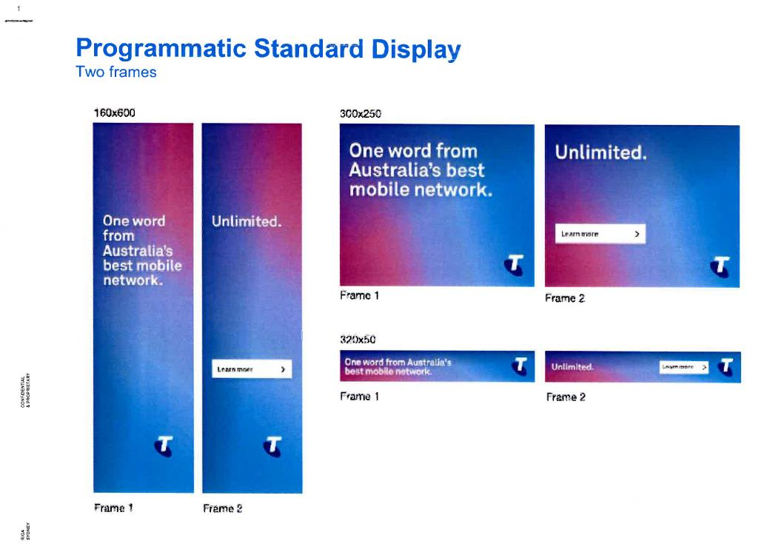

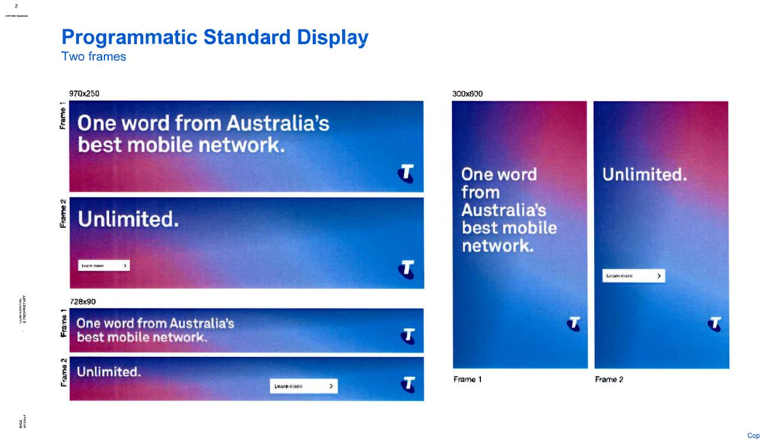

ANNEXURE 4
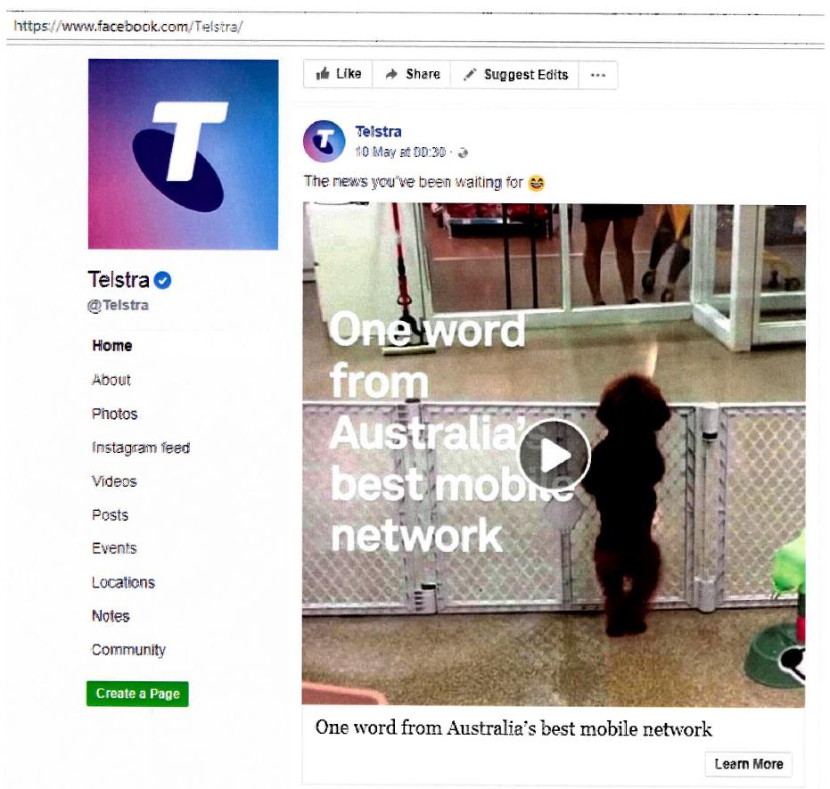

ANNEXURE 5
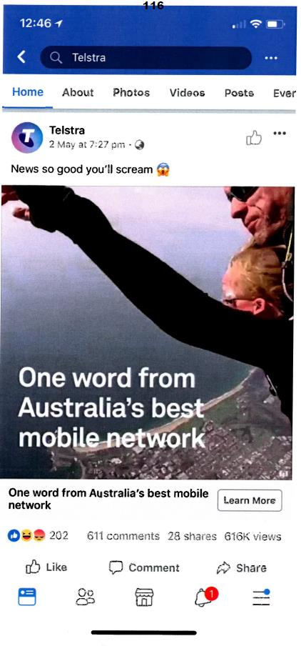

ANNEXURE 6

ANNEXURE 7
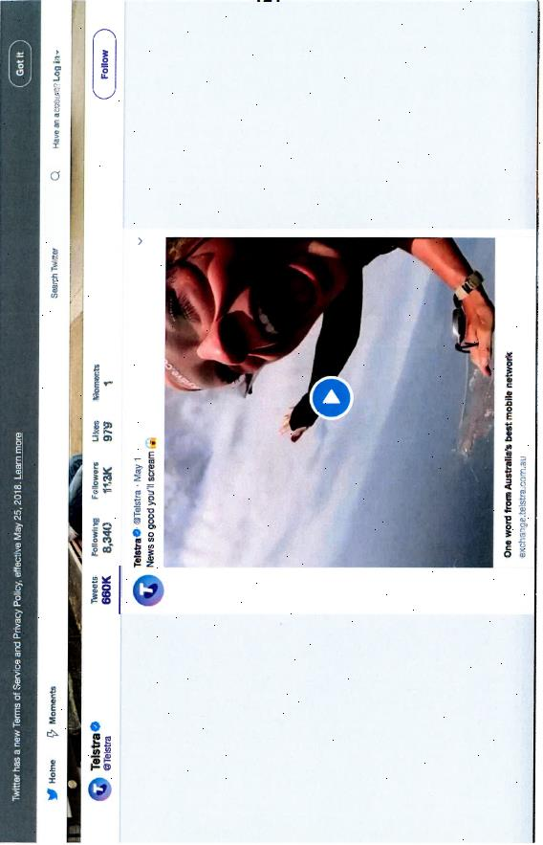

ANNEXURE 8

ANNEXURE 9
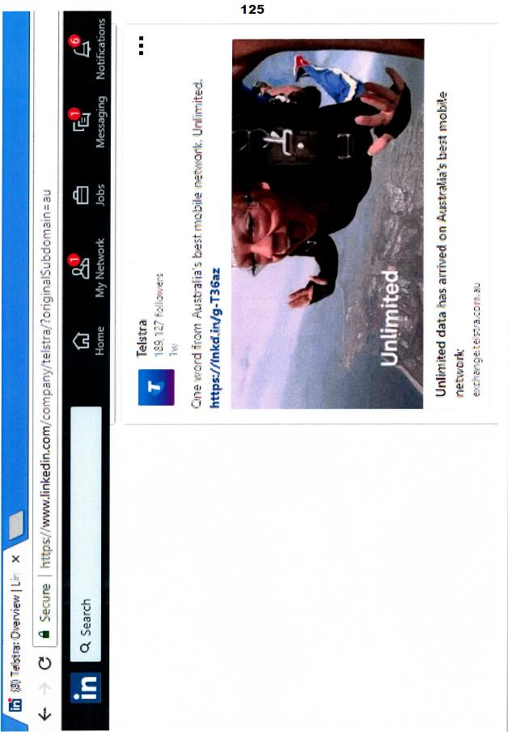

ANNEXURE 10
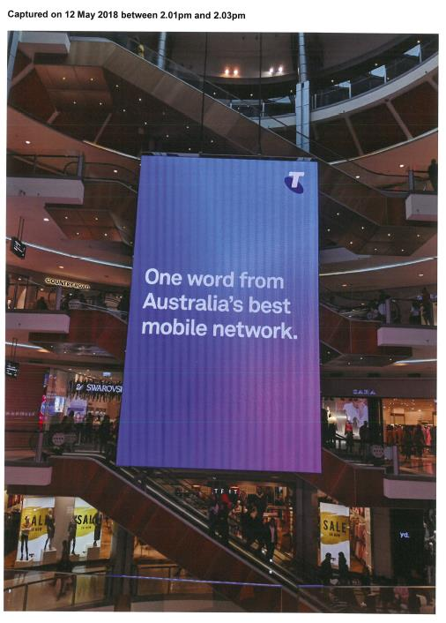

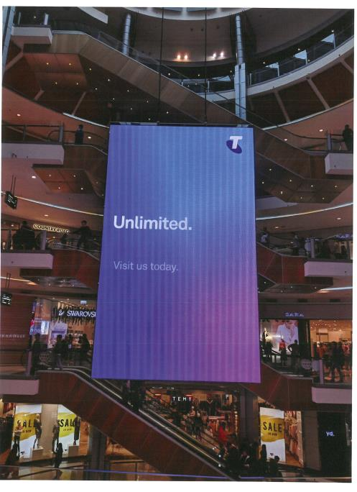

ANNEXURE 11
