FEDERAL COURT OF AUSTRALIA

Vitaco Health IP Pty Ltd v AFI Cosmetic Pty Ltd (No 2) [2024] FCA 99
File number: | VID 953 of 2023
Judgment of: | ROFE J
Date of judgment: | 19 February 2024
Catchwords: | PRACTICE AND PROCEDURE – application for an order for deemed service of documents – failed attempts to effect personal service – documents brought to attention of second respondent – application allowed  PRACTICE AND PROCEDURE − application for substituted service – where second respondent is sole director and secretary of the first respondent – where orders for substituted service have been made in respect of the first respondent
Legislation: | Federal Court Rules 2011 (Cth)
Cases cited: | Heenan (Recs), Ruby Apartments Pty Ltd (In Liq) v Ralan Paradise No 1 Pty Ltd (In Liq) (2020) 149 ACSR 205  Kosmos Capital Pty Ltd v Turiya Ventures LLC [2019] FCA 528  Vitaco Health IP Pty Ltd v AFI Cosmetic Pty Ltd [2023] FCA 1463
Division: | General Division
Registry: | Victoria
National Practice Area: | Intellectual Property
Sub-area: | Trade Marks
Number of paragraphs: | 42
Date of hearing: | Determined on the papers
Counsel for the Applicants: | Mr A N Sykes
Solicitor for the Applicants: | Cornwalls

ORDERS
 |  | VID 953 of 2023
BETWEEN: | VITACO HEALTH IP PTY LTD (ACN 607 496 542)  First Applicant  VITACO HEALTH AUSTRALIA PTY LTD (ACN 073 560 737)  Second Applicant
AND: | AFI COSMETIC PTY LTD (ACN 631 881 831)  First Respondent  SHIKAI HAN  Second Respondent

order made by: | ROFE J
DATE OF ORDER: | 19 February 2024

THE COURT ORDERS THAT:
1. Pursuant to r 10.48 and/or r 10.23 of the Federal Court Rules 2011 (Cth), the following originating documents be deemed as having been served on the second respondent on 6 February 2024:
a. the originating application dated 14 November 2023; and
b. the statement of claim dated 14 November 2023,
substantially in the form as filed with the Court.
2. The timing for the second respondent to file a notice of address for service and a defence to the statement of claim be extended to 30 days from the date of these orders.
3. Until such time as the second respondent files and serves a notice of address for service, or further order, service by the applicants on the second respondent of any further documents in this proceeding may be effected by the applicants sending a copy of those documents to both:
a. the email address at kf@onlinezh.net; and
b. the mailing address of Level 6, 552 Lonsdale Street, Melbourne VIC 3000.
4. A copy of these orders are to be served on the respondents within two days of the date of these orders.
5. Costs reserved.
6. Liberty to apply.

Note: Entry of orders is dealt with in Rule 39.32 of the Federal Court Rules 2011.

REASONS FOR JUDGMENT
ROFE J:

1. INTRODUCTION
1 By interlocutory application filed 9 February 2024, the applicants, Vitaco Health IP Pty Ltd and Vitaco Health Australia Pty Ltd, seek orders pursuant to r 10.48 and/or r 10.23 of the Federal Court Rules 2011 (Cth) for deemed service of the originating application and statement of claim (together, the Originating Documents) on the second respondent, Shikai Han.
2 The applicants are unable to ascertain the whereabouts of the second respondent and therefore seek orders for deemed service both in Australia (r 10.23) and outside of Australia (r 10.48).
3 On 19 December 2023, I made orders for substituted service of documents filed in this proceeding on the first respondent, AFI Cosmetic Pty Ltd, permitting documents to be sent to both:
(a) the email address at kf@onlinezh.net; and
(b) the mailing address of Level 6, 552 Lonsdale Street, Melbourne VIC 3000.
4 The second respondent is the sole director, secretary and shareholder of the first respondent.
5 In addition to orders for deemed service, the applicants seek orders for substituted service of court documents on the second respondent. Analogous to substituted service on the first respondent, the applicants seek to effect service by sending documents to both:
(a) the email address at kf@onlinezh.net; and
(b) the mailing address of Level 6, 552 Lonsdale Street, Melbourne VIC 3000.

2. BACKGROUND
6 On 14 November 2023, the applicants issued proceedings against the respondents for, amongst others, trade mark infringement, copyright infringement, breaches of the Australian Consumer Law and passing off. This impugned conduct concerns the publication of two nearly identical websites. The applicants sought final and interlocutory relief. They also sought an order for cancellation of a trade mark registration (Australian registered trade mark 2325650) in the name of the second respondent.
7 On 22 November 2023, I heard the application for interlocutory relief in my capacity as duty judge and made orders that, inter alia, required the cessation of publication of the two impugned websites: Vitaco Health IP Pty Ltd v AFI Cosmetic Pty Ltd [2023] FCA 1463. Those reasons provide background and context to the present application.
8 This proceeding was later formally allocated to me for the hearing and determination of the substantive issues.
9 In support of the present interlocutory application, the applicants rely on the affidavit of their solicitor, Leonard Thomas Hickey of Cornwalls Lawyers, affirmed 9 February 2024 (Hickey affidavit). Mr Hickey’s evidence can be summarised as follows:
Delivery via trade mark address for service
10 Mr Hickey conducted a search of the Australian Trade Marks Office online database and identified the official details for trade mark registration 2325650, finding the official address to be:
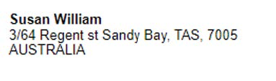
11 On 6 February 2024, a process server engaged on behalf of the applicants attended the official address referred to above and left copies of the following documents with an adult at that address:
(a) the originating application;
(b) the statement of claim;
(c) the applicant’s Genuine Steps Statement dated 17 November 2023;
(d) Mr Hickey’s affidavits of 14 and 15 November 2023;
(e) the affidavit of Craig Dawson Kearney dated 15 November 2023;
(f) the Court's orders dated 15 and 22 November and 20 December 2023; and
(g) a covering letter written by Mr Hickey to Susan William.

Delivery via email
12 The domain report for the domain name <healtheries.net> identified the Registrar URL <http://www.joz.cn>.
13 On 22 November 2023, Mr Hickey sent emails to 315@joz.cn; caiwu@joz.cn; support@joz.cn, being the email addresses he identified on the website <http://www.joz.cn> attaching orders of this Court made on the same date.
14 On 1 December 2023, the following response was received from “Shane” at JOZ.CN, INC.:
hello，
We have forwarded the email to this client and domain name resolution is currently suspended.
15 After receiving this email, Mr Hickey checked the domain names at <healtheries.net> and <healtheries.net.au> and identified that they no longer displayed or resolved to any websites.
16 On 14 December 2023, Mr Hickey replied to Shane attaching various other documents including the Originating Documents and requested for the documents to be forwarded to his client Han Shikai of AFI Cosmetic Pty Ltd.
17 On 23 December 2023, Mr Hickey received the following reply from Shane:
hello,
I have forwarded the email to them before, but this domain name is currently inaccessible.
Attempted delivery in Hong Kong
18 On 1 November 2023, Mr Hickey undertook searches of the Hong Kong Companies Registry at < https://www.cr.gov.hk/en/home/>. In conducting the search, Mr Hickey identified what he understood to be the official records held by the Hong Kong Companies Registry for “AFI Cosmetic Pty Ltd” and “Shikai Han”.
19 Mr Hickey engaged Hong Kong law firm, Chui & Lau, on behalf of the applicants. Mr Hickey deposes that he was informed by Norman Chiu (a partner at Chui & Lau) that on 6 February 2024, Johnson Ho of Chui & Lau attended Flat 1512, 15th Floor, Lucky Centre, No.165-171 Wan Chai Road, Wan Chai, Hong Kong, being the registered office per the records referred to above.
20 Mr Hickey is further informed that:
(a) upon arrival Mr Ho found that the premises was occupied by a business, namely “S-Q Business (HK) Limited (世僑商務(香港)有限公司)”;
(b) Mr Ho pressed the doorbell and a female answered the door;
(c) Mr Ho enquired of the female whether Shikai Han was there and she replied that she did not know such person and closed the door;
(d) Mr Ho took the following photograph of the door:
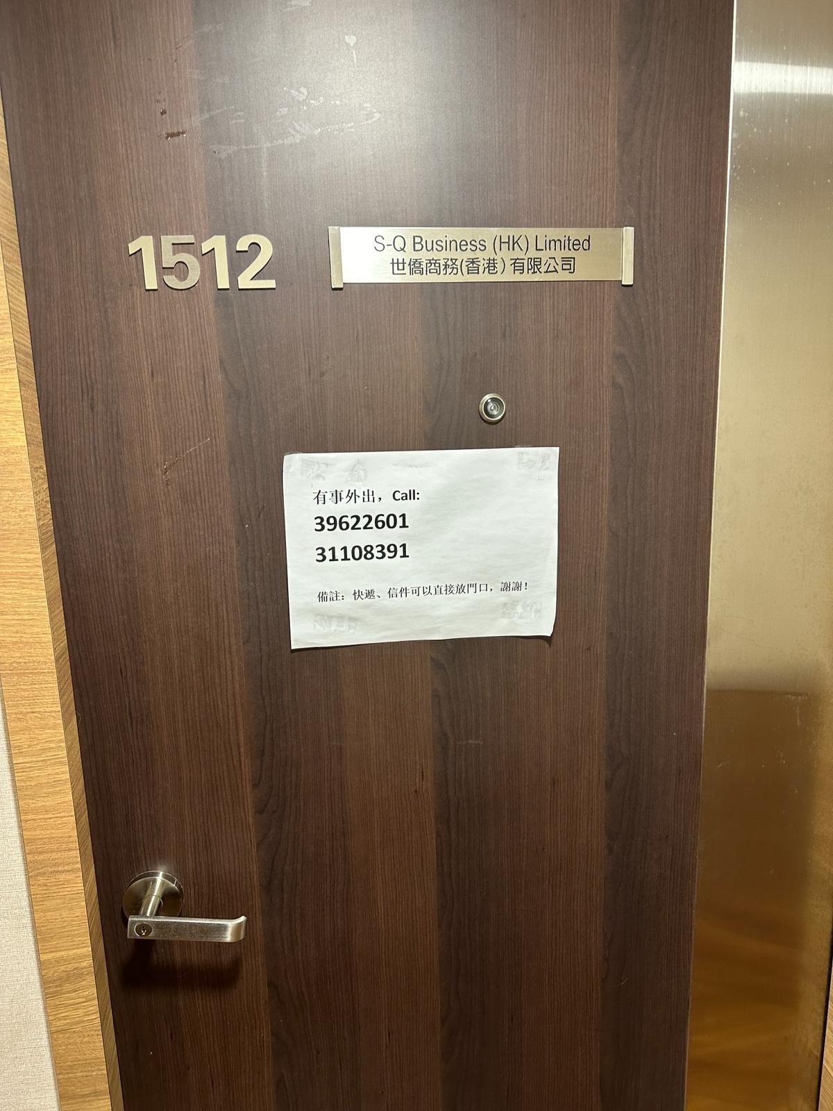
21 Mr Hickey is informed by Mr Chui that the Chinese characters written on the white paper on the door in the photograph above translate to English as: “Out for business, call 39622601, 31108391 Remark: For Courier service, letters can be placed outside the door, Thanks.”
22 Mr Hickey deposes that he does not believe it is practicable to formally serve the second respondent personally in accordance with either the laws of China, Australia or the Hague Convention. The main reason he gives for his belief is that, despite engaging process servers in both China and Australia, the Applicants have been unable to locate the second respondent at any of his registered addresses.

3. APPLICABLE LEGAL PRINCIPLES
23 Rule 8.06 of the Rules prescribes the manner in which originating documents are to be served on respondents. Further, r 10.01 provides that personal service on an individual is to be effected by leaving the documents with the individual.
24 Where personal service on an individual is not practicable, applicants may apply for other methods provided for by the Rules to effect service.
25 In the event the second respondent is located in China, the applicants rely on r 10.48 for deemed service. Rule 10.48 provides:
10.48 Deemed service
A party may apply to the Court without notice for an order that a document is taken have been served on a person on the day mentioned in the order, if:
(a) it is not practicable to serve the document on the person outside Australia in accordance with a convention, the Hague Convention or the law of the country in which the person resides; and
(b) the party provides evidence that the document has been brought to the attention of the person.
26 The “Hague Convention” referred to in r 10.48 is the Convention on the Service Abroad of Judicial and Extrajudicial Documents in Civil or Commercial Matters (the Convention), to which the People’s Republic of China is a party: at [4] of Heenan (Recs), Ruby Apartments Pty Ltd (In Liq) v Ralan Paradise No 1 Pty Ltd (In Liq) (2020) 149 ACSR 205 (per Reeves J).
27 Alternatively, if the second respondent is in Australia, the applicants rely on r 10.23 for deemed service. Rule 10.23 provides:
10.23 Deemed service
A party may apply to the Court, without notice, for an order that a document is taken to have been served on a person on a date mentioned in the order if:
(a) it is not practicable to serve a document on the person in a way required by these Rules; and
(b) the party provides evidence that the document has been brought to the attention of the person to be served.
28 Given that the second respondent has registered addresses in both China and Australia, I accept the applicable rules for deemed service are r 10.48 and r 10.23.
29 The principles applicable to r 10.23 have been helpfully summarised by Jackson J at [50] in Kosmos Capital Pty Ltd v Turiya Ventures LLC [2019] FCA 528:
In the context of r 10.23(a), the word 'practicable' has a wide meaning which will depend on the circumstances of the particular proceeding: Australian Securities and Investments Commission v China Environment Group Ltd [2013] FCA 286 at [11]−[15]. Rule 10.23 does not require the applicant to prove the impossibility of service of documents upon a party in accordance with the rules, or that further attempts to effect service in accordance with the rules would be futile or not sensible or feasible: Speedo Holdings B.V. v Evans [2011] FCA 1089 at [12]. The question is not whether reasonable effort has been shown by the applicant over a particular period, but whether at the date on which the application regarding service is made, the applicant, using reasonable effort, is unable to serve the respondent personally: Foxe v Brown [1984] HCA 69 at [16]; (1984) 58 ALR 542 at 547 as applied in O'Neil v Acott (1988) 59 NTR 1 at 2. Evidence of attempts to serve, attempts to speak by telephone and lack of knowledge of whereabouts will be relevant to the question of practicability: see eg Ross v Cotter [2015] FCA 310 at [2].
30 Furthermore, the applicants draw attention to the observations of Reeves J at [16]−[19] of Heenan:
the word “practicable” has a wide meaning which depends on the nature of the particular proceedings, including the relief sought and the requirement that litigation be progressed quickly and efficiently (see Australian Securities and Investments Commission v China Environment Group Ltd [2013] FCA 286 at [11]-[12] and Ross v Cotter [2015] FCA 310 at [1]). Personal service need not be impossible or futile to be “not practicable” (see Federal Commissioner of Taxation v Zeitouni (2013) 306 ALR 603; [2013] FCA 1011 at [66] and the cases cited therein)).
Rather, rr 10.23 and 10.48 are wide enough to capture circumstances where further attempts at service would not be “sensible or realistic”, even if possible or feasible (see Humane Society International Inc v Kyodo Senpaku Kaisha Ltd [2007] FCA 124 at [14]; Statewide Secured Investments Pty Ltd v Tarrant [2011] FCA 1067 at [9]; British American Tobacco Australasia Limited v Taleb (No 1) [2012] FCA 1065 (British American Tobacco) at [28]-[29]; Australian Competition and Consumer Commission v Safety Compliance Pty Ltd (in liq) (No 3) [2016] FCA 303 at [8] and Commissioner of Taxation v Caratti (No 2) [2018] FCA 1500 at [10]).
In British American Tobacco, Dodds-Streeton J observed (at [46]):
There is … a distinction between, on the one hand, evidence that a document has been brought to a person’s attention and, on the other hand, evidence that the person accorded it attention or acknowledged it. In my view, r 10.23(b) does not require the latter. Such a requirement would materially reduce the ambit and efficacy of the provision for deemed service, which is characteristically invoked precisely because service is being evaded or is otherwise difficult …
Her Honour concluded (at [50]):
… where there is evidence of actions, steps and circumstances which alone or in combination support, on the balance of probabilities, an inference that the documents have been brought to the relevant person’s attention, the requirement in r 10.23(b) will be satisfied.
(Emphasis added.)

3.1 “Not practicable to serve”
31 Despite several attempts of service at both registered addresses, the applicants cannot ascertain the physical whereabouts of the second respondent. The evidence shows that the applicants have conducted numerous searches and attended addresses registered by the second respondent as his place of trading.
32 The applicants submit that it would not be “sensible or realistic” to delay proceedings further in search of the second respondent’s physical whereabouts, especially given the public interest in removing a trade mark that has been used to confuse consumers.
33 Further, efforts to locate the second respondent’s physical whereabouts will lead to the applicants accruing additional unnecessary costs. Given the various methods that have been engaged by the applicants thus far, it may be the case that the second respondent is purposely attempting to evade personal service and/or cause difficulties in the efficient conduct of this proceeding.
34 Effort beyond the means that have been exerted by the applicants in attempting service is not practicable. Although further investigation may eventually reveal the second respondent’s whereabouts, such investigations will place a substantial burden on the applicants who have already engaged in various attempts to effect service.
35 I am satisfied that the applicants have engaged in reasonable efforts in their attempts to serve the second respondent.

3.2 “Brought to the attention”
36 The applicants submit that it is reasonable to infer documents served on the address for service nominated by the second respondent on his trade mark registration will be brought to his prompt attention. Whilst an address for service listed on the Registrar of Trade Marks is distinct from an address for service for the purpose of the Rules, the applicants submit that it is reasonable to infer those representatives who take responsibility to be listed at such an address for service will promptly forward correspondence to their clients, the registrant. If such representatives did not do so, it could expose them to liability in the event the registrant suffered loss. I accept this submission.
37 Relevantly, the impugned websites previously hosted on the impugned domain names have now been taken down. I accept that it is reasonable to infer that this would have been brought to the attention of the second respondent and would trigger some form of investigation/enquiry on his part to ascertain the cause of this.
38 These are reasonable inferences to make and, on balance, I consider it very likely that these proceedings have been brought to the attention of the second respondent.

4. CONCLUSION
39 Having considered the submissions and matters deposed to in the Hickey affidavit, I am content to grant the orders sought in the interlocutory application with costs.
40 The Originating Documents are to be deemed served on the second respondent on 6 February 2024.
41 Lastly, the applicants seek orders substituting personal service to enable them to serve documents on the second respondent by sending them to the registered office of the first respondent. Given that the second respondent is the sole director and secretary of the first respondent, I am satisfied that any communication sent to the first respondent should be brought to the second respondent’s attention.
42 Accordingly, until such time that second respondent formally appears in this matter, service may be effected on him by sending documents to:
(a) the email address at kf@onlinezh.net; and
(b) the mailing address of Level 6, 552 Lonsdale Street, Melbourne VIC 3000.

I certify that the preceding forty-two (42) numbered paragraphs are a true copy of the Reasons for Judgment of the Honourable Justice Rofe.

Associate:
Dated: 19 February 2024

