FEDERAL COURT OF AUSTRALIA

Roberts-Smith v Fairfax Media Publications Pty Limited (No 41) [2023] FCA 555
File numbers: | NSD 1485 of 2018  NSD 1486 of 2018  NSD 1487 of 2018
Judgment of: | BESANKO J
Date of judgment: | 1 June 2023
Catchwords: | DEFAMATION — defamation proceedings — where the applicant is a very well-known Special Air Service Regiment (SASR) soldier and a Victoria Cross recipient — where 14 defamatory imputations alleged — where there are multiple print and online publications — where imputations are of the most serious kind — imputations involving murder, bullying, assault and domestic violence — where substantial damage caused to both reputation and earning capacity of the applicant — where defences include allegations of very serious criminal conduct — defence of justification or substantial truth s 25 Defamation Act 2005 (NSW) — defence of contextual truth s 26 of the Defamation Act 2005 (NSW) — where National Security Information (Criminal and Civil Proceedings) Act 2004 (Cth) applied to proceedings — whether the alleged imputations were conveyed by the publications — consideration of s 140 of the Evidence Act 1995 (Cth) and common law principles concerning the standard of proof where serious criminal conduct is alleged including Briginshaw v Briginshaw [1938] HCA 34; (1938) 60 CLR 336 — consideration of whether the material before the Court may be so limited that it does not form an appropriate basis upon which to reach a reasonable decision — distinction between absence of proven motive and proven absence of motive — consideration of the effect of the passage of time on the reliability of oral testimony — consideration of the nature of circumstantial evidence — inferences in relation to the failure of a party to call a particular witness: Jones v Dunkel [1959] HCA 8; (1959) 101 CLR 298 — principles in Browne v Dunn (1893) 6 R 67 (HL) — consideration of lies as evidence of consciousness of guilt — consideration of whether the respondents have established the substantial or contextual truth of the imputations  DEFAMATION — where imputations concern the applicant’s involvement in two murders —— mission to Whiskey 108 on 12 April 2009 — factual disputes — were Afghan men found in the tunnel — location of the body of EKIA56 — extensive challenges to the honesty and reliability of witnesses — where respondents have established the substantial truth of the relevant imputations  DEFAMATION — incidents involving the applicant during pre-deployment training at Lancelin and Bindoon — where incidents alleged are not directly relevant to any imputation in issue — factual dispute — whether the incidents alleged in the Particulars of Truth took place — whether evidence is inadmissible on the basis that it is tendency evidence — whether applicant’s conduct constituted preparatory conduct  DEFAMATION — where the imputations concern the applicant’s involvement in the murder of an unarmed Afghan male — mission to Darwan on 11 September 2012— where evidence given by local Afghan witnesses — factual disputes — whether the interpreter was sent back before the southern set of compounds was cleared — whether the unarmed Afghan male was kicked off a cliff by the applicant — whether there was an agreement between the applicant and Person 11 that the unarmed Afghan male be killed after the cliff kick — whether a throwdown was placed on the body — whether the applicant made false report about the engagement — where respondents have established the substantial truth of the relevant imputations  DEFAMATION — where the imputations concern the applicant’s involvement in a murder — mission to Chinartu on 12 October 2012 — factual disputes— whether the time of engagement recorded in the OPSUM deliberately false — whether Person 12 was present on the mission — where respondents have established the substantial truth of the relevant imputations  DEFAMATION — mission to Syahchow 18-20 October 2012 — where witness objects to giving evidence on the grounds of self-incrimination (s 128 of the Evidence Act 1995 (Cth)) — whether or not there are reasonable grounds for the objection — where the allegations in the Particulars of Truth are not made out  DEFAMATION — where imputations concern the applicant’s involvement in a murder —mission to Fasil 5 November 2012 — factual dispute — identification evidence — where the allegations in the Particulars of Truth are not made out  DEFAMATION — where the imputation concerns the applicant’s engagement in a campaign of bullying — factual dispute — whether the bullying acts set out in the Particulars of Truth occurred — consideration of what constitutes a campaign of bullying — where respondents have established the substantial truth of the relevant imputation  DEFAMATION — where the imputations allege that the applicant unlawfully assaulted persons under control or containment — factual dispute — whether the applicant assaulted an Afghan male in Deh Rafshan on 15 March 2010 — whether the applicant assaulted an Afghan male in late August to early September 2012 — where respondents have established the substantial truth of the relevant imputations  DEFAMATION — blue-on-blue during mission in the Chora Valley on 15 July 2021 — factual dispute — whether the applicant assaulted Person 10 post-mission — whether the applicant made the threat alleged — where the respondents have not made out the substantial truth of the relevant imputation — where the defence of contextual truth is made out  DEFAMATION — where imputations concern an act of domestic violence — factual dispute — whether the applicant punched Person 17 — where the respondents have not made out the substantial truth of the relevant imputations — where the defence of contextual truth is made out  DEFAMATION — where intimidation of witnesses is alleged — whether the applicant engaged in conduct that intimidated witnesses — whether the applicant colluded with witnesses — whether the applicant concealed relevant evidence and material
Legislation: | Criminal Code Act 1995 (Cth) ss 11.2, 11.2A, 11.5, 268.70, 268.115, 471.12  Defence Force Discipline Act 1982 (Cth) ss 33, 34, 55  Evidence Act 1995 (Cth) ss 51, 55, 64, 97, 99, 108, 126K, 128, 140, 164  Fair Work Act 2009 (Cth) s 789FD  Federal Court of Australia Act 1976 (Cth) ss 37AF, 37AG, 37AH  National Security Information (Criminal and Civil Proceedings) Act 2004 (Cth) ss 7, 19(3A), 38B  Defamation Act 2005 (NSW) ss 25, 26, 35  Inspector-General of the Australian Defence Force Regulation 2016 (Cth) s 21
Cases cited: | Ajinomoto Sweeteners Europe SAS v Asda Stores Ltd [2011] QB 497  Alexander v The Queen (1981) 145 CLR 395  Amalgamated Television Services Pty Ltd v Marsden (1998) 43 NSWLR 158  Amalgamated Television Services Pty Limited v Marsden [2002] NSWCA 419  Ashby v Slipper [2014] FCAFC 15; (2014) 219 FCR 322  Attwood v The Queen (1960) 102 CLR 353  Australian Broadcasting Corporation v Chau Chak Wing [2019] FCAFC 125; (2019) 271 FCR 632  Australian Securities and Investments Commission v Hellicar [2012] HCA 17; (2012) 247 CLR 345  Blatch v Archer (1774) 1 Cowp 63 at 65; (1774) 98 ER 969  Bradshaw v McEwans Pty Ltd (1951) 217 ALR 1  Briginshaw v Briginshaw [1938] HCA 34; (1938) 60 CLR 336  Browne v Dunn (1893) 6 R 67 (HL)  Carr v Baker (1936) 36 SR (NSW) 301  Caswell v Powell Duffryn Associated Collieries Ltd [1940] AC 152  Channel Seven Sydney Pty Ltd v Mahommed [2010] NSWCA 335; (2010) 278 ALR 232  Charleston v News Group Newspapers Ltd [1995] 2 AC 65 (HL)  Cheikho v Nationwide News Pty Ltd (No 5) [2016] NSWSC 29  Church of Scientology Inc v Woodward [1982] HCA 78; (1983) 154 CLR 25  Citadel Financial Corporation Pty Ltd (Administrator Appointed) v Action Scaffolding & Rigging Pty Limited (In Liq) [2019] FCAFC 145  Claremont Petroleum NL v Cummings (1992) 110 ALR 239  Commonwealth of Australia v Fernando [2012] FCAFC 18; (2012) 200 FCR 1  Communications, Electrical, Electronic, Energy, Information, Postal, Plumbing & Allied Services Union of Australia v Australian Competition and Consumer Commission [2007] FCAFC 132; (2007) 162 FCR 466  Coshott v Prentice [2014] FCAFC 88; (2014) 221 FCR 450  Day v Perisher Blue Pty Ltd [2005] NSWCA 110; (2005) 62 NSWLR 731  De Gruchy v The Queen [2002] HCA 33; (2002) 211 CLR 85  Edwards v The Queen [1993] HCA 63; (1993) 178 CLR 193  Fabre v Arenales (1992) 27 NSWLR 437  Fairfax Media Publications Pty Ltd v Kermode [2011] NSWCA 174; (2011) 81 NSWLR 157  Farquhar v Bottom [1980] 2 NSWLR 380  Federal Commissioner of Taxation v SNF (Australia) Pty Ltd [2011] FCAFC 74; (2011) 193 FCR 149  Festa v The Queen (2001) HCA 72; (2001) 208 CLR 593  Flack v Chairperson, National Crime Authority (1997) 80 FCR 137; (1997)150 ALR 153  Fox v Percy [2003] HCA 22; (2003) 214 CLR 118  FTZK v Minister for Immigration and Border Protection [2014] HCA 26; (2014) 310 ALR 1  Gardiner v R [2006] NSWCCA 190; (2006) 162 A Crim R 233  Gatto v Australian Broadcasting Corporation [2022] VSCA 66  Gautam v Health Care Complaints Commission [2021] NSWCA 85  Gionfriddo & Faure v R (1989) 50 A Crim R 327  Goodrich Aerospace Propriety Limited v Arsic [2006] NSWCA 187; (2006) 66 NSWLR 186  Handlen v The Queen [2011] HCA 51; (2011) 245 CLR 282  Hayson v The Age Company Pty Ltd (No 2) [2020] FCA 361  Ho v Powell [2001] NSWCA 168; (2001) 51 NSWLR 572  Hobbs v Tinling (CT) & Company, Limited [1929] 2 KB 1  Hockey v Fairfax Media Publications Pty Ltd [2015] FCA 652; (2015) 237 FCR 33  Holt v TCN Channel Nine Pty Ltd [2012] NSWSC 770  Hurley v Clements [2010] 1 Qd R 215; [2009] QCA 167  Hyam v Director of Public Prosecutions [1974] 2 WLR 607  Jackson v Lithgow City Council [2008] NSWCA 312  Jensen v Cultural Infusion (Int) Pty Ltd [2020] FCA 358  John Fairfax Publications Pty Ltd v Blake [2001] NSWCA 434; (2001) 53 NSWLR 541  John Fairfax Publications Pty Ltd v Obeid [2005] NSWCA 60; (2005) 64 NSWLR 485  John Fairfax Publications Pty Ltd v Rivkin [2003] HCA 50; (2003) 77 ALJR 1657; (2003) 201 ALR 77  Jones v Dunkel [1959] HCA 8; (1959) 101 CLR 298  Jones v Great Western Railway Co (1930) 144 LT 194  Jones v Skelton [1963] 1 WLR 1362  Joseph v Spiller [2012] EWHC 2958 (QB)  Khan v State of Trinidad and Tobago [2004] 2 WLR 692 (PC)  Kuhl v Zurich Financial Services Australia Ltd [2011] HCA 11; (2011) 243 CLR 361  Kuligowski v Metrobus [2004] HCA 34; (2004) 220 CLR 363  Leung v State of Western Australia [2020] WASCA 81  Lewis v Daily Telegraph Ltd [1964] AC 234  Longman v The Queen [1989] HCA 60; (1989) 168 CLR 79  Mercer v R (1993) 67 A Crim R 91  Mirror Newspapers Limited v Harrison [1982] HCA 50; (1982) 149 CLR 293  Mirror Newspapers Ltd v World Hosts Pty Ltd (1979) 141 CLR 632  Morley v Australian Securities and Investments Commission [2010] NSWCA 331; (2010) 247 FLR 140  Moubarak by his tutor Coorey v Holt [2019] NSWCA 102; (2019) 100 NSWLR 218  Musa v Alzreaiawi [2021] NSWCA 12  Neat Holdings Pty Ltd v Karajan Holdings Pty Ltd [1992]  HCA 66; (1992) 67 ALJR 170; (1992) 110 ALR 449  Nguyen v Cosmopolitan Homes (NSW) Pty Ltd [2008] NSWCA 246  Nguyen v R [2022] NSWCCA 126  NOM v Director of Public Prosecutions [2012] VSCA 198; (2012) 38 VR 618  O’Brien v Australian Broadcasting Corporation [2017] NSWCA 338; (2017) 97 NSWLR 1  O'Donnell v Reichard [1975] VR 916  Pamplin v Express Newspapers Ltd (No 2) [1988] 1 WLR 116  Papakosmas v The Queen [1999] HCA 37; (1999) 196 CLR 297  Payne v Parker [1976] 1 NSWLR 191  Pitkin v R [1995] HCA 30; (1995) 130 ALR 35; (1995) 80 A Crim R 302; (1995) 69 ALJR 612  Prager v Times Newspapers Ltd [1988] 1WLR 77  Qantas Airways Ltd v Gama [2008] FCAFC 69; (2008) 167 FCR 537  Pell v The Queen [2020] HCA 12; (2020) 268 CLR 123  R v Boscaino [2020] QCA 275  R v Cummins [2004] VSCA 164; (2004) 10 VR 15  R v Hillier [2007] HCA 13; (2007) 228 CLR 618  R v Liddy [2002] SASC 19; (2002) 81 SASR 22  R v Manunta [1989] SASC 1628; (1989) 54 SASR 17  R v Tangye (1997) 92 A Crim R 545  R v Watt (1905) 20 Cox CC 852  Rao v R [2019] NSWCCA 290  Reg v Lucas (Ruth) [1981] QB 720  Rejfek v McElroy [1965] HCA 46; (1965) 112 CLR 517  Rhesa Shipping Co SA v Edmunds (The Popi M) [1985] 1 WLR 948; [1985] 2 All ER 712  RHG Mortgage Ltd v Ianni [2015] NSWCA 56  Roberts-Smith v Fairfax Media Publications Pty Limited [2019] FCA 36  Roberts-Smith v Fairfax Media Publications Pty Limited (No 3) [2020] FCA 2  Roberts-Smith v Fairfax Media Publications Pty Limited (No 5) [2020] FCA 1067  Roberts-Smith v Fairfax Media Publications Pty Ltd (No 6) [2020] FCA 1285  Roberts-Smith v Fairfax Media Publications Pty Limited (No 10) [2021] FCA 317; (2021) 151 ACSR 79  Roberts-Smith v Fairfax Media Publications Pty Limited (No 12) [2021] FCA 465  Roberts-Smith v Fairfax Media Publications Pty Limited (No 13) [2021] FCA 549  Roberts-Smith v Fairfax Media Publications Pty Limited (No 23) [2021] FCA 1460; (2021) 157 ACSR 438  Roberts-Smith v Fairfax Media Publications Pty Limited (No 28) [2022] FCA 115  Roberts-Smith v Fairfax Media Publications Pty Limited (No 30) [2022] FCA 266  Roberts-Smith v Fairfax Media Publications Pty Limited (No 36) [2022] FCA 578  Roberts-Smith v Fairfax Media Publications Pty Limited (No 37) [2022] FCA 580  Roberts-Smith v Fairfax Media Publications Pty Limited (No 40) [2022] FCA 1614  Rowell v Larter (1986) 6 NSWLR 21  Sands v State of South Australia [2015] SASCFC 36; (2015) 122 SASR 195  Seltsam Pty Ltd v McGuiness (2000) 49 NSWLR 262  Seymour v Australian Broadcasting Commission (1977) 19 NSWLR 219  Shepherd v The Queen [1990] HCA 56; (1990) 170 CLR 573  Slim v Daily Telegraph Ltd [1968] 2 QB 157  Smith v The Queen [2001] HCA 50; (2001) 206 CLR 650  Stead v Fairfax Media Publications Pty Ltd [2021] FCA 15; (2021) 387 ALR 123  Stocker v Stocker [2020] AC 593  Teeluck v State of Trinidad and Tobago [2005] 1 WLR 2421; [2005] 2 Cr App R 378 (PC)  Trkulja v Google LLC [2018] HCA 25; (2018) 263 CLR 149  Trudgett v R [2008] NSWCCA 62; (2008) 70 NSWLR 696  Victory Projects Pty Ltd v AAA Self Storage Pty Ltd [2016] NSWSC 1758  V’landys v Australian Broadcasting Corporation (No 3) [2021] FCA 500  Watson v Foxman (1995) 49 NSWLR 315  West v Government Insurance Office (NSW) [1981] HCA 38; (1981) 148 CLR 62
Division: | General Division
Registry: | New South Wales
National Practice Area: | Other Federal Jurisdiction
Number of paragraphs: | 2618
Dates of hearing: | 7–11, 15–18, 21–25, 28–29 June 2021, 26–30 July 2021, 2 August 2021, 2–4, 7–11, 14–18, 21–25, 28 February 2022, 1–4, 7–11, 14–18, 21–25, 28–31 March 2022, 1, 4–5, 11, 14, 19, 21–22, 26–29 April 2022, 2–6, 9–13, 16–20, 23–24, 27, 30–31 May 2022, 1–3, 15, 24 June 2022, 12, 18–22, 25–27 July 2022
 | On various dates during the hearing:
Counsel for the Applicant: | Mr B McClintock SC (June/July 2021 & February/March 2022), Mr A Moses SC, Mr M Richardson SC and Mr P Sharp
Solicitor for the Applicant: | Mark O’Brien Legal
Counsel for the Respondents: | Mr N Owens SC, Ms L Barnett and Mr C Mitchell
Solicitor for the Respondents: | MinterEllison
Counsel for the Commonwealth of Australia: | Ms A Mitchelmore SC (until March 2022), Ms K Stern SC (until April 2022), Ms J Single SC (from May 2022), Mr J Edwards and Ms C Ernst
Solicitor for the Commonwealth of Australia: | Australian Government Solicitor

ORDERS
 |  | NSD 1485 of 2018
BETWEEN: | BEN ROBERTS-SMITH  Applicant
AND: | FAIRFAX MEDIA PUBLICATIONS PTY LIMITED (ACN 003 357 720) (and others named in the Schedule)  First Respondent

 |  | NSD 1486 of 2018
BETWEEN: | BEN ROBERTS-SMITH  Applicant
AND: | THE AGE COMPANY PTY LIMITED (ACN 004 262 702) (and others named in the Schedule)  First Respondent

 |  | NSD 1487 of 2018
BETWEEN: | BEN ROBERTS-SMITH  Applicant
AND: | THE FEDERAL CAPITAL PRESS OF AUSTRALIA PTY LIMITED (ACN 008 394 063) (and others named in the Schedule)  First Respondent

order made by: | besanko J
DATE OF ORDER: | 1 June 2023

THE COURT ORDERS THAT:

1. The proceeding be dismissed.

Note: Entry of orders is dealt with in Rule 39.32 of the Federal Court Rules 2011.

REASONS FOR JUDGMENT
PART 1 — INTRODUCTION | [1]
PART 2 — THE IMPUTATIONS CONVEYED OR COMMUNICATED BY THE ARTICLES | [28]
The Group 2 Articles | [44]
Imputation 4 – The applicant while a member of the SASR, committed murder by pressuring a newly deployed and inexperienced SASR soldier to execute an elderly, unarmed Afghan in order to “blood the rookie” | [44]
Imputation 5 - The applicant while a member of the SASR, committed murder by machine gunning a man with a prosthetic leg | [50]
Imputation 6 - The applicant having committed murder by machine gunning a man in Afghanistan with a prosthetic leg, is so callous and inhumane that he took the prosthetic leg back to Australia and encouraged his soldiers to use it as a novelty beer drinking vessel | [53]
The Group 3 Articles | [56]
PART 3 — SUBSTANTIAL TRUTH AND CONTEXTUAL TRUTH | [92]
Section 1 — Issues Relating to the Fact Finding Exercise in these Proceedings | [92]
The Onus of Proof | [93]
The Standard of Proof | [95]
The Court is not bound to make findings one way or the other | [117]
The material before the Court may be so limited that it does not form an appropriate basis upon which to reach a reasonable decision | [119]
1. The transcripts of the evidence given to the IGADF Inquiry | [127]
2. The notes of the journalists | [136]
3. Person 12 | [140]
4. The absence of forensic evidence | [143]
5. Contact with the Afghan witnesses | [144]
6. Evidence concerning the preparation of contemporaneous documents | [149]
7. The arrangements with Persons 4 and 56 | [151]
8. The absence of other witnesses who were present at Darwan | [153]
Conclusion | [155]
Motive | [156]
The Effect of the Passage of Time on the Reliability of Oral Testimony | [162]
Circumstantial Evidence | [167]
Demeanour of Witnesses | [171]
Jones v Dunkel | [174]
Character Evidence | [184]
The Principles in Browne v Dunn | [195]
Lies as Evidence of a Consciousness of Guilt | [196]
Other Matters | [206]
Section 2 — Whiskey 108 | [207]
Introduction and Background | [207]
The Applicant’s Contention that the Pleaded Allegations are Insufficient in Law and that there has been a Departure in the Evidence from the Pleaded Allegations | [215]
Approach and Witnesses | [223]
References to Person 4 as the “Rookie”, “to Blooding the Rookie” and Events on a Prior Mission | [227]
The Mission to W108 on 12 April 2009 | [287]
The Location of Person 6’s Patrol during the Assault and Clearance of W108 and thereafter | [303]
The Clearance of W108 | [356]
Was the Compound Declared Secure Before the Tunnel was Discovered? | [362]
Were Afghan Men Found in the Tunnel? | [434]
The Respondents’ Case as to the Execution of EKIA56 | [535]
The Location of the Body of EKIA56 | [558]
Challenges to the Respondents’ Case | [579]
The Respondents’ Case as to the Execution of EKIA57 | [713]
Moving to W109 | [802]
Aspects of the Applicant’s Account and those of his Witnesses | [815]
Key Findings and Conclusions | [863]
Section 3 — Incidents involving the Applicant during Pre-Deployment Training in 2012 | [884]
Section 4 — Darwan | [933]
Introduction | [933]
Background | [944]
The Background of the Afghan Witnesses | [958]
Events in Darwan on 10 September 2012 | [975]
Insertion into Darwan by the Task Force on 11 September 2012 | [979]
The Activities of the Afghan Witnesses before and at the time of the Insertion of the Task Force | [982]
The Engagements in and around COI 31 | [986]
The Afghan Witnesses encounter Ali Jan | [989]
The Engagement by the Applicant in the area adjacent to the Helmand River at approximately 0805DE | [995]
The Applicant’s Patrol joins Other Patrols and is in the Middle Group of Compounds by 0906DE | [1010]
The Applicant’s Patrol moves across the Gap into the Southern Set of Compounds | [1021]
Clearing the Compounds in the Southern Set of Compounds including Shahzada Fatih’s Compound | [1027]
Clearing the Last Compound, that of Mangul Rahmi | [1034]
Tactical Questioning in and around the Last Compound | [1047]
Events after Person 56 and the Interpreter leave the Southernmost Compound | [1052]
The Soldiers leave and the Body in the Cornfield is identified | [1071]
On Return to Tarin Kowt | [1086]
The Respondents’ Witnesses | [1089]
Person 4 | [1090]
Person 56 | [1145]
Mohammed Hanifa | [1159]
Mangul Rahmi | [1177]
Shahzada Fatih | [1188]
Documentary Material | [1201]
The Applicant’s Witnesses | [1209]
The applicant | [1209]
Person 11 | [1240]
Person 35 | [1284]
Person 32 | [1292]
Matters advanced by the Applicant | [1293]
Conclusions including Key Findings of Fact | [1364]
Section 5 — Chinartu | [1371]
Introduction | [1371]
Events during the Mission | [1382]
Does the OPSUM falsely record the timing and circumstances of the second EKIA of the Mission to Chinartu? | [1430]
Was Person 12 present on the Mission to Chinartu? | [1448]
Was the Afghan Male executed as described by Person 14? | [1512]
Conclusions | [1536]
Section 6 — Syahchow 18–20 October 2012 | [1539]
Section 7 — Fasil 5 November 2012 | [1544]
Introduction | [1544]
Person 16’s Evidence | [1548]
Other Evidence which the Respondents contend is Relevant | [1597]
The Records Produced by the Department of Defence | [1603]
The Applicant’s Evidence | [1612]
Person 11 | [1634]
The Applicant’s Challenges to Person 16’s Evidence | [1637]
The Respondents’ Submissions | [1669]
Findings and Conclusions | [1681]
Section 8 — The Bullying of Person 1 | [1693]
Pre-deployment Training for Rotation 3 | [1705]
The Mission to the Chora Pass | [1709]
Events after the Mission at the Base | [1743]
Reports of the Engagement | [1755]
Person 1’s Performance after the Mission and his Contact with the Applicant | [1760]
Person 1 is moved to Person 21’s Patrol in early July 2006 and Events thereafter | [1775]
Person 1’s Performance from April to June 2006 | [1805]
The Significance of Persons 23, 33 and 37 not being called as Witnesses by the Applicant | [1817]
The Particulars of Truth Revisited | [1825]
Findings and Conclusions | [1836]
Section 9 — Alleged Unlawful Assaults on PUCs | [1849]
Introduction | [1849]
The Assault of an Afghan Male in Deh Rafshan on 15 March 2010 | [1857]
The Assault of an Afghan Male in late August to early September 2012 | [1869]
The Applicant’s Account | [1875]
Person 7 | [1881]
Findings and Conclusions | [1900]
Section 10 — The Blue-on-Blue and the Alleged Threat to Person 10 | [1914]
Introduction | [1914]
The Mission | [1918]
The Assault | [1934]
The Debrief | [1941]
Person 10 is disciplined | [1944]
Contemporaneous Reporting | [1945]
Person 10 prepares his Statement | [1952]
Subsequent Events | [1958]
Findings and Conclusions | [1961]
Section 11 — The Alleged Act of Domestic Violence | [1968]
Introduction | [1968]
The Beginning of the Relationship and Events until the end of 2017 | [1981]
The Relationship continues and Person 17 tells the Applicant that she is pregnant | [1997]
Events on 6 March 2018 | [2010]
Person 17 makes notes on her telephone on 7 March 2018 | [2045]
Person 17 goes to Brisbane on 13 March 2018 | [2046]
The Alleged Assault on 28 March 2018 | [2051]
The Following Day | [2082]
Events on 3 April 2018 | [2105]
Events on 5 April 2018 | [2115]
Events on 6 April 2018 | [2123]
Events on 8 April 2018 | [2136]
Events on 20 April 2018 | [2140]
The Correspondence with Danielle Kennedy | [2146]
Messages by Applicant on Gmail Account | [2151]
Person 17 contacts Mr McKenzie, makes a complaint to the AFP and withdraws the complaint on 24 August 2012 | [2154]
Events from June 2018 to 2020 | [2168]
The Submissions | [2175]
Findings and Conclusions | [2207]
Section 12 — Intimidation of Witnesses, Collusion and Contamination of Witnesses, Concealment of Relevant Evidence and Material, Lies and the Alleged Separation of the Applicant and Ms Roberts | [2228]
Intimidation of Witnesses | [2240]
Person 6 | [2240]
Person 18 | [2271]
Person 14 | [2347]
Person 40 | [2356]
Collusion and Contamination of Witnesses | [2363]
Concealment of Relevant Evidence and Material | [2468]
Introduction and Background | [2468]
The process of discovery begins | [2477]
Where did the applicant keep the USBs? | [2483]
The concealment of the USBs | [2526]
The documents relating to the alleged assault of Person 17 | [2542]
Person 5’s statement of complaint and other documents | [2551]
Lies and deliberately giving False Evidence | [2554]
The Separation | [2559]
PART 4 — CONCLUSIONS WITH RESPECT TO SUBSTANTIAL TRUTH AND CONTEXTUAL TRUTH | [2599]
PART 5 — CONCLUSION WITH RESPECT TO THE PROCEEDINGS | [2613]
ANNEXURE A
ANNEXURE B
ANNEXURE C
ANNEXURE D
ANNEXURE E
ANNEXURE F
ANNEXURE G
ANNEXURE H

BESANKO J:

PART 1 — INTRODUCTION
1 There are three proceedings before the Court. They have been heard together.
2 The applicant in each proceeding is Mr Ben Roberts-Smith VC MG. He was a member of the Special Air Service Regiment (SASR) between 2003 and 2013. During that period, he undertook six tours of Afghanistan. He has received a number of awards and medals, including the Medal for Gallantry in 2006, the Victoria Cross in 2011 and a Commendation for Distinguished Service in 2014.
3 The respondents in the first proceeding (NSD 1485 of 2018) are Fairfax Media Publications Pty Limited (Fairfax Media), Mr Nick McKenzie, Mr Chris Masters and Mr David Wroe. The respondents in the second proceeding (NSD 1486 of 2018) are The Age Company Pty Limited (The Age), Mr Nick McKenzie, Mr Chris Masters and Mr David Wroe. The respondents in the third proceeding (NSD 1487 of 2018) are The Federal Capital Press of Australia Pty Limited (Federal Capital Press), Mr Nick McKenzie, Mr Chris Masters and Mr David Wroe. It is not in dispute in each proceeding that at the relevant time, the second, third and fourth respondents were journalists employed or engaged by the first respondent. Fairfax Media is the publisher of The Sydney Morning Herald (SMH) and Sun Herald newspapers and of articles which appear on the SMH website. The Age is the publisher of The Age and Sunday Age newspapers and of articles which appear on The Age website. The Federal Capital Press is the publisher of The Sunday Canberra Times newspaper and of articles which appear on The Canberra Times website. The three proceedings relate to articles published in both the newspapers and on the websites in June and August 2018. The proceedings against each of Fairfax Media and The Age involves six articles and the proceedings against the Federal Capital Press involves four articles.
4 Each of the respondents published articles on or about 9 June 2018. Fairfax Media and the second and third respondents published articles in the SMH newspaper on 9 June 2018 entitled “SAS’s Day of Shame” and “Troops kept ‘kill board’: SAS’s Day of Shame”. They published an article on the SMH website on 8 June 2018 entitled “Abdul’s brother went out to buy flour. He never came home”. The Age and the second and third respondents published an article in The Age newspaper on 9 June 2018 entitled “SAS’s Day of Shame” and “Did the SAS kick a cuffed man off cliff?” They published an article on The Age website on 8 June 2018 entitled “Abdul’s brother went out to buy flour. He never came home”. The Federal Capital Press and the second and third respondents published an article on The Canberra Times website on 8 June 2018 entitled “Abdul’s brother went out to buy flour. He never came home”. These articles referred to a soldier known as “Leonidas” and contained allegations that an Afghan detainee was kicked off a cliff by Leonidas and subsequently executed. The articles have different headlines and some distinct sections, but they are substantially similar. It is convenient to refer to these articles as the “Group 1 articles”.
5 On 10 June 2018, Fairfax Media and the second and third respondents published an article in The Sun Herald newspaper entitled “Special forces rookie ‘blooded’ by executing an unarmed man”. They also published an article on the SMH website on 9 June 2018 entitled “Special forces rookie ‘blooded’ by executing an unarmed man”. On 10 June 2018, The Age and the second and third respondents published an article in The Sunday Age newspaper entitled “Blood Ties”. They also published an article on The Age website on 9 June 2018 entitled “Special forces rookie ‘blooded’ by executing unarmed man”. The Federal Capital Press and the second and third respondents published two articles on 10 June 2018. They published an article in The Sunday Canberra Times newspaper on 10 June 2018 entitled “S.A.S. rookie told to shoot unarmed man”. They also published an article on The Canberra Times website on 10 June 2018 entitled “Special forces rookie ‘blooded’ by executing an unarmed man”. These articles also referred to a soldier known as “Leonidas” and contained a number of allegations, including an allegation concerning the execution of an elderly, unarmed Afghan in circumstances in which a “rookie” was “blooded”. The articles also referred to another killing involving a prisoner with a prosthetic leg and repeated the allegation that a prisoner had been kicked off a cliff. Again, the articles have different headlines and some distinct sections, but they are substantially similar. It is convenient to refer to these articles as the “Group 2 articles”.
6 On 11 August 2018, Fairfax Media and the second, third and fourth respondents published an article in the SMH newspaper entitled “War hero fires back over abuse claims” and “Beneath the bravery of our most decorated soldier”. They also published an article on the SMH website on 10 August 2018 entitled “Beneath the bravery of our most decorated soldier”. On 11 August 2018, The Age and the second, third and fourth respondents published an article in The Age newspaper entitled “The cracks in a war hero’s façade”, “Beneath the bravery” and “Beneath lauded soldier’s bravery”. They also published an article on The Age website on 10 August 2018 entitled “Beneath the bravery of our most decorated soldier”. The Federal Capital Press and the second, third and fourth respondents published an article on 10 August 2018 on The Canberra Times website entitled “Beneath the bravery of our most decorated soldier”. These articles refer to the applicant by name and contain a number of allegations concerning his conduct as a soldier in Afghanistan and an allegation of domestic violence. The articles have different headlines and some distinct sections, but they are substantially similar. It is convenient to refer to these articles as the “Group 3 articles”.
7 It is not suggested that there is any substantial difference between the articles which comprise the Group 1 articles or between the articles which comprise the Group 2 articles or between the articles which comprise the Group 3 articles. In those circumstances, the articles published by Fairfax Media and the other respondents in the first proceeding may be used as representative of the articles which are the subject of the other two proceedings. I annex to these reasons the Group 1 (Annexures A and B), Group 2 (Annexures C and D) and Group 3 (Annexures E and F) articles in the proceeding involving Fairfax Media and in each case, I include a schedule prepared by the applicant’s solicitors which enables the reader to identify by number particular passages in the articles.
8 There was no dispute about the publication of the articles. The applicant administered interrogatories addressed to the extent of publication of the articles and the answers to those interrogatories were tendered by the applicant at the trial.
9 By the end of the trial, there was no dispute about the identification of the applicant in the Group 1 and Group 2 articles. The respondents admit that the applicant has adduced evidence which establishes that at least one person read each of the articles comprising the Group 1 and Group 2 articles and, on the basis of extrinsic facts, understood those articles to refer to the applicant. The respondents do not dispute that such identification was reasonable. In addition, there is evidence adduced by the applicant of readers identifying him as being the subject of the Group 1 and Group 2 articles.
10 There is a dispute between the parties concerning some of the imputations said to be conveyed or communicated by the articles. In each case, the applicant relies on the natural and ordinary meaning of the matters complained of.
11 The applicant alleges that the following defamatory imputations of and concerning him were conveyed or communicated by the Group 1 articles:
(1) The applicant while a member of the SASR, murdered an unarmed and defenceless Afghan civilian, by kicking him off a cliff and procuring the soldiers under his command to shoot him (Imputation 1).
(2) The applicant broke the moral and legal rules of military engagement and is therefore a criminal (Imputation 2).
(3) The applicant disgraced his country Australia and the Australian army by his conduct as a member of the SASR in Afghanistan (Imputation 3).
The respondents do not dispute that these imputations were conveyed or communicated by the Group 1 articles.
12 The applicant alleges that the following defamatory imputations of and concerning him were conveyed or communicated by the Group 2 articles:
(1) The applicant while a member of the SASR, committed murder by pressuring a newly deployed and inexperienced SASR soldier to execute an elderly, unarmed Afghan in order to “blood the rookie” (Imputation 4).
(2) The applicant while a member of the SASR, committed murder by machine gunning a man with a prosthetic leg (Imputation 5).
(3) The applicant while a member of the SASR, murdered an unarmed and defenceless Afghan civilian, by kicking him off a cliff and procuring the soldiers under his command to shoot him (Imputation 1).
(4) The applicant having committed murder by machine gunning a man in Afghanistan with a prosthetic leg, is so callous and inhumane that he took the prosthetic leg back to Australia and encouraged his soldiers to use it as a novelty beer drinking vessel (Imputation 6).
The respondents do not dispute that Imputation 1 was conveyed or communicated by the Group 2 articles. They dispute on various grounds that Imputations 4, 5 and 6 were conveyed or communicated by the Group 2 articles.
13 The applicant alleges that the following defamatory imputations of and concerning him were conveyed or communicated by the Group 3 articles:
(1) The applicant committed an act of domestic violence against a woman in the Hotel Realm in Canberra (Imputation 7).
(2) The applicant is a hypocrite who publicly supported Rosie Batty, a domestic violence campaigner, when in private he abused a woman (Imputation 8).
(3) The applicant as deputy commander of a 2009 SASR patrol, authorised the execution of an unarmed Afghan by a junior trooper in his patrol (Imputation 9).
(4) The applicant during the course of his 2010 deployment to Afghanistan, bashed an unarmed Afghan in the face with his fists and in the stomach with his knee and in so doing alarmed two patrol commanders to the extent that they ordered him to back off (Imputation 10).
(5) The applicant as patrol commander in 2012 authorised the assault of an unarmed Afghan, who was being held in custody and posed no threat (Imputation 11).
(6) The applicant engaged in a campaign of bullying against a small and quiet soldier called Trooper M which included threats of violence (Imputation 12).
(7) The applicant threatened to report Trooper J to the International Criminal Court for firing at civilians, unless he provided an account of a friendly fire incident that was consistent with the applicant’s (Imputation 13).
(8) The applicant assaulted an unarmed Afghan in 2012 (Imputation 14).
The respondents dispute that any of these imputations were conveyed or communicated by the Group 3 articles.
14 The applicant’s case is that the imputations conveyed by the articles are of the most serious kind and that he is entitled to a substantial award of damages in each of the three proceedings. In addition, he claims aggravated damages and he claims that the circumstances of aggravation mean that the statutory cap or limit on damages for non-economic loss imposed by s 35 of the Defamation Act 2005 (NSW) does not apply. In addition, the applicant seeks a substantial award of damages for economic loss or loss of earning capacity.
15 The applicant also claims in each proceeding a permanent injunction restraining publication by the respondents of such defamatory imputations as are found by the Court, an order requiring the removal from the websites of any of the matters complained of which remain thereon, interest and costs.
16 The defences in each proceeding are similar. They are justification or substantial truth (s 25 of the Defamation Act) and contextual truth (s 26 of the Defamation Act). In the alternative, the respondents plead a number of matters said to mitigate damages. In the further alternative, the respondents sought to invoke, by reason of the circumstances they identified, the principle that the Court is entitled to have regard to all the evidence before it and that if that evidence establishes that the applicant in the proceeding has deceived the Court and has engaged in misconduct then, in those circumstances, even if the respondents’ defences fail, the applicant should be awarded only nominal damages (Joseph v Spiller [2012] EWHC 2958 (QB); Cheikho v Nationwide News Pty Ltd (No 5) [2016] NSWSC 29; Gatley C, Parkes R and Busuttil G, Gatley on Libel and Slander (13th ed, Thomson Reuters, 2022) at para 10–005). As will become clear, it is not necessary for me to address this submission.
17 Before proceeding to the next Part of these reasons, the following should be noted.
18 These proceedings were commenced in August 2018. On 31 March 2020, the Attorney-General for the Commonwealth gave a notice in writing to the parties to the proceedings, the legal representatives of the parties to the proceedings and the Court to the effect that the National Security Information (Criminal and Civil Proceedings) Act 2004 (Cth) (the NSI Act) applied to these proceedings. On 15 July 2020, I made orders under s 38B and s 19(3A) of the NSI Act. Section 38B is in the following terms:
(1) At any time during a civil proceeding:
(a) the Attorney-General, on the Commonwealth’s behalf; and
(b) the parties to the proceeding, or their legal representatives on their behalf;
may agree to an arrangement about the disclosure, protection, storage, handling or destruction, in the proceeding, of national security information.
(2) The Court may make such order (if any) as it considers appropriate to give effect to the arrangements (see also s 38D).
19 Section 19(3A) of the NSI Act is in the following terms:
In addition to the powers of a court under this Act in a civil proceeding, the court may make such orders as the court considers appropriate in relation to the disclosure, protection, storage, handling or destruction, in the proceedings, of national security information if:
(a) the court is satisfied that it is in the interest of national security to make such orders; and
(b) the orders are not inconsistent with this Act; and
(c) the orders are not inconsistent with regulations made under this Act.
20 A number of orders were made and those orders have been amended from time to time.
21 The sections to which I have referred contain a reference to national security information which is defined in s 7 of the NSI Act as information that relates to national security or the disclosure of which may affect national security. National security means Australia’s defence, security, international relations or law enforcement interests (see s 8).
22 The orders made by the Court are based on the following key concepts:
(1) identifying information which means any information which identifies, or tends to identify, a special operations command member;
(2) national security information which is defined by reference to the NSI Act;
(3) NPO information which means information contained in an NPO document. “NPO” means a non-publication order and an NPO document is a document which is identified in the orders or the process adopted thereunder;
(4) a Sensitive Court Document and a Sensitive Court File;
(5) a Sensitive Document and Sensitive Information which is information contained in a Sensitive Document; and
(6) a Sensitive IGADF Document and Sensitive IGADF Information.
23 The orders had the effect that evidence was given in both open Court and closed Court. There is open Court transcript and closed Court transcript and redacted closed Court transcript. This third category consists of closed Court transcript which the Commonwealth has had the opportunity to consider as suitable for release to the public.
24 Even in the case of hearings in open Court, Sensitive Witnesses gave evidence in a way in which they could be seen and heard by each person who is an Authorised Person, a Sensitive Witness or a Sensitive Witness Representative who represents the Sensitive Witness giving evidence who is present in the courtroom as defined in the orders, but the Sensitive Witness may be heard, but not seen by any person who is not an Authorised Person, a Sensitive Witness or a Sensitive Witness Representative who represents the Sensitive Witness giving evidence. “Sensitive Witness” is defined as a special operations command member who a party proposes to call as a witness in the proceedings, or a person who the Commonwealth notifies the parties and the Court in writing is a Sensitive Witness. There was an exclusion clause in relation to Mr Andrew Hastie MP.
25 The closed Court arrangements applied in the case of Sensitive Documents as defined in the orders. A party representative or Commonwealth representative was prohibited by the orders from tendering or otherwise asking the Court to receive a Sensitive Document unless the Court was closed. There was also a prohibition on an Authorised Person communicating or causing or inviting a Sensitive Witness or any other person to communicate identifying information unless the Court is closed and a prohibition on a party representative or Commonwealth representative tendering or otherwise asking the Court to receive a document which contains identifying information unless the Court is closed. There are other prohibitions relating to communications of other national security information and tendering of documents containing national security information.
26 The effect of these orders made under the NSI Act is that Sensitive Documents were dealt with in closed Court. The effect of that, in turn, is that certain matters have been dealt with in closed Court submissions and now in closed Court reasons. I will be publishing closed Court reasons. I can indicate that those reasons address in some detail aspects of the closed Court evidence relevant to the missions to Whiskey 108, Darwan and Chinartu. There is a fairly short reference to the mission to Fasil. There are very short references to the bullying of Person 1, the alleged unlawful assaults on PUCs (persons under control or confinement) and the intimidation of witnesses, collusion and contamination of witnesses, concealment of relevant evidence and material and lies and the alleged separation of the applicant and Ms Roberts.
27 I turn now to the dispute between the parties concerning the imputations conveyed or communicated by the articles.

PART 2 — THE IMPUTATIONS CONVEYED OR COMMUNICATED BY THE ARTICLES
28 The principles which govern the determination of meaning are not in dispute. They are summarised in Hockey v Fairfax Media Publications Pty Ltd [2015] FCA 652; (2015) 237 FCR 33 at [63]–[73] per White J and V’landys v Australian Broadcasting Corporation (No 3) [2021] FCA 500 at [41]–[55] per Bromwich J.
29 Questions of meaning are determined objectively by reference to the “ordinary reasonable reader”. The applicant carries the onus of satisfying the Court that the matters sued upon carry the pleaded meanings. The characteristics of the ordinary reasonable reader have been identified in a number of cases, including Lewis v Daily Telegraph Ltd [1964] AC 234 (Lewis v Daily Telegraph) at 258–260 per Lord Reid; Farquhar v Bottom [1980] 2 NSWLR 380 at 396 per Hunt J; Amalgamated Television Services Pty Ltd v Marsden (1998) 43 NSWLR 158 at 165; and Charleston v News Group Newspapers Ltd [1995] 2 AC 65 (HL) at 69–74. With respect, a clear statement of the attributes of the ordinary reasonable reader is set out in the decision of the High Court in Trkulja v Google LLC [2018] HCA 25; (2018) 263 CLR 149 (at [32]):
… The ordinary reasonable person is not a lawyer who examines the impugned publication over-zealously but someone who views the publication casually and is prone to a degree of loose thinking. He or she may be taken to “read between the lines in the light of his general knowledge and experience of worldly affairs”, but such a person also draws implications much more freely than a lawyer, especially derogatory implications, and takes into account emphasis given by conspicuous headlines or captions. Hence, as Kirby J observed in Chakravarti v Advertiser Newspapers Ltd, “[w]here words have been used which are imprecise, ambiguous or loose, a very wide latitude will be ascribed to the ordinary person to draw imputations adverse to the subject”.
(Citations omitted.)
30 As I have said, the applicant pleads that the imputations are conveyed or communicated by the natural and ordinary meaning of the matters complained of. The nature and ordinary meaning of words is not limited to their literal meaning.
31 In Lewis v Daily Telegraph, Lord Reid said (at 258):
What the ordinary man would infer without special knowledge has generally been called the natural and ordinary meaning of the words. But that expression is rather misleading in that it conceals the fact that there are two elements in it. Sometimes it is not necessary to go beyond the words themselves, as where the plaintiff has been called a thief or a murderer. But more often the sting is not so much in the words themselves as in what the ordinary man will infer from them, and that is also regarded as part of their natural and ordinary meaning.
32 In Jones v Skelton [1963] 1 WLR 1362, Lord Morris of Borth-y-Gest in delivering the judgment of the Privy Council said (at 1370–1371):
The ordinary and natural meaning of words may be either the literal meaning or it may be an implied or inferred or an indirect meaning: any meaning that does not require the support of extrinsic facts passing beyond general knowledge but is a meaning which is capable of being detected in the language used can be a part of the ordinary and natural meaning of words. See Lewis v. Daily Telegraph Ltd. The ordinary and natural meaning may therefore include any implication or inference which a reasonable reader guided not by any special but only by general knowledge and not fettered by any strict legal rules of construction would draw from the words.
(Citation omitted.)
33 It is necessary to consider the publication as a whole and conspicuous headlines, headings and captions must be given due weight (John Fairfax Publications Pty Ltd v Rivkin [2003] HCA 50; (2003) 77 ALJR 1657; (2003) 201 ALR 77 at [26] per McHugh J). The emphasis provided by the publisher, for example, by the size of the headline relative to the whole publication, is not to be ignored (Mirror Newspapers Ltd v World Hosts Pty Ltd (1979) 141 CLR 632 at 646 per Aickin J).
34 In the context of submissions concerning meaning, the respondents referred to what has been called the “single meaning” rule and what the respondents described as gradations of seriousness.
35 The single meaning rule was discussed by Diplock LJ in Slim v Daily Telegraph Ltd [1968] 2 QB 157 (at 174):
… The decision as to defamatory meanings which words are capable of bearing is reserved to the judge, and for this reason, and no other, is called a question of law. The decision as to the particular defamatory meaning within that category which the words do bear is reserved to the jury, and for this reason, and no other, is called a question of fact. But the recognition that there may be more than one meaning which reasonable men might understand words to bear does not absolve the jury from the duty of deciding upon one of those meanings as being the only “natural and ordinary meaning” of the words. Juries, in theory, must be unanimous upon every issue on which they have to adjudicate; and since the damages that they award must depend upon the defamatory meaning that they attribute to the words, they must all agree upon a single meaning as being the “right” meaning. And so the unexpressed major premise, that any particular combination of words can bear but a single “natural and ordinary meaning” which is “right”, survived the transfer from judge to jury of the function of adjudicating upon the meaning of words in civil actions for libel.
But where an action for libel is tried by a judge alone without a jury, it is he who has to arrive at a single “right” meaning as “the natural and ordinary meaning” of the words complained of; and with the concentration of functions in a single adjudicator, the need for his distinguishing between meanings which words are capable of bearing and the choice of the one “right” meaning which they bear disappears. …
(Emphasis in original.)
36 It follows, as the respondents correctly submit, that the Court’s task is to determine the one sense in which the matter complained of is to be understood.
37 The respondents relied on the reference by Sedley LJ in Ajinomoto Sweeteners Europe SAS v Asda Stores Ltd [2011] QB 497 at [2] to the single meaning rule and to the shifting of the preferred meaning to the middle ground. The respondents made it clear in their oral submissions that they were not suggesting that there was a rule that where various meanings are open, the non-defamatory meaning is to be preferred or that the middle meaning must be adopted as the meaning so that, in the case of criminal or other misconduct, an article could never be read as conveying the meaning of guilt.
38 It was in this context that the applicant referred to the decision of the Supreme Court of the United Kingdom in Stocker v Stocker [2020] AC 593 (Stocker) and Gatto v Australian Broadcasting Corporation [2022] VSCA 66 (Gatto).
39 In Stocker, Lord Kerr said (at [34], [37] and [38]):
34 … [i]t is clear that the single meaning approach is well entrenched in the law of defamation and neither party in the present appeal sought to impeach it. And, whatever else may be said of it, it provides a practical, workable solution. Where a statement has more than one plausible meaning, the question of whether defamation has occurred can only be answered by deciding that one particular meaning should be ascribed to the statement.
…
37 Clearly, therefore, where a range of meanings is available and where it is possible to light on one meaning which is not defamatory among a series of meanings which are, the court is not obliged to select the non-defamatory meaning. The touchstone remains what would the ordinary reasonable reader consider the words to mean. Simply because it is theoretically possible to come up with a meaning which is not defamatory, the court is not impelled to select that meaning.
38 All of this, of course, emphasises that the primary role of the court is to focus on how the ordinary reasonable reader would construe the words. And this highlights the court’s duty to step aside from a lawyerly analysis and to inhabit the world of the typical reader of a Facebook post. To fulfil that obligation, the court should be particularly conscious of the context in which the statement was made, and it is to that subject that I now turn.
40 In Gatto, the Victorian Court of Appeal said (at [41], [44] and [45]):
41 The question for the trier of fact, in a defamation proceeding, however, is what is the single or dominant meaning which the trier of fact believes was actually conveyed by the relevant publication — what many of the authorities in this area have referred to as the ‘single meaning rule’.
…
44 As we have already observed, the issue for the trier of fact is to select the single meaning which is the ‘natural and ordinary meaning’ of the words published. This (the single meaning), depending on the words used and the manner of publication, may or may not be ‘the approximate centre point in the range of possible meanings’. There is no uniform rule that, in every case, the natural and ordinary meaning of a publication is the centre point in the range of possible meanings. The choice of a meaning at one end of the spectrum of the range of meanings that are open, however, may well invite greater scrutiny of whether that meaning was in fact conveyed.
45 While the ‘right’ (single or uniform) meaning of a publication will often be ‘the approximate centre point in the range of possible meanings’, because a reasonable reader tries to strike a balance between the most extreme meaning that the words could have and the most innocent meaning, there is (as we have said) no uniform rule to that effect. In every case, the publication complained of must be read as a whole, in order to determine the single or uniform natural and ordinary meaning of the publication. Nothing said in Hardie (either at first instance or on appeal) gainsaid these propositions.
(Citations omitted.)
41 In the case of an article which links or associates a person with criminal or other misconduct, it may be that three levels of meanings are open. They are as follows: (1) that the person is guilty of criminal or other misconduct; (2) that there are reasonable grounds to suspect that the person is guilty of criminal or other misconduct; and (3) that there are grounds for investigating whether the person is guilty of criminal or other misconduct (Gatley et al (2022) at para 32-006; Collins M, Collins on Defamation, (Oxford University Press, 2014) para 6.89; George P, Defamation Law in Australia (3rd ed, LexisNexis, Butterworths, 2017), at para 11.1) .
42 Before leaving the statement of relevant principles, there is one other matter which should be identified. In the case of an article which links or associates a person with criminal or other misconduct, it may be appropriate to attribute to the ordinary reasonable reader knowledge of the presumption of innocence (see Lewis v Daily Telegraph at 285 per Lord Devlin; Mirror Newspapers Limited v Harrison [1982] HCA 50; (1982) 149 CLR 293 at 300–301 per Mason J (as his Honour then was)), although the circumstances of the matter complained of may be such that the ordinary reasonable reader should not be attributed with that knowledge at the time he or she reads the publication (see John Fairfax Publications Pty Ltd v Obeid [2005] NSWCA 60; (2005) 64 NSWLR 485 at [71] and [78] per McColl JA (with whom Sheller JA and McClellan AJA agreed)). The precise imputation conveyed or communicated depends upon the terms of the article.
43 As I have said, there is no dispute between the parties as to the imputations conveyed or communicated by the Group 1 articles. I turn to address the contested imputations in relation to the Group 2 and Group 3 articles.

The Group 2 Articles

Imputation 4 – The applicant while a member of the SASR, committed murder by pressuring a newly deployed and inexperienced SASR soldier to execute an elderly, unarmed Afghan in order to “blood the rookie”
44 The applicant drew the Court’s attention to a number of matters in support of his submission that this imputation was conveyed or communicated by the Group 2 articles. The headline of both the newspaper article and the online article, “Special forces rookie ‘blooded’ by executing an unarmed man” appears to be a statement of fact. In para 5 of the newspaper article and para 6 of the online article, there is reference to an SAS trooper in his first deployment to Afghanistan being pressured to execute an elderly unarmed detainee by fellow higher ranking soldiers as part of a “blooding ritual”, according to defence insiders who were witnesses at the scene. The applicant points to the reference in these statements to higher ranking soldiers and to the fact that the source of the information is said to be defence insiders who were witnesses at the scene. In para 6 of the newspaper article and para 7 of the online article, there is a reference to a man with a prosthetic leg being killed by machine-gun fire. In the case of the online article, and only that article, the caption under the photograph of the man with the prosthetic leg refers to that man having been killed in 2009 in an incident that involved an alleged war crime.
45 The subject matter of the article then reverts to the summary execution of the elderly detainee and, as the applicant points out, there is a reference in that context to a rogue SASR team operating in Afghanistan and information uncovered by a Fairfax Media investigation and corroborated by special forces insiders. In para 8 of the newspaper article and para 10 of the online article, there is reference to two more senior soldiers, one of whom was earlier overheard proclaiming a need to “blood the rookie”. The applicant referred to paras 9 and 10 of the newspaper article and paras 11 and 12 and to the image of the prosthetic leg in the online article. In para 11 of the newspaper article and para 14 of the online article, it is said that SASR sources claim the man with the prosthetic leg was machine-gunned by a soldier that, for legal reasons, Fairfax Media will call “Leonidas”. In para 12 of the newspaper article and para 15 of the online article, there is a statement that Leonidas “is also implicated” in the killing of a detainee three years later in September 2012 during a SASR mission in the village of Darwan. The applicant places emphasis on the words “is also implicated”.
46 The applicant referred to the statement in para 14 of the newspaper article and para 17 of the online article to the effect that the allegations which have circulated among insiders for years, have now been corroborated by various sources across the globe during a six-month Fairfax Media investigation. The applicant submits that the references to the length of the investigation, multiple sources, corroboration and insiders all point to an imputation that the matters stated in the article are true. The applicant submits that his involvement in the execution of the elderly unarmed Afghan is made clear by the references to “fellow higher ranking soldiers”, “two more senior soldiers”, the references to “a rogue SASR team” operating in Afghanistan and the references to Leonidas machine gunning the man with the prosthetic leg and also being implicated in the killing of a detainee three years later in Darwan. The applicant submits that it is clear that it is being said that Leonidas is part of the rogue SASR rogue team and he is a senior member of that team. In all the circumstances, the ordinary reasonable reader would conclude that one of the “fellow higher ranking soldiers” who pressured the trooper on his first deployment to Afghanistan to execute the elderly, unarmed detainee was Leonidas.
47 The respondents submit that Imputation 4 is not conveyed or communicated by the Group 2 articles. Leonidas is said to have machine-gunned the man with the prosthetic leg and to be implicated in the killing of the man at Darwan. The respondents submit that, in those circumstances, the ordinary reasonable reader would assume that if it was being claimed that Leonidas was involved in the incident involving the elderly detainee, then he would have been mentioned. There is reference to “fellow higher-ranking soldiers”, “a rogue SASR team” and “two more senior soldiers”. The respondents submit that the ordinary reasonable reader would not conclude that “Leonidas” was one of the two unnamed “higher-ranking soldiers” involved in the blooding murder. The respondents submit that at best, the ordinary reasonable reader would consider that there were reasonable grounds to suspect that Leonidas committed murder by pressuring a newly deployed and inexperienced SASR soldier to execute an elderly, unarmed Afghan in order to “blood the rookie”.
48 I do not accept the respondents’ submissions. The articles identified a small group of soldiers of which “Leonidas” is a member. He is the only man “identified” and it is said that he is given a pseudonym for legal reasons. He killed the man with the prosthetic leg and, as the respondents admit, the articles convey or communicate an imputation that he murdered an unarmed and defenceless Afghan civilian by kicking him off a cliff and procuring the soldiers under his command to shoot him (Imputation 1). Furthermore, if as I find to be the case, Imputation 5 is made out, Leonidas is said to have committed two murders and to be part of “a rogue SASR team”. One of the two murders happened on the same mission as the execution of the elderly detainee.
49 In my opinion, Imputation 4 was conveyed or communicated by the Group 2 articles. The ordinary reasonable reader would assume that the applicant was one of the “two more senior soldiers”.

Imputation 5 - The applicant while a member of the SASR, committed murder by machine gunning a man with a prosthetic leg
50 It is clear that the ordinary reasonable reader would conclude from the articles that it was Leonidas who “machine-gunned” the man with the prosthetic leg and killed him. However, the respondents submit that there is no statement in the articles to the effect that the killing of the man with the prosthetic leg was unlawful or indeed, constituted murder. In that respect, it is important to bear in mind, so the respondents submit, that the context in which the killing occurred is clearly the war in Afghanistan.
51 In my opinion, the respondents’ argument must fail in the case of the online article because of the caption under the photograph suggesting that the man with the prosthetic leg was killed in an incident that involved an alleged war crime. I reject the submission by the respondents that the alleged war crime is a reference to the souveniring of the prosthetic leg. It is the killing that involved the alleged war crime and that would be the understanding of the ordinary reasonable reader. In the case of the newspaper article where this caption did not appear, I consider that the same conclusion should be reached when the context is considered. Clearly, the articles convey the meaning that the summary execution of the elderly detainee (which was said to be one of several incidents) and the execution of the man in Darwan three years later were unlawful executions. As to the former, the sources are identified as “defence insiders who were witnesses at the scene”. As to the latter, the claims were said to have been backed by relatives of Ali Jan and now corroborated by various sources across the globe during a six month Fairfax Media investigation. In that context, the clear implication is that the killing of the man with the prosthetic leg was an unlawful killing, not an accidental killing or a killing that occurred within the rules of engagement.
52 In my opinion, Imputation 5 was conveyed or communicated by the Group 2 articles.

Imputation 6 - The applicant having committed murder by machine gunning a man in Afghanistan with a prosthetic leg, is so callous and inhumane that he took the prosthetic leg back to Australia and encouraged his soldiers to use it as a novelty beer drinking vessel
53 The applicant accepts that the article does not expressly say that he returned the prosthetic leg to Australia. Nevertheless, he is identified as the man responsible for the killing of the man with the prosthetic leg and the act of removing the prosthetic leg is not attributed to anyone else. The applicant submits that he is, in effect, the only candidate in terms of the act of souveniring the prosthetic leg.
54 The respondents submit that this imputation is not conveyed or communicated by the Group 2 articles. As to the allegation of murder, the respondents submit that that has been dealt with previously. There is no express statement that the applicant took the prosthetic leg back to Australia and encouraged his soldiers to use it as a novelty beer drinking vessel. They point to the fact that others are mentioned in the article and could have been responsible, such as the rookie or the higher ranking soldiers.
55 In my opinion, this imputation is conveyed or communicated by the Group 2 articles. I have already dealt with the aspect involving murder. Although the articles are directed at “fellow higher-ranking soldiers”, a “rogue SASR team operating in Afghanistan” and “two more senior soldiers” and “Leonidas” and the latter is not the only soldier mentioned, the fact is that Leonidas is the soldier identified as the soldier who killed the man with the prosthetic leg and, therefore, absent an express reference otherwise, is the obvious person in the mind of the ordinary reasonable reader to have souvenired the leg.

The Group 3 Articles
56 The dispute between the parties concerning Imputations 7 to 14 inclusive and, in particular Imputations 7 and 8, is whether the words in the Group 3 articles conveyed or communicated imputations of guilt of the criminal or other misconduct alleged or only reasonable grounds to suspect that the applicant is guilty.
57 The applicant identified those matters in the articles which he contends convey or communicate guilt and not merely reasonable grounds to suspect. He did so by reference to the online article (Annexure F).
58 The applicant refers to the headline of the articles (“Beneath the bravery of our most decorated soldier”), the reference to Rosie Batty and himself and the statement that the photograph of the two of them fitted his public ethos, which was to value “moral courage” above physical prowess and “cherish your family every single day”. He submits that the reference to “public ethos” points out to the ordinary reasonable reader the contrast between what is in the public arena and the “sordid” private reality.
59 The applicant submits that para 18 is important because it referred to interviews over almost a year of dozens of veterans, officials and people with knowledge of the applicant’s personal conduct, including decorated soldiers who served alongside him (emphasis added). The applicant submits that that language suggests the meaning is one of truth, not one of reasonable grounds to suspect. The applicant highlights the reference to “disturbing rumours” and submits that that indicates to the ordinary reasonable reader the seriousness of the allegations. He refers to the statement in para 23 that the patrols under scrutiny featured him as a key player, either as a deputy or a lead patrol commander, and to the statement in para 25 that SAS veterans have also alleged to Fairfax Media that he bullied and intimidated fellow soldiers.
60 The domestic violence allegation is introduced in paras 27 to 30 and the applicant draws attention to para 30 and, in particular, the reference to senior defence officials later learning of allegations the woman raised with the police about what happened later that night at the Hotel Realm in Canberra, “an alleged act of domestic violence and intimidation”. The applicant submits that the word “allegation” does not provide any “cover”. The statement is repeated on two further occasions. With respect to para 32, the applicant submits that the statement in para 32 that he declined to respond to allegations cast him in a poor light as, in effect, a man “on the run”.
61 The applicant next referred to para 39 and, in particular, the reference to multiple special forces insiders speaking to Fairfax Media and confirming that among the allegations made to the Inspector-General of Australian Defence Force Inquiry (IGADF Inquiry), was that the patrols the applicant helped lead brutally mistreated unarmed Afghans. The applicant said that the reference to the sources being “multiple” and to “insiders” suggests to the ordinary reasonable reader that what is being referred to is guilt, not reasonable grounds to suspect.
62 There is then a reference in para 41 to four defence insiders having alleged that they observed patrols under the applicant’s direct or deputy leadership severely mistreat unarmed Afghans on four occasions. There then follows reference to these four instances in paras 42 to 49. Paragraph 42 contains a statement that a member of the applicant’s 2009 patrol encouraged a more junior trooper to execute a detainee who was a suspected militant and that member of the applicant’s patrol was later heard boasting about. There is a further statement that Fairfax Media had obtained a photograph of the dead man and two witness accounts describing the circumstances in which the Afghan died. In paras 43 to 48, there is reference to an assault in 2010. There is then reference to two alleged assaults in 2012.
63 The statements concerning bullying by the applicant first appear in para 55 and are followed by a clear statement in para 64 that multiple sources contended that the applicant repeatedly bullied Trooper M. More than one witness claims to have heard the applicant threatening to harm Trooper M. The alleged threat by the applicant to Trooper J is the subject of paras 78 and 79. There is reference to the complaints by patrol commanders about the applicant receiving a Commendation for Distinguished Service in paras 81, 82 and 83. The article then has a heading of “Denials and accusations”. The applicant drew particular attention to paras 95, 96 and 97 under that heading and the comparison made in those paragraphs between the way he has been challenged and the treatment of other recipients of the Victoria Cross. The applicant referred to the paragraphs under the heading “Pushing back”.
64 The applicant then drew particular attention to para 110 and the statement that Canberra sources had said that the female lawyer was alleging that the applicant had subjected her to an act of domestic violence and intimidation in the hours after the event in the Great Hall in late March 2018. Paragraph 111 contains a statement concerning how defence officials became aware of the woman’s complaint and the fact that the woman had later told police of her claims. In para 112, the circumstances of her fall as she was leaving the event and her arrival at the Hotel Realm are referred to and, for the third time according to the applicant, it is stated that the woman was subjected to an act of domestic violence. In para 116, there is a statement that on 22 April 2018, the woman received an email from “Danielle Kennedy”. In para 119, there is a statement that the applicant has declined requests from Fairfax Media to be interviewed or to answer any questions about any knowledge he might have about Danielle Kennedy. In para 120, there is a statement that it was understood that after the applicant received questions, he told his public relations adviser that no affair had occurred and that that particular claim that no affair had occurred was undermined by copious evidence. In other words, the meaning conveyed is that the applicant had told a lie. In para 120, it is also stated that on Wednesday, 8 August 2018, and after he had been alerted that Fairfax Media knew of the allegations reported to police as well as the mysterious “Danielle Kennedy”, the applicant contacted a Queensland police station claiming to be a victim of stalking by the lawyer. In other words, the meaning conveyed, according to the applicant, is that he was arguably inventing the stalking claim. The applicant then referred to para 131wherein it is stated that SAS insiders who are aware of some of the adverse allegations about the applicant or the conduct of his patrols have said that credible evidence has already been placed on record and on oath.
65 Finally, the applicant referred to the section dealing with his response (i.e., para 133 onwards). He submits that by that point, the damage to him had, in effect, already been done and could not be undone.
66 Before leaving the applicant’s submissions, one particular point should be noted and it concerns Imputation 9 to the effect that the applicant as deputy commander of a 2009 SASR patrol, authorised the execution of an unarmed Afghan by a junior trooper in his patrol. The applicant submits that if the articles support a meaning which is a nuance of, or does not differ in substance from, the pleaded meaning, then that meaning may be considered. Further, if the Court determines that some lesser meaning is available, but that that meaning does differ in substance from the pleaded meaning, then the applicant said that he seeks leave to rely on that other meaning. The applicant submits that given the Particulars of Truth, and the fact that the Court is likely to have to make comprehensive findings on this point, there is no relevant unfairness in a departure from the pleaded meaning. He relies on the approach taken by Lee J in Stead v Fairfax Media Publications Pty Ltd [2021] FCA 15; (2021) 387 ALR 123 (Stead) at [27]–[31]. In that case, Lee J considered differences between a pleaded imputation and the imputation found by the Court to have been conveyed or communicated by the publication in question. If there is no difference in substance between the two, then the applicant may rely on the meaning as found. If there is a difference in substance, but the meaning is a lesser meaning, then the applicant may rely on the unpleaded meaning where that would not cause unfairness to the respondents.
67 In oral submissions, this particular submission by the applicant was linked to the articles comprising the Group 3 articles and this particular imputation. Counsel for the applicant submits that if the Court considers that “acquiesced in the execution” or “observed and endorsed” or something to similar effect, was more “felicitous” wording, then because that imputation does not differ in substance from the pleaded imputation, it was open to the Court to allow the applicant to rely on it. Counsel for the applicant submits that if the Court felt that there is a difference in substance between the two then, in any event, there is no unfairness or unjustness to the respondents in allowing the applicant to rely on the unpleaded imputation (Stead at [31] per Lee J).
68 Finally in terms of the applicant’s submissions, I note that in relation to Imputation 14 (the applicant assaulted an unarmed Afghan in 2012), the applicant withdrew a written submission to the effect that there is relevantly no difference in substance between an allegation that he committed the assault or that he, for instance, encouraged or authorised the assault.
69 The respondents submit that the imputations conveyed or communicated by the article rise no higher than reasonable grounds to suspect the matters pleaded and they drew to the Court’s attention to the following well-known propositions: (1) the ordinary reasonable reader reads the whole of the article and such a person reads the article once. They do not parse and analyse the publication, nor do they have lawyers assisting them to deconstruct it; (2) the ordinary reasonable reader is not naïve and they do not live in an ivory tower. They are not morbid or suspicious; and (3) it is important to recall that it is the publication which is relevant and, although the summary document is helpful, it is not a substitute for the article.
70 The respondents addressed the imputations said to be conveyed or communicated by the Group 3 articles and, in particular, Imputations 7 and 8. The respondents submit that the ordinary reasonable reader would not comprehend meanings of guilt. They accept that the ordinary reasonable reader would comprehend meanings of suspicion, “probably even strong suspicion”. It is important to recall that, in the case of Imputations 7 and 8, there is only one accuser, in other words, there is only one person making the allegation. The respondents submit that the ordinary reasonable reader would not conclude that the meaning was a meaning of guilt when regard is had to the following: (1) that the ordinary reasonable reader is told that the woman had been drinking at the event (para 111); (2) that she had fallen down some stairs at Parliament House (para 112); and (3) that she had disclosed the affair to the applicant’s wife (para 114). In addition, the article states that the woman had declined to comment and that the applicant had also declined requests from Fairfax Media to be interviewed. At no stage is it stated in the article that the applicant had been interviewed by the police about the purported complaint. Furthermore, the article contains a statement of a strong denial by the applicant in para 136. The respondents submit that when all of those matters are taken into account, the ordinary reasonable reader could not reasonably conclude that the applicant had actually engaged in the act of domestic violence. The ordinary reasonable reader may strongly suspect that he had, but the ordinary reasonable reader would not conclude that he must have committed an act of domestic violence and that he is guilty of it.
71 In relation to the imputations said to be conveyed or communicated by the Group 3 articles more generally, the respondents rely on the following matters.
72 In support of their contention that the articles give rise to an imputation of reasonable grounds to suspect rather than guilt, the respondents rely on the fact that sprinkled throughout the articles are references to “claims”, “rumours” and “allegations”. The respondents do not contend that those references are decisive. They acknowledge that they are not as the cases make clear. In Lewis v Daily Telegraph Ltd, Lord Devlin said (at 283–284):
In the first place, he [counsel for the plaintiffs] relies on what I have called the ‘rumour cases’. I agree, of course, that you cannot escape liability for defamation by putting the libel behind a prefix such as ‘I have been told that …’ or ‘It is rumoured that …’, and then asserting that it was true that you had been told or that it was in fact being rumoured. You have, as Horridge J. said, in a passage that was quoted with approval by Greer LJ in Cookson v Harewood, ‘to prove that the subject-matter of the rumour was true’. … For the purpose of the law of libel a hearsay statement is the same as a direct statement, and that is all there is to it.
(Citation omitted.)
73 The same point is made in Australian Defamation Law and Practice (NexisLexis Butterworths, subscription service) at [3410] (update 92) and Gatley on Libel and Slander (13th ed, Thomson Reuters, 2022) at 12-017. In the latter text, the following appears:
This is because ‘repeating someone else’s libellous statement is just as bad as making the statement directly’, and therefore ‘for the purpose of the law of libel a hearsay statement is the same as a direct statement’.
(Footnotes omitted.)
74 The respondents submit that in assessing whether an imputation of guilt rather than an imputation of reasonable grounds to suspect is conveyed or communicated by the articles, the ordinary reasonable reader would have regard to the applicant’s description of the sources of the allegations made against him. In para 88 of the article, the applicant’s supporters are said to insist that the allegations stem from envy and most particularly from disgruntled veterans. I assume the point being made is that the reference to biased or potentially biased sources would reinforce in the mind of the ordinary reasonable reader that the statements in the article went no further than reasonable grounds to suspect the alleged matters.
75 The respondents make a related point in support of their argument as to the correct imputations conveyed or communicated by the article. They refer to the applicant’s response in paras 134 to 138 of the article. They submit that it is a strong and vigorous response from the applicant and it would leave the ordinary reasonable reader with a view that the imputations conveyed were of reasonable grounds to suspect, not statements of guilt.
76 The respondents point to the fact that the article identifies a number of matters favourable to the applicant which the ordinary reasonable reader would take into account in deciding whether the articles were conveying or communicating guilt, or no more than reasonable grounds to suspect. The applicant is referred to as Australia’s most decorated Afghanistan veteran (para 8) having received the Victoria Cross (para 3) and a Medal for Gallantry and a Commendation for Distinguished Service (para 9). The applicant is identified as Australian Father of the Year (paras 3 and 11), Chairman of the Australia Day Council (para 12), and as having helped select domestic violence campaigner, Rosie Batty, as an Australian of the Year (para 13). He is identified as the Deputy Chairman of the Prime Minister’s Defence Mental Health Committee and Veterans Employment Committee (para 12) and the public face of the campaign against “one punch” violence and the “stay kind” campaign. He was also identified as a business leader, mental health advocate and one of Australia’s most respected public figures (para 3).
77 The respondents made it clear that if the Court is to consider an alternative meaning in relation to Imputation 9 (as suggested by the applicant), then the respondents would seek to be heard on such an application.
78 I reject the respondents’ submissions.
79 I start with Imputation 9 which it will be recalled is as follows:
The applicant as deputy commander of a 2009 SASR patrol, authorised the execution of an unarmed Afghan by a junior trooper in his patrol.
80 The most directly relevant paragraph in the article in relation to that imputation is para 42 which is as follows:
A member of Roberts-Smith’s 2009 patrol allegedly encouraged a more junior trooper to execute a detainee – a suspected militant – and was later overheard boasting about it. Fairfax Media has obtained a photo of the dead man and two witness accounts describing the circumstances in which the Afghan died.
This statement refers to a member of the applicant’s patrol allegedly encouraging a more junior trooper to execute a detainee. As I read the article, this is one of the four occasions referred to in para 41 upon which four defence insiders alleged that they observed patrols under the applicant’s direct or deputy leadership, severely mistreat unarmed Afghans.
81 Earlier in the article, there is reference to the applicant’s involvement in small SAS teams suspected of the abuse of unarmed civilians and the use of force that goes well beyond what is acceptable in the theatre of war. In para 23, the applicant is identified as a key player in the patrols under scrutiny, either as a deputy or lead patrol commander and para 24 refers to the patrol’s treatment of detainees or unarmed Afghans, including acts of brutality. In para 38, there is a reference to the fact that the applicant was deputy commander of a small SAS patrol during his deployments to Afghanistan in 2009 and 2010.
82 The applicant submits that these paragraphs in combination support the conclusion that the ordinary reasonable reader would conclude that, in view of his leadership position, the applicant must have authorised the junior trooper in his patrol to act in the manner referred to in Imputation 9. I have difficulty in accepting this submission and I do not consider that the relevant material rises to the level of “authorised”. However, I do consider that it rises to the level of “acquiesced in”. The question then becomes whether the applicant should be permitted to rely on Imputation 9 reformulated in this way.
83 As I have said, the applicant relies on the decision in Stead at [27]–[31] per Lee J.
84 The imputation as reformulated is not more serious than the pleaded imputation and it is not substantially different from the pleaded imputation. To the extent fairness is relevant in these circumstances, I do not consider there to be any unfairness to the respondents in allowing the applicant to rely on the reformulated imputation. As will become clear later in these reasons, the respondents have advanced a detailed and full case as to what happened on the mission to Whiskey 108 and the other missions referred to in its Particulars of Truth.
85 Imputation 9 as reformulated is conveyed or communicated by the Group 3 articles.
86 On the face of it, there is force in the respondents’ submission with respect to Imputations 7 and 8. However, it is negated, or substantially negated, when regard is had to the following matters. First, the reference to the woman drinking at the event is linked to the applicant’s state of mind at and immediately after the event. In para 111, it is said that the applicant appeared angry at the woman’s behaviour because he was worried it would expose his affair to the military’s top brass. In para 112, it is said that the alleged victim fell down some stairs as she left the event causing further embarrassment and that the police had been told that by the time the pair arrived back at the hotel, the applicant “was allegedly furious and she was subjected to an act of domestic violence”. In other words, the woman’s behaviour is put forward, not as a reason events may not have occurred as alleged, but as an explanation for a high level of anger on the part of the applicant, that is to say, a possible reason for the assault. Further, I consider it significant that there is a compelling inference in para 120 that the applicant lied in asserting that no affair had ever occurred because it is contradicted by “copious evidence”. Furthermore, it is implied that he made a complaint of being stalked by the alleged victim only after being alerted that Fairfax Media knew of the allegations reported to the police as well as the “mysterious” Danielle Kennedy.
87 The notion that in some way the reference to the view of the applicant’s supporters as to the motivation of those making the allegations negates or qualifies the imputation of guilt in some way is not sound because the reference is then neutralised or substantially reduced in force by the reference in para 95 to the fact that the argument that critical accounts of the applicant amount to tall-poppy syndrome “sits uneasily” with the testimony of many who served in the SAS, including in Afghanistan. Furthermore, in the following paragraph, there is a reference to the fact that other Victoria Cross recipients for actions in Afghanistan have faced no such challenges and in para 97, it is said that most significantly, the allegations about the applicant and his patrols had, according to regiment sources, been made under oath before the Inspector-General and that that is a step for those witnesses that is well beyond simply “muttering darkly to colleagues and journalists” (emphasis added).
88 I accept the applicant’s submission that the reporting of the applicant’s response in the articles comes too late to remove the meaning in the mind of the ordinary reasonable reader. The defamatory imputations of guilt are not removed by the applicant’s denials at the very end of the articles.
89 The effect of the references to the applicant’s achievements and public positions might otherwise have had on the mind of the ordinary reasonable reader is negated, or substantially negated, by the fact that there are a number of statements in the article which suggest that the references to the applicant’s public profile are there so that they can be contrasted with his true character. The heading to the article is “Beneath the Bravery of our most decorated soldier” and after the reference to a number of the applicant’s achievements, the article poses the question as to why so many questions are being asked about the applicant’s past. In para 7, there is reference to the applicant in the context of the struggle some veterans face readjusting to civilian life. In para 14, there is reference to the photograph of the applicant and “a tearful Batty” and a statement that the photograph fitted the applicant’s public ethos, “which was to value ‘moral courage’ above physical prowess and ‘cherish your family every single day’”. In para 27, there is reference to further allegations that suggested that the applicant was struggling with the difficult task of living up to all that was expected of him and in para 53, there is reference to some of his SAS colleagues asking if the decorated warrior might have shirked scrutiny because less experienced soldiers were worried about challenging him.
90 I reject each of the respondents’ arguments and conclude that the Group 3 articles convey or communicate Imputations 7, 8, 9 (as reformulated), 10, 11, 12, 13 and 14.
91 In conclusion, the Group 1 articles convey or communicate Imputations 1, 2 and 3. The Group 2 articles convey or communicate Imputations 1, 4, 5 and 6. The Group 3 articles convey or communicate Imputations 7, 8, 9 (as reformulated) 10, 11, 12, 13, and 14.

PART 3 — SUBSTANTIAL TRUTH AND CONTEXTUAL TRUTH

Section 1 — Issues Relating to the Fact Finding Exercise in these Proceedings
92 There are a number of principles which I must apply and take into account in approaching the fact finding exercise involved in the consideration of the respondents’ defences. They are addressed in this Part.

The Onus of Proof
93 As I have said, the respondents have pleaded a defence of justification or substantial truth under s 25 of the Defamation Act in relation to each of the imputations. Section 4 of that Act contains a definition of the words “substantially true” and it is “true in substance or not materially different from the truth”. The respondents have also pleaded a defence of contextual truth under s 26 of the Defamation Act.
94 The respondents carry the onus of proof with respect to their defences. The respondents must establish that every material part of an imputation is true and the defence of substantial truth is concerned with meeting the sting of the defamation. In Channel Seven Sydney Pty Ltd v Mahommed [2010] NSWCA 335; (2010) 278 ALR 232 (Channel Seven Sydney v Mahommed), the New South Wales Court of Appeal said the following (at [138]):
In order to establish imputation 12 was substantially true, the appellant had to establish that every material part of it was true: Howden v Truth & Sportsman Ltd [1937] HCA 74; (1937) 58 CLR 416 (at 419) per Starke J; (at 420) per Dixon J; (at 424 - 425) per Evatt J. However this does not mean the appellant had to prove the truth of every detail of the words established as defamatory (Li v The Herald & Weekly Times Pty Ltd [2007] VSC 109 (at [85]) per Gillard J), rather the defence of substantial truth is concerned with meeting the sting of the defamation: Herald & Weekly Times Ltd v Popovic [2003] VSCA 161; (2003) 9 VR 1 (at [274]) per Gillard AJA (Winneke ACJ generally agreeing and Warren AJA agreeing). As Lord Shaw of Dunfermline explained in Sutherland v Stopes [1925] AC 47 (at 79):
“It remains to be considered what are the conditions and breadth of a plea of justification on the ground of truth. The plea must not be considered in a meticulous sense. It is that the words employed were true in substance and in fact. I view with great satisfaction the charge of the Lord Chief Justice when he made this point perfectly clear to the jury, that all that was required to affirm that plea was that the jury should be satisfied that the sting of the libel or, if there were more than one, the stings of the libel should be made out. To which I may add that there may be mistakes here and there in what has been said which would make no substantial difference to the quality of the alleged libel or in the justification pleaded for it.” (emphasis added).
(See Gatley et al (2022) at 12.003.)

The Standard of Proof
95 The Evidence Act 1995 (Cth) applies to these proceedings and s 140 of that Act is in the following terms:
(1) In a civil proceeding, the court must find the case of a party proved if it is satisfied that the case has been proved on the balance of probabilities.
(2) Without limiting the matters that the court may take into account in deciding whether it is so satisfied, it is to take into account:
(a) the nature of the cause of action or defence; and
(b) the nature of the subject matter of the proceeding; and
(c) the gravity of the matters alleged.
96 The matters set out in subsection (2)(a), (b) and (c) are mandatory considerations. They are not exhaustive. In Communications, Electrical, Electronic, Energy, Information, Postal, Plumbing & Allied Services Union of Australia v Australian Competition and Consumer Commission [2007] FCAFC 132; (2007) 162 FCR 466 (CEPU v ACCC), the Full Court of this Court said (at [30]):
The mandatory considerations which s 140(2) specifies reflect a legislative intention that a court must be mindful of the forensic context informing an opinion as to its satisfaction about matters in evidence. Ordinarily, the more serious the consequences of what is contested in the litigation, the more a court will have regard to the strength and weakness of evidence before it in coming to a conclusion.
97 It is well established that other matters may be taken into account. In Qantas Airways Ltd v Gama [2008] FCAFC 69; (2008) 167 FCR 537 (Gama) at [138], Branson J (with whom French and Jacobson JJ agreed on this issue) identified two other matters which may be taken into account. One of those matters was identified by reference to the well-known decision of Briginshaw v Briginshaw [1938] HCA 34; (1938) 60 CLR 336 (Briginshaw) being the inherent unlikelihood, or otherwise, of the occurrence of the matter of fact alleged. The other matter identified by Branson J in Gama is the common law rule that evidence is to be weighed according to the proof which it was in the power of one party to produce and the power of the other party to contradict. The examples given by Branson J in Gama of the “other matters” which may be taken into account are not exhaustive.
98 It has been said that as a general proposition the statute, that is, the Evidence Act, made changes to the common law and is not to be approached as involving an attempt to codify the common law. Gleeson CJ and Hayne J in Papakosmas v The Queen [1999] HCA 37; (1999) 196 CLR 297 said the following (at [10]):
… It is the language of the statute which now determines the manner in which evidence of the kind presently in question is to be treated. …
99 Nevertheless, s 140(2) of the Evidence Act has been treated as reflecting, in part at least, the common law. In Morley v Australian Securities and Investments Commission [2010] NSWCA 331; (2010) 247 FLR 140 (Morley v ASIC) (there was an appeal to the High Court: Australian Securities and Investments Commission v Hellicar [2012] HCA 17; (2012) 247 CLR 345 (ASIC v Hellicar), but not on this point), the New South Wales Court of Appeal said that s 140, while superimposing a mandatory statutory requirement, reflects the common law as stated in Briginshaw and as explained and applied in subsequent authority. In Musa v Alzreaiawi [2021] NSWCA 12 at [40], the New South Wales Court of Appeal referred with apparent approval to authorities which have said that s 140(2) provided for no new principle and reflected the principles stated in Briginshaw (see also the discussion in Commonwealth of Australia v Fernando [2012] FCAFC 18; (2012) 200 FCR 1 at [128] and Jensen v Cultural Infusion (Int) Pty Ltd [2020] FCA 358 at [24]–[29] per Wheelahan J).
100 In a well-known passage in Briginshaw, Dixon J (as his Honour then was) said the following (at 361–362):
Fortunately, however, at common law no third standard of persuasion was definitely developed. Except upon criminal issues to be proved by the prosecution, it is enough that the affirmative of an allegation is made out to the reasonable satisfaction of the tribunal. But reasonable satisfaction is not a state of mind that is attained or established independently of the nature and consequence of the fact or facts to be proved. The seriousness of an allegation made, the inherent unlikelihood of an occurrence of a given description, or the gravity of the consequences flowing from a particular finding are considerations which must affect the answer to the question whether the issue has been proved to the reasonable satisfaction of the tribunal.
101 The other members of the High Court also referred to the relevance of the seriousness of the allegation to whether or not the court or tribunal could be satisfied of the fact alleged (at 347 per Latham CJ; at 350 per Rich J; at 353 per Starke J; and at 372 per McTiernan J).
102 Various members of the Court identified the strength of the evidence required or, approaching the matter from the other direction, the evidence which would be insufficient in the case of serious allegations. Justice Dixon said that reasonable satisfaction would not be reached “by inexact proofs, indefinite testimony, or indirect inferences” (at 362). Justice Rich said that reasonable satisfaction could not be reached “by slender and exiguous proofs or circumstances pointing with a wavering finger to an affirmative conclusion” (at 350). Justice McTiernan referred to the need for strictness of proof (at 372).
103 Another important point made in Briginshaw is that actual persuasion is required and Dixon J said that it could not be found “as a result of a mere mechanical comparison of probabilities independently of any belief in its reality” (at 361).
104 Chief Justice Latham said (at 343):
There is no mathematical scale according to which degrees of certainty of intellectual conviction can be computed or valued. But there are differences in degree of certainty, which are real, and which can be intelligibly stated, although it is impossible to draw precise lines, as upon a diagram, and to assign each case to a particular subdivision of certainty.
105 Finally, Dixon J said that where there is an issue in a civil proceeding as to whether a crime has been committed, the standard of proof is the same as upon other civil issues, but weight is to be given to the presumption of innocence and exactness of proof is required (at 363; see also McTiernan J at 372).
106 In Khan v State of Trinidad and Tobago [2004] 2 WLR 692 (PC) Lord Bingham of Cornhill described the presumption of innocence in the following terms (at [14]):
The presumption of innocence is perhaps the most fundamental principle underlying the administration of the criminal law. It places on the prosecution, fairly and squarely, the duty of proving guilt. …
107 Authorities which have followed Briginshaw have also referred to the presumption of innocence (CEPU v ACCC at [32] and Hurley v Clements [2010] 1 Qd R 215; [2009] QCA 167 at [27]).
108 Briginshaw has been followed in subsequent High Court cases. The civil standard of proof applies, but the degree of satisfaction required may vary according to the gravity of the facts to be proved (Rejfek v McElroy [1965] HCA 46; (1965) 112 CLR 517 at 521–522). In Neat Holdings Pty Ltd v Karajan Holdings Pty Ltd [1992] HCA 66; (1992) 67 ALJR 170; (1992) 110 ALR 449 (Neat Holdings); the plurality said (at 449–450):
The ordinary standard of proof required of a party who bears the onus in civil litigation in this country is proof on the balance of probabilities. That remains so even where the matter to be proved involves criminal conduct or fraud. On the other hand, the strength of the evidence necessary to establish a fact or facts on the balance of probabilities may vary according to the nature of what it is sought to prove. Thus, authoritative statements have often been made to the effect that clear or cogent or strict proof is necessary “where so serious a matter as fraud is to be found”. Statements to that effect should not, however, be understood as directed to the standard of proof. Rather, they should be understood as merely reflecting a conventional perception that members of our society do not ordinarily engage in fraudulent or criminal conduct and a judicial approach that a court should not lightly make a finding that, on the balance of probabilities, a party to civil litigation has been guilty of such conduct.
(Citations omitted.)
109 Authorities applying Briginshaw have emphasised, among other things, the requirement that actual persuasion on the part of the fact finder is required (NOM v Director of Public Prosecutions [2012] VSCA 198; (2012) 38 VR 618 at [123]; Morley v ASIC at [749]–[751]; and Citadel Financial Corporation Pty Ltd (Administrator Appointed) v Action Scaffolding & Rigging Pty Limited (In Liq) [2019] FCAFC 145 at [57]).
110 With respect, a helpful statement of the application of Briginshaw to a defamation proceeding appears in Seymour v Australian Broadcasting Commission (1977) 19 NSWLR 219 per Mahoney JA (at 226):
In approaching this question it is, as the plaintiff urged, proper at the outset to bear in mind the gravity of that which was alleged against the plaintiff, and, correspondingly, the nature of the proofs required to establish it. No objection has been taken in this Court to the directions given by the learned trial judge to the jury in this regard, nor could it have been. But the gravity of the allegations bears peculiarly upon the defendant's defence of truth and public interest. For the defence as to truth was based upon circumstantial evidence: it depended upon the existence of the plaintiff's association with the fraudulent scheme being derived as a “reasonable inference” from the facts: Director of Public Prosecutions v Kilbourne [1973] AC 729 at 758. This, as the plaintiff has urged, is of particular significance. The allegations and their consequences are very serious. If the plaintiff was a principal in the fraud, he was guilty both of a civil fraud and of a crime of some seriousness. The process of decision does not involve a “mere mechanical comparison of probabilities, independent of any belief in” the truth of the matters in issue; “the tribunal must feel an actual persuasion of its occurrence or existence”: Briginshaw v Briginshaw (1938) 60 CLR 336 at 361. In matters of such gravity, the plaintiff urged, “the Briginshaw test” applies: “‘reasonable satisfaction’ should not be produced by inexact proof, indefinite testimony, or indirect inferences”: at 361-362; (1940) 63 CLR 691.
(See also Sands v State of South Australia [2015] SASCFC 36; (2015) 122 SASR 195 at [253].)
111 The nature of the cause of action in this case is a claim for damages and injunctive relief based on the tort of defamation. The defences are substantial truth and contextual truth. Those defences include allegations of very serious criminal conduct. The nature of the subject matter of the proceedings is the widespread publication of highly defamatory imputations of and concerning the applicant which, absent established defences, have caused him substantial damage, both in terms of his reputation and in terms of his earning capacity.
112 The allegations in this case are extremely serious. They include the murder of an unarmed and defenceless Afghan civilian and machine-gunning a man with a prosthetic leg. It is alleged that the applicant has acted in breach of the Geneva Conventions. The allegations of domestic violence and assault are also serious. The consequences to the applicant of findings that he has committed murder and domestic violence are very significant. The applicant described them as life changing and as including reputational repercussions and that is not overstating the position. Reputational harm is a relevant matter to be taken into account (Ashby v Slipper [2014] FCAFC 15; (2014) 219 FCR 322 at [68]). The applicant is a Victoria Cross recipient who is known both nationally and internationally.
113 As I understand it, the applicant also submits that I should take into account that a serious consequence of findings adverse to him is that the making of such findings will result in it being more likely that the applicant will be charged with war crimes. He submitted that that was, in fact, a submission made by the respondents themselves. In that regard, the applicant referred to submissions made by the respondents concerning the alleged involvement of some of the applicant’s witnesses in the alleged murders, arrangements between the applicant and some of his witnesses concerning the payment of legal fees and the motive to lie of some of the applicant’s witnesses. It is not clear to me that the respondents are making the submission or perhaps more accurately, accepting that findings adverse to the applicant make it more likely that the applicant will be charged with war crimes. Putting that particular issue to one side and dealing with the applicant’s submission, it might be said that at a general level it is inherent in the finding of criminal conduct that that may increase the likelihood of the alleged actor being charged. I take that matter into account at that general level. I do not think that it is permissible to go beyond that general level and, even if it is, it would not be permissible to go beyond that general level in the absence of evidence and there is no evidence here bearing on the extent of the increase in the likelihood in this particular case.
114 The applicant submits that the Court should also have regard to the following matters. First, he submits that the Court does not have “all the evidence available, that would ordinarily be available in a criminal trial, including a prosecutor with duties of disclosure and fairness”. I address this submission in detail below. Secondly, he points to the fact that the Court is also being asked to find that Person 4 committed murder and that Person 11 committed murder. I take those matters into account. He also asks the Court to take into account that it is being asked to find that Person 12 gave an order that an Afghan male be shot. I take that matter into account. The applicant asks the Court to take into account the inherent unlikelihood of him committing murder and that that inherent unlikelihood increases when regard is had to the fact that the respondents’ case is that he committed six murders. I take that matter into account. Finally, the applicant reminds the Court of the strength of evidence required and the presumption of innocence (Morley v ASIC at [752]; Neat Holdings at 450).
115 In the sections which follow, I have made a number of findings against the applicant which are extremely adverse. I am satisfied that the proof is clear and cogent and I have applied the above principles.
116 I address next two matters which are related to the applicant’s submissions concerning the onus of proof with respect to the respondents’ defences and the standard of proof. Those matters are that the Court is not bound to make findings one way or the other and that (so the applicant contends) there is such limited material before the Court that there is no appropriate basis upon which to reach a reasonable decision.

The Court is not bound to make findings one way or the other
117 There is no doubt that a court is not bound to accept the case of one or other of the parties. It may reject the case of both parties. In Kuligowski v Metrobus [2004] HCA 34; (2004) 220 CLR 363, the High Court said (at [60]):
In general, disbelief in a witness’s evidence does not establish the contrary. Similarly, disbelief in the case presented by the moving party does not necessarily permit the court to conclude that the positive case of the opposing party is correct. In particular cases it may not be possible to reach a conclusion either way:
[T]he judge is not bound always to make a finding one way or the other with regard to the facts averred by the parties. He has open to him the third alternative of saying that the party on whom the burden of proof lies in relation to any averment made by him has failed to discharge that burden.
[Rhesa Shipping Co SA v Edmunds (The Popi M) [1985] 1 WLR 948 at 955; [1985] 2 All ER 712 (Rhesa Shipping v Edmunds) at 718.]
A failure to ﬁnd a matter alleged does not establish the truth of the contrary of that which is alleged. …
(Citations omitted; see also Hobbs v Tinling (CT) & Company, Limited [1929] 2 KB 1 at [21] per Scrutton LJ.)
118 With respect, Lord Brandon of Oakbrook (with whom the other members of the House of Lords agreed) in Rhesa Shipping v Edmunds stated the point with great clarity when he said the following (at 718):
My Lords, the late Sir Arthur Conan Doyle in his book The Sign of Four, describes his hero, Mr Sherlock Holmes, as saying to the latter's friend, Dr. Watson: “How often have I said to you that, when you have eliminated the impossible, whatever remains, however improbable, must be the truth?” It is, no doubt, on the basis of this well-known but unjudicial dictum that Bingham J decided to accept the shipowners’ submarine theory, even though he regarded it, for seven cogent reasons, as extremely improbable.
In my view there are three reasons why it is inappropriate to apply the dictum of Mr Sherlock Holmes, to which I have just referred, to the process of fact-finding which a judge of first instance has to perform at the conclusion of a case of the kind here concerned.
The first reason is one which I have already sought to emphasise as being of great importance, namely, that the judge is not bound always to make a finding one way or the other with regard to the facts averred by the parties. He has open to him the third alternative of saying that the party on whom the burden of proof lies in relation to any averment made by him has failed to discharge that burden. No judge likes to decide cases on burden of proof if he can legitimately avoid having to do so. There are cases, however, in which, owing to the unsatisfactory state of the evidence or otherwise, deciding on the burden of proof is the only just course for him to take.
…
In my opinion Bingham J adopted an erroneous approach to this case by regarding himself as compelled to choose between two theories, both of which he regarded as extremely improbable, or one of which he regarded as extremely improbable and the other of which he regarded as virtually impossible. He should have borne in mind, and considered carefully in his judgment, the third alternative which was open to him, namely, that the evidence left him in doubt as to the cause of the aperture in the ship’s hull, and that, in these circumstances, the shipowners had failed to discharge the burden of proof which was on them.
(See also Jackson v Lithgow City Council [2008] NSWCA 312 at [9]–[10] per Allsop P with whom Basten JA and Grove J agreed.)

The material before the Court may be so limited that it does not form an appropriate basis upon which to reach a reasonable decision
119 In the course of their respective submissions, both parties refer on a number of occasions to the principle in Jones v Dunkel [1959] HCA 8; (1959) 101 CLR 298 (Jones v Dunkel) in connection with evidence not called or adduced by the other party. That is one point. The other is that in the applicant’s written submissions, he submits that both he and the Court were precluded from having access to the transcript of the interviews of some of the respondents’ witnesses because of the operation of, among other things, s 21 of the Inspector-General of the Australian Defence Force Regulation 2016 (Cth) (IGADF Regulation). He made the submission that the Court did not have before it the entirety of evidentiary material upon which it could otherwise assess the reliability of the oral testimony of these witnesses. This gave rise to what the applicant said was a vacuum in the evidence before the Court.
120 By the time he came to make his oral submissions, the applicant broadened his submission about the vacuum in the evidence before the Court. I have already referred to the applicant’s submission that this Court does not have all the evidence available that would ordinarily be available in a criminal trial, including that provided by a prosecutor with duties of disclosure and fairness. The applicant also submitted in the course of his submissions that the Court had to approach the respondents’ allegations with caution because they are not war crimes investigators and they are not the police and they do not have access to all the evidence. They do not have powers of law enforcement and they do not have access to all the Defence Force material “to present a case such as this”. The applicant submitted that the Court had none of the evidence that one would expect in a war crimes trial. He submitted that the respondents were not assisted by war crimes investigators. He submitted that there was no forensics and ballistics evidence, no access to prior versions of events given by witnesses and no access to footage “which one would expect would ordinarily be available when missions are being conducted”.
121 These submissions by the applicant seem to give rise to an overarching or general submission that even if the Court was persuaded by the respondents’ case, the Court would not be satisfied to the relevant standard by reason of the known vacuum in the evidence before the Court.
122 In Ho v Powell [2001] NSWCA 168; (2001) 51 NSWLR 572 (Ho v Powell), Hodgson JA (with whom Beazley JA agreed) made the following two points. First, Lord Mansfield’s maxim in Blatch v Archer (1774) 1 Cowp 63 at 65; (1774) 98 ER 969 at 970 that all evidence is to be weighed according to the proof which it was in the power of one side to have produced, and in the power of the other to have contradicted, may affect the assessment of matters which are relevant to whether the limited material before the Court is an appropriate basis on which to reach a reasonable decision. Secondly, the principle in Jones v Dunkel is a particular application of Lord Mansfield’s maxim. Hodgson JA said the following (at [14]–[16]):
14 There is a long-standing controversy whether the civil standard of proof requires a numerical probability in excess of 50 per cent (see Davies v Taylor [1974] AC 207 at 219), or belief amounting to reasonable satisfaction (see Briginshaw v Briginshaw (1938) 60 CLR 336 at 361–362). My own opinion is that the resolution of the controversy involves recognition that, in deciding facts according to the civil standard of proof, the court is dealing with two questions: not just what are the probabilities on the limited material which the court has, but also whether that limited material is an appropriate basis on which to reach a reasonable decision. I discussed this in some detail in an article published at (1995) 69 ALJ 731 (D H Hodgson, “The Scales of Justice: Probability and Proof in Legal Fact-finding”).
15 In considering the second question, it is important to have regard to the ability of parties, particularly parties bearing the onus of proof, to lead evidence on a particular matter, and the extent to which they have in fact done so: cf 69 ALJ at 732–733, 736, 740. As stated by Lord Mansfield in Blatch v Archer (1774) 1 Cowp 63 at 65; 98 ER 969 at 970: “… [A]ll evidence is to be weighed according to the proof which it was in the power of one side to have produced, and in the power of the other to have contradicted”. See also Azzopardi v The Queen (2000) 75 ALJR 931 at 935 [10]; 179 ALR 349 at 353 [10].
16 The case of Jones v Dunkel (1959) 101 CLR 298 is a particular application of this principle. That case itself related to a situation where there was evidence supporting an inference against a party, and that party did not give or call evidence, which that party was plainly in a position to have given or called, in order to explain or contradict the material presented. In my opinion, a similar principle applies where a person bearing the onus of proof does not give or call evidence which that person is plainly in a position to give or call; and unless some explanation is given of this failure, the tribunal of fact is entitled to infer that this evidence would not have assisted that person’s case: cf Commercial Union Assurance Co of Australia Ltd v Ferrcom Pty Ltd (1991) 22 NSWLR 389.
123 In Coshott v Prentice [2014] FCAFC 88; (2014) 221 FCR 450 (Coshott v Prentice), the Full Court of this Court referred with approval to Lord Mansfield’s maxim and the observations of Hodgson JA in Ho v Powell (at [80]) and went on to say the following (at [81]–[82]):
81 Thus, where the evidence relied upon by a party bearing the onus of proof does not itself clearly discharge the onus, the failure by that party to call or give evidence that could cast light on a matter in dispute is relevant to determining whether the onus is being discharged: Hampton Court Ltd v Crooks (1957) 97 CLR 367 at 371 (Dixon CJ); Shalhoub v Buchanan [2004] NSWSC 99 at [71] (Campbell J). This principle is therefore wider than that in Jones v Dunkel (1959) 101 CLR 298. As Austin J in Australian Securities and Investments Commission v Rich (2009) 236 FLR 1 explained at 93 [440], “[w]hereas Jones v Dunkel reinforces an inference drawn against the party who has not called evidence, to the effect that the evidence would not have assisted that party’s case, Blatch v Archer leads either to the drawing of such an inference, or to some other assessment of the weight of evidence, unfavourable to the party against whom the principle is applied.” (emphasis added).
82 In short, the Coshott parties bore the onus of proving the trust over Robert’s interest but failed to call or give evidence explaining the documents and transactions on which they rely. Yet Robert, in particular, was in the best position to explain them. This cannot be ignored when weighing the limited evidence they relied upon to support their case with all the other evidence which tended to undermine it.
124 In Heydon JD, Cross on Evidence (13th ed, LexisNexis Australia, 2021), the learned author states (at [1215]):
Lord Mansfield CJ’s maxim is wider than the rule in Jones v Dunkel because the rule is available against a party not bearing the onus of proof. But the maxim is also available against a party bearing that onus — in permitting a conclusion that uncalled evidence would not have helped the case of a party not calling it, or permitting inferences against the party to be more strongly drawn, or assisting in deciding whether the party bearing the onus has discharged it.
125 The applicant seemed to rely on eight matters in the course of his closing submissions in support of a submission that the material is so limited that there is no appropriate basis on which to reach a reasonable decision. As I will explain, I reject each of these matters, either on the ground that the matter does not indicate that the material is limited, or because the respondents did not have it within their power to adduce the material or the material is not so limited that it is insufficient to make a reasonable decision.
126 I make two matters clear. First, the conclusion I have just expressed does not mean a particular matter is not relevant in assessing the findings to be made. I deal with that when I address the particular allegations later in these reasons. Secondly, I am not at this point dealing with the particular Jones v Dunkel submissions made by one or other of the parties. They are dealt with in the particular context in which they were made.

1. The transcripts of the evidence given to the IGADF Inquiry
127 The applicant submits that the Court is being asked to make assessments of the honesty and reliability of a number of witnesses without access to their previous version of events or information as to how their evidence may have been shaped by their contact with the IGADF Inquiry. He submits that the parties have not been permitted to look at the material because of the operation of the IGADF Regulation. This means that the parties and the Court do not know what previous versions of the events they gave, what they were shown, what was suggested to them and what might have triggered a particular recollection. The applicant submits that that is “a missing piece” and this is relevant to the standard of proof and the presumption of innocence. The applicant submits that what the respondents were urging upon the Court without all of the material was “a pretty big call”.
128 It is necessary to say something about the Inquiry conducted by the IGADF. In 2020, Colvin J described the background to the IGADF Inquiry in his reasons in Roberts-Smith v Fairfax Media Publications Pty Ltd (No 6) [2020] FCA 1285 (at [3]–[10]):
3 Before those events, in May 2016, at the request of the Chief of Army, the Inspector-General of the Australian Defence Force (IGADF) had commenced an inquiry to ascertain whether there is any substance to rumours and allegations of breaches of the Laws of Armed Conflict by elements of the Special Forces in Afghanistan (Inquiry). The Inquiry is ongoing and is being conducted by the Honourable Paul Brereton AM RFD, a Justice of the Court of Appeal of the Supreme Court of New South Wales who has been appointed to the statutory position of Assistant IGADF. It is being conducted under the provisions of the Inspector-General of the Australian Defence Force Regulation 2016 (Cth) (Regulation), having been established under a previous regulation.
4 When established, the Inquiry was required to be conducted in private. In the manner described below, the Inquiry has continued to be conducted in private. It has now reached a point where notices are being issued to persons who might be adversely affected by the Inquiry's findings and recommendations (described by the Inquiry as Potentially Affected Persons). A number of notices have been issued to Potentially Affected Persons that contain the details of potential findings or recommendations that the Inquiry is considering whether to make that may affect the individual person to whom the notice is addressed. In addition, each notice sets out relevant factual background and a summary of relevant evidence (PAP Notices).
5 On 3 July 2020, the respondents served a notice to produce in the defamation proceedings requiring production by Mr Roberts-Smith of the following documents:
1. Any notice received from the Inspector General of the Australian Defence Force (IGADF) indicating that the Applicant is a potentially affected person (PAP notice);
2. All documents accompanying the PAP notice; and
3. Any response by the Applicant to the PAP notice.
6 In addition, after being pressed by the respondents to discover documents concerning the Inquiry, Mr Roberts-Smith filed an amended list of discovered documents dated 13 July 2020. In the part of the list setting out the documents in respect of which privilege is claimed, the following description was stated at paragraph 67:
Documents to which the Inspector General of the Australian Defence Force Regulation 2016 applies.
7 The dates of the documents described at paragraph 67 were said to be ‘various’ and the grounds of the privilege claim were expressed in the following terms:
Production of the documents would constitute an offence under s21 of the Regulation.
8 Section 21(3) of the Regulation provides that it is an offence to contravene a direction given under s 21(1) which in turn provides:
If the Inspector-General ADF is satisfied that it is necessary to do so in the interests of the defence of the Commonwealth, or of fairness to a person who the Inspector-General ADF considers may be affected by an inquiry, the Inspector-General ADF may give a direction restricting the disclosure of the following:
(a) information contained in oral evidence given during the inquiry, whether in public or in private;
(b) all or part of any document received during the course of the inquiry;
(c) information contained in a report about the inquiry that is given to a person under section 27.
9 Section 28E of the Regulations provides that an Assistant IGADF who is a judicial officer with the conduct of an inquiry may exercise the power under s 21(1) without being authorised to do so by the IGADF. Directions of the kind described in s 21(1) have been made in the Inquiry.
10 Relevantly for present purposes, s 27 provides that the IGADF must give to the Chief of the Defence Force a report about the Inquiry if an Assistant IGADF has given the IGADF a report as required by the Regulation. So, when concluded, the Inquiry will result in the delivery of a report to the Chief of the Defence Force.
129 The IGADF claimed public interest immunity over the documents sought in the respondents’ Notice to produce and described in para 67 of the applicant’s amended list of documents. The applicant supported the position of the IGADF. Justice Colvin ruled that the PAP documents sought by the respondents should be produced, subject to restrictions under s 38B of the National Security Information (Criminal and Civil Proceedings) Act 2004 (Cth).
130 As the respondents correctly point out, if their application had been unsuccessful the trial would nevertheless have proceeded without the respondents having access to the material in the PAP Notice and that would not have made the trial unfair (see Church of Scientology Inc v Woodward [1982] HCA 78; (1983) 154 CLR 25 at [61]).
131 As the respondents also point out, the applicant was supporting the public interest immunity claim and had that been successful, he would have had information that the respondents did not have. Furthermore, the PAP Notice produced had redactions which meant that the respondents did not have information that the applicant had.
132 The parties were not given access to the transcripts of the witnesses at that point. However, there were applications for access to the transcripts of witnesses during the course of the trial and that access was granted upon proper grounds being shown. Access to the transcripts of the Afghan witnesses who were in Darwan in 2012 and Persons 24 and 27 was granted and, in part, to the transcripts of Persons 5, 11, 29 and 35.
133 The applicant has had access to an unredacted copy of the PAP Notice and he has had a summary of the evidence of the witnesses. Both parties have been able, if so advised, to make an application for access to the transcripts of the witnesses who have been interviewed by the IGADF Inquiry.
134 The applicant refers, in particular, to the lack of access to the transcript of the evidence of Person 41. The applicant made a submission that Person 41’s evidence about lending his suppressor is incredible. They refer to the fact that he did not say anything about witnessing two executions at W108 until 2019. The applicant submits that he did not know what triggered Person 41’s recollection, or whether it was something he raised, or whether it was something suggested to him, or whether he was shown something. The applicant also submits that neither he nor the Court has the material concerning Person 41’s first interview by the IGADF.
135 The respondents made two submissions in response, both of which, in my view, are correct. First, if the applicant was concerned to find out what had triggered Person 41’s recollection and that related to something outside the IGADF process, then the applicant could have asked Person 41. Secondly, the respondents point to the fact that at no time did the applicant make an application for access to the transcript of evidence of Person 41. He could have done that.

2. The notes of the journalists
136 The applicant submitted that the individual respondents may have a “treasure trove of documents” which indicate that some of the witnesses have said something different before their evidence in Court. In that context, he referred to the fact that there was no prosecutorial duty of disclosure. He pointed to what had occurred with respect to Person 14 who he described in his closing oral submissions as a perjurer and a straight out liar and perjurer. In Roberts-Smith v Fairfax Media Publications Pty Limited (No 3) [2020] FCA 2, I upheld the respondents’ claim for journalist privilege under s 126K of the Evidence Act with respect to notes of the individual respondents. In the course of my reasons, I said the following (at [55]):
Before leaving this summary of the applicant’s submissions, I should mention a matter counsel for the applicant raised at the outset of his submissions. It is a matter which had occurred to me on reading the written submissions. It is whether the privilege, whatever its present status, would be destroyed at trial upon a source being called as a witness at trial and identified by a few simple questions as a source. The argument would be that the documents are relevant (they have been discovered) and should be produced. The potential for the disruption to the orderly progress of the trial should this occur is obvious. As I understood the respondents’ reply to that submission, it was that no assumptions should be made as to what might occur at trial and, as far as the period before trial is concerned, if this potential for disruption is relevant, it can only be relevant as a public interest consideration on application under s 126K(2) of the Evidence Act. It seems to me that the fact that there may be disclosure of identity as an informant at trial cannot affect the determination of the privilege issue at this stage. The fact that as at the present time that may happen, or is likely to happen, at trial may be relevant to an application under s 126K(2), but, as I have said, thus far no such application has been made.
137 Person 14 gave evidence at the trial. He was asked about conversations with journalists. I ruled that the questions were not rendered impermissible by s 126K of the Evidence Act (see Roberts-Smith v Fairfax Media Publications Pty Limited (No 28) [2022] FCA 115). In the result, the notes of Mr Masters, the third respondent, were produced and Person 14 was asked about what was contained in the notes. Certain matters from the notes were put to him which the applicant contends show that Person 14 is a liar and a perjurer. The applicant gives this as an example of the possibility of important material existing which neither he nor the Court was aware until Person 14 was in the witness box and I made the rulings which I did.
138 The fact is I upheld the claim for privilege on the basis of s 126K of the Evidence Act. However, it did not apply to the source when the source was asked questions in the witness box. Person 14 was asked such questions as was Person 7. The journalists’ notes were also produced in the case of Person 7.
139 The applicant’s submission that there is potentially a treasure trove of undisclosed material is not made out. The evidence establishes that as far as the journalists are concerned, Persons 18 and 1 were not sources. Persons 24, 40, 41, 42 and 43 were not sources because, as the respondents submitted, those witnesses only came to their attention as part of the circumstances connected with the PAP Notice. The applicant does not suggest that Persons 4 and 56 were a source and the applicant himself has made the point that the respondents have had no relevant contact with Persons 4 and 56.

3. Person 12
140 Person 12 features in the alleged murder at Chinartu. He is also the subject of what the respondents call the Person 12 lie which they contend is part of the circumstantial evidence in the case and evidence which constitutes an admission against interest by the applicant. The respondents did not call Person 12 as a witness at the trial. The applicant makes a submission by reference to Jones v Dunkel in relation to the absence of Person 12 from the witness box. That submission is dealt with later in these reasons. The issue at this stage is whether the fact that the respondents did not call Person 12 means that there is such limited material as to lead to the conclusion that there is not an appropriate basis upon which to reach a reasonable decision.
141 The applicant referred to the absence of Person 12 from the witness box on a number of occasions during the course of his closing submissions. He submitted that his absence from the witness box indicated an apprehension that Person 12 would not support the respondents’ case and that it is no answer to that submission to say that Person 12 is being accused of being part of a war crime. He submitted that there was no evidence from the respondents that they have tried to contact Person 12 and he has refused to speak to them. There is no evidence that they have tried to deal with him. There is, in counsel for the applicant’s words, “just a vacuum there”.
142 I reject the applicant’s submission that Person 12’s absence from the witness box goes further than a Jones v Dunkel submission. The respondents’ submission is correct that there is both testimonial and documentary evidence and the Person 12 lie itself as circumstantial evidence that bears or may bear upon his presence on the mission. There is direct evidence from Person 14 of what occurred on the mission. There are also other witnesses, including the applicant and Persons 11 and 32.

4. The absence of forensic evidence
143 I referred above to a submission by the applicant concerning the absence of various forms of forensic evidence. The short answer to this submission is that Lord Mansfield’s maxim is relevant to the assessment of whether the material before the Court is an appropriate basis upon which to reach a reasonable decision. One aspect of Lord Mansfield’s maxim is the power of one side to produce evidence. I agree with the respondents’ submission that it cannot be seriously suggested that it was within the respondents’ power to exhume bodies from Afghanistan, conduct post mortems of persons who died more than 10 years ago, conduct botanical analysis of grass, obtain high quality photographs etc., and that it is by no means clear what light such forensic evidence would shed on the issues as they have developed.

5. Contact with the Afghan witnesses
144 In addressing a submission made by the respondents that there is a consistency between the evidence of the three Afghan witnesses from Afghanistan and the evidence of the two Australian soldiers in relation to events at Darwan that supported the respondents’ case that those events had occurred, the applicant submitted that it was relevant that by the time the Afghan witnesses gave evidence “they had already been the subject of contact with the middle man of the respondents, who allegedly tracked them down”.
145 The precise point the applicant says follows from that submission is not clear to me. Later, the applicant’s counsel observed that the three Afghan witnesses “apparently were found fortuitously by a middle man or agent for the respondents”. Again, the precise point the applicant says follows from that submission is not clear to me.
146 The applicant also submitted in relation to the Afghan witnesses that it was clear that they had spoken to agents and lawyers of the respondents many times before they came to give their evidence. The applicant’s counsel then submitted that it was sufficient to say that the Afghan witnesses did not come to the Court to give evidence in such circumstances that it could be suggested that their evidence is “pristine and clear of any suggestibility”. He said he would deal with the matter in closed Court. In similar vein, the applicant’s counsel also said that it would be misleading to suggest that the evidence of the Afghan witnesses was reliable and unprompted and uncontaminated by third party contact or discussion between themselves. Again, counsel said he would deal with the matter further in closed Court. The matter was not further developed in either open or closed Court.
147 None of these matters suggest to me a lacuna or vacuum in the evidence such that the material is so limited that it does not form an appropriate basis to reach a reasonable decision. I am able to determine whether there was any difficulty with the way they were questioned by the IGADF Inquiry and there was no evidence to suggest that there was third party contact which resulted in their accounts being consistent with the accounts of Persons 4 and 56.
148 The respondents submit, correctly in my view, that it was open to the applicant to question the Afghan witnesses in such manner as he saw fit.

6. Evidence concerning the preparation of contemporaneous documents
149 The applicant’s counsel submitted that, in relation to a number of contemporaneous documents, there is a gap in the evidence in relation to who it is, it is said, prepared the documents and where, it is said, information came from that is unreliable or wrong. The applicant submitted that it is not entirely clear who prepared, on the respondents’ case, documents which are false, wrong or, in some instances, deliberately fabricated and when that was done.
150 I will need to consider carefully the contemporaneous documents and the effect they have on the findings of fact to be made. At this point, I reject the submission that there is a fatal lacuna or vacuum in the evidence about their preparation. For example, evidence was given, including by the applicant himself, concerning the preparation of After Action Reports, SITREPs, OPSUMs, story-boards and INTREPs.

7. The arrangements with Persons 4 and 56
151 The applicant submitted that had the Court not asked a question, the arrangement between Person 4 and the respondents would not have been disclosed. The applicant would not have known of the arrangement and the arrangement was, on the applicant’s submission, plainly relevant to the potential honesty and reliability of Person 4. The applicant went on to submit that a prosecutor would have been in breach of his or her duty had they not disclosed that arrangement when alleging a serious criminal offence such as that alleged against the applicant. The applicant referred to the respondents’ submission that they were not a prosecutor and they had no duty to disclose the arrangement. The applicant submitted that that may or may not be correct, but the significant matter is that the respondents, at the same time, ask the Court to make a finding that the applicant committed a criminal offence on a mission (Darwan) based on the evidence of a person (Person 4) who they had struck an arrangement with in relation to not asking him questions, but they wanted to allege in respect of another mission (W108) that he (Person 4) was a murderer. The applicant made a similar, although not identical, submission in relation to Person 56. He submitted that a prosecutor would not conduct themselves in that manner because it would raise a real question as to the integrity of the evidence from the witness that they were leading. It is not entirely clear whether this submission was directed to the absence of the disclosure of the arrangements or the fact of the arrangements.
152 Insofar as the submissions were directed to the absence of the disclosure of the arrangements, the fact is that the arrangements were disclosed and there is no lacuna or vacuum in the evidence in this respect. The fact of the arrangements is a matter I will consider in the context of the particular mission.

8. The absence of other witnesses who were present at Darwan
153 With respect to the mission to Darwan, the applicant submitted that if the cliff kick had happened, half the troop would have seen the cliff kick. He submitted that the problem with this is that it is conjecture and speculation based on evidence of one group which is not corroborated by other evidence. The applicant submitted that there are hypotheticals, but no evidence and certainly nothing put to people to explain the behaviour.
154 This is not a lacuna or vacuum in the evidence such that the material is so limited that it does not form an appropriate basis to reach a reasonable decision. It is a matter to be considered in relation to events during the mission to Darwan.

Conclusion
155 None of these matters, individually or collectively, lead to the conclusion that the material is so limited that it does not form an appropriate basis on which to reach a reasonable decision. A number of them or associated matters will need to be considered in determining the facts which should be found. The Jones v Dunkel submissions will also need to be considered.

Motive
156 In Hyam v Director of Public Prosecutions [1974] 2 WLR 607, Lord Hailsham of St Marylebone LC addressed the meaning of the word “motive”. His Lordship said (at [73]):
It has been pointed out more than once that “motive” has two distinct but related meanings. I do not claim to say which sense is correct. Both are used, but it is important to realise that they are not the same. In the first sense “motive” means an emotion prompting an act. This is the sense in which I used the term when I said that the admitted motive of the appellant was jealousy of Mrs. Booth. The motive for murder in this sense may be jealousy, fear, hatred, desire for money, perverted lust, or even, as in so-called “mercy killings”, compassion or love. In this sense motive is entirely distinct from intention or purpose. It is the emotion which gives rise to the intention and it is the latter and not the former which converts an actus reus into a criminal act. … On the other hand “motive” can mean a “kind of intention” (see Glanville Williams, Criminal Law (The General Part), 2nd ed., p. 48). In this sense, in his direction to the jury, the judge (quoted above, and in the judgment of the Court of Appeal) has said: “It matters not if her motive was to frighten Mrs. Booth.” …
It is, however, important to realise that in the second sense too motive, which in that sense is to be equated with the ultimate “end” of a course of action, often described as its “purpose” or “object,” although “a kind of intention,” is not co-extensive with intention, which embraces, in addition to the end, all the necessary consequences of an action including the means to the end and any consequences intended along with the end.
(See the discussion of the relevance of motive as used in the first sense in R v Cummins [2004] VSCA 164; (2004) 10 VR 15 at [24] per Ormiston JA, with whom Warren CJ and Winneke P agreed.)
157 The High Court considered the relevance of motive in De Gruchy v The Queen [2002] HCA 33; (2002) 211 CLR 85. Justices Gaudron, McHugh and Hayne said the following (at [28]–[30]):
28 Motive, if proven, is a matter from which a jury might properly infer intention, if that is in issue, and, in every case is relevant to the question whether the accused committed the offence charged. As was observed by Lord Atkinson in R v Ball
Evidence of motive necessarily goes to prove the fact of the homicide by the accused … inasmuch as it is more probable that men are killed by those who have some motive for killing them than by those who have not.
So, too, absence of motive is equally relevant to the question whether the accused committed the offence charged and, as observed by Menzies J in Plomp v R, “is commonly relied upon as a circumstance tending in favour of … a person accused of a crime.”
29 Although absence of motive is relevant, the appellant’s argument overlooks a critical distinction between absence of proven or apparent motive, on the one hand, and proven absence of motive, on the other. In the present case, there was no evidence of motive, which is not the same thing as proven absence of motive. And although the character evidence called on behalf of the appellant tended to negate possible motive, it by no means established the absence of motive.
30 The absence of evidence of possible motive is clearly a matter to be taken into account by a jury, particularly in a case based on circumstantial evidence. However, if, as in the present case, the prosecution does not have to establish motive, it is difficult to say that the absence of evidence in that regard is a matter of “positive significance”, either in the sense that it is a weakness in the prosecution case or a strength in the defence case. It might be otherwise if there were positive evidence that the accused lacked motive. However, that would be a most unusual case. The present is not a case of that kind. It is simply a case where there was no evidence of motive.
158 The applicant, proceeding on the basis that the respondents rely on the applicant’s statement to Person 10 during pre-deployment training to the effect that “this is how it’s going to be when we get there”, submitted that this evidence is not evidence of motive on any view of it. At best, it is evidence of intention, not motive.
159 The respondents submitted that they do not have to prove motive. In addition, they relied on the distinction between the absence of proven motive and proven absence of motive and submitted that at best, from the applicant’s point of view, the evidence supports the former, but not the latter conclusion.
160 The respondents submitted that it is important to distinguish between a submission that a murder is inherently unlikely and a submission that there is an absence of evidence of motive. In relation to the former, that is a matter built into the factor in s 140(2)(c). The respondents submitted that, in any event, they have proved a motive on the part of the applicant. They have done that based on the applicant’s statements during pre-deployment training to the effect that that is how it is going to be on the day and anyone suspected of being an enemy combatant would be taken into a room and shot. They submitted that none of this is a tendency use of the evidence. They submitted that the motive that they identify is obvious if one has regard to the circumstances of each of the murders at W108, Darwan, Chinartu and Fasil. The murders at W108 involved two men hiding in a tunnel in a compound that had been engaged in serious fighting with the Mentoring and Reconstruction Task Force (MRTF) all day. In relation to Darwan, Ali Jan was revealed by questioning to be someone who was not from the village of Darwan and the village was thought to be harbouring the Taliban. Chinartu provides perhaps the best example. Person 14 said that there was an instantaneous change in the mood in the room when the cache was discovered in the compound of the man who was being questioned. The respondents submit that the discovery of the cache was the thing that turned the man who was subsequently shot from an innocent compound owner into a suspected insurgent. Finally, the youth at Fasil was taken from a motor vehicle which was found to contain improvised explosive device (IED) componentry.
161 This is not a case where there is a proven absence of motive. Furthermore, the motive identified by the respondents is one that is open on the evidence.

The Effect of the Passage of Time on the Reliability of Oral Testimony
162 As will be seen, the respondents’ case is, in large measure, based on the oral testimony of witnesses who, in some cases, gave evidence of events in 2009 which was approximately 12 years before they gave their evidence and, in other cases, of events in 2012 which was approximately nine years before they gave their evidence.
163 In assessing that evidence, I must take into account the effect of the passage of time on human memory and the processes of memory being overlaid by perceptions or self-interest as well as conscious considerations of what should have been or could have been said. I must also bear in mind the possible effect of rumours and discussions and the capacity of the human mind for ex-post facto rationalisation of events and the phenomenon of false memories.
164 In Watson v Foxman (1995) 49 NSWLR 315 (Watson v Foxman) by McLelland CJ in Eq said (at 319):
Furthermore, human memory of what was said in a conversation is fallible for a variety of reasons, and ordinarily the degree of fallibility increases with the passage of time, particularly where disputes or litigation intervene, and the processes of memory are overlaid, often subconsciously, by perceptions or self-interest as well as conscious consideration of what should have been said or could have been said. All too often what is actually remembered is little more than an impression from which plausible details are then, again often subconsciously, constructed. All this is a matter of ordinary human experience.
(See also Moubarak by his tutor Coorey v Holt [2019] NSWCA 102; (2019) 100 NSWLR 218, at [77] per Bell P; and Gautam v Health Care Complaints Commission [2021] NSWCA 85 (Gautam v Health Care Complaints Commission) at [21] per Leeming JA.)
165 The effect of the passage of time and intervening matters, including rumours was addressed by McHugh JA in the well-known case of Herron v McGregor [1986] 6 NSWLR 246 said (at 254–255):
Memories fade. Relevant evidence becomes lost. Even when written records are kept, long delay will frequently create prejudice which can never be proved affirmatively. As the United States Supreme Court said in Barker v Wingo (at 532) “what has been forgotten can rarely be shown”. In some cases delay makes it simply impossible for justice to be done: Birkett v James (at 317-318, 327). In R v Lawrence [1982] AC 510 at 517, Lord Hailsham LC pointed out that: “Where there is delay the whole quality of justice deteriorates.” The difficulties in ascertaining the truth about a matter after time has done its work are vividly portrayed by Street CJ in the Report of the Royal Commission of Inquiry into Certain Committal Proceedings Against K E Humphreys (July 1983). His Honour said (at 9-10):
“In the intervening five or six years, rumours waxed and waned. In some cases suspicion underwent subtle change to belief, which itself progressed to reconstruction, which in turn escalated to recollection. No presently stated recollection could be safely assumed not to have progressed upwards and not to be the product of one of these earlier stages. The sheer frailty of human memory of necessity required a most anxious and critical appraisal of the evidence of the witnesses, no matter how credit-worthy they might be.
It became apparent that in the years since August 1977 the recollections even of those with undoubted first-hand knowledge have in some instances faded, in some instances fermented, and in some instances expanded. Moreover, in many cases the realisation of the significance — indeed, the enormity — of what had occurred has tended to transmute into a more or less cynical acceptance of what had, or was believed or rumoured to have, taken place.”
166 Justice McHugh addressed the matter again in Longman v The Queen [1989] HCA 60; (1989) 168 CLR 79. This was a criminal case, but his Honour’s observations about the effects of delay apply with equal force to civil proceedings. His Honour said (at 107–108):
The fallibility of human recollection and the effect of imagination, emotion, prejudice and suggestion on the capacity to “remember” is well documented. The longer the period between an “event” and its recall, the greater the margin for error. Interference with a person’s ability to “remember” may also arise from talking or reading about or experiencing other events of a similar nature or from the person’s own thinking or recalling. …
Experience derived from forensic contests, experimental psychology and autobiography demonstrates only too clearly how utterly false the recollections of honest witnesses can be.

Circumstantial Evidence
167 The applicant referred to the authorities dealing with circumstantial evidence. He submitted that the respondents’ case in relation to some of the allegations of war crimes is circumstantial in nature. The respondents did not dispute the statements contained in the authorities to which the applicant referred. They did make the point that there were eyewitnesses to all the alleged murders other than the alleged murder during the mission to Fasil. They submit that it is only in relation to that murder that it can be said that their case is wholly circumstantial.
168 In Bradshaw v McEwans Pty Ltd (1951) 217 ALR 1, Dixon, Williams, Webb, Fullagar and Kitto JJ said (at 5):
The difference between the criminal standard of proof in its application to circumstantial evidence and the civil is that in the former the facts must be such as to exclude reasonable hypotheses consistent with innocence while the latter you need only circumstances raising a more probable inference in favour of what is alleged. In questions of this sort where direct proof is not available it is enough in the circumstances appearing in the evidence give rise to a reasonable and definite inference: they must do more than give rise to conflicting inferences of equal degrees of probability so that the choice between them is mere matter of conjecture (see per Lord Robson, Richard Evans & Co Ltd v Astley [1911] AC 674 at 687). But if circumstances are proved in which it is reasonable to find a balance of probabilities in favour of the conclusion sought then though the conclusion may fall short of certainty it is not to be regarded as a mere conjecture or surmise: cf per Lord Loreburn, above, at 678.
169 In a circumstantial case, all of the circumstances that are established by the evidence are to be considered and weighed in deciding whether the circumstances raise a more probable inference in favour of what is alleged (Australian Broadcasting Corporation v Chau Chak Wing [2019] FCAFC 125; (2019) 271 FCR 632 at [134]). Spigelman CJ considered the difference between permissible inference and conjecture and the difficulties on occasion in detecting the difference between the two in Seltsam Pty Ltd v McGuiness (2000) 49 NSWLR 262 referring to Jones v Great Western Railway Co (1930) 144 LT 194 at 202 per Lord Macmillan; Carr v Baker (1936) 36 SR (NSW) 301 (Carr v Baker); and Caswell v Powell Duffryn Associated Collieries Ltd [1940] AC 152 at 169 per Lord Wright. Sir Frederick Jordan in Carr v Baker said (at 306):
The existence of a fact may be inferred from other facts when those facts make it reasonably probable that it exists; if they go no further than to show that it is possible that it may exist, then its existence does not go beyond mere conjecture. Conjecture may range from the barely possible to the quite possible.
170 I must bear in mind, of course, that in deciding what, if any, inferences should be drawn, proper regard must be had to the effect of s 140 of the Evidence Act as described above and other evidentiary principles that may be relevant in the particular circumstances such as those in Jones v Dunkel.

Demeanour of Witnesses
171 In Fox v Percy [2003] HCA 22; (2003) 214 CLR 118 (Fox v Percy), Gleeson CJ, Gummow and Kirby JJ said the following (at [30]– [31]):
30 It is true, as McHugh J has pointed out, that for a very long time judges in appellate courts have given as a reason for appellate deference to the decision of a trial judge, the assessment of the appearance of witnesses as they give their testimony that is possible at trial and normally impossible in an appellate court. However, it is equally true that, for almost as long, other judges have cautioned against the dangers of too readily drawing conclusions about truthfulness and reliability solely or mainly from the appearance of witnesses. Thus, in 1924 Atkin LJ observed in Société d’Avances Commerciales (Société Anonyme Egyptienne) v Merchants’ Marine Insurance Co (The “Palitana”):
“… I think that an ounce of intrinsic merit or demerit in the evidence, that is to say, the value of the comparison of evidence with known facts, is worth pounds of demeanour.”
31 Further, in recent years, judges have become more aware of scientific research that has cast doubt on the ability of judges (or anyone else) to tell truth from falsehood accurately on the basis of such appearances. Considerations such as these have encouraged judges, both at trial and on appeal, to limit their reliance on the appearances of witnesses and to reason to their conclusions, as far as possible, on the basis of contemporary materials, objectively established facts and the apparent logic of events. This does not eliminate the established principles about witness credibility; but it tends to reduce the occasions where those principles are seen as critical.
(Footnotes omitted; see also Gautam v Health Care Complaints Commission at [25] per Leeming JA.)
172 In a handful of cases on each side, the party made an express submission that a witness was impressive. Otherwise, in addressing the evidence of a witness, the parties proceeded by reference to contemporary materials, objectively established facts, the apparent logic of events, the presence or otherwise of corroboration and the effect of the evidence as a whole.
173 I mention at this point that the applicant submitted that in terms of appearance, he remained polite and courteous and composed during a long and challenging cross-examination. It is certainly true that the cross-examination was detailed and challenging. Both the witness and cross-examining counsel remained composed during that process. For reasons I will give, I find that the applicant was not an honest and reliable witness in the many areas I will identify. In addition, I have found a number of other witnesses were not honest and reliable witnesses in the areas I will identify.

Jones v Dunkel
174 Each party advanced an argument in support of a Jones v Dunkel inference in relation to the failure of the other party to call a particular witness or to seek to adduce evidence on a particular topic from a witness that that party did call. The details will be discussed in due course.
175 In Kuhl v Zurich Financial Services Australia Ltd [2011] HCA 11; (2011) 243 CLR 361 (Kuhl v Zurich Financial Services), Heydon, Crennan and Bell JJ described the rule in Jones v Dunkel in the following terms (at [63]–[64]):
63 The rule in Jones v Dunkel is that the unexplained failure by a party to call a witness may, in appropriate circumstances, support an inference that the uncalled evidence would not have assisted the party’s case. That is particularly so where it is the party which is the uncalled witness. The failure to call the witness may also permit the court to draw, with greater confidence, any inference unfavourable to the party that failed to call the witness if that uncalled witness appears to be in a position to cast light on whether the inference should be drawn. …
64 The rule in Jones v Dunkel permits an inference not that evidence, not called by a party, would have been adverse to the party but that it would not have assisted the case. …
176 In ASIC v Hellicar, Heydon J described the scope of the rule in Jones v Dunkel as follows (at [232]):
Secondly, the Court of Appeal accepted that its reasoning went “beyond Jones v Dunkel”. Indeed, it agreed with the trial judge’s conclusion that the rule in Jones did not apply. As the Court of Appeal said, two consequences can ﬂow from the unexplained failure of a party to call a witness whom that party would be expected to call. One is that the trier of fact may infer that the evidence of the absent witness would not assist the case of that party. The other is that the trier of fact may draw an inference unfavourable to that party with greater conﬁdence. But Jones does not enable the trier of fact to infer that the evidence of the absent witness would have been positively adverse to that party.
177 The rule in Jones v Dunkel operates in circumstances in which a party is required to explain or contradict something and so will almost always have an operation where a party bears the burden of proof on a matter: Ho v Powell at [16] and Coshott v Prentice at [80]–[81]. A Jones v Dunkel inference will not always be drawn and whether it is drawn depends on weighing all of the evidence: Flack v Chairperson, National Crime Authority (1997) 80 FCR 137 at 148–149; (1997)150 ALR 153 at 164.
178 The conditions for the operation of the rule in Jones v Dunkel are as follows: (1) the absent witness would be expected to be called by one party rather than the other; (2) the witness’ evidence would elucidate a particular matter; and (3) the witness’ absence is unexplained (Payne v Parker [1976] 1 NSWLR 191 (Payne v Parker) at 201–202 per Glass J (with whom Hutley J agreed)).
179 A witness may be expected to be called by one party rather than the other in circumstances where he or she might be regarded as being in the camp of one party, so as to make it unrealistic for the other party to call him: O'Donnell v Reichard [1975] VR 916 at 920 per Gillard J.
180 In Claremont Petroleum NL v Cummings (1992) 110 ALR 239 at 259, Wilcox J rejected an argument that a former director of the applicant should be regarded as being within the applicant’s camp. There was no reason to believe that the uncalled witness “feels any allegiance or goodwill towards the company … the evidence shows he has had no contact with members of the present board”, and it was found the witness was equally available to both parties (the respondent being a previous director of the company).
181 The second condition is made out when the uncalled witness is “a person presumably able to put the true complexion on the facts relied on [by a party] as the ground” for any inference favourable to the plaintiff: RHG Mortgage Ltd v Ianni [2015] NSWCA 56 at [75], per McColl AJA. The condition is not satisfied if there is no demonstrated reason to think the evidence of the uncalled witness would elucidate any particular matter: ASIC v Hellicar at [266].
182 In respect of the third condition, the significance to be attributed to the fact that a person did not give evidence will in the end depend upon whether, in the circumstances, it is to be inferred that the reason why the person was not called was because the party expected to call him or her feared to do so. The reason why the witness is not called may have no relevant relationship to the fact in issue: it may be related to, for example, the fact that the party simply does not know what the witness will say, the party is aware a witness has a reason for not telling the truth or refusing to assist or a party doubts the witness will cooperate given prior consultation, proof of evidence or the like. A party is not obliged to call a witness “blind” in order to avoid the inference being drawn against them: Fabre v Arenales (1992) 27 NSWLR 437 at 449–450, per Mahoney JA, Priestley and Sheller JJA agreeing.
183 Any “explanation”, such as unavailability or the absence of recollection, for the failure to call the witness must be established by evidence and is not to be merely presumed from the passage of time: West v Government Insurance Office (NSW) [1981] HCA 38; (1981) 148 CLR 62 (at 70) per Murphy J; Rowell v Larter (1986) 6 NSWLR 21 (at 24–25) per Young J (as his Honour then was).

Character Evidence
184 The applicant relies on evidence of his good character in relation to his credibility and in relation to the probability or improbability of guilt (Teeluck v State of Trinidad and Tobago [2005] 1 WLR 2421; [2005] 2 Cr App R 378 (PC); Attwood v The Queen (1960) 102 CLR 353 at 359). The character evidence relates to his military service and record, and his treatment of women.
185 These are defamation proceedings and the applicant adduced a substantial body of evidence relevant to his reputation prior to the publication of the matters complained of. That evidence included statements of Mr Adam Veale, Ms Susan Wood, Ms Sarah Kelly, Mr Anthony Tremlett, Ms Deborah Rolfe AM and oral evidence from Dr Parbodh Gogna (who served with the applicant) and Dr Brendan Nelson AO (who had a close association with the applicant by reason in part of his position as Director of the Australian War Memorial). There was also an outline of evidence of Person 30 who was a captain of the SASR and who was involved in writing a citation for the applicant in relation to his actions at the Battle of Tizak and it was in respect of that citation that the applicant was awarded the Victoria Cross. The Battle of Tizak took place on 11 June 2010 and Person 30 wrote citations for other SASR soldiers who took part in the battle. The evidence establishes without contradiction by the respondents that the applicant had a very good reputation in the community as an Australian soldier.
186 The applicant put at the forefront of what he said was his exemplary military service record and distinguished military service to Australia the following. In cross-examination, Person 4 said that as far as he knew, the applicant was a good man and a brave soldier. In examination-in-chief, Person 32 said that during his deployments to Afghanistan with the applicant in 2010 and 2012, he did not observe any breach of the rules of engagement by the applicant and nor was he directed by the applicant to breach any of the rules of engagement. Had he observed a breach of the rules of engagement either by the applicant or by the Wakunish Partner Force in Afghanistan, he would have reported that breach up the chain of command. As I will make clear in Section 5 dealing with the mission to Chinartu, I do not accept the evidence of Person 32. I have already referred to the evidence of Person 30.
187 The applicant was awarded the Medal for Gallantry on 22 November 2006. That award related to his bravery on 2 June 2006. The award states that the applicant’s actions on 2 June 2006 were carried out under heavy Anti-Coalition Militia fire and in a precarious position, threatened by a numerically superior force. The award states that the applicant’s actions are a testament to his courage, tenacity and sense of duty to his patrol. The award states that his display of gallantry in disregarding his own personal safety in maintaining an exposed sniper position under sustained fire with a risk of being surrounded by the Anti-Coalition Militia was outstanding.
188 The applicant was awarded the Victoria Cross on 23 January 2011. The citation states that the Victoria Cross was awarded for the most conspicuous gallantry in action in circumstances of extreme peril as a Patrol Second-in-Command with the Special Operations Task Group on Operation SLIPPER.
189 The award states that on 11 June 2010, a troop of the Special Operations Task Group conducted a helicopter assault into Tizak, Kandahar province, in order to capture or kill a senior Taliban commander. Upon insertion, the troop was engaged by machine-gun and rocket propelled grenade fire from multiple dominating positions. Two soldiers were wounded in action and the troop was pinned down by fire from three machine-guns in an elevated fortified position to the south of the village. The award states that under the cover of close air support, suppressive small arms and machine-gun fire, the applicant and his patrol manoeuvred to within 70 metres of the enemy position in order to neutralise the machine-gun positions and regain the initiative. The award states that upon the commencement of the assault, the patrol drew very heavy, intensive effective and sustained fire from the enemy position. The applicant and his patrol members moved towards the enemy position until at a range of 40 metres they could move no further. The applicant identified an opportunity to exploit some cover provided by a small structure. The applicant approached the structure and, in the course of doing so, identified and engaged an insurgent grenadier in the throes of engaging his patrol. The applicant exposed his own position in order to draw fire away from his patrol. His patrol was pinned down by three enemy machine-gun positions. This conduct enabled his patrol commander to throw a grenade and silence one of the machine-guns. The applicant seized the advantage and stormed the enemy position killing the two remaining machine-gunners. After seizing the fortified gun position, the applicant took the initiative again and continued to assault enemy positions in depth during which he and another patrol member engaged and killed further enemy. The citation states that the applicant’s acts of selfless valour directly enabled his troop to go on and clear the village of Tizak of Taliban. The decisive engagement subsequently caused the remainder of the Taliban in Sha Wali Kot district to retreat from the area.
190 On 26 January 2014, the applicant was awarded the Commendation for Distinguished Service. This award was for the distinguished performance of duty in warlike operations as a patrol commander with the Special Operations Task Group on Operation SLIPPER from June to November 2012. The citation states that the applicant distinguished himself as an outstanding junior leader on more than 50 high risk counter-leadership operations against a determined enemy. It states that the applicant invested heavily in training and mentoring the members of his patrol and less experienced members in the wider Task Group. In planning operations, he drew on a detailed understanding of enemy networks and the human and physical terrain in which they operate to develop lateral tactical concepts. In execution he consistently demonstrated great courage, resourcefulness and endurance.
191 The citation states that the applicant took responsibility for mentoring and developing both his own patrol and the personnel of the wider Special Operations Task Group. He readily offered advice on planning, equipment and tactical techniques, contributing directly to individual and collective capability. The award states that the applicant’s efforts ensured the effective transfer of his professional knowledge and experience to a new generation of special forces soldiers. The applicant led from the front in even the most difficult and dangerous of circumstances, maintaining the highest levels of motivation and readiness in his patrol. His performance in leading five special reconnaissance missions exemplified his professional approach and technical skill. These high-threat missions required a superior situational awareness, patience, and preparedness. The applicant planned meticulously and executed skilfully, ensuring the security of his patrol and enabling mission success. The citation refers to the success of a mission on 21 October 2012 when the applicant led a lone special reconnaissance patrol deep into the insurgent stronghold of Char-Chineh, Afghanistan, to gain intelligence for future operations.
192 Except where I reject the evidence (i.e., Person 32), I take these matters into account in considering the allegations made by the respondents concerning the applicant’s conduct as a member of the SASR.
193 With respect to the applicant’s good character concerning his treatment of women, the applicant relies on the following evidence:
(1) Mr Adam Veale is an accountant and a registered tax agent and a director of Alleviate Group which is an accounting firm based in Perth. He went to school with the applicant and has been his friend since 1993. He has been his personal accountant since about 2005 and he was his manager between 2012 and 2014 when the applicant was carrying on a business as a public speaker. Mr Veale said that the applicant had a reputation for behaving in a gentlemanly and respectful manner towards women;
(2) Ms Sarah Kelly is an associate professor of law and marketing at the University of Queensland and occupies a number of community positions. She first met the applicant in 2013 when he commenced a course at the university. They are good friends. Ms Kelly said that she had never seen the applicant being aggressive with women and, to her observation, the applicant has at all times treated his wife with respect. She finds it hard to believe the allegation of domestic violence against the applicant;
(3) Mr Anthony James Tremlett is an investment director at Argyle Capital Partners which he described as a manager of private investments by institutional investors and other investors in the Australian agricultural sector. He joined the Australian Army in 1996 and was a member of the SASR from 2003 to 2018. He first met the applicant in 1996 and is good friends with him. Mr Tremlett said that the applicant was not the kind of person who would hurt a woman. He treated his wife and daughters with respect and had the ability to control his emotions in very challenging circumstances;
(4) Ms Deborah Rolfe AM is a partner of a Canberra law firm and holds community positions. She met the applicant in 2011 and has become a close friend of Ms Roberts. Mr Rolfe described the allegation of domestic violence against the applicant as outrageous and that he is not the kind of person to hit a woman. He has never lost control of his emotions and always treated women with absolute respect.
194 I take this evidence into account when assessing the allegations concerning Person 17.

The Principles in Browne v Dunn
195 The principles in Browne v Dunn (1893) 6 R 67 (HL) (Browne v Dunn) are discussed in my reasons in Roberts-Smith v Fairfax Media Publications Pty Limited (No 36) [2022] FCA 578 (Roberts-Smith (No 36)) in connection with certain evidence given by Person 5. I will not repeat that discussion. It is sufficient to note that the most significant example of a failure to comply with the principles in Browne v Dunn occurred in the case of Person 38 and his evidence in relation to events on the mission to W108. That failure is discussed in Section 2 of this Part which deals with the mission to W108.

Lies as Evidence of a Consciousness of Guilt
196 Lies are clearly relevant to credit, but in some circumstances may also be evidence of a consciousness of guilt. The respondents identified a number of lies by the applicant which they contend are not only relevant to credit, but also are evidence of a consciousness of guilt. Those lies mainly related to the missions to W108, Darwan and Chinartu respectively. At this point, I will simply identify the relevant principles.
197 The circumstances in which lies by a party give rise to a finding of a consciousness of guilt or the making of an implied admission can be complex and highly contentious. The principles applied in a civil case are similar to those applied in a criminal case (FTZK v Minister for Immigration and Border Protection [2014] HCA 26; (2014) 310 ALR 1 at [92] per Crennan and Bell JJ).
198 The circumstances in which a lie may be capable of providing corroboration or independent proof of guilt were considered in Reg v Lucas (Ruth) [1981] QB 720 (Reg v Lucas (Ruth)) at 724 per Lord Lane CJ and Edwards v The Queen [1993] HCA 63; (1993) 178 CLR 193 (Edwards).
199 The matters that must be satisfied before a lie can be considered to constitute corroboration in accordance with Reg v Lucas (Ruth) are that the lie must: (1) be deliberate; (2) relate to a material issue; (3) spring from “a realisation of guilt and a fear of the truth”; and (4) be clearly shown to be lies by evidence other than that to be corroborated.
200 In the context of a discussion which includes references to corroboration, it should be noted that s 164 of the Evidence Act abolishes all pre-existing corroboration requirements. In other words, it is not necessary as a matter of law that evidence on which a party relies be corroborated.
201 In Edwards, Deane, Dawson and Gaudron JJ, in addressing a submission that the second and third elements of the test in Reg v Lucas (Ruth) involved reasoning which is circular, said the following (at 210):
There is, however, a difficulty with the bare requirements in R v Lucas (Ruth) that a lie must be material and that it must be told from a consciousness of guilt. Again it is convenient to confine ourselves to that last requirement. A bare direction that consciousness of guilt is required does not provide sufficient guidance as to what matters indicate its presence. Unexplained, such a direction allows the jury to decide, in the light of all the evidence, that a lie was told with a consciousness of guilt and then to use that finding to corroborate some part of the evidence that led to the finding of a consciousness of guilt.
The plurality went on to say that in court, as well as out of court, lies may amount to an admission against interest so as to constitute corroborative evidence or independent evidence tending to establish guilt (at 208–209; see also R v Watt (1905) 20 Cox CC 852 at 853; R v Liddy [2002] SASC 19; (2002) 81 SASR 22 at [243] per Mulligan J).
202 The decision of the Court of Appeal of New South Wales in Amalgamated Television Services Pty Limited v Marsden [2002] NSWCA 419 is instructive in terms of the use of lies as evidence of a consciousness of guilt in civil cases. After reviewing a number of authorities, the Court said (at [87]–[88]):
87 The authorities to which we have just referred are criminal ones. In R v Liddy, Mullighan J said at para 242-243:
It is unnecessary to set out the circumstances in which a deliberate lie told by an accused person may amount to positive evidence of guilt as opposed to adversely reflecting upon the accused’s credibility. The telling of relevant lies is a piece of circumstantial evidence from which an adverse inference of guilt may be drawn if the lie is told out of a consciousness of guilt and no other rational inference may be drawn.
88 The concept that “no other rational inference may be drawn” is a concept of the criminal law, necessitated by the standard of proof beyond reasonable doubt. In a civil case, it is sufficient in our view for a lie to be accepted as an admission of guilt, if that is the more probable inference to be drawn. In this regard we adopt the like approach taken by the trial judge to the adoption of the knowledge test in Pereira v Director of Public Prosecutions (1988) 63 ALJR 1 (to which we come later in these reasons) to the civil sphere. That adoption is not only appropriate but necessary to accommodate the differing standard of proof.
203 In R v Boscaino [2020] QCA 275, Sofronoff P (with whom Morrison JA and Brown J agreed) addressed the way in which lies may be used beyond credit and said (at [30]):
The circumstantial evidence in this case was constituted by so-called “post-offence conduct” from which the jury was invited to draw an inference of guilt of murder. Sometimes this evidence is called evidence of “consciousness of guilt” and sometimes it is called evidence of an implied admission. As long ago as 1796, in R v Crossfield the expression “consciousness of guilt” was used to describe evidence of this kind. In the trial of an alleged conspirator in a plot to assassinate King George III the trial judge directed the jury to the significance of the accused’s “flight” from England as “circumstances which do at least infer a consciousness of very great guilt, and if there be no other reason assigned for the conduct of the party, very much corroborating and supporting the charge of the particular guilt that is imputed to him” (emphasis added). In an 1896 American textbook, the learned author wrote that the behaviour of a person who fabricates evidence or lies to conceal facts “necessarily implies an admission of their truth, and a consciousness of their inculpatory effect, if uncontradicted or unexplained” (emphasis added). Both expressions are useful, in the way that jargon is often useful, as a handy tag to refer to this kind of evidence as long as the underlying concept itself is understood and applied correctly. Evidence that a person accused of a crime told a lie about a material fact concerning the crime is a piece of circumstantial evidence. Circumstantial evidence is evidence which proves a fact from which another fact may be inferred. The prosecution leads evidence about the accused’s telling of a lie because that fact raises an inference that the accused is guilty of the charged crime. The reason why one might infer guilt is that, people being largely rational, there must have been a reason why the accused told the lie. As was said in Crossfield, “if there be no other reason assigned for the conduct of the party” one might conclude that the circumstantial fact raises an inference of the accused’s guilt. This is because a jury can infer that the accused’s reason for telling the lie was to hide something that pointed to the accused’s guilt and wanting to hide something that points to one’s guilt of an offence is the motivation of a guilty person. In that sense, the lie constitutes evidence of “consciousness of guilt” because the lie proves a motivation based on guilt. It can also be regarded as an implied admission of guilt in the sense that it is voluntary conduct by an accused that evinces guilt.
(Footnotes omitted.)
204 His Honour went on to say that there may be competing inferences and there might be a number of non-inculpatory explanations for lies. Furthermore, his Honour made the following observations with respect to the cumulative effect of lies with other lies or with other conduct from which an inference of a consciousness of guilt may be drawn (at [33]):
However, the prosecution’s circumstantial case was not confined to post-offence lies. It included all of the other acts of the appellant to hide Thompson’s killing. Each individual inference of guilt in a circumstantial case need not itself be established beyond a reasonable doubt before a jury is entitled to draw an inference that the appellant was guilty of murder. A jury is entitled to have regard to the whole combination of facts, none of which viewed alone could support that ultimate inference, but which taken together can do so, provided that they reach that conclusion upon the criminal standard of proof. When the lies, which on their own might be equivocal as to guilt, are considered along with all of the other post-offence conduct, as part of an assembly of facts each of which raises its own incriminating inference, then it becomes open to the jury to accept, beyond a reasonable doubt, the ultimate inference that the appellant was guilty of murder.
(Citation omitted; see also Leung v State of Western Australia [2020] WASCA 81 at [38]–[50] per Buss J; R v Hillier [2007] HCA 13; (2007) 228 CLR 618 at [46]–[48] per Gummow, Hayne and Crennan JJ.)
205 In summary and without wishing to be exhaustive, a court must be cautious before treating a lie as an implied admission or evidence of a consciousness of guilt and, in particular, bear in mind the following: (1) a witness cannot corroborate himself or herself so that a lie of an accused or party proved to be a lie by reason of the witness’ evidence cannot be used to corroborate the witness’ evidence (Edwards per Deane, Dawson and Gaudron JJ at 210); (2) it is difficult to take a false denial of guilt and conclude that it amounts to an implied admission of guilt and that is so self-evidently, but also because it would involve circular reasoning or the prosecution pulling itself up by its own bootstraps (Gionfriddo & Faure v R (1989) 50 A Crim R 327 at 332–333 per Crockett and O’Bryan JJ) or it gives rise to the prospect of the Court not recognising both the Crown’s onus and standard of proof (Mercer v R (1993) 67 A Crim R 91 at 98 per Hunt CJ at CL); and (3) the fact-finder must bear in mind and consider that there may be reasons for the telling of a lie apart from a realisation of guilt (Edwards at 211 per Deane, Dawson and Gaudron JJ).

Other Matters
206 I have addressed other matters such as the principles relevant to consciousness of guilt by reason of conduct other than lies and the principles relevant to collusion between witnesses and contamination of a witness’ evidence in Section 12 of this Part. I have also referred to authorities concerning identification evidence (see, for example, [700] and [1361]).

Section 2 — Whiskey 108

Introduction and Background
207 The respondents contend that the applicant’s involvement in two murders at Whiskey 108 establishes the substantial truth of Imputations 2, 3, 4, 5, 6 and 9.
208 The Particulars of Truth with respect to the mission to Whiskey 108 on 12 April 2009 are as follows:
Incident on Easter Sunday 2009
(40) On or about 12 April 2009 the Applicant and the troop of which he was a member conducted a mission providing commentary and sniper support to the infantry who were trying to get across a river.
(41) In or about the late afternoon the Applicant and the troop of which he was a member were instructed to assault a compound code-named Whiskey 108. The Applicant’s patrol was one of the patrols responsible for conducting the assault.
“Blooding the rookie”
(42) Rotation 9 was Person 4’s first deployment. Person 4 was a member of the Applicant’s patrol.
(43) At various times throughout rotation 9 the Applicant and his patrol commander, Person 5, made statements, in substance that they needed to “blood the rookie” (referring to Person 4).
(44) “Blooding” refers to initiating a person in the practice of killing, or giving them the taste for killing.
(45) During the mission in relation to Whiskey 108 an Afghan male (Afghan Male 1) was detained.
(46) In the presence of the Applicant Person 5 ordered Person 4 to execute Afghan Male 1. Pursuant to that order Person 4 placed Afghan Male 1 on his knees and shot him in the back of the head. Person 4 was ordered to execute Afghan Male 1 so that he could be “blooded”. The Applicant did not say or do anything to encourage Person 5 to withdraw the order or to stop Person 4 following the order. In these circumstances, and in the circumstances set out in particular 43 above, it may be inferred that the Applicant was complicit in and approved of the order.
(47) In the circumstances, by his conduct with respect to Afghan Male 1, the Applicant breached Common Article 3 in that he was complicit in and responsible for murder.
(a) [Deleted]
(b) [Deleted]
(48) In the circumstances, by his conduct with respect to Afghan Male 1, the Applicant was complicit in and responsible for murder.
Murder of Afghan Male 2
(49) After the assault was complete and the patrols were conducting SSE (sensitive site exploitation, being a process post-assault where a detailed and thorough search of the site is performed in order to gather intelligence) the Applicant carried an Afghan male with a prosthetic leg (Afghan Male 2) outside the compound and threw him on the ground. The Applicant then shot Afghan Male 2 approximately 10-15 times with a F89 LSW. A F89 LSW is a light machine gun.
(50) Afghan Male 2 was a “PUC” (person under control) who posed no imminent threat, particularly given that Afghan Male 2 was physically impaired and the Applicant was able to carry him outside of the compound and throw him to the ground.
(51) In the circumstances, by his conduct with respect to Afghan Male 2, the Applicant breached Common Article 3 in that his conduct constituted murder.
(a) [Deleted]
(b) [Deleted]
(52) In the circumstances, the Applicant’s conduct with respect to Afghan Male 2 constituted murder.
Prosthetic leg
(53) After Afghan Male 2 had been killed by the Applicant, Person 6 retrieved the prosthetic leg and brought it back to base. To the Applicant’s knowledge the prosthetic leg was subsequently:
(a) brought back to the SASR base in Australia;
(b) mounted and framed;
(c) used as a prop in photographs; and
(d) used as a beer drinking vessel by members of the troop, including the Applicant.
(54) By drinking from the prosthetic leg the Applicant, as a senior member of the troop, encouraged and contributed to a culture within the troop in which it was acceptable to drink from the prosthetic leg.
(55) The Applicant’s conduct in drinking from the prosthetic leg and in encouraging and contributing to the culture referred to in the preceding paragraph was callous and inhumane.
209 The allegation with respect to Afghan Male 1 is one of a breach of Common Article 3 of the Geneva Convention and complicity in and responsibility for murder (Particulars (47) and (48)), and the allegation with respect to Afghan 2 is one of a breach of Common Article 3 and murder (Particulars (51) and (52)).
210 I begin by identifying some background matters. Whiskey 108 was the codename for an Afghan compound. The question of whether it was one compound or two adjoining compounds was alluded to in the course of the trial, but not answered. It is not necessary to resolve that issue. I will refer to the compound as W108. W108 is located in Deh Rafshan in the village of Kakarak in the West Dorafshan district of Uruzgan Province in Afghanistan. Although I refer from time to time to the mission to W108, it should be noted that after clearing W108, at least part of the troop went on to clear Whiskey 109 (W109) which was nearby.
211 A 500-pound bomb was dropped on the compound by Coalition Forces shortly before it was cleared. An unmanned aerial vehicle (ScanEagle) took photographs of W108 before, during and after the bomb was dropped. The photographs were produced at the trial. Almost every witness who gave evidence of events at W108 was asked to mark one or more of the photographs showing that witness’ evidence concerning his position and the position of other soldiers at various points in time, the location of structures and areas, the direction of movements through the compound and the location of bodies and a number of other matters. I attach to these reasons for the assistance of the reader an unmarked aerial photograph of W108 before the bomb had struck the compound and an unmarked aerial photograph of W108 after the bomb had struck the compound (Annexure G). The evidence is that the bomb did considerable damage to W108.
212 There was a misunderstanding on the day of the mission by those recording events concerning the cardinal points and that led to the location of areas, bodies and objects not being correctly described. The location of north is correctly shown on the attached photographs and the courtyard which was the focus of a great deal of evidence is at the north-eastern end of W108. On the day, north was thought to be more towards the bottom right hand corner of the photograph placing the courtyard at the north-western end of W108. This misunderstanding did not cause any confusion in the evidence. There was only ever one courtyard referred to in the evidence and it was agreed on all sides that a tunnel was found in that courtyard. Except where otherwise indicated, I will refer to locations by reference to the cardinal points as they were understood on the day.
213 It will be necessary to refer to the time at which various events occurred. A number of Australian Defence Force (ADF) records were tendered in evidence and in those records, DE (Delta Echo) refers to the local time in Afghanistan. Local time is four and-a-half hours ahead of Zulu (Z) time which is also referred to in some of the records. Zulu time is Greenwich Mean Time.
214 Finally, Afghan Male 1 referred to in the Particulars was referred to in the evidence as the old or older Afghan male or EKIA56. EKIA is the abbreviation for enemy killed in action. Afghan Male 2 was referred to in the evidence as the man with prosthetic leg or EKIA57. For convenience, I will continue to describe those two men as EKIA56 and EKIA57 respectively, although whether they were, in fact, killed in action is the key issue. There are photographs of both deceased men and those photographs are the subject of non-publication orders. Exhibit R6 comprises five photographs of EKIA56 and exhibit R7 comprises six photographs of EKIA57.

The Applicant’s Contention that the Pleaded Allegations are Insufficient in Law and that there has been a Departure in the Evidence from the Pleaded Allegations
215 The applicant contends that there are two difficulties facing the respondents with respect to their pleading of the alleged murder of EKIA56. The first is an argument of an insufficiency in law and the second is an argument of an impermissible departure from the Particulars.
216 The first argument is as follows. First, it is clear from the respondents’ Particulars of Truth that the allegation is that Person 4 murdered EKIA56 and that the applicant’s responsibility is alleged to be based on complicity in murder, that is to say, that he aided, abetted, counselled or procured Person 4 to commit the offence (see s 11.2 of the Criminal Code Act 1995 (Cth) (the Criminal Code)). Secondly, it is clear from the Particulars that the respondents do not invoke or engage the type of command criminal responsibility identified in s 268.115 of the Criminal Code. Thirdly, in order for the applicant to be criminally responsible as an aider or abetter, he must have provided intentional assistance or encouragement to the principal offender. The Particulars do not identify any intentional assistance or encouragement by the applicant because all he is alleged to have done is not say anything or do anything to encourage Person 5 to withdraw the order or to stop Person 4 following the order (Particular (46)). The applicant submits that that “conduct” is not sufficient to bring his conduct within s 11.2 of the Criminal Code. Furthermore, insofar as the Particulars might be taken to suggest an agreement between the applicant and Person 5 to aid, abet, counsel or procure murder (see Particular (43) referring to statements about the need to “blood the rookie”), there was no liability for a joint criminal enterprise until after 20 February 2010 when s 11.2A was introduced into the Criminal Code and the relevant events at W108 are said to have occurred on 12 April 2009.
217 The words, “aids, abets, counsels or procures” in s 11.2 are not defined in the Criminal Code. They are to be given their established legal meaning (Handlen v The Queen [2011] HCA 51; (2011) 245 CLR 282 at [6]). The applicant submits that that established legal meaning involves some form of assistance or encouragement.
218 The applicant’s submission seems to be that the pleading is insufficient in law. In the ordinary case, that would have been a matter raised before the trial. In any event, even on the Particulars, the position concerning criminal responsibility by reason of s 11.2 of the Criminal Code is not as clear as the applicant submits. It should be noted that the matter was not the subject of detailed submissions from the parties and, in particular, the applicant. I note from a perusal of the commentary on s 11.2 in Watson and Watson, Australian Criminal Law: Federal Offences (Thomson Reuters, subscription service) at [CC.11.2.40] (update 224) that under the traditional common law approach, much depends on the circumstances and minor encouragement and simply standing by may be sufficient.
219 As will become clear, the case presented by the respondents in terms of evidence and submissions undoubtedly involves complicity by the applicant within s 11.2 of the Criminal Code. If that case is established and if it does not involve an impermissible departure from the Particulars, then the first argument does not, in fact, arise.
220 The second argument is as follows. It is said by the applicant that through the evidence of Person 41, the respondents now seek to maintain a case in which the applicant, not Person 5, ordered Person 4 to shoot EKIA56. That case is, the applicant submits, an impermissible departure from the Particulars being the pleaded case. I note that no objection on this basis was taken by the applicant at the time Person 41 gave his evidence.
221 The applicant has had proper notice that the respondents advance a case in accordance with Person 41’s evidence. In Roberts-Smith v Fairfax Media Publications Pty Limited (No 12) [2021] FCA 465 (Roberts-Smith (No 12)) (published with redactions on 6 May 2021), I considered an application by the respondents for leave to issue Subpoenas to give evidence to Persons 24, 40, 41, 42, 43 and 56. No outlines of evidence had been filed in relation to those persons, but there was in each case, except for Person 56, what I considered to be a sufficient equivalent. I granted leave in the case of each person, except for Person 56. I said (at [52]):
The applicant’s principal objection to the application in relation to Persons 24, 40, 41, 42 and 43 is that their evidence is inconsistent with the pleading of the incident in the existing Particulars of Truth. I do not propose to go through the details of what the applicant said were inconsistencies, other than to address the applicant’s best example. In (46) of the existing Particulars of Truth, the respondents allege that in the presence of the applicant, Person 5 ordered Person 4 to execute Afghan Male 1, XXXXXXXXXXXXXXX XXXXXXX XXXXXXXXXXXXXXXXXXXXXX XXXXXXXXXXXXXXXXXXXXXXXXXXXXXXXX XXXXXXXXXXXX XXXXXXXXXXXXXXXXXXXXX XXXXXXXXXX No doubt this is a significant difference on an important topic. However, inconsistency per se is not a reason to refuse the application. It might be if it is such as to raise a new case, but I do not consider that any inconsistencies (if, and to the extent, there are inconsistencies) rise to that level. I grant the application with respect to Persons 24, 40, 41, 42 and 43.
There was no appeal from that decision. An unredacted copy of this paragraph is set out in the closed Court reasons (at [1]).
222 I am also informed by the respondents, without contradiction by the applicant, that they wrote to the applicant on 6 June 2021 stating that, for the avoidance of doubt, they relied on the evidence that the parties could anticipate would be given by Person 41. In the circumstances, I do not consider that there has been an impermissible departure or that there is any unfairness to the applicant in considering the case the respondents now advance.

Approach and Witnesses
223 In undertaking the fact-finding exercise, I must bear in mind the matters in Section 1 of this Part.
224 I will proceed by describing the relevant events at W108 in chronological order. I will make findings in the course of doing that. Of course, in making findings, earlier or later or subsequent events may be relevant and where they are, must be taken into account. In other words, findings are made having regard to (where relevant) the whole sequence of events of which they form a part.
225 The key witnesses for the respondents in relation to events at W108 are Persons 41, 40, 42, 43, 18, 14 and 24. The applicant makes a clear challenge to the honesty and reliability of Persons 14 and 24. He suggested to both of them in cross-examination that they were lying and referred to them in closing submissions as “liars”, “perjurers” and “discredited witnesses”. The applicant challenged the evidence of Persons 41, 40, 42, 43 and 18, but it was less clear whether that was done on the basis of both honesty and reliability or reliability alone. The matter was the subject of submissions, but I will proceed by considering the nature of the challenges as formulated, rather than engaging in a process of characterisation (i.e., does the challenge relate to honesty or reliability or both) and then dealing with the matter in light of that characterisation. That seems to me to be the appropriate course in light of the seriousness of the allegations. Some of the respondents’ witnesses are also witnesses in relation to other missions and events. For example, Person 14 is the respondents’ key witness in relation to events at Chinartu and Person 18 is an important witness in relation to the threatening letters. In assessing the credit of a witness, it is necessary to have regard to the whole of the witness’ evidence while at the same time recognising that the witness may be correct as to one matter and mistaken as to another, or truthful as to one matter and dishonest as to another. As will be seen, I accept the evidence of Persons 41, 40, 42, 43 and 18. As I will explain, there are reasons to scrutinise Person 14’s evidence with care, but having done that, I accept his evidence. Person 24’s evidence must be approached with considerable caution, but it does not stand alone and is supported by the evidence of Persons 14 and 41.
226 The key witnesses for the applicant in relation to events at W108 are the applicant and Persons 5, 29, 35 and 38. As with the respondents’ witnesses, some of these witnesses gave evidence in relation to other missions or events. The applicant is the obvious example. Person 35 gave evidence in relation to the Person 12 lie. In assessing credit, all of the witness’ evidence must be taken into account in the same way and subject to the same qualifications as I have indicated in relation to the respondents’ witnesses. In addition, in the case of the applicant and Persons 5, 29 and 35, I take into account the adverse credit findings set out in Section 12 of this Part. As I will explain, I do not accept the applicant and Persons 5, 29, 35 and 38 as honest and reliable witnesses.

References to Person 4 as the “Rookie”, “to Blooding the Rookie” and Events on a Prior Mission
227 Rotation 9 was for the period from approximately March to July 2009. The respondents’ Particulars are to the effect that at various times throughout Rotation 9, Person 5 and the applicant made statements, in substance, that they needed to “blood the rookie” referring to Person 4 and that “blooding” refers to initiating a person in the practice of killing, or giving them the taste for killing (Particulars (43)–(44)).
228 In the circumstances of this case, this issue gives rise to a number of sub-issues. Those sub-issues are as follows: (1) whether Person 4 was referred to as the “rookie”; (2) whether Person 5, the applicant and perhaps others spoke of “blooding the rookie”; and (3) whether Person 4 had already been responsible for killing an insurgent or being involved in the killing of an insurgent prior to the mission to W108 and, therefore, the blooding allegation made by the respondents should be rejected.
229 The respondents link the “blooding the rookie” allegation with the murder of EKIA56 because they allege that Person 4 was ordered to shoot EKIA56 so that he could be “blooded”. Although the respondents pressed this part of their case with force, they submit in the alternative, that even if it is not established, it is not fatal to their case because there is no obligation on them to prove a motive or reason for the killing of EKIA56. This submission is correct.
230 For his part, the applicant submits that the “blooding the rookie” allegation is an intermediate fact which is a legally indispensable step upon the way to an inference of guilt (Shepherd v The Queen [1990] HCA 56; (1990) 170 CLR 573).
231 Motive, in the circumstances of this case, is not a legally indispensable step. This “fact” may be contrasted with the “fact” that two men were taken from the tunnel which the respondents accept is central to their case.
232 Person 4 was the newest member of Person 5’s patrol in 2009. His first deployment to Afghanistan as an SASR trooper was in 2009.
233 Person 14 said in his evidence that in early 2009, his understanding of the term “rookie” was a junior trooper who was very new to the squadron or troop, if not on their first deployment. Person 14 said that his understanding was that the “rookie” in 2009 was Person 4. The respondents submit that he was not expressly challenged on that evidence. I do not need to pursue this issue because, in any event, I accept Person 14’s evidence.
234 In 2009, Person 18 was in the same patrol as Person 4, the applicant and Person 5 and he said in his evidence that it was a running joke, derived from the movie “Super Troopers”, between Person 4 and himself that although Person 4 was a good 20 years older than Person 18, he (Person 4) was the “rookie fuck”. The respondents submit that he was not expressly challenged on that evidence. I do not need to pursue this issue because, in any event, I accept Person 18’s evidence.
235 Person 18 also gave evidence that at a meeting in 2013 involving the Regimental Sergeant Major (RSM) (Person 102), Persons 32, 4 and himself, he was asked by the RSM whether he had heard a rumour about blooding the rookie at W108. The applicant asked me to reject this evidence which he elicited in cross-examination, but I accept Person 18’s evidence and I see no reason to reject the evidence.
236 Person 24 gave evidence that shortly prior to the mission to W108, he understood Person 5’s reference to the “rookie” to be a reference to Person 4. He considered that as far as Person 5 and the applicant were concerned, Person 4 was the “new guy” who they could influence. The respondents submit that he was not challenged on his understanding that Person 4 was the “rookie”. For reasons I will give, Person 24’s evidence must be approached with considerable caution. Nevertheless, I accept Person 24’s evidence that Person 4 was referred to as the “rookie”.
237 The applicant said that he did not challenge the evidence of Persons 14, 18 and 24 that Person 4 was understood by them as a “rookie”. He submits that their evidence was of limited probative value because it was their understanding and no more.
238 However, there was other evidence that the junior member in a patrol, or at least in Person 5’s patrol, was referred to as the “rookie”.
239 First, in 2010, Person 8 had replaced Person 4 as the newest member of Person 5’s patrol. A photograph of the patrol room door for Person 5’s patrol has a sign identifying the members of the patrol and Person 8 is described on the sign as the “rookie fuck” (R210 open Court exhibit; R200 closed Court exhibit). It is true that this is in 2010, but in my opinion when this evidence is considered with all the evidence in the case, there is a strong body of evidence that the junior member of Person 5’s patrol was known as the “rookie” or “rookie fuck” earlier and more generally and widely than just by Persons 14, 18 and 24.
240 In his closing written submissions, the applicant sought to have the evidence concerning what was on the patrol room door in 2010 excluded on the basis that it is tendency evidence which did not meet the requirements of s 97 of the Evidence Act. The point was not developed in circumstances where there was no objection to the evidence at the time it was tendered. It is not clear to me that it is tendency evidence as distinct from evidence which, with other evidence, suggests a practice. Furthermore, whilst there is no suggestion a notice in writing in relation to the evidence was given by the respondents (s 97(1)(a)), I can indicate that had the point been reached of considering s 97(1)(b), I would have had no difficulty in concluding that the evidence, with other evidence, has significant probative value in this case. Furthermore, as I have said, the evidence was not objected to at the time of its tender and was admitted and it is too late to object to it now (Federal Commissioner of Taxation v SNF (Australia) Pty Ltd [2011] FCAFC 74; (2011) 193 FCR 149 at [26]).
241 Secondly, Person 19 was in the applicant’s patrol in 2012 and he said that the term “rookie” was both used and understood. I will return to the evidence of Person 19 in Section 3 of this Part. I can indicate now that I accept his evidence on this issue.
242 The applicant submits that the respondents must establish that Person 5 said in 2009 that he wanted to blood the rookie, that Person 5 was referring to Person 4 when he referred to the rookie and that he, Person 5, meant killing an insurgent whether the killing was lawful or unlawful.
243 The applicant’s witnesses included Persons 5, 27, 29, 35 and 38 and they denied having heard of Person 4 being referred to as the “rookie” or referring to him in that way themselves. I reject that evidence for two reasons. First, I do not accept them as honest and reliable witnesses. Secondly, such evidence is inconsistent with evidence I do accept. They certainly have a motive for denying that they heard Person 4 referred to as the “rookie” in view of the allegation that there was a need to “blood the rookie”.
244 The applicant relies on the fact that, although the respondents called Person 4, they did not seek to adduce evidence from him as to what he was called by Person 5 in 2009. That is correct. The applicant submits that, in those circumstances, a Jones v Dunkel inference that Person 4’s evidence would not have assisted the respondents’ case should be drawn. I decline to draw this inference from the fact that the respondents did not ask Person 4 what he was called by Person 5 in 2009. Clearly, that issue is closely related to the issue of the events that occurred at W108 on 12 April 2009. Person 4 claimed the privilege against self-incrimination in relation to events that occurred at W108 on 12 April 2009 and it is reasonable to assume he would have done so in relation to the issue now under consideration. I upheld Person 4’s claim to the privilege in relation to a number of questions and would have upheld the claim had the question now under consideration been asked.
245 Counsel for the respondents asked Person 4 what he could recall of the mission to W108 on Easter Sunday in 2009 and at that point Person 4 claimed the privilege against self-incrimination. The offence identified by his counsel was that set out in s 268.70 of the Criminal Code, that is, the war crime of murder. I held that Person 4 had reasonable grounds for the objection within s 128(2) of the Evidence Act. Person 4 was not willing to give the evidence even with the benefit of a certificate under s 128(3) of the Evidence Act and, after addressing the matters in s 128(4) of the Evidence Act, I ruled that I would not require Person 4 to give the evidence.
246 In cross-examination, Person 4 took an objection on the same ground when asked whether he told his psychiatrist that if he was required to give evidence about W108, that could potentially result in him taking his own life. I ruled that I would not require Person 4 to give the evidence. Person 4 was also asked whether he was aware the respondents have alleged in the case that he murdered an unarmed Afghan male on 12 April 2009 and he objected to that question. In the case of that question, I was not satisfied that there were reasonable grounds for the objection and ruled accordingly. Person 4 was asked in cross-examination whether he was anxious that the respondents may put to him their allegation in these proceedings that he unlawfully killed an Afghan male on 12 April 2009 and a question as to whether he would have come to Court to give evidence under the subpoena if he felt he would be in a position where the respondents would inform the Court that he ought to be compelled to answer questions in relation to the allegation that he murdered an unarmed Afghan male in April 2009. Person 4 objected to answering those questions on the basis of self-incrimination. I held that there were reasonable grounds for the objection and that I would not require Person 4 to give that evidence. I overruled an objection by Person 4 to a question about whether he started to have ruminations about W108 on the basis of self-incrimination.
247 In addition to these questions, in the course of a long and detailed cross-examination, Person 4 was asked questions to the following effect:
(1) how many kills within the rules of engagement he had in 2009;
(2) whether he had the right to refuse to carry out an unlawful order;
(3) whether he, Person 5 and Person 6 had killed Objective Depth-Charger;
(4) what his patrol was tasked with doing on 12 April 2009;
(5) what was the scheme of manoeuvre for 12 April 2009;
(6) whether his patrol entered W108;
(7) whether he saw a fighting age male in the compound; and
(8) whether he observed a tunnel;
He objected to answering these questions on the basis of self-incrimination. I did not require him to give the evidence.
248 In the circumstances, I decline to draw an adverse inference that Person 4’s evidence would not have assisted the respondents’ case from the respondents’ failure to ask Person 4 what Person 5 called him in 2009. Even if this be wrong, the relevant inference is that it would not assist a party’s case, not that it would damage the case. Furthermore, the rule does not compel the rejection of the evidence of the party said to have failed to have called a witness, or ask a question of a witness, or the drawing of an inference in favour of that party.
249 I find that in 2009, Person 4 was referred to as the “rookie” or the “rookie fuck” within Person 5’s patrol and by other members of the troop.
250 The next question is whether in the weeks leading up to the mission to W108, Person 5 said that he was going to “blood the rookie”.
251 Person 14 said in his evidence that in the period leading up to the mission, he heard Person 5 say in a troop or group setting in Tarin Kowt that he was going to “blood the rookie” which Person 14 understood to be a reference to Person 4 and to Person 4 getting a kill in action. The applicant was present in the room on the occasion. However, Person 14 made it clear that Person 5 was not addressing the room. He said that, to his recollection, Person 5 was speaking to Persons 3 and 24 and himself. Counsel for the applicant elicited from Person 14 in cross-examination that the applicant was not within earshot when Person 5 said that he was going to “blood the rookie”.
252 It is relevant in assessing this evidence, although not decisive, that as the respondents point out, the challenge by the applicant in cross-examination to this aspect of Person 14’s evidence was not that Person 5 never said that he was going to “blood the rookie”, but that “blooding” could mean a lawful killing of the enemy in action and that, in fact, Person 14 agreed that Person 5 has never said that the rookie would be asked to undertake an unlawful killing.
253 Person 5, although denying that he had used the expression “blood the rookie” in 2009, said that the term “blooding” has been used for centuries in the military to mean a first kill in battle or action.
254 The applicant submits that I should not accept Person 14’s evidence about what Person 5 said. He pointed to the fact that the evidence of Person 14 was not corroborated by Person 24 who was said by Person 14 to be a party to the conversation.
255 I agree that I should take into account the fact that another party to the conversation, according to Person 14, that is to say, Person 24, did not give evidence of the conversation.
256 The applicant also relies on the absence of corroboration of Person 14’s evidence from other persons who were in the room according to Person 14, being Persons 3, 4, 5, 6, 14, 18, 24, 27, 29, 68 and 73. I have already referred to Persons 5 and 24. Person 3 did not give evidence in the case and, in that sense, he did not corroborate Person 14’s account. The others were in the room, but not party to the conversation and the absence of evidence from them is immaterial.
257 I find that the conversation described by Person 14 took place. I accept Person 14’s evidence. I do not accept Person 5’s evidence.
258 Person 24 gave evidence that about one week before the mission to W108, Person 5 came to Person 6’s patrol room at Tarin Kowt when he, Person 6 and others were present and said that “we” are going to “blood the rookie”. Person 24’s understanding at that time was that that meant to get Person 4 in a position where he could get a kill under his own name.
259 The challenges to this evidence by the applicant in his cross-examination of Person 24 ranged from no challenge to the words used, but a challenge to Person 24’s understanding of their meaning (based on what he read, particularly that the words meant an unlawful killing, whereas previously he would have understood them to mean to kill someone lawfully) to a suggestion that he might have imagined the making of the statement. However, as to the latter suggestion, there is no obvious basis for it as the interaction at the doorway of the patrol room was not referred to in the articles complained of and nor was a suggestion made by the applicant that it had been “implanted” in Person 24’s memory by something someone else had said.
260 The respondents accept that there was a clear challenge in closed Court on 14 April 2022 to Person 24’s evidence that Person 5 had said that “we’re going to blood the rookie” on a particular basis, but submit that that particular basis was flawed. The respondents submit that the challenge by the applicant to Person 24’s evidence was without any basis having regard to the contents of closed Court exhibit A188. I reject the particular challenge made by the applicant in closed Court for the reasons given in the closed Court reasons (at [52]–[54]).
261 The applicant submits that Person 24’s evidence about the conversation at the patrol room door is not corroborated. That is correct. Furthermore, they submit that Person 6 who, on Person 24’s account was present, was not called to support Person 24’s account and, in those circumstances, they ask that an inference be drawn from the fact that Person 6 was not called as a witness by the respondents that his evidence would not have assisted the respondents’ case. The applicant also suggested that it is relevant that, albeit in a different context, the respondents acknowledged that their decisions about what witnesses to call were forensic decisions based on the evidentiary case identified in the outlines of evidence. In other words, the respondents made a deliberate and considered decision not to call Person 6. I do not consider that what was said by the respondents’ counsel in a different context adds a great deal because it would be assumed anyway in the absence of a suggestion of carelessness or mistake.
262 Assuming for present purposes that Person 6 is in the respondents’ “camp” and that there is no explanation for his absence from the witness box, I do not consider that, in any event, a Jones v Dunkel inference has any significant role to play. The fact is that I have direct evidence from Person 24 of the alleged conversation and I must decide whether I accept it.
263 The applicant submits that there is a further reason why Person 24’s account of the conversation at the patrol room door should be rejected and that is that there was evidence from Person 5 that he disliked Persons 6, 14 and 24. In those circumstances, the applicant submits that it is inherently unlikely he would have gone to Person 6’s patrol room. Person 5 did say that he did not like “any of them”, but he did not seem to advance that as a reason he would not go to Person 6’s patrol room. I do not consider that this so-called further reason has a basis in the evidence.
264 In addition to his evidence about the use of the term “rookie”, Person 19 gave evidence that he had heard Person 5 use the term “blooding” and the respondents contend that the applicant did not expressly challenge that evidence. Person 19’s understanding of the word was that it meant an unlawful killing, “the fortitude to shoot – to shoot a prisoner if required”. I accept Person 19’s evidence that he had heard Person 5 use the term “blooding”. I do not accept the applicant’s submission that the evidence has no probative value because Person 19 could not remember where and when he heard Person 5 use the term. However, the probative value of the evidence is limited because of those circumstances.
265 As I will indicate later in these reasons, I find that Person 5 mentioned having “blooded the rookie” after the mission to W108. This provides further support for the finding, which I make, that Person 5 made comments to the effect that he or we were going to “blood the rookie” before the mission to W108. Those were the comments made by Person 5 as related by Person 14, the comments made by Person 5 as related by Person 24 and supported by Person 19’s evidence that he had heard Person 5 use the term “blooding”.
266 Although 2009 was Person 4’s first deployment to Afghanistan with the SASR, he went on a mission during the deployment before he went on the mission to W108. This mission involved the pursuit of a high-value target known as Objective Depth-Charger in the Mirabad Valley. The oral evidence establishes that the mission was shortly before the mission to W108. A closed Court exhibit (A10 Tab 6) appears to establish a more precise date for the mission.
267 The significance of the mission to the Mirabad Valley is said to be that Person 4 was “involved” in an engagement and during the mission, Objective Depth-Charger was killed. Depending on the extent of Person 4’s involvement and the circumstances, it might be said that there was no longer a need to blood Person 4. The issue is not necessarily one of objective fact and may involve perceptions and, in particular, the perception of Person 5 and other soldiers.
268 The applicant’s case about the mission is to the effect that whether Objective Depth-Charger was killed by Person 4 alone or by a combination of rounds from more than one SASR soldier is beside the point, because, “blooding” according to the respondents’ Particulars of Truth (at para (44)) “refers to initiating a person in the practice of killing, or giving them the taste for killing”. The applicant submits that the definition of “blooding” propounded by the respondents “eschews any requirement that the initiate take sole and unambiguous credit for the kill”. “Blooding” had undoubtedly occurred in the case of Person 4 and even if there was a practice of “blooding” (which the applicant denies) the blooding of Person 4 had occurred before the mission to W108.
269 The respondents on the other hand, submit that the need for “blooding” still existed because Person 4 shot at Objective Depth-Charger after other SASR operators had shot and killed him or, at the very least, the responsibility for killing Objective Depth-Charger could not be “securely” attributed to Person 4.
270 In his evidence, Person 4 described the mission as involving a clandestine infiltration where he and the rest of Person 5’s patrol were behind a gate in an alleyway next to a compound. Person 4 said that he was third in the order of march as the gate was opened and they rushed out and engaged the target. Person 6, as the lead planner, was first out followed by Person 5. Person 4 agreed that he, together with Persons 6 and 5, rushed out and engaged the target.
271 Person 18 was on the mission and involved in the engagement in which Objective Depth-Charger was killed. He was in a different position from Persons 6, 5 and 4. He was on a ladder next to a high wall with Person 14 who was also on a ladder. Person 18 said that Person 6 on the ground as the commander engaged first followed by Persons 18 and 14 followed by (Person 18 believed) Person 73 as Person 6’s 2IC. Person 18 said that if anyone else engaged thereafter, he did not see it or hear it and that they would have been engaging “dead bodies”. Person 18 said that he could not see anyone else below from his elevated (or overwatch) position. He said that he could hear Person 6’s M14 engage and that Person 4 did not have an M14. Person 4 would have had an M4 rifle. In cross-examination, Person 18 said that he could not rule out Person 4 engaging, but the first he had heard of it as a possibility was during the week before he was cross-examined in March 2022.
272 Person 5 gave evidence that the mission was a kill/capture mission which was planned by Person 44. Person 44’s patrol took up an overwatch position. Person 6’s patrol and Person 5’s patrol were on the ground. Person 5 said that he, Persons 4, 18 and the applicant were at the front. They ran out with Person 6 and the rest of his patrol. He and Person 4 engaged Objective Depth-Charger first. Persons 14 and 73 were in another part of the compound on telescopic ladders.
273 Person 5’s account of the engagement was unsatisfactory because it changed from his evidence-in-chief to cross-examination and then in the course of cross-examination. Under cross-examination, Person 5 said that Person 4 shot and killed Objective Depth-Charger and that he (Person 5) was, in fact, shooting at “the guy on the back of the motorbike” who was Objective Depth-Charger’s bodyguard. Later in his cross-examination, Person 5 reverted to saying that he was “aiming at the men on the bike” and that he fired “at both of them”.
274 I accept Person 4’s evidence as to the order of march out of the gate and I accept Person 18’s evidence that he was on a ladder next to the wall in preference to Person 5’s evidence that Person 18 was on the ground. I accept Person 18’s evidence that he and Person 14 engaged from an elevated position shortly after the first member of the ground force engaged.
275 I accept Person 18 as an honest and reliable witness. As I will explain in connection with the mission to Darwan, I accept Person 4 as an honest and reliable witness. I do not accept Person 5 as an honest and reliable witness. In terms of the perceptions at the time, they would have been that Person 4 was involved in the engagement, but they would not have been that Person 4 was responsible for killing Objective Depth-Charger, or his associate(s). The perceptions at the time were that the soldier(s) who fired the fatal shots were Person 6 or Persons 18 and 14.
276 These conclusions are supported by the evidence of what was said by Person 5 and the applicant immediately after the mission to W108. It is convenient to address that evidence at this point.
277 Person 18 gave the following evidence with respect to that matter:
…within the period shortly after the mission, did you hear anything said about what had happened on the mission?---When we got to the troop – vehicle drop-off point back on the western side of the valley out of the green belt, we got back into the harbour and I then heard by Person 5 and Ben Roberts-Smith that they’ve blooded the rookie.
Right. Did both of them – did you hear both people say that?---Yes, it was a conversation that the team had had – or these members had had. I didn’t know what they were talking about at the time.
278 Person 14 gave the following evidence:
Now, Person 14, you might remember this morning you mentioned a conversation that you had heard about blooding the rookie that I said I would come back to; do you remember that?---Yes.
Right. Can you tell his Honour now where and when that conversation took place, and who said what in it?---In the vehicle LUP [lay-up point], and that was, obviously, when we had returned from that mission. When you come into the LUP, obviously, our patrol came in first and we received, if you will, the rest of the patrols. They come – they will generally file through us. And it was at that point of marry up, within the vehicle harbour, that Person 5 mentioned - - -
Well, just try – if you can, try and remember the words that you heard him say?---“I finally blooded the rookie”.
279 The respondents submit that the applicant did not expressly challenge either witness to the effect that the conversation or statement the witness related did not occur.
280 In the course of the applicant’s evidence, he addressed the respondents’ case concerning Person 4 and the execution of EKIA56 and he said that he never heard the use of the word “blooded” or “blooding the rookie” in relation to any of these actions. He said he had not heard the phrase used in the SASR until a few years ago when it was being bandied around.
281 Person 5 denied that when the troop was back at the Vehicle Drop-Off Point (VDOP), he had a conversation with the applicant in which they both said words to the effect of “we blooded the rookie” and he denied that he said to someone other than the applicant “I’ve finally blooded the rookie”.
282 The applicant submits that I should reject the evidence of Person 18 about what was said at the VDOP because it is vague, uncorroborated and makes no sense in circumstances where Person 4 had participated in the killing of Objective Depth-Charger. I reject that submission. It is true that the evidence is general, but as I have said, I find Person 18 was an honest and reliable witness. I accept Person 18’s evidence about what was said by the applicant and Person 5 at the VDOP immediately after the mission to W108. I reject the evidence of the applicant and Person 5.
283 I also accept Person 14’s evidence of what he heard Person 5 say at the vehicle layup point (LUP). Person 14 did not suggest that the applicant or Person 18 were present during the conversation and Person 14’s evidence is not corroborated by Person 18’s evidence. I take into account the absence of corroboration and, as is the case with all the witnesses where relevant, the fact that the alleged conversation or statement occurred or was made approximately 13 years before Person 14 gave evidence. Nevertheless, I accept the evidence of Person 14 on this topic. I reject the evidence of Person 5.
284 There was evidence from some of the respondents’ witnesses that “blooding” did not necessarily mean an unlawful killing and that it could mean a lawful killing in action. For example, there is evidence to that effect from Persons 14 and 24 and it is implicit in parts of Person 18’s evidence. I accept that evidence and it follows that the meaning of the words depends on the circumstances and the particular context in which the words are used. To that extent, I accept the applicant’s submission that the statements which I find were made do not of themselves amount to an admission of unlawful conduct by Person 5, let alone establishing that Person 4 murdered someone at W108. It is a question of considering the statements in the context in which they were made and having regard to other facts as found, a matter that I will address.
285 I note at this stage a submission by the respondents that the false denials by the applicant and Person 5 of having made the statements is suggestive of a consciousness by each of them of a meaning of unlawfulness. I would not go that far, although clearly the false denials are relevant to credit.
286 I also note that it was in this context that the applicant made a broader submission that the respondents have not put forward a case theory as to why in 2009, Person 5 would “all of a sudden” become a patrol commander who would give directions to members of his patrol to engage in unlawful killings. Certainly, motive or absence of motive is a factor to take into account but, as the respondents submit, it is not decisive.

The Mission to W108 on 12 April 2009
287 On 12 April 2009, G Troop consisted of five patrols and the names and composition of those patrols was as follows:
(1) Gothic 1: Person 44 (PC), Person 45 (2IC), Persons 27, 46, 47 and 48;
(2) Gothic 2: Person 29 (PC), Person 40 (2IC), Persons 35, 38, 41, 42;
(3) Gothic 3: Person 43 (PC), Person 72 (2IC), Persons 3, 98, 108, and 109;
(4) Gothic 4: Person 6 (PC); Person 73 (2IC), Persons 14, 24, 68 and 80; and
(5) Gothic 5: Person 5 (PC); the applicant (2IC), Persons 4, 18 and 52.
288 The “Headquarters” element of the G Troop consisted of Person 81 who was the troop commander, Person 82 who was the troop sergeant, and an interpreter.
289 It is not in dispute that G Troop established an overwatch position a short distance from the green belt on the western side of the Deh Rafshan River. An element of the MRTF, the 7th Battalion of the Royal Australian Regiment, was on the eastern side of the river and was being engaged by insurgents who appeared to be operating out of a number of compounds on the western side of the river, including W108 and W109.
290 G Troop could observe insurgents manoeuvring against the MRTF and engaged some with sniper fire. Three insurgents were identified entering W108. Person 81 said and I accept that the troop also received intelligence from a ScanEagle drone utilised in support of Australian forces which identified insurgents in W108.
291 As I have said, a 500-pound bomb was dropped on W108. The bomb was dropped at 1221DE following the observation of insurgent activity in and around the compound. The bomb caused extensive damage to the compound.
292 The respondents point out that the operators on 12 April 2009 regarded the side of the compound closest to the river as east with the opposite wall being west. Consistently with that understanding, the corner of the compound where the tunnel courtyard of the compound was located was thought to be the north-western corner and the markings on the Sensitive Site Exploitation (SSE) bags reflect that fact. As I have said, there was only one tunnel courtyard referred to in the evidence. As the respondents submit, later documents and, in particular, the aerial photographs of W108 shown to a number of witnesses, have identified north as being closer to what was understood as west on the day of the mission. As the respondents submit, evidence given in the context of such documents, and sometimes other times, thus involved a corresponding adjustment of the cardinal points used and an example is the area where the tunnel courtyard was located being described as the “northeast corner”.
293 After the bomb, there was a lot of rubble and large mounds of dirt in W108. The applicant said that the bomb had effectively blown out the internal component of the compound, but left a lot of the external structures and some of the external accommodation intact. It can be seen from the photograph which is annexed to these reasons that substantial damage was done to what was understood on the day to be the northern half of W108.
294 Following the dropping of the bomb, Person 81 gave orders to the patrol commanders to clear both W108 and W109.
295 It is convenient at this point to refer to information in ADF documents which are sensitive and which were referred to in closed Court. They set out details of pre-mission intelligence and various events during the day. Both sides referred to entries for their own purposes. The entries said to be relevant are set out in the closed Court reasons (at [2]–[8]).
296 Each patrol was assigned a particular role in the assault and clearance of W108. Person 5’s patrol and Person 29’s patrol were assigned the role of assault patrols. That meant that they were to conduct the clearance of the compounds. Person 6’s patrol was assigned the role of leading the approach of the troop from the VDOP to W108 and then of providing external security and performing cordon duties while the compound was being cleared. Person 43’s patrol and Person 44’s patrol were, like Person 6’s patrol, each given the role of providing external security and performing cordon duties during the clearance. Various witnesses described the roles in a way which is not contentious. Person 14 described the role of the primary assault patrols as follows:
… once we got to the compounds of interest and a cordon was set they would answer [enter] the compounds of interest and assault and clear.
297 Person 42 (a member of Person 29’s patrol) described the role assigned to Person 6’s patrol as follows:
I remember Person 6’s patrol led us in. So they would to scout the path in. Clear the path in. They – they remained on the outside of the compound providing cover – cover and screening for us basically to the north of – of the compound whilst we did the clearance.
298 Person 18 referred to Person 6’s patrol as the cordon team and the team which was the advance party. Person 6’s patrol would do perimeter security on the north-western corner and Person 43’s patrol would do security on the southern aspect of the target compound.
299 The troop stepped off from the VDOP at 1500DE. Again, I refer to the closed Court reasons and the entries in the Sametime chat record (at [5]–[6]).
300 As I have said, Person 6’s patrol was the lead patrol for the movement of the troop from the VDOP to W108 and Person 14 was the scout or lead soldier. Person 6 engaged an insurgent on the way into W108. It seems that that EKIA was not photographed during the SSE process. A second insurgent was engaged by Person 24 approximately 500 metres south of W108. The information in a closed Court exhibit confirms the engagement (at [14]). A third EKIA was engaged by Person 14 at a point close to the compound. This insurgent was designated “EKIA50”. Exhibit R5, an NPO document, comprises five photographs of his body. The information in a closed Court exhibit confirms the location of the engagement (at [28]). I am satisfied on the evidence that Person 14 engaged and shot an insurgent and that insurgent was designated EKIA50 in the reports prepared after the engagement.
301 Persons 14 and 24 were members of Person 6’s patrol which was providing security by way of a cordon outside the compound. The location of Persons 14 and 24 at the time of the assault and clearance of W108 and for a period thereafter is important because each of them said that they saw the incident in which EKIA57 was shot and each of them gave a description of what they saw.
302 One of the matters various witnesses were asked to mark on the aerial photographs (assuming they were in a position to do so) was the location of Person 6’s patrol at the time of the assault and clearance of W108 and for a period thereafter. I turn to that issue.

The Location of Person 6’s Patrol during the Assault and Clearance of W108 and thereafter
303 During the course of the evidence at the trial, it seemed there was a difference between the respondents’ witnesses and the applicant and some of his witnesses as to the location of Person 6’s patrol and, in particular, Persons 14 and 24 while Person 6’s patrol was performing cordon duties outside W108. A related issue also bearing on the location of Person 6’s patrol was the location of Person 14 and EKIA50 at the time Person 14 engaged him.
304 The applicant marked the location of Person 6’s patrol in the shape of an arc or semi-circle at the southern end of the compound (exhibit R4). By contrast, Persons 14 and 24 marked their location as members of Person 6’s patrol much further to the north and in a similar general area (exhibits R98, R141 and A130). There are some differences between the location that Person 14 identified and that identified by Person 24 in terms of their distance to the north and out from the compound wall, but for present purposes, I do not consider these differences to be material. The material difference is between the evidence adduced by the respondents and the evidence adduced by the applicant.
305 The applicant’s closing written submissions in relation to W108 include a heading of “C. Facts Not in Dispute” and then a subheading of “Location of Person 6’s patrol in the cordon”. Under that subheading, there is no mention of the applicant’s evidence or that of his witnesses as to the position of Person 6’s patrol, including Persons 14 and 24. The applicant submits that the evidence of Persons 14 and 24 is at best unreliable and that it is likely they were positioned somewhere between the respective positions which the two identified. In other words, the applicant appears to place no reliance on his own evidence and the evidence of some of his witnesses as to the location of Person 6’s patrol.
306 However, it is necessary to consider the evidence because the respondents contend that the applicant and his witnesses colluded about the entry point of the assault or clearance patrols. They submit that the entry point has little significance in itself; its significance in this case is the extent to which it, in turn, suggests the likely position of Person 6’s patrol acting as a cordon. The respondents also contend that the applicant lied about the location of Person 6’s patrol being on the southern side of W108 and that this is not only relevant to the applicant’s credit, but is also evidence of a consciousness of guilt.
307 The evidence from Persons 14 and 24 was to the effect that they were close to the north-western corner of W108.
308 Person 14 gave evidence that both he and Person 24 were stationed near the north-western corner of W108. He marked his location and his line of approach to that point on exhibit R98. He also marked Person 24’s position on exhibit R98.
309 Person 24 marked his location on exhibits R141 and A130 and he said that he was approximately two to three metres from Person 14. As I have said, this is not in exactly the same location as Person 14’s evidence, but I do not consider the differences to be such as to give rise to concerns as to credit or, as the respondents put it, to undermine the essential consistency of their evidence.
310 Person 18 gave evidence that just prior to his arrival at the compound as a member of Person 5’s patrol, which was one of the assault or clearance patrols, Person 6’s patrol had broken away from the main body and moved left which would have been to the northwest to take up a position on the north-western corner of the compound. He marked the location of Person 6’s patrol on exhibit R132. This is in the same general area identified by both Persons 14 and 24. He said that the troop converged on the western side of W108 and prepared to make entry along that wall. He recalls seeing part of a door on the western side which had been partly removed and he can recall going through that entry point. Person 18 also gave evidence that when he went outside the compound and saw a low wall about 10 metres in front of him which he could see over, he then looked to his left and he could see persons from Person 6’s patrol who were “off to the northwest”.
311 The evidence of other witnesses called by the respondents as to the location of Person 6’s patrol was as follows. Person 41 said that his understanding was that Person 6’s patrol would be a cordon and overwatch to the left and as to the other two patrols, one was in the rear and the other one was out to the right hand side for a cordon. Person 42 said that his understanding of the role assigned to Person 6’s patrol was that they were to scout the path in and then remain outside the compound providing cover and screening basically to the north of the compound while the assault patrols did their clearance. He said that the north was covered by Person 6’s patrol.
312 It is relevant to note the particular challenges made in cross-examination by the applicant to the evidence of Persons 14, 24 and 18 as to the location of Person 6’s patrol and, in particular, Persons 14 and 24.
313 With respect to Person 14, the only challenge made to his evidence on this topic was that it was put to him that he was not in an open field. As the respondents point out, Person 14 had never said that he was in an open field and he made it clear in his evidence that he was at or beside a tree.
314 With respect to Person 24, the applicant put to Person 24 that his position on the cordon was at the north-western corner of the open field that is rectangular in shape to the north of W108. In other words, it was put to him that he was in the location identified by Person 14 on exhibit R98. As I have said, that location is not markedly different from the location identified by Person 24.
315 Person 24 said that he had only seen the particular compound from the ground over 10 years ago and he was trying to be as accurate as was possible. He made it clear that his specific role was to cover an infield route to the north and east from W109. He was carrying the Maximi 7.62-mm machine-gun and his specific job was to maintain security and to keep an eye out for spotters who may have approached from the direction of W109. He must have been located towards the northern end of W108 because he was covering the approach from W109. He was firm in his recollection that Person 14 was a couple of metres to his left. He denied the suggestion put to him that he was making up his evidence that Person 14 was to his left.
316 With respect to Person 18, he was not challenged on his evidence that he saw Person 6’s patrol as he moved outside the compound during the SSE process to photograph the two bodies outside the northern end of the compound. He was not challenged on his evidence about the role of Person 6’s patrol in the scheme of manoeuvre or seeing them move to the northwest corner before he made entry to the compound. He was cross-examined as to whether he saw Person 6’s patrol enter the compound, but he was not challenged, as I have said, about their role in the scheme of manoeuvre or seeing them move to the northwest corner before he made entry to the compound.
317 Returning then to the applicant’s evidence, it was that Person 6’s patrol was at the southern end of the compound and were formed in an arc shape. Later he said that Person 6’s patrol “had gone firm, effectively in a half-moon shape, around the entry point, so on that southeastern corner”. The applicant denied the suggestion that Person 6’s patrol was on the eastern edge of the ploughed field which was the location identified by Person 14.
318 Person 5 marked on a copy of an aerial photograph of W108 (exhibit A194) the location of Person 6’s patrol at the time Person 5 made entry into the compound at the south-western corner of the compound. In cross-examination, he said that Person 6’s patrol was split and part of Person 6’s patrol moved further north on the north-western side. They were still some distance to the south of the position identified by Persons 14, 18 and 24. Person 5 denied seeing Persons 14 and 24 near the edge of the field on the northwest corner of W108. When asked whether he had a recollection of seeing Person 14 in a particular location on the day of W108, he said that he did not. He was inside and Person 14 was outside. He agreed that the evidence he had given about the location of Person 14 was based on assumptions he had made.
319 Person 29 did not see Person 14 and he did not know exactly where he was. He was not aware of where Persons 14 and 24 were positioned on the ground.
320 The respondents submit that, in circumstances where it was not put to any of Persons 14, 24 and 18 that their evidence as to their location or, in the case of Person 18, the location of Person 6’s patrol, was false or mistaken and no positive alternative case consistent with the applicant’s evidence was put to them, the Court would not disbelieve them and would not accept the evidence of the applicant. There are two observations to be made about this submission. First, the submission appears in the respondents’ closing written submissions which were filed and served before the applicant filed his closing written submissions. I have already referred to the applicant’s approach to this issue in those submissions (at [305]). Secondly, the applicant had given his own evidence about the issue before the respondents adduced any evidence on the topic so the respondents were aware of what the applicant said on the topic. That was the result of an order I made on 25 May 2021 about the order in which evidence was to be adduced at the trial. That order was as follows:
4. The trial proceed as follows:
a. The Applicant’s Counsel will open his case.
b. The Applicant will give evidence-in-chief and be cross-examined on all issues joined on the pleadings, including the defences of justification, section 25 of the Defamation Act 2005 (NSW), and contextual truth, section 26 of the Defamation Act 2005 (NSW).
c. The Applicant will call such other witnesses as he proposes to call on all issues joined on the pleadings other than justification and contextual truth.
d. The Respondents will present their case.
e. The Applicant will then call such other witnesses as he proposes to call (not being any of the witnesses he has called at the third stage identified above) with respect to the defences of justification and contextual truth.
f. Should the Applicant himself wish to give further evidence, it will be limited to evidence in reply.
(Roberts-Smith v Fairfax Media Publications Pty Limited (No 13) [2021] FCA 549.)
321 The applicant himself elected not to give evidence in reply.
322 The effect of the order is that where the matter not put to one of the respondents’ witnesses arises from the applicant’s earlier evidence, there is no Browne v Dunn point as such because the respondents and their witnesses are on notice of the applicant’s case. The position is different where the matter not put to the respondents’ witnesses arises from the evidence of the applicant’s witnesses called in reply on the issues of substantial truth and contextual truth.
323 None of this is to say that the way in which a witness is cross-examined is irrelevant. Inevitably, cross-examination highlights points of difference.
324 As it happens, the evidence of Persons 14, 24 and 18 as to the location of Person 6’s patrol and, in particular, Persons 14 and 24 themselves, is supported by a number of objective matters.
325 First, there is no suggestion that Person 14 did not engage and kill EKIA50. The location of EKIA50’s body was next to the break in a field wall 15 to 20 metres from the northwest corner of W108. The field wall can be seen in one of the photographs which is exhibit R5. Person 14 marked the wall with a solid black line and the location of the insurgent he engaged with a dot on exhibit R98.
326 In closed Court, Person 5 was taken to the Exploitation Report with respect to W108 and W109 (closed Court exhibit A10 Tab 11 p3) and he agreed that the location of a circle with the number 50 in it, accurately identified the location of the person engaged by Person 14.
327 Person 29 marked the location of EKIA50 on exhibit A219.
328 The applicant marked the wall with a black line and the location of the body of EKIA50 on exhibit R4.
329 Person 14 said that the assault or clearance patrols were close to the entry point at the time he engaged EKIA50. Person 14 must have been in a position to take the shot that killed EKIA50 and, although there are limits to how precise one can be in light of the very general nature of the materials, it is difficult to see how he would have been in a position to take the shot if he was located at the southern end of the compound as described by the applicant.
330 The second objective matter which supports the evidence of Persons 14, 24 and 18 as to the location of Persons 14 and 24 is Person 14’s role at W108 and the position of W109 to the north of W108. As I have said, Person 14 was the patrol scout or lead soldier of the lead patrol into W108. There was obvious potential for threats to emerge from the uncleared areas between W108 and W109. I agree with the respondents’ submission that it accords with sound military tactics that Person 14 and the cordon formed by Person 6’s patrol was in the position indicated by Person 14. If it were otherwise, there would be a significant area unprotected in terms of attackers coming from W109 or persons attempting to leave W108, that is to say, squirters.
331 Person 14 referred in his evidence to his approach and being “obviously trained” towards W109 and kneeling on one leg at a tree which was “roughly in line with the edge of Whisky 108 towards Whisky 109”. Other witnesses supported or implied that it made sense that Person 14 and the cordon formed by Person 6’s patrol would be in the position indicated by Person 14. Person 41 was cross-examined about the positions that might be adopted by a patrol performing the task of a cordon. He agreed that he would not put himself in a position where he was in an open field without cover. Significantly, he agreed with the proposition put to him by counsel for the applicant that while on the cordon, the task was to monitor activity at W109 to keep an eye out for spotters, who may have approached from the direction of W109.
332 Person 5 was cross-examined about the positon of Person 6’s patrol. He said that Person 6’s patrol was on the north-western side of the compound. Initially, he disagreed with the proposition that to place the cordon generally in the area identified by Person 14 was “tactically sensible”. When it was suggested to him that it would be tactically sensible to put the cordon in the general area identified by Person 14 because the cordon could then deal with threats to the north and west of the compounds and squirters, he answered “potentially, yes”.
333 Person 29 was asked whether there would have been a cordon placed to guard against any further threats from W109 had there been two engagements outside W108 with the insurgents thought to have emerged from W109. He answered that that would be correct and that that was his understanding of what Person 18 was doing and Person 6’s patrol was doing, that is to say, guarding against potential threats from W109.
334 In his cross-examination, Person 35 said that if he was placing the cordon, he would place it to the north, but further away from the compound.
335 This is a convenient context in which to identify certain evidence given by Person 29 which was unsatisfactory. I say that because it is linked to what Person 14 could or could not see from his stationary position.
336 The respondents submit that at the time Person 29 gave his outline of evidence, he believed that there were two insurgents outside the north-western corner or exit of W108. At that time, he was unaware that Person 14 had engaged EKIA50. He gave an account in which he said that he saw the dead body of the insurgent with the prosthetic leg. At the trial, he denied being able to identify either body. That was, according to the respondents, because he was aware by that time that Person 14 had engaged EKIA50.
337 In his outline of evidence, Person 29 made statements as to the location of Person 6’s patrol of which Person 14 was a member and asserted that Person 14 could not have seen anything that occurred outside the northern end of W108. In his outline of evidence, Person 29 said the following:
24 I recall seeing the bodies of the two insurgents, including the insurgent with the prosthetic leg, as my patrol exited W108, using the exit on the north-west side. The man with the prosthetic leg was a middle-aged FAM. The Applicant and members of his patrol were near the bodies. My patrol then moved out and proceeded to clear W109.
25 Based on the location of Person 14’s patrol, I do not know how Person 14 could have seen anything that occurred outside the northern end of W108. The two bodies that I observed were not within visual of the southern entry point of the compound because of the presence of the compound’s walls and the thick vegetation surrounding the compound. While the dividing wall in the middle of the compound was damaged from the bombs, the other external walls were largely intact.
338 Person 29’s evidence at the trial was that he could not see where Person 6’s patrol was at the time he made entry. Under cross-examination, Person 29 gave the following evidence:
What I want to put to you is that, in fact, you colluded with Mr Roberts-Smith to agree that the entry point was where you’ve marked it at letter A; do you agree with that?---No, I don’t agree with that.
And that was what you were doing when Mr Roberts-Smith sent you that email with the marked-up image of Whisky 108 showing the entry point at that location, correct?---No, that is not correct.
And I want to put to you that at the time you approved your outline of evidence which stated that entry was made at around point A, you knew that Person 14 had said that he could see Mr Roberts-Smith’s engagement of the man with the prosthetic leg. You knew that, didn’t you?---No, I did not.
You’re saying you didn’t know in July 2019 that Person 14 said that he could see the location where Mr Roberts-Smith shot the man with the prosthetic leg?---No, I did not.
… Look at paragraph 25 that we looked at before. That whole paragraph is dealing with whether Person 14 could have seen what happened outside Whisky 108, correct?---Yes.
And if you look at paragraph 18, you will see that you said you were advised of allegations that Person 14 had seen the applicant, etcetera, shoot the man outside Whisky 108, correct?---I – I would concede that I was aware of that at that time, yes.
So it’s right, isn’t it, that you and Mr Roberts-Smith decided together that you had to say something that would mean that Person 14 couldn’t have seen what he said he saw, correct?---No, that is not correct.
And what I want to put to you is that you and Mr Roberts-Smith decided that you would say the entry point was on the opposite side of the compound to try to place Person 6’s patrol in that location, correct?---No, that is not correct.
You were trying to place Person 6’s patrol in a location where the compound walls would have inhibited them from seeing what Person 14 said he saw, correct?---No, that is not correct.
And you now agree, don’t you, that you didn’t see the location of Person 6’s patrol on the day of Whisky 108?---I’ve stated that I wasn’t immediately aware of where Person 6’s patrol was.
Do you now – do you – well, sorry, let me ask this question. On the day of Whisky 108, did you see Person 6’s patrol located in the cordon somewhere?---Yes.
Where?---Effectively, in line with the southern edge of Whisky 108.
That is false, isn’t it?---No. That’s not false.
And you know it’s false, because you know that Person 14 engaged the insurgent at point E; correct?---That is correct.
And so Person 14 must have had a clear line of sight to that location; correct?---Yes. He must have.
And what I want to put to you is that, in fact, Person 14 was located on the left side edge of that cleared area just to the north of Whisky 108. Do you see the area that I’m indicating?---Yes.
Yes. Do you agree that that is, in fact, where Person 14 was located?---No. I can’t agree or disagree, because I don’t know exactly where – I did not see Person 14. Didn’t see Person 14, and I didn’t see Person 14 engage the EKIA in the vicinity of E. So I can’t confirm or deny whether he was there.
All right. And is it also correct that you can neither confirm nor deny whether Person 24 was there?---Two seconds, Mr Owens.
Yes?---No. I can’t confirm or deny.
339 As to the identification of the dead bodies that he saw, Person 29 gave the following evidence:
Thank you. In relation to the body that you saw at E first, do you recall, sitting here today, any identifying features of that body?---No.
In relation to the body that you have marked as being at point F, do you recall any identifying features of that body?---No.
…
What I want to put to you for the moment is just this: that once you came to learn that the body at point E had been engaged by Person 14, at that point, you understood that if Mr Roberts-Smith’s account was correct, there would be three bodies outside that corner of Whisky 108; correct?---No, that is correct, Mr Owens, but I would like to add that I’ve only, like, at the start of my visit here in Sydney was the first time that I had been informed that the EKIA at position E was engaged and killed by Person 14.
I don’t dispute that and, indeed, I put to you that it is the fact that you have only recently been informed that that EKIA was Person 14s that you have come to court and given evidence that you have no recollection whatsoever of any distinguishing features of either of the bodies that you saw?---That is not correct.
Because you realised, didn’t you, that you had already committed to seeing only two bodies outside Whisky 108?---I can only recall seeing two bodies outside of Whisky 108.
And you knew for a fact, didn’t you, that one of those bodies was the man with the prosthetic leg; correct?---No, that is not correct.
You certainly knew that in July 2019, didn’t you?---No, I did not. My – my statement of evidence states that I was aware that one of the EKIA had a prosthetic leg. Without, you know, quoting or paraphrasing that statement, I can’t recall – in court I can’t recall whether that body was one of the bodies I saw. I can only recall two bodies coming outside Whisky 108.
Look at paragraph 24 of your outline that you approved. It says you recall seeing the bodies of the two insurgents, including the insurgent with the prosthetic leg; correct?---Yes. That’s what that paragraph says. Yes.
And in July 2019 you had a very clear recollection that one of the bodies you had seen was the man with the prosthetic leg; correct?---Not a – not a – I can’t say I had a clear recollection. But, as it says there in paragraph 24, yes, I recall seeing that.
What I’m putting to you is that the reason you have come to tell his Honour that you now do not have any recollection about anything to do with the two bodies you saw is because you have realised that saying that poses a problem for Mr Roberts-Smith’s case; correct?---No. That is not correct.
Now, what I want to put to you is that you knew and still know full well that the body you saw around point F was the body of the man with the prosthetic leg; correct?---That is not correct.
And you knew that there were photographs of that man that would show clearly that that is exactly where he was; correct?---That is not correct.
And what you did was come to court and deliberately lie to his Honour to try to leave open the possibility that the body you saw was, in fact, the body of the old man?---That is not correct, your Honour.
And what I want to put to you is that you’ve changed your account as given under oath to his Honour from the account in your outline because you were trying to help Mr Roberts-Smith; correct?---That is not correct, your Honour.
When is the last time you looked at your outline?---It would have been most probably in 2019 when I initially gave it.
And how do you explain the fact, on your evidence, that something you had a recollection of in 2019 is something about which you have no recollection today?---The fact it was two years ago. And the fact that memory isn’t robust. And I may have recalled – you know, not forgetting that this recollection in my statement of – outline of evidence is from an event that occurred, in 2019, that was 10 years prior. And now we’re a further, you know, three years after that. I’m not saying that my memory is infallible, Mr Owens.
No. And you would accept, wouldn’t you, if nothing else, that your memory in July 2019 of the events at Whisky 108 would be likely to be better than your memory today?---That is correct. Well, you could reasonably make that assumption. Yes.
340 I do not accept Person 29’s evidence that he did not recall any distinguishing features of the body identified by the letter “F” on exhibit A219. I find that he falsely invented that evidence for the reason put to him in cross-examination, that is, it posed a problem for the applicant’s case in terms of the location of the body of EKIA56. That problem was that the statement in his outline of evidence that he saw the body of the man with the prosthetic leg outside the compound coupled with evidence that the other body was that of EKIA50 supports the notion that the body of EKIA56 was somewhere else, whereas his evidence at trial leaves open the possibility the body he saw in addition to seeing the body of EKIA50, could have been the body of either EKIA56 or EKIA57.
341 The respondents submit that I can have further confidence in the evidence they have adduced as to the location of Person 6’s patrol by reason of the fact that the applicant and some of his witnesses have colluded to give false evidence concerning the entry point into W108. They identified an entry point at the southern end of the compound in order to make it more likely that Person 6’s cordon was at the southern end of the compound. If that were so, it would follow that Person 14 was not in the location he said he was in and it would mean that neither he nor Person 24 was in a position to see the alleged execution of the Afghan male with the prosthetic leg by the applicant.
342 The respondents’ allegations of collusion between the applicant and some of his witnesses are dealt with in Section 12 of this Part. One matter of alleged collusion between the applicant and some of his witnesses concerns the entry point into W108 by the assault or clearance patrols. This is a convenient point to set out the key features of that particular matter of alleged collusion.
343 The applicant filed and served his outlines of evidence in reply (i.e., dealing with matters relevant to the pleas of substantial truth and contextual truth) on 12 July 2019. The respondents’ outlines of evidence with respect to those pleas had been filed and served six weeks prior to that date on 31 May 2019 and they included an outline of the evidence to be given by Person 14.
344 On 29 June 2019, the applicant sent an email to Person 29. That involved a link to “108.avi” in the applicant’s Dropbox. The applicant said that his recollection is the attachment was footage of the bomb hitting W108. He said that he obtained that footage from one of the USBs he had been sent in the mail. The applicant agreed that it was most likely he communicated with Person 29 about it. He agreed that to some degree, he was sending the video to Person 29 and communicating with him for the purpose of working out what had happened at W108. He said that, in addition, they were looking at what happened at the compound. They talked about what happened in the video and about the “route” in. The applicant said that he did not recall exactly what they talked about, but “we were not talking about our evidence”. Person 29 said that he could only surmise the applicant’s reasons for sending him the video. It may have been to refresh his memory, although he was not sure. He said in that context that there was a whole lot of doubt and misunderstanding about where W108 was and the nature of the mission on W108.
345 On 3 July 2019, the applicant sent Person 29 an email entitled “W108 copy.pptx”. The email attached an aerial photograph of W108. The photograph was marked up by the applicant. The relevant metadata indicates that Person 5 was the author of the document. The markings on the document indicate a purported entry point, a breach point, field walls, the tunnel entrance and the location of a “Dead Insurgent”. This document was sent to Person 29 nine days before the applicant’s outlines of evidence were due to be filed. The entry point shown is at the southern end of the compound and in a position consistent with the evidence of the applicant and Persons 5 and 29 at the trial.
346 Ms Emma Roberts gave evidence that Person 29 stayed at the home of the applicant and herself in July 2019 and she could recall the applicant and Person 29 in the office within the home looking at documents on the applicant’s laptop. She said that she could recall the image of an aerial shot of a white building “and they were describing what was going on around the building”. As I will explain, I accept Ms Roberts’ evidence.
347 On the other hand, the applicant’s evidence about the images of W108 that he had before he prepared his outline was not particularly satisfactory. His evidence was as follows:
All right. And whether it was those initial images or images of Whisky 108 on the USBs, you had shown them to your lawyers for the purposes of preparing your evidence?---No. I don’t recall that.
Well, isn’t that what you - - -?---I never had – I didn’t have the images of 108 when I did my outline. I’m sure of it. Because we had trouble trying to work it out. That was the whole point. We didn’t have images.
Mr Roberts-Smith, go back, please, to tab 17. This is an email that you sent to Person 29 on 3 July about a week before your outline of evidence was due; correct?---2019. Yes.
All right. And you gave evidence before that you and Person 29 and others
- - -?---I’m sorry. I thought you said my outline was in ’18. That’s what I was talking about.
Right. Your outline was in 2019?---Yes. I got no problem with that.
You had these images and the USBs, at least some of them, with images of Whisky 108 by the time you prepared your outline; correct?---Yes.
348 Furthermore, as I will explain in Section 12 of this Part, I do not accept the distinction the applicant sought to draw between talking about what happened in the video and the route in on the one hand, and not talking about “our evidence” on the other.
349 I have already referred to Person 29’s evidence concerning the entry point to W108, the location of Person 6’s patrol and the bodies he saw outside the north-western corner and the fact that that evidence was unsatisfactory. I am satisfied that there were discussions between the applicant, Person 5 and Person 29 (and possibly others) about what occurred at W108, including the entry point into the compound, at or about the time at which the outlines of evidence were prepared. Their evidence is contaminated to that extent. I will consider later in these reasons whether it was deliberately fabricated so that, in the case of the applicant’s evidence as to the location of Person 6’s patrol, it is evidence of a consciousness of guilt.
350 I accept the evidence of Persons 14, 18 and 24 as to the location of Person 6’s patrol. I consider Person 14’s representation in exhibit R98 is the most likely to be accurate. He, Person 24 and Person 73 were a distance out from the northwest corner of W108 and near what appears to be an open field or cleared area.
351 Although a finding as to the entry point for the assault or clearance patrols to W108 is not essential, I accept the evidence of Person 14 that the entry point was about halfway along the western wall of the compound at a point he marked on exhibit R98. I accept Person 14’s evidence as to the location of the entry point. Person 14 described the entry point about halfway along the western wall as an “alcove area” or “alcove/alley system” and that when he was perpendicular with it, he could see “10 to 15 metres down this — like a half, hallway lane”.
352 After Person 14 had taken up a position by the tree, Person 6 came up to him and told him that he was going to clear the entry point. Person 14 marked the entry point and what he described as the force separation point on exhibit R98. He saw the assault teams come to the force separation point. He said he saw them as they pivoted from the force separation point to the entry point.
353 I agree with the respondents’ submissions that as the scout of the lead patrol, Person 14 was in a unique position to observe the entry point. Furthermore, Person 14 said that after the assault of W108, the entry point became a thoroughfare and that evidence is, to some extent, supported by Person 5 who entered and exited the compound through the central alleyway throughout the mission. Person 14’s evidence is also supported to some extent by the evidence of Person 29 who said that if there was an easy access to the west (referred to as north side of the compound in the transcript) side of the compound, then “we would have gone through it”. Person 42 (Person 29’s patrol) gave evidence that the entry point to the compound was on the western side, as did Person 18 (Person 5’s patrol), although in the case of the latter, a relatively short distance from the point marked by Person 14.
354 The respondents’ evidence as to the entry point was not all one way. Person 41 recalls that the patrol of which he was a member (Person 29’s patrol) made entry into W108 on the southern side and that his recollection was that it was only his patrol that made entry to the building. He said that he did not have any recollection of other patrols entering from that direction. Person 29 did not see Person 5’s patrol enter the compound. Person 42 (Person 29’s patrol) could not remember where Person 5’s patrol entered the compound. Person 5 said that he did see Person 29’s patrol, and Person 38 (Person 29’s patrol) said that he could see Person 5’s patrol during entry. Person 38 said that he believed that Person 5’s patrol were through the door before them and that he, as part of Person 29’s patrol, followed after Person 5’s patrol.
355 Person 14 was the scout. I accept his evidence as to the entry point (marked on exhibit R98). It was approximately halfway along the western wall of the compound as the cardinal points were understood on the day.

The Clearance of W108
356 Various witnesses gave evidence of what they saw as they moved through the compound. It is clear that in the case of a number of witnesses, their recollections were general and not precise. For example, recollections varied between witnesses as to whether they saw Afghan women and children and (if they did) where they were in the compound.
357 The weight of the evidence is to the effect that Person 5’s patrol entered the compound first and that the southern half of the compound was cleared first. Person 29 could not recall any persons being in the first portion of the compound. He could recall some women in the second portion “on the, sort of, northeast portion” of the compound. Person 35 (Person 5’s patrol) did not recall encountering any local Afghan nationals in the southern half of the compound and into the northern half of the compound.
358 On the other hand, Person 41 (Person 29’s patrol) said that in the first building of the compound, the Australian soldiers found women and children and they were “rounded up so to speak” and passed down the line and back to the troop sergeant. The troop sergeant would have collated them in a location and the soldiers continued on. Person 41 said that he saw women near what he marked as to the entry point to the compound (exhibit R92). Person 5’s evidence is to similar effect. Person 38 said he saw Afghan women in the southern side of the compound.
359 The applicant said that some women and children were found in the compound at some point. He was asked in cross-examination “when” and he said in response that it was “fairly close to the main entry”. Person 27 (Person 44’s patrol) said that there were two women at least. He said that the troop did not encounter any fighting age males. The Afghan women were taken to another compound on the “exfill” and they were secured there. W108 was later destroyed. Person 27’s recollection is that the other compound was W109 and that it was vacant.
360 Sensitive Documents provide information about the effect of the “cordon and callout conducted at W108” and the fate of a PUC. I refer to the closed Court reasons (at [17]).
361 Person 29 recalled coming across women in the northern part of the compound. Person 40 identified two women in the area adjacent to the tunnel. Person 42 (Person 29’s patrol) said that there were women within the courtyard where the tunnel was discovered.

Was the Compound Declared Secure Before the Tunnel was Discovered?
362 There was a courtyard at what was thought on the day to be the north-western end of the compound. A tunnel was discovered in the courtyard.
363 The respondents submit that it is at around the point when the assault or clearance patrols entered the courtyard at the northern end of the compound, where the tunnel would ultimately be discovered, that the evidence of the witnesses called by them and the witnesses called by the applicant begins to diverge. In their closing written submissions, the respondents submit that a key matter in dispute can be reduced to the following question: “Who was present in the tunnel courtyard when the tunnel was discovered, and shortly thereafter?”. The respondents submit that the significance of this issue is concerned with the identification of those witnesses who were able to observe whether or not any men were found in the tunnel.
364 The respondents submit that the evidence of each relevant witness called by them was that the tunnel was discovered after the compound had been declared secure and that the SSE process had commenced while the witness was present, or shortly before the witness was present. The respondents submit that that issue had appeared to be uncontroversial and, subject to limited exceptions, the respondents’ witnesses were not challenged by the applicant on these aspects of their evidence. They submit that it was in only peripheral respects that a positive contrary case to what the witnesses in fact did, saw, or heard was put to them by the applicant.
365 Person 18’s evidence, which is summarised below, provides a description of the clearance process, the decision or declaration that the compound is secure and then the SSE process which is undertaken (at [377]–[379]). One event which takes place only after a compound has been declared secure is a Commanders’ Rendezvous (Commanders’ RV) involving the troop commander and the patrol commanders. If a Commanders’ RV is to take place in the compound, it will provide an occasion for a patrol commander on cordon duty outside the compound during the clearance to enter the compound in order to attend the Commanders’ RV. Person 43 was a patrol commander who was on cordon duty at W108.
366 The respondents submit that, in addition and significantly, the lack of a dispute about the tunnel being discovered while the SSE process was being undertaken was reinforced by the outlines of evidence served in relation to the applicant’s witnesses. Person 35’s outline of evidence (exhibit R270 at [14]) said that the tunnel system was discovered while the SSE process of W108 was being undertaken. Person 35 was cross-examined about this and seemed to say that what he meant was that the clearance of W108 was extremely quick and it was obvious that there was no-one there. Person 29 said in his outline of evidence that while conducting an SSE, the troop located a large cache of rockets and a tunnel in the northern part of the compound towards the northern wall (exhibit R271 at [22]).
367 The respondents submit that the evidence of these witnesses changed in the witness box. The respondents submit that despite the manner in which the respondents’ witnesses had been cross-examined, the case advanced by the applicant through his witnesses (after the respondents’ witnesses had given their evidence) was that none of the respondents’ witnesses were present in the tunnel courtyard at the time of the tunnel’s discovery. The respondents submit that the obvious inference to be drawn is that the position changed for the reason that at the time the applicant served the outlines of evidence in reply for his witnesses, none of Persons 40, 41, 42 or 43 were on the respondents’ witness list. After leave to subpoena those witnesses was granted by the Court in the circumstances identified in Roberts-Smith (No 12) at [49]–[54], decision pronounced 23 April 2021 and reasons published 6 May 2021, the applicant had to contend with four witnesses who were not only going to say they were present when the tunnel was discovered, but that they observed one or more Afghan males emerge from it. The respondents submit that one way in which to contend that the witnesses were not in the tunnel courtyard at the critical time was to shift the timing of the tunnel’s discovery from a time during which the SSE process was being undertaken to a time before the compound had been declared secure. In that way, Persons 40, 41 and 42 could be said to have not yet reached the tunnel courtyard at the critical time, while Person 43 could be placed outside the compound where he and his patrol were still part of a cordon. Persons 40, 41 and 42 were all members of Person 29’s patrol and Person 43 was the patrol commander of a different patrol.
368 The respondents submit that the Court should prefer the evidence of the respondents’ witnesses on this issue as it was honest, accurate, materially consistent and largely unchallenged. By contrast, the evidence of the applicant’s witnesses had material inconsistencies, including prior inconsistent statements of Persons 29 and 35, and material inconsistencies between each other. The respondents submit that the most striking effect of the change of position is that on the applicant’s case, only he and his closest friends — Persons 5, 29, 35 and 38 — were in the tunnel courtyard when the tunnel was discovered. The respondents submit that it is wholly implausible that with two assault patrols inside the compound and three more outside, it just happened to be the peculiar combination of the applicant and his close friends, by themselves, who found the tunnel.
369 These then were the submissions made by the respondents in their closing written submissions with respect to the defences of substantial truth and contextual truth which, as I have said, were filed before the applicant’s closing written submissions with respect to those matters.
370 However, the respondents submit that the developing nature of the applicant’s case as to who was present when the tunnel was discovered did not stop there. In the applicant’s closing written submissions, he first notes that the respondents contend that the following persons were present in the courtyard or near the courtyard just before the tunnel was discovered:
(1) A group of commanders who were beginning to assemble for the Commanders’ RV, including Persons 81, 80, 43, 5 and 29. The troop interpreter was also present;
(2) Members of Person 5’s patrol, who had commenced SSE duties, including the applicant and Person 4;
(3) Members of Person 29’s patrol, who had commenced SSE duties, including Persons 35, 38, 40, 41 and 42; and
(4) A group of Afghan women, who were agitated and indicating something in relation to the tunnel.
371 The applicant then notes that he does not dispute and there is no dispute between the parties that the applicant and Persons 5, 29, 35 and 38 were in the northern tunnel courtyard area when the tunnel was discovered or very shortly after the tunnel was discovered.
372 The applicant then goes on to say that he does not challenge the evidence of Persons 18, 40, 41, 42 and 43 that they were present in the tunnel courtyard area either when the tunnel was discovered or shortly afterwards except to the extent that it also involves the proposition that they were present at a time when the compound had been declared secure and at a time when the SSE process had properly commenced. The applicant seeks a finding that the tunnel was discovered before the compound was declared secure and “therefore” before the SSE process had properly commenced. The applicant makes it clear that this lack of challenge to the evidence of these witnesses goes no further than the location of those persons at the tunnel courtyard contemporaneously with the discovery of the tunnel and does not extend to their evidence “insofar as it is relied upon to support the Respondents’ allegations that two Afghan men came out of the tunnel, were PUC’d and then executed by [the applicant] and/or Person 4”.
373 There is a related point made by the respondents which I have already addressed and that is, although the applicant makes a strong challenge to the credit of Persons 14 and 24, he claims to make no challenge to the honesty of Persons 18, 40, 41, 42 and 43.
374 The respondents pointed to difficulties in the coherence of the evidence in the findings identified by the applicant, including the limited concessions he appeared to make. The difficulties are best illustrated by reference to two examples given by the respondents. Person 43 was a patrol commander. His patrol held the entry point to the compound and then set up a cordon outside the compound on the south-western aspect. His patrol would have been called in once the compound had been declared secure and the SSE process was in progress and he would have gone into the compound for the purpose of attending the Commanders’ RV. As I have said, a Commanders’ RV is not called until after a compound has been declared secure. The applicant’s approach involves accepting Person 43’s presence in the tunnel courtyard area, but effectively denying his only reason for being there. Another example is the evidence of Person 18. He went to the tunnel courtyard area from another area in the compound where he was conducting the SSE process, that is, a process that commences after the compound had been declared secure in response to a radio call to the effect that a tunnel had been found. The applicant’s approach involves accepting his presence in the tunnel courtyard area, but not what he was doing immediately beforehand. Person 40 is another example in the same category.
375 The respondents identify other difficulties with the applicant’s limited concession about the persons present at or shortly after the discovery of the tunnel. First, the concession contradicts his own witnesses or raises at least a doubt about their recollection being the applicant, Persons 5, 29, 35 and 38 who either denied others were present or could not recall others being present. Secondly, whilst it is clearly open to a court to accept parts of a witness’ evidence and reject other parts, if it is accepted that Persons 18, 40, 41, 42 and 43 were present in the tunnel courtyard area at or shortly after the time at which the tunnel was discovered and that they were honest and reliable witnesses, then it is difficult to see a basis to reject their evidence that a man or men came out of the tunnel.
376 The respondents’ submissions about the development of the applicant’s case and the effect of the applicant’s so-called concessions raise points of some subtlety. I return to them to the extent necessary. For present purposes, I put them to one side and address by reference to the evidence whether the compound had been declared secure at the time the tunnel was discovered.
377 Person 18 was a member of Person 5’s patrol. He gave evidence that 2009 was, what he described as, the commencement of 2 Squadron’s introduction “into SSE”. He said that the SSE process commenced a year before with the rotations of 103 Squadron and that one of his roles in 2008 was to be 2 Squadron’s SSE developers with Person 68. He said that that involved taking the lessons identified in previous rotations and putting them into a process which suited 2 Squadron. He described the main output from the troop’s perspective was obtaining a labelling process so that the troop could coordinate moving evidence from the battlefield back to the base.
378 Person 18 described what he called the “fight through”. That involved the assault patrols going through assaulting and clearing the compound. He recalls his patrol assaulting up into an open area which was in the northern sector of the compound. From there, they met up with other teams who had gone to the right from the entry point and come to a convergence. At that point, they had cleared the compound and covered off on all the areas. The patrol commanders (or team commanders as they were alternatively referred to in the evidence) then give the order for a fight back. A fight back was described by Person 18 as a more methodical clearance and search of the compound back to the entry point. Person 18 said that during the fight through, the soldiers commenced doing exploitations and that a more thorough search was done during the fight back. There would then be, what he referred to as a “re-org”, which involved the patrol/team commanders initiating a conversation with the troop commander to say that areas are complete. An order would then be given as to who was going out on security. He recalls Person 6’s patrol remaining outside and doing perimeter security around the northwest corner. Person 44’s team was also assigned a security role. The remainder of the teams commenced exploitation inside the compound.
379 The steps in the process then are fight through, fight back and then a re-org. The next stage after that is the exploitation. Person 18 said that once the troop commander had placed the teams out on the ground, compound secure would be declared and the troop commander would say clearly on the radio “to let everyone know, and the officer commanding the squadron” that the target was secure. Person 18 estimated that the time it would have taken to carry out the process up to the declaration of compound secure was no more than five minutes.
380 Person 18 said that during the exploitation process, he began searching the compound. He went back to the main entry point which was along the western wall and he commenced searching through the rubble; working in a clockwise direction from the entry point. A cache of rockets was found inside the walls.
381 While Person 18 was undertaking the SSE process on the western side of the compound, there was a radio call to the effect that a tunnel had been found, or a tunnel entrance, and that there is a person or people who have been pulled out of the tunnel. He went and gave assistance in relation to the tunnel. Person 18 can recall that there was a meeting of team commanders. When he started his exploitation, the team commanders were congregating around a point in the southern half of the compound which he marked on exhibit A117. However, the Commanders’ RV was moved because they were all standing in the vicinity of a pile of rockets.
382 Person 18 was not expressly challenged by the applicant on his evidence as to the sequence of events and the discovery of the tunnel after the compound had been declared secure. He was challenged about the content of the radio call he said that he heard and the location of the Commanders’ RV.
383 The challenge to Person 18’s evidence by the applicant concerning the radio call appeared to relate to that part of the call which referred to a person or people being pulled out of the tunnel. The applicant’s own witnesses referred to a radio call announcing the discovery of the tunnel. Person 5 said that he made the radio call to make everyone aware that “we had found a tunnel in case there were any other potential tunnels within the compound”. Person 29 said that he could not recall whether he sent out a message that a tunnel had been found over the tactical net or he made a verbal call, “but I communicated the fact that we had found a – a tunnel”. Person 35 recalled that at some point during the clearance he described in his evidence, a call over “our troop net came – came the call that a tunnel had been discovered”.
384 With respect to the Commanders’ RV, the suggestion made to Person 18 by counsel for the applicant that the Commanders’ RV occurred outside, was not only denied by him, but not supported by any evidence.
385 Leaving to one side for present purposes the contentious aspect of Person 18’s evidence about the content of the radio call, I accept Person 18’s evidence as summarised above.
386 Person 40 was the 2IC in Person 29’s patrol. He said that when they arrived at the compound, it was “in rubble; pretty much destroyed, yes”. He said that after he had entered the compound, the SASR operators cleared it to make sure it was safe and that that involved working through the compound clearing all the rooms. The initial sweep is the fight through and once that is completed, a fight back is done. That involves a more detailed search. Once that is completed and the “re-org” is given, at that point the compound is relatively safe. Person 40 described a “re-org” as the reorganisation of troops. That means that troops are placed or manoeuvred into certain positions to provide overwatch if that is required. If there are any PUCs, tactical questioning would be conducted. Drawings, photographs, sketches would be made or taken during that phase. The next phase would be extraction and that would involve orders given by the troop commander. Person 40 said that there were no engagements before the compound was declared secure.
387 Person 40 said that after the compound had been declared secure and during the SSE process and the thorough search, he recalls finding a cache that was well hidden within a wall. He said that during the SSE phase, he was “kind of running back and forth”. There was commotion or heightened interest in an area and he recalls hearing that there was a tunnel.
388 Person 40 said that he became aware of the tunnel in the following circumstances. There was a gathering of key personnel from the troop in broadly the courtyard area and as he was running back and forth or, as he put it on one occasion in his evidence, “bouncing” back and forth and asking what was going on, he received the response from the person who responded that he believed or said that “we believe that there’s a tunnel there”. He went into the area and he recalls the following persons being present: the patrol commanders and troop headquarters, Persons 81 and 82, and the troop interpreter. The other people in the area were the applicant, Person 35 and two women who were obviously concerned. He said that when he was told that there was a tunnel, he was approximately five to seven metres from the area of the tunnel.
389 It was not expressly put to Person 40 in cross-examination that he was wrong about the following two matters: (1) that the tunnel was found during exploitation; and (2) that he was present in the vicinity of the tunnel in the immediate aftermath of its discovery. He was challenged about the location of the Commanders’ RV. It was put to Person 40 that he was wrong about the location of the Commanders’ RV. It was put to him that he observed the Commanders’ RV “at the southwest after the assault on the compound”. He appears to have accepted that at one point, although he then denied it and said that he saw it in the courtyard area. I will come to Person 43’s evidence in due course. For present purposes, it should be noted that Person 40’s evidence is directly supported by that of Person 43.
390 Person 41 did not say whether the tunnel was discovered before the compound had been declared secure or in the course of the SSE process. However, the respondents submit that his evidence is consistent with the conclusion that the tunnel was discovered during the SSE process. They point to the following matters. Person 41 said that when he went to the courtyard area, the applicant, Persons 4, 5, 35 and 29 were there. He had “a bit of a look around” and there did not appear to be too much there. At that point, someone, and he believes it was either Person 29 or Person 35, discovered a tunnel entrance. He said that Person 29 started yelling down the tunnel and that this went on for a short time. Person 41 decided that there was not much there and he left the tunnel area and went to look at two rooms which were to the northwest of the courtyard area. He saw batteries, wires, wood, hacksaw blades and concluded that the Afghan nationals must have been making Improvised Explosive Devices (IEDs) in that room. He also observed a black sticky substance which he later discovered was opium.
391 Person 41 was cross-examined on the basis that his evidence about the discovery of the tunnel and then leaving to search the two rooms he described was correct.
392 It was suggested to Person 41 in cross-examination by counsel for the applicant that he left the area of the tunnel and did not protect the back of Persons 29 and 35 because he was scared to go down into the tunnel. The following question was put to him:
See, is this the case, that you’ve been lying to yourself about what happened that day in order to cover up for the fact that you were scared and walked away from backing up Persons 29 and 35?---No. That’s incorrect.
393 The “backing up” referred to by the applicant’s counsel in this passage is a reference to the proposition put to Person 41 that after the tunnel had been discovered, Person 41 left and did not cover the back of either Person 29 or Person 35.
394 Person 42 was also a member of Person 29’s patrol. Person 42 said that the tunnel in the courtyard was not found “on the initial assault”, but that there were some women in the area making a noise and indicating that there was something else within the courtyard. A more thorough search was done and the tunnel entrance was exposed. Person 42 has a recollection of Persons 35 and 38 being present when the tunnel was found. He could not recall which other members of his patrol were still present at that point.
395 It was put to Person 42 in cross-examination that he was not present when the tunnel was discovered. He denied that. As the respondents point out, the place where he was said to be, on the applicant’s case, was never put to him. It was not put to Person 42 that he was back in the northern half of the compound at the time the tunnel was discovered. Person 5 gave the following evidence:
So after you made your way to the area which is marked L, [a point in the northern half of the compound proper] what then happened?---I saw a member of Person 29’s patrol. I asked him if that area was clear. He said “Yes”, and then I moved back to the tunnel.
Can you recall who that person was?---Yes, Person 42.
396 It was never put to Person 42 in cross-examination that at the time the tunnel was discovered, he was at the location that Person 5 marked with the letter “L” on exhibit A194.
397 Person 42 was a member of Person 29’s patrol. The respondents submit that given that it is, on any view, clear that all members of Person 29’s patrol were in the vicinity of the tunnel when it was discovered, and no motive for lying whatsoever could be attributed to Person 42, there is no reason not to accept Person 42’s evidence as summarised above.
398 Person 43 was a patrol commander. His 2IC was Person 72 and the other members of his patrol were Persons 98, 3, 108 and 109. He described setting up a cordon and then a cordon and callout being completed. The cordon was set up on the south-western aspect. Two patrols made entry and once they had finished clearing the compound, they would call in the other patrols for a commanders’ briefing. The commanders (troop headquarters) on that day were Persons 81 and 82.
399 Person 43 could not recall precisely where the meeting was to take place. He said that there was a lot of bomb damage to the compound. He could not recall the area other than to say it was an open area so that it would have been on, “probably, the – the eastern end of that building”. He described the process where “[we] were getting ready to have a commanders’ brief and everybody else was involved in the SSE process” when he saw Person 35 kick over some green hay or straw whilst he was doing his SSE and he noticed immediately that he “had spotted something and his weapon was pointed down at a hole, a tunnel entrance …”. Person 43 immediately ran over to provide assistance. It was not expressly put to Person 43 that these aspects of his evidence were wrong and, as the respondents point out, a positive alternative case was not put to Person 43 as to where he was when the tunnel was discovered. The respondents pose the question as to whether it is being said by the applicant that the compound had not been declared secure and thus that Person 43 remained outside the compound at the relevant time. Alternatively, the respondents pose the question of whether it is being said by the applicant that the Commanders’ RV had been called, but was being held in a different part of the compound. Alternatively, the respondents pose the question whether it is accepted that Person 43 was present when the tunnel was discovered, but is lying about seeing people come out of the tunnel. The first part of that last question has, in the sense I have described, been answered by the fact that the applicant has made it clear in his closing written submissions which were filed after the respondents’ closing written submissions that he does not challenge that Person 43 was present at or shortly after the time at which the tunnel was discovered.
400 The respondents submit that, especially in circumstances where Person 40’s evidence squarely supports that of Person 43 and vice versa, and the applicant did not challenge Person 40’s evidence that he was in the vicinity of the tunnel when it was discovered, and the applicant did not challenge any witness’ evidence about the tunnel being discovered during the SSE process, the Court should accept Person 43’s evidence as summarised above.
401 The respondents’ primary submission is that, in light of the lack of direct challenges to the evidence of the above witnesses, the contrary evidence of the applicant’s witnesses should be rejected. The respondents further submit that, even considered on its own terms, the evidence of the applicant’s witnesses is unpersuasive and ought not to be accepted. I turn to consider the applicant’s evidence and that of his witnesses.
402 The applicant gave evidence that at the time he arrived in the tunnel courtyard, Person 29’s patrol arrived soon after, although he cannot recall whether all of them were there. He did not remember how the tunnel was found. All he can recall is seeing a couple of the guys “and I don’t remember who, move the grass and find the grate”. He does not know whether they found it or someone else found it. He said that all he knew was that he remembered seeing someone move the grass and find the grate that was sitting on top of the hole.
403 The applicant said that he had no idea whether or not the compound had been declared secure at the point immediately after the tunnel had been found and, on his account, he was walking outside. He said the SSE process would not have started before the tunnel was cleared.
404 Person 5 said that on the mission to W108 and W109, the troop had two Afghan army members attached to it and it was one of those members who drew his attention to what turned out to be the tunnel. Person 5’s evidence of the presence of ANA members or Afghan Partner members was not supported by other witnesses. Person 81 said that the troop did not have any ANA members or Afghan Partner members with it at W108. Person 29 said that an Afghan Partner member or an interpreter was present. Person 38 could not recall any Afghan Partner members. Person 41 did not refer to ANA members or Afghan Partner members. I do not accept Person 5’s evidence. I consider it more likely that Person 81 is correct on this issue. Furthermore, I do not accept Person 5 as an honest and reliable witness.
405 Person 5 said that Person 18 was with him at the time he was called back by the Afghan Partner member. Person 18 gave evidence that he went into the tunnel courtyard following a radio call to the effect that a tunnel had been found. The applicant did not put to Person 18 that he was with Person 5 at the time Person 5 was called back by the Afghan Partner member. I prefer the evidence of Person 18 on this point. Person 18 was an honest and reliable witness and there is no reason to think he is mistaken about this evidence.
406 Person 5 gave evidence that at the point at which the tunnel was discovered, the applicant and Persons 29 and 35 ran over. The respondents submit that it may be accepted that those witnesses were present, but the Court would not conclude from this evidence that Persons 40, 41, 42 and 43 were not present.
407 Person 5 said that after Person 35 said the tunnel was clear, he advised Person 81 that the compound was secure. I do not accept this evidence because I find that the tunnel was found after the compound had been declared secure and the SSE process had commenced.
408 Person 29 in his evidence disagreed with the proposition that the tunnel was found after the SSE process had commenced. However, the following statement appears in the outline of evidence approved by Person 29:
22. While conducting a sensitive site exploitation (SSE), we located a large cache of rockets. We also located a tunnel in the northern part of the compound towards the northern wall. …
409 When asked about this statement, Person 29 said that he probably should have proof-read and communicated with the applicant’s counsel “a bit better about this outline of evidence”. He denied that he had deliberately changed his evidence so that it aligned with the evidence of the applicant’s other witnesses. Prior to his explanation in relation to this alleged inconsistency, Person 29 had said in his evidence that he had approved his outline of evidence and he did not at that time suggest that he had not carefully considered the outline of evidence. The respondents submit that Person 29’s oral evidence should be seen as a transparent attempt to undermine the evidence of eyewitnesses giving evidence unfavourable to the applicant, that is to say, witnesses who said that they were present in the courtyard when the tunnel was discovered or shortly thereafter.
410 The Court’s Defamation Practice Note provides that outlines of evidence are not to be the subject of cross-examination or tendered as a prior statement of the witness without the leave of the Court. That, as the Practice Note makes clear, is because the purpose of an outline is to provide notice of the evidence a witness is to give. Person 29 gave evidence that he approved his outline of evidence. In the circumstances, I granted the respondents leave to cross-examine Person 29 on the outline. I did this in similar circumstances in the case of other witnesses as well, both witnesses called by the respondents and witnesses called by the applicant. I accept that, generally speaking, it is necessary to be careful before placing too much weight on differences or omissions between a witness’ evidence in the witness box and the outline of the witness’ evidence. The latter document is, after all, only an outline and often a document prepared by the lawyers for one of the parties. However, the weight to be accorded to apparent inconsistencies and omissions depends on the circumstances and where a specific statement is made and approved, it may be significant. I consider the inconsistency referred to above to be another reason to regard Person 29’s evidence to be unsatisfactory.
411 Person 35 agreed that at the time he approved his outline of evidence, he did not know that Persons 40, 41, 42 and 43 would be giving evidence. He denied changing his evidence to say that the tunnel was discovered before the compound was declared secure. He denied that he was giving a new and deliberately false account of what happened at W108 because he wanted to say that Persons 40, 41 and 42 were not in the tunnel courtyard at the time the tunnel was discovered. Person 35 gave the following evidence:
And you’ve decided to change your evidence only after you’ve learnt that Persons 40, 41 and 42 were coming to give evidence?---No, that’s incorrect, Mr Owens.
Because you know that each of those men was, in fact, in the tunnel courtyard when the tunnel was discovered?---That’s incorrect, Mr Owens.
And you know that they were there during the SSE process, correct?---That’s incorrect, Mr Owens.
And another reason you have deliberately changed your evidence to this false account of when the tunnel was discovered is because you knew that Person 43 was coming to give evidence, correct?---That’s incorrect, Mr Owens.
And the reason you have changed your evidence to say that the tunnel was discovered during clearance is because you knew that Person 43 only came into the compound after the compound was declared secure?---That’s – that’s incorrect, Mr Owens.
Because you knew that Person 43 came into the compound for the purpose of attending the commanders’ RV, correct?---That’s incorrect, Mr Owens.
And so what you’ve done is change your evidence so as to undermine the account of Person 43?---That’s incorrect, Mr Owens.
412 Person 35 was asked about a statement which appeared in the outline of evidence which he approved as follows:
14. While conducting a sensitive site exploitation (SSE) of W108, a tunnel system was discovered within the confines of an outhouse on the northern side of the compound. As I was the smallest of the team, I was nominated to clear the tunnel system. …
413 In cross-examination, it was put to him that he intended to convey by this statement that the tunnel was found after the compound had been declared secure. He denied that. He said the following:
…. Like, when conducting a sensitive site exploitation of Whisky 108, like, there – there was no – there wasn’t opposition on the – on the – on the compound itself. We were essentially doing a battle damage assessment on that strike. The many – its clearance was extremely quick; there was no one there. The bomb had destroyed most of the compound that was to the east, so – and you can see in a number of the photos that it was a search, and then that search was still underway when that – that tunnel was found. …
414 Insofar as that statement might be taken to suggest that the troop was unconcerned about the potential risk in approaching and clearing W108, it is contrary to a good deal of other evidence. I realise that there may be a difference in apprehended risk in the approach to the compound and in the clearance of the compound itself, but that was not a difference reflected in the evidence to which I now refer. For example, Person 14 said that he thought he was going to be either wounded or killed on 12 April 2009, “based off how that day had panned out”. Person 5 referred to the situation as the troop marched to W108 and said that the situation was already one of troops in contact (TIC). He said that by the nature of what happened that day, TIC was called straightaway and that comes about where hostile intent is present. Person 5 explained that the reason TIC would be called is because “you want to vie for assets”, that is, “you want to get assets above you”. Person 29 said that in the morning of 12 April 2009, W108 and W109 were regarded as serious threats. Person 38 referred to “a lot of shooting everywhere” on the way to W108 and that insurgents had been engaged on the way to W108. Person 40 said that the expectation was that on the approach to W108 they were going to get engaged and he said that everyone seemed to be on alert level expecting to be shot at.
415 The applicant submits that the force of the respondents’ submission concerning the inconsistency between statements in the outlines of evidence and evidence in Court in the case of Persons 29 and 35 is diminished because when the outlines of evidence were prepared in 2019, the applicant was not on notice that the timing of the discovery of the tunnel would be in issue, nor was he on notice that the respondents would allege that EKIA56 and EKIA57 were PUCs who had been found hiding in a tunnel in a courtyard at W108. The respondents’ answer to that submission is that there is no evidence that the difference between the clearance process and the SSE process was then considered a minor or trivial detail. In my opinion, the inconsistency between outline and oral evidence in the case of Persons 29 and 35 is not an inadvertent slip by either witness and it is a matter to be taken into account in the assessment of both witnesses.
416 Person 38 was a member of Person 29’s patrol. He gave evidence towards the end of the applicant’s case in reply on substantial truth and contextual truth. He denied that the compound was declared secure before the tunnel was found, but I reject that evidence. This is a convenient point at which to deal with a significant matter which arose in the course of Person 38’s evidence and which means that I do not accept him as an honest and reliable witness. In one important respect, Person 38’s evidence was different from the evidence of every other witness who gave evidence in relation to the events at W108. He introduced an entirely new matter. His evidence as to what he did immediately after Person 35 had reappeared from the tunnel and advised those on the surface that it was clear, was as follows:
And what did you do after that?---I then pushed – I pushed forward from that compound and passed the area that I’ve marked E [the area in which the tunnel was found], and in the thick foliage area there that is, I guess, past that last line that I – I’ve drawn, there was an orchard area, and I asked Person 40 to assist me with that clearance. He – he declined, because he – he stated that his rifle was too long. He had an SR-25 sniper rifle. And then Person – hang on. Where are we at? Person 41 joined me, and we cleared the orchard area to the – as the cardinal point image on this map indicates, it would be an orchard to the northeast of the compound.
Are you able to indicate the route that you took from the position you’ve marked D to the area which you’ve referred to as the orchard that you went to clear, and mark with the letter F the orchard area on MFIA240.
MR OWENS: Can I just make a formal objection on Browne v Dunn grounds.
417 The orchard area marked on exhibit A240 by Person 38 was to the northeast of the compound next to the courtyard area in which the tunnel was found. Person 41 gave eyewitness evidence in this case of the execution of EKIA56 by Person 4 at the applicant’s direction and it is very difficult, if not impossible, to see how Person 41 could have witnessed the events he said that he did if Person 38’s account that he and Person 41 were clearing the orchard is correct.
418 The evidence of Person 38 about clearing the orchard with Person 41 was not put to any of the respondents’ witnesses, including Person 41. Nor was the “event” referred to by any of the other SASR witnesses called by the applicant. In my opinion, it is quite clear that Person 38’s account of clearing the orchard with Person 41 should have been put, not just to Persons 40 and 41, but also to Persons 14 and 24 who would have been in a position to observe Person 38’s (and, on his account, Person 41’s) movements outside the compound and to Persons 42 and 43, and potentially Person 18. When these matters were put to Person 38 in cross-examination, he said the following:
And to be clear, I’m putting to you that there were also present in the court [sic courtyard] at that point in time at least Persons 40, 42 and 43 and if they were there, whether or not they actually looked, they would have been in a position to see you move from the tunnel courtyard to the orchard; correct?---Yes, that is correct.
And it’s correct, isn’t it, that if you were in the orchard area, you would have been visible to the cordon patrols; correct?---Again, that is not correct. I – I don’t know what the cordon could or couldn’t see. I didn’t see any member of the cordon. Person 41 certainly saw me move, because he ended up coming with me. And Person 40 knew that I moved, because I asked him to assist me. So they will definitely know that I moved.
419 The respondents submit that had Person 38’s account of clearing the orchard been put to their witnesses in cross-examination, they would have cross-examined each of Person 5, Person 29 and Person 35 about Person 38’s account and may have sought to lead additional evidence-in-chief to deal with it. I accept that submission. I also accept the respondents’ submission that, in the circumstances, the failure to comply with the principles in Browne v Dunn is sufficient reason in and of itself to reject the evidence of Person 38.
420 The respondents raised an objection during the evidence of Person 5 (who gave evidence well before Person 38) on the basis that a number of matters about which Person 5 gave evidence and was giving evidence, had not been put to the respondents’ witnesses as required by the principles in Browne v Dunn. I considered this objection in Roberts-Smith (No 36). I referred to the range of “remedies” for a breach of the principles in Browne v Dunn (at [24]), but in that ruling, I was only required to consider the issue of whether the evidence of Person 5 identified by the respondents should be ruled inadmissible and excluded (see at [22]).
421 The respondents submit that, in any event, that is leaving aside the objection based on the rule in Browne v Dunn, the evidence of Person 38 was inherently implausible. A series of propositions were put to Person 38 in cross-examination which, although he denied, suggested that his account of clearing the orchard was implausible. It was put to Person 38 that an orchard would be cleared by an entire patrol and not just two men, particularly in circumstances in which the presence of insurgents in the area was well known. It was put to Person 38 that a decision to clear an orchard would be the subject of orders from the commander of the patrol and a decision to clear an orchard would not be made by the most junior member of a patrol. Nor would the most junior member of a patrol be telling the 2IC of his patrol (Person 40) to come with him to do that. It was also put to Person 38 that he did not know where the cordons were located and that clearing the orchard on his hands and knees which he said he did would involve a significant risk of him being mistaken by a member of the cordon for an insurgent.
422 In my opinion, these matters strongly suggest that Person 38’s account of clearing the orchard is implausible. A further matter suggesting that Person 38’s evidence about clearing the orchard is implausible is the evidence of Person 29 to the effect that once the troop had cleared the tunnel courtyard area, that was the limit of exploitation for the clearance. Person 29 explained the concept of the limit of exploitation for a clearance in the following way:
So generally, we would, you know, designate a stop point for where we, you know, finish our actual clearance or actual assault so we just don’t continue, you know, overextending. And at this point in time, you know, the compound and any affiliated courtyards or outbuildings to that compound would have, you know, been designated as that limit of exploitation just as a – as a physical barrier.
423 Counsel for the applicant recognised that no part of Person 38’s account of clearing the orchard with Person 41 was put to Person 41 when the latter gave evidence at the beginning of February 2022. In closing submissions, counsel for the applicant said that no part of the evidence from Person 38 about clearing the orchard was relied upon by the applicant to impugn the credit of Person 41 in these proceedings and that that particular evidence was not deployed by the applicant in the proceedings. Counsel for the applicant made it clear that he was not submitting that Person 38 should not be accepted as a witness of credit, and he said that the applicant relies on Person 38’s evidence in respect of other issues, such as blooding the rookie and whether the tunnel was discovered before the compound was declared secure. I presume the applicant also relies on Person 38’s evidence that he did not see any men come out of the tunnel. Counsel for the applicant submitted that Person 38 was an impressive witness. Counsel explained that the reason the applicant was not relying on Person 38’s account in relation to clearing the orchard is because the applicant accepts that it would be contrary to the principle in Browne v Dunn to deploy that evidence in circumstances where Person 41 was not given an opportunity to address it. Counsel for the applicant also noted that the applicant did not give evidence that Person 38 cleared the orchard with Person 41. Counsel for the applicant also recognised that the account was not in Person 38’s outline of evidence.
424 The respondents submit that the failure of the applicant to comply with the rule in Browne v Dunn leads to the inescapable inference that Person 38’s evidence was a recent invention, designed as an attempt to salvage the applicant’s case. They submit that this is especially so in circumstances where the substance of Person 41’s evidence was known to the applicant’s legal representatives, those legal representatives were aware that Person 38’s evidence was relevant to Person 41’s evidence and Person 38 was available at all relevant times to meet with the applicant’s lawyers and did, in fact, meet with them. It was certainly put to Person 38 in cross-examination by counsel for the respondents that his account about clearing the orchard with Person 41 was a recent invention. He denied that.
425 I have previously referred to the fact that in the first half of 2021, the respondents sought leave to issue Subpoenas to give evidence to various persons, including Person 41. The circumstances in which that application was made are set out in Roberts-Smith (No 12) (at [28]–[48]). I noted in those reasons (at [47]) that Mr O’Brien of Mark O’Brien Legal, the solicitors for the applicant, believed that if the respondents were granted leave to rely upon the evidence of Person 18 as now set out in his amended outline and four or five witnesses (including Person 41) in respect of whom no outlines of evidence had been or would be served, the applicant’s legal representatives would be required, among other things, to reinterview Person 38 and others. That is the effect of Mr O’Brien’s affidavit of 24 March 2021. Person 38 agreed in cross-examination that he was generally available to speak to the applicant’s solicitors at any point between June 2018 and May 2022. The respondents submit that, in those circumstances, the reasons to infer that Person 38’s account of clearing the orchard with Person 41 is a recent invention are overwhelming.
426 I asked counsel for the applicant whether the fact that the applicant did not rely on Person 38’s evidence about clearing the orchard affected the Court’s approach to the other evidence he gave. He submitted that it did not and that it did not impact on his credit. He submitted that I should not draw an inference adverse to Person 38 from the fact that his account of clearing the orchard was not put to the respondents’ witnesses. Counsel for the applicant referred to the decision in R v Manunta [1989] SASC 1628; (1989) 54 SASR 17 (R v Manunta) at 23 per King CJ.
427 I have considered the relevant passage in R v Manunta carefully. That case involved a jury trial and central to the Chief Justice’s observations is that the jurors may not be familiar with the course of trial or preparation for trial such that they may not be aware of the reasons an account is not put to a witness other than recent invention. It seems to me, however, that I can rule out in this case the other explanations suggested in R v Manunta, such as counsel misunderstanding his or her instructions, a lack of cooperation by the witness, forensic pressures resulting in looseness or exactitude in framing questions or that the matter was simply overlooked. In rejecting those possible explanations, I have had regard to how the parties have conducted their respective cases and how the matter has proceeded generally. It is fair to say that neither party in this case has given any indication that any possible line of inquiry has not been pursued to the fullest extent. I have reached the conclusion that Person 38’s account of clearing the orchard with Person 41 is a recent invention. I consider that that conclusion reflects in a significant and adverse way on the honesty and reliability of Person 38’s evidence and I am not prepared to rely on any of his evidence unless it is corroborated by evidence which I accept. I should say that even if the account had been put to the respondents’ witnesses, I would reach the conclusion based solely on the implausibility of the account of clearing the orchard and Person 29’s evidence that it was a dishonest invention which fundamentally undermines all of Person 38’s evidence.
428 Person 81 said that he would not have seen the tunnel before the compound had been declared secure because he would not have approached the compound until it was secure. Furthermore, he could not recall whether he had been told that the tunnel had been found before or after the compound had been declared secure. Person 81 said, when asked whether it is possible that the tunnel was found while he was present in the area where the tunnel was located, that he would not like to speculate. Person 81 said that he was engaged in a range of tasks and he did not carefully observe what other SASR operators were doing around him. He let them get on with their job. Person 81 said that it would follow logically if he saw the tunnel at or about the time of the Commanders’ RV that, although he could not recall where the Commanders’ RV was held, it was likely to have been close to the tunnel entrance.
429 The respondents submit that Person 81’s evidence is consistent with the tunnel being found after the compound had been declared secure and while he was waiting nearby for the Commanders’ RV to commence. The applicant submits that I should reject this submission and that considered “as a whole”, Person 81’s evidence was consistent with the tunnel being discovered before the compound was declared secure and he entered it. That was said to follow from the fact that he could not recall being nearby when a tunnel was discovered. The passage of Person 81’s evidence is as follows:
Now, I also want to put to you that, when you were standing with that group of people including Person 43 and Person 82, it was around that point in time that the tunnel was actually discovered. Are you able to say whether you were standing nearby when the tunnel was discovered?---I don’t recall that.
Now, when you say you don’t recall it, do you mean you don’t recall one way or another?---Well, yes. I don’t recall it. Yes.
Person 81 did not have a good recollection of events at W108. That is not a criticism, but a reflection of his evidence and the fact that his focus was on a number of matters in respect of which, as troop commander, he bore responsibility. I do not consider his evidence provides any real assistance in terms of the present issue.
430 In summary, the respondents ask the Court to make a finding that the tunnel was discovered after the compound had been cleared and declared secure, the commanders had been called in for the Commanders’ RV and the SSE process had commenced. The applicant seeks a finding that the tunnel was found before the compound was declared secure based on the troop’s standard operating procedures and the evidence of Persons 5, 29, 35 and 38. The applicant submits that the troop’s standard operating procedures were such that, to take this particular circumstance, a compound would not be declared secure until after a tunnel had been cleared and troop headquarters would not have been called into the compound for the purpose or, at least a purpose of conducting a Commanders’ RV, until a compound had been declared secure. I do not understand the respondents to dispute that that would be the standard operating procedure; their point, which I consider is correct, is that the tunnel was not discovered until after the compound had been declared secure as the evidence of their witnesses was to the effect that they were carrying out tasks related to the SSE process at the relevant time or, in the case of Person 43, by, among other things, his very presence in the compound.
431 I accept the evidence of the respondents’ witnesses, Persons 18, 40, 41, 42 and 43, and, as I have said, I do not accept the evidence of the applicant and Persons 5, 29, 35 and 38 on this issue insofar as it suggests that the tunnel was found before the compound was declared secure.
432 The applicant made a submission in closed Court by reference to Sensitive Documents involving a related point and that is whether the engagements of EKIA56 and EKIA57 occurred before the compound was declared secure The submission to that effect, and the reasons I reject it, is dealt with in the closed Court reasons (at [39]–[44]).
433 I find that the tunnel in the courtyard area in W108 was discovered after the compound had been declared secure.

Were Afghan Men Found in the Tunnel?
434 The next factual issue is whether two men came out of the tunnel at W108. This is a critical issue in the case. In addition to the evidence of eyewitnesses, the respondents rely on the evidence of Persons 14 and 24 even though they were at all times outside the compound. The respondents submit that if the evidence of Persons 14 and 24 is accepted as to what happened outside the compound, then that makes it more likely that men were found in the tunnel. At the same time, the respondents submit that if men were found in the tunnel, then it is more likely that the evidence of Persons 14 and 24 is correct. As general propositions, those submissions are correct.
435 Three of the respondents’ witnesses — Persons 40, 42 and 43 — gave evidence that they saw men come out of the tunnel. Two of the respondents’ witnesses — Persons 18 and 41 — saw fighting age males under guard in the courtyard when they went into the courtyard not long after the tunnel’s discovery. The evidence of the applicant’s witnesses was that there were no men in the tunnel.
436 Person 40 said that there were two women in the tunnel area and they and the interpreter were doing callouts, that is to say, calling the insurgents to come out of the tunnel. The interpreter was speaking Farsi or an Afghan dialect. Under cross-examination, it became apparent that Person 40’s recollection as to the language spoken by the interpreter was poor other than that he was using an Afghan dialect. Person 40 agreed that he could neither speak nor understand Farsi. He agreed that it was possible that the interpreter was speaking Pashto. Person 40 said that Person 35 was instrumental in persuading the individuals to come out of the tunnel and that:
There was a lot of talk. There was a lot of yelling, shouting, assurance. “Come out. You will not be harmed”.
437 Person 40’s evidence was to the effect that the person who spoke to the interpreter said words to the following effect:
“Come out, you will be safe. You’re not going to be harmed. We want to talk to you”.
438 There were two insurgents in the tunnel and when they came out they were “obviously very frightened”. One of the insurgents had a distinctive limp and that was the insurgent with the prosthetic leg. As he was coming out of the tunnel, he was lifting his trouser leg and pointing to the prosthetic leg “expecting some sort of sympathy”. Person 40 described the insurgent with the prosthetic leg as an older sort of man with a beard and no shoes. He said that he did not recall anything significant about the second insurgent:
You know, beard. Baldish.
439 Person 40 said that the two insurgents were searched and then marched off to another area by the applicant and Person 35.
440 The insurgent with the prosthetic leg did not have the prosthetic leg taken off and searched. The two insurgents were marched off by the applicant and Person 35 who were behind the insurgents. Person 35 was behind the insurgent with his hands on the scruff of his neck. The applicant was controlling the other insurgent either by holding his shoulder or the scruff of his neck. Person 40 considered that what was happening was that the insurgents were led to an area for the conduct of tactical questioning. Person 40 could not recall whether the insurgents were handcuffed, but he said that it would have been standard practice for them to have been handcuffed.
441 The respondents submit that it is important to consider the nature of the applicant’s challenge to Person 40’s evidence. Person 40 said that he was moving back and forth between the tunnel area and an area within the northern half of the compound which he marked on exhibit R137. He was not challenged on that evidence and, therefore (so the respondents contend), he was not challenged on his evidence that he was in a position to see whether or not men emerged from the tunnel. It was put to Person 40 that he did not have an actual recollection of two men coming out of the tunnel and that he had come to think that he saw something on that day because somebody had told him that the applicant had pulled the trigger that killed the insurgent with the prosthetic leg. It was put to him that he had come to think that he saw something on that day and that he had convinced himself that he saw something on that day that is relevant to the rumour that was circulating. The rumour is what somebody had told him.
442 The respondents submit that the theory put to Person 40 in cross-examination cannot be correct. They submit that there is nothing in Person 40’s evidence to suggest that his memory is unreliable and he made appropriate concessions in terms of the matters he could remember and those matters he could not. When challenged in cross-examination about the strength of his recollection of events at W108, he said:
I would say it’s – the key – really important bits and pieces are very accurate, but, like, ma’am asked me, you know, what was the assault plan. I can’t remember, you know?
443 As the respondents point out, it was put to Person 40 by the applicant that there was no interpreter present at W108 on 12 April 2009 and yet Person 29, a witness called by the applicant, gave evidence that he recalled a person who was either an interpreter or an ANA Partner Force soldier shouting something in Pashtun in the vicinity of the courtyard. In addition, Person 29 said that he and his patrol moved from W108 to W109 with a member of the ANA Partner Force or the interpreter who accompanied his patrol “for the purposes of communicating if we came across persons on 109”. Furthermore, Person 81, a witness called by the applicant, indicated that he had an interpreter with him.
444 As I understand it, there is no suggestion by the applicant that Person 40 was dishonest, motivated or affected by jealously or ill will, suffered from a mental illness or issue that would or might affect his recollection, or was confusing W108 with another mission, or innocently mistaken in his observations. There is no evidence of any of those matters. The applicant’s submission was that Person 40’s evidence had, through the passage of time, which in this case is substantial, “fermented to reconstruction, which in turn has escalated into selective recollection”.
445 As I will explain, I do not accept that submission. The difficulty with the submission is that not only is there no reason for me to think that Person 40 was not an honest and reliable witness, but his evidence was supported by other witnesses who had no interest in the matter and who gave no indication that they were doing anything other than honestly and reliably recounting their respective recollections. The passage of time is an important matter to take into account, but is not of itself a reason to reject a witness’ evidence.
446 In my opinion, there is no evidence to suggest that it is possible that Person 40 has undergone a process of creating a false memory about men coming out of the tunnel.
447 Furthermore, the evidence of Person 40’s contemporaneous conversations negates any such suggestion.
448 First, Person 41 recounted a conversation he had on the day with Person 40 in the course of his evidence in which Person 40, using Person 41’s name, said “Hey”, Person 41, “do you know what happened to those two blokes that they pulled out of the tunnel?” Person 41 said in response the following “No, mate, I was just in that cowshed there”. The applicant did not put to either Person 41 or Person 40 that that conversation did not occur.
449 Secondly, Person 43 said he had a conversation with Person 40 on 12 April 2009 about the PUCs. He said that Person 40 asked him when they were walking off or getting ready to walk off W108 where the PUCs were and Person 43 said, “You know where they are”. Person 43 said that he made a vague comment so as not to incriminate someone for something that he did not know had happened or not happened. Person 40 said in response, “That’s fucked”. Again, the applicant did not put to Person 43 that that conversation did not occur.
450 Thirdly, Person 40 said although he did not recall the “precise verbiage”, he recalled a conversation with Person 42 in Tarin Kowt in their accommodation. He said to Person 42 that what occurred was wrong and that was a reference to the killing of the man with the prosthetic leg.
451 I accept that these three contemporaneous conversations involving Person 40 occurred and I make it clear that I do so irrespective of whether there was a challenge by the applicant to the evidence.
452 Person 41 gave evidence of standing around the tunnel with Persons 29 and 35 and Person 29 yelling down the tunnel to see if there was anybody in there that would come out. This continued for a short time and Person 41 said that there was not really much there and he went to search two rooms in the north-western area of the courtyard. He marked those rooms on exhibit R92. He then heard some louder voices and talking “a bit of a commotion” outside in the courtyard. He stepped out of the room he was in and to his immediate left he noticed the applicant and Person 4 standing there and just beyond them squatting against the wall just near the tunnel entrance was an Afghan male. He described the Afghan male as an older male dressed in traditional Afghan loose top and clothing, either white or a very light colour. He had short cropped hair. Person 41’s evidence is as follows:
All right. Now, when you went off to look in those rooms, you said before you had seen Mr Roberts-Smith, Person 4, Person 5, Person 29, Person 35, I think, in that courtyard area. Do you remember what they were doing, or do you remember what you saw them doing around the time that you went into those rooms?---No, I don’t.
Okay. Now, tell me, when you went into those rooms, when did you see or do in there?---So I went into the first room, and there was a bit of damage to the walls from the percussion from the bomb strike. I saw there was, like, batteries on, like, a makeshift sort of shelf in there. A lot of wires. Things like wood, hacksaw blades, a couple of wires where attempted to be hidden within the mud walls. I sort of decided myself then that they must have been making IEDs in that room or within that area. There was also two – two or three large bags of a black sticky substance, which I didn’t know then, but it turned out that was opium, and they were also located in that room.
…
Do you remember giving that evidence? And the question I asked you was what do you remember happened next after you had gone into those rooms and found the IEDs and opium?---I had been searching in that room for probably a minute or two, finding the IED components, etcetera. I then started to hear some louder voices and talking and a – a bit of a commotion outside in the courtyard. I then stepped out of the room I was in, and to my immediate left, I noticed RS and Person 4 standing there. And just beyond them, squatting down against the – the wall, sort of the north-eastern wall, just near the tunnel entrance was an Afghan male squatting down. I was then approached by Person 4 - - -
453 The respondents submit that no coherent theory which might lead the Court to doubt Person 41’s evidence to the effect that he saw an Afghan male squatting down near the tunnel entrance not long after the tunnel was discovered was put to Person 41 in cross-examination. The respondents submit that a number of matters were put to Person 41 that in the end went nowhere. For example, he was asked about whether he had been told about the events or had read about them, or had had them suggested to him by enemies of the applicant. In each case, he denied that any of those things had happened. As the respondents submit (correctly in my opinion), there was no suggestion that Person 41 was a person with any grievance against the applicant or was influenced by any of the applicant’s enemies.
454 Person 41 was asked by the applicant whether he had been receiving psychiatric treatment. He said that he had been receiving such treatment since the middle of 2020 and he put that down to hearing that he had been subpoenaed and having a large workload and a manager who, he described, as quite a micro-manager. I do not consider that anything emerged from the evidence of Person 41, or indeed the evidence in the case, that suggested Person 41 had a mental health illness or issue which had or may have affected his evidence.
455 It was put to Person 41 by the applicant that he may have been feeling guilty about not reporting what he saw. Person 41 denied that he had a feeling that he was a coward because he saw something that should not have happened and did nothing to stop it.
456 It was also put to Person 41 by the applicant that he walked away from the tunnel because he was too scared to go into the tunnel. He went to the other rooms instead. I have already referred to this suggestion (at [392]–[393]). It was put to him that he had been lying to himself about what happened to cover up for his own conduct. The relevant passage in cross-examination is as follows:
But on this day, 12 April 2009, in which you saw other members of your patrol engage in heroic acts, you were scared?---No. I don’t recall see any heroic acts on that day by members of my patrol.
See, is this the case, that you’ve been lying to yourself about what happened that day in order to cover up for the fact that you were scared and walked away from backing up Persons 29 and 35?---No. That’s incorrect.
And you’ve read articles about happened on Easter Sunday and have come to believe that is what happened?---No. I know what I saw, and that’s the evidence I gave, your Honour.
Well, that is what you think you saw?---That’s what I know I saw. That’s why I gave that evidence.
457 I do not consider that Person 41 has or had feelings of guilt or shame as suggested to him by the applicant. Even if he did, that would not, to my mind, explain a false story about an Afghan male squatting down adjacent to the tunnel. The connection between the two is not in any way apparent.
458 I will need to come back to Person 41’s evidence. I note at this point that he denied being told anything by anybody about what had happened at W108. He was asked about reading media reports and he agreed that he had done that.
459 Person 42 said that after the tunnel had been discovered, the members of the patrol had their weapons trained on it. There were Afghan women present who by their body language were indicating there was something “they didn’t want hurt or damaged or something”. Members of his patrol were shouting out Pashto phrases in order to have anyone in the tunnel come out. Person 42 recalls men coming out of the tunnel and he said there were at least two, but potentially there could have been three. The men were compliant. They were unarmed and came out freely. The SASR operators present did an initial pat down search. He recalls clearing and searching one of the individuals. They needed to make sure that they did not have any concealed weapons, or any type of suicide vest or fragmentation grenades that could injure the SASR operators. Person 42 said that after he had conducted his search, he passed the individual on, but he could not remember to whom. He could not recall whether the individual was handcuffed, although he said it would be normal practice to handcuff the individual. Person 42 could only recall members of Person 29’s patrol being present at that point.
460 The respondents submit that no proposition was put to Person 42 that would explain why he had either misremembered or manufactured evidence about seeing men come out of the tunnel. The respondents went further and said that in the final portion of Person 42’s cross-examination he confirmed his evidence without any challenge being made to it. The respondents submit that although it was put to Person 42 that he was not present when the tunnel was discovered, that two or three women were not present and that he was making up his evidence that Person 29 called out to any people in the tunnel, no proposition was put to Person 42 to the effect that he had fabricated any part of his evidence, or that there was any particular reason why his evidence would be unreliable and, in those circumstances, the Court would accept it. The respondents’ submission that it was not put to Person 42 that he had not fabricated any part of his evidence is not correct and it was put to him at various points that he had made evidence up. However, no plausible motive for him to lie was suggested. Again, as I will explain, in the result Person 42’s evidence falls into the same category as Person 40’s evidence. He was an honest and reliable witness whose evidence is supported by other witnesses with no interest in the matter and like those witnesses, he gave no indication he was doing anything other than honestly and reliably recounting his recollection.
461 Person 43’s patrol was part of a cordon on the south-western aspect. The compound was declared secure and the SSE process was underway. He was called into the compound for a Commanders’ RV. The people present were getting ready to have their meeting when Person 43 saw Person 35 discover the tunnel. He ran over to render assistance. He was pointing his weapon down at the entrance to the tunnel. There were other soldiers present. Person 43 was calling for the interpreter so that anybody in the tunnel could be warned to come out. Before the interpreter reached them, he saw someone crawling out of the tunnel. The person was an elderly Afghan male with a beard and dressed in local clothing. Person 43 said that he helped remove the elderly Afghan male from the tunnel along with several other pairs of hands and that they PUC’d the person straight away. Person 43 said that the elderly Afghan male had his hands out in front of him in the universal “I give up” position. Person 43 recalled the elderly Afghan male being placed on the ground head first and searched. Person 43 then went back to his job of decision-making. It was decided that the majority of the call sign was going to move on to W109 and clear that compound before returning.
462 The elderly Afghan male was handcuffed and walked away by people holding his upper body and walking him. After he had been handcuffed and possibly blindfolded, he was handed over to the tactical questioning team which was Person 5’s team.
463 It was put to Person 43 by the applicant that his evidence that he was present when an elderly Afghan male emerged from the tunnel was made up and that it was part of a story that he had been spreading as a rumour in relation to what happened at W108. He denied that. He denied that he was one of the persons who had been spreading rumours about W108. It was put to him that he was telling stories. It was put to him that he had deliberately refrained from mentioning the presence of particular persons at W108 other than Person 35 so that his “story” could not be disputed. He denied that. It was put to him that the only important recollection that he had of W108 is what he wanted to tell the Court. He denied that.
464 Person 43 agreed in cross-examination that he did not consider that the applicant was entitled to the Victoria Cross and that he has expressed that view to other people a number of times. He agreed that he had told other people that the applicant is a bully. He said that he did not particularly like the applicant. He denied that he had come to Court to give evidence favourable to the respondents’ case.
465 The respondents submit that Person 43’s evidence is corroborated by other witnesses whose honesty was not challenged. They submit that Person 43 was plainly making an honest attempt to give evidence only as to those matters he could recall, and his plausible recollection of more unusual or significant events, and non-recollection of more mundane occurrences, is entirely consistent with genuine memory. For example, he said that it did not matter whether he came through the wall or through a door or over a fence. He said that the “only important recollection” he had of W108 is the tunnel with that PUC. The respondents submit that the Court should reject the suggestion that the matters of detail which Person 43 said he could not recall were designed to insulate his evidence from challenge by the evidence of other witnesses.
466 The respondents submit that the initial attack on Person 43’s recollection by the applicant was to the quality of his recollection. That can be seen from the questions in cross-examination about his mental health. He agreed that he took medication, but he denied that it in any way impacted upon his memory. The respondents submit that the lines of cross-examination based on mental health problems and the taking of medication go nowhere in the absence of medical evidence. Person 43 agreed that it is possible to confuse matters when one is recalling them, but denied that that had happened in the case of the man who was pulled out of the tunnel. The respondents submit that it was only when it became clear that an attack on Person 43’s memory would not succeed that there was an attack on his honesty.
467 Person 43 had heard rumours about the execution of PUCs, but not the discovery of a man in a tunnel.
468 I do not consider that the fact that Person 43 did not like the applicant and did not think that he deserved the Victoria Cross motivated him to give false evidence and, as I will explain, I consider that he was an honest and reliable witness.
469 After Person 18 had received the radio call about the tunnel, he left the area where he had been searching and he went to the area where the tunnel had been found. As he walked from the area where he had been searching to the tunnel area, he saw two or three soldiers standing around a person in white. He gave that person a quick glance. He said “it was just an Afghan who had been found, so that it was nothing out of the ordinary”. He moved to the tunnel entrance and there was a solider there with a weapon pointing down into a black dark hole or the recess in the grass. He does not recall the identity of the Australian soldiers standing around the person in white. All he could remember about that person was that he was dressed in white. He marked on exhibit R132 the area where the tunnel was found and the location of those soldiers and the person in white. The person in white had flexi cuffs on his wrists. Person 18 said that he went over to the tunnel entrance and had a look down into the tunnel. Person 35 went into the tunnel and Person 18 slid after him so that he was in up to his waist “inside the tunnel leaning on the – on the stairs”.
470 Person 18 said that he had heard rumours about the man with the prosthetic leg being murdered. He started hearing rumours about the event in Afghanistan. He denied the suggestion by the applicant that he had decided to “jump in and spread a bit of rumours” himself in relation to W108 and he denied a suggestion that the evidence he had given in respect of going to the tunnel was false. He denied a suggestion that the evidence about him going halfway into the tunnel was false.
471 The respondents submit that it was never expressly put to Person 18 that his evidence that he saw a person in white under the control of the Australian soldiers was incorrect.
472 The respondents submit that the applicant in his evidence appears to accept Person 18’s evidence to the effect that he was not present in the courtyard when the tunnel was found. This is contrary to the evidence of Person 5 who said that Person 18 was with him when the tunnel was discovered and the respondents submit that Person 5’s evidence is presumably disavowed by the applicant to that extent.
473 The applicant gave evidence that whilst Person 35 was in the tunnel, “one of the other team members, possibly Person 18” was supporting him at the top of the tunnel. In other words, the SASR operator, possibly Person 18, was covering Person 35 at the top of the tunnel. As the respondents submit, having accepted that Person 18 was giving honest evidence as to his location when the tunnel was discovered, and as to his involvement in assisting to clear the tunnel, it is unclear why Person 18’s evidence should be regarded as other than honest in other respects. The respondents submit that the applicant has not pointed to any rational reason why Person 18, who the applicant accepts was covering Person 35 at the top of the tunnel, would add to the rumour by throwing in “the false story in respect of the tunnel”.
474 Person 18 admitted that he did not consider that the applicant deserved the Victoria Cross and that he had said that to other people, but he denied that he had expressed that view because he was upset that he had not received a medal. It was not expressly put to Person 18 that he made up the story about seeing the person in white with two or three soldiers in the tunnel courtyard because he considered that the applicant did not deserve the Victoria Cross and because he was upset that he himself had not been awarded a medal.
475 Person 18 said that he had heard rumours about a killing at W108, but how that circumstance might have led him to invent a memory of a man in white with flexi cuffs on and standing in a small group of soldiers was never made clear by the applicant.
476 I have referred to the evidence of five witnesses, Persons 40, 41, 42, 43 and 18, concerning an Afghan man or Afghan men coming out of the tunnel while they were there or being near or adjacent to the tunnel when they arrived in the courtyard.
477 In their closing written submissions, the respondents referred to the nature of the challenges made to the evidence of those witnesses and submit that the weaknesses of those challenges when properly considered leads to the conclusion that the applicant is unable to offer any plausible explanation as to why the witnesses should not be believed.
478 By reference to the applicant’s cross-examination of Persons 40 and 42, the respondents submit that the applicant effectively concedes that they were honest witnesses. As I have said, I do not accept that there was no challenge in cross-examination to the honesty of Person 42. The respondents submit that there is no rational explanation for how those witnesses could honestly have given the evidence they did which aligned with each other and other witnesses called by the respondents, if it was untrue.
479 Furthermore, the lack of a rational explanation in relation to those witnesses undermines the submission that the evidence of Persons 41, 43 and 18 was invented. The respondents submit that there was no explanation for how the evidence of each of those men could have been so consistent if it was fabricated, both with the honest evidence of Persons 40 and 42 and with the evidence of the other allegedly dishonest witnesses. The respondents submit that the motivation given for each of those men to lie was utterly implausible as a motivation to invent such serious untruths.
480 The respondents submit, correctly in my view, that although the witnesses’ evidence did not accord in all respects, it is a coherent and plausible account of two Afghan men being in the tunnel.
481 First, all of the respondents’ witnesses who were present say that after the tunnel was discovered, many SASR operators trained their weapons on the entrance to the tunnel. Person 41 said that he recalled standing around with Persons 29 and 35. Person 42 recalled the complete patrol (i.e., Person 29’s patrol) being present when he first entered the courtyard. Person 42 recalled Persons 35 and 38 at the time he looked into the tunnel, but said that “the people around me and exactly who they were is not the focus. The focus is the threat in the tunnel”. Person 43 recalled Person 35 being on his right, but could not recall anybody else. He was “focussed on the hole”.
482 The respondents submit that the fact that different witnesses recall different people does not mean that they are providing inconsistent accounts. It simply means that of all of the people present, individual witnesses recall different individuals. The respondents submit that, in any event, to the extent that a witness may have misremembered the identity of an individual, that is unexceptionable in circumstances where the tunnel was a newly discovered threat. The respondents submit that the presence of so many people makes Person 41’s recollection that he perceived that he was not required and, therefore, left to search another area, particularly plausible.
483 Secondly, all of the respondents’ witnesses who were present recall a callout taking place. The respondents submit that while only some of those witnesses recall an interpreter being involved in the callout, none positively denied it.
484 Person 40 recalled an interpreter essentially doing callouts. The interpreter was speaking Farsi. In cross-examination, Person 40 said that an interpreter was present at W108 and that he heard that person speaking Farsi and then later, Person 40 said, speaking an Afghan dialect. Somebody was speaking to the interpreter who relayed whatever it was in an Afghan dialect. Person 40 could not remember who was saying things to the interpreter. He remembers troop headquarters being present. He said that the two men in the tunnel were spoken to in both English and in Farsi and, in the latter case, that was done by the interpreter. The interpreter was in the vicinity of the tunnel entrance.
485 Person 42 said that either he or another member in the patrol started calling out into the tunnel using broken Pashtun. He did not recall an interpreter being present. He said he was unsure whether there was an interpreter on the task at all, but that it would be highly unlikely that they would be there at that phase of the assault anyway. Person 42 said that he believed that it was Person 29 who called the people out of the tunnel. Later in his evidence he said that he was not one hundred per cent sure that it was Person 29 who called them out.
486 Person 43 said that he and others were shouting out for an interpreter and that he was shouting out in English for the people to come out of the tunnel. The effect of Person 43’s evidence is that someone appeared crawling out of the tunnel before the interpreter reached the tunnel.
487 The respondents submit that the fact that different witnesses recall different people calling out is unremarkable as the scene was likely to have been a chaotic one. In answer to the suggestion made by some of the applicant’s witnesses that calling out into the tunnel would not have been performed because it would have alerted any occupants of the tunnel to the presence of Australian soldiers, the respondents submit that that suggestion should be rejected as it was readily accepted that anyone in the tunnel would have been aware that it had been discovered as soon as the cover to the tunnel had been removed. For example, the evidence of Person 38 was as follows:
It’s correct, isn’t it, that the presence of SAS operators outside this tunnel would have been obvious whether or not a callout was performed?---You could assume that. Yes. It would have been obvious.
Because once the tunnel covering has been removed, light would have flooded into the tunnel?---That – that would be an assumption.
And there’s no way that anyone in the tunnel wouldn’t have heard the noise going on in the tunnel courtyard; correct?---You could – you could say that would be a good assumption.
488 Thirdly, the respondents submit that the evidence of Persons 40, 42 and 43 was consistent as to Afghan men coming out of the tunnel.
489 Person 43 remembered a person emerging from the tunnel who he described as an elderly Afghani male with a beard and dressed in local clothing which was light coloured. He helped pull the man out of the tunnel and then in PUCing the man. He does not recall anyone else coming out of the tunnel. He is not sure whether any other person came out of the tunnel. Person 40 recalled two men coming out of the tunnel, one had a distinctive limp and he was lifting his trouser, pointing to the prosthetic leg, expecting some sort of sympathy from the troops. He further described that man as an older sort of man with a beard and no shoes. He did not recall anything significant about the other man other than that he had a beard and was baldish. Person 42, on the other hand, said he recalled at least two, but there potentially could have been three, men come out of the tunnel. He could not remember anything specific about the physical appearance of the people that came out of the tunnel other than that they were Afghan males.
490 Fourthly, the respondents’ relevant witnesses recalled the men coming out of the tunnel being PUC’d. I have already referred to the evidence of Person 43. Person 42 said that it was normal practice to handcuff individuals. Person 40 said that he saw the PUCs being searched and then marched off to another area. The respondents submit that that is consistent with the evidence of both Person 42 and Person 43 who each recalled passing the PUC that they assisted with to other SASR operators who took them away. Person 40 recalled that the two insurgents were marched off by the applicant and Person 35. Person 43 said that the insurgent he was involved with was handed over to the tactical questioning team which was Person 5’s patrol. Person 42 said that, as to the individual he searched, he could not recall to whom he passed on the individual. Person 41 gave a description of the Afghan male that he saw squatting down just near the tunnel entrance which was consistent with the evidence of Person 43. He referred to the Afghan male as an older male dressed in traditional Afghan loose top and clothing, either white or very light in colour, short cropped hair. Person 18’s description of what he saw when entering the tunnel in the courtyard area concerning the group of two to three soldiers with a person in white who had flexi cuffs on his wrists is also consistent with the accounts of other witnesses.
491 Person 81 was asked about this topic. He said that he was not informed as to whether there were any Afghan fighting age males found in the tunnel. He did not see any Afghan fighting age males come out of the tunnel. Person 81 said that he had a recollection of seeing fighting age males as he moved through the compound, but he did not have a recollection as to where they were in the compound. He then gave the following evidence:
Now, when you – I accept that you don’t have a crystal clear recollection. But when you think that you may have gone to see the tunnel entrance, are you able to say one way or another whether there would have been any local nationals at all in that area where the tunnel was when you went to see it? --- The exact position of the local nationals: I couldn’t give firm details of it. But, you know, it wasn’t a large area that I would have gone through in that compound, so wherever that troop [commanders’] RV was is likely to where I have seen - - -
And - - -? – ---those persons.
492 Person 81 also agreed that he is unable to say one way or another whether there were people in the tunnel. All he could say was that he did not see any people come out of the tunnel. The respondents’ submission is that Person 81’s recollection of seeing fighting age males in the area near the Commanders’ RV is as highly corroborative of the fact that men were found in the tunnel. I would not put the matter that highly. Person 81’s evidence does not rule out a finding that two Afghan males were taken from the tunnel. Person 81’s evidence about whether there were Afghan women present shortly after he entered the compound was as follows:
Okay. Now, I also want to put to you – and it may be that you just can’t say. But at the point in time just before the commanders’ RV, there were some Afghan women nearby, some of whom were quite agitated. Are you able to say one way or another whether you recall that?---I don’t recall anything significant, but that is reasonably typical that they would be agitated as we enter the compound. So - - -
And, to be clear, I wish to suggest that their agitation suggested that they were concerned about people or something being hidden in the vicinity?---I don’t recall.
493 I accept the submission made by the respondents that, although the documentary evidence found in the tunnel relating to EKIA57 (that is, the Afghan male with the prosthetic leg) does not prove that he himself was present in the tunnel at any particular point in time, it does establish a connection between that man and the tunnel, and strongly suggests that he used the tunnel and had been present in it. The identity documents are exhibit R193 and they relate to a man named Ahmadullah who was a right leg amputee and had a right below knee prosthesis. Furthermore, the connection between EKIA57 and the documents in the tunnel was made at the time. The Exploitation Management Data Card, Op Harpoon – COI W0108 (exhibit R17), contains the following note:
Info obtained from FE-TSE of KIA 57. NE Corner W108. 5 metres from doorway. Had prosthetic leg. Documents likely related to KIA 57 recovered from tunnel complex, in the name of “Ahmadullah”. Photographed on target.
494 I turn now to address the evidence adduced by the applicant concerning the discovery of the tunnel at W108 and whether there were men in the tunnel.
495 The applicant said that he did not see any fighting age males in W108 on 12 April 2009.
496 The applicant said that the tunnel was discovered and Person 35 was chosen to go into the tunnel because he is very short in stature. The applicant did not go into the tunnel at that point. Other team members, possibly Person 18, were supporting Person 35 while he was in the tunnel by covering him at the top of the tunnel “from what I understand”. The applicant did not become aware of what was found in the tunnel at that point. The applicant recalled that there were some local women in the compound. In his closing written submissions, the applicant contends that it was not expressly put to him in cross-examination that there were Afghan women in the courtyard, although precisely what he seeks to make of that is unclear. The applicant left the area of the tunnel to go outside. He went through an exit point in the courtyard on the north-western side of the extension to W108. In cross-examination, the applicant said that he did not have a recollection of who covered Person 35 at the tunnel entrance. He said that there were no men found in the tunnel.
497 Person 5 said that one of two Afghan army soldiers with the troop pointed out the place where the tunnel was discovered. The soldiers present were the applicant and Persons 18, 29 and 35. He referred to the discovery of the tunnel and said that it was followed by a call on the radio to make everybody aware that a tunnel had been found “in case there were any other potential tunnels within that compound”. Person 5 said that he made a decision to hold on the tunnel. They were going to continue the assault through the living area. Person 5 said that the troop was not going to open up two avenues of approach and he referred to the possibility of a courier system all the way down to the river. He said that it was important to clear what was in front of one and then take on the next problem. Security was held on the tunnel by Person 35 who kept his weapon trained on the entrance point. The rest of the compound was cleared, including the living areas. That was done by Person 29’s patrol. On reaching that area, Person 5 was informed by a member of Person 29’s patrol, that is, Person 42, that the area was clear and Person 5 went back to the tunnel with Person 18. Person 5 did not recall seeing any Afghan women in the compound, let alone in the tunnel courtyard. It was at that point that a decision was made by Persons 5 and 29 that Person 35 would go down into the tunnel.
498 No other witness in the case said that there was a delay in clearing the tunnel. It is against the weight of the evidence and I reject Person 5’s evidence to this effect. At the same time, I consider that it is speculation to say, as the respondents submit, that Person 5 made this aspect up to reinforce the case that the compound had not been declared secure at the time the tunnel was discovered.
499 Person 5 went on to say that before going down into the tunnel, Person 35 took off his body armour and helmet, took out his pistol and put his long gun down and jumped into the tunnel. After no more than a couple of minutes, Person 35 came back, stuck his head up and said the tunnel was clear. Person 5 said that no-one came out of the tunnel. Person 81 was informed that the compound was secure and the troop commenced a rummage search of the compound. Person 5 moved to the Commanders’ RV. (The balance of the key features of Person 5’s evidence is dealt with below (at [709], [846], and [859])). As I have said, I do not accept Person 5’s evidence.
500 The applicant’s case is that EKIA56 and EKIA57 were lawfully killed by him and another SASR soldier in engagements outside the north-western corner of W108. A full description of his account is set out later in these reasons. He submits that the contemporaneous reporting supports his account of the engagements outside the north-western corner of W108 because it establishes the following:
(1) a significant level of foot traffic between W109, W103 and W108 throughout the afternoon;
(2) the presence of more than one tunnel at W108; and
(3) the presence of insurgents moving between W108 and W109.
501 The respondents submit that the engagements as described by the applicant did not occur. There are, among others, two factors suggesting that such engagements were unlikely. First, the insurgents were not seen by Person 6’s patrol and they would have been if they had been there. Secondly, the failure of Person 6’s cordon team to detect the insurgents is a serious matter which would have been brought to Person 81’s attention had it happened and yet it was not.
502 With respect to the first matter, the applicant submits that the courtyard walls and relatively dense vegetation would or may have prevented Person 6’s patrol from seeing the insurgents.
503 With respect to the second matter, the applicant relies on the following evidence of Person 81 in cross-examination:
Now, if insurgents had managed to approach Whisky 108 from the north to a distance of, say, 10 metres, that would have been a serious matter that you would have expected to be brought to your attention; is that right?---Not necessarily. Obviously, a range of contacts occur, a range of time and other complicating factors. In the end, my job is coordinating a range of different support mechanisms to enable that action to occur rather than specifically about that tactical manoeuvre inside a compound.
504 I will return to these submissions.
505 The applicant submitted that contemporaneous sensitive records support the engagements which he described. Those matters are addressed in the closed Court reasons.
506 Person 29 said that he found the tunnel and he communicated that fact to others. He cannot recall whether he did that over the tactical net or he made a verbal call. The only persons he distinctly recalls being present were Person 35 and the applicant. He could not recall the presence of Afghan women. He could recall Afghan women being in the compound, more specifically that they were in the northern half of the compound not far from the tunnel courtyard (see the location marked on exhibit A219). He could not confirm or deny whether they were in a location where there was visibility of the tunnel courtyard. The next thing he recalls is an interpreter or an ANA Partner Force soldier shouting something in Pashtun in the vicinity of the courtyard. He was not directly next to Person 29. His voice seemed to emanate from the walkway between the compound and the courtyard. He marked the position of the walkway on exhibit A219. He maintained a security posture at the tunnel and there was then a discussion as to who should go into the tunnel. It was agreed that Person 35 would do so. Person 35 took off his body armour and his weapon and unholstered his pistol which had a light source on it. He crawled into the tunnel head first and Person 29 had his hand grabbing the back of Person 35’s pants where his belt order was as he entered the tunnel. Person 29 had hold of Person 35 for 15 to 20 seconds before he wriggled to let Person 29 know to release him. After about 30 seconds or so, Person 35 communicated to Person 29 that the tunnel was clear. Person 35 then started handing equipment out of the tunnel to Person 29 and he started laying it next to the tunnel entrance. Person 29 recalls what he called the “ubiquitous” yellow palm oil container of water, batteries, wire, documents and chest rig. Person 29 said that no fighting age males came out of the tunnel. Once the tunnel had been cleared and all items removed, Person 29 moved to the Commanders’ RV.
507 Person 35 said that at some point during his involvement in the clearance of the compound, a call came over the troop net that a tunnel had been discovered. He cannot recall whose voice it was. He only had to move 15 to 20 metres to be at the tunnel entrance. Person 29 moved into a position where he could cover the entrance into the tunnel. The applicant was present. Person 35 could not recall seeing any members of the Afghan Defence Force and he said that there were no Afghan local nationals present. He did not see anyone emerge from the tunnel. There was a discussion about clearing the tunnel and that Person 29 was in cover. Person 35 did not call out prior to going into the tunnel. Person 35 said that he removed his body armour. He was carrying the breaching charge on his back and it is bulky and so is his armour. The hole was small so it would just be an encumbrance. His M4 rifle was too long for tunnel clearance so he left that behind. He cleared the tunnel with his pistol. Prior to going into the tunnel, he fixed his night vision goggles out of the back of his armour to his helmet so that he could clear the tunnel under “NODs”. He did not locate or observe any individuals in the tunnel. He did locate and observe weaponry in the tunnel. He described what he observed. Person 35 said that he was in the tunnel for about a minute. He then went back into the tunnel and proceeded to gather everything up and started ferrying it up to the surface. He took photographs of the tunnel and the layout of the tunnel.
508 Person 35 denied the suggestion that Person 18 covered him whilst he was in the tunnel. Person 35’s evidence was as follows:
And when you went into the tunnel, Person 18 covered you; correct?---That is incorrect, Mr Owens, and that simply physically could not happen. You could not describe to me that scenario where Person 18 can cover me when I made entry into that tunnel; you cannot.
Person 18 was lying down on his stomach in the tunnel hole entrance pointing his weapon into the tunnel; correct?---He was not, Mr Owens. Person 29 was covering that tunnel and only Person 29.
509 Person 38 said that he saw the applicant, Persons 5, 29 and 35 in the courtyard area in the vicinity of “some form of tunnel”. He could not see any Afghan women in that area and when he was asked whether there were any fighting age males in that area, he said no and went further and said:
… there were no fighting age males in the compound.
510 Person 38 observed Person 35 take off his armour and he said that he believed that Person 35 used a handgun, a pistol and possibly his night vision and entered the tunnel. He said that he believed Person 29 had a hand on the back of Person 35 for the initial entry so as to pull him out if he was engaged. Person 38 saw Person 35 after he had cleared the tunnel, stick his head back out of the tunnel and say “clear”. Person 35 said that he had found a “bunch of equipment” in the tunnel. Person 38 said that he then pushed into the orchard area to clear it. As I have already said, the applicant does not rely on that evidence and, in any event, I reject that evidence and indeed, any evidence of Person 38 except where it is supported by evidence that I do accept.
511 The applicant submits that Person 81’s evidence about seeing fighting age males in the compound supports his case rather than the respondents.
512 On Wednesday, 1 June 2022, Person 81 gave the following evidence in the course of his evidence-in-chief:
Are you able to recall in terms of the area that you moved into after the Whisky 108 compound was called secure whether you saw any Afghan fighting-aged males in the Whisky 108 compound?---I did see people in Whisky 108, yes. As to their actual description, I would say I couldn’t give you an accurate picture, but there was people inside the compound, yes.
Are you able to recall whether you saw any Afghan women in the compound?---Yes, one of the memories I do have is a lady sweeping.
513 On the following day, Person 81 gave this evidence in the course of his cross-examination:
Now, did I understand your evidence correctly yesterday that you do have a recollection of seeing fighting-age males as you moved through the compound?---That is correct.
And may we take it again that you don’t have a recollection of where in the compound you saw fighting-age males?---That is also correct.
514 A little later, Person 81 gave the following evidence:
But are you able to say that there were men and – local men and women present?---There was. Yes.
515 The applicant submits that the first question put to Person 81 in cross-examination as set out above did not summarise accurately his evidence from the previous day. Whether that be so or not, the fact is that Person 81 listened carefully to the questions he was asked and he answered quite clearly that he had a recollection of seeing fighting age males as he moved through the compound and I do not consider that he was misled at the time.
516 The respondents submit that the evidence of Persons 5, 29, 35 and 38 about how Person 35 cleared the tunnel does not contradict the evidence of the respondents’ witnesses in that it may be that Person 35 entered the tunnel and cleared it in the manner described after the two men had already come out of the tunnel compliantly as described by the respondents’ witnesses. It may also be the case that Person 29 covered him for this initial clearance. However, the respondents submit that evidence that Person 29 was the one assisting Person 35 when he exploited the tunnel — as opposed to the initial clearance which was completed in a matter of minutes — and was receiving items “ferried out of” the tunnel should not be accepted.
517 It was not put to Person 18 that it was Person 29 performing the task and not him and, furthermore, the performance of such a task is inconsistent with the role of a patrol commander who, as the respondents submit, has the role of planning and commanding and not the carrying out of menial tasks such as receiving items ferried out of a tunnel. I prefer the evidence of Person 18 on this matter.
518 The respondents submit that the applicant, Persons 5, 29, 35 and 38 are very close friends, have a range of shared interests giving them a powerful motive to lie and have engaged in a course of sustained communications designed to arrive at a common narrative concealing the commission of crimes. The reasons I do not accept them as honest and reliable witnesses are addressed later in this Section.
519 The applicant put forward a number of reasons in closed Court as to why I should find that there were no men in the tunnel. Those submissions and the reasons I reject them are set out in the closed Court reasons (at [45]).
520 I return then to the evidence of the respondents’ witnesses.
521 Person 40 was asked a number of questions in cross-examination and various matters were put to him. He agreed that he disliked Person 29 and had a poor relationship with him. He ceased being 2IC of Person 29’s patrol. He disagreed that he had been removed for poor performance and he considered that Person 29 had treated him unfairly. He was questioned about his recollection concerning the events at W108 and there were gaps in his recollection. He agreed that he had heard rumours that the man with the prosthetic leg had been unlawfully killed. However, none of the matters put to him caused me to doubt his honesty or reliability.
522 I mention these matters because I have considered Person 40’s evidence irrespective of whether his honesty was conceded by the applicant. His evidence must be considered in light of the fact that it was given some 13 years after the relevant events. That is an important matter, but is not one that causes me to doubt the honesty or reliability of his evidence. The existence of rumours must also be considered, but I did not detect any link between rumours and Person 40’s recollection. His evidence must be considered in light of other evidence advanced by the respondents of the relevant events about which he gave evidence. Persons 18, 40, 41, 42 and 43 saw different things. For example, Person 43 saw one man come out of the tunnel, whereas Person 42 saw at least two and potentially three men come out of the tunnel. I have considered these differences. The fact is that there were a number of people in the area, they were in a highly tense situation attending to different tasks and they saw different things. None of the differences persuade me that Person 40’s account should be rejected.
523 In considering Person 40’s evidence, I must also have regard to subsequent events insofar as they bear on his evidence and the applicant’s evidence and that of his witnesses. For reasons I will give, I have considered and accept Person 41’s evidence as to the execution of EKIA56 and EKIA57. Although the evidence of Person 14 must be scrutinised with care and that of Person 24 with considerable caution, I have considered and accept their evidence of what they observed outside the north-western corner of W108.
524 For reasons I will give, I have considered and reject the applicant’s evidence as to the engagements outside the north-western corner of W108. I do not accept the evidence of the applicant or his witnesses unless it is corroborated by evidence which I do accept.
525 I find that Person 40 was an honest and reliable witness and I accept his evidence.
526 Person 42 was asked a number of questions in cross-examination and various matters were put to him. A couple of matters were put to him concerning statements or information in or omitted from his proof of evidence compared with his evidence at the trial. None of the matters put to him caused me to doubt his honesty or reliability. He was straightforward about what he could and could not recall. There were clearly matters he could not recall.
527 I have taken the same approach to Person 42 as I have with Person 40 and considered all of the matters I considered in the case of Person 40. I have reached the same conclusion and I find that Person 42 was an honest and reliable witness and I accept his evidence.
528 Person 43 was asked a number of questions in cross-examination and various matters were put to him. He was asked some questions about health issues he had as a result of his service in Afghanistan, but I do not consider that anything emerged from his evidence that affected his honesty and reliability. As I have said, he did not like the applicant and considered him a bully. He did not consider that the applicant was entitled to the Victoria Cross for his actions at the Battle of Tizak. However, nothing emerged that suggested to me that he was inventing his evidence because of his views about the applicant. Person 43 could not remember a number of details of events at W108 and he was quite forthcoming and candid about that.
529 I have taken the same approach to Person 43 as I have taken with Persons 40 and 42 and considered all of the matters I considered in the case of those persons. I have reached the same conclusion. I find that Person 43 was an honest and reliable witness and I accept his evidence.
530 Person 18 was asked a number of questions in cross-examination and various matters were put to him. He falls into a different category from Persons 40, 42 and 43 in that, in addition to evidence concerning events at W108, he gave evidence on other topics and he was cross-examined about those other topics. He was asked about a number of matters including the following. He agreed that he did not consider that the applicant deserved the Victoria Cross and that he had expressed that opinion to a number of people. He agreed that a number of people did not like the applicant and that included Persons 6 and 7, who were friends of his and who had also expressed the view that they did not think the applicant deserved the Victoria Cross. Person 18 agreed that there were a lot of rumours and discussions within the Regiment about whether the applicant deserved the Victoria Cross and there were rumours about what happened at W108 and that a man with a prosthetic leg had been murdered. None of these matters caused me to think he was inventing his evidence because of a dislike of the applicant or that his memory was affected by the rumours. Person 18 agreed that in his amended outline of evidence, he referred to the radio message that a tunnel had been found, but did not mention the reference to a person or persons being pulled out of the tunnel. In the context of all of Person 18’s evidence, I do not consider this matter affects his honesty or reliability. Nor do I consider Person 18’s honesty or reliability affected by his agreement with the proposition that the first time he mentioned the conversation between the applicant and Person 5 which he overheard dealing with the intelligence surveillance reconnaissance platform flying above was in 2018. This conversation is discussed below.
531 I have considered all of Person 18’s evidence. I find that he was an honest and reliable witness and I accept his evidence.
532 I will set out my conclusions with respect to Person 41’s evidence after I have addressed his evidence of witnessing the execution of EKIA56 and the execution of EKIA57.
533 With respect to the discovery of the tunnel, the persons who were present when the tunnel was discovered and whether there were men in the tunnel, the respondents seek the following findings:
(1) Immediately prior to the discovery of the tunnel, the following persons were present in the courtyard, or very nearby:
(a) a group of commanders who were beginning to assemble for the Commanders’ RV, including Persons 81, 80, 43, 5 and 29. The troop interpreter was also present;
(b) members of Person 5’s patrol, who had commenced SSE duties, including the applicant and Person 4;
(c) members of Person 29’s patrol, who had commenced SSE duties, including Persons 35, 38, 40, 41 and 42; and
(d) a group of Afghan women, who were agitated and indicating the presence of something in the vicinity of the tunnel.
(2) The tunnel was discovered by a member of Person 29’s patrol, most likely Person 35;
(3) When the tunnel was discovered, a group of operators quickly moved to the tunnel entrance, pointed their weapons down the entrance, began calling out and called for an interpreter;
(4) The interpreter soon joined and began calling out; and
(5) Two Afghan men came out of the tunnel and were placed under control.
534 The respondents submit that the most powerful indication of whether men came out of the tunnel is found in a consideration of the competing accounts of the deaths of EKIA56 and EKIA57. I turn to consider those accounts. It is worth noting that such an approach emphasises a point I made earlier (at [224]), that is, that findings are made having regard to (where relevant) the whole sequence of events of which they form a part.

The Respondents’ Case as to the Execution of EKIA56
535 The respondents’ approach in their submissions was to analyse the competing cases of the parties in relation to the incidents which led to the deaths of EKIA56 and EKIA57. The analysis involved the following steps. First, the respondents analysed their witnesses’ account of the death of EKIA56. The respondents submit that the location of the body of EKIA56 provides the surest guide to the resolution of the conflict between the respective cases of the parties. The respondents’ case is that the body of EKIA56 was located inside the tunnel courtyard. On the applicant’s case, the body was located outside the compound. The respondents submit that it will follow, almost inevitably, from a finding about the location of the body, that the corresponding party’s case in relation to the circumstances of EKIA56’s death should be accepted. Similarly, once a party’s case concerning the circumstances of EKIA56’s death is accepted, it will follow almost inevitably that the party’s case in relation to the death of EKIA57 should be accepted. The respondents submit that because there is a considerable amount of evidence, both testimonial and documentary, capable of shedding light on the question of the location of the body of EKIA56, that death provides a useful prism through which to commence the analysis.
536 The second step in the respondents’ analysis involves an analysis of the evidence of the applicant’s witnesses relevant to the death of both EKIA56 and EKIA57. On the applicant’s account, both those men were killed in close succession outside the north-western corner of the compound in what was effectively a single engagement. It is thus not possible to analyse the applicant’s account of the death of one of those men independently of the other.
537 The third and final step in the respondents’ analysis is to analyse the accounts of the respondents’ witnesses of the death of EKIA57.
538 The respondents’ approach provides a convenient framework in which to analyse the circumstances. I bear in mind throughout the analysis that the onus of proof remains from start to finish on the respondents.
539 Each of the respondents’ witnesses who were in the tunnel area when it was discovered or shortly thereafter (i.e., Persons 40, 41, 42, 43 and 18) gave an account of what they did immediately after the discovery of the tunnel. None of those respective accounts were challenged by the applicant in cross-examination.
540 Person 40 moved out of the compound to the north-western side and took up a defensive position which he marked on exhibit R137.
541 Person 41 left the tunnel area and went to look at the two rooms in the north-western corner of the compound which he marked on exhibit R92.
542 Person 42 left the courtyard area and continued with the clearance of the compound. He said he remembered clearing down to the south, that is, down the southern side, down closer to the river.
543 Person 43 said that after he had assisted with the detention of the elderly Afghan male who came out of the tunnel, he continued with the Commanders’ RV. The decision was made, according to Person 43, that the majority of the call sign was going to move on to W109 and clear that compound.
544 Person 18 gave evidence that after his particular involvement in the clearance of the tunnel, he moved back to where he had finished doing exploitation and recommenced searching that area. The area consisted of rooms on the western side of the compound.
545 I turn now to the evidence of the respondents’ witnesses with respect to the alleged murder of EKIA56.
546 Person 24 was located outside the compound. He never went into the compound. He circled the area in which he was located with Person 14 on exhibit R141. Person 24 said that before he saw the applicant come outside the building with the other man in his hand, he heard Person 5 referring by name to Person 4 a couple of times saying “get in here, get here now”. It seemed that Person 5 was close to the same entrance/exit that the applicant subsequently used. The respondents point out that Person 24 was not challenged about that evidence. I will refer to Person 24’s evidence in some detail later in these reasons. I indicate now that I accept his evidence on this particular topic.
547 I have already referred to Person 41’s evidence to the effect that he was searching one of the rooms he marked on exhibit R92 for about a minute or two when he heard some louder voices and talking, a bit of commotion outside in the courtyard. I have already described his evidence of what he saw when he stepped back into the courtyard (at [452]).
548 Person 41 gave evidence as to what happened thereafter. His evidence was as follows:
And what happened next? Person 4 and RS then approached me, and using my nickname, they said, “Hey, Person 41, can we borrow your suppressor?” I thought a bit of a strange request at first, but I complied. I removed the suppressor from my M4 assault rifle and handed it to Person 4.
Can I just stop you there. Why did you think it was a strange request? I would have thought that Person 4 would have had his on him at the time, as it was – fact that it was – well, in my patrol, at least, you either – if it wasn’t on your rifle, you carried it when you left, so you had it on you at all times. So I thought initially it was a bit strange Person 4 did not have his suppressor on him. So I removed mine and handed it to Person 4, thinking he must need it because he’s going to go into the tunnel and the suppressor would have muffled the loud noise if he had to use his rifle within that tunnel. So I handed it to Person 4. He then proceeded to turn around and commenced fitting the suppressor to his M4 rifle. They started to walk back towards where this Afghan male was squatting against the wall.
Just to be clear, who’s they? RS and Person 4. I then thought to myself, “I think I know what’s about to happen here.” So I just stood there for another few seconds and – watching. Person 4 stood facing where the Afghan male was towards the tunnel entrance. RS then walked down and grabbed the Afghan male by the scruff of the shirt, picked him up, marched him a couple of metres forward to – he was in front of Person 4. He then kicked him in the back of the legs behind the knees until he was kneeling down in front of Person 4. He pointed to Person 4 and said – sorry, he pointed to the Afghani and said to Person 4, “Shoot him.” And as he said that and he stepped to the side, I didn’t wish to witness what was about to happen and I stepped back into that room where I found those IED components.
549 Person 41 clarified in cross-examination who asked him for his suppressor. He said that he thought it was the applicant because the applicant would call him by his nickname, whereas Person 4 would call him by his christian name. When asked for his suppressor, he recalled his nickname being used.
550 Person 41 said that he was about three metres from Person 4, the applicant and the Afghan male during the events previously described. He stepped back into the room where he had been and within a second or two he heard a single suppressed shot which he knew was from an M4 rifle. He waited for 15 or so seconds and stepped back out. He noticed the following:
Person 4 was the only one there at the time and there was a dead Afghan male at his feet.
551 He gave evidence that the dead Afghan male was the same person that he had previously seen by the wall and handled by the applicant. Person 41 said he walked up to Person 4 who did not say anything. Person 4 removed the suppressor from his rifle and gave it back to Person 41. The suppressor was warm so Person 41 knew that it had just been used to shoot the Afghan male with Person 4’s M4 rifle. Person 41 fitted the suppressor back onto his rifle and walked over to see the dead Afghan male. Person 4 was just standing there and he seemed “to be in a bit of a shock to me”.
552 Person 41 noticed that the Afghan male had been shot once in the head and that he was dead. There was quite a bit of blood flowing down around out of his head wound. He was lying on his back.
553 The respondents submit that Person 41’s description of the injury is consistent with the photographs in exhibit R6. That submission is correct.
554 The applicant submits that I should not accept Person 41’s evidence. An execution in the courtyard could not have taken place without a number of the witnesses, who the respondents contend were in the courtyard, having witnessed it. None of the witnesses who were in the courtyard gave evidence of having seen an execution.
555 The steps in the applicant’s submission are as follows: (1) there were a significant number of people in the tunnel courtyard or very nearby, including Person 5 and members of his patrol including the applicant and Person 4, Person 29 and the members of his patrol (Persons 40, 42, 35, 38 and 41), Person 43 and Persons 81, 80 and an interpreter and a group of Afghan women. It must have been, according to the applicant, a hive of activity with the applicant seeking to draw an analogy or parallel with the factual situation in Pell v The Queen [2020] HCA 12; (2020) 268 CLR 123; (2) Person 41’s evidence was that he was in the tunnel courtyard at the time the tunnel was discovered and at that point, the only people he can recall seeing were the applicant, Persons 4, 5, 29 and 35; (3) Person 41 left to examine two rooms nearby and he described what he did; (4) Person 41 said that he searched there for a minute or two before hearing a commotion in the courtyard and stepping back into the courtyard and witnessing the execution. He could not remember people other than the applicant, Person 4 and the Afghan male being in the courtyard, although he said that he was fixated on the applicant, Person 4 and the Afghan male; (5) Person 41’s account cannot be correct because there would have been insufficient time for two men to be pulled from the tunnel courtyard and for all those who were in the courtyard on the respondents’ case, to disperse; (6) the notion that the other people mentioned by the respondents as being in the tunnel courtyard were present and witnessed the execution and said nothing, either at the time or in their evidence to the Court, is a possibility that can be quickly ruled out; and (7) the execution as described by Person 41 did not take place.
556 For their part, the respondents made it clear that they do not contend that Persons 18, 40, 42 and 43 were in the tunnel courtyard at the time when, on their case, EKIA56 was shot. Their case is that those persons had left the tunnel courtyard to undertake the activities they identified. The respondents’ case is the reference by Person 41 to a minute or two was a figure of speech for a short time or not a very long time. In my opinion, when all the evidence is considered, that must be the case. Two Afghan men were found in the tunnel. EKIA56, the older Afghan male, was shot in the tunnel courtyard and that is where he fell and his body remained. Person 41 was not using the expression “a minute or two” literally, a conclusion supported not only by the location of the body of EKIA56, but also by his evidence of what he did in those rooms.
557 I turn then to the important question of the location of the body of EKIA56.

The Location of the Body of EKIA56
558 Person 41 marked the location of the body of EKIA56 on exhibit R92. This location is within the tunnel courtyard area. On the applicant’s account, by contrast, EKIA56 was shot outside the compound and courtyard area.
559 The evidence of Person 18 is important as to the location of the body of EKIA56. Person 18 was involved in the SSE process at W108. He described how he carried out that process in 2009. He said that he had a white piece of paper that was laminated that allowed him to do a quick sketch map and place down items he had found or events that had occurred. This sketch map would be transcribed into a larger line diagram at Tarin Kowt. Person 18 said that prior to going out on a mission, a line diagram would be established by the multimedia cell if possible. If not, he would make this up on the ground and just do a sketch map on the white piece of laminated paper. That would allow him to put in such things as a tunnel entrance. He would also be able to place persons detained and any specific variations in the compound that was not apparent from the imagery they had. Person 18 would mark the location of the persons under confinement and he would also mark where the bodies of the EKIAs were located. Person 18 went out to the northern side of the compound where he had been told there were two bodies. He commenced the scrunch method of searching. Person 18 said that he did not have a recollection of doing that with respect to the first body, but he definitely did in relation to the second body. The first body had a gunshot wound to the face and the second body was significant because the body had a prosthetic leg. Person 18 described the procedure in relation to the first body which had an injury to the face which, to his recollection, was a gunshot wound around the eyeball. He did not locate any weapons on the first body. He searched the body and anything found on the body was placed into an evidence bag and the evidence bag was placed on the body’s chest. He then took a photograph. Person 18 described his search of the second body, EKIA57. He said that he took the prosthetic leg off and inspected the inside of the prosthetic leg. It was hollow. He did not locate any weapons on EKIA57. As with the first body, Person 18 said that everything that was found on the body of EKIA57 was placed in a bag and the bag was placed on the person’s chest and a photograph was taken.
560 Exhibit R18 consists of 36 photographs. The first four photographs taken by Person 18 are of the body of EKIA50. Person 18 took the next five photographs which are photographs of the body of the man with the prosthetic leg, EKIA57. He identified this person as the first person outside the door or closest to the door and the man with the prosthetic leg. It was the second body he searched. He marked on the aerial photographs of W108 which contain his markings (exhibit R132; see also exhibit A117) the location of the first body he searched and the location of the second body he searched. He completed the evidence bag in relation to EKIA57.
561 Person 18 did a search of another body which was inside the compound. This body was of a man in white lying on his back. Person 18 said that he used the same searching method he had previously described with respect to the other two bodies. He put everything in a bag and took a photograph of the body. He said that this body was inside the compound, roughly near the tunnel entrance. He marked the location of the body on exhibit R132. He said that this body is shown in photographs he took which are pp 10 to 13 in exhibit R18. They show the person found in the compound (EKIA56). Person 18 said that the notation “NW corn tunnel” on the evidence bag placed on the chest of EKIA56 signified that “it was the northwest corner in the vicinity of the tunnel”.
562 Person 18 said that he believes he took most of the remaining photographs in exhibit R18, although he may have passed off the camera at some stage. He did not remember taking photographs 30 to 33 inclusive and he did not take photograph 34 because he is shown in that photograph. He said that the photograph shows the low wall just outside the northern doorway and the body of EKIA50. Person 18 did not recall whether he took photographs 35 and 36.
563 Person 18’s evidence with respect to these matters was not the subject of a direct challenge. Person 5 said that the reason he chose Person 18 to be a member of his patrol in 2009 was because Person 18 was good at his job.
564 The respondents submit that given the unchallenged evidence of Person 18 that the body of EKIA56 was photographed during the SSE process just near the tunnel entrance, the overwhelming inference is that that was the location where the man was both shot and later photographed.
565 The location of EKIA50 and EKIA57 was recorded on the SSE evidence bags for those bodies as “NW corner” and the location of EKIA56 was recorded on the SSE evidence bag for that body as “NW corn tunnel”. This is evidence that the body of EKIA56 was found in a different area from the other bodies, being the courtyard in which the tunnel was found. Further support for this conclusion is another ADF document being the Exploitation Management Data Card, Op Harpoon – COI W0108, previously referred to (exhibit R17) which describes the location of EKIA56 as follows:
NE Corner W108. In courtyard containing tunnel complex. Photographed on target.
566 The respondents also rely on some other matters to support the conclusion that the body of EKIA56 was found in the tunnel courtyard.
567 Person 42 gave evidence that the area shown in the photograph of the body of EKIA56 was consistent with his memory of what the courtyard in which the tunnel was found looked like. The features he referred to included the fact that the grass which was part of the matting that covered the tunnel was consistent with what Afghan locals would have as feed in the areas in which they kept their animals. Person 42 said:
… I think I said at the start my experience is whilst Afghans live in mud huts, they maintain their living area quite well, so that doesn’t look well-maintained as a normal living area would be. There is a couple of those oval/circle shapes which – which is normally their cooking areas, which again can be – can be sometimes slightly outside – outside their compounds. So it – it looks like it could be the area where the – the tunnel was found.
568 Person 43 said that the grass or hay shown in the photograph is similar to what was covering the entrance to the tunnel and “kicked over” by Person 35.
569 Person 29 said that one of the items handed to him by Person 35 as he was removing items from the tunnel was “the ubiquitous yellow palm oil container of water”. A yellow palm oil container is shown in the photograph of the body of EKIA56. Person 29 went on to say that yellow palm oil containers are everywhere in and around compounds in Afghanistan and that one would find a yellow palm oil container in the vicinity of almost any room in any compound in Afghanistan. Person 29 said that he did not consider that there was anything significant about the yellow palm oil container. The respondents submit that, in fact, the presence of the yellow palm oil container strongly corroborates the location of the photograph of the dead body of EKIA56 as being in the tunnel courtyard.
570 The respondents also rely on the timing of the photographs which comprise exhibit R18. Each photograph bears a time-stamp. There is a three minute time period between the last photograph Person 18 took of EKIA50 and the first photograph he took of EKIA57. There is a four minute time period between the last photograph Person 18 took of EKIA57 and the first photograph he took of EKIA56. There in a one minute time period between the last photograph Person 18 took of EKIA56 and the first photograph he took of the tunnel. The respondents ask the Court to infer from the order in which these photographs were taken and the time period between the last photograph Person 18 took of EKIA56 and the first photograph he took of the tunnel, that the body of EKIA56 was located relatively approximate to the tunnel entrance and not where the applicant says it was located. On the applicant’s account of the engagement of EKIA56 and EKIA57 (which I will refer to shortly), the body of EKIA56 would have been between the body of EKIA50 and the body of EKIA57.
571 Before any conclusions are drawn from the location of EKIA56 at the time his body was photographed, consideration must be given to the possibility that the body was moved after the person was shot and before the body was photographed. Person 18 was asked in cross-examination whether bodies were sometimes moved for SSE photographs. He said he did not remember a time “right now” and again, it would be an assumption. There was a possibility that they were moved. During exploitation, the bodies may need to be moved in order to do a correct search. He agreed that it really depended on the situation confronting the operator. Person 18 agreed that he did not know whether the bodies were moved after the engagement and before he engaged in the SSE process.
572 I find that the body of EKIA56 was not moved to another location after the person was shot. EKIA56 was shot and fell to a position lying on the ground. His body was photographed as part of the SSE process in the area in which he was shot. The body may have been moved slightly for the purposes for searching it and taking different photographs for the SSE process, but that is all. Nothing put to Person 18 or emerging from the evidence generally suggests a contrary conclusion.
573 First, the questioning of Person 18 about a body being moved before it was photographed was ambiguous. As I have said, a body may be moved for the purposes of conducting a search or taking a photograph from a particular angle or it may be moved to an entirely different location. The respondents correctly submit that the questioning of Person 18 was not capable of establishing that he accepted the possibility that any particular body he saw may have been moved from an entirely different location.
574 Secondly, the applicant’s evidence is inconsistent with the notion of the body of EKIA56 had been moved. Exhibit R8 comprises a number of photographs of the tunnel, items retrieved from the tunnel and other weapons. Page 9 of that exhibit is a photograph of an SASR operator holding a rifle. The photograph is not time-stamped. The applicant admitted that he is the SASR operator and that the photograph was taken in the tunnel courtyard. The photographs comprising exhibit R18 are time-stamped and they include the photograph of the applicant holding the rifle in the tunnel courtyard. That photograph was taken approximately six minutes (8.43 pm) after the photographs of EKIA56 were taken (8.37 pm). The respondents submit, correctly in my view, that it follows that if the body of EKIA56 had been moved into the tunnel courtyard after the person had been shot, but before the SSE process was undertaken with respect to the body, the body would have been in the tunnel courtyard when the applicant was assisting with the SSE process. The applicant did not suggest that the body had been moved. He said in cross-examination that “the body dropped and lay where it fell” and he denied that the body of EKIA56 was inside the compound wall.
575 Thirdly, the respondents submit that the physical circumstances of the body of EKIA56 as shown in the photographs is inconsistent with the body having been moved after he had been shot. I would ordinarily hesitate before drawing any conclusions of that nature from a photograph and without the aid of evidence, including perhaps medical evidence, but in this case, the photographs, which are NPO information and cannot be described in the open Court reasons, make it clear that the person was killed in the location he was photographed.
576 Fourthly, there is nothing in the evidence at all which suggests a reason the body of EKIA56 would have been moved. The bodies of EKIA50 and EKIA57 were left outside the compound and the SSE process was conducted on them outside. In other words, they were not brought into the compound and there is no apparent reason why the body of EKIA56 would have been brought inside the compound.
577 Finally, the applicant did not put to any witness of the events at W108 that he, the witness, had moved the body of EKIA56 or had seen it being moved or had seen it in some other location.
578 The respondents submit that the Court can be “comfortably satisfied” that EKIA56 was killed in the tunnel courtyard. No witness suggested that any legitimate engagements occurred inside the compound. In the circumstances, the fact that EKIA56 was killed in the tunnel courtyard, corroborates Person 41’s evidence and undermines the evidence of the applicant and his witnesses about EKIA56’s death occurring outside the compound. The respondents submit that it is thus powerful evidence that EKIA56 was found in the tunnel and executed by Person 4 in the circumstances described by Person 41.

Challenges to the Respondents’ Case
579 Before making any findings about the location of the body of EKIA56 (other than that it was not moved) and the circumstances of his death, it is necessary to consider a number of matters, including the applicant’s account of the engagements of EKIA56 and EKIA57.
580 The applicant reminded the Court (correctly) on a number of occasions that he does not bear the onus of proof and that that rests on the respondents. Whilst an acceptance of the applicant’s account means the respondents’ case must be rejected, a rejection of the applicant’s case does not of itself mean that the respondents’ case is established. I must be satisfied to the required level that the respondents’ case is correct.
581 The applicant relied on documents relevant to the deaths of EKIA56 and EKIA57 and on oral evidence of engagements outside the north-western corner of W108. I turn to consider those matters.
582 The applicant relies on, inter alia, the contemporaneous reporting as to the circumstances surrounding the deaths of EKIA56 and EKIA57.
583 I refer at this point to the closed Court reasons (at [5]–[6]) for details of entries in the Sametime chat record, including the time at which the compound was declared secure.
584 The Patrol Debrief for Gothic Troop for Operation Harpoon (Phase 1), including the mission to W108, includes the following entries:
5. …
c. Spotter and squirter engagement: Throughout the day numerous INS were engaged. The INS were identified as either spotters or squirting from known INS locations within the green.
…
f. Clearance of W108 & W109:
i. Infil: A daylight infil was conducted into the green. Due to the high risk and the known threat G TP conducted the infil with two patrols up and one back with two patrols further back for reserve. The infil route pushed toward W125 and then changed direction NE to W108. This gave the Tp an approach that would prevent any friendly fire and also enable MRTF to provide fire support if required. The infl route is shown at figure 3.
ii. Passage of info from ISR: Scan Eagle was available, but there is no capacity to have direct liaison with the asset and therefore not viable.
iii. Approach route: There were numerous aqueducts and channels throughout the approach route with good water flow. The rate of movement was approximately 1km/hr. The heavy cloud, rain and good vegetation provided excellent cover and concealment for the approach. This inturn enabled the FE to close with the INS and kill using stealth and precision. Three x INS were KIA on the approach.
iv. Clearance W108:
(1) MOE: EMOE used.
(2) Squirters: 2 x squirters were killed.
(3) Exploitation:
(a) EKIA: 9 x EKIA (including 3 x EKIA from JDAM).
(b) PUCs: Nil.
(c) FAMs: 1 x FAM.
(d) LN Protected: Several WaCs.
(e) Items of Interest: Substantial cache found with 107, 73 RCL, 7.62, 2.75”, AKs, RPD, etc. There were tunnel systems, false walls and cache locations throughout the compound. More detail can be found in the Exploitation Report to be released SEPCOR.
…
24. MRTF engagement. The INS used spotters to report on CF locations. They were positioned north and south of the engagement area. During the infil for the clearance of W108 and W109 the INS used spotters in the green IOT attempt to detect CF movements.
…
26. Upon breaching the compound and commencement of clearance INS attempted to squirt, but were engaged.
585 Person 81 cleared the Patrol Debrief for release in 2009 and he agreed that the reference to “2 x squirters were killed” in para 5. f. iv (2) of the document was based on something he was told. Person 81 said that the statement in para 26 would have been based on what he was told and that he had no recollection of such an event or of the conversation reporting such an event. Person 81 said that whatever he was told about the event, he would have endeavoured to record it accurately in the report.
586 The parties agree that the reference to the two squirters in the Patrol Debrief is a reference to EKIA56 and EKIA57. Person 81 said that he did not know this and he proceeded on the basis of what he was told.
587 Person 81’s understanding of what was meant by the statement in para 5. f. iv (2) was that “on approach, two people were seen departing the compound and they were engaged”.
588 The likely source for the information in the Patrol Debrief is Person 5.
589 There was a dispute between the parties about the meaning of the term, “squirter”. The respondents contend that the term means, and only means, a person leaving a compound of interest. The applicant’s contention seems to be that a “squirter” is a person moving away from a target area, being an area the SASR is trying to contain and, as a generalisation, a person around a compound. The first part of the applicant’s definition is not materially different from the respondents’ definition. The second part, based on the evidence of Person 5, is different. I do not accept Person 5’s evidence on this point. It is contrary to the other evidence in the case.
590 The applicant gave evidence that as used by SASR operators in Afghanistan, in simple terms, the word “squirter” relates to any person who is trying to leave an area that the SASR is trying to contain. He agreed with the proposition that effectively it is someone who is trying to run away. Person 14 described a squirter as a fighting age male leaving the vicinity of the VRI (Very Reliable Intelligence). Person 11 said that in 2012, his understanding of a squirter was any individual who was attempting to flee a target area in the presence of Coalition Forces. Person 32 said that he understood a squirter to be someone fleeing the target area, for example, a target building or out of a cordon, either on foot or on a motorbike. Person 38 understood a squirter to be someone who was leaving an area of interest in a suspicious manner, usually because they did not want to be processed or identified and they were moving in a manner that was not normal. It could be somebody who is moving fast.
591 Person 81 gave evidence to the effect that he would not describe a person approaching a compound as a “squirter”. He said:
So we may take it that what you were told after the mission was that, upon breaching the compound and commencing clearing, there was an attempt to squirt by insurgents?---Yes.
Now, is this right: you certainly don’t have any recollection of being told, either during the mission or after the mission, that while G Troop was present at Whisky 108 there had been any EKIAs of insurgents who were approaching – the insurgents who were approaching the compound?---No. I don’t recall that.
And if you had been told that, ie, that insurgents had approached the compound, you wouldn’t have described that situation in the report as “insurgents squirting”; correct?---That is correct.
592 The applicant also referred to a report, Australian Special Operations Task Group (ASOTG), titled “Tactical Site Exploitation (TSE) results from TF66–A Operations in Deh Rafshan”, and said to be correct as at 15 April 2009 and, in particular, the references therein to an eastern tunnel, a southern tunnel and a northern tunnel which is consistent (so the applicant submits) with references in the Patrol Debrief to “tunnel systems, false walls and cache locations throughout the compound”. The report also contains the following information:
2. …TF66-A conducted special operations in DEH RAFSHAN (specifically KAKARAK and SEYYEDAN) over the period 11 – 13 Apr. On 11 Apr, the FE conducted ‘cordon and call out’ and subsequent clearances of compounds W0108 and W0109 near KAKARAK. The details of actions taken on target and initial TSE results are provided in ref A.
3. … In addition to an INS KIA 500m South of W0108, a further two INS were KIA; one of these 10m from the North-west corner of W0108 and third 5m from the North-west corner of W0108. Hand held imagery was captured of the first INS but not of the second and third INS due to the tactical situation at the time.
4. … Three INS were also found KIA inside W0108 as a result of an earlier CAS engagement; however, they could also not be identified or photographed due to the tactical situation.
(Footnotes omitted.)
593 The applicant also relied on Sensitive Documents to support his version of the engagements. They are dealt with in the closed Court reasons (at [9]–[16]).
594 Person 29, upon being shown a video of the bomb being dropped on W108, raised the prospect of another tunnel by reason of the location and shape of the dispersal of dust and debris (exhibit A221) which is on the secure laptop and was shown to Person 29 on 6 May 2022.
595 I turn now to the evidence of the applicant concerning the engagements at W108.
596 On 12 April 2009, G Troop cleared two compounds which had been designated W108 and W109. Prior to the clearance of the compounds, the troop had been out for a number of days conducting a vehicle mounted operation targeting elements of the Taliban using particular equipment. The troop were in the desert when they were told that they were required at W108. The Australian Regular Army had been engaged in a battle with the Taliban in the vicinity of various compounds, including W108 and W109. The applicant’s evidence was that the Australian Regular Army had said that it had a problem with W108 or W109 due to the amount of fire that the Army had received from those compounds and G Troop was asked to deal with it.
597 The applicant was 2IC in Person 5’s patrol. The troop drove to the VDOP. They were then to approach the compounds on foot. They did not immediately approach. For a time, they adopted sniper positions on top of buildings close to the VDOP. Once they had obtained situational awareness, they walked to W108 in open file. Open file is a formation where one patrol is at the front and two patrols are behind and offset to the left and right. There is a patrol at the back with troop headquarters effectively in the middle of that patrol.
598 The applicant said that they knew that a battle was going on as they could hear the chain guns firing. They are larger guns from the armoured vehicles. Person 5’s patrol was offset on the left hand side. Person 6’s team was the lead patrol. The applicant said he could recall that Person 6’s team had one or two engagements. He saw insurgents on the way through.
599 The route taken by the troop was to walk to Whiskey 116 and then take a hard left turn moving north towards W108.
600 Upon arrival at W108, Person 6’s patrol spread out on the south-western side to secure the entry into the compound of Person 5’s patrol and Person 29’s patrol. A 500-pound bomb had previously been dropped on W108 and, according to the applicant, it had been close to a direct hit. The bomb had done considerable damage to the compound.
601 The applicant said that it was raining on and off and that immediately upon entering W108, it was apparent that it was a Taliban facility because there were a number of rockets and IEDs.
602 Person 5’s patrol and Person 29’s patrol entered the building. Person 29’s patrol started to clear the rooms closest to the entry point. Person 5’s patrol provided some assistance, but then moved towards the northern end of the compound. There was another team which entered the building at some point. The applicant was not clearing rooms because he had a Para Minimi machine-gun which was not effective for combat within a room. It is a large weapon and the user does not have as much control over the weapon as he does in the case of a rifle.
603 The applicant recalled that there were a couple of women and possibly a couple of children in the compound. He did not recall seeing any fighting age males in the compound on 12 April 2009, although he said in evidence that he is now aware that there was one such person.
604 The applicant said that there was a sheet hanging over a gap in one of the exterior walls which opened up into what was a courtyard that was at the very end of W108.
605 The applicant said that the courtyard was quite a large area, perhaps 18 by 30 metres and that there were no animals in the courtyard. There was a large pile of grass hay towards the outer wall which he said was not typical. Somebody moved the grass hay and there was a grate on the ground which served as an entrance to a tunnel. Because of his short stature, Person 35 was chosen to go down into the tunnel. Ultimately, the applicant went down into the tunnel, but he did not do that until sometime later.
606 Person 35 was instructed to clear the tunnel. The applicant said that he understood that possibly Person 18 was supporting him by covering him at the top of the tunnel. The other soldiers, including the applicant, were searching the areas. The applicant said that because he had a machine-gun there was no point in him assisting in the clearance of the last couple of rooms. The applicant decided to go outside the compound. He did not at that point in time know what had been found in the tunnel. There was an exit point from the courtyard on the north-western side of the extension to W108 and he walked outside towards the corner of W108. He said that he walked down the track and as he did so, he saw an insurgent moving from right to left on the outside of the line of the compound. He said that the insurgent was:
… just coming around — it wasn’t in corn; it was effectively around the outside of corn, sort of on an arc, and I engaged that individual with my Minimi, but I had a stoppage. I think I got maybe two rounds away. …
607 The insurgent was killed and given the designation “EKIA57”. The applicant said that there was a second insurgent who was shot by a soldier who came up from behind him. He did not see who that soldier was. The second insurgent was killed and given the designation “EKIA56”.
608 The applicant said that the insurgent he shot was running in a crouched position and was holding a bolt action rifle in his hand.
609 The applicant said that once he had rectified the stoppage, he saw that the insurgent he had shot had fallen past the line of the compound. He considered it would be dangerous for him to try and clear the body or conduct any type of SSE in the open because he would have no cover. He decided to move out and grab the insurgent’s body and drag it back perhaps five metres so that it was on the inside of the corner of the building side. He had the protection of a wall. He gave the body a quick pat search in order to identify whether the insurgent had any further weapons. The applicant had secured the insurgent’s weapon. He took the bolt out of it and placed it in a position at the far end of the building against the wall. At that point, the applicant did not notice anything about the insurgent’s leg. The search he conducted was a quick one.
610 The applicant denied the allegations made by the respondents to the effect that the “two insurgents” had been taken out of the tunnel and executed. The applicant identified the man with the prosthetic leg as the man he had shot. The evidence bag for that man identifies the insurgent by the number 57 and also contains the following reference:
108
NW corner
611 The applicant identified the photograph of Person 18 near a damaged wall with a dead body (designated “EKIA50”) next to him. The applicant also identified the photograph of the elderly Afghan male who was shot. He identified the raised path upon which the body was lying and what appeared to be a plastic fuel jerry can. He said the path looked like a foot pad. The applicant had no idea what the oval shaped small structures were in the photograph. The applicant said that his recollection was that the elderly Afghan male had a PKM, which is a Russian machine-gun, at the time he was engaged. The applicant realised that the insurgent he had shot had a prosthetic leg at some point during the SSE process. He said that he knew that one of the particular Taliban commanders hid homemade explosives in his prosthetic leg. The applicant said that he was not aware of Person 18’s location during the engagements, although he still believed Person 18 or Person 4 was one of the people that engaged the elderly Afghan male.
612 The applicant said an information operations pamphlet was placed on dead insurgents which basically said to those that read it that they should contact the allied forces if they see Taliban and that they should not trust the Taliban.
613 The applicant said that when he went down into the tunnel, most of the items had been removed from it. He went down because it was unique, he had not seen a tunnel system in Afghanistan like that before.
614 Person 6 took the prosthetic leg of EKIA57 and it was used as a drinking vessel in the Fat Lady’s Arms at Tarin Kowt. The Fat Lady’s Arms was a SASR “pub” at Tarin Kowt. People drank from the leg. The applicant himself did not drink from the leg.
615 The applicant said that he dragged the body of the insurgent with the prosthetic leg (EKIA57) back to the approximate point from which he had shot him.
616 ISR refers to information surveillance and reconnaissance and is a reference to an aerial platform which may be a Predator drone or one of the Australian drones known as ScanEagle.
617 In cross-examination, the applicant said that he did not remember which patrols were the cordon patrols on the mission to W108 and W109 other than Person 6’s patrol. He did recall that Gothic 5 (Person 5’s patrol) and Gothic 2 (Person 29’s patrol) were assault patrols. Gothic 4 (Person 6’s patrol) was a cordon team. The applicant said that he recalled that there were two engagements after the troop left Whiskey 115 where it had paused to put sniper overwatch up. He was not sure whether the two engagements he recalls occurred before the troop reached Whiskey 116. The applicant recalled that Person 14 was number one scout for Person 6’s patrol and that he had an engagement. He could see an EKIA and he was told that that person had been engaged by Person 14.
618 As I have said, the applicant placed the cordon formed by Person 6’s patrol in a semi-circular position or arc on the southern side of the compound as the cardinal points were understood on the day. The applicant said that the women and children were encountered fairly close to the entry point. Person 5’s patrol pushed through in a northerly direction to the courtyard. The applicant said that he did not know whether Person 6’s cordon moved during the course of the assault. The applicant described the tunnel courtyard as “effectively an animal pen”. The courtyard was enclosed by walls, but there was a gap on the north-eastern side (assuming the correct cardinal points) where it joined the wall of the compound.
619 Person 29’s patrol joined Person 5’s patrol in the tunnel courtyard, but the applicant did not recall whether “all of them were there”. The applicant recalled someone moving grass out of the way and removing the grate. There was a discussion and Person 35 was chosen to clear the tunnel. The applicant remembered women and children, not necessarily being around when the tunnel was found, but potentially being with Person 29’s team. He did not recall whether the women and children were in the tunnel courtyard. He did not recall whether anybody conducted a callout. He was in the tunnel courtyard when Person 35 went in. Once Person 35 went into the tunnel, the applicant went outside. He moved to the north-eastern corner of the compound, assuming the correct cardinal points. The applicant said that part of the reason he went outside was because the machine-gun he was carrying was not conducive to room combat. He decided to push to that corner of the compound and hold a security position. He was providing security in the area so he was doing something, rather than not doing something. He walked along the edge of the compound wall and wanted to have a look and assess what was out there. He had no idea whether the compound had been declared secure at that point, although he did not consider that likely in view of the fact that the troop was still searching the tunnel. For the same reason, he did not think it likely that the SSE process had commenced. As soon as he went out, he saw an insurgent moving and he had the engagement. He said that he had taken a few steps “down the wall”. He considered that he was halfway down the wall when it happened. He described the manner in which the insurgent was holding his weapon as an “admin” carry.
He wasn’t patrolling with it. He was holding the top of it.
620 At that point, the applicant was not aware or conscious of the presence of another SASR soldier. He fired a two or three round burst and the insurgent basically fell instantly. He then had a stoppage in his weapon. Again, at this point he was not aware of another SASR soldier in his vicinity. He estimated that there was a distance of approximately three metres between the two insurgents.
621 He assumed that the person behind him was someone in his patrol:
So either Person 18 or Person 4 was my assumption, but I actually don’t know.
622 The applicant said that he dragged his insurgent back and that while he was doing that, the other body was back and there was a weapon there. The applicant said that he moved out to clear the body and that he could remember that the other operator was with him. He dragged the body of the insurgent he had shot back behind the wall. The other operator dragged the other body back behind the wall as well. The applicant said that he dragged the body back because he needed to clear it. He said he did not “radio in” the engagement. In 2009, things like that were done by the team commanders. He is sure that the engagements would have been reported because his weapon was loud. He did not have a suppressor. He was sure it had been reported, although he did not recall speaking to his patrol commander or Person 29. He said that once they had had an engagement, people were coming outside to see what had happened. Then he said he could not recall if people came out or not. During his movement to drag the body back, the applicant had his weapon up. The applicant said he went out twice, once to get the body and a second time to take possession of the insurgent’s bolt action rifle. The body of the insurgent dragged back by the other operative was to the north of the body of the insurgent engaged by the applicant.
623 In his evidence given on the following day, the applicant sought to correct his evidence insofar as he had said on the previous day that the second operator had dragged back the body he, the second operator, had engaged. He said that he had reflected on his evidence and that his evidence was a mistake. The insurgent’s body engaged by the second operative lay where it fell. The applicant said he had no idea why the second operative had not followed the drill of clearing the body. He said that he was dealing with the situation presented to him. He described his mistake in saying that the second operative dragged back the body as a problem with his memory saying in that context that he had had multiple engagements in Afghanistan.
624 The applicant said he did not know whether the second body was ever moved. He participated in the SSE process. He recalled that he was around the location of the bodies at some point. He did not recall whether he saw the body of the second EKIA in a different position to the position it was in when that person was shot. He did not recall if the body was moved. The applicant said that he placed the rifle he retrieved from his insurgent near the entry/exit point he had used to leave the tunnel courtyard and go outside. The applicant did not recall whether the second operative remained outside the compound to guard the entrance. He accepted that it was likely that somebody would remain outside to perform security duties. The applicant said that he may have contacted Person 5 by radio or he may have spoken to Person 5 in person. He may have spoken to Person 29. He could not remember.
625 When the applicant went back inside, he noticed that the SSE process had or was about to start. As the 2IC of his patrol, one of his responsibilities was to initiate that process. The applicant said he assisted with the SSE process with respect to the insurgent he had killed; he is not sure who assisted with the SSE process with respect to the other body. The applicant said that the machine-gun which the second insurgent had was placed at the wall where the bolt action rifle was. He does not know who placed it there.
626 The applicant’s recollection was that he was present when the SSE process was carried out with respect to the insurgent he had shot and Person 18 was also present. He said that he would probably have noticed the prosthetic leg in the initial search, although he does not recall whether it was the first search or during the SSE process that he realised the insurgent had a prosthetic leg. The applicant’s recollection was that he removed the prosthetic leg when he was undertaking the SSE process. It was left somewhere near the body. He was not aware of putting it back on the body. The applicant identified the man with the prosthetic leg as the man he shot. The evidence bag refers to the northwest corner of the compound. The applicant agreed that there was a lot of confusion about the cardinal points because of the way the patrols had entered the building. He agreed that the reference to the northwest corner, now that it is known precisely which way north is, should be understood to be a reference to the northeast corner. The applicant agreed that he may have assisted with the SSE process in relation to the body designated EKIA50. He took the photograph of Person 18 kneeling near the wall with the dead body of EKIA50 next to him (exhibit R18 p 34).
627 The applicant said that it was his understanding that the elderly Afghan male (EKIA56) was shot by the second operative. The evidence bag for that EKIA contains the following notations:
56
108
NW corn
Tunnel
The applicant said that he did not write the notation and that he had no explanation for why the author did that.
628 Some of the photographs showing weapons which are in evidence were taken inside the tunnel courtyard. The applicant said that he did not know where Person 6’s patrol was at or about the time he was in the tunnel courtyard. The insurgent he shot was not moving to attack and, as previously stated, the applicant said that the insurgent was carrying his gun in what the applicant called an “admin” carry.
629 The applicant was again asked how he had made a mistake about the body of the second insurgent being dragged back. He said that he had corrected his evidence:
… because on reflection last night, I felt that it was just not right. I got it wrong yesterday. I made a mistake.
630 He denied the suggestion that he needed to have the body outside the compound to explain the killing as the engagement of an insurgent. He said that his recollection was that the body dropped where it fell and he does not know what happened in the SSE process. He denied the suggestion that he knew that the body of the elderly Afghan male was never outside the compound. He denied that he knew that the elderly Afghan male was killed inside the courtyard. He agreed that he did not remember who it was that was behind him and shot the elderly Afghan male. He said that somebody had probably told him that they were the person who shot the elderly Afghan male. When he was pressed, the applicant said that he had no recollection at all of anyone ever telling him that they had shot the elderly Afghan male.
631 The applicant agreed in cross-examination that he did not remember the name of the person who, on his account, saved his life. His evidence was as follows:
Yourself and one other unknown soldier; is that what you mean?---Well, clearly, someone else had engaged, so I was being supported.
And there were lots of people in the – well, you don’t remember who that was, do you?---No, I don’t.
No. This is a person who, on your account, saved your life?---Yes.
And you have no recollection whatsoever of who that person was?---That’s correct.
Or of ever having a conversation with them in which you spoke about this engagement?---No, that’s not correct.
Are you saying you do have a recollection of talking to this person about the engagement?---I have a recollection of talking to everybody about the engagement on the day, and perhaps someone may have said that. What I’m suggesting is, as you have previously asked me, do I have a recollection of the individual during that engagement who fired? And the answer to that question is no, I don’t.
And just to be clear, I’m putting to you that you have no recollection of ever having a conversation with the person who you say shot that second insurgent?---That’s correct.
632 The applicant denied that he had invented the story of dragging the body of the man with the prosthetic leg back in order to explain why, on his account, the body was in the positon it was.
633 The applicant described the reason a body needs to be cleared quickly. He said that that is done to make sure there is no further threat by way of weapons or “anything out there that you should or don’t want to leave out there”.
634 When the applicant was asked why he did not move the body of the second insurgent, he said that task was the responsibility of the second SASR operative. He said that he made a decision to drag back the body of the insurgent he engaged in order to clear it.
635 The applicant disagreed with the suggestion put to him by the respondents that it is clear from the photographs of the elderly Afghan male EKIA56 (exhibit R6, p 5), that his body had never been moved and had never been dragged anywhere.
636 The applicant was unable to say whether Person 6’s patrol was on the eastern side of the cleared field shown on the aerial photograph of W108 which he had marked (exhibit R4).
637 The Exploitation Management Data Card for the mission to W108 contains the following notation:
Info obtained from FE TSE of KIA56. NE corner W108. In courtyard containing tunnel complex. Photographed on target.
638 The applicant was cross-examined about aspects of the photographs which were taken during the SSE process and which comprise exhibit R18. The photographs of EKIA50 were taken between 8.26 pm and 8.27 pm on 12 April 2009. The photographs of EKIA57 were taken between 8.30 pm and 8.32 pm, and the photographs of EKIA56 were taken between 8.36 pm and 8.37 pm. The photograph of the man with the prosthetic leg, EKIA57, at p 35 of exhibit R18 bears the time of 9.31 pm and the prosthetic leg is still on the body. The applicant denied the suggestion that he did not remove the prosthetic leg. He said that he did remove it. He said that he had a recollection of Person 5 telling him that he should be checking the prosthetic leg.
639 The applicant said in cross-examination that there was no standard operating procedure about immediately making a radio call for help upon the occurrence of an engagement. The applicant gave the following evidence:
I want to put to you that too that you would not have left the area of contact until there was a properly organised presence in the region to provide security, correct?---Which there may well have been. And in fact, given the other individual that I don’t remember, it probably was out there, which is why I don’t remember it, because I went back inside.
Are you saying that you have a recollection of this second person being out there as the person to provide security in the area?---No, I’m putting forward, as you’re putting forward a proposition to me, that that was probably the most likely thing that happened.
But you have no recollection of that happening, do you?---No, I don’t.
640 The applicant was questioned about whether he made a radio call reporting the engagement. He said that he did not recall making one, but he may have made a radio call. There was some fencing with the cross-examiner by the applicant about whether he made a radio call reporting the engagement. The applicant said it was “a matter for hindsight” as to whether he should have taken possession of the rifle before dragging back the body rather than the other way round.
641 The applicant agreed that he had cheered on other soldiers drinking from the prosthetic leg and that he is in photographs in which people are drinking from the prosthetic leg. He agreed that as a senior member of the troop, he encouraged and attributed to a culture within the troop in which it was acceptable to drink from the prosthetic leg.
642 The applicant agreed that the rifle carried by EKIA57 and the machine-gun carried by EKIA56 are shown in a photograph in the Exploitation Report (p 32). He disagreed with the suggestion that the weapons were part of a cache found in the north-eastern corner of W108 under a haystack and destroyed on target.
643 This then is the applicant’s account of the engagements outside the compound which resulted in the deaths of EKIA56 and EKIA57.
644 The applicant submits that the Court should find that EKIA56 was engaged outside the tunnel courtyard on the north-western side of W108. The applicant submits that the contemporaneous reporting as to the location of the body of EKIA56 is inaccurate for the reasons which follow.
645 First, the applicant submits that none of his witnesses who were each present in the tunnel courtyard at the time of the discovery of the tunnel said that they saw an engagement in that courtyard or that they saw the body of EKIA56 in the courtyard. This is part of a key point made by the applicant and is related to Person 41’s time-line of events.
646 Secondly, the applicant submits to the fact that none of Persons 40, 42 or 43, who were also present in the tunnel courtyard at the time of the discovery of the tunnel or shortly thereafter, gave evidence that they saw the body of EKIA56 in the tunnel courtyard. This again, is part of a key point made by the applicant relying on Person 41’s time-line of events, but this time focussing on the evidence of Persons 40, 42 and 43.
647 Thirdly, the applicant relies on the evidence of Person 81 as follows:
And in relation to the body of the old man, I want to put to you that the location of that body was inside the courtyard area where the tunnel was. Now, are you able to say one way or another whether that body was in that location?---Not when I was there.
Now – which was close to the time of the patrol commanders’ RV, correct?
HIS HONOUR: Sorry, did you answer that?---Sorry, yes. Yes, your Honour.
648 Again, this is part of a key point made by the applicant relying on Person 41’s time-line of events.
649 Fourthly, the applicant relies on the evidence of himself, Persons 5 and 35 to the effect that the location of the body of EKIA56 as shown in the Exploitation Report is incorrect.
650 Fifthly, the applicant submits that there are circumstances surrounding the preparation of the Exploitation Report and errors therein which, although they do not relate directly to the location of the body of EKIA56, mean that the document may be unreliable, including what it shows about the location of the body of EKIA56. The circumstances surrounding the preparation of the Exploitation Report are that it was prepared between 2 am and 3 am in the morning and the errors include an error regarding cardinal directions and Person 18’s acceptance that there may be other errors in the report.
651 Finally, the applicant makes a series of points about the dangers of relying on a witness’ opinion as to the area, the similarities in grass, the presence of a yellow palm oil container and time-stamps on photographs.
652 The applicant submits that the evidence of Persons 42 and 43 as to the location shown in the photograph of the body of EKIA56 and some of the surrounding area (exhibit R6 p 5) should be given no weight.
653 As I have said earlier in these reasons, Person 42 gave evidence that there was nothing specific that indicated to him where exactly the photograph is taken, but that what is shown is consistent with his memory of what the courtyard looked like. He identified the cut grass as similar to the cut grass covering the tunnel and the type of grass kept by Afghan nationals as feed for their animals. He referred to the small man-made structures shown in the photograph which he considered were their cooking areas which can sometimes be outside their compounds. He said that it “looks like it could be the area where the – the tunnel was found”. I note for completeness that Person 42 did not give evidence that he saw EKIA56 at any time, much less in the courtyard.
654 Again, as I have said earlier in these reasons, Person 43 was asked about the same photograph and he was asked whether he was able to tell the Court anything about the area depicted in the photograph. He said that it showed the grass or hay which was kicked over, or was similar to the grass or hay that was covering the entrance to the tunnel and that was kicked over, by Person 35 and Person 43 identified the man shown in exhibit R6 as the person he pulled out of the tunnel, but he did not give evidence that he saw the man’s dead body in the courtyard.
655 The applicant submits that the Court should place no weight on the identification evidence relating to the grass depicted in the photograph for the following reasons: (1) the Court is able to draw its own inferences and conclusions from a comparison of the grass depicted in the photograph and the grass depicted in the area adjacent to the tunnel entrance. The applicant submits that even if the cut grass shown in the photograph seems to be similar to the cut grass shown in the area near the tunnel entrance as seen on p 1 of exhibit R8, that the Court should not go any further than that; (2) neither Person 42 nor Person 43 recalled the area depicted in the photograph as being the tunnel courtyard. At most, Person 42 said that it looked like it could be the area where the tunnel was found; (3) Person 42’s evidence that the oval shaped mud structures shown in the photograph were cooking areas and that such areas can be sited outside the compound was not corroborated by any other witness. There was conflicting evidence on the point. Person 35 agreed that the oval shaped mud structures were cooking ovens of a kind commonly found inside Afghan compounds, but said that he found it strange that you would cook any food in an animal pen. Person 5 did not even know whether the oval shaped mud structures were cooking ovens. Person 29 did not recognise the oval shaped mud structures as cooking ovens. Person 38 gave evidence to similar effect and said that the oval shaped mud structures were latrines and that the area “looks like an external area”; (4) none of the respondents’ witnesses said that they recalled seeing the mud structures or the drainage channel that appear in the photograph in the tunnel courtyard area. The applicant submits that the absence of evidence to this effect confirmed that the area depicted in the photograph was not inside the tunnel courtyard.
656 The applicant submits that it would be pure conjecture to conclude that the area shown in the photograph of the body of EKIA56 is the tunnel courtyard based only on the fact that there is cut grass in the area and cut grass in the area adjacent to the tunnel. The applicant submits that, in fact, the evidence of Person 41 who marked “animal stables” on exhibit R92 and said that there was a drainage channel that ran adjacent to a compound wall, although he could not recall its exact location and that there were a couple of small foot pads leading up to those small buildings, describes an area consistent with that shown on exhibit R92 as outside the north-western tunnel courtyard.
657 Furthermore, the applicant submits that the presence of the yellow palm oil container in the photograph of the body is of no significance, having regard to the following evidence from Person 29:
And you know for sure, don’t you, that there was a yellow palm oil container in that courtyard on that day?---The yellow palm oil – yes. I can say that. Because there was a yellow – to the best of my recollection, a yellow palm oil container came out of that tunnel. Whether that yellow palm oil container is that yellow palm oil container there, I can’t say. And I can’t say whether that was inside – well, I can say that that’s not inside the courtyard, because when I was inside the courtyard there was no EKIA engaged or killed inside that courtyard.
658 The applicant submits that the time-stamps on the SSE photographs taken by Person 18 (exhibit R18) do not unambiguously support the respondents’ case about the location of the body of EKIA56. For example, there is a one minute difference between photograph 13 (a photograph of the upper part of the body of EKIA56) and photograph 14 (a photograph of the tunnel entrance). However, there also appears to be only a one minute time difference between photograph 35 (a photograph of EKIA57) and photograph 36 (a photograph of EKIA56). The applicant submits that ultimately the evidence of the time-stamps of the photographs in exhibit R18 is equivocal and equally supports the applicant’s submission that EKIA56 was engaged outside the tunnel courtyard in close proximity to EKIA57.
659 Whether EKIA56 was killed in the tunnel courtyard and his body later photographed in that location depends on a consideration of a number of interrelated issues, including whether two men came out of the tunnel, whether Person 41’s evidence should be accepted or rejected, including what is to be made of his reference to a minute or two, whether the applicant’s account is to be accepted and whether the evidence of other witnesses, including Persons 14 and 24 is to be accepted.
660 Person 18 gave evidence that the body of EKIA56 was found inside the compound and near the tunnel entrance. This is confirmed by a contemporaneous document, that is to say, the notation on the evidence bag. I find two men came out of the tunnel. I accept the evidence of Person 41. I find that Person 41’s “minute or two” is not to be taken literally. It was a short period, but a sufficient time for the majority of people in the courtyard area to disperse. I reject the applicant’s account of the engagements of EKIA56 and EKIA57. The first three points made by the applicant are rejected.
661 With respect to the applicant’s fourth point, my findings with respect to the honesty and reliability of the applicant and Persons 5 and 35 are set out elsewhere.
662 With respect to the fifth point, I do not accept that the circumstances surrounding the preparation of the Exploitation Report or the errors which were identified and the fact that SSE Reports were not designed to be evidentiary documents, leads to the conclusion that the location of the body was incorrectly marked on the Exploitation Report, particularly when one has regard to the evidence of Person 18 and the contemporaneous and on the ground notations on the evidence bags.
663 A number of challenges were made by the applicant to the Exploitation Report and the SSE process in closed Court. I consider and reject those challenges in the closed Court reasons (at [17]–[38]).
664 With respect to the final collection of points concerning the evidence of Person 42 about the area, the evidence about the grass shown in the photographs, the presence of the yellow palm oil container and the time-stamps on the photographs and whether they show the body of EKIA56 in the courtyard, I would not be prepared on the basis of that evidence to conclude that they do show the courtyard. It is simply too slender a basis to reach that conclusion. I have reached the conclusion that the photograph of EKIA56 shows his body in the courtyard based on all the evidence and there is nothing in the final collection of points which dissuades me from reaching that conclusion.
665 The applicant relies on the contemporaneous records (see at [584]–[592]). He submits that the respondents are, in effect, seeking a finding that the records are inaccurate. The assertion in the Patrol Debrief is that two squirters were killed. The background to this submission is a contention by the applicant that the respondents do not allege that anyone other than Person 5 and/or the applicant had any involvement in the fabrication or falsification of the accounts in the contemporaneous meeting and yet the evidence establishes that the documents were the result of the input of a number of persons. In those circumstances, the allegation that the reporting is false cannot be made out.
666 The applicant points to his own evidence about how After Action Reports or Patrol Debriefs are prepared. The applicant said:
… As we evolved into strike operations, the debriefing remained in a similar – a similar way, but the patrol commanders would typically have to take – or do a debrief with their team, then they would leave the team, they would go to the officer commanding the squadron’s office with the operations staff there. We would then all go around the room and explain what our part of that mission was on the – on the actual job and the operations officer would record that. Typically record it with a – you know, a notebook and pen. And then they would write the after action report, which can come in many forms. We had – a lot of duplication was done because you need certain reports to be sent to coalition partners, which may contain more or less information due to, you know, our secrets. And then there had to be reports done for headquarters itself.
… In 2009, the troop commanders were still writing the after action reports, if you like. But you’re also talking about an issue around terminology, your Honour. So an after action report is what we call it now, whereas there may have been – back then, it could be simply termed a patrol report. It could have been termed a debrief ---
… because some things – I mean, 2006, people would literally get a Toughbook laptop out and they would type it up on a laptop and send the Word document to the headquarters and that was the after action report. And now we have a templated system. In 2009, it was definitely the troop commanders that were – the troop commander that would write the reports because we were still in vehicles for the moment.
667 The applicant also referred to the evidence of Person 5. Person 5 gave evidence of a troop debrief after the Tizak mission which was in 2010 involving the troop commander, the troop sergeant and the patrol commanders. Person 5 said:
So it’s pretty much a set standard, a debrief; you go through the whole process from prelims to launch to orders to the execution, the exfil and then the post-assault, as I said. He generally starts it off and opens it up to the floor and then all the team leaders give their – their version of – or the lessons learnt that they want to add to that document or their version of events.
668 A number of witnesses were asked about whether there was a troop debrief after the W108 mission. Person 5 said that there was a troop debrief after the mission. Person 29 could not recall whether there was or not, but expressed the opinion that it would have been something that would have occurred. Person 42 believed that there would have been a troop debrief on return to Tarin Kowt, although he did not have an independent recollection of it. Person 24 said that he could recall a Patrol Debrief in relation to W108. He said that all of Person 6’s patrol would have been there. That was “the SOP post a mission”. It was not always clear in the evidence what the witnesses meant by a “Troop Debrief”. It seems that the usual procedure was that there was a Patrol Debrief involving the patrol commander and members of his patrol and then the patrol commanders met with each other and the troop commander and troop sergeant.
669 Person 81 agreed that in 2009, he relied on his patrol commanders to provide information to him concerning EKIAs that their patrols had had and to tell him the circumstances. He relied on them to give an honest and accurate report in relation to any EKIAs that they had had. He agreed that whatever it was that he came to learn of the circumstances of any EKIAs at W108, would only be based on what people had told him. He explained that what the patrol commanders told him would have been put in a report and that report provided to the operations team who would have put it in an operational summary. Person 81 read it and “cleared it” for release.
670 Based on the assumption that only a minute or two elapsed between Person 41 going into a nearby room and then re-emerging into the courtyard to see the execution of EKIA56, the applicant submits that not only were the applicant, Persons 4, 5 29, 35 and 38 in the courtyard, but Persons 40, 41, 42, 43 and 81. All of those persons must have seen two fighting age males emerge from the tunnel and be PUC’d and would have seen or heard the alleged executions, the subject of Person 41’s evidence. I have already indicated that I reject the assumption.
671 I mention at this point that in relation to EKIA57 who, on the respondents’ case, was executed by the applicant outside the compound, Person 14 claimed that everyone in his patrol witnessed the alleged execution by the applicant of EKIA57 and that included Persons 6, 24, 73, 80 and 68. The applicant submits that even if it may be doubted that all members of Person 6’s patrol witnessed the alleged execution, Person 14 was adamant that Person 6 saw it. Person 24 claimed that the topic of an execution and a blooding had been discussed at his Patrol Debrief with Person 6 following the mission.
672 The applicant submits that even if only a fraction of the SASR operators claimed by the respondents to have been present in the close vicinity of the alleged executions by the applicant and Person 4 were, in fact, present, it would have been all but impossible for Person 5 and the applicant to get away with falsely reporting the circumstances in which EKIA56 and EKIA57 were killed. The applicant submits that enough members of the troop would have seen and/or heard sufficient of the relevant conduct alleged by the respondents for the patrol commanders at the troop debrief to immediately reject Person 5’s account. Person 43 who was a patrol commander claimed that he had understood that PUCs had been executed during that mission. On his version, he must have done nothing to challenge Person 5’s account about the engagement of squirters at the troop debrief. Furthermore, if the evidence of Persons 14 and 24 is accepted, Person 6 knew about at least the alleged execution by the applicant and did not challenge Person 5’s account at the troop debrief either. The applicant submits that the respondents’ case theory about false reporting presupposes, at the least, the existence of a widespread failure to challenge a false account of how two PUCs came to be executed during the W108 mission or, at worst, a widespread conspiracy by at least four patrol commanders (Persons 5, 29, 43 and 6) to conceal the truth concerning the deaths of EKIA56 and EKIA57 in the reporting of the operation.
673 The applicant submits that he and Person 5 did not fabricate the contemporaneous reporting that two squirters were killed to conceal the deaths of EKIA56 and EKIA57. The high number of persons who are alleged to have seen the PUCs alive, the likely presence of a high number of troops in the vicinity when the PUCs were allegedly executed shortly thereafter and the troop’s debriefing process, which in effect requires the whole troop to contribute to the consolidated reporting, make it highly unlikely that the contemporaneous reporting about the W108 contains fabricated accounts.
674 The applicant’s point is not that he is accepting that two men were taken from the tunnel. His case is that no men were found in the tunnel. He points to the unlikelihood of the respondents’ case that two men were taken from the tunnel and then executed because one of the features of that case is that a large number of SASR soldiers knew about the executions and did not report them or do anything about them. There is obvious force in that point, but the respondents’ case is too strong otherwise and sadly this is part of the conclusion.
675 The applicant submits that if the evidence of Persons 14, 18, 24, 40, 41, 42 and 43 is accepted, broadly speaking, EKIA56 and EKIA57 were removed from the tunnel and then shortly afterwards executed by the applicant and Person 4 in or just outside the tunnel courtyard.
676 As I have previously said, the applicant accepts that Persons 81, 80, 43, 5, 29, 18, 4, 35, 38, 40, 41 and 42 were in the tunnel courtyard either at the time of its discovery or shortly afterwards. Although the applicant accepts that Persons 18, 40, 41, 42 and 43 were in the tunnel courtyard either at the time of its discovery or shortly afterwards, he does not accept the evidence given by those witnesses as to what they saw. The applicant submits that given Person 41’s time-line relating to when he left the tunnel courtyard and then re-entered it, there would have been a large number of persons in the tunnel courtyard carrying out the SSE process when the alleged executions occurred or proximate enough, as the applicant put it, for example, at the Commanders’ RV, to hear them. None of Persons 18, 40, 41, 42, 43 or 81 gave evidence of witnessing executions or hearing them. I have already dealt with this point which is based on an interpretation of Person 41’s evidence which I do not accept.
677 The applicant submits that the Court should not accept the evidence of Persons 14, 24 and 41 to the extent that each of them say that they witnessed an execution or executions. The applicant also submits, in effect without elaboration, that the recollections of Persons 40, 41, 18, 42 and 43, who say they saw local nationals in the vicinity of the tunnel courtyard, should also not be accepted by the Court.
678 With respect to EKIA57, the applicant submits that considerable weight should be placed on the fact that the alleged unlawful killing was not the subject of contemporaneous reporting. When Person 14 did raise the matter, he did so with Mr Masters nearly a decade after the event and on that occasion, he gave an inconsistent account to the one provided to the Court. Person 6, who on the respondents’ case had a degree of animus towards the applicant, raised complaints about the applicant on a range of matters, but never mentioned this allegation. Person 24 is a discredited witness and his evidence has clearly been coloured by his discussions with Person 14 over the years.
679 I have already explained the reasons I do not consider there were a large number of people who knew about the execution of EKIA56. Those that must have known were the applicant, Person 5, Person 4 and Person 41. Others may have known, others may have suspected, for example, Persons 40, 42 and 43, but not known.
680 As to the alleged execution of EKIA57, I will deal with who must have known about that, or may have known of that, when I come to deal with the circumstances of that event.
681 The applicant submits that the evidence given by Person 41 is not reliable. He points to the following matters.
682 First, the applicant submits that no other person has corroborated Person 41’s evidence about the alleged execution of EKIA56 by Person 4 and the actions of the applicant. I have already identified the applicant’s submission about the improbabilities of the events Person 41 described assuming his time-line is correct, that is to say, the events either did not happen or they were (improbably) witnessed by a large number of people who did not see the body or failed to report an execution. I reject this submission. On Person 41’s account, there were three people present. He has given evidence of the incident. The applicant has denied it and Person 4 claimed the privilege against self-incrimination under s 128 of the Evidence Act and was not required by the Court to give evidence about events at W108.
683 Secondly, the applicant makes the point that Person 41’s account is inconsistent with the contemporaneous mission reporting in two respects. First, none of the reports record more than one fighting age male being located at W108 and secondly, the Patrol Debrief describes EKIA56 and EKIA57 as squirters who were engaged while attempting to squirt during the clearance of W108. Those matters as to the contents of the reports are correct. However, they are likely based on information provided by Person 5 and the applicant, both of whom were aware of what, in fact, had happened.
684 Thirdly, the applicant submits that Person 41’s account of the execution of EKIA57 contradicts Person 14’s account and the account of Person 24. Under cross-examination, Person 41 said he did not see the applicant carry an Afghan male. He saw the applicant holding onto an Afghan male. He was holding the male with one hand and holding the weapon in his other hand. By contrast, Persons 14 and 24 said that the applicant was carrying the Afghan male with one arm while carrying his Minimi in the other. Furthermore, neither Person 14 nor Person 24 corroborated the alleged conversation between the applicant and Person 41 following the alleged execution. These are differences which must be taken into account, but in my view they are not fatal to an acceptance of Person 41’s evidence. I will return to these differences when addressing the alleged execution of EKIA57.
685 Fourthly, the applicant submits that Person 41’s evidence about the borrowing of his suppressor is not credible. It is necessary to examine what a suppressor does and when it is used.
686 Person 5 said that a suppressor quietens the round coming out of the end of a gun and that it is exactly the same thing as a silencer. The applicant said that there was a difference with the suppressor being designed to suppress the noise and flash of the weapon to which it is attached to make it “more low-signature when you’re in battle”. Person 41 said that unlike a silencer, a suppressor will not make a weapon completely silent. A suppressor will reduce the noise and the muzzle flash. Person 14 said that a suppressor reduces the noise of a weapon when fired, but does not remove it altogether. I accept the evidence of Persons 41 and 14.
687 Person 5 said that in 2009, there was a standard operating procedure in relation to carrying a suppressor with an M4 rifle and that that standard operating procedure, which he enforced within his patrol, was that suppressors were not required to be fitted to a weapon during the day, but were required to be used at night. It was put to Person 5 that if Person 4 only intended to fire one shot from his rifle, it would have been an easier and quicker process simply to borrow the suppressor of a nearby operator whose suppressor was actually fitted to his rifle at the time. In response, Person 5 said that in the alternative, Person 4 could have asked someone to go into his pack and pull it out for him which would have been just as fast.
688 Person 29 said that if a suppressor was not on the weapon, it would be carried “readily accessible on the body armour” and that although there was no designated place for it to be carried on the body armour, “the member had to be able to access it himself”. Person 29 said that a suppressor was designated to be carried in a position whereby it could be retrieved by the soldier carrying it.
689 Person 35 said that he had never borrowed another person’s suppressor. He explained his reason as follows:
By adding the suppressor onto the end of your barrel, you change – you change the barrel harmonics of that rifle. They’re – in layman’s terms, that’s – that bullet is not going to go where you want it to go once you suppress that gun with a suppressor that’s not yours, that has not been zeroed to your rifle. That’s not something you change out. It would make as much sense to change out a suppressor as it would to change out a scope mid operation.
690 The applicant also referred to the evidence of Person 4 in cross-examination to the effect that he was competent in respect of the operation of weaponry and knew what he was doing. He knew what type of equipment to carry with him in respect of his weapons and he did that without exception during his whole time within the SASR.
691 The applicant makes two submissions about Person 41’s evidence that he lent his suppressor to Person 4. First, he submits that in light of the above evidence, it is unlikely that Person 4 forgot to bring his suppressor with him during the mission to W108 or that he had placed it in a position on his body that meant it was not readily accessible to him. The Court is also asked to infer that another reason why Person 4 would not have borrowed a suppressor is because using somebody else’s suppressor may affect the firing ability of the rifle. The second reason relied on by the applicant is that there was no apparent reason for Person 4 to borrow a suppressor because it would not hide the fact that someone had been shot and the use of a suppressor would simply have the effect of distinguishing the shots as friendly fire.
692 Person 4’s request to borrow Person 41’s suppressor was the subject of considerable evidence and debate during the course of the trial. In cross-examination, Person 41 agreed that a suppressor is an essential part of his kit and that Person 29 required every member of his patrol to use suppressors as part of standard operating procedure. Person 41 said he could not recall if it was still personal choice back then or it was “the patrol commander said you will use a suppressor”. Person 41 did not know what the position was in respect of Person 5’s patrol. Person 41 also said that in 2009, a suppressor was an item which members of Person 29’s patrol would carry with them at all times. Suppressors were used at night time. Person 14 agreed in cross-examination that in 2009, it was standard operating procedure to carry a suppressor with an M4 rifle and that a suppressor was part of the weapon system. SASR operators were taught to carry a suppressor with them if it is not attached to the rifle. The evidence of Persons 40 and 43 was to similar effect.
693 Person 5 gave the following evidence about the use of suppressors in cross-examination:
Now, by saying that it was SOP to carry a suppressor, you agree, don’t you that it wasn’t SOP for the members of your patrol to actually have their suppressor fitted to their weapons at all times?---No, that’s correct, and there was a reason for that.
Yes, what was the reason?---So the reason was suppressors were used at night to, you know, hide your position. When we owned the night, we had NVGs on. They were used in unison. We found during the day when we got in contact with the enemy, when our weapons were firing like cap guns, it didn’t really get us the – the advantage in winning the battle because they thought they were winning it because the most noise was coming from their side. So the decision was made by some of the TLs that during the day, we would remove them, so after initial contact, the weight of fire went down. Could essentially, you know, scare the enemy into defeat before we even got any of them. That was the reason for that.
(See closed Court exhibit R130.)
694 Person 18 said that back in 2009, it was the standard operating procedure of 2 Squadron not to have suppressors on all the time. They were still using the basis of reconnaissance whereby the suppressor was left off during the day and was only attached to the weapon at night. Person 18 said that the effect that this had was that if and when they were in contact, the sound of the weapon systems would assist in regaining initiative during a contact.
695 Person 5 was cross-examined about a SASR operator’s ability to retrieve his suppressor. He said the following:
And if the suppressor was in his pack, in order to fit it, do you agree that the steps that he would have been required to take would first to be to put his M4 down, correct?---I guess so.
Yes. He would have to take his pack off and open it?---Yes.
He would have to find the suppressor in his pack?---Well, I don’t know if he would have to find it. I would hope he would know where it was.
Well, he would have to locate it in his pack?---Yes.
Yes. He would have to close the pack?---Yes.
He would have to put the pack back on his back?---Yes.
He would have to pick up his rifle?---Yes.
And the fit the suppressor to the end?---Yes.
Now, it’s the case, isn’t it, that if Person 4 only intended to fire one shot from his rifle, it would have been easier and quicker for him to borrow the suppressor from someone who had one already fitted to the end of their rifle rather than rummaging through his pack, correct?
MR MOSES: Objection.
THE WITNESS: Well - - -
HIS HONOUR: What’s the basis for the objection?
MR MOSES: Well, your Honour, it’s calling for the witness to speculate as to what Person 4 may or may not have done in respect of a situation that the witness is not aware of.
HIS HONOUR: All right. Thank you. I overrule the objection. Yes.
MR OWENS: Do you remember the question?---Could you repeat it, please.
Sure. If - - -?---Obviously, I – I – I remember all the steps you went through. Just what the last part was, please.
I understand. What I was putting to you is that if Person 4 only intended to fire one shot from his rifle, it would have been an easier and quicker process simply to borrow the suppressor of a nearby operator whose suppressor was actually fitted to his rifle at the time?---Or he could have asked someone to go into his pack and pull it out for him as another option, which would have been just as fast.
It still would have required that person then to open the pack, to look inside the pack, to find it, to get it out, to close the pack - - -?---I - - -
- - - repeat the process, correct?---I mean, we can speculate all day, but I can’t put myself in the mind of Person 4.
696 The respondents submit that there may have been circumstances in which it made it more convenient for Person 4 to borrow Person 41’s suppressor and because Person 41 considered it to be quite safe at the time, he was content to lend his suppressor to Person 4.
697 The respondents submit that if Person 41 was making up his account, it is inherently unlikely that he would have built such a “strange” detail into his evidence about the request to borrow his suppressor. In the circumstances, the presence of the detail enhances, rather than undermines, the credibility of Person 41’s account.
698 The evidence does not establish a reason why Person 4 or the applicant would want or need to borrow a suppressor from Person 41. That is a matter to be taken into account. At the same time, it seems to me that there is considerable force in the respondents’ submission that it is a very strange detail for Person 41 to include in his account if he is making up that account.
699 Fifthly, Person 41 did not explain why it was 11 years before he told anybody about what he had seen. He gave an account of what he had seen in 2020. The evidence of Person 41 was that he attended an interview with the IGADF Inquiry in late 2019 and then, at Person 41’s request, a second interview in early 2020. The applicant submits that it may be inferred that it was at this time that he gave his account. This is certainly a matter to be taken into account. As part of this submission, the applicant submits that the Court should not accept Person 41’s explanation as to why he did not tell Person 40 what he had seen. Person 41 said that he was toeing the line, he was a new trooper and it was his very first trip with the SASR. He said he “just wanted to toe the line and it’s sort of an unwritten rule is you just go along with whatever happens”. The applicant submits that this evidence should not be accepted in view of the fact that Person 41 was not afraid to express his concerns to Person 29 about the performance of the patrol’s 2IC, Person 40, and nor was he afraid to criticise the performance of the commanding officer. It seems to me that there is a significant difference between those types of matters and raising the murder of PUCs. The applicant submits that the “[t]he critical issue is the delay”. Person 41’s failure to report what he had seen is dealt with in more detail later in these reasons (at [728]). The applicant submits that whatever the reason for its occurrence, the existence of the delay is a matter that undermines the reliability of Person 41’s evidence about the mission to W108.
700 Sixthly, the applicant submits that Person 41’s identification of EKIA56 and EKIA57 from photographs shown to him in his evidence-in-chief should be given little weight as that evidence was given in circumstances that strongly suggested the answer that was ultimately given. The applicant identified the risk with identification by means of selection as “the inherent risk of error associated with suggestibility, and what is sometimes called the displacement effect” (Alexander v The Queen (1981) 145 CLR 395 at 426 per Mason J; Festa v The Queen [2001] HCA 72; (2001) 208 CLR 593 at [22] per Gleeson CJ). The applicant submits that, in this case, being presented with exhibits R6 (EKIA56) and R7 (EKIA57) at the relevant junctures during his evidence-in-chief, strongly suggested the answers that were ultimately given by Person 41 about the imagery shown in the photograph.
701 The applicant submits that Person 41’s identification of EKIA56 as “an older male dressed in traditional Afghan loose top and clothing, either white or very light colour with short cropped hair” and of EKIA57 as wearing a “dark coloured top” should be given little weight as it is not credible that Person 41 could recall to the level of detail that he provided to the Court the physical attributes of a person who he had seen fleetingly some 13 years previously. The applicant submits that Person 41’s identification evidence is a reconstructed memory based on imagery that he has seen prior to giving evidence in these proceedings. The Court should place no weight on Person 41’s description of the appearance of EKIA56 and EKIA57.
702 In my opinion, Person 41’s identification evidence, although I consider that it was given in good faith, must, for the reasons given by the applicant, be approached with considerable caution.
703 Person 43 identified the Afghan male shown in the photographs comprising exhibit R6 as the man he pulled out of the tunnel. He explained the notations on the evidence bag as follows. The “56” was used to identify who had taken or filled that bag and the number underneath, “108” was the target building. The description underneath is where the Afghan male was found, that is to say, the northwest corner tunnel. I have already referred to Person 43’s evidence of his conversation with Person 40 about the PUCs and of Person 41’s conversation with Person 40 about the PUCs. Person 43 said that the photographs did not “particularly” refresh his memory because he could recall the details shown in the photographs. In other words, he recalled the face of the person in the photographs.
704 Before moving to the respondents’ case with respect to the execution of EKIA57, it is necessary to identify the respondents’ case with respect to the involvement of Person 5 in the execution of EKIA56.
705 There is no direct evidence of Person 5’s actions prior to the execution of EKIA56. The respondents submit that Person 5’s involvement is established by circumstantial evidence. They submit that the fact that Person 5 ordered or directed the murder of EKIA56 by Person 4 is the most probable inference on all of the evidence and they rely on the following matters:
(1) The evidence given by Person 24 about hearing Person 5 call Person 4 into the compound;
(2) Person 5’s statement before the mission of his intention to “blood the rookie” (i.e., Person 4);
(3) A conversation between Person 5 and the applicant overheard by Person 18 during which the following was said:
Person 5: “You’ve just done this while the ISR is still flying above and may have recorded you?”.
The applicant: “We need to find out if the ISR was still above us:.
Person 5 sent a message on the troop internal chat to the JTAC during which the following was said:
Person 5: “Where is the ISR platform and was it recording?”
JTAC: “No, I pushed the ISR off station before we made entry and pushed it into another area that was a threat area:.
As I have said previously, the ISR is the intelligence surveillance and reconnaissance platform which flies above the area.
Person 18 gave evidence that he heard this conversation while searching the rooms inside the western wall. The respondents’ case is that this conversation took place shortly after the applicant had executed EKIA57. The respondents submit that the inference is that Person 5 was expressing frustration with how the applicant had done what he had done, rather than with what the applicant had done. In checking with whether there was a problem which needed to be addressed, Person 5 revealed that he was part of the plan which involved the two killings. This conversation overheard by Person 18 is addressed in detail below;
(4) Person 5 said after the mission that he had “blooded the rookie”. In particular, he had said “I” blooded the rookie;
(5) The respondents submit that the reference to “squirters” in the Patrol Debrief was information provided by Person 5 and that that was a deliberate lie from which a consciousness of guilt should be inferred. The content of the Patrol Debrief is referred to above (at [584]); and
(6) The respondents submit that Person 5’s denials of those matters demonstrates a consciousness of guilt along with other lies concerning EKIA56.
706 Person 18 said that he had completed exploitation of the tunnel and had returned to the area where he was before going to the tunnel and he was conducting an exploitation of a hay shed and a small tool shed at the point he marked on exhibit A117. The applicant and Person 5 were standing outside and Person 18 marked on exhibit A117 where the applicant and Person 5 were. Person 18 said that he was no more than three metres away from the applicant and Person 5. The terms of the conversation overheard as related by Person 18 are set out above.
707 It was put to Person 18 that he had made up the account of the conversation between the applicant and Person 5 and it was something he had added to the rumour. Person 18’s evidence was that he had not mentioned the conversation to anyone before the point in time at which he had his first interview with the IGADF Inquiry. He could not rule out the possibility that prior to 2018, he may have told others about the conversation.
708 The only evidence of the conversation came from Person 18 himself and there was no evidence of the conversation from any other witness. Nevertheless, I find that Person 18 was an honest and reliable witness and I accept his evidence. I reject Person 5’s denials.
709 The conversation expresses a concern that the applicant’s act of shooting EKIA57 outside the compound may have been recorded. That concern is consistent with the fact that Person 5 was aware that “Troops in Contact” (TIC) was open and one reason to leave TIC open was to get assets above you. Person 5 said that, as far as he aware, when the troop was clearing W108, the Force Element had ISR on W109. Person 5 gave evidence that he did not expect ScanEagle would be above the compound during the mission because ISR does not stay above the compound during missions. He said it gets pushed off and it goes defensive and starts looking for potential threats coming in towards the compound. He said that ScanEagle would not have been above the compound; it would be out in a defensive mode looking at potential avenues of approach for enemies and “stuff like that”. Person 5 said that once the troop makes entry, then they control the space and ScanEagle can move out and look at roads, routes and anything where a potential Taliban or anything can come in and attack. It is where JTAC pushes the ScanEagle to.
710 Person 5 agreed with the proposition that ScanEagle would definitely be in the general area looking around generally for threats. Person 5 agreed that ScanEagle was operating throughout the day of the W108 mission. Person 5 knew it was somewhere up above flying in circles. He had no precise knowledge of where it was that it was looking and he said that one would have to ask the JTAC who was in control on that day. He said that they get updates and get told on the radio where the sensors are. He said they always get updates and in the case of every target they hit, there are constant updates on ISR and what it is looking at and where it is. It was put to Person 5 that he did not get any updates during the SSE process at W108. He said that he could not be exact on the updates they got, but there is constant updates coming over the radio on where the ISR is and what it is looking at. It was put to Person 5 that he thought ScanEagle was up there somewhere and he responded by saying that he knew that ScanEagle was up there. It was put to him that he was not exactly sure what it was looking at at any given point in time and he responded by saying that he would put his money on it looking at W109. When it was finally put to him that he was not sure where ScanEagle was, he said that he could not answer that now and that if he was back on the ground he would be able to answer the question straight away. Person 5 said that ScanEagle’s camera was not good enough to pick up someone in the green belt. The ScanEagle would be put out onto roads and tracks and things like that where it would be easier for them to pick up movement coming towards the compound. The respondents submit that a concern that the ISR platform may have recorded an execution in a cleared area just outside the compound was consistent with Person 5’s understanding of the situation on the ground at W108. None of the evidence given by Person 5 causes me to doubt the evidence of Person 18.
711 Person 18’s evidence of the response from the JTAC officer (as recounted by Person 5 and overheard by Person 18) that the ISR platform was not recording and had been pushed off station after the troop made entry and into another area that was a threat area accords with the objective facts. The evidence is that the ScanEagle UAV on 12 April 2009 was on station at 0648D/E and off station at 1230D/E and there was a lack of post-strike images due to the re-tasking of the UAV. The ScanEagle UAV was back on station at 1845D/E.
712 As I will explain, I find that EKIA56 and EKIA57 came out of the tunnel and that EKIA56 was executed by Person 4 at the direction of the applicant. The patrol commander, Person 5, had expressed an intention to “blood” Person 4 before the mission and had said that that had been done after the mission. Person 5 called Person 4 into the compound at or about the time of the execution of EKIA56. He expressed no objection to the fact of the applicant’s execution of EKIA57. The proper inference is that Person 5 knew before the execution of EKIA56 that it was to take place and later that it had taken place.

The Respondents’ Case as to the Execution of EKIA57
713 I turn now to the accounts of the death of EKIA57 given by the respondents’ witnesses. There are four relevant witnesses, two of whom were located around the animal sheds just outside the western wall of the compound (Persons 40 and 41), and two of whom were located in the cordon off the north-western corner of the compound (Persons 14 and 24).
714 Person 41’s account of events after he had looked at the body of the man dressed in white or in a very light colour was that he then walked off to the exit on the north-western side of the compound. He marked his path of travel with a dotted line on exhibit R92. He said that he stopped at a point where he was on a foot pad maybe two metres wide running alongside the walls of the compound. He looked to the front and noticed two small buildings just up a slight hill in front of him, not very far. He decided that he would go and search those areas. At that point, out of the right side of the corner of his eye he noticed the applicant walking along the outside wall of the compound. Person 41 marked the two small buildings and the position of the applicant when he saw him on exhibit R92. The applicant was about five metres away from Person 41. The applicant was walking up and he had another Afghan male by the scruff of his clothing with his left arm. The Afghan male had a dark top. He was being held by the scruff of the clothing, or the equivalent of the shirt collar area around near the shoulder. The applicant had his machine-gun in his right hand, right arm holding it up and “sort of frog marching the Afghan by the scruff of the neck with his left arm”. Person 41 gave evidence as to what followed:
… I turned to face RS to see what was happening. He then proceeded to throw the Afghan male down onto the ground. The Afghan male landed on his back. RS then reached down, grabbed him by the shoulder, flipped him over onto his stomach, and then I observed him lower his machine gun and shoot approximately three to five rounds into the back of the Afghan male. After he had done that, he looked up and saw me standing there, and he looked at me and said, “Are we all cool? Are we good?”. And I just replied, “Yeah, mate, no worries”. I continued to look at him. He then stood up and walked past me and went back into the exit that I had come towards the courtyard.
715 Person 41 identified the Afghan male shot as EKIA57, that is to say, the man with the prosthetic leg. Person 41 then proceeded to the two small buildings which he had previously identified and there he had the conversation with Person 40 which I described earlier in these reasons. He accepted that it is possible that there were other members of the patrol in the vicinity when he was searching the two small buildings.
716 The respondents submit that there is no reason to doubt the honesty of Person 41, nor the substance of his evidence. The respondents submit that there were a number of failures to comply with the principles in Browne v Dunn in relation to the cross-examination of Person 41 which mean that the Court is in the unsatisfactory position of it having been put to Person 41 that his account is false, but without the applicant putting to Person 41 what he (the applicant) contends are the true facts. The respondents submit that, in any event, the grounds that the applicant advances in support of a finding that the evidence of Person 41 should not be accepted are without substance.
717 The applicant put to Person 41 that his account of the applicant executing EKIA57 was not correct, although it was not suggested to him that he was not in the vicinity of the two small buildings he had previously identified at or about the time the applicant shot EKIA57. The applicant put to Person 41 that he did not witness the applicant’s engagement, but it was not put to him that he was not in the area.
718 The respondents submit that Person 38’s evidence that he and Person 41 were clearing an orchard on the northern side of the compound was never put to Person 41 and could not be a basis upon which the Court would find that he was not present in the vicinity of the two small buildings at the time the applicant shot EKIA57. For reasons previously given in relation to Person 38’s evidence, I accept that submission.
719 Furthermore, the respondents submit that the applicant did not put his account of his engagement with EKIA57 to Person 41 and, therefore, Person 41 was not given the opportunity to provide a possible explanation as to why an engagement could not have happened in the way described by the applicant.
720 The respondents submit that, in those circumstances, “the only submission” that is open to the applicant is that Person 41’s evidence, when considered in light of all the other evidence relied on by the respondents, is incapable of supporting a finding for the respondents on the balance of probabilities. As I understand this submission, it is that because the applicant’s account was not put to Person 41, Person 41’s evidence could not be rejected on the basis of the applicant’s account.
721 My approach to the respondents’ submission concerning what was or was not put to Person 41 in cross-examination is as follows. First, as far as the applicant’s account of the engagements outside the north-western corner of W108 is concerned, that evidence was given by the applicant before Person 41 gave evidence. It was open to either party to put the applicant’s account to Person 41. The fact is neither did in circumstances in which neither contends that both versions could be correct. Secondly, the respondents’ approach of pointing to matters not put to their witnesses is a matter I have already addressed. The example in the case of Person 41 is that it was put to him that he did not witness the execution of EKIA57 by the applicant which he described, but it was not put to him that he was not in the area. That is a matter which is a feature of the body of evidence which is Person 41’s evidence, but it does not, on the submissions made to the Court, amount to some form of concession by the applicant.
722 Person 41 agreed that he had drunk from the prosthetic leg on numerous occasions. It was put to Person 41 that he was not the type of person who would happily drink from the prosthetic leg of an individual who he thought had been killed contrary to the laws of engagement. Person 41’s response to that suggestion was:
Well, I did.
723 Person 41 admitted that he had drunk from the prosthetic leg, but maintained his denial that his account of what he saw was invented. He agreed that he now feels ashamed that he drunk from the prosthetic leg. He said that it was not “exactly appropriate, but in those situations, it was just a bit of black humour, and everyone was all in it together and it was almost like an amusing thing to do”.
724 Whilst one might proceed generally on the basis that a person is less likely to drink from the prosthetic leg of a man unlawfully killed than of a man lawfully killed, the problem remains of identifying a reason Person 41 might have fabricated his evidence that he witnessed two unlawful killings. There was some suggestion that Person 41 had not “cut it” at W108, but even if in retrospect he felt some shame in leaving the tunnel area (and he denied it), that falls well short of a motive for fabricating evidence of two executions.
725 The respondents submit that, in the circumstances, there is no basis for finding that Person 41 fabricated his evidence. The respondents submit that, in the circumstances of the culture of the SASR, and especially Person 41’s status as a junior trooper at the time, that the fact he drank from the leg does not cast any real doubt over the accuracy of his evidence.
726 Person 41 was asked why he did not tell Person 40 what he had seen. He said:
I just wanted to keep quiet about the whole thing and figured it wasn’t my business. And, you know, I was toeing the line, so to speak. I was a new trooper; my very first trip with the SAS, so I didn’t – I just wanted to toe the line and it’s sort of an unwritten rule is you just go along with whatever happens.
727 As the respondents correctly submit, if anything, the fact that Person 41 had drunk numerous times from the prosthetic leg might be considered an incentive for Person 41 to say that the man had been engaged lawfully rather than unlawfully.
728 The related topic of why Person 41 did not report what he had seen has already been addressed in part in connection with EKIA56 (at [699]). He did not report it to any of his superiors in 2009 whilst on deployment in Afghanistan or upon his return to Australia. He said he may have spoken to other SASR operatives in 2009 about what he had seen. He does not recall speaking to anyone about it after returning to Australia. He was interviewed by the IGADF Inquiry towards the end of 2019. He agreed that he had another meeting with the IGADF in early 2020 and that was at his request. He told Person 66 that he was going back to the IGADF, but he did not tell Person 66 what he was going to say. His belief was that Person 66 said that he was going back for another interview with the IGADF Inquiry as well. He said that Person 66 was worried. Person 66 was called as a witness by the respondents in relation to events on the mission to Syahchow and I refer to my reasons in relation to that mission. Person 41 admitted in the course of his cross-examination that he had raised with others issues he had with his 2IC, Person 40, and with respect to the commanding officer.
729 Person 41 agreed in cross-examination that nobody told him about the unwritten rule he had referred to in his evidence. He gave a further explanation as to why he did not report the incident he witnessed which was as follows:
It was just a general knowledge, being a new trooper on the deployment, and toe the line, as you say. Back then, I was afraid that if I had had brought it up and mentioned it, I would have been seen as someone who wasn’t willing to conduct the tasks of SAS trooper, and the fear with that was possibly being unsuitable to be operating within that troop, possible removal from my patrol and given a – a mundane job, for example, looking after possibly the Afghan nationals or even sent back to HQ, or, worse case, deemed just unsuitable to be a SAS soldier and possibly sent back to Australia. Word would have gotten back before I had have gotten back if I had have made anything about the events and possibly just bounced around back in Perth at the barracks with everyone knowing what you dobbed in, so to speak, not wanting to work with you, and effectively the career you had worked sort of so hard for could possibly be over just like that.
730 In re-examination, Person 41 was asked why he was prepared to make a complaint about his 2IC and about the commanding officer, but not make a complaint about what he observed at W108. He said the following:
The reason I didn’t make a complaint about Whisky 108 is because I wanted to keep my job, and I was afraid what would possibly happen to me if I was seen to be the bloke who was speaking out about incidents and not playing the team game.
731 I accept this explanation. To my mind, it is entirely plausible. There is no evidence of any involvement or threat to Person 41 which explains the fabrication by him of an extremely controversial and likely to be highly contentious account of two executions and furthermore, implicit in the account is an acknowledgement of his own failure to report at the time what he had seen.
732 The respondents submit that the most powerful argument in favour of the credibility of Person 41’s evidence with respect to the killing of EKIA57 is its consistency with the evidence of Persons 14 and 24. The respondents submit that there was no suggestion of collusion between the evidence of Persons 14 and 24 on the one hand, and Person 41 on the other. They submit that there would need to have been collusion because there can be no credible suggestion of innocent fabrication on the part of Person 41. Absent collusion, there is no explanation for how Person 41 could have concocted a story that matches the evidence of other witnesses.
733 I will address the evidence of Persons 14 and 24 shortly. The point to note at this stage is that there is no evidence of collusion between Person 41 on the one hand, and Persons 14 and 24 on the other, and the latter’s evidence does support Person 41’s account.
734 Person 40 saw two men come out of the tunnel. He saw them being marched off by the applicant and Person 35. He took up a position on the north-western side of the compound which he described as a defensive posture. He said that he was waiting for the next command. He heard a burst of machine-gun fire from an LSW or F89. He was facing out and the sound came from the right. It was quite close. He estimated “maybe 30 metres, thereabouts”. There was initial confusion on the radio with people saying “What was that? Where did that come from?”. On the way out of the compound, he saw the dead body of the man with the prosthetic leg and he marked the location of the body on exhibit R137.
735 Person 40 estimated that 20 to 25 minutes elapsed between when he saw the PUCs being marched off by the applicant and Person 35 and when he heard the machine-gun fire.
736 There was no challenge in cross-examination to this part of Person 40’s evidence. The respondents accept that, in and of itself, Person 40’s evidence is consistent with both the respondents’ case and the applicant’s case. However, that is the case only to a point. Person 40 only gave evidence that he heard a burst of machine-gun fire and he did not give evidence of hearing either suppressed or unsuppressed fire from an M4 rifle. On the assumption that on the applicant’s account Person 4 was the second shooter, then the evidence is his weapon would have been unsuppressed. Person 18 said that Person 4 was carrying an M4 rifle. He said that in 2009, 2 Squadron’s standard operating procedure for carrying suppressors was not to have them on all the time. They were still using the basis of reconnaissance whereby the suppressor was left off during the day and was only attached to the weapon at night (see closed Court exhibit R135). Even if the weapon was suppressed, the evidence is that a distinctive audio noise is still made. Person 18 referred to the sound being like a “whip crack”. Person 14 described the sound of an M4 rifle suppressed as “Pffft, Pffft, pffft, pfft”. Person 41 accepted that even with a suppressor on it, an M4 rifle still makes a loud noise. It is clear that even an M4 rifle with a suppressor on it makes a noise that is capable of being heard by those in the vicinity.
737 The fact that, on the applicant’s account of the engagements outside the north-western corner of W108, there would have been audible machine-gun fire (which Person 40 heard) and, assuming Person 4 was the second soldier, audible M4 rifle fire (which Person 40 did not hear) is relevant to the acceptance or otherwise of the applicant’s account. However, I do not accept the respondents’ submission that the failure of the applicant to put his case as to the engagements he said occurred can only be interpreted as driven by a fear that the witness would convincingly reject it. As I said in the context of Person 41, I do not think that the applicant was obliged to put his account to Person 40.
738 Person 14’s evidence was that he was in the position he marked on exhibit R98. In other words, he was outside the compound on what was thought to be the north-western side near a cleared field. He said:
… and there was silence, I heard – I was – I was looking towards Whisky 109 and I heard, like, noise to my right, which was similar to stomping or heavy footsteps, and a little bit of, you know, chatter, some like kind of people talking. Wasn’t clear to me. But anyway, it – it caught my attention, obviously, and as I turned to my right – my head, only my head to my right – there was like, three Australian soldiers, and a black object which was, like, similar to a human was – was thrown to the ground, and there was, like a – a thud when the – when that person hit the ground. There was a – that kind of noise, expulsion of air when someone is kind of winded, and – and then a soldier raised their Minimi F89 Para and fired, like, an extended burst. It was loud; it was, like ….. one second and I was, like, “Okay”. And that person turned and walked away out of sight back into Whisky 108, which was – walked towards – on this one, point A.
739 The point “A” referred to in this answer by Person 14 is the location of an entry/exit point along the western wall of the compound.
740 Person 14 marked the location of the object which looked like a human body thrown on the ground on exhibit R98. Person 14 did not recognise the soldier who fired the weapon. However, he noticed the camouflage paint of the soldier. It was the brown and grey camouflage paint of Person 5’s patrol. He saw that out of the three people he observed, two had “that highly illuminated grey – brown cam paint”. As the respondents point out, grey camouflage paint can be seen on the face of the applicant on p 25 of exhibit R18. Person 14 said that the other two soldiers were standing there observing. The respondents submit that in light of Person 41’s evidence, it is possible that one of the soldiers who Person 14 observed was Person 41. In addition, it is to be noted that Person 40 was, on his own account, present in that same general area. Person 14 agreed that he was not in a position to deny that Person 29’s patrol used the same camouflage paint as that used by Person 5’s patrol. Persons 41 and 40 were members of Person 29’s patrol. Person 14 said that after he had witnessed this event, he turned to his 2IC who was Person 73 and said “what the hell was that?”. He said that Person 73 shrugged his shoulders and nodded his head as in, “and” which Person 14 interpreted as meaning that he did not know. The applicant put to Person 14 that his evidence in relation to the killing of EKIA57 was false. As I have said, he submits that Person 14 is a perjurer and a liar. The respondents submit that the applicant presented no persuasive or coherent theory as to why he would have made up such a lie and nor how it happened that the “lie” was consistent with the accounts of other witnesses, such as Persons 41 and 24.
741 The respondents submit that none of the four topics raised with Person 14 in cross-examination establishes that he was not a witness of credit and his evidence in relation to EKIA57 should not be accepted. Those topics, and the respondents’ response in relation to each of them, was as follows.
742 First, the respondents filed an outline of evidence for Person 14 and a number of alleged inconsistencies between his evidence to the Court and statements in that outline were put to him by the applicant. The respondents submit that none of the alleged inconsistencies could fairly be described as material.
743 Person 14 said in his evidence that a black object “which was, like, similar to a human” was thrown to the ground. Paragraph 25 of Person 14’s outline of evidence reads as follows:
25. During the SSE, Person 14 remained kneeling outside the compound approximately 15 – 20 metres away from the assault entry point. Person 14 saw movement in his right peripheral vision at the entry point of Whiskey 108. Person 14 observed an Australian soldier throw a dark object from shoulder height onto the ground near the entry to the compound. The Australian soldier then shot the object approximately 10 - 15 times. From the sound of the weapon Person 14 could tell that the weapon was a F89 LSW. An F89 LSW is a light machine gun.
744 Person 14 was cross-examined about the fact that he did not refer in his outline of evidence to the fact that the dark object was similar to a human. Person 14 was cross-examined about his reference to the dark object being thrown from shoulder height and he said in his evidence that the object was thrown from a height of somewhere between the knee and the waist to the ground. The respondents submit that neither of these alleged inconsistencies is material. Other alleged inconsistencies put to Person 14 by the applicant are, according to the respondents, particularly trivial, for example, Person 14’s reference in his evidence to a black object and his reference in para 25 to a dark object. The respondents submit that none of the matters raised with Person 14 in relation to his evidence are capable of casting any doubt over his honesty, or the reliability of the substance of his evidence. They submit that, if nothing else, it is apparent that the document was not prepared by Person 14, and not approved by him before it was finalised. Person 14 explained that he met with lawyers for the respondents in 2019 in Canberra. MinterEllison Lawyers provided the outline in 2020. He read the outline and had no concerns about it. When he was asked whether he was happy with it, he said that he did not enjoy reading “this stuff”. He said that there was not anything in it that was not right. When asked whether it was accurate, he said:
It was close enough for me.
745 Secondly, Person 14 was cross-examined about notes that Mr Masters had made of his conversation with Person 14 at a meeting on 27 February 2018. The notes are exhibit A63 and Person 14 was asked about a note at the bottom of the first page to the following effect:
E Troop went in. P5s patrol seen through the doorway of their next compound. R-S had an M-14 and P4 a Minimi. Understood P4 had shot an old guy with a prosthetic leg.
746 He agreed that his initial assumption “on the ground” was that Person 4 was carrying the Minimi. He later came to learn the identity of the soldier who was carrying the Minimi.
747 Person 14 gave the following evidence with respect to this matter:
So are you now saying that you told Mr Masters that you understood it was Person 4 who shot the Afghan man with the prosthetic leg?---That was my initial assumption on the ground, tactically, but I later came to learn who was carrying the Minimi.
Stick with me. What I’m asking you is did you tell Mr Masters that you understood that Person 4 had shot the Afghan male with the prosthetic leg?---No.
You said that to him, didn’t you?---No.
You – just let me finish. You said that to him on 27 February 2018, do you accept that?---No.
You never said to Mr Masters on 27 February 2018 that you understood it was Mr Roberts-Smith who had shot the man with the prosthetic leg; you accept that?---What I accept is that my initial assumption was Person 4 had the Minimi, as the junior person in the patrol, and that was my initial assumption on what I saw.
You are a liar, aren’t you?---No.
I’m going to ask you the question again: did you tell Mr Masters at this meeting that it was Mr Roberts-Smith who shot the Afghan male with the prosthetic leg?---I later came to learn that it was Ben Roberts-Smith, and yes, I would have.
No, no. You told the court earlier that you did tell Mr Masters that. Do you recall giving that evidence?---Yes.
So that’s what you told Mr Masters, you say?---Yes.
At this meeting?---At the second meeting.
Which Mr McKenzie later turned up at?---Yes.
What I want to suggest to you is that you said to Mr Masters you understood it was Person 4 who had shot the Afghan male; correct?---Incorrect.
And the reason you say you understood was because you never saw anything. Do you accept that?---100 per cent incorrect.
You were spreading rumours, weren’t you?---100 per cent incorrect.
You are a liar, aren’t you?---I am not.
748 The respondents submit that it is clear on their face that the notes are a very abbreviated summary of what was said at the meeting and do not purport to be a transcript. They also incorporate Mr Masters’ impressions about the subject matter. They submit that there is no reason to doubt Person 14’s evidence that they do not accurately capture the complexity of his account being an initial assumption that the shooter was Person 4 and then a later realisation that it was the applicant. Another way of putting the matter is that the notes are incomplete.
749 Thirdly, Person 14 was asked about whether he had doubts about the applicant’s Victoria Cross and was jealous of the applicant. Person 14 said that he did not question, but had “some doubts” about the awarding of the Victoria Cross to the applicant for his heroic acts of bravery at Tizak. Person 14 denied that he was jealous of the fact that the applicant had been awarded the Victoria Cross. It was never put to Person 14 that he was jealous about the fact that the applicant had been awarded the Victoria Cross and that as a result of that jealously, he told a lie about what happened at W108 (emphasis added). The respondents submit that jealously about the Victoria Cross could not be an adequate explanation for taking such a step as making up a false account of a war crime.
750 Fourthly, Person 14 was cross-examined extensively about his contact with journalists. Save and except with respect to alleged inconsistencies between his account as given to the Court and his account as given to journalists, Person 14’s dealings with journalists are not relevant to any matter of substance, or his credit, in this case. The respondents accept that Person 14 was not at the start completely honest in answering questions about his dealings with journalists. Initially, Person 14 did not wish to speak about that topic and he indicated he was not willing to give evidence about it even with the protection of a certificate under s 128 of the Evidence Act. The respondents submit that Person 14 candidly accepted that he was dishonest about his contact with the media when asked by the ADF. Person 14 explained that the reasons he had been untruthful with the ADF was because he was focussed on self-preservation, security and safety, because in that period of time people who were seen to have spoken to the media were being targeted and because there was a quick turnaround for the record of conversation and he was under a lot of pressure. The record of conversation was conducted with the unit at short notice in an attempt to determine who had disclosed information to the media about an address given to the unit by Special Operations Commander Australia (SOCAUST). The respondents submit that it is clear from the evidence that there was a very strong feeling within the regiment against members who had spoken to the media. Person 7 gave evidence that at a meeting there was concern being raised about people speaking to the media rather than following proper processes and that view was put, according to Person 7, “very strongly”. The respondents submit that, in the circumstances outlined, Person 14’s lack of complete honestly was confined to a discrete topic, of no substantive relevance to these proceedings, in circumstances where there were particular reasons for him to fear personal and professional consequences if he were to speak candidly. They submit that Person 14’s initial lack of complete candour about his contact with journalists does not provide a basis not to accept his evidence on other issues.
751 Person 14 was honest about what he was able to say and what he was not able to say. He could not identify the soldier he saw shoot EKIA57. He admitted that he was unable to say that the Minimi he saw the applicant carrying into the vehicle layup position was the Minimi that was used in relation to the dark object (LUP equals VDOP). The respondents submit that had Person 14 been attempting falsely to implicate the applicant in a war crime, it would have been expected that his evidence would have done so directly. The respondents submit that there is no explanation for how the evidence of Person 14 is so consistent with that of Person 41 other than that both are true.
752 The respondents submit that the applicant’s version of his engagement of EKIA57 was not put to Person 14. Person 14’s unchallenged evidence as to his location means he would have been perfectly placed to observe the engagement of EKIA56 and EKIA57 if the applicant’s account was correct. The failure to put that account to Person 14 deprived him of the opportunity of providing a detailed rejection of it. The respondents ask the Court to infer that the account was not put to Person 14 for fear of what he would have said about it. As I have made clear in relation to previous witnesses, I reject this submission. Person 14 gave his evidence after the applicant gave his account. I do agree that Person 14 would have been well-placed to see the engagements described by the applicant if they had occurred.
753 These are the submissions that the respondents, who filed their closing written submission first, anticipated would be made by the applicant based on his cross-examination of Person 14 and their answers to the submissions. The submissions the applicant made about Person 14’s evidence in both his closing written submissions and his closing oral submissions were as follows. Person 14 should not be accepted as a reliable witness. Person 14 is a perjurer and the applicant challenges his credibility (honesty) as well as his reliability. The applicant relies on the submissions he makes in the context of the mission to Chinartu concerning Person 14’s reliability as a witness. I have addressed those matters in Section 5 of this Part. As I said early in this Section, the whole of a witness’ evidence must be taken into account. In addition, the applicant relied on the matters which follow.
754 First, the applicant submits that Person 14 was, to start with, not completely honest in answering questions about his dealings with journalists and that this lack of honesty was not confined and affects his evidence more generally. The applicant submits that Person 14 was evasive about his contact with Mr Masters. He said that Mr Masters called him in January 2018 trying to organise a “catch up” in Canberra. Person 14 suggested that Mr Masters indicated that the catch up was as a result of, or connected with, Mr Masters developing or preparing a second edition of his book. He said that he had no further contact with Mr Masters after January 2018. Later in his cross-examination, he admitted that he had another meeting with Mr Masters in 2018. Person 14 said in his evidence that another meeting with Mr Masters was coming back to him on there being mention of Mr McKenzie (the second respondent). Initially, Person 14’s evidence was that at the subsequent meetings with Mr Masters and Mr McKenzie, he did not discuss operations in Afghanistan.
755 Secondly and relatedly, the applicant submits that Person 14’s evidence that he could not recall what was discussed in meetings with Mr McKenzie at further meetings that occurred in February and/or March 2018 was not credible in view of his recollection of the topics he discussed at the meeting with Mr Masters in January 2018. In addition, Person 14’s denial that he provided information against the applicant to Mr McKenzie was not credible. He was asked about his meetings with Mr McKenzie and Mr Masters in or around February and March 2018. Person 14 said he definitely did not discuss matters concerning operations in Afghanistan in the subsequent meetings. Later, he agreed that he told Mr Masters at the meeting at which Mr McKenzie later turned up, that is, the meeting on 27 February 2018, that it was the applicant who shot the Afghan male with the prosthetic leg. Later in closed Court, he gave evidence that he did not tell Mr Masters that he had observed something on 12 April 2009 in relation to the applicant and W108. This summary of the evidence Person 14 gave is broadly correct.
756 Thirdly, the applicant submits that Person 14 admitted lying to the ADF about his contact with Mr Masters and Mr McKenzie when confronted with the record of conversation which he signed on 30 June 2020. The SASR required a signed record of conversation as part of determining who had disclosed information to the media about an address to the SASR given by SOCAUST. The record of conversation which was signed by Person 14 contained the following statement:
You are reminded that it is an offence under the Commonwealth Criminal Code to disclose Defence information obtained in your official capacity where you are not authorised to do so. Unauthorised engagement with the media constitutes a breach of Defence’s “Media and Communication Policy”. Additionally, as a member of this unit you have been specifically directed not to engage with the media.
757 In response to the question about whether he had contacted or been contacted by or communicated with any journalist or media representative in the past 10 years, Person 14 made reference to the applicant, and only the applicant, in June 2018 in Canberra. The applicant was an executive at Seven Media. Person 14 accepted that he had lied to the ADF and that he had been dishonest in his answers. He did not accept that he had done so to cover up the fact that he had been disclosing information to journalists. He denied that he had referred to a meeting with the applicant in June 2018 in an attempt to mislead the ADF. Person 14 agreed that he lied to cover up the fact that he had spoken to Mr Masters and Mr McKenzie. As I have said, he said that he did so because members of the SASR who were seen to be communicating with the media were being targeted. He also referred to the absence of notice that a record of conversation would have to be completed.
758 Person 14 understood he was under an obligation to be honest when signing his record of conversation. The applicant points out that s 55(1) of the Defence Force Discipline Act 1982 (Cth) provides that a defence member commits an offence if with intent to deceive, the person makes or signs a service document that is false in a material particular. The applicant submits that the Court should infer that Person 14’s misstatement in the record of the conversation was deliberate and the Court should have no confidence in the reliability of Person 14 as a witness given that he knowingly made a false representation in circumstances when he understood that he was obliged to tell the truth.
759 Fourthly, the applicant submits that Person 14 was not truthful about his contact with other SASR soldiers during the period he was giving evidence. During the evening of the first day of his evidence he was contacted by Person 24 who gave him a “welfare call”. Person 24 said in his evidence that he wanted to know from Person 14 how he was going. That would have been on the evening of 4 February 2022. The fourth of February was a Friday. On Monday, 7 February 2022 when Person 14’s cross-examination resumed, he was asked whether he received any telephone calls over the weekend. He said (relevantly) that he had only spoken to his wife and he could not recall speaking to anyone else. The applicant’s submission is that Person 14 was not simply a poor historian, but deliberately chose to conceal the fact of his communication with Person 24 over the weekend.
760 All of these matters must be taken into account in assessing Person 14’s honesty and reliability. I note that none of the four matters just mentioned relate directly to Person 14’s account of events at W108.
761 In addition to these matters, the applicant submits that the following aspects of Person 14’s evidence were inherently improbable and not corroborated by any other witness: (1) that Person 14 could recall, unaided, the camouflage paint worn by members of Person 5’s patrol during the W108 mission; (2) that his entire patrol, including Person 6, witnessed the alleged execution. This was not corroborated by Person 24 who said that the only other operator he could see at the time was Person 14. The applicant submits that if it were true, then the failure by Person 6 or other members of the patrol to report the alleged execution with the chain of command is “inexplicable”.
762 The fact that a witness claims to remember a minor detail from many years ago is a matter to take into account, but no more than that. Person 14 gave evidence that Person 6 saw the execution and he did not report it. That is a matter to take into account, together with the fact that on the respondents’ case, Persons 41, 14 and 24 also did not report it. It seems to me that despite Person 14’s general statement, it is not possible to make a clear finding as to how many members of Person 6’s patrol witnessed the events described by Persons 14 and 24.
763 The applicant also points out that Person 14’s evidence that he saw two other soldiers in close proximity to the applicant at the time of the alleged execution was not corroborated by any other witness. That is true, although it may be that Person 14 saw Person 41 and perhaps Person 40 who were in the general vicinity.
764 Person 14’s evidence must be scrutinised with care having regard to the matters set out above.
765 Person 24 said that he was carrying a 7.62 Maximi on the mission to W108. He took up a position within two to three metres of Person 14. At no time did he go into the compound. He indicated where he and Person 14 were on exhibit R141 by placing a circle or oval shape on the document. He marked the location of EKIA50 on exhibit R141. He could not remember where the assault teams entered the compound. He saw the applicant walk out of building. He marked the point where he first saw the applicant on exhibit R141. He said:
… Now, can you tell his Honour what you saw Mr Roberts-Smith doing?---Mr Roberts-Smith walked out of the compound of the spot I’ve indicated. At this stage, he was holding a man in his hand. It appeared that he had come off his feet and he was being held parallel to the ground. He was held by the pants or the back of the shirt. He marched approximately 15 metres directly out from that entrance, dropped the man on the ground and immediately began with a machine gun burst into his back.
Okay. Are you able to indicate either, again, by a circle or a point if you’re able where it is that you saw Mr Roberts-Smith machine-gun the person. And if you could put the letter C next to that? And if the officer could show us that, please. Now, Person 24, in relation to the person that you said Mr Roberts-Smith was carrying, was – could you tell if that person was alive or dead?---He was making a noise as he came out of that threshold across the doorway. Like a grunting noise.
Okay. The person that was being - - -?---Correct.
- - - carried. Okay. Now, you then mentioned that Mr Roberts-Smith fired a machine gun burst. Were you able to – are you able to recall either how long the burst was or how many rounds approximately or anything of that kind?---Eight –eight to 10 rounds.
Okay. And what did Mr Roberts-Smith do after he had finished firing those eight to 10 rounds?---He – as soon as he stopped firing, because the machine gun had a stoppage, he immediately turned and started rectifying the stoppage with his - - -
When you say “turned”, which way?---Turned back towards the entrance of the building and started walking back towards the way that he came.
Okay?---Rectifying the stoppage whilst he was moving.
Okay. And did you see where he went?---Back inside the compound.
766 At this point, Person 24 said to Person 14, “Did we just witness an execution?”. Person 14 responded, but Person 24 could not recall what his response was. Person 24 identified the person shot by the applicant as EKIA57, that is to say, the man with the prosthetic leg.
767 In terms of the applicant’s cross-examination, the challenges to Person 24’s evidence were based on two principal grounds.
768 The first ground was that Person 24’s mental health and the medication he was taking had an effect on his memory such that it is unreliable. Person 24 was discharged from the SASR on mental health grounds. He has been diagnosed with mental health illnesses, including a general anxiety disorder in 2007 and depression in 2014–2015. Person 24 has been diagnosed with alcohol dependence and that continues. He is taking blood pressure medication and what he described as a “very small” depression medication called Duloxetine. He takes pain medications. He has not been told that his mental health affects his memory. He has not had flashbacks in relation to his service in Afghanistan, although he has had nightmares. Person 24 did not accept that his anxiety caused him to have memory or concentration difficulties.
769 Person 24 was cross-examined in closed Court on 15 March 2022 about what he had told a medical practitioner and his visits to a psychiatrist. The diagnoses of those practitioners were the subject of questions as was the medication that Person 24 is taking. He said that he had difficulty recalling some events from his time in Afghanistan. His memory had improved. It was suggested to Person 24 that it was difficult for him to recall what occurred 13 years ago. In answering that suggestion, he gave the following response:
Not when it comes to watching an execution.
770 Person 31 was a witness called by the respondents. Person 31 gave evidence that Person 24 had told him whilst they were both still serving in the regiment that he had seen something at W108. He did not recall the exact detail.
771 The respondents submit that the challenge based on mental health issues and medication was not capable of undermining Person 24’s evidence on any matter of importance. They point to the fact that no expert evidence was adduced to prove a causal relationship between Person 24’s health and his ability to give honest and accurate evidence. To the extent that Person 24’s memory on matters of detail may be deficient, there was no suggestion that he misremembered or otherwise imagined any of the key events, the subject of his evidence. The respondents submit that if Person 24’s evidence is to be challenged, it could only be on the basis of deliberate dishonesty.
772 The respondents submit that the second basis upon which Person 24’s evidence was challenged was what they referred to as an “outright attack” on the honesty and truthfulness of Person 24’s evidence about seeing the applicant carry a man, throw him on the ground and shoot him. It was suggested to Person 24 on numerous occasions that his evidence was false or that he had come to Court to tell a story or that he was making his evidence up. It was suggested that he was trying to backup Person 14 and his evidence. The suggestion seemed to be that his account was the result of being coached by Person 14. It was suggested that he was in the witness box to support Person 14. In response, Person 24 said that he was in Court to support Person 4.
773 The closed Court reasons deal extensively with the respective submissions of the parties as to the approach the Court should take to the evidence of Person 24 (at [46]–[66]).
774 Person 24 denied that he was making up his evidence. He said that he was as uncomfortable as any other person has been “coming through here”. He said he did not want to be in the witness box and that he was there because he had been subpoenaed. He said he found it extremely difficult to stomach having to give evidence “against the man in the corner” (referring to the applicant).
775 Person 24 attended the launch of Mr Masters’ book “No Front Line” in or around October 2017 in Sydney. He said that to him it was more about catching up with friends than attending the media launch. He did not agree with “the guys” going to the media at all. In his opinion, it is extremely unfair the way the matter had “panned out” for the applicant. Person 24 said that he did not want to speak to the media and he did not agree with “how this started”. He said that he had severed friendships over it. He said that he had severed his friendship with Person 6 and he explained his reasons as follows:
I didn’t agree with the agenda that he was pushing and he was pushing it really hard. And I – I still don’t agree with the fact that BRS is here and he’s under an extreme amount of duress for killing bad dudes who we went over there to kill.
776 Person 24 said that he had no flashbacks as to events at W108 and went on to say that he had no qualms whatsoever with what happened to the people on the ground at W108.
777 Person 24 said that he was here to support his mates who were adversely affected through “blooding”. He said that he was here to support Person 4. The respondents submit that it is apparent that Person 24 was giving evidence in relation to the killing of EKIA57 most reluctantly. That was a killing in which Person 4 was not involved. His “support” for Person 4 thus involved no more than telling the truth.
778 The respondents submit that the suggestion that Person 24 was giving evidence merely to backup Person 14 should be rejected in light of the fact that there are differences in their evidence which are consistent with honest differences of recollection and difficult to reconcile with a dishonest attempt to give corroborative evidence. The respondents submit that, in any event, Person 24’s evidence is not just consistent with the evidence of Person 14. His evidence is also consistent with the evidence of Person 41. There is no suggestion of friendship, let alone collusion, between Person 24 and Person 41.
779 The respondents make a similar submission in relation to the evidence of Person 24 as they made in relation to the evidence of Persons 14, 40 and 41. That submission is that, although the account of those witnesses as to what occurred outside the compound was challenged, the applicant’s version of the two engagements was never put to them by the applicant’s counsel. The respondents submit that that meant that Person 24, like the other witnesses, was deprived of the opportunity to give a detailed explanation of why that account could not have occurred. They submit that the Court should infer that the applicant feared what Person 24 would have been able to say. The respondents put their case in the following way. The applicant’s account of the two engagements outside the north-western corner of W108 should not be accepted over the respective accounts of Persons 14, 40, 41 and 24 because the applicant did not put his account to those witnesses. The only question is whether the evidence of Persons 14, 40, 41 and 24 is capable of discharging the onus of proof. I provide the same response to the submission in the case of Person 24 as I did in the case of Person 14.
780 With respect to the evidence of Person 24, the applicant submits that he should not be accepted as a witness of credit.
781 There were a number of attacks on Person 24’s honesty and reliability in closed Court. I refer to the closed Court reasons (at [44]–[66]).
782 The applicant submits that Person 24’s evidence of what was said about the blooding and execution of the PUC in the patrol room after the mission to W108 should not be accepted. The applicant submits that it is inherently unlikely that a patrol commander, informed of serious allegations of the kind that Person 24 suggested were discussed at the Patrol Debrief, would not raise these allegations with the chain of command. The applicant also relied on the fact that the letter prepared by Person 6 in 2013 complaining about the applicant’s conduct in 2012 makes no reference to possible misconduct by him in 2009. The applicant submits that even though the letter is directed to the applicant’s conduct during the period from June to November 2012, it was clear that Person 6 had a dislike for the applicant and, in those circumstances, would have taken the opportunity of attacking his reputation by referring to allegations of war crimes in the letter.
783 The applicant also submits that Person 24’s demeanour is relevant to his credit. He submits that Person 24 was argumentative. They referred to this passage in his evidence concerning Person 5 coming to the patrol room door of Person 6’s patrol and referring to blooding the rookie:
Okay. Do you have a recollection of any other member of your patrol being there?---There were other members there, but I – if – if I say, “I think it was this person”, or, “I think it was that person”, we will go around on the Mr Moses Merry-Go-Round for the next hour.
784 The applicant also submits that Person 24 was prone to making speeches and providing non-responsive answers. In that respect, they referred to closed Court transcript of 14 April 2022 at pp 30 and 33 of which the redacted portions are as follows:
No. Answer my question, Person 24. XXXXXXXXXXXXXXX XXXXXXXXXXXX XXXXXX X XXXXXXXXXXXXX XXXXXXXX XXXXXXXX XXXXX
XXX XXXXX XXXXXX XXXXXX Because I wanted to protect the soldier, Mr Moses. I – as I said, I don’t agree with how this has all panned out, trial by media. Um, I don’t agree with how it’s been the agenda that people have started with. I don’t agree with BRS being under scrutiny for every kill that has come up in Afghanistan. Um, I – my – my mantra in my head has been, “Protect the solider”, all along, and coming to that, it’s – you know, it’s just way too evil. What he’s done to other people, how it’s affected their lives, is way too evil to, ah, not, um – yeah. Let – get it all out on the table now, so.
Are you finished?---Yes, I am.
Okay. I’ll ask you the question again. XXXXXXXXXX XXXXXXXXXXXXXX XXXXXXXXXXXXXX XXXXXXX XX X XXXXXXXX?---Because I wanted to protect the soldier.
…
XXXXXXXXXXXXXXXXXX XXXXXXXXXXXXX X XXXXXXX
XXXXXXXXXXXXXXXXXX XXXXXXXXX X X XXXXX XXXX
X X XXXXXX XX XXXXXXX XXXXXXXXXXXX XX X
Why did you say it?---I don’t know. I don’t recall.
You don’t know why you said it?---I don’t know.
So why are you now saying to his Honour that you deny that conversation happened XXXX XXXXXXXXXXXXXXXXX XXX X X XXXXXXXXX
XXXXXX XXXXXXXXXXX If – if – I don’t even know where you’re going with this. I ---
Don’t worry. Just answer the question?---I - I - look, you’re turning this into a convoluted, um, confusing conversation. Um, I’m trying to be as honest and frank as possible, your Honour. Um, I - I thought I’ve answered your questions clearly, Mr Moses.
Are you finished?---Yes.
Okay. So I’m going to go back and ask you this question. You denied to this Court that Person 14 said to you XXXXX XXXXXX XXXXXXX XXXXX XXXXXX
XXXXXXXX” You denied that, correct?---Yes.
785 Finally, the applicant submits that Person 24’s admission that he had lied to the ADF about the true circumstances of an injury he suffered and his continued reliance on that injury to obtain a financial benefit means that he is not a witness of credit. In that respect, the applicant referred to his closed Court submissions at para 34. I have already referred to the relevant parts of the closed Court reasons (at [46]–[66] and, in particular, at [56]).
786 I repeat the conclusions I expressed in the closed Court reasons about Person 24’s evidence (at [65]–[66] of the closed Court reasons). His evidence of what he saw involving the killing of EKIA57 is supported by the evidence of Persons 14 and 41 just as that evidence is supported by the evidence of Afghan men coming out of the tunnel.
787 In addition to the submission previously referred to, the applicant made three further submissions as to why the respondents’ case should be rejected, or at least found not to have been proved.
788 First, the applicant submits that the respondents have not advanced or established a motive for the applicant’s actions as alleged by them. It could not be that Person 5 ordered the applicant to direct Person 4 to execute a PUC as that allegation has not been established on the evidence. None of the witnesses suggested that the applicant wished to “blood” Person 4 on that mission. The absence of any established motive for the murders is a factor that points to the unlikelihood that any such murders occurred. As I have said previously, the absence of a proved motive is not a proved absence of motive. There is no requirement on the respondents to prove a motive. Furthermore, I have already indicated the finding I make as to the involvement of Person 5. The applicant submits that the findings sought by the respondents in relation to EKIA56 was that this person was executed by Person 4 in the tunnel courtyard at the direction of the applicant, but not at the direction of Person 5. This is true, but if it is intended by this statement to exclude any involvement by Person 5, then I do not accept it and again, I refer to my findings as to the involvement of Person 5.
789 Secondly, the applicant noted that Person 4 objected to answering questions about the mission to W108 pursuant to s 128(1) of the Evidence Act and submits that he would otherwise have been in a position to give the best evidence about the circumstances of the engagement. The applicant accepts that no Jones v Dunkel inference may be drawn by the Court against the respondents in respect of Person 4’s failure to give evidence on the basis that the Court may be satisfied that there is a satisfactory explanation for the failure. The applicant’s submission is that Person 4’s election not to give evidence about the mission to W108 has left a gap in the evidence which must ultimately fall upon the respondents who bear the onus of proving their allegations. This is in a sense an observation by the applicant. I have already addressed the submission that there is simply insufficient evidence to make a decision one way or the other and rejected it. Insofar as the present submission is that the respondents bear the onus of proof and if the evidence is insufficient to discharge the onus, then the respondents fail, that proposition is undoubtedly correct.
790 The third point is related to motive and involves emphasising a point previously made. It is that the Court is being asked to find that a member of the ADF with an exemplary service record with no history of conducting himself contrary to the rules of engagement “would on 12 April 2009 decide for no reason to engage in an act of murder”. That is a matter to be taken into account. The applicant also points to the evidence of Person 81 in re-examination that on 12 April 2009, he did not observe any conduct by Persons 4, 5 or the applicant that caused him to have a suspicion that they had PUC’d and murdered anybody. That is a matter to be taken into account, but is to be assessed having regard to, and in light of, the opportunity Person 81 would have had to observe the event had it occurred.
791 There were some small differences between the accounts of the respondents’ witnesses with respect to the alleged execution of EKIA57. The question is whether they affect the honesty or reliability of any of the witnesses.
792 The first difference is the part of EKIA57’s body being held by the applicant prior to him being put on the ground. Person 41 observed the applicant to be holding EKIA57 by the scruff of his clothing, that is, the collar/shoulder area. Person 24 said that the applicant was holding EKIA57’s clothing in the region of the lower back. Person 14 did not say that he saw where EKIA57 was being held. He did say that a dark object was thrown to the ground from a height of between waist and knee. The witnesses were viewing the rough manhandling of a struggling PUC from different directions and at different distances and I agree with the respondents that the significant point is that both Persons 41 and 24 recalled the applicant holding EKIA57 by his clothing at the back.
793 The second difference relates to whether the applicant “flipped” EKIA57. Person 41’s evidence was that the applicant threw EKIA57 down to the ground and EKIA57 landed on his back. The applicant turned him over before shooting him in the back. Person 24’s evidence was that the applicant threw the man on the ground and immediately shot him in the back. Person 14’s evidence was silent on the point. Again, I think the difference is not significant and as the respondents submit, the event was a fast moving event involving a struggling man. The witnesses were viewing the event from different distances and angles. Both Persons 41 and 27 said that they saw the applicant shoot the man in the back.
794 The third difference relates to the number of rounds fired by the applicant from the Minimi. Person 14 said that he saw an extended burst of Minimi fire which he estimated to be 10 to 15 rounds. Person 24 estimated 8 to 10 rounds. Person 41’s estimate was 3 to 5 rounds. Person 40 did not say how many rounds were in the burst of Minimi fire that he heard.
795 It is important to bear in mind in this context that the issue is not whether the Minimi was fired or not, but rather the number of rounds fired. Furthermore, there was evidence from Person 5 about counting accurately the number of rounds fired from a Minimi:
And you would agree, wouldn’t you, it’s very difficult to count precisely how many rounds are fired from the Minimi?---I don’t understand the question.
Well, it’s very difficult to accurately count how many rounds are fired from a Minimi; correct?---Yes. What – on time, it’s a rough estimate because it’s maximum rate of fire is rough as well. It’s not exact.
Well, it’s maximum rate of fire is somewhere between 700 to 1100 rounds a minute; correct?---That’s correct.
So it’s firing at least, well, 11 rounds a second?---Yes. Somewhere between 9 and 13 a second.
Yes. So you could never be too precise about how many rounds had been fired; correct?---Well, you can. You can fire one round from a Minimi.
Other than one round; correct?---Yes. I was just answering your question.
I accept that. But it’s correct, isn’t it, that if what you’re dealing with is a burst of fire, it will be very difficult to provide anything other than a rough estimate; correct?---The lower – the lower the burst, you can definitely count them. As it – the burst gets longer, then obviously it’s harder to count those rounds. Yes.
796 In those circumstances, I do not think that the differences are significant. Nor do I consider it significant that all observed him firing the gun with one hand. As the respondents correctly submit, the cross-examination on those topics was directed to the correct operation of a Minimi in ordinary battle conditions and those standard procedures have no application or no necessary application to an illegal murder.
797 The fourth difference is whether the applicant had a stoppage. Person 24 recalls the applicant having a stoppage, whereas Person 14 did not observe a stoppage. The evidence of Persons 40 and 41 was silent on this topic. The respondents submit that it is relevant that the applicant himself said he had a stoppage in his account of the engagement outside W108, but it is not clear to me how this last point assists if the applicant’s account is rejected. In any event, I consider that the difference is relatively minor and far outweighed by the essential similarities on the accounts.
798 The fifth difference is as to how many soldiers were seen in the vicinity at the time of the alleged execution of EKIA57. Person 14’s evidence was that he could see three soldiers in the vicinity of EKIA57. Person 41 said he could see no-one other than the applicant. Person 24’s evidence is to similar effect. Obviously this difference must be carefully considered. As I have said, it is possible Person 14’s field of vision took in Persons 40 and 41. In any event, the similarities far outweigh this difference or, indeed, all of the differences.
799 The final difference is who said what to whom in the cordon as to what they saw. Person 14 recalled saying “What the hell was that?” to Person 73. Person 24 recalls asking “Did we just witness an execution?” to Person 14. Both those comments could have been made or alternatively, there are different recollections of what was said. Either way, this difference is not a reason for rejecting either witness’ account generally.
800 I have mentioned the essential similarities in the evidence of Persons 14, 24 and 41. In summary, those similarities are as follows: (1) each of Persons 14, 24 and 41 observed a PUC being forcibly and aggressively moved in an area outside the north-western part of W108; (2) each of them heard, together with Person 40, an extended burst from a machine-gun; and (3) each of them witnessed a soldier fire a burst of machine-gun into the body of a human being outside the northwest corner of W108. Persons 41 and 24 identified the soldier as the applicant. Person 41 was independent and he had no obvious motive to fabricate the account he gave. There is no evidence of any collusion between Person 41 on the one hand, and Persons 14 and 24 on the other.
801 Before moving to aspects of the applicant’s account and those of his witnesses, I will address briefly the move by the troop, or at least part of the troop, to W109.

Moving to W109
802 It seems that different elements of the troop moved to W109 at different times.
803 Person 18 said that the troop commander said that the troop was going to split and commence the assault on W109. Person 18 said that his team remained in W108 prior to the move. Person 18 said that the last elements of the troop probably left W108 as he was approaching W109. He said the following:
… It’s not everyone just going and walking out together; it’s a – it’s a slow, methodical manoeuvre to get everyone out.
804 Person 18, who was a member of Person 5’s patrol, thought that his patrol was the only patrol that remained in W108.
805 Person 43 said that it was decided at the Commanders’ RV that the majority of the call sign was going to move on to W109 and clear that compound before returning. He said that he went on to W109 and that they came back via W108 to pick up the teams that had been left behind and then continued on to the vehicles. Person 43 said that his recollection was not clear, but one or possibly two teams may have been left at W108. Later in his cross-examination, Person 43 said that his team was to assault W109, but he could not recall which other teams were to do so.
806 The evidence does not clearly establish which members of the troop were involved in the initial clearance of W109. Person 29 said that his patrol was given the task of clearing W109. He said that his patrol was authorised to conduct a dynamic breach of W109 in order to maintain initiative of their assault through the compounds. He gave his patrol a quick set of verbal orders. Person 38 prepared his specific equipment so that a dynamic breach of W109 could be conducted. Person 29 said that the full complement of his patrol was part of this mission and, in addition, there was a member of the ANA Partner Force or the interpreter for communicating if they came across persons in W109. There may have been SASR operators in addition to Person 29’s patrol involved in the clearance of W109. Person 5 said that his patrol undertook the task of assaulting W109 save and except for Person 52 who was still on the roof. He said that Person 29’s patrol was going to take the lead because he had a full complement and his patrol was going to assist them in the assault of W109.
807 Person 42, who was a member of Person 29’s patrol, said that he was involved in the assault on that compound. He thought that explosives had been used in relation to that assault. He is unsure whether it was just Person 29’s patrol or a “collective of people” which was sent to clear W109.
808 The Sametime chat for the mission to W108 on 12 April 2009 is closed Court exhibit A10 Tab 12. That indicates various matters in relation to the clearing of W109 and the times at which those matters occurred. I refer to the closed Court reasons (at [5]–[6]).
809 As the troop left W108, two matters of significance occurred. Person 43 said that as they were walking off and getting ready to walk off W108, he had the conversation he related which is referred to earlier, with Person 40, and Person 40 gave evidence that he saw the body of EKIA57 as they were walking off target and he recognised that man on the day as the man who came out of the tunnel.
810 Person 14 said that he went and inspected the object which looked like a human body and he confirmed that it was a human body. He noticed the prosthetic leg. He had observed Person 18 clearing the body. Person 18 described the body as a man lying on his back. He had a shaved head, a bit of a beard, dark Afghan robes or dress. He had a prosthetic leg. He had blood generally concentrated around the upper torso, upper body and centre and some blood that was kind of coming out of the nose and the mouth. He identified the body as the EKIA shown as the man with prosthetic leg, that is to say, EKIA57.
811 No witness gave evidence of seeing the body of EKIA56 outside of W108 as they departed.
812 In addition to evidence that in the post-mission discussion and reporting there was discussion about Person 4 having had an engagement, it is important to note there was evidence that shortly after the mission it was reported that there had been two men found in the tunnel who had been shot. There is evidence given in closed Court which is relevant in this respect. I refer to the closed Court reasons (at [67]).
813 The respondents submit that the initial reporting relating to the W108 mission did not include any reference to the engagement of EKIA56 and EKIA57 or the circumstances of the engagements (refer to A7 and A8 of the respondents’ closed Court submissions). The first description of the circumstances of the engagement of those men was contained in the Patrol Debrief (see closed Court exhibit A10 Tab 5) which contained the now admittedly (so the respondents contend) false account that they were “squirters”. The respondents submit that the lack of any contemporaneous support for the account that the applicant now advances, supports the conclusion that that account is a recent invention, and false.
814 There is no dispute between the parties that Person 6 removed the prosthetic leg of EKIA57 from W108. There is no dispute that the prosthetic leg was used as a drinking vessel in the Fat Lady’s Arms in Tarin Kowt. It was brought to Australia, although the evidence does not establish who brought the leg to Australia. The applicant did not himself drink from the prosthetic leg. He has cheered on other soldiers as they have drunk from the prosthetic leg and he has been in photographs showing people drinking from the prosthetic leg. He has two glasses shaped like a prosthetic leg with the emblem of 2 Squadron engraved on it. The applicant agreed that as a senior member of the troop, he encouraged and contributed to a culture within the troop in which it was acceptable to drink from the prosthetic leg.

Aspects of the Applicant’s Account and those of his Witnesses
815 The applicant’s account of the engagements of EKIA56 and EKIA57 outside the north-western corner of the compound is set out above (at [595]–[642]).
816 On the applicant’s account, EKIA56 was shot some distance outside the north-western corner of the compound. The body lay where it fell and was not dragged back by the second operator. The body of the man with the prosthetic leg was dragged back by the applicant.
817 The applicant gave evidence that he did not know whether the body of EKIA56 was moved. For reasons previously set out, I find that the body of EKIA56 was not moved (at [572]–[577]).
818 With one exception, none of the witnesses apart from the applicant gave evidence that they saw the body of EKIA56 outside the compound. The one exception was Person 5 who gave an account to the effect that as he left W108 to conduct a reconnaissance on W109, he passed the body of EKIA57 at a point which he marked with the letter “S” on exhibit A194 and the body of EKIA50 at a point he marked “P” on that exhibit. He did not see any other bodies at that point in time. He said that when he returned, there was another body there at that point near the body of EKIA57. He marked the location of that body with the letter “T” on exhibit A194. Person 5 said that his understanding was that EKIA56 was one of the two squirters that ran away to the northwest. They were on the outside of the compound walls and then they were dragged back. He was told this by the applicant. The evidence of the body of EKIA56 being dragged back is not consistent with the applicant’s evidence as corrected.
819 Person 29 saw two bodies and one of them was the body of EKIA50. Initially, Person 29 said in his outline that one of the bodies was of a man with a prosthetic leg. His evidence was different and he said he could not remember an identifying feature of either body. As I have said, Person 29’s evidence on this topic was unsatisfactory (at [335]–[340]).
820 Person 35 said that he did not see the body of EKIA56 or the body of EKIA57 on the ground at any time during the mission to W108.
821 There are aspects of the applicant’s account of the engagements at W108 which are improbable. They vary in significance and it is a matter of standing back and assessing the sequence of events as a whole.
822 First, the reason the applicant gave for leaving the compound is difficult to accept at face value. His explanation in cross-examination was that he could not go into rooms in the compound with the Minimi machine-gun because it was not suitable for room combat and so while people were standing around the courtyard, he was going to push to the north-western corner and “hold a security position”. In other words, he was going to provide security in the area so that he was not simply standing around and not doing anything. He went alone, it seems, without taking anyone else with him.
823 Secondly, it does seem unlikely, although not impossible, that two insurgents would appear so close to the compound at almost the precise instance the applicant walked out. The applicant said in his evidence that the insurgents appeared in a matter of three seconds. Person 6’s patrol was performing cordon duties in the area identified by Persons 14 and 24 and it is unlikely that two insurgents would appear from the direction which was the threat area as far as the cordon was concerned. That would have involved a serious failure of the cordon and it is reasonable to expect that had it occurred, it would have been the subject of comment on the ground or in the post-mission reporting, or both.
824 Thirdly, I have great difficulty accepting the applicant’s evidence that he does not know the identity of the SASR operator who engaged EKIA56. More accurately, I do not accept that had the engagements occurred as he described, he would not know the identity of the soldier who engaged and killed EKIA56. For convenience, I repeat some evidence of the applicant in cross-examination previously set out:
Yourself and one other unknown soldier; is that what you mean?---Well, clearly, someone else had engaged, so I was being supported.
And there were lots of people in the – well, you don’t remember who that was, do you?---No, I don’t.
No. This is a person who, on your account, saved your life?---Yes.
And you have no recollection whatsoever of who that person was?---That’s correct.
825 Earlier in his cross-examination, the applicant had said that he assumed the person who had engaged EKIA56 was either Person 18 or Person 4, “but I actually don’t know”. It would appear that he never asked either of them whether they were the SASR operator who engaged EKIA56. He has no recollection of anyone ever telling him that they had shot that man. Although I do not accept the evidence of Person 5 or Person 35, it may be noted that on their evidence, the applicant’s evidence of not knowing the identity of the second operator becomes even more improbable. In the case of Person 5, I refer to his quite detailed evidence of seeing the applicant and Person 4 and being advised by the applicant that they had just engaged two squirters to the north and of seeing the applicant and Person 4 near bodies upon his return from W109 and his evidence that at the troop debrief that Person 4 had said words to the effect that he had killed an insurgent and outlined the circumstances. In the case of Person 35, I refer to his evidence that he heard at Tarin Kowt after the mission that the applicant and Person 4 had had engagements.
826 Person 5 said that the fact that Person 4 had had an engagement on the day of W108 was discussed in the troop debrief and the applicant would have been there. Person 5 gave the following evidence:
And so do you say that everyone in the debrief would have known that it was Person 4 who had the second engagement outside that corner of the compound?---Yes. Again, it was a troop debrief, so everybody would – would have been – would have heard what he – what was said in there.
Has Mr Roberts-Smith ever spoken to you about the fact that Person 4 had an engagement of other insurgent?---Yes, the – it would have happened in the same debrief.
And has Mr Roberts-Smith told you that he knew that it was Person 4 that shot that insurgent?---Yes. It began – well, I’m answering the same question – it was under debrief.
So is this right? The troop debrief it was made very clear that it was Person 4 who had shot the second insurgent?---As – as – as best as I can recall it; you know, it was 13 years ago.
827 If that evidence of Person 5 was correct, it would significantly undermine the applicant’s evidence that he never had any knowledge of who shot the second insurgent in the engagement he described.
828 Fourthly, there are aspects of the applicant’s account of dragging the body of EKIA57 back which are improbable. In his evidence-in-chief, the applicant said that the insurgent he engaged had fallen past the line of the compound. For him to go outside and into the open and try and clear the body or carry out any form of SSE process with respect to the body would be dangerous because he would be exposing himself with no cover. In the circumstances, the applicant moved out and grabbed hold of the insurgent and dragged him back perhaps five metres just so it was on the inside of the corner of the building side with the protection of the wall. He then gave the body a quick pat search and that initial search was simply to identify whether there were any further weapons or anything like that. The applicant put the weapon the insurgent had up at the far end of the building against the wall at the entrance point. In cross-examination, the applicant said that the body of the insurgent he had engaged was approximately three metres from the body of the insurgent engaged by the SASR operator behind him. The applicant said that he grabbed hold of the insurgent he had engaged and dragged him back behind the wall. He walked to the end of the tunnel courtyard wall and looked around the corner to the right. He went out and grabbed hold of the body and dragged it back behind the wall. His focus was on making sure there was no other insurgent in the area where the two insurgents had come from.
829 As I previously said, when the applicant first gave his account he said that when he grabbed the body of the insurgent he had engaged, the other SASR operator grabbed hold of the other body because they both ended up getting dragged back behind the wall. The applicant said that he dragged the body of the insurgent he engaged back in because it needed to be cleared. He said that that was the drill. The body needs to be cleared once the SASR operator is not in threat. The applicant did not radio in the engagement. Having dragged the body back in, the applicant confirmed that he gave the body a quick pat search. It involves making sure that there are no weapons military equipment. It is a primary search, said the applicant, to make sure there is no threat or danger like a suicide vest. He said it could be anything and that the SASR operator was simply making sure there was nothing there.
830 The applicant said that the insurgent he engaged had a bolt action rifle. The applicant is fairly sure that he went out a second time to retrieve the rifle.
831 On the following day, the applicant changed his evidence about the second operator dragging the body of the insurgent he engaged back in the same way as the applicant had done with the insurgent he engaged. The applicant said he had no idea why the other SASR operator did not follow the same drill. The situation was the same, there was an insurgent in a similar position with a weapon. The applicant disagreed with the proposition put to him in cross-examination that EKIA57 had never been moved. He disagreed with the suggestion that it was not standard procedure to clear a body in the circumstances of the engagement of EKIA57. He said that it was necessary to clear the bodies to make sure that there was no further threat and he identified further threats as weapons or things that you need to be aware of. He was asked why, if it was necessary to move the body of EKIA57, he did not go and move the body of EKIA56. He said the following:
… As I said, it’s up to each individual operator as to what they’re doing, how they want to do it. If you’re clearly a – we’re in TIC here. The TIC was still open. That’s in the documents; everybody agrees with that. Troops in contact. You make decisions when you’re in contact about what you want to do and how you want to do it to the best of your ability. If someone didn’t clear that body; if I should’ve gone out and cleared it; if you can second-guess that in retrospect, maybe, but I was dealing with what I had in front of me and what I perceived to be what I had to deal with before I went back inside. That’s it.
832 Person 5 said that the standard operating procedure in terms of clearing the body of a dead insurgent after an engagement was that they would be the subject of the SSE process and that would be during the post-assault procedure. In the case of the insurgent engaged by Person 14, EKIA50, that body was cleared by Person 18.
833 Person 29 was asked whether there was a standard operating procedure with respect to clearing the body in terms of checking the body of an insurgent engaged by an SASR operator. He said that as part of the SSE process, the bodies would be searched for weapons, equipment, documents. Everything that came off the body would be placed in a bag and that bag would be allocated to that body. Photographs would be taken and geographical data would be recorded.
834 The evidence of how the body of EKIA50 was dealt with is instructive. The body of EKIA50 lay close to where EKIA57 lay and that body remained in place for the duration of the mission. The body of EKIA50 was not cleared until the SSE process began and that was in circumstances where Person 14 had heard a mobile phone ringing in the vicinity of the body which was a known indicator of the dead person having been an insurgent. Person 14 said that the fact that a mobile phone rang was a good indication of someone being an insurgent. Person 14 said that he did not clear the body at that stage. There was no need to. He was in a good position, static with hard cover of the tree in front of him. To clear the body, he would have to move across open field. A little later, Person 14 gave the evidence I have referred to that the body of EKIA50 was cleared by Person 18. On the way back from W109 to W108, Person 5 observed EKIA50 in the location he marked on exhibit A194. Person 29 saw Person 18 and EKIA50 as he went from W108 to W109 and he marked the position on exhibit A219.
835 It seems to me improbable that the applicant would have seen the need to drag the body of EKIA57 back. The following factors vary in significance, but all are relevant. First, there does not appear to be a drill or standard operating procedure requiring the body to be immediately cleared. Secondly, the immediate danger must have been considerable. Two insurgents had just appeared and it was not known whether there were others in the immediate vicinity. Thirdly, not only was the applicant exposing himself to danger in retrieving the body, but also he was not fully protected in the position to which he dragged the body. Fourthly, if the matter of clearing the body was of concern to the applicant, then it is difficult to understand why the applicant did not clear the body of EKIA56 or suggest to the second SASR operator that he do so. Finally, it is even more improbable that the applicant would go out a second time, as he said he did, to retrieve the rifle EKIA57 was carrying. If his concern was with a rifle lying around, he would have retrieved that before the body.
836 The respondents submit that the photographs of the body of EKIA57 (exhibit R7) do not suggest that it has been dragged. The area the applicant marked as showing drag marks suggesting the body had been moved from the right of the page to the centre of the page do not appear to be drag marks when p 5 of exhibit R7 is compared with p 6. On the respondents’ analysis of the photographs (exhibit R7) and the transcript, the drag marks postulated by the applicant would suggest that the body was dragged away from the compound, not towards it as the applicant contends. I have considered the photographs carefully. I am not disposed to draw any firm conclusions from them.
837 During the SSE process, it was recorded that EKIA57 was found in the NE corner W108 “5 metres from doorway” and the applicant himself said in cross-examination that the body of EKIA57 was “[p]erhaps two metres” from the compound wall. That is close to the compound. Whilst it is possible that insurgents would be very close to the compound, the respondents submit that a story invented about the engagements would be more plausible if the insurgents engaged were further out from the compound. In light of the location of EKIA57 when it was photographed, that could be achieved by saying that the body had been dragged back in. It seems to me that that is a possible explanation for a matter otherwise established. In a similar category is the point made by the respondents that the change of evidence overnight was not the result of an altered recollection, but an appreciation by the applicant that the photographic evidence strongly suggested that the body of EKIA56 had not been moved after the person had been shot.
838 The respondents submit that the applicant’s evidence about the weapons carried by EKIA56 and EKIA57 should be rejected having regard to Person 18’s evidence that those weapons were discovered during a search of the compound and there was no challenge to Person 18’s evidence on that point. The fact that there was no challenge to Person 18’s evidence does not mean that it has to be accepted as the applicant gave his evidence first. The applicant gave evidence to the effect that the machine-gun on p 17 of exhibit R8 (the gun on the right) was the weapon carried by EKIA56 and that the rifle with the strip of blue tape around its barrel (the gun on the left) was the bolt action rifle being carried by EKIA57. He said that the two guns did not form part of a weapons cache found in the north-eastern corner of W108 under a haystack as the title to the photographs of the weapons suggests.
839 Person 18 said that after he had finished taking the photographs up to p 29 of exhibit R18, he leaned up against “the hay store or what remained of that – of the hay shed, and had my arm go into, fell in, hit something hard, and that’s when I pulled out these – these weapons”. They are the weapons shown on p 30 of exhibit R18 and include the machine-gun and the bolt action rifle previously referred to. The description in the Exploitation Report of the provenance of these weapons supports Person 18’s account.
840 I accept Person 18’s evidence on this matter. I reject the applicant’s evidence.
841 Fifthly, the applicant’s account of what happened immediately after the engagements was improbable. The applicant gave the following evidence:
Had you told anybody at this point what had happened?---I do not recall telling anybody specifically in terms of having a conversation with a particular individual, but it is inevitable that if that had happened – that’s one of the reasons I either went back inside – I may have even made a radio transmission. But it was known that an engagement had taken place. I may have radioed Person 5; I may have physically told Person 5. I actually don’t remember. It could have been Person 29. But the reason for going back in is to give them the situational awareness of what’s happening.
…
Now, after you went back inside, what did you do then?---Going back inside, it was effectively, I believe, SSE called, or to start SSE. And being a 2IC, that was one of my responsibilities was to help initiate the process. Not necessarily carry it out, but help start the process.
842 It seems to me improbable that the applicant, having just been involved in engagements with two insurgents who were quite close to the compound, would not remain outside the compound in a security position, but instead would go inside and help with the SSE process. It is improbable that, having regard to the engagements, the area would have been left without increased security. The applicant was asked whether he recalled the other SASR operator remaining outside to guard that entrance and he said he did not know. At the same time, it is true that he agreed that it was very likely that somebody would have been required to guard the compound at that point. In relation to that, I make some allowance for the fact that the applicant’s recollection may be poor.
843 The applicant’s evidence about whether a radio call reporting the engagements was made was vague and unconvincing.
844 The applicant’s evidence about when he first noticed the prosthetic leg on EKIA57 was unclear. In his evidence-in-chief, he said that his initial search of EKIA57 was a quick search and he did not notice anything about his leg. A little later in his evidence-in-chief, he said that he discovered that EKIA57 had a prosthetic leg at some point after he had gone back into the compound to help with the SSE process and they had come outside to carry out the process on the bodies. He said that at that point, he identified EKIA57 as having a prosthetic leg. In cross-examination, he said that when he did his initial search, he could see there was a prosthetic leg. He qualified that immediately by saying that he did not remember whether he saw it then or whether he saw it when he was involved in the SSE process. Later in his cross-examination, it was put to him that there was an inconsistency in his evidence-in-chief and the cross-examination. In his evidence-in-chief, he had been quite clear that he did not discover the prosthetic leg on the initial search, but did so during the SSE process. In his earlier cross-examination, he said that he could not remember whether it was upon the initial search or at the SSE process that he discovered that EKIA57 had a prosthetic leg. I found some of the applicant’s evidence on this topic in cross-examination to be unconvincing. The respondents make the further point that the applicant’s evidence in relation to the removal of the prosthetic leg to search for explosives was inconsistent. In his evidence-in-chief, the applicant suggested that it was his idea to take the prosthetic leg off the insurgent. Under cross-examination, the applicant said that Person 5 had spoken to him about hiding explosives within the leg and “that’s why it came off”. Then, later in cross-examination, he said that he could recall at the end of the SSE process, Person 5 telling him that he should be checking the leg. It appears that until Person 5 spoke to him, it had not occurred to him to remove the leg. Again, I found some of the applicant’s evidence on this topic in cross-examination to be unconvincing.
845 The accounts of the applicant’s other witnesses must also be considered in assessing the applicant’s account.
846 Person 5 said that he was at the Commanders’ RV meeting and they were discussing the munitions which had been found at W108 and a plan for W109. A plan was being formulated and then Person 5 said that he heard gunshots outside the compound towards the north-western corner. He ran out of the compound on the western side towards where the gunshots were coming from. That took him about 10 to 15 seconds. He could see the applicant and Person 4 up to the northern corner. Person 5 shouted at the applicant asking him if they were alright. The applicant said yes and that they had just engaged two squirters to the north. Person 5 asked whether they were KIA and the applicant said yes. Person 5 went back to the Commanders’ RV. He said he informed Person 81 that there would be two KIA on the northwest corner of the compound. The Commanders’ RV meeting continued. One matter to note about this account if it is correct, is that it does illustrate that engagements of the nature described by Person 5 would to his mind have been regarded as a serious matter requiring immediate reporting up the chain of command.
847 However, I do not consider it is correct. There are a number of problems with it, including the following: (1) it is not supported by Persons 29 and 81; (2) if it is correct, it is inconsistent with earlier statements made by Person 5 and it is inconsistent with the applicant’s evidence; (3) and it was not put to Person 43.
848 Person 29 said that he did not recall hearing the engagement described by the applicant, but that he did recall that during the exploitation of the tunnel a call went out over the radio that insurgents had been engaged, or EKIA was the term. He did not recall whose voice it was on the radio or whether the message indicated who had had the engagements. He said that a reference would have been made to the call sign, but he does not recall the reference.
849 Person 29 gave evidence that the Commanders’ RV was in the right hand part of the main compound. He moved there from the tunnel courtyard. Person 29 said that at the Commanders’ RV, those present discussed how the plan was going to that point and what needed to be done in the future. Person 29 said that one matter that was discussed and decided upon was that there needed to be an increase in security, having regard to engagements on the northeast side of W108. Those engagements were outside “the north-eastern quadrant of the compound” (correct cardinal points). Person 29 said he did not recall hearing the engagement, but, as I have said, he recalls that during the clearance or exploitation of the tunnel, a call went out over the radio. Under cross-examination, Person 29 said that the two engagements that the applicant said happened outside W108 occurred before the Commanders’ RV was called and he said that he was quite sure that there were no engagements during the Commanders’ RV. He did not recall Person 5 having to leave the Commanders’ RV to go and investigate an engagement. His evidence in this respect was clear:
Now, are you quite sure that there was no engagements that occurred during the patrol commanders’ RV?---I’m quite sure.
Did any patrol commander have to leave the RV to investigate an engagement?---Not that I recall. Out – sorry. If I may, I do – I don’t recall Person 6 being at the team commanders’ RV, and that may be a reason why Person 6 wasn’t there. I can’t recall.
All right. You certainly don’t recall Person 5 having to leave the RV to go and investigate an engagement?---No. I don’t recall. No.
850 Person 81 did not recall hearing any engagement whilst he was within the compound and he did not recall receiving any reports of any engagements taking place whilst he was within the compound. He agreed under cross-examination that he did not recall there being any engagement just outside the walls of the compound during the Commanders’ RV. He said he did not recall any of the patrol commanders leaving the Commanders’ RV to investigate “any engagement”. Person 81’s best recollection was of being told of EKIAs back at the VDOP or at some later point in time.
851 I consider that if there had been engagements during the Commanders’ RV that would be a matter a witness would be likely to recall. In fact, Person 29’s account is quite inconsistent with the proposition.
852 The account of the engagement provided by the applicant to the Court differs from earlier accounts given by the applicant and Person 5. It is difficult to describe two armed insurgents running in an arc around a compound as squirters.
853 I have referred to Person 5’s evidence of his interaction with the applicant when the applicant told him that he, together with Person 4, had engaged two squirters to the north or who:
… ran away to the northwest. Or northeast by your cardinal direction.
854 If that is correct and that is what the applicant said, then the applicant’s account now is different from what it was immediately after the engagements. If it is correct, then it is inconsistent with Person 5’s statement of complaint on or about 15 June 2018. I refer to the closed Court reasons (at [68]–[69]).
855 The respondents submit that the description of the men as squirters was connected with an earlier false assertion that the tunnel had a second exit outside the compound walls. Person 5 assumed that the tunnel had a second exit and he continued to make that assumption until he was told by Person 35 that he had looked for another exit and did not find one. He was told that a couple of years before he gave evidence. He said that he had always thought that the two insurgents had come from the tunnel until a couple of years ago in July 2019, “probably after IGADF”.
856 Person 29 agreed that he had discussed with Person 35 and possibly Person 5, a theory that the tunnel at W108 had a second exit.
857 It is difficult to understand how anyone could entertain the notion that the tunnel had a second exit. It seems clear that it did not and that no-one who had been inside the tunnel could ever have contemplated the possibility that it did. Person 35 agreed that there was no other exit to the tunnel and in answer to a question suggesting it would be obvious if there was one, he said he believed he would have found an exit in his search.
858 Person 5’s account that whilst he was at the Commanders’ RV meeting he heard gunshots outside the compound towards the north-western corner and that he ran out of the compound on the western side towards where the gunshots were coming from, that he had a conversation with the applicant and that he then went back to the Commanders’ RV meeting, was not put to Person 43 and was contradicted by Person 29 and not supported by Person 81. An aspect of Person 5’s account was that when he returned to the Commanders’ RV meeting, he informed Person 81 that “there would be two KIA on the northwest corner of the compound”. Person 43 was a patrol commander. It was not put to him by the applicant in the course of Person 43’s cross-examination that there had been shots and that Person 5 had left the Commanders’ RV meeting and returned a short time afterwards and advised Person 81 (on the basis that he was within hearing distance) of two KIAs in the vicinity of the north-western corner of the compound. This is a breach of the rule in Browne v Dunn and is to be accorded weight (Roberts-Smith v Fairfax Media Publications Pty Limited (No 36) [2022] FCA 578 at [16]).
859 To recapitulate on some of the irreconcilable differences between the evidence of Person 5 and that of the applicant: Person 5’s account supports the conclusion that the applicant and Person 4 were outside the north-western corner of the compound in the presence of bodies for a considerable period of time. The lengthy presence of the applicant and Person 4 in the vicinity of the bodies of the insurgents allegedly engaged makes it very difficult to accept the applicant’s evidence that he returned immediately into the compound after the engagements and did not know the identity of the SASR operator who shot the second insurgent (i.e., EKIA56). In addition, Person 5’s evidence that upon his return from the reconnaissance of W109, he saw another body near the applicant and Person 4 was not supported by any other evidence, except for the initial evidence of the applicant that both bodies were dragged back. These matters concerning Person 5’s evidence are in addition to his evidence that the applicant’s contemporaneous account was that EKIA56 and EKIA57 were “squirters” who were “running away” from the compound.
860 Person 29’s evidence cannot be reconciled with the applicant’s account or those of some of his other witnesses. I have already referred to his evidence that he did not recall hearing the engagement, but he did recall hearing a radio call reporting the engagement. That occurred whilst Person 29 was involved in the clearance, or the exploitation, of the tunnel. If there had been an engagement, Person 29 would have heard the engagement from the tunnel courtyard in circumstances where the applicant was using an unsuppressed Minimi machine-gun. The applicant himself said that his weapon was loud as he did not have a suppressor. He gave this evidence in the context of being asked about whether he reported the engagement. Person 41 also said that a Minimi makes a loud noise. It is a weapon that does not have a suppressor on it and it can be heard some distance away. The applicant was carrying a Minimi. Person 14 said that the Minimi is a loud weapon which has a distinctive sound. Person 29 said that, although he could not recall “specifically”, he was sure that Person 81 referred to the engagements at the Commanders’ RV and insurgents coming in from the northeast. As previously stated, Person 5 said that the engagements happened during the Commanders’ RV and Person 81 said that he could not recall receiving any reports of engagements taking place while he was inside the compound.
861 Person 35’s evidence was largely restricted to the proposition that no men were found in the tunnel. He could not recall hearing any Minimi fire and could not recall seeing any bodies. He does not provide any express support for the applicant’s account beyond the proposition that there were no men in the tunnel.
862 Person 38’s evidence was that after he had seen the applicant and Persons 5, 29 and 35 in the vicinity of the tunnel, and after Person 35 had gone into the tunnel and come back up and said “clear”, he and Person 41 cleared the orchard area immediately adjacent to the courtyard area. Having regard to the applicant’s evidence and the short time Person 35 was in the tunnel initially, that would mean that Persons 38 and 41 would have been in the area from which the applicant said two insurgents appeared, that is to say, the area directly to the north of the tunnel courtyard. Not only did Person 38 say that he only heard single shots or at most double taps during the mission at W108 and that he did not hear any engagements with belt-fed automatic weapons, his presence in the danger area is inconsistent with the applicant’s account. It is not possible to reconcile both accounts and one or both are wrong.

Key Findings and Conclusions
863 On 23 April 2021, I granted leave to the respondents to issue Subpoenas to give evidence to Persons 40, 41, 42 and 43. None of those witnesses had provided outlines of evidence. Leave was granted to the respondents to issue subpoenas almost two years after the respondents had filed their outlines of evidence on 31 May 2019. There was no mention in 2019 of Persons 40, 41, 42 or 43. The circumstances in which the respondents became aware that these persons may be able to provide information relevant to events at W108, and decided to seek leave to subpoena them, are set out in Roberts-Smith (No 12).
864 Each of those persons came to Court and gave evidence which supports a conclusion that one or more Afghan males were taken from the tunnel at W108. Person 41’s evidence goes further, but I put that to one side for present purposes. No plausible motive for lying was identified in the case of these witnesses and nor was there any evidence to suggest that they had colluded to present a false account. There were other criticisms of their evidence which I have addressed, but there was no evidence of a plausible motive to lie or collusion. These witnesses were independent, had no interest in the result and were aware of the significance of giving evidence. Furthermore, they were in a position to observe the events about which they gave evidence. The combined effect of their evidence is, without more, powerful.
865 Person 18 also gave evidence which suggests that at least one Afghan male was found in the tunnel.
866 The respondents’ case involves a sequence of events and in the same way as an earlier event may make a later event more or less probable, as the case may be, a later event may bear on the probability or otherwise of an earlier event.
867 In this case, there is nothing in the later events that suggest to me that the apparently straightforward and honest evidence of Persons 40, 42, 43 and 18 about one or more Afghan males coming out of the tunnel should not be accepted.
868 Person 41 gave evidence of witnessing the execution of EKIA56 in the courtyard by Person 4 at the direction of the applicant. Again, he was a witness who was independent and had no interest in the result. He was aware of the significance of his evidence and in a position to observe the events about which he gave evidence. I accept his evidence. His evidence means that the body of EKIA56 would be in the courtyard. That, in fact, was the evidence of Person 18 and was supported by an inherently reliable piece of evidence being the markings on the SSE evidence bags on the day.
869 I accept Person 41’s evidence about witnessing the execution of EKIA57 outside the north-western corner of W108. Persons 14 and 24 also witnessed the execution. There are reasons to scrutinise Person 14’s evidence with care, but in the end and having done that, I accept his evidence and it supports Person 41’s evidence. Person 24’s evidence must be approached with considerable caution. However, it does not stand alone and is supported by the evidence of Persons 14 and 41. Further, relevant to the analysis is that there is no suggestion that there has been any collusion, or indeed contamination, between Person 41 on the one hand, and Persons 14 and 24 on the other.
870 It has to be said that even in the case of Persons 14, 24 and 18 the motives to lie suggested to them, being matters such as professional jealously, seem unlikely to lead one witness, let alone three witnesses, to knowingly give false evidence. In any event, I do not consider that those three witnesses have knowingly given false evidence.
871 I have considered the applicant’s case and the supporting evidence of Persons 5, 29, 35 and 38. I reject it. Of course, that does not of itself prove the respondents’ case in that the respondents carry the onus throughout. Furthermore, I remind myself that it is open to me to not accept the case of either party.
872 The applicant’s account is highly improbable when all the matters I have identified previously are considered together. Furthermore, there are a series of inconsistencies between the applicant’s account and the respective accounts of his witnesses which I have identified above.
873 I have made a number of adverse credit findings against the applicant in Section 12 of this Part. I take those findings into account and, in particular, the findings in relation to Person 6 and the threatening letters sent to Person 18. In addition, I have made a number of adverse findings against the applicant in other Sections of this Part. In terms of credit, I am entitled to take them into account, although I would make the point that the conclusions I have expressed are established without them.
874 I have not drawn any consciousness of guilt inferences against the applicant in relation to his conduct with respect to Persons 6, 14 and 18 for reasons I have given in Section 12 of this Part and I have not addressed consciousness of guilt by reason of lies for the reasons also given in that Section. Nevertheless, a number of matters reflect adversely on the applicant’s credit and some such as, for example, the threatening letters to Person 18 reflect very poorly on his credit.
875 The applicant has motives to lie, being a financial motive to support his claim for damages in these proceedings, a motive to restore his reputation which he contends has been destroyed by the publication of the articles and significantly, a motive to resist findings against him which may affect whether further action is taken against him.
876 I take into account the fact that Persons 5, 29 and 35 are close friends of the applicant, that he had arranged the payment of the legal fees of Persons 5 and 35 respectively and, in the case of all three, he has had discussions with them concerning events at W108. These are matters to take into account, but they are not matters that of themselves mean that the evidence of these witnesses is to be rejected.
877 Person 5’s account of the role of EKIA56 and EKIA57 is inconsistent between what he claims to have been told by the applicant on the day and statements in the Patrol Debrief on the one hand, and the account in the statement of complaint on or about 15 June 2018 on the other. His account of hearing shots and leaving the Commanders’ RV is not supported by any other witness and, in fact, is contrary to the evidence of other witnesses. His evidence of seeing the body of EKIA56 on his return from W109 is not supported by any other evidence and is contrary to evidence I accept. I have also made some adverse findings about Person 5’s credit in Section 12 of this Part and I have taken those findings into account. He also has motives to lie. He was the patrol commander and would wish to resist any findings which would involve him in the killings of EKIA56 and EKIA57. In addition, his present employment is connected with his former role as a special forces soldier and would wish to avoid reputational and financial harm from a finding that soldiers under his command murdered PUCs.
878 Person 29’s evidence was unsatisfactory as to whether the tunnel was found during the clearance of the compound or while the SSE process was being undertaken and as to whether he noticed any distinguishing features on the bodies outside W108. His approaches to Persons 14 and 40 referred to in Section 12 of this Part show just how closely he is aligned with the applicant, and even putting to one side whether his approach to Person 40 was appropriate or not, I simply do not accept his evidence that his approach was done without the applicant’s knowledge.
879 Person 35’s evidence was unsatisfactory as to whether the tunnel was found during the clearance of the compound or while the SSE process was being undertaken. He gave evidence about the location of the interpreter on the mission to Darwan which was untrue and he was a prominent figure in the Person 12 lie. I also refer to my credit findings in Section 12 of this Part. I do not accept Person 35’s evidence.
880 For reasons previously given, I do not accept any of Person 38’s evidence unless it is corroborated by evidence I do accept.
881 I have set out above findings in the course of these reasons, including findings concerning the involvement of Person 5. I am satisfied of the following and make findings accordingly:
(1) that two Afghan males who were later designated EKIA56 and EKIA57 came out of the tunnel in the courtyard at W108 and were placed under confinement by Australian soldiers;
(2) that EKIA56 was executed by Person 4 in the tunnel courtyard at the direction of the applicant; and
(3) that EKIA57 was executed by the applicant outside the north-western corner of W108.
882 These findings mean that the respondents have established the substantial truth of Imputations 2, 3, 4, 5, 6 and 9 (as reformulated).
883 Imputation 6 includes an allegation that the applicant took the prosthetic leg back to Australia. It is not known on the evidence who took the prosthetic leg back to Australia. The applicant did encourage his soldiers to use it as a novelty beer drinking vessel and that is the sting of the imputation.

Section 3 — Incidents involving the Applicant during Pre-Deployment Training in 2012
884 The applicant was deployed to Afghanistan on Rotation 18 from about June to November 2012. He was a patrol commander on that deployment and in the pre-deployment period, his patrol consisted of Persons 4, 11, 19 and 10. Person 4 was the 2IC of the patrol. It transpired that Person 19 did not deploy to Afghanistan on Rotation 18.
885 Prior to the deployment on Rotation 18, the applicant’s patrol and other patrols were involved in pre-deployment training in Australia at the Lancelin Training Facility (Lancelin) and at the Bindoon Training Facility (Bindoon).
886 The respondents’ case is that the applicant did and said certain things during the training exercises at Lancelin and Bindoon respectively which are probative in the sense of making it more probable that the alleged murders at Darwan, Chinartu and Fasil in 2012 occurred (s 55(1) of the Evidence Act). The respondents’ case is that the applicant’s conduct constituted preparatory conduct for the later murders in that the conduct involved him in specifically training and preparing members of his patrol to carry out and then cover up extra-judicial killings. Although the alleged incident at Lancelin is referred to in the Group 3 articles, the applicant has not sued on any imputation in relation to that alleged incident. The respondents accept that the alleged incidents at Lancelin and at Bindoon are not directly relevant to any imputation in issue. However, they submit that the alleged incidents are relevant to the substantial truth of at least Imputations 1, 2, 3, 11 and 14. These imputations are set out above.
887 The applicant denies that the alleged incidents took place. He submits that even if the Court finds that the incidents, or some of them, did in fact occur, they cannot be relied on by the respondents for the purpose the respondents advance because, properly analysed, the respondents are seeking to rely on the evidence as tendency evidence and the evidence is not admissible on that basis (s 97 of the Evidence Act). The respondents in their closing oral submissions made it crystal clear that they do not rely on the evidence as tendency evidence. In other words, as I understand it, if the only possible use of the evidence is as tendency evidence, that is not a use to which the respondents seek to put the evidence.
888 I will make my findings of fact and then address the question of whether the respondents can rely on those facts for the purpose they advance.
889 The Particulars of Truth in relation to the incident at Lancelin are as follows:
(65) In or about May 2012 the Applicant and the troop of which he was a member engaged in a training exercise at the Lancelin Defence Training Area, Perth. At about the conclusion of that training exercise the exercise involved a scenario that a compound had been cleared and a detainee had been taken. The detainee, being played by Person 9, was squatted in a corner of the compound with handcuffs on. The Applicant then walked to the other end of the room, grabbed Person 10, who was preparing for his first deployment, and brought him back to where the detainee was squatting. The Applicant said to Person 10, in substance, “kill him”. Person 10 looked taken aback, however he complied with the order and jokingly simulated killing the detainee by gesturing and saying “bang” to indicate he had shot the detainee. The Applicant then grabbed Person 10 by the shoulder and said in substance “You good with that? Because that’s how it’s gonna be when we get over there.”
(66) In the circumstances, in the event that this scenario was real, the Applicant’s conduct would constitute a breach of Common Article 3 in that it would constitute murder.
890 As with the incidents at Bindoon, Person 19 is an important witness for the respondents in relation to the incident at Lancelin, although the respondents also rely on other witnesses.
891 There was an event before the incident at Lancelin which is said by the respondents to be relevant.
892 Person 19 said that one morning in 2012, he, the applicant and Person 4 went to breakfast at a café near the Swanbourne Barracks. During breakfast, the applicant said that Person 10, who was new to the SASR, needed to be blooded and needed to prove himself. Person 19 did not need to prove himself because he had been with the Commandos and had previously deployed to Afghanistan. The applicant denied that such a conversation took place. Person 4 did not recall such a conversation, although he admitted it was possible there was such a conversation.
893 The respondents submit that the applicant then rehearsed his plan to blood Person 10 in May 2012 during a live fire training exercise at Lancelin. Person 4 was not present on that occasion as he had deployed to Afghanistan over that period.
894 Person 7 said that the troop conducted training at Lancelin at the very end of pre-deployment training in 2012. He said the final exercise in the week involved simulating the detention of a PUC in order to give the incoming troop commander and troop sergeant an understanding of the process. The troop commander and troop sergeant were doing their first deployment in these positions. I interrupt the narrative at this point to make two points.
895 First, the applicant made a very substantial attack on the honesty and reliability of Person 7. This attack was dealt with by the parties and will be dealt with by me in the context of the alleged assaults on PUCs. As I will make clear in that context, I find that Person 7 was an honest and reliable witness with respect to the principal matters upon which he gave evidence.
896 Secondly, the applicant’s submissions about the incident at Lancelin focus on whether the applicant said the words attributed to him and referred to below. The circumstances surrounding the training exercise were not dealt with by the applicant in his submissions. The applicant’s evidence concerning those circumstances was that there could well have been such an exercise at Lancelin where a member or members of the troop were playing the role of PUCs.
897 I accept Person 7’s evidence as to the circumstances of the exercise as set out above. I also accept his evidence (and that of Persons 19 and 10) that the exercise involved a live fire exercise, a dog serial and a mock assault and the clearance of a makeshift Afghan compound under live fire conditions. I accept the evidence of Person 7 (and Person 31) that there was a Conex or shipping container at the training base with partitions on the eastern side of it to give the effect of a compound, and there were steel-head targets within the training area used for the live fire part of the exercise.
898 The various patrols were assigned different tasks as part of the exercise. The applicant’s patrol was the assault team charged with the clearance of the compound. Person 31’s patrol formed a cordon outside the compound. Person 7’s patrol was the roof team.
899 Person 9 was playing the role of a non-combatant and wearing a bite suit as he was to be the subject of a dog attack. The live fire part of the exercise was completed and Person 9 was subdued by the dog and detained by the applicant’s patrol. He was brought inside the partitions and the PUC process began.
900 Person 7 had placed himself on top of the Conex or shipping container, but kept his patrol out to the west as there was no need for them to be on the Conex or shipping container because it was a quick exercise. Person 31 was also on top of the Conex or shipping container.
901 The applicant and Persons 10, 11 and 19 were present in the compound.
902 Person 10 gave evidence in these proceedings not only in relation to this incident at Lancelin, but also in relation to the events on a mission to the Chora Village on 15 July 2012. There was a substantial challenge to Person 10’s honesty and reliability in that context (see Section 10). For reasons I will give in that context, I reject any challenge to his honesty. I consider that he was reliable as to events during the training exercise at Lancelin.
903 Person 10 said that he was given the job of security once the compound had been secured during the training exercise at Lancelin. He was standing inside the doorway and facing out. The applicant walked up to him and called him to come with him. He was taken into an area where the rest of the patrol was located. Person 9 was there and he was playing the role of a PUC. He was bound and kneeling facing the corner or wall. The patrol was standing in a semi-circle and the applicant was discussing the next stage of the assault. The applicant said to Person 10 words to the effect of “shoot him” and Person 10 said words to the effect of “But its [Person 9]”. The applicant again said words to the effect of “shoot him” and Person 10 responded by saying “Bang, bang”. The applicant then said words to the effect of “that’s how it is going to be on the day”.
904 Person 19 said that the applicant said to Person 10 “I want you to shoot the PUC” and Person 7 said that the applicant said to Person 10 “kill him” and “are you good with that? Because that’s how it’s going to be when we get over there”.
905 Person 19 described the look on Person 9’s face during these events. He said that Person 9 looked quite surprised. Person 7 witnessed the incident from the top of the Conex or shipping container. Person 31 gave evidence that Person 7 spoke to him about the incident on top of the Conex or shipping container or in the car and Person 7 said:
Person 7: “For fucks sake, Mr Roberts-Smith has had Person 10 do a scenario of executing a PUC.”
906 Person 7 said that he had a conversation with Person 31 as follows:
Person 31: “What was that all about?”
Person 7: “Geez. He’s a fucking idiot.”
907 After these events, Person 9 or Person 7 said to Person 10 words to the effect of “Don’t get involved in that shit. It’s not good” and in the car later, Person 19 said to Person 10 words to the effect of “Can you believe that bullshit?”. I accept Person 7’s evidence as to what he saw and the conversation.
908 Person 7 spoke to the applicant after the training exercise. He approached the applicant and said words to the effect of “RS, you got a second?”. The applicant turned around and appeared to Person 7 to be annoyed. He went over to Person 7. Person 7 said to the applicant words to the effect of “What was that shit all about?”. The applicant responded by asking, “What shit?”. Person 7 said words to the effect of “You know what shit I’m talking about”, “Pull your head in. Grow up, and wake up to yourself”. The applicant turned around and walked away. He was mumbling something of which Person 7 said he understood to include, “Fucking war”. I accept Person 7’s evidence.
909 Person 31 also spoke to the applicant about the incident. That night or the next afternoon, he stopped as he was walking past the applicant and said words to the effect of, “Fuck. You need to pull — you know, pull your head in. You know. You can’t be doing that shit”. Person 31 said that the applicant looked down, grunted, nodded and walked off. As I say later in these reasons, Person 31 was a straightforward witness and I accept his evidence.
910 The applicant submits that I should not accept the evidence that he said to Person 10 during a training exercise at Lancelin words to the effect of “shoot him” and “that’s how it is going to be on the day”. The applicant denied saying those words, but I reject that denial in light of the evidence of the other witnesses which I accept and the other findings I have made about the applicant’s lack of honesty and reliability. I reach the same conclusion about Person 11’s evidence that he never heard the applicant encourage a member of his patrol to simulate the execution of PUCs and that the applicant never directed him to execute a PUC. I reject that evidence for the same reasons I reject the applicant’s evidence.
911 The applicant submits that it is improbable that a patrol commander would instruct one of his patrol to engage in a mock execution. On the face of it, that is true, but I take into account the whole of the evidence in this case, including the findings I have made in relation to W108 and the clear evidence in this case that it occurred. Similarly, although the senior patrol commanders did not immediately remonstrate with the applicant, they did remonstrate with him shortly afterwards.
912 It is true, as the applicant submits, that Person 19 did not give evidence that the applicant said words to the effect of “that’s how it is going to be on the day”, but that in itself is not a reason to reject his evidence or the other powerful evidence to which I have referred. It is possible Person 19 did not hear the comment or has forgotten about it.
913 Before leaving the findings of fact, it is necessary to refer briefly to Person 9 who was on the applicant’s witness list, but who was not called as a witness at the trial. Person 9 is still a member of the SASR and he is on a long-term military posting to the United Kingdom and presently in the United Kingdom. He is on short notice to move and cannot be released to travel to Australia because of his role. The applicant made an application that Person 9 be permitted to give evidence by audio-visual link. I refused that application for the reasons set out in Roberts-Smith v Fairfax Media Publications Pty Limited (No 37) [2022] FCA 580. The applicant submits that Person 9 could not be subpoenaed and, in those circumstances, a Jones v Dunkel inference should not be drawn against the applicant. The respondents made it clear in their closing oral submissions that they do not seek a Jones v Dunkel inference based on the fact that Person 9 did not give evidence.
914 There is a further point related to the fact that Person 9 did not give evidence and it is as follows. Person 4 gave evidence that he had a conversation with Person 9 during which the latter said that the applicant pointed or spoke to another individual to shoot Person 9 and that Person 9 found that odd. That evidence from Person 4 was objected to on the basis that it was hearsay. It was admitted on the basis that Person 9 “is to be called to give evidence” within the terms of s 64(3) of the Evidence Act. The applicant submits that Person 4’s evidence on this topic should be excluded because Person 9 was not called as a witness in the circumstances set out above. I do not need to consider this point because in their closing oral submissions, the respondents made it clear that they do not rely on Person 4’s evidence in this respect and I exclude it from my consideration.
915 I find that at Lancelin during pre-deployment training in about May 2012, the applicant ordered Person 10 to carry out a mock execution of Person 9 who was playing the role of a PUC and said to Person 10 words to the effect that that was how it was going to be in Afghanistan.
916 The Particulars of Truth in relation to the alleged incidents at Bindoon are as follows:
(66A) In or about June 2012 in a short period of time between mock attacks in a training exercise there was an informal discussion between the Applicant’s patrol and a patrol under the command of Person 31, in one of the fake ‘Afghan compounds’. The discussion involved general conversation about the process involved in conducting such attacks. Part of that discussion involved discussion of the process for gathering evidence where a “bad guy” had been killed. The Applicant did most of the talking in this part of the discussion. During the discussion the Applicant said words in substance:
“If we catch someone who is guilty we will shoot them. We will place weapons on them and take photos. Officers should be kept away from the compounds until we have set up the crime scene and the photos have been taken. Then once everyone is happy, that's when the officers will be brought in and told what happened.”
(66B) The ROE would not allow someone who had been “caught” to be shot in the sense that that person was not playing an active part in hostilities. In the circumstances, in the event that this scenario was real, the Applicant’s conduct would constitute a breach of Common Article 3 in that it would constitute murder.
(66C) The weapon of the kind referred to in the statement in (66A) is sometimes referred to as a “throw-down”. A “throw-down” is an item of military equipment including a weapon, radio or chest webbing carried by a friendly force or found on site and placed with the body of a deceased during SSE to use as evidence that the deceased was armed or otherwise an active participant in hostilities. This practice was used in an attempt to make a killing look legitimate within the ROE and the Geneva Conventions.
917 Person 19 was the key witness for the respondents in relation to the incidents. He described the incidents in the following way.
918 In May or June 2012, troop training exercises were being carried out at Bindoon. On one occasion, an exercise was being carried out by the applicant’s patrol and a patrol commanded by Person 31. The exercise involved an assault on a mud brick compound in an Afghan village and the assault involved an initial assault or “fight through”. The patrols paused at that point to discuss what would be done by way of SSE and reorganisation. The soldiers present were the applicant and Persons 4, 11, 19 and 10, and Person 31 and two members of his patrol, Persons 35 and 56. The applicant and Person 31 were standing and the other soldiers were sitting in a semi-circle on the ground in a courtyard of the mud brick compound.
919 During the discussion, the applicant said words to the effect that “any unmanned aerial vehicles would be pushed off station so they weren’t observing the target area” and “you will shoot the bad cunts”. The applicant also said that officers would be kept outside the compound until they were ready to receive them and “that’s when any people that we suspect of being enemy combatants, we take them into a room and shoot the cunts”.
920 During the discussion, either the applicant or Person 35 also said words to the effect that “if someone has been shot you can put a weapon that you carried into target down and photograph them so that they would be deemed an enemy combatant”.
921 The applicant submits that this evidence of Person 19 should not be accepted for the following reasons.
922 First, he submits that neither of the other two witnesses called by the respondents who were said by Person 19 to be present, that is, Persons 31 and 56, corroborated Person 19’s evidence. Person 31 said that he had no recollection of anything the applicant said. The point goes no further than that. In the case of Person 56, he was not asked by the respondents to provide his recollection of the event and the applicant submits that I should conclude from this that his evidence would not have assisted the respondents. The respondents submit that the fact Person 56 was not asked about the conversation is explained by his objection on the basis of self-incrimination to a question about whether he or any other member of the applicant’s patrol carried throwdowns in 2012. I upheld Person 56’s objection and I decided not to require him to give the evidence under s 128(4) of the Evidence Act. I refuse to draw an adverse inference against the respondents in those circumstances.
923 Secondly, the applicant submits that the Court must bear in mind the observations of McLelland CJ in Eq in Watson v Foxman at 319 which is set out above concerning the fallibility of human memory. I accept that and do bear in mind those observations. At the same time, I note that one aspect (and only one aspect) contributing to the fallibility — perceptions of self-interest as well as conscious consideration of what should have been said or could have been said — is not present in this case. I say that because in the case of Person 19, I do not think that there were any considerations of self-interest. I accept Person 19’s evidence that he and Person 10 discussed how and whether they could avoid giving evidence in this case and, to the extent it was suggested in cross-examination that Person 19 had some sort of grudge against the applicant, I reject that suggestion. As the respondents pointed out, there is support for Person 19’s evidence about directions as to throwdowns in the evidence of Person 4 who said that at the beginning of the deployment in Afghanistan in 2012, the applicant said that they needed to carry items on their equipment to validate engagements.
924 Thirdly, the applicant points to the fact that the evidence of the applicant, Person 11 and Person 35 is that the alleged discussion did not take place. As I make clear elsewhere in these reasons, I do not accept the evidence of those witnesses. The applicant made a separate point about that part of the discussion which related to the placing of weapons on deceased persons. In addition to the fact that Person 19 could not remember whether the relevant words were said by the applicant or Person 35, the applicant pointed out, as was the case, that Person 19 said that his recollection “is not great of this part”. I have considered that, but have reached the conclusion that Person 19 has a genuine recollection that either the applicant or Person 35 said words to the effect that “if someone has been shot, you can put a weapon that you carried into target down and photograph them so that they would be deemed an enemy combatant”. However, on any view, Person 19’s evidence does not support a finding that those words were said by the applicant and not by Person 35. The Particulars of Truth are to the effect that these words were said by the applicant.
925 I find that at pre-deployment training exercise at Bindoon in May or June 2012, the applicant said in the course of a discussion involving Persons 4, 10, 11, 19, 31, 35 and 56 words to the effect of “any unmanned aerial vehicles would be pushed off station so they weren’t observing the target area” and “you will shoot the bad cunts” and that officers would be kept outside the compound until they were ready to receive them and “that’s when any people that we suspect of being enemy combatants, we take them into a room and shoot the cunts”.
926 I add the following. There were two topics put to Person 19 in cross-examination which were said to raise issues about Person 19’s credibility and, in the case of the first matter, a possible motive for Person 19 wishing to give evidence adverse to the applicant. The first matter involved disciplinary action against Person 19 for removing ammunition and other service equipment from the base. The second matter involved Person 19’s dismissal from the ADF following his conviction on a charge of recklessly gaining a financial advantage. That conviction related to the signing of a false statutory declaration concerning his girlfriend’s place of residence in connection with an accommodation allowance. In his closing submissions, the applicant did not rely on either of those matters in support of his attack on Person 19’s credibility or reliability. Nevertheless, for completeness and out of an abundance of caution, I have considered the evidence and neither of these matters dissuade me from accepting the evidence of Person 19 to the extent I have indicated.
927 The next question is what, if any, use can be made by the respondents of these findings?
928 The applicant did not object to the evidence about his conduct during the training exercises at Lancelin and at Bindoon at the time it was adduced on the basis that it was tendency evidence or irrelevant. Nevertheless, he contends, as I understand it, that the respondents are seeking to use the evidence as tendency evidence and that it cannot be used for this purpose for the following reasons. First, he contends that by reason of ss 97 and 99 of the Evidence Act, the evidence cannot be used as tendency evidence in the absence of a notice from the respondents that they intend to adduce such evidence. The respondents have not applied to have the notice requirement waived. Secondly, even had a notice been given by the respondents, the evidence cannot be relied on as tendency evidence unless it has significant probative value and the evidence here does not have significant probative value. Finally, the applicant contends that the respondents’ reliance on the evidence as tendency evidence is fatally flawed because the respondents have not identified the particular tendency. For example, they have not identified whether the tendency was to shoot any person who was PUC’d or only those PUCs who are considered to be members of the Taliban.
929 As I have said, the respondents do not contend that the evidence is tendency evidence or has been adduced for that purpose. As I have said, they say the evidence is properly seen as evidence of the preparatory conduct for the later murders that were carried out during Rotation 18 (at Darwan, at Chinartu and at Fasil) in that the applicant specifically trained and prepared members of his patrol to carry out and cover up extra-judicial killings.
930 The precise way in which the respondents seek to use this evidence, which is not a tendency use, is not clear to me. The issue of whether a party adducing evidence is seeking to use it for the purpose of establishing a tendency or otherwise can itself be a contentious one (see Heydon JD, Cross on Evidence (13th ed, Lexis Nexis, Australia, 2021) at [21252]; Odgers S, Uniform Evidence Law (17th ed, Lawbook Co, 2022) at p 745).
931 As far as the alleged murder at Darwan is concerned involving, as the respondents allege, the participation of Person 11 and the placing of a radio on the body, it is possible to see the evidence as preparatory conduct. It is more difficult to see the conduct in that light in the case of Chinartu where the alleged murder was committed by a NDS-Wakunish soldier on the alleged order of the applicant and Fasil where the alleged murder was committed by the applicant himself.
932 I propose to take a cautious approach to this evidence to avoid an unintended tendency use of the evidence. As I will explain, I find that the murders at Darwan and Chinartu took place irrespective of the findings in this Section and the alleged murder at Fasil not made out, even if I was to take the findings in this Section into account. If this be an overcautious approach, then the findings in this Section provide additional support for conclusions already reached in relation to the murders at Darwan and Chinartu respectively.

Section 4 — Darwan

Introduction
933 The Particulars of Truth with respect to the mission to Darwan on 11 September 2012 are as follows:
Darwan mission – 11 September 2012
(93) On or about 11 September 2012 intelligence had been received to the effect that Hekmatullah was in, or had been at, a village named Darwan.
(94) On or about 11 September 2012 the Applicant and the troop of which he was a member conducted a mission in Darwan in search of Hekmatullah (the Darwan mission).
(95) Shortly after the commencement of the Darwan mission a member of the overwatch patrol, being a patrol stationed at a higher position to keep a watch over the mission, sent a message over the radio to the effect “We’ve got a squirter, he just ran out of the green and crossed the river and we can’t see him anymore, he is on the other side to us.” The message did not indicate that the ‘squirter’ was armed or (explicitly or impliedly by its terms or tone) that he was a threat. A ‘squirter’ is a person who leaves the scene of the mission when soldiers approach.
(96) The Applicant responded to that message, in substance “Roger that, I’ll look after it”.
(97) At some time after that radio communication the Applicant crossed the Helmand River in search of the ‘squirter’. The Applicant located an Afghan male (Afghan Male 5) hiding amongst the rocks on the other side of the Helmand River, stood over him and shot him in the head from close range. At the time the Applicant shot Afghan Male 5 he was standing so close to Afghan Male 5 that the Applicant was splattered with his brain matter and some of it entered the Applicant’s mouth.
(98) [Deleted]
(99) [Deleted]
(100) [Deleted]
(101) [Deleted]
Murder of Ali Jan
(102) [Set out in the Confidential Annexure to the Defence].
(102A) Towards the end of the mission the Applicant and a number of soldiers including members of the Applicant’s patrol were clearing compounds at the South-East end of the village. In one compound they located and detained (placed under control) three fighting aged males. The detention of these males rendered each of them hors de combat. One of them was an Afghan male named Ali Jan (Ali Jan). The other two were Person 62 and Person 63. The three Afghan men, including Ali Jan, were handcuffed and questioned. The Applicant questioned Ali Jan and Person 62.
(103) Once the mission was complete a request for extraction (helicopters) was communicated.
(104) [Set out in the Confidential Annexure to the Defence].
(105) [Set out in the Confidential Annexure to the Defence].
(106) [Set out in the Confidential Annexure to the Defence].
(107) Towards the end of the interrogation referred to in (102A) above the Applicant moved Ali Jan, who was still handcuffed, to outside the compound. The Applicant caused Ali Jan to be placed at the edge of a small rocky cliff which was greater than 10m high, and forced him into a kneeling position. The Applicant then took a number of steps back before he moved back towards Ali Jan and kicked him hard in the midriff/abdomen causing him to fall back over the cliff and land in the dry creek bed below. The impact of the fall to the dry creek below was so significant that it knocked Ali Jan’s teeth out of his mouth.
(107A) It may be inferred from the Applicant’s conduct in placing Ali Jan at the edge of the cliff and in kicking him off the cliff as particularised at paragraph 107 above, that the Applicant:
(a) intended to kill Ali Jan; and/or
(b) acted with reckless indifference to Ali Jan’s life.
(107B) After Ali Jan had fallen the full height of the cliff down to the dry creek bed he was moved by two soldiers whose identity the Respondents do not know to the other side of the creek bed where there was vegetation. After he had been moved to that location Ali Jan was shot multiple times in the presence of the Applicant and Person 11. The shots were fired by either the Applicant or Person 11 (a soldier under the Applicant’s command), or alternatively by both the Applicant and Person 11.
(107C) Ali Jan died as a result of injuries sustained from the cliff fall particularised at paragraph 107, or the gunshot wounds particularised at paragraph 107B, or both.
(108) The shooting of Ali Jan was a result of an understanding or arrangement, amounting to an agreement between the Applicant and Person 11, to ensure that Ali Jan was dead following the cliff kick. The existence of the agreement between the Applicant and Person 11 to kill Ali Jan may be inferred from all of the facts and circumstances, including:
(a) Person 11, as a member of the Applicant’s patrol, was stationed near the cliff before, during and after the kick particularised at paragraph 107, and was in a position to see any or all of the following:
(i) Ali Jan being placed in a kneeling position at the top of the cliff;
(ii) the Applicant kicking Ali Jan off the cliff;
(iii) Ali Jan falling down the cliff; and/or
(iv) Ali Jan’s body resting at the base of the cliff;
(b) after Ali Jan had fallen the full height of the cliff down to the dry creek bed, the Applicant and Person 11 walked down the cliff and conferred. The Respondents do not know the contents of the conversation;
(c) the Applicant and Person 11 both observed Ali Jan’s body after the cliff kick and were in a position to see the serious injuries Ali Jan had sustained including that his teeth had been knocked out as particularised at paragraph 107;
(d) the Applicant and Person 11 both knew that Ali Jan was hors de combat at the time of the cliff kick particularised at paragraph 107, by reason of the matters particularised at paragraph 102A;
(e) the Applicant and Person 11 were both present when Ali Jan was shot as particularised at paragraph 107B; and
(f) the Applicant and Person 11’s conduct in covering up the killing of Ali Jan as particularised in paragraphs 109 to 110A below.
(108A) The shooting of Ali Jan particularised in paragraph 107B was carried out pursuant to a joint criminal enterprise, being the understanding or arrangement amounting to an agreement between the Applicant and Person 11 to kill Ali Jan as particularised in paragraph 108 above.
(108B) The shooting of Ali Jan was carried out in furtherance of the Applicant’s intention that was formed as set out in paragraph 107A above.
(108C) Further or alternatively to paragraphs 107A and 108B, the Applicant’s intention to kill Ali Jan may be inferred from the Applicant’s presence and/or conduct particularised in paragraph 107B and the agreement, knowledge and conduct referred to in paragraph 108 above.
(109) Person 4, a soldier under the Applicant’s command and in Person 11’s patrol, performed SSE (sensitive site examination), that is, took photos of Ali Jan’s body, before he and the Applicant returned to their patrol’s helicopter landing zone for extraction. During the process of SSE Ali Jan’s handcuffs were cut off him and a throw-down ICOM radio was placed next to Ali Jan for the purpose of the photographs, in an attempt to make it appear that Ali Jan was a spotter who was killed legitimately.
(110) The Applicant sent a signal over the radio, in substance, “11, this is 211, we’ve just engaged a spotter, that is 1 EKIA” (enemy killed in action).
(110A) The Applicant, Person 4 and Person 11 covered up the unlawful killing of Ali Jan by falsely alleging that Ali Jan was a spotter. The Applicant falsely alleged that Ali Jan was a spotter on at least the following occasions, relying upon the ICOM radio he knew had been placed next to Ali Jan as particularised in paragraph 109 above as the basis for his allegation that Ali Jan was a spotter:
(a) in the radio communication referred to in paragraph 110 above;
(b) in post mission de-briefs and reports; and
(c) in his outline of evidence in reply in these proceedings (filed 12 July 2019).
(110B) It may be inferred from the Applicant’s conduct in falsely alleging that Ali Jan was a spotter that he was conscious that the killing of Ali Jan was unlawful.
(111) It may be inferred that Ali Jan was not a spotter in circumstances where:
(a) he had been located by the Applicant and his patrol in a compound and then detained and handcuffed by the Applicant or a solider in his patrol, and consequently was hors de combat, and had been questioned by the Applicant;
(b) his hands were hand-cuffed when he was retrieved from the holding compound and kicked off the cliff;
(c) he was not seen to be using any mobile telephone or radio (which is a common feature identifying a spotter);
(d) no spotter was seen by the Apache helicopter or overwatch patrol;
(e) prior to Ali Jan’s death the Applicant did not send any message to the effect that a spotter had been located so that the extraction could be aborted until it was safe;
(f) in his radio communication sent after Ali Jan was killed the Applicant did not indicate any concern for who Ali Jan may have passed a message to (which is the threat a spotter poses) or give any indication that there was a threat such that the extraction should be aborted until it was safe;
(g) the mission was complete and it was unlikely a spotter would have approached the village or the compounds, which were under the control of Australian SAS soldiers, at that time;
(h) it was unlikely a spotter would have come within such a short distance of the village such that he was able to be killed in the manner he was (spotters ordinarily operate from several hundred (500-1000) metres away);
(i) it was unlikely a spotter would have come within such a short distance of the village such that the Applicant or any member of his patrol could get to his body to perform SSE and return to his patrol’s helicopter landing zone within three minutes.
(112) Further, whilst it is permissible to kill a spotter under the ROE, it is not permissible to kill any spotter in an inhumane manner such as kicking them off a cliff.
(113) Further, whilst it is permissible to kill a spotter under the ROE, it is not permissible to kill the spotter if the spotter is detained, hand-cuffed, unarmed and poses no threat or danger.
(114) In the circumstances, by his conduct with respect to Ali Jan, the Applicant breached Common Article 3 in that his conduct constituted violence, cruel treatment and murder.
(115) [deleted]
(116) In the circumstances, the Applicant’s conduct with respect to Ali Jan constituted murder.
(117) Alternatively, by his conduct with respect to Ali Jan the Applicant was complicit in and responsible for murder.
934 The Particulars which are set out in the Confidential Annexure to the Defence relate to the PUCing of fighting age males and the surveillance of areas adjacent to extraction zones.
935 The applicant alluded to an argument that in some way the respondents had altered their case from the case identified in the Particulars by “now” alleging that Person 11 had shot Ali Jan. This argument was not developed by the applicant and, in any event, must fail because there is a clear plea in para (107B) of the Particulars of Truth that Ali Jan was shot by either the applicant or Person 11.
936 The point of substance made by the applicant seemed to be that there is no evidence of an alleged agreement between the applicant and Person 11 that Person 11 shoot Ali Jan. The understanding or arrangement said to constitute the joint criminal enterprise as pleaded was between the applicant and Person 11 and was to ensure Ali Jan was dead following the cliff kick (para (108) of the Particulars of Truth).
937 Although the respondents pointed out that this is different to an agreement that Person 11 shoot Ali Jan, their principal submission is that the matter is to be judged through the eyes of the ordinary reasonable reader and not by having regard to the technicalities of the criminal law. In other words, the question is judged by reference to the ordinary reasonable reader’s understanding of “murder” and not by reference to the statutory definitions of the offence.
938 The respondents submit that, in any event, the result is the same because the facts establish a joint criminal enterprise. The respondents referred to R v Tangye (1997) 92 A Crim R 545 in which Hunt CJ at CL identified four directions which should be given to a jury in the case of a straightforward joint criminal enterprise. Two of these directions are as follows (at 556–557):
(2) A joint criminal enterprise exists where two or more persons reach an understanding or arrangement amounting to an agreement between them that they will commit a crime. The understanding or arrangement need not be express, and its existence may be inferred from all the circumstances. It need not have been reached at any time before the crime is committed. The circumstances in which two or more persons are participating together in the commission of a particular crime may themselves establish an unspoken understanding or arrangement amounting to an agreement formed between them then and there to commit that crime.
(3) A person participates in that joint criminal enterprise either by committing the agreed crime itself or simply by being present at the time when the crime is committed, and (with knowledge that the crime is to be or is being committed) by intentionally assisting or encouraging another participant in the joint criminal enterprise to commit that crime. The presence of that person at the time when the crime is committed and a readiness to give aid if required is sufficient to amount to an encouragement to the other participant in the joint criminal enterprise to commit the crime.
(See also the section which describes the offence of conspiracy: s 11.5 of the Criminal Code.)
939 In their closing oral submissions, the respondents pointed to the following matters as establishing a joint criminal enterprise between the applicant and Person 11:
(1) Person 11 was holding Ali Jan by the shoulder when the applicant kicked him off the cliff. Ali Jan was handcuffed at the time and clearly in a state of hors de combat;
(2) The applicant and Person 11 walked down to the creek bed together and arrived at the point where the injured and handcuffed Ali Jan lay;
(3) The applicant directed Person 11 and Person 4 to drag Ali Jan’s body across the creek bed into the green area and Person 11 (and Person 4) did that while Ali Jan was injured and still handcuffed;
(4) The applicant and Person 11 had a short conversation and it may be inferred that that conversation was about the fate of Ali Jan;
(5) Person 11 shot Ali Jan who was standing and still handcuffed. The applicant was only four or five metres away at that point. The handcuffs were not removed until the SSE process was carried out;
(6) The applicant or Person 11 placed an ICOM radio on the body before it was photographed and that was done to create the impression that the engagement was a lawful one; and
(7) The applicant falsely reported over the radio a lawful engagement of a spotter as he also did in the Patrol Debrief. He also told his patrol at the base that the story would be that a spotter had been engaged.
940 It is clear that those findings, if made, establish a joint criminal enterprise within s 11.2A of the Criminal Code or aiding, abetting, counselling or procuring by the applicant within s 11.2 of the Criminal Code.
941 The respondents bear the onus of proof and I must bear in mind the matters set out in Section 1 of this Part. I remind myself that mere rejection of the applicant’s case does not establish the respondents’ case and that it is open to me to reject both cases.
942 For the reasons which follow, the respondents have established their case. I reject the applicant’s case.
943 The approach I will adopt is to summarise the evidence of the various witnesses by reference to events set out in chronological order during the mission to Darwan and thereafter. To the extent the evidence permits, I will identify the time at which various events took place. Having done that, I will address the challenges made to the evidence of each witness. I will then set out my findings of fact. I repeat the point I made in my discussion of the mission to W108 about the approach to a sequence of events.

Background
944 I start with a number of general matters.
945 The principal witnesses called by the respondents with respect to the mission to Darwan were two members of the applicant’s patrol on 11 September 2012, Persons 4 and 56, both of whom appeared to give evidence pursuant to a Subpoena to give evidence, and three Afghan farmers who lived in the village of Darwan in September 2012. None of the Afghan farmers could read or write.
946 The principal witness called by the applicant other than himself was a member of his patrol, Person 11. Person 35 was also on the mission and he was called by the applicant.
947 There are other witnesses who have given evidence which is relevant to the events at Darwan on 11 September 2012 and I will address their evidence in the course of these reasons. Each party also relied on documents and some of those documents are Sensitive Documents. They are addressed in the closed Court reasons.
948 As with the mission to W108, some of the witnesses who have given evidence which is relevant to the events at Darwan on 11 September 2012 have also given evidence which is relevant to other missions and acts which are relevant in these proceedings. As I made clear in my reasons dealing with the mission to W108, it is necessary to consider the whole of the evidence of each relevant witness while at the same time recognising that the witness may be correct as to one matter and mistaken as to another, or truthful as to one matter and dishonest as to another.
949 There is no dispute that Person 11 shot an Afghan male in or about a cornfield opposite Afghan compounds in the village of Darwan on 11 September 2012. There is a dispute as to the circumstance in which that man was shot. There is also a dispute as to whether the man who was shot was a man known as Ali Jan.
950 Darwan is in the District of Shahid-E-Hasas in the Province of Uruzgan, Afghanistan. The cornfield and a number of trees abutted what was at that time of the year a dry creek bed. On the other side of the creek bed on an elevated area were a number of Afghan compounds which were part of the village of Darwan. Two compounds approximately opposite the cornfield and on the other side of the dry creek bed were owned or at least occupied, in one case, by Shahzada Fatih and in the other, by Mangul Rahmi. Shahzada Fatih’s eldest son is Mohammed Hanifa Fatih. These three men gave evidence at the trial. I will refer to them, when referring to them as a group, as the Afghan witnesses.
951 The compounds were positioned in a line that ran (approximately) in a north to south direction and the farming areas for each compound were on the other side of the dry creek bed. There were photographs of the relevant compounds taken on the day by an overwatch team located some distance to the east of the dry creek bed and looking to the west. Those photographs were shown to a number of witnesses who were asked to identify physical features and mark the place where, on their evidence, various events occurred. As I did with the mission to W108, I annex to these reasons an unmarked copy of two of the photographs for the assistance of the reader (Annexure H). One photograph shows the compounds and the other shows the middle set of compounds. The second photograph also shows numbers assigned by the Coalition Forces to each compound in the middle set.
952 Mangul Rahmi’s compound is the southernmost compound and Shahzada Fatih’s compound is the compound immediately to the north. They both form part of a group of compounds which were referred to in the evidence as the southern set of compounds because as one moves from north to south, which is the direction in which the SASR assault patrols moved, there is a gap or open area between a middle set of compounds and the southern set of compounds. The precise height of the “small rocky cliff” referred to in the Particulars of Truth was not established by the evidence. The applicant’s evidence was that it was in the order of seven to 10 metres.
953 There was no challenge by the applicant to the evidence that Mangul Rahmi ordinarily occupies the compound he identified and farms the property on the other side of the dry creek bed. The same may be said of Shahzada Fatih and Mohammed Hanifa and the compound and property they identified. In any event, I accept the evidence of these witnesses to this effect.
954 There is a dispute as to whether there were any fighting age males in the compounds at the time they were cleared by the applicant’s patrol.
955 2 Squadron carried out the mission to Darwan on 11 September 2012. The objective or person of interest for the mission was codenamed “Objective Jungle Effect”. That person was a person known as Sergeant Hekmatullah who had been a member of the Afghan army. Hekmatullah had opened fire at the patrol base at Wahab on 29 August 2012 and killed three Australian soldiers and injured two others.
956 2 Squadron consisted of G Troop and E Troop. G Troop consisted of tactical headquarters and four patrols known as Gothic 1, Gothic 2, Gothic 3 and Gothic 4. The patrol commanders of these patrols were Person 7, the applicant, Person 55 and Person 57 respectively. The troop sergeant of G Troop was Person 26.
957 The troop commander of E Troop was Person 6 and the troop consisted of an NDS mentoring team operating as three patrols. NDS are Afghan Partner Force soldiers also known at the time as Wakunish or Wakas. The patrol commanders of the three patrols operating as part of E Troop were Person 6, Person 31 and Person 35 respectively.

The Background of the Afghan Witnesses
958 The Afghan witnesses gave evidence from Kabul by audio-visual link in the circumstances foreshadowed in an interlocutory ruling I delivered in the proceedings (Roberts-Smith v Fairfax Media Publications Pty Limited (No 10) [2021] FCA 317; (2021) 151 ACSR 79). The evidence was given in the Pashto language and interpretation from English to Pashto and Pashto to English was performed by Mr Shehzad who was in Ontario, Canada.
959 The personal circumstances of the Afghan witnesses and their relationships were described by them in the following way.
960 Mohammed Hanifa was born in the village of Darwan on 29 April 1983. He lived in Darwan from the date of his birth to 2021. He worked cultivating wheat, corn, kidney beans and tomatoes.
961 Mohammed Hanifa’s father is Shahzada Fatih. His mother is Bibi Jan. His father has another wife and her name is Bibi. Ali Jan Faqir is his stepmother’s brother. Mohammed Hanifa has six sisters and 12 brothers, one of whom had passed away.
962 Mohammed Hanifa said that he grew up with Ali Jan and they used to visit each other. Ali Jan and his family lived in the Baag village which was a three hour walk (approximately) from Darwan.
963 Mohammed Hanifa said that Ali Jan cultivated crops, had some cattle and also sold wood. He said that Ali Jan was not connected to Taliban in anyway. Ali Jan was married and had two or three children.
964 Mohammed Hanifa lived with his family in his father’s house. All but three of his brothers were living there.
965 Mangul Rahmi’s compound is on the southern side of the compound in which Shahzada Fatih and Mohammed Hanifa live and Koko Aka lives in the compound on the northern side. Shahzada Fatih and Mohammed Hanifa share a guesthouse with Mangul Rahmi.
966 In 2012, there was a mill in the village and it was owned by Haji Wali Jan. There is a graveyard in the village and near it is the compound of Haji Muhammad Gul. Shahzada Fatih’s fields for cultivation are on the opposite side of the creek bed.
967 Mangul Rahmi is 40 years old. As I have said, he owns the compound at the southernmost end of the southern set of compounds and his neighbour to the north is Shahzada Fatih and Mohammed Hanifa lives in that compound.
968 Mangul Rahmi was born in Darwan and, prior to 2021, he had lived in Darwan for all of his life. He worked cultivating crops, including corn, wheat, tomatoes and potatoes and, as he put it, any crops of value. He travelled to Kandahar in the spring of 2021 and he stayed there for a time. He moved to Kabul approximately three months before he gave evidence.
969 Mangul Rahmi said that he knew Ali Jan. He said that Ali Jan was from his region. Ali Jan lived in a village called Baag. He said that Ali Jan had lived in Baag all his life and that Ali Jan was married and had children. Mangul Rahmi knows Ali Jan’s brothers and his father. Ali Jan kept animals and he would collect wood to sell. Mangul Rahmi said that he was not a relative of Ali Jan, but “there is something we call like a distant cousin”.
970 Ali Jan was killed at the time of the corn crop. Mangul Rahmi said that Ali Jan was not connected to the Taliban.
971 Mangul Rahmi knew the names of Mohammed Hanifa’s brothers, including Mohammad Shah.
972 Mangul Rahmi identified the location of his fields opposite his compound. He knew Haji Muhammad Gul who is from Darwan. He was able to identify the location of Haji Muhammad Gul’s compound and the location of Haji Wali Jan’s mosque.
973 Shahzada Fatih said that his age “could be 60, 70 years. 70 years”. He was born in Darwan and he has lived in Darwan all his life except for about a year before he gave evidence. He went to Kandahar and then from Kandahar to Kabul. At Darwan, he worked the land. He had two wives, but one had passed away. He has 11 sons and Mohammed Hanifa is his oldest son. He has five daughters. He said that his house in Darwan was in the middle of Darwan. His neighbours are Mangul Rahmi and Amir Jan Aka.
974 Shahzada Fatih knew Ali Jan who was his brother-in-law. Ali Jan was the brother of the wife to whom he was first engaged. Ali Jan was married and he had one son and two daughters. His father’s name was Jamal Sha Alka. Ali Jan lived in the mountains in a place called Bagh. Ali Jan collected wood and kept goats and animals. He would bring what he had down to the village and sell it. Shahzada Fatih said that Ali Jan “got martyred”. There was a raid by soldiers and he got martyred. The raid took place in summer time when they had cultivated crops. Prior to Ali Jan’s death, Shahzada Fatih would see Ali Jan every 20 days or once a month. Ali Jan had no link to the Taliban.

Events in Darwan on 10 September 2012
975 Mohammed Hanifa said that in the days before the soldiers came to Darwan, the foreign forces distributed letters which said that a reward would be given to anyone who provided information about Hekmatullah. He did not know Hekmatullah.
976 Mohammed Hanifa saw Ali Jan the day before the raid on Darwan. Ali Jan told him that he (Ali Jan) had brought wheat which he wanted to mill and that he wanted to go to the mountain tomorrow. Mohammed Hanifa said to Ali Jan that he would go with him. Mohammed Hanifa wanted to bring his stepmother Bibi back to Darwan. Ali Jan did not tell Mohammed Hanifa where he was intending to spend the night.
977 The day before the raid, Shahzada Fatih saw Ali Jan at the riverbed near his house. Ali Jan had come to Darwan to mill wheat and Shahzada Fatih asked him whether he was going to the mountain tomorrow in the morning and Ali Jan said that he would be going to the mountain. Shahzada Fatih said to Ali Jan that Mohammed Hanifa would go with him so that he can bring his mother back to the village. His wife, Mohammed Hanifa’s mother, was Ali Jan’s sister and she was up in the mountain. Her name was Bibi Jan.
978 Mangul Rahmi was asked in cross-examination whether he had been told by Ali Jan where Ali Jan had spent the previous evening. His initial answer was Haji Muhammad Gul’s house and then he said that Ali Jan had said that he had spent the night at Haji Wali Jan’s house and that he brought wheat to mill it in his mill.

Insertion into Darwan by the Task Force on 11 September 2012
979 The Task Force travelled by helicopter from the main base at Tarin Kowt to Darwan. There were two turns involving four Black Hawk helicopters accompanied by two Apache helicopters. The Task Force consisted of 42 Australian soldiers and 18 NDS or Partner Force members.
980 During the mission, the ground force was supported by two manned ISR aircraft and an unmanned aerial vehicle, being a Heron drone. The Sametime chat record and the OPSUM for the mission shows that Turn 1 of the Task Force was wheels-up at Tarin Kowt at 0532DE and wheels-down at Darwan at 0547DE. Turn 2 was wheels-up at Tarin Kowt at 0608DE and wheels-down at Darwan at 0623DE. One way, the flight time was approximately 15 minutes and the round trip was approximately 30 minutes. The SASR soldiers were part of Turn 1 for insertion and the commandos were part of Turn 2.
981 Person 7, whose evidence on these matters I accept, said that the helicopter he was on which included the applicant’s patrol (this was the evidence of both Person 7 and other witnesses) landed at a location i.e., Helicopter Landing Zone (HLZ) designated as “Stream 2” which was some distance to the northwest of the respective compounds of Shahzada Fatih and Mangul Rahmi. This landing location was not far from a particular compound of interest (COI 31). Two other helicopters landed in the vicinity of “Stark 5”, “System 5” or “Stark 7”. These HLZs seem to be reasonably close to COI 31. The overwatch team comprising Troop Alpha (i.e., the headquarters element) landed in a position designated as “Bottle 3”. The respondents are correct in asserting that by reference to the scale on the map, exhibit R1, the overwatch team was no more than approximately 450 metres from the compounds of Mangul Rahmi and Shahzada Fatih respectively.

The Activities of the Afghan Witnesses before and at the time of the Insertion of the Task Force
982 On the morning of 11 September 2012, Mohammed Hanifa started the day by doing his prayers. He said that he heard vehicles honking. He opened his door and he saw helicopters with lights flashing. He said that he saw two helicopters with four others following those two helicopters. This evidence contains a significant detail, namely, the number of helicopters on each turn. The helicopters passed by their houses and then three of them landed when they got to Mohammed Gul’s house. The other stayed in the air before returning to a location near his cousin’s house.
983 Mohammed Hanifa went towards the house and he saw Mangul Rahmi coming towards him. He said to Mangul Rahmi that there was a raid. He went to the house. Mangul Rahmi went back to his house.
984 On the morning of 11 September 2012, Mangul Rahmi, after his morning ablution, went to the mosque and prayed. He then went to irrigate some land that he was leasing. At that point, helicopters landed and so he went back to his house. He said that he had heard on the radio that when there is a raid and foreigners arrive, people should not leave their houses. On arriving at his house, Mohammed Hanifa said to him “This is a raid”. Mangul Rahmi said to Mohammed Hanifa that he should just go home. He went to his house and Mohammed Hanifa called him and they went to the guesthouse. They went to the front of the guesthouse and sat there.
985 On the day of the raid, Shahzada Fatih began his day by offering prayer at the mosque of Haji Amir Jan Aka. Shahzada Fatih was asked whether his other wife was in the compound that day and he said that she was in the house. Shahzada Fatih gave the names of the sons who were living with him on the day of the raid. Shahzada Fatih said that after he had offered prayer at the mosque, he started going towards his house when the “planes” appeared. He saw three planes coming towards his house and one plane went towards the mountain. He went to his house and sat there and he noticed dust rising from the ground when they landed and one plane landed at the mountain.

The Engagements in and around COI 31
986 COI 31 was Haji Mohammed Gul’s compound.
987 Person 35’s patrol, which consisted of Person 32 and three or four NDS members and accompanied on occasion by an interpreter, Person 13, cleared compounds and engaged two insurgents in the room which was referred to in the evidence as the almond room which I understood to mean a room where almonds were stored. This occurred at approximately 0610DE and resulted in two deaths which were designated as EKIA1 and 2.
988 The evidence of the Afghan witnesses, Mohammed Hanifa and Mangul Rahmi, was that the names of EKIA1 and 2 were Haji Nazar Gul and Yaro Mama Faqir respectively. Four fighting age males were located in a second compound in the vicinity and they were PUC’d. Person 35 said that they were taken under the control of his patrol and searched and handcuffed. They accompanied his patrol on its movement subsequent to the clearing of the compounds.

The Afghan Witnesses encounter Ali Jan
989 Mohammed Hanifa said that he was standing where the new guesthouse is and he saw Ali Jan coming with two donkeys. Ali Jan was holding the rope of one of the donkeys and the other one was in front of him. He left Mangul Rahmi and went towards Ali Jan beside the creek or the hillside. He took one of the donkeys from him:
… thinking that we will look like nomads, and then the foreign soldiers will all – the foreign soldiers will think that we are nomads.
990 The two of them moved off together, but shortly after that, two shots were fired at them and they returned back with the donkeys and stopped at the guesthouse. They went to the old guesthouse (i.e., the guesthouse as it was at the time) near Mangul Rahmi’s house.
991 Mohammed Hanifa said that the shots were fired from the overwatch position. He and Ali Jan went to the guesthouse and started eating melon and drinking tea. Then, four other helicopters passed by and they landed in the forest or the jungle. This evidence suggests that these events occurred before 0623DE because that was the time of wheels-down for Turn 2.
992 Mohammed Hanifa said that the soldiers were going through the houses and they also came from Haji Muhammad Gul’s house side. He could see them on the rooftops.
993 Mangul Rahmi said that he and Mohammed Hanifa were talking to each other about the raid when they saw Ali Jan with three of his donkeys. He was coming along the riverbed. He was coming towards their house and he passed Haji Wali Jan’s house. Mohammed Hanifa called out to Ali Jan saying that he should wait because Mohammed Hanifa wanted to go with him. Mohammed Hanifa then joined him and started walking with Ali Jan and Mangul Rahmi could not see them anymore. At that point, two shots were fired and he could see some soldiers. He could see the soldiers from his guesthouse. Mohammed Hanifa and Ali Jan and the donkeys came back towards Mangul Rahmi’s house. The three of them were together and they were drinking tea and talking to each other. They also ate melon. At that point, the sun came up and the weather was hot. They could see the soldiers.
994 Shahzada Fatih said that the soldiers came towards his house. Mohammad Shah had gone to the fields so he had only his children and his daughters in the house with him. Mohammed Hanifa was down at the river with Ali Jan. He was going with Ali Jan to bring back his mother. He said that they were down there when the planes came. He said that he saw Ali Jan and Mohammed Hanifa down in the riverbed walking towards the valley. Shots were fired at them and they returned. He saw the shots hit in front of them and he said that that meant “that they should not go”. They returned and went to Mangul Rahmi’s house.

The Engagement by the Applicant in the area adjacent to the Helmand River at approximately 0805DE
995 At approximately 0805DE, the applicant engaged and killed an insurgent near the Helmand River. This person was designated EKIA3. He is referred to in the Particulars of Truth as Afghan Male 5. It was previously alleged by the respondents that this engagement was unlawful, but that allegation is no longer pursued.
996 The applicant’s patrol, Gothic 2, consisted of Person 4 (2IC), Person 56, Person 11 and Person 47. Person 47 was a military working dog handler. All the members of the applicant’s patrol gave evidence other than Person 47.
997 Except for two matters, there did not appear to be any issues in dispute concerning the engagement by the applicant of EKIA3 in the area adjacent to the Helmand River.
998 The two matters are first, whether the applicant used his foot to roll the body of EKIA3 down a slope adjacent to the Helmand River and, if he did, the significance of that fact and secondly, whether an ICOM radio was recovered from EKIA3 and, if so, what became of the ICOM radio.
999 The background to the first issue is that in the opening of counsel for the applicant, he addressed the engagement and, in the course of describing its aftermath, he described the applicant as having dragged the body down to the river. After a short adjournment on the same day, counsel for the applicant sought to clarify what he said about moving the body of the insurgent. Counsel said:
MR McCLINTOCK: Could I clarify two matters, your Honour, that I dealt with this morning. The first is the – relates to what occurred across the Helmand River after my client killed the insurgent there. I said he dragged him down – or I may have said that he dragged – in fact, he kicked him down. It’s a more complex situation than that reveals, actually, your Honour. My client will deal with it in evidence. The insurgent was in a cleft in the rocks and there were difficulties getting him out of their pathway because of the nature of moving a literally dead weight. I won’t detract from the force of my client’s evidence by actually going – explaining what happened, but the culmination of it was that he did roll the insurgent down the slope, where he ultimately sat him up – and he did say, by kicking him with his boot or pushing him with his boot. Whether that had a knock-on effect to other events that day or perceptions of other vents that day is a matter that can wait till later.
I will return to the two answers I have identified.
1000 I turn now to the evidence dealing with the engagement. I start with the evidence of the applicant. He was the first to give evidence on this issue at the trial.
1001 The applicant said the role of his patrol was to act as, or to conduct, a blocking force to the north of the assault force. The applicant’s patrol needed to move down towards the Helmand River in order to cut off any potential squirters from crossing the river in that location. The applicant’s patrol went into the green belt which was thick near the river. The patrol pushed forward through the green belt until it arrived at a point where it could see across the river. The applicant said that Person 11 identified an insurgent across the other side of the river on what looked to be a foot track or a foot pad running along the base of a cliff. The applicant described the “cliff” by saying that on the other side of the river, the terrain was very steep and there was a road cut into the side with a large monee drain on the river side. The applicant saw an insurgent with a weapon slung on his back and both he and Person 11 began to engage the insurgent. The insurgent disappeared behind some large boulders. The applicant’s patrol engaged in enfilade fire and the applicant and Person 11 moved up the river. The applicant decided to swim across the river.
1002 The applicant described a monee drain as an irrigation ditch that typically runs either through fields or alongside of rivers. It is used by the local nationals to irrigate their fields. They are often next to rivers. The river water will overflow into the monee drain and then it is farmed out into the rest of their fields. They can be reasonably deep and up to knee level. The applicant found the insurgent and engaged him from a distance of approximately two metres. The insurgent was killed instantly. The applicant dragged the insurgent out into the irrigation ditch that he had walked through initially and held him up on the bank. He discovered that the insurgent had an AK variant rifle and the rifle itself had a bullet hole at the top of the rifle. There were magazines within a dark coloured shawl and a small box of detonators wrapped in plastic. They were, in the applicant’s opinion, high end detonators having regard to what was typically seen in Afghanistan.
1003 The applicant decided that some photographs should be taken of the dead insurgent in case the insurgent was Objective Jungle Effect. The applicant said that he took the body to the side of the monee drain and dragged it over the drain to the top which was closest to the river. He put his foot in the back of the insurgent’s body and pushed the body down the embankment so it rolled down to the base. The applicant’s intention was to hold him up at the base and ask Person 4 to take photographs with a digital camera. That occurred and Person 4 took photographs. The applicant left the body at that point, gathered up the insurgent’s equipment and swam back across the river. He and Person 11 moved back to the rest of his patrol and at that point, the role of the applicant’s patrol as a blocking force had become redundant because the assault force had started to sweep through the village. The applicant’s patrol then took on the role of a reserve assault team.
1004 Person 4 said that as the applicant’s patrol moved towards the river, the patrol identified an individual on the opposite side of the river walking away from the target area. The applicant and Person 11 fired a number of shots at the individual. The patrol moved into an extended line. The individual took cover behind some rocks. The applicant decided to go and clear the individual and he and Person 11 went to find a crossing point. The applicant swam across the river. He engaged the individual. He lifted the individual up and Person 4 attempted to take a photograph of the individual. The photograph was of poor quality and ultimately deleted. Some items were recovered from the individual. There was an AK-47 rifle, a length of det cord and an ICOM radio. The applicant’s patrol then moved up to meet up with an element of troop headquarters. The weapon was handed over to the troop sergeant. Person 4 thinks that the det cord was placed in an evidentiary bag which was handed over. In cross-examination, Person 4 said that he could not recall the applicant putting his foot in the back of the insurgent’s body to roll it down the embankment, although he conceded that it was possible such an event had occurred. He said that it was not possible that the applicant’s later statement that “I kicked the cunt off a cliff” was said in the context of the engagement at the Helmand River.
1005 Person 56 said that the initial role of the applicant’s patrol after the patrol had been inserted by helicopter was to patrol the river. There was an engagement during that operation. The patrol went firm into all round security. The applicant crossed the river and engaged an individual on the opposite side of the river “throughout his clearance”. Person 56 did not see the engagement. He became aware of it by reason of a radio communication and the subsequent activity of the patrol photographing an EKIA. The applicant and the EKIA were on one side of the river and the rest of the patrol, including Person 56, were on the other side of the river. Person 56 recalls the applicant bringing an AK variant which had been struck by a round when he recrossed the river. In cross-examination, Person 56 said that he did not see the applicant use his foot to roll the dead insurgent down the side of the drain close to the river’s edge. He accepted that it was possible it happened and he did not see it.
1006 Person 11 said that he understood that the role of the applicant’s patrol was to insert some distance away from the target and then to manoeuvre towards the target area through any area that may potentially allow for people to try and escape the cordons. The applicant’s patrol set up a cordon from one area. Person 11 described the applicant’s engagement of the squirter at the Helmand River. He said that the applicant held the body up for identification purposes and then “dropped the body where it lay”. Person 11 did not give any evidence about the applicant using one of his feet to push the body of the insurgent down a slope. Nor did he give any evidence of an ICOM radio being recovered from the insurgent. His recollection was that a rifle which had been impacted and a half a dozen electric detonators which appeared to be of military grade were recovered. After the engagement at the Helmand River, the applicant’s patrol rejoined the rest of the troop and commenced the clearance of the village.
1007 There is no evidence, apart from the evidence of the applicant, that he used his foot to push or roll the body of the dead insurgent down the slope. If that “act” was the source of the kicking off the cliff story, then one would assume that at least one of Persons 4, 56 or 11 would have recalled the event if it had occurred. In any event, I would not accept the applicant’s evidence on the point without supporting evidence and there is none. There is no evidence from any witness that supports the notion that the incident was discussed among the troop and in some way later confused with the circumstances of the engagement which occurred just prior to the extraction of the applicant’s patrol from Darwan.
1008 The applicant may have recognised these difficulties because he did not advance any submission in closing submissions based on the evidence he gave of having used his foot in the insurgent’s back to push him down the embankment. I will refer to this evidence again in Section 12 of this Part. This is one of the lies by the applicant which the respondents claim reveals a consciousness of guilt.
1009 I have referred to the evidence of the various witnesses as to their respective recollections of the items recovered from EKIA3. As far as ADF records are concerned, both the “storyboard” (exhibit R1) and OPSUM for the mission (exhibit R10) record the recovery from the insurgent engaged near the Helmand River of an ICOM, as well as 1 Chicom Type 56 Assault Rifle and 1 PCD with 2 sim cards.

The Applicant’s Patrol joins Other Patrols and is in the Middle Group of Compounds by 0906DE
1010 The applicant’s patrol moved back to the compounds in the village and met up with Troop Bravo, that is, the troop sergeant. He is 2IC to the troop commander. The applicant gave Troop Bravo the dark coloured shawl containing the equipment and the rifle itself. The applicant said that the AK-47 variant was rendered inoperable because of the shot through the receiver and it was in the patrol room for a number of weeks. Finally, it was kept in the Fat Lady’s Arms.
1011 According to the applicant, his patrol then had a break and other patrols were moving through. Some patrols were moving north while the rest of the force, including the applicant’s patrol, headed up the dry creek bed that branched off the Helmand River. The various patrols effectively combined and the applicant described the process as “rolling through those initial compounds down closest to the river” and then working its way up.
1012 The applicant said that he understood his patrol had taken PUCs, although he had no independent recollection of this. The applicant’s patrol reached a point that was effectively the end of one compound set before a large gap and the last compound set on the side of the river, that is, the southern compound set. He said that prior to reaching the big gap between the compounds, his patrol had been in a multitude of teams. He did not recall seeing the PUC holding area.
1013 Person 4 recalls that the applicant told his patrol that it was going to help with the assault.
1014 Person 56 said that after completing the task at the Helmand River, the applicant’s patrol proceeded into the main village and began searching compounds. He does not recall encountering other patrols at that point. He has a recollection of finding people in the compounds he searched. The applicant’s patrol was moving down one side of a creek bed “paralleling the creek bed”.
1015 Person 11 said that on the way to the village from the Helmand River, they saw other patrols.
1016 Persons 35 and 16 also gave relevant evidence. Person 35 said after he had finished clearing COI 31, his patrol moved in a northerly direction towards Stark 1 and that he saw the applicant at Stark 1. He had a conversation with him about the engagement at the Helmand River. He noticed that the applicant was “all wet”, “soaking”. Person 16 said he saw the applicant when, as part of tactical headquarters, he was about two-thirds of the way through the compounds being cleared with a large PUC train and he saw the applicant was drenched from the waist down.
1017 There are a group of compounds in the middle set of compounds which from north to south (the direction in which the assault patrols were proceeding) are numbered 522, 37, 38, 40 and 41 (plus to the side another compound numbered 522) and 43.
1018 By 0906DE, the applicant’s patrol had reached compound 40 and had several persons under control. Further relevant events took place at 0911DE and 0922DE. These events are described in the closed Court reasons (at [70]–[72]).
1019 Person 7, whose patrol was the PUC-handling team, said he saw the applicant at compound 43 and he was wet. He did not see the applicant or any member of his patrol after that point.
1020 It is to be noted at this point that Mohammed Hanifa who was in front of the guesthouse gave evidence that he saw soldiers going through the houses and they also came from Haji Muhammad Gul’s “house side”. He could see the soldiers on the rooftops.

The Applicant’s Patrol moves across the Gap into the Southern Set of Compounds
1021 Subject to what I have said about the issues concerning the engagement at the Helmand River, there is no significant dispute between the parties as to the events which occurred up until approximately this point. It is at approximately this point that the first major issue in dispute arises and that is whether the interpreter accompanied the applicant’s patrol throughout the remaining clearance down to Mangul Rahmi’s compound, or was at about this time, sent back to Troop Bravo accompanied by Person 56 following an order from Troop Bravo to the applicant to return the interpreter. The significance of the presence or otherwise of the interpreter arises because of the evidence of the respondents’ witnesses and, in particular, the Afghan witnesses.
1022 The applicant said that during the clearance of the middle set of compounds, he can recall having an interpreter with his patrol in order to talk to local women and children. The applicant said that they rolled into the last building of that compound set and at that point he received a call from Troop Bravo saying that they wanted the interpreter back at the PUC holding area. The applicant gave orders to Person 56 to take the interpreter back to Troop Bravo because interpreters are unarmed and need to be protected. The applicant was irritated because he had only a four man patrol at that point because the dog handler himself was mixing in with the other teams. The applicant said that once they are not required on something like a block, dog handlers could and would float between teams wherever they are needed. He described Person 47 as “doing his own thing at that point”. The applicant was unhappy that he only had three soldiers and there was a large gap between their position and the “last compound sets”. The applicant’s patrol crossed the gap and got to the last group of compounds which the applicant described as “reasonably run down”. The compounds were on a very steep part of the terrain and he said that some of the compounds did not have buildings in them. They were just a compound fence with nothing inside. That was relevant because when that was the case, the clearance team did not need to go up and clear it. If the clearance team could see inside and there is no building, then there is no need to clear.
1023 At the point at which the applicant’s patrol moved into the last set of compounds, that is the southern set of compounds, his patrol consisted of himself, Person 4 and Person 11.
1024 Person 4 said that the applicant’s patrol moved over the large gap between the compounds in the middle and the southern set of compounds and at that point, the patrol consisted of the applicant, himself and Persons 11, 56 and 47. Person 4 does not have a recollection of an interpreter being present at that point in time. At the beginning of the southern set of compounds, the applicant’s patrol deconflicted with another patrol. Person 4 said that that meant they ascertained the limit of exploitation of that patrol and then continued on with their assault. The limit of exploitation of the other patrol was about a third of the way along (i.e., moving from north to south) the southern set of compounds. The applicant’s patrol then moved south clearing compounds until it reached and cleared the southernmost compound (i.e., Mangul Rahmi’s compound).
1025 Person 56 said that he was with the applicant’s patrol down to the clearance of the last compound to the south which was the limit of exploitation. When he left the rest of the patrol, he did so on the order of the applicant or Person 4 and he took the interpreter with him.
1026 Person 11 said that the interpreter did not remain with the applicant’s patrol to the end of the clearance of the compounds. The interpreter left the patrol before it had reached the limit of its exploitation to the south. The limit of exploitation was in or around the southernmost compound, being Mangul Rahmi’s compound. Person 11’s understanding was that the interpreter was required in a different location. He was escorted back by Person 56. The order to Person 56 was given by the applicant. Person 11 did not have a precise recollection of when Person 56 and the interpreter left, but it was in the vicinity of the southern set of compounds. Later, he marked the “vicinity” in which the interpreter left about a third to halfway down (moving from north to south) the southern set of compounds.

Clearing the Compounds in the Southern Set of Compounds including Shahzada Fatih’s Compound
1027 The applicant said that his patrol started to clear the last set of compounds. There was nothing significant in the last set of compounds. The other patrols continued to clear with the applicant’s patrol to a point approximately two-thirds of the way along the last set of compounds. The compounds were empty. There was no activity within the set of compounds. The other soldiers started to head back to join up with their patrols and the applicant and Persons 4 and 11 “ended up right at the very end of that compound set once it was cleared, effectively waiting for extraction to take place”.
1028 The applicant said that they waited at the last set of compounds for at least 10 minutes or more before receiving the call to extract. He then described what typically happened. The troop commander provides an extraction window which means that the soldiers have to be ready and at their designated HLZ by that particular time. There is a short period of time before the helicopters actually land.
1029 Person 11 said that he did not see any fighting age males in the group of compounds that the applicant’s patrol cleared after the interpreter left with Person 56. He cannot recall whether they came across any women or children. Once the clearance was complete, the applicant’s patrol waited for their orders for extraction. At that time, the applicant and Persons 11 and 4 were present.
1030 For reasons I will give, I do not accept the evidence of the applicant and Person 11 about the absence of Afghan males in the southern set of compounds.
1031 At or about this time, Shahzada Fatih said that he saw Mohammad Shah, who had been in the fields, with his hands tied up and positioned beside a wall. He said that the soldiers came to his compound and said “Show me the Taliban”. Shahzada Fatih said that he did not know where the Taliban were. Shahzada Fatih was not touched by the soldiers and they did not tie his hands. They were talking to him in his language through an interpreter and he said that there was an interpreter there the whole time. He said that he saw many soldiers and he saw soldiers on the rooftop and also soldiers “down there”. The soldiers had paint on their faces, on their cheeks, and there was one tall soldier with them. After he had been questioned, some of the soldiers went to Mangul Rahmi’s house. They had the “big soldiers” with them.
1032 The other soldiers took Shahzada Fatih down to Amir Jan Aka’s hut. The hut is near the river and the fields. Four of Amir Jan Aka’s sons who had their hands tied up were there and they were made to sit with their heads down. Amir Jan Aka was there also, but his hands were not tied up.
1033 Person 4 had a recollection of encountering an individual in the second to last compound as the patrol moved south, that is to say, Shahzada Fatih’s compound. Person 4 described the individual as “stout, relatively short, relatively heavy, standard dark beard”. I agree with the respondents that this description is more likely to match Mohammad Shah rather than the older Shahzada Fatih. In cross-examination, he appeared to put the individual two compounds to the north of Shahzada Fatih’s compound, but he made it clear that he did not have a recollection one way or the other as to whether there was an individual in Shahzada Fatih’s compound.

Clearing the Last Compound, that of Mangul Rahmi
1034 I have already set out the evidence of the applicant and Person 11 and, in particular, their evidence that there were no fighting age males in the last compounds.
1035 Although it is not possible to be precise about the time of the clearance, it is likely to have occurred at approximately 0930DE. The Sametime chat record provides that at that time, “GFC”, that is, the Ground Force Commander advised that clearances were nearing limits of exploitation and extraction details were being planned and that at 0949DE the extraction plan was briefed and crews moving to aircraft. As it happened, a mechanical issue with one of the aircraft meant that Turn 1 did not leave Darwan until 1052DE and Turn 2 did not leave Darwan until 1121DE.
1036 Mohammed Hanifa said that as the soldiers arrived, he told Mangul Rahmi to go and sit in his house. Then a dog came which had glasses and something on its neck. It was in front of the guesthouse. A soldier had a flashlight and pointed it at Mohammed Hanifa and said “Get up. Stand up”. A soldier grabbed him by the neck. There is a small wall in front of Mangul Rahmi’s house and the soldier took hold of Mohammed Hanifa’s head and hit it against the wall.
1037 Mohammed Hanifa said that a soldier had the colour of paint on one side of their face and they had another colour of paint on the other side of their face. Mohammed Hanifa was covering his daughter and the soldiers came and tied his hands behind his back. He was near the small wall that was in front of the guesthouse and Ali Jan was also standing next to the wall. Mangul Rahmi was also tied up. Then they were taken to Mangul Rahmi’s house and they sat in the middle of Mangul Rahmi’s house. The soldiers were on the rooftops. Some were on the rooftop, some were in Mangul Rahmi’s house.
1038 Ali Jan, Mohammed Hanifa and Mangul Rahmi were under a “balcony” in Mangul Rahmi’s house. The soldiers went from one door from the room and they went from the other room, “from the other way to the room … to the room inside”. The big soldier knelt down. He had “blue eyes, like, kind of brownish”. Mohammed Hanifa said that his uniform was wet up to near his chest area. He did not have a rifle with him. Mohammed Hanifa, Ali Jan and Mangul Rahmi were taken to a place near a wall and made to face the wall.
1039 Mangul Rahmi said that as the soldiers came closer, he, Mohammed Hanifa and Ali Jan went into the room in the guesthouse. Mangul Rahmi told Mohammed Hanifa and Ali Jan that he would go and get the children so that the foreigners did not fire at them. He took care of the children and then he heard a sound like shouting, but he did not understand the language. The soldiers were pointing guns at him and they unleashed the dog. The dog bit Mangul Rahmi on the right thigh. He said that he was near the hut and that the hut is in the house. The dog was a black dog. The soldiers started searching him. They said something to the dog and the dog went away. The soldiers tied Mangul Rahmi’s hands behind his back. The soldiers took him by the back of his neck and he was lowered onto his knees. He lowered his head. The soldier took him towards the wall that was in front of the guesthouse. Mangul Rahmi saw Mohammed Hanifa and Ali Jan under the hut facing the cliff.
1040 The interpreter explained the meaning of “hut” as like an umbrella. There are no walls around it. If there were walls around it, he would translate the word as a “shade”. Mangul Rahmi said that the interpreter in the compound on 11 September 2012 told him to tell the children to go to their rooms which Mangul Rahmi did. A soldier grabbed Mangul Rahmi from his neck and brought him to sit beside Mohammed Hanifa and Ali Jan.
1041 Person 4 said that an individual was located a short distance to the south of the southernmost compound. The individual had a donkey which had a distinct Afghani rug on it which Person 4 described as a “red designed rug”. There were baskets on the donkey that were full of wood for them to use for cooking. Person 4 said that Person 47 was present at this point. The individual found in and about the last compound was PUC’d which Person 4 described as placing the person under control. It involved handcuffing the individual’s hands behind his back. The individual was searched as was the donkey. Person 4 did not PUC this individual.
1042 Person 4 had no recollection of what happened to the individual encountered earlier on. He said that he would have been PUC’d, “absolutely”.
1043 Person 56 marked on the overwatch photograph, the southernmost point of clearance by the applicant’s patrol and that was a short distance south of Mangul Rahmi’s compound. He said that he was involved in the clearance of the compound immediately to the right of that line (i.e., Mangul Rahmi’s compound). He said that that was as far as the patrol extended and that the patrol was there “for some period of time towards the end of the task”. He recalls that there were locals present at the last compound. He could not provide a number in relation to the locals present, but he can recall local nationals of both sexes and children in the compound. He said that there were fighting age males. He was asked whether he had a recollection of what, if anything, was done to the fighting age males. He said that he believed they would have been segregated from the women and children. He was not involved in dealing with the fighting age males. Other members of his patrol were involved with the fighting age males and that would include Person 4, who would sometimes collect equipment and take photographs, and the applicant, who at times would conduct questioning. However, he had no direct knowledge of these matters because he did not observe anyone questioning the fighting age males.
1044 Person 56 said that during and after the clearance of the final compound, he was searching rooms within the compound for anything that may have been of interest to the Task Force and he was then involved in providing security. He was asked what “providing security” involved and he gave an answer which indicated that he had no clear recollection of what was actually done. He said:
Typically, we would post up at some location in or around a compound facing outwards, just to make sure – yes, to provide security for the patrol.
1045 Person 56 had no recollection at all of where he was standing or where he was looking at any point during the process of providing security. He said that he definitely remembered the applicant, Person 4, Person 11 and the interpreter being present. He said that the other operative who may have been present was the dog handler.
1046 Person 56 had no exact recollection of how long the patrol remained at the last compound. He estimated half an hour “perhaps”.

Tactical Questioning in and around the Last Compound
1047 Person 4 said after the individual with the donkey had been PUC’d, the applicant directed Person 56 to move back towards troop headquarters and get the interpreter. Person 56 did that and tactical questioning then occurred. The applicant was the primary tactical questioner. Person 4 thinks that the other individual (i.e., the other local Afghan) was there, but he was not deemed to be a primary concern. Person 4 was not involved in the tactical questioning. Person 47 was not with the patrol at that point. He had left, it seems, at the same time that Person 56 went back to get the interpreter.
1048 Person 56 said that he left the compound when he was given an order by either the applicant or Person 4 to head to an area to select and/or provide security for a helicopter extraction site. He took the interpreter with him and his recollection was that at some point during that task, there was another member of the regiment with him also. He cannot remember that soldier’s name. He said that he and the interpreter left the compound approximately 30 minutes before extraction by the helicopters. On reaching the HLZ, he waited there with the interpreter for approximately 30 minutes. He did not hear any engagements during this period or hear any radio reports of engagements. He met up with other members of his patrol on the extraction platform of the helicopter.
1049 Mohammed Hanifa said that after he had been taken to a position near a wall and made to face the wall, he was asked questions and the main effect of those questions was whether he was “Talib” and he was asked to disclose the whereabouts of Hekmatullah. This was done through an interpreter. Mohammed Hanifa said he was not Taliban. He was being interrogated by the interpreter who had a pistol and put it to his throat. It was suggested that he was Taliban. He was asked about the whereabouts of Hekmatullah. He was told that his father had been shot. Mohammed Hanifa said it was the interpreter who then slapped Mangul Rahmi and had hit Mohammed Hanifa. Mohammed Hanifa was then asked by the interpreter about his relationship with Mangul Rahmi. Mohammed Hanifa and Ali Jan were then brought outside while Mangul Rahmi was left in the house. Ali Jan was put towards the river or close to the river. Mohammed Hanifa was questioned by the big soldier through the interpreter and punched a number of times by the big soldier. He was also kicked in the upper abdomen area by the big soldier.
1050 Mangul Rahmi said that when he was sitting beside Mohammed Hanifa and Ali Jan, the interpreter was speaking in Pashto and the interpreter asked him whether he knew “this person”. There were many soldiers around, some on the rooftop and some where the pathway is and some were sitting with Mangul Rahmi. The interpreter asked Mangul Rahmi whether he knew these people, pointing to Mohammed Hanifa and Ali Jan. Mangul Rahmi gave the names of those persons. The interpreter pulled out a pistol and he was holding the pistol at Mohammed Hanifa and asking “Where are the Taliban?”. Mohammed Hanifa provided a response. The interpreter said that they had killed Shahzada Fatih and Mangul Rahmi asked them why they had done that. Mangul Rahmi was hit. A big soldier was sitting next to him and he hit Mangul Rahmi twice. The soldiers and the interpreter kept asking “Where are the Taliban?” and they were also asking where was Hekmatullah. After that, they did not ask Mangul Rahmi any more questions. They took Mohammed Hanifa and Ali Jan and made them stand in front of the guesthouse. The interpreter was holding a pistol to Mangul Rahmi’s head asking whether Mohammed Hanifa and Ali Jan were Taliban. Mangul Rahmi said that they were not Taliban. Mangul Rahmi said he was sitting near the hut towards the cliff. He was on one side of the wall and they took Mohammed Hanifa and Ali Jan to the other side of the wall and he could not see them anymore. Mangul Rahmi was again asked whether they are Taliban and he said that they were not. He was told that he would now hear shots and that they were going to shoot them dead.
1051 At that point, there were soldiers on the rooftops and there were soldiers where the path was. Mangul Rahmi was told not to look around. He was asked in his evidence whether he saw the big soldier from this point and he said that he did not see him anymore. No soldiers were sitting with him. They were near the hut and the rooftop near the pathway. Mangul Rahmi could hear a conversation that was taking place between Mohammed Hanifa and Ali Jan and the soldiers, but he could not see them.

Events after Person 56 and the Interpreter leave the Southernmost Compound
1052 Mohammed Hanifa said that at a point after Ali Jan had been put towards the river or close to the river, the big soldier came and he said something to Ali Jan who then smiled. He said something further and at that point he kicked him really hard. Ali Jan fell on his back. At this point, Mohammed Hanifa was really scared and he lowered his head. Mohammed Hanifa noticed that at the time Ali Jan was kicked, he had his hands tied in the back. Mohammed Hanifa said that Ali Jan was kicked with the toes, not with the sole of the feet. Ali Jan was rolling down until he reached the river. The soldier was looking at him. Mohammed Hanifa could see Ali Jan in the beginning, but after that he could not see. The big soldier shouted. At this point, Mohammed Hanifa said the helicopters, they were firing, they were firing in some area, but:
… we could not see exactly where they were firing at.
1053 Mohammed Hanifa then heard a shot. The big soldier shouted and then there was a shot that he heard, but after that, the big soldier disappeared. He said that they then dragged Ali Jan towards the berry tree. He said:
… They were firing shots – the soldiers, they were firing. The helicopters, they were also firing shots.
1054 Mohammed Hanifa then described what he saw:
They – two soldiers. They were holding Ali Jan from his shoulder area, and the witness was pointing to his shoulder area. They were dragging him, and the witness was gesturing as if Ali Jan was somehow on his back, and they were dragging him. They took him to the berry tree, and then there were shots everywhere, so after that, I don’t know what happened.
1055 After that, Mohammed Hanifa lost sight of Ali Jan behind the berry trees. Then four “planes” came in and one landed even less than 50 metres from where Ali Jan was. After the “planes” landed, Mohammed Hanifa said that he saw “first the dog went there, and that the soldiers went there”.
1056 Shahzada Fatih was asked about the location of the fields and Amir Jan Aka’s hut. He was asked whether there was an embankment on the side of the dry creek bed which abutted the fields and he said that it was “not too high”. He estimated a height in the following way:
… from his elbow to the tips of his outstretched fingers.
1057 While sitting in Amir Jan Aka’s hut, Shahzada Fatih saw soldiers near his house. He saw Ali Jan and Mohammed Hanifa. He saw that they had had their hands tied up and they had been made to sit near the wall in the corner there. This was near the wall in Mangul Rahmi’s compound. He said the big soldier near their houses made Ali Jan stand up. There were no other soldiers with him, but they were on the rooftops and in the house. They were sitting there with them. He said that he saw that Ali Jan’s hands were tied up and they made him stand up. He said that Ali Jan was facing the soldier and then the soldier kicked him and he went down. He fell down there and then he referred to the trees. He said “we didn’t see him because the tree blocked him from us – from our sight”.
1058 The next event recalled by Person 4 was the call for extraction which came over the troop net. The applicant directed Person 56 to take the interpreter back towards the troop headquarters element. Person 4 watched the interpreter leave and then moved down a rocky slope between some compounds. He got to the corner of a compound and as he did so, he saw Person 11 positioned with his back towards a large drop-off and holding the person under control. That was the person who had arrived with the donkey. The person under control had his back towards the large slope and Person 11 was holding him by the right shoulder. The applicant walked to a position three or four metres away and he turned around and walked forward and kicked the individual in the chest. The individual was catapulted backwards and fell down the slope. Person 4 saw the individual’s face strike a large rock and sustain a serious injury. He said the individual had a number of his teeth knocked out, including his front teeth.
1059 The applicant and Person 11 started to move down the track system that led to the creek bed. Person 4 was following them. He was in shock. He had never seen such an event before and it was conducted during extraction so there were quite a few elements manoeuvring.
1060 The individual was in the dry creek bed and was quite dusty and had sustained a serious facial injury. As the soldiers approached, he attempted to sit up and then fell back down again. The applicant directed Persons 4 and 11 to take hold of the man and drag him. They dragged him to a large tree directly across the riverbed. Person 4 had no recollection of an embankment that would have been quite high in the sense of something in the order of two metres. On placing the individual on the ground, Person 4 moved off a distance of four to five metres. He heard the applicant and Person 11 have a quick conversation. He was facing back towards the designated HLZ to try and identify where Person 56 was. He turned around and he saw that the PUC was standing and was still handcuffed. Person 4 then turned around again to see where Person 56 and the other call signs were and then a number of shots – two to three rounds – rang out. The shots were fired from an M4. The applicant and Person 11 were carrying M4s on that day. Person 4 turned around and he saw Person 11 with his rifle to his shoulder, that is, the butt in the shoulder and supported with the left hand. Person 4 said that he went back down towards where he was expecting Person 56 to be. He was then asked to provide the camera and the SSE process was conducted.
1061 Person 4 said that when he saw Person 11 with the rifle raised, the applicant was to the rear still located around the tree. He was within four or five metres and in the same location he had been in when he was having the conversation with Person 11 that Person 4 heard. The applicant said to Person 4 that he needed to grab the camera as they needed to take some photographs. Person 4 gave the camera to Person 11 and he saw Person 11 taking photographs. Person 4 noticed that there was an ICOM radio positioned next to the body. He does not know how the ICOM radio came to be placed next to the body. To Person 4’s knowledge, the PUC kicked off the cliff and dragged across the river did not have an ICOM radio on his body. The ICOM radio was slightly wet. Water had penetrated into the screen and it was fogged up. It dawned on Person 4 that the ICOM radio had come from the individual across the river. Person 4 thinks that the handcuffs were removed whilst the SSE process was being conducted. He did not remove the handcuffs. After finishing the SSE process, the three of them moved to the extraction point. Person 56 joined them at that point.
1062 As I have said, the evidence of the applicant and Person 11 was that the interpreter was not with the patrol when they were clearing the southernmost compounds and there were no fighting age males in those compounds.
1063 The applicant said that after his patrol had received the call that it was time to move to the HLZ, the applicant moved from the end of that building set down into the creek line itself and in single file, they moved across the creek line heading towards the large open area between the two sections of green. He said that they moved across the river (i.e., the dry creek bed) in single file and started to move up the embankment. The order of march was Person 11 followed by the applicant followed by Person 4. Person 11 made his way up. The applicant started to move up the embankment and he does not recall whether Person 4 yelled “we’re definitely firing” which drew his attention and made him move up there to support him. It seems from all of the applicant’s evidence that this reference to Person 4 is an error and that the correct reference is to Person 11. The applicant said that as he got there, Person 4 and the applicant started to engage an individual which was effectively going down or was down. The applicant fired three or five rounds in the vicinity of that into the individual as well. He saw dust and strike on the ground around him suggesting to the applicant that his bullets were hitting him or very close to him. The applicant said at that point the patrol had identified that the individual, or Person 11 had identified that the person, was a spotter. On searching the individual, they found an ICOM radio. They said that in addition, because of the tactics, techniques and procedures (TTPs) of the enemy at that time, the patrol knew that people, particularly at extraction, hiding in corn or moving around in cornfields or thick areas of vegetation were likely to be a threat. The applicant said that in 2012, spotters had stopped trying to hit the Force Element on insertion and had focussed on trying to hit them as they were leaving. The applicant further said, in addition, that it was not the normal pattern of life for local nationals to sit in the corn. He said that even if they were frightened, what they would typically do is come out and get on their haunches and sit on the edge of cornfields or somewhere where it is open. They did this to indicate that they were not Taliban or members of the enemy force. Local nationals do not run because they know the potential of what will happen if they do.
1064 The applicant said that once the engagement had taken place, he learnt that the helicopters were only three minutes away and he made a radio transmission to the Troop Commander (Alpha) saying that they had one EKIA and that they had engaged a spotter in the cornfield. He gave the troop commander a rough direction which he said he now understood was recorded on the mission chat. After that, “SSE was done on the body, collected the SSE bags, postured on the extraction point which was effectively this cleared space next to the thick green area” and the helicopter came in and that was it, they were extracted.
1065 The applicant identified the place in the green area next to the HLZ where the insurgent was engaged. In addition, he identified the photographs which show the insurgent with the evidence bag and the ICOM radio. The evidence bag and equipment was processed on the return of the Task Force to Tarin Kowt. The applicant made brief reference to the SSE process. He said that it was not about evidence gathering, but rather it involved intelligence gathering. Sometimes the body would be moved so that it was on its back and the face could be photographed. The applicant said that his patrol did not have any PUCs with them when he was in the last compound.
1066 The applicant elaborated on the engagement by saying that Person 11 engaged the spotter and that he then engaged the spotter. He supported the engagement by Person 11. He said that Person 11 was already firing which meant that “he had deemed that the ROE – or he was able to engage under the ROE”. The applicant referred to atmospherics, one of which was that they had been receiving ICOM traffic all day. He said that there were real-time reports that identified that people on ICOMs were talking about the troops’ dispositions. He also said that there had been spotters in that area previously and that intelligence had told them that they would be spotted coming in. He said the insurgent was behaving in a manner that was consistent with current enemy tactics, techniques and procedures by being in the corn. He said that a civilian pattern of life would not lead that person to be in the cornfield.
1067 The applicant denied having handcuffed a PUC in the last compound. The applicant said that he understood the Task Force had an ISR platform. Because the mission was in relation to Objective Jungle Effect, the applicant said his recollection is that there were “a lot of US assets” provided to the Task Force. That meant that the Task Force was really using predator or Global Hawk which is a significant unmanned drone. The applicant’s understanding was that a drone of that sort was above them at Darwan. He said he was conscious that there was such a drone above them on 11 September 2012.
1068 Person 11 said that upon receiving the order for extraction, they came to the area from which they were going to be extracted, and as part of their movement, cleared some of the areas to make sure that the HLZ was secure. Person 11 maintained his role as scout. Person 11 said that the patrol moved to the dry creek bed. Once they had reached the dry creek bed, he led the patrol across into the vegetated areas. His purpose in doing so was to clear any of the potential threats at the HLZ. He said that was standard operating procedure for any extraction, that they would clear the area in the immediate vicinity of the HLZ.
1069 Person 11 entered the vegetated area. He said that shortly after coming out of the dry creek bed, he identified an individual amongst the corn and the rest of the fields. The individual was moving in a suspicious manner and carrying a radio. Person 11 assessed that he was a spotter. He assessed that he was a direct threat and so he engaged the person with his M4 which had its suppressor on. At that point, the applicant was not in Person 11’s line of view. However, there was fire from another weapon coming from his rear right which he later understood to be that of the applicant. He could not see where Person 4 was at this point. The male was about 15 metres from Person 11. Person 11 cannot recall how many rounds he fired. The applicant’s patrol then conducted “a hasty SSE”. Person 4 had joined Person 11 and the applicant. Persons 11 and 4 searched the body. An evidence bag was used. It is Person 11’s handwriting on the evidence bag. Person 11 said that during the search, they recovered the ICOM radio. The evidence bag included an eight figure grid reference to identify the location of where the search was conducted or items recovered.
1070 Person 11 said that the applicant’s patrol then moved to the adjacent HLZ waiting for extraction. Person 56 rejoined the applicant’s patrol at the HLZ. It was then only a matter of minutes before the helicopter arrived.

The Soldiers leave and the Body in the Cornfield is identified
1071 Mohammed Hanifa said that after he had seen the soldiers leave, he went to Mangul Rahmi’s house and asked Mangul Rahmi’s daughter to untie his hands. He came out and saw Mohammad Shah sitting with his hands tied near the well. They then went to where Ali Jan was. Mohammed Hanifa was with his sister and Mangul Rahmi. They followed a line of drops of blood. His father had come down a different way. He saw dust on Ali Jan’s face on his beard and he cleaned him up. He could see that one of his hands was under his back. He was lying down on his back. Ali Jan’s hands were not tied. One hand was on the side and the other was behind his back. Mohammed Hanifa noticed the following:
… his right jaw, and he was hit in this area, and his tooth was also broken. And also, the witness pointed to the left side of his skull, and there was – he was shot in that area as well. And then the witness pointed to his belly area, and he was shot there as well. He was laying down on his back. One hand was underneath his body. And the left hand – the witness was gesturing his left hand – the left hand, some of the flesh was gone with the shooting, from his left hand.
1072 He identified the photograph of the dead man in the cornfield as being Ali Jan. He said that he had never seen Ali Jan carry a radio.
1073 Mohammed Hanifa was taken to other photographs said to be the photographs of the EKIA in COI 31 and he identified the dead body shown on p 6 of exhibit R91 as Haji Nezurgon. He described that person as his father’s paternal cousin. He said that he was from Helmand and not Taliban. He also identified the dead body shown on p 8 of exhibit R91 as Yaru from a placed called Sigatch. He is Ali Jan’s father-in-law and he is not Taliban.
1074 Mohammed Hanifa said that the man killed on the other side of the river was Mula Gafur and he was Taliban.
1075 The three corpses (Ali Jan, Haji Nezurgon and Yaru) were buried together in the graveyard. Mula Gafur was not buried in the graveyard. He was from the other side of the river.
1076 Mangul Rahmi said that after a while, “the planes” came and there was fire from the plane and also from the ground. There was lots of dust. He clarified his evidence by saying that he could hear the firing from the plane and from the ground, but he could not see it. He said that he was under the shade of the hut and his wife and children were in the room. He then saw Mohammed Hanifa who came out of the room. Mangul Rahmi said to him “What are you doing? There are still, I can see, two soldiers. They might fire at you”. Mangul Rahmi called for his daughter and she cut off the “wires or whatever” and did the same for Mohammed Hanifa. Mangul Rahmi asked Mohammed Hanifa “Where is Ali Jan?” and Mohammed Hanifa said that they had kicked him and he went down to the river. He elaborated further by adding that they dragged Ali Jan towards the trees. Mangul Rahmi went down from his house towards the river and Mohammed Hanifa started walking towards the guesthouse. Mangul Rahmi reached the riverbed and saw some blood. They went toward the cornfield. Mohammed Hanifa had his sister with him and she was crying a lot. Shahzada Fatih also arrived and they saw Ali Jan’s body. He said that he met Mohammed Hanifa and his sister near the berry tree. When asked where he first met Shahzada Fatih, he said that:
We all came together where the body was at that place. Everybody came together.
1077 Mangul Rahmi understood that Shahzada Fatih had come from Amir Jan’s hut. He identified their location in the cornfield.
1078 Mangul Rahmi described the position of Ali Jan’s body. He said that one hand was under his body and one hand was “a little bit extended”. He said that Ali Jan was on his back. He had been shot to the right side of his jaw and to the left of the skull. He was also shot in the chest area. Mangul Rahmi said that they cleaned Ali Jan’s face as there was a lot of dirt on his face. They brought him under the shade of the berry tree and put a shawl over his body. They sent someone to advise Ali Jan’s brothers that Ali Jan had been killed. They then went to the graveyard and found out that Nazar Gul and Yaro had also been killed.
1079 Mangul Rahmi identified photographs of the dead man in the cornfield as Ali Jan. He said that the white bag and the wireless were not there when he saw the body. He said that Ali Jan did not know how to operate a watch. Mangul Rahmi said that even he does not know how to operate a wireless device.
1080 Mangul Rahmi said that he knows Haji Nazar Gul. He and Ali Jan were distant cousins. Haji Nazar Gul was not Taliban. He said that Yaro Mama Faqir was not from Darwan. He is Ali Jan’s father-in-law. He is not Taliban. He lives in another place. He identified the photographs of Haji Naza Gul (or Naji Nazar Gul) and Yaro Mama Faqir.
1081 Mangul Rahmi knew that Mula Gafur of Ruyan had been killed on that day on the other side of the river. He found that out from other people. He said that Mula Gafur was Talib.
1082 Shahzada Fatih said that the big soldier came down a path through Mangul Rahmi’s house and he said that after that he could not see him and that the soldier disappeared from him. He said that the soldier came down and then there was light firing. He said that it was not firing in the air and that it was light firing. He said that he could not see who was doing the firing because of the berry trees.
1083 The soldiers then came towards him and Amir Jan Aka. The big soldier came towards him and Amir Jan Aka. He said that the soldiers were sitting and only the big soldier came to him and Amir Jan Aka. The soldier told them the following:
Until our planes come, none of you should move.
1084 Shahzada Fatih said that two of the planes passed by and one of the planes came towards Amir Jan Aka’s land. It passed his land and then landed in Amir Jan Aka’s land. He then corrected himself and said that it landed on his son’s land, not Amir Jan Aka’s land. The “plane” landed about 150 steps from the hut. The big soldiers got into the plane and the other soldiers got into the plane. The plane passed by the berry tree and then Shahzada Fatih got up and started going through the tree towards the “warehouse”. He said “You know where Ali Jan had fell down”. He clarified that and said he went towards his house, but into the creek, the river area. He went looking for Ali Jan and Mohammed Hanifa. His answer was further clarified. He said when he left the hut, he started going towards his house. He was looking for Ali Jan. He went towards where the creek is. Mohammed Hanifa and Shahzada Fatih’s daughter and Shahzada Fatih were looking for Ali Jan. They went towards the berry trees and found Ali Jan’s body in the cornfield. Shahzada Fatih said that Mangul Rahmi was also there and they found Ali Jan’s body.
1085 He said that he first met Mohammed Hanifa where the river is. Ali Jan’s body was near the berry tree. He described the position of Ali Jan’s body. He said that he was lying down on his back and he had a bullet shot to the right side of his jaw. There was a bullet in his chest and also there were bullets or shards on his arm and some of the flesh had gone with the shots. One of his hands was behind his body. There was dust on his face and there were things in his beard. They took his body and placed it in a “little bit higher place”. The body was moved approximately 10 steps. Ali Jan was taken to the graveyard. Shahzada Fatih identified the dead man in the cornfield as Ali Jan. He said that the wireless device shown in the photograph was not there when he saw the body. He has never seen Ali Jan with a wireless device.

On Return to Tarin Kowt
1086 Person 4 said that at Tarin Kowt, he, Persons 11 and 56 went to the ready room, while the applicant went to the troop debrief. When the applicant returned from the troop debrief, he said to Persons 4, 11 and 56 words to the effect that this is what the story is: we engaged a spotter whilst moving to our HLZ.
1087 Person 56 said that in the ready room at Tarin Kowt after the mission, either Person 4 or Person 11 said that an individual had been kicked off a cliff and subsequently shot. He never discussed the incident with the applicant.
1088 Person 11 denied that either of those conversations took place.

The Respondents’ Witnesses
1089 The onus of proof is on the respondents. They must establish their case and it is not enough for them simply to show no more than that the applicant’s case ought to be rejected.

Person 4
1090 Clearly, the evidence of Person 4 supports the respondents’ case. The applicant submits that Person 4’s evidence should not be accepted because he is not a reliable witness for a number of reasons. He submits that Person 4 was not being deliberately dishonest in giving his evidence. That submission is not easy to reconcile with some of the applicant’s other submissions, but I will not pause on that because I will consider thoroughly Person 4’s credibility, both in the sense of his honesty and his reliability as a witness.
1091 The first matter identified by the applicant as relevant to Person 4’s reliability is his mental health and the effect that had and has on his ability to recall events in Afghanistan in 2012. I remind myself that Person 4 was giving evidence of events that had occurred 10 years earlier.
1092 In his evidence-in-chief, Person 4 gave evidence of his recollection of events on the mission to Darwan up to the point where he, as a member of the applicant’s patrol, crossed the gap between the middle set of compounds and the southern set of compounds. A further question was asked and Person 4 objected to answering it on the basis that there were reasonable grounds for an objection on the basis of self-incrimination within s 128(1) and (2) of the Evidence Act. I upheld the objection and provided Person 4 with the information referred to in s 128(3). Person 4 indicated that he was willing to give the evidence with the benefit of a certificate. I granted a certificate and Person 4’s evidence continued with respect to the Darwan mission.
1093 Later in his evidence-in-chief, Person 4 was asked a question about the mission to W108. Again, he objected on the basis of self-incrimination and I held that there were reasonable grounds for the objection. On this occasion, Person 4 was not willing to give the evidence even with the benefit of a certificate. There was then substantial argument before the Court about whether Person 4 should be required to give the evidence under s 128(4) of the Evidence Act. In the course of that argument, Person 4’s counsel put forward evidence which was relevant to Person 4’s mental health and a letter dated 7 February 2022 from the respondents’ solicitors to Person 4’s solicitor stating the attitude the respondents would take to whether Person 4 should be required to give evidence under s 128(4) in relation to the mission to W108 in the circumstances set out in the letter. The letter dated 7 February 2022 is the second matter I will address. Of present relevance is the evidence relevant to Person 4’s mental health. The applicant contends that that evidence, either alone or with the other matters I will identify, supports a conclusion that Person 4 is an unreliable witness.
1094 Medical reports relating to Person 4’s mental health which were put forward on the argument relating to the issue arising under s 128(4) of the Evidence Act were tendered and ultimately became exhibits in the trial. Person 4 also gave evidence in cross-examination about his mental health. I made non-publication and non-disclosure orders under s 37AF(1)(a) and s 37AG(1)(a) and (c) of the Federal Court of Australia Act 1976 (Cth) with respect to the description of four medical conditions from which Person 4 suffers and the medications taken by Person 4 for those conditions. The details of those matters are set out in the closed Court reasons (at [73]–[74]).
1095 Person 4 admitted that he has been diagnosed with a number of mental health conditions and that he was admitted to hospital in 2020 and 2021 in relation to those conditions. He took antipsychotic medication during his stay in hospital in early 2021 to deal with two of his conditions. He stopped taking antipsychotic medication because of the problems it caused, such as a lack of energy, clouding or a fog and difficulties concentrating. In this context, he gave the following evidence:
Difficult recalling things?---Potentially. Yes.
Memory loss?---Yes. I think the minutia of things was fading away.
Okay?---Small detail. Large detail definitely not.
1096 Person 4 agreed that his psychiatrist had told him that the medications he takes for his mental health conditions impacts on his memory and he agreed that he suffers from a memory impairment.
1097 The applicant referred to the first question and answer in the following passage in Person 4’s cross-examination. However, the whole passage is plainly relevant together with his evidence concerning any contact he had with a journalist, Mark Willacy:
Thank you. Now, Person 4, you accept, don’t you, that your memory is not good?---That is correct.
Yes. And you’ve had a bad run of mental health issues?---That’s correct.
Yes. And you accept, don’t you, in 2020, you were taking antipsychotic medication?---In late 2020, yes.
And that caused your mind to fog, you told his Honour yesterday?---There is – yes. Yes. Caused you not to recall things?---That is correct, but - - -
Caused – I apologise. I interrupted you.
HIS HONOUR: Sorry. You finish your answer.
MR MOSES: I apologise, your Honour.
HIS HONOUR: Yes.
THE WITNESS: Your Honour, just the – the – the minor elements to the incidences, but the major elements I can absolutely recall.
MR MOSES: Okay. I will come back to that. Caused memory loss?---That’s correct.
Yes. Now, yesterday at transcript page 2769, line 1, I asked you whether you could recall contact with a Mark Willacy from the ABC?---That’s correct.
And you said no?---Absolutely not.
And that is absolutely not, you had no contact from that person?---I’ve never contacted that individual.
No, no, have you had contact from Mr Willacy? That was the question I asked you yesterday, Person 4?---No.
Absolutely not?---Yes.
Okay. Okay. I’m going to show you a document and ask you whether you want to change the evidence you’ve just given to his Honour. This is for his Honour, I apologise. Thank you.
That record of conversation: is that your signature that appears on the page? Well, it has been redacted, but - - -?---Yes.
Yes. And is that your handwriting?---That is my handwriting.
Okay. And it says:
Have you been contacted –
this is the question:
Have you been contacted by or communicated with any journalist or media representatives in the past 10 years?---Yes.
If so, what was the nature of this engagement?---Unofficially contacted by Chris Masters, Nick McKenzie and Mark Willacy.
Do you see that?---That is correct.
Does that refresh your memory that what you told his Honour yesterday, “Absolutely not, no contact with Mr Willacy,” and again this morning, is wrong?---Yes.
Yes. And what I want to suggest to you is this, Person 4: is that when you told his Honour that moments ago, you were not deliberately lying to his Honour, correct?---Absolutely.
No. And it’s just that your memory is not as good as it should be sometimes, correct?---That’s correct.
Yes. And when you gave that evidence moments ago, you thought that you had had no contact from Mr Willacy, correct?---That is correct.
Yes. Okay. Thank you. Now – I apologise. I’m interrupting you. You finish what you want to say?---Just, your Honour, I wasn’t aware, or I – I did not remember that, but I’ve never spoken to the media.
Yes. Could you just repeat what you said? And I apologise, I couldn’t hear you?---Sorry.
If you can keep your voice up?---I was just telling your Honour that I’ve never spoken to or – or made any form of communications with the media.
No, I understand. Your evidence has been that they’ve contacted you, correct?---That’s correct.
1098 The applicant referred to other examples of Person 4’s poor memory. First, Person 4 could not recall precisely when in the previous week he had a telephone consultation with his psychiatrist, although he said that it was probably towards the end of the week. Secondly, Person 4 was cross-examined about his conversation with his solicitor concerning the arrangement proposed by the respondents and, in the course of his answer, he said “if my memory serves me correct”. He agreed that he said that because of the difficulty with his memory and that that was because of the memory impairment he has.
1099 Person 4 admitted that media reporting of events in Afghanistan triggered memories for him of his service in Afghanistan and caused him to ruminate about his service in Afghanistan and experience night terrors and severe anxiety with near panic episodes. Person 4 saw media reporting about the mission to Darwan and a “60 Minutes” television program containing a re-enactment of what is alleged to have occurred at Darwan and the latter caused him to have flashbacks and ruminate about the mission to Darwan.
1100 The applicant also raised a point which needs to be considered carefully and that concerns the point in time at which Person 4 raised the alleged cliff kick incident with Person 7 and separately with Person 18. Person 4 said he did that in 2016 with Person 7 and in 2019 with Person 18, whereas Person 18 said that Person 4 disclosed the incident to him in late 2012 and Person 7 said that Person 4 disclosed the incident to him in early 2013. This matter is addressed below.
1101 The applicant submits that the medical evidence and Person 4’s own “candid” admissions of the effects of his conditions and the medications he takes for them have on his memory mean that he is an unreliable witness. The submission is that likelihood of error is compounded by reading and seeing media reports about events at Darwan and hearing the events in other forums.
1102 These matters must be taken into account. However, they are taken into account with the whole of his evidence. Clearly, I will have to return to this. At this point, I record that Person 4 was in the witness box over a number of days and I did not detect anything in his ability to comprehend the questions he was asked and the answers he gave or any suggestion that his mental health issues, including the medications he was taking, affected his ability to recount the substance of what he saw. Nor did I detect at any time an attempt by Person 4 to give deliberately false evidence. There is no medical evidence explaining how the memory problems Person 4 identified could result in his misremembering events at Darwan to the point of saying that the cliff kick incident occurred, the man was carried across the dry creek bed to the cornfield and subsequently shot. Nor is there any medical evidence to the effect that absent deliberate dishonesty (which is not present) Person 4’s mental health condition could lead to him, based on what he had heard, to forget not only certain matters that occurred in the past, but to substitute in his own mind (without dishonesty) an elaborate and relatively intricate false account. It may be noted in this context that even on his own account he told Person 7 about the cliff kick incident in 2016 which was before any media reporting of the incident. For reasons I will give, I find that he is mistaken about that and I accept Person 18’s evidence that Person 4 told him of the incident in late 2012 and Person 7’s evidence that Person 4 told him of the incident in early 2013. Although I must take into account Person 4’s mistake about that matter, the finding about when he told others of the cliff kick incident makes it most unlikely that a detailed false recollection was in some way implanted in Person 4’s mind by what he had seen or heard or both.
1103 The second matter identified by the applicant as relevant to Person 4’s honesty or reliability or both arises from the contents of the letter which the respondents’ solicitors wrote to Person 4’s solicitor on 7 February 2022.
1104 The background to this matter is as follows. The respondents filed an outline of evidence of Person 4 in May 2019. They did so without speaking to Person 4. The outline implicated him in the killing of an Afghan male at W108 and set out in broad outline the events at Darwan about which he gave evidence. On 7 February 2022, the respondents’ solicitors wrote to Person 4’s solicitor in the following terms:
We refer to the above-mentioned proceedings.
As you are aware, the Respondents filed an Outline of Evidence on behalf of Person 4 in May 2019.
As set to out in the Outline of Evidence, we anticipate that your client can give relevant evidence in relation to two missions the subject of these proceedings: (a) a mission to Whiskey 108 on 12 April 2009 (Whiskey 108); and (b) a mission to Darwan on 11 September 2012 (Darwan).
If your client agrees to willingly give evidence at trial in relation to Darwan, we undertake to adopt the following forensic positions under s 128 of the Evidence Act 1995 (Cth) in respect of his evidence.
First, in relation to Darwan:
1. we agree not to oppose a submission by your client under s 128(1)(a) that the evidence may tend to prove that he has committed an offence against or arising under Australian law; and
2. we agree not to oppose a submission by your client under s 128(2) that there are reasonable grounds for the objection.
If the Court determines that there are reasonable grounds for such an objection, then in accordance with the position outlined above, your client would then give the evidence willingly with the protection of a certificate issued under s 128(3)(b)(i).
Secondly, in relation to Whiskey 108:
1. we agree not to oppose a submission by your client under s 128(1)(a) that the evidence may tend to prove that he has committed an offence against or arising under Australian law;
2. we agree not to oppose a submission by your client under s 128(2) that there are reasonable grounds for the objection; and
3. if the Court determines that there are reasonable grounds for such an objection, and your client does not willingly give the evidence with the protection of a certificate issued under s 128(3)(b)(i), we agree not to ask the Court to require your client to give the evidence under s 128(4) of the Evidence Act.
Please let us know if you would like to discuss any aspect of the above.
1105 I will refer to the proposal set out in this letter as an “arrangement”. The applicant submits that the arrangement was an inducement to Person 4 to give evidence favourable to the respondents in relation to Darwan and the applicant submits again, without suggesting deliberate dishonesty, that it had that effect and means that Person 4 is an unreliable witness. It is not clear to me that the applicant was at all times putting his submission on the basis of not suggesting deliberate dishonesty because at one point in his written submissions, he submitted that the arrangement coloured “whether consciously or subconsciously” the evidence Person 4 gave about the Darwan mission. As I have said, I will consider the matter regardless of the applicant’s approach and I will consider the effect of the letter on Person 4’s evidence both from the point of view of the possibility of deliberate dishonesty and a state of mind not involving deliberate dishonesty.
1106 Person 4 said in cross-examination that he had not seen the letter before his counsel showed it to him. He also said that if there was an agreement, he was not completely aware of it and that nothing was confirmed. Later he appeared to say that he had been told by his counsel only days before giving evidence that there was an agreement that the questions would only be focussed on the Darwan matter, but he went on to say that he hoped he was not wrong and he still was not aware that there was an agreement. He did say he was given advice about self-protection which in the context of the evidence means the privilege against self-incrimination. At another point, Person 4 said that his solicitor had given him advice along the lines that if he gave evidence about the events in relation to Darwan, the respondents were not going to ask him any questions in relation to W108. He also said that although he was not sure, it is possible his counsel told him that upon him taking objection to answering questions about W108, the respondents would agree that he should not be required to answer the questions.
1107 The respondents made a number of submissions to the effect that the arrangement had no effect on the evidence Person 4 gave concerning the events at Darwan.
1108 First, the respondents submit that the terms of the letter did not relate to the content of his evidence in relation to Darwan, but only that he appear at Court and willingly give evidence in relation to Darwan. The respondents referred to the fourth paragraph of the letter to support that argument. That is correct having regard to the terms of the letter, but difficulties remain. Person 4 said that he never saw the letter and, even if he did, I consider it is unlikely he would have understood the complexities of the legal position and that he would most likely act and proceed on the basis of the advice of his legal advisers.
1109 Secondly, the respondents submit that they had not undertaken in the letter to avoid any questions on W108. In fact, the letter presupposed Person 4 would be asked questions about W108, that Person 4 would object to the questions and the respondents would not submit that there were not reasonable grounds for the objection. If the objection was upheld and Person 4 was not willing to give the evidence, then the respondents agreed that they would not submit that he should be required to give the evidence under s 128(4). Furthermore, there is nothing in the letter which indicates that the applicant would not attempt to ask questions about W108. Those submissions are correct having regard to the terms of the letter and assuming a clear understanding of what is a complex legal position. As I have said, Person 4 did not see the letter and, in any event, was likely relying on the advice he was being given. There is no clear evidence of all of the advice he was given or what he thought (if anything) of the prospect of the applicant asking questions about W108. In any event, even on a correct understanding of the letter, the recipient of such a letter may consider there is some benefit in at least knowing that one party would not press for an order under s 128(4).
1110 Thirdly, the respondents submit that the arrangement did not act as an inducement because Person 4 did not know whether an agreement had been reached. The difficulty with that submission, as with this topic generally, is that all the evidence is not before the Court, in particular, full details of the advice Person 4 received and his state of mind at particular points in time.
1111 Having made those observations, it is also appropriate to bring to account the fact that Person 4 was at all times represented by an experienced solicitor and counsel. He had psychological and psychiatric advice about the effects on him of giving evidence at the trial. Although clearly not decisive, this is a relevant circumstance to be taken in account.
1112 In the same way as Person 4’s mental health conditions are to be taken into account in assessing his honesty and reliability as a witness in the context of the whole of the evidence, so too are the contents of the letter from the respondents’ solicitors dated 7 February 2022 to be taken into account.
1113 The applicant submits that Person 4’s evidence contained “irreconcilable inconsistences” and was “hopelessly inconsistent” in certain respects.
1114 Person 4’s account that after the operational debrief, the applicant came back to the patrol room and said words to the effect that the story is that we engaged a spotter whilst moving to our HLZ, and he agreed in cross-examination that what occurred in Darwan was to be a secret between the four of them (the applicant and Persons 4, 11 and 56) is said by the applicant to be irreconcilably inconsistent with the following:
(1) the applicant telling a group of soldiers, including Person 32, that he had kicked someone off a cliff; and
(2) Person 35 drawing on a whiteboard a winged penis kicking an individual off a cliff.
1115 The respondents ask me to accept Person 4’s evidence in preference to that of Person 32 and find that there was a drawing of a winged penis kicking an individual off a cliff on the whiteboard drawn by Person 35 (if Person 35’s denial is rejected) or by somebody else (if Person 35’s denial is accepted).
1116 I do not consider it irreconcilably inconsistent for the applicant to be saying a certain account of the story for official reporting purposes and, at the same time, boasting of his account to a group he considered could be trusted not to take further action.
1117 The applicant submits that there is an inconsistency in Person 4’s evidence about the ICOM radio shown in the photograph of the dead man in the cornfield. Person 4 said that various items had been recovered from the insurgent engaged at the Helmand River, including an AK-47 rifle, a length of det cord and an ICOM radio. When asked what was handed over at troop headquarters, his evidence was initially unclear, but when asked to clarify the items handed over in addition to the rifle, he said he thought it was the det cord. Person 4 said that the ICOM radio near the body was fogged up because the water had penetrated it and it “dawned” on Person 4 that it had come from the insurgent at the Helmand River. Person 4 discussed the mission to Darwan with Person 18 and in his description he said:
We closed to his position. We saw an AK-47, an ICOM radio and some other items, with one item being some – a piece of det cord. The – the items were bagged in an evidentiary bag by Person 11, and from there we proceeded to move up to the elements of tactical headquarters that was on the ground attached to the assault force. Once we married up with that element, the weapon was handed off, and items were handed off in that evidentiary bag to the troop sergeant.
1118 He later appeared to confirm that the items handed over to the troop sergeant included the ICOM radio. The applicant submits that this inconsistency is not capable of explanation.
1119 The respondents’ response to this point is as follows. First, the respondents point to the fact that the OPSUM for the mission indicates that two ICOMs were recovered during the mission — one in connection with EKIA3 (the insurgent killed near the Helmand River) and the other in connection with EKIA4 (the man in the cornfield) — and yet only one ICOM radio was returned to Tarin Kowt. That supports the proposition that there was only ever one ICOM radio recovered on the mission. Secondly, the respondents submit that it is not an indispensable element of their case to prove that the ICOM on the body in the cornfield came from the insurgent killed near the Helmand River. One thing is clear, assuming the earlier aspects of the respondents’ case are accepted, the man was detained, searched and handcuffed and that the ICOM radio was placed on the body. Both the statements are correct, but they do not quite answer the point that it is highly unlikely that the ICOM radio found with the insurgent killed near the Helmand River was both handed into troop headquarters and placed on the man killed in the cornfield. Person 4 must be mistaken about at least one of those matters and that is a matter I must take into account.
1120 The applicant submits that Person 4’s evidence was inconsistent in two further respects.
1121 First, the applicant submits that Person 4’s evidence as to whether he deserved the same award as the applicant for his actions at the Battle of Tizak was inconsistent. The applicant received the Victoria Cross on 23 January 2011 for his actions at the Battle of Tizak. Person 4 received the Medal of Gallantry, but not until 2013, a matter which caused him hurt and disappointment. Person 4 said that he thought the applicant deserved the Victoria Cross, but that the awards were politicised and that the authorities could have “accepted the fact that both of us did as much as each other that day” and that he believed that his actions were the same as the applicant’s actions on that day.
1122 I reject the suggestion that that evidence contains an inconsistency. Person 4 has a grievance about the process and conflicting emotions of feelings of humility on the one hand, and the injustice of the process on the other, both of which I consider to be genuine. I do not consider his feelings were directed at the applicant and I reject entirely the submission by the applicant that Person 4’s evidence was “coloured by his disappointment and feelings of jealously regarding the awarding of the Victoria Cross to Mr Roberts-Smith”. Nor do I consider that, having regard to the unique circumstances under which two members of the SASR work together, there is any inconsistency relevant to honesty or reliability in Person 4 knowing that the applicant had kicked a restrained Afghan male off a cliff and, at the same time, saying that as far as he knew, the applicant was a good man and that he had seen “that individual perform heroic feats on the battlefield”.
1123 Secondly, the applicant submits that the photographs of the man in the cornfield do not support Person 4’s evidence that the individual was “quite dusty” or that the ICOM was “slightly wet” and because water had penetrated it, the ICOM had “fogged up”. As the respondents correctly submit, “dusty” in an imprecise term and, in any event, there is a significant amount of dust and debris on the face of the man. Furthermore, the photographs do not show the man’s back and it was said that he was dragged across the dry creek bed with his back to the ground. Insofar as the respondents submit that the fourth photograph of the body supports a conclusion that the ICOM radio was “fogged up”, I do not think that I can draw a conclusion about the matter either way from the photograph.
1124 The applicant then states that he “does not contend that Person 4’s evidence was deliberately false”. I understand that submission insofar as it is contended that Person 4’s mental health is relevant, but it is more difficult to understand insofar as the arrangement and professional jealously are said to be motives or reasons Person 4 gave the account he did. In any event, I have considered the submissions, both in the context of honesty and reliability.
1125 Finally, the applicant asks the Court to find that there was a substantial period of delay of “approximately a number of years” between the occurrence of the alleged event at Darwan and Person 4’s first complaint about it to Person 7. The applicant submits that no more precise finding as to timing is open on the evidence. Although the applicant is not required to prove anything, he does seem to accept that Person 4 did complain about the incident. However, he submits that the delay in doing so without any explanation supports a conclusion that his evidence is unreliable.
1126 Person 18 said that in late 2012, Person 4 at the Gratwick Club on base told him that “something very bad happened on the last job” and that the applicant had kicked a detainee off a cliff while a team mate had hold of the detainee. The evidence set out below followed:
Did he say – did he identify who that teammate was?---No.
Did he say anything else to you in that conversation?---He said Ben Roberts-Smith then told him to go down and sort it out.
What else did he say?---It was at this point where I – I stopped the conversation. This was another night where watching friends break down over things that happened in Afghanistan, and I had a – I was sick of it. I had had enough of it, and that was for me going, “I don’t want to hear any more.”
Did you do something after that conversation, either that night or later?---This – this occurred late in 2012 right before we were going on the Christmas standdown period, so holidays. I don’t recall having a conversation with anyone about this towards that end. In 2013 – early in 2013, I did speak to Person 6, Person 7 and – and my team commander at the time, who’s not listed.
1127 Person 4 said that he had a conversation with Person 18 about the Darwan mission at Person 18’s home in around 2019, probably in the second half of the year.
1128 Person 18 did recall inviting Person 4 to his home in 2019 and he did not recall ever asking Person 4 to tell him what happened on the mission to Darwan.
1129 As I understand the submission of the applicant, it is that the Court should not accept either account because Person 4’s evidence does not support Person 18’s evidence and Person 18’s evidence does not support Person 4’s evidence.
1130 Person 18 has given evidence in relation to events at W108. He was also the recipient of the threatening letters. As I have said previously, I must consider the whole of a witness’ evidence while recognising that a witness may be wrong or even dishonest as to some matters and not others. In the case of Person 18, I consider that he was an honest and reliable witness.
1131 Person 7 said that he spoke to Person 4 in early 2013 about the Darwan mission and Person 4 told him about the cliff kick incident.
1132 On the other hand, Person 4 said that his conversation with Person 7 was a face-to-face conversation in 4 Squadron headquarters in 2016. In response to a question about this, Person 7 said that he was not in Australia in 2016. Again, the applicant’s submission is that I should not accept either account.
1133 Person 31 was a patrol commander and his patrol was a member of E Troop on the mission to Darwan. He said that in Australia in late 2012 or early 2013, Person 7 told him that he had just heard from Person 4 that the applicant had (words to the effect of ) “kicked a – a PUC off the – off the cliff whilst we were on that job”.
1134 Person 31 was a straightforward witness and his evidence provides clear corroboration of Person 7’s evidence that Person 4 told him of the cliff kick incident in early 2013.
1135 Mr Andrew Hastie was a straightforward witness and he said that in the second half of 2014, Person 7 said at a meeting also involving the troop sergeant that the applicant had kicked a PUC off a cliff. This provides a level of indirect support for Person 7’s account. Mr Hastie said, and I accept, that at about this time, that is, in the second half of 2014, he had already heard the story of the applicant kicking a PUC off a cliff from multiple people.
1136 Person 7 spoke to Mr Masters in late 2015 and early 2016. Mr Masters’ extensive notes were produced. Mr Masters himself did not give evidence. There is reference in the notes to some fairly minor incidents involving the applicant, but nothing about the kick cliff incident.
1137 Person 7 spoke to Mr McKenzie in 2018. Mr McKenzie’s notes were produced. Mr McKenzie himself did not give evidence. There is a reference to the kick cliff incident in the notes.
1138 Person 7 denied that there was no reference to the kick cliff incident in his conversation with Mr Masters in 2016. He said Mr Masters had, in fact, heard about it and he raised it with Person 7. Mr Masters asked Person 7 whether he had heard about the allegation and the latter said he had.
1139 The applicant submits that I should reject Person 7’s evidence on this topic.
1140 I have considered Person 7’s evidence on this topic. I have considered his evidence on other topics as well (and challenges to it by the applicant) such as pre-deployment training and the assaults on the PUCs. I consider him to be an honest and reliable witness.
1141 The applicant relies on the following matters in support of his contention that Person 4 did not mention the cliff kick incident until many years after the event:
(1) the cliff kick incident was not raised at a meeting of sergeants in or about early 2013 involving Person 100 and Persons 7, 43, 44 and 51; or
(2) at a meeting of corporals involving Person 100 and Persons 4, 14, 18 and one other also in 2013.
1142 Person 100 was the RSM in 2013. He was called by the applicant. He gave evidence that various complaints about the applicant relating to his Victoria Cross, bullying and claiming he killed various EKIA when others were responsible, were made at the sergeants’ meeting and at the corporals’ meeting, but no complaints were made about war crimes, either at W108 or involving a PUC being kicked off a cliff. I reject that evidence. I accept Person 7’s evidence that he was told of the cliff kick allegation by Person 4 in 2012 and he raised the allegation at the sergeants’ meeting. I have no doubt that if Person 7 knew about the allegation he would have raised it and I find that he did know of the allegation. It seemed to me that Person 100’s memory of the meetings was not particularly good, including as to what was said and who was present and he had plainly reinforced his memory by discussions with Person 51. Whether Person 100 has had a genuine memory failure, perhaps aided by the allegation being a somewhat sensational one and one which he shut down quite quickly, or he was consciously covering up his own failure to act at the time because he did not want to create a scandal within the unit, or engender the animosity of the applicant’s powerful friends and associates, as the respondents allege, is difficult to determine. One thing is clear and that is that the allegation was raised and I reject Person 100’s evidence to the contrary. The applicant seemed to submit that Person 100 appeared impartial, but I did not find anything in his demeanour to be a reason to either accept or reject his evidence.
1143 A related point made by the applicant is that Person 7 could not have been told about the cliff kick incident when he said that he was otherwise it would have been mentioned in the letter of complaint prepared by Person 6 and signed by Person 6 and Person 7 in 2014 and it was not. I have considered this point carefully. I accept Person 7’s explanation about this. The letter of complaint related to the applicant’s Commendation for Distinguished Service and is prepared by reference to the statements in the Commendation. Furthermore, Person 7 had already raised the matter in the meeting with Person 100.
1144 It remains the case that Person 4’s memory is faulty in terms of when he told Person 18 and Person 7 of the cliff kick incident and that is a matter I must take into account in assessing his evidence.

Person 56
1145 The applicant submits that I should reject Person 56’s evidence in two major respects: (1) there were no local nationals in the last or southernmost compound; and (2) the interpreter was not present in that compound. The applicant relies on two matters in support of that general submission. First, he submits Person 56’s recollection of the mission to Darwan was poor. Secondly, he points out that Person 56 had initially entered into an arrangement with the respondents and, in Person 56’s case, it involved the mission to Darwan and the mission to Fasil. He subsequently decided that he did not wish to proceed with the arrangement and he sought to be excused from giving evidence. He only gave a statement to the respondents, so the applicant submits, because he felt threatened by the respondents’ solicitors.
1146 Before identifying the respects in which Person 56’s recollection was said to poor, I should describe how the applicant structured his submissions. First, he sets out a summary of the evidence-in-chief of his witnesses, including himself. In the case of Darwan, that is himself and Person 11. He then summarises the documentary evidence. He then makes submissions about the credibility or reliability of the respondents’ witnesses: in the case of Darwan, the reliability of Person 4 and Person 56 and the credibility of the Afghan witnesses. There is then a section which is largely devoted to reasons why certain findings proposed by the respondents should not be made. By way of conclusion, the applicant advances 12 reasons the respondents have not discharged the onus of proof.
1147 The applicant identifies a number of matters in respect of which he contends Person 56 had either a poor recollection or no recollection. First, Person 56 saw the applicant with an AK rifle, but cannot recall seeing him with other equipment. Secondly, Person 56 could not recall whether the applicant’s patrol met up with troop headquarters after leaving the area near the Helmand River. Thirdly, Person 56’s recollection that he did not PUC any fighting age males was wrong as was his recollection of where in the village his patrol located fighting age males. Person 56 accepted that he could be wrong in relation to both those matters. Fourthly, Person 56 accepted that he might be wrong about being directed to take the interpreter to the HLZ and that he may instead have been directed to take the interpreter back to the PUC holding area. Fifthly, Person 56 did not recall seeing an interpreter on the helicopter on the way back. He only recalls himself and the applicant and Persons 4 and 11. Sixthly, although Person 56 denied that his evidence that there were fighting age males, women and children at the last compound was wrong, he then agreed that it was possible he was thinking of a compound further to the north.
1148 It is true that Person 56 did have a poor or no recollection on a number of matters and that is a matter which I must take into account. However, none of those matters is so striking that it suggests that the whole of Person 56’s account should be rejected.
1149 The applicant also submits that Person 56’s account as to what was said in the ready room after the mission to Darwan was not corroborated by Person 4. I do not find this remarkable. Person 4, who had witnessed the event, said Person 11 went into a “bit more description” of what happened, but could not remember the details, whereas Person 56, who had not witnessed the event, said that either Person 4 or Person 11 said that an individual had been kicked off a cliff and subsequently shot. Their respective recollections differ at a level of detail, but both remember the topic being raised.
1150 Secondly, the applicant submits that despite the termination of the arrangement between Person 56 and the respondents, Person 56 was clearly concerned about the risk that he would have to answer questions about the mission to Fasil and “that concern, whether consciously or unconsciously, coloured the evidence he gave about the Darwan mission ‘to get the respondents off his back’” and ensure they did not ask him questions about the mission to Fasil. Person 56 did say that he considered the statement from the respondents’ solicitors that if he did not agree to speak to them about what they need for their case against the applicant, they would subpoena him as a hostile witness and ask him questions about other matters, including Fasil, as a threat and it was the making of the statement that caused him to meet with the respondents’ solicitors.
1151 As with Person 4, the applicant did not appear to challenge Person 56’s honesty as distinct from his reliability. I say “did not appear” because in relation to the arrangement, the applicant’s submission was that his evidence may have been coloured by the arrangement (presumably meaning influenced) “whether consciously or unconsciously”.
1152 In giving his evidence, Person 56 was co-operative in the sense that he answered the questions he was asked.
1153 The circumstances surrounding the arrangement, Person 56 giving a statement to the respondents’ solicitors and the subsequent applications to this Court, one by the respondents and the other by Person 56, are set out in my interlocutory rulings in Roberts-Smith v Fairfax Media Publications Pty Limited (No 30) [2022] FCA 266 (Roberts-Smith (No 30)) at [12]–[24], [32]–[33], [35] and [60]. Those reasons should be read with these reasons.
1154 I should mention something about the order of closing written submissions. The respondents filed and served their written submissions on justification and contextual truth first and, in those circumstances, they anticipated the challenges that would be made by the applicant to Person 56’s evidence based on, it seems, the cross-examination of Person 56 viz., (1) his vulnerability when approached to speak with the respondents; (2) the arrangement concerning his evidence; (3) alleged suggestibility; and (4) alleged memory issues. Some of these anticipated challenges did not materialise or were put in a different way to that anticipated by the respondents.
1155 The first anticipated challenge included reference to Person 56’s mental health conditions. Details of those conditions are outlined in Roberts-Smith (No 30) at [57]–[58] and in some of the evidence given by Person 56 in cross-examination. Certain aspects of Person 56’s mental health conditions are the subject of a non-disclosure order made pursuant to s 37AH of the Federal Court of Australia Act on 25 February 2022. Person 56’s mental health conditions were not referred to in the applicant’s closing submissions. In any event, leaving aside his poor or no recollection with respect to certain matters, I did not detect any effect on Person 56’s evidence of his mental health conditions.
1156 The next anticipated challenge did materialise in the form the respondents anticipated. The issue is not the propriety of the arrangement or its effect, having regard to its terms. The issue is the effect on Person 56’s state of mind. It may be accepted that but for the respondents’ approach and offer, Person 56 would not have given a statement about the mission to Darwan. However, there is no indication that the content of the statement was influenced by the approach and offer. There was no suggestion at the time of Roberts-Smith (No 30) that the statement was inaccurate or the result of undue pressure or duress. By the time of trial, the arrangement had been dissolved and there was no evidence establishing the continuing existence of a causal link by Person 56 saying that having made the statement he felt obliged not to depart from it.
1157 As to alleged suggestibility, I accept the respondents’ submission that Person 56’s evidence was important in three major respects: (1) there were fighting age males, women and children in the southernmost compound; (2) he and the interpreter participated in the clearance of that compound and after a time there, he was sent away with an interpreter; and (3) there was a conversation in the ready room after the mission during which either Person 4 or Person 11 said that an individual had been kicked off a cliff and subsequently shot. None of those matters were the subject of media reports in the terms in which they were put by Person 56. It is true that Person 56 said in cross-examination that it is possible he is wrong about matters he had given evidence about in chief, including whether there were women, children and fighting age males at the last compound when he was with the applicant’s patrol and that it may have been a compound further to the north, but I do not consider that that was anything more than a concession that his memory was not infallible. He did say he gave his statement to the best of his recollection.
1158 The respondents pointed to the fact that it was never put to Person 56 that the conversation in the ready room after the mission did not take place. Whether weight is put on a matter such as this depends on all the circumstances. Sometimes a witness’ evidence is sufficiently challenged without challenges being put on every statement the witness had made. It all depends on the circumstances. The conversation in the ready room is important and that suggests that some weight should be given to the failure to challenge it. I can indicate that whether Person 56’s evidence about the conversation was challenged or not, I accept it.

Mohammed Hanifa
1159 The applicant submits that Mohammed Hanifa was dishonest and unreliable. He relies on, among other things, a number of inconsistencies between information he had provided elsewhere and evidence he gave to this Court. There are two aspects to the challenges, although they both form part of an assessment of his honesty and reliability. The first is the identification of the dead man in the cornfield as Ali Jan and, insofar as that involves closed Court evidence, is dealt with in the closed Court reasons (at [92]–[104]). The second is more general and, insofar as that involves closed Court evidence, is dealt with in the closed Court reasons (at [105], [112]–[134]).
1160 In addition to those matters, the applicant submits that parts of Mohammed Hanifa’s evidence are so improbable that they cast doubt on the reliability on anything said by him.
1161 First, the applicant relies on the fact that Mohammed Hanifa said that at the time he saw two soldiers dragging Ali Jan’s body to the other side of the riverbed, there were three soldiers who were shooting in the air. It was put to him that he was lying about that matter. He denied that he was lying.
1162 The respondents submit that there was no evidence of where the three soldiers were or in what direction they were shooting and there was no soldier witness who confirmed one way or the other whether the events did or did not happen. The respondents submit that there is no evidentiary basis to conclude that the evidence is plausible or implausible and that the evidence is simply an uncorroborated detail that is entirely peripheral to the substance of the witness’ evidence. To a point, I agree with that submission.
1163 I would not describe the matter as entirely peripheral. It is true that it is not central to the events that the respondents seek to prove. Nevertheless, it is a matter to be taken into account. At the same time, the situation must have been a very frightening and fast-moving one from Mohammed Hanifa’s perspective.
1164 Secondly, the applicant submits that Mohammed Hanifa’s evidence that he heard vehicles honking immediately before the arrival of the helicopters and that the purpose of the honking was for passengers that were supposed to go with the driver to Helmand rather than to warn of the commencement of the raid was highly improbable. The applicant submits that the timing makes this evidence highly improbable. The applicant put to Mohammed Hanifa in cross-examination that the purpose of the honking was to warn the villagers that there was a raid coming and he denied that. As I understand the applicant’s submission, it is not that vehicles honking immediately prior to the arrival of the helicopters was highly improbable, but that it is highly improbable that that occurred because the person carrying out that activity wanted to pick up passengers rather than to warn of the commencement of a raid.
1165 The respondents submit that Mohammed Hanifa does not know what was in the mind of the person honking the horn. His evidence was not implausible.
1166 This is a peculiar detail. It is possible that someone was honking a horn to catch the attention of people wanting to leave the village because of the raid, or Mohammed Hanifa is simply mistaken as to the actor’s purpose. Either way, I do not consider it a significant matter in terms of the assessment of his honesty and reliability.
1167 Thirdly, the applicant submits that Mohammed Hanifa’s evidence that he observed and heard helicopters shooting at the ground at or about the time he heard the shots, is plainly wrong. It is not corroborated by any Australian witness and nor by the contemporaneous documents. Mohammed Hanifa gave evidence that he saw Ali Jan being dragged towards the berry tree and he then said the following:
They were firing shots – the soldiers, they were firing. The helicopters, they were also firing shots.
1168 The respondents submit that an obvious explanation for what Mohammed Hanifa heard was the Task Force’s destruction of the caves at about the same time which may well have sounded like heavy aircraft fire.
1169 The respondents’ explanation is a possible explanation. The evidence of Mohammed Hanifa, other than his evidence of seeing the man being kicked off the cliff, did not always distinguish between what he saw, what he heard and what he assumed.
1170 This is a matter I take into account.
1171 Fourthly, the applicant submits that the notion that Mohammed Hanifa and Ali Jan would set off on a journey in the middle of a raid and in circumstances in which Ali Jan had abandoned his flour, was improbable. To a point this is true, but it is also the case that Ali Jan had planned to return to his village on 11 September 2012 and Mohammed Hanifa had planned to go with him in order to bring back his stepmother. I also note the matter raised by the applicant and addressed in the closed Court reasons (at [135]).
1172 Fifthly, the applicant submits that it is implausible that Mohammed Hanifa could see soldiers in the overwatch position. I reject this submission. The documentary evidence indicates that the distance between Mangul Rahmi’s compound and the overwatch position is in the order of approximately 450 metres and a human figure can be seen at that distance. Furthermore, the overwatch photographs themselves indicate that human figures at the compound, tiny though they be, can be seen from the overwatch position.
1173 Sixthly, the applicant submits that I should conclude from the manner in which Mohammed Hanifa gave his evidence (and the applicant referred in particular to passages in cross-examination) that he had attempted to learn and relay a story by rote, “and then became hopefully [sic hopelessly] confused under questioning, losing all sequence”. I do not accept this submission. He was enthusiastic in relaying his account which he had no doubt been asked to recount on many occasions. However, I did not detect any sign that he was relaying a detailed false story having learnt to repeat it by rote.
1174 Finally, the applicant submits that Mohammed Hanifa’s hatred of foreign soldiers gave him a motive to lie. Mohammed Hanifa admitted that the soldiers are called “infidels” and he does not like them. Persons killed by soldiers are called “martyrs”. Nor, it may be said, would Mohammed Hanifa have liked the relatively frequent raids on Darwan that were occurring at about that time. It may be accepted that these matters gave him a potential motive to lie. However, I do not consider this, or indeed the other general motive to lie advanced by the applicant of the sustenance (food and transportation ) provided by the respondents through Dr Sharif, to be strong motives for Mohammed Hanifa to lie.
1175 On the other hand, there were a number of matters referred to by Mohammed Hanifa in his evidence that are consistent with his presence in Darwan during the raid. They are as follows:
(1) in the early morning he saw two helicopters coming in, followed by four others. They passed by his compound and three landed near Mohammed Gul’s compound and one came back and landed near the house of Mohammed Hanifa’s cousin;
(2) Mohammed Hanifa correctly described soldiers at the top of the mountain and to the east;
(3) Mohammed Hanifa described four helicopters consistent with Turn 2;
(4) Mohammed Hanifa correctly described the scheme of manoeuvre of the Task Force (i.e., how it was proceeding through the compounds);
(5) Mohammed Hanifa correctly described the presence of a black dog, a “big soldier who was wet up to his chest area” and the presence of an interpreter;
(6) Mohammed Hanifa marked the area to which Ali Jan’s body was dragged and it is consistent with the area identified by Person 4; and
(7) Mohammed Hanifa’s description of the movement of the helicopters for extraction was consistent with the helicopter extraction plan in terms of where they landed and the direction from which they approached.
1176 For the reasons set out in the closed Court reasons and the reasons set out above, the evidence of Mohammed Hanifa must be scrutinised with care. However, as I will explain in more detail later in these reasons, I accept the key aspects of Mohammed Hanifa’s evidence because it forms part of a strong, consistent and coherent body of evidence called by the respondents, including the other Afghan witnesses and Persons 4 and 56. Even if one discounts the consistency and coherence with the other Afghan witnesses on the basis that they have discussed their recollections with each other, the strong consistency and coherence with the evidence of Person 4 and, to a lesser extent, Person 56, is evident.

Mangul Rahmi
1177 As I understood it, the applicant submits that Mangul Rahmi was dishonest and unreliable. He relies on, among other things, a number of inconsistencies between information he has provided elsewhere and evidence he gave to this Court. Again, there are two aspects to the challenges, although they both form part of an assessment of his honesty and reliability. The first is the identification of the dead man in the cornfield as Ali Jan and, insofar as that involves closed Court evidence, is dealt with in the closed Court reasons (at [92]–[104]). The second is more general and, insofar as that involves closed Court evidence, is dealt with in the closed Court reasons (at [105]–[111]).
1178 In addition to those matters, the applicant submits that Mangul Rahmi’s credit is materially damaged by the following matters.
1179 First, the applicant makes the same submission as he did in the case of Mohammed Hanifa to the effect that it is implausible that Ali Jan and Mohammed Hanifa would embark on a journey (with Ali Jan leaving his flour behind) in the middle of a raid when people were told to stay at home. Mangul Rahmi’s evidence was that he heard on the radio that people were advised to stay at home during a raid. The applicant submits that either the event of Ali Jan and Mohammed Hanifa setting off on a journey did not happen or, if it did, the only plausible explanation is that Ali Jan and Mohammed Hanifa were Taliban. I take the same approach to this submission as I have in the case of the equivalent submission with respect to Mohammed Hanifa. I also note the matter raised by the applicant and addressed in the closed Court reasons (at [135]).
1180 Secondly, the applicant submits that Mangul Rahmi’s evidence that Mohammad Shah was in Darwan on 11 September 2012 was wrong. I reject that submission for reasons given in the closed Court reasons (at [75]).
1181 Thirdly, the applicant submits that Mangul Rahmi’s evidence that he heard firing from helicopters is implausible and not supported by the evidence or by contemporaneous documents. Mangul Rahmi did not see the firing from the “planes”. He said it was from the “planes” because it was heavy fire, not light fire from the ground. The respondents offered an alternative explanation for the sound which Mangul Rahmi heard and that is the blowing up or destruction by the Task Force of two caves almost directly opposite Mangul Rahmi’s compound at approximately 1100DE. Again, I take the same approach to this submission as I have in the case of the equivalent submission with respect to Mohammed Hanifa.
1182 Fourthly, the applicant submits that Mangul Rahmi’s evidence is that he could see two soldiers and that he warned Mohammed Hanifa that they might shoot at him was implausible because the only soldiers were those in the overwatch position and they were too far away to be seen and to shoot at Mohammed Hanifa or Mangul Rahmi. Again, I take the same approach to this submission as I have in the case of the equivalent submission with respect to Mohammed Hanifa.
1183 Fifthly, the applicant submits that Mangul Rahmi’s evidence about the high number of soldiers present is implausible. I reject that submission for reasons given in the closed Court reasons.
1184 Finally, the applicant submits that Mangul Rahmi’s expressed hatred of foreign soldiers and his view that they were infidels and those that they killed were martyrs “unavoidably coloured” his evidence. I take this to mean that his feelings affected his evidence in a way adverse to Australian soldiers, including the applicant. He also said that he did not agree with the Taliban and they had done injustices to the villagers as well. He was asked about financial support provided by the respondents through Dr Sharif. This was limited to the costs of accommodation, food and transport. I make the same observations about these possible motives to lie as I did in relation to the equivalent submission in the case of Mohammed Hanifa.
1185 The starting point is that Mangul Rahmi is in, or in the vicinity of, his compound on the day of the raid early in the morning. That starting point is, in fact, confirmed by the evidence of Mohammed Hanifa, Shahzada Fatih and, in a general way, by Person 56.
1186 As with the evidence of Mohammed Hanifa, Mangul Rahmi gave evidence that could only have been given by someone present on the day or a person who had spoken to someone present on the day and memorised the details with respect to the following matters:
(1) that helicopters passed by and one helicopter went to the hillside;
(2) the location of the soldiers on the top of the mountain;
(3) the presence of the interpreter, the dog and the big soldier;
(4) that the soldiers in the overwatch position were picked up last. In this regard, I refer to the closed Court reasons (at [91]); and
(5) that he correctly identified the location of the body in the cornfield.
1187 I have reached the same conclusion with respect to Mangul Rahmi’s evidence as I have in relation to Mohammed Hanifa’s evidence. In other words, it is to be scrutinised with care, but having done that, I accept the key aspects of his evidence.

Shahzada Fatih
1188 In addition to the submission about this witness’ demeanour (which is dealt with below), the applicant submits that Shahzada Fatih’s evidence contained “serious inconsistencies” and “serial implausibilities”.
1189 First, the applicant submits that Shahzada Fatih “shifted position” on whether the “big soldier” was firing shots as he came down from the mountain towards the hut. At one point in his evidence, the witness did say as to the “big soldier”
… when he was coming down, the shot – he – he fired the shots.
1190 However, the passage of evidence is confusing and it was later clarified in cross-examination by Shahzada Fatih when he said that he did not see the soldier firing shots as he came down. It seems to me that the witness was confused and I do not consider that this was a change of position.
1191 Secondly, the applicant submits that Shahzada Fatih’s evidence that the big soldier, that is, the applicant, said to him and others in Pashto words to the effect of “Do not move until the planes come here and leave” was plainly wrong. It is possible that something more basic was said by the applicant as there was evidence that some Australian soldiers, including the applicant, could speak some basic Pastho words. However, I do not think that this evidence can be strictly correct and this is a matter I take into account.
1192 Thirdly, the applicant submits that Shahzada Fatih’s evidence that while in Amin Jan Aka’s hut, he saw the big soldier kick Ali Jan and Ali Jan fell down should be rejected because Shahzada Fatih admitted that his eyesight was poor, the distance involved was in the order of 250 metres and there was a stand of trees between Shahzada Fatih’s position and the place of the events at Mangul Rahmi’s compound. In fact, although precision is not possible on the material, by reference to the documents, the distance seems to be in the order of 100 metres and by reference to the photographs, I reject the submission that it is clear Shahzada Fatih could not have seen what he claimed to have seen because of the vegetation. It is certainly likely that there were gaps in the vegetation as Shahzada Fatih claimed.
1193 Fourthly, the applicant submits that it was improbable that the high number of soldiers identified by Shahzada Fatih were present. The applicant referred to Shahzada Fatih’s evidence that there were a number of soldiers up at the compounds and down on the side of the riverbed and near the hut. The evidence is not precise and there may be a degree of embellishment by the witness, but nothing to the point of suggesting that Shahzada Fatih has invented the whole account. The applicant did not deny that there would have been soldiers on the roof of compounds at various times and these are likely to have been members of the applicant’s patrol.
1194 The respondents made three points in response to this submission: (1) it is likely there would have been another patrol at HLZ ready for extraction with the applicant’s patrol; (2) the particular HLZ was used by the commandos on Turn 1 about a half an hour before; and (3) there were two helicopters which extracted from Stream 6, although in the end, I think the respondents accepted that is probably too far north to have played a part in Shahzada Fatih’s assessment of the number of soldiers in the area. I accept the first two points.
1195 Fifthly, the applicant submits that the following evidence from Shahzada Fatih is improbable:
(1) that shots were fired from the overwatch position or the plane earlier in the day given the distances and the fact that no document or soldier recorded engagements involving the helicopters;
(2) that he had never seen photographs of Ali Jan’s body; and
(3) that he had never discussed the case with his son, Mohammed Hanifa.
The respondents address the first point and submit that there is a misconstruction of the evidence and that, properly construed, Shahzada Fatih was saying that the shots came from the soldiers on the mountain who came out of the helicopter. That does not seem to me to be clear and I think that the evidence is confusing. I take this matter into account. I also find it difficult to accept that he has never discussed the case with Mohammed Hanifa.
1196 Sixthly, the applicant’s submission that Shahzada Fatih was wrong when he said that Mohammad Shah was present in Darwan on the day must be rejected for the reasons given in relation to Mohammed Hanifa and Mangul Rahmi and set out in the closed Court reasons (at [75]).
1197 Finally, I reject the submission that I should find that Shahzada Fatih’s demeanour was erratic such that I should conclude that he was dishonest or hopelessly confused. I did not form that conclusion from the evidence of Shahzada Fatih. He appeared to me to be taciturn and not as articulate as Mohammed Hanifa and Mangul Rahmi.
1198 In this connection, I bear in mind the observations of the New South Wales Court of Appeal in Goodrich Aerospace Propriety Limited v Arsic [2006] NSWCA 187; (2006) 66 NSWLR 186 (at [21]–[22]):
21 Another area where great care must be exercised in making demeanour findings is where a witness is from a different cultural and ethnic background to that with which the judge is familiar. That occurred in this case. Mr Arsic was born in Slovenia. The court was told that he came to Australia in about 1995. Mr Maslic was born in Bosnia and also came to Australia in 1995. Neither was fluent in English. Both had difficulty in expressing themselves. Mr Maslic, in particular, was said to have a strong accent.
22 Sir Thomas Bingham (as he then was) illustrated the difficulties clearly when he said (in “The Judge as Juror”, (1985) Current Legal Problems 1 at 10-11):
[H]owever little insight a judge may gain from the demeanour of a witness of his own nationality when giving evidence, he must gain even less when … the witness belongs to some other nationality and is giving evidence either in English as his second or third language, or through an interpreter. Such matters as inflection become wholly irrelevant; delivery and hesitancy scarcely less so. … If a Turk shows signs of anger when accused of lying, is that to be interpreted as the bluster of a man caught out in a deceit or the reaction of an honest man to an insult? If a Greek, similarly challenged, becomes rhetorical and voluble and offers to swear to the truth of what he has said on the lives of his children, what (if any) significance should be attached to that? If a Japanese witness, accused of forging a document, becomes sullen, resentful and hostile, does this suggest that he has done so or that he has not? I can only ask these questions. I cannot answer them. And if the answer be given that it all depends on the impression made by the particular witness in the particular case that is in my view no answer. The enigma usually remains. To rely on demeanour is in most cases to attach importance to deviations from a norm when there is in truth no norm.
See also SRA (NSW) v Earthline Constructions Pty Limited per Kirby J at 329.
1199 As with Mohammed Hanifa and Mangul Rahmi, Shahzada Fatih knew details of events he could only have known if he was there on the day and those events included the number and landing areas of the Black Hawk helicopters, the location of the overwatch team and the presence of the tall soldier and the interpreter during the clearance of the southern compounds.
1200 I approach Shahzada Fatih’s evidence with considerable caution. Nevertheless, as I will explain, I accept the key aspects of his evidence for similar reasons that I accept the evidence of Mohammed Hanifa and Mangul Rahmi.

Documentary Material
1201 It is necessary to consider the contemporaneous or near contemporaneous documents.
1202 The OPSUM or operational summary records that it was prepared at 1445DE on 11 September 2012. It contains a statement that there were four EKIAs and six detainees in connection with the mission. It also records the following:
(1) Turn 1 left Tarin Kowt at 0532DE and arrived at Darwan at 0547DE.
(2) At 0610DE, there was an engagement in a compound which resulted in two EKIAs.
(3) Turn 2 left Tarin Kowt at 0608DE and arrived at Darwan at 0623DE. Clearance is recorded to have commenced at 0623DE.
(4) The engagement by the applicant at the Helmand River is recorded as occurring at approximately 0805DE and the record provides that the insurgent was:
TAKING A DIRECT PART IN HOSTILE ACTION BY MANOEUVRING INTO A FIRING POSITION FROM WHICH TO ENGAGE THE CLEARANCE FORCE.
The document records that the Force Element engaged the insurgent resulting in:
1 X EKIA. BDA RECOVERED 1 X CHICOM TYPE 56 ASSAULT RIFLE, 1 X ICOM AND 1 X PCD (WITH 2 X SIM CARDS).
(5) At 0806DE, there is a record of the identification and destruction of a motor cycle being used by the insurgents.
(6) At 0907DE, there is a record of the clearance continuing to move south through the western and eastern compound series.
(7) At 0930DE, there is a record that the clearance was nearing completion.
(8) At 0945DE, there is a record to the effect that clearance KLE and SSE was complete and that the Force Element requested extraction.
(9) At 1045DE, there is a reference to Force Element moving to extraction locations and adopting a “PZ posture”. There is a record of six persons of interest being detained based on behaviour, association with the compound of interest and prevailing circumstances at the time of capture.
(10) At 1052DE, Turn 1 leaves Darwan and at 1106DE arrives at Tarin Kowt.
(11) There is a record that at approximately 1110DE, a Force Element member whilst waiting for extraction, observed an individual moving through a thickly vegetated cornfield and utilising an ICOM radio. The Force Element assessed that the individual was taking a direct part in hostile activity against the Force Element by reporting on Force Element movements and that it was likely that the individual was manoeuvring between tactical weapons caches. The Force Element called to the individual to stop and pursued him into the cornfield. The manner in which he manoeuvred (deliberate rapid movement followed by ignoring clear and repeated warnings from the Force Element) was consistent with the application of this insurgent’s TTP. The Force Element assessed that they would not be able to apprehend the individual before he reached a potential weapons cache. A military working dog was not immediately available in order to effect detention. The Force Element engaged the individual resulting in 1 x EKIA. “BDA OF THE EKIA RECOVERED 1 X ICOM”.
(12) At 1121DE, Turn 2 left Darwan for Tarin Kowt with persons of interest and at 1137DE, Turn 2 arrived at Tarin Kowt.
(13) Six persons of interest were handed over to the ISA at 1153DE.
1203 The OPSUM also records that a significant amount of accurate ICOM activity indicated a detailed understanding and awareness of “CF RW Patterns”. In addition, the OPSUM records that historical fighting position located in the vicinity of high ground indicated insurgent activity in the area.
1204 The OPSUM records that one ICOM radio was recovered.
1205 The commanders’ comments in the OPSUM are to the effect that the clearance was successful in confirming the presence of insurgents in the area.
1206 The applicant also referred to the Sametime chat record and, in particular, the following entries:
(1) Turn 1 left Tarin Kowt at 0532DE and arrived in Darwan at 0547DE.
(2) Turn 2 left Tarin Kowt at 0608DE and arrived in Darwan at 0623DE.
(3) At 0653DE, the Force Element reports three EKIAs and the recovery of chest rig and weapons.
(4) At 0744DE and again at 0907DE, the Ground Force Commander advised that clearance was ongoing and had progressed to certain identified compounds.
(5) At 0930DE, the Ground Force Commander advised that clearances were nearing the limits of exploitation and extraction details were being planned. It is stated that the Force Element is “tracking 4 x POI likely to come off tgt ATT”.
(6) At 0949DE, the extraction plan had been briefed and crews were moving to aircraft. The removal of four persons of interest is planned for Turn 2. At 1008DE, a mechanical issue with one of the extraction aircraft is noted and that the likely wheels-up for Turn 1 extraction had been pushed to approximately 1040DE.
(7) At 1038DE, there is a person of interest update. One person of interest is to be taken at Turn 1 and three are to be taken at Turn 2.
(8) At 1052DE, Turn 1 leaves Darwan for Tarin Kowt. Turn 1 arrives at Tarin Kowt at 1106DE.
(9) At 1106DE, it is noted that there will be an additional person of interest on Turn 2.
(10) At 1109DE, it is noted that there is an additional EKIA.
(11) At 1121DE, Turn 2 departs from Darwan and at 1137DE Turn 2 arrives at Tarin Kowt.
(12) At 1153DE, six persons of interest are handed over to the ISA and the end of the mission is recorded.
(13) At 1437DE, a “Post de-brief consolidation” is recorded. The various engagements are noted and in the case of the engagement at approximately 1110DE, the following is recorded:
A SIGNIFICANT AMOUNT OF ICOM TRAFFIC INDICATED THAT INS WERE ATTEMPTING TO CO-ORDINATE AN ATTACK AGAINST THE FE. WHILST AWAITING RW EXTRACTION, AN FE MEMBER OBSERVED AN INDIVIDUAL.
(14) At 1444DE, the OPSUM for the mission was sent.
1207 The applicant also referred to exhibit R1 which is a map showing the location of the persons of interest and the EKIAs from the mission to Darwan. The document shows that EKIA4 is close to compound 45. Exhibit R3 is a map indicating the HLZs at Darwan. Exhibit R21 is a photograph of the PUC train taken on Person 1’s camera at 9.06 am. Exhibit R2 is what the applicant contends is a well-referenced photograph of Darwan taken from the overwatch position. The metadata associated with this photograph suggests it was taken at 12.26 pm on 11 September 2012, but the applicant submits that this cannot be correct as the photograph depicts at least one soldier standing outside the next to last set of structures on the left hand side, whereas the OPSUM and Sametime chat record indicates that Turn 2 had departed at 1120DE. Exhibit R13 contains a series of photographs of a body and there is no dispute between the parties that these photographs depict the person killed in the cornfield.
1208 This then is the documentary evidence. The applicant also relied on Sensitive Documents which are identified and discussed in the closed Court reasons. I refer to the closed Court reasons (at [136]–[147]).

The Applicant’s Witnesses

The applicant
1209 The applicant said that the objective of the mission to Darwan was to kill or capture Hekmatullah or, at the very least, to obtain intelligence relating to his whereabouts.
1210 The applicant said that he could not remember whether he found an ICOM on the body of the insurgent he engaged near the Helmand River. The applicant marked on one of the overwatch photographs (exhibit R2) with the letter “A”, the position where his patrol inserted. He marked with the letter “B” the position where his patrol met up with Troop Bravo. He still had Person 47 with him at that stage. It was at that point that his patrol had a break. The applicant’s patrol moved to the more central group of buildings which he marked with the letter “C”.
1211 The applicant could not recall how many interpreters were with the troop on that day. The commandos were there clearing compounds on the other side of the river. The applicant confirmed that at the time he and at least one other patrol moved through the middle set of compounds, there was an interpreter present. His patrol did not have responsibility for the interpreter. The applicant recalls that at one point he needed an interpreter because there were women and children in a compound. The applicant said that Person 47 was assigned to his patrol for the blocking force. However, once the blocking force was complete and the applicant’s patrol became a reserve assault patrol, Person 47 went back to troop headquarters as an asset for the troop. He was a dog handler. He was also used in the PUC areas. The applicant said that it was at or about the point he has marked “C” that he received a radio call from Troop Bravo asking for the interpreter. The substance of the radio call was that Troop Bravo needed an interpreter at his position.
1212 When asked why he regarded it as his responsibility to ensure that the interpreter was taken back to Troop Bravo, the applicant said:
Because I must have just used him, or I was the patrol commander in the vicinity when that radio call came through.
1213 The applicant gave an order to Person 56 to escort the interpreter back to the troop sergeant. The understanding was that he, Person 56, would take the interpreter back and then move back to “our location”. The applicant said that this occurred prior to his patrol moving across the gap between the middle set of compounds and the southern set of compounds. The applicant said that he does not know whether he had any further communications with Person 56 before extraction. He did not see Person 56 again. The applicant agreed that, as he understood it at the time, it was likely that Troop Bravo would have been located in the PUC consolidation area. The PUC consolidation area was the area he marked “B” on the photograph.
1214 The applicant said that he could not recall whether his patrol moved to the southern set of compounds with another patrol or by itself. He was asked about his previous evidence concerning the presence of another patrol at some stage during the clearance of the southern set of compounds. The applicant said he could not recall whether another patrol came with his patrol or not.
1215 The applicant said that there were other SASR operators who crossed the gap with his patrol. He cannot remember whether Person 47 was one of those SASR operators. The applicant said that when his patrol was by itself, they did not find any other people. The applicant said that at the point at which the other teams had left, the applicant’s patrol did not find any other people. They did not find any women or children or old men or fighting age males. They did not PUC anyone. The applicant said that at the point at which other patrols left, Person 47 was not with his patrol.
1216 On one of the overwatch photographs (exhibit R2 p 3), the applicant marked with the letter “A” the point at which other patrols left his patrol. The compounds to the left or south of the letter “A” to the extent that they were assaulted and cleared, were assaulted and cleared by his patrol. No people were found in these compounds. The applicant marked with the letter “X” the compounds his patrol did not go into.
1217 The applicant confirmed that the time which elapsed between completing the clearance and the extraction call was in the vicinity of 10 minutes. The applicant, Person 4 and Person 11 began moving towards the extraction point. The applicant marked with the letter “B” the position where he was waiting for the 10 minute period. The applicant agreed that at some point he was effectively on the roof. Persons 4 and 11 were in the same general vicinity. The applicant did not have a recollection as to the arrangements he made to meet up with Person 56. The applicant marked the location of the HLZ with the letter “C”. The applicant marked his route of travel from the place at which he waited for a period of in the vicinity of 10 minutes (i.e., the position marked with the letter “B”) to the point at which he reached the dry creek bed. The applicant was asked to draw the same route on the blown up satellite image of the southern set of compounds (exhibit R3 p 2). The applicant said that there was an embankment of a metre and-a-half or more coming out of the creek line. The embankment extended most of the way up the creek line. The applicant was asked why he chose the route he did to reach the HLZ and, in particular, why he did not continue to walk up the dry creek bed until he reached the HLZ. He said that his patrol was walking in single file with Person 11 at the front, the applicant in the middle and Person 4 behind. Person 11 reached the top of the embankment and started engaging. The applicant said:
… So all I recall is hearing shots, getting up, trying to get to a side of Person 11 so that I could engage as well, and by that time, the spotter was already down, effectively, or just hitting the ground, but it was very – it was already done.
1218 The applicant first saw the ICOM when the patrol were doing the SSE in relation to the EKIA. He remembers it being on the ground, “sort of underneath him”, that is, the EKIA. Person 11 conducted the initial SSE and then Person 4 did the proper SSE. The applicant marked his route from the cornfield to the HLZ.
1219 The applicant was cross-examined as to why, having regard to the engagement, he did not suggest that the helicopter extraction in the immediate area be abandoned. The applicant identified a level area next to the area where he was waiting and a steep drop down to the dry creek bed of 7 to 10 metres. The applicant was asked about the entry in the Sametime chat record for Darwan (exhibit R10) on the second page at 0907DE. The entry is that the Ground Force Commander update advises that clearance has progressed to compound of interest 43 and compound of interest 45. Person 11 took a PUC in compound 43. Compound 43 was the last compound in the middle set of compounds. The entry for 0930DE is the Ground Force Commander update advises clearances nearing LOEs (limits of exploitation) and planning extraction details. The applicant disagreed that by approximately 9.30 in the morning, his patrol had finished clearing the southern set of compounds. The applicant was also taken to the OPSUM Report (exhibit R11) and the entry for 9.30 local time to the effect that the Force Element update advised that clearance was nearing completion. The entry for 9.45 local time was that clearance, KLE and SSE was complete and the Force Element requested extraction. The applicant agreed in cross-examination that there was no reason to think that this was not right. An entry in the Sametime chat record for 9.49 local time was to the effect that the extraction plan was briefed and crews were moving to aircraft. The earliest wheels-up at the main base in Tarin Kowt for extraction was 10.20 local time. The engagement in the cornfield happened shortly before 11.09 local time. Wheels-up at Darwan for the Turn 2 helicopters was 11.21 am. The engagement the applicant says happened in the cornfield happened shortly before extraction. The applicant agreed that it is possible that Person 56 would have been gone for over an hour-and-a half and close to two hours by the time the applicant’s patrol left the last set of compounds. He gave the following evidence:
Yes. So that’s much longer than he should have been gone if he was taking an interpreter back to Bravo and returning to you; correct?---Well, as I said before, he could have been retasked. They could have told me that. I can’t remember every single detail. You asked me that about the interpreter the other day. Things happen on the ground, and people are used. Missions change; things happen. If he wasn’t there, he wasn’t there.
If Person 56 hadn’t turned up for over an hour and a half, or nearly two hours, you would have radioed at some point, saying, “Where are you?” wouldn’t you?---Possibly.
1220 The applicant denied that Person 56 had not been tasked to take the interpreter back at an earlier point. Person 56 and the interpreter accompanied the applicant’s patrol to the southern set of compounds and Person 56 was not tasked to take the interpreter back until about 10.45 am. The applicant identified six compounds in the southern area.
1221 The applicant did not accept that Person 47 was present and that the military dog bit one of the PUCs in the southern set of compounds. He did accept that it is possible that Person 47 did come to at least some of those southern compounds.
1222 The applicant agreed that both sides of the valley had been cleared by large numbers of soldiers with the SASR on the western side and the commandos on the eastern side. All of those soldiers would have been looking very carefully for squirters or spotters.
1223 The applicant agreed that very comprehensive scans of the area around extraction HLZs are performed by airborne assets. He disagreed with the proposition that it was very unlikely an insurgent could have remained hidden in the cornfield, having regard to those assets, the observations made by those in the overwatch position and the activity of both the commandos, the SASR and the Partner Force. He did agree that it would have been more difficult for an insurgent to have entered the cornfield from another location at a time close to extraction. The applicant agreed that the insurgent was unarmed.
1224 Not only is the applicant’s evidence about the point at which he sent the interpreter back to Troop Bravo and, for that matter, Person 11’s evidence although he has the interpreter going back at a slightly later point, contradicted by the evidence of Mangul Rahmi, Mohammed Hanifa, Shahzada Fatih and Person 56 and, by inference Person 4, but in my opinion it is highly unlikely to be correct in light of the period it would mean that Person 56 was away from the applicant’s patrol.
1225 The applicant said that after sending the interpreter away accompanied by Person 56, he did not see Person 56 again until extraction. Person 11 gave a similar account in that he said that Person 56 went away with the interpreter and that the next time he saw Person 56 was at the HLZ just prior to extraction. The Sametime chat record reveals that the engagement in the cornfield was reported at 1109DE and that wheels-up for Turn 2 was at 1121DE. It is a relatively short distance from Mangul Rahmi’s compound to the cornfield and it would only take a short time to traverse it.
1226 It would seem then that at sometime between 1109DE and 1121DE, Person 56 was reunited with his patrol at the HLZ.
1227 There is no evidence before the Court of the precise times the applicant’s patrol engaged in particular activities. However, there is in the Sametime chat record and OPSUM for the mission, a reasonably clear indication of the progress of the assault through the compounds adjoining the dry creek bed.
1228 By 0907DE, the clearance had progressed to COI 43 which is the compound immediately to the north of the gap and by 0930DE, the clearances were nearing the limits of exploitation and extraction details were being prepared. Furthermore, by 0949DE, extraction plans had been briefed and crews were moving to aircraft at Tarin Kowt. There was a mechanical issue with one of the aircraft and Turn 1 were not extracted from Darwan until 1052DE.
1229 If one assumes (and in my opinion it is reasonable to do so) that it was about 0930DE at the point at which, on the applicant’s account, he sent the interpreter back accompanied by Person 56, then Person 56 was on that account away from his patrol for a period of in the order of an hour and-a-half for a task, returning the interpreter to Troop Bravo, which should have taken no more than 10 minutes, even on the applicant’s account.
1230 The applicant could not recall the reasons why, on the applicant’s account, Person 56 was away for so long. He may have received an explanation from Troop Bravo or Person 56. He was unable to recall.
1231 I reject the applicant’s account of events at Darwan on 11 September 2012 for the following reasons.
1232 First, the applicant’s account of events is fundamentally inconsistent with the respondents’ case which, for reasons I will give, I accept.
1233 Secondly, there are a number of improbabilities in the applicant’s account of events, including the following:
(1) that Person 56 would be away from the applicant’s patrol for one and-a-half hours or more;
(2) that Person 47 and the military working dog would not be with the applicant’s patrol during the clearance of the southern set of compounds; and
(3) that a spotter either entered the cornfield during the mission and was not observed, or remained undetected in the cornfield for the duration of the mission which was a period of over five hours. In this regard, I refer, in particular, to the closed Court reasons (at [77]–[81] and [89]–[90]).
1234 Thirdly, the applicant’s evidence as to the path he took from the compound to the creek bed was unsatisfactory and, in that regard, I refer to the closed Court reasons (at [82]–[88]). Further, I consider that he has lied about the height of any embankment on the side of the creek bed abutting the fields and he has lied about using his foot to move the insurgent near the Helmand River with a view to possibly explaining evidence from witnesses which might otherwise seem unfavourable to him.
1235 Fourthly, the irresistible inference is that he has discussed his evidence at length with Person 11. In this context, I refer to the analysis of the contact between the applicant and Person 11 over the years which is described in Section 12 of this Part.
1236 Finally, for the purposes of credit, I am entitled to take into account my adverse credit findings concerning the applicant set out in Section 12 of this Part. In fact, I am entitled to take into account on credit all the adverse credit findings in relation to the applicant in these reasons, but like W108, I strictly do not need to do so to reach the conclusions I have with respect to the events at Darwan.
1237 The other matter which emerges from these times and the sequence of events is that the applicant and his patrol spent a good deal longer in Mangul Rahmi’s compound than the applicant’s estimate of “in the vicinity of 10 minutes”.
1238 A related point is the presence or otherwise of Person 47 and the military working dog in the last compound. It will be recalled that Mangul Rahmi said that he was bitten on the right thigh by the dog. A black dog is shown in one of the closed Court exhibits (exhibit R21). Person 47 was a dog handler and it is reasonable to assume that if he was present, so was the dog and vice versa.
1239 The evidence of Mohammed Hanifa and Mangul Rahmi is that the dog was present and Person 4’s evidence was that Person 47 was present, although he went away at some point, perhaps with Person 56 and the interpreter. Person 56 said whilst at the southernmost compound with himself, the applicant, Person 4 and the interpreter and “other regiment members” with respect to whom he said he was unsure whether he was with them the whole time and who may have been the dog handler. I prefer this evidence to the evidence of the applicant and Person 11 which was that Person 47 was not present in the last compound (the applicant) or a dog was not present in the last compound (Person 11), particularly as there is good reason in military terms to have a dog when assaulting compounds.

Person 11
1240 Person 11 joined the ADF in 2002 and he was selected for the SASR in 2009. Between 2002 and 2009, he undertook deployments to Iraq and to Afghanistan. He received commendations with respect to his deployments to Iraq and to Afghanistan. He began his service with the SASR as a trooper. He was deployed to Afghanistan on three occasions, being 2011–2012, 2012 and 2013.
1241 Person 11 has left the SASR. At the time he did so, he held the rank of corporal.
1242 Person 11 first met the applicant in 2009. He said that he has a good relationship with the applicant and that he is a good friend and has been for a long time. He said that he spoke to the applicant on and off, perhaps every one to two weeks.
1243 The deployment in 2012 was for approximately four months. Person 11 was in G Troop. The troop commander was Person 58. Person 11’s patrol commander was the applicant and the 2IC of the patrol was Person 4. Person 56 was also a member of the patrol and, on occasion, Person 27, Person 79 and Person 14.
1244 Person 11’s role in the patrol was as a scout. He also was the patrol medic and the designated breacher. He was the designated sniper for the team should that be required. As the scout, Person 11’s role was to pick the best routes in terms of the safest or most tactically sound routes.
1245 Person 11 was part of approximately 77 missions during the deployment in 2012 and he had a number of engagements.
1246 Person 11 was medically discharged from the ADF in July 2020.
1247 There were five other patrols in G Troop in 2012 and the other patrol commanders that Person 11 could recall were Persons 7, 57 and 31. The troop sergeant was Person 26.
1248 Person 11 described a “spotter” as an individual who was taking an active part in hostilities:
… Their main role was to observe and to report on coalition dispositions, movements and actions, to report those to other insurgent groups for the purposes of them being able to manoeuvre and to bring to bear fire upon us or any other kind of action upon us, essentially in a way to gain some kind of tactical advantage.
1249 Person 11 said that the troop’s most vulnerable times were upon insertion and extraction. Person 11 said that after the mission to the Chora Valley in the vicinity of the Baluchi Pass on 15 July 2012, he saw the applicant hit Person 10. Person 11 was asked by the applicant to prepare a statement about the incident and he did so (exhibit A226). This incident is discussed in Section 10 of this Part.
1250 Person 11 explained his understanding of the purpose of the mission to Darwan on 11 September 2012 as being to track down and locate Sergeant Hekmatullah, a member of the Afghan National Army, who had on 29 August 2012, murdered three Australian soldiers. The mission was part of a Task Force operation with FE Bravo and FE Alpha. The Task Force had received intelligence to the effect that Hekmatullah was in the area, or had recently been in the area.
1251 The other members of the patrol were the applicant, Persons 4, 56 and 47. The other patrol commanders for the mission were Persons 7, 57, 31 and 55. Insertion was by helicopter. The other patrol on the helicopter carrying the applicant’s patrol was Person 7’s patrol.
1252 Person 11 could not recall whether Person 47, who was a specialist dog handler, or an interpreter was present when the applicant’s patrol commenced clearing the compounds. He said at some point, the applicant’s patrol had an interpreter. He agreed that there was a need for an interpreter to deal with the local population. He recalls coming across members of the local population, being a mix of fighting age males, women and children. He cannot recall detaining any PUCs. He cannot recall how many compounds the applicant’s patrol cleared. The patrol moved generally from north to south and his estimate was that the clearance took a number of hours.
1253 After Person 56 and the interpreter left, the patrol consisted of the applicant, Person 11 and Person 4.
1254 Person 11 denied that the injuries to the face of the man the respondents contend is Ali Jan were caused by his head hitting a rock after he had been kicked off a slope by the applicant.
1255 Person 11 was then asked about the respective missions to Chinartu, Char Chineh, Syahchow and Fasil.
1256 Person 11 was asked about the exercises performed during pre-deployment training. He said that he never heard the applicant speak about placing weapons or equipment on the bodies of deceased persons in order to give the appearance of legitimacy to what would otherwise be unlawful killings on the battlefield. Nor did he observe the applicant encourage members of the patrol to simulate the execution of PUCs.
1257 Person 11 said that he did not know who was paying the legal fees of the lawyers who were representing him as a witness in the proceedings.
1258 Person 11 was interviewed by the Assistant Inspector-General. He appeared on one occasion without representation. As a result of this experience, he contacted the applicant by telephone. The applicant said that he would make some inquiries about legal representation. The next thing that happened in this respect is that Ms Munsie from Addisons contacted Person 11.
1259 Person 11 became aware that the IGADF was conducting an Inquiry in relation to matters pertaining to the service of ADF members in Afghanistan in 2016. He became aware of that by reason of the fact that he was asked to attend an interview. There is confusion about the date and it is likely that the reference to 2016 should be a reference to 2017.
1260 Person 11 said that he did not speak to the applicant about his three interviews.
1261 Person 11 said that he first became aware of the allegation that he was involved in an unlawful killing during the Darwan mission in 2017.
1262 Person 11 said that Person 35 would draw winged penises at Tarin Kowt, but he never saw a drawing of a winged penis kicking a PUC off a cliff in 2012.
1263 Person 11 first met Person 4 in 2010. He served with Person 4 in Afghanistan on two deployments. Person 4 was Person 11’s best man at his wedding. That was in 2015. However, Person 4 is no longer a friend of Person 11. Person 11 said that Person 4 never spoke to him between 2012 and 2015 about allegations that a person had been unlawfully killed during the 2012 mission. The last time he spoke to Person 4 was in 2018. Person 11 initiated the contact. Person 11 made it clear that their personal relationship was over.
1264 Person 11 identified an outline of evidence and a supplementary outline of evidence that had been prepared. The outline of evidence was prepared in 2019 and Person 11 has read it recently. Person 11 was directed to paras 26 and 27 and sought to make them clearer. I will return to this topic.
1265 There are 13 areas or topics in relation to which I either do not accept Person 11’s evidence or his evidence should be noted in light of other evidence in the case. I should say that Person 11 gave evidence in relation to the missions to Chinartu and Fasil as well as Darwan and I have taken into account the whole of his evidence in the proceedings.
1266 First, Person 11 did not give evidence that there was an embankment on the side of the dry creek bed which abutted the fields and his position on approach to the dry creek bed does not suggest that there was an embankment of any real height. He said that he was in the front position and that he was in a patrol ready position which meant that his weapon was in his shoulder ready to react if need be. He was holding his weapon with both hands. He cannot recall if he removed a hand at any point in time as he moved from the dry creek bed into the fields. He was asked whether there was any reason he might need to remove his hand and he said that there may have been, but he could not recall.
1267 Secondly, Person 11 did not see an insurgent with a radio in his hand before he engaged the insurgent. I do not accept his evidence-in-chief to this effect. Paragraphs 26 and 27 of Person 11’s outline of evidence, read as follows:
26. Once we had completed clearing the compounds, we were then directed to move to our extraction point, which was located in a large dry riverbed. On route to our extraction point, our patrol engaged with a spotter on an “island” area in the riverbed. The island had trees and cornfields on it. It had become a tactic for the insurgents to target our forces at the extraction stage, when we were potentially vulnerable.
27. I observed the individual to be a fighting age male who was manoeuvring suspiciously in a corn field on the island. His pattern of movement suggested that he posed a threat and that he was a spotter. He was engaged by me and the Applicant. In accordance with procedure, we conducted a SSE of his body and found a radio on him. We took photographs of the insurgent and the radio. The presence of a radio confirmed he was a spotter and therefore a legitimate target. The Applicant then said over the radio in substance: “Gothic 21. One EKIA. Cornfield. South East”.
1268 As I have said, Person 11 sought to correct this in his evidence-in-chief. He said it would have been clearer to mention earlier in the paragraphs that the ICOM radio was seen by him. He said that when the outline was prepared, the identification of a spotter implied that these items were present, and that “the assessment made of it being a spotter for the items that the person carried as well as their behaviour”. Person 11 was cross-examined about this matter. I do not accept his explanation that the reference to the man being a spotter implied that he had a radio because I think that the outline is clear. The radio was found during the SSE process and the presence of a radio confirmed that the man was a spotter.
1269 Thirdly, Person 11 is wrong about the point in time (and place) Person 56 and the interpreter left the applicant’s patrol. He is either mistaken or lying. Person 11 was taken through the sequence of events during the mission by reference to the Sametime chat record and the other ADF documents and it is apparent that on Person 11’s account, Person 56 would have been away from the applicant’s patrol for in the order of one to one and-a-half hours. I consider that to be most improbable. The relevant entries in the Sametime chat record for the Darwan mission are as follows:
0532DE: Turn 1 W/U MNB-TK to OBJ
0547DE: W/D OBJ
0608DE: Turn 2 W/U MNB-TK for OBJ
0653DE: FE update reports 3 x IKIA, chest rig and wpns recovered. NFI ATT
0744DE: GFC [Ground Force Commander] update advises clearance ongoing – G Tp consolidated IVO [in the vicinity of] of COI [compound of interest] SC0027, N PL IVO COIs SC0018 and SC0020 ATT
0907DE: GFC update advises clearance has progressed to COI SC0043 (G Tp) and COI SC0045 (N PL).
(Person 11 said that to the best of his recollection as the applicant’s patrol moved from the middle set of compounds across the gap to the southern set of compounds, the applicant’s patrol consisted of the applicant, Persons 11, 4, 56 and the interpreter. He could not recall Person 47 being present.)
0930DE: GFC update advises clearances nearing LOEs [limit of exploitation] and planning extraction details. WNGO – FE is tracking 4 x POI likely to come off tgt ATT.
0949DE: Extraction plan briefed and crews moving to acft ATT. Earliest W/U MNB-TK for extraction 1020DE. Turn 1 will be FE-B N Pl, no POI. Turn 2 will be G Tp, 4 x POI.
1008DE: Mech issue with one of the extraction acft – likely W/U for turn 1 extraction pushed to approx. 1040DE.
1035DE: W/U MNB-TK for extraction turn 1.
1052DE: Turn 1 extraction W/U OBJ for MNB-TK with POI
1109DE: FE reporting additional 1 x EKIA (now tracking total of 4 x EKIA)
This last entry relates to the alleged engagement in the cornfield.
1270 Person 11 agreed that the patrol left the limit of exploitation (the southernmost compound) very shortly before the engagement in the cornfield. The respondents put their case to Person 11 in cross-examination as follows:
Now – and just to be clear in terms of timing, what I’m putting to you is that it was about 10.45 am that Person 56 and the interpreter were sent away by Mr Roberts-Smith?---I cannot – I cannot recall the time that they were re-tasked.
So they were sent away, I put to you, about an hour after the last compound had been cleared, which occurred at about 9.45?---Mr Owens, I can’t agree with you on that.
Why can’t you agree with me on that?---Well, because I cannot with certainty tell you what time that Person 56 was, you know, separated from the team and nor can I tell you how long it took for us to complete the clearance of those compounds.
1271 Fourthly, Person 11’s evidence about going through a particular section of the cornfield to clear an area close to the HLZ was unconvincing. It was unconvincing in two respects, namely, conduct before the engagement and conduct after the engagement.
1272 With respect to conduct before the engagement, he said in his evidence-in-chief that it was a standard operating procedure. He resiled from this in cross-examination when he said that he would not say that it was a troop-wide standard operating procedure. Person 11 was probed about his evidence. Ultimately, he seemed to say that it came down to his judgment as to what areas were “checked out”. He had the liberty to, as he put it, “step left or right of that to assess the ground and terrain”.
1273 With respect to conduct after the engagement, there does not appear to have been a search conducted of the adjoining area, nor was the fact that the man engaged and killed was a spotter conveyed over the radio.
1274 Fifthly, Person 11 appeared to have a very poor recollection with respect to a number of matters. That in itself may not be suggestive. However, what is suggestive is that he appeared to have had a clear recollection in favour of his account of what occurred. He had a clear recollection (he said) that there were no fighting age males in the southernmost compound, no dog with Person 47, and the point at which Person 56 and the interpreter left the applicant’s patrol.
1275 Sixthly, in fairness to Person 11, the matters the respondents rely on for the proposition that it is most unlikely a spotter could have remained undetected in the cornfield were put to him. He did not agree with those matters. They were as follows: (1) there had been a lengthy and detailed clearance of both sides of the village by the SASR on the one hand, and the commandos on the other, for a number of hours during the morning; (2) the overwatch position throughout the mission had a clear line of sight to the area in and around the engagement in the cornfield; (3) the location of the applicant’s patrol near the cornfield in a defensive position and looking out for threats for a period of time before the orders for extraction; and (4) the likelihood that the areas adjacent to the HLZ would have been thoroughly scanned by a Heron drone and Apache helicopters less than half an hour before the engagement. I refer to the closed Court reasons (at [77]–[81] and also [89]–[90]).
1276 Seventhly, there is evidence to suggest that Person 11’s recollection of where the engagement took place is incorrect. The satellite coordinates on the evidence bag and the Google map indicate that the alleged engagement took place at or about the trees which abut the dry creek bed. It was also suggested to Person 11 that the legs of the man were tucked up and that this is shown in the photographs. It was put to Person 11 if that was so, that was inconsistent with Person 11’s evidence that a head to toe search of the man’s body was undertaken. The photographs are exhibit R13. Person 11 said that he could not see the man’s legs tucked up. It was also put to Person 11 that there was an absence of blood on the man’s wrists which indicated that he had been tied up before he was shot. It was also put to him that the injuries to the man’s left arm were consistent with the man having his hands tied behind his back at the time he was shot. That can be seen perhaps most clearly in photograph number 7. Person 11 denied these matters.
1277 Eighthly, on Person 11’s account, the man engaged was a spotter adjacent to the HLZ. On his account, the report of the engagement did not make reference to the fact that the man was considered to be a spotter. In the ordinary course, one would expect there to be a reference to this fact in view of the real possibility of other insurgents being present and focussed on the HLZ. There is an element of implausibility in the suggestion that if, in fact, the man was a spotter, that fact was not reported.
1278 Ninthly, Person 11 had three interviews with the Assistant Inspector-General and a fourth which was arranged, but which he did not attend. The interviews he attended and their location are as follows: (1) 1 March 2017 (Perth); (2) 21 September 2017 (Perth); and (3) 13 June 2018 (Sydney). The fourth interview from which Person 11 was excused from attending was due to take place on 29 January 2020. It seems that the following occurred between Person 11 and the applicant in and around these interviews:
(1) Person 11 had a conversation with the applicant on 20 September 2017;
(2) Person 11 met with the applicant at the Floreat Hotel in February 2018;
(3) Person 11 contacted the applicant on 5 June 2018 and advised him that he had been called back for another interview before the Assistant Inspector-General;
(4) Person 11 met with the applicant on 9 June 2018 when the latter had flown to Perth;
(5) Person 11 flew to Sydney on 12 June 2018. The applicant flew to Sydney on 12 June 2018. Person 11 and the applicant met in the applicant’s hotel room on the night of 12 June 2018; and
(6) Person 11 had dinner with the applicant and Person 29 on the evening of 13 June 2018. Person 29 had driven up to Sydney from Nowra.
This is a summary of matters fully described in Section 12 of this Part.
1279 Tenthly, Person 11’s evidence of and concerning his liability for legal fees was, in my opinion, improbable and I do not accept it. He said that he was not aware of “what any arrangement is for fees”. He had no knowledge of the applicant paying the legal fees under an arrangement whereby the applicant had borrowed money. Person 11 gave the following evidence:
Now, is this right, to this day you say you have no knowledge of who is paying for your lawyers?---I’m not aware of what any arrangement is for fees.
Lawyers have done a lot of work for you over the last few years; correct?---Correct.
And have you ever asked them, “Are you going to send a bill”?---No. I have not.
Have they ever told you they’re not going to send a bill?---They have not told me that either.
Have you ever asked what they charge?---No. I have not.
These are all questions that you would have wanted to ask; correct?---I was – had no need or desire to ask them.
Why do you say you had no need to ask?---I just did not feel the need to ask them. I was just happy to have them as part of my team.
Is that because you thought someone else was paying for your fees?---I have made no assumptions about how fee – what the deal is with any fees.
You’re not being honest, are you, Person 11? You must have had a concern that, at some point, you might be asked to pay for these lawyers?---I am not concerned that if, at some point, I am asked to pay, then I will pay.
The reason I put to you that you are not concerned is because you know that someone else is paying; correct?---I do not know if anyone else is paying.
You’ve never asked Ms Munsie, “Who’s paying my fees”?---No.
You’ve never asked her, “Do I have to pay the fees”?---No.
The reason you haven’t asked those questions is because Mr Roberts-Smith and you agreed that you wouldn’t have to pay anything for the fees for the lawyers that he arranged back in June 2018; correct?---That is not correct.
1280 Eleventh, the Australian Federal Police (AFP) sought to interview Person 11 in December 2019. He was aware that the AFP wished to interview him. He said that he was not aware of an investigation. I found his evidence on this topic to be evasive.
1281 Twelfth, Person 11 prepared a brief statement at the applicant’s request of the events involving Person 10. He did not refer in that statement to the applicant hitting Person 10. Person 11’s suggestion that he did so by referring to the applicant having “sternly counselled” Person 10 was unconvincing.
1282 Thirteenth, Person 11’s denial that he had harboured thoughts of violence against the IGADF interviewers was unconvincing in light of the statement made in the medical notes (exhibit R255):
Person 11 disclosed ideation of violence against the interviewers.
1283 I reject Person 11’s account of events at Darwan on 11 September 2012 for the reasons that I accept the respondents’ case, the account of Person 11 gave involves a number of improbabilities of the type I have identified in relation to the applicant, and the remaining points set out above. The applicant submitted that Person 11’s demeanour was impressive. I did not find anything in his demeanour to be a reason to either accept or reject his evidence. Generally, I do not accept him as an honest and reliable witness.

Person 35
1284 Person 35 was part of the mission to Darwan. His 2IC was Person 32 and the rest of his patrol comprised Person 13 who was an interpreter, and a number of NDS soldiers. Person 35 said that he communicated with the NDS soldiers (and they with him) through the interpreter, Person 13. Person 35 said that Person 13 was with him throughout the mission and that he was not asked to allocate Person 13 to any other patrol. Person 35 disagreed with the suggestion that Person 13 assisted other patrols.
1285 I do not accept Person 35’s evidence, having regard to the cumulative effect of the following evidence:
(1) Person 35 denied that many members of the Partner Force could speak a few words of English or that he could communicate with NDS members using basic words and phrases and/or through the use of hand signals. A number of NDS members could communicate in English. I refer to the closed Court reasons (at [76]);
(2) Person 35 agreed that the interpreter was a troop asset and (normally he said) attached to Troop Bravo;
(3) Person 35 could not explain how the necessary tactical questioning of PUCs could be performed by Troop Bravo if he did not have an interpreter;
(4) The applicant said that he had an interpreter with his patrol as he was clearing some of the middle compounds and indeed, sent him back to Troop Bravo accompanied by Person 56 (as did Person 11).
1286 Person 13 would not have been with Person 35’s patrol throughout the entire mission and Person 35’s assertions that he was were deliberately false.
1287 Person 35 also gave evidence in relation to other missions, including W108 and he was a key figure in the “Person 12 lie” which is addressed at length in Section 5 of this Part. In assessing his honesty and reliability, I have had regard to the whole of his evidence. I do not accept him as an honest and reliable witness.
1288 It is appropriate to address, in this context, a submission by the applicant concerning Person 13.
1289 The applicant submits that it is appropriate for the Court to draw a Jones v Dunkel inference against the respondents in relation to their failure to call Person 13 to give evidence about whether he was, in fact, present at the last compound. The applicant submits that Persons 4 and 56 both said that an interpreter was present at the last compound but their evidence conflicted about how the interpreter came to arrive at the last compound and neither account was corroborated. Person 13 was the only interpreter on the mission to Darwan. The applicant submits that the inference is appropriate in circumstances where the respondents had initially notified that Person 13 would be called by them as a witness in relation to the events of Darwan, had served an outline of his anticipated evidence and did not satisfactorily explain their subsequent failure to call him as a witness. The applicants asks the Court to infer that nothing Person 13 could say would assist the respondents’ case.
1290 The respondents submit that the grounds for a Jones v Dunkel inference are not made out in the case of Person 13 primarily because an adequate explanation for not calling him has been provided and can be found in Roberts-Smith v Fairfax Media Publications Pty Limited (No 5) [2020] FCA 1067 (Roberts-Smith (No 5)) at [47]–[49]. The explanation demonstrates that Person 13 was refusing to engage at all and was clearly engaged in misconduct, therefore, he could on no view be said to be in the respondents’ camp. The respondents submit that an inference, even if drawn, would not have any practical effect as an inference that Person 13’s evidence would not have assisted their case is not converted into positive evidence that it would have harmed their case or have helped the applicant’s case.
1291 The respondents are correct in that I consider that there is an adequate explanation for them not calling Person 13. That explanation is described in Roberts-Smith (No 5).

Person 32
1292 Person 32, who was 2IC to Person 35, quite reasonably accepted that it was unlikely the interpreter remained with Person 35’s patrol throughout the mission. He would have been needed elsewhere.

Matters advanced by the Applicant
1293 The applicant advanced a number of matters in support of his contention that the respondents have not discharged the burden of proof.
1294 First, the applicant submits that it is improbable that he would have assaulted and killed a civilian.
1295 The applicant submits that the only motive for the killing of the person said to be Ali Jan open to the respondents on the evidence is that Ali Jan smiled at the applicant. The applicant submits that it is not open to the respondents to ask the Court to infer that the applicant killed Ali Jan because he suspected him of being an insurgent by reason of the fact that he was not from the village of Darwan and the fact that he had been prevented from leaving the village from the shots fired by the overwatch position. The applicant submits that neither of those matters and the overall motive of suspecting Ali Jan to be an insurgent were put to the applicant in cross-examination and, in the circumstances, the rule in Browne v Dunn precludes the respondents from relying on the motive they now assert. If the only motive or reason the applicant is said to have killed Ali Jan is because he smiled at him, then the killing of Ali Jan by the applicant is even more improbable. He submits that such conduct is out of character and in this respect he relies on his record of courage and composure in the face of extreme danger (Section 1 of this Part) and the concern that he showed for the consequences to Person 10 and to the unit if innocent civilians were killed in his admonishment of Person 10. This indicates that killing a civilian for little or no reason is completely out of character for the applicant (Section 10 of this Part).
1296 The respondents advance three submissions in response to this. First, the respondents contend that the improbability of an event is, in the circumstances of this case, factored into the standard of proof dictated by s 140 of the Evidence Act and the relevant principles (Section 1 of this Part). Secondly, the respondents submit that they have no obligation to prove a motive and that they can succeed without proving a motive. Thirdly, the respondents submit that there is on the facts an explanation which the Court might adopt for the applicant’s conduct and that is that bad people will be taken into another room and shot. This explanation is established by the pre-deployment training incidents at Bindoon and Lancelin.
1297 In my opinion, the correct analysis of these matters is as follows. The improbability of the applicant behaving in the way alleged by the respondents is clearly a matter to be taken into account and that is done as part of the Court’s obligation to apply s 140 of the Evidence Act and the Briginshaw principle. The clearest modern statement to this effect is that made by the plurality in Neat Holdings at 450.
1298 The applicant’s good character as described in Section 1 of this Part is an added factor to be taken into account. It adds to the improbability or unlikelihood of the applicant behaving in the manner alleged by the respondents.
1299 The respondents are correct in saying that they do not have to prove motive in order to succeed, but the absence of a proved motive is relevant to the degree of improbability or unlikelihood of the applicant behaving in the way the respondents allege.
1300 The respondents submit that it is open to infer a motive and that is that the applicant would execute or participate in the execution of persons he considered were Taliban or “bad guys”. The findings I have made in relation to pre-deployment training in 2012 and the murders at W108 provide support for a conclusion that the applicant would execute persons he thought were Taliban or likely to be Taliban. This motive, if it be such, was not specifically put to the applicant in relation to the murder of Ali Jan, but the pre-deployment statements were put to him and the applicant must have appreciated that that was what was said to be his method of operation.
1301 Even if I am wrong and the respondents are precluded from advancing the “motive”, their case is established in the absence of proof of motive.
1302 Secondly, the applicant submits that EKIA4 had an ICOM radio.
1303 The applicant submits that the appropriate finding is that EKIA4 (the man the respondents say was Ali Jan) had an ICOM radio. The photographs of the body show that. Neither the applicant nor Person 11 or Person 56 could recall the recovery of an ICOM radio from EKIA3, that is the man the applicant shot on the other side of the Helmand River. It is true that Person 4 referred to the recovery of an ICOM radio and the OPSUM for the mission refers to the recovery of an ICOM radio. However, it is reasonable to conclude that the OPSUM is in error in this respect. The applicant and Person 11 referred to the recovery of detonators and Person 4 referred to the recovery of a piece of det cord. There is no reference in the OPSUM to the recovery of a detonator cord. This is an illustration of the fact that the OPSUM can be in error in certain respects. Furthermore, a Sensitive Document makes no reference to the recovery of an ICOM radio (see exhibit A10 Tab 33 para 6).
1304 It is true that Person 4 considered that the ICOM radio on EKIA4 was waterlogged and was the ICOM radio recovered from EKIA3, but Person 4 gave evidence inconsistent with that possibility because he gave evidence that the ICOM radio, other items and a piece of det cord were placed in an evidentiary bag and with the weapon handed to the troop sergeant.
1305 The respondents’ case is that the man killed was Ali Jan and he was not a spotter and did not have an ICOM radio. First, if the evidence of Mohammed Hanifa, Mangul Rahmi and Shahzada Fatih and Person 4 (and to a lesser extent Person 56) is accepted, then the man in the cornfield who was detained in the compounds at the southern end and then kicked off a cliff did not have an ICOM radio. Secondly, it would seem from the defence documents that two ICOMs were apparently recovered, but only one was returned to Tarin Kowt. Thirdly, the respondents refer to closed Court documents and they submit that if there was a Taliban spotter hiding in the cornfield with an ICOM radio, it is highly improbable that it was not activated at any time during the entire mission, notwithstanding multiple helicopter insertions and extractions.
1306 In my opinion, there is a good deal of force in the respondents’ closed Court submissions. I refer to the closed Court reasons (at [89]–[90]). Further, the OPSUM for the mission does refer to two ICOM radios, one in connection with the engagement with EKIA3 and the other in connection with the engagement with EKIA4, but only one being recovered and returned to Tarin Kowt. The fact is that I am satisfied that the man in the cornfield was Ali Jan and that he was not a spotter and did not have an ICOM radio.
1307 Thirdly, the applicant submits that the overwatch photograph corroborates his case.
1308 The applicant submits that the photograph was clearly taken at a time when the applicant’s patrol had reached their limit of exploitation towards the end of the mission and prior to their move to the extraction zone. The applicant submits that the photograph does not reveal the presence of any person in the vicinity of the compound other than one or two persons standing on the roof of the compound. It does not reveal the presence of one or more donkeys in the vicinity of the compound and that is inconsistent with the evidence of Mohammed Hanifa, Mangul Rahmi and Person 4. Person 11 gave evidence that he could not recall the presence of a donkey just outside the compound.
1309 The applicant submits that the photograph is important for another reason and that is that it shows that the overwatch team would have had a clear view of the area where it is alleged Ali Jan had been kicked off a cliff and a clear view of the creek bed at the base of the cliff where it is alleged that Person 4 and Person 11 dragged Ali Jan’s body. There is no evidence, so the submission goes, that any member of the overwatch team observed any illegal activity conducted by any member of the applicant’s patrol on 11 September 2012.
1310 The overwatch photograph appears to show one, possibly two persons, on the roof of the compound. The respondents submit that the photograph does not corroborate the applicant’s case because it does not show what was going on inside the compound at the time the photographs were taken.
1311 Mohammed Hanifa said that Ali Jan’s donkeys were tethered with Mangul Rahmi’s cows. Mohammed Hanifa said that the soldiers took him and Ali Jan and Mangul Rahmi to Mangul Rahmi’s house and at that time there was soldiers on the rooftops, that is, the rooftop of the guesthouse. They were made to sit in the middle of Mangul Rahmi’s house. Some of the soldiers were on the rooftop and some were in Mangul Rahmi’s house. The soldiers cut the leash of the donkeys and they came and stood beside Mohammed Hanifa, Ali Jan and Mangul Rahmi. The respondents submit that, in those circumstances, the photograph does not assist the applicant. In fact, it supports a detail in the evidence given by Mohammed Hanifa of soldiers being on the rooftop. That is a detail which could only be known by a person present on the day. The respondents submit that otherwise, the overwatch photograph is neutral. It is not known what time it was taken or who was looking where, when and what can be seen and what cannot be seen.
1312 I agree with the respondents’ submissions. The overwatch photograph does support a detail of Mohammed Hanifa’s evidence that there were soldiers on the rooftop, but is otherwise neutral in its effect.
1313 Fourthly, the applicant submits that the alleged assault would have been observed by others.
1314 The applicant submits that it is improbable that there is no other Australian military eyewitness to the alleged assault and execution other than Person 4. The respondents’ case is that the applicant kicked a man off a small cliff and that the man was then dragged across an open creek bed. The applicant submits that if those activities had occurred, then they would have been observed by the overwatch team. The overwatch team was there to observe the mission and to provide fire support if required and, according to Person 7, was sufficiently attentive to have observed one squirter leaving the green and crossing the river before losing sight of him. The applicant submits that the distance from the Helmand River to the observation post is self-evidently greater than the distance between the southernmost compounds in the village and the observation post. That certainly appears to be the case from an examination of Exhibit R2.
1315 Furthermore, the incident would have been observed by any other Australian soldier who would have been in an elevated position, either adjacent to the creek bed or in the creek bed to the north of where the alleged execution occurred, including the hut in the creek bed adjacent to the HLZ. The applicant’s submission is that at the time of the alleged execution which occurred in the minutes prior to the Turn 2 extraction, the FE Alpha teams would have been moving from the village into the HLZs located in the creek bed. Person 35 said that it was not safe to linger at the HLZ for an extended period of time so the movements of the patrols from the village to the HLZs in the creek bed would likely to have been conducted at about the time when the spotter was engaged, that is, a matter of minutes prior to the Turn 2 extraction. The Afghan witnesses said there were a large number of soldiers in the vicinity of the alleged assault and execution, a number far exceeding those who were actually members of the applicant’s patrol. Person 56, who said he did not see or hear the engagement from his position in the hut in the creek bed, also said that there was another regiment member with him in the hut.
1316 The applicant also submits that it is improbable that the alleged assault and execution of Ali Jan was not observed by the aerial assets that were scanning the extraction zones for signs of a threat. The applicant submits that unlike the spotter concealed in the cornfield, the alleged cliff kick and dragging of Ali Jan were in the open and in full view of anyone who had a clear line of sight to that part of the village, including the overwatch team and the aerial assets. There is a high likelihood, so the submission goes, that if the alleged assault and execution had occurred, they would have been observed by either the aerial assets, the overwatch team or other soldiers on the ground.
1317 The respondents’ answer to these submissions is that the fact that someone might have been in a position to observe the events does not mean that they were observing at the relevant time. The applicant has not sought to adduce any evidence from any member of the overwatch team that they were watching this area at the relevant time and that they did or did not see anything consistent with the case. Furthermore, the respondents submit that, as the applicant has properly conceded, the cliff kick occurred at a time when the SASR were moving to their extraction zones and it was to be expected that the attention of the soldiers was focussed elsewhere other than the very last compound of the village. The respondents submit that in the absence of any evidence that anyone was in fact looking towards the compound, the absence of that evidence means that the fact that it is possible that someone could have seen something really does not “shift the dial” in any way at all.
1318 With respect to the aerial assets, the respondents submit that it is unlikely that they were trained on or looking at the small cliff or steep slope near Mangul Rahmi’s compound in circumstances where they had three different extraction sites to scan (Stream 8, Eudoros 1 and Bottle 3) and the scans they were required to make went out a significant distance from each extraction site. The respondents asked the Court to compare the likelihood or otherwise of the aerial assets being focussed on Mangul Rahmi’s compound with the likelihood or otherwise that the aerial assets would have missed a spotter located in the cornfield next to a HLZ. There is no suggestion that that spotter took up a position in the cornfield shortly prior to the engagement.
1319 These points made by the applicant are matters that I must take into account.
1320 At the same time, the point made by the respondents about the unlikelihood of a spotter remaining undetected in the cornfield for a number of hours is correct and is an important point.
1321 Fifthly, the applicant refers to what he described as the integrity of the documentary records.
1322 The applicant submits that enough persons outside of his patrol, including the members of the overwatch team, would have seen and/or heard sufficient of the relevant conduct alleged by the respondents for the patrol commanders at the meeting to know enough to immediately reject the applicant’s account. The respondents submit that the difficulty with this submission is there is no evidence that any person did, in fact, see what had happened and even if they did, it does not follow at all that they would have been likely to say anything.
1323 The applicant’s submission that there was a significant amount of ICOM traffic attempting to coordinate an attack against the Force Element is answered by the fact that there was no attack and that is inconceivable if there had been a Taliban spotter in the cornfield.
1324 The applicant submits that ICOM traffic, that is to say radio communications among insurgents reporting on the disposition of the Task Force, was recorded in the vicinity of Darwan during the mission and that this is consistent with the presence of spotters in and around the village that day. Aircrews reported observing a spotter with an ICOM radio during the transit back from Darwan to Tarin Kowt. The applicant submits that there is nothing remotely improbable about a spotter with an ICOM radio hiding in or close to the village that morning.
1325 The submission made by the respondents appears to me to be correct. If one looks at exhibit A10 Tab 33 at paras 14 and 17, it is not at all apparent that the ICOM traffic was detected in the vicinity of the cornfield. In fact, a particular place is identified as a source of the ICOM traffic.
1326 The applicant submits that Mullah Ghafur, a Taliban commander carrying a kalashnikov, had been killed by the applicant earlier in the morning and that the presence of the enemy in Darwan was clear and obvious. Person 4 referred to the general area as non-permissive, meaning that there is “quite a lot of enemy around there and a lot of spotting at work”.
1327 Sixthly, the applicant submits that it is improbable that the applicant or Person 11 chose to keep a throwdown for later use.
1328 The applicant submits that it is implausible that either he or Person 11, when handing over the items recovered from EKIA3 to the troop sergeant for processing, opportunistically chose to retain one item of equipment on the chance that the applicant or someone in his patrol would need to conceal an unlawful execution of a civilian later in the mission. The applicant submits that this chain of reasoning, which the respondents urge the Court to accept, is inconsistent with the inherent probabilities of the situation. The objective was to capture or kill Objective Jungle Effect and he was the Joint Prioritised Effects List (JPEL).
1329 In the circumstances, a throwdown was not required. The applicant submits that just as members of society do not ordinarily engage in criminal conduct, members of the armed forces do not ordinarily deliberately kill innocent civilians and, therefore, do not require throwdowns to legitimise what are otherwise unlawful kills.
1330 The respondents submit that it is not implausible that an ICOM radio from the body across the river would be kept as a throwdown. It is consistent with the evidence given by Person 4 and the evidence given by the Afghan witnesses that Ali Jan did not have a radio. It is consistent with the OPSUM that, although there is a reference to two ICOM radios, only one was brought back. It is consistent with the evidence of Person 19 that he was instructed on the use of throwdowns in pre-deployment training. Furthermore, the fact that Hekmatullah was on the JPEL did not mean that it was unnecessary to have a throwdown if he had been captured and PUC’d and there was a wish to make any subsequent killing of him appear legitimate. The flaw in the applicant’s submission is that it assumes the only possible cause for the use of a throwdown would be the discovery of Hekmatullah. The respondents submit that as the Ali Jan incident shows, it was possible that other people suspected of being Taliban insurgents, would have been discovered.
1331 In my opinion, the objective of the mission did not make it more improbable that the applicant or Person 11 would keep a throwdown for later use. That is established by one simple fact. On any view, there were four Afghan males killed during the mission and none of them was Objective Jungle Effect.
1332 Seventhly, the applicant submits that it is improbable that no-one else saw the applicant or Person 11 carry an ICOM radio as a throwdown.
1333 The applicant submits that ICOM radios are not inconspicuous because the antenna is protuberant. It is improbable that the ICOM radio would not have been observed by the troop sergeant when the other items were being handed over to him or another member of the troop as the applicant’s patrol moved through the village and he met up with other patrols during the clearance phase. It is highly likely that if the applicant or another member of his patrol had carried an ICOM radio during the clearance of the village, some other member of the troop would have observed and commented upon this item of equipment. Person 7 said he saw the applicant and his patrol in the village after Person 7’s patrol had finished clearing the compounds that were assigned to them and he said that the applicant was wet. Person 16 saw the applicant and saw that he was wet from the waist down. Person 35 also saw the applicant and his patrol after he had swum across the Helmand River. All of these witnesses observed that the applicant was wet or soaking wet from the waist down. Person 35 recalled that the applicant showed him the weapon that was recovered from the insurgent across the river. None of them said that they observed the applicant or Person 11 was carrying a Taliban issued ICOM radio as a throwdown. One might reasonably expect someone to have observed this had the applicant or Person 11 been carrying an ICOM radio.
1334 In addition, following the handing over of the equipment to the troop sergeant, it is improbable that no other member of the applicant’s patrol, including Person 4, who was the 2IC, Person 56 or Person 47 noticed that the applicant or Person 11 had opportunistically retained an ICOM radio for the remainder of the mission and said nothing about it. Neither Person 4 nor Person 56 gave evidence that they saw the applicant or Person 11 carry a Taliban issued ICOM radio as a throwdown during the mission in Darwan. Again, one might reasonably expect (so the applicant argues) that Person 4 or Person 56 would have observed this had the applicant or Person 11 been carrying an ICOM radio.
1335 This is a matter to be taken into account, but so also are the following matters: (1) the evidence of the Afghan witnesses and Person 4 that Ali Jan did not have a radio; (2) the OPSUM referred to the recovery of two ICOM radios, but only one was returned to Tarin Kowt; and (3) the findings I have made in relation what was said during pre-deployment training.
1336 Eighthly, the applicant submits that the scanning capabilities of the aerial assets are not infallible.
1337 The applicant submits that the ability of aerial assets or an overwatch team to detect a spotter in the vicinity of an extraction point was not infallible, as is demonstrated by the fact that, according to the applicant, FE Alpha was attacked on extraction on four or five occasions during the deployment in 2012. Person 11 said that it was his experience that “we had been heavily engaged upon extraction” despite “best efforts to clear areas”. The applicant said that on one occasion, the troop commander was shot and wounded during an extraction.
1338 The applicant submits that anyone observing from the air would have had difficulty identifying a person wearing khaki green clothing among the vegetation. The applicant submits that it is improbable that the aerial assets or the overwatch team would have, on the one hand, detected a camouflaged spotter concealed in thick vegetation in the creek bed and, on the other, failed to observe a PUC being kicked off a cliff, dragged across an open creek bed and then executed. The problem with the submission made by the respondents to the effect that the overwatch team could have easily missed the alleged cliff kick, but would not have missed the spotter, is that the cliff kick took place in full view of their position. The spotter, by contrast, would have been attempting to conceal himself in the vegetation.
1339 The respondents accept that the scanning capabilities of the aerial assets are not infallible. They submit, however, that it is very unlikely that the technology used in both the Apache helicopters and the Heron drones, both of which were used in the scanning of the area surrounding the HLZs, would fail to detect a human presence. They submit that the scan is not merely a visual scan, but a highly capable technological set of scans. They submit that the improbability or implausibility of the scans missing something hiding in the cornfield arises because the scans were performed not once, but twice. The commandos were extracted shortly before the SASR and the scan was performed at the same HLZ in short succession. It is highly unlikely that even if the first scan might have missed someone, the second scan would also fail to detect someone hiding in the cornfield. The respondents submit that there is a difference between scans taking place over time over an area, including an area of the cornfield, and the cliff kick which is something that happens at a particular moment in time. The scan has to be focussed on the particular area at a particular point in time.
1340 This point is a responding point made by the applicant. Insofar as the respondents contend that an insurgent in a cornfield next to a HLZ would have been picked up by scans, the applicant submits that scans are not infallible. That is true, but there is a high probability, in my view, that if there had been a spotter in the cornfield next to the HLZ, he would have been picked up by the scans.
1341 Ninthly, the applicant submits that the alleged causes of the wounds on EKIA4 are speculative.
1342 The applicant submits that the Court is not in a position to make a finding based on the photographic imagery of EKIA4 about the likely cause or causes of the observable wounds to the person’s face or to his body other than that he was shot. With respect to the wound to the face and the mouth, the wounds may be entry wounds caused by a bullet passing at an oblique angle to the face or they may be exit wounds caused by a bullet fragmenting after entering the body. Another alternative is that the person’s mouth may have impacted on the ground as it fell in situ after being shot in the cornfield.
1343 With respect to the wound or wounds to the left arm, the level of trauma may depend on where the person’s arms were when he was shot. The applicant expressed the opinion that the wound is totally possible. With respect to the partial absence of blood on the left wrist of the man, the partial absence of blood does not prove that he was wearing flexi cuffs. If he was wearing flexi cuffs, one would have expected to see an absence of blood around the entire area.
1344 The applicant submits that all reasonable hypotheses consistent with the non-existence of a fact do not need to be excluded before a fact can be found (Nguyen v Cosmopolitan Homes (NSW) Pty Ltd [2008] NSWCA 246 at [55]). Nevertheless, the probable cause of the wounds to the left arm and the partial absence of blood on the left wrist of the man can only be resolved by resort to conjecture.
1345 The respondents submit that they were not asking the Court to engage in any expert forensic exercise or draw any conclusion that would require some expertise. The respondents’ submission is that the Court will evaluate the competing accounts of different witnesses by reference to what appears in the photographs. The submission is that the injuries shown in the photographs are more consistent with the respective accounts of the respondents’ witnesses than they are with the respective accounts of the applicant and Person 11. The matters to which the respondents draw attention are the tight clustering of wounds around the man’s heart, which the respondents submit is more consistent with the execution of a stationary target at close range; the strip of white skin and the absence of blood which the respondents submit is consistent with the hands having been bound; and the ragged wound on the arms of the man which are consistent with those wounds having been caused by the bullet exiting the man’s body while his hands were tied behind his back.
1346 I have considered these matters carefully. The respondents have identified some features of the photographs. However, it would be dangerous to draw any firm conclusions from the photographs. There is nothing shown in the photographs which is inconsistent with the respondents’ case.
1347 Tenthly, the applicant submits that EKIA4 was not dusty.
1348 The applicant submits that the photographs show the deceased’s man’s face and clothing to be largely free of dust, sand and/or dirt and that the absence of a substantial amount of dust, sand and/or dirt corroborates the account of the applicant and of Person 11 that they encountered the man in the cornfield. The applicant submits that if the deceased man had been rolled down a cliff/dirt slope and dragged across a sandy creek bed as alleged, then it would be reasonable to expect that a substantial amount of dust, sand and/or dirt would have been collected on the man’s clothing. He submits that if the man’s face had struck a rock before he landed in the dry creek bed where he attempted to sit up and then fell down again, it would be reasonable to expect to see dust, sand and/or dirt from the creek bed mixed among the congealed blood on the person’s mouth and face. Person 4 said that the man was quite dusty and each of the Afghan witnesses claim that Ali Jan had dirt/dust on his face.
1349 The respondents submit that the term “dusty” is capable of encompassing a wide spectrum of conditions from being caked in dirt or sand (and the respondents accept that the photographs do not show that) to someone who is clearly dirty and the respondents submit that that is shown in the photographs. Furthermore, Mohammed Hanifa said that Ali Jan was dragged across the creek bed on his back, so that there would be dust on his back. The photographs do not show his back. One other point is that there is a possibility that the condition of the body would have been different from the time the man was shot to the time that he was viewed by the Afghan witnesses because the body was in the vicinity of the helicopters which had taken off.
1350 In my opinion, there is too much imprecision about the term “dusty” and too many variables for conclusions to be drawn either way. This factor is effectively neutral.
1351 Eleventh, the applicant submits that if fighting age males had been found an hour before extraction, they would have been processed and moved to the PUC holding area.
1352 The applicant makes a number of submissions with respect to this topic. First, the applicant accepts that he may be wrong about the length of time that his patrol spent at the southernmost compound. He submits that that does not mean that his evidence was deliberately false. In his evidence-in-chief, the applicant said that his patrol “sat there for a while, actually. It would have been at least 10 minutes or more. And then, we got the call to extract”. In cross-examination, the applicant was taken through the Sametime chat record and OPSUM insofar as they contain the timing of various events. He was asked whether he agreed that on any view, by 0945DE he would have finished clearing the southern compounds. He said that according to those documents, that would sound right and agreed when it was put to him that there was no reason to think that it is anything other than right. Such a conclusion would mean that he would have been waiting at the last compound for approximately an hour and 15 minutes before moving to the extraction zone.
1353 The applicant submits the fact that he and Person 11 did not recall being there for that long was a minor detail which is unsurprising. He submits that it does not make it more likely than not that they are lying about the events that occurred at that compound. In fact, he submits that if accepted, it makes it more likely that there was no fighting age males in the last compound.
1354 The applicant gave evidence that had he taken PUCs, he would have “back loaded them” back to the PUC holding area. He said that this was the troop practice and that Person 35 corroborated that in his evidence that the four persons PUC’d by his patrol were searched and handcuffed. They accompanied his patrol on their move from the compounds in which they had been found. They were taken to the place where Person 35’s patrol met up with the rest of the troop. Person 32 confirmed that the PUCs he was involved with were dropped off. The applicant said that this practice was corroborated by Person 14 who said in the context of the mission to Chinartu, that he and Person 27 PUC’d various Afghan males and PUC “trained” them towards the “TQ/VRI” area.
1355 The applicant submits that had he encountered fighting age males in the southernmost compound of the village when there was more than an hour to go before extraction, there would have been no reason for him not to move them back to the PUC holding area as he said he would have done. In the context of this submission, the applicant accepts that it would have only taken a few minutes to walk from the southern end of the village back towards the PUC holding area.
1356 The applicant also relies on the fact that the practice was, in the case of persons being PUC’d, to photograph those persons and identify them by reference to the call sign of the member who had PUC’d them as well as by reference to the compound in which they were located. The applicant submits that if PUCs were taken in the last compound, it would be reasonable to expect that photographic evidence corroborating that fact exists. There is no such photographic evidence, “despite exhaustive production by the Department of Defence”.
1357 This is a matter to take into account, although it is largely based on evidence of the applicant and Person 35 who are witnesses I do not accept.
1358 Finally, the applicant submits that the identification of Ali Jan was unreliable.
1359 The applicant submits that the only evidence of the identification of the deceased man in the cornfield as Ali Jan is that given by the Afghan witnesses and that evidence should not be accepted for two reasons.
1360 First, the applicant submits that in-court identification evidence from a photograph is notoriously unreliable because it is usually performed in circumstances that strongly suggest the answer that is ultimately given. The applicant submits that that is what occurred in this case with the Afghan witnesses. He submits that in each case, the identification was made after the witness had just described the events surrounding Ali Jan’s assault and execution. In those circumstances, the presentation of an image of a deceased Afghan male with bullet wounds lying in a cornfield strongly suggested the answers that were ultimately given. The applicant submits that although each of the witnesses claimed to know Ali Jan, which if accepted, would render their identification less prone to error, they had not seen him alive in nine years. A substantial portion of the deceased’s man’s face, mouth and right eye is obscured by blood. The applicant submits that even relatives can make mistakes of identification from photographs (Smith v The Queen [2001] HCA 50; (2001) 206 CLR 650 at [55] per Kirby J).
1361 The respondents’ answers to these submissions are correct. The evidence of the Afghan witnesses that the body they saw in the cornfield was that of Ali Jan does not depend on the photographs. That is evidence that they gave as to their recollection of what they saw on the day. They went to the cornfield and they saw the body of Ali Jan. The submission made by the applicant confuses the two related concepts of recognition and identification (Trudgett v R [2008] NSWCCA 62; (2008) 70 NSWLR 696 at [23]–[31] and Gardiner v R [2006] NSWCCA 190; (2006) 162 A Crim R 233 at [68]–[69]). The Afghan witnesses knew Ali Jan from their lives in Darwan and they gave evidence that they recognise in the photographs the man that they know.
1362 As the respondents put it, the identification of the deceased person in the photographs does not “move the dial terribly much on this” because there is no dispute that the body in those photographs was in the cornfield. The real question is how he came to get there and in what circumstances did he die. The respondents submit that if the evidence of the Afghan witnesses and Persons 4 and 56 is otherwise accepted, then it follows that the deceased man was Ali Jan.
1363 I have taken the matters advanced by the applicant into account to the extent I have indicated.

Conclusions including Key Findings of Fact
1364 Person 4 gave an eyewitness account of the man who had arrived with the donkey being held by Person 11 and being kicked off a large drop-off by the applicant. He described the injuries the man suffered. He described the subsequent movement of the man, the conversation between the applicant and Person 11 and the shooting of the man in the cornfield.
1365 Person 4 was an honest witness. I do not consider that any of his evidence was driven by ill-will or professional jealousy against the applicant. I accept his evidence, except in relation to those matters where I have found that his memory is faulty or he is mistaken.
1366 Person 56 said that there were local nationals of both sexes in the last compound. There were fighting age males. Person 56 recalled a conversation in the ready room after the mission when either Person 4 or Person 11 said that an individual had been kicked off a cliff and subsequently shot. Although a plainly reluctant witness, he was honest and I accept his evidence.
1367 Person 4’s evidence is corroborated in material respects by the evidence of the Afghan witnesses, particularly Mohammed Hanifa. I have no doubt the Afghan witnesses were present in and around the compounds on 11 September 2012. There is no evidence of any communication between Person 4 and the Afghan witnesses or any suggestion that they had some form of common motive to fabricate a story to harm or injure the applicant. I accept the evidence of the Afghan witnesses.
1368 Based on the evidence I accept, I make the following findings:
(1) The interpreter was not sent back before the southern set of compounds were cleared;
(2) The applicant’s patrol consisting of the applicant, Persons 4, 11, 56 and 47 and an interpreter cleared the last two compounds;
(3) Shahzada Fatih was detained in his compound and later sent to the hut next to the HLZ;
(4) The patrol found at least Ali Jan, Mohammed Hanifa and Mangul Rahmi in and around Mangul Rahmi’s compound which is the southernmost compound;
(5) Those three men were detained (handcuffed behind their back) and questioned by at least the applicant through an interpreter;
(6) Individuals were asked whether they, or the people they were with, were Taliban and as to the whereabouts of Hekmatullah. Some physical force was applied to one or more of the three individuals. The precise details are unclear on the evidence and, in any event, the precise details are not essential to a conclusion upholding the respondents’ case with respect to Darwan;
(7) At a point in time, Person 56, the interpreter and Person 47 left the area in and about Mangul Rahmi’s compound. Person 56 and the interpreter may have left at a different time than Person 47;
(8) Shortly prior to the extraction from Darwan, Ali Jan, who was handcuffed at the time, was taken to a position near Mangul Rahmi’s compound adjacent to a small cliff to the dry creek bed below or a steep slope to the dry creek bed below. He was held by the shoulder by Person 11 and facing the applicant. The applicant took some steps back and then moved forward and kicked Ali Jan off the small cliff or steep slope into the dry creek bed below;
(9) Ali Jan injured his face and teeth in the course of his fall from the small cliff or steep slope;
(10) At the applicant’s direction or order, Persons 11 and 4 carried the injured and handcuffed Ali Jan from the position at which he had fallen to a cornfield on the opposite side of the dry creek bed;
(11) Ali Jan was placed on the ground. The applicant and Person 11 conferred briefly. Person 11 shot Ali Jan who at that point was standing and still handcuffed. The applicant was only four or five metres away at that point. I infer that the applicant and Person 11 agreed that Ali Jan would be shot;
(12) An SSE process was subsequently performed in relation to Ali Jan and, during that time, the handcuffs were removed and an ICOM radio was placed on Ali Jan’s body by either the applicant or Person 11. That was done before photographs were taken;
(13) The applicant falsely reported that Ali Jan was a spotter who had been engaged in the cornfield. The applicant continued to report falsely that Ali Jan was a spotter who had been engaged in the cornfield; and
(14) After the troop debrief, the applicant advised Persons 4, 11 and 56 that the story was that they had engaged a spotter in the cornfield. In the absence of the applicant, but in the presence of Person 11, either Person 11 or Person 4 advised Person 56 that during the mission a man had been kicked off a cliff and subsequently shot.
1369 These findings and, in particular, those in paras (8)–(14) inclusive lead to the conclusion that the applicant murdered Ali Jan. They also lead to the conclusion that the applicant was party to an agreement with Person 11 to murder Ali Jan and Ali Jan was murdered in accordance with the agreement within ss 11.2A and 268.70 of the Criminal Code or that he aided, abetted, counselled or procured Person 11 in the murder of Ali Jan within ss 11.2 and 268.70 of the Criminal Code.
1370 The respondents have established that Imputations 1, 2 and 3 are substantially true based on the events in Darwan on 11 September 2012.

Section 5 — Chinartu

Introduction
1371 The Particulars of Truth with respect to the mission to Chinartu on 12 October 2012 are as follows:
(118) On or about 12 October 2012 the Applicant and the troop of which he was a member conducted a mission in Khaz Oruzgan.
(119) Towards the end of the mission the Applicant, together with his patrol, the interpreter Person 13 and a number of members of the Afghan Partner Force including Person 12 were questioning an Afghan male in a compound (Afghan Male 6) as they were waiting for the helicopters to extract them from the mission. Afghan Male 6 was not exhibiting any signs of being a threat or violent. Whilst the Applicant was questioning Afghan Male 6, Person 14, a member of the Applicant’s patrol noticed an area in the wall of the compound which looked like a wall cache (being a false wall with a cavity behind it where items can be hidden). Person 14 kicked the wall cache and a number of weapons including rocket propelled grenades and warheads fell out. The Applicant saw the weapons fall out. He then said to Person 13, in substance “tell him [referring to Person 12] to shoot him or get his men to or I’ll do it”. Following instructions from Person 12, a member of the Afghan Partner Force then shot Afghan Male 6 four to six times.
(120) It may be inferred that the Applicant was able to detain Afghan Male 6 in circumstances where:
(a) Afghan Male 6 was not exhibiting any signs of being an imminent threat or violent;
(b) Afghan Male 6 was seriously outnumbered; and
(c) the Applicant had enough time to issue the direction referred to in the preceding paragraph.
(121) In the circumstances, by his conduct with respect to Afghan Male 6, the Applicant breached Common Article 3 in that he was complicit in and responsible for murder.
(a) [deleted]
(b) [deleted]
(122) In the circumstances, by his conduct with respect to Afghan Male 6 the Applicant was complicit in and responsible for murder.
1372 The mission to the District of Chinartu in the Province of Uruzgan on 12 October 2012 involved a kill/capture mission with respect to a high value target known as Objective Stolen Idea. The alleged murder of Afghan Male 6 is alleged to have taken place as the Task Force were waiting for the helicopters to extract the soldiers from the mission.
1373 The Task Force involved 2 Squadron and 2 Squadron comprised G Troop and E Troop. G Troop consisted of four patrols, the troop sergeant was Person 26, and the patrol commanders were Person 7, the applicant and Persons 55 and 57. The applicant’s patrol consisted of the applicant and Persons 4 (2IC) 11, 14 and 27. Person 56, who was ordinarily a member of the applicant’s patrol, had an ankle injury and did not take part in the mission. Persons 14 and 27, who were ordinarily members of another patrol, were brought into the applicant’s patrol to bring it up to full strength. Initially, there was some uncertainty on the applicant’s side as to whether Person 27 was on the mission. He had no recollection of being on the mission, but he accepted that, having regard to certain documents he was shown, he must have been. I find that he was on the mission.
1374 E Troop comprised three patrols and the patrol commanders were Persons 6, 31 and 35. Each of the patrols in E Troop also had a number of Afghan Partner Force or NDS-Wakunish soldiers as part of the patrol. The troop commander of E Troop was Person 6 and the troop was the NDS Mentoring Team. Person 35’s patrol consisted of Person 32 as 2IC and a number of NDS-Wakunish members.
1375 Department of Defence documents indicate that there were two EKIA reported during the mission. There is no dispute between the parties that there were two Afghan males killed during the mission. The respondents’ case is that one of those reported EKIA was a PUC under interrogation who was shot by a member of the NDS-Wakunish following an instruction by the applicant to Person 12 and then by Person 12 to the NDS-Wakunish member. The respondents’ case is that shortly before the PUC was shot, a significant cache of weapons was discovered in the PUC’s compound by Person 14 who then witnessed the execution. The respondents’ case is that it was the discovery of the cache which appears to have provoked the murder.
1376 The respondents’ case is that the murder happened only minutes before the extraction of the Task Force from Chinartu. That circumstance, the respondents submit, gave rise to a difficulty in explaining how an engagement resulting in an EKIA occurred in circumstances in which all the compounds and the surrounding areas had long since been secured. The respondents’ case is that the solution to this difficulty was to insert a false account into the OPSUM for the mission in which, among other things, the time of the engagement was brought forward by approximately one and-a-half hours. The clearance of compounds at Chinartu commenced at 1329DE and the account of the engagement in the OPSUM, which the respondents claim is false, states that it took place at approximately 1405DE.
1377 On the respondents’ case, the Commander of the NDS-Wakunish on 12 October 2012 was Person 12 and he was the man to whom the applicant issued the instruction to shoot the PUC. An issue between the parties with respect to this mission which occupied a considerable amount of time at the trial is whether, in fact, Person 12 could have been on the mission to Chinartu on 12 October 2012 and even if he could have been present, whether he was, in fact, present. The distinction between these two circumstances is as follows. At one point in time, the applicant’s case seemed to be that Person 12 could not have been present on 12 October 2012 because he had been stood down or removed from his position as Commander of the NDS-Wakunish because of a shooting incident in which Person 12 was involved on or about 31 July 2012. The alternative proposition is that whether there was a shooting incident involving Person 12 or not, he was simply not present on the mission. The respondents’ case is that Person 12 was not stood down or removed from his position on or about 31 July 2012 and he was present on the mission to Chinartu. The respondents submit that the evidence reveals a coordinated and deliberate lie on the part of the applicant and four of the witnesses he called, Persons 35, 32, 39 and 27, concerning whether Person 12 could have been present on the mission on 12 October 2012. This lie has, the respondents submit, irretrievably destroyed the credit of the applicant and was the result of collusion between the applicant and those persons. The respondents also ask the Court to find that the lie and the collusion demonstrates a consciousness of guilt on the part of the applicant.
1378 The respondents’ key witness in relation to the mission to Chinartu is Person 14. It will be clear from what I have written about the mission to W108 that he is also an important witness in relation to that mission. There is also some supporting evidence from Person 31.
1379 The applicant’s key witness is the applicant. There is supporting evidence from Persons 11 and 32, although as will become clear, neither of them had a strong recollection of the details of the mission. The applicant, Persons 35, 32, 27 and 39 all gave evidence relevant to what the respondents characterise as the Person 12 lie.
1380 I will proceed by describing the key events in chronological order by reference to certain documents and the evidence of Person 14. Where appropriate, I will identify matters that are not in dispute. I will also identify the matters that are in dispute.
1381 I remind myself of the principles and other matters set out in Section 1 of this Part that the whole of a witness’ evidence must be considered and that findings are made having regard to (where relevant) the whole sequence of events of which they form a part.

Events during the Mission
1382 Two of the key ADF documents for the purposes of identifying the events during the mission to Chinartu are the Sametime chat record and the OPSUM. The latter document is said by the respondents to be false in a key respect.
1383 The Sametime chat record (exhibit R36; sensitive version A10 Tab 51) for the mission which is a live or real time record of events during a mission, indicates by way of update at 1114DE that Force Element Alpha (FE-A) had been tracking Objective Stolen Idea in the vicinity of Chinartu since approximately 0750DE. Objective Stolen Idea had moved several times and had been correlated to activity observed by intelligence, surveillance and reconnaissance (ISR) “(funeral/gathering etc)”. The Sametime chat record states that FE-A was waiting on the Objective to present in a more targetable location before committing to launch. At 1159DE, the FE was committed and preparing to launch against Objective Stolen Idea based on “last VRI” (very reliable intelligence). It is the respondents’ case that “VRI” was often used as a metonyn for the Objective to which it related, that is, either an individual or a compound.
1384 The Sametime chat record states that the FE on the mission was comprised of 28 Coalition Force members and 16 Afghan Partner Force members, including three interpreters. The names of the 16 Afghan Partner Force members are set out in the helicopter load plan or manifest.
1385 It is common ground that the primary role of the applicant’s patrol on the mission was as part of a cordon team. That was the evidence of both the applicant and Person 14. It seems that the applicant’s patrol also had a role as a reserve assault force.
1386 Person 14 described the role of a cordon as a blocking force. Typically, there is an outer and an inner cordon and the outer cordon stops movement coming into the mission area and the inner cordon stops movement coming out of the high value target area. Person 14 said that on this mission, the FE did not have the luxury of both an inner or an outer cordon and operated as both an inner and an outer cordon “based off resource limitations”. The role of the applicant’s patrol as the primary assault took place was to be a blocking force to stop anyone coming in or going out. The patrol can support the assault if required and, therefore, it is also a reserve assault patrol.
1387 The applicant’s patrol and Persons 31 and 35 were on the helicopters which were part of Turn 1 and were wheels up from Tarin Kowt at 1317DE and wheels down at Chinartu at 1329DE.
1388 Person 14 said that on the helicopter, he was sitting next to Person 27 and the applicant was in front of both of them. Persons 4 and 11 were in front of the applicant and closest to the door.
1389 Person 14’s recollection is that as the helicopter approached the target area for landing, the applicant turned around and faced everybody and said the following:
Fuck the cordon. We will head for the VRI.
1390 Person 14 said that that was what the applicant said sounded like to him. Person 14 turned to Person 27 and asked Person 27 whether that was what the applicant had said. By what Person 14 described as Person 27’s “non-verbal shrug of the shoulders and a nod of the head”, Person 27 indicated to Person 14 that he did not know. The applicant’s evidence was that he said something about moving the cordon in a particular direction which was closer to the compound of interest and that followed from him being informed of a squirter.
1391 The respondents submit that the difference between the accounts of what was said on the helicopter may not be significant. On both accounts, the applicant was issuing a last minute order changing the location to which his patrol was to move. The respondents submit that the differences between the accounts may be the result of the noise in the helicopter or varying recollections of detail after a decade. As it happened, neither party sought to make anything of the difference.
1392 The applicant submits that Person 14’s evidence is doubtful because, among other reasons, he maintains that there was no such a thing as a VRI compound and, in fact, “VRI” referred to a piece of equipment.
1393 It was put to Person 14 in cross-examination in open Court, that there was no such thing as a VRI compound. Person 14 said in response that it was more troop talk, that is, the reference to a VRI compound. It was put to Person 14 that there was no such thing as a VRI compound designated on a wrist map and he accepted that that was correct. It was put to Person 14 that he had made up his evidence when he told the Court about the VRI compound. He denied that. He denied that he was, to adopt the terms of the question put to him by the cross-examiner, “trying to use a bit of military speak to confuse us”.
1394 The applicant agreed in cross-examination that the VRI might be used in association with the last known location of the Objective. Person 35 agreed that VRI stands for “very reliable intelligence”, that he is familiar with the term and that it is a term frequently used by the SASR when targeting objectives. Although related to a different mission, that is, the mission to Fasil on 5 November 2012, it is relevant to note that exhibit R105, which is a photograph showing a dead male with an evidence bag, has a handwritten note of the applicant on the bag referring to the location as “VRI compound”.
1395 I firmly reject this criticism of Person 14’s evidence because it has no proper basis. In addition, I refer to the closed Court reasons (at [202]–[204]).
1396 As I have said, the helicopters on Turn 1 for the mission landed at Chinartu at 1329DE. There is an aerial photograph of Chinartu which provided some indication of what the area looked like on the day of the mission (exhibit R102). It is a closed Court exhibit. Person 14 marked various locations on it, starting with the area where the helicopter landed (marked “A”).
1397 Person 14 said that after disembarking, the applicant’s patrol ran in a single file towards the compound of interest. Person 14 was last in the file and Person 27 was in front of him. As the patrol was passing quite a large compound to their left, Person 14 thought that the patrol was going to clear that compound, but the patrol kept running. Person 14 said that the patrol did not even look at the compound. Person 14 looked into the compound and he could see three to four males of fighting age deep in a room where the door was open. Person 14 called out to Person 27 and asked him to come and support him. Person 14 trained his weapon on the men who he had seen. They did not appear to him to be a threat. He could not determine whether they were armed or not. The men were compliant and he gave them a quick pat down search. He started going through the PUC procedure which involved checking for threats and putting the pocket litter into a PUC bag. The men were not scared or anxious and he did not place handcuffs on them. Person 14 marked the compound on the aerial photograph (marked “B”). Person 14 and Person 27 lined up the three or four PUCs and placed them in what is known as a “PUC train”, that is, in single file following one after the other. They were to be taken to a pre-designated tactical questioning room (TQ room). As Person 14 and Person 27 proceeded towards the TQ room, they came across an Australian soldier and Person 13. Person 13 was an Afghan interpreter. Person 14 asked the Australian soldier to take the PUCs to the TQ room, which he did. Person 14 could not recall whether Person 27 went with the PUCs or moved into a position where Person 14 could not see him. Person 14 said that he started to chat with Person 13. Person 14 marked the location on the aerial photograph (marked “C”).
1398 Person 14 said that the next thing which happened was that there was a request over the troop radio for Person 14 to go to the TQ room. He did so and when he arrived he noticed a number of PUCs and the applicant. The applicant appeared to Person 14 to be leading the tactical questioning of the PUCs. The applicant asked Person 14 whether he knew a particular PUC. Person 14 said that he did and the applicant asked Person 14 where he had found him. Person 14 said that he had found him back where “we were supposed to be”. That was the end of the conversation. Person 14 marked the TQ room on the aerial photograph (marked “D”). Person 14 walked back down the hill by himself to the area where he had been chatting with Person 13. Person 13 was no longer there.
1399 Person 11, who did not have a detailed recollection of the mission, described an incident which occurred as the applicant’s patrol made their way to the “target area”, that is, the compounds of interest. There was an individual identified who was trying to flee the scene and Person 11 went with one of the dog handlers to try and apprehend the person. The dog was released to assist, but in the course of “rounding up” the person, the dog was seriously injured. Person 11 said that he and the dog handler were somewhat dislocated from the rest of the patrols. The dog was assessed as needing immediate treatment. The individual was secured and detained and then Person 11started to provide treatment to the dog. Person 11 and the dog handler made a decision to request a CASEVAC helicopter for the dog. Person 11 and the dog handler met with the CASEVAC helicopter. The dog was loaded onto the helicopter and taken back to Tarin Kowt. At that point, Person 11 rejoined his patrol. The OPSUM for the mission states that these events occurred at about 1353DE and the Sametime chat record states that the CASEVAC helicopter left Chinartu at 1419DE.
1400 As I have said, Person 35 was the patrol commander of one of the three patrols comprising E Troop and Person 32 was the 2IC of the patrol. Person 35 agreed in cross-examination that neither he nor any member of his team had an engagement that day. He had no recollection of any engagements by the three NDS Partner Force members attached to his patrol during the clearance of compounds. Person 32 agreed that to the best of his knowledge, no NDS Partner Force member attached to his patrol had any engagements during the clearance of compounds. This is an important matter to which I will return.
1401 The Sametime chat record states that at 1408DE, the Ground Force Commander advised that the Objective compound had been secured and that the SSE process was taking place. The OPSUM for the mission is to similar effect adding that a wider area clearance was ongoing and that a number of persons of interest were being screened.
1402 There is then the entry in the OPSUM which the respondents contend is false. It is of an engagement of an insurgent by an Afghan Partner Force member. It reads as follows:
APPROX 12 1405DE OCT 12. FE APPROACHED A COMPOUND OF INTEREST IVO MGRS 42S TB 3763 1521 IOT CONDUCT A CLEARANCE. NDS-W CONDUCTED A CALL-OUT OF THE COMPOUND WITH NO RESPONSE. AN NDS-W TEAM THEN MADE ENTRY TO THE COMPOUND. THE LEAD NDS-W MEMBER IMMEDIATELY PID 1 X INS ARMED WITH AN AK47. DUE TO THE IMMEDIATE THREAT TO FORCE, THE NDS-W MEMBER ENGAGED THE INS WITH SAF RESULTING IN 1 X EKIA. BDA OF THE COMPOUND RECOVERED 1 X AK47, 1 X BINOCULARS, 3 X RPG-7 ROCKETS AND 4 X RPG-7 ROCKET MOTORS. ALL ITEMS WERE RECOVERED TO MNB-TK FOR TECHNICAL EXPLOITATION.
1403 The following features of this entry should be noted at this point: (1) the entry refers to an engagement of an insurgent by an Afghan Partner Force member; (2) the engagement occurred in a compound of interest which had been entered for the purpose of a clearance; (3) the insurgent was armed with an AK47 rifle; and (4) the items recovered from the compound were an AK47 rifle, a pair of binoculars, three RPG-7 rockets and four RPG-7 rocket motors which were returned to Tarin Kowt for technical exploitation.
1404 The OPSUM records a second engagement at approximately 1410DE. It is described in the OPSUM in the following way:
APPROX 12 1410DE OCT 12. FE MOVING TO CONDUCT A COMPOUND SEARCH IVO MGRS 42S TB 3765 1512 PID 1 X INS ARMED WITH AN AK47. THE FE ASSESSED THAT THEY WOULD BE UNABLE TO SAFELY DETAIN THE INS AND, DUE TO THE IMMEDIATE THREAT TO FORCE, ENGAGED THE INS WITH SAF. THE INS CONTINUED TO MANOEUVRE TO AND THEN TAKE COVER IN A NEARBY COMPOUND. THE FE CONDUCTED A CALL-OUT OF THE COMPOUND WITH NO RESPONSE. FE ASSESSED THAT THE INS HAD LIKELY MOVED INTO THE COMPOUND IOT GAIN TACTICAL ADVANTAGE AGAINST THE PURSUING FE AND WAS LIKELY TO ENGAGE THE FE AS THEY MADE ENTRY. DUE TO THE SIZE OF THE COMPOUND, ACTY OBSERVED IN THE VICINITY AND NIL RESPONSE TO FE CALL-OUT, THE FE ASSESSED THAT THE INS WAS THE ONLY OCCUPANT OF THE STRUCTURE AND EMPLOYED A FRAGMENTATION GRENADE IOT NEUTRALISE THE THREAT. FE THEN MADE ENTRY AND PID 1 X EKIA. BDA RECOVERED 1 X AK47 WHICH WAS RETURNED TO MNB-TK FOR TECHNICAL EXPLOITATION. THE GRENADE DETONATION ALSO STARTED A SMALL STRAW FIRE IVO THE COMPOUND. NEITHER THE SMALL FIRE NOR THE GRENADE DETONATION CAUSED SIGNIFICANT DAMAGE TO THE COMPOUND.
1405 As I have said, there were two reported EKIA for the mission. The OPSUM reports them as occurring at approximately 1405DE and approximately 1410DE.
1406 The Sametime chat record also identifies two EKIA for the mission. The first is recorded as follows:
1414DE: FE advise 1 x EKIA (NFI ATT)
1407 The applicant gave evidence that as the patrols were preparing to leave, he went past a compound where an insurgent had been engaged with a hand grenade. He believed that Person 57’s patrol was involved. He had a discussion with Person 57 who explained to him that they had had an engagement. This engagement seems to be the engagement which is recorded in the OPSUM for the mission as having occurred at approximately 1410DE. The applicant gave the following evidence:
Did you go to any other compounds in this mission apart from the target compound?---Yes.
Which ones, do you remember?---I went directly past the compound that an insurgent had been engaged with a hand grenade, which I believe was Person 57’s team. He explained to me that they had had an engagement, and this was on the way to extraction. So that was my – the only engagement that we heard about at that point was Person 57’s team, because we walked past it.
1408 It is clear that following the clearance of the compounds, there was a lengthy period of over an hour between approximately 1410DE and approximately 1530DE during which the SSE process and tactical questioning were carried out. There is no record of any engagements during this period. At 1512DE, the Force Element requested extraction. The following entry appears in the Sametime chat record:
1512DE: FE requested extraction, earliest W/U. Aircrew briefed and having to acft, planned W/U MNB-TK NB 1545DE
1409 I return to the description of the relevant events by reference to Person 14’s evidence. As I have said, after his visit to the tactical questioning area or TQ room, Person 14 went back to where he had been chatting to Person 13. He said that the next thing that happened was that he heard a radio call to the effect that the helicopters on Turn 1 had left Tarin Kowt and that it was necessary to prepare for extraction. Person 14 said that he knew there would be at least 20 to 30 minutes before extraction. At that point, the FE starts collapsing in from their positions and moving to the helicopter landing zone and extraction points.
1410 The Sametime chat record indicates that the helicopters on Turn 1 left Tarin Kowt bound for Chinartu at 1534DE.
1411 Person 14 sought to rejoin the applicant’s patrol and so he went to the TQ room. The applicant was not there and Person 14 was advised that he had gone up the hill. Person 14 said that the hill was quite steep and he moved to a compound about 80 to 100 metres away. Person 14 marked the compound on the aerial photograph (marked “E”).
1412 The Sametime chat record and the OPSUM each contain a relevant entry for 1530DE. The Sametime chat record contains the following:
1530DE: WNGO – there will be POI coming off tgt. Numbers still TBC, planning on 3-4 ATT.
“POI” means persons of interest, “TBC” means to be confirmed and “ATT” means at this time.
1413 The OPSUM contains the following:
APPROX 12 1530DE OCT 12. CLEARANCE, SSE AND KLE COMPLETE. RUMMAGE SEARCH OF A COMPOUND IVO MGRS 42S TB 3767 1523 RESULTED IN MINOR DAMAGE TO LN PROPERTY. A KLE WITH THE COMPOUND OWNER WAS CONDUCTED AND A TPS PAYMENT OF US$60 WAS MADE AS COMPENSATION. 2 X POI WERE DETAINED BY FE-A BASED ON BEHAVIOUR, ASSOCIATION WITH THE COMPOUNDS OF INTEREST AND PREVAILING CIRCUMSTANCES AT THE TIME OF CAPTURE. FE MOVED TO EXTRACTION LOCATIONS AND ADOPTED PZ POSTURE.
“KLE” means key leadership engagement and involves the Coalition Forces liaising with village leaders about issues such as compensation for damage done during a raid.
1414 Person 14 arrived at the compound on the hill. He walked into a compound alcove which he described as an outdoor area within the perimeter wall. He was not inside the compound. He saw Person 32 leaning up against a cut-out window. They were to the left of the door and could look inside the compound. He was to the left of Person 32. He could see the applicant, Persons 11, 12, 13 and multiple Afghan Partner Force members (about four). In the outside courtyard area, there was himself, Person 32, Person 34 and another combat engineer.
1415 Person 14 could see an Afghan male in the room. He described the Afghan male as slender, middle-aged and with a beard. He was in a white robe, a traditional robe, or an Afghan robe, and he was holding his grey waist jacket in his right hand. The Afghan male’s right hand was closest to Person 14 and he was “kind of facing towards” Person 14. The applicant was behind the Afghan male. Person 13 was directly in front of Person 14 at the window with his back to Person 14 looking at the Afghan male and the applicant. Person 11 was in the corner and the Afghan Partner Force, including Person 12, were to Person 14’s right. After he had arrived, Person 14 asked Person 32 what was going on and Person 32 responded by saying that they were “questioning this bloke”.
1416 The next thing that happened was that Person 14 turned around and leaned back anticipating that the questioning would conclude and the helicopters would arrive and the Australian soldiers would leave when, on leaning back, he looked at the perimeter wall of the compound. The internal side of the wall had a “massive discolouration in the wall like it had been recently plastered with mud”. Person 14 considered that it was a cache and he walked up and gave it two kicks. The area was at about shin height (half a metre) and about a metre wide. On kicking it, Person 14 discovered a cache. In the cache, there were white and pink rice bags of bullets, binoculars, RPG warheads with boosters and some rifles. Person 14 starting pulling the items out, but the combat engineers came in and he stepped back. He let them perform their task and he went back to the window. He immediately noticed that the mood in the room had changed. He said that the applicant said to Person 13 while pointing at Person 12 the following:
Tell him to shoot him or I will.
1417 Person 13 looked at the applicant as if to say “What?”. The applicant again said to Person 13 the following:
Tell him to shoot him or I will.
1418 Person 13, in an Afghan dialect which was not Pashtun, said something to Person 12. Person 14 said that at that stage he could understand basic Pashtun. Person 12 then asked something of Person 13, “a very short word”. Person 13 spoke to Person 12 in a similar sentence to the previous one. Person 12 turned to his soldiers and said something. There was a “small” discussion between them. One of the soldiers who had a balaclava or a recon wrap around his face stepped out of the group of soldiers and trained his suppressed M4 on the Afghan man. He fired five to eight rounds in the centre mass of the Afghan man and the man dropped to the ground. The Afghan soldier then fired at least another two rounds into the man up near the head area.
1419 Person 14 said that the next thing that happened is that they moved out of the compound. The engineers had finished what they needed to do. They moved back down to the VRI compound area. It was “still in the dash”. Person 14 saw Person 26 who was the troop sergeant. Person 26 was not happy. He said “What happened – what happened to the fucking PUC?”. No-one responded. Person 26 then said something like the following:
The PUC count has already gone in and the helos are – helos are coming in.
1420 The estimate had been of three to four PUCs; in fact, two PUCs or detainees were taken back to Tarin Kowt.
1421 The Sametime chat record contains an entry for a second EKIA as follows:
1539DE: FE reports 1 x (additional) EKIA. Total now 2 for the msn.
1422 Person 14 identified the deceased male shown on the first page of exhibit R101 as the man he saw shot in the compound. He said that he first saw the photograph in 2012 immediately after the mission. Other than the photograph, no SSE material has been produced in relation to this engagement.
1423 Both the Sametime chat record and the OPSUM record that helicopters on Turn 1 left Tarin Kowt for Chinartu at 1534DE. The helicopters on Turn 1 left Chinartu for Tarin Kowt with “POIs” or “2 x POI” at 1551DE.
1424 Person 14’s account of the events in the compound shortly before extraction from Chinartu is denied by the applicant, Person 11 and Person 32. Neither Person 35 nor Person 27 is said to have been present at the point in time when the alleged execution took place. Person 27 said that he did not recall the mission to Chinartu in October 2012. He was tested on this in cross-examination. He said that he had no recollection of the mission at all. He does not deny that he was present because there is no entry for his gym for that day. However, he does not remember the mission.
1425 Two events involving Person 14 in 2018 are said to be relevant. It is appropriate to mention them at this point.
1426 First, there was a meeting between the applicant and Person 14 on 19 October 2018. The circumstances in which this meeting was arranged is dealt with in Section 12 of this Part. For present purposes, the following should be noted. The applicant made notes of the meeting. The applicant showed Person 14 para (119) of the Particulars of Truth. Person 14 said that he was not comfortable in signing a statutory declaration and that what was set out in para (119) was how he remembered the situation. Person 14 said that he was going to tell the truth. The applicant’s notes then contain the following with respect to para (119):
- We went back and forward on the FFX document with me asking him to explain when and where this allegation allegedly took place and what the scenario was as I had no idea what he was talking about.
- He said he would not not [sic] lie and I stated that I really don’t remember any scenarios like that and you can’t get in trouble for perjury if you legitimately can't remember.
- [REDACTED] then made the statement, “2012 was pretty loose, you did a lot of things in front of the young guys you shouldn’t have”. To which I responded, “what are you talking about’.
- I asked [REDACTED] if in the scenario he described did the partner force actually shoot someone to which he replied yes
- I maintained throughout this conversation that I didn’t remember the situation at all because I have never ordered anyone to shoot prisoners. [REDACTED] then commented that he would not lie on the stand, and that “the truth is the only thing that will protect him”. At no point did I mention lying or changing testimony.
1427 It may be noted that, according to his notes, the applicant did not at that time suggest to Person 14 that Person 12 was not on the mission to Chinartu.
1428 Secondly, Person 14 met with Mr Masters on 27 February 2018. Person 14 and Mr Masters discussed the mission to Chinartu, among other matters. Mr Masters recorded that part of the conversation as follows.
By 2012 more integrated with the WAKAs. Remembers R-S on approach to a job suddenly changing everything and shouting ‘fuck we are going straight for the VRI’. (Very reliable info — [REDACTED]). This meant plans went out the window. R-S hops out and runs straight for the VRI. He was surprised when compounds where locals were spotted were bypassed. Seeing this he and Person 27 went off as a pair and cleared a compound where they found six guys.
Caught up 20 mins later. R-S TQing. Suspicious about one bloke and wanted to blow him away. P14 told him he was one he had PUCed ‘in the compound you bypassed’ so had an alibi.
Then spotted discolouration on a wall, chipped it open and a large cache of RPGs etc fell out. Turned on the guy in the compound. WAKA troop commander was a guy almost as tall as R-S. A terp was also there, ‘a young guy with a mullet who loved mouthing Americanisms’. Person 32 also. Heard R-S say to the WAKA, ‘get your men to shoot him’. And then, ‘if you don’t I will’. The WAKA shot him with his M4.
Did you see this? ‘Yes’. (Seen through porthole?) There was a problem with recording the man as a PUC and/or EKIA as the count had already gone in over radio.
Thinks it was the last job in 2012 out east of TK, probably October.
1429 I will need to come back to these notes because the applicant points to what he contends are inconsistencies between Person 14’s evidence in these proceedings and what is recorded by Mr Masters.

Does the OPSUM falsely record the timing and circumstances of the second EKIA of the Mission to Chinartu?
1430 The first point to note is that the applicant submits that there are a number of other ADF records which support an engagement in terms of the entry in the OPSUM for approximately 1405DE. These records are identified in the closed Court reasons (at [149]–[164]). The respondents submit that the OPSUM is either deliberately dishonest or wrong as opposed to deliberately dishonest. To establish either is sufficient for their purposes.
1431 An OPSUM for a mission is prepared after the mission and it contains a summary of “timings and events” and other information relevant to the mission. The applicant himself said that they are operational summaries prepared by “ops staff” at headquarters after missions and they are generally based on after action reports. The latter were prepared after a post-mission meeting of the troop commander, troop sergeant and patrol commanders and the patrol commanders “would each provide a debrief on what our team did on that particular mission, which would be captioned by the operations staff”.
1432 The OPSUM for Chinartu referred to two engagements each resulting in an EKIA, one at approximately 1405DE and the other at approximately 1410DE. Photographs of the two deceased Afghan males killed during the mission to Chinartu were tendered in evidence. The respondents submit that the Court should infer from the injuries shown in the photographs that the second male shown on the second page of the photographs (exhibit R101) was the male killed during the incident involving the use of the fragmentation grenade. I accept that having regard to the injuries to the man’s face. According to the OPSUM for the mission, the male killed in that incident was identified by a local national as a name match for Objective Stolen Idea.
1433 The other Afghan national killed during the mission is the deceased man shown on p 1 of exhibit R101. That is the man Person 14 saw shot in the compound. The applicant pointed out a number of problems with Person 14’s identification evidence, including the limited opportunity to see the man, the passage of time and then being shown photographs shortly before trial. Although identification from a photograph many years after the event (although Person 14 had seen the photograph in 2012) is to be approached with considerable caution, as I will explain, I accept Person 14’s evidence. Even if that be wrong, that is not fatal to the respondents’ case because I accept that the other photograph relates to the EKIA killed in the grenade attack.
1434 There is no suggestion by either party that the engagement by Person 57’s patrol, that is, the engagement involving the use of a fragmentation grenade, did not occur in the circumstances summarised in the OPSUM for the mission. The circumstances of that engagement set out in the OPSUM for the mission are consistent with the applicant’s evidence as to what Person 57 told him.
1435 I find that the engagement involving Person 57’s patrol resulting in an EKIA is the incident in which a fragmentation grenade was used and it is reported in the OPSUM for the mission as occurring at approximately 1410DE during a compound search and it is the incident involving the EKIA reported in the Sametime chat record at 1414DE (see [1404]–[1405] above).
1436 It must follow from that finding that the other engagement by the NDS-Wakunish soldier said in the OPSUM to have occurred at approximately 1405DE during a compound clearance was not reported until 1539DE (see [1402] and [1421] above). The engagement remained unreported for approximately one and-a-half hours after it occurred and for almost the same period of time after advice from the Ground Force Commander that the Objective compound had been declared secure and that the SSE process was ongoing. Furthermore, it must follow that it remained unreported for just under half an hour after the Force Element had requested extraction (1512DE) and just under 10 minutes after an estimate of three or four persons of interest to be taken to Tarin Kowt by helicopter was given (1530DE). These times are taken from the record produced as events occurred (i.e., the Sametime chat record).
1437 The respondents submit that this is a most unlikely course of events. The document most likely to be correct is the document produced in real time and the document most likely to be incorrect is the OPSUM for the mission.
1438 I find that there was no engagement at 1405DE as stated in the OPSUM.
1439 First, there is simply no reason to explain why the engagement recorded in the OPSUM for the mission as having happened at approximately 1405DE was not reported until 1539DE. Further, as I have said, the engagement was not reported until almost half an hour after extraction had been requested and nearly 10 minutes after the number of PUCs to be taken off target was being considered. The applicant said by reference to his general knowledge that there could be a number of circumstances which might explain why an engagement is not reported promptly. He referred to the possibility of the person who had the engagement still being involved in clearing compounds or difficulties with the terrain. The applicant agreed that one piece of information which would be regularly provided to troop commanders is the reporting of an EKIA. He said that if there is no threat and one is able to report an EKIA, then that will be done. If there is a task to complete or a threat, then the report of an EKIA will have to wait.
1440 In this case, there does not appear to be any reason on the ground preventing the report of an EKIA. Both the Sametime chat record and the OPSUM for the mission state that the Objective Compound was declared secure at 1408DE and the SSE process was ongoing. There did not appear to be any emergencies for quite sometime.
1441 There is a further important point. I accept, based on all of the evidence, that ordinarily before there is a call for extraction, the Ground Force Commander will have spoken to each of the patrol commanders to ensure that they are not in contact and are ready to be extracted and to ascertain how many PUCs are to be taken off target. The fact that there had been a call for extraction (at 1512DE) and estimates of PUCs had been given (at 1530DE), strongly implies that the Ground Force Commander had been in contact with all patrol commanders and that any EKIAs to that point in time would have been reported.
1442 Secondly, the evidence of the patrol commander and 2IC of the patrol which included the NDS-Wakunish soldier who shot an Afghan male on 12 October 2012 was that there were no engagements by them or their patrol during the clearance of compounds. The NDS-Wakunish soldier is identified in the closed Court reasons (at [168]). He was a member of Person 35’s patrol and both Person 35 and his 2IC, Person 32, said that they had no engagements during the clearance of compounds.
1443 Thirdly, there is the evidence of Person 14 that the incident he witnessed in the compound happened shortly before, or at the time the Task Force was preparing for extraction and “the helicopters were close”. Person 14’s statements to Mr Masters are to the effect that the incident occurred late in the mission as Mr Masters records that Person 14 spoke about “a problem with recording the man as a PUC and/or EKIA as the count had already gone in over the radio”. There is no suggestion that Person 14 had seen any ADF documents – produced much later pursuant to a Subpoena to produce documents – at that time.
1444 There were some other matters identified by the respondents which perhaps add to the conclusion, although are not necessary for it.
1445 First, the killing of a person of interest between 1530DE and 1551DE would explain the difference between the estimate of three to four persons of interest to be taken off target at 1530DE and the fact that two persons of interest were actually taken off target at 1551DE, a matter which caused the troop sergeant to become very angry.
1446 Secondly, the entry in the OPSUM states that the insurgent shot at 1405DE was armed with an AK47. A photograph was taken of the dead insurgent (exhibit R101) and despite a practice at the time of photographing an insurgent with any weapon found in the vicinity, the photograph of the dead insurgent does not show any weapon or the pair of binoculars. By contrast, the SSE Report which is addressed in more detail in the closed Court reasons, contains photographs of the rifle and binoculars with the contents of the cache. The other curious aspect of the SSE Report is that it refers to limitations of time, whereas if the engagement happened at 1405DE as recorded in the OPSUM, then it is difficult to see how there would be any limitations in terms of time. The respondents submit that the most probable explanation is that a cache was found with all the items photographed and then in one way or another, in the OPSUM the AK47 rifle and the binoculars have been attributed to the EKIA. That does seem to me to be the most probable explanation.
1447 Thirdly, there is a possible motive for a false entry in the OPSUM as to the time of the killing and that is to put it at a time when an engagement might be expected, that is, during the clearance of compounds and to put it outside the period where it might be linked to the reduction in the anticipated number of PUCs to be returned to Tarin Kowt.

Was Person 12 present on the Mission to Chinartu?
1448 Person 14 remembered Person 12 being on the mission. Person 14 said that he socialised with the NDS-Wakunish soldiers and he knew Person 12. Person 12 was the only Commander of the NDS-Wakunish who Person 14 met in 2012. Person 14 correctly identified Person 12 in the photograph, which is exhibit R41.
1449 The presence of Person 12 at Chinartu on 12 October 2012 is critical to the success of the respondents’ case. If he was not present, then the respondents’ case with respect to Chinartu fails.
1450 For reasons which will become clear, it is convenient at this point to set out a short chronology of events which occurred between the commencement of these proceedings and a point in time shortly before the commencement of the trial:
Date | Event
17 August 2018 | These three proceedings were commenced.
9 October 2018 | A Defence was filed in each proceeding. Person 12 was alleged to be involved in murder of Ali Jan 11 September 2012 in Darwan and the execution of Afghan male on 12 October 2012 in Chinartu.
31 May 2019 | Respondents filed and served outlines of evidence, including outline of Person 14 with respect to pleas of justification and contextual truth
11 July and 12 July 2019 | Applicant filed and served Outlines of Evidence in Reply. Those outlines included outlines of the applicant and Persons 35, 32, 27 and 39: Person 12 stood down or removed from involvement with SASR for his role in an incident on 31 July 2012
23 October 2019 | Applicant answers interrogatories, including interrogatories about his knowledge of the circumstances of Person 12’s removal.
18 May 2020 | Application by the respondents to, inter alia, amend the Defence adding new allegations and amending existing allegations. The application included an application to amend the Particulars of Truth in relation of the alleged murder of Ali Jan at Darwan on 11 September 2012 to delete reference to the presence of Person 12 and Person 13. The circumstances which led to the application are set out in my reasons in Roberts-Smith v Fairfax Media Publications Pty Limited (No 5) [2020] FCA 1067 (Roberts-Smith (No 5)) at [30]–[48]. Ultimately, the respondents were given leave to amend their Particulars to delete reference to Person 12 and Person 13 in relation to the alleged murder of Ali Jan.
8 September 2020 | Respondents file an Amended Defence. Reference to Person 12 and Person 13 in connection with alleged murder of Ali Jan deleted.
The first half of 2021 | Documents produced by the Department of Defence in response to a subpoena relating to the performance of the NDS-Wakunish Partner Force and an incident in which Person 57 sustained an injury to his leg.
1451 Immediately prior to the commencement of the trial on 7 June 2021, it seemed from the applicant’s outlines of evidence that he would contend that the respondents’ case of an alleged murder at Chinartu was false because (among other reasons) Person 12 was not on the mission. Person 12 was not on the mission because he had been stood down permanently or removed on or about 31 July 2012 for shooting at a wild dog in circumstances in which the bullet then ricocheted into the leg of an Australian soldier. At the risk of stating the obvious, had this been established, it would have been a complete answer to the respondents’ allegations in relation to Chinartu and have had a significant effect on Person 14’s credit. It might also be seen as having a significantly adverse effect on the respondents’ case with respect to the mission to Darwan had the respondents persisted with the allegation that Person 12 was present on that mission.
1452 It is appropriate to proceed on the basis that in the first half of 2021, the applicant obtained copies of the documents produced by the Department of Defence in relation to the NDS-Wakunish Partner Force involved in Rotation 18.
1453 In his opening on 7 June 2021, and in addressing the allegations concerning the alleged murder of Ali Jan, the applicant’s counsel said:
… Person 13, as I have said, is an out-and-out liar and a fabulist. Person 12 wasn’t there on the day in question, a matter that my client pointed out, although the reason why he wasn’t there expressed in my client’s outline and some of the other outlines needs modification.
(Emphasis added.)
1454 In the applicant’s evidence-in-chief dealing with the respondents’ allegations in relation to the mission to Chinartu, he said:
… --- When I was made aware that I had allegedly made – given an order to Person 12, your Honour, I had no idea who that individual was to begin with, so the first thing that I did was try to ascertain who he was. So I talked to people who worked with the partner force; I talked to the individual that had been wounded to try and get an understanding of who – who the bloke was, because I didn’t know what they were talking about. So it became – well, I was told that the individual that had fired the round that had wounded Person 57 was, in fact, Person 12. That’s how I come to understand it was him. Someone was stood down, but unfortunately, as it has turned out through the reporting, it was not Person 12. But when you get an article printed about you about someone that you don’t know saying that you’ve told that person that they’ve got to go and execute a prisoner, I – I was actually trying to work out what they were talking about. And it made sense to me because I had been in a meeting with people who had told us someone had been stood down.
In cross-examination, the applicant conceded that his account of Person 12 being stood down was incorrect. He knew that it was not Person 12 who was stood down. He reached that view, he said, after seeing the documents produced by the Department of Defence shortly before the commencement of the trial.
1455 Despite that apparent concession by the applicant, the position was not maintained by him and at least one of his witnesses throughout the case. As I understood the applicant’s position on whether Person 12 was stood down permanently or removed on or about 31 July 2012, it was that the position was unclear, but that the Court did not need to decide the point because, for another reason (the absence of a reference to Person 12 on the helicopter load plan or manifest for the mission to Chinartu), the Court should find that Person 12 was not on the mission to Chinartu.
1456 It is not in dispute that Person 12 was a Commander of the NDS-Wakunish soldiers and that during a different period, Person 123 was the Commander of the NDS-Wakunish soldiers. Each was the commander for a different period and there is no suggestion that they alternated as commanders for different missions. Nor is there any suggestion of a third NDS-Wakunish Commander during the relevant period. Finally, having regard to the undoubted presence of NDS-Wakunish soldiers as part of E Troop on the mission to Chinartu on 12 October 2012, there is no suggestion that a NDS-Wakunish Commander (either Person 12 or Person 123) would not have been part of the mission to Chinartu on 12 October 2012.
1457 The applicant submits that the respondents, who carry the onus, have failed to prove that Person 12 was part of the mission to Chinartu. He advances two reasons in support of that submission.
1458 First, he points to the absence of a reference to Person 12 in the helicopter load plan or manifest for the mission to Chinartu as evidence that Person 12 was not part of the mission.
1459 Secondly, he contends, as I understand it, that the evidence is unclear as to whether Person 12 had been stood down permanently or removed as the Commander of the NDS-Wakunish soldiers on or about 31 July 2012 as a result of a shooting incident. Person 12 shot at a dog and the bullet ricocheted into the leg of an Australian soldier (Person 57) thereby injuring him. This was a serious incident and resulted in Person 12 being stood down permanently or removed. I put the matter in this way because at some points he seems to concede that it was not Person 12 and at others that the documents the respondents rely on to establish that it was not Person 12 are doubtful or, to use the applicant’s word, “problematic”.
1460 The applicant submits that in light of his first point, it is not strictly necessary for the Court to determine the second point. In my opinion, it is necessary to consider the second point. It has not been expressly conceded and, in any event, is relevant to the credit of witnesses and the respondents’ consciousness of guilt submissions.
1461 A considerable body of evidence was adduced at the trial directed to these issues. That evidence included a number of documents which may only be referred to in the closed Court reasons.
1462 The conclusions I have reached are as follows. Person 12 was part of the mission to Chinartu on 12 October 2012, and to the extent the helicopter load plan or manifest suggests otherwise, it is wrong. Person 12 did not shoot the dog and he was not stood down or removed on 31 July 2012. The NDS-Wakunish soldier who did shoot the dog is identified in the closed Court reasons (at [167]). Person 12 became the NDS-Wakunish Commander on and from 21 September 2012. I refer generally to the closed Court reasons (at [165]–[198]). The witnesses who said that he did shoot the dog and was stood down or moved as a result, have either lied or put forward the account without any proper basis. I will identify particular witnesses and my findings as to their state of mind in the reasons which follow.
1463 The respondents’ contention is that the story of Person 12 being stood down permanently or removed on or about 31 July 2012 is a material lie on the part of the applicant and each of Persons 35, 32, 27 and 39. They seek to deploy that conclusion in various ways. First, the respondents submit that the conclusion is “devastating” to the credibility of the applicant and each of Persons 35, 32, 27 and 39 “such that their evidence cannot be accepted on any matter in contest”. The fact that it is relevant to the credit of a witness that he or she has told a lie on a material matter is obvious and indisputable. Secondly, the respondents submit that a deliberate lie may be evidence of a consciousness of guilt and characterised legally as an admission by conduct or circumstantial evidence from which an inference may be drawn. The respondents submit that a lie may be accepted as an admission of guilt if that is the more probable inference to be drawn. The respondents made it clear in their oral submissions that they put the submission as to consciousness of guilt in two ways. First, a conclusion of a consciousness of guilt may be inferred from the applicant’s individual conduct. Secondly, a conclusion of a consciousness of guilt may be drawn from a number of circumstances considered in combination. I will come back to identify what those circumstances are later in these reasons.
1464 I refer to my discussion of relevant principles governing the circumstances in which lies may be used as evidence of a consciousness of guilt in Section 1 of this Part.
1465 I turn to the evidence.
1466 The respondents adduced evidence from Person 31. He said that, in relation to the NDS-Wakunish soldiers he was responsible for mentoring, there was an A team and they were selected to be on base and living with the Coalition Forces. The remainder of the NDS-Wakunish soldiers were located at a compound that was a few kilometres away. The Coalition Forces naturally selected the NDS-Wakunish soldiers who were the most capable and they had approximately 10 to 14 at any one time located on the base. There was one officer of the NDS-Wakunish located on the base at Tarin Kowt. During the course of his deployment in 2012, two officers rotated through the position, one was Person 123 and the other was Person 12. Person 31’s recollection was that Person 12 took over from Person 123. Person 31 identified Person 12 in a number of photographs. He identified Person 12 on the video of the helicopter journey on 12 October 2012. Person 31 was a straightforward witness and I accept that evidence.
1467 The applicant’s outline of evidence filed on 12 July 2019 contained the following paragraph dealing with the mission to Darwan:
161. Person 12, a commander of the NDS, was not with us during that mission. I did not observe Person 12 in Darwan at all. I had previously been informed on or about 31 July 2012 at a command group meeting that Person 12 had been stood down and replaced as Commander of the NDS soldiers after he shot a mongrel dog and shrapnel wounded an Australian Patrol Commander.
There is a similar statement in relation to the mission to Chinartu (para 168). The applicant agreed that he read the outline carefully before it was finalised and, to the best of his ability, he satisfied himself that it was correct. He gave instructions to his solicitor to serve the document and he understood that its purpose was to outline the evidence he would give at the trial. He understood that it was important that the outline be completely truthful.
1468 The applicant gave the following answers to interrogatories administered by the respondents concerning his statement as to the standing down and removal of Person 12:
16A. Please look at paragraph 161 of your Outline of Evidence dated 12 July 2019 and answer the following questions:
(a) Who informed you that Person 12 had been stood down and replaced as Commander of the NDS soldiers?
(b) What in substance was said in this regard?
(c) Where was the command group meeting held?
(d) Who attended the command group meeting?
(e) State the name of the person who replace Person 12 as Commander of the NDS soldiers.
16B.
(a) To the best of the Applicant’s recollection it was Person 31.
(b) The Applicant does not recall the specific details of what was said to the command group. However, to the best of the Applicant’s recollection, Person 31 informed the command group, in substance, that there had been an incident on a mission involving Person 12 attempting to shoot a stray dog and, in the process, wounding Person 57. Person 31 noted that Person 12 had been stood down as Commander of the NDS as a result of the incident.
(c) In the Officer Commanding Force Element Alpha’s office, Camp Russell, Tarin Kowt.
(d) Person 58, Person 54, Person 26, Person 7, Person 55, Person 31, Person 35 and the Applicant.
(e) To the best of the Applicant’s recollection, the soldier who replaced Person 12 was Commander Person 59.
1469 The applicant made it clear in his answers in cross-examination that his recollection was that there was a meeting and he was told a partner force member had been stood down. However, he had never heard of Person 12 before in his life and “didn’t know him from a bar of soap”. The applicant indicated that he had no recollection one way or the other whether the person who had been stood down was Person 12 and that at the time he composed his outline of evidence, his evidence was based on what he had been told by Person 35 and Person 68. He contacted the soldier who had been accidentally shot, Person 57, perhaps prior to finalising his outline of evidence and asked him whether it was Person 12 who had shot him. Person 57 said no that he did not think that it was Person 12. He contacted Persons 35 and 68 by telephone before filing his outline of evidence and, in the case of Person 35, his question was whether Person 35 knew which one of the “Wakas” engaged Person 57 and, in the case of Person 68, he asked Person 68 whether he knew who got stood down for shooting Person 57. He would have said to them that it was “for the defo” or something like that.
1470 The applicant said that in response to his question, Person 35 used Person 12 as a reference point, “as in the commander, being Person 12”. He said that when he spoke to Person 68, he said the same thing “without prompting” which made the applicant think, “well, it just corroborated the story, so that’s the guy that they were talking about in the meeting”. The applicant said the following in his evidence when asked about his conversation with Person 35:
And what did you ask – well, let’s start with person 35: what did you say to him?---I said, “Do you remember the incident where Person” - - -
Isn’t it 57?--- - - - “57 was engaged?” And he responded, “Yes.” I said “it was one of the Wakas”, in substance, and he said, “Yes.” I said, “Do you know which one it was?” And then he explained it to me and used Person 12 as the reference point – as in the commander, being Person 12. When I spoke to the other person, which was Person 68, I said to him, “Do you know who got stood down for shooting Person 57?” And again, without prompting, he said the same thing, which made me think – well, it just corroborated that story, so that’s the guy that they were talking about in the meeting.
1471 The respondents submit that if the inquiry by the applicant had been triggered by allegations in the defence and the outlines of evidence filed by the respondents, then the more logical question to ask would have been who was Person 12. There is nothing in the allegations made by the respondents to connect Person 12 with the incident involving the shooting of the dog and no rational reason why the applicant’s inquiry would be so directed. The respondents submit that those circumstances indicate that the applicant’s evidence as to the conversation is revealing of the dishonest purpose of the inquiry to begin with.
1472 The applicant submits that, at most, he had made an honest mistake and that there is no evidence that he knew that it was not Person 12 who had shot the dog and injured the Australian soldier and yet falsely asserted that it was. All the applicant has done is to conflate what Person 31 said about the incident on or about 31 July 2012 with what he was told by Person 35 and Person 68 about the identity of the shooter. Furthermore, it was not unreasonable (the applicant submits) for him to prefer the account of Person 35 and Person 68 over the account of the person who was shot.
1473 The applicant admitted that he had spoken to Person 57 and he had said that he did not think that it was Person 12 who had been stood down for shooting at the dog. He said that he first realised the account concerning Person 12 was wrong when the Department of Defence documents were provided under subpoena.
1474 I did not find the applicant’s evidence concerning his answers to interrogatories to be satisfactory. The applicant said:
How was it an honest answer to say that you had a – you had a recollection that it was Person 31 who told you that, when you had admitted that you did not have a recollection of Person 31 telling you that it was Person 12?---Because I had a recollection of Person 31 telling me that one of the Wakunish soldiers had been stood down. By that time, I had been informed by the rest of his team – Person 31’s team that it was Person 12. They were there. To me, it – that’s what my recollection was about. It’s not at all about trying to be dishonest. We had that meeting. Person 31 was there. One of the Wakunish soldiers had done something that injured one of the Australians. Person 31 was the person that talked about it. It made sense to me that it was him – Person 12, because the people, there, said that. No intention of being dishonest about it, because that would not serve me any good anyway, because if he was there, it was always going to come out in the .....
HIS HONOUR: Sorry, what was the last word you used? In the - - -?---I said, your Honour, if he was there, it would come out on all of the military documents anyway.
MR OWENS: You understood, didn’t you, that the fact of which you had a recollection was a meeting at which an unspecified member of the partner force had been stood down, correct?---Yes.
You had no - - -?---No, sorry. It wasn’t that I had a recollection it was an unspecified member. It was that I didn’t – at that point, I wasn’t recalling exactly who it was.
All right. You had no recollection whatsoever of which partner force member had been identified in that meeting, did you?---I agree with that.
Doesn’t it then follow that it was false to say, in these answers, that to the best of your recollection, Person 31 told you it was Person 12?---Not on the basis that I was trying to remember it. So I know there was a meeting. I know Person 31 spoke. Everyone in his team said it was Person 12. I don’t see that as being dishonest; I see that as being what the answer is to the question.
Well, I put it to you that it was dishonest, Mr Roberts-Smith. What do you say to that?---I say it was not my intent to be dishonest, and in any event, Person 12 wasn’t there on either of the missions you’re referring to.
1475 I am prepared to accept that the applicant attended a command group meeting on or about 31 July 2012 and the incident involving the shooting of the dog and the injury to Person 57 was discussed. I do not accept that Person 12 or a “Commander” was identified as being responsible for the act and being stood down as a result. Such a statement would have been completely contrary to the facts and known to be contrary to the facts as the closed Court reasons make clear. The applicant’s answers to interrogatories are inaccurate in that respect and further, even on the applicant’s case, they are inaccurate in not disclosing the applicant’s reliance on his conversations with Person 35 and Person 68.
1476 The next question is whether the applicant colluded with Person 35 to advance a false account that Person 12 had been stood down or removed on or about 31 July 2012 by reason of shooting a dog and injuring Person 57. That question can only be addressed after considering the evidence of Person 35 and the other witnesses on this issue. As I will explain, I find that the applicant did collude with Person 35.
1477 Person 35 said the following in the outline of evidence which was filed by the applicant on 12 July 2019 and which was approved by Person 35:
49. On or about 31 July 2012, we were on a mission in the Chora Valley where we had secured a compound. There were a number of Afghan dogs chained up. I was about 4-5 metres away from Person 12 when I saw that he was preparing to shoot one of the dogs. Before I could stop him, he shot the dog. The bullets went through the dog, into the door behind the dog, and shrapnel hit another Australian Patrol Commander’s leg, who had just entered the compound. While I did not believe Person 12’s conduct to have been deliberate, at first glance it could have been considered a ‘green on blue’ incident, particularly given the prevalence of ‘green on blue’ attacks at that time. It was looked upon seriously.
50. The incident showed a significant lack of situational awareness and extremely poor judgment on the part of Person 12.
51. We continued the mission until extraction and then returned to base. As a result of the incident, myself and other members of the team that were responsible for training the NDS soldiers determined it would be best that Person 12 not come out on any subsequent missions. I recall that Person 12 was escorted off our base and I never saw him on the base again. He was replaced in our troop by a younger troop commander from the NDS. Person 12 did not accompany us on any other missions after that time.
…
Khaz Uruzgan mission on 12 October 2012
67. I am informed that the Respondents allege during a mission in Khaz Uruzgan, the Applicant, through the interpreter Person 13, directed Person 12 to execute an Afghan detainee. I have no recollection of that mission. Had there been a discovery of a large cache of weapons, I believe I would recall it. For the reasons indicated above, Person 12 could not have taken part in the mission in Khaz Uruzgan on 12 October 2012 because he had been removed from our troop on or about 31 July 2012.
1478 As I have said, in 2012 Person 35 was part of E Troop. Initially, he was the 2IC in Person 31’s patrol. Once they partnered with the NDS-Wakunish soldiers, they were split into two teams and Person 35 took command of one team with Person 32 as his 2IC. In the case of the other team, Person 31 was in command and he had Person 122 with him. Person 35 had a mentoring role and one involving training and operations. Person 35 said that at any one point in time, there was only ever one officer of the NDS-Wakunish and at any one point in time, he knew who that officer was. He agreed that he would never have confused Person 12 and Person 123. Person 12 seemed to him to be good. Person 35 said he knew who the officers were and he would never have become confused about who was an officer and who was an ordinary NDS-Wakunish soldier.
1479 Person 35 repeated in his evidence-in-chief the account he had given in his outline of evidence. He identified the officer who replaced Person 12 as Person 123.
1480 Person 35 denied that the photograph of the person with the relevant badge number on p 2 of exhibit R34 was Person 12. Person 35 could not identify Person 12 in exhibits R41 and R42. In the case of exhibit R41, he said he could not tell from this end, from that photograph. He was asked about a series of exhibits and whether they showed Person 12. He said in relation to exhibits R168, R169, R170, R171 and R212 that they did not.
1481 Person 35 recognised Person 12 as the person depicted in exhibit R231 and the respondents submit that the person shown in that exhibit is clearly the same person in the photographs which are exhibits R34 (at pp 2 and 3), R35, R41, R42, R168, R169, R170, R171, R172, R212 and R221. That certainly appears to be the case.
1482 Secondly, Person 35 did not accept the accuracy of documents produced by the Department of Defence on subpoena, namely exhibit A10 Tab 66. As to this matter, the respondents submit that Person 35 was unable to clearly explain his conspiracy theory in relation to the authenticity of the documents, or when, how or why they had been altered. As I will explain, Person 35’s conspiracy theory concerning Person 6 is completely fanciful. Person 35 was shown two closed Court documents being Task Force Weekly NDS Engagement Reports, one for the period from 6 November to 13 November 2012 and the other for the period from 4 December to 11 December 2012 (exhibits R222 and R223), and he accepted on seeing these documents that he was wrong about Person 12 having shot the dog. He agreed that the only available explanations were that he was either misremembering or lying. He denied that he was lying.
1483 The respondents submit that misrecollection cannot be the explanation because it would involve the following false memories:
(1) a false memory that Person 12 (a commander) was present on 31 July 2012 and shot at a dog, thereby injuring Person 57;
(2) a false memory that it was not Person 124 (who was a soldier, and not a commander) who shot the dog;
(3) a false memory that it was a commander who was removed on 31 July 2012 and not a soldier;
(4) a false memory that Person 12 was replaced by Person 123 as a result of the dog shooting incident;
(5) false memories of Person 12 being the NDS-Wakunish Commander before 31 July 2012; and
(6) false memories of Person 123 being the NDS-Wakunish Commander after 21 September 2012.
1484 The respondents submit that it is inconceivable that Person 35, with his role of close and daily contact with the NDS-Wakunish soldiers, could have honestly misremembered so many details and that the only explanation for Person 35’s false evidence is that it was a deliberate lie designed to assist the applicant. Person 35 and the applicant agree that they spoke about this issue at about the time they prepared their outlines of evidence. The respondents submit that the overwhelming conclusion is that in that conversation, they colluded with each other to include this false account in their evidence on this topic.
1485 The applicant submits that Person 35’s evidence about the identity of the first NDS-Wakunish Commander was not dishonest. Even if mistaken (and the applicant submits that it is strictly unnecessary for the Court to decide this), that does not amount to dishonesty or proof of collusion. Person 35’s reservations about the authenticity of exhibit A10 Tab 66 and exhibit R34 were understandable in light of his view as to the identity of the author of those documents.
1486 I have made findings as to Person 35’s honesty and reliability in connection with the mission to W108 (in particular, as to whether there were men in the tunnel) and Darwan (in particular, as to whether the interpreter stayed with his patrol throughout the mission).
1487 Person 35 was an eyewitness to the incident on 31 July 2012 when a dog was shot and an Australian soldier injured and is likely to have been the author of the report of the incident Person 35 claims to have a clear recollection which is plainly wrong and without a basis in circumstances in which he worked sufficiently closely with the NDS-Wakunish soldier that he could not have a recollection that Person 12 shot the dog and injured an Australian soldier. He maintained his story in the face of strong evidence that he was wrong on a basis which lacked any substance, that is, that Person 6 had been involved in the preparation of the documents. I am comfortably satisfied that he made up the story about Person 12 shooting the dog and being stood down permanently or removed in consultation with the applicant.
1488 Person 32 said that he was a member of E Troop in 2 Squadron in 2012. Initially, there was one patrol and that patrol consisted of Person 31 as patrol commander, Person 35 as 2IC, Person 32 and Person 122. The patrol was then split into two elements with Person 31 and Person 122 working as a pair with the partner force and Person 35 and Person 32 working as a pair with the other elements of the partner force. Person 32 said that in 2012, the work of his patrol was, in essence, devoted to training and accompanying the NDS-Wakunish Partner Force on operations. The soldiers worked closely with the partner force, almost every day.
1489 Person 32 said that there were two Wakunish officers attached to the patrol during the 2012 deployment, but that they were attached to the patrol at different times. Person 12 was the first Wakunish officer attached to the patrol. Person 32 said that he could distinguish between the two officers and that he had a clear recollection of what they looked like. He said that they looked different and that there was “[q]uite a lot of difference”. Person 32 said that his recollection was that the first Wakunish officer was Person 12 and the second Wakunish officer was Person 123. He said that it was not something he could be mistaken about. Person 32 approved an outline of evidence which contained the following:
Person 12
18. Person 12 was the Commander of the all the NDS soldiers assigned to our Squadron when we first arrived in Afghanistan.
19. While I am not sure of the exact date, I recall that early on in our deployment, I believe around the end of July 2012, Person 12 was stood down as Commander of the NDS soldiers following an incident during a mission in which an Australian Patrol Commander was hit by shrapnel from a bullet fired by Person 12. There had been an increasing number of ‘green on blue’ attacks around this time (being when a member of the local partner force would attack coalition soldiers) so the incident was dealt with quickly.
Person 32 gave evidence to this effect in his evidence-in-chief. He did not witness the incident. He could not recall who told him, but he said that he heard about it “pretty much when we got back I imagine”.
1490 The respondents submit that having regard to the facts, Person 32’s evidence involves a significant number of false memories as follows:
(1) a false memory of first meeting Person 123 midway through the rotation in 2012;
(2) false memories of Person 12 being on missions before the incident involving the dog, participating in training exercises with the patrol before the incident and socialising with Person 12 before the incident;
(3) a particular false memory of being involved in officer training with Person 6 and Person 12 before the incident;
(4) a false memory of being informed upon return from the mission on 31 July 2012 that the boss of the Wakunish, i.e., Person 12, fired his weapon and hit an Australian Defence Force member;
(5) a false memory of the Wakunish officers changing on about 31 July 2012;
(6) a false memory of Person 12 being replaced by Person 123; and
(7) mixing up the order in which Person 12 and Person 123 were the Wakunish officers during the rotation.
1491 Person 32 described the photograph on the second page of exhibit R34 as a photograph of a person who looks like Person 12. Person 32 also said that the Afghan male shown in exhibits R41, R42, R168, R169, R170 and R171 looked similar to Person 12. He described him as having certain features. He was not able to think of any other partner force member who looked more like the person in the photograph than Person 12. Person 32 said the man in the photograph, which is exhibit R225, looked similar to Person 123 and he recognised Person 123 in the photographs which are exhibits R217 and R219.
1492 Each of the photographs of Person 123 were taken prior to 31 July 2012 and each of the photographs of Person 12 were taken after that date. For Person 32’s recollection to be correct, it would be necessary for the objective data in the metadata of the photographs to be wrong. Person 32 agreed under cross-examination that for his recollection to be correct, a number of entries in exhibits R34 and R35 would have to be wrong. Person 32 was also taken to exhibits R222 and R224, but he refused to concede that his recollection was wrong. Person 12 was the “first boss” and he was replaced by Person 123. Person 32 said:
I can’t change my memory; that’s – that’s it, sir. Yeah.
1493 The respondents submit that the only realistic options for Person 32 were to admit he had lied or to maintain his lie. They submit that he maintained his lie. They ask the Court to conclude that Person 32 has shown himself to be a dishonest witness whose evidence cannot be accepted on any issue, save and except to the extent that that evidence is adverse to the interest of the applicant.
1494 The applicant made similar submissions with respect to Person 32 as he had with respect to Person 35 (see [1485] above).
1495 Person 32 worked closely with the NDS-Wakunish soldiers. Person 32 said on more than one occasion that he could not be mistaken about the identity of the first of the NDS-Wakunish officers in Rotation 18. He maintained his “recollection” in face of overwhelming evidence. I have reached the conclusion that, like Person 35, he was deliberately dishonest about the identity of the first of the NDS-Wakunish officers in Rotation 18.
1496 Person 39 was deployed to Afghanistan in 2012 and his role during that deployment was as the squadron chief of operations running the operations room. Person 39 approved an outline of evidence in which he set out his recollection concerning the removal of Person 12. He said that Person 12 was removed from the command of the NDS-Wakunish soldiers on 31 July 2012 because of an incident on a mission when he acted dangerously with the result that a patrol commander was left with shrapnel in his leg. The incident was taken very seriously. Person 39 said that every evening the squadron commander conducted a commanders’ synchronisation meeting known as a “sync brief”. Person 39 attended those meetings as did Person 6 and Person 31 (sometimes both were present and at other times, at least one would be present) and others. Person 39 said that on or about 31 July 2012, Person 6 or Person 31 reported to the sync brief as follows:
An incident occurred during the mission today. Person 12 has been removed from command and won’t be working with us until further notice. They are going to find a replacement for him.
1497 Person 39 said that there was a short period during which a replacement for Person 12 had not been identified and that during that period they were unable to undertake any operations because there was no Afghan Commander for the NDS-Wakunish soldiers. Person 39 said that after a week or so, Person 12 was replaced by a much younger and less experienced NDS-Wakunish soldier. Person 39 said that Person 12’s name did not subsequently appear in any of the operational manifests following his removal. He said that, to the best of his knowledge, Person 12 never returned to Tarin Kowt or accompanied the SASR on missions after that time.
1498 Person 39 was asked in cross-examination whether anything had been said about the nature of the incident. He said that in the discussion at that time:
Person 6 wouldn’t have been able to tell or he didn’t tell us whether it was Person 12 that shot that or whether it was Person 12 that ordered that to happen, but this became more relevant in a further interview.
1499 This was the first time it was suggested that it might have been one of the partner force soldiers who shot the dog. The respondents also point to the fact that Person 39 purported to have a clear recollection that it was Person 6 who informed him of the issue at the sync brief despite previously not being clear whether it was Person 6 or Person 31. The respondents also point to the fact that Person 39 said for the first time that Person 12 had been replaced by “one of the junior guys that was already in there”.
1500 The respondents submit that these changes to Person 39’s evidence represent a blatant attempt to incorporate into the lie features that retain the element that Person 12 was stood down (and hence was not with the FE on 12 October 2012), but were not as obviously inconsistent with at least some of the objective material. This change to the lie is significant because it reflects a recognition that it would be untenable to suggest (as each of the applicant’s previous witnesses had) that Person 12 was the person who shot the dog, and that Person 123 was not operating with the FE prior to 31 July 2012.
1501 The respondents submit that the difficulty with Person 39’s evidence remains, however, that on the contemporaneous evidence it is clear that Person 12 was not the NDS-Wakunish Commander on 31 July 2012, was not stood down on 31 July 2012 and he did not rotate in as NDS-Wakunish Commander until 21 September 2012. Each of Person 35 and Person 32, who operated closely with the partner force, accept that there was only ever one commander at the time. Person 39’s evidence that Person 123 was already operating with the FE is untenable. Moreover, his evidence that there was a period in which the FE was unable to operate is inconsistent with Person 35’s evidence that he does not recall a pause as “that’s probably not something you would pause for” and the weekly report for the period. The respondents submit that Person 39’s evidence was a desperate attempt to salvage the lie and amounts to a dishonest reconstruction which should be rejected.
1502 Person 39’s evidence that he was told by Person 6 in July 2012 that Person 12 was removed cannot be correct. It is inconsistent with Person 31’s recollection, the objective evidence of contemporaneous documents maintained by Person 6 and the objective evidence of Person 12’s involvement in the FE after 21 September 2012, including photographs. I reject Person 39’s evidence.
1503 Person 27 provided an outline of evidence which was filed on 12 July 2019 and which contained the following statement:
30. I recall that early in our deployment, in about late July/early August 2012, the Commander of the NDS, Person 12, was removed from participating in missions with the SASR after he shoot at a dog and the bullet ricocheted hitting another Patrol Commander in the leg.
That paragraph was put to him in his evidence-in-chief and he corrected it to the extent of saying that the identity of the Wakunish soldier who shot the dog was not known to him.
1504 In his cross-examination, Person 27 confirmed that he was not present at the incident when the dog was shot and had never met Person 12. He had no direct knowledge of the NDS-Wakunish Partner Force member who shot the dog and injured Person 57. He received his draft outline of evidence which included para 30, or something similar in it, and he wanted to confirm that. He had just heard a rumour. He said that in 2019 before he gave his outline of evidence, he said he would confirm the identity of the person who had shot with dog with Person 57. Person 27 contacted Person 57 after his outline of evidence had been filed and asked him to identify the NDS-Wakunish member who had shot the dog in circumstances where the bullet ricocheted and hit him. Person 57 said that it was not the bloke everybody thinks it is. He subsequently spoke to the applicant after he gave his outline of evidence, which was in around July 2019. He relayed to the applicant that it was not the person and that he should speak to Person 57 if he wanted to discuss the matter. Why he contacted the applicant rather than the applicant’s solicitors after speaking to Person 57 is not clear. What he told the applicant after speaking to Person 57 is not clear. At one point he said that he conveyed the message to the applicant that Person 57 was happy to speak to him and that he did not convey what Person 57 had said (“it had no relevance to me”).
1505 It seems that no steps were taken by Person 27 or the applicant to correct Person 27’s outline of evidence. In cross-examination, Person 27 agreed that even if Person 57 had confirmed that it was Person 12 who had shot the dog, it would still have been false for him to say that he recalled that it was Person 12. It was put to Person 27 that the reason he wanted to confirm the matter with Person 57 was because he wanted to ascertain whether the thing he was saying he remembered was, in fact, true, Person 27 said the following:
I just want to ascertain the name of the person to help out Ben. Get his – get my witness statement correct in his defence.
1506 The respondents submit that the Court should conclude that the fact Person 27 was prepared to give this false evidence to assist his good friend, “tends very strongly against Person 27 being a witness who can be accepted” unless his evidence is against his interests or those of the applicant.
1507 The applicant submits that the criticisms of Person 27 were unfounded for two reasons. First, he submits that no documents were available at the time the outline of evidence was prepared that contradicted Person 12 being the shooter. This does not assist Person 27’s evidence. The issue is not the reasonableness or otherwise of the view of the applicant’s solicitors. The issue is the truth or otherwise of the statement about a person’s recollection. Secondly, the applicant submits that the failure to correct the reference to Person 12 in his outline of evidence, based on what he was told by Person 57, was neither dishonest nor a matter that warranted criticism. It is in Person 27’s favour that he sought to clarify the issue with Person 57, but the statement should not have been made in the first place and it should have been corrected. It shows that Person 27 was prepared to sacrifice accuracy to a point to assist his friend, the applicant.
1508 In my view, the evidence is overwhelming that Person 12 was the Commander of the NDS-Wakunish soldiers from 21 September 2012 to the end of the rotation. He was the Commander of the NDS-Wakunish soldiers on 12 October 2012.
1509 The applicant and Person 35 colluded to put forward a false story that Person 12 had been removed or stood down following a shooting incident on 31 July 2012. They did that following discussions between themselves with a view to the applicant defeating the respondents’ case with respect to the mission to Chinartu and, at that point in time, the mission to Darwan. An outline of evidence containing the story about Person 12 being removed or stood down on 31 July 2012 was prepared on Person 27’s behalf. It did not reflect his recollection. He tried to verify it, but following his inquiries, the outline was not corrected. Person 32’s evidence about Person 12 being stood down on 31 July 2012 was false. Person 39 had no proper basis for his evidence that Person 12 was stood down or removed on 31 July 2012 and I do not accept his evidence.
1510 These findings clearly have an adverse impact on the credit of the applicant and Persons 35, 27, 32 and 39. The respondents submit that the Person 12 lie (i.e., that Person 12 shot the dog on 31 July 2012 and was stood down permanently or removed) was deliberate, material and told out of a consciousness of guilt. There is considerable force in that, subject to one matter. The lie was advanced initially not only in relation to the mission to Chinartu, but also in relation to the mission to Darwan. Initially, the respondents’ case was that Person 12 was present in the last compound in Darwan. That particular case was abandoned by the respondents (see Roberts-Smith (No 5)). In other words, the difficulty with the respondents’ submission is that the lie might have been created as a response to the respondents’ initial case in relation to Darwan.
1511 The applicant relied on a closed Court document, being a helicopter manifest or loading plan in support of his contention that irrespective of whether Person 12 was stood down or removed on 31 July 2012, he, Person 12, was not on the mission to Chinartu on 12 October 2012. As I have said, Person 12 was the Commander of the NDS-Wakunish soldiers on 12 October 2012 and I address the helicopter manifest or loading plan in the closed Court reasons (at [193]–[198]). I find that Person 12 was part of the mission to Chinartu on 12 October 2012.

Was the Afghan Male executed as described by Person 14?
1512 Person 14’s description of the execution of the Afghan male shortly before extraction is set out above.
1513 The applicant denied the respondents’ account as set out in the Particulars of Truth. He said that he was unsure whether they detained any person in the course of the mission. His recollection is that Person 12 was not on the mission. He said that the OPSUM for the mission was prepared after the mission in the usual way, that is, at or following a meeting of patrol commanders and troop hierarchy and squadron hierarchy.
1514 Person 11 was present on the mission to Chinartu and is said by Person 14 to have been present in the compound when the applicant ordered the execution of an Afghan male.
1515 As I have said, Person 11 did not have a detailed recollection of the mission. He remembered the injury to the military working dog and the dog’s evacuation from the area. He had no engagements during the mission and he did not see any members of his patrol have any engagements. He said that he never heard any rumours of there having been an unlawful killing during the mission.
1516 Person 11 denied the respondents’ case of an unlawful killing during the mission when it was put to him in cross-examination.
1517 Person 32 was on the mission and Person 14 placed him next to him at the cut-out “window” looking into the compound. On Person 14’s account, Person 32 would have witnessed the execution or, at least, was in a position to do so. Person 32 did not recall the mission. He denied any wrongdoing and he denied the respondents’ case of an unlawful killing when it was put to him in cross-examination.
1518 Person 35 was on the mission to Chinartu, but he is not said to have been in the area at the time of the alleged execution and he did not have a detailed recollection of events on the day. Person 27 was also on the mission to Chinartu, but he did not recall the mission.
1519 The applicant submits that Person 14 has lied about an unlawful killing at Chinartu and that his account of the events of the mission should be rejected. He submits that on rejection of Person 14’s evidence, the respondents’ case with respect to the mission to Chinartu collapses.
1520 Each party relied on their respective written submissions with respect to Person 14’s evidence concerning the mission to W108. I refer to my discussion of Person 14’s evidence in that context.
1521 The applicant submits that there are a number of additional reasons for rejecting Person 14’s evidence which emerge from his evidence in relation to the mission to Chinartu.
1522 First, the applicant submits that Person 14’s account of the discovery by him of a cache which was very similar to the cache which was documented is improbable. The applicant points out that the discovery of the cache is an important element in Person 14’s account of the execution of the Afghan male. That is correct as it is the event that the respondents advance as the reason for the change of mood in the compound/room and the order from the applicant to shoot the Afghan male. The discovery of the cache is undocumented, that is to say, there is no SSE Report or photographs in relation to the discovery of the cache and its contents.
1523 The following should be noted at this point: (1) the OPSUM for the mission states that in relation to the engagement at 1405DE, a search of the compound in which the engagement occurred led to the recovery of 1 AK47 assault rifle, 1 pair of binoculars, 3 RPG-7 rockets and 4 RPG-7 rocket motors. No other weapons or other items recovered are mentioned in the OPSUM for the mission; (2) a bundle of six photographs, two of which were of the cache and four of which were of the contents of the cache being weapons, binoculars and other items, were produced by the Department of Defence; (3) the photographs became exhibit R38 (sensitive) and exhibit R100 (non-sensitive). These photographs are the same as photographs in the SSE Report and the metadata for the photographs indicates that they were taken at between 3.24 pm and 3.26 pm (1524DE–1526DE); (4) it was put to the applicant by the respondents that the cache shown in the photographs was the cache found by Person 14 shortly prior to extraction. The applicant denied this; (5) Person 14 was shown the six photographs comprising exhibit R100 in his examination-in-chief and he said that while similar to the cache he found, it was not the cache he found; (6) in cross-examination, Person 14 said that he found an AK variant and two bags, bullets, RPG warheads, boosters which were separate and a pair of binoculars. The engineers were working on the cache. Person 14 also described the contents of the cache as 2 AK variants, 2 bags of bullets, 1 set of binoculars and “RPG with boosters, two”. Person 14 has never seen photographs of the cache which he discovered. He agreed in cross-examination that he could not comment on the SSE Report apparently prepared by the engineers.
1524 The effect of the matters I have summarised is that on the respondents’ case, two caches were discovered during the mission to Chinartu, one by the engineers and the other by Person 14 (although, on his account, immediately attended to by the engineers) and one documented and the other not documented in any way.
1525 As a separate point, the applicant submits that it is difficult to know what the authors of the SSE Report knew about the engagement which they addressed in the report. I refer to the closed Court reasons.
1526 Secondly, the applicant submits that Person 14’s failure to report the execution he saw at Chinartu means that his account is highly improbable. He did not report the incident to the troop commander, troop sergeant, Sergeant Major or to Person 6. The first time he mentioned what he saw was in March 2018. This issue of a failure to report when under an obligation to do so was raised with Person 14 in cross-examination in the redacted closed Court transcript.
1527 Thirdly, the applicant submits that Person 14’s account of the events at Chinartu differed from the account he gave to Mr Masters on 27 February 2018 as revealed in the notes of Mr Masters of a meeting between the two. I have already referred to Person 14’s discussion with Mr Masters and I have set out the relevant part of Mr Masters’ notes (at [1428]).
1528 The applicant points to the sequence of events suggested by Mr Masters’ notes compared with the sequence of events in Person 14’s evidence in this Court. There is no mention of Person 14’s second visit to the TQ room or of his journey up the hill to the compound where the alleged execution took place and, in fact, the notes might be taken to suggest that the execution took place in the TQ room on Person 14’s first visit there.
1529 On the other hand, there are a number of consistencies, including that the applicant was questioning a PUC, the discovery of the cache, the presence of the Commander of the NDS-Wakunish soldiers, Person 13 and Person 32, the circumstances of the alleged execution and the fact that the PUC count had already gone in.
1530 I do not consider that the alleged inconsistencies are of any significance in those circumstances. Person 14 was talking to a journalist who was not taking a transcript, but, I infer, recording the key points of a discussion.
1531 Fourthly, the applicant submits that it is improbable that events occurred as they were recounted by Person 14 because the timing becomes very tight, if not, impossible. Person 14 said that he left the area where he was waiting when the call came through that the first turn had left Tarin Kowt and to prepare for extraction. The Sametime chat document records that Turn 1 wheels-up from Tarin Kowt was 1534DE. The EKIA is reported at 1539DE and so, on Person 14’s account, he has moved from the waiting area to the TQ compound or room and then 80 to 100 metres up an incline to the compound where he looks into a room, discovers a cache and then witnesses the execution of an Afghan male. The applicant’s submission is that it is most unlikely that all those events could have occurred in such a short period of time. It is true that, on Person 14’s account, the events happened within a short period of time, but it is not impossible that they would have happened within that time.
1532 Finally, the applicant submits that there are significant gaps in Person 14’s memory about events on the mission. For example, Person 14 was unclear as to the following: (1) the number of local nationals he and Person 27 detained in the first compound (marked “B”); (2) the identity of the Australian soldier he handed the detainees to for movement to the TQ room; (3) where Person 27 went at that point; (4) the identity of the person who contacted him by radio and asked him to go to the TQ room and the word or words he used to acknowledge the message; and (5) he could not remember the identity of the soldier who told him that the applicant was up the hill. The applicant also submits that Person 14 has added to his account details not in his account when he first gave it, such as Person 11 being present in the compound in which the man was allegedly shot, whether he kicked the discoloured wall once or twice and whether one or two engineers were present when he discovered the cache.
1533 It is unsurprising that after nine years, Person 14 is unable to remember a number of details of events on the mission and has an imperfect memory as to others. These are matters I take into account as well as the fact that there are matters more likely to be remembered than others, and the execution of a PUC is likely to fall into the former category. I also take into account that, in his cross-examination on these matters, I did not detect any attempt by Person 14 to evade questions or fabricate answers.
1534 The applicant submits that an inference should be drawn from the fact that Person 12 was not called by the respondents that his evidence would not have assisted their case. He submits that the respondents might reasonably be expected to call Person 12 and it is to be inferred from their failure to do so that they feared doing so. There are two answers to this submission. First, I do not think that it can be said that the respondents might reasonably be expected to have called Person 12. The basis which the applicant advances for this submission, that is, contact with Persons 14 and 31, is not sufficient. I refer to the closed Court reasons (at [199]–[201]). Secondly, and perhaps relatedly, the issue is whether the respondents’ case is proved based on the evidence of Person 14. If it is, the absence of evidence from Person 12 does not detract from that proof. If it is not proved based on the evidence of Person 14, then the absence of Person 12 adds nothing.
1535 I do not accept the evidence of the applicant or Person 11 for reasons already given. I do not accept either of them as an honest and reliable witness. I refer to the findings in Section 12 of this Part and, indeed, the other adverse credit findings in relation to the applicant and Person 11 in other Sections of this Part. I do not accept the evidence of Person 32. He is a close friend of the applicant and he persisted with his account of Person 12 being stood down towards the end of July 2012 in the face of overwhelming evidence to the contrary.

Conclusions
1536 I have considered the whole of Person 14’s evidence and I accept his evidence with respect to Chinartu. It is true that it is an unexplained feature of his evidence that the cache he said that he discovered is not documented or referred to in the ADF documents. It is true that Person 14 did not report what he saw which was a clear breach of the rules of engagement. I must and I do take those matters into account. Nevertheless, I am satisfied of an important conclusion. I am satisfied that there was no engagement at 1405DE and that the OPSUM is wrong. The second engagement on the day occurred shortly prior to extraction at around about 1539DE. At about 1530DE, the estimate of persons of interest being taken back to Tarin Kowt was three to four persons. The number taken back was two. I accept Person 14’s evidence that this last minute change annoyed the troop sergeant. This provides clear and strong support for the account by Person 14.
1537 I find that in a compound in Chinartu on 12 October 2012, the applicant, through an interpreter (Person 13) ordered Person 12 to shoot an Afghan male who was under detention. That occurred shortly after a cache was found by Person 14. Person 12 then gave instructions to an NDS-Wakunish soldier who then shot the Afghan male in circumstances amounting to murder. The applicant was complicit in and responsible for murder.
1538 These findings mean that Imputations 2 and 3 are substantially true.

Section 6 — Syahchow 18–20 October 2012
1539 The Particulars of Truth with respect to the mission to Syahchow on 18–20 October 2012 are as follows:
(122A) In or about 18-20 October 2012 the Applicant and the troop of which he was a member conducted an operation to catch or kill a target in an area called Syahchow.
(122B) Person 66 went out on the mission as part of the Applicant’s patrol. Person 66 had not killed anyone prior to this mission. Person 67 was also on the mission.
(122C) During the mission the Applicant directed Person 66 to come with him into a compound. Inside the compound were a number of PUCs including two Afghan Males (Afghan Males 7 and 8).
(122D) Afghan Males 7 and 8 were removed from the compound by the Applicant and Person 66 and taken to a nearby field. The Applicant stood behind Person 66 and ordered him to shoot one of Afghan Males 7 or 8. Person 66 did so.
(122E) After the incident the Applicant said in substance, that he had blooded Person 66 (referring to him by his nickname).
(122EA) In accordance with the practice particularised at (66C) above, the Applicant or a member of his patrol placed a number of throw downs, being a chest rig, an AK 47 magazine and a pistol, on the Afghan Male’s body for the purpose of SSE photos in an attempt to make the killing look legitimate within the ROE and the Geneva Conventions.
(122F) In the circumstances, by his conduct with respect to Afghan Male 7 or 8, the Applicant breached Common Article 3 in that he was complicit in and responsible for murder.
(122G) In the circumstances, by his conduct with respect to Afghan Male 7 or 8 the Applicant was complicit in and responsible for murder.
(122H) A couple of days after the mission the Applicant was sitting at a table in the mess hall at Camp Russell with other soldiers including Person 67. The Applicant said to Person 67 in substance “Oh, yeah, you know, officers shouldn’t be on the ground, you guys should be sitting on a hill away from it all. You know, we’ve got to do certain things, so, you know, you shouldn’t be around”.
1540 The respondents accept that they cannot succeed with respect to these allegations. They accept that that follows from a ruling I gave with respect to the evidence, or proposed evidence, of Person 66.
1541 The background to the matter is that the respondents adduced evidence from Mr Andrew Hastie who, at the time he gave evidence, was a member of the Australian Parliament and the Assistant Minister for Defence in the Australian government. He was a straightforward witness. Mr Hastie served in the SASR from January 2010 to 22 August 2015. He was deployed to Afghanistan briefly in October 2012 and then again in February 2013 and between October 2014 and February 2015. He held the rank of captain for the entirety of his service in the SASR. He came to know Person 1 and gave some evidence relevant to the alleged bullying of Person 1 and his attributes as a soldier. He came to know the applicant and Person 66. He was part of the mission to Syahchow in October 2012. He made certain observations on the mission. He is referred to in the Particulars of Truth as Person 67. His observations included the following: (1) he saw Person 66 in the ready room and he appeared nervous or anxious; (2) Person 66 was attached or co-located to the applicant’s patrol; (3) he saw the applicant’s patrol in the objective compound with 10 to 15 PUCs and they were carrying out tactical questioning. He saw Person 66 who did not appear his usual self; (4) he then left the objective compound to observe other matters; (5) he heard over the radio a call announcing shots fired, although he did not hear the shots himself; (6) he moved to the perimeter where he was tasked to do security and the applicant, and possibly Person 4, walked past and the applicant said, “Just a couple more dead cunts”; and (7) at the Patrol Debrief, the applicant spoke of one of the insurgents firing and another reaching for a grenade.
1542 After Mr Hastie had given evidence, Person 66 was called to give evidence by the respondents. Person 66 was asked about how many missions he went on in 2012 where the applicant was his patrol commander. Person 66 objected to giving an answer to that question on the ground that it may tend to prove that he had committed the offence of the war crime of murder under s 268.70 of the Criminal Code. I decided that he had reasonable grounds for his objection and I gave Person 66 the information referred to in s 128(3) of the Evidence Act. Person 66 indicated that he was unwilling to give the evidence. The question which then arose was whether the Court should require Person 66 to give the evidence. Person 66 submitted that he should not be required to do so. The respondents submitted that he should be required to do so. I ruled that I would not require Person 66 to give the evidence. I had made a similar ruling in relation to Person 4 and the events at W108 and was to give a subsequent ruling of a similar nature in the case of Person 56 and events at Fasil on 5 November 2012. I have delivered one set of reasons for my ruling (Roberts-Smith v Fairfax Media Publications Pty Limited (No 40) [2022] FCA 1614).
1543 In the circumstances, the respondents accept that they cannot succeed with respect to their allegations of events that occurred during the mission to Syahchow between 18 and 20 October 2012.

Section 7 — Fasil 5 November 2012

Introduction
1544 The Particulars of Truth with respect to the mission to Fasil on 5 November 2012 are as follows:
Execution of an unarmed Afghan male on about 5 November 2012
(123) In or about late October or early November 2012 the Applicant said to the members of his patrol, in substance “Hey fellas, we’re on 18, we need two more to get to 20”. In saying this the Applicant was referring to the kill board.
(124) In or about late October or early November 2012 the Commanding Officer of the troop, Person 15 expressed concern to the troops that the number of persons killed in action during rotation 18 was too high.
(125) On or about 5 November 2012, during the last mission conducted by the Applicant and the troop of which he was a member, a Toyota Hilux was intercepted by a number of members of the troop, including Person 16. The Hilux contained four Afghan males, including a male of approximately 15 to 18 years old (Afghan Adolescent). The Afghan Adolescent was searched and detained by Person 16 and then handed over to the Applicant’s patrol for questioning, together with the other occupants of the Hilux. At the time the Afghan Adolescent was visibly extremely nervous.
(125A) After the Afghan Adolescent had been PUC’d, but before he was photographed, the Applicant shot the Afghan Adolescent in the head.
(126) Shortly after the occupants of the Hilux were handed over to the Applicant’s patrol the Applicant sent a radio communication, in substance, “two EKIAs”.
(126A) In accordance with the practice particularised at (66C) above, the Applicant or a member of his patrol placed a throw down, being an AK-47, on the Afghan Adolescent’s body for the purpose of SSE photos in an attempt to make the killing look legitimate within the ROE and the Geneva Conventions.
(127) One or two days after the mission Person 16 said to the Applicant, in substance, “What happened to the young bloke who was shaking like a leaf?” The Applicant responded, in substance, “I shot that c*** in the head. [Person 15] told me not to kill any c*** on that job so I pulled out my 9mm and shot him in the head. It was the most beautiful thing I’ve ever seen.”
(128) In the circumstances, by his conduct with respect to the Afghan Adolescent, the Applicant breached Common Article 3 in that his conduct constituted murder.
(a) [deleted]
(b) [deleted]
(129) In the circumstances, the Applicant’s conduct with respect to the Afghan Adolescent constituted murder.
1545 2 Squadron, comprising G Troop and E Troop and NDS-Wakunish soldiers, conducted a mission to Fasil in the Province of Uruzgan on 5 November 2012. The mission involved a target known as Objective Sole Inheritance. G Troop comprised Troop Headquarters (sometimes called Tactical Headquarters) consisting of a troop commander (Person 58 later replaced by Person 86), troop sergeant (Person 26), troop medic (Person 16), and an engineer (Person 34) and four patrols lead by Persons 7, the applicant, Person 55 and Person 57 respectively. The applicant was the patrol commander of “Gothic 2” and his patrol consisted of Person 4 as 2IC and Persons 56, 11 and 79. E Troop consisted of Person 6 as troop commander and it operated as three patrols with Person 6, Person 35 and Person 31 respectively as patrol commanders.
1546 The OPSUM for the mission states that the personnel for the mission involved 32 International Security Assistance Force members and 18 Afghanistan National Special Forces or NDS-Wakunish soldiers. The insertion was rotary wing and there were two turns. The first turn was wheels-down at Fasil at 0913DE and the second turn was wheels-down at Fasil at 0933DE.
1547 The respondents did not call an eyewitness to the alleged murder. Their principal witness with respect to the mission to Fasil was the troop medic, Person 16. It is convenient to begin by setting out his account of what occurred.

Person 16’s Evidence
1548 Person 16 joined the SASR at the beginning of 2011. His posting to the SASR finished in August 2013. Person 16 served as a medic and he was deployed to Afghanistan on Rotation 18 in 2012.
1549 Person 16 described his primary role as providing medical assistance during a mission. He said that unless and until such time as someone needs medical assistance, his role is to help out where directed. Usually that means within tactical headquarters, but it can extend to within other patrols as well where that is required.
1550 Person 16 was on the mission to Darwan on 11 September 2012. He recalls seeing the applicant during the mission. Person 16 was clearing compounds and was approximately two-thirds of the way through the compounds with a PUC train when he saw the applicant. A PUC train is multiple persons under constraint organised in a single file. Person 16 recalls that the applicant was drenched from the waist down.
1551 Person 16 recalls the mission to Fasil on 5 November 2012. It was the last mission on that rotation. The Taskforce was inserted by helicopter. Person 16 recalls Persons 26 and 34 being on the helicopter. Person 16 said that there would have been other people on the helicopter, but he is not able to remember the identities of those other persons.
1552 The soldiers on Person 16’s helicopter disembarked and Person 16 recalls being on one side of a road and Person 34 being on the other side of the road. A Toyota HiLux motor vehicle (Toyota HiLux) was approaching and Persons 16 and 34 stopped it with hand signals. There were four male occupants in the motor vehicle. They got out of the motor vehicle and were required to lift up their robes so that Persons 16 and 34 could determine whether they had any IEDs on their bodies (e.g., suicide vests).
1553 The next thing Person 16 did was that he patted down two of the occupants of the motor vehicle to make sure that they were not carrying any weapons and he then placed handcuffs on them with their hands behind their back. Person 16 does not recall what happened in relation to the other two male occupants of the motor vehicle.
1554 Person 16 described one of the occupants of the motor vehicle who he dealt with as a middle aged Afghan male wearing traditional robes, thickset, full beard and as appearing very staunch. The second occupant was a younger Afghan male. Person 16 considered that the younger Afghan male was in his late teens. He was a “bit taller” than Person 16 with “not a full beard, a little bit chubby, and shaking with — in terror”. He appeared to be “extremely nervous” and “trembling uncontrollably”. Person 16 said that the main thing that stood out to him was the age of the young male and how terrified he appeared to be.
1555 Person 16 recalls that Person 34 conducted a search of the Toyota HiLux and told others that he found IED componentry in the vehicle. Person 16 cannot remember the precise words that Person 34 used. He cannot recall where the other two people who had come out of the motor vehicle were at that point.
1556 Person 16 said that a short time later, the applicant’s patrol came over and collected the two males whom he had placed under constraint. More precisely, Person 16 can remember the applicant and Person 11 coming over. He said that he did not remember one way or the other as to whether there were others with the applicant and Person 11. He did not remember what was said or what happened at the handover. He recalls that the two PUCs he handed over were walked over to another compound where he assumed they would be tactically questioned.
1557 Person 16 said that shortly thereafter he went to another compound where the bulk of the tactical questioning of PUCs was occurring with the majority of the patrol. Person 16 said that he can remember Persons 86 and 57 being there. He did not see the two PUCs he had taken from the Toyota HiLux. Person 16 observed that tactical questioning was underway and so he “found some shade and rested up”.
1558 Person 16 said that about 15 to 20 minutes after he had handed over the two PUCs to the applicant and Person 11, he heard a call over the radio by the applicant saying “two EKIA”.
1559 Person 16 said that from memory it was only five or ten minutes between when he disembarked from the helicopter and when he and Person 34 intercepted the Toyota HiLux.
1560 Person 16 was shown nine photographs which together became exhibit R104. The photographs may be divided into three groups. The first three photographs comprise a photograph of a tag or piece of tape with identifying information placed on a PUC and two photographs of the man upon whom the tag or piece of tape was placed. Each of the other two groups consist of the same type of photographs, but with respect to a different man. In short, there are photographs of three PUCs said to have been detained from a vehicle by Bravo Troop and they were given the designation GB–1, GB–3 and GB–4 respectively.
1561 Person 16 was also shown three photographs of a dead Afghan male with an AK-47 variant weapon and, in the case of one photograph, an evidence bag which together comprise exhibit R105. Person 16 said, as to the dead Afghan male shown in those photographs:
The person in these photographs looks like the young Afghan male I detained from the Toyota HiLux.
At the time he detained the young Afghan male, the male did not have an AK-47 variant weapon.
1562 Person 16 was asked whether he ever spoke to the applicant about the mission to Fasil. He made a claim not to be required to answer the question on the grounds of self-incrimination. I upheld his objection and after giving him the information required by s 128(3) of the Evidence Act, he indicated that he was willing to give the evidence and I granted him a certificate.
1563 Person 16 said that he spoke to the applicant within a day or so of the mission. He said that they crossed paths in the hallway of the accommodation at Camp Russell Barracks. Person 16 said to the applicant:
What happened to that young fellow that was shaking like a leaf?
The applicant said in response:
I shot that cunt in the head. Person 15 told me not to kill anyone on the last job, so pulled out my nine-mill, shot the cunt in the side of the head, blew his — blew his brains out, and it was the most beautiful thing I’ve ever seen.
1564 Person 16 said that he was shocked by what the applicant said. He said that he did not report the conversation to the relevant authorities because there was a code of silence within the regiment “as to these things occurring”. Person 16 said that he feared retribution and that to have reported the matter would have been a “career-ending move”. He considered that he would have been ostracised and that his personal safety would have been in danger by making such allegations against someone so influential. He thought it best to keep quiet and move on with life.
1565 Person 16 said that the applicant had a formidable reputation within the SASR as a no-nonsense individual, “pretty straight, hard-hitting individual who didn’t suffer fools”.
1566 Person 16 said that there were two camps in the SASR in terms of the applicant’s reputation. There was a “for camp” and an “against camp”. The “against camp” saw the applicant as belligerent and a bully who would trash and tarnish other people’s reputations.
1567 Person 16 said that he personally was never bullied by the applicant and although Person 10 had told him that he was bullied by the applicant, Person 16 did not witness any physical bullying.
1568 I turn to identify briefly the matters raised with Person 16 in cross-examination because they form the basis of a submission by the applicant that Person 16 was an unreliable witness.
1569 Person 16 identified Persons 6 and 7 as members of the “against camp” in relation to the applicant and he added that Person 10 had told him that he had been bullied by the applicant. He identified Persons 5, 11, 35, 39 and 56 as members of the “for camp”.
1570 Person 16 was a medic. He attended to injuries suffered by members of the ADF and by Afghans. He said it was difficult to observe dead Afghans. He said that there were times when he feared for his own life. He has suffered nightmares. He had a psychological debriefing when he returned to Australia in November 2012. He has received psychological support. He was not on any medication at the time he gave evidence, although he has been prescribed medication previously. He stopped taking that medication because it did not agree with him. He was taking that medication for nightmares. Some of those nightmares related to his time in Afghanistan. He said that considers that he is functioning well.
1571 Person 16 participated in excess of 90 missions during Rotation 18 in 2012 in Afghanistan.
1572 Person 16 denied that he had previously said that the mission he gave evidence about had occurred on 21 October 2012. He had always maintained that the mission was the last mission.
1573 Person 16 agreed that he could not recall who was on the helicopter with him on insertion other than Persons 26 and 34 or where the helicopter landed or who disembarked from the helicopter before him.
1574 Person 16 said that the Toyota HiLux was on a road coming towards Person 34 and himself. It was not on an open road and it was not coming from a compound. He was unable to recall the order in which the four men disembarked from the motor vehicle. He estimated their distance from him when they disembarked from the vehicle to have been approximately 10 to 15 metres.
1575 Person 16 could not recall who was covering him when he was searching the two Afghan males. Someone would have been covering him as that was standard operating procedure. Person 16 said that the Toyota HiLux was coming towards the compounds.
1576 Person 16 agreed that the first time he described the younger Afghan male as having a baby face was in his evidence in cross-examination. He estimated the person to be in his late teens. He said that he was a “sort of older adolescent male”. Person 16 could not remember the colour of the robes the younger Afghan male was wearing.
1577 Person 16 does not know what happened to the two Afghan males that Person 34 dealt with.
1578 Person 16 said that the main compound that he went to where there were PUCs probably had up to 10 or so PUCs in it “taking a stab”. He could only remember Persons 57 and 86 being there. He said he also had a recollection of Person 53 being there. He wrote down other names on a post-it note. In the end, he clarified that he could recall the names of six persons who were in that compound. He did not participate in the tactical questioning and he sat in the shade for possibly “up to an hour or even longer”. He could not remember the turn he was on leaving Fasil.
1579 Person 16 remembered a call over the radio advising that a wall was going to be blown up.
1580 When tested about his recollection of the applicant’s call on the radio advising of two EKIAs, Person 16 indicated that he could not remember whether the applicant used his call sign.
1581 Person 16 said that it had always been his recollection that he heard the call over the radio of “two EKIAs” about 15 to 20 minutes after he had handed the two PUCs over to the applicant and Person 11. He does not have a recollection of saying that it was approximately 30 to 60 minutes.
1582 Person 16 said that it would not have been standard operating procedure for an assault team to handle PUCs whilst it was performing its function as an assault team.
1583 Person 16 was unable to say whether the three PUCs shown in exhibit R104 were the three men from the Toyota HiLux.
1584 Person 16 said that he had seen the photographs of the dead Afghan male with the AK-47 variant weapon which comprise exhibit R105 in late 2018, in December 2021/January 2022 and then on an occasion within the week before he gave evidence. He reiterated that the male shown in the photographs looked very much like the young man he detained. When pressed by the cross-examiner, he said that he stuck by his statement that he is highly confident that this was the young man he detained. He said that he had a high degree of confidence that this was the person. He said that the more time he had to reflect and ruminate on detaining the young man, the more confident he was that this was the person who was in the Toyota HiLux. He accepted that there was always a slight possibility that it was not.
1585 Exhibit R33 consists of seven photographs. The first three photographs are of the young Afghan male shown in exhibit R105. The other four photographs are of an older Afghan male. Person 16 could not identify the person in the photographs who I have described as an older Afghan male. Person 16 agreed in cross-examination that he had been shown a number of photographs of young Afghan males in preparing to give his evidence in order to ascertain who was the Afghan male that he said he passed over to the applicant’s patrol.
1586 An outline of evidence of Person 16 had been filed by the respondents and it became exhibit A65. The outline of evidence refers to the last mission of Rotation 18 as occurring on 21 October 2012 and the events involving the interdiction of the Toyota HiLux as having occurred on that date. That outline was amended and the amended outline of evidence became exhibit A67. The only amendment to the outline was with respect to the date of the mission which was changed from 21 October 2012 to 5 November 2012. Person 16 agreed that the fact that he detained an Afghan male in addition to the Afghan adolescent or young Afghan male is not referred to in his outline of evidence. He agreed that he estimated the period of time between when he handed over the adolescent and when he heard the applicant say over the radio “two EKIAs” in his outline at 30 to 60 minutes. In cross-examination, Person 16 agreed that he had an “index” of suspicion that the young Afghan male had been killed when he heard the call concerning two EKIAs. It was put to Person 16 that the conversation he had with the applicant was “something that you’ve imagined”. He denied that. He said this conversation “100 per cent happened and his reply shocked me to the core and that’s why I remember it”.
1587 With respect to the details of his conversation with the applicant, Person 16 was cross-examined about the difference between his evidence-in-chief when he referred to “young fellow” and the reference in his outline of evidence to “young bloke”. He said that from memory it was “young bloke”. He was cross-examined about the difference between his evidence-in-chief in which he referred to the applicant speaking about shooting the young Afghan male “in the side of his head” and the statement in his outline of evidence that the applicant had said he had shot him “in the head”. He said that he had always maintained that the words used were “in the side of the head”. He was also cross-examined on the difference in what the applicant said he had been told by Person 15 and the difference between his evidence-in-chief “not to kill anyone on the last job” and the outline of evidence “not to kill any c***s on that job”.
1588 Person 16 was asked about the change of date in the amended outline of evidence. He agreed that he was told that the last mission was on 5 November 2012. However, he said that he had always remembered the events he described as having occurred on the last mission. Person 16 agreed that the first time he related to anyone the conversation that he had with the applicant within a day or two of the mission to Fasil was in 2018.
1589 Person 16 was asked whether he had spoken to journalists about his conversation with the applicant within a day or two of the mission to Fasil. He objected to answering the question on the basis of self-incrimination. I upheld the objection and provided him with the information referred to in s 128(3) of the Evidence Act. He indicated that he was willing to give the evidence and I granted him a certificate.
1590 Person 16 spoke to the Mr McKenzie sometime in late 2018. Mr McKenzie contacted him. They met in Queensland in October or November 2018 for approximately an hour. Mr McKenzie said that he had heard about “the HiLux job”. When pressed in cross-examination, Person 16 said that Mr McKenzie had said the mission in Fasil.
1591 Person 16 said that he did not have a strong recollection of his meeting with Mr McKenzie. He can recall that he was asking about a couple of suspicious deaths in relation to that mission. He said that Mr McKenzie knew that the applicant had made a statement describing one of those deaths as “a beautiful thing”. Person 16 understood that he had an obligation not to speak to the media, but he did not disclose anything to Mr McKenzie other than what Mr McKenzie already knew.
1592 Person 16 and Mr McKenzie had a mutual friend who is a former member of the SASR and who is having some health difficulties.
1593 Person 16 said that the last time he spoke to Mr McKenzie was approximately three weeks before he, Person 16, gave evidence on 11 February 2022. At this point, I refer to the closed Court reasons (at [210]).
1594 The applicant put to Person 16 that the evidence he gave to the Court in respect to the mission to Fasil was false and Person 16 denied that that was the case.
1595 Person 16 agreed that in 2018 he had been reading newspaper articles about various missions. He denied that he was influenced by those articles. He said that he was astonished at their degree of accuracy.
1596 Person 16 clarified his evidence about bullying. He had never seen the applicant bully any person, but he had seen and he had heard of the applicant ostracising Persons 8, 1 and 10. The applicant put to Person 16 that he was making up his evidence about seeing the applicant ostracise Person 8 and he denied that.

Other Evidence which the Respondents contend is Relevant
1597 Person 7 referred to the death of Sergeant Blaine Diddams in an engagement with enemy forces on the last mission of the previous squadron’s deployment in or about July 2012. A number of days later, Person 7 was in the ready room preparing his equipment. He had a conversation with the applicant during which the applicant said that he was going to talk the talk and he wanted Person 7 to make sure that he (the applicant) walked the walk. The applicant walked up to Person 7 and was standing alongside him. Person 7 asked the applicant what was the matter. The applicant said words to the following effect:
Before this trip is over, I’m going to choke a man to death with my bare hands. I’m going to look him in the eye, and I’m going to watch the life drain out of his eyes.
The applicant used hand motions as he said this. Person 7 in response said to the applicant:
Come on, RS. We’ve got to switch on here. …
Person 7 has given evidence about a number of matters which are referred to elsewhere in these reasons. I have considered the whole of his evidence. I accept him as an honest and reliable witness.
1598 Person 2 remembers being on picket duty with the applicant shortly after the Chora Pass mission in 2006. The applicant said to Person 2 during the course of picket duty, the following:
I just want to kill cunts. I don’t give a fuck. I just want to kill cunts.
I accept that evidence of Person 2.
1599 With respect to “throw downs”, Person 19 said that during pre-deployment training at the Bindoon training area in preparation for Rotation 18, Person 35 and the applicant discussed if the requirement arose that you could put down a throw down weapon on a body and photograph them and it could be submitted as evidence that they were killed in the conduct of the assault. Person 19 was unable to remember the words used. He referred to other things that the applicant said concerning drones. The applicant said that any unmanned aerial vehicles would be pushed off station so that they were not observing the target area and “you will shoot the bad cunts”.
1600 I refer to the findings I have made earlier in connection with pre-deployment training in 2012 (Section 3 of this Part).
1601 Person 4 said that during pre-deployment at the Bindoon training area in 2012, he recalls the applicant saying that the soldiers need to carry items on our equipment to validate engagements. I accept that evidence.
1602 Person 56, who was called by the respondents, was asked by counsel for the respondents whether he participated in a mission to Fasil on or about 5 November 2012. Person 56 objected to answering the question on the ground that the evidence may tend to prove that he had committed murder or a breach of s 268.70 of the Criminal Code. I held that there were reasonable grounds for the objection. I gave the information required by s 128(3) of the Evidence Act and Person 56 indicated that he was unwilling to give the evidence even with the benefit of a certificate. I ruled that I would not require Person 56 to answer the question under s 128(4) of the Evidence Act.

The Records Produced by the Department of Defence
1603 The OPSUM for the mission states that there were 2 EKIAs during the mission. There is no dispute that the two killings on the mission were as a result of actions of the applicant or members of his patrol in or around a compound.
1604 The OPSUM for the mission states that the interdiction of the Toyota HiLux by the SASR occurred at approximately 0920DE. The OPSUM states that there were three adult males and one adolescent male in the vehicle. The vehicle was searched and found to contain two RPG warheads (deconstructed) and they were assessed as prepared for use as an IED. The OPSUM states that the three adult males were subsequently detained by FE-Alpha and the adolescent male was released. The vehicle was destroyed in order to prevent its use by insurgents in the future.
1605 The three adult males are the men shown in the photographs which comprise exhibit R104. They were taken back to Tarin Kowt and photographed.
1606 The OPSUM for the mission states that the engagements by the applicant’s patrol occurred at approximately 0945DE. The applicant’s patrol was approaching a compound of interest. Two insurgents were observed moving rapidly into cover within the compound. One insurgent was wearing a chest rig and the other had an AK-47. The OPSUM states that due to the threat to the FE posed by a direct entry through the compound gateway, the FE elected to conduct an explosive entry to breach the compound’s outer wall. This occurred and the FE made entry to conduct the clearance. The insurgents were engaged resulting in two dead insurgents. The following items were recovered: 1 x AK-47; 3 x AK-47 magazines (full); 1 x grenade, 1 x chest rig; and 3 x PCD all with batteries and SIM cards removed. The subsequent SSE of the compound revealed two Pakistani passports. The compound owner was identified during KLEs and paid compensation of $US600 for extensive structural damage to the compound and damage incurred to belongings during a rummage search by the FE. The entry in the OPSUM is as follows:
APPROX 05 0945DE NOV 12. FE APPROACHING A COI IVO MGRS 42S TB 2558 0339 PID 2 X INS MOVING RAPIDLY INTO COVER WITHIN THE COMPOUND. 1 X INS WAS WEARING A CHEST RIG, THE OTHER WAS PID WITH AN AK47. DUE TO THE THREAT TO FE POSED BY A DIRECT ENTRY THROUGH THE COMPOUND GATEWAY, THE FE ELECTED TO CONDUCT AN EXPLOSIVE ENTRY TO BREACH THE COMPOUND’S OUTER WALL. EXPLOSIVE BREACH WAS CONDUCTED AND THE FE MADE ENTRY TO CONDUCT THE CLEARANCE. THE INS WERE PID AND ENGAGED UTILISING SAF RESULING IN 2 X EKIA. BDA RECOVERED 1 X AK47, 3 X AK47 MAGAZINES (FULL), 1 X GRENADE, 1 X CHEST RIG AND 3 X PCD (ALL WITH BATTERIES AND SIM CARDS REMOVED). THE GRENADE WAS BIP. ALL OTHER ITEMS WERE RECOVERED TO MNB-TK FOR TECHNICAL EXPLOITATION. SUBSEQUENT SSE OF THE COMPOUND ALSO LOCATED 2 X PAKISTANI PASSPORTS THAT WERE ALSO RECOVERED TO MNB-TK FOR EXPLOITATION. THE COMPOUND OWNER WAS IDENTIFIED DURING KLE AND PAID A TPS OF US$600 FOR EXTENSIVE STRUCTURAL DAMAGE TO THE COMPOUND AND DAMAGE INCURRED TO BELONGINGS DURING RUMMAGE SEARCH BY THE FE.
1607 As far as reports of EKIAs during the mission are concerned, there are three relevant reports in the Sametime chat record and they are of one EKIA at 1000DE, a report of two EKIA at 1029DE and a correction of a total of two EKIA for the mission at 1458DE.
1608 A further report for the mission refers to the engagements at approximately 0945DE and it is in similar terms to the description of the explosive entry and the engagements in the OPSUM for the mission. There is a statement in para 8 to the effect that detailed intelligence development of this target area justified the clearance.
1609 In addition to the photographs which comprise exhibits R104 and R105, the following photographs are relevant. First, I have already mentioned the seven photographs comprising exhibit R33 and they include three photographs of the dead Afghan adolescent or young Afghan male shown in exhibit R105 and four of a second dead Afghan male. These are the photographs of the two insurgents said to have been killed on 5 November 2012. Secondly, there are a large number of photographs of PUCs taken at Fasil and produced by the Secretary, Department of Defence in response to Item 11(d) of the subpoena to the Secretary, Department of Defence dated 26 March 2021 (exhibit R184). Item 11(d) of the subpoena is as follows:
11 The following documents relating to the mission involving the Applicant near Fasil on or around 5 November 2012:
…
(d) SSE images, including those of the two EKIA;
1610 It is entirely reasonable to infer that the younger Afghan male would have been designated “GB–2”. None of the photographs comprising exhibit R184 show a male designated as GB-2. They do show the males designated as GB–1, GB–3 and GB–4 respectively. It appears that the younger Afghan male was not photographed like the other PUCs. I so find. It was standard practice for every PUC or fighting age male who was not being taken back to Tarin Kowt to be photographed on target.
1611 The closed Court reasons refer to sensitive records produced by the Department of Defence (at [205]–[209]).

The Applicant’s Evidence
1612 In addition to the records produced by the Department of Defence, the applicant relied on his own evidence and, so far as it went, the evidence of Person 11.
1613 The applicant denied that he was responsible for murdering an Afghan adolescent found in a Toyota HiLux on 5 November 2012. The applicant’s patrol was a reserve assault team and the patrol used an explosive charge on that day. The applicant had nothing to do with interdicting a Toyota HiLux and he did not take custody of PUCs who had been in that vehicle. His patrol did not have any PUCs given to it on that day. The applicant said that he did not recall whether his patrol took PUCs while they were part of the assault of the compounds, but that his patrol certainly did not have any PUCs passed onto it. The applicant denied having the conversation with Person 16 attributed to him by Person 16.
1614 The applicant said that Person 15 was the officer in command of 2 Squadron and he never said to the applicant that he was not to kill any insurgents. The applicant agreed that he had a pistol, but he said that he never had an engagement in Afghanistan with his pistol. He described his pistol as a backup weapon to be used if his primary weapon failed.
1615 The applicant was in Shahir Usaz in the northern part of Uruzgan on 21 October 2012 and that mission is mentioned in Mr Masters’ book. He described how he felt in those circumstances about the allegation of committing a murder at a difference place on that day.
1616 As I have said, the applicant’s patrol on 5 November 2012 consisted of Persons 4, 11, 56 and another soldier (Person 79). The role of his patrol was to provide aerial fire support while the other teams landed and to act as a reserve assault team. His patrol, in fact, actually participated in the assault on the compounds. His patrol was the last to land and they inserted onto a road. He did not think it was a long period of time that they stayed in the air covering the other patrols on the ground before they landed. His helicopter got down to the compound set reasonably quickly and from that point, they inserted onto the road. His patrol went to join the assault force as the reserve assault force. The applicant said that the vehicle had been intercepted at that point. He said that the Toyota HiLux had been intercepted by a team and that Troop Headquarters, who were in his helicopter, got off and started to move towards the motor vehicle. He said that they pushed up towards the vehicle. His patrol as a reserve assault team went into the buildings and the village itself, into the compounds. The Toyota HiLux was no closer than 100 metres away. Once the applicant’s patrol got into the buildings, they started to assault and secure the first compound on the side on which they approached and that compound would later become the PUC holding area. They cleared another (perhaps) three compounds before they came to the compound where they used the explosive charge. They identified two fighting age males inside the compound. They did a callout. Instead of coming out, the males ran back into the building and the applicant at that point decided that they would do an explosive breach because his concern was now that they had done that, they would ambush or attack his patrol. His patrol laid the explosive charges. Once the charge had exploded, the applicant’s patrol entered the building. He described it as a large courtyard. The men that his patrol had seen were nowhere to be seen. His patrol had the engagements when they entered the first or second room. He did not recall whether both of the insurgents were engaged in the same room. He was not sure who had had the engagement. He said that he had possibly killed one of the two. He said that he did not want to say that he had done that and then find out he had not. He could not remember the identity of any member of his patrol that had an engagement on that day. His recollection is that they found military equipment after they had the engagements. He would probably have advised others by radio of the engagements.
1617 The applicant did not have any recollection of the SSE process that was performed on the bodies. The bodies may have been moved to undertake the SSE process. The applicant had no recollection of whether that had occurred or not.
1618 The applicant was quite clear in his evidence that a patrol had operated as a vehicle checkpoint and had stopped the Toyota HiLux and that Troop Headquarters had moved up the road to assist them.
1619 The applicant said that the men who had been in the Toyota HiLux were brought into the PUC holding area. He said that there were 10 to 20 PUCs, but no-one ever pointed out to him which ones had come from the Toyota HiLux.
1620 The applicant gave evidence in closed Court which the Commonwealth subsequently indicated could be disclosed publicly. It is as follows.
1621 The OPSUM for the mission was prepared at 8.30 pm local time on 5 November 2012. The applicant said that it was prepared in the same way as the other OPSUMs about which he gave evidence. The applicant said that on this particular mission, there were additional elements from the squadron that were rotating in as this was one of the last missions, if not the last mission. Those elements were the troop hierarchy and some patrol commanders from Squadron 1 or Squadron 3. They were there to get an understanding of the atmospherics and they were taken through the procedure “or the way we conducted procedures at the time”. The target for the mission was Objective Sole Inheritance. Wheels-down for Tum 1 was 0913DE. The reserve group would have landed minutes after that.
1622 The applicant’s patrol had nothing to do with the interdiction of the Toyota HiLux motor vehicle. His patrol was not given an adolescent boy and he said that he did not see an adolescent boy the whole time he was in Fasil. He did not kill an adolescent boy.
1623 The applicant recalled seeing the Toyota HiLux because when the applicant's patrol got off the helicopter, Troop Bravo and the troop headquarters moved to support the team that were clearing it, whereas the applicant and his patrol went into the assault to start clearing buildings. As I have said, he estimated that the closest he was to the Toyota HiLux was 100 metres. He had nothing to do with the Toyota HiLux or the occupants of the Toyota HiLux.
1624 The applicant agreed in cross-examination that he was on the same helicopter to Fasil as Persons 26, 16 and 34. The applicant said that as a reserve assault team, his helicopter would orbit the target while people were landing. They would provide aerial fire support and would circle until all call signs had made it to the buildings. His helicopter would have landed a couple of minutes, five minutes maximum, after the other helicopters landed.
1625 Wheels-down for Turn 1 at Fasil was 0913DE. The OPSUM for the mission indicates that the Toyota HiLux was interdicted at 0920DE. The applicant agreed that the Toyota HiLux would have been interdicted very close to the point in time at which he landed. The applicant was not aware of who PUC’d the occupants of the vehicle. From the documents, he has an understanding that all four occupants of the vehicle were PUC’d. The three adult occupants of the vehicle were taken back to base (see closed Court reasons at [213]).
1626 The applicant agreed that it would make sense that the second PUC would have been the fourth occupant of the vehicle. He said that one would assume that if the fourth occupant of the vehicle had been PUC’d, but was not going to be taken back to base, it would be standard procedure for a photograph to be taken of that person. If they had been PUC’d, it would make no difference that the person was an adolescent male to whether or not a photograph was taken of him. The applicant agreed that typically, the fact that a PUC is released is ordinarily a matter of “utter indifference” for the purposes of post-mission reporting. All PUCs are released if they are not taken back to base.
1627 The applicant was taken to exhibit R33 which are seven photographs of the two EKIA referred to in the OPSUM for the mission. The evidence bag referring to G23–1 refers to the third member of the applicant’s patrol (Person 56) and signifies that that person undertook the SSE process. That person is not necessarily the person who engaged the dead male. The bag includes the notation “VRI COI NW CORN RM2”. The evidence bag for the younger Afghan male says “21–2” and that indicates the applicant and that means that that is his second bag. His evidence bag refers to “VRI compound”. The evidence bag refers to “[something] corner 2”. The applicant agreed that the notations on the two bags are consistent with the engagements happening in the same room.
1628 At 1000DE on the day of the mission, a radio call advising of one EKIA had been made.
1629 The only EKIAs on the mission were those involving the applicant’s patrol and it is likely, in those circumstances, that a member of his patrol advised the Ground Force Commander that there had been one EKIA. There was then an explosive entry and a radio call reporting an additional two EKIA. That report is 29 minutes after the report of one EKIA. I refer in this context to the closed Court reasons (at [211]).
1630 The radio calls were clarified later in the day at 1458DE indicating a double handling of the EKIA count and that the total for the mission was two EKIA. It was suggested to the applicant in cross-examination that his patrol had advised of the first EKIA at about 10 o’clock and then about half an hour later had advised of an additional two EKIAs. He denied that was necessarily the case. The circumstances did suggest to him that someone had made a mistake. He did agree that it was very unlikely that anyone would have advised of an EKIA that did not happen. The applicant did not know what happened. He agreed that if the EKIAs happened in the same room, it is unlikely that someone would have taken the initiative and just advised of the EKIA for which they were responsible.
1631 The applicant could not remember whether the Afghan younger male shown in exhibit R33 was carrying the AK-47 rifle. He agreed that it could have been placed on him if it was found in the area around the body. He denied that that the two bodies had been staged to make it look like an engagement. I refer to the closed Court reasons (at [212]).
1632 The applicant believed that the entry at 1000DE in the Sametime chat record referring to a single EKIA was an error. He believed that his patrol would have reported the two EKIA after the engagements. He points to the fact that the Troop Alpha is responsible for the transmissions in the Sametime chat record and the applicant did not know how he passed the earlier message on and why a subsequent correction was required. The message was, in any case, changed a half an hour or so later to two additional EKIA before a final total of two was communicated at 1458DE.
1633 The applicant identified the respondents’ case to be that the applicant’s patrol made an explosive entry before 10.00 am and that one person had died and this was the EKIA reported at 10.00 am and that a second separate killing occurred in the same compound between 10.00 am and 10.29 am and that this was reported at 10.29 am.

Person 11
1634 Person 11 did not recall the mission to Fasil on 5 November 2012. Person 11 was on Turn 1. He did not recall seeing the OPSUM for the mission prior to it being shown to him in the course of evidence and he had no role in the preparation of the document.
1635 Person 11 was cross-examined about his recollection of the mission to Fasil. He agreed with the proposition that he had almost no recollection of the mission. He was asked a series of questions about the mission and up to a certain point, he indicated on each occasion that he had no recollection of the matter put to him occurring.
1636 It was put to Person 11 that the person shown in the photographs comprising exhibit R105 was the person the applicant shot in the head in the compound in respect of which the applicant’s patrol had made an explosive entry. Person 11 said he was not aware of any engagement that the applicant had. Person 11 rejected the suggestion that after the Afghan male shown in the photographs was shot, an AK-47 was placed on his body and photographed to give the false impression that he was armed at the time of his death.

The Applicant’s Challenges to Person 16’s Evidence
1637 The applicant challenged two important aspects of Person 16’s evidence.
1638 First, the applicant challenged Person 16’s identification evidence, that is to say, his evidence that the young Afghan male shown in the photographs comprising exhibit R105 and produced by the Department of Defence as one of the two “EKIA” on the mission, is the young Afghan male who he PUC’d and handed over to the applicant. Secondly, the applicant challenged Person 16’s account of his conversation with the applicant within a day or two of the mission.
1639 In addition, the applicant challenged Person 16’s reliability as a witness having regard to a number of matters.
1640 As will become clear, the identification evidence of Person 16 is critical. At the risk of some repetition, that evidence was as follows.
1641 Person 16 did not recognise any one of the three adult Afghan males taken from the motor vehicle and shown in exhibit R104. He identified the call sign on the tags or pieces of tape shown in those photographs as that of Person 26, the Troop Bravo. Person 16 said initially that the Afghan adolescent or young Afghan male shown in the three photographs which are exhibit R105 looked like the young Afghan male he detained from the Toyota HiLux.
1642 Person 16 was asked about when he had seen the photographs of the three adult Afghan males which is exhibit R104. As I understood his evidence it was that he saw those photographs in December 2021 or January 2022 and then approximately three days before he gave evidence. He was asked when he saw the three photographs of the dead Afghan adolescent or the young Afghan male which are exhibit R105. As I have said, his evidence was that he first saw those photographs in 2018 and then again in December 2021 or January 2022 and again, approximately three days before he gave evidence.
1643 Person 16 was pressed on whether he was, in fact, able to identify the young Afghan male in exhibit R105 as the young Afghan male he detained on 5 November 2012. When it was put to him that he was unable to discount the possibility that the man shown in the photographs was not the man he detained, he said that he would stick by his statement saying that he was highly confident that the person shown in the photographs was the young male he detained. He said that the more he thought about it, the more confident he is that that was the person in the Toyota HiLux. He accepted there was always a slight possibility that it is not.
1644 It seems that Person 16 saw the photographs of the PUCs which comprise exhibit R184. In closed Court, he agreed that he had been shown a number of photographs of Afghan males by the respondents in order to ascertain the identity of the Afghan male he handed over to the applicant’s patrol.
1645 To summarise, the applicant’s submission is that Person 16’s identification evidence is unreliable for the following reasons. First, Person 16 gave evidence that he could not recall how many dead Afghan males he observed during the deployment in 2012. He said that he accompanied SASR patrols on in excess of 90 missions in 2012. The applicant submits that it is improbable, in those circumstances, that 10 years after the event Person 16 could recall the face of a man he searched and handcuffed. Secondly, the applicant submits that the young Afghan male shown in exhibit R105 is “most probably” older than 15 to 18 years old. Furthermore, Person 16 agreed that the relatively detailed description of the young Afghan male he gave in evidence was the first time he had given that description. The applicant submits that it is likely that Person 16’s viewing of the photographs has substantially compromised his identification evidence.
1646 The applicant submits that Person 16’s evidence about the alleged confession by the applicant is unreliable for the following reasons. First, he points to the fact that Person 16 did not report the conversation. Person 16 said that the first time he told any person about the alleged conversation was in 2018. He was not permitted to provide any further information about the circumstances to this Court. Mr McKenzie raised the subject matter of the conversation with Person 16 in 2018, but it is unclear whether the conversation between Mr McKenzie and Person 16 wherein Mr McKenzie told Person 16 that he knew about his alleged conversation with the applicant, occurred before or after Person 16’s interview with the IGADF Inquiry. The applicant submits that it is unlikely Person 16 would not have reported the conversation if he had genuinely believed that he had been the recipient of a genuine confession of murder by the applicant. Secondly, the applicant submits that it is unlikely that he would have made a confession in the terms suggested by Person 16’s evidence. The submission was “that sort of lyrical remark is inconsistent with his demeanour in this Court and even with the sort of remarks attributed to him by his staunchest detractors”. The applicant submits that the lapse of time is so considerable that it is entirely possible that Person 16 has confused different conversations with different people and context. Thirdly, the subject matter of the conversation is uncorroborated in that there is no evidence that Person 15 ever expressed any concern about the number of killings to the applicant. Furthermore, even if Person 15 had made such a remark, there is no explanation as to why the applicant would immediately disobey an order by Person 15.
1647 The applicant again calls in aid the observations of McLelland CJ in Eq in Watson v Foxman at 319:
… Furthermore, human memory of what was said in a conversation is fallible for a variety of reasons, and ordinarily the degree of fallibility increases with the passage of time, particularly where disputes or litigation intervene, and the processes of memory are overlaid, often subconsciously, by perceptions or self-interest as well as conscious consideration of what should have been said or could have been said. All too often what is actually remembered is little more than an impression from which plausible details are then, again often subconsciously, constructed. All this is a matter of ordinary human experience.
1648 In addition to these submissions, the applicant made a more general, albeit overlapping, submission that Person 16’s recollection of events in November 2012 was “patchy, inconsistent and generally unreliable”. He put forward 20 matters in support of that submission. Of the 20 matters, 14 seem to me to be put forward as gaps in Person 16’s recollection and an indication that his recollection was, as the applicant submits, “patchy”. Eleven of the 14 matters can be stated in the terms put forward by the applicant in the sense Person 16 indeed did not have a recollection about the matter.
1649 The 11 matters Person 16 could not recall are as follows:
(1) The number or identity of persons on the helicopter at insertion (other than Persons 26 and 34);
(2) Where the helicopter landed and who disembarked first;
(3) Who covered him whilst he conducted his search of the two individuals from the vehicle, the provision of cover being part of standard operating procedure;
(4) What happened to the other two individuals from the Toyota HiLux. Person 34 may have searched them and may have handed them over, but Person 16 was not sure;
(5) In which vehicle the applicant’s patrol arrived. Person 16 assumed they had inserted with him, but did not recall;
(6) Which members of the applicant’s patrol were present when he handed over the PUCs other than the applicant and Person 11. Person 16 believed there were most likely other persons present, but had no recollection;
(7) The names of the Australians present at the compound to which he went after interdicting the vehicle. He initially thought maybe five or six, but could only identify Person 57 and Person 86. Later he identified three other named soldiers plus the incoming Alpha whose name he could not recall. At this point he said he definitely recollected those six persons being present, but that there were more;
(8) How long he spent waiting in the shade at the compound with multiple prisoners and other Australian soldiers. He stated that it could have been longer than an hour;
(9) Whether the applicant used his name or call sign during the radio call;
(10) Whether he found out about the explosive breach before or after the radio call from the applicant; and
(11) Which helicopter he left on and who accompanied him and the number of helicopters.
1650 There were three further matters (making up the 14) where Person 16 did not have a recollection or a complete recollection, but not quite in the terms put forward by the applicant. Those matters are as follows:
(12) The applicant submits that Person 16 could not recall from which direction the Toyota HiLux had come. Person 16’s evidence when he was asked about the direction the Toyota HiLux was travelling from, was that he would have to look at a map and see the directions. He then said that the Toyota HiLux was coming towards him and Person 34 and that he did not remember the actual direction that he was facing;
(13) The applicant submits that Person 16 could not recall where the persons in the Toyota HiLux were sitting, nor the order in which they disembarked. Person 16 could not recall the order in which the occupants of the vehicle disembarked. He said from memory there were two in the back and two in the front; and
(14) The applicant submits that Person 16 could not recollect the number of PUCs in the compound and said that he “would be taking a stab, but there — there was a few. I — I would say you know, maybe up to 10 or so”. Person 16 also said that he could not recall the exact number and that:
There was — there was more than a handful, definitely, yes.
1651 The remaining six matters were matters where the applicant’s submission is to the effect that Person 16’s evidence was inconsistent or was improbable, having regard to other evidence. I address each of those matters.
1652 The first matter is the error as to the date of the mission which was reflected in the respondents’ initial pleadings and in Person 16’s first outline of evidence. The Particulars of Truth with respect to this incident in their original form alleged that the mission to Fasil took place on 21 October 2012. The respondents applied to amend their Particulars of Truth to allege that the incident took place on 5 November 2012. The circumstances in which that application was made are set out in Roberts-Smith (No 5) at [128]–[141]. I allowed the amendment on condition that either a supplementary outline of evidence from Person 16 was obtained or the respondents’ solicitor provided a statement that he had spoken to Person 16 and been told by him that he is, or maybe, wrong about the dates. The amendment was subsequently made. I was told by the respondents’ counsel in closing submissions, and I accept, that an affidavit of the respondents’ solicitor was sworn and that the deponent deposes to the fact that Person 16 was not the source of the date in the pleadings or outline, that Person 16 did not remember the date and only remembered that it was the last mission and that Person 16 was not responsible for the date of 21 October 2012. The applicant referred to various explanations proffered by Person 16 in the course of his evidence about the date. This matter has no bearing on my view as to Person 16’s honesty or his ability to recall events. I accept his evidence that he has always recalled that the events he outlined occurred on the last mission.
1653 The second matter is said to be an inconsistency between Person 16’s oral evidence and his outline of evidence concerning the period of time which elapsed between the point at which he handed over the two PUCs he had taken to the applicant’s patrol and the point at which he heard the applicant provide a report over the radio of two EKIAs. In his oral evidence, he said that the period of time was about 15 to 20 minutes. The outline of evidence of Person 16 said that the period of time was approximately 30 to 60 minutes later. This difference was put to Person 16 in cross-examination and he said that approximately 30 to 60 minutes later was not his recollection. He agreed that potentially his recollection might have been different at an earlier point in time, but his recollection at the time of giving evidence was 15 to 20 minutes. This difference is a matter I must take into account in assessing the accuracy and reliability of Person 16’s recollection.
1654 The third matter is that Person 16 said that when he heard the radio call from the applicant of two EKIAs, he had a “strong index of suspicion” that the young Afghan male had been killed. The applicant submits that this is improbable if at roughly the same time, Person 16 agrees he heard a radio call about an explosive entry, that is to say, he knew an engagement had occurred. Person 16’s recollection of the chronology is unclear. As I will explain, it is more likely he handed the PUCs to the applicant and Person 11 after the explosive breach.
1655 The fourth matter is that there was a variation in Person 16’s evidence concerning the conversation he had with the applicant between what is in his oral evidence and what is set out in the outline of evidence. The two particular differences were the difference between “in the head” and “in the side of the head” and an expletive attributed to Person 15. Person 16’s evidence was that he had always maintained that the applicant had said “in the side of the head”. Again, these are matters that must be taken into account in assessing the accuracy and reliability of Person 16’s recollection.
1656 The fifth matter is that there were other differences between Person 16’s oral evidence and the outline of evidence. First, the outline of evidence simply states that after Person 16 had searched the Afghan adolescent, or young Afghan male, he handed the adolescent over to the applicant’s patrol for questioning. There is no mention of Person 11 as there was in his oral evidence. There is no reference in the outline of evidence to Person 16 handcuffing the two PUCs and, in fact, there is no reference to a second person being handed over to the applicant's patrol as there was in his oral evidence. I do not consider that in the context of an outline of evidence and the general way in which the outline is framed, any of these differences or omissions are significant.
1657 The final matter is that Person 16 said that when he spoke to Mr McKenzie, Mr McKenzie already knew about the applicant describing a death as a “beautiful thing”. If the only parties to the conversation were Person 16 and the applicant as Person 16 contends, and if Person 16 had not told anybody about the conversation, it is difficult to see how Mr McKenzie could have said such a thing. The evidence is not clear whether Mr McKenzie spoke to Person 16 before or after his interview with the IGADF Inquiry. The evidence does not provide an explanation.
1658 The applicant submits that there is a possible explanation for the difficulties Person 16 encountered in recalling events accurately. Person 16 has suffered emotional trauma and he gave evidence of feeling upset at the loss of human life in Afghanistan and his belief that senseless deaths were occurring. Person 16 said he found it difficult to observe the bodies of those killed in combat. He had experienced flashbacks and nightmares concerning his time in Afghanistan for which he had at times been prescribed medication.
1659 I will return to these criticisms by the applicant when I come to address the appropriate findings of fact.
1660 There are four key aspects to Person 16’s account of events at Fasil and they are as follows: (1) the PUCing of a young Afghan male who had come from the Toyota HiLux; (2) Person 16 handing that young Afghan male over to the applicant; (3) the conversation between Person 16 and the applicant one or two days after the mission; and (4) Person 16’s identification of the dead young Afghan male shown in exhibit R105 as the young Afghan male who had come from the Toyota HiLux.
1661 The applicant submits that a proper appreciation of the chronology of events or timing of events means that events could not have occurred as they were described by Person 16 and that, in turn, means that his evidence should be rejected.
1662 Assuming for present purposes that the OPSUM for the mission is accurate, the interdiction of the Toyota HiLux occurred at approximately 0920DE. If it is assumed the PUCing procedure undertaken by Person 16 took a few minutes and no more than 5 or 10 minutes at most, then the Afghan adolescent has been handed over at say 0930DE and the applicant and Person 11 have the Afghan adolescent in their custody (somewhere) during the explosive entry to the compound. The applicant submits that that seems unlikely, particularly if the older PUC is treated one way and the young Afghan male is treated differently, that is, the former is part of the PUC group and is later taken back to Tarin Kowt. The applicant submits that there is a further difficulty with Person 16’s account. He says that it was between 15 to 20 minutes after handing over the PUCs that he heard the radio call of the applicant reporting two EKIAs. If that is correct, it is difficult to account for FE-A’s report of “2 EKIA” at 1029DE. On Person 16’s account, FE-A’s report should have been well and truly before that time.
1663 It is necessary to note at this point potential ambiguities in the evidence about when the radio call that a wall was to be blown up came through. Was it before or after Person 16 handed over the PUCs to the applicant’s patrol? Was it before or after hearing the applicant report on the radio that there were two EKIAs? As to the latter, it is not plausible that the radio call reporting “2 EKIA” would have gone out before the call advising that a wall was going to be blown up? That is neither party’s case. The respondents’ case is that the two PUCs were handed over after the explosive entry at approximately 0945DE and one killing occurred before 1000DE and another killing occurred before 1029DE. The applicant’s case as revealed by the applicant’s evidence is that there were two engagements and they were reported. The error lies in the report at 1000DE. Therefore, assume the call about explosive entry was before the PUCs were handed over. That leaves the Court with the evidence that Person 16 could have handed over the PUCs before or after the call about explosive entry; Person 16 does not remember.
1664 If it is assumed that the two PUCs were handed over to the applicant’s patrol after the explosive entry, a question then arises about what Person 16 was doing between the interdiction of the Toyota HiLux at approximately 0920DE and a short time after 0945DE. It is possible the detention of PUCs and concurrent discovery of IED componentry might have taken some minutes, but a period of in excess of 25 minutes seems a long period, particularly when Person 16 said in his evidence the applicant came over a short time later after IED componentry had been found in the Toyota HiLux.
1665 As I have said, the respondents’ case is that one of the deceased Afghan males in exhibit R33 was shot before 1000DE and the other was shot before 1029DE. Person 16 gave evidence that he heard the applicant report “2 EKIAs” and unless there is an error by FE-A (and that is possible), the most probable inference is that the applicant’s report heard by Person 16 was at 1029DE. The applicant may nevertheless have also made the earlier report at 1000DE. The older EKIA is not one of the PUCs who was photographed and nor is he one of the three adult males taken from the Toyota HiLux. How he came to be part of events on 5 November 2012 is unknown to the respondents and, in a sense, illustrates that not all of the relevant information is available. Assume the other male in exhibit R33 is an insurgent and he was killed where his body is photographed, then the respondents’ case is that the young Afghan male was taken into the room and shot and, therefore, unlawfully killed. The second possibility is that the older male’s body was moved into the room which means there is a possibility the young Afghan male was killed first. If the call at 1000DE was not a mistake, in other words, the mistake was made at 1029DE in reporting two rather than one additional EKIA, then the likelihood is that the older male was an insurgent and was killed first. If the 1000DE report is not a mistake by FE-A or a deliberate ploy by the applicant, then the likelihood is that the older Afghan male was killed in an engagement and later the young Afghan male was killed. Otherwise, if they were both engagements, or both executions made to look like engagements, they would have been reported at the same time in the normal course. There is a further point suggesting the older male was killed in a legitimate engagement and that is that the applicant chose to make an explosive entry into the compound. That is unlikely to be fabricated and, indeed, Person 16 heard the radio call announcing that an explosive entry was to take place. That suggests a risk of danger was apprehended by the applicant.
1666 If the respondents’ case is correct, then the official records have been falsified. It is necessary to consider the extent to which the official records would have needed to have been falsified in order to assess the probabilities of that occurring.
1667 The OPSUM for the mission may be taken as an example.
1668 The report of the engagements in the compound to which explosive entry was made contained in the OPSUM would have emanated, it is reasonable to infer, from the applicant’s patrol. The applicant could have falsified that report. The report of the interdiction of the Toyota HiLux in the OPSUM stands differently. The applicant’s patrol was not in charge of the interdiction of the Toyota HiLux or in securing and detaining the PUCs taken from the vehicle or, more generally. It is reasonable to infer that Troop Headquarters through Troop Bravo was in charge of the interdiction of the Toyota HiLux and the PUCs taken from the vehicle. That was the call sign on the tag or pieces of tape. The applicant submits that the appropriate inference is that someone connected with Troop Bravo would have prepared the report about the interdiction of the vehicle and would have made the statement that the adolescent taken from the vehicle was released. There is a further issue as to whether one infers that the person who provided the statement had direct knowledge of the fact, or it may be the person inferred the conclusion from circumstances, including perhaps an inability to find the adolescent male.

The Respondents’ Submissions
1669 The respondents submit that the four key elements of its case are established: (1) Person 16 detained a young Afghan male after the interdiction of a Toyota HiLux; (2) the young Afghan male who was detained by Person 16 was handed over by him to the applicant; (3) the applicant and Person 16 had a conversation one to two days after the mission to the effect outlined by Person 16 in his evidence; and (4) the male detained by Person 16 is the dead Afghan male shown in the photographs comprising exhibit R105. The respondents’ case involves an allegation of a very callous murder, having regard to the dead male’s age and the fact that the older male also detained by Person 16 and handed over by him to the applicant was apparently dealt with in accordance with procedure and later taken back to Tarin Kowt whereas the younger male was separated and murdered. A possible explanation is that his age meant that he presented the only opportunity to kill, but otherwise disguise it, in other words, it was likely that the young Afghan male was otherwise going to be released.
1670 The respondents put forward eight reasons in support of the case they advance.
1671 First, Person 16 identified the photographs of the younger Afghan male as the male he had detained from the Toyota Hilux and subsequently handed over to the applicant. There were two Afghan males killed during the mission to Fasil on 5 November 2012. Photographs of their deceased bodies were produced by the Department of Defence and they became exhibit R33 (both bodies) and exhibit R105 (the same photographs, but only those of the younger Afghan male).
1672 The elements of Person 16’s identification evidence are as follows:
(1) in his evidence-in-chief, Person 16 said that the young Afghan male in the photographs (exhibit R105) “looks very much like the young … man that I detained”;
(2) in his evidence-in-chief, Person 16 was shown the photographs of the three other individuals in the Toyota HiLux who were PUC’d (exhibit R32) and he was unable to identify them, or any one of them, as males who were in the Toyota HiLux. He explained that what stood out to him about the young Afghan male was “how terrified he appeared” to be;
(3) in cross-examination, Person 16 said he was “highly confident” the male in the photograph was the young Afghan male and he was able to match his memory of the features of the male with features shown in the photographs, namely, a beard not well formed, same size and stature, a little bit of weight on his belly and a youngish looking face; and
(4) in cross-examination when it was put to Person 16 that his memory was affected by seeing the photographs, he said that the more he thought about it, the more confident he was that the photographs showed the young Afghan male who was in the Toyota HiLux, although he accepted that there was always a slight possibility it was not the male.
This identification evidence of Person 16 is very important and I will return to it.
1673 Second, the respondents submit that the only plausible explanation on the evidence for the absence of any photograph of the young Afghan male who was taken from the Toyota HiLux is that he was unlawfully murdered. There are a number of matters which are said to form the basis of this submission.
1674 The evidence of Person 16 established that a young Afghan male was removed from the Toyota HiLux and PUC’d by Person 16. It is to be inferred that he was given the designation “GB-2” and as having been taken from the vehicle on the road. It is to be inferred from the fact that no photograph of the young Afghan male has been produced by the Department of Defence that no photograph of the young Afghan male was taken. It seems to me that the respondents overstate the position in contending that the only plausible explanation for the absence of a photograph of the young Afghan male is that he was murdered.
1675 Third, it is part of standard operating procedure that all PUCs taken are photographed on target except if they are to be taken back to Tarin Kowt in which case they are photographed at Tarin Kowt. The overall or final inference to be drawn from the circumstances is that the young Afghan male was PUC’d by Person 16 and marked by Person 26 “GB-2” and then not passed on to or, at least, not processed by the PUC-handling team in the usual way. That seems to me to be the inference that should be drawn, having regard to the circumstances.
1676 Fourth, the respondents submit that the EKIA reported by the Ground Force Commander at 1000DE followed a radio call by the applicant or a member of his patrol. The applicant agreed that this was likely. This circumstance goes some way toward establishing that the deaths of the two Afghan males shown in exhibit R33 could not have occurred at the same time and, therefore, in the manner described by the applicant in his evidence and in the manner described in the OPSUM for the mission. The alternatives are that the first call (assuming that the Ground Force Commander based his call on a call from one of the assault teams) was not made by the applicant or a member of his patrol (it seems to me that this is so unlikely it should be excluded) or it did come from the applicant or a member of his patrol and it was in error in describing any EKIA (this seems very unlikely) or in describing one EKIA and not two EKIA (this seems unlikely). Another possibility is that the Ground Force Commander reported on the Sametime chat 1 EKIA at 1000DE when he should have reported 2 EKIA. These are possibilities, but the point of substance is that if the report of 1 EKIA at 1000DE is accurate, then the accounts in the OPSUM and incident reports respectively cannot be correct.
1677 Fifth, the respondents submit that if the Court accepts Person 16’s evidence that he handed over two PUCs to the applicant, including the young Afghan male, then the applicant’s denial that that occurred is a deliberate lie and the lie can only be explained as evidence of a consciousness of guilt. It cannot, the respondents submit, be explained on any other basis.
1678 Sixth, the respondents submit that the specific reference in the OPSUM for the mission to the adolescent male being released is in itself suggestive of guilt. The applicant gave evidence that PUCs who are not taken back to Tarin Kowt are left on site and “released” (i.e., the handcuffs are removed) by the women and children after the FE has left. In a sense, all PUCs not taken back to Tarin Kowt are released and this unremarkable circumstance is not the subject to specific post-mission reporting. The respondents submit that the reference in the OPSUM for the mission to the adolescent male being released is an attempt by the applicant to provide “an innocent cover-story for his murder”. However, it seems to me that there are other explanations for the reference to the adolescent male being released. The adolescent male may have been “untied” during the mission and let go, rather than left to be freed after the FE had left the site. Alternatively, the author may have felt it necessary to provide a complete description of the fate of the occupants of the vehicle and the vehicle itself, particularly as the vehicle contained IED componentry.
1679 Seventh, the respondents ask the Court to infer that there were no legitimate engagements in the compound to which the applicant’s patrol made an explosive entry from the fact that the OPSUM recorded a payment of compensation to the compound owner for damage to the compound and its contents. The submission is that compensation would not have been paid to a compound owner who was harbouring insurgents in his compound. I am not prepared to draw any inference about the legitimacy of engagements in a compound from whether or not compensation is paid to the compound owner in circumstances where I do not have precise details of the arrangements whereby, in the ordinary case, compensation is paid, or is withheld.
1680 Finally, the respondents ask the Court to accept Person 16’s evidence about the conversation he had with the applicant a day or two after the mission. The respondents pointed to the photographs of the dead young Afghan male and submit that the details in the photographs are consistent with what the applicant said to Person 16. In a general sense, that appears to be so, although I am reluctant to draw too many conclusions from the photographs.

Findings and Conclusions
1681 Subject to my conclusions concerning Person 16’s identification of the deceased Afghan male shown in exhibit R105 as being the male he detained from the Toyota HiLux, Person 16 was an honest and reliable witness. In my opinion, he was entirely straightforward and he had no motive to lie. It was not suggested that he had a motive to lie and, in any event, he did not have a motive to lie. He was not part of the “against camp” even assuming, for present purposes, that that would constitute a sufficient or plausible motive to lie. I reject the suggestion that the trauma of his experiences in Afghanistan had affected his memory. There was no indication of that in the evidence he gave. That is not to say that the passage of time has not affected his memory, but that is a different matter.
1682 The documentary evidence, including the photographs, establish that the Toyota HiLux was stopped and three adults and an adolescent or young Afghan male were removed from the vehicle. The adolescent was processed at least to the point of being assigned the description of “GB–2 and Veh Rd”. That is the logical inference from the number sequence of the other occupants of the vehicle.
1683 I accept Person 16’s evidence that he handed the two PUCs he detained to the applicant and Person 11. I have no reason to doubt Person 16’s evidence on that point. It is consistent with the conversation he had with the applicant in the days following the mission. Person 16 asked the applicant the question he did because he considered that the applicant would be able to provide the answer. The applicant’s response was an extraordinary one and an answer that I have no difficulty in accepting that Person 16 would remember. I accept Person 16’s explanation for not reporting the conversation, being that there was a code of silence and that he saw disclosure as a “career ending” move. It is true that there were a number of matters with respect to which Person 16 had no recollection and they were identified by the applicant, but none of those matters cause me to doubt that Person 16 detained two PUCs from the Toyota HiLux, including an adolescent or young Afghan male, that he passed those PUCs onto the applicant and Person 11 and that Person 16 had the conversation with the applicant that he related in his evidence in the days following the mission.
1684 I do not accept the evidence of the applicant or, to the extent to which it is relevant, the evidence of Person 11. I have made a number of adverse credit findings about those witnesses in these reasons. The applicant gave clear evidence that no PUCs were passed onto him during the mission. That is false. The respondents submit that that is not only relevant to the applicant’s credit, but is also evidence of a consciousness of guilt. The respondents also submit that the applicant’s response to Person 16’s question is an admission, particularly in circumstances where he falsely denied that the conversation had taken place and did not suggest that his response to Person 16 was made in jest or made to elicit some form of reaction from Person 16. I have given careful consideration to these two matters, but as I will explain, I consider that, in all the circumstances of this particular matter, including the seriousness of the allegations and the evidence, the identification evidence of Person 16 is a critical ingredient in the respondents’ case.
1685 If the young Afghan male was released as the OPSUM states, that was done in unusual circumstances. He was partly processed as a PUC in the sense that he was detained, handcuffed and had a tag or piece of tape applied to him. However, contrary to the usual practice, he was not photographed. He was detained early in the mission and so a rushed departure would not be a reason he was not photographed and, as exhibit R184 shows, a large number of fighting age males were photographed. This is an unusual feature as is the reporting of one EKIA at 1000DE and two EKIA at 1029DE and the later correction of two EKIA for the mission at 1458DE.
1686 Having regard to all the evidence, including the absence of an eyewitness to the alleged execution, and the nature of the allegations, I do not think the respondents’ case can succeed unless the Court is clearly satisfied that the deceased Afghan male shown in exhibit R105 is the young Afghan male detained by Person 16.
1687 In his evidence-in-chief, Person 16 said that the deceased Afghan male in the photographs comprising exhibit R105 looked like the young Afghan male he detained from the Toyota HiLux. Person 16 had seen the photographs on three occasions prior to giving evidence in Court as follows: (1) in approximately September or October 2018; (2) in December 2021 or January 2022; and (3) on 8 February 2022 which was three days before he gave evidence. The first time he saw the photographs, therefore, was approximately six years after the relevant events. He said in cross-examination that it “looked very much like the young Afghan male I detained” and “I stick by my statement saying that I’m highly confident this is the young man that I detained” and “I would have a high degree of confidence that that is the person”. He also said that the more time he had to reflect on the matter, the more confident he was that the Afghan male in the photographs was the young Afghan male he detained. There was a “slight possibility” that it was not.
1688 I do not doubt the honesty of Person 16’s identification evidence. Nevertheless, the dangers of identification evidence from photographs are well known. Although a criminal case, the High Court described the dangers of identification evidence where photographs are used in Pitkin v R [1995] HCA 30; (1995) 130 ALR 35; (1995) 80 A Crim R 302; (1995) 69 ALJR 612 (Pitkin) (at 614–615) as follows:
The use of photographs of suspects by law enforcement agencies for the purpose of identifying an offender is a necessary and justifiable step in the course of efficient criminal investigation. Nonetheless, it is attended by some danger of consequential and unfair prejudice to an accused. One such danger is that identification through a photograph is likely to be less reliable than direct personal identification since differences in appearance between the offender and a suspect may be less noticeable when a photograph of the suspect is used. In that regard, once there has been purported identification through a photograph, any subsequent direct identification may be less reliable by reason of the subconscious effect of the photograph upon the witness’s recollection of the actual appearance of the offender. Another such danger is that a witness who is shown photographs by investigating police will ordinarily be desirous of assisting the police and will be likely to assume that the photographs shown to her by the police are photographs of likely offenders. In that context, and in an environment where the ultimate accused will necessarily be absent and unrepresented, there may be subconscious pressure upon the witness to pick out any photograph of a “suspect” who “looks like” the offender notwithstanding that the witness cannot, and does not purport to, positively identify the subject of the photograph as the offender. Yet another danger from the point of view of an accused is that a witness’s evidence that she identified a photograph of the accused which was in the possession of the police may suggest to the jury that the accused either has a criminal record involving the relevant kind of crime or is otherwise unfavourably known to the police as a person likely to commit that kind of crime. That danger of prejudice is likely to be increased in a case, such as the present, where the police have produced a number of different photographs of the accused taken at different times.
1689 Not all of the dangers are present in a civil case tried by a judge, but the risks of misidentification by the witness remain.
1690 The Court in Pitkin also made the following observations about an identification from photographs that the person in the photograph “looks like” the person they saw (at 615–616):
In the present case, the words used by Ms Vella in selecting the three photographs did not, as a matter of literal meaning, amount to positive identification. They were plainly consistent with an intention by Ms Vella to indicate nothing more than that the person depicted in the three photographs looked like the offender whom she had seen. It may well be, as Levine J speculated, that Ms Vella did intend to convey, by the words that she used, that the person depicted in the photographs actually was the offender. It may also well be, as Hunt CJ at Common Law suggested in his judgment, that the phrase “that looks like” was used in a colloquial sense by Ms Vella and was “certainly capable in [the] circumstances of asserting an identification of the appellant”. Nonetheless, the plain fact remains that the words used by Ms Vella were consistent with an absence of positive identification. That being so, the evidence of her selection of three photographs was, of itself, incapable of sustaining a finding by a reasonable jury that the appellant was, in fact, the person who stole Ms Clarke’s handbag and was driven off in the stolen vehicle. In the absence of any evidence by way of explanation or elucidation of Ms Vella’s words and of any other evidence implicating the appellant, the convictions were necessarily unsafe and unsatisfactory.
1691 Of course, this is not a criminal case and there is more than a “looks like” identification in the evidence given by Person 16 in cross-examination. On the other hand, Person 16 was only shown the photographs six years after the relevant events and he was only shown photographs of one person. He was also shown the photographs of the three adult males in the Toyota HiLux (none of whom he recognised) in December 2021 or January 2022 and again on 8 February 2022, but none of them could be described as a young Afghan male.
1692 I do not consider that Person 16’s identification evidence is sufficiently clear and cogent to support a finding that the deceased Afghan male shown in exhibit R105 is the adolescent or young Afghan male he detained. In the circumstances, the respondents have not established a necessary element of their case in relation to the mission to Fasil on 5 November 2012. The allegations in the Particulars of Truth are not made out.

Section 8 — The Bullying of Person 1
1693 The applicant’s case is that the Group 3 articles conveyed, among other defamatory imputations, the following imputation:
The Applicant engaged in a campaign of bullying against a small and quiet soldier called Trooper M which included threats of violence. (Imputation 12)
Trooper M is a reference to Person 1.
1694 The respondents’ Particulars of Truth in support of their case that this imputation is substantially true are as follows:
(17) At all material times prior to the deployment of rotation 3, the Applicant was acrimonious towards Person 1, who was a small and quiet soldier, as the Applicant did not consider Person 1 to be capable of performing as a water operator within the SASR.
(18) On about 31 May 2006 the Applicant and the patrol of which he was a member were conducting a mission overwatching the Chora Pass for a larger American mission.
(19) The purpose of an overwatch mission is to remain in place undetected in order to observe and provide intelligence.
(20) During the mission, on about 2 June 2006, Person 1 and Person 2 were stationed at the observation post (OP). The Applicant and the remainder of the patrol were in the laying up position (that is an area behind the OP where the patrol members eat, perform administration etc).
(21) Whilst Person 1 and Person 2 were stationed at the OP they noticed an unarmed teenage boy of about 13 or 14 walking along a goat track about 70 metres below the OP. Person 2 whispered into his radio, in substance “all call signs, single individual, moving from right to left in front of the OP”. The boy then picked up a sack and moved back in front of the observation post. Person 2 sent another whispered message on the radio, in substance “all call signs, same male, now moving from left to right in front of the OP”. Person 1 and Person 2 considered that the boy had not seen them and that the observation post had not been compromised.
(22) At or about this time the Applicant and the late Matt Locke ran towards the OP and said to Person 1 and Person 2 in substance “why the f*** didn’t you shoot him? Which way did he go?” The Applicant and Matt Locke then ran after the boy and shot him.
(23) The shots caught the attention of Taliban fighters and shortly after Taliban fighters started patrolling out of the valley below to get up the hill. A fierce gun battle between the Applicant’s patrol and a number of Taliban fighters followed.
(24) During the battle Person 1 engaged an enemy insurgent. The first two times Person 1 attempted to fire his gun the belt had not been seated in the feed plate properly and it did not fire. After re-cocking the gun it fired on the third attempt.
(25) The fact that the OP was compromised as a result of the Applicant’s involvement in chasing and shooting the teenage boy reflected poorly on the Applicant.
(26) The Applicant has subsequently falsely alleged, in substance, that the reason he was required to engage so fiercely was because Person 1 was unprepared for battle. The Applicant made these allegations to detract attention for his own conduct on the mission.
(27) Shortly after the Chora Pass battle the Applicant said to members of his patrol, in substance “[Person 1] better be careful because there may be a mistake out there [on a mission in the battlefield] and he gets a bullet in the back of his head”.
(27A) After the Chora Pass battle the Applicant said to Person 1, in substance “next time we go out on patrol, if your performance doesn’t improve I will shoot you in the back of the head”.
(28) From at least the time of the Chora Pass battle the Applicant has treated Person 1 with a high degree of contempt including by ostracising him, being openly rude and dismissive towards him and saying negative things about him to others including, in substance:
(a) “He’s a coward”.
(b) “He’s not up to the standards of being an SAS soldier”
(c) “He’s undeserving of his position as a water operator”.
(29) Further to the particulars in the preceding paragraph, from at least the time of the Chora Pass battle the Applicant consistently made insulting and threatening remarks to Person 1, including in substance:
(a) “We’re going to f*** you off out of the unit”.
(b) “You’re not going to be a water operator anymore”.
(c) “You better watch your back”.
(d) “Get over here you f***head”.
(30) Further to the particulars in the preceding two paragraphs, from at least the time of the Chora Pass battle the Applicant, on more than one occasion, approached Person 1 in an aggressive manner and made a gun gesture toward Person 1 by putting two fingers into the side of Person 1’s head.
(30A) During the time Person 1 was in the Applicant’s patrol the Applicant would reach from the back seat of the vehicle and hit Person 1 in the head whilst he was driving.
(30B) During the time Person 1 was in the Applicant’s patrol Person 1 was excluded from the group and often had meals by himself, was not invited to contribute to discussions and was not included in the team culture.
(31) [deleted]
(32) [deleted]
(33) During rotation 12 in 2010, Person 1 was standing outside the ready room (an area where soldiers keep their armour, gear and weapons on base) when the Applicant exited the ready room and aggressively pushed Person 1 in the chest with his gear and said to Person 1 in substance “‘get out of my way you c*** or I’ll f***ing kill ya”.
(33A) On or around the beginning of 2012 the Applicant said to Person 7 in substance “I heard f***ing Person 1 is starring again. He is always f***ing up and never meets the standards.”
(34) The Applicant’s conduct in respect of Person 1 constituted bullying.
(35) The Applicant’s bullying of Person 1 continued up until about 2013. In about 2013 Person 1 filed a complaint with ADF authorities in relation to the Applicant’s conduct towards him, which resulted in a mediation being arranged between and attended by Person 1 and the Applicant.
(36) It may be inferred that the Applicant’s conduct in respect of Person 1 was, in part, to detract attention from the Applicant’s own responsibility for directing the Taliban’s attention towards the observation post by shooting the teenager.
1695 In their Defence, the respondents also allege that these Particulars support the substantial truth of Imputation 3 which the applicant contends is conveyed in the Group 1 articles and is as follows:
The Applicant disgraced his country Australia and the Australian army by his conduct as a member of the SASR in Afghanistan.
1696 In their closing submissions, the respondents did not advance the Particulars in paras (17)–(36) in support of the substantial truth of Imputation 3. The Particulars in paras (17)–(36) inclusive are advanced, and only advanced, in support of the substantial truth of Imputation 12.
1697 There is an issue as to the meaning in the imputation of the phrase “a campaign of bullying”. The respondents contend that the expression is to be given the meaning which accords with the ordinary meaning of the words used. The Macquarie Dictionary refers to “campaign” as including a meaning of “any course of aggressive activities for some special purpose: a sales campaign”. “Bullying” is defined to mean “to act the bully towards” and “to be loudly arrogant and overbearing”, and “bully” is defined as “a blustering, quarrelsome, overbearing person who browbeats smaller or weaker people”. The applicant referred to the introduction after the events in question of the Fair Work Amendment Bill 2013 (Cth) which introduced Part 6.4B into the Fair Work Act 2009 (Cth). That part includes s 789FD which contains a definition of “bullying” which is in the following terms:
(1) A worker is bullied at work if:
(a) while the worker is at work in a constitutionally-covered business:
(i) an individual; or
(ii) a group of individuals;
repeatedly behaves unreasonably towards the worker, or a group of workers of which the worker is a member; and
(b) that behaviour creates a risk to health and safety.
(2) To avoid doubt, subsection (1) does not apply to reasonable management action carried out in a reasonable manner.
1698 The respondents’ case is that the bullying occurred over a number of years. Their case is that the bullying escalated after a mission to the Chora Pass between 31 May 2006 and 2 June 2006.
1699 Although the mission to the Chora Pass remains relevant and I will need to deal with it in some detail, the way in which the evidence has come out and the effect of the closing submissions of the parties means that the mission has receded somewhat in relevance.
1700 The alleged acts of bullying in this case may be broadly described as hitting Person 1 in the back of the head, making death threats to him, spitting near him, repeatedly slamming doors in his face and continuing to express negative opinions about his abilities as a soldier based on outdated information. The issues are whether those acts occurred and if they did, whether they constituted a campaign of bullying.
1701 The relevance of the mission to the Chora Pass is two-fold. First, Person 1 made a significant mistake on the mission. He forgot to bring the oil for the machine-gun he was carrying and it failed to fire due to a lack of lubrication. He admitted that mistake. Secondly, in the course of the mission, an Afghan male who was referred to as a spotter was shot by the applicant and the late Sergeant Locke (Sergeant Locke). The respondents do not suggest that the engagement of the Afghan male was not legitimate. Their point, as I understand it, relates to the tactical wisdom of the engagement. The patrol was part of an observation post and non-detection was critical to its role. An engagement may alert the enemy to the presence of the observation post and, in fact, the respondents contend that the presence of an observation post was disclosed as a result of the engagement. The nature and extent of the threat will, in those circumstances, bear on the tactical wisdom of the engagement. The respondents allege that Person 1 knew the true circumstances of the engagement and the applicant bullied him to stop him speaking out about those circumstances. Those circumstances are whether there were two insurgents or one and whether those insurgents or that insurgent were or was armed.
1702 The respondents made it clear that even if they did not establish the motive for the bullying or the escalation of the bullying they allege as having arisen by reason of events at the Chora Pass, the evidence establishes that the applicant bullied Person 1 and that the bullying escalated after the mission.
1703 Person 1 joined the ADF as an army reservist in September 2000. He undertook basic training and then full-time service with the Regular Army. He was deployed to East Timor for approximately six months in late 2002 and 2003.
1704 In March 2004, Person 1 undertook selection for the SASR. He was posted to I-Troop in 3 Squadron. He was deployed to Afghanistan in 2006. That was his first deployment overseas with the SASR and his rank was trooper. He has undertaken seven deployments to Afghanistan in total and his current rank is sergeant. His current position is as a parachute instructor at the ADF Parachuting School. His patrol commander in 2006 was Person 33 and the other members of the patrol were the 2IC, Sergeant Locke, Persons 36, 2 and the applicant. The deployment was part of Rotation 3 which was for the period from about May to September 2006.

Pre-deployment Training for Rotation 3
1705 Person 1 described the pre-deployment training for Rotation 3. He said it involved training for approximately one month and it was broken into two phases. The patrol did foot mounted exercises at Bindoon and worked with vehicles at Lancelin.
1706 Person 1 described the terrain at Lancelin as open and sparse and he said that the patrol was involved in vehicle-mounted training. They operated out of long range patrol vehicles and utilised heavy weapons. Person 1 was the driver for the vehicle and he said that on at least two to three occasions, if he drove over the rocky off-road terrain and hit something, such as a large bump, the applicant would reach down and slap him across the back of the head. Person 1’s account is included in the statement he made in 2013 to which I will refer in more detail later in these reasons. Person 1 said that towards the end of pre-deployment training, Sergeant Locke and the applicant pulled him aside and the applicant said to him that he did not think that Person 1 had the required skills or ability to deploy to Afghanistan with the Task Force. The applicant said that he was going to do everything he could within his power to have Person 1 removed from the team and to get one of his colleagues to replace Person 1. He identified Person 74 as a desired replacement. The applicant denied making these statements to Person 1 and he contends that Person 1 changed his evidence in cross-examination about who said these things to him and said that it was Sergeant Locke who made the statements. I do not consider Person 1 was changing his evidence. He was saying that both of them said these things.
1707 A number of reports and performance reviews of Person 1’s performance as an SASR soldier were tendered. The Exercise/Training/Activity Reports contain a ranking of certain attributes and skills of the person whose performance is being reviewed. An “A” ranking indicates disappointing progress, a “B” ranking indicates steady or satisfactory progress, a “C” ranking indicates impressive progress and a “D” ranking indicates that the subject has maintained very high standards. The report completed by Person 33 for the first half of April was positive with Person 1 being given four B’s, three C’s and four D’s. Person 33 also said the following:
P1 performed well during this activity. His experience is limited, not his fault, but his enthusiasm makes up for this. I was happy to see that during this activity that any points brought to his attention were quickly grasped. Person 1 is on a steep learning curve at this time with OP Slipper II around the corner.
1708 Person 1 said that the SASR troop deployed to Afghanistan in May 2006.

The Mission to the Chora Pass
1709 Person 33’s patrol undertook a mission to the Chora Pass at the end of May and early in June 2006. They were taken to the base of the Koran Ghar Mountain by vehicle-mounted type patrols. Their mission was to provide an observation post onto Chora and the Chora Pass. The mission was to last for either one or two weeks. Person 1 could not remember how long. The idea behind the mission was to remain clandestine and gain intelligence as to the normal patterns of life of the inhabitants.
1710 Person 1 carried a Para Minimi on the mission which is a belt-fed 5.56 machine-gun.
1711 Person 1 said that the members of the patrol who were on the mission in addition to himself, were Person 33, Sergeant Locke (2IC), Person 2, the applicant and Person 23.
1712 The patrol marched up the side of Koran Ghar. It took them in the order of 10 to 12 hours. They were each carrying food, water, ammunition and sleeping equipment weighing in the vicinity of 75 kgs. The mountain was extremely steep. There was a flat area on the top of the mountain. From the top, the patrol could see the Chora Pass. The location for the observation post was selected and back from that position up the hill was the layup position. Person 1 said that you could not see the observation post from the layup position.
1713 On the morning of the second day of the mission, Person 1 and Person 2 were in the observation post. They were looking down towards Chora and the Chora Pass observing anything of note. The other members of the patrol were in the layup position. Person 1 heard a sound and he saw an individual put their head around a set of rocks in front of the observation post. Persons 1 and 2 had laser range finding binoculars and the individual they saw was a distance of 76 or 78 metres from them. The person was looking up towards their location. Person 1’s view was that the individual had not seen the observation post. Person 1 said that the individual was a male with facial hair and wearing traditional Afghan dress. In cross-examination, Person 1 agreed that the individual had a beard. Person 1 did not observe any weapons or webbing. He estimated the age of the individual at between 15 and 20 years. The individual walked from right to left as observed from the observation post and disappeared behind some rocks further to the left. The individual then moved back across in front of the observation post from left to right. Person 1 noted the individual had a satchel bag strung across his body as he moved back from left to right. He did not observe it the first time that he saw the individual. On each movement of the individual, Person 2 sent a message by radio advising those in the layup position of the individual’s movements.
1714 The next thing that Person 1 recalled was Sergeant Locke coming down and asking Persons 1 and 2 what had happened. They said that they saw an individual step out from the rocks “there” indicating he walked across from the right to the left, and then moved back from the left to the right. Sergeant Locke asked Persons 1 and 2 why they did not engage the individual. Person 1 responded by saying that they were in an observation post meaning, according to Person 1, that the idea is not to compromise yourself.
1715 The applicant who observed the male closely when he later engaged him gave evidence that he was at least 20 years old.
1716 Person 1 said that not long afterwards, he had a conversation with Sergeant Locke in the layup position and the latter said that the individual had some sort of device on him when they engaged him and that device let off some sort of signal. Sergeant Locke was not sure whether it was a flare or whether it was smoke.
1717 The OP log is a record of the activity and patterns of life in the area being observed by those in the observation post. It is prepared by the persons manning the observation post. The OP log records activity on 2 June 2006 at 0441Z as follows:
1 ACM spotted from OP moving NE along ridge (see Incident RPT)
The time is Greenwich meantime. ACM means anti-coalition militia and OP means observation post. In this context, I refer to the closed Court reasons (at [219]).
1718 Person 1 said he would have made the entry in the OP log if he was on the OP log at the time. He has no knowledge as to who wrote the words “(see Incident RPT)”.
1719 The applicant agreed that the absence of any reference in the OP log to the individual carrying ammunition or armaments is consistent with no weaponry or ammunition being observed on the person.
1720 Person 1 was shown a document which was referred to as a SITREP which means a situation report. He said it would have been compiled by Person 33 or Sergeant Locke. The report contains the following statement:
AT 020441Z OP SPOTTED 1 ARMED ACM WITH AK VARIENT WEAPON 140 METERS NORTH EAST OF OP. ACM MEMBER APPEARED TO BE AGGRESSIVELY PATROLING, BOTH HANDS ON WEAPON, READY TO FIRE. LOST SIGHT OF ACM MEMBER IN DEAD GROUND.
K22 & K25 DISPATCHED AND NEUTRALISED ACM MEMBER.
020455Z K22 & K25 RETURNED TO OP AND REPORTED THAT THE ACM EITHER THREW SMOKE OR SMOKE CANISTER WAS HIT BY SMALL ARMS FIRE.
1721 As will become clear, this report is wrong insofar as it states the “1 ACM” was armed and patrolling aggressively with both hands on his weapon and ready to fire. The respondents submit that it should be inferred that the report was written in this way in order to justify an engagement which compromised the observation post.
1722 Person 2 said that Sergeant Locke and the applicant moved to the observation post and that there was a conversation and in that conversation, Sergeant Locke asked Persons 1 and 2 why they did not shoot the individual and in which direction the individual had gone. Person 2 pointed to the right of the observation post, being the direction of where they had lost sight of the individual and said “that way”.
1723 Person 1 said that after the conversation, he saw Sergeant Locke move back towards the layup position and then he saw Sergeant Locke and the applicant move off to engage the individual.
1724 The applicant’s account is different. He said that Persons 1 and 2 were in the observation post. Those in the layup position had a radio transmission to the effect that a male was approaching and the applicant recalls moving slightly to get a better position to see the observation post. He was there with Sergeant Locke and Person 33. He cannot recall where Person 23 was at that time. He had his rifle up and he remembers seeing an individual approaching the observation post who was approximately 50 to 60 metres away. The individual was wearing chest webbing. The applicant believes that he did not have a weapon. At that point, the individual stopped and broke off to his left. The applicant said that the individual was walking directly towards where he was and he stopped and turned on a hard left turn and started to traverse the side of the mountain away from the patrol to their right side. That means that the individual was moving north. When that happened, the applicant recalled another radio transmission from the members of the troop in the observation post saying that the male had moved, that is to say, he had changed direction. It was “pretty obvious” to those in the layup position that the individual had seen them and had made a decision to try and walk off. At that point, Person 33 said to Sergeant Locke and the applicant to “go” and the applicant took that as an order to go after the spotter. Sergeant Locke left first and the applicant followed. The applicant denied going to the observation post at all before encountering the individual.
1725 The respondents submit that whether the applicant and Sergeant Locke saw the individual from the layup position or whether the applicant and Sergeant Locke went to the observation post before the engagement is not a matter of great significance. Nevertheless, the respondents submit that there are three reasons why the evidence of Persons 1 and 2 should be preferred.
1726 First, the applicant had given a prior account of the mission where he said he did not see the individual from the layup position. That account was given to Dr Peter Pederson on 22 February 2011. The applicant said that “a couple of blokes just walked up” and then said the following:
Literally ah probably about two hours before dark walked straight up to the front of the OP, got about 30 metres to our front ah and the guys that were on OP duty, ‘cause I was at the back at this point with ah Matt Locke, saw them and relayed it over the ear piece is that there was you know enemy approaching and obviously our job was not to start a fight um and they turned off sharply and started walking into another re-entrant and at that point the decision was made that they had seen us, we thought and they were playing coy and that they were just doing a you know, let’s get out of here go and get some other lads so Matt and myself left the OP and ah hunted them down and ah got rid of them. …
(Emphasis added.)
1727 When the applicant was cross-examined about the account he gave to Dr Pederson, he said he had conflated the incident with a later incident when two insurgents approached from the rear.
1728 Secondly, the applicant’s evidence was that he could see the individual from the layup position through the scope of his rifle. The respondents submit that had this occurred, the applicant could have engaged the individual from the layup position and there would have been no need to leave the layup position at all.
1729 Thirdly, there are three documents referred to as After Action Reports, two prepared by Person 33 and Sergeant Locke or one of them (i.e., a longer version (exhibit R48) and a shorter version which is said to be authored by Person 33 (exhibit R49)) and the other prepared by Person 23.
1730 The longer version of the After Action Report contains a statement that it was assessed that the ACM had not compromised the observation post. The applicant agreed that his view was that the individual had taken a hard left hand turn and, therefore, had seen the patrol and that the statement in the report is inconsistent with this. He believed that it was Person 33 who wrote the After Action Report. The respondents ask the Court to conclude that the applicant has invented the story about looking at the individual through his rifle to give credence to his assertion that the layup position and observation post had been compromised by the individual.
1731 Person 1 recalled Sergeant Locke approaching the observation post, whereas Person 2 recalled both Sergeant Locke and the applicant approaching the observation post. I do not consider that the difference between the two has a substantial effect on the reliability of either. The probabilities are that both Sergeant Locke and the applicant approached the observation post and questioned Persons 1 and 2 about why they had not engaged the individual. I prefer the evidence of Persons 1 and 2 to that of the applicant.
1732 Sergeant Locke and the applicant engaged the individual and then went back to the layup position. The longer version of the After Action Report refers to the ignition of an explosive or signalling device as follows:
… the ACM was Neutralized as he dropped to the ground a smoke grenade was deployed it is unconfirmed whether he released this or whether it was hit by small arms shortly after hitting the ground he burst into flames, the burn was very similar to a red Phosphorous.
1733 The respondents submit that the engagement compromised the observation post and ask the Court to so find. The applicant told Dr Pederson the following:
… Ah and he [Person 33] said look I’m happy to stay in location, didn’t think we’d been compromised too badly. I mean obviously it was a soft compromise, well it was hard because we’d gone loud but we all had suppressors on and apart from the flare going up in the re-entrant it wasn’t as obvious as you might have thought.
1734 The shorter version of the After Action Report contains a statement that the killing of the insurgent and the deployment of the smoke grenade “triggered MG fire from the ground below to the area of the deployed smoke”. The respondents submit that this is consistent with Person 1’s evidence who said that the observation post had been compromised because another person had been engaged. Apparently, Person 33 took the view that there was a “soft” compromise. A “hard” compromise means that you have had an engagement with the enemy and they definitely know that you are there and you have been compromised. A “soft” compromise is used to describe a situation where you may have been seen by somebody.
1735 I do not consider that the reference in the shorter version of the After Action Report to machine-gun fire is a sufficient basis to make a finding that the observation post had been compromised. At best, there was a soft compromise. I will consider later whether the major battle involving those at the observation post approximately eight hours later indicates that the observation post was compromised by the engagement.
1736 Returning then to the SITREP, as I have said it is not correct that one armed ACM with an AK variant weapon was spotted or that such a person was “aggressively patroling, both hands on weapon, ready to fire”. The applicant agreed that this reporting was not correct, and he said that he did not send the message or play any part in creating it.
1737 The respondents contend that the false statements in the SITREP have never been retracted. Instead, the lie that the individual was armed was picked up and repeated in further reports which are Sensitive Documents and which I deal with in the closed Court reasons (at [214]–[218]).
1738 The respondents’ case is that the lie was repeated by the applicant on subsequent occasions.
1739 Person 1 thought that it sounded about right that the major battle at Koran Ghar started about eight or nine hours after the initial engagement with the spotter. Person 1 said that he and Person 2 were on the reverse side of the layup position and he heard some yelling to the east. A major engagement followed and Person 1’s machine-gun had a number of stoppages because it was not properly lubricated. Person 1 did not take the oil with him on the mission and he needed to keep oiling it. As I have said, he accepted that he should have taken oil with him on the mission and that his failure to do so was a mistake. Later that night, the patrol left the observation post/layup position and went down the mountain along the same route it had taken to climb the mountain.
1740 Person 1 gave evidence that before leaving the layup position, he woke up from his sleep with his hand out in front of him saying “friendly, friendly”. He recalled the applicant yelling at him and Person 33 yelling at the applicant to stand down as Person 1 was sleep talking. Person 1 said that he was not holding his weapon at the time he woke up. He cannot recall whether the applicant was holding his weapon when he was yelling at Person 1. The applicant said that Person 1 screamed “I am a friendly” five or six times. He said that when he turned around he saw that Person 1 was pointing his Minimi straight at the applicant saying “I am a friendly”. The applicant said that Person 33 stepped in between himself and Person 1 and he eventually got Person 1 to wake up and he calmed him down. The applicant is said by the respondents to have accepted that he was holding his weapon at the time. This emerges, so it is said, from the following question and answer:
Is this the same machine gun that you said had seized up and couldn’t work anymore?----Yes, and that’s exactly why I didn’t fire at him.
1741 I do not consider that the precise details of this incident affects any issue that I need to resolve.
1742 The applicant was awarded the Medal of Gallantry for his actions in relation to the major engagements at Koran Ghar as was the late Sergeant Locke.

Events after the Mission at the Base
1743 Person 69 joined the ADF in June 1998 and his current rank is lieutenant colonel. He graduated as a junior officer in 2000 and had a number of deployments all at the rank of captain. He was deployed to Afghanistan from April to September 2006.
1744 Person 69 recalled the SOTG Rotation 3 and, in particular, the mission to Koran Ghar. He remembered the mission because the insertion was exceptionally difficult.
1745 Person 69 had a conversation involving Person 1 in a hut in which he and electronic warfare (EW) operators were located. He believed that he was the only member inside the compound who was not posted to the SASR. There were three people present during the conversation, an EW operator, Person 69, and Person 1. There was an objection by the applicant to Person 69 giving evidence of the conversation. The respondents submitted that the evidence was relevant because there had been a challenge to Person 1’s evidence as to what had happened on Koran Ghar and, “in particular the presence of webbing, the presence of ICOMs and the fact that the person was not — the fact that the person had not observed the presence of the observation post”. The respondents contended that it was said by the applicant that Person 1 had made up all of those elements and the fact that the person was unarmed. He had done so for the purpose of deflecting attention from his own poor conduct.
1746 The respondents sought to rely on the evidence as a contemporaneous prior consistent statement “which will be relied upon in support of a submission that your Honour should accept Person 1’s evidence about what happened on Koran Ghar”.
1747 The applicant relied on the fact that Person 1 had not given any evidence of the conversation. That was accepted by the respondents who pointed out that Person 1 said that he did not recall it. The respondents submitted that the evidence fell within the terms of s 64(3) of the Evidence Act or was admissible with leave under s 108.
1748 Section 64 of the Evidence Act is in Part 3.2 of the Evidence Act which deals with the hearsay rule. The section applies in a civil proceeding if a person who made a previous representation is available to give evidence about an asserted fact. Subsection (3) provides:
If the person who made the representation has been or is to be called to give evidence, the hearsay rule does not apply to evidence of the representation that is given by:
(a) that person; or
(b) a person who saw, heard or otherwise perceived the representation being made.
1749 Person 69 was a person who heard the representation being made. I allowed the evidence subject to proof of the identity of the trooper. I am satisfied on the evidence that the trooper was Person 1.
1750 Person 69 said that he entered the room and the trooper and the EW operator were seated on the EW operator’s bed which was about three metres across from Person 69’s bed. They were already talking. The trooper was upset and emotional. Person 69 could tell from his facial expressions and his tone of voice which was wavering a little bit, that he was upset and emotional. Person 1 was saying that he was in an observation post with another trooper. Person 69 did not remember the name that was used. They saw an Afghan male walk across their position at a reasonable distance and Person 1 radioed it in. The Afghan male was carrying no ICOM, no radio, no weapon and no webbing. A short time later the male walked back across their position and then he disappeared. Shortly after that, the applicant and Sergeant Locke arrived and the applicant started yelling at Person 1 and abusing him for not engaging the male. The applicant and Sergeant Locke then moved forward out of sight. They returned a short time later and said to Person 1 that they had killed him. They did not bring him back. The applicant yelled at Person 1 again and Person 1 did not know what to do. Person 69 interrupted Person 1 and said that he should probably tell someone about that. Person 1 responded that there was no point. Person 1 then went on to describe the contact and said that he had a weapons stoppage. The applicant again abused him and on their return from the operation, the patrol ostracised him.
1751 Person 69 visited the Fat Lady’s Arms on the same evening as this conversation. He went with two warrant officers. He sat near the door and the applicant was over his left shoulder about one metre away. Shortly after his arrival, he overheard a conversation in which the applicant was talking to some other troopers and he said words to the effect, “I was watching the expression on the guy’s face as the bullets crept closer”. Prior to that statement by the applicant, the conversation was about the engagement at Koran Ghar. Person 69 can recall words to the effect that “The enemy were all around us. There was an individual at long range”.
1752 Person 69 turned and looked over his shoulder towards the applicant. The applicant turned to him and said the following:
What the fuck are you doing here? I should smash your face in.
Person 69 was shocked. He said he had never been spoken to in that way by a subordinate. One of the warrant officers spoke to the applicant.
1753 Person 69 was an honest and straightforward witness and I accept his evidence.
1754 Person 1 said that he can recall going to the hut after the mission, but he did not recall having a conversation about the mission. He thinks he would have talked about it because it was a contemporary issue, but he cannot recall having a conversation.

Reports of the Engagement
1755 The longer version of the After Action Report prepared after the mission referred to “1 ACM” and “the spotter”. It says nothing either way about whether the individual was armed.
1756 The shorter version of the After Action Report:
(1) contains a reference to “1 ACM”, but no statement either way as to whether or not the individual was armed;
(2) states that the individual deployed a smoke grenade, whereas the longer version said he either deployed a smoke grenade or the smoke grenade was ignited by the small arms fire; and
(3) omitted any reference to the weapons failures of Person 1 and Person 2 respectively.
1757 A third After Action Report prepared by Person 23 said nothing about whether or not the ACM was armed and referred to the fact that the individual had “popped smoked to signal to the others he had been killed as a signalling device”.
1758 It is convenient at this point to identify two later accounts of the engagement given by the applicant. I have already referred to an interview between the applicant and Dr Pederson in February 2011. That interview was carried out for the Australian War Memorial. In that interview, the applicant said that there were two men “all armed and wearing chest rigs” and that they had “dragged the bodies”. The applicant corrected that statement on 11 July 2017 when he wrote to the Director of the Australian War Memorial and said that there was one insurgent not two and they had not cleared the body of the insurgent. In April 2011, the applicant was interviewed by Mr Brendan Nicholson of The Australian newspaper and during that interview, he said that there was one Afghan male and he was armed and wearing webbing.
1759 In his evidence in these proceedings, the applicant indicated that his recollection was that the man was wearing webbing, but was not armed.

Person 1’s Performance after the Mission and his Contact with the Applicant
1760 The Exercise/Training/Activity Report for Person 1 for the period from 28 May to 4 June 2006 was completed by Person 33 with comments from the troop commander, Person 37. Person 1 scored an A (disappointing progress) for 7 of the 11 attributes identified and a B (steady/satisfactory progress) for 4 of the attributes identified. In addition, Person 33 made the following comments:
C/S [redaction] conducted an OP looking over a target. The insertion was difficult and the going hard. The OP was compromised by spotters and a fire fight ensued. P1 was tasked with rear protection with [redaction]. On seeing an ACM spotter who was already injured by fire, but still posed a threat P1 failed to engage, asking me to do so first, the indecision could have been fatal one for the patrol. He was tasked to suppress the enemy, however the weapon failed to fire due to a lack of lubrication, he did not have any oil in his kit, essential for a LMG. Shortly afterwards the patrol remained on 50% stand to before commencing an extraction. He woke to the noise of another patrol member moving shouting “friendly, friendly”, he had woken from a state of deep sleep, but his state of mind was not on the task in hand. He had to be calmed down and controlled until he gathered his senses again.
1761 Person 1 agreed with the observations set out above, save and except for the criticism that he failed to engage the threat asking Person 33 to do so first. As to that matter, Person 1 felt that he had to get permission to engage because he was carrying the Minimi machine-gun. Person 1 accepted that other appraisals of his performance in which he was criticised were justified.
1762 Sergeant Locke prepared a performance appraisal of Person 1 in June 2006 in which he said that Person 1 had failed to meet the required standard of a soldier at numerous times during the conduct of patrol preparation and he went on to say of Person 1 that “he does not complete assigned tasks without constant supervision. He does not have a proactive approach and will not seek out guidance if unsure of his requirements.”
1763 Person 1 said that he did not feel confident in seeking guidance from members within his own team. Person 1 was asked about an occasion in which he was asked to prepare a rocket launcher and he said that the way in which the question or order was conveyed left him in doubt as to whether he was actually being asked to prepare the weapon and, therefore, he equivocated. He said that the question or order was “vague, casual, cursory comments, rather than an actual fire control order”.
1764 The applicant referred to this incident in his evidence as an example of Person 1’s failings. In fact, he said that Person 1 did not want to carry out the order because it would require him to get out of the vehicle and load the Carl Gustav and Person 1 considered that they were too exposed. Eventually, Person 1 carried out the order.
1765 The respondents submit that, properly understood, this is an example of the lack of confidence Person 1 was experiencing at the time.
1766 This lack of confidence was made worse by the applicant’s conduct. On or about 2 July 2006, Person 1 was placed under an OC’s warning for failing to meet the required standard on the deployment and moved to another patrol. Person 1 was moved to Person 21’s patrol. Person 21 was a vehicle-mounted patrol commander.
1767 Person 1 said that after the mission and in the one month period between the mission to Koran Ghar and his transfer to Person 21’s patrol, his relationship with the applicant got worse and they could not really be in the same room together. The applicant verbally attacked Person 1 in an aggressive manner. On one occasion, the applicant said to Person 1 the following:
If your performance doesn’t improve on our next patrol, you’re going to get a bullet in the back of the head.
1768 Person 1 interpreted this comment to mean that the applicant would shoot him in the back of the head on the next patrol if his performance did not improve. Person 1 said that he did not consider the comment by the applicant to be legitimate professional criticism or feedback. It made Person 1 fearful of his own personal safety and made him lose confidence. This meant that his performance became worse. Person 1 spoke to Persons 21 and 89 and they recommended that he report the applicant to troop headquarters. Person 1 told the troop commander and Troop Bravo, Persons 37 and 61, about the comment. Person 1 understood that Person 61 subsequently approached the applicant.
1769 After this, and on an occasion when Person 1 was standing in the lunch line waiting to go into the mess, the applicant approached him standing very close to him and looked down on him and said the following:
If you’re going to make accusations, cunt, you better have some fucking proof.
1770 Person 1 said that the applicant would try and intimidate him. The base was a small base and they would see each other relatively often. Person 1 said that if they were walking past each other, the applicant would try and make eye contact with him and when they got close, he would spit on the ground in front of him. If they were walking into a building, the applicant would hold the door for Person 1 and then let it slam in his face.
1771 Person 21 gave evidence and he said that Person 1 had said to him words to the effect of:
Ben Roberts-Smith told me he was going to fuck me off out of the unit. “You’re never going to be a war operator again” and “He threatened to kill me”.
1772 Person 21 was not challenged on his evidence about this conversation. It is a contemporaneous consistent statement by Person 1 and corroborates the death threat. The death threat is also referred to in the statement Person 1 made in 2013.
1773 The applicant agreed in cross-examination that he would speak to other SASR patrols and describe Person 1 as useless and incompetent.
1774 I will come back to the one month period between the mission to the Chora Pass and Person 1’s transfer to Person 21’s patrol because the applicant contends that Person 1’s performance as a soldier during this period was very poor. He contends that his comments about Person 1 were matters of legitimate professional criticism.

Person 1 is moved to Person 21’s Patrol in early July 2006 and Events thereafter
1775 On joining Person 21’s patrol, Person 1 became Person 21’s driver. Person 21 wanted to observe Person 1 closely and to take responsibility for him. Person 21 said that Person 1’s performance was satisfactory. He was nervous and asked a lot of questions. Over time, he came out of his shell and became more confident and appeared to be relieved and happier. The performance report completed by Person 21 with comments from the troop commander as at 7 July 2006 indicates a B (steady/satisfactory progress) for 8 attributes and a C (impressive progress) for 3 attributes. Person 21 records in his comments that Person 1 had fitted in well with the patrol “considering the personality clashes he has had with other members of the Tp to date”.
1776 In a Soldier Performance Appraisal Report prepared by Person 37 and dated 4 September 2006, he states that it had been assessed that Person 1 had met the required standard of an ECN 353 operator during the past two months. He had displayed a positive attitude towards his remedial training and has strived to meet the performance criteria outlined by THQ and OC 637. Person 1 was removed from his OC’s warning. Person 1’s performance appraisals have continued to be positive.
1777 Person 7 as patrol commander of Person 1 made the following observations of Person 1’s performance from February to March 2008:
Person 1 performance as a member of OSE during OPERATION SLIPPER II has been good. He consistently displays good initiative and common sense. He demonstrated sound decisions making skills and good judgement in a high threat environment. Person 1 could be relied upon to organise and complete tasks with minimal supervision and maintained a very good level of productivity throughout the deployment.
…
Person 1 is deemed suitable for employment in further unconventional operations
…
Person 1 attitude whilst working with the Team has been positive and he is a confident individual. His teamwork has been effective and he is an active individual in the effort that he puts into tasks. An example of this being the effort that he placed into ensuring that the det operational IT equipment was always workable. His skills in this area have been used on numerous occasions when mission essential gear has malfunctioned.
There were further positive reports of Person 1’s performance over the following years.
1778 The respondents’ case is that the applicant continued to tell other people that Person 1 was incompetent and a coward.
1779 During a handover patrol in 2006, the applicant spoke to Person 24 about Person 1 in derogatory terms.
1780 Person 31 was deployed to Afghanistan in 2009. He was a patrol commander and Person 1 was in his team. He said that he had some concerns about Person 1’s ability as he had heard from other operators that Person 1 “wasn’t up to speed”. In cross-examination, Person 31 said that he believed it was Person 5 who told him that. In view of the close friendship between the applicant and Person 5 and the applicant agreeing that he would speak to other SASR patrols and describe Person 1 as useless and incompetent, I infer that Person 5’s source was the applicant.
1781 Person 1 gave evidence of an incident involving the applicant in 2010. Person 1 had been in the ready room and he was outside waiting for the rest of his team to come out. The applicant was walking back into the ready room and Person 1 was standing in his way. The applicant pushed Person 1 squarely in the middle of his chest plate and said the following:
Get out of my way, cunt, or I will kill you.
1782 Person 7 said that he had a conversation with the applicant in the gym in early 2012 during which the applicant described Person 1 as an incompetent soldier and a coward (exhibit R143).
1783 In early 2013 (or possibly late 2012), the applicant attended a “manning meeting”. The meeting concerned the staffing of patrols. The respondents’ case is that at the meeting, the applicant made disparaging remarks about Person 1 and indicated that he did not deserve to be made the 2IC of a patrol.
1784 Person 1 was not at the manning meeting. However, he was informed by Persons 43 and 44 that the applicant had made disparaging remarks about him at the meeting and comments to the effect that he did not deserve the position of 2IC.
1785 Person 7 was not at the manning meeting, but he said that he heard from Person 26 subsequently that the applicant was giving it to Person 1 again, saying that he was a coward and that he was not up to the standard and that he would be a very bad choice to take away as a 2IC.
1786 The respondents also rely on a contention that the applicant’s bullying of Person 1 was notorious within the regiment. Mr Andrew Hastie gave evidence of an incident at Bindoon in late 2012. He said:
… we sat down to breakfast prior to starting the day’s training. Sunrise was playing on the big screen as we sat there eating our breakfast. Mr Roberts-Smith appeared on The Morning Show in his service dress, full medals, and he was talking about mental health charities that he was supporting. Person 68 stopped for a second and said loudly so that everyone could hear, “RS gave Person 1 depression. Now, he’s going to help him fight it”, and everyone laughed.
1787 Mr Hastie was an honest and straightforward witness. I accept that this incident occurred. However, I do not think that it adds a great deal. The case is one of specific acts of bullying and the questions are whether those acts occurred and whether they constitute a “campaign of bullying”.
1788 After Person 1 had learned of the applicant’s intervention at the manning meeting, he made a complaint to the RSM, Person 100, that he had been unfairly treated by the applicant. Person 100 told Person 1 to obtain statements from people who were willing to write statements on what they have observed over the years. Person 100 said that if he was provided with statements, he would take action.
1789 Person 1 prepared a statement and it is in evidence. However, he did not provide it to Person 100. He said that persons were not prepared to make a statement against the applicant or the behaviour of the applicant that they had observed over the years. In the circumstances, Person 1 did not have enough by way of statements to formalise the complaint.
1790 On 2 August 2013, after the applicant himself had requested action, Person 138, who held the rank of captain, was appointed to make a quick assessment:
INTO THE ALLEGED ACTIVITIES OF CPL B. ROBERT-SMITH IN RELATION TO THREATING LANGUAGE AGAINST CPL PERSON 1.
1791 Person 138 interviewed both Person 1 and the applicant. The assessment of the occurrence by Person 123 was as follows:
16. Initial assessment of the occurrence involving CPL Robert-Smith and CPL [redaction] has found that;
a. From the information supplied by both parties during the conduct of the QA there is sufficient evidence to suggest that CPL Robert Smith may have verbally insulted CPL Person 1 in Afghanistan on SOTG III in 2006;
b. That an act of unacceptable behaviour may have been carried out by CPL Robert Smith during that deployment in Afghanistan in 2006; and
c. Anecdotal evidence that post the deployment, CPL Person 1 believes his character has been placed in disrepute by further slander.
1792 On 22 November 2013, there was a form of mediation between the applicant and Person 1. Person 1 indicated that he wanted to understand why he had been slandered by the applicant and he wanted it to stop. The applicant indicated that he wanted to explain why he has raised the issue and wanted to demonstrate that it was business. The respondents contend that the applicant did not deny the allegations made by Person 1, but rather he contested the characterisation of the conduct as bullying. He said that they were matters of professional opinion made as a result of Person 1’s conduct in 2006. The following appears in the notes of the mediation:
Person 1: I have been badly affected by your harassment of me (states two examples including death threat that was made during a deployment).
[REDACTED]: Do you have other examples or want to talk about any points?
RS: (Explains why he asked questions and took certain actions).
[REDACTED]: The event in 2006 was the start of your dispute. Do you want to continue to be a key driver of tour [sic] dispute?
RS: I see the error in 2006 as being very serious. I did not think that you learnt from that error. I told other members of the patrol and the patrol commander what I thought was a professional opinion.
Person 1: I have statements that your comments were personal. I have been told by WOI [redacted] that you called me a coward.
RS: I had a strong opinion of the event in 2006. I have made comments for work reasons. I want to know about the allegations regarding bullying.
Person 1: I have examples of character assassination and they are listed by name.
RS: That explains what/why you spoke to SGT Person 7, SGT Person 44 and SGT [redacted]. I raised issues regarding Pers 1’s performance on a sniper course. I raised issues regarding Pers 1 in 05/06. I believed that Pers 1 had placed the lives of the other patrol members at risk.
[REDACTED]: I will give the right of reply to Person 1
Person 1: I did make an error by not taking oil while on patrol and my gun did not function correctly and I have not denied that. You have slandered me about other events that have no basis. I was a new soldier and you were senior to me in the patrol. I would not have spoken to or treated a new soldier in the way you did to me.
RS: We were the same rank and I wasn’t even the most senior soldier in the patrol.
[REDACTED]: Even though you were both the same rank?
RS: I made specific comments to the other members such as SGT Person 7 for professional reasons. I have made those comments but I retain my opinion as stated.
1793 The mediation concluded with the applicant saying that he now understood what effect this “has had on Person 1” and “as it is no longer my business I will say nothing further about my opinion of Person 1”.
1794 On 6 July 2017, Mr Masters provided the applicant with a copy of parts of the manuscript of his book. Those parts dealt with, among other things, the mission to the Chora Pass. The manuscript contains the following:
On the afternoon of 2 June the patrol was compromised. Accounts of what occurred vary markedly. Person 2 and Trooper M, manning the OP, saw a young male approaching from the right. He wore traditional Afghan garb with no chest rig or weapons. They had a good view of his face and head, the range finder placing him at 76 metres distance. The troopers saw him look past the OP, then walk on across their front from right to left. The movement and the teenager’s subsequent disappearance was reported.
Then, soon after, he was sighted again walking back the way he had come, at the same pace, this time with a bag slung over his shoulder. Sergeant Locke and Lance Corporal Roberts-Smith arrived to question the troopers about why they did not engage. The first and most obvious answer was as a clandestine, observation only patrol a prime objective was to maintain the concealment.
The conundrum highlights competing moral responsibilities common to the Afghanistan conflict. One view was you do not gain selection in the regiment, “to shoot an unarmed teenager in the back”. But equally confronting was an ethical challenge. The battlefield was unforgiving. Rules of engagement allowed use of lethal force if hostile intent was demonstrated and the survival of patrol members was under threat. Given his proximity to massing Taliban below the male, whether armed or unarmed was likely a spotter and if he had sighted the patrol, relaying that information would put Kilo 2 at serious risk.
1795 Mr Masters’ manuscript then goes on to refer to the disparity between this account and the applicant’s account to Dr Pederson for the Australian War Memorial and his account to Mr Nicholson of The Australian newspapers.
1796 On 18 July 2017, Mark O’Brien Legal, on behalf of the applicant, wrote to Person 1 in the following terms, relevantly:
My client has received extracts from Chris Masters of a draft manuscript of his proposed book about Australia’s involvement in the war in Afghanistan.
It is apparent from the extracts, that you have made allegations to Mr Masters of bullying conduct by my client, during a tour of duty in Afghanistan in 2006. Furthermore, you have given an account of the battle of Koran Ghar in 2006, significantly different from the official After Action Report.
…
It is evidence of your malice towards my client to repeat these false allegations to Mr Masters for inclusion in his book. The book is scheduled for publication in October 2017, and I urge you to immediately contact Mr Masters to withdraw any allegations against my client of abusive, threatening, or bullying behaviour and to confirm that you do not dispute the sequence of battle in June 2006 as set out in the After Action Report.
1797 The respondents sought to characterise this letter as a brazen attempt by the applicant to intimidate Person 1 into not revealing the truth that the Afghan male below the observation post was unarmed, contrary to the false SITREP and the false account that the applicant had promulgated to both The Australian newspaper and to the Australian War Memorial. The respondents submit that despite threatening to sue Person 1 for defamation in 2017, the applicant now concedes that Person 1 is correct and the Afghan male was not armed.
1798 At the time this letter was written, the applicant had given his account to Dr Pederson and to Mr Nicholson six years previously and approximately one week prior to the letter he had written to the Director of the Australian War Memorial correcting his earlier account to Dr Pederson to the extent of saying that there was one insurgent not two and they had not cleared the insurgent bodies. He did not say that the one insurgent was not armed. The applicant now accepts that the insurgent was not armed. Insofar as it was put by the applicant that it is easy to confuse events (see, for example, closed Court reasons at [218]), that proposition may be accepted to a point. The difficulty in giving that any weight in these circumstances is that what the applicant was doing was correcting an original account.
1799 The solicitor’s letter refers to allegations of bullying conduct and the applicant denies such conduct. That is the issue before me. As I will indicate, I find that there was bullying conduct by the applicant.
1800 The substantive point made by the respondents relates to whether the ACM was armed. The solicitor’s letter is not precise as to what aspect of “the sequence of battle in June 2006 as set out in the After Action Report” was being falsely and maliciously contradicted by Person 1. The applicant was cross-examined about what aspects of the “sequence of battle” Person 1 was falsely and maliciously contradicting and he identified the age of the insurgent as a young boy and the reasons both Person 1 and Person 2 had stoppages.
1801 The manuscript refers to the insurgent as a “young male” and an “unarmed teenager”. The manuscript refers to the “clear discrepancies” as “in the number of enemy, whether they were armed or unarmed and whether bodies were dragged or a single body exploited”. The fact is that about five days after Mr Masters’ email to the applicant and a week before the solicitor’s letter, the applicant advised the Australian War Memorial that there was one insurgent and not two and that the insurgent’s body had not been cleared. As to whether the insurgent was armed, the applicant said in his evidence-in-chief in these proceedings that he did not know and in cross-examination he said that it was his recollection that the insurgent was not armed.
1802 The clear disparities identified by Mr Masters were resolved in favour of Person 1’s account, that is, there was one insurgent, he was not armed and the body was not cleared or exploited. In my opinion, by the solicitor’s letter, the applicant was seeking to control the narrative without being particular as to which aspects of Person 1’s account of the mission to the Chora Pass he alleged were falsely and maliciously made.
1803 I refer to my findings in Section 12 of this Part about the threatening letters sent by the applicant to Person 18. The applicant drafted letters to be sent to Person 1, but they were not sent. Although the content of the draft letters to Person 1 are not known, I accept the respondents’ submission that the fact that the applicant drafted the letters at all indicates his ongoing obsession with Person 1.
1804 Person 1 gave evidence as to the effect of the applicant’s conduct on him between 2006 and 2013. He said that not only did he have to worry about the Taliban, but he also had to look over his back at his people in his squadron. He said that it resulted in years of lost sleep and worrying about his position, his future, his employment and his chosen career. He believed that it had “hamstrung” his career for many years and “slowed his career progression” from his peers. I accept Person 1’s evidence as to the effect on him of the applicant’s conduct, save and except that there is insufficient evidence for me to make a finding as to the effect on his career progression.

Person 1’s Performance from April to June 2006
1805 Before leaving the description of the evidence, it is convenient to address a number of incidents in the period from April to June 2006 which the applicant contends reflect poorly on Person 1’s capabilities as a soldier. The applicant submits that these incidents are relevant because they assist in putting the relationship between Person 1 and his fellow patrol members at this time in proper context and they are also, in some cases, relevant to credit.
1806 First, there was an occasion when Person 1 was slow to act. Person 1 had been preparing his lunch and whilst rockets were in air, the patrol commander assessed that there was a requirement for the vehicles to be moved. Person 1 had to be ordered three times before discarding his lunch and taking his position in the driver’s seat apparently because he was reluctant to drop his noodles. It was put to the applicant that the incident did not occur. He disagreed.
1807 Secondly, during the same patrol later that night, the patrol was ordered to move into a position of overwatch on high ground to the front. A cross country move was required for the patrol to move into the allocated location. Person 1 moved at a speed that would indicate a level of perceived anxiety in a situation that remained benign at that stage. Person 1 was asked about this incident and said that he was not sure what it meant.
1808 Thirdly, Person 1 failed to use the appropriate optical equipment during a 45 minute piquet at night and his attention was focussed on a group of rocks at his feet. Person 1 believed he did not need his goggles at the time, but he accepted that it was legitimate for a patrol commander to give instructions to a trooper such as himself as to when and in what circumstances they should use night vision goggles.
1809 Fourthly, Person 1 was employed as a vehicle driver in the second vehicle of a patrol tasked to provide flank and rear security. He was told to move his vehicle to the flank to support the lead vehicle of the patrol moving to suppress a spotter. He stated that he felt vulnerable in this position and decided to move the vehicle leaving the forward vehicle exposed to the flank and rear. Person 1 instead moved his vehicle to the right of the lead vehicle which placed two cars of the patrol to the front directly into the line of fire. The MK 19 gunner had to order him to hold in the position as directed or the other patrol vehicle would have been unsupported. Person 1 said that he did not recall the incident.
1810 Fifthly, Person 36 described an incident as follows:
As the Tp arrived at the SBF location, Person 1 was advised to prepare the 84mm MRAAW as the edge of the treeline was within 200m and an ACM engagement seemed imminent. Person 1 was observed to cock the 84mm [i.e., Carl Gustav] and apply safe without moving from his seat. Shortly after the vehicles to our left began to receive RPG and SAF, the MAG58 and 50 cal were both immediately utilised as fire support to the target area, these weapons were having limited effect and 84mm air burst was being utilized by the Tp vehicles under fire. [Redaction] had a good attack angle to assist the engagement and I observed Person 1 still sitting in the driver seat. I then moved around the car to find that 84mm rounds had not been prepared for engagement. I proceeded to remove the 84mm and load a round when I became aware that the dust covers had not been removed from the ends of the weapon. I was able to engage the target area and prepare for reload before Person 1 showed any sign of attempting to suppress the enemy.
1811 Sergeant Locke’s description of this incident included the following:
… At this point the 2IC ordered to set range and go to the action condition on his 84mm. Person 1 was hesitant and initially did not go to action; he was subsequently ordered to do this three times before he finally carried out this task. Person 1 was counselled about his performance after the first patrol. Although at some stages he appeared to be improving and becoming more comfortable with the environment, he still did not have an understanding of the bigger picture in relation to the security provided whilst operating in a Troop environment.
1812 I have already referred to this incident and Person 1’s evidence that he did not recall being given a fire control order and he recalled being given “vague, casual, cursory comments, rather than an actual fire control order”. Person 1 did not accept that the criticism was legitimate. He said that Person 36, who was the 2IC, did not give him a target indication. Person 1 denied that he had failed to prepare the weapon, failed to get out of the car and failed to fire on the commander’s order. The applicant submits that, in the face of evidence from the applicant and Person 36 as well as the contemporaneous records, the Court should not accept the uncorroborated evidence of Person 1, nor the submission from the respondents that the incident is simply a lack of confidence felt by Person 1. Person 1 had failed to load the Carl Gustav rocket launcher. A Carl Gustav is a shoulder fired rocket launcher that can be reloaded and reused. It fires an 84mm rocket which can travel up to and over a kilometre. The applicant said that Person 1 did not want to get out of the vehicle and load the Carl Gustav even after Person 36 had told him to do so because Person 1’s view was that they were too exposed. Person 36 gave evidence. He did selection for the SASR in 2001. He was discharged in 2019. Person 36’s first deployment to Afghanistan was in 2002. He was deployed to Afghanistan in 2006. Person 36 gave evidence of the incidents and that Person 1’s performance as a soldier was questionable and below the standard required. Person 36 was in the witness box for a relatively short time and his evidence of poor performance by Person 1 is not in dispute at a general level. He was perhaps over critical at times, but as I will explain, it is not necessary to make precise findings about the incidents, even if that was otherwise possible.
1813 Sixthly, Person 1, contrary to orders it seems, positioned one of the vehicles so that only one of the weapons was useful and exposed the flank of the vehicle and had to be redirected to manoeuvre the vehicle back into the correct location. Shortly after that, another one of the call signs was pinned down and asking for support. The capability of the Carl Gustav was such that it had the potential to use long range rockets to support that call sign. Person 1 was unwilling to do that and again, his weapon was used by another member of the patrol.
1814 It is fair to say the applicant submits that a range of incidents occurred during training. Although Person 33 had a positive view of Person 1 during pre-deployment training, by as early as mid-May it was clear that Person 33 had a more equivocal view. After the mission to the Chora Pass, he had a decidedly negative view.
1815 The applicant submits that by the end of June 2006, the conclusions drawn by Sergeant Locke, Persons 36, 33 and 37 were seriously adverse for Person 1. This culminated in a meeting on 2 July 2006 attended by Persons 1, 37 and 61. Person 1 was put on an OC’s warning.
1816 I do not consider that precise findings need to be made about these incidents, assuming that was otherwise possible. I say “assuming that was otherwise possible” because a number of the incidents were not examined in detail and there is undoubtedly a value judgment in assessing performance. Having said that, it is clear by his own admission that Person 1’s performance, particularly during June 2006, was poor. It is impossible to tell to what extent his lack of confidence contributed to his poor performance. What is clear is that his performance improved almost as soon as he had changed patrols and that he has maintained a satisfactory standard over a number of years. Poor performance does not justify a death threat or the other acts or the criticisms and disparaging comments made many years later.

The Significance of Persons 23, 33 and 37 not being called as Witnesses by the Applicant
1817 The respondents relied on the fact that Persons 23, 33 and 37 were on the applicant’s witness list and outlines of evidence of these witnesses had been filed, but they were not called. The submission is that it should be inferred that their evidence would not have assisted the applicant’s case.
1818 I do have some evidence from these soldiers in the form of documents as follows:
(1) Person 23: After Action Report (exhibit R52);
(2) Person 33: Exercise/Training/Activity Reports (exhibit R121 Tabs 1, 2, 3); Performance Appraisal (exhibit R121 Tab 6) and the shorter version of the After Action Report (exhibit R49) and probably the longer version of the After Activity Report (exhibit R48); and
(3) Person 37: Performance Appraisal, Record of conversation, Operational Report, Performance Appraisal (exhibit R121 Tabs 7, 8, 9, 10).
1819 The applicant made a particular submission in relation to the fact that he did not call Person 33. He submits that there is no basis for drawing an inference against him by reason of Person 33’s refusal to attend Court. Exhibit A292 is an affidavit sworn by one of the applicant’s solicitors, Mr Paul Victor Svilans. Mr Svilans deposes to the fact that the applicant’s legal representatives have conferred with Person 33 on a number of occasions in relation to his proposed evidence in the proceedings. The last conference was on 11 May 2022 and involved Person 33, Mr Richardson SC and Mr Svilans. On 19 May 2022, Mr Svilans received a telephone call from Person 33 who said to him words to the following effect:
I am having a meeting with the military lawyers later today. They do not want me to give evidence in the matter, but I have every intention to do so. I will send you an email after I have the meeting to let you know what happened.
1820 On 20 May 2022, Person 33 sent an email to Mr Svilans. The substance of the email was as follows:
In your recent emails you included a word document in which the naming of the document identified me as person 33. Please can you confirm whether that word document was sent to the Court, the Respondents and any other party?
Furthermore I must inform you that I will not be able to give evidence in this case going forward.
1821 Mr Svilans wrote to Person 33 on 23 May 2022. The substance of his email was as follows:
In the event any military or other lawyer has been involved in relation to your advice to us that you will not be able to give evidence in the case, could you either ask the lawyer to contact me to discuss the matter, or alternatively would you be able to provide the name and contact details of the lawyer to me so that we can then contact the lawyer to discuss.
We look forward to hearing from you.
1822 Mr Svilans said that as at the time he swore his affidavit on 24 May 2022 he had not received any response from Person 33.
1823 It seems to me that the short answer to the respondents’ submission about the absence of the soldiers referred to, that is, Persons 23, 33 and 37, is as follows. The only matter in dispute on the evidence as it emerged where the evidence of Person 33 and possibly Person 23 may have assisted is in providing an explanation as to how it was that an incorrect SITREP was sent. The respondents submit that that matter is unknown and that it is unnecessary for the Court to resolve it.
1824 In any event, there is no evidence to support a finding that the SITREP, and indeed the sensitive ADF records referred to in closed Court, were prepared, in whole or part, by the applicant.

The Particulars of Truth Revisited
1825 It is convenient to clarify the issues that must be resolved by reference to a number of the Particulars of Truth.
1826 As I have said, the respondents’ counsel made it clear that the respondents are not alleging that the engagement of the unarmed Afghan male at the Chora Pass was other than a legitimate engagement.
1827 In para (21) of the Particulars of Truth, it is alleged that Persons 1 and 2 noticed, among other things, an unarmed teenage boy of about 13 or 14 years of age.
1828 It would seem from the respondents’ case in closing submissions that they now allege that the unarmed male was 14 to 20 years old with some facial hair. The applicant said that the male was definitely over 20 years of age and Person 1 said that the male was 15 to 20 years of age and had facial hair and later in cross-examination, he agreed that he had a beard. Person 2 said that the unarmed male was 14 to 15 years old. Nothing in particular seems to turn on the age of the unarmed male, particularly in light of the fact that it is not suggested that the engagement was other than a legitimate engagement. It seems to me that he is likely to have been within the range identified by Person 1, perhaps more towards the upper end of that range.
1829 In para (22) of the Particulars of Truth, it is alleged that at about the time Persons 1 and 2 had sent a message by radio to the layup position, the applicant and Sergeant Locke ran towards the observation post and said to Persons 1 and 2, in substance “why the fuck didn’t you shoot him? Which way did he go?”. The applicant and Sergeant Locke then ran after the boy and shot him. I have already addressed this matter.
1830 Paragraph (23) of the Particulars of Truth immediately follows the Particular dealing with the engagement by the applicant and Sergeant Locke and is to the effect that the shots they fired caught the attention of Taliban fighters and shortly after Taliban fighters started patrolling out of the valley below to get up the hill. It contains an allegation that a fierce gun battle between the applicant’s patrol and a number of the Taliban fighters followed. The fierce gun battle happened approximately eight hours later. It appears that this is the battle being referred to in the Particular. Paragraph (36) of the Particulars of Truth contains an allegation that it may be inferred that the applicant’s conduct in respect of Person 1 was, in part, to “detract” attention from the applicant’s responsibility for directing the Taliban’s attention towards the observation post by shooting the teenager. I have already addressed the respondents’ case that the machine-gun fire from the ground below to the area of the deployed smoke shortly after the engagement indicates that the observation post was compromised. As to whether the major battle approximately eight hours later shows that the engagement compromised the observation post, I agree with the applicant’s submission that it is not possible to know whether the battle that ensued some eight hours later might have been causally connected. It may or may not have been and it is not possible to know on the evidence.
1831 It emerged from the respondents’ oral closing submissions that the allegation of the applicant’s motive was that Person 1 knew that the applicant had compromised the mission, or had compromised the mission in order to shoot someone who was not armed. In the alternative, the applicant did not want anyone to contradict his public story that there were two armed males and then later that there was one armed male.
1832 In para (24) of the Particulars of Truth, it is alleged that the problem Person 1 had experienced with his machine-gun was caused by the fact that the belt had not been seated in the feed plate properly and it did not fire. Person 1 did not give any evidence to this effect. Person 1’s evidence was that the machine-gun malfunctioned because he did not bring the oil and he accepted that this was a basic failure on his part.
1833 Paragraph (27) of the Particulars of Truth refers to something the applicant is alleged to have said to members of his patrol shortly after the Chora Pass battle. There is no evidence from either Person 1 or Person 4 that the applicant made this observation to members of his patrol, that is, the patrol under the command of Person 33. Person 2 did not give evidence to this effect.
1834 Paragraph (27A) of the Particulars of Truth relates to the death threat made by the applicant to Person 1. Person 1’s evidence of the threat is in slightly different terms than the Particular, but I do not think the difference is material. In evidence, Person 1 said that the threat was in the following terms:
If your performance doesn’t improve on our next patrol, you’re going to get a bullet in the back of the head.
1835 Paragraph (30) of the Particulars of Truth is to the effect that on more than one occasion after the Chora Pass battle, the applicant approached Person 1 in an aggressive manner and made a gun gesture toward Person 1 by putting two fingers into the side of Person 1’s head. Person 1 did not give any evidence to the effect that this conduct had occurred.

Findings and Conclusions
1836 I accept the evidence of Person 1. He was an honest and reliable witness. He admitted his serious error in failing to bring machine-gun oil on the mission to the Chora Pass. He admitted to failings in the early period and, in particular, in the month or so between the mission to the Chora Pass and his transfer to Person 21’s patrol. He accepted many of the criticisms of his performance as a soldier as set out in the official records such as the Exercise/Training/Activity Reports and the Performance Appraisals. The idea that Person 1 has made up his complaints of bullying because of some link with poor performance reviews has no basis in the evidence. Person 1 was cross-examined about complaints he may have made against Person 33, the late Sergeant Locke and Person 36. He denied making a complaint against Person 33. His recollection on this topic was not strong. It is of no moment that he may have complained about others at this time. The fact is that it was the applicant who undertook a course of conduct over a period of time. In my opinion, it is implausible in the extreme that Person 1 would pursue a meeting with Person 100 and a mediation in 2013 as an act of revenge for poor performance reviews in 2006. The death threat by the applicant is corroborated by Person 1’s near contemporaneous statement to Person 21 and the fact of other statements and conduct by the applicant is consistent with what he said in the statement he prepared in 2013. Person 1’s evidence as to events on the mission to the Chora Pass was corroborated in material respects by the evidence of Person 2. Person 2 was honest and generally reliable. He may have underestimated the age of the insurgent and he was mistaken about the cause of the failure of Person 1’s machine-gun, but he was generally reliable. I have referred to other evidence he gave in Section 7 of this Part (at [1598]).
1837 The applicant’s submission is that Person 1 has conflated his bullying allegations with genuine performance criticism or negative interactions with his colleagues. My findings as to the applicant’s conduct are set out below. The conduct is the applicant’s conduct and it can hardly be characterised as genuine performance criticism.
1838 I find that the conduct which the applicant engaged in was as follows:
(1) During pre-deployment training for Rotation 3 in 2006 and, in particular vehicle-mounted training, on at least two or three occasions when Person 1was the driver, the applicant would reach down and slap Person 1 across the back of the head if he drove over rocky off-road terrain and hit something, such as a large bump.
(2) Before the mission to the Chora Pass, the applicant and Sergeant Locke pulled Person 1 aside and the applicant said to him that he did not think that Person 1 had the required skills or ability to deploy to Afghanistan with the Task Force. The applicant went on to say that he would do everything he could within his power to have Person 1 removed from the team and to get one of his colleagues to replace Person 1. He identified Person 74 as a desired replacement.
(3) Person 1 was abused by the applicant on the mission to the Chora Pass. Person 1 made a major and serious mistake on the mission and, in those circumstances, I put the abuse to one side in terms of the bullying allegation.
(4) On one occasion in 2006, the applicant said to Person 1 the following:
If your performance doesn’t improve on our next patrol, you’re going to get a bullet in the back of the head.
The context in which that statement was made leads me to conclude that this was a death threat. I firmly reject any suggestion that it was the applicant advising Person 1 that he needed to improve his performance as a soldier otherwise he might be shot by the Taliban.
(5) During a handover patrol in 2006, the applicant spoke to Person 24 about Person 1 in derogatory terms.
(6) After Person 1 had made a complaint about the death threat, and on an occasion when he was standing in the lunch line waiting to go into the mess, the applicant approached him and standing very close to him, he looked down on him and said the following:
If you’re going to make accusations, cunt, you better have some fucking proof.
Furthermore, the base was a small base and the applicant and Person 1 would see each other relatively often. I find that if they were walking past each other, the applicant would try and make eye contact with Person 1 and when they got close, he would spit on the ground in front of him. If they were walking into a building, the applicant would hold the door for Person 1 and then let it slam in his face.
(7) The applicant continued to denigrate Person 1 in strong terms when speaking to others, for example, Person 5 in 2009.
(8) In 2010, Person 1 had been in the ready room and he was waiting outside for the rest of his team to come out. The applicant was walking back into the ready room and Person 1 was standing in his way. The applicant pushed Person 1 squarely in the middle of his chest plate and said the following:
Get out of my way, cunt, or I will kill you.
(9) In early 2012, Person 7 had a conversation in the gym with the applicant when the applicant disparaged Person 1’s reputation and said that he was a coward.
(10) The applicant was disparaging of Person 1’s abilities at a “manning meeting” in early 2013. Person 26 told Person 7 that the applicant said that Person 1 was a coward and that he was not up to the standard required and that he would be a very bad choice to take away as a 2IC.
1839 The significance of the ongoing denigration of Person 1 by the applicant is magnified by the fact that Person 1 and the applicant had only worked closely together for a couple of months in 2006 and yet, the applicant over six years later (in the case of the manning meeting) was offering extreme adverse opinions about Person 1. This is not a case of opinions being prised out of him. The course of events before and after make it clear that the applicant was only too willing to denigrate Person 1’s reputation at any and every opportunity.
1840 Bullying involves oppressive or unreasonable behaviour which often has an element of repetition because it often involves targeting a particular person. The element of repetition often inherent in the concept of bullying is also part of the concept of the phrase in the imputation of “a campaign of bullying”.
1841 Reasonable action taken to discipline for misbehaviour or non-performance is not bullying. What constitutes bullying is very dependent on the context and the reason for the behaviour of the alleged bully. In a very high risk environment, a strong reaction to poor performance may not only be understandable, but necessary to prevent a recurrence of an act or omission which may have potentially serious consequences. Furthermore, personality clashes are an inevitable part of human interaction.
1842 Bearing those matters in mind, I consider that the applicant’s conduct towards, and in respect of, Person 1 considered as a whole amounts to a campaign of bullying.
1843 As to motive, I consider that the applicant had a poor view of Person 1 and a lack of respect for him before the mission to the Chora Pass and did not consider him up to the required standard for an SASR operator. He was even more antagonistic towards Person 1 after the mission.
1844 An obvious potential reason for that escalation is Person 1’s basic failure to bring machine-gun oil. The motive suggested by the respondents of keeping Person 1 silent about the engagement compromising the observation post, or the engagement of a young Afghan male who was unarmed compromising the observation post, is not made out in circumstances where it is not clear the observation post was compromised and it appears that the applicant was acting under the orders of Person 33.
1845 The difficulty with the other motive suggested by the respondents of keeping Person 1 silent so that he did not contradict the applicant’s public statements is that those statements were made five years after the mission and by then, the pattern of bullying had been established.
1846 In my opinion, the obvious motive for the escalation in the bullying after the mission to the Chora Pass is the applicant’s perception of Person 1’s failings on that mission.
1847 In any event, I find the applicant engaged in a campaign of bullying towards Person 1 and that is sufficient to establish that Imputation 12 is substantially true.
1848 In the alternative, and should I be wrong, the Group 3 articles convey Imputations 9, 10, 11 and 14. It follows that they also convey Imputations 2 and 3. I have found that the murders at W108, Darwan and Chinartu occurred and, therefore, Imputations 2 and 3 have been shown by the respondents to be substantially true. In my opinion, Imputation 12 does not further harm the applicant’s reputation because of the substantial truth of Imputations 2 and 3. Therefore, in the alternative, the respondents have a defence under s 26 of the Defamation Act to the defamatory matter giving rise to Imputation 12.

Section 9 — Alleged Unlawful Assaults on PUCs

Introduction
1849 There are three imputations which are relevant to the alleged unlawful assaults on PUCs and they are Imputations 10, 11 and 14. These imputations are as follows:
10. The Applicant during the course of his 2010 deployment to Afghanistan, bashed an unarmed Afghan in the face with his fists and in the stomach with his knee and in so doing alarmed two patrol commanders to the extent that they ordered him to back off.
11. The Applicant as patrol commander in 2012 authorised the assault of an unarmed Afghan, who was being held in custody and posed no threat.
14. The Applicant assaulted an unarmed Afghan in 2012.
1850 The respondents’ case is that Imputation 10 is substantially true and that is established by the assault of an Afghan male by the applicant on 15 March 2010 during a mission in an area known as Deh Rafshan. The Particulars of Truth in relation to the alleged assault at Deh Rafshan are as follows:
(56) During rotation 12 the Applicant held the position within his patrol of Second in Command.
(57) On or about 15 March 2010 the Applicant and the troop of which he was a member conducted a mission in an area named Deh Rafshan targeting a medium value Taliban leader.
(58) The target fled from the compound as the helicopters were landing.
(59) As they were clearing the target compound Person 7 and Person 8 came across an Afghan male (who was not the target) (Afghan Male 3). Afghan Male 3 was sitting cross-legged in a carpeted room in the compound and was not armed. It was the intention of Person 7 and Person 8 to “PUC” (meaning arrest; “PUC” meaning “person under control”) Afghan Male 3 for questioning. After Person 7 and Person 8 directed Afghan Male 3 to stand up and put his hands behind his back, Afghan Male 3 moved himself into the foetal position and made a whimpering sound. Afghan Male 3 was not exhibiting any threatening conduct but rather was exhibiting signs of fear.
(60) Person 7 and Person 8 attempted to place Afghan Male 3’s hands behind his back so that they could be handcuffed (with plastic cables), however, exhibiting signs of fear, Afghan Male 3’s body was stiff and he remained in the foetal position. Person 7 and Person 8 let go of Afghan Male 3 in the hope that he would relax his body and then after a period of time repeated the attempt.
(61) As Person 7 and Person 8 were attempting to arrest Afghan Male 3 in the manner described in the preceding paragraph the Applicant entered the room wearing Kevlar gloves. The Applicant walked up to where Person 7 and Person 8 were attempting to arrest Afghan Male 3, got down on one knee and drove several punches hard into Afghan Male 3’s face around his cheek bone and eye. A lump/swelling appeared in the area around Afghan Male 3’s cheek bone and eye socket almost instantly. The Applicant then drove his knee into Afghan Male 3’s abdominal area two to four times. As the Applicant did this Afghan Male 3 made a sound as though the wind had been knocked out of him. Person 7 said to the Applicant words in substance “Whoa, whoa, whoa what are you doing? Get out of here we are looking after this!” The Applicant then left the room.
(62) In the circumstances, by his conduct with respect to Afghan Male 3, the Applicant breached Common Article 3 in that his conduct constituted violence to the person and/or cruel treatment.
(a) [deleted]
(b) [deleted]
(63) In the circumstances, the Applicant’s conduct with respect to Afghan Male 3 constituted an unlawful assault.
1851 The respondents’ case is that Imputation 11 is substantially true and that is established by the following:
(1) the killing of EKIA56 by Person 4 at W108 on 12 April 2009;
(2) the killing of Ali Jan by Person 11 at Darwan on 11 September 2012;
(3) the killing of an Afghan male by a member of the partner force at Chinartu on 12 October 2012.
1852 I have found that the applicant was complicit in and responsible for the murder of EKIA56 at W108 in 2009 and the murder of Ali Jan at Darwan on 11 September 2012 and the murder of the Afghan male at Chinartu on 12 October 2012. I accept the respondents’ submission that for the purposes of the defence of substantial truth in a defamation action, murder may be considered an extreme form of assault. Any one of these findings therefore proves the substantial truth of Imputation 11 and certainly, if contrary to my view that the date is not part of the sting of the imputation, the findings in relation to the killings in 2012 prove the substantial truth of Imputation 11.
1853 The respondents’ case is that Imputation 14 is substantially true and that is established by the following matters:
(1) the killing of EKIA57 at W108 on 12 April 2009;
(2) the assault of an Afghan male in Deh Rafshan on 15 March 2010;
(3) kicking Ali Jan off the cliff at Darwan on 11 September 2012;
(4) the assault of an Afghan male in a village in the northwest of the Oruzgan Province in late August to early September 2012.
1854 The matters in (1) and (3) were considered in Sections 2 and 4 of this Part. I have found that both have been established. Either matter proves the substantial truth of Imputation 14. Again, if contrary to my view that the date is not part of the sting of the imputation, the substantial truth of Imputation 14 is established by the act of kicking Ali Jan off the cliff on 11 September 2012.
1855 Nevertheless, I will consider the allegation that the applicant assaulted an Afghan male in a village in the northwest of the Oruzgan Province in late August to early September 2012.
1856 The Particulars of Truth in relation to the assault of an Afghan male in late August to early September 2012 are as follows:
(86) On about 29 August 2012 a member of the Afghan Army, Sergeant Hekmatullah (Hekmatullah), opened fire at Patrol Base Wahab killing three Australian soldiers and injuring two others.
(87) In about the period 29 August 2012 to early September 2012 the Applicant and the troop of which he was a member conducted a mission in a village in the north-west of the Oruzgan province in search of Hekmatullah.
(88) [Set out in the Confidential Annexure to the Defence].
(89) [Set out in the Confidential Annexure to the Defence].
(90) One of the detainees (Afghan Male 4) was a civilian who had a young girl with him. The Applicant asked Afghan Male 4 in substance if the girl was his daughter and what her name was. Afghan Male 4 responded in substance that the girl was his daughter but hesitated in giving her name. The Applicant then grabbed Afghan Male 4 by the front of his clothing, picked him up and forcefully pushed his head into the mud wall of the compound one or two times.
(91) In the circumstances, by his conduct with respect to Afghan Male 4, the Applicant breached Common Article 3 in that his conduct constituted violence to the person and/or cruel treatment.
(a) [deleted]
(b) [deleted]
(92) In the circumstances, the Applicant’s conduct with respect to Afghan Male 4 constituted an unlawful assault.
For completeness, paras (88) and (89) are set out in the closed Court reasons.

The Assault of an Afghan Male in Deh Rafshan on 15 March 2010
1857 The alleged assault by the applicant occurred in the room of a compound in the area known as Deh Rafshan on 15 March 2010. Shortly prior to the assault, a fighting aged Afghan male was present in the room with Persons 7 and 8. The respondents’ case is that the applicant entered the room and committed the assault. The key witness for the respondents is Person 7. Person 8 did not give evidence in the trial. The applicant denied assaulting the Afghan male.
1858 Person 7 commenced his evidence at the beginning of the day on 16 March 2022 and his evidence-in-chief took half a day. He was cross-examined for the rest of that day and then on 17 March, 18 March, 21 March and on the morning of 22 March 2022. The cross-examination of Person 7 is set out in over 450 pages of transcript, including closed Court transcript. There was a very substantial attack by the applicant on Person 7’s honesty. In broad terms, it was put to Person 7 that he was carrying out a vendetta against the applicant and that he hated the applicant and was jealous of his military achievements. As I will explain, I reject that attack and I accept that Person 7 was an honest and reliable witness.
1859 Person 7 is a member of the SASR. His current rank is Warrant Officer Class 2. He joined the ADF in 1994 and became a member of the SASR in 2001. He has been deployed overseas as a member of the SASR on 18 occasions and 11 of these deployments have been to Afghanistan.
1860 Person 7 was deployed to Afghanistan in 2010 and his rank was sergeant. He was a patrol commander and the members of his patrol were Persons 27 (2IC), 38, 52 and 53.
1861 Person 7 was deployed to Afghanistan in 2012. He held the same rank and positon as he did in 2010 and the members of his patrol were Persons 48 (2IC), 1, 38 and 90.
1862 On 15 March 2010, Person 7’s patrol was part of a mission to the village of Deh Rafshan in search of a medium value Taliban leader. The patrols were inserted by helicopter. A number of Afghan males were detained by the troop in the course of its clearance of the compounds. Persons 7 and 8 were involved in clearing the compounds and they entered a room which was rectangular in shape and had carpet on the floor. It looked like a dining room, except that there was no table. There were chai cups on the carpet and what looked to be a cooker or a heater at the back of the room. There was one Afghan male in the room. He was at the far end of the room and he was sitting with his legs crossed. Person 7 formed the view that the Afghan male posed no threat “whatsoever”. Persons 7 and 8 approached the Afghan male in order to detain him. As they did so, the Afghan male rolled onto his right side and he began making a whimpering sound. The Afghan male was very tense and in a foetal position and Person 7 considered that he was seriously afraid. Person 7 could not stand the Afghan male up so that he could detain him. Person 7 decided to let go of the Afghan male to see if he relaxed. He considered that the Afghan male posed no threat. Person 7 said to Person 8, words to the effect of “Jeez, this bloke; he’s shitting himself. We will give him a moment and then we will attempt to detain him again. Hopefully – see if he settles down”.
1863 At that point in time, the applicant entered the room. He walked past Persons 7 and 8 without saying anything and went to the Afghan male. The applicant was on one knee and he punched the Afghan male in the head three or four times with what Person 7 described as quick-fire punches. He then kneed the Afghan male twice in the chest and stomach area. At this point, Person 7 said words to the effect of “Whoa, whoa, whoa. What are you doing? We’re looking after this. Get out of here”. The applicant got up and without saying a word left the room.
1864 Person 7 said that the Afghan male was not in a good way, but he was eventually brought to his feet and detained. The Afghan male had been punched on the left side of the face and by the time Persons 7 and 8 had taken him outside, he had significant swelling on the left side of his face and around his nose.
1865 Person 7 said the applicant had his rifle and his body armour on, including Kevlar gloves which are gloves with hard protection over the knuckles.
1866 Person 7 said that he then went to find his patrol. He said that it was not unusual for different members to move into different rooms.
1867 Person 7 considered the use of force by the applicant to be “completely and utterly unnecessary” as the Afghan male posed no threat “whatsoever”.
1868 The Department of Defence produced photographs of an Afghan male with some injuries to his face and apparently detained on 15 March 2010 (exhibit R82). Person 7 identified the male shown in the photographs as the Afghan male assaulted by the applicant on 15 March 2010.

The Assault of an Afghan Male in late August to early September 2012
1869 In late August 2012, the troop carried out a mission in search of Hekmatullah to a village on the Uruzgan-Helmand border. As I have previously said, Hekmatullah was a member of the Afghan National Army who had murdered three Australian soldiers and a number of missions were conducted with a view to apprehending him. The village in question consisted of approximately 50 compounds and there were a number of fighting age males in the village.
1870 The applicant’s patrol was initially an assault patrol, but became a PUC-handling patrol as the number of PUCs increased. Person 7’s patrol was also an assault patrol and he and his patrol continued to clear compounds and collect PUCs. Person 7 and his patrol then returned to the centralised PUC-handling area with the PUCs they had collected. Person 7 left his patrol and went to see if he could find the troop sergeant. He came across an area which he described as a relaxation area and in the area there were 15 to 20 PUCs and the applicant and his patrol.
1871 As Person 7 entered the area, he saw that the applicant had an Afghan male by the shirt and up against a wall and he punched him four times “like a football punch”. In other words, the fist delivering the punches is at the same time also holding the shirt. In the vicinity of the applicant and the Afghan male was a young girl approximately three to four years of age who was sitting and another Afghan male who was comforting the young girl while squatting next to her. The young girl was looking at the Afghan male the applicant had against the wall.
1872 As Person 7 approached, the applicant let go of the Afghan male he had against the wall and that Afghan male picked up the young girl as she ran to him and he went to squat next to the Afghan male who had been comforting the young girl.
1873 Person 7 had the following conversation with the applicant:
Person 7: “What's going on here, RS?”
Applicant: “He's a fucking bad cunt”.
Person 7: “Okay. What’s the – What’s going on?”.
Applicant: “When I was questioning him I asked him if that was his daughter. He said ‘Yes’, and then I asked him what her name was. He hesitated.”
Person 7: “Yes, and?”.
Applicant: “Well, I’ve got two daughters and I know what their names are”.
Person 7: “RS, you ragged on this bloke, you’ve just gone and asked him what this girl’s name is, of course he's going to be – you know, why do you think he’s hesitating?”.
1874 Person 7 looked at the applicant, shook his head and walked off. Person 7 said in his evidence-in-chief that he could not remember seeing the interpreter, “so I couldn’t tell you where he was”. He said that he did not see the applicant communicate with any of the PUCs through an interpreter and that the applicant did not speak Pashto.

The Applicant’s Account
1875 At the very beginning of his cross-examination, the applicant was asked about, and gave evidence of, his understanding of how PUCs were to be treated. He understood that it was never permissible to assault a PUC irrespective of the role they played prior to being PUC’d and irrespective of the role they might play if freed. Nor was it permissible to order or direct or encourage another person to assault or kill a PUC. The applicant said that he considered that it was permissible to use such force as was “necessary and required to effect the arrest of a PUC”.
1876 The applicant denied assaulting the Afghan male in 2010. The allegation in para (61) of the Particulars of Truth was put to him in the course of his evidence-in-chief and he said that no part of what was read to him had happened. Further, he denied in his evidence-in-chief that he had authorised the assault of an unarmed Afghan who was held in custody and posed no threat in 2012. Under cross-examination, he denied the alleged assault in 2010. Under cross-examination, the applicant denied the alleged assault of an Afghan male against a wall in 2012 and he denied that he had a conversation with Person 7 immediately after the alleged assault. He said “the scenario” made no sense because he and the alleged victim did not speak the same language.
1877 The applicant submits that the respondents’ case with respect to the alleged assaults should be rejected on the basis that they have not discharged the onus of proof which they bear, having regard to a limited number of key considerations in relation to each assault.
1878 In relation to the alleged assault in 2010, the onus has not been discharged by the respondents having regard to the following considerations:
(1) as to whether the assault occurred, it is Person 7’s word against that of the applicant. It is unlikely Person 7 would remember the assault of a PUC as long ago as 2010;
(2) Person 8 did not give evidence in the trial. In any event, he was a member of Person 5’s patrol at the time and it is unlikely he would have been assisting Person 7 in the clearance of a compound;
(3) there was no contemporaneous report by Person 7 of the alleged assault. Person 7’s evidence that he reported the alleged assault should be rejected; and
(4) there is no documentary evidence which corroborates the alleged assault. The photographs of the Afghan male which became exhibit R82 show an injury not consistent with the Particulars of Truth and which could have been caused in any number of ways.
1879 In relation to the alleged assault in 2012, the onus has not been discharged by the respondents having regard to the following considerations:
(1) as to whether the assault occurred, it is Person 7’s word against that of the applicant;
(2) there was no contemporaneous report by Person 7 of the alleged assault;
(3) the alleged conversation between the applicant and Person 7 immediately after the alleged assault could not have taken place. The applicant could not have related a conversation with the alleged victim in circumstances in which the applicant does not speak Pashto; and
(4) Person 7 said that the applicant’s patrol, or at least some members of the patrol, were in the relaxation area, but the respondents did not ask any questions of Persons 4, 11 and 56 about the alleged incident.
1880 I will come back to analyse these matters later in these reasons.

Person 7
1881 It is convenient to outline the factual basis of the applicant’s challenge to Person 7’s honesty and reliability. That factual basis related to Person 7’s contact with the media, his views about whether the applicant deserved the Victoria Cross, his complaints or lack of complaints about the applicant and other matters.
1882 With the protection of a certificate under s 128 of the Evidence Act, Person 7 gave evidence of the contact he had with Mr McKenzie and Mr Masters. That contact may be summarised as follows:
(1) a telephone call from Mr Masters in late 2015 when Mr Masters told him he was writing a book which was ultimately called “No Front Line”. Person 7 contacted the media section of the Department of Defence and he was told that he could speak to Mr Masters, but he was not to reveal any classified information;
(2) a meeting between Person 7 and Mr Masters in Canberra in late 2015 which went for six to six and-a-half hours;
(3) a couple of telephone calls in January 2016 when Mr Masters was chasing up further information;
(4) a meeting in Melbourne in about March 2016 when Mr McKenzie and Mr Roy Masters were present which went for approximately one hour. Mr McKenzie left the meeting not long after it had commenced;
(5) a telephone call from Mr McKenzie in very late 2018 or very early 2019 when Mr McKenzie asked Person 7 whether he would be interested in appearing on a “60 Minutes” program Mr McKenzie was preparing. Person 7 initially said no, but then reflected on it and decided to appear on the program. He explained that he did so because he had seen a number of soldiers adversely affected by the applicant’s conduct and because he saw that the applicant was conducting an aggressive intimidation and threatening campaign against those speaking out. He said he saw himself as a voice from within. He understood that he was breaching the policy of the Department of Defence in participating in the program.
1883 Typewritten notes of Mr Masters were tendered in evidence and became exhibit A142. They comprise over 21 pages of details and have a date on p 10 of 16 February 2016. Two sets of notes of Mr McKenzie were also tendered in evidence and they became exhibits A143 and A144 respectively.
1884 The applicant submits that it is “telling” that there is no firm evidence that Person 7 told anyone of the alleged assaults until shortly prior to the allegations appearing in the Group 3 articles in 2018.
1885 Mr Masters’ notes of his discussion or discussions with Person 7 must relate to discussions had in late 2015 and early 2016. The notes contain no reference to the alleged assaults. Person 7 said that he did tell Mr Masters in 2015 or 2016 about the alleged assaults. The applicant submits that Person 7’s evidence that he told Mr Masters about the assaults is implausible when regard is had to what Mr Masters recorded in his notes. In other words, Person 7’s level of detail in his criticism of the applicant as recorded in Mr Masters’ notes is such that it is in the highest degree improbable (so the submission goes) that had the alleged assaults occurred, Person 7 would not have mentioned them and Mr Masters would not have recorded them in his notes.
1886 The following matters appear in Mr Master’s notes:
(a) that an old lady from Perth had said that Mr Roberts-Smith was a bastard of a kid;
(b) that on an occasion Mr Roberts-Smith and his wife split up, she moved in with a friend, and was saying that he bullies her but she puts up with it for the sake of a good life;
(c) that Mr Roberts-Smith bullied people when he was in 3RAR;
(d) that Mr Roberts-Smith bashed someone in Malaysia;
(e) that Mr Roberts-Smith was not a “bright bloke”;
(f) that Mr Roberts-Smith was flat out writing a report for his soldiers and now he’s supposed to be running Channel 7 in Queensland. Person 7 could not imagine him writing an annual report;
(g) that Mr Roberts-Smith’s father had resigned from an inquiry for personal reasons not long after Person 10 put his bullying complaint in;
(h) that before he was awarded the Victoria Cross Mr Roberts-Smith “did not give a shit about charities”;
(i) that Mr Roberts-Smith was known as bully from his school days;
(j) that Mr Roberts-Smith had only been to one football match and function held annually in memory of his friend the late Sergeant Locke;
(k) that on rotation 9 he Mr Roberts-Smith “snotted Person 3” because Person 3 had “put the bounce on his wife”;
(l) that Mr Roberts-Smith was an average soldier and out of his depth as a patrol commander;
(m) that in 2012 Mr Roberts-Smith shot a dead body and claimed he killed him;
(n) that the Victoria Cross citation was “lies and embellishment”; and
(o) that Mr Roberts-Smith told his wife not to speak to Person 44’s wife again.
1887 On 26 January 2014, the applicant was awarded a Commendation for Distinguished Service for his performance of duty in warlike operations as a patrol commander with the Special Operations Task Group on Operation Slipper from June to November 2012. The citation highlights a number of qualities shown by the applicant during Rotation 18, including leadership, mentoring of more junior soldiers, skill in planning operations and courage, resourcefulness and endurance.
1888 Person 6 wrote a letter of complaint about the applicant receiving the award which Person 7 signed.
1889 The letter of complaint which was tendered and became exhibit A51 describes the citation as for the most part a “work of fiction” and “an act of fraud” and takes 12 passages in it as subheadings and comments on each of them. Having considered the letter of complaint carefully, I do not accept the applicant’s submission that it is “difficult to conceive of how such a letter could miss the alleged assault of a prisoner in 2012 – unless that is, such an allegation had not yet been invented”. I accept Person 7’s explanation for the fact that the assault is not mentioned in it being that the letter of complaint was written “based on the citation” and that the matters referred to in the letter were “to counter what was written in the citation”. Person 6 had written the letter based on “What was written. The citation”.
1890 Person 7 said that he did not report the assault in 2010 because he considered that what he said as a sergeant and a senior NCO to the applicant as a corporal and junior NCO was sufficient. He said that the incident did come up as part of the complaint of bullying by the applicant in the meeting involving Person 7 and other patrol commanders with the RSM, Person 100, in 2013. Person 7 said that the alleged assault in 2012 was raised with the RSM, Person 100, in the same meeting in 2013 and as part of the allegation of bullying.
1891 The applicant points out that it was not put to Person 100 by the respondents that the alleged assaults had been raised with him during the meeting in 2013. This is not a Browne v Dunn point because Person 100 gave his evidence after Person 7 and the applicant knew what Person 7 had said. I have referred to the meeting between the sergeants and Person 100 in 2013 in the context of my discussion of the mission to Darwan. I have indicated that I do not accept Person 100’s evidence in one respect. Person 7 said that the assaults were raised as part of the bullying complaint. It seems to me that the assaults would have been low on the list of matters to be raised. After all, Person 7 considered that his comments in 2010 after the assault were sufficient warning without a formal report. I consider that they would have been mentioned, but very much in passing.
1892 The applicant spent a good deal of time in both the cross-examination of Person 7 and in his closing written submissions referring to Person 7’s attitude to the applicant being awarded the Victoria Cross and his contact with the media. The applicant submits that Person 7 had an obsession with the applicant’s Victoria Cross “which substantially diminishes his credibility as an accuser” of the applicant (Applicant’s Closing Written Submissions Section IX para 42). He further submits that he only took steps to make his allegations of war crimes after he had failed in his efforts to attack the applicant’s awards. His appearance on the “60 Minutes” program was “to further his vendetta” against the applicant (Applicant’s Closing Written Submissions Section IX para 43(b)).
1893 Person 100 said that in his meeting with the sergeants, including Person 7, in 2013, Person 7 said that he had concerns about whether the applicant was a fit and proper person to be awarded the Victoria Cross and that he was not entitled to the award. Person 100 said that Person 7 had said at the meeting that he had engineered a reason to go back and visit the battleground at Tizak and he had measured the distance referred to in the citation as 80 metres at 50 metres and “the awarding of the Victoria Cross wasn’t in accordance with the citation”. Person 7 said that they wanted the award of the Victoria Cross to the applicant rescinded. The applicant contends that this part of Person 100’s evidence was not challenged by the respondents. I do not consider that there is any particular significance in that fact alone. Person 7 agreed in cross-examination that he had gone back to the village of Tizak and had compared the citation to the terrain and had formed the opinion that the citation was not correct. He did make it clear that he went back to Tizak as part of a mission and he had no say in whether his patrol went back to Tizak.
1894 Person 7 said that he considered that the applicant did not deserve the Victoria Cross. He denied that he felt angry and frustrated that the applicant is the only person whose name is mentioned in relation to the Battle of Tizak. The applicant submits that I should not accept this evidence in view of a statement at the end of Mr Masters’ notes as follow: “Weight of evidence re Tizak. Anger and frustration when mention one bloke’s name incredible” and the fact that Mr Masters did not give evidence. I reject this submission. Person 7 agreed that back in those days, he was angry and frustrated, but he said, and I accept, that he was more referring to the feeling at the time within the squadron “at varying levels”.
1895 The applicant submits that I should not accept Person 7’s evidence that he did not consider that he personally deserved recognition for his role at Tizak. That was said to be in some way contradicted by his obsession — described as paranoia by the applicant — with the award of the Victoria Cross to the applicant. There might be force in that submission if Person 7 was motivated by self-interest, but I do not consider he was motivated by self-interest.
1896 The applicant submits that there is an inconsistency between Person 7’s opinion that Person 5’s patrol acted bravely at Tizak and his opinion that the Victoria Cross citation for the applicant contained “lies and embellishments”. I am unable to see any material inconsistency in this respect.
1897 I refer to the closed Court reasons for a matter that the applicant relies on as bearing on Person 7’s credit (at [221]). This is a matter which I take into account.
1898 The applicant submits that Person 7’s appearance on the “60 Minutes” program was “entirely gratuitous” and was part of Person 7’s vendetta against the applicant. That is the proper conclusion in light of the following:
(1) whilst Person 7 said that his purpose was to let the public know about the allegations and that he wanted the applicant to be held accountable, he knew an investigation by the IGADF was underway — he had appeared before the Inquiry in June 2017 and again in October 2018 — and the allegation of kicking a man off a cliff was part of the Inquiry. He also said that he wanted “to reaffirm that allegation so it was kept – so that the Australian people understood it and certainly knew about it and took it seriously”. At another point, he said that “pushed the allegation” about the kick off the cliff “to ensure that that allegation was taken seriously”;
(2) the allegations had already been widely circulated in 2018 in the matters complained of; and
(3) on the program, Person 7 spoke about the kicking off the cliff allegation, but he was not a witness to the incident.
1899 I have considered Person 7’s evidence carefully. Person 7 said that he disliked the applicant, but he denied that he hated him. Person 7 feels strongly that the applicant does not deserve the Victoria Cross and has bullied Person 1 and that the allegation about the applicant kicking a PUC off a cliff needed to be investigated. As the foregoing illustrates, he has certainly been prepared to go to some length to have these views accepted, including, but not limited to, breaching the policy of the Department of Defence in relation to his dealings with Mr McKenzie. However, I found his answers throughout a long cross-examination to be frank and straightforward. He might be obsessive to some degree in his pursuit of what he believes to be right, but I did not detect in his answers to questions any propensity to fabricate evidence.

Findings and Conclusions
1900 As to the particular points raised by the applicant, my conclusions are as follows.
1901 With respect to the alleged assault in 2010, it is true that it is Person 7’s word as against the applicant’s word as to whether the assault occurred. It is also true that I must bear in mind that Person 7’s evidence related to an assault alleged to have happened as long ago as 2010. The Department of Defence photographs (exhibit R82) were produced well after the Particulars of Truth had been filed and well after Person 7’s outline of evidence was filed. In those circumstances, they are an independent piece of evidence which corroborates Person 7’s account of an assault occurring. The photographs show injuries to the PUC’s nose and that corroborates Person 7’s evidence. The extent they show swelling to his face is less clear, but there is nothing in the photographs to lessen their effect as corroborative evidence.
1902 It is true that Person 8 did not give evidence at the trial and that he was a member of Person 5’s patrol. I reject the applicant’s submission that it was unlikely that Person 8 would be assisting Person 7 in the clearance of a compound. Certainly, it can be said that Person 8 is likely to spend more time with his patrol than others, but mixing with other patrols was not at all uncommon and the events in the tunnel area at W108 is but one example of this.
1903 It is also true that there was no contemporaneous report of the assault by Person 7. That was because of Person 7’s view that he had adequately dealt with the matter, perhaps indicating that the assault was at the lower end of seriousness. None of that detracts from what Person 7 saw. I have already indicated that I find that Person 7 mentioned the assaults, probably generally and as part of a bullying allegation at the meeting with Person 100.
1904 The final matter relates to the absence of documentary evidence. Clearly that is relevant, but not decisive. I have already addressed the effect of the photographs.
1905 I find that the applicant assaulted an Afghan male on 15 March 2010, although it was not regarded as particularly serious. It involved the unnecessary application of physical force and was an unlawful assault. Imputation 10 is substantially true.
1906 In any event, in view of my findings in relation to the mission to W108, the mission to Darwan and the mission to Chinartu, there is a defence of contextual truth to Imputation 10.
1907 For reasons already given, Imputation 11 is substantially true.
1908 I turn to Imputation 14.
1909 As with the assault in 2010, the applicant contends that it is his word against Person 7’s word in relation to the assault in 2012. That is true, but I accept Person 7’s evidence and not the applicant’s evidence. It is also true that Person 7 did not make a contemporaneous report of the alleged assault. In my opinion, that was because it was considered relatively minor in light of the killings and daily stresses of the war in Afghanistan.
1910 The applicant makes a forceful submission that the conversation with Person 7 could not have taken place because the applicant could not have said anything in a conversation with the PUC because they did not speak the same language and Person 7 said he could not see an interpreter. There is benefit in examining how Person 7 put the matter in his evidence-in-chief:
Did you say anything to Mr Roberts-Smith about what you had just seen - - -?---I walked up to him and he was standing there glaring at the Afghan that was now with the little girl. And I said – because of this scene, I said, “What’s going on here, RS?” And he was looking at him, and he just said, “He’s a fucking bad cunt”. And I said, “Okay. What’s the – what’s going on?” And he said, “When I was questioning him I asked him if that was his daughter. He said, ‘Yes’, and then I asked him what her name was”. And he said that he hesitated. RS said that the Afghan hesitated. I said, “Yes, and?” He goes, “Well, I’ve got two daughters and I know what their names are”. So I looked at him. We looked at each other for a couple of seconds and I said, “RS, you ragged on this bloke, you’ve just gone and asked him what this girl’s name is, of course he’s going to be – you know, why do you think he’s hesitating?” So from that I looked at him, shook my head and then walked off.
Okay. Now, did you observe Mr Roberts-Smith communicating with any of the PUCs?---No, not – not – certainly not through a interpreter, no.
Did you see him talking to them other than through an interpreter?---Well, he can’t speak Pashto, as I understand, I don’t think many of us could. So it was pretty much just the aggressive shirt-punching up against the wall.
Right. Did you see whether or not an interpreter was present at this point?---I can’t remember seeing the interpreter, so I couldn’t tell you where he was.
1911 Person 7’s evidence is not that an interpreter was not present or was not present shortly before he arrived. It is that he cannot recall seeing the interpreter. The applicant’s case is that Person 7 was dishonest and fabricated his evidence. It has to be that or he is telling the truth about the incident. It is difficult to see how he could have a false memory about the incident. If the dishonesty is driven by professional jealously and intense personal dislike of the applicant, it is difficult to see why Person 7 would not fabricate a more serious allegation without involving an interpreter or one that “built in” the presence of an interpreter. In any event, as I have said, I accept Person 7 as an honest and straightforward witness.
1912 I find that the applicant assaulted an Afghan male in late August or early September 2012. It was a fairly minor assault, but an assault nonetheless.
1913 Imputation 14 is substantially true by reason of the above or the other incidents relied on by the respondents. In the alternative, there is a defence of contextual truth having regard to my findings in relation to the mission to W108, the mission to Darwan and the mission to Chinartu.

Section 10 — The Blue-on-Blue and the Alleged Threat to Person 10

Introduction
1914 Imputation 13 is in the following terms:
The Applicant threatened to report Trooper J to the International Criminal Court for firing at civilians, unless he provided an account of a friendly fire incident that was consistent with the Applicant’s.
1915 The respondents contend that this imputation is substantially true. The Particulars of Truth advanced by the respondents in support of the substantial truth of the imputation are as follows:
(70) Rotation 12 was Person 10’s first deployment. At the commencement of the rotation Person 10 was a member of the Applicant’s patrol.
(71) On about 15 July 2012 the Applicant and the troop of which he was a member conducted a mission in the Chora Valley. The mission was planned by the Applicant.
(72) The mission involved the Applicant’s patrol (Gothic 2) and another patrol (Gothic 3) [set out in the Confidential Annexure to the Defence].
(73) On the way to the ambush positions on or about 14 July 2012 Person 10’s radio failed such that Person 10 had no communications for the remainder of the mission. When the Applicant’s patrol moved into their positions at the ambush position the Applicant positioned Person 10 in a position pointed towards an aqueduct. Prior to the mission the troop had been informed of intelligence to the effect that the Taliban use the aqueduct system to move around.
(74) Gothic 3 were located near the aqueduct in the direction (from Gothic 2) in which the Applicant had pointed Person 10.
(75) At about 6:05am on about the morning of 15 July 2012, a member of Gothic 3 (positioned near the aqueduct) engaged an armed fighting aged male, that is, fired his weapon. The shot from Gothic 3 impacted near a member of Gothic 2. Person 10 believed the shots came from an enemy insurgent using the aqueduct and shot two short bursts of two to three shots each from his weapon in accordance with standard training. The Applicant yelled out “check fire” and Person 10 stopped firing.
(76) As the shots fired by the member of Gothic 3 and Person 10 were fired in the direction of another patrol the incidents were “blue on blue incidents” (that is, an attack by one’s own side that has the potential to harm one’s own forces). Nobody was injured or harmed as a result of the blue on blue incidents.
(77) Shortly after Person 10 stopped firing a woman and child walked into the vicinity of the ambush positions at a distance of about 200-300 metres.
(78) The mission was deemed a failed mission.
(79) As the patrol commander responsible for planning the mission, the fact that the mission failed and that it involved a blue on blue incident reflected poorly on the Applicant.
(80) After the troop returned to base, the Applicant called his patrol into the patrol room. The Applicant came into the patrol room and shut the door behind him. Person 10 was sitting on a chair. The Applicant directed Person 10 to stand up, which he did. After Person 10 stood up the Applicant punched Person 10 hard in the face, belittled him and verbally abused him in front of the patrol. After assaulting Person 10, the Applicant said to him in substance “not a word of this [referring to the assault that had just occurred in the room] is to leave this room”.
(81) In debriefing meetings and in an investigation into the blue on blue incident the Applicant falsely alleged, in substance, that Person 10 was overwhelmed in the situation and fired shots in an uncontrolled manner whilst ignoring commands from the Applicant.
(82) As a result of the Applicant’s claims in relation to Person 10, Person 10 was placed on administrative duties and was restricted from going outside the wire (that is, outside of the base on operational missions).
(83) On or about 14 February 2013 the Applicant threatened Person 10, in substance, that if he reported the assault or did not support the Applicant’s version of the blue on blue incidents the Applicant would (falsely) report Person 10 to the Hague for war crimes for firing at women and children.
(84) The Applicant’s conduct in respect of Person 10 constituted bullying.
(85) It may be inferred that the Applicant’s conduct in respect of Person 10 was to detract attention from the Applicant’s own responsibility for planning a tactically flawed mission which contributed toward the blue on blue incident.
For completeness, the balance of paragraph (72) is set out in the closed Court reasons (at [222]).
1916 The reference to Trooper J is a reference to Person 10. In their Defence, the respondents also relied on these Particulars, among other Particulars, in support of the truth of Imputation 3 to the effect that the applicant disgraced his country Australia and the Australian Army by his conduct as a member of the SASR in Afghanistan. That is no longer pursued by the respondents. They rely on these Particulars in relation to the substantial truth of Imputation 13.
1917 In 2012, the applicant was a patrol commander and in early July 2012, the members of his patrol were Person 4 as 2IC and Persons 11, 22 and 10. Each of those soldiers, except for Person 22, has been referred to in earlier Sections in this Part of the reasons and, in one case, will be referred to again. I reiterate what I have said on a number of occasions, that is, that in assessing a witness’ evidence, I take into account the whole of the witness’ evidence.

The Mission
1918 On 15 July 2012, the troop, including the applicant’s patrol, conducted a mission in the Chora Valley. The mission was a special reconnaissance mission. There was a tactical planning group which consisted of all patrol commanders, including the applicant. The applicant was the lead planner for phase 1 of the mission.
1919 The mission was to be conducted in two phases. The first phase involved the applicant’s patrol (Gothic 2) and Person 55’s patrol (Gothic 3). Those two patrols were to proceed to the target area by foot and take up blocking positions. A blocking position relative to the target area is designed to prevent squirters from leaving the target area. The assault force comprising the patrols of Persons 7, 31 and 57 were to insert by helicopter near the compound of interest. The compound of interest was known to the Coalition Force as the Hilton. As I understand the applicant’s evidence, phase 1 of the mission ended and phase 2 commenced on the landing of the helicopters.
1920 The applicant and his patrol and Person 55 and his patrol took up positions previously agreed between the applicant and Person 55. The applicant sent over Persons 4 and 10 to Person 55’s location. They signalled to the other patrol and received a response. That meant that each patrol knew where the other patrol was. Person 55’s patrol was to the south of the applicant’s patrol. It then became a matter of waiting until the morning. The applicant’s patrol were in a disused building. They were to wait there until the helicopters with the assault teams were inbound. They would then shake out to take up their blocking position. The assault force left Tarin Kowt for the objective at 0558DE on 15 July 2012. At about this time, the applicant’s patrol shook out to form its blocking position.
1921 Person 10 said that he could hear the helicopters come in. He was with Person 22 and they were no more than five metres apart. Three shots were fired in quick succession and Person 10 saw a three round splash, just above Person 22’s head, a distance of no more than 30 cms. Persons 10 and 22 were unable to identify the exact location of where the shots had come from. Person 10 considered that they had definitely come from the south, southwest. Person 22 said that the shots had come from the direction of the patrol that was to the southwest, that is, Person 55’s patrol. The applicant said that he did not know what had taken place at that point and all he knew was that Person 22 had told him over the radio that he had received incoming fire.
1922 The applicant said that he could remember having a radio communication with Person 55 who said something about having seen a fighting age male in the vicinity of the area south of his location.
1923 There appears to be a factual issue as to whether Person 22 and possibly the applicant were aware that the shots had come from Person 55’s patrol. The applicant does not appear to suggest that he knew that at that particular point in time, or that Person 55 had advised him during the radio call, that the shots had come from his patrol. Person 22, on the other hand, said that it was only for a short period of time that he thought that they were receiving fire from a Taliban source. After the mission, it was ascertained that these shots had, in fact, been fired by Person 55.
1924 The applicant accepted that there was likely to be an investigation, but he denied that he was concerned that there was a possibility that such an investigation may conclude that there had been poor tactical planning in placing blocking forces opposite each other. He said that possibility did not even come into his mind. The applicant denied that he determined to make a false report that the initiating factor of the blue-on-blue were the shots fired by Person 10 and to make Person 10 a scapegoat for the failed mission.
1925 After receiving the incoming fire from an unknown source, the applicant, Persons 10 and 22 moved east of their current location across what was effectively an open field. Person 10 said that that was done to marry up with Person 55’s patrol. Person 22 said that the quick battle orders concerned the means whereby the applicant’s patrol were going to clear the ground between themselves and the other patrol to the south. The applicant said that they still thought that they were in contact or did not know what had happened other than that somebody had shot at the patrol.
1926 Person 10 took cover behind a mound to give covering fire should it be necessary. Person 10 said that out of his peripheral vision, he saw a movement like a “snap exposure” moving into the wadi (i.e., a riverbed with steep banks) which he perceived to be a threat. He said that he thought that there were two insurgents, one of whom was carrying a medium calibre machine-gun or a PKM where they hold the handle. He started “Drake shooting” in the area to the southwest. Person 10 described Drake shooting as a method employed to fire at likely enemy positions. It is firing at perceived threats and it is to stop the enemy from getting a firing position or manoeuvring. It involves firing at an area, not at an identified individual.
1927 Person 10 was firing the Minimi and he had a number of stoppages. He considered that he discharged no more than five bursts and then he heard the applicant say “Ceasefire. Ceasefire. Ceasefire” and he stopped firing.
1928 Shortly after Person 10 ceased firing, Person 55’s patrol threw blue smoke to indicate their position. That position was approximately 50 metres east of the area where Person 10 was Drake shooting. Person 10 said that at that point, a woman and child emerged from the wadi and the woman was holding a birdcage.
1929 There is a factual dispute as to whether Person 10 was giving target indications while shooting. Person 10 said that he was giving target indications and that involved stating the number of enemy (two) and a rough distance and direction. Person 10 said that the engagement would have been no more than 100 metres.
1930 The applicant said he was yelling out for target indications, but Person 10 did not respond. When he had stopped firing, Person 10 looked visibly shaken. Person 22 said both he and the applicant were yelling at Person 10 asking him what he was firing at. He said that Person 10 did not respond.
1931 The respondents ask the Court to find that the most likely explanation for the difference in evidence is that Person 10’s responses were unheard over the sound of the machine-gun. It is not in dispute that upon being told to cease fire, Person 10 did so. The resolution of this factual issue is not directly relevant to any major factual issue in this case. I am disposed to accept the evidence of Person 22 on this point. He was a straightforward witness with no apparent interest in the outcome.
1932 The first serious event on the mission was Person 55 shooting in the vicinity of the applicant’s patrol. The second was Person 10 discharging his weapon. It is not suggested that Person 10 deliberately shot in the direction of a woman and child. Person 10 prepared a statement about the incident on 30 July 2012. In that statement, he admitted that he made an error in not positively identifying the target.
1933 Person 10 said that when he was on cordon security waiting on the helicopters for extraction, the applicant came to him and said that he wanted Person 10 to tell him who he was shooting at and whether it was a woman and child or the Taliban. The applicant also said that he did not have to tell him then and he then walked away. Person 10 said that the applicant came around again before they extracted and Person 10 told the applicant that he had shot at a woman and child. The applicant said that he had a conversation with Person 55 at the extraction point when Person 55 said to him “those first shots were mine”.

The Assault
1934 After returning to Tarin Kowt, the patrol other than the applicant went into the patrol room. The applicant came into the room and shut the door behind him. He told Person 10 to stand up. After Person 10 had stood up, the applicant punched him on the left of his jaw. Person 10 said that he was standing up from a couch. The applicant punched him, forcing him “back to stop my fall”. Person 10 said that the punch rattled him a bit. He said that the applicant was shouting at him. He can recall the applicant saying at the end the following:
As far as I’m concerned, that’s it. And, you know, nothing leaves this room.
1935 The respondents submit that the applicant’s conduct in assaulting a subordinate was inexcusable. It seems clear that the conduct constituted an offence under ss 33 and 34 of the Defence Force Discipline Act. The respondents submit that it also constituted bullying and a gross failure of leadership. The applicant admitted the assault and he agreed in cross-examination that it was not appropriate leadership or mentorship to assault a subordinate no matter what that person had done. He did not accept that the conduct was bullying.
1936 The applicant said that before he punched Person 10, he asked the following question:
What were you doing?
Person 10 responded with a giggle and the applicant interpreted this as an indication that Person 10 thought it was a joke.
1937 Person 22 said that everybody in the room was in a sombre mood except for Person 10 who was in a jovial mood. Person 10 denied that he giggled at the applicant or chuckled. Person 22 conceded that he did not see Person 10 laugh. He said that Person 10 was giggling. Having considered the evidence, I think it likely that Person 10 was in a jovial mood (perhaps due to embarrassment) and did not appear to grasp the seriousness of the situation.
1938 Person 22 recalled the applicant striking Person 10, but nothing further.
1939 The applicant said that he reported his assault to the troop commander and the troop sergeant. He went to them and said that he had just punched Person 10. No action was taken as a result of the report. I do not accept that evidence of the applicant. I accept Person 10’s evidence that the applicant said that nothing was to leave the room and I do not consider that the applicant went and reported the assault.
1940 There is no record of a report and no action was taken as a result of an alleged report and the troop sergeant did not speak to Person 10 after the assault. The notion that the applicant reported the assault and admitted the assault, but that no action was taken is inconsistent with Person 100’s evidence that when Person 10 reported the assault to him in 2013, Person 100 said he would investigate it and asked Person 10 if he would appear as a witness if the matter was taken further. If the applicant had already admitted the assault, then there would be no need for Person 10 to appear as a witness. As will be seen, the applicant threatened Person 10 in connection with the later report of the assault. That conduct is inconsistent with the applicant self-reporting the assault.

The Debrief
1941 Person 7 said that there were whispers coming through that there had been a blue-on-blue, that is, Australian troops shooting at fellow troops. At the debrief in the troop office, the troop commander said that they had heard some things about a possible blue-on-blue. He asked the applicant and Person 55 to explain what had happened. Person 55 explained that he had seen movement and that he and one other engaged the individual that he saw moving. The troop commander then asked the applicant what his recollection was and Person 7 gave the following evidence as to what the applicant said:
RS straightaway started finger-pointing on the table and saying, “That cunt — that cunt, I fucking gave him an opportunity. He’s gone and let me down”, and he was talking about — so at that point in time, the troop commander said, “What happened?” And he said, “His eyes rolled in the back of his head and he was blazing away uncontrollably with his Minimi rifle.
Person 7 said that the applicant was referring to Person 10 and he had used his name.
1942 The applicant said that in the troop debrief, which included the troop commander, the troop sergeant and every patrol that was on the mission, Person 55 accepted his mistake and said that he had initiated the blue-on-blue. He said to those present that if they did not want to work with him, he was happy to go home.
1943 I do not accept the applicant’s evidence. It is inconsistent with Person 7’s evidence which I accept. There would not have been two meetings. Person 31 said he had no recollection of Person 55 saying anything in the debrief. He did not recall anything being said about a blue-on-blue. He recalls the applicant being notably angry about Person 10’s performance.

Person 10 is disciplined
1944 Person 10 then went to bed. He was woken up by Person 4 who said that he was to go into the Tactical Operations Centre. The applicant, Person 26, who was the troop sergeant, and Person 58, who was the troop commander, were present. A number of performance issues were raised. The blue-on-blue was raised, that is, the accusation that Person 10 fired at his patrol. Person 10 could not remember who raised it. After the meeting, Person 10 went back to bed. The following day, he was brought into the SSM’s office and told that the blue-on-blue meant that he would be going home. Person 10 said that he was not actually sent home. He was moved into another patrol. Person 31 was the patrol commander. He said that it was perceived that it was a blue-on-blue and other patrol commanders raised concerns surrounding what actually happened on the ground. Person 10 was given a formal warning and not allowed to go outside the wire.

Contemporaneous Reporting
1945 The respondents submit that the most compelling evidence that the applicant conflated the two incidents and used Person 10 as the scapegoat for the blue-on-blue initiated by Person 55 is the contemporaneous reporting and the action, or lack of action, taken after the mission. That evidence consists of the following.
1946 First, the OPSUM for the mission makes no reference to Person 55 firing shots near members of the applicant’s patrol. It does refer to a suspected insurgent being engaged.
1947 Secondly, an assessment called a quick assessment was carried out into Person 10’s weapon incident which was described as “the unauthorised discharge of [redaction] TPR Person 10 weapon”. No quick assessment was conducted in relation to Person 55’s discharge of his weapon in the direction of friendly fire. The quick assessment relied on (among other sources of information) statements from the applicant and Person 55. There is no reference at all to the blue-on-blue having been initiated by Person 55. The initial engagement is referred to as follows:
At 150605DE July 2012, shots were heard to the left flank of G2 and, after an initial investigation, the G2 Patrol Commander, CPL Roberts-Smith, assessed that his patrol had come under fire.
1948 There is then a reference to Person 10’s engagement without any reference to the woman and child. The following then appears:
At this time blue smoke could be seen IVO G3’s location. CPL Roberts-Smith informed TPR Person 10 that he had probably seen elements of G3, as there was no sign of the FAM in the area of ground between G2 and G3.
1949 Thirdly, the applicant’s statement dated July 2012 for the purposes of the quick assessment also contains an account of the initial shots fired which excludes any reference to Person 55 having fired the shots; no reference to Person 10 having shot in the direction of a woman and child; and a statement that at the same time as Person 10’s engagement, “G3 had thrown a blue smoke grenade to mark their location which at that point was around 150 meters to our West South West. Subsequently I then impressed upon G23 that he had probably seen G3 patrol members as there were no other FAM’s between G3 and our callsign”.
1950 In his evidence-in-chief, the applicant was asked to read his statement dated July 2012. He was asked whether it was accurate. He said that it was accurate other than the fact that the sighting of the woman and child is omitted. He said that there was no particular reason for that omission “other than the fact that the point of the document was about him [i.e., Person 10] losing control more so than I thought he was firing at woman and children”. There were women and children in Person 10’s arc, but the applicant explained that the issue he had with Person 10 was that he lost his situational awareness and behaved in a manner that could have become a danger to himself and others. In cross-examination, the applicant agreed that there was nothing in his statement about Person 55 firing the shots that impacted near his patrol and initiated the blue-on-blue. He agreed that there was nothing in his statement about Person 10 having fired at women and children. The applicant said that the latter was irrelevant and that he had no interest in trying to make Person 10 look bad. As far as he was concerned, Person 10 lost control and fired randomly across open ground and he could have hit anybody. The applicant said that everybody acknowledged that there women and children there and that he, the applicant, had never said that Person 10 shot at them deliberately, but he certainly put them in danger.
1951 It is perhaps understandable that the applicant did not mention that Person 10 was firing in the direction of women and children in order to protect him, but in not mentioning what he said he knew which was that Person 55 had fired the initial shots and in suggesting that Person 10 had seen members of Person 55’s patrol, he was suggesting that if there was a blue-on-blue, then Person 10 was responsible.

Person 10 prepares his Statement
1952 It was in this context that Person 10 came to prepare his statement and, on the respondents’ case, the applicant made the threat referred to in the imputation. Person 10 had trouble as indicated in the General Comments Sheet dated 20 July 2012 (exhibit R159) in understanding why he had been punished. He said in evidence he had trouble understanding why he had been punished because he had fired at a perceived threat which was in line with his ROE and OFOF (orders for opening fire), in protection of a call sign that were moving in the open. The accusation that he was firing at a friendly call sign was simply false.
1953 At the time he prepared his statement, Person 10 did not have an understanding as to where the shots had been fired from.
1954 The applicant helped Person 10 prepare his statement because he (Person 10) had not done anything like that before in terms of getting “the timings correct”. He said that during the preparation of the statements, there were differences in them. He said that he and the applicant were in the Tactical Operations Centre where there were computers. The applicant said to Person 10 that he could go to The Hague if he put in his statement that he was firing at women and children. Person 10 said that he did not finish the statement and that he went to the legal officer in country. He decided to keep to his original statement. He said that the applicant told him not to say that he was firing at a woman and child. Person 10 identified his statement.
1955 The imputation concerns a threat by the applicant. The precise words used are important. In his evidence-in-chief, Person 10 said:
And do you have any recollection of anything in particular that Mr Roberts-Smith told you while you were preparing that statement?---Yes. Mr Roberts-Smith, in relation to the actual – the firing, was compelling me.
Do you remember the words that he used? As best you can, what he said to you?---Yes. Yes. He said I could go to The Hague if I put that I was firing at a woman and child.
Okay. And when he told you that you could go to The Hague if you were firing at a woman and child, did you do anything in response to that comment or say anything?---Yes. I didn’t finish the statement, and I went to the legal officer in country.
Okay. Now, don’t – just excuse me for one moment. Sorry. Okay. Now, I don’t want to know what the legal officer told you. But, after you spoke to the legal officer, what did you do?---I – I kept my original statement.
Okay. Now, do you have a recollection of anything else? So you said Mr Roberts-Smith told you not to mention – not to say that you were firing at a woman and child. Do you remember anything else that he told you while you were in the same room writing the statements?---No.
1956 His statement dated 30 July 2012 relevantly reads:
7. Shots were fired from the South West of our position. I turned towards the West knowing that G25 had taken up a fire position on the North Western corner. I saw the splash of rounds against the building as he moved behind it for cover. He indicated that the rounds came from the South. At this stage I thought we were in contact. I didn’t have ptl communications so I had no way of knowing otherwise.
8. … I checked their position in preparation to push up to them when I noticed what I thought to be two FAMs manoeuvring keeping a low profile and holding what I thought to be a weapon. They moved into the wadi to our West from where we had received fire. I immediately opened fire as G21 and G25 were in relatively open ground and the FAMs direction of movement indicated to me that they were going to set up a fire position from the wadi. I fired two bursts of 2-3 rounds from the lying prone position in an attempt to suppress and fix them.
9. Through my sight picture I could see compound C4684B behind the engagement area and a South-West running aquaduct to the north of the compound. After firing I had a stoppage so I went through the IA and attempted to refire resulting in another stoppage. At this stage I heard G21 yell out for a target indication which I yelled back West, 100m bridge two enemy. I put a new belt of link on as I was sure the link had tangled on the last belt and fired two more bursts into the wadi. He asked what I was shooting at and what they were wearing he also said that there were friendly callsigns in a blocking formation to the South which I had previously ID. I told him I was shooting at two Insurgents in the wadi, and at that point a woman wearing a yellow burkah and holding a bird cage and her son came out of the wadi moving East. I hadn’t seen them previously, it was the first time I’d seen them. I didn’t know where they had come from. …
11. I honestly believed I was engaging FAMs. At no stage did I engage friendly call-signs as I was aware of their position relative to the engagement area. Post engagement, it occurred to me that I may have fired at LN’s mistaking them for enemy. However I thought given the open ground and exposure of G21 and G25 I would initiate. I now understand that I should have gained PID first and I admit my error.
It is important to understand that Person 10 is admitting to a particular error. It is not firing on a friendly force. It is firing in an area without a positive identification where it transpired there was an Afghan woman and a child.
1957 In cross-examination, Person 10 denied that the applicant did not threaten to report him to the International Criminal Court for firing at a woman and child and he said that he had threatened him. He said that the applicant had threatened to report him to The Hague if he did not write a statement that was conducive to his. Person 10 did not see any inconsistency between that evidence and the evidence he gave in chief. Person 10 maintained his position that the applicant threatened to report him to The Hague if he did not put in a report that was conducive to his statement. It was put to Person 10 that that was not what he told the Court in his evidence-in-chief. The evidence which Person 10 gave in cross-examination was as follows:
Mr Roberts-Smith did not threaten to report you to the International Criminal Court for firing at the woman and child; correct?---He threatened me, yes.
I’m sorry?---He did threaten me, yes.
Mr Roberts-Smith – put this proposition. He did not threaten to report you to the International Criminal Court for firing at civilians unless you provided an account that was consistent with his version?---Sorry, Mr Moses. Can you please say that one more time.
Mr Roberts-Smith did not threaten to report you to the International Criminal Court for firing at civilians unless you provided an account that was consistent with his version. Do you accept that?---Just one more time, Mr Moses, please.
Mr Roberts-Smith did not threaten to report you to the International Criminal Court for firing at civilians unless you provided an account that was consistent with his version. Do you accept that?---Mr Moses, he threatened to report me to the Hague if I did not write a statement that was conducive to his.
That was – sorry?---Conducive.
That was conducive to his?---Correct.
You told the court that what Mr Roberts-Smith said to you was that you could go to the Hague if you put that you were firing at a woman and child. Wasn’t that your evidence to his Honour yesterday?---That is correct.
He did not threaten to report you to the International Criminal Court for firing at civilians unless you provided an account that was consistent with his; correct?---He threatened to report me to the Hague if I did not state that I was firing at the other patrol, essentially the blue on blue.
But that was not your evidence yesterday?---It was.
You did not say yesterday that Mr Roberts-Smith was threatening to report you to the Hague. That wasn’t your evidence yesterday?---Mr Moses, you could go to the Hague if I do not – if I didn’t write a statement conducive to his. That’s a – that’s a threat.
No, what you – apologise. Please finish. I interrupted you. I am sorry?---That’s okay. I’ve finished, Mr Moses.
Okay. What you told his Honour was that:
Mr Roberts-Smith said I could go to the Hague if you put that you were firing at a woman and child.
?---That’s correct.
And that’s why you went to seek legal advice about how you should draft your statement; correct? Correct?---Not about how I should draft my statement. It was to fact-check that statement.
To seek legal advice?---Correct.
Yes. But do you accept my proposition that Mr Roberts-Smith did not threaten to report you to the International Criminal Court for firing at civilians unless you provided an account that was consistent with his version. Do you accept that?---Can you please say that one more, time, Mr Moses, and - - -
That’s okay. Do you accept that Mr Roberts-Smith did not threaten to report you to the International Criminal Court for firing at civilians unless you provided an account that was consistent with Mr Roberts-Smith’s version? Do you accept that?---He threatened to report me to the Hague if I said – if – if I didn’t put in a report that was conducive to his, Mr Moses.
That’s not what you told the court yesterday. Do you accept that?---Threat – yes.
So the evidence that you gave yesterday – I just want to be clear upon this. Is the evidence that you gave yesterday still correct?---Yes, it is, Mr Moses.
Is what you just told the court, to be fair to you – is that what you believe was the effect of what Mr Roberts-Smith was saying to you?---Yes, I believe so.
Rather than what he said to you, correct?---Just for your Honour, when we did the statements, I had down that I fired at a woman and child, and he said that if I don’t put it basically to align with his, I could go to the Hague. That’s the crux of it, your Honour.
Yes. Now, what – your Honour, could the witness be shown exhibit R160, which is an open court document, your Honour.
If you go to paragraph 9, it’s the last line there on page 2 of the document:
I told him I was shooting at two insurgents in a wadi, and at that point, a woman wearing a yellow burqa and holding a birdcage and her son came out of the wadi, moving east. I hadn’t seen them previously. It was the first time I had seen them. I didn’t know where they had come from.
Do you see that?---Yes.
Now, was that what you were referring to earlier in terms of part of your statement that you say was a reference to your conversation with Mr Roberts-Smith?---I just need five minutes, your Honour, to read.
Sorry?---I just need five minutes, please.
Of course. Your Honour, could I just resume my seat for a moment?
HIS HONOUR: Yes.
THE WITNESS: Mr Moses, I’m ready.
MR MOSES: You’ve read that?---Yes.
Thank you. Is that what you were referring to?---I believe so, Mr Moses, yes.
When you say you believe so, do you have a recollection?---Yes, that’s what I’m referring to.
And your evidence is that you did not – I just want to understand your evidence. Your evidence is that after you spoke to the legal officer, that you made no changes to the statement; is that right?---I – I can’t recall, Mr Moses.
Because the fact is, isn’t it, that you didn’t finish the statement before you went to see the legal officer in country, correct?---I can’t recall, Mr Moses.
And just to be clear, your evidence is that Mr Roberts-Smith said to you that you could go to the Hague if you put in your statement that you were firing at a woman and child, correct?---That’s correct.

Subsequent Events
1958 Person 19 gave evidence that he had a telephone conversation with the applicant during which he told the applicant that Person 10 was intending to make a formal complaint against the applicant for punching him at which stage the applicant said words to the following effect:
You tell that cunt, he’d better not say anything, otherwise, I’ll get him charged for war crimes.
1959 Person 19 said that he told Person 10 about his conversation with the applicant and what the applicant had said. I accept Person 19’s evidence.
1960 Person 10 described his performance as a solider in Echo Troop as poor. He subsequently received a notice to show cause. He gave evidence that he received a telephone call from the applicant in February 2013. The crux of the conversation was that the applicant said to Person 10 the following:
If you threaten me or my family, I will fuck you up.
Person 10 understood that to mean that if he referred to the assault in connection with his notice to show cause, then there would be consequences. Person 10 was subsequently removed from the regiment. I accept Person 10’s evidence on these matters.

Findings and Conclusions
1961 As I have said, I do not accept the applicant’s evidence that he reported his assault of Person 10 to his superiors and I do not accept his evidence that Person 55 disclosed the fact that he initiated the blue-on-blue to a troop meeting. I consider that the applicant was aware that if the whole incident could be attributed to the uncontrolled actions of a soldier who, to use the applicant’s words, “did not understand what he was doing”, then that lessened the likelihood of his role in planning the first phase of the mission being investigated. I cannot accept that the fact the helicopters had landed meant the position of the blocking forces would not be investigated if that was considered appropriate.
1962 The applicant submits that proof of the applicant’s responsibility for the blue-on-blue is an essential aspect of the respondents’ case and is not established. I reject that submission. I think avoiding an investigation would have been a sufficient motive for the applicant.
1963 The difficulty with the respondents’ case comes down to whether the evidence of the threat referred to in the imputation is sufficiently clear. A statement that you could go to The Hague if you put in your statement that you were firing at a woman and a child is not a threat and, in any event, it is not the threat in the imputation.
1964 I have considered the evidence carefully, including the passages set out above. Whilst I do not consider Person 10 to be dishonest, I do not think the evidence is sufficiently clear to support a threat of the type advanced by the respondents.
1965 The respondents have not established the substantial truth of Imputation 13.
1966 I have found that the Group 3 articles convey Imputations 9, 10, 11 and 14. It follows that they also convey as contextual imputations, Imputations 2 and 3. I have found that the murders at W108, Darwan and Chinartu occurred and, therefore, Imputations 2 and 3 have been shown by the respondents to be substantially true. In my opinion, Imputation 13 does not further harm the applicant’s reputation because of the substantial truth of Imputations 2 and 3. The respondents have a defence under s 26 of the Defamation Act to the publication of the defamatory matter giving rise to Imputation 13.
1967 Before leaving this section, I record the following. Insofar as it was submitted by the applicant that his assault of Person 10, although wrong, was evidence of, or motivated by, his concern for the welfare of Afghan civilians, I firmly reject that submission. As will be clear, I do not accept the applicant’s evidence. His concern was the potential embarrassment to himself and his patrol.

Section 11 — The Alleged Act of Domestic Violence

Introduction
1968 I have found that the Group 3 articles carry, among other defamatory imputations, the following imputations of and concerning the applicant:
(a) The Applicant committed an act of domestic violence against a woman in the Hotel Realm in Canberra (Imputation 7);
(b) The Applicant is a hypocrite who publicly supported Rosie Batty, a domestic violence campaigner, when in private he abused a woman (Imputation 8).
1969 The respondents raise the defence of substantial truth and the defence of contextual truth with respect to these imputations. The Particulars of Truth with respect to the imputations are as follows:
(130) From about 2014 to 2017 the Applicant held the position of Chair of [the] National Australia Day Council.
(131) On 26 January 2015 Rosie Batty was awarded the 2015 Australian of the Year. Rosie Batty is a domestic violence campaigner. The Applicant publicly congratulated and supported Ms Batty on her award.
(132) From about 13 October 2017 to 5 April 2018 the Applicant engaged in an extramarital affair with Person 17.
(133) On 28 March 2018 the Applicant attended a function for the Prime Minter’s [sic] Veterans Employment Awards held at the Great Hall in Parliament House. The Applicant brought Person 17 as his guest to the awards and introduced her as a guest of his employer, Channel Seven.
(134) During the function Person 17 became intoxicated and fell down the stairs leading into the underground carpark as she was leaving the function.
(135) After the function the Applicant and Person 17 went to a room at the Realm Hotel. When they were in the hotel room an argument ensued between the Applicant and Person 17 as the Applicant was angry with Person 17 due to her behaviour at the function and his fear that she may have exposed the affair.
(136) During the argument Person 17 said to the Applicant, in substance “my head hurts”. The Applicant responded in substance “It’s going to hurt more” or “I’ll show you what hurt is” and punched Person 17 hard in her left eye with a clenched right fist. Person 17 sustained a black eye as a result of this punch.
(137) On 30 May 2018, Person 17 approached the Australian Federal Police and complained about being assaulted by the Applicant.
(138) On 24 August 2018, after seeking legal advice about the process of being involved in a criminal prosecution as a witness, Person 17 decided that she did not wish to proceed with a formal complaint to the AFP and notified the AFP accordingly.
1970 The only Particulars in dispute are paras (135) and (136). As to para (135), I find that there was an exchange between the applicant and Person 17 after the function in a room at the Hotel Realm during which the applicant was angry. The key factual question is whether the applicant punched Person 17.
1971 Shortly after these proceedings were commenced on 15 August 2018, the respondents applied for a suppression order in relation to Person 17’s name and any matter which might identify her. Person 17 swore an affidavit in support of the application on 18 October 2018. That affidavit, with some redactions, was said to be relevant to some of the substantial issues in these proceedings, and it was tendered in these proceedings by the applicant. It will be necessary to refer to parts of the affidavit in due course.
1972 I decided that it was appropriate to make a suppression order in relation to Person 17’s identity (Roberts-Smith v Fairfax Media Publications Pty Limited [2019] FCA 36). I expressed my conclusions in the following way (at [40]):
I have considered the evidence carefully, including the various social media posts. It is true, as the applicant submitted, that some of the social media posts do no more than express a point of view, while others are abusive rather than threatening, or abusive and threatening. I take into account that a primary objective of the administration of justice is to safeguard the public interest in open justice (s 37AE of the Act). Nevertheless, I am satisfied that, at this stage, the order sought should be made on the basis that it is necessary to protect the safety of Person 17 (s 37AG(1)(c) of the Act). In reaching that conclusion, I have had regard to the combined effect of the evidence, including, in particular, Person 17’s evidence, the Facebook posts and the evidence of the incident involving Ms Stynes and its aftermath. Furthermore, I consider that there is a sufficient risk of threats to, or intimidation of, Person 17 as a proposed witness in the proceedings should her identity be revealed, to justify the order by reference to s 37AG(1)(a) of the Act.
The order I made was as follows:
1. Pursuant to s 37AF of the Federal Court of Australia Act 1976 (Cth) (the Act) and on the grounds referred to in s 37AG(1)(a) and s 37AG(1)(c) of the Act, there is to be no disclosure, by publication or otherwise, of information that identifies, or tends to identify, the person referred to in the Confidential Annexure to the Defence to Statement of Claim as Person 17.
1973 The date of the alleged assault was 28 March 2018. The relationship between the applicant and Person 17 began on 13 October 2017 and ended on or about 6 April 2018, although events after that date are also relevant. There is a related issue involving the applicant and his then wife, now Ms Roberts. That issue is whether those parties were separated for part of the period (the applicant’s case) or living together throughout the period (the respondents’ case). I will deal with that issue separately.
1974 The principal witness for the respondents in relation to the alleged act of domestic violence was Person 17. Ms Emma Roberts and Mr John McLeod also gave evidence which was relevant to the respondents’ case. Ms Emma Roberts was formerly Ms Emma Roberts-Smith, the wife of the applicant. They have divorced and they entered into a financial agreement under the Family Law legislation on or about 23 February 2021. The applicant filed outlines of evidence of Ms Roberts-Smith in 2019 and the respondents filed an outline of evidence of Ms Roberts in May 2021. In the course of these reasons, reference will be made to a Ms Danielle Scott who was an old school friend of Ms Roberts. Ms Scott was previously known as Ms Scott-Kennedy. Ms Roberts described Ms Scott as her best friend. They were in daily communication with each other (often many times a day) and Ms Roberts was accustomed to confide in Ms Scott. The respondents filed an outline of evidence of Ms Scott in May 2021, but she was not called as a witness. Ms Scott and Mr McLeod knew each other.
1975 Mr McLeod was at one time a security and safety manager at a hotel. Mr McLeod said that he was a member of the Queensland Police Force from 1986 or 1987 to 1992. The applicant said that Mr McLeod described himself as an ex-policeman and private investigator who had contact in intelligence and State and Federal police circles. He met the applicant and Ms Roberts in 2011 and, from his point of view, he and the applicant became friends. Mr McLeod said that he did various jobs for the applicant and Ms Roberts, often mundane such as arranging tradesmen and arranging and picking up tickets.
1976 The principal witness for the applicant in relation to the allegation was the applicant himself. Mr Terry Nichols was a witness with no connection to either side and he gave evidence in the applicant’s case and was not cross-examined by the respondents. A statement of an Officer Jack Grosskreutz, who was on security duties at Parliament House on 28 March 2018, was tendered by the applicant without Officer Grosskreutz being required for cross-examination.
1977 In addition to the oral evidence, a number of documents were tendered, including a large number of text messages which passed between the applicant and Person 17 prior to and after the alleged assault.
1978 The applicant also relies on evidence of his good character with respect to his treatment of women and I take that evidence into account. That evidence is summarised in Section 1 of this Part. I also take into account the other matters referred to in that Section.
1979 I proceed by setting out the events in chronological order and the evidence relevant to those events. Generally, the description of the evidence consists of the account given by Person 17 and then that given by the applicant.
1980 I make two important points at this stage. First, I set out the respective submissions of the parties at some length. The findings are set out in the conclusions (at [2207]–[2226]). Secondly, I refer to evidence of Ms Roberts and Mr McLeod. I deal with the applicant’s challenges to their evidence generally in Section 12 of this Part. As I will explain, there are reasons in each case to approach their evidence with caution, but in each case, I accept the substance of their evidence.

The Beginning of the Relationship and Events until the end of 2017
1981 Person 17 met the applicant at a social function on 13 October 2017. She attended the function with her husband and the applicant was present at the function. The applicant’s husband left the function to attend to family duties and Person 17, the applicant and others went to a venue in town. Later in the evening, the applicant and Person 17 went to the applicant’s hotel room and engaged in sexual intercourse. There is no dispute that the relationship commenced on 13 October 2017. Person 17 said the relationship ended on 6 April 2018 which was the last time she saw the applicant. The applicant does not dispute that the relationship ended on 6 April 2018.
1982 Person 17 described her relationship with the applicant as intense and passionate, fast moving and all consuming. She said that during the relationship, she would see the applicant approximately every 10 days or so, usually at a function at which the applicant was speaking or at least attending. They would then see each other for a period of one or two nights, although on occasions, it was for three to four nights. Person 17 and the applicant communicated over the telephone. Person 17 said that the applicant purchased a telephone to be used only for communications with Person 17. Initially at least, they often communicated by using WhatsApp.
1983 Person 17 said that at one point early in the relationship, the applicant told her that he loved her. During the relationship, Person 17 understood that the applicant was still together with his wife.
1984 In late 2017, Person 17 and the applicant stayed at the Star Hotel on the Gold Coast. Person 17 considered that by that point, the relationship was serious and she said that both she and the applicant started to talk about their plans for the long term. Person 17 was aware that the applicant was travelling to Singapore with his family and that on his return, he was to participate in marriage counselling. The applicant told her that he did not intend for the marriage counselling to be successful, but the applicant gave evidence that he did not recall ever saying that. Person 17 said that the applicant told her that he would buy her a pink argyle diamond engagement ring while she was in London with her family, but the applicant denied saying this. Person 17 was travelling to London with her family for a holiday. In the middle of 2017, she made plans to travel to London with her family for approximately three months from January 2018. Person 17 and her family went to London in January 2018, but they did not stay there for a period of three months.
1985 Person 17 prepared a chronology of events in connection with her complaint to the AFP about the alleged assault and that document was tendered by the applicant. It shows that the applicant and his family were in Singapore from 10 January 2018 to 20 January 2018 and Person 17 and her family were in London from 15 January 2018 to 23 February 2018.
1986 Person 17 said that in order for her and the applicant to be able to communicate whilst they were away, the applicant suggested to her that she set up a Gmail account and both of them have the details necessary to log in and they could “log in independently and leave messages for each other in the drafts folder so that the emails didn’t go through any server”. Person 17 agreed with this suggestion and in late December 2017, she set up such an account. The applicant denied suggesting to Person 17 that she set up a Gmail account, although he agreed that she did set up such an account.
1987 Shortly after 13 October 2017, Person 17 told her husband that she had spent the night with the applicant on that date. However, she said that he was not aware that there was an ongoing relationship until he saw messages on her telephone on 26 December 2017.
1988 By Christmas 2017, the applicant and Person 17 had started to communicate with each other by the use of Telegram.
1989 The applicant gave evidence that he and his wife separated at the end of September 2017 and that they were separated for a period of approximately six months. The separation was amicable and during the separation, the applicant would sometimes stay in the granny flat or separate quarters in the matrimonial home and, on other occasions, he would stay at Mr Jed Wheeler’s house in Brisbane or Mr Neil Mooney’s house on the Sunshine Coast. Ms Roberts said that she and the applicant were never separated during this period. As I have said, I deal with this issue separately.
1990 The applicant said that he met Person 17 in early to mid-October 2017 and he commenced a relationship with her. In the initial period, he communicated with her by WhatsApp on his personal telephone.
1991 In December 2017, the applicant received an anonymous letter sent to his post office box on the Sunshine Coast (exhibit A34). The letter was in the following terms:
Dear Ben,
I can imagine what you were doing with another lady (other than Emma) at Suite 991 Hyatt Regency in Sydney for 3 nights from Sunday 19 November to Wednesday 22 November? People saw you there. Its on your credit card and phone records.
Why are you risking everything that you have built in your life – your wife/marriage, your daughters/family, your career, your reputation?
Where is the affair taking you?
You need to stop and maintain your high standards and reignite your love/marriage with Emma. It is not too late…. yet. Try more marriage counselling. Save your marriage and your family please.
A friend at 7.
1992 Person 17’s chronology of events records that the applicant and Person 17 stayed at the Hyatt Regency on 19 November 2017.
1993 The applicant said he suspected that this letter had or may have come from Person 17 because of the private nature of the information in the first paragraph, but this was not put to Person 17 in the course of her cross-examination. There is no evidence as to the identity of the author. On the face of it, it seems unlikely that Person 17 would write to the applicant urging him to end his affair with her.
1994 The applicant said that on Boxing Day 2017, he was contacted by telephone by Person 17’s husband who said to him that he was aware of the relationship and that Person 17 would be better off with the applicant and that his children would be “better than me”. The applicant described the telephone conversation as quite “bizarre”.
1995 The applicant, his wife and his children went to Singapore in January 2018. The applicant said that the purpose of the trip for him was to ascertain whether he and his wife were going to maintain their relationship.
1996 The applicant identified four factual disputes between himself and Person 17 about events in late 2017 and early 2018. They are as follows: (1) Person 17’s alleged flirtatious behaviour during an evening with a Mr James Hervey and the applicant’s alleged aggressive reaction to that behaviour; (2) Person 17’s evidence that the applicant had said that he did not intend that his marriage counselling be successful; (3) Person 17’s evidence that it was the applicant who suggested setting up a Gmail account; and (4) Person 17’s evidence that the applicant had said to her that he was an alcoholic. The applicant submits that the resolution of these issues is unnecessary because however they are resolved, they are too remote from an alleged assault on 28 March 2018. I am disposed to accept Person 17’s evidence in relation to these matters in preference to that of the applicant, although ultimately it will make no difference to the result.

The Relationship continues and Person 17 tells the Applicant that she is pregnant
1997 Early in 2018, probably on or around 9 January 2018, an anonymous parcel containing a sexual manual was received by Ms Roberts. There is no evidence as to the identity of the sender.
1998 The applicant and his family returned to Australia from their holiday in Singapore not long after Person 17 and her family had arrived in London. On or about 22 January 2018, the applicant told Person 17 that he had been to his first marriage counselling session with his wife and that he was confused. The applicant’s case is that on or about 22 January 2018, he told Person 17 that the relationship between them had no future.
1999 Person 17 sent the applicant a text message on 29 January 2018 at 3.58 pm which included the following statement:
… I woke up today thinking how exactly one week ago we were having the conversation that changed our lives.
Person 17 was asked about the meaning of this message and she agreed that on or about 22 January 2018, the applicant had said that he was having second thoughts and that she had the impression that he had decided to stay with his wife.
2000 It is clear from the text messages which passed between the applicant and Person 17 in early February 2018, that Person 17 indicated to the applicant that she was very hurt and at or about this time she started making comments suggesting that she was having suicidal thoughts. The applicant gave evidence that he received a telephone message from Person 17 at about this time to the effect that her children would be better off without her. The applicant received a text message from the telephone of Person 17’s husband. He then received a second text message from Person 17’s husband. He said that the next message he received was from Person 17.
2001 Person 17 said that on or about 7 February 2018, she did a pregnancy test and the result was positive. Person 17 knew that the applicant was the father and that it could not be her husband because she had not slept with him and, in any event, he had had a vasectomy. Person 17 spoke to the applicant on 9 February 2018. The call was a very emotional one and Person 17 did not tell the applicant at that point that she was pregnant. Person 17 told the applicant that she was pregnant about a week later during a telephone conversation on a Friday night. The following morning, the applicant, who at that time was in New Zealand, contacted Person 17. He asked Person 17 why she was telling him about the pregnancy at that point and he said that he would want “some proof of that”.
2002 Person 17 returned to Australia from London on or around 25 February 2018 and she and the applicant planned to meet on 27 February 2018. They met at the Milton Hotel in Brisbane and they talked about the pregnancy. They each agreed that the pregnancy should be terminated. They talked about where the termination should occur and they agreed that it was best for the procedure to take place in Brisbane.
2003 Person 17 then started to have second thoughts about a termination. The applicant became angry and urged Person 17 to book in for a termination. He told Person 17 that if she kept the baby, he would not stay around long term. The applicant denied saying this.
2004 The applicant submits that I should reject Person 17’s evidence to the effect that at or about the time Person 17 was having second thoughts about terminating the pregnancy, the applicant said he would not stick around long term. The applicant denied that matter in his evidence and submits that such an attitude is inconsistent with his generally supportive attitude as shown by the text messages exchanged between Person 17 and the applicant in early March 2018. I have read those text messages and his attitude may be described as generally supportive. However, the text messages are written in a context of the termination going ahead and Person 17 said that the applicant made his comment about not “sticking around” long term if Person 17 kept the baby.
2005 The applicant said that he told his wife about Person 17 during the holiday in Singapore between 10 January 2018 and 20 January 2018. The applicant said his separation from his wife continued, but that he was trying to work through the relationship with his wife. As I have said, I will deal with this in the context of addressing the alleged separation of the applicant and Ms Roberts. The applicant said that he had indicated to Person 17 that their relationship needed to end.
2006 The applicant said that at some point when Person 17 and her family were in London, she appeared to go missing for a couple of days and her husband contacted the applicant. The exact relevance of this evidence to the ultimate issue is not clear to me.
2007 The applicant said that after this incident, Person 17 contacted him by text message. She told the applicant that she was pregnant. The applicant and Person 17 discussed the matter and decided to terminate the pregnancy.
2008 The applicant agreed that Person 17 sent him some evidence, whether it be a video or a photograph, of a positive pregnancy test.
2009 The respondents submit that “critically” it was not put to Person 17 that she had lied about being pregnant. At the same time, I note that what was put to Person 17 was that she sought no treatment for the miscarriage she said that she subsequently had or any verification that she was pregnant. Further, she was asked in cross-examination whether she was “actually ever pregnant”.

Events on 6 March 2018
2010 Person 17 did not arrange a termination. However, she lied to the applicant and told him that she had arranged for a termination to take place on 12 March 2018. Person 17 said that during that period, she had a miscarriage.
2011 Person 17 and the applicant continued to argue and Person 17 said that she would come to Brisbane on 6 March 2018. She did not tell the applicant that she had had a miscarriage and she let him believe that she was coming to have a termination.
2012 Person 17 said that she suffered a miscarriage on Friday, 2 March 2018 and that it extended over several days. She did not immediately inform the applicant of this fact. She agreed that she wanted him to think that she was still pregnant. She said that she wanted to tell the applicant about the miscarriage face to face.
2013 The applicant submits that Person 17’s explanation for not telling the applicant of the miscarriage is inconsistent with the “no holds-barred” frankness and intimacy that characterises the text messages before the Court. The applicant submits that the relevant issue is not so much Person 17’s failure to communicate promptly to him the fact of her miscarriage, but rather it is her conduct in actively encouraging him to believe that she was proceeding with a termination.
2014 The applicant and Person 17 were arguing during this period. This can be seen in a number of text messages. An illustration, which is also relevant for another purpose, is the following text message from the applicant on 2 March 2018:
14:05:43
Wake up to yourself… I’m trying to mitigate the fallout for you with [redacted]. We can talk about how that looks but you really need to get your shit together or you will be doing it alone. Don’t fucking abuse me again because it won’t end well!
2015 Further illustrations are messages on 4 March 2018:
7:37:52
Applicant: P17 I couldn’t talk yesterday because I wasn’t in the right frame of mind. I can’t spend hours fighting on the phone and hours texting everyday because it serves no purpose other than to cause you angst and make me depressed, and yesterday I was depressed!
I’m happy to help you when you need it but I simply can’t deal with the constant bickering and threats back and forth. It does nothing for you or I and quite frankly is only negatively impacting on both our lives. Just let me know what you need for next Monday.
…
11:25:58
Person 17: Please will you call me? I can talk now. You misinterpreted my message. I am sorry. I have been selfish & irrational & wallowing in grief & despair. I know that & I can only hope you understand why. I agree with what you said in your first message. I haven’t turned on you. I love you. I’m really worried about you. I don’t want you to be tormented. I don’t want payback. That’s why I said what I did this morning. More than anything I want & need you by me side through this – of course I do – I’ve just been too proud to admit it. But I feel like you just aren’t strong & calm enough to help me right now. Although it kills me – I’m trying to make things easier for you by dealing with it myself – that’s all.
Person 17 said, and I accept, that she was in a very poor frame of mind over this period.
2016 Person 17 told the applicant that she was going to have the termination at the Greenslopes Day Surgery and they arranged that he would pick her up from Greenslopes Private Hospital which is nearby. Person 17 caught the mid-morning flight into Brisbane rather than the early morning flight and caught a taxi to the Greenslopes Private Hospital. The applicant was engaged when Person 17 contacted him and they arranged to meet at the Milton Hotel.
2017 Person 17 did go to the Greenslopes Private Hospital on 6 March 2018. She went into the hospital briefly to use the toilet next to the front door. The video taken by Mr McLeod shows Person 17 walking to a taxi and getting into the taxi.
2018 Person 17 said that she had had a miscarriage. In those circumstances, there was no reason for her to be at the Greenslopes Private Hospital for a purpose related to her pregnancy. She said in evidence that she went to the Greenslopes Private Hospital because that is where she had arranged to meet the applicant. The applicant submits that her decision to visit the hospital can only have been part of a plan to “prolong the charade of a need to terminate a pregnancy that didn’t exist”. The applicant does not appear to challenge Person 17’s evidence that at some point she had arranged to meet the applicant at the Greenslopes Private Hospital and those arrangements changed. There is no evidence to suggest that she went to the Greenslopes Private Hospital because she knew that Mr McLeod would be watching her. However, the key point made by the applicant is that on Person 17’s evidence, she maintained an arrangement to meet at the Greenslopes Private Hospital and that only made sense if she was visiting the hospital or the day surgery to have a termination. In other words, she maintained the deception that she was undertaking the termination of a pregnancy.
2019 The respondents submit that Person 17 is not to be criticised for not disclosing the termination of the pregnancy by miscarriage in the highly traumatic and emotional circumstances prevailing until she met with the applicant. There is force in that, but the difficulty is that I am not satisfied she would have disclosed the true position had she not been pressed to do so by the applicant.
2020 Person 17 said that she and the applicant had a conversation in a hotel room at the Milton Hotel. The applicant wanted Person 17 to explain why she did not get the early morning flight. The applicant said to Person 17 that he had access to the Virgin flight manifest and knew that she had taken a different flight. The applicant also knew that she had not had a termination that morning and he said that if she was not even pregnant, then she might as well leave immediately. The applicant showed her a video on his telephone of the Greenslopes Day Surgery showing a different woman coming in and out of the surgery. The video also showed Person 17 at the Greenslopes Private Hospital getting into a taxi. The applicant had a pregnancy test and asked Person 17 to perform the pregnancy test in front of him. The test did not work and the applicant took Person 17 to a nearby shopping centre where another pregnancy test was purchased. Person 17 performed that test in front of the applicant and it returned a positive result. The applicant asked Person 17 whether she had had the termination performed in Townsville. Person 17 was upset and she said yes. The applicant then said he would get the CCTV from Townsville. Person 17 was crying and told the applicant what had really happened, that is to say, she told him that she had had a miscarriage. Person 17 said that at first, the applicant was sympathetic.
2021 Person 17 and the applicant had dinner that evening in a restaurant at the hotel and during the dinner the applicant said things to her to the effect that he was a good friend to have, but not someone she would want to get on the wrong side of. The applicant told Person 17 that he could gain access to her bank accounts if he wanted to.
2022 Person 17 said the applicant gave her an example of an army friend who had been able to create a false apprehended violence order (AVO). The applicant asked Person 17 whether she had checked her Telegram messages. Person 17 did not have her telephone with her and it was in the hotel room. Person 17 later checked her telephone and found that the original message chat thread involving messages between the applicant and Person 17 had been deleted. Person 17 asked the applicant how he did that and what was he doing, and the applicant replied that Person 17 should not be keeping the messages and that she should get rid of “that stuff”.
2023 This then is Person 17’s account of events on 6 March 2018. As I will explain, the applicant denied a number of these matters. Before examining his evidence, it is necessary to refer to the evidence of Mr McLeod.
2024 Mr McLeod confirmed that he took the video of Person 17 outside the Greenslopes Private Hospital which was tendered in evidence. The circumstances in which that occurred were described by Mr McLeod as follows. The applicant contacted him saying that he had a surveillance job that he wanted Mr McLeod to do for an executive at Channel 7. He wanted a video taken of a woman entering and leaving the Greenslopes Day Surgery. He gave Mr McLeod the flight details for the woman. The conversation between the applicant and Mr McLeod took place shortly before the woman the applicant was referring to was due to arrive. Mr McLeod went to the airport. He was in contact with the applicant by the use of an App. The woman was not on the particular flight, nor the next flight and at that point, Mr McLeod received a message from the applicant to say that she was at the clinic. Mr McLeod said that he has not kept any of the relevant messages. Mr McLeod went to the Greenslopes Day Surgery. That is where the terminations are carried out. He had a photograph of the woman which he had received from the applicant. He was watching the one and only entrance to the Greenslopes Day Surgery. However, the woman did not arrive. He said that he sat there for several hours before he received a message from the applicant saying that the woman was about to come out. The Greenslopes Private Hospital is nearby and Mr McLeod believed that the woman had gone to the wrong hospital. He decided to go to the Greenslopes Private Hospital which was only a couple of minutes away. He took a video of the woman and he sent it to the applicant. In early 2020 or the first half of 2020, he provided the video to Ms Danielle Scott. The applicant paid Mr McLeod $1,500 for his surveillance services.
2025 The video shows a woman walking a short distance to a taxi with a trolley bag, the size ordinarily taken as carry-on luggage on an aeroplane. The woman does not appear to be restricted in any way and there are no visible bandages on her arms. The woman lifts the bag to place it in the back seat of the taxi. The woman is Person 17 and the location is the area in front of the Greenslopes Private Hospital.
2026 The applicant said that he did not believe that Person 17 was pregnant. He asked Mr McLeod to help him identify whether Person 17 was, in fact, pregnant. He asked Mr McLeod to attend the Greenslopes Private Hospital and he provided Mr McLeod with a photograph of Person 17 and a description of her. The applicant said that he felt that he was being manipulated by Person 17 in circumstances in which she had told him she was pregnant shortly after he had said that the relationship between the two needed to end. Mr McLeod took a video of Person 17 leaving the Greenslopes Private Hospital. Person 17 was able to walk normally and pick up her own bag. Person 17 arrived at the Milton Hotel to meet the applicant as had been arranged. The applicant said that he noticed a change in her appearance. She looked quite frail and had a type of bandage or band aid on her arm that is used after a cannula is inserted into the arm.
2027 The applicant said that he thought he was being manipulated and, in those circumstances, he asked Mr McLeod to attend the clinic with a view to confirming whether Person 17 was pregnant. The applicant submits that Mr McLeod’s characterisation of Person 17’s movements in and about the Greenslopes Private Hospital as expressed in the following text message is a correct characterisation of her movements. Mr McLeod said in a message to Ms Scott on 20 October 2018 the following:
She thought someone was picking her up so she had to be there. She fucked up on the hospital. Instead of going to the procedure clinic, she went to green slopes hospital which I have a voice recording of them saying they don’t do that procedure. She told others that she had just had the procedure and needed picking up thinking they would come. I knew she wasn’t at the clinic as I and two others that work for me sat off the clinic for 6 hrs. So I thought, she’s fucked up and is down at greenslopes. So we bolted down there and I filmed her getting into a cab
2028 Although it is not likely to make a significant difference, it seems to me more probable that the applicant engaged Mr McLeod for the purposes of satisfying himself that Person 17 had had a termination, rather than that she was pregnant in the first place.
2029 The applicant submits that there is no plausible reason for him to wish to conceal the video in circumstances where it was not simply proof that Person 17 had not had an abortion, but it also showed her behaving in a very peculiar manner.
2030 The applicant said that he and Person 17 had a conversation in the hotel room in the Milton Hotel. The applicant formed the view that Person 17 was not telling the truth and he showed her the video taken by Mr McLeod. Person 17 said that she did not have the procedure and that she had had it in Townsville. The applicant said that Townsville did not have a clinic (he said that he did not actually know whether that was the case or not) and Person 17 finally told the applicant that she had had a miscarriage. The applicant said that at that point, he had three stories from Person 17 as to what was actually going on.
2031 There is clearly a dispute between Person 17 and the applicant as to what was discussed in the hotel room at the Milton Hotel on the afternoon of 6 March 2018. The applicant said that the only evidence he saw of a completed pregnancy test was that sent to him electronically and he denied telling Person 17 that he had the Virgin flight manifest for her flight earlier that day. I accept Person 17’s evidence as to the two pregnancy tests carried out, including the fact that the first one did not produce a result. I also accept her evidence that the applicant told her that he knew that Person 17 had not been on the earlier morning flight because he had access to the Virgin flight manifest. In my opinion, that conduct is consistent with the applicant engaging a private detective to act secretly in undertaking surveillance of Person 17 and the events at dinner that night. Also, I note in this context, that Ms Roberts said the applicant had told her that he was sure Person 17 was pregnant because he was with her when she bought the pregnancy test, although he was not with her when she did the actual test.
2032 On the other hand, the fact is that Person 17 continued to deceive the applicant about how her pregnancy had been terminated. After seeing the video, she asserted that she had had the termination done in Townsville. He said in response to that that she had better be able to show him proof of that and that he would get the CCTV from Townsville. She broke down crying and told him what had really happened. As I have said, it is not at all clear to me that she would have revealed the true position and if so, when she would have done so.
2033 The respondents ask the Court to conclude that the applicant deliberately concealed the video because it would show that he had Person 17 under surveillance and that would reflect poorly on him.
2034 The facts relevant to this submission are as follows: (1) the respondents issued a Notice to produce on 15 December 2020 to the applicant seeking, inter alia, any video of Person 17 taken on or around 6 March 2018; (2) the applicant’s solicitors responded on 2 February 2021 and again on 11 February 2021 by saying, subject to an exception not presently relevant, that the applicant no longer held native film of the material requested in the Notice to produce; (3) in October 2018, Ms Scott obtained from Mr McLeod a copy of the video of Person 17 and provided it to the applicant; and (4) the video was produced by the applicant’s solicitors on 30 April 2021 with the explanation that until he received the outline of Ms Scott on or about 12 April 2021, he was unaware that he was in possession of a copy of the video (in that the video was apparently stored in a folder of financial records as well as one of the six USBs that he subsequently consolidated in or about August or September 2020). The respondents submit that the applicant had the video to disprove any assertion by Person 17 that she had an abortion and that Person 17’s outline of evidence served on 31 May 2019 made it clear that that assertion was not being made, the video was only damaging to him as showing that he was the type of person to have his lover secretly filmed and, in those circumstances, he decided to deliberately conceal it.
2035 The applicant said that he had dinner with Person 17 on the evening of 6 March 2018 and they discussed the best way to end their relationship. The applicant felt that he was being manipulated. He did not know whether Person 17 was pregnant and she had sent him text messages “around suicide”, as the applicant put it. Person 17 did not want to end the relationship.
2036 There is a dispute between the applicant and Person 17 as to what was said at dinner on the evening of 6 March 2018. The applicant denied saying to Person 17 that he could get into her bank accounts and telling her a story about the obtaining of a false AVO. As I have said, the applicant gave evidence that they discussed the best way to end the relationship. The respondents submit that that is unlikely in light of the fact that they continued to see each other on further occasions. The applicant’s response to the respondents’ submission is that it ignores the human element in circumstances where it is plain that from 22 January 2018, “the relationship was expiring, albeit slowly”.
2037 It was in the context of the applicant saying that he had never threatened Person 17 that the meaning of the text message of 2 March 2018 at 2.05 pm was raised. The terms of that message are set out above (at [2014]).
2038 The respondents submit that this is a threat and it formed part of a course of controlling and intimidatory behaviour by the applicant towards Person 17. The applicant submits that this is overemphasising the words used and that a suggestion that if a particular thing or behaviour is not stopped, it will not end well, is “scarcely unknown in human discourse and most unlikely to be a threat of violence”.
2039 The difficulty with the applicant’s submission arises because of his explanation in evidence of what he meant by the phrase that it would not end well. The applicant said that what he meant by the phrase was that he would probably leave Person 17. There is an obvious tension between this suggested meaning and the submission made that the relationship was expiring from 22 January 2018. In the circumstances, I do not accept the applicant’s explanation. Furthermore, I consider that he was threatening, in a general way, adverse or unpleasant consequences to Person 17, although not necessarily physical consequences.
2040 There is a dispute between the parties about the alleged question by the applicant of Person 17 at the dinner as to whether she had checked her Telegram messages. She later did so in the hotel room and there was a conversation between the two of them about what she ought to be keeping on her telephone. The applicant denied this conversation and said that he was “very confident” that Telegram could not delete messages on other people’s telephones at that time.
2041 The applicant asks the Court to find that no Telegram messages were deleted by him at or about this time and in that context he refers to the 130 pages of messages from 23 December 2017 to 6 April 2018 and submits that the message thread appears to be continuous. In the alternative, he submits that he has not carried out any inappropriate conduct in relation to deletion of messages. That is a different proposition. He submits that even if he did delete messages, he could only have done so by using some kind of facility on Telegram that users were entitled to avail themselves of. He submits that the notes that Person 17 made on 7 March 2018 are consistent with this proposition. He submits that there is no suggestion the applicant actually physically took Person 17’s phone and tampered with it in any way. The applicant submits that Person 17 knew in 2018 of the existence of a function that facilitated remote deletion of messages. For example, Person 17 told Ms Roberts on 6 April 2018 that she had been “screenshotting” the messages that had passed between herself and the applicant in circumstances where the applicant thought that the messages had been deleted. She took a screenshot of a message because she thought the applicant would delete it.
2042 This last submission by the applicant is curious. It is put in the alternative to a submission that the applicant did not delete messages as Person 17 alleged. It seems to be a submission to the effect that his behaviour in doing so was not inappropriate because Person 17 knew that he was doing it. This ignores the plain terms of Person 17’s notes made on 7 March 2018:
I know I shouldn’t be surprised but what you did with Telegram last night freaked me out! I didn’t sign up for that sort of thing.
2043 The applicant submits that the messages comprising the 130 pages in exhibit A150 do not appear to be in the same form as messages which constitute a saved thread in two respects, namely that the “RS” in the version of the Telegram messages in the possession of the police (see exhibit R276) is “deleted account” in the 130 pages in exhibit A150 and the heading “saved messages” in the police version does not appear in the 130 pages in exhibit A150. On the other hand, as the respondents pointed out, the times on the right hand side of the messages are different.
2044 Although there is force in the applicant’s observations, it is clear having regard to the context in which he mentioned the Telegram messages and the notes Person 17 made the following day, that he had manipulated Person 17’s Telegram messages in a way she did not desire and which frightened her.

Person 17 makes notes on her telephone on 7 March 2018
2045 Person 17 felt uncomfortable about what the applicant had said about the Telegram messages and on 7 March 2018, she made a note on the Notes App on her telephone dealing with the deletion of the Telegram messages from her telephone. The note reads as follows:
At the risk of setting things off again, which I really, really don’t want to do … I understand why you need to delete at your end … but can you please let me decide what I do & don’t keep on my own phone?! Whether it’s good for me or not I actually do like to look back on old messages, photos etc. I know I shouldn’t be surprised but what you did with Telegram last night freaked me out! I didn’t sign up for that sort of thing. It’s unfair because I don’t get to do it to you & I wouldn’t even if I knew how! Promise me you won’t go through my phone or do that kind of thing again? I really don’t like it. I’m not from your world & I don’t have a public profile. No-one is interested in me. If you’re worried that they might be then help me set up my phone better.
The metadata in Person 17’s telephone for this message was checked in the course of her evidence and it revealed a time stamp of 7 March 2018 at 6.13 pm.

Person 17 goes to Brisbane on 13 March 2018
2046 The next time Person 17 met with the applicant was a week later in Brisbane on 13 March 2018. On the morning upon which she was travelling to Brisbane, Person 17 contacted a Ms Sue Newton by telephone. Ms Newton was a friend and a police officer with the Queensland Police Service. Person 17 had lunch with Ms Newton on that day. She told Ms Newton that the applicant had had her followed and had somehow been able to delete messages from her telephone. He had issued what Person 17 considered to be veiled threats. Person 17 said that she was worried because such behaviour was not normal. Ms Newton advised Person 17 to end the relationship.
2047 At about this time, Person 17 and the applicant had a telephone conversation about an occasion when Person 17 and her family were in London and Person 17 left her family and her husband was looking for her. The applicant told Person 17 that he had accessed data on her telephone to find out where she was. By the time he had done that, she was back with her family “so he knew that I was safe”.
2048 A number of text messages passed between the applicant and Person 17 on 13 March 2018 and they included a message from Person 17 to the applicant at 12.18 pm to the effect that she hoped she was not being “shadowed today” with a laughing emoji followed by messages later in the day from Person 17 indicating a desire to have sexual intercourse with the applicant and stating her love for him. These messages and an apparent inconsistency between their tone and effect and Person 17’s apparent concern with the applicant’s abnormal behaviour were put to Person 17 and she said that she was in love with the applicant and concerned about what he was doing at the same time.
2049 The applicant submits that the pregnancy and the termination and the events on 6 and 13 March 2018 respectively are remote from the alleged assault on 28 March 2018 in Canberra. The applicant submits that one matter in that area which is of relevance is that Person 17 was prepared to lie to the applicant about important matters concerning their relationship. She was prepared to do so at length until she was caught and further denial and prevarication became impossible.
2050 The applicant submits that other than the following of Person 17 by Mr McLeod, the other allegations of Person 17 of controlling behaviour (the threat in email dated 2 March 2018, the applicant’s statement about access to Virgin flight manifest, pregnancy tests, the threat at dinner on 6 March 2018, the applicant’s statements about access to bank accounts and obtaining false AVOs and the deletion of text messages) should not be accepted. Furthermore, if the applicant had not arranged for Mr McLeod to follow Person 17, it is likely the applicant would never have known the truth. The applicant submits that, in any event, even if the other matters did occur, such matters are not remotely probative of a tendency to commit an assault. The alleged assault occurred weeks later and there is no rational connection between it and the alleged earlier events so as to suggest that it demonstrates that the applicant assaulted Person 17.

The Alleged Assault on 28 March 2018
2051 Person 17 met the applicant in Brisbane on Sunday, 25 March 2018 and they flew to Canberra the following day. This was the week before Easter.
2052 On Wednesday, 28 March 2018, Person 17 and the applicant went to the Australian War Memorial where the applicant was giving an interview. After that and a short stay in their hotel room, they went to lunch at the Pialligo Estate Winery. They were at lunch for approximately two and-a-half hours. Person 17 said that she had a cocktail and the two of them then shared two bottles of wine with the applicant drinking most of the first bottle. They returned to the hotel and had another drink. They then went upstairs to get ready for the function at Parliament House, being the Prime Minister’s Veterans Employment Awards. They were picked up at approximately 5.00 pm to 5.30 pm that evening. There were two masters of ceremonies for the function and the applicant was one of them. Person 17 was required to sit on a different table from the applicant. She sat next to the Veteran Affairs Minister and Vice Admiral Ray Griggs. She was drinking and talking to the men on either side of her. The applicant was looking at her and his demeanour indicated that he was disapproving of her conduct. She said he was subtly shaking his head as if to say, “What are you doing”.
2053 Person 17 admitted that she was quite drunk by the time she and the applicant left the function. The applicant left first. Person 17 then went out and asked a man whether he could help her find the applicant and the carpark. Person 17 and the man walked out the main doors. Person 17 fell over whilst walking down a set of steps. She said that she fell two or three steps onto the landing and hit her head. In addition, she said that she hit her left thigh because there was a large bruise on that part of her body on the following day. She denied that at the site of where she hit her head she had swelling between “the size of half a golf ball and half a tennis ball”. She does not remember a great deal from that point. Her head was sore. The applicant appeared and took her to the carpark. There were security people around.
2054 There is brief security camera footage of Person 17 and Mr Nichols passing through the security area at Parliament House, of Person 17 and Mr Nichols walking across the Great Verandah towards the elevators and the stairs where Person 17 tripped and fell, and of the applicant escorting Person 17 down the stairs shortly after she had fallen. It was tendered in evidence. It does not add a great deal to Person 17’s evidence. As I have said, she admitted that she was quite drunk by the time she tripped and fell.
2055 Mr Nichols is employed by GM Defence UGL Pty Ltd which he described as a large Australian industrial company covering a range of services, including mining, rail transportation and defence. Prior to that employment, he was employed by Rheinmettal Defence Australia and, prior to that, by Boeing Defence Australia. He had been a commissioned officer in the army for 20 years.
2056 Mr Nichols attended the dinner at Parliament House on 28 March 2018. Rheinmettal Defence Australia had nominated a veteran who was in their employment for an award on that evening and Mr Nichols was at the dinner representing the company. Prior to 28 March 2018, he had not met the applicant and he did not speak to the applicant until after Person 17 had tripped and fallen.
2057 Mr Nichols left the dinner at about 9.30 pm. He said farewell to some friends and was walking back towards the entrance of the Great Hall when a lady approached him and asked him if he knew the applicant. Mr Nichols saw the applicant had exited the building and was walking across from left to right towards where the prearranged transport was down in the basement carpark. Mr Nichols told the woman he had seen the applicant and he said that he would take her to the applicant. Mr Nichols noted that the woman was unsteady and quite slurred in her speech at the time and he said that he was concerned that she would not be able to meet up with the applicant safely. Mr Nichols escorted Person 17 from a point in the foyer of Parliament House and they walked towards the stairs. There was a lift near to the stairs and he asked the woman if she would like to wait and take the lift. He was concerned about her ability to navigate the stairs. Person 17 declined the offer to wait for the lift and she was halfway down the stairs by the time Mr Nichols got back to the top of the stairs. Towards the bottom of the first flight of stairs, she lost her balance and fell forward onto the stairs and down to the platform. Mr Nichols said that she fell somewhere in the vicinity of six stairs. He described Person 17 landing forward, “left side of the front of her body, head first down the stairs, feet up the stairs”. He heard a “terrible thud” when she impacted on the stairs. He noticed a very large haematoma on the left side of her forehead above the eye which he assumed was a direct result of her landing head first on the bottom of the stairs or the landing itself. The haematoma had not been there prior to the fall. Person 17 said that she was “okay” and that she just needed to see the applicant. A Federal police officer came towards the top of the stairs. Mr Nichols asked for help.
2058 Mr Nichols described the injury to Person 17’s face as “a large egg, half an egg, sort of, on this part of the forehead”. It was a short distance above the left eyebrow and it was quite sizeable.
2059 Mr Nichols went off to find the applicant. He saw the applicant and called out to him. He told the applicant what had happened. The applicant said “Thanks, mate” and walked off.
2060 This was the evidence of Mr Nichols and, as I have said, he was not cross-examined by the respondents.
2061 Officer Grosskreutz of the AFP was performing security guard duties at the main front entrance of Parliament House on 28 March 2018. The other person performing security guard duties was Officer Hayden Walker. Officer Grosskreutz prepared a report of the incident involving Person 17 in an email dated 17 August 2018. That email was tendered without objection and Officer Grosskreutz was not required for cross-examination.
2062 Officer Grosskreutz said the following:
About 9.50pm I was performing static duties at the Main Front Entrance of Parliament House with Hayden Walker. About this time a function that had been occurring in the Great Hall was ending and all of the attendees were exiting the building and heading downstairs to the public underground carpark, including Ben ROBERTS-SMITH.
About 9.55pm a blonde female exited the building. The female appeared to be fairly intoxicated; she was unsteady on her feet, struggled to keep her head up and was reaching out to the wall for stability as she walked. A member of the public who was in the same vicinity as her commented on how drunk she was and that she should take her heels off before she walked down the stairs in case she fell.
At this same time I noticed a potential mental health consumer pacing back and forth near the mosaic area at the front of Parliament House, and left the area near the stairs to go and talk to him.
Almost Immediately after I began towards him I heard a loud thud from the stairwell area, so I turned around and headed back towards the stairs to see what had happened. When I arrived at the top of the stairs I could see the female that I had previously observed to be unsteady on her feet, lying face­down on the stairwell landing.
Myself and Hayden walked down the stairs and helped her to her feet. As she got to her feet she was extremely unsteady and was struggling to stand in the one spot without assistance from me, so I put my arm out and held her left arm to ensure that she didn't fall over. As she attempted to fix her hair and her clothing, I observed a some bruising and swelling on the left hand side of her forehead. The swelling would’ve been between the size of half a golf ball and half a tennis ball and located above her left eye.
I also observed her to have bloodshot eyes, and she was struggling to look straight at me. I couldn't determine whether this was as a result of intoxication or her head injury, so I began to ask her questions in an attempt to ascertain the extent of her injury.
I asked her what her name was and who she attended the function with, to which she replied that she was there “with Ben ROBERTS-SMITH”. As she was answering those questions she began to cry and apologise profusely for falling down the-stairs, stating that she was embarrassed for causing a scene.
She also attempted to walk away from me and continue down the stairs, which I prevented her from doing in case she fell down again.
About this time I offered her medical attention, which she denied. Due to the fact that there was no one else in the area that appeared to be part of her party for the night and I didn’t believe she could reasonably take care of herself, I asked Hayden to go and get an ice pack while I remained on the stairwell with her. Whilst Hayden left to ask security for an ice pack, I attempted to ask her who else she was with the event with, in order to see if I could locate them and place her in their care. She didn’t give me an answer, instead she continued to apologise and state that she was embarrassed.
I then asked her where she was staying, and she stated that she couldn’t tell me because “she was having an affair”'. I informed her that I only needed to know where she was staying in case I needed to get in contact with the hotel to speak with someone that she was staying with, however she still wouldn’t answer my question.
A short time later ROBERTS-SMITH walked up back up the stairs and met myself and the woman on the landing. I asked him if she was attending the event with him, to which he replied that she was. I then explained to him that she had fallen down the stairs, and that she had refused medical treatment, and subsequently asked him if he would like her to receive medical treatment or if he was happy for her to be placed in his care. He responded that he was happy to take care of her, and then he left back down the stairs towards the car park with her, helping her walk down the stairs to ensure that she didn’t fall.
Once they had made it to the bottom of the stairs and turned the corner out of my sight I proceeded back up the stairs to the security point and met Hayden. I informed him that the woman had left in the care of ROBERTS-SMITH.
2063 There was a difference between the applicant and Person 17 about the amount of alcohol Person 17 had consumed prior to attending at the dinner. The applicant gave evidence that Person 17 consumed a bottle of wine at lunch and had a couple more drinks in the hotel room. It seems to me it is unlikely that either the applicant or Person 17 has a recollection as to the precise amount of alcohol consumed by Person 17 before they left for the dinner. Even if the evidence supported a precise finding, it will not assist in resolving any particular issue in this case because on any view, Person 17 had consumed a reasonably substantial amount of alcohol before attending the dinner. She herself, in reporting to the doctor on 29 March 2018, referred to 28 March 2018 as a long wine tasting day. In any event, it is only half the story because she continued to drink during the function and how much she consumed is unknown.
2064 There was a dispute between the parties as to whether Person 17 took a Valium tablet on 28 March 2018. The applicant said that he saw Person 17 taking a Valium tablet each day prior to 28 March 2018. Person 17 said that she did not take any Valium tablets whilst she was in Canberra. This issue appears to have arisen because the applicant gave the following evidence in his evidence-in-chief as to the reason he did not take Person 17 to the hospital after she had fallen:
Why didn’t you go to the hospital?---At that point, Person 17 had already indicated she didn’t want to go. And, secondly, my feeling on it was it was more intoxicating than the bump on her head, because I had seen her – what she had drunk that day, and also the fact that she had taken the Valium before we left the Realm Hotel to go to the event, which at the time I saw that didn’t mean anything to me other than now. It could be a complication.
2065 A little later, the applicant said, in explaining the reason he had looked inside Person 17’s handbag in the hotel room the following:
I then went to get a photo of the drugs that I had just mentioned, because I didn’t know what they actually were or how strong they were. I just knew it was a – a Valium type drug. And I thought that may be relevant if emergency services turned up, or if I did need to call an ambulance I would need to identify the drugs that she had taken.
2066 Not only did the applicant take a photograph of the blister pack containing the Valium tablets, but he also looked through and photographed private notes made by Person 17 of and concerning the relationship. These notes are of the most private nature. I will return to examine the applicant’s explanation for undertaking these activities.
2067 Person 17 agreed that she was quite drunk by the time she and the applicant left the function and in cross-examination she agreed that she was very drunk. She agreed that she had dropped a glass of champagne during the course of the evening and that she had told Vice Admiral Ray Griggs that she was having an affair with the applicant.
2068 Person 17 said that she thought that Mr Nichols was “trying to pick me up” and the applicant submits that this is evidence of the extent of her inebriation and poor memory of events. It seems clear that Mr Nichols was trying to help, but even so, I do not think Person 17’s misinterpretation of this event adds very much.
2069 The applicant gave evidence that Person 17 was extremely intoxicated and not really coherent. He said that she could not string words together and the only things she could say to him were simple one word answers and/or that her head hurt. He said that he put his arms around her to steady her and carry her effectively down the stairs towards the vehicle. I make two observations about this evidence. First, insofar as the applicant relies on the third part of the video comprising exhibit A158, that video shows the applicant guiding, not carrying, Person 17 down the stairs. Secondly, I refer to the evidence of Officer Grosskreutz to the effect that Person 17 kept apologising for making a scene which suggests to me that Person 17 had at least some insight into her behaviour at the time.
2070 Person 17 was put in the back seat of the car on the left hand side and the applicant sat in the front passenger seat. There was some discussion about whether she should be taken to hospital. Person 17 said that she thought she should be. The driver offered to take them to the hospital emergency centre, but the applicant said no, that they would go back to the hotel and he would look after her. They went straight to their hotel room. The applicant was very angry with Person 17. He was shaking her shoulders and he said to her:
Fuck, [Person 17], what the fuck have you done?
2071 The applicant said to Person 17 that she was “all over” the other men at the dinner and that they would know that she and the applicant were having an affair. He said that she had made a big scene as they were leaving. He said that he had let her into his world and had trusted her and she had treated the occasion like a high school formal. Person 17 said that she knew that she had behaved badly. She told the applicant that her head was hurting and asked if they could just go to bed and forget about it. She was moving towards the bedroom area. The applicant was pacing around and getting angry with Person 17. Person 17 said that this went on for a while. She then described the assault in the following terms:
And I – I had his hands, and I was saying, like, “Please, let’s just go to bed and forget about it.” And then he punched me with his right fist on the left side of my face, and I – I went back. I think that there was, like, an ottoman type thing at the end of the bed. I went back onto that. Ended up lying on the bed. And I just lay there still, because I – I didn’t know what he was going to do next. And then I heard him go round the side of the bed into the bathroom. And that’s all I remember.
Person 17 elaborated on that description by saying that in response to what she said, the applicant had said words to the effect “It’s going to fucking hurt more” or “I will show you hurt” before he struck her.
2072 The next thing that Person 17 remembers is waking up in the night and going to the bathroom. Person 17 noticed that she was naked. Person 17 said to the applicant that her head hurt and that she wanted to go to hospital. The applicant said that she would be fine and that he would look after her and they went back to bed. Later still that night, Person 17 and the applicant woke up and had sexual intercourse.
2073 The applicant’s account of events on 28 March 2018 was as follows.
2074 The applicant and Person 17 were in Canberra on 28 March 2018. They went to the Australian War Memorial and then to the Pialligo Winery for lunch. The applicant said that each of them would have consumed a bottle of white wine. They then went back to the Hotel Realm and the applicant said that he stopped drinking because he was a joint master of ceremonies for the Prime Minister’s Veterans Employment Awards that night. Person 17 had a couple of drinks in the hotel. The applicant arranged for Person 17 to obtain a ticket to attend the dinner.
2075 At the dinner, the applicant stayed at the head table for most of the night. At the end of the dinner, he went to Person 17 and said that the car was booked and that he would meet her out the front. The applicant walked out of the Great Hall, through security to the forecourt. He waited at the front of the forecourt for Person 17 to join him. He said that he stood there for 15 to 20 minutes. He went back inside. Person 17 was still talking to other people. He said that in the end he went back in twice. When Person 17 finally did leave, he said that he saw her walking through the main doors of the Great Hall towards security with a drink in her hand. She was asked by the ushers to put the drink down. The applicant went to let the driver of the car know that they were there. He was talking to the driver when a man approached him and said there was a woman on the stairs who had fallen. The applicant went back inside, up the stairs from the forecourt basement to the forecourt. He arrived at the middle landing and there were two Federal police officers holding Person 17 against the wall. Person 17 had a significant bump on the top of her left eye. She was extremely intoxicated.
2076 The applicant said that Person 17 could not speak in a coherent fashion. The applicant took Person 17 to the car and he put on her seat belt. The applicant asked the driver if there was a hospital nearby. He asked Person 17 how she felt and she said that her head hurt. He asked her if she wanted to go to a hospital and she said no. The applicant said that he did not take her to a hospital because Person 17 had indicated that she did not want to go. Further, his feeling was that she was more intoxicated than feeling the effects of the fall. He had seen what she had drunk that day and, in addition, she had taken a Valium tablet before they left the hotel to go to the event.
2077 On arriving at their hotel room, the applicant put Person 17 on the bed and at that point, she completely passed out. He ordered ice and undressed Person 17 and put her in the bed. He placed ice on the bump above her left eye.
2078 The applicant said the next time he spoke to Person 17 was when he woke her up the next morning so that she would be ready to catch her flight to return home.
2079 During the night, the applicant checked Person 17’s vital signs. He took a photograph of the blister pack containing the “Valium type drug”. He said that he flicked through a notebook she had in her bag looking for a schedule of drugs or some indication of anything else that may have impacted on her physical state at that point. He saw some handwritten notes that pertained to him.
2080 The applicant said that he did not strike Person 17 on 28 March 2018 or at any other time. He said that he did not sleep during the night of 28 March 2018. He said that he did not say anything to the effect that her head was going to hurt a lot more.
2081 The applicant submits that Person 17 is a liar and a fantasist. He did not assault her on the evening of 28 March 2018 or at any other time. She has lied about the assault, other events on the evening and events said to have happened on other occasions.

The Following Day
2082 Person 17 and the applicant were due to catch an early flight the next morning. The applicant woke Person 17 up at approximately 5.00 am. He had packed her bag and laid out her clothes and he had charged her telephone during the night. The applicant showed Person 17 photographs on his telephone that he had taken and they were photographs of Person 17 lying naked in bed. He asked her whether he needed to keep these photographs. Person 17 did not say anything. As I have already said, Person 17 said she did not take any Valium tablets during the time that she was in Canberra.
2083 The applicant submits that Person 17’s evidence to the effect that on the following morning the applicant showed her photographs on his telephone of her lying naked in the bed should be rejected. In the draft statement she gave to the police, she said:
22. … He showed me photos that he’d taken of me lying in bed with my clothes removed and with an ice pack on my head. I believe he was trying to show me that he was looking after me.
2084 The applicant submits that the photographs referred to in this paragraph are the photographs of Person 17 in bed covered with an ice pack on her head. It follows that Person 17 did not tell the police about the threat concerning the photographs of her naked in bed. The applicant submits that this story is, in any event, improbable in that the applicant would not have achieved anything by threatening Person 17 in this way because Person 17’s husband already knew about the affair.
2085 The applicant summarised the probability of his case and the improbability of the respondents’ case. He referred, on the one hand, to his reputation and character as described by witnesses he called as part of his case and, on the other, the fact that Person 17 was drunk and had already sustained an injury in the same place where she later said she was punched and that she reported to at least three people (the doctor, Ms Roberts and the mother of Ms Roberts) that her injury was caused by the fall within 10 days or so of 28 March 2018.
2086 On the flight home, Person 17 and the applicant sat separately from each other. Whilst they were waiting in the airport, they did not talk very much. When they reached the Brisbane Airport, the applicant said to Person 17 that what happened “for us now” was going to depend on what she said to her husband when she got home. The applicant asked Person 17 what she was going to tell her husband about what had happened the previous night. The applicant asked her whether she remembered what happened in the hotel room and she said no. The applicant then said to her something like: “Good girl, you know, you hurt yourself when you fell over”.
2087 Person 17 said that the reason she said to the applicant that she could not remember what had happened the previous night was because she was afraid what the applicant would do if she did not say that.
2088 Person 17 said that the applicant told her that she needed to tell her husband that she was drinking alone in her hotel room in Brisbane and took some medication to help her sleep. She got up later in the night to go and get some food and during that, she fell down stairs and suffered an injury to her face. The applicant said that Person 17 needed to tell her husband that he, the applicant, was not with her.
2089 There is a conflict in the evidence about the conversation between the applicant and Person 17 concerning what Person 17 was going to say to her husband. The applicant said that he said to Person 17 that her husband was going to think that he, the applicant, had struck her and that she should tell him that she had fallen down the stairs and that they had been together. He said that Person 17 reacted to that suggestion with unhappiness because she had not told her husband that she was with the applicant at that time. Person 17 agreed that the applicant had said something to the effect that her husband was going to think that he, the applicant, had struck her. However, she did not agree that he said that she was to tell her husband that she had fallen down the stairs and that they were together. She said that the applicant said to say that he was not there.
2090 The applicant submits that Person 17’s account is inconsistent with her concession that the relationship was effectively over the previous night. Person 17 agreed that the applicant told her and she agreed that the relationship was over after the events on 28 March 2018 in Canberra. In those circumstances, there would be no reason for the applicant to say (as per Person 17’s account) “what happens for us now” or words to that effect. The applicant submits that the answer to the suggestion by reference to Person 17’s evidence that he was effectively coaching her, is that Person 17 had, in fact, fallen on the stairs and injured herself. That is true, but the difficulty with the submission is that it does not explain why he said (assuming he did say) “Good girl, you know, you hurt yourself when you fell over”.
2091 Person 17 sent a message to her husband to the effect that she had a black eye and a little later she sent a photograph of her face to him. Person 17’s husband asked her whether the applicant had done that to her.
2092 Later that day, that is on 29 March 2018 commencing at 9.47 am, the applicant and Person 17 exchanged the following messages:
Applicant: I hope your head feels ok… are you leaving soon?
Person 17: Thanks. It’s actually killing me. I feel awful. I board in half an hour. I made a drs appt for this afternoon. I spoke to [redacted] & sent him a photo. He reacted exactly how you predicted. I think he believes me but is a bit sceptical.
Applicant: I thought he would, what did you say?
Does he think I did it?
Person 17: Yeah he did to begin with & he didn’t believe that I’d fall down stairs. I just told him what we talked about.
Applicant: Did you say I was there at all
Person 17: No. I said I caught up with you earlier in the week but you had to go away for work. He was really worried I was by myself all night after such a bad fall & can’t understand why I didn’t call him or someone else for help.
Applicant: Just say you didn’t realise until you woke up as it has swelled. Also say you were embarrassed call him
Person 17: Yeah I said that last night I thought it was only a bit swollen up where I’d knocked it so I put some ice on it & fell asleep not realising until this morning how serious it was. I’ve some other bruises – including a massive one on my thigh on the same side of my body – which will hopefully make the falling story more believable. I think having my period will also work in my favour in terms of convincing him I wasn’t with you.
One matter which can be clearly inferred from this exchange of messages is that Person 17 told her husband that she was not with the applicant.
2093 Person 17 saw a doctor later that afternoon. Her regular doctor was not available and she saw another doctor at the practice. The doctor asked her whether someone had hit her and she said that she had fallen over when she was drunk. She said that the reason she gave that information to the doctor was that she did not want to open a “can of worms” by saying that someone had hit her and, in that context, she referred to, among other things, the social relationship between her husband’s business partner and the doctor.
2094 The medical report of the visit to the doctor by Person 17 records the visit as having taken place on 29 March 2018 and the reason for the visit as “Fall down stairs”. The injury reported is a “banged head above and lat [lateral] to the left eye” when the patient tripped and fell down some concrete steps. The immediate aftermath is described as “got big egg” which had almost completely subsided (90%). Person 17 seems to have admitted to being “fairly drunk” at the time of the fall and to have conveyed to the doctor that the level of alcohol intake (“a long wine tasting day”) was an exceptional event.
2095 After Person 17 had finished at the doctor, the following exchange of text messages between the applicant and Person 17 took place at 2.40 pm and 3.11 pm respectively:
Person 17: I just finished at the doctor. He said the black eye will be around for 3-4 weeks & will likely get worse & spread further down my face! Otherwise all ok. If I go backwards in the next couple of days he’ll do a scan but that’s very unlikely.
Applicant: [P17] I’m really glad to hear that your injuries are not worse and that you’ll be better soon. I was legitimately worried last night which is why I stayed up but I’m sure that ice helped to some degree. I’m not going to bullshit you [P17] your behaviour has given me real cause to think and I’m a little in shock myself. Apart from putting yourself in a dangerous situation I found it really disrespectful and inappropriate. In saying that however I acknowledge you have apologised and I accept your apology.
2096 The applicant was taken to his exchange of text messages with Person 17 on 29 March 2018 in his evidence-in-chief. He said that Person 17 had told him that she did not know what to tell her husband. He said that it was evident to him that because of her injury, Person 17’s husband may have thought that he had struck her. The applicant suggested to Person 17 that she should tell her husband that she had fallen down the stairs and that she was with him at the time. Person 17 was not happy with the idea of telling her husband that she had been with the applicant.
2097 The applicant was asked in his evidence-in-chief about the passage in a text message he sent to Person 17 on 29 March 2018 at 9.53 am as follows:
Does he think I did it?
2098 The applicant explained that he sent this message because, as he put it, a woman walking around with a big bruise on her head, the applicant assumed that her husband would feel that something “untoward had happened”.
2099 The respondents place considerable weight on the chain of text messages on 29 March 2018 commencing at 9.47 am. Those messages are set out above (at [2092]). The respondents refer to and rely upon, in particular, the applicant’s message at 9.52 am “does he think I did it?” and Person 17’s response at 10.08 am which includes:
… I’ve some other bruises – including a massive one on my thigh on the same side of my body – which will hopefully make the falling story more believable…
(Emphasis added.)
2100 The applicant, on the other hand, submits that these messages are completely neutral in terms of whether or not an assault had occurred. The word “story” is not necessarily a reference to a fictional account. Furthermore, none of the messages are inconsistent with circumstances in which Person 17 tripped and fell down stairs and suffered bruising to the left side of her forehead (as happened) and she did not want to say that she was with the applicant on that particular night. Further, it is plausible that the applicant’s husband may think that Person 17 had been assaulted by the man she was having an affair with, namely, the applicant.
2101 The applicant submits that the previous point is even stronger when coupled with Person 17’s apology on 31 March 2018 at 5.25 pm as follows:
Please don’t punish me. I’m already hurting – physically & mentally. I know it’s my fault & I hate that I can’t change what happened. I really need to know what you’re thinking & where we stand.
2102 The applicant places considerable reliance on Person 17’s report to the doctor on the following day and the fact that there is a reference to the fall, but no reference to the alleged assault. The applicant submits that the absence of a reference to an allegation of assault is significant and that, at that point, Person 17 had not invented the allegation. He submits that Person 17’s reason for not reporting the assault is unconvincing. Person 17 said in evidence that her reason for not doing so was because of her links, including her family’s links, with the practice. She said that she did not want to go into any of that and she just wanted to make sure she was okay. The applicant submits that she could have visited a different medical practice whether in her home city or in Brisbane.
2103 The applicant submits that Person 17’s apology should not be discounted in this case by the application of some principle that victims typically blame themselves for the violent behaviour. The applicant submits that such an approach is unsupported by the evidence and each case must be assessed on its own facts. He points to the fact that at the time Person 17 was an independently wealthy married lawyer in her 30’s who lived in a different city from the applicant with whom she engaged in an entirely voluntary extra-marital affair and that she had “agencies”.
2104 Person 17 said that on 30 March 2018 (i.e., Good Friday), Person 17 told her husband that the applicant had hit her. Person 17’s husband did not give evidence in the case.

Events on 3 April 2018
2105 Person 17 said that the applicant contacted her by telephone on Tuesday, 3 April 2018. The applicant and Person 17 agreed that they needed to end their relationship. Person 17 said that she wanted to see the applicant one more time because she did not want the relationship to end the way it had been left after the trip to Canberra.
2106 The applicant submits that Person 17 had an obsession with him and that her conduct towards him involved serious dishonesty and her allegation of assault was a by-product of her obsession with him. She was seeking to re-establish their relationship or seeking revenge on the applicant for leaving the relationship, or both. The applicant submits that Person 17 is not a witness of credit.
2107 A major aspect of the applicant’s challenge to Person 17’s credit was her alleged fabrication of the incident on 3 April 2018 involving a man on the beach.
2108 Person 17 gave the following evidence in cross-examination of an event on 3 April 2018:
What was the significant event?---Earlier that morning, when I had gone for a walk on the beach near my house, I was approached by a man who had photos of Ben and I – or it looked like Ben and I – having sex in a hotel room.
You said somewhere else that you recognised the photographs had been taken from outside the windows of the Milton Hotel, didn’t you?---That’s how it appeared.
I beg your pardon?---That’s how it appeared.
Yes. A place – a hotel where you had stayed on seven, eight occasions; correct?---I don’t know how many, but, yes, numerous times.
Yes. And what did this man who had the photographs of you and my client having sex on his phone say to you?---He said to me, “You’ve been seeing Ben Roberts-Smith.” He showed me the photos and he said that I was to tell Emma about this ….. or the photos would be made public.
You see, that’s the explanation you gave to the Federal Police, isn’t it, for why you went to see my client’s wife on 6 April; that’s the explanation you gave them, isn’t it?---I gave them multiple explanations.
You didn’t anything to the AFP, did you, about it being necessary to bring the affair to an end by telling his wife, did you?---I don’t know.
Yes. I’m going to come back to this incident on 3 April in some detail a bit later on, Person 17. But, for now, I just want to suggest to you that it is a complete fabrication; that’s correct, isn’t it?---That’s not correct.
2109 The applicant contends that Person 17 has given different versions of this incident as follows:
(1) Paragraph 29 of the draft statement Person 17 gave to AFP officers on 30 May 2018 is as follows:
On Tuesday 3 April 2018, I was approached by a man walking on the beach near my house. The man showed me two photographs of Ben and I naked in a room at the Milton Hotel in Brisbane. The photos looked as though they had been taken from outside the room through the window. The man told me to tell Ben’s wife about the affair otherwise the photos would be made public. I would describe the man as big possibly 190cm tall, strong build, Caucasian, tanned with short dark hair. He was wearing a long sleeved dark T-shirt and blue jeans. He spoke with an Australian accent. I felt terrified.
The summary by Detective Sergeant Cato is as follows:
On 3 April 2018, while walking on the beach at [redacted] she was approached by a male who shoved two photographs at her. The [sic] recognised them to be photographs of BRS and herself naked in a bed at the Milford Hotel Brisbane during an earlier night together. The male warned her to tell his wife about the affair or the photographs would be made public.
(2) The chronology which Person 17 prepared for the AFP contains a brief reference to the incident as follows:
Tuesday 3 April
Approached about photos/telling Emma.
(3) Person 17’s evidence to this Court in cross-examination wherein she said, inter alia, that the photographs appeared to show the applicant and herself up against a glass window having sex She thought it was the Milton Hotel because that is the only location in which she had sex with the applicant in that position. Person 17 also appeared to agree that it was one explanation she gave for visiting the applicant’s wife on 6 April 2018.
2110 Person 17 gave evidence that she spoke to the applicant on Tuesday, 3 April 2018. The applicant said that they needed to end their relationship and that it had become “sort of like toxic and bad – bad for both of us and dangerous for both of us”. Person 17 said that she agreed with that, but she went on to say that she would like to see him one more time because she did not want things to end the way they had after the Canberra trip. She agreed in cross-examination that she had pleaded for one more night and that she had wanted to see him as soon as possible.
2111 The applicant refers to the messages passing between Person 17 and the applicant on 3 and 4 April 2018 and, in particular, the following messages:
Applicant: You should get a room at the Airport Novotel in case I late and so you have some where to stay. I will also get one there! I still don’t understand what you need to discuss but in any case why can’t you just focus on being there?
Person 17: Why there? Aren’t you coming from GC? Are we not going to stay together? ...
Person 17 Sorry but I don’t get why you want to stay there? I just assumed we’d go to Milton or Sofitel? ...
There is no reference by Person 17 to the incident involving the man on the beach. Person 17 appears to be enthusiastic about seeing the applicant one more time.
2112 The applicant asks the Court to infer that there is no indicia of coercive control by the applicant and that it was Person 17 who was pursuing a further night with the applicant. Her explanation that she was in love with him and in fear of him at the same time should be rejected. The applicant submits that the standard of proof remains the balance of probabilities and all of her cumulative decisions and actions must be assessed by that standard.
2113 The applicant made a further submission. He relies on the improbability of Person 17’s husband allowing her to see the applicant again on 5 April 2018 in circumstances where she told him that she had been assaulted by the applicant. The evidence of Person 17 was that she told her husband of the assault over the Easter weekend which was between Friday, 30 March 2018 and Monday, 2 April 2018. Person 17 also said that she told her husband that she was going to see the applicant “one last time”. Person 17 said that her husband was worried about her going to see the applicant. Person 17 agreed her husband was in good health and available to give evidence. There was no explanation as to why he was not called to corroborate Person 17’s evidence that she told him about the assault over the Easter weekend. The applicant submits that the Court should draw a Jones v Dunkel inference that his evidence would not have assisted the respondents. I am not convinced a Jones v Dunkel inference should be drawn or, even if it should, that it advances the matter. I refer to the discussion of the relevant principles in Section 1 of this Part. First, I am not convinced that Person 17’s husband was a witness the respondents would be expected to call. Secondly, I am not convinced that even if this be wrong, an inference that he would not have assisted the respondents’ case takes the issue very far. The permissible inference is not that his evidence would have been positively adverse to the respondents’ case.
2114 The applicant points to a text message Person 17 sent to the applicant on 4 April 2018 which he submits is consistent with joking about a recent accident. The text message was sent at 6.56 pm and is as follows:
Ok, thanks. It’d be nice to go out .… if you can live with the stares at my black eye! What time did you book for? Let’s try & talk before then so we can just enjoy it.
This text message is followed by a winking emoji.

Events on 5 April 2018
2115 The applicant and Person 17 saw each other at the Novotel Hotel at the Brisbane Airport on 5 April 2018. They had a drink and then dinner. The applicant said to Person 17 that she was like “crack” and that he would find it very difficult to give her up. He also said that as long as they were on the same page, Person 17 had nothing to worry about. However, the applicant said to Person 17 that if she did anything stupid or turned on the applicant, he would burn her house down and “it might not be you that get’s hurt, but people that you love and care about”. The applicant then showed Person 17 photographs from the hotel in Canberra and photographs of her diary or notebook and photographs of cards from inside her purse. The applicant and Person 17 spent the night together and had sexual intercourse.
2116 The applicant’s version of events was that in early April 2018, the applicant spent one last night with Person 17 at a hotel at the airport in Brisbane. He had a conversation with her before flying to Canberra. She said she did not need to be at the airport that early. The applicant left the hotel and went to the airport lounge. When he came out of the airport lounge he saw Person 17 standing at the end of the corridor at the front of the airport lounge. The applicant asked Person 17 what had changed and she said that she had changed her flight.
2117 The applicant said that what, in fact, occurred was that Person 17 hired a car and drove up to the applicant’s matrimonial home and when the applicant landed in Canberra, he received a message from his wife saying that Person 17 was at the matrimonial home.
2118 The applicant referred to the exchange of telephone messages between himself and Person 17 on 6 and 7 April 2018.
2119 The applicant said that the next time he heard from Person 17 was a month later. Person 17 wanted him to contact her and the applicant said that “he had her contacted” by Ms Scott.
2120 There was a dispute between the applicant and Person 17 about the conversation that took place during the evening of 5 April 2018. The applicant denied the “crack” statement and the “burn the house down” threat. He denied showing Person 17 any photographs.
2121 I note that the police report in relation to Person 17’s visit to the police station on 8 April 2018 refers to the fact that Person 17 reported that she was scared that the applicant was going to burn her house or access her bank account. That contemporaneous, or near contemporaneous record, supports Person 17’s account.
2122 The applicant submits that it is improbable that the applicant would take photographs of her bank cards in order to threaten her. It is said that it is “wildly improbable” that he would threaten to steal money from the bank account of an independent wealthy lawyer. Whatever the probabilities, the fact is that Person 17 reported to the police on 8 April 2018 that she was scared the applicant was going to access her bank account.

Events on 6 April 2018
2123 Person 17 said that she decided that she had to put an end to the relationship or she was never going to be free of the applicant. While he was in the shower in the morning of 6 April 2018, she looked at his driver’s licence and noted his address. He went to the airport ahead of her. She then went to the airport and checked in. She then decided that she needed to end the relationship. She went to the applicant’s matrimonial home on the Sunshine Coast to tell Ms Roberts about the affair. She spoke to Ms Roberts’ mother and Ms Roberts. She did not tell them that the applicant had hit her in the face. She said that she had fallen down stairs when she was drunk.
2124 Person 17 identified text messages with the applicant sent on 6 April 2018. Those messages were as follows:
Applicant: (8:02 am) I’m glad we got to see each other [Person 17] … You will be ok… you can work through it… you don’t need to dwell on the past anymore…
(11:50 am) You have been holding this over me since last year… what have you done, this is outright blackmail.
Person 17: (5:51 pm) No. It most certainly is not blackmail. I’m not asking for or expecting anything from you.
(6:20 pm) Please don’t waste your time with intimidation or payback either. The benefit of seeing what you were capable of a few weeks back & knowing the threats you’ve made to me since is that I immediately put in place “insurance” in the event that anything should happen to me or my family. I know you will blame me but I hope you’ll also remember that we’re in this position because of what we’ve BOTH done.
(6:20 pm) What I did today wasn’t planned & it’s not something I ever thought I would do but I believe I made the right decision. I know you’re angry but I did it for your own good. Some day I hope you’ll see that & be thankful. If you love Emma & genuinely want to fix your marriage then it needed to come out. She deserves the truth & she was never going to get it from you. You’ve been lying to everybody & it’s time to stop. To quote your message to me from this morning – I know you will be ok & you will work though [sic] it. Your marriage is strong & you love each other. Tell her everything, take responsibility for your actions, deal with your own issues & ask for forgiveness. You & your marriage will be better off in the long run.
(6:21 pm) And if the media finds out it will not be from me or anyone associated with me. As far as I’m concerned it’s a private matter & I truly hope it remains that way for everyone’s sake.
2125 Person 17 explained that the reference by her in the second of the messages set out above to seeing what the applicant was “capable of a few weeks back” was a reference to everything that had happened since 6 March 2018 when she had met the applicant in Brisbane and that he “had me followed, threatened me, done things with my phone, right up until what had happened the previous week in Canberra”.
2126 The applicant submits that Person 17’s explanation about the meaning of the text message is plainly false.
2127 Person 17 denied that the reference to what had happened a “few weeks back” was a reference to events on 6 March 2018 concerning Person 17’s visit to the Greenslopes Private Hospital. It was put to her that the reference to a “few weeks back” could not include what had happened on 28 March 2018.
2128 Ms Roberts and Person 17 each gave an account of what occurred at the matrimonial home on 6 April 2018. The applicant submits that their evidence is mostly consistent, but to the extent there are contradictions, the version of Ms Roberts should be accepted. The reason the events are said to be significant is that they include Person 17 providing an explanation about the cause of her black eye which is inconsistent with the allegation of an assault.
2129 Ms Roberts’ version of what occurred was as follows. Ms Roberts asked Person 17 to remove her sunglasses. Ms Roberts saw Person 17’s black eye and asked her what had happened to her face. Person 17 said she had fallen down a set of stairs at Parliament House when she was drunk at the end of March. She said that she had fallen down stairs at Parliament House at the Prime Minister’s Veterans Employment Awards and that that had happened last week. Person 17 kept touching her bruised eye and she said that it was because of “this” that the applicant did not want to see her anymore and that he did not want to see her because she got so drunk and embarrassed him when she fell down the stairs. Ms Roberts said that Person 17 had two telephones with her. On one telephone she could see that Person 17 was receiving text messages from the applicant. Ms Roberts observed that each time Person 17 received a message from the applicant, she “screenshot” the message. Ms Roberts asked Person 17 why she was doing that. Person 17 said to Ms Roberts that she had kept all of the applicant’s messages and that the applicant did not know that and thought that they had all been deleted.
2130 Person 17 gave evidence that Ms Roberts’ mother and stepfather arrived at the family home before Ms Roberts arrived and that Ms Roberts’ mother asked her what had happened to her face. Ms Roberts’ mother suggested that the applicant had done that to Person 17. Person 17 denied that and said that she had fallen down stairs in the previous week when she was drunk. Person 17 gave evidence that Ms Roberts’ mother said that that had not happened and that she had seen injuries like that before. The applicant submits that the evidence should not be accepted and that it is inconsistent with the subsequent conversation between Ms Roberts and Person 17 for which her mother was present, at least in part. He submits that the respondents’ submission that silence by Person 17 in response to a question by Ms Roberts’ mother means that Person 17 did not want to continue the lie the applicant was imposing upon her, but she was also too scared to disclose the truth, stretched credulity.
2131 The applicant submits that the explanation Person 17 gave for not telling the truth about the injury to her eye should not be accepted. Person 17 said that she had gone to the matrimonial home to make sure that that was the end of the affair. She did not want to say anything more than what she had “because I just knew I would then be targeted by him”. That explanation for not mentioning the assault should not be accepted because the relationship had ended and both parties knew it and Person 17 would not have gone to the matrimonial home if she was genuinely frightened about being targeted by the applicant.
2132 The applicant submits that Person 17’s true motive for visiting the matrimonial home was an attempt to end the applicant’s marriage so that she could restore their relationship or, at the very least, to take revenge on the applicant for ending the relationship. The applicant submits that those are the only plausible explanations for Person 17’s conduct in contrast to the explanations put forward by Person 17.
2133 The applicant submits that the text message which Person 17 sent to the applicant on 6 April 2018 at 6.20 pm does not in any way advance the respondents’ case that the applicant assaulted Person 17. This message is set out above (at [2124]).
2134 The applicant submits that a number of matters should be noted about this message. First, and this has already been referred to, the message refers to the benefit of seeing what the applicant was capable of “a few weeks back”. That cannot be a reference to the alleged assault because a few weeks back from 6 April 2018 is about 23 March 2018. The alleged assault is said to have occurred on 28 March 2018. On the applicant’s case, the reference is likely a reference to the applicant having Person 17 followed by Mr McLeod on 6 March 2018. However, that creates the same difficulty, this time with the applicant’s submission as “a few weeks back” is not one month ago. Secondly, the message refers to Person 17 having put in place insurance and yet Person 17 admitted in cross-examination that there was no insurance and that was “just something I said”.
2135 The applicant points to the message Person 17 sent shortly after at 6.21 pm on 6 April 2018 as follows:
And if the media finds out it will not be from me or anyone associated with me. As far as I’m concerned it’s a private matter & I truly hope it remains that way for everyone’s sake.
The applicant submits that late in May, Person 17 herself approached the media making that statement meaningless.

Events on 8 April 2018
2136 Person 17 said that at around this time, she made an attempt to report the assault to the police. She did not want to do that. She was afraid that no-one would believe her and she blamed herself for what had happened. Nevertheless, she went to a police station in her area. The documents reveal that this was on 8 April 2018. She asked to speak to a senior person. She was not able to speak to a senior person and so she gave them some details without disclosing the name of the perpetrator whom she described, according to the police report, as a “high profile military person”. The police report of the Queensland Police Service was tendered in evidence. It records that Person 17 reported that Person 17 had recently ended an affair with a high profile military person and had told his wife. She told the police that she was worried about what the person may do, including burning her house or accessing her bank account. She wanted the police to obtain CCTV footage at the hotel to prove the affair, but absent a name, the police were not prepared to act.
2137 The applicant drew attention to a number of features of this police report. There is no reference in the report to the applicant assaulting Person 17. Person 17 reports to the police that she was having an affair with a high profile military person and she was asking them to obtain CCTV footage at a hotel to prove that she was having an affair with the person. The applicant submits that this is a strange thing for Person 17 to do in circumstances in which she had 130 pages of text messages which contain a number of references to sexual activity and, in addition, Person 17 had retained the envelopes holding the hotel key cards for the nights they had spent together. Person 17 said that she did not retain the key cards deliberately and that it just happened that she still had the key cards. Person 17 said that she asked the police to try and obtain CCTV footage from the Hotel Realm, but that she had not done so for the purpose of proving that she was having an affair with this person. In other words, the statement in the police report that she requested police obtain CCTV footage at a hotel was correct, but not the statement that she did so to prove that she was having an affair.
2138 The applicant submits that there is nothing in the police report which indicates that Person 17 made an allegation that she had been threatened. She spoke only of her own fears and she did not mention the man on the beach or his threat.
2139 The police reports were tendered by the respondents in Person 17’s re-examination. In her evidence-in-chief, Person 17 referred to the visit to the police station and said that she wanted to speak to someone senior, but she could not get past the person on the desk. The applicant points to the statement in the police report that, in fact, advice and referral were given. Furthermore, the applicant submits that if Person 17 had really wanted to speak to a senior police officer, she could have spoken to Ms Newton. When this matter was put to Person 17 in cross-examination, she said that Ms Newton did not live in the same town as her.

Events on 20 April 2018
2140 On 20 April 2018, Person 17 made an approach to her local police station. A police report of the Queensland Police Service in relation to this visit was tendered in evidence. Again, Person 17 would not provide the name of the “high profile military person” and that led to a similar result. Her concerns as recorded in the police report were that the person had her bank details and “can externally remote into her phone and emails”.
2141 With respect to Person 17’s visit to the police station on 20 April 2018 and the police report relating to that visit, the applicant makes the same submissions as he did in relation to the earlier police report. There is no reference in the report to an assault. There is no suggestion that she sought an appointment with or was told that she was unable to speak to, a senior officer. Person 17 asked the police to run a telephone number to see if it was registered to anyone as she believed the high profile military person was using burner phones to contact her. In cross-examination, Person 17 said that the reference to burner phones was a reference to the previous burner phones he used. She agreed that the applicant had broken off contact with her. The police report suggests that the applicant is attempting to make contact at that time. The applicant submits that the only probable inference to be drawn is that her attempt to get the police to run a number was part of a means to re-establish contact with the applicant. It is not clear whether Person 17 admitted in cross-examination that she had not asked to see a senior police officer on 20 April 2018.
2142 On the same day, that is 20 April 2018, Person 17 made a further attempt to contact the applicant. She was told by her husband that there was a big news story coming out about the applicant and she assumed it was about the affair. She was worried about that. Person 17 telephoned the applicant’s executive assistant and asked her to pass on a message to the applicant. The message was the password to the Gmail account.
2143 The applicant’s executive assistant sent an email to the applicant on 23 April 2018 advising him of the telephone conversation with Person 17 on 20 April 2018. The following excerpt is the relevant part of this email:
This is how the conversation went:
I am sorry for calling you but I have no other choice as Ben appears to have changed his mobile number and I can’t get hold of him and I need to urgently get a message to him.
Leonie: Ok what is the message?
Can you please call him with this message as I cannot have a paper trail.
Leonie: Ben is busy at an event at the moment.
Yes I know he is speaking in Brisbane, I wanted to fly down there today but I couldn’t get a flight. I need to get this message to him.
Leonie: What is the message?
You need to tell him “Switzerland 2018” he will know what that means. You need to tell him that “someone has the story and I am getting threatened and I am frightened and I need Ben’s help”.
Leonie: This all sounds a bit confusing to me.
Silence… I know but you need to tell him “Switzerland 2018”.
Leonie: How urgently do I need tell Ben?
Today, before everyone gets back to work on Monday. She apologised again for contacting me and I said goodbye.
2144 With respect to Person 17’s contact with the applicant’s executive assistant on 20 April 2018, the applicant submits that Person 17’s attempt to contact the applicant and to seek help from him is on the balance of probabilities inconsistent with her having been recently assaulted by the applicant and is inconsistent with Person 17 being afraid of the applicant.
2145 The applicant submits that the two events on 20 April 2018 indicate that Person 17 was desperate to attract the attention of the applicant at that time. She was not alleging any assault occurred. The applicant submits that at this time Person 17 had not yet invented the allegation.

The Correspondence with Danielle Kennedy
2146 On or about 22 April 2018, Person 17 received an email purporting to be from a Ms Danielle Kennedy which was in the following terms:
My name is Danielle Kennedy and I represent Mr and Mrs Roberts-Smith.
I am aware of all details pertaining to your particular situation and have been instructed to contact you using the gmail account details you supplied to Mr Robert-Smith’s office by phone on Friday 20 April 2018.
I have now tried to call your mobile on several occasions on Friday 20 April and Saturday 21 April 2018. These calls went unanswered. I have also been corresponding with you via your nominated gmail account and have tried to ascertain a suitable time to speak with you in person. Due to you not providing me an appropriate time to call, I am now sending this email.
Due to you calling Mr Roberts-Smith’s place of employment and leaving a panicked message that included you stating you have been “threatened” by a 3rd party, I feel an obligation to offer you assistance and as such recommend that if you have or are being threatened you should engage the Qld Police. If you require my assistance with that process, I am able to connect you with the relevant persons.
I will highlight that at no stage has Mr Roberts-Smith, his family, or any associates tried to communicate with you post Friday 06 April 2018 when you arrived unannounced and without invitation to the Roberts-Smith’s private residence and were eventually asked to leave.
Mr Roberts-Smith has made clear to you now on several occasions he does not wish to personally communicate with you through any means. Given the disturbing nature of your last message to Mr Roberts-Smith’s office he has requested I assist you where and if required.
I can be contacted through this gmail account by reply.
You can expect further correspondence shortly to follow up.
2147 Person 17 responded by asking the sender to identify themselves and by suggesting that the assertions in the email does not represent what happened. On or about 24 April 2018, Person 17 received a further email from Ms Kennedy which was in the following terms:
In regard to your letter of reply on the 23rd April at 1:15am, please find the following response.
We offered you assistance as you contacted Mr Roberts-Smith office requesting help and this was recorded through Mr Roberts-Smith’s personal assistance on the 20 April at 12.57 pm. You specifically stated that you were being threatened and required Mr Roberts-Smith’s help.
We now acknowledge that you have since changed your position and no longer require any assistance or help.
We accept your position and you can expect all communication from myself to cease immediately.
I will reiterate that Mr and Mrs Roberts-Smith have requested that you do not attempt to communicate with them, their family or associates and places of employment.
2148 The applicant admits that he drafted the two letters from Danielle Kennedy to Person 17 dated 22 April 2018 and 24 April 2018 respectively. He had nothing to do with the use of the name “Danielle Kennedy”. The respondents filed an outline of evidence from Ms Danielle Scott on 3 May 2021, but she was not called as a witness.
2149 The applicant makes two points about the correspondence. Further, in the letters from Danielle Kennedy, it is made clear by the applicant that he wishes to have no contact with Person 17. Secondly, in Person 17’s response, she says that her only reason in attempting to contact him late last week was to warn him that she had received information to the effect that the affair was about to be made public. She said that she would think this to be of “significant interest & concern to him & something he may have wanted to discuss”. The applicant submits that whether this related to the man on the beach or her husband’s news about a big story, it again confirms Person 17’s willingness to engage with the applicant even when she knew he had broken off contact.
2150 At 11.47 am on 30 April 2018, Channel 7 Maroochydore sent an email to the applicant saying:
11.47am phone call for you to try your Switzerland gmail again. Asked for woman’s name and she did not provide it.
The applicant submits that although Person 17 denied this attempted contact, the note is obviously recording a call by her. This is yet another example of Person 17 trying to get in contact with the applicant.

Messages by Applicant on Gmail Account
2151 Person 17 posted two messages to the Gmail account to which she and the applicant had access. The first message was dated 1 May 2018 and read as follows:
This has become ridiculous. I’m so frustrated.
I get that you’re in damage control mode & no doubt under immense scrutiny at home –as am I.
I’m trying to reach out to you – in order to help us both. Why do you have to be so stupid about it?
All I care about at this point is not becoming a headline. It’s a terrible outcome for everybody & things are bad enough already.
I’ve been going round & round in circles for weeks now trying to figure out what the hell is going on. It seems to me that someone has a serious vendetta against you & now I’m caught up in it.
The police can’t & won’t do anything – but I think you can. Unless you’re prepared to throw me to the wolves because you feel I betrayed you?
All I can say is that – as difficult & painful as it was – I did what I thought was best for everyone in the circumstances at the time. I didn’t turn to you for help because I felt scared & alone & you’d already lost my trust.
I don’t want things to deteriorate further. I don’t know how to stop that happening. I don’t know what to do if it happens anyway. I don’t even have a genuine understanding of the situation we’re actually in!
And now you can’t or won’t communicate with me…
2152 The second message was dated 5 May 2018 and read as follows:
Why won’t you talk to me – before things get out of our control?! Find a way.
2153 With respect to these two messages, the applicant submits that Person 17 must have been aware by that stage that he did not want to have any contact with her. In the email dated 1 May 2018, Person 17 states that all she cares about is not becoming a headline. Person 17 states that it seemed to her that someone had a serious vendetta against the applicant and that the police cannot and would not do anything. The applicant submits that the true meaning of this email is unclear. What is clear, so the applicant submits, is that Person 17 is trying to attract the applicant’s attention.

Person 17 contacts Mr McKenzie, makes a complaint to the AFP and withdraws the complaint on 24 August 2012
2154 As I have said, Person 17’s evidence is that she told her husband about the assault over Easter in 2018.
2155 It would seem that the next person Person 17 told about the assault was Mr McKenzie and that occurred on or about 29 May 2018. Person 17 said that she contacted Mr McKenzie anonymously as he had been writing articles about the applicant. She contacted Mr McKenzie because she was afraid of what she was caught up in. She said that she was really paranoid and fearful. She was hoping that Mr McKenzie could give her more information about what she was caught in. Mr McKenzie was keen to talk to her.
2156 Person 17 flew to Melbourne at her own expense. She met Mr McKenzie in a hotel room at the Sofitel on Collins Street. Person 17 said that her husband had told her about the story coming out and a number of strange things had happened, such as the Danielle Kennedy emails, the anonymous letters the applicant claimed to have received and the approach by the man on the beach.
2157 The applicant submits that Person 17’s evidence should not be accepted on these matters for the following reasons. The anonymous letters said to have been received by the applicant were received in December 2017 and January 2018; the man on the beach incident had occurred on 3 April 2018; the Danielle Kennedy correspondence had occurred on 22 and 24 April 2018; and her husband had told her about a “big story” prior to 20 April 2018. The applicant’s submission is that what, in fact, had changed is that by early to mid-May, Person 17 understood that the applicant would no longer speak to her and had ended any contact with her.
2158 Person 17 said that she had said to Mr McKenzie that she was not telling him the story of the assault because she wanted it made public. She said that she initially asked him not to publish the story.
2159 The applicant submits that this evidence of Person 17 should not be accepted. She had given the story to the media. She had selected Mr McKenzie because he was writing articles critical of the applicant. The applicant submits that it is not to the point that he may have found another way of verifying the allegations. Person 17 elected to take her allegations to the press before she reported them to the police. She is responsible for this decision.
2160 Person 17 spoke to the AFP on 30 May 2018. Person 17 spoke to Detective Sergeant (DS) Stephen Cato and Federal Agent (FA) Carol Hugi at the Sofitel Hotel in Collins Street, Melbourne and FA Hugi took a five page statement. She said that she did not want to make a formal complaint. She just wanted to tell “somebody about this”. She was scared and she was scared of what the applicant would do. She was scared if it all become public, then the applicant would think it was her doing and seek payback.
2161 The applicant submits that this evidence is not credible. Person 17 had spoken to a journalist and told him her story. The applicant submits that if Person 17 was genuinely frightened of him, she would not have pleaded to spend a night with him on 5 April 2018, visited the family the following day, and then attempted to contact the applicant on at least 20 April 2018, 30 April 2018, 1 May 2018 and 5 May 2018. Ultimately, the complaint to the AFP was withdrawn on 24 August 2018. Prior to that time, the articles had been published. The complaint was withdrawn shortly after the Australian Capital Territory police had asked Person 17 for permission to access her medical records and in her formal letter of withdrawal, Person 17 referred to that correspondence. The applicant submits that the “immediate trigger” in the sequence seems to have been the request for medical records. The applicant submits that the sequence of events in terms of not reporting, going to a journalist, reporting and then withdrawing the report weighed heavily against the credibility of Person 17.
2162 The applicant submits that Person 17 acted dishonestly in withholding from the AFP the critical text message from the applicant to Person 17 at 3.11 pm on 29 March 2018. That message is set out above (at [2095]), but for convenience, I will repeat it:
Applicant: [P17] I’m really glad to hear that your injuries are not worse and that you’ll be better soon. I was legitimately worried last night which is why I stayed up but I’m sure that ice helped to some degree. I’m not going to bullshit you [P17] your behaviour has given me real cause to think and I’m a little in shock myself. Apart [sic] putting yourself in a dangerous situation I found it really disrespectful and inappropriate. In saying that however I acknowledge you have apologised and I accept your apology.
2163 In cross-examination, Person 17 was taken to some photographs of Telegram messages dated 29 March 2018. She was asked how the AFP obtained these photographs. She said that she thought she held her phone up with the messages she wanted them to see and allowed them to photograph the telephone. She then said that she did not remember, but that it looked to her like the actual message. Person 17 denied that she made the decision as to what to show to the AFP officers. She said that the officers were with her and could have accessed her telephone. She could not remember whether the AFP officers actually touched her telephone.
2164 Person 17 was taken to a series of Telegram messages on 29 March 2018. It was put to her that she only showed the messages up to, but not including, the one identified above. Not only that, but in addition, she did not show them the message she sent at 5.25 pm on 31 March 2018 which is set out above (at [2101]), but which for convenience, I repeat:
Please don’t punish me. I’m already hurting – physically & mentally. I know it’s my fault & I hate that I can’t change what happened. I really need to know what you’re thinking & where we stand.
2165 It was put to Person 17 that the two messages are “entirely inconsistent” with her story about an assault. It was put to Person 17 that she did not give these messages to the AFP because she knew that they were entirely inconsistent with the story that she had fabricated. Person 17 disagreed with that suggestion. The applicant submits that the omission of the message from the applicant on 29 March 2018 is material and affects the meaning of the whole chain of messages. The message suggests that it is Person 17 who has done something wrong and not the applicant. It is said to be inconsistent with Person 17’s allegation of assault. Person 17 agreed that they are probably relevant. The applicant submits that a failure by a complainant, in particular a lawyer, alleging a serious assault to show the police documents which she knows are relevant and which tend to suggest her allegation may be incorrect is a matter “reflecting most adversely on the honesty and integrity of the complainant”.
2166 On 24 August 2018, Person 17 wrote to Detective Sergeant Matt Innes in the following terms:
… In all of the circumstances and as a result of this advice, I advise that I do not wish to proceed with my complaint of assault or an application for apprehended violence against Ben Roberts-Smith at this time.
Thank you for the support and assistance that you have provide to me in relation to this matter. If there are any documents you require me to sign to confirm the withdrawal of this complaint, I will attend to this when they are provided.
2167 The documents tendered included correspondence between Detective Sergeant Innes and Person 17 wherein the former is seeking a signed consent from the latter to obtain medical information from the medical practice Person 17 consulted in relation to the following:
Any records pertaining to a facial injury sustained on 28 March 2018.

Events from June 2018 to 2020
2168 On 20 June 2018 Ms Lauren Jewell of Channel 7 sent an email to Ms Leonie Atkinson, who is the applicant’s executive assistant, as follows:
I received a call from Louise Sparrow for Ben.
She asked if he could check his Gmail account and said to tell him that “2018 is now 2019”.
She was fairly evasive when I tried to obtain more details from her and would not leave a return phone number.
Person 17 denied using the name “Louise Sparrow”, but otherwise said that she had a conversation with Ms Atkinson to the effect set out above.
2169 Person 17 agreed that she called Ms Atkinson again on 25 June 2018. Her evidence was as follows:
She said – she said, “These calls are being recorded. This is harassment.” And I said, “Is that you, Emma?” Because I thought that it was not her that had answered the phone. And she said, “No. It’s Leonie.” And then I was just annoyed, because she had taken the message the previous week without incident, and when she said that I just hung up, and I didn’t then attempt to contact them again. That was the first time that anybody had – other than the fake Danielle Kennedy person – had actually said to me not to contact them.
2170 Person 17 said that she made the attempt to contact the applicant on 20 June 2018 because she had found out about the war crime allegations and a lot of things that had happened between her and the applicant started to fall into place for her. She wanted an explanation from the applicant about “what on earth was going on”.
2171 The applicant submits that this evidence should not be accepted. It is a falsehood created to try and explain away her ongoing desire for contact in the face of an assault allegation and other evidence to the effect that she was frightened of the applicant. Her true attitude was as revealed in the notes of a clinical psychologist, Dr Alyssa Ryan, whom Person 17 was consulting (at the expense of the respondents) and who wrote in her notes dated 9 April 2020:
— If saw him, Could All be back on.
— may meet needs, Shouldn’t matter.
2172 Person 17 said that she did not think that is what she would have said to Dr Ryan because that is not how she felt. The applicant submits that the sentiment as recorded in the notes is consistent with her ongoing desire for contact with him.
2173 Person 17 agreed that she contacted the applicant’s solicitor, Ms Monica Allen, in July 2020 and asked whether the applicant would contact her. She said that she did this for the following reason:
I just wanted to tell him to just stop. Just stop traumatising everybody.
2174 The applicant submits that that evidence should not be accepted. It tells against the credibility of her assault allegation and against her claim that she was in fear of the applicant.

The Submissions
2175 Although in the description of the evidence set out above I have identified a number of areas of factual dispute, the bulk of the submissions of the parties were directed to events on 28 March 2018 which was the day of the alleged assault and events on 3 April 2018 when Person 17 claims that she was approached on the beach by a man who showed her photographs.
2176 The applicant submits that the affidavit which Person 17 swore in support of the application for a suppression order as to her name and other matters which may identify her was false or misleading by omission in three respects.
2177 The affidavit contains the following paragraphs under the heading “Police Aware of Assault”:
3. Between 13 October 2017 to 5 April 2018, I had an intimate relationship with the Applicant, Ben Roberts-Smith (Ben).
4. On 28 March 2018, during an argument, Ben punched me on the left side of my face with his right hand. I spoke to the police about the assault. That is the act of domestic violence referred to in the article dated 11 August 2018, which Ben has sued over in these proceedings.
5. I have given the police photographic evidence of the black eye I suffered as a result of the assault and a series of Telegram messages from the day after the assault in which Ben is coaching me about how I should explain the black eye to my husband.
6. Exhibited hereto and marked [redacted] is a copy of a photograph which I took of myself at 8:49am on 29 March 2018 at Brisbane airport whilst I was waiting for a connecting flight to [redacted] (having travelled earlier in the morning from Canberra) showing the black eye caused by Ben punching me.
7. Exhibited hereto and marked [redacted] is a copy of the series of Telegram messages between myself and Ben on 29 March 2018.
8. At all times I advised the police that I did not wish to make a formal police complaint which then proceeds to Court. I do not wish for a police complaint to proceed to Court as I am genuinely scared about my safety and that of my children if I am identified in the media, as discussed further below.
2178 The photograph referred to in para 6 is a photograph of Person 17 showing the black eye. The Telegram messages of 29 March 2018 referred to in para 7 starts with the message at 9.46 am and then ends with the message at 10.08 am. It does not include the message at 3.11 pm or the message on 31 March 2018 at 5.25 pm.
2179 The affidavit contains the following paragraph under the heading “Identity Not Widely Known”:
11. As far as I know, at the moment, very few people apart from the parties to these proceedings know that Ben and I were having an affair and would therefore be able to work out that I am the person who claims to have been assaulted by him on 28 March 2018. To the best of my knowledge, those people are:
(a) My husband;
(b) Ben's wife and mother in law;
(c) Legal advisers involved in this case;
(d) A close friend in whom I confided;
(e) A very senior ranking military official;
(f) Police officers to whom I spoke about the assault.
2180 The first false or misleading statement identified by the applicant relates to Person 17 attributing the black eye as shown in the photograph to the assault in circumstances where she had also fallen over and had significant swelling above her left eye and yet she made no reference to the fact that she fell over. The second false or misleading statement involves the failure of Person 17 to produce later text messages on 29 March 2018 and a text message on 31 March 2018 in which she indicated the incident was her fault and she apologised. The third false or misleading statement involved the man on the beach story. If it is true, and the applicant’s principal submission is that it is not, it is relevant that Person 17 made no reference to that person in para 11 of her affidavit.
2181 The applicant submits that Person 17 is not a witness of credit. She was prepared to lie to the police and in her affidavit. The applicant submits that Person 17’s evidence should not be accepted unless corroborated independently by documentary or oral evidence. The applicant submits that his denial of the assault is corroborated by the contemporaneous record of Person 17’s doctor and by the messages Person 17 and the applicant exchanged in which Person 17 apologised for her conduct.
2182 The applicant emphasised four matters in particular.
2183 First, the applicant submits that Person 17 sustained an injury to her head above her left eye when she tripped and fell down the stairs. There was an egg shaped swelling above her eye. Various witnesses gave evidence to this effect and, in addition, this is what Person 17 told her doctor on the following day and Ms Roberts and Ms Roberts’ mother on 6 April 2018. The applicant submits that Person 17’s allegation is highly improbable. It would involve accepting that the applicant, on the one occasion he has assaulted her over a six month period, has hit her in precisely the same place, or almost precisely the same place, as the injury sustained from the fall less than an hour after it happened.
2184 It is not entirely clear to me why the applicant submits that this is improbable and, in particular, whether it is because, on Person 17’s account, this would be the one and only occasion he hit her over the period of the affair, or whether it is because it would have been a particularly cruel and dangerous thing to do in circumstances where Person 17 had already suffered an injury.
2185 In my opinion, if the assault took place, the likely explanation is that the applicant was very angry at the way in which Person 17 behaved that night. At the same time, to frame the issue in terms of whether the applicant took the “opportunity” presented, as the respondents appeared to submit, seems to me to distract attention from the real issue.
2186 Secondly, the applicant submits that Person 17 was sufficiently affected by the alcohol she consumed on the night of the alleged assault that her memory of events is clearly unreliable. It is not possible on the evidence to be precise about the effects on Person 17 of the alcohol she consumed. On the one hand, she appears to have been uninhibited and she told Officer Grosskreutz she was having an affair, but on the other, she was sufficiently alert to appreciate some aspects of her situation. Officer Grosskreutz refers to Person 17 apologising profusely for falling down the stairs and saying that she was embarrassed for causing a scene. Person 17 said she was quite drunk and that accords with the other evidence in the case and, whilst that is likely to mean that her perception of events was not as good as it might otherwise have been had she been sober, at the same time, as the respondents submit, there is really nothing to suggest that it would engender a false memory.
2187 The point here is that it is not entirely clear how the applicant seeks to deploy the effects of Person 17’s alcohol consumption on the critical issue of whether the assault took place. The applicant relies on what he submits is an inconsistency between Person 17 saying at one point in her evidence that she did not really remember much about what happened next after she tripped and fell, and saying later in her evidence that her recall of what happened on the night when she fell the stairs was “fairly good”. I do not consider that there is necessarily any significant inconsistency because such open-ended evaluations need to be assessed and given content by the whole of the witness’ evidence.
2188 Thirdly, the applicant submits that Person 17’s conduct after the alleged assault is inconsistent with an assault having occurred. He points to the fact that at the time Person 17 was married, independently wealthy, a lawyer and a person living in a different city from the applicant. She had, according to the applicant’s submission, “agencies”. The applicant submits that it is highly improbable that if Person 17 had been assaulted, she would, within days, be pleading with the applicant to be alone with him again in another hotel room. Person 17’s apology to the applicant and her persistent attempts to contact him over the ensuing months and years are also totally inconsistent with the truth of the allegation. The suggestion that her conduct should be overlooked or ignored because she was “in love” does not withstand scrutiny.
2189 As I understood the applicant’s submission, it is that it may be accepted that someone who is under the power, economic or otherwise, of another person may stay in that person’s company even though they are being abused by that person. However, the opposite is not necessarily true because it does not take account of the complexities in human relationships. Person 17 said that she both loved and feared the applicant at the same time. Perhaps more to the point is how Person 17 felt about her own behaviour. Person 17 felt that she had embarrassed the applicant by her conduct and she knew that on the night. She said that he was looking at her in a disapproving fashion. The text messages sent on 29 March 2018 clearly indicate that Person 17 considered the events to be her fault. Not only is there a reference in the applicant’s message to an apology by Person 17, but Person 17’s message on 31 March 2018 at 5.25 pm is particularly illustrative that she saw the events as her fault.
2190 In the context of these arguments, I bear in mind the warnings against applying stereotypical expectations of how victims will respond to certain offences. It seems to me that those offences include, not only sexual assault, but also domestic violence (Nguyen v R [2022] NSWCCA 126 at [57]–[58]; Rao v R [2019] NSWCCA 290 at [98]).
2191 Fourthly, the applicant mounts a strong attack on Person 17’s credit. He asks the Court to find that she is a liar and/or a fantasist. I will deal with his submissions to this effect in due course. Important among the applicant’s submissions is a submission that Person 17’s evidence about the man on the beach is plainly a fabrication. The applicant submits that there is no remotely plausible culprit for this incident and that the threat, being a demand that a lover tell a wife, is the most peculiar threat in the history of sexual blackmail.
2192 There was a dispute between the applicant and Person 17 as to whether in the car leaving Parliament House she indicated that she wanted to be taken to hospital. The applicant said that he asked the driver whether there was a hospital nearby and he was told that there was one a reasonable distance away. He asked Person 17 whether she wanted to go to hospital and she said no. At this point, she is trying to lie down in the back seat and he is trying to keep her upright and she is “sort of, in and out of consciousness”.
2193 Person 17’s evidence, on the other hand, was that there was some discussion about whether she should be taken to a hospital or a doctor and that she thought she should be. The driver offered to take Person 17 to the hospital emergency department, but the applicant said no and that he would look after Person 17.
2194 In support of his version of the conversation, the applicant places significant reliance on the fact that she was offered medical attention in Parliament House by Officer Grosskreutz and she refused it. However, it seems to me that Person 17 was sufficiently aware of the circumstances to be embarrassed for “causing a scene” and the fact that she refused medical attention at that point does not necessarily indicate that she would refuse medical attention later when she and the applicant were in the car leaving Parliament House. I think that she probably went along with what the applicant indicated was appropriate. The fundamental flaw in his account is that if she was so seriously incapacitated as to be moving in and out of consciousness, then the decision was his.
2195 The applicant submits that the respective accounts of Mr Nichols and Officer Grosskreutz largely, if not entirely, corroborate his account. This submission does not take the matter very far other than establishing that Person 17 had significant swelling on the left hand side of her forehead above her left eye as a result of the fall because those accounts relate to the period between Person 17 coming out of the hall and leaving with the applicant to go to the car and there is no significant dispute about what occurred during that period.
2196 The applicant submits that the respondents’ submission that the applicant did not want to take Person 17 to hospital because he was frightened Person 17 would say something about the assault should be rejected. Again, the applicant relies on his own evidence that Person 17 did not want medical attention and had not wanted to attend hospital. As I have said, it is true that Officer Grosskreutz said that he offered to seek medical attention for Person 17 and she refused, but there is a difference between refusing an offer of medical attention in a public place and being away from that public place and deciding whether or not to go to hospital. The applicant’s case is that Person 17 was very drunk and was passing in and out of consciousness in the car after it had left Parliament House and that shortly after their arrival at the hotel, Person 17 passed out and the applicant stayed up all night observing her vital signs. It is difficult to be precise, but it seems to me unlikely Person 17 would not have been taken to hospital if she was passing in and out of consciousness. Person 17 was significantly affected by alcohol, but I do not think she was affected to the extent described by the applicant.
2197 The applicant submits that there was nothing unusual about his conduct in taking photographs of the medication and of the private notes of Person 17. I have already described that conduct. It should be noted in this context that the photographs of Person 17 in bed sent by Ms Roberts to Ms Scott on 27 April 2018 suggest (on the applicant’s case) that Ms Roberts was accessing emails from the applicant’s deleted items. The applicant submits that bearing in mind the fact that Person 17 was in fact prescribed and was taking medication, he is not to be criticised for searching the notebook to locate a schedule of medication. The prescribed medication referred to in this submission is the Valpam 5, that is to say, the Valium tablets.
2198 The applicant asked the Court to reject Person 17’s evidence that during the night when she woke up, she asked to go to the hospital. He submits that that evidence should be rejected, again having regard to Officer Grosskreutz’s corroborative evidence to the effect that she had refused medical treatment earlier. Again, I make the same observation that that refusal was in a public place and some hours before Person 17 said that she woke up and asked to be taken to a hospital.
2199 The applicant submits that there are inconsistencies in various accounts of the assault given by Person 17 and that they are important. In the draft statement taken by the AFP officers, Person 17 said the following:
21 He then punched me straight in my left eye with a clenched right fist. I staggered back but didn’t fall…
In her outline of evidence filed with the Court, Person 17 said the following:
The Applicant then withdrew his right hand from Person 17’s hold and punched Person 17 on her left temple with a clenched fist. Person 17 staggered back towards the bed and fell back onto an ottoman along the end of the bed and ended up lying on the bed.
2200 The account of being hit in the left temple and staggering back and falling onto the bed was the account put to the applicant in cross-examination. In her evidence at trial, Person 17 said that the applicant had punched her with his right fist on the left side of her face and that she went back. She thought there was an “ottoman type thing” at the end of the bed and she went back onto that and ended up lying on the bed. Under cross-examination, she said that the applicant hit her in the left temple and eye, but on “that same side of my face”. He hit her in the same area, but not the same spot where she sustained the injury when she fell down the stairs. Person 17 said that she would class her left temple and the left side of her face as in the same position. The applicant submits that these inconsistencies as to the location of the blow and whether she fell or not are evidence of her fabrication of the event or, in the alternative, of her not having a real memory of what had happened.
2201 The applicant submits that Person 17’s story about being approach by a man on the beach is so improbable that it should be rejected as a complete fabrication for the following reasons:
(1) there are no plausible candidates for the man who Person 17 said approached her on the beach;
(2) despite communicating with the applicant by text messages in the days following the alleged incident and seeing the applicant in person on 5 April 2018, she did not tell him about the incident or make any reference to it;
(3) allied to the previous point is the unsatisfactory nature of Person 17’s explanation for not telling the applicant in that she said that she did not trust the applicant and that he might have been involved in the incident. Her explanation as to the applicant’s interest in being involved in the incident, that is, to make her appear to be the bad person, is illogical and inconsistent with the applicant’s reaction to hearing that Person 17 was at the family home as evidenced by his text message of 6 April 2018 at 11.57 am which included a statement, “what you have done is outright blackmail”;
(4) on 4 April 2018 in a text message to the applicant, Person 17 queries with him why they will not be staying at the “Milton or Sofitel”;
(5) there is no mention of the incident in either the police report of 8 April 2018 or the police report of 20 April 2018. Nor did Person 17 approach Ms Sue Newton and advise her of the incident. Ms Newton was the logical option, being a senior police officer and someone Person 17 had already spoken to about the applicant. The applicant also relies on the fact that the incident is not mentioned in the correspondence Person 17 had with Danielle Kennedy; the story is improbable in that the Milton Hotel is a high rise hotel and Person 17 said that the photographs appeared to be taken outside a window and “just looking straight on”. It was put to Person 17 that she and the applicant had never stayed in a room at the Milton Hotel on a level below level 20. She said that they were usually quite high up in the building;
(6) the threat itself seems implausible in the following respects. What interest did the man have in the applicant’s wife being told of the affair? How would the man know whether Person 17 had told the applicant’s wife of the affair? Why did Person 17 not take a photograph of the man?; and
(7) Person 17 has given inconsistent versions of the incident between the version given to the AFP, that is, the photographs showed Person 17 and the applicant naked in a room at the Milton Hotel or, as per DS Cato’s statement, “naked in a bed”, compared with the version given to the Court, that is, “up against the --- glass window where we had had sex several times”. Such conduct, that is, sexual intercourse at a window, is inconsistent with Person 17’s description of the applicant as paranoid and the fact that he was always on “about private investigators or people following us”.
2202 The applicant submits that Person 17 had a strong motive to fabricate “the man on the beach story” in that it provided an explanation for others (and for her) for her “cruel and classless conduct” in going to the family home on 6 April 2018 and telling the applicant’s wife of the affair.
2203 For their part, the respondents accept that the man on the beach story is a very strange incident and they note that Person 17 herself agreed that it was “bizarre”. However, it is one of a number of strange incidents which are clearly established on the evidence in this case. Those incidents include the anonymous letter sent to the applicant in December 2017 and the parcel sent to Ms Roberts on or about 9 January 2018, the applicant arranging for Mr McLeod to follow Person 17 at the Greenslopes Day Surgery and Greenslopes Private Hospital and to film her, and the correspondence from Danielle Kennedy in April 2018 and the misleading use in that correspondence of a photograph of an unrelated third party, being apparently a woman who is an administrator in a hospital in New Zealand.
2204 The respondents submit that another strange feature, assuming the evidence of Person 17 is accepted, is the applicant’s deletion of the original chat thread of messages between Person 17 and the applicant in circumstances where the applicant did not have access to Person 17’s telephone.
2205 The respondents submit that it is highly significant that the applicant’s counsel put to Person 17 in cross-examination that she had never had sex with the applicant up against the windows in a hotel when, in fact, the evidence is clearly to the contrary. A message from the applicant to Person 17 on 17 March 2018 at 6.35 pm is as follows:
And I’m now sitting in a suite over looking the Yarra river and Melbourne city… fuck I wish you were here…we would break these windows…
Person 17 said in re-examination that this was a reference to them having sex looking out through the window.
2206 The respondents also submit that the applicant did not say anything different to the AFP about the content of the photographs. Her recollection, which should be accepted, is that she told the AFP officers that the photographs were of her and the applicant up against the windows having sex.

Findings and Conclusions
2207 The key question is whether the applicant assaulted Person 17 by punching her in the head in the room at the Hotel Realm on 28 March 2018.
2208 With respect to a number of matters, I prefer the evidence of Person 17 to that of the applicant. Further, there are aspects of the applicant’s evidence which I do not accept.
2209 First, I consider that Person 17’s evidence as to her interaction with the applicant on 6 March 2018 is correct in the following respects. I accept her evidence that in the hotel room at the Milton Hotel on 6 March 2018, the applicant told her that he knew she had taken a different flight and that he had access to the Virgin flight manifest. The applicant had a pregnancy test and asked Person 17 to perform the test in front of him. The test did not work and he took her to a nearby shopping centre where another pregnancy test was purchased. Person 17 performed that test in front of him and it returned a positive result. The applicant said that he would get the CCTV from Townsville after Person 17 said that she had a termination performed in Townsville.
2210 I accept that at dinner that evening, the applicant told Person 17 that he was a good friend to have, but not someone she would want to get on the wrong side of. He told Person 17 that he could get access to her bank accounts if he wanted to and he told her of the army friend who had been able to create a false AVO. He also did something involving the deletion of a message thread of the messages between herself and the applicant.
2211 I accept that at dinner on 5 April 2018, the applicant told Person 17 that she was like “crack” and that he would find it difficult to give her up. He also said to her that as long as they were on the same page, she had nothing to worry about. He said to her that if she did anything stupid or turned on the applicant, he would burn her house down and “it might not be you that gets hurt, but people you love and care about”. He showed her photographs, including photographs of her diary or notebook.
2212 This behaviour was intimidatory, threatening and controlling. The evidence is supported by the following objective matters or contemporaneous, or near contemporaneous statements: (1) the threatening tone of the message from the applicant to Person 17 on 2 March 2018; (2) the fact that the applicant engaged Mr McLeod to undertake covert surveillance of Person 17 on 6 March 2018; (3) Person 17’s notes on her telephone on 7 March 2018 and her statement in those notes that what the applicant had done with the Telegram messages the night before had “freaked” her out and that she wished to decide what messages she kept on her telephone; (4) the statement in the police report of 8 April 2018 that she was scared the high profile military person was “going to burn her house or access her bank account”; and (5) Person 17’s text message to the applicant at 6.20 pm on 6 April 2018.
2213 The applicant’s denials of engaging in this conduct are false.
2214 Furthermore, I do not accept the applicant’s explanation for failing to disclose the video taken by Mr McLeod. I consider that the non-disclosure was due to an appreciation by the applicant that proof that he had had his lover followed and filmed without her knowledge would reflect poorly on him as indeed it does.
2215 I do not accept the applicant’s explanation for going through Person 17’s handbag after she had fallen asleep in the room at the Hotel Realm and photographing the unopened blister pack and the private notes. Even if there was a prospect of Person 17 having to go to hospital, he could have taken her handbag. I do not accept that he looked at the private notes because he was looking for a prescription schedule. The more likely inference, and the inference I draw, is that the applicant was looking to gather information which he could use to influence Person 17’s behaviour should it be necessary to do so or to have a hold over her which he could use to his advantage if necessary.
2216 I do not accept the applicant’s evidence that on arriving in the room at the Hotel Realm, he put Person 17 into bed without any discussion between them. I accept Person 17’s evidence that the applicant was very angry and that he was very critical of her conduct at the dinner. He did complain of her conduct at the dinner and of her creating a big scene as they were leaving the dinner. The applicant said that he undressed Person 17 and put her to bed. He did take photographs of her in bed with an ice pack on her head and the bed clothes covering her. Even though the photographs of her with the bed clothes removed were not produced, I am satisfied such photographs were taken and the applicant showed them to Person 17 the following morning and asked her whether he needed to keep the photographs. Such conduct is entirely consistent with his intimidatory, threatening and controlling behaviour generally and with the reasons he photographed the blister pack and private notes.
2217 I have considered carefully the dispute between the applicant and Person 17 about what they agreed she would tell her husband. As I have said, one matter which emerges clearly from the text messages between the applicant and Person 17 on the morning of 29 March 2018 is that Person 17 would tell her husband that the applicant was not present when Person 17 fell and injured herself. The applicant had had to go away for work. That is not true.
2218 There are only two versions of the account that were allegedly discussed between the applicant and Person 17 and they are that Person 17 had fallen down the stairs and they had been together, or that Person 17 had been drinking alone in her hotel room in Brisbane and taken some medication to help her sleep and later in the night, she got up to go and get some food and during that, she fell down stairs and suffered an injury to her face. Whatever was precisely said, it is clear the applicant was concerned that Person 17’s husband would think that the applicant had hit her. The applicant was the dominating person in the relationship and, in my opinion, he is likely to have been the originator of the story about Person 17 being alone and injuring herself when she got up to get some food. I reject the suggestion that the applicant was unconcerned about Person 17’s husband knowing she was with him and that he passively agreed to a false account that he was not with Person 17 because Person 17 did not want her husband to know she was with the applicant.
2219 However, this conclusion does not give rise to a consciousness of guilt inference as urged by the respondents. It is plausible that the applicant was concerned about Person 17’s husband thinking the applicant had hit Person 17 and the complications of that circumstance even though he had not, in fact, hit Person 17.
2220 In the circumstances, I have difficulty accepting the applicant’s evidence on any disputed issue. Clearly, his lie about being separated from Ms Roberts also reflects adversely on his credit. Even if his account is rejected on grounds other than acceptance of Person 17’s evidence that the assault occurred, that does not establish the respondents’ case. They bear the onus of proof and I must be satisfied that the assault occurred.
2221 Although I accept Person 17’s evidence on a number of matters, there are some matters that require close examination.
2222 Person 17 said that she was pregnant, but had had a miscarriage. She did not tell the applicant of the miscarriage and went to the Greenslopes Private Hospital. She said she wanted to tell the applicant of the miscarriage “face to face”. However, she did not immediately tell the applicant about the miscarriage, but lied about having had a termination in Townsville. This creates a doubt in my mind, and I put it no higher than that, about whether she did intend to tell the applicant about the miscarriage as she claimed.
2223 Person 17 gave evidence about a man on the beach approaching her on 3 April 2018 with photographs of her naked in bed with the applicant at the Milton Hotel and threatening to make the photographs public if she did not tell the applicant’s wife of the affair. I agree with the applicant’s identification of the many flaws in this story. Not all of the matters identified by the applicant (at [2201]) should be accorded the same weight. On the one hand, the failure to mention the approach of the man on the beach to the police, Ms Newton or Ms Kennedy and the difficulty of understanding how the photographs were taken, are important considerations. On the other hand, I would place no weight on Person 17’s alleged “failure” to photograph the man on the beach and I would not place weight on the applicant’s alleged concerns about privacy in light of his message to Person 17 on 17 March 2018 at 6.35 pm (at [2205]). Nevertheless, the combined effect of the other matters is considerable and raise a doubt in my mind about the truth of Person 17’s evidence with respect to this incident.
2224 Person 17 gave evidence about her reason for contacting Mr McKenzie. Person 17 said she wanted to find out more about what was going on with the applicant and initially did not want anything published. I find this difficult to accept. It is possible, but unlikely. It would indicate a very great infatuation or obsession with the applicant that she was prepared to travel to Melbourne to find out about a man who had made it clear he did not want to see her. The more likely inference is that she was still interested in the applicant, but was aware from the outset that something she said was likely to be the basis of a newspaper article.
2225 Person 17 gave evidence about her contact with Dr Ryan on 9 April 2020 and Ms Allen in July 2020. I found her evidence of that contact and the reason for it difficult to accept. It is not a matter of finding she still wanted to have contact with the applicant and that in some way indicated that the assault did not occur. It is a matter of her evidence on the topic being confusing and difficult to accept. It is very difficult to see any plausible alternative to the conclusion that she did tell Dr Ryan on or about 9 April 2020 that if she saw the applicant, it (i.e., the relationship) could all be back on.
2226 In conclusion, I do not accept the applicant’s evidence. Nevertheless, I must be satisfied on the balance of probabilities having regard to the criminal conduct alleged, that Person 17’s evidence is reliable and should be accepted. For the reasons I have given, I am not satisfied that Person 17’s evidence is sufficiently reliable to form the basis of a finding that the assault occurred and Imputations 7 and 8 are substantially true.
2227 However, as I will explain, I am satisfied that the defence of contextual truth has been established in relation to the imputations.

Section 12 — Intimidation of Witnesses, Collusion and Contamination of Witnesses, Concealment of Relevant Evidence and Material, Lies and the Alleged Separation of the Applicant and Ms Roberts
2228 This Section addresses conduct by the applicant which is said by the respondents to be relevant to his honesty and reliability as a witness and, in some cases, the conduct is said to reveal a consciousness of guilt on the part of the applicant. Conduct showing a consciousness of guilt can be variously described as an implied admission or circumstantial evidence permitting an adverse inference to be drawn. In Kuhl v Zurich Financial Services, Heydon, Crennan and Bell JJ said (at [64]):
… Depending on the circumstances, when a party lies, or destroys or conceals evidence, or attempts to destroy or conceal evidence, or suborns witnesses, or calls testimony known to be false, or fails to comply with court orders for the production of evidence (like subpoenas or orders to answer interrogatories), or misleads persons in authority about who the party is, or flees, the conduct can be variously described as an implied admission or circumstantial evidence permitting an adverse inference. …
2229 In the respondents’ closing written submissions, they identify four categories of conduct by the applicant. Each category of conduct is said to establish a consciousness of guilt on the part of the applicant.
2230 First, the respondents submit that the applicant has attempted to intimidate Persons 6, 18, 14 and 40 not to give evidence against him or to change evidence the witness had previously given to the IGADF Inquiry. The respondents submit that should the conduct, or a substantial part of the conduct, be established then it is evidence of a consciousness of guilt on the part of the applicant in relation to the respondents’ allegations concerning the mission to W108, the mission to Chinartu and the bullying allegations in relation to Person 1. As I understand it, the respondents submit that each attempt at intimidation is of itself evidence of a consciousness of guilt. If there be some doubt about that conclusion in the case of any one such attempt, then that doubt is clearly dispelled when all four are considered together.
2231 Secondly, the respondents submit that the applicant has colluded with various witnesses with a view to producing an account which, although false, is consistent. The respondents submit that there has been collusion between the applicant and Persons 5, 29 and 35 in respect of the mission to W108, collusion between the applicant and Person 11 in respect of the mission to Darwan, and collusion between the applicant and Persons 27, 32, 35 and 39 in respect of the involvement of Person 12 in the Squadron after 31 July 2012. I have dealt with the allegation of collusion between the applicant and Persons 27, 32, 35 and 39 in respect of the involvement of Person 12 in the Squadron after 31 July 2012 in Section 5 of this Part which deals with the mission to Chinartu.
2232 With respect to the first two allegations of collusion, that is, collusion with respect to the mission to W108 and the mission to Darwan, the respondents rely on the same conduct to contend in the alternative that even if the conduct does not amount to collusion, the conduct means that each witness’ evidence is contaminated to the point where no reliance can be placed on it.
2233 Thirdly, the respondents submit that the applicant has deliberately concealed evidence in the course of this proceeding and that that conduct constitutes an implied admission with respect to the truth of the respondents’ case, including but not limited to, “W108 (to which the Person 5 statement and the Person 29 emails were directed) and the Person 17 assault allegation”.
2234 Finally, the respondents submit that the applicant has deliberately told a number of lies with respect to material facts. In their closing written submissions, the respondents identify 17 lies, most of which relate to the applicant’s account of the mission to W108 and his account of the mission to Darwan, and they submit that these lies constitute admissions against interest which prove the truth of the respondents’ allegations with respect to the mission to W108 and the mission to Darwan.
2235 The respondents narrowed their submissions in the course of their closing oral submissions. They maintain their submission that all of the matters referred to in this Section, to the extent found, reflect adversely on the honesty and reliability of the applicant and, in some cases, other witnesses involved in the relevant events.
2236 The respondents narrowed their submissions as to the conduct they contend supports an inference of a consciousness of guilt.
2237 With respect to the first category of conduct, namely, the intimidation of witnesses, the respondents contend that the applicant’s conduct with respect to Persons 6, 18 and 40 supports an inference of a consciousness of guilt with respect to events at W108. They further contend that the applicant’s conduct with respect to Person 14 justifies an inference of a consciousness of guilt with respect to events at Chinartu.
2238 With respect to the third category of conduct, namely, the concealment of relevant evidence and material, the respondents maintain the submission that the applicant’s conduct in relation to certain USBs is relevant to credit, but they accept that it cannot support an inference of a consciousness of guilt. The respondents maintain a submission that the applicant’s concealment of a photograph of Valium medication and a screenshot of a text message sent by Person 17 on 6 April 2018 are relevant to credit and support an inference of a consciousness of guilt in relation to the domestic violence allegation involving Person 17.
2239 With respect to lies, the respondents maintain their case as outlined in their written submissions. They note that the Person 12 lie is a prominent feature of their case in relation to events at Chinartu. They accept that other than lies, there is no stand-alone consciousness of guilt evidence in relation to events at Darwan.

Intimidation of Witnesses

Person 6
2240 Person 6 was a patrol commander and part of G Troop (2 Squadron) in 2009 and a troop commander and patrol commander and part of E Troup (2 Squadron) in 2012. He did not give evidence in these proceedings.
2241 There is no dispute that there was a high level of animosity between the applicant and Person 6. They did not get “along together” during their deployments in Afghanistan. The applicant said that he saw Person 6 as his enemy and that that belief or state of mind started in 2010. Person 6 was one of the men who complained in 2014 about the applicant receiving a Commendation for Distinguished Service.
2242 In 2017, the applicant considered that Person 6 was talking to other people about him in connection with events in Afghanistan in 2006, 2009, 2010 and 2012. Towards the end of 2017, the applicant was concerned that Person 6 was part of a whispering campaign in the regiment against him. He also considered that Persons 1, 18, 42 and 44 were part of the whispering campaign.
2243 The applicant made efforts to have Special Operations Command investigate who was talking to the media about him. He reached the view that the hierarchy of the SASR was ineffective in stopping the whispering campaign against him.
2244 The applicant agreed that by late 2017, he was concerned that allegations that were being conveyed to the media were also being repeated to the IGADF Inquiry. In or about September or October 2017, he was frustrated at the inability of Special Operations Command to stop people from making allegations about him.
2245 As I will explain in due course in connection with the discussion of the alleged collusion between the applicant and Person 11, Person 11 received a notice to attend a second interview at the IGADF Inquiry on 19 September 2017 with the interview due to take place on 21 September 2017. Person 11 told the applicant about the notice and, as I will explain in due course, I find that Person 11 discussed with the applicant the evidence he was likely to give, or had given, at his interview.
2246 In September or October 2017, the applicant told Mr McLeod that an SASR soldier had smuggled unregistered guns from Australia into Afghanistan. The applicant agreed that the SASR solider he was referring to was Person 6. The applicant told Mr McLeod that Person 6 had an unregistered firearm in his possession.
2247 Mr McLeod gave evidence that the applicant told him that the SASR soldier had a semi-automatic weapon and that he, the applicant, wanted it investigated. Mr McLeod’s response was that the police would not investigate an unsubstantiated claim from an anonymous source and that if he wanted the matter investigated he, that is Mr McLeod, would need “dates, times, locations”. I accept Mr McLeod’s evidence on this matter. As I will explain, I do not accept the applicant’s evidence of his interaction with Mr McLeod in relation to the events concerning Person 6.
2248 Ms Roberts said that at some point she heard a discussion between the applicant and Mr McLeod concerning an SASR soldier, Person 6. She cannot recall when she heard the conversation. She said that on one occasion she was in the room when the applicant was talking to Mr McLeod on the telephone. She could not hear what Mr McLeod was saying. She could not remember what the applicant said. I accept this evidence from Ms Roberts for reasons I will give.
2249 Mr McLeod said that the applicant gave him a USB which contained a document detailing allegations against Person 6 and said that it was “all on there”. The applicant could not recall whether he gave a USB to Mr McLeod, although he accepted that he did give him a document. The document prepared by the applicant is a document approximately two pages long and consists of 14 paragraphs set out as dot points and relates to Person 6’s actions in taking weapons into Afghanistan in the period between September and November 2012. The conclusion as set out in the last paragraph of the document is as follows:
• SGT P6 continues to be a toxic influence within the SAS and his blatant disregard for the standards of the unit are a disgrace. He gloats about his ownership of illegal handguns acquired through international military personnel visiting the unit and the array of illegal paraphernalia he has acquired and keeps between the range armoury, his work lockers and his personal residence, including illegal ballistic plates, suppressors and weapon parts.
2250 The applicant said that he could not recall writing the last paragraph and he denied doing so. I find that he did write the last paragraph. That was the evidence of Mr McLeod which I accept.
2251 Mr McLeod created an anonymous email account and on 3 October 2017, he forwarded the information he had been given by the applicant to the Commissioner of the AFP. He also included statements about the matter being time sensitive and a critical public safety issue due to the fact that the individual had a high level of specialised training and allegedly had access to “untraceable automatic weapons”. The applicant is not referred to in the information and nor is Mr McLeod.
2252 In his evidence to this Court, the applicant attempted to distance himself from Mr McLeod’s actions. The applicant denied giving instructions to Mr McLeod to send the material to the Commissioner of the AFP. For example, he said the following in an answer to one of the questions he was asked in cross-examination:
Mr McLeod had told me that he had friends or contacts in the AFP and that he could provide that to them, and I said to him if he wanted to do that, that was fine by me.
2253 Another example was the applicant saying that he had not made a complaint to the AFP and that all he had done was give Mr McLeod the approval to take the matter to the AFP if that is what Mr McLeod wanted to do.
2254 Insofar as the applicant’s evidence might suggest that Mr McLeod was acting on his own initiative and for his own purpose (other than the purpose of assisting the applicant), I reject that suggestion entirely. Subject to the issue about the last dot point, the applicant admitted that the allegations were allegations he had formulated. He was the one who had an interest in changing the behaviour of Person 6, not Mr McLeod. I found the applicant’s evidence trying to distance himself from the results of a process he had set in train most unimpressive.
2255 On 13 October 2017, Mr McLeod sent an email to Senator Nick Xenophon using an anonymous email address. In addition to the points prepared by the applicant, the email referred to the “Los [sic] Vegas massacre” and suggested that Person 6 with automatic and semi-automatic weapons was a risk to public safety. The email stated that the matters had been raised with the Commissioner of the AFP.
2256 On 18 October 2017, the applicant’s solicitors wrote to Mr McKenzie in response to an email from Mr McKenzie of 17 October 2017. The solicitors referred to the rejection by the Department of Defence of a complaint made by Person 6, among others, and went on to refer to Person 6’s conduct in smuggling unregistered automatic rifles into Afghanistan. It mentioned defamation proceedings against Mr McKenzie should he publish any defamatory material about the applicant.
2257 On 20 October 2017, Mr McLeod sent an anonymous email to Mr Andrew Burrell at The Australian newspaper attaching the anonymous complaint to the Commissioner of the AFP and notes and the email to Senator Xenophon.
2258 Mr Burrell asked the anonymous source, that is Mr McLeod, if he was a serving member of the SASR. Mr McLeod raised that question with the applicant and said that he did not want to say that he was a member of the SASR. The applicant told Mr McLeod that it was not from him and that it was from the applicant and to just respond “yes”. That is what Mr McLeod did.
2259 It is clear to this point that the applicant was intending to pursue, as far as he could, the allegations involving Person 6.
2260 On 3 November 2017, and again on 9 November 2017, The Australian newspaper (Mr Burrell) published articles about the matters raised in the anonymous complaints. The source of the complaints is referred to as a “whistle blower” that The Australian understood was a former SASR member or a member of the military. The applicant denied that the reference to the whistle blower as a former SASR member was a reference to him. He considered it was a reference to the individual who sent the complaints to The Australian newspaper and that he did not send them to the newspaper. Again, his attempts to distance himself from what had occurred were unconvincing and unimpressive. He was the one who told Mr McLeod that he wanted matters investigated. He was the one who prepared the information which formed the basis of the complaints and the newspaper articles and he was the one who told Mr McLeod to respond in the affirmative to the question about whether the complainant was a serving member of the SASR.
2261 The respondents submit that the applicant had trenchantly criticised others who spoke anonymously to the media about him and that those criticisms should be viewed with deep scepticism given that he engaged in the very same conduct. The respondents submit that the applicant’s criticisms on this point are driven by self-interest, not principle. There is force in that submission, but in term of the issues I have to decide, it does not really advance any of those matters.
2262 It seems that at about this time, the AFP referred the matter to the ADF’s Investigative Service and the Western Australian police commenced an investigation into Person 6 allegedly possessing prohibited items in Western Australia. Person 6’s home was raided as a result of the allegations. No illegal weapons were found and the police investigation concluded with no charges being laid against Person 6.
2263 On 14 December 2017, there was an exchange of text messages between the applicant and Ms Roberts. One of the messages from the applicant read as follows:
What happened to Person 6 Will scare the others
2264 Ms Roberts said in her oral evidence that the applicant had told her that Person 6 had had his home raided by the AFP and that he, the applicant, had told Mr McLeod to do that. I accept Ms Roberts’ evidence.
2265 The respondents submit that the reference in the text message to what happened to Person 6 was a reference to the police investigation into Person 6’s conduct.
2266 The applicant said that his reference to what happened to Person 6, which he said could be a reference to a number of things, could not be a reference to a police investigation because he was not aware of the fact that the complaint had led to a police investigation. I do not accept the applicant’s evidence on this point. The sequence of events is that a complaint was made to the AFP on 3 October 2017. The newspaper article of 9 November 2017 referred to the AFP referring the case to the ADF’s Investigative Service. The applicant knew that Person 6 had had his house raided by the AFP and that that had been as a result of what he had asked Mr McLeod to do. He knew in November 2017 that the investigation had been concluded and no charges were to be laid. Even if I was to accept that the applicant was not aware that the police investigation had been concluded before 14 December 2017, there is no other plausible explanation for the reference to “What happened to Person 6” in the text message other than that it was a reference to the action taken against Person 6 as a result of the applicant’s engagement of Mr McLeod and his instructions to him. As the respondents correctly submit, it is implausible that at the time he sent his text message to Ms Roberts on 14 December 2017, the applicant remained unaware that his efforts to instigate an investigation into Person 6 had borne fruit over a month earlier.
2267 I will explain in due course the reasons I accept the evidence of Mr McLeod and Ms Roberts with respect to the matters referred to above.
2268 The applicant’s response to these matters consists of the following points. He submits, correctly, that Mr McLeod did not give evidence that he was instructed by the applicant to provide the information directly to the Commissioner of the AFP. The applicant submits that he has not been guilty of any intimidation and there is nothing adverse to his credit in the conduct identified. The applicant had no reason to consider that the allegations were false or not to hand them over so that they could be passed on to the proper authorities. The applicant had tried to raise the issue of Person 6 going to the media and trying to ruin his reputation publicly with the SASR leadership and yet no action had been taken. The problem with this submission is that it is not based on all the facts. The Australian newspaper was not a proper authority, in the sense used in the applicant’s submission, and the applicant knew Mr McLeod had been asked a question by the newspaper and directed him as to how to respond to it.
2269 The other submission made by the applicant was that Person 6 was not called as a witness by the respondents and it is to be assumed that his evidence would not have assisted the respondents’ case. Other than to assert this, it was not made clear how the absence of evidence from Person 6 on this issue was being deployed by the applicant. It seems to me that the facts are quite clear and it is not at all clear what account is to be more readily accepted or inference more confidently drawn because of Person 6’s absence from the witness box. Bearing in mind the applicant’s evidence of his frustration at the inability of the hierarchy of the SASR to prevent allegations being made about him, it is quite clear from the applicant’s own evidence that his primary purpose in engaging Mr McLeod to take steps to have Person 6 “investigated” was not to protect the public from an allegedly unstable man who had weapons, but to stop Person 6 speaking to the media or to the IGADF Inquiry. Although he denied the proposition, I do not accept his denial. He was aware that the trouble and inconvenience suffered by Person 6 “[w]ill scare the others”, that is to say, other soldiers inclined to speak to the media or the IGADF Inquiry.
2270 As I have said, the respondents submit that these events, combined with the events involving Persons 18 and 40, justify an inference of a consciousness of guilt with respect to the events at W108. The point to note at this stage and one to which I will have to return, relates to the applicant’s knowledge of what Person 6 was saying and doing. Clearly, it may be inferred that it related to the applicant’s activities in Afghanistan and was adverse to him. Beyond that, there is no specific evidence linking what Person 6 was doing or saying to events at W108 on 12 April 2009.

Person 18
2271 Person 5 was interviewed by the IGADF Inquiry on 8 May 2018. An exchange of text messages between Ms Roberts and her friend, Ms Danielle Scott, on 9 May 2018 included the following message from Ms Roberts:
Hey mate, yeh P5 rang brs late … he was drilled for hours! Lots of questions about Ben and even to the point of questioning his VC action … hence to say he didn’t get much sleep! P5 was free to leave for the US with 5 hours until his flight!!
…
It’s obvious that someone has said a hell of a lot about Ben
2272 The respondents submit that the applicant suspected that the “someone” referred to in this message was Person 18. The applicant had believed for sometime that Person 18 was making allegations against him. Person 18 was one of the group he suspected in late 2017 of being part of the whispering campaign.
2273 The applicant’s solicitors wrote to the Assistant Inspector-General ADF on 21 June 2018 and in the letter, there is reference to a number of persons at the request of Person 6 providing information to Mr Masters, including Person 18. This is also confirmed in the applicant’s draft letter to Person 28 as commanding officer of the SASR prepared between 8 and 10 June 2018.
2274 Person 5 saw Person 18 at the headquarters building at the time he went in to attend his interview with the IGADF Inquiry. Person 5 had a telephone conversation with the applicant after his interview and told him to prepare himself because it was “a witch hunt”. He told the applicant that they had dragged Person 18 in as well. Furthermore, it appears that Person 5’s interview primarily concerned deployments in 2009 and 2010, and the only other SASR members who served in Person 5’s patrol, which included the applicant, in those years were Persons 4 and 18. As the respondents correctly submit, none of the applicant’s correspondence which is before the Court identifies Person 4 as a suspected source of leaking information to the media.
2275 In the course of the applicant’s evidence about the telephone conversation he had with Person 5 during the evening of 8 May 2018, he did not indicate that Person 5 had told him that he had seen Person 18 at the premises at which the interviews were conducted.
2276 The respondents submit that the applicant deliberately concealed this information because he knew it was relevant to the question of who sent the threatening letters to Person 18 in June 2018 because it is apparent from the terms of these letters that the author knew that Person 18 had been interviewed by the IGADF Inquiry. It is certainly apparent from the terms of the letters that it is highly likely that the author knew that Person 18 had been interviewed by the IGADF Inquiry. The respondents submit that by concealing his knowledge that Person 18 had been interviewed by the IGADF Inquiry, the applicant sought to create the false impression that the letters received by Person 18 contained information of which he was unaware and, therefore, he could not be the author of the letters. The respondents submit that this omission by the applicant was deliberate and is indicative of the applicant’s consciousness of guilt that he did, in fact, send, or cause to be sent, the letters which were received by Person 18. In those circumstances, the omission should be used as an admission against interest. I accept that Person 5 told the applicant that he had seen Person 18 at the premises at which the interviews were being conducted by the IGADF Inquiry and that the applicant arranged for the threatening letters to be sent to Person 18. In those circumstances, I do not need to consider the respondents’ consciousness of guilt submission with respect to the threatening letters. I would only make the observation that having regard to the question the applicant was asked, there is some difficulty in concluding that he deliberately omitted to mention what Person 5 had said about seeing Person 18.
2277 It appears that the applicant was not asked by the respondents whether Person 5 had told him on the evening of 8 May 2018 that he had seen Person 18 at the headquarters building, perhaps because at that stage they did not know that Person 5 was going to say that. In any event, the evidence is evidence adduced as part of the applicant’s case.
2278 The applicant disliked Person 1. As I have already set out in Section 8 of this Part, the applicant caused his solicitors to write a letter to Person 1 on 18 July 2017 threatening defamation proceedings should certain allegations of bullying and allegations relating to the sequence of battle at Chora Pass be included in Mr Masters’ book which was soon to be published. The applicant believed Person 1 was one of the persons spreading rumours about him towards the end of 2017. Person 1 is referred to in the applicant’s draft letter to Person 28, the commanding officer of the SASR.
2279 Ms Roberts gave evidence, which I accept, that she recalled having a conversation with the applicant about Person 18. A story appeared in the newspapers that members of the regiment had been sent letters in the mail. Ms Roberts asked the applicant to explain what he had done. The applicant said that he had written the letters, had saved them on a USB and printed them at the offices of Channel 7 and had sealed them in the envelopes and given them to Mr McLeod to post.
2280 Ms Roberts said that she recalled another conversation with the applicant about sending letters to members of the regiment when he asked her to tell him what the post office box was for the regiment. He also asked her how Australia Post worked and whether there were security cameras there. He became quite paranoid about the stamps. He asked Ms Roberts to ask Ms Scott how the mail system worked because Ms Scott had once worked for Australia Post. The applicant told Ms Roberts that Mr McLeod had driven over the border between New South Wales and Queensland and posted the letters. Ms Roberts said that in the week prior to seeing the article in the press and the applicant telling her that he had written those letters, the applicant had come home with a grey shopping bag in which she recalled seeing a packet of Reflex paper, a packet of envelopes and a packet of gloves. I accept Ms Roberts’ evidence.
2281 Mr McLeod said that in 2018 as a part of a general catch up with the applicant at a coffee shop at Bunnings in North Lakes, the applicant said that he was under the pump. He had a blue folder in his hand and said to Mr McLeod that he was under the pump and asked if he could post these for him. The applicant said that the names were inside and that he would give Mr McLeod the addresses that evening.
2282 The applicant gave Mr McLeod the blue folder. That evening, the applicant rang Mr McLeod and gave him two addresses. He advised him not to post two of them. Mr McLeod said that the applicant said that he had the addresses for him and that Mr McLeod took the details of those addresses. There was something about stamps and how to identify which envelopes pertained to each of the recipients. Mr McLeod’s best recollection was that that had something to do with the different number of stamps.
2283 Mr McLeod said he had four envelopes and that there were two for each person. He said that the applicant told him that Person 1 was either on deployment or overseas and to throw them into the bin. The applicant said to McLeod that he could send the envelopes to Person 18. The addresses the applicant gave him related to Person 18. Mr McLeod then clarified that the addresses related to both people and that they were both post office boxes. He said that the applicant told him to throw the other two away that were destined for Person 1. That is all Mr McLeod was able to remember.
2284 The blue folder contained four envelopes and two scraps of paper between pieces of blank A4 paper. The scraps of paper had the names of Person 18 and Person 1 on them, together with details of the relevant Squadron and Troop and, in each case, an arrow with the words “insert address”. The applicant agreed that the handwriting on the pieces of paper is his handwriting.
2285 Person 18 received a letter on 12 June 2018. He received another letter which was in the same terms on 14 June 2018. The terms of each letter were as follows:
You and others have worked together to spread lies and rumours to the media and the IGADF inquiry. You have one chance to save yourself. You must approach the inquiry and admit that you have colluded with others to spread these rumours and lies about certain individuals or you will become their focus. We are very aware of your murderous actions over many tours in Afghanistan and we have specific mission details, dates and witnesses who now are willing to expose you to the authorities so you are criminally investigated. Just like when you participated in the execution of 2 PUCs from the Taliban’s makeshift medical compound following the battle in Tizak. You know what you have done and so do we. Approach the inquiry and admit to working with others to concoct lies about other SAS members. You have until the end of the month to tell them the truth, and don’t ignore this because it will not go away. You will go down. Better to take a reprimand than murder charges
A friend of the regiment
2286 The applicant’s evidence about these events was as follows. Mr McLeod had put himself forward as a person with numerous contacts in “State and Federal Police circles”. The applicant asked him if he could obtain the home addresses of Persons 1, 6, 18, 42, 44 and one other person because the applicant said he wanted to find out if those individuals were speaking to the media and he wanted to “obtain some form of evidence to provide to Defence to show their illegal activities, because it seemed to me, at that time, one of the few options that I had to try and gain that evidence”. The applicant said he wanted to approach a private investigator or firm of private investigators in Western Australia and engage them to find out whether these persons were talking to the media or collaborating with each other. The applicant said he provided the names of the individuals by writing them down on a piece of paper. He did not ask other members of the regiment if they knew the home addresses of the relevant persons because he was concerned other people were going to target him illegally and use that information to try and damage him in the press. He identified the two pieces of paper with the details of the rank of Persons 18 and 1.
2287 Mr McLeod did not get back to the applicant and the applicant did not cause Persons 1, 6, 18, 42, 44 and the other person to be put under surveillance and he did not cause any other person to contact them. The applicant denies being responsible for the letters sent to Person 18.
2288 The applicant explained that his idea was to approach a “PI firm” in Western Australia that would have the capacity to ascertain whether or not these individuals (i.e., Persons 1, 6, 18, 42, 44 and the other person) were actually speaking to members of the media.
2289 As I have said, Ms Roberts gave evidence that the applicant asked her to give him the details of the post office box number for the regiment. Ms Roberts knew that because she and the applicant had used the same post office box number when they lived in Perth.
2290 As I have also said, Mr McLeod’s evidence was that the applicant advised him of the addresses that evening and he told Mr McLeod to throw away the envelopes relating to Person 1 as Person 1 was overseas or on deployment. It is relevant to note (as the respondents submit) that if Mr McLeod is making up this conversation with the applicant as the applicant contends, then in adding the detail concerning Person 1’s location, Mr McLeod was taking a considerable risk in disclosing a matter that was capable of being easily disproved. The fact is that Person 1 was on deployment overseas at the time.
2291 Mr McLeod wrote Person 18’s name on two of the envelopes. He also wrote the addresses. Mr McLeod had a way of distinguishing the envelopes which pertained to each of the recipients but he could not recall what that was. Mr McLeod said that he placed the two envelopes and the scrap of paper relating to Person 1 back into the blue folder which he kept in his office. Mr McLeod said that the two envelopes which were not posted and the two scraps of paper were given to the AFP by his legal adviser.
2292 Mr McLeod identified the first five pages of exhibit R43 Tab 10 as showing the two envelopes he was given by the applicant and he said the post code in relation to each envelope was in his handwriting. He said that the address on the two envelopes was an address he obtained from the applicant. Mr McLeod identified the two scraps of paper and he said that it was the applicant’s handwriting on those two scraps of paper. He said that those two scraps of paper were provided to him by the applicant during their meeting at the coffee shop at Bunnings at North Lakes. Mr McLeod identified the two envelopes shown on the last page as envelopes given to him by the applicant and intended to be used in the case of Person 1.
2293 On 14 June 2018, an article written by Mr McKenzie and Mr Masters was published in The Sydney Morning Herald newspaper titled “Witnesses at war crimes inquiry subject to ‘mafia style’ threats”. The article reported that sources within the Defence Force had confirmed that a witness and member of the SASR had been sent a letter earlier in the week “threatening retaliation if he did not recant his testimony to an inquiry led by NSW Supreme Court judge Paul Brereton”. Ms Roberts gave evidence that she read the article and asked the applicant what he had done. Ms Roberts said that it was at this point the applicant described the process he had undertaken as I have set out above (at [2279]). The applicant said that Mr McLeod did not know of the content of the letters. Ms Roberts asked the applicant where he had obtained the stamps from and he said that he had obtained them from his drawer. He told her that Mr McLeod had driven over the border between Queensland and New South Wales and posted the letters. There is nothing to indicate that Ms Roberts had a source for this information other than the applicant’s statements to her.
2294 Mr McLeod said that approximately a week to 10 days after he had posted the letters, he was “summonsed” by the applicant to a meeting in Milton. Mr McLeod arrived in his motor vehicle. The applicant was standing on the footpath with one of his friends. As Mr McLeod got out of the vehicle, the applicant walked towards him and yelled “No phones. No phones. No phones”. Mr McLeod turned his phone off and left it in the car. He and the applicant walked to the side of the building. The applicant asked Mr McLeod if he had seen the media. Mr McLeod asked him, “What media?”. The applicant said that the media was saying that the letters were threats. Mr McLeod cannot remember the exact conversation, but at some point, he realised that this could relate to the envelopes. The applicant said that the letters were not threats and it was just a “touch up”. Mr McLeod realised what the applicant was talking about and said the following to him:
If you put me in the frame, you’ve compromised me somewhere, you better get me a fucking – a good lawyer.
2295 The conversation then continued as follows:
The applicant: “There’s no need for that”.
Mr McLeod: “Mate, if you’ve done something stupid, put your hand up for it, because the cover up is 10 times worse than the offence.”
The applicant: “No, no, no. All you got to say is that – just tell them you’re a supporter of mine and you were sick of the way that I was being treated.”
Mr McLeod: “I’m not saying that.”
The applicant: “No, no. It will be all right. They’re not threats. Just tell them that you’re a supporter of mine, and you sent the – you sent the letters because you were sick of – sick of the way I was being treated.”
2296 Mr McLeod said that he just looked at the applicant and said:
Fuck that, you weak dog.
Mr McLeod walked away and he has had no contact with the applicant since that conversation.
2297 The respondents submit that I should reject the applicant’s account because it is implausible and unlikely and because it is contrary to the evidence of Mr McLeod and Ms Roberts which I should accept. In terms of the implausibility of the applicant’s account, the respondents relied on the following five matters.
2298 First, the applicant’s account requires what the respondents described as a “tortured interpretation of both the language and the intended use of the scraps of paper”. On the applicant’s account, Mr McLeod was to ascertain, inter alia, the private addresses of Persons 18 and 1 respectively and insert them on the pieces of paper and return those pieces of paper to the applicant. The more natural conclusion from the circumstances is that the applicant was instructing Mr McLeod to complete the envelopes in the manner indicated on the scraps of paper, together with the addresses.
2299 Secondly, the military details (Squadron and Troop) have no apparent relevance to the request the applicant says he made of Mr McLeod. There is no evidence of how details as to the Squadron and Troop to which Person 18 and Person 1 belonged would assist Mr McLeod in obtaining the home addresses of those persons. By contrast, an instruction by the applicant to Mr McLeod to insert the SASR post office box in Perth upon the applicant providing that information to Mr McLeod is more consistent with the circumstances.
2300 Thirdly, it is a circumstance to be taken into account that, on the applicant’s account, he did not approach either his wife for the SASR post office box in Perth and provide that to Mr McLeod, or ask his friends, Persons 29, 27, 32 and 35, who were still in the regiment whether they had any knowledge or information as to the private addresses of the six people concerned. It needs to be borne steadily in mind that on the applicant’s case, his ultimate aim was to have six people made the subject of surveillance.
2301 Fourthly, at or about this time, the applicant was speaking to his friends, Persons 5, 11, 29 and 35 using encrypted apps on burner phones. On his own admission, he was speaking to them about articles in the media and, as I will explain later in these reasons, I find that he was also speaking to them about the allegations of war crimes. It is a circumstance to be taken into account against the applicant’s account that he considered that he would communicate with Mr McLeod via scraps of paper with his handwriting on it, rather than by the use of encrypted apps.
2302 Fifthly, there is an inherent improbability in the applicant’s account. His account was that he intended to engage a firm of private investigators in Western Australia to carry out surveillance of six persons for the purposes of determining whether they were speaking to the media and to each other. This is likely to have involved a substantial exercise and is not immediately apparent how the home addresses of the six individuals would result in information as to whether or not they were speaking to the media. In any event, it is significant that the applicant, on his own admission, never followed up with Mr McLeod the request he said that he made of Mr McLeod. He said he concluded it was something that was not going to happen and he disregarded it.
2303 I agree that these considerations mean that the applicant’s version of events is inherently unlikely. The applicant’s account involves an odd way of proceeding, it is undeveloped and there was no convincing explanation for not pursuing the matter further.
2304 The respondents submit that there are eight matters which need to be considered in connection with the issue of whether a finding should be made that the applicant sent the letters to Person 18 through the agency of Mr McLeod. It seems to me that the first four matters are matters of context and circumstances relevant to the issue. The fifth and sixth matters involve the acceptance of the evidence of Mr McLeod and Ms Roberts. The seventh matter is the consistency between the alleged conduct in issue and the applicant’s conduct in relation to Person 6. The eighth and final matter is the rejection of the applicant’s account.
2305 Again, I reiterate the point that the factual issues are to be determined having regard to all of the evidence. This includes the surrounding circumstances or what the respondents referred to as the objective evidence of which the first four matters are examples and the evidence of the witnesses and, in particular, the key witnesses being Mr McLeod, Ms Roberts and the applicant.
2306 The sending of the letters may constitute a criminal offence of attempting to pervert the course of justice (the Criminal Code Act 1899 (Qld) s 140; the Crimes Act 1900 (NSW) s 319) or using a postal or similar service to menace, harass or cause offence (the Criminal Code s 471.12). Although the sending of the letters is not the subject of any of the imputations in issue in these proceedings, it is an issue in the case to which I must apply the principles referred to in Section 1 of this Part.
2307 I also remind myself that disbelief of the applicant’s account does not of itself establish the respondents’ account. The respondents carry the onus of proof. In Rhesa Shipping v Edmunds, Lord Brandon of Oakbrook said (at 718):
The judge is not bound always to make a finding one way or the other with regard to the facts averred by the parties. He has open to him the third alternative of saying that the party on whom the burden of proof lies in relation to any averment made by him has failed to discharge that burden.
(See also Kuligowski v Metrobus at [60].)
2308 I turn then to the respondents’ eight matters.
2309 First, the respondents point to the fact that the applicant agreed in cross-examination that the statement in the first sentence of the letter that Person 18 and others had “worked together to spread lies and rumours to the media and the IGADF Inquiry”, reflected his state of mind in June 2018. Furthermore, the applicant’s draft letter to the commanding officer of the SASR (exhibit R33) accused Person 18 of materially the same conduct, as did the letter from the applicant’s solicitors dated 21 June 2018. Those propositions are correct. Furthermore, it is correct, as the respondents submit, that there is no evidence that in or around June 2018, anyone other than the applicant had feelings of animosity towards Person 18 or any concern that Person 18 was speaking negatively to the media or the IGADF Inquiry about them. In this context, it is important to keep in mind that the concern of the letter is that Person 18 was spreading lies and rumours to the media and the IGADF Inquiry. That is the subject matter of the letter.
2310 Secondly, the respondents submit that the applicant held a “deep negative animus” (to use the respondents’ words) towards Person 1 in June 2018 and had done so since 2006. On 18 July 2017, the applicant caused his solicitors to write to Person 1 threatening him with defamation proceedings should allegations of bullying, among other matters, appear in Mr Masters’ book. The applicant did have a strong dislike of Person 1. I refer to my findings in relation to the alleged bullying of Person 1 in Section 8 of this Part.
2311 In the applicant’s draft letter to the commanding officer of the SASR, the applicant stated that Person 1 had been approached by others to provide “negative and defamatory comments” to Mr Masters about the applicant. He states that although Person 1 had claimed to have declined to do so, “he admitted to the attempted collusion by Person 6 and Person 2 to the Unit RSM”.
2312 The respondents submit, correctly, that there is no evidence that in or around June 2018, anyone other than the applicant held any animosity towards Person 1 or any concern that Person 1 was speaking to the media or the IGADF Inquiry.
2313 Thirdly, the respondents submit that the author of the letters to Person 18 and the proposed letter to Person 1 had a deep animus in June 2018, not just to Person 18 or Person 1, but to the unlikely combination of both. The respondents submit, again correctly in my opinion, that there is no evidence before the Court of any person other than the applicant with any level of animus towards Persons 18 or 1 in June 2018, let alone both of them. The applicant alone fits that profile. I should say that I bear in mind on this point, as I do on the previous two points, that the evidence does not go so far as to exclude all other possibilities.
2314 Fourthly, the respondents rely on the fact that the letter contains information which would have been known to only a very small group of persons and that group includes the applicant. The information to which I refer is as follows:
(a) The letter refers to the alleged execution of two PUCs from the Taliban’s makeshift medical compound following the Battle of Tizak. The applicant gave evidence that Person 18 was a member of his patrol in 2009 and 2010 and that he was Person 18’s 2IC. Person 18 was a member of his patrol at the Battle of Tizak. It was put to the applicant that he would have been with Person 18 after the Battle of Tizak and the applicant denied this saying that because he, the applicant, was attached to Person 43’s team and that:
… while my team was at the medical centre, I was pushing down to the bottleneck of the valley itself with a different team.
The medical centre at Tizak was not referred to by any other witness in these proceedings.
(b) The letter refers to Person 18 being interviewed by the IGADF Inquiry. Person 5’s evidence establishes that the applicant knew that Person 18 had been interviewed by the IGADF Inquiry on 8 May 2018.
(c) The author of the letter states that he or she has “specific mission details, dates and witnesses” who it is said are willing to expose Person 18 to the authorities. The applicant served in the same patrol as Person 18 in 2009 and 2010.
Each of these points is correct and it is correct to say that the group of persons who had the information referred to in the letter, or suggested by the letter, was relatively small in size and that it included the applicant.
2315 Fifthly, the respondents submit that the evidence of Mr McLeod is significant and should be accepted. He had no apparent motive to lie and his evidence identifying his handwriting on the envelopes was not challenged. Furthermore, the evidence of Mr McLeod is supported by his knowledge of a confidential operational matter, that is to say, that Person 1 was deployed overseas which he would not have known. On the other hand, the applicant would have had access to that information.
2316 Mr McLeod denied the allegation put to him in cross-examination that he had engaged in bribery in Bali and he denied anything sinister in his messages with Ms Scott and Ms Roberts respectively. He denied that he had a “severe grudge” against the applicant and that he would do anything to destroy him. When it was put to him that he was giving evidence so that the applicant lost his case, he said the following:
I did not want to be here. I had no intentions of being here. I was subpoenaed to appear here.
2317 The applicant made an unqualified attack on Mr McLeod’s honesty and reliability which I deal with below. I conclude that I accept the substance of Mr McLeod’s evidence.
2318 Sixthly, the respondents submit that the evidence of Ms Roberts concerning the applicant’s admissions that he wrote the letters and asked her for the SASR post office box number and told her that Mr McLeod had posted the letters in New South Wales was consistent with both the evidence of Mr McLeod and the objective evidence. The applicant challenged Ms Roberts’ honesty and reliability which I deal with below.
2319 Seventhly, the respondents submit that the conduct alleged against the applicant in relation to Person 18 is consistent with the conduct alleged against the applicant in relation to Person 6, including the text message of 14 December 2017 from the applicant to Ms Roberts as follows:
What happened to Person 6 Will scare the others
I find that to scare Person 6 so that he stopped speaking against him was precisely what the applicant sought to achieve, or at least it was a result of which he approved. The author of the threatening letters had a similar purpose with respect to Person 18 with the added purpose of making him correct information he was thought to have given to the IGADF Inquiry.
2320 Finally, the respondents submit that the Court should reject the applicant’s denial that he wrote the letters to Persons 18 and 1 and caused Mr McLeod to send the letters to Person 18. I do reject the applicant’s denial.
2321 I turn now to deal with the applicant’s challenge to the honesty and reliability of Mr McLeod. The applicant submits that Mr McLeod is a liar and a fantasist. He submits that Mr McLeod’s evidence cannot be relied upon. He attacked Mr McLeod’s honesty on a number of grounds.
2322 First, the applicant submits that it is a feature of Mr McLeod’s character that he exaggerates his own importance. This is true to a point. Mr McLeod was cross-examined about certain messages passing between Ms Scott and himself during the period from October 2018 to April 2021. Mr McLeod claimed to have had “techs” and “Computer Nerds” working for him. In a message to Ms Scott on 20 October 2018, Mr McLeod referred to his attendance at the Greenslopes Day Surgery clinic on 6 April 2018 and he states that he and two others that work for him “sat off the clinic for 6 hours”. Mr McLeod agreed in cross-examination that when he said he had two others working for him who were with him on 6 April 2018, that was not true. He said that he had no idea why he had said what he had in his message to Ms Scott and he did not know what it related to. Mr McLeod was also asked about another message which he sent to Ms Scott on 20 October 2018 and in which he said that he needed some sleep and that he was sending “the techs home”. Mr McLeod said in cross-examination that he did not know what that referred to. When it was put to him that he did not have any “techs” working for him, he said the following:
This could be a – in relation to a problem I had with my computer at home.
2323 Mr McLeod was asked whether he had provided security services to the applicant. He answered that question by saying that at a function at the applicant’s home, he had pretended to be a bartender to listen to conversations that were happening and report back to the applicant about the conversations. When he was asked what he meant by “pretended to be a bartender”, he said that he dressed in white. He put on black pants and stood behind the bar and served the Channel 7 guests alcohol all night. The following exchange then occurred:
So you were actually a bartender, I take it?---An average one.
2324 Both Mr McLeod and Ms Roberts gave evidence relating to the fate of the applicant’s uniforms and military equipment. Mr McLeod said that in December 2020, Ms Roberts gave him the applicant’s uniforms and military equipment. He could not be sure of the time when that happened. He then referred to when everything was thrown out of the home. He then denied that Ms Roberts had given him the applicant’s uniforms. He said that he picked the uniforms up from the rain. He said that the uniforms were thrown all over the driveway and they were in the rain. He did not know who had thrown them there. He collected the uniforms from the driveway to keep for the applicant’s daughters and he still has them. He has not returned them to the applicant because he believes it was the applicant who had thrown them out into the rain. Mr McLeod denied that he was keeping the uniforms for himself.
2325 Ms Roberts said that the applicant had already come to the home and collected what he wanted. He had left the uniforms at the family home and, in those circumstances, she was going to throw them in the skip bin. Mr McLeod urged her not to. He took them from Ms Roberts. He did not say what he was going to do with them. Those events occurred at or about the time Ms Roberts moved out of the home.
2326 The events concerning the uniforms are said by the applicant to be not only examples of Mr McLeod’s grandiose imagination as with the previous examples, but also to show that Mr McLeod had some kind of peculiar obsession with the applicant and to emphasise his tendency “to self-aggrandise and exaggerate his connections to, and involvement in the lives, of powerful or well-known people”.
2327 Mr McLeod was asked about his relationship with Mr Stokes. There are various references to Mr Stokes in Mr McLeod’s messages to Ms Scott. On 11 April 2021, Mr McLeod, in messages to Ms Scott, referred to the fact that “Kerry” was stoic and that the feds should speak to “Kerry”. In his cross-examination, Mr McLeod said that he was worried about Kerry. He agreed that he had never met Mr Stokes and was not on first name terms with him. He said that he was to work for him on two different occasions, but that did not eventuate.
2328 Mr McLeod has a strong dislike of the applicant. He referred to the applicant in very uncomplimentary terms in March 2021. He referred to the applicant as a “psycho” and made the comment:
How many lives has this prick fucked up!!!
2329 The applicant submits that Mr McLeod’s evidence concerning a “60 Minutes” program telecast by Channel 9 on 11 April 2021 strained credulity. That program dealt with actions of the applicant, including his action of allegedly burying the lunchbox, the correspondence in relation to Person 6 and the correspondence in relation to Person 18. Mr McLeod said that he recorded the program on 11 April 2021. He did not know whether he had watched the whole program since then. He had watched “bits and pieces of it”. He did not know when he first watched it.
2330 On 11 April 2021, the following messages passed between Mr McLeod and Ms Scott:
Scott: “U good?”
McLeod: “They will come for me.”
Scott: “Referred to ‘an associate’”.
McLeod: “Do you think it was enough to wake Kerry?”
Scott: “Not sure, hope so.”
McLeod: “Kerry is stoic, if not sure it won’t be enough.”
2331 Mr McLeod was asked about the reference in this passage to the “they” will come for me. He said that this was a reference to the applicant “or his people”. The applicant’s case is that that answer was dishonest and that when he made the comment on 11 April 2021, he meant either the AFP or the journalists. I have difficulty accepting Mr McLeod’s evidence on this particular point. The nature of the comment and the context suggests quite strongly that the reference is a reference to the AFP or (less likely) to the journalists.
2332 Mr McLeod gave evidence, in the context of it being put to him that he had watched the 60 Minutes program on 11 April 2021 and knew what Ms Scott meant when she referred in the exchange of messages set out above to “an associate”, that he did not know what Ms Scott was talking about. He then denied that in giving that evidence he was lying. The reference to an “associate” is a reference to a statement in the program by Mr McKenzie as follows:
60 Minutes can confirm the malicious complaints were sent to the police and others by an associate of Ben Roberts-Smith who, according to sources, was acting on his orders.
2333 Initially, Mr McLeod said that he did not recall who he was referring to when he said in his message to Ms Scott on 11 April 2021 “do you think it was enough to wake Kerry”. He immediately said that reading the rest of it, it appeared to be the case that that was a reference to Mr Stokes. Mr McLeod denied that he wanted Mr Stokes to withdraw his support of the applicant, but the applicant submits that that denial is inconsistent with the plain meaning of the words used. It seems to me difficult to view the comment as disinterested speculation in light of the reference to “enough to wake Kerry”. Mr McLeod said that he had never spoken to Channel 9 about the envelopes or the letter to the Commissioner of the AFP. The applicant submits that the only plausible way in which his allegations could have reached Channel 9 is via MinterEllison or Ms Scott or Ms Roberts. He asks the Court to conclude that the overwhelming probability is that Mr McLeod knew how this had occurred, but wishes to paint himself in the witness box as distant from the 60 Minutes program. There is, in my view, insufficient evidence to draw that conclusion.
2334 Finally, on 12 April 2021 in a message to Ms Scott, Mr McLeod said that he was worried about getting shot in the head. The applicant submits that that was another example of Mr McLeod’s tendency to exaggerate and fantasise. I would not put the matter that strongly. In my opinion, it is an example of Mr McLeod’s tendency to dramatise events and his role in them.
2335 The applicant submits that Mr McLeod’s account concerning the letters sent to Person 18 suffer from the following “critical implausibilities”.
2336 Mr McLeod said that the applicant gave him two addresses relating to Person 18. Ms Roberts said that the applicant had asked her for the regiment post office box number. It was put to the applicant that the two addresses were Campbell Barracks and a post office box in Claremont. The applicant submits that if the addresses had been obtainable so easily from Ms Roberts, then Mr McLeod’s whole story about the pieces of paper simply makes no sense. I do not agree with this as I will explain.
2337 The applicant submits that the applicant’s reason for requesting Mr McLeod’s assistance as relayed by Mr McLeod that he, the applicant, was “under the pump” did not make sense on the respondents’ account. On the respondents’ account, the applicant had already done the work of buying the envelopes and stamps and filling in names on pieces of paper. I reject the applicant’s submission that this as a “critical implausibility”. It is not implausible at all, bearing in mind that ultimately, Mr McLeod, not the applicant, wrote the names and addresses on the envelopes and he drove to Tweed Heads to post them. The applicant had every reason not to have his handwriting on the envelopes or risk being seen posting them.
2338 The applicant submits that he had no reason to apprehend that Person 18’s evidence to the IGADF Inquiry would be a particular threat to him. The applicant submits that even if he had become aware that Person 18 was giving evidence to the IGADF Inquiry (and, as I have said, I find that he did become aware of that fact by reason of speaking to Person 5), he had no reason to believe that Person 18, as distinct from Person 6 or Person 7, was a person making serious allegations against him. I reject this contention. The draft letter to the commanding officer of the SASR prepared by the applicant between 8 and 10 June 2018 refers to “negative commentary, rumours and false allegations” and to Person 18 being approached by Person 6 to speak to Mr Masters. The draft letter goes on to say that given the information Mr Masters divulged in interviews with the applicant, the applicant believed that Person 18 engaged with Mr Masters because the information could only have been known to Person 18. The letter which was sent by the applicant’s solicitors on 21 June 2018 to the Wing Commander, Assistant Inspector-General ADF referred to serving and ex-SASR members being asked to provide to Mr Masters false and disparaging claims about the applicant’s service in Afghanistan. Person 18 is referred to in this context. This evidence discloses that the applicant believed that Person 18 had made false and disparaging claims about the applicant’s service in Afghanistan to Mr Masters. This is to be coupled with the fact that I find that Person 5 told the applicant that Person 18 was attending an interview with the IGADF Inquiry. The applicant had a reason to apprehend that Person 18’s evidence to the IGADF Inquiry would be adverse to him.
2339 Mr McLeod appeared pursuant to a Subpoena to give evidence. He is secretive and tends to dramatise and exaggerate his role in events. I would hesitate to rely on his recollection of the details of events. There are topics such as the circumstances in which he came to have the applicant’s uniforms and his viewing and understanding of the “60 Minutes” program where I have considerable reservations about his evidence. However, I accept his evidence about the threatening letters he was given by the applicant. His evidence about that matter is supported by the objective circumstances identified by the respondents and referred to above (at [2309]–[2314] and [2319]) and by the evidence of Ms Roberts of what she was told by the applicant and what she herself saw. It is also to be borne in mind that the context is that even on the applicant’s account he had contact with Mr McLeod about tasks the latter was to perform in relation to Persons 18 and 1 and it is not in dispute that Person 18 received the threatening letters. Even if the latter point was not expressly conceded by the applicant, I have no hesitation in finding on the evidence that Person 18 received the threatening letters.
2340 The applicant submits Ms Roberts’ evidence to the effect: (1) that the applicant admitted writing the letters, saving them on a USB, printing them at the offices of Channel 7, sealing them in envelopes and giving them to Mr McLeod to post; (2) that the applicant had asked her for the post office box for the regiment and had asked her about how Australia Post worked; (3) that the applicant had told her that Mr McLeod had driven over the border of Queensland and New South Wales to post the letters; and (4) that the applicant came home with a grey shopping bag in which there was a packet of Reflex paper, a packet of envelopes and a packet of gloves about a week before an article appeared in the press about soldiers receiving threatening letters, should be rejected.
2341 The applicant made the following submissions. First, Ms Roberts is an unreliable witness who has given false evidence concerning whether she and the applicant were separated between late September 2017 and about April 2018, and whether the applicant buried USBs in the backyard of the family home. Secondly, even on her own evidence, Ms Roberts was prepared to provide outlines of evidence which were false. Thirdly, there are a number of matters which indicate that Ms Roberts strongly disliked or even hated the applicant and sought to cause him harm when an opportunity to do so presented itself.
2342 I will address each of these matters in detail. Ms Roberts’ account in relation to the USBs is addressed in that part of this Section dealing with the concealment of relevant evidence and material and the alleged separation is dealt with at the end of this Section. I resolve both matters in favour of Ms Roberts’ account after taking into account the matters which I identify, including the false outlines of evidence, the fact that the divorce between the applicant and Ms Roberts was a very bitter one and the evidence concerning access to the RS Group Australia Pty Ltd (RS Group) email account.
2343 The applicant also submits that there is an “obvious contradiction” between Ms Roberts’ claim that the applicant brought Reflex paper home (with the gloves and the envelopes) on the one hand, and that he printed the letters at work on the other. This submission does not accurately summarise the evidence. Ms Roberts said that the applicant had told her that he had written the letters, had saved them on a USB and printed them at the Channel 7 office, had sealed them in envelopes and had given them to Mr McLeod to post. That is what the applicant said to Ms Roberts. Whether or not that is entirely accurate, does not cause me to change my view of her honesty. In addition, I find that she did see the applicant with a packet of Reflex paper, a packet of envelopes and a packet of gloves in the week prior to the articles appearing in the press.
2344 The applicant submits that the Court should accept his version of events. He submits that his account is supported by his evidence that previous attempts to address leaks to media via the chain of command had been unsuccessful. Even assuming that to be true, it does not say anything as to the method he adopted in taking matters into his own hands. The applicant submits that the respondents’ case as to the conduct carried out by the applicant is inconsistent with the draft letter he prepared in or about June 2018 and the subsequent letter from his solicitors on 21 June 2018. That is a matter to take into account, but even on his own version of events, he had decided to take his own action, that is, engaging private investigators in Perth to address leaks to the media.
2345 Finally, the applicant relies on the fact that the respondents carry the onus of proof. He submits that it would be erroneous to accept a submission that there is no other plausible candidate for the sending of the letters to Person 18 in circumstances in which there were persons who were aware that he was attending or had attended an interview at the IGADF Inquiry and there has been no exploration by the respondents of whether those persons informed anybody about Person 18’s attendance before the IGADF Inquiry. The applicant submits that a related point is that there is no evidence before the Court as to what evidence Person 18 provided to the IGADF Inquiry and whether there were persons he named at the Inquiry who may have become aware of his evidence to the Inquiry. Such persons would clearly have a motive to send a letter or letters to Person 18. These are matters I take into account in assessing the whole of the evidence.
2346 Nevertheless, I am satisfied on the evidence that the applicant, through Mr McLeod, arranged for two threatening letters to be sent to Person 18. I accept the evidence of Mr McLeod and Ms Roberts and I reject the evidence of the applicant. Clearly this conclusion reflects adversely on the credit of the applicant. I will come back to the respondents’ submission that, combined with the applicant’s conduct with respect to Persons 6 and 40, this conduct indicates a consciousness of guilt by the applicant with respect to events at W108. It is pertinent to note at this point that the evidence does not reveal the subject matter of Person 18’s interview by the IGADF Inquiry.

Person 14
2347 The applicant commenced these proceedings on 15 August 2018. The respondents filed their Defence in each of the proceedings on 9 October 2018. On 19 October 2018, the applicant met Person 14 at a coffee shop in Canberra. The applicant had a copy of the respondents’ Defence with him at the meeting.
2348 Person 14 said, and I accept, that Person 29 called him and said that he was “reaching out” on behalf of the applicant and that the applicant wanted to have a chat with him. Person 29 asked Person 14 whether he could give his telephone number to the applicant and Person 14 agreed. Person 29 agreed that he put Person 14 in contact with the applicant or vice versa. Person 14 said that he received a message on WhatsApp from the applicant.
2349 Although Person 29 said that his understanding of the purpose of the meeting was a catch up of old comrades, so to speak, it is apparent from the applicant’s own notes of the meeting that the reason for the meeting was because the applicant had commenced defamation proceedings against the respondents and the respondents had used Person 14’s name in their Defence in each proceeding. I do not accept Person 29’s evidence about his understanding of the purpose of the meeting and I find that his understanding was that the applicant wanted to speak to Person 14 because it appeared that Person 14 would be speaking against the applicant in the proceedings.
2350 Person 14 was given the document by the applicant and read a paragraph relating to the mission to Chinartu. The applicant suggested that his lawyers could prepare a statutory declaration confirming that he, Person 14, had not spoken to the respondents and that what they were attributing to him was not true. Person 14 said that the statement in the document was accurate. He said to the applicant the following:
Well, actually, that’s how I remember – remember it.
2351 The applicant’s response was as follows:
So it’s going to be like that, is it?
2352 The applicant said at that point Person 14 said that he would not lie. The applicant said that he did not remember any scenarios “like that” and that “you can’t get into trouble for perjury if you legitimately cannot remember”. Person 14 said to the applicant that “2012 was pretty loose” and in connection with the mission in 2009, the applicant said to Person 14 “your team was not even with us” to which Person 14 responded along the lines of “come on mate, you machine gunned that guy”. The applicant said that Person 14’s patrol was on the other side of the compound. The meeting ended.
2353 The applicant claimed in cross-examination that he believed he was being recorded during the conversation. When Person 14 was asked in cross-examination whether he was wearing a hearing device, the Commonwealth made a claim for public interest immunity and the question was not pressed.
2354 Person 14’s recollection of the conversation was somewhat patchy. It is clear that he was not expressly threatened or offered any inducements. He would have learnt from the conversation that his account of events on the mission to Chinartu was disputed by both the applicant and Person 11.
2355 In the absence of a threat or material inducement, I do not consider that this meeting bears on any issue in the case. Clearly, the applicant was concerned about what Person 14 might say about the mission to Chinartu, but absent a threat or material inducement, there is nothing inappropriate in the conduct. It does not provide a basis for an inference of a consciousness of guilt in relation to the alleged murder at Chinartu.

Person 40
2356 Person 40 was served with a Subpoena to give evidence in these proceedings in approximately April or May 2021. That followed my decision in Roberts-Smith (No 12). Approximately three or four weeks later, he was with Person 29. Person 29 was running a parachute training course for the unit and he and Person 40 were working closely together. Person 29 was Person 40’s superior in the SASR at the time. It was a Friday and Person 40 said that out of the blue, he and Person 29 had the following conversation:
Person 29: “RS knows that you’re going to be a witness for this defamation case. You don’t — you don’t have to be a witness. You know, if you speak to RS’s lawyers, they will get you to sign some sort of a piece of paper, and you won’t have to act as a witness.”
Person 40: “Yes. Okay”.
Person 29: “If you don’t, he will see you in court”.
2357 Person 29 did not dispute that a conversation broadly in these terms occurred. Person 29 attempted to paint the conversation as an attempt by him to administer pastoral care. I reject that characterisation of the conversation. The applicant and Person 29 were close friends and Person 29 was following closely the IGADF Inquiry and these proceedings. Person 29 had been involved in setting up the meeting between the applicant and Person 14. Person 29 said that he had not spoken to Person 40 at the applicant’s request. I do not accept that evidence. I take the conversation at face value and that is that Person 29 knew from the applicant that if Person 40 did not sign a piece of paper excusing him from appearing as a witness, then the applicant’s attitude was that he would see Person 40 in Court.
2358 In other words, the answer to the applicant’s submission that there is no evidence that Person 29 had spoken to the applicant before speaking to Person 40 is that I infer that they did speak to each other before Person 29 spoke to Person 40. I do so, not only on the basis of their previous close involvement, but also because the terms of the conversation itself strongly suggests that the applicant and Person 29 had spoken about approaching Person 40.
2359 It is true, as the applicant submits, that Person 40 himself did not give evidence that he viewed what Person 29 said as a threat or attempt to intimidate him. That is relevant, but not decisive because the focus is on the actions of the applicant and Person 29 and, in particular, the former’s state of mind. This conversation shows the close association between the applicant and Person 29. In my opinion, the conversation was inappropriate coming as it did from a superior and involving a threatening undertone evidenced by the reference to the applicant seeing him in court if he did not sign the piece of paper.
2360 I have found the alleged murders at W108 were committed and it is not strictly necessary for me to consider whether the applicant’s conduct with respect to Persons 6, 18 and 40 forms a sufficient basis for an inference of a consciousness of guilt with respect to the murders at W108. That conduct and his lies about it in the case of Persons 6 and 18, reflects adversely on the applicant’s credit, but does it also reveal a consciousness of guilt?
2361 I infer that the applicant’s intention in relation to Person 6 was to silence him with respect to allegations about the applicant and his conduct in Afghanistan being made to the media and to the IGADF Inquiry. The applicant’s intention in relation to Person 18 was similar with the added feature of trying to have Person 18 “correct” his evidence before the IGADF Inquiry. The difficulty with the respondents’ submission that the conduct is evidence of a consciousness of guilt is that each of Persons 6 and 18 accompanied the applicant on a number of missions and there is no clear and detailed evidence of the subject matter of the media articles and the information provided by them to the IGADF Inquiry. Absent clear evidence that it was with respect to events at W108, I am unable to see how the respondents’ submission can succeed. The applicant’s conduct with respect to Person 40 does not encounter the same difficulty because the subject matter is quite clearly evidence to be given in this Court and it was clear that that evidence related to events at W108. Nevertheless, in view of the fact the conduct in relation to Person 40 involves “no more” than a threatening undertone, I am not satisfied that I should draw a consciousness of guilt inference in respect of it.
2362 If I am wrong and a consciousness of guilt inference is appropriate in relation to the applicant’s conduct with respect to one or more of Persons 6, 18 and 40, such an inference simply adds to a case already established.

Collusion and Contamination of Witnesses
2363 The respondents ask me to find that the applicant has colluded with various witnesses (Persons 5, 11, 29 and 35) with a view to the presentation of a consistent story to the IGADF Inquiry and to this Court. The respondents submit that this collusion, together with the witness intimidation, concealment of relevant evidence and material and lies, is evidence of a consciousness of guilt on the part of the applicant.
2364 If witnesses collude in order to present a consistent, albeit false, account of events or conversations, that will be a basis to reject their account and it might also lead to an inference of a consciousness of guilt.
2365 A case where the plaintiff alleged that there had been collusion between witnesses or inappropriate pressure placed on witnesses is Day v Perisher Blue Pty Ltd [2005] NSWCA 110; (2005) 62 NSWLR 731. The trial judge accepted the defendants’ witnesses, but did not deal with the plaintiff’s submission that their evidence should be rejected because of the contact between them. The appeal was allowed and a new trial ordered. Sheller JA (with whom McColl JA and Windeyer J agreed) described the dangers of witnesses discussing their accounts with each other before a hearing as follows (at [30]):
It has long been regarded as proper practice for legal practitioners to take proofs of evidence from lay witnesses separately and to encourage such witnesses not to discuss their evidence with others and particularly not with other potential witnesses. For various reasons, witnesses do not always abide by those instructions and their credibility suffers accordingly. In the present case, it is hard to see that the intention of the teleconference with witnesses discussing amongst themselves the evidence that they would give was for any reason other than to ensure, so far as possible, that in giving evidence the defendant’s witnesses would all speak with one voice about the events that occurred. Thus, the evidence of one about a particular matter which was in fact true might be overborne by what that witness heard several others say which, as it happened, was not true. This seriously undermines the process by which evidence is taken. What was done was improper. The process adopted was more concerned with ensuring that all the witnesses gave evidence which would best serve their employer’s case. This realisation makes particularly sinister the precept in the Witness Protocols for Court Cases and Arbitration Hearings, “Not about facts about credibility”.
His Honour did make it clear that it may be possible for a witness’ credibility to survive an attack based on extensive discussions with other witnesses, but the point must be considered by the trial judge (at [35]).
2366 Even if collusion is not established, contact between witnesses may lead to a conclusion that the evidence of one witness has been contaminated by the evidence of another such that it cannot provide corroboration of the other witness’ evidence (Victory Projects Pty Ltd v AAA Self Storage Pty Ltd [2016] NSWSC 1758 at [6]–[7] per Black J).
2367 It is convenient to identify the conduct relied on by the respondents by describing the relevant events in chronological order.
2368 Person 11 attended his second interview at the IGADF Inquiry on 21 September 2017. He received notice to attend that interview two days before that date.
2369 Person 11 denied sending the applicant a message to tell him that he had been summoned to appear before the IGADF Inquiry shortly after receiving his notice to attend an interview. He said that he did not recall any communications with the applicant regarding the interview. He did notify various members of his chain of command of the notice. When he was pressed in cross-examination on whether he had a communication with the applicant, he said that he could not recall if he did and he was saying that he could not confirm if he did. He did not agree with the proposition that the only person outside his chain of command that he told he had been summoned was the applicant.
2370 Person 11’s denial of the proposition that he contacted the applicant almost immediately after he had been given a notice to attend an interview was false. I refer to the closed Court reasons (at [223]).
2371 Person 11 also denied the suggestion that at the time he received the notice to attend an interview he had any indications of any allegations about wrongdoing and he said that he was not aware of any allegations which had been discussed in these proceedings until he was with the IGADF Inquiry in 2017. He denied that he knew of the allegation involving a cliff kick by the applicant prior to the IGADF Inquiry in 2017. He denied that the engagement by the applicant over the river at Darwan by the applicant was likely to be raised or, at least, he did not know. He denied that he had a discussion with the applicant about what he would say to the IGADF Inquiry about the allegation of a cliff kick by the applicant. He denied that he had a discussion with the applicant about what he would say about all of the topics that he thought would come up at the interview. He denied that he knew the allegation of a cliff kick by the applicant would be raised at the IGADF Inquiry. He denied that he concealed those facts because he knew it would reveal significant collusion on their part and, therefore, was adverse to the applicant’s interest and his own credit. Person 11 only conceded he was wrong when confronted with incontrovertible proof to the contrary. I refer to the closed Court reasons (at [224]–[226]).
2372 The applicant and Person 11 met at the Floreat Hotel on 5 February 2018.
2373 The applicant admitted that he met with Person 11 at the Floreat Hotel on 5 February 2018. He said it was not true to say that he spoke to Person 11 about the IGADF Inquiry. He said he was not sure if he was aware whether Person 11 had or had not been to an interview with the IGADF Inquiry at that point, that is to say, at 5 February 2018. That evidence was untrue. He had had contact with Person 11 three to four months earlier.
2374 The applicant and Person 11 remained in contact after their meeting on 5 February 2018. The applicant said that he remained in contact with Person 11 after the meeting at the Floreat Hotel. Person 11 said that he spoke to the applicant once every week or two after his interview by the IGADF Inquiry in 2017.
2375 As has been stated previously, on 8 May 2018, Person 18 attended an interview by the IGADF Inquiry at Campbell Barracks. He saw Person 5 in the office of the Chief Personnel Officer. Person 5 was also interviewed on that day.
2376 Person 5 gave evidence to similar effect. He agreed that it was apparent to him when he saw Person 18 that he had either already been in for an interview or was going in for an interview, or had otherwise had some involvement with the IGADF Inquiry. Person 5 had a telephone conversation with the applicant during the evening of 8 May 2018 and during that telephone conversation, he told the applicant that he had seen Person 18 in the administration office before he went in for his interview. Person 5 said that he told the applicant during the telephone conversation that and that he needed to prepare because it was a “witch hunt”. The applicant agreed that Person 5 probably did say something about being drilled for hours and that there was stuff about the Victoria Cross in there.
2377 The respondents submit that the denials of both Person 5 and the applicant that any other matters were discussed were false. They submit that the denials are contradicted by a contemporaneous record being a text message from Ms Roberts to her friend, Ms Scott. I have already set out the contents of the message which passed between Ms Roberts and Ms Scott on 9 May 2018 (at [2271]). As I have indicated, I accept the evidence of Ms Roberts and I accept that what is contained in the text message is what the applicant told her.
2378 The respondents ask the Court to infer that Person 5 disclosed the substance of his interview to the applicant during his telephone call that night. They submit that it is implausible that Person 5 would have told the applicant that he had been “drilled for hours” and asked “lots of questions about Ben” without disclosing what he was drilled about and what the “lots of questions” concerned. Person 5 and the applicant’s denials are directly contradicted by the fact that Ms Roberts records one of the interview topics in her text message, being “his VC action” at Tizak. I do not think there is a direct contradiction because the applicant accepted in his evidence that Person 5 told him that “there was stuff about the VC in there”. Nevertheless, the respondents submit that it is implausible that Person 5 would warn the applicant to prepare himself because it was a witch hunt without informing his close friend what he was meant to be preparing for. The respondents submit that the conclusion that Person 5 disclosed the substance of the interview during the telephone call is reinforced by Person 5’s decision on 15 June 2018 to send his statement of complaint to the applicant disclosing the substance of his interview by the IGADF Inquiry.
2379 I accept the respondents’ submission to the point of inferring that the applicant and Person 5 discussed the substance of the matters raised during Person 5’s interview by the IGADF Inquiry, at least insofar as they involved the applicant or Person 5 and the applicant. I cannot be any more precise than “the substance of the matters raised”. I draw this inference having regard to the following matters: (1) the close contact the applicant maintained with his close personal friends, including Person 5 as described below; (2) the inherent probability that the substance of the matters raised were discussed in the circumstances; and (3) the extent to which Person 5 was prepared to disclose the contents of his interview in the statement of complaint sent to the applicant on or about 15 June 2018. I reject the evidence of the applicant and of Person 5 to the contrary.
2380 One other piece of evidence is of some significance in terms of this topic. The applicant told Ms Roberts after the telephone conversation on 8 May 2018, that Person 5 had gone into somebody’s office at the SASR and that when he walked in, Person 18 was in the office and there was an altercation. This evidence is relevant as to the applicant’s state of mind. As I have said, the respondents submit that the applicant did not give any evidence about Person 5 seeing Person 18 before, during or after Person 5’s interview by the IGADF Inquiry and that that omission was deliberate because the evidence had the potential to support the respondents’ case that the applicant was the person who sent the threatening letter to Person 18. I have already addressed this submission (at [2276]).
2381 On 23 May 2018, Person 11’s chain of command was notified that the IGADF Inquiry sought to reinterview Person 11 on 4 June 2018. The IGADF Inquiry later agreed to reschedule the interview to 6 June 2018. It would seem that there was a further rescheduling of the interview to 13 June 2018. Person 11 contacted the applicant almost immediately after he had been advised that the IGADF Inquiry sought a further interview. He told the applicant that he was very worried that the IGADF Inquiry wanted to speak to him again.
2382 The respondents submit that Person 11 posed a material risk to the applicant at this point because he knew the truth about the murders at Darwan, Chinartu and Fasil and within a matter of days, Person 11 would have the opportunity to divulge that information in an interview where any admissions or disclosures would have attracted use and derivative use immunity for Person 11. Although Person 11 was entitled to legal representation provided by the Department of Defence, the applicant raised the issue of legal representation and put Person 11 (and Persons 5 and 35) in contact with his solicitors. The solicitors engaged Mr Moses SC to act on Person 11’s behalf. The possibility of a conflict of interest arose and different lawyers (Addisons) took over and acted for Person 11 (and Persons 5 and 35).
2383 The arrangements for the payment of the legal fees of Persons 5, 11 and 35 were unusual and difficult to penetrate. The respondents tendered the following documents:
(1) exhibit R195 – a bundle of accounts rendered by Addisons to Seven Network (Operations) Limited (Seven Network) for legal work carried out for Person 5 in relation to the IGADF Inquiry and these proceedings over the period from 12 May 2020 to 31 March 2022;
(2) exhibit R228 — a bundle of accounts rendered by Addisons to Seven Network for legal work carried out for Person 35 in relation to the IGADF Inquiry and these proceedings over the period from 15 June 2018 to 31 March 2022; and
(3) exhibit R252 — a bundle of accounts rendered by Addisons to Seven Network for legal work carried out for Person 11 in relation to the IGADF Inquiry and these proceedings over the period from 11 June 2018 to 31 March 2022.
2384 The invoices rendered by Addisons to Seven Network were paid by Seven Network and were then added to the loan account that the applicant maintained with Seven Network. The legal effect of the arrangement was that the applicant was responsible for paying the legal fees of Persons 5, 11 and 35, in connection with the IGADF Inquiry and these proceedings.
2385 Each of Persons 5, 11 and 35 were cross-examined about their knowledge concerning the payment of their legal fees. I do not consider that any of them were completely frank and forthcoming about their knowledge concerning the payment of their legal fees and that is a matter that affects their credit.
2386 Person 5 has never had any discussions with his solicitors about their rates of charging, the times at which accounts would be rendered or an overall estimate of the cost of the work. He has never received an invoice for the work and he has never paid any money. He is unaware of the basis upon which any of his barristers charge their fees. He has never had any discussion with any person, including the applicant, about why in the first instance a public company, Seven Network, has been paying his legal fees. He has never spoken to anybody at Seven Network. He found out on Tuesday, 19 April 2022, which was the first day upon which he gave evidence, that Seven Network had been paying his bills for the last two years. He did not ask his solicitor, Ms Munsie, how that came about. Person 5 said that he has never spoken to the applicant about his fees. Person 5 said that no-one from Seven Network had ever told him that the money was a loan. On the other hand, he would not describe it as a gift as he has not spoken to anyone at Seven Network about fees. When asked whether he was concerned that the value of the legal work being done for him might exceed the $100,000 that he has left in his account, he said that he would cover that when he got to it.
2387 Person 11 not only denied that he knew on or about 5 June 2018 that the costs of his legal representation would be added to the applicant’s loan account in respect of a loan that the applicant had taken out for legal fees, but he said he denied knowledge of anything to do with that. He denied knowing from the time he spoke to the applicant about the arrangement concerning lawyers that he would not have to pay for the costs personally. Person 11 said that he made no assumptions about what “the deal” is with any fees.
2388 Person 35 said that his understanding was that Mr Kerry Stokes was paying for the legal representation. He denied any knowledge of the fact that the applicant had agreed to add the amount of any legal fees paid by Mr Stokes for Person 35 to his loan account with Mr Stokes. Person 35 said his understanding was that Mr Stokes was paying for the legal representation and then one of his lawyers contacted him and “we progressed from there”.
2389 The invoices indicate that the value of the legal work done for Person 11 is approximately $125,000; approximately $65,000 is for legal work done for Person 5; and approximately $86,000 is for legal work done for Person 35.
2390 The respondents submit that this is a material financial benefit conferred or arranged by the applicant for the benefit of these individuals and that its purpose was to instil in them a sense of obligation and loyalty to the applicant and to ensure that they did not turn on him. In the circumstances, these arrangements have an adverse effect on the credibility of Persons 5, 11 and 35. A further issue bearing on their credibility is that the denial by each of them of knowledge of some, or all, parts of the arrangement and of whether they were responsible for their own legal fees was not itself credible. I will come back to these submissions after I have identified an apparent change to the payment arrangements during the course of the trial.
2391 A further matter in relation to the topic of the payment of the legal fees of Persons 5, 11 and 35 respectively is said by the respondents to go directly to the applicant’s credit. The applicant swore an affidavit on 21 September 2021 in connection with an interlocutory application in the proceedings. The affidavit was witnessed by his solicitor (Ms Monica Allen). The affidavit included the following paragraph:
11. On 6 August 2019, I signed a loan agreement with Seven Network (Operations) Limited. A copy is annexed at BRS-1. I have caused redactions to be made to that document to redact references to amounts.
BRS-1 is annexed to the affidavit and it includes a ledger of the applicant’s loan account with Seven Network. The redactions do not merely redact amounts. The redactions also include redactions of references to Addisons who were and are the legal practitioners acting for Persons 5, 11 and 35. An unredacted loan schedule was produced on 26 April 2022 in response to the respondents’ Notice to produce to the applicant dated 24 April 2022 and that shows the references to Addisons. The respondents submit that para 11 of the applicant’s 21 September 2021 affidavit was deliberately false and that the redactions concealed more than amounts. The respondents submit that the positive inference of dishonesty arises from the following four matters: (1) the references to Addisons would have revealed the existence of an arrangement that bore on the credibility of the applicant’s key witnesses; (2) no witness knew the details of the arrangement, which is consistent with an intention to keep it concealed; (3) no witness possessed or produced any material relevant to the arrangement, which again is consistent with an intention to conceal; and (4) the subsequent efforts to unravel the arrangement, which I now turn to describe.
2392 Person 5 concluded his evidence on 26 April 2022 and Person 35 commenced his evidence on the same day. As I have said, Person 5 was asked about the payment arrangements involving Seven Network. On the same day, Mr Bruce McWilliam, an officer of Seven Network, wrote an email to internal parties and a representative of Australian Capital Equity and Herbert Smith Freehills in the following terms:
It appears $60K – Alicia will give u exact figure shortly -of addisons bills have been charged to BRS and added to loan account
These were for witness expenses so not payable by Ben. So can we pls credit his loan account with that much and just hve ACE take the witness expenses as an expense like the rest of the addisions
Ring if not clear. Alicia will confirm amount.
2393 A response included the following:
Confirming an adjusting journal has been processed in the books of ACE this afternoon to reduce the BRS loan receivable by $59,178.66 and to recognise this same amount as a direct legal expense of ACE.
2394 Later in the afternoon of 26 April 2022, a representative of Seven Network wrote to a representative of Australian Capital Equity stating that that representative had arranged for an adjusting entry that needed to be “journalled” for the applicant’s loan account. The email goes on to say:
Legal fees posted in the opening balance of the loan receivable from SNOL June 2020 that are to be directly expensed by ACE.
2395 A Transaction Detail Print of Australian Capital Equity as at 27 April 2022 shows a credit to the loan account of $59,178.66 and a debit for legal fees to Australian Capital Equity.
2396 The respondents submit that no witness gave evidence that the arrangements which involved the Addisons’ invoices being added to the applicant’s loan facility with Seven Network prior to 26 April 2022 was an error. They further submit that if it was an error, it almost certainly would have been detected when redactions were being applied to the loan schedule which was attached to the applicant’s affidavit sworn on 21 September 2021. In other words, if it was an error, one would have expected the applicant to have noticed hundreds of thousands of dollars being wrongly added to his personal loan account. The veil of secrecy over the arrangement makes little sense if the applicant was not involved in it. The respondents ask the Court to draw the inference that the retrospective attempt to alter the arrangement was a recognition by the applicant that the arrangement was likely to raise questions about his credibility and the credibility of his witnesses.
2397 The applicant made a number of submissions about the subject of the payment of the legal fees of Persons 5, 11 and 35. A number of the submissions addressed inessential or peripheral aspects of the respondents’ submissions.
2398 The applicant submits that an essential part of the argument advanced by the respondents is that there was something untoward in Person 5, Person 11 and Person 35 not availing themselves of legal representation provided by the Department of Defence. The applicant submits that this was a curious suggestion made by the respondents as it is a matter for any citizen to choose his or her lawyer. In my opinion, the applicant has misstated the essence of the respondents’ argument. The essence of the respondents’ argument is that the applicant was paying the legal fees of three of his key witnesses and that matter, with other circumstances, must be taken into account in assessing the credit of these witnesses. A related aspect of the respondents’ argument also said to be relevant to the credit of Persons 5, 11 and 35 is their lack of knowledge of the arrangements for the payment of their legal fees.
2399 The applicant characterises the allegation made by the respondents as very serious. He submits that there is no suggestion that it was an implied or express condition of any assistance that Persons 5, 11 and 35 would provide false testimony to the IGADF Inquiry or in these proceedings. It is not entirely clear what the applicant means by this assertion. It is certainly true that there is no evidence of a document or conversation wherein Persons 5, 11 and 35 agreed to provide false testimony.
2400 The applicant submits that Persons 5, 11 and 35 were represented by senior lawyers and there can be no suggestion that these lawyers acted in some manner other than in accordance with their obligations to their clients. I assume that this submission is put forward by the applicant as some type of contextual matter, but it does not seem to meet the essence of the respondents’ submissions.
2401 The applicant submits that he is not responsible for the fees of the lawyers acting for Persons 5, 11 and 35. He submits that whilst the fees of Persons 5, 11 and 35 were added to his loan account with Seven Network at the time they were incurred, that was an error and that that error has now been reversed and the applicant is not financially responsible for their fees. It appears to be common ground that that situation has now been reversed. The fact is that until recently, Seven Network were paying for the legal fees of Persons 5, 11 and 35 and then adding those payments to the applicant’s loan account with the result that the applicant was paying the legal fees of those persons.
2402 The applicant submits that the payment by a party of the legal expenses of a witness who is seeking independent legal representation is not unlawful. I do not think that the respondents suggested that the arrangement was unlawful. The applicant goes on to submit that a party paying the legal expenses of a witness who is seeking independent legal representation, without more, cannot be relevant to an assessment of the credit of a witness. There are two observations to be made about this submission. First, it needs to be clearly stated that the legal expenses of the witnesses related not only to their appearance in these proceedings, but also to matters relating to the IGADF Inquiry. Secondly, I do not accept that the matter without more cannot be relevant to an assessment of the credit of a witness. It seems to me clear that it is a matter to be taken into account even if, after doing so, the conclusion is reached that it does not adversely affect the credit of the witness.
2403 The applicant submits that it is “unfair and disingenuous” for the respondents in aid of their contention to suggest that there was something unusual in the applicant providing assistance to Persons 5, 11 and 35 to obtain legal representation, to assert that in the course of swearing an affidavit on 21 September 2021, he deliberately concealed that Addisons were representing Persons 5, 11 and 35. This is not quite the point. The point is that Addisons’ fees were being paid by Seven Network and then added to the applicant’s loan account. The applicant’s submission is that his affidavit was prepared as part of a claim for privilege by him and Seven Network in relation to documents produced on subpoena by Cato & Clive Partners Pty Ltd and Mr Ross Coulthard. The claim for privilege was upheld by this Court and a description of the applicant’s affidavit and the reasons for upholding the claim for privilege is set out in Roberts-Smith v Fairfax Media Publications Pty Limited (No 23) [2021] FCA 1460; (2021) 157 ACSR 438 (at [25]–[29] per Abraham J). The applicant’s submission is that the claim for privilege had nothing to do with what legal fees, if any, were being paid in relation to lawyers acting for witnesses. That is correct. The question remains, however, whether the applicant dishonestly redacted the references in the loan account documents.
2404 It is clear to me that I do not have all the relevant evidence which it is within the power of the applicant to adduce as to whether there was an error in the payment arrangements and the circumstances in which that error arose and there is no explanation as to who made the redactions to the ledger of the applicant’s loan account. There is no evidence either way as to why, if it was an error, it was not picked up at the time the redactions were done to the ledger for the applicant’s loan account.
2405 A number of matters may be relevant to an assessment of a witness’ honesty and reliability. They include the matters in fact raised by the respondents in the case of the applicant and his main witnesses, being friendship between the witnesses, the fact that a party is paying the legal fees of the witnesses or otherwise conferring a material benefit on the witnesses and the fact that the witnesses have discussed amongst themselves the events which are the subject of the proceedings.
2406 The applicant described Persons 5, 11, 29 and 35 as close personal friends. Person 5 described his relationship with the applicant as very good and said that he was also very good friends with Person 35 (and Persons 29 and 38). Person 11 described the applicant as a good friend over a long period of time. Person 29 described the applicant as one of his close friends and said that they spoke often. Person 35 described the applicant as a good mate and friend.
2407 As to the payment of legal fees, the critical question is the state of mind of the applicant and of Persons 5, 11 and 35 respectively. I find that Persons 5, 11 and 35 have not been frank and forthcoming about their knowledge concerning the payment of their legal fees. In large measure, the arrangements were made by the applicant. It seems that the appropriate inference is that Persons 5, 11 and 35 do not believe they will have to repay the fees. It is a benefit to them arranged by the applicant.
2408 I find that the applicant made the arrangements because he considered that these witnesses, among others, support his version of events. He was and is no doubt alive to the fact that whoever is paying, the witnesses will feel less inclined to change their mind and refuse to cooperate or to change an account previously given in circumstances in which the applicant has arranged for the payment of their legal fees. From the perspective of the witnesses, that is to say, Persons 5, 11 and 35, in addition to my conclusion that they were not frank and forthcoming about their knowledge as to the arrangements for the payment of their legal fees, they did know that the applicant had made arrangements for their legal fees to be paid by another and that gives rise to the potential that they will feel obliged to cooperate or maintain an account previously given or both (my emphasis).
2409 I have considered carefully whether the applicant dishonestly redacted the reference to Addisons in the ledger of the applicant’s loan account. The issue is finely balanced. On the one hand, it is a serious allegation. On the other hand, it was clearly within the power of the applicant to adduce evidence on the matter. Having considered all of the evidence, I have decided that it could have been an innocent error and, in the circumstances, I am not prepared to draw the inference for which the respondents contend.
2410 I turn now to the contact, including conversations, the applicant had with his witnesses concerning the subject matters of these proceedings before the trial.
2411 On 8, 9 and 10 June 2018, the respondents published the Group 1 and Group 2 articles and they contained allegations concerning events at W108 in 2009 and Darwan in 2012.
2412 Shortly after reading these articles, the applicant contacted Persons 5, 11, 29 and 35 who, as I have said, were all close personal friends. He said in evidence-in-chief that he had not thought about the relevant missions for nearly a decade and he was trying to ascertain what was going on and why the things said in the articles were written. He said that his recollections were initially quite vague because he had not talked about it for a while. He said that he had an independent recollection of what he had personally done, but he did not have an independent recollection of the entire mission.
2413 It was put to the applicant that he has reconstructed his account of events at Darwan and W108 on the basis of reading documents and discussions with his friends. He did not agree with that proposition. He said that he had only reconstructed insofar as the scheme of manoeuvre and the external workings of the operations were concerned.
2414 Person 5 said that he spoke to the applicant about “everything that was in the media” and he said he went through the mission to W108 with the applicant “step-by-step”. He likened the discussion to “any debrief or anything, we went through it again reminding ourselves of what happened on 108, because I had never given it a second thought in nearly 12 years or whatever it was”. Person 5 also went through the mission to W108 step-by-step with Person 29 who is a good friend. He was asked whether he did the same thing with Person 35. He then qualified his evidence with respect to Person 29 and said that with respect to Person 29 and Person 35 “it was more about trying to work out where the hell this was coming from and why it was coming”. He could not recall whether he had spoken to Person 52 about W108 in June or July 2018. It is possible that he discussed the mission to W108 with Person 38. He has spoken to Person 27 about W108, but not, according to him, in June or July 2018.
2415 Person 29 said that at times, he communicates with the applicant on a weekly basis and then at other times, every couple of weeks. During the period of their respective interviews by the IGADF Inquiry, they would have spoken to each other “within a reasonable timeframe of those interviews”. Although he said he did not remember it, Person 29 drove up to Sydney from Nowra on 13 June 2018 which was the day of Person 11’s further interview by the IGADF Inquiry. Persons 29, Person 11 and the applicant had dinner on the night of 13 June 2018.
2416 Person 35 spoke with the applicant at the time of the newspaper articles. The applicant visited Person 35 in New Zealand in August 2018.
2417 Person 11’s interview with the IGADF Inquiry in June 2018 was initially scheduled to take place on 4 June 2018. As I have said, it was rescheduled to occur on 13 June 2018. On 9 June 2018, the applicant flew to Perth and met with Person 11. I should point out that as to this trip to Perth, the applicant submits that the “Respondents’ witness, Ms Roberts, addressed the trip to Perth in her Outline of Evidence and described it as a pre-existing work commitment”. The evidence said by the applicant to support this proposition does not do so. Paragraphs 9 to 12 inclusive of Ms Roberts’ outline of evidence filed on 5 April 2019 were not tendered and there is nothing on page 1983 of the transcript which is to this effect. In any event, even if it was a pre-existing work commitment, the fact is that the applicant took the opportunity to meet with Person 11.
2418 On 12 June 2018, the applicant flew from Brisbane to Sydney because Person 11’s interview by the IGADF Inquiry was rescheduled for the following day. The applicant said that he did not think he met with Person 11 in Sydney before his interview. Person 11 did not recall meeting with the applicant the night before his interview. In closed Court, Person 11 conceded that this evidence was incorrect and the applicant and Person 11 met in the former’s hotel room in Sydney the night before Person 11’s interview by the IGADF Inquiry. I refer to the closed Court reasons (at [227]–[228]).
2419 The respondents ask the Court to infer that the purpose of this meeting on the evening of 12 June 2018 was to discuss Person 11’s evidence at the IGADF Inquiry and that there is no other rational or innocent explanation as to why these two men met hours before an investigative interview in the unusual setting of a hotel room and in an interstate city. The applicant’s suggestion that he came to Sydney to provide mental health support to Person 11 because he was in a “very bad state” ought not to be accepted. The respondents submit that the applicant had a personal interest in ensuring that Person 11 did not disclose the truth to the IGADF Inquiry as Person 11 was a key ally in defeating the murder allegations in relation to the events during the mission to Darwan.
2420 I find that the applicant and Person 11 met in a hotel room on 12 June 2018 which was the day before Person 11’s interview with the IGADF Inquiry. The applicant had an interest in what Person 11 told the IGADF Inquiry insofar as it concerned him and the serious allegations against him. That concern was in the forefront of his mind. I find that they discussed the information that Person 11 was likely to provide to the IGADF Inquiry.
2421 On the evening of 13 June 2018, Persons 11, 29 and the applicant had dinner together in Sydney. They each denied discussing the contents of Person 11’s interview with the IGADF Inquiry. Person 11 accepted that he did complain to the applicant and Person 29 about his treatment by the IGADF Inquiry on that day. I am prepared to accept that Person 11’s wife travelled to Sydney with him and was present at the dinner on the evening of 13 June 2018. I do not consider that that meant that there was no discussion about Person 11’s interview. Person 11 complained about his treatment at the interview and said enough to indicate to the applicant that he would be complaining about his treatment.
2422 On 15 June 2018, the applicant wrote to his solicitors by email. He attached the draft letter of complaint by Person 5. He also advised his solicitors that Person 11 would be writing a letter of complaint. The respondents submit that there was a discussion at the dinner on 13 June 2018 about Person 11’s experience during the interview and how unhappy he was and that it is implausible that he complained about his treatment by the IGADF Inquiry without disclosing any matters of substance. I agree, as the respondents submit, that it is almost impossible to imagine how such a nuanced conversation could have occurred. In my opinion, the inference should be drawn that there was a discussion at some level about the subject matter of Person 11’s interview at the dinner on the evening of 13 June 2018.
2423 The applicant had flown to Perth on 9 June 2018 and to Sydney on 12 June 2018 to see Person 11 and at about the same time, he had made arrangements for the payment of Person 11’s legal fees. Person 11 said that he knew little of those arrangements and, as I understand it, at that time the documents record that the applicant had undertaken to pay those fees. By this time, the applicant had taken steps to silence Person 6 and he had arranged to send the threatening letters to Person 18. The applicant was desperate at the time to discover who was revealing adverse information about him to the IGADF Inquiry and to the media. I draw the inference that matters of substance were discussed between the applicant and Person 11. I do not accept that he undertook a trip to and from Perth and then to and from Sydney within four or five days for the principal purpose of providing mental health support to Person 11.
2424 Person 5’s statement of complaint which is titled “Statement about treatment under interrogation by the IGADF” is nearly three pages long and its subject matter is Person 5’s interview by the IGADF Inquiry on 8 May 2018. By email dated 15 June 2018, Person 5 sent the statement to the applicant with a message which read “Have a read”.
2425 On the same day, the applicant sent an email to his solicitors attaching the statement. He sent a copy of his email to his solicitors and Person 5’s statement to Mr McWilliam at Seven Network. The applicant’s email referred to Person 5’s “draft letter of complaint” and suggested to his solicitor that it could be “formally staffed by yourself with the intent of being forward to IGADF …”.
2426 Almost two weeks later, the applicant’s solicitors wrote to the IGADF Inquiry raising a number of matters, including the fact that if SASR soldiers were giving information to Mr McKenzie about the Inquiry, then that was an offence under s 21(3) of the IGADF Regulation.
2427 I find that by the statement Person 5 was providing, and was intending to provide, details of his interview with the IGADF Inquiry to the applicant. I have had close regard to the statement and the way it is framed. I refer to the closed Court reasons in relation to the mission to W108.
2428 The applicant advanced two arguments in response.
2429 First, the applicant submits in the absence of knowledge of the information the applicant and Person 5 gave to the IGADF Inquiry and in the absence of an ability on the part of the applicant and Person 5 to disclose what they said at the IGADF Inquiry, it is not possible to conclude that they were attempting to “line-up their stories”. To a point that is true, but the critical matter is that even on the applicant’s own account, there were a couple of matters where he was seeking information (see [2413] above) and, more significantly, he was arming himself with the full details of Person 5’s account of the mission to W108.
2430 Secondly, the applicant submits that Person 5 made no attempt to conceal the fact that he was providing information to the applicant. Again, to a point that is true, but it should not be overlooked that his statement of complaint went further than a statement merely about the process. Further, the applicant submits that there would have been no point in Person 5 providing information to the applicant. The applicant was not interviewed by the IGADF Inquiry until 28 and 29 November 2018 and by then, most of the allegations and rumours were in the public domain by reason of the respondents’ conduct in publishing the matters complained of. That chronology is correct as a matter of fact, but the submission ignores the fact that the allegations and rumours are part of the picture, but not the whole picture. The content of what witnesses said to the IGADF Inquiry, particularly close personal friends, was valuable information.
2431 Person 5’s statement refers to various topics raised with him during the course of his interview by the IGADF Inquiry and Person 5’s responses to allegations put to him at the interview. Under s 21 of the IGADF Regulation, a direction may be given by the Inspector-General ADF, or an authorised inquiry officer, or an Assistant Inspector-General ADF not to discuss with or disclose to any person any information contained in the evidence that a person has given to an inquiry. A direction in those terms was given to Person 5 at the conclusion of his interview on 8 May 2018. It seems clear that viewed objectively, the provision of the statement by Person 5 to the applicant was in clear breach of the direction given at the conclusion of the interview.
2432 The applicant gave evidence that, at the time, he proceeded on the assumption that there was a legal obligation not to communicate the content of what had happened in the course of an interview at the IGADF Inquiry. At the time he received the email with the statement of complaint from Person 5, his view was that Person 5 had sent him a complaint letter and he did not form the opinion at that time that Person 5 had breached his obligations by sending him the letter. The applicant considered that Person 5 sent him the letter because they were friends and Person 5 was upset and probably wanted the applicant’s view on what he had written or how he had framed it. Person 5 said that the statement was not meant for the applicant — it was meant to “go against the IGADF” — and that he did not care whether the applicant read the letter. The latter assertion is inconsistent with Person 5’s request of the applicant in his email and is different from the applicant’s understanding of the reason Person 5 sent him the statement. As I have said, I reject Person 5’s denial that the purpose of the letter was to inform the applicant of the substance of the interview or at least some aspects thereof.
2433 There is another respect in which the respondents submit that Person 5’s statement is relevant and that is in the context of concealment. The statement was not discovered by the applicant and only came to light when it was produced by Ms Roberts in response to a subpoena issued by the applicant on 20 May 2021. The respondents submit that, in the circumstances, the applicant’s failure to produce the document was deliberate. I will return to this submission later in this Section.
2434 On 3 June 2018, and following a referral by the then Chief of the ADF, Air Chief Marshal Mark Binskin AC, the AFP commenced an investigation into the alleged murder of Ali Jan on 11 September 2012. Approximately one week later, the applicant received a text or telephone call from Mr Michael Keelty, the former AFP Commissioner. The applicant met Mr Keelty twice. The first meeting was on 15 June 2018. The second meeting was on 20 June 2018 and, on that occasion, Mr Keelty told the applicant that he could not speak to the applicant any more. The reason he gave was that there had been “referrals” made to the AFP.
2435 The Group 1 articles were published by the respondents on 9 June 2018 and, on the same day, the applicant asked Ms Roberts to ask Ms Scott to purchase two pre-paid iPhones, including SIM cards. The applicant reimbursed Ms Scott in relation to the purchase of the two pre-paid iPhones. They were registered on or about 5 July 2018. The applicant and Ms Scott referred to the two iPhones as “handbag 1” and “handbag 2” and, from time to time, the applicant would ask Ms Scott to top up the iPhones. One iPhone was in Ms Scott’s name and the other was in her husband’s name. Soon after the iPhones were activated, a number of encrypted messaging applications were installed on the iPhones. The applicant said that he used the encrypted apps to talk to everyone and that included Persons 5, 11, 29 and 35.
2436 The applicant gave evidence that the purpose of using these pre-paid iPhones was to avoid being compromised by the media and it was not part of his purpose in using the pre-paid iPhones to avoid detection by any law enforcement agency or to avoid his conversations coming to the attention of the IGADF Inquiry. The respondents submit that the applicant’s primary purpose in communicating with Persons 5, 11, 29 and 35 using encrypted apps on burner phones was to speak without being intercepted by law enforcement agencies, including the AFP and the IGADF Inquiry . By the time the burner phones were activated on or about 5 July 2018, the applicant knew that the IGADF Inquiry was focussed on him and by 20 June 2018, he knew of the referrals to the AFP.
2437 With respect to the referrals made to the AFP, the applicant denied knowing on 20 June 2018 of an investigation into him particularly. I consider that denial was false. The applicant knew that the AFP referrals concerned him through his contacts with Mr Keelty.
2438 The respondents submit that I should not accept the applicant’s evidence denying that the purpose of using encrypted apps or burner phones was to avoid detection by the law enforcement agencies or the IGADF Inquiry. The applicant admitted that he said to people that not even the intelligence agencies can access encrypted apps.
2439 The applicant submits that on the topic of the purchase of the pre-paid phones, I should infer that Ms Scott’s evidence would not have assisted the respondents’ case. The respondents filed and served an outline of evidence of Ms Scott, but she was not called to give evidence. I do not accept the applicant’s submission. The issue concerns the applicant’s state of mind. The position is not changed by the fact that counsel for the respondents put a question to the applicant in cross-examination about something he is alleged to have said to Ms Scott in connection with the purchase of the pre-paid phones and which he denied.
2440 The applicant knew in May 2018 that he was one of the subjects of the IGADF Inquiry. He knew by 20 June 2018, that there had been a referral to the AFP which had the effect that Mr Keelty could no longer speak to him. The question is whether I should reject his evidence that it was no part of his purpose in purchasing pre-paid telephones and using encrypted apps to avoid detection by law enforcement authorities. I do not accept the applicant’s evidence. I consider that he wanted to avoid any interception of his telephone conversations whether it be an interception by the media, the IGADF Inquiry or the AFP.
2441 On 3 November 2018, Person 29 sent an email to the applicant with three aerial photographs of the area in which W108 and W109 were thought to be located. The email read as follows:
Mate,
I don’t know whether this is totally correct but I think it matches up.…
108 and 109 sorts of look different but close.….
Thoughts
2442 The aerial photographs contained red markings by Person 29 of the VDOP of W108 and W109 and the route from the VDOP to W108. The applicant agreed that Person 29 had got it completely wrong.
2443 The applicant said that, at that point in time, he was trying to work out the directions of the buildings and that had some purpose in terms of these proceedings. As I have said, a Defence in each of the three proceedings was filed on 9 October 2018. The applicant agreed that the respondents’ outlines of evidence were not filed until 31 May 2019 and that his evidence in reply was not filed until 12 July 2019. On the other hand, his interview by the IGADF Inquiry was due to proceed, and did proceed, in late November 2018.
2444 The applicant did not agree that he was talking to Person 29 in early November 2018 about W108 for the purposes of preparing for his interview by the IGADF Inquiry. He said that he and Person 29 were just trying to work out what was going on with W108 and that it was to work out what actually happened. As I understand it, the applicant’s evidence was that he was communicating with Person 29 for the purposes of understanding what was going on and being able to convey that to his lawyers in connection with these proceedings as Defences had only recently been filed. The respondents on the other hand, ask me to reject this evidence and find that the discussions with Person 29 were part of a plan by them to synchronise their evidence for the purposes of the IGADF Inquiry.
2445 Person 29, when asked about the photographs attached to his email to the applicant of 3 November 2018, said that the applicant had asked him for his recollections of the mission set. Person 29 admitted that on the facts as he now knew them, most of the locations were wrong. The respondents submit that this process of discussion between Person 29 and the applicant, even if innocent, contaminated both of their recollections of the mission.
2446 Exhibit R187 are charts of data usage on both pre-paid iPhones and indicates a spike in usage on 7 and 8 November 2018. The respondents’ case is that this is about the time the applicant received a notice requiring him to attend before the IGADF Inquiry. The applicant said in his evidence that the spike in data usage means he could have been talking to anybody at that time and not just Persons 5, 11, 29 and 35 because he was concerned about the fact that he was going to be interviewed by the IGADF Inquiry.
2447 The respondents submit that the applicant offered no positive alternative as to the persons to whom he was speaking and as to the subjects he was speaking to them about. The applicant submits that: (1) there are spikes in usage shown for other months such as July, August, October, November and December 2018; (2) the measuring tool is data usage and that is not equivalent to telephone calls or texts, let alone telephone calls or texts involving the applicant and Persons 5, 11, 29 and 35.
2448 I consider that some of the increase in data usage is because of conversations between the applicant on the one hand, and one or more of Persons 5, 11, 29 or 35 on the other, and that this related to the applicant’s upcoming interview by the IGADF Inquiry. It is not possible on the evidence to be any more precise than that.
2449 The applicant was interviewed by the IGADF Inquiry on 28–29 November 2018. Shortly after his interview by the IGADF Inquiry, the applicant asked Ms Scott to purchase two new pre-paid SIM cards for him and those SIM cards were activated on 3 December 2018. There was a significant spike in data usage on the SIM cards on 5–6 December 2018. The applicant said that he would routinely swap over his SIM cards. The respondents submit, and I accept, that the proper inference is that the applicant wanted new SIM cards to minimise the possibility of his communications being intercepted.
2450 The respondents’ outlines of evidence were filed and served on 31 May 2019. Those outlines of evidence addressed matters relevant to the respondents’ defence of substantial truth and contextual truth. The applicant was due to file and serve his outlines of evidence in reply by 12 July 2019.
2451 On 29 June 2019, the applicant shared with Person 29 a video of a bomb being dropped on W108 on 12 April 2009. The applicant obtained the footage from one of the USBs that was sent to him in the mail. The applicant could not recall any particular reason he was emailing this video to Person 29 at this time. He agreed that it was most likely that he communicated with Person 29 about the video. By contrast, Person 29 did not know for certain why the applicant sent him the video, although he proffered the suggestion that it was in order to refresh his memory because there was still “a whole lot of doubt and misunderstanding and – about where Whiskey 108 was and the nature of the mission on 108”.
2452 On 3 July 2019, the applicant forwarded to Person 29 an aerial photograph of W108 with markings on it. The markings show the cardinal points, an entry point, a breach point, field walls, a tunnel entrance and the location of a dead insurgent. The metadata to this document indicates that the author of the document was Person 5 and that the document was marked by the applicant. The date, 3 July 2019, was a little over a week before the applicant’s outlines of evidence in reply were due to be filed.
2453 The applicant’s recollection was that he put the markings on the photograph. He does not recall whether Person 5 or Person 29 or Person 35 put markings on the document. He said that he would not have been surprised if the document had been shared with Person 35.
2454 As I understand it, the applicant’s submission is that these acts of himself and Persons 5 and 29 in sharing with each other photographs, a video and other information are really no more than the acts of colleagues in the face of serious allegations being raised in the media.
2455 Person 29 visited the applicant’s home on 7 July 2019. Ms Roberts recalled the occasion. She recalled that the applicant and Person 29 were in the office in the home looking at documents on the applicant’s laptop computer. She recalled seeing an image of a white building that was an aerial shot, and that they were describing what was going on around the building. I accept this evidence and infer that the photograph the applicant and Person 29 were looking at was the aerial image of W108. The applicant initially said that he did not have the images of W108 when he did his outline. He said that he was sure of it because “we had trouble working it out”. He said that that was the whole point, “we didn’t have the images”. The email with the aerial photograph of W108 was put to him. He seemed to imply that he had a difficulty remembering when his outline had been filed. He agreed that he had images of W108 at the time he prepared his outline of evidence in reply.
2456 The applicant drew a distinction between something they were talking about on the one hand, and talking about their evidence on the other. I will come back to this so-called distinction after I have finished my description of the contact between the applicant and his witnesses.
2457 As I have said at the outset, the respondents’ case on collusion between witnesses includes the collusion between the applicant and Persons 35, 32, 27 and 39 to the effect that Person 12 was not present at Chinartu on 12 October 2012 because he was removed months earlier after shooting a dog and injuring an Australian patrol commander. That matter has already been addressed in Section 5 of this Part which deals with the mission to Chinartu.
2458 The applicant had a second interview with the IGADF Inquiry on 2–4 December 2019. Ms Roberts gave evidence that the applicant asked her in December 2019 to telephone Person 29 from her telephone and just give him an address and a time that he was to meet the applicant and not ask any questions. The address was of a hotel in Sydney. The applicant told Ms Roberts that he had had dinner with Person 29 and Ms Monica Allen and that he had given Person 29 a copy of his notes from the IGADF Inquiry. Person 29 denied being given any notes by the applicant. This alleged handing over of notes was not put to the applicant and it is unclear whether it was relied on by the respondents in their closing submissions.
2459 The applicant accepted that on 4 December 2019, he had dinner with Person 29 and Ms Allen. He said that he arranged to have dinner with Person 29 because he had not seen him for a long time due to the fact that he had been posted from Perth to New South Wales. The applicant said that he did not discuss his interview with Person 29. Person 29 recalled the dinner, but, as I have said, denied that the applicant gave him notes of his interview. Shortly after, Person 29 received a notice to attend a second interview by the IGADF Inquiry in January 2020.
2460 As I have indicated previously, I accept Ms Roberts’ evidence and I accept her evidence about the arrangements for the dinner and the content of what the applicant told her about the dinner.
2461 On 6 December 2019, the applicant flew to New Zealand with his family. He said that he was on holidays. He met Person 35 in New Zealand. Person 35 said that the applicant had come to visit him for Person 35’s birthday. After that, the applicant went to the United States to ski with his family and he saw Person 5 and his family at that time. The applicant said that the holidays to New Zealand and the United States were booked before he became aware of the dates of his second interview with the IGADF Inquiry and that he did not discuss his interview with either Person 5 or Person 35. On 27 December 2019, and after the applicant had returned from the United States, Person 29 visited the applicant’s home on the Sunshine Coast. Early in January 2020, the applicant flew to Perth to meet Person 11. The applicant denied discussing the contents of his interview with either Person 29 or Person 35.
2462 On 16 December 2019, The Sydney Morning Herald published an article which stated that the AFP had launched a second war crimes investigation into the applicant and that the investigation was examining allegations that the applicant was implicated in the summary execution of a man at a compound in southern Afghanistan in April 2009. Person 5 said that he would have discussed the article with the applicant.
2463 The respondents submit that in the four weeks following his second interview by the IGADF Inquiry on 2–4 December 2019, the applicant crossed the globe to meet with his four key witnesses in this case and that that cannot have been a coincidence. The respondents ask the Court to draw the inference that he chose to visit these four men because they were cornerstones of his defence to the allegations in the IGADF Inquiry and the allegations in this case. The respondents submit that whether or not some, or all, of those trips were initially organised for a different purpose, the fact is that within a short time of his second interview by the IGADF Inquiry, the applicant had met in person with those four key witnesses and discussed the allegations with them. The applicant submits that there was nothing wrong with him meeting friends and, in the case of Person 11, providing support to him.
2464 In response to a subpoena issued by the applicant on 20 May 2021, Ms Roberts produced several documents, including Person 5’s statement about his interview by the IGADF Inquiry and the marked up copy of the aerial photograph of W108 sent by the applicant to Person 29 on 3 July 2019.
2465 The applicant submits first, that there is no basis in the evidence for concluding that the applicant and Persons 5, 11, 29 and 35 colluded about the evidence they, or some of them, would give to the IGADF Inquiry in the absence of their evidence before the Inquiry, and secondly, that no adverse inference should be drawn from the fact that ex-work mates or colleagues have discussed aspects of their service in circumstances in which articles are being published which allege the commission of the most serious of war crimes.
2466 I am satisfied that the applicant and Persons 5, 11, 29 and 35 discussed their respective recollections of the missions in which they were involved, including the missions to W108, Darwan, Chinartu and Fasil and that they discussed their recollections in detail. On the one hand, it is difficult to make a finding of collusion in the sense of lining up their stories for the purpose of the IGADF Inquiry in the absence of evidence of what each of them said to the Inquiry. On the other hand, I do not accept in the present context the distinction the applicant sought to draw between talking about something and talking about their “evidence” which I assume means the statements made to the IGADF Inquiry. The applicant put the matter in various ways — trying to work out what was going on and what actually happened and no more than the acts of ex-work mates or colleagues discussing matters in the face of serious allegations being raised in the media — but however it is put, the same conclusion is reached. The fact is these witnesses were talking in detail about relevant missions and events and their respective recollections of the same and even if they were not trying to “line-up” their stories, there is a significant risk that that would be the result of the process.
2467 The discussions between the applicant and his witnesses, as outlined above, is a matter, which like the strong ties of friendship and the arrangements with respect to the payment of legal fees, is to be borne in mind when assessing the evidence of the relevant witnesses.

Concealment of Relevant Evidence and Material

Introduction and background
2468 In their closing written submissions, the respondents submitted that there were various acts of concealment by the applicant which amount to admissions against interest or circumstantial evidence permitting an inference to be drawn of a consciousness of guilt on the part of the applicant. As I have said, in their closing oral submissions, the respondents narrowed their submissions. They submit that all acts of concealment are relevant to credit, but they accept that only one category of the documents concealed, being two documents relating to the allegation of domestic violence, give rise to an inference of a consciousness of guilt.
2469 The alleged acts of concealment related to a failure by the applicant to make proper discovery of documents in accordance with orders made by the Court.
2470 On 24 September 2019, the solicitors for the respective parties agreed to discovery by the applicant by reference to 37 categories of documents.
2471 The applicant subsequently filed and served four affidavits of discovery on 23 October 2019, 13 July 2020, 12 August 2020 and 23 December 2020 respectively, that is, affidavits updating discovery and verifying that the obligations to make proper discovery had been complied with.
2472 The applicant’s failures to make proper discovery said by the respondents to be sufficient in the circumstances to support a finding of deliberate or reckless concealment on his part relate to documents which fall into the following three categories of documents:
(1) a number of USBs which the applicant had received in the mail and which contained photographs, videos and other mission-related documents;
(2) aerial photographs and video of W108 and Person 5’s email and statement of complaint; and
(3) material, including photographs, and a text message relating to the alleged assault by the applicant of Person 17.
2473 There are two aspects to the respondents’ submissions with respect to the USBs. The first aspect relates only to credit and is whether the USBs were buried by the applicant in the backyard of the matrimonial property as alleged by the respondents or kept by him in a drawer of a desk in the study in the matrimonial home as alleged by the applicant. The resolution of this issue is significant in terms of the credit of the applicant and of Ms Roberts. The second aspect of the respondents’ submission with respect to the USBs is whether, irrespective of whether they were buried in the backyard of the matrimonial home or kept in the drawer, they were deliberately concealed by the applicant. As I have said, initially in their closing written submissions, the respondents advanced the non-disclosure of the USBs as evidence of an implied admission. In their closing oral submissions, the respondents indicated that they no longer pressed that argument. They accept that in the absence of a “dispositively relevant document” and evidence that the applicant was aware of such a document, they cannot advance the non-disclosure of the USBs as evidence of a consciousness of guilt, although they submit that it is evidence giving rise to “a very serious negative credit finding against the applicant”.
2474 On 17 August 2018, two days after the applicant commenced these proceedings, Ms Roberts sent to Ms Scott photographs of Person 17’s Valium medication and diary notes taken by the applicant on the night of the alleged assault and a screenshot of a text message from Person 17 to the applicant sent on 6 April 2018. The photograph showing Person 17’s Valium medication shows an unopened blister pack. The screenshot of the text message from Person 17 to the applicant on 6 April 2018 has been set out previously, but is repeated here for convenience:
No. It most certainly is not blackmail. I’m not asking for or expecting anything from you.
Please don’t waste your time with intimidation or payback either. The benefit of seeing what you were capable of a few weeks back & knowing the threats you’ve made to me since is that I immediately put in place “insurance” in the event that anything should happen to me or my family. I know you will blame me but I hope you’ll also remember that we’re in this positon because of what we’ve BOTH done
What I did today wasn’t planned & it’s not something I ever thought I would do but I believe I made the right decision. I know you’re angry but I did it for your own good …
There is a dispute between the parties as to how Ms Roberts obtained these documents.
2475 Ms Roberts said that the applicant sent the documents to her and that he told her he did so because he wanted her to keep them in case “we ever needed them”. The applicant said that he did not recall sending the email to his wife, but that he did know that his wife found these images. The applicant agreed that the photograph was on his computer. The applicant said he did not recall sending the photograph to his wife and he referred to the fact that his wife had access to his accounts. The applicant said, in response to a suggestion that he sent the photograph of the blister pack to his wife for safe keeping, that his wife would routinely take photographs of his deleted items and send them to her friend, Ms Scott.
2476 The respondents submit that the notion that Ms Roberts secretly accessed the applicant’s emails, searched through his deleted items and decided to preserve particular images that the applicant had taken of Person 17’s belongings is fanciful. The respondents ask the Court to infer that shortly after commencing these proceedings, the applicant sought to preserve material that he considered might be valuable to use against Person 17, but did not want to discover. That explains, they submit, the fact that he annexed photographs of Person 17’s diary notes to his outline of evidence in reply filed and served on 12 July 2019. The photographs of Person 17’s diary contain, on any view, extremely personal and private information and have no relevance to the case. The respondents ask the Court to infer that the applicant disclosed them at that point to embarrass Person 17. The applicant’s evidence in reply did not attach the screenshot of a text message sent by Person 17 on 6 April 2018, or the photograph of the Valium medication.

The process of discovery begins
2477 As I have said, on 24 September 2019, the respondents and the applicant agreed on the categories of documents to be discovered by the applicant and, on 23 October 2019, the applicant served an affidavit setting out a list of documents. He discovered 63 documents in his control.
2478 On 6 November 2019, the respondents’ solicitors wrote to the applicant’s solicitors in the following terms:
Your client’s discovered material also fails [to] disclose a single piece of correspondence relating to these proceedings and its related matters. It is plainly absurd to suggest, for example, that your client does not have in his possession any correspondence with individuals upon whose behalf he filed Outlines of Evidence in this proceeding relating to the matters referred to in those Outlines …
We invite your client to attend to his discovery obligations as soon as possible and look forward to your response as to what is proposed to remedy its present deficiency.
2479 On 11 November 2019, the applicant’s solicitors responded in the following terms:
2. Correspondence between the Applicant and individuals upon whose behalf he filed Outlines of Evidence in this proceeding relating to the matters referred to in those Outlines. As noted in our client’s initial Outline of Evidence dated 5 April 2019, our client does not retain messages sent or received by him. However, to avoid any unnecessary argument, our client will serve a Supplementary List of Documents noting that to the extent he received or sent any communications relevant to an agreed category for discovery to any of the individuals upon whose behalf Outlines of Evidence have been filed, those communications are no longer in his possession and have been deleted in the usual course.
2480 The respondents submit, correctly, as at 23 October 2019 and 6 November 2019, the applicant had in his possession the following documents:
(1) USBs the applicant had received in the mail which included hundreds of discoverable photographs, videos and other mission-related documents;
(2) Person 5’s email and statement of complaint;
(3) the email and three aerial photographs sent by Person 29 to the applicant on 3 November 2018;
(4) the video shared by the applicant with Person 29 on 29 June 2019; and
(5) the email from the applicant to Person 29 dated 3 July 2019 with the marked up copy of the aerial photograph of W108. This document was created by Person 5.
2481 The applicant said that from mid-2019 to January 2021, he received a number of USBs in the mail. He estimated that he received in the vicinity of four or five USBs. He did not know who sent him the USBs. He looked at the USBs when they came in. The applicant said that the USBs primarily contained photographs of SASR operators in Afghanistan and photographs of the Fat Lady’s Arms and a number of parties. In addition, there was imagery of W108 and a post-operation report and ScanEagle footage.
2482 In the context of the USBs, the applicant explained his failure to make proper discovery on the basis that he did not understand his obligations how “it was ongoing” and “how detailed it was”. The applicant said in his evidence-in-chief that he used the aerial images to explain to the lawyers how W108 looked and that he used a couple of the pictures “when talking to some of the guys to explain how we went into the building and who was where”. He had not seen the building for 10 years and it made sense to talk about who was where. The applicant said, in relation to the images on the USB, that with respect to W108 it was about, “from my perspective, dealing with the defo, these proceedings, so I thought that I was entitled to leave it with the lawyers and I didn’t have to do that, but clearly, that wasn’t the case”. The respondents submit that no explanation was provided by the applicant or his lawyers as to why obviously relevant material was not discovered despite being used by them to prepare for the case. Material which should have been discovered by the applicant was, in the result, obtained by the respondents from third parties. For example, Person 5’s statement and the communications between the applicant and Person 29 about W108 were all produced by Ms Roberts in response to a subpoena issued by the applicant on 20 May 2021.

Where did the applicant keep the USBs?
2483 As I have said, there was a dispute about whether the USBs were at one stage buried in the backyard of the matrimonial home.
2484 The applicant and Ms Roberts ceased living together as a married couple on 20 January 2020. Ms Roberts said that in the lead up to her separation from the applicant, she had noticed the applicant withdrawing cash on a regular basis and she thought that he must be keeping that cash somewhere. Ms Scott was at Ms Roberts’ home in early 2020 and Ms Roberts had a discussion with her about the applicant being outside and burying things in the garden. Ms Roberts and Ms Scott went to the location where Ms Roberts used to see the applicant in the garden. There was a rock under the hose reel. Ms Roberts moved the rock and the hose reel and dug into the ground, approximately 30 centimetres. She found one of her daughter’s lunchboxes. The lunchbox was clear and had pink tabs on it. Ms Roberts picked it up and opened it. Inside the lunchbox there was several USBs, double bagged in snap lock bags. Ms Roberts recalled four or five USBs. She gave the USBs to Ms Scott who downloaded them on her computer. After that, the USBs were put back in the snap lock bags, and they were put back in the lunchbox which was then reburied.
2485 The applicant submits that Ms Roberts’ account of finding the USBs buried in the garden is implausible and should be rejected. Ms Roberts said that she dug up the USBs in or around 16 March 2020. The applicant submits that the following explanations proffered by Ms Roberts are not plausible:
(1) Ms Roberts’ explanation for not trying to search for the cash earlier was that she had forgotten about it;
(2) Ms Roberts’ explanation that she had noticed withdrawals from their bank account every time the applicant went to Sydney is implausible because it makes no sense that the applicant would bring cash home from Sydney and bury it in his garden in Queensland;
(3) Ms Roberts’ explanation of going to the particular spot she did and digging down 30 centimetres; and
(4) Ms Roberts’ explanation for not taking a photograph of the lunchbox that she and Ms Scott were disturbed by Ms Scott’s son is implausible.
2486 In addition to these matters, the applicant points to the following: (1) Ms Scott was not called as a witness despite an outline of evidence of Ms Scott being filed and, in the circumstances, it should be inferred that her evidence would not have assisted the respondents’ case; and (2) there is no mention of the discovery of the USBs in any of the many text messages that passed between Ms Roberts and Ms Scott.
2487 These submissions must be assessed in a context which includes: (1) the evidence as a whole; (2) other credit issues affecting the evidence of the applicant and Ms Roberts, including the evidence concerning the alleged separation; and (3) the fact that there is no dispute that the USBs were at the family property at the relevant time and were either in a Tupperware container in the desk or in a child’s lunchbox buried in the ground.
2488 In early June 2020, the applicant asked Ms Roberts whether he could have access to the matrimonial property in order to retrieve material for their Family Court matter. Ms Roberts said that the applicant could have access to the property in the afternoon and that she would make sure he had access to the property at 2.30 pm. She went on to say the following:
I have packed most of your personal belongings (all bar files in the cabinet) from the office and placed most of it in the garage as the girls needed the space for homeschooling. You will see the packing boxes in there.
2489 Ms Roberts spoke to Ms Scott on the telephone and said that the applicant was on the way to the family home. She said that he was coming to pick up some files. Ms Scott asked Ms Roberts whether she thought they were the “file files”, being a reference, according to Ms Roberts, to the USB files. That caused Ms Roberts to go out and photograph the area around the hose reel. This showed the hose reel with the rock in the centre of the wire base. The time stamp on the photograph is 2.06 pm. After the applicant had been to the property, the rock was in a different position, as was a conduit sitting on top of an adjacent air conditioning unit. The time stamp of this photograph is 2.32 pm.
2490 The applicant denies that he buried the USBs in a lunchbox in the backyard. He said that he kept the USBs in a Tupperware container in his desk in his study at his former matrimonial home. He retrieved them in June 2020 and it is clear that it was on 5 June 2020.
2491 The respondents submit that the applicant’s account should be rejected for the following reasons.
2492 First, the applicant could not have retrieved the USBs from the desk drawer in his study because Ms Roberts had packed most of his personal belongings (except for files in the cabinet) from the office and placed most of it in the garage as the applicant’s daughters needed the space for home schooling (see [2488] above). On 23 February 2020 and on 10 March 2020, Ms Roberts took several photographs of the contents of the desk drawers and there are no USBs visible in the photographs of the desk drawers. The contents of the desk drawers were put in a box and the box was placed in the garage.
2493 Secondly, shortly after the applicant had left the property, Ms Roberts sent the photographs she had taken to Ms Scott and then she sent a text to Ms Scott saying it has to be the photos, which was a reference to the photos that Ms Scott had downloaded onto her laptop in March that year. Later that evening, Ms Roberts sent a text message to Ms Scott which was as follows:
Maybe he is going to sydney and knew he had to get the lunch box
2494 Thirdly, the applicant knew that he was the subject of an IGADF Inquiry at that point and, on the respondents’ case, an investigation by the AFP (see what is said earlier about the investigation/referral distinction). It is consistent with the precautions of using burner phones and encrypted apps to bury the USBs in a lunchbox, rather than leaving highly sensitive and classified operational material in an accessible desk drawer.
2495 The applicant submits that the photographs of the desk drawers taken by Ms Roberts on 23 February 2020 and 10 March 2020 are not conclusive because the photographs do not show all the items in the drawers and, in any event, Ms Roberts had photographed what she wanted to photograph.
2496 The applicant advanced a number of matters in support of the contention that the Court should reject Ms Roberts’ account of the events of that day.
2497 First, the photographs taken by Ms Roberts on 5 June 2020 were not accompanied by the metadata which would verify or otherwise the time stamps. Ms Roberts gave the iPhone to her mother who later disposed of it.
2498 Secondly, Ms Roberts claimed she sent the two photographs to Ms Scott, but Ms Scott did not produce the photographs in response to a subpoena. The four photographs produced by Ms Scott on subpoena were sent by Ms Roberts to Ms Scott at 15.02 on 5 June 2020. They do not have the time stamps of 2.06 pm and 2.32 pm. The full chain of messages passing between Ms Roberts and Ms Scott were tendered (Exhibit A261). The applicant’s explanation of the message from Ms Roberts to Ms Scott at 20.57 on 5 June 2020 about the applicant going to Sydney and retrieving the lunchbox is a reference to him retrieving the USBs from the desk and not as a message corroborating the “burial story”.
2499 Thirdly, the applicant submits that Ms Roberts’ denial that she knew Ms Scott had provided the photographs to the respondents was not credible in light of their frequent exchange of messages. It is an agreed fact that in the period from 5 January 2020 to 26 February 2021, Ms Roberts and Ms Scott exchanged thousands of WhatsApp messages, often many per day, about a wide range of topics. It is simply not plausible, so the argument goes, that Ms Scott would give the photographs to the respondents without telling Ms Roberts.
2500 Fourthly, it is likely, given the state of acrimony between the parties, that the applicant would not have arrived before the time he specified of 2.30 pm and, therefore, he could not have been responsible for the disturbance of soil shown in the photograph which is time stamped 2.32 pm. The applicant’s time of arrival was linked to the fact that he had picked the girls up from school should be accepted and Ms Roberts’ explanation that she picked the children up from school that day and had to make up an excuse of going to the bathroom as a reason not to follow him out so that she could take an “after photograph” of the area where the USBs had been buried, should be rejected.
2501 Fifthly, the applicant submits that the “bathroom” excuse was implausible as Ms Roberts hardly needed an excuse “to stay a few extra minutes in her own house”.
2502 Finally, the applicant submits that the whole story of USBs being buried in the garden is predicated on an equally, if not more improbable, version of events on 16 March 2020.
2503 The applicant again relies on the respondents’ failure to call Ms Scott and submitted that there is no-one to verify that Ms Roberts sent the two photographs with the 2.06 pm and 2.36 pm time stamps. Ms Scott cannot corroborate the alleged conversation with Ms Roberts.
2504 I do not accept that Ms Roberts’ explanation for not trying to search for the cash earlier to the effect that she had forgotten about it, is implausible. The applicant and Ms Roberts had separated on 20 January 2020. Ms Roberts said that they had recently separated and were “in conversations about cash in [their] divorce”. She went looking for the cash on 16 March 2020 because it had come up in the course of a conversation between her and Ms Scott.
2505 I do not accept that Ms Roberts’ explanation that she had noticed withdrawals from their bank account every time the applicant went to Sydney is implausible because it makes no sense that the applicant would bring cash home from Sydney and bury it in his garden in Queensland. This explanation is not implausible when considered with Ms Roberts’ evidence about finding cash in the applicant’s briefcase in October 2019 and her recollection of seeing the applicant burying things in the garden.
2506 I do not accept that Ms Roberts’ explanation of going to the particular spot she did and digging down 30 centimetres is implausible. As to the particular spot, Ms Roberts knew the location of where she used to see the applicant in the garden. Ms Roberts gave an indication in her evidence about how far down she dug. Her evidence-in-chief proceeded as follows:
I moved the garden reel that had no hose, just a reel. And we dug down about that deep, and then ---
Just – you’re indicating about – what was that, 30 centimetres-ish?---It was not deep, yes.
2507 I do not accept that Ms Roberts’ explanation for not taking a photograph of the lunchbox that she and Ms Scott were disturbed by Ms Scott’s son is implausible.
2508 It is not obvious that a photograph would be taken as the focus was the contents of the lunchbox, not the fact that it had been buried. Ms Roberts knew that Ms Scott downloaded the content of the USBs onto a laptop. At one point in her evidence in cross-examination she said that she had not “even thought about taking photos”. Ms Roberts also said that if she had known the content of the USBs, she would have taken a photograph in order to protect herself. The general effect of Ms Roberts’ evidence is that it did not occur to her to take photographs of the lunchbox.
2509 I accept the applicant’s submission that the photographs of the desk drawers taken by Ms Roberts on 23 February 2020 and 10 March 2020 are not conclusive because the photographs do not show all the items in the drawers. In any event, as the applicant submits, Ms Roberts photographed what she considered she ought to photograph. However, the photographs of the drawer must be considered with other evidence in the case, including Ms Roberts’ contemporaneous statement that most of the applicant’s personal belongings from the office were placed in packing boxes in the garage as their daughters needed the space for home schooling. The other matter that needs to be considered is that the applicant appears to be very security conscious and that points strongly away from the USBs being stored in drawers whilst the applicant was not living at the family home.
2510 It is true, as the applicant submits, that the photographs taken by Ms Roberts on 5 June 2020 were not accompanied by the metadata which would verify or otherwise the time-stamps. Ms Roberts said that she gave the i-Phone to her mother who later disposed of it.
2511 The times shown on the photographs are 2.06 pm and 2.32 pm on 5 June 2020. It was put to Ms Roberts in cross-examination that it is possible to change the date and time settings on the i-Phone so that it produces a different time from the time when the photograph was actually taken. Ms Roberts said that she did not know how to do that, “if that is even possible”. It was put to Ms Roberts in cross-examination that the metadata could not be manipulated and she said that she did not know the answer to that.
2512 The explanation given by Ms Roberts was she had sent the photographs to Ms Scott to keep. She gave her mother her phone in May 2021. In my opinion, it is most unlikely that Ms Roberts planned and altered her telephone settings so that a screenshot of the photographs show them being taken at 2.06 pm and 2.32 pm to hide the true time that they were taken.
2513 The applicant seeks to make something of the point that Ms Roberts claimed that she sent the two photographs to Ms Scott, but Ms Scott did not produce the photographs in response to a subpoena. The four photographs produced by Ms Scott on subpoena were sent by Ms Roberts to Ms Scott at 15.02 on 5 June 2020 and they do not have the time-stamps of 2.06 pm and 2.32 pm. The exchange of text messages at 15.02 on 5 June 2020 is as follows:
15:30 ERS: It’s got to be the photos
15:32 ERS: I think he doesn’t think I’m smart enough to go and dig for it
…
20:51 ERS: I know what brs did with his treasure
20:57 ERS: Maybe he is going to sydney and knew that he had to get the lunch box
2514 I note the applicant’s submission that Ms Roberts’ denial that she knew Ms Scott had provided the photographs to the respondents was not credible in light of their frequent exchange of messages. As I have said, it is an agreed fact that in the period from 5 January 2020 to 26 February 2021, Ms Roberts and Ms Scott exchanged thousands of WhatsApp messages, often many per day about a wide range of topics. That does seem somewhat unlikely. However, it is not impossible and it is a matter that I must and do take into account.
2515 I do not accept the applicant’s submission that he would not have arrived before the specified time of 2.30 pm given the state of acrimony between the parties and, therefore, he could not have been responsible for the disturbance of soil shown in the photograph with a time-stamp of 2.23 pm. The acrimony between the parties may have led the applicant to arrive early and an arrival time of 5 to 10 minutes before that planned would not interfere significantly with either party’s arrangements. Ms Roberts said that the applicant was at the property for no more than 10 minutes.
2516 Ms Roberts gave evidence that she picked up the couple’s daughters from school that day. There is a difficulty with this evidence. There is a message from the applicant to Ms Roberts on 5 June 2020 at 7.53 am which begins as follows:
As agreed I will picking the girls up from the sen school drop off today at 3:10pm.
2517 Finally, with respect to the applicant’s submission that the “bathroom” excuse was implausible as Ms Roberts hardly needed any excuse to stay a few extra minutes in her own home, I do not consider this submission to carry any significant weight. Ms Roberts said that she was about to pick up the girls from school and the applicant asked if she would follow him out and she said that she was going to the bathroom and that she would let him out. She did this because she wanted to go back and take the photograph. Given the applicant asked Ms Roberts a direct question, it is not surprising that she may have felt it necessary to justify her answer.
2518 In my opinion, it is unlikely that the USBs would have been kept in the desk drawer in the study in circumstances in which Ms Roberts had packed most of the applicant’s personal belongings into packing cases and placed them in the garage. One adds to this circumstance, the photographs of the contents of the desk drawers and the fact that there are no USBs visible in those photographs. Ms Roberts’ account is also supported by her text message to Ms Scott saying that it had to be the “photos” and her text message later that evening to Ms Scott saying that maybe the applicant was going to Sydney and knew that he had to get the lunchbox. Finally, and significantly, the conduct of burying the USBs in the garden is consistent with the precautions taken by the applicant in using burner phones and encrypted apps. It would not be consistent with that conduct to leave the USBs in a desk drawer. At the time he retrieved the USBs, the applicant knew that he was an important subject of the IGADF Inquiry. Any small inconsistencies or uncertainties in Ms Roberts’ evidence, such as who was picking up the children from school, do not cause me to doubt the substance of Ms Roberts’ evidence.
2519 I find that the USBs were buried in the garden of the matrimonial property.
2520 In reaching these conclusions particularly based on the evidence of Ms Roberts, I have taken into account the following additional matters which the applicant submits indicates that Ms Roberts is not a credible witness.
2521 First, the divorce of the applicant and Ms Roberts was a very bitter one. In an exchange of text messages in 2020 with Ms Scott, Ms Roberts spoke of the applicant in most uncomplimentary terms. She was undoubtedly very angry. She said in cross-examination that she did not loathe the applicant, but that she was very angry. She said that she did not hate the applicant, but she was “very frustrated in a very, very bitter divorce”. I accept that evidence. I bear in mind that on her own account she was prepared to throw the applicant’s uniforms in the skip bin after he had been to the home and collected what he wanted.
2522 Secondly, Ms Scott sent Ms Roberts images of soldiers obtained from the USBs Ms Scott had copied on 16 March 2020. Some images show soldiers drinking from the prosthetic leg and some of the men shown in the photograph are circled. Ms Roberts denied that the purpose of circling the men was so that information could be passed on to Mr McKenzie and other media representatives. This leads into a further point made by the applicant. Ms Roberts was motivated to cause him harm. She waited until the financial agreement had been signed and then at a meeting at her home in late March 2021, she with Ms Scott met Mr McKenzie and representatives of MinterEllison (the respondents’ solicitors) and provided the USBs to them and details of the alleged burial of the USBs in the backyard of the former matrimonial home. That information formed the basis of the 60 Minutes program broadcast on 11 April 2021. Ms Roberts’ cross-examination on this topic gave rise to claims of legal professional privilege. I overruled a number of objections, but even so, the picture that emerges is not entirely clear. Having regard to the whole of Ms Roberts’ evidence and the extent to which it is supported by other evidence, I do not accept the applicant’s submission that she alone, or with Ms Scott, provided the USBs and relevant information to Mr McKenzie for the purpose of inflicting maximum revenge on the applicant. I accept Ms Roberts’ evidence which means that it was, in fact, Ms Scott who was the person performing the active role in terms of the USBs and the associated information.
2523 Thirdly, the applicant submits that Ms Roberts’ evidence about whether she accessed the applicant’s RS Group email account was unsatisfactory and indicates that she is not a credible witness. The applicant and Ms Roberts separated on 20 January 2020. She said that, subject to two qualifications, she had not accessed the applicant’s RS Group email account after that date. She had to correct that evidence in cross-examination in relation to a private matter. She said that she misunderstood the original question. This leads to a larger issue about the circumstances as understood by Ms Roberts in which Ms Scott accessed the applicant’s RS Group email account in 2020 and 2021.
2524 Ms Roberts said that the applicant provided Ms Scott with, among other things, the password to the RS Group email account as part of a joint decision by Ms Roberts and the applicant to use Ms Scott as their representative in dealings with Person 17. The plan changed and it was decided Ms Scott would communicate by using a private email account she (Ms Scott) was to set up. I do not think that it is “utterly implausible”, as the applicant put it, that the applicant would provide Ms Scott with the password to the RS Group email account. The relevant persons had good relationships at the time, Ms Scott was being used as the representative of the applicant and Ms Roberts and the plans were evolving. I find that the applicant did provide the password to Ms Scott. Ms Roberts agreed in cross-examination that she had no basis for thinking the applicant had authorised access to the RS Group email account beyond the purpose of communicating with Person 17. The fact is that Ms Scott accessed the RS Group email account over 100 times between January 2020 and April 2021. Initially, Ms Roberts said that she did not know this until the proceedings before another judge of this Court in 2021. Later in cross-examination, she admitted she knew Ms Scott had access and that Ms Scott told her that she was checking from time to time. Eventually, she agreed that she had asked Ms Scott to check from time to time. Ms Roberts’ evidence was as follows:
You see, I also want to just ask you a couple more questions. When was the first time that Danielle Scott told you that she was accessing my client’s email account?---I don’t recall the date.
Could you give me an approximate date? 2020? 2021? When?---2020.
And did she say why – did she tell you why she was doing that?---I had asked her to.
You asked her to do it?---Yes.
You had asked her to access my client’s email account - - -?---Yes.
- - - knowing that he hadn’t given permission for that, didn’t you?---He gave her the password.
He gave her the password - - -?---Yes.
- - - to deal with Person 17, didn’t he?---Yes.
And the access that you’re talking about had nothing to do with Person 17, did it?---No, it did not.
You knew that you were asking her to do something that he had not authorised, didn’t you?---Yes.
It was sneaky and dishonest, wasn’t it?---No. She was helping me in a very difficult time.
It was a sneaky and dishonest thing to give access to private information by a person – whether he’s your ex-husband or anyone – that he hadn’t given permission for. That was a sneaky and dishonest thing to do, wasn’t it, Ms Roberts?---I don’t believe so, no.
…
MR McCLINTOCK: I will repeat my question. I think I can remember it. When was the last time that Danielle Scott told you she had been accessing my client’s email account?---I don’t remember the exact date, but it was in 2021. Mid-2021.
In fact, you know that she continued doing it until April last year, don’t you?---Yes.
And, indeed, after you – to a time after you and her had – you and she had both agreed to give evidence on behalf of the respondents in these proceedings. That’s correct, isn’t it?---Yes, we had.
Yes. So at a time that you knew that you had, in effect, changed sides and were helping the respondents by giving evidence, to your knowledge, Danielle Scott was still accessing my client’s email address?---Correct.
Yes. And telling you about it?---No.
I see. Now, I – did you ask Danielle after the Bromwich proceedings were commenced – I withdraw that. Discourteous to his Honour. After the proceedings before Bromwich J were commenced, did you ask Danielle whether she was accessing the account?---No.
Did you ask her when she had last done so?---No.
No reference to it at all?---No.
2525 Ms Roberts’ affidavits in the other proceedings involving the applicant, Ms Roberts and RS Group Australia Pty Ltd (NSD 511 of 2021), although not strictly inaccurate, do not present the full picture. These matters lead me to conclude that Ms Roberts’ evidence should be approached with caution, but as I have said elsewhere, considered as a whole and having regard to the other evidence, I accept the substance of her evidence.

The concealment of the USBs
2526 The respondents submit that irrespective whether the USBs were buried in the backyard of the family home or kept in the desk drawer, they have been in the applicant’s custody or control since late in 2018 or 2019. He plainly knew of them, having both asked for them and collected them on 5 June 2020. They were in his physical possession on and from 5 June 2020. None of the discoverable material on those USBs was disclosed when it ought to have been. The respondents ask the Court to draw an inference of deliberate concealment by the applicant.
2527 The applicant filed an affidavit of discovery on 13 July 2020 and an affidavit of discovery on 12 August 2020. In each case, he said on oath that he had made reasonable inquiries as to the existence and location of the documents specified in the order. The applicant had not, in fact, disclosed any of the documents previously referred to or any discoverable documents contained on the USBs that he retrieved from the matrimonial home on 5 June 2020. It is to be recalled that the applicant said that he now understood, that is, at the time he gave evidence, he had hundreds of documents in his possession which were responsive to the categories of discovery. He said that at the time he was going through a difficult divorce and he was not focussed on the USBs. They were put in a trunk or somewhere with the rest of his storage material while he was trying to work out where he was going to live and what he was actually going to do. The respondents submit that the applicant’s explanation ought not to be accepted. The applicant had left the matrimonial home six months earlier. In addition, he had lawyers to assist him to comply with his obligations. The respondents ask the Court to draw the inference that the applicant deliberately or recklessly concealed the material on the USBs to deprive the respondents of any advantage that they might obtain from having access to it.
2528 On 23 December 2020, the applicant filed a further affidavit of discovery. This was his fourth List of Documents. Again, he swore that he had made reasonable inquiries as to the existence and location of the documents specified in the order for discovery. In his List of Documents describing documents in his control, he added documents of and concerning the IGADF Inquiry. Nevertheless, he did not discover the documents identified in [2480] above or any other discoverable material on the USBs. The applicant gave evidence that sometime around late 2020, he had moved the contents of the USBs onto his laptop and he had then deleted the contents of the USBs. He retained a complete copy of the material on the USBs on his laptop.
2529 On 11 April 2021, an episode of 60 Minutes was telecast and in that program it was asserted that the applicant had buried USBs in his backyard. On 12 April 2021, the respondents’ solicitors wrote to the applicant’s solicitors saying that they had a copy of the material contained on the USBs and that that material was relevant and discoverable material. They said that the circumstances described in the outline of evidence of Ms Scott gave rise to a serious concern about the applicant’s compliance with his discovery obligations and whether he has engaged in a deliberate attempt to conceal relevant evidence in the proceedings. The respondents’ solicitors suggested to the applicant that he should preserve each of the six USB sticks and any communications between him and other witnesses in relation to the USB sticks and their contents. The applicant copied what was on his laptop onto a USB stick and gave it to his lawyers. About a week later, the applicant was trading in his laptop and he erased the hard drive on his laptop. The applicant agreed that after he had received the letter from the respondents’ solicitors saying that he should retain any copies of the USBs, he decided to erase the hard drive on his computer. He said that he believed that there was already a copy that was held by the respondents and that he had his copy on the drive. He did not save a copy of the material to the cloud, save for the RS Group documents. The respondents submit that the applicant’s failure to disclose documents previously identified is to be considered in circumstances where he had moved the contents of the USBs onto his laptop in or around late 2020.
2530 The respondents issued a Notice to produce dated 16 April 2021 requiring the production on 28 April 2021 of the following documents:
1. All USB drives which were taken by the Applicant from his former home in Ilkley Road, Ilkley, Queensland, on or around 5 June 2020.
2. Any copies of the contents of the USB drives which were taken by the Applicant from his former home in Ilkey Road, Ilkley, Queensland, on or around 5 June 2020.
2531 I have already referred to the actions of the applicant on or about 17 April 2021, when he copied the contents of the USBs contained on his laptop onto a new USB and gave it to his solicitors (see [2529] above).
2532 The applicant asserted through his solicitors that, in accordance with his usual practice and the recommendation of Apple when trading in electronic equipment, he erased the hard drive on his laptop on or about 17 April 2021. The recommendation of Apple, in terms of erasure, is that the best way to restore “your Mac” to factory settings is to erase the hard drive and reinstall macOS. The applicant did not reinstall macOS. An expert examined the applicant’s old laptop which he had retained. The applicant had used a method of wiping the hard drive called zero filling or zero wiping. The applicant agreed that this was not the way it would be done if Apple’s ordinary instructions are followed to restore the Mac to factory settings.
2533 The respondents submit that there are only two reasonable explanations for the applicant’s conduct and they are as follows: (1) the laptop contained additional material he did not want to discover; or (2) the laptop would reveal the metadata of the material on the USBs, including who sent them to him. The respondents submit that both inferences are consistent with a deliberate attempt by the applicant to conceal relevant (or likely to be relevant) information.
2534 The explanation for the failure to discover the documents provided by the applicant’s solicitors on 30 April 2021 again referred to inadvertence, although not as previously specifically said to be the inadvertence of the applicant’s solicitors. The letter states:
…
4. We are instructed to respond as follows:
…
h. Since receiving your letter of 12 April 2021, our client has undertaken a further review of material in his possession. At the time of preparing his List of Documents on 23 December 2020 our client did not turn his mind to the discovery of the material that was the USBs.
i. As a result of that review, the Applicant has prepared a Supplementary List of Documents, which is enclosed with his letter.
j. As is apparent, the explanation for the failure to include the supplementary material as part of our client’s initial list of documents is inadvertence.
2535 As the respondents point out, this is the second claim of inadvertence by the applicant through his solicitors made on 30 April 2021. By contrast, the applicant himself seemed to provide a different explanation. He seemed to suggest that the documents were for the use of those on his side and not for the use of those on the other side. The respondents submit that how and why this material was not disclosed in a timely manner despite the applicant and his lawyers knowing about it has never been adequately explained.
2536 The next step in the chronology is that on 13 May 2021, the respondents issued a Notice to produce seeking, among other things, the applicant’s laptop and a copy of the metadata for each of the documents that had been itemised in the applicant’s List of Documents dated 30 April 2021, i.e., the Supplementary List. The respondents also sought an explanation as to various matters concerning the USBs and how they had been dealt with by the applicant.
2537 The applicant’s solicitors responded to this letter by letter dated 21 May 2021. The applicant’s solicitors state that their client accepts that:
… a (relatively small) proportion of the documents ought to have been discovered …
That statement appears to be an understatement and the applicant accepted as much in his evidence.
2538 The applicant also asserted through his solicitors that none of the documents were adverse to his interests and nor could it be said that it is likely they will have any material impact on the Court’s determination on the issues raised in the defence of justification. The respondents disputed this assertion and they identified the following important documents that would not otherwise have been available to them:
(1) photograph of Epic 1’s patrol room door in 2020 with the words “rookie fuck” on the door;
(2) photograph of the applicant and Person 12 on 5 October 2012;
(3) photograph of Chinartu taken from a helicopter on 12 October 2012;
(4) photograph of Person 35 and Person 123 taken in August 2012; and
(5) photograph of the applicant’s patrol on 17 October 2012.
2539 The explanation for the non-disclosure given by the applicant’s solicitors in the letter dated 21 May 2021 is simple inadvertence and that the applicant reviewed the contents of the USBs when he received them and he considered that the material was either irrelevant or of peripheral relevance to the issues in the litigation. The respondents submit that this cannot be true because several documents had “W108” in their file name and the applicant sought out this imagery because he needed to try and demonstrate to the legal team what it was like in Afghanistan and what they were doing over there.
2540 The respondents submit that the “USB saga” did not end at this point because the respondents had still not received the USB material as at the first day of trial due to the fact the applicant had not moved as he should have to ensure compliance with the NSI Act.
2541 I do not accept the applicant’s case that the failure to discover the USBs was due to inadvertence. The applicant lied about not burying the USBs in the backyard of the matrimonial home. He must have known they were relevant. He had sworn three affidavits of discovery and each time has not discovered them. I find that he decided not to discover them.

The documents relating to the alleged assault of Person 17
2542 On 15 December 2020, the respondents issued a Notice to produce requiring the applicant to produce the following documents:
1. All photographs taken by the Applicant in the hotel room at the Hotel Realm Canberra on or around 28 March 2018, including those referred to in paragraph 201 of the Applicant’s Outline of Evidence filed in Reply filed on 12 July 2019, with such documents to be produced in native electronic format.
2. Any video or videos taken of Person 17 on or around 6 March 2018, with such videos to be produced in native electronic format.
2543 The Notice to produce required the production of the documents on 3 February 2021. On 4 February 2021, the applicant’s solicitors sent to the respondents’ solicitors two screenshots of Person 17 asleep in bed in the hotel room on 28 March 2018. No other documents were produced in response to the Notice to produce. The respondents point out that the applicant did not at that time produce the video of Person 17 outside Greenslopes Private Hospital on 6 March 2018. That video was on the USB which the applicant retrieved from the matrimonial property on 5 June 2020 and which he consolidated onto his laptop in late 2020.
2544 The applicant did not produce the photograph of the Valium medication in response to the respondents’ Notice to produce dated 15 December 2020.
2545 On 12 April 2021, the respondents served the outline of evidence of Ms Scott and that document annexed copies of the emails sent by the applicant to Ms Roberts on 17 August 2018.
2546 On 30 April 2021, the applicant produced photographs of belongings in Person 17’s handbag on the night of 28 March 2018 and the video of Person 17 at Greenslopes Private Hospital. In a letter from the applicant’s solicitors to the respondents’ solicitors dated 30 April 2021, the former said:
2. In response to that Notice, the Applicant produced two screenshots or photos showing Person 17. The omission to produce a copy of the JPG files of additional images described in paragraph 201 of the Applicant’s Outline of Evidence in Reply dated 12 July 2019 was an inadvertent error on the part of this firm. The Applicant was not responsible for this omission. We enclose copies of those additional JPG files.
2547 The respondents submit that no details of the explanation were provided and that the suggested explanation must be viewed in light of the fact that the applicant sent the photograph to his wife’s email address two days after commencing proceedings in an obvious attempt to conceal them and the fact that they showed that no tablets had been removed from the packet which is contrary to what the applicant said in his outline of evidence.
2548 I have carefully considered this explanation. On the one hand, I do not accept the applicant’s explanation for going through Person 17’s handbag and taking photographs of the contents. I refer to [2215] in Section 11 and the finding I make in that context. Furthermore, I reject the applicant’s denial of knowledge of sending documents to Ms Roberts two days after he commenced these proceedings. Despite these strong credit findings against the applicant, I cannot reach the point of concluding that he deliberately concealed the documents in light of the fact that para 201 of the outline referred to in the solicitors’ letter does seem to envisage that all copies of the photographs taken in the room would be annexed to the outline, leaving the possibility of an error, at least as to the photograph of the blister pack and the screenshot of the text message. One complication is that while the solicitors’ letter was tendered, para 201 of the outline was not. I will treat the last sentence of the paragraph as incorporated in the tender.
2549 With respect to the video of Person 17 at the Greenslopes Private Hospital, the explanation provided by the applicant’s solicitors in a letter dated 30 April 2021 is as follows:
4. We refer to paragraph 15 of Ms Scott’s Outline of Evidence and the copy of a video of Person 17 in October 2018 that is referred to therein. A copy of that video was not produced in response to the Notice because the Applicant was unaware, until after he received the Outline of Ms Scott served on 12 April 2021, that he was in possession of this video (in that the video was apparently stored in a folder of financial records on one of the six USBs that he subsequently consolidation in/or about August or September 2020). A copy of the video is enclosed.
2550 The respondents submit that this explanation should not be accepted. The respondents ask the Court to infer that the video was concealed because it reflected poorly on the applicant in that it showed he had used a private investigator to follow Person 17 and determine whether she had an abortion. The non-disclosure is consistent with the applicant’s pattern of withholding any documents that he perceived did not assist his case. As I have indicated in [2033]–[2034] and [2214] of Section 11, I do not accept the applicant’s explanation for failing to disclose the video of Person 17 taken by Mr McLeod.

Person 5’s statement of complaint and other documents
2551 On 3 June 2021, Person 5’s statement of complaint and the marked up copy of the image of the W108 compound that the applicant sent to Person 29 in July 2019 came to the attention of the respondents by reason of a subpoena issued by the applicant and directed to Ms Roberts.
2552 The respondents submit that the Person 5 statement of complaint was within categories 14, 15 and 16 of the agreed categories of documents. Those categories are as follows:
14. All documents referring to or concerning the practice of “blooding” in the sense described in particular of truth (44) of the Defence in these proceedings.
15. All documents referring to or concerning the mission in relation to Whiskey 108 on or about 12 April 2009, including, but not limited to all documents referring to or concerning any allegation about the Applicant’s conduct in connection with that mission.
16. All documents referring to or concerning the prosthetic leg retrieved from around Whiskey 108, including but not limited to all photographs and videos depicting the prosthetic leg.
2553 There is simply no satisfactory explanation for the failure to disclose this document or the marked-up aerial photograph.

Lies and deliberately giving False Evidence
2554 The respondents submit that the applicant told deliberate lies on material facts as follows:
(1) Person 6’s patrol was located on the southern side of W108;
(2) no Afghan males came out of the tunnel at W108;
(3) EKIA56 and EKIA57 at W108 were killed while armed and moving outside the north-east corner of the W108 compound;
(4) the applicant is unaware of the identity of the SASR soldier who killed EKIA56;
(5) the applicant dragged the body of EKIA57 from out in the open to the location in which it was photographed;
(6) the applicant’s change of evidence concerning whether the body of EKIA56 was moved;
(7) the body of EKIA6 was located outside the W108 compound;
(8) at Darwan, the applicant kicked the body of an insurgent down an embankment on the other side of the Helmand River;
(9) there were no Afghan fighting age males found in the end compound at Darwan;
(10) Person 56 was not present at the end compound in Darwan, having been sent back earlier with the interpreter;
(11) there was no interpreter, no Person 47 and no military working dog in the end compound at Darwan;
(12) EKIA4 at Darwan was a spotter engaged in the cornfield;
(13) the Person 12 lie;
(14) the applicant did not make a false complaint against Person 6 in late 2017 for the purpose of “scaring” Person 6 and “others”;
(15) the applicant did not send threatening letters to Person 18 in June 2018;
(16) the applicant’s evidence that he did not speak with Person 11 about the substance of Person 11’s interview by the IGADF Inquiry in September 2017 or June 2018; and
(17) the applicant did not speak with Person 5 about the substance of Person 5’s interview by the IGADF Inquiry on 8 May 2018.
2555 The respondents submit that each lie identified above was deliberate and related to a material fact and, in the circumstances, the Court should draw an inference that, in each case, the applicant’s motive for the lie is the realisation of guilt and a fear of the truth and that is the appropriate inference when all the falsehoods are considered collectively. The respondents rely on this conduct as admissions against interest which prove the truth of the respondents’ allegations concerning W108 and Darwan.
2556 I have decided that the respondents’ case in relation to the two alleged murders at W108, the alleged murder at Darwan and the alleged murder at Chinartu should be accepted. It is not strictly necessary, therefore, to consider the respondents’ case that the applicant’s lies are evidence of a consciousness of guilt. That is one reason not to enter the field. In addition, I refer to my discussion earlier about the complexities of this area of the law (see Section 1 of this Part).
2557 Although I received very considerable assistance in this case on most matters, the respondents’ case on lies as showing a consciousness of guilt was not developed in any detail. When the list of lies is considered, the Person 12 lie (13) is addressed elsewhere and may be put to one side. The denial of making a false complaint against Person 6 (14) and of sending the threatening letters to Person 18 (15) face the same difficulties as relying on the conduct of making a false complaint against Person 6 and sending the threatening letters to Person 18. At first blush, the denials of the applicant of speaking to Person 11 (16) and Person 5 (17) about their respective interviews by the IGADF Inquiry would not reach the level necessary to support an inference of a consciousness of guilt. As to the remaining matters, other than perhaps the location of Person 6’s patrol (1), the issue would appear to be the extent to which the lie is established only upon acceptance of the respondents’ case. Another matter involving complex issues is the extent lies in relation to W108 can be used as implied admissions in relation to Darwan.
2558 I am not rejecting the respondents’ case on lies. I am simply declining to deal with it in circumstances where it is not necessary to do so and submissions have been limited.

The Separation
2559 The applicant gave evidence that he and Ms Roberts were separated from about late September 2017 to April 2018. He met Person 17 in early to mid-October 2017 and commenced a relationship with her. Ms Roberts gave evidence that she and the applicant were not separated.
2560 This issue is relevant, and only relevant, to the assessment of the credit of the applicant and of the credit of Ms Roberts. The genesis of this issue is as follows. The Group 3 articles which were published on 10 and 11 August 2018 referred to an alleged act of domestic violence and intimidation and to the woman involved (i.e., Person 17) as the applicant’s “mistress” and to the applicant’s relationship with her as an “affair” and as an “extramarital relationship”. The applicant subsequently gave an interview to The Australian newspaper in which he said that during the period in question, he was separated from his wife. That appeared in an article in The Australian newspaper over the weekend of 11 and 12 August 2018. A photograph of the applicant and Ms Roberts together appeared in the article. The applicant has made the statement that he was separated from Ms Roberts for approximately six months from in or about September 2017 in the following documents: (1) an affidavit affirmed on 2 September 2020; (2) sworn answers to interrogatories; and (3) his evidence before this Court.
2561 The applicant’s evidence was that his separation from Ms Roberts for approximately six months between about late September 2017 and April 2018 was part of an amicable arrangement. On occasion, the applicant would stay in the matrimonial home itself or in a granny flat or in separate quarters in the home. On other occasions, he would stay at Mr Jed Wheeler’s house in Brisbane or in Mr Neil Mooney’s house on the Sunshine Coast. Mr Mooney was a former general manager of Seven Queensland. He had retired and been replaced by the applicant.
2562 The applicant said that at most he would have stayed in the matrimonial home on average maybe two to three nights a week.
2563 The applicant said that during the period, Ms Roberts continued to help coordinate some of the administration in the applicant’s public speaking business.
2564 The applicant and Ms Roberts and their children went on a holiday to Singapore in January 2018. The applicant described the purpose of the trip as being to ascertain whether he and Ms Roberts were going to maintain their relationship. The applicant told Ms Roberts about the relationship with Person 17. The applicant said that he did not specifically tell Ms Roberts about Person 17, but rather he told her that he was seeing another woman. Whether the applicant did tell Ms Roberts that he was seeing another woman is denied by Ms Roberts and is an area of factual dispute between the parties.
2565 The applicant said that after the trip to Singapore, the separation continued and that he and Ms Roberts wanted to have the opportunity to try and see where the relationship could go in terms of staying together. The applicant denied threatening or pressuring Ms Roberts to lie about the separation.
2566 The applicant said he did not recall whether, when he was staying at the matrimonial home, he slept in the same bed as Ms Roberts, although he may have. He possibly had sex with his wife on at least one occasion.
2567 Ms Roberts gave evidence that she and the applicant were not separated between October 2017 and April 2018. The applicant was living in the family home on the Sunshine Coast in Queensland and he was sleeping in the same bed as Ms Roberts. The house included a spare bedroom or granny flat or separate living quarters. The applicant did not sleep in the spare room or separate living quarters between October 2017 and April 2018. The spare room or separate living quarters was a self-contained apartment on the lower level of the family home. Ms Roberts said that between October and up to December 2017, her parents slept in the self-contained apartment. Ms Roberts said that they were there “pretty much full time” as she had just had foot surgery and her mother was helping her look after the children.
2568 Ms Roberts said that she knows Mr Wheeler and that he is a friend of the applicant. She said that between October 2017 and April 2018, the applicant stayed overnight at Mr Wheeler’s house and that he did that every couple of weeks while he was working in Brisbane. On those occasions, he would stay for one night before returning back to the Sunshine Coast.
2569 Ms Roberts said that Mr Mooney was the applicant’s superior at Seven Queensland and that, to her knowledge, the applicant did not stay at Mr Mooney’s house between October 2017 and April 2018.
2570 Ms Roberts said that during that period, she and the applicant attended events together as a couple or as a family. For example, Ms Roberts and the applicant attended the wedding of Mr McLeod’s daughter in December 2017. The family went on a holiday to Singapore in January 2018 for 10 days. During the period October 2017 and April 2018, the applicant and Ms Roberts attended marriage counselling on four occasions. Ms Roberts gave evidence that their wedding anniversary was on 6 December 2017. The applicant and Ms Roberts went out to dinner and bought each other gifts.
2571 Ms Roberts said that she did not know the applicant was having an affair before 6 April 2018, although she had her suspicions. The applicant did not tell her in January 2018 that he was having an affair with another woman during the holiday in Singapore.
2572 The applicant suggested to Ms Roberts that they say that they were separated. She said that on the occasion they were discussing the matter, he pointed to the children in the lounge room and said to Ms Roberts that if she did not lie, she would lose the children.
2573 The applicant filed an outline of evidence of Ms Roberts on or about 5 April 2019. Paragraph 20 was in the following terms:
Ben and I had difficulty coping with what had been written. We had previously separated, with Ben having moved out of our home in about October 2017 to about April 2018, when we reconciled and he moved back in. I was aware that Ben had a relationship with another woman. The article had brought back the issues that led to our separation which we had been working on, and it was emotional, stressful and hurtful for us both.
2574 The applicant filed a further outline of evidence of Ms Roberts on 11 July 2019. Paragraph 3 of that affidavit was in the following terms:
In October 2017, Ben and I separated. I knew from conversations that I had had with Ben since we separated that he had been seeing someone by that name. Although Ben had moved out of the house during our separation, I continued to manage his public speaking engagements, he regularly came for dinner to see the girls and he would sometimes stay over at the house in the spare room. We also went on a family holiday to Singapore together in January 2018.
2575 Ms Roberts said that the information in para 20 of the first outline was information she provided to the applicant’s lawyers. The information is not true. The applicant asked her to lie. He did that on the occasion that he pointed to the children and referred to her losing them.
2576 Ms Roberts agreed that she provided the information to the applicant’s lawyers set out in para 3 of the second outline. The information was not true. Ms Roberts said that she provided the untrue information because she was scared.
2577 The applicant submits that his account should be accepted and the account of Ms Roberts should be rejected. In support of his argument, he points to the following matters.
2578 First, the applicant refers to an exchange of text messages between Ms Roberts and Ms Scott on 28 December 2017 as follows:
Ms Roberts: “Yeh I’m trying to be conscious of that, it’s just new and raw at the moment. I’m still trying to come to terms with it all.”
Ms Scott: “Totally understand but keep that in the back of your mind. He fell in love with you because you were strong and wonderful and proud be that person now.”
Ms Roberts: “Do you think he’s made his mind up?”
Ms Scott: “Doesn’t make sense that he has otherwise he would not want holiday etc”
2579 The applicant submits that the clear import of the exchange is that Ms Roberts and Ms Scott believed that the applicant at this time was in the process of deciding whether he wanted to continue in the marriage. Ms Roberts agreed that the question she raised as to whether the applicant had made his mind up was a reference to whether he had mind up to leave her permanently. It is not clear that this supports either party’s case. On the applicant’s case, the parties had been separated for about three months at the time of this exchange and the “new and raw” matter was in all probability a recent discussion about the future of the relationship.
2580 Secondly, the applicant points to a message from Ms Roberts to Ms Scott on 13 January 2018 which reads as follows:
How is he ever going to tell Kerry we are separated??
I honestly think things like that is on his mind??
2581 Ms Roberts agreed that the reference to “Kerry” is a reference to Mr Stokes, the Chairman of the Seven Network. In cross-examination, Ms Roberts said that she cannot recall what she meant by asking this question. The applicant submits that her evidence should not be accepted and that the plain meaning of what she said is clear, that is to say, they were separated and how the applicant was going to tell Mr Stokes. The respondents’ submission about this matter is that the question is a hypothetical one in the sense that it had not actually happened, but was something that may happen. This is in circumstances (so the argument goes) that the applicant has told Ms Roberts that he does not love her anymore and the previous message was “Do you think he’s made his mind up?”. This seems to me to raise a doubt about the meaning of the message and that doubt is to be resolved by reference to context and other relevant matters.
2582 Thirdly, the applicant points to the fact that on 17 August 2018, and shortly after the publication of the Group 3 articles, Ms Roberts sent a message to three friends, Snazzy, Jodes and Missy, who she was scheduled to go on a holiday with. The message included the following:
… I wanted to touch base with you all before I see you tomorrow and in particular talk to you about a deeply personal issue. Last year Ben and I separated for a short while. We kept this extremely private. It’s now being made very public … In that time Ben saw someone else who has leaked damaging, false and slanderous allegations to the press. …
Ms Roberts said in her evidence that she was told to lie by the applicant and that is why she lied in the message to her friends. The applicant submits that this answer reflects poorly on her credit because this was a personal message she had crafted herself and, in the circumstances, she was under no obligation to lie. I consider this factor to be neutral. Some might have taken the risk of informing close friends and others would not.
2583 Fourthly, the applicant submits that his account of the separation is, to some extent, corroborated by the text messages sent by Person 17. On 22 January 2018, which was two days after the applicant had returned from Singapore, he wrote to Person 17 saying that he saw no future in the relationship and Person 17 agreed that from this time, she had the impression that the applicant had decided to stay with his wife. On the same day, Person 17 sent a text message to the applicant which included the following:
… You’ve spent the last year away for work all the time & barely home with your kids because you were so unhappy in your marriage.
2584 I do not consider that these general statements made by Person 17 assist in resolving the issue.
2585 Fifthly, with respect to the related question of whether the applicant told Ms Roberts in January 2018 that he was seeing another woman, the applicant relies on a second message sent by Ms Scott to Ms Roberts on 13 January 2018 in support of the proposition that Ms Roberts plainly knew at that time that the applicant was having an affair. The messages are as follows:
Ms Scott: “And personally, I wouldn’t want to be married to some s***mother who didn’t want to spend time with the kids anyway.”
Ms Roberts: “Seriously…he might want to upgrade, but he will always wonder if shes there for the right reasons.”
Ms Roberts said that her reference to a “she” reflected the fact that she suspected the applicant was having an affair. She denied that she was actually referring to a real person, being Person 17. The respondents submit that the reference to “some s*** mother” is a reference to “mother-fucker” and means the applicant, whereas the applicant submits Ms Roberts gave no evidence to support this theory and there is no hint of a misspelled word or an error. Ms Roberts had previously used this description of the applicant without apparent difficulty. I have difficulty in seeing the significance of this dispute. It is a comment made by Ms Scott, not Ms Roberts. In my opinion, the message is an insufficient basis to form a conclusion either way.
2586 The applicant submits that the cumulative effect of these contemporaneous documents broadly supports the applicant’s evidence that a separation in fact occurred and that Ms Roberts is not telling the truth.
2587 Sixthly, and again with respect to the related question of whether the applicant told Ms Roberts in January 2018 that he was seeing another woman, the applicant points to the fact that in family law affidavits sworn on 30 September 2020, Ms Roberts deposed to events in a way which suggested that she became aware of the applicant’s affair with Person 17 in December 2017. Ms Roberts said that that was not correct and that the statement was a mistake. The respondents submit that Ms Roberts’ explanation of the statement being a mistake is supported by the applicant’s evidence that he did not tell her about the affair until later in January 2018. The applicant’s response to that is that the message between Ms Scott and Ms Roberts on 13 January 2018 clearly indicates that Ms Roberts had acquired knowledge of the applicant’s relationship one way or the other. He submits that this matter materially affects the credit of Ms Roberts and that if she was prepared to tell untruths on oath in identifying the time about which she became aware of the applicant’s affair, her evidence as to the separation is also suspect.
2588 The respondents accept that Ms Roberts’ evidence should be approached with caution because of the fact that she lied in relation to her outlines of evidence. As it happens, I consider that there is strong evidence that the parties were not separated and the applicant did not tell Ms Roberts in January 2018 that he was seeing another woman.
2589 I find that the separation story is false. The parties were not separated as claimed by the applicant. The applicant asked Ms Roberts to lie about being separated. He threatened her with the loss of the children. The applicant did not tell Ms Roberts in January 2018 that he was seeing another woman. My reasons for reaching these conclusions are as follows.
2590 First, it is significant that the applicant and Ms Roberts undertook marriage counselling in January and February 2018 and at that time, neither of them advised the marriage counsellor that they were separated or that the applicant was seeing another woman. There were four sessions with the counsellor and the counsellor’s notes are more consistent with the parties being together than separated. In the final session, the report is that the parties are “going well” and “both are in good space” and the file was closed after “successful ending of therapy”.
2591 The applicant said that neither he nor Ms Roberts wanted the fact of separation written down because the applicant had a public profile and they did not want it to come out. They had been keeping up appearances for many years. The applicant did not dispute the entries which suggested that the relationship was improving. In fact, he agreed that that was the case. The applicant’s response to this is to submit that a relationship which improves during the course of counselling is not inconsistent with a couple being separated at the time the counselling occurs.
2592 Secondly, the applicant saw medical practitioners during the period and made no mention of being separated in circumstances in which one would have expected him to do so if it had, in fact, been the case. Those medical practitioners were a general practitioner from whom he sought a reference to a psychiatrist, and that psychiatrist. The general practitioner was Dr Gogna who was a friend and a person he trusted to treat information disclosed to him with the utmost confidence. The psychiatrist was Dr Bruce Lawford who the applicant understood was required to treat information disclosed to him in complete confidence. Such comments as the applicant made to these doctors about his marital relationship suggested that there were no difficulties to the point of the applicant telling Dr Lawford that he had a good relationship at home.
2593 The applicant agreed that he did not tell either Dr Lawford or Dr Gogna about the separation. He did not consider that they needed to know that. The applicant submits it is in no way contrary to human nature that the applicant may take this approach.
2594 The applicant’s submissions with respect to the first two matters might have some force in other circumstances, but I do not accept the explanations when all of the circumstances of this case are considered together.
2595 Thirdly, the respondents rely on a message from Ms Roberts to Ms Scott on 27 April 2018. Ms Roberts says the following:
BRS thinks if it hits the press I say we were separated …
Ms Scott asked her whether she was okay with that and, in response, Ms Roberts said:
Not really
He thinks that will stop a story lingering
The respondents submit, correctly in my view, that this message is not consistent with a separation having actually occurred.
2596 Fourthly, the respondents rely on various text messages in December 2017 and January 2018 passing between the applicant and Ms Roberts, or the applicant and Person 17, as supporting its case that the parties were not separated as alleged by the applicant. I will identify the text messages without going through each and every one of them. They are text messages passing between the applicant and Ms Roberts in December 2017 (exhibit R43 Tab 6), text messages passing between the applicant and Person 17 in December 2017 (exhibit R64), text messages passing between the applicant and Person 17 on 23 December 2017 (exhibit R65), text messages passing between the applicant and Person 17 on 26 December 2017 (exhibit R66), text messages passing between the applicant and Person 17 on 30 December 2017 (exhibit R67), two photographs of the applicant and Ms Roberts on 31 December 2017 (exhibit R59), text messages passing between the applicant and Person 17 on 9 January 2018 (exhibit R68) and text messages passing between Ms Roberts and Ms Scott on 17 January 2018 (exhibit R106). I highlight the following matters:
(1) the exchange of messages in December 2017 (exhibit R43 Tab 6) are in affectionate terms with the parties saying that they miss each other;
(2) in the exchange of text messages on 6 December 2017, the applicant states that he thinks Ms Roberts has “bought the story”;
(3) in the exchange of text messages on 23 December 2017, the applicant states that Ms Roberts asked him on the previous evening whether he was seeing someone else and he said that he was not;
(4) in the exchange of text messages on 26 December 2017, the applicant states that Ms Roberts is feeling his lack of affection;
(5) in the exchange of text messages on 30 December 2017, the applicant tells Person 17 that he has slept with Ms Roberts during the previous week;
(6) the photographs taken on 31 December 2017 show the applicant and Ms Roberts in affectionate poses on New Year’s Eve 2017;
(7) in the exchange of text messages between the applicant and Person 17 on 9 January 2018, the applicant advises Person 17 that Ms Roberts has received a sexual manual in the mail;
(8) in the exchange of text messages between Ms Roberts and Ms Scott on 17 January 2018, Ms Roberts states the following:
Still not back from the gym … gone 2 hrs
2597 In my opinion, these reasons support the conclusion that the applicant and Ms Roberts were not separated as alleged by the applicant. I reject the applicant’s evidence to the contrary. In the circumstances, I do not need to deal with the respondents’ submission that I should infer that the evidence of Mr Neil Mooney, Mr Jed Wheeler, Ms Diane Young (all of whom were on the applicant’s witness list, but not ultimately called) and Person 29 would not have assisted the applicant’s case had it been adduced.
2598 I accept Ms Roberts’ evidence that the applicant did not advise her in January 2018 that he was seeing another woman. His reactions on 6 April 2018 and Ms Roberts’ transfer of money to her parents and the fact that the affair continued and was not disclosed to the marriage counsellor all support Ms Roberts’ account. I reject the applicant’s evidence to the contrary.

PART 4 — CONCLUSIONS WITH RESPECT TO SUBSTANTIAL TRUTH AND CONTEXTUAL TRUTH
2599 The respondents have established that Imputations 1, 2 and 3 are substantially true. The same applies to Imputations 4, 5 and 6 and, in the circumstances, the defence of contextual truth does not need to be considered in relation to the Group 2 articles.
2600 With respect to the Group 3 articles, the respondents contend that if Imputations 9, 10, 11 or 14 are found to have been conveyed or communicated by the articles, then Imputations 2 and 3 are also conveyed or communicated as contextual imputations. I do not think that that was disputed by the applicant, but whether it is disputed or not, it is certainly correct. The issue of contextual truth does arise in relation to the Group 3 articles because of the following:
(1) I find that the Group 3 articles convey or communicate Imputations 7, 8 9 (as reformulated), 10, 11, 12, 13 and 14;
(2) In addition, Imputations 2 and 3 are conveyed or communicated by the Group 3 articles as contextual imputations;
(3) The respondents have shown that Imputations 9, 10, 11, 12 and 14 are substantially true and they have shown that the contextual imputations are substantially true;
(4) The respondents have not shown that Imputations 7, 8 and 13 are substantially true.
2601 The question which then arises is whether the defamatory imputations which have not been justified do not further harm the applicant’s reputation because of the substantial truth of the contextual imputations.
2602 In undertaking the assessment of whether the defamatory imputations do not further harm the reputation of an applicant, the Court considers the facts, matters and circumstances relied upon to support the substantial truth of the contextual imputations rather than the terms of the imputations itself (see John Fairfax Publications Pty Ltd v Blake [2001] NSWCA 434; (2001) 53 NSWLR 541 per Hodgson JA at [61]).
2603 It seems to me that the result is clear in the case of Imputation 13. I have already addressed this matter in Section 10 of Part 3. That imputation does not further harm the applicant’s reputation in light of the substantial truth of the contextual imputations being Imputations 2 and 3.
2604 In the case of Imputations 7 and 8, the applicant contends that it cannot be shown that those imputations do no further harm to his reputation because of the substantial truth of the contextual imputations. He relies on a line of authority supporting the proposition that a person has a reputation, or may have a reputation, which has different sectors.
2605 The applicant referred to the decision of the New South Wales Court of Appeal in O’Brien v Australian Broadcasting Corporation [2017] NSWCA 338; (2017) 97 NSWLR 1 where Macfarlane JA (with whom Leeming JA agreed) said (at [224]–[225]):
224 In my view this distinction between the imputations is significant. It leads me to differ from the primary judge’s conclusion concerning the s 26 defence. Whilst the appellant’s reputation would have been substantially damaged by contextual imputation A, her honesty would not have been impugned by it. As the plaintiff’s imputation (a) did impugn her honesty, I consider that that imputation further harmed her reputation beyond that caused by the substantially true contextual imputation.
225 The distinction to which I have referred is one between different “sectors” of the appellant’s reputation, a distinction well-recognised in other aspects of defamation law: see Australian Broadcasting Corporation v McBride (2001) 53 NSWLR 430; [2001] NSWCA 322 at [16]–[23]; Channel Seven Sydney Pty Ltd v Mahommed (2010) 278 ALR 232; [2010] NSWCA 335 at [162]–[186]; Holt v TCN Channel Nine Pty Ltd (2014) 86 NSWLR 96; [2014] NSWCA 90 at [29]. Whilst the level of generality at which sectors of reputation should be identified will in some cases be in doubt (see Mahommed at [182]), it is sufficient to say in the present case that the appellant’s honesty and competence constitute different sectors of her reputation. Even a severe blow to the latter will not necessarily, and in my view in this case did not, affect the former. The trickery imputation did however affect the former.
2606 The respondents submit that it would be an error to apply the “different sector” approach in this case if the imputations relating to domestic violence and hypocrisy are not shown to be substantially true, but the allegations of unlawful killings in Afghanistan are proved. They advanced two matters in support of this submission. First, they submit that the reputation enjoyed by the applicant was based on and intrinsically linked with his military service and reputation. It was not a reputation that stood alone. As I understand this submission, it is that every aspect of the applicant’s reputation is in some way linked to his military service and military deeds. To a point, I accept that that is the case. Secondly, the respondents submit that although the imputations of domestic violence and hypocrisy related to the applicant’s domestic conduct in the sense of his conduct in a private relationship and in Australia, the two sets of conduct bear what the respondents described as an “uncanny similarity” in that both related to violent conduct towards a vulnerable person to whom the applicant had a duty, legal and moral, to refrain from assaulting. Both forms of conduct involved an attempted cover up. The only difference is that one assault was committed against his girlfriend, whereas the other conduct was committed against Afghan persons under confinement. I agree with this second submission. Once the conduct is clearly and fully described (and that is the appropriate basis upon which to proceed), then there is sufficient similarity in the conduct to preclude an approach based on different sectors of reputation.
2607 There is another approach which leads to the same result. The imputations which I found to be substantially true because of the conduct I have identified are so serious that the applicant has no reputation capable of being further harmed. I consider that this is an appropriate case to take such an approach.
2608 For completeness, I mention the following. In addition to the defences, the respondents plead that if the applicant has suffered any damage as a result of the imputations pleaded in the Statement of Claim, then the respondents intend to rely upon five matters in mitigation of such damage. One particular matter was identified by the respondents in their closing submissions. In assessing damages, the respondents are entitled to rely in mitigation of damages on the truth of any imputations which are found to be substantially true, as well as the evidence before the Court, directed to the plea of justification. In Fairfax Media Publications Pty Ltd v Kermode [2011] NSWCA 174; (2011) 81 NSWLR 157, McColl JA (with whom Beazley and Giles JJA agreed) said (at [86]):
In summary, a defendant seeking to justify the defamatory matter under the 2005 Act may take the following courses of action, some statutory, some based on the common law:
(a) prove that the defamatory imputations carried by the defamatory matter of which the plaintiff complains are substantially true: s 25;
(b) prove that rather than the defamatory imputations pleaded by the plaintiff the defamatory matter carries nuance imputations which are substantially true;
(c) to the extent that the defendant fails to establish all the defamatory imputations carried by the defamatory matter of which the plaintiff complains are substantially true, rely on those proved to be true in mitigation of the plaintiff’s damages: partial justification; and
(d) to the extent the defendant cannot prove that the defamatory imputations carried by the defamatory matter of which the plaintiff complains are substantially true, prove that it carries contextual imputations that are substantially true, by reason of which the defamatory imputations do not further harm the reputation of the plaintiff: s 26.
2609 In Pamplin v Express Newspapers Ltd (No 2) [1988] 1 WLR 116 (Pamplin), Neill LJ said (at 120):
There may be many cases, however, where a defendant who puts forward a defence of justification will be unable to prove sufficient facts to establish the defence at common law and will also be unable to bring himself within the statutory extension of the defence contained in section 5 of the Defamation Act 1952. Nevertheless the defendant may be able to rely on such facts as he has proved to reduce the damages, perhaps almost to vanishing point. Thus a defence of partial justification, though it may not present the plaintiff from succeeding on the issue of liability, may be of great importance on the issue of damages.
(See also Prager v Times Newspapers Ltd [1988] 1WLR 77 at 93 per Nicholls LJ.)
2610 The principle in Pamplin has been applied in this country (Hayson v The Age Company Pty Ltd (No 2) [2020] FCA 361 at [86]; Holt v TCN Channel Nine Pty Ltd [2012] NSWSC 770 (Holt v TCN Channel Nine)).
2611 Again for completeness, I note that consideration has been given, particularly in a number of New South Wales cases, to whether adverse credit findings made against a plaintiff or applicant in defamation proceedings may be used against the plaintiff or applicant in mitigation of damages in those proceedings (Amalgamated Television Services Pty Ltd v Marsden [2002] NSWCA 419; Channel Seven Sydney v Mahommed; Holt v TCN Channel Nine).
2612 Finally, I record the fact that part of the respondents’ mitigation of damages plea is that the applicant has a general bad reputation within the SASR of the ADF and that this is a matter which acts in mitigation of damages.

PART 5 — CONCLUSION WITH RESPECT TO THE PROCEEDINGS
2613 Each proceeding should be dismissed. In the ordinary case, costs would follow the event.
2614 As the defences have been successful, the question of damages does not arise.
2615 The issues attending damages were reasonably complex and included the following issues:
(1) the proper construction of s 35(2) of the Defamation Act and whether the words, “the circumstances of the publication of the defamatory matter to which the proceedings relate are such as to warrant an award of aggravated damages” limit the relevant circumstances to a subset of the circumstances which might otherwise justify an award of aggravated damages at common law;
(2) whether the six matters identified by the applicant, or any of them, (and which) justify an award of aggravated damages;
(3) factual issues relating to the applicant’s reputation prior to the publication of the matters complained of and the hurt to his feelings as a result of the publication of the matters complained of; and
(4) the effect on the applicant’s earning capacity of the publication of the matters complained of and, in particular, on his public speaking business and his potential position as a partner of Price Waterhouse Coopers (PwC).
2616 As to the last matter, accountants were engaged by each side and those accountants prepared individual reports and a joint experts report. The effect of the global COVID-19 pandemic and the effect of the Federal Government’s establishment on 7 November 2020 of the Office of the Special Investigator (and an investigation by the AFP) are relevant to both past loss of earning capacity and future loss of earning capacity. The experts identified a number of “Decisions” which needed to be made and provided options as to those decisions, before final calculations in terms of monetary loss could be performed. The point of mentioning these particular matters is as follows. Even if I considered that it was appropriate for me to assess damages on the hypothetical basis that I am wrong, I would not be able to indicate a figure in these reasons because I would have to make the various “Decisions” (e.g., an allowance in percentage terms for the COVID-19 pandemic) and the matter would be referred back to the experts for the final calculations to be performed.
2617 A more important point in terms of whether I assess damages on the hypothetical basis that I am wrong is the following.
2618 I had assumed for a time in preparing these reasons that I would assess damages on the hypothetical basis that I was wrong and I had considered a number of matters associated with damages. I had proceeded on that assumption because it is generally desirable for the Court hearing the proceedings to resolve as many issues as is possible. However, on working through the issues, it has become apparent to me that largely because of the significant number of possible alternative outcomes if I am wrong and to a much lesser extent (but relevant nevertheless) the extreme difference between the decision I have reached and the assumptions I would need to make, that that would not be an appropriate or useful exercise. Neither of these matters are decisive in themselves as judges not infrequently consider matters on alternative bases, including that they might be wrong. However, the force of the matters together in this case has led me to conclude that I will not embark on an assessment of damages on a hypothetical basis.

I certify that the preceding two thousand six hundred and eighteen (2618) numbered paragraphs are a true copy of the Reasons for Judgment of the Honourable Justice Besanko.

Associate:

Dated: 1 June 2023

ANNEXURE A
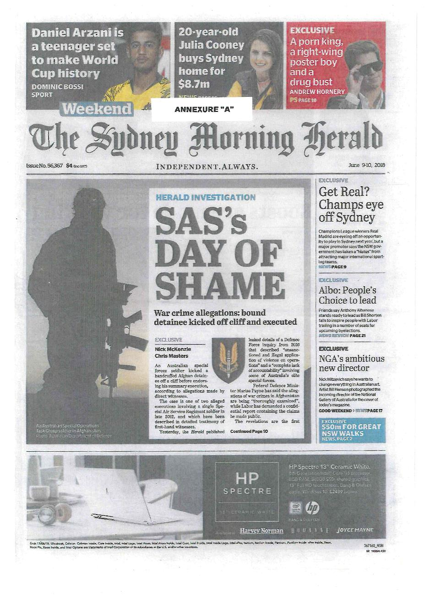
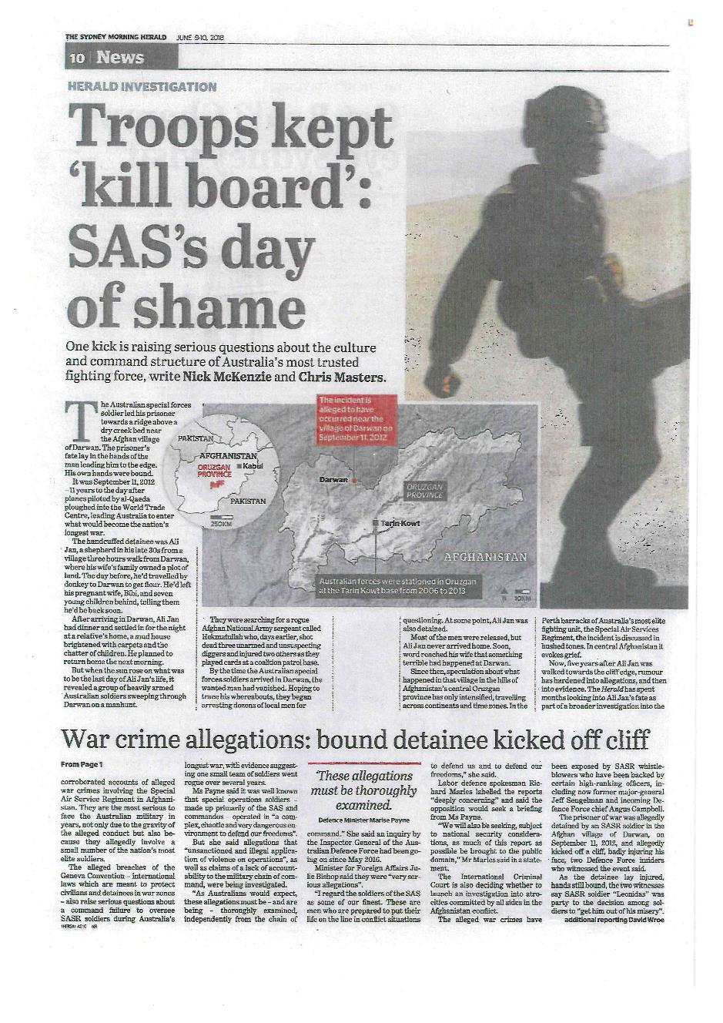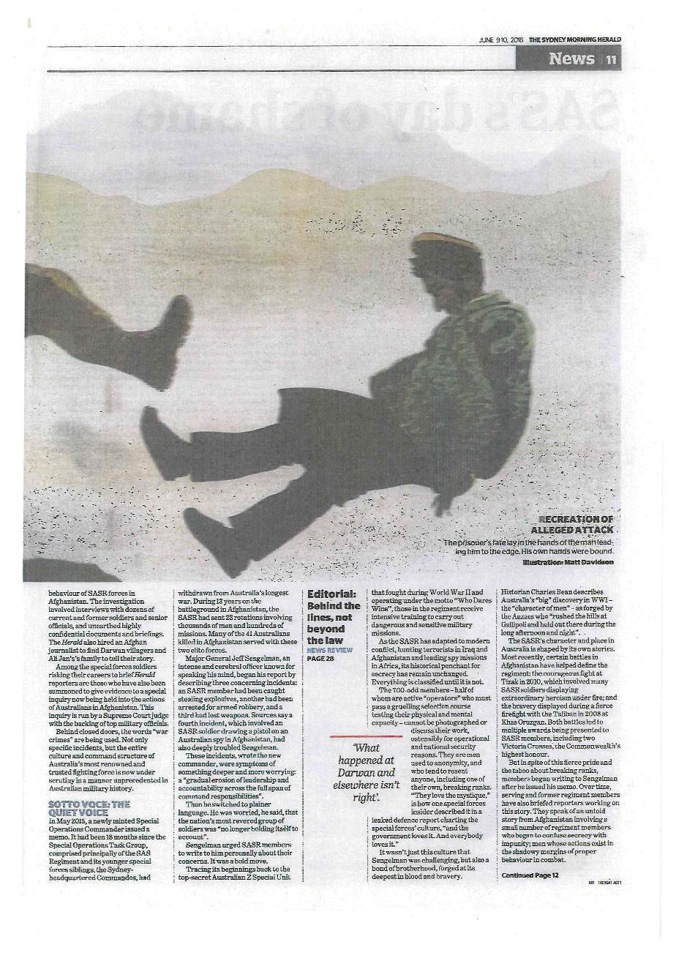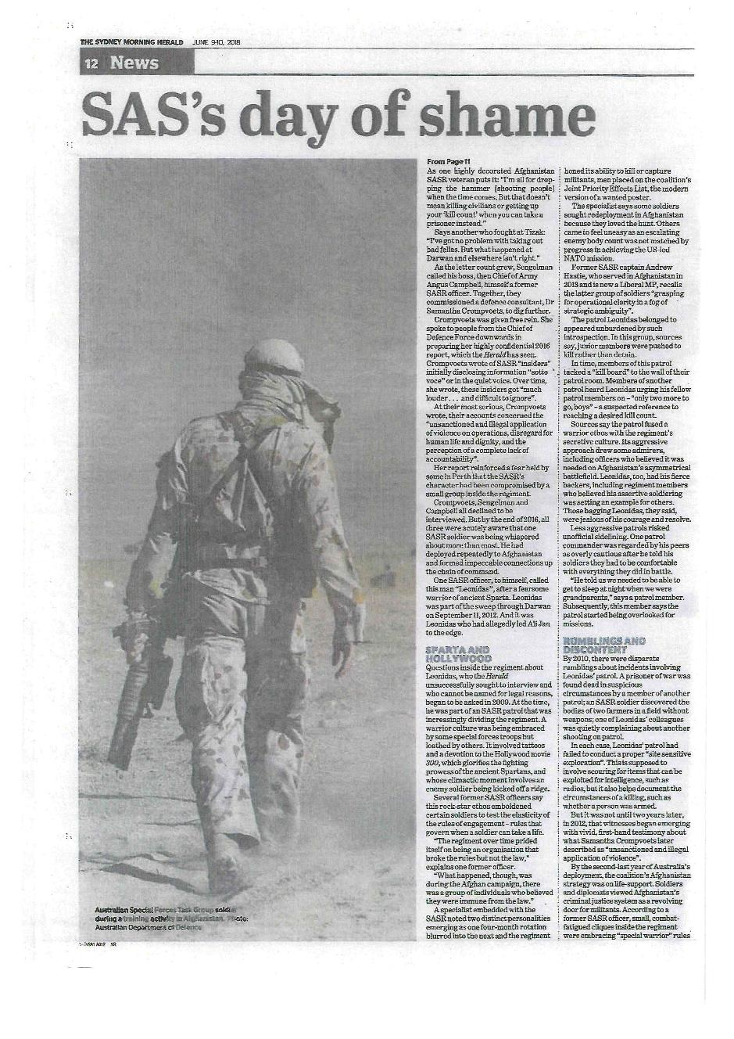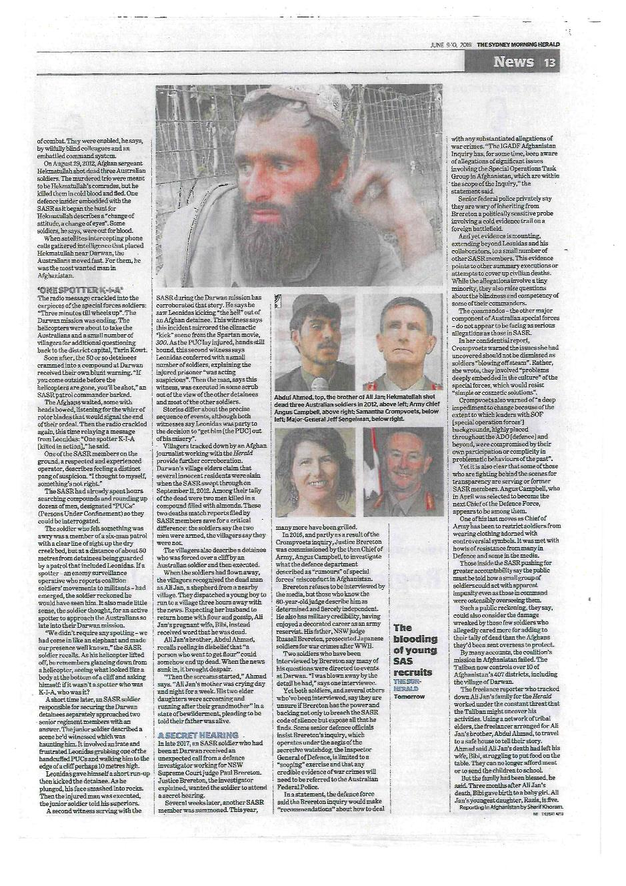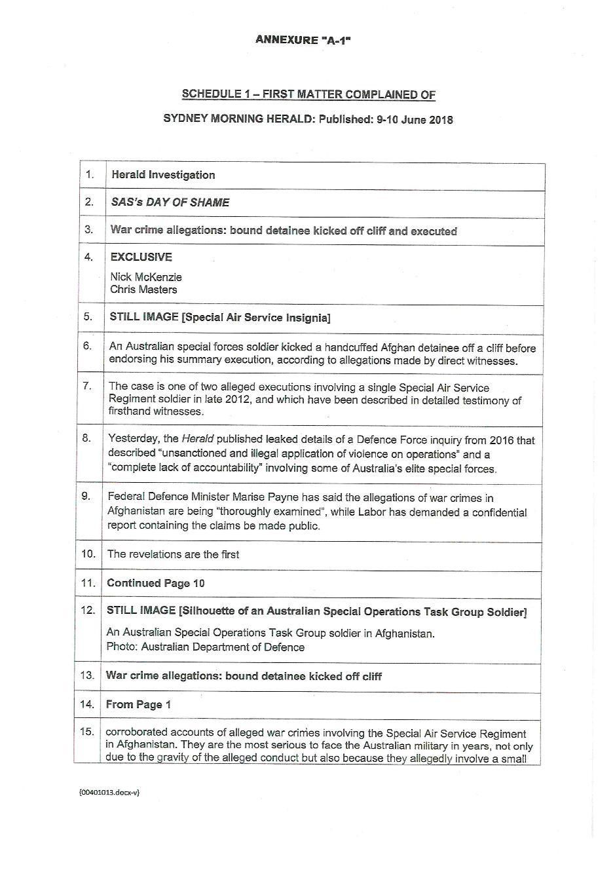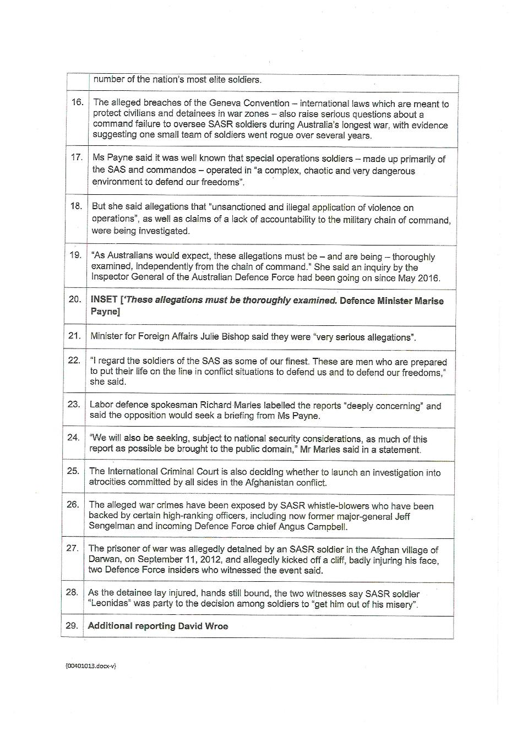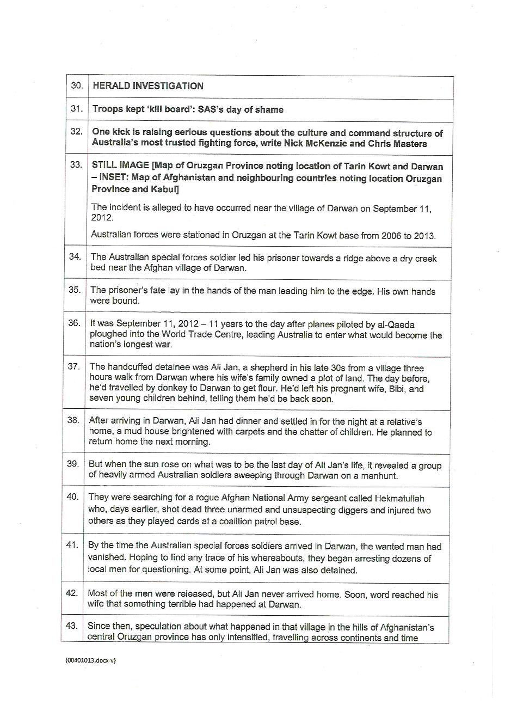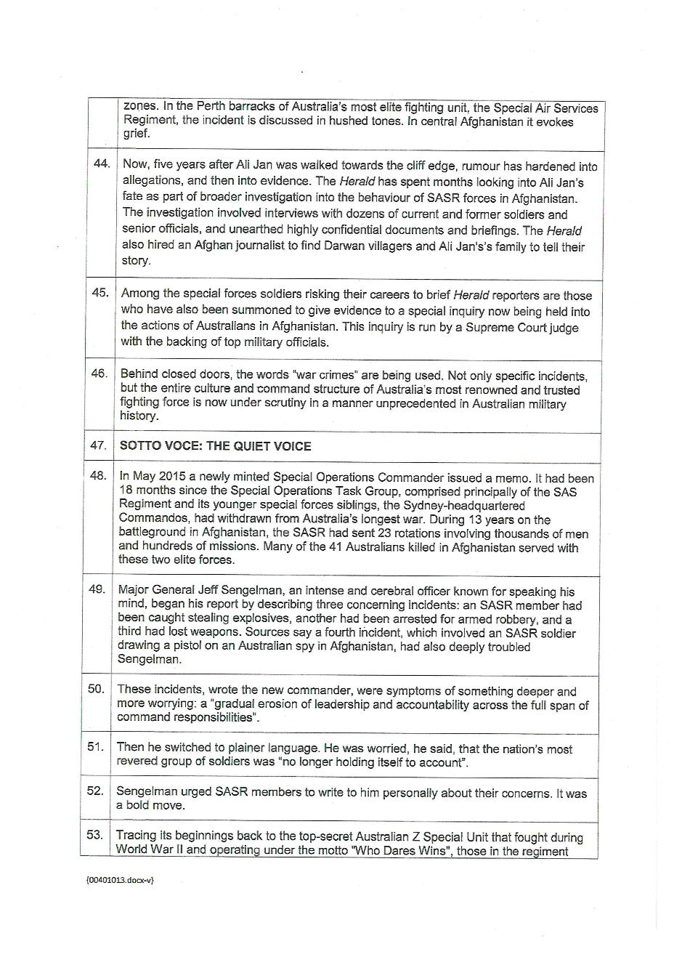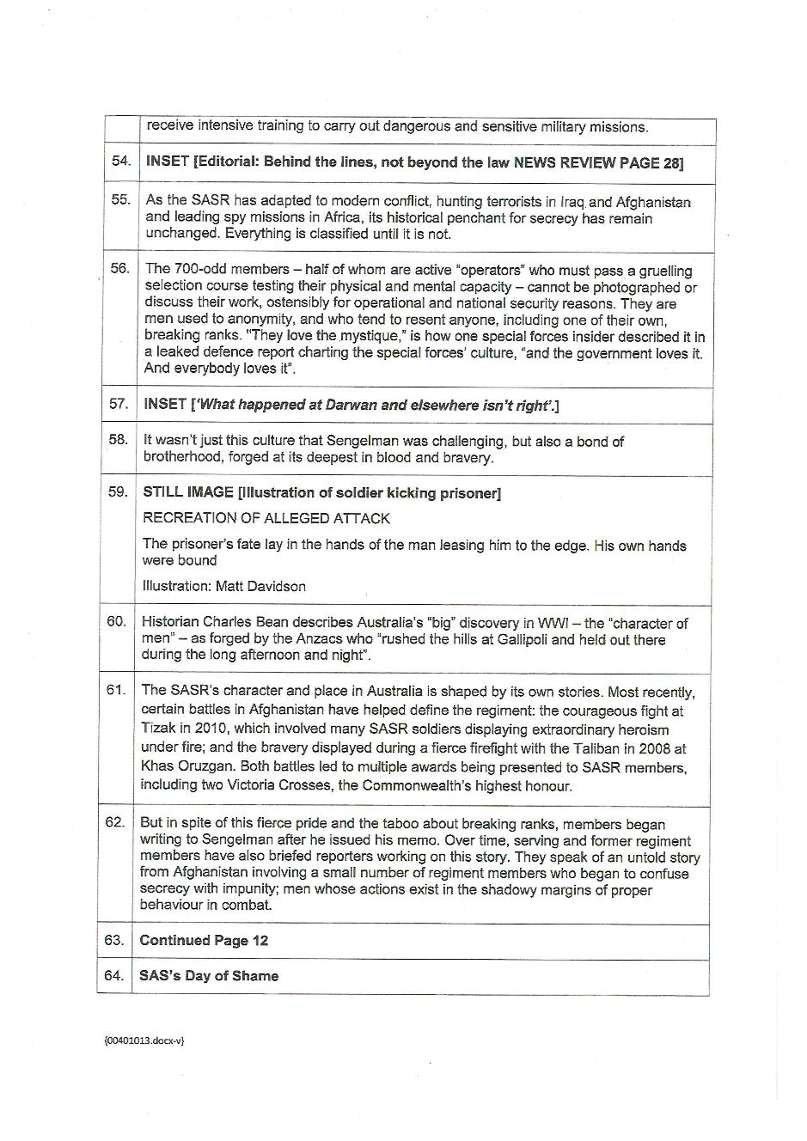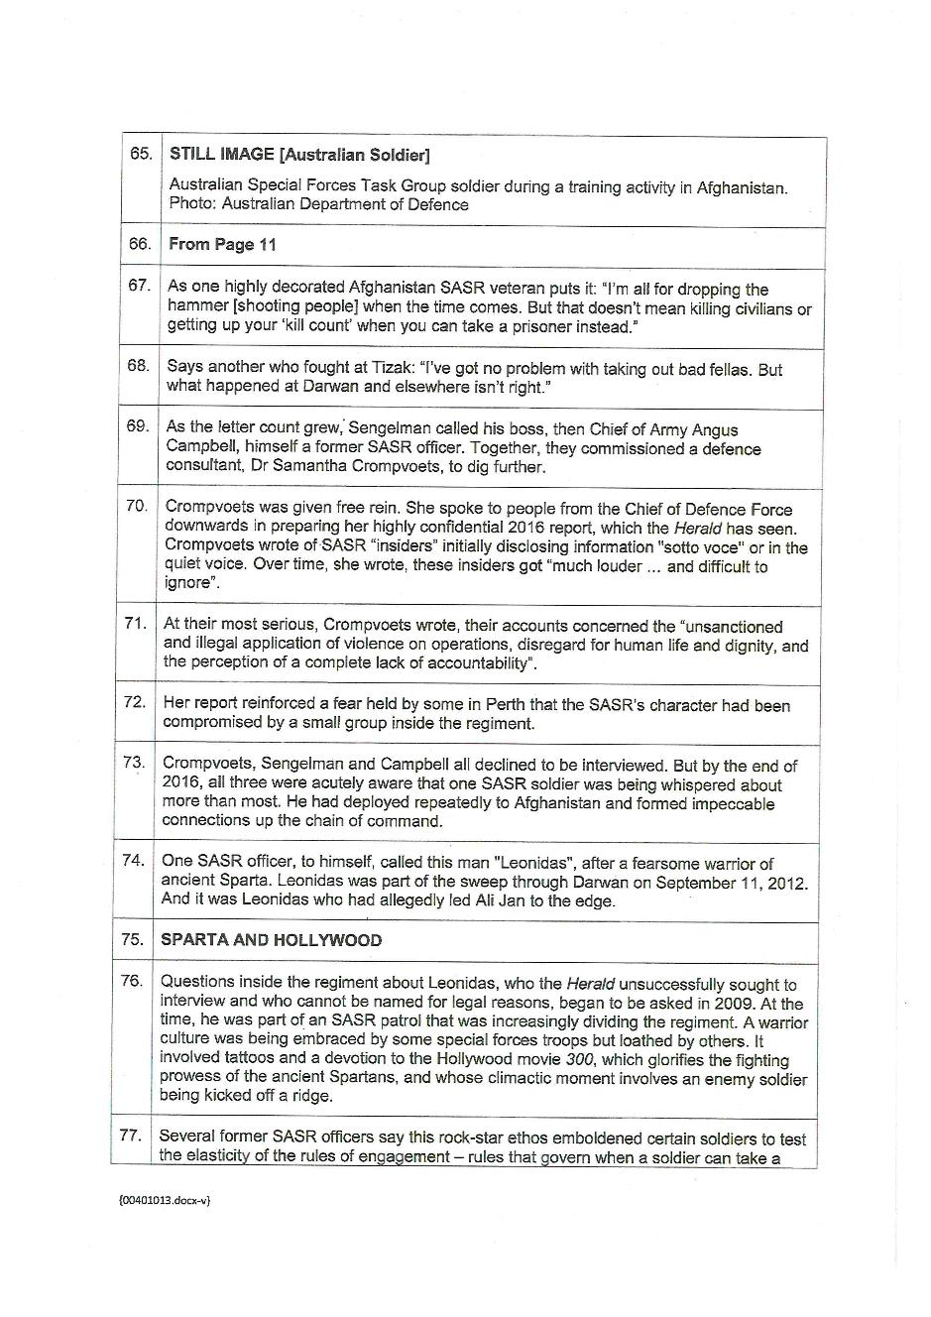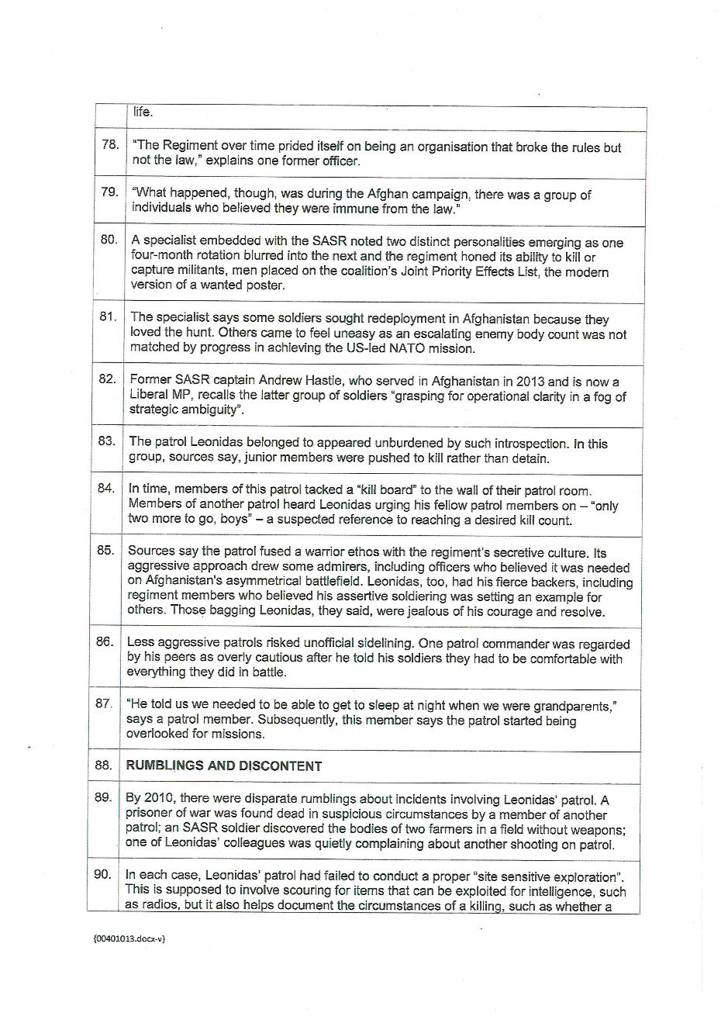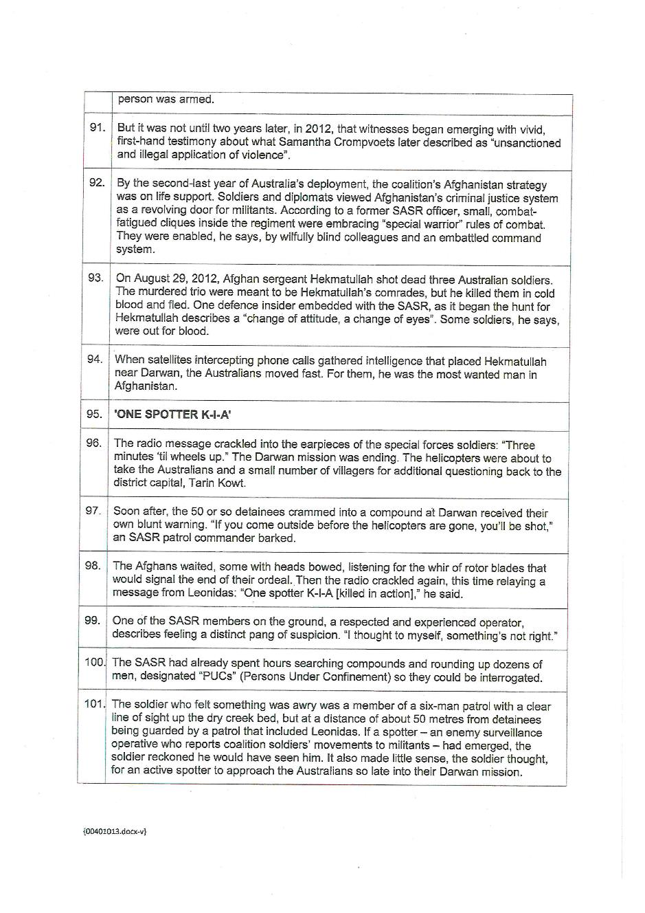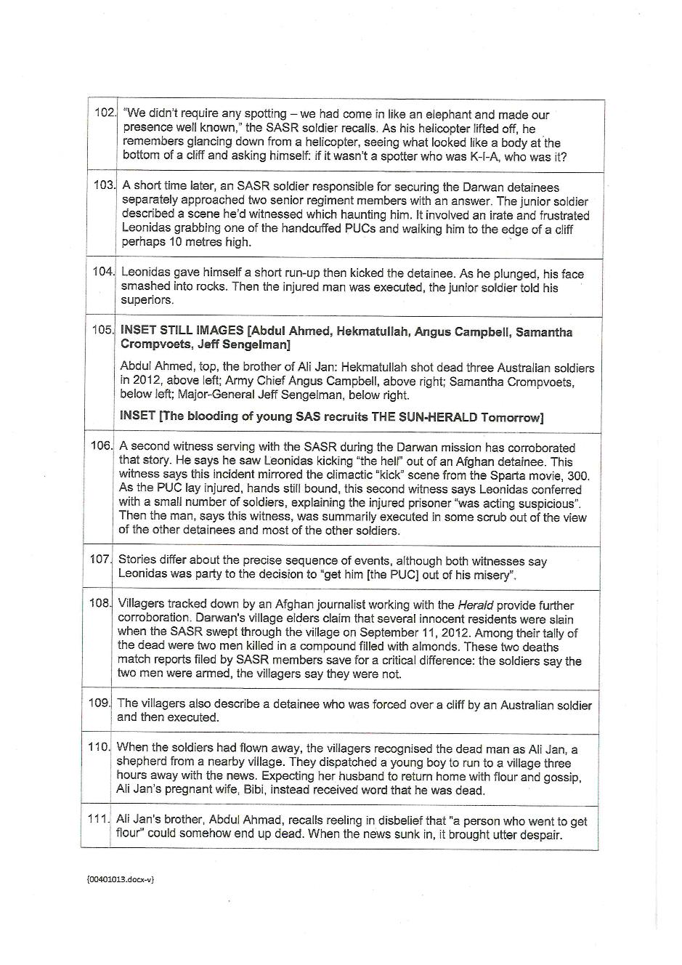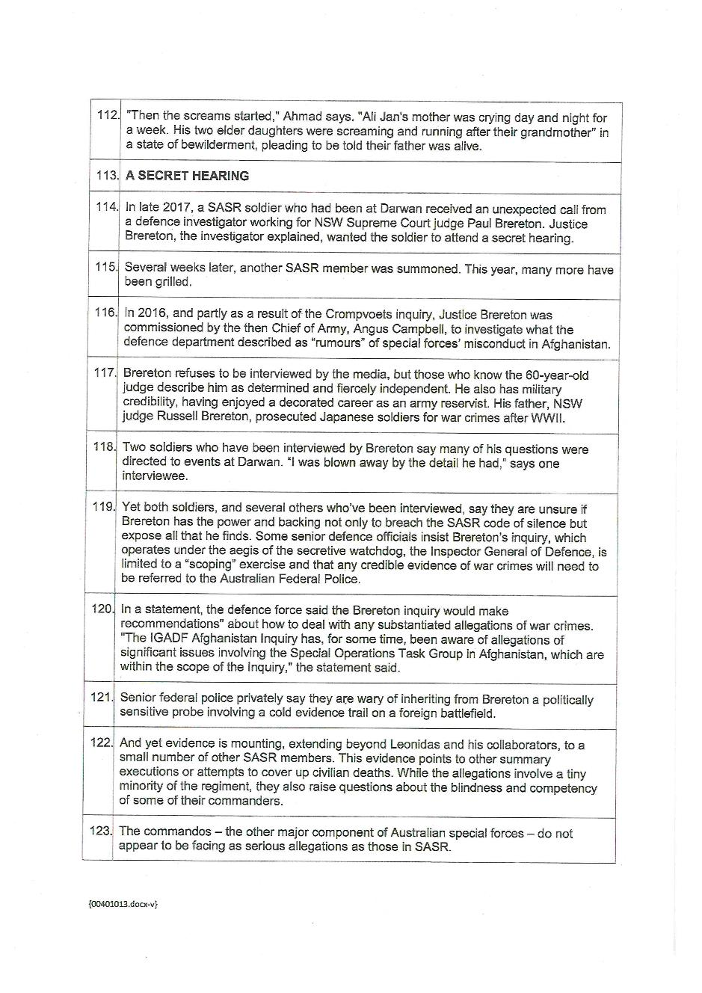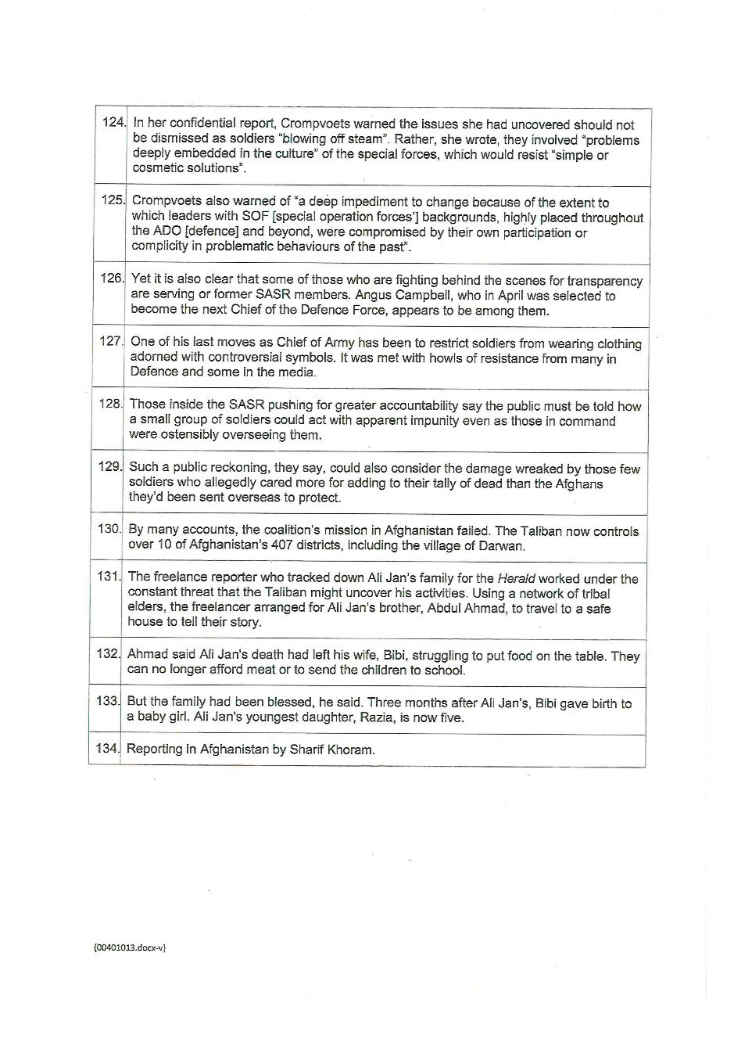

ANNEXURE B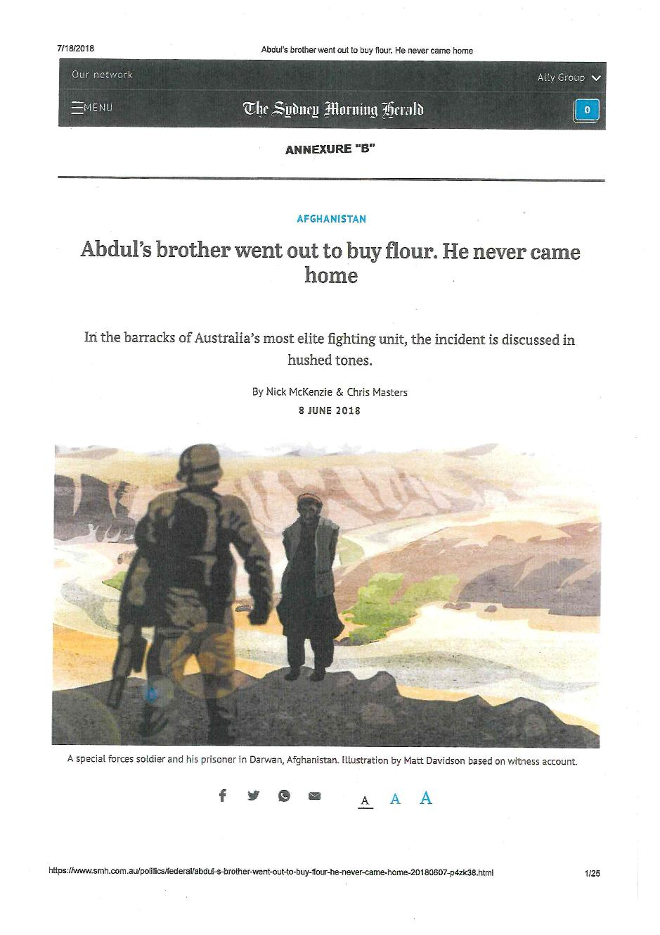
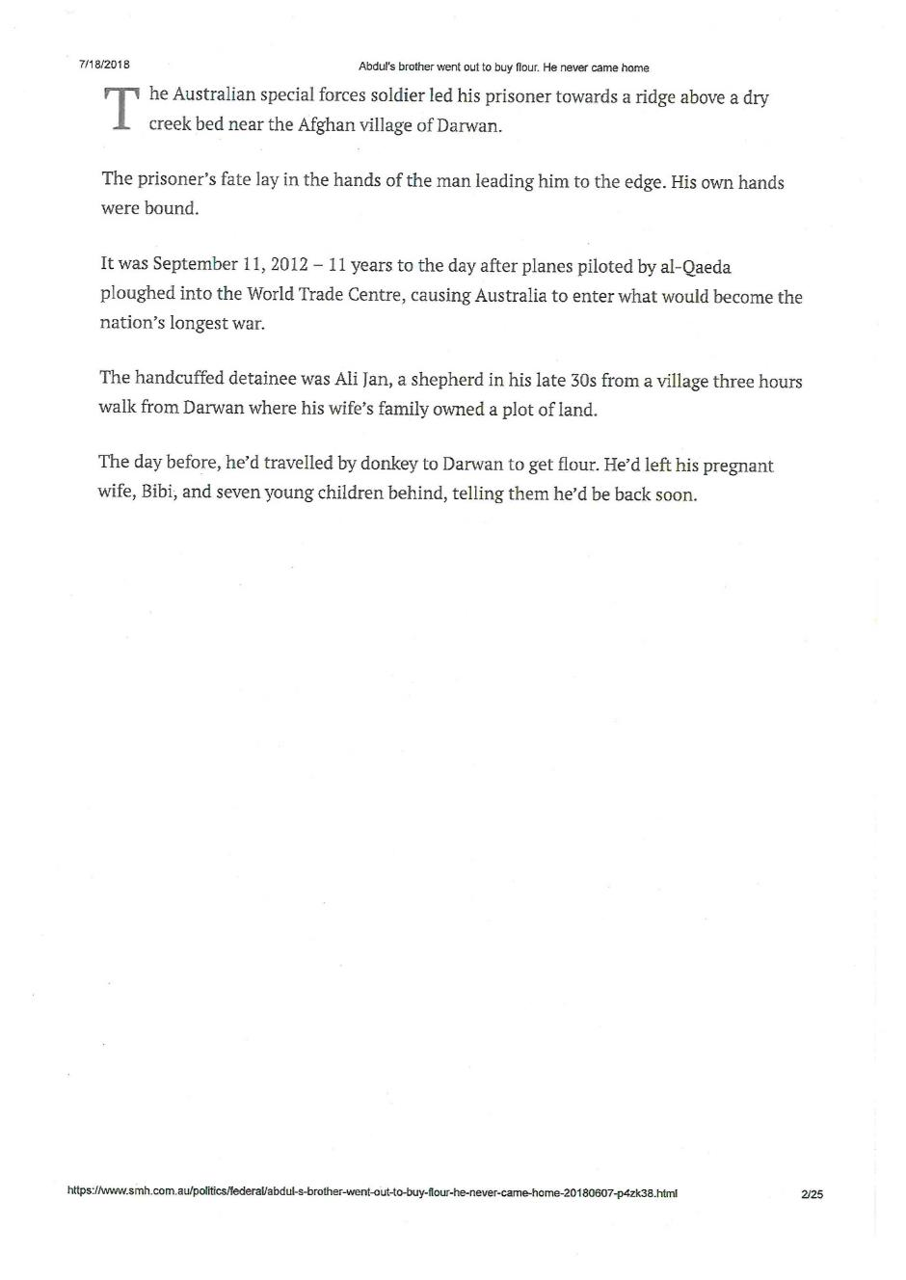
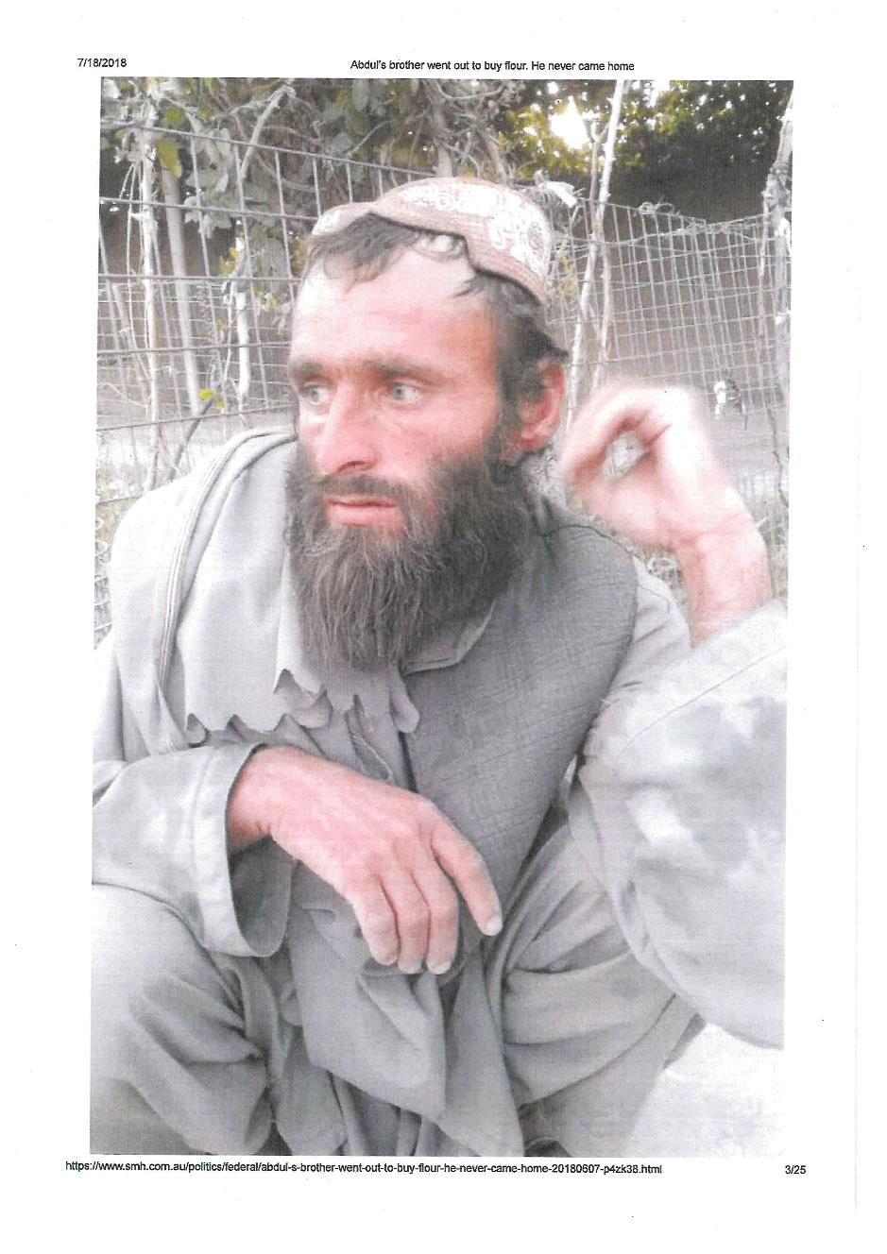
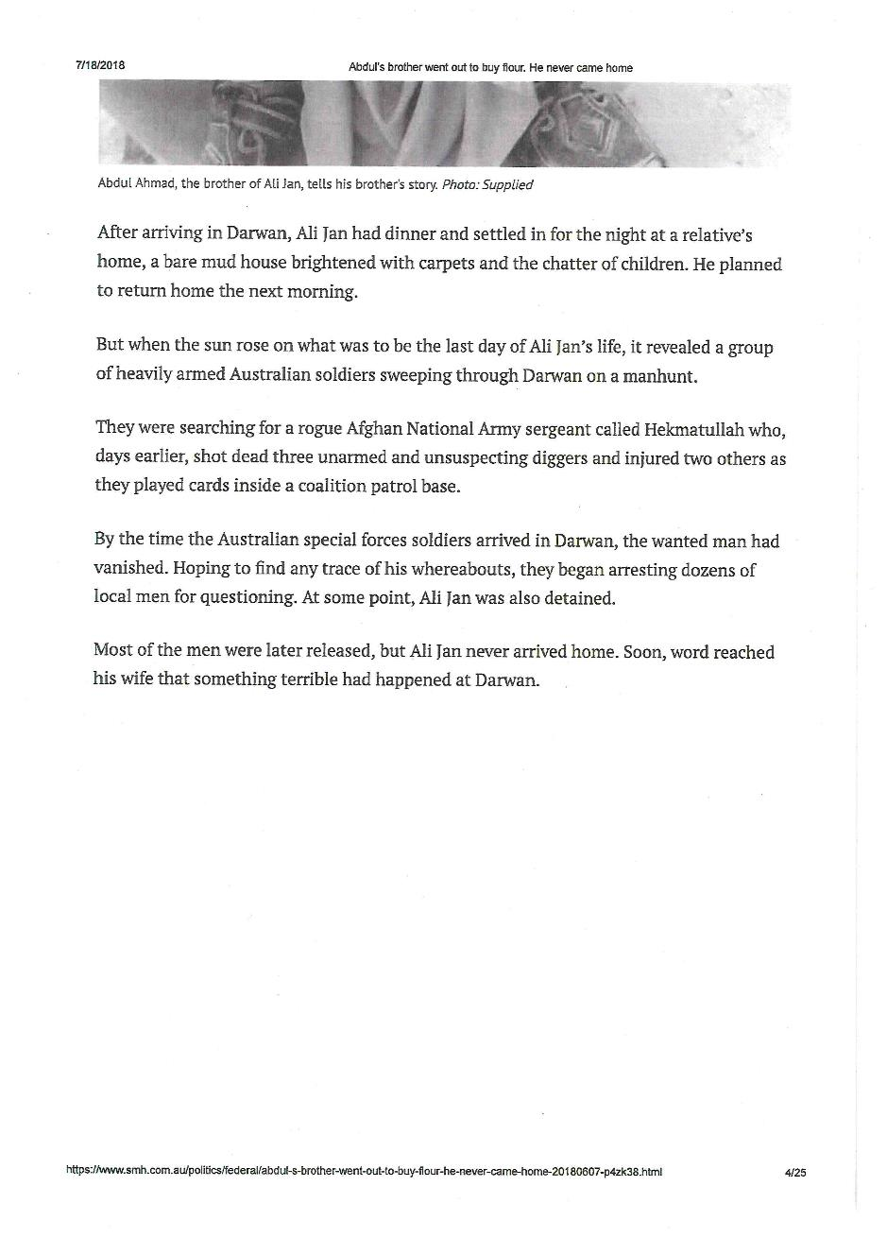
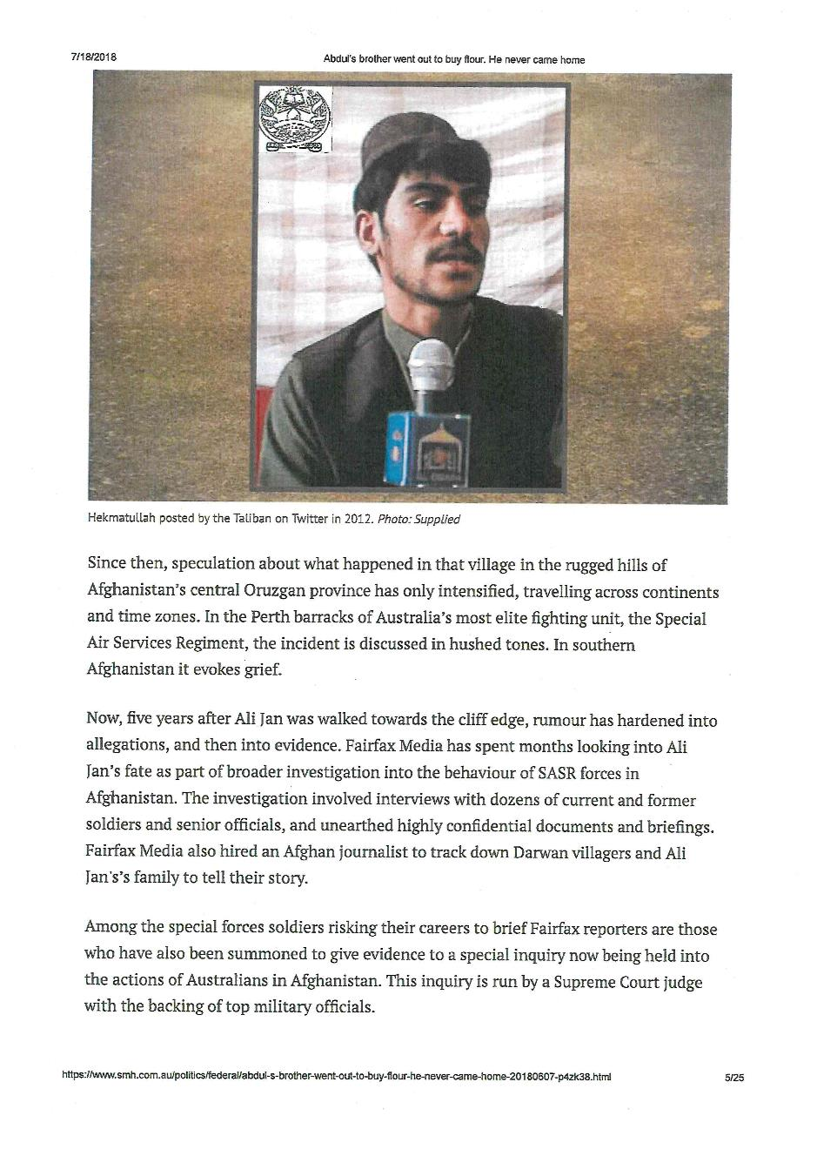
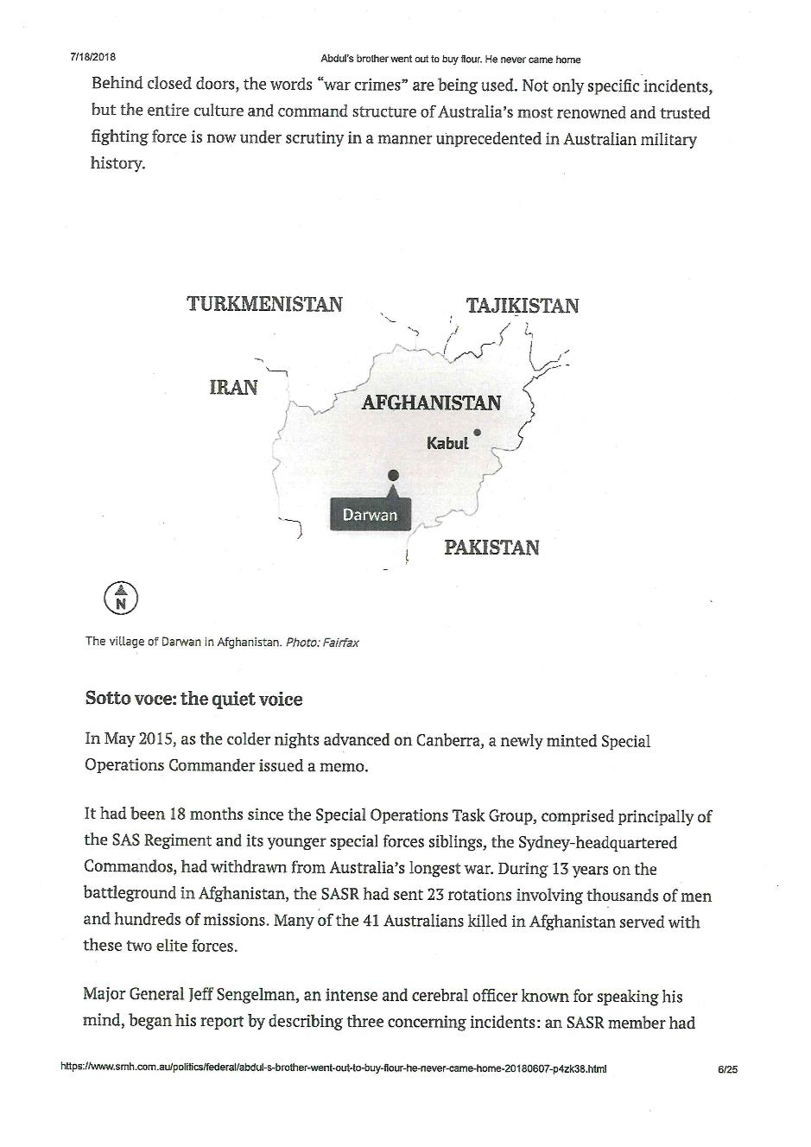
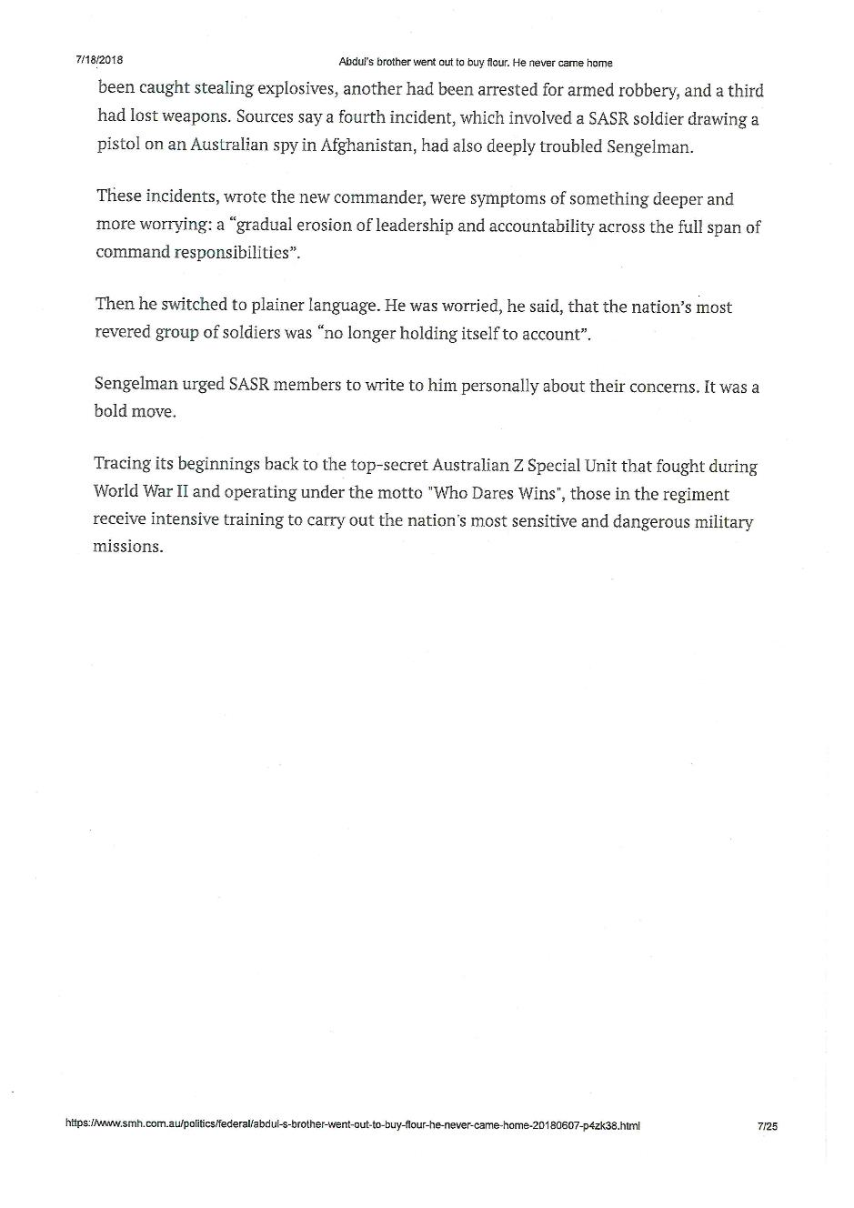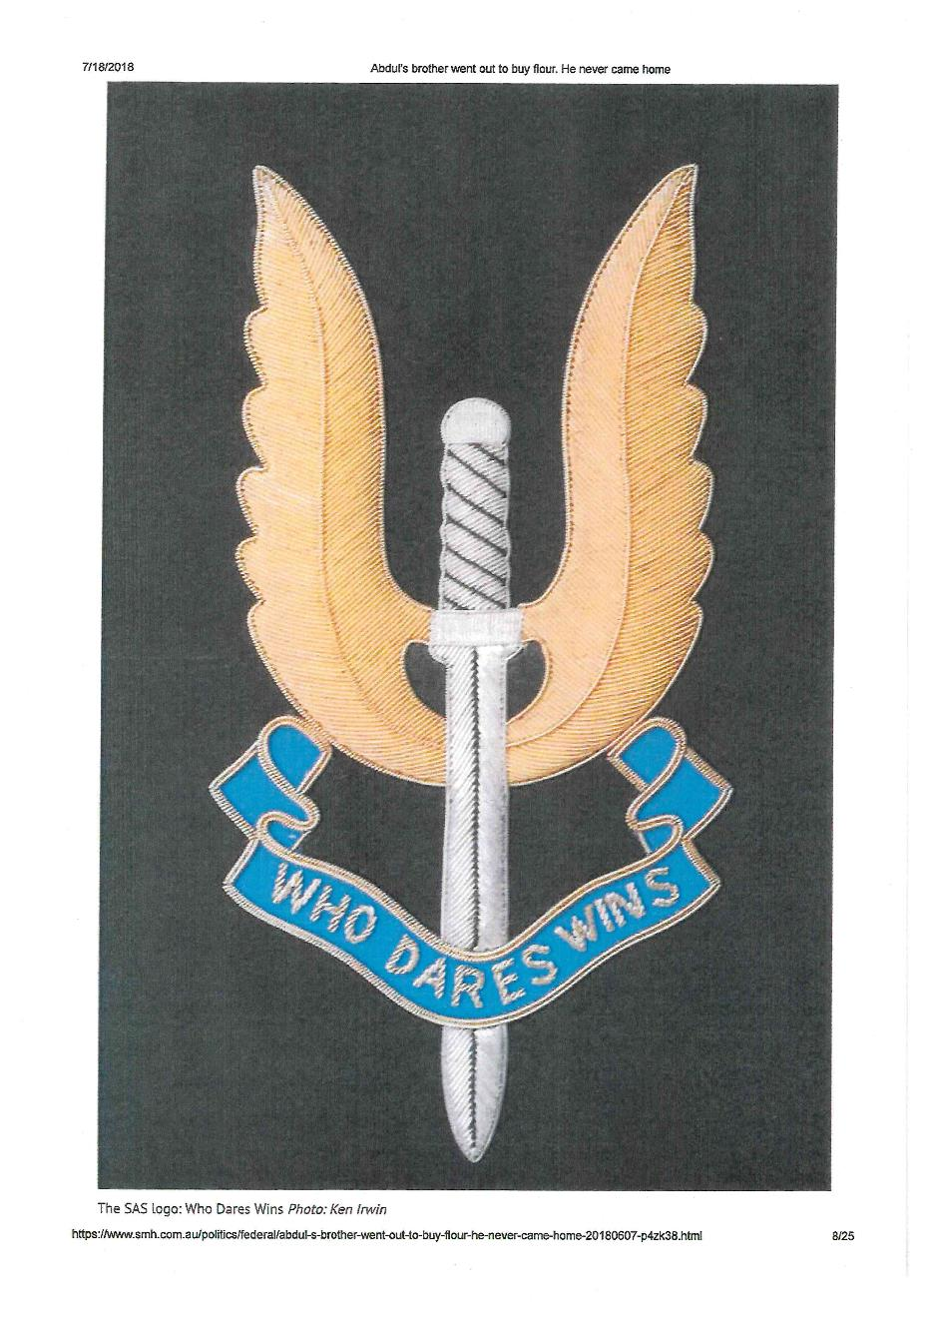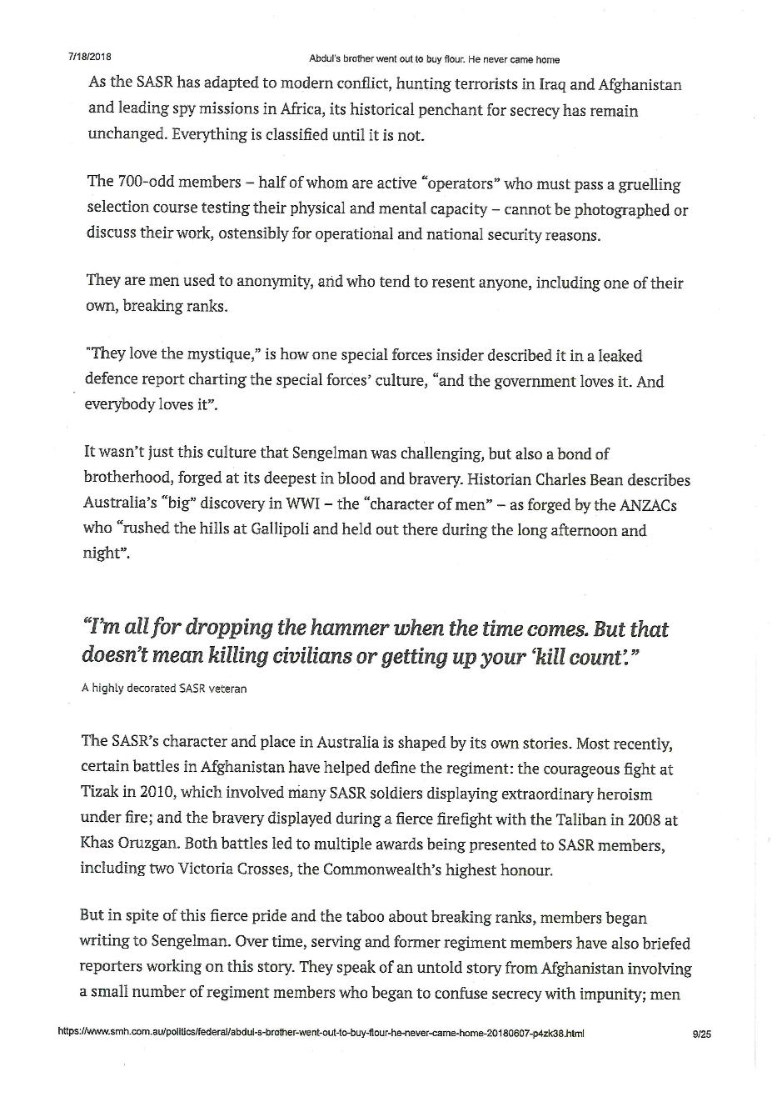
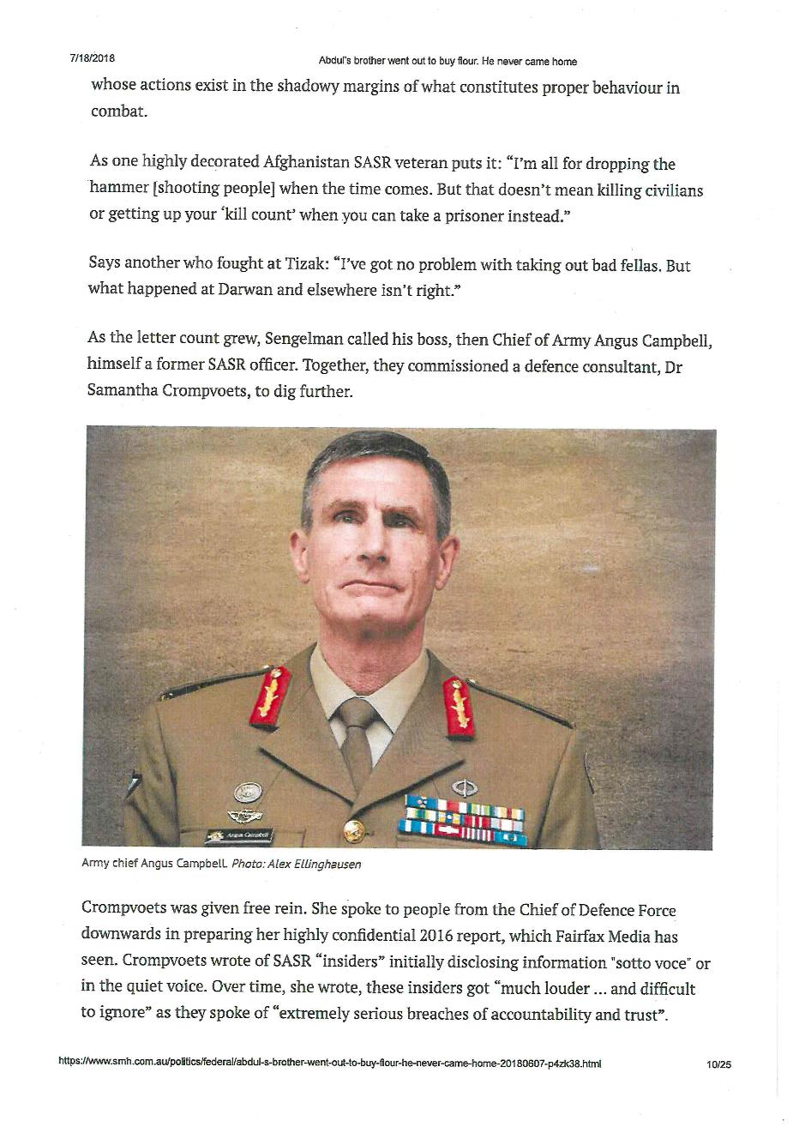
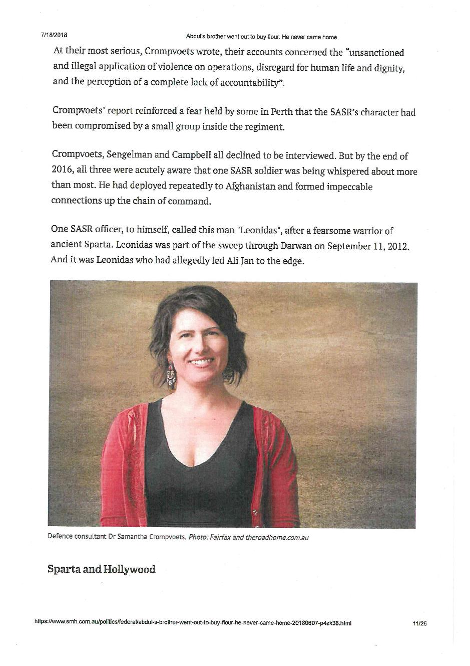
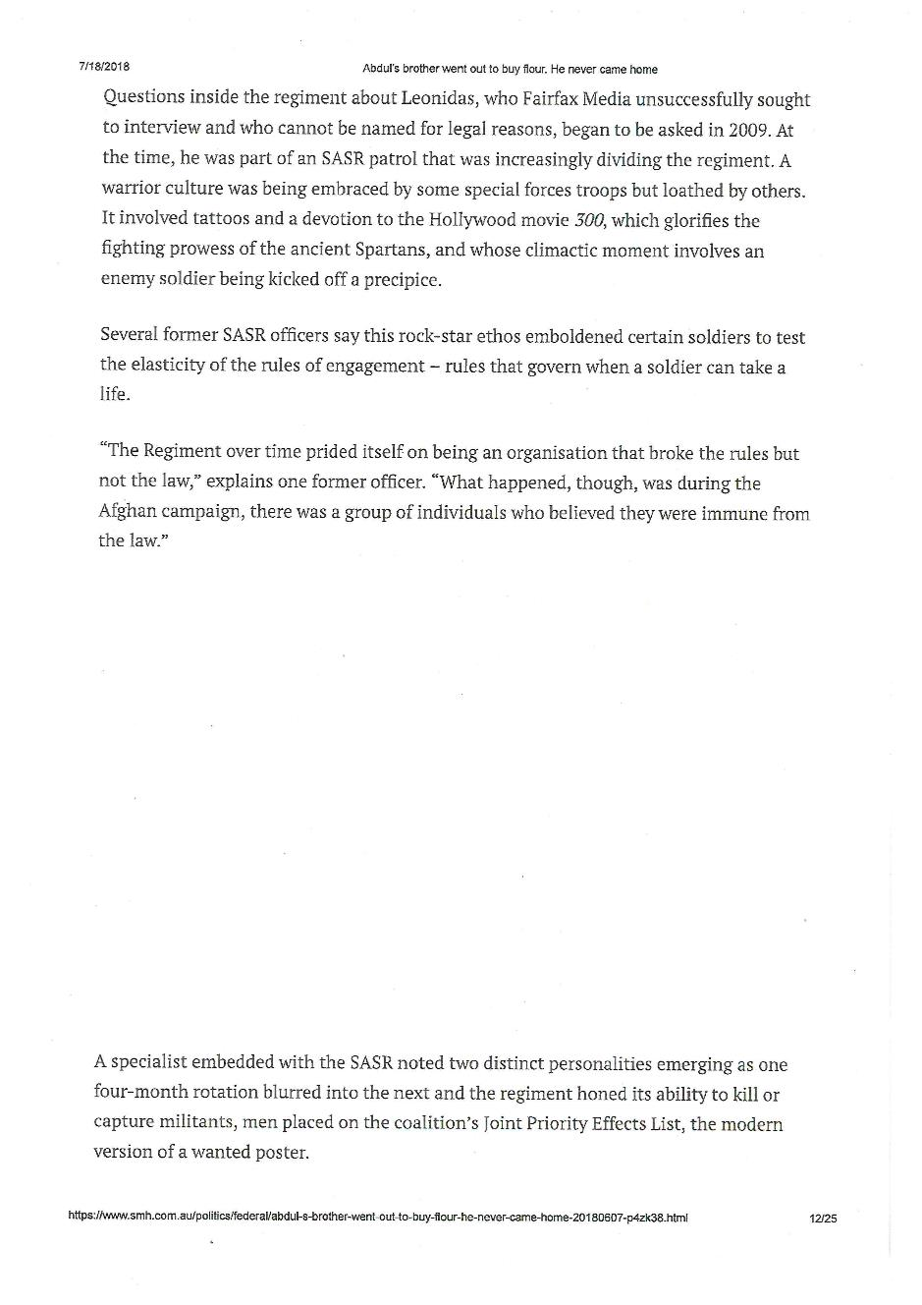
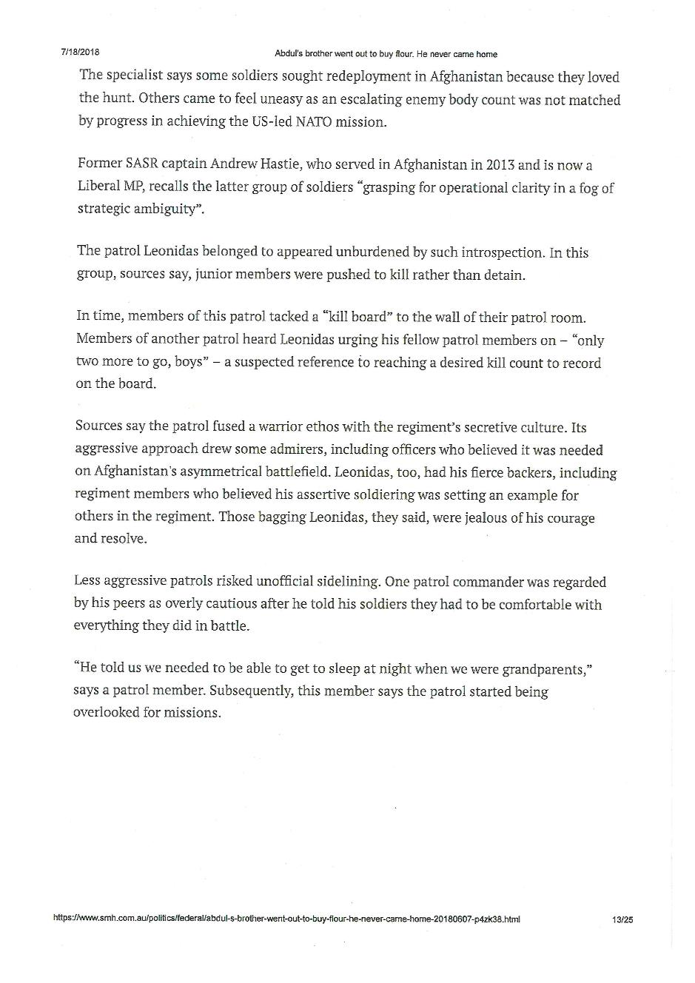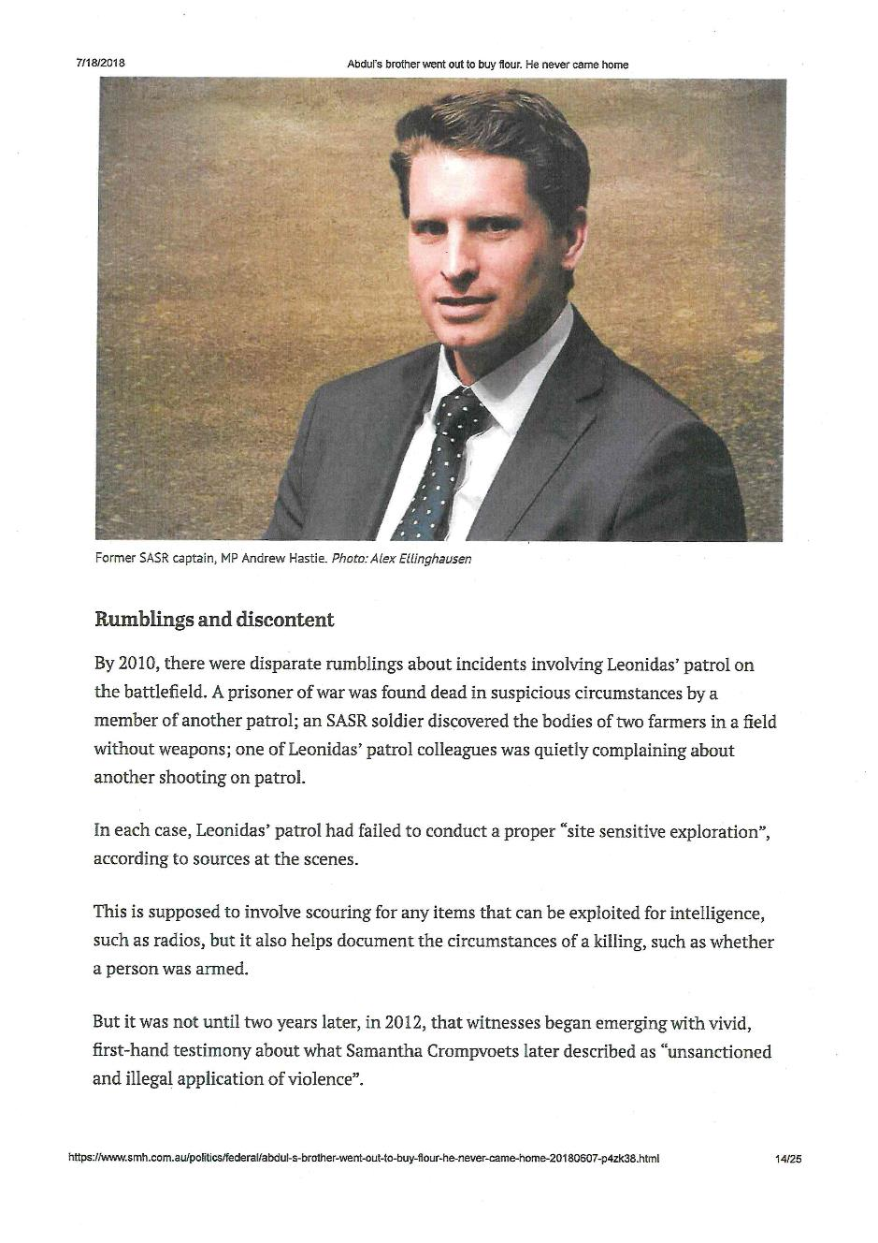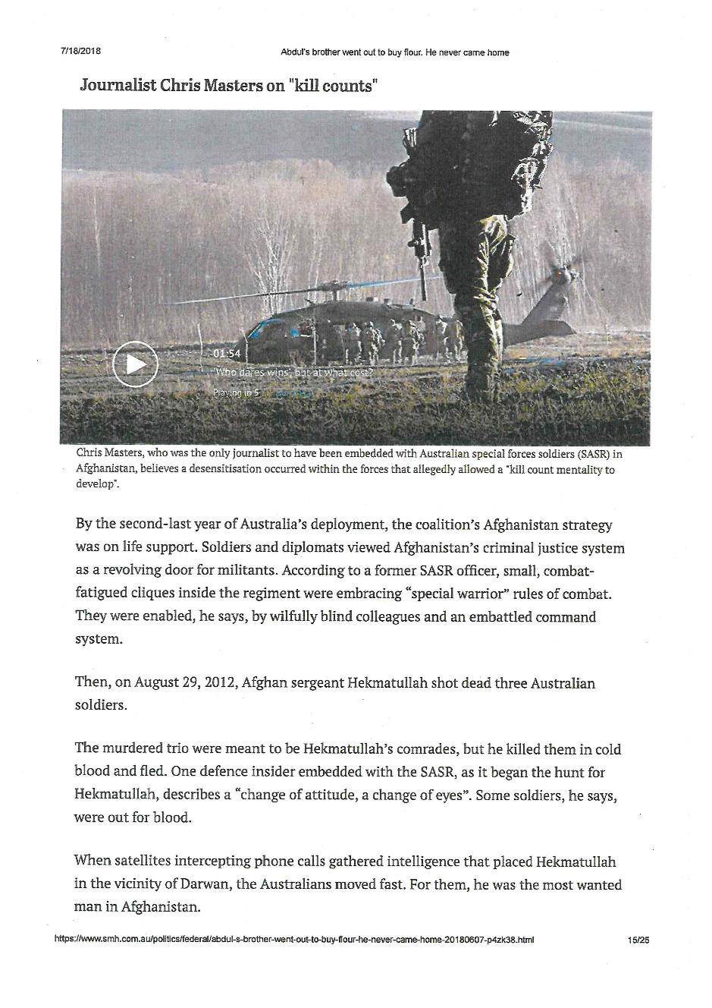
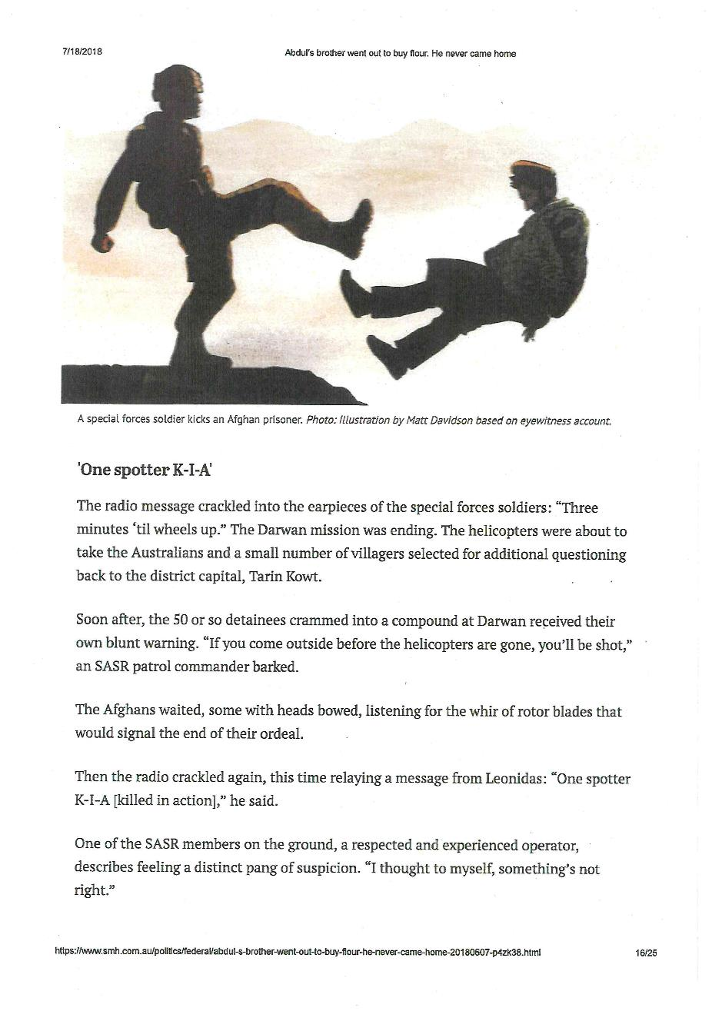
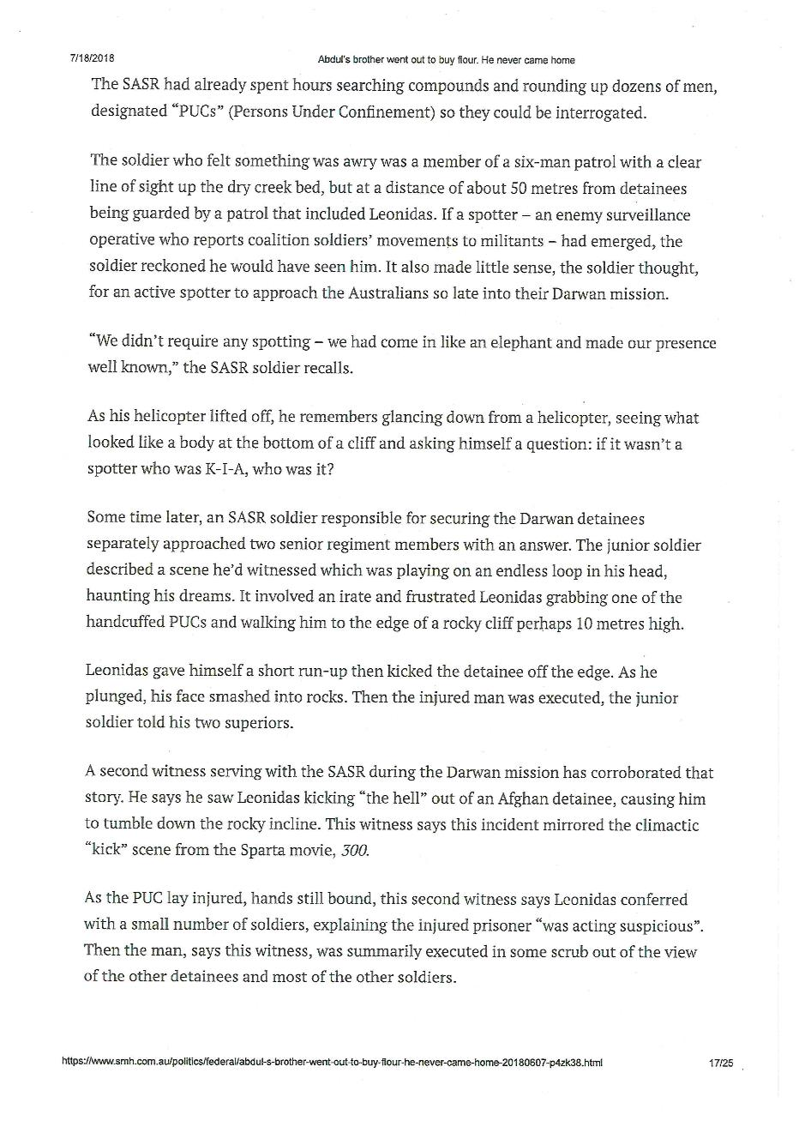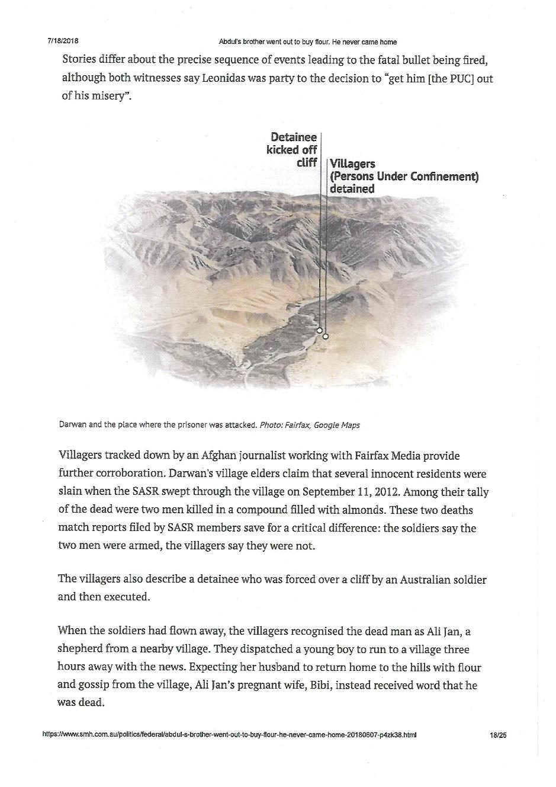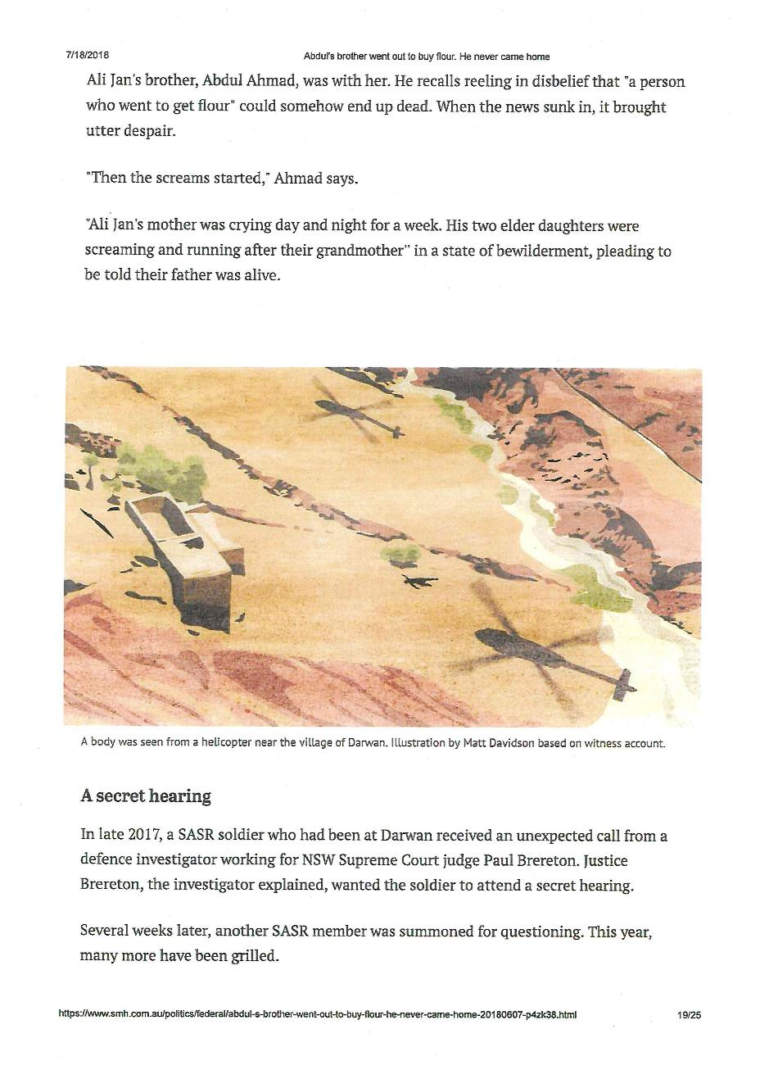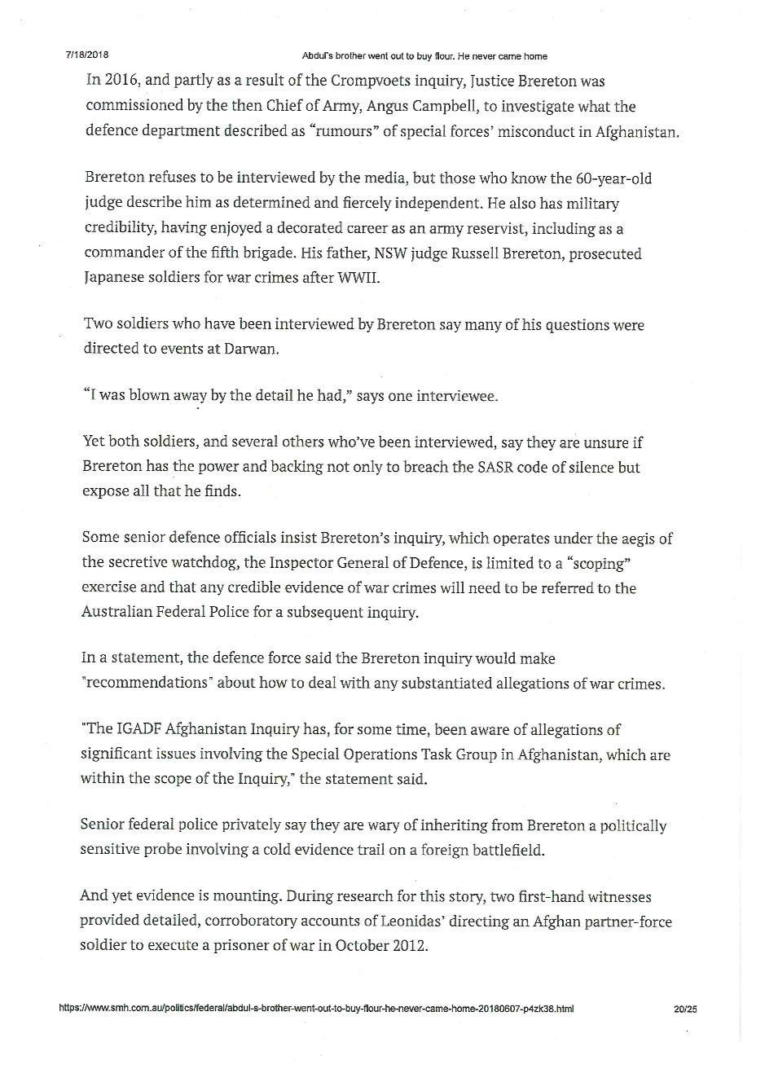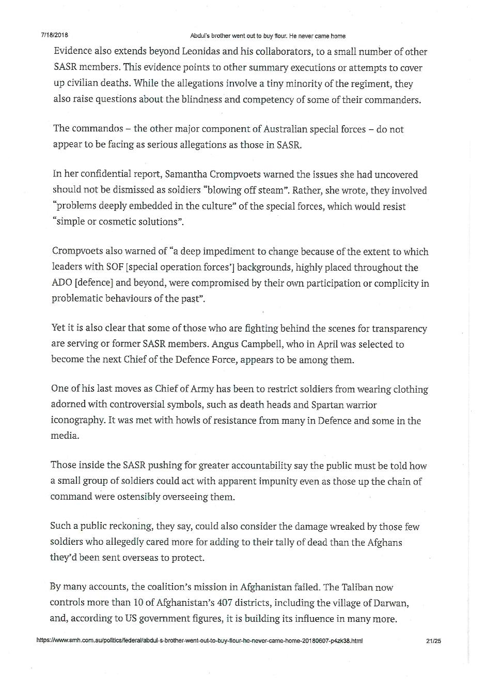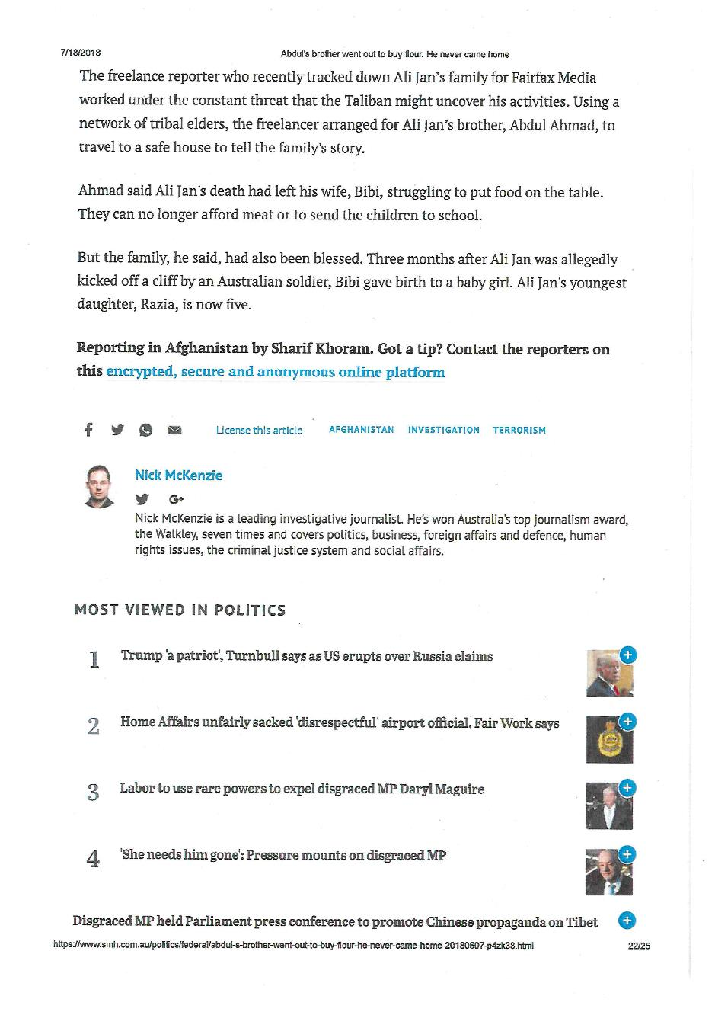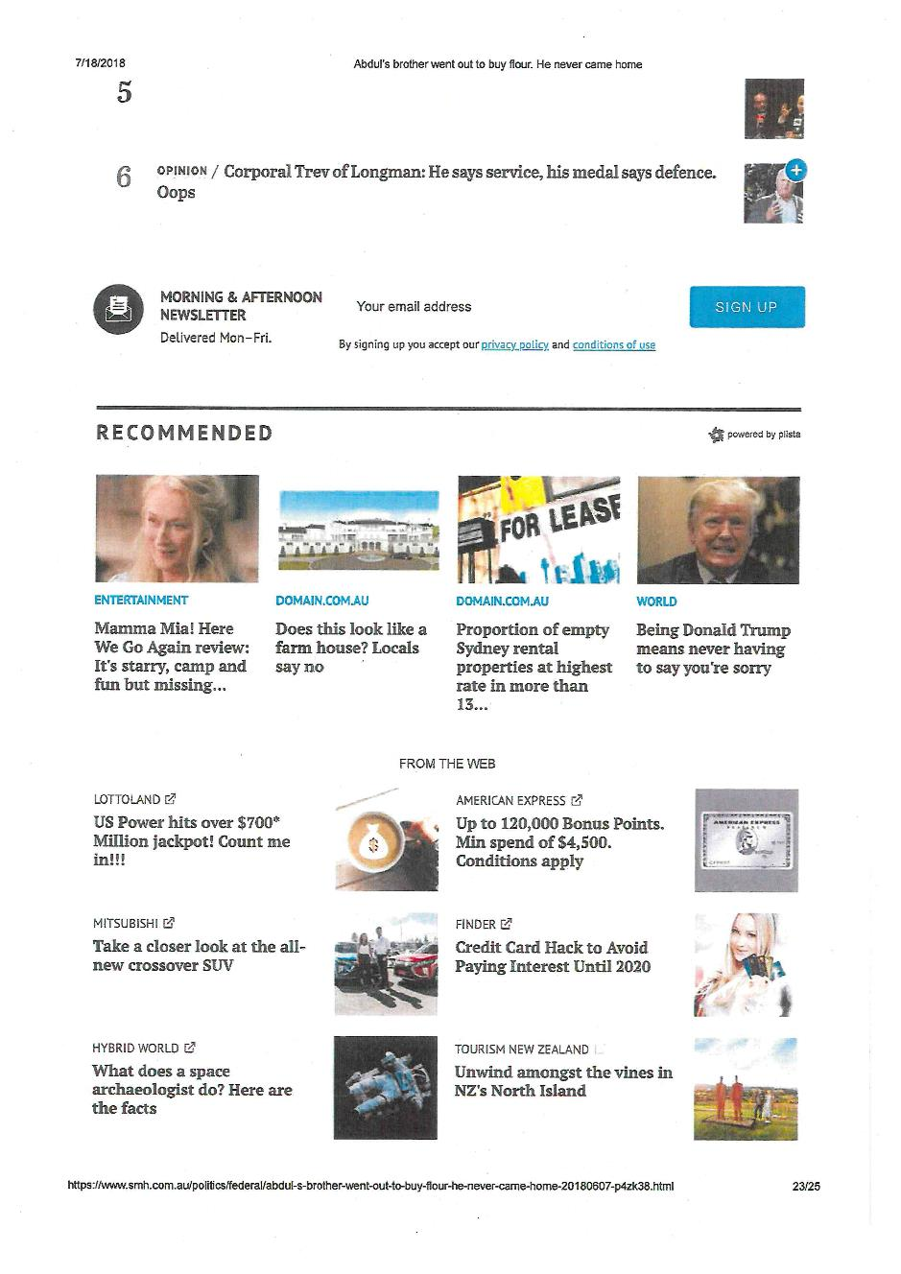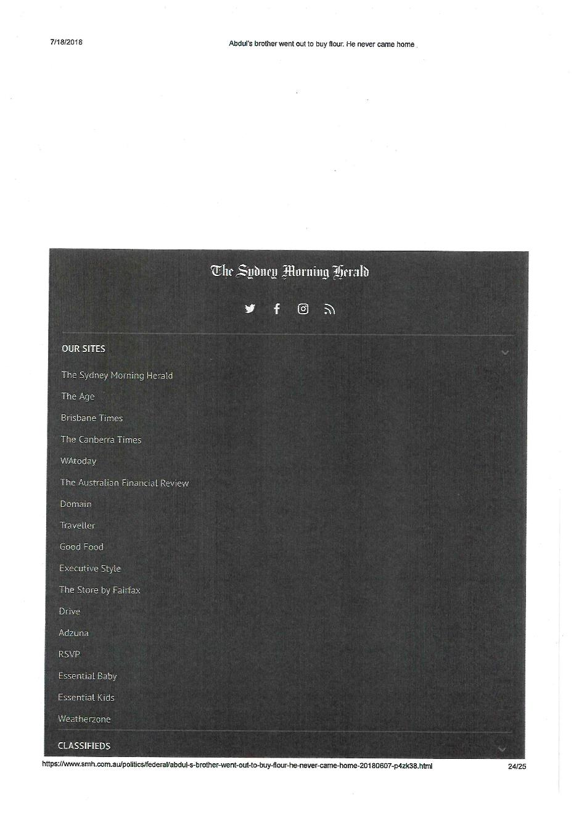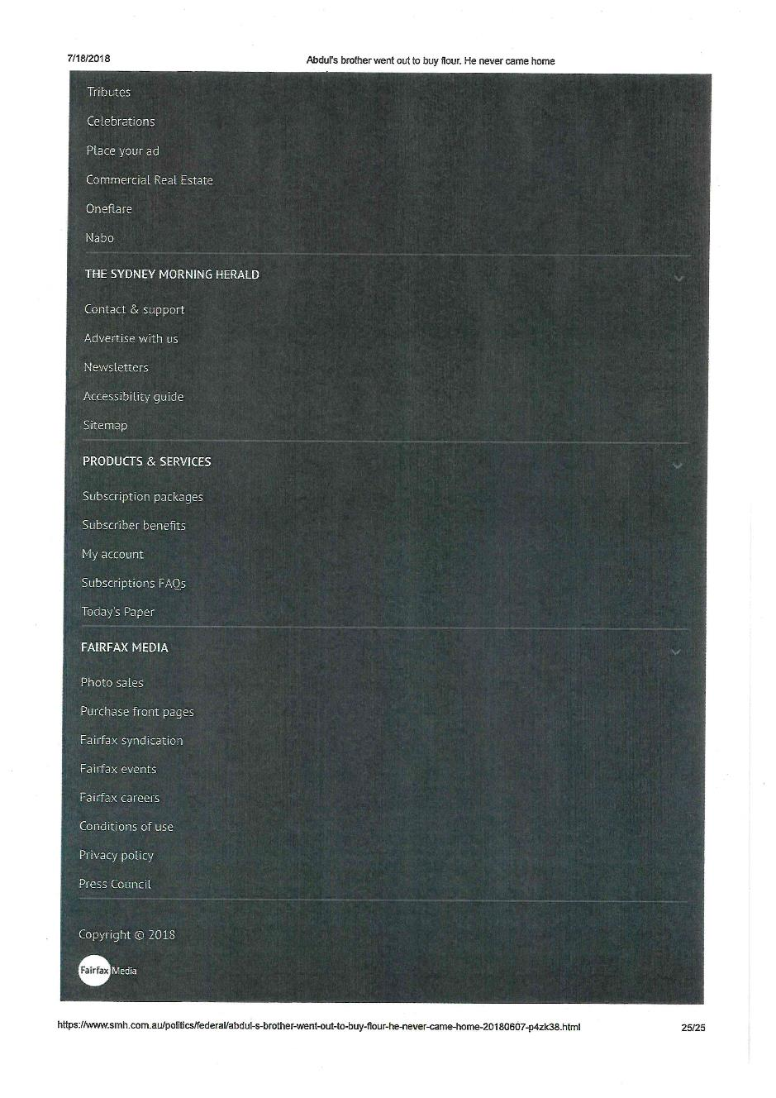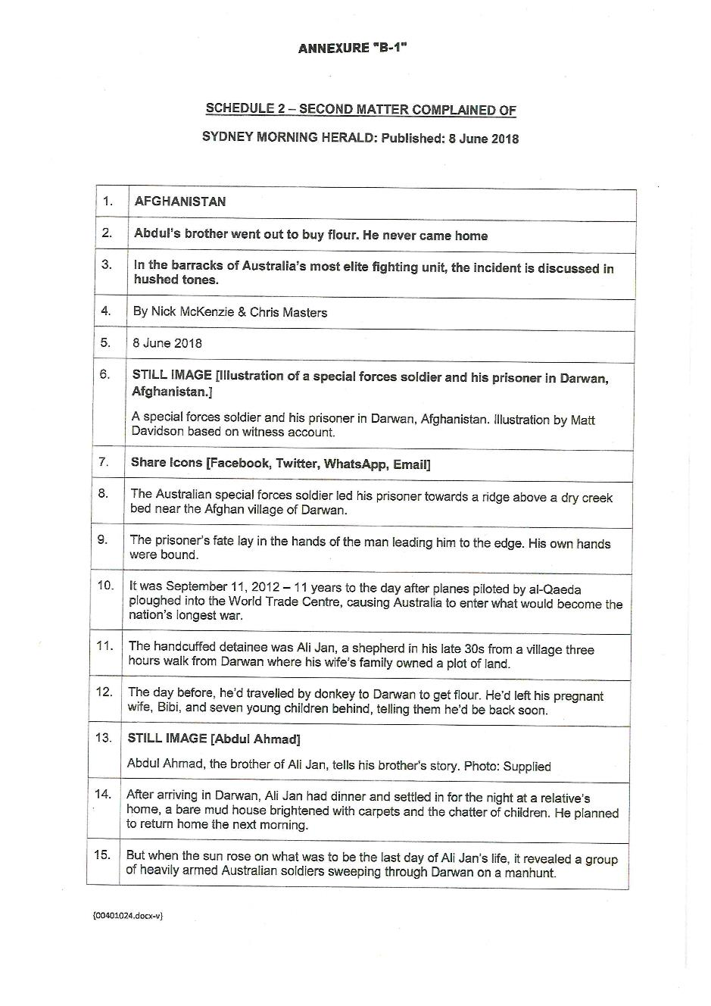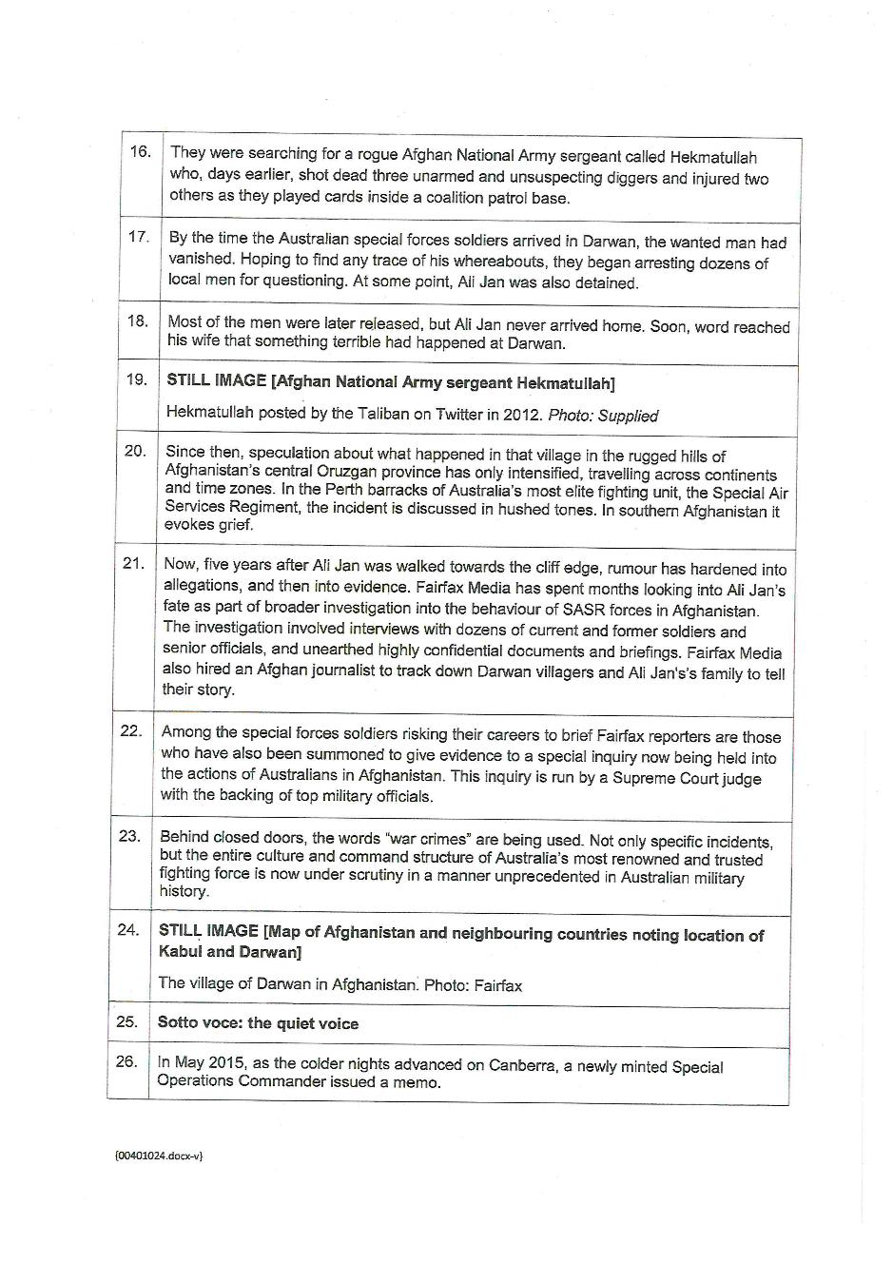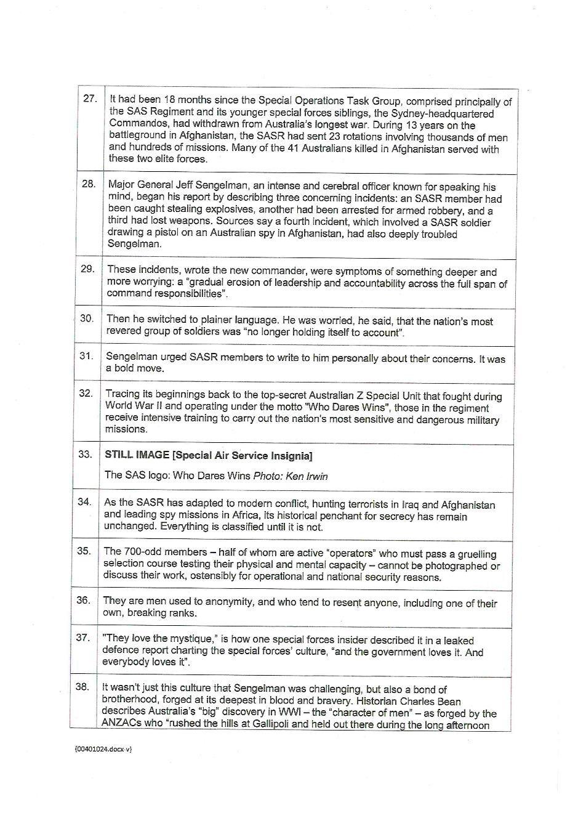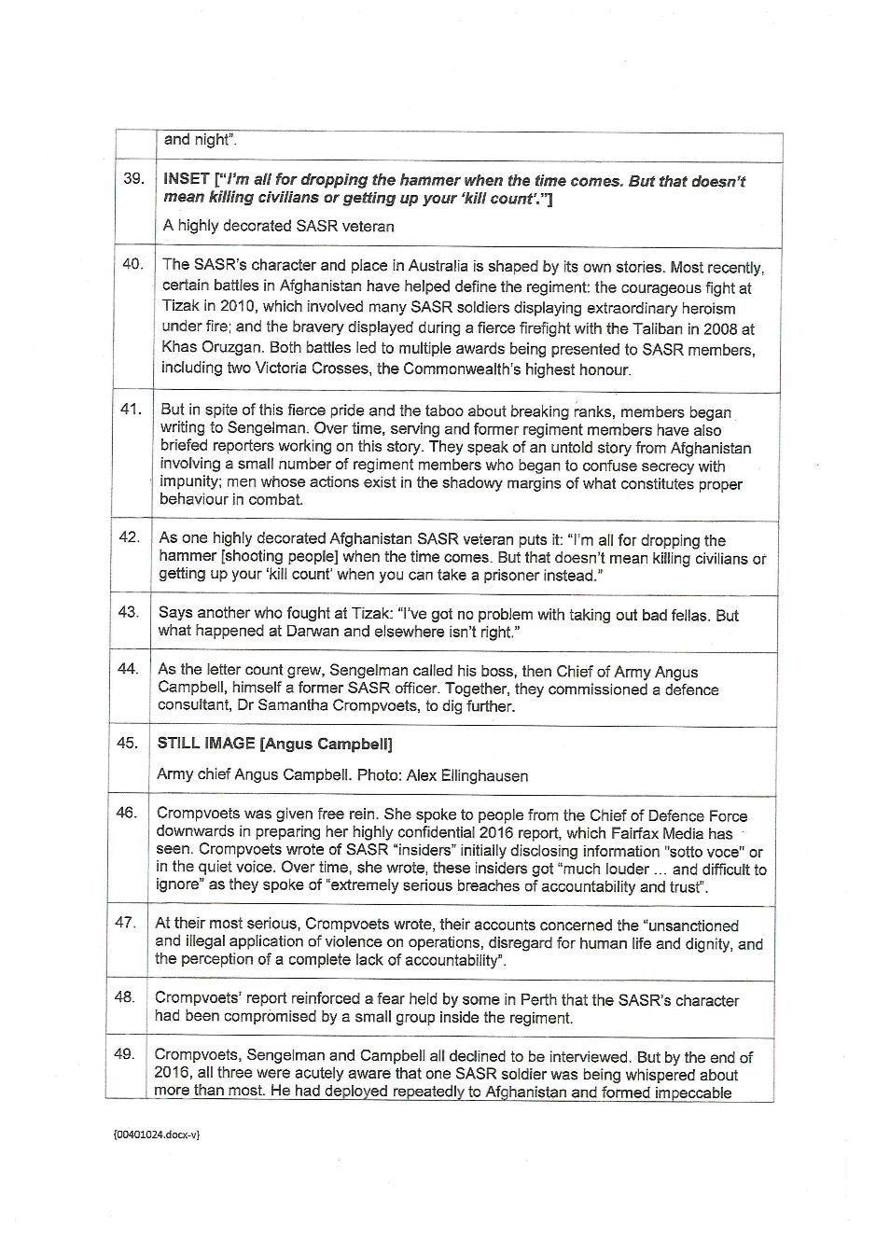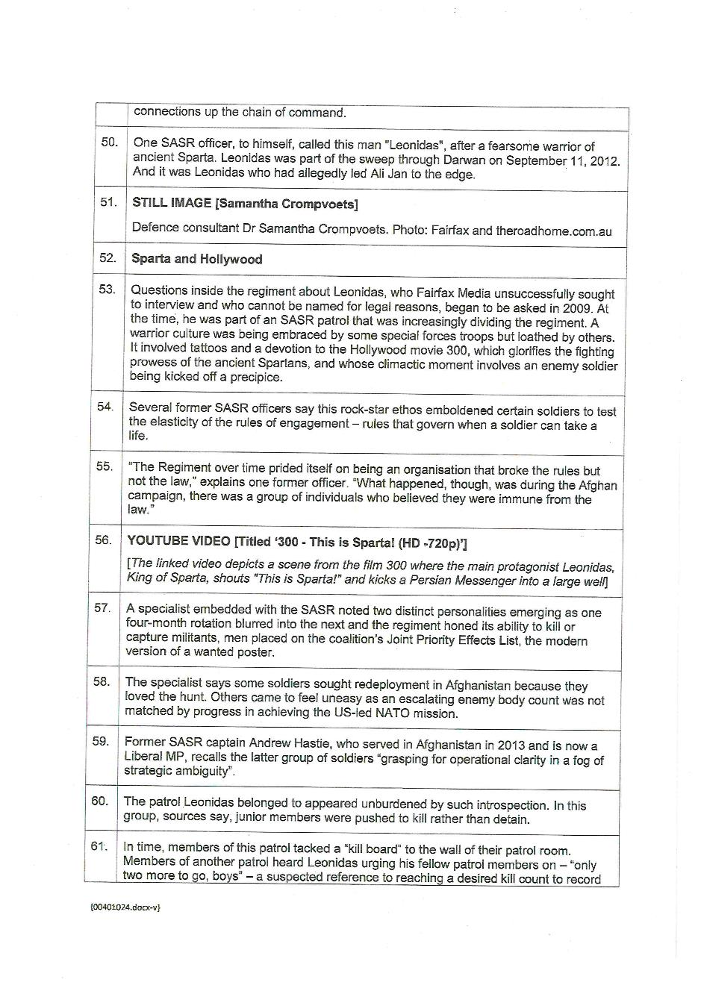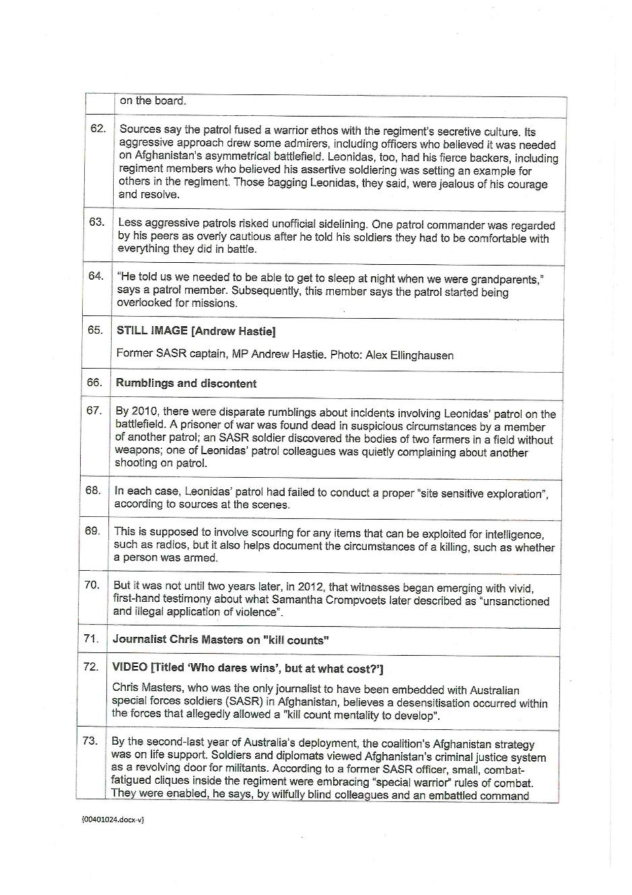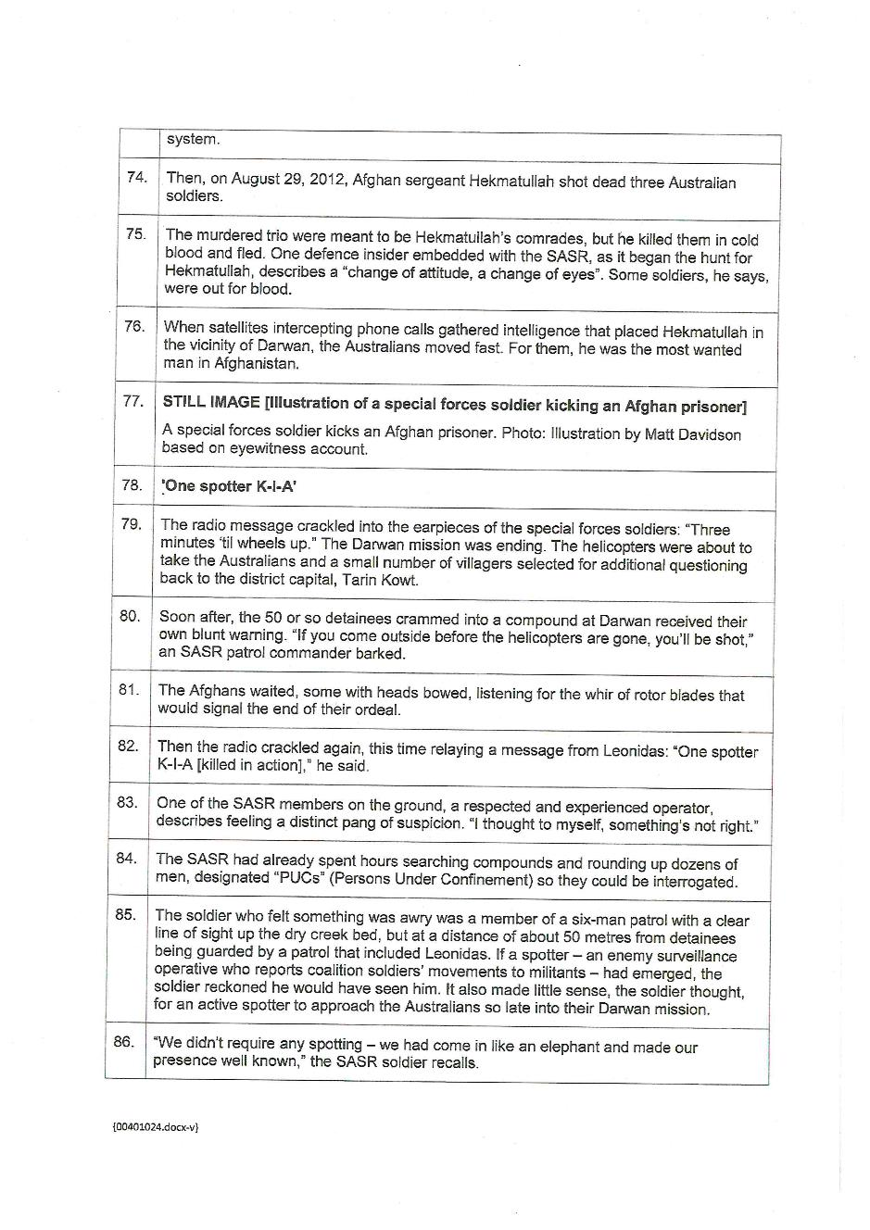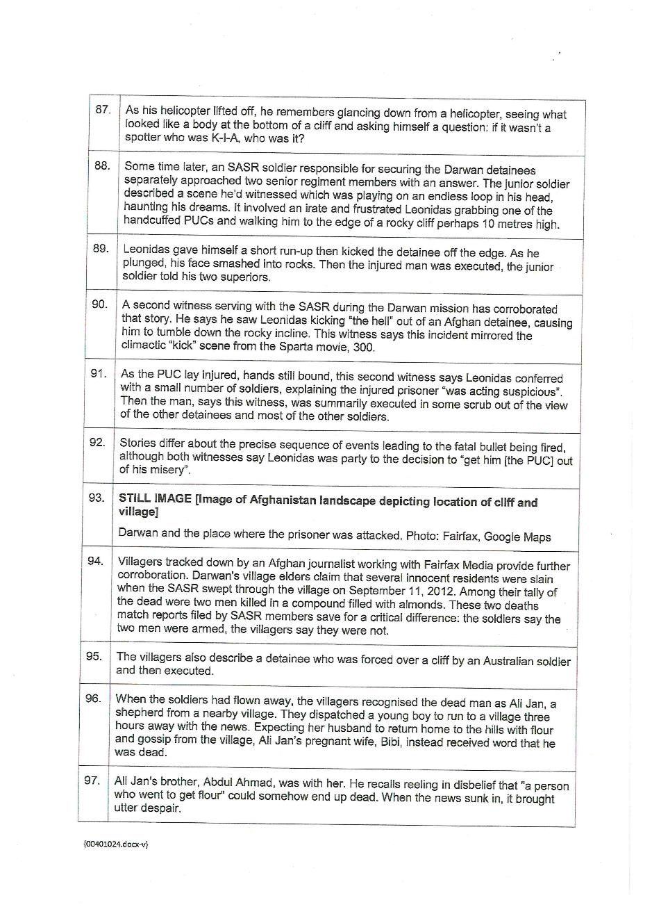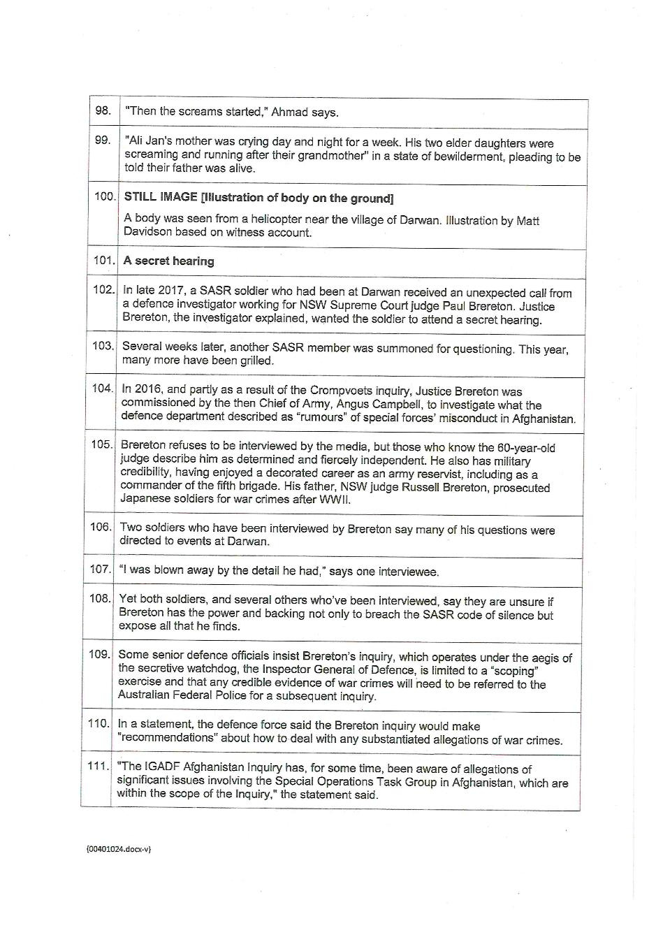
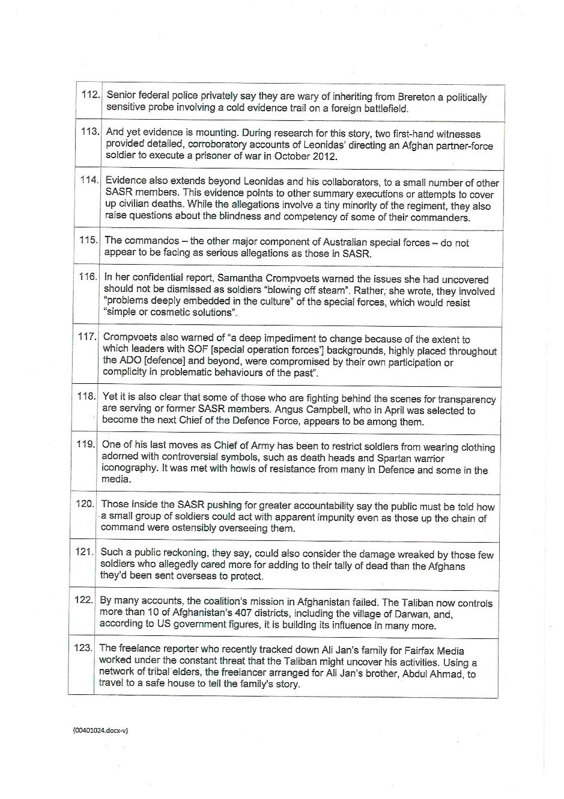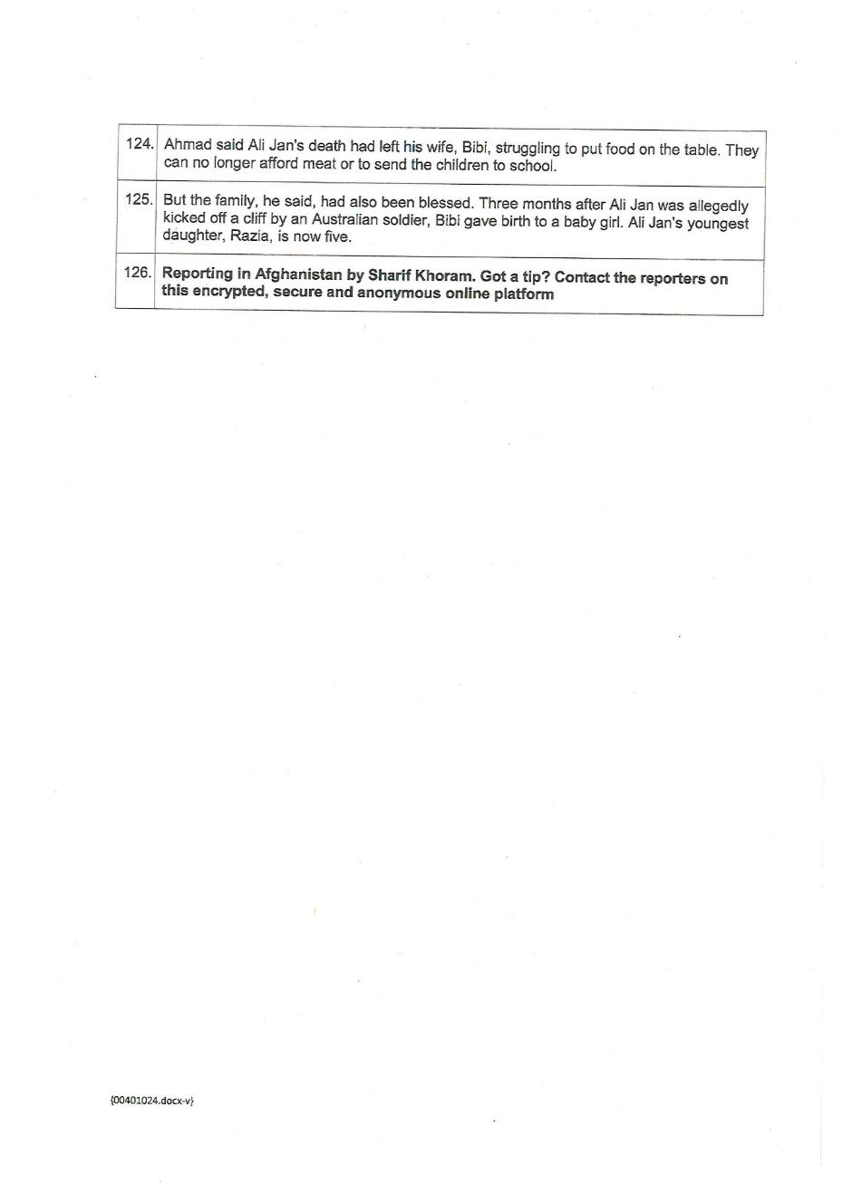

ANNEXURE C
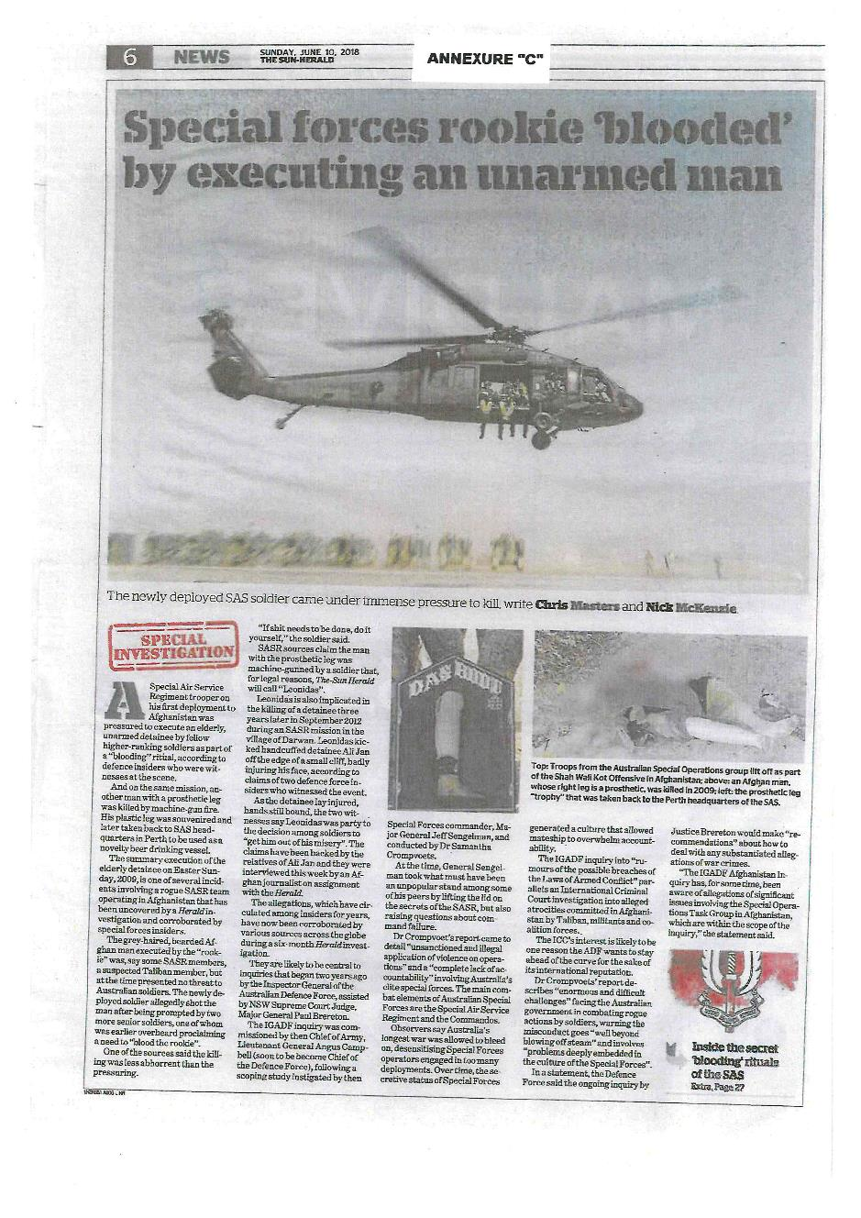
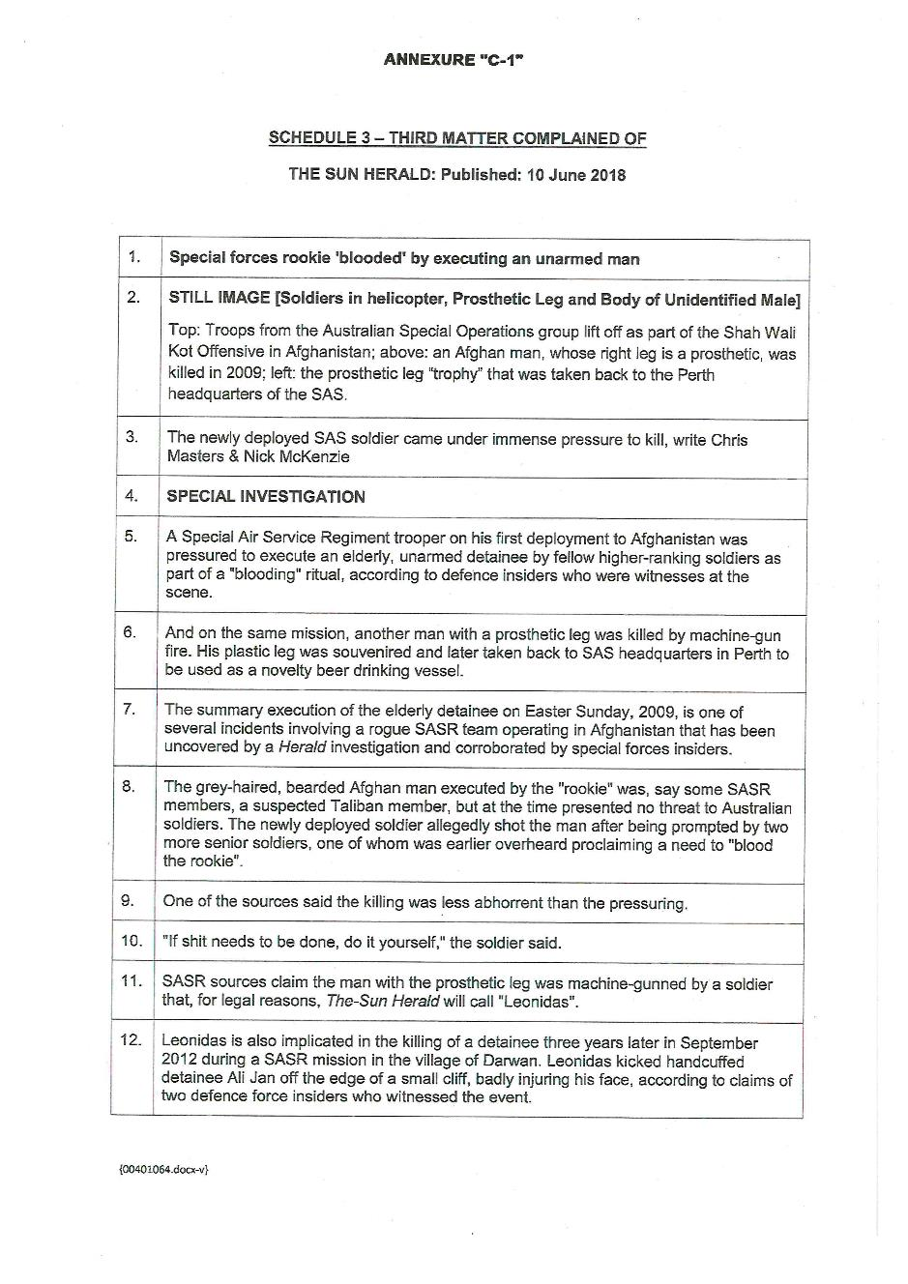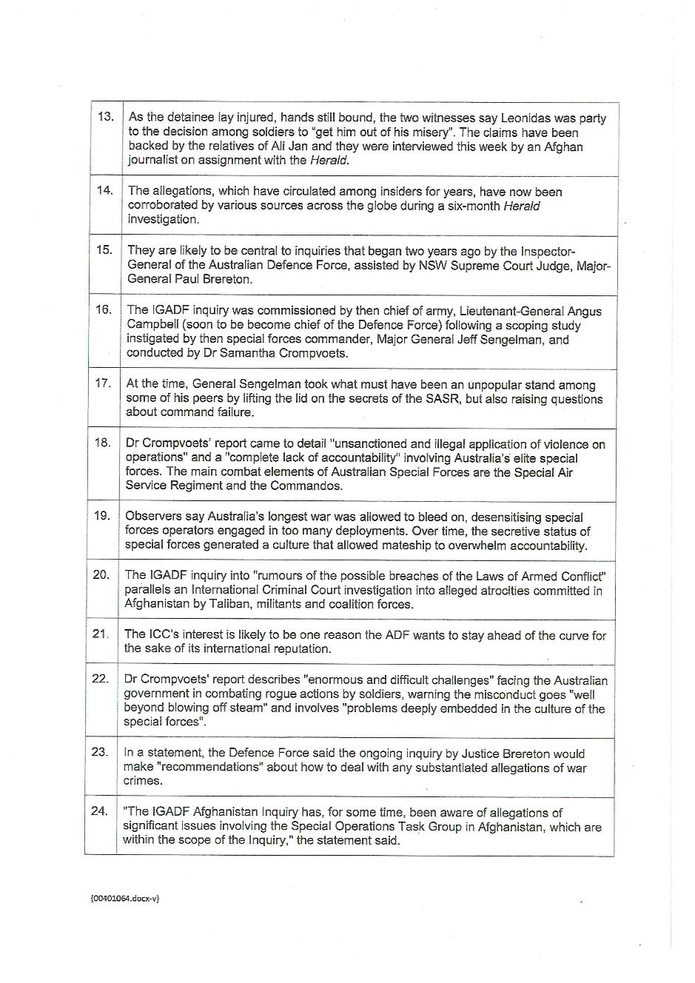

ANNEXURE D
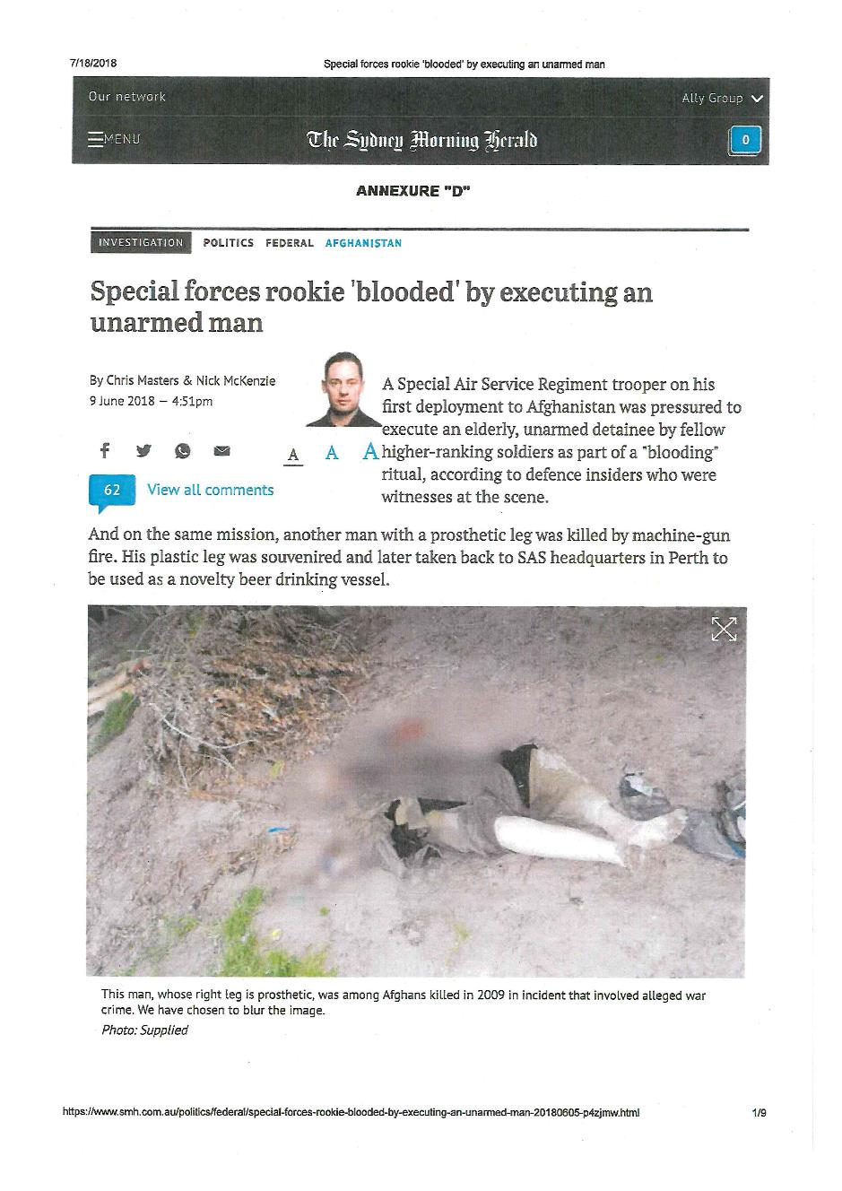
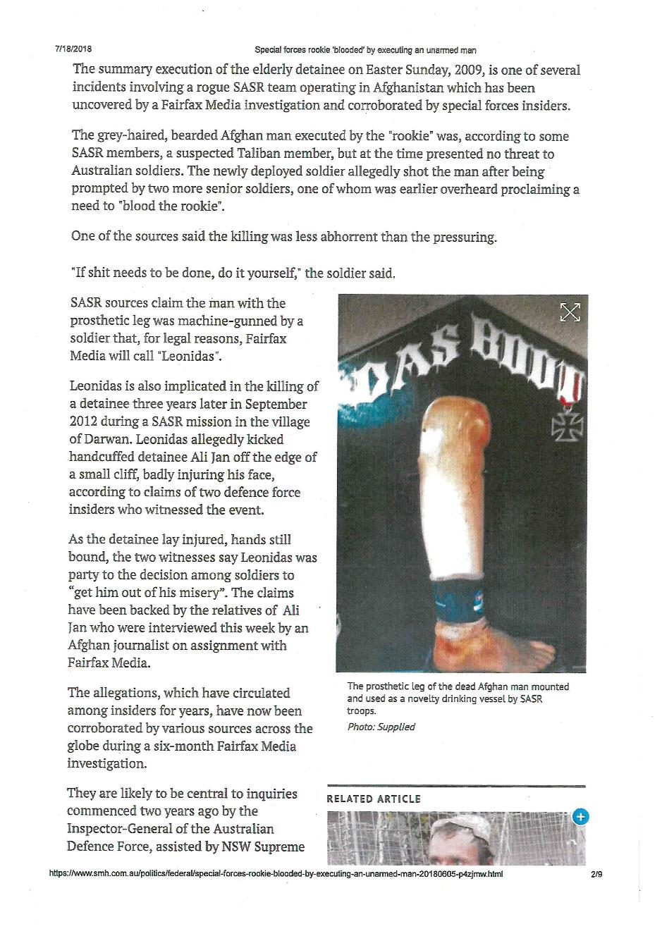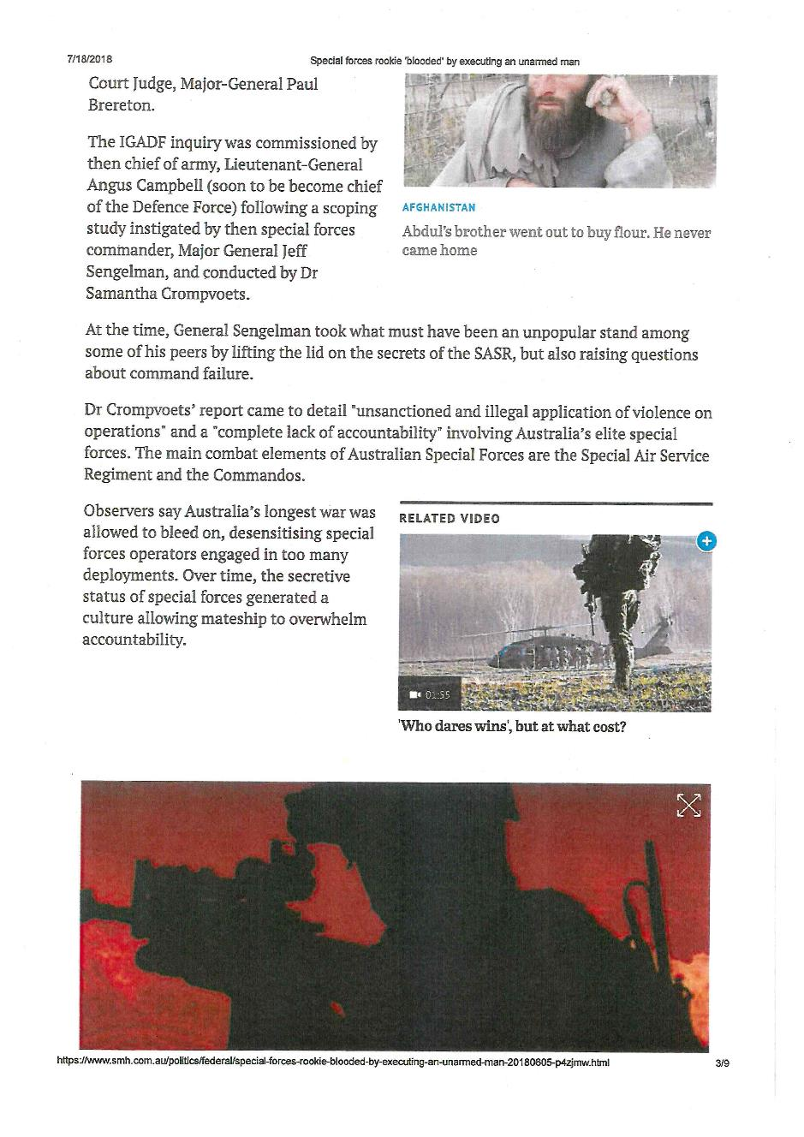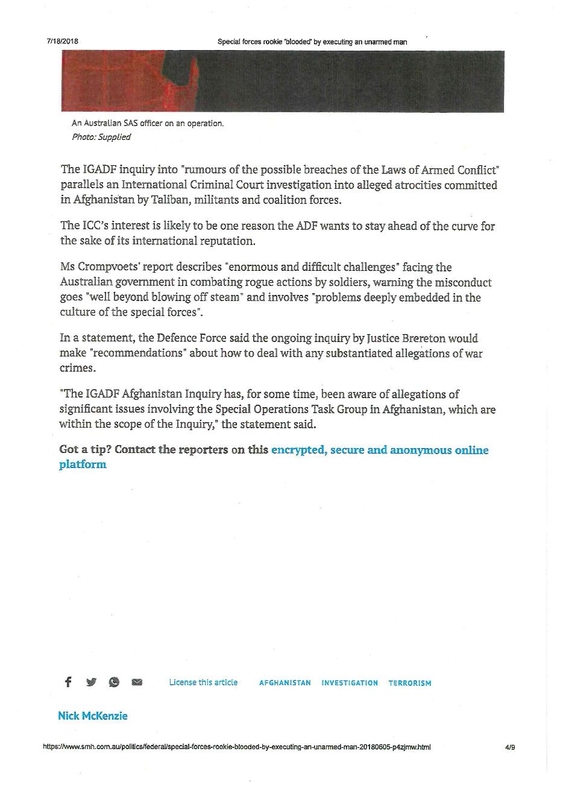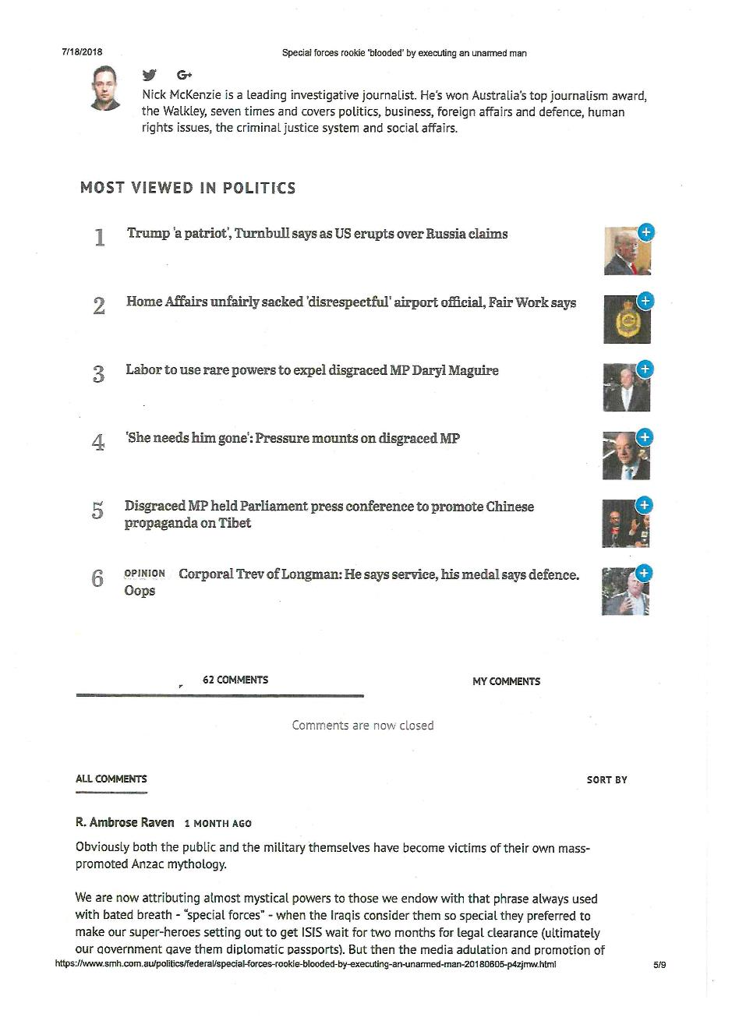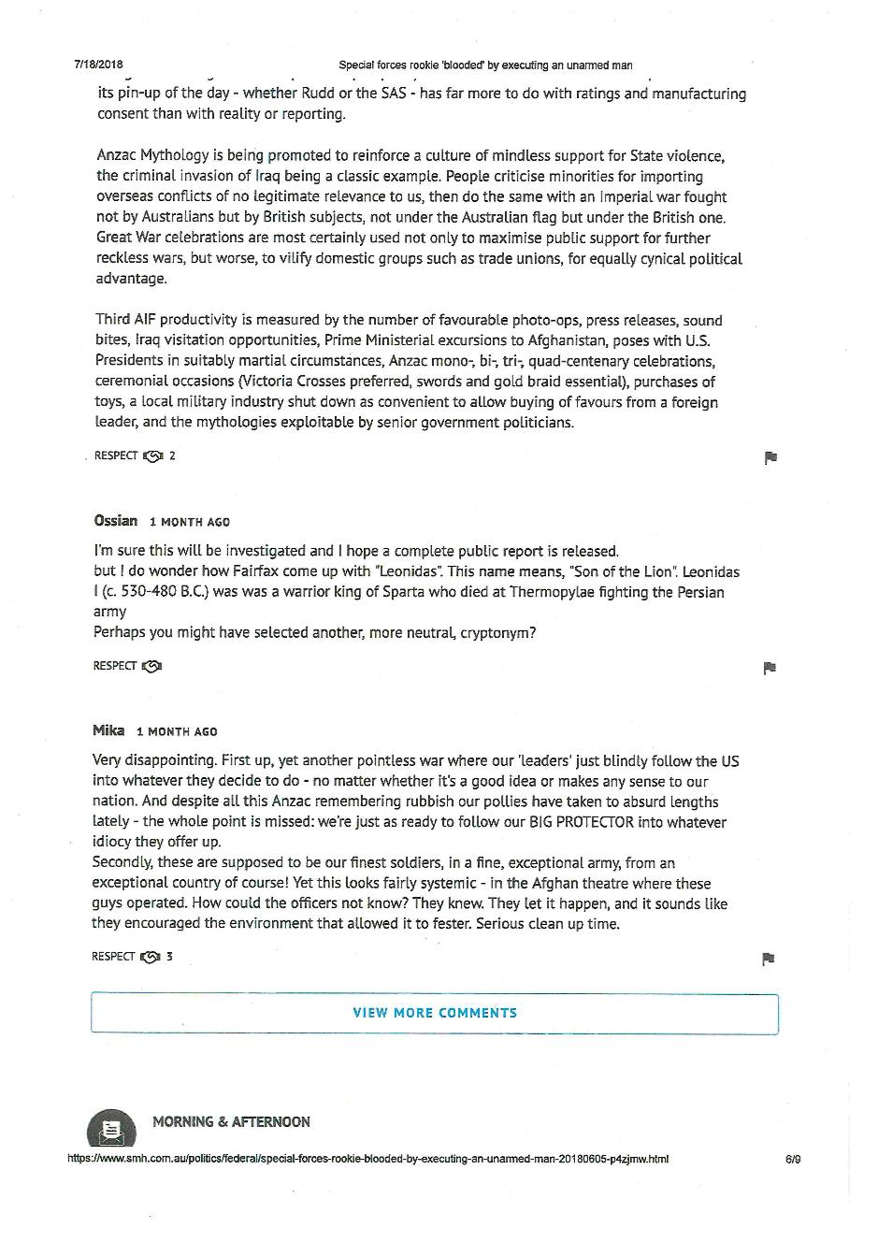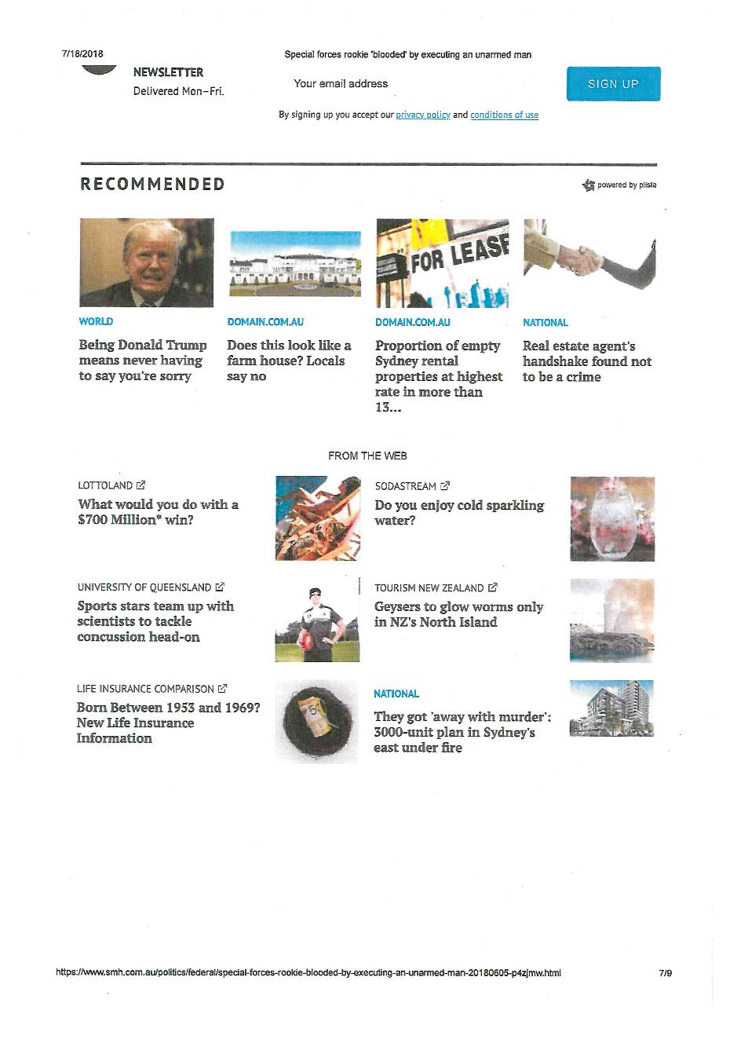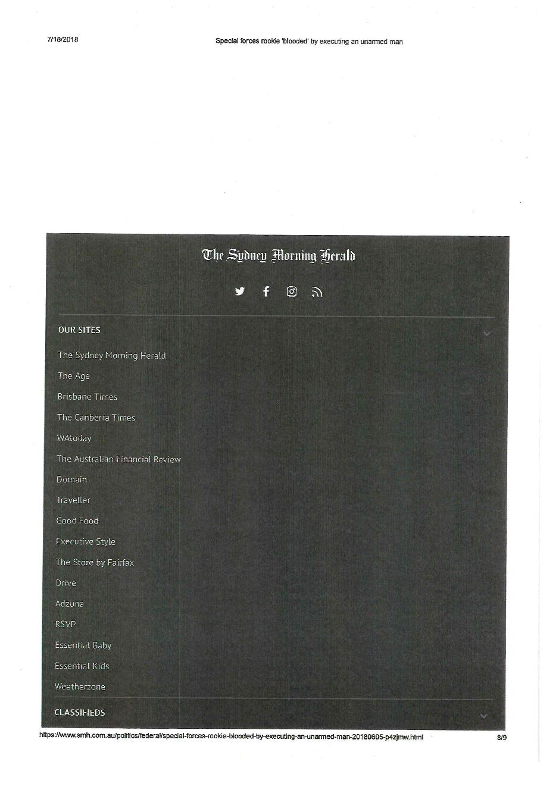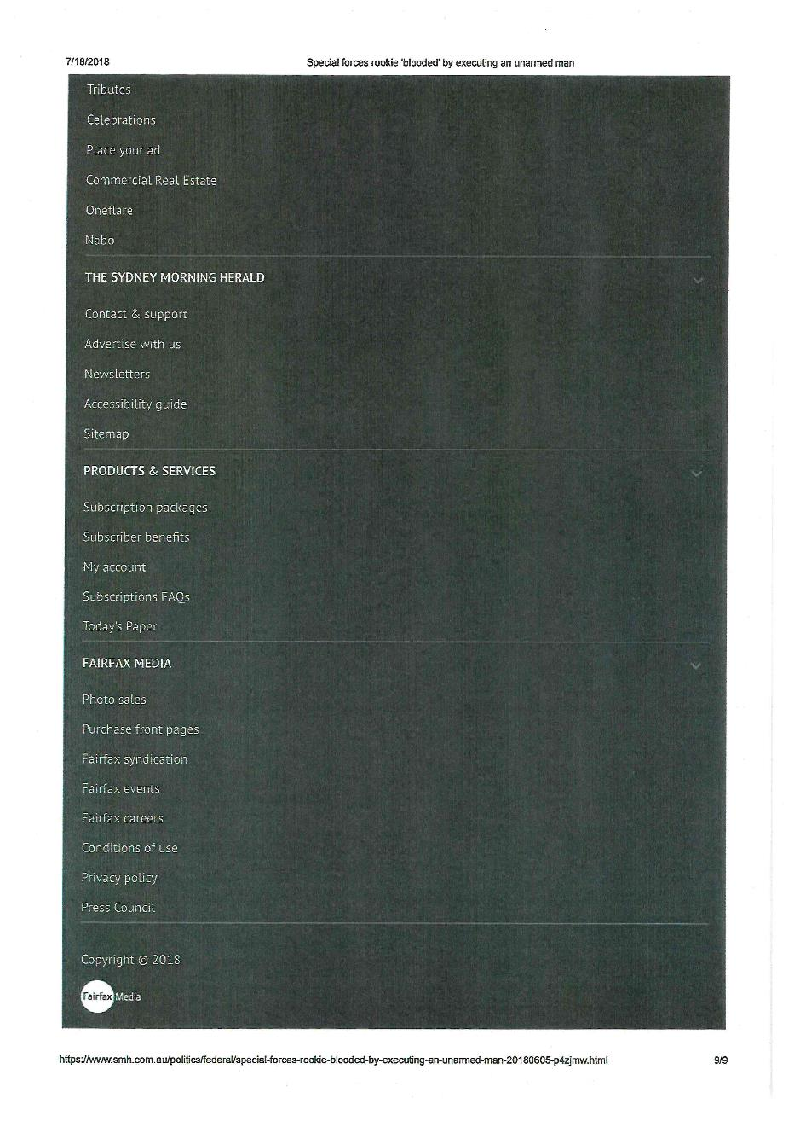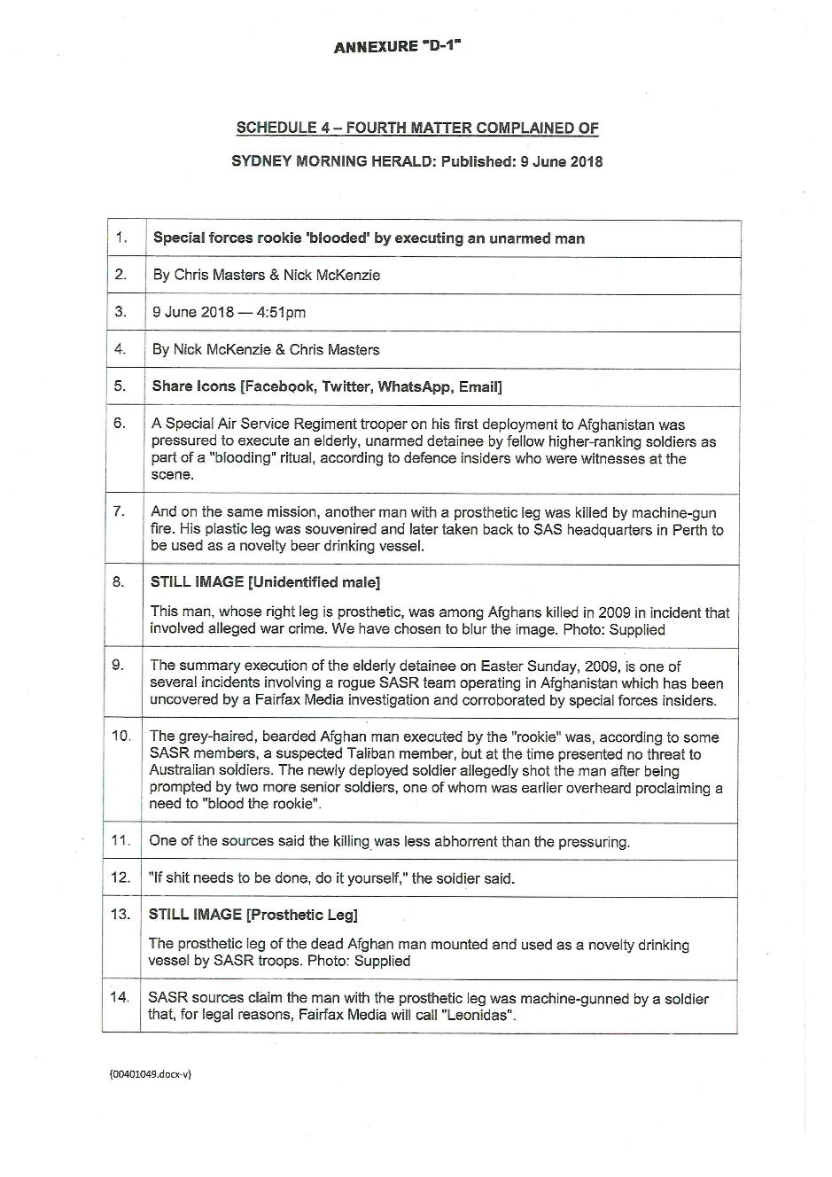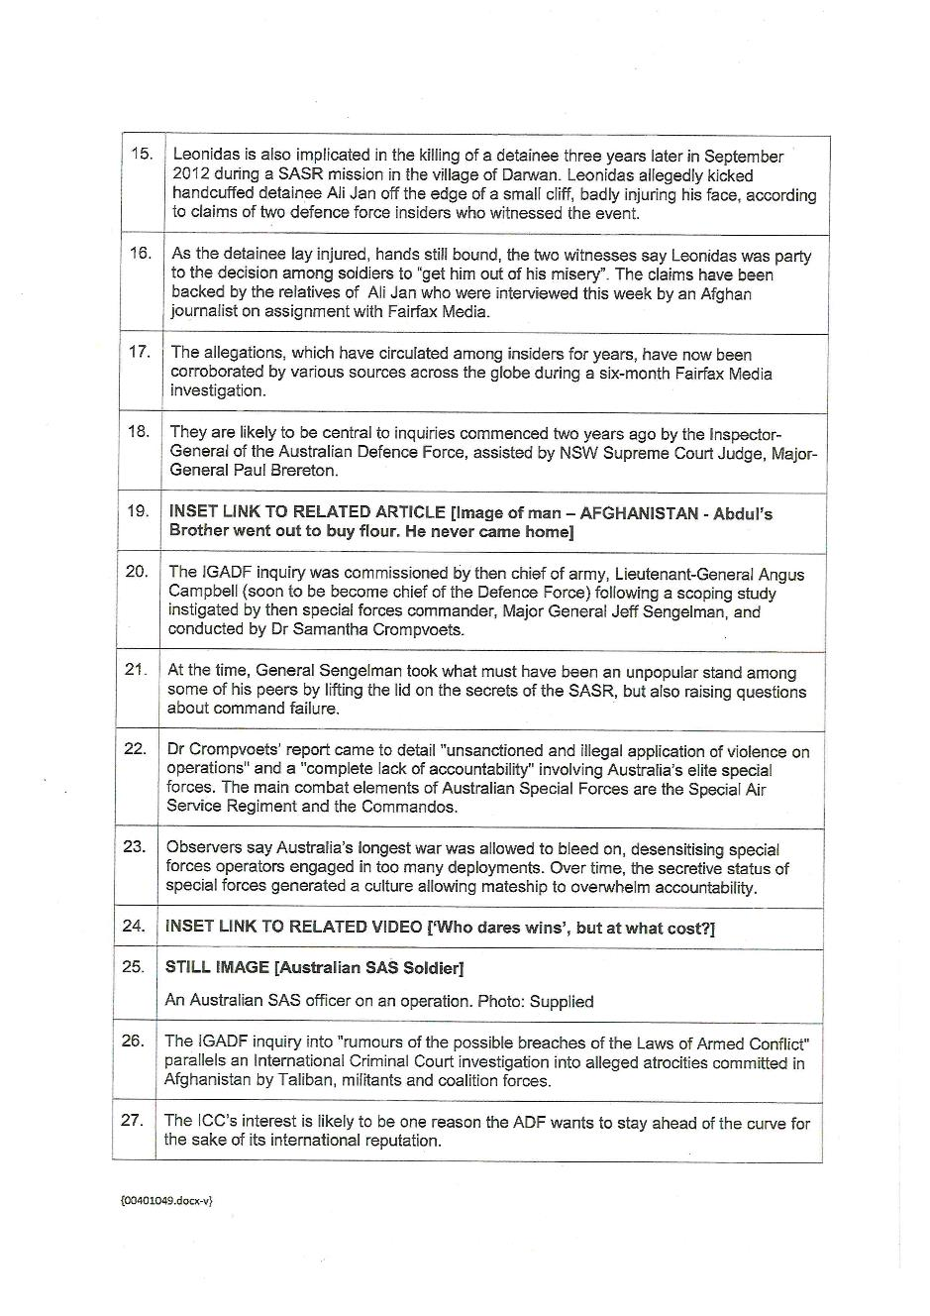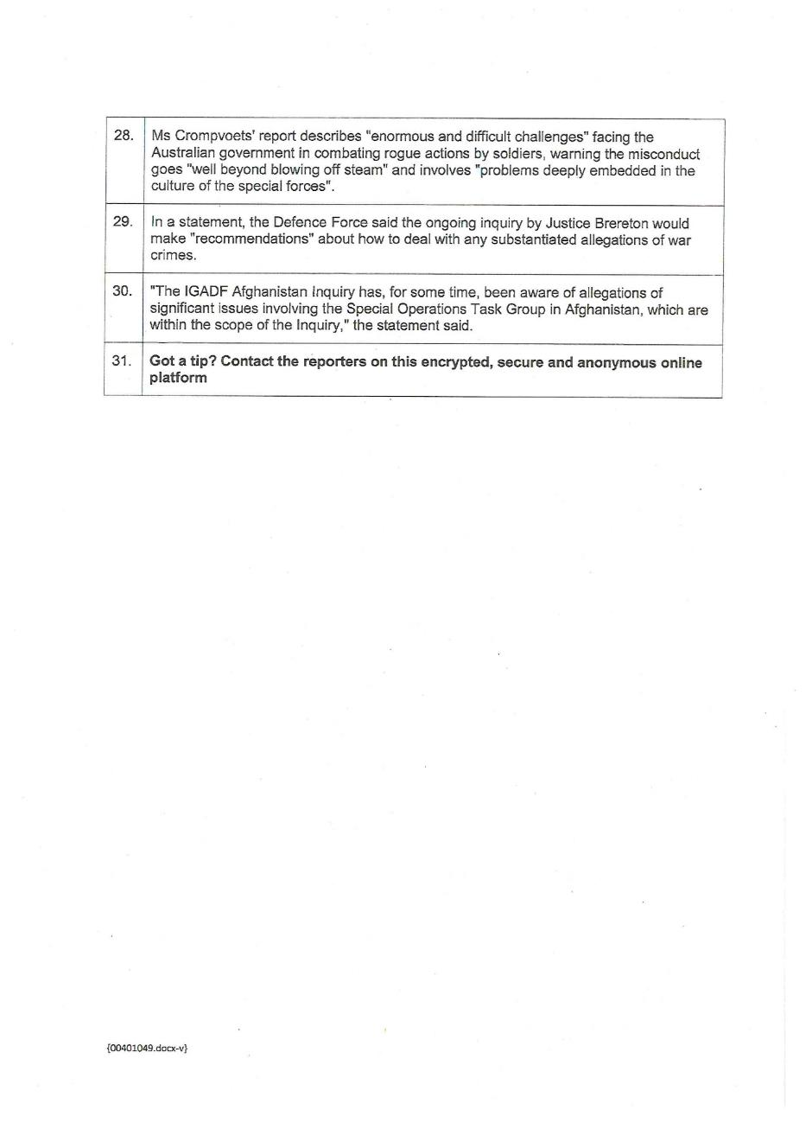

ANNEXURE E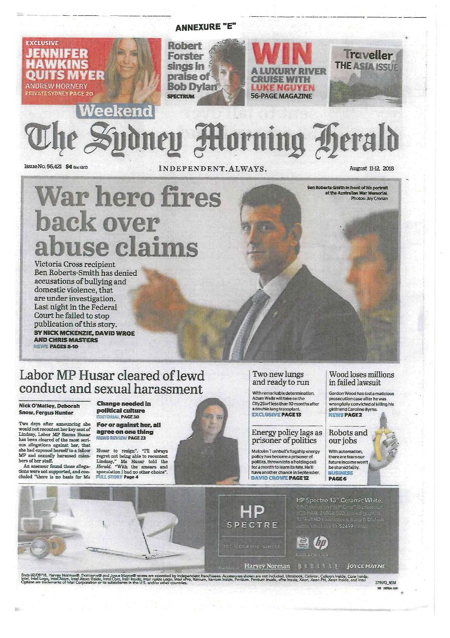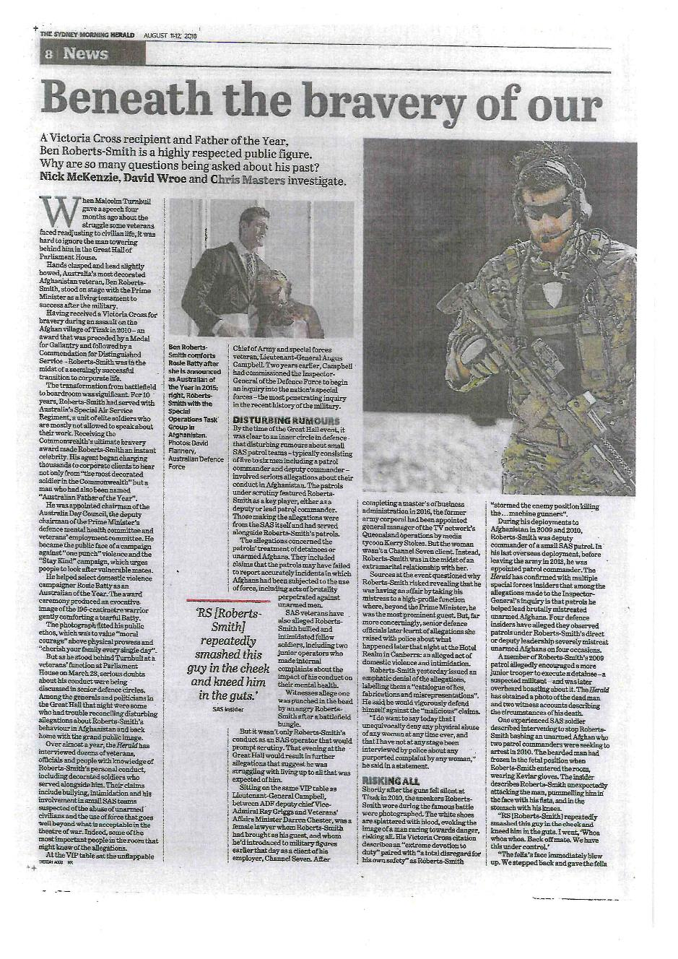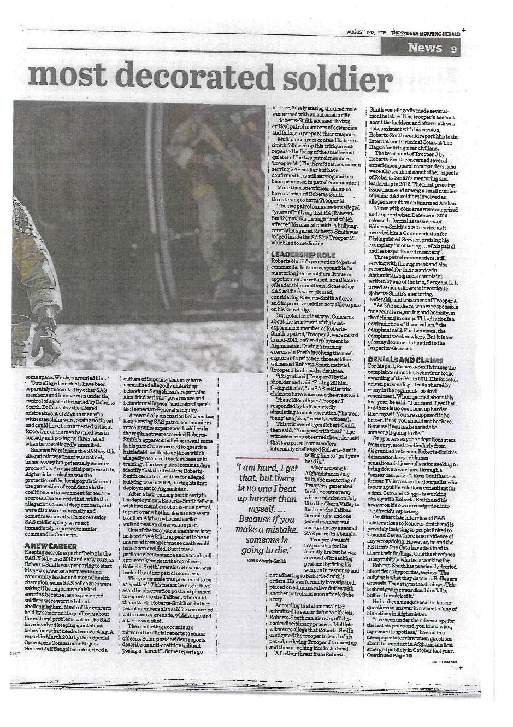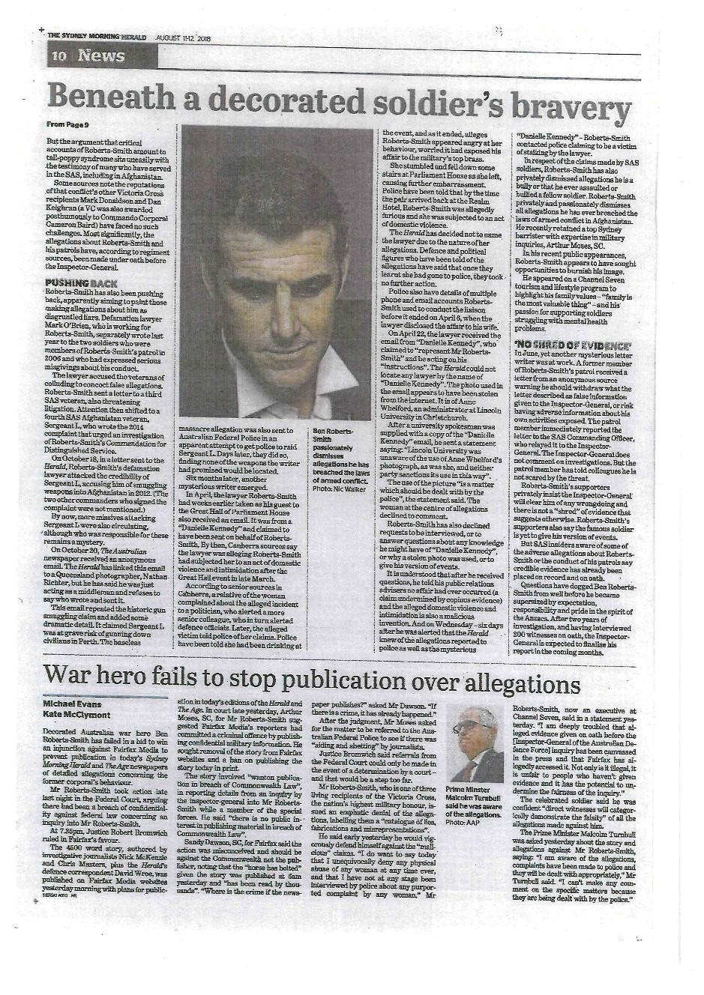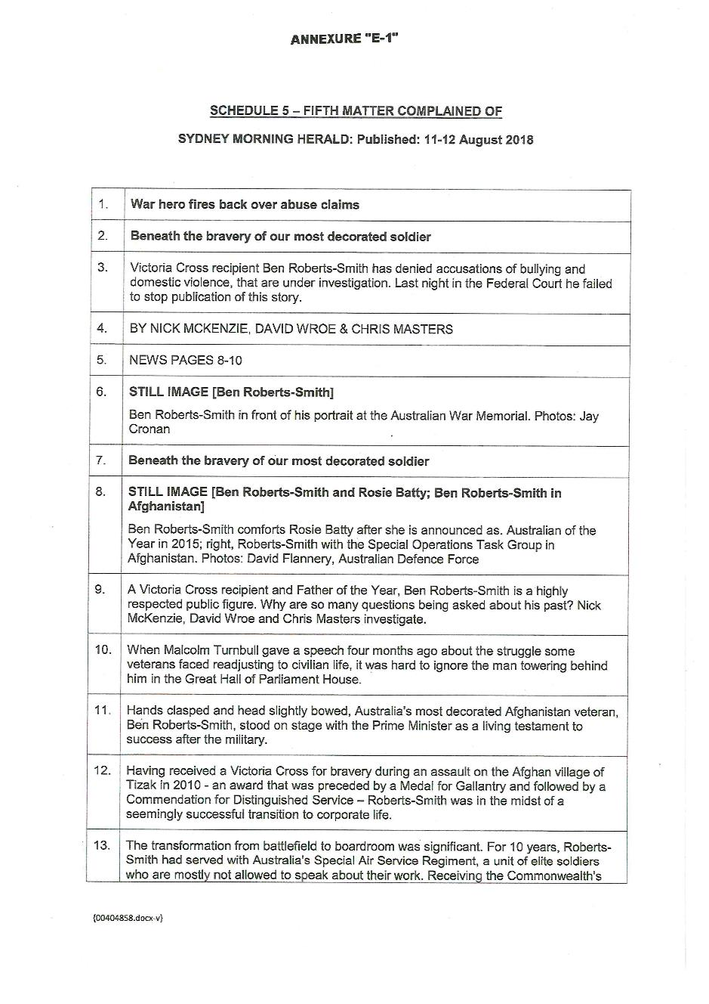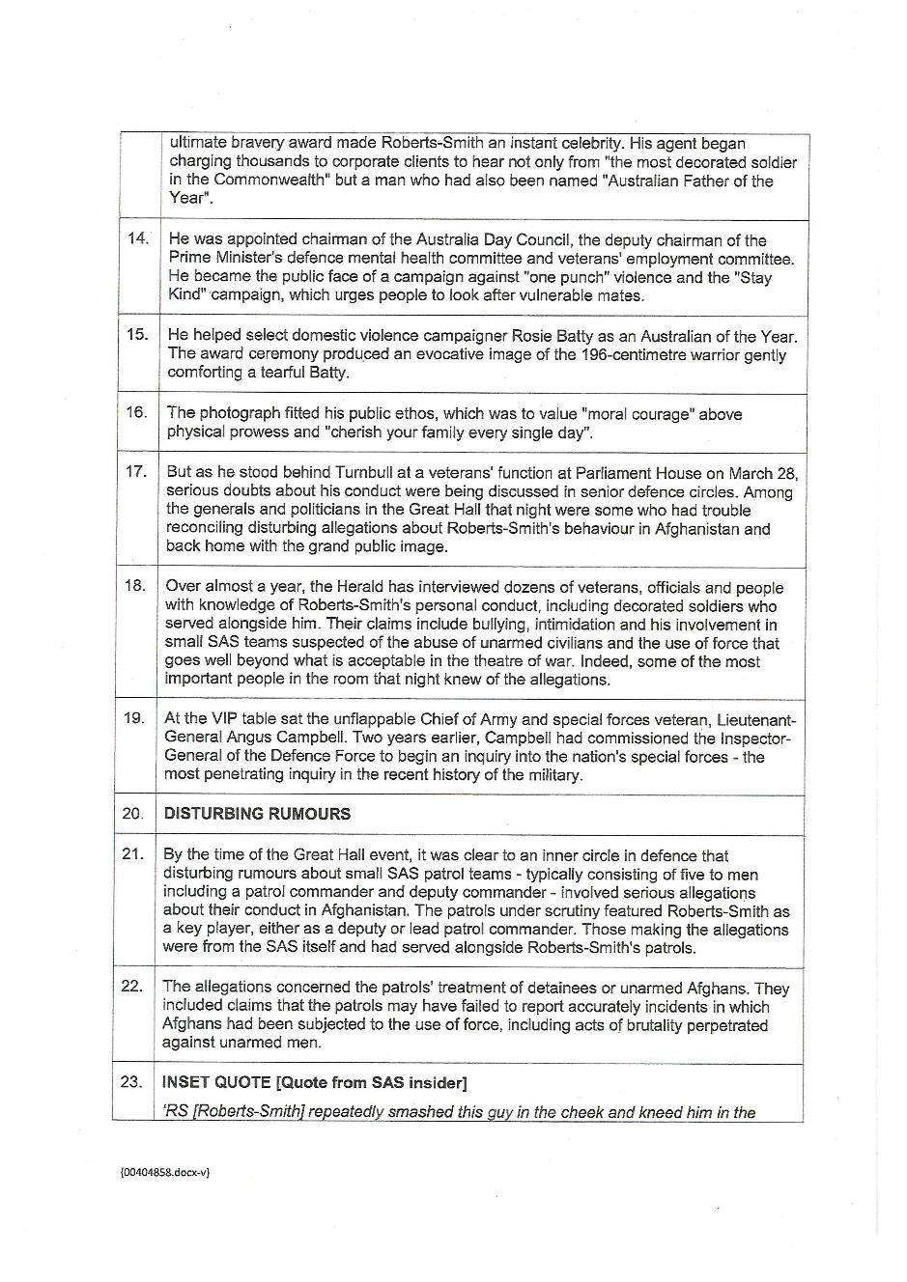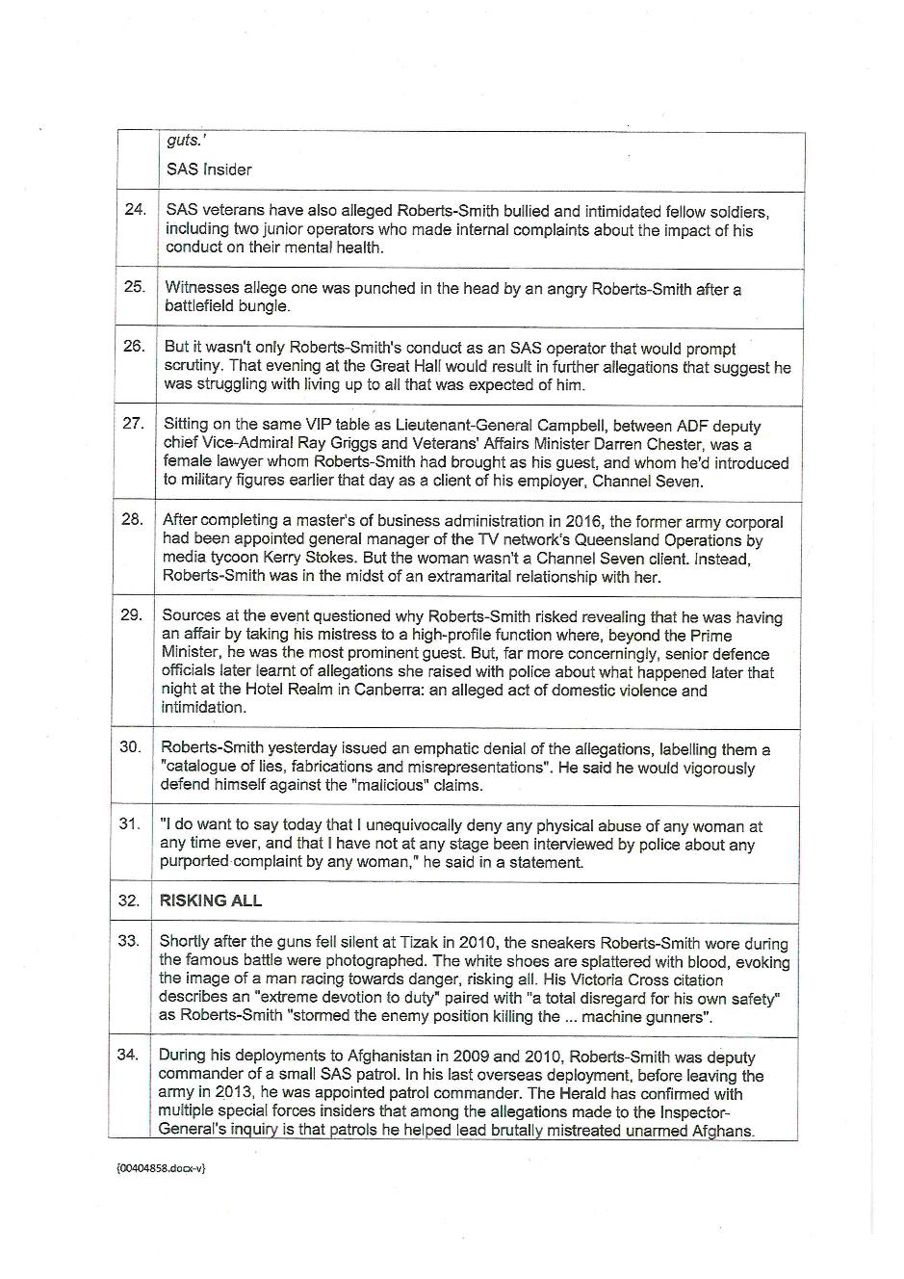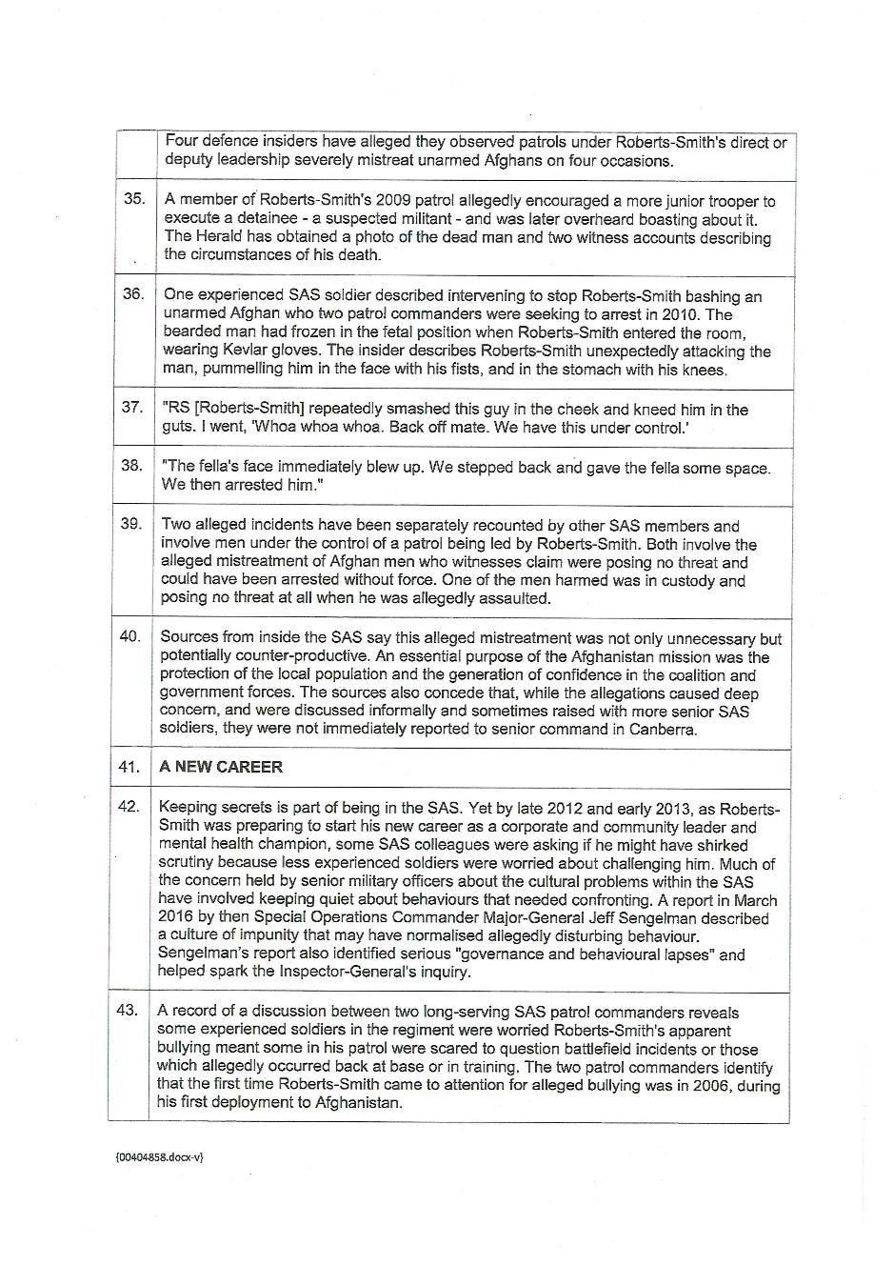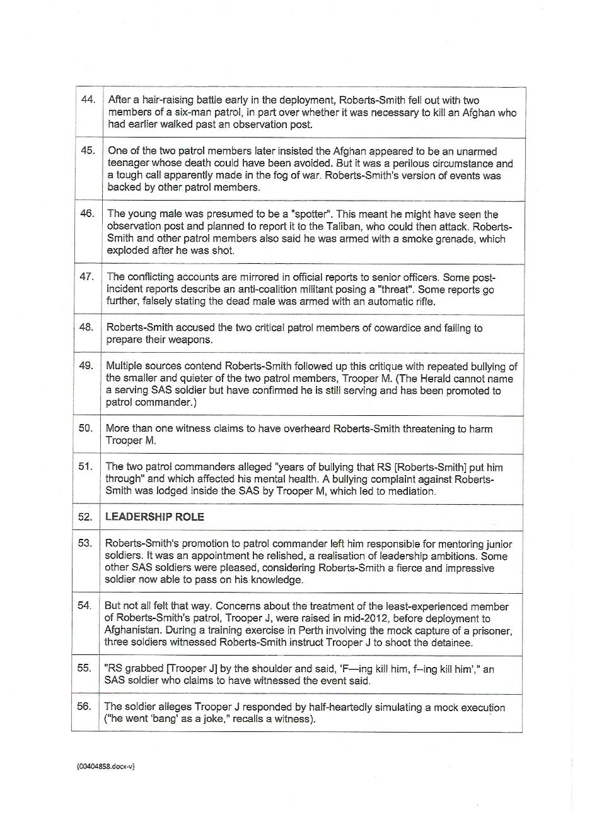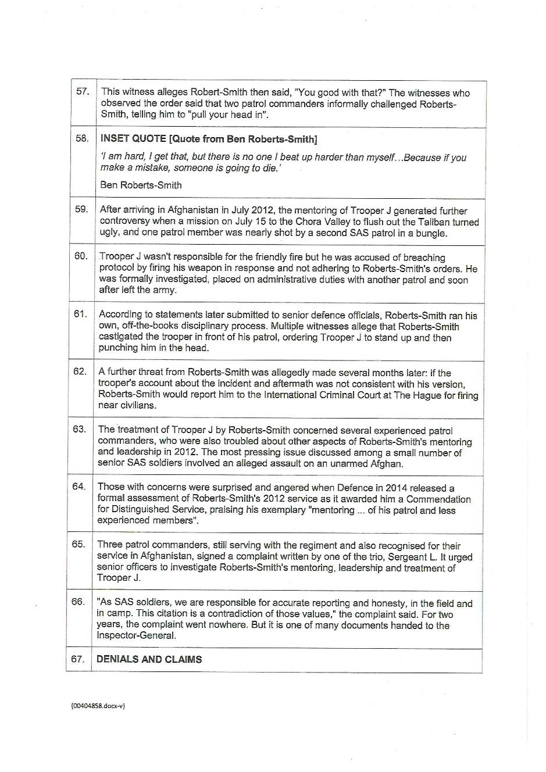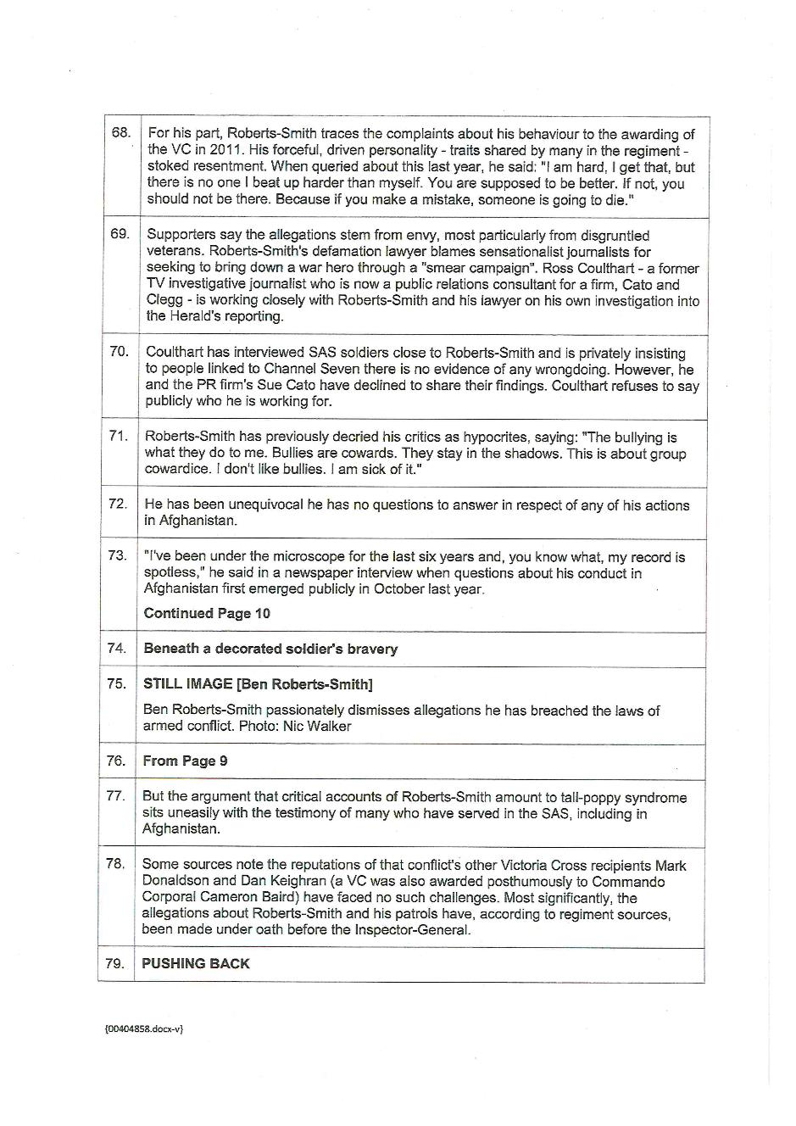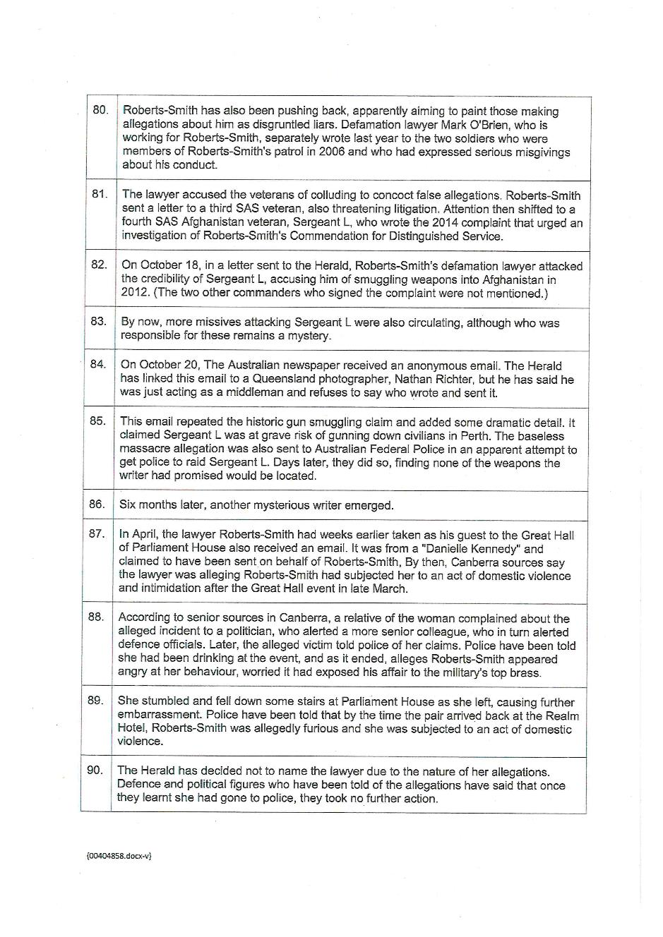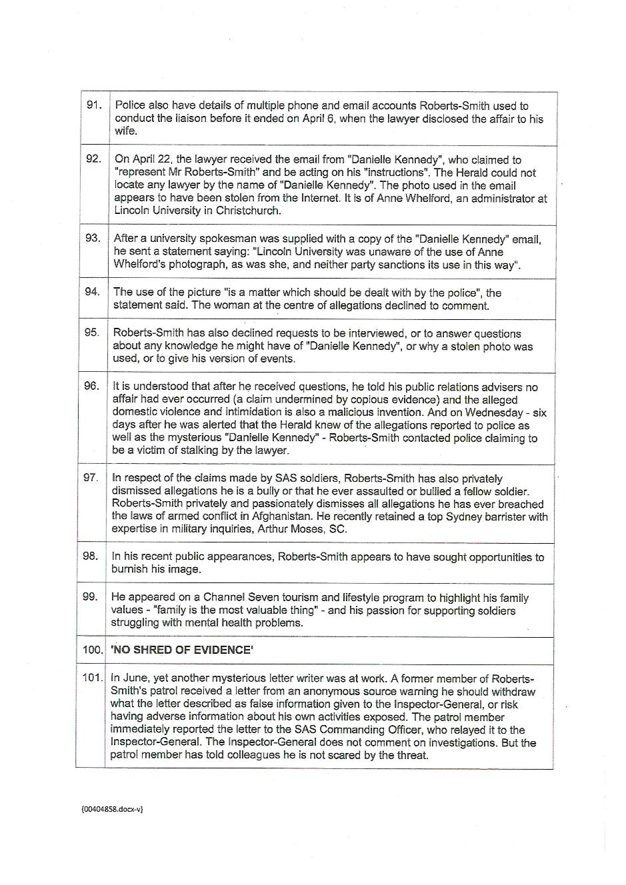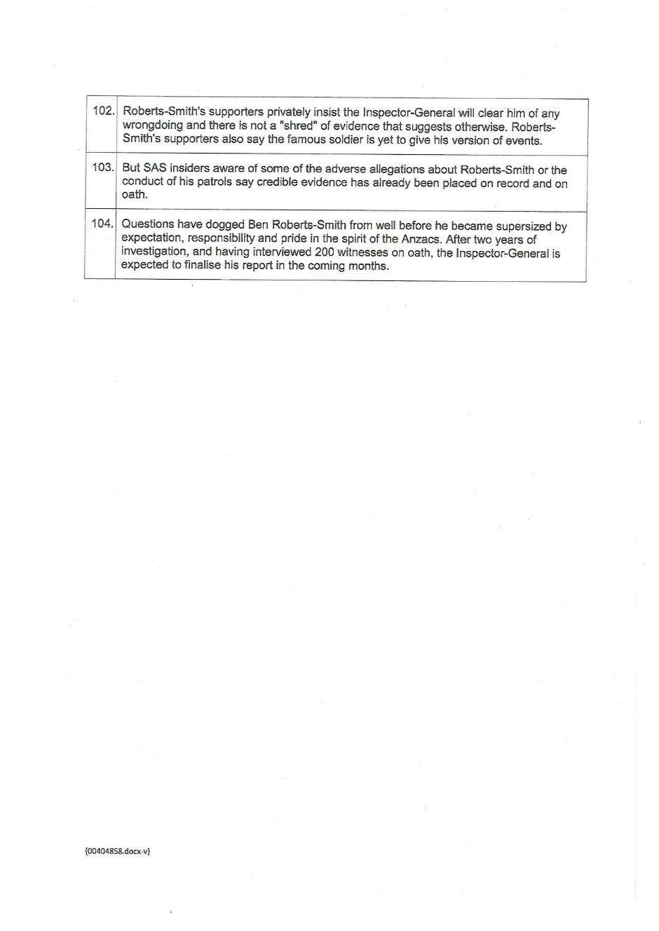

ANNEXURE F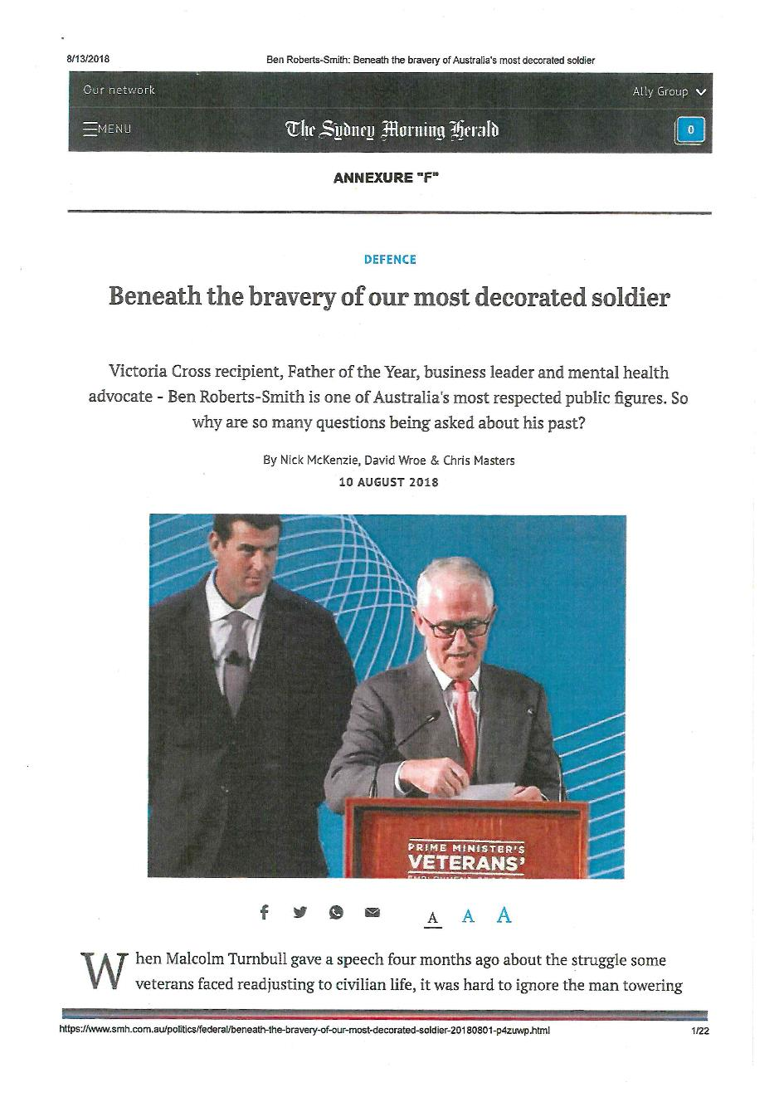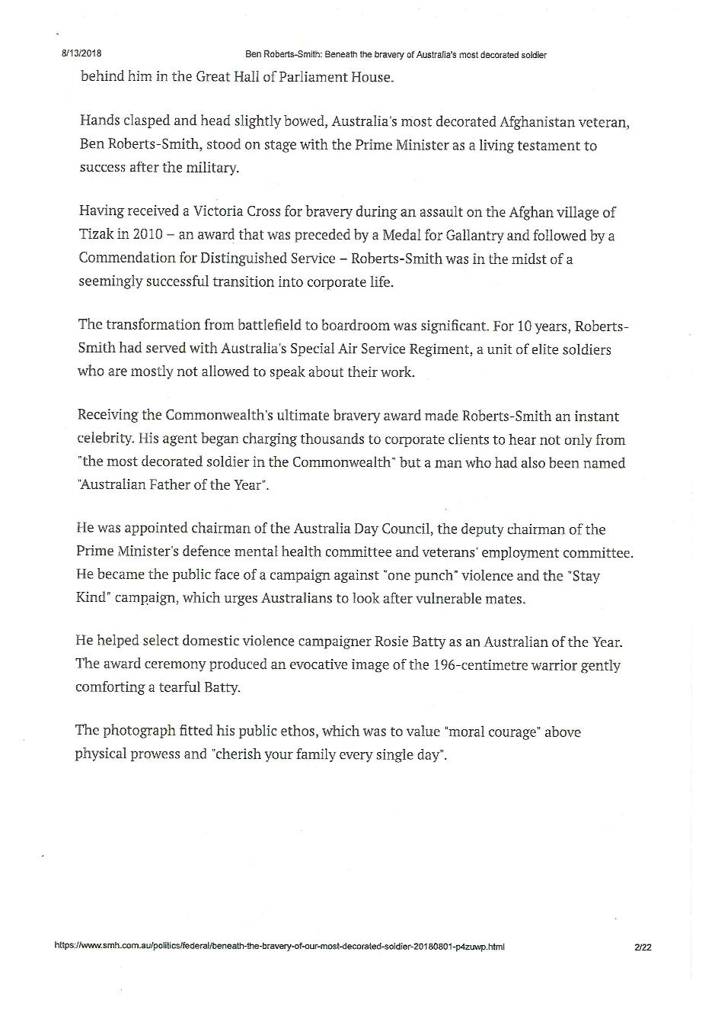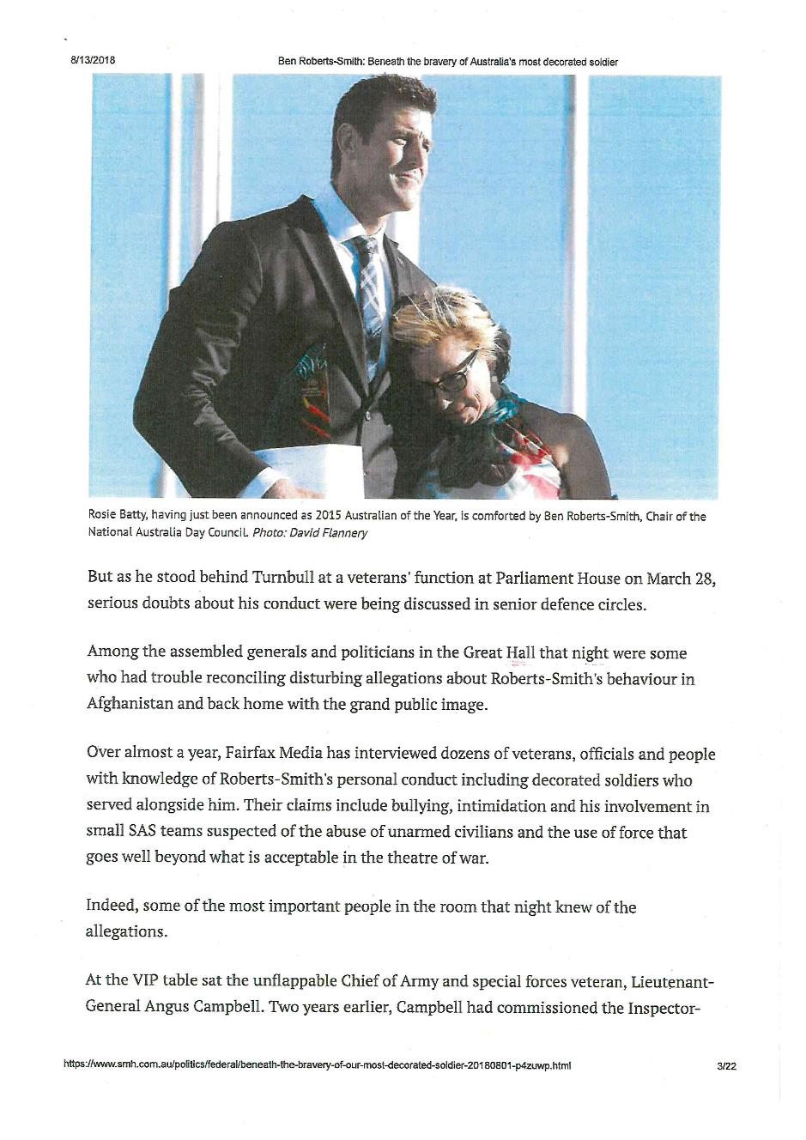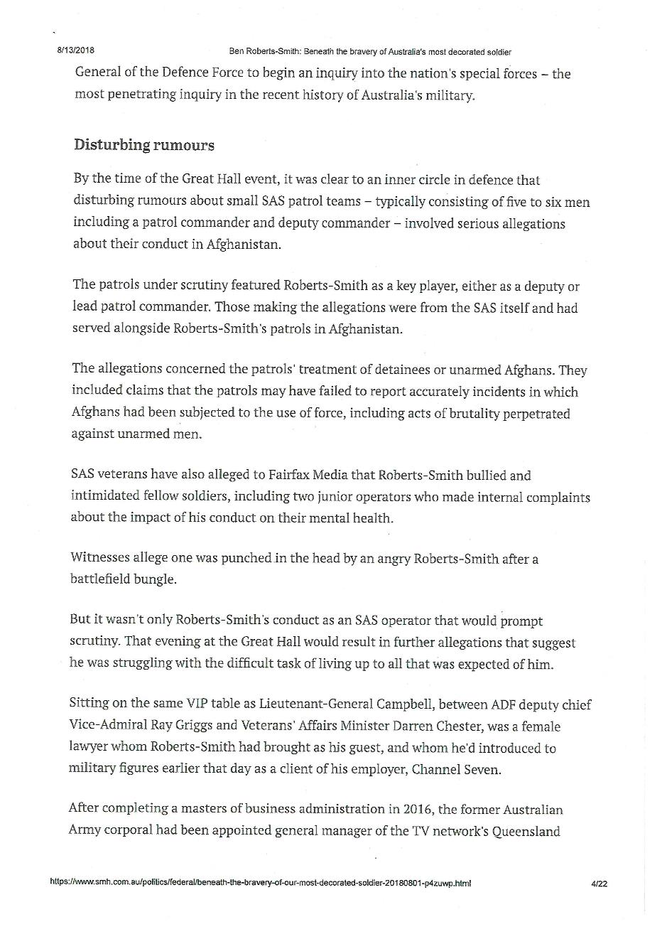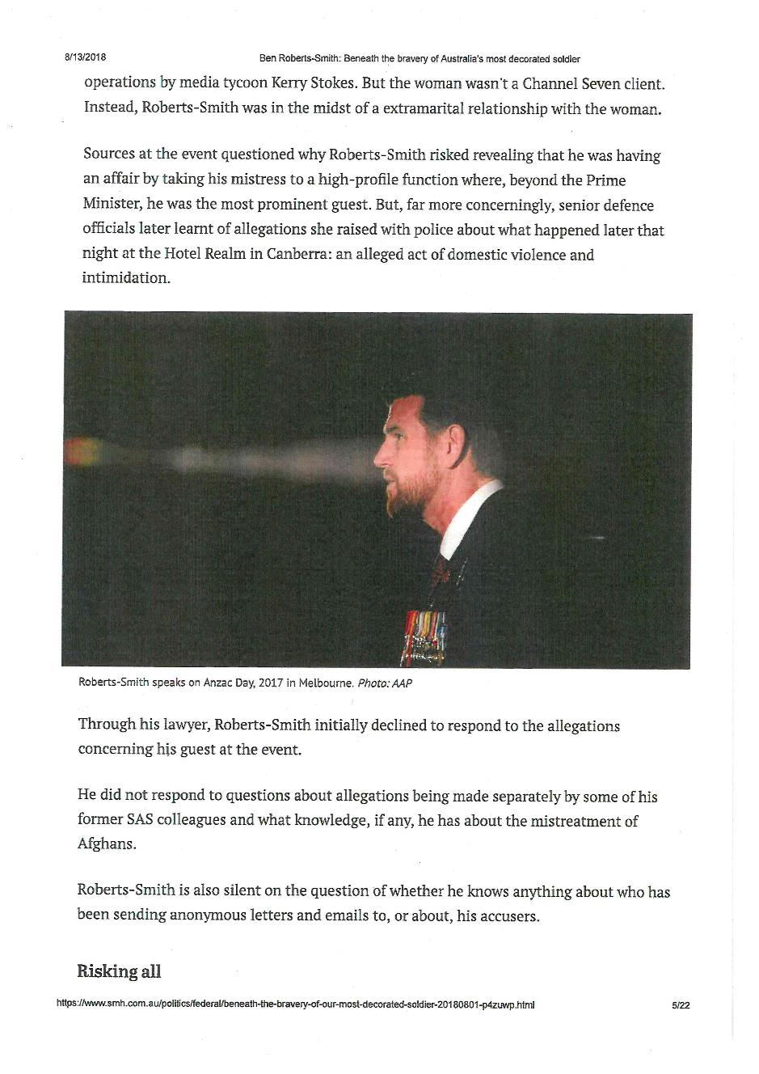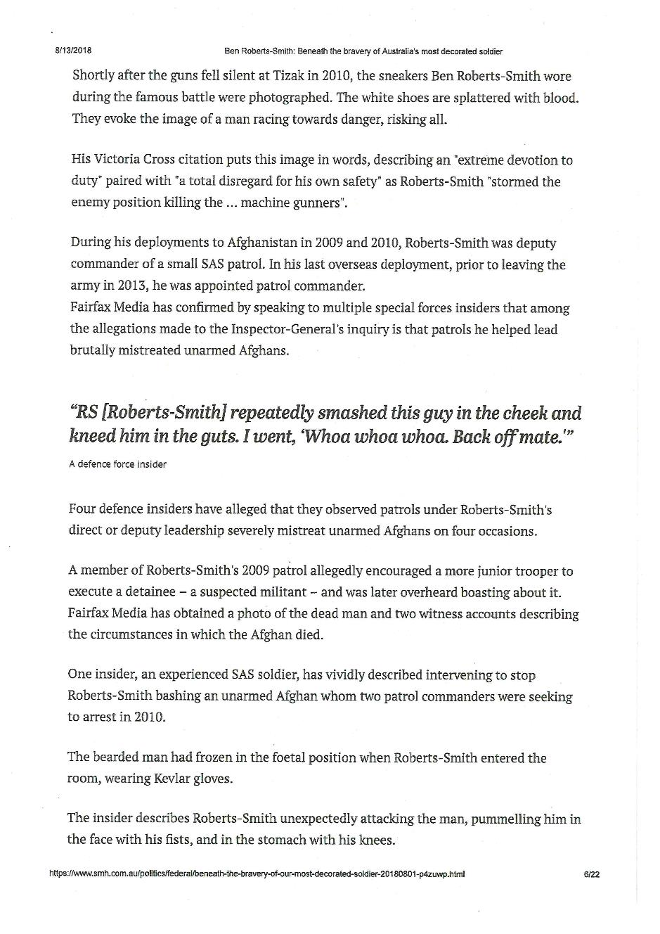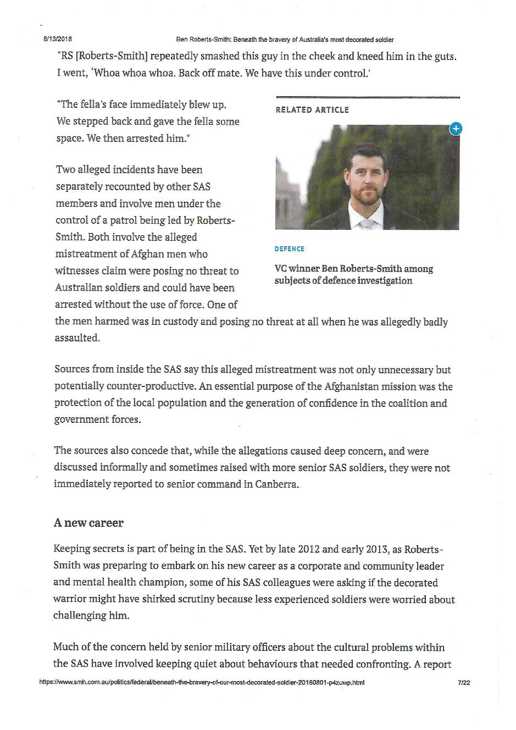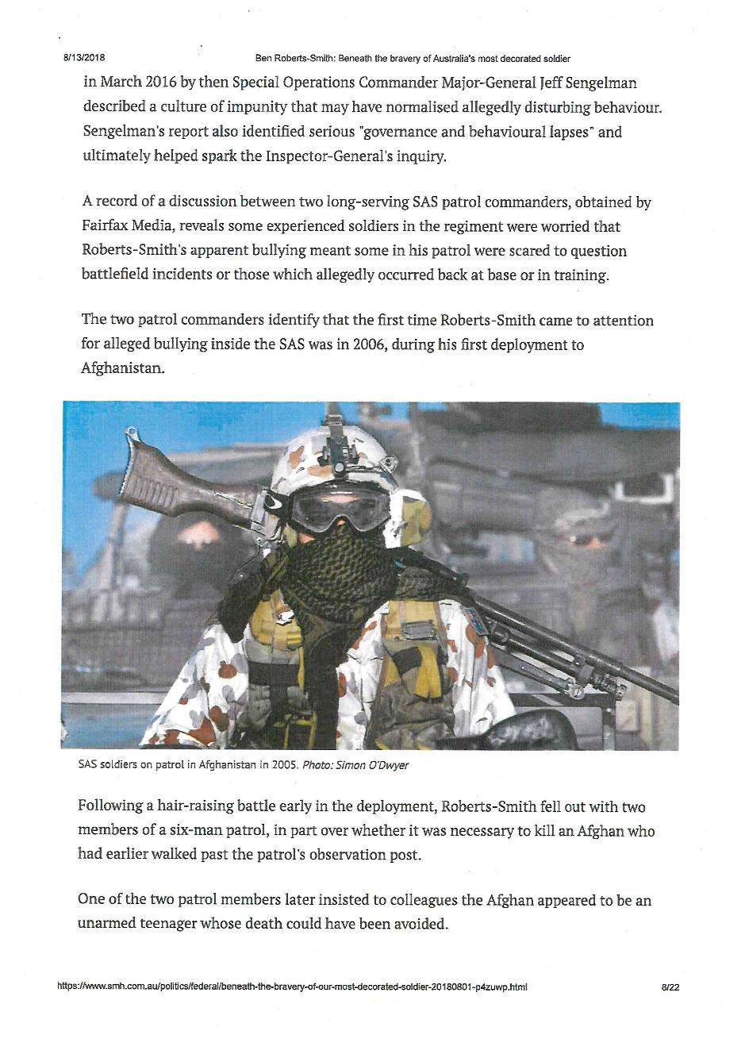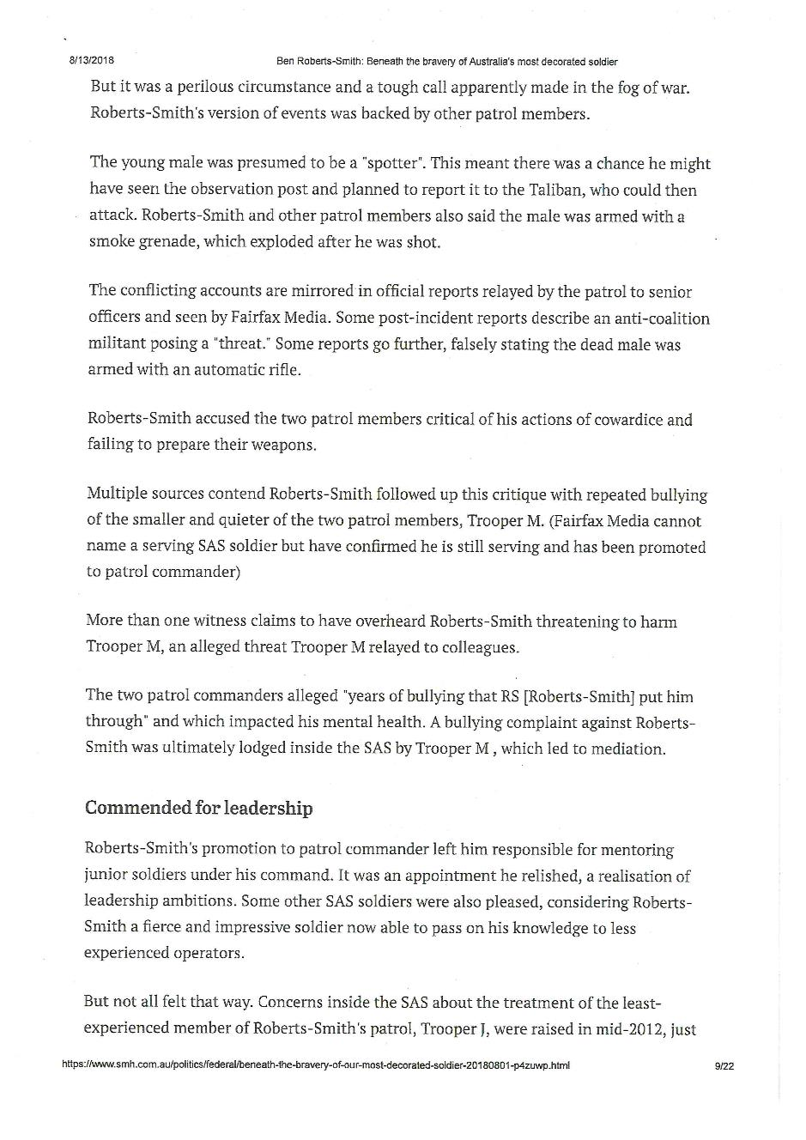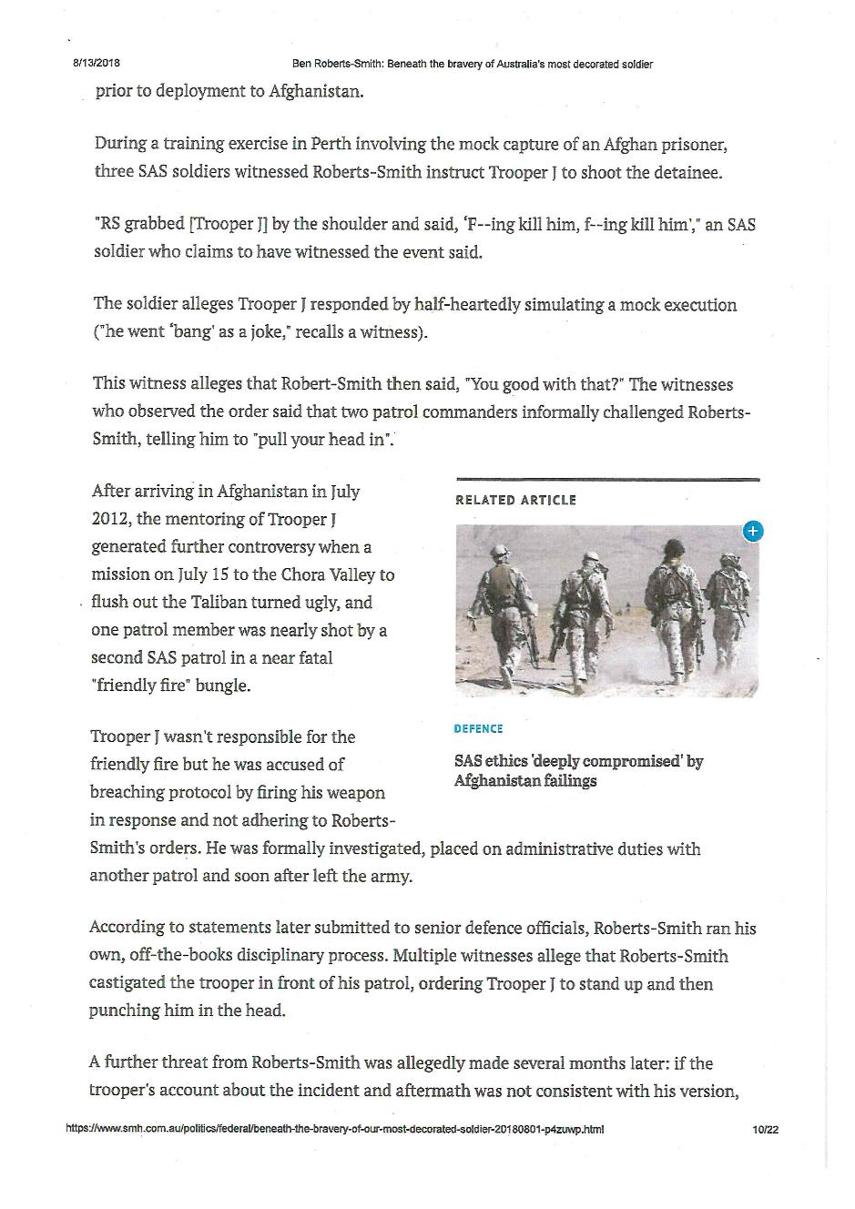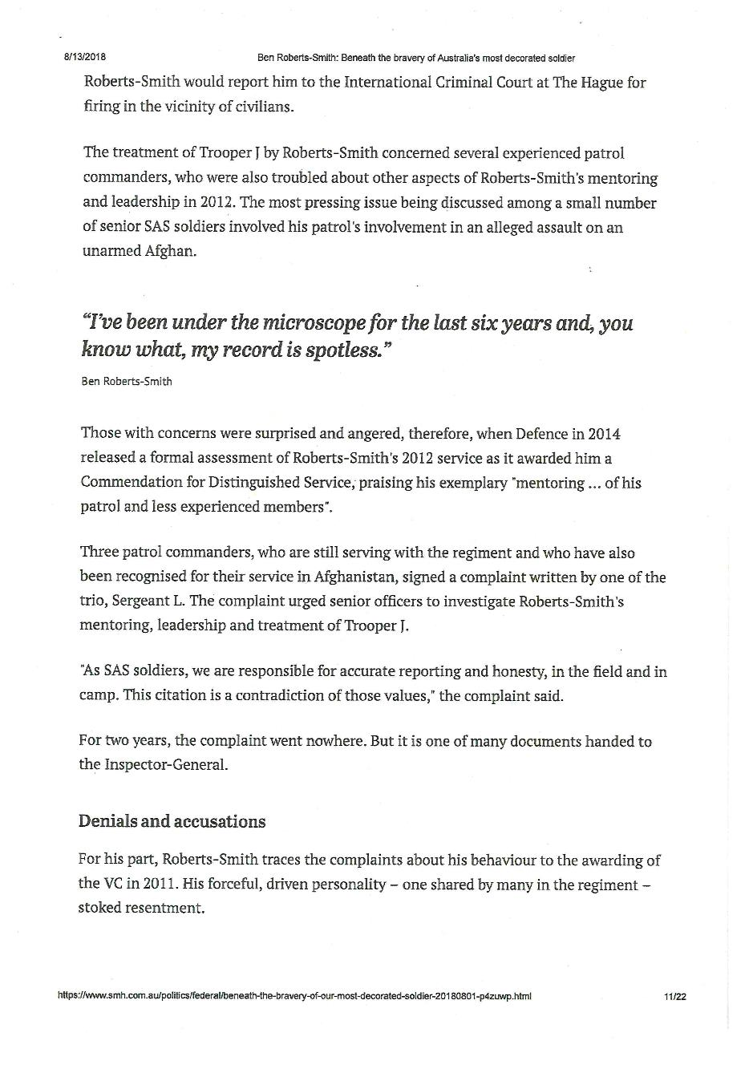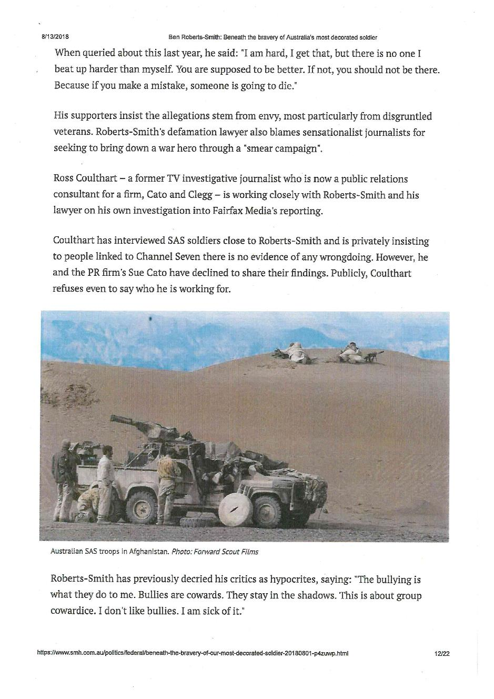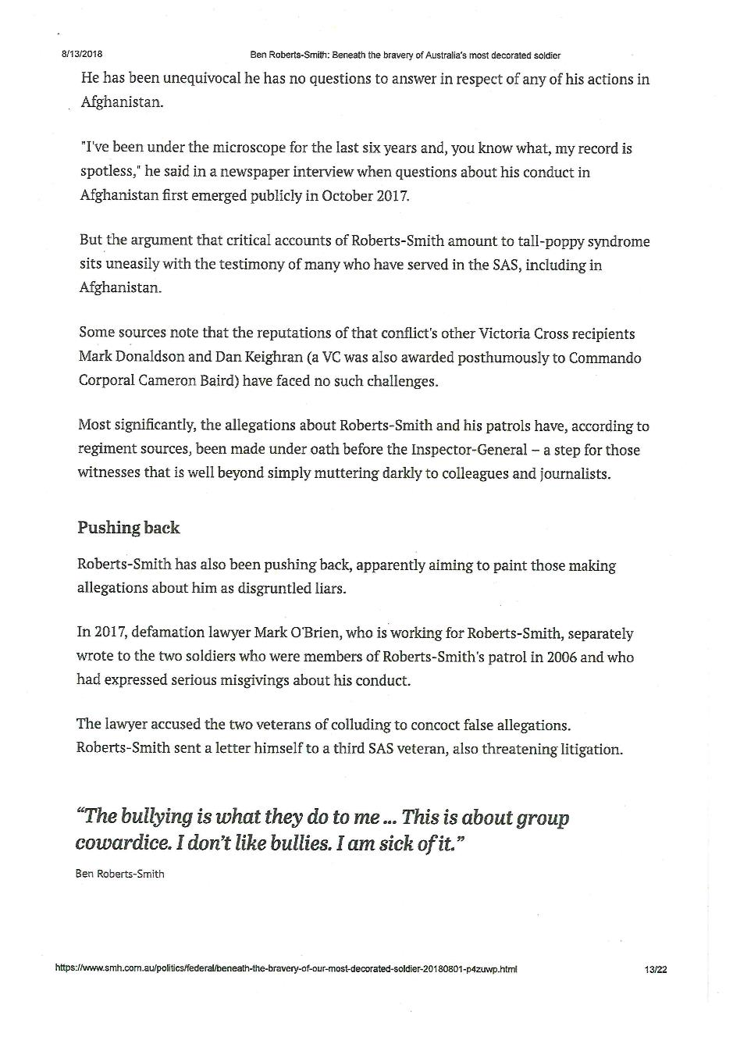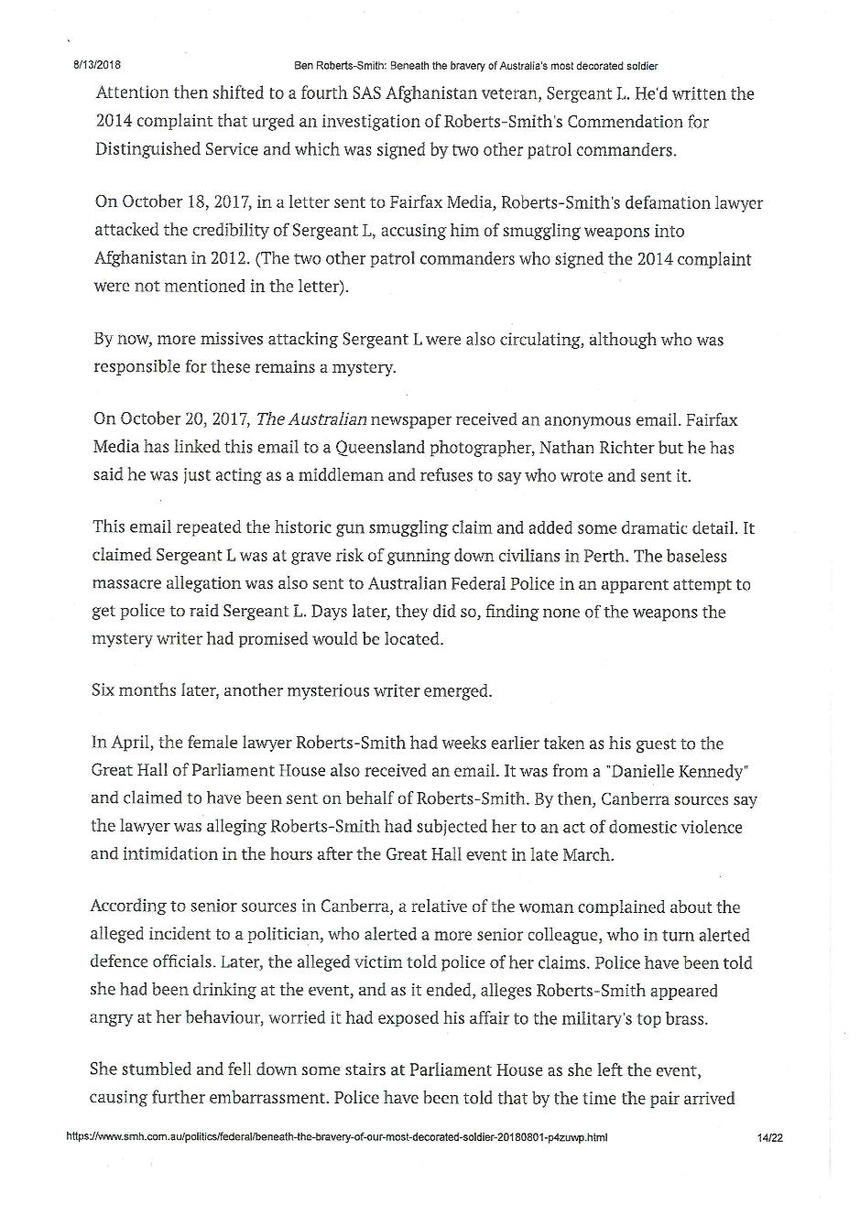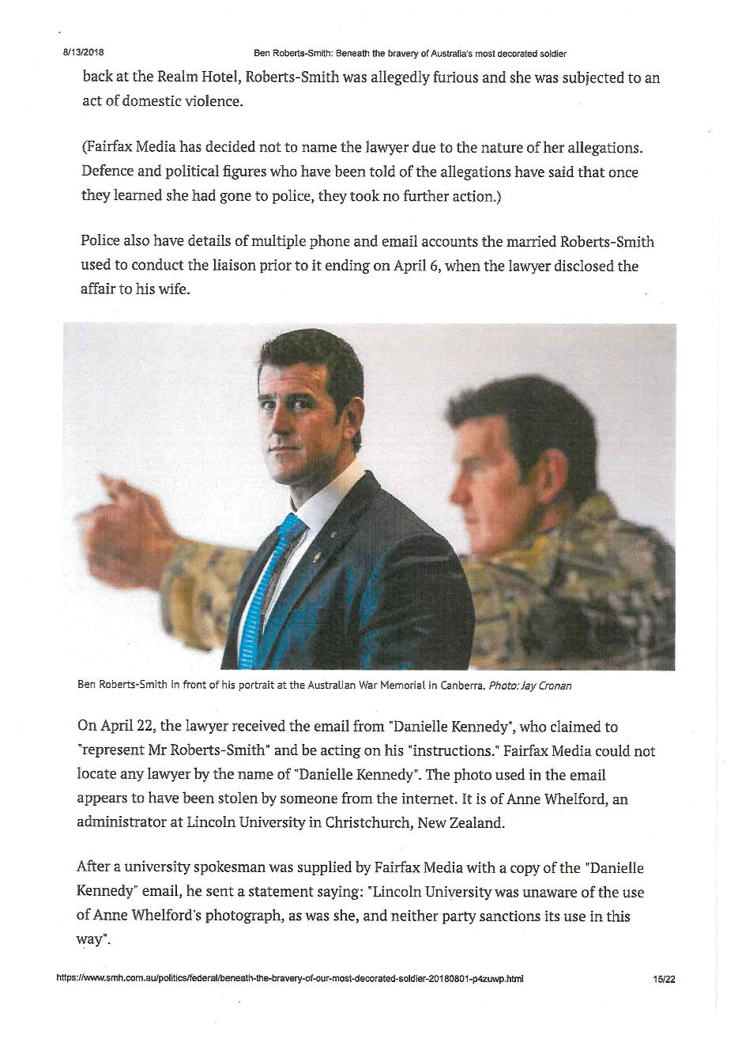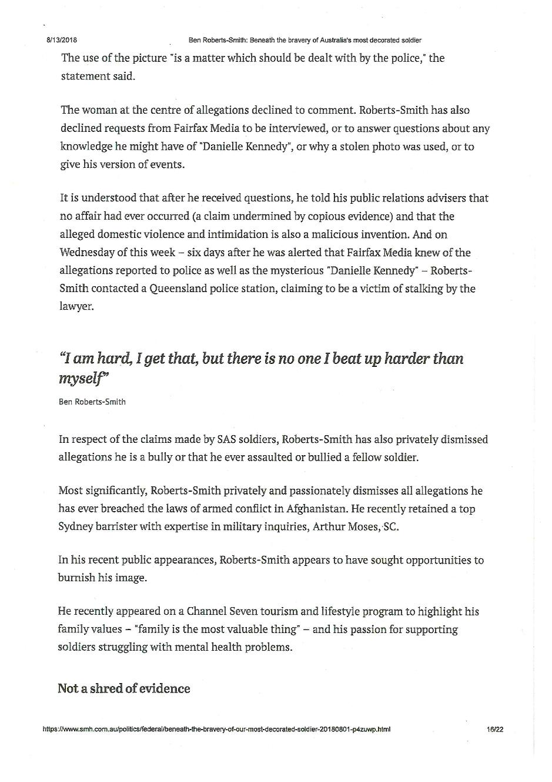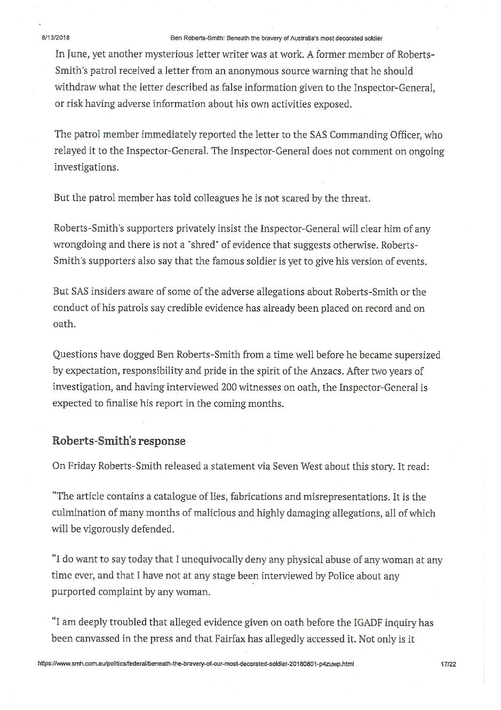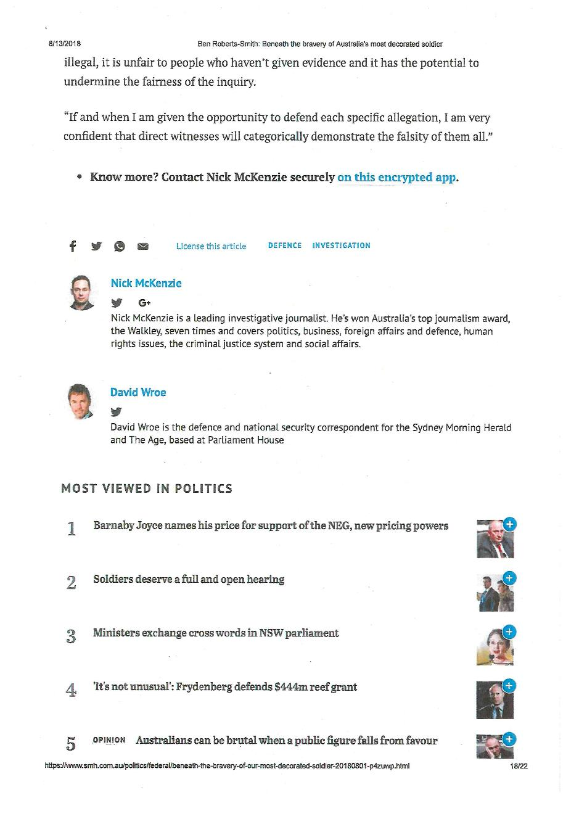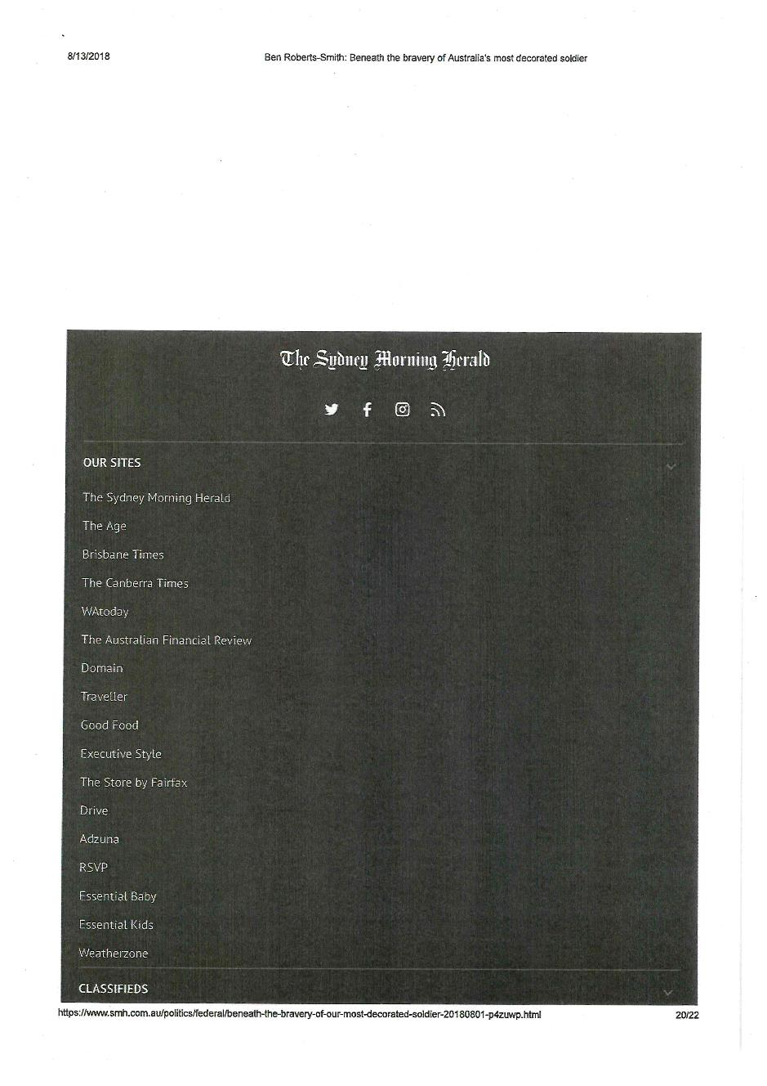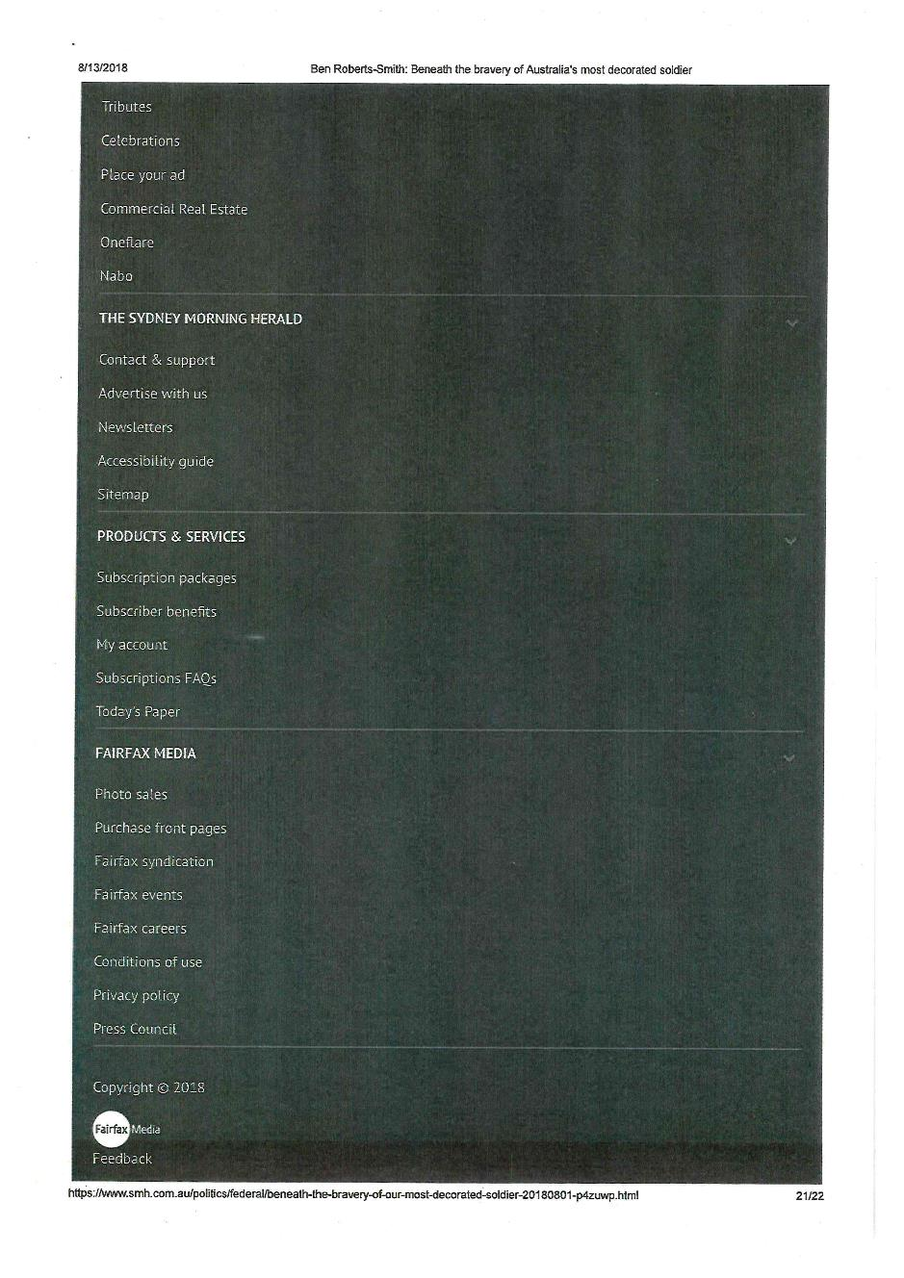

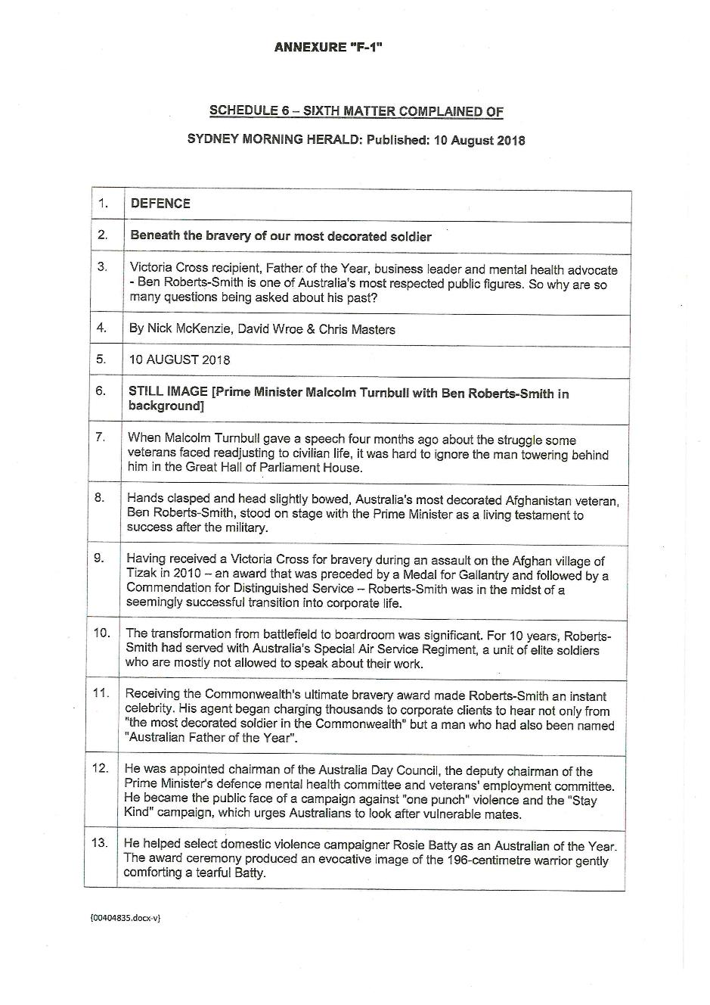
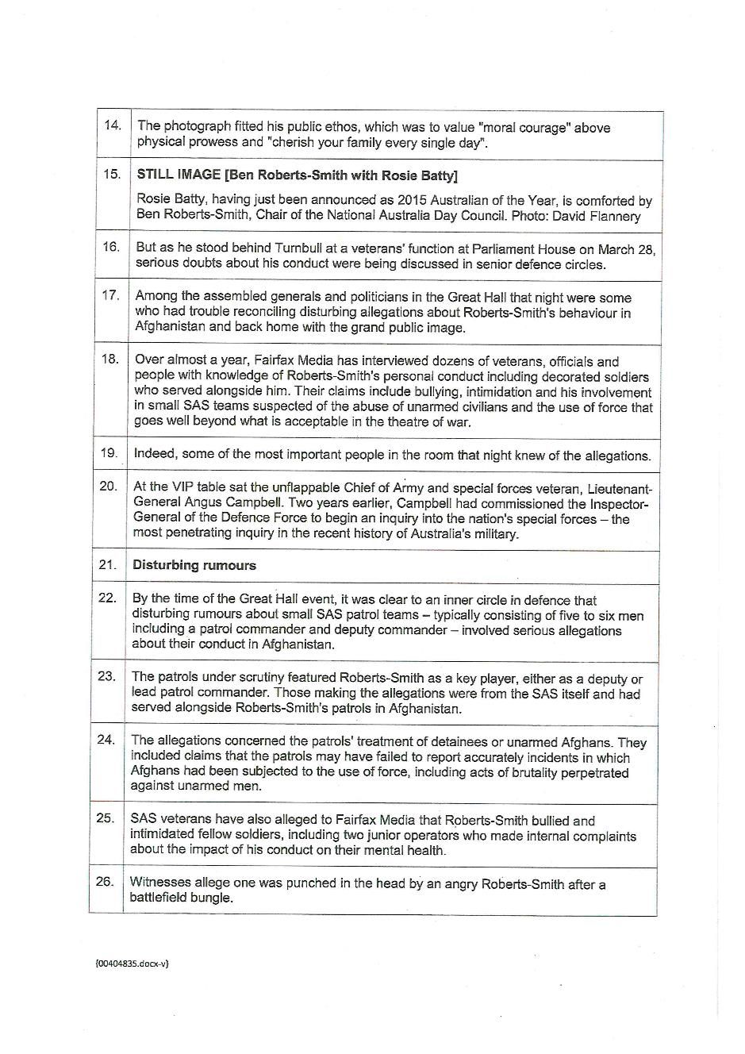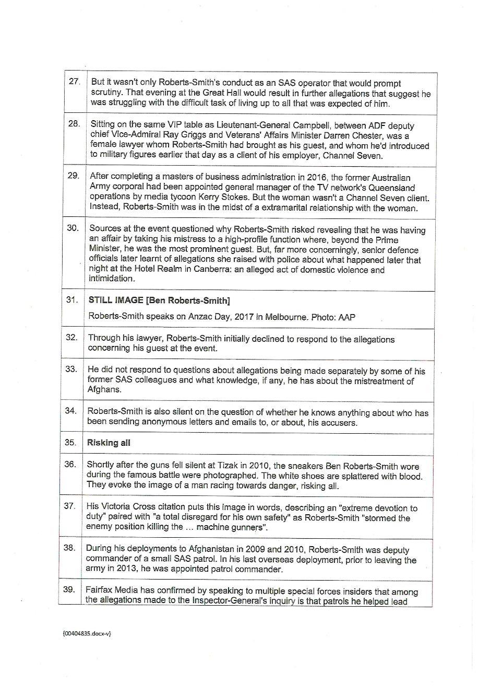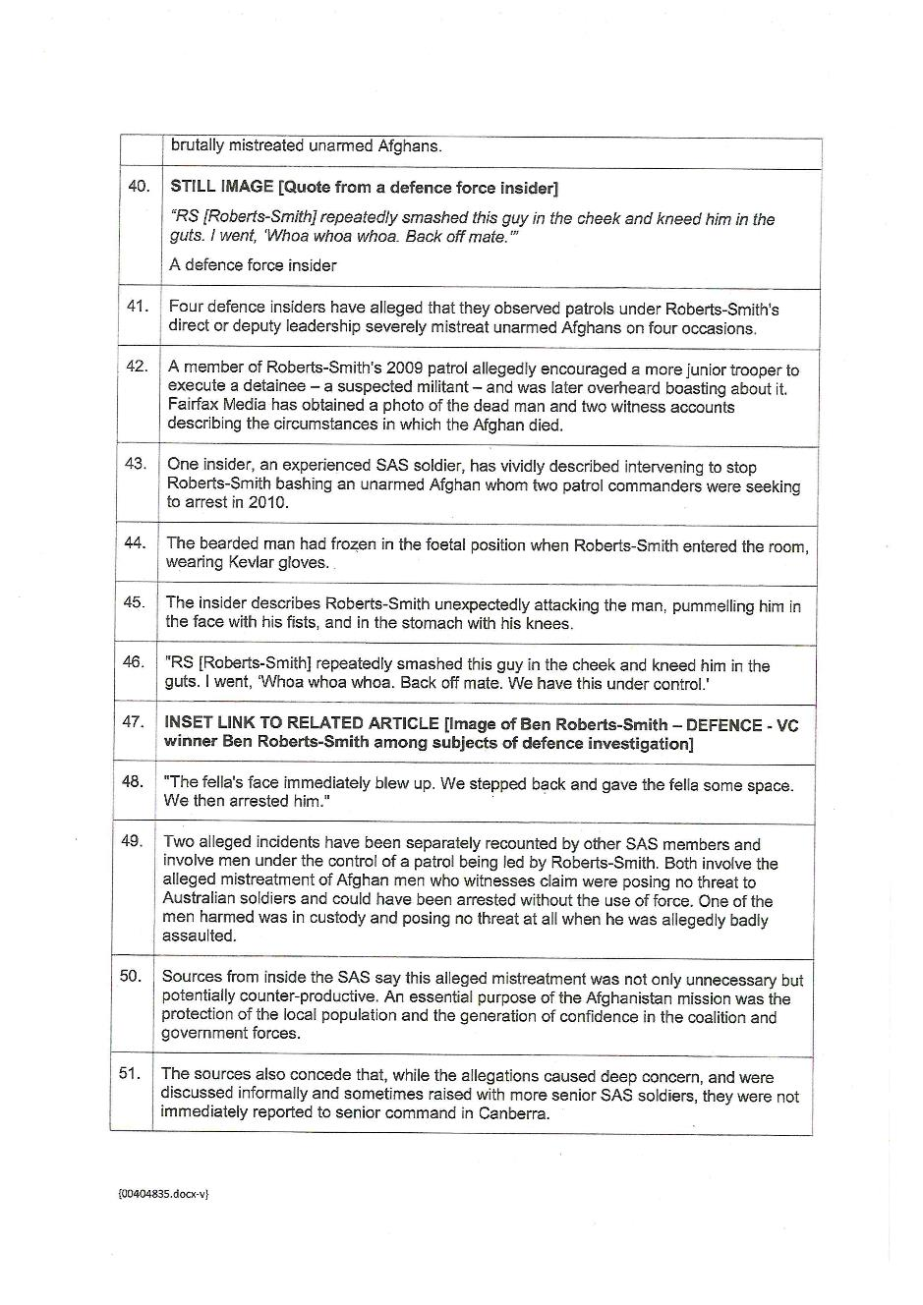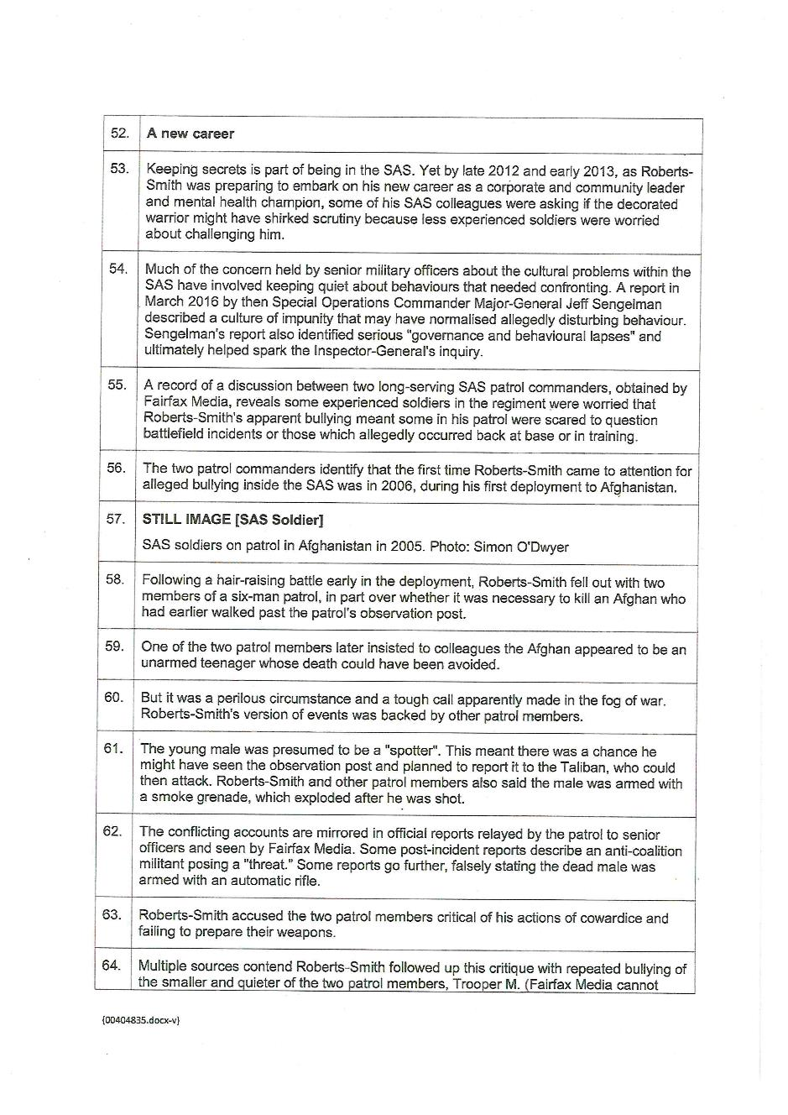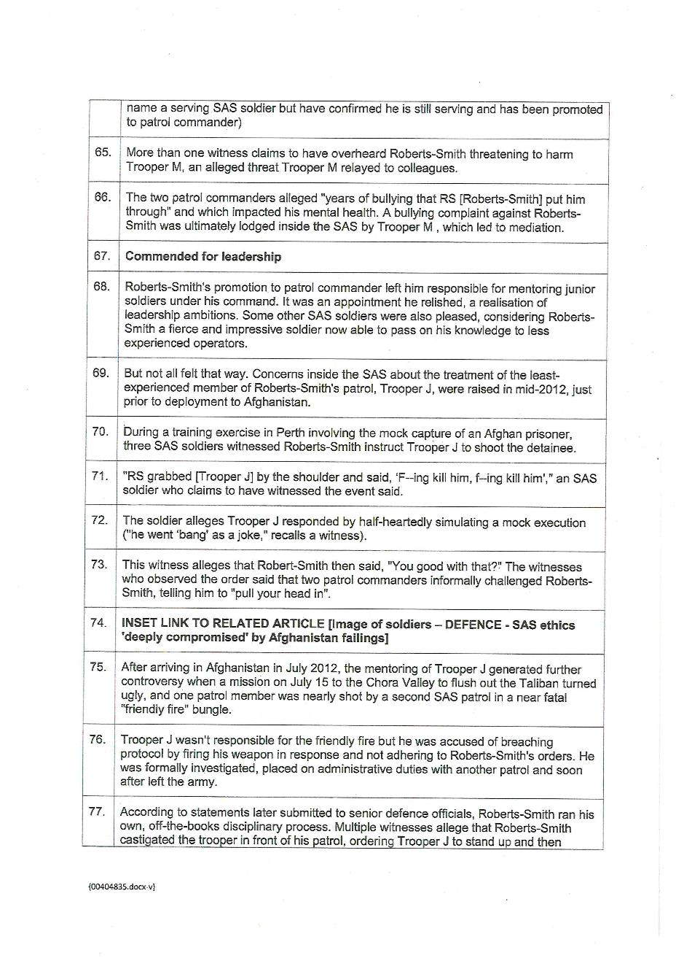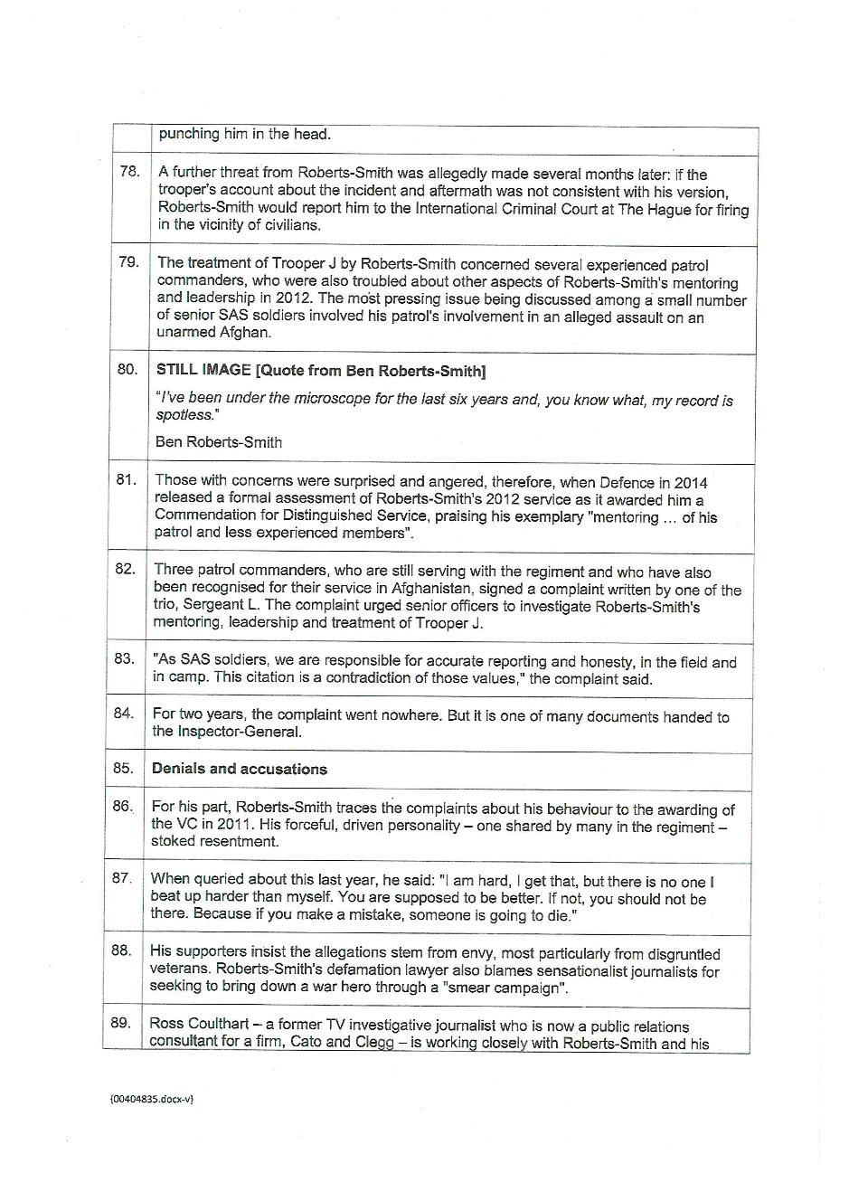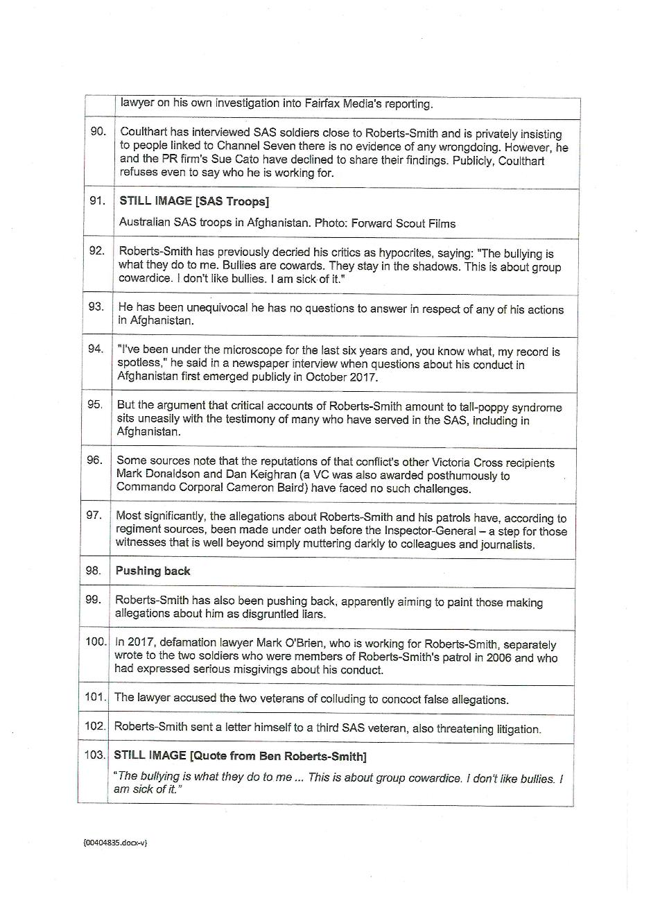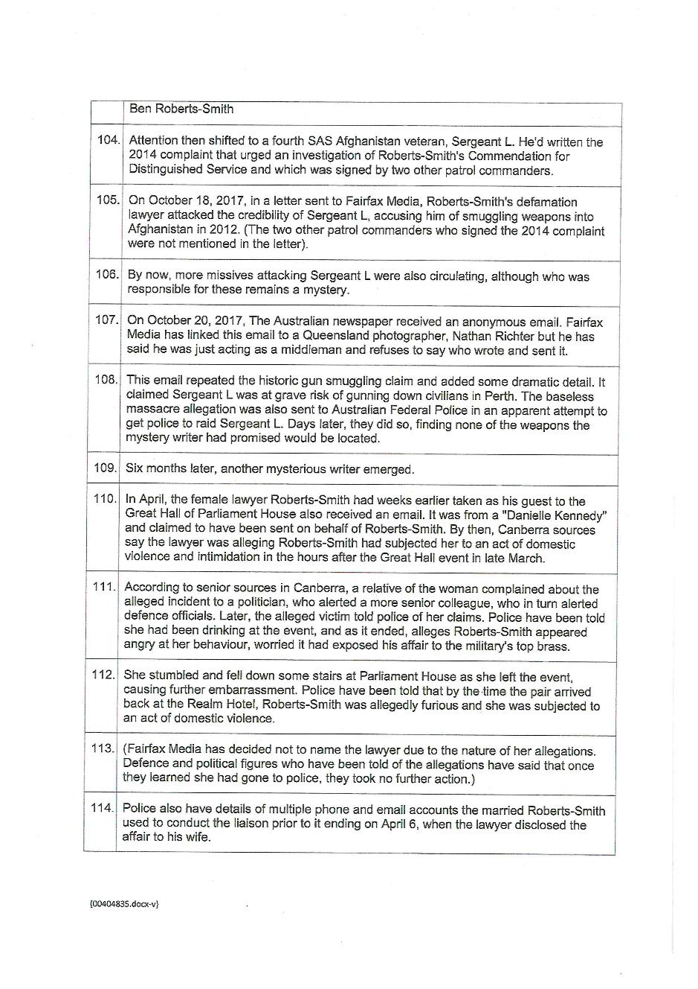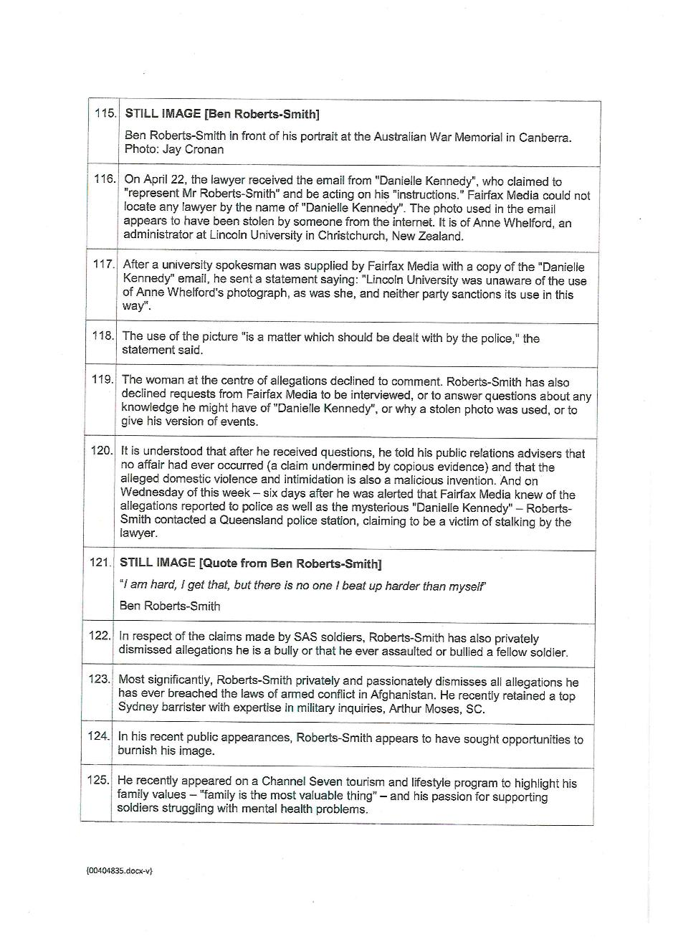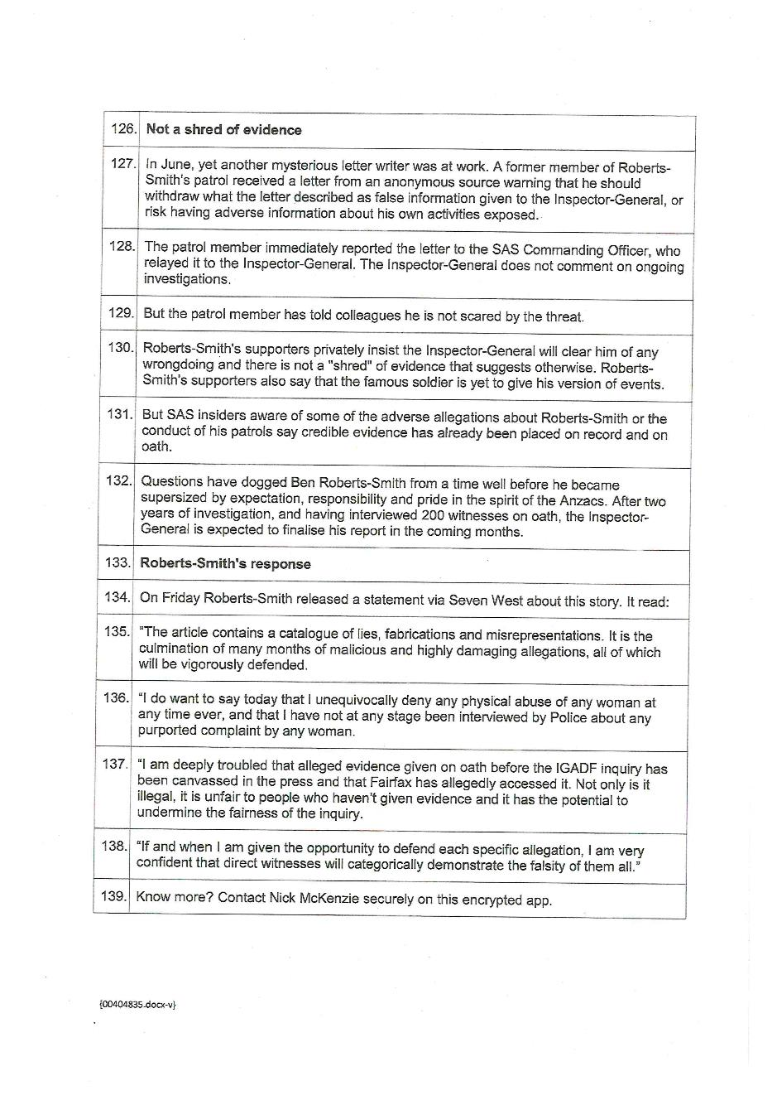

ANNEXURE G
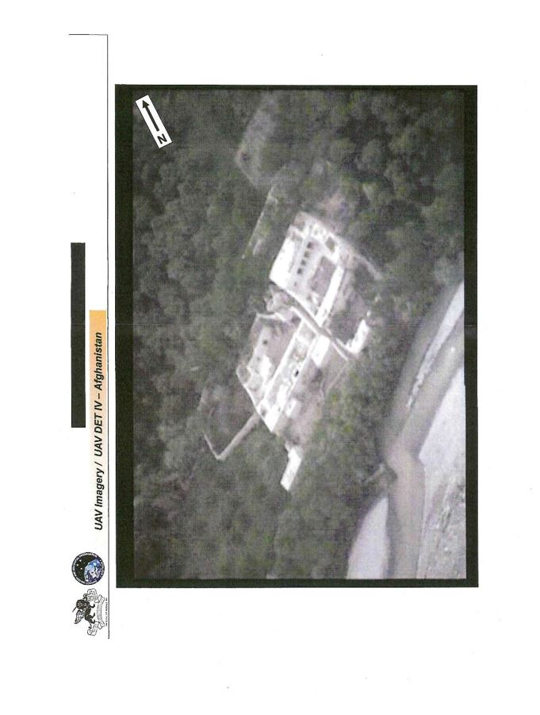
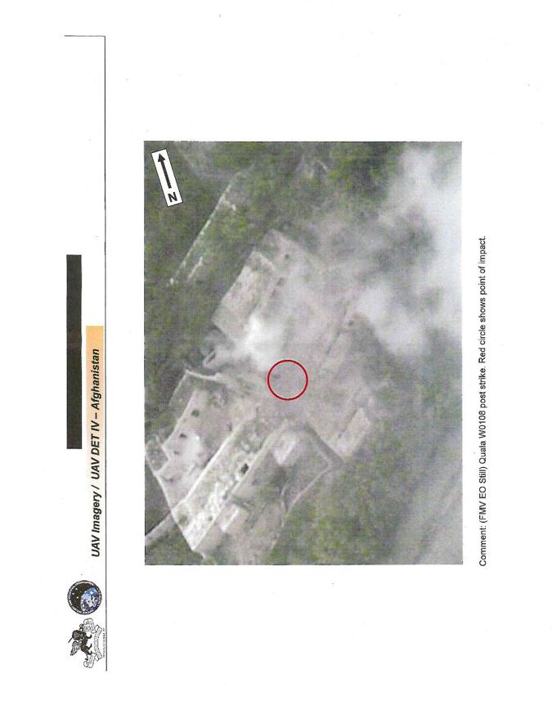

ANNEXURE H
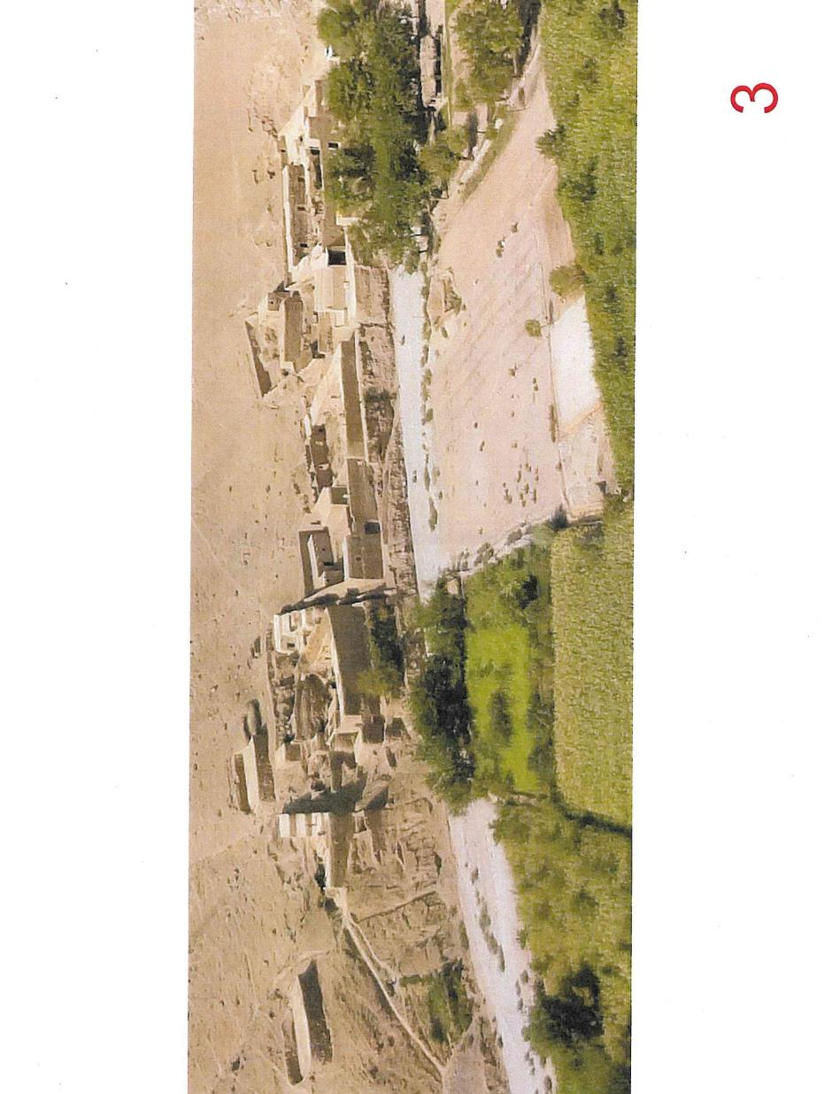
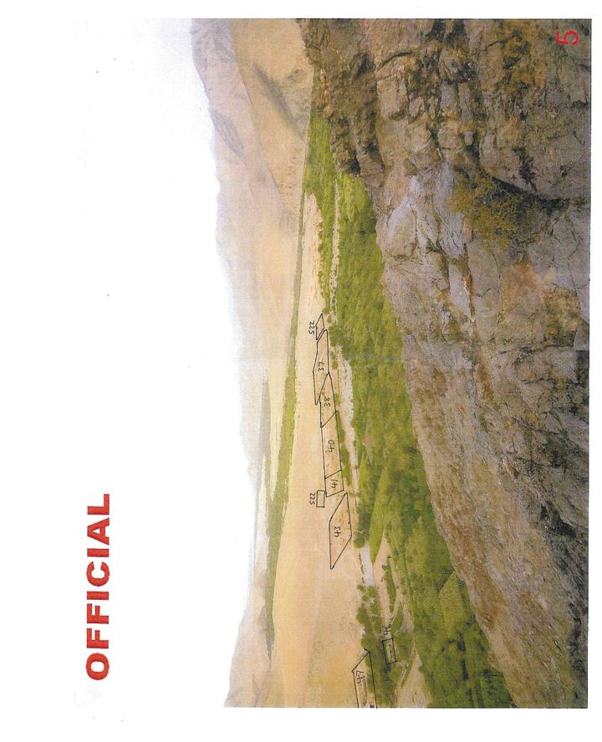

SCHEDULE OF PARTIES

NSD 1485 of 2018
NSD 1486 of 2018
NSD 1487 of 2018
Respondents
Second Respondent: | NICK MCKENZIE
Third Respondent: | CHRIS MASTERS
Fourth Respondent: | DAVID WROE

