FEDERAL COURT OF AUSTRALIA

Deputy Commissioner of Taxation v Raptis [2021] FCA 1192
File number(s): | QUD 310 of 2021
Judgment of: | COLLIER J
Date of judgment: | 1 October 2021
Catchwords: | PRACTICE AND PROCEDURE – ex parte application for freezing orders
Legislation: | Federal Court Rules 2011 rr 7.32, 7.33, 7.34, 7.35, 10.43, 10.44 (1)  Freezing Orders Practice Note (GPN-FRZG)  Income Tax Assessment Act 1997 (Cth)s 175
Cases cited: | Aristocrat Technologies Australia Pty Ltd v Allam [2016] HCA 3  Cardile v LED Builders Pty Ltd (1999) 198 CLR 380  Deputy Commissioner of Taxation (ACT) v Sharp (1988) 91 FLR 70  Deputy Commissioner of Taxation v Gashi [2010] VSC 120  Deputy Commissioner of Taxation v Hua Wang Bank Berhad (2010) 273 ALR 194; [2010] FCA 1014  Deputy Commissioner of Taxation v Shi [2018] FCA 1915  Deputy Commissioner of Taxation v Vasiliades [2014] FCA 1250  Kukulka v Google LCC [2020] FCA 1299  R v Commonwealth Court of Conciliation and Arbitration; Ex parte Barrett [1945] HCA 50; (1945) 70 CLR 141  Rumsley v Vegas Enterprises Pty Ltd [2016] FCAFC 84  Zhen v Mo [2008] VSC 300
Division: | General Division
Registry: | Queensland
National Practice Area: | Taxation
Number of paragraphs: | 91
Date of hearing: | 1 October 2021
Counsel for the Applicant: | Mr P Looney QC and Ms F Chen
Solicitor for the Applicant: | K & L Gates

ORDERS
 |  | QUD 310 of 2021
BETWEEN: | DEPUTY COMMISSIONER OF TAXATION  Applicant
AND: | JAMES RAPTIS  First Respondent  NORTHERNSON PTY LIMITED ACN 090 704 902 AS TRUSTEE FOR THE NORTHERNSON TRUST  Second Respondent  SEVINHAND COMPANY LIMITED (COMPANY NUMBER 02100771) (and others named in the Schedule)  Third Respondent

order made by: | COLLIER J
DATE OF ORDER: | 1 OCTOBER 2021

THE COURT ORDERS THAT:

1. The application for interlocutory relief be returnable immediately.
Freezing Orders
2. Upon the Applicant, by her Counsel, giving the undertakings set out in Schedule A to each of the following annexures, a freezing order be made:
(a) against the First Respondent in form of Annexure A to these orders;
(b) against the Second Respondent in form of Annexure B to these orders;
(c) against the Third Respondent in form of Annexure C to these orders;
(d) against the Fourth Respondent in form of Annexure D to these orders;
(e) against the Fifth Respondent in form of Annexure E to these orders;
(f) against the Sixth Respondent in form of Annexure F to these orders;
(g) against the Seventh Respondent in form of Annexure G to these orders;
(h) against the Eighth Respondent in form of Annexure H to these orders;
(i) against the Ninth Respondent in form of Annexure I to these orders;
(j) against the Tenth Respondent in form of Annexure J to these orders;
(k) against the Eleventh Respondent in form of Annexure K to these orders; and
(l) against the Twelfth Respondent in form of Annexure L to these orders.
Service
3. Pursuant to rule 17.04 of the Federal Court Rules 2011 (Cth) (Rules), service on the Respondents of the Interlocutory Application for interim relief be dispensed with.
4. Pursuant to rules 10.43 and 10.44 of the Rules, the Applicant have leave to serve the Third Respondent in the United Kingdom in accordance with the Convention on the Service Abroad of Judicial and Extrajudicial Documents in Civil or Commercial Matters done at the Hague on 15 November 1965 with:
(a) the originating application;
(b) the interlocutory application;
(c) the affidavit of Vasilee Zarogiannis affirmed on 1 October 2021 (Zarogiannis Affidavit) and exhibit VZ-1;
(d) the affidavit of Andrew John Chambers sworn on 1 October 2021 and exhibit AJC-1;
(e) the applicant’s outline of submissions dated 1 October 2021; and
(f) these orders;
(the Documents).
5. Pursuant to rules 10.49 and 1.34 of the Rules, leave be granted to serve the Documents on the Third Respondent in the manner set out in Annexure C.
6. Pursuant to rule 10.24 and 10.27 of the Rules, leave be granted to serve the Documents on the Respondents in the manner set out in Annexures A, B and D to L respectively.
7. The Court directs that, upon the undertaking of the Applicant to provide a paper copy of the exhibit to any supporting affidavit within three business days of a request by a Respondent to do so, service of any exhibit may be effected by:
(a) in the case of service by post, providing a copy on a USB drive; or
(b) in the case of service by email, by making it available for download by electronic link.
Other matters
8. The proceeding be listed for a case management hearing at a date to be fixed by the Registry of the Federal Court of Australia on or after 14 October 2021.
9. These orders be entered forthwith.
10. The costs of this application be reserved.
11. Any party affected by these orders has liberty to apply on 24 hours' notice.

Note: Entry of orders is dealt with in Rule 39.32 of the Federal Court Rules 2011.

ANNEXURE A
No. QUD 310 of 2021
Federal Court of Australia
District Registry: Queensland
Division: General
Deputy Commissioner of Taxation
Applicant
James Raptis and others named in the schedule
Respondent

PENAL NOTICE
TO: James Raptis
IF YOU (BEING THE PERSON BOUND BY THIS ORDER):
(A) REFUSE OR NEGLECT TO DO ANY ACT WITHIN THE TIME SPECIFIED IN THIS ORDER FOR THE DOING OF THE ACT; OR
(B) DISOBEY THE ORDER BY DOING AN ACT WHICH THE ORDER REQUIRES YOU NOT TO DO,
YOU WILL BE LIABLE TO IMPRISONMENT, SEQUESTRATION OF PROPERTY OR OTHER PUNISHMENT.
ANY OTHER PERSON WHO KNOWS OF THIS ORDER AND DOES ANYTHING WHICH HELPS OR PERMITS YOU TO BREACH THE TERMS OF THIS ORDER MAY BE SIMILARLY PUNISHED.
TO: James Raptis
This is a 'freezing order' made against you on 1 October 2021 by Justice Collier at a hearing without notice to you after the Court was given the undertakings set out in Schedule A to this order and after the Court read the affidavits listed in Schedule B to this order.
THE COURT ORDERS THAT:
INTRODUCTION
1.
(a) The application for this order is made returnable immediately.
(b) The time for service of this order, the application, supporting affidavits, the applicant's outline of submissions and originating process is abridged and service is to be effected by:
(i) emailing the abovementioned documents to:
A. Brendan.Balasekeran@bdo.com.au;
B. i.hughes@hopgoodganim.com.au; and
C. andrew.johnson@greystoneslaw.com.au,
by 4.00 pm on 4 October 2021;
(ii) posting the abovementioned documents by express post to:
A. Raptis Group Limited, Level 7, 10 Eagle Street, Brisbane QLD 4000;
B. 143 Commodore Drive, Surfers Paradise QLD 4217;
C. Greystones Lawyers and Corporate Advisors, PO Box 12203, Brisbane, QLD 4000;
D. BDO, Level 10, 12 Creek Street, Brisbane, QLD 4000; and
E. HopgoodGanim Lawyers, Level 8, Waterfront Place, 1 Eagle Street, Brisbane QLD 4000,
by 4.00 pm on 4 October 2021;
2. Subject to the next paragraph, this order has effect up to and including the next hearing date ("the Return Date").
3. Anyone served with or notified of this order, including you, may apply to the Court at any time to vary or discharge this order or so much of it as affects the person served or notified.
4. In this order:
(a) 'applicant', if there is more than one applicant, includes all the applicants;
(b) 'you', where there is more than one of you, includes all of you and includes you if you are a corporation;
(c) 'third party' means a person other than you and the applicant;
(d) 'unencumbered value' means value free of mortgages, charges, liens or other encumbrances.
5.
(a) If you are ordered to do something, you must do it by yourself or through directors, officers, partners, employees, agents or others acting on your behalf or on your instructions.
(b) If you are ordered not to do something, you must not do it yourself or through directors, officers, partners, employees, agents or others acting on your behalf or on your instructions or with your encouragement or in any other way.
FREEZING OF ASSETS
6.
(a) You must not remove from Australia or in any way dispose of, deal with or diminish the value of any of your assets in Australia ('Australian assets') up to the unencumbered value of AUD$23,815,519.60 ('the Relevant Amount').
(b) If the unencumbered value of your Australian assets exceeds the Relevant Amount, you may remove any of those assets from Australia or dispose of or deal with them or diminish their value, so long as the total unencumbered value of your Australian assets still exceeds the Relevant Amount.
7. For the purposes of this order,
(a) your assets include:
(i) all your assets, whether or not they are in your name and whether they are solely or co-owned;
(ii) any asset which you have the power, directly or indirectly, to dispose of or deal with as if it were your own (you are to be regarded as having such power if a third party holds or controls the asset in accordance with your direct or indirect instructions); and
(iii) the following assets in particular:
A. Lexus 2018 LS500H Sedan (VIN JTHBYLFF105001528) (registration CC100);
B. any shares held by you in the following companies:
        - CVC Limited (ASX: CVC): and
        - Telstra Corporation Limited (ASX: TLS); and
C. any money in the following bank accounts:
        - CBA bank account BSB 064430 account number 10995745 in the name of James Raptis and Helen Raptis in trust for J&H Raptis Retirement Trust;
        - CBA bank account BSB 064432 account number 10446468 in the name of James Raptis and Helen Raptis in trust for J&H Raptis Retirement Trust;
        - NAB bank account BSB 084034 account number 508427988 in the name of James Raptis and Helen Raptis;
        - ANZ bank account BSB 014141 account number 9076 84623 in the name of James Raptis and Helen Raptis;
        - Bank of Queensland bank account BSB 124394 account number 22857313 in the name of James Raptis;
        - Suncorp-Metway bank account BSB 484799 account number 322789841 in the name of James Raptis and Helen Raptis;
        - Suncorp-Metway bank account BSB 484799 account number 605960185 in the name of James Raptis and Helen Raptis; and
        - Suncorp-Metway bank account BSB 484799 account number 329342206 in the name of James Raptis and Helen Raptis.
(b) the value of your assets is the value of the interest you have individually in your assets.
PROVISION OF INFORMATION
8. Subject to paragraph 9, you must:
(a) at or before the further hearing on the Return Date (or within such further time as the Court may allow) to the best of your ability inform the applicant in writing of all your assets in Australia, giving their value, location and details (including any mortgages, charges or other encumbrances to which they are subject) and the extent of your interest in the assets;
(b) within 10 working days after being served with this order, swear and serve on the applicant an affidavit setting out the above information.
9.
  - This paragraph 9 applies if you are not a corporation and you wish to object to complying with paragraph 8 on the grounds that some or all of the information required to be disclosed may tend to prove that you:
(i) have committed an offence against or arising under an Australian law or a law of a foreign country; or
(ii) are liable to a civil penalty.
(b) This paragraph 9 also applies if you are a corporation and all of the persons who are able to comply with paragraph 8 on your behalf and with whom you have been able to communicate, wish to object to your complying with paragraph 8 on the grounds that some or all of the information required to be disclosed may tend to prove that they respectively:
(i) (have committed an offence against or arising under an Australian law or a law of a foreign country; or
(ii) are liable to a civil penalty.
(c) You must:
(i) disclose so much of the information required to be disclosed to which no objection is taken; and
(ii) prepare an affidavit containing so much of the information required to be disclosed to which objection is taken, and deliver it to the Court in a sealed envelope; and
(iii) file and serve on each other party a separate affidavit setting out the basis of the objection.
EXCEPTIONS TO THIS ORDER
10. This order does not prohibit you from:
(a) paying up to AUD$10,000 a week on your ordinary living expenses;
(b) paying your reasonable legal expenses;
(c) dealing with or disposing of any of your assets in the ordinary and proper course of your business, including paying business expenses bona fide and properly incurred; and
(d) in relation to matters not falling within (a), (b) or (c), dealing with or disposing of any of your assets in discharging obligations bona fide and properly incurred under a contract entered into before this order was made, provided that before doing so you give the applicant, if possible, at least two working days written notice of the particulars of the obligation.
11. You and the applicant may agree in writing that the exceptions in the preceding paragraph are to be varied. In that case the applicant or you must as soon as practicable file with the Court and serve on the other a minute of a proposed consent order recording the variation signed by or on behalf of the applicant and you, and the Court may order that the exceptions are varied accordingly.
12.
(a) This order will cease to have effect if you:
(i) pay the sum of AUD$23,815,519.60 into Court; or
(ii) pay that sum into a joint bank account in the name of your lawyer and the lawyer for the applicant as agreed in writing between them; or
(iii) provide security in that sum by a method agreed in writing with the applicant to be held subject to the order of the Court.
(b) Any such payment and any such security will not provide the applicant with any priority over your other creditors in the event of your insolvency.
(c) If this order ceases to have effect pursuant 12(a) above, you must as soon as practicable file with the Court and serve on the applicant notice of that fact.
COSTS
13. The costs of this application are reserved to the Court hearing the application on the Return Date.
PERSONS OTHER THAN THE APPLICANT AND RESPONDENT
14. Set off by banks
This order does not prevent any bank from exercising any right of set off it has in respect of any facility which it gave you before it was notified of this order.
15. Bank withdrawals by the respondent
No bank need inquire as to the application or proposed application of any money withdrawn by you if the withdrawal appears to be permitted by this order.
16. Notices under s 260-5 of Schedule 1 to the Taxation Administration Act 1953 (Cth)
Nothing in this order shall prevent any third party complying with the terms of a notice issued by the Commissioner of Taxation to the third party pursuant to section 260-5 of Schedule 1 to the Taxation Administration Act 1953 (Cth) in respect of any money which the third party may owe or may later owe to you.

SCHEDULE A
UNDERTAKINGS GIVEN TO THE COURT BY THE APPLICANT
1. The applicant undertakes to submit to such order (if any) as the Court may consider to be just for the payment of compensation (to be assessed by the Court or as it may direct) to any person (whether or not a party) affected by the operation of the order.
2. As soon as practicable, the applicant will file and serve upon the respondent copies of:
(a) this order;
(b) the application for this order for hearing on the return date;
(c) the following material in so far as it was relied on by the applicant at the hearing when the order was made:
(i) affidavits (or draft affidavits);
(ii) exhibits capable of being copied;
(iii) any written submission; and
(iv) any other document that was provided to the Court.
(d) a transcript, or, if none is available, a note, of any exclusively oral allegation of fact that was made and of any exclusively oral submission that was put, to the Court;
(e) the originating process, or, if none was filed, any draft originating process produced to the Court.
3. As soon as practicable, the applicant will cause anyone notified of this order to be given a copy of it.
4. The applicant will pay the reasonable costs of anyone other than the respondent which have been incurred as a result of this order, including the costs of finding out whether that person holds any of the respondent’s assets.
5. If this order ceases to have effect the applicant will promptly take all reasonable steps to inform in writing anyone to who has been notified of this order, or who he has reasonable grounds for supposing may act upon this order, that it has ceased to have effect.
6. The applicant will not, without leave of the Court, use any information obtained as a result of this order for the purpose of any civil or criminal proceedings, either in or outside Australia, other than this proceeding.
7. The applicant will not, without leave of the Court, seek to enforce this order in any country outside Australia or seek in any country outside Australia an order of a similar nature or an order conferring a charge or other security against the respondent or the respondent’s assets.
SCHEDULE B
AFFIDAVITS RELIED ON
 | Name of deponent | Date affidavit made
(1) | Vasilee Zarogiannis | 1 October 2021
(2) | Andrew John Chambers | 1 October 2021

NAME AND ADDRESS OF APPLICANT'S LAWYERS
The applicant's lawyers are: K&L Gates
Level 25 South Tower, 525 Collins Street
Melbourne VIC 3000
Tel: +61 3 9205 2000
Tel: +61 3 9640 4269 (after office hours)
Fax: +61 3 9205 2055
Email: Andrew.Chambers@klgates.com
Ref: TTRO.AJC.7390795.00090

ANNEXURE B
No. QUD 310 of 2021
Federal Court of Australia
District Registry: Queensland
Division: General
Deputy Commissioner of Taxation
Applicant
James Raptis and others named in the schedule
Respondents

PENAL NOTICE
TO: Northernson Pty Limited ACN 090 704 902 as trustee for the Northernson Trust
IF YOU (BEING THE PERSON BOUND BY THIS ORDER):
(A) REFUSE OR NEGLECT TO DO ANY ACT WITHIN THE TIME SPECIFIED IN THIS ORDER FOR THE DOING OF THE ACT; OR
(B) DISOBEY THE ORDER BY DOING AN ACT WHICH THE ORDER REQUIRES YOU NOT TO DO,
YOU WILL BE LIABLE TO IMPRISONMENT, SEQUESTRATION OF PROPERTY OR OTHER PUNISHMENT.
ANY OTHER PERSON WHO KNOWS OF THIS ORDER AND DOES ANYTHING WHICH HELPS OR PERMITS YOU TO BREACH THE TERMS OF THIS ORDER MAY BE SIMILARLY PUNISHED.
TO: Northernson Pty Limited ACN 090 704 902 as trustee for the Northernson Trust
This is a 'freezing order' made against you on 1 October 2021 by Justice Collier at a hearing without notice to you after the Court was given the undertakings set out in Schedule A to this order and after the Court read the affidavits listed in Schedule B to this order.
THE COURT ORDERS:
INTRODUCTION
1.
(a) The application for this order is made returnable immediately.
(b) The time for service of this order, the application, supporting affidavits, the applicant's outline of submissions and originating process is abridged and service is to be effected by:
(i) emailing the abovementioned documents to:
A. Brendan.Balasekeran@bdo.com.au;
B. i.hughes@hopgoodganim.com.au; and
C. andrew.johnson@greystoneslaw.com.au,
by 4.00 pm on 4 October 2021;
(ii) posting the abovementioned documents by express post to:
A. Raptis Group Limited, Level 7, 10 Eagle Street, Brisbane QLD 4000;
B. 143 Commodore Drive, Surfers Paradise QLD 4217;
C. Greystones Lawyers and Corporate Advisors, PO Box 12203, Brisbane, QLD 4000;
D. BDO, Level 10, 12 Creek Street, Brisbane, QLD 4000; and
E. HopgoodGanim Lawyers, Level 8, Waterfront Place, 1 Eagle Street, Brisbane QLD 4000,
by 4.00 pm on 4 October 2021.
2. Subject to the next paragraph, this order has effect up to and including the next hearing date ("the Return Date").
3. Anyone served with or notified of this order, including you, may apply to the Court at any time to vary or discharge this order or so much of it as affects the person served or notified.
4. In this order:
(a) 'applicant', if there is more than one applicant, includes all the applicants;
(b) 'you', where there is more than one of you, includes all of you and includes you if you are a corporation;
(c) 'third party' means a person other than you and the applicant;
(d) 'unencumbered value' means value free of mortgages, charges, liens or other encumbrances.
5.
(a) If you are ordered to do something, you must do it by yourself or through directors, officers, partners, employees, agents or others acting on your behalf or on your instructions.
(b) If you are ordered not to do something, you must not do it yourself or through directors, officers, partners, employees, agents or others acting on your behalf or on your instructions or with your encouragement or in any other way.
FREEZING OF ASSETS
6.
(a) You must not remove from Australia or in any way dispose of, deal with or diminish the value of any of your assets in Australia ('Australian assets') up to the unencumbered value of AUD$83,205,597.96 ('the Relevant Amount').
(b) If the unencumbered value of your Australian assets exceeds the Relevant Amount, you may remove any of those assets from Australia or dispose of or deal with them or diminish their value, so long as the total unencumbered value of your Australian assets still exceeds the Relevant Amount.
7. For the purposes of this order,
(a) your assets include:
(i) all your assets, whether or not they are in your name and whether they are solely or co-owned;
(ii) any asset which you have the power, directly or indirectly, to dispose of or deal with as if it were your own (you are to be regarded as having such power if a third party holds or controls the asset in accordance with your direct or indirect instructions); and
(iii) the following assets in particular:
A. the property known as 141-143 Commodore Drive, Surfers Paradise QLD 4217 (Title References 15888143 and 15888144) or, if it has been sold, the net proceeds of the sale;
B. any money in any bank accounts, including but not limited to National Australia Bank Limited bank account BSB 084-004 account number 550080244 in the name of Northernson Pty Limited; and
(b) the value of your assets is the value of the interest you have individually in your assets.
PROVISION OF INFORMATION
8. Subject to paragraph 9, you must:
(a) at or before the further hearing on the Return Date (or within such further time as the Court may allow) to the best of your ability inform the applicant in writing of all your assets in Australia, giving their value, location and details (including any mortgages, charges or other encumbrances to which they are subject) and the extent of your interest in the assets;
(b) within 10 working days after being served with this order, swear and serve on the applicant an affidavit setting out the above information.
9.
(a) This paragraph (9) applies if you are not a corporation and you wish to object to complying with paragraph 8 on the grounds that some or all of the information required to be disclosed may tend to prove that you:
(i) have committed an offence against or arising under an Australian law or a law of a foreign country; or
(ii) are liable to a civil penalty.
(b) This paragraph (9) also applies if you are a corporation and all of the persons who are able to comply with paragraph 8 on your behalf and with whom you have been able to communicate, wish to object to your complying with paragraph 8 on the grounds that some or all of the information required to be disclosed may tend to prove that they respectively:
(i) (have committed an offence against or arising under an Australian law or a law of a foreign country; or
(ii) are liable to a civil penalty.
(c) You must:
(i) disclose so much of the information required to be disclosed to which no objection is taken; and
(ii) prepare an affidavit containing so much of the information required to be disclosed to which objection is taken, and deliver it to the Court in a sealed envelope; and
(iii) file and serve on each other party a separate affidavit setting out the basis of the objection.
EXCEPTIONS TO THIS ORDER
10. This order does not prohibit you from:
(a) paying your reasonable legal expenses;
(b) dealing with or disposing of any of your assets in the ordinary and proper course of your business, including paying business expenses bona fide and properly incurred; and
(c) in relation to matters not falling within (a) or (b), dealing with or disposing of any of your assets in discharging obligations bona fide and properly incurred under a contract entered into before this order was made, provided that before doing so you give the applicant, if possible, at least two working days written notice of the particulars of the obligation.
11. You and the applicant may agree in writing that the exceptions in the preceding paragraph are to be varied. In that case the applicant or you must as soon as practicable file with the Court and serve on the other a minute of a proposed consent order recording the variation signed by or on behalf of the applicant and you, and the Court may order that the exceptions are varied accordingly.
12.
(a) This order will cease to have effect if you:
(i) pay the sum of AUD$83,205,597.96 into Court; or
(ii) pay that sum into a joint bank account in the name of your lawyer and the lawyer for the applicant as agreed in writing between them; or
(iii) provide security in that sum by a method agreed in writing with the applicant to be held subject to the order of the Court.
(b) Any such payment and any such security will not provide the applicant with any priority over your other creditors in the event of your insolvency.
(c) If this order ceases to have effect pursuant 12(a) above, you must as soon as practicable file with the Court and serve on the applicant notice of that fact.
COSTS
13. The costs of this application are reserved to the Court hearing the application on the Return Date.
PERSONS OTHER THAN THE APPLICANT AND RESPONDENT
14. Set off by banks
This order does not prevent any bank from exercising any right of set off it has in respect of any facility which it gave you before it was notified of this order.
15. Bank withdrawals by the respondent
No bank need inquire as to the application or proposed application of any money withdrawn by you if the withdrawal appears to be permitted by this order.
16. Notices under s 260-5 of Schedule 1 to the Taxation Administration Act 1953 (Cth)
Nothing in this order shall prevent any third party complying with the terms of a notice issued by the Commissioner of Taxation to the third party pursuant to section 260-5 of Schedule 1 to the Taxation Administration Act 1953 (Cth) in respect of any money which the third party may owe or may later owe to you.

SCHEDULE A
UNDERTAKINGS GIVEN TO THE COURT BY THE APPLICANT
1. The applicant undertakes to submit to such order (if any) as the Court may consider to be just for the payment of compensation (to be assessed by the Court or as it may direct) to any person (whether or not a party) affected by the operation of the order.
2. As soon as practicable, the applicant will file and serve upon the respondent copies of:
(a) this order;
(b) the application for this order for hearing on the return date;
(c) the following material in so far as it was relied on by the applicant at the hearing when the order was made:
(i) affidavits (or draft affidavits);
(ii) exhibits capable of being copied;
(iii) any written submission; and
(iv) any other document that was provided to the Court.
(d) a transcript, or, if none is available, a note, of any exclusively oral allegation of fact that was made and of any exclusively oral submission that was put, to the Court;
(e) the originating process, or, if none was filed, any draft originating process produced to the Court.
3. As soon as practicable, the applicant will cause anyone notified of this order to be given a copy of it.
4. The applicant will pay the reasonable costs of anyone other than the respondent which have been incurred as a result of this order, including the costs of finding out whether that person holds any of the respondent’s assets.
5. If this order ceases to have effect the applicant will promptly take all reasonable steps to inform in writing anyone to who has been notified of this order, or who he has reasonable grounds for supposing may act upon this order, that it has ceased to have effect.
6. The applicant will not, without leave of the Court, use any information obtained as a result of this order for the purpose of any civil or criminal proceedings, either in or outside Australia, other than this proceeding.
7. The applicant will not, without leave of the Court, seek to enforce this order in any country outside Australia or seek in any country outside Australia an order of a similar nature or an order conferring a charge or other security against the respondent or the respondent’s assets.
SCHEDULE B
AFFIDAVITS RELIED ON
 | Name of deponent | Date affidavit made
(1) | Vasilee Zarogiannis | 1 October 2021
(2) | Andrew John Chambers | 1 October 2021

NAME AND ADDRESS OF APPLICANT'S LAWYERS
The applicant's lawyers are: K&L Gates
Level 25 South Tower, 525 Collins Street
Melbourne VIC 3000
Tel: +61 3 9205 2000
Tel: +61 3 9640 4269 (after office hours)
Fax: +61 3 9205 2055
Email: Andrew.Chambers@klgates.com
Ref: TTRO.AJC.7390795.00090

ANNEXURE C

No. QUD 310 of 2021
Federal Court of Australia
District Registry: Queensland
Division: General
Deputy Commissioner of Taxation
Applicant
James Raptis and others named in the schedule
Respondents

PENAL NOTICE
TO: Sevinhand Company Limited (company number 02100771)
IF YOU (BEING THE PERSON BOUND BY THIS ORDER):
(A) REFUSE OR NEGLECT TO DO ANY ACT WITHIN THE TIME SPECIFIED IN THIS ORDER FOR THE DOING OF THE ACT; OR
(B) DISOBEY THE ORDER BY DOING AN ACT WHICH THE ORDER REQUIRES YOU NOT TO DO,
YOU WILL BE LIABLE TO IMPRISONMENT, SEQUESTRATION OF PROPERTY OR OTHER PUNISHMENT.
ANY OTHER PERSON WHO KNOWS OF THIS ORDER AND DOES ANYTHING WHICH HELPS OR PERMITS YOU TO BREACH THE TERMS OF THIS ORDER MAY BE SIMILARLY PUNISHED.
TO: Sevinhand Company Limited (company number 02100771)
This is a 'freezing order' made against you on 1 October 2021 by Justice Collier at a hearing without notice to you after the Court was given the undertakings set out in Schedule A to this order and after the Court read the affidavits listed in Schedule B to this order.
THE COURT ORDERS:
INTRODUCTION
1.
(a) The application for this order is made returnable immediately.
(b) The time for service of this order, the application, supporting affidavits, the applicant's outline of submissions and originating process is abridged and service is to be effected by:
(i) emailing the abovementioned documents to:
A. brendan.balasekeran@bdo.com.au;
B. i.hughes@hopgoodganim.com.au;
C. johndonnelly@rb-dubai.com;
D. markturner@lubbockfine.co.uk;
E. hasmukhvara@lubbockfine.co.uk;
F. andrew.johnson@greystoneslaw.com.au; and
G. paul.jones@spglawyers.com.au;
by 4.00 pm on 4 October 2021;
(ii) posting the abovementioned documents by express post to:
A. Raptis Group Limited, Level 7, 10 Eagle Street, Brisbane QLD 4000;
B. 141-143 Commodore Drive, Surfers Paradise QLD 4217;
C. Greystones Lawyers and Corporate Advisors, PO Box 12203, Brisbane, QLD 4000;
D. Short Punch & Greatorix, PO Box 5164, Gold Coast Mail Centre QLD 9726;
E. BDO, Level 10, 12 Creek Street, Brisbane, QLD 4000;
F. HopgoodGanim Lawyers, Level 8, Waterfront Place, 1 Eagle Street, Brisbane QLD 4000,
by 4.00 pm on 4 October 2021;
(iii) posting the documents by international express post or courier to:
A. Paternoster House, 65 St. Paul's Churchyard, London, England, EC4M 8AB;
B. 1 Princeton Mews, 167-169 London Road, Kingston Upon Thames, Surrey, KT2 6PT;
by 4.00 pm on 4 October 2021.
2. Subject to the next paragraph, this order has effect up to and including the next hearing date ("the Return Date").
3. Anyone served with or notified of this order, including you, may apply to the Court at any time to vary or discharge this order or so much of it as affects the person served or notified.
4. In this order:
(a) 'applicant', if there is more than one applicant, includes all the applicants;
(b) 'you', where there is more than one of you, includes all of you and includes you if you are a corporation;
(c) 'third party' means a person other than you and the applicant;
(d) 'unencumbered value' means value free of mortgages, charges, liens or other encumbrances.
5.
(a) If you are ordered to do something, you must do it by yourself or through directors, officers, partners, employees, agents or others acting on your behalf or on your instructions.
(b) If you are ordered not to do something, you must not do it yourself or through directors, officers, partners, employees, agents or others acting on your behalf or on your instructions or with your encouragement or in any other way.

FREEZING OF ASSETS
6.
(a) You must not remove from Australia or in any way dispose of, deal with or diminish the value of any of your assets in Australia ('Australian assets') up to the unencumbered value of AUD$26,468,384.17 ('the Relevant Amount').
(b) If the unencumbered value of your Australian assets exceeds the Relevant Amount, you may remove any of those assets from Australia or dispose of or deal with them or diminish their value, so long as the total unencumbered value of your Australian assets still exceeds the Relevant Amount.
7. For the purposes of this order,
(a) your assets include:
(i) all your assets, whether or not they are in your name and whether they are solely or co-owned;
(ii) any asset which you have the power, directly or indirectly, to dispose of or deal with as if it were your own (you are to be regarded as having such power if a third party holds or controls the asset in accordance with your direct or indirect instructions); and
(iii) the following assets in particular:
A. all shares owned by you in Raptis Group Limited ACN 010 472 858 (ASX: RPG);
B. registered mortgage number 711903418 over the property known as 141-143 Commodore Drive, Surfers Paradise QLD 4217 (Title References 15888143 and 15888144);
C. fixed and floating charge dated 3 September 2008 granted by Northernson Pty Limited ACN 090 704 902 as trustee for the Northernson Trust (registered on the Personal Property Securities Register bearing registration number 201112200093681);
D. any money in any bank accounts.
(b) the value of your assets is the value of the interest you have individually in your assets.
PROVISION OF INFORMATION
8. Subject to paragraph 9, you must:
(a) at or before the further hearing on the Return Date (or within such further time as the Court may allow) to the best of your ability inform the applicant in writing of all your assets in Australia, giving their value, location and details (including any mortgages, charges or other encumbrances to which they are subject) and the extent of your interest in the assets;
(b) within 10 working days after being served with this order, swear and serve on the applicant an affidavit setting out the above information.
9.
(a) This paragraph 9 applies if you are not a corporation and you wish to object to complying with paragraph 8 on the grounds that some or all of the information required to be disclosed may tend to prove that you:
(i) have committed an offence against or arising under an Australian law or a law of a foreign country; or
(ii) are liable to a civil penalty.
(b) This paragraph 9 also applies if you are a corporation and all of the persons who are able to comply with paragraph 8 on your behalf and with whom you have been able to communicate, wish to object to your complying with paragraph 8 on the grounds that some or all of the information required to be disclosed may tend to prove that they respectively:
(i) (have committed an offence against or arising under an Australian law or a law of a foreign country; or
(ii) are liable to a civil penalty.
(c) You must:
(i) disclose so much of the information required to be disclosed to which no objection is taken; and
(ii) prepare an affidavit containing so much of the information required to be disclosed to which objection is taken, and deliver it to the Court in a sealed envelope; and
(iii) file and serve on each other party a separate affidavit setting out the basis of the objection.
EXCEPTIONS TO THIS ORDER
10. This order does not prohibit you from:
(a) paying your reasonable legal expenses;
(b) dealing with or disposing of any of your assets in the ordinary and proper course of your business, including paying business expenses bona fide and properly incurred; and
(c) in relation to matters not falling within (a) or (b), dealing with or disposing of any of your assets in discharging obligations bona fide and properly incurred under a contract entered into before this order was made, provided that before doing so you give the applicant, if possible, at least two working days written notice of the particulars of the obligation.
11. You and the applicant may agree in writing that the exceptions in the preceding paragraph are to be varied. In that case the applicant or you must as soon as practicable file with the Court and serve on the other a minute of a proposed consent order recording the variation signed by or on behalf of the applicant and you, and the Court may order that the exceptions are varied accordingly.
12.
(a) This order will cease to have effect if you:
(i) pay the sum of AUD$26,468,384.17 into Court; or
(ii) pay that sum into a joint bank account in the name of your lawyer and the lawyer for the applicant as agreed in writing between them; or
(iii) provide security in that sum by a method agreed in writing with the applicant to be held subject to the order of the Court.
(b) Any such payment and any such security will not provide the applicant with any priority over your other creditors in the event of your insolvency.
(c) If this order ceases to have effect pursuant 12(a) above, you must as soon as practicable file with the Court and serve on the applicant notice of that fact.
COSTS
13. The costs of this application are reserved to the Court hearing the application on the Return Date.
PERSONS OTHER THAN THE APPLICANT AND RESPONDENT
14. Set off by banks
This order does not prevent any bank from exercising any right of set off it has in respect of any facility which it gave you before it was notified of this order.
15. Bank withdrawals by the respondent
No bank need inquire as to the application or proposed application of any money withdrawn by you if the withdrawal appears to be permitted by this order.
16. Notices under s 260-5 of Schedule 1 to the Taxation Administration Act 1953 (Cth)
Nothing in this order shall prevent any third party complying with the terms of a notice issued by the Commissioner of Taxation to the third party pursuant to section 260-5 of Schedule 1 to the Taxation Administration Act 1953 (Cth) in respect of any money which the third party may owe or may later owe to you.

SCHEDULE A
UNDERTAKINGS GIVEN TO THE COURT BY THE APPLICANT
1. The applicant undertakes to submit to such order (if any) as the Court may consider to be just for the payment of compensation (to be assessed by the Court or as it may direct) to any person (whether or not a party) affected by the operation of the order.
2. As soon as practicable, the applicant will file and serve upon the respondent copies of:
(a) this order;
(b) the application for this order for hearing on the return date;
(c) the following material in so far as it was relied on by the applicant at the hearing when the order was made:
(i) affidavits (or draft affidavits);
(ii) exhibits capable of being copied;
(iii) any written submission; and
(iv) any other document that was provided to the Court.
(d) a transcript, or, if none is available, a note, of any exclusively oral allegation of fact that was made and of any exclusively oral submission that was put, to the Court;
(e) the originating process, or, if none was filed, any draft originating process produced to the Court.
3. As soon as practicable, the applicant will cause anyone notified of this order to be given a copy of it.
4. The applicant will pay the reasonable costs of anyone other than the respondent which have been incurred as a result of this order, including the costs of finding out whether that person holds any of the respondent’s assets.
5. If this order ceases to have effect the applicant will promptly take all reasonable steps to inform in writing anyone to who has been notified of this order, or who he has reasonable grounds for supposing may act upon this order, that it has ceased to have effect.
6. The applicant will not, without leave of the Court, use any information obtained as a result of this order for the purpose of any civil or criminal proceedings, either in or outside Australia, other than this proceeding.
7. The applicant will not, without leave of the Court, seek to enforce this order in any country outside Australia or seek in any country outside Australia an order of a similar nature or an order conferring a charge or other security against the respondent or the respondent’s assets.
SCHEDULE B
AFFIDAVITS RELIED ON
 | Name of deponent | Date affidavit made
(1) | Vasilee Zarogiannis | 1 October 2021
(2) | Andrew John Chambers | 1 October 2021

NAME AND ADDRESS OF APPLICANT'S LAWYERS
The applicant's lawyers are: K&L Gates
Level 25 South Tower, 525 Collins Street
Melbourne VIC 3000
Tel: +61 3 9205 2000
Tel: +61 3 9640 4269 (after office hours)
Fax: +61 3 9205 2055
Email: Andrew.Chambers@klgates.com
Ref: TTRO.AJC.7390795.00090

ANNEXURE D
No. QUD 310 of 20
Federal Court of Australia
District Registry: Queensland
Division: General
Deputy Commissioner of Taxation
Applicant
James Raptis and others named in the schedule
Respondents

PENAL NOTICE
TO: Hanslow Holdings Pty Ltd ACN 600 765 213
IF YOU (BEING THE PERSON BOUND BY THIS ORDER):
(A) REFUSE OR NEGLECT TO DO ANY ACT WITHIN THE TIME SPECIFIED IN THIS ORDER FOR THE DOING OF THE ACT; OR
(B) DISOBEY THE ORDER BY DOING AN ACT WHICH THE ORDER REQUIRES YOU NOT TO DO,
YOU WILL BE LIABLE TO IMPRISONMENT, SEQUESTRATION OF PROPERTY OR OTHER PUNISHMENT.
ANY OTHER PERSON WHO KNOWS OF THIS ORDER AND DOES ANYTHING WHICH HELPS OR PERMITS YOU TO BREACH THE TERMS OF THIS ORDER MAY BE SIMILARLY PUNISHED.
TO: Hanslow Holdings Pty Ltd ACN 600 765 213
This is a 'freezing order' made against you on 1 October 2021 by Justice Collier at a hearing without notice to you after the Court was given the undertakings set out in Schedule A to this order and after the Court read the affidavits listed in Schedule B to this order.
THE COURT ORDERS:
INTRODUCTION
1.
(a) The application for this order is made returnable immediately.
(b) The time for service of this order, the application, supporting affidavits, the applicant's outline of submissions and originating process is abridged and service is to be effected by:
(i) emailing the abovementioned documents to:
A. Brendan.Balasekeran@bdo.com.au;
B. i.hughes@hopgoodganim.com.au; and
C. andrew.johnson@greystoneslaw.com.au,
by 4.00 pm on 4 October 2021;
(ii) posting the abovementioned documents by express post to:
A. Raptis Group Limited, Level 7, 10 Eagle Street, Brisbane QLD 4000;
B. 143 Commodore Drive, Surfers Paradise QLD 4217;
C. Greystones Lawyers and Corporate Advisors, PO Box 12203, Brisbane, QLD 4000;
D. BDO, Level 10, 12 Creek Street, Brisbane, QLD 4000; and
E. HopgoodGanim Lawyers, Level 8, Waterfront Place, 1 Eagle Street, Brisbane QLD 4000,
by 4.00 pm on 4 October 2021.
2. Subject to the next paragraph, this order has effect up to and including the next hearing date ("the Return Date").
3. Anyone served with or notified of this order, including you, may apply to the Court at any time to vary or discharge this order or so much of it as affects the person served or notified.
4. In this order:
(a) 'applicant', if there is more than one applicant, includes all the applicants;
(b) 'you', where there is more than one of you, includes all of you and includes you if you are a corporation;
(c) 'third party' means a person other than you and the applicant;
(d) 'unencumbered value' means value free of mortgages, charges, liens or other encumbrances.
5.
(a) If you are ordered to do something, you must do it by yourself or through directors, officers, partners, employees, agents or others acting on your behalf or on your instructions.
(b) If you are ordered not to do something, you must not do it yourself or through directors, officers, partners, employees, agents or others acting on your behalf or on your instructions or with your encouragement or in any other way.
FREEZING OF ASSETS
6.
(a) You must not remove from Australia or in any way dispose of, deal with or diminish the value of any of your assets in Australia ('Australian assets') up to the unencumbered value of AUD$23,815,519.60 ('the Relevant Amount').
(b) If the unencumbered value of your Australian assets exceeds the Relevant Amount, you may remove any of those assets from Australia or dispose of or deal with them or diminish their value, so long as the total unencumbered value of your Australian assets still exceeds the Relevant Amount.
7. For the purposes of this order,
(a) your assets include:
(i) all your assets, whether or not they are in your name and whether they are solely or co-owned;
(ii) any asset which you have the power, directly or indirectly, to dispose of or deal with as if it were your own (you are to be regarded as having such power if a third party holds or controls the asset in accordance with your direct or indirect instructions); and
(iii) the following assets in particular:
A. all shares owned by you in Raptis Group Limited ACN 010 472 858 (ASX: RPG); and
B. any money in any bank accounts.
(b) the value of your assets is the value of the interest you have individually in your assets.
PROVISION OF INFORMATION
8. Subject to paragraph 9, you must:
(a) at or before the further hearing on the Return Date (or within such further time as the Court may allow) to the best of your ability inform the applicant in writing of all your assets in Australia, giving their value, location and details (including any mortgages, charges or other encumbrances to which they are subject) and the extent of your interest in the assets;
(b) within 10 working days after being served with this order, swear and serve on the applicant an affidavit setting out the above information.
9.
(a) This paragraph 9 applies if you are not a corporation and you wish to object to complying with paragraph 8 on the grounds that some or all of the information required to be disclosed may tend to prove that you:
(i) have committed an offence against or arising under an Australian law or a law of a foreign country; or
(ii) are liable to a civil penalty.
(b) This paragraph 9 also applies if you are a corporation and all of the persons who are able to comply with paragraph 8 on your behalf and with whom you have been able to communicate, wish to object to your complying with paragraph 8 on the grounds that some or all of the information required to be disclosed may tend to prove that they respectively:
(i) (have committed an offence against or arising under an Australian law or a law of a foreign country; or
(ii) are liable to a civil penalty.
(c) You must:
(i) disclose so much of the information required to be disclosed to which no objection is taken; and
(ii) prepare an affidavit containing so much of the information required to be disclosed to which objection is taken, and deliver it to the Court in a sealed envelope; and
(iii) file and serve on each other party a separate affidavit setting out the basis of the objection.
EXCEPTIONS TO THIS ORDER
10. This order does not prohibit you from:
(a) paying your reasonable legal expenses;
(b) dealing with or disposing of any of your assets in the ordinary and proper course of your business, including paying business expenses bona fide and properly incurred; and
(c) in relation to matters not falling within (a) or (b), dealing with or disposing of any of your assets in discharging obligations bona fide and properly incurred under a contract entered into before this order was made, provided that before doing so you give the applicant, if possible, at least two working days written notice of the particulars of the obligation.
11. You and the applicant may agree in writing that the exceptions in the preceding paragraph are to be varied. In that case the applicant or you must as soon as practicable file with the Court and serve on the other a minute of a proposed consent order recording the variation signed by or on behalf of the applicant and you, and the Court may order that the exceptions are varied accordingly.
12.
(a) This order will cease to have effect if you:
(i) pay the sum of AUD$23,815,519.60 into Court; or
(ii) pay that sum into a joint bank account in the name of your lawyer and the lawyer for the applicant as agreed in writing between them; or
(iii) provide security in that sum by a method agreed in writing with the applicant to be held subject to the order of the Court.
(b) Any such payment and any such security will not provide the applicant with any priority over your other creditors in the event of your insolvency.
(c) If this order ceases to have effect pursuant 12(a) above, you must as soon as practicable file with the Court and serve on the applicant notice of that fact.
COSTS
13. The costs of this application are reserved to the Court hearing the application on the Return Date.
PERSONS OTHER THAN THE APPLICANT AND RESPONDENT
14. Set off by banks
This order does not prevent any bank from exercising any right of set off it has in respect of any facility which it gave you before it was notified of this order.
15. Bank withdrawals by the respondent
No bank need inquire as to the application or proposed application of any money withdrawn by you if the withdrawal appears to be permitted by this order.
16. Notices under s 260-5 of Schedule 1 to the Taxation Administration Act 1953 (Cth)
Nothing in this order shall prevent any third party complying with the terms of a notice issued by the Commissioner of Taxation to the third party pursuant to section 260-5 of Schedule 1 to the Taxation Administration Act 1953 (Cth) in respect of any money which the third party may owe or may later owe to you.

SCHEDULE A
UNDERTAKINGS GIVEN TO THE COURT BY THE APPLICANT
1. The applicant undertakes to submit to such order (if any) as the Court may consider to be just for the payment of compensation (to be assessed by the Court or as it may direct) to any person (whether or not a party) affected by the operation of the order.
2. As soon as practicable, the applicant will file and serve upon the respondent copies of:
(a) this order;
(b) the application for this order for hearing on the return date;
(c) the following material in so far as it was relied on by the applicant at the hearing when the order was made:
(i) affidavits (or draft affidavits);
(ii) exhibits capable of being copied;
(iii) any written submission; and
(iv) any other document that was provided to the Court.
(d) a transcript, or, if none is available, a note, of any exclusively oral allegation of fact that was made and of any exclusively oral submission that was put, to the Court;
(e) the originating process, or, if none was filed, any draft originating process produced to the Court.
3. As soon as practicable, the applicant will cause anyone notified of this order to be given a copy of it.
4. The applicant will pay the reasonable costs of anyone other than the respondent which have been incurred as a result of this order, including the costs of finding out whether that person holds any of the respondent’s assets.
5. If this order ceases to have effect the applicant will promptly take all reasonable steps to inform in writing anyone to who has been notified of this order, or who he has reasonable grounds for supposing may act upon this order, that it has ceased to have effect.
6. The applicant will not, without leave of the Court, use any information obtained as a result of this order for the purpose of any civil or criminal proceedings, either in or outside Australia, other than this proceeding.
7. The applicant will not, without leave of the Court, seek to enforce this order in any country outside Australia or seek in any country outside Australia an order of a similar nature or an order conferring a charge or other security against the respondent or the respondent’s assets.
SCHEDULE B
AFFIDAVITS RELIED ON
 | Name of deponent | Date affidavit made
(1) | Vasilee Zarogiannis | 1 October 2021
(2) | Andrew John Chambers | 1 October 2021

NAME AND ADDRESS OF APPLICANT'S LAWYERS
The applicant's lawyers are: K&L Gates
Level 25 South Tower, 525 Collins Street
Melbourne VIC 3000
Tel: +61 3 9205 2000
Tel: +61 3 9640 4269 (after office hours)
Fax: +61 3 9205 2055
Email: Andrew.Chambers@klgates.com
Ref: TTRO.AJC.7390795.00090

ANNEXURE E
No. QUD 310 of 20
Federal Court of Australia
District Registry: Queensland
Division: General
Deputy Commissioner of Taxation
Applicant
James Raptis and others named in the schedule
Respondents

PENAL NOTICE
TO: Kingsriver Services Pty Ltd ACN 159 328 926
IF YOU (BEING THE PERSON BOUND BY THIS ORDER):
(A) REFUSE OR NEGLECT TO DO ANY ACT WITHIN THE TIME SPECIFIED IN THIS ORDER FOR THE DOING OF THE ACT; OR
(B) DISOBEY THE ORDER BY DOING AN ACT WHICH THE ORDER REQUIRES YOU NOT TO DO,
YOU WILL BE LIABLE TO IMPRISONMENT, SEQUESTRATION OF PROPERTY OR OTHER PUNISHMENT.
ANY OTHER PERSON WHO KNOWS OF THIS ORDER AND DOES ANYTHING WHICH HELPS OR PERMITS YOU TO BREACH THE TERMS OF THIS ORDER MAY BE SIMILARLY PUNISHED.
TO: Kingsriver Services Pty Ltd ACN 159 328 926
This is a 'freezing order' made against you on 1 October 2021 by Justice Collier at a hearing without notice to you after the Court was given the undertakings set out in Schedule A to this order and after the Court read the affidavits listed in Schedule B to this order.
THE COURT ORDERS:
INTRODUCTION
1.
(a) The application for this order is made returnable immediately.
(b) The time for service of this order, the application, supporting affidavits, the applicant's outline of submissions and originating process is abridged and service is to be effected by:
(i) emailing the abovementioned documents to:
A. mcory@raptis.com;
B. Brendan.Balasekeran@bdo.com.au;
C. i.hughes@hopgoodganim.com.au; and
D. andrew.johnson@greystoneslaw.com.au,
by 4.00 pm on 4 October 2021;
(ii) posting the abovementioned documents by express post to:
A. 79 Santa Cruz Boulevard, Clear Island Waters, QLD 4226;
B. Raptis Group Limited, Level 7, 10 Eagle Street, Brisbane QLD 4000;
C. 143 Commodore Drive, Surfers Paradise QLD 4217;
D. Greystones Lawyers and Corporate Advisors, PO Box 12203, Brisbane, QLD 4000;
E. BDO, Level 10, 12 Creek Street, Brisbane, QLD 4000; and
F. HopgoodGanim Lawyers, Level 8, Waterfront Place, 1 Eagle Street, Brisbane QLD 4000,
by 4.00 pm on 4 October 2021.
2. Subject to the next paragraph, this order has effect up to and including the next hearing date ("the Return Date").
3. Anyone served with or notified of this order, including you, may apply to the Court at any time to vary or discharge this order or so much of it as affects the person served or notified.
4. In this order:
(a) 'applicant', if there is more than one applicant, includes all the applicants;
(b) 'you', where there is more than one of you, includes all of you and includes you if you are a corporation;
(c) 'third party' means a person other than you and the applicant;
(d) 'unencumbered value' means value free of mortgages, charges, liens or other encumbrances.
5.
(a) If you are ordered to do something, you must do it by yourself or through directors, officers, partners, employees, agents or others acting on your behalf or on your instructions.
(b) If you are ordered not to do something, you must not do it yourself or through directors, officers, partners, employees, agents or others acting on your behalf or on your instructions or with your encouragement or in any other way.
FREEZING OF ASSETS
6.
(a) You must not remove from Australia or in any way dispose of, deal with or diminish the value of any of your assets in Australia ('Australian assets') up to the unencumbered value of AUD$23,815,519.60 ('the Relevant Amount').
(b) If the unencumbered value of your Australian assets exceeds the Relevant Amount, you may remove any of those assets from Australia or dispose of or deal with them or diminish their value, so long as the total unencumbered value of your Australian assets still exceeds the Relevant Amount.
7. For the purposes of this order:
(a) your assets include:
(i) all your assets, whether or not they are in your name and whether they are solely or co-owned;
(ii) any asset which you have the power, directly or indirectly, to dispose of or deal with as if it were your own (you are to be regarded as having such power if a third party holds or controls the asset in accordance with your direct or indirect instructions); and
(iii) in particular, any money in any bank accounts, including but not limited to Westpac Banking Corporation bank account BSB 034239 account number 342964 in the name of Kingsriver Services Pty Ltd.
(b) the value of your assets is the value of the interest you have individually in your assets.
PROVISION OF INFORMATION
8. Subject to paragraph 9, you must:
(a) at or before the further hearing on the Return Date (or within such further time as the Court may allow) to the best of your ability inform the applicant in writing of all your assets in Australia, giving their value, location and details (including any mortgages, charges or other encumbrances to which they are subject) and the extent of your interest in the assets;
(b) within 10 working days after being served with this order, swear and serve on the applicant an affidavit setting out the above information.
9.
(a) This paragraph 9 applies if you are not a corporation and you wish to object to complying with paragraph 8 on the grounds that some or all of the information required to be disclosed may tend to prove that you:
(i) have committed an offence against or arising under an Australian law or a law of a foreign country; or
(ii) are liable to a civil penalty.
(b) This paragraph 9 also applies if you are a corporation and all of the persons who are able to comply with paragraph 8 on your behalf and with whom you have been able to communicate, wish to object to your complying with paragraph 8 on the grounds that some or all of the information required to be disclosed may tend to prove that they respectively:
(i) (have committed an offence against or arising under an Australian law or a law of a foreign country; or
(ii) are liable to a civil penalty.
(c) You must:
(i) disclose so much of the information required to be disclosed to which no objection is taken; and
(ii) prepare an affidavit containing so much of the information required to be disclosed to which objection is taken, and deliver it to the Court in a sealed envelope; and
(iii) file and serve on each other party a separate affidavit setting out the basis of the objection.
EXCEPTIONS TO THIS ORDER
10. This order does not prohibit you from:
(a) paying your reasonable legal expenses;
(b) dealing with or disposing of any of your assets in the ordinary and proper course of your business, including paying business expenses bona fide and properly incurred; and
(c) in relation to matters not falling within (a) or (b), dealing with or disposing of any of your assets in discharging obligations bona fide and properly incurred under a contract entered into before this order was made, provided that before doing so you give the applicant, if possible, at least two working days written notice of the particulars of the obligation.
11. You and the applicant may agree in writing that the exceptions in the preceding paragraph are to be varied. In that case the applicant or you must as soon as practicable file with the Court and serve on the other a minute of a proposed consent order recording the variation signed by or on behalf of the applicant and you, and the Court may order that the exceptions are varied accordingly.
12.
(a) This order will cease to have effect if you:
(i) pay the sum of AUD$23,815,519.60 into Court; or
(ii) pay that sum into a joint bank account in the name of your lawyer and the lawyer for the applicant as agreed in writing between them; or
(iii) provide security in that sum by a method agreed in writing with the applicant to be held subject to the order of the Court.
(b) Any such payment and any such security will not provide the applicant with any priority over your other creditors in the event of your insolvency.
(c) If this order ceases to have effect pursuant 12(a) above, you must as soon as practicable file with the Court and serve on the applicant notice of that fact.
COSTS
13. The costs of this application are reserved to the Court hearing the application on the Return Date.
PERSONS OTHER THAN THE APPLICANT AND RESPONDENT
14. Set off by banks
This order does not prevent any bank from exercising any right of set off it has in respect of any facility which it gave you before it was notified of this order.
15. Bank withdrawals by the respondent
No bank need inquire as to the application or proposed application of any money withdrawn by you if the withdrawal appears to be permitted by this order.
16. Notices under s 260-5 of Schedule 1 to the Taxation Administration Act 1953 (Cth)
Nothing in this order shall prevent any third party complying with the terms of a notice issued by the Commissioner of Taxation to the third party pursuant to section 260-5 of Schedule 1 to the Taxation Administration Act 1953 (Cth) in respect of any money which the third party may owe or may later owe to you.

SCHEDULE A
UNDERTAKINGS GIVEN TO THE COURT BY THE APPLICANT
1. The applicant undertakes to submit to such order (if any) as the Court may consider to be just for the payment of compensation (to be assessed by the Court or as it may direct) to any person (whether or not a party) affected by the operation of the order.
2. As soon as practicable, the applicant will file and serve upon the respondent copies of:
(a) this order;
(b) the application for this order for hearing on the return date;
(c) the following material in so far as it was relied on by the applicant at the hearing when the order was made:
(i) affidavits (or draft affidavits);
(ii) exhibits capable of being copied;
(iii) any written submission; and
(iv) any other document that was provided to the Court.
(d) a transcript, or, if none is available, a note, of any exclusively oral allegation of fact that was made and of any exclusively oral submission that was put, to the Court;
(e) the originating process, or, if none was filed, any draft originating process produced to the Court.
3. As soon as practicable, the applicant will cause anyone notified of this order to be given a copy of it.
4. The applicant will pay the reasonable costs of anyone other than the respondent which have been incurred as a result of this order, including the costs of finding out whether that person holds any of the respondent’s assets.
5. If this order ceases to have effect the applicant will promptly take all reasonable steps to inform in writing anyone to who has been notified of this order, or who he has reasonable grounds for supposing may act upon this order, that it has ceased to have effect.
6. The applicant will not, without leave of the Court, use any information obtained as a result of this order for the purpose of any civil or criminal proceedings, either in or outside Australia, other than this proceeding.
7. The applicant will not, without leave of the Court, seek to enforce this order in any country outside Australia or seek in any country outside Australia an order of a similar nature or an order conferring a charge or other security against the respondent or the respondent’s assets.
SCHEDULE B
AFFIDAVITS RELIED ON
 | Name of deponent | Date affidavit made
(1) | Vasilee Zarogiannis | 1 October 2021
(2) | Andrew John Chambers | 1 October 2021

NAME AND ADDRESS OF APPLICANT'S LAWYERS
The applicant's lawyers are: K&L Gates
Level 25 South Tower, 525 Collins Street
Melbourne VIC 3000
Tel: +61 3 9205 2000
Tel: +61 3 9640 4269 (after office hours)
Fax: +61 3 9205 2055
Email: Andrew.Chambers@klgates.com
Ref: TTRO.AJC.7390795.00090

ANNEXURE F
No. QUD 310 of 2021
Federal Court of Australia
District Registry: Queensland
Division: General
Deputy Commissioner of Taxation
Applicant
James Raptis and others named in the schedule
Respondents

PENAL NOTICE
TO: Philadelphia Developments Pty Ltd ACN 614 829 551 as trustee for the Main Beach Raptis Trust
IF YOU (BEING THE PERSON BOUND BY THIS ORDER):
(A) REFUSE OR NEGLECT TO DO ANY ACT WITHIN THE TIME SPECIFIED IN THIS ORDER FOR THE DOING OF THE ACT; OR
(B) DISOBEY THE ORDER BY DOING AN ACT WHICH THE ORDER REQUIRES YOU NOT TO DO,
YOU WILL BE LIABLE TO IMPRISONMENT, SEQUESTRATION OF PROPERTY OR OTHER PUNISHMENT.
ANY OTHER PERSON WHO KNOWS OF THIS ORDER AND DOES ANYTHING WHICH HELPS OR PERMITS YOU TO BREACH THE TERMS OF THIS ORDER MAY BE SIMILARLY PUNISHED.
TO: Philadelphia Developments Pty Ltd ACN 614 829 551 as trustee for the Main Beach Raptis Trust
This is a 'freezing order' made against you on 1 October 2021 by Justice Collier at a hearing without notice to you after the Court was given the undertakings set out in Schedule A to this order and after the Court read the affidavits listed in Schedule B to this order.
THE COURT ORDERS:
INTRODUCTION
1.
(a) The application for this order is made returnable immediately.
(b) The time for service of this order, the application, supporting affidavits, the applicant's outline of submissions and originating process is abridged and service is to be effected by:
(i) emailing the abovementioned documents to:
A. Brendan.Balasekeran@bdo.com.au;
B. i.hughes@hopgoodganim.com.au; and
C. andrew.johnson@greystoneslaw.com.au,
by 4.00 pm on 4 October 2021;
(ii) posting the abovementioned documents by express post to:
A. Nexia Sydney, Level 16, 1 Market Street, Sydney NSW 2000;
B. Raptis Group Limited, Level 7, 10 Eagle Street, Brisbane QLD 4000;
C. 143 Commodore Drive, Surfers Paradise QLD 4217;
D. Greystones Lawyers and Corporate Advisors, PO Box 12203, Brisbane, QLD 4000;
E. BDO, Level 10, 12 Creek Street, Brisbane, QLD 4000; and
F. HopgoodGanim Lawyers, Level 8, Waterfront Place, 1 Eagle Street, Brisbane QLD 4000,
by 4.00 pm on 4 October 2021.
2. Subject to the next paragraph, this order has effect up to and including the next hearing date ("the Return Date").
3. Anyone served with or notified of this order, including you, may apply to the Court at any time to vary or discharge this order or so much of it as affects the person served or notified.
4. In this order:
(a) 'applicant', if there is more than one applicant, includes all the applicants;
(b) 'you', where there is more than one of you, includes all of you and includes you if you are a corporation;
(c) 'third party' means a person other than you and the applicant;
(d) 'properties' means the properties known as 3350 and 3552 Main Beach Parade, Main Beach, QLD 4217 (Lots 1, 2, 3 and 4 of Building Unit Plan 1943 and Lot 508 of Crown Plan M7382) (Title References 15439056, 15439057, 15439058, 15439059 and 12017043) or, if any of them (or any part thereof) have been sold, the net proceeds of the sale;
(e) 'unencumbered value' means value free of mortgages, charges, liens or other encumbrances.
5.
(a) If you are ordered to do something, you must do it by yourself or through directors, officers, partners, employees, agents or others acting on your behalf or on your instructions.
(b) If you are ordered not to do something, you must not do it yourself or through directors, officers, partners, employees, agents or others acting on your behalf or on your instructions or with your encouragement or in any other way.
FREEZING OF ASSETS
6.
(a) You must not remove from Australia or in any way dispose of, deal with or diminish the value of any of the properties ('Australian assets') up to the unencumbered value of AUD$23,815,519.60 ('the Relevant Amount').
(b) If the unencumbered value of your Australian assets exceeds the Relevant Amount, you may remove any of those assets from Australia or dispose of or deal with them or diminish their value, so long as the total unencumbered value of your Australian assets still exceeds the Relevant Amount.
PROVISION OF INFORMATION
7. Subject to paragraph 9, you must:
(a) at or before the further hearing on the Return Date (or within such further time as the Court may allow) to the best of your ability inform the applicant in writing of all your assets in Australia, giving their value, location and details (including any mortgages, charges or other encumbrances to which they are subject) and the extent of your interest in the assets;
(b) within 10 working days after being served with this order, swear and serve on the applicant an affidavit setting out the above information.
8. For the purposes of this order,
(a) your assets include:
(i) all your assets, whether or not they are in your name and whether they are solely or co-owned;
(ii) any asset which you have the power, directly or indirectly, to dispose of or deal with as if it were your own (you are to be regarded as having such power if a third party holds or controls the asset in accordance with your direct or indirect instructions).
(b) the value of your assets is the value of the interest you have individually in your assets.
9.
(a) This paragraph 9 applies if you are not a corporation and you wish to object to complying with paragraph 7 on the grounds that some or all of the information required to be disclosed may tend to prove that you:
(i) have committed an offence against or arising under an Australian law or a law of a foreign country; or
(ii) are liable to a civil penalty.
(b) This paragraph 9 also applies if you are a corporation and all of the persons who are able to comply with paragraph 7 on your behalf and with whom you have been able to communicate, wish to object to your complying with paragraph 7 on the grounds that some or all of the information required to be disclosed may tend to prove that they respectively:
(i) have committed an offence against or arising under an Australian law or a law of a foreign country; or
(ii) are liable to a civil penalty.
(c) You must:
(i) disclose so much of the information required to be disclosed to which no objection is taken; and
(ii) prepare an affidavit containing so much of the information required to be disclosed to which objection is taken, and deliver it to the Court in a sealed envelope; and
(iii) file and serve on each other party a separate affidavit setting out the basis of the objection.
EXCEPTIONS TO THIS ORDER
10. This order does not prohibit you from:
(a) paying your reasonable legal expenses;
(b) dealing with or disposing of any of your assets in the ordinary and proper course of your business, including paying business expenses bona fide and properly incurred; and
(c) in relation to matters not falling within (a) or (b), dealing with or disposing of any of your assets in discharging obligations bona fide and properly incurred under a contract entered into before this order was made, provided that before doing so you give the applicant, if possible, at least two working days written notice of the particulars of the obligation.
11. You and the applicant may agree in writing that the exceptions in the preceding paragraph are to be varied. In that case the applicant or you must as soon as practicable file with the Court and serve on the other a minute of a proposed consent order recording the variation signed by or on behalf of the applicant and you, and the Court may order that the exceptions are varied accordingly.
12.
(a) This order will cease to have effect if you:
(i) pay the sum of AUD$23,815,519.60 into Court; or
(ii) pay that sum into a joint bank account in the name of your lawyer and the lawyer for the applicant as agreed in writing between them; or
(iii) provide security in that sum by a method agreed in writing with the applicant to be held subject to the order of the Court.
(b) Any such payment and any such security will not provide the applicant with any priority over your other creditors in the event of your insolvency.
(c) If this order ceases to have effect pursuant 12(a) above, you must as soon as practicable file with the Court and serve on the applicant notice of that fact.
COSTS
13. The costs of this application are reserved to the Court hearing the application on the Return Date.
PERSONS OTHER THAN THE APPLICANT AND RESPONDENT
14. Set off by banks
This order does not prevent any bank from exercising any right of set off it has in respect of any facility which it gave you before it was notified of this order.
15. Bank withdrawals by the respondent
No bank need inquire as to the application or proposed application of any money withdrawn by you if the withdrawal appears to be permitted by this order.
16. Notices under s 260-5 of Schedule 1 to the Taxation Administration Act 1953 (Cth)
Nothing in this order shall prevent any third party complying with the terms of a notice issued by the Commissioner of Taxation to the third party pursuant to section 260-5 of Schedule 1 to the Taxation Administration Act 1953 (Cth) in respect of any money which the third party may owe or may later owe to you.
SCHEDULE A
UNDERTAKINGS GIVEN TO THE COURT BY THE APPLICANT
1. The applicant undertakes to submit to such order (if any) as the Court may consider to be just for the payment of compensation (to be assessed by the Court or as it may direct) to any person (whether or not a party) affected by the operation of the order.
2. As soon as practicable, the applicant will file and serve upon the respondent copies of:
(a) this order;
(b) the application for this order for hearing on the return date;
(c) the following material in so far as it was relied on by the applicant at the hearing when the order was made:
(i) affidavits (or draft affidavits);
(ii) exhibits capable of being copied;
(iii) any written submission; and
(iv) any other document that was provided to the Court.
(d) a transcript, or, if none is available, a note, of any exclusively oral allegation of fact that was made and of any exclusively oral submission that was put, to the Court;
(e) the originating process, or, if none was filed, any draft originating process produced to the Court.
3. As soon as practicable, the applicant will cause anyone notified of this order to be given a copy of it.
4. The applicant will pay the reasonable costs of anyone other than the respondent which have been incurred as a result of this order, including the costs of finding out whether that person holds any of the respondent’s assets.
5. If this order ceases to have effect the applicant will promptly take all reasonable steps to inform in writing anyone to who has been notified of this order, or who he has reasonable grounds for supposing may act upon this order, that it has ceased to have effect.
6. The applicant will not, without leave of the Court, use any information obtained as a result of this order for the purpose of any civil or criminal proceedings, either in or outside Australia, other than this proceeding.
7. The applicant will not, without leave of the Court, seek to enforce this order in any country outside Australia or seek in any country outside Australia an order of a similar nature or an order conferring a charge or other security against the respondent or the respondent’s assets.
SCHEDULE B
AFFIDAVITS RELIED ON
 | Name of deponent | Date affidavit made
(1) | Vasilee Zarogiannis | 1 October 2021
(2) | Andrew John Chambers | 1 October 2021

NAME AND ADDRESS OF APPLICANT'S LAWYERS
The applicant's lawyers are: K&L Gates
Level 25 South Tower, 525 Collins Street
Melbourne VIC 3000
Tel: +61 3 9205 2000
Tel: +61 3 9640 4269 (after office hours)
Fax: +61 3 9205 2055
Email: Andrew.Chambers@klgates.com
Ref: TTRO.AJC.7390795.00090

ANNEXURE G
No. QUD 310 of 2021
Federal Court of Australia
District Registry: Queensland
Division: General
Deputy Commissioner of Taxation
Applicant
James Raptis and others named in the schedule
Respondents

PENAL NOTICE
TO: Rosea Pty Limited ACN 119 837 455
IF YOU (BEING THE PERSON BOUND BY THIS ORDER):
(A) REFUSE OR NEGLECT TO DO ANY ACT WITHIN THE TIME SPECIFIED IN THIS ORDER FOR THE DOING OF THE ACT; OR
(B) DISOBEY THE ORDER BY DOING AN ACT WHICH THE ORDER REQUIRES YOU NOT TO DO,
YOU WILL BE LIABLE TO IMPRISONMENT, SEQUESTRATION OF PROPERTY OR OTHER PUNISHMENT.
ANY OTHER PERSON WHO KNOWS OF THIS ORDER AND DOES ANYTHING WHICH HELPS OR PERMITS YOU TO BREACH THE TERMS OF THIS ORDER MAY BE SIMILARLY PUNISHED.
TO: Rosea Pty Limited ACN 119 837 455
This is a 'freezing order' made against you on 1 October 2021 by Justice Collier at a hearing without notice to you after the Court was given the undertakings set out in Schedule A to this order and after the Court read the affidavits listed in Schedule B to this order.
THE COURT ORDERS:
INTRODUCTION
1.
(a) The application for this order is made returnable immediately.
(b) The time for service of this order, the application, supporting affidavits, the applicant's outline of submissions and originating process is abridged and service is to be effected by:
(i) emailing the abovementioned documents to:
A. Brendan.Balasekeran@bdo.com.au;
B. i.hughes@hopgoodganim.com.au; and
C. andrew.johnson@greystoneslaw.com.au,
by 4.00 pm on 4 October 2021;
(ii) posting the abovementioned documents by express post to:
A. Raptis Group Limited, Level 7, 10 Eagle Street, Brisbane QLD 4000;
B. 143 Commodore Drive, Surfers Paradise QLD 4217;
C. Greystones Lawyers and Corporate Advisors, PO Box 12203, Brisbane, QLD 4000;
D. BDO, Level 10, 12 Creek Street, Brisbane, QLD 4000; and
E. HopgoodGanim Lawyers, Level 8, Waterfront Place, 1 Eagle Street, Brisbane QLD 4000,
by 4.00 pm on 4 October 2021.
2. Subject to the next paragraph, this order has effect up to and including the next hearing date ("the Return Date").
3. Anyone served with or notified of this order, including you, may apply to the Court at any time to vary or discharge this order or so much of it as affects the person served or notified.
4. In this order:
(a) 'applicant', if there is more than one applicant, includes all the applicants;
(b) 'you', where there is more than one of you, includes all of you and includes you if you are a corporation;
(c) 'properties' means:
(i) Lot 41 and 45 of Crown Plan WD545 (Title References 12152152 and 16539240) in Wongawallan, QLD 4210; and
(ii) Lots 2, 3, 4, 5 and 6 of Registered Plan 221071 (Title References 17360234, 17360235, 17360236, 17360237 and 17360238) in Wongawallan, QLD 4210;
or, if any of them (or any part thereof) have been sold, the net proceeds of the sale;
(d) 'third party' means a person other than you and the applicant;
(e) 'unencumbered value' means value free of mortgages, charges, liens or other encumbrances.
5.
(a) If you are ordered to do something, you must do it by yourself or through directors, officers, partners, employees, agents or others acting on your behalf or on your instructions.
(b) If you are ordered not to do something, you must not do it yourself or through directors, officers, partners, employees, agents or others acting on your behalf or on your instructions or with your encouragement or in any other way.
FREEZING OF ASSETS
6.
(a) You must not remove from Australia or in any way dispose of, deal with or diminish the value of any of the properties ('Australian assets') up to the unencumbered value of AUD$23,815,519.60 ('the Relevant Amount').
(b) If the unencumbered value of your Australian assets exceeds the Relevant Amount, you may remove any of those assets from Australia or dispose of or deal with them or diminish their value, so long as the total unencumbered value of your Australian assets still exceeds the Relevant Amount.
PROVISION OF INFORMATION
7. Subject to paragraph 9, you must:
(a) at or before the further hearing on the Return Date (or within such further time as the Court may allow) to the best of your ability inform the applicant in writing of all your assets in Australia, giving their value, location and details (including any mortgages, charges or other encumbrances to which they are subject) and the extent of your interest in the assets;
(b) within 10 working days after being served with this order, swear and serve on the applicant an affidavit setting out the above information.
8. For the purposes of this order,
(a) your assets include:
(i) all your assets, whether or not they are in your name and whether they are solely or co-owned;
(ii) any asset which you have the power, directly or indirectly, to dispose of or deal with as if it were your own (you are to be regarded as having such power if a third party holds or controls the asset in accordance with your direct or indirect instructions).
(b) the value of your assets is the value of the interest you have individually in your assets.
9.
(a) This paragraph 9 applies if you are not a corporation and you wish to object to complying with paragraph 7 on the grounds that some or all of the information required to be disclosed may tend to prove that you:
(i) have committed an offence against or arising under an Australian law or a law of a foreign country; or
(ii) are liable to a civil penalty.
(b) This paragraph 9 also applies if you are a corporation and all of the persons who are able to comply with paragraph 7 on your behalf and with whom you have been able to communicate, wish to object to your complying with paragraph 7 on the grounds that some or all of the information required to be disclosed may tend to prove that they respectively:
(i) have committed an offence against or arising under an Australian law or a law of a foreign country; or
(ii) are liable to a civil penalty.
(c) You must:
(i) disclose so much of the information required to be disclosed to which no objection is taken; and
(ii) prepare an affidavit containing so much of the information required to be disclosed to which objection is taken, and deliver it to the Court in a sealed envelope; and
(iii) file and serve on each other party a separate affidavit setting out the basis of the objection.
EXCEPTIONS TO THIS ORDER
10. This order does not prohibit you from:
(a) paying your reasonable legal expenses;
(b) dealing with or disposing of any of your assets in the ordinary and proper course of your business, including paying business expenses bona fide and properly incurred; and
(c) in relation to matters not falling within (a) or (b), dealing with or disposing of any of your assets in discharging obligations bona fide and properly incurred under a contract entered into before this order was made, provided that before doing so you give the applicant, if possible, at least two working days written notice of the particulars of the obligation.
11. You and the applicant may agree in writing that the exceptions in the preceding paragraph are to be varied. In that case the applicant or you must as soon as practicable file with the Court and serve on the other a minute of a proposed consent order recording the variation signed by or on behalf of the applicant and you, and the Court may order that the exceptions are varied accordingly.
12.
(a) This order will cease to have effect if you:
(i) pay the sum of AUD$23,815,519.60 into Court; or
(ii) pay that sum into a joint bank account in the name of your lawyer and the lawyer for the applicant as agreed in writing between them; or
(iii) provide security in that sum by a method agreed in writing with the applicant to be held subject to the order of the Court.
(b) Any such payment and any such security will not provide the applicant with any priority over your other creditors in the event of your insolvency.
(c) If this order ceases to have effect pursuant 12(a) above, you must as soon as practicable file with the Court and serve on the applicant notice of that fact.
COSTS
13. The costs of this application are reserved to the Court hearing the application on the Return Date.
PERSONS OTHER THAN THE APPLICANT AND RESPONDENT
14. Set off by banks
This order does not prevent any bank from exercising any right of set off it has in respect of any facility which it gave you before it was notified of this order.
15. Bank withdrawals by the respondent
No bank need inquire as to the application or proposed application of any money withdrawn by you if the withdrawal appears to be permitted by this order.
16. Notices under s 260-5 of Schedule 1 to the Taxation Administration Act 1953 (Cth)
Nothing in this order shall prevent any third party complying with the terms of a notice issued by the Commissioner of Taxation to the third party pursuant to section 260-5 of Schedule 1 to the Taxation Administration Act 1953 (Cth) in respect of any money which the third party may owe or may later owe to you.

SCHEDULE A
UNDERTAKINGS GIVEN TO THE COURT BY THE APPLICANT
1. The applicant undertakes to submit to such order (if any) as the Court may consider to be just for the payment of compensation (to be assessed by the Court or as it may direct) to any person (whether or not a party) affected by the operation of the order.
2. As soon as practicable, the applicant will file and serve upon the respondent copies of:
(a) this order;
(b) the application for this order for hearing on the return date;
(c) the following material in so far as it was relied on by the applicant at the hearing when the order was made:
(i) affidavits (or draft affidavits);
(ii) exhibits capable of being copied;
(iii) any written submission; and
(iv) any other document that was provided to the Court.
(d) a transcript, or, if none is available, a note, of any exclusively oral allegation of fact that was made and of any exclusively oral submission that was put, to the Court;
(e) the originating process, or, if none was filed, any draft originating process produced to the Court.
3. As soon as practicable, the applicant will cause anyone notified of this order to be given a copy of it.
4. The applicant will pay the reasonable costs of anyone other than the respondent which have been incurred as a result of this order, including the costs of finding out whether that person holds any of the respondent’s assets.
5. If this order ceases to have effect the applicant will promptly take all reasonable steps to inform in writing anyone to who has been notified of this order, or who he has reasonable grounds for supposing may act upon this order, that it has ceased to have effect.
6. The applicant will not, without leave of the Court, use any information obtained as a result of this order for the purpose of any civil or criminal proceedings, either in or outside Australia, other than this proceeding.
7. The applicant will not, without leave of the Court, seek to enforce this order in any country outside Australia or seek in any country outside Australia an order of a similar nature or an order conferring a charge or other security against the respondent or the respondent’s assets.
SCHEDULE B
AFFIDAVITS RELIED ON
 | Name of deponent | Date affidavit made
(1) | Vasilee Zarogiannis | 1 October 2021
(2) | Andrew John Chambers | 1 October 2021

NAME AND ADDRESS OF APPLICANT'S LAWYERS
The applicant's lawyers are: K&L Gates
Level 25 South Tower, 525 Collins Street
Melbourne VIC 3000
Tel: +61 3 9205 2000
Tel: +61 3 9640 4269 (after office hours)
Fax: +61 3 9205 2055
Email: Andrew.Chambers@klgates.com
Ref: TTRO.AJC.7390795.00090

ANNEXURE H
No. QUD 310 of 2021
Federal Court of Australia
District Registry: Queensland
Division: General
Deputy Commissioner of Taxation
Applicant
James Raptis and others named in the schedule
Respondents

PENAL NOTICE
TO: Kiedis Investments Pty Ltd ACN 062 677 365
IF YOU (BEING THE PERSON BOUND BY THIS ORDER):
(A) REFUSE OR NEGLECT TO DO ANY ACT WITHIN THE TIME SPECIFIED IN THIS ORDER FOR THE DOING OF THE ACT; OR
(B) DISOBEY THE ORDER BY DOING AN ACT WHICH THE ORDER REQUIRES YOU NOT TO DO,
YOU WILL BE LIABLE TO IMPRISONMENT, SEQUESTRATION OF PROPERTY OR OTHER PUNISHMENT.
ANY OTHER PERSON WHO KNOWS OF THIS ORDER AND DOES ANYTHING WHICH HELPS OR PERMITS YOU TO BREACH THE TERMS OF THIS ORDER MAY BE SIMILARLY PUNISHED.
TO: Kiedis Investments Pty Ltd ACN 062 677 365
This is a 'freezing order' made against you on 1 October 2021 by Justice Collier at a hearing without notice to you after the Court was given the undertakings set out in Schedule A to this order and after the Court read the affidavits listed in Schedule B to this order.
THE COURT ORDERS:
INTRODUCTION
1.
(a) The application for this order is made returnable immediately.
(b) The time for service of this order, the application, supporting affidavits, the applicant's outline of submissions and originating process is abridged and service is to be effected by:
(i) emailing the abovementioned documents to:
A. Brendan.Balasekeran@bdo.com.au;
B. i.hughes@hopgoodganim.com.au; and
C. andrew.johnson@greystoneslaw.com.au,
by 4.00 pm on 4 October 2021;
(ii) posting the abovementioned documents by express post to:
A. Brown & Chase, Level 4, 71 York Street, Sydney NSW 2000;
B. Raptis Group Limited, Level 7, 10 Eagle Street, Brisbane QLD 4000;
C. 143 Commodore Drive, Surfers Paradise QLD 4217;
D. 246 Connells Point Road, Connells Point, NSW 2221;
E. Greystones Lawyers and Corporate Advisors, PO Box 12203, Brisbane, QLD 4000;
F. BDO, Level 10, 12 Creek Street, Brisbane, QLD 4000; and
G. HopgoodGanim Lawyers, Level 8, Waterfront Place, 1 Eagle Street, Brisbane QLD 4000,
by 4.00 pm on 4 October 2021.
2. Subject to the next paragraph, this order has effect up to and including the next hearing date ("the Return Date").
3. Anyone served with or notified of this order, including you, may apply to the Court at any time to vary or discharge this order or so much of it as affects the person served or notified.
4. In this order:
(a) 'applicant', if there is more than one applicant, includes all the applicants;
(b) 'you', where there is more than one of you, includes all of you and includes you if you are a corporation;
(c) 'property' means Unit 7, 40-42 Mona Road, Darling Point NSW 2027 (Folio Reference 7/SP44108), or, if it has been sold, the net proceeds of the sale;
(d) 'third party' means a person other than you and the applicant;
(e) 'unencumbered value' means value free of mortgages, charges, liens or other encumbrances.
5.
(a) If you are ordered to do something, you must do it by yourself or through directors, officers, partners, employees, agents or others acting on your behalf or on your instructions.
(b) If you are ordered not to do something, you must not do it yourself or through directors, officers, partners, employees, agents or others acting on your behalf or on your instructions or with your encouragement or in any other way.
FREEZING OF ASSETS
6.
(a) You must not remove from Australia or in any way dispose of, deal with or diminish the value of the property ('Australian assets') up to the unencumbered value of AUD$23,815,519.60 ('the Relevant Amount').
(b) If the unencumbered value of your Australian assets exceeds the Relevant Amount, you may remove any of those assets from Australia or dispose of or deal with them or diminish their value, so long as the total unencumbered value of your Australian assets still exceeds the Relevant Amount.
PROVISION OF INFORMATION
7. Subject to paragraph 9, you must:
(a) at or before the further hearing on the Return Date (or within such further time as the Court may allow) to the best of your ability inform the applicant in writing of all your assets in Australia, giving their value, location and details (including any mortgages, charges or other encumbrances to which they are subject) and the extent of your interest in the assets;
(b) within 10 working days after being served with this order, swear and serve on the applicant an affidavit setting out the above information.
8. For the purposes of this order,
(a) your assets include:
(i) all your assets, whether or not they are in your name and whether they are solely or co-owned;
(ii) any asset which you have the power, directly or indirectly, to dispose of or deal with as if it were your own (you are to be regarded as having such power if a third party holds or controls the asset in accordance with your direct or indirect instructions); and
(b) the value of your assets is the value of the interest you have individually in your assets.
9.
(a) This paragraph 9 applies if you are not a corporation and you wish to object to complying with paragraph 7 on the grounds that some or all of the information required to be disclosed may tend to prove that you:
(i) have committed an offence against or arising under an Australian law or a law of a foreign country; or
(ii) are liable to a civil penalty.
(b) This paragraph 9 also applies if you are a corporation and all of the persons who are able to comply with paragraph 7 on your behalf and with whom you have been able to communicate, wish to object to your complying with paragraph 7 on the grounds that some or all of the information required to be disclosed may tend to prove that they respectively:
(i) (have committed an offence against or arising under an Australian law or a law of a foreign country; or
(ii) are liable to a civil penalty.
(c) You must:
(i) disclose so much of the information required to be disclosed to which no objection is taken; and
(ii) prepare an affidavit containing so much of the information required to be disclosed to which objection is taken, and deliver it to the Court in a sealed envelope; and
(iii) file and serve on each other party a separate affidavit setting out the basis of the objection.
EXCEPTIONS TO THIS ORDER
10. This order does not prohibit you from:
(a) paying your reasonable legal expenses;
(b) dealing with or disposing of any of your assets in the ordinary and proper course of your business, including paying business expenses bona fide and properly incurred; and
(c) in relation to matters not falling within (a) or (b), dealing with or disposing of any of your assets in discharging obligations bona fide and properly incurred under a contract entered into before this order was made, provided that before doing so you give the applicant, if possible, at least two working days written notice of the particulars of the obligation.
11. You and the applicant may agree in writing that the exceptions in the preceding paragraph are to be varied. In that case the applicant or you must as soon as practicable file with the Court and serve on the other a minute of a proposed consent order recording the variation signed by or on behalf of the applicant and you, and the Court may order that the exceptions are varied accordingly.
12.
(a) This order will cease to have effect if you:
(i) pay the sum of AUD$23,815,519.60 into Court; or
(ii) pay that sum into a joint bank account in the name of your lawyer and the lawyer for the applicant as agreed in writing between them; or
(iii) provide security in that sum by a method agreed in writing with the applicant to be held subject to the order of the Court.
(b) Any such payment and any such security will not provide the applicant with any priority over your other creditors in the event of your insolvency.
(c) If this order ceases to have effect pursuant 12(a) above, you must as soon as practicable file with the Court and serve on the applicant notice of that fact.
COSTS
13. The costs of this application are reserved to the Court hearing the application on the Return Date.
PERSONS OTHER THAN THE APPLICANT AND RESPONDENT
14. Set off by banks
This order does not prevent any bank from exercising any right of set off it has in respect of any facility which it gave you before it was notified of this order.
15. Bank withdrawals by the respondent
No bank need inquire as to the application or proposed application of any money withdrawn by you if the withdrawal appears to be permitted by this order.
16. Notices under s 260-5 of Schedule 1 to the Taxation Administration Act 1953 (Cth)
Nothing in this order shall prevent any third party complying with the terms of a notice issued by the Commissioner of Taxation to the third party pursuant to section 260-5 of Schedule 1 to the Taxation Administration Act 1953 (Cth) in respect of any money which the third party may owe or may later owe to you.

SCHEDULE A
UNDERTAKINGS GIVEN TO THE COURT BY THE APPLICANT
1. The applicant undertakes to submit to such order (if any) as the Court may consider to be just for the payment of compensation (to be assessed by the Court or as it may direct) to any person (whether or not a party) affected by the operation of the order.
2. As soon as practicable, the applicant will file and serve upon the respondent copies of:
(a) this order;
(b) the application for this order for hearing on the return date;
(c) the following material in so far as it was relied on by the applicant at the hearing when the order was made:
(i) affidavits (or draft affidavits);
(ii) exhibits capable of being copied;
(iii) any written submission; and
(iv) any other document that was provided to the Court.
(d) a transcript, or, if none is available, a note, of any exclusively oral allegation of fact that was made and of any exclusively oral submission that was put, to the Court;
(e) the originating process, or, if none was filed, any draft originating process produced to the Court.
3. As soon as practicable, the applicant will cause anyone notified of this order to be given a copy of it.
4. The applicant will pay the reasonable costs of anyone other than the respondent which have been incurred as a result of this order, including the costs of finding out whether that person holds any of the respondent’s assets.
5. If this order ceases to have effect the applicant will promptly take all reasonable steps to inform in writing anyone to who has been notified of this order, or who he has reasonable grounds for supposing may act upon this order, that it has ceased to have effect.
6. The applicant will not, without leave of the Court, use any information obtained as a result of this order for the purpose of any civil or criminal proceedings, either in or outside Australia, other than this proceeding.
7. The applicant will not, without leave of the Court, seek to enforce this order in any country outside Australia or seek in any country outside Australia an order of a similar nature or an order conferring a charge or other security against the respondent or the respondent’s assets.
SCHEDULE B
AFFIDAVITS RELIED ON
 | Name of deponent | Date affidavit made
(1) | Vasilee Zarogiannis | 1 October 2021
(2) | Andrew John Chambers | 1 October 2021

NAME AND ADDRESS OF APPLICANT'S LAWYERS
The applicant's lawyers are: K&L Gates
Level 25 South Tower, 525 Collins Street
Melbourne VIC 3000
Tel: +61 3 9205 2000
Tel: +61 3 9640 4269 (after office hours)
Fax: +61 3 9205 2055
Email: Andrew.Chambers@klgates.com
Ref: TTRO.AJC.7390795.00090

ANNEXURE I
No. QUD 310 of 2021
Federal Court of Australia
District Registry: Queensland
Division: General
Deputy Commissioner of Taxation
Applicant
James Raptis and others named in the schedule
Respondents

PENAL NOTICE
TO: HS5 Pty Ltd ACN 169 017 976
IF YOU (BEING THE PERSON BOUND BY THIS ORDER):
(A) REFUSE OR NEGLECT TO DO ANY ACT WITHIN THE TIME SPECIFIED IN THIS ORDER FOR THE DOING OF THE ACT; OR
(B) DISOBEY THE ORDER BY DOING AN ACT WHICH THE ORDER REQUIRES YOU NOT TO DO,
YOU WILL BE LIABLE TO IMPRISONMENT, SEQUESTRATION OF PROPERTY OR OTHER PUNISHMENT.
ANY OTHER PERSON WHO KNOWS OF THIS ORDER AND DOES ANYTHING WHICH HELPS OR PERMITS YOU TO BREACH THE TERMS OF THIS ORDER MAY BE SIMILARLY PUNISHED.
TO: HS5 Pty Ltd ACN 169 017 976
This is a 'freezing order' made against you on 1 October 2021 by Justice Collier at a hearing without notice to you after the Court was given the undertakings set out in Schedule A to this order and after the Court read the affidavits listed in Schedule B to this order.
THE COURT ORDERS:
INTRODUCTION
1.
(a) The application for this order is made returnable immediately.
(b) The time for service of this order, the application, supporting affidavits, the applicant's outline of submissions and originating process is abridged and service is to be effected by:
(i) emailing the abovementioned documents to:
A. Brendan.Balasekeran@bdo.com.au;
B. i.hughes@hopgoodganim.com.au; and
C. andrew.johnson@greystoneslaw.com.au,
by 4.00 pm on 4 October 2021;
(ii) posting the abovementioned documents by express post to:
A. Raptis Group Limited, Level 7, 10 Eagle Street, Brisbane QLD 4000;
B. 143 Commodore Drive, Surfers Paradise QLD 4217;
C. Greystones Lawyers and Corporate Advisors, PO Box 12203, Brisbane, QLD 4000;
D. BDO, Level 10, 12 Creek Street, Brisbane, QLD 4000; and
E. HopgoodGanim Lawyers, Level 8, Waterfront Place, 1 Eagle Street, Brisbane QLD 4000,
by 4.00 pm on 4 October 2021.
2. Subject to the next paragraph, this order has effect up to and including the next hearing date ("the Return Date").
3. Anyone served with or notified of this order, including you, may apply to the Court at any time to vary or discharge this order or so much of it as affects the person served or notified.
4. In this order:
(a) 'applicant', if there is more than one applicant, includes all the applicants;
(b) 'you', where there is more than one of you, includes all of you and includes you if you are a corporation;
(c) 'properties' means:
(i) 5702/5 Harbour Side Court, Biggera Waters QLD 4216 (Title Reference 51203716);
(ii) 5803/5 Harbour Side Court, Biggera Waters QLD 4216 (Title Reference 51203728); and
(iii) 5808/5 Harbour Side Court, Biggera Waters QLD 4216 (Title Reference 51203733),
or, if any of them (or any part thereof) have been sold, the net proceeds of the sale;
(d) 'third party' means a person other than you and the applicant;
(e) 'unencumbered value' means value free of mortgages, charges, liens or other encumbrances.
5.
(a) If you are ordered to do something, you must do it by yourself or through directors, officers, partners, employees, agents or others acting on your behalf or on your instructions.
(b) If you are ordered not to do something, you must not do it yourself or through directors, officers, partners, employees, agents or others acting on your behalf or on your instructions or with your encouragement or in any other way.
FREEZING OF ASSETS
6.
(a) You must not remove from Australia or in any way dispose of, deal with or diminish the value of any of the properties ('Australian assets') up to the unencumbered value of AUD$23,815,519.60 ('the Relevant Amount').
(b) If the unencumbered value of your Australian assets exceeds the Relevant Amount, you may remove any of those assets from Australia or dispose of or deal with them or diminish their value, so long as the total unencumbered value of your Australian assets still exceeds the Relevant Amount.
PROVISION OF INFORMATION
7. Subject to paragraph 9, you must:
(a) at or before the further hearing on the Return Date (or within such further time as the Court may allow) to the best of your ability inform the applicant in writing of all your assets in Australia, giving their value, location and details (including any mortgages, charges or other encumbrances to which they are subject) and the extent of your interest in the assets;
(b) within 10 working days after being served with this order, swear and serve on the applicant an affidavit setting out the above information.
8. For the purposes of this order,
(a) your assets include:
(i) all your assets, whether or not they are in your name and whether they are solely or co-owned; and
(ii) any asset which you have the power, directly or indirectly, to dispose of or deal with as if it were your own (you are to be regarded as having such power if a third party holds or controls the asset in accordance with your direct or indirect instructions).
(b) the value of your assets is the value of the interest you have individually in your assets.
9.
(a) This paragraph 9 applies if you are not a corporation and you wish to object to complying with paragraph 7 on the grounds that some or all of the information required to be disclosed may tend to prove that you:
(i) have committed an offence against or arising under an Australian law or a law of a foreign country; or
(ii) are liable to a civil penalty.
(b) This paragraph 9 also applies if you are a corporation and all of the persons who are able to comply with paragraph 7 on your behalf and with whom you have been able to communicate, wish to object to your complying with paragraph 7 on the grounds that some or all of the information required to be disclosed may tend to prove that they respectively:
(i) have committed an offence against or arising under an Australian law or a law of a foreign country; or
(ii) are liable to a civil penalty.
(c) You must:
(i) disclose so much of the information required to be disclosed to which no objection is taken; and
(ii) prepare an affidavit containing so much of the information required to be disclosed to which objection is taken, and deliver it to the Court in a sealed envelope; and
(iii) file and serve on each other party a separate affidavit setting out the basis of the objection.
EXCEPTIONS TO THIS ORDER
10. This order does not prohibit you from:
(a) paying your reasonable legal expenses;
(b) dealing with or disposing of any of your assets in the ordinary and proper course of your business, including paying business expenses bona fide and properly incurred; and
(c) in relation to matters not falling within (a) or (b), dealing with or disposing of any of your assets in discharging obligations bona fide and properly incurred under a contract entered into before this order was made, provided that before doing so you give the applicant, if possible, at least two working days written notice of the particulars of the obligation.
11. You and the applicant may agree in writing that the exceptions in the preceding paragraph are to be varied. In that case the applicant or you must as soon as practicable file with the Court and serve on the other a minute of a proposed consent order recording the variation signed by or on behalf of the applicant and you, and the Court may order that the exceptions are varied accordingly.
12.
(a) This order will cease to have effect if you:
(i) pay the sum of AUD$23,815,519.60 into Court; or
(ii) pay that sum into a joint bank account in the name of your lawyer and the lawyer for the applicant as agreed in writing between them; or
(iii) provide security in that sum by a method agreed in writing with the applicant to be held subject to the order of the Court.
(b) Any such payment and any such security will not provide the applicant with any priority over your other creditors in the event of your insolvency.
(c) If this order ceases to have effect pursuant 12(a) above, you must as soon as practicable file with the Court and serve on the applicant notice of that fact.
COSTS
13. The costs of this application are reserved to the Court hearing the application on the Return Date.
PERSONS OTHER THAN THE APPLICANT AND RESPONDENT
14. Set off by banks
This order does not prevent any bank from exercising any right of set off it has in respect of any facility which it gave you before it was notified of this order.
15. Bank withdrawals by the respondent
No bank need inquire as to the application or proposed application of any money withdrawn by you if the withdrawal appears to be permitted by this order.
of the application is given to the applicant.
16. Notices under s 260-5 of Schedule 1 to the Taxation Administration Act 1953 (Cth)
Nothing in this order shall prevent any third party complying with the terms of a notice issued by the Commissioner of Taxation to the third party pursuant to section 260-5 of Schedule 1 to the Taxation Administration Act 1953 (Cth) in respect of any money which the third party may owe or may later owe to you.

SCHEDULE A
UNDERTAKINGS GIVEN TO THE COURT BY THE APPLICANT
1. The applicant undertakes to submit to such order (if any) as the Court may consider to be just for the payment of compensation (to be assessed by the Court or as it may direct) to any person (whether or not a party) affected by the operation of the order.
2. As soon as practicable, the applicant will file and serve upon the respondent copies of:
(a) this order;
(b) the application for this order for hearing on the return date;
(c) the following material in so far as it was relied on by the applicant at the hearing when the order was made:
(i) affidavits (or draft affidavits);
(ii) exhibits capable of being copied;
(iii) any written submission; and
(iv) any other document that was provided to the Court.
(d) a transcript, or, if none is available, a note, of any exclusively oral allegation of fact that was made and of any exclusively oral submission that was put, to the Court;
(e) the originating process, or, if none was filed, any draft originating process produced to the Court.
3. As soon as practicable, the applicant will cause anyone notified of this order to be given a copy of it.
4. The applicant will pay the reasonable costs of anyone other than the respondent which have been incurred as a result of this order, including the costs of finding out whether that person holds any of the respondent’s assets.
5. If this order ceases to have effect the applicant will promptly take all reasonable steps to inform in writing anyone to who has been notified of this order, or who he has reasonable grounds for supposing may act upon this order, that it has ceased to have effect.
6. The applicant will not, without leave of the Court, use any information obtained as a result of this order for the purpose of any civil or criminal proceedings, either in or outside Australia, other than this proceeding.
7. The applicant will not, without leave of the Court, seek to enforce this order in any country outside Australia or seek in any country outside Australia an order of a similar nature or an order conferring a charge or other security against the respondent or the respondent’s assets.
SCHEDULE B
AFFIDAVITS RELIED ON
 | Name of deponent | Date affidavit made
(1) | Vasilee Zarogiannis | 1 October 2021
(2) | Andrew John Chambers | 1 October 2021

NAME AND ADDRESS OF APPLICANT'S LAWYERS
The applicant's lawyers are: K&L Gates
Level 25 South Tower, 525 Collins Street
Melbourne VIC 3000
Tel: +61 3 9205 2000
Tel: +61 3 9640 4269 (after office hours)
Fax: +61 3 9205 2055
Email: Andrew.Chambers@klgates.com
Ref: TTRO.AJC.7390795.00090

ANNEXURE J
No. QUD 310 of 2021
Federal Court of Australia
District Registry: Queensland
Division: General
Deputy Commissioner of Taxation
Applicant
James Raptis and others named in the schedule
Respondents

PENAL NOTICE
TO: HS6 Pty Ltd ACN 169 019 854
IF YOU (BEING THE PERSON BOUND BY THIS ORDER):
(A) REFUSE OR NEGLECT TO DO ANY ACT WITHIN THE TIME SPECIFIED IN THIS ORDER FOR THE DOING OF THE ACT; OR
(B) DISOBEY THE ORDER BY DOING AN ACT WHICH THE ORDER REQUIRES YOU NOT TO DO,
YOU WILL BE LIABLE TO IMPRISONMENT, SEQUESTRATION OF PROPERTY OR OTHER PUNISHMENT.
ANY OTHER PERSON WHO KNOWS OF THIS ORDER AND DOES ANYTHING WHICH HELPS OR PERMITS YOU TO BREACH THE TERMS OF THIS ORDER MAY BE SIMILARLY PUNISHED.
TO: HS6 Pty Ltd ACN 169 019 854
This is a 'freezing order' made against you on 1 October 2021 by Justice Collier at a hearing without notice to you after the Court was given the undertakings set out in Schedule A to this order and after the Court read the affidavits listed in Schedule B to this order.
THE COURT ORDERS:
INTRODUCTION
1.
(a) The application for this order is made returnable immediately.
(b) The time for service of this order, the application, supporting affidavits, the applicant's outline of submissions and originating process is abridged and service is to be effected by:
(i) emailing the abovementioned documents to:
A. Brendan.Balasekeran@bdo.com.au;
B. i.hughes@hopgoodganim.com.au; and
C. andrew.johnson@greystoneslaw.com.au,
by 4.00 pm on 4 October 2021;
(ii) posting the abovementioned documents by express post to:
A. Raptis Group Limited, Level 7, 10 Eagle Street, Brisbane QLD 4000;
B. 143 Commodore Drive, Surfers Paradise QLD 4217;
C. Greystones Lawyers and Corporate Advisors, PO Box 12203, Brisbane, QLD 4000;
D. BDO, Level 10, 12 Creek Street, Brisbane, QLD 4000; and
E. HopgoodGanim Lawyers, Level 8, Waterfront Place, 1 Eagle Street, Brisbane QLD 4000,
by 4.00 pm on 4 October 2021.
2. Subject to the next paragraph, this order has effect up to and including the next hearing date ("the Return Date").
3. Anyone served with or notified of this order, including you, may apply to the Court at any time to vary or discharge this order or so much of it as affects the person served or notified.
4. In this order:
(a) 'applicant', if there is more than one applicant, includes all the applicants;
(b) 'you', where there is more than one of you, includes all of you and includes you if you are a corporation;
(c) 'property' means Lot 32, 5 Harbour Side Court, Biggera Waters QLD 4216 (Title Reference 51083679) or, if it (or any part thereof) has been sold, the net proceeds of the sale;
(d) 'third party' means a person other than you and the applicant;
(e) 'unencumbered value' means value free of mortgages, charges, liens or other encumbrances.
5.
(a) If you are ordered to do something, you must do it by yourself or through directors, officers, partners, employees, agents or others acting on your behalf or on your instructions.
(b) If you are ordered not to do something, you must not do it yourself or through directors, officers, partners, employees, agents or others acting on your behalf or on your instructions or with your encouragement or in any other way.
FREEZING OF ASSETS
6.
(a) You must not remove from Australia or in any way dispose of, deal with or diminish the value of the property ('Australian assets') up to the unencumbered value of AUD$23,815,519.60 ('the Relevant Amount').
(b) If the unencumbered value of your Australian assets exceeds the Relevant Amount, you may remove any of those assets from Australia or dispose of or deal with them or diminish their value, so long as the total unencumbered value of your Australian assets still exceeds the Relevant Amount.
PROVISION OF INFORMATION
7. Subject to paragraph 9, you must:
(a) at or before the further hearing on the Return Date (or within such further time as the Court may allow) to the best of your ability inform the applicant in writing of all your assets in Australia, giving their value, location and details (including any mortgages, charges or other encumbrances to which they are subject) and the extent of your interest in the assets;
(b) within 10 working days after being served with this order, swear and serve on the applicant an affidavit setting out the above information.
8. For the purposes of this order,
(a) your assets include:
(i) all your assets, whether or not they are in your name and whether they are solely or co-owned; and
(ii) any asset which you have the power, directly or indirectly, to dispose of or deal with as if it were your own (you are to be regarded as having such power if a third party holds or controls the asset in accordance with your direct or indirect instructions).
(b) the value of your assets is the value of the interest you have individually in your assets.
9.
(a) This paragraph 9 applies if you are not a corporation and you wish to object to complying with paragraph 7 on the grounds that some or all of the information required to be disclosed may tend to prove that you:
(i) have committed an offence against or arising under an Australian law or a law of a foreign country; or
(ii) are liable to a civil penalty.
(b) This paragraph 9 also applies if you are a corporation and all of the persons who are able to comply with paragraph 7 on your behalf and with whom you have been able to communicate, wish to object to your complying with paragraph 7 on the grounds that some or all of the information required to be disclosed may tend to prove that they respectively:
(i) have committed an offence against or arising under an Australian law or a law of a foreign country; or
(ii) are liable to a civil penalty.
(c) You must:
(i) disclose so much of the information required to be disclosed to which no objection is taken; and
(ii) prepare an affidavit containing so much of the information required to be disclosed to which objection is taken, and deliver it to the Court in a sealed envelope; and
(iii) file and serve on each other party a separate affidavit setting out the basis of the objection.
EXCEPTIONS TO THIS ORDER
10. This order does not prohibit you from:
(a) paying your reasonable legal expenses;
(b) dealing with or disposing of any of your assets in the ordinary and proper course of your business, including paying business expenses bona fide and properly incurred; and
(c) in relation to matters not falling within (a) or (b), dealing with or disposing of any of your assets in discharging obligations bona fide and properly incurred under a contract entered into before this order was made, provided that before doing so you give the applicant, if possible, at least two working days written notice of the particulars of the obligation.
11. You and the applicant may agree in writing that the exceptions in the preceding paragraph are to be varied. In that case the applicant or you must as soon as practicable file with the Court and serve on the other a minute of a proposed consent order recording the variation signed by or on behalf of the applicant and you, and the Court may order that the exceptions are varied accordingly.
12.
(a) This order will cease to have effect if you:
(i) pay the sum of AUD$23,815,519.60 into Court; or
(ii) pay that sum into a joint bank account in the name of your lawyer and the lawyer for the applicant as agreed in writing between them; or
(iii) provide security in that sum by a method agreed in writing with the applicant to be held subject to the order of the Court.
(b) Any such payment and any such security will not provide the applicant with any priority over your other creditors in the event of your insolvency.
(c) If this order ceases to have effect pursuant 12(a) above, you must as soon as practicable file with the Court and serve on the applicant notice of that fact.
COSTS
13. The costs of this application are reserved to the Court hearing the application on the Return Date.
PERSONS OTHER THAN THE APPLICANT AND RESPONDENT
14. Set off by banks
This order does not prevent any bank from exercising any right of set off it has in respect of any facility which it gave you before it was notified of this order.
15. Bank withdrawals by the respondent
No bank need inquire as to the application or proposed application of any money withdrawn by you if the withdrawal appears to be permitted by this order.
16. Notices under s 260-5 of Schedule 1 to the Taxation Administration Act 1953 (Cth)
Nothing in this order shall prevent any third party complying with the terms of a notice issued by the Commissioner of Taxation to the third party pursuant to section 260-5 of Schedule 1 to the Taxation Administration Act 1953 (Cth) in respect of any money which the third party may owe or may later owe to you.

SCHEDULE A
UNDERTAKINGS GIVEN TO THE COURT BY THE APPLICANT
1. The applicant undertakes to submit to such order (if any) as the Court may consider to be just for the payment of compensation (to be assessed by the Court or as it may direct) to any person (whether or not a party) affected by the operation of the order.
2. As soon as practicable, the applicant will file and serve upon the respondent copies of:
(a) this order;
(b) the application for this order for hearing on the return date;
(c) the following material in so far as it was relied on by the applicant at the hearing when the order was made:
(i) affidavits (or draft affidavits);
(ii) exhibits capable of being copied;
(iii) any written submission; and
(iv) any other document that was provided to the Court.
(d) a transcript, or, if none is available, a note, of any exclusively oral allegation of fact that was made and of any exclusively oral submission that was put, to the Court;
(e) the originating process, or, if none was filed, any draft originating process produced to the Court.
3. As soon as practicable, the applicant will cause anyone notified of this order to be given a copy of it.
4. The applicant will pay the reasonable costs of anyone other than the respondent which have been incurred as a result of this order, including the costs of finding out whether that person holds any of the respondent’s assets.
5. If this order ceases to have effect the applicant will promptly take all reasonable steps to inform in writing anyone to who has been notified of this order, or who he has reasonable grounds for supposing may act upon this order, that it has ceased to have effect.
6. The applicant will not, without leave of the Court, use any information obtained as a result of this order for the purpose of any civil or criminal proceedings, either in or outside Australia, other than this proceeding.
7. The applicant will not, without leave of the Court, seek to enforce this order in any country outside Australia or seek in any country outside Australia an order of a similar nature or an order conferring a charge or other security against the respondent or the respondent’s assets.
SCHEDULE B
AFFIDAVITS RELIED ON
 | Name of deponent | Date affidavit made
(1) | Vasilee Zarogiannis | 1 October 2021
(2) | Andrew John Chambers | 1 October 2021

NAME AND ADDRESS OF APPLICANT'S LAWYERS
The applicant's lawyers are: K&L Gates
Level 25 South Tower, 525 Collins Street
Melbourne VIC 3000
Tel: +61 3 9205 2000
Tel: +61 3 9640 4269 (after office hours)
Fax: +61 3 9205 2055
Email: Andrew.Chambers@klgates.com
Ref: TTRO.AJC.7390795.00090

ANNEXURE K
No. QUD 310 of 2021
Federal Court of Australia
District Registry: Queensland
Division: General
Deputy Commissioner of Taxation
Applicant
James Raptis and others named in the schedule
Respondents

PENAL NOTICE
TO: Kyros Stage 3 Pty Ltd ACN 618 217 977 as trustee for the Second Avenue Trust
IF YOU (BEING THE PERSON BOUND BY THIS ORDER):
(A) REFUSE OR NEGLECT TO DO ANY ACT WITHIN THE TIME SPECIFIED IN THIS ORDER FOR THE DOING OF THE ACT; OR
(B) DISOBEY THE ORDER BY DOING AN ACT WHICH THE ORDER REQUIRES YOU NOT TO DO,
YOU WILL BE LIABLE TO IMPRISONMENT, SEQUESTRATION OF PROPERTY OR OTHER PUNISHMENT.
ANY OTHER PERSON WHO KNOWS OF THIS ORDER AND DOES ANYTHING WHICH HELPS OR PERMITS YOU TO BREACH THE TERMS OF THIS ORDER MAY BE SIMILARLY PUNISHED.
TO: Kyros Stage 3 Pty Ltd ACN 618 217 977 as trustee for the Second Avenue Trust
This is a 'freezing order' made against you on 1 October 2021 by Justice Collier at a hearing without notice to you after the Court was given the undertakings set out in Schedule A to this order and after the Court read the affidavits listed in Schedule B to this order.
THE COURT ORDERS:
INTRODUCTION
1.
(a) The application for this order is made returnable immediately.
(b) The time for service of this order, the application, supporting affidavits, the applicant's outline of submissions and originating process is abridged and service is to be effected by:
(i) emailing the abovementioned documents to:
A. Brendan.Balasekeran@bdo.com.au;
B. i.hughes@hopgoodganim.com.au; and
C. andrew.johnson@greystoneslaw.com.au,
by 4.00 pm on 4 October 2021;
(ii) posting the abovementioned documents by express post to:
A. Nexia Sydney, Level 16, 1 Market Street, Sydney NSW 2000;
B. Raptis Group Limited, Level 7, 10 Eagle Street, Brisbane QLD 4000;
C. Greystones Lawyers and Corporate Advisors, PO Box 12203, Brisbane, QLD 4000;
D. 143 Commodore Drive, Surfers Paradise QLD 4217;
E. BDO, Level 10, 12 Creek Street, Brisbane, QLD 4000; and
F. HopgoodGanim Lawyers, Level 8, Waterfront Place, 1 Eagle Street, Brisbane QLD 4000,
by 4.00 pm on 4 October 2021.
2. Subject to the next paragraph, this order has effect up to and including the next hearing date ("the Return Date").
3. Anyone served with or notified of this order, including you, may apply to the Court at any time to vary or discharge this order or so much of it as affects the person served or notified.
4. In this order:
(a) 'applicant', if there is more than one applicant, includes all the applicants;
(b) 'you', where there is more than one of you, includes all of you and includes you if you are a corporation;
(c) 'properties' means any lots on Survey Plan 313520 (former title references 15942092 and 14355082) at Broadbeach QLD 4218 held by you as registered proprietor or, if any of them (or any part thereof) have been sold, the net proceeds of the sale;
(d) 'third party' means a person other than you and the applicant;
(e) 'unencumbered value' means value free of mortgages, charges, liens or other encumbrances.
5.
(a) If you are ordered to do something, you must do it by yourself or through directors, officers, partners, employees, agents or others acting on your behalf or on your instructions.
(b) If you are ordered not to do something, you must not do it yourself or through directors, officers, partners, employees, agents or others acting on your behalf or on your instructions or with your encouragement or in any other way.
FREEZING OF ASSETS
6.
(a) You must not remove from Australia or in any way dispose of, deal with or diminish the value of any of the properties ('Australian assets') up to the unencumbered value of AUD$23,815,519.60 ('the Relevant Amount').
(b) If the unencumbered value of your Australian assets exceeds the Relevant Amount, you may remove any of those assets from Australia or dispose of or deal with them or diminish their value, so long as the total unencumbered value of your Australian assets still exceeds the Relevant Amount.
PROVISION OF INFORMATION
7. Subject to paragraph 10, you must:
(a) at or before the further hearing on the Return Date (or within such further time as the Court may allow) to the best of your ability inform the applicant in writing of all your assets in Australia, giving their value, location and details (including any mortgages, charges or other encumbrances to which they are subject) and the extent of your interest in the assets;
(b) within 10 working days after being served with this order, swear and serve on the applicant an affidavit setting out the above information.
8. For the purposes of this order,
(a) your assets include:
(i) all your assets, whether or not they are in your name and whether they are solely or co-owned; and
(ii) any asset which you have the power, directly or indirectly, to dispose of or deal with as if it were your own (you are to be regarded as having such power if a third party holds or controls the asset in accordance with your direct or indirect instructions).
(b) the value of your assets is the value of the interest you have individually in your assets.
9.
(a) This paragraph 9 applies if you are not a corporation and you wish to object to complying with paragraph 7 on the grounds that some or all of the information required to be disclosed may tend to prove that you:
(i) have committed an offence against or arising under an Australian law or a law of a foreign country; or
(ii) are liable to a civil penalty.
(b) This paragraph 9 also applies if you are a corporation and all of the persons who are able to comply with paragraph 7 on your behalf and with whom you have been able to communicate, wish to object to your complying with paragraph 7 on the grounds that some or all of the information required to be disclosed may tend to prove that they respectively:
(i) (have committed an offence against or arising under an Australian law or a law of a foreign country; or
(ii) are liable to a civil penalty.
(c) You must:
(i) disclose so much of the information required to be disclosed to which no objection is taken; and
(ii) prepare an affidavit containing so much of the information required to be disclosed to which objection is taken, and deliver it to the Court in a sealed envelope; and
(iii) file and serve on each other party a separate affidavit setting out the basis of the objection.
EXCEPTIONS TO THIS ORDER
10. This order does not prohibit you from:
(a) paying your reasonable legal expenses;
(b) dealing with or disposing of any of your assets in the ordinary and proper course of your business, including paying business expenses bona fide and properly incurred; and
(c) in relation to matters not falling within (a) or (b), dealing with or disposing of any of your assets in discharging obligations bona fide and properly incurred under a contract entered into before this order was made, provided that before doing so you give the applicant, if possible, at least two working days written notice of the particulars of the obligation.
11. You and the applicant may agree in writing that the exceptions in the preceding paragraph are to be varied. In that case the applicant or you must as soon as practicable file with the Court and serve on the other a minute of a proposed consent order recording the variation signed by or on behalf of the applicant and you, and the Court may order that the exceptions are varied accordingly.
12.
(a) This order will cease to have effect if you:
(i) pay the sum of AUD$23,815,519.60 into Court; or
(ii) pay that sum into a joint bank account in the name of your lawyer and the lawyer for the applicant as agreed in writing between them; or
(iii) provide security in that sum by a method agreed in writing with the applicant to be held subject to the order of the Court.
(b) Any such payment and any such security will not provide the applicant with any priority over your other creditors in the event of your insolvency.
(c) If this order ceases to have effect pursuant 12(a) above, you must as soon as practicable file with the Court and serve on the applicant notice of that fact.
COSTS
13. The costs of this application are reserved to the Court hearing the application on the Return Date.
PERSONS OTHER THAN THE APPLICANT AND RESPONDENT
14. Set off by banks
This order does not prevent any bank from exercising any right of set off it has in respect of any facility which it gave you before it was notified of this order.
15. Bank withdrawals by the respondent
No bank need inquire as to the application or proposed application of any money withdrawn by you if the withdrawal appears to be permitted by this order.
16. Notices under s 260-5 of Schedule 1 to the Taxation Administration Act 1953 (Cth)
Nothing in this order shall prevent any third party complying with the terms of a notice issued by the Commissioner of Taxation to the third party pursuant to section 260-5 of Schedule 1 to the Taxation Administration Act 1953 (Cth) in respect of any money which the third party may owe or may later owe to you.

SCHEDULE A
UNDERTAKINGS GIVEN TO THE COURT BY THE APPLICANT
1. The applicant undertakes to submit to such order (if any) as the Court may consider to be just for the payment of compensation (to be assessed by the Court or as it may direct) to any person (whether or not a party) affected by the operation of the order.
2. As soon as practicable, the applicant will file and serve upon the respondent copies of:
(a) this order;
(b) the application for this order for hearing on the return date;
(c) the following material in so far as it was relied on by the applicant at the hearing when the order was made:
(i) affidavits (or draft affidavits);
(ii) exhibits capable of being copied;
(iii) any written submission; and
(iv) any other document that was provided to the Court.
(d) a transcript, or, if none is available, a note, of any exclusively oral allegation of fact that was made and of any exclusively oral submission that was put, to the Court;
(e) the originating process, or, if none was filed, any draft originating process produced to the Court.
3. As soon as practicable, the applicant will cause anyone notified of this order to be given a copy of it.
4. The applicant will pay the reasonable costs of anyone other than the respondent which have been incurred as a result of this order, including the costs of finding out whether that person holds any of the respondent’s assets.
5. If this order ceases to have effect the applicant will promptly take all reasonable steps to inform in writing anyone to who has been notified of this order, or who he has reasonable grounds for supposing may act upon this order, that it has ceased to have effect.
6. The applicant will not, without leave of the Court, use any information obtained as a result of this order for the purpose of any civil or criminal proceedings, either in or outside Australia, other than this proceeding.
7. The applicant will not, without leave of the Court, seek to enforce this order in any country outside Australia or seek in any country outside Australia an order of a similar nature or an order conferring a charge or other security against the respondent or the respondent’s assets.

SCHEDULE B
AFFIDAVITS RELIED ON
 | Name of deponent | Date affidavit made
(1) | Vasilee Zarogiannis | 1 October 2021
(2) | Andrew John Chambers | 1 October 2021

NAME AND ADDRESS OF APPLICANT'S LAWYERS
The applicant's lawyers are: K&L Gates
Level 25 South Tower, 525 Collins Street
Melbourne VIC 3000
Tel: +61 3 9205 2000
Tel: +61 3 9640 4269 (after office hours)
Fax: +61 3 9205 2055
Email: Andrew.Chambers@klgates.com
Ref: TTRO.AJC.7390795.00090

ANNEXURE L
No. QUD 310 of 2021
Federal Court of Australia
District Registry: Queensland
Division: General
Deputy Commissioner of Taxation
Applicant
James Raptis and others named in the schedule
Respondents

PENAL NOTICE
TO: Education Corporation of Australia Pty Limited ACN 062 003 641 as trustee for The Educational Gold Trust
IF YOU (BEING THE PERSON BOUND BY THIS ORDER):
(A) REFUSE OR NEGLECT TO DO ANY ACT WITHIN THE TIME SPECIFIED IN THIS ORDER FOR THE DOING OF THE ACT; OR
(B) DISOBEY THE ORDER BY DOING AN ACT WHICH THE ORDER REQUIRES YOU NOT TO DO,
YOU WILL BE LIABLE TO IMPRISONMENT, SEQUESTRATION OF PROPERTY OR OTHER PUNISHMENT.
ANY OTHER PERSON WHO KNOWS OF THIS ORDER AND DOES ANYTHING WHICH HELPS OR PERMITS YOU TO BREACH THE TERMS OF THIS ORDER MAY BE SIMILARLY PUNISHED.
TO: Education Corporation of Australia Pty Limited ACN 062 003 641 as trustee for The Educational Gold Trust
This is a 'freezing order' made against you on 1 October 2021 by Justice Collier at a hearing without notice to you after the Court was given the undertakings set out in Schedule A to this order and after the Court read the affidavits listed in Schedule B to this order.
THE COURT ORDERS:
INTRODUCTION
1.
(a) The application for this order is made returnable immediately.
(b) The time for service of this order, the application, supporting affidavits, the applicant's outline of submissions and originating process is abridged and service is to be effected by:
(i) emailing the abovementioned documents to:
A. Brendan.Balasekeran@bdo.com.au;
B. i.hughes@hopgoodganim.com.au; and
C. andrew.johnson@greystoneslaw.com.au,
by 4.00 pm on 4 October 2021;
(ii) posting the abovementioned documents by express post to:
A. Glenorra Pty Limited, Level 7, 10 Eagle Street, Brisbane City QLD 4000;
B. Raptis Group Limited, Level 7, 10 Eagle Street, Brisbane QLD 4000;
C. 143 Commodore Drive, Surfers Paradise QLD 4217;
D. 246 Connells Point Road, Connells Point, NSW 2221;
E. Greystones Lawyers and Corporate Advisors, PO Box 12203, Brisbane, QLD 4000;
F. BDO, Level 10, 12 Creek Street, Brisbane, QLD 4000; and
G. HopgoodGanim Lawyers, Level 8, Waterfront Place, 1 Eagle Street, Brisbane QLD 4000,
by 4.00 pm on 4 October 2021.
2. Subject to the next paragraph, this order has effect up to and including the next hearing date ("the Return Date").
3. Anyone served with or notified of this order, including you, may apply to the Court at any time to vary or discharge this order or so much of it as affects the person served or notified.
4. In this order:
(a) 'applicant', if there is more than one applicant, includes all the applicants;
(b) 'you', where there is more than one of you, includes all of you and includes you if you are a corporation;
(c) 'properties' means:
(i) 9/24-26 Queensland Avenue, Broadbeach QLD 4218 (Title Reference 50168066);
(ii) 4/7-11 Elkhorn Avenue, Surfers Paradise QLD 4217 (Title Reference 50043396);
(iii) 8/24-26 Queensland Avenue, Broadbeach QLD 4218 (Title Reference 50168065); and
(iv) 23 Ferny Avenue, Surfers Paradise QLD 4217 (Title Reference 50421095),
or, if any of them (or any part thereof) have been sold, the net proceeds of the sale;
(d) 'third party' means a person other than you and the applicant;
(e) 'unencumbered value' means value free of mortgages, charges, liens or other encumbrances.
5.
(a) If you are ordered to do something, you must do it by yourself or through directors, officers, partners, employees, agents or others acting on your behalf or on your instructions.
(b) If you are ordered not to do something, you must not do it yourself or through directors, officers, partners, employees, agents or others acting on your behalf or on your instructions or with your encouragement or in any other way.
FREEZING OF ASSETS
6.
(a) You must not remove from Australia or in any way dispose of, deal with or diminish the value of any of the properties ('Australian assets') up to the unencumbered value of AUD$23,815,519.60 ('the Relevant Amount').
(b) If the unencumbered value of your Australian assets exceeds the Relevant Amount, you may remove any of those assets from Australia or dispose of or deal with them or diminish their value, so long as the total unencumbered value of your Australian assets still exceeds the Relevant Amount.
PROVISION OF INFORMATION
7. Subject to paragraph 10, you must:
(a) at or before the further hearing on the Return Date (or within such further time as the Court may allow) to the best of your ability inform the applicant in writing of all your assets in Australia, giving their value, location and details (including any mortgages, charges or other encumbrances to which they are subject) and the extent of your interest in the assets;
(b) within 10 working days after being served with this order, swear and serve on the applicant an affidavit setting out the above information.
8. For the purposes of this order,
(a) your assets include:
(i) all your assets, whether or not they are in your name and whether they are solely or co-owned; and
(ii) any asset which you have the power, directly or indirectly, to dispose of or deal with as if it were your own (you are to be regarded as having such power if a third party holds or controls the asset in accordance with your direct or indirect instructions).
(b) the value of your assets is the value of the interest you have individually in your assets.
9.
(a) This paragraph 10 applies if you are not a corporation and you wish to object to complying with paragraph 7 on the grounds that some or all of the information required to be disclosed may tend to prove that you:
(i) have committed an offence against or arising under an Australian law or a law of a foreign country; or
(ii) are liable to a civil penalty.
(b) This paragraph 10 also applies if you are a corporation and all of the persons who are able to comply with paragraph 7 on your behalf and with whom you have been able to communicate, wish to object to your complying with paragraph 7 on the grounds that some or all of the information required to be disclosed may tend to prove that they respectively:
(i) (have committed an offence against or arising under an Australian law or a law of a foreign country; or
(ii) are liable to a civil penalty.
(c) You must:
(i) disclose so much of the information required to be disclosed to which no objection is taken; and
(ii) prepare an affidavit containing so much of the information required to be disclosed to which objection is taken, and deliver it to the Court in a sealed envelope; and
(iii) file and serve on each other party a separate affidavit setting out the basis of the objection.
EXCEPTIONS TO THIS ORDER
10. This order does not prohibit you from:
(a) paying your reasonable legal expenses;
(b) dealing with or disposing of any of your assets in the ordinary and proper course of your business, including paying business expenses bona fide and properly incurred; and
(c) in relation to matters not falling within (a) or (b), dealing with or disposing of any of your assets in discharging obligations bona fide and properly incurred under a contract entered into before this order was made, provided that before doing so you give the applicant, if possible, at least two working days written notice of the particulars of the obligation.
11. You and the applicant may agree in writing that the exceptions in the preceding paragraph are to be varied. In that case the applicant or you must as soon as practicable file with the Court and serve on the other a minute of a proposed consent order recording the variation signed by or on behalf of the applicant and you, and the Court may order that the exceptions are varied accordingly.
12.
(a) This order will cease to have effect if you:
(i) pay the sum of AUD$23,815,519.60 into Court; or
(ii) pay that sum into a joint bank account in the name of your lawyer and the lawyer for the applicant as agreed in writing between them; or
(iii) provide security in that sum by a method agreed in writing with the applicant to be held subject to the order of the Court.
(b) Any such payment and any such security will not provide the applicant with any priority over your other creditors in the event of your insolvency.
(c) If this order ceases to have effect pursuant 12(a) above, you must as soon as practicable file with the Court and serve on the applicant notice of that fact.
COSTS
13. The costs of this application are reserved to the Court hearing the application on the Return Date.
PERSONS OTHER THAN THE APPLICANT AND RESPONDENT
14. Set off by banks
This order does not prevent any bank from exercising any right of set off it has in respect of any facility which it gave you before it was notified of this order.
15. Bank withdrawals by the respondent
No bank need inquire as to the application or proposed application of any money withdrawn by you if the withdrawal appears to be permitted by this order.
16. Notices under s 260-5 of Schedule 1 to the Taxation Administration Act 1953 (Cth)
Nothing in this order shall prevent any third party complying with the terms of a notice issued by the Commissioner of Taxation to the third party pursuant to section 260-5 of Schedule 1 to the Taxation Administration Act 1953 (Cth) in respect of any money which the third party may owe or may later owe to you.

SCHEDULE A
UNDERTAKINGS GIVEN TO THE COURT BY THE APPLICANT
1. The applicant undertakes to submit to such order (if any) as the Court may consider to be just for the payment of compensation (to be assessed by the Court or as it may direct) to any person (whether or not a party) affected by the operation of the order.
2. As soon as practicable, the applicant will file and serve upon the respondent copies of:
(a) this order;
(b) the application for this order for hearing on the return date;
(c) the following material in so far as it was relied on by the applicant at the hearing when the order was made:
(i) affidavits (or draft affidavits);
(ii) exhibits capable of being copied;
(iii) any written submission; and
(iv) any other document that was provided to the Court.
(d) a transcript, or, if none is available, a note, of any exclusively oral allegation of fact that was made and of any exclusively oral submission that was put, to the Court;
(e) the originating process, or, if none was filed, any draft originating process produced to the Court.
3. As soon as practicable, the applicant will cause anyone notified of this order to be given a copy of it.
4. The applicant will pay the reasonable costs of anyone other than the respondent which have been incurred as a result of this order, including the costs of finding out whether that person holds any of the respondent’s assets.
5. If this order ceases to have effect the applicant will promptly take all reasonable steps to inform in writing anyone to who has been notified of this order, or who he has reasonable grounds for supposing may act upon this order, that it has ceased to have effect.
6. The applicant will not, without leave of the Court, use any information obtained as a result of this order for the purpose of any civil or criminal proceedings, either in or outside Australia, other than this proceeding.
7. The applicant will not, without leave of the Court, seek to enforce this order in any country outside Australia or seek in any country outside Australia an order of a similar nature or an order conferring a charge or other security against the respondent or the respondent’s assets.
SCHEDULE B
AFFIDAVITS RELIED ON
 | Name of deponent | Date affidavit made
(1) | Vasilee Zarogiannis | 1 October 2021
(2) | Andrew John Chambers | 1 October 2021

NAME AND ADDRESS OF APPLICANT'S LAWYERS
The applicant's lawyers are: K&L Gates
Level 25 South Tower, 525 Collins Street
Melbourne VIC 3000
Tel: +61 3 9205 2000
Tel: +61 3 9640 4269 (after office hours)
Fax: +61 3 9205 2055
Email: Andrew.Chambers@klgates.com
Ref: TTRO.AJC.7390795.00090

Note: Entry of orders is dealt with in Rule 39.32 of the Federal Court Rules 2011.

REASONS FOR JUDGMENT
COLLIER J:
1 Today the Deputy Commissioner of Taxation (DCT) filed an originating application seeking judgment against three respondents in respect of identified tax related liabilities for significant sums. Materially :
• In respect of the first respondent, Mr James Raptis, the DCT seeks judgment in the amount of $23,815,519.60 plus any further general interest charges thereon, for income tax, administrative penalties and shortfall interest charges;
• In respect of the second respondent, Northernson Pty Ltd ACN 090 704 902 as trustee for the Northernson Trust (Northernson), the DCT seeks judgment in the amount of $59,390,078.36 plus any further general interest charges thereon, for income tax, administrative penalties and shortfall interest charges;
• In respect of the third respondent, Sevinhand Company Limited (company number 02100771) (Sevinhand) the DCT seeks judgment in the amount of $26,468,384.17 plus any further general interest charges thereon, for income tax, administrative penalties and shortfall interest charges.
2 Before the Court now is an interlocutory application, also filed today by the DCT. Materially, on an ex parte basis, pursuant to Div 7.4 of the Federal Court Rules 2011 (Cth) the DCT seeks:
• interim freezing and ancillary orders against Mr Raptis, Northernson and Sevinhand;
• interim freezing and ancillary orders against nine other named respondents, being corporate entities named in the Schedule to the interlocutory application (Asset Entities);
• orders for dispensation with service of this interlocutory application;
• substituted service on the respondents; and
• service of the originating application and relevant documents on Sevinhand in the United Kingdom in accordance with the Convention of 15 November 1965 on the Service Abroad of Judicial and Extrajudicial Documents in Civil or Commercial Matters (Convention).
3 The DCT relies on two affidavits, sworn and filed today. The first affidavit is that of Vasilee Zarogiannis, Acting Business Strategy Manager in the Debt and Lodgment Management, Service Delivery Group at the Australian Taxation Office (ATO) in Melbourne. The second affidavit is that of Andrew Chambers, a partner at K&L Gates the solicitors for the DCT in this matter.

BACKGROUND FACTS AS ALLEGED BY THE DCT
4 In summary, and referable to evidence in affidavits of Messrs Zarogiannis and Chambers, the DCT alleges the following.

Mr Raptis
5 Mr Raptis is a property developer, who has been involved in the property development industry in Australia since the 1960s. He is currently the managing director, Chief Executive Officer, and Chairman of ASX-listed Raptis Group Limited ACN 010 472 858, a developer of mixed-use properties in the Gold Coast Queensland. He is also a director of a significant number of other companies, including companies collectively referred to as the Raptis Group.
6 Mr Raptis has been the subject of a number of ATO reviews and audits into his income tax affairs.
7 Mr Raptis has maintained a long association with Mr Vanda Gould as his accountant. Mr Gould was the subject of compliance investigations by the ATO in relation to tax avoidance arrangements involving offshore service providers providing services to Australian taxpayers associated with Mr Gould. Mr Gould was convicted under the Crimes Act 1914 (Cth).
8 Mr Raptis has been involved with offshore entities associated with Mr Gould. ATO investigations have revealed what appear to be tax avoidance arrangements in respect of Mr Raptis, members of his immediate family, and entities with which he is associated.
9 Mr Raptis and entities with which he is associated have a long history of failing to file tax returns and pay tax debts.
10 As a result of a review/audit the Commissioner of Taxation (Commissioner) has concluded that there are significant amounts of undisclosed income and evasion by Mr Raptis. On 1 October 2020 the Commissioner issued to Mr Raptis :
• notices of amended assessment of income tax payable for the 2014-2019 income years (inclusive) and
• notice of assessment of shortfall penalty for the 2014-2019 income years (inclusive).

Northernson
11 The second respondent, Northernson, was incorporated on 16 November 1999. Mr Raptis has been the sole director and secretary of Northernson since 12 December 2003. The sole (non-beneficial) shareholder of Northernson is Merilee Lisle, an employee of one of Mr Raptis’ companies. Northernson acts as corporate trustee of the Northernson Trust, a discretionary trust of which eligible beneficiaries include Mr Raptis, his family and relatives, any company in which Mr Raptis is a director or shareholder, and any trust in which Mr Raptis is a beneficiary or holds a beneficiary interest.
12 As a result of a review/audit, the Commissioner concluded that taxable income has not been reported correctly by Northernson. On 1 October 2021 the Commissioner issued to Northernson (as trustee for the Northern Trust) :
• notices of assessment of income tax payable for the 2007, 2008 and 2013-2016 income years (inclusive),
• a notice of assessment of penalty for failing to provide a document for the 2013-2016 income years (inclusive); and
• a notice of assessment of shortfall penalty for the 2007 and 2008 income years.

Sevinhand
13 The third respondent, Sevinhand, is a private limited company in the United Kingdom. The sole director is Mr John Donnelly. The shareholders are two companies associated with Mr Gould. Sevinhand has never lodge an income tax return in Australia.
14 Mr Raptis has denied any beneficial interest in Sevinhand, however the Commissioner is of the view that its central management and control was with Mr Gould, who made decisions at the direction of or on behalf of Mr Raptis. Accordingly the Commissioner has identified income of Sevinhand which is taxable. On 1 October 2021 the Commissioner issued to Sevinhand:
• notices of assessment of income tax payable for the 2000-2011 income years (inclusive) and
• a notice of assessment of penalty for failing to provide a document for the 2001-2011 income years (inclusive).

RELEVANT ASSETS
15 Assets allegedly owned by Mr Raptis, Northernson, Sevinhand and the Asset Entities, either individually, jointly or as trustee, are set out in the affidavit of Mr Zarogiannis.

Mr Raptis
16 The Commissioner identified the following Australian assets held by Mr Raptis:
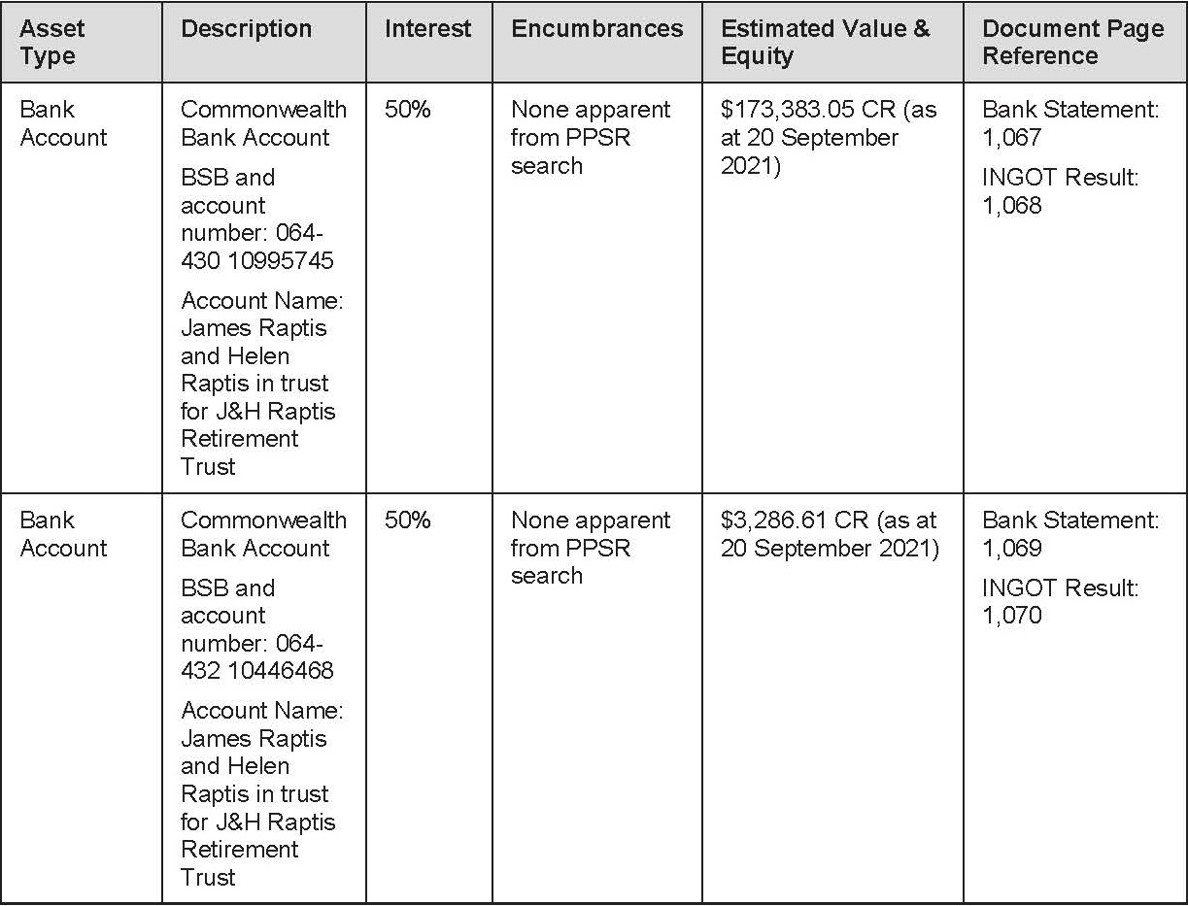
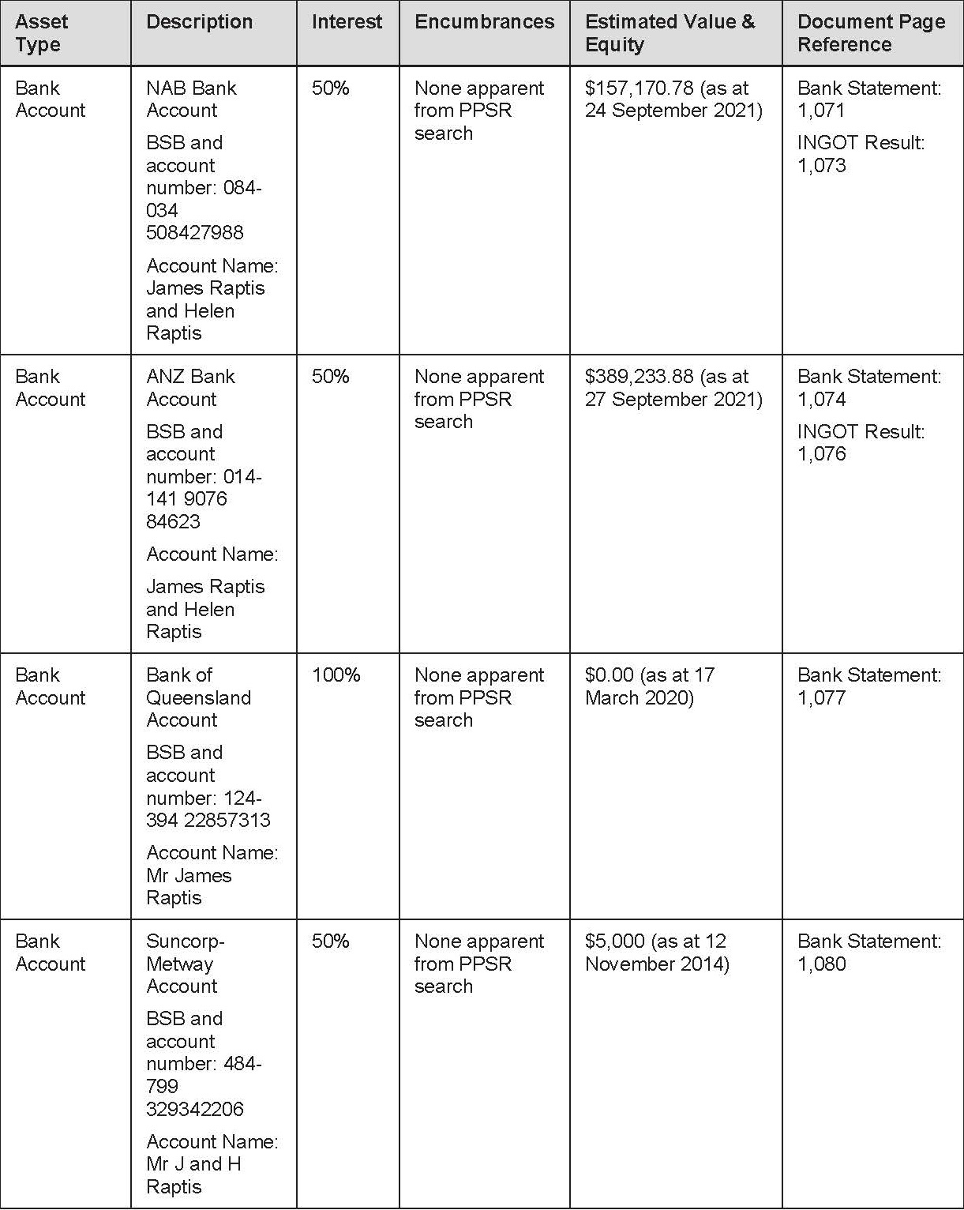
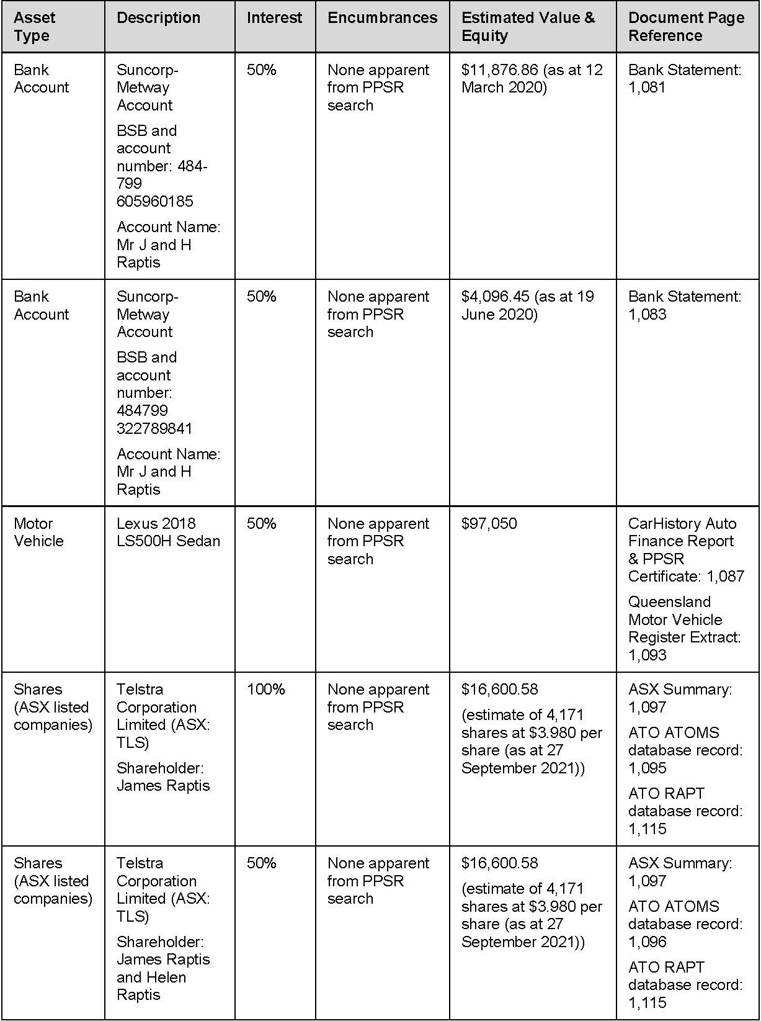
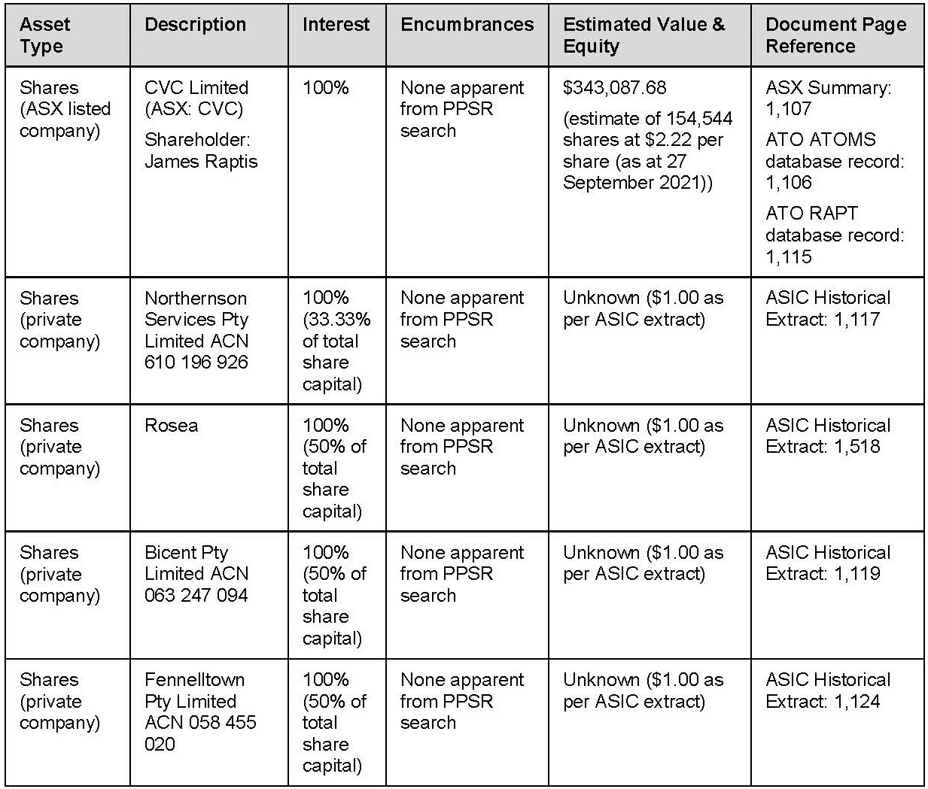

Northernson
17 The following assets were identified by the Commissioner as being held by Northernson.
18 Property 141-143 Commodore Drive, Paradise Waters / Surfers Paradise QLD 4217 (Title References 15888143 and 15888144) (Paradise Waters Property). The Commissioner estimated the Paradise Waters Property to have a value of approximately $20,000,000;
19 The Commissioner noted that title searches of the Paradise Waters Property revealed that it was subject to the following encumbrances:
(a) first registered mortgage (dealing number 711903418) registered on 5 September 2008 granted in favour of Sevinhand (Sevinhand Mortgage); and
(b) second registered mortgage (dealing number 717138543) registered on 18 March 2016 granted in favour of CVC Loan Managers Pty Ltd ACN 101 447 429 (CVCLM) (CVCLM Mortgage).
20 The Commissioner was unaware of the current amounts secured under the CVCLM Mortgage or the Sevinhand Mortgage, if any. Financial statements for Northernson for the 2009 financial year provided to the Commissioner during the course of the 2020 review stated that the balance of the Sevinhand/HWBB loan was $13,423,500 as at 30 June 2009. The Commissioner, however, did not have a view on whether these financial statements were accurate.
21 An active NAB bank account in the name of “Northernson Pty Ltd Business Management” (BSB 84004, account number 550080244) was also identified by the Commissioner.

Sevinhand
22 The Commissioner identified the following Australian assets held by Sevinhand:
• Sevinhand Mortgage (referred to above);
• Fixed and Floating Charge dated 3 September 2008 given by Northernson in favour of Sevinhand, formerly registered on the ASIC Register of Company Charges and now registered on the Personal Property Securities Register bearing registration number 201112200093681 (Northernson Charge);
• 4,000,000 fully paid ordinary shares in ASX-listed RPG. At the market close on 27 September 2021, RPG shares were trading at $0.033 per share. Accordingly, as at 27 September 2021, the value of the shareholding is $132,000.
23 The following international bank accounts of Sevinhand were identified by the Commissioner:
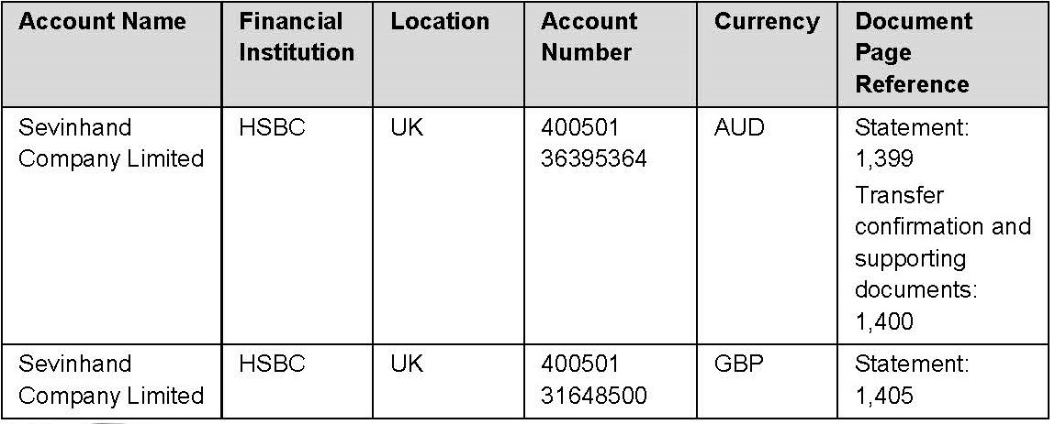
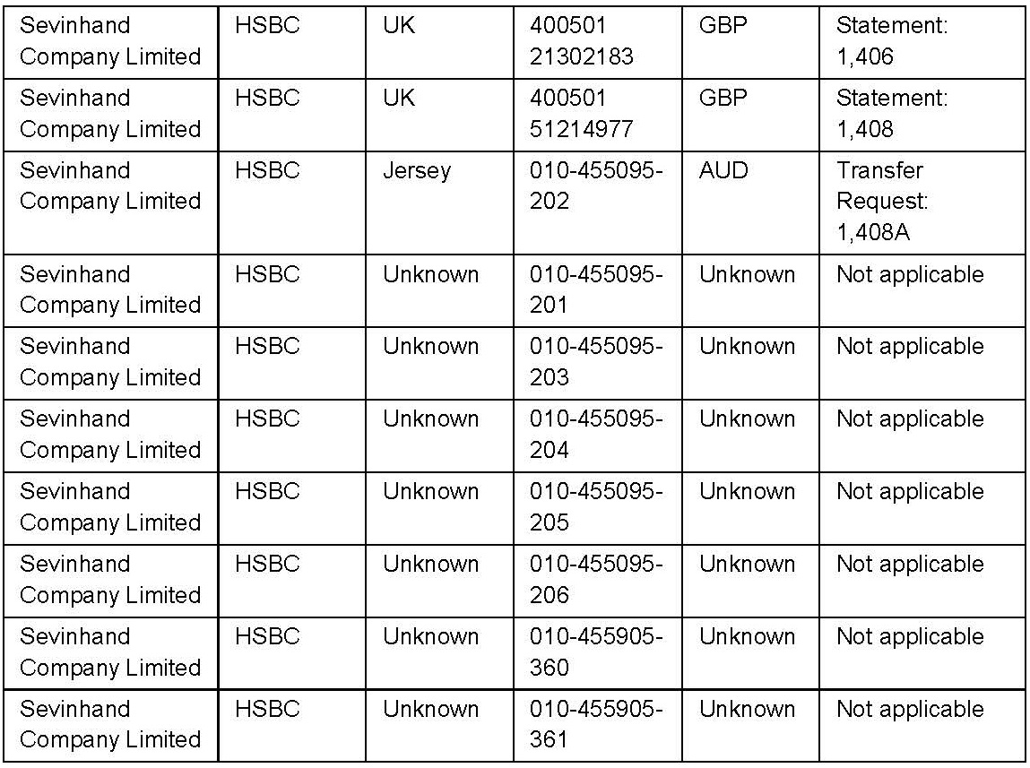

Asset Entities
24 As part of the 2020 review conducted by the Commissioner in Mr Raptis and the Raptis group, BDO (Mr Raptis’ representatives) provided an excel spreadsheet disclosing his beneficial interests (jointly with Helen Raptis and/or Evan Raptis) in a number of companies and trusts which hold assets, notwithstanding the fact that he may not be a director or shareholder of those companies (Asset Spreadsheet).
25 In the Asset Spreadsheet, Mr Raptis disclosed a beneficial interest in a number of entities, including:
(a) each of the Asset Entities, but for Kingsriver Services, which was the subject of a separate discloser; and
(b) Elenevan (a Greek entity) and Sanzia Ltd (a Cyprus entity (Sanzia).

Philadelphia
26 The Commissioner was aware of the following assets owned by Philadelphia:
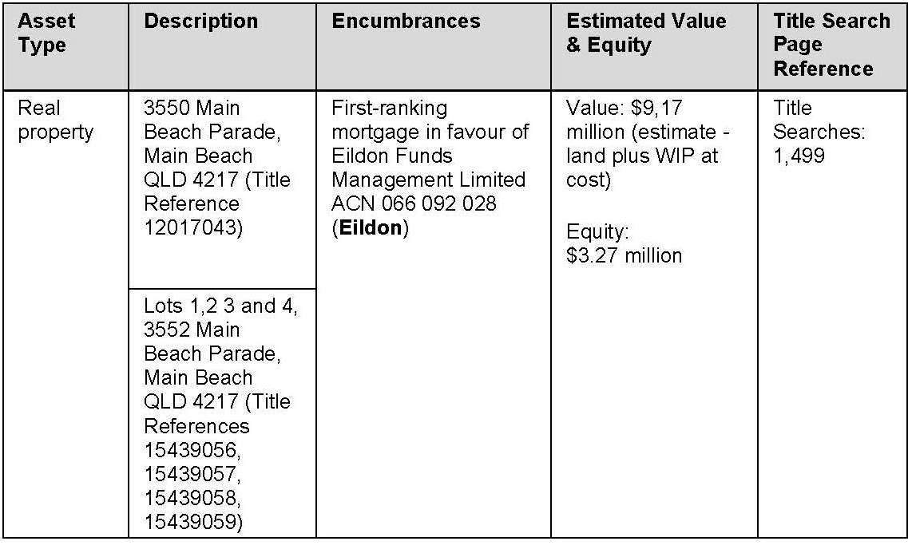
27 The Asset Spreadsheet disclosed that James, Helen and Evan Raptis beneficially own the assets held by Philadelphia.

Rosea
28 The Commissioner was aware of the following assets owned by Rosea:
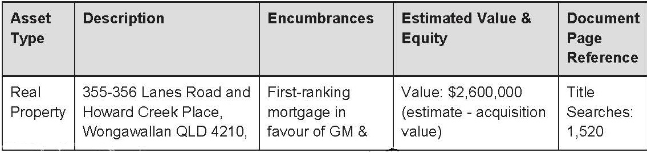
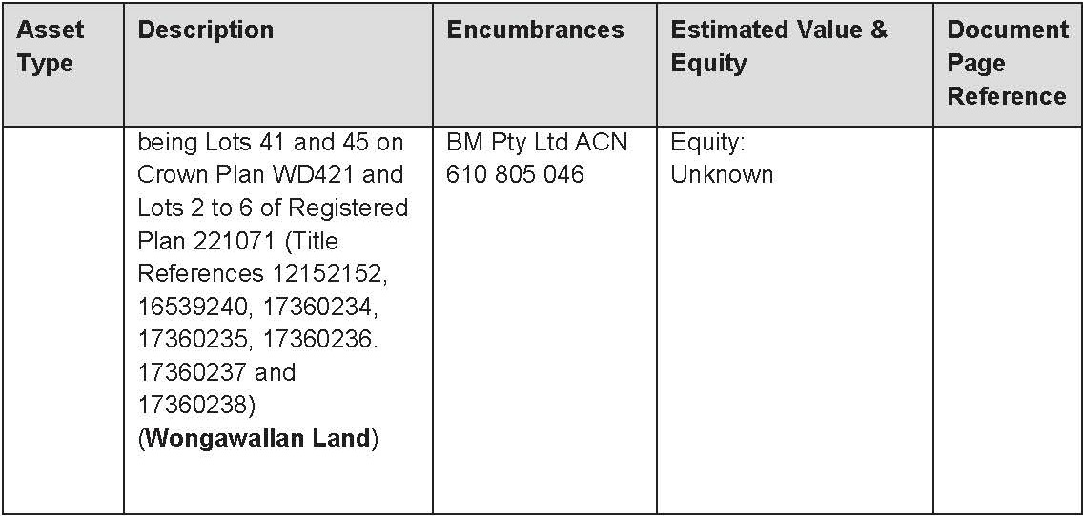
29 The Asset Spreadsheet disclosed that James, Helen and Evan Raptis beneficially own the assets held by Rosea.

Kiedis
30 The Commissioner was aware of the following assets held by Kiedis:
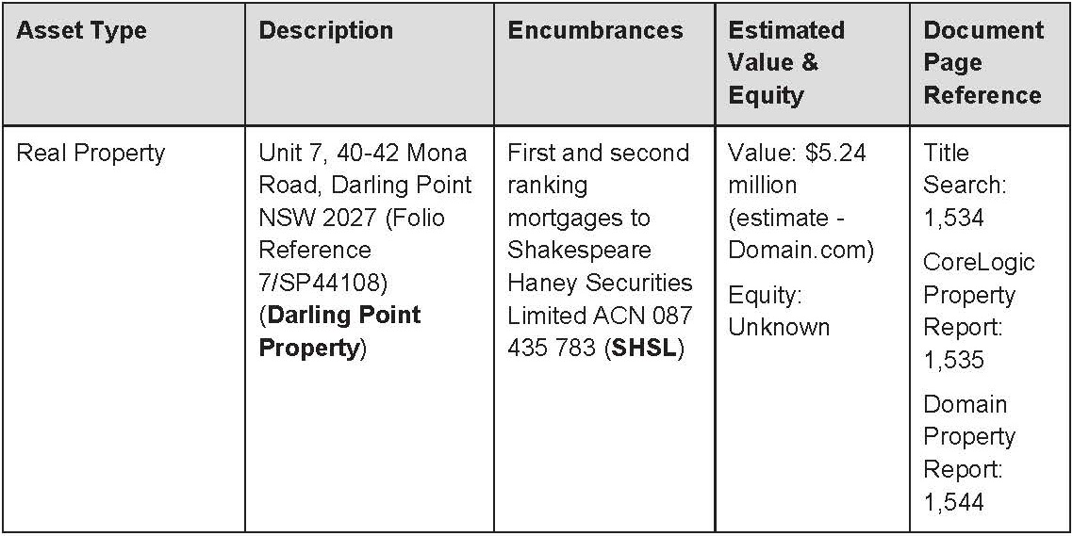
The Asset Spreadsheet disclosed that James, Helen and Evan Raptis beneficially own the asset held by Kiedis.

HS5
31 The Commissioner was aware of the following assets owned by HS5:
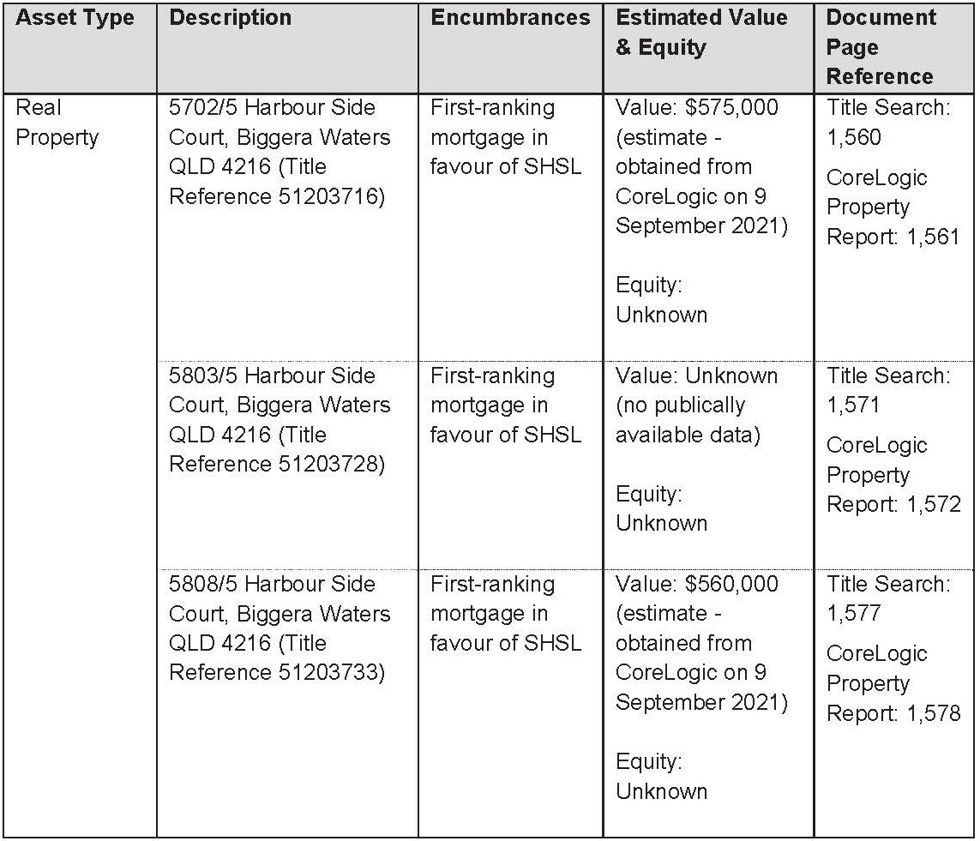
32 The Asset Spreadsheet disclosed that James, Helen and Evan Raptis beneficially own the assets held by HS5.

HS6
33 The Commissioner was aware of the following assets owned by HS6:
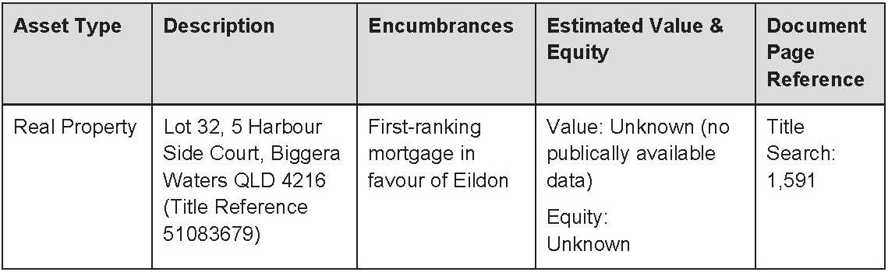
34 The Asset Spreadsheet disclosed that James, Helen and Evan Raptis beneficially own the asset held by HS6.

Kyros
35 The Commissioner was aware of the following assets owned by Kyros:
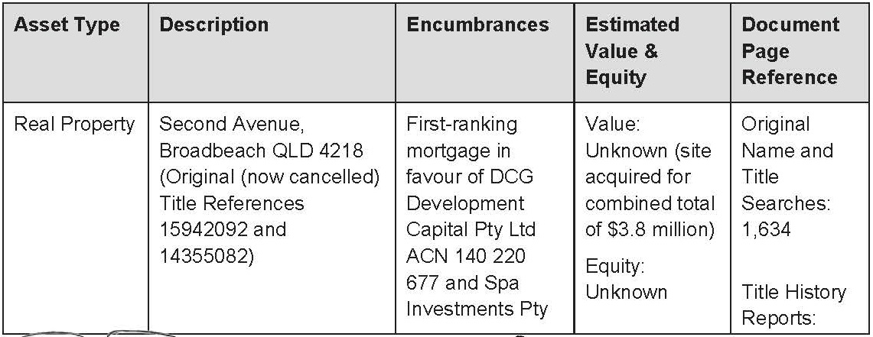
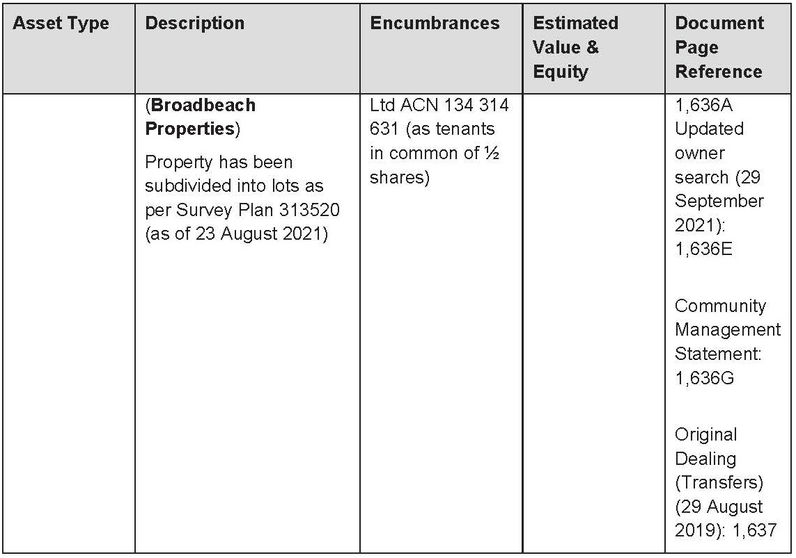
36 The Asset Spreadsheet disclosed that James, Helen and Ecan Raptis beneficially own the asset held by Kyros.

Education Corporation
37 The Commissioner was aware of the following assets owned by Education Corporation:
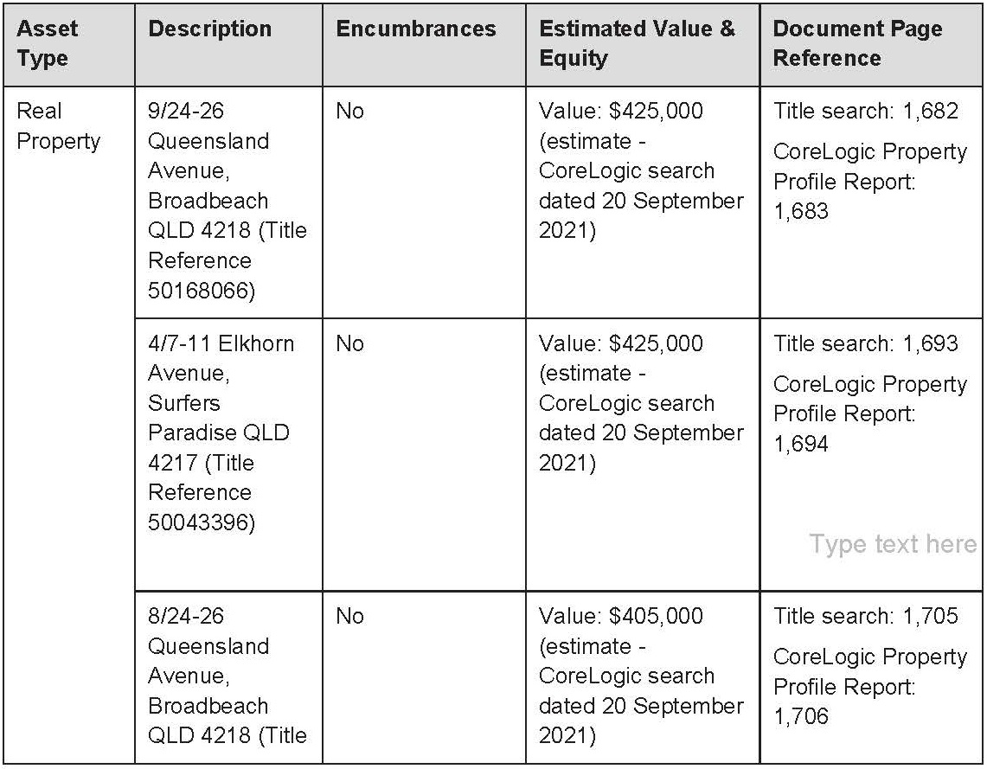
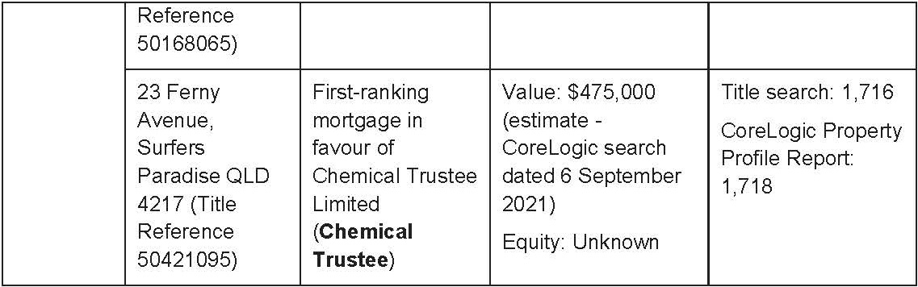
38 The Asset Spreadsheet disclosed that James, Helen and Evan Raptis own a 50% beneficial interest in the Educational Gold Trust (EGT), and by extension, the assets held by the trust, via a partnership.
39 The terms of the EGT record that:
(a) the wife and children of James Raptis; and
(b) the wife and children of Mr Gould,
are the primary beneficiaries of the EGT. Mr Gould and Mr Raptis are also eligible beneficiaries, along with the other persons and entities specified in the definition of “Eligible Beneficiaries” at cl 1(e) of the EGT Deed.

Hanslow
40 The Commissioner was aware of the following assets owned by Hanslow:
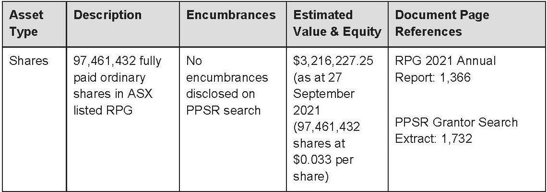
41 The Asset Spreadsheet disclosed that Mr and Mrs Raptis beneficially own the shares held by Hanslow. The Asset spreadsheet also stated that the shares are held by Hanslow as trustee for the “Hanslow Trust”. However, the Commissioner did not possess any evidence that confirmed Hanslow’s appointment as trustee of a trust.

Kingsriver Services
42 The Commissioner was not aware of any real property or other tangible assets owned by Kingriver Services. However, the Commissioner was aware of a bank account maintained by Kingsriver Services – Westpac Banking Corporation Account 034239 342964 (Kingsriver Account). Mr Raptis’ tax agent had represented to the Commissioner that this account was administered by Raptis group personnel to enable Mr and Mrs Raptis to pay and receive funds.
43 Mr Raptis and Mr Cory are signatories to the Kingsriver Account.

Elenevan and Sanzia
44 The Commissionre understands that Sanzia beneficially owns a property in Athens, Greece, which is held by Elenevan in its capacity as trustee for Sanzia (Greek Property).
45 The address of that property or its value was unknown to the Commissioner. However, documents provided to the Commissioner during the 2020 review confirmed:
(a) electronic fund transfers were made from the Kingsriver Account to a person named Theodora Thanou in Greece; and
(b) the transfers were made for the purpose of paying utility bills connected with the Greek property.

RELEVANT LEGAL PRINCIPLES
46 The Court is empowered to make freezing orders by r 7.32 of the Federal Court Rules, which provides as follows :
7.32 Freezing order
(1) The Court may make an order (a freezing order), with or without notice to a respondent, for the purpose of preventing the frustration or inhibition of the Court’s process by seeking to meet a danger that a judgment or prospective judgment of the Court will be wholly or partly unsatisfied.
(2) A freezing order may be an order restraining a respondent from removing any assets located in or outside Australia or from disposing of, dealing with, or diminishing the value of, those assets.
Note: Without notice is defined in the Dictionary.
47 Orders ancillary to freezing orders are the subject of r 7.33, which provides :
7.33 Ancillary order
(1) The Court may make an order (an ancillary order) ancillary to a freezing order or prospective freezing order as the Court considers appropriate.
(2) Without limiting the generality of subrule (1), an ancillary order may be made for either or both of the following purposes:
(a) eliciting information relating to assets relevant to the freezing order or prospective freezing order;
(b) determining whether the freezing order should be made.
48 Rule 7.34 extends the powers of the Court in rules 7.32 and 7.33 to persons who are not otherwise parties to the substantive proceedings, namely third parties. For completeness I note that r 7.34 provides :
7.34 Order may be against person not a party to proceeding
The Court may make a freezing order or an ancillary order against a person even if the person is not a party in a proceeding in which substantive relief is sought against the respondent.
49 Rule 7.35 anticipates freezing orders against a judgment debtor, or prospective judgment debtor, or a third party. In particular r 7.35 (1)(b) states that :
(1) This rule applies if:
(a) …
(b) an applicant has a good arguable case on an accrued or prospective cause of action that is justiciable in:
(i) the Court; or
(ii) ...
50 Further factors guiding the exercise of the Court’s discretion are set out in r 7.35 (4)-(6) as follows :
(4) The Court may make a freezing order or an ancillary order or both against a judgment debtor or prospective judgment debtor if the Court is satisfied, having regard to all the circumstances, that there is a danger that a judgment or prospective judgment will be wholly or partly unsatisfied because any of the following might occur:
(a) the judgment debtor, prospective judgment debtor or another person absconds;
(b) the assets of the judgment debtor, prospective judgment debtor or another person are:
(i) removed from Australia or from a place inside or outside Australia; or
(ii) disposed of, dealt with or diminished in value.
(5) The Court may make a freezing order or an ancillary order or both against a person other than a judgment debtor or prospective judgment debtor (a third party) if the Court is satisfied, having regard to all the circumstances, that:
(a) there is a danger that a judgment or prospective judgment will be wholly or partly unsatisfied because:
(i) the third party holds or is using, or has exercised or is exercising, a power of disposition over assets (including claims and expectancies) of the judgment debtor or prospective judgment debtor; or
(ii) the third party is in possession of, or in a position of control or influence concerning, assets (including claims and expectancies) of the judgment debtor or prospective judgment debtor; or
(b) a process in the Court is or may ultimately be available to the applicant as a result of a judgment or prospective judgment, under which process the third party may be obliged to disgorge assets or contribute toward satisfying the judgment or prospective judgment.
(6) Nothing in this rule affects the power of the Court to make a freezing order or ancillary order if the Court considers it is in the interests of justice to do so.
51 Having regard to these rules I note the following.
52 First, Freezing Orders Practice Note (GPN-FRZG) issued by the Chief Justice on 25 October 2016 applies to any proceeding involving an application in this Court for a freezing order, and to that extent supplements the provisions of the Federal Court Rules relating to the making of such orders.
53 Second, the DCT seeks interim orders ex parte. I note however that r 7.32 (1) empowers the Court to make a freezing order with or without notice to a respondent.
54 In relation to the making of orders ex parte, I note the following observation of Gageler J in Aristocrat Technologies Australia Pty Ltd v Allam [2016] HCA 3 :
15. It is an elementary principle of our ordinarily adversarial system of justice that full and fair disclosure must be made by any person who seeks an order from a court ex parte, with the result that failure to make such disclosure is ordinarily sufficient to warrant discharge of such order as might be made. The principle is not confined to particular types of interlocutory orders. Its rationale lies in the importance to the administration of justice of the courts and the public being able to have confidence that an order will not be made in the absence of a person whose rights are immediately to be affected by that order unless the court making the order has first been informed by the applicant of all facts known to the applicant which that absent person could be expected to have sought to place before the court had the application for the order been contested.
(footnotes omitted)
55 (See also Rumsley v Vegas Enterprises Pty Ltd [2016] FCAFC 84 at [20].
56 Third, as the Practice Note states at 2.6, a freezing order should be viewed as an extraordinary interim remedy because it can restrict the right to deal with assets even before judgment, and is commonly granted without notice. In this respect I further note the following observation of Gaudron, McHugh, Gummow and Callinan JJ in Cardile v LED Builders Pty Ltd (1999) 198 CLR 380 at 403-404:
We agree with the tenor of what was said with particular respect to Mareva relief before judgment by the Court of Appeal of New South Wales (Mason P, Sheller JA, Sheppard A-JA) in Frigo v Culhaci:
"[A Mareva order] is a drastic remedy which should not be granted lightly....
A [Mareva order] is an interlocutory order which, if granted, imposes a severe restriction upon a defendant's right to deal with his or her assets. It is granted at the suit of a plaintiff whose status as a creditor is in dispute and who need not be a secured creditor. Its purpose is to preserve the status quo, not to change it in favour of the plaintiff. The function of the order is not to 'provide a plaintiff with security in advance for a judgment that he hopes to obtain and that he fears might not be satisfied; nor is it to improve the position of the plaintiff in the event of the defendant's insolvency' ... Many authorities attest to the care with which courts are required to scrutinise applications for [Mareva orders]…”
(footnotes omitted, emphasis added)
57 In view of the extreme seriousness of a freezing order it is also appropriate for the Court to take into account the balance of convenience of making an order in these terms : Deputy Commissioner of Taxation v Shi [2018] FCA 1915 at [20].
58 Fourth, the Court must be satisfied that a freezing order is necessary to prevent the frustration or inhibition of the Court’s process by seeking to meet a danger that a – in this case – prospective judgment of the Court will be wholly or partly unsatisfied. In respect of prospective judgment debtors, the Court must be satisfied that there is a danger of a prospective judgment being wholly or partly unsatisfied because the debtor (or another person) might abscond, or relevant assets will be removed, disposed of, dealt with or diminished in value (r 7.35 (4)).
59 Fifth, r 7.32 (2) contemplates orders restraining a respondent in respect of assets located in or outside Australia.
60 Sixth, the purposes for which ancillary orders may be made are limited by r 7.33 (2), namely for eliciting information relating to assets relating to the freezing order or determining whether the freezing order should be made.
61 Seventh, plainly either freezing orders or ancillary orders may be made against a person even if not a party to the substantive application. However the circumstances in which the Court may make such orders against third parties are subject to r 7.35 (5). Rule 7.35 (5)(a) requires that there must be a danger that a judgment or prospective judgment will be wholly or partly unsatisfied because:
• the third party holds or is using, or has exercised or is exercising, a power of disposition over relevant assets; or
• the third party is in possession of, or in a position of control or influence concerning, relevant assets.
62 Alternatively, r 7.35 (5)(b) enlivens the Court’s power to make freezing or ancillary orders against third parties where, having regard to all the circumstances, a process is or may ultimately be available to the applicant as a result of a judgment or prospective judgment, wherein the third party may be obliged to disgorge assets or contribute towards satisfying the judgment or prospective judgment.
63 Eighth, an applicant for a freezing order bears the onus of satisfying the Court that the order should be made, and in satisfying the Court as to the amount which is to be the subject of the order : Zhen v Mo [2008] VSC 300 at [24].
64 Ninth, an order can only be made on the basis of admissible evidence which supports the contentions made by the party seeking the order : Zhen at [25].
65 Finally, and critically, an applicant for a freezing order must demonstrate that it has a good arguable case on an accrued or prospective cause of action that is justiciable in the Court.

CONSIDERATION
66 Turning now to the facts before me, as I have already noted the respondents to the substantive application are Mr Raptis, Northernson and Sevinhand. Within the scope of r 7.35 they are “prospective judgment debtors” in respect of the amounts claimed by the DCT in the substantive application, referable to the claims of the DCT pursuant to the Income Tax Assessment Act 1997 (Cth) and the Taxation Administration Act 1953 (Cth) (TAA). The Asset Entities are plainly not parties to the substantive application, but rather are third parties as contemplated by r 7.35 (5).

Freezing orders against Mr Raptis, Northernson and Sevinhand
67 I am satisfied that freezing orders should be made against Mr Raptis, Northernson and Sevinhand pursuant to Div 7.4 of the Federal Court Rules, for the following reasons.
68 First, I am satisfied that the DCT’s prospective claims for judgment against Mr Raptis, Northernson and Sevinhand pursuant to the substantive application are justiciable in this Court. Section 39B (1A)(c) of the Judiciary Act 1903 (Cth) confers original jurisdiction on the Federal Court in any matter in which the Commonwealth is seeking an injunction or declaration in any matter arising under any laws made by the Parliament (see R v Commonwealth Court of Conciliation and Arbitration; Ex parte Barrett [1945] HCA 50; (1945) 70 CLR 141 at 154, Deputy Commissioner of Taxation v Vasiliades [2014] FCA 1250 at [41]). As Yates J observed in Deputy Commissioner of Taxation v Shi [2018] FCA 1915:
16. An assessment of tax issued by the Commissioner creates a statutory debt when the liabilities assessed become “due and payable”. The production of the notice of assessment, or a copy of it, is conclusive evidence of the due making of the assessment and, subject to certain exceptions (not presently relevant), that the amount and all the particulars of the assessment are correct. The Commissioner may sue in a court of competent jurisdiction to recover a taxation liability due to the Commonwealth: s 255-5 of Sch 1 to the TAA. Such as action is justiciable in this Court: Deputy Commissioner of Taxation v Vasiliades [2014] FCA 1250 at [42].
69 Second, I am satisfied that, in respect of the DCT’s substantive claims against Mr Raptis, Northernson and Sevinhand, the DCT has a good arguable case within the meaning of r 7.35 (1)(b). In particular :
• section 350-10 (1) of Sch 1 to the TAA stipulates at Item 2 that a notice of assessment issued by the Commissioner shall be conclusive evidence that the assessment was properly made, and that (except in Part IVC reviews or appeals only relating to the notice) the amount and particulars of the assessment are correct : see also Deputy Commissioner of Taxation v Hua Wang Bank Berhad (2010) 273 ALR 194; [2010] FCA 1014 at 199 [15];
• sections 14ZZM and 14ZZR of the TAA provide that the Commissioner can pursue recovery proceedings, despite outstanding appeals and reviews against the underlying merits of the notice of assessments;
• it is not necessary to show that the assessment is due and payable. Rather it is sufficient that a statutory debt is payable in the future : Shi at [19], Deputy Commissioner of Taxation (ACT) v Sharp (1988) 91 FLR 70 at 74; and
• section 175 of the Income Tax Assessment Act 1936 (Cth) (ITAA36) provides that any assessment shall not be affected by reason that any of the provisions of that Act have not been complied with.
70 I am satisfied from the extensive and detailed evidence before me that the Commissioner has issued notices of assessment in respect of claimed taxation liabilities of Mr Raptis, Northernson and Sevinhand. Pursuant to s 175 of the ITAA36 and item 2 of s 350-1- of Sch 1 to the TAA, the notices of assessment are conclusive evidence of debts owed to the DCT by these respondents.
71 Third, on the basis of the extensive and detailed evidence before me I consider that there is a danger of dissipation of assets within the meaning of r 7.35 (4), such that a judgment or prospective judgment in the DCT’s favour will go unsatisfied if freezing orders are not made. While there is no evidence that Mr Raptis is likely to abscond, as Bell J observed in Deputy Commissioner of Taxation v Gashi [2010] VSC 120 in determining whether there is a danger that a prospective debtor might remove, diminish, deal with or reduce the value of their assets:
33. … the court does not rely on intuition or guess-work, but may take into account the prior conduct of the defendant, the value of the actual or prospective judgment and the assets or income available to the defendant to satisfy it. Although the court must be cautious before making such orders, it must be borne in mind that the “very purpose of a freezing order is to ensure that assets are not alienated so as to avoid or frustrate the Court process.
72 In this case the DCT submits that she remains concerned that, upon issuing assessments to Mr Raptis, Northernson and Sevinhand, they and the Asset Entities will take steps to put available assets beyond the reach of the DCT, particularly in light of the quantum of the assessments issued. This is because, as deposed by Mr Zarogiannis, in summary :
• Mr Raptis has a history of taking steps to limit liability following review and audit activity by the Commissioner, for example by resigning as a director of taxpayer entities and backdating the effective date of the resignation;
• Mr Raptis has a history of failing to disclose beneficial interests in foreign entities and their international and domestic assets, despite being asked questions to that effect (including in a statutory notice issued by the DCT to Mr Raptis on 19 January 2010 pursuant to then s 264 of ITAA36 in respect of the particulars of Mr Raptis’ interests in, inter alia, Sevinhand);
• There is a history of entities in which Mr Raptis has admitted a beneficial interest (including Northernson) mortgaging their assets in favour of other entities beneficially owned or controlled by Mr Raptis (such as Sevinhand) or Mr Gould;
• Mr Raptis and his associated entities have a history of transferring funds offshore, including to countries that are known tax havens;
• There is a history of Mr Raptis and associated entities failing to disclose income (including but not limited to the income the subject of assessments of Mr Raptis, Northernson and Sevinhand) which (in the Commissioner’s view) arose due to evasion);
• There is a long history of Mr Raptis and his associated entities failing to comply with their income tax return lodgement obligations. At the commencement of the 2020 review Mr Raptis, Northernson and Sevinhand were identified as having had between 2 and 10 years of income tax returns outstanding;
• Several companies and trusts either controlled by Mr Raptis, or in which the Commissioner concluded that he had a beneficial interest, had entered external administration and/or been deregistered without taxation liabilities being paid to the Commissioner;
• The Raptis group had failed to submit a payment arrangement proposal for consideration in order to meet undisputed income tax liabilities of group entities which had been outstanding for a considerable period, such tax liabilities exceeding $24.1 million, and notwithstanding previous requests by the Commissioner of a payment proposal for those undisputed debts;
• While a number of assets identified by the Commissioner were non-liquid assets, they were nevertheless capable of being disposed of, or further encumbered during the period in which the Commissioner undertook debt recovery action in this Court, and/or objection and objection appeal processes under Part IVC of the TAA took place;
• A 2020 review undertaken by the Commissioner revealed that Raptis group entities examined by ATO officers during the course of the review had a history of poor financial reporting and record keeping, and mingling of funds, and Mr Raptis and his associates had provided vague answers to direct questions from ATO officers; and
• A review of data provided by the Australian Transaction Reports and Analysis Centre (AUSTRAC) revealed that, between 2006 and 2020, significant sums of money had been transferred out of Australia by Raptis group entities to offshore entities in which Mr Raptis had admitted a beneficial interest or which were associated with Mr Gould (although it appeared that the majority of money transferred out in the 2008-2010 income years had been repatriated).
73 For the purposes of the present interlocutory application I am prepared to accept that these factors point to a danger of dissipation of assets of Mr Raptis, Northernson and Sevinhand that could frustrate any judgment obtained by the DCT.
74 Finally, I note that the freezing orders proposed by the DCT contain a number of protections for the respondents, including :
• the undertaking as to damages provided by the DCT;
• the freezing orders being limited by reference to the size of the relevant taxation-related liabilities;
• providing for the ability of Mr Raptis to meet living expenses of up to AUD$10,000 per week;
• providing for the respondents to each pay up to AUD$100,000 on reasonable legal expenses;
• permitting the respondents to deal with or dispose of any assets in the ordinary and proper course of business, including paying business expenses bona fide and properly incurred; and
• permitting the respondents to satisfy existing contractual obligations.
75 The amount of $10,000 per week for ordinary living expenses of Mr Raptis appears generous, and in my view should stand. However it is very difficult to estimate “reasonable legal expenses” the respondents may need to incur. I am reluctant to quantify this amount and, consistently with other authorities to which I have had regard, prefer to leave the amount unquantified at this stage.
76 In my view the balance of convenience favours the making of the freezing orders sought.

Freezing orders against the third party Asset Entities
77 In his affidavit Mr Zarogiannis gave evidence of significant assets held by the Asset Entities.
78 The DCT submitted, in summary, that :
• The DCT may obtain a judgment debt against Mr Raptis in relation to relevant assessments;
• If Mr Raptis is unable to pay any judgment debt from the assets in his name, a trustee in bankruptcy may be appointed, in which case the DCT would be a creditor and prove in bankruptcy;
• The trustee in bankruptcy may seek to realise Mr Raptis’ beneficial interests in the Asset Entities;
• Mr Raptis would receive his share of the value of the Asset Entities’ assets in proportion to his ownership, which could then be used to satisfy any creditors in his bankruptcy;
• It follows that the Asset Entities hold a power of disposition over or have possession of assets which may be able to be used to satisfy any judgment debt the Commissioner obtained against Mr Raptis.
79 I am satisfied from the evidence before the Court that Mr Raptis has a beneficial interest in the Asset Entities. The prospect of Mr Raptis being declared bankrupt following an inability to pay a judgment debt owing to the Commissioner is at present somewhat remote. However, it is sufficiently real for the Court to conclude that significant assets including real property held or controlled by the Asset Entities could be used to satisfy any judgment debt obtained by the DCT against Mr Raptis, in particular within the meaning of r 7.35 (5)(b) of the Federal Court Rules.
80 As I have already noted, protections of respondents to the present interlocutory proceedings are built into the orders proposed by the DCT. From the material before me these protections are reasonable, and favour the orders sought.
81 To that extent, I consider it appropriate for freezing orders to be made against the Asset Entities.

Service
82 In written submissions the DCT contended that she held concerns that, if the respondents were put on notice of the present interlocutory application, there was a risk that they could take steps to dissipate assets or frustrate the Court’s processes. Accordingly the DCT sought orders that service of the present interlocutory application, for the purposes of obtaining interim relief, be the subject of dispensation.
83 In my view this is reasonable.
84 The DCT submits, however, that pursuant to r 10.24 and/or 10.27 of the Federal Court Rules, she have leave to serve relevant documents on the respondents in the manner set out in Annexures A, B and D to L of orders proposed. These annexures contemplate service by email to nominated recipients (including accounting and legal representatives), and postage to various addresses including corporate and representative recipients. In my view this is similarly reasonable.
85 A complication exists in respect of Sevinhand, being a foreign corporation. I have already noted that the DCT seeks leave pursuant to rules 10.43 and 10.44 (1) of the Federal Court Rules to serve Sevinhand in accordance with the Convention. Examination of Annexure C to the proposed orders provided to the Court indicates that the DCT proposes email to nominated recipients including :
• the director of Sevinhand, Mr John Donnelly;
• accounting representatives employed by accounting firm Lubbock Fine; and
• Australian legal and accounting representatives.
86 Further, the DCT proposes posting relevant documents by express post within Australia, and by international express post or courier.
87 Division 10.4 of the Federal Court rules sets out requirements for service outside Australia, including that a cause of action has arisen in Australia : r 10.42 (1) of the Federal Court Rules. I am satisfied that the present proceeding falls into Item 1 of r 10.42 (1).
88 I note however the submission of the DCT that, in light of the present global COVID19 pandemic, postage (both domestic and international) is delayed.
89 In Kukulka v Google LCC [2020] FCA 1299 Anastassiou J relevantly noted postal delays. His Honour considered that substituted service ought be permitted pursuant to r 10.24 of the Federal Court Rules.
90 For similar reasons to those explained by his Honour at [5]-[18] of Kukulka, I consider that an order for substituted service on Sevinhand of documents including the freezing order and related material be made.

CONCLUSION
91 It follows that I am prepared to make orders substantially in the terms sought.
I certify that the preceding ninety-one (91) numbered paragraphs are a true copy of the Reasons for Judgment of the Honourable Justice Collier.

Associate:

Dated: 1 October 2021

SCHEDULE OF PARTIES

 | QUD 310 of 2021
Respondents
Fourth Respondent: | HANSLOW HOLDINGS PTY LTD ACN 600 765 213
Fifth Respondent: | KINGSRIVER SERVICES PTY LTD ACN 159 328 926
Sixth Respondent: | PHILADELPHIA DEVELOPMENTS PTY LTD ACN 614 829 551 AS TRUSTEE FOR THE MAIN BEACH RAPTIS TRUST
Seventh Respondent: | ROSEA PTY LIMITED ACN 119 837 455
Eighth Respondent: | KIEDIS INVESTMENTS PTY LTD ACN 062 677 365
Ninth Respondent: | HS5 PTY LTD ACN 169 017 976
Tenth Respondent: | HS6 PTY LTD ACN 169 019 854
Eleventh Respondent: | KYROS STAGE 3 PTY LTD ACN 618 217 977 AS TRUSTEE FOR THE SECOND AVENUE TRUST
Twelfth Respondent: | EDUCATION CORPORATION OF AUSTRALIA PTY LIMITED ACN 062 003 461 AS TRUSTEE FOR THE EDUCATIONAL GOLD TRUST

