FEDERAL COURT OF AUSTRALIA

Roadshow Films Pty Limited v Telstra Corporation Limited [2019] FCA 885

File number: | NSD 2410 of 2018
Judge: | NICHOLAS J
Date of judgment: | 12 June 2019
Catchwords: | Copyright – application for “site blocking” orders under s 115A of the Copyright Act 1968 (Cth) – whether requirements of s 115A satisfied – whether orders should be made
Legislation: | Copyright Act 1968 (Cth) s 115A  Copyright Amendment (Online Infringement) Act 2018 (Cth)
Cases cited: | Roadshow Films Pty Ltd v Telstra Corporation Ltd (2016) 248 FCR 178  Universal Music Australia Pty Ltd v TPG Internet Pty Ltd (2017) 126 IPR 219
Date of hearing: | 17 May 2019
Registry: | New South Wales
Division: | General Division
National Practice Area: | Intellectual Property
Sub-area: | Copyright and Industrial Designs
Category: | Catchwords
Number of paragraphs: | 30
Counsel for the Applicants: | Ms F St John
Solicitor for the Applicants: | Baker & McKenzie
Counsel for the First to Third Respondents | The First to Third Respondents filed submitting appearances
Counsel for the Fourth to Thirteenth Respondents | The Fourth to Thirteenth Respondents filed submitting appearances
Counsel for the Fourteenth to Forty-Ninth Respondents | The Fourteenth to Forty-Ninth Respondents did not appear
Counsel for the Fiftieth and Fifty-Second Respondents | The Fiftieth and Fifty-Second Respondents filed submitting appearances

ORDERS
 |  | NSD 2410 of 2018
BETWEEN: | ROADSHOW FILMS PTY LIMITED  First Applicant  VILLAGE ROADSHOW FILMS (BVI) LTD  (and others named in the Schedule)  Second Applicant
AND: | TELSTRA CORPORATION LIMITED (ABN 33 051 775 556)  First Respondent  PACNET INTERNET (A) PTY LTD (ACN 085 213 690)  (and others named in the Schedule)  Second Respondent

JUDGE: | NICHOLAS J
DATE OF ORDER: | 12 June 2019

In these orders, the following terms have the following meanings:

(a) Domain Name means a name formed by the rules and procedures of the Domain Name System (DNS) and includes subdomains.
(b) DNS Blocking means a system by which any user of a Respondent's service who attempts to use a DNS resolver that is operated by or on behalf of that Respondent to access a Target Online Location is prevented from receiving a DNS response other than a redirection as referred to in Order 5.
(c) IP Address means an Internet Protocol address.
(d) Optus means the fourth to thirteenth Respondents.
(e) Target Online Locations means the online locations as referred to in Schedule A and that are or were accessible:
(i) at the URLs listed in Schedule A to this Order (together, the Target URLs);
(ii) at the IP Addresses listed in Schedule A to this Order (together, the Target IP Addresses); and
(iii) at the Domain Names listed in Schedule A to this Order (together, the Target Domain Names).
(f) Telstra means the first to third Respondents.
(g) TPG means the thirty-second to the forty-ninth Respondents.
(h) URL means a Uniform Resource Locator.
(i) Vocus means the fourteenth to thirty-first Respondents.
(j) Vodafone means the fiftieth and fifty-second Respondents.

THE COURT ORDERS THAT:

1. The requirement under s 115A(4) of the Copyright Act 1968 (Cth) that the Applicants give notice of their application to the persons who operate the Target Online Locations be dispensed with in so far as any such notice has not already been given.
2. Leave be granted to the Ninth Applicant to proceed with this application without joining the copyright owner of the Applicants’ Cinematograph Films of which it is the exclusive licensee.
3. Each Respondent must, within 15 business days of service of these Orders, take reasonable steps to disable access to the Target Online Locations.
4. Order 3 is taken to have been complied with by a Respondent if that Respondent implements any one or more of the following steps:
(a) DNS Blocking in respect of the Target Domain Names;
(b) IP Address blocking or re-routing in respect of the Target IP Addresses;
(c) URL blocking in respect of the Target URLs and the Target Domain Names; or
(d) any alternative technical means for disabling access to the Target Online Locations as agreed in writing between the Applicants and a Respondent.
5. If a Respondent in complying with Order 4 does not implement one of the steps referred to in Order 4, that Respondent must, within 15 business days of service of these Orders, notify the Applicants of the step or steps it has implemented.
6. Each Respondent must redirect any communication by a user of its service seeking access to the Target Online Locations which have been disabled pursuant to Order 3 to a webpage established, maintained and hosted by either:
(a) the Applicants, or their nominee, pursuant to Order 7; or
(b) that Respondent or its nominee.
The Applicants’ obligations pursuant to Orders 7 and 8 only arise if a Respondent notifies the Applicants that the Respondent will redirect a communication pursuant to Order 6(a) and for so long as at least one Respondent redirects communications to that webpage.
7. The Applicants, or their nominee, must establish, maintain and host a webpage which informs users of a Respondent’s service who have been redirected to the webpage pursuant to Order 6 that access to the website has been disabled because this Court has determined that it infringes or facilitates the infringement of copyright.
8. Within 5 business days of these Orders, the Applicants will notify each of the Respondents in writing of the URL of the webpage established, maintained and hosted under Order 6 and, if the webpage ceases to operate for any reason, will notify each of the Respondents in writing of a different URL that complies with Order 7.
9. If, in complying with Order 6, a Respondent redirects any communication by a user of its service to a webpage established, maintained and hosted by it, that Respondent or its nominee must ensure that the webpage informs the user of that Respondent's service that access to that the website has been disabled because this Court has determined that it infringes or facilitates the infringement of copyright.
10. In the event that any of the Applicants has a good faith belief that:
(a) any Target URL, Target IP Address or Target Domain Name which is subject to these Orders has permanently ceased to enable or facilitate access to any Target Online Location; or
(b) any Target URL, Target IP Address or Target Domain Name has permanently ceased to have the primary purpose of infringing or facilitating the infringement of copyright,
a representative of the Applicants must, within 15 business days of any of the Applicants forming such a good faith belief, notify each Respondent of that fact in writing, in which case the Respondents shall no longer be required to take steps pursuant to Order 3 to disable access to the relevant Target URL, Target IP Address or Target Domain Name that is the subject of the notice.
11. A Respondent will not be in breach of Order 3 if it temporarily declines or temporarily ceases to take the steps ordered in Order 3 (either in whole or in part) upon forming the view, on reasonable grounds, that suspension is necessary to:
(a) maintain the integrity of its network or systems or functioning of its blocking system;
(b) upgrade, troubleshoot or maintain its blocking system;
(c) avert or respond to an imminent security threat to its networks or systems; or
(d) ensure the reliable operation of its ability to block access to online locations associated with criminal content if it reasonably considers that such operation is likely to be impaired, or otherwise to comply with its statutory obligations including under section 313(3) of the Telecommunications Act 1997 (Cth),
provided that:
(e) unless precluded by law, it notifies the Applicants or their legal representative(s) of such suspension, including the reasons and the expected duration of such suspension, by 5.00 pm on the next business day; and
(f) such suspension lasts no longer than is reasonably necessary and, in any case, no longer than 3 business days or such period as the Applicants may agree in writing or the Court may allow.
12. The owner or operator of any of the Target Online Locations and the owner or operator of any website who claims to be affected by these Orders may apply on 3 days' written notice, including notice to all parties, to vary or discharge these Orders, with any such application to:
(a) set out the orders sought by the owner or operator of the Target Online Locations or affected website; and
(b) be supported by evidence as to:
(i) the status of the owner or operator of the Target Online Locations or affected website; and
(ii) the basis upon which the variation or discharge is sought.
13. The parties have liberty to apply on 3 days' written notice, including, without limitation, for the purpose of any application:
(a) for further orders to give effect to the terms of these Orders;
(b) for further orders in the event of any material change of circumstances including, without limitation, in respect of the consequences for the parties and effectiveness of the technical methods under Order 3; and/or
(c) for orders relating to other means of accessing the Target Online Locations not already covered by these Orders.
14. If a website the subject of any of the Target Online Locations is at any time during the operation of these Orders provided from a different Domain Name, IP Address or URL:
(a) the Applicants may file and serve:
(i) an affidavit which:
(A) identifies the different Domain Name, IP Address or URL;
(B) states that, in the good faith belief of the deponent, the website operated from the different Domain Name, IP Address or URL is a new location outside Australia for the Target Online Locations the subject of these Orders and brief reasons therefor; and
(ii) proposed short minutes of order to the effect that:
(A) the definition of Target Online Locations in these Orders is amended to include the different Domain Name, IP Address or URL; and
(B) the time period in Order 3 of these Orders starts to run in relation to the different Domain Name, IP Address or URL upon service of the orders in accordance with Order 18(d) below.
15. These Orders are to operate for a period of 3 years from the date of these Orders.
16. Six months prior to the expiry of these Orders:
(a) the Applicants may file and serve:
(i) an affidavit which states that, in the good faith belief of the deponent, the Target Online Location continues to have the primary purpose of infringing or facilitating the infringement of copyright; and
(ii) short minutes of order extending the operation of these Orders for a further 3-year period; and
(b) the process contained in Order 18 shall apply.
17. The affidavit referred to in Orders 14 and 16 is to be given by a deponent duly authorised to give evidence on behalf of the Applicants and may be given by their solicitor.
18. If an affidavit and short minutes of order are filed and served in accordance with Orders 14 or 16:
(a) within 7 business days, the Respondents must notify the Applicants and the Court if they object to the Orders being made in accordance with the short minutes of order served by the Applicants;
(b) if any Respondents give notice of any objection, or the Court otherwise thinks fit, the proceeding will be relisted for further directions;
(c) if no Respondent gives notice of any objection and the Court does not otherwise require the proceeding to be relisted, then the Court may make orders in terms of the short minutes of order served by the Applicants without any further hearing; and
(d) the Applicants must serve on the Respondents any such orders made.
19. The Applicants pay Telstra’s, Optus’, Vocus’, TPG’s and Vodafone’s compliance costs calculated at the rate of $50 per Domain Name the subject of DNS Blocking undertaken for the purposes of complying with Order 3.
20. There be no order as to costs.

Note: Entry of orders is dealt with in Rule 39.32 of the Federal Court Rules 2011.

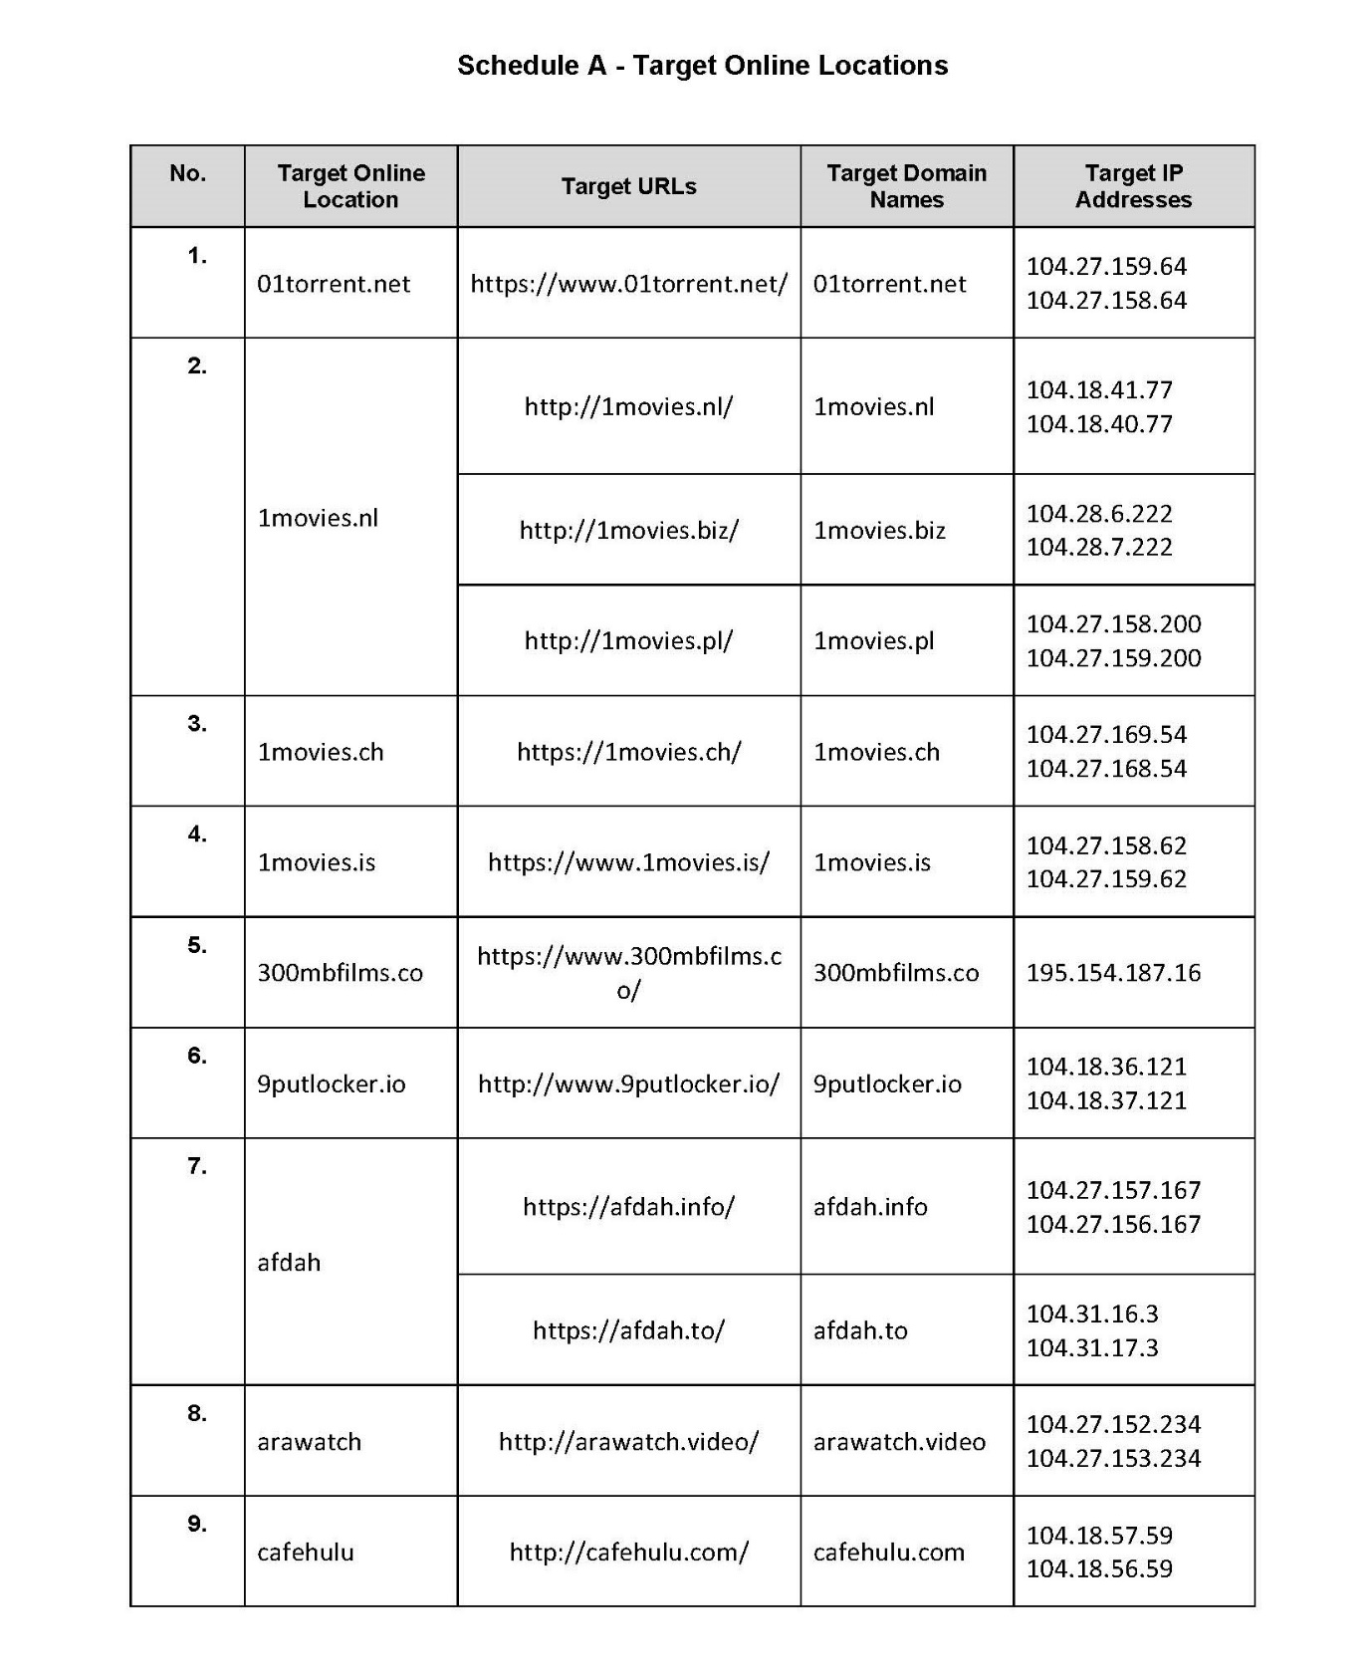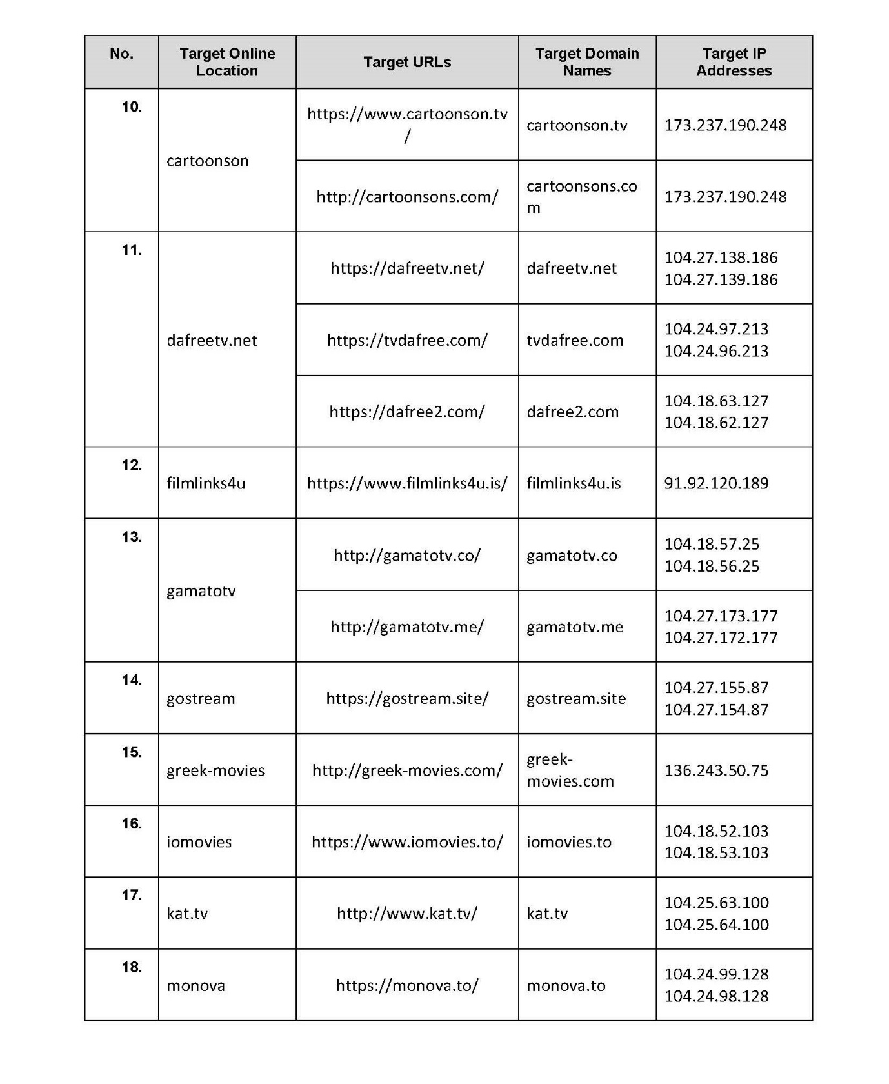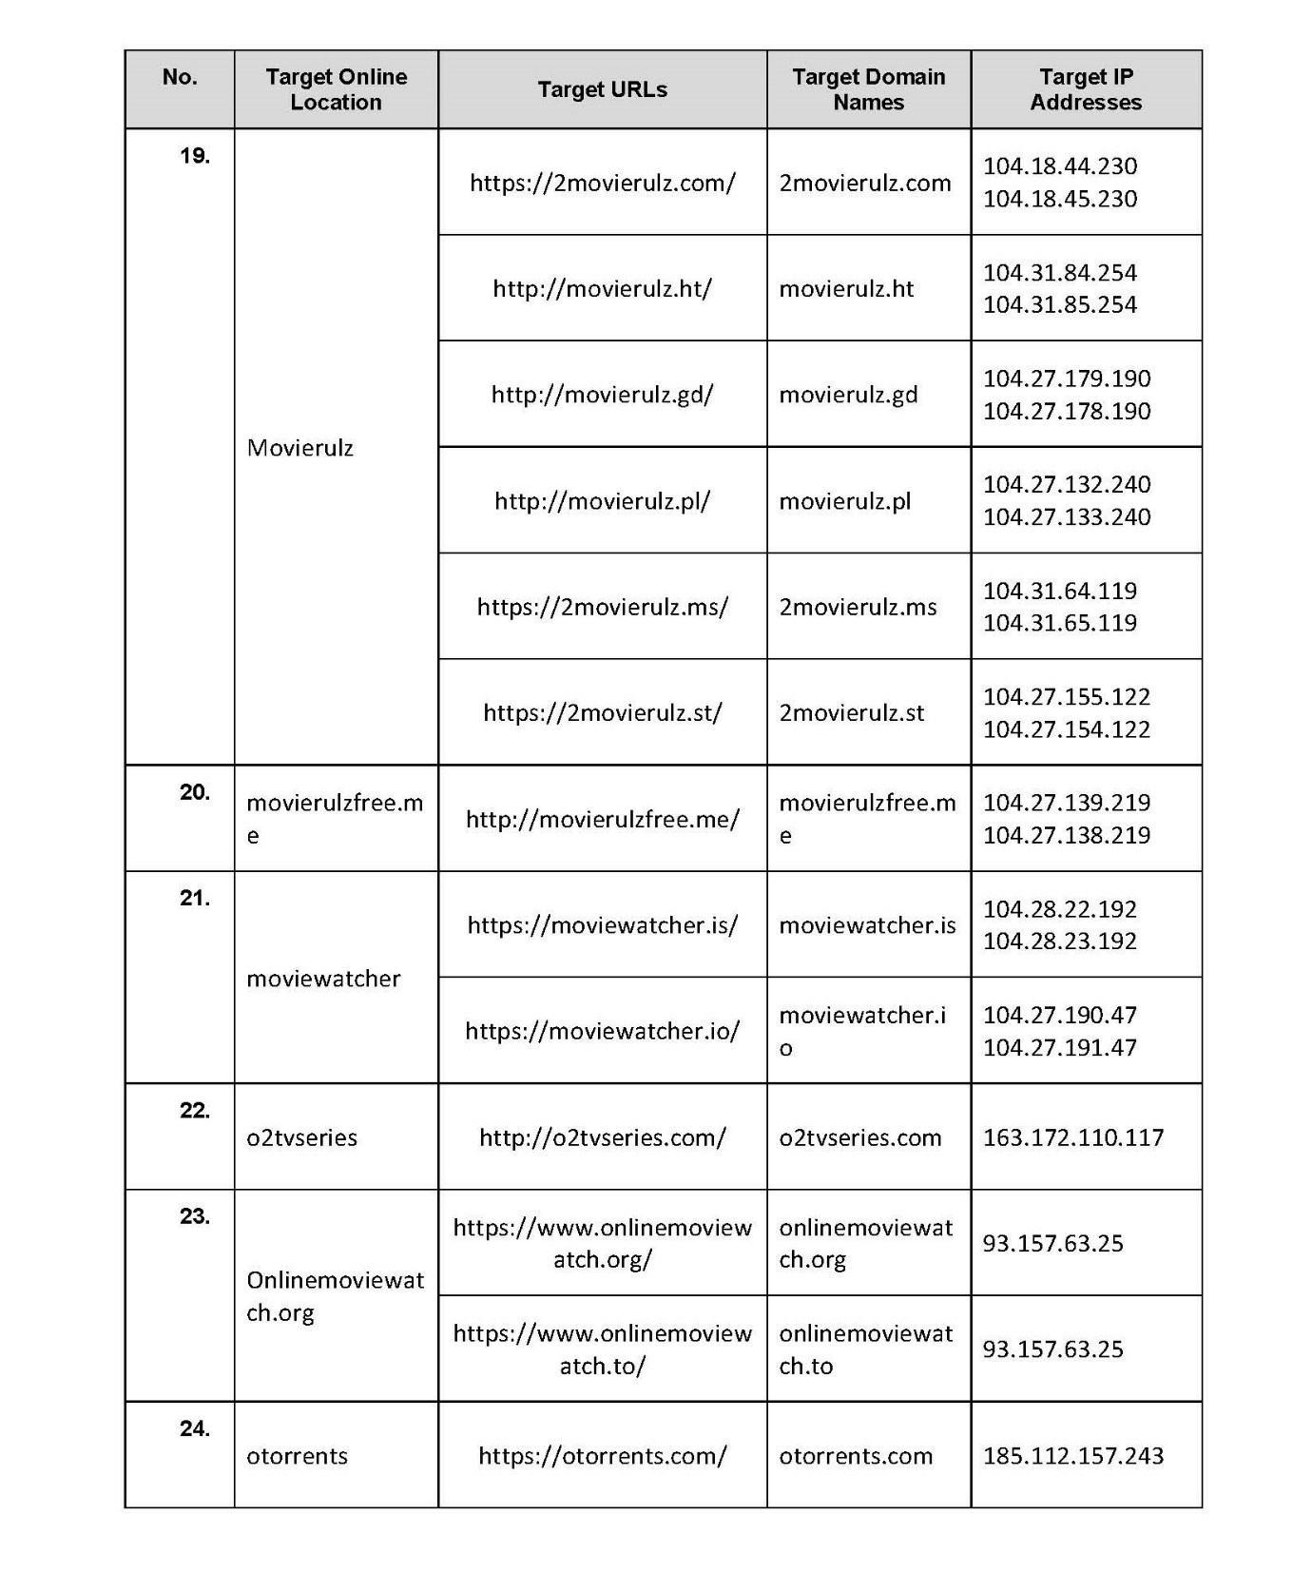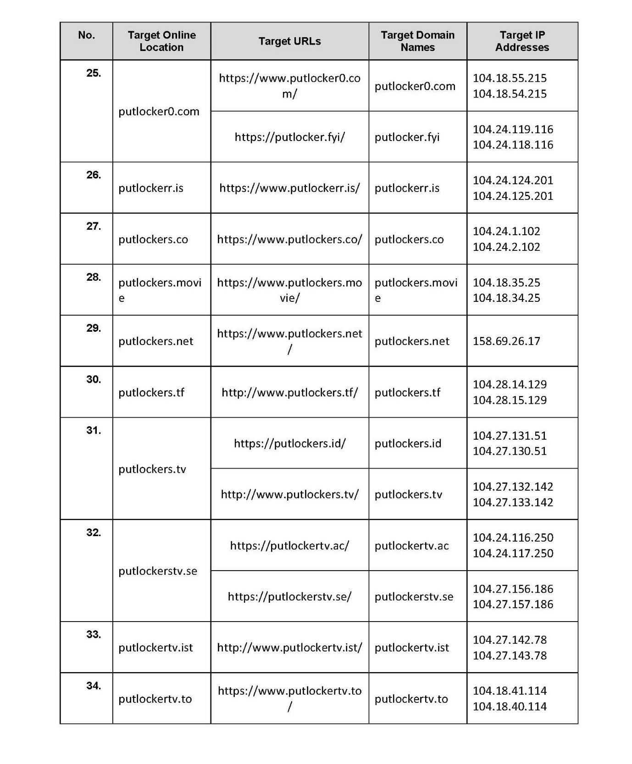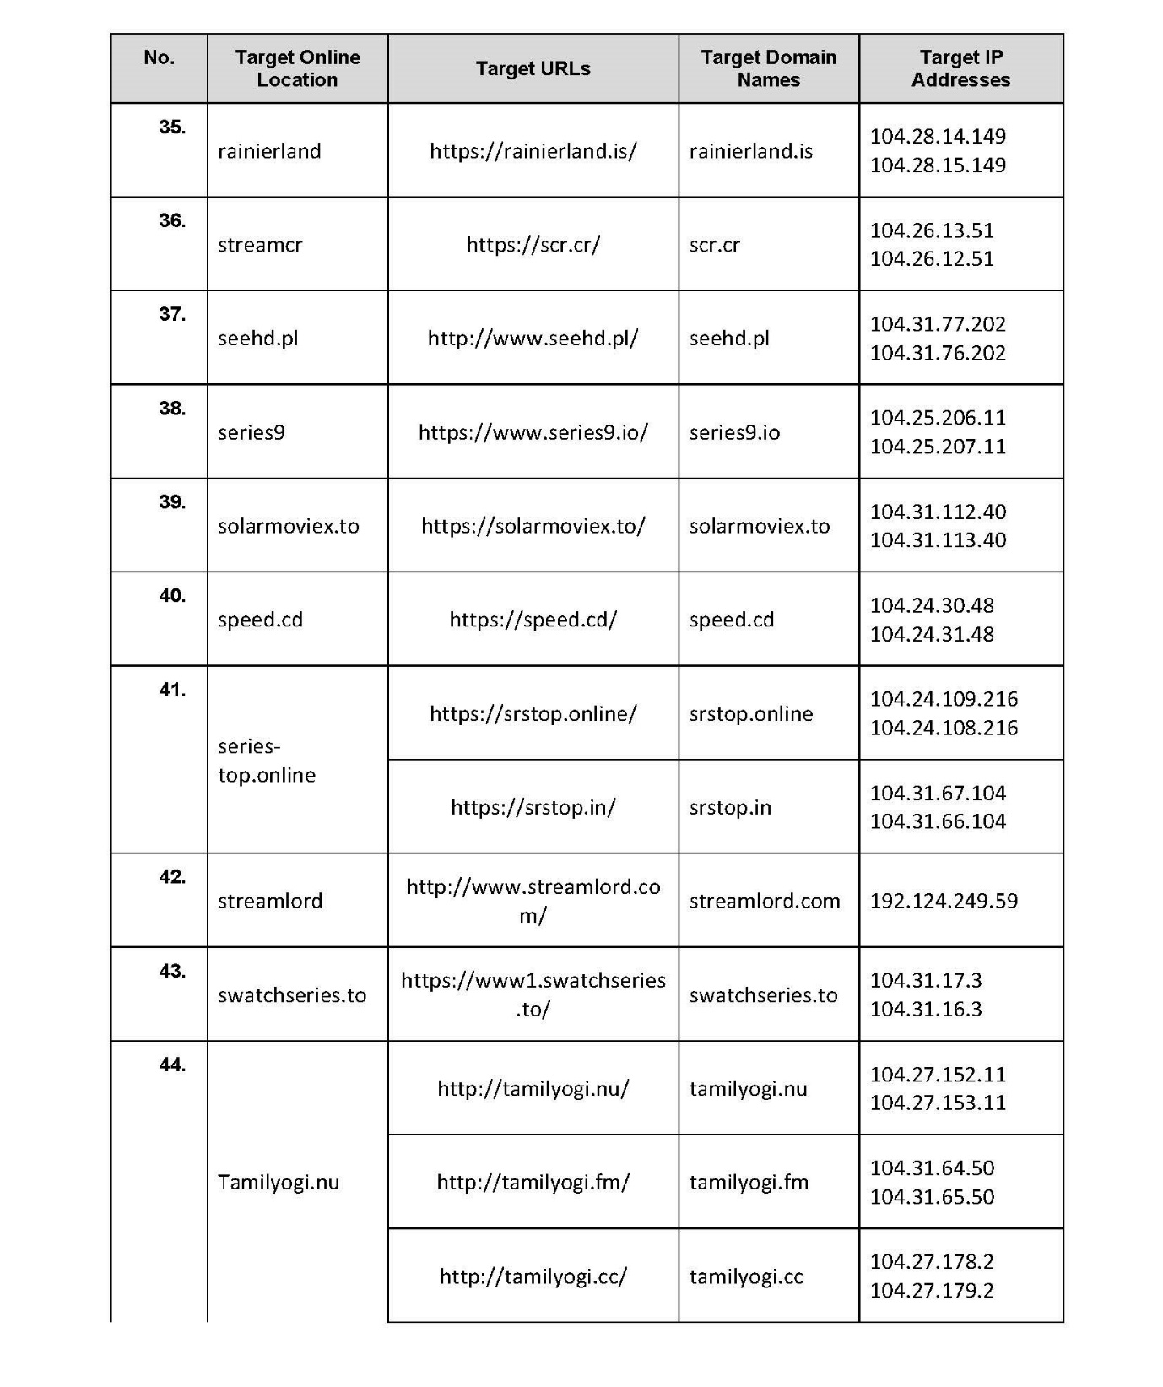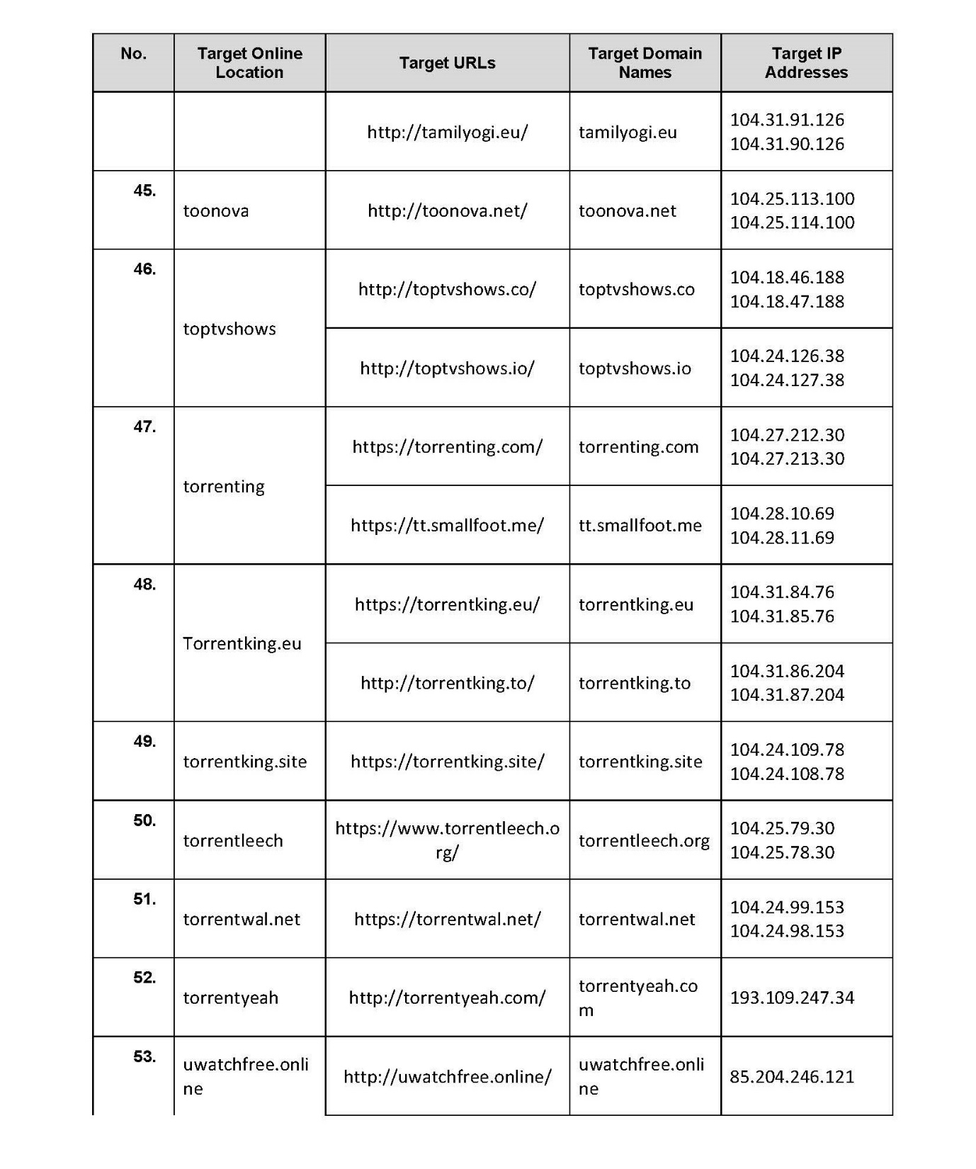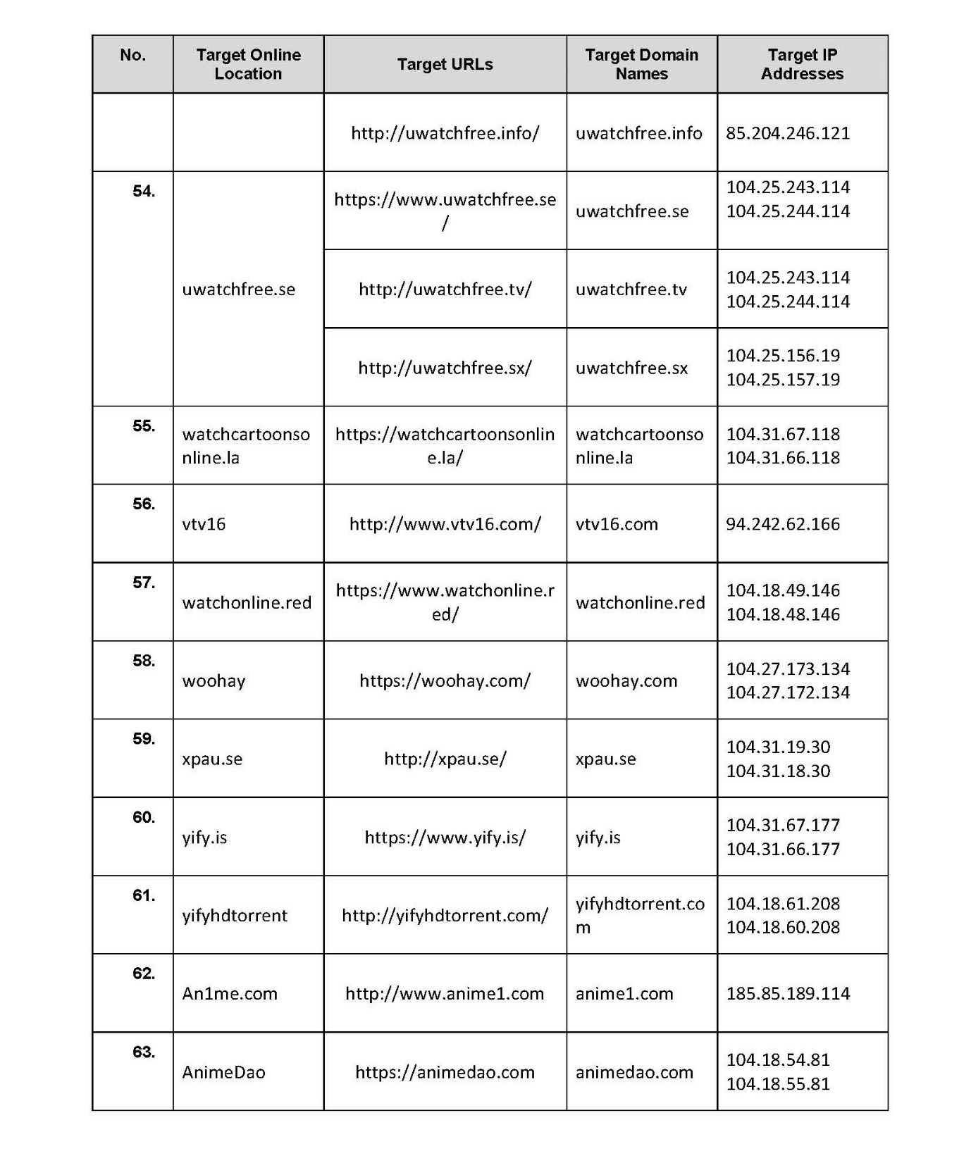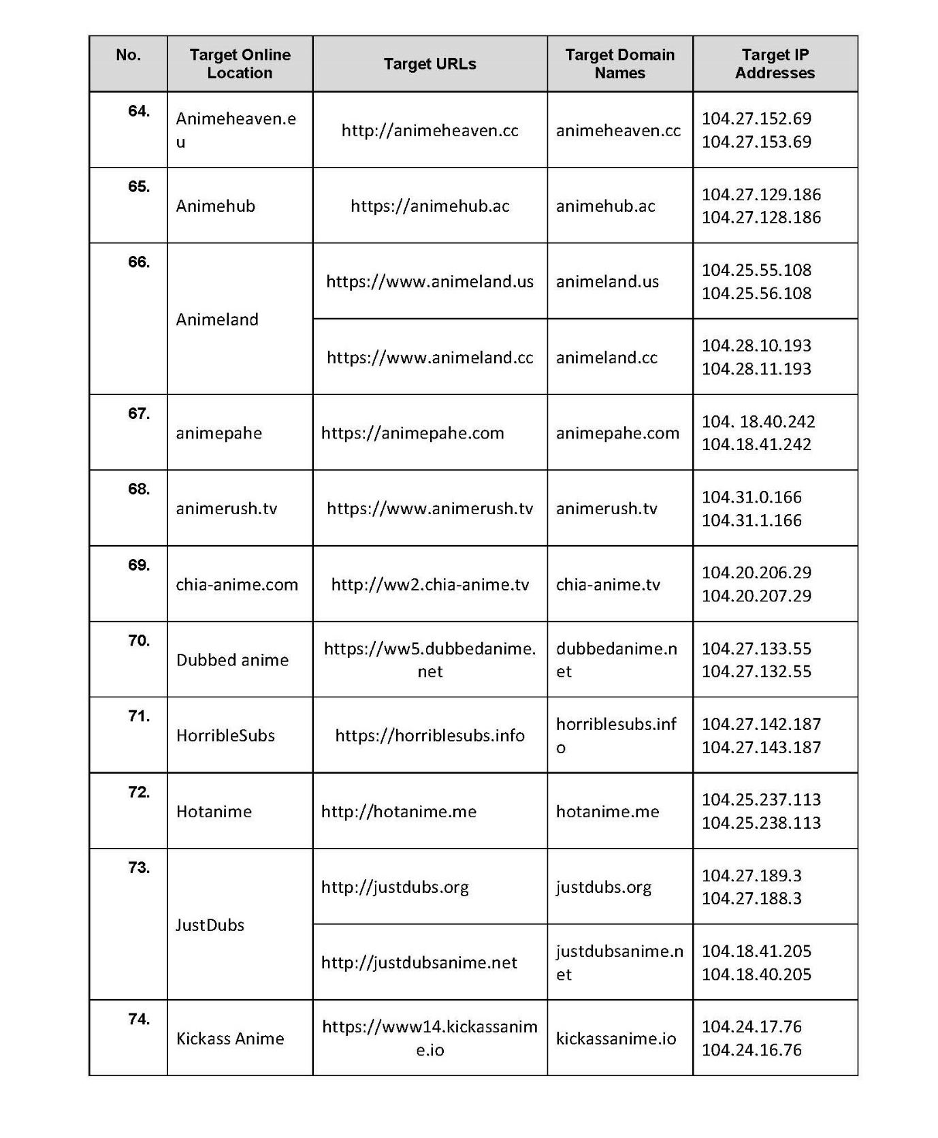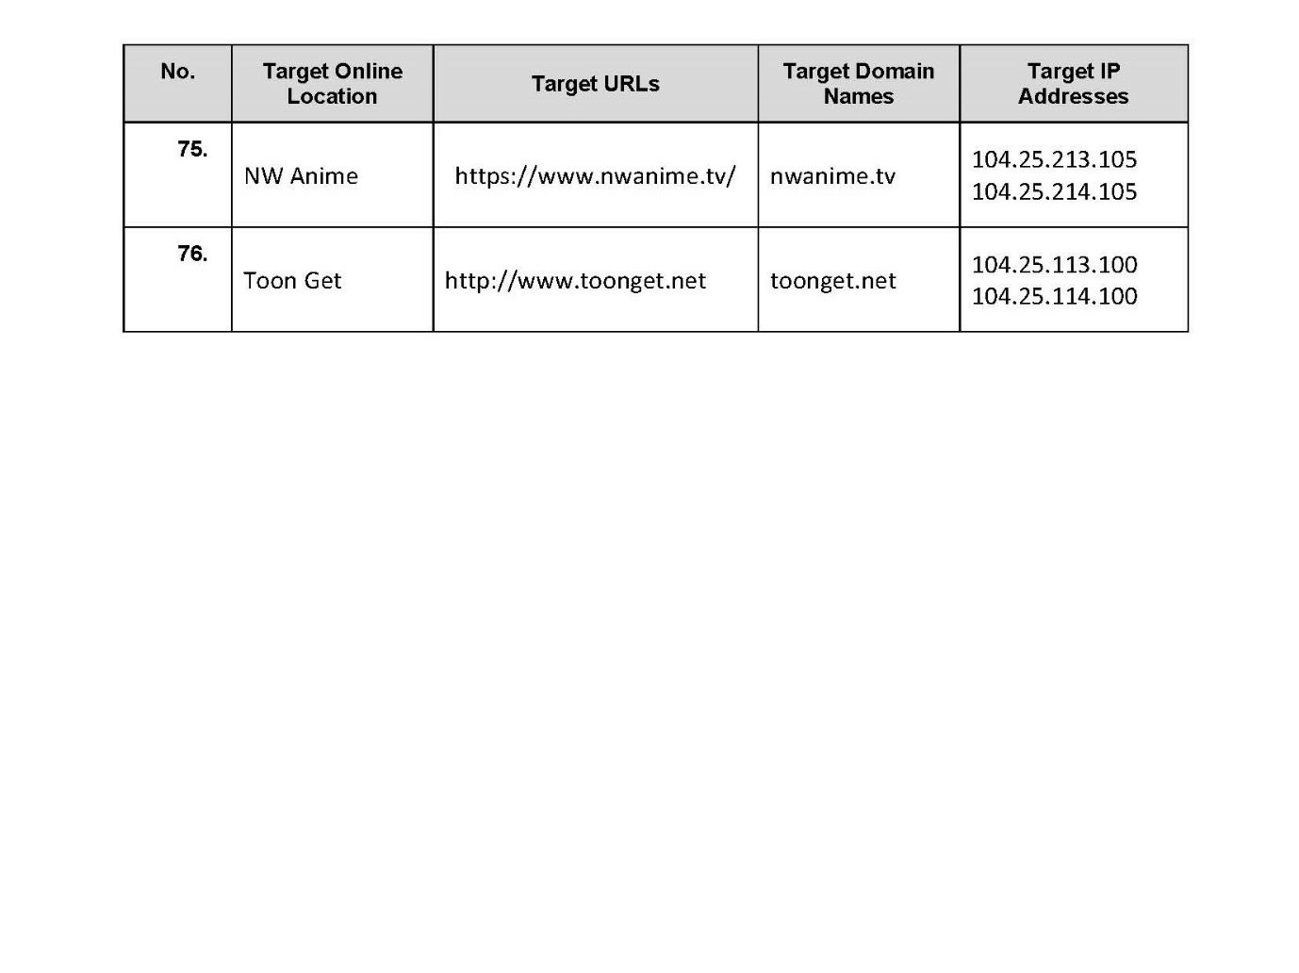

REASONS FOR JUDGMENT
NICHOLAS J:
1 Before me is an application under s 115A of the Copyright Act 1968 (Cth) (“the Act”). The orders sought by the applicants are in almost identical to those made in Roadshow Films Pty Ltd v Telstra Corporation Ltd (2016) 248 FCR 178 (“Roadshow”) except, of course, that they relate to different online locations.
2 There are 51 respondents in all, each of which is a carriage service provider, and a member of the Telstra, Optus, Vocus (formerly M2), TGP or Vodafone groups. The First to Thirteenth, Fiftieth and Fifty-Second Respondents have not sought to be heard in the proceeding and submitting appearances have been filed on their behalf. The Fourteenth to Forty-Ninth Respondents did not appear.
3 The applicants allege that the relevant websites are online locations situated outside Australia and that they infringe, or facilitate the infringement of, copyright in large numbers of cinematograph films including motion pictures and television programs the copyright in which is owned by the applicants.
4 None of the operators of the relevant websites applied to be joined as a party to either proceeding and none sought to appear at the hearing. There was affidavit evidence in the proceeding given by solicitors acting for the applicants describing attempts to notify the persons who operate each of the relevant websites. In light of that evidence I am satisfied that the applicants have made reasonable efforts to determine the identity and address of the persons who operate the relevant websites, and to send notices to those persons.
5 The affidavit evidence relied upon by the applicants consists of affidavits made by Nicholas Vincent Kraegan, Andrew Gavin Stewart, Gregory Donald Fraser and Joel Robert Vagnoni.
6 Mr Stewart and Mr Kraegen are solicitors with Baker & McKenzie who act for the applicants. Mr Stewart’s evidence identifies certain cinematograph films in which copyright is owned by one of the applicants. I do not propose to list the cinematograph films referred to in Mr Stewart’s evidence but they are all commercially released motion pictures some of which are very well known. Mr Kraegen’s affidavits refer to the efforts made by the applicants’ solicitors to notify the persons who operate the target online locations of the proceeding.
7 Mr Fraser is the Content Protection Investigations Manager Australia/New Zealand for the Motion Picture Association of America. Mr Vagnoni is the business and legal affairs executive for Madman Entertainment Pty Ltd, an entity related to the ninth applicant (“Madman”). Mr Fraser and Mr Vagnoni gave evidence regarding their investigations into each of the target online locations, including the nature of the copyright material accessible at or via (ie. by hyperlinks) those locations and the contact information for their owners/operators (such as it was) that was provided at those locations.
8 “Anime” is a term that refers typically and broadly to animated audio-visual content from Japan, or audio-visual content in a particular animation style which is typically associated with Japanese animation. Madman is a theatrical, home entertainment distribution and rights management company, specialising in the wholesale distribution of Anime DVD and BLU RAY products into sales channels throughout Australia and New Zealand. Madman also owns and operates in Australia and New Zealand an online streaming service called “Animelab”, which is available at the website accessible at the domain name animelab.com. AnimeLab provides access to “Anime” content in respect of which Madman holds licences from various copyright owners and rightsholders, authorising Madman to make copyright material available in that way.
9 Various amendments were made to s 115A by the Copyright Amendment (Online Infringement) Act 2018 (Cth) which took effect on 11 December 2018. Section 115A(1)-(2A) of the Act now provides:
115A Injunctions relating to online locations outside Australia
Application for an injunction
(1) The owner of a copyright may apply to the Federal Court of Australia to grant an injunction that requires a carriage service provider to take such steps as the Court considers reasonable to disable access to an online location outside Australia that:
(a) infringes, or facilitates an infringement, of the copyright; and
(b) has the primary purpose or the primary effect of infringing, or facilitating an infringement, of copyright (whether or not in Australia).
(2) The application under subsection (1) may also request that the injunction require an online search engine provider (other than a provider that is covered by a declaration under subsection (8B)) to take such steps as the Court considers reasonable so as not to provide a search result that refers users to the online location.
Granting the injunction
(2A) The Court may grant the injunction in the terms, and subject to the conditions, that the Court considers appropriate.
Note 1: For the matters that the Court may take into account when determining whether to grant the injunction, see subsection (5).
Note 2: The terms and conditions of the injunction that apply to a carriage service provider under subsection (1) may be different from those that apply to an online search engine provider under subsection (2).
(2B) Without limiting subsection (2A), the injunction may:
(a) require the carriage service provider to take reasonable steps to do either or both of the following:
(i) block domain names, URLs and IP addresses that provide access to the online location and that are specified in the injunction;
(ii) block domain names, URLs and IP addresses that the carriage service provider and the owner of the copyright agree, in writing, have started to provide access to the online location after the injunction is made; and
(b) require the online search engine provider to take reasonable steps to do either or both of the following:
(i) not provide search results that include domain names, URLs and IP addresses that provide access to the online location and that are specified in the injunction;
(ii) not provide search results that include domain names, URLs and IP addresses that the online search engine provider and the owner of the copyright agree, in writing, have started to provide access to the online location after the injunction is made.
10 Subsection (1) now refers to “the primary purpose or the primary effect”. More significantly, subsection (2) now permits the applicant to apply for an injunction requiring an online search engine provider to take steps not to provide a search result that refers to the online location. One purpose of this amendment is to prevent persons using a search engine to find additional domain names or URLs at which an online location that is the subject of an order under s 115A may be accessed. The applicants do not seek any such orders in this proceeding.
11 Subsection (2B) expressly permits the court to grant an injunction under subsection (2A) requiring the carriage service provider to block domain names, URLs and IP addresses that the carriage service provider and the owner of the copyright agree have started to provide access to the online location after the injunction is granted. However, this procedure is only available where it is provided for under the terms of the injunction granted by the court. In the present case the injunction sought by the applicants does not make any such provision.
12 Another change to s 115A involves the creation of a presumption in accordance with the new subsection (5A). It provides that, for the purpose of the proceedings, the online location is presumed to be outside Australia, unless the contrary is established. This change is likely to reduce the difficulty and cost of establishing that an online location is located outside Australia, as required by subsection (1).
13 Turning to the present case, I find that each of the target online locations identified in the applicants’ proposed orders infringes or facilitates the infringement of the copyright of the applicants in various well-known cinematograph films. I also find that the target online locations have the primary purpose, or the primary effect, of infringing or facilitating an infringement of copyright in large numbers of commercially released cinematograph films many of which are very well-known. These include, in the case of the websites with which Madman is most concerned, television programs and films in respect of which it is the exclusive licensee for Australia including Dagashi Kashi, Shonen Maid and Dragon Ball.
14 Having considered the matters listed in s 115A(5), I am satisfied that a blocking order should be made in the terms sought by the applicants against each of the respondents in respect of each of the target online locations.
15 The only operator of a target online location who argued against the making of an order in relation to an online location was Dr Socrates Dimitriadis. Dr Dimitriadis did not appear but he did forward to the Court correspondence dated 11 February 2019 and 14 May 2019. According to his correspondence, Dr Dimitriadis is the owner of the Greek-Movies.com website and an assistant professor of computer science at the George Mason University in the USA.
16 According to Dr Dimitriadis his website does not infringe copyright and does not facilitate the infringement of copyright. He states in this correspondence that there have been a number of judgments given in European courts in which “this has been proven multiple times”. Copies of certified translations of at least some of those decisions are included in the evidence.
17 The evidence indicates that Dr Dimitriadis’ website includes a page that refers to “Terms of Use” for the website. These include:
Greek-Movies is a search and indexing service for special content. It searches, collects, classifies and publishes URLs that refer to third-party public websites that legally host and broadcast audiovisual works. These videos are neither hosted nor projected by Greek-Movies themselves. At the moment you select any link from the Greek-Movies index, you are automatically transferred or logged in to these third-party services. This is true even if a third-party site is embedded on Greek-Movies websites.
Greek-Movies contains links (links) to third-party sites. Referring to links belonging to third-party websites is not an adoption of their views and actions, or the acceptance or support of the content they express, publish or postpone. The third parties – the operators of the websites responsible for the law – are solely responsible for the content of their websites or for any damage that may result from their use when the user / visitor of Greek-Movies goes to them. Greek-Movies is not responsible for the content of the web pages it indexes, nor can, or has the right or the obligation to know, the terms by which these third-party websites publish their content.
Greek-Movies provides its own index and does not bear any responsibility or obligation for the proper and uninterrupted operation of the third-party websites it indexes. Greek-Movies reserves the right to add, remove, or alter any third-party internet address from its index at any time and without any notice.
Greek-Movies does not sell, rent or otherwise exploit the content of the web pages it indexes. Their exploitation is subject to sole control of these websites. Greek-Movies is a service provided free of charge and maintained by advertisements that it views on its own websites alone.
…
18 In his correspondence of 11 February 2019 Dr Dimitriadis states:
1. My site does not host, or publish in any other form, any kind of copyright material whatsoever. My site is just a search engine that refers users to third-party websites.
2. Greek-Movies.com operates for 13 years now, and it has always abided by the law. Although there were similar false accusations in the past, by companies that are much bigger than the applicants in this case, none of them has ever been substantiated in any court.
3. In four different cases … that were tried in Europe, all courts have made the same judgement, that the allegations against Greek-Movies are completely false, and confirmed that the site complies with the law.
4. Greek-Movies has absolutely no relation with any of the other sites that are listed as “Target Online Locations”. Just the fact that most of them are using Cloudfare Inc. which is a content delivery network, whereas my site is using Hetzner GmbH which is a regular web hosting service, clearly shows that, a) Greek-Movies is doing something very different from the other sites, and b) Greek-Movies doesn’t have the required resources of a content delivery network in order to serve copyright material over the internet.
19 I have taken the opportunity to visit and explore the Greek-Movies.com website using a computer supplied by the applicants.
20 Dr Dimitriadis’ website includes an extensive and searchable catalogue of audio visual content which can be directly accessed for streaming or downloading using links on the website. The catalogue includes many popular commercially released cinematograph films the dialogue for which is dubbed in Greek. These include:
The Lego Movie | Despicable Me 3 | Shrek
Toy Story 2 | Shark Tale | Paddington
Cinderella | Happy Feet | Happy Feet 2
Cars 2 | Moana | Winnie the Pooh
The Simpsons Movie | Stuart Little | Hotel Transylvania
Lion King II | Alice Through the Looking Glass | The Cat in the Hat
Wall E | Frozen | Ice Age 2
Smurfs: The Lost Village | Harry Potter and the Sorcerer’s Stone | 101 Dalmations
The Incredibles | The Incredibles 2 | Chicken Run
Up | Kung Fu Panda | Kung Fu Panda 2

21 The copyright in the vast majority of these films is owned by one of the applicants. None of them has authorised any of the various third party websites to which Dr Dimitriadis’ website provides links to make the films available online or to electronically transmit them.
22 It is apparent from Dr Dimitriadis’ correspondence that some of the applicants have been making efforts to curtail his activities for at least ten years. His answer to their complaints has remained the same: his website does not host infringing content, but merely provides indexed and catalogued links to content stored on third party websites.
23 I have read the decisions referred to by Dr Dimitriadis. They relate to efforts by the Greek Antipiracy Association of Audio Visual Works (“EPOE”) to prosecute Dr Dimitriadis for copyright infringement under Greek law including, in particular, Law No 2121/1993 on Copyright, Related Rights and Cultural Matters. Dr Dimitriadis says that EPOE is a creature of, or at least closely associated with, some of the applicants.
24 The decisions relied on by Dr Dimitriadis relate to allegations of copyright infringement under the laws of Greece. They do not bear on the question whether, in the language of s 115A(1), Dr Dimitriadis’ website infringes copyright or “facilitates an infringement of copyright”.
25 It is apparent from Dr Dimitriadis’ correspondence and the terms of use for his website that he contends that his website does not infringe copyright, or facilitate the infringement of copyright, in any of the applicants’ cinematograph films, because none are made available online, or electronically transmitted, from his website.
26 The meaning of the words “facilitates an infringement of copyright” was considered in Roadshow. As explained in that case at [47]:
Even if the online location does not itself infringe copyright, the requirements of s 115A(1)(b) may be satisfied if the online location “facilitates” an infringement of copyright. The language used is deliberately broad. The word “facilitate” means “to make easier or less difficult; help forward (an action or process etc)”: Macquarie Dictionary (6th ed, 2013) at p 525. In determining whether an online location facilitates the infringement of copyright, the Court will seek to identify a species of infringing act and ask whether the online location facilitates that act by making its performance easier or less difficult. An online location may both infringe and facilitate the infringement of copyright by making an electronic copy of a work or other subject matter available online for transmission to users. But it may also facilitate the infringement of copyright merely by making it easier for users to ascertain the existence or whereabouts of other online locations that themselves infringe or facilitate the infringement of copyright.
See also Universal Music Australia Pty Ltd v TPG Internet Pty Ltd (2017) 126 IPR 219 (Burley J) at [17]-[18].
27 The correspondence from Dr Dimitriadis does not address the issue of whether his website facilitates the infringement of copyright in the relevant sense. I am satisfied that it does. It makes it easier for users of the website to ascertain the existence and whereabouts of other online locations that infringe or facilitate the infringement of copyright in popular films and television programs on a large scale. In my opinion the primary purpose and effect of Dr Dimitriadis’ website is to facilitate copyright infringement.
28 On the question of discretion, the following considerations are, in the case of Dr Dimitriadis’ website, of particular significance:
• The facilitation of the copyright infringement is in my opinion flagrant. Dr Dimitriadis does not deny that many of the films catalogued on his website are protected by copyright and that visitors to his website who download such films using the links he has created will do so in breach of copyright.
• Dr Dimitriadis has authorised the infringement of copyright in films that are catalogued on his website where such films are downloaded by Australian users using links he has created. The fact that Dr Dimitriadis does not host the copyright material on his own website or server is not inconsistent with that proposition.
• Dr Dimitriadis has not proposed any alternative remedy or resolution of the applicants’ complaints with respect to his website. He has not offered to remove links to infringing content or to take any other step that might lessen the amount of infringing material that may be accessed using the facilities made available at his website. Nor has he identified any hardship or inconvenience that will be suffered by any users of his website in Australia if a blocking order is made.
29 I am satisfied that the discretionary considerations under s 115A(5) of the Act weigh heavily in favour of making a blocking order in respect of Dr Dimitriadis’ website.
30 Orders accordingly.

I certify that the preceding thirty (30) numbered paragraphs are a true copy of the Reasons for Judgment herein of the Honourable Justice Nicholas.

Associate:

Dated: 12 June 2019

SCHEDULE OF PARTIES

 | NSD 2410 of 2018
Applicants
Third Applicant | DISNEY ENTERPRISES, INC.
Fourth Applicant | TWENTIETH CENTURY FOX FILM CORPORATION
Fifth Applicant | PARAMOUNT PICTURES CORPORATION
Sixth Applicant | COLUMBIA PICTURES INDUSTRIES, INC.
Seventh Applicant | UNIVERSAL CITY STUDIOS LLC.
Eighth Applicant | WARNER BROS. ENTERTAINMENT INC.
Ninth Applicant: | MADMAN ANIME GROUP PTY LTD
Tenth Applicant: | TOKYO BROADCASTING SYSTEM TELEVISION INC
Respondents
Third Respondent: | PACNET SERVICES (A) PTY. LTD. (ACN 056 783 852)
Fourth Respondent | OPTUS MOBILE PTY LIMITED (ACN 054 365 696)
Fifth Respondent | OPTUS NETWORKS PTY LIMITED (ACN 008 570 330)
Sixth Respondent | OPTUS ADSL PTY LIMITED (ACN 138 676 356)
Seventh Respondent | OPTUS SATELLITE PTY LIMITED (ACN 091 790 313)
Eighth Respondent | UECOMM OPERATIONS PTY LIMITED (ACN 093 504 100)
Ninth Respondent | VIVIDWIRELESS PTY LIMITED (ACN 137 696 461)
Tenth Respondent | OPTUS INTERNET PTY LIMITED (ACN 083 164 532)
Eleventh Respondent | VIRGIN MOBILE (AUSTRALIA) PTY LIMITED (ACN 092 726 442)
Twelfth Respondent | ALPHAWEST SERVICES PTY LIMITED (ACN 009 196 347)
Thirteenth Respondent | OPTUS WHOLESALE PTY LIMITED (ACN 092 227 551)
Fourteenth Respondent | M2 WHOLESALE PTY LTD (ABN 99 119 220 843)
Fifteenth Respondent | M2 WHOLESALE SERVICES PTY LTD (ACN 119 220 843)
Sixteenth Respondent | M2 COMMANDER PTY LTD (ACN 136 950 082)
Seventeenth Respondent | PRIMUS NETWORK (AUSTRALIA) PTY LTD (ACN 109 142 216)
Eighteenth Respondent | PRIMUS TELECOMMUNICATIONS PTY LTD (ACN 071 191 396)
Nineteenth Respondent | PRIMUS TELECOMMUNICATIONS (AUSTRALIA) PTY LTD (ACN 061 754 943)
Twentieth Respondent | DODO SERVICES PTY LTD (ACN 158 289 331)
Twenty First Respondent | ENGIN PTY LTD (ACN 080 250 371)
Twenty Second Respondent | EFTEL CORPORATE PTY LTD (154 634 054)
Twenty Third Respondent | EFTEL RETAIL PTY LTD (ACN 092 667 126)
Twenty Fourth Respondent | EFTEL WHOLESALE PTY LTD (ACN 123 409 058)
Twenty Fifth Respondent | CLUBTELCO PTY LTD (ACN 144 488 620)
Twenty Sixth Respondent | WHOLESALE COMMUNICATIONS GROUP PTY LTD (ACN 109 626 011)
Twenty Seventh Respondent | 2TALK PTY LTD (ACN 161 656 499)
Twenty Eighth Respondent | VOCUS PTY LTD (ACN 127 842 853)
Twenty Ninth Respondent | AMCOM IP TEL PTY LTD (ACN 065 092 962)
Thirtieth Respondent | AMNET BROADBAND PTY LTD (ACN 092 472 350)
Thirty First Respondent | NEXTGEN NETWORKS PTY LTD (ACN 094 147 403)
Thirty Second Respondent | TPG INTERNET PTY LTD (ACN 068 383 737)
Thirty Third Respondent | TPG NETWORK PTY LTD (ACN 003 064 328)
Thirty Fourth Respondent | FTTB WHOLESALE PTY LTD (ACN 087 533 328)
Thirty Fifth Respondent | CHARIOT PTY LTD (ACN 088 377 860)
Thirty Sixth Respondent | SOUL PATTINSON TELECOMMUNICATIONS PTY LIMITED (ACN 001 726 192)
Thirty Seventh Respondent | SPT TELECOMMUNICATIONS PTY LIMITED (ACN 099 173 770)
Thirty Eighth Respondent | SPTCOM PTY LIMITED (ACN 111 578 897)
Thirty Ninth Respondent | SOUL COMMUNICATIONS PTY LTD (ACN 085 089 970)
Fortieth Respondent | PIPE NETWORKS PTY LIMITED (ACN 099 104 122)
Forty First Respondent | INTRAPOWER TERRESTRIAL PTY LTD (ACN 081 193 259)
Forty Second Respondent | IINET LIMITED (ACN 068 628 937)
Forty Third Respondent | INTERNODE PTY LTD (ABN 82 052 008 581)
Forty Fourth Respondent | TRANSACT CAPITAL COMMUNICATIONS PTY LTD (ACN 093 966 888)
Forty Fifth Respondent | TRANSACT VICTORIA COMMUNICATIONS PTY LTD (ACN 063 024 475)
Forty Sixth Respondent | WESTNET PTY LTD (ACN 086 416 908)
Forty Seventh Respondent | ADAM INTERNET PTY LTD (ACN 055 495 853)
Forty Eighth Respondent | AAPT LIMITED (ACN 052 082 416)
Forty Ninth Respondent | REQUEST BROADBAND PTY LTD (ACN 091 530 586)
Fiftieth Respondent | VODAFONE HUTCHISON AUSTRALIA PTY LIMITED (ACN 096 304 620)
Fifty Second Respondent | VODAFONE PTY LIMITED (ACN 062 954 554)

