FEDERAL COURT OF AUSTRALIA

Australian Building and Construction Commissioner v O’Connor (No 3) [2018] FCA 43

File number: | SAD 253 of 2014
Judge: | BESANKO J
Date of judgment: | 6 February 2018
Catchwords: | EVIDENCE – whether leave should be granted for a witness to revive their memory under s 32(1) of the Evidence Act 1995 (Cth) – whether the matters in s 32(2) of the Evidence Act are satisfied – whether leave should be granted for a witness to read aloud part of their evidence in accordance with s 32(3) of the Evidence Act – whether any of the factors listed under s 192(2) of the Evidence Act lead to the conclusion that leave for a witness to revive their memory under s 32(1) of the Evidence Act should be refused – whether evidence ought to be excluded or limited in its use under ss 135 or 136 of the Evidence Act – whether exceptions to the hearsay rule apply under ss 63 and 64 of the Evidence Act  INDUSTRIAL LAW – whether the first respondent was seeking to exercise rights under Part 3-4 of the Fair Work Act 2009 (Cth) – whether the first and third respondents contravened ss 348, 355 and 500 of the Fair Work Act – whether the second respondent contravened ss 348 and 355 of the Fair Work Act – whether the third respondent is liable for a contravention of s 500 of the Fair Work Act by reason of ss 363 and 793 of the Fair Work Act – whether the second and third respondents contravened s 550 of the Fair Work Act – whether each of the respondents ought to pay pecuniary penalties under s 546 of the Fair Work Act  COSTS – whether the applicant is liable to pay the respondents’ costs of an adjournment pursuant to s 43 of the Federal Court of Australia Act 1976 (Cth) and s 570 of the Fair Work Act
Legislation: | Acts Interpretation Act 1901 (Cth)  Evidence Act 1995 (Cth) ss 32, 63, 64, 59, 135, 136, 140, 192  Fair Work Act 2009 (Cth) ss 12, 30L, 30R, 347, 348, 355, 361, 363, 484, 490, 500, 546, 550, 551, 570, 793  Federal Court of Australia Act 1976 (Cth) s 43
Cases cited: | ACCC v Australian Safeway Stores Pty Ltd [1999] FCA 1269  Australian Building and Construction Commissioner v Construction, Forestry, Mining and Energy Union (No 3) [2017] FCA 10  Australian Building and Construction Commissioner v Construction, Forestry, Mining and Energy Union (The Quest Apartments Case) [2017] FCA 1398  Australian Building and Construction Commissioner v Harris [2017] FCA 733  Australian Building and Construction Commissioner v McDermott (No 2) [2017] FCA 797  Australian Building and Construction Commissioner v Parker [2017] FCA 564; (2017) 266 IR 340  Australian Building and Construction Commissioner v Upton (The Gorgon Project Case) [2017] FCA 847  Australian Competition and Consumer Commission v Lux Pty Limited [2003] FCA 949  Blair and Others v Curran and Others [1939] HCA 23; (1939) 62 CLR 464  Bragdon and Others v Director of the Fair Work Building Industry Inspectorate [2016] FCAFC 64; (2016) 242 FCR 46  Briginshaw v Briginshaw and Another [1938] HCA 34; (1938) 60 CLR 336  Campaign Master (UK) Ltd v Forty Two International Pty Ltd (No 3) and Another [2009] FCA 1306; (2009) 181 FCR 152  Commonwealth of Australia v Director, Fair Work Building Industry Inspectorate and Others [2015] HCA 46; (2015) 258 CLR 482  Commonwealth of Australia v McLean [1996] NSWSC 657; (1996) 41 NSWLR 389  Construction, Forestry, Mining and Energy Union v BHP Coal Pty Ltd [2015] FCAFC 25; (2015) 230 FCR 298  Construction, Forestry, Mining and Energy Union v De Martin & Gasparini Pty Ltd (No 2) [2017] FCA 1046  CSR Limited (ACN 000 001 2276) and Another v Amaca Pty Ltd (ACN 000 035 512) (under NSW Administered Winding Up) [2016] VSCA 320  Dare v Pulham [1982] HCA 70; (1982) 148 CLR 658  Dillon v Cush; Dillon v Boland [2010] NSWCA 165  Director of the Fair Work Building Industry Inspectorate v Cartledge [2015] FCA 453; (2015) 239 FCR 405  Director of Fair Work Building Industry Inspectorate v Construction, Forestry, Mining and Energy Union (The Red and Blue Case) [2015] FCA 1125; (2015) 254 IR 200  Director of the Fair Work Building Industry Inspectorate v O’Connor [2016] FCA 856  Director of the Fair Work Building Industry Inspectorate v O’Connor (No 2) [2016] FCA 1050  Esso Australia Pty Ltd v Australian Workers’ Union [2016] FCAFC 72; (2016) 245 FCR 39  Esso Australia Pty Ltd v The Australian Workers’ Union [2017] HCA 54  John Holland Pty Ltd and Another v Construction, Forestry, Mining and Energy Union (New South Wales Branch) and Others [2009] FCA 645; (2009) 186 FCR 88  National Tertiary Education Industry Union v Commonwealth of Australia and Another [2002] FCA 441; (2002) 117 FCR 114  Osborne Metal Industries (NSW) Pty Ltd v Bullock MFG Pty Ltd (No 1) [2011] NSWSC 636  Port of Melbourne Authority v Anshun Proprietary Limited [1981] HCA 45; (1981) 147 CLR 589  Rafferty and Another v Madgwicks [2012] FCAFC 37; (2012) 203 FCR 1  Renowden v McMullin and Another [1970] HCA 24; (1970) 123 CLR 584  Roach & Ors v Page & Ors (No 11) [2003] NSWSC 907  Rural Press Limited and Others v Australian Competition and Consumer Commission [2003] HCA 75; (2003) 216 CLR 53  Setka v Gregor (No 2) [2011] FCAFC 90; (2011) 195 FCR 203  Seven Network (Operations) Ltd v Communications, Electrical, Electronic, Energy, Information, Postal, Pluming and Allied Services Union of Australia and Others [2001] FCA 456; (2001) 109 FCR 378  Stevens v McCallum [2006] ACTCA 13  Tomlinson v Ramsey Food Processing Pty Limited [2015] HCA 28; (2015) 256 CLR 507  Yorke and Another v Lucas [1985] HCA 65; (1985) 158 CLR 661
Dates of hearing: | 21, 22, 23 March 2017 and 27 April 2017
Date of last submissions: | 10 May 2017
Registry: | South Australia
Division: | Fair Work Division
National Practice Area: | Employment & Industrial Relations
Category: | Catchwords
Number of paragraphs: | 162
Counsel for the Applicant: | Mr I Neil SC with Mr D Chin
Solicitor for the Applicant: | Clayton Utz
Counsel for the Respondents: | Mr M Abbott QC with Mr M Ats
Solicitor for the Respondents: | Lieschke & Weatherill Lawyers

ORDERS
 |  | SAD 253 of 2014
BETWEEN: | AUSTRALIAN BUILDING AND CONSTRUCTION COMMISSIONER  Applicant
AND: | JIM O'CONNOR  First Respondent  JACK MERKX  Second Respondent  CONSTRUCTION, FORESTRY, MINING AND ENERGY UNION  Third Respondent

JUDGE: | BESANKO J
DATE OF ORDER: | 6 February 2018

THE COURT ORDERS THAT:

- The applicant file and serve draft minutes of order reflecting the conclusions in these reasons.
- The proceeding be adjourned to a date to be fixed.
- The respondents’ application for costs be refused.

Note: Entry of orders is dealt with in Rule 39.32 of the Federal Court Rules 2011.

REASONS FOR JUDGMENT
BESANKO J:

INTRODUCTION
- This is an application by the Australian Building and Construction Commissioner (formerly the Director of the Fair Work Building Industry Inspectorate) under the Fair Work Act 2009 (Cth) (FW Act) and the Federal Court of Australia Act 1976 (Cth) for declarations that three respondents have contravened sections of the FW Act and for orders that the respondents pay pecuniary penalties under s 546 of the FW Act. The applicant also seeks an order that under s 546(3)(a) of the FW Act, the pecuniary penalties be paid to the Commonwealth. The applicant’s standing to bring the proceeding is not in issue.
- The three respondents to the proceeding are Mr Jim O’Connor, Mr Jack Merkx and the Construction, Forestry, Mining and Energy Union (CFMEU). It is not in dispute that at all material times, Mr O’Connor was an officer, employee and/or agent of the CFMEU for the purposes of ss 363 and 793 of the FW Act and a permit holder within the meaning of that term in ss 12 and 500 of the FW Act. It is not in dispute that at all material times, Mr Merkx was an officer and/or agent of the CFMEU for the purposes of ss 363 and 793 of the FW Act and an employee of Hansen Yuncken Pty Ltd (Hansen Yuncken).
- It is not in dispute that at all material times, the CFMEU was:
- an organisation of employees registered under the Fair Work (Registered Organisations) Act 2009 (Cth) (FW (RO) Act) and by reason of being so registered, a body corporate by reason of s 27 of the FW (RO) Act;
- a body corporate capable of being sued in its registered name;
- an ‘industrial association’ within the meaning of that term in ss 12 and 347 of the FW Act, the rules of which provide for membership by persons whose employment consists of or includes building work; and
- a ‘building association’ and a ‘building industry participant’ within the meaning of s 4(1) of the Fair Work (Building Industry) Act 2012 (Cth).
- The applicant alleges that on 13 May 2014, Mr O’Connor contravened ss 348, 355 and 500 of the FW Act and that the CFMEU is also liable for contraventions of those sections. The applicant does not seek pecuniary penalties against Mr O’Connor for reasons I will explain. The applicant alleges that Mr Merkx contravened ss 348 and 355 of the FW Act and that the CFMEU is also liable for those contraventions.
- The alleged contraventions by the respondents arise out of the same facts. That does not mean there cannot be contraventions of different sections, although it will be relevant to penalty.
- Sections 348, 355 and 500 of the FW Act are civil remedy provisions. The standard of proof for a contravention of a civil remedy provision is proof on the balance of probabilities (FW Act, s 551). However, a contravention of a civil remedy provision may lead to the imposition of a pecuniary penalty and that is a matter to be taken into account in determining whether the standard of proof has been met (Evidence Act 1995 (Cth), s 140(2); Briginshaw v Briginshaw and Another [1938] HCA 34; (1938) 60 CLR 336). The High Court identified the purpose of civil remedy provisions in Commonwealth of Australia v Director, Fair Work Building Industry Inspectorate and Others [2015] HCA 46; (2015) 258 CLR 482 at [53]-[58].

A BRIEF SUMMARY OF THE APPLICANT’S CASE
- The following summary of the applicant’s case is taken from the applicant’s Amended Statement of Claim dated 1 March 2017 (Statement of Claim). I will indicate where a particular allegation made by the applicant is admitted by the respondents.
- The applicant claims and the respondents admit that at all relevant times Hansen Yuncken was engaged as a head contractor for a project involving the construction of the new Royal Adelaide Hospital (the Project) at Port Road, Adelaide in South Australia (the Site).
- The applicant alleges in its Statement of Claim that at all relevant times, Bleasdale National Contractors – South Australia was engaged as a subcontractor to perform work on and in connection with the Project. The respondents have denied this allegation. That allegation and the denial raises an issue which I now turn to address.
- The Further Amended Originating Application dated 23 March 2017 (Originating Application) sets out the declarations and other relief which the applicant seeks against the respondents and that document refers to “Bleasdale National Contractors (BNC)”. By contrast, the Statement of Claim refers to “Bleasdale National Contractors – South Australia (Bleasdale)”.
- Mr Bleasdale said in cross-examination that he thought Bleasdale National Contractors was a trading name and that he never claimed to be working for Bleasdale National Contractors – South Australia.
- The applicant tendered Australian Securities and Investments Commission (ASIC) records which show that a company called Bleasdale National Personnel SA Pty Ltd is a company which has its principal place of business in South Australia and is the registered owner of the business name, “Bleasdale National Contractors”. Bleasdale National Contractors – South Australia is not a registered business name. The evidence establishes that Mr Nicolas Bleasdale is an officer and employee of Bleasdale National Personnel SA Pty Ltd trading as Bleasdale National Contractors.
- The respondents submit that the allegations of coercion as pleaded in the Statement of Claim relate to “Bleasdale National Contractors – South Australia” and that as that is not a juristic entity, the allegations must fail.
- The applicant advanced two submissions in response to the respondents’ submission.
- First, he submits that the Statement of Claim is ambiguous in that “Bleasdale National Contractors – South Australia” could be a reference to Bleasdale National Contractors in South Australia, that is, trading or operating in South Australia (see FW Act, ss 30L and 30R). The Originating Application which refers to Bleasdale National Contractors may be used to resolve the ambiguity. The applicant referred to Renowden v McMullin and Another [1970] HCA 24; (1970) 123 CLR 584 at 596 per Barwick CJ and McTiernan J in support of this submission.
- Secondly, the applicant submits that the disconformity between the Originating Application and the Statement of Claim was made clear at trial and that it was clear to the respondents that the applicant’s case was that the target of the alleged coercion was Bleasdale National Contractors which, as I have said, the ASIC records reveal was a registered business name owned by a corporate entity whose principal place of business was in South Australia. The case can and should be decided on this basis. In support of this submission, the applicant referred to Construction, Forestry, Mining and Energy Union v BHP Coal Pty Ltd [2015] FCAFC 25; (2015) 230 FCR 298 and, in particular, [59]-[61] inclusive. The Full Court said at [65]:
The long and the short of it, then, is that, in a civil proceeding of a penal nature, a statement of claim must allege a contravention known to law and with a sufficient statement of material facts to alert a respondent to the case to be met. Nevertheless, where an applicant’s pleading is ambiguous but a respondent has nonetheless meaningfully engaged with it in its defence, that engagement and the manner in which an applicant’s case is consequentially opened and the trial conducted and defended can and ought to be considered in deciding whether a respondent has suffered any procedural unfairness. That is so even if there has been no formal application to amend the pleading. The obligations imposed on the Court and the parties by Pt VB of the FCA Act do not lead to any different conclusion.
- In my opinion, the applicant’s second submission is correct and there is no need for me to consider the first submission. What has been clear throughout that the applicant’s case is that a threat was made to Mr Bleasdale who was acting for an entity which operated in South Australia under a business name which included the description, “Bleasdale National Contractors”. The addition of the words, “South Australia” in the Statement of Claim, but not the Originating Application, has had no material bearing on the case (see Dare v Pulham [1982] HCA 70; (1982) 148 CLR 658 at 664). The respondents will suffer no prejudice in terms of procedural unfairness or otherwise if the case is decided on the basis established by the ASIC records and none was suggested by the respondents in their written closing submissions. I will refer to Bleasdale National Personnel SA Pty Ltd trading as Bleasdale National Contractors as BNC.
- The applicant claims that in early May 2014, Mr O’Connor approached Mr Nicholas Bleasdale, an officer or employee of BNC, and requested or required that BNC employ a Mr Jason Clark. The applicant claims that the request or requirement was made orally by Mr O’Connor to Mr Bleasdale when he asked Mr Bleasdale to help find Mr Clark, who was on the CFMEU executive, a job as he (Mr Clark) was awaiting a job with another contractor on the Project, TLT, a hoist company.
- The applicant claims that in about early May 2014, Mr Merkx made demands to Mr Bleasdale that he terminate the employment of Mr Daniel Hylands. The applicant claims that those demands were made orally by Mr Merkx when he said to Mr Bleasdale words to the effect of, “Why didn’t you sack that muppet, Dan Hylands? I can find blokes to work for you”. Mr Merkx also informed Mr Bleasdale that Mr Hylands was not a member of the CFMEU.
- The applicant claims and the respondents admit that on 9 May 2014, Mr O’Connor issued an entry notice to Hansen Yuncken, which provided that he intended to enter the Site on 13 May 2014 to hold discussions with employees for the purposes of s 484 of the FW Act.
- The applicant claims that at or about 6.15 am on 13 May 2014, Mr O’Connor attended the Site pursuant to the entry notice dated 9 May 2014. Mr O’Connor and the CFMEU admit that Mr O’Connor attended the Site pursuant to the entry notice.
- The applicant claims that at or about 11.30 am on 13 May 2014, Mr Merkx, in the company of Mr O’Connor, approached Mr Bleasdale in Mr Bleasdale’s office on the Site and forcefully requested a meeting with him.
- The applicant claims that at or about 12.30 pm on 13 May 2014, Mr Merkx in the company of Mr O’Connor, attended Mr Bleasdale’s office at the Site and thereafter a meeting took place between Mr O’Connor, Mr Merkx and Mr Bleasdale. The applicant claims that during the meeting, Mr O’Connor supported everything that Mr Merkx said or did, and did not disassociate himself from anything that Mr Merkx said or did and that Mr Merkx supported everything that Mr O’Connor said or did, and did not disassociate himself from anything that Mr O’Connor said or did.
- The applicant claims that during the course of the meeting, each of Mr O’Connor and Mr Merkx, threatened to organise or take action against BNC with intent to coerce BNC to engage in industrial activity within the meaning of s 347(b)(iv) of the FW Act, being compliance with a lawful request or requirement that BNC employ Mr Clark. The applicant claims that this occurred because Mr Merkx said to Mr Bleasdale words to the effect of, “Why haven’t you sacked that muppet, Dan Hylands?”; that Mr Merkx demanded that Bleasdale pay its employees’ union dues and that if employees failed to join the union, it should sack them and employ union members; and that in the context of a request by Mr O’Connor that Bleasdale should find a job for Clark, Mr O’Connor said to Mr Bleasdale words to the effect of, “You don’t want to go to war with us. You know how it works, Nicko”.
- The applicant claims that during the course of the meeting, each of Mr O’Connor and Mr Merkx threatened to organise or take action against BNC with intent to coerce it, for the purposes of s 355(a) of the FW Act to employ a particular person, being Mr Clark; and/or not to employ a particular person, being Mr Hylands. The applicant also claims that the conduct by Mr O’Connor also constituted a contravention of s 500 of the FW Act.
- The applicant also claims, on various grounds, that the CFMEU is liable for these contraventions.
- Before turning to the applicant’s evidence, it is necessary to identify a previous proceeding in this Court involving the same events which are the subject of this proceeding.

THE CONTEMPT PROCEEDINGS
- On 24 March 2014, the applicant (then known as the Director of the Fair Work Building Industry Inspectorate (DFWBII)) commenced a proceeding under s 546 of the FW Act for orders imposing pecuniary penalties against officials of the CFMEU, including Mr O’Connor, for contraventions of s 500 of the FW Act. The applicant also sought orders for interim injunctive relief to prevent, stop and remedy the effects of the contraventions of s 500. On 25 March 2014, this Court made an interim order against, amongst others, Mr O’Connor. Relevantly as far as Mr O’Connor is concerned, the interim order restrained Mr O’Connor from attending the Site unless he was lawfully exercising or seeking to exercise rights in accordance with Part 3-4 of the FW Act.
- On 13 May 2015, on an application by the applicant for the punishment of Mr O’Connor for civil contempt in connection with his attendance on the Site on 13 May 2014, this Court found that Mr O’Connor had acted in contempt of the interim order made on 25 March 2014. The Court found that on 13 May 2014, Mr O’Connor acted in contempt of the interim order by threatening Mr Bleasdale, the manager of BNC, to take industrial action if Mr Bleasdale did not find a job for a member of the CFMEU’s executive, Mr Clark (Director of the Fair Work Building Industry Inspectorate v Cartledge [2015] FCA 453; (2015) 239 FCR 405). The Court found that Mr O’Connor acted in contravention of s 348 of the FW Act, or if that be wrong, s 355(a), or, in the further alternative, s 500 of the FW Act.
- There was a debate before the judge who heard the Contempt Proceedings about whether this proceeding, which by then had been commenced, should proceed to hearing and determination at the same time as the Contempt Proceedings. The judge hearing the Contempt Proceedings summarised the contentions of the respective parties as to that issue as follows (at [21]-[22]):
First, the Director has commenced by separate proceeding SAD 253 of 2014 an action against the CFMEU, O’Connor and Merkx for the imposition of civil pecuniary penalties in respect of the same incident on 13 May 2014 for contraventions of ss 348, 355 and 500 of the FW Act, and for declaratory orders (the civil penalty proceeding). It was the Director’s application that that proceeding be heard and determined at the same time as the present contempt proceeding.
O’Connor’s position was that, because the contempt proceeding is a criminal proceeding, s 553 of the FW Act precludes the contemporaneous civil penalty proceeding arising out of the same facts taking place at the same time. The Director contested that on the basis that the contempt proceeding concerns a civil contempt rather than a criminal contempt, and in any event s 553 did not operate to prevent or preclude the concurrent hearing of the civil penalty proceeding against the CFMEU or Merkx or against O’Connor at least so far as declaratory orders are sought.
- For reasons he gave (at [23]-[27]), the judge decided that this proceeding, or any part of this proceeding, should not be heard with the Contempt Proceedings.
- In his reasons for judgment, the judge said that the applicant’s case relied on the evidence of Mr Bleasdale. He said that it was clear that the evidence of Mr Bleasdale was not consistent in all respects. He recorded the fact that following Mr Bleasdale’s cross-examination, he granted leave under s 38 of the Evidence Act for the applicant to re-examine Mr Bleasdale in certain respects as if cross-examining him. The judge referred to the course of the evidence and noted the changes in Mr Bleasdale’s demeanour (at [127]). He said the following (at [136]):
That lengthy description of the evidence of N Bleasdale in part explains why I have significant reservations about his reliability as a witness. It is clear that in important respects his evidence in chief and his cross-examination on the first hearing day differed from his evidence during cross-examination on the second day and on the third day. On the latter two periods, his evidence was directed to exculpating O’Connor from, or minimalizing his role and responsibility for the conduct during the second conversation which is said by the Director to support the present contempt application against him. It does not readily lie alongside his evidence in chief.
- Despite his reservations about Mr Bleasdale’s evidence, the judge said at [138]:
Approaching the evidence of N Bleasdale with considerable caution for that reason, I am nevertheless satisfied beyond reasonable doubt (beyond the background facts and the findings that I have already made) of the following (with some repetition of findings already made):
- the first conversation took place at about 11:00 am or sometime after that on 13 May 2014 in N Bleasdale’s office, in the presence of Nunweek and both Merkx (standing in the door) and O’Connor (standing behind him, but visible to both N Bleasdale and Nunweek) and that O’Connor was able to hear what was said by Merkx;
- at the first conversation, a very brief one, Merkx forcefully requested a meeting with N Bleasdale and agreed to return in a short while as N Bleasdale was then engaged;
- a little time later, about 12.30 on 13 May 2014 also in N Bleasdale’s office, the second conversation took place with N Bleasdale, Merkx and O’Connor present; and
- in the course of the second conversation, and in the context of the request that N Bleasdale should find a job for Clark, O’Connor said words to the effect of: “You don’t want to go to war with us. You know how it works, Nicko”, and that those words conveyed to N Bleasdale that there was a risk of industrial action if Clark was not found a job.
- After examining the authorities dealing with the element in s 348 of an intent to coerce, the judge said (at [166]):
I accept the submission of the Director that the statement of O’Connor amounted to a threat to take action which would be unlawful, illegitimate or unconscionable, that is to take a form of industrial action, which involved the threat of disrupting the work of N Bleasdale at the site with economic detriment or disadvantage to N Bleasdale if the request to find a job for Clark was not met. Secondly, I am satisfied that the statement of O’Connor was in terms which satisfied the element of negating choice of whether or not to find a job for Clark, because it conveyed the risk of serious adverse consequences to N Bleasdale in its ability to continue to perform its role at the site if no job was found for Clark.
- On 14 August 2015, the judge imposed a monetary penalty on Mr O’Connor and made an order for costs against him. In those circumstances, the applicant in this proceeding seeks declarations against Mr O’Connor, but he does not seek pecuniary penalties against him.
- The Contempt Proceedings are important to this proceeding for a number of reasons. First, Mr O’Connor submitted that the applicant is estopped in this proceeding from seeking the declaratory relief he seeks against him in the Originating Application by reason of the applicant’s failure to seek that relief in the Contempt Proceedings. He contends that the applicant could and should have sought that relief in the Contempt Proceedings. In the alternative, Mr O’Connor submitted, relying on the same matter, that declaratory relief sought be refused in the exercise of the Court’s discretion. It is convenient to deal with this submission at this point.
- Mr O’Connor relies on an estoppel of the type identified by the High Court in Port of Melbourne Authority v Anshun Proprietary Limited [1981] HCA 45; (1981) 147 CLR 589 (see also Tomlinson v Ramsey Food Processing Pty Limited [2015] HCA 28; (2015) 256 CLR 507). The submission was that the claims for declarations in this proceeding were so connected with the subject matter of the Contempt Proceedings that it was unreasonable in the context of that latter proceeding for the claim not to have been made, or the issue not to have been raised, in that proceeding.
- The applicant did not seek the declarations against Mr O’Connor in the Contempt Proceedings, but it did in this proceeding which was on foot at the time of the Contempt Proceedings. Furthermore, he asked that the two proceedings be heard at the same time. It was the Court which decided that that should not occur and that included rejecting a submission by the applicant that the proceedings could be heard together “against Mr O’Connor at least so far as declaratory orders are concerned” (at [22]). It was Mr O’Connor who submitted that the two proceedings should not be heard at the same time.
- In my opinion, an estoppel does not arise against the applicant in those circumstances.
- Mr O’Connor sought to meet an argument based on a concession or acknowledgement by Mr O’Connor recorded by the judge in the Contempt Proceedings in the following terms (at [27]):
I indicated in the course of submissions that, subject to hearing from the parties at the time when the civil penalty proceeding comes on for hearing, the Court would anticipate that the evidence led on the contempt application should be tendered and received as evidence in the civil penalty proceeding, especially having regard to ss 37M and 37N of the Federal Court of Australia Act 1976 (Cth). Counsel for O’Connor agreed that O’Connor would find it difficult to resist that. Part of the efficiency urged by the Director would be achieved in that way.
- Mr O’Connor argued this position was “overtaken” by developments during Mr Bleasdale’s evidence. Whether Mr O’Connor could be criticised for taking the position in this proceeding which he did in light of his Honour’s observations in the Contempt Proceedings does not bear on the question of whether an estoppel arose. For the reasons I have given, an estoppel against the applicant did not arise.
- Secondly, for his part the applicant submitted that in fact an issue estoppel arises against Mr O’Connor in relation to the findings and conclusions of the judge in the Contempt Proceedings. He referred to Blair and Others v Curran and Others [1939] HCA 23; (1939) 62 CLR 464 at 531-532. I have summarised in broad terms above the findings and matters the applicant relies on. I do not need to address this argument because I am satisfied that the applicant has established the relevant facts and matters in this proceeding.
- Thirdly, evidence of Mr Michael Nunweek in the Contempt Proceedings became evidence in this proceeding.
- Finally, Mr Bleasdale allegedly made a number of out-of-court statements about the relevant events which became exhibits in the Contempt Proceedings. Two of those documents or their contents were the subject of important rulings in this proceeding.

THE APPLICANT’S EVIDENCE
- I have mentioned Mr Nunweek. He was a crane logistics manager employed in that capacity by Leighton Contractors Pty Ltd (Leightons) for the Project. He swore an affidavit in this proceeding which was tendered by the applicant. His evidence in the Contempt Proceedings was also tendered in evidence. The respondents did not seek to cross-examine Mr Nunweek.
- Mr Nunweek said that construction of the Project at the Site was being undertaken by a joint venture involving Hansen Yuncken and Leightons (HYLC). He said that his responsibilities as the crane logistics manager involved the management of the HYLC crane crews on the Site and that he had performed this role since February 2011.
- Mr Nunweek said that he started work at the Project at about 6 am on 13 May 2014. At about 11 am on 13 May 2014, he was in the office of BNC which was located in a small portable cabin at the rear of the office and amenities complex on the Site. At this time, he was meeting with Mr Bleasdale who he knew to be the manager of BNC. He said that he had known Mr Bleasdale from working on the Project since about the start of 2013. The subject of his meeting with Mr Bleasdale was a discussion concerning two workers from BNC becoming directly employed by HYLC. He said that since commencing work on the Project, this had been a common occurrence with BNC workers becoming directly employed by HYLC.
- As I have said, Mr Nunweek’s evidence in the Contempt Proceedings was tendered by the applicant. Mr Nunweek said that during his meeting with Mr Bleasdale, Mr Merkx appeared standing in the doorway and that Mr O’Connor was standing behind him. He said that Mr Merkx said quite loudly the following:
Nick, we want to fucking see you.
In response, Mr Bleasdale said the following:
I’m doing the payrolls.
Mr Merkx responded by saying the following:
Okay, then, we will be back.
- I have read the transcript of Mr Nunweek’s evidence in the Contempt Proceedings. I accept Mr Nunweek’s evidence and make findings in accordance with his evidence as I have summarised it. I note that this was also the conclusion of the judge hearing the Contempt Proceedings (at [66]). I accept that Mr O’Connor was present with Mr Merkx even though Mr Bleasdale in document 4 did not refer to Mr O’Connor. It is consistent with what Mr Merkx said as reported by Mr Nunweek that Mr O’Connor was present. Mr Bleasdale’s failure to refer to Mr O’Connor may be explained by where Mr O’Connor was standing.
- Mr David Johns was employed by Leightons as the industrial relations manager at the Project. He swore an affidavit which was tendered by the applicant. The respondents did not seek to cross-examine Mr Johns. Mr Johns referred to his responsibilities as industrial relations manager. His evidence establishes that Mr O’Connor sent an entry notice to HYLC on or about 9 May 2014 giving notice that he proposed to enter the Site on 13 May 2014. Mr Johns said that when a permit holder attends the Site after having provided an entry notice, they are required to complete a Visitor Induction Form before being granted access to the Site. Mr O’Connor attended the Project on 13 May 2014 in accordance with the 9 May 2014 entry notice. He completed a Visitor Induction Form and signed and dated it.
- Mr Johns’ evidence also establishes that Mr O’Connor gave a further entry notice on or about 9 May 2014 giving notice that he proposed to enter the Site on 14 May 2014. Mr O’Connor attended the Site on 14 May 2014 in accordance with the second 9 May 2014 entry notice and he completed a Visitor Induction Form which was produced by Mr Johns. I accept Mr Johns’ evidence.
- Mr James Mathers is an inspector attached to the applicant. In May 2014, he was attached to the authority then known as the Fair Work Building Industry Inspectorate (FWBII) and he held an appointment as a Fair Work Building Industry Inspector. His duties with the FWBII included conducting investigations into breaches of industrial relations legislation applicable to participants in the building and construction industry. He swore an affidavit which was tendered. It is not necessary to refer to its contents. He also gave evidence at the trial which I will mention later in these reasons.
- Mr Bleasdale attended Court in answer to a subpoena. There is a good deal of background to Mr Bleasdale’s attendance at Court under subpoena which I will summarise briefly. In March 2016, the applicant applied for various orders, including an order that the evidence in the Contempt Proceedings be read in the trial of this proceeding. I granted the orders sought in part, but not in relation to the evidence of Mr Bleasdale (Director of the Fair Work Building Industry Inspectorate v O’Connor [2016] FCA 856). The applicant was ordered to file and serve an affidavit of Mr Bleasdale’s evidence-in-chief. Mr Bleasdale refused to provide an affidavit. On 26 August 2016, I revoked the order requiring the filing and serving of an affidavit from Mr Bleasdale (Director of the Fair Work Building Industry Inspectorate v O’Connor (No 2) [2016] FCA 1050). On 1 March 2017, I made an order for substituted service of a subpoena on Mr Bleasdale. I said that I was satisfied of a number of matters, including the fact that Mr Bleasdale was avoiding personal service of the subpoena.
- Before summarising Mr Bleasdale’s oral evidence, it is necessary to identify four documents in a book of documents which was marked MFI A2 in this proceeding. The four documents were exhibits in the Contempt Proceedings and in the book of documents were marked by their exhibit numbers in those proceedings. The four documents were as follows:
- A document in the book of documents (MFI A2) identified as Exhibit A1 which purports to be a typewritten statement of Mr Bleasdale signed by Mr Bleasdale and dated 26 May 2014. To avoid confusion, I will refer to this document as document 1. Ultimately, this document played no part in this proceeding.
- A document in the book of documents (MFI A2) identified as Exhibit A8 which purports to be a handwritten statement or notes prepared on or about 13 May 2014. The document bears a signature in the top right hand corner and a date of 19 May 2014. To avoid confusion, I will refer to this document as document 2. Initially the applicant attempted to engage the leave provisions in s 32 of the Evidence Act in relation to this document or its contents, but then changed tack and applied to tender the document under s 64 of the Evidence Act. The document was received into evidence and became Exhibit A3.
- A document in the book of documents (MFI A2) identified as Exhibit A7. This document purports to be a typewritten but unsigned statement of Mr Bleasdale dated 22 May 2014. To avoid confusion, I will refer to this document as document 3. Ultimately, this document played no part in this proceeding.
- A document in the book of documents (MFI A2) identified as Exhibit A6. This document purports to be a typewritten statement of Mr Bleasdale dated 26 May 2014 and signed by him and by Mr Mathers on that day. To avoid confusion, I will refer to this document as document 4. Subject to some excisions, the contents of this document were read aloud by Mr Bleasdale as part of his evidence under s 32 of the Evidence Act.
- My rulings concerning the admissibility of Exhibit A3 and the reading aloud by Mr Bleasdale of the contents of document 4 were the subject of detailed submissions by the parties and I heard evidence on the voir dire in relation to those documents. In order to explain my reasons for those rulings, it is necessary to set out in some detail of the course of Mr Bleasdale’s evidence.
- Mr Bleasdale was able to give some general and uncontentious evidence about the Project and BNC’s involvement in it. He was not able to give any details of his dealings with Mr O’Connor or Mr Merkx in relation to the Project. He said that he had no ability to recall whether he had any dealings with Mr O’Connor in the weeks leading up to 13 May 2014. He was not able to recall having had any dealings with Mr Merkx in the weeks leading up to 13 May 2014. When asked whether he knew Mr Johns as at 13 May 2014, he said:
Not really. No, I couldn’t give you a date.
He said that he did not have any ability to recall any meeting that he had with Mr Johns in May 2014. Mr Bleasdale said that he remembered speaking with an inspector from “Fair Work Building and Construction” (FWBC), but he could not recall how he came to speak with the inspector. He recalled making a statement, but he could not recall what the statement was about. He said that he did not have any ability to recall the subject of the statement he made on the occasion when he spoke with the inspector from FWBC. He said that he had no ability to recall what led him to speak with an inspector of FWBC on the occasion he did so.
- Mr Bleasdale said that he did not have any ability to recall any dealings which he had with Mr O’Connor in 2014 at the Project and he said the same thing when he was asked about May 2014, and then 13 May 2014. Mr Bleasdale gave the same evidence with respect to Mr Merkx.
- During Mr Bleasdale’s evidence, counsel for the applicant referred to the documents in the book of documents (MFI A2) and asked the Court to hear evidence on the voir dire with respect to those documents and with a view to seeking leave under s 32 of the Evidence Act. It seemed to me appropriate to accede to that request. Mr Johns was called on the voir dire. He was taken to document 1 and he linked it with evidence he had given in the Contempt Proceedings. It is not necessary to refer to this evidence because, as I have said, document 1 ultimately played no part in the proceeding.
- Mr Mathers was called to give evidence on the voir dire. He said that he met with Mr Bleasdale on 19 May 2014. Mr Bleasdale handed to Mr Mathers the handwritten statement or notes which are document 2. At the time he handed the document to Mr Mathers, Mr Bleasdale said that he had made the notes “on the day in question about 7.30 pm later the same day at his home”. Mr Bleasdale was asked by Mr Mathers to identify and sign the document on 19 May 2014 and he did that.
- Mr Mathers was asked about document 4. He said that he signed and dated the document on an occasion when he was present with Mr Bleasdale at the applicant’s offices. Mr Mathers said that after his meeting with Mr Bleasdale on 19 May 2014, he asked a colleague to prepare a draft statement and the colleague did so. Mr Mathers went back to the draft and made some slight amendments before Mr Bleasdale came into the applicant’s offices on 26 May 2014. On that day, Mr Mathers went through the statement line by line with Mr Bleasdale on the computer directly in front of the two of them. Mr Bleasdale sat next to Mr Mathers reading the words on the screen and Mr Mathers said he clarified a number of points with him at that particular time. If a point was clarified by Mr Bleasdale, the statement was amended on the screen. When they had been through the statement as it appeared on the computer screen, it was printed and at that point he and Mr Bleasdale then went through the printed copy as well. He said that process entailed again, reading the statement line by line to ensure its accuracy. There are some paragraphs in the document which have Mr Bleasdale’s initials after them and Mr Mathers said that that came about because he read that particular paragraph to Mr Bleasdale word for word and indeed, he went further and explained what the paragraph actually meant. Paragraph 1 of the statement relates to the maker of the statement telling the truth and not providing any false or misleading information. Mr Mathers said that he saw Mr Bleasdale sign each page of the document in the bottom right hand corner.
- Mr Mathers was not cross-examined on the evidence he gave on the voir dire.
- The applicant then sought leave under s 32(1) of the Evidence Act with respect to documents 1, 2 and 4.
- After hearing argument, I granted leave under s 32(1) of the Evidence Act in relation to documents 2 and 4, and I indicated that it was open to the applicant to elicit further evidence in relation to document 1. As it happened, no further evidence was elicited in relation to document 1.
- Mr Bleasdale’s evidence-in-chief resumed. He was asked about document 2. He identified the handwriting in the document as his handwriting. He said he did not recall writing the document and when asked whether he had any ability to recall writing any part of the document, he said that he did not recall the document. Although he did not recall writing the document, he identified his signature on the document. He said that he was not able to use the document to try to revive his recollection of any of the events recorded in the document in his handwriting. He clarified that to mean that the document does not “make me recall the event”.
- Mr Bleasdale was then asked about document 4. He identified his signature in the bottom right hand corner of each page and said that the date was in his handwriting. He said that he did not have any ability to recall the occasion when he signed, dated and initialled the document. He said when asked whether he recognised the document that he did not recall. He was asked whether he had any recollection of seeing the document before and he said that he could not recall seeing it, and he then said:
That’s my signature and I would not have signed it if I didn’t believe it.
He said that the document did not refresh his recollection as to the circumstances in which he came to sign it.
- The applicant then made an application for leave under s 32(3) of the Evidence Act. I heard detailed submissions from the parties. After hearing submissions, I ruled that I would grant leave under s 32(3) of the Evidence Act in relation to document 4, but was not in a position at that time to rule on document 2 because I wished to give the matter further consideration.
- Subject to some excisions, Mr Bleasdale then read the contents of document 4 as part of his evidence.
- At the conclusion of Mr Bleasdale’s evidence-in-chief, counsel for the applicant indicated that he did not wish to pursue any questions with a view to the tender of document 1. He applied to tender document 2 under s 64 of the Evidence Act. He asked that Mr Mathers’ evidence on the voir dire be received as evidence in the trial. That was opposed by counsel for the respondents and I gave the applicant leave to recall Mr Mathers to give evidence in the trial directed to the circumstances surrounding document 2.
- Mr Mathers said that in May 2014, he and Mr Temple were inspectors for the FWBII. He interviewed Mr Bleasdale on 19 May 2014 with Mr Temple. Mr Bleasdale introduced document 2 into the discussions. Mr Bleasdale said that he had made some handwritten notes on the day of the incident and that he had done so at approximately 7.30 pm later that same day at home. He gave Messrs Mathers and Temple document 2. Mr Mathers asked Mr Bleasdale if document 2 comprised notes that he made on the day of the incident and Mr Bleasdale confirmed that they were. Either Mr Mathers or Mr Temple asked Mr Bleasdale to sign and date the document which he did. It became clear in Mr Mathers’ evidence, both in chief and in cross-examination, that Mr Bleasdale also put the identification reference “NB/1” on the document.
- Counsel for the applicant then applied to tender document 2 under s 64(3) of the Evidence Act. I admitted the document and it was marked Exhibit A3.
- Mr Bleasdale was then cross-examined by counsel for the respondents. He said that he could not recall being threatened by Mr O’Connor or Mr Merkx in 2014 or on 13 May 2014. He did not recall Mr O’Connor saying anything to him that he took as a threat and he did not recall Mr O’Connor saying “You don’t want to go to war with us. You know how it works Nicko”.
- Mr Bleasdale was asked about Exhibit A3. He said that he could not recall writing the document and he could not recall “any event” to which the document relates. He said that he had no record of what the document purports to recall. He recognised the document as being in his handwriting. He does not recall writing the document. When asked whether he recalled whether it was accurate, he said:
Well, I don’t – I don’t recall the document.
He said he had no recollection of the circumstances in which the document was written and he has no memory of the events referred to in the document. When asked whether he claimed that the events purportedly recorded in the document occurred, he said that he could not remember them. When it was put to him that the event or events referred to in the document did not happen, he said he could not remember the event and he could not say one way or the other whether the event happened. He said that he had no recollection of a CFMEU organiser and a site delegate coming to his office and he had no recollection of an organiser demanding that he employ Jason (Mr Clark). He had no recollection of someone saying “If I don’t, they will go to war with me”. He had no recollection of a man saying “I should know how it works”. He had no recollection of a union delegate demanding that he pay all his employees’ union dues or of the statement “if employees fail to join, I should sack them and employ union members”. He had no recollection of advising anybody that he could not do that and that he would approach HYLC. He had no recollection of the note and he has no recollection of writing the following:
“The site delegate has approached me at least 3 times over the past 2 months to demand that I terminate Dan Hylands because he would not join the CFMEU”.
He said that he could not recall Mr Merkx ever demanding that he pay all the union dues of his employees. He does not assert that there was an occasion when Mr Merkx approached him demanding that he terminate the employment of Mr Hylands because he would not join the CFMEU.
- Mr Bleasdale was then cross-examined about the contents of document 4. Mr Bleasdale said he had no recollection of Tuesday, 13 May 2014. He was asked about various statements in document 4 on the basis that counsel for the applicant had undertaken that if counsel undertook that course, the applicant would not require the respondents to tender document 4. In short, when various matters were put to him from the statement, he said that he could not recall them and he did not assert that events and conversations referred to in the document had happened. When he was asked about his statement that he understood the statement from Mr O’Connor about “going to war” to mean that there would be industrial action, he said that he cannot recall having that understanding and did not assert that it happened. He said that he did not recall the discussion and he did not assert that it happened. He agreed that he did not recall making the handwritten notes and he did not recall handing the handwritten notes to Mr Mathers on 19 May 2014 and saying that they were accurate. He did not recall any of the events said to have happened on 14 May 2014.
- He was then asked about events prior to 13 May 2014 and referred to in document 4. He had no recollection of the various matters which were put to him. The closing passage of his evidence concerning the information in document 4 which he had read to the Court and Exhibit A3 was as follows:
So, in essence, if I ask you any questions about the interaction between you and any other person – and by any other person, I mean in particular Jack Merkx or Jimmy O’Connor – in May 2014, you are unable to remember any such interaction?---No, I’m not.
And you are unable to give us any assistance, and in particular, unable to give me any assistance, as to what transpired in what way and how?---No, I’m not.
And furthermore, whether anything did in fact occur?---No, I’m not.
And this is the situation, isn’t it, that you don’t accept that any prior document that purports to contain something you said to someone else is accurate, you can’t say at this point in time?---No, I can’t.
So in terms of anything that I can put to you, there’s no document that I can show you that you will agree is accurate?---No, there’s not.
Now, accordingly, in relation to the document that is before you, that is, our A3.
HIS HONOUR: This is the handwritten document which is exhibit A8 in the bundle?
MR ABBOTT: Yes.
HIS HONOUR: You’ve got that?---Yes, your Honour.
Yes. Thank you.
MR ABBOTT: You’re unable to say anything about when it was made or how it was made?---No, I’m not.
And in relation to what you were asked to read out and what you did read, you’re unable to say anything about whether what you read out and orally stated to the court – you are unable to state whether any of that was accurate?---No, I’m not.
Mr Bleasdale was not re-examined by the applicant.
- The applicant then called Mr Mark Temple who is an inspector with the applicant. His evidence establishes that Mr O’Connor left a message on Mr Bleasdale’s voicemail at 12.34 pm on 14 May 2014 as follows:
Nick, how are you going mate. Sorry about your comment about the war. Could we catch up and discuss what’s going on. Cheers.
- The respondents then indicated that they would not be adducing any evidence.
- On the day the parties were due to make submissions, the applicant applied to reopen its case to submit a company search for Bleasdale National Personnel SA Pty Ltd and a business name search for Bleasdale National Contractors. I granted leave to the applicant to reopen its case to tender those documents on condition that the respondents have leave to reopen their case to respond should they wish to do so. Counsel for the respondents indicated that he needed to consult his clients about how they wished to proceed. They were not both available at that time. The further hearing of the matter was adjourned to a convenient date. Before that date, the respondents advised the Court that they did not propose to adduce evidence. Both parties then proceeded to make closing submissions, both in writing and orally. The adjournment gave rise to an application for costs by the respondents which I deal with later in these reasons.

RULINGS AS TO EVIDENCE
- As I have said, subject to some excisions, the contents of document 4 were read aloud by Mr Bleasdale as part of his evidence. Document 2 was admitted into evidence and marked Exhibit A3. I should say that with respect to one matter which the respondents sought to have excised from document 4, being the balance of paragraph 45 where I reserved my ruling on the ground of relevance, that I will receive the evidence for the limited purpose of describing what Mr Bleasdale did. In addition, I revise one of my earlier rulings. The statement in paragraph 28 in document 4 about Mr Merkx’s tone being quite aggressive should, on further reflection, be removed on the ground that it is a conclusion without a basis being identified.
- It will assist if I annex the documents to these reasons. Document 4 with the excisions marked is Annexure A. Document 2 (now Exhibit A3) is Annexure B.
- I made rulings during the course of the trial and said that I would give reasons for those rulings as part of my final reasons.
- At the conclusion of the evidence, counsel for the respondents made an application for the Court to exclude Mr Bleasdale’s evidence under s 135 of the Evidence Act and what he called the general unfairness discretion in light of the evidence Mr Bleasdale gave in cross-examination. The respondents’ written closing submissions addressed not only this matter, but also expanded on some of the submissions made at the time of my rulings. I have decided that, having regard to all the submissions made, both at the time they were made and thereafter, the rulings should stand. In those circumstances, it is not necessary for me to consider the circumstances in which earlier rulings should or may be reconsidered by the Court.
- The following are my reasons.

Contents of Document 4
- Section 32 of the Evidence Act is in the following terms:
32 Attempts to revive memory in court
(1) A witness must not, in the course of giving evidence, use a document to try to revive his or her memory about a fact or opinion unless the court gives leave.
(2) Without limiting the matters that the court may take into account in deciding whether to give leave, it is to take into account:
(a) whether the witness will be able to recall the fact or opinion adequately without using the document; and
(b) whether so much of the document as the witness proposes to use is, or is a copy of, a document that:
(i) was written or made by the witness when the events recorded in it were fresh in his or her memory; or
(ii) was, at such a time, found by the witness to be accurate.
(3) If a witness has, while giving evidence, used a document to try to revive his or her memory about a fact or opinion, the witness may, with the leave of the court, read aloud, as part of his or her evidence, so much of the document as relates to that fact or opinion.
(4) The court is, on the request of a party, to give such directions as the court thinks fit to ensure that so much of the document as relates to the proceeding is produced to that party.
- Section 32 refers in subs (1) and subs (3) to the Court granting leave. Section 192 is in the following terms:
192 Leave, permission or direction may be given on terms
(1) If, because of this Act, a court may give any leave, permission or direction, the leave, permission or direction may be given on such terms as the court thinks fit.
(2) Without limiting the matters that the court may take into account in deciding whether to give the leave, permission or direction, it is to take into account:
(a) the extent to which to do so would be likely to add unduly to, or to shorten, the length of the hearing; and
(b) the extent to which to do so would be unfair to a party or to a witness; and
(c) the importance of the evidence in relation to which the leave, permission or direction is sought; and
(d) the nature of the proceeding; and
(e) the power (if any) of the court to adjourn the hearing or to make another order or to give a direction in relation to the evidence.
- The hearsay provisions of the Act are in Part 3.2 of the Act. Section 59(1) contains the general rule against hearsay evidence and it refers to evidence of “a previous representation” which is defined in the Dictionary to the Act to mean:
… a representation made otherwise than in the course of giving evidence in the proceeding in which evidence of the representation is sought to be adduced.
- Sections 63 and 64 of the Act provide for exceptions to the hearsay rule in civil proceedings in the case of first-hand hearsay. Those exceptions are in the following terms:

63 Exception: civil proceedings if maker not available
(1) This section applies in a civil proceeding if a person who made a previous representation is not available to give evidence about an asserted fact.
(a) evidence of the representation that is given by a person who saw, heard or otherwise perceived the representation being made; or
(b) a document so far as it contains the representation, or another representation to which it is reasonably necessary to refer in order to understand the representation.
64 Exception: civil proceedings if maker available
(1) This section applies in a civil proceeding if a person who made a previous representation is available to give evidence about an asserted fact.
(2) The hearsay rule does not apply to:
(a) evidence of the representation that is given by a person who saw, heard or otherwise perceived the representation being made; or
(b) a document so far as it contains the representation, or another representation to which it is reasonably necessary to refer in order to understand the representation;
if it would cause undue expense or undue delay, or would not be reasonably practicable, to call the person who made the representation to give evidence.
(3) If the person who made the representation has been or is to be called to give evidence, the hearsay rule does not apply to evidence of the representation that is given by:
(a) that person; or
(b) a person who saw, heard or otherwise perceived the representation being made.
(4) A document containing a representation to which subsection (3) applies must not be tendered before the conclusion of the examination in chief of the person who made the representation, unless the court gives leave.
- The questions which arose in relation to s 32 of the Evidence Act were as follows:
- Should leave be granted under s 32(1) for Mr Bleasdale to use document 4 to try to revive his memory about the events in and around May 2014 involving contact with Mr O’Connor and Mr Merkx? In that context, ss 32(2) and 192 of the Evidence Act must be considered.
- Should leave be granted under s 32(3) for Mr Bleasdale to read aloud as part of his evidence, the contents of document 4? In that context, s 192 of the Evidence Act must be considered. Furthermore, a major issue in considering the application of that subsection is whether it is engaged in circumstances where the document does not revive or refresh the memory of the witness.
- Should the evidence be excluded under s 135 or limited in its use under s 136 of the Evidence Act?
- I start with the question of leave under s 32(1). Mr Bleasdale had no ability to recall any dealings he had with Mr O’Connor or Mr Merkx on 13 May 2014 or in the weeks leading up to that date. He could remember speaking to an FWBC inspector and he could recall making a statement. He could not recall the circumstances in which he did so and he could not recall what the statement was about. He could not recall what led him to make a statement. I do not think that there was any doubt that Mr Bleasdale would not be able to recall the events and conversations in document 4 without using document 4. There was a sufficient prospect that the document would assist his recollection. Section 32(2)(a) was satisfied. As to s 32(2)(b), the evidence on the voir dire established to my mind that the document was made by Mr Bleasdale for the purposes of s 32(2)(b)(i). The process described by Mr Mathers of going through the document with Mr Bleasdale line by line on the computer screen and then undertaking a similar process in relation to the printed document and the fact that Mr Bleasdale signed each page of the document supports that conclusion. I am prepared to infer that when the document was made, the events recorded in it were fresh in Mr Bleasdale’s memory. The requirements of s 32(2)(b)(i) were satisfied. In the alternative, if Mr Mathers was the maker of the document, I infer that Mr Bleasdale found it to be accurate at the time he signed each page of the document (s 32(2)(b)(ii)). I should make clear what is perhaps only implicit to this point and that is that, in my opinion, there is no reason why the matters in s 32(2) cannot be satisfied by evidence other than evidence of the witness referred to in the subsection.
- I do not think any of the matters in s 192(2) were such as to lead to the conclusion that leave should be refused.
- The length of the hearing would not be materially affected by a grant of leave. Furthermore, it seems to me that the opportunity to refresh memory by reference to a document cannot give rise to relevant unfairness to a party and, in fact, it might be said to be unfair to a witness not to give him an opportunity to refresh his memory. As far as the importance of the evidence is concerned, there is no doubt that the evidence of Mr Bleasdale concerning the events of 13 May 2014 is critical to the applicant’s case. As I understand it, the applicant accepts that he cannot succeed in this proceeding without the evidence of Mr Bleasdale. Finally, I am of the opinion that there is nothing which arises under s 192(2)(c) or (d) which suggested that Mr Bleasdale should not be given an opportunity to refresh or revive his memory.
- I turn now to the question of leave under s 32(3). When Mr Bleasdale was shown document 4, he said that he could not recall seeing the document and that it did not refresh his memory as to the circumstances in which he came to sign it. However, he was able to identify his signature and that the date on the document was in his handwriting. Furthermore, he said that he would not have signed the document if he did not believe it. In other words, when he signed the document, he believed it.
- The applicant asked me to grant leave under s 32(3) for Mr Bleasdale to read the statement aloud as part of his evidence. He submitted that leave under s 32(3) was not contingent on the witness successfully refreshing his or her memory and he referred to the words in the section, “to try to revive his memory”. The applicant also referred to the decision of the Court of Appeal of the Supreme Court of Victoria in CSR Limited (ACN 000 001 2276) and Another v Amaca Pty Ltd (ACN 000 035 512) (under NSW Administered Winding Up) [2016] VSCA 320 (CSR Limited) and submitted that it was to the effect that a recorded memory may engage the power to grant leave under s 32(3) of the Evidence Act.
- In CSR Limited, a key factual issue was whether certain workers had been exposed to asbestos. All of the eight claimants had died before trial and of the few workers from the relevant period who were alive, none of them could give evidence at trial regarding the nature of their work or their exposure to asbestos at various work sites. Medical practitioners had taken histories from the claimants and at least one of them gave evidence. The evidence which was in issue were the statements made by the claimants to the medical practitioner which he had recorded. The medical practitioner had no independent recollection of the statements and his memory was not revived or refreshed by his report. The trial judge held that the evidence was first-hand hearsay and admissible pursuant to s 63(2)(a) of the Evidence Act 2008 (Vic). He gave the plaintiff leave to read the reports of the medical practitioners into evidence under s 32(3). The issue on appeal was whether he had erred in doing so. There was a further issue, assuming the statements were admissible, which was whether the judge should have exercised the discretion in s 136 of the Evidence Act to limit their use.
- The Court of Appeal referred to the logical distinction between evidence reflecting the refreshed memory of a witness on the one hand, and the recitation by the witness of the witness’ recorded memory on the other. The Court said that in practice the line between the two categories of “remembered evidence” can be quite indistinct or obscure so that the distinction becomes quite illusory. The Court of Appeal said that there was nothing in s 32 that distinguishes between, on the one hand, giving evidence from refreshed memory, and on the other, giving evidence of recorded memory. The Court said at [81], [83], [85] and [86]:
There is nothing to suggest that this provision is capable of applying only when the attempt to revive memory has been successful. On the contrary, on the plain meaning of the provision all that is required is that the witness should have used the document ‘to try to revive his or her memory’. This is unsurprising, in our view, as it would be a task of great difficulty for a judge to decide, in any given case, whether what had occurred was an actual ‘revival’ of an earlier memory or the short-term creation of a fresh memory of the content of the document.
…
The scheme contained in s 32 is broadly similar to the circumstances in which, at common law, a witness is permitted to give evidence by referring to, or reading, a statement in order to supplement or refresh that witness’s memory. There is no indication in s 32 of an intention by the legislature to confine or restrict the previous practice of permitting a witness to use a statement for the purposes of giving evidence as to recorded memory, as distinct from refreshed memory. It is understandable that the legislature did not seek to incorporate such a dichotomy into s 32, in light of the artificiality of the distinction to which we have just referred.
…
CSR’s contention — that s 32 only permits the use of a previous document to refresh memory, and not to introduce recorded memory — is not only contrary to the evident intention of the section but, if adopted, would produce anomalies in practice that could not have been intended by the legislature. As counsel for James Hardie pointed out, that construction of s 32 would produce the incongruous situation that, if a witness was able to commit to memory the contents of a statement made some time earlier (as the witness McCartney did in Alexander and Taylor), the witness would be able to give such evidence, whereas if another witness, not blessed with such an acute memory, could not do so, that witness would be precluded from referring to and using such a statement in the course of giving evidence in court.
It follows from what we have said that, when the medical practitioner (having tried and failed to revive his memory by reading the medical report) reads aloud the relevant part of the report containing the claimant’s representations, he is ‘giving evidence of’ those representations, just as he would be if he did so from his own recollection. The manifest purpose of s 32(3) is to assimilate those two things, just as the common law did.
- As I have said, there was also an argument in CSR Limited that even if the evidence was admitted, its use should be limited under s 136 of the Evidence Act. The trial judge had addressed the matters in s 192, but he did not specifically address s 136. The Court said that the factors that might be taken into account under s 136 were, to all intents and purposes, the same as those taken into account by the judge in granting leave under s 192. The trial judge was aware of the defendant’s arguments that it would be unfair to permit the evidence to be given because they would not be able to test by cross-examination the accuracy of the accounts given by the claimants or to test the veracity and accuracy of the record taken by the medical practitioner since he had no memory of the interviews. Nevertheless, the trial judge said that he was persuaded by the importance of the evidence to admit it. The Court of Appeal said that there was no error in the exercise by the trial judge of his discretion.
- The respondents submitted that leave could only be given under s 32(3) to the extent that the witness’ memory was revived. They referred to Dillon v Cush; Dillon v Boland [2010] NSWCA 165 at [95] and Stevens v McCallum [2006] ACTCA 13 at [179]. The respondents also submitted that document 4 was hearsay and not admissible by reason of s 59. They submitted that s 32 was a machinery provision appearing as it does in Chapter 2 – Adducing Evidence, Division Part 2.1 Witnesses, Division 3 – General rules about giving evidence, and that it could not be used to avoid the prohibition in s 59 on hearsay evidence. By contrast, s 59 appears in Chapter 3 – Admissibility of evidence, Part 3.2 Hearsay, Division 1 – The hearsay rule. In this respect, they relied on the following observations of the Court of Appeal in CSR Limited at [56]:
We would uphold CSR’s submission that s 32 does not bear on the question of admissibility. It is a machinery provision. A grant of leave under s 32(3) does not enable a party to adduce, through a witness, hearsay evidence which does not fall within any of the statutory exceptions to the hearsay rule.
- The fact in issue in CSR Limited was the exposure to asbestos. The recorded memory of the medical practitioner was first-hand hearsay relevant to that fact. To be admissible, the evidence had to overcome the hearsay rule which it did because the case fell within s 63(2)(a). By contrast, the recorded memory of Mr Bleasdale in a document he made contained his direct knowledge of the facts. Refreshed memory is not hearsay and I am of the opinion that if recorded memory is the same as refreshed memory for the purposes of s 32, then it is not subject to the hearsay rule. The Court of Appeal in CSR Limited said that at common law reciting recorded memory was not hearsay evidence and there is no reason to think that that position was not retained under s 32 (at [75]-[87]). The significance of that conclusion is that it led to the rejection of the argument that the medical practitioner reading the recorded memory was not giving evidence for the purpose of s 63(2)(a). The circumstances in this case do not get to that point because the evidence is not hearsay evidence in the first place. In this case, it is direct evidence of recorded memory which falls within s 32(3).
- Building on their starting point that Mr Bleasdale’s recorded memory was hearsay, the respondents then purported to negate the application of the only exception to the hearsay rule which they submitted could conceivably apply in this case, that is to say, s 64. That section is set out above. The respondents submitted that s 64(3) did not apply because Mr Bleasdale who had no recollection of the relevant events had not been “called to give evidence”. They also made a submission that s 64(1) was not satisfied because Mr Bleasdale was not available “to give evidence about an asserted fact”. They referred to cases where the Court emphasised as an important aspect of the exception to the hearsay rule in s 64 the ability of the party against whom the evidence is given to cross-examine the witness (Campaign Master (UK) Ltd v Forty Two International Pty Ltd (No 3) and Another [2009] FCA 1306; (2009) 181 FCR 152; Osborne Metal Industries (NSW) Pty Ltd v Bullock MFG Pty Ltd (No 1) [2011] NSWSC 636).
- As I have already explained, I do not think Mr Bleasdale’s statement in document 4 is hearsay evidence. He had direct knowledge of the relevant facts. I am persuaded that I should follow the decision in CSR Limited to the effect that leave may be granted under s 32(3) in relation to recorded memory as well as refreshed memory. The Court of Appeal conducted a very detailed analysis of the common law position and the intention of the legislature at the time s 32 was introduced. However, unlike CSR Limited, Mr Bleasdale’s evidence is not hearsay. Even if this be wrong and the evidence is hearsay, I am of the opinion that the evidence would be admissible under s 64(3) because Mr Bleasdale was “called to give evidence” in the same way as the doctors in CSR Limited were “giving evidence” within s 63(2)(a) (CSR Limited at [75]-[87]).
- Before leaving this section of my reasons, I make two observations. The first is perhaps obvious. The interpretation of s 32 which I have adopted does not “open up” the possibility of prior consistent statements being admitted. Aside from the powers in ss 192 and 135 and 136 of the Evidence Act, s 32 is only likely to be engaged where the witness cannot recall the facts or opinions without using the document. Secondly, if contrary to my view the hearsay rule is relevant and, contrary to my view, Mr Bleasdale’s lack of recollection meant that he was not available to give evidence about an asserted fact, then there is a good argument that s 63 is engaged and by virtue of s 63(2)(b) the hearsay rule did not apply to the document.
- It remains for me to consider ss 192 and 135. In light of the arguments raised, they raise broadly similar issues. In my opinion, s 136 is not relevant because no sensible limit on the use of the evidence has been suggested. It is either admissible as proof of the asserted facts or not admissible. In any event, the observations concerning s 135 apply equally to s 136. In relation to ss 135 and 136, the respondents relied on these sections at the time of the rulings, but also relied on them at the time they asked me to exclude Mr Bleasdale’s evidence after he had been cross-examined. By then it was clear (so the submission went) that they were not able to challenge the evidence read aloud by Mr Bleasdale.
- The respondents relied heavily on authorities which have emphasised the unfairly prejudicial nature of evidence which the party against whom the evidence is given is unable to challenge or contest. Foremost among these authorities was the decision of Sperling J in Roach & Ors v Page & Ors (No 11) [2003] NSWSC 907 and, in particular, his Honour’s comments at [19], [20], [25], [34], [74] and [77]. The respondents also referred to ACCC v Australian Safeway Stores Pty Ltd [1999] FCA 1269 at [28]; Australian Competition and Consumer Commission v Lux Pty Limited [2003] FCA 949 at [7]; Commonwealth of Australia v McLean [1996] NSWSC 657; (1996) 41 NSWLR 389 at 402 per Handley JA and Beazley JA.
- This case is unusual because it is surprising that Mr Bleasdale was not able to remember at least something of the relevant events. Neither party sought to have him explain his lack of recollection in terms of the reasons for it. I accept that having regard to his lack of recollection, the respondents were not in a position to challenge his evidence from document 4. Furthermore, the proceedings are for contraventions of civil remedy provisions. Nevertheless, the evidence is very important evidence and without it the applicant’s case would fail. Furthermore, on the face of it, the evidence had substantial probative value. It was given on a serious occasion while events (I am prepared to infer) were still fresh in Mr Bleasdale’s memory and, as Mr Mathers explained, it was meticulously prepared. In addition, Mr Bleasdale said that he would not have signed the document if he did not believe it. A final relevant matter is this: Mr Bleasdale’s evidence is not evidence which could not have been directly challenged by contrary evidence from Mr O’Connor and Mr Merkx. This is not to suggest that they were obliged to give evidence; only that evidence which could not be directly challenged by contrary evidence might more readily engage the discretion to exclude the evidence.
- For these reasons, I was of the view (and remain of the view) that leave should be granted under s 32(3) and that it was not a case for the exercise of the discretion in either s 135 or s 136.

Document 2 (Exhibit A3)
- I was satisfied that the handwritten notes were prepared by Mr Bleasdale shortly after the events in question. Mr Bleasdale was called to give evidence. I refer to what I have said earlier on that topic (at [99]). At the time the document was prepared, he had direct knowledge of the events referred to in the document. The document was admissible under s 64(3) and (4). For similar reasons to those I have given in relation to the contents of document 4, I decline to exclude the document under s 135 or to limit its use under s 136.

FINDINGS
- Mr Nunweek’s evidence (as well as Mr Bleasdale’s evidence) establishes that Mr Merkx and Mr O’Connor sought to meet with Mr Bleasdale on 13 May 2014. The voicemail message from Mr O’Connor on 14 May 2014 is important objective evidence in support of the applicant’s case. As I have said, Mr O’Connor left a voicemail message on Mr Bleasdale’s phone at 12.34 pm on 14 May 2014 which was as follows:
Nick, how you going mate. Sorry about your comment about the war. Could we catch up and discuss what’s going on. Cheers.
Although Mr O’Connor referred to “your” comment about a war in the context of an apology by Mr O’Connor, that was either a mistake or a reference to Mr Bleasdale’s comment on 14 May 2014 which, in turn, was a reference to Mr O’Connor’s statement on 13 May 2014.
- Exhibit A3 is the document referred to in paragraphs 46 and 47.1 of document 4. It is a contemporaneous document which Mr Bleasdale acknowledged to be in his handwriting. Although not as comprehensive as document 4, it refers to the key events being the “war comment” and the aims of Mr O’Connor and Mr Merkx in relation to the employment of “Jason” and the termination of the employment of “Dan Hylands”.
- I have already identified matters which lead me to conclude that the contents of document 4 are reliable (at [103]).
- I accept that there was a certain amount of noise associated with Mr Bleasdale’s working environment as the respondents submitted, but that does not dissuade me from making the findings set out below. Nor am I dissuaded from making the findings by the respondents’ submission that there was no evidence of Mr Merkx’s position in the room and, therefore, it is not possible to know whether he heard the war comment. I reject that submission because the exchange indicates that Mr Merkx was fully participating in the conversation.
- The applicant submitted that I could place weight on the respondents’ failure to give evidence. I do not need to consider that matter because I think the following findings should be made irrespective of that matter.
- In the period of approximately four to six weeks before 13 May 2014, Mr Bleasdale was approached by Mr Merkx and asked about the union’s financial status of employees of BNC. Mr Bleasdale told Mr Merkx that it was none of his business to know whether or not employees of BNC were union members or not. He also told Mr Merkx that if he wanted to speak to the men, then he was more than welcome.
- In or about early May 2014, Mr Bleasdale received a couple of telephone calls on his mobile telephone from Mr O’Connor. He also had some discussions with Mr O’Connor in passing on the Site at around this time. In these discussions, Mr O’Connor asked Mr Bleasdale to help find a man, who he identified as a Jason Clark, a job with BNC on the Project. Mr O’Connor told Mr Bleasdale that Mr Clark was on the CFMEU executive and he had a job on the Project with TLT, but that the job did not start for a few weeks so Mr Clark was looking for some work prior to commencing with TLT. These discussions between Mr Bleasdale and Mr O’Connor were not threatening in any way. Mr Bleasdale told Mr O’Connor to have Mr Clark fill out an application form of BNC which Mr Clark ultimately did.
- At about the same time, Mr Merkx approached Mr Bleasdale on the Site on at least three occasions and demanded that he terminate the employment of Mr Dan Hylands because he would not join the CFMEU. Mr Bleasdale could not recall the exact words Mr Merkx used in making these demands. In May 2014, Mr Hylands was an employee of BNC who worked as a labourer on the Project.
- On 13 May 2014, Mr Bleasdale was in his office on the Site. At approximately 11.30 am, Mr Merkx entered his office and stated that he wanted to talk to him. Mr O’Connor was standing behind Mr Merkx. Mr Merkx did not expand on what he wanted to talk to Mr Bleasdale about. At the time, Mr Bleasdale was processing the payroll of the business and he told Mr Merkx to come back later. I have already set out Mr Nunweek’s version of this event which I accept.
- At approximately 12.15 pm, Mr Merkx and Mr O’Connor came back into Mr Bleasdale’s office. Mr Merkx said to Mr Bleasdale words to the effect of the following:
Why haven’t you sacked that muppet Dan Hylands? All of your workers receive all the benefits. Why haven’t you found Jason a job? He could be doing what Dan’s doing.
- Mr Bleasdale interpreted “Jason” to mean Jason Clark, and “Dan” to mean Mr Hylands, and that the workers benefits were in relation to those entitlements in the Leighton’s enterprise agreement with the CFMEU. Mr Bleasdale said that he was aware that both Hansen Yuncken and Leightons have enterprise agreements with the CFMEU which apply to the Site on which the Project is carried out.
- Mr Bleasdale then said words to the effect of the following:
You can’t be serious.
Mr Merkx then said words to the effect of the following:
Why are you laughing at us?
Mr Bleasdale said to Mr Merkx words to the effect of the following:
I’m not going to sack Dan, but if you want to talk to Dan about his union membership that’s up to you.
Mr Merkx then said words to the effect of the following:
Why don’t you pay the money for your boys and just take it off them?
Mr Bleasdale interpreted that comment to be a demand that he, on behalf of BNC, pay union dues for all of the business’ employees and then recoup the membership fees from their pay.
Mr Merkx then went on to use words to the effect of the following:
If your guys don’t want to join the union, you should sack them and the union will find workers for BNC to hire.
Mr Bleasdale said to Mr Merkx words to the effect of the following:
I’m not going to do payroll deductions for any employee.
Mr O’Connor then said words to the effect of the following:
If you don’t find him a job, we’ll go to war with you. You know how it works, Nicko.
Mr Bleasdale said that Mr O’Connor’s tone when he used these words was “firmly flat and non-descriptive”. He understood Mr O’Connor’s reference to “going to war” to mean that there would be industrial action.
- Mr Bleasdale then told Mr O’Connor that he needed to speak to Mr Brad Sugar who was the HYLC senior manager at the site. Mr O’Connor then used words to the effect of the following:
Let me know how you go.
- The discussion lasted 15 minutes. After Messrs O’Connor and Merkx had left his office, Mr Bleasdale went to see Mr Sugar in his office. Mr Sugar told him to speak further with Mr Con Kerpiniotis and HYLC’s industrial relations manager, Mr Johns. Later that evening at around 7.30 pm, he made notes of his meeting and discussions with Messrs O’Connor and Merkx from earlier in the day. He produced those notes to Inspectors Mathers and Temple. The following morning at 7 am, Mr Bleasdale spoke with Mr Kerpiniotis and the latter advised him to speak to Mr Johns about the incident.
- On the following day, Mr Bleasdale saw Mr O’Connor on the Site as he was swiping his security pass to exit the Site. Mr O’Connor said words to the effect of the following:
How did you go about fixing up that issue?
Mr Bleasdale used words to the effect of the following:
Aren’t we at war?
Mr O’Connor did not reply and kept walking.

CONTRAVENTIONS

Sections 348 and 355
- It is convenient to deal with ss 348 and 355 together as they both employ the concept of threatening to take action against a person with intent to coerce that person.
- Section 348 of the FW Act is in the following terms:
A person must not organise or take, or threaten to organise or take, any action against another person with intent to coerce the other person, or a third person, to engage in industrial activity.
Note: This section is a civil remedy provision (see Part 4-1).
- Section 347 defines the circumstances in which a person engages in industrial activity and, on the applicant’s case, the relevant paragraph is s 347(b)(iv), being compliance with a lawful request or requirement that BNC employ Mr Clark.
- Relevant to this case, the elements of the alleged contravention of s 348 are as follows:
- a threat to take action against BNC;
- with intent to coerce BNC; and
- to comply with a lawful request of the CFMEU to employ Mr Jason Clark.
- Section 355 of the FW Act relevantly provides as follows:
A person must not organise or take, or threaten to organise or take, any action against another person with intent to coerce the other person, or a third person, to:
(a) employ, or not employ, a particular person;
…
Note: This section is a civil remedy provision (see Part 4-1).
- Relevant to this case, the elements of the alleged contravention(s) of s 355 are as follows:
- a threat to take action against BNC;
- with intent to coerce BNC; and
- to employ Mr Jason Clark or not to employ Mr Dan Hylands or both.
- The applicant relies on the presumption in s 361 of the FW Act. That section relevantly provides:
- If:
(a) in an application in relation to a contravention of this Part, it is alleged that a person took, or is taking action for a particular reason or with a particular intent; and
(b) taking that action for that reason or with that intent would constitute a contravention of this Part;
it is presumed that the action was, or is being, taken for that reason or with that intent, unless the person proves otherwise.
- In this case, the applicant’s case is that the respondents threatened to take action and, on the face of it, such an allegation does not engage s 361. Jessup J noted the difference between taking action and threatening to take action in Director of Fair Work Building Industry Inspectorate v Construction, Forestry, Mining and Energy Union (The Red and Blue Case) [2015] FCA 1125; (2015) 254 IR 200 where he said (at [111]):
In making findings as to Mr Edwards’ intent on 14 June 2013, I have placed no reliance on s 361 of the FW Act. In the submissions made on behalf of the applicant, it was treated as self-evident that s 361 applied to so much of s 355 as dealt with the matter of intent. Although counsel for the respondents said nothing on the subject, I regard the position as unclear at best. Section 355 makes a distinction between organising and taking action, on the one hand, and threatening to do so, on the other hand. Section 361 applies only to the mental element involved in taking action. In terms, it does not apply to a threat to take action. Historically, the prohibitions now to be found in s 355 were located in s 43 of the Building and Construction Industry Improvement Act 2005 (Cth) (“the BCII Act”). Their antecedents were not in Pt 16 of the Workplace Relations Act 1996 (Cth) (“the WR Act”), to which the reverse onus provision, then s 809, applied. No such provision applied to s 43 of the BCII Act. Section 361 now does apply to s 355, of course, but its extension beyond its actual terms, ie to threats, would be more than a mere continuation of a pre-existing legislative regime. It would be law reform of a kind which went unmentioned in the relevant Explanatory Memorandum. The result of applying s 361 as proposed by the applicant would, of course, be to expose a respondent to penal liability in a case in which the relevant applicant had not independently proved the facts relied on. Before taking such a step, and in the face of the plain language of s 361, I would require a more definite indication of legislative intention than the history of the legislation, and the parliamentary materials, disclose.
With respect, I agree with his Honour’s reasoning and will take the same approach. Other judges of the Court have also taken the same approach: Australian Building and Construction Commissioner v Parker [2017] FCA 564; (2017) 266 IR 340 at [105] (Flick J); Australian Building and Construction Commissioner v Upton (The Gorgon Project Case) [2017] FCA 847 at [119] (Barker J); Construction, Forestry, Mining and Energy Union v De Martin & Gasparini Pty Ltd (No 2) [2017] FCA 1046 at [364] (Wigney J); Australian Building and Construction Commissioner v Construction, Forestry, Mining and Energy Union (The Quest Apartments Case) [2017] FCA 1398 at [70] (Tracey J).
- The meaning of “coerce” has been considered in a number of authorities. In Seven Network (Operations) Ltd v Communications, Electrical, Electronic, Energy, Information, Postal, Pluming and Allied Services Union of Australia and Others [2001] FCA 456; (2001) 109 FCR 378, Merkel J said (at [41]-[42]):
The above cases establish that there must be two elements to prove “intent to coerce” under s 170NC(1). First, it needs to be shown that it was intended that pressure be exerted which, in a practical sense, will negate choice. Second, the exertion of the pressure must involve conduct that is unlawful, illegitimate or unconscionable. The requirement that the pressure exerted be unlawful, illegitimate or unconscionable must be considered in the context of the scheme of the Act and of the fact that, subject to the immunity in respect of protected industrial action under s 170MT of the Act, many forms of industrial action are unlawful: see Ansett Transport Industries (Operations) Pty Ltd v Australian Federation of Air Pilots [1991] 1 VR 637.
The requirement of unlawfulness etc might, in a sense, be said to have been superimposed upon the ordinary meaning of “coercion”: cf Hanley at [11]. However, without such a requirement s 170NC(1) could have an anomalous operation in so far as it might prevent the legitimate exercise of rights by employees or employers. In Hanley the Full Court did not really consider this issue. In all the circumstances I consider that it is appropriate to apply the approach taken to s 170NC(1) in Cadbury Schweppes, Finance Sector Union and Qenos unless I am satisfied that that approach is clearly wrong, which I am not.
- In National Tertiary Education Industry Union v Commonwealth of Australia and Another [2002] FCA 441; (2002) 117 FCR 114, Weinberg J considered the meaning of “intent to coerce” in s 170NC of the Workplace Relations Act 1996 (Cth). His Honour said (at [97] and [103]):
With regard to the second issue to be determined, in my view the expression “intent to coerce” should be construed as requiring something more than a mere inducement to comply. The term “coercion” connotes something akin to the use of force, or at least the threat of harm to the interests of another.
The approach to the expression “intent to coerce” taken in each of the authorities set out above makes it clear that what is required is an intent to negate choice, and not merely an intent to influence or to persuade or induce. Coercion implies a high degree of compulsion, at least in a practical sense, and not some lesser form of pressure by which a person is left with a realistic choice as to whether or not to comply.
- In Esso Australia Pty Ltd v Australian Workers’ Union [2016] FCAFC 72; (2016) 245 FCR 39, Buchanan J (with whom Siopis J agreed) considered the meaning of intent to coerce in s 348 of the FW Act. His Honour noted by reference to a number of authorities to which he referred that coercion had been held to involve proof of two elements, being the negation of choice and the use of unlawful or illegitimate or unconscionable means (at [174]). As to the second element, his Honour said that it was not necessary to establish that a person intended to act unlawfully, illegitimately or unconscionably and nor was it a defence to show that a person believed that their action would be lawful, legitimate or not unconscionable (at [176]). His Honour summarised his conclusion as to the second element as follows (at [194]):
… The requirement of intent applies to the purpose of negating choice. The additional element that the means employed be unlawful, etc. involves an objective test. That approach is consistent with the common law origins of the notion of coercion which can be traced back to the tort of economic duress, as explained in the cases to which I referred earlier. In that common law context, the notion of purpose, or intent, applies to the first element but not the second. There is no reason to think that the statutory adoption of the common law concept has altered its nature. …
- On appeal, the High Court reached the same conclusion (Esso Australia Pty Ltd v The Australian Workers’ Union [2017] HCA 54). Kiefel CJ, Keane, Nettle and Edelman JJ (with whom Gageler J agreed on this point at [65]) said at [2]:
The AWU's appeal relates to coercive conduct of the kind proscribed by ss 343 and 348 of the Fair Work Act. The question is whether, in order to amount to organising or taking, or threatening to organise or take, action against another person with intent to coerce the other person within the meaning of s 343 or s 348, the person organising, taking or threatening the action must do so with intent that the action be unlawful, illegitimate or unconscionable. The answer to that question is that a contravention of s 343 or s 348 is constituted of organising, taking or threatening action against another person with intent to negate the other person's choice. It is unnecessary that the person organising, taking or threatening the action know that the action is, or intend that the action be, unlawful, illegitimate or unconscionable. The AWU's appeal should thus be dismissed.
Later their Honours said (at [61]):
… Either way, it is clear that a person taking coercive action need not have an accurate appreciation of the legal nature of the action. As Gleeson CJ said in Electrolux Home Products Pty Ltd v Australian Workers' Union in relation to s 170NC of the Workplace Relations Act, it was sufficient to establish an intent to coerce to demonstrate that the person organising, taking or threatening the action intended it to negate the other person's choice and that the person organising, taking or threatening the action had actual knowledge of circumstances that made his or her conduct coercive:
“The elements of the conduct prohibited by s 170NC, so far as presently relevant, are action, or threats of action, with intent to coerce another to agree, or not to agree, to the making of an agreement under Div 2 or Div 3. An accurate appreciation of the legal nature of the agreement in question is not an element of the intent required by s 170NC.”
The fact that a person may be acting under a mistake of law as to whether industrial action is protected industrial action is no more relevant than would be the fact that the person neither knew nor cared whether the industrial action was protected industrial action. The same applies to ss 343 and 348 of the Fair Work Act.
(Citations omitted.)
- The threat of going to war was a threat of unlawful, illegitimate, unconscionable action, that is, to take a form of industrial action and would be reasonably understood as such. I adopt the same approach as that adopted by Mansfield J in the Contempt Proceedings (see [34] above). The respondents submitted that the war comment may have meant no more than that the CFMEU would commence proceedings for all infractions of industrial laws concerning its members which related to BNC, no matter how minor. In my opinion, that ignores the context in which the war comment was made which is all important. I refer to the findings which I have made. There were a number of conversations in the weeks and days before 13 May 2014 when the employment of Mr Clark and the termination of Mr Hylands’ employment was raised. Before the war comment was made, Mr Bleasdale made it clear to Mr O’Connor and Mr Merkx that he was not going to accede to their demands. I infer an intent to coerce on the part of Mr O’Connor, particularly as Mr Bleasdale had made it clear that he was not going to accede to the demands made. The conduct fell within the terms of s 348 (and s 347(b)(iv)).
- Mr O’Connor’s threat also fell within the terms of s 355 of the FW Act. As I understand it, the applicant alleges that there were two contraventions of s 355, one in relation to the threat seeking the employment of Mr Clark, and the other in relation to the threat seeking the termination of Mr Hylands’ employment.
- In my opinion, the applicant’s submission is correct. The subject-matter of the conversation was the employment of Mr Clark and the termination of Mr Hylands’ employment and the suggestion was even made that Mr Clark replace Mr Hylands. Even though the war comment was preceded by the words, “If you don’t find him a job”, the context indicates that the threat related to the employment of Mr Clark and the termination of Mr Hylands’ employment.
- The CFMEU is also liable for Mr O’Connor’s contraventions of ss 348 and 355 by reason of the operation of ss 363 and 793 of the FW Act. The parties focused on s 793. The respondents admitted the following in its Further Amended Defence (Defence):
21. The CFMEU denies the allegations in paragraph 21, save that it admits that to the extent that O’Connor or Merkx admit conduct or a state of mind or are found to have engaged in conduct or to have had a state of mind by this Honourable Court, that any such conduct or state of mind is taken to be the conduct or state of mind of the CFMEU pursuant to section 793 of the FW Act.
(A similar plea is made in relation to s 363 and in relation to the alleged contravention of s 355.)
- The CFMEU is liable for contraventions of ss 348 and 355.
- The applicant alleges that Mr Merkx also contravened ss 348 and 355 as a principal contravener because he acted in concert with Mr O’Connor. In the alternative, he was a person involved in the contraventions under s 550 of the FW Act.
- As I understood it, Mr Merkx submitted that the applicant has not pleaded that he was a principal contravener of ss 348 and 355. It is not pleaded (so the submission goes) that Mr Merkx said anything that could be construed as a threat within ss 348 and 355. The threat was the “war comment” and that statement was made by Mr O’Connor.
- It is true that the applicant pleads that Mr O’Connor made the war comment and that it is that comment which, on the applicant’s case, constituted the threat. However, that does not mean that, if the circumstances warrant it, a conclusion cannot be drawn that Mr Merkx was a joint contravener of the sections with Mr O’Connor. Such a conclusion is within the terms of the applicant’s Statement of Claim.
- In my opinion, the circumstances warrant a conclusion that Mr Merkx was a principal contravener because he acted in concert with Mr O’Connor. On the findings I have made, Mr O’Connor and Mr Merkx were concerned about the union status of BNC’s employees. Mr Merkx raised that issue with Mr Bleasdale. More particularly, they wanted BNC to employ Mr Clark who was on the CFMEU executive and they wanted the termination of Mr Hylands’ employment because he would not join the CFMEU. Each of them approached Mr Bleasdale before 13 May 2014 about one or more aspects of this plan. It was Mr Merkx who “did the talking” when they first approached Mr Bleasdale on 13 May 2014. At the meeting at approximately 12.15 pm, both Mr Merkx and Mr O’Connor fully participated in the discussion which took place. In fact, Mr Merkx made the opening comments. In my opinion, the inference is irresistible that each fully endorsed the comments made by the other. That is how the discussion proceeded and neither qualified what the other had said. In those circumstances, in my opinion, both Mr O’Connor and Mr Merkx are principal contraveners of ss 348 and 355 of the FW Act.
- If I am wrong in holding that Mr Merkx was a principal contravener, I would find him liable as a person involved in the contraventions under s 550. In my opinion, he participated in the relevant acts with the necessary knowledge so as to make him a person involved (Yorke and Another v Lucas [1985] HCA 65; (1985) 158 CLR 661; Rural Press Limited and Others v Australian Competition and Consumer Commission [2003] HCA 75; (2003) 216 CLR 53; Rafferty and Another v Madgwicks [2012] FCAFC 37; (2012) 203 FCR 1 at [249]-[254]).
- On the face of it, the CFMEU is responsible for Mr Merkx’s conduct in the same way it is responsible for Mr O’Connor’s conduct. However, a question arises as to whether the CFMEU is responsible for two contraventions of s 348 and four contraventions of s 355, or one contravention of s 348 and two contraventions of s 355. Unlike the facts in Australian Building and Construction Commissioner v Construction, Forestry, Mining and Energy Union (No 3) [2017] FCA 10, in this case there was only one threat. In my opinion, the latter is the correct position in those circumstances.

Section 500
- It is alleged that Mr O’Connor contravened s 500 of the FW Act. That section is in the following terms:
A permit holder exercising, or seeking to exercise, rights in accordance with this Part must not intentionally hinder or obstruct any person, or otherwise act in an improper manner.
Note 1: This section is a civil remedy provision (see Part 4 1).
Note 2: A permit holder, or the organisation to which the permit holder belongs, may also be subject to an order by the FWC under section 508 if rights under this Part are misused.
Note 3: A person must not intentionally hinder or obstruct a permit holder, exercising rights under this Part (see section 502).
- The elements of the alleged contravention in this case are as follows:
- a permit holder;
- acting in an improper manner; and
- while exercising rights or seeking to exercise rights in accordance with Part 3-4 of the FW Act.
- Mr O’Connor submitted that he did not contravene s 500 because, in discussing matters with Mr Bleasdale, he was not holding discussions with employees and, therefore, he was not exercising or seeking to exercise rights under Part 3-4 within s 500. The submission seemed to be that acting in an improper manner needed to occur while exercising or seeking to exercise rights, but the word, while, does not appear in the section. Sections 484 and 490 of the FW Act are in the following terms:
484 Entry to hold discussions
A permit holder may enter premises for the purposes of holding discussions with one or more employees or TCF award workers:
(a) who perform work on the premises; and
(b) whose industrial interests the permit holder’s organisation is entitled to represent; and
(c) who wish to participate in those discussions.
490 When right may be exercised
(1) The permit holder may exercise a right under Subdivision A, AA or B only during working hours.
(2) The permit holder may hold discussions under section 484 only during mealtimes or other breaks.
(3) The permit holder may only enter premises under Subdivision A, AA or B on a day specified in the entry notice or exemption certificate for the entry.
I reject Mr O’Connor’s submission.
- The entry notice which Mr O’Connor gave on 9 May 2014 for entry on 13 May 2014 included a statement that the entry was authorised by s 484 of the FW Act. In my opinion, Mr O’Connor’s argument involves too narrow a construction of s 500. The evidence establishes that Mr O’Connor entered the Site on 13 May 2014 in the exercise of his rights as a permit holder. He was on the Site by reason of that circumstance and if, in the course of being on the Site, he behaves in an improper manner, then he contravenes s 500 of the FW Act. The cases Mr O’Connor referred to are distinguishable (John Holland Pty Ltd and Another v Construction, Forestry, Mining and Energy Union (New South Wales Branch) and Others [2009] FCA 645; (2009) 186 FCR 88; Bragdon and Others v Director of the Fair Work Building Industry Inspectorate [2016] FCAFC 64; (2016) 242 FCR 46). In this case, the proper inference or conclusion is that Mr O’Connor entered the Site and was on the Site in the exercise of rights under Part 3-4.
- Mr O’Connor’s threat was acting in an improper manner within s 500 of the FW Act and, in those circumstances, he has contravened that section. In the Contempt Proceedings, the judge said (at [171]):
… The conduct of O’Connor in making that statement whilst attending at the site to exercise rights in accordance with his permit would amount to a contravention of s 500 because it would be a breach of the standards of conduct that would be expected of a person in the position of O’Connor by reasonable persons with knowledge of the duties, powers and authority of the position as a permit holder and in the circumstances as I have found them: R v Byrne & Hopwood (1995) 183 CLR 501 at [514]-[515]; Director of the Fair Work Building Industry Inspectorate v Myles [2013] FCCA 2229 at [103].
(See also Setka v Gregor (No 2) [2011] FCAFC 90; (2011) 195 FCR 203 at [31].)
- In my opinion, the CFMEU is not liable for Mr O’Connor’s contravention of s 500 of the FW Act by reason of ss 363 or 793 of that Act. The reasons for that conclusion are set out in decisions of single judges of this Court, which I am not persuaded are clearly wrong (Australian Building and Construction Commissioner v Harris [2017] FCA 733 at [21]-[52]; Australian Building and Construction Commissioner v McDermott (No 2) [2017] FCA 797 (ABCC v McDermott) at [46]-[67]). However, by operation of those sections, Mr O’Connor’s conduct and state of mind is to be attributed to the CFMEU and that has the consequence that the CFMEU was a person involved within s 550 of the FW Act in a contravention of s 500 (see ABCC v McDermott at [94]-[123]). I reject the submission that person in s 550 should be read down to mean natural person, at least for the purposes of an alleged contravention of s 500 of the FW Act. In my opinion, there is no reason to think that the Act manifests an intention that person not include a body corporate (Acts Interpretation Act 1901 (Cth)).
- In the circumstances, it is unnecessary to consider vicarious liability as a basis for liability.

THE RESPONDENTS’ APPLICATION FOR COSTS of the ADJOURNMENT on 23 march 2017
- The hearing of the evidence adduced at the trial concluded on 22 March 2017. Closing submissions were due to be made by the parties on 23 March 2017. On that day, the applicant applied to tender the ASIC records relating to Bleasdale National Contractors. The hearing was adjourned to 27 April 2017. The respondents have applied for their costs associated with the adjournment. Their application is made under s 43 of the Federal Court of Australia Act 1976 (Cth) and s 570 of the FW Act. The latter section relevantly provides:
(2) The party may be ordered to pay the costs only if:
(a) …
(b) the court is satisfied that the party’s unreasonable act or omission caused the other party to incur the costs; or
…
- The thrust of the respondents’ submission is that the applicant’s belated application to reopen his case to tender the ASIC records caused an adjournment which led to the respondents incurring costs. The respondents submit that the applicant’s conduct falls within s 570(2)(b).
- It is necessary to trace the course of events in some detail. As I have previously said, the Originating Application referred to Bleasdale National Contractors whereas the Statement of Claim referred to Bleasdale National Contractors – South Australia. In their Defence, the respondents denied the allegation that Bleasdale National Contractors – South Australia was engaged as a subcontractor to perform work on and in connection with the Project. In cross-examination, Mr Bleasdale said that he thought Bleasdale National Contractors was a trading name and he said that he had never claimed to work for an “entity” known as Bleasdale National Contractors – South Australia.
- After the applicant had closed his case on 22 March 2017, the respondents indicated that they would not be calling any evidence. The hearing was adjourned to a slightly later time on 23 March 2017 because the applicant indicated that he would deliver detailed written submissions with a view to shortening the time needed for oral submissions and, in those circumstances, I considered it appropriate to give the respondents additional time to consider the submissions.
- I was told when the hearing resumed on 23 March 2017 that the applicant had delivered detailed written submissions to the respondents. As it happened, those submissions were 27 pages in length. The parties then raised three issues. First, counsel for the respondents made an application for the Court to exclude Mr Bleasdale’s evidence under s 135 of the Evidence Act and what he described as the general unfairness discretion in light of Mr Bleasdale’s evidence in cross-examination. Secondly, counsel for the respondents said that he sought further time to consider the applicant’s written submissions. Thirdly, counsel for the applicant indicated that he sought leave to reopen his case in order to tender ASIC records concerning Bleasdale National Contractors. I adjourned the matter to midday on 23 March 2017.
- When the matter resumed at midday, I heard the application by the applicant to reopen his case and I granted that application. Counsel for the respondents sought the opportunity to take instructions as to whether as a result of that the respondents wished to reopen their case. He was not able to do that on that day. The next convenient date was 27 April 2017.
- Before 27 April 2017, the respondents affirmed their decision not to call any evidence. They delivered detailed written submissions dated 26 April 2017. I infer that the adjournment gave them the opportunity to prepare, or at least complete, those submissions. On 27 April 2017, both parties made submissions and the hearing was completed in a little under a half a day.
- In document 4, Mr Bleasdale referred to Bleasdale National Contractors and gave an Australian Business Number for the “entity”. That did not overcome the difficulty caused by the reference to Bleasdale National Contractors – South Australia in the Statement of Claim. At the same time, the application to reopen was made by the applicant the day after he had closed his case and the respondents had announced that they would not be calling evidence.
- In my opinion, an order for costs should not be made. It is true that the application to reopen led to the adjournment, but I am not satisfied that the adjournment led to any additional costs, or if it resulted in any additional time that it was of any real substance. It seems to me most unlikely that even if the application to reopen had not been made, the hearing would have been completed on 23 March 2017 and it is likely that further time would have been required. As it happened, the adjournment meant that both parties were able to place substantial reliance on their written submissions and the oral submissions on 27 April 2017 which occupied just under a half a day were completed in a timely fashion.
- I refuse the respondents’ applications for costs.

CONCLUSION
- In my opinion, Mr O’Connor is responsible for one contravention of s 348, two contraventions of s 355 and one contravention of s 500 of the FW Act. Mr Merkx is responsible for one contravention of s 348 and two contraventions of s 355 of the FW Act. The CFMEU is responsible for one contravention of s 348, two contraventions of s 355 and one contravention of s 500 of the FW Act. In due course the parties will make submissions about how sentencing should proceed in light of my findings.
- I will hear from the parties as to the appropriate orders in lights of these reasons and further orders.

I certify that the preceding one hundred and sixty-two (162) numbered paragraphs are a true copy of the Reasons for Judgment herein of the Honourable Justice Besanko.

Associate:

Dated: 6 February 2018

Annexure A
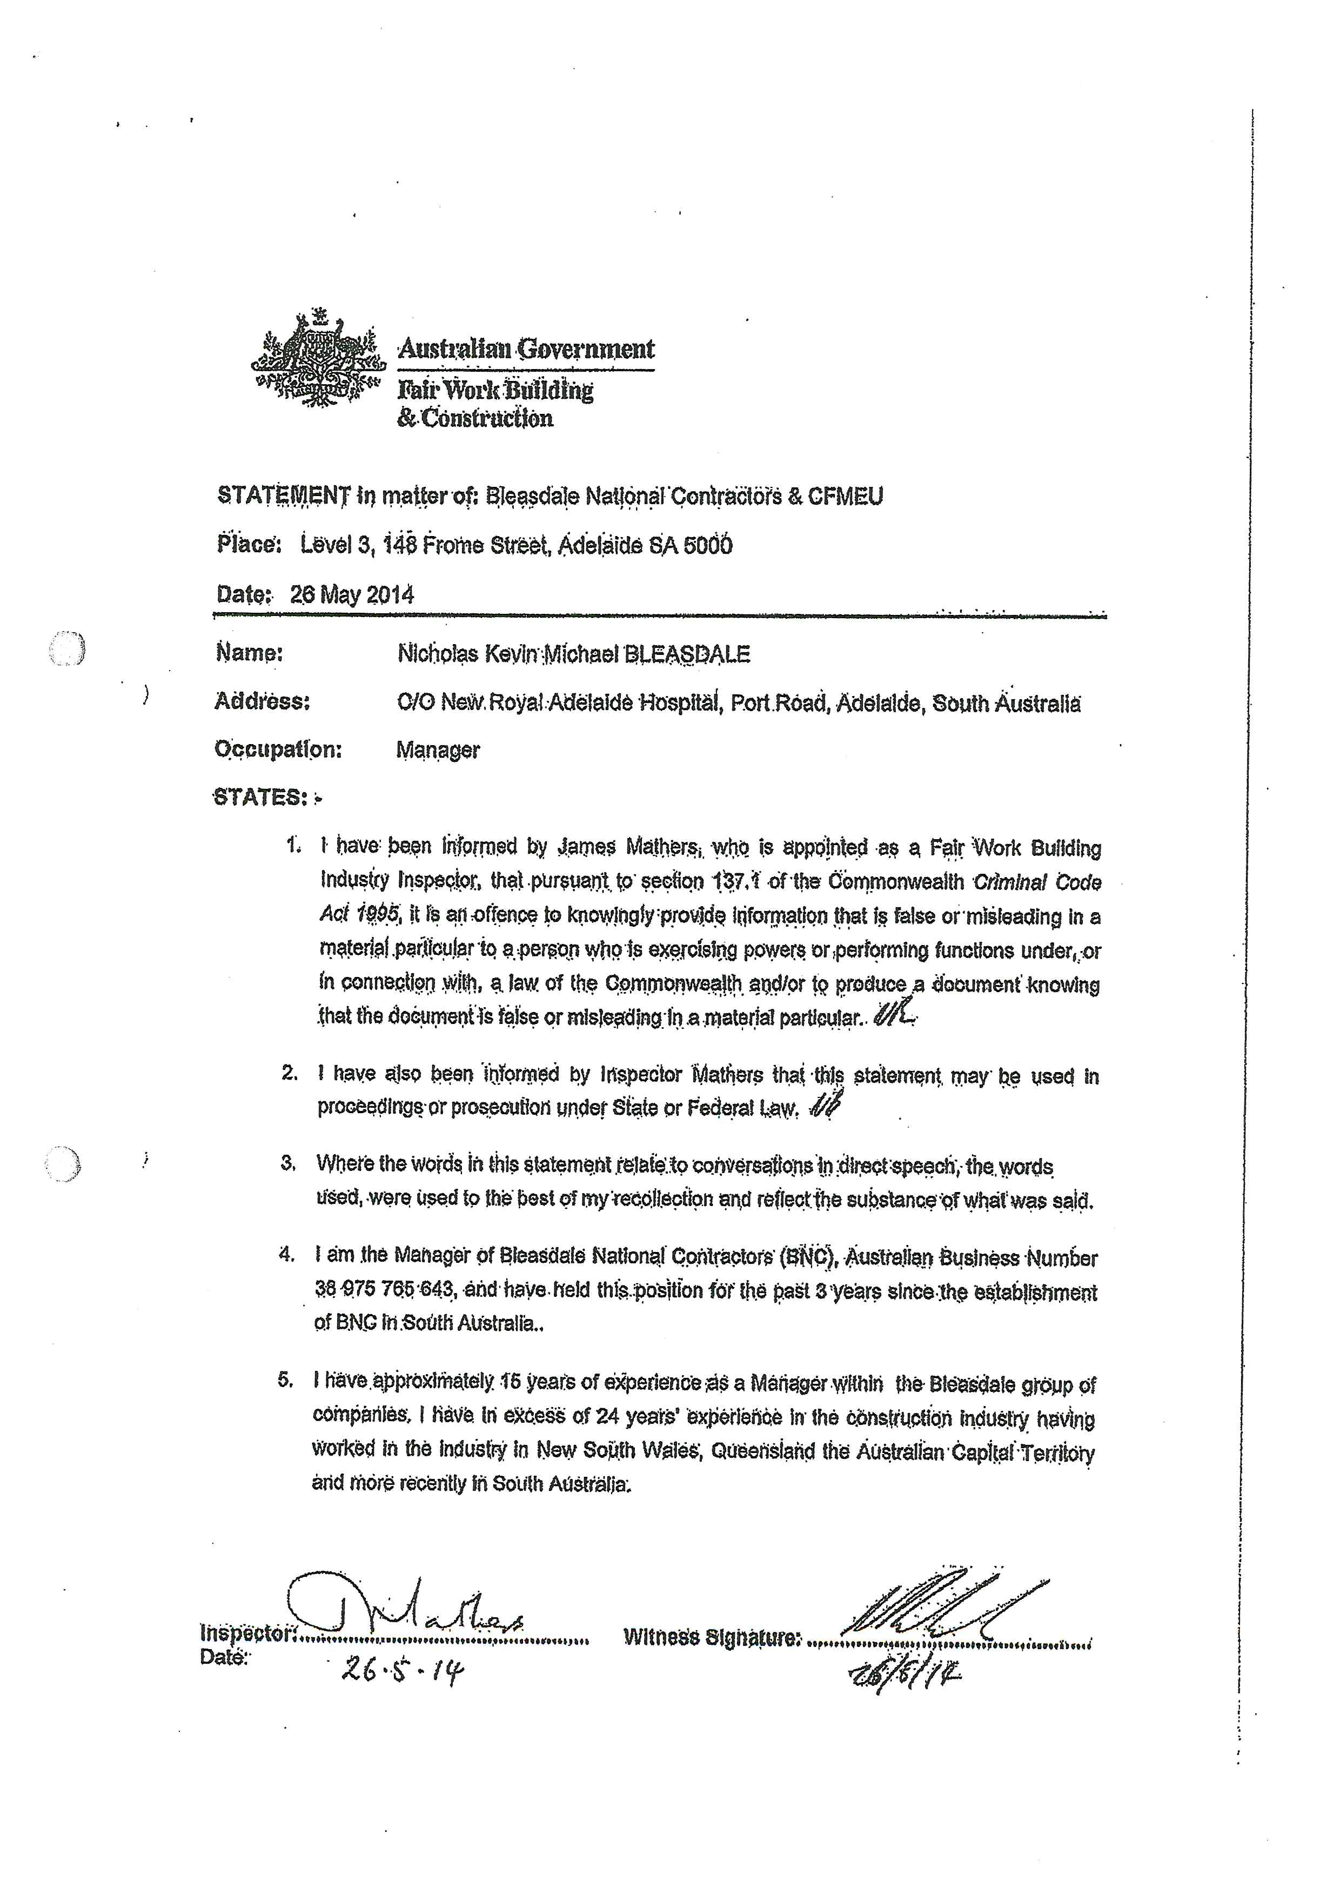

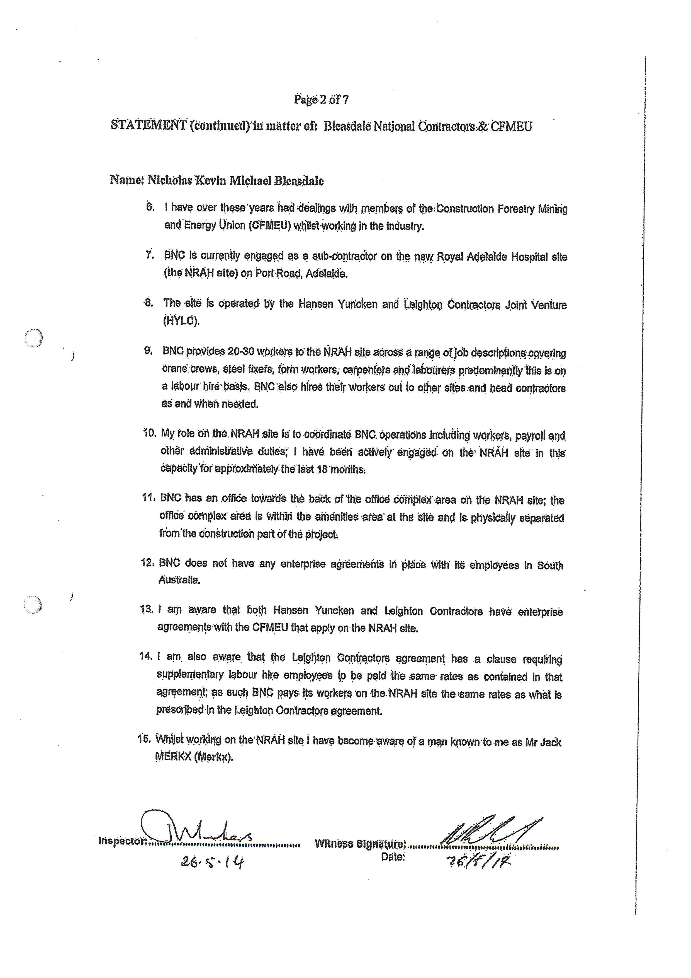

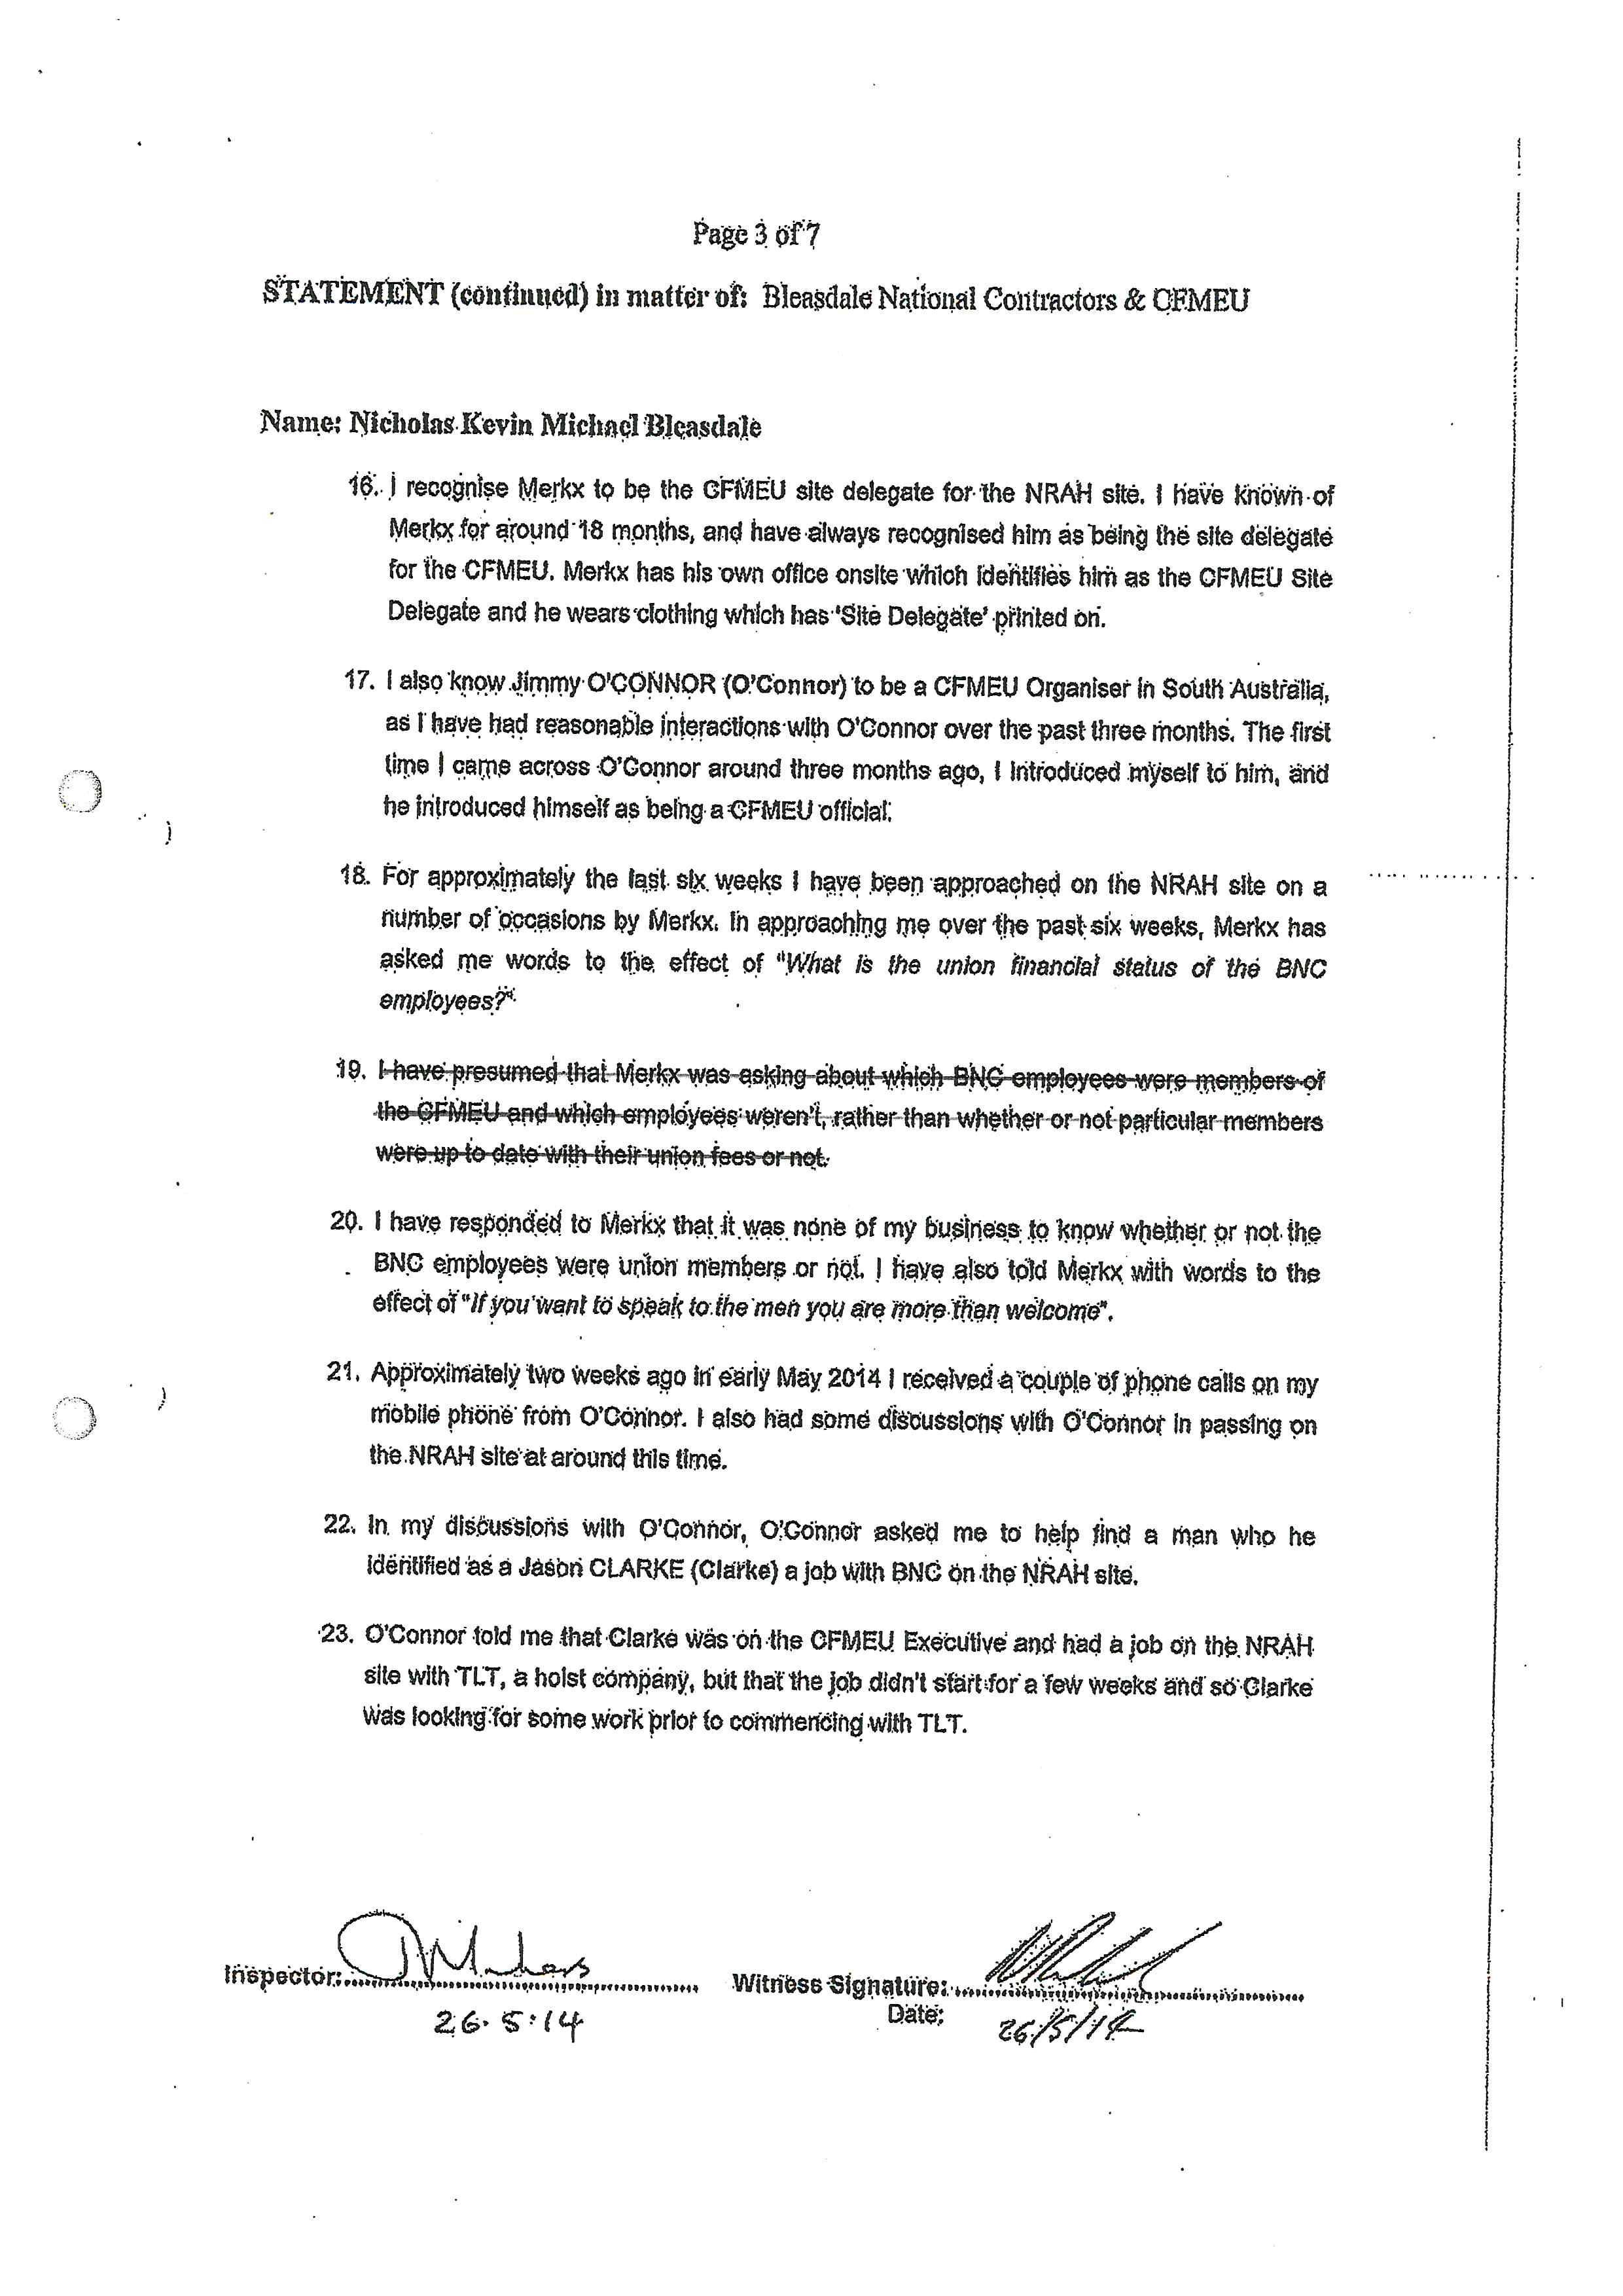

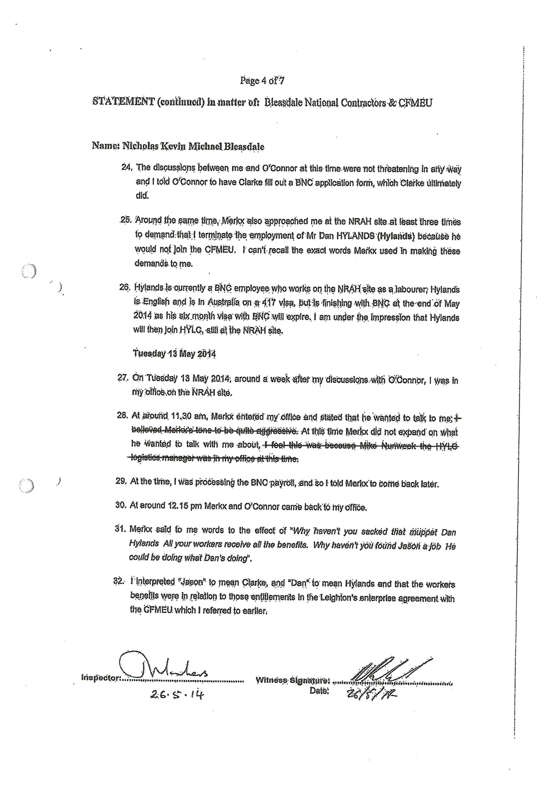

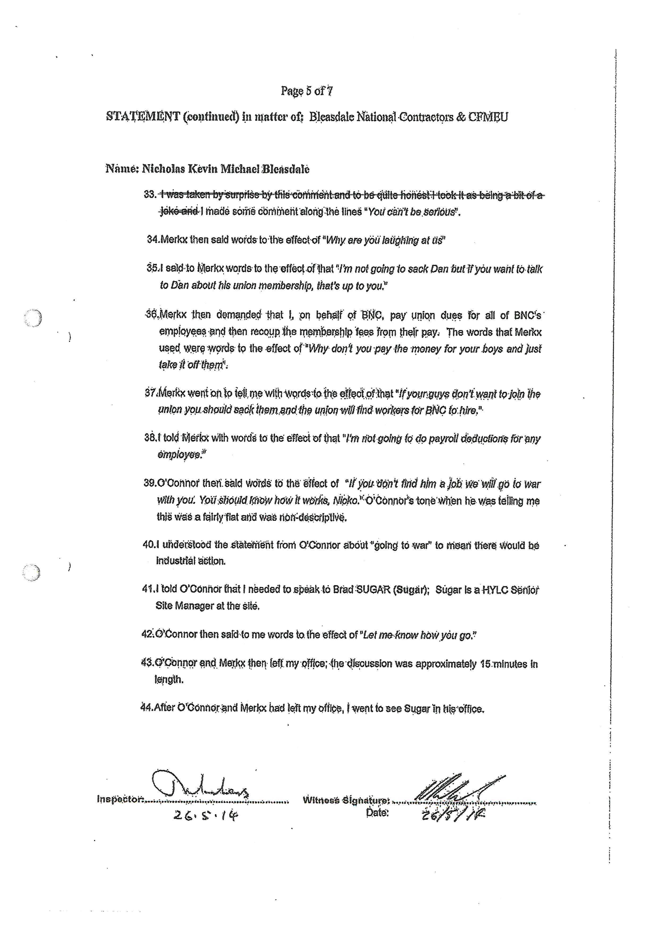

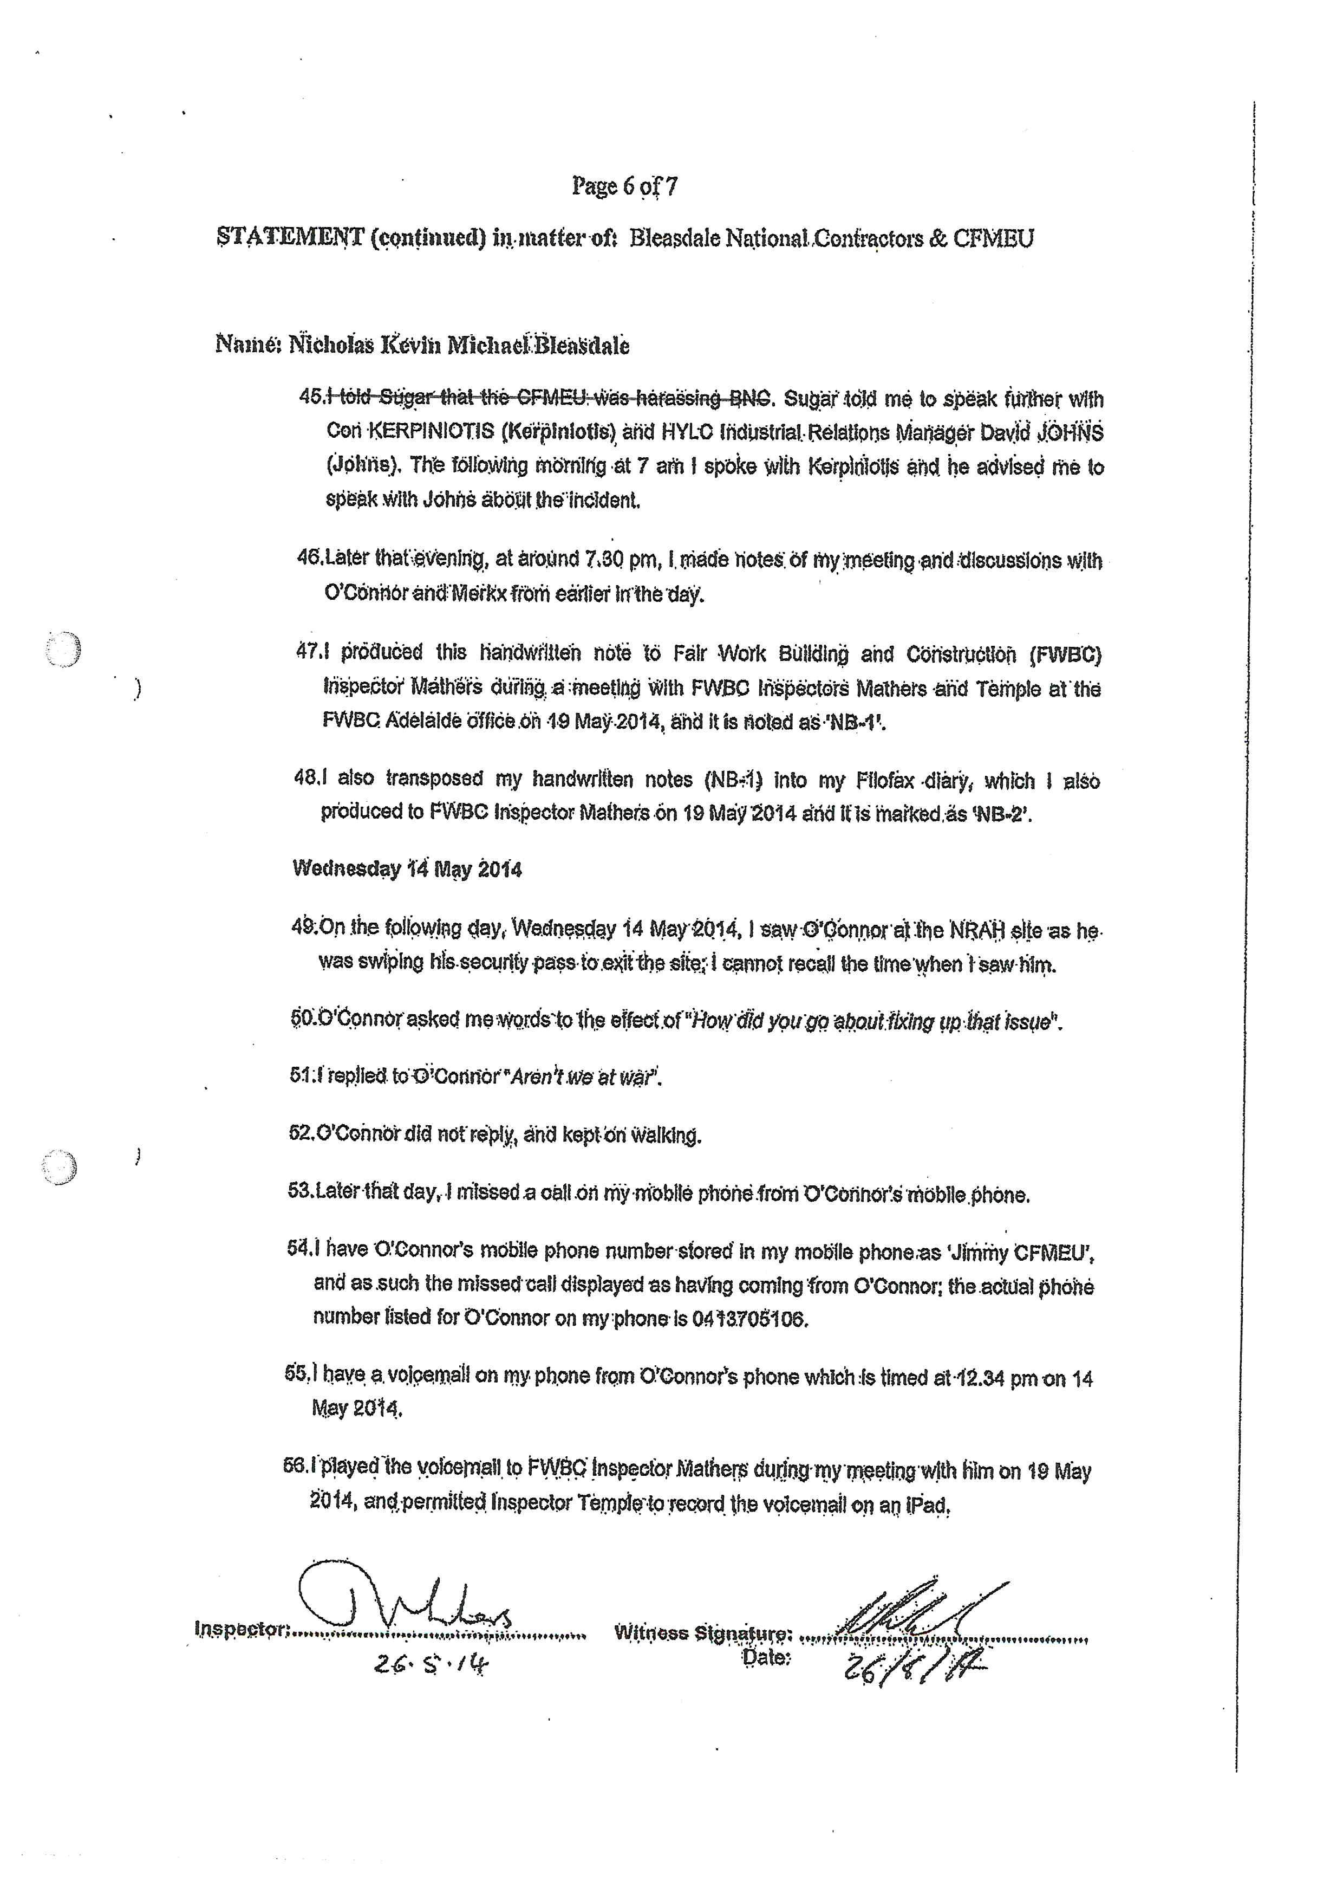

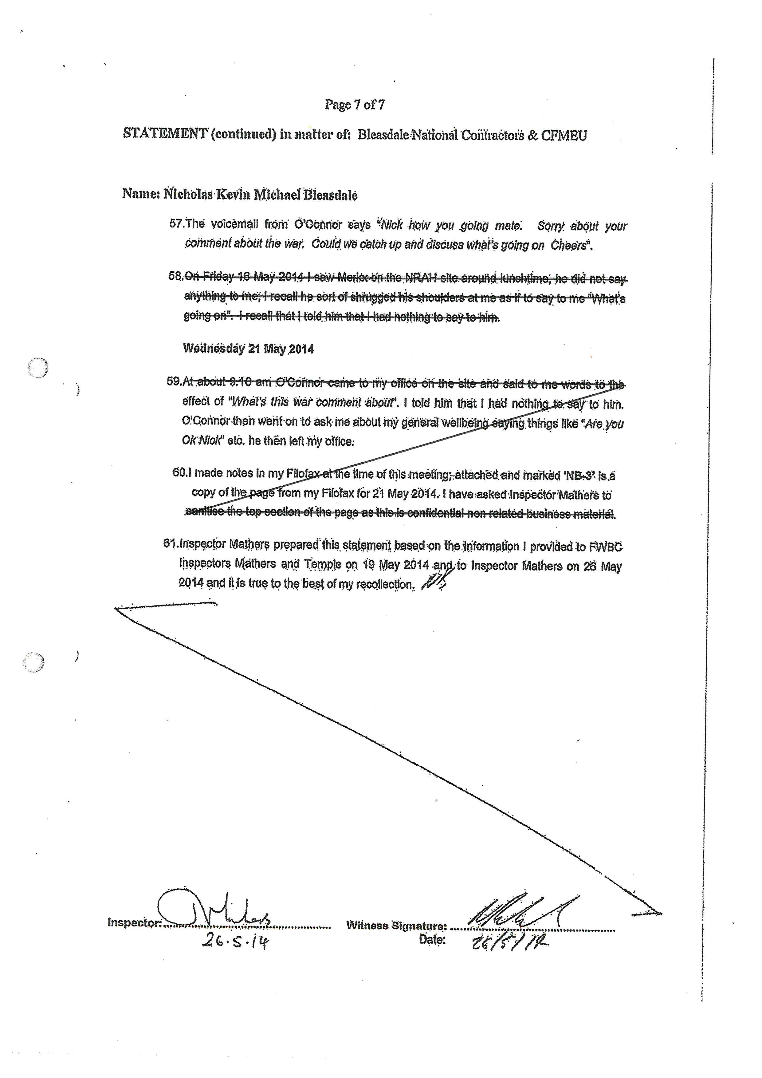

Annexure B
