FEDERAL COURT OF AUSTRALIA

Yaegl People #2 v Attorney General of New South Wales [2017] FCA 993

File number(s): | NSD 168 of 2011
Judge(s): | JAGOT J
Date of judgment: | 31 August 2017
Catchwords: | NATIVE TITLE – consent determination – offshore claim – agreement under s 87A of the Native Title Act 1993 (Cth)
Legislation: | Federal Court of Australia Act 1976 (Cth) ss 37M, 37N  Native Title Act 1993 (Cth) ss 55, 56, 64, 87, 87A, 225
Cases cited: | Mabo v Queensland (No 2) (1992) 175 CLR 1  Western Bundjalung People v Attorney General of New South Wales [2017] FCA 992  Yaegl People #1 v Attorney General of New South Wales [2015] FCA 647
Date of hearing: | 31 August 2017
Registry: | Sydney
Division: | General Division
National Practice Area: | Native Title
Category: | Catchwords
Number of paragraphs: | 21
Counsel for the Applicant: | S Phillips
Solicitor for the Applicant: | NTSCORP Limited
Counsel for the First Respondent: | V Hughston SC
Solicitor for the First Respondent: | Crown Solicitor’s Office
Solicitor for the Fourth Respondent: | S Davis of Australian Government Solicitors
Solicitor for the Fifth Respondent: | J Behrendt of Chalk and Behrendt

 |  | NSD 168 of 2011
BETWEEN: | LILLIAN WILLIAMS, RON HERON, VIVIENNE KING, EILEEN MCLEAY, JUDY BRECKENRIDGE, DEIDRE ANN RANDALL, WILLIAM WALKER, NOELINE KAPEEN, FERLIN LEE LAURIE, CLARENCE RANDALL, KEN LAURIE ON BEHALF OF THE YAEGL PEOPLE  Applicant
AND: | ATTORNEY GENERAL OF NEW SOUTH WALES  First Respondent  CLARENCE VALLEY COUNCIL  Second Respondent  RICHARD CROFTON  Third Respondent  THE COMMONWEALTH OF AUSTRALIA  Fourth Respondent  BIRRIGAN GARGLE LOCAL ABORIGINAL LAND COUNCIL  Fifth Respondent
ORDERS

JUDGE: | JAGOT J
DATE OF ORDER: | 31 AUGUST 2017

BEING SATISFIED that a determination of native title in the terms sought by the parties is within the power of the Court and, it appearing to the Court appropriate to do so by consent of the parties and pursuant to sections 87A(1) and (4) of the Native Title Act 1993 (Cth):

THE COURT NOTES THAT:
A. On 23 February 2011, the Applicant filed a native title determination application in accordance with sections 13(1) and 61 of the Native Title Act 1993 (Cth) in the Federal Court of Australia (proceeding NSD 168 of 2011) (the “Application”).
B. On 13 May 2015, the Court ordered that the Application insofar as it concerned the area west of the mean high water mark be designated as Yaegl People #2 Part A (the “Part A Application Area”) and insofar as it concerned the area east of the mean high water mark be designated as Yaegl People #2 Part B (the “Part B Application Area”).
C. On 25 June 2015, the Court made a determination in relation to the Part A Application Area (Yaegl People #1 v Attorney General of New South Wales [2015] FCA 647)
D. The parties have reached an agreement as to the terms of a determination which is to be made by consent in relation to the land or waters within the external boundaries of the Part B Application Area, that native title exists in relation to the:
(a) Inner Extent Native Title Area; and
(b) Outer Extent Native Title Area.
E. The terms of the agreement involve the making of orders by consent for a determination pursuant to sections 87A, and in accordance with section 94A, of the Native Title Act 1993 (Cth).
F. Pursuant to sections 87A(2) of the Native Title Act 1993 (Cth) the parties have filed a Minute of Proposed Consent Determination of Native Title which reflects the terms of the agreement.
G. The Applicant has nominated Yaegl Traditional Owners Aboriginal Corporation RNTBC pursuant to section 56(2) of the Native Title Act 1993 (Cth) to hold the determined native title in trust for the common law holders.
H. The Yaegl Traditional Owners Aboriginal Corporation RNTBC has consented in writing to hold the rights and interests comprising the native title in trust for the common law holders and to perform the functions of a registered native title body corporate under the Native Title Act 1993 (Cth).

THE COURT ORDERS THAT:
- There be a determination that native title exists in the terms set out below (“the Determination”).
- The native title as determined is to be held on trust by Yaegl Traditional Owners Aboriginal Corporation RNTBC.
- The Yaegl Traditional Owners Aboriginal Corporation RNTBC is to:
(a) be the prescribed body corporate for the purposes of section 57(1) of the Native Title Act 1993 (Cth);
(b) perform the functions set out in sections 56 and 57(1) of the Native Title Act 1993 (Cth) and the Native Title (Prescribed Bodies Corporate) Regulations 1999 (Cth); and
(c) hold the rights and interests from time to time comprising the native title in trust for the common law holders.
4. There be no order as to costs.

THE COURT DETERMINES THAT:
- Native Title exists in the Inner Extent Native Title Area described and depicted in the maps in Schedule One.
- Native Title exists in the Outer Extent Native Title Area described and depicted in the map in Schedule Two.
- To the extent of any inconsistency between the written description in Part A of Schedule One and the corresponding maps in Part B of Schedule One, the written description prevails.
- To the extent of any inconsistency between the written description in Part A of Schedule Two and the corresponding map in Part B of Schedule Two, the written description prevails.

Native title holders
5. Native title in the Determination Area is held by the Yaegl People who comprise all the descendants of the following apical ancestors:
(a) Dugald Cameron (who was born in Chatsworth Island around 1870);
(b) Jack Freeburn (who was born in Yamba around 1868);
(c) Sailor Morris (who was born in Chatsworth Island around 1831);
(d) Nodo Combo (who was born in Yamba around 1859); and
(e) Rose Combo nee Yamba and also known as Rosie Yamba (who was born in Yamba around 1856);
and persons adopted or incorporated into the families of those persons and who identify as and are accepted as Yaegl People in accordance with Yaegl traditional laws and customs (and the biological descendants of any such adopted or incorporated persons).

Nature and extent of native title rights and interests
6. Subject to paragraphs 9 and 10 the nature and extent of the native title rights in the Inner Extent Native Title Area described and depicted in the maps in Schedule One are:
(a) the right to access, to remain on and to traverse those areas;
(b) the right to access resources in those areas and to take, use, share, offer and exchange resources, including traditional trade, in those areas for non-commercial purposes;
(c) the right to maintain and to protect places, objects and areas of importance or significance under traditional laws and customs on those areas;
(d) the right to be accompanied on those areas by persons who, though not Native Title Holders, are:
(i) spouses, partners or parents of Native Title Holders, together with their children and grandchildren; or
(ii) people required under traditional laws and customs for the performance of cultural activities, practices or ceremonies; or
(iii) people requested by the native title holders to assist in, observe or record cultural activities, practices or ceremonies.
Note: ‘traditional trade’ as referred to in clause 6(b) of this determination does not expand the right to take and use the resources of the Inner Extent Native Title Area beyond “share and exchange”.
7. Subject to paragraphs 9 and 10, the nature and extent of the native title rights in the Outer Extent Native Title Area described and depicted in the map in Schedule Two are:
(a) the right to access, to remain on and to traverse those areas;
(b) the right to maintain and to protect places, objects and areas of importance or significance under traditional laws and customs on those areas;
(c) the right to be accompanied on those areas by persons who, though not Native Title Holders, are:
(i) spouses, partners or parents of Native Title Holders, together with their children and grandchildren; or
(ii) people required under traditional laws and customs for the performance of cultural activities, practices or ceremonies; or
(iii) people requested by the native title holders to assist in, observe or record cultural activities, practices or ceremonies.

General qualifications on native title rights and interests
8. Native title does not exist in:
(a) Minerals as defined in the Mining Act 1992 (NSW) and the Mining Regulation 2010 (NSW); and
(b) Petroleum as defined in the Petroleum (Onshore) Act 1991 (NSW) and the Petroleum (Submerged Lands) Act 1982 (NSW).
9. The native title rights and interests described in paragraphs 6 and 7 do not confer:
(a) possession, occupation, use and enjoyment to the exclusion of all others;
(b) any right to control access to, or use of, the Determination Area.
10. The native title rights and interests in the Determination Area are subject to and exercisable in accordance with:
(a) the laws of the State of New South Wales and of the Commonwealth;
(b) the traditional laws acknowledged and traditional customs observed by the Yaegl People; and
(c) the terms of any Indigenous Land Use Agreement, which may be registered by the National Native Title Tribunal in respect of any part of the Determination Area made after the making of this Determination.

The nature and extent of any Other interests
11. The Other Interests in the Determination Area are the interests described in Schedule Three.

Relationship between native title rights and Other Interests
12. Subject to paragraph 13, and except as otherwise provided by law, the relationship between the native title rights and interests in the Determination Area and the Other Interests is that:
(a) the Other Interests continue to have effect;
(b) the Other Interests co-exist with the native title rights and interests;
(c) the Native Title Holders do not have the right to control access to or the use of the land or waters by the holders of the Other Interests, and do not have any right to control access to and use of tidal waters; and
(d) to the extent of any inconsistency, the Other Interests and any activity that is required or permitted by or under the exercise of a right conferred or held under the Other Interests, while they are in existence, prevail over but do not extinguish the native title rights and interests and any exercise of those native title rights and interests.
13. The relationship between:
(a) the native title rights and interests in the land or waters which are transferred to an Aboriginal Land Council under the Aboriginal Land Rights Act 1983 (NSW) after the date of the Determination as a result of a claim lodged under that Act on or after 28 November 1994; and
(b) the Other Interests described in paragraph 1 of Schedule Three;
is that:
(i) pursuant to section 36(9) of the Aboriginal Land Rights Act 1983 (NSW), the Other Interests referred to in this paragraph shall be subject to any native title rights and interests existing in relation to the land or waters immediately before the transfer; and
(ii) the land or waters may only be dealt with by the Aboriginal Land Council in accordance with the Aboriginal Land Rights Act 1983 (NSW) and the Native Title Act 1993 (Cth).

Definitions
14. In this Determination, unless the contrary intention appears:
‘Application Area’ means the land or waters subject to native title determination application NSD168 of 2011.
‘Determination Area’ means the Inner Extent Native Title Area and the Outer Extent Native Title Area as described and depicted in the maps in Schedules One and Two.
‘Inner Extent Native Title Area’ means the land and waters described and depicted in blue outline in the maps in Schedule One.
‘land’ has the same meaning as in the Native Title Act 1993 (Cth).
‘laws of the State of New South Wales and of the Commonwealth’ include statutes, regulations and other subordinate legislation and the common law.
‘native title rights and interests’ means the rights and interests described in paragraphs 6 and 7.
‘Native Title Holders’ means the persons described in paragraph 5.
‘Outer Extent Native Title Area’ means the land and waters described and depicted in red hatching in the map in Schedule Two.
‘Yaegl People’ has the same meaning as Native Title Holders.
‘Yaegl Traditional Owners Aboriginal Corporation’ means Yaegl Traditional Owners Aboriginal Corporation RNTBC ICN 8254 incorporated under the Corporations (Aboriginal and Torres Strait Islander) Act 2006 (Cth).
‘Other Interests’ means the interests described in Schedule Three.
‘waters’ has the same meaning as in the Native Title Act 1993 (Cth).
15. If a word or expression is not defined in these orders or this Determination, but is defined in the Native Title Act 1993 (Cth) or the Native Title (New South Wales) Act 1994 (NSW), then it has the meaning given to it in the Native Title Act 1993 (Cth) or the Native Title (New South Wales) Act 1994 (NSW), whichever is relevant.

SCHEDULE ONE – Inner extent NATIVE TITLE area

PART A. Description of the Inner Extent Native Title Area
- The Inner Extent Native Title Area comprises all the land and waters described in paragraph 2 below and depicted in blue outline on the maps in Part B of Schedule One.
- All the land and waters, including the tidal waters, commencing at the intersection of the Mean High Water Mark of the South Pacific Ocean and the southern bank of Wooli River and extending generally northerly, generally north westerly and again generally northerly along that Mean High Water Mark, crossing the mouths of any waterways between the seaward extremities of each of the opposite banks of each such waterway to a point on the north eastern boundary of Wooded Bluff (Shark Bay) at Longitude 153.362980º East; then due east to a point on a 200 metre buffer east from the Mean Low Water Mark; then generally southerly along a 200 metre buffer east of the Mean Low Water to Latitude 29.887037° South; then westerly back to the commencement point, and includes, to the extent they fall within the external boundary of the Application Area, the following Part IDs/Part Lots and DPs:
State ID | Lot Plan / CADID Identifier
ID 353 | Lot 7049 DP1106980
ID 354 | Lot 7018 DP1108437
ID 355 | Lot 7017 DP1108436
ID 411 | Lot 7026 DP1114851
ID 482 | Lot 7031 DP1128361
ID 494 | Lot 7302 DP1140380
ID 497 | Lot 7303 DP1143443
ID 13522 | Unidentified CADID 104436443
ID 13524 | Unidentified CADID 104061042
ID 13427 | Unidentified CADID 163060516
ID 13525 | Unidentified CADID 104283360
ID 13526 | Unidentified CADID 163060515
ID 583 | Unidentified CADID 104061055
ID 586 | Unidentified CADID 104435828
ID 587 | Unidentified CADID 104061056

PART B. Map of the Inner Extent Native Title Area

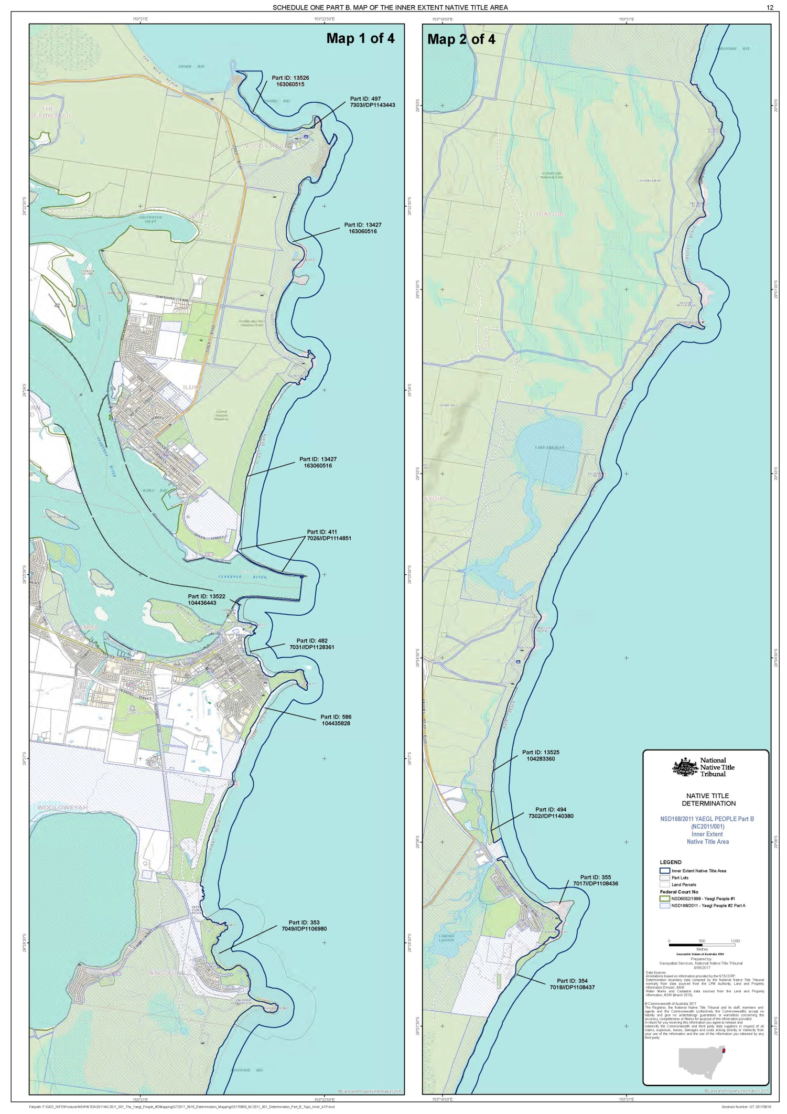
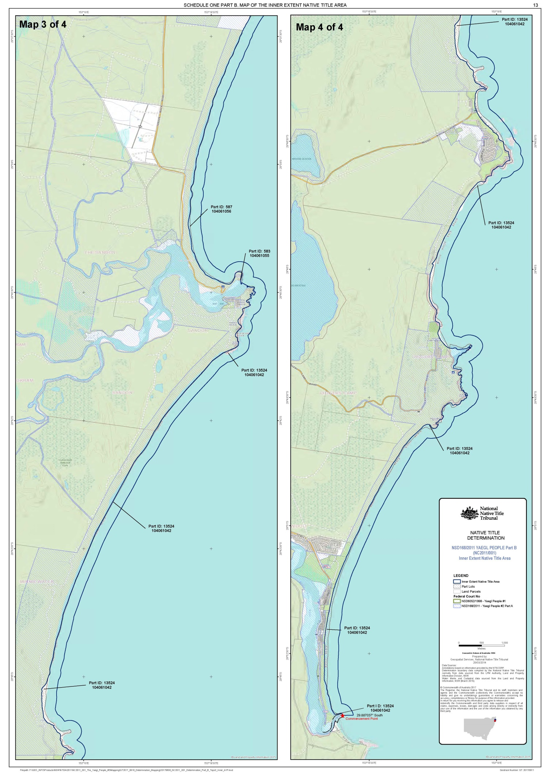
SCHEDULE TWO – Outer extent Native Title Area

PART A. Description of the Outer Extent Native Title Area
- The Outer Extent Native Title Area comprises all the land and waters described in paragraph 2 below and depicted in red hatching on the map in Part B of Schedule Two.
- All the land and waters, including the tidal waters, commencing at a point at the intersection of a 200 metre buffer east from the Mean Low Water Mark and the northern boundary of a 350 metre buffer of the dirrangun line, being a line joining the following coordinate points:
Longitude East | Latitude South
153.372580 | 29.429538
153.375933 | 29.429187
153.377821 | 29.426114

then generally north easterly, generally southerly and generally westerly and generally north westerly along the boundary of that 350m buffer to its intersection with again the 200 metre buffer east of the Mean Low Water Mark; then again generally easterly and generally northerly along that 200 metre buffer back to the commencement point.

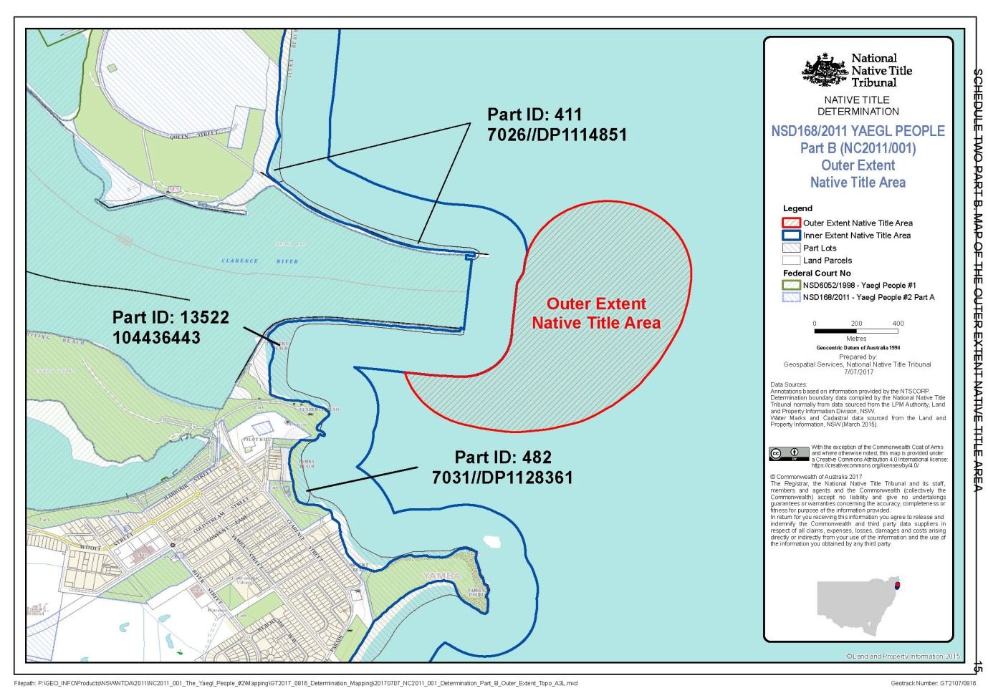
PART B. Map of the Outer Extent Native Title Area

SCHEDULE THREE – Other Interests

Other Interests in the Determination Area
The Other Interests, as they exist at the date of this Determination, are as follows:

Aboriginal Land Council interests
The rights and interests of Birrigan Gargle Local Aboriginal Land Council pursuant to undetermined Aboriginal land claims made under section 36 of the Aboriginal Land Rights Act 1983 (NSW) in respect of certain lands within the Determination Area, including the right to have each such claim determined according to law and, subject only to a determination that the land is claimable Crown land as defined in s 36(1) of Aboriginal Land Rights Act 1983 (NSW), the right to the transfer of an estate in fee simple pursuant to the Aboriginal Land Rights Act 1983 (NSW).

Reserves
(a) The rights of State, Local Government and other organisations or persons who have the care, control and management of any reserves within the Determination Area; and
(b) the rights of persons entitled to access and use reserves within the Determination Area for the purposes for which they are reserved, subject to any statutory limitations upon those rights.

Mining and Petroleum Interests
  - The rights of the holders of any mining interests.
  - The rights of holders of any petroleum interests.

Water Interests
The rights of any holder as at the date of this determination of any licences or permissive occupancies granted under the Water Act 1912 (NSW) and the Water Management Act 2000 (NSW).

Fishing Interests
The rights of the holders from time to time of leases, licences and permits granted or issued under the Fisheries Management Act 1994 (NSW) and associated regulations.

National Park Interests
  - The rights of the holders from time to time of leases, licences and permits granted or issued under the National Parks and Wildlife Act 1974 (NSW) and associated Regulations.
  - Other rights and interests under the care, management and control of the NSW Office of Environment and Heritage.

Electricity and Energy Supply Interests
  - The rights and interests of an electricity or energy supply authority within the meaning of the Electricity (Consumer Safety) Act 1995 (NSW) and the Energy Services Corporations Act 1995 (NSW) to exercise functions, powers or rights in accordance with the laws of the State of New South Wales or of the Commonwealth and as owner and operator of facilities for the transmission of electricity and other forms of energy and associated infrastructure situated on the Determination Area including but not limited to the right to enter the Determination Area in order to access, use, maintain, repair, replace, upgrade or otherwise deal with existing facilities and infrastructure.
  - The rights and interests of:
(i) a network operator within the meaning of the Electricity Supply Act 1995 (NSW); and
(ii) for the purposes of any privatisation transaction, any lessor or lessee of a transmission system or person who owns or is authorised to control or operate a transmission system, to exercise functions, powers or rights in accordance with the laws of the State of New South Wales or of the Commonwealth as operator of facilities for the transmission of electricity and other forms of energy and associated infrastructure situated on the Determination Area including but not limited to the right to enter the Determination Area in order to access, use, maintain, repair, replace, upgrade or otherwise deal with existing facilities and infrastructure.

Local Government Interests
The rights and interests of Clarence Valley Council as a council constituted under the Local Government Act 1993 (NSW).

Commonwealth interests
The rights and interests of the Commonwealth.

Other interests generally
(a) Rights and interests, including licences and permits, granted by the Crown in right of the State of New South Wales, the Clarence Valley Council or of the Commonwealth pursuant to statute or under regulations made pursuant to such legislation.
(b) Rights and interests held by reason of the force and operation of the laws of the State of New South Wales or of the Commonwealth.
(c) Rights and interests of members of the public arising under common law or statute including, but not limited to the following:
(i) any public right to fish;
(ii) the public right to navigate; and
(iii) the international right of innocent passage through the territorial sea.
(d) So far as is confirmed pursuant to section 18 of the Native Title (New South Wales) Act as at the date of the Determination, any existing public access to and enjoyment of:
(i) waterways;
(ii) the bed and banks or foreshores of waterways;
(iii) coastal waters;
(iv) beaches;
(v) stock routes; and
(vi) areas that were public places at the end of 31 December 1993.
(e) The rights of:
(i) an employee, agent or instrumentality of the State of New South Wales;
(ii) an employee, agent or instrumentality of the Commonwealth;
(iii) an employee, agent or instrumentality of any Local Government Authority,
to access the Determination Area and carry out actions as required in the performance of his/ her or its statutory or common law duty.

Note: Entry of orders is dealt with in Rule 39.32 of the Federal Court Rules 2011.

REASONS FOR JUDGMENT
JAGOT J
- On 25 June 2015 I said this in Yaegl People #1 v Attorney General of New South Wales [2015] FCA 647:
Today, at last, the Yaegl People will be recognised as having that which they always in truth had – but which remained unrecognised by the common law of Australia – native title rights and interests in the land within the claim area.
- As we know these words related to the land within the area claimed in the claims of the Yaegl People filed in 1996 and 2011, but not the waters identified in the 2011 claim over which the Yaegl People claimed native title rights and interests under their traditional laws and customs.
- Accordingly, as at 25 June 2015, it was acknowledged and declared in the orders of the Court that all of the land in the claim area to the immediate west of the mean high water mark of the ocean bordering the land within the claim area was, at sovereignty, the land of the Yaegl People and had continued thereafter to be the land of the Yaegl People under the Yaegl People’s traditional laws and customs, with the consequence that under the laws of Australia, specifically the Native Title Act 1993 (Cth) (the NTA), the continuing native title rights and interests of the Yaegl People could be recognised. The continuation of the claimed native title rights and interests in the waters to the immediate east of the mean high water mark alone remained for future determination.
- The sea claim, as it was called, was supported by extensive material. For example, Deidre Russell was taught by her elders that the waters bordering Yaegl land were also Yaegl country. She described dreaming stories relating to these waters including about the Dirrangun which all Yaegl People know and which explains the rocks you can see offshore. She explained traditional fishing customs and rules, and protection of the beach and the reef from degradation which was a necessary part of caring for Yaegl country. She explained the rules about being on country including the beaches and waters. She explained why certain sites have spiritual significance. Her evidence of the continuing connection of the Yaegl People to the sea was detailed and convincing. The same can be said of the statements of others, including Carmel Charlton and Ferlin Laurie.
- The evidence of the Yaegl people which supported the claim thus showed how the sea forms part of their lives, permeates their culture, and is an integral part of their rich traditional customs and laws, explaining how this landscape was created and how it must be treated and cherished. The Yaegl People have their own laws and customs of the sea and those laws and customs continued to inform and enrich their daily lives. The Yaegl People ensure these laws and customs continue through their oral tradition, speaking elder to younger.
- The existence, nature and extent of the claimed rights remained in issue, however. Various orders were made and, as has regrettably become common place in native title matters in New South Wales, extensions of time were granted to clarify the positions of the State and the Commonwealth about the sea claim. By 2 December 2016 a negotiated agreement had been achieved recognising that the traditional connection of the Yaegl People had continued in relation to the inter-tidal zone, 200 metres east of the mean low water mark, and in the vicinity of the Dirrangun 920 metres east of the mean low water mark and within 350 metres of all points surrounding the Dirrangun. Tenure issues were also effectively resolved by 2 December 2016.
- Despite this, and the parties being ahead of schedule at this time, the kinds of problems we see frequently in native title matters in New South Wales meant that the due date for the filing of all material also had to be extended. On 4 October 2016, I ordered the parties to file all material on which they wished to rely for the making of the consent determination by 17 July 2017. This was extended until 4 August 2017. By 4 August 2017, however, it was apparent that the parties would not comply despite the extension. Three matters were listed for urgent directions on that day, this proceeding, that of the Barkandji People, and that of the Western Bundjalung People. All were scheduled for consent determination hearings. The course of that case management hearing disclosed what I have referred to in my reasons for judgment in relation to the Western Bundjalung native title claim (Western Bundjalung People v Attorney General of New South Wales [2017] FCA 992) as apparently systemic incapacities, primarily on the part of the State, to comply with orders in native title proceedings. Senior counsel appeared for the first respondent and, based on his submissions, another extension of time for the filing of all relevant material was granted until 9 August 2017. While the agreement and proposed consent determination were filed as ordered, the material in support from the applicant was not. I should say that this delay, by the applicant represented by NTSCORP Limited, strikes me as atypical of NTSCORP’s approach to compliance with Court orders.
- Nevertheless, while the exigencies of litigation resulting in occasional delays is accepted, the timely filing of material necessary to enable the Court to consider whether it can and should make a consent determination is essential. While nothing that has occurred in this matter appears to approach the circumstances of the Western Bundjalung case, the following should not be overlooked because it discloses the operation of a system consistent with that identified in the Western Bundjalung reasons for judgment:
- The applicant provided connection material accompanying its claim in 2011. Further material was filed relating to the sea claim in November 2014 and yet further material again (some of which is referred to above) was filed in April 2016, including historical and anthropological reports.
- Three sets of submissions were provided by the applicant to the State in support of the sea claim between September and November 2016, including another outline of evidence.
- The State commissioned no less than five reports or papers from its in-house experts about the sea claim between April and October 2016.
- The State obtained no less than six advices from counsel, including four involving senior counsel, between April and November 2016.
- The consent determination recognises native title rights and interests of the Yaegl People in two areas, referred to as the Inner Extent Native Title Area and the Outer Extent Native Title Area. The rights in both areas are non-exclusive rights in the Yaegl People to access, remain on and traverse the areas (accompanied by certain other persons) and to maintain and protect places, objects and areas of importance or significance under traditional laws and customs of the Yaegl People, with the only difference between the two areas being the recognition of the additional native title right in the Inner Extent Native Title Area to access resources in the area for non-commercial purposes.
- The significance of the recognition of these rights of the Yaegl People, the first consent determination relating to the sea in New South Wales, cannot be overstated. It is a manifestation of the stated intention in the Preamble to the NTA to “rectify the consequences of past injustice” to Aboriginal and Torres Strait Islanders and to “ensure that Aboriginal peoples and Torres Strait Islanders receive the full recognition and status within the Australian nation to which history, their prior rights and interests, and their rich and diverse culture, fully entitle them to aspire”. The Preamble to the NTA leaves us in no doubt about what those past injustices were, identifying that:
The people whose descendants are now known as Aboriginal peoples and Torres Strait Islanders were the inhabitants of Australia before European settlement.
They have been progressively dispossessed of their lands. This dispossession occurred largely without compensation, and successive governments have failed to reach a lasting and equitable agreement with Aboriginal peoples and Torres Strait Islanders concerning the use of their lands.
As a consequence, Aboriginal peoples and Torres Strait Islanders have become, as a group, the most disadvantaged in Australian society.
- All of this occurred under the doctrine of terra nullius, rejected in its application to Australia by the High Court in Mabo v Queensland (No 2) (1992) 175 CLR 1.
- As I have said before, this context places a special obligation on those involved in the resolution of native title claims to ensure they discharge their duties consistently with the overarching purpose of the civil litigation procedures.
- The overarching purpose of the procedures for civil litigation is to facilitate the just resolution of disputes according to law as quickly, inexpensively and efficiently as possible (s 37M(1) of the Federal Court of Australia Act 1976 (Cth)). By s 37M(2) the overarching purpose includes the following objectives:
(a) the just determination of all proceedings before the Court;
(b) the efficient use of the judicial and administrative resources available for the purposes of the Court;
(c) the efficient disposal of the Court's overall caseload;
(d) the disposal of all proceedings in a timely manner;
(e) the resolution of disputes at a cost that is proportionate to the importance and complexity of the matters in dispute.
- Section 37N of the Court Act provides that:
(1) The parties to a civil proceeding before the Court must conduct the proceeding (including negotiations for settlement of the dispute to which the proceeding relates) in a way that is consistent with the overarching purpose.
(2) A party’s lawyer must, in the conduct of a civil proceeding before the Court (including negotiations for settlement) on the party's behalf:
(a) take account of the duty imposed on the party by subsection (1); and
(b) assist the party to comply with the duty.
- In Yaegl #1 I said this at [5]:
The kind of delays which have been experienced in native title matters entrench injustice over generations. How sad, indeed how shameful it is, that in many of these matters the people who started the claim often become too aged or infirm to see the matter through or pass away, never having seen their labours bear fruit. Delay of this kind saps away any sense of justice or fairness in the process. It erodes confidence in the institutions which are meant to serve our common interests. It can instil a sense of despair and incapacity in those who should be actively engaged in and empowered by the process.
- Has this dispute been resolved in an efficient and timely manner and at a cost that is proportionate to the importance and complexity of the matters in dispute? Given that it took from 2011 until 2017 for the sea claim to be resolved, and resolution appears to have involved such a substantial commitment of resources, I doubt it. An ultimate outcome which is substantively just is nevertheless unjust if to get to it takes too long or consumes too many resources. As I said in the Western Bundjalung reasons for judgment it would be wrong to conceive of the State’s duty as one of protecting the public interest as if the public interest excluded the legitimate interests of native title claimants; claimants are part of the community for which the State is responsible and to whom it owes its duties and to conceive of the public interest as if it were in opposition to native title rights and interests is contrary to the provisions of the NTA, particularly the stated object in the Preamble.
- One other matter should be noted at this stage. The agreement in question is made under s 87A of the NTA which applies to an agreement “in relation to an area (the determination area) included in the area covered by the application” (s 87A(1)(b)). This section is to be understood with s 64(1B) of the NTA which provides that:
An application is taken to have been amended to reduce the area of land or waters covered by the application if an order is made under section 87A by the Federal Court. The area of land or waters is reduced by the area in relation to which the order is made.
- These provisions indicate that where there has been a determination over part of a claim area and all that remains to be determined is the balance of the claim area, the applicable provision is s 87 rather than s 87A of the NTA. This indication is supported by s 87A(3) which requires “notice to the other parties to the proceeding that the proposed determination of native title has been filed with the Court”, the assumption apparently being that in the case of an agreement under s 87A the parties to the agreement may not be all of the parties to the proceeding (an assumption that cannot be correct where, as here, the agreement relates to all land in the extant claim area). Needless to say after seven years of negotiations between the parties, I am prepared to proceed under s 87A, the requirements of which are satisfied but I raise this for consideration as different practices exist around Australia.
- In terms of s 87A, all pre-conditions are satisfied. There is a proceeding. The notification period which was 27 July 2011 to 26 October 2011 has expired. Agreement has been reached on a proposed determination of native title in relation to an area included in the area covered by the application. All of the parties to the proceeding are parties to the agreement. The agreement has been filed, as have the terms of the proposed consent determination. The Federal Court Chief Executive Officer has given notice to the other parties to the proceeding that the proposed determination of native title has been filed with the Court. The orders are consistent with the agreement and are within the power of the Court and are appropriate. The native title rights and interest in the waters off the coast of Yaegl country should be recognised in Australian law consistent with the provisions and objectives of the NTA.
- Otherwise, the terms of the determination satisfy the requirements of s 225 of the NTA. The requirements of ss 55 and 56 of the NTA are also satisfied in that the Yaegl Traditional Owners Aboriginal Corporation RNTBC will hold the determined native title in trust for the common law holders and will perform the functions of a registered native title body corporate under the NTA.
- The final matter I will say is this. The claims pursued by the Yaegl People since November 1996 are at last resolved today. But for the fortitude, tenacity and courage of the Yaegl People, and those who have assisted them, they could not have achieved this outcome. But should we be surprised? The Yaegl People are part of a continuous culture which has occupied this continent for 60,000 years. They were here for millennia before European settlement. They developed their connection with country over those millennia. The injustices to which they have been subjected as a result of the legal and practical dispossession effected by European settlement did not bring their connection to an end. The land and waters the subject of these determinations are recognised to be Yaegl country over which the Yaegl People have rights and interests under their traditional laws and customs. The Yaegl People have endured. May this and the previous determination from 2015 go some way to achieving the object of the NTA that the Yaegl People “receive the full recognition and status within the Australian nation to which history, their prior rights and interests, and their rich and diverse culture, fully entitle them to aspire”.

I certify that the preceding twenty one (21) numbered paragraphs are a true copy of the Reasons for Judgment herein of the Honourable Justice Jagot.

Associate:

Dated: 31 August 2017

