FEDERAL COURT OF AUSTRALIA

QBE Insurance (Australia) Ltd, in the matter of Division 3A of Part III of the Insurance Act 1973 (Cth) & QBE Insurance (Australia) Ltd (No 2) [2016] FCA 288

File number: | NSD 1225 of 2015
Judge: | ALLSOP CJ
Date of judgment: | 30 March 2016
Catchwords: | INSURANCE — general insurance — transfer of general insurance business from one insurer to another group entity — application for confirmation of scheme — order for transfer of reinsurance contracts
Legislation: | Employment Act 1988 (NI) s 9(1)(h)  Insurance Act 1973 (Cth) ss 17A-17G
Cases cited: | Gordian RunOff Limited, in the matter of Insurance Australia Limited (No 2) [2011] FCA 1116  Application of Sompo Japan Insurance Inc. under the Insurance Act 1973 (Cth) (No 2) [2014] FCA 677  Re Royal & Sun Alliance Life Assurance Ltd [2000] FCA 1259; 104 FCR 37  Re Westport Insurance Corporation (No 2) [2009] FCA 1598; 181 FCR 530  QBE Insurance (Australia) Ltd in the matter of Division 3A of Part III of the Insurance Act [2015] FCA 1223
Date of hearing: | 2 March 2016
Registry: | New South Wales
Division: | General Division
National Practice Area: | Commercial and Corporations
Sub-area: | Commercial Contracts, Banking, Finance and Insurance
Category: | Catchwords
Number of paragraphs: | 84
Counsel for the Applicant: | N J Owens
Solicitor for the Applicant: | Dibbs Barker
Solicitor for the Australian Prudential Regulation Authority: | R Claxton

ORDERS
 |  | NSD 1225 of 2015
IN THE MATTER OF DIVISION 3A OF PART III OF THE INSURANCE ACT 1973 (CTH) & QBE INSURANCE (AUSTRALIA) LTD
QBE INSURANCE (AUSTRALIA) LTD ACN 003 191 035
Applicant
JUDGE: | ALLSOP CJ
DATE OF ORDER: | 30 MARCH 2016

THE COURT ORDERS THAT:

Norfolk Island Scheme
In relation to the proposed scheme for the transfer of the Norfolk Island insurance business of QBE Insurance (International) Limited (QII) to the Applicant (the Norfolk Island Scheme):
- Pursuant to s 17F of the Insurance Act 1973 (Cth), the Norfolk Island Scheme, in the form of Annexure A to these orders, be confirmed without modification.
- The Applicant pay the costs of APRA in connection with the hearing of the application to confirm the Norfolk Island Scheme and also in connection with the hearing of the Applicant’s interlocutory application heard on 5 November 2015, as agreed or assessed.
- The Effective Date for the purposes of the Scheme is to be 1 April 2016.

QBE Re Scheme
In relation to the proposed scheme for the transfer of the QBE Re and Sydney Re insurance business of QII to the Applicant (the QBE Re Scheme):
1. Pursuant to s 17F of the Insurance Act 1973 (Cth), the QBE Scheme, in the form of Annexure B to these orders, be confirmed without modification.
2. Pursuant to s 17F(2) of the Insurance Act 1973 (Cth), all of QII’s outwards reinsurance that responds to any casualty reinsurance contract transferred pursuant to the QBE Re Scheme, and all rights and obligations attaching to such reinsurance, be transferred to the Applicant.
3. The Applicant pay the costs of APRA in connection with the hearing of the application to confirm the QBE Re Scheme and also in connection with the hearing of the Applicant’s interlocutory application heard on 5 November 2015, as agreed or assessed.

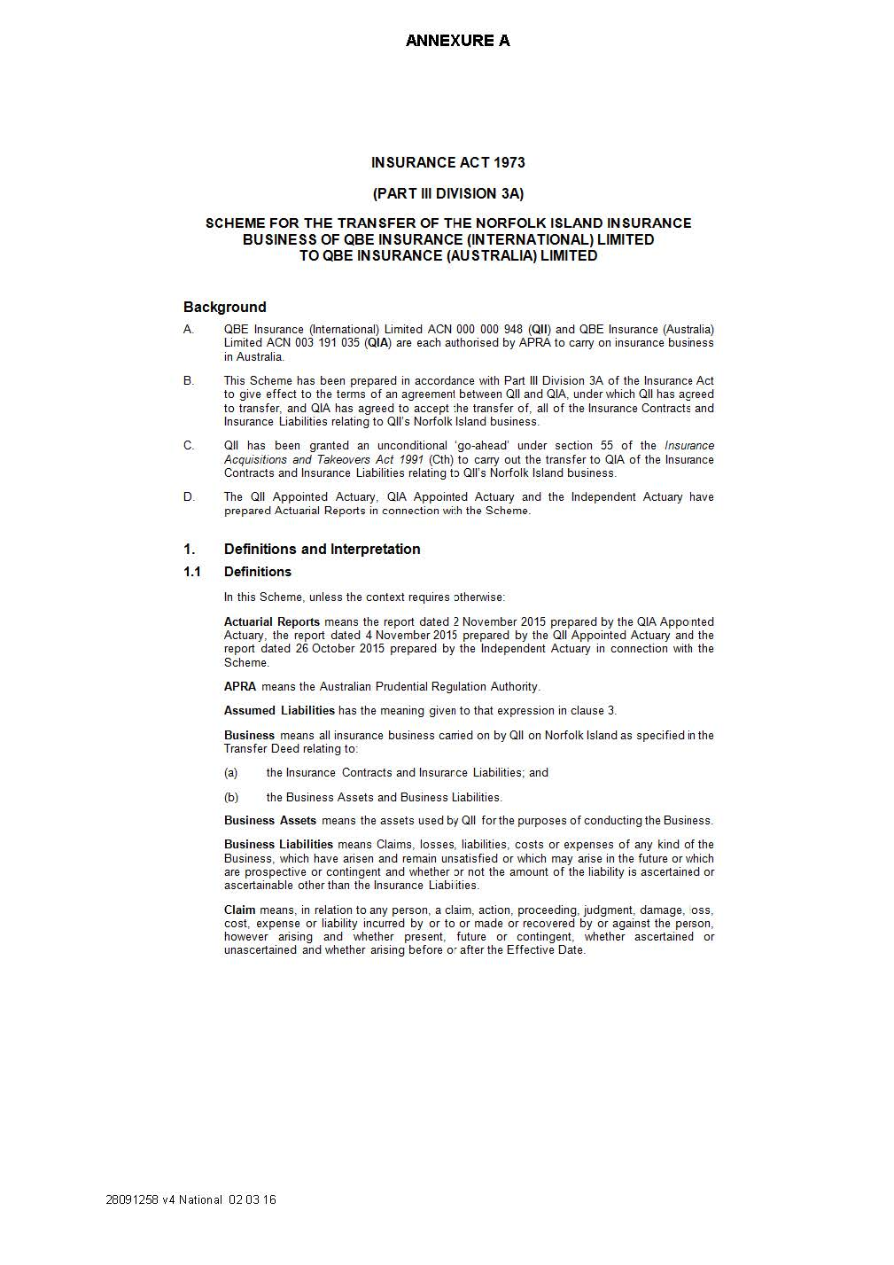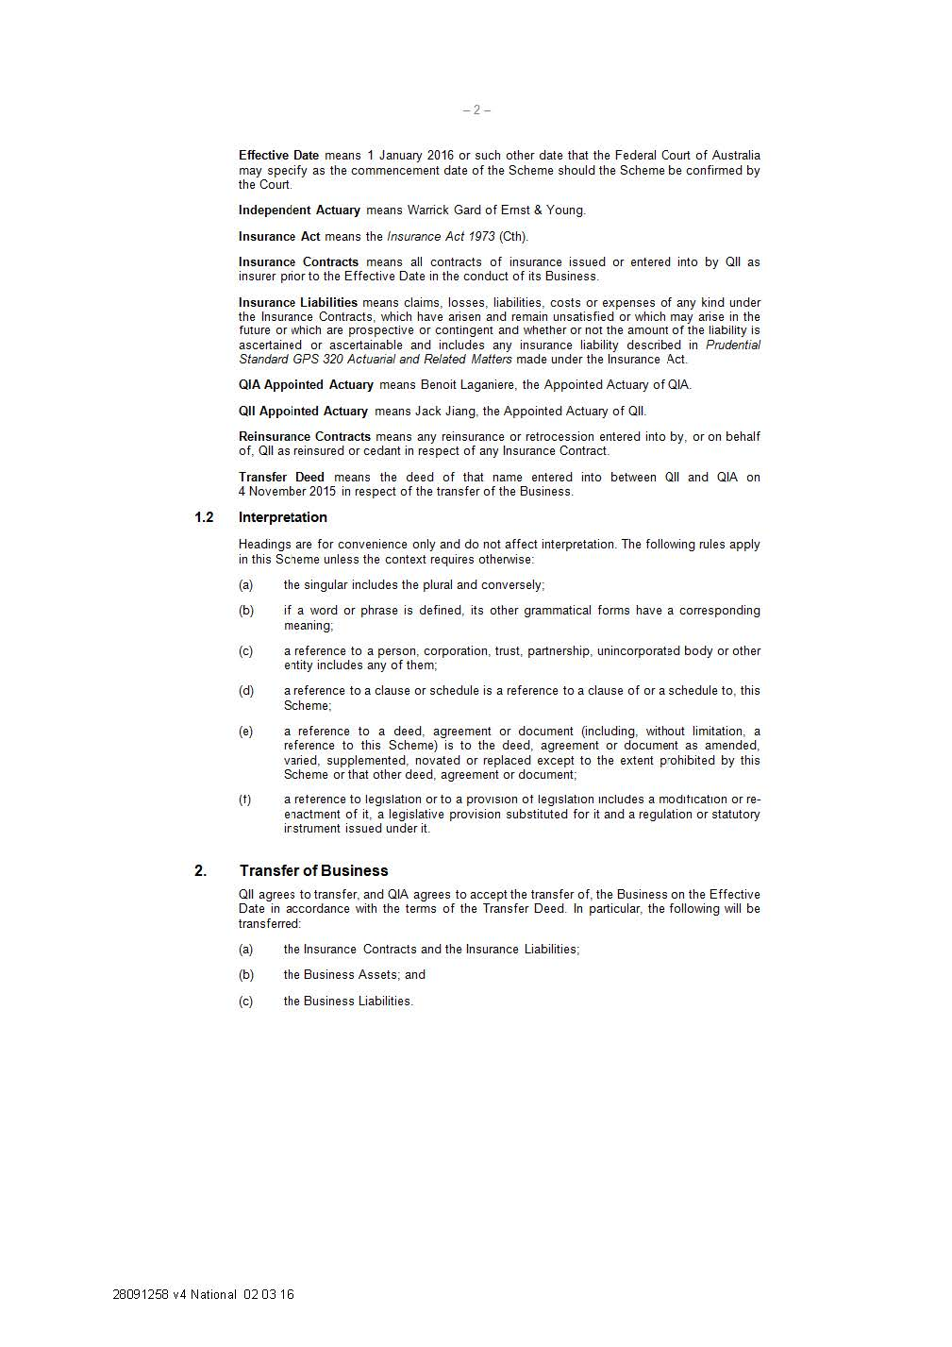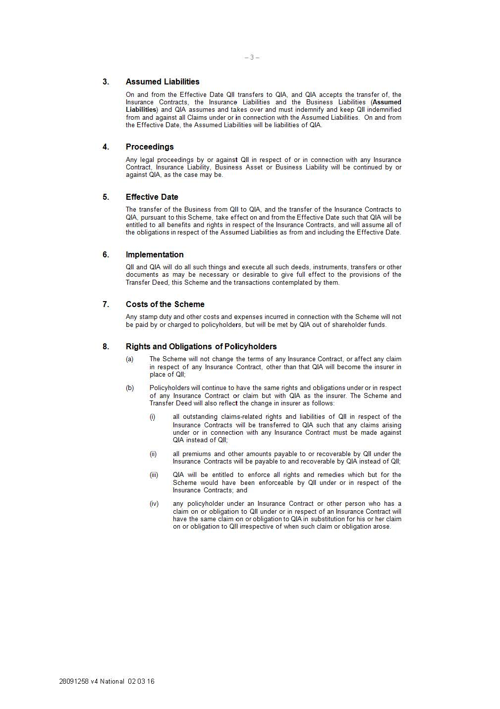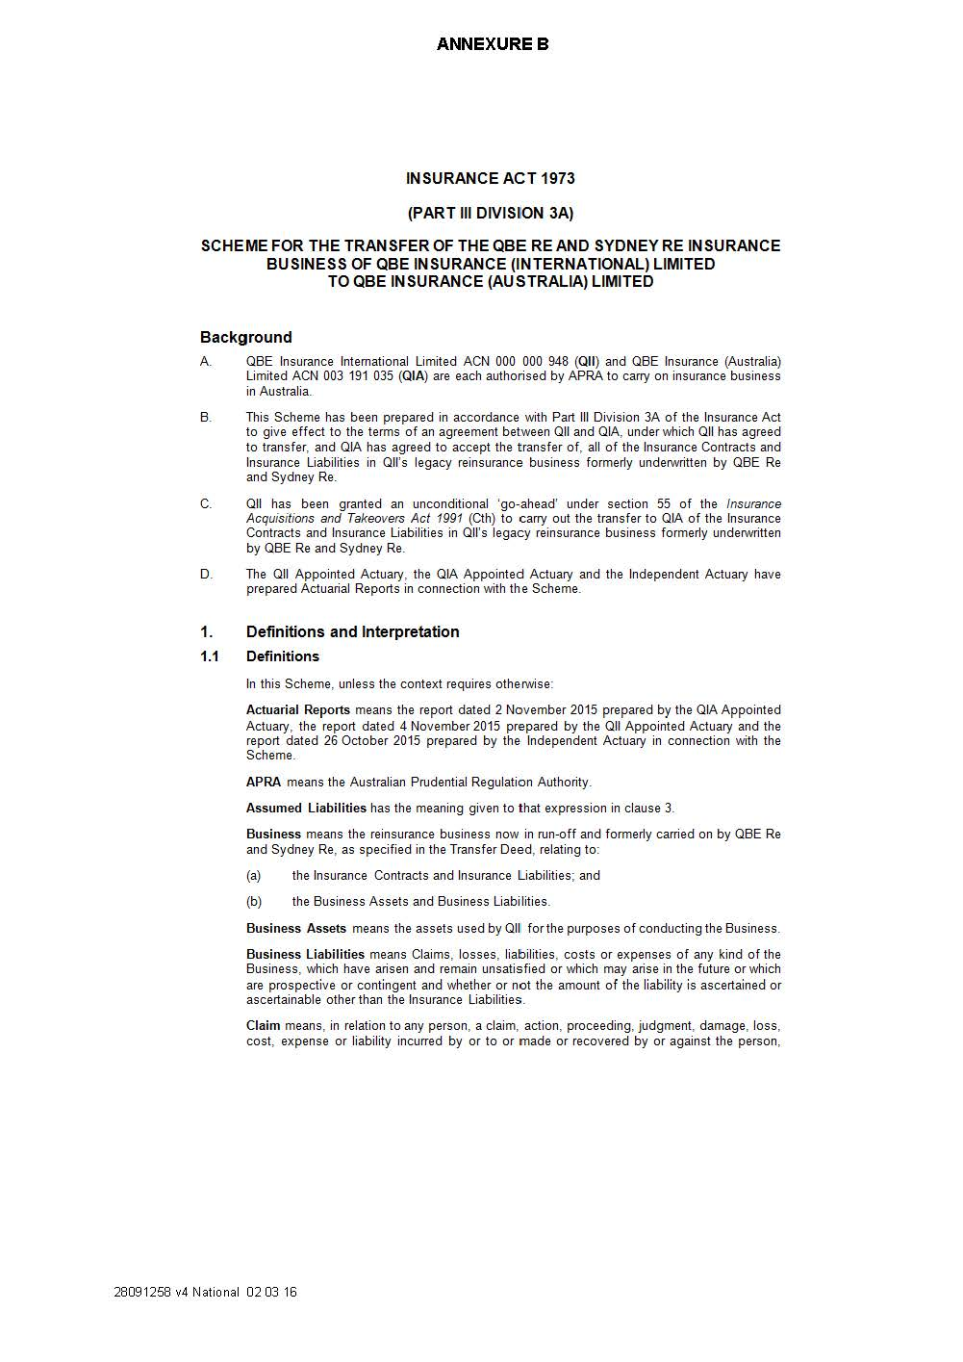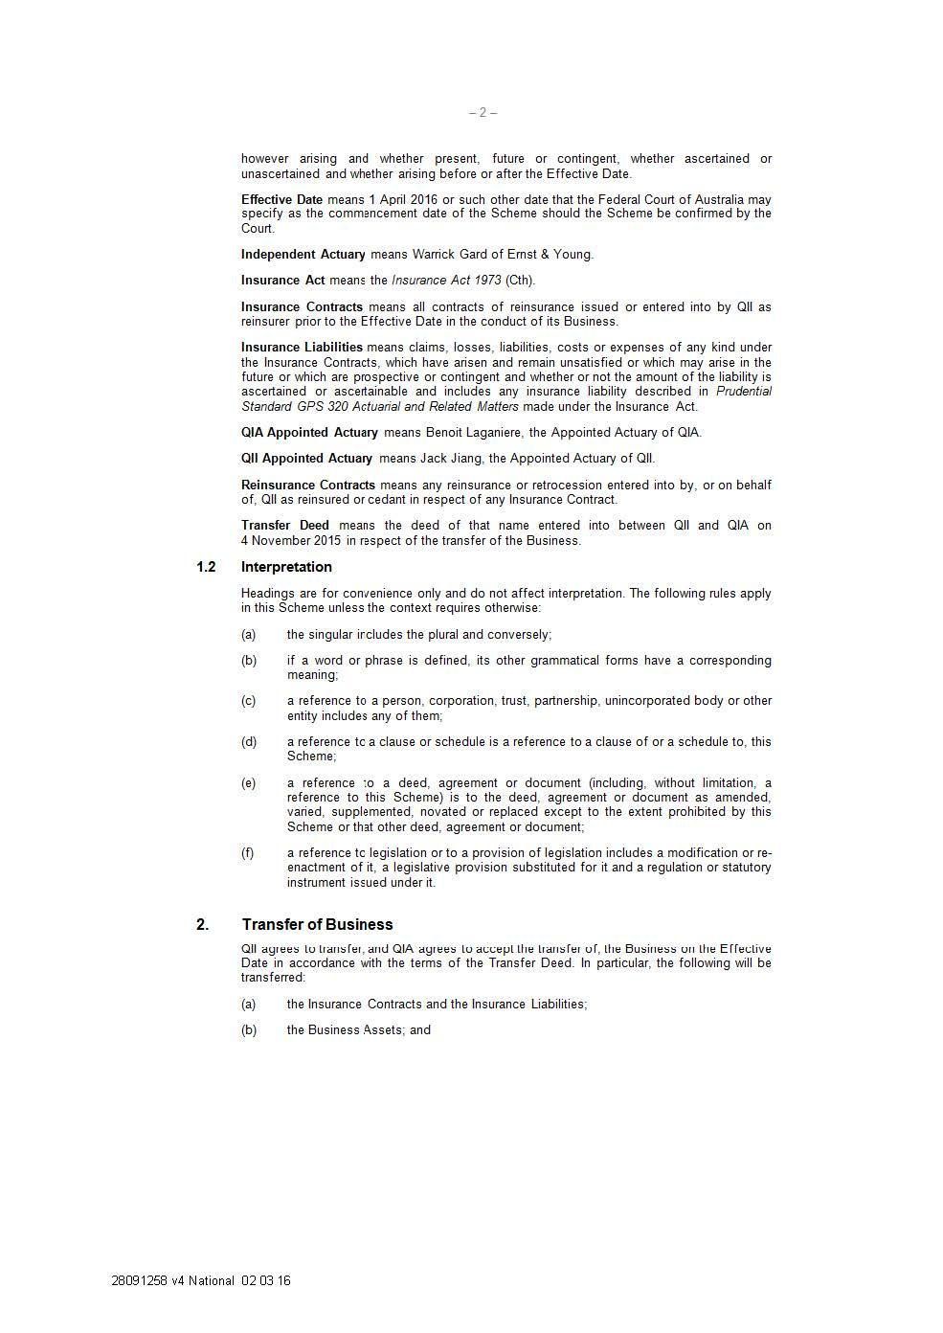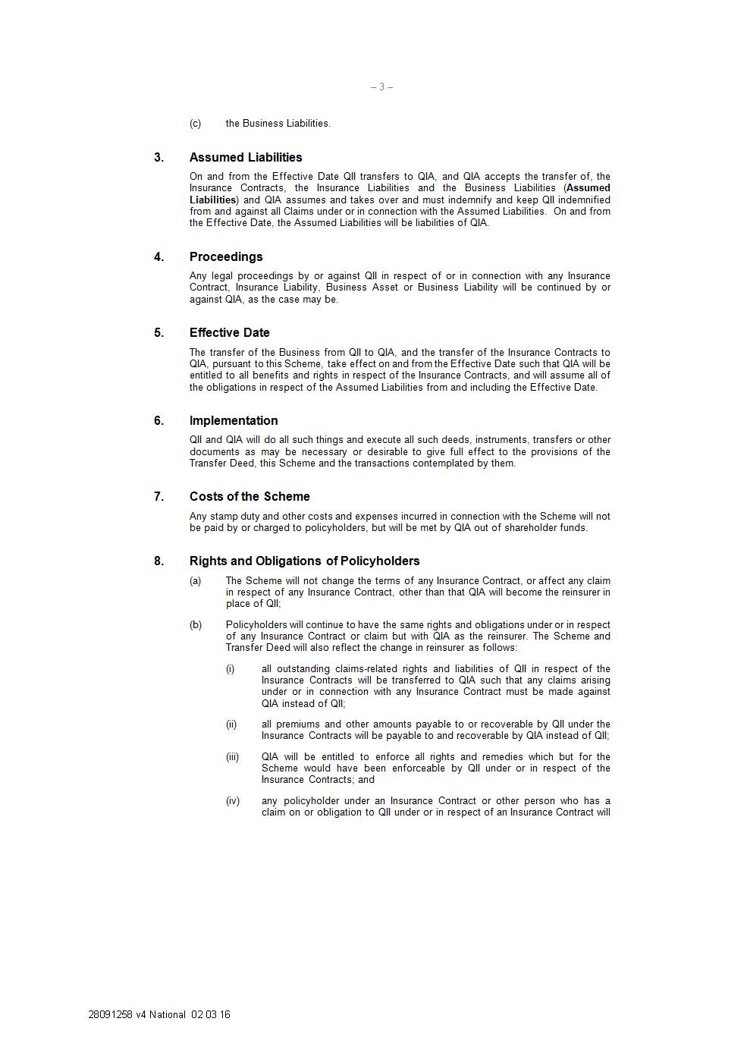

REASONS FOR JUDGMENT
ALLSOP CJ:

BACKGROUND
- This is an application made by QBE Insurance (Australia) Limited (QIA) under Division 3A of Part III of the Insurance Act 1973 (Cth) (the Act). The Applicant seeks orders for confirmation of two schemes which involve the transfer of parts of the general insurance business of QBE Insurance (International) Limited (QII) to the Applicant.
- The first scheme (the Norfolk Island Scheme) involves the transfer of all of the business of QII where the insured risk is located on Norfolk Island. The classes of insurance in that business broadly could be described as short-tail business comprising home and motor vehicle insurance as well as some commercial insurance.
- The second scheme (the QBE Re Scheme) involves the transfer of a legacy reinsurance business, which was written originally either by QII under the trading name QBE Re Asia Pacific, or by other insurers (Sydney Re or Reinsurers Pty Ltd), and that was subsequently assumed by QII.
- Both the Norfolk Island Scheme and the QBE Re Scheme constitute part of a wider reorganisation sought to be undertaken by the QBE group of companies. One aspect of that reorganisation is to streamline the group’s operations so that all Australian business will be located inside QIA.

THE RELEVANT ENTITIES
- Both QII and QIA are Australian corporations and wholly-owned subsidiaries of QBE Insurance Group Limited. Both are authorised under s 12 of the Act to carry on insurance business in Australia.

QII
- QII writes general insurance business through branches in Asia and the Pacific.
- The Norfolk Island business represents a very small part of its operations. In 2014, it represented less than 0.18% of the total net earned premium of QII in that year of $338,200,000.
- QBE Re has been in runoff since 2003. It previously wrote treaty and facultative reinsurance.
- The following is relevant business and financial information about QII.
- As at 31 December 2014, QII had total assets of $1,588,500,000 and total liabilities of $1,081,200,000 (of which $600,000 were referable to the Norfolk Island business). The net asset position of QII therefore was $507,300,000. Its capital base was $470,900,000 and its solvency coverage ratio was 228%. Its capital base was calculated pursuant to the Australian Prudential Regulation Authority’s (APRA’s) Prudential Standard GPS 110 Capital Adequacy (Prudential Standard GPS 110). Prudential Standard GPS 110 is made under s 32 of the Act and seeks to ensure that general insurers maintain the required level and quality of capital.
- As at 31 December 2015, QII had total assets of $1,294,904,000 and total liabilities of $868,404,000. Its net asset position was therefore $426,500,000. Its capital base, calculated pursuant to Prudential Standard GPS 110, was $408,775,000 and its solvency coverage ratio was 257%.
- APRA evaluates the Internal Capital Adequacy Assessment Process (ICAAP) of a regulated institution and takes supervisory action if dissatisfied with the quality of an ICAAP. QII’s ICAAP targets a solvency ratio of 180% to 220% at all times.

QIA
- QIA writes most general insurance classes of business in Australia.
- The following is relevant business and financial information about QIA.
- As at 31 December 2014, QIA had total assets of $9,261,900,000 and total liabilities of $7,262,800,000. Its net asset position therefore was $1,999,100,000. Its capital base, calculated pursuant to Prudential Standard GPS 110, was $2,193,500,000 and its solvency coverage ratio was 169%.
- As at 31 December 2015, QIA had total assets of $9,709,418,000 and total liabilities of $7,560,588,000. Its net asset position therefore was $2,148,830,000. Its capital base, calculated pursuant to Prudential Standard GPS 110, was $2,287,167,000 and its solvency coverage ratio was 164%.
- QIA’s ICAAP targets a solvency ratio of 160% to 180% at all times.

THE LEGISLATIVE FRAMEWORK
- The legislative framework under which the present application is made is set out in ss 17A to 17G of the Act.
- Section 17B(1) of the Act provides that no part of the insurance business of a general insurer may be transferred to another general insurer or amalgamated with the business of another general insurer except under a scheme confirmed by the Court.
- Section 17E(1) provides that any of the bodies corporate affected by a scheme may apply to the Court for confirmation of such a scheme and s 17E(2) requires such an application to be made in accordance with prudential standards. 17E(3) entitles APRA to be heard on an application.
- The steps to be taken before an application for confirmation can be heard are set out in s 17C(2).
- Under s 17F(1) the Court may confirm the scheme without modification, confirm the scheme subject to such modifications as it thinks appropriate, or refuse to confirm the scheme.

THE DISCRETION TO CONFIRM THE SCHEMES
- Section 17F(1A) sets out several factors to which the Court must have regard when deciding whether to confirm a scheme. These include:
  - the interests of the policyholders of a body corporate affected by the scheme; and
  - if a report relevant to all or part of the scheme has been filed with the Court under s 62ZI—that report; and
  - any other matter the Court considers relevant.
- Sub-section (b) does not apply to the circumstances of these schemes.
- Sub-section (a) requires the Court not only to consider the interests of the policyholders of the Norfolk Island business and of QBE Re, but also the interests of the policyholders of the transferee company, in this case the existing policyholders of QIA. In particular, the Court will ask whether the implementation of the scheme will materially detrimentally affect any of the relevant policyholders: Re Westport Insurance Corporation (No 2) [2009] FCA 1598; 181 FCR 530 at 535 [32].

Factors Relevant to the Exercise of the Discretion

The Pre- and Post-Transfer Solvency Position of QIA and QII
- In considering the way in which the two schemes will affect the interests of the policyholders of QII and QIA as required by s 17F(1A), actuarial evidence as to the pre- and post-transfer solvency position of both QIA and QII is of central significance.
- The principal report is the independent actuarial report of 26 October 2015 prepared by Mr Warrick Evan Gard of Ernst & Young. That report outlines the assets (including the reinsurance assets) and liabilities being transferred from QII to QIA under the proposed schemes and sets out Mr Gard’s opinion on the changes in solvency of QII and QIA and the impact on the security and the contractual rights of the policyholders that will arise from those transfers.
- From 16 February 2016 to 25 February 2016, Mr Gard received documents, forms and other data sources which updated the financial and capital information on QII and QIA that was previously available to him.
- That body of information included the following information pertaining to QII:
(a) QII Insurance Liability Valuation Report as at 31 December 2015;
(b) QII audited financial statements as at 31 December 2015;
(c) APRA Form 110 detailing QII's capital position as at 31 December 2015; and
(d) Pro-forma APRA Form 110 detailing QII's capital position as at 1 January 2016 after the transfer of QII’s New Zealand insurance business to QIA on 1 January 2016; the transfer by QII of AUD 182 million of its assets to QIA; the expected transfer out of the Norfolk Island and the QBE Re businesses; and the transfer out of the Vietnam and Thailand subsidiaries of QII.
- It also included the following information pertaining to QIA:
(a) QIA Insurance Liability Valuation Report as at 31 December 2015;
(b) QBE New Zealand Insurance Liability Valuation Report as at 31 December 2015;
(c) QIA audited financial statements as at 31 December 2015;
(d) APRA Form 110 detailing QIA's capital position as at 31 December 2015; and
(e) Draft QIA Internal Capital Adequacy Assessment Process Report (draft ICAAP Report) which contained a summary of the Pro-forma APRA Form 110 detailing QIA's capital position as at 1 January 2016 after the transfer of QII’s New Zealand insurance business to QIA on 1 January 2016; the transfer by QII of AUD 182 million of its assets to QIA; and the expected transfer out of the Norfolk Island and the QBE Re businesses.
- The further affidavit of Mr Gard, sworn 26 February 2016, summarises his findings in light of this updated information.
- Mr Gard notes in this further affidavit that as at 31 December 2015, the solvency coverage ratio:
(a) of QII was 257% with excess capital of AUD 250 million above the APRA required minimum; and
(b) of QIA was 164% with excess capital of AUD 896 million above the APRA required minimum.
- Mr Gard estimates that when the transfer of the New Zealand business, the transfer of AUD 182 million of assets, and the expected transfers of the Norfolk Island Scheme and the QBE Re Scheme and the Vietnam and Thailand subsidiaries are taken into account, the solvency coverage ratio as at 1 January 2016:
(a) of QII will become 263% with excess capital of AUD 138 million above the APRA required minimum; and
(b) of QIA will become 170% with excess capital of AUD 1,022 million above the APRA required minimum.
- The affected policyholders are estimated to experience a change in solvency ratio in the following ways:
(a) For transferring QII policyholders, the solvency coverage ratio of their insurer will fall from 257% to 170%; and
(b) For existing QIA policyholders, the solvency coverage ratio of their insurer will rise from 164% to 170%.
- One relevant issue here is whether these impacts on the solvency ratio will detrimentally affect the interests of the transferring Norfolk Island and QBE Re policyholders.
- Mr Gard states in his affidavit, sworn 26 February 2016, that in his opinion the transferring policyholders of QII would experience no material disadvantage under either scheme. He notes that while the QII solvency margin is currently higher than the target range in the QII management plan, this does not necessarily afford additional security to policyholders. Mr Gard considers that the QII target range and QIA target range will provide a comparable level of security to policyholders, noting that the higher QII target range addresses the additional risk borne by a smaller entity with less predictable earnings. He further points out that the QIA solvency margin is within its target range as set out in the QIA capital management plan.
- As noted in the affidavit of Mr Gard, sworn 26 February 2016, the actuarial report of 26 October 2015 was prepared before the updated information referred to above at [29] and [30] was received by Mr Gard.
- Mr Gard states that while the updated information provides further certainty around the financial and solvency impact of the transfers of the Norfolk Island and QBE Re businesses on QII and QIA, it does not alter any of the conclusions made by him in the actuarial report to the effect that the schemes will not have a materially adverse impact on the solvency or policyholders of QII and QIA.
- In the report of 26 October 2015, Mr Gard noted the immateriality of the transferred assets and liabilities of the Norfolk Island and QBE Re businesses, which represent around or less than 1% of the assets and liabilities of QII and QIA as at 31 December 2014 and the date on which the proposed transfers are effective. The solvency impact of the transfers on QII and QIA is likely to be minimal. Further, the report also states that the Norfolk Island and QBE Re policyholders will benefit from the transfer as QIA has significantly more net assets than QII. Further, the fact that QIA has a larger capital base and a more diversified balance sheet than QII may lead to a lower probability of its breaching regulatory capital requirements than QII. This may constitute a further benefit for the transferring Norfolk Island and QBE Re policyholders.
- Mr Jack Kai Jiang, Chief Actuary Asia Pacific for QII and Mr Benoit Laganiere, Head of Actuarial and Reinsurance at QBE Management Services Pty Limited, reviewed the actuarial report of Mr Gard and communicated in letters addressed to Mr Victor Walter, Chief Financial Officer of QBE Insurance Limited, the outcome of their respective reviews of the report. Both Mr Jiang and Mr Laganiere were satisfied that the interests of the policyholders of QIA as well as the interest of QII’s transferring policyholders would retain adequate protection under the proposed schemes. Those letters are attached to the affidavits of Mr Jiang, sworn 3 December 2015, and Mr Laganiere, affirmed 4 December 2015.
- The actuarial evidence before me therefore provides a satisfactory basis to conclude that the interests of the transferring Norfolk Island and QBE Re policyholders and the existing policyholders of QIA will suffer no material detriment as a result of the schemes. I so conclude.

Claims Management and Contractual Terms
- The actuarial report of 26 October 2015 notes that in light of the fact that these transfers are ‘intra-group’ transfers, changes to insurance policies and claims handling for QII and QIA policyholders, including Norfolk Island and QBE Re businesses, are not expected. Policyholders therefore will experience no material disadvantage in this respect.
- The terms of the transferring insurance contracts will not be varied as a result of the schemes, except that QIA will be substituted as insurer.

The Views of APRA and the Affected Policyholders
- APRA, which under s 17E(3) of the Act is entitled to be heard on an application for confirmation, expressed no objection to any aspect of the schemes. It has been involved in the oversight of both schemes and those improvements to process and substance that it suggested were adopted by QBE. The non-objection of APRA to any of the proposed orders and the compliance of the Applicant with APRA are further factors that I take into account in the making of the orders for confirmation: Jacobson J in Gordian RunOff Limited, in the matter of Insurance Australia Limited (No 2) [2011] FCA 1116 at [31]; Katz J in Re Royal & Sun Alliance Life Assurance Ltd [2000] FCA 1259; 104 FCR 37 at 40-41 [24]–[27].
- Further, I am satisfied that the affected policyholders were given adequate notice of the schemes and opportunity to comment or refrain from commenting upon them. The steps taken to fulfil this requirement are detailed below. It should be noted that no affected policyholders opposed the schemes.

THE STEPS TO BE TAKEN BEFORE AN aPPLICATION FOR CONFIRMATION
- In exercising its discretion, the Court also looks to the Applicant’s compliance with the required steps to be taken before an application for confirmation is made. Those steps are set out in s 17C(2) of the Act and are supplemented by APRA’s prudential standards made under s 32 of the Act. The relevant standard here is Prudential Standard GPS 410 – Transfer and Amalgamation of Insurance Business for General Insurers (Prudential Standard GPS 410). In an earlier judgment, I set out detailed conditions for orders under s 17C(2): See QBE Insurance (Australia) Ltd in the matter of Division 3A of Part IIIA of the Insurance Act [2015] FCA 1223.

Norfolk Island Scheme

APRA’s Approval of the Notice of Intention
- Under s 17C(2)(a), a copy of the scheme and any actuarial report on which the scheme is based must be given to APRA in accordance with the prudential standards before an application for confirmation of a scheme is made. Further, an Applicant must secure APRA’s approval of the summary of the scheme before publishing a notice of intention: Prudential Standard GPS 410, para 8. The first affidavits of Mr Mark Damien Linfield, sworn 4 December 2015 and Ms Linda Quatermass, sworn 4 December 2015, state and provide evidence that APRA approved QIA’s summary of scheme and notice of intention in respect of the Norfolk Island Scheme.

Period of Inspection
- APRA’s Prudential Standard GPS 410 requires that a copy of the scheme be available for public inspection from 9.00am until 5.00pm for a period of 15 business days: Prudential Standard GPS 410, para 16.
- The affidavit of Mr Mark Damien Linfield, sworn 4 December 2015, states that the public inspection period commenced on 12 November 2015 and was extended by one day to end on 3 December 2015 rather than 2 December 2015. This was due to the fact that it had been overlooked that the last Wednesday in November of each year is a public holiday on Norfolk Island pursuant to s 9(1)(h) of the Employment Act 1988 (NI).
- Mr Linfield subsequently made arrangements with the persons responsible for the public inspection sites on Norfolk Island to extend their inspection periods by one day. Mr Linfield also contacted the publishers of the Norfolk Island Government Gazette, The Norfolk Islander newspaper and the Norfolk Online website to publish a notice regarding the extension of the public inspection period on the Island. This notice was subsequently published in the Norfolk Island Government Gazette and Norfolk Online website on 27 November 2015 and in the Norfolk Islander newspaper on 28 November 2015. Mr Linfield also arranged for the notice of extension of the inspection period to be published on the Norfolk Island Facebook page.
- The affidavits of Ms Colleen Mary Derby, sworn 4 December 2015 and Mr Terence John Grube, sworn 4 December 2015, state that Ms Derby and Mr Grube made the required Scheme documents available for public inspection at the Norfolk Island public inspection sites until 5.00pm on 3 December 2015. Further, they made a free copy of the Scheme documents available upon request from any affected policyholder.
- I am satisfied that the period of public inspection occurred for the required number of days and that the extension of the inspection period was communicated broadly on Norfolk Island.

Compliance with Orders of 5 November 2015
- On 5 November 2015, I made orders under s 17C(5) of the Act, dispensing with the requirement to comply with s 17C(2)(c) provided that the Applicants took certain steps before applying for confirmation of the Norfolk Island scheme. The compliance of the Applicant with these orders is outlined below.

Distribution of the Summary approved by APRA
- The Applicants were required to send a summary approved by APRA in respect of the Norfolk Island Scheme to:
  - every affected policyholder insured by QII in respect of a risk situated on Norfolk Island under a policy issued on or after 1 January 2012, for whom or for which QII has, after reasonable enquiry, been able to obtain a postal address; and
  - the office of each insurance broker through which QII transacts insurance business the subject of the Norfolk Island Scheme.
- I am satisfied from the affidavits of Mr Ian Robert Fulton, sworn 3 December 2015, Ms Linda Quatermass, sworn 4 December 2015 and Ms Jenny Sandinata, sworn 4 December 2015, that envelopes containing a letter to affected policyholders and a copy of the Norfolk Island Scheme summary were lodged with the Norfolk Island postal service on 10 and 11 November 2015 and sent to the 1173 affected policyholders on Norfolk Island. I am further satisfied that the same documents were lodged with Australia Post on 9 November 2016 and sent to the 18 affected policyholders in locations outside of Norfolk Island.
- The affidavit of Ms Quatermass also states that on 9 November 2015, Ms Quatermass arranged for a copy of the Norfolk Island Scheme summary to be sent to each of the five insurance brokers through which QII transacts insurance business the subject of the Norfolk Island Scheme.
- I therefore am satisfied that the Applicant fulfilled the procedural requirements in sending the Norfolk Island Scheme summary approved by APRA.

Publication of the Notice of Intention
- The orders of 5 November 2015 also required the Applicant to cause a notice concerning the proposed Norfolk Island Scheme to be published:
  - in the Norfolk Island Government Gazette;
  - in the Norfolk Islander, a weekly newspaper that circulates on Norfolk Island; and
  - on Norfolk Online, a website that features content of particular relevance to residents of Norfolk Island at www.norfolkonlinenews.com.
- Further, the Applicant was required to make the Scheme Summary available on the QBE Asia Pacific Website maintained by the Applicant’s corporate group until the date on which the Norfolk Island Scheme becomes effective.
- The affidavit of Mr Mark Damien Linfield, sworn 4 December 2015, states that on 11 November 2015, the notice of intention was published in the Commonwealth Government Gazette, The Australian newspaper, the Norfolk Island Government Gazette, the Norfolk Islander newspaper and on the Norfolk Online website.
- A miscommunication with the publisher of the Norfolk Island Government Gazette meant that the notice of contention was printed prematurely in that publication on 6 November 2015, before approval was granted by APRA on 9 November 2015. The Norfolk Islander newspaper then republished the notice of intention in its edition on 7 November 2015, in line with its practice to republish all official notices as a matter of course.
- I am satisfied that this premature publication has no bearing on the application before me. The notice of intention published on 6 and 7 November 2015 was identical in content to the version approved by APRA. Further, the notice of intention was published subsequently on 11 November 2015 in the Norfolk Island Government Gazette and was automatically republished in the Norfolk Islander newspaper in the next print edition that came out on 14 November 2015.
- Mr Linfield also agreed to a proposal by the publisher of the Norfolk Online website to post the notice of intention on the Norfolk Island Facebook page to facilitate further publicity of the proposed scheme.
- The affidavit of Ms Jenny Sandinata, sworn 4 December 2015, states that Ms Sandinata arranged for publication of the Norfolk Island Scheme documents on QBE’s Asia Pacific webpage prior to and during the public inspection period. Ms Sandinata states that the documents were available from prominent links on that page from 12 November 2015 until 2 December 2015. The solicitors for QIA have informed the Court, and the Court accepts, that the Norfolk Island Scheme documents were on QBE’s Asia Pacific webpage at least until the hearing date in March 2016.
- I am satisfied that all steps were taken by the Applicant to cause the notice of intention concerning the proposed Norfolk Island Scheme to be published in accordance with the orders and that adequate and full publicity has been given to the Scheme.

The QBE Re Scheme

APRA’s Approval of the Notice of Intention
- I am satisfied that the Applicant fulfilled the steps set out in s 17C(2)(a) and Prudential Standard GPS 410, para 8. Annexed to the second affidavit of Ms Linda Quatermass, sworn 29 February 2016, is a letter from APRA to QIA, dated 9 November 2015, that it approved both the notice of intention in respect of the QBE Re Scheme and the QBE Re Scheme summary.

Period of Inspection
- The second affidavit of Ms Linda Quatermass, sworn 29 February 2016 and the second affidavit of Ms Jenny Sandinata, sworn 29 February 2016, contain evidence that the relevant inspection sites made the notice of intention and scheme documents pertaining to the QBE Re Scheme available for inspection. The inspection period for the QBE Re Scheme ran from the period of 11 January 2016 to 2 February 2016. The second affidavit of Ms Jenny Sandinata states that, after e-mailing the individuals responsible for managing each of the inspection sites on 22 January 2016, she was informed that none of the inspection sites had received requests from affected policyholders to inspect the QBE Re Scheme documents.

Compliance with Orders of 5 November 2015
- The orders of 5 November 2015 dispensed with the requirement for compliance with s17C(2)(c) in relation to the QBE Re Scheme, provided that the Applicant took certain steps before applying for confirmation.

Distribution of the Summary approved by APRA
- The Applicant was required to send the summary approved by the APRA in respect of the QBE Re Scheme:
(a) to every affected policyholder reinsured by QII under a reinsurance contract:
(i) underwritten by QII under the trading name QBE Re Asia Pacific; or
(ii) assumed by QII and originally underwritten by Sydney Reinsurance Company Pty Limited or Reinsurers Pty Limited,
for which QII has, after reasonable enquiry, been able to obtain a postal address except where more than one policyholder is located within the same corporate group, in which case the summary need only be sent to the national head office; and
(b) to the government authority or agency responsible for regulating insurance business in each country where QII or its predecessor issued a reinsurance contract to an affected policyholder for which QII has, after reasonable enquiry, been unable to obtain a postal address.
- The second affidavit of Ms Linda Quatermass, sworn 29 February 2016, confirms that a template letter and Scheme summary were arranged to be sent to the QBE Re affected policyholders and overseas regulators. The affidavit of James Patrick Gorman, sworn 29 February 2016, states the on 21 December 2015, the internal mailroom used by QIA posted the relevant documents to 68 overseas regulators and on 23 December 2015, it posted the relevant documents to 773 QBE Re affected policyholders. Mr Gorman notes in this affidavit and further affidavits sworn on 1 March 2016 and 21 March 2016 that he received a number of ‘Return to Sender’ responses from affected policyholders. I am satisfied that adequate efforts were made through internet searches to locate alternative addresses for these policyholders.

Publication of the Notice of Intention
- Further, the Applicant was required to cause a notice to be published in the Wall Street Journal Asia Edition and make a QBE Re Scheme Summary available via a link on the QBE Asia Pacific website and on the QBE Singapore website.
- The second affidavit of Mr Mark Damien Lindfield, sworn 29 February 2016, states that the notice of intention was published in the Commonwealth Government Gazette, The Australian newspaper and the Wall Street Journal Asia on 21 December 2015, prior to the public inspection period for the QBE Re Scheme.
- The second affidavit of Ms Jenny Sandinata, sworn 29 February 2016, states that the summary was published on the QBE Asia Pacific and QBE Singapore website, and that the Scheme documents were published on the websites prior to and during the inspection period. The solicitors for QIA informed the Court, and the Court accepts, that the Scheme documents were on the website at least until the date of hearing on 2 March 2016.
- On these bases, I am satisfied that the Applicant has fulfilled the procedural requirements regarding the publication and dissemination of the Scheme summary.

REINSURANCE
- Section 17F(2) of the Act provides that the Court may make such orders as it thinks fit in relation to reinsurance.
- The Applicant seeks a reinsurance order pursuant to this section that all of QII’s outwards reinsurance that responds to any casualty reinsurance contract transferred pursuant to the QBE Re Scheme, and all rights and obligations attaching to such reinsurance, be transferred to the Applicant.
- The third and fourth affidavits of Mr James Patrick Gorman, sworn 1 March 2016 and 21 March respectively, explain the outwards reinsurance arrangements for the QBE Re Insurance business. In a review into such arrangements led by Mr Gorman, QBE Re’s outwards reinsurance contracts were divided into two categories:
  - property catastrophe and property risks; and
  - casualty risks
- Mr Gorman states that in his opinion, no reinsurance recoveries are expected in connection with those contracts pertaining to property catastrophe and property risks. This is due to the age of such contracts and the short-tail claims that attach to them.
- Further, no reinsurance recoveries are expected in connection with those contracts pertaining to casualty risks. Nevertheless, Mr Gorman states that in his opinion, it is appropriate for the Court to make a novation order for this category of contract because of the possibility that some future event may give rise to such a claim.
- The casualty reinsurance within the QBE Re Insurance Business is provided by 38 retrocessionaires, whom Mr Gorman contacted in November by letter. Mr Gorman asked for confirmation of the receipt of his letter and confirmation that underwriters have no objection to the novation. He also asked the retrocessionaires to sign and return an attached novation deed.
- At the date of hearing, Mr Gorman had received three responses with attached signed deeds of novation. Further, he received two responses requesting additional information and he responded accordingly. Finally, he received two letters marked ‘Return to Sender’. These letters have since been sent to what Mr Gorman now believes are the correct addresses for those retrocessionaires. Mr Gorman has not received replies from 35 retrocessionaires as at 21 March 2016.
- In Application of Sompo Japan Insurance Inc. under the Insurance Act 1973 (Cth) (No 2) [2014] FCA 677 at [45], Yates J stated that the fact that all reinsurers in that case had been given notification of the Applicant’s intention to seek an order under s 17F(2) providing for the transfer of the reinsurance contracts to it and none had objected to it or approached the Applicant to communicate their objection persuaded him that the reinsurance orders were appropriate.
- In relation to this matter, I consider that Mr Gorman took the necessary steps to inform the retrocessionaires of the novation attached to the QBE Re Scheme. While 35 retrocessionaires have made no response to the letter of Mr Gorman and therefore have not returned a signed novation deed, they also have not expressed active opposition to the scheme or indicated specific concerns regarding the transfer. I also take note of the oral submissions of the Applicant that the quantum of business in relation to the claims arising from the casualty reinsurance contracts is minimal. For these reasons, it is appropriate for the reinsurance orders under s 17F(2) to be made.

CONCLUSION
- For the above reasons and in light of evidence placed before the Court, the Court is satisfied that it is appropriate that the schemes be confirmed, without modification, and the reinsurance orders sought by the Applicant also be made.
I certify that the preceding eighty-four (84) numbered paragraphs are a true copy of the Reasons for Judgment herein of the Honourable Chief Justice Allsop.

Associate:

Dated: 30 March 2016

