FEDERAL COURT OF AUSTRALIA

Cable & Wireless Australia & Pacific Holding BV (in liquidatie) v Commissioner of Taxation [2016] FCA 78

File number: | NSD 1165 of 2014
Judge: | PAGONE J
Date of judgment: | 11 February 2016
Catchwords: | TAXATION – share buy-back – dividend withholding tax payable by non-resident – part of off-market purchase price deemed to be dividend – part of purchase price debited against amounts standing to the credit of the share capital account of the company is not dividend – application for refund of withholding tax claimed to have been paid in error – share capital account – buy-back reserve account – whether record of transaction into which company had entered in relation to share capital – whether record of financial position of the company in relation to its share capital – substance and form of share buy-back transaction
Legislation: | Corporations Act 2001 (Cth) Div 2J.1, 2M.2, ss 257E, 257H, 258E, 286, 1308  Income Tax Assessment Act 1936 (Cth) ss 6D, 159GZZZP  Taxation Administration Act 1953 (Cth) Sch 1 s 18-70  Explanatory Memorandum to the Taxation Laws Amendment Bill (No 3) 1990 (Cth)  Statement of Accounting Concepts SAC 4, Definition and Recognition of the Elements of Financial Statements (March 1995) Australian Accounting Standards Board  Urgent Issues Group Consensus View UIG 22, Accounting for the Buy-Back of No Par Value Shares (November 1998)
Cases cited: | Alcan (NT) Alumina Pty Ltd v Commissioner of Territory Revenue (2009) 239 CLR 27  Archibald Howie Pty Ltd v Commissioner of Stamp Duties (NSW) (1948) 77 CLR 143  Commissioner of Taxation v Consolidated Media Holdings Ltd (2012) 250 CLR 503  Commissioner of Taxation v Uther (1965) 112 CLR 630  Commissioner of Taxation (NSW) v Stevenson (1937) 59 CLR 80  Consolidated Media Holdings Ltd v Commissioner of Taxation (2011) 82 ACSR 637  Guinness v Land Corporation of Ireland (1882) 22 Ch D 349  Nominal Defendant v GLG Australia Pty Ltd (2006) 228 CLR 529  Re The Swan Brewery Co Ltd (1976) 3 ACLR 164  Trevor v Whitworth (1887) 12 App Cas 409  Davies PL and Worthington S, Gower and Davies’ Principles of Modern Company Law (9th, 2012) Sweet & Maxwell  Review of the Taxation Treatment of Off-Market Share Buy-Backs (June 2008) Report to the Treasurer, Board of Taxation
Dates of hearing: | 9 and 10 December 2015
Registry: | Victoria
Division: | General Division
National Practice Area: | Taxation
Category: | Catchwords
Number of paragraphs: | 35
Counsel for the Applicant: | Mr BJ Sullivan SC with Mr BL Jones
Solicitor for the Applicant: | Ernst & Young Law Pty Ltd
Counsel for the Respondent: | Mr J Hmelnitsky SC with Ms C Burnett and Mr M Cosgrove
Solicitor for the Respondent: | Australian Government Solicitor

ORDERS
 |  | NSD 1165 of 2014
BETWEEN: | CABLE & WIRELESS AUSTRALIA & PACIFIC HOLDING BV (IN LIQUIDATIE)  Applicant
AND: | COMMISSIONER OF TAXATION  Respondent

JUDGE: | PAGONE J
DATE OF ORDER: | 11 february 2016

THE COURT ORDERS THAT:

- The application be dismissed.
- The applicant pay the respondent’s costs.

Note: Entry of orders is dealt with in Rule 39.32 of the Federal Court Rules 2011.

REASONS FOR JUDGMENT
PAGONE J:
- The dispute in this proceeding concerns an amount of $3,918,797,343.42 debited to an account described as a “buy-back reserve account” in the ledger of Cable & Wireless Optus Ltd (“Optus”) following a buy-back of shares on 6 September 2001. The applicant was a shareholder in Optus before 6 September 2001 and contends that the buy-back reserve account was a share capital account within the meaning of s 6D of the Income Tax Assessment Act 1936 (Cth) (“the 1936 Act”) and, therefore, that the amount debited to that account in payment to the applicant for the shares bought back by Optus is not taken to be a dividend paid by Optus pursuant to s 159GZZZP of the 1936 Act. The Commissioner, in contrast, contends that the amount paid to the applicant and debited to the buy-back reserve account is part of the payment by Optus which is taken to be a dividend paid out of profits derived by Optus pursuant to s 159GZZZP(1) of the 1936 Act. The amount debited to the buy-back reserve account was part of the consideration paid by Optus to buy back approximately 43% of its shares on 6 September 2001 for a total consideration of $6,225,502,631.68. At the time Optus had $5,327,193,221 standing to the credit of its share capital account and debited $2,306,705,228.26 of the total consideration to that account and $3,918,797,343.42 of the consideration to the buy-back reserve account. The consideration paid to the applicant from the buy-back reserve account was treated by all concerned at the time as part of the dividend on which withholding tax was paid. The taxpayer now contends that $452,452,013 of the withholding tax was paid in error.
- The issue in dispute arises in an application under s 18-70 of Schedule 1 to the Taxation Administration Act 1953 (Cth) (“the Administration Act”) for a refund of the $452,452,013 which had been withheld as dividend withholding tax from the consideration paid to the applicant for its shares in Optus. The applicant was not an Australian resident taxpayer and, therefore, was subject to the withholding tax regime in respect of dividends received from Optus. A total amount of $586,983,026 was withheld from the applicant by Optus and paid to the Commissioner as dividend withholding tax payable by non-resident shareholders of which $452,452,013 was paid to the Commissioner from the buy-back reserve account. Section 18-70(1)(b)(i) permits an application to be made to the Commissioner for the refund of money withheld or paid “in error” and the Commissioner must refund the amount where the conditions in s 18-70(2) are satisfied. One of those conditions is that the Commissioner is satisfied that it is fair and reasonable to refund the amount having regard to the matters specified in s 18-70(2)(d) to (f). The Commissioner rejected the application for a refund of $452,452,013 on the basis that the amount had not been withheld or paid “in error”, and, therefore, the Commissioner did not have to consider whether it would be fair and reasonable to refund the amount having regard to the matters in s 18-70(2)(d) to (f). In those circumstances the parties agreed that the matter should be remitted to the Commissioner for further consideration under s 18-70(2) if the applicant succeeded in its principal contention that the amount had been withheld or paid in error within the meaning of s 18-70(1)(b)(i).
- The resolution of the dispute between the parties depends upon the nature of the debit made by Optus to the buy-back reserve account. The applicant disposed of its shares in Optus in September 2001 under an off-market buy-back of those shares. Section 159GZZZP(1) provided that part of the purchase price of an off-market buy-back of shares was taken to be a dividend paid by the company to its former shareholder. The amount taken to be a dividend, however, excluded that part of the purchase price “debited against amounts standing to the credit of the share capital account of the company”. Section 159GZZZP provided:
159GZZZP Part of off-market purchase price is a dividend
(1) For the purposes of this Act, but subject to subsection (1A), where a buy-back of a share by a company is an off-market purchase, the difference between:
(a) the purchase price; and
(b) the part (if any) of the purchase price in respect of the buy-back of the share which is debited against amounts standing to the credit of the share capital account of the company;
is taken to be a dividend paid by the company:
(c) to the seller as a shareholder in the company; and
(d) out of profits derived by the company; and
(e) on the day the buy-back occurs.
(1A) If the dividend is included to any extent in the seller’s assessable income of any year of income, it is not taken into account to that extent under section 118-20 of the Income Tax Assessment Act 1997.
(2) The remainder of the purchase price is taken not to be a dividend for the purposes of this Act.
The meaning of “share capital account” for the purposes of s 159GZZZP(1) was to be found in s 6D which relevantly provided:
6D Meaning of share capital account
(1) A share capital account is:
(a) an account which the company keeps of its share capital; or
(b) any other account (whether or not called a share capital account), created on or after 1 July 1998, where the first amount credited to the account was an amount of share capital.
(2) If a company has more than one account covered by subsection (1), the accounts are taken, for the purposes of this Act, to be a single account.
[…]
An objective of these provisions is to ensure that a shareholder is not taken to receive a taxable dividend to the extent that what the shareholder receives in an off market buy-back of shares is a return of the capital which had been contributed to the company for the issue of the shares. That objective is achieved by excluding from the taxable returns to shareholders the amount which had been standing as a credit in the company’s account of its share capital. For those purposes it is not necessary for the contributing shareholders to be the same as the shareholders receiving the payment: Archibald Howie Pty Ltd v Commissioner of Stamp Duties (NSW) (1948) 77 CLR 143, 153, 157-8; see also: Commissioner of Taxation (NSW) v Stevenson (1937) 59 CLR 80, 98; and Commissioner of Taxation v Uther (1965) 112 CLR 630, 636.
- Optus was listed on the Australian Stock Exchange before the buy-back on 6 September 2001 with 3,786,766,521 shares on issue as at 18 May 2001. The applicant owned approximately 52% of those shares which made it the majority shareholder and the effective controller. The other 48% of the shares in Optus were held by many other shareholders. At that time Optus had an account numbered 310100 called “share capital” which recorded capital of $5,327,193,221 which Optus had received from the issue of its shares. On 6 September 2001 Optus bought back 1,642,101,319 shares from its shareholders, including 1,639,849,948 shares from the applicant. The shares bought back on 6 September 2001 represented 43% of the Optus shares that had been on issue as at that date. The number of shares bought back from the applicant represented 99.9% of the total shares bought back on 6 September 2001. There was a further buy-back of 999,985 Optus shares on 28 September 2001 representing 0.06% of the total shares bought back, but the applicant did not participate in that buy-back. Optus paid a total consideration of $6,225,502,631.68 for the buy-back of shares on 6 September 2001, of which $6,216,762,899.29 was the buy-back consideration attributable to the applicant. The shares bought back were then cancelled.
- Optus accounted for the consideration paid on the buy-back by (a) debiting the account labelled the “share capital” account by the percentage of shares bought back of the total number of Optus shares then on issue (namely, 43%), and (b) debiting the balance of the consideration to a new account labelled a “buy-back reserve” account. That was consistent with the accounting treatment which had been agreed in an Implementation Agreement which had been entered into between Optus and Singapore Telecommunications Limited (“SingTel”) to facilitate the acquisition of Optus by SingTel.
- The accounting adopted by Optus was also consistent with the basis upon which the applicant had obtained a private binding ruling from the Commissioner in June 2001 on the subject of the buy-back of the applicant’s shares. The applicant had applied for the private ruling from the Commissioner in June 2001 on questions which included the application of s 159GZZZP to the buy-back consideration. It was thought by those advising Optus at the time that the account labelled “share capital” was, but that the account labelled “buy-back reserve” was not, an account of share capital within the meaning of s 6D for the purposes of s 159GZZZP of the 1936 Act. The ruling application maintained that the amount of the buy-back consideration which was not taken to be a dividend was the amount to be debited to the account labelled “share capital”, which was to be calculated by the percentage of shares bought back over the total number of Optus shares on issue, and that the buy-back reserve account was not an account of share capital. The ruling request stated in part:
The taxation consequences of a share buy-back are codified in Division 16K of Part III of the Income Tax Assessment Act 1936 (“the Act”). The SingTel takeover proposal would be considered an “off market” buy-back pursuant to s 159GZZZK, resulting in the tax consequences for [the applicant] being calculated in accordance with Subdivision C.
Pursuant to section 159GZZZP(1), for all purposes of the Act, the difference between the purchase price (ie. the buy-back price) and the amount debited against the company’s share capital account is taken to be a dividend paid by the company to the seller, out of profits derived by the company, and on the day the buy-back occurs.
Pursuant to section 159GZZZP(2) the remainder of the purchase price is taken not to be a dividend for the purposes of the Act.
As noted above, Optus has received accounting opinions from PricewaterhouseCoopers and KPMG which advise that the appropriate accounting treatment for the buy-back involves the debiting of share capital by the percentage of shares bought-back over the total number of Optus shares on issue. In respect of each share bought-back, the debit to share capital will be calculated as:

1
Total number of Optus shares on issue on the Settlement Date | × | Balance of Optus share capital account on the Settlement Date
The balance of the Buy-Back Consideration will be debited to a buy-back reserve. A buy-back reserve is not an account of share capital.
Accordingly, the dividend component of the buy-back in respect of each share, for all purposes of the Act, will be determined under s 159GZZZP(1) of Division 16K as the Buy-Back Consideration (see earlier for calculation) in respect of that share less the amount debited by Optus to share capital i.e.:
Buy-Back Consideration
minus
1
Total number of Optus shares on issue on the Settlement Date | × | Balance of Optus share capital account on the Settlement Date
[…]
Optus had created, as the ruling request explained, a new ledger account called a “share buy-back reserve” account to reflect the buy-back in accordance with the terms of the Implementation Agreement which had been entered into by Optus and SingTel. In accordance with the explanation in the ruling request, and the terms of the Implementation Agreement, the total consideration paid by Optus for the buy-back of $6,225,502,631.68 was debited in part to the share capital account and in part to the share buy-back reserve account. $2,306,705,228.26 was debited to the share capital account. The balance of the consideration of $3,918,797,343.42 was debited to the share buy-back reserve account. There is no dispute between the parties that the manner in which Optus accounted for the share buy-back was acceptable under the relevant Australian Accounting Standards. Two experts gave evidence and in a joint report agreed (by reference to the relevant Accounting Standards, Corporations Law requirements, Statements of Accounting Concepts, and Urgent Issues Group Consensus Views applicable to the buy-back transaction) that the accounting adopted by Optus in its general ledger was an acceptable method of recording the buy-back transaction.
- The applicant now contends that it was an error to treat the amount in the buy-back reserve as not being part of the share capital account of Optus at the time of the buy-back. The error was submitted to have been identified following the decision of the High Court on 5 December 2012 in Commissioner of Taxation v Consolidated Media Holdings Ltd (2012) 250 CLR 503 (“Consolidated Media”). The “identification of error” was described in the applicant’s amended appeal statement as follows:
On 7 [sic] December 2012, the High Court of Australia handed down its decision in [Consolidated Media]. After reviewing the High Court’s decision in [Consolidated Media], the Applicant formed the view that the amount debited to the “Share Buy-Back Reserve” was an amount debited against a share capital account and, accordingly, was not deemed by s 159GZZZP to be a dividend. On that basis, the Applicant formed the view that the payment of withholding tax was made in error. Accordingly, the Applicant claimed a refund of withholding tax pursuant to s 18-70 of Schedule 1 to the [Administration Act].
The Commissioner took a similar view, namely that the buy-back reserve account was a share capital account, in the context of a different private ruling issued on 30 January 2013. On 7 November 2012 Optus applied for a private ruling with respect to a proposed capital reduction which called for consideration of whether the buy-back reserve account was a share capital account. The Commissioner’s 2013 ruling considered the High Court’s decision in Consolidated Media and concluded that both the buy-back reserve account and the share capital account were share capital accounts to be taken as a single account for the purposes of the ruling in 2013.
- The decision in Consolidated Media was concerned with whether an account labelled a “share buy-back reserve account” was an account which a company had kept of its share capital within the definition of s 6D for the purposes of s 159GZZZP of the 1936 Act. The taxpayer in that case, at the relevant time called Publishing and Broadcasting Limited (“PBL”), received consideration for the sale of its shares to Crown Melbourne Limited, then called Crown Limited (“Crown”), in an off market buy-back in the year of income ended 30 June 2002. PBL owned all of the nearly 3 billion issued and paid up ordinary shares in Crown for the whole of the year ended 30 June 2002. On 28 June 2002 PBL and Crown entered into an agreement for Crown to buy-back 840,336,000 of its issued shares in order for Crown to return the capital to PBL which was in excess of Crown’s needs: see Consolidated Media Holdings Ltd v Commissioner of Taxation (2011) 82 ACSR 637, 641 [16]. The 28 June 2002 agreement between Crown and PBL provided for PBL to sell 840,336,000 shares to Crown by 1 August 2002 for a purchase price of $1 billion. Crown had created accounts in its general ledger before 28 June 2002, including those labelled a “shareholders’ equity account” and an “inter-company loan (payable) account”. On 28 June 2002 Crown created a new account in its general ledger labelled a “share buy-back reserve account”. On that date a debit of $1 billion was made to the share buy-back reserve account and a credit of $1 billion was made to an account labelled “inter-company receivables account”, although the latter was subsequently reversed by correcting journal entries processed on 25 July 2002, with effect from 30 June 2002, which resulted in a credit being recorded in the inter-company loan (payable) account. No entry was made in the shareholders’ equity account in relation to the buy-back, although Crown’s financial report for the year ended 30 June 2002 showed a reduction of $1 billion in the item for “contributed equity” during the year. Note 16 to the accounts against the item “contributed equity” disclosed a reduction in the number of shares from 2,938,587,410 to 2,098,251,410 shares.
- The trial judge found that the debit recorded in the share buy-back reserve account was to an account kept by Crown of its share capital for the purposes of ss 6D and 159GZZZP of the 1936 Act. His Honour said at (2011) 82 ACSR 637, 652 [70]:
The consequence of the share buy-back was that the shares bought by Crown from the taxpayer were cancelled and capital was returned to the taxpayer. The cancelled shares were part of the share capital of Crown. Some record must be made by Crown of the fact that part of its share capital was returned to the taxpayer. The sum of $1 billion was capital returned to the taxpayer that was in excess of the needs of Crown. As a consequence of the share buy-back, the capital contributed by Crown’s shareholders was reduced by $1 billion. That debit was recorded in the share buy-back reserve account, number 310250. I consider that that was part of the account kept by Crown of its share capital, namely, that part that was returned as a consequence of the buy-back.
The High Court upheld the view that both the shareholders’ equity account and the share buy-back reserve account were share capital accounts that were to be taken as a single share capital account against which the purchase price was debited. The Court said in a joint judgment at (2012) 250 CLR 503, 520-1 [44]-[46]:
44 In a context in which the relevant record-keeping obligation of a company under Pt 2M.2 of Ch 2M of the Corporations Law was to keep written financial records that correctly recorded and explained its transactions and financial position and performance and that would enable true and fair financial statements to be prepared and audited, it was sufficient for an account to answer the description in s 6D(1)(a) of “an account which the company keeps of its share capital” (emphasis added) that the account, whether debited or credited with one or more amounts, be either a record of a transaction into which the company had entered in relation to its share capital, or a record of the financial position of the company in relation to its share capital.
45 Section 6D(2) required that all share capital accounts that individually answered the description in either s 6D(1)(a) or s 6D(1)(b) be treated as a single account for all purposes of the ITAA 1936. Section 6D(2) could not be confined in a way that made it merely facilitative of transfers between share capital accounts. That the operation of s 6D(2) in combination with Div 7B of Pt IIIAA might result in a transfer from a profit account to a reserve account tainting the whole company’s combined share capital account was not, as PBL argued, “anomalous”. It was the outcome specifically foreshadowed in the note to s 6D(2) forming part of the statutory text.
46 Crown’s Share Buy-Back Reserve Account in which, as corrected, the only entry as at 30 June 2002 was a $1 billion debit was a record of the transaction by which Crown had on 28 June 2002 entered into an executory contract to reduce its share capital by that amount. As illustrated by the derivation of the figure for “Contributed Equity” later shown in Crown’s audited financial statements, the financial position of Crown in relation to its share capital as at 30 June 2002 could only be understood by subtracting the $1 billion debit balance in its Share Buy-Back Reserve Account from the credit balance of just over $2.4 billion in its Shareholders Equity Account. On either basis, the Share Buy-Back Reserve Account answered the description of an account which Crown kept of its share capital within s 6D(1)(a). The Share Buy-Back Reserve Account was therefore a share capital account.
The decision of the High Court that the buy-back reserve account was a share capital account of Crown does not, however, carry with it the conclusion that all accounts with that label are share capital accounts within the meaning of s 6D and s 159GZZZP of the 1936 Act. The facts in Consolidated Media involved a buy-back of shares by Crown from its sole shareholder for the purpose, as had been found by the trial judge at first instance, of returning to its shareholder “capital that was in excess of the needs of Crown”: Consolidated Media Holdings Ltd v Commissioner of Taxation (2011) 82 ACSR 637, 641 [16]. The return of capital in that case may, to that extent, be as seen as a return by a company to its shareholder of capital that was in the company before the buy-back and which, upon its return, reduced the share capital in the company.
- The buy-back of the applicant’s shares was different in substance and form from the transaction in Consolidated Media which had involved a return of excess capital from a company to its shareholder. The buy-back in the case of Optus did not return capital to its shareholders in excess of the needs of Optus but can, in an economic sense, be seen as a substitution of the capital which had previously been contributed by its previous shareholder with that funded by its subsequent shareholder. The buy-back of the applicant’s shares in Optus occurred in the context of the applicant, as the majority shareholder in Optus, disposing of its shareholding in Optus as part of a takeover by the SingTel group. The parent company of the applicant had previously initiated a program during the course of 1999 “to reshape its global group to focus on the market for data services to business customers, primarily in the US, Europe and Japan”. The implementation of the program led to a divergence between the strategies of the applicant’s parent company and that of Optus and a decision by the applicant’s parent company to dispose of the interests it had in Optus through the applicant. That, in turn, led to a review, announced on 27 September 2000, which was conducted on a global basis, involving the preparation and distribution of an information memorandum to parties that had expressed interest in participating in the review. SingTel emerged “as the only formal bidder for Optus” after a lengthy process involving a number of interested parties. The agreement which emerged for the acquisition by SingTel of the applicant’s shares in Optus included a proposal for all of the then existing Optus shareholders to be able to elect to have their Optus shares bought back in an off-market buy-back. That proposal contemplated that Optus might be called upon to pay for the shares bought back and required that Optus be put in funds by SingTel to pay for the shares to be bought back. Optus, unlike the company in Consolidated Media, was neither reducing nor seeking to reduce its capital by the proposed buy-back, but was seeking to facilitate the substitution of its shareholders.
- The Implementation Agreement entered into between SingTel and Optus to give effect to SingTel’s proposal provided that a bidder, to be determined by SingTel, would make an offer to all Optus shareholders in respect of all of their Optus shares on the terms set out in the Implementation Agreement and in compliance with the Corporations Law. Clause 3.2 of the Implementation Agreement provided that Optus shareholders would be invited to dispose of their Optus shares for one of three forms of consideration. Clause 3.2 provided:
3.2 Consideration
(a) Pursuant to the Offer, Optus Shareholders will be invited to dispose of their Optus Shares for one of the following forms of consideration (the "Offer Consideration") as the shareholder elects from the following menu:
(i) 1.66 SingTel Shares for each Optus Share;
(ii) A$2.25 cash (or the US$ Cash Alternative) and 0.8 SingTel Shares for each Optus Share; or
(iii) A$2.00 cash (or the US$ Cash Alternative) and A$0.45 worth of Bonds (determined by reference to the Bond Issue Price) and 1 Unsecured Note for each Optus Share.
(b) If an Optus Shareholder does not make an election regarding the Offer Consideration it wishes to receive, or if it makes conflicting elections, the shareholder will be deemed to have elected the Offer Consideration described in clause 3.2(a)(ii).
(c) If the number of SingTel Shares to be issued to an Optus Shareholder as a result of acceptance of an Offer by that shareholder is not a whole number, the number of SingTel Shares issued to that shareholder will be rounded up to the nearest whole number.
Clause 3.7 provided that the SingTel bidder was to ensure that all Optus shareholders would be given the choice to dispose of all or any of their Optus shares by either selling and transferring their shares (“the transfer alternative”) or by having all or any of their Optus shares bought back by Optus (“the buy-back alternative”).
- The buy-back alternative, however, required Optus to have funds available from SingTel to pay for any shares bought back, including those of the applicant. The Implementation Agreement provided that a lender would advance monies to Optus to enable Optus to pay for the shares bought back where the shareholder opted for that alternative. The lender was to be either SingTel or a subsidiary nominated by SingTel as contemplated by the combined effect of clause 3.17 and the definition of “lender” in clause 1.1. The lender was not also to be the bidder, but SingTel was obliged to ensure that Optus would have the funds needed to discharge all of its obligations arising from any shareholder who had opted for the buy-back alternative. Clauses 4.4 to 4.6 of the Implementation Agreement provided:
4.4 Withholding Tax
On each Settlement Date, before Optus draws a Cheque, Lender must lend to Optus an amount equal to the sum of:
(a) amounts which are required to discharge Optus' obligation to pay Withholding Tax (if any) in relation to the completion of any Buy-Back Agreement which Optus enters into as part of the Transaction; and
(b) any fees, duties, levies, taxes or charges which are or will be incurred by Optus in connection with the existence or operation of the bank account described below as it relates to the Transaction,
by crediting a bank account of Optus at the Nominated Bank on that date in immediately available funds.
4.5 Buy-Back Consideration
(a) The consideration payable by Optus to each Optus Shareholder who enters into a Buy-Back Agreement will be an amount equal to the sum of the following (the "Buy-Back Consideration"):
(i) the cash component of the Offer Consideration due to be paid to the Optus Shareholder (if any) calculated as:
(A) the A$ amount; or
(B) the A$ Equivalent of the US$ Cash Alternative; and
(ii) the A$ Equivalent of the aggregate US$ amount of the Bond Issue Prices (calculated by applying the Announcement Exchange Rate) of the Bond component of the Offer Consideration due to be issued to the Optus Shareholder (if any);
(iii) the A$ Equivalent of the Market Value of the SingTel Shares component of the Offer Consideration due to be issued to the Optus Shareholder (if any); and
(iv) the Initial Redemption Amount of the Unsecured Notes component of the Offer Consideration due to be issued to the Optus Shareholders (if any).
(b) Optus will pay the Buy-Back Consideration to each Optus Shareholder who enters into a Buy-Back Agreement by:
(i) firstly, paying the amount of any Withholding Tax to the Australian Tax Office; and
(ii) secondly, delivering a Cheque in favour of the Optus Shareholder or order for an A$ face amount equal to the Buy-Back Consideration less the amount of any Withholding Tax to the Optus Shareholder's agent, Bidder.
4.6 Lender to advance monies to Optus
(a) On each Settlement Date, before Optus draws a Cheque, Lender must lend to Optus an amount equal to the sum of:
(i) the amounts which are required by Optus to pay in full the Cheques to be issued in accordance with clause 4.5(b)(ii); and
(ii) any fees, duties, levies, taxes or charges which are or will be incurred by Optus in connection with the existence or operation of Optus' Account as it relates to the Transaction,
by crediting Optus' Account on that date in immediately available funds.
(b) In its role as agent, Lender agrees it will not take any action which is not contemplated by this agreement and its role as agent is limited accordingly.
The amounts to be lent to Optus under these clauses were, by clause 4.9, agreed to be subordinated to all other indebtedness of Optus on the terms set out in a subordination deed.
- The terms upon which Optus was to be lent the money for the buy-back are significant. The borrowings by Optus were to facilitate the acquisition of Optus by the SingTel group in consequence of the decision that the applicant was to dispose of its interests in Optus. The money to be lent to Optus, in other words, was not for Optus to obtain an increase in its capital. The money advanced to Optus would all be applied by Optus to pay for the shares bought back, but Optus would otherwise neither reduce nor increase its available capital. The Implementation Agreement provided that Optus was to receive the funds needed for the buy-back initially as a no interest loan from the SingTel lender. Clause 5.5 provided that the subordinated debt would not bear interest during any period when the SingTel bidder held less than 100% of the Optus shares but thereafter it would bear interest at commercial rates of interest to be agreed between SingTel and Optus from time-to-time. The Implementation Agreement contemplated, and specifically dealt with, the possibility that the SingTel bidder might not acquire, or not become entitled to proceed with the compulsory acquisition of, 100% of the shares in Optus. The SingTel bidder had the option under clause 5.2 to subscribe for Optus shares if at the end of the offer period it was entitled to proceed with compulsory acquisition. Clause 5.1, however, provided that the bidder had the option, and was compelled if required by Optus, to subscribe for one Optus share for each Optus share bought back under the buy-back agreement if, amongst other circumstances, the bidder was not entitled to proceed with compulsory acquisition at the end of the offer period. In each case the subscription for Optus shares under either clause 5.1 or clause 5.2 would have the effect of putting Optus in funds to enable it to repay the subordinated debt used to pay for the shares it had bought back. The commercial effect of these provisions was such, in part, to make it “reasonable to infer” that the SingTel bidder would choose to subscribe for one Optus share for each Optus share bought back because the subordinated debt did not attract interest unless the bidder acquired 100% of Optus. The SingTel bidder, however, had the option to require the payment of interest on the subordinated debt if it acquired 100% of the shares in Optus rather than to call for the issue of shares, and the various options available to the parties in respect of the money lent to Optus (being the money in the buy-back reserve account) were contingent upon future events.
- SingTel Australia Investment Ltd, a wholly owned subsidiary of SingTel, became the formal bidder for the Optus shares. The Bidder’s Statement dated 18 May 2001 lodged with the Australian Securities and Investments Commission explained that the offer included a choice of three consideration options and “two disposal mechanisms (the Transfer Alternative and the Buy-Back Alternative)”. Optus, as the target of the proposed takeover by SingTel, provided a Target’s Statement to shareholders which was dated 18 May 2001. Clause 3.18(b) explained the bidder’s reasons for including the buy-back alternative as part of the offer as follows:
- SingTel made it clear to the Independent Directors that inclusion of the Buy-Back Alternative was required to secure SingTel's agreement to make the Offer. For the reasons set out in the Letter from the Independent Directors, securing SingTel Australia's agreement to make the Offer was considered in the best interests of Optus and its shareholders.
- The Buy-Back will be funded in full by SingTel by way of Subordinated Debt. The terms of that funding arrangement were negotiated by the Company with a view to ensuring that the Buy-Back will not materially prejudice Optus' ability to pay its creditors. These funding arrangements are discussed in Section 3.18(c) below.
- Under the terms of the Implementation Agreement, Optus can require SingTel Australia to subscribe for shares in Optus on a one-for-one basis to replace the Optus Shares bought back (except if SingTel Australia is entitled to proceed to compulsory acquisition or where an insolvency event subsists in relation to Optus). This subscription will provide sufficient funds to Optus to allow it to repay the Subordinated Debt advanced by SingTel (other than the amounts referred to in Section 3.18(c)(ii) below, which are expected to be immaterial). It will also give SingTel Australia a shareholding in Optus that is commensurate with the aggregate funding outlay the SingTel Group would be required to make as a result of acceptances of the Offer through the Buy-Back Alternative. In other words, if SingTel Australia is unable to acquire 100% of Optus, Optus can ensure that the number of its issued shares remains unchanged and there is no reduction in its total shareholders' equity. This is explained in greater detail in Section 3.18(e) below.
The Target’s Statement went on to explain that the funding of the buy-back would be by SingTel lending to Optus an amount equal to the sum of, in effect, the total buy-back consideration payable on a settlement date together with any fees, and other costs and outgoings, incurred by Optus in connection with the payment mechanism. An aspect of that funding involved the possibility, as mentioned above, of new shares being issued to the bidder. Clause 3.18(e) explained the placement of shares as follows:
(e) Placement
SingTel Australia may (and, if required by Optus, must) subscribe for one Optus Share for each Optus Share bought back under a Buy-Back Agreement if:
- at the end of the Offer Period, SingTel Australia is not entitled to compulsorily acquire all Optus Shares it does not own (or a Court makes an order disallowing the compulsory acquisition of those Optus Shares following an application made to the Court by an Optus shareholder); and
- no insolvency event subsists in relation to Optus.
If at the end of the Offer Period SingTel Australia is entitled to compulsorily acquire all Optus Shares it does not own, SingTel Australia will be entitled to subscribe for one Optus Share for each Optus Share bought back under a Buy-Back Agreement.
Any Optus Shares issued to SingTel Australia under the placement described above will be issued at a subscription price per share equal to the total Buy-Back Consideration divided by the total number of Optus Shares bought back. Optus will use the funds subscribed by SingTel Australia for Optus Shares under the Placement to repay an equal amount of Subordinated Debt.
It seems reasonable to infer that SingTel Australia will choose to subscribe for one Optus Share for each Optus Share bought back under the Buy-Back Alternative as:
- the Subordinated Debt does not attract interest; and
- if SingTel does not acquire 100% of Optus, SingTel Australia's shareholding will otherwise not be commensurate with the aggregate funding outlay of the SingTel Group made in connection with acceptances under the Offer.
Furthermore, Optus is in a position to ensure that there will be no overall change to total shareholders' equity because it can require SingTel Australia to subscribe for shares in Optus to replace those shares bought back.
The Target’s Statement by Optus also referred to the taxation implications of accepting the offer and referred to the description in section 7 of the Bidder’s Statement and to a letter to the directors from PricewaterhouseCoopers confirming agreement with that description.
- The directors recommended acceptance of the SingTel offer relying in part upon an opinion obtained from Grant Samuel that the offer was “not fair but reasonable”. Grant Samuel had assessed the value of the Optus shares, based on a 100% interest in Optus, to be within the range of A$3.85 to A$4.42 per share. The Grant Samuel opinion was dated 10 May 2001 and formed part of the Target’s Statement by Optus on the takeover offer by SingTel. The value range per share was based on a valuation of the full underlying value of Optus to be in the range of between $14.6 and $16.8 billion.
- The Implementation Agreement specifically dealt with the accounting treatment that Optus would use to record the buy-back. How the buy-back amount was to be treated for both accounting and tax purposes was of concern to the participants and had been the subject of expert advice. Schedule 4 to the Implementation Agreement set out the terms of the buy-back agreement as entered into by Optus and relevant shareholders (including the applicant), and provided by clause 6 that Optus was to account for the buy-back in accordance with the pro forma accounting entries set out in Schedule B. Schedule B of the buy-back agreement was as follows:
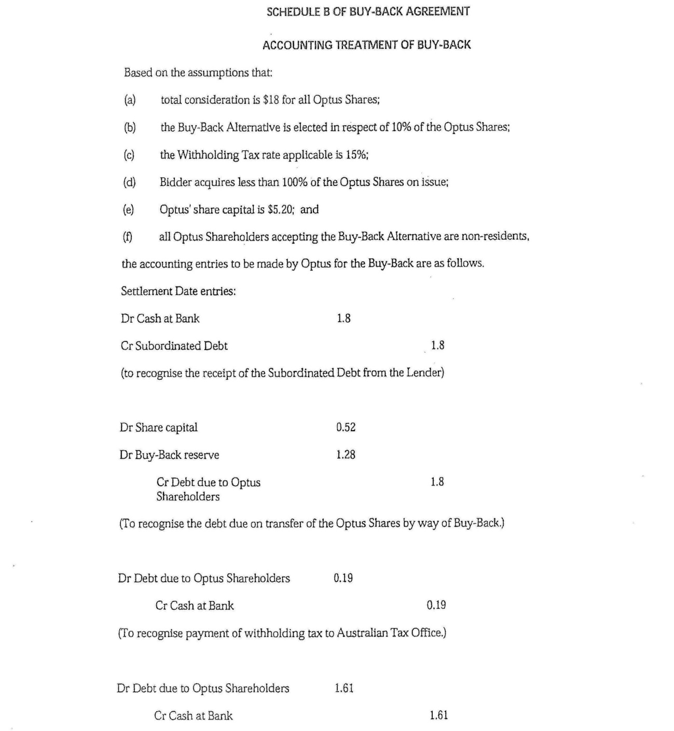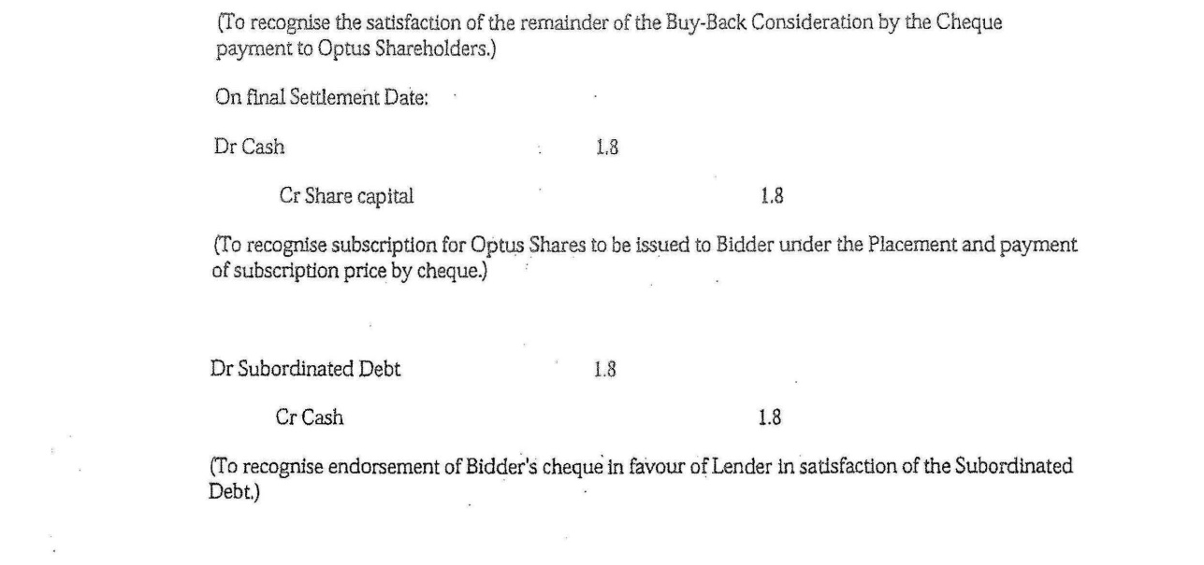
The accounting treatment provided for in this way was to treat part of the consideration as a debit against contributed capital and part as a debit to a buy-back reserve. The whole of the consideration was not to be debited against the share capital account which, in any event, would have been insufficient if 100% of the shares were to be bought back. The amount of the share capital account to be debited was, rather, to reflect the proportion of the total shareholders who had elected to have their shares bought back. A letter from PricewaterhouseCoopers dated 2 May 2001 to the Commissioner expressed the view that the amount debited to the share capital account in respect of the buy-back consideration was an appropriate amount. The view taken was in part that the share capital account was to be debited pro rata to the number of shares bought back and in part that the balance of the consideration was to be debited to an account that was an equity, but not a share capital, account. The letter from PricewaterhouseCoopers explained:
The accounting advice received strongly recommended that the appropriate amount of the Buy-Back Consideration to debit to [Optus’] share capital account is an amount pro rata to the number of shares bought back (all [Optus] shareholders would then receive an equal return of share capital if all [Optus] shareholders accepted the bid by way of the Buy-Back Alternative).
The balance of the Buy-Back Consideration would then be debited either to the retained profits/losses account or a buy-back reserve. The buy-back reserve was chosen because it was considered that the amounts would better reflect the substance of the transaction ie the transaction should not create accumulated losses. Rather, the Buy-Back accounting should reflect a matter of equity and be carried as a negative reserve in the same way as foreign currency translation and other reserves.
The view taken, in other words, was that part of the consideration to the former shareholders for the buy-back repaid capital which had been contributed to Optus and was to be treated as such, but that the balance of the consideration was not a return of capital which had been contributed to Optus but that it needed to be reflected in the accounts as “a matter of equity” and was to carry as a negative reserve.
- The capital contributed to a company is not the same as the equity in the company. In Archibald Howie Pty Ltd v Commissioner of Stamp Duties (NSW) (1948) 77 CLR 143 Williams J observed at 159:
The capital of a successful company is usually represented by assets which, after providing for the claims of creditors, exceed in value the amount of paid up capital.
Assets and liabilities of a company will affect its value and, therefore, will affect the equity which a shareholder has in a company. Its share capital, in contrast, is the amount contributed by shareholders in respect of their shares: see Trevor v Whitworth (1887) 12 App Cas 409, 423; Guinness v Land Corporation of Ireland (1882) 22 Ch D 349, 375; and Re The Swan Brewery Co Ltd (1976) 3 ACLR 164, 166; see also Gower and Davies’ Principles of Modern Company Law (2012) 9th edition, Sweet & Maxwell, 272. In Archibald Howie Pty Ltd Dixon J (with whom Rich J agreed) explained the significance of share capital as follows at 153:
From the standpoint of company law the division of the capital of a company into shares and the payment up of shares issued are regarded as respectively significant and real. The shareholder contributes the amount of the share to the capital of the company. This contribution measures his right to any return of capital which the company may make either as a going concern or in a winding up. Subject to any regulation the articles may make as to the basis upon which assets in excess of share capital may be distributed, the amount of the share determines the proportion in which he shares with other shareholders in a distribution of excess assets.
The accounting by Optus of the share buy-back transaction reflected the distinction between its capital and the equity of its shareholders. The statement of financial position subsequently published by Optus for the financial year ended 31 March 2002 recorded the amount of $9,248.5 million as “contributed equity”. It also showed negative reserves of $3,931.8 million. The former was to be read in conjunction with note 18 and the latter was to be read in conjunction with note 19. Notes 18 and 19 relevantly stated:
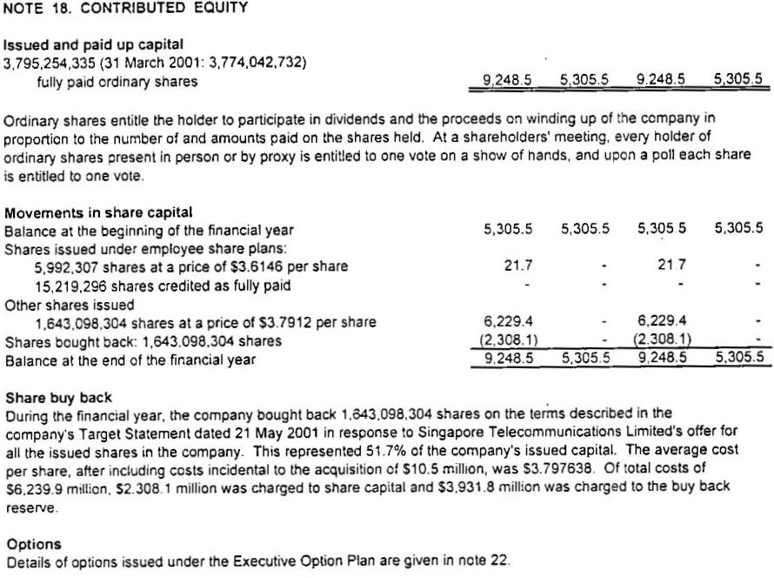
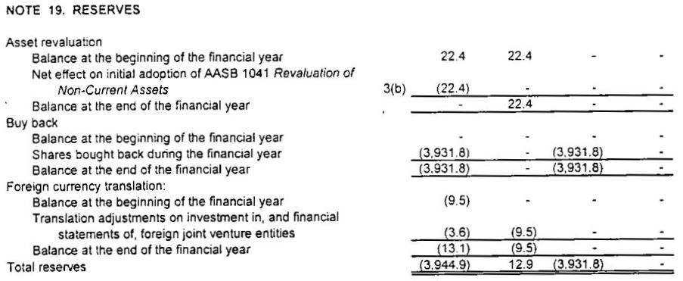
The financial statements recorded the buy-back transaction from the point of view of Optus as a matter affecting the equity of the shareholders. The amount shown as “contributed equity” increased from $5,305.5 million to $9,248.5 million by reason overwhelmingly of the share buy-back as explained in note 18, namely the acquisition of 1,643,098,304 shares for $2,308.1 million and the issue to SingTel of the same number of shares at the price of $3.7912 per share. The buy-back transaction also affected the total reserves shown in note 19.
- Two experts gave evidence in the proceeding about the nature of the buy-back reserve account, but they disagreed about the substance of the share buy-back transaction and about the nature of the buy-back reserve. A joint report was prepared by Mr Warren McGregor and Mr Wayne Lonergan in which they identified those matters on which they agreed and those on which they differed. They were each also called to give oral evidence and gave that evidence concurrently. Mr McGregor is a director of the financial reporting firm of Stevenson McGregor and is a senior consultant with PricewaterhouseCoopers. He is also an adjunct professor at the Department of Accounting and Finance at Monash University and has been involved in the independent setting of accounting standards domestically and internationally. Mr Lonergan is a founding director of Lonergan Edwards and Associates which is a specialist corporate valuation firm based in Sydney. He was previously a corporate finance partner at the firm of Coopers and Lybrand (which subsequently amalgamated with the firm PricewaterhouseCoopers). He has been a member of a number of bodies including the Companies and Securities Advisory Committee and the Australian Accounting Standards Board. The expertise of neither expert was challenged.
- The difference between the experts in how they saw the nature of the share buy-back reserve lay in the difference between them about how they saw the substance of the share buy-back transaction. Mr McGregor’s opinion was that the substance of the share buy-back transaction involved “a return of capital and a return on capital” to the shareholders (including the applicant). The amount received by the shareholders from Optus was seen by Mr McGregor to have a component representing the return of the capital which had been contributed to the company together with a component representing something in the nature of a reward or profit on that contribution. The former was seen to come from the share capital account and the latter from the buy-back reserve account. Mr Lonergan took issue with Mr McGregor’s understanding of the substance of the transaction as involving a return on, and a return of, investment. Mr Lonergan saw the substance of the buy-back transaction “as a share capital transaction in the context of a change of control transaction” whereby the shareholders were made an offer to purchase their shares in Optus for a specified bid price. An important basis of Mr Lonergan’s opinion was that the offer to acquire shares was “linked” with the change of control and in particular with the mechanism by which “SingTel had to undertake to subscribe for share capital ([namely,] the same number of shares and the amount subscribed equating to the buy-back price excluding transaction costs) to fund the payment”. Each of the experts was cross-examined and neither view of the substance of the transaction, or of the nature of the buy-back reserve, was shown to be without difficulty or wholly without merit. The substance of the buy-back share transaction, and the mechanism by which it was accounted for (including the buy-back share reserve), can with some justification be seen as involving either a share capital transaction whereby the capital in Optus of the existing shareholders was substituted with that from SingTel, or as involving a takeover in which the existing shareholders were paid an amount through the buy-back which gave them both a return of their equity and some return on the equity.
- The experts each referred to and relied upon relevant accounting standards, although none of the standards dealt conclusively with the circumstances concerning the Optus share buy-back. The only authoritative pronouncement at the relevant time specifically referring to the accounting for, and reporting of, share buy-backs was the Urgent Issues Group Abstract 22 (“UIG 22”) dealing with “accounting for the buy-back of no par value shares” issued by the Australian Accounting Research Foundation on behalf of the Australian Society of Certified Practising Accountants and the Institute of Chartered Accountants in Australia. Guidance had previously been issued on accounting for share buy-backs in the context of shares with a par value and a need was felt to clarify whether the requirements of that guidance applied in accounting for a buy-back of no par value shares. The issue considered in UIG 22 was how the buy-back of no par value shares was to be recognised in the general purpose financial report of a company. UIG 22 expressed consensus that shares included in the equity of an entity which were bought back required that the equity of the entity be reduced directly by the cost of acquisition of the shares bought back. The cost of acquisition was said to comprise the purchase consideration plus the costs incidental to the acquisition, and “a description of the nature and terms of the share buy-back and any other information material to an understanding of the transaction must be disclosed in the financial year in which the buy-back occurs”.
- The discussion in UIG 22 which followed the statement of consensus by the Urgent Issues Group referred to the Statement of Accounting Concepts entitled “Definition and Recognition of the Elements of Financial Statements” (“SAC 4”). Paragraph 8 of UIG 22 referred to the definition in SAC 4 of distributions to owners as “future economic benefits distributed by the entity to all or part of its ownership group, either as a return on investment or as a return of investment”. Mr Lonergan emphasised the sentence in UIG 22 following this reference to SAC 4 which noted that in “the case of a share buy-back, the parties (shareholders/owners) are receiving consideration for their shares” because they are equity participants in the entity. Mr Lonergan went on to note that the discussion in UIG 22 referring to the definition in SAC 4 of a distribution to owners as “being either a return on investment or a return of investment” did “not specifically state that a buy-back has to be split between these components”. Paragraph 11 in UIG 22, however, noted the fact that the details of buy-back arrangements may vary from time-to-time and that the consensus in UIG 22 did not prescribe which equity accounts were to be adjusted for the cost of the acquisition of the shares bought back. Paragraph 11 of UIG 22 stated:
11 […] The terms of the buy-back arrangement will normally be specified in the buy-back documentation. Those terms will have been developed consistent with relevant requirements of the Corporations Law that deal with the establishment and use of particular equity accounts. This Consensus does not prescribe which equity accounts are to be adjusted for the cost of the acquisition of the shares bought back. It allows the accounting for the buyback to reflect the substance of the buy-back transaction. This is consistent with AASB 1001 / AAS 6 "Accounting Policies" which requires that accounting policies must be selected and applied in a manner which ensures that the resultant financial information satisfies the concepts of relevance and reliability, therefore ensuring that the substance of the underlying transactions and other events is reported. [Emphasis in the joint experts’ report in the context of Mr Lonergan’s opinion]
Mr McGregor also referred to this paragraph in UIG 22 noting that it allowed for the “accounting for the buy-back to reflect the substance of the buy-back transaction”. This was consistent with the requirements of Australian Accounting Standard AASB 1001 that accounting policies must be selected and applied in a manner which ensures that the resulting financial information satisfies the concepts of relevance and reliability.
- The experts agreed that the Optus buy-back transaction affected the equity in Optus but disagreed about whether the amount in the share buy-back reserve was part of the return of the investment or a return on the investment. Mr McGregor identified this difference in the joint report stating:
The difference of opinion relates to the nature of the buy-back amount, ie the “distribution to shareholders” and, as a corollary, the nature of the “buy-back reserve”. As noted […] above, the authoritative accounting literature characterises “distributions” as either returns of investment or returns on investment. Mr McGregor believes the buy-back amount comprised in part a return of investment and in part a return on investment. Optus’ accounting for the transaction was consistent with that perspective. The buy-back amount was apportioned between a reduction in paid up capital, reflecting the proportion of the total number of shareholders participating in the buy-back, and the share buy-back reserve. [Emphasis added by Mr McGregor]
Mr Lonergan was also of the view that the share buy-back was one affecting equity but considered that the only account available to record that was an account relating to share capital. Mr Lonergan said at paragraph 32 of the joint report:
In the case of Optus, there was only one available form of positive equity and that was issued capital. Thus, it would have been clear to any reader of the accounts that the debit to the buy-back reserve was to an account relating to share capital because it could not have been to anything else.
Mr Lonergan also took issue with Mr McGregor’s view about whether the substance of the transaction determined which equity accounts ought to be reduced because, in Mr Lonergan’s view, this would be a factual matter depending upon what form of equity was available and was used to make the buy-back, and also because Mr Lonergan was of the view there was no “such requirement as Mr McGregor purports”.
- The application of s 159GZZZP(1), coupled with the definition in s 6D, in the present case depends upon a factual inquiry to determine which part, if any, of the purchase price for the applicant’s shares in Optus bought back was debited against the amounts standing to the credit of the share capital account of Optus at the time Optus debited the amounts. That factual inquiry in the present circumstances depends upon whether the buy-back reserve was an account which Optus kept at that time of its share capital within the meaning of s 6D(1)(a). The expert opinions of Mr Lonergan and Mr McGregor assist that factual inquiry but do not resolve it.
- The substance and form of the Optus buy-back transaction was different from that considered in Consolidated Media. In that case the company was returning its capital to its shareholder and the capital in the company was reduced by the amount returned to the shareholder. The Optus buy-back, in contrast, was part of a takeover offer whereby the bidder was funding the disposal of shares where shareholders had elected for their shares to be bought back by Optus as an option available to them in the takeover by SingTel. Optus was to be put in funds by SingTel to enable Optus to fund the buy-back without diminution or increase of its available capital. The issue for Optus was how to account for the difference between the amount it would receive to fund the payment to its shareholders and the amount it had in its share capital account numbered 310100 that was referrable to capital contributed by those shareholders. The approach taken, on advice, was to create a share buy-back reserve to account for that difference. The character of the buy-back reserve account at the time of the debit against amounts standing in credit in that account reflected a transaction which was in substance a funding mechanism for the Optus shareholders to obtain a return of their capital and on their capital. The shareholders were selling their shares in Optus to enable SingTel to acquire them at the amount offered. The role played by the buy-back reserve account was to facilitate the payment of the consideration to the shareholders to the extent that the consideration exceeded the amount standing in the accounts of Optus as capital contributed by them as shareholders.
- The SingTel bidder was obliged by clause 3.7 of the Implementation Agreement to ensure that every Optus shareholder, including the applicant, had the option of transferring their Optus shares to the SingTel bidder or of having Optus buy-back those shares. The availability of a buy-back option in the takeover necessitated that Optus have the means to fund the shares bought back, and, to that end, the Implementation Agreement provided that Optus would be lent money by the SingTel lender. The bidder was given an option by clause 5.1 to acquire one Optus share for each share Optus bought back if the bidder did not become entitled to proceed with compulsory acquisition at the end of the offer period. The same clause gave Optus the option to require the bidder to subscribe for shares equal to the number of shares bought back, but the acquisition of shares by the bidder as the means by which Optus would fund the buy-back was neither obligatory nor a certainty. It is true, as the Optus directors remarked in clause 3.18(e) of the target statement, that it seemed reasonable to infer that the bidder would choose to subscribe for Optus shares, but that was only upon the basis that the subordinated debt created to fund the buy-back would not attract interest until the bidder became entitled to 100% of the Optus shares, and that the bidder’s shareholding would not be commensurate with the funding outlay of the SingTel group if the lender had not acquired 100% of Optus and had not opted to subscribe for shares. However, the bidder was not obliged to subscribe for shares if it became entitled to 100% of Optus and could, in that event, determine that the subordinated loan would bear interest at commercial rates. The bidder’s statement had referred to the opportunity for SingTel “to achieve an appropriate mix of debt and equity” to the extent that the buy-back alternative was chosen by the existing Optus shareholders. Optus, for its part, was not obliged to exercise the option given by clause 5.1 of the Implementation Agreement to require the bidder to subscribe for shares if it had not been entitled to proceed with compulsory acquisition. The directors in that context remarked at clause 3.18(e) of the target’s statement that Optus remained in a position to ensure that there would be no overall change to total shareholders’ equity because it could require the bidder to subscribe for shares to replace those bought back.
- Every share buy-back involves a reduction of capital to the extent that shares bought back are cancelled (see s 257H(3) of the Corporations Act 2001 (Cth)), but the consideration payable for the shares bought back and cancelled need not be from funds previously contributed to the company for the acquisition of those shares. Section 159GZZZP(1) of the 1936 Act operates to deem an amount to be a dividend to the extent, in effect, that the purchase price in respect of any buy-back was not from the amounts which had previously been contributed as capital to the company in acquisition of the shares against amounts standing to the credit of the share capital account. The provision thus recognises that the payment for shares bought back off-market may be from sources other than share capital. Paragraph 2.6 of the Report to the Treasurer of the Board of Taxation titled Review of the Taxation Treatment of Off-Market Share Buy-Backs (June 2008) stated:
When a company buys back its shares under an off-market share buy-back, the amount paid to shareholders is taken to be a dividend to the extent that the amount is drawn from the company’s distributable profits. This is consistent with the general notion that any payment made by a company to shareholders, other than a return of capital, is treated as a dividend for tax purposes. Therefore, for shareholders, the tax consequences of an off-market share buy-back will depend on the relative proportions in which the company has chosen to debit the purchase price against amounts standing to the credit of its share capital account and its other accounts (for example, its profits). It will also depend on whether the purchase price paid for a share is greater than, equal to, or less than its price on the Australian Securities Exchange (ASX).
The consideration debited to the share buy-back reserve account came from borrowings pursuant to an agreement for the funding of a takeover in which the buy-back was a component. The SingTel bidder subsequently acquired shares and the purchase price for the subsequent acquisition was credited to the account labelled “share capital”. On 30 October 2001 Optus issued 1,643,098,304 shares to SingTel for an amount of $6,229,387,472.78 and on 31 October 2001 a credit of that amount was made to account 310100 being the account labelled “share capital”. A corresponding debit of that amount was made to account numbered 295400 being the account labelled “subordinated debt”.
- The Optus buy-back reserve account, unlike that considered in Consolidated Media, was not a record of a transaction reducing the share capital of the company. The Optus buy-back reserve account was needed to account for the payment of part of the consideration paid for the shares bought back from money lent to Optus by SingTel for that purpose. The key requirement of the appropriate approach to account for the buy-back (as explained by the PricewaterhouseCoopers letter to the Commissioner dated 2 May 2001) was that the equity of Optus was “reduced by the cost of acquisition of the shares bought back”. Optus at the time had only two accounts which could have been used to reflect the reduction in shareholders’ equity; namely the share capital account and the retained losses account. The buy-back reserve account was created as a new equity account to carry the negative reserve occasioned by payment of the difference between the total consideration and the amount standing in the credit of the share capital account referrable to the capital contributed by shareholders whose shares were bought back. The buy-back transaction had an impact upon the equity in the company because of the amount of the consideration to be paid in the buy back, but the buy-back reserve account did not record a transaction reducing (or increasing) the contributed capital of the shareholders to the company at the time of the debits. The whole of the amount in the buy-back reserve account was standing in the account to pay part of the consideration to the shareholders for the disposal of their shares in a takeover.
- The Optus buy-back reserve account was also, unlike that considered in Consolidated Media, not “a record of the financial position of the company in relation to [Optus’] share capital”. The buy-back reserve account had an impact upon the equity of the shareholders, but it did not record the financial position of Optus “in relation to its share capital”. Optus reported its financial position following the buy-back transaction in audited published accounts dated 15 July 2002. Optus was required by s 286, in Part 2M.2, of the Corporations Act 2001 (Cth) (see also the offence created by s 1308) to keep financial records that:
(a) correctly record and explain its transactions and financial position and performance; and
(b) would enable true and fair financial statements to be prepared and audited.
The financial statement in Optus’ audited accounts recorded an increase in contributed equity (explained in note 18 set out above) and an increase in negative equity (explained in note 19 set out above). The published audited accounts were careful to distinguish between equity and share capital. The accounts recorded that some 1,643 million shares were bought back at a cost charged against the company’s share capital account of some $2,308.1 million. This was explained in note 18 to represent some 51.7% of the company’s issued capital and that the balance of the cost of the buy-back affecting equity had been charged to the buy-back reserve account. The Optus accounts do not reveal a situation, unlike that in Consolidated Media, of a financial position in relation to share capital that could only be understood by subtracting the total consideration for the buy-back as a reduction of the credit balance in Optus’ share capital account.
- The application of the funds in the share buy-back reserve account as the consideration for the buy-back of shares does not require a different conclusion. The buy-back in this case was governed by, and took place under, Division 2 of Part 2J.1 of the Corporations Act 2001 (Cth). A reduction of share capital by Optus buying back its shares was authorised by s 258E(1)(b) “if the shares [were] paid for out of share capital”, but there was no restriction on the source of funds that Optus could use to effect its buy-back. Section 257A(b) permitted Optus to buy back its own shares provided that it followed the procedures laid down in Division 2 of Part 2J.1 of the Corporations Act 2001 (Cth). The buy-back of Optus’s shares fell within the provisions governing the selective buy-back of shares and required, amongst other things, the lodging with the Australian Securities and Investments Commission of the offer documents: see s 257E. Recital C of Schedule 4 to the Implementation Agreement, which set out the proposed terms of the buy-back, and which the parties accepted as having been in the terms entered into between the bidder and the applicant, provided:
By choosing the buy-back alternative, each relevant shareholder has made a buy-back offer to Optus whereby that relevant shareholder has offered to sell to Optus its relevant shares on the terms of this agreement.
Clause 6 then provided:
Subject to the Corporations Law, Optus must account for the buy-back in accordance with the pro-forma accounting entries set out in Schedule B.
The accounting entries referred to in clause 6 were those in Schedule B to the Implementation Agreement set out above which expressly provided for a pro rata reduction in the share capital account to the number of shares bought back. It was that reduction of share capital which was authorised by s 258E as a reduction in share capital, namely, the proportion of the consideration to be debited against the share capital account.
- The applicant also relied upon four other matters in its written submissions in addition to the two matters expressly referred to in Consolidated Media in support of the contention that “the whole of the buy-back consideration outlaid by Optus reduced its share capital”. The four additional matters have largely been dealt with above but it may be desirable to deal with them individually briefly.
- The first additional matter was what was submitted to be revealed in the financial statements of Optus for the year ending 31 March 2002 about the absence of any positive equity funds, other than share capital, available to fund the buy-back. In that context it was submitted:
The company had no positive equity reserves, and no retained profits. Clearly the financial position of Optus in relation to its share capital could only be understood by subtracting the debit balance in its buy-back reserve account from the credit balance in its shareholders capital account.
The fact that an outgoing has an impact upon a company’s equity does not stamp upon the outgoing the character of a reduction in capital. The comparison of the accounts considered by the High Court in Consolidated Media at [46] revealed a reduction of the capital available to Crown, but a comparison of the accounts of Optus showed that the share buy-back transaction had an impact upon equity in the company rather than any reduction of capital. Optus used its assets as consideration for the buy-back which in this case was sourced from loans governed by the Implementation Agreement. Optus was able to make the buy-back from its assets regardless of whether it had available profits, an asset revaluation reserve or any other positive equity account.
- The second matter relied upon was the subscription for further share capital by SingTel on 30 October 2001 in amount equivalent to the total buy-back consideration. In that regard it was submitted that:
The precise correspondence between the total buy-back consideration paid by Optus, and the share capital subscribed by SingTel confirms that Optus raised new share capital to replace share capital paid out by it to shareholders who chose the buy-back alternative pursuant to the takeover offer.
In considering this argument it is important not to lose sight of the proper application of the relevant words in s 159GZZZP(1). For present purposes the relevant inquiry is whether part of the amount paid as purchase price to the outgoing shareholders was debited against amounts which were standing to the credit of the share capital account as defined by s 6D. It may be accepted, as was the case, that SingTel contributed capital to Optus two months after the buy-back, but the subsequent contribution of capital to a company tells against the view that the funding recorded in the buy-back reserve account had previously been contributed as capital. The subsequent purchase of shares by SingTel was a subsequent transaction and was recorded by a credit to the share capital account and a debit to the subordinated debt account. The journal entries thus confirmed the source of the previous payment to the applicant as being from the moneys borrowed by Optus for the payment and not from amounts which had been contributed as capital.
- The third matter relied upon was described as “the history of the treatment of the buy-back reserve account by Optus in its accounts”. The debit entries made in September 2001 gave rise to a negative balance in the buy-back reserve account which was maintained in that form, with no further entries made, until March 2013 when the debit balance of the account was set off against the share capital account. In that context it was submitted that:
The entries made in March 2013 confirmed what had been clear since September 2001, that the debit balance in the buy-back reserve account related to the share capital of Optus.
Optus drew attention in this context to the fact that the Commissioner issued a private binding ruling to Optus on 30 January 2013, to which reference has already been made, treating the buy-back reserve account as a share capital account in relation to a different question in 2013. The present proceeding does not call for consideration of the correctness of the character of the account for the purposes of the 2013 ruling, however, the history of the buy-back reserve account between September 2001 and March 2013 is consistent with its initial treatment as a negative reserve, as had been explained in the letter from PricewaterhouseCoopers to the Commissioner dated 2 May 2001.
- The fourth additional matter relied upon was the submission that the applicant’s position was said to be consistent with the legislative purpose of s 159GZZZP as being “to prevent profits from being used to pay for share buy-backs and distributed to shareholders as a return of capital rather than as a taxable dividend by treating amounts other than share capital returned to shareholders as a dividend”. In that context reference was made to a sentence in the Explanatory Memorandum to the Taxation Laws Amendment Bill (No 3) 1990, which introduced Division 16K (including s 159GZZZP) into the 1936 Act, that the purpose of the provision was to ensure that “to the extent that an off-market purchase is funded from a company’s distributable profits, the purchase price will be treated as a dividend”. The sentence quoted was from the Explanatory Memorandum of the earlier version of Division 16K rather than to the 1998 version in which the relevant terms of s 159GZZZP are found, but it may for present purposes be accepted that the sentence from the earlier Explanatory Memorandum may be helpful in understanding some part of the purpose of the successor provision. The sentence, however, cannot be used to contradict the otherwise clear terms of s 159GZZZP(1) (see: Consolidated Media, 519 [39]; Alcan (NT) Alumina Pty Ltd v Commissioner of Territory Revenue (2009) 239 CLR 27, 46 [47]; and Nominal Defendant v GLG Australia Pty Ltd (2006) 228 CLR 529, 538 [22]) which are not limited to deeming a dividend only to the limited extent that an off-market purchase was funded “from a company’s distributable profits”. Section 159GZZZP deems any part of the consideration for a buy-back to be treated as profit whether or not the consideration represents profit provided only that the consideration is not debited against amounts standing to the credit of a share capital account. The policy, and clear language of s 159GZZZP(1), is to exclude from the deeming it effects amounts paid to shareholders from amounts recorded as having been contributed by them as capital to the company. The text and policy of s 159GZZZP(1) does not require an inquiry into whether the payment is from the company’s distributable profit but, rather, whether it is from what the company had received as contributions of capital from its shareholders.
- Accordingly, the application will be dismissed and, subject to hearing from the parties, there will be an order that the applicant pay the Commissioner’s costs.

I certify that the preceding thirty-five (35) numbered paragraphs are a true copy of the Reasons for Judgment herein of the Honourable Justice Pagone.

Associate:

Dated: 11 February 2016

