FEDERAL COURT OF AUSTRALIA

ESCO Corporation v Ronneby Road Pty Ltd [2018] FCAFC 46

Appeal from: | Ronneby Road Pty Ltd v ESCO Corporation [2016] FCA 588
File number: | VID 711 of 2016
Judge(s): | GREENWOOD, RARES AND MOSHINSKY JJ
Date of judgment: | 28 March 2018
Catchwords: | INTELLECTUAL PROPERTY – consideration of an application for leave to appeal and an appeal under s 60(4) of the Patents Act 1990 (Cth) (the “Act”) from a decision of the Commissioner’s delegate rejecting all grounds of opposition – consideration of questions of construction of the Patent Application including the claims and the specification – consideration of the principles of construction  INTELLECTUAL PROPERTY – consideration of the ground of want of novelty – consideration of whether the claims as construed are anticipated by a prior published product  INTELLECTUAL PROPERTY – consideration of the historical development in Australia of the statutory formulation contained in s 18(1)(c) of the Act that an invention is a patentable invention for the purposes of a standard patent “if the invention, so far as claimed in any claim, is useful” – consideration on the question of utility of earlier formulations engaging the grounds on which a patent might be repealed by the writ of scire facias – consideration of The Patents, Designs and Trade Marks Act 1883 (UK), the Report of the United Kingdom Board of Trade (the “Sargant Committee Report”) of 1931, the Patents and Designs Act 1907-1932 (UK), the Report of the United Kingdom Board of Trade (the “Swan Committee Report”) of 1947, the Patents Act 1949 (UK), the Report of 1952 of the “Dean Committee” established by the Commonwealth Attorney-General (which led to the Patents Bill 1952 (Cth)), and the Patents Act 1952 (Cth)  INTELLECTUAL PROPERTY – consideration of the question of utility of whether a failure to attain an element of a composite promise comprising two or more elements renders the invention, so far as claimed in any claim, inutile – consideration of the authorities on that question
Legislation: | Intellectual Property Laws Amendment (Raising the Bar) Act 2012 (Cth)  Patents Act 1990 (Cth), s 18, s 79B, s 29, s 43, s 59  Patent Regulations 1991 (Cth), Regs 3.12(1)(c) and 3.12(2C)  Patents Act 1952 (Cth)  Patents Act 1903 (Cth)  Statute Law Revision Act 1934 (Cth)  Patents and Designs Act 1907-1932 (UK)  Patents Act 1903-1950 (Cth)  Patents Act 1949 (UK)  The Patents, Designs and Trade Marks Act 1883 (UK)
Cases cited: | Advanced Building System Pty Ltd v Ramset Fasteners (Aust) Pty Ltd (1998) 194 CLR 171  Austal Ships Pty Ltd v Stena Rederi Aktiebolag (2005) 66 IPR 420  Britax v Infa-Secure (No 4) (2015) 113 IPR 280  Commissioner of Patents v Sherman (2008) 172 FCR 394  Commissioner of Patents v Microcell Ltd (1959) 102 CLR 232  Dabscheck v Hecla Electrics Pty Ltd (1936) 57 CLR 418  Décor Corporation Pty Ltd v Dart Industries Inc (1988) 13 IPR 385  Denison Manufacturing Company v Monarch Marking Systems Inc (1983) 76 FLR 200  Elias v Grovesend Tinplate Company 7 R.P.C. 455  Fawcett v Homan (1986) R.P.C. 398  Flour Oxidising Company Ltd v Hutchinson (1909) 26 RPC 597  Hatmaker v Joseph Nathan & Co. Ld. (1919) 36 RPC 231  Horville Engineering Company Limited v Clares (Engineering) Limited (1975) FSR 196  Interlego A.G. v Toltoys Pty Ltd (1973) 130 CLR 461  In the matter of Alsop’s Patent (1907) 24 RPC 733  Inverness Medical Switzerland GmbH v MDS Diagnostics Pty Ltd (2010) 85 IPR 525  Jafferjee v Scarlett (1937) 57 CLR 115  Kirin-Amgen Inc and Others v Hoechst Marion Roussel Ltd (2004) 64 IPR 444  Kraft, Kraft Cheese Company (Incorporated) v McAnulty (1931) 48 RPC 536  Lane-Fox v Kensington and Knightsbridge Electric Lighting Co (1892) 9 R.P.C. 413  H Lundbeck A/S v Alphapharm Pty Ltd (2009) 177 FCR 151  Martin Engineering Co v Trison Holdings Pty Ltd (1989) 14 IPR 330  National Research Development Corporation v Commissioner of Patents (1959) 102 CLR 252  Pracdes Pty Ltd v Stanilite Electronics Pty Ltd (1995) 35 IPR 259  Product Management Group Pty Ltd v Blue Gentian LLC (2015) 240 FCR 85  Ranbaxy Australia Pty Ltd v Warner-Lambert Co LLC (2008) 77 IPR 449  Rehm Pty Ltd v Websters Security Systems (International) Pty Ltd (1988) 11 IPR 289  Rescare Ltd v Anaesthetic Supplies Pty Ltd (1992) 111 ALR 205  Sandvik Intellectual Property AB v Quarry Mining & Construction Equipment Pty Ltd [2017] FCAFC 138  Townsend Controls Pty Ltd v Gilead (1989) 16 IPR 469  Vidal Dyes Syndicate Ltd v Levinstein Ld (1912) 29 RPC 245  Welch Perrin & Co Pty Ltd v Worrel (1961) 106 CLR 588  13th Edition of Terrell on the Law of Patents  Patent Law in Australia, Lawbook Co., 2008; 2nd Edition 2014
Date of hearing: | 4 November 2016
Date of last submissions: | 4 November 2016
Registry: | Victoria
Division: | General Division
National Practice Area: | Intellectual Property
Sub-area: | Patents and Associated Statutes
Category: | Catchwords
Number of paragraphs: | 309
Counsel for the Applicant/ Appellant: | Mr R Macaw QC with Mr T Cordiner
Solicitors for the Applicant/ Appellant: | MinterEllison Lawyers
Counsel for the Respondent: | Mr B Caine QC with Mr I Horak
Solicitor for the Respondent: | DLA Piper Lawyers

ORDERS
 |  | VID 711 of 2016
BETWEEN: | ESCO CORPORATION  Applicant/Appellant
AND: | RONNEBY ROAD PTY LTD  Respondent

JUDGES: | GREENWOOD RARES AND MOSHINSKY JJ
DATE OF ORDER: | 28 MARCH 2018

THE COURT ORDERS THAT:

- The applicant is granted leave to appeal.
- The appeal is upheld having regard to the reasons for judgment published today.
- The appellant is directed to submit final orders for the consideration of the Court, giving effect to the reasons for judgment, such orders to include an order that the respondent pay the appellant’s costs of and incidental to the appeal.

Note: Entry of orders is dealt with in Rule 39.32 of the Federal Court Rules 2011.

REASONS FOR JUDGMENT
THE COURT

Background and Context
- The appellant (and applicant for leave), ESCO Corporation (“ESCO”) is the applicant for the grant of an Australian standard patent entitled “Wear assembly”. The patent application is number 2011201135 (the “Patent Application” or “PA”). It was filed on 15 March 2011 as a divisional application, that is to say, the application was divided out of an earlier application (the so-called “parent” application) being Application No. AU2007241122 having a priority date of 30 March 2006.
- Thus, the divisional application claims the same priority date as the parent application: see Ch 6A, Patents Act 1990 (Cth) (the “Act”); s 79B, s 29, and s 43; Regs 3.12(1)(c) and 3.12(2C) of the Patent Regulations 1991 (Cth) (being the pre-15 April 2013 Regulations).
- ESCO filed a Request for Examination of the Patent Application on 15 September 2011 with the result that the provisions of the Act applying to the determination of the questions in issue in these proceedings are those provisions of the Act as they stood prior to the commencement of the Intellectual Property Laws Amendment (Raising the Bar) Act 2012 (Cth) (the “Raising the Bar Act”) which received assent on 15 April 2012 with some provisions commencing on 15 April 2012 and 16 April 2012 and many of the provisions of that Act commencing on 15 April 2013.
- The application was advertised as accepted by the Commissioner on 8 November 2012.
- On 7 February 2013, the respondent, Ronneby Pty Ltd (“Ronneby”) filed opposition under s 59 of the Act to the grant of a patent to ESCO on grounds that the invention is not a patentable invention (s 59(b)) because the invention, so far as claimed in any claim, lacks novelty and does not involve an inventive step (when compared with the prior art base): s 18(1)(b) of the Act; and that the claim or claims are not clear and succinct or fairly based on matter disclosed in the specification and not fully described: s 59(c) and s 40(3) of the Act.
- On 7 February 2013, CQMS Pty Ltd also filed opposition proceedings relying on the same grounds as Ronneby but adding a contention that the invention so far as claimed in any claim does not constitute a manner of manufacture as that term is understood.
- On 8 February 2013, Caterpillar Inc also filed opposition proceedings in reliance on all of the grounds just mentioned and added a contention that the invention so far as claimed in any claim is not useful: s 59(b) and s 18(1)(c) of the Act.
- On 5 February 2015, the Commissioner’s delegate rejected all grounds of opposition finding that “the claimed invention is novel, inventive, clear, fairly based, sufficient and a manner of manufacture”. Although no submissions were made by Caterpillar before the Commissioner’s delegate concerning the ground of lack of utility, the Commissioner’s delegate also found “no basis to reject the claimed invention” on that ground.
- On 26 February 2015, Ronneby filed an appeal to this Court under s 60(4) of the Act from the delegate’s decision.
- Such an appeal is, of course, an exercise of the Court’s original jurisdiction and is conducted as a rehearing (sometimes called, as the Full Court, Heerey, Kenny and Middleton JJ, observed in Commissioner of Patents v Sherman (2008) 172 FCR 394 (“Sherman”) at [18], a hearing de novo); Jafferjee v Scarlett (1937) 57 CLR 115 at 119-120, Latham CJ. Whatever the consequences might now be in formulating the test to be applied by the Court in determining a matter arising in a proceeding under s 60(4) as a result of the introduction into s 60 of s 60(3A) (which formed no part of the Act relevant to these proceedings), the Primary Judge correctly recognised that the court upholds the opposition only if “clearly satisfied” that the patent, if granted, would be invalid: Commissioner of Patents v Microcell Ltd (1959) 102 CLR 232 at 244 and 245; Denison Manufacturing Company v Monarch Marking Systems Inc (1983) 66 ALR 265 at 266; 76 FLR 200 at 201. Nevertheless, that question of the Court’s state of satisfaction is determined on the balance of probabilities on the basis of the evidence before the Court in the proceedings: Sherman at [21]; see generally Sherman at [18] to [24].
- The grounds relied upon by Ronneby before the Primary Judge in opposing the grant of a patent to ESCO were want of novelty in relation to particular claims recited in the Patent Application, want of fair basis and inutility. In the result, the Primary Judge determined (by Order 1 of the Orders made on 14 June 2016 supported by Reasons for Judgment published on 27 May 2016) that the decision of the Commissioner’s delegate of 5 February 2015 be set aside to the extent that the delegate:
  - found that each of claims 1, 6, 7, 9 to 15 and 18 to 23 [of the Patent Application] was for a novel invention;
  - found that each of the claims of the Patent Application was for a useful invention;
  - required that [Ronneby] pay [ESCO’s] costs according to Schedule 8 of the Patent Regulations 1991 (Cth).
- ESCO, by its appeal proceedings, seeks leave to appeal from the Orders of the Primary Judge and challenges the findings of lack of novelty and inutility as findings said to be made in error. As to the question of leave to appeal, s 158(2) of the Act provides that except with the leave of the Federal Court, an appeal does not lie to the Full Court from a Judgment or order of a single judge of this Court exercising jurisdiction to hear and determine appeals from decisions or directions of the Commissioner (and thus his or her delegate). Accordingly, in these proceedings ESCO is an applicant for leave to appeal and seeks to rely upon the notice of grounds of appeal, should leave be given. In these reasons, we will simply describe ESCO, where relevant, as the appellant. The application for leave is not opposed by Ronneby.
- Before turning to the reasons of the Primary Judge in support of the Orders made on 14 June 2016 and the grounds of appeal, it is necessary to say some things about the relevant art and the Patent Application. It will, obviously enough, be necessary to examine in some detail later in these reasons, further aspects of the patent specification and the language of the claims defining the integers and the scope of the monopoly sought by ESCO but for present purposes the following things should be noted.
- The Patent Application is for an invention that “pertains to a wear assembly for securing a wear member to excavating equipment”: PA, para 1.
- The Patent Application contains an “Abstract of the Disclosure” contained in the specification. The Abstract, consistent with Reg 3.3 of the Patents Regulations 1991 (Cth) contains a summary of the disclosure, the claims and the drawings relevant to the technical field of art to which the invention relates, for classification purposes. We recognise, of course, that by Reg 3.3(6) the Abstract is not to be taken into account in construing the nature of the invention the subject of the specification. As a description simply of the field of art engaged by the description in the specification, the Abstract says this:
A wear assembly for excavating equipment which includes a wear member and a base each with upper and lower stabilising surfaces that are offset and at overlapping depths to reduce the overall depth of the assembly while maintaining high strength and a stable coupling. The nose and socket each includes a generally triangular-shaped front stabilising end to provide a highly stable front connection between the nose and wear member for both vertical and side loading. The lock is movable between hold and release positions to accommodate replacing the wear member when needed, and secured to the wear member for shipping and storage purposes.
- We are confident that the references to the Abstract by the Primary Judge formed no part of his Honour’s construction of the claims which was informed by the disclosures in the specification itself and the language of the claims.
- As to the specification, the document tells the reader that heavy excavating equipment is used in conducting digging operations in a range of environments and ground conditions often characterised by harsh conditions: PA, para 5. “Excavating buckets” or “cutterheads” are used in such digging operations: PA, para 3. The “digging edge” of heavy excavating equipment is subjected to wear and heaving loading: PA, paras 3, 4 and 5; Primary Judgment (“PJ”) at [2]. Paragraph 3 of the Patent Application tells the reader this:
Wear parts are commonly attached to excavating equipment, such as excavating buckets or cutterheads, to protect the equipment from wear and to enhance the digging operation. The wear parts may include excavating teeth, shrouds, etc. Such wear parts typically include a base, a wear member, and a lock to releasably hold the wear member to the base.
[emphasis added]
- So far as wear parts or wear members in the form of excavating teeth are concerned, such teeth bear the abrasion, friction and wear of operating in harsh conditions under heavy loads. Paragraph 4 of the Patent Application tells the reader this:
In regard to excavating teeth, the base includes a forwardly projecting nose for supporting the wear member. The base may be formed as an integral part of the digging edge or may be formed as one or more adapters that are fixed to the digging edge by welding or mechanical attachment. The wear member is a point which fits over the nose. The point narrows to a front digging edge for penetrating and breaking up the ground. The assembled nose and point cooperatively define an opening into which the lock is received to releasably hold the point to the nose.
[emphasis added]
- So, put simply, such wear mechanisms used in relation to excavating teeth include a base, sometimes called an adapter fixed to (often welded to) the digging edge of, for example, an excavating bucket or otherwise made an integral part of the digging edge of such a bucket. The base is shaped to form a projecting nose so as to receive a wear member shaped to a point or “front digging edge” which will engage with, penetrate and break up the ground. The base with its shaped projecting nose and the wear member placed over it cooperatively define an opening to receive a lock device so as to hold (but releasably hold) the wear member to the nose of the base.
- However, wear members wear out over time and must be replaced (that is, removed from the fixed base and replaced with a new wear member).
- Paragraph 5 of the Patent Application tells the reader something about design efforts to address perceived difficulties arising out of the use of “such wear members”. The author of the specification says this:
Many designs have been developed in an effort to enhance the strength, stability, durability, penetration, safety, and/or ease of replacement of such wear members with varying degrees of success.
[emphasis added]
- Although we will return to the question of construction of the claims and the relationship between the claims and the body of the specification later in these reasons, it seems unlikely that by that short sentence, the author was doing anything other than to identify the distributed range of areas or fields of inquiry in which many design efforts have been occurring over time (with varying degrees of success) in seeking to enhance one or more of the six identified challenges in designing “such wear members” relating to excavating teeth as described in para 4.
- Paragraphs 6 to 19 of the Patent Application all fall under the heading “Summary of the Invention”.
- Paragraph 6 tells the reader this:
The present invention pertains to an improved wear assembly for securing wear members to excavating equipment for enhanced stability, strength, durability, penetration, safety and ease of replacement.
[emphasis added]
- Ronneby contended before the Primary Judge, and contends on appeal, that para 5 of the specification identifies six areas of inquiry in which many attempts have been made to develop designs addressing six perceived problems of strength, stability, durability, penetration, safety and ease of replacement of wear members forming part of wear assemblies, and para 6 tells the reader that ESCO has developed an “improved” wear assembly for “securing” wear members to excavating equipment for enhancement of each of the same six features recited in para 5 of the specification (the subject of varying degrees of success in the many previous design efforts to enhance those features).
- Ronneby says that the promise of the invention (and thus the consideration for the grant of the monopoly) lies in attaining, in each of the claims, each and every one of those enhancements as the consideration for the grant of the monopoly.
- ESCO says that as a matter of construction of para 6 in the context of the whole specification and claims, para 6 is not cast in the language of “promises”. Rather, relevant to the question of inutility, ESCO says that the language of para 6 of, “for securing wear members to excavating equipment for enhanced stability, strength, etc”, is, put simply, the language of purpose to which the described improvements are directed, as opposed to the language of promise and moreover the use of the words “pertains to” in para 6 confirms that this is a paragraph that is speaking really of generalised desiderata”: T, p 6, lns 19-22.
- ESCO also says that even if para 6 is to be construed as containing six promises for the “present invention” of enhancing stability, strength, durability, penetration, safety and ease of replacement, it is not necessary, as a matter of construction of the claims having regard to the specification (and as a matter of law), on the question of utility, to attain each of those promises in each of the claims. The invention, so far as claimed in any claim, is said to be “useful” for the purposes of s 18(1)(c) and s 59(b) of the Act if one or more of those promises (if they be promises) are attained by the relevant claim. Ronneby, in answer, re-asserts its contention described at [26] of these reasons and says that even if it is not necessary to find each of the six promises in each claim, it remains necessary to find each of the six promises achieved distributively over the claims and as to that matter, the findings of the Primary Judge are said to be fatal to ESCO. That is said to follow as the Primary Judge found that para 6 contains six promises and accepted at [70] of the reasons that none of the claims achieved the advantages of enhanced strength, enhanced durability or enhanced penetration. Thus, the consideration for the grant is said to fail and all claims are said to be inutile. However, we will return to these issues later in these reasons.
- Paragraphs 7 to 12 of the Patent Application all identify “aspects” of the invention. Paragraph 13 identifies a preferred embodiment and para 14 identifies a further “aspect” of the invention.
- Paragraph 15, upon which ESCO places emphasis as the contended true source of the promises of the Patent Application, addresses “one other aspect of the invention” in which the lock (the function of locks in the art being to releasably hold the wear member to the base (PA, para 3)) is “integrally secured” to the “wear member” for shipping and storage as a single integral component. In this aspect, the lock is maintained within the “lock opening” (of the wear member) “irrespective of the insertion of the nose [of the base] into the cavity”, which is said to result in less shipping costs, reduced storage costs and less inventory concerns.
- The word “cavity” in para 15 is used in its general sense of an opening at the rear of the wear member designed to receive the nose of the base. The specification tells the reader that the nose of the base is inserted into a “rearwardly-opening socket” in the wear member so as to “matingly receive the nose” (when assembly is occurring: see PA, para 68.) The word “cavity” is also used in another sense in the specification as the “pocket or cavity” located in the side of the nose with which the lock, located in the “lock opening” (that is, integrally secured in a “through-hole” feature in the wear member), engages when the lock is placed in the “hold position”, or ceases to engage when the lock is placed in the “release position”. The “release position” is said by ESCO to be a pre-determined position in which the lock is fully recessed in the through-hole of the wear member which, when in that position, enables the function of releasing the wear member from the base. The “hold position” is said to be a pre-determined position in which the lock is cooperatively fully seated in the pocket or cavity of the nose which, in that position, enables the function of securing the wear member to the nose yet the lock, in either position, also remains integrally connected to the through-hole in the wear member.
- Critically, ESCO says that because the lock is integrally connected in the through-hole in the wear member, it can be placed in the “release position” or the “hold position” independently of or irrespective of any relationship, association or connection with the base.
- We will, later in these reasons, also seek to explain “aspects” of the invention by reference to drawings in the Patent Application to which reference was made in the course of ESCO’s submissions and we will seek to illustrate aspects of the invention by reference to small-scale model components which were uncontroversially handed up to the Court by counsel for ESCO as illustrating aspects of the invention.
- ESCO also places emphasis on para 16 as another source (apart from para 15) of promises of the Patent Application which is in these terms:
In another aspect of the invention, the lock is releasably securable in the lock opening in the wear member in both hold and release positions to reduce the risk of dropping or losing the lock during installation. Such an assembly involves fewer independent components and an easier installation procedure.
[emphasis added]

The claims
- There are 26 claims defining the scope of the monopoly sought to be obtained by ESCO.
- Claim 1 is in these terms:
A wear member for attachment to excavating equipment comprising a front end to contact materials being excavated and protect the excavating equipment, a rear end, a socket that opens in the rear end to receive a base fixed to the excavating equipment, a through-hole in communication with the socket, and a lock integrally connected in the through-hole and movable without a hammer between a hold position where the lock can secure the wear member to the base and a release position where the wear member can be released from the base, the lock and the through-hole being cooperatively structured to retain the lock in the through-hole in each of the said hold and release positions irrespective of the receipt of the base in the socket or the orientation of the member.
- Claims 2, 3 and 4 are dependent claims and they are in these terms:
2. A wear member in accordance with claim 1 wherein lock is secured in the through-hole for pivotal movement about a pivot axis.
3. A wear member in accordance with claim 2 wherein the pivot axis extends generally in a direction generally parallel to the receipt of the base into the socket.
4. A wear member in accordance with any one of claims 1-3 wherein the lock is free of a threaded adjustment for movement between the hold and release positions.
- Claim 5 is in these terms:
A wear member for attachment to excavating equipment comprising a front end defining a narrow front edge for penetrating into the ground, a rear end, a socket defined by top, bottom and side walls that opens in the rear end to receive a nose fixed to the excavating equipment to define an excavating tooth, a through-hole in communication with the socket, and a lock received in the through-hole for pivotal movement between a hold position where the lock secures the wear member to the nose and a release position where the wear member can be released from the nose, wherein the pivotal axis extends in a direction generally parallel to the receipt of the base into the socket.
- Claim 6 is in these terms:
A wear member for attachment to excavating equipment comprising a front end to contact materials being excavated and protect the excavating equipment, a rear end to mount to a base fixed to the excavating equipment, and a lock movable between a hold position where the lock secures the wear member to the base and a release position where the wear member can be released from the base, wherein the lock remains secured to the wear member in the release position irrespective of whether the wear member is mounted to the base or the orientation of the wear member.
- Claims 7 and 8 are dependent claims and they are in these terms:
7. A wear member in accordance with claim 6 including a socket that opens in the rear end to receive a base fixed to the excavating equipment, and a through-hole in communication with the socket, wherein the lock is positioned within the through-hole.
8. A wear member in accordance with claims 6 or 7 wherein the lock is free of a threaded adjustment for movement between the hold and release positions.
- Claim 9 is in these terms:
A wear member for excavating equipment comprising :
a wearable body having a wear surface to contact materials being excavated and protect the excavating equipment, and a cavity to receive a base fixed to the excavating equipment; and
a lock integrally secured to the wearable body for movement between a hold position wherein the lock engages the base to hold the wearable body to the base and a release position wherein the lock permits installation and removal of the wearable body on and from the base, the lock being secured to the wearable body in both the hold and release positions irrespective of whether the base is in the cavity or the orientation of the wear member.
- Claims 10, 11 and 12 are dependent claims and they are in these terms:
10. A wear member in accordance with claim 9 wherein the lock turns about an axis less than a full turn to move between the hold and release positions.
11. A wear member in accordance with claim 9 or 10 wherein the lock is movable without a hammer between the hold and release positions.
12. A wear member in accordance with any one of claims 9-11 wherein the lock is free of a threaded connection with the wearable body.
- Claim 13 is in these terms:
A wear assembly for attachment to excavating equipment comprising:
a base fixed to the excavating equipment;
a wear member including a front end to contact materials being excavated and protect the excavating equipment, and a rear end to mount to the base fixed to the excavating equipment; and
a lock integrally connected to the wear member and movable without a hammer between a hold position where the lock contacts the base and the wear member to secure the wear member to the base and a release position where the wear member can be released from the base, wherein the lock remains secured to the wear member in the release position.
- Claims 14, 15, 16, 17 and 18 are dependent claims and they are in these terms:
14. A wear assembly in accordance with claim 13 including a rear wall portion that defines a socket in the rear end to receive the base, and a through-hole that communicates with the socket, wherein the lock is movable in the through-hole between the hold and release positions.
15. A wear assembly in accordance with claim 14 wherein the lock is alternatively secured to the wear member in the hold and release positions regardless of whether the base is received in the socket or the orientation of the wear member.
16. A wear assembly in accordance with any one of claims 13-15 wherein the lock is free of a threaded adjustment for movement between the hold and release positions.
17. A wear assembly in accordance with claim 13 or 14 wherein the base is a one piece member free of movable components.
18. A wear assembly in accordance with claim 13 or 14 wherein the base has a lock-engaging formation that is a fixed and immovable portion of the base against which the lock contacts in the hold position to secure the wear member to the base.
- Claim 19 is in these terms:
A wear assembly for excavating equipment comprising a base fixed to the excavating equipment and a wear member having (i) a wearable body having a wear surface to contact materials being excavated and protect the excavating equipment, and a cavity to receive a base fixed to the excavating equipment, and (ii) a lock integrally secured to the wearable body for movement between a hold position wherein the lock engages the base to hold the wearable body to the base and a release position wherein the lock permits installation and removal of the wearable body on and from the base, the lock being secured to the wearable body in both the hold and release positions irrespective of whether the base is in the cavity or the orientation of the wearable body.
- Claims 20, 21, 22, 23 and 24 are dependent claims and they are in these terms:
20. A wear assembly in accordance with claim 19 wherein the lock turns about an axis less than a full turn to move between the hold and release positions.
21. A wear assembly in accordance with claim 19 or 20 wherein the lock is movable without a hammer between the hold and release positions.
22. A wear assembly in accordance with any one of claims 19-21 wherein the lock is free of a threaded connection with the wearable body.
23. A wear assembly in accordance with claim 19 wherein the base has a lock-engaging formation that is a fixed and immovable portion of the base against which the lock contacts in the hold position to secure the wear member to the base.
24. A wear assembly in accordance with claim 19 wherein the base is a one piece member free of movable components.
- Claim 25 is in these terms:
A wear assembly for excavating equipment comprising: a base fixed to the excavating equipment, the base having a nose free of moving components; a wear member including a front end to contact materials being excavated and protect the excavating equipment, and a rear end having a socket for receiving the nose to support the wear member on the base; and a lock movably secured to the wear member for movement between a hold position where the lock engages the base and the wear member to secure the wear member to the base, and a release position where the wear member can be released from the base, the lock remaining secured to the wear member irrespective of receipt of the nose into the cavity or the orientation of the wear member.
- Claim 26 is a dependent claim in these terms:
A wear assembly in accordance with claim 25 wherein the wear member includes a through-hole extending through a wall defining the socket such that the through-hole communicates with the socket, and the lock being secured within the through-hole to contact the base in the hold position.
- As already mentioned, the Primary Judge found that claims 1, 6, 7, 9 to 15 and 18 to 23 lacked novelty and that none of the 26 claims are claims for a useful invention.
- Returning to Claim 1, the elements or integers of the claim, according to the language of the claim, seem to be these.
- The claim is for a wear member for attachment to excavating equipment. The wear member comprises: (a) a front end (to contact materials being excavated and to protect the excavating equipment); (b) a rear end; (c) a socket that opens in the rear end of the wear member (to receive a base fixed to excavating equipment); (d) a “through-hole” in communication with the socket; (e) a lock “integrally connected” in the through-hole and movable without a hammer; (f) between a “hold position” and a “release position”; (g) the lock and the through-hole being cooperatively structured to retain the lock in the through-hole in each of the hold and release positions; (h) irrespective of the receipt of the base into the socket of the wear member or the orientation of the wear member; (i) a “hold position” (where the lock can secure the wear member to the base); and (j) a “release position” (where the wear member can be released from the base).
- Had the question been one of whether a third party wear member infringed Claim 1 of a patent granted on the basis of the present Patent Application, it would have been necessary for ESCO to show that each of these integers are present in the impugned wear member. Where the question is one of lack of novelty arising under s 59(b) and s 18(1)(b) of the Act on the footing of anticipation by publication of another article prior to the priority date, anticipation (and thus lack of novelty), only arises if each of the integers of Claim 1 of the Patent Application are present in the article said to anticipate the claimed invention.
- As to that matter, ESCO says that the Primary Judge fell into error in the construction attributed to the integer concerning the “hold position” and “release position” by failing to construe the “hold position” and the “release position” of Claim 1 as requiring a fixed, certain and pre-defined position of the lock relative to the wear member in each case, where those positions are “identifiable” “independently of the base”. ESCO says that a second aspect of the claim is that one fixed or pre-determined position, the “hold position”, enables the wear member to be held to the base for operation in digging and the other fixed or pre-determined position, the release position, enables the wear member to be released from the base for replacement.
- ESCO says that these two positions are fixed and pre-determined in the sense that, for example, Claim 1 contemplates a precise point at which the lock is either “on” or “off” much in the nature of a switch which is either on or off. The pre-determined point, in each case, is a precise (and absolute point) at which the lock is placed. When placed in the relevant position the lock is said to enable either the securing of the wear member to the base or the removal of the wear member from the base. ESCO says that the lock, integrally connected in the through-hole of the wear member, can be placed in the hold position or the release position irrespective of any engagement at all with the base. The pre-determination of each position of the lock in the wear member alone (without any necessary relationship with the base) is said to make clear the construction that the “hold position” and “release position” are fixed and pre-determined points of absolute precision.
- ESCO also says that the Primary Judge erred in concluding that a product or device described as “Torq Lok” produced by Quality Steel Foundries Ltd (“Quality Steel”) of Nisku, Canada and disclosed publicly prior to the priority date, possessed the “hold position” and “release position” integer of Claim 1, when these terms are properly construed. ESCO says that the same proposition applies “with minor variations to claims 6, 9, 13 and 19 of the Patent Application”.

Further aspects of the specification, the drawings and the model components
- In construing the claims of the Patent Application, we approach that matter entirely in accordance with the orthodoxy of the canons of construction as we set out at [144] to [147]. We will return briefly to those principles later in these reasons when we determine the question of construction.
- At this point however, it is convenient to have regard to the drawings to which we were taken in submissions by ESCO simply for the purpose of illustrating some of the aspects of the base, the wear member, the lock, the through-hole in the wear member, the pocket or cavity in the side of the nose and aspects of the way, as depicted in the drawings, the lock is said to engage with the through-hole and cooperatively engage with the cavity or pocket in the side of the nose. We recognise that the drawings simply represent embodiments of the invention.
- We, of course, construe the claims according to the language adopted by the author having regard to the orthodoxy of the principles to be applied for that purpose, on the footing that the specification is a statement addressed to persons with practical knowledge and experience in the field in which the invention is intended to be used. In making reference to the drawings we do not seek to narrow or expand the boundaries of the monopoly as fixed by the words of the claim read in the context of the specification as a whole and we recognise that some descriptions of the invention and associated figures are concerned with specific “aspects” of the invention which may, as a matter of construction of the claims, be narrower than the claims. We will come to the matter of construction later in these reasons. However, as Dixon CJ, Kitto and Windeyer JJ said in Welch Perrin & Co Pty Ltd v Worrel (1961) 106 CLR 588 at 616 (“Welch Perrin v Worrel”), the “body of the specification and the illustrations as a dictionary of the jargon” may give clarity to the meaning of the claims.
- On that footing, we now turn to the drawings to which we were taken to by ESCO in order to provide some context to the invention.
- Figures 4 and 5 are set out below.
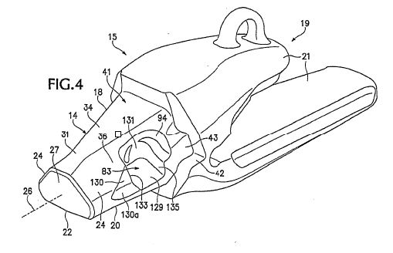
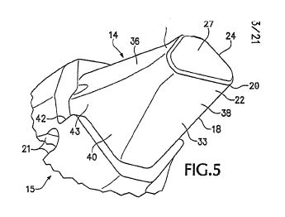
- Figure 4 is an upper perspective view of a base of the wear assembly and Figure 5 is a lower perspective view of the nose of the base. These drawings show one embodiment of a base and a nose to which a wear member is adapted to fit.
- Looking at Figure 4, on the right hand side of the drawing, the base has two legs (a pair of rearward legs marked 21) for affixing the base to a bucket in a number of common ways. The legs typically extend over and are welded to the lip of a bucket. When the base is secured to the lip of a bucket the base is typically called an “adapter”. The drawing also shows the nose of the base (marked generally 14). The body of the nose is marked 18 and the front section of the nose is marked 20. The front surface (sometimes called the front thrust surface) is marked 27. The front end of the nose has a generally triangular shape as depicted. The lower surface of the nose (the horizontal lower surface) is marked 22 and the triangulated surfaces of the nose are marked 24. Those surfaces are generally inclined facing upward and outward defining an inverted V-shape. The lower horizontal surface (22) and the front triangulated surfaces (24) represent front stabilising surfaces. The top or upper wall of the nose is marked 31.
- Figure 4 also shows an area marked 83 in the drawing which is a pocket or cavity defined in one side of the nose. It is this cavity which is engaged by the lock when the lock, located in a “through-hole” in the wear member, is moved from the release position (once installation of the wear member has occurred) to the hold position where the lock holds the wear member to the nose and thus the base.
- Figures 1, 2 and 3 are set out below.
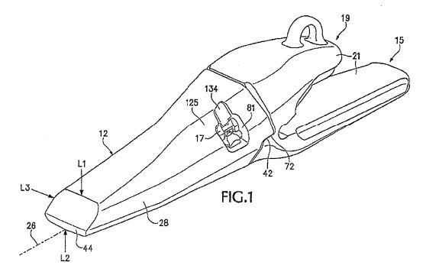
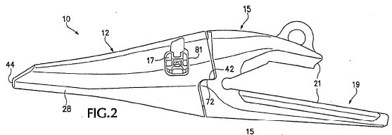
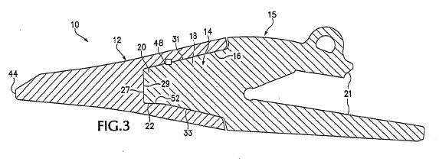
- Figure 1 shows a base (15) with two rearward legs (21) and a wear member marked 12 attached to the base. The front digging edge of the wear member is marked 44. Figure 3 shows the outline of the rear opening socket of the wear member marked 16. The socket is said to be preferably formed to matingly receive the nose of the base and accordingly the front end of the socket and the surfaces within it are designed to operate as stabilising surfaces in harmony with the surfaces of the nose of the base. Figures 1 and 2 show, marked 81, a cavity, opening or “through-hole” in the side wall of the wear member. The cavity is called a “through-hole” because it operates in communication with the socket passing through the side wall of the wear member (into the socket). When the wear member is placed over the nose of the base as shown in Figures 1 and 2, the through-hole will communicate with the cavity defined in one side of the nose. Thus (in one construction), the lock located in the through-hole (marked 81) in the wear member fits into a communicating pocket or cavity in the side of the nose. The cavity is marked 83 in Figure 4.
- Figures 12 and 13 are set out below.
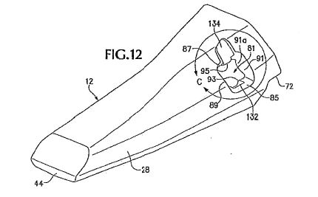
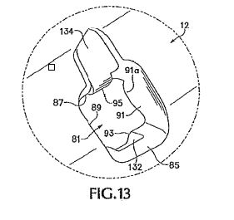
- Figure 12 is a perspective view of a wear member showing in greater detail the features of the through-hole and Figure 13 is an enlarged view, within the depicted circle, of the through-hole.
- Those illustrative general shapes depicted in the drawings need a little explanation. Through-hole 81 generally has a rectangular shape with an upper or top end wall marked 87 and a corresponding lower or end wall marked 85. It has a side wall (shown on the left hand side of the rectangular shape closest to the front of the nose) marked 89 and a corresponding rear side wall marked 91 (shown on the right hand side of the rectangular shape opposite side wall 89). The lower end wall marked 85 defines a pivot member (marked 93) in the form of a rounded “bulb”.
- That bulb generally defines a longitudinal axis (that is, relative to the direction of the wear assembly) which, put simply, having regard to what is sometimes called the “narrow end” of the lock, cooperates with the bulb on the lower end wall (marked 85) to enable the lock, located in the through-hole, to pivotally swing or move between a hold position and a release position.
- The amplitude of the swing or movement from the release position to the hold position and back is, in part, determined by a “stop” device marked 95 on Figures 12 and 13 (but most noticeably seen on Figure 13) on the upper end wall marked 87.
- Figures 18 and 19 are set out below.
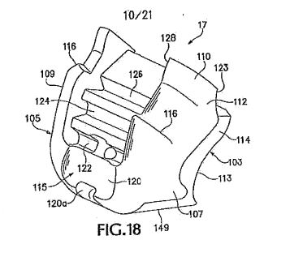
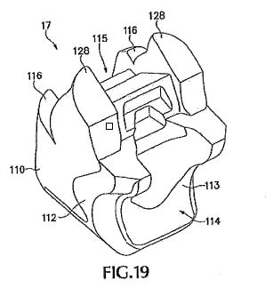
- These figures are a perspective view of the lock. It is not necessary to describe the particular shape, contours and configuration of the lock all of which are said to have a role to play in enabling the lock to be integrally secured in the through-hole and move or pivotally swing from a hold position to a release position and back irrespective of whether the wear member is engaging with the nose of the base. However, it is necessary to say something about how the lock is said to operate in conjunction with the nose of the base and in order to do so it is necessary to have regard to Figures 22, 23, 24 and 25.
- Before turning to those drawings, it is necessary to illustrate further the cavity in the nose. The cavity in the nose of the base with which the lock engages can be seen in Figure 4 marked 83 as already described. It can also been seen in Figure 8 set out below.
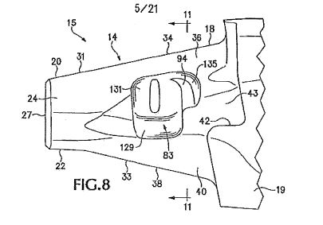
- These figures are, of course, two dimensional drawings. The cavity, simply as a matter of illustration, can be better seen in the three dimensional small-scale model handed up to the Court. Depicted below are three photographs of the model of the base which show the projecting nose of the base with the cavity or pocket (marked 83 in Figure 4).
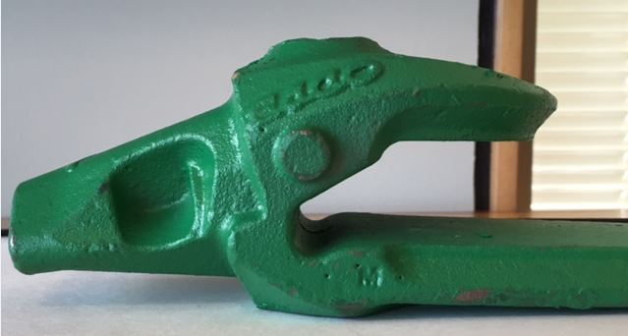
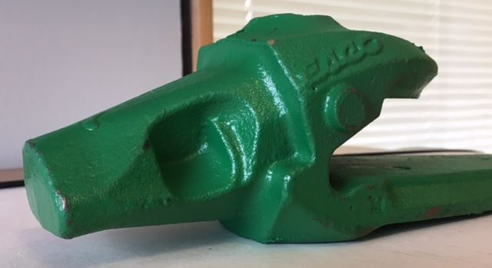
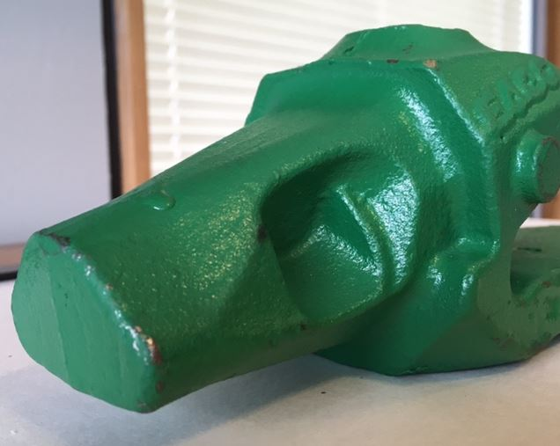
- As can be seen, the cavity in the nose does not extend through the nose and thus the nose is said to retain greater strength. The lower wall of the cavity (marked 129 in Figure 8) provides a platform against which the lock can be set when engaging with the cavity. Another wall (the rear profile marked 131 in Figure 8) is shaped so as to follow the path of the lock when swung into the hold position. Depicted below is a photograph of the wear member component independent of the base.
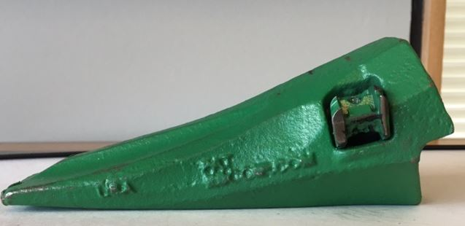
- The lock in the embodiment described in Figures 1-32 is said in the specification to operate in this way.
- The lock fits into the through-hole (marked 81 on Figures 1 and 2) such that a pivot feature or pivot member of the lock bears against the bulb (earlier described and marked 93 in Figure 13) within the through-hole for effecting pivotal movement of the lock between a hold position and a release position. To secure a wear member to the nose (and thus the base) the lock is swung about the bulb in the through-hole so as to “fit fully within cavity 83” in the nose of the base (marked 83 on Figures 8 and 4). In a preferred embodiment, a tool called a pry tool is used to move the lock pivotally into the “hold position”. It is not necessary to describe the features of the fingers of the lock and the precise mechanism of engagement. The more important matter is said to be that once the lock is swung into the “hold position” the relevant features of the lock “fully fit within cavity 83” in the nose. When in that position, one of the end walls of the cavity in the nose operates as a “catch” for the lock. The configuration of the lock and opposing facet within the socket of the wear member prevents movement of the lock away from the seated hold position.
- As earlier mentioned, Figure 4 illustrates the cavity within the nose and shows a wall of the cavity marked 133. Also, Figures 12 and 13 (and particularly Figure 13) show the rear side wall marked 91 of the rectangular shaped through-hole. When the lock is placed in the “hold position”, the front face of the lock marked 107 on Figure 18 (illustrated in the photograph below but merely as one commercial embodiment so as to show a three-dimensional image of such an embodiment; see also the three-quarter photograph below), engages with, that is, opposes the front wall of the cavity (marked 133 in Figure 4) in the nose and at the same time the rear or opposing wall of the lock engages with, that is, opposes, the rear wall (marked 91 in Figures 12 and 13 but particularly Figure 13) of the through-hole in the wear member. By reason of this engagement and opposition, the wear member is securely held to the base when the lock is placed in the “hold position”.
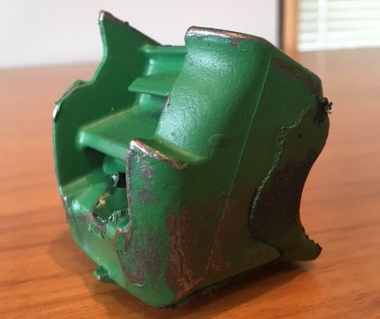
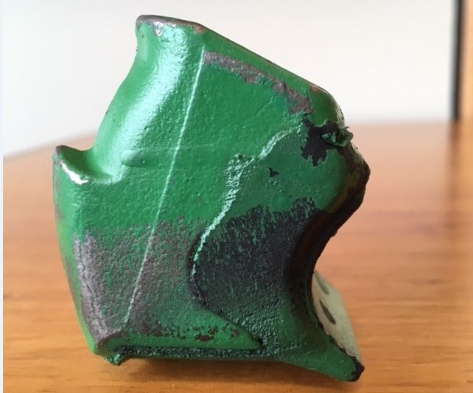
- Set out below are Figures 22, 23, 24 and 25.
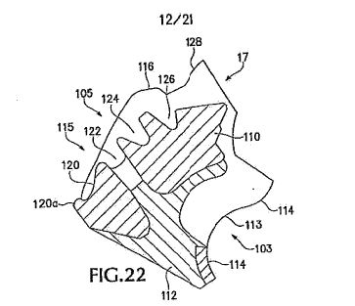
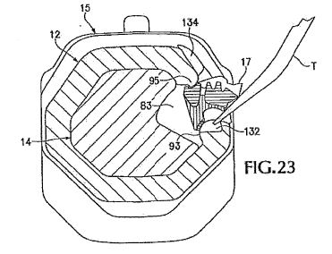
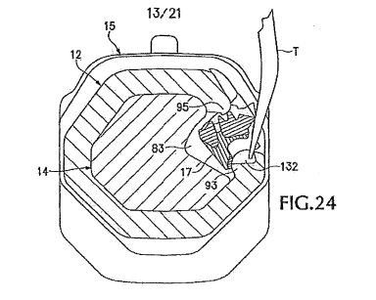
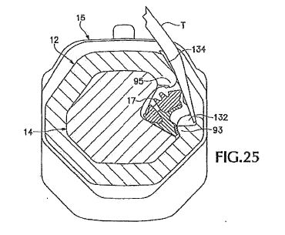
- Figure 22 is a cross-sectional view of the lock.
- Figures 23, 24 and 25 are transverse cross-sectional views showing “the incremental installation of the lock” (PA, para 42), that is to say the pivotal movement of the lock using a pry tool from the release position to the hold position. Figure 23 shows a transverse cross-sectional view of the wear assembly, that is, the wear member attached to the nose of the base with the lock seated in the through-hole but not engaging with the cavity in the nose. The pry tool marked “T” can be seen ready for use to pivotally move the lock into the cavity of the nose. Figure 24 shows a “stage” of that process and Figure 25 shows the lock in the “hold position” at which point the relevant section of the lock fully fits within Cavity 83 of the nose such that the faces described at [78] are engaged (that is, opposed). Figures 30 and 30a show the lock in the hold position ready for digging operations (without, this time, the pry tool in evidence). Figures 30 and 30a are set out below.
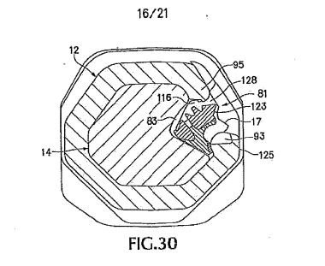
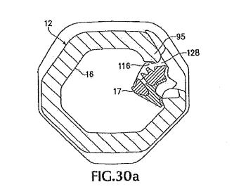
- Figures 26, 27, 28 and 29 show the reverse process by which a pry tool is inserted at a particular point in the configuration of the lock and through-hole so as to pivotally move the lock from the “hold position” shown in Figure 26 to the “release position” shown at Figure 29.
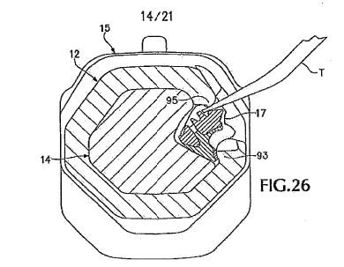
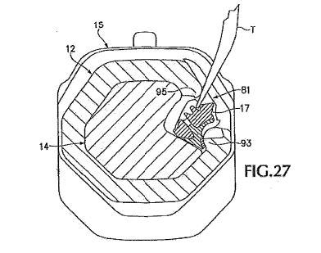
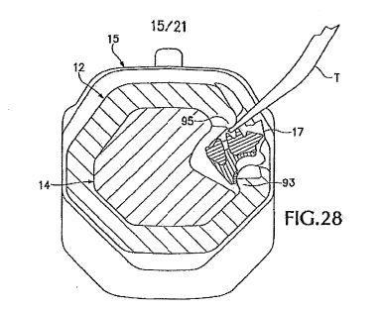
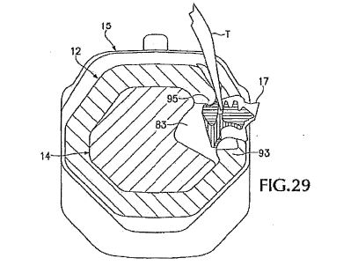
- Depicted below, for illustrative purposes, are two photographs of the small-scale model, marked 1 and 2, of the lock in the release and hold positions. The first photograph shows the lock secured in the through-hole of the wear member in the “release position” of Figure 29. The second photograph shows the lock in the “hold position” of Figures 30 and 30a. The difference between the two photographs and thus the position of the lock (at least as appears from an external examination of the lock in the through-hole of the wear member rather than from inside the cavity in the wear member) is that in Photograph 1, the lock can be seen to be more withdrawn within the through-hole such that two points of the lock are lower down in the image in the “release position” than the position in Photograph 2. In Photograph 2, the points of the lock are more upright as the lock sits in the “hold position” in the through-hole of the wear member.
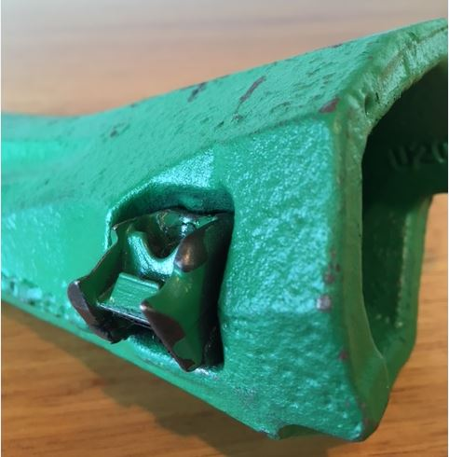
Photograph 1
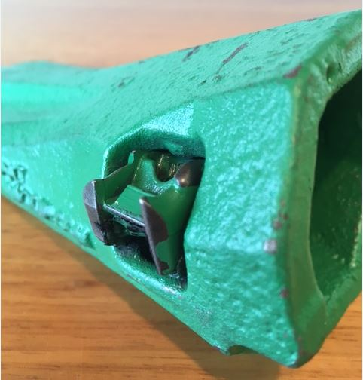
Photograph 2
- Returning then to the language of Claim 1, ESCO says that when Claim 1 speaks of a wear member comprising (among other integers) a lock integrally connected in the through-hole (of the wear member) and movable without a hammer between a hold position “where the lock can secure the wear member to the base” and a release position “where the wear member can be released from the base”, the language defining those positions contemplates two fixed or pre-determined positions each at the extremity or end point of the amplitude of the pivotal movement of the lock. One position is called “release position” (although it might also be called an “off position”) and it is represented by a point which is the end point of the amplitude of the pivotal movement of the lock into what might be called the fully recessed or fully flush position. In that position (notwithstanding that the lock can assume that position in the wear member without receipt of the nose of the base into the socket of the wear member or any engagement of the base by the wear member), the wear member can be placed on the nose of the base just as a glove might be placed on the fingers of a hand.
- The other position is called a “hold position” (although it might also be called an “on position”) and it is represented by a point which is the end point of the amplitude of the pivotal movement of the lock into what might be called a fully protuberant or fully extended position. In that position, when engaging with the cavity in the nose of the base (although, again, the lock can be placed in the hold position irrespective of any engagement with the base), the relevant parts of the lock fully occupy or fully fit into the cavity in the nose with the result that the wear member is secured to the base by the lock. If the lock is placed in the hold position (so understood) before engaging any relationship with the nose of the base (that is, before attempting to place the wear member on the base just as a glove might be placed on the fingers of a hand), the protuberant position of the lock prevents the wear member from being placed over the nose and thus on the base.
- Thus, on the question of construction, ESCO says, having regard to the language of Claim 1 and informed by paras 15 and 16 of the specification, that there are “two functions” of the lock in its relationship with the wear member. The first “is to be releasably secured” in a way that means the lock will not “pop out” of the wear member and secondly, the lock performs the function of engaging with a recess in the nose so as to ensure that when installation is made, the wear member is not going to “slip off like a glove”: T, p 15, lns 10-17.
- ESCO says that because the “hold position” and “release position” are defined by reference “only” to the through-hole in the wear member, those two positions are “identifiable” without reference to the nose and irrespective of the insertion of the nose into the rear opening socket of the wear member. Thus, the two positions do not “have to be” identified by reference to the “second function, that is to say, the insertion of the nose into the wear member”: T, p 20, lns 33-47, T, p 21, lns 1-5. The “second function” is said to “stop longitudinal movement” of the wear member from the nose but that function is said to “follow” from the position which is “independently identified by reference to the cooperation between the lock and the through-hole in the wear member”: T, p 22, lns 31-42. Counsel for ESCO put the point this way at T, p 23, lns 32-37:
… you can say that when in those positions, certain things will be possible. It will enable you to put the wear member on the nose in the release position, and it will enable you to secure the wear member to the nose in the lock position, but those two functions are facilitating installation and removal, on the one hand, and its facilitating securing on the other [does not] define the position. The position is defined by reference only to the lock and the cooperative wear member.
[emphasis added]
- The notion that the hold and release positions are defined by reference only to the lock’s relationship with the through-hole in the wear member and not by reference to the base is said to be “emphasised” by the language “irrespective of the receipt of the base in the socket or orientation of the [wear] member” at the end of Claim 1, that is to say, the lock and the through-hole are said to be “cooperatively structured” to “retain the lock” in the through-hole and also in each of the hold and release positions irrespective of receipt of the base or the orientation of the wear member: T, p 29, lns 42-47; T, p 30, lns 1-3; T, p 32, lns 35-39. Counsel for ESCO, drew the contentions on construction together in this way at T, p 30, lns 5-15:
There are two functions of the hold and release positions in the cooperatively structured lock and through-hole. The first is the retention of the lock in the through-hole, so that it is integrally connected in the through-hole … and accordingly can achieve the advantages that are referred to in [paras] 15 and 16 [of the specification]. The second is the enablement of the securing and release of the wear member from the base. And the third thing we would say about the claim is that the language of the claim makes it plain that the hold position and release position are defined by reference only to the through-hole, but that construction is consistent with the purposes which one sees in [paras] 15 and 16, so that were there any doubt about it, a [purposive] construction would achieve the same result.
[emphasis added]
- Finally, the lock is said to be “releasably securable” in the lock opening in the wear member (in the through-hole) such that it can be moved from one position to the other (hold or release) and yet remains “secured” in the wear member due to the cooperation between the lock and the through-hole in the wear member: T, p 31, lns 28-40.
- Ronneby says that such a construction is not consistent with the language of Claim 1; Claim 1 does not use the terms “pre-determined”, “pre-defined” or “fixed”; the only definition given to the terms “a hold position” and “a release position” in Claim 1 is a functional one; and, the Primary Judge correctly construed those two terms. Ronneby supports the reasoning of the Primary Judge as described at [109] to [125] of these reasons. Ronneby also says that the Primary Judge correctly construed para 6 of the Specification as containing a textually composite promise unfulfilled by each claim with the result that all claims fail for reasons of inutility.
- At this point, it is also convenient to mention another aspect of the specification which goes to the prior art. As already mentioned, the specification says, as an aspect of the invention, that the lock is “swung about an axis” that extends generally longitudinally for easy use and stability and in the hold position the lock “fits within” a cavity in the sidewall of the nose which “avoids the conventional through-hole and provides increased nose strength” [emphasis added]. Moreover, the sides of the lock in such an aspect are said to form a secure and stable locking arrangement without substantial loading of the hinge portion of the lock: PA, para 18. The reference to a “conventional through-hole” is said to be one in which there is a hole through a section of the nose which generally aligns with a through-hole in a wear member once the wear member is fully received by the base. Put simply, conventionally, a lock in the form of a screw apparatus (comprising a housing of one kind or another and a screw or wedge to be wound into the housing) is inserted or hammered into the aligned opening (passing into and occupying the hole through the nose) with the screw part of that apparatus then being rotated such that the lock (housing and screw) firmly secures the wear member to the base.

Torq Lok
- It is also convenient at this point to note some things about the Torq Lok product produced by Quality Steel and in doing so we refer to the observations of the Primary Judge and the photographs adopted by the Primary Judge. There is no challenge to the finding that the Torq Lok product forms part of the prior art.
- The Torq Lok product is described as a “locking pin/retainer” arrangement: PJ at [20]. It is a hammerless method of fitting a wear component to an excavator. It initially consisted of a “screw” and a “polymer retainer”: PJ at [20]. It operates in this way. The wear component (which essentially has the same digging role as the wear member) is manufactured with a cavity for locating the polymer retainer (and screw). When the Torq Lok is being assembled in the wear component, the first step is to fit the polymer retainer within the cavity in the wear component. The polymer retainer is “interference fitted” into the cavity: PJ at [20]. The screw is then “securely threaded” into the retainer: PJ at [20]. There is a “very tight fit between them”: PJ at [20].
- However, the threading of the screw is ideally undertaken such that the end of the screw, when the screw is rotated, does not protrude beyond the “underside” of the polymer retainer (otherwise called the “distal end” of the screw, (PJ at [20]), that is, the point more distant from the head of the screw). However, this preferred practice of not rotating the screw such that the distal end does not protrude beyond the underside of the polymer retainer, proved to be problematic because some screws, during assembly, were rotated too far such that the distal end of the screw did protrude beyond the underside of the polymer retainer making it necessary for operators of excavating equipment to “back the screw off” (which, by then, was “securely threaded” and a “very tight fit”): PJ at [20]. Operators needed to “back the screw off” so as to be able to fit the wear component to the corresponding base attached to an excavator: PJ at [20]. This protrusion problem was solved by the manufacturer developing a “gauge” which the distal end of the screw would contact at a point of alignment with the underside of the polymer retainer: PJ at [20]. The workers assembling the Torq Lok lock and the wear component would then have an indication of when to stop rotating the screw any further: PJ at [20].
- The wear component with the Torq Lok in position was then shipped to customers. The components of the Torq Lok thus became the pin or screw, the polymer retainer and the gauge although the critical two elements seem to be the pin or screw and the polymer retainer.

The photographs in relation to the Torq Lok product
- The following photograph is set out at [22] of the Primary Judge’s reasons.
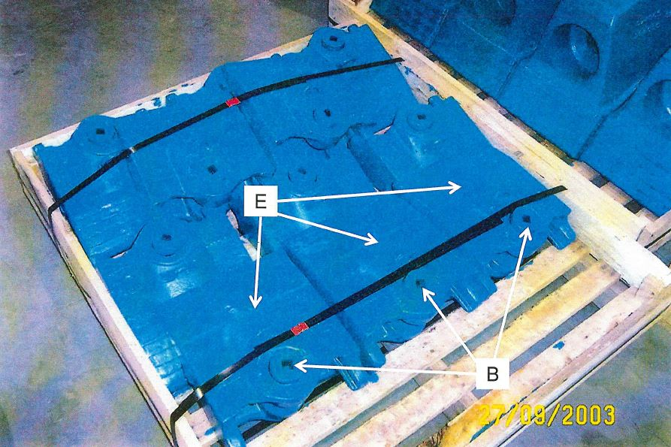
- The photograph at [96] shows (although not very clearly; marked “E”), a number of “wear components” to be attached to a “lip adapter” (T, p 62, lns 1-3) which sits on an excavator bucket. The wear components in this image are strapped to a palette. What can be seen more clearly, marked “B”, is the top of the Torq Lok “locking pin” or screw, with a square depression to enable a screw tool (a ratchet) to be inserted for rotating the screw. In this photograph, the locking pin (or screw) is in the “unlocked position”: PJ at [22]. The notion “unlocked position” is explained by the Primary Judge by reference to two other photographs at [22]. The first is the following photograph:
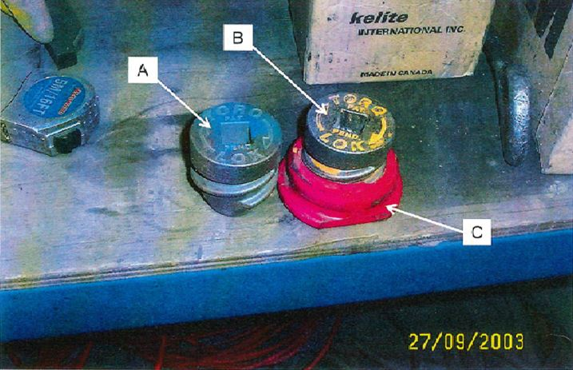
- This photograph shows the screw or locking pin marked “A”. The thread is clear and the clockwise rotation is shown on the head of the screw. Another example of the Torq Lok screw is shown marked “B” and in this example the screw is shown located threaded, in part, into a red polymer retainer marked “C”. In the example marked “B” and “C”, the screw is depicted with one cycle of the thread showing with the result that the screw is not “fully located” in the polymer retainer.
- The second photograph relevant to the question of what might be the “unlocked position” is the following photograph:
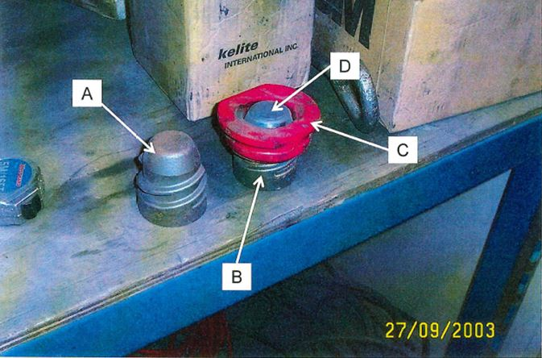
- This photograph shows, marked “A”, the same screw or pin component as shown in the photograph at [97] except that the screw is now turned upside down. The image clearly shows the thread and the shape of the distal end of the screw. It also shows the other component from the photograph at [97] also upside down so as to show (marked “B”, “C” and “D”), the screw (marked “B”) threaded into the polymer retainer (marked “C”) from the “underside” in such a way that the distal end of the screw (marked “D”) is “generally flush” with the underside of the polymer retainer: PJ at [22]. This “generally flush alignment” represents the “unlocked position” of the Torq Lok lock. In this position, the wear component could be placed over, or removed from, the lip adapter (or base) attached to the excavator: PJ at [22]. In such a position, the wear component would not be “secured” to the adapter. In the “locked position” the screw “would have been threaded further into the [polymer] retainer” such that the distal end of the screw would be “proud of the [underside] of the retainer”: PJ at [22].
- Apart from these photographs, the Primary Judge also had regard to four drawings (caused to be made by a witness called by Ronneby, Mr Hughes, a mechanical engineer; PJ at [23]), of a wear component and a Torq Lok locking pin arrangement which Mr Hughes viewed at Quality Steel in 2003 at Nisku, Canada. The four drawings depict the “stages of attachment” of the wear component to the lip adapter or base attached to and the “engagement” of the locking pin: PJ at [23].
- The drawings depicted at [23] of the Primary Judge’s reasons (marked 1, 2, 3 and 4) are not as clear as they might be. Clearer examples of the drawings have been provided to us. Drawing 1 is set out below:
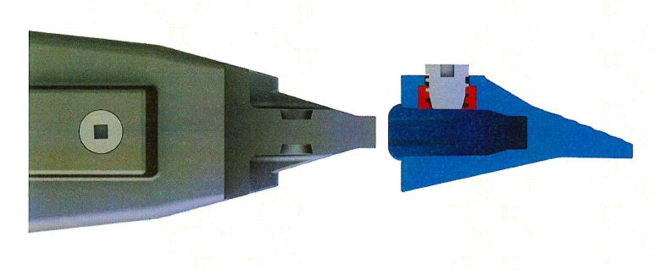
- Drawing 1 shows the lip adapter or base (on the left) about to receive the wear member (on the right). The digging end of the wear member can be seen on the right-hand side of the wear member. The drawing shows a cavity in the wear member and located within it is the polymer retainer and screw. In black and white images, the polymer retainer is not particularly obvious although these reasons contain colour photographs which clearly show the red polymer retainer. The screw, rotated into the retainer, is shown in such a way that the distal end is not protruding beyond the underside of the polymer retainer. A recess (or cavity) in the lip adapter can be seen which will ultimately progressively receive the distal end of the screw once alignment is achieved.
- Drawing 2 is set out below.
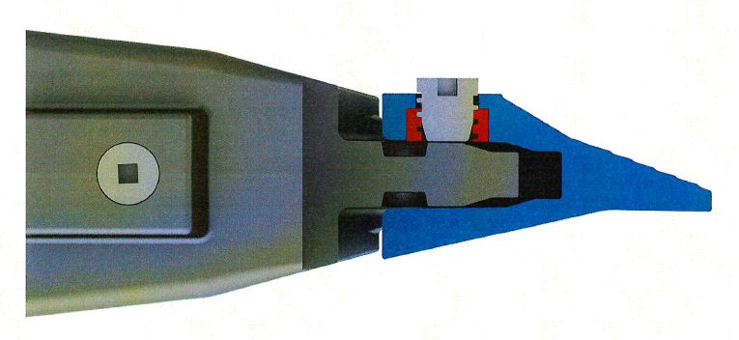
- Drawing 2 shows a further stage of receipt by the base of the wear member. It also shows the pin or screw seated in the polymer retainer. The distal end of the screw is shown “generally flush” and not “proud of” the underside of the retainer. The cavity in the wear member with retainer and screw is, in this drawing, not yet aligned with the recess in the base. Drawing 3 is set out below.
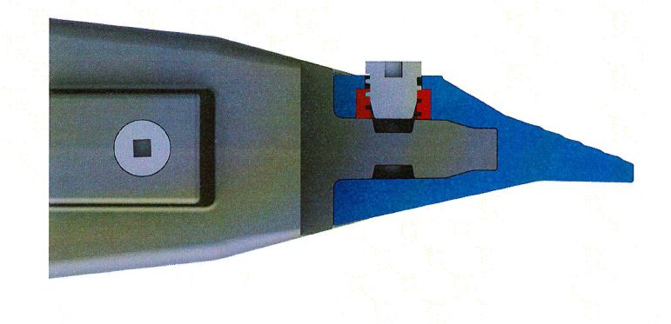
- Drawing 3 shows the wear member seated on the base with the cavity and screw in the wear member in alignment with the recess in the base. The distal end of the screw remains flush with, and not proud of, the polymer retainer. Drawing 4 is set out below.
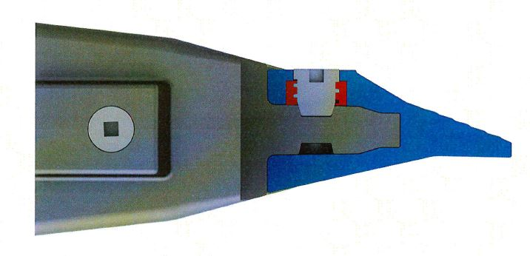
- Drawing 4 shows the screw fully rotated into the polymer retainer such that the top of the screw is flush with the top surface of the wear member and the distal section of the screw is now fully seated in the recess in the base. Consistent with the upside-down photograph of the screw (seen as example marked “A” in the image at [98] of these reasons), Drawing 4 shows the shape of the distal section of the screw and the corresponding profile of the recess which receives the distal section of the screw.
- In Drawing 3, the screw is in a position described by the Primary Judge on the basis of the evidence of Mr Hughes as the “unlocked position”. In Drawing 4, the relevant section of the distal end of the screw is fully located in the recess in the base. At that point, the wear member is “held in place”: PJ at [20]. The position depicted in Drawing 4 might also be described as a position in which the wear member is “locked” in place.

The findings of the Primary Judge

Novelty
- At [29], the Primary Judge observed that the “description of the invention in the specification and associated diagrams” were of little assistance to him on the question of construction as they were substantially concerned with aspects of the invention which are “much narrower than those covered by Claim 1”.
- At [31], the Primary Judge took the view that he was not assisted on the controversy as to the question of construction of Claim 1 by the evidence given by either of the experts. Ronneby called evidence from Mr William Hunter and ESCO called evidence from Mr Howard Robinson. Both men are mechanical engineers “of considerable experience”: PJ at [31].
- At [31], the Primary Judge notes that Mr Robinson gave evidence that the Torq Lok lock was not an “integral lock” having a “hold position” and a “release position”, “as described in the Opposed Application”, and did not have a “clearly defined hold position and release position for the lock”. The Primary Judge notes that Mr Robinson was not cross-examined on those views and, in an affidavit filed subsequently by Mr Hunter, Mr Hunter made no reference to those views. The Primary Judge took the view, however, that Mr Robinson, in expressing his opinions, appeared to have “assumed a particular construction of Claim 1 rather than [having] given the matter [of construction] any specific consideration”, partly at least because the “qualifier clearly defined”, used by Mr Robinson, did not appear in the language of Claim 1 or otherwise appear in the Specification: PJ at [31].
- In the result, the Primary Judge considered that “for better or for worse, … the constructional question arising with respect to Claim 1 must be resolved within the four corners of the claim itself, against an understanding, of course, of the relevant field of engineering and the industrial settings in which arrangements of the kind proposed by the inventors would be used” [emphasis added]: PJ at [32].
- At [33], the Primary Judge said this:
To the extent that the hold position and the release position are given definition in Claim 1, those definitions are functional ones. The hold position is “where the lock can secure the wear member to the base”, and the release position is “where the wear member can be released from the base”. In my view, a lock which could be moved between a position where the wear member would be secured to the base and a position where it could be released from the base would come within these words in Claim 1. So long as those two functional criteria are satisfied, the claim is, in my view, unconcerned with the precise location of the two positions referred to. That is not to say, of course, that an arrangement that operated other than by reference to two positions, such as one that involved the progressive application of force, for example, would come within the claim. The construction I prefer would not airbrush out of the claim the need for the lock to operate in a way which might broadly be described as binary. But it is to say that the predetermination of exact positions, abstracted from the industrial usage of the lock is not, in my view, a requirement of the claim.
[emphasis added]
- At [33], the Primary Judge finds that the hold position and release position are positions determined by function. Once the lock is in a place “where it can secure the wear member to the base”, the lock of Claim 1 is, “to the extent that the hold position [is] given definition in Claim 1”, in the hold position and once the lock is in a place where the wear member can be released from the base (to the extent any definition can be found in Claim 1), the lock is in the release position. Thus, the Primary Judge concludes that the claim is unconcerned with the precise location of either position. A pre-determined or exact position “abstracted from the industrial usage of the lock” is not a requirement of the claim, as a matter of construction: PJ at [33].
- The Primary Judge, however, also construes Claim 1 as incorporating a need for the lock to operate in a way which might broadly be described as binary (on/off; 0/1) and concludes that his “preferred construction” ought not be seen as “airbrushing” out of the language of Claim 1, the need for the lock to operate in a broadly binary way: PJ at [33]. The Primary Judge also recognises (and thus accepts, in the sentence at [33] commencing: “That is not to say …”) that the claimed invention of Claim 1 contemplates an arrangement that operates “by reference to two positions”.
- At [34], the Primary Judge then considered whether the Torq Lok product contained those features. The Primary Judge concluded that the Torq Lok has a “hold position” and a “release position” in the sense contemplated by Claim 1 as construed. The Primary Judge said this at [34] of the Torq Lok product:
Once the wear member was engaged with the base, the lock would be moved to a position where it would “secure the wear member to the base”. When the wear member needed to be replaced, the lock would be moved to a position where “the wear member [could] be released from the base”.
- As to the notion that the introduction of the “gauge” demonstrated the absence of a singular release position at which the lock could be set before being shipped to a customer, the Primary Judge observed that the introduction of the gauge to fix the particular position for shipment to customers made no difference to the question of construction and that was especially so because Claim 1, in the view of the Primary Judge, “does not require the presence of a precise, pre-determined position as the release one”: PJ at [35]. At [36], the Primary Judge accepted that Claim 1 is concerned not with the position of the lock ex works (for transmission to customers), but with the position to which the lock would be moved for the purposes of releasing the wear member from the corresponding base and so long as there is “such a position”, “it is neither here nor there that the lock might not have been in that position at the point of shipment from the supplier”.
- For the reasons described at [109] to [113] of these reasons, the Primary Judge concluded that the Torq Lok lock fell within the terms of Claim 1 of the Patent Application and thus anticipated the claim.
- The Primary Judge also upheld Ronneby’s novelty case in relation to Claims 6, 7, 9 to 15 and 18 to 23 of the Patent Application.
- At [49], [50] and [51], the Primary Judge held that Claims 6, 7 and 9 involve no material differences from Claim 1 and thus all three claims lack novelty for the same reasons given in relation to Claim 1.
- At [52], the Primary Judge held that Claims 10, 11 and 12 depend, directly or indirectly, on Claim 9 and since those claims do not introduce any integer of relevant material difference from those contained in Claim 1, each of these three claims lack novelty for the same reasons given in relation to Claim 1.
- Claim 13 was found to have been anticipated by the Torq Lok product for the same reasons given in relation to Claim 1: PJ at [53].
- The Primary Judge held that since Claims 14, 15 and 18 depend, directly or indirectly, on Claim 13 and do not otherwise introduce any integer of relevant material difference, those claims lack novelty for the same reasons given in relation to Claim 1: PJ at [54].
- At [55], the Primary Judge held that Claim 19 is relevantly indistinguishable from Claim 1 except in one relatively minor respect. The Primary Judge observed that Claim 1 describes the “release position” as one in which the wear member can be released from the base whereas Claim 19 describes the release position as one in which “the lock permits installation and removal of the wearable body on and from the base” [emphasis added]. As to Claim 19, the Primary Judge said this:
However, taking the view, as I do, that the existence of a pre-determined, precise, position either hold or release, is not a requirement of Claim 1, and likewise taking the view that Claim 19 should be similarly understood, I would also hold that the Torq Lok fell within the terms of the latter because the pin was, as observed by Mr Hughes and as inferentially supplied to customers, in the position in which the wear member would be installed on the base, being the same position as the pin would occupy when the wear member was subsequently released from the base. Thus the applicant’s novelty case in relation to Claim 19 should also be upheld.
- At [56], the Primary Judge found that since Claims 20, 21, 22 and 23 depend, directly or indirectly, on Claim 19 and do not otherwise introduce any integer of relevant material difference from those in Claim 1, Claims 20, 21, 22 and 23 lack novelty as being anticipated by the Torq Lok lock.

Utility
- At [66], the Primary Judge notes Ronneby’s contention that the advantages promised by the authors of the Patent Application are those set out at paras 5 and 6 of the Specification (see [21] and [24] of these reasons), namely, “enhanced stability, strength, durability, penetration, safety and ease of replacement”. The Primary Judge also notes that fundamental to Ronneby’s contention about lack of utility was the proposition that these advantages are expressed “cumulatively” such that the relevant promise is that all of these advantages will be delivered by the invention “so far as claimed in every claim” [original emphasis].
- At [67], the Primary Judge addresses aspects of the evidence and notes that the experts, Mr Hunter for Ronneby and Mr Robinson for ESCO, were asked this question:
What is meant by the following statements in paragraphs 5 and 6 of the Patent Application?
5. Many designs have been developed in an effort to enhance the strength, stability, durability, penetration, safety, and/or ease of replacement of such wear members with varying degrees of success.
...
6. The present invention pertains to an improved wear assembly for securing wear members to excavating equipment for enhanced stability, strength, durability, penetration, safety, and ease of replacement.
- At [68], the Primary Judge notes that Mr Hunter gave the following answer:
Hence, in relation to the first paragraph above, this means that in the past the patentee acknowledges that wear members have been developed with different designs in an attempt to improve them in the following ways:
1. Enhanced strength. This would mean that it could be expected that in operation the wear member would be less likely to fail or break as a result of the loads or stresses to which it was subjected during excavation than would otherwise be the case.
2. Enhanced stability. This would mean that it could be expected that in operation the wear member would be more resistant to being displaced by the loads to which it was subjected during excavation than would otherwise be the case.
3. Enhanced durability. This would mean that it could be expected that in operation the wear member would have a longer life, and would wear less rapidly during excavation than would otherwise be the case.
4. Enhanced penetration. This would mean that it could be expected that in operation the wear member would more easily penetrate the ground during excavation than would otherwise be the case. It would also be expected that as a result of better penetration into the ground, the flow of earthen materials into the bucket during excavation would be improved.
5. Enhanced safety. This would mean that when installing or removing the wear member, it would be more safe to install or remove the wear member to or from the base with less risk of injury to the installer. It would also be expected that the lock would hold the wear member to the base more securely than would otherwise be the case. The experts agree that a wear member that becomes loose and is dislodged from the base during excavation poses an additional safety risk.
6. Enhanced ease of replacement. This would mean that it would be easier to remove a wear member from the base, and to fit a wear member to the base than would otherwise be the case.
In relation to the second paragraph above, this means that the invention is also seeking to improve the six (6) parameters of strength, stability, durability, penetration, safety and ease of replacement via an improved wear assembly, that is via improvements to the wear member, the base, and the lock.
[emphasis added]
- At [68], the Primary Judge also notes that Mr Robinson agreed with the above observations of Mr Hunter.
- At [69], the Primary Judge notes that the experts were also asked this question:
What are the advantages that, collectively, the aspects of the invention described in the Patent Application are said to achieve?
[emphasis added]
- At [69], the Primary Judge notes that Mr Hunter summarised the “aspects” of the invention at paras 7, 8, 9, 10, 11, 12 and 14 of the Specification, the preferred embodiment at para 13 of the Specification and the “aspects” of the invention described at paras 15, 16, 17, 18, 19 and 20 of the Specification. Mr Hunter then sought to answer the question at [127] above by reference to the para 6 “advantages” of enhanced stability, strength, durability, penetration, safety and ease of replacement. As to the aspects at paras 7 to 14 of the Specification, the Primary Judge notes that Mr Hunter explained that those aspects relate to the geometry of the nose and the wear member and were said to have “benefits” related to “strength, stability, penetration and durability”: that is, four of the six matters recited at para 6 of the Specification. However, Mr Hunter gave evidence that those benefits would only be achieved when the wear member is “fitted” and the “assembled wear member is being used for excavation”: PJ at [69]. The Primary Judge also notes Mr Hunter’s evidence that the six aspects set out in para 6 of the Specification “related to the inclusion of a lock integrally secured to the wear member [and were] said to have benefits of ease of replacement and safety”. The Primary Judge also notes Mr Hunter’s evidence that those benefits “would appear to be achieved either prior to the wear member being fitted (for example, when stored in inventory), or during installation of the wear member”. Having noted those matters, the Primary Judge notes Mr Hunter’s conclusion that: “All of the aspects of the invention would need to be combined together … to allow all of the advantages of the invention described in paragraph [6] of the Patent Application to be obtained” [emphasis added].
- At [69], the Primary Judge also notes that Mr Robinson agreed with Mr Hunter’s answer described at [131] of these reasons to the question set out at [130] of these reasons.
- At [70], the Primary Judge notes that the experts were also asked this question:
For each claim of the Patent Application:
a) what advantage(s) does the Patent Application identify for the features of the wear member or wear assembly in that claim?
b) for any other advantages identified in question 2, would a wear member or wear assembly having the features in that claim necessarily achieve that advantage? Why or why not?
- At [70], the Primary Judge notes that, in answer to that question, Mr Hunter devised a detailed table setting out the “features” of each claim identifying the “advantages” achieved by the respective features. Mr Hunter’s summary seeks to take each of the para 6 “advantages” and identify whether each claim achieves the particular advantage. As to that, the Primary Judge notes at [70] Mr Hunter’s summary as set out in a table in these terms:
In relation to enhanced strength, none of the claims would achieve this advantage.
In relation to enhanced stability, claims 3 and 5 may provide a minor stability advantage as set out in paragraphs 14-21 of my first affidavit. [sic - this was clearly an intended reference to Mr Hunter’s second affidavit sworn on 21 October 2015]
In relation to enhanced durability, none of the claims would achieve this advantage.
In relation to enhanced penetration, none of the claims would achieve this advantage.
In relation to enhanced safety, claims 1, 11, 13, 21, and 22 would achieve this advantage.
In relation to enhanced ease of replacement, claims 1, 4, 6, 8, 9, 12, 13, 16, 19, 22, and 25 would achieve this advantage.
- As to this evidence, the Primary Judge said that two further things should be noted. The first was that in accordance with the authorities, a “minor advantage” ought to be held to be enough for ESCO to succeed on a question of utility in an appeal under s 60(4). The second was that as to claims not mentioned in Mr Hunter’s summary at all, his Honour said at [71]:
Claim 2 is dependent on Claim 1, Claim 7 is dependent on Claim 6, Claim 10 is dependent on Claim 9, Claims 14, 15, 17 and 18 are, directly or indirectly, dependent on Claim 13, Claims 20, 23 and 24 are dependent on Claim 19 and Claim 26 is dependent on Claim 25.
- The Primary Judge observes at [71] that in each case the independent claim would achieve an advantage by way of enhanced ease of replacement (and, in the case of Claim 13, also by way of enhanced safety). At [71], the Primary Judge also said this:
Since each dependent claim will, by its terms, contain all the integers of the relevant independent claim, I am in no position to conclude – and the experts’ report does not clearly state – that those dependent claims do not likewise achieve that advantage (or, in the case of Claims 14, 15, 17 and 18, advantages [of enhanced ease of replacement and enhanced safety]).
[emphasis added]
- The Primary Judge noted that Ronneby framed the question for determination as one of whether all of the claims were bad for want of utility because none of them delivered on the promise made in the Specification that the invention would bring to each claim all of the six advantages set out in para 6 of the Specification. The Primary Judge recognised that that question, of course, contains an anterior question of whether the six advantages are to be regarded as the promise of the Specification for each claim. ESCO contended that the promise was not to be found in that paragraph but rather in a consideration of the Specification as a whole having regard to the title of the invention. Alternatively, ESCO contended that the para 6 advantages (if promises) were to be understood according to the claims which addressed, respectively, the para 6 “advantages”, rather than as a composite promise conveying all six advantages in every claim.
- As to the resolution of those matters, the Primary Judge at [73] sought to resolve what he described as “the problem of how a promise which was textually composite would feed into the court’s consideration of the utility of a claim which did not deliver on each and every one of the advantages contained in it [that is, the ‘promise’]” [emphasis added]. Thus, it seems that the Primary Judge construed para 6 of the Specification as containing “textually composite” promises for the invention. Were they, as a matter of utility, required to be present in each claim?
- At [73], the Primary Judge refers to an extract from Bodkin, C, Patent Law in Australia, Law Book Co, 2008 at pp 265-266 in which the author addresses a number of authorities relevant to the question. The extract addresses early English authority said to be to the effect that all of the promised results must be attained by the invention as claimed. The extract also addresses some Australian authorities and, in particular, the decision of Windeyer J in the Supreme Court of New South Wales in Pracdes Pty Ltd v Stanilite Electronics Pty Ltd (1995) 35 IPR 259 at 272-275 (“Pracdes v Stanilite”) which holds that the claimed invention lacked utility even though it was conceded that four of the six “promised results” were obtainable by the claimed invention, and the decision of von Doussa J in Townsend Controls Pty Ltd Gilead and Another (1989) 16 IPR 469 at 490 in which his Honour suggests that a claim will be useful if it produces “one of the results claimed in the specification”. For that proposition, von Doussa J relied upon the 13th Edition of Terrell on the Law of Patents at para 5.39 but also one of the early English authorities which, however, is said to suggest otherwise, namely: In the matter of Alsop’s Patent (1907) 24 RPC 733 (“Re Alsop’s Patent”) (High Court of Justice – Chancery Division).
- In the extract, Bodkin observes:
In view of the origins of the utility requirement in the prohibition of inventions which are “mischievous to the state”, it is difficult to see why an invention that in fact provides some benefit should not be regarded as useful even if it does not provide all the benefits that the patent promises.
- At [74], the Primary Judge addresses two of the more recent examples of early English authority including Re Alsop’s Patent (1907) and, a decision of Warrington J, Flour Oxidising Company Ltd v Hutchinson (1909) 26 RPC 597 at 629, both of which might be said to suggest that if any one of the promises fails to be achieved by the relevant claim, the Crown has been “deceived” and the grant is void. At [76], the Primary Judge observed that the authority most directly relevant to the proceeding in question is the decision of Windeyer J in Pracdes v Stanilite to the effect that since the “promised result” was “not delivered” by the “invention as claimed”, that failure amounted to a ground of revocation. At [77], the Primary Judge said this:
Notwithstanding the view expressed by Mr Bodkin towards the end of the [extract] referred to above [quoted at [140] of these reasons], I consider that the weight of authority favours [Ronneby] on this point. In particular, Pracdes is a directly applicable superior court judgment which I should follow unless persuaded that it was plainly wrong. Where the controversial question arises under federal statutory law, there is the strongest of reasons to adhere to that principle. By contrast, Townsend Controls (a case decided, I would add, without the benefit of a contribution from a contradictor) did not involve the same issue: there was, it seems, a single embodiment apropos of which all of the challenged claims lacked utility (see 16 IPR at 490).
- Thus, at [78], the Primary Judge upheld Ronneby’s utility objection in respect of all of the claims in the Patent Application.

Grounds of appeal
- The grounds of appeal are these:
- The Court erred in concluding that claims 1, 6, 7, 9 to 15 and 18 to 23 of Australian Patent Application 2011201135 (the Patent Application) are not for a novel invention because:
- The Court erred in concluding (at [33]) that the term “a hold position where the lock can secure the wear member to the base and a release position where the wear member can be released from the base” as used in claim 1 (and, with minor variations, in claims 6, 9, 13 and 19) of the Patent Application (the hold and release position integer) encompassed:
“a lock which could be moved between a positon where the wear member would be secured to the base and a position where it could be released from the base … [without requiring] pre-determination of exact position [of the lock relative to the wear member]”
when, properly construed, the hold and release position integer requires that there be pre-defined or fixed positions of the lock relative to the wear member, which positions are identifiable independently of the base – one position which would enable the wear member to be held to the base for operation and the other position which would enable the wear member to be released from the base.
- The Court erred in concluding (at [34]) that the Torq Lok possessed the hold and release position integer within the meaning of claim 1 (and, with minor variations, in claims 6, 9, 13 and 19) of the Patent Application, because, when that integer is properly construed as set out in (a) above, the Torq Lok did not possess the hold and release position integer within the meaning of claim 1.
- The Court further erred in concluding (at [35]) that the Torq Lok had a “release position” within the meaning of claim 1 (and, with minor variations, in claims 6, 9, 13 and 19) of the Patent Application, notwithstanding the “gauge” being introduced into operation, because, when the term “release position” is properly construed as set out in (a) above, the Torq Lok did not possess a “release position” within the meaning of claim 1.
- The Court erred in concluding that the claims of the Patent Application are not for a useful invention, because:
(a) The Court erred in concluding, as it must have done (at [73] to [78]), that paragraph 6 of the Patent Application contains cumulative promises as to what the claimed invention will achieve when, properly construed, paragraph 6 of the Patent Application does not contain any such cumulative promises or any promise at all.
(b) The Court erred in failing to find that paragraph 15 of the Patent Application contained the relevant promise of the result to be attained by the wear members and wear assemblies claimed in the Patent Application and that such results were attained by those wear members and wear assemblies.
(c) In the alternative, the Court erred in:
(i) concluding (at [77]), that where a specification lists a number of promises to be attained by the claimed invention, it is necessary for more than one promise to be so attained; and
(ii) failing to find that the wear member or wear assembly claimed in each claim of the Patent Application is useful, notwithstanding the Court’s finding (at [71]) that each of the independent and dependent claims “would achieve an advantage by way of enhanced ease of replacement (and, in the case of Claim 13, also by way of enhanced safety)”.

The principles of construction
- The principles governing claim construction are well understood. In Sandvik Intellectual Property AB v Quarry Mining & Construction Equipment Pty Ltd [2017] FCAFC 138; (2017) 348 ALR 156 (“Sandvik”), we (Greenwood, Rares and Moshinsky JJ) set out the relevant principles. In doing so, we adopted a convenient summary of those principles by Kenny and Beach JJ in Product Management Group Pty Ltd v Blue Gentian LLC (2015) 240 FCR 85 at [36]-[37] and [39]-[42] (“PMG”). For convenience we again set out those paragraphs of the joint judgment of Kenny and Beach JJ although we commence, on this occasion, with [35]:
35 A claim is to be construed from the perspective of a person skilled in the relevant art as to how such a person, who is neither particularly imaginative nor particularly inventive (or innovative), would have understood the patentee to be using the words of the claim in the context in which they appear. A claim is to be construed in the light of the common general knowledge before the priority date.
36 In construing the claims, a generous measure of common sense should be used (Ranbaxy Laboratories Ltd v AstraZeneca AB (2013) 101 IPR 11 at [108] per Middleton J and Streetworx Pty Ltd v Artcraft Urban Group Pty Ltd (2014) 110 IPR 82 at [58]-[69] per Beach J). Further, ordinary words should be given their ordinary meaning unless a person skilled in the art would give them a technical meaning or the specification ascribes a special meaning (Kimberly-Clark Australia Pty Ltd v Multigate Medical Products Pty Ltd (2011) 92 IPR 21 at [39] per Greenwood and Nicholas JJ).
37 The body of the specification may be used in the following fashion in construing a claim:
- The claim should be construed in the context of the specification as a whole even if there is no apparent ambiguity in the claim (Britax Childcare Pty Ltd v Infa-Secure Pty Ltd (2012) 290 ALR 47 at [222] per Middleton J and more generally Welch Perrin & Company Pty Ltd v Worrel (1961) 106 CLR 588 at 616); even the ordinary meaning of words may vary depending on the context, which the specification may provide;
- Nevertheless, it is not legitimate to narrow or expand the boundaries of the monopoly as fixed by the words of a claim by adding to these words glosses drawn from other parts of the specification (Jupiters Ltd v Neurizon Pty Ltd (2005) 222 ALR 155 at [67]; Kinabalu Investments Pty Ltd v Barron & Rawson Pty Ltd [2008] FCAFC 178 at [44]); and
- More particularly, if a claim is clear and unambiguous, to say that it is to be read in the context of the specification as a whole does not justify it being varied or made obscure by statements found in other parts of the specification.
…
39 A claim should be given a “purposive” construction. Words should be read in their proper context. Further, a too technical or narrow construction should be avoided. A “purposive rather than a purely literal construction” is to be given (Kimberly-Clark Australia Pty Ltd v Multigate Medical Products Pty Ltd at [41] per Greenwood and Nicholas JJ). Further, the integers of a claim should not be considered individually and in isolation. Further, a construction according to which the invention will work is to be preferred to one in which it may not (Pfizer Overseas Pharmaceuticals v Eli Lilly & Company (2005) 225 ALR 416 at [250]).
40 But to give a claim a “purposive” construction “does not involve extending or going beyond the definition of the technical matter for which the patentee seeks protection in the claims” (Sachtler GmbH & Company KG v RE Miller Pty Ltd (2005) 221 ALR 373 at [42] per Bennett J). To apply a “purposive” construction does not justify extending the patentee’s monopoly to the “ideas” disclosed in the specification (GlaxoSmithKline Australia Pty Ltd v Reckitt Benckiser Healthcare (UK) Ltd (2013) 305 ALR 363 at [60]).
41 Finally on this aspect, it is useful to set out Lord Hoffmann’s observation in Kirin-Amgen Inc v Hoechst Marion Roussel Ltd (2004) 64 IPR 444 at [34] where he said:
“Purposive construction” does not mean that one is extending or going beyond the definition of the technical matter for which the patentee seeks protection in the claims. The question is always what the person skilled in the art would have understood the patentee to be using the language of the claim to mean. And for this purpose, the language he has chosen is usually of critical importance. The conventions of word meaning and syntax enable us to express our meanings with great accuracy and subtlety and the skilled man will ordinarily assume that the patentee has chosen his language accordingly. As a number of judges have pointed out, the specification is a unilateral document in words of the patentee’s own choosing. Furthermore, the words will usually have been chosen upon skilled advice. The specification is not a document inter rusticos for which broad allowances must be made. On the other hand, it must be recognised that the patentee is trying to describe something which, at any rate in his opinion, is new; which has not existed before and of which there may be no generally accepted definition. There will be occasions upon which it will be obvious to the skilled man that the patentee must in some respect have departed from conventional use of language or included in his description of the invention some element which he did not mean to be essential. But one would not expect that to happen very often.
42 His Lordship also said at [35] that:
I do not think that it is sensible to have presumptions about what people must be taken to have meant, but a conclusion that they have departed from conventional usage obviously needs some rational basis.
- It is convenient to recall the observations of Dixon CJ, Kitto and Windeyer JJ in Welch Perrin v Worrel (1961) 106 CLR 588 at 610 (propositions affirmed by Barwick CJ and Mason J in Interlego A.G. v Toltoys Pty Ltd (1973) 130 CLR 461 at 478):
The specification must be read as a whole. But it is a whole made up of several parts, and those parts have different functions. Courts have often insisted that it is not legitimate to narrow or expand the boundaries of monopoly as fixed by the words of a claim by adding to those words glosses drawn from other parts of the specification. Similarly, if a claim be clear it is not to be made obscure simply because of obscurities can be found in particular sentences in other parts of the document.
- Lord Hoffmann in Kirin-Amgen Inc and Others v Hoechst Marion Roussel Ltd (2004) 64 IPR 444, also made these observations at [32] on the question of the approach to construction:
Construction, whether of a patent or any other document, is of course not directly concerned with what the author meant to say. There is no window into the mind of the patentee or the author of any other document. Construction is objective in the sense that it is concerned with what a reasonable person to whom the utterance was addressed would have understood the author to be using the words to mean. Notice, however, that it is not, as is sometimes said, “the meaning of the words the author used”, but rather what the notional addressee would have understood the author to mean by using those words.
[original emphasis]
- Lord Hoffmann also recognised at [32] that although words, as a matter of convention, are governed by rules “found in dictionaries and grammars”, the question of what an author would have been understood to mean by using particular words is not simply a matter of rules but rather “[i]t is highly sensitive to the context of and background to the particular utterance [words]”.

Construction of Claim 1 and novelty
- It is convenient to again set out Claim 1 of the Patent Application:
A wear member for attachment to excavating equipment comprising a front end to contact materials being excavated and protect the excavating equipment, a rear end, a socket that opens in the rear end to receive a base fixed to the excavating equipment, a through-hole in communication with the socket, and a lock integrally connected in the through-hole and movable without a hammer between a hold position where the lock can secure the wear member to the base and a release position where the wear member can be released from the base, the lock and the through-hole being cooperatively structured to retain the lock in the through-hole in each of the said hold and release positions irrespective of the receipt of the base in the socket or the orientation of the member.
- Ronneby says, based on the affidavit of Mr Hunter dated 3 July 2015, that there are no special or unusual terms of art contained in the language of Claim 1. Mr Hunter says this at para 13 of his affidavit:
I have read the claims of the Patent. I do not have any difficulty in understanding them. I also do not consider that any of the terms used in the claims has any special or unusual meaning in the context of the patent as a whole. Consequently, I understand the terms used in the claims to have their ordinary English meaning.
- Nevertheless, the language of Claim 1 uses terms such as “wear member”, “a base”, “a through-hole in communication with the socket”, “a lock integrally connected in the through-hole”, “a hold position”, “release position”, “the lock and the through-hole being cooperatively structured”, a notion of retaining the lock in the through-hole in each of the said hold and release positions “irrespective of the receipt of the base in the socket or the orientation of the member”. Each of these references and the language adopted in Claim 1 are “highly sensitive to the context of and background to” the language adopted and must be construed in the context of the claim and the Specification as a whole even if it be thought that there is no apparent ambiguity in the claim.
- Ronneby says that ultimately the question of construction is a relatively short point. Ronneby says that the hold and release positions of the lock are defined and determined by function (as the Primary Judge held) because the language of Claim 1 selects a position determined by, put simply, the locus of the function, that is, a hold position “where” the lock “can secure” the wear member “to the base” and a release position “where” the wear member “can be released from the base”. Moreover, Ronneby says that the final integer of Claim 1, that is, the language, “the lock and the through-hole being cooperatively structured to retain the lock in the through-hole in each of the said hold and release positions irrespective of the receipt of the base in the socket or orientation of the wear member”, does not “define” the hold and release positions but simply requires that the lock be retained in the through-hole and not “fall out” (of the through-hole in the wear member) irrespective of whether the wear member is engaged with the base or irrespective of the orientation of the wear member (on its side, upside down, etc).
- ESCO says that such a construction fails to have regard to the language of Claim 1 which recognises that there are two functions of the lock and the through-hole concerning the hold and release positions for the lock, in the cooperatively structured lock and through-hole. The first is concerned with the retention of the lock in the through-hole in either position so that it is “integrally connected” in the through-hole (thus achieving the advantages in paras 15 and 16 of the Specification) and the second is one of “enabling” the securing and release of the wear member to and from the base respectively.
- In other words, ESCO says that the locus of the function referable to the base does not determine the hold and release positions. Rather, the hold and release positions are two binary positions, between which the lock can (releasably) move, “determined” only by the lock’s integral connection in the through-hole and thus relative to the wear member, and determined independently of the base. One of those two positions, so determined, the hold position, enables the important second function of securing the wear member to the base and the other position (also so determined) enables the release of the wear member from the base. Each binary position is determined, however, by a lock which is “integrally connected in the through-hole and moveable between [each position]”.
- Thus, on that view, the claim is concerned with a “wear member” comprising a number of things (integers) including a lock integrally connected and retained in the through-hole and moveable between two identified positions. The language immediately following each identified position of the lock, namely, “a hold position” and “a release position”, of respectively, “where the lock can secure the wear member to the base” and “where the wear member can be released from the base” is said to be simply descriptive of that which is made functionally possible (enabled) by placing the lock in one or the other of the two positions determined by the lock’s relationship with the wear member.
- On that footing, ESCO says that the Torq Lok lock does not exhibit the hold and release position integer of Claim 1.
- The contended error at [33] in the construction of the hold and release positions of Claim 1 on the part of the Primary Judge (and the continuing error in Ronneby’s approach to construction) is said to be that the Primary Judge concentrated only on the language of the claim relating to the “second function” of enabling the securing and release of the wear member to and from the base and ignored the language of the claim concerning the “first function” which suggests that the hold and release positions are determined by reference to only the lock and its relationship with the through-hole, not by reference to the base. ESCO says that once no weight is given to the language of the first function relative to the through-hole in the wear member and all constructional weight is placed on the language of the enabling function relative to the base, error arises in the construction of the hold and release positions of Claim 1: T, p 30, lns 25-35; T, p 32, lns 28-31.
- Such a construction is said to fail to recognise that regardless of whether the wear member is applied to the base or not, the lock is retained in its position in either the hold or release position: T, p 32, lns 11-16. Counsel for ESCO put the position this way at T, p 32, lns 35-39:
The way we put it was that the lock and the through-hole have to be cooperatively structured to retain the lock and the through-hole in each of the hold and release positions, and the “irrespective” language merely emphasises that the only relationships which define the hold and release position is the one between the lock and the through-hole.
- At [33], the Primary Judge construed the words immediately following the terms “hold position” and “release position” as definitional (or at least descriptive) of what constitutes each position and held that those words do not posit a pre-determined or fixed position but simply a position that achieves that end. When asked to formulate the error in that approach, ESCO’s senior counsel said this at T, p 34, lns 40-45 and T, p 35, lns 1-13:
… the lock and the through-hole [are] cooperatively structured to retain the lock in the through-hole in each of the said hold and release positions and [the language] “irrespective of the receipt of the base in the socket or the orientation of the wear member” make it perfectly plain that the hold and release positions are defined by reference only to the cooperation between the lock and the through-hole in the wear member – their position is not defined by reference to the subsequent function they’re able to perform in those positions … whereas, in our submission, what [the words immediately following the terms “hold position” and “release position”] do is identify the function which the lock is capable of performing, those positions having been obtained …
- ESCO says that the words “irrespective of the receipt of the base in the socket or the orientation of the wear member” help to identify the hold and release positions and the Primary Judge seemed to take “no account of that function and that wording”: T, p 35, lns 12-13.
- The point of distinction ESCO seeks to draw between the language of Claim 1 (which, according to ESCO’s construction, “defines” each of the hold and release positions in a binary way as pre-determined positions by reference to the relationship between the lock and the wear member), on the one hand, and a screw operating as a lock, on the other hand, is that a screw does not have a pre-determined position although it might nevertheless incrementally reach the limit of its rotation at a “particular point”. A screw, across the path of its rotation, will begin to engage, incrementally, and begin to achieve (to a greater or lesser degree) a “locking connection”. Such a screw might be either well retracted or the distal end might be projecting (to a greater or lesser degree) into the corresponding cavity. There may also be difficulties in unscrewing or retracting the screw. “[I]n other words, in the screw arrangement there wouldn’t be a hold position and a release position which was determined by reference only to the cooperative structure of the lock and the wear member”: T, p 36, ln 46; T, p 37, lns 1-2. Counsel also put the matter this way at T, p 37, lns 5-11:
[In the case of a screw apparatus], if one wanted to remove the wear member from the nose, one wouldn’t know whether one had achieved a position where that were possible without trying to lever the thing off and finding that one could do it. The ease of installation benefit which is referred to in 16 [of the Specification] is the benefit of knowing, by reference to these positions, that it will be capable of being installed or removed in the release position, and in the hold position – will be adapted to secure the wear member to the base.
- Senior counsel for ESCO does not seek to “diminish the function of holding the wear member to the nose” (T, p 37, lns 45-46) and, as to that, says this at T, p 41, lns 13-21:
… because it is a function that in the hold position is capable of [being performed]. The wear member is, after all, for attachment to excavating equipment, and this identifies what might be called the ultimate function of the lock in that hold position. But it’s not the only function and it’s not, we would say, the function by which the hold and release positions are defined. That function instead is defined by reference only to the cooperation between the lock and the through-hole and the wear member. I don’t want to minimise the significance of the lock. Of course it has to perform the locking function, but our point is that that function doesn’t assist in the definition of the hold position.
- ESCO says that there are two other errors on the part of the Primary Judge that seem to have informed his Honour’s approach to construction in placing emphasis (either entirely or in very large part) on the language immediately following the terms “hold position” and “release position” as definitional or descriptive (and determinative) of the terms. The first is at [36] of the reasons where the Primary Judge accepts, in effect, “the force” of the proposition that since the language “where the wear member can be released from the base” following the term “release position” is definitional of such a position, Claim 1 is “not concerned” with the position of the lock “ex works” and thus “it is neither here nor there that the lock might have been in that position [the release position] at the point of shipment”. ESCO says that such an approach ignores the “whole point” of the lock being defined in each position as “retained in the through-hole of the wear member” so as to confer the benefit of not just ease of installation and removal but the advantages of shipment of inventory in parts (separate wear member, lock retained in the wear member, separate bases etc): T, p 41, lns 41-44.
- The second is at [30] of the reasons where the Primary Judge considers the reference in para 16 to the aspect of the invention concerning the lock being “releasably securable” in the lock opening (through-hole) in the wear member in both the hold and release positions so as to reduce the risk of dropping or losing the lock during installation. The Primary Judge at [30] considered that para 16 appeared not to be directed to “the problem of present interest” (that is, construction of the terms hold and release positions) because the reference to “releasably” securable relates not to a release position of the lock “apropos the removal of the wear member from the base” but to the ability to “remove the lock from the opening in the wear member where it is, in both the hold and release positions, normally secured”.
- ESCO says that that view is not correct and says that the lock is secured in the lock opening in both the hold and release positions for the specified purposes and “those have nothing to do with the removal of the lock from the wear member altogether”: T, p 42, lns 12-13. ESCO says that the term “releasably securable” contemplates that the lock can be released from either the hold or release position and move from one to the other whilst remaining secured in the lock opening in the wear member with the result that the lock is not going to fall out during transport or installation. ESCO also says that it is difficult to see how his Honour’s construction could be said to reduce the risk of dropping or losing the lock during, for example, installation: T, p 42, lns 25-27.
- The terms “hold position” and “release position” are but two terms adopted by the authors of the Patent Application as part of a particular integer concerning the lock. The words in Claim 1, “a hold position”, and “a release position”, are naturally read as referring to identifiable or pre-determined positions. The words that follow each of those expressions, that is, “where the lock can secure the wear member to the base” and “where the wear member can be released from the base”, respectively, describe that which is able to be achieved when the lock is in each pre-determined position. In construing the two terms, the Court seeks to attribute meaning, according to the orthodoxy of the tests earlier described, to the language of the integer and the claim as a whole. In order to do so, it is necessary to have regard to all of the language of the claim that properly informs the construction of the integer and terms used within it, in the context of the claim itself and the Specification. The integer in question speaks of a lock integrally connected in the through-hole in the wear member moveable between two nominated positions, a hold position and a release position. The lock and the through-hole are cooperatively structured to retain the lock in the through-hole in the wear member in each such position irrespective of the receipt of the base into the socket of the wear member or the orientation of the wear member. It would be contrary to accepted principles, with respect to the Primary Judge (and Ronneby), in seeking to understand what the notional addressee would have understood the authors to mean by using the two terms “hold position” and “release position” and thus attribute meaning to them, to only have regard to the particular language of the claim concerned with the relationship between the lock, the wear member and the base and ignore or dismiss the role and contextual significance of other language relating to the integer and the claim.
- It is important to recognise on the question of construction that Claim 1 comprises a lock integrally connected in the through-hole and able to be moved between two (binary) positions such that the lock and the through-hole are cooperatively structured to retain the lock in the through-hole of the wear member in each binary position irrespective of the receipt of the base or the orientation of the wear member.
- As to the lock’s relationship with the through-hole, the wear member and the base, when the lock is placed in one or other of the two binary positions, one of two functions is then made possible. If the lock is placed in the hold position when the wear member is on the nose of the base, and the through-hole is relevantly aligned with the recess in the nose, the lock “can secure” the wear member to the base. If the lock is then moved to the other binary position, the release position, the wear member “can be released” from the base. If the lock is placed in the release position in the through-hole of the wear member before any engagement of the wear member with the base, the wear member can be placed over the base and relevantly aligned. Moving the lock to the other binary position, the hold position, will then enable the securing function.
- In other words, the language “where the lock can secure the wear member to the base” and “where the wear member can be released from the base”, immediately following the respective terms “hold position” and “release position”, is important language descriptive of the functions enabled by placing the lock in the relevant binary position. However, each binary position is determined or set or identified only by reference to the relationship or structural cooperation between the lock, the through-hole and the wear member. It should also be noted that the concluding words of Claim 1 are these: “… the lock and the through-hole being cooperatively structured to retain the lock in the through-hole in each of the said hold and release positions irrespective of the receipt of the base in the socket or the orientation of the wear member”. The words in italics quoted above also convey the notion that there is only one “hold position” and one “release position” in which the lock and the through-hole are cooperatively structured to retain the lock “in the through-hole” in each of the said positions. This notion that there is only one “hold position” and one “release position” is consistent with the earlier references in Claim 1 to “a hold position” and “a release position”.
- We accept, with respect, that the Primary Judge fell into error in failing to take into account, in seeking to determine the meaning of the two terms, all of the language of the claim and the Specification which inform the question of construction of the claim and the terms “hold position” and “release position” in Claim 1.
- We also accept, with respect to the Primary Judge, the contentions of ESCO discussed at [162] to [164] of these reasons. It is not clear whether those errors ultimately informed the error of construction reflected at [33] of the Primary Judge’s reasons although we think it likely that the views the Primary Judge formed on those matters contributed to the Primary Judge focusing upon the language “where the lock can secure the wear member to the base” and “where the wear member can be released from the base” in relation to each of the hold and release positions, to the exclusion of other words contained within Claim 1.
- We accept that the Torq Lok lock does not exhibit two binary positions within the meaning of the hold and release position integer of Claim 1. The locking pin screw apparatus of the Torq Lok lock engages a series of incremental rotations of the screw with a ratchet device that transitions the locking pin along a continuum from fully recessed to progressive engagement through the polymer retainer and into the cavity of the base (to a greater or lesser degree), to full rotation of the screw and corresponding extension of the distal end of the screw into the cavity. Thus, the Torq Lok lock does not exhibit a binary “hold position” and “release position” in the sense contemplated by Claim 1.
- Accordingly, the Torq Lok lock does not anticipate Claim 1 of the Patent Application.
- Claim 6 uses slightly different language to that of Claim 1 in terms of the expression which follows the phrase “a hold position”. In this claim, the expression used is “where the lock secures the wear member to the base” rather than “where the lock can secure the wear member to the base”. This language of Claim 6 might be thought to support a construction to the effect that the hold position is determined functionally rather than being an identifiable or pre-determined position. However, Claim 1 provides a stronger natural indication that the words “a hold position” and “a release position” are referring to identifiable pre-determined positions rather than functionally determined positions. The same construction adopted for Claim 1 ought to be adopted in the construction Claim 6 on the basis that Claim 6 uses, again, the words “a hold position” and the words “a release position” suggesting an identifiable pre-determined position, as earlier described.
- Claim 7 is relevantly dependent on Claim 6.
- In Claim 9, the expression following the words “a hold position” is this: “wherein the lock engages the base to hold the wearable body to the base”. The expression following the words “a release position” is this: “wherein the lock permits installation and removal of the wearable body on and from the base”. Claim 9 concludes with these words: “the lock being secured to the wearable body in both the hold and release positions irrespective of whether the base is in the cavity or the orientation of the wear member”. Having regard to the use of the two terms “a hold position” and “a release position” and the concluding words of Claim 9, which are compatible and comparable with the concluding words of Claim 1, the same construction ought to be adopted for Claim 9 as adopted for Claim 1 to the effect that each position is an identifiable pre-determined position.
- Claims 10-12 are claims dependent on Claim 9.
- In Claim 13 the words “a hold position” are followed by the expression: “where the lock contacts the base and the wear member to secure the wear member to the base”. The words “a release position” are followed by the expression: “where the wear member can be released from the base, wherein the lock remains secured to the wear member in the release position”. The concluding words of Claim 1 concerning retention of the lock in the through-hole in each position “irrespective of the receipt of the base in the socket or the orientation of the member” are not recited in Claim 6. Nevertheless, Claim 13 uses the words “a hold position” and “a release position”. The claim describes a lock which is “integrally connected” to the wear member. Although we accept that the language of Claim 13 is not as clear as the language of Claim 1, the same construction ought to be adopted for Claim 13 as that adopted for Claim 1 concerning the notion that the words “a hold position” and “a release position” refer to identifiable pre-determined positions.
- Claims 14, 15 and 18 are claims dependent on Claim 13.
- Claim 15 has additional words comparable to the concluding words of Claim 1.
- In Claim 19 the words “a hold position” are followed by the expression: “wherein the lock engages the base to hold the wearable body to the base”. The words “a release position” are followed by the expression: “wherein the lock permits installation and removal of the wearable body on and from the base”. Although the expression following the term “a hold position” is an expression in different terms to that adopted for Claim 1, Claim 19 is otherwise comparable with Claim 1 and the same construction ought to be adopted for Claim 19 as that adopted for Claim 1, that is, the terms “a hold position” and “a release position” refer to identifiable positions.
- Claims 20-23 are dependent on Claim 19.

Utility
- The Primary Judge concluded, for the reasons described at [126] to [142] of these reasons, that none of the claims of the Patent Application are claims for a useful invention and thus the invention is not a “patentable invention”: s 60(4); s 59(b) and s 18(1)(c). Section 18(1) of the Act, at the relevant date was, in relation to utility, in these terms:
18 Patentable inventions
Patentable inventions for the purposes of a standard patent
(1) Subject to subsection (2), an invention is a patentable invention for the purposes of a standard patent if the invention, so far as claimed in any claim:
…
(c) is useful;
…
- Subsection (2) of s 18 is not relevant for present purposes. It should also be noted that for the reasons identified at [3] of these reasons, the definition of the term “useful” introduced into the Act on 15 April 2013 as s 7A formed no part of the legal framework at the relevant time.
- The important thing to note about s 18(1)(c) of the Act is that an invention is rendered a patentable invention if the invention, so far as claimed in any claim, is useful.
- It is now necessary to examine some aspects of the evolution of that statutory formulation. The statutory notion of a relationship between the invention “so far as claimed in any claim” and utility was first introduced into Commonwealth statutory patent law by the Patents Act 1952 (the “1952 Act”). The first Commonwealth Act relating to patents was the Patents Act 1903 (the “1903 Act”). That Act was amended in 1921 with further amending Acts passed in 1930, 1932, 1933 and 1935. The Statute Law Revision Act 1934 (Cth) repealed a number of provisions of the 1903 Act said by the Knowles Committee in its Report to be “obsolete provisions of the law”. The Knowles Committee was established in 1935 by the then Attorney-General for the Commonwealth, the Rt Hon R G Menzies KC, to “consider what alterations were desirable in the patent law of the Commonwealth”. The Chairman, Mr G S Knowles, was the then Solicitor-General for the Commonwealth. The Committee presented four reports and a draft Bill to give effect to its recommendations. The draft Bill was introduced into the Commonwealth Parliament. However, the outbreak of war in 1939 prevented the enactment of the Bill.
- On 10 October 1950, Senator the Hon J A Spicer QC, the Attorney-General for the Commonwealth, established a Committee chaired by a Judge of the Supreme Court of Victoria, the Hon Arthur Dean (the Dean Committee), to further consider what alterations might be desirable in the patent law of the Commonwealth. The Committee submitted a report on 17 April 1952 with a draft Bill which, in substance, became the 1952 Act.
- The 1903 Act immediately prior to the enactment of the 1952 Act was cited as the Patents Act 1903-1950 (Cth). That Act contained provisions, among other things, relating to provisional and complete specifications. Section 36 provided that a complete specification “must end with a distinct statement of the invention claimed” [emphasis added]. Section 56 set out the grounds on which a person might oppose the grant of a patent accepted by the Commissioner. Those grounds did not include any ground that the invention was not useful.
- Section 65 provided that a patent shall be granted for one invention only “but may contain more than one claim”. Section 61 provided that “where the complete specification contains two or more claims in respect of the invention, the invalidity of any one shall not affect the validity of any other claim or the validity of the patent so far as it relates to any valid claim”. At common law, the invalidity of any claim would avoid the patent and afford a good ground for its revocation. However, s 61 enabled the Court to revoke letters patent “as to claims that are bad, and to allow claims that are good, or are not attacked, to stand”: Dabscheck v Hecla Electrics Pty Ltd (1936) 57 CLR 418 at 422, Starke J. Section 61 formed part of the 1903 Act (as s 61 although s 61 was cl 57 in the Bill) upon its enactment. As to cl 57, Senator Drake said this in the Senate Debate of 15 July 1903: “Clause 57 deals with a point about which there has been a difference of opinion, and that is that where there are two or more claims in the complete specification one claim may [by this Bill/Act] be held to be bad, without affecting the validity of the other claim or the patent”.
- Section 86 made provision for petitions to a relevant Court (the High Court or the Supreme Court of a State) for revocation of a patent on every ground “on which a patent might be repealed at common law by [the writ of] scire facias”. The conventional view (and that of the Knowles Committee; see para 97 of the Knowles Report) was that the extensive British consolidating Act of 1932 which became cited as the Patents and Designs Act 1907-1932 (the “UK 1932 Act”) had, by s 25, sought to define “exhaustively the grounds upon which a patent might at common law be repealed by scire facias” and those common law grounds included a ground “that the invention is not useful”. Thus, the Patents Act 1903-1950 (Cth) also made provision (by way of petition to the relevant court) for revocation of a patent on the ground that the invention is not useful, as a subsisting common law ground of revocation by scire facias.
- In May 1929, the United Kingdom Board of Trade established the Sargant Committee to consider changes that might be made to the Patent Law of the United Kingdom. The relevant foundation Act was The Patents, Designs and Trade Marks Act 1883 (UK) (the “UK 1883 Act”). The requirement that a complete specification must end with a distinct statement of the invention claimed was introduced by the UK 1883 Act: s 5(5) of that Act. There was, however, no provision like s 61 of the 1903 Act in the UK 1883 Act. The UK 1883 Act had been amended in 1907 and 1919. The Sargant Committee submitted its report in 1931 which led to the enactment of the UK 1932 Act which, by s 25, sought to, in effect, codify all of the common law grounds of revocation contemplated by scire facias. The Sargant Committee in its report said that the proposed s 25(2) sought to “enact every ground” at common law immediately before 1 January 1884 upon which a patent might be revoked by scire facias. Those were the grounds contemplated by s 86 of the Patents Act 1903-1950 (Cth) immediately before the enactment of the 1952 Act.
- In 1944, the United Kingdom Board of Trade established the Swan Committee to consider what changes might be thought desirable to the UK 1932 Act. The Swan Committee submitted its Final Report in September 1947. That report led to the enactment of the Patents Act 1949 (UK) (the “UK 1949 Act”). The Swan Committee Report and the UK 1949 Act were very influential instruments leading to the draft Bill formulated by the Dean Committee for the 1952 Act. Section 4 of the UK 1949 Act provides, among other things, that every complete specification shall describe the invention with particularity, the best method of performing it known to the applicant and “shall end with a claim or claims defining the scope of the invention claimed”. The UK 1932 Act also required the complete specification to end with a “distinct statement of the invention claimed”: s 2(4).
- Although s 25 of the UK 1932 Act sought to exhaustively set out the pre-existing common law grounds of revocation, it also, in a cautionary way, added the words “and any other ground upon which a patent might immediately before [1 January 1884] have been repealed by scire facias. Section 32(1) of the UK 1949 Act sets out exhaustively (without cautionary reservation) 12 grounds on which a patent may be revoked on petition to the Court. Section 32(1)(g) introduced the ground that “the invention, so far as claimed in any claim of the complete specification, is not useful”. The earlier ground contained in s 25(2)(g) of the UK 1932 Act had been simply that “the invention is not useful”. No explanation is given by the Swan Committee for the change to the formulation of the ground.
- The Dean Committee largely adopted the recommendations of the Swan Committee. The procedure adopted to give effect to the recommendations was the repeal of the old Act and substitution of it with the 1952 Act. The 1952 Act adopts at s 100(1)(h) the ground of revocation that “the invention so far as claimed in any claim of the complete specification, is not useful”. Nothing is said in the Dean Committee Report about that ground of revocation specifically. All that is said is that the Committee has “attempted to define the various grounds with precision” based largely on the earlier UK formulations. There is nothing in the second reading speech of the Attorney-General which addresses this question except to say that the Attorney-General observes that many of the provisions of the UK 1949 Act have been adopted. By s 115 of the 1952 Act, the same grounds of revocation were available to a cross-claimant in an infringement proceeding. The “patent” might be revoked “either wholly or in so far as it relates to any claim of the complete specification”: s 100(1); s 119(1). Section 157 of the 1952 Act is essentially in the same terms of s 61 of the previous Act, mentioned earlier. The UK 1932 Act and the UK 1949 Act did not contain provisions like s 61 of the amended 1903 Act (see [188] of these reasons) or s 157 of the 1952 Act. However, s 32A of the 1932 Act and s 62 of the 1949 Act in the context of infringement proceedings and cross-claims for revocation provided that invalidity in one claim did not deprive the court of power to make orders in respect of a valid claim.
- The relevant provision in issue in these proceedings is s 18(1) of the Patents Act 1990 (Cth) and, in particular, s 18(1)(c) as set out at [182]. Section 18(1) provides that an invention is a patentable invention for the purposes of a standard patent if, so far as claimed in any claim, it cumulatively satisfies the four elements of the section. One of those elements is the notion that the invention, so far as claimed at any claim, is a manner of manufacture within the meaning of s 6 of the Statute of Monopolies, 1624 (the Statute of James I). Although we are now, of course, and have been in the relatively recent history of patent statutes, concerned expressly with utility, it should be recognised that utility (usefulness) has been a central conception of s 6 of the Statute of Monopolies because that Statute made plain that letters patent must not be “mischievous to the State” or “generally inconvenient”. Lindley LJ put it this way in Elias v Grovesend Tinplate Company 7 R.P.C. 455 at 467:
It is very singular that the Statute of James says nothing whatever about utility, but utility has been engrafted into it because of the words to which I have called attention [quoted above]; that is to say, it has been found by experience to be mischievous to the State to grant patents which are not useful as well as new.
- As to the particular relationship between what the High Court called “the broad sweep of the concept” of “manner of manufacture” and that which is not only “new” but new “and useful” (utility) see also National Research Development Corporation v Commissioner of Patents (1959) 102 CLR 252 at 264, 265, 268, 270, 271 and 275-276.
- After the UK 1949 Act and the Commonwealth 1952 Act, the statutory question was not whether the patent ought to be revoked because the invention is not useful but rather whether the patent ought to be revoked because the invention, so far as claimed in any claim of the complete specification, is not useful. This change was almost certainly designed to recognise that the boundaries of the monopoly conferred in respect of an invention had come to be marked out by the claim or claims at the end of the complete specification and although a claim marking out the scope of a patentee’s monopoly might be shown to be bad on any one of a number of possible grounds (including utility), other claims were not rendered invalid by that consideration (and other claims may not have been called into question). Thus, so far as invalidity of a claim rested upon a successful challenge to utility, the invention was not useful, so far as claimed in that claim, but only that claim (unless other claims were also shown to be invalid on the ground of inutility).
- In Lane-Fox v Kensington and Knightsbridge Electric Lighting Co (1892) 9 RPC 413; (“Lane-Fox”), the complete specification contained nine claims all of which but one were abandoned. The remaining claim concerned a claim for an invention described as the “use of secondary batteries in conjunction with dynamos for the purpose of keeping the electro-motive force constant in mains [supply] at about 100 volts”. The claim itself was in these terms: “Employment as described of secondary batteries as reservoirs of electricity in combination with a mode or system of distribution such as herein before explained”. That claim was said to be inutile and as to that, Lindley L.J. (Lopes L.J. agreeing) said this at RPC 417:
I pass … to the utility of the alleged invention … The utility of the alleged invention depends not on whether by following the directions in the complete specification all the results now necessary for commercial success can be obtained, but on whether by such directions the effects which the Patentee professed to produce could be produced, and on the practical utility of those effects. Can it be said that the invention as described in the amended specification was, in 1878, a practically useful addition to the then stock of inventions? To judge … utility the directions in the amended specification must be followed, and, if the result is that the object sought to be attained by the Patentee can be attained and is practically useful at the time when the patent is granted, the test of utility is satisfied. Utility is often a question of degree, and always has reference to some object. “Useful for what?” is a question which must be always asked, and the answer must be useful for the purposes indicated, by the patentee.
[emphasis added]
- Four years later, Lindley LJ also said this in Fawcett v Homan (1896) 13 RPC 398 at 405 of the invention then in question:
The utility of this invention is beyond controversy. [T]he evidence shows that the invention attains the ends aimed at, and those ends are useful. … If an invention does what it is intended by the patentee to do, and the end attained is itself useful, the invention is a useful invention.
[emphasis added]
- Thus, a question of construction of the Specification and the relevant claim or claims arises so as to identify what the patentee “intended to do” by his or her invention. The answer comes from the whole of the Specification. Gummow J in Rehm Pty Ltd v Websters Security Systems (International) Pty Ltd (1988) 11 IPR 289 (“Rehm”) at 293 (35-39) and 306 (10-25) describes this construction question as the search for the “promise of the invention”, adopting the formulation of Lindley L.J. in Fawcett v Homan quoted at [198] of these reasons as “the basic principle”. The analytical process involves identifying the promise of the invention and (Gummow J at 306):
… it is in the light of this that one has to consider the question of utility, and the question is whether in the sense of patent law the device is useless for that purpose.
[emphasis added]
- In that case, the device was a security device for particular keyboards which randomly scrambled the designated values of the keys so as to prevent an observer from detecting a code (or password) by simply noting the order of the keystrokes. The “circumstance” that greater security might be obtained by adding additional features (such as the further viewing restrictions of the rival product making it even more difficult for the observer) did not mean that the invention as claimed was “useless” for the “purpose” of the “promise of the invention” or that “it does not attain the object of the invention”: Rehm, Gummow J at 306. Inutility in Australia “means that the invention as claimed in the patent does not attain the result promised for it” (Décor Corporation Pty Ltd v Dart Industries Inc (1988) 13 IPR 385 at 394, Lockhart J) or put another way by the plurality, citing Lane-Fox “its [the invention as claimed] utility depends upon whether, by following the teaching of the complete specification, the result claimed is produced”: Advanced Building System Pty Ltd v Ramset Fasteners (Aust) Pty Ltd (1998) 194 CLR 171 at [24] (“Advanced Building System”), Brennan CJ, Gaudron, McHugh and Gummow JJ.
- In Lane-Fox, Lindley L.J. at 417 observed that utility depends upon whether by following the directions “the effects the Patentee has professed to be produced can be produced” (and the “practical” utility of those effects). That might suggest that all of the professed effects must be capable of being produced. Advanced Building System suggests that the teaching of the Specification is to be followed to see whether “the result claimed” is produced. In Vidal Dyes Syndicate Ltd v Levinstein Ld (1912) 29 RPC 245 at 268, Fletcher Moulton L.J. said this:
By his specification, and the claim with which it concludes, the patentee delimits the area of his monopoly. If the validity of his patent is challenged, he has to show that all within that area is novel and useful, and if he does so his Patent is valid, assuming, of course, that he has duly performed his other obligations.
[emphasis added]
- In Rehm, Gummow J identified “the promise” of the invention. Mr Bodkin, the author of Patent Law in Australia (Lawbook Co., 2008; 2nd Edition 2014) observes in both editions at [6040] that where a patent promises more than one result, “it is somewhat unclear whether what is claimed must attain all of them”. In addressing that contended lack of clarity, the starting point is the decision of Parker J in Re Alsop’s Patent (1907) 24 RPC 733 (“Re Alsop’s Patent”). In that case, a rival petitioned for revocation of Alsop’s Patent on a number of grounds including want of utility. On the question of the “construction of the Specification” and the “claiming clauses” Parker J was satisfied (at 754) that:
… the process [for the treatment of flour] referred to in each clause is a process resulting in the bleaching of the flour and in increasing its proteids and diminishing its carbohydrates as suggested in the title and detailed and emphasised in the body of the Specification.
[emphasis added]
- Parker J considered that these statements were not simply “laudatory” of the results obtained by the process. Rather, they were “themselves the results of the process for which protection is claimed”: at 755. However, the treatment of flour in the manner described did not, and could not, “increase its proteids or diminish its carbohydrates”: at 755. Thus, two of the three results said to be obtained by the process could not be obtained. Applying the “principles of law already referred to”, Parker J held the patent invalid for want of utility. Those principles were these (at 752 and 753):
In considering the validity of a Patent for a process, it is therefore material to ascertain precisely what the patentee claims to be the result of the process for which the Patent has been granted; the real consideration which he gives for the grant is the disclosure of a process which produces a result, and not the disclosure of a process which may or may not produce any result at all. If the patentee claims protection for a process for producing a result, and that result cannot be produced by the process, in my opinion the consideration fails. Similarly, if the patentee claims for a process producing two results combined and only one of these results is in fact produced by the process, there is a partial failure of consideration, just as there is in the case of a Patent containing one valid and one invalid Claim; and such partial failure of consideration is sufficient to avoid the patent. If [adopting an earlier authority] “the Patentee says that by one process he can produce three things and he fails in any one, the consideration of his merit, and for which the Patent was granted, fails and the Crown has been deceived in the grant”.
…
Objections to Patents on the grounds above referred to are sometimes treated as objections for want of utility, and when so treated the well-known rule is that the utility of an invention depends upon whether, by following the directions of the patentee, the result which the patentee professed to produce can in fact be produced [Lane-Fox at 417].
[emphasis added]
- So, on that view (at least so far as a process is concerned), a failure to produce the result claimed or a failure to produce one of two or more results claimed as combined results, brings about invalidity. Partial failure of the combined promise is sufficient to avoid the patent.
- It should be noted, however, that Parker J (deciding the matter in 1907) seemed to proceed on the basis that a failure to produce all of the results claimed by the patentee fell into the same class of case as that where the grant of a patent would fail on the ground of partial failure of consideration where one of a number of claims were shown to be invalid notwithstanding that other claims were valid.
- The passages quoted at [203] of these reasons formed the basis of the decision on invalidity when applied to the facts. Parker J also observed that want of utility has two senses. One is the sense described at [203] and the other is want of utility “in the sense of the invention being useless for any purpose whatsoever” [emphasis added]. In the second sense, the invention is said to fail as mischievous to the State under s 6 of the Statute of Monopolies: at 753. Although the first sense described by Parker J is clear enough, the authority has also been cited, based on the description of the second sense, as authority for the proposition that an invention may be useful as producing at least “some result”. That seems to have arisen out of two further observations of Parker J at 753 in these terms:
But it may well be that an invention, which is void because it does not produce the result, or one of the results, as claimed, may nevertheless be useful as producing other results.
Further, there may be cases in which the result which the patentee claims to have produced can in fact be produced, but the patentee has gone on to detail the useful purposes to which such result can be applied, and that in fact the result produced cannot be applied to one or more of such purposes. In such a case I do not think the Patent is necessarily void, provided there are purposes for which the result is useful. If it be avoided it can only be because it contains a misrepresentation so material that it can be said that the Crown has been deceived.
[emphasis added]
- The first statement, however, continues to recognise invalidity for want of utility in the first sense earlier described by Parker J and the remark seems to be a further reference to the notion that even though the claimed invention fails for want of utility, such an invention may be useful in the sense contemplated by the Statute of Monopolies as producing “other results”. The second statement contemplates “results” that can actually be produced as claimed, but there is nevertheless a failure to be able to apply those results to “one or more” of the “useful purposes” asserted or recited by the patentee as purposes to which the results can be applied. In such a case, the patent would not be “necessarily void” provided there are “purposes for which the result is useful”: at 753.
- The statements at [206] do not seem to support a broad notion that provided there is a purpose which is useful for the invention as claimed, the claimed invention does not fail for want of utility. These two statements seem to be directed to the particular relationship between claimed results that can be produced and purposes that cannot. The idea inherent in the observations of Parker J set out at [206] of these reasons is that, first, provided the results promised by the specification can, on the evidence, be achieved and, second, provided that those results can be applied to at least one useful purpose, the patent for the claimed invention does not fail for inutility. If, however, the promised results are unfulfilled or unrealised, the patent for the claimed invention will be bad for inutility. This is consistent with the views of Mr Bodkin at [6050]. The real question, as Gummow J identifies in Rehm at 306 and the plurality identifies at [24] in Advanced Building System, is this: “Is the claimed invention useless in light of the promise of the invention for that purpose, determined by following the teaching to identify whether the result claimed is produced? [emphasis added]”
- In Hatmaker v Joseph Nathan & Co. Ld. (1919) 36 RPC 231, Lord Birkenhead at 237 (Viscount Cave, Lord Buckmaster and Lord Wrenbury agreeing at 238), described the remarks of Parker J (set out at [203] of these reasons) as “well settled” and “never more clearly stated” and added: “In other words, protection is purchased by the promise of result. It does not and ought not to survive the proved failure of the promise to produce the results”.
- Since, in that case, there were two promised results in relation to dry milk solids (and on the factual findings one promised result was “probably not fully and sufficiently borne out by the result” and the other promised result was not achieved), the observations of Lord Birkenhead ought probably be taken to mean, for the House of Lords, that all of the promised results must be achieved: see also Kraft, Kraft Cheese Company (Incorporated) v McAnulty (1931) 48 RPC 536, Lord Hanworth M.R. for the Privy Council at 550 (43-50) and 551 (1-2).
- In Rescare Ltd v Anaesthetic Supplies Pty Ltd (1992) 111 ALR 205, Gummow J in the course of considering a challenge to the validity of claims on the ground of inutility (among others) concerning an apparatus for use upon patients suffering from conditions characterised by occlusion of the upper air passage and which respond to the administration of continuous positive airway pressure, observed at 230 that it is “important to bear in mind” that “a claim may have utility even though the promised advantage is not achieved in all cases”.
- This, however, was not a departure from the proposition that a claim is bad on the ground of inutility if the invention as claimed does not attain the result promised for it nor is it support for the proposition that so long as one of a number of promised results are attained, the invention as claimed is useful. The point being made by Gummow J was simply this (at 232):
One looks at the claim to see whether there is a failure to fulfil the promise. It is not necessary, to show utility, that the promise be fulfilled in every case [that is, in the case of every patient]. On the evidence, the claimed invention plainly is of considerable practical utility in the treatment of substantial numbers of persons who are “patients” within the meaning of claim 1.
- It is convenient at this point to note the observations of the four authors of the 13th Edition of Terrell on the Law of Patents upon which ESCO places particular emphasis. At para 5.39, the authors say this:
5.39 The test of utility
Inutility in the sense in which that word is used in modern patent law and practice, is concerned solely with the scope of the claim, and means that the claim covers a mechanism or a process which is useless for the purposes indicated by the patentee i.e. which does not produce the result or one of the results claimed in the specification. A patent would also be void for inutility if the invention was useless for any purpose whatsoever, but this is a circumstance which is unlikely to occur in practice.
[bold emphasis added in the text]
- Thus, ESCO says that provided that the claim produces at least one of the results identified (promised) in the Specification, the claim under challenge is useful.
- In Townsend Controls Pty Ltd v Gilead (1989) 16 IPR 469 (“Townsend”), von Doussa J was concerned with a patent (the “Gilead patent”) which consisted of three classes of claims. The claims included claims for a product (Claims 1, 9 to 17); claims for an apparatus to manufacture the product (Claims 2 to 8); and claims for a process of manufacture (Claims 18 to 20). The questions in issue arose this way. Mr Gilead and his son were the proprietors of an Australian patent for a drip irrigation tube. Townsend Controls claimed to have developed a drip irrigation tube in Australia and a patent application had been made. A product had been made and marketed in accordance with the patent application. The Gileads threatened action for infringement of their patent. Townsend Controls brought proceedings for unjustified threats and the Gileads cross-claimed for infringement. Townsend Controls filed a defence and cross-claim for revocation relying upon a number of grounds including a contention that the invention, so far as claimed in any claim of the complete specification, was not useful. That challenge was made to “every claim in the specification in suit” although, in truth, the ground was “really directed” to only the “apparatus and process claims”: at 490. The Gileads were citizens and residents of Israel. They had been ordered to provide security for costs and failed to do so. They did not appear in the proceedings. Townsend Controls was called upon to prove its case.
- The Primary Judge (in the present proceedings) observes that all claims were in contest on the ground of inutility before von Doussa J in Townsend. However, that seems not to be so because the challenge on the ground of utility was ultimately only “really directed” to two of the three classes of claims, namely the apparatus claims and the process claims but not the product claims. The Primary Judge also notes that, in the proceedings before von Doussa J, there was no contradictor. For these two reasons, Jessup J elected not to attribute particular weight to the observations of von Doussa J so far as they might inform a principled approach to the resolution of the primary proceedings now under appeal. Von Doussa J said this at 490:
Inutility in this context [of apparatus claims and process claims] is concerned solely with the scope of each claim, and means that the claim covers an apparatus or a process which is useless for the purposes indicated by the patentee, ie which does not produce the result or one of the results claimed in the specification.
[emphasis added]
- Von Doussa J cites para 5.39 of the 13th Edition of Terrell as authority for that proposition. Thus, von Doussa J seems to be accepting that a claim for an apparatus or a process which produces one of the results claimed in the specification is useful. However, von Doussa J seems to also cite the observations of Parker J at 752-3 in Re Alsop’s Patent for that proposition (although not that section of the reasoning which focuses upon the consequences for a patentee who claims on the basis of a composite promise of producing two results but, in fact, only produces one of those results). Von Doussa J then said this:
The evidence, as I have already held, establishes that the apparatus and process disclosed by the specification will not work and cannot achieve the promised result. The invention, so far as it might be claimed in any of the claims of the completed specification [the apparatus and process claims], is not useful within the meaning of s 100(1)(h).
- However, there is no deliberative discussion by von Doussa J of the question now in issue.
- Nor was there any controversy between the parties in Pracdes v Stanilite (1995) 35 IPR 259 before Windeyer J in the Supreme Court of New South Wales on the question of whether the patent in question would be susceptible of revocation for inutility if the Court found, on the facts, that any one of a number of claims failed to attain all the promises claimed for them even though other claims might do so. Rather, that conclusion as a matter of law seemed to be common ground and the controversy turned upon whether a particular promise was attained or not. The Primary Judge relied upon Pracdes v Stanilite as largely determinative of the question of law.
- Pracdes v Stanilite concerned a patent held by Pracdes for an invention entitled “control circuit for gas discharge lamps”. The specification recited that in the prior art, almost invariably, in this type of circuit, an “inductive ballast” is used in conjunction with a starter switch or circuit. Components are then described. The ballast acts to stabilise the current. The prior art systems are said to suffer from six disadvantages one of which is “heat generated in the ballast”. The invention sought to eliminate the conventional form of inductive ballast (and related components) and overcome the “lagging effect” of the current due to the inductive ballast and thereby “largely avoid” all six disadvantages. The invention was said by Stanilite to lack utility because two of the six promises were not secured. Those two promises were: the avoidance of heat generation in the ballast; and the avoidance of the need of “power factor correction”. As it turned out, no contention was advanced, as to utility, on the second matter: at 272 and 273. As to the first matter, Windeyer J said this at 273:
I deal with the question of heat generation, which is by far the most difficult matter for decision in this case. … As this is not a case where it can be said the invention does not work at all, the question, which is appropriately raised in the particulars, is whether the claimed invention achieves the promised useful result: [citing Rescare at 231; Re Alsop’s Patent; Terrell, 13th Ed, 5.39]. The promised result here (there being no suggestion that four of the six promised results are not obtained by the invention) is that the disadvantage in the prior circuitry using an inductive ballast alone of “heat generated in the ballast” would be “largely avoided”. There was a considerable body of evidence adduced on the question of heat generation and power loss and the question whether or not the promise made was fulfilled. If it were not then there was a partial failure of the consideration given for the patent and the claim for revocation would succeed.
[emphasis added]
- Windeyer J found that the evidence established that all ballasts, inductive, capacitive or resistive, will generate heat. Stanilite accepted that the patent did not promise elimination of heat generation but rather an improvement on the heat generated by mainly inductive ballasts and that there was no promise to “avoid heat generation”. The advantage claimed, as a matter of construction, was “comparative”, not “absolute”. On the footing of that construction, Windeyer J found that it could not be said that the disadvantage of heat generation was “largely avoided” and therefore his Honour concluded that “the invention does not deliver the promise made that the disadvantage of heat generation would be largely avoided”: at 275. That being so, it followed that there was a partial failure of consideration given for the patent and the claim for revocation succeeded.
- Pracdes v Stanilite is a case in which it was common ground that, first, there was a composite promise of six promised results; second, a failure to deliver any one of those six promised results would amount to partial failure (and thus, a failure) of the promise, leading to revocation of the patent; and, third, the question in issue was whether, on the facts, the heat generation promise was attained or fulfilled. There is no deliberative discussion of whether fulfilling one or more of six promises, but not all promises, is sufficient or insufficient to establish utility, largely because that question was not in contest and there is no deliberative discussion of the legal principle to be applied in the case of either composite or non-composite promises which are shown to be unfulfilled. However, notwithstanding that, Windeyer J stated the law as he understood it to be.
- One further authority should be mentioned. In Horville Engineering Company Limited v Clares (Engineering) Limited (1975) FSR 196 at 210, Whitford J observed that it was “well established” that if a claim includes a mechanism or a process which “does not produce one of the results promised, that is to say, it is of no use for the purpose indicated by the patentee” [emphasis added], the claim is bad for inutility. The words after the phrase “that is to say” make clear that Whitford J had in mind that it was well-established that if a relevant claim does not produce any one of the results promised, the claim is bad for reasons of inutility. This observation suggests that utility is made out by demonstrating some use by making good at least one of the results promised.
- Mr Bodkin expresses this view at [6040] (in both Editions):
In view of the origins of the utility requirement in the prohibition of inventions that are “mischievous to the State” [the language of the Statute of James I], it is difficult to see why an invention that in fact provides some benefit should not be regarded as useful, even if it does not provide all of the benefits that the patentee promises.
[emphasis added]
- There are a number of things that should be noted.
- First, there is no decisive authority in Australia put to us in which the two competing views have been expressly in controversy between parties leading to a deliberative consideration by the Court of the two positions.
- Second, Re Alsop’s Patent is concerned with a “composite promise” where one element of the promise is not attained rather than several or distributive promises where only one of those promises might find expression in a particular claim, that is to say, where a particular claim is concerned with only that promise or perhaps one or more of the promises but not all of the several promises.
- Third, the reasoning in Re Alsop’s Patent (in 1907) suggests that Parker J treated the failure to deliver upon one element of a composite promise as analogically in the same class of case as that case where a patent would be rendered invalid by the failure of a claim notwithstanding that other claims might be valid: that is, the common law position.
- Section 7A of the Act addresses the topic of the “meaning” of the term “useful”. Section 7A was introduced into the Act by the Raising the Bar Act and commenced operation on 15 April 2013. Even though s 7A formed no part of the legal framework relevant to these proceedings, it is nevertheless worth noting that the Parliament chose to amend the Act to say something about the Parliament’s view of the meaning of the term as it would apply going forward. Was the Parliament trying to solve a perceived problem? By s 7A(1), the Parliament chose these words:
For the purposes of the Act, an invention is taken not to be useful unless a specific, substantial and credible use for the invention (so far as claimed) is disclosed in the complete specification.
- Section 7A(2) provides that the disclosure must be sufficient for that specific, substantial and credible use to be appreciated by a person skilled in the relevant art, and s 7A(3) provides that ss (1) does not “otherwise” affect the meaning of the word useful in the Act.
- The Parliament chose by s 7A to enact the recommendation of the Australian Law Reform Commission (contained in the Report entitled Review of Gene Patenting and Human Health, Genes and Ingenuity: Gene Patenting and Human Health, 2004; the “ALRC Report”) to not only “clarify” the meaning of “useful” to “accord more closely” with its meaning in United States patent law (a recommendation contained in the earlier Report of The Intellectual Property Competition Review Committee (the “Ergas Report”)) but also to “provide that an invention will satisfy the requirement of usefulness only if the patent application describes a specific, substantial and credible use”: Explanatory Memorandum (“EM”), Intellectual Property Law Amendment (Raising the Bar) Bill 2011, p 44. The EM also suggests that another concern was that “in some fields [claims relating to DNA; para 6.100, ALRC Report] the uses claimed are often speculative and the current provision does not effectively prevent the claiming of such speculative inventions”: EM, p 44. The amendment was said to “strengthen” the test for usefulness and “prevent” the “speculative claiming” of inventions that would require further experimental effort before they could be put into practice: EM, p 45. However, the new meaning of “useful” was not “intended to displace the existing Australian case law on usefulness” (EM, p 44) as found in Rescare; Rehm; Fawcett v Homan; and Lane-Fox (EM, fn 49) to the effect that “broadly speaking the claimed invention must achieve what is promised by the patentee”: EM, pp 43, 44. Rather, the invention must meet the new test and meet the requirements of the existing law: EM, p 44.
- To the extent that the new test was designed to “prevent” the claiming of “speculative” inventions, an approach apparently thought to be accommodated by the law as it stood prior to the enactment of s 7A, the law governed by what Gummow J described in Rehm, 11 IPR 289 at 306, as the “basic principle”, as drawn from Fawcett v Homan, did not accommodate claims for speculative inventions (although, plainly enough, the ALRC understood that an undesirable unchecked practice may have evolved in relation to gene patents along the lines of seeking to claim for speculative inventions (at least in part)).
- The proper course then is to recognise, as the plurality said in Advanced Building System at [24] (see [200] of these reasons), that utility “depends upon” whether, by following the teaching of, in this case, the Patent Application, the result claimed is produced. That involves identifying, as a matter of construction, the promise of the invention and asking whether the invention as claimed does what it is intended by the patentee to do.
- This is a case in which each claim of the Patent Application is said to lack utility because each claim fails to attain all of the six elements of the contended composite promise of the Specification said to be found in para 6 of the Specification, read in conjunction with the claims. So far as the principles of construction focused upon the question of utility are concerned, this case is not that class of case where it is said that the invention as claimed achieves the result promised but the result itself is not useful (Britax v Infa-Secure (No 4) (2015) 113 IPR 280 at [553] and [555]; Ranbaxy Australia Pty Ltd v Warner-Lambert Co LLC (2008) 77 IPR 449 at [141]).
- Nor is it a case where each claim is said to lack utility because each claim asserts a monopoly over the useful and the non-useful thus offending the “rule” that all that is within the scope of a claim must be useful: H Lundbeck A/S v Alphapharm Pty Ltd (2009) 177 FCR 151, Bennett J at [217]; Middleton J at [249]; Austal Ships Pty Ltd v Stena Rederi Aktiebolag (2005) 66 IPR 420 at [235] (“Austal Ships”); Martin Engineering Co v Trison Holdings Pty Ltd (1989) 14 IPR 330 at 337 (30-35) citing Blanco White, Patents for Inventions, 5th Ed, 1983, sections 4-408 to 4-412. As to that, of course, the “rule” is tempered by the consideration that the specification and claims should not “be construed in a way that any sensible person would appreciate would lead to unworkability when by construction it could be given a more limited meaning”: Welch Perrin v Worrel (1961) 106 CLR 588, Menzies J at 602; Austal Ships at [240].
- Nor is it that class of case where each claim is said to be invalid because it contains “something that will not produce the desired result even [though] a skilled person would know which means to avoid [that something]”: Inverness Medical Switzerland GmbH v MDS Diagnostics Pty Ltd (2010) 85 IPR 525 at [117].
- Austal Ships is a case in which it was contended that all of the vessels which could be built within the monopoly of Claim 1 (and all dependent claims) must have the promised advantages set out in the Patent Application, that is, a “promised hull structure [having] the beneficial combination of [five] characteristics”. Bennett J seemed to accept that the Patent Application contained a composite promise in that regard although the question of whether all vessels so built “must have the promised [five] advantages” was ultimately to be “understood with the same limitations on claim construction [described by Bennett J], [that is], ... the necessity to consider the claims as would the person skilled in the art desirous of making use of the invention [including] ‘limitations’ dictated by common sense after a perusal of the whole of the specification including the claims”: Austal Ships [241], [242] and [237] (at 10-14).
- Bennett J accepted the proposition of law (which did not seem to be contested although the facts as to whether the promises were fulfilled were in issue) that the “test for utility is whether the subject matter of the claims fulfils the ‘promises’ [a composite promise of five things] of the Patent Specification”, as construed, that is, all the promises as construed applying the principles of construction adopted by her Honour as described above. However, there is a hint of reservation in her Honour’s acceptance of the proposition as her Honour puts it this way: “To the extent that a test for utility is whether the subject matter of the claims fulfils the ‘promises” of the patent specification, etc”. Although the question of whether an invention as described in the Specification is rendered inutile due to the failure of a claim to attain an element of a composite promise was not expressly in controversy in the cases described above, in Re Alsop’s Patent, the Court proceeded on the basis that a failure to attain an element of a “combined promise” rendered the invention, as claimed, inutile and in at least Pracdes v Stanilite and Austal Ships, the Court understood the law to be that a failure to attain an element of a composite promise in any claim rendered the invention inutile so far as claimed in any claim.
- We therefore accept that if para 6 of the Patent Application, properly understood having regard to the whole of the Specification including the claims, contains a “composite” promise for the described invention, a failure to attain any one of the elements of the composite promise in any claim defining the invention renders the invention so far as claimed in any claim, inutile. The question then is – what is the promise for the invention?

Further aspects of the construction and teaching of the Patent Application
- ESCO makes the following contentions in relation to paragraphs of the Specification and the claims in relation to the question of identifying the promise or promises made for the invention, as described at [241] to [277] and [282] to [287].
- Paragraph 6 says that the “present invention”, “pertains to”, that is to say, relates to, an improved wear assembly for securing wear members to excavating equipment for enhanced stability, strength, durability, penetration, safety and ease of replacement. This is said to be the language of purpose and suggests that the present invention relates to subject matter (an improved wear assembly) for securing a wear member to excavating equipment for the purpose of enhancing “stability etc”. This is said to be not the language of promises.
- Paragraph 7 describes “an aspect” of the invention in which the nose and the socket are each provided with stabilising surfaces to provide a stable but streamlined design that provides higher strength, better penetration and an improved flow of material into the excavator. Thus, this aspect, immediately following para 6, contemplates, when compared with para 6, only limited benefits of stability, strength and better penetration but not durability, safety or ease of replacement, and moreover, includes a matter not mentioned in para 6 at all, that is, improved flow of material into the excavator. Thus, ESCO says that the approach adopted by the author tends to suggest that para 6 is a general reference to those things to which the present invention relates. ESCO asks: why would one expect any aspect of the present invention to provide enhancement of each of the para 6 things especially when particular aspects are described as providing some only of those things and in some cases, as providing different things to the para 6 elements? ESCO says that the language of para 7 is the language of promise not the language of purpose: T, p 7, lns 22-23. ESCO’s point is that when the Specification is examined, including the claims, it is apparent that the promise must be regarded as limited to the features which characterise the claims and thus the promise is found “only in those aspects to which the claims are directed”: T, p 8, lns 2-4.
- Paragraphs 8, 9 and 10, like para 7, address aspects of the invention and are concerned with stabilising surfaces, stabilising shoulders and shape formations, respectively, of the nose and of the wear member.
- As to para 8, the stabilising surfaces of the nose and the socket of the wear member produce less relative motion under load thus producing greater stability and less wear.
- As to para 9, the stabilising shoulders provide increased stability and strength of the assembly.
- Neither of these paragraphs refers to enhanced penetration, safety or ease of replacement.
- Paragraph 10 is another aspect of the invention concerned with the “first faceted shape” of the front end of the nose and the socket of the wear member and a transition into a “second faceted shape” of the nose and socket (and also the shape of the rear end of the nose). The use of such shape changing formations enables use of a slender wear assembly for “good penetration while maintaining high strength characteristics and side stability”: para 10. Again, only some of the para 6 things are mentioned in para 10 and the reference to enabling “good penetration while maintaining high strength characteristics and stability” is said not to be the para 6 language of “enhancement” but suggests that these shape changes are designed to secure a compromise between trying to maintain good penetration yet maintain higher strength and side stability at the same time.
- Paragraph 11 addresses another aspect of the invention concerned with facets of the body of the nose and the complementary main portion of the socket. These facets achieve “the desired stabilisation, strength and slimmer profile …”: para 11. Thus, again, para 11 is concerned with only some of the para 6 things, that is, stability and strength, which is said to suggest, properly construed, that the para 6 things are not promises but merely (desirable) topics.
- Paragraph 12 is another aspect of the invention concerned with the formation of inclined sidewalls of the front ends of the nose and socket of the wear member. The use of such “inclined stabilising surfaces along the side walls further reduces wear as vertical and side loads are both resisted by the same surfaces”: para 12. This is said to be the language of “promise” rather than the language of “desirability” (T, p 9, lns 4-5) thus reinforcing the notion that the promise must be regarded as limited to the features which characterise the claims and thus the promise is found only in those aspects to which the claims are directed.
- Paragraph 13 is concerned with “one preferred embodiment” of the invention which addresses the “generally triangular-shaped front stabilising end” of the nose and socket. The construction described in para 13 is said to “enhance penetration, increase the usable life of the wear member by minimising the risk of break-through and resists both side and vertical loads with the same surfaces”: para 13. This, again, is said to be the language of promise with limited references to some only of the matters identified in para 6.
- Paragraph 14 is concerned with another aspect of the invention in which the nose includes an upper converging wall and a lower converging wall which have a common wedge shape “as a compromise of strength and penetration”. The upper wall continues converging towards the lower wall through the front end “for enhanced penetration while continuing to provide the desired stabilisation”: para 14. Thus, again, ESCO contends that para 14 recognises that not all of the para 6 features will necessarily be enhanced. Paragraph 14 is concerned with only penetration and stability and a workable compromise between those two things.
- ESCO says that in relation to paras 7 to 14, the aspects all relate to the configuration of the base and the wear member and, in particular, the nose of the base and the socket for improvement of strength, stability, durability and/or penetration. It says that the language of promise is used in some of those paragraphs, and none of those paragraphs have anything to do with two of the matters referred to in para 6, that is, safety and ease of replacement.
- We now turn to paras 15 and 16.
- ESCO’s position is that the only promises that have to be made good by the claims are those promises contained in paras 15 and 16 of the Patent Application: T, p 44, lns 27-28. At [30] to [34], [84] to [89] and [165] to [169] of these reasons, we discuss aspects of those paragraphs. For the sake of convenience, we set out below both paragraphs:
[15] In one other aspect of the invention, the lock is integrally secured to the wear member for shipping and storage as a single integral component. The lock is maintained within the lock opening irrespective of the insertion of the nose into the cavity, which results in less shipping costs, reduced storage needs, and less inventory concerns.
[16] In another aspect of the invention the lock is releasably securable in the lock opening in the wear member in both hold and release positions to reduce the risk of dropping or losing the lock during installation. Such an assembly involves fewer independent components and an easier installation procedure.
- We will turn shortly to the basis upon which ESCO says that paras 15 and 16 contain the only promises that have to be made good by the relevant claims.
- Paragraph 15, as discussed in the earlier part of these reasons and in connection with the construction of Claim 1, is an aspect of the invention concerned with the lock in which the lock is integrally secured to the wear member for shipping and storage as a single integral component. Because the lock is integrally secured to the wear member, the two components can be shipped and supplied as an integral unit. ESCO says that this language of para 15 concerning the relationship between the lock and the wear member (which has nothing to do with the base) is the language of promise and it is not framed in terms of the para 6 things. Moreover, the features of para 15 are said to find their way into Claim 1.
- Paragraph 16, as discussed earlier in these reasons, is another aspect of the invention concerned with the lock being releasably securable in the lock opening in the wear member in both the hold and release positions so as to reduce the risk of dropping or losing the lock during installation. Paragraphs 17 to 20 deal with aspects of the invention relating to the lock. Paragraph 17 is a further aspect of the invention in which the lock and the wear member can be maintained as a single integral component through shipping, storage, installation and use through an easily moveable system without reliance on threaded members (such as the Torq Lok example). The arrangement enables improved part management and easier installation of the wear member with less risk of losing the lock.
- Paragraph 18 is concerned with another aspect of the invention in which the lock is swung about an axis that extends generally longitudinally for easy use and stability. Paragraph 18 provides that in the hold position the lock fits within a cavity in the side wall of the nose and avoids the conventional through-hole thus providing increased nose strength. In this aspect, the sides of the lock form a secure and stable locking arrangement without substantial loading of the hinge or latch portions of the lock. The lock is operable without a hammer for ease of use and enhanced safety. Paragraph 18 thus addresses questions of strength, stability, ease of use and safety.
- Paragraph 19 is another aspect of the invention in which the lock is formed with a pivot support and a biasing member to permit pivotal movement of the lock between hold and release positions and a shifting movement to permit latching in the hold position and/or the release position. In one preferred embodiment of the invention, the body of the lock defines a pry slot for securely engaging a pry tool to shift and pivot the lock between the hold and release positions for easy installation and removal.
- Paragraphs 21 to 52 contain descriptions of the drawings forming part of the Patent Application. The authors of the Patent Application began para 53, which is the first paragraph providing a detailed description of the preferred embodiments, saying: “The present invention pertains to a wear assembly 10 for releasably attaching a wear member 12 to excavating equipment (not shown)” [emphasis added]. The numbers 10 and 12 in that sentence are depicted in Figure 2, which we have reproduced at [64] of these reasons.
- Paragraphs 54 to 61 all address matters concerning the configuration of the nose and the socket. They all go to questions of stability both as to shape and surfaces, and stability under load.
- Paragraph 62 defines further aspects of the nose of the base by reference to upper and lower walls converging to form a common wedge shape so as to provide a compromise of strength and an ability to penetrate materials. These walls which converge through the front end of the nose to the thrust surface results in “enhanced penetration without sacrificing stability”. ESCO says that para 62 addresses penetration and stability and expressly recognises the need for a compromise between enhancing penetration without sacrificing stability rather than enhancing both penetration and stability. ESCO says that, again, para 62 recognises that not all of the para 6 things are addressed by para 62 and, in any event, a compromise is expressly contemplated between the two features.
- Paragraphs 63 to 65 also relate to inclinations in the walls of the nose and faceted features of the surfaces which lead to stability. The paragraphs are concerned with stability.
- Paragraph 66 is concerned with a preferred embodiment in which, at the rear end of the nose, the body transitions into an eight-faceted structure. In part, para 66 says this: “The use of a nose and socket which transitions through three phases each having more facets than the more forward phases … provides an advantageous combination of strength and slenderness for improved operation and penetration”. Again, ESCO says that the features of strength and penetration are addressed and thus only limited aspects of para 6 are identified and, moreover, the language is not the language of enhancement but the language of workable compromise.
- Paragraph 67 contains language going to stabilisation.
- Paragraph 68 contains a description of the socket in the wear member.
- Paragraph 69 returns to a discussion of the shoulders and their orientation and concludes with these words: “This arrangement, then, as compared to cantilevered ears, provides shoulders 72 with greater support and requires the use of less metal”. ESCO says that these advantages are not matters mentioned in para 6 although the mention of shoulders providing greater support probably goes to questions of stability in any event. Nevertheless, in that event, only one of the matters in para 6 is addressed by para 69.
- Paragraph 70 deals with stabilising surfaces and thus addresses stability as do paras 71, 72 and 73.
- Paragraph 74 addresses the advantages of, by reason of the inclination of the relevant surfaces, resisting both vertical and side loading.
- Paragraph 75 also addresses the features of stabilising surfaces. Thus, paras 69 to 75 are concerned with only one aspect of the para 6 features, namely stability.
- Paragraph 76 addresses the lock and its relationship with the through-hole in the wear member and the pocket or cavity in the nose of the base. The lock is moveable between a hold position and a release position as described earlier in these reasons.
- Paragraph 77 describes a preferable extension of the through-hole through a side facet although it could be located in other parts of the wear member. Paragraph 77 describes features of the through-hole and preferences concerning some of those features such as the bulb or access, aspects of which have been discussed earlier.
- Paragraph 78 describes features of the lock in some detail, aspects of which have been discussed earlier.
- Paragraph 79 describes a resilient member of the lock which provides it with “resilient compressibility”.
- Paragraph 80 describes a preference in the configuration of the walls comprising the cavity in the nose as described earlier in these reasons.
- Paragraphs 81 and 82 describe the lock, its position in the through-hole and the pivotal movement of the lock as described at [77] and [78] of these reasons with cross-sectional illustrations at [79] to [82] of these reasons.
- Paragraph 83 is concerned with an arrangement identified by reference to aspects from paras 15 and 16 in that there is a reference to the lock being integrally secured by being releasably held in the through-hole of the wear member in the release position at the time of manufacture and shipping to the customer and storage by the customer until use, and the lock being swung from that position to its hold position on installation. Notwithstanding the lock being releasably held in an integrally secured position and moveable between a release position and a hold position, the lock can be “completely removed from the wear member [using a pry tool] if desired for shipping, storage, replacement, installation and/or removal”: para 83.
- It is not necessary to describe the features set out at paras 84 to 91 of the Patent Application.
- In determining the utility of the invention, it is necessary to follow the teaching of the complete specification to isolate the promise of the invention and determine whether the result claimed is produced. References to “the invention” and the “complete specification” in this context have a contextual relationship with s 40(2) of the Act as it stood at the date relevant to these proceedings. Section 40(2)(a) and (b) at the relevant time provided that the complete specification (in this case a specification forming part of a divisional application) must describe the invention fully and end with the claims defining the invention. In determining the teaching of the specification and the promise of the invention, it is necessary to consider the claims and the body of the specification each of which serve their respective functions under s 40(2) of the Act. The term “invention” in this context means “the embodiment which is described, and around which the claims are drawn”: AMP Incorporated v Utilux Pty Limited (1971) 45 ALJR 123, McTiernan J at 127 (a decision reversed on other grounds; (1974) 48 ALJR 17). That view was accepted as a correct statement of the meaning of the term “invention” for the purposes of s 40(2) in Kimberley-Clark Australia Pty Limited v Arico Trading International Pty Limited (2001) 207 CLR 1, Gleeson CJ, McHugh, Gummow, Hayne and Callinan JJ at [21] and further affirmed in Lockwood Security Products Pty Limited v Doric Products Pty Limited (2004) 217 CLR 274, Gleeson CJ, McHugh, Gummow, Hayne and Hayden JJ at [53] recognising that by s 3 of the Act the term also includes “an alleged invention”.
- In these authorities, the term “embodiment” is used in the general sense rather than the more precise notion of one of a number of preferred embodiments.
- By s 40(2), there was, in framing the Patent Application, an obligation to describe the invention fully including, by reason of the conception of the term invention, any embodiment around which the claims are drawn. Moreover, the requirements of sufficiency and the obligation to describe the best method known to the applicant of performing the invention meant that the applicant would be likely to disclose more than those things around which the claims are drawn. In this case, where the claims are concerned with a wear member for attachment to excavating equipment and a wear assembly, the Specification necessarily describes elements of the assembly other than the particular combination of integers that characterise each claim. As the Specification reveals, the author has sought to describe the base, the best way to configure and incline the nose and its facets, among other things. So too the socket and other things described in the various paragraphs of the Specification which do not find their way into the claims.
- As to the threshold question of para 6, ESCO says that the things recited in para 6 are not “promises” and nor are they to be regarded as a “composite promise” of the six features recited in para 6.
- ESCO’s essential contention is that in this Patent Application there are claims which characterise the invention by reference only to certain aspects described in the Specification and therefore, objectively construed, any promises in the body of the Specification that relate to things other than those aspects characterising the claims, are not promises for the invention. Thus, paras 15 and 16 are said to be the only promises for the invention because they are the only aspects of the “described invention” to which Claim 1 (and dependent claims) is directed. ESCO says that there is no reason why the claims should not be limited to a particular aspect of the disclosure in the Specification and, moreover, claims are typically so limited. That is said to be especially true in respect of a divisional application where limited aspects only of the parent application have been divided out and made the subject of particular claims.
- So, the method is said to be one of looking to the claims as part of the specification in order to see which aspect or aspects of the “described invention” are made the subject of the claims and if the claims are directed, in their characterising features or integers, only to certain aspects of the invention as described, then the claims can be used to assist in identifying what must have been the “promise”. Thus, the described invention might well be broader than any one of the claims and the invention is only patentable “so far as claimed in any claim”: s 18(1)(c). Counsel for ESCO put the contention this way at T, p 46, lns 5-15:
The first point about section 18(1) is that one looks to the claim to see whether it secures the promises. The second thing is that one derives the promises from the whole of the specification including the claims. That’s not to say that one looks at the particular language in a claim in order to read down things which otherwise would be promises. But it is to say that one can look at the claims to see what they’re directed to in order to see what would be applicable promises. You might have something in the specification which has nothing to do with the invention as claimed, that is to say, an invention directed to particular aspects. And in that case, you would not be able to say – and you can’t in this case, in our submission say – that they represent promises of the invention.
- ESCO says that applying that method to the circumstances of the Patent Application in this case, the described invention is useful, so far as claimed in Claim 1, by recognising that Claim 1 has “nothing to do with” those aspects described in the Specification concerning stabilising surfaces, the particular configuration of the base and the socket, the achievement of strength, stability, better penetration or durability. Those things do not assist in identifying the promise of the invention as those matters are simply by way of description (not promise) so as to enable someone to perform an invention which ultimately involves an assembly and in order to fulfil the obligation of identifying the best method known to the appellant of performing the invention. On that footing, the aspects of the Specification which contain promises relevant to Claim 1 are those aspects at paras 15 and 16 of the Specification.
- ESCO makes two further points on this topic. First, if the Primary Judge is correct in the approach adopted in relation to utility, a claim other than one which is an aggregation of every one of the contended advantages described in the Specification, would be inutile. Second, ordinarily claims are structured by reference to independent claims followed by dependent claims which introduce some limitations. Thus, it would be inconsistent with the normal structure of the making of claims having dependent claims following upon independent claims to insist that every claim should achieve every one of the contended advantages.

ESCO’s contentions on this topic
- Ultimately, counsel for ESCO accepted this summary of ESCO’s position on this topic as put to counsel by the Court. First, para 6 of the Specification is really just a collection of purposes not promises. Second, the Primary Judge erred in construing para 6 as containing a set of promises to be delivered because they are just a statement of purposes. Third, paras 15 and 16 contain the promises. Fourth, in determining the promises, the correct approach is to turn to the language of the claim not so much to textually take every word of the claim but to understand the topics or integers addressed by the claim. Fifth, having understood the topic addressed by the claim and its integers, the question is: what are the promises that the claim, taken together with the Specification, is seeking to address? Sixth, the invention, so far as claimed in any claim, will be useful if the claim attains the promises so identified: T, p 48, lns 13-47.

Ronneby’s contentions on this topic
- Ronneby’s position can be summarised in this way. First, para 6 is not simply a “broad assertion”. Rather, it is a summary of the invention which contains six promises. Second, para 6 contains a composite promise for the invention in words of the applicant’s own choosing and each claim must exhibit or attain all of the six elements of the composite promise. Third, if any one element of the composite promise is not present in each claim, the claim fails on the ground of inutility. Fourth, of the six promises residing in para 6, three of them are not present in each claim: enhanced strength, enhanced durability and enhanced penetration. Fifth, the promises do not reside in paras 15 and 16. Rather, they reside in para 6 as a composite promise. Sixth, the method contended for by ESCO in isolating the promise or promises for the invention, as described at [283] to [285] of these reasons, is methodologically flawed because it is inconsistent with the principles to be applied as determined by the authorities. Seventh, counsel for Ronneby concedes that if para 6 is read disjunctively rather than cumulatively as a composite promise, any claim attaining any one of those six promises would be useful.

Conclusions on utility
- The Patent Application ends with 22 claims “defining the invention” in conformity with s 40(2)(b) of the Act as it stood at the relevant time. The first 12 of those claims define the invention in terms of a wear member exhibiting particular features. Some are independent claims and others are dependent claims. Claims 13 to 22 define the invention in terms of a cognate thing, a wear assembly exhibiting particular features and of those claims, some are independent claims and others are dependent claims.
- Paragraph 5 of the Specification refers to the many designs produced in an effort to enhance the strength, stability, durability, penetration, safety and/or ease of replacement of “such wear members” (a reference to the wear members described in paras 3 and 4), with varying degrees of success. Paragraphs 6 to 20 fall under the heading “Summary of the Invention”. The first of those paragraphs, para 6, returns to the six topics, the subject of historical efforts of enhancement described in para 5, and tells or teaches the reader that the “present invention” pertains to an “improved wear assembly” for “securing” “wear members” to excavating equipment, and adds the words: “for enhanced stability, strength, durability, penetration, safety, and ease of replacement”. Although the present invention pertains to an improved wear assembly for securing wear members to excavating equipment for enhanced stability etc, the claims defining the invention are concerned with two clusters: claims concerning a component of the wear assembly (the wear member) and claims concerning the wear assembly itself. Paragraphs 7 to 12 and 14 to 20 then address various “aspects” of “the invention”. Paragraph 13 addresses a preferred embodiment. Paragraphs 53 to 91 provide a detailed description of the preferred embodiments.
- It seems to us that the language of para 6 consisting of a single sentence under the heading “Summary of the Invention” is not, properly construed, the language of “promises” (as Ronneby would have it) for the invention described in the Specification as a whole, including the 22 claims, some of which are concerned only with the wear member and others with the wear assembly. Rather, the language of para 6 is seeking to do something less than that. The language of para 6 resonates with para 5 and seems to be used in the sense of reciting those things to which the invention relates having regard to the design efforts that went before, and thus the relationship between “the invention” and those things recited in para 6 is one of identifying the topics or subject matter to which the invention relates (rather than “promises” for the invention), which, having regard to paras 7 to 20 “describing” the invention (including the best method in conformity with s 40(2)(a)), may or may not find expression in the claims “defining” the invention for the purposes of s 40(2)(b). In that sense, the fully described invention may go beyond the scope of that which is actually claimed. Thus, it is necessary to identify the “teaching” of the Specification and the relationship between the teaching and the claims. Rather, the promises for the invention so far as claimed in, at least, Claim 1 and the dependent claims, are to be found in paras 15 and 16 of the Specification as we explain later in these reasons.
- However, if the language of para 6, properly construed, contains a collection of “promises”, those promises, in our view, are to be read disjunctively as characteristics to which the invention relates. In other words, para 6 should be understood as reciting that the present invention pertains to an improved wear assembly for securing wear members to excavating equipment for enhanced stability or enhanced strength or enhanced durability or enhanced penetration or enhanced safety or ease of replacement or some combination of one or more of these things. We appreciate, of course, that in para 6 the collection of characteristics ends with the phrase “and ease of replacement” which, on the face of it, suggests conjunction rather than disjunction. However, the promises of the invention are to be derived from a consideration of the Specification as a whole (including the claims).
- We say that the six characteristics of para 6, if considered to be promises, are to be understood disjunctively for three principal reasons.
- First, para 6 seems to take up where para 5 left off and we doubt that the author of the Patent Application was conveying, by using the phrase “and ease of replacement” such a fundamental proposition that the patentee was “promising” that the invention would deliver, in every claim, a composite promise of those six things.
- Second, none of the paragraphs of the Specification seeks to come to grips with describing aspects of the invention that capture each and every one of the features recited in para 6 and some of the paragraphs talk about additional things outside the reference in para 6 to those six recited things. If those six para 6 features were truly seminal promises for the invention, the paragraphs would seek to seek to come to grips with doing so. That emerges from a consideration of the Specification as a whole and from the matters described at [242] to [270] of these reasons.
- Third, the 22 claims address two different but ultimately related things, yet nevertheless distinct things: the features of the wear member and the features of a wear assembly. Is the Specification really to be understood as saying that the 12 claims for the “wear member” must produce or attain, for the invention to be useful, as claimed in any one claim, the composite promise of enhanced stability, strength, durability, penetration, safety, and ease of replacement? That language is not compatible with the notion of a composite promise for the invention described in the Specification so far as it relates to claims concerning the component described as the wear member.
- We recognise that such a construction has greater linguistic integrity in relation to the cluster of claims concerning the wear assembly. However, as a matter of consistency, it seems odd that the Specification would contemplate, simply by operation of the single sentence constituting para 6, a composite promise in relation to one cluster of claims and a non-composite promise in relation to another cluster of claims. The obvious answer might be that, as a matter of consistency, the para 6 characteristics should be regarded as a composite promise applicable to all 22 claims. However, for the reasons already indicated, construing the promises in para 6 (if they be promises) as a composite promise in relation to the first 12 claims concerning the wear member brings about contortions in the language when contextually read and understood in the light of the whole Specification (including the claims).
- Thus, assuming for the moment that para 6, properly construed (contrary to the view expressed in [290] of these reasons) contains a promise, the elements of the promise are to be read disjunctively. Thus, it follows that in relation to the promise or collection of promises contained in para 6, the invention so far as claimed in any claim does not lack utility, there being no issue that at least one of the elements of para 6 of the Specification was achieved by each of the claims, as Ronneby concedes.

Where is the promise for the invention to be found?
- However, if the promise for the invention is not to be found in para 6, what promise is made for the invention by the Specification and where is the promise (or the promises) for the invention to be found?
- The promise for the invention is to be found by, put simply, following the teaching of the Specification to see what result is claimed for the invention. Utility “depends” upon whether the result claimed is attained or produced. The principles to be applied are the principles we have identified at [198], [199], [200] and [233] of these reasons. The simplicity of such a proposition is apt to conceal at least some difficulty of application where the described invention is defined by two clusters of claims one of which is confined to a component such as the wear member and the other is concerned with the wear assembly itself, recognising that the present invention is said to pertain to “an improved wear assembly”: para 6.
- Ronneby says that ESCO’s contended method for identifying the promise for the invention is heterodoxy (our term), as a matter of principle, because the proposed method looks to the claims first to isolate characteristics concerning the lock and the wear member (said to be novel and inventive – and found by us not to have been anticipated by the Torq Lok product) and then turns back to the Specification to seek to “divine a promise” that “marries up” with that which the claim delivers. Ronneby says that the correct method is to go to the body of the Specification as a whole, divine what, if any, promises are made for the invention and then go to the claims to see whether the promises so described are made good (attained) by each claim.
- In a world where a promise for “the invention” described in the Specification as a whole can be plainly isolated, whether the promise is a “combined promise” such as that described in Re Alsop’s Patent or a “composite promise” such as that described in Pracdes v Stanilite or Austal Ships, or a disjunctive promise comprehending one or more elements any one of which is properly understood as a promise for the invention, the task for the Court in determining whether the described invention, so far as claimed in any claim, is useful, is to see whether the claim attains the promise so identified. This is orthodoxy. In that sense, Ronneby correctly states the received method for answering the question of whether the invention as claimed, in any and each claim, is useful. In that sense, there is a linear progression from the body of the Specification to the claims.
- However, in a world where the Specification describes an invention that contemplates two clusters of claims defining the invention, it may well be difficult to isolate the “promise” for the invention. In that class of case (this case), it may well be necessary to turn to the body of the Specification, then turn to the claims, and then turn back to the Specification to identify what degree of symmetry exists between the subject matter of the claims (for example those relevant to the wear member only) and the paragraphs of the Specification which contain the promise relevant to those claims. The Court ought not to give a construction to the Specification read as a whole (including the claims) which brings about discontinuity or asymmetry. Such an approach is not inconsistent with the method required by Advanced Building System at [24]: see [201] of these reasons.
- When that task is undertaken, it can be seen that the promise of the invention so far as claimed in Claim 1, and the dependent claims, is found in paras 15 and 16 of the Specification. That follows because these paragraphs of the Specification contain the only aspects of the described invention relevant to Claim 1 (and dependent claims) defining the invention. Claim 1 is not concerned with those aspects of the Specification which talk about stabilising surfaces, the inclined facets of the nose and the socket in the wear member, a configuration that brings about enhanced strength, stability, greater penetration or durability. Paragraphs 15 and 16 are concerned with a wear member that has integrally secured to it a lock for shipping and storage as an “integral component”. Moreover, the lock is maintained within the lock opening (the through-hole in the wear member) irrespective of the insertion of the nose into the cavity in the wear member. Moreover, the lock is releaseably securable in the lock opening in the wear member in both the hold position and the release position so as to reduce the risk of dropping or losing the lock during installation. An assembly of this kind is said to involve fewer independent components and an easier installation procedure. There can be no doubt that Claim 1 reflects those elements of paras 15 and 16 and in that sense, the promises of paras 15 and 16 are to be found in Claim 1.
- Accordingly, we take the view that Claim 1 attains the promise of the invention and is thus useful.
- As to the remaining claims of the Patent Application, once it is accepted that para 6 of the Specification does not set out the promise of the invention or, alternatively, that if para 6 is promissory, the elements of the promise are to be read disjunctively, the challenge to each of the claims on the ground of inutility necessarily falls away. It was not contended that the invention, so far as claimed in any claim, is not useful on the footing that there are other promises said to be found in the Specification not attained by the claims.

Conclusions as to the Orders of the Primary Judge
- We respectfully conclude that the Primary Judge erred as contended for in Grounds 1(a), (b) and (c) of the grounds of appeal. We also respectfully conclude that the Primary Judge erred in terms of Grounds 2(a) and (b) of the grounds of appeal although we find that paras 15 and 16 of the Specification contain the relevant promise to be attained for the invention. We also find that, in any event, if the promise for the invention is to be found in para 6 of the Specification, the promise is not a composite promise of the elements recited in that paragraph and those elements, if promises, are to be read disjunctively with the result that the invention so far as claimed in the claims, does not lack utility.
- We grant leave to appeal and uphold the grounds of appeal as described at [307].
- We direct the appellant to submit final orders for the consideration of the Court. The respondent is to pay the appellant’s costs of and incidental to the appeal and the orders to be submitted to the Court are to include such an order.
I certify that the preceding three hundred and nine (309) numbered paragraphs are a true copy of the Reasons for Judgment herein of the Honourable Justices Greenwood, Rares and Moshinsky.

Associate:

Dated: 28 March 2018

